Al-Farabi Kazakh National University

UDC 81’243
+81’42 Manuscript rights

ISKAKOVA GULNAZ NURDILDAYEVNA

Prosodic portrait of academic discourse

6D021000 – Foreign Philology

A dissertation submitted
for the degree of Doctor of Philosophy (PhD)

Scientific supervisor:
D.A. Karagoishiyeva
candidate of philological sciences, PhD
assistant-professor

Foreign scientific supervisor:
M. Dorleijn
PhD, associate professor
Amsterdam, Netherlands

Republic of Kazakhstan
Almaty, 2026

CONTENTS

 | DEFINITIONS | 3
 | INTRODUCTION | 5
1 | DISCOURSE IN ACADEMIC CONTEXTS: LECTURE AS A GENRE | 12
1.1 | The concept of discourse in linguistic studies | 12
1.2 | Academic discourse: definitions and key features | 21
1.3 | Lecture as a genre of academic discourse | 27
1.4 | Coherence relations in academic lectures | 34
1.4.1 | Repetition and its prosodic functions | 36
1.4.2 | Correction as a coherence strategy | 38
1.4.3 | Paraphrasing as a tool of clarification | 39
1.4.4 | Parenthetical insertions and their role | 41
1.4.5 | Questions as interactive and coherence-building devices | 42
 | Conclusion of chapter 1 | 46
2 | PROSODY IN ACADEMIC DISCOURSE: THEORETICAL FOUNDATIONS AND METHODOLOGICAL APPROACHES | 47
2.1 | Prosody as a defining feature of academic discourse | 47
2.2 | Constituent components of prosody | 53
2.2.1 | Pitch variation in utterances | 54
2.2.2 | Pausing patterns in spoken production | 56
2.2.3 | Intensity variation in oral delivery | 58
2.2.4 | Duration as a Prosodic Feature of Speech | 59
2.3 | Methodological approaches to the study of prosody | 60
 | Conclusion of chapter 2 | 62
3 | PROSODIC FEATURES OF ACADEMIC LECTURES: ENGLISH, KAZAKH, AND ENGLISH-MEDIUM CONTEXTS | 64
3.1 | Studies on the prosody of English academic lectures | 64
3.2 | Prosodic features of lectures in the Kazakh language | 67
3.3 | English-medium lectures in Kazakhstan | 85
3.4 | Challenges and recommendations on prosodic aspect of lecture delivery | 111
 | Conclusion of chapter 3 | 117
 | CONCLUSION | 119
 | LIST OF REFERENCES | 122

DEFINITIONS

Discourse – a unit of language larger than a sentence, viewed as language in use in a particular social, cognitive and communicative context, including spoken and written interaction.
Academic discourse – a variety of discourse used in academic settings for the production, transmission and evaluation of knowledge, characterized by specific genres, conventions and communicative purposes.
Lecture – an extended monologic form of spoken academic discourse in which a speaker presents information to an audience, typically structured, planned and goal-oriented.
Coherence – the semantic and pragmatic connectedness of a discourse, reflecting how its parts are interpreted as forming a meaningful whole.
Repetition – the recurrence of linguistic material within discourse, used to reinforce information, enhance coherence and facilitate comprehension.
Correction – a discourse process in which a speaker explicitly revises or modifies previously produced linguistic material to improve accuracy or clarity.
Paraphrasing – the reformulation of an utterance by expressing the same propositional content using different linguistic forms, often employed for clarification or emphasis.
Parenthetical insertions – units of discourse inserted into an ongoing utterance that are syntactically optional and provide additional, explanatory or metadiscursive information.
Question – an interrogative utterance used to request information, confirmation or response, typically marked by specific syntactic and prosodic features.
Prosody – the suprasegmental properties of speech, including pitch, loudness, rhythm, tempo and pause, which organize spoken language and contribute to meaning beyond individual segment.
Intonation – the systematic variation of pitch over an utterance, used to signal grammatical structure, discourse organization and speaker attitude.
Prosodic phrase / Intonational phrase – a prosodic unit larger than the word and smaller than the utterance, characterized by a coherent intonation pattern and typically marked by boundary tones and pauses.
Pitch accent – a localized pitch movement, associated with a syllable that marks it as prosodically prominent within a phrase.
Discourse unit / Discourse segment – a stretch of discourse that forms a coherent functional unit, often signaled by lexical, syntactic and prosodic cues.
Information structure – the organization of information in discourse according to notions as given/new, topic/comment or focus/background.
Boundary – a limit or division that marks the edge of a linguistic unit such as a prosodic phrase or discourse segment, often signaled by prosodic cues.
Pitch (F0) – the perceptual correlate of the fundamental frequency of vocal fold vibration used in speech to signal intonation patterns, prominence and discourse structure.
Pause – a temporary cessation of speech either silent or filled functioning as a temporal and structural marker in spoken discourse.
Prominence – the perceptual salience of a linguistic unit relative to its context, typically realized through prosodic features such as pitch movement, loudness and duration.
Duration – the temporal length of a speech segment or prosodic unit, measures acoustically and contributing to rhythm, prominence and discourse segmentation.

INTRODUCTION

The relevance of the topic: The study of academic discourse has become increasingly relevant in contemporary linguistics due to the growing role of higher education as a key domain of institutional communication. The lecture, as a central genre of academic discourse and a model of academic speech, serves as a primary means of knowledge transmission and professional socialization. Due to the expanding use of English as a medium of instruction within the development of a trilingual education system, interest in the nature and features of such lectures has been steadily increasing in recent years.
Within this framework, prosody and intonation constitute essential mechanism for structuring and conveyance of spoken academic discourse. While lexical and syntactic aspects of academic discourse have been extensively studied, the prosodic dimension of lecture discourse remains comparatively underexplored, particularly from discourse-oriented and experimentally grounded perspectives. Moreover, big majority of the research is based on English and other well-studied languages, while the prosodic features of academic discourse in the Kazakh language has received less systematic attention. In particular, Kazakh academic discourse remains insufficiently studied from the perspective of discourse coherence that plays a significant role in connecting linguistic units and thoughts. Comprehensive analyses focusing on the interaction between prosody and coherence-building devices in Kazakh academic lectures are lacking.
In addition, the relevance of the study is determined by national educational priorities in the Republic of Kazakhstan. In public addresses the first president of the Republic of Kazakhstan N. Nazarbayev (2018 Address by the President) and the president of the Republic of Kazakhstan K. Tokayev (2024 Kurultai) have emphasized the importance of developing high-quality academic language as a foundation for intellectual development, scientific communication and the international competitiveness of higher education. These priorities further underscore the significance of linguistic research aimed at understanding the mechanisms of academic speech, including its prosodic and coherence-related organization.
Thus, the present research is topical due to its focus on the organization of lecture discourse as a key genre of academic communication, its contribution to the insufficiently explored area of Kazakh academic discourse, particularly from the perspective of coherence, its contrastive approach involving Kazakh and English, its reliance on experimental phonetic methodology and its alignment with current theoretical, methodological and educational priorities.
The object of the research is the academic discourse viewed as a type of institutional discourse within the lecture genre.
The subject of the research is the prosodic organization of lectures that contributes to the coherence of academic discourse through coherence-building devices.
The purpose of the work: to investigate the prosodic features characteristic of lectures as a means of structuring and maintaining coherence in academic discourse, focusing on the elements as pitch, pause, intensity and duration.
Objectives of the work:
- To examine the theoretical foundations of discourse analysis, focusing on academic discourse as an institutional type and lecture as its distinctive genre;
- To identify and characterize the coherence features peculiar to lecture such as repetition, correction, paraphrasing, parenthetical insertions and questions;
- To define the concept of prosody as an integral feature of academic discourse and study its key elements;
- To conduct a prosodic analysis of lectures delivered in Kazakh and English revealing the particular features of their prosodic organization and communicative effectiveness;
- To interpret the findings of research for determination of prosodic features and compilation of recommendations for the effective prosodic addressing the lecture delivery in English as a medium instruction by non-native English-speaking lecturers.
Methods and techniques of the research. The dissertation is based on the combination of theoretical and experimental methods that foster the comprehension of prosodic and discursive features of academic discourse. According to the outlined above objectives qualitative discourse analysis in combination with quantitative acoustic analysis are applied to comprehensively investigate the prosodic organization of academic discourse. The core methods are theoretical and descriptive ones that allow to examine and define the main features of academic speech, particularly lecture and its coherence mechanism. To understand how prosody works in construction and effective delivery of lectures the empirical methods like acoustic and instrumental analyses are addressed. With the help of Praat software prosodic elements like pitch, intensity, pause and duration are measured and interpreted to reveal the way the prosody contributes to coherence and effectiveness of lecture. Contextual analysis is addressed to interpret the prosodic features in relation to discourse environment and lecturer’s intention. In addition to this the analysed findings are subjected to classification and systematization to construct the recommendation for the appropriate use of prosody in lecture delivery process.
The theoretical and methodological framework of the research is grounded in the foundational and contemporary works of foreign and Kazakhstani scholars. The general theory of discourse draws on the contributions of B. Akhatova,
N.D. Arutyunova, G.G. Burkitbayeva, T. van Dijk, M. Foucault, M. Halliday,
V.I. Karasik, E.D. Suleimenova. The study of academic discourse builds upon the works of N.G. Burmakina, A.J. Desiderato, I.P. Khoutyz, F.T. Rahmen Cassim,
Ya.V. Zubkova. The issues related to prosody and its features are considered in the works of Z.M. Bazarbayeva, D. Crystal, A. Fazylzhanova, M.K. Isayev, A. Junisbekov, D. Karagoishiyeva, R. Potapova, M. Swerts, especially of academic discourse
G.I. Fortanet, E.L. Freydina, F. Giménez, A. Seitzhanova, M.A. Tajik, A.M. Zhalalova etc.
The sources and materials of the research: The materials used in the research include a selection of lectures conveyed in the Kazakh language by native speakers and in the English language as a medium instruction by non-native lecturers. The research corpus of Kazakh-language lectures used in this paper consists of ten university lectures in Kazakh, five of which were recorded at al-Farabi Kazakh National University, two of them were taken from the personal archive of lecturers and other three ones are the archive of Abay Institute at al-Farabi KazNU (20 943 seconds). The transcription has a total word count of 32182 words. Subjects are university lecturers. The lectures represent a formal register. The lectures are taken from different fields of science: Linguistics, Literature, Law, Biology.
The English part of the corpus comprises a small-sized corpus of a total of 5 lectures, each lasting 25-30 minutes and 5 traditional lectures each lasting an academic hour. The video and audio materials of 5 lectures were taken from the base of massive open online courses of al-Farabi KazNU and others were recorded at al-Farabi KazNU for the research purposes (15 614 seconds). The lecturers involved in this research conveyed lectures on various subject disciplines such as Macro-Economics, Physical Geography, Environmental Science, Advanced Corporate Finance and Biotechnology and Philology. The transcription has a total word count of 23139 words. The primary reason for choosing the lectures under analysis is that they represent the typical characteristics of academic lectures as a spoken genre. All recording is made in natural classroom conditions which ensures the authenticity of prosodic phenomena and real communicative strategies used by lecturers.
The scientific novelty of the research. The dissertation presents an original investigation of the prosodic features of academic discourse focusing on the lecture genre based on authentic Kazakh and English-language lectures. The research offers findings derived from a theoretical-discursive analysis and acoustic-experimental study of prosodic features that function as coherence-building devices in lecture delivery.
A distinctive aspect of the dissertation lies in the analysis of authentic lecture materials delivered in the Kazakh language, which have not been previously studied in terms of their prosodic organization within academic discourse. The analysis identifies prosodic features that cover pitch, intensity, pause and duration, which contribute to the coherence of spoken academic communication thus developing the field of Sociolinguistics Sociophonetics. The study also establishes that discourse devices such as repetition, correction, paraphrasing, parenthetical insertions and questions serve as key coherence-building mechanisms in spoken academic speech, particularly in lectures. These findings reveal the ways in which prosody interacts with discourse structure and facilitates information transmission in Kazakh academic lectures.
Another aspect of novelty in the dissertation is the examination of English-medium lectures delivered by lecturers at higher educational institutions, which identifies how the established prosodic features manifest in a non-native academic environment. The research determines the elements of interference between the lecturers’ native prosodic patterns and the norms of English academic speech. influencing the coherence of lecture delivery. The integration of linguistic interpretation and acoustic analysis through PRAAT provides deeper understanding of how prosody is realized in English-language lectures and enables the development of recommendation for improving academic speech delivery and comprehension.
The theoretical significance: The key contribution of the dissertation lies in the development of prosodic theory and discourse linguistics within the framework of academic speech. The approach to defining the concepts ‘discourse’ and ‘academic discourse’ expands the theoretical basis of modern linguistics. Through the integration of linguistic, discourse and acoustic approaches the study provides a comprehensive theoretical model for analysing the interaction between prosody and coherence in spoken academic speech. The findings form a solid theoretical basis for functional phonetics, text and discourse theory and Pragmalinguistics. It also broadens the scope of the genre studies, institutional communication and sociophonetic studies, demonstrating how prosodic organization reflects the lecturer’s professional identity and intention. The identified peculiarities of Kazakh and English-language lectures like their distinctive and overlapping prosodic and coherent patterns, offer valuable insights for contrastive and cultural communicative studies. Overall, the findings enrich the theoretical framework of the studies conducted in the fields of academic discourse, speech communication and educational linguistics.
The practical significance: The dissertation provides findings that are applicable in the spheres like university teaching and professional communication training. The identified prosodic features and coherence mechanisms can be employed to improve the effectiveness of lecture delivery in Kazakh- and English-medium classroom discourse. The methodological approach and acoustic analysis techniques developed in the research can serve as a model for further linguistic and philological studies of spoken academic discourse. Moreover, the developed recommendations can be applied in the design of lecture materials and massive open online learning platforms. The data and findings can be valuable for compiling corpora or subcorpora of academic spoken discourse.
The statements submitted for the defense:
1. Academic discourse is an institutional type of discourse that combines educational and scientific features, characterized by specific thematic and prosodic properties that ensure coherence and information structure and reflect the communicative intention of a participant engaged in academic interaction within higher educational institutions. Academic discourse is considered as a mixture of scientific and educational discourse as it consists of both features.
2. Lecture as a genre of academic discourse is effective if only the content and its prosodic organization are equally considered. Proper prosodic structuring ensures coherence and communicative intention, while content organization provides the logical foundation for meaning. Therefore, neither can function effectively in isolation. The coherence-building features like correction, paraphrasing, repetition, parenthetical insertion and questions are identified as the widely used ones. Kazakh-medium lectures rely primarily on interrogative scaffolding and iterative presentation, whereas EMI lectures prioritize corrective and paraphrastic moves, reflecting real-time management of accuracy and comprehensibility in a non-native-language setting.
3. The prosodic portrait of lecture, as a distinct genre of academic discourse, is determined by coordinated prosodic cues like pitch, intensity, duration, and pause to organize information and sustain coherence. Across devices, repetition and paraphrasing place primary prominence on the first occurrence of the target element, whereas corrections and parenthetical insertions shift prominence to the second, corrected/inserted segment, typically bracketed by micro-pauses. Parentheticals form prosodically distinct “islands” marked by short entry/exit pauses and a compressed or rise–fall contour, allowing listeners to integrate asides without losing the main thread. Question types are reliably distinguished by their contours: genuine Yes/No questions end in a rise and invite response; rhetorical/tag questions close with a fall and signal non-response; Wh-questions carry a mid-to-low final fall with focus-aligned prominence.
Kazakh-medium lectures tend to signal coherence with clear boundary timing (especially in parentheticals and Wh-questions) and high pitch for corrective and tag forms, while EMI lectures amplify corrective prominence (higher F0 and intensity), extend explanatory timing in Wh-questions, and use shorter pauses for repetition and parentheticals – prosodic choices consistent with managing accuracy, engagement, and comprehensibility in English.
4. In English-medium lectures, traces of the lecturer’s first language show up in both wording and intonation, and they matter differently for different audiences. Tag questions are often reduced to single words like yes or okay instead of the usual English pattern. Russian words still appear and are then paraphrased into Kazakh, showing ongoing contact at the lexical level. Yes\no questions frequently end with a falling tone, which is not typical for English and can sound like a rhetorical statement rather than a real question. The pattern of extended explanatory timing peculiar to the Kazakh language persists in EMI that are traced in Wh-questions and parenthetical insertions, which retain very long durations even when bracketing pauses are shortened. Corrections remain a primary locus of prominence across modes but are more strongly marked in EMI (higher F0 and longer pauses), reflecting repair strategy amplified in English. Features of native tongue transfer affect how questions and meanings are signaled.
5. Prosody is an integral component of lecture design rather than an accessory to delivery. The prosodic portrait of lectures demonstrates specific peculiarities influenced by both cultural and individual characteristics of a lecturer. Such prosodic patterns are more likely to be perceived properly by the target audience when the lecturer and the audience share the same linguistic and cultural background. However, when English is used as the medium of instruction for English-speaking audiences, lecture delivery should be approximate authentic prosodic models, requiring adaptation to the characteristic features of English prosody.
Research approbation. The main provisions and results of the research have been published in 16 scientific articles, of which 6 articles were published in a journal recommended by the Committee for Quality Assurance in Science and Higher Education (CQASHE) of the Republic of Kazakhstan, 1 article in a Scopus indexed journal (Q3, percentile - 35%) and 9 articles in the collections of materials of international conferences.
Articles published in Scopus-indexed journals:
- Karagoishiyeva D.A., Bektemirova S., Iskakova G.N. Intonation of English and Kazakh languages // The Social Science. – 2016. – Vol. 11. – P. 4660–4671.
Articles published in CQASHE-approved journals:
- Искакова Г.Н. Просодия және дискурс // ҚазҰУ хабаршысы. Филология сериясы. – 2016. – № 1 (59). – 408–415 бб.
- Есембеков Т. У., Мусалы Л. Ж., Искакова Г. Н. Специфика переводческого анализа поэтического текста и дискурса // Вестник КазНУ. Серия филологическая. – 2021. – № 4 (184). – С. 201–209.
- Искакова Г.Н. Дәріс академиялық дискурстың жанры ретінде // Павлодар мемлекеттік университетінің хабаршысы. Филология сериясы. – 2017. – № 2. – 177–185 бб.
- Искакова Г.Н. Елбасы сөзінің просодиясы // ЕҰУ хабаршысы. Филология сериясы. – 2017. – № 5 (120). – 504–510 бб.
- Карагойшиева Д.А., Искакова Г.Н. Магический дискурс в социолингвистической коммуникации // Вестник Евразийского национального университета имени Л.Н.Гумилёва. Серия филология. – 2022. – № 2 (139). – С. 31–41.
- Iskakova G.N., Karagoishiyeva D.A. Prosodic features of spoken academic discourse // Bulletin of Al-Farabi Kazakh National University. Philology Series. – 2025. – No. 2 (198). – P. 76–86.
Articles published in materials of conferences:
- Iskakova G.N. Role of prosody in creating speech synthesis systems // Language as a soft power: materials of international conference. – Almaty: Kazakh University, 2016. – P. 218–221.
- Искакова Г. Н. К вопросу об академическом дискурсе // Ломоносов – 2016: материалы XII Междунар. науч. конф. студентов, магистрантов и молодых ученых. – М., 2016. – С. 211–214.
- Искакова Г. Н. Интерпретация понятия «академический дискурс» // Новые тренды в науке и образовании: материалы рамочного симпозиума, посвященного Э. Д. Сулейменовой. – Алматы, 2016. – С. 58–61.
- Искакова Г. Н. Академиялық дискурс мәселесін корпустық зерттеу // Ғылым мен білім берудегі жаңа трендтер : профессор Э. Д. Сүлейменоваға арналған II ғылыми-әдістемелік симпозиум материалдары. – Алматы, 2017. – Б. 29–31.
- Iskakova G. N. Analysis of discourse markers in academic speech // Academic Science – Problems and Achievements: Proceedings of the International Scientific Conference. – North Charleston, USA, 2017. – P. 169–172.
- Iskakova G. N. Academic discourse and its features // Management in Education. – 2018. – No. 4. – P. 17–20.
- Tausogarova A. K., Bektemirova S. B., Musayeva G., Iskakova G. N., Bekzhanova A. Ethnonymic Headlines as an Element of Media Discourse // 5th International Multidisciplinary Scientific Conference on Social Sciences and Arts: Conference Proceedings. – Vienna, Austria, March 19–21, 2018. – Vol. 5, Issue 3.1. – P. 177–188.
- Есембеков Т. У., Искакова Г. Н., Алимбаева А. Т. Значение диалога субъектов в проектировании коммуникативного дискурса в образовательном процессе // Филология, лингводидактика и переводоведение: актуальные вопросы и тенденции развития: сб. науч. и учеб.-метод. ст. – Алматы: КазНУ им. аль-Фараби, 2019. – С. 3–5.
- Iskakova G. N. English medium instruction in the Kazakhstani HEI // Industry 4.0: Dialogue of Generations and New Guidelines for Young Scientists: Proceedings of the VII Republican Scientific and Practical Conference of Young Scientists and Specialists dedicated to the 175th anniversary of Abai Kunanbayev. – Almaty, 2020. – P. 11–16.
The structure and volume of dissertation. This dissertation is structured into an introduction, three sections, a conclusion, a list of references.

- DISCOURSE IN ACADEMIC CONTEXTS: THE LECTURE AS A GENRE

1.1 The concept of discourse in linguistic studies
In recent years, the term “discourse” has been widely used in scientific researches. Discourse in a broad sense is considered as a socially conditioned organization of speech or in the words of N. Arutuynova speech ‘immersed in life’. Discourse can’t be considered within the frame of a text as it covers its participants as a member of society and its procedure occurring in the real time of life [1]. However, there is no common opinion on the definition of “discourse” to this day [2].
Discourse defined as the communication between individuals belonging to a particular social group is much focused. However, the fact that the discourse is examined in different ways can be a cause of that this concept still does not have a clear and general definition. As far as the history of the discourse is concerned, this term for the first time in the field of linguistics was reflected in the work of American linguist Z. Harris “Discourse Analysis” in 1952 [3].
In the Kazakhstani scientific space, the concept of discourse has attracted the interest of many researchers [4], [5]. These researchers regard discourse as text, speech, communication, interaction, and even behavior.
The notion of discourse is regarded as a text, coherent text within its form and content, in conjunction with different factors, especially extralinguistic ones, involved in the subjective situation of communication, which includes its participants [6], [7].
The result of any discourse is obviously a text. It is a material object that reflects the peculiarity of communication that aims at exchanging information amongst people. It’s evident that discourse is a phenomenon that is dynamic and how it is possible to study it defining it as a text. In this moment a question of wide discussion comes to our mind: how is it possible to identify if an arrow is flying or not when in each point of its course it is motionless. Only putting together all points of its flight course makes it possible to measure the whole distance. The same case is here. The text as a result of each point of the flight of an arrow in a form of speech can demonstrate the whole process. The foreign researchers use the term discourse analysis highlighting the peculiar feature of discourse as the actualization of the text, which occurs through the clarification of situational and paralinguistic factors of textual activity. This very feature of discourse i.e. situationality turned the focus of many scientists to another way of defining this phenomenon.
The next group of scientists pursued the view that discourse was the synonym of the word communication and interaction. Original meaning of the term discourse “talk, discussion, communication” might make them identify it as a communicative behavior and activity of its participants. This verbalized speech and cogitative activity that appear as a set of process and result, and have two plans: linguocognitive and proper linguistic one. Here we should note that verbal communication is based on ethno-cultural and group presuppositions, manifested in a specific sphere of communication in accordance with the interaction norms of this sphere [8], [9], [10].
According to the definitions of the term discourse presented above, we can conclude that discourse is a process that covers both verbal (pitch of voice, intonation, pause) and non-verbal (kinesic) behavior of a speaker. This makes sense to consider
T. van Dijk’s way of distinguishing two types of definition of discourse: in the broad sense, discourse is a complex communicative event that passes between the speaker and the listener in a certain temporal, spatial and other context; in a narrow sense discourse is an oral and written text with the consideration of only one verbal component [11]. This attempt to defining discourse draws a line between primary and secondary discourse. In the words of J.P. Gee that devoted his work to the identification of the essence of the terms and phenomena Discourse this is presented as “Discourse with a ‘big D’” or “big D Discourse” and “Discourse with a ‘little D’” or “little D Discourse” [12]. Gee used the term “discourse” (with a little “d”) for any stretch of language in use. Little “d” discourse analysis studies how the flow of language-in-use across time and the patterns and connections across this flow of language make sense and guide in interpretation. “Big ‘D” Discourse” analysis embeds little “d” discourse analysis into the ways in which language melds with bodies and things to create society and history. As we see these terms in general coincide with the distinguishing the types of discourse by V. Karasik (personal and institutional) into primary and secondary Discourse. This can explain the focus of some researchers on the social status and role of a participant of this activity in the process of digging the depth of this term.
V.I. Karasik recognizes discourse as “the relationship between people considered according to the fact that they belong to a particular social group or to the type of speaking behavior” [13, p. 194].
Interaction must be between individuals belonging to a particular social group. Discourse focused on this status has an institutional characteristic. Institutional discourse includes the scientific, political, religious, pedagogical, mass media, medical, business, military and other types in the society. In order to achieve institutional discourse, at least one of the interlocutors should be a representative of that social institution, because not only exchange of information within the context of the topic peculiar to that environment, but also influence upon the partner in interaction are realized.
It is well-known that institutional discourse exists in public institutions, so that the type of discourse is in line with institutional discourse, it must meet the requirements such as the purpose, value, agent, strategy, genre, precedent texts and discourse formula of interaction [14]. As an example, academic discourse meets the requirements of this institutional discourse. Academic communication has a public function, so academic discourse can be fully integrated into institutional discourse.
D. Meer in his work determines the peculiarities distinguishing existential and institutional discourse [15, p. 33], [16] that are presented in Table 1.
Nevertheless, there are some researchers whose opinion opposes this viewpoint stating that every kind of institutional discourse is based on the activity related to everyday life, that’s why it is necessary to regard them not contrasting but hierarchy between them [16]. Every member of a society is equal and uses the language spoken in that society in their everyday life besides that they have a definite role and status in it being a member of a certain institution, but one person may play several roles and have different statuses in their life, e.g. a person who works as a teacher at the university (academic discourse) may be at the same time a patient consulting a doctor (medical discourse) etc. He realizes his activities and role by means of a language which in its turn contributes to the formation of a linguistic identity who has acquired a particular communicative style used specifically within a social institute the member of which he is. We should also note that every person should have a specialized knowledge in order to play a particular social role.

Table 1. The peculiarities of discourse types by D. Meer.

Everyday discourse | Institutional discourse
Normal | Deviated from the Norms
Free | Regulated
Equal Distribution of Activity Rights | Unequal Distribution of Activity Rights
Based on Partnership | Based on Subordination
on Equal Terms | Privileged Interlocutors
Uncontrolled | Controlled
Knowledge of Partners on the Equal Level | Knowledge Advantage of the Experts
Equal Power Use | Abuse of Power
Symmetrical | Asymmetrical

Having considered different definitions of the term discourse and analyzed literature of the Russian linguistics M.V. Gorbunova identified discourse as “a complex unity of language practice and extra-linguistic factors necessary for understanding the text, i.e. giving an idea of the participants in communication, their attitudes and objectives, the conditions of production and perception of the message” [17].
As a result of researching this concept from certain positions, it can be concluded that in its study there are different approaches, depending on the goals and objectives, which led to a certain classification of the concept and the formation of different definitions.
L.S. Beilinson highlights four main approaches to studying discourse: 1) from the position of sociology and sociolinguistics it is important to identify who organizes communication and who takes part in it (social parameter); 2) from the position of pragmalinguistics and communicative theory it is necessary to determine how communication is realized (pragmatic parameter); 3) from the position of semantic theory we must find out what the speech is about (semantic parameter); 4) from the position of structural linguistics it is required to characterize the linguistic means of expressing the sense in statements, composing this or that discourse (formally linguistic parameter) [18].
L.A. Sharikova, in turn, extends the range of analytical perspectives by introducing several complementary approaches. Among them are the psycholinguistic approach, which focuses on the transition from internal coding to external verbalization during speech production and interpretation, taking into account the socio-psychological characteristics of linguistic personalities, their role orientations, and communicative norms. The linguocultural approach aims to identify the distinctive features of communication within a specific ethnolinguistic community, to describe formulaic models of etiquette and verbal behavior, to characterize the cultural dominants of a community represented through conceptual units of its mental sphere, and to explore the use of precedent texts relevant to a given linguistic culture. The linguostylistic approach involves defining communication registers, distinguishing between oral and written forms of speech in their genre variations, and determining the functional parameters of communication based on the features typical of functional styles. All these approaches are viewed as mutually compatible and methodologically consistent [19].
There are also some researches that focus their attention on the relation of discourse and text as the viewpoints of scientists differ from each other in the point that some prove that discourse is text itself while other half oppose to this opinion justifying the difference between them. In the works of G. Kress the notions of text and discourse and their use are differentiated. He adheres to the point that discourse is a social phenomenon that can be reflected in a text that is considered as a linguistic phenomenon [20].
The viewpoint of the next scientists related to the interconnection of text and discourse mustn’t be left without a particular attention. N.N. Michailov considers that text isn’t just a certain source of correct grammar constructions and thoughts that are ‘ready to be used’ in taking an examination, but a space open for pedagogic communication corresponding to the modern educational paradigm in the centre of which there is a student mastering information space under the supervision of teacher. The linguistic basis for such kind of communication is not well-formed statements, but discourse – an extremely complex linguistic phenomenon the nature of which is based on the principle of dialogue that has been the main pedagogical principle since the period of Socrates [21].
In studying the concept of discourse one of the first associations that visit our mind is the combination of words ‘discourse analysis’. Looking deep into its definition we can have a possibility to see the nature of the concept of discourse: the analysis of linguistic behaviour, written and spoken, beyond the limits of individual sentences, focusing primarily on the meaning constructed and interpreted as language is used in particular social contexts. As it’s highlighted discourse can’t be regarded within the boundaries of single sentences, but beyond them. Two focused constituents of this definition can clarify this moment: the idea that language can be analysed not just on the level of the phoneme/morpheme, the word, the clause or the sentence, but also on the level of the text, and the idea that language ought to be analysed not as an abstract set or rules, but as a tool for social action [22].
The notion of discourse is defined in a multitude of ways. However, all of these definitions ultimately conclude that discourse can be understood as a language unit that exhibits both cohesion and coherence. Cohesion refers to the connections or sequences between parts, while coherence concerns the integration of these parts to form a unified meaning that is used in communication within a social context. The formation of discourse is contingent upon the construction of paragraphs, which in turn is dependent upon the composition of sentences. The act of forming paragraphs entails the combination of one sentence with the subsequent sentence, with the objective of establishing a unified whole or further idea. Additionally, paragraphs are assembled as a whole to form a discourse that has a complete theme.
From this, we can ascertain that text constitutes a unit of language, whether written or spoken, that emerges from human interaction and communication. A speech may be defined as an oral discourse delivered in a public setting with the intention of expressing a viewpoint or providing an overview of a topic. The act of delivering a speech typically falls upon an individual who is well versed in the subject matter at hand and possesses the requisite elocutionary skills to engage an audience. A speech can be defined as a statement with a well-structured delivery intended for an audience of considerable size [23].
This in its turn is closely connected with three aspects in discourse producing and understanding: information, intention and structure. In the opinion of the researchers that strive for developing an abstract model of discourse structure “any discourse has a structure that is a composite of three distinct but interacting components i.e. the structure of the actual sequence of utterances in the discourse, a structure of intentions and an attentional state” [24, p. 176].
The term “intention” refers to the subjective orientation towards a certain object, i.e. the activity of the subject's consciousness. In cognitive research, the biological basis of intentionality as a property of a living system is considered to be the modification of the behavior of an organ due to the significance of representations. At the same time, “significance arises from the establishment of causal connections between various interactions of the organism (including interactions with representations), i.e. from experience.
If a living system is a function that has experience as its argument, the quantity and quality of which are directly dependent on time, then the following conclusion can be drawn: intentionality is the property of a living system to modify the state of mutual causation with the world on the basis of experience acquired over time, in order to maintain an ecological system that provides the possibility of mutual causation between the organism and the world. In other words, intentionality is the cognitive function of the organism” [25, p. 257].
The connection between the speech act and the intentional state lies in the fact that through the speech act there is an expression of the corresponding emotional content, while the conditions for the feasibility of the speech act and the mental state it expresses are also relevant.
In examining the field of oral discourse, which is currently regarded as a crucial area of study due to its capacity to offer a genuine representation of communication, we draw upon the insights of discourse analysis, also known as the study of conversation. It is important to note that the standards of textuality represent a fundamental aspect of discourse analysis. The analysis of discourse allows us to identify the main factors that define the standards of textuality, which include cohesion, coherence, intentionality, acceptability, informativity, situationality and intertextuality [26]. The speech that is the subject of discourse analysis should be connected within and beyond sentences and paragraphs in order to achieve a specific objective that is accepted and comprehended by the audience, providing them with information that is relevant to the particular situation.
The standards set out above are exemplified by spoken academic discourse presented in the context of lectures. It is crucial to emphasise the significance of cohesion and coherence in effectively conveying the lecture to the audience, which can be facilitated through the use of intonation and prosody. Nevertheless, although the role of prosody in discourse has been widely acknowledged, it remains poorly understood. Linguistic pragmaticians have observed that different types of information can be distinguished by their intonation, that the interpretation of spoken messages may be significantly influenced by the speaker's intonation, that intonation can be used to clarify potentially ambiguous utterances, and that indirect speech acts can be identified through certain intonational features. The analysis of naturally occurring conversational data has revealed that speakers may use intonation to signal a change in topic, a digression, an interruption, as well as to indicate the beginning and end of a turn.
Cohesion can be defined as the utilisation of suitable vocabulary, linguistic structures and sentence construction in order to facilitate the organic connection of disparate information, viewpoints and sentences, thereby enhancing the fluidity, coherence and accessibility of an article or speech. The objective of cohesion is to assist readers or listeners in comprehending the author or speaker's intentions and ideas, and to facilitate the seamless progression of the article or speech's logical structure. Cohesion is realized with the help of follows:
1) Reference: This concept concerns the use of pronouns, demonstratives and other linguistic devices to refer back to previously mentioned entities or ideas in a text. The utilisation of reference enables writers and speakers to circumvent the necessity for repetition and to maintain coherence by establishing connections between the various components of the text.
2) Substitution: This involves the replacement of a word or phrase with another word or phrase belonging to a different category. This can assist in the avoidance of repetition and the maintenance of coherence through the introduction of variety and vividness in the language employed.
3) Ellipsis is the omission of words or phrases that are superfluous or inconsequential to the comprehension of the text. This can facilitate cohesion by enabling the reader or listener to infer the omitted information based on contextual cues.
4) Conjunction: The term 'conjunction' is used to describe the use of coordinating and subordinating conjunctions, which are employed to link together different clauses and sentences. This facilitates the creation of coherence by indicating the logical relationships between ideas and demonstrating the manner in which they are connected.
5) Lexical cohesion: Lexical cohesion entails the utilisation of words and phrases that are conceptually aligned to foster coherence. This may be accomplished through the utilisation of synonyms, antonyms, hyponyms, and other semantic relationships.
6) Collocation: The term 'collocation' is used to describe the tendency of certain words to occur together frequently. The utilisation of collocations enables writers and speakers to establish cohesion and enhance the naturalness and fluency of their language.
The theoretical perspective of cohesion underscores the significance of linguistic devices and strategies in establishing coherence and cohesion within discursive contexts. It constitutes a framework for the comprehension of the manner in which the various components of language interact in order to convey meaning and ensure the continuity of information. By grasping and implementing the principles of cohesion, writers and speakers can optimise the clarity, coherence and impact of their communication.
The study of coherence has a long history, predating the emergence of linguistics. In the field of rhetoric, coherence is regarded as a fundamental aspect that underpins the cohesion of a text. The term ‘coherence’ is used to describe the logical and semantic correlation between sentences and paragraphs in language expression. When sentences and paragraphs are coherent, readers or listeners can understand and follow the ideas and content of an article or speech with ease. The purpose of coherence is to facilitate the clarity, ease of comprehension and persuasiveness of language expression.
The following concepts and principles are of particular importance in the theory of coherence:
1) Unity: The central theme or main idea that is consistently developed and maintained throughout the text. This approach provides a clear focus and direction for the reader or listener, thereby enhancing overall coherence.
2) Organisation: Ideas and information must be logically arranged and structured in a text. This can be achieved through the use of clear topic sentences, headings, and subheadings, as well as the use of transitional words and phrases to indicate relationships between ideas.
3) Coherence markers: The use of coherence markers, such as conjunctions, transitional words, and discourse markers, serves to signal the relationships between the various parts of a text. Such devices assist in the indication of connections, including those of a causal, contrasting, comparative, and additive nature, thereby facilitating the reader or listener's comprehension of the information presented.
4) Pronoun reference: The use of pronouns serves to avoid repetition and ensure coherence by connecting different parts of a text together. In linguistic terms, pronouns are used to refer back to previously mentioned entities or ideas.
5) Lexical cohesion: Lexical cohesion is established through the use of words and phrases that are semantically related, including synonyms, antonyms, hyponyms, and other analogous connections. This technique serves to enhance coherence.
6) Contextual information: The provision of contextual information, including background details, elucidations, and exemplifications, serves to assist in comprehension.
In essence, the theory of coherence highlights the paramount importance of these principles and strategies in the construction of a text or discourse that displays coherence and comprehensibility. By incorporating these principles, writers and speakers can ensure the harmonious and logical progression of their ideas, thereby effectively conveying their intended message to the reader or listener.
T. van Dijk posits a distinction between text and discourse, delineating the former as a theoretical construct pertaining to a language user's competence and the latter as the actual instances of language use, representing the outcome of communication acts [27, p. 25]. Similarly, G. Brown and G. Yule characterise text as the “verbal record of a communicative act” and emphasise the distinction between text as a static product and discourse as a dynamic process [28, p. 6].
This discussion takes the position that text and discourse represent distinct concepts. The term ‘discourse’ is used to describe a coherent collection of sentences or fragments that emerge from the interactive communication between participants in a given context. In contrast, the term ‘text’ is used to refer exclusively to written forms of discourse.
Cohesion and coherence are widely acknowledged as fundamental properties of discourse. However, they are frequently challenging to distinguish in discourse analysis. Despite sharing the morpheme ‘cohere’, these terms differ significantly, with scholars offering a plethora of definitions and classifications. The following discussion aims to elucidate the relationship between the concepts of cohesion and coherence.
In their seminal work, Cohesion in English, M. Halliday and R. Hasan undertook an initial examination of the concepts of cohesion and coherence. They posit that cohesive relationships within and between sentences are the primary factor determining whether a sequence of sentences constitutes a text, as these relationships create texture. As they state, a text possesses a distinctive texture, which serves to differentiate it from a non-textual entity. This texture is derived from the fact that it functions as a unity with respect to its environment [29, p. 2]. Cohesion is a semantic concept that refers to the meaningful connections within a text, which define it as such. These cohesive links bind text segments into a semantic whole, with cohesion playing a vital role in establishing continuity between different parts of the text [29, p. 4].
The notion of coherence is not intrinsic to the language itself; rather, it is the result of the individual's interpretive abilities. It is the individual who derives meaning from the text or auditory input by aligning it with their existing understanding of the world. This represents a more general cognitive capacity to comprehend experiences and perceptions. To illustrate, when confronted with a discourse, readers or listeners proactively seek to contextualise it within a situation or experience that encompasses all its constituent elements. This frequently necessitates the identification of implicit relationships within the discourse, which are then integrated into a coherent whole. This process is not exclusive to ambiguous or disjointed discourse; rather, it is an integral aspect of the interpretation of all forms of communication.
The concept of coherence has been defined in various ways by linguists. In his work, D. Crystal defines coherence as “the main principle of organization, which is assumed to account for the underlying functional connectedness” of spoken or written language. This definition indicates that coherence entails an examination of factors such as individuals' world knowledge, their inferential reasoning, and their assumptions, particularly in relation to the structuring of communication through speech acts [30, p. 85]. It is noteworthy that this perspective does not prioritise grammatical or lexical connections, instead emphasising the cognitive and contextual elements that underpin coherence.
T. Reinhart defines coherence as the degree to which the content and structure of a text are aligned with the surrounding context. He identifies three key components that facilitate this coherence: connectedness, consistency, and relevance. The term ‘connectedness’ is used to describe the semantic and grammatical links between sentences within a text. The notion of consistency pertains to the veracity and coherence of the propositions presented within the text. It ensures that the statements made do not contravene one another and are, to a certain extent, accurate. The term ‘relevance’ denotes that the text should be in accordance with the context, with sentences interconnected and aligned with the overarching topic. This definition conflates the concepts of coherence and cohesion, suggesting that they are intertwined [31].
In contrast, R. de Beaugrande and W. Dressler put forth the argument that cohesion and coherence are distinct concepts. They posit that cohesion refers to the structural relationships discernible at the text’s surface level, whereas coherence pertains to the underlying structural relationships that imbue the discourse with meaning [26]. This perspective is supported by other scholars, including G. Brown and G. Yule [28], M. Stubbs [32], who similarly distinguish between the surface-level links of cohesion and the deeper, interpretive connections of coherence.
Understanding how multi-word sequences function within particular discourse contexts is essential for identifying the communicative purpose and structure of a text. One of the most significant contexts in which such sequences play a crucial role in comprehension is spoken academic discourse, especially university lectures. In this setting, multi-word sequences fulfill a range of discourse functions, including the organization and structuring of information throughout the lecture [33]. Discourse organization is how a spoken text is organized in a logical progression in order to understand how ideas are connected to each other so that the listener understands, for instance, when a new topic is signaled versus how specific details that elaborate on the main topic are signaled. One way this organization is achieved is through the use of multi-word sequences that serve as discourse cues, helping listeners anticipate the type or flow of upcoming information. For instance, the phrase “I’m going to talk about” can be used to introduce a new topic, as in: “Okay, today we’re going to talk about cell communication. We’re going to review the general concepts discussed last time and see how they apply in two physiological systems, the nervous system first, and then the immune system.” Such examples illustrate that multi-word sequences function as discourse-signaling devices, facilitating both information recall and listener comprehension within spoken academic contexts [34], [35].

1.2 Academic discourse: definitions and key features
In linguistics, there are different interpretations and approaches to the study of academic discourse and its criteria. The type of discourse that we consider in this work is academic, which is studied as a form of pedagogical, standing alongside political, diplomatic, administrative, legal, military, pedagogical, religious, mystical, medical, business, advertising, scientific and others as a kind of institutional discourse. It is impossible to list all types of institutional discourse, since this list can be expanded depending on the purpose of the study [36].
Academic discourse has been the object of numerous scientific studies. However, in these studies rather diverging definitions of the term ‘Academic Discourse’ are employed. Russian studies [16], [37], [38], [39] consider academic discourse as communication between members of higher educational institutions while European researchers address it as a communication in the academic world in general, without distinguishing academic from scientific communication [40]. The term academic discourse is often studied alongside academic literacy, the definition of which starts from an idea of the typicality of academic discourse [41].
N. Burmakina refers to the definition of the noun academy that is interpreted as “higher scientific or artistic institution” as well as “higher educational institution”, so she defines academic discourse as “communication between the members of academic society particularly scientists-researchers, teachers and students, according to the vectors of vertical and horizontal interaction within the framework of appropriate communicative genres” [16, p. 11], while from the point of Ya. Zubkova’s view “professional pedagogical communication at higher educational institutions directed at training specialists of high qualification” [37, p. 28].
The comprehensive interpretations provided by L. Kulikova [38] and
N. Burmakina [16] have informed our approach, leading us to adopt their definition of academic discourse as the professionally oriented interaction among members of the academic community within higher educational institutions. This choice aligns with the present study’s focus on academic institutional discourse.
We should realize that not all types of communication realized within educational institutions can be regarded as academic discourse, since the speech of teachers does not always concern academic problems but questions of a more organizational nature, whereas the speech of scientists and researchers at conferences could better be categorized under a distinct label, such as ‘scientific discourse’.
Discourse is understood as an act of communication, therefore, it has, by necessity, participants. In academic discourse, then, students and teachers are the typical participants. The communication of students can also be attributed to academic discourse, but only as long as the communication takes place within the classroom domain. Other types of communication between students, for example, of a personal or household character, cannot be considered academic discourse [37, p. 29]. This may be justified with the viewpoint of I. Khoutyz who defined ‘academic discourse’ as a product of professional interaction in academic sphere. Academic discourse combines the features of scientific discourse, where textbooks and materials verbalize scientific knowledge, and educational discourse - interaction between participants with unequal status [39].
Analyzing the opinions of Polish scientists M. Krul concludes that the term ‘academic discourse’ hasn’t found an exact definition yet. M. Krul proposes that one should differentiate between the types of academic discourse according to the criteria of participants of communicative acts as communication between teachers as scientific academic discourse, teachers and other workers of Higher educational institutions – professional academic discourse, teachers and students – didactic academic discourse [40]. Yet in another study Y. Chubarova and N. Rezepova offer the narrowest definition. According to them, the term academic discourse should be defined as: a type of scientific and institutional discourse the purpose of which is to convey information to students [41].
In this paper we adopt the definition given by L. Kulikova [38] and
N. Burmakina [16], namely that academic discourse is a professionally oriented interaction of members of the academic world in higher educational institutions.
Further we are going to focus on the features distinguishing academic discourse from other types of institutional discourse. According to the criteria of V.I. Karasik, in which participants, chronotope, goals, values (including the key concept), strategy, material (subject matter), varieties and genre and precedent (culturogenic) texts and discursive formulas are included, distinctions between school pedagogical and academic discourse are strongly highlighted [8]. B. Gasparov considers these parameters as circumstances which include: 1) communicative intentions of author, 2) the relationship between author and recipients, 3) all possible circumstances, significant and random, 4) shared ideological and stylistic features of the climate of the era in general and the specific environment and specific individuals to whom the message is addressed, directly or indirectly, in particular 5) genre and stylistic features of both the message and the communicative situation in which it is included, 6) a lot of associations with previous experience that somehow fell into the orbit of this language action [42, p. 10]. Judging by the terms that determine the types of discourse, we can conclude that the academic one only applies to higher educational institutions.
According to the analyzed lexicographic sources, the word academic in the explanatory dictionaries, in one of the meanings, is the closest to the studied topic – “Educational (in application to higher educational institutions)”.
The concept of academic discourse in the works of scientists, for example,
Ya.V. Zubkova is interpreted as “a professional pedagogical communication in a higher educational institution, aimed at training highly qualified specialists” [37, p. 28]. N.G. Burmakina defines it as “a communication between members of the academic community, namely, researcher-scientists, teachers and students, on the vectors of vertical and horizontal interaction within the framework of appropriate communicative genres” [16].
In English, the term academic discourse denotes any kind of communication in the academic world. But, unfortunately, not all types of communication carried out within educational institutions can be attributed to academic discourse. For example, the speech of teachers does not always reflect academic problems, but questions of a more organizational or production nature, whereas the speech of scientists and researchers at conferences is more relevant to scientific discourse. Discourse is understood as an act of communication; therefore, it must necessarily have its participants, who in an academic discourse are a teacher and a student. As L. Beilison mentions in his work about the participants of an institutional discourse as its representative (agent) and that who addresses this institution (client). He highlights three modes of communication in the context of institutional discourse: 1) between agents, 2) between agent and client and 3) between clients concerning their needs satisfied by the institute. In this case, the communication of students can also be attributed to academic discourse, but only within the classroom, and another type of communication can have personal or household characteristics [43, p. 143].
Academic discourse combines the signs of scientific discourse, where textbooks and materials verbalize scientific knowledge, and educational discourse - texts used by participants whose statuses do not imply equality.
In Kazakhstani linguistics, the question of academic discourse is topical, there is a need for its study, based on Russian and foreign scientific researches.
Ya. Zubkova does not consider academic discourse as a type of pedagogical discourse. In her opinion school pedagogical discourse concerns the schools unlike with academic discourse, even though they have the same common purpose – to convey knowledge [37]. In Russian, two separate terms are used for discourse in secondary schools and institutions of higher education, respectively.
Thus, it is possible to conclude that if academic discourse meets the criteria set by V.I. Karasik for describing the type of institutional discourse:
- participants - teacher and student,
- chronotope - university, audience, laboratory, etc.,
- goals - training, professional development of participants through the acquisition of knowledge,
- values (including the key concept) - knowledge, research, moral values,
- strategies - evaluation, research realization, gaining knowledge and introducing the new [13], etc.,
- varieties and genres - thesis, statements, report, article, etc.,
- the precedent (culturogenic) texts - textbooks, articles, scientific works, etc., it could be attributed to the types of institutional discourse.
It is obvious that there is a distinct difference between the language for example of poetry and of medical discourse, or between the economically qualified language of a business transaction and scientifically stamped language. In the study of the issue of discourse the researchers aim at defining the typical features of the considered type of discourse that differentiate from other discourse types. These various types of language, for instance poetic, medical, economic, academic, educational, etc. – are clearly different in terms of formal differences that exist on the lexical and syntactic levels [44]. However, there are also typical differences such as social forms and relationships that bring about different brands of language – that are specifiable. These differences don’t distinguish lexical or syntactical features, but relate to the content and subject matter associated with a specific material lingual sphere or discourse type.
One more significant criterion to focus in academic discourse in comparison with other institutional discourses is the language of science, which presents the precision, logicality, coherence and wholeness in realization of academic communication [45]. According to J. Gee aside from that discourse involves more than language as he calls it ‘social language’. They always involve coordinating language with ways of acting, interacting, valuing, believing, feeling and with bodies, clothes, non-linguistic symbols, objects, tools, technologies, times and places [46, p. 46].
In the Anglo-Saxon scientific world, the term academic discourse means any kind of communication in the academic world. However, on closer inspection, not all types of communication realized within educational institutions can be regarded as academic discourse, since the speech of teachers does not always concern academic problems but questions of a more organizational nature, whereas the speech of scientists and researchers at conferences could better be categorized under a distinct label, such as ‘scientific discourse’.
One more basic intention of academic communication besides formulation of new knowledge is in the opinion of N. Burmakina discursive constructing of authority. Proving that in academic interaction, each participant tries to show and increase his authority she distinguishes five types of discursive practices of increasing authority of like a) increasing authority of scientific narration b) self-presentation as a faithful researcher c) constructing an image of expert d) constructing an image of smart orator e) construction a status of researcher-practician [47].
E. Goffman confirms that specific interaction itself is understood as part of a dynamic pattern of socially constituted frames, which he understood as the basis of social institutions [48, p. 254].
Academic discourse is an interaction between interlocuters occurred in an academic environment and influence on the change of their consciousness. Certainly, in this case there may appear the questions like whose consciousness is affected to be changed, what their attitude towards such changes, what it is realized etc. For this reason, we think that it is better to determine the participants of academic discourse. Addresser, who is an experienced professional in this field and who teaches, sends a message to a person, addressee who aims at getting education. He doesn’t only inform, but also proves and analyzes the given information, thereby changing the viewer's opinion and mind. The second member is an addressee, whose purpose is not just silently accepting the given information, but also giving a correct response, discussing by questioning, and receiving it consciously realizing its verity. It means that there must be a dialogue between these two participants. In our case, addresser and addressee are teacher and student. This again justifies the main peculiarity of academic discourse – its institutionality. This indicates that academic discourse is a type of scientific and institutional discourse aiming at informing students [41, p. 57] and a communication realized on the basis of vertical and horizontal interaction within the required communicative genres between the members of academic society that comprises researchers, teachers and students [16, p. 12]. The term ‘institute’ is used to define “a certain socially confirmed norms or cultural patterns related to an individual aspect of sociocultural life” [49, p. 48].
The sociolinguistic approach is no less significant in consideration of the issue related to academic discourse as a type of institutional discourse as institutionality is a sociolinguistic category. Institutional discourse is characterized with stereotypeness, as it is realized based on a certain scheme according to the type of discourse. But we should admit the fact that this typicality may go beyond the set structure. As an example, we can say that in academic discourse seminar as a genre of this type of institutional discourse may incur deviation from norms more in comparison with other genres.
As A. Weideman differentiated human relationships into associational, communal and institutional relationships. They are different from each other in terms of durability and authority. Associational relationship that occurs between equal parties doesn’t have both durability and authority while in institutional relationship both of them can be found. But in a communal relationship either authority or durability exists, but not both of them. In academic discourse the relationship between the participants is based on both authority (a lecturer’s authority over a student) and durability (an academic institution endures regardless of membership changes). And the horizontal relationship in academic discourse is considered as a communal relationship rather than an institutional one. Therefore, communal and institutional academic relationships are mutually embedded and interdependent, with the institutional relationship taking the principal role by virtue of its durability [50].
Each type of discourse determined in discourse study has the registers of its realization presented in its genres. For example, religious discourse assumes such genres as moleben, confession, sermon as an oral format and psalms, prayers, Akathist as a written format; for political discourse this may be speeches, political debates and declaration, bill etc., and for academic discourse the genres as articles, dissertation etc. and lecture, reports and public speeches etc.
At the same time, M.M. Bakhtin presented to the scientific linguistic community a clear theory of genres, defining the genre as a historically established stable type of text, for which the unity of form and content is characteristic [51]. However, each genre has its own peculiar parameters of actualization. The genre (text) in each individual case is determined by the target setting of the communicative act (speech actualization) and the social status of the audience (discourse) [52, p 64].
Studies on Academic Discourse comprise both spoken and written discourse. Hitherto, most studies concentrate mainly on written discourse, also because written data are easy to collect, store and analyze. But with the development of information technologies and new devices used for the research of speech the number of works devoted to this sphere increased in general. Some researchers take a comparative and contrastive approach to the study of written and spoken languages (e.g. [53], [54])), which is in the words of J.A. Desiderato and F.T. Rahmen Cassim “a mistake constantly made when comparing spoken and written language that is considered to conceive them as completely opposed” [55, p. 323]. So, the interest of contemporary time is directed to the investigation of spoken language, particularly spoken academic discourse, the significance of features, functions, genres etc. This trend and possibilities give a way to study Kazakh spoken language that was not widely available until recently.
The attention of most researchers in studying academic discourse was primarily focused on writing aspect, which led to the low level of research quantity of academic spoken discourse that entails mostly spontaneous spoken events.
The main purpose of spoken academic discourse is to inform. All genres of academic discourse need to be effective, not only for being understood, but also for persuading the target audience of its relevance. Admitting the significant role of verbal expression in academic discourse, we consider that all modes have their own contribution to delivering the meaning. Unfortunately, only a few studies have devoted to the research of the multimodal nature of academic discourse. T. Morell shows that effective speakers use modes that often overlap and combine to convey meaning [56].
One characteristic of oral academic genres to consider is the relationship established between the speaker and the audience. Regarding this, R. Giménez [57] creates the following classification of genres:
a. expository genres: lecture, paper presentation, poster presentation, etc.;
b. interactive genres: the interview, the speech, the workshop, the negotiation,
the academic meeting, etc.;
c. teaching genres: the tutorial, the seminar, and the academic lecture.
Academic discourse realization is impossible in a higher educational institution without interaction between teachers and students, which includes the effective organization of interaction with students, logically and competently building classes, using various methods, techniques and tactics for acquiring the material, as well as establishing psychological contact with students for successful educational work.
Consequently, the interaction between the teacher and students is cognitive or affective-evaluative in nature (lecturing, analysis of grammatical exercises, explanation of new material, etc.). This type of activity is carried out both with the help of verbal (speech) means of communication, and with the help of non-verbal (gestures, facial expressions, poses, intonation, body position, etc.).
In addition to the segmental, verbal component, there is also a non-segmental, prosodic component. Prosody is very diverse – there are dozens of prosodic phenomena and most of them are semantically loaded. The most obvious ones are pauses, accents, tones in accents, tempo and longitude characteristics, tonal registers, degrees of reduction, laryngeal signs, loudness, etc. To highlight the informativeness of the prosodic channel, it is enough to imagine oral speech without prosody and intonation. Here it’s complicated to understand the sense of the spoken. Or vice versa, in case of hearing the conversation through some barrier, which makes difficult to hear the verbal component of speech but not prosodic contour. We should admit with the help of prosody we can partly understand what is said. Although no one doubts the existence of prosody, nevertheless, this problem remains on the periphery of linguists' attention.
Interestingly, it is non-verbal means of communication that allow us to determine with confidence not only the student's attitude to the material presented, willingness and desire to perform tasks, interest in the topic of the lesson, but also show the attitude of the teacher himself to the audience (how he entered the audience, how he moves, how he flips through the magazine, etc.). Being an additional component of communication, this form of communication acts as a significant element of professional pedagogical interaction.

1.3 Lecture as a genre of academic discourse
In the work of Ya. Zubkova “Constitutive features of academic discourse” the types of genres of academic discourse as lecture, seminar, laboratory, practical lessons, colloquium, examination, test, consultation and educational and industrial practice are presented and this justified once again the choice of lecture as a genre of academic discourse [9, p. 31].
Several studies such as M. Martin del Pozo [58] and E. Tikhomirova [59] emphasize the centrality of the lecture genre within academic discourse. Considering the significance of study a lecture genre the first researcher considers discourse markers and structure of lecture, while the last one pays more attention to electronic lecture as a newly forming genre of academic discourse. We have reviewed several works devoted to the study of spoken academic discourse, the most important ones being
F. Farr on the various linguistic devices employed by both parties – teachers and students and how they are engaged in listenership [60], C. Chaudron and J. Richards on the influence of the categories of discourse markers on comprehension of lectures [34], and A. Adel on expert attribution in spoken academic lectures in comparison with academic writing. Based on this, we made a point of researching lecture and its prosodic features within spoken academic discourse as this genre is poorly researched, as well as it raises the issues considered in the works listed above [61].
The fact that the number of works devoted to the study of lecture as a genre of academic discourse is increasing, suggests its central position within academic discourse. The lecture is considered the main genre of academic speech: the other genres of academic discourse are derived from the lecture genre. Academic discourse takes place within an institution of higher education, where students get knowledge on a topic from the lecture conveyed and use it in other genres of academic discourse, such as seminar, examinations, independent work etc. I. Fortanet and B. Fortuno, in their classification of academic discourse genres, emphasizes the significance of the lecture among other classroom genres of spoken academic discourse [62].
The authors of the present study also consider the lecture as the primary genre of spoken academic discourse, because it is mainly through lectures that the knowledge and directions of lecturers are conveyed to students. This is at least the case in the practices in Kazakhstani higher educational institutions. The fact that in Kazakhstan attendance to lectures is obligatory and checked on, as well as the fact that students are evaluated by lecturers, indicates that the role of lecture is more important than other genres.
The duties of the lecturer include not only providing the audience with knowledge, but also attracting the attention of the addressee and retaining it, maintaining communication in an active mode. In the course of academic discourse, making the first influence on the addressees verbally is of great significance, since it can control the students through his voice and actions, on the basis of which the author's energy is directly related to the effect on the addressee. One of the main means of this influence and of responding to reactions, such as the audience's understanding of the topic, how seriously they listen, and whether they perceive or reject the information provided is intonation. While conveying a lecture, the lecturer communicates his thoughts to the audience in a complete and accessible way, using different rhythms.
One of the researchers involved in the study of the topic of spoken academic discourse was I. Fortanet, who classified the genres of spoken academic discourse [63]. According to the Figure 1, the author reveals the uniqueness of the lecture in comparison with other genres of academic discourse. This is also evidenced by the growing interest of many researchers in the study of the lecture.

Other Research Genres
- PhD thesis defence
- Master thesis presentation
- Research project
Conference Genres
- Plenary lecture
- Paper presentation
- Poster presentation
- Colloquium
- Seminar
- Research meeting
Research Genres
Classroom Genres
- Lecture
- Seminar
- Tutorial interview
- Student’s presentation
- Oral exams
Institutional Genres
- Academic year opening lectures
- Commencement addresses
- Honoris Causa speeches
- Prize acceptance speeches

Spoken academic discourse

Figure 1 – Spoken academic discourse genres

The lecture and its various features have been studied from different perspectives. For example, Y. Chang examined the influence of disciplinary culture on the use of questions by professors in English lectures as a genre of academic spoken discourse [64]. B.C. Camiciottoli focuses on questions as a main interactional tool in spoken lectures in comparison with the written text materials [53]. Interrogatives drew the attention of K. Hyland [65], who highlights their importance, but he discusses them in the context of academic writing as a tool bringing the interlocutor into a discourse arena. The present paper, however, targets spoken discourse. J. Flowerdew and
L. Miller study the lecture situation in a second language on the sample of lecturing of native speakers of English to ethnic Chinese students in Hongkong, and its cultural aspects [66]. Other studies on the analysis of the lecture as an academic discourse genre address various aspects of it: its structure [67], [68], [58], its functions [69], the effect of discourse markers on structuring the lecture, its comprehensionibility [70], [34], [71], [72], [73].
It should be noted that over time, many changes are taking place in the educational process due to the discovery of new innovations and the emergence of innovative technologies. A simple example of this is a change in the forms and styles of lectures, forms of passing exams, types of seminars, and so on. Previously, the phenomenon of teaching meant such actions as teaching or explaining, but now, in order to make it more convenient, it is widely used to convey lectures with the help of various presentations using computer programs. However, their main function and purpose remain unchanged. According to Benson, the lecture is “the central ritual of the culture of learning” [cited in 29, p.162].
- Dudley Evans and T. Johns distinguish three styles of lectures:
Style A – ‘Reading style’ where lecturer reads a lecture
Style B – ‘Conversational style’ where lecturer speaks, but doesn’t read
Style C – ‘Rhetorical style’, where lecturer acts as a performer [74].
In general lectures are fairly monologic and the relationship between lecturer and students is rather formal and distant, but according to our observation of Kazakhstani lecturers nowadays interaction of both parties and their mutual involvement in the lecture is getting widespread.
Currently, there is a deviation from the traditional lecture style to the interactive lecture style, which, of course, has great benefits and results. However, we think that it is necessary to take into account which audience the lecture is intended for. We can say that in higher educational institutions of Kazakhstan, previously more and more traditional lectures were used, but now lecturers are increasingly using a conversational or rhetorical style. In Kazakhstan, lectures of style A used to be common, but as of today a livelier interaction between lecturer and student can be observed (Style B). As style C represents giving performance using jokes and digressions, which is not peculiar to Kazakhstani lecturing traditions, it didn’t occur among the data [75].
However, during the lecture, the scope of use of presentations made with the help of computer programs increases, which has a lot of benefits for students. Students are given a lecture on this topic in the form of a short thesis, because most students perceive information better and more productively through vision than through hearing. This was the main purpose and function of the presentation from the very beginning. It is a pity that some lecturers do not fully understand its main purpose and skip most of the lecture by copying the information presented in the presentation.
It’s obvious, the lecture is a genre of academic discourse necessarily based on a certain structure. The systematic and structured presentation of the lecture also affects the student’s listening comprehension, understanding and perception of the information provided. In order for a lecture to be considered as a genre, special attention should be paid to its macrostructure. Traditionally, considering introduction, main part, and conclusion as the parts of the structure of a lecture cannot fully cover its complexity as a discursive act. Therefore, J. Cook proposed to consider the macro - and microstructure of the lecture in two parts [76]. Following his footsteps, L. Young studied the structure, including macrostructure, of lectures conveyed in higher educational institutions in 1994. According to L. Young, lectures are delivered on the basis of alternating use of certain moves and phases. He notes that they are not necessarily used in a certain order, even might be repeatedly met several times.
L. Young defined the macrostructure of the lecture using the Table 2 below [77]:
In the first three stages, the lecturer presents information about the content and structure of the lecture-discourse, in the next three stages transmits theoretical information using examples establishing contact with students.

Table 2 – Lecture stages (L. Young 1994)

Metadiscoursal | Structuring discourse | Lecturer indicates the direction that they will take in the lecture.
Metadiscoursal | Conclusion | Lecturers summarize points made during the class
Metadiscoursal | Evaluation | The lecturer reinforces each of the other strands by evaluating information which is about to be or has already been transmitted.
Non-Metadiscoursal | Interaction | The lecturer establishes contact with students to check if they have understood or to reduce distance.
Non-Metadiscoursal | Content | The lecturer transmits theoretical information.
Non-Metadiscoursal | Exemplification | The lecturer explains theoretical concepts through concrete examples.

The stages of this lecture can certainly be used differently depending on the individual positions of lecturer and the purpose of the lecture, but almost all of them are reflected in the course of the lecture. They cannot be distinguished from each other, since they form a single systematic structure, although in order to connect them, lecturers necessarily use discursive markers, i.e. linking words, parenthetical phrases, i.e. linguistic units, in their speeches. Linguistic units should be considered as one element of discourse.
The concept of discourse markers is mainly important for organizing and composing discourse and text, according to many scientists. Discourse markers are variously referred to in some works as connotations, linking units, discursive elements, or complementaries. However, they all have the same function. For example,
Yu. Chubarova and N. Rezepova prefers to call the concept of discourse markers in their works discursive elements, including adverbs, conjunctions, numerals, performance verbs, regular expressions, and syntactic structures [41]. In her research, B.B. Fortuno considers Redecker's definition of a discourse marker: “...a word or phrase that is uttered with the primary function of bringing to the listener’s attention a particular kind of linkage of the upcoming utterance with the immediate discourse context. An utterance in this definition is an intonationally and structurally bound, usually clausal unit”, that is, a word or phrase that has an important function of bringing to the attention of the listener the connection of the spoken speech with the discursive context. Speech in this definition is intonationally and structurally related, usually a clausal unit [71, p. 61].
In his book “Discourse markers”, D. Schiffrin regarded the role of the function of discourse markers in “adding to discourse coherence”. He also studied the semantic and pragmatic meaning of discourse markers, in addition to their organization [78, p. 326]. Since lecture is a genre of spoken academic discourse, its transmission requires the use of these discourse markers, as well as word-binding conjunctions, rather than written ones.
The conclusion that follows is that the role of style, structure and discourse markers used to connect, organize and highlight the aforementioned discourse is distinct in making the lecture a genre of spoken academic discourse. Lecture has its peculiar features and similarities. Many researchers consider the use of discourse markers traced in lectures in two languages in a comparative way and identify similarities and differences between them, and reveal their features. When
B.B. Fortuno defines the features of lectures delivered in English and Spanish [71],
M. Martin del Pozo examines the structure of lectures in English and the role of discourse markers in comprehension through listening while delivering them to students whose English is their second language [58]. The next goal of our research is focused on the lectures conveyed in the Kazakh and English languages which are required by the trilingual policy, their differences and similarities in our study.
We must admit that there are several difficulties associated with the trilingual education in higher educational institutions of the Republic of Kazakhstan. One of the difficulties is that the native language of many teachers is not English. It is clear that conveying lectures in English on the basis of the influence of the native language leads to some misunderstandings on the part of students.
The effectiveness of teaching in higher education institutions is directly related to the level of students' perception of the data provided by the teacher. According to scientists, the lecture is one of the genres aimed at developing the skills of perception of transmitted data, which plays an important role in the academic process. During listening to a lecture in English, students perform such tasks as reading or tapping on a piece of paper the transmitted information for the purpose of a presentation or additional independent work presented. One of the features of the lecture is its presentation, many lectures are conveyed in the form of monologues, and students do not interfere with the lecturing process. The lecturer may make pause in the middle of lecture in order to check how well the students understand the data. In modern society, the format of lectures is changing to an interactive form of information transmission. In this context, we would like to draw the attention to the answer of a student that was asked about the reason of behaving passively at the lesson “I think I will learn more by listening. Because I know everything that I can say” given in the work of
V. Medavattegedera [70, p. 72]. This was the answer that could reveal the true significance and image of lecture. But even if we take into account that this nature of the lecture has not completely changed, we should not forget that the choice of how and in what form to deliver the lecture to students and which one is most effective depends on the situation and the lecturer himself. The lecturer, for his part, should not neglect the role of voice rhythm, systematic structure and lexical units in facilitating students' comprehension of the lecture. When compiling a lecture, marking words, called discourse markers that emphasize important information or moments in it, require special attention from researchers.
The concept of discourse markers, according to many scientists, plays an important role in the composition of discourse and text. In research papers, they perform the same function, although they are expressed in different words, such as linking words, elements of discourse, or filler words. Discourse markers are grouped based on the materials of university lectures depending on the purpose of the research work.
The results of V. Medavattegedera's research work, which examined the influence of discourse markers on the comprehension of the lecture, the presence or absence of discourse markers in academic lectures, showed that using them in the lecture is more effective [70]. Based on these data, the goal to identify lectures in English, in particular, discourse markers and their general characteristics is set.
For the purpose of justifying the significance of using discourse markers in spoken discourse there was made an attempt of analyzing the materials collected on the given topic. Audio recordings of lectures by lecturers whose native language is English, given in the fields of linguistics and philology were studied. The selected lecturers are professors of higher educational institutions. There are spoken English academic corpora which are referred to as a source for research works like MCASE, BASE, etc. It should be highlighted that it’s very difficult to get an access to their data. That was the main reason for choosing the recorded lectures from the reliable internet sources. Two lectures from an internet source with a total duration of 2 hours and 8 minutes were taken as the object of research work. In this lecture, 215 discursive markers were found, of which 75 were macro-discourse markers, and 32 were operators.

Figure 2. Data on discourse markers
The process of analyzing discourse markers began with the selection of lectures in English in the fields of linguistics and philology. Then a written transcript of these lectures was made. This helps to facilitate the determination of the use of discourse markers. The main purpose of collecting these discourse markers is to define their general characteristics and purpose of use, as well as the percentage of types of markers based on the classification proposed in the work of B. Hutchinson [79]. It is expected that the results obtained will show a picture of the structure of lectures in English.
Our goal is to identify macro-discourse markers that convey structural relationships and contribute to understanding the content, such as starter, organizer, rephraser, topic shifter, conclusion (suggested by B. Fortuno).

Figure 3. Macro discourse markers.

The data on the categories of macro-discourse markers in this figure is presented as follows: while the majority of macro-discourse markers belong to the type of subject topic shifter (40.8%), organizer (25%) and rephraser (17.1%), only 9.2% are conclusion and 7.9% are starter macro-discourse markers. The data provided, reflects that discouse markers are mainly used to draw students' attention to the main sections of the lecture, to link parts of the lecture according to the systematic structure of the material being transmitted.
Both lectures are interactive in nature, i.e. there is a connection between the lecturers and the students attending the lecture, and there is an opportunity to ask questions at least in accordance with the purpose of the lecture given in the last part of the lecture. According to the results of T. Morrel's research, the use of personal pronouns in lectures indicates whether the lecture is interactive or not. The pronouns You and We are more commonly used in interactive lectures, whereas I is more common in non-interactive lectures [80, p. 330]. Based on this argument, we tried to analyze the pronouns used in the lectures and found that all types of pronouns were used in both lectures. One thing that deserves attention is that in the first lecture, the professor tried to attract the attention of students, so for this purpose he often used the pronoun You. While the second lecturer used the pronoun I for most of the lecture, the pronouns We and You were used in the lecture to clarify some points and give examples related to the topic. If you look at the lectures of Kazakhstani lecturers in Kazakh or Russian, you can see that the pronoun we is widely used, although it doesn’t have an interactive nature. This is probably one characteristic of the CIS countries’ way of conveying lectures.
In a narrow-scale study of the discourse markers used in academic lectures, it was clarified which discourse markers are used in English-language lectures, especially macro-discourse markers that students understand in lectures. It seems that these features should be taken into account in transmitting lectures in English in our country.

1.4 Coherence relations in academic lectures
In studying academic discourse, and lectures in particular, the main features of spoken discourse distinguishing and highlighting a definite genre from others should be focused on. As T. Van Dijk suggests: “A discourse may be briefly defined as an utterance type of natural language which realizes a sequence of sentences which satisfies a number of properties … the semantic property of coherence” [81, p. 52].
J. Desiderato and T. Rahmen Cassim in their work devoted to the investigation of coherence relations in academic spoken discourse propose that interaction types such as paraphrasing, correction, repetition and parenthetical insertion are frequently encountered in or are a universal feature of university lectures [55]. These widely used interaction types come with prosodic features that differentiate them from one another. According to J. Desiderato and T. Rahmen Cassim, these phenomena contribute to the “coherence of the speech” and as such plays an important role for the lecturer and the audience when it comes to delivering and comprehending a lecture.
Admitting the significance of the study of the above-mentioned phenomena, we also decided to include questions into the list of relevant features. Questions, we would like to argue, play an important role in keeping coherence in spoken academic discourse.
The above-mentioned features, including questions, will be the main object of analysis in this paper. Below we provide arguments for the importance of these features for lectures:
1. Correction. In spoken academic discourse a lecture may make a mistake in presenting an example or explaining data or even change his/her mind in the middle of the speech giving another idea, which is frequently met in the speech, since lectures can be both spontaneous and prepared. So, it is vital to correct the mistake made with another statement which is correct. This we call correction or more precisely self-correction. Self-correction is the only feature among the phenomena that is not used widely in written academic discourse.
2. Paraphrasing. The main aim of a lecturer in academic discourse is to deliver the information more clearly sometimes using and looking for simple language means such as simple sentences, examples, interpretations etc. and help the audience, students to understand the proposed information concerning the topic. Paraphrasing is a different representation of the information mentioned previously, to clarify the material. As the main function of correction is to change the content and structure of delivered information, it is very close to paraphrasing, which is used to reformulate the discourse using other words. In spoken academic discourse both of them are widely used by lecturers. To identify whether having the similar functions in speech also entails that their peculiar prosodic features are similar, is one of the tasks of the paper.
3. Repetition. Repetition is considered as a means to facilitate the comprehension of the lecture delivered. One of the people who proved the importance of repetition in academic spoken discourse is R. Gimenez who studied the use of repetition in lectures on the materials of Social Sciences for a logical understanding [57]. According to
J. Flowerdew and L. Miller who researched the issues of lecturing in the second language on the material of English lectures in Hong Kong, repetition is one of three ways of simplification of academic language used at lectures. Repetition builds cohesion and topic continuity [66, p. 130].
4. Parenthetical insertion. The next means of clarification of some parts of discourse used in both spoken and written academic discourse is parenthetical insertion. Parenthetical insertion is defined in written academic discourse as a method of involving the addressee into academic discourse allowing the author to address directly the reader and to introduce an additional comment and argument interrupting the main stream of information. In spoken academic discourse it has the same function and “although parenthetical insertions might seem diversionary regarding the discourse topic, they are actually bound to the topic as they bring information which is considered by the speaker essential to the understanding of the subject matter” [55, p. 330].
5. Questions. The next technique applied in academic discourse, mostly in spoken academic discourse, with the objective of attracting the attention and raising the interest of listeners (students) for the topic discussed, is questions. K. Hyland defines the use of interrogatives in academic speech as “the strategy of dialogic involvement par excellence, often functioning to express an imbalance of knowledge between participants, but also working to create rapport and intimacy” in one of his studies on written academic discourse [65, p. 530]. In spoken academic discourse, as a “tool used by teachers to activate and facilitate the learning process” [64, p. 1216] it should have more functions than in writing. In written discourse the only type of widely used interrogative rhetorical, which is obvious, since the audience cannot reply on the spot. They are then answered by the author himself. By contrast, in spoken academic discourse the use of different types of questions, rhetorical and non-rhetorical ones, is a frequent phenomenon.
It is acknowledged that lectures demand clarity and the facilitation of comprehension; to this end, explicitness strategies may be employed, such as repetition, simplification, the signaling of importance, paraphrasing and so on. The employment of such explicitness strategies has been examined in studies undertaken by J. Kaur [82]. The focus of these studies was the negotiation of understanding among international postgraduate students, and the various manifestations of some commonly used explicitness strategies were identified. A. Kirkpatrick's work examined the explicitness strategies used be English language teachers can give a supportive idea. In light of the research findings, it can be concluded that explicit strategies, such as self-repetition, self-repair, self-paraphrasing, parenthetical insertions and questions, play a pivotal role in enhancing the comprehension of the delivered material during lectures. These strategies are instrumental in ensuring the effective conveyance of the lecture content, thereby contributing to the efficacy of the educational process [83].

1.4.1 Repetition and its prosodic functions
A number of strategies have been identified, including code-switching, which involves the simultaneous use of multiple languages, and synonymification, which involves the use of synonyms. These can be considered as reformulation or paraphrasing. However, due to the insufficient number of these elements for analysis, it was decided to include them in the repetition, correction or paraphrasing categories.
In the context of the educational process, it is imperative to acknowledge the pivotal role of repetition in facilitating comprehension and profound understanding of the material presented. While the prevailing notion posits that repetition is a pivotal tool for learning, this assertion is employed not in the context of learning but rather in the realm of teaching. The manner in which a teacher employs repetition can prove to be more efficacious than that of the learner.
It is imperative to delineate the term ‘repetition’ in order to avoid misinterpretation. In the context of teaching, repetition can be equated to the reiteration of material previously taught multiple times. Repetition can be considered from different angles, such as students' repeating actions with and without the instruction of a teacher, or repeating after the teacher's flow of speech. This can be seen in a communicative situation involving faculty members and students, where according to J. Lichtkoppler repetition can serve multiple functions, namely time-gaining, utterance-developing, prominence-providing, ensuring accuracy of understanding, showing listenership, cohesion, and borrowing [84]. In addition, Sartika found that repetition was used to express emphasis, clarity, emotion, to emphasise the obvious, to question, to convey annoyance, to retain a particular piece of information, to persuade, to indicate surprise, to give instructions, and as a filler to take up time, to fill silence and to hold the floor while the speaker searches for the right words to say next [85].
However, the present study is concerned with the intricacies of repetition in a more minute component. It examines repetition as a pedagogical strategy employed by lecturers for diverse objectives. It is important to note that repetition is distinctive to spontaneous spoken language, such as repairs.
Repetition can be defined as the act of repeating or reproducing verbal or non-verbal actions created by oneself or another in communicative contexts. A precise meaning of repetition is the reproduction of the linguistic elements of the previously stated element (words and grammar) in an identical manner. The definition demonstrates that the words ‘by oneself’ and ‘others’ can indicate that there are different types and forms of repetition. P. Anesa in her analysis of the phenomenon of repetition has offered a classification of repetition [86].

Table 3. A classification of repetition by P. Anesa

Criterion | Type
Speaker | Same  Other
Exactness | Exact  Quasi-exact  Reformulation
Time-lapse | Immediate  Delayed
Intentionality | Spontaneous  Deliberate

Depending on the type of repetition, they can have different functions. Since the object of the research is lecture and repetitive action is produced by a lecturer, we focus on the consideration of self-repetition. However, in the case of lectures, self-repetition generally predominates. Self- repetition in lectures refers to a teaching technique where a lecturer repeats key points, phrases or concepts throughout the lecture.
Self-repetition is a fundamental component of lectures as a spoken and monologic form of communication. Although repetition in general is peculiar to dialogues and monologues, however self-repetition, defined as the repetition of one's own words or phrases in the same speech, is frequently observed in monologues. This phenomenon has been the subject of research based on fifteen Law lectures by
P.G.T. Healey and M. Purver, who sought to address the question, ‘Do people repeat themselves more in monologues or dialogues?’ [87]. Their research findings suggest that monologues, as opposed to dialogues, exhibit a higher propensity for repetition. It has been observed that as individuals engage in discourse, they tend to repeat the words and syntax of their preceding utterances with increasing frequency.
As demonstrated in the following analysis, the researchers have identified several functions of repetition in lectures. Firstly, it can act as a stabilizer for holding a floor; secondly, it can provide time for planning; thirdly, it can serve as a bridge between interruptions; fourthly, it can enhance textual coherence; and fifthly, it can facilitate understanding and improve correctness. It should be noted that this list is not exhaustive and can be expanded according to the intention of the lecturer.
Furthermore, the researchers identified the forms of repetition present in the analysed lectures, encompassing parallel phrasing, key word repetition, and repetition of lexical bundles, as well as repetition of repaired segments. Parallel phrasing, frequently observed in lists of elements, involves the repetition of phrases or words in a parallel structure. Key word repetition entails the reiteration of the primary highlighted words or lexical phrases. The final form analysed was that of repetition of repaired segments, which manifests itself in modified words that are close in meaning and which occur immediately after the pronunciation of the initial segment. It is also noteworthy that these forms of repetition can be delayed, i.e. they can be traced in the same speech, but at a subsequent point, in order to strengthen the significance of that moment. In the analysis, both forms will be observed.

1.4.2. Correction as a coherence strategy
In spoken academic discourse a lecturer may make a mistake in presenting an example or explaining data or even change his/her mind in the middle of the speech giving another idea, which is frequently met in the speech, since lectures can be both spontaneous and prepared. So, it is vital to correct the mistake made with another statement which is correct. This we call correction or more precisely self-correction. Self-correction is the only feature among the phenomena that is not used widely in written academic discourse.
The primary significant instrument employed in the classroom is language, which can be utilised to fulfil communicative, educational, cognitive, and other roles. In the context of unprepared speech, it is evident that speakers may encounter repetition, rephrasing, or the need to amend specific components of their utterances. As spontaneous utterances are made during lectures, there may be instances of failure that require correction. As initially defined by E. Schegloff, G. Jefferson and H. Sacks, repair constitutes an action of correction for speech difficulties, including misarticulation, the use of an incorrect word, malapropism, and misunderstanding by the listener, amongst others. Conversation analysis posits that repair is initiated by the speaker's recognition of a speech issue, leading to a repetition of the preceding statement fixing it. This process is also referred to as conversational repair, self-repair, linguistic repair, reparation, false start, accommodation, or restart. According to
E. Schegloff et al., the speaker has the capacity to address any difficulties in their speech by means of self-repair [88].
In the course of our study of the term ‘correction’, we have encountered a number of cases in which researchers use the terms ‘correction’, ‘self-correction’, ‘repair’ and ‘self-repair’ to reformulate the utterances produced by the speaker. They initially acknowledged the interchangeability of the terms ‘correction’ and ‘repair’, however, they subsequently replaced the term ‘correction’ with ‘repair’ on the basis that the actions of correction are not covered by the concept of repair [86]. This point prompted E. Keating to employ the terms ‘correction’ for ‘other-correction’ actions and ‘repair’ for ‘self-repair’ [89]. As demonstrated in this study, self-repair constitutes a natural component of spoken discourse, encompassing activities such as restating, reformulating, or adjusting an utterance to enhance clarity or accuracy. The broader concept of self-correction, however, is employed more extensively to deliberately address and rectify errors.
The majority of researchers concur that correction is classified as one of numerous potential repair types. In addition, the concept of repair extends beyond the mere replacement of components; it encompasses any aberration or ‘trouble’ encountered in spontaneous speech. As C. Rieger asserts, ‘repair’ is a tool for error correction, word search, and use of hesitation pauses, lexical, quasi-lexical, or non-lexical pause fillers, immediate lexical changes, false beginnings, and instantaneous repetitions [90, p. 48]. The analysis of recorded academic lectures in English and Kazakh has shown that repair has three main constituents: ‘repairable, repair initiation, and the repairing segment’ [90]. This suggests that when a lecturer identifies an issue in their delivery, they instinctively attempt to rectify it by employing fillers, subsequently correcting the error that has been produced. The utilisation of fillers, even when imperceptible to listeners, is an integral component of employing repairs in spoken discourse. This phenomenon was the subject of a study by J. Hlavac, who developed a classification of repairs: Unfilled pauses; Filled pauses (non-lexicalized); Filled pauses (lexicalized); False starts (pre-positioned); Backtracking, repairs (post-positioned); Explicit preempting (pre-positioned); Explicit justification (post-positioned); Paralinguistic markers: laughter, nervous coughing (pre- and post-positioned); Equivalents from Croatian accompanying English code-switches [91, p. 3798].
In the study where interaction issues are examined in relation to the English language material provided by E. Schegloff ten repair operations encompassing replacing, inserting, deleting, searching, parenthesising, aborting, recycling, sequence-jumping, reformatting, and reordering have been identified [92]. However, it should be noted that these operations pertain to general interaction, i.e. spoken speech.
The focus of many scientists on the issue of self-repair is indicative of its status as a key feature of effective lecturing. Research findings indicate the manner and content of repairs in speech, thereby underscoring the necessity for prosodic presentation of self-repairs in lectures across various languages.

1.4.3 Paraphrasing as a tool of clarification
Paraphrasing is a tool that can be employed in both written and spoken language. A significant body of research has been conducted on the issue of paraphrasing academic texts, predominantly in the written form. This paraphrasing is related to the phenomenon of plagiarism. However, it has been demonstrated that paraphrasing can also play a crucial role in speech, particularly in spontaneous discourse.
In light of contemporary scholarly pursuits, there is a mounting recognition of the importance of the study of paraphrasing. Many scientists now consider its generation to fall under the umbrella of monolingual machine translation, a field encompassing translation and language models [93]. The notion that paraphrasing can contribute significantly to the evolution of artificial intelligence-generated rewriting is a compelling proposition.
The term 'paraphrasing' is understood differently depending on the medium (e.g. writing or speaking). Nevertheless, it demonstrates transformations that can occur in the syntactic structure or lexical composition of the original idea, in order to make it more concrete and explicit [94, p. 110]. The purpose of this is to make it intelligible, comprehensible and interpretable [95]. It is evident that the fundamental nature of paraphrasing involves the reiteration of an original source in alternative wording.
Having the feature of meaning reproduction like repetition paraphrasing draws attention to the meaning of an utterance to reproduce meaning. Paraphrasing is identified in two types like other paraphrasing, used while paraphrasing someone or something other than self and self-paraphrasing, broken down according to the source of the original producer of meaning, in a way similar to the categorization of repetition.
Paraphrasing is regarded as a reformulation in the work of J. Svennevig, which is defined as replacing one referring expression with another while referring to the same referent. Self-reformulation is defined as practices whereby speakers produce a ‘second saying’ of something they have already said [96]. In this context, the term ‘self-reformulation’ is employed to denote substitutions that occur after the complete formulation of a referring expression, thereby ensuring that the process is neither aborted nor interrupted midway. A reformulation thus necessitates the comprehensive execution of a preliminary formulation. Moreover, this concept pertains to second utterances that are perceivable as referring to a same referent.
In the present study, the decision has been taken to utilise the term ‘self-paraphrasing’ in lieu of ‘self-reformulation’, on the grounds that the former is more widely recognised within the scientific community as one of the means of reformulation. A further salient point pertains to the act of paraphrasing, namely that the individual responsible for the paraphrasing must consider not only the words, terms and keywords, but also the background knowledge and cultural and societal context of the addressee.
This once more again justifies the purpose of using paraphrasing by a lecturer that seeks the comprehension of the material conveyed in a lecture by the students and fosters this considering the linguocultural background of the learners.
It’s necessary to address the question of the vital importance of paraphrasing in academic discourse. Paraphrasing is a pivotal component of academic communication and writing, serving to elucidate and simplify complex concepts.
Lectures, as the cornerstone of academic study, encompass a broad spectrum of topics and audiences. In the discourse of complex or technical subjects, paraphrasing enables ideas to be rendered more accessible to a broader audience through the distillation of complex concepts into more straightforward terms. It is also incumbent upon the lecturer to take into account the abilities and skills of the students to whom the lecture is directed.
Furthermore, paraphrasing is regarded as a highly effective method of avoiding plagiarism, particularly in the context of written work. With regard to oral lectures, lecturers should be able to utilise the ideas and concepts of various researchers, expressing these in their own words to ensure clarity. It is acknowledged that during lectures, lecturer can detect body language and behaviour of students that can indicate which concepts are challenging to comprehend. This may result in paraphrasing of earlier ideas. Paraphrasing in such instances can be regarded as an indication of an active and productive interaction between the lecturer and the audience.

1.4.4 Parenthetical insertions and their role
The following element that is commonly observed in academic lectures is parenthetical insertion. These are expressions which appear to be separable from the main string of utterance, yet simultaneously appear to be structurally independent. They can be deleted without altering either the semantics or the syntax of the utterance. It has been posited that parenthetical insertions interrupt the prosodic flow of an utterance, introducing intonational breaks and displaying prosodic properties which differ from those of the host. They are commonly employed to modify or add to the ongoing discourse, and frequently serve to indicate the speaker's stance on the content or the degree of endorsement for it.
The presence of parenthetical insertions in speech is readily discernible through the use of punctuation in written language and intonation in spoken discourse. These insertions can also signal their importance in the speech of a lecturer. This phenomenon has been the subject of research by numerous scholars, who have employed a variety of terms to describe it, including ‘theticals’ and ‘supplements’. However, the term ‘parenthetical insertion’ is widely recognized and effectively conveys its purpose.
The scientific community has recently focused its efforts on the analysis of parenthetical insertions from a variety of perspectives. These include their position within sentences or utterances [97], their functions and types [98], and their structural characteristics [99]. In addition, research has been conducted on the prosodic peculiarities of parenthetical insertions in different types of speech [100].
A. Brandausova divides parenthetical insertions in relation to the structure into three categories: one-word insertions, phrasal insertions and sentence insertions [98]. However, this classification does not exhaust the full range of parenthetical insertions. N. Dehe and Y. Kavalova propose an alternative classification system, which includes one-word expressions, sentence adverbials, comment clauses, reporting verbs, nominal appositions, clauses and backtracking [101]. The types of insertions that can be made by an utterer are subject to variation in accordance with the utterer's intention. N. Dehe's study, which focused on the intonational phrasing of parenthetical insertions, identified three categories of parenthetical elements utilised in authentic spoken language: non-restrictive relative clauses (NRRCs), sentential parentheticals, and comment clauses (CCs) [102]. The study's results demonstrate a correlation between the length of a parenthetical and its phrasing. She evidenced that there are several factors to be taken into account, especially for spoken language, such as the role of the discourse situation, utterance planning, and others. In analysing the lecture materials in the research, the objective is set to identify the most frequently used insertions by the lecturer in their speech.
The position of the parenthetical insertions in the utterance is also of significance. Indeed, they can be used in different places: at the beginning, in the middle or at the end of the utterance. The key consideration is that they are arranged in a logical and sequential order so that the addressee can understand and conclude the information conveyed. It’s indisputable that the position of parenthetical insertions does influence on the intonational contour.
It’s known that intonational elements are the peculiar feature of parenthetical insertions used in speech. The results of the early studies can show that parenthetical insertions do have the features that can prevent from confusion them other devices and parts of speech flow. Typical parentheticals are characterised by a lower pitch, separation through pauses and a rising intonation at the end [103]. Reduced loudness is also a feature [104]. N. Dehé and Y. Kavalova describe variations in pitch, volume, and speech tempo [101]. Research shows that shorter parentheticals, such as ‘I think’, can be integrated into the main clause with different intonational patterns [105]. Despite these variations, a consensus holds that parentheticals do not alter the intonation of the main clause. One thing that is clear here is that parentheticals serve as grammatical insertions within host clauses, and can stand independently as complete sentences. We also should take into consideration the fact that the peculiarities of different languages can affect the position and prosodic features they usually carry.
Indeed, a multitude of ambiguous instances pertaining to the characteristics of parenthetical insertions have been identified, distinguishing them from alternative devices. Furthermore, the thesis work of C. Bodenbender has considered the question of whether punctuation and intonation in the use of parentheticals can be interrelated. C. Bodenbender employed the text-to-speech system SABLE to produce natural-sounding parentheticals through text markups. The results obtained revealed that the use of different punctuation marks for parentheticals has no acoustic correspondence. This finding suggests that punctuation is not directly tied to intonation, but rather functions as a distinct linguistic system. The sole acoustic consequence of punctuation as identified by this study is that parenthetical punctuation prompts pausing. However, no correlation was found between pause length and the type of punctuation [106].
It is crucial to acknowledge the significance of parenthetical insertions as a fundamental tool for lecturers in delivering effective instruction and enhancing student comprehension. However, it is evident that research in this domain remains limited, particularly with regard to their utilisation in spoken lecturing.

1.4.5 Questions as interactive and coherence-building devices
Questions represent an integral component in the delivery of lectures, serving to enhance student engagement and as a means for instructors to assess the effectiveness of their pedagogical approach. In the preceding classification of lectures, it was noted that interrogatives are employed across all lecture types, irrespective of their interactive nature. The utilisation of questions in lectures is not only for the purpose of eliciting answers from students, but rather to stimulate audience participation and to draw their attention to the salient points of the lecture. In such instances, the responses may be provided within the lecture material by the lecturers themselves. A further effective aspect of employing interrogatives is the facilitation of recalling prior material or offering clarification.
Interrogatives have attracted the interest of numerous researchers, who have approached their analysis from diverse perspectives. A common objective among these scholars is to ascertain the nature and characteristics of the utilisation of questions within academic discourse. According to S. Thompson, 'questions in monologues generally do not receive a verbal response from the audience' [107, p. 139]. However, through her meticulous analysis of the peculiarities and discursive functions of questions use in lectures, she has identified the essence of questions as being audience-oriented and content-oriented. This coincides with the taxonomy proposed by I. Fortanet, where she indicates them as expecting answers and not expecting them at all [108]. The first type of question is posed by the lecturer to elicit a response from the student. The second type of question is a rhetorical question, i.e. one which does not require a pause for consideration of answering.
Taking into account these classifications M. Querol-Julian identified the types of questions traced in lecturing. She has included the subcategories of questions aimed at checking, evoking audience response, corrective feedback, inviting to formulate a question, inviting students to intervene, seeking clarification, seeking repetition, seeking confirmation and seeking agreement into audience-oriented questions that call for an answer. The questions that are directed to introduce information, rhetorical questions, give examples, raise issues are considered as content-oriented ones expecting no reply from students [109].
According to the findings of the study, there is a high level of confusion surrounding the identification of the appropriate interrogative type used during a lecture. The primary concern regarding this issue is the significant similarity that certain types of interrogatives demonstrate. Within the subcategory of questions intended to elicit an audience's response, an exemplar is provided, illustrating a question that is posed during the lecture by the lecturer himself. As indicated by the name of the category, 'evoke audience's response', the question is posed to elicit an answer from the audience. Therefore, it is pertinent to inquire why the questions answered by the lecturer himself are included in this category. In this case, a hypothesis can be offered that it may be connected with the duration of the pause made by the lecturer before giving an answer. This position is supported by the research of
A. Chubaryan and N. Hakobyan [110].
The subsequent scholar to demonstrate interest in the utilisation of questions within academic lectures is C. Maíz Arévalo [111]. The study's findings indicate that five primary question types can facilitate the preservation of interactivity in classroom discourse: rhetorical questions, display questions, comprehension checks, referential questions and clarification checks. It is important to note that these types of questions were identified solely on the basis of their interactive characteristics, whereas in our research, lectures are predominantly considered a traditional medium, devoid of audience participation.
The classification that has been formulated is evidently formed according to the purpose of the questions that are used in lectures. However, in the study it is intended to consider the usage of questions in lectures according to the traditional classification of questions as follows: yes/no, special or Wh-questions, tag, alternative, rhetorical and intonation-based questions. Following a qualitative analysis of the given types of questions, the findings will undergo a quantitative and qualitative analysis according to their purpose of use. It is expected that a classification will be made according to the corpus material and language as an instruction medium, as there may be some peculiar features.
However, C. Maíz Arévalo’s study focused on the question of whether the frequency and type of questions could be influenced by the language of instruction on the material of English and Spanish lectures. The study found that the number of question types used in lectures may vary according to the language of instruction. The study's findings suggest that the language can partially affect the number of questions, while the type of questions used can directly depend on the language of instruction [111]. It is important to note that these findings are based on a single study with a limited volume of material analysed. Nevertheless, there is a high probability that the findings can relate to other languages.
A question of this nature is designed to elicit a binary response, either ‘yes’ or ‘no’. Such questions are commonly employed in academic discourse to prompt a definitive answer, often in the form of an affirmation or denial. This question type is employed in academic lectures for a variety of purposes. Specifically, they are employed in the introductory phase of a lecture, where the instructor seeks to ascertain the audience's general knowledge and the prevailing atmosphere in the learning environment. It is widely acknowledged that general questions posed in lectures often assume the form of rhetorical enquiries, for which it is not necessary to provide a response.
The subsequent category of interrogative questions are special questions, which are designed to obtain information and answers from the audience. Questions that commence with the wh-word and are directed at the audience are classified as
Wh-questions or special questions. However, within the context of a lecture, these questions may serve different purposes. In the majority of research contexts, they are regarded as a medium for interaction. It is one of the objectives of the study to define the purpose and nature of such questions applied by lecturers while holding the floor.
It is believed that tag questions, which are aimed at getting confirmation from the audience, can be a good tool for interacting with students even in a non-verbal way. The intonational idiosyncrasies of tag questions have the capacity to infuse the lecture with a sense of recalling and re-engaging the audience. The structure of tag questions is subject to variation according to the language of instruction. This factor must be given due consideration when studying.
In order to assess students' comprehension, lecturers may employ alternative questions. It is evident that alternative questions are not a prevalent feature in conventional lecture formats. Nevertheless, the lecturer's intention in employing this particular form of interrogation should be given focused consideration in the present study. It is evident that the intonational structure of alternative questions is distinctly divergent from that of other question types.
In the context of rhetorical questions, all these types of questions can be rhetorical, depending on the purpose of their use. As is customary, rhetorical questions do not necessitate a response, as the answer is self-evident without the need for substantiation. In a lecture setting, the primary function of a lecture note is to direct the attention of students towards the topic or context being discussed, as well as serving as a tool to corroborate and validate the content being presented. Nevertheless, it is important to acknowledge that intonation can influence the interpretation of questions, potentially altering their intended meaning. For instance, we can say that questions of a general nature are subject to modification in meaning when they commence with a negation of an auxiliary verb.
It is a common practice among lecturers to employ variations in intonation during the delivery of lectures, with the intention of transforming statements into questions and thus capturing the attention of students. This question can be employed in a variety of ways, depending on the linguistic characteristics of the text. In the present study, the intention is to consider two languages from different families; therefore, it is reasonable to hypothesise that different structures of questions will be observed. The Kazakh language, for instance, is known to incorporate additional functional words in composing questions.
A common strategy employed by lecturers to ensure smooth interaction with their audience is the use of questions. In many cases, questions function as a simulation of dialogue in public speaking, since actual verbal responses from listeners are not usually anticipated. Nevertheless, analysis of the lecture samples reveals that speakers often employ different types of questions to initiate genuine interaction with the audience. The choice of format like direct address, rhetorical question, or the question-answer technique varies according to the lecturer’s personal style, audience size, and other situational factors. Within the examined material, the question-answer pattern emerges as the most frequent, serving either as a dialogic imitation or, more often, prompting actual verbal or non-verbal responses from listeners.
Rhetorical questions, by contrast, fulfill functions such as highlighting important information, directing attention to central points, and sustaining audience engagement. Their rhetorical nature is typically signaled prosodically: falling nuclear tones in the final intonation group mark them as statements rather than genuine inquiries. Since the Low Fall contour conveys finality and the introduction of new information, listeners interpret such questions as not requiring an answer. Prosodic features accompanying rhetorical questions such as extended pauses before and after, and a slower speech rate compared with surrounding discourse further emphasize their role in allowing the audience time to reflect without demanding a reply.
When genuine responses are invited, lecturers may repeat or comment on answers from the audience. Prosodic cues help listeners interpret the lecturer’s intention. If the lecturer poses a question but immediately provides the answer, prosodic parameters such as pitch range, tempo, and loudness remain stable, and the pause before the answer is minimal. By contrast, when verbal feedback is encouraged, the lecturer often employs a higher key, slower tempo, and increased loudness, along with a longer pause after the question. This combination signals the expectation of audience participation, transforming the exchange into an authentic instance of dialogue between speaker and listeners.

Conclusion of chapter 1
The theoretical overview conducted in this part has shown that discourse, particularly academic discourse as an institutional type is professionally oriented interaction of members of the academic world in higher educational institutions that represents a multifaceted communicative process characterized by linguistic, cognitive and social factors. Among various genres of academic discourse lecture is considered as a primary genre that is distinguished with its own structural and functional organization aimed at promoting the effective exchange of knowledge and understanding between lecturer and target audience. In lectures the focus is often placed mostly on the content of the material to be delivered. For contributing to the logical progression and interpretability of the material the role of coherence as an organizing principle is of great significance. Certainly, various discourse markers are applied not only to structure information but also facilitate the comprehension and engagement of students. However, the coherence-building devices like repetition, correction, paraphrasing, parenthetical insertions and questions play a decisive role in connecting ideas and revealing communicative intentions of a lecturer. Together with prosodic means these devices provide a well-structured logical and effective lecture delivery process.

Figure 4. The relation of prosody and content

Consequently, it is equally important to regard prosodic organization as an integral component of lecture discourse, since the intended communicative effect cannot be achieved without appropriate prosodic structuring. Conversely, prosody alone cannot ensure effective delivery unless it is accompanied by a well-structured and coherent content base. This theoretical foundation can be a solid basis for considering prosodic peculiarities and components of lectures of authentic nature.

2 PROSODY IN ACADEMIC DISCOURSE: THEORETICAL FOUNDATIONS AND METHODOLOGICAL APPROACHES

2.1 Prosody as a defining feature of academic discourse
One of the most relevant directions in the field of phonetics today is the study of speech prosody. The switch of researchers' interest from phrasal prosody to speech made it possible to consider several problems of the intonation theory in a new way and form ideas about prosody units in various forms and types of discourse. However, due to the multi-meaning and multi-functional properties of prosody, it is difficult to consider it as a subject of research [112, p. 5]. A ‘man’ who is always in dynamics, considered as an object of research work, and his speech activity and state in the course of performing that activity, very rarely give an accurate and stable evidence and can cause a lot of difficulties. In the past centuries, due to changes in the demand of the time, the world pillars and secrets were searched in the world of numbers, but today many branches of science are focusing on linguistics, that is, the world of language and speech. Proof of this is the birth of new branches of science in the intersection of the language sphere with several branches of Natural Sciences. A simple example is the field of robotics, which R.K. Potapova studied in detail in her work “Speech control of the robot”. This paper describes the great importance of research in the field of fundamental and applied speech science, the results of which are directly related to the verbal components of robotic systems (speech and listening), which include automatic recognition, understanding and synthesis of speech messages. This is another manifestation of the fact that the field of prosody has become a subject of research and is of great interest [113, p. 30].
In addition, many works are being written on the role of prosody in the human-human relationship, as well as in the human-machine relationship. Linguists, especially computer linguists and speech engineers, are increasingly considering intonation and prosody as the most important component of language. Previously, the scope of prosody research was only text-to-speech, but now the subject of research is expanding, and its manifestation in other technologies, such as automatic speech recognition, is of great interest to researchers. Scientists who study speech prefer to use prosody information in order to improve their understanding of the language and the difficulties encountered in the search service in the process of automatic speech recognition [114].
The role of prosody in comprehension of spoken discourse is very significant. But there are few works devoted to the study of this issue. Most of these studies have paid attention to the nature, features and production of speech prosody opposed to reading. J. Cevasco and F. Ramos [115] studied the importance of studying prosody in the comprehension of spontaneous spoken discourse on the material of English language. They have focused on paralinguistic factors like prosodic breaks and pitch accents and the way they effect the cognitive process. They presented a model of construction of shared embodied situation models during comprehension and production of spontaneous discourse. The next work by C. Auran and R. Loock [116] aimed at exploring the discourse functions and their prosody in spoken British English. They have studied the way the parentheticals correspond to a variety of prosodic configurations. As for the Kazakh language material, D. Karagoishiyeva [117] devoted her seminal study to the experimental-phonetic study of intonation of the Kazakh language. Moreover, different aspects of intonation and prosody in the speech based on the materials of the Kazakh language have been the focus of many researchers: problems of prosodic organization in Turkic words and the syllabic harmony of the Kazakh lexeme [118], [119] the prosodic and intonational features associated with the realization of complex sentences [120], phonetic interference in Kazakh-English bilingualism [121], phonotactic structure of words in comparative aspect [122], intonational patterns that express, transmit, and enable the perception of objective semantic distinctions between utterances [123] etc.
Therefore, considering speech and its prosody requires the need to define the main term “prosody”. The concept of prosody in various dictionaries has the definition of a set of phonetic features, such as pitch, loudness, tempo, general timbre of speech, or a system of phonetic units that are realized at all levels of speech segments (syllables, words, word combination, syntagma, phrase, unit more than phrase, text) and have the function of determining meaning. In this sense, this term is considered synonymous with the concept of “intonation”. Intonation and prosody also have such components as melody, accent, pitch, rhythm, pause, tempo, timbre, so they can be considered synonymous with each other. However, according to many researchers, although these two concepts are closely related, there are significant differences between them. As one of the components of intonation, N.S. Trubetskoy, in line with Western phonological traditions, defines intonation as a means of determining the meaning of an utterance primarily at the level of melody, that is, through rising and falling pitch movement, whereby prosodic units serve to differentiate meaning at the level of the word, word combination, and the utterance as a whole [124, p. 235].
Here the concepts of prosody and prosodics are distinguished, while “prosodics” refers only to the syllable, “prosody” is associated with all segmental and supersegmental units (syllable, phrase, syntagma).

Prosody

Prosodics
Prosomedics
Intonation

Figure 5. Branches of prosody

However, in Russian and Kazakh, the terms prosody and prosodics have the same meaning. In Kazakh-language works, prosodics are described as “a linguistic phenomenon (pattern) in general phonetics, which forms the basis of small language units and forms volume units” [125, p. 42]. R. Potapova in her work “Syllabic phonetics of German languages” reveals the relationship between the concepts of prosody – prosodics – prosodemics. It gives a metaphorical definition: “Prosody is a building material, prosodics is the implementation of a building in the thought and its operations, prosodemics is the social purpose of construction and its difference from other structures by a certain feature”. It is shown in the Figure 5 [126]:
The term “prosody” (from Greek prosodia – accent, melody) was originally used related to poems and songs and refer to the rhythmic and melodic scheme created in the sequence of sounds.
And in English, the concepts of prosody or prosodics are used as a single term, that is, “prosody”, the differences between them are not noticeable. While in the Merriam-Webster Dictionary the concept of “prosody” is defined as “the rhythmic and intonational aspect of language” [127], in the works of some researchers, prosody is the study of those aspects of speech that typically apply to a level above that of the individual phoneme and very often to sequences of words (in prosodic phrases)”. Prosody is characterized by vocal pitch (fundamental frequency), loudness (acoustic intensity), rhythm (phoneme and syllabic duration) [128].
For many years, scientists who have dealt with identifying the differences and features between pitch of voice, i.e. intonation and prosody, have proven that they are two different concepts and phenomena. As a result, their linguistic units were identified, which distinguish these two phenomena from each other: intoneme and prosodeme. The first to introduce intonation unity is A.I. Smirnitsky [129, p. 17]. In the language, there are sentences meaning of which is determined only by intonation. For example, the phrase in the Russian language “On prishel?” (He came?), here, based on the intonation, you can determine what the sentence means, and there are a lot of such examples in the Kazakh language: e.g. the sentence “Kelmedi? (Didn’t come?)”. This phenomenon is also not alien to the English language, although according to standard English grammar, interrogative sentences are created using auxiliary words and verbs. Questions that require repetition or are asked as a result of surprise are used in the construction of a declarative sentence, for example, “Pardon?” or “He invited me?». (Figure 6.)
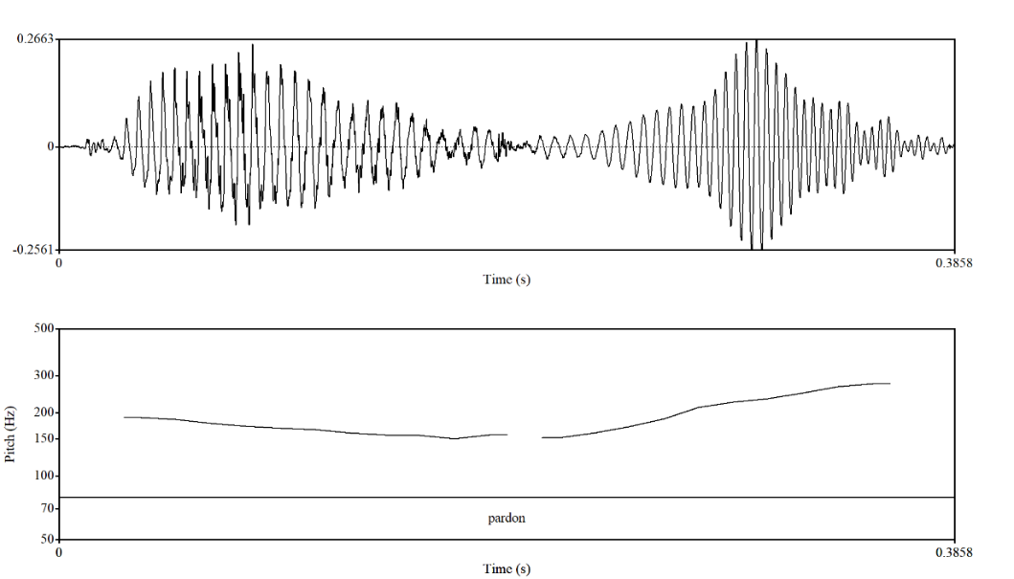
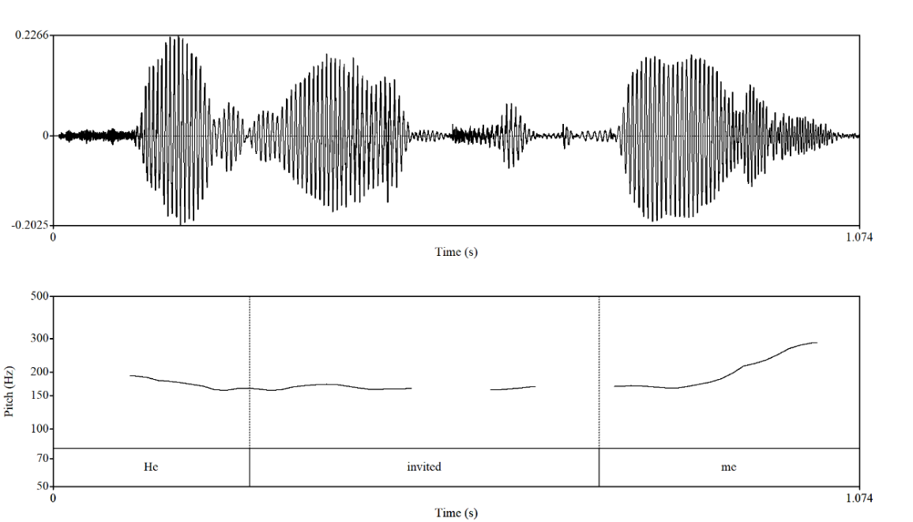
Figure 6. Representation of sentences through the PRAAT program

Of these two mentioned terms, prosodeme and intoneme, intoneme is used only to refer to intonational phenomena, while prosodeme refers to intonational and accentual phenomena. The peculiarity of prosodeme is that it is not pronounced individually as a phoneme, since it consists of a sequence of several phonemes [130, p. 106].
V.A. Artemov, defining prosodeme as a unit at the suprasegmental level, considered its function, limiting it only within the framework of a syllable. In relation to syllables and phrases considered at a higher level, it was assumed that the distinctive function is performed by intoneme, while prosodeme distinguishes only syllables.
N.S. Trubetskoy shared his thoughts. Obviously, one of those who emphasized the relation of prosodeme with intonational and accentual phenomena was
A.A. Reformatsky [cited in 131].
Prosodeme determines the function of prosody. In general, three main functions of prosody are formed in English: constitutive, distinctive and identificatory function. The constitutive function reflects the relationship between speeches and intonation groups and aims to highlight words of high semantic importance within speeches or intonation groups. The following distinctive function is considered, partially divided into several types: communicative-distinctive, modal-distinctive, culminative (logical)-distinctive, syntactic-distinctive, stylistic-distinctive. According to the purpose of the speeches, different situations prosody also performs a corresponding function. As the last function of prosody, the identificatory function is considered. Prosody enables a listener to determine the communicative and modal type of speech, to identify its semantic and syntactic structure in accordance with the context of the discourse.
In A. Muller’s opinion, the functions of prosody are divided into systematic-linguistic, stylistic-pragmatic and expressive. According to these functions, the linguistic, pragmatic and affective prosody types are also distinguished. Linguistic prosody is associated with lexico-syntactic rules and indicates word or phrasal stress in speeches, while pragmatic prosody indicates the intention of the speaker, the third type of prosody expresses the personality characteristics of the speaker and his emotional state [132].
The issue concerning the meaning of prosody requires a deeper study. The prosody of speech depends on the multiplicity of its function. K.K. Baryshnikova fully disclosed the functions of speech prosody: phonetic tools form words from units of other levels of the language, turn them into phrases, separate them, make them the main or additional [133, p. 20]. However, the function of prosody is not limited to this: they are divided into general and private. General functions include organization, style creation, and semantics, while individual functions cover division, connection, formulation, and identification.
It is known that prosody plays an important role in any communication and in speaking and information exchange.
The researches of many scientists, like E.L. Freidina et.al. [134], N.A. Katina [135], M.Ya. Bloch [136] devoted to the representation and function of prosody in discourse and speech are of high significance. L. Urmanova studied prosody on the basis of television discourse, that is, the prosodic means in the speech of presenters on the basis of modern television materials [137], E.G. Musayeva studied the intonational formalization of political discourse, the use and emphatic marking of emphatic stress in public political discourse [138].
It would be remiss to exclude from our analysis the compositional approach employed in the study of sentence semantics and the speech. The meaning of individual words is of great significance in the construction of a sentence. However, the meaning of words cannot convey the message without the use of grammar. Similarly, at the sentence level in spoken discourse, the individual words are unable to convey the intended meaning unless they are combined in a coherent and cohesive manner. This highlights the importance of coherence and cohesion in longer messages. A longer message is frequently regarded as a discourse by numerous researchers, including the esteemed scholar M. Bakhtin, who underscored the dialogic essence of discourse and how extended discourses and texts shape meaning [139]. T. van Dijk made a significant contribution to discourse analysis, viewing discourse as not merely isolated sentences but as coherent sequences of language that convey broader meanings and social contexts [81]. E. Goffman, another influential figure, analysed the interactional aspects of discourse, focusing on how longer messages and conversations reflect social relationships and contexts [140]. In spoken discourse, the interconnectivity of discourse units is facilitated using speech prosody, encompassing aspects such as pitch, pause and rhythm. However, in spoken language, interlocutors do not always adhere to the established rules of grammar and proper structure due to the influence of various factors, including hesitation, disruption of the flow of speech, and interruptions. It is therefore evident that the role of prosody in such situations is of paramount importance.
The term ‘prosody’ is used to describe the process of dividing the flow of speech into discrete segments, which are then classified as belonging to a specific discourse. In spoken language, the discourse structure, comprising clauses, sentences and paragraphs, is signaled by the prosody. Prosody is defined as the suprasegmental properties of spoken language, which are systematic acoustic features that extend beyond the level of a single phoneme. The primary function of prosody is to structure discourse [cited in 141]. The primary properties of prosody are rhythmic, dynamic and melodic, and they are closely related to the acoustic correlates of duration, intensity and pitch, respectively. The principal function of prosody is to confer prominence, to categorise and to facilitate communication of discourse functions such as turn-taking or the indication of attitude. In the study of spoken language, it is essential to consider the prosodic aspects as a fundamental element, in addition to the syntactic, lexical and non-verbal forms of expression. In his work, Bruce presents alternative methods for expressing prominence, grouping and discourse functions (Table 4).

Table 4. The principal function of prosody (by Bruce)

 | Prosodic | Syntactical and lexical | Non-verbal
Prominence  Bringing out, emphasizing  Withholding, deemphasizing | Difference in stress  Pitch accent  Deaccenting | Syntactic construction  Emphatic paraphrasing, topicalization  Pronominalization ellipse | Accompanying gestures
Grouping  Boundary  Coherence | Prosodic phrasing  Pausing, etc.  Prosodic connection | Phrase structure  Syntactic boundary  Phrase connection, conjunctions | -
Discourse | Intonation, intensity etc. | Word order, choice of lexeme | Body language, gestures, facial expressions

As evidenced by the provided table, it is imperative to consider both syntactical and lexical, as well as non-verbal forms, in conjunction with the prosodic form of discourse segments.
The research of the relations between discourse segments and prosody on the materials of the Swedish language conducted by S. Gustafson-Capkova can display that “discourse segments are signaled through an interaction of the string of words and prosody” [142, p. 225].
G. Brown and G. Yule proposed the term “paratone” to refer to “structural units of spoken discourse which take the form of ’speech paragraphs’” [28, p.100-101], as when people who are asked to read written text aloud use certain intonational cues to mark boundaries between paragraphs.
The issues on intonation and prosody of the Kazakh language are addressed by many researchers, however the volume of work devoted to the study of prosodic features of academic spoken discourse isn’t enough [143], [144]. For this reason, we have made an attempt to consider the role of prosody, especially the variation of pitch of voice in the lecture delivering process, paying attention to the features of academic spoken discourse that keep the information coherent. The speech of the leader of any country is considered as a lecture conveyed to whole population. Realizing the significance of prosody in their speech there was made an attempt to study the speech of the country’s leader [145].
The study of prosody, or the way words are spoken, is of particular value to the field of spoken language technology, given that a significant amount of information is conveyed by a speaker through their prosody. This encompasses the pitch rise at the final part of a question, the emphasis employed to indicate topic, contrast and focus, and the intricate correlates of emotion. The five major prosodic qualities are pitch, intensity, spectral qualities such as tilt and balance, duration and pausing. The most significant of these for the proper comprehension of uttered speech are pitch, intensity, pausing and duration of patterns.

2.2 Constituent components of prosody
In the lecturing process, the lecturer functions as a conduit of both knowledge and culture, tasked with transmitting these elements to students and thereby influencing their intellectual development. The lecturer’s speech possesses several distinct characteristics: it is public, specifically directed and addressed to students, audio-visually perceived by the audience, and often contains elements of improvisation. Although lectures are typically prepared in advance, even when delivered orally, the lecturer must remain a dynamic presence capable of engaging and maintaining the students’ interest and attention. This necessitates spontaneous adaptation to the immediate context and conditions, which may arise from unforeseen circumstances such as responding to unexpected student inquiries or managing atypical situations during clinical rounds. Through their discourse, the lecturer not only organizes and coordinates the subject matter but also conveys essential information, thereby impacting students’ emotional, volitional, and cognitive.
Building upon the lecturer’s central role in structuring and delivering subject matter, L. Ginyatullina investigates the intonational features distinctive to lecture discourse within the academic style. The study elucidates several fundamental characteristics of academic intonation that significantly enhance the effectiveness and clarity of oral communication in educational settings. Specifically, L. Ginyatullina identifies the following intonational features as typical of academic speech:
- Tone of voice: characterized by an imperative, impressive, instructive, and self-assured quality;
- Loudness: generally elevated, occasionally markedly so, contingent upon audience size;
- Speech rate: predominantly normal, with deliberate deceleration in segments requiring emphasis, such as the presentation of rules or illustrative examples;
- Pauses: primarily prolonged, serving to segment communicatively salient portions of discourse, while brief pauses are infrequently employed;
- Rhythm: systematically organized, particularly during the explication of rules and formulation of conclusions;
- Terminal tones: frequent utilization of complex terminal contours, including High-fall + Low-Rise, Fall-Rise, and Rise-Fall-Rise patterns, alongside numerous high-categorical falls;
- Intonational scales: regular use of Stepping Head and Falling Head patterns, with occasional deployment of the High-Level Head [146, p 26-27].
These intonational characteristics play a pivotal role in the lecturer’s ability to maintain student engagement and facilitate comprehension, thereby reinforcing the emotional, volitional, and cognitive domains affected through lecture discourse as previously discussed.
It is important to note that these prosodic characteristics may vary depending on the language used as the medium of instruction. This linguistic variability underscores the necessity of examining the individual components of prosody within academic discourse. A detailed investigation of each constituent allows for a more nuanced understanding of how prosody contributes to the effectiveness of lecture delivery across different linguistic and cultural contexts.

2.2.1 Pitch variation in utterances
Pitch, or fundamental frequency (F0), refers to the auditory perception of the highness or lowness of the speaker's voice, determined by the frequency of vocal fold vibration [147]. In spoken discourse, pitch is a primary component of intonation, which contributes to syntactic disambiguation, discourse structuring, and speaker attitude. Within academic lectures, pitch variation often signals informational status, such as highlighting new versus given information, indicating rhetorical contrast, or marking boundaries between discourse units [148], [149].
In examining how pitch functions in spoken discourse, D. Brazil’s model of intonational grammar particularly is insightful. His framework suggests that rising pitch typically indicates non-finality, openness, or an expectation of further information, whereas falling pitch is more often associated with finality and a sense of certainty [148]. This modulation in pitch plays a crucial role in helping speakers – such as lecturers – organize their discourse into coherent, digestible units. It also provides listeners with interpretative cues that support comprehension. For instance, important terms or transitions are often highlighted through the use of higher pitch, which serves to enhance their prominence and draw the audience’s attention to their significance [150].
Researchers from Kyoto University conducted a study examining how variations in a speaker’s voice pitch affect listeners’ intellectual concentration during online lectures [151]. Their experimental findings highlight the significant role of pitch in maintaining attention. Specifically, they observed that pitch variation positively influenced listeners’ cognitive engagement, with attention levels showing an upward trend following instances of pitch change. Moreover, subjective feedback from participants indicated that the use of varied pitch not only helped them concentrate more effectively but also assisted in staying alert during the lecture. These results underscore the potential value of prosodic modulation in enhancing the effectiveness of spoken educational content.
The role of pitch accent in speech has been underscored in linguistic research as a critical prosodic feature that contributes to the marking of information structure in discourse. Pitch accent is an intonational phenomenon that renders certain words more prominent within an utterance, distinguishing them from others in terms of their intonational emphasis. This prominence is not synonymous with lexical stress, as not every word that carries lexical stress is necessarily pitch-accented; rather, pitch accent serves as a dynamic prosodic marker that highlights information relevant to the discourse context.
In her investigation of spontaneous Dutch discourse, M.E. van Donzel identified that pitch accent predominantly signals the informational focus, marking elements that express new, inferable, or contrastive information. Her findings suggest that pitch accent functions as a primary prosodic tool to highlight lexical content crucial for the coherence and interpretation of spoken discourse [152]. This demonstrates how pitch accent operates at the intersection of phonology and pragmatics, facilitating listeners' comprehension by indicating which parts of the utterance carry significant informational weight.
Complementing these findings, the research conducted by Swedish scholars has further elucidated the role of pitch accent in discourse comprehension. Studies indicate that Swedish pitch accents are integral in guiding listeners’ understanding of information structure, helping to distinguish between given and new information and thereby enhancing the interpretive process during communication [153], [154]. These investigations collectively emphasize the functional importance of pitch accent in spoken language as a marker of discourse salience and an aid to effective communication.
The role of pitch accent in spoken language is fundamental for marking information structure and guiding discourse comprehension. Pitch accent functions as an intonational feature that highlights specific words within an utterance, distinguishing them as more prominent relative to others. This prominence is not simply a reflection of lexical stress but serves as a dynamic cue to signal new, contrastive, or important information in the discourse [152], [155].
Complementing this, pitch modulation more broadly plays a crucial role in structuring oral lectures. Rising pitch contours generally signal non-finality, openness, or the anticipation of further information, whereas falling pitch contours indicate finality and speaker certainty. This modulation enables lecturers to segment their speech into coherent, manageable units, thereby facilitating audience comprehension. For instance, key terms or transitional phrases are often marked by elevated pitch, which enhances their prominence and signals their pragmatic importance within the lecture.
Together, these prosodic mechanisms, i.e. pitch accentuation and pitch contour modulation, work synergistically to organize information flow and aid in the effective transmission of meaning during lectures delivered orally.

2.2.2 Pausing patterns in spoken production
A pause constitutes an essential element of spoken discourse, contributing to the construction and interpretation of meaning within the communicative act. It is characterized by a temporary suspension of speech, which may be realized either as a silent (unfilled) or vocalized (filled) interruption. The functional significance of pauses is closely linked to the communicative intent underlying their use. In a study investigating the pedagogical value of pauses in facilitating listening comprehension, L. Herrera Armas [156, p. 13] defines pauses as “spaces of time (temporal stops) given during a spoken discourse which are applied as an active strategy in class to foster the comprehension of the spoken language.” Her findings indicate that well-timed pauses aid listeners in recalling, clarifying, and reflecting on what they have heard, thereby supporting more effective auditory processing. This view is consistent with the definition offered by Merriam-Webster Dictionary, which refers to a pause as “a temporary stop” and “a brief suspension of the voice to indicate the limits and relations of sentences and their parts” [157]. Together, these perspectives highlight the cognitive function of pauses in reducing information density, thus enabling learners to engage with oral discourse in segments that are more manageable.
In the study of speech, particularly in lecture discourse, pauses have been identified as a key prosodic feature that influences both comprehension and listener engagement. A number of researchers have explored the role of pauses in spoken communication, with one particularly notable contribution being M. Elmers’ study titled Evaluating Pause Particles and Their Functions in Natural and Synthesized Speech in Laboratory and Lecture Settings. In this research, Elmers introduces the concept of PINTs (Pause-Internal Phonetic Particles), a category that encompasses various acoustic events occurring within pauses, such as phonetic silence, breath sounds (e.g., inhalations and exhalations), filler particles like uh and um, and even non-verbal vocalizations such as tongue clicks.
The findings suggest that these PINTs significantly affect how listeners process spoken material, particularly in terms of recall and information retention. Interestingly, the inclusion of PINTs in synthetic speech systems has been shown to enhance their naturalness and intelligibility, further underlining the communicative function of pauses. For lecture discourse, this evidence reinforces the idea that strategic pausing – whether silent or filled, serves not merely as a break in speech, but as a tool for structuring information, guiding attention, and supporting listener comprehension [158].
Pauses can be broadly categorized into physiological and linguistic types. Physiological pauses occur naturally due to the speaker’s physical need to breathe or manage the articulatory process, while linguistic pauses serve communicative functions by supporting the structure, coherence, and interpretation of spoken discourse. The presence of pauses is essential for both the production and comprehension of spoken language; without them, the encoding and decoding of meaning in real-time interaction would be significantly impaired. This is clearly displayed in Zellner’s research on pauses and the temporal structure of speech. In this work he proves the significance of pauses in understanding the meaning of the sentences where he takes an example “A Turkish carpet salesman” and proves that duration of pause can change the meaning of a speech.
The communicative value of linguistic pauses becomes particularly evident when examining their role in shaping meaning at the sentence level. Research has shown that pauses can function as prosodic cues that influence how listeners group words and interpret syntactic relations. B. Zellner, in her study on the temporal structure of speech, provides compelling evidence for the semantic role of pauses. She illustrates this with the example “a Turkish carpet salesman”, demonstrating how different placements and durations of pauses within the phrase can yield multiple interpretations such as whether “Turkish” modifies “carpet” or “salesman.” This finding underscores the idea that pauses are not arbitrary breaks in speech but serve as intentional cues for syntactic grouping and semantic disambiguation. As such, pauses are essential not only for managing speech production but also for ensuring that spoken language is processed and understood correctly by the listener. [159] In this context, two primary types of pauses are identified: inter-segmental pauses, which occur within the articulation of individual words, and inter-lexical pauses, which take place between separate lexical items. This classification is also discussed in the studies of B. Zellner [159] and N. Sorokoletova [160], both of whom investigate the typology and functional features of pauses in relation to prosodic organization and meaning-making in spoken discourse.
However, the classification of pauses cannot be limited to a single framework. Pauses may be categorized into several types: (1) articulation pauses, (2) listener pauses, (3) transition pauses occurring during conversational turn-taking, and (4) pauses within connected speech. The present thesis focuses on the fourth type, as it is most relevant to lecture discourse.
Previous research has shown that pauses are most readily perceived when their duration falls within approximately 200-250 milliseconds, which appears to represent the standard auditory threshold for pause detection [161]. Furthermore, studies have identified a relationship between both the duration and frequency of pauses and the hierarchical structure of syntactic constituents. This suggests that pausing patterns are not random, but instead closely linked to the grammatical and informational organization of speech.
It is also essential to consider the situational context in which pauses occur. Temporal pressure on the speaker like environmental conditions, time constraints, or communicative demands, can either facilitate or hinder expressive capacity. For example, conveying important information rapidly in a noisy environment presents significant challenges. In such situations, the likelihood of increased pauses, hesitations, and even disfluencies such as stuttering is higher. These observations reinforce the importance of analysing both the presence and duration of pauses in lectures, where they can play a decisive role in structuring information, supporting comprehension, and maintaining audience engagement.

Table 5. Types of pauses traced in lecture genre.

Duration bin | Operational definition | Typical prosodic cue stack
Micropause | < 200 ms | slight articulatory timing
Short pause | 200–500 ms | brief silence ± small F0 reset
Medium pause | 500–1000 ms | silence + pre-boundary lengthening + clearer F0 reset
Long pause | > 1000 ms | extended silence + lengthening + distinct F0 reset; sometimes audible breath
Filled pause | any duration (typically 200–800 ms) | vocalized uh/um; often holds floor
Breath pause | any duration (often > 500 ms) | audible inhalation/exhalation

Drawing on existing studies of pauses in spoken discourse, we synthesize a classification that organizes pauses by acoustic form, duration, and discourse function (Table 5). This systematization provides a consistent framework for annotation and subsequent analysis. Micropauses are not considered in the analysis because they are not discourse-relevant in our framework.

2.2.3 Intensity variation in oral delivery
In the context of lecturing, the primary objective extends beyond the mere transmission of information contained in the lecture. Equally, if not more, significant is the way in which the lecturer is perceived by the audience. When the material fails to resonate with listeners, the lecture cannot be considered effective. This observation underscores the importance of recognizing that the lecture format is not purely monologic but inherently dialogic in nature.
As E. Freydina and G. Abramova note, the notion of ‘dialogue’, when understood in a broad sense, reflects a general orientation of speech toward active interaction with the audience. This perspective highlights the inseparability of dialogic and monologic elements in spoken academic discourse, which differ only in subtle ways [162]. In this regard, M. Bloch’s statement that “monologue is dialogical, while dialogue is monological” is particularly relevant, as it emphasizes the complex interplay between these modes of speech [163, p. 176].
This raises an important question: how can a lecturer sustain the audience’s attention throughout the delivery of a lecture? Numerous studies, particularly those conducted by linguists, indicate that one of the key factors lies in the use of intensity, that is, the loudness of speech, as a marker of prominence and emphasis. Alongside pitch variation, modulation of loudness serves to highlight the significance and novelty of specific information. In practice, the deliberate amplification of certain segments within a clause or phrase functions as a cue for students, signaling the need to focus closely on the material being presented at that moment. As a rule, the use of lower intensity can indicate the less important and mostly background information. This idea is clearly illustrated in the study by M. Aylett and A. Turk [164]. Their findings show that when a word carries more information and is therefore less predictable in the flow of speech, it is more likely to be emphasized prosodically. In contrast, words that are easier to anticipate, and thus less informative, tend to receive less prominence. In practical terms, this means that the way speakers highlight certain words through stress or loudness is not random; rather, it serves a clear communicative function by drawing listeners’ attention to new or particularly important points within the discourse.
Moreover, lecturers may deliberately increase the intensity of their speech to convey confidence and enthusiasm, particularly in moments when it is necessary to re-engage the audience’s attention. Such modulation of loudness can serve not only to underscore key content but also to manage the dynamics of the learning environment. For instance, in situations where ambient noise arises and threatens to obscure the lecturer’s voice, a temporary increase in intensity functions less as a marker of emphasis and more as a practical strategy to maintain audibility and control over the classroom atmosphere. In these contexts, the purpose of employing intensity shifts from signaling informational salience to addressing immediate communicative and managerial needs.
These observations highlight the multiple factors that influence the use of intensity in academic discourse, further reinforcing its crucial role in the effectiveness of lecturing. A. Buxó-Lugo et al. investigate whether speakers are able to adjust subtle acoustic–phonetic properties of prosody when situated in contexts where precise communication is essential. Their research explores the extent to which communicative context, alongside discourse structure, influences prosodic choices, particularly in the production of acoustic prominence. This perspective suggests that prominence is not solely determined by linguistic structure but is also dynamically shaped by situational demands and the speaker’s communicative intent [165].

2.2.4 Duration as a prosodic feature of speech
In addition to the prosodic features discussed above, the role of duration, particularly the temporal characteristics of words, word combinations, and even entire sentences, holds considerable significance in academic discourse. Variations in the length of sounds and speech segments have been examined by several researchers as key indicators of communicative intent and instructional strategies in academic settings. R. Hämäläinen et al., for instance, highlight that alterations in vocal quality such as adopting a tenser or laxer speaking style, or employing different patterns of vocal fold vibration, can provide valuable insights into the nuances of teacher talk and its impact on classroom interaction [166].
A closer examination of speech duration reveals that several factors influence its variability in discourse. At a fundamental level, the phonological structure of a language and its phonetic implementation significantly affect the temporal properties of speech. For instance, the intrinsic characteristics of vowels such as vowel height and tenseness can result in measurable differences in segmental duration. Additionally, speaker-related variables, including individual speaking style, habitual tempo, and syntactic structure, can further shape the rhythm and pacing of spoken language.
Beyond these linguistic and physiological factors, intentional manipulation of duration also plays a pragmatic role. Speakers often lengthen segments strategically, for example, to clarify complex or unfamiliar content, or to emphasize points that require special attention. Conversely, they may compress or accelerate delivery when addressing content that is repetitive, obvious, or considered less engaging, in order to maintain audience attention and manage time effectively. Such adjustments in timing not only enhance intelligibility but also reflect the speaker’s sensitivity to communicative context and listener needs.
In addition to melodic variables such as pitch, durational features play a crucial role in organizing speech into meaningful units. Specifically, variation in duration helps segment utterances into phrases that align with the topical structure of the discourse, thereby supporting the listener’s understanding of how ideas are grouped and related. Duration does not operate in isolation; rather, it interacts closely with other prosodic elements, most notably pitch and intensity, to produce speech that is both coherent and comprehensible. Through this interplay, speakers can not only shape the rhythm and flow of discourse but also highlight the relative importance of particular segments, drawing attention to key points and aiding information retention.

2.3 Methodological approaches to the study of prosody
The primary objective of this study is to examine the use of prosodic features in the spoken language of an academic representative, specifically a lecturer in higher education. While a lecture may be scripted for delivery in read-aloud form, it is common for lecturers to draw upon spontaneous speech in their interactions with students for various purposes, including clarifying material or seeking acknowledgement of comprehension.
The present study will concentrate on speech patterns that exemplify the communicative style typically observed in academic classroom settings. This type of discourse will serve as a principal point of reference for our research. In this study, the term ‘discourse’ is used to refer to a coherent set of spoken expressions produced by a speaker with the intention of conveying information to an audience for a specific purpose. For the purposes of this study, spoken discourse will be considered as a monologue, which differs from dialogue that involves multiple speakers.
All discourses are characterised by an internal organisation, which may be described as a hierarchical structure comprising a number of components, including paragraphs, sentences, clauses, phrases, concepts and words. Although this hierarchy can be further dissected down to the level of individual words, our analysis will primarily concentrate on words and the broader structures above them.
Irrespective of whether the spoken discourse is meticulously planned or delivered extemporaneously, it can be structured in a comparable fashion. This indicates that the overarching framework, comprising words, concepts, phrases, clauses, sentences and paragraphs, is applicable to both types of discourse. This structured approach enables us to comprehend the way academic communication is constructed and to gain insights into its efficacy in educational settings.
In order to reach the goal of the study a corpus with a total twenty-two lecture transcripts and audio materials is compiled. As the study aims at studying the academic lectures in three different aspects, a part of the corpus, i.e. ten lectures, consists of Kazakh-language lectures, another part Kazakhstani English-language lectures.
The research corpus of Kazakh-language lectures used in this paper consists of ten university lectures in Kazakh, five of which were recorded at al-Farabi Kazakh National University, two of them were taken from the personal archive of lecturers and other three ones are the archive of Abay Institute at al-Farabi KazNU. The transcription has a total word count of just over 32000 words. Subjects are university professors. The lectures represent a formal register. The lectures are taken from different fields of science: Linguistics (4 lectures), Literature (2 lectures), Law (2 lectures), Biology (2 lectures).
The Kazakhstani English part of the corpus comprises a small-sized corpus of a total of 10 lectures, each lasting one academic hour. The video and audio materials of 5 lectures were taken from the base of massive open online courses of al-Farabi KazNU and five lectures were recorded at al-Farabi KazNU for the given research purposes. The lecturers involved in this research conveyed lectures on various subject disciplines such as Macro-Economics, Physical Geography, Environmental Science, Advanced Corporate Finance, Philology and Biotechnology. The transcription has a total word count of 23139 words.
In the absence of a corpus of spoken academic discourse in the Kazakh and English languages as an instructional medium in Kazakhstan, it was necessary to record the lectures of selected lecturers who had given their approval to be recorded. It should be noted that all participants consented to take part in the research and collaborated in the recording process. The lectures selected for analysis represent a range of subjects, allowing for a comprehensive understanding of the features of lectures and their delivery process.
Given that all lectures are delivered orally, and there is no prepared text or transcription of the lectures that has been recorded and selected, there arises the necessity of transcribing them. Since the materials have to be tagged and parsed, it is imperative that the transcripts are also adapted to serve as input for the tagger and parser. It is therefore essential to select the optimal transcription method. The lectures are conveyed in a variety of languages; therefore, it was decided that a transcription based on standard orthography would be optimal for analysis. Furthermore, alternative transcription methods, such as phonetic or phonological, could be employed; however, they are challenging to interpret for those without training in this field and are not well-suited for analysis and parsing. In the course of analysing the materials with the assistance of the PRAAT software, the spelling format provided by the software itself is employed. Nevertheless, some signs, such as sighs, humming, and hesitations, are transcribed in accordance with the established orthographic conventions.
In this study, the analysis focused on the prosodic features present in lectures delivered in both English and Kazakh. Particular attention was given to examining whether, and in what ways, the lecturer’s use of prosody varied across different instructional mediums and lecture patterns. An integrated approach, combining in-depth qualitative analysis with descriptive statistics, was employed to interpret the lecturer’s academic speech. The selected lecture samples were analysed through a combination of frequency counts and illustrative qualitative examinations to provide a comprehensive view of prosodic use in the academic context.
Furthermore, the study considered the sequential organization of lecture material, recognising that each utterance within a sequence is understood in relation to the preceding utterance in the ongoing discourse. This sequential perspective allowed for the analysis of how prosodic choices contribute not only to individual utterances but also to the broader structure and flow of lecture delivery.
Utterances in the lecture material that are not directly related to the topic under discussion are classified as other and excluded from the analytical flow. It should be noted that such instances constitute only a small portion of the lecture and occur infrequently. Due to space limitations, it is not feasible to present and illustrate every example from the lectures in detail. Therefore, only those excerpts that most clearly demonstrate the relevant prosodic features were selected for inclusion. To enhance the reliability of the findings, the selected data excerpts and their analyses were discussed extensively with specialists in the field. Constructive feedback and collaborative analytical efforts have played a significant role in strengthening the validity of the empirical analysis.
Voices can be studied acoustically. The characteristic of sound that is perceived as pitch originates from the fundamental frequency (F0). This, in turn, in human voice production, corresponds to the number of vocal fold vibrations per second. It is measured in Hertz (Hz); one vibration per second is 1 Hz. The faster the vocal folds vibrate, that is the more vibrations they produce per second, the higher a pitch we hear. The average F0 of a male speaking voice is about 120 Hz and a female voice about 200 Hz; however, the frequencies (i.e. the pitch use) may be somewhat language and culture dependent [167].

Conclusion of chapter 2
The analysis of prosody and its peculiarities justify their essential role in lecturing that contributes to organizing meaning, highlighting key information and sustaining coherence in the lecture by ensuring clarity, precision and expressiveness of thought. The main components of prosody function as acoustic cues that demonstrate the intention and discourse strategy whereas changes in pitch signal thematic focus, pauses outline semantic boundaries, duration contributes to rhythm and emphasis and intensity adds expressiveness. Together they create the prosodic portrait of a lecturer that can distinguish and reveal the cultural and individual features of lectures. This theoretical foundation provides a solid basis for the subsequent empirical analysis of prosodic organization and coherence-building mechanisms in authentic lecture discourse and conducting an acoustic instrumental analysis through Praat software.
In sum, prosody acts as a unifying force in the lecture genre bridging linguistic form, cognitive processing, and pedagogical purpose, and lays the groundwork for the empirical analysis that follows.
3 PROSODIC FEATURES OF ACADEMIC LECTURES: ENGLISH, KAZAKH, AND ENGLISH-MEDIUM CONTEXTS

3.1 Studies on the prosody of English academic lectures
In recent decades, the role and influence of English in the global arena have intensified, largely as a consequence of globalization. The expansion of international cooperation has further accelerated this process, consolidating the position of English as the most widely applied and published language in academia. Such developments demonstrate that the academic sphere and its language may be regarded as the nucleus of a country’s standard literacy, as they establish the norms of intellectual communication, codify knowledge, and provide models of linguistic accuracy and stylistic consistency. Inevitably, these shifts exert a profound influence on the local academic languages of individual nations. The academic domain thus functions not only as a site of knowledge production and dissemination but also as a reference point that shapes literacy standards within society as a whole. The investigation by
R. Hämaläinen et.al. devoted to the prosodic analysis of a teacher’s talk where he could prove that when the teacher acted in the authentic classroom setting, she often used her voice in a different way. The results show that when addressing the complete classroom, her voice was more raised, resulting in a more pressed voice (indicated by a higher pitch) than in other occasions, such as talking to the student in a one-to-one way or to small group of students when guiding them. In the latter situation, the voice was more relaxed and thus closer to her natural voice [166].
Language and culture are inextricably connected, and the use of language is always shaped by the settings in which it occurs. Cultural features exert a significant influence on discourse, particularly in terms of its organization and the range of its realizations. This relationship is supported by M. Gotti’s observations “Indeed, academic discourse is not at all uniform but varies according to a host of factors, such as language competence, local culture, disciplinary field, community membership, professional expertise, gender and generic conventions” [168, p. 61]. All these features are peculiar to a phenomenon that plays a crucial key role in an academic discourse. From the definition of identity by B. Benwell and E. Stokoe “a public phenomenon, a performance or construction that is interpreted by other people. This construction takes place in discourse and other social and embodied conduct, such as how we move, where we are, what we wear, how we talk and so on” [169, p 4].
Voice and its prosodic features are widely recognized as an important dimension of identity, since they allow individuals to represent themselves and to distinguish their identity from that of others. At the same time, the debate over whether voice should be understood primarily as an expression of individuality or as a socially constructed phenomenon remains ongoing. On a social level, however, voice can be seen as a tool through which individuals articulate social identities that are shaped and reinforced by culturally and socially prescribed labels. Еhe PhD investigation by M. Swerts that presents the results related to the prosodic features of academic lectures based on the material oh the language studied at their university can be a good example for the further researches [170].
This line of reasoning provides the basis for examining the prosodic features of the lecturer’s voice as a reflection of membership within a social community. The focus is placed on identifying the distinctive characteristics that differentiate this discourse from that of other language users. Such analysis makes it possible to determine whether, and to what extent, English academic discourse influences English-medium lectures delivered by non-native speakers.
Research on the prosodic features of English academic lectures has already received notable attention, both in studies focusing on native speakers and in comparative investigations involving English-medium lectures delivered by non-native speakers. These works approach the lecture genre from multiple perspectives, often highlighting its dual role as a mode of knowledge transmission and as a performance shaped by interactional and rhetorical demands. A growing body of literature situates prosody at the center of this communicative practice, examining how pitch movement, pausing, rhythm, and intensity function not only as acoustic phenomena but also as discourse-organizing and meaning-making resources.
Preceding studies thus provide a foundation for treating academic lectures as representative discourse events in which prosodic features play an integral role. They demonstrate that parameters such as fundamental frequency (F0), duration, and intensity contribute to the lecturer’s ability to structure information, guide listener comprehension, and establish credibility. In this respect, they also offer valuable methodological and conceptual tools for later research, including the present dissertation.
One particularly valuable contribution is the doctoral dissertation by J.M. Im, Native English speakers' perceptions of intelligibility in the extended discourse produced by non-native speakers. J.M. Im investigates the prosodic peculiarities of non-native speakers’ extended discourse, focusing on how intonation, rhythm, and pausing shape native listeners’ perceptions of intelligibility. The findings show that deviations in prosodic realization can affect comprehension more significantly than segmental errors, underscoring the centrality of prosody in effective academic communication. This study is especially relevant for English-medium lectures delivered by non-native speakers, where intelligibility plays a critical role in knowledge transfer [171].
Other scholars have explored prosody in terms of lecturer style and interaction. One important contribution in this area is made by A. Chueshkova, who investigates prosodic markers of lecturer charisma through a case study of two lectures delivered by David Crystal. Her analysis shows how variation in F0, intensity, and temporal organization enhances the speaker’s authority and fosters listener engagement, thereby linking prosodic delivery with perceptions of personal style and rhetorical effectiveness. This perspective resonates with broader debates in discourse prosody about the interplay between linguistic form, speaker identity, and audience response [172].
Another dimension is highlighted in the work of E. Freydina and G. Abramova, who analyze dialogue strategies and their prosodic realization in English lectures. Their findings underscore the interactional aspect of academic discourse: even when framed as monologic, lectures incorporate dialogic cues such as rhetorical questions, confirmation checks, or evaluative comments, that are reinforced through specific intonational patterns. This approach enriches our understanding of the lecture as a hybrid discourse type, balancing monologue with elements of conversational interaction [162].
Further insights come from L. Buss et.al., whose pilot study on discourse intonation in L2 academic presentations reveals how second-language speakers use prosody to signal discourse boundaries, highlight salient information, and project interpersonal stance. While the study focuses on student presentations rather than formal lectures, its results illuminate challenges and strategies relevant to English-medium instruction more broadly. Notably, the authors point to discrepancies between native and non-native speakers in the use of pitch range and final contours, raising questions about intelligibility, perceived competence, and communicative effectiveness in academic settings [173].
Taken together, these studies reflect a shared recognition of the multifunctional role of prosody in lectures: it organizes discourse, enhances clarity, projects stance, and shapes the lecturer’s persona. For current research, they provide not only empirical findings but also methodological precedents—ranging from acoustic analysis of F0, pause distribution, and intensity to discourse-functional interpretations of prosodic cues. In this way, the existing literature establishes a robust platform for investigating the distinctive features of English academic lectures and for examining how prosodic variation mediates between linguistic structure and communicative effectiveness.
Building on the methodologies and findings of the aforementioned studies, the present research turns to the analysis of prosodic features in English-medium lectures delivered in Kazakhstan. In order to evaluate the degree of similarity and divergence between these lectures and those produced by native English speakers, it is essential to establish a reliable baseline grounded in first-language data. However, research that provides such comparative reference points remains limited, particularly in relation to the Kazakhstani academic context. This scarcity highlights an additional objective of the current study: to examine the prosodic characteristics of lectures delivered in Kazakh by native Kazakh-speaking lecturers. Such an investigation will make it possible to trace both language-specific and universal features of lecture prosody, thereby creating a more solid foundation for cross-linguistic comparison and for understanding how local academic traditions interact with the global practices of English-medium instruction.
By establishing a comprehensive prosodic profile of lectures delivered in Kazakh, it becomes possible to identify instances of interference that may emerge when lecturers shift to English-medium instruction. Although some research has been conducted on the intonation and prosody of the Kazakh language, these studies are still limited in scope. In particular, they often focus on general speech or conversational registers and provide insufficient detail regarding the academic register and the lecture genre specifically. As a result, the available literature does not yet supply the necessary depth of information to account for the unique prosodic features of formal instructional discourse. Addressing this gap is therefore an important step in building a more reliable framework for comparing Kazakh-medium and English-medium lectures, and for understanding how native prosodic patterns influence the delivery of academic content in a second language.

3.2 Prosodic features of lectures in the Kazakh language
The research corpus used in this paper consists of ten university lectures in Kazakh, with a total length of about 21 000 seconds. Five lectures were recorded at al-Farabi Kazakh National University, two of them were taken from the personal archive of lecturers and other three ones are the archive of Abay Institute at al-Farabi KazNU. The transcription has a total word count of just over 32000 words. Subjects are university professors. The lectures represent a formal register. The lectures are taken from different fields of science: Linguistics (4 lectures), Literature (2 lectures), Law (2 lectures), Biology (2 lectures).
Before description of the research process, we decided to say a few words about the style of lectures chosen for this study. As it was mentioned in the section of theoretical framework there are three styles of lecturing. According to the materials of the research in a form of lectures we defined three styles that were used. The first is read-aloud lectures where lecturers read from the notes (L5, L8), the second is spontaneous or well-prepared lectures without using the notes (L2, L3, L4, L10), and the last one – mixed lectures (L1, L6, L7. L9) where a lecturer uses the notes partly. The last lecture style is peculiar mostly for the CIS countries that had a traditional way of conveying a lecture reading and repeating the parts for several times to dictate it for the students to make notes. We realize that defining the style of lectures is very significant for prosodic patterns analysis (Table 6).
The lectures were coded in the research work as L (that means Lecture) and the number which is given according to the sequence of transcribed lectures (e.g. L1, L2 …). It should be noted that all lecturers and the audience the lectured were directed to were native speakers of the Kazakh language.
Each lecture was transcribed and segmented into fragments that express the features of academic discourse that are under analysis as corrections and paraphrasing, repetition, parenthetical insertions and questions. The transcription of the lectures is not extremely detailed, as we did not seek studying all aspects of prosody. Our aims is in the analysis of just a realization of pitch contours with the help of Praat programme [174]. The transcriptions were necessary for us in finding the samples of features of academic discourse and study the context these units were used in. As there is no device that can be used for appropriate realization of transcription of the texts in the Kazakh language, we had to transcribe it manually putting each word on paper.
The fragments for the analysis were selected from the audio materials using their transcription. The fragments were the samples of correction, paraphrasing, repetition, parenthetical insertion and questions.

Table 6. Information about lectures in the Kazakh language

# | Lectures | Filed of science | Subject | Duration | Word number | Gender of lecturer | Age of lecturer | Recording device
1 | L1 | Linguistics | Introduction into Linguistics | 50 min 23 sec | 3717 | female | 40-50 | Voice tracer, Philips, DVT1150
2 | L2 | Linguistics | about Abay | 15 min 20 sec | 1749 | female | 50-60 | Voice tracer, Philips, DVT1150
3 | L3 | Linguistics | Introduction into Linguistics | 34 min 52 sec | 3945 | female | 40-50 | Voice tracer, Philips, DVT1150
4 | L4 | Biology | Molecular Biology | 52 min 20 sec | 5242 | male | 50-60 | Voice tracer, Philips, DVT1150
5 | L5 | Literature | About Abay | 20 min 12 sec | 1900 | male | 60-70 | Voice tracer, Philips, DVT1150
6 | L6 | Law | Ecological Law of the Republic of Kazakhstan | 34 min 19 sec | 2564 | female | 30-40 | Voice tracer, Philips, DVT1150
7 | L7 | Law | Right to handle a criminal case | 50 min 30 sec | 4436 | male | 30-40 | Voice tracer, Philips, DVT1150
8 | L8 | Literature | About Abay | 19 min 30 sec | 1460 | male | 60-70 | Voice tracer, Philips, DVT1150
9 | L9 | Linguistics | Modern Kazakh language | 52 min 22 sec | 5881 | male | 50-60 | Video material of personal archive
10 | L10 | Biology | Physiology of Humans and Animals | 19 min 15 sec | 1288 | male | 60-70 | Video material of personal archive

From the Table 7 we can see that according to the lectures analyzed Wh-questions were mostly used in comparison to others while the least amount of the samples belonged to parenthetical insertions. The fragments were of different lengths and only the medium ones (lasted no more than 10-15 seconds) that could be covered with the help of PRAAT programme were analyzed. As the repetitions, especially syntactical repetitions and parenthetical insertions occurred to be of more than 10-15 seconds in length, so only the nuclear parts of intonation contour were cut for analysis. But for the analysis and identification of the prosodic peculiarities the wider contexts were taken into consideration, particularly in case of parenthetical insertions and paraphrasing. We realize that it is very important to take into account the factors why a lecturer decided to paraphrase or give clarification in the speech.
Table 7. The data on the features of Kazakh lectures

Features |  | Found | Selected | Inaudible
Corrections and Paraphrasing | Corrections | 150 | 145 | 5
Corrections and Paraphrasing | Paraphrasing | 97 | 93 | 4
Repetitions |  | 270 | 264 | 6
Parenthetical insertions |  | 77 | 73 | 4
Questions | Yes/No questions | 97 | 91 | 6
Questions | Wh-Questions | 429 | 412 | 17
Questions | Tag Questions | 123 | 113 | 10

Figure 7. Units found in Kazakh lectures

The results of the analyses of the categories like corrections, paraphrase, repetitions, parenthetical insertions and questions we labeled in the mini Kazakh Spoken Academic Corpus described in Table 6 above. We will discuss the data regarding the distribution of their prosodic features, characteristics, and the variation we encountered.
Each individual instance (see Table 7) of a category was analyzed and studied.
Corrections and paraphrases are used in academic discourse to restate information given earlier in other words. So, in this respect their communicative functions are similar. However, in the literature they are classified as different interaction types. The paper wants to find out whether the difference of the prosodic features of each of them warrants the classification of the two as different types.
Here we used an example that was taken from a lecture in Linguistics (L1) where the lecturer corrected the words ‘language is the result of speech’ (1) with the words ‘speech is vice versa the result of language use…’ (2) (the translation is given by the authors) having noticed that she had mixed the words up. As we see the lecturer used the words ‘kerisinshe’ (vice versa) that can function here as a connective to highlight that corrected part. We observed that in the Kazakh lectures, lecturers use the lexical units, filled pause, non-verbal means (e.g. headshake) and interjections. They are followed by the change of the intonation of lecturers that makes the corrected part more prominent. We can see it in the following Figure 8.

- Тіл бұл сөйлеудің
Til by’l soileu-diŋ
Language this PRON speech-GEN

сөйлеу бұл, керісінше, тілді қолданудың нәтижесі
soileu by’l kerisinshe til-di qoldanu-dyŋ na’tizhesi
speech this PRON vice versa language-ACC use-GEN result POSS3
‘Language is the result of speech, vice versa speech is the result of language.’
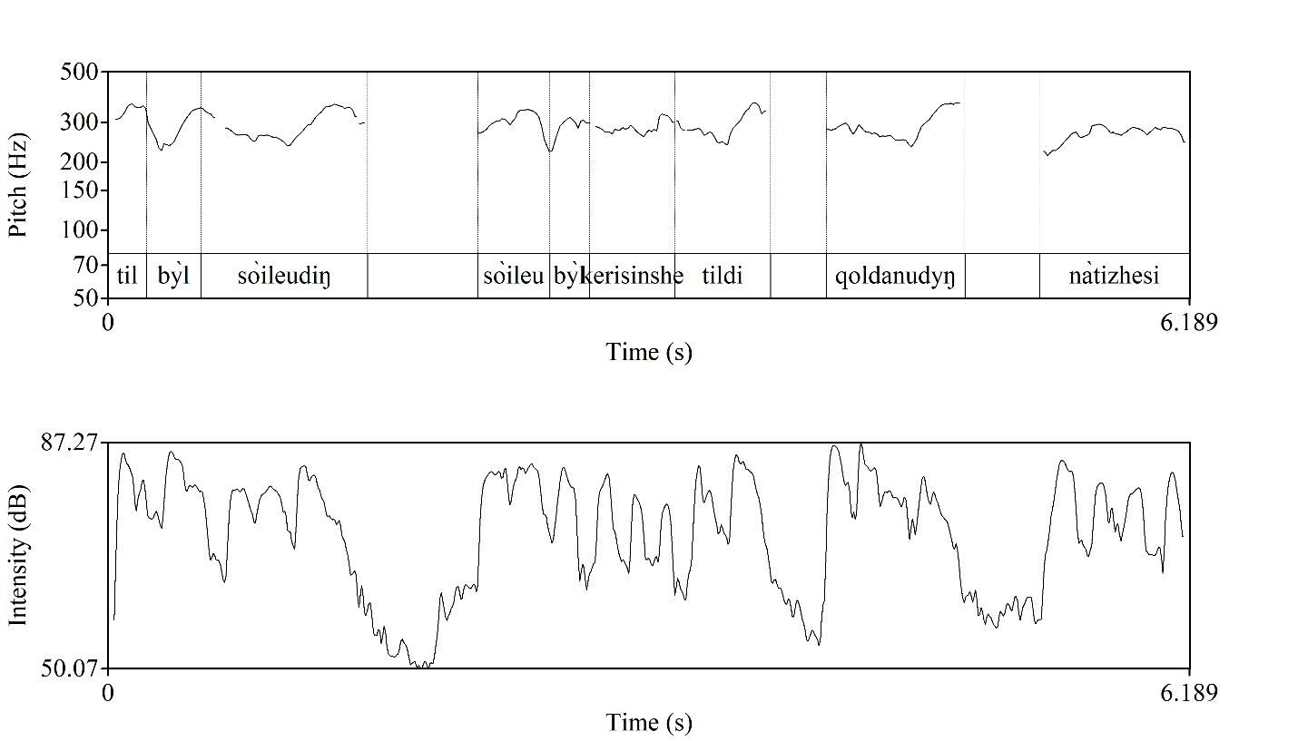
Figure 8. Sample of correction realized (L1) in female voice. Horizontally time in seconds is indicated, vertically – frequency of pitch in Hz on a logarithmic scale.

In the Kazakh language the stress in the word is made on the last syllable of a word. In this example we can see that the high pitch of the lecturer’s voice is laid on the words ‘so’ileudiŋ’, ‘tildi’ and ‘qoldanudyŋ’ in the speech. In the first case ‘so’ileudiŋ’ the pitch of voice rises from 245.5 Hz to 365.9 Hz with an interval in 7 ST, followed by a salient fall that is interrupted by a pause. This indicates the beginning of the corrected part of the segment. While pronouncing the prominent word ‘tildi’ the speaker raises the pitch from 263 Hz to 369.2 Hz with an interval in 6 ST that is followed with a short pause of 0.3 sec and low level pitch. This ends with a rising pitch in the syllable –dyŋ in the word ‘qoldanudyŋ’ from 231.5 Hz to 373.4 Hz, the interval between which in semitones is 8ST. Here we clearly see that the speaker uses the highest pitch in the corrected part of the speech, which can be a sign of highlighting the correction.
The intensity contour of the utterance given as example of correction in Kazakh lecture reveals that in the initial part high intensity occurs reaching approximately 87 dB and it demonstrates the beginning of the thematic material. However, this is followed by a marked reduction of intensity in the beginning of the second part where the values fall to 50-55 dB. This is considered as a sign of changing the mind and realization of a mistake uttered. When the corrected part is presented, intensity rises again to more than 87 dB indicating the significance of the corrected part, the intensity index after falls down marking the end of the utterance. This phenomenon was observed in all other examples of corrected parts of the material.

Example (2) below was found in (L6).

- Бұрын бізді екінші инстанция ретінде де
By’ryn biz-di ekinshi instantsiya retinde de
Earlier we-ACC two ORD instance as either

ой, бірінші инстанция ретінде де...
oi, birinshi instantsiya retinde de…
oh, one ORD instance as either...
‘Earlier we as the first instance, oh, as the second instance ...’

In example (2) the lecturer of Law used the word ekinshi (second) which was then changed into birinshi (first) and gave a sign of correcting herself by means of the interjection ‘oi (oh)’. The lecture fragment is about civil cases considered at cassation instance. Here the lecturer mixes – the second with the first instance.
In the Figure 9 the change of pitch level is clearly visible in the final part of both expressions (mistake and correction) where in the incorrect part of the expression the pitch on the synsemantic word de shows the rise from 267.8 Hz to 369 Hz but in the corrected one from 246.8 Hz to 420.8 Hz. The size of the interval between them shows 5.5 ST and 9 ST. This proves again the fact. From this it can be inferred that in the corrected part the pitch of voice is higher than in the part where a mistake was made. There is no great change in pitch use in pronouncing the corrected (birinshi) and inserted words (ekinshi) from 301.2 Hz to 293.5 Hz. This can be due to the phonetic peculiarity of Kazakh narrative sentences where the accent is made on the final part of the expression.

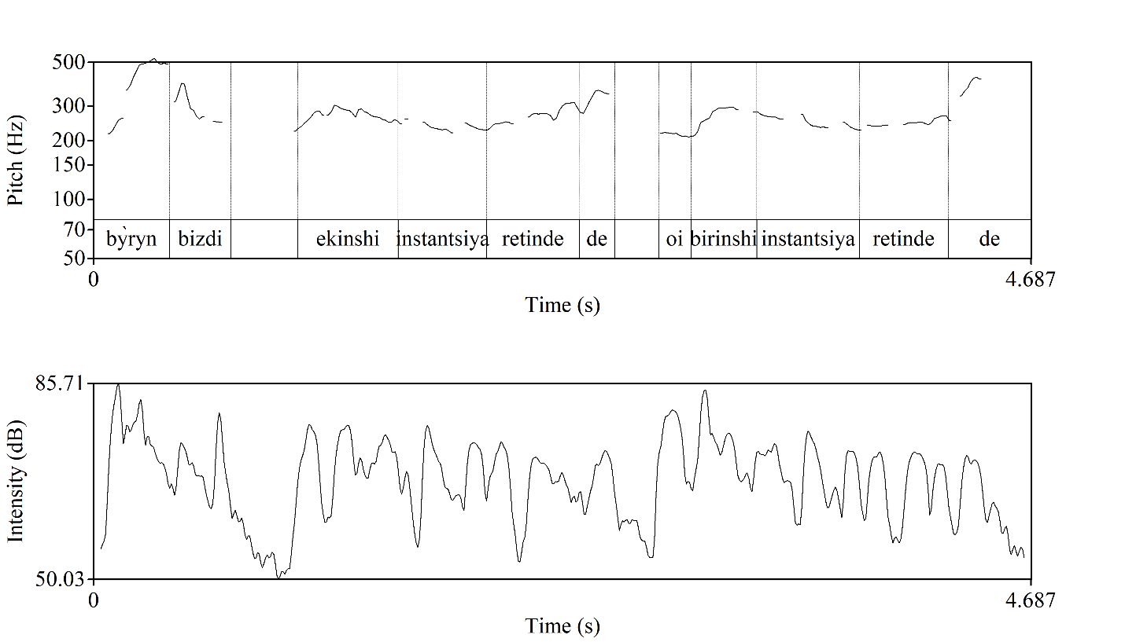
Figure 9. Sample of correction realized (L6) in female voice. Horizontally time in seconds is indicated, vertically – frequency of pitch in Hz on a logarithmic scale.

But if we pay close attention to the pronunciation of the expression of the speaker it can be noticed that she pronounces the part where the word birinshi was highlighted more prominently, accentuating the corrected part of the expression.
If the focus is made on the intensity of Figure 10 where the utterance spanning 4,7 seconds, the opening part contains relatively high intensity values (85,7 dB) highlighting the introduction of information. Shortly thereafter, intensity declines sharply to about 50 dB marking a transition to an explanatory material that is pronounced with the intensity around 70 dB. It is clearly seen that the latter half of the utterance is intensified showing 70-80 dB after a short pause which is the sign of hesitation or restoring the information due to the incorrection occurred initially. This re-intensification restores prominence and underscores the structural parallelism between the “second” and “first” instances being contrasted. Overall, the pattern of initial emphasis and final rhythmic intensification reflects a deliberate prosodic strategy for organizing contrastive information in Kazakh-medium lecture discourse.
Both incorrect and corrected parts are divided with an interjection ‘oi’ that belongs to one of three types of interjections that is called sense interjections. The speaker attracts the attention of students using high pitch on the interjection.
Lecturers rephrase the words with the purpose of clarification, simplification, by using paraphrasing. In the Kazakh academic discourse, some words are paraphrased with other expressions or Russian equivalents. This may be the consequence of the fact that the Kazakhstani academic world is closely connected with the Russian one as most of the manuals and textbooks are either in Russian or translated from Russian. In order to avoid misunderstanding from the side of the students some lecturers still give Russian equivalents to the paraphrased words. In the following expression from a lecture of Law (L7), in the speech of a male lecturer, the sample of paraphrasing is reflected in the use of terms.

- … Егер прокурор іске қатысқан жағдайда адвокаттың
… Eger prokuror iske qatysqan zhagdaida advokattyŋ
… If prosecutor caseDAT participatePART caseLOC advocateGEN

қорғаушының қатысуы міндетті...
ķorğaushynyŋ ķatysuy mïndettï…
attorneyGEN participation obligatory …
‘If a prosecutor participates in case the participation of an advocate, an attorney is obligatory…’

Here the lecturer paraphrases the word ‘advokattyŋ’ (advocate) with the word ‘qorgaushynyŋ’, which means defense attorney, in order to clarify that this notion may be given in both variants. The word ‘advokat’ (advocate) is used mostly in Russian, and it was used a borrowing in Kazakh in the sphere of law for a long time, but in the current process of ‘Kazakhisation’ the terms are being translated into Kazakh or given Kazakh equivalents, and thus in the academic sphere such phenomena occur frequently.
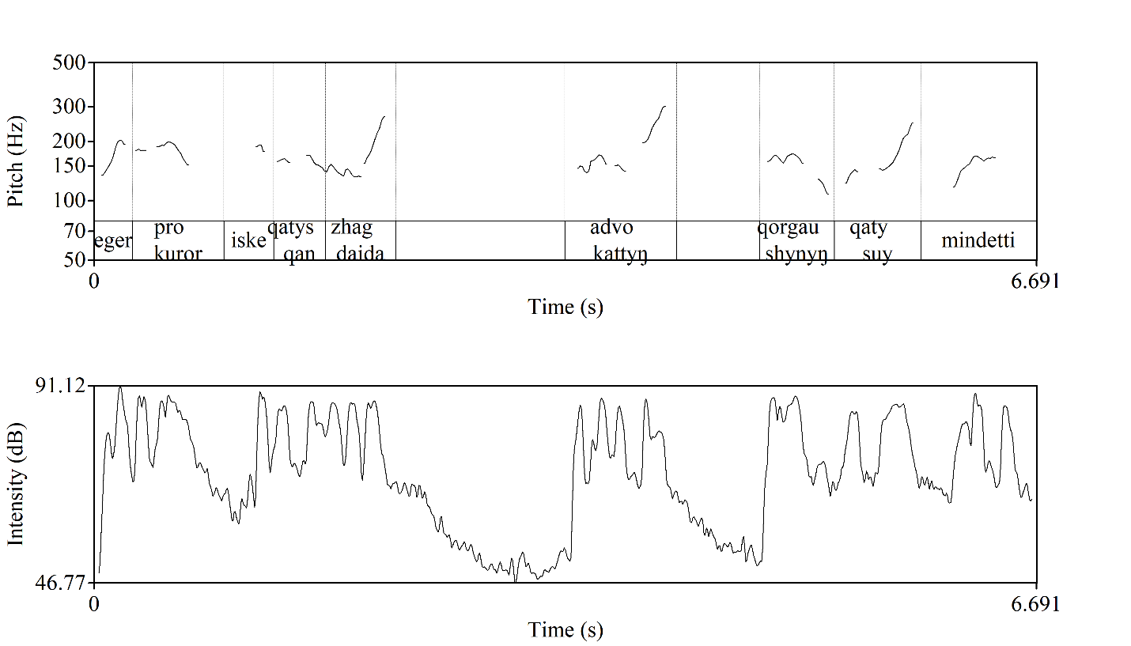
Figure 10. Sample of paraphrasing realized (L7) in male voice.
Horizontally time in seconds is indicated, vertically – frequency of pitch in Hz
on a logarithmic scale.

As we see from the given picture of paraphrasing (Figure 10), the speaker (L7) realized rising pitch in the final part of the initial expression ‘advokattyŋ’ from 141.8 Hz to 297 Hz with an interval in 12 ST while in the paraphrased part ‘qorgaushynyŋ’ the lecturer used the same pitch level but pitch fell from 168.7 Hz to 106.6 Hz (-7ST) in the final part of the word. The picture of intensity displays that in uttering the word under analysis as well as its paraphrased form intensity increases with repeated peaks in 70-85 dB range signaling the relative informational value of discourse segment.
This picture shows that in paraphrasing, the paraphrased part is less prominent, whereas, by contrast, in corrections the pitch rises in the corrected part. Therefore, despite the fact that their communicative intentions are very similar, the prosodic features reflect that they are different interaction types.
Related to the next category as repetitions the analysis takes the following picture. The sample given in unit (4) taken from a lecture of Biotechnology (L4) is about replication of DNA. Here the speaker is explaining about an experiment where DNA is centrifuged in cesium chloride gradient and there, they get a single band. He repeated the words ‘bir gana zholaq’ (a single band) twice in order to highlight the result of this experiment as there were different experiments with different results.

- ... Центрифугаласа, бір ғана жолақ пайда болады
... Tsentrifugalasa, bir gana zholaq paida bolady
... centrifugeCND one only band appear

бір ғана жолақ
bir gana zholaq …
one only band
‘If … centrifuged only one band appears only one band’
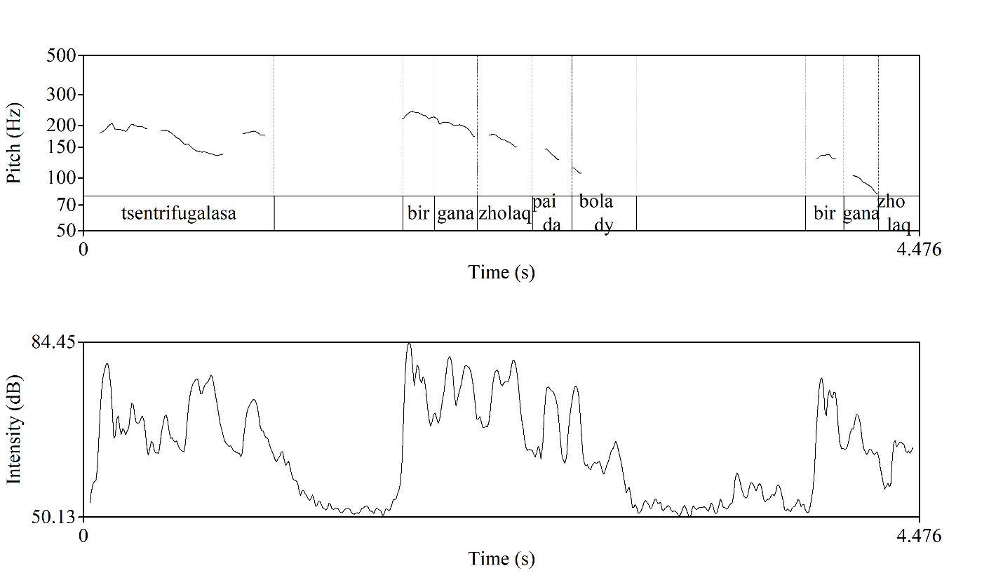
Figure 11. Sample of lexical repetition realized (L4) in male voice.
Horizontally time in seconds is indicated, vertically – frequency of pitch in Hz on a logarithmic scale.

In these Figure 11 we can see that the pitch level is higher 247.7 Hz in pronouncing the expression ‘bir gana zholaq’ which falls down gradually to 145.4 Hz on the word ‘zholaq’ the interval of which is -9 ST. If we compare it to the repeated part where the pitch of voice falls down from 139 Hz on the word ‘bir’ to 82 Hz (-9 ST) which is not as prominent as the first part. In the second repeated part we see fall on the last word that indicates that this is the end of this expression.
According to the intensity picture of the repetition example. The first mention of the phrase ‘bir gana zholaq’ occurs within the first part of the informational statement with approximately 70-80 dB. Following this, intensity drops substantially to about 50 dB signaling a prosodic reset and prepares the discourse space for the repeated segment. With the second occurrence of ‘bir gana zholaq’ intensity rises again to 70 dB making the repetition less prominent than the initial mention. The final descent toward 60 dB aligns with the closing element (zholaq), restoring the baseline and indicating the completion of the repeated emphasis. This pnenomenon displays that in Kazakh-medium lectures repetition is often executed through a combination of high in the first mention and comparable lower prominence in the second one.
In our analysis we encountered two types of repetitions applied in lectures: syntactic (repetition of structure) and lexical repetitions (repetition of words). The sample given in the figure 5 is the reflection of lexical repetition in the speech of a lecturer. In Figure 12 below, an utterance with a syntactic repetition is shown, the example is drawn from a lecture of Linguistics (L3), in which the speaker explains about the difference and peculiarities of linguistic systems in every language, using syntactic repetition.

- … Әріп саны бөлек
... A’rip sany bo’lek,
... Letter numberPOSS3 different,

дыбыс саны бөлек,
dybys sany bo’lek,
sound numberPOSS3 different,

фонема бөлек иә
fonema bo’lek… ya
phoneme different yes
‘The number of letters is different, the number of sounds is different, phoneme is different, isn’t it’.

The lecturer states that the number of letters is different, the number of sounds is different, phoneme is different.
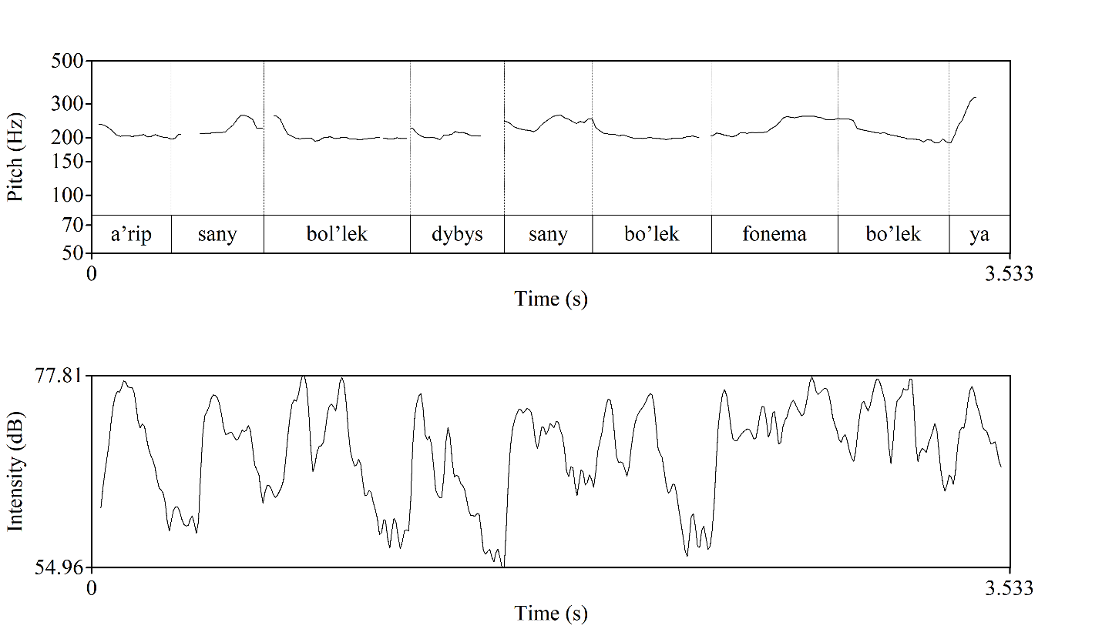
Figure 12. Sample of syntactical repetition realized (L3) in female voice. Horizontally time in seconds is indicated, vertically – frequency of pitch in Hz on a logarithmic scale.

The example of syntactic repetition in Figure 12 can be divided into three syntactic parts: the first two of which are pronounced on the same pitch level (197.8 Hz -196 Hz) while there is a slight change in the final syllable of the third part ‘fonema bo’lek’ which is represented in the fall of the pitch (from 261.9 Hz to 188.2 Hz). For the repetitions of this type the falling pitch in final part of the repeated chain is identical. In both examples we can see that lecturers use the repetition to contribute to understanding and memorization of the repeated material by students and use falling tone in the final part of the final repeated part of the expression.
As for the intensity used in uttering the structural repetition, the first occurrence of the combination with bo’lek appears with high intensity 75-77 dB and falling down. Following this, the intensity contour rises again, producing several prominent peaks in the 70-75 dB range, which serve to sustain the listener’s attention as the lecturer transitions through dybys sany bo’lek. The third occurrence of bo’lek is accompanied by another rise in amplitude, characterized by a denser sequence of peaks nearing 70-78 dB, making the repeated item slightly more acoustically prominent than the initial realization. This incremental intensification during the repetition contributes to its highlighting function, signaling clarification and reinforcing the conceptual focus of the utterance. Such slight fluctuation in the peak of intensity can demonstrate that in structural repetition the prominence is mostly preserved throughout the repeated parts.
In the Kazakh lectures there are some cases where the sentences, even whole paragraphs are repeated several times. This is due to the habit of Kazakh lecturers to dictate some important passages, in order to enable students to write down the most important and useful data. This is similar to repetition of some parts, but since these repetitions are considered artificial, they were extracted from the analysis material.
Parenthetical insertion can be detected in the lecture on Biology (L10) where the lecturer talks about osmotic pressure of blood the following expression occurs.

- … буферлік жүйе деген бар
... buferlik zhu’ie degen bar
... bufferADJ system such be3

буферлік жүйе
buferlïk zhu’ie
bufferADJ system

буфер деген сөз тепе-теңдікті сақтау болады деген сөз ...
bufer degen so’z tepe-teŋdikti saqtau bolady degen so’z …
buffer such word stabilityACC maintain possible such word …
‘There is buffer system, buffer system, the word buffer is the word that means it is possible to keep balance’

Here the speaker after repeating the words ‘buferlik zhu’ie’ explains the meaning of the word ’bufer’ twice, it is a nucleus word in this expression in order to facilitate the comprehension by the students. The expression may be interpreted as ‘there is a phenomenon ‘buffer system’, buffer system. The word ‘buffer’ means the possibility to maintain stability’.
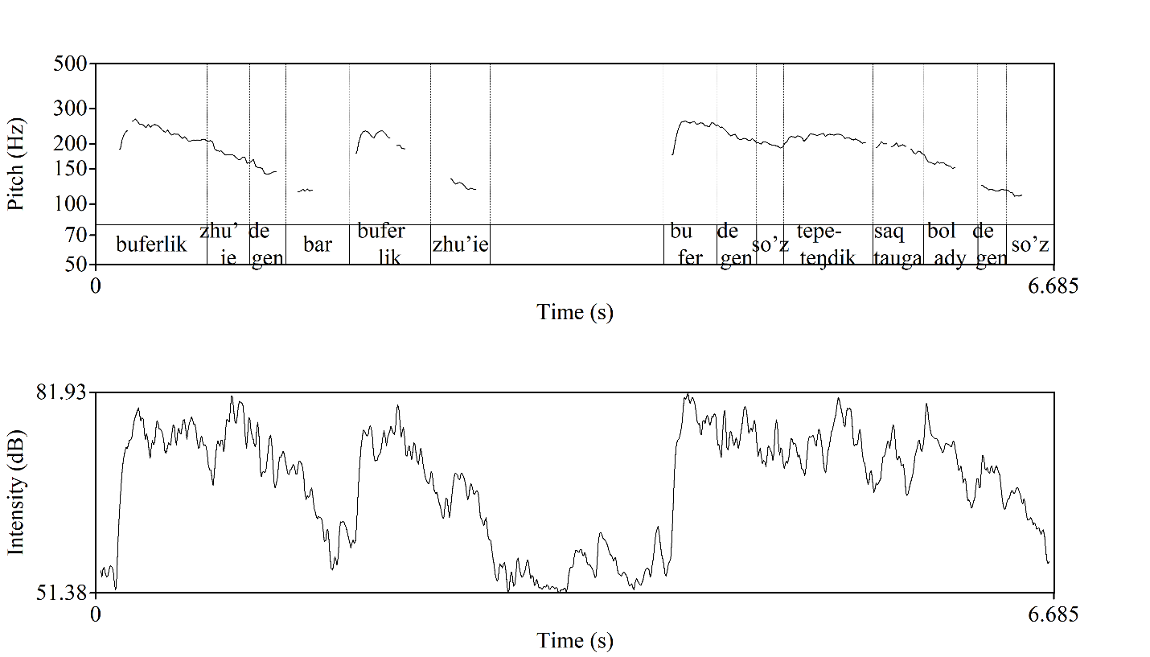
Figure 13. Sample of parenthetical insertion realized (L10) in male voice. Horizontally time in seconds is indicated, vertically – frequency of pitch in Hz on a logarithmic scale.

In figure 13, we notice a pause in the middle of the information flow, which is caused by parenthetical insertion. In the given example the speaker makes a pause of 1.15 seconds before introducing a new information. Before formulating a new idea, speakers pause to prepare for this. This happens when there are no connectives or fillers between two ideas. The level of pitch of voice in pronouncing the main word ‘buferlik’ rises from 167.8 Hz to 267.5 Hz the interval of which is 8 ST and in pronouncing ‘bufer’ from 151 Hz to 268 Hz with an interval 10 ST in parenthetical insertion which difference is not high, almost at the same level 267.5 Hz-268 Hz which may justify that the information delivered by parenthetical insertion is as important as the information in the main flow.
The intensity contour draws a special attention as it reveals a clear prosodic bracketing pattern that distinguish the main informational line from the inserted explanatory segment. The main information flow is uttered with the intensity values 70-82 dB maintaining a stable amplitude that supports the discourse progression. This is followed by a decrease in intensity that might be an entry boundary marking that supplementary content is being added. As the parenthetical insertion unfolds, intensity gradually increases again, uttered around the intensity range 75-82 dB coinciding with the re-entry into the primary message. This rise in intensity signals restoring of the discourse focus. Overall, parenthetical insertions are pronounced in a framed intensity, enhancing coherence and guiding listener attention across shifts in informational hierarchy.
In the analysis, questions posed by students were not taken into account. At the same time questions consisting of only a single word (e.g. A? (Its equivalent in English may be the question word ‘What?’. In Kazakh it is used for asking to repeat in case of mishearing and lack of comprehension), Ia? (Yes? It is used to get an approval for the stated information)) were not considered. So in the materials of the study consisted of lectures in the Kazakh language three groups of questions were observed.
- Wh-questions
- Yes/No questions
- Tag questions
All three types of interrogative sentences are widely used almost in all lectures analyzed. From the data/our analysis it appears that most of the interrogative sentences occurring in the lectures are rhetorical. Only a few of them (80 out of 649 questions) are non-rhetorical and require answers. They are oriented to giving content comprehension or instruction [175].
(7) below is an example that was taken from the lecture of Literature (L5) about the works, especially the translations, of the Kazakh poet Abai Kunanbayev.

- … неге аударған?
... nege audarğan?
... why translatePast

Крыловтың мысалдарын неге аударған?
Krylovtyŋ mysaldaryn nege audarğan? …
KrylovGEN fable Pl POSS3ACC why translatePast?…
‘Why did he translate? Why did he translate Krylov’s fables?’

Here the speaker asks questions such as ‘Why did (he) translate?’ (7), ‘Why did (he) translate the fables of Krylov?’. The lecturer repeats the Wh-question twice in order to attract the attention of the students to the importance of Abai’s choice of Krylov’s fables. These interrogatives are followed by the answer given by the lecturer himself. The students were not expected to answer. This tool is frequently employed in lectures.
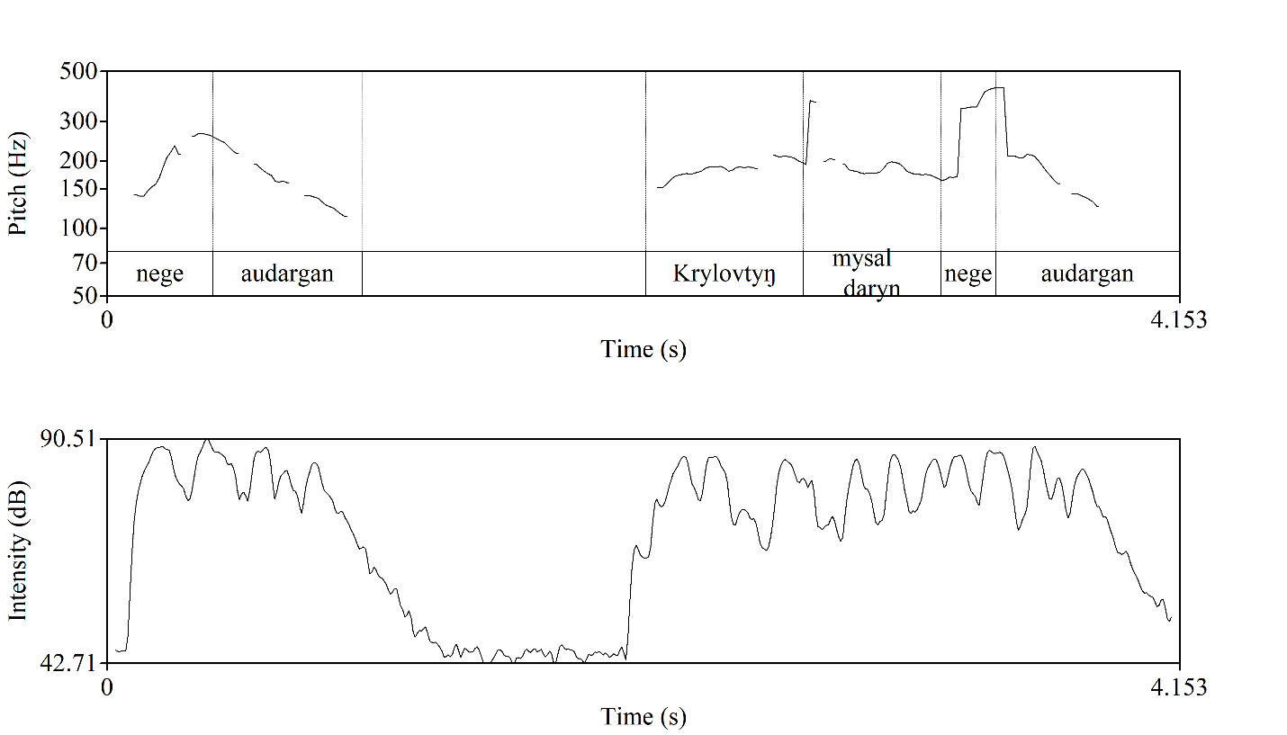
Figure 14. Sample of Wh-question realized (L5) in male voice.
Horizontally time in seconds is indicated, vertically – frequency of pitch in Hz on a logarithmic scale.

According to the change of pitch (Figure 14) it is obvious that the speaker highlights the question word ‘nege’ in the first part – from 139.2 Hz to 263.6Hz. The interval between two levels constitutes 11 ST, while in the second part this question word is less prominent showing the rise of pitch from 164.5 Hz - 173.6 Hz with the interval in 1 ST. This example once more demonstrates that in repetition the first part is more prominent than the following one, whereas in Kazakh the final tone usually falls on the last word of a sentence and the Wh-questions end with falling tone.
The picture of this fragment illustrates a typical Wh-question contour in Kazakh academic speech, where prominence is assigned to the interrogative word nege, which initiates the utterance with a noticeable rise in intensity as well as pitch 88-90 dB. Following the peak the continuation of it shows a gradual decrease in intensity signalling the unfolding of the question structure. After the short pause the prosodic contour regains intensity rising back to 88-90 dB, with highes peak on the word nege again in the second question supplemented with the additional words for clarification. The picture we get from this is that strong initial prominence on the Wh-word, followed by declination.
If we compare the use of Wh-questions of a rhetorical nature with Wh-questions to which an answer is expected, we get the following picture (Figure 15). The lecturer (L9) of Linguistics talks in his lecture about the role in some topical issues of the Kazakh language, such as translating words and the identification of mistakes made in online communication. In the course of the lecture the speaker uses a lot of questions, only a few of them are of non-rhetorical character. One example of a non-rhetorical question is the following:

- … Кім ол Халел Досмұхамедұлы? ...
... Kim ol Khalel Dosmy’khamedy’ly? …
... Who he Khalel Docmukhameduly? …
‘Who is he Khalel Docmukhameduly?’

This example is interpreted as “Who is he Khalel Dosmukhameduly?”. This question was asked the students as the lecturer was talking about one of his works titled “Qazaq-Qyrgyz tilderindegi singarmonism zaŋy” (Vowel harmony law in the Kazakh-Kyrgyz languages) and mentioned his name. He also wanted to check if the students knew who he was. In the Kazakh language the question word who is ‘kim’, but in this expression the word ‘kim’ is used with the word ‘ol’ which means he (she/it) and together give the meaning of who. This is a feature of spoken language, rather than written language.
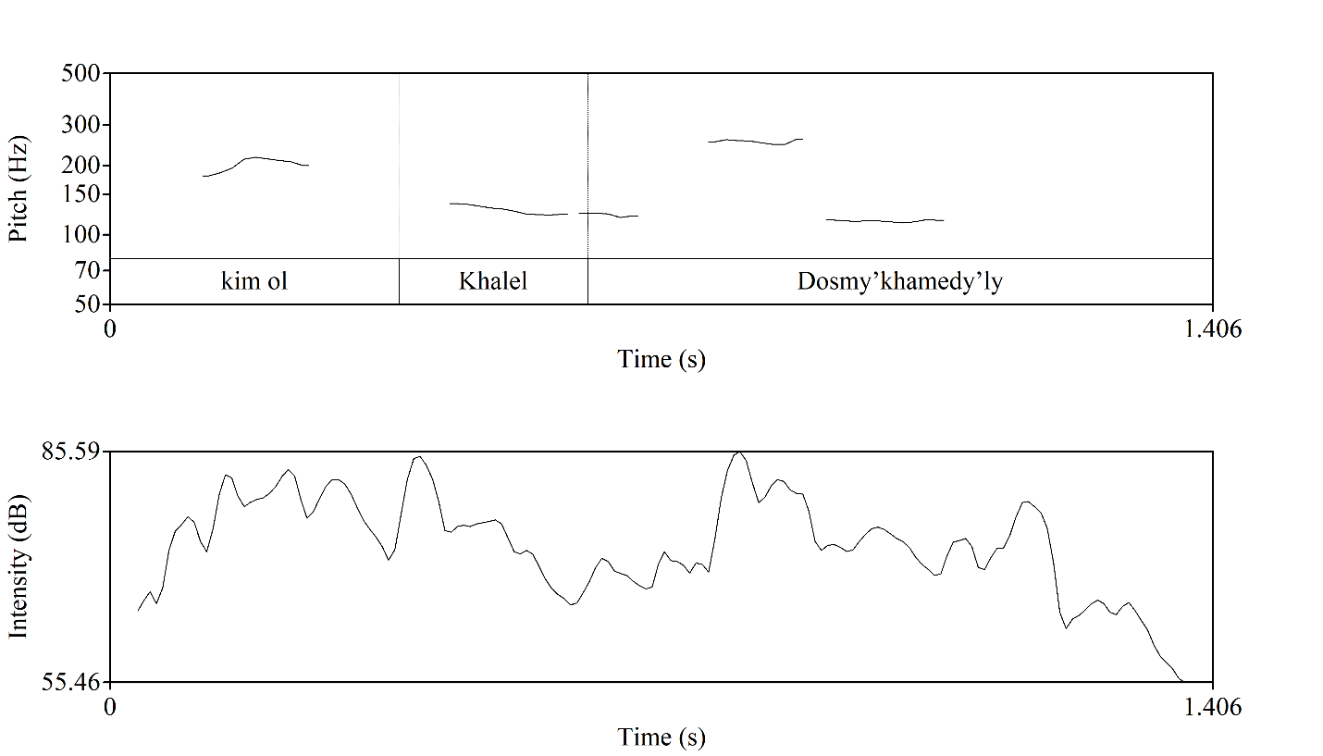
Figure 15. Sample of Wh-question realized (L9) in male voice. Horizontally time in seconds is indicated, vertically – frequency of pitch in Hz on a logarithmic scale.

The given example is pronounced with falling pitch and the pitch rises on the question word up from 168.1 Hz to 217.6 Hz comprising the interval in 4 ST then gradually falls down until the rise and fall on the syllable ‘-dos’ which is followed by a low-level pitch. The pictures of both cases (Figure 14 and Figure 15) are rather similar, except for the pause made after asking the question. In rhetoric questions the pause is not as long as in non-rhetoric questions. This may be explained by the lecturer’s anticipation of students’ reaction.
If we pay attention to the intensity contour, it is clearly observed that the utterance begins with a moderately high intensity level, which rises rapidly and reaches approximately 80 dB. This pattern reflects the functional role of the Wh-word, which signals the interrogative type of the utterance. Subsequently, intensity gradually decreases to the range of 62-65 dB, indicating a shift toward informational continuity. The final segment is marked by the highest intensity peak, reaching about 85 dB on the syllable Dos. This renewed increase in intensity highlights the informational focus, emphasizing the proper name as the semantic nucleus of the Wh-question. The utterance concludes with a declining intensity contour, which is characteristic of special (Wh-) questions in academic spoken discourse.
While studying the examples of non-rhetoric Wh-questions one case drew our attention. This was taken from L6, about a cassation instance in Kazakhstani law system.

(9) … Ол қандай соттар? ...
... Ol qandai sottar? …
… That what courtPL? …
‘What courts are they?’

Explaining about the new Procedural Code the lecturer mentions that all cases are heard at a first-instance court. Then the question under consideration comes “Ol qandai sottar?” ‘What courts are they?’.
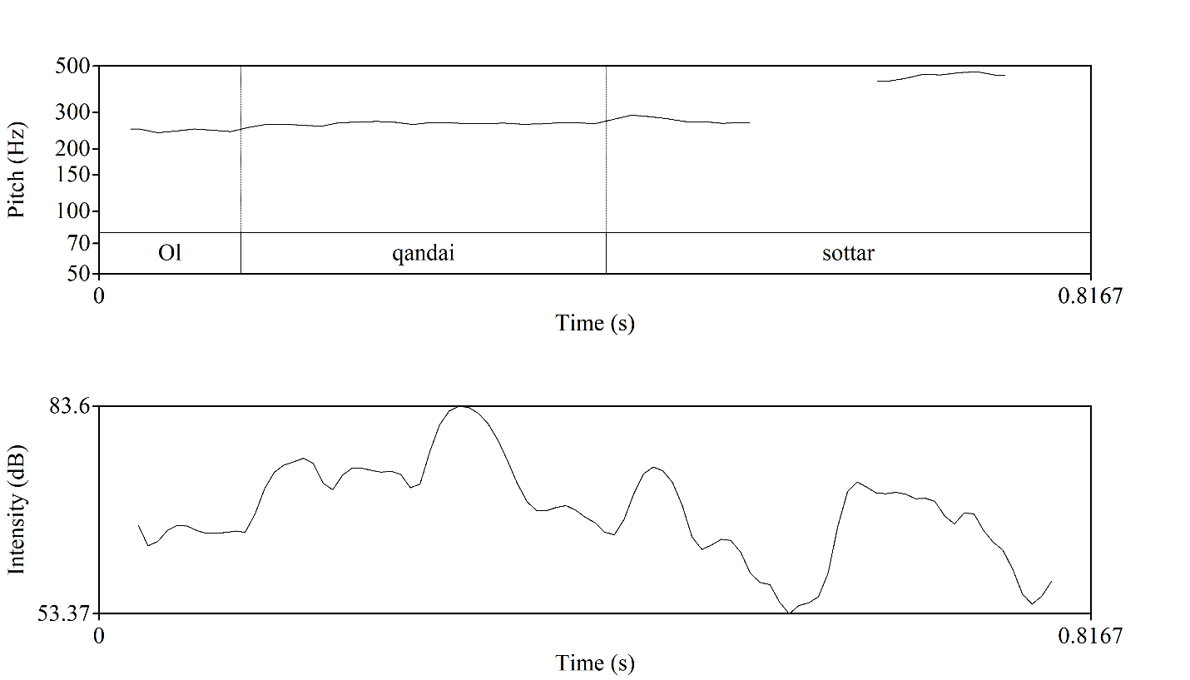
Figure 16. Sample of Wh-question realized (L6) in female voice.
Horizontally time in seconds is indicated, vertically – frequency of pitch in Hz on a logarithmic scale.
This Figure 16 shows that even if this is a Wh-question that has falling tone at the end of the expression the lecturer used rising pitch on the last word ‘sottar’ (courts) and kept this pitch on the level between 469.6 Hz - 446.4 Hz which may occur when the speaker wants to continue the utterance or expects someone else to do it. The students answered this question which shows that they have already mastered/processed this information. In almost all cases after getting an answer of the students to the question the lecturer repeats the answer again or gives the answer himself.
As for the intensity, it takes its start in the given question from approximately 60-65 dB which keeps up until it reaches its highest intensity values 83 dB that is located on the word qandai. It reflects the functional load of the Wh-element. In the final segment intensity gets reinforcement reaching 72 dB, which highlights the semantic core of the question, but it should be noted that it’s weaker than the intensity used in Wh-question word. The decline following it can indicate the prosodic completion of the question.
The next type of interrogative sentence is yes/no questions. Yes/No questions are used in the lectures because the presence of a live audience allows lecturers to interact with students. Not all of them always require verbal answer from the students, in most cases just silence or gaze or non-verbal expressions of the students suffices as a reaction for a lecturer.

(10) … ал мақала қашан жазылды, білесіздер ме? ...
... al maqala qashan zhazyldy bilesizder me? …
... and article when write Past Pass know POL PTC
‘… and when the article was written, do you know?...’
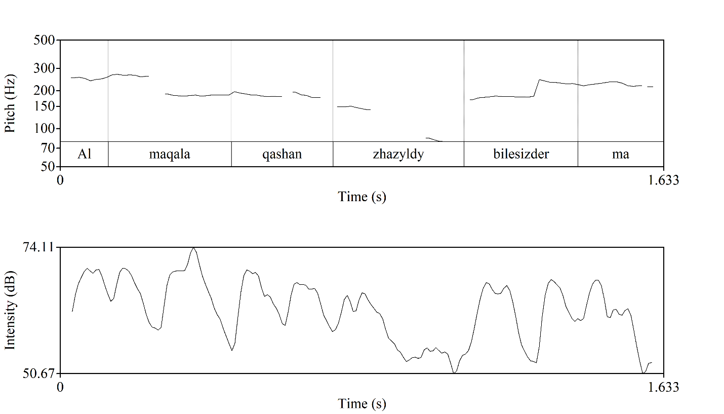
Figure 17. Sample of Yes/No question realized (L9) in male voice. Horizontally time in seconds is indicated, vertically – frequency of pitch in Hz on a logarithmic scale.
This example was taken from the lecture of Linguistics (L9) devoted to the problems of the modern Kazakh language. It may be interpreted as ‘Do you know when the article was written?’. In the Kazakh language Yes/No questions are formed with the help of interrogative particles –ma, -me, -pa, -pe, -ba, -be at the end or after the main verb or the suffixes as –my-, -mi-, -by-, -bi-, -py-, -pi- which are added to the main verb (barganbysyŋ – have you gone). The examples of yes/no questions formulated with the help of suffixes haven’t been encountered in the corpus. In the example given the particle comes at the end of the question and is pronounced with rising tone. The pitch rises from the main verb (80 Hz to 226.1 Hz). It can be observed in the Figure 18. General questions are marked with fall rise tone while intensity applied is high at the start (70 dB), higher in the middle (74dB) and low at the final point (55-58 dB). The reduction of intensity reflects the functional separation of prosodic parameters, whereby interrogativity is encoded primarily through pitch movement, while declining intensity signals prosodic completion and physiological declination, rather than a loss of communicative force.
Example (11) below is taken from L4 on Biotechnology, where the lecturer explains about the method of DNA sequencing developed by Allan Maxam and Walter Gilbert. In English it may be formulated as “Is there any more guanine?”

(11) … бар ма тағы гуанин? ...
... bar ma tağy guanin? …
... be3 PTC else guanine?
… is there else guanine? …
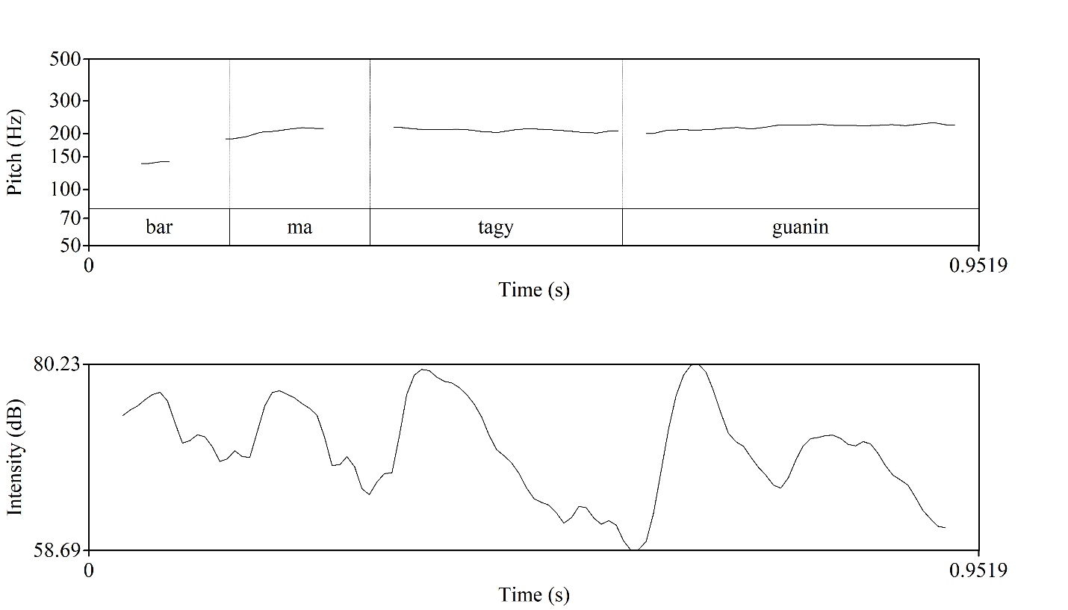
Figure 18. Sample of Yes/No question realized (L4) in male voice. Horizontally time in seconds is indicated, vertically – frequency of pitch in Hz on a logarithmic scale.

Whereas in the previous example (Figure 18) the pitch rises from the main verb coming before the interrogative particle ma from 78.23 Hz to 240 Hz, in the following Yes/No question, extracted from the lecture of Biotechnology (L4) the change of pitch is from the verb bar (to be - is) from 115.6 Hz to 215.6 Hz and it preserves this level til the end of the expression. The size of the interval between the levels in the first case is 19 ST while in the second one it is 10 ST. It shows that in using Yes/No questions lecturers mostly raise their pitch of voice very high. This can also be inferred from the considerable interval between the levels.
The intensity contour of this question displays a wave-like prominence pattern, beginning with a moderate intensity level on bar (approximately 68-72 dB), while the particle ma does not carry independent loudness prominence. A primary intensity peak occurs on tagy, reaching about 78-80 dB, followed by a decrease to 58-60 dB and a secondary rise on guanin (around 72-74 dB). The semantic load carrying words are more prominent and intensified than the participle as a feature Yes/No question even if it is encountered in the initial part of the utterance.
The following Yes/No question was encountered frequently in the data, and serves exclusively to assess whether students have understood the topic or not. This question is ‘Tu’sinikti me?’, ‘Tu’sindin’zder me?’ (Is it clear? or Have you understood?) or in the form of an alternative question ‘Tu’sinikti me, zhoq pa?’ (Is it clear or not? or Have you understood or not?).
In the process of analyzing the lectures delivered in the Kazakh language we came across cases where the majority of lecturers used a sentence structure in which the first part is given in the narrative form, but ends with the words ‘iya’ or ‘da’ (‘da’ is the Russian equivalent of the word ‘iya’) (‘yes?’ ‘right?’) raising the pitch of voice. These words are used in cases where a speaker wants to witness the positive reaction of students towards the given information, or, in other words, to be approved, and to check if the students have understood the material. These can be classified as tag questions.

(12) Демек бұл әсемпаз деген сөздің ар жағындағы
Demek bǖl äsempaz degen sözdiŋ ar zhağyndağy
Consequently this asempaz such wordGEN behind

сипаты, мәні Абай қолданған, иә?
sipaty, mänin Abai ķoldanğan, iya?...
featurePOSS3, meaning POSS3 Abai usePAST, yes…?
‘Consequently it was Abay who used the word ‘asempas’ in its deepest quality, its deepest meaning, yes?…’

Example (12) can be interpreted as “Consequently, the deepest feature, meaning of this word ‘a’sempaz’ was used by Abai, wasn’t it?”. Here the speaker talked about the linguistic features of Abai’s works, particularly the initial meaning of the words ‘o’nerpaz and a’sempaz’.
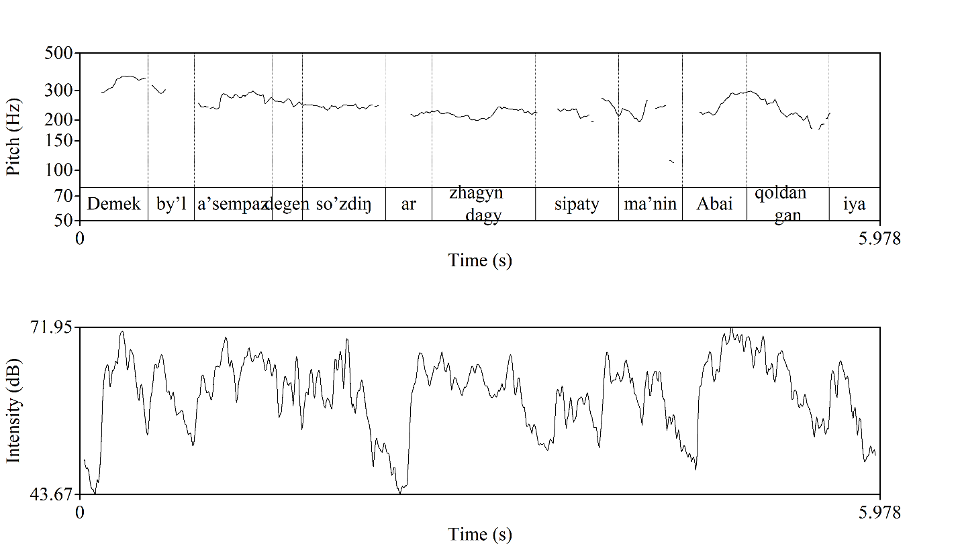
Figure 19. Sample of tag question realized (L2) in female voice. Horizontally time in seconds is indicated, vertically – frequency of pitch in Hz on a logarithmic scale.

As we see in the Figure 19 the first narrative part of the expression was pronounced with falling pitch at the end, but the change is noticed in the second part where the pitch of voice was raised from 86.31 Hz up to 359.1 Hz. The size of the interval between the levels is 24ST.
However, the intensity contour demonstrates a bit variable intensity pattern. This is typical for declarative statements in academic discourse. Intensity values fluctuate within the intensity range of 55-70 dB with several peaks which indicate semantically salient segments. The prosodic drops occurred with the intensity of 45 dB coincide with transitional or syntactically lighter segments. Lower loudness is observed on the final, though not less semantically significant, segment containing the participle iya, which marks the disjunctive character of the tag question. This reduction in intensity indicates that the tag question is employed without a strong expectation of an explicit response, functioning instead as a discourse-structuring or confirmatory device.
All questions of this formation were considered as tag questions. Except for them there are some tag questions used with the words ‘solai emes pe?’ and ‘solai ma?’.
Other types of questions that were encountered in the data were ‘alternative questions and questions that were formed with intonation alone. However, their number was so low that they were not taken into consideration: they appeared not to be widely used tools in spoken academic discourse.

3.3 English-medium lectures in Kazakhstan
The achievements of the educational system of the Republic of Kazakhstan as one of the member countries of the Bologna process and the European education area on the way of reformation show the high level of internationalization of higher education. The bright achievements are the implementation of the international programmes, students’ mobility, faculty exchange programmes, introduction of English in educational process (pre-school, high, higher and postgraduate education) as a language of academic space, development of curriculum according to the international standards, etc. All these changes in the education system have been realized with the purpose of gaining a stable high position in the world arena and be recognized by the foreign countries. According to M. Hartley et. al “transferring education policies from one national context to a different one is a challenging and uncertain business” [176, p. 278]. We should admit that great changes happened especially in the spheres of life that can have a huge influence on the future of the whole country, nation lead to some challenges. Some of them are the preparation of professional trilingual staff, what curricula to adopt, what sacrifice we have to make in the course of reformation. In spite of the difficulties occurred in this field a lot of doors opened for the future generation of Kazakhstan to realize their dreams and achieve goals and for foreign students that are attracted to study in Kazakhstan to learn, study and exchange experience. This moment may be a stimulus for our students to be competitive and to build a bridge between their homeland and other world.
According to the results of QS World Ranking survey 2019 one of the Kazakhstani universities Al-Farabi Kazakh National University (al-Farabi KazNU) ranked 220th position among the 800 best universities in the world climbing 16 places. Such results can be a demonstrative proof of the hard labour on the way to the set aims.
One of the ambitious points of reformation – the introduction of trilingualism into education system is the main issue focused in this paper. According to the division of higher education reforming system stages identified by R. Massyrova et.al the reformation process is in its fourth stage “Strategic development of higher professional education system”, which covers the period from 2001 up to present time [177, p. 50]. Nowadays English has already been recognized as a “language of integration into global economy” and is used as a medium of instruction in higher education institutions [178].
The issues concerning the promotion and the condition of trilingualism in education system as changes and challenges occurred in trilingual education in Kazakhstan [177], [179], readiness to study and to teach academic subjects taught in English [180], [181], the surveys conducted on the identification of the strong and weak points of the adopted system [182], has been in the focus of many researchers. According to the studies the achievements realized during all stages of reformation process are clearly seen. Nowadays all secondary schools and higher education institutions are transferred to the new system of education in three languages which was the result of ‘reform by example’. The principal example for primary and secondary school to replicate its practice is “the Nazarbayev Intellectual School program that is building trilingual centers of excellence that will attract Kazakhstan’s best and brightest students from all parts of the country and all ethnic groups” and “Nazarbayev University, with its integrated teaching and researching and design activities and unique partnership model will become a template for the development of other Kazakhstani universities” [183, p. 10].
However, some discrepancies between the government’s goals regarding the implementation of English as an instruction medium and their actual realization in practice cannot be ignored. We identify three main challenges in realization of the educational reforms, particularly trilingual education. First, the adoption of new system reflects the changes in the content of the textbooks and materials as well as the methods and approaches of teaching applied by teachers at the lessons are revised and updated, this in its turn can lead to some problems in the comprehension of the delivered material. The study of E. Suleimenova et.al reviews this issue on the sample of the Russian language as a non-native language taught at schools on the basis of the trilingual system of education [184]. The achievement of the goals set related to the change of the curriculum and the content of the textbooks can be realized by retraining the teaching staff. This can be temporal solution of the problem as the specialists teaching the subjects in English at educational institutions cannot demonstrate the high level of results. The preparation of the future teachers mastering professional English, especially of the natural sciences and mathematics for secondary schools are the obligation of the higher educational institutions. Zh. Zhilbayev et. al also of the viewpoint that teaching of natural-mathematical cycle subjects in English is the most complex issue in promotion of trilingual education in Kazakhstan. They justified their opinion presenting the data of the online monitoring on the qualitative teaching staff carried out by them indicating the average qualification level of biology, physics and chemistry [185]. G. Tazhigulova et.al. having considered the issue of English language competence related to biology teachers highlight the significance of organizational and pedagogical conditions for language training of future biology teachers in the context of the updated content of school education. As we see the enumerated challenges could find their solutions in the content and effectiveness of the knowledge and training at universities and this can direct to the next issue of the reform implementation [181].

Figure 20. Target indicators of the State programme on education development in 2011-2020
We should admit the fact that there are more chances to complete exchange programmes for students in comparison to the schoolchildren of the compulsory schools. The possibilities offered by the government are international scholarship programmes as Bolashak, academic mobility, internships etc. The amount of such possibilities will be increasing year by year according to the State programme on education development in 2011-2020 (Figure 20) [186].
Now the period of the Education Development Programme is coming to its end and the achievements of the state should comply with the planned objectives.
G. Oralova came to conclusion that “even there is agreement about the necessity of English language by students and faculty, the current situation shows that there is lack of readiness and motivation to learn English and use it in professional purposes” [187, p. 132]. We should admit impossibility of the state to offer all students chances of academic mobility programmes in foreign countries. But we are sure the condition of the reform implementation is at the higher level in comparison with the beginning of the education development programme realization period. The number of students and teaching staff studied and completed internships in foreign, mostly English-speaking countries and the number of English groups at the universities increased, a part of the subjects are held in English as a tool of instruction, which, for certain, has an effect on the realization of trilingual policy at the university. English plays a great role not only in the life of students but also for academic staff in widening the scope of the sources of new knowledge and communication. It is one of the obligations of the academic staff to teach and provide students with knowledge, train them to be competitive in the modern integrated world by means of English as an instruction medium. For this purpose academic staff from foreign countries (Europe, USA, China, Russia etc.) are attracted to Kazakhstani universities to deliver lectures and train both students and university teachers. Despite such opportunities we realize that most of the part of this responsibility lies on the shoulders of the Kazakhstani academic staff that provide knowledge and research practice in English. The data on the viewpoints of Biology teachers and lecturers at higher educational institutions obtained in the research of
G. Tazhigulova et. al can prove this fact [181].
Even the master students who are supposed to be with best results of English tests that they have taken before entering master schools among other applicants showed the low level of English [180].
All steps taken and work done from the side of the government cannot solve the raised problems and eliminate the difficulties. There should be another aspect to scrutinize which is the way of delivering the knowledge in English, how the instruction medium is applied. A lot of researches were conducted aimed at identification and comparison of the use of linguistic features of academic discourse in English as L1 and English as FL. Research has been completed on various aspects of using English linguistic features and we should highlight that most of them have been devoted to the study of the written academic discourse [188]. But the study of academic English produced by authors with Kazakh as L1, especially the use of prosody is a new filed of research.
In academic discourse “... one of the specific aspects to which attention needs to be drawn is that of teacher discourse” [189, p.130]. Most part of the result of a lesson depends on how a lecturer delivers a lecture both linguistically and pedagogically. Even if a teacher masters the foreign language to use it as an instruction medium and has knowledge of a subject taught it is just the half of the academic discourse realization. They should be able to deliver the knowledge in a clear, concise and comprehensible way in non-native language, which is in our case English. We wonder what can be a problem in acquisition of knowledge on a definite subject presented in English. Most of the researchers focus on oral interaction (lecturer-students, student-students) in a class [189], [190], [191], [80] and comprehension of the listened lectures by students [192]. These studies have investigated the listening process at the lecture where mostly students were focused on, discourse features of lecture as a genre of academic discourse, some factors that may have an influence on the comprehension level of students. But less attention is paid on lecture features from the angle of lecturers. What can we say about the comprehension of information delivered by a lecturer if the information isn’t acquired by a learner. This issue challenges the study of prosodic features of lecture delivered. Our work will focus on the prosodic features of lectures in English delivered by non-native Kazakhstani lecturers that play a great role in the construction of learner knowledge.
The spoken language study is focused in the works of several Kazakhstani researchers like Z. Bazarbayeva [143], [193], D. Karagoishiyeva [117], [194], [195], R. Kondybayeva [196], [197], A. Zhalalova [198], [199], which compiles only a part of all researches devoted to the linguistic study and less in comparison to the research of the written language. This may be justified by the lack of the experience and practice in the realization of experiments and analysis on the spoken materials. The absence of the corpus of spoken Kazakh discourse or other types of mini corpora may be explained with this fact. While the foreign researchers devoted a plenty of papers and works to this field of study. We have made an attempt to consider the academic discourse; particularly academic lectures delivered in English by Kazakhstani lectures.
The precise and clear prosodic portrait of academic discourse can be drawn with the help of corpus-based approach. Employing the corpus-based approach to compute and compare the use of prosodic features, our study considers academic texts produced by non- English lecturers from Kazakhstan.
There is no doubt, the association that comes to our mind when we hear the word academic discourse is lecture or lecturing. It is widely practiced in all higher education institutions all over the world. Lecture is not just presenting information in an oral form to students, but it is “an efficient and economical way of conveying complex information to large student groups in an enthusiastic and engaging way, providing a good structure and introduction to complex topics, with current information put into an appropriate context for the students, tailor making the material for the students’ needs, used to provoke thought and deepen understanding and to develop independent learning” [200, p. 93]. However, lectures are not homogeneous [62, p. 162]. It is being changed in style and in the way of presentation. T. Dudley-Evans distinguishes three main styles of lecturing as reading, conversational and rhetorical styles. Taking into account the fact that each lecturer may have his or her own lecturing style, we would like to add another lecture style practiced nowadays at HEI, which presumes just presenting information in a silent way “silent style” with the help of visual aids as presentation or video material without the participation of a lecturer [201].
In the era of globalization, the lecture styles applied at Kazakhstani universities are changed from the traditional mode i.e. reading from the notes without any interventions from the side of students, to an interactive mode of lecture which means the mixture of the above-mentioned lecture styles. The development of e-lectures challenged the change of the lecture style where the interaction of participants (lecturer-student) cannot take place should be taken into consideration. It’s a good possibility for the students that don’t need or have a possibility to attend the lectures personally but can get knowledge applying for online lectures. They meet and fulfill all salient discourse functions (informing, elaborating, evaluating, organizing discourse, interacting and managing the class) of lecture discerned from the BASE material by K. Deroey and M. Taverniers [69]. However, on what level they fulfill the given functions in comparison to the real face-to-face lectures is another issue to address.
The features of lectures that might facilitate the comprehension of lecture materials by students are repetitions, paraphrasing, authenticity, questions, parenthetical insertions [55], [64], [66]. Correction (self-correction) should also be regarded as one of the features of spoken lectures as the main peculiarity that distinguish spoken speech from written one.
The study adopted a discourse analytical approach that encompasses primarily a textual analysis of the lecture transcriptions. The linguistic features as repetition, paraphrasing, correction (self-correction), parenthetical insertions and questions were analysed based on their location of occurrences in the transcribed text and their pictures made by PRAAT software programme. The findings of text analysis were later cross-referenced with voice analysis results which contributes to the comprehensive study of features as vocabulary, grammar, syntax and sentence coherence that are not of less significance in discourse.
The collected data comprise a small-sized corpus of a total of 10 lectures (15 614 seconds), each lasting one academic hour. The video and audio materials of 5 lectures were taken from the base of massive open online courses of al-Farabi KazNU and 5 lectures were recorded by the authors at al-Farabi KazNU. They were lectures in Macro-Economics, Physical Geography, Environmental Science, Philology and Advanced Corporate Finance, and we refer to the lecturers as Lecturers 1, 2, 3, 4, 5 etc. in our discussions which can be reflected in the paper as L1, L2, L3, L4, L5 etc. to mark individual lecturers’ sampled extracts, especially in the analysis section. A brief profile of each of the lecturers is presented in Table 8.
The fragments for the analysis were selected from the audio and video materials using their transcription. The fragments were the samples of correction, paraphrasing, repetition, parenthetical insertion and questions.

Table 8. Information about lectures in the English language by non-native speakers

# | Lectures | Filed of science | Subject | Duration | Word number | Gender of lecturer | Age of lecturer | Source
1 | L1 | Marketing | Essence of marketing | 12 min 38 sec | 1465 | female | 30-40 | Al-Farabi MOOC
2 | L2 | Finance | Financial management in corporations | 14 min | 1562 | female | 40-50 | Al-Farabi MOOC
3 | L3 | Management | What is management | 10 min 7 sec | 1026 | female | 40-50 | Al-Farabi MOOC
4 | L4 | Information and communication technologies | Smart technologies | 12 min 49 sec | 1028 | male | 30-40 | Al-Farabi MOOC
5 | L5 | Marketing | Marketing concepts | 16 min 40 sec | 1912 | female | 30-40 | Al-Farabi MOOC
6 | L6 | Biotechnology | Tissue engineering | 41 min 35 sec | 3806 | female | 30-40 | Voice tracer, Philips, DVT1150
7 | L7 | Philology | Stylistics | 36 min | 3005 | female | 40-50 | Voice tracer, Philips, DVT1150
8 | L8 | The Russian language and literature | Abai’s teaching | 35 min | 3056 | female | 40-50 | Voice tracer, Philips, DVT1150
9 | L9 | Linguistics | Linguistic schools | 40 min | 3209 | female | 40-50 | Voice tracer, Philips, DVT1150
10 | L10 | Law | Corporate law | 41 min 25 sec | 3070 | male | 40-50 | Voice tracer, Philips, DVT1150

From the Table 9 it is clear that corrections are the most frequently used device in the analyzed lectures, whereas yes–no questions occur least often. When analysing the lecture samples delivered in English by Kazakhstani lecturers, it became clear that self-correction was the most common type of speech adjustment.
This is unsurprising, given that English is not the lecturers’ first language, especially in cases where their field of expertise is unrelated to foreign language studies.

Table 9. The data on the features of English lectures

Features |  | Found | Selected | Inaudible
Corrections and Paraphrasing | Corrections | 107 | 106 | 1
Corrections and Paraphrasing | Paraphrasing | 86 | 86 | 0
Repetitions |  | 54 | 54 | 0
Parenthetical insertions |  | 20 | 20 | 0
Questions | Yes/No questions | 10 | 10 | 0
Questions | Wh-Questions | 52 | 51 | 1
Questions | Tag Questions | 21 | 20 | 1

Further we will look more closely at how these corrections emerged in the lecturers’ speech and what prosodic features accompanied them.

(13) Marketing involves all activities between uhhh moving of product
uhhh oiii between uhh between producer and consumer.
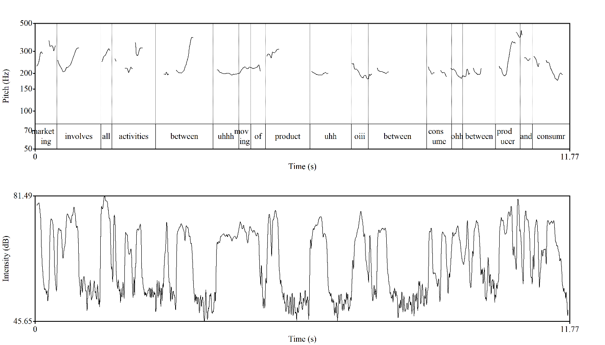
Figure 21. Sample of correction realized (LKE1) in female voice. Horizontally time in seconds is indicated, vertically – frequency of pitch in Hz on a logarithmic scale.

In the analysed excerpt (Figure 21) from a Kazakhstani English-language lecture, the lecturer’s highest pitch targets are observed on the lexical items marketing, between, and producer. The word marketing, positioned at the beginning of the utterance, initiates a narrative communicative type in which the intonational head commences with a high pitch. Specifically, the fundamental frequency rises from 229.8 Hz to 330.20 Hz, spanning an interval of 6.3 ST, and is maintained at a comparable level until the onset of between. The latter marks the beginning of a hesitation preceding a self-correction. At this point, the pitch increases from 203.7 Hz to 386.6 Hz, constituting a range of 11 ST.
The preposition between, which under normal circumstances would be unstressed, is produced over a duration of 1.43 seconds, inclusive of the pauses preceding and following it. This duration is notably longer than in typical cases, suggesting that the hesitation is associated with both pause insertion and pitch elevation.
The third and highest pitch peak occurs during the articulation of producer, which initiates the corrected segment. Here, the speaker raises the pitch from 227.6 Hz to 412.8 Hz (a 10 ST interval), followed by a falling terminal contour. This pattern indicates that the highest pitch is employed within the corrected portion of the utterance, likely functioning as a prosodic marker of the correction. Similar tendencies were consistently observed across other instances of self-correction in the dataset.
Additional indicators supporting the presence of correction in the excerpt include the occurrence of hesitation markers, specifically the filler uhhh, which appears three times, and the interjection oii, used twice. Moreover, following the observed utterance, the speaker explicitly apologises for an inaccuracy in speech.
A similar pattern emerges in the other lectures examined, where auxiliary words or correction markers, such as sorry, oiii, uhm, ahhh, and uhhh, are employed in the course of speech. Since English functions not as the lecturers’ native language but as the medium of instruction, instances of correction frequently arise during the flow of lecturing. These corrections often stem from momentary lexical or grammatical inaccuracies, as well as from the need to adjust word choice or syntactic patterns to better align with the intended content.
As for the intensity pattern across the utterance we can see how the speaker balances moments of emphasis with pauses for planning and transition. At the start (“marketing involves all activities…”), the delivery is strong, with clear peaks reaching about 80 dB. This opening energy highlights the introduction of the topic, though a slight dip at “all activities” signals a natural shift before continuing. In the middle (“uhh moving of product, uhh oiii…”), the contour becomes less stable. Hesitations such as “uhh” and “oiii” are marked by noticeable drops in intensity, sometimes falling as low as 46-55 dB, which reflects both reduced articulation and a moment of cognitive pause. Yet, once the speaker resumes content words like “moving” and “product,” intensity rises again to 75-78 dB, underscoring their informational importance. By the closing section (“between consumer and producer and consumer”), the voice stabilizes once more, with consistently high peaks around 78-80 dB, showing regained fluency and placing clear emphasis on the opposition between “producer” and “consumer.”
Taken together, these shifts create a rhythm in which strong intensity peaks highlight key terms, while low points mark hesitations or less important words such as connectors. This alternation is typical of spontaneous lecture speech: it signals to the listener where the focus lies, while also revealing the natural pauses of thought and planning in real-time delivery. In this way, intensity is not simply a matter of loudness but a meaningful resource for structuring discourse and guiding audience attention.
This can be clearly seen in the Figure 22 where the lecturer hesitated in choosing the appropriate word or phrase.

(14) All about you all of you sorry all the most of you know about Oriflame, Roboclean…

In sample (14), taken from Kazakhstani English-language lecture 5, the lecturer’s highest pitch is observed on the word you in both instances where self-correction occurs. In the first occurrence, F₀ rises from 280.9 Hz to 412.4 Hz, marking the end of the corrected segment that replaced the earlier inaccuracy, though the correction itself remains imperfect. In the second instance, the pitch increases from 312.8 Hz to 426.6 Hz. The corresponding pitch intervals amount to 6.6 ST in the first case and 5.4 ST in the second, suggesting greater emphasis during the first correction and reduced prosodic prominence in the second. A 0.9-second pause occurs between the two attempts, functioning as a hesitation cue and signaling error recognition. However, in both cases, the highest pitch on the significant words occurs within the corrected portion of the phrase, which supports our hypothesis that, in instances of self-correction, speakers tend to produce more prominent speech, characterized by higher pitch levels and wider semitone intervals and accompanied with pause occurrence.
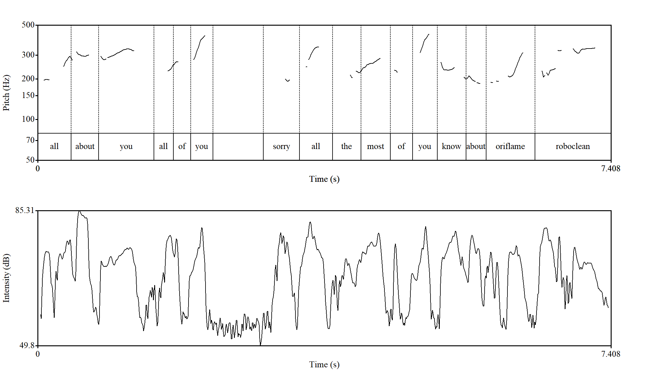
Figure 22. Sample of correction realized (LKE5) in female voice. Horizontally time in seconds is indicated, vertically – frequency of pitch in Hz on a logarithmic scale.

The duration of the utterance is 7.4 seconds which can carry a long message however during this time the speaker makes a pause, hesitate and repeats the words several times. this can be observed in the intensity contour of this utterance which reveals an expressive and rhythmically varied delivery. The general intensity range extends from 49.8 dB to 85.3 dB, with an average clustering between 70-78 dB. Such variation illustrates how the speaker alternates between strong emphatic moments and softer segments that reflect hesitation, correction, or transition.
At the beginning (“all about you all of you”), intensity is relatively high, reaching peaks of around 80-82 dB, which creates a strong and engaging start. This prominence highlights the collective reference to the audience and establishes contact. A sharp drop follows during the insertion “sorry,” where intensity falls closer to 50-55 dB. This reduction signals a moment of self-repair or hesitation, softening the delivery and reducing emphasis. Immediately afterwards, intensity rises again on “all the most of you,” restoring energy and resuming a steady pattern around 75-80 dB.
In the final part of the utterance (“know about oriflame roboclean”), intensity displays recurrent peaks on the lexical items “know,” “oriflame,” and “roboclean,” each rising to around 78-83 dB. These peaks foreground the informational content, particularly the product names, which are clearly highlighted for rhetorical effect. The contour avoids deep troughs here, suggesting a smoother and more confident close compared to the earlier part of the utterance.
Analysis of the collected samples of corrections shows that some parts of a lecture can be mistaken for paraphrasing, where certain phrases or words are reworded. However, in Kazakhstani English-language lectures, lecturers sometimes misuse parts of phrasal expressions or collocations. This can lead to the replacement of a word with another of similar meaning, or the substitution of a verb used in a fixed expression. Although such forms may be grammatically acceptable in everyday speech, they can still alter the intended meaning of the utterance. Most of these cases are therefore treated as corrections. For illustrating paraphrasing, the selected examples are those where the core idea remained the same but was expressed using different wording.
Paraphrasing is one of the most frequently employed strategies by lecturers delivering lectures in English, which is a foreign language for them. This tendency may be linked to the lecturers’ intention to explain the material more clearly, particularly given that the medium of instruction is also not the native language of the audience. In addition, paraphrasing can serve as a means for lecturers to reconsider and refine their ideas as well as the overall flow of their speech. The following analysis illustrates this phenomenon in more detail.

(15) Marketing includes … the process, activities
which help to uhh sell product uhhh
which help to move product from … uhhh manufacturer
from producer to customer

In sample (15), two instances of paraphrasing are identified. The first involves a lexical reformulation, where the phrase to sell the product is re-expressed as to move product from manufacturer. The second concerns a case of lexical substitution, in which the term manufacturer is paraphrased with producer, both functioning as semantically equivalent alternatives in this context. The ellipsis in the excerpt indicates the omission of certain self-corrections made by the speaker, as these are not pertinent to the present stage of analysis.

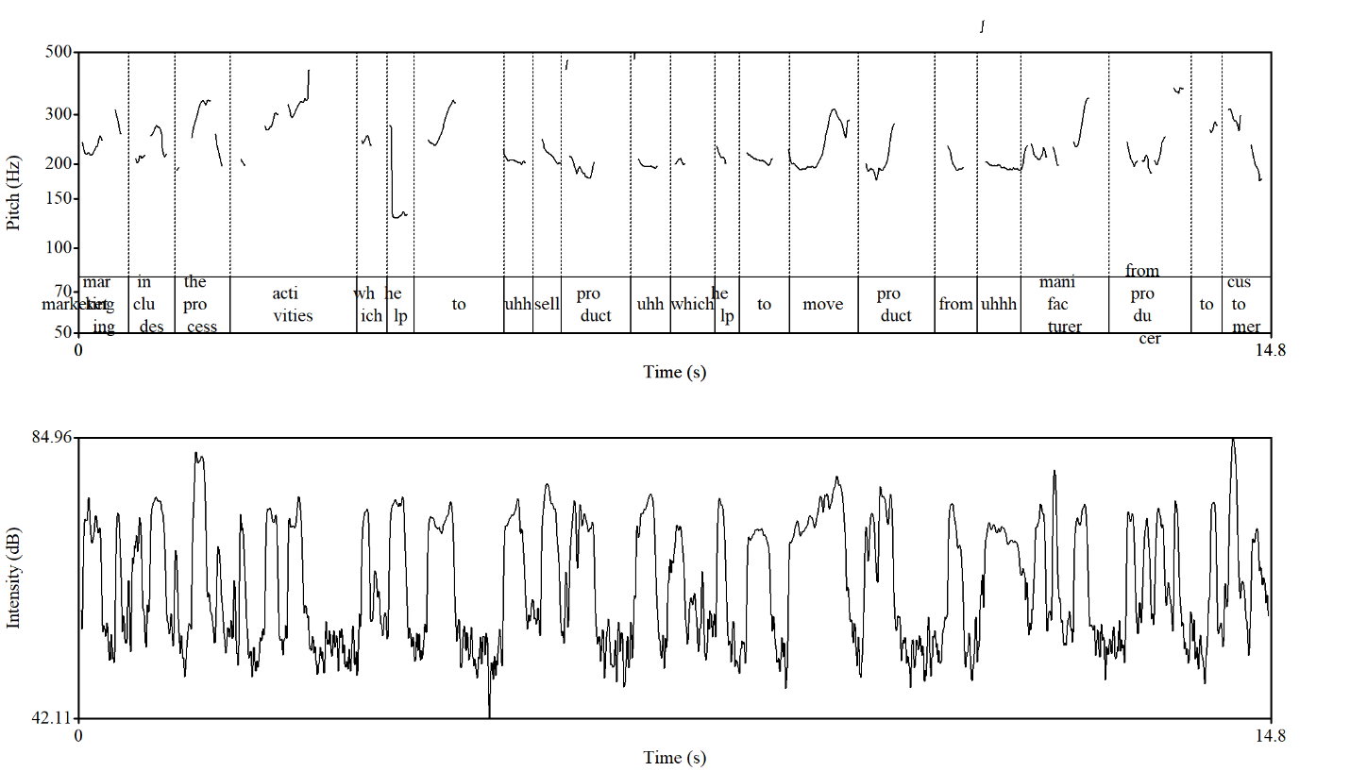
Figure 23. Sample of paraphrasing realized (LKE1) in female voice. Horizontally time in seconds is indicated, vertically – frequency of pitch in Hz on a logarithmic scale.

Figure 23 illustrates that the speaker (LKE1) produced the phrase to sell the product with a pitch contour that rises on to and then falls gradually toward the end of the word product, ranging from 334.7 Hz to 203.6 Hz (−8.6 ST). In the paraphrased segment to move product from, the lecturer maintained a similar pitch level until the word move – the key verb in the paraphrase – where a rising intonation is observed, starting from to at 215.2 Hz and peaking at 307.6 Hz (+6.2 ST), followed by product at 268.2 Hz. This prosodic pattern suggests an intentional attempt to direct the audience’s attention toward the paraphrased portion of the utterance.
Notably, the speaker’s hesitation is evident, with the presence of the filler uhhh reinforcing this impression. This prosodic and disfluent behavior may indicate that the second, paraphrased construction was the lecturer’s original intention, and that once recalled, it was delivered with a higher pitch to signal its importance. It was observed that the paraphrased part after the usage of the hesitation fillers get more stress and higher pitch in comparison with the first part.
The intensity contour ranges from approximately 42.1 dB to 84.9 dB, with higher peaks corresponding to lexically salient items such as sell, move, and manufacturer. This suggests that intensity, alongside pitch, is used to reinforce prominence. Multiple hesitation markers (uhh, uhhh) occur between the original and paraphrased constructions, each accompanied by brief pitch resets and reductions in intensity. These disfluencies indicate real-time speech planning, supporting the interpretation that the paraphrased segment may have been the lecturer’s initially intended formulation. Once retrieved, it is delivered with a higher pitch on the key verb, signalling its importance and drawing the audience’s attention to the revised expression. The high peaks if intensity are observed in the words process and consumer around 82-85dB. This indicated that they are the most content-centered words
A second instance of paraphrasing is evident in the substitution of the term manufacturer with producer, both pronounced at a similar ascending pitch level. For manufacturer, the pitch rises from 230.3 Hz to 342.9 Hz, with an average of 238.5 Hz (+6.9 ST). For producer, the pitch rises from 205.1 Hz to 374.0 Hz, with an average of 251.3 Hz (+10.4 ST). Although the overall pitch patterns are comparable, greater prosodic prominence is observed in the pronunciation of producer, suggesting an intentional emphasis in the paraphrased form.
There are also the cases where the whole sentences are paraphrased where the second sentence is pronounced with the lower tone than in the first one. There is given an example of such cases.

(16) They designed very qualitative product.
The quality of this product is high.
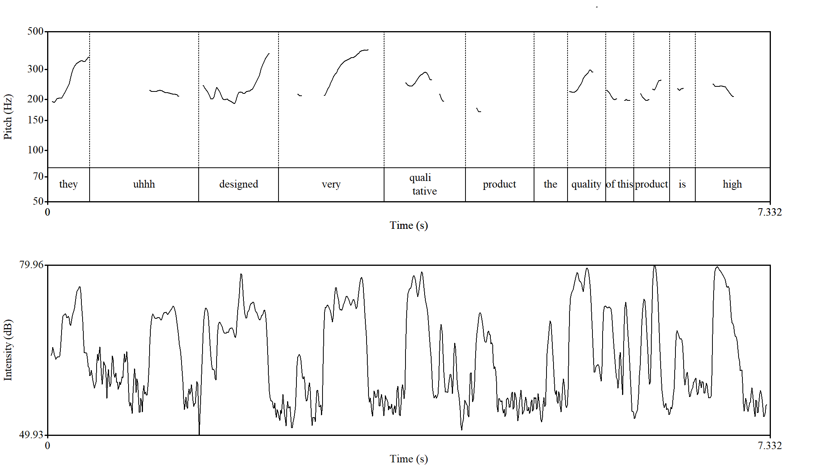
Figure 24. Sample of paraphrasing realized (LKE5) in female voice. Horizontally time in seconds is indicated, vertically – frequency of pitch in Hz on a logarithmic scale.

In this example, we can observe how the lecturer rephrases the utterance by altering the sentence structure. This strategy is employed to draw the audience’s attention to the significance of the moment. Thus, the function of paraphrasing in this case is to serve as a means of emphasis.
According to Figure 24, the words very (318.1 Hz) and designed (231.1 Hz) receive the highest pitch prominence. The word designed functions as the key element of the utterance, carrying the main informational load as the predicate. The pitch contour rises at the moment of pronouncing very, which serves as an intensifying device, rising from 213.8 Hz to 389 Hz (10.4ST) and then gradually descends toward the end of the utterance. In the paraphrased version, however, the highest pitch shifts to the word quality, from 221.7 Hz to 296.6 Hz (5 ST), while the remainder of the utterance is delivered in a more narrative manner with a falling tone. Furthermore, the duration of the original sentence is 4.9 seconds, whereas the paraphrased segment takes only 2.5 seconds, making it nearly twice as short. This reduction in time demonstrates that the paraphrased version receives less prosodic emphasis, thereby attracting comparatively less attention.
This analysis demonstrates that when entire utterances are paraphrased, the second version carries less prominence compared to the initial one. Such a strategy may function as a means of consolidating or reinforcing the information previously conveyed. This is clearly seen in the intensity used in it. The intensity contour of this utterance shows a carefully modulated pattern reflecting both hesitation and emphasis. The overall intensity range extends from 49.9 dB to 79.9 dB, with an average clustering around 70-75 dB, which is typical for lecture delivery.
The part that attracts the attention is the drop of the intensity at the beginning (“they uhhh designed”), where the contour alternates between a peak on “they” (~77 dB) and a significant drop during the hesitation “uhhh,” where intensity falls toward 50-55 dB. It signals a pause in speech planning as the lecturer thinks how to say. The delivery then regains force on “designed,” with intensity rising again to 75-78 dB, highlighting the reintroduction of the central idea.
In the middle of the utterance (“very qualitative product”), intensity demonstrates a series of well-marked peaks (74-79 dB), especially on “qualitative” and “product.” These peaks underscore the semantic load of the phrase, while valleys between them reflect transitional or unstressed material. Toward the end (“the quality of this product is high”), intensity remains relatively high and stable, with several peaks around 77-79 dB. This stability creates rhetorical clarity and confirms the rephrased message. The repeated emphasis on “quality” and “product” illustrates how intensity is used to foreground key terms across the paraphrased construction, reinforcing comprehension for the audience. This prosodic pattern ensures that the paraphrased idea is not only delivered clearly but also highlighted for the audience as a key point of focus. Moreover, here we can’t see the pause between the paraphrased part and paraphrase itself. The lecturer tries to utter the second art quickly without interrupting the focus of the audience from the previous part.
There are also instances where a pronoun is paraphrased through clarification, with the clarified element receiving greater pitch prominence. Normally, according to the rules of intonation, pronouns belong to the parts of speech that do not typically carry stress within the flow of speech. However, when the pronoun is demonstrative, it may receive stress and prominence in order to emphasize its role and distinguish it from other words in the utterance.
The use of synonyms in paraphrasing also deserves particular attention. In such cases, the second synonym typically carries less prosodic prominence than the one used initially. This tendency suggests that synonymic substitution in paraphrasing is less about introducing new emphasis and more about reinforcing the previously highlighted meaning. This observation once again highlights how paraphrasing interacts with prosodic features, serving not only to clarify meaning but also to manage the distribution of emphasis in spoken academic discourse.
The results indicate that, unlike the paraphrasing patterns observed in Kazakh lectures, paraphrasing in English-medium instruction demonstrates greater variability. This difference can be attributed primarily to the distinctive intonational characteristics of the two languages. In English, shifts in pitch are permissible and even expected, depending on the lecturer’s communicative intention and the goal of conveying information. By contrast, in Kazakh lectures the paraphrased segments tend to receive less prosodic prominence, reflecting a more restrained intonational pattern.
Another frequently observed feature in lectures delivered in English by non-native speakers in the Kazakhstani context is repetition. In the data analysed there are the lexical and syntactical repetitions as well as in the Kazakh-language lectures studied earlier.
In employing lexical repetition, lecturers make use of several rhetorical devices. These include anaphora, where phrases are repeated at the beginning of successive clauses; epiphora, where repetition occurs at the end; and anadiplosis, where the final word of one clause is repeated at the beginning of the next. In addition, individual words or phrases may also be repeated independently, serving primarily as a means of intensification or emphasis.

(17) They do marketing research to identify the consumers,
to identify the market,
to identify how to sell…

In sample (17), the speaker repeats the same word to identify three times in order to accentuate the information under analysis and, at the same time, to draw the audience’s attention to this segment of the lecture. Such tool as a rule is further reinforced prosodically, as the repeated word is pronounced with heightened pitch and slightly lengthened duration, which together serve to intensify its prominence and ensure it is perceived as a focal point by the listeners. Let us now examine how this phenomenon is realized prosodically in the given sample.
It can be observed in Figure 25 that the repeated word in this utterance is pronounced at a consistent pitch level, ranging between 200 Hz and 219 Hz across all occurrences. The duration allocated to each instance is also nearly identical, approximately 1.1-1.2 seconds. Since the repetitions occur in the middle of the utterance, the overall speech flow remains stable, producing a relatively flat intonational contour. For the purpose of economizing both time and space, the final part of the utterance has been omitted and it doesn’t have a great influence on the analysis process.

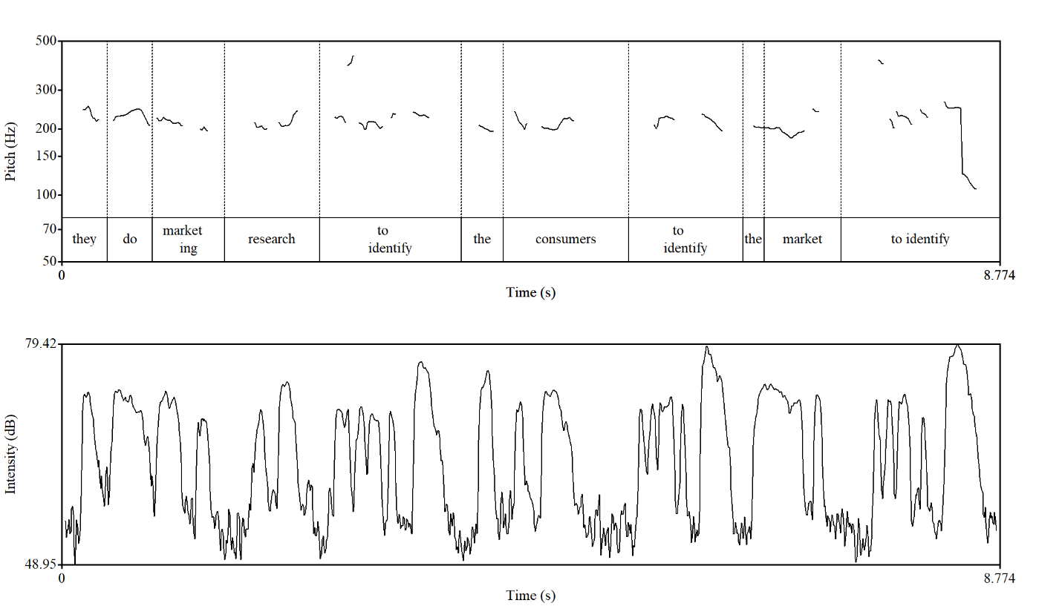
Figure 25. Sample of lexical repetition realized (LKE1) in female voice. Horizontally time in seconds is indicated, vertically – frequency of pitch in Hz on a logarithmic scale.

The intensity contour of this utterance fluctuates between 49-79 dB, showing a clear alternation between strong and weak segments. Peaks occur on the key lexical items marketing, research, consumers, and market, emphasizing their informational weight, while valleys are found on function words (they, do, the, to), which are less prominent. The repeated phrase to identify is marked by renewed intensity peaks around 80 dB, demonstrating how prosody supports paraphrased emphasis. Overall, intensity highlights core academic terms and organizes the utterance into meaningful units for the listener.
In the use of the repetitions at the beginning of the utterances the words or phrases are stressed and pronounced with the similar pitch of voice and followed by a descending tone. It can be closely connected with the intonational character of the narratives.
There are also cases where the lecturer intentionally repeat the phrase and says it directly that she is repeating it to draw the attention of the students.

(18) They not only produce, I want to repeat,
they not only produce but also they tried to sell, promote the product.

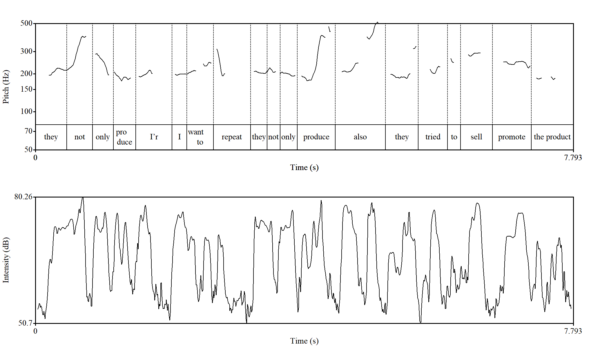
Figure 26. Sample of lexical repetition realized (LKE5) in female voice. Horizontally time in seconds is indicated, vertically – frequency of pitch in Hz on a logarithmic scale.

In the given example (Figure 26), the repetitions are produced along the same pitch contour; however, the placement of the highest pitch changes. In the first occurrence of the phrase, the speaker emphasizes the word not, raising the pitch from 215.2 Hz to 391.1 Hz, which corresponds to an interval of 10.3 ST. In the second occurrence, however, the pitch peak shifts from not to the word produce, rising from 192 Hz to 401.4 Hz (12.7 ST). This shift may be explained by the speaker’s intention to adapt prosodic emphasis to the progression of the utterance, which is framed as a negative sentence. At the same time, the possibility of inaccuracy in repeating the phrase cannot be ruled out. The presence of the interjection further adds weight to the utterance, suggesting that the word produce would be more appropriately highlighted with high pitch in this context. Moreover, the use of parenthesis gets rising tone yet the lower pitch level than the repetitions.
In the analysed patterns when repetitions occur at the beginning of utterances, the repeated words or phrases are typically stressed and pronounced at a similar pitch level, followed by a descending tone. This prosodic pattern is closely associated with the intonational characteristics of narrative speech. As an example, we can give the utterances that have the word combination green technology from the LKE 4.

(19) Green technology includes both process and product technologies that generate low or no waste…
Green technology does not only mean individual technologies but also systems including…
Green technology covers a broad area of production.

Anadiplosis deserves particular attention, as its construction differs from that of epiphora and anaphora. By definition, anadiplosis occurs when the final word or phrase of one sentence is repeated at the beginning of the next. In the lectures under analysis, delivered in English as the medium of instruction, this device most often appears in instances where lecturers pose rhetorical questions and immediately provide the answer themselves. Notably, these questions are not followed by a deliberate pause that would normally allow the audience to respond. Instead, the lecturer continues seamlessly. Prosodically, the initial part of the utterance carries the intonation typical of interrogative sentences, most often special or wh-questions that are characterized by a falling tone. By contrast, the onset of the following utterance usually adopts a rising tone, creating a distinct rhythmic and intonational pattern (LKE5).

(20) What it means.
It means that according to this concept manufacturers and producers … focus on needs and wants of their consumers.

It should be noted that, from a grammatical perspective, the first occurrence of the phrase appears somewhat unconventional; however, in terms of intonation, it is entirely appropriate. This prosodic correctness plays a direct role in the emergence of the repetition.
While anadiplosis illustrates how lecturers rely on rhetorical strategies to structure their speech, another type of repetition also deserves attention. This is syntactic repetition, which can serve as an effective means of reinforcing and intensifying the delivery of information in lectures. Although such examples are relatively rare in the lectures under consideration, they are nonetheless significant. In particular, it is important to observe the prosodic features that accompany syntactic repetition in English-language lectures.

(21) But no, marketing is not advertising. Marketing is not selling. Marketing is not only promotion.

The example of syntactic repetition presented in Figure 27 can be divided into three syntactic segments, all pronounced within a similar pitch range (227.1 Hz-251.2 Hz). A slight rise in pitch occurs, however, in the final phrase of the third segment, only promotion, in contrast to the preceding utterances. This rise, followed by a relatively flat continuation, creates the impression that the idea is still unfolding. Such prosodic behavior may be linked to the subsequent utterance, which provides a response to the initial negation.
In repetitions of this type, the final part of the chain is consistently marked by a falling tone. Across all three segments, emphasis falls on the word not, as the example belongs to a negative sentence type. Interestingly, each occurrence of not is given approximately 0.4 seconds of duration, highlighting the marked prominence attributed to it. Moreover, in all three cases, the tone rises from an average of 190 Hz to 325 Hz, corresponding to an interval of 9.3 ST, which further reinforces the expressive weight of the repetition.

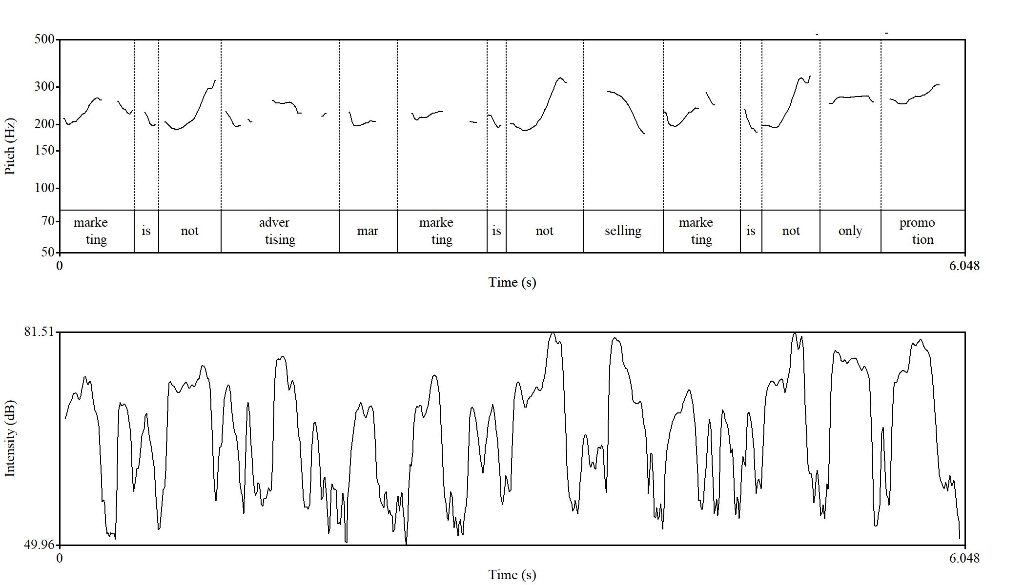
Figure 27. Sample of syntactical repetition realized (LKE1) in female voice. Horizontally time in seconds is indicated, vertically – frequency of pitch in Hz on a logarithmic scale.

As for the intensity contour of this utterance it spans 50-81 dB, with strong peaks consistently placed on the repeated phrase marketing is not. This syntactical repetition is prosodically reinforced by stable high-intensity values, which underline the lecturer’s corrective emphasis. Other lexical items such as advertising, selling, and promotion also carry prominent peaks about 78-81dB, while function words (is, not, only) show lower intensity (50-60dB), creating contrast. Overall, intensity works in tandem with syntactic repetition to highlight the lecturer’s argumentative stance and guide the audience’s focus to the key conceptual clarification.
As the analysis of lecture transcripts and recordings demonstrates, repetition serves three main functions. The first is intensification, whereby the lecturer seeks to draw the audience’s attention to particularly important elements of the discourse. Repeating a phrase several times, in considered lectures it is often located at the beginning of an utterance in the form of anaphora, signals its significance and ensures that the information is firmly registered by listeners.
The second function of repetition is clarification and reinforcement. In this case, lecturers repeat a phrase not to emphasize its importance, but rather to ensure comprehension and to consolidate understanding among students. This type of repetition is especially common in English-medium instruction delivered by non-native lecturers, as it allows them to check that the message has been effectively conveyed and to bridge possible gaps in students’ perception.
The final case of repetition observed in lectures delivered in English by Kazakhstani lecturers is its use as a strategy to manage hesitation or word searching. In such instances, repetition functions as a compensatory device, allowing the lecturer to maintain the continuity of speech while formulating the next part of the utterance. These repetitions are often accompanied by hesitation markers or pauses, which further indicate the speaker’s attempt to preserve the flow of the lecture without interrupting its delivery. There is made an attempt to study the prosodic peculiarities of repetition in the context of all mentioned functions.
One of the phenomena observed in Kazakhstani English-medium lectures is the use of parenthetical insertions, which serve to provide additional information within the flow of discourse. Compared with the Kazakh-language lecture material, such insertions occur less frequently – typically only two or three instances per lecture. This tendency may be explained by the format of the lectures under study, the majority of which were delivered in an online distance-learning setting. In such contexts, the lecturer cannot easily gauge the audience’s immediate reactions, and the primary goal becomes the straightforward transmission of material. Nonetheless, lecturers occasionally address their audience directly, which suggests an attempt to imagine and maintain a connection with listeners. Parenthetical insertions, therefore, function not only as responses to potential audience needs but also as strategies for clarification and enrichment, ensuring that the content is accessible and comprehensible. Nevertheless, as the observations show, the instances of parenthetical insertions are used by the lecturers that have conveyed their lectures offline in traditional way.

(22) So metal scaffolds like titanium,
because you have of course heard that titanium can be used in a certain way, ya
so this material may process advantages biocompatibility.

From the example presented in Figure 10, it can be observed that the lecturer introduces additional information intended to remind students of their background knowledge relevant to this part of the lecture. In general, parenthetical insertions momentarily interrupt the flow of speech, producing noticeable shifts in the prosodic contour. The speech stream is cut at the point where the insertion is introduced. For instance, following the filler ahh, the pitch rises, signaling the beginning of a new idea, and subsequently falls with the word ya, which marks the completion of the initiated sentence.
It should be noted that the second half of the sentence is not displayed in Figure 10, since the Praat spectrogram captures only a limited time frame. Nevertheless, the excerpt allows us to observe that the pitch level during the insertion does not exceed that of the main informational segment. The most prominent pitch peak appears on the word course (296.5 Hz), which functions as a focal point, drawing students’ attention to the lecturer’s reference to their prior knowledge.
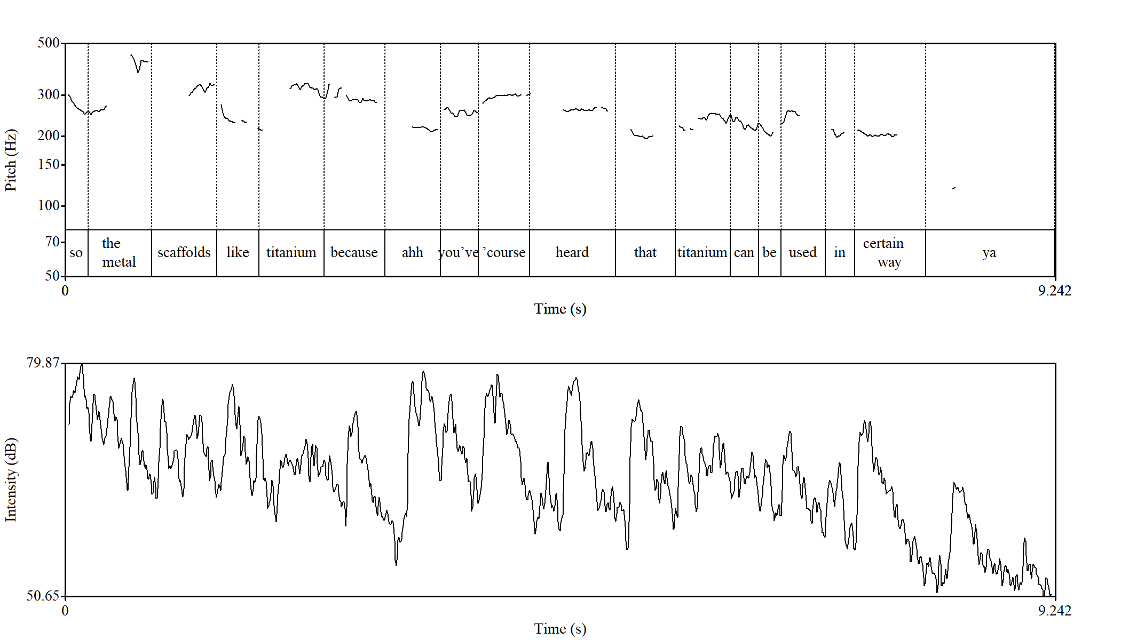
Figure 28. Sample of parenthetical insertion realized (LKE6) in female voice. Horizontally time in seconds is indicated, vertically – frequency of pitch in Hz on a logarithmic scale.

This example (Figure 28) demonstrates how prosodic cues particularly pitch movement, highlight the communicative function of insertions. By analyzing such patterns with the PRAAT program, it becomes possible to trace how lecturers structure discourse to both deliver new information and activate students’ existing cognitive resources.
The intensity contour presented in the lower panel of Figure 28 ranges between approximately 50.6 dB and 79.8 dB, showing clear fluctuations rather than a flat or monotone pattern. These variations indicate that the lecturer actively uses changes in loudness as a communicative resource to structure the flow of information and to emphasize particular elements of the lecture.
At the beginning of the utterance (so the metal scaffolds like titanium because), intensity reaches one of its highest points, close to 79 dB. This strong onset functions as a way of capturing the audience’s attention and marking the introduction of a new idea. When the lecturer shifts to the parenthetical insertion (ahh you’ve ’course), the intensity decreases slightly. This reduction in loudness distinguishes the insertion from the main informational stream, signaling to the audience that what follows is supplementary rather than central.
As the lecturer continues with the core message (heard that titanium can be used in…), intensity rises again and displays a wave-like pattern. Peaks of loudness align with key lexical items such as titanium and used, which reinforces their informational weight and helps guide the listeners’ focus. Toward the end of the utterance (in certain way ya), intensity gradually declines, creating a sense of closure and indicating the completion of the thought.
Overall, the analysis suggests that intensity in this example serves not only as a prosodic accompaniment to pitch but also as an independent cue for discourse organization. Higher intensity values highlight the central informational content, while lower values characterize parenthetical insertions, thus helping the audience to distinguish between primary ideas and supplementary comments. In a teaching context, such dynamic variation enhances auditory segmentation and supports comprehension, making the lecture more engaging and accessible.
Another commonly used feature of academic discourse is the interrogative sentence. In the analyzed Kazakhstani English-medium lectures, however, questions initiated by students were not recorded and therefore are not taken into consideration. Instead, the data show instances where lecturers themselves employ interrogative forms. One specific pattern observed is the use of the word yes with a rising intonational contour. In such cases, yes functions in a way similar to a tag question, providing implicit confirmation and inviting support for the lecturer’s point. This phenomenon has a cultural parallel in Kazakh lecturing practice, where short confirmatory questions such as Ia? or Solai mes pe? (“Isn’t it?”) are frequently used. For this reason, isolated yes with interrogative intonation is not treated in the analysis as a full-fledged question but rather as a discourse marker that reinforces shared understanding.
Another important observation is that when the same interrogative expression occurs multiple times in the flow of a lecture, for example, What does it mean?, it is counted as a single instance. Repetition in this case serves a rhetorical function rather than introducing a new question. Furthermore, not all questions are grammatically well-formed. Utterances such as What it means? appear in the material, yet their rising intonation unmistakably marks them as questions. These examples illustrate how interrogative meaning in lecture discourse is shaped not solely by grammar but also by prosodic and pragmatic features, which together create a dialogic effect even in a predominantly monologic genre.
In the analyzed material, the most frequently occurring type of interrogatives are Wh-questions, followed by yes/no questions and tag questions. Importantly, in the context of these lectures, such questions primarily function as rhetorical devices rather than genuine requests for information. They do not require or anticipate a direct response from students; instead, they serve to structure the discourse, highlight key points, and maintain a sense of engagement within the otherwise monologic lecture format.
There is an example of the use of Wh-question taken from the LKE 3 that is devoted to the study of management. The lecturer here addresses mostly the question use comparing to other features of academic discourse.

(23) Why is the study of management currently so popular among our citizens?

In this example, the question serves as a rhetorical device aimed at concluding and consolidating the lecture material. The lecturer poses the question but immediately answers it herself, thereby drawing students’ attention to the central ideas that should be retained. Such a strategy highlights the key points of the lecture while simultaneously creating the impression of interaction. In this way, rhetorical questioning functions not as an invitation for dialogue, but as a pedagogical tool that reinforces understanding and supports memorization of the conveyed material.

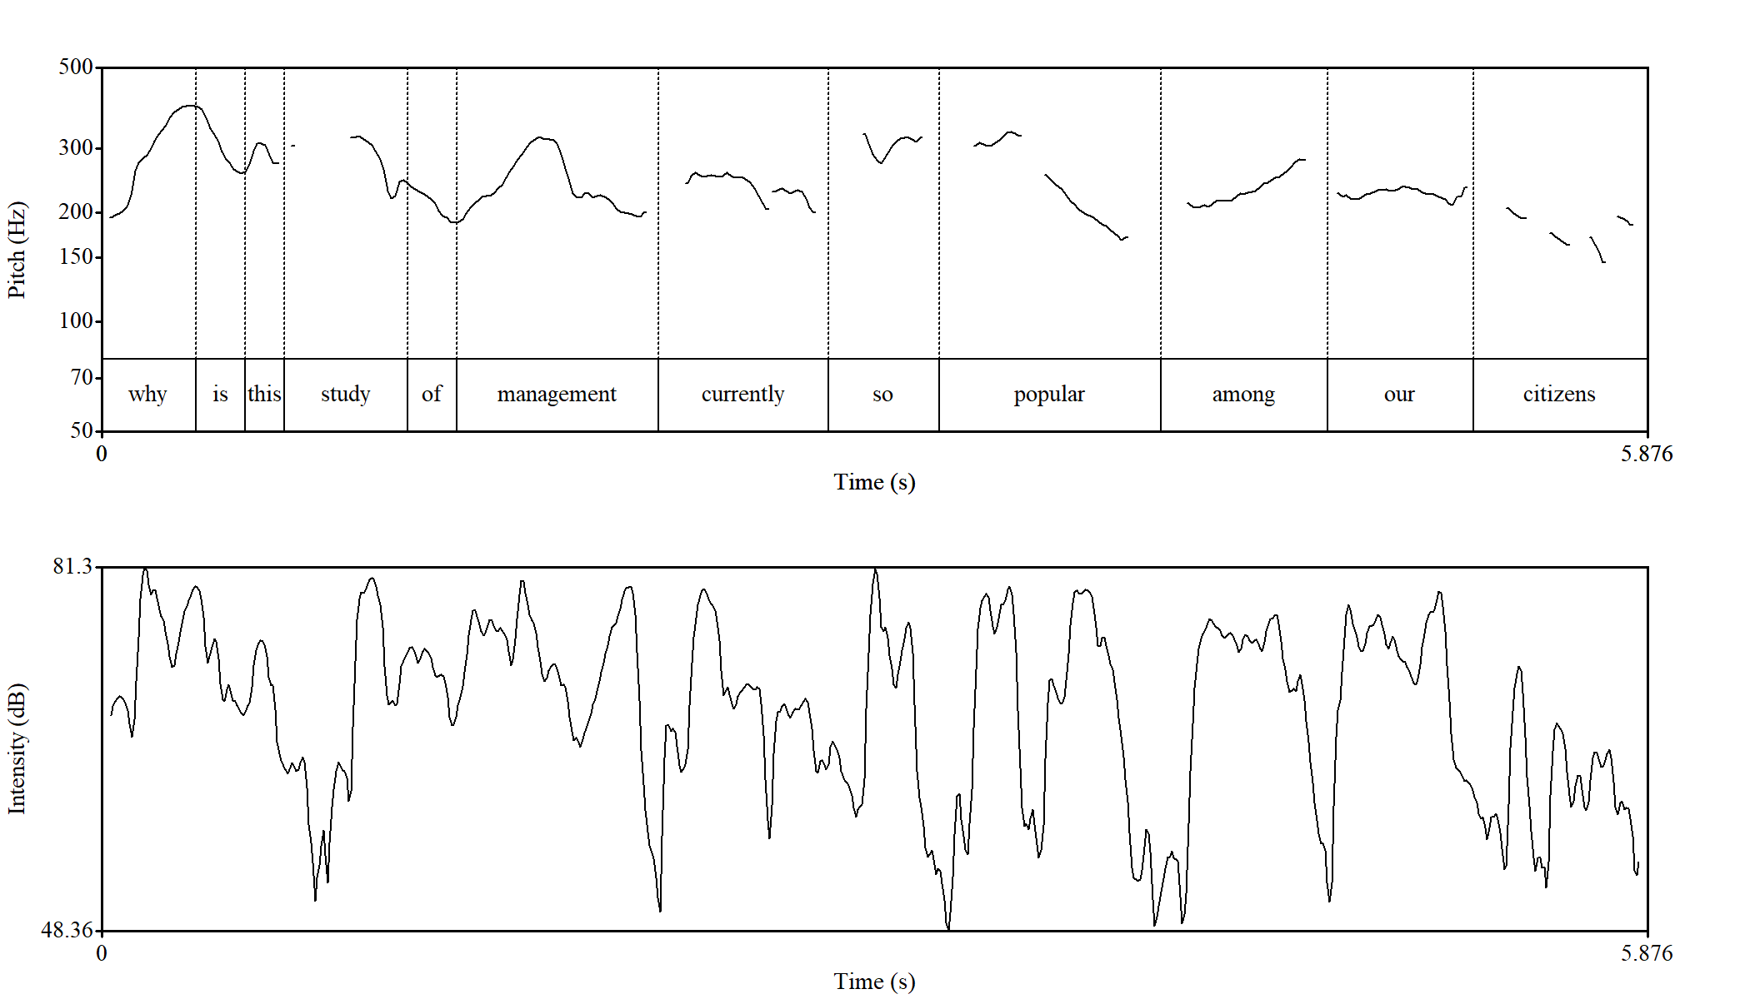
Figure 29. Sample of Wh-question realized (LKE3) in female voice. Horizontally time in seconds is indicated, vertically – frequency of pitch in Hz on a logarithmic scale.

According to Figure 29, the lecturer places prosodic emphasis on the interrogative word why at the beginning of the utterance, where the pitch rises sharply from 193.6 Hz to 393 Hz, forming an interval of 12.2 ST. This rising onset is characteristic of English Wh-questions, marking the interrogative as a prominent focal point. Following this initial rise, the pitch stabilizes, creating a slight wave with an average value of 242.2 Hz, which maintains the listener’s attention without major fluctuations. The final stressed element falls on the word citizens, where the pitch gradually declines, signaling the completion of the thought and guiding the audience toward the closure of the question.
The analysis of the given utterance demonstrates how intensity is employed as a rhetorical and pedagogical device. At the onset, the question word “why” is marked by a strong peak of around 81 dB, which serves to capture the audience’s attention and foreground the interrogative nature of the utterance. This heightened intensity, in combination with the sharp rise in pitch, reflects a characteristic strategy of English Wh-questions, where emphasis on the initial element frames the subsequent information as significant. In contrast, the following sequence “is this study of” shows a reduction in intensity, with values dropping to approximately 55-65 dB. This relative weakening creates a background against which the subsequent key lexical item “management” emerges more prominently. The word “management” is indeed articulated with renewed emphasis, reaching nearly 80 dB, which highlights its status as the central concept of the question.
As the utterance develops into “currently so popular”, the intensity contour becomes more variable, oscillating between 60-75 dB. This fluctuation produces a rhythmic quality that maintains the listener’s engagement and conveys the lecturer’s evaluative stance toward the subject matter. Finally, in the closing segment “among our citizens”, intensity gradually decreases from around 72 dB to below 55 dB. Such tapering mirrors the function of rhetorical closure: the lecturer poses the question, but also implicitly signals that no external response is required.
Taken together, the intensity contour demonstrates how the lecturer combines strong initial peaks, targeted emphasis on key concepts, and gradual attenuation at the end to structure the utterance persuasively. This prosodic shaping reinforces the rhetorical purpose of the question, guiding the audience’s attention to the main theme while ensuring that the delivery remains dynamic, clear, and pedagogically effective.
In the analysis of English-medium lectures, it was observed that the majority of tag questions are realized through short markers such as yes and right. This tendency reflects an instance of language interference, as it mirrors a common feature of the Kazakh language. From the perspective of English grammar, however, tag questions are typically formed by combining a declarative sentence with a follow-up clause containing an auxiliary verb that corresponds to the tense and person of the main clause. In contrast, the lecturers in the recorded material rarely employed this grammatical construction, opting instead for simplified forms that disregard the conventional rules of English syntax.
The only feature that allows these utterances to be identified as tag questions is the rise in pitch during their pronunciation, which signals the speaker’s intention to seek approval or confirmation from the audience. Since the primary aim of this research is the investigation of prosodic features rather than the grammatical accuracy of isolated words, such instances are treated as examples of tag questions despite their non-standard syntactic form.

(24) Purpose of marketing is to satisfy the consumers, yes?

This example (Figure 30) is taken from an English-medium lecture in Marketing (LKE 9), which focused on the introduction to marketing. As shown in Figure 30, the first declarative part of the utterance is pronounced with a falling pitch at the end. The utterance demonstrates a clear division between the declarative segment and the tag-like ending. The declarative part that includes the part ‘Purpose of marketing to satisfy consumers’ is pronounced with a relatively stable pitch contour, showing minor oscillations around an average of 230-280 Hz. This in its turn maintains a neutral and explanatory tone. A slight fall in pitch observed at the end of the word consumers marks the closure of the statement. A clear shift is observed, however, in the second part, where the pitch rises sharply from 208.9 Hz to 416.6 Hz, producing an interval of approximately 12 ST. Such prosodic behavior allows these constructions to be classified as tag questions. In addition to these cases, the material also reveals instances where tag questions are formed with discourse markers such as right?, further illustrating the variation in their use across the lectures.
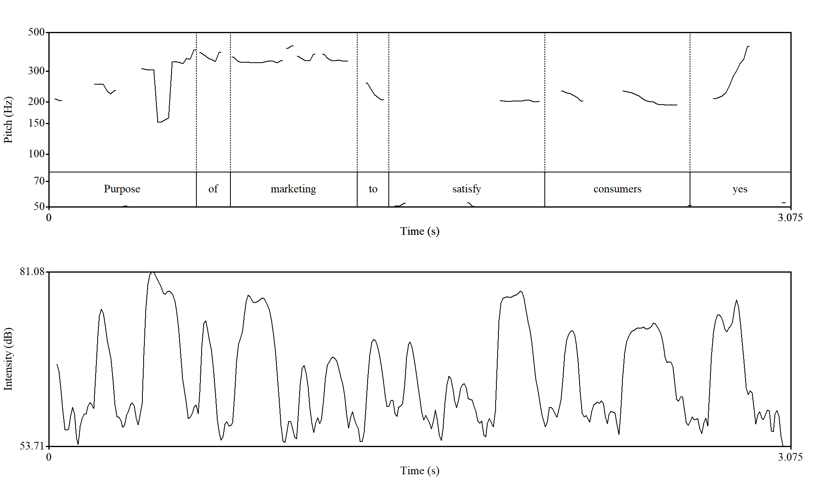
Figure 30. Sample of tag question realized (LKE1) in female voice. Horizontally time in seconds is indicated, vertically – frequency of pitch in Hz on a logarithmic scale.

The intensity contour also supports this interpretation. Throughout the declarative part, intensity fluctuates between 65 and 78 dB, with noticeable peaks on semantically significant words such as purpose, marketing and consumers. These variations highlight the informational weight of the key terms and help structure the utterance for the listener.
At the final yes, intensity does not fall off as might be expected in a declarative closure. Instead, it remains relatively elevated at around 74-76 dB, aligning with the steep pitch rise. The combination of high pitch and sustained intensity produces a prosodic cue that unmistakably frames the utterance as a question-seeking confirmation, despite its grammatically non-standard form. Even this demonstrates a clear proof of interference from the Kazakh discourse pattern, communicative effectiveness is still achieved.
The next type of question identified in the analyzed lectures, though occurring less frequently than the two previously discussed types, is the Yes/No question. These questions are typically employed by lecturers as a means of drawing attention or involving the audience in the lecture process. At the same time, it should be noted that Yes/No questions may also function rhetorically, posed not with the expectation of a response but rather to emphasize a point or to guide students’ reflection. Although the overall number of Yes/No questions in the English-medium lectures of Kazakhstani lecturers is relatively limited, their strategic use underscores the dual role of such questions in both engaging listeners and reinforcing the lecturer’s argument. This might be justified with the fact that majority of LKEs is borrowed from the base of online lectures of al-Farabi KazNU.

(25) Do you see someone like Steve Jobs was a pioneer of the microcomputer revolution of the nineteen seventies … along with Apple cofounder Steve Wozniak?

The given example has a duration of over 17 seconds; therefore, the segment containing the words and 1980’s was cut in order to allow its analysis in Praat, which limits recordings to 15 seconds. The meaning of the utterance isn’t distorted by this. Structurally, the Yes/No question is formed in accordance with English grammar. Nevertheless, as D. Karagoishiyeva et al. note, the intonational contour of Yes/No questions typically rises at the end, since their primary purpose is to elicit an answer [195]. In contrast, Figure 13 clearly demonstrates a descending pitch at the end of the question. This deviation from the expected rising contour suggests that the lecturer did not intend to receive a response from the audience, thereby giving the utterance the status of a rhetorical question.
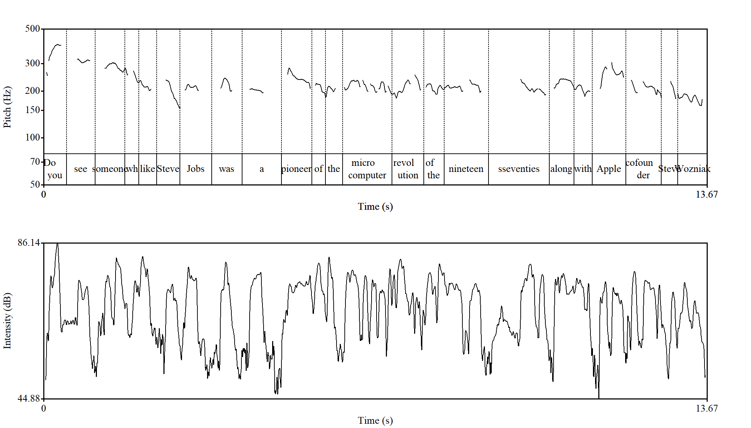
Figure 31. Sample of Yes/No question realized (LKE3) in female voice. Horizontally time in seconds is indicated, vertically – frequency of pitch in Hz on a logarithmic scale.

The example of a Yes/No question (Figure 31) under analysis demonstrates that the utterance begins with a relatively high pitch (394.3 Hz), which descends smoothly up to the word like (till 201.8 Hz) and then maintains relative stability, oscillating around 214 Hz. This stable contour continues until the word Apple, which is articulated with a comparatively higher tone, followed by a noticeable fall to 161.4 Hz. Such pitch fluctuations are largely associated with the pronunciation of key stressed words, which naturally attract prominence. Additionally, the lecturer produces a pause of approximately 1.47 seconds on the words a and was. These items, being function words, would not normally require emphasis, and the pause may therefore be interpreted as a hesitation rather than a prosodic strategy. Furthermore, the pronunciation of the year 1970 (nineteen seventies) extends over 2.2 seconds, which may signal either the lecturer’s intention to highlight the significance of the information or a moment of hesitation before providing the year.
According to the intensity picture presented the intensity contour of the utterance shows a dynamic pattern that aligns closely with the distribution of stressed and semantically significant words. At the beginning, intensity rises sharply, reaching approximately 77-78 dB, which immediately draws attention to the opening part of the question. After this peak, intensity gradually decreases, stabilizing around 68-70 dB through the mid-section of the utterance. This decline is interrupted by fluctuations associated with the pronunciation of key lexical items such as Apple, where intensity rises again to nearly 75 dB, reinforcing its prominence in the utterance. Overall, the intensity pattern does not display a gradual weakening typical of neutral declarative speech. Instead, it is characterized by recurrent peaks on stressed words and sustained levels during hesitation, which together function to maintain audience attention and emphasize critical elements of the utterance.

3.4 Challenges and recommendations on prosodic aspect of lecture delivery

The growing interest in English-medium lectures shows that this topic is both important and timely. Direct comparison between lectures delivered in English which is widely practiced in the world and lectures delivered in the native language of lecturer and students is not simple due to linguistic, cultural and institutional factors influence. This might be the main reason of that English-medium instruction has been studied from different angles like pedagogy, teaching methodology, linguistics, sociology, psychology, and others. Some works describe the main challenges and conditions that influence lecture delivery in English while others focus on outcomes and weigh strong and weak sides.
Taking Kazakhstan as a focus in research, M. Tajik and his colleagues examine graduate students’ experience with EMI to see how well they managed with EMI lectures. Their conclusion sounds that a tension still exists between policy ambitions and real classroom implementation [202]. From another perspective, F. Gimenez looks at information structure through phonology and shows how prominence and tone influence the comprehension of lectures. Taking into account cross-linguistic specifics, the study notes that Spanish-speaking university lecturers use a wide range of pitch contours when lecturing in English, although level tones are often overused. These results together support the idea that prosodic organization is central for understanding and improving it influence the effectiveness of EMI lectures [203].
This investigation proves the fact that each language has the features that can’t be replaced by other language peculiarities. This highlights the significance of conducting the research on the material based on a specific language without generalizing it.
We should admit the fact that dealing with applied studies like the given research faces some challenges related to the organization and content-based issues. The primary difficulty concerned the availability of source materials. Although the topic of academic discourse, particularly its prosodic dimension, has been gaining increasing attention among scholars, the resources related to the prosodic features of Kazakh-language lectures remain notably limited. This scarcity of theoretical and empirical references constrained the development of a robust conceptual framework and reduced the possibility of conducting comparative analyses with other linguistic contexts. This limitation, however, became a motivating factor for including authentic Kazakh-language lectures delivered by Kazakhstani lecturers to Kazakh-speaking audiences as the object of study. The data and findings obtained from this analysis not only filled a significant gap in describing the prosodic characteristics of Kazakh academic speech but can also serve as a valuable foundation for future research in the field of Kazakh lecture discourse. The results obtained in the research provide a detailed prosodic portrait of Kazakh academic discourse, offering valuable insights for both the theoretical development of functional phonetics and prosody and the practical improvement in lecture delivery strategies and approaches in higher educational institutions.
Another difficulty concerns the transfer of prosodic features from the speakers’ native language into academic speech delivered in a foreign language, which often functions as a second or even third language for both lecturers and students. Such cross-linguistic influence commonly results in flattened intonation patterns, a restricted and monotonous pitch range, irregular or non-standard phrasing, and the inappropriate placement or misuse of pauses. These prosodic deviations weaken the natural segmentation of discourse and obscure the hierarchy of information within the lecture. There is no doubt that such patterns reduce overall coherence and may lead to misinterpretation, loss of key points, and diminished comprehension on the part of students, especially in cognitively demanding academic contexts.
Having observed these challenges in the process of research it becomes more evident how significant it is to examine the way they are reflected in actual lecture delivery in a certain language. The findings of the study have been systematized to provide a clear and concise representation of the prosodic portrait of academic lectures in both languages examined. Therefore, the figures present the empirical findings of the study, offering a concise yet comprehensive description of pitch, pause, intensity, and duration patterns across the coherence-building devices. Together, these results form the basis for constructing a prosodic portrait of the lecture genre, which represents the final analytical component of this research.
Analysis of the data concerning pause use and its function in lecture delivery justifies its central role in shaping the prosodic organization of academic lectures. In the corpus of Kazakh and English-medium lectures, micropauses haven’t been taken into consideration due their primary articulatory purposes. As they don’t fulfill any discourse-organizing function they were excluded from the analysis, as were breath pauses.
The distribution of pause types across Kazakh- and English-medium lectures demonstrates how each language employs pausing to structure discourse and support coherence-building devices. Short pauses are predominantly used before definitions, key terms, and exemplifications, signalling emphasis and guiding listeners toward essential information; this pattern is slightly more frequent in English lectures due to clearer lexical–prosodic alignment.

Table 10. Discourse function of pause in lectures

Pause Type | Discourse Function in Academic Lectures | Most Frequent Coherence-Building Devices (Kazakh-Medium Lectures) | Most Frequent Coherence-Building Devices (English-Medium Lectures)
Micropause | Articulatory timing within a phrase; does not mark a boundary; not analytically significant | Not used for coherence-building; excluded | Not used for coherence-building; excluded
Short Pause | Signals minor boundary; used for brief planning; highlights a term or definition | Repetition, parenthetical insertions (to isolate key items) | Correction, repetition (before emphasis or rephrasing)
Medium Pause | Marks clause or intonational boundary; facilitates transition between sub-ideas or steps in explanation | Paraphrasing, exemplification; supports gradual topic expansion | Paraphrasing, topic shift, and definition clarification
Long Pause | Marks major boundary; introduces/ends a topic; used before/after a slide change; creates rhetorical suspension | Topic opening/closure, question prompting, rhetorical emphasis | Topic framing, section transition, post-question wait-time
Filled Pause (e.g., “эээ”, “мм”, “uh”, “um”) | Holds the floor; signals planning difficulty or temporary hesitation | Repair (correction), self-initiated reformulation | Reformulation, topic continuation, anticipatory planning
Breath Pause | Physiological reset; sometimes aligns with major boundaries but not a discourse marker itself | Not used analytically; excluded | Not used analytically; excluded

Medium pauses serve as reliable indicators of clause and intonational-phrase boundaries and function as markers of subtopic shifts; in Kazakh lectures they tend to be longer and more pronounced, supporting the discourse devices of repetition and paraphrasing, while in English lectures they more often accompany topic development and contrastive elaboration. Long pauses operate as high-level organizational cues marking new sections, rhetorical suspension, or slide transitions, displaying relative similarity across both languages. Filled pauses, meanwhile, appear mainly during planning difficulty or lexical search, functioning as floor-holding devices more common in English lectures. Overall, the use of pauses reflects language-specific rhythmic patterns but universally contributes to coherence management and listener orientation in academic lecture discourse.
A comprehensive overview of how prosodic elements are employed through coherence-building devices in Kazakh-medium lectures is presented in Table 11.

Table 11. Prosodic portrait of coherence-building devices (Kazakh lectures)

Coherence-building tools | Kazakh-medium lectures |  |  |  | Kazakh typical pattern
Coherence-building tools | Pitch (F0) | Intensity (dB) | Pause (ms) | Duration (ms) | Kazakh typical pattern
Correction | ~ 390 Hz | ~ 78 dB | ~ 600 ms | ~ 1100 ms | Prominence on the corrected part (second) segment; Strong prosodic marking of repair with a high pitch peak and elevated intensity; correction is framed by a medium pause and extended duration, clearly signaling speaker intervention and discourse control.
Paraphrasing | ~ 280 Hz | ~ 66 dB | ~ 700 ms | ~ 1200 ms | First formulation carries prominence; Moderate pitch and intensity combined with a medium pause and prolonged duration support explanatory reformulation while maintaining prosodic continuity.
Repetition | ~ 200 Hz | ~ 67 dB | ~ 700 ms | ~ 900 ms | First occurrence receives prominence; Lower pitch with moderately raised intensity; repetition is realized with a medium pause and shorter duration, reinforcing information without initiating a new prosodic boundary.
Parenthetical insertions | ~ 270 Hz | ~ 68 dB | ~ 900 ms | ~ 2200 ms | Clear prosodic island; Mid-range pitch and intensity with a long pause and extended duration marking the inserted segment as secondary, backgrounded information within the main discourse flow.
Yes\No question | ~ 235 Hz | ~ 68 dB | ~ 500 ms | ~ 900 ms | Distributed prosodic marking with moderate pitch and intensity; interrogativity is primarily encoded through pitch movement, while pauses and duration remain relatively compact.
Wh-question | ~ 320 Hz | ~ 72 dB | ~ 600 ms | ~ 2000 ms | Elevated pitch and intensity highlight the Wh-element; longer duration supports explicit signaling of the informational gap and sustained interrogative focus.
Tag question | ~ 360 Hz | ~ 60 dB | ~ 300 ms | ~ 1100 ms | High pitch combined with reduced intensity; the short pause and moderate duration indicate a confirmatory or discourse-managing function rather than a strong request for response.
The prosodic portrait of Kazakh academic discourse is marked by functionally differentiated use of pitch, intensity, pause and duration to structure coherence in the lecture genre. Correction or self-correction demonstrate the strongest prosodic prominence with high pitch peaks, especially on the corrected segment, elevated intensity and expanded temporal framing that signal explicit discourse correction and lecture control. Paraphrasing maintains moderate prosodic values and temporal expansion supporting explanatory reformulation without disrupting discourse flow while repetition is realized with lower pitch, shorter duration and medium pauses reinforcing information without creating new prosodic boundaries. Parenthetical insertions form clearly distinguished prosodic islands characterized by extended duration and long pauses, marking inserted material as secondary supplementary. As for the questions, they are prosodically differentiated with their own features from each other. Yes/No questions rely primarily on pitch movement with compact timing while Wh-questions display heightened prominence and extended duration to signal that information is needed to fill it. Tag questions, in their turn, combine high pitch with reduced intensity reflecting their discourse-managing and confirmatory function.
Overall, the prosodic portrait of English-medium lectures (Table 12) reveals a highly marked and structurally explicit use of prosody across all coherence-building devices. Corrections are characterized by strong prominence, high F0 peaks, and clearly signaled boundaries, indicating a deliberate effort to highlight repaired information. Paraphrasing and repetition display consistently elevated pitch values and stable intensity levels, reflecting the lecturers’ intention to maintain clarity and reinforce key conceptual material without disrupting the flow of discourse. Parenthetical insertions retain their insular prosodic profile but are integrated more efficiently into the surrounding speech through shorter bracketing pauses, suggesting a smoother embedding strategy than in Kazakh-medium lectures. Question types, particularly yes/no and tag questions, show elevated pitch but reduced intensity, revealing a distinctive interactional pattern where interrogatives often function rhetorically rather than dialogically. Taken together, these patterns demonstrate that English-medium lecturers rely on a more explicit, contrastive, and rhythmically compact prosodic system, which prioritizes clarity, emphasis, and controlled boundary marking in the delivery of academic content.
Examining the prosodic portraits of Kazakh and English-medium lectures makes it possible to outline several patterns that are useful for understanding spoken academic discourse and for improving lecture delivery in both languages. The study of the essence of the lectures has identified that the internal content of the lecture material covering prosody and constructing devices. Corrections, for example, are easier to follow when the lecturer briefly pauses before and after the corrected item, marking it off from the rest of the utterance. Parenthetical insertions, on the other hand, benefit from slightly lengthened boundaries, which help recognize the shift away from the main flow and return back to it. These subtle adjustments help maintain coherence, especially in information highly loaded sections of the lecture.

Table 12. Prosodic portrait of coherence-building devices (EMI lectures)

Coherence-building tools | English-medium lectures |  |  |  | English typical pattern
Coherence-building tools | Pitch (F0) | Intensity (dB) | Pause (ms) | Duration (ms)
Correction | ~ 400 Hz | ~ 80 dB | ~ 1000 ms | ~ 1300 ms | Marked by very high pitch and intensity with long pauses and extended duration, correction in English-medium lectures signals explicit repair and strong discourse boundary marking.
Paraphrasing | ~ 320 Hz | ~ 80 dB | ~ 800 ms | ~ 1000 ms | Moderately high pitch and consistently high intensity combined with medium pauses and duration support clarification while maintaining a smooth, explanatory discourse flow.
Repetition | ~ 300 Hz | ~ 80 dB | ~ 200 ms | ~ 1300 ms | Characterized by high pitch and intensity with minimal pausing but extended duration, repetition reinforces key content without interrupting the prosodic continuity of the lecture.
Parenthetical insertions | ~ 297 Hz | ~ 80 dB | ~ 200 ms | ~ 2200 ms | Realized with stable mid-range pitch and high intensity, short pauses, and very long duration, parentheticals function as embedded elaborations rather than prosodically detached segments.
Yes\No question | ~ 390Hz | ~ 75 dB | ~ 1200 ms | ~ 900 ms | High pitch with slightly reduced intensity and long pauses foreground interrogativity, while relatively short duration keeps the question compact; frequently realized with a falling final that is not natural.
Wh-question | ~ 300 Hz | ~ 75 dB | ~ 300 ms | ~ 2500 ms | Moderate pitch and intensity combined with very long duration and minimal pausing sustain interrogative focus and emphasize information-seeking intent across the utterance.
Tag question | ~ 400 Hz | ~ 75 dB | ~ 400 ms | ~ 900 ms | Very high pitch with moderate intensity and short-to-medium pauses indicates a confirmatory, alignment-checking function rather than a strong request for information.

A related issue is the placement of prominence. When lecturers repeat or paraphrase a content-related segment or item prominence is given to the first mention that helps draw the attention to the concept that is about to be developed. In corrections, however, prominence should shift to the corrected item to make the contrast visible. Managing the prominence realized with the help of pitch movement and intensity in this way supports coherence preventing misunderstanding.
One important area concerns the way lectures handle questions. In Yes/No questions a rising contour proves effective even when the question is rhetorical, because it is the pause that signals whether a response is awaited or not. Tag questions also benefit from using natural English forms such as, isn’t it? or don’t we?, as these carry clearer communicative value that short particles like yes or okay. For Wh-questions, a short pauses and high intensity on Wh-elements work best as it offers time to process the information without implying that they are required to answer. In case the answer is expected to the question type the duration of pause should be a medium or long one.
All these observations point to a conclusion that prosody is not an optional or decorative element of lecture delivery, but a practical tool for shaping how information is presented and understood, moreover the real intention of the lecturer. When it is used competently, it can enhance clarity, support student comprehension and contribute to a more organized and engaging lecture in both Kazakh and English. These findings suggest that prosodic awareness could be incorporated into lecturer training and considered more explicitly in discussions of academic speaking competence.

Conclusion of chapter 3
This part of the dissertation was devoted to the study of prosodic features of lectures delivered in Kazakh and English as an instruction medium focusing on the coherence-constructing devices such as repetition, paraphrasing, correction, parenthetical insertions and questions. According to the results of examining and analyzing authentic lectures it was identified that the effectiveness of an academic discourse is shaped not only by its content but also by the prosodic organization that is applied in delivering this content.
The developed detailed prosodic portrait of academic discourse drawn on the basis of the coherence-building devices in both Kazakh and English can justify the key and valuable outcome of the research. These portraits revealed that features such as pitch range, intensity, pause and segmental duration differ depending on the communicative function of the device and the language of instruction.
The research conducted demonstrated the results that while lectures delivered in Kazakh tend to rely on broader pitch movements and more explicit boundary marking, English-medium lectures often employ shorter pauses, highly frequency of rhetorical questions and more prominence patterns. These differences suggest that lecturers using the non-native language as an instruction medium in delivering lectures may encounter some challenges connected to managing pauses, marking parenthetical information or using natural-sounding strategies. This indicated once more again that prosodic competence is a key component of successful EMI practice.
As a summarization of the research a set of practical recommendations aimed at improving lecture delivery and sounding as a native speaker has been formulated. It emphasizes effective use of rising contours in yes-no questions and authentic forms of tag questions and clearer prosodic organization of corrections and parenthetical insertions. The recommendations reflect the practical significance of prosodic features used in lecture delivery especially in multilingual higher-education contexts.

CONCLUSION

The dissertation has studied the prosodic organization of lecture as a genre of academic discourse. Prior researches conceptualize academic discourse from different perspectives. To align with the object of study, this research provides a definition of this term through a discourse-based approach. Many scholars mentioned in their works that discourse should be considered according to the social status of the members taking part in it. Here, academic discourse is understood as a professionally oriented interaction among members of the academic community in higher educational institutions, particularly lecturers and students. It is aimed at construction, transmission and evaluation of knowledge. Academic discourse is an integration of scientific and educational discourses as topics addressed in the interaction are discipline-specific and it takes place in academic institutions like universities, the members of which are teaching staff, learners. The widely used genre of academic discourse is lecture as the main knowledge basis depends on its delivery effectiveness.
The theoretical overview of discourse and academic discourse provides a conceptual basis for interpreting the lecture as a socially and institutionally conditioned form of speech that reflects the speaker’s cognitive and pragmatic intentions. Effective lecture delivery depends not only on the organization of content but also on prosodic features that shape information flow and communicative impact. By integrating discourse-analytic and phonetic approaches, this research establishes a framework for understanding prosody as a multidimensional system that links linguistic form, meaning, and communicative purpose.
Within this context, the lecture constitutes a distinct genre in which prosody plays an organizing role. The core components of prosody—pitch, intensity, pause, and duration—structure information and support coherence. Working together with typical lecture devices such as correction, repetition, paraphrasing, parenthetical insertions, and questions, these prosodic cues contribute to the structuring and effective delivery of lecture material. Pitch signals informational load and aligns with the speaker’s intention; it also delineates the opening and closing of intonational paragraphs. Intensity draws attention to key moments and helps differentiate primary from backgrounded material, in interaction with speech rate/tempo. Pauses, placed strategically within the utterance, indicate intention, mark discourse and syntactic boundaries, and guide listeners through the developing argument. Duration, including pre-boundary lengthening, further reinforces these cues, sustaining coherence across dense stretches of talk. Such results drawn form the study led us to define academic discourse as an institutional type of discourse that combines educational and scientific features, characterized by specific thematic and prosodic properties that ensure coherence and information structure, reflect the communicative intention of a participant engaged in academic interaction within higher educational institutions.
The peculiarities of their use in lectures were examined through an empirical analysis based on recordings of lectures delivered in Kazakh and in English by Kazakhstani lecturers. This analysis revealed distinctive patterns of prosodic use shaped by linguistic and cultural factors. Kazakh-medium lectures were included because comprehensive studies of lecture prosody in the Kazakh language remain scarce. Establishing the prosodic profile of Kazakh lectures provides a necessary baseline for explaining the sources and background of divergences observed in English-medium delivery by Kazakhstani lecturers. There is no doubt that cultural and national features in lecturing cannot be overlooked. This study offers a lens for examining English-medium lectures delivered by Kazakhstani lecturers, which have gained prominence with globalization and the country’s trilingual education policy.
The key peculiarities identified are as follows. In Kazakh-medium lectures, repetitions and paraphrases are characterized by higher pitch and greater intensity on the first occurrence of the target segment. By contrast, in corrections and parenthetical insertions, the second occurrence (the corrected or inserted segment) is more prominently highlighted and intensified. A more measured rhythm and longer pauses commonly signal explanatory intent and contribute to discourse structuring. In English-medium lectures, a more dynamic pitch range, shorter pauses, and generally higher intensity were observed, consistent with lecturers’ efforts to sustain engagement and ensure comprehensibility in a non-native-language environment. However, divergences in disjunctive (tag) questions in English-medium lectures have minimal prosodic impact. Even when the question form is ill-structured and does not align with English grammatical norms, its intonational realization remains largely stable.
The dissertation contributes to discourse theory and functional phonetics by specifying how prosodic parameters (pitch, pause, intensity, duration) structure coherence and support meaning construction in lectures. In addition, it expands the Kazakhstani research landscape on academic discourse through original empirical data drawn from locally delivered English-medium and Kazakh-medium lectures and serves as a foundation for further cross-linguistic studies of academic speech. The findings provide a basis for actionable recommendations that members of the academic community can adopt to prepare and deliver lecture material more effectively for their target audiences.
Although this study offers important insights into the prosodic shaping of coherence in Kazakh and English-medium lectures, it doesn’t mean to provide a full portrait of the phenomenon. Academic discourse is a dynamic and multifaceted, influenced by linguistic and individual factors, especially the lecture genre, and a boarder range of data and various analytical approaches would help refine and extend the pattern identified in the work. A wider expansion of the research material would allow for a deeper understanding of how prosody together with coherence devices are managed in lecture delivery in native and target language. In this sense, the dissertation should be viewed as a significant starting point for further investigations. The development of a spoken subcorpus of Kazakh and EMI academic discourse, as well as the examination of gesticulation in academic communication, would represent promising directions for future research.
In conclusion, prosody in academic discourse reflects not only the lecturer’s linguistic competence but also their professional identity and pedagogical intention. The study confirms that prosodic organization is a key factor in achieving coherence, expressiveness, and mutual understanding in the educational environment, thus reinforcing its central role in the effective transmission of knowledge.

LIST OF REFERENCES

- Арутюнова Н.Д. Лингвистический энциклопедический словарь. – М.: Большая российская энциклопедия, 2002. – С. 136.
- Туманова А.Б. К вопросу определения понятия дискурс как объекта лингвистического исследования [Электронный ресурс]. – URL: https://pps.kaznu.kz/en/Main/FileShow2/119355/111/3/9618/0//
- Harris Z. Discourse analysis // Language. – 1952. – Vol. 28, No. 1. – P. 1-30.
- Ахатова Б. А. Политический дискурс и языковое сознание: монография. – Алматы: Экономика, 2006. – 302 с.
- Ибраева Ж. Қ. Қазақстанның саяси дискурсындағы саясаткерлердің тілдік тұлғасы // Абай атындағы ҚазҰПУ хабаршысы. Серия «Филология ғылымдары». – 2010. – № 2 (32). – Б. 43-46.
- Рапишева Ж., Карамсакова А. Ғылыми дискурс: негізгі теориялық мәселелер [Электрондық ресурс]. – URL: http://www.rusnauka.com/27_NPM_2012/Philologia/3_117011.doc.htm (қолданылған күні: 28.12.2020).
- Лущинская О.В. Обучение студентов неязыкового вуза иноязычному профессиональному общению на основе дискурсного подхода // Академический дискурс и дискурсный подход в преподавании иностранных языков. – Минск: БГУ, 2015. – С. 56-58.
- Карасик В.И. Язык социального статуса. – М., 2002. – 333 с.
- Зубкова Я.В. Конститутивные признаки академического дискурса // Известия ВГПУ. – 2009. – № 5. – С. 28-32.
- Буркитбаева Г.Г. Деловой дискурс. Онтология и жанры: монография. – Алматы: НИЦ «Ғылым», 2005. – 230 с.
- Van Dijk T.A. Discourse and context: A sociocognitive approach. – Cambridge: Cambridge University Press, 2008. – 267 p.
- Gee J.P. Social linguistics and literacies: Ideology in discourses. – London: Routledge, 2011. – 248 p.
- Карасик В.И. Языковой круг: личность, концепты, дискурс. – Волгоград: Перемена, 2002. – 477 с.
- Карасик В.И. О типах дискурса // Языковая личность: институциональный и персональный дискурс: сб. науч. тр. – Волгоград: Перемена, 2000. – C. 5-20
- Meer D. Kommunikation im Alltag – Kommunikation in Institutionen: Überlegungen zur Ausdifferenzierung einer Opposition // Institutionalisierter Alltag: Mündlichkeit und Schriftlichkeit in unterschiedlichen Praxisfeldern / ed. by K. Birkner, D. Meer. – Mannheim: Verlag für Gesprächsforschung, 2011. – P. 28-50.
- Бурмакина Н.Г. Дискурсивно-интегративные и культурно-конвенциальные характеристики академической коммуникации: дис. … канд. филол. наук: 10.02.19. – Красноярск, 2014. – 217 с.
- Горбунова М.В. О понятии «дискурс» в отечественном речеведении // Знание. Понимание. Умение. – 2008. – № 3. – С. 161–164.
- Бейлинсон Л.С. Функции институционального дискурса // Вестник ИГЛУ. – 2009. – № 3 (7). – URL: https://cyberleninka.ru/article/n/funktsii-institutsionalnogo-diskursa (дата обращения: 18.12.2018).
- Шарикова Л.А. Основы теории дискурса: словарный дискурс // Альманах современной науки и образования. – Тамбов: Грамота, 2008. – № 2 (9): в 3-х ч. – Ч. I. – С. 212–214.
- Kress G. Ideological structures in discourse // Handbook of Discourse Analysis / ed. by T.A.van Dijk. – Vol. 4. – Orlando: Academic Press, 1985. – P. 27-42.
- Михаилов Н.Н. Теория художественного текста: учеб. пособие для студ. филол. фак. высш. учеб. заведений. – М.: Академия, 2006. – 218 с.
- Bhatia V.K., Flowerdew J., Jones R.H. (eds.). Advances in discourse studies. – London; New York: Routledge, 2008. – 320 p.
- Карагойшиева Д.А., Искакова Г.Н. Магический дискурс в социолингвистической коммуникации // Вестник Евразийского национального университета имени Л.Н.Гумилёва. Серия филология. – 2022. – № 2 (139). – С. 31-41.
- Grosz B.J., Sidner C.L. Attention, intentions, and the structure of discourse // Computational Linguistics. – 1986. – Vol. 12, No. 3. – P. 175-204.
- Кравченко А.В. Знак, значение, знание // Проблемы общего языкознания. Вып. 1. Языковой знак. Сознание. Познание: хрестоматия / ред. Михалев А.Б. – Пятигорск: Изд-во ПГЛУ, 2002. – С. 240-259.
- Beaugrande R.de, Dressler W.U. Introduction to text linguistics: monograph. – London: Longman, 1981. – 270 p.
- van Dijk T.A. Macrostructures: An interdisciplinary study of global structures in discourse, interaction, and cognition: monograph. – Hillsdale, NJ: Erlbaum, 1980. – 213 p.
- Brown G., Yule G. Discourse analysis: monograph. – Cambridge: Cambridge University Press, 1983. – 288 p.
- Halliday M.A.K., Hasan R. Cohesion in English: monograph. – London: Longman, 1976. – 374 p.
- Crystal D. A dictionary of linguistics and phonetics. – Oxford: Blackwell, 1985.
- Reinhart T. Conditions for text coherence // Poetics Today. – 1980. – Vol. 1, No. 4. – P. 161-180.
- Stubbs M. Discourse analysis: The sociolinguistic analysis of natural language: monograph. – Oxford: Basil Blackwell, 1983. – 272 p.
- Biber D., Conrad S., Cortes V. If you look at…: Lexical bundles in university teaching and textbooks // Applied Linguistics. – 2004. – Vol. 25, No. 3. – P. 371-405.
- Chaudron C., Richards J. The effect of discourse markers on the comprehension of lectures // Applied Linguistics. – 1986. – Vol. 7, No. 2. – P. 113-127. – URL: http://dx.doi.org/10.1093/applin/7.2.113
- Flowerdew J., Tauroza S. The effect of discourse markers on second language lecture comprehension // Applied Linguistics. – 1995. – Vol. 16, No. 4. – P. 435-458.
- Степаненко Е. В., Досмуханова Ж. А., Жумагалиева А. С. Характеристика учебного дискурса казахстанских вузов // Вестник Карагандинского университета. Серия «Филология». — 2017. — № 1(85). — С. 56–63.
- Зубкова Я.В. Конститутивные признаки академического дискурса // Известия ВГПУ. – 2009. – № 5. – С. 28-32.
- Куликова Л.В. Коммуникативный стиль в межкультурной парадигме: монография. – Красноярск: КГПУ, 2006. – 390 c.
- Хутыз И.П. Академический дискурс: культурно-специфическая система конструирования и трансляции знаний: монография. – М.: Флинта, 2018. – 176 с.
- Круль М. Академический дискурс в польской научной картине мира (обзор специальной литературы) // Академический дискурс и дискурсный подход в преподавании иностранных языков: материалы Международного круглого стола (Минск, 16–18 апр. 2015 г.) [Электронный ресурс]. – Минск: БГУ, 2015. – С. 54–55. – URL: https://elib.bsu.by/bitstream/123456789/120525/1/54-55.pdf
- Chubarova Y., Rezepova N. Discourse elements in English academic discourse // Journal of Language and Education. – 2016. – Vol. 2., No. 1. – P. 56-64. – URL: http://old-ojs.hse.ru/index.php/jle/article/view/22877
- Гаспаров Б.М. Язык, память, образ. Лингвистика языкового существования. – М.: Новое литературное обозрение, 1996. – 352 с.
- Бейлинсон Л.Л. Институциональный дискурс: типология и функции: монография. – Волгоград: Перемена, 2009. – 248 с.
- Patterson R., Weideman A. The typicality of academic discourse and its relevance for constructs of academic literacy // Journal for Language Teaching. – 2013. – Vol. 47, No. 1. – P. 107-123. – URL: http://dx.doi.org/10.4314/jlt.v47i1.5
- Аликаев Р.С. Язык науки в парадигме современной лингвистики. – Нальчик: Эль-Фа, 1999. – 318 с. – URL: https://cyberleninka.ru/article/n/2001-01-032-alikaev-r-s-yazyk-nauki-v-paradigme-sovremennoy-lingvistiki-nalchik-el-fab-1999-318-s-bibliogr-s-291-317/viewer
- Gee J.P. An introduction to discourse analysis: Theory and method. – 3rd ed. – New York; London: Routledge, 2011. – 218 p.
- Бурмакина Н.Г. Дискурсивные практики конструирования авторитетности в жанре научного доклада // Дискурсивные практики современной институциональной коммуникации: монография / под науч. ред. Л.В. Куликовой. – Красноярск: Сиб. федер. ун-т, 2015. – С. 64-89.
- Goffman E. Frame analysis: An essay on the organization of experience. – New York: Harper & Row, 1974. – 586 p.
- Орлова Э.А. Культурная (социальная) антропология: учеб. пособие для вузов. – М.: Академический проект, 2004. – 480 с.
- Weideman A.J. Beyond expression: A systematic study of the foundations of linguistics. – Grand Rapids, MI: Paideia Press / Reformational Publishing Project, 2009. – 252 p.
- Бахтин М.М. Проблема речевых жанров // Собрание сочинений. – М.: Русские словари, 1996. – Т. 5. – С. 159-206.
- Трунова О.В. Лингвистика. Академический дискурс: терминологические диссонансы // Вестник Томского государственного педагогического университета. – 2016. – № 6 (171). – С. 61-65.
- Camiciottoli B.C. Interaction in academic lectures vs. written text materials: The case of questions // Journal of Pragmatics. – 2008. – Vol. 40, No. 7. – P. 1216-1231.
- Thanh N.C. The differences between spoken and written grammar in English, in comparison with Vietnamese // Gist Education and Learning Research Journal. – 2015. – No. 11. – P. 138-153.
- Desiderato A.J., Rahmen Cassim F.T. Coherence relations in academic spoken discourse // Linguistica. – 2012. – Vol. 52, No. 1. – P. 323-336.
- Morrel T. International conference paper presentations: A multimodal analysis to determine effectiveness // English for Specific Purposes. – 2015. – Vol. 37. – P. 137-150.
- Giménez R. La repetición lingüística en el género de la clase magistral: el inglés académico oral en el ámbito de las ciencias sociales: Unpublished PhD Dissertation. – Valencia : Publicacions de la Universitat de València, 2000.
- Martín del Pozo M.Á. Discourse markers and lecture structure: their role in listening comprehension and EMI lecturer training // Language Value. – 2016. – Vol. 8., No. 1. – P. 26-48.
- Тихомирова Е.А. Электронная лекция как формирующийся жанр академического дискурса // Академический дискурс и дискурсный подход в преподавании иностранных языков: материалы Международного круглого стола [Электронный ресурс]. – Минск: БГУ, 2015. – С. 41-42.
- Farr F. Engaged listenership in spoken academic discourse: the case of student–tutor meetings // Journal of English for Academic Purposes. – 2003. – Vol. 2. – P. 67-85.
- Adel A. “What uh the folks who did this survey found”: Expert attribution in spoken academic lectures // Nordic Journal of English Studies. – 2008. – Vol. 7, No. 3. – P. 83-102.
- Fortanet G.I., Belles Fortuno B. Spoken academic discourse: An approach to research on lectures // Volumen Monografico. – 2005. – P. 161–178. – URL:http://www.academia.edu/4358590/Spoken_Academic_Discourse_An_approach_to_research_on_lectures
- Fortanet G.I. Honoris causa speeches: An approach to structure // Discourse Studies. – 2005. – Vol. 7, No. 1. – P. 31-51
- Chang Y.Y. The use of questions by professors in lectures given in English: Influences of disciplinary cultures // English for Specific Purposes. – 2012. – Vol. 31. – P. 103-116. – URL: https://doi.org/10.1016/j.esp.2011.08.002
- Hyland K. What do they mean? Questions in academic writing // Text. – 2002. – Vol. 22, No. 4. – P. 529-557.
- Flowerdew J., Miller L. Lectures in a second language: Notes towards a cultural grammar // English for Specific Purposes. – 1996. – Vol. 15, No. 2. – P. 121-140. – URL: http://dx.doi.org/10.1016/0889-4906(96)00001-4
- Thompson S.E. Text-structuring metadiscourse, intonation and the signalling of organisation in academic lectures // Journal of English for Academic Purposes. – 2003. – Vol. 2, No. 1. – P. 5-20.
- Camiciottoli B.C. Interactive discourse structuring in academic lectures // Journal of English for Academic Purposes. – 2004. – Vol. 3, No. 1. – P. 39-54.
- Deroey K., Taverniers M. A corpus-based study of lecture functions // Moderna Sprak. – 2011. – Vol. 105, No. 2. – P. 1-22.
- Medawattegedera V. The effect of discourse markers on academic listening comprehension: An investigation of Sri Lankan university students listening to lectures in the English medium // Vistas Journal of the Faculty of Humanities and Social Sciences. – 2003. – Vol. 2. – P. 71-108.
- Fortuno B.B. Discourse markers within the university lecture genre: A contrastive study between Spanish and North-American lectures: PhD dissertation. – Castellion, 2006. – 333 p.
- Cabarrão V., Moniz H., Ferreira J., Batista F., Trancoso I., Mata A.I., Curto S. Prosodic classification of discourse markers // International Congress of Phonetic Sciences. – 2015. – P. 1-5.
- Christodoulidou M. Lexical markers within the university lecture // Novitas-ROYAL (Research on Youth and Language). – 2011. – Vol. 5, No. 1. – P. 143-160.
- Dudley-Evans A., Johns T.F. A team-teaching approach to lecture comprehension for overseas students // The teaching of listening comprehension. – London: British Council, 1981. – (ELT Documents. Special).
- Искакова Г.Н. Дәріс академиялық дискурстың жанры ретінде // Павлодар мемлекеттік университетінің хабаршысы. Филология сериясы. – 2017. – № 2. – 177-185 бб.
- Cook J.R.S. A communicative approach to the analysis of extended monologue discourse and its relevance to the development of teaching materials for ESP: unpublished M.Litt. thesis. – Edinburgh: University of Edinburgh, 1975. – 204 p.
- Young L. University lectures – macro-structure and micro-features // Academic listening: Research perspectives / ed. by J. Flowerdew. – Cambridge: Cambridge University Press, 1994. – P. 159-176.
- Schiffrin D. Discourse markers. – Cambridge: Cambridge University Press, 1987. – 364 p.
- Hutchinson B. Automatic classification of discourse markers on the basis of their co-occurrences // Proceedings of the ESSLLI Workshop “The Meaning and Implementation of Discourse Particles” / ed. by M. Stede, H. Zeevat. – Nancy, 2003. – P. 1-8.
- Morrel T. Interactive lecture discourse for university EFL students // English for Specific Purposes. – 2004. – No. 23. – P. 325-338.
- van Dijk T.A. The semantics and pragmatics of functional coherence in discourse // Speech act theory: Ten years later / ed. by A. Ferrara. – Milano: Versus, 1980. – P. 49-65.
- Kaur J. Ambiguity-related misunderstanding and clarity-enhancing practices in ELF communication // Intercultural Pragmatics. – 2017. – Vol. 14, No. 1. – Article 0002. – URL: https://doi.org/10.1515/ip-2017-0002
- Kirkpatrick A. The communicative strategies of ASEAN speakers of English as a lingua franca // English in Southeast Asia: Varieties, literacies and literatures / ed. by D.Prescott. – Newcastle: Cambridge Scholars Publishing, 2007. – P. 118-137.
- Lichtkoppler J. “‘Male. Male.’ – ‘Male?’ – ‘The sex is male.’ The role of repetition in English as a lingua franca conversations” // Vienna English Working Papers. – 2007. – Vol. 16, No. 1. – P. 39-65.
- Sartika. Types of repetition functions used by the instructors of I Study English Here (ISEH): undergraduate thesis. – Makassar: Universitas Islam Negeri Alauddin Makassar, 2018. – 52 p. – URL: https://repositori.uin-alauddin.ac.id/16847/1/SARTIKA.pdf
- Anesa P. Legal English as a lingua franca in academia: The strategic use of repetitions in lectures // Token: A Journal of English Linguistics. – 2020. – Vol. 10. – P. 274–290. – URL: https://bibliotekacyfrowa.ujk.edu.pl/publication/4367
- Healey P.G.T., Purver M. Self-repetition in dialogue and monologue // Proceedings of the 22nd Workshop on the Semantics and Pragmatics of Dialogue. – Aix-en-Provence, France, 2018. – URL: https://www.semdial.org/anthology/Z18-Healey_semdial_0029.pdf
- Schegloff E.A., Jefferson G., Sacks H. The preference for self-correction in the organization of repair in conversation // Language. – 1977. – Vol. 53, No. 2. – P. 361-382. – https://doi.org/10.2307/413107
- Keating E. Correction/repair as a resource for co-construction of group competence // Journal of Pragmatics – 2009. – Vol. 3, No. 4. – P. 411-423. – https://doi.org/10.1075/prag.3.4.03kea
- Rieger C.L. Repetitions as self-repair strategies in English and German conversations // Journal of Pragmatics. – 2003. – Vol. 35, No. 1. – P. 47-69.
- Hlavac J. Hesitation and monitoring phenomena in bilingual speech: A consequence of code-switching or a strategy to facilitate its incorporation? // Journal of Pragmatics. – 2011. – Vol. 43, No. 15. – P. 3793-3806. – https://doi.org/10.1016/j.pragma.2011.09.008.
- Schegloff E.A. Ten operations in self-initiated, same-turn repair // Conversational repair and human understanding / ed. by M. Hayashi, G. Raymond, J. Sidnell. – Cambridge: Cambridge University Press, 2013. – P. 41-70. – https://doi.org/10.1017/CBO9780511757464.002.
- Quirk C., Brockett C., Dolan W. Monolingual machine translation for paraphrase generation // Proceedings of the Conference on Empirical Methods in Natural Language Processing (EMNLP). – Barcelona, Spain, 2004. – P. 142-149.
- Kaur J. Pre-empting problems of understanding in English as a lingua franca // English as a lingua franca: Studies and findings / ed. by A. Mauranen, E. Ranta. – Newcastle upon Tyne: Cambridge Scholars Publishing, 2009. – P. 107-123.
- Smith L.E., Nelson C.L. International intelligibility of English: Directions and resources // World Englishes. – 1985. – Vol. 4, No. 3. – P. 333-342.
- Svennevig J. Self-reformulation as a pre-emptive practice in talk addressed to L2 users // Research on Language and Social Interaction. – 2023. – Vol. 56, No. 3. – P. 250-268. – https://doi.org/10.1080/08351813.2023.2235967.
- Jafarov S. Formal study of the parenthetical clauses in English // South Florida Journal of Development. – 2024. – Vol. 5, No. 7. – P. 1-13.
- Брандаусова А.В. Функционирование парентетических внесений в тексте английской литературной сказки // Вестник РУДН. Серия Вопросы образования: языки и специальность. – 2007. – № 3. – С. 18-23.
- Sonnenhauser B. Parentheticals // Encyclopedia of Slavic Languages and Linguistics / ed. by M.L. Greenberg, R.M. Genis. – Leiden; Boston: Brill, 2014. – P. 1-16
- Payà M. Prosody and pragmatics in parenthetical insertions in Catalan // Catalan Journal of Linguistics. – 2003. – No. 2. – P. 207-227.
- Dehé N., Kavalova Y. Parentheticals: An introduction // Parentheticals / ed. by N. Dehé, Y. Kavalova. – Amsterdam: John Benjamins, 2007. – P. 1-24. – (Linguistik Aktuell/Linguistics Today; 106).
- Dehé N. Clausal parentheticals, intonational phrasing, and prosodic theory // Linguistics. – 2009. – Vol. 45. – P. 569-615.
- Bolinger D. Intonation and its uses: Melody in grammar and discourse. – Stanford: Stanford University Press, 1989. – 492 p.
- Crystal D. Prosodic systems and intonation in English. – Cambridge: Cambridge University Press, 1969. – 381 p
- Dehé N. Parentheticals in spoken English: The syntax–prosody relation. – Cambridge: Cambridge University Press, 2014. – 257 p.
- Bodenbender C. The punctuation and intonation of parentheticals: thesis. – Victoria: University of Victoria, 1999. – 131 p.
- Thompson S. Why ask questions in monologue? Language choices at work in scientific and linguistic talk // Language at work / ed. by S. Hunston. – Clevedon: BAAL / Multilingual Matters, 1998. – P. 137-150.
- Fortanet I. Enhancing the speaker–audience relationship in academic lectures // Current trends in intercultural, cognitive and social pragmatics / ed. by P. Garcés, R. Gómez, L. Fernández, M. Padilla. – Sevilla: Kronos, S.A., 2004. – P. 83-96.
- Querol-Julián M. The role of questions in academic lectures // Newcastle Working Papers in Linguistics. – 2008. – No. 14. – P. 100-111.
- Chubaryan A., Hakobyan N. Phatic function in academic discourse // Foreign Languages in Higher Education. – 2018. – Vol. 22, No. 2 (25). – P. 3-12. – https://doi.org/10.46991/FLHE/2018.22.2.003.
- Maíz Arévalo C. Questions in English as a Medium of Instruction versus non-English as a Medium of Instruction lectures // Education and Learning Research Journal. – 2017. – No. 14 (January–June). – P. 6–31. – ISSN 1692-5777.
- Фрейдина Е.Л. Риторическая функция просодии: на материале британской академической публичной речи: дис. … д-ра филол. наук. – М., 2005. – 407 с.
- Лингвистическая полифония: сборник в честь юбилея профессора Р.К.Потаповой / отв. ред. В.А.Виноградов. – М.: Языки славянских культур, 2007. – 998 с.
- Искакова Г.Н. Просодия және дискурс // ҚазҰУ хабаршысы. Филология сериясы. – 2016. – № 1 (59). – 408-415 бб.
- Cevasco J., Marmolejo-Ramos F. The importance of studying prosody in the comprehension of spontaneous spoken discourse // Revista Latinoamericana de Psicología. – 2013. – Vol. 45, No. 1. – P. 21-33.
- Auran C., Loock R. The prosody of discourse functions: The case of appositive relative clauses in spoken British English // Corpus Linguistics and Linguistic Theory. – 2011. – Vol. 7, No. 2. – P. 181-201.
- Карагойшиева Д.А. Экспериментально-фонетический анализ интонации казахского языка: автореф. дис. … д-ра филол. наук: 10.02.00. – Алматы, 2008. – 25 с.
- Джунисбеков А. Проблемы тюркской словесной просодии и сингармонизм казахского слова: дис. … д-ра филол. наук: 10.02.06 / АН КазССР, Ин-т языкознания. – Алма-Ата, 1988. – 329 с.
- Джунисбеков А. Просодика слова в казахском языке. – Алма-Ата: Наука КазССР, 1987. – 92 с.
- Фазылжанова А. М. Сөз сазы және интонация. – Алматы: Алматы-Болашақ баспасы, 2022. – 208 б.
- Исаев М. К. Фонетическая интерференция при казахско-английском искусственном двуязычии: учеб. пособие / М. К. Исаев ; Каз. гос. ун-т им. С. М. Кирова. – Алма-Ата: КазГУ, 1986. – 121 с.
- Авазбаев Н. Фонотактическая структура односложного слова во флективных и агглютинативных языках: на материале некоторых индоевропейских и тюркских языков: дис. … д-ра филол. наук: 10.02.19. – Ташкент, 1991. – 349 с.
- Мурзалина Б. К. Коммуникативная природа интонации в сопоставительном освещении: дис. … д-ра филол. наук. – Алматы, 2004. – 200 с.
- Трубецкой Н.С. Основы фонологии / пер. с нем. А.А. Реформатского; под ред. С.Д. Кацнельсона. – М.: Аспект Пресс, 2000. – 352 с.
- Ибраймов Қ.Ш. Қазіргі қазақ тілтанымындағы тіл, тілдесім, тілдесімдік қызмет ұғымдарының қалыптасуы // Тараз мемлекеттік педагогикалық институтының хабаршысы. Ғылыми-педагогикалық журнал. – 2012. – № 11. – 37-43 бб.
- Потапова Р.К. Слоговая фонетика германских языков. – М.: Высшая школа, 1986. – 144 с.
- Merriam-Webster dictionary. Electronic resource: http://www.merriam-webster.com/dictionary/prosody
- Robert M. Introduction to prosody theories and models [Electronic resource]. – Sydney: Macquarie University, 2007. – URL: http://is.mq.edu.au/speech/phonetics/phonology/intonation/prosody.html
- Смирницкий А.И. Синтаксис английского языка. – М.: Изд-во литературы на иностранных языках, 1957. – 286 с.
- Синев А.Д. Просодия как суперсегментное фонологическое явление в контексте современных лингвистических исследований // Вестник Челябинского государственного университета. Серия: Филология. Искусствоведение. – 2010. – № 17. – С. 104-113.
- Григорьев Е.И., Тычинина В.М. Звуки речи и их коммуникативная функция: учеб. пособие для студентов филологических специальностей, аспирантов и преподавателей. – Тамбов: ТГУ им. Г.Р.Державина, 2006. – 84 с.
- Müller A. Die Macht der Stimme. – Tübingen: Niemeyer, 1997. – 198 S.
- Барышникова К.К. О типологии исследований просодии // Республиканский симпозиум «Лингвистическая интерпретация результатов экспериментально-фонетических исследований речевого текста». – Минск, 1977. – С. 19-22.
- Фрейдина Е.Л., Ковпак Н.А., Королева Ю.П., Пчелина Т.М., Сейранян М.Ю., Смирнова О.Н. Просодия публичной речи: монография. – М.: Прометей, 2013. – 300 с.
- Катина Н.А. Роль просодии в реализации дискурсивных маркеров речевого отгораживания (на материале британских лекций): дис. … канд. филол. наук. – М., 2014. – 162 с.
- Блох М.Я., Фрейдина Е.Л. Публичная речь и ее просодический строй: монография. – М.: Прометей, 2011. – 236 с.
- Урманова Л.Э. Просодические особенности телевизионных дискурсов // В мире науки и искусства: вопросы филологии, искусствоведения и культурологии. – Новосибирск: СибАК, 2014. – № 11 (42). – С. 67–74. – URL: https://cyberleninka.ru/article/n/prosodicheskie-osobennosti-televizionnyh-diskursov
- Мусаева Е.Г. Просодические характеристики британского политического дискурса // Вестник Челябинского государственного университета. Серия «Филология. Искусствоведение». – 2010. – № 22 (203). – С. 89-93.
- Bakhtin M.M. Speech genres and other late essays / ed. by C. Emerson, M. Holquist; trans. by V.W. McGee. – Austin: University of Texas Press, 1986. – 208 p.
- Goffman E. The presentation of self in everyday life. – New York: Knopf Doubleday Publishing Group, 1959. – 272 p.
- Øvrelid L. Prosodic resolution of syntactic ambiguity [Electronic resource]. – Speech prosody materials, 2004. – URL: https://www.speech.kth.se/~rolf/NGSLT/gslt_papers_2004/ovrelid_termpaper.pdf.
- Gustafson-Capková S. Integrating prosody into an account of discourse structure: dis. … PhD. – Stockholm: Stockholm University, Faculty of Humanities, Department of Linguistics, 2005. – 237 p.
- Базарбаева З.М. Казахская интонация. – Алматы: Daik-Press, 2008. – 294 с.
- Мырзабеков С. Қазіргі қазақ тілінің фонетикасы. – Алматы: Дәуір-Кітап, 2013. – 219 б.
- Искакова Г.Н. Елбасы сөзінің просодиясы // ЕҰУ хабаршысы. Филология сериясы. – 2017. – № 5 (120). – 504-510 бб.
- Гиниятуллина Л.Р. Особенности реализации интонации в лекционном дискурсе // TERRA LINGUAE: сб. науч. ст. – Вып. 5. – Казань: Изд-во Казанского университета, 2019. – С. 26-32.
- Ladd D.R. Intonational phonology. – 2nd ed. – Cambridge: Cambridge University Press, 2008. – 349 p.
- Brazil D. The communicative value of intonation in English. – Cambridge: Cambridge University Press, 1997. – 188 p.
- Wennerstrom A. The music of everyday speech: Prosody and discourse analysis. – Oxford: Oxford University Press, 2001. – 317 p.
- Grabe E., Low E.L. Durational variability in speech and the rhythm class hypothesis // Papers in Laboratory Phonology. – Vol. 7. – Cambridge: Cambridge University Press, 2002. – P. 515-546.
- Liu D., Shimoda H., Ishii H., Ueda K., Obayashi F. Training, education, and learning sciences // Advances in Human Factors and Ergonomics. – 2022. – Vol. 59. – P. 295-301.
- van Donzel M. Prosodic characteristics of information structure in spontaneous discourse in Dutch // Proceedings of the 14th International Congress of Phonetic Sciences (ICPhS 99). – San Francisco, 1999. – P. 1177-1180.
- Bruce G. Swedish word accent in sentence perspective. – Lund: Lund University Press, 1977. – 87 p.
- Grabe E. Pitch accent realization in English and German // Phonetics and Phonology. – 1998. – Vol. 29, No. 4. – P. 41-58.
- Zora H., Bowin H., Heldner M., Riad T., Hagoort P. The role of pitch accent in discourse comprehension and the markedness of Accent 2 in Central Swedish // Proceedings of Speech Prosody 2024. – 2024. – P. 921-925.
- Herrera Armas L.J. Significance of pauses in the improvement of the listening for specific information subskill: research project. – Ambato: Universidad Técnica de Ambato, 2022. – 75 p.
- Merriam-Webster. Pause // Merriam-Webster.com dictionary. – 2022. – URL: https://www.merriam-webster.com/dictionary/pause
- Elmers M. Evaluating pause particles and their functions in natural and synthesized speech in laboratory and lecture settings: dissertation. – Saarbrücken: Saarland University, 2023. – 122 p.
- Zellner B. Pauses and the temporal structure of speech // Fundamentals of speech synthesis and speech recognition / ed. by E. Keller. – Chichester: John Wiley & Sons, 1994. – P. 41-62.
- Сороколётова Н.Ю. Типология пауз и функциональные особенности их локализации и длины в англоязычной онлайн-лекции // Мир науки, культуры, образования. – 2023. – № 5 (102). – С. 332-335.
- Goldman-Eisler F. Psycholinguistics: Experiments in spontaneous speech. – London; New York: Academic Press, 1968. – 169 p.
- Freydina E.L., Abramova G.S. Dialogue strategies in English lectures and their prosodic realisation // Dialogue of cultures – culture of dialogue: From conflicting to understanding / ed. by E. Tareva, T.N. Bokova. – Vol. 95. – European Proceedings of Social and Behavioural Sciences. – European Publisher, 2020. – P. 1-10.
- Блох М.Я. Человек и мир сквозь призму языка. Философские раздумья: монография. – М.: Прометей, 2020. – 534 с.
- Aylett M., Turk A. The smooth signal redundancy hypothesis: A functional explanation for relationships between redundancy, prosodic prominence, and duration in spontaneous speech // Language and Speech. – 2004. – Vol. 47. – P. 31-56.
- Buxó-Lugo A., Toscano J.C., Watson D.G. Effects of participant engagement on prosodic prominence // Discourse Processes. – 2018. – Vol. 55, No. 3. – P. 305-323.
- Hämäläinen R., De Wever B., Waaramaa T., Laukkanen A.-M., Lämsä J. It’s not only what you say, but how you say it: Investigating the potential of prosodic analysis as a method to study teacher’s talk // Frontline Learning Research. – 2018. – Vol. 6, No. 3. – P. 204-227.
- Pepiot E. Voice, speech and gender: Male–female acoustic differences and cross-language variation in English and French speakers // XVèmes Rencontres Jeunes Chercheurs de l’ED 268. – 2013. – URL: https://halshs.archives-ouvertes.fr/halshs-00764811.
- Gotti M. Cross-cultural aspects of academic discourse // Brno Studies in English. – 2012. – Vol. 38, No. 2. – P. 59-78.
- Benwell B., Stokoe E. Discourse and identity. – Edinburgh: Edinburgh University Press, 2006. – 314 p.
- Swerts M.G.J. Prosodic features of discourse units: dis. … PhD. – Eindhoven: Technische Universiteit Eindhoven, 1994. – 134 p.
- Im J.M. Native English speakers’ perceptions of intelligibility in the extended discourse produced by non-native speakers: dissertation. – New York: Columbia University, 2007. – 85 p.
- Chueshkova A.V. Prosodic features of a charismatic lecturer: Case study // Russian Linguistic Bulletin. – 2024. – No. 11 (59). – P. 1-4
- Buss L., Cardoso W., Kennedy S. Discourse intonation in L2 academic presentations: A pilot study // Proceedings of the 6th Pronunciation in Second Language Learning and Teaching Conference / ed. by J. Levis, R. Mohammed, M. Qian, Z. Zhou. – Santa Barbara, CA, 2015. – P. 27-37.
- Boersma P., Weenink D. Praat: Doing phonetics by computer [Electronic resource]. – Version 6.4. – Amsterdam: University of Amsterdam, 2024.
- Iskakova G.N., Karagoishiyeva D.A. Prosodic features of spoken academic discourse // Bulletin of Al-Farabi Kazakh National University. Philology Series. – 2025. – No. 2 (198). – P. 76-86.
- Hartley M., Gopaul B., Sagintayeva A., Apergenova R. Learning autonomy: Higher education reform in Kazakhstan // Higher Education. – 2016. – Vol. 72, No. 3. – P. 277-289.
- Massyrova R., Tautenbaeva A., Tussupova A., Zhalalova A., Bissenbayeva Zh. Changes in the higher education system of Kazakhstan // Procedia – Social and Behavioral Sciences. – 2015. – Vol. 185. – P. 49–53.
- Назарбаев Н.А. Социальная модернизация Казахстана: Двадцать шагов к Обществу всеобщего труда // Литер. – 2012. – 10 июля – №125 (2039) – С. 2-6.
- Ismail K., Tuspekova A., Mustaffa R. English oral communication in public secondary schools in Kazakhstan: Understanding its practice and challenges // 3L: The Southeast Asian Journal of English Language Studies. – 2018. – Vol. 24, No. 2. – P. 112-126.
- Dontsov A. Measuring students’ abilities to study academic subjects taught in English at postgraduate level in the Republic of Kazakhstan // Journal of Learning and Teaching in Higher Education. – 2016. – Vol. 13, No. 1. – Art. 3. – Dublin: Dublin Institute of Technology. – P. 1-8.
- Tazhigulova G.O., Assanova D.N., Uteubayeva E.A., Mekezhanova A.B., Tleuzhanova G.K. Conditions of English language teaching to prospective biology teachers in Kazakhstan // Bulletin of Novosibirsk State Pedagogical University. – 2018. – Vol. 8, No. 6. – P. 23-40.
- Yelbayeva Z., Mynbayeva A. School policy of Kazakhstan in conditions of globalization // Man in India. – 2017. – Vol. 97, No. 21. – P. 381–392.
- Orynbayev Y. Education reforms in Kazakhstan // Eurasian Higher Education Leaders Forum: Conference proceedings. – Astana: Indigo Print LLP, 2013. – P. 10-11.
- Suleimenova E.D., Kozhamkulova G.E., Urazaeva K.B. School textbooks with updated content in Kazakhstan in the aspect of education reform // Journal of Siberian Federal University. Humanities & Social Sciences. – 2018. – Vol. 11, No. 6. – P. 987-1001.
- Zhilbayev Zh.O., Syrymbetova L.S., Mukasheva M.Y., Zhetpisbayeva B.A., Smagulova G.T. Promotion of trilingual education in Kazakhstan schools: Online monitoring results // Journal of Siberian Federal University. Humanities & Social Sciences. – 2019. – Vol. 12, No. 2. – P. 285-301.
- The state program of education development of the Republic of Kazakhstan for 2010–2020. – Astana: Government of the Republic of Kazakhstan, 2010.
- Oralova G. Internationalization of higher education in Kazakhstan: Issues of instruction in foreign languages // Journal of Teaching and Education. – 2012. – Vol. 1, No. 2. – P. 127-133.
- Kochetova L.A., Kononova I.V. Corpus-based contrastive study of discursive strategy of construing interpersonal relations in English language academic discourse // Journal of Siberian Federal University. Humanities & Social Sciences. – 2022. – Vol. 15, No. 10. – P. 1516-1523.
- Milne E.D., García D.S. Does everybody understand? Teacher questions across disciplines in English-mediated university lectures: An exploratory study // Language Value. – 2013. – Vol. 5, No. 1. – P. 129-151.
- Kim E.J.A. A comparative study of academic oral interaction in English-medium lectures and Korean-medium lectures // English Teaching. – 2003. – Vol. 58, No. 3. – P. 3-20.
- White J.W. Resistance to classroom participation: Minority students, academic discourse, cultural conflicts, and issues of representation in whole-class discussions // Journal of Language, Identity, and Education. – 2011. – Vol. 10. – P. 250-265.
- Eslami Z.R., Eslami-Rasekh A. Discourse markers in academic lectures // Asian EFL Journal. – 2007. – Vol. 9, No. 1. – P. 22–38.
- Базарбаева З.М. Интонационный анализ казахского дискурса // Тілтаным. – 2015. – № 4. – С. 11-16.
- Karagoishiyeva D.A., Zhanabekova M.Zh., Aitmukhanbetova A.S. Investigation of the pitch accent of declarative statements of the Kazakh language (on the basis of Praat programme) // Bulletin of Al-Farabi Kazakh National University. Philology Series. – 2016. – No. 2 (160). – P. 148-152.
- Karagoishiyeva D.A., Bektemirova S., Iskakova G.N. Intonation of English and Kazakh languages // The Social Science. – 2016. – Vol. 11. – P. 4660-4671.
- Кондыбаева Р. Экспериментально-фонетический анализ просодии слова казахского языка: дис. … PhD. – Алматы: Казахский национальный университет им. аль-Фараби, 2011. – 128 с.
- Кондыбаева Р. Об особенностях восприятия акцентно выделенных слов // Вестник КазНУ. Серия филологическая. – 2011. – № 2 (132). – С. 105-107.
- Жалалова А.М. Интонацияның дискурстық сипаты (қазақ және ағылшын тілдеріндегі материалдар негізінде): филология ғылымдары бойынша PhD дәрежесін алу үшін дайындалған диссертация. – 2016. – 186 б.
- Zhalalova A.M. The pragmalinguistic character of intonation units in discourse // Journal of Language and Linguistic Studies. – 2021. – Vol. 17, No. 4. – P. 2081-2095.
- Foley D. The lecture is dead: Long live the e-lecture // Electronic Journal of e-Learning. – 2010. – Vol. 8, No. 2. – P. 93-100.
- Dudley-Evans A. Variations in the discourse patterns favoured by different disciplines and the pedagogical implications // Academic listening / ed. by J. Flowerdew. – Cambridge: Cambridge University Press, 1994. – P. 146-158.
- Tajik M.A., Manan S.A., Arvatu A.-C., Shegebayev M. Growing pains: Graduate students grappling with English-medium instruction in Kazakhstan // Asian Englishes. – 2024. – Vol. 26, No. 1. – P. 249-267.
- Giménez F. Information structure in university lectures in English as a foreign language in Argentina // Proceedings of the 11th Pronunciation in Second Language Learning and Teaching Conference / ed. by O. Kang, S. Staples, K. Yaw, K. Hirschi. – Northern Arizona University, 2019. – P. 208-217.

