L.N. Gumilyov Eurasian National University

UDK 693.557 On manuscript rights

ZHARASSOV SHYNGYS ZHARASSOVICH

Sensor based investigation of the relationship between internal and external factors influencing the concrete strength gain

8D07329 – Construction

Thesis for the Degree of
Doctor of Philosophy (PhD)

Scientific supervisor
PhD, Professor
Ye. Utepov

Foreign scientific advisor
C.t.s.,
Assistant Professor
A. Aniskn
(University North,
Varaždin, Croatia)

Republic of Kazakhstan
Astana, 2024
CONTENT

NORMATIVE REFERENCES……………………………………………... | 4
ABBREVIATIONS……………………………………………………….….. | 5
INTRODUCTION……………………………………………………………. | 7
1 STATE OF THE ART ANALYSIS AND LITERATURE REVIEW…... | 20
1.1 Existing types of measuring systems……………………………………… | 23
1.2 The experience of utilizing various types of sensors……………………… | 26
Summary of chapter one………………………………………………………. | 57
2 ASSEMBLING OF WIRELESS SENSING DEVICES TO MONITOR THE INTERNAL AND EXTERNAL PARAMETERS…………………… | 58
2.1 Prototyping of a concrete maturity sensor with a hermetically sealed housing………………………………………………………………………… | 59
2.2 Developing of the concrete maturity sensor housing……………………… | 63
2.3 Testing of the concrete maturity sensor housing………………………….. | 66
Summary of chapter two………………………………………………………. | 76
3 CONDUCTING LABORATORY AND FIELD TESTS BASED ON TRADITIONAL METHODS AND SENSOR-BASED MEASUREMENTS………………………………………………….………. | 78
3.1 Pilot and prototyping testing of the multisensory device………………….. | 78
3.2 RSSI testing of the maturity sensor……………………………………….. | 80
3.3 Maturity Sensor's Role in Analyzing Temperature's Effect on Concrete Strength via Isotherms………………………………………………………… | 86
3.4 On-site pilot testing of maturity sensors in conjunction with ambient condition monitoring device…………………………………………………... | 88
3.5 Performance of maturity method for estimation of concrete strength based on cubic specimens……………………………………………………………. | 89
Summary of chapter three……………………………………………………... | 107
4 INVESTIGATING THE RELATIONSHIP BETWEEN INTERNAL AND EXTERNAL FACTORS AFFECTING THE CONCRETE STRENGTH GAIN…………………………………………………………... | 109
4.1 Maturity Method for Concrete Strength Estimation: Factoring in Curing and Ambient Temperatures with Humidity…………………………………… | 109
4.2 Advanced method for predicting concrete strength using curing temperature, surrounding temperature, and moisture levels………………….. | 116
4.3 Exploring the Impact of Initial Water pH on the Development of Concrete Strength………………………………………………………………………... | 120
Summary of chapter four……………………………………………………… | 134
5 DEVELOPING OF A METHOD STATEMENT FOR CONCRETE STRUCTURES WIRELESS MONITORING……………………………... | 136
5.1 Scope of Application………………………………………………………. | 137
5.2 Regulatory documents…………………………………………………….. | 138
5.3 Terms and definitions……………………………………………………... | 138
5.4 General provisions………………………………………………………… | 139
5.5 Sensor description…………………………………………………………. | 139
5.6 User interaction with the temperature sensor……………………………… | 140
5.7 Participants of the technological process of monitoring…………………... | 143
5.8 Laboratory tests……………………………………………………………. | 144
5.9 Occupational safety when working with the temperature sensor…………. | 144
5.10 Closing Provisions……………………………………………………….. | 146
Summary of chapter five……………………………………………………… | 147
CONCLUSION………………………………………………………………. | 148
REFERENCES……………………………………………………………….. | 150
APPENDIX A – Method Statement………………………………………….. | 160

NORMATIVE REFERENCES

The present dissertation has references to the following standards and guidelines:
GOST 26633-2015. Heavy and Fine-Grained Concretes. Technical Conditions.
GOST 10180-2012. Concrete. Methods for Determination of Strength of Control Samples.
GOST 7473-2010. Concrete Mixes. Technical Conditions.
GOST 10181-2014. Concrete Mixes. Test Methods.
GOST 18105-2010. Concrete. Rules for Control and Evaluation of Strength.
GOST 22690-2015. Concrete. Determination of Strength by Non-Destructive Mechanical Methods.
ST-NP SRO UCC-04-2013. Temperature-Strength Control of Concrete During Construction of Monolithic Structures in Winter.
ASTM C192/C192M-18. Standard Practice for Making and Curing Concrete Test Specimens in the Laboratory.
ASTM C1074. Standard Practice for Estimating Concrete Strength by the Maturity Method.
GOST 427. Inter-State Standard. Metallic Measuring Rulers. Technical Conditions.
SNiP 12. Occupational Safety in Construction. General Requirements.
SP 63.13330. Code of Regulations. Concrete and Reinforced Concrete Structures. Basic Provisions.

ABBREVIATIONS

FBG | – Fiber Bragg Gratings
DCS | – Data Collection Station
pH | – potential of Hydrogen
RCS | – Reinforced Concrete Structure
LE | – Low Energy
NCDOT | – North Carolina Department of Transportation
SCP | – Self-Climbing Protective screen
CIBC | – Canadian Imperial Bank of Commerce
RFID | – Radio Frequency Identification
USB | – Universal Serial Bus
ESB | – Electricity Supply Board
ISO | – International Organization for Standardization
GPS | – Global Positioning System
T | – Temperature
R | – Relative humidity
W – | – wetness
DIN EN | – Deutsches Institut fur Normung (German Institute for Standardisation) European standard
NEN | – Nederlands Normalisatie (Netherlands Standards Institute)
ST-NP SRO UCC | – Standard of Non-commercial Partnership of Self-Regulating Organization of the Union of Construction Companies
ASTM | – American Society for Testing Materials
SHRP | – Strategic Highway Research Program
GOST | – Governmental Standard
TTF | – Temperature-Time Factor
M(t) | – temperature-time factor at age t
T_{a} | – average temperature during a given time interval Δt, ºC
T_{o} | – base or datum temperature, ºC
Δt | – time interval can be measured in days or hours
Mw | – weighted maturity
n | – temperature-dependent parameter
C | – constant for which the strength curves for isothermal strength testing at 20 and 65°C coincide, or the specific value of the cement
IP | – International/Ingress Protection rating
PC | – Personal computer
LED | – Light Emitting Diode
Wi-Fi | – wireless networking technology
MSD | – Multisensory Device
IDE | – Integrated Development Environment
IMM | – Injection Molding Machines
CAD | – Computer-Aided Design
ABS | – Acrylonitrile Butadiene Styrene
PG | – Protection Gland
SHM | – Structural Health Monitoring
LLP | – Limited Liability Partnership
t | – range of curing times for concrete, which vary from 1/48 day (i.e., half an hour) to 28 days
$P_{i}$ and $\overline{P_{i}}$ | – i a specific parameter and its average value at a given time point (measured in days), which are expressed in units of either one parameter or another
$S$ and $\overline{S}$ | – a given time point t (measured in days)
EMI | – Electromagnetic interference
RFID | – radio-frequency identification
LPWAN | – Low Power Wide Area Networks
LoRaWAN | – LoRa Alliance Low Power, Wide Area Networking protocol
M2M | – Machine to Machine
GSM | – Global System for Mobile Communications
GPRS | – General Packet Radio Service
CSS | – Cascading Style Sheets
ISM | – Industrial, Scientific, and Medical frequency bands
AES | – Advanced Encryption Standard
HMAC | – Hash-based message authentication code
IoT | – Internet of Things
RSSI | – Received Signal Strength Index
B | – Class of concrete for general use
M | – Grade of cemente for general use
SS | – Small Specimens
LS | – Large Specimens
RCC | – Roller-Compacted Concrete
i | – parameters affecting the concrete strength gain
$M_{i}$ | – maturity of i parameter
$${\overline{γ}}_{i}$$ | – average weight of i parameter for 28 days of curing
$r_{i,t}$ | – is a correlation coefficient between the i parameter and the strength of the concrete at curing age of t
IT | – Internal Temperature
AT | – Ambient Temperature
CS | – Compressive Strength
M_{c} | – Complex maturity
ARH | – Ambient Relative Humanity
M_{IT} | – maturity of internal temperature
M_{AT} | – maturity ambient temperature
M_{ARH} – | – maturity ambient relative humanity
r_{IT} | – correlation coefficients between internal temperature and compressive strength
r_{AT} | – correlation coefficients between ambient temperature and compressive strength
r_{ARH} | – correlation coefficients between ambient relative humanity and compressive strength
${\overline{γ}}_{IT}$ | – weights of maturity of internal temperature
${\overline{γ}}_{AT}$ | – weights of maturity of ambient temperature
${\overline{γ}}_{ARH}$ | – weights of maturity of ambient relative humanity
ANOVA | – analysis of variance
R² | – coefficient of determination
AVG | – average
N-S | – Nurse-Saul method
S-P | – Shock Pulse method
C | – Compression test
HTML | – HyperText Markup Language
PHP | – Hypertext Preprocessor
API | – Application Programming Interface

INTRODUCTION

Relevance of the topic. Concrete, a fundamental building block in the construction industry, is omnipresent across the structural landscape, forming the backbone of countless architectural endeavors. Its prevalence is underpinned by its versatility and resilience, qualities that are pivotal in a material that shapes our physical world. However, the journey of concrete from its malleable form to its hardened state – a process known as curing – is fraught with potential variability. This variability is not just a matter of inconsistency; it's a complex ballet of internal chemistry and external environmental conditions that can dramatically affect the quality of the end product.
The curing process is where concrete's inherent potential for strength and longevity is either realized or compromised. As concrete cures, it undergoes a chemical reaction known as hydration, where water combines with cement to form a stone-like substance. But this transformation is sensitive to the conditions under which it occurs. Temperature fluctuations, humidity levels, the presence of contaminants, the concrete mix design, and even the curing duration can all influence the outcome. Variations in these factors can lead to a wide range of issues, from superficial cracking to deep-seated structural weaknesses that may manifest years after construction.
The advent of sensor technology has heralded a new age in concrete monitoring, allowing for an unprecedented glimpse into the concrete's curing journey. These sensors, embedded within the concrete itself, serve as vigilant sentinels, recording data on temperature, moisture, strain, and even chemical changes in real-time. With this data, engineers and construction professionals can construct a detailed narrative of the concrete's maturation process, identify any deviations from the expected path, and understand the intricate dance between internal reactions and external conditions.
This real-time monitoring is not merely for academic interest; it has practical, immediate benefits. With accurate data, decisions about when to remove formwork, apply loads, or implement post-treatment procedures can be made with confidence, minimizing the risk of premature failure and optimizing the material's performance. Moreover, this knowledge empowers professionals to tailor curing conditions to match the specific demands of each project, ensuring that the full strength and durability potential of concrete is achieved.
Furthermore, the implications of such monitoring extend beyond the construction phase. The lifetime maintenance of concrete structures is a significant concern, with repairs and reinforcements often costing more than the initial construction. Early detection of potential problems through sensor data can lead to proactive maintenance, preventing minor issues from escalating into major structural failures.
In our era of smart technology and data-driven decision-making, the relevance of research into sensor-based concrete quality assessment cannot be overstated. It is a critical component in the ongoing quest to improve construction methodologies, enhance structural safety, and achieve sustainability in the built environment. As we continue to push the boundaries of what is architecturally possible, understanding the fundamental properties of materials like concrete is paramount. Sensor technology represents a crucial tool in this endeavor, providing the insights needed to harness concrete's full potential, ensuring its role as a reliable, robust material for generations to come.
Object of study: Internal and external factors affecting the sensor-based strength of concrete in the concrete body.
Goal: Experimentally reveal the relationship between internal and external factors affecting the concrete strength gain using embedded and external sensing devices.
Research tasks:
1. State-of-the-art analysis and literature review.
2. Assembling of wireless sensing devices to monitor the internal and external parameters.
3. Conducting laboratory and field tests based on traditional methods and sensor-based measurements.
4. Investigating the relationship between internal and external factors affecting the concrete strength gain.
5. Developing of a method statement for concrete structures wireless monitoring.
Theoretical significance: Universities and Research Institutes as an initial material may use main findings and recommendations of current thesis in similar studies.
Scientific novelty is justified by utilizing LoRaWan communication protocol that concurrently transfer measurement data from low power embedded sensors to a singular station enabling pervasive concrete strength monitoring in monolithic structures.
Research in the field of sensor implementation in construction and geotechnical engineering has captivated the attention of numerous scientists [1]. These studies shed light on significant advancements in the realm of mobile network applications within the context of earth-moving and construction machinery. The pioneering study by [2] introduces an innovative definition of distributed computing and a corresponding network model, offering a comprehensive framework to optimize power consumption in sensor networks. Meanwhile, the study by [3] underscores the critical significance of efficient data transmission and management for ensuring the seamless operation of intelligent information systems in this domain. Collectively, these works provide a better understanding of mobile network applications in the sphere of construction and earth-moving machinery, promising to enhance operational efficiency and reliability. In their publication [4], the authors delve into the development of a fiber-optic sensor system based on fiber Bragg gratings, which have gained global recognition in the domain of sensor technologies for monitoring engineering and construction structures. The research centers on the characteristics, deformation behavior, and temperature sensitivity of fiber Bragg gratings within this sensor system, meticulously examined through computer modeling. The primary objective is to analyze the characteristics, deformation, and temperature behavior of fiber-optic Bragg sensors, which employ tilted gratings to measure object deformation and detect temperature variations, holding potential implications for fire prevention and safety. Remarkably, the authors harnessed simulation modeling within the MATLAB (Simulink) software to advance their research in this domain. The maintenance and repair of road infrastructure hold paramount importance for the socio-economic development of nations. Distinct from other civil structures, the composition, temperature sensitivity, and viscoelastic properties of road materials introduce unique challenges to structural analysis [5]. This study is passionately dedicated to enhancing fiber sensors based on fiber Bragg gratings to elevate their accuracy in measuring deformation, stress, displacement, and temperature. The novelty of this research lies in modernizing FBG-based fiber sensors to facilitate the simultaneous measurement of deformation and temperature for monitoring road surfaces. The article comprehensively explores the application of fiber-optic sensors based on fiber Bragg gratings for road surface monitoring and evaluates their synchronicity, repeatability, and linearity. The results convincingly demonstrate the substantial potential of FBG-based fiber sensors in enhancing road safety and stability. In a recently published paper [6], the authors engage in a profound exploration of the utilization of Wireless Multimedia Sensor Networks for object tracking, a technology widely applied in diverse domains, including healthcare, surveillance, and traffic control. In surveillance applications, where sensor nodes generate real-time data while tracking objects, the data often assumes the form of big data, necessitating storage in NoSQL databases. The article introduces a groundbreaking object tracking approach for surveillance applications, featuring a big data model based on graphs and multilevel fusion. This pioneering approach is structured around three key steps: intra-node fusion, inter-node fusion, and object trajectory construction. The authors brought their concepts to life through the implementation of a prototype system, conducting a comprehensive evaluation of its performance using both real and synthetic datasets. These experiments underscore the remarkable efficiency of third-level fusion, when coupled with inter-node and intra-node fusions, in the realm of object tracking within Wireless Multimedia Sensor Networks applications. In essence, these studies collectively exemplify the ongoing evolution and innovation in the field of sensor technology. They serve as catalysts for improved safety, efficiency, and overall performance across a wide range of industries, ultimately bestowing significant benefits upon society at large. The groundbreaking work by [7] introduces a fiber-optic sensor system, finely tuned for the monitoring of building support structures. This cutting-edge system possesses the capability to detect damage and identify areas of high stress in reinforced concrete structures, enabling the timely implementation of preventive measures. Its quasi-distributed monitoring approach enhances real-time oversight of building structures in densely populated urban areas. Simultaneously, the article by [8] confronts the limitations of traditional wireless sensor network deployment, typically centered on a single sink. The authors introduce a sophisticated distributed data aggregation scheduling algorithm tailored to Wireless Sensor Networks featuring two sinks. In a bid to further improve network performance, a novel distributed energy-balancing algorithm is proposed to equalize energy consumption among aggregators. These innovations hold the potential to enhance fault tolerance and extend the operational lifetime of such networks. Additionally, the article authored by [9] presents the adoption of fiber optics for structural health monitoring, with a specific focus on a high-rise building located in Astana, Kazakhstan. Employing a distributed fiber optic strain sensing system, the system continuously captures data on temperature and strain. This invaluable data aids in the understanding of strain patterns and the early detection of cracks within the concrete structure of the building. Notably, the research discussed in [10] addresses the critical geotechnical monitoring of high-rise buildings in Astana, Kazakhstan, particularly those relying on pile foundations for structural integrity. A distributed fiber optic strain sensing system is instrumental in tracking soil deformations and their potential impacts on nearby structures and utility systems. This research contributes significantly to the development of secure foundations for high-rise buildings, particularly in complex soil conditions. The [11] article tackles the formidable challenge of managing the heat generated by cementitious materials during mass concreting projects. It introduces a cutting-edge solution in the form of the smartrock2 device, a wireless sensor thoughtfully placed on rebars to continuously track temperature variations. The invaluable data derived from this technology plays a pivotal role in enhancing heat management during mass concrete placements, a crucial factor in averting cracks and ensuring the structural integrity of constructed works. Meanwhile, the [12] article delves into the realm of early-age strength prediction for reinforced concrete structures, a critical aspect of construction. It brings to the fore non-destructive testing techniques, most notably ultrasonic wave propagation and concrete maturity analysis, to forecast the development of compressive strength. In an impressive display of innovation, the research introduces a novel relationship between wave propagation, penetration tests, and hydration temperature. This breakthrough offers a comprehensive and cost-effective approach to forecasting in-situ early-age concrete strength, catering to the needs of secure and enduring construction projects. These studies collectively represent an important stride in the ongoing quest for innovation and excellence in construction and geotechnical engineering.
In light of the findings presented in the aforementioned articles, it becomes evident that optical systems, WiFi, and Bluetooth may not always be the optimal choices for data monitoring in various scenarios. The research discussed in these articles highlights specific challenges and limitations associated with these technologies.
Optical systems, such as fiber optic sensors, undoubtedly offer high precision in certain applications, particularly for structural health monitoring. However, their effectiveness may be compromised in complex geological conditions or for real-time monitoring of dynamic and rapidly changing environments, such as construction sites.
Similarly, while WiFi and Bluetooth are widely used for data transmission in various domains, they may not be the most suitable options for certain critical applications. The studies emphasize the importance of efficient data transmission, especially in scenarios where data is generated in real-time and categorized as big data, such as in the case of surveillance or geotechnical monitoring. In such situations, the limitations of these wireless communication technologies may become apparent, potentially affecting the reliability and speed of data transfer.
To summarize, while optical systems, WiFi, and Bluetooth have their strengths and widespread applications, it is essential to consider the specific requirements and challenges of a given monitoring scenario. Depending on the nature of the application, alternative or supplementary technologies may be more appropriate to ensure accurate, timely, and reliable data monitoring. The choice of technology should align with the unique demands and constraints of the monitoring task at hand. That is why, the utilization of the LoRaWAN communication protocol in the context of pervasive concrete strength monitoring in monolithic structures offers significant scientific novelty and several justifications based on the conclusion above:
- Efficient Data Transmission: LoRaWAN is known for its long-range and low-power capabilities, making it well-suited for applications where efficient data transmission is crucial. In scenarios where concrete strength data is generated and transmitted in real-time, such as monitoring early-age strength in mass concreting, the LoRaWAN protocol's efficiency ensures that data is transmitted promptly and reliably.
- Overcoming WiFi and Bluetooth Limitations: The conclusion highlights limitations of WiFi and Bluetooth in certain monitoring applications, especially those involving real-time data transmission and the management of large datasets. LoRaWAN provides an alternative that overcomes these limitations, offering a robust communication protocol for scenarios where WiFi and Bluetooth may not be the best options.
- Cost-Effective and Scalable: LoRaWAN is cost-effective and highly scalable. In pervasive concrete strength monitoring, where numerous embedded sensors are deployed across a monolithic structure, LoRaWAN's scalability allows for the simultaneous monitoring of multiple sensors with minimal infrastructure costs. This is particularly valuable in large construction projects.
- Low Power Consumption: Embedded sensors in concrete structures often rely on limited power sources. LoRaWAN's low power consumption ensures that these sensors can operate for extended periods without frequent battery replacements, reducing maintenance and operational costs.
- Long-Range Capabilities: Monolithic structures can be vast, and traditional communication protocols like WiFi or Bluetooth may struggle to provide adequate coverage. LoRaWAN's long-range capabilities enable sensors to communicate over considerable distances, ensuring comprehensive coverage within the structure.
- Reliable Monitoring: Concrete strength monitoring is critical for ensuring the integrity and safety of structures. LoRaWAN's reliability and ability to transmit data from low-power sensors to a central station ensure that data is consistently and accurately monitored, contributing to the overall reliability and safety of the structure.
The use of the LoRaWAN communication protocol in pervasive concrete strength monitoring represents a scientifically justified novelty. It addresses the limitations of other communication technologies, offers cost-effectiveness, scalability, and efficient data transmission, all of which are crucial factors in ensuring the success and safety of construction projects involving monolithic structures.
Practical significance: Is in the possibility of using the research material for practical activities on the testing and application of RCS in Kazakhstan.
The use of concrete sensors in construction and engineering offers several key advantages:
- Real-time Monitoring: Concrete sensors act as a kind of "health monitor" for concrete, providing continuous real-time data on parameters like temperature. This data allows contractors to closely track the condition of the concrete throughout the construction process.
- Efficiency and Speed: The data collected from concrete sensors can be used to optimize construction schedules and processes. For instance, contractors can accelerate the formwork by analyzing concrete maturity and strength calculations. This can result in time savings of up to 20%.
- Quality Assurance: Concrete sensors help ensure the quality of concrete by measuring temperature at different locations and controlling temperature differentials. This, in turn, aids in optimizing schedules and maintaining the thermal integrity of the concrete.
- Data-Driven Decision-Making: Contractors can use sensor data to make informed and accurate decisions. Machine learning and artificial intelligence are increasingly used to analyze sensor data, helping to detect anomalies, patterns, and predict concrete behavior.
- Environmental Impact Reduction: Concrete sensors contribute to sustainability efforts by enabling more efficient use of resources and reducing the carbon footprint of concrete construction. Data can help optimize the use of materials and processes.
- Automation and Predictive Analytics: The data collected by sensors, when combined with AI algorithms, holds the potential to automate processes and predict concrete strength. This can lead to cost savings and process optimization, making job sites safer and more efficient.
- Application Flexibility: Concrete sensors find application in various construction projects, from building slabs and civil projects to road construction. Their flexibility in monitoring temperature and strength makes them valuable across a wide range of construction scenarios.
- Data Analysis and Reporting: Concrete sensors are integrated with software applications that analyze data and provide insights. They can also generate reports and provide notifications, streamlining data-driven decision-making.
- Small Form Factor: Despite their advanced capabilities, concrete sensors are relatively small, making them easy to integrate into construction projects without significantly affecting the structure's design or aesthetics.
- Evolution and Advancements: The field of concrete sensors is continually evolving, with new types of sensing technologies, improved analytics, and enhanced data collection methods. Ongoing research aims to further improve the accuracy and predictability of concrete behavior.
Concrete sensors are a significant technological advancement in construction, offering a range of benefits including efficiency, quality assurance, environmental sustainability, and automation possibilities that are poised to transform the construction industry in the coming years.
Research Methods: The literature review underwent scrutiny. The primary material used consisted of a cement-based mixture specified as class B25 and grade M350. Additionally, the experiment utilized a two-component ABS Plastic and silicon, buffer powders with pH levels of 4.00 and 9.18, and distilled water with a pH level of 7.00. The equipment array featured a sclerometer, hydraulic press, climatic chamber, and a laptop. Preparations for the experiment involved crafting concrete samples in different shapes, including Cylindrical, Cubic, and Large box-shaped. To ensure accuracy, measurements underwent recording every 30 minutes for a span of 28 days, and the collected data received visual representation using various graphical tools. Monitoring stations found strategic placement in the laboratory or on the construction site.
The design phase incorporated both 2D and 3D elements. CAD software facilitated the creation of precise 2D sketches of the device, while Blender software allowed for visualization of the 3D components. The 3D printed prototypes underwent refinement by removing or dissolving any unnecessary structures post-printing. Throughout the iterative prototyping process, flaws were consistently identified and corrected. During the testing phase, the housings filled with tissue paper were submerged in water for water resistance assessment. The emergence of moisture on the tissue indicated water infiltration. An electromechanical press-machine was utilized for evaluating compression strength, and the point of damage on the housing was documented. Shock resistance tests involved dropping the housings from varying heights and noting any resultant damage.
In the realm of hardware and software development, the system relied on components like the Arduino microcontroller, temperature, and pH sensors, and a dedicated Data Collection Station (DCS). On the software side, coding took place in C++ within the VisualStudio Code: Platformio environment. Moreover, the Arduino microcontroller featured a standard bootloader to facilitate code updates via the Arduino IDE software, directing all sensor data to a custom server application.
Regarding concrete strength analysis, the Nurse-Saul method, combined with a specific equation for temperature changes, was adopted. Superimposing trend lines using values from both the Nurse-Saul method and the distinct equation resulted in an accuracy level of 99.9% for strength values. Daily calculations took place to ascertain coefficients for parameters like curing temperature, ambient temperature, humidity, and pH level, aiming to assess their influence on concrete strength. By comparing concrete strength outcomes from various methodologies, insights into the relationship between strength gain and maturity became apparent. Signal strength tests involved relocating concrete samples at various distances from the monitoring station and incorporating urban obstacles to gauge their influence.
To achieve a profound understanding, advanced statistical analyses were conducted. A comprehensive examination resulted from single-factor ANOVA. Based on temperature data, significant variations in parameter averages emerged using both the Scheffé method and Tukey’s Honest Significance Test. Additionally, the mercury intrusion porosimetry technique proved instrumental in unveiling details about pore volume and distribution within the samples.
Publications:
Articles in peer-reviewed scientific journals recommended by the Committee for Quality Assurance in the Sphere of Education and Science of the MES RK:
- RSSI Performance of Maturity Sensor Based on LoRaWAN Network // Trudy Universiteta. – 2021. – Vol. 3, No. 84 – P. 232-240.
- Prototyping of a concrete maturity sensor with a hermetically sealed housing made of two-component plastic // Bulletin of the Karaganda University. «Physics» Series. – 2021. – Vol. 103, No. 3. – P. 60-70 (Impact Factor 0.4).
- Specifics of regulatory requirements for concrete strength monitoring using measurement systems // Industrial transport of Kazakhstan. – 2021. – Vol. 2, No. 71. – P. 86-96.
- Application features of concrete strength monitoring sensors // Bulletin of Kazakh Leading Academy of Architecture and Construction. – 2021. – Vol. 81, No. 3. – P. 146-156.
- Effect of the shape and structure of maturity sensor’s plastic housing on its physico-mechanical properties // Eurasian Physical Technical Journal. – 2021. – Vol. 18, No. 3(37). – P. 83-87 (CiteScore 0.8, Percentile 20).
- Assembling a multisensory device for monitoring and assessing concrete curing conditions // Eurasian Physical Technical Journal. – 2022. – Vol. 19, No. 1. – P. 90-98 (CiteScore 1.1, Percentile 25).
- Evaluation of the Nurse-Saul method using maturity sensors for concrete strength control // Bulletin of the Karaganda University. «Physics» Series. – 2022. – Vol. 105, No. 1. – P. 66-74 (Impact Factor 0.4).
Articles in the proceedings of international and national conferences held in Kazakhstan and abroad:
- Effects of Different Factors on Concrete Strength gain // TURK-COSE 2020: 2. International Turkic World Congress on Science and Engineering 14-15 November 2020, Astana - Kazakhstan: Vol. 2. – Nur-Sultan: International Turkic World Congress on Science and Engineering, 2020. – P. 359–361.
- Strength gain in the first important 28 days of concrete life based on maturity method // Materials of the International Scientific and Practical Online Conference "Modern Engineering Innovations and Technologies" dedicated to the 30th Anniversary of Independence of the Republic of Kazakhstan and World Engineering Day, Kazakhstan: Vol. 1. - University named after. Sh. Ualikhanov, 2021. - P. 126-129.
- Alternative methods of temperature and strength control of concrete // International Scientific Conference "Science: Theory and Practice - 2021" - Astana, Kazakhstan: Center "Bilim Innovations Group", 2021. - P. 365-370.
- World practice of application of wireless concrete strength monitoring sensors // Fundamental Scientific Research: - Penza: International Center for Scientific Cooperation "Science and Enlightenment", 2021. - P. 41-44.
Articles in international peer-reviewed scientific journals with a percentile by CiteScore of at least 25 (twenty-five) in the Scopus database:
- Complex Maturity Method for Estimating the Concrete Strength Based on Curing Temperature, Ambient Temperature and Relative Humidity // Applied Sciences. – 2021. – Vol. 11, No. 16. – P. 7712 (CiteScore 3.7, Percentile 73, Impact Factor 2.838, Q2).
- Performance of a wireless sensor adopted in monitoring of concrete strength // International Journal of GEOMATE. – 2022. – Vol. 23, No. 95. (CiteScore 1.8, Percentile 40, Impact Factor 0.7, Q4).
- Investigating the Influence of Initial Water pH on Concrete Strength Gain Using a Sensors and Sclerometric Test Combination // Infrastructures. – 2022. – Vol. 7, No. 12. – P. 159 (CiteScore 4.3, Percentile 70, Impact Factor 2.6).
Collective monograph:
- Development of an Embedded Wireless Sensor for Non-Destructive Testing and Monitoring of Reinforced Concrete Structures // Monograph: ISBN 978-601-337-701-8. - Astana, Kazakhstan, 2022. - 246 pp.;
Articles in other peer-reviewed scientific journals and books:
- Method for determining the degree of influence of the heating temperature on the strength set of concrete based on isotherms // Bulletin of Kazakh Leading Academy of Architecture and Construction. – 2021. – Vol. 79, No. 1. – P. 294-299.
- Development of a case for a wireless sensor for monitoring of reinforced concrete structures // Bulletin of Kazakh Leading Academy of Architecture and Construction. – 2021. – Vol. 2, No. 80. – P. 264-274.
- Best practices in the use of concrete strength monitoring measurement systems // Bulletin of D. Serikbayev EKTU. – 2021. – No1. – P. 94–100.
- On-site pilot testing of maturity sensors in conjunction with ambient condition monitoring device to get an insight into the concrete strength gain process // Technobius. – 2022. – Vol. 2, No. 2. – P. 0019.
- Potential applications of maturity sensors for monitoring geotechnical structures and their setup methods // Smart Geotechnics for Smart Societies. – London: CRC Press, 2023. – P. 2054-2059.
Certificates of Record in the State Register of Rights to objects protected by copyright:
- Authorship No. 22906 dated January 18, 2022. Title of the object: Software for DCS of wireless concrete strength monitoring with the ability to track the power of wireless data transmission from the temperature meter.
Approbation:
In 2020, a presentation was given on November 14-15 at 2nd International Turkic World Congress on Science and Engineering, Astana, Kazakhstan.
In 2021, a presentation was given on March 30 during a scientific seminar at the Kazakh Head Architectural and Construction Academy, Faculty of General Construction, Almaty, Kazakhstan.
In 2021, a presentation was given on April 21 during a scientific seminar at E.A. Buketov Karaganda University, Faculty of Mathematics and Information Technologies, Karaganda, Kazakhstan.
In 2021, a presentation was given on April 28 during a scientific seminar at Atyrau Institute of Engineering and Humanities, Faculty of Engineering and Technology, Atyrau, Kazakhstan.
In 2021, a presentation was given on May 21 during a scientific seminar at Mukhtar Auezov South Kazakhstan State University, Faculty of Architecture, Construction and Transport, Shymkent, Kazakhstan.
In 2021, a presentation was given on March 4 at International Scientific and Practical Online Conference dedicated to the 30th anniversary of Independence of Kazakhstan Republic, Kokshetau, Kazakhstan.
In 2021, a presentation was given on January 28-29 at International Scientific Conference «Science - Theory and Practice», Astana, Kazakhstan.
In 2021, a presentation was given on January 15 at International Scientific and Practical Conference «Fundamental Applied Scientific Research: Current Issues, Achievements and Innovations», Penza, Russia.
In 2023, a presentation was given on April 12 at the extended meeting of the Department of «Construction» of the Faculty of Architecture and Construction of L.N. Gumilyov ENU, Astana, Kazakhstan.
Volume and structure
This thesis consists of introduction and main body, which includes 5 chapters, conclusions, references and appendixes. List of references include 158 sources. The work is outlined on 162 pages of printed text and contains 116 figures and 19 tables.

Abstract
This research explores the sensor-based investigation of the relationship between internal and external factors influencing concrete strength gain. Initially, a comprehensive literature review was undertaken, examining top-performing methodologies, various measuring systems, and prior experiences with different sensor types. There was also a comparative assessment of existing regulatory documents pertaining to concrete strength measurement.
A significant portion of the study focused on assembling wireless sensing devices capable of monitoring internal parameters of concrete during curing, such as curing temperature, water content, and pH. Notably, a multisensory device was developed, including a concrete maturity sensor with a hermetically sealed housing.
Laboratory and field testing were conducted using these sensor devices. This included pilot testing, prototyping tests, RSSI testing of the maturity sensor, and extensive evaluations on the role of the maturity sensor in assessing temperature effects on concrete strength. Crucially, on-site pilot tests evaluated the performance of these maturity sensors, especially when paired with ambient condition monitoring devices. The impact of starting water pH on concrete strength was also examined using both sensor and sclerometric testing methods.
Upon analysis, the relationship between internal and external factors affecting concrete strength gain was revealed. The pilot testing results of the multisensory devices underscored their reliability and accuracy. The performance of wireless sensors in monitoring concrete strength was highlighted, along with the practical implications of their findings. An innovative approach for predicting concrete strength, taking into account curing temperature, surrounding temperature, and moisture levels, was proposed and evaluated.
In the latter sections, comprehensive recommendations were formulated for monitoring concrete strength using these sensor-based devices. The scope of their application was defined, in alignment with existing regulatory documents. User interactions, the technological process of monitoring, laboratory tests, and safety precautions were also discussed in-depth.
The results and discussions shed light on the tangible benefits of using sensor-based devices for concrete strength assessment. Notably, the research revealed the significant impact of factors like curing temperature, ambient conditions, and initial water pH on the development of concrete strength, emphasizing the pivotal role of sensor-based measurements in modern civil engineering practices.

Acknowledgements
Embarking on the journey of academic and professional growth in civil engineering and geotechnics, I find myself deeply moved to express my profound respect and heartfelt gratitude towards those who have been instrumental in shaping my path. At the forefront of this influential circle is my first academic advisor, Professor Yelbek Utepov, whose guidance has been nothing short of transformative. Professor Utepov not only introduced me to the complexities and fascinations of civil engineering and geotechnics but also provided a nuanced mentorship that extended far beyond the conventional academic relationship. His comprehensive approach to teaching, characterized by a deep wealth of knowledge, insightful visions, and unwavering support, has been a cornerstone of my development as a researcher. The unique blend of mentorship, friendship, and intellectual stimulation I received from working on multiple scientific projects under his tutelage has enriched my academic journey, making it both memorable and invaluable. My experience with Professor Utepov has left an indelible mark on my career, for which I am eternally grateful. I extend my sincerest wishes for his and his family's happiness and success in all their future endeavors.
Equally deserving of my gratitude is Professor Alexej Aniskin, my scientific consultant, whose support was pivotal during my laboratory experiments at the University of North in Varaždin, Croatia. His expertise and willingness to engage in scientific dialogue and discussion have not only sharpened my technical skills but also significantly enhanced my proficiency in the English language. The value of his assistance cannot be overstated, as it has greatly contributed to my growth and confidence as a researcher.
My journey has also been enriched by the camaraderie and wisdom of my colleagues and faculty members involved in scientific projects. Their insightful discussions, seasoned guidance, and unwavering support in preparing for international conferences and critically reviewing significant papers have been invaluable. Their contributions have prepared me well for the challenges and opportunities that lie ahead in the academic realm.
I am also indebted to the international professors who have broadened my academic horizons with their enlightening lectures and invaluable consultations. Their diverse perspectives and expertise have added depth to my understanding and appreciation of civil engineering and geotechnics, enriching my academic tenure immeasurably.
Furthermore, I would like to extend my appreciation to my peers, fellow PhD students, and all members of the Geotechnical Institute. Their support, camaraderie, and invaluable advice have been the pillars of my academic journey, providing a supportive and stimulating environment that has been critical to my development.
Lastly, this dissertation is dedicated with all my heart to my cherished family—my father, mother, and younger brother. Their unwavering faith in my abilities and their boundless love have been the driving forces behind my endeavors. Their belief in my potential to make a significant impact in the world has been a source of constant motivation and inspiration, giving me the strength to pursue and achieve my goals. Their support has been my refuge during challenging times, and their love and dedication have been my guiding lights. My gratitude towards them is boundless, transcending the confines of time and space.
As I reflect on my academic journey, it is clear that the milestones achieved and the growth experienced were made possible by the collective support, guidance, and encouragement of these remarkable individuals. Their influence has not only shaped my professional trajectory but has also instilled in me a deep sense of purpose and a commitment to contribute meaningfully to the field of civil engineering and geotechnics. The journey thus far has been an enriching experience, filled with learning, discovery, and personal growth. I am immensely grateful for the opportunities I have been afforded, the challenges I have overcome, and the support I have received. Moving forward, I am inspired to continue this journey with the same passion, dedication, and ambition that have been nurtured by the remarkable individuals who have graced my path. Their legacy of mentorship, friendship, and support will continue to inspire me as I embark on future endeavors, striving to make a meaningful contribution to the world of civil engineering and geotechnics.

1 STATE OF THE ART ANALYSIS AND LITERATURE REVIEW

The construction industry stands out as a continually evolving and dynamic sector within the economic landscape. Its ever-changing nature directly influences both the quality and the pricing of the final output. This transformation has been significantly propelled by the advent of innovative materials, cutting-edge equipment, and advanced quality control methodologies. As a result, today's market boasts of products that not only have superior strength but also exhibit exceptional longevity and durability [13].
In construction, achieving excellence goes beyond quality materials and methods. Companies aim for high-quality work while managing profit margins. Their growth heavily depends on this balance [14].
However, balancing costs with customer satisfaction is tough due to unforeseen challenges like scheduling issues, delivery delays, weather, fluctuating resource prices, and labor unpredictability. If not managed, these can spike costs, like rising prices per square meter due to delays [15].
In scenarios where companies prioritize cost-cutting, it's often the quality that takes a hit. And while finding avenues to reduce expenses is essential, it's equally crucial that this doesn't compromise the quality and integrity of the final product. Hence, construction companies must navigate these challenges deftly to ensure they deliver products of the highest standards while also staying financially viable [16-18].
However, the introduction of new technologies in construction can optimize labor and reduce lead times while maintaining the required level of quality. The early identification of reinforced concrete structure (RCS) maturity can reduce construction time by enabling uninterrupted construction work, ultimately leading to time savings. The removal of formwork allows progression to the subsequent phase of building. The hardening process of concrete is influenced by numerous factors that can either expedite or hinder strength gain. Understanding the intricate processes involved in concrete structures is not just about having knowledge; it's about deep comprehension. When one delves into the nuances of how concrete solidifies and gains strength, it becomes possible to truly grasp the factors that contribute to its final quality. This comprehension enables professionals in the field to design and create structures that not only exude high quality but are also remarkably durable [19, 20].
Furthermore, a deep-seated knowledge of these processes can pave the way for significant cost savings, especially in terms of labor. If one knows exactly when and how the concrete will achieve its optimal strength, unnecessary man-hours can be reduced, and efficiency can be optimized, ultimately leading to reduced labor costs.
Monitoring the strength of concrete is an essential aspect of this understanding. Through diligent observation and analysis, primary methods can be pinpointed that shed light on the inherent characteristics of the material. Various approaches, each with its unique advantages and methodologies, can be utilized to achieve this. The diverse strategies to understand and assess the strength and characteristics of concrete are effectively portrayed in the scheme provided. This scheme serves as a roadmap, guiding professionals in the field to make informed decisions and employ best practices in their projects [21-23].

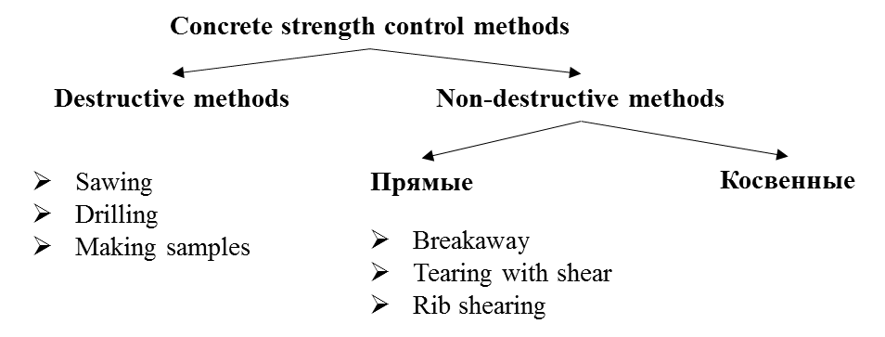
Direct
Indirect

Figure 1.1 – Methods for monitoring concrete strength

Note - Compiled by the source [24]

Methods to evaluate the longevity of structures can be classified into two types: invasive and non-invasive. Destructive methods involve testing control specimens (samples) that are either sawed or drilled from the poured structure or made separately using a single batch of concrete used in construction. Such techniques yield information about the robustness of the examined structure, and therefore, they are categorized as destructive. On the other hand, non-destructive methods are used to assess the strength of the tested structure without disrupting its structure or integrity. Non-destructive techniques can be subdivided into direct and indirect approaches, based on the methodology employed to gauge the structure's strength [25-28].
While the non-destructive methods are advantageous in that they do not compromise the structure and integrity of the tested specimen, they are not without their limitations. Analysis of the characteristics of each of the non-destructive methods reveals that each method has its own advantages and disadvantages. It is, therefore, difficult to identify a single dominant method based on their distinctive features.
These non-destructive techniques are deemed indirect because they offer an estimation of the structure's strength through secondary measurements, rather than direct assessments.
In essence, the selection of a technique to assess a structure's strength hinges on various factors, such as the structure's nature, the test's objective, and the resources at hand. Thus, weighing the pros and cons of each method is crucial to determine the best approach for the assessment.
Laboratories that specialize in the field of testing and measurement typically have a vast array of instruments and equipment at their disposal. These tools are used to conduct tests using various methods, each with its own strengths and limitations. Accuracy and measurement errors are crucial factors to consider when performing tests, and a methodical approach is necessary when selecting the appropriate techniques, instruments, and equipment for research [29-31].
Non-destructive testing techniques are advantageous as they enable indirect evaluations of key parameters like post-impact energy, trajectory during impact, ultrasonic speed, and indentation. Conversely, with destructive testing, test samples are derived from a precisely mixed concrete batch, shaped as cubes, rectangular prisms, or cylinders. There's also an option to extract samples from a specific section of the structure, but this method can be intricate, time-intensive, and may result in uneven specimen surfaces. In these instances, manual surface leveling becomes essential to guarantee precise testing outcomes [32-34].
To somewhat mitigate this concern, the impact technique can be employed to infer the concrete's strength indirectly. This approach utilizes a unique instrument that produces a pulse when a striker contacts the concrete, which the device then captures. Prior to testing, the structure's surface under examination should be even and devoid of cracks or other imperfections. Moreover, before performing the test, it's essential to establish a calibration curve or a concurrence coefficient.
Establishing the strength of a structure is essential for its safety and dependability. Nevertheless, conventional techniques for evaluating concrete structures' strength frequently face constraints due to the device's reach, which offers insights only about a particular zone within the structure. Such a limitation implies that a comprehensive understanding of strength dispersion can be achieved only by testing various points on the same component [35-37].
While conventional testing techniques are considered benchmarks for gauging strength, they can be costly and lengthy. To counteract these drawbacks, innovative approaches have been introduced, harnessing contemporary technologies like in-built sensors, machine learning, and artificial intelligence. Such methodologies present benefits in terms of reduced manpower and equipment expenses and the possibility of swift assessments by perpetually observing the inner condition of the reinforced concrete edifice [32, р. 492-508; 38, 39].
It's essential to recognize that these alternative techniques come with their own set of obstacles. Indirect testing methods, while less labor-intensive and less expensive, are often subject to higher measurement errors due to the influence of a large number of factors. For example, the ultrasonic strength control method is highly sensitive to the state of the surface, which must correspond to a specific level of roughness.
Using advanced technologies, these techniques can deliver a more comprehensive view of strength distribution and allow for swifter assessment and surveillance, ultimately leading to time and cost savings.
Non-destructive testing is crucial for evaluating structures when destructive methods are impractical or risky, such as with old buildings, nuclear facilities, and the food sector. It allows for defect detection without harming the structure. This method is particularly effective for inspecting vast areas, multiple components, within tight timeframes, and determining safe drilling spots. It can also be used during anchor drilling to collect core samples [40].
To this end, three main areas of focus can be identified: inspection and design, safe drilling, and subcontractor control. All three areas require reliable and accurate testing of concrete strength to assess the overall condition of the structure. By employing non-destructive testing methods, these areas can be addressed more efficiently and effectively, allowing for better decision-making and the prioritization of necessary repairs or upgrades [41].
In order to comply with regulatory requirements, concrete strength must be in line with the design value, which is typically set at 70% of the grade strength. This threshold must be achieved before construction organizations can proceed with subsequent stages, ensuring safety throughout the construction process. As a result, work cannot begin until the concrete has hardened completely. The hardening process is dependent on several factors, including temperature. As temperature decreases, strength gain decelerates, halting completely at zero, which adversely affects the material's properties.
Given the importance of concrete strength in ensuring the safety and longevity of structures, choosing the right indirect method for determining concrete strength is critical. One commonly used approach is the temperature-strength method, which relies on the relationship between hardening temperature and time to estimate concrete strength. This method is advantageous in that it enables early determination of concrete strength, reducing the risk of potential safety hazards.
To facilitate monitoring of concrete strength, wireless systems are often utilized. This technology has been hailed as a "breakthrough" due to its ability to provide accurate and real-time data on the condition of a structure. By utilizing wireless systems, construction organizations can quickly identify potential issues and take corrective action before problems arise [42].

1.1 Existing types of measuring systems
There exists a plethora of measurement systems in the market, each distinguished by its unique wiring configuration and installation methodology. When choosing amongst these systems, it's imperative to consider several factors. Key selection criteria encompass not only the accuracy of the measurements they provide but also their effective range and the longevity of the system itself [43-47].
Concrete thermocouples serve as a prime example of these systems. Constructed from interlinked wires that form specific electrical connections, these thermocouples are ingeniously designed to exploit their inherent thermoelectric properties. When subjected to temperature variations, they produce a voltage, which can then be precisely measured using specialized equipment [48].
One of the standout attributes of these thermocouples is their cost-effectiveness. Their production doesn't entail exorbitant costs, making them an economically viable choice for many projects. This affordability doesn't compromise their utility; they can extensively measure temperature variations across a vast spectrum. Such extensive data, when collected and analyzed, plays a crucial role in evaluating the strength of concrete. Thus, by utilizing tools like concrete thermocouples, professionals can gather vital information that aids in ensuring the quality and durability of construction projects [49].
Thermocouples are intricately designed, with their wires meticulously coiled and adjusted to specific lengths. This length customization primarily depends on the proximity to the measuring apparatus. At one end, the thermocouple wires are carefully intertwined to form a unified metal connection, whereas the opposite end is designed to connect seamlessly to a plug. To ensure a smooth and error-free measurement process, it's essential for these wires to bear clear labels and maintain a consistent connection with the external measuring device. Typically, this external device is equipped with a display that showcases individual temperature readings [50].
After the measurements are taken, it's standard procedure to transfer this data to a computer where it undergoes rigorous analysis. Modern advancements have also introduced wireless tools in this arena. These state-of-the-art tools have the capability to directly transmit data to cloud storage systems or even directly to smartphones, ensuring instantaneous access to crucial data and facilitating prompt analysis [51].
However, it's imperative to note that thermocouples come with their set of limitations. One primary concern centers around their precision levels. Many international benchmarks mandate that temperature readings for concrete applications maintain an accuracy threshold within 0.5°C. In contrast, thermocouples often register an accuracy deviation of at least 2.2°C. This deviation is considerably larger than the stipulated international standards [52].
Moreover, the manufacturing and assembly of thermocouple devices aren't straightforward affairs. They involve intricate processes that can be both time-consuming and labor-intensive. One of the most daunting stages in this procedure is the attachment phase. Given the delicate nature of the thermocouple wires, they are highly susceptible to damage. Even a minor mishap can compromise the integrity of these wires, leading to skewed or entirely inaccurate measurements. Therefore, during the measurement process, utmost care and precaution are essential to safeguard these fragile wires from potential damage, ensuring the reliability and accuracy of the data collected [53].
In light of these limitations, early-stage concrete strength monitoring recorders have been developed and introduced to the market. These recorders are designed to store temperature data at pre-determined intervals on an electronic board, which can be downloaded later by the user. The presence of a battery in the recorder ensures long-term data recording, eliminating the need for external equipment connection.
Installation of the recorder involves placing it in the required location and attaching it to the end of wires for temperature data retrieval. Unlike thermocouples, these wires are more robust and less susceptible to damage during work. The external device is also less prone to damage in confined spaces since it is only used for data loading. Furthermore, external devices offer various data analysis capabilities in the field. However, for a comprehensive analysis and report generation, data must be downloaded onto a computer [22, р7 1-12; 54, 55].
Despite their benefits, the recorders have some limitations. For example, they do not have a switch and continuously operate, leading to a relatively short shelf life. They are also challenging to use for larger structures due to the length of the cable. Additionally, the recorder's size can lead to time loss during installation and maintenance. Moreover, the same problems associated with wire damage that affect thermocouples are also encountered with these recorders. The detection of cable wires is also a complication, as other work tools are present at the construction site, requiring extra care during the work process.
Traditional wired recorders have struggled with concrete maturity measurements due to installation and connectivity issues at construction sites, prompting a shift towards wireless sensors. Cloud automation now aids data collection, sending alerts to off-site project leads. However, wired connections remain vulnerable to damage, and the complexity of the system with its many components can be tricky to set up. In remote areas without cellular connections or if any component fails, these systems might not function properly, indicating continued challenges in device efficacy [56-58].
Research on previous prototypes has identified the necessary characteristics for equipping new and improved devices, which has led to the development of wireless concrete sensors [59].
These sophisticated sensors are designed to capture and store detailed temperature readings over a given period. Once the data has been recorded, it is equipped to be transmitted using a multitude of advanced wireless communication protocols, all integrated seamlessly within the sensor itself. One notable example of such communication technology is Bluetooth LE (Low Energy) [60].
Bluetooth LE doesn't just facilitate data transmission; it significantly enhances the user experience by allowing a wireless connection between the sensor and user-friendly devices like smartphones or tablets. This interactive connectivity means that users can swiftly download the stored data directly to their devices. Moreover, the availability of specialized mobile applications further empowers users. With these apps, data can be instantly processed and analyzed in real-time, right on their handheld devices [61].
What's even more advantageous is that these real-time analyses aren't just limited to understanding temperature variations. They extend to more comprehensive assessments such as gauging the maturity and strength of the materials involved. This convergence of sensor technology and mobile app analysis offers professionals a potent tool, providing them with instant insights and facilitating timely decisions based on the real-time data presented. The data is also transmitted to the cloud through the mobile device's cellular network connection. Alternatively, sensor data can be automatically uploaded using a wireless local concentrator to transmit data to the cloud without the need to visit the job site. For other wireless protocols, an external concentrator is required to upload and transmit data to the cloud, as mobile devices do not support them [62, 63].
The use of built-in wireless sensors eliminates the risk of damage to devices on the job site, as measurements obtained remain in the device's memory, and the user can download them at their convenience. Additionally, the absence of wires allows for quick installation, and there is no need to work with an external unit, which reduces costs associated with device installation and maintenance [64, 65].
Despite potentially lower ongoing costs compared to wired sensors, the initial purchase of these built-in sensors is costlier due to their intricate electronics. Additionally, their wireless signals can only penetrate a few inches of concrete. For deeper measurements, a cable gauges the temperature, with the wireless transmitter positioned within the concrete, usually attached to a reinforcing bar and not exceeding a depth of 10 cm [66].
In conclusion, the use of wireless concrete sensors presents a significant advancement in measuring concrete maturity, which offers an effective solution to overcome the limitations associated with wire-based recorders. With the continued advancements in technology, these devices are expected to become even more efficient, providing greater accuracy and reliability in concrete maturity measurement.

1.2 The experience of utilizing various types of sensors
Analyzing best practices from experiences with concrete strength monitoring systems is essential to grasp factors influencing their efficiency. Such an evaluation sheds light on the systems' pros and cons, guiding the formulation of the best methods and strategies for their use.
The evaluation of specific cases of application allows for the identification of the key factors that impact the performance of concrete strength monitoring systems. This includes considerations of the environmental and operational conditions in which the devices are used, as well as the compatibility of the devices with the specific construction materials and methods employed. Such insights enable a more comprehensive understanding of how to effectively utilize these systems and develop best practices for their implementation [27, р. 7712; 67-69].
Using concrete strength monitoring systems is an ever-evolving domain, with consistent technological advancements. Analyzing best practices and hands-on experiences is vital to stay abreast of these changes, ensuring optimal system usage. Sharing such knowledge fosters continuous improvement. Regular evaluations in this rapidly-changing field help keep the systems current and effectively used (table 1.1).

Table 1.1 – Types of sensors

Name/Title | Thermocouples | Wired tem perature and ma turity recorders | Wired sensors with external wireless transmitter | Fully embe dded wire less systems
1 | 2 | 3 | 4 | 5
Command Center, Transtec Group Inc. (USA) |  | + | +
Concremote, Doka (Germany) |  |  | +
Concrete Sensors, Hilti (USA) |  |  |  | +
Con-Cure Nex, Con-Cure (USA) |  | + | +
Converge Signal, Converge (UK) |  |  | + | +
Exact, Exact Technology (Canada) |  |  | +
Continuation of table 1.1

1 | 2 | 3 | 4 | 5
HardTrack,Wake Inc. (USA) |  |  | + | +
HOBO, Onset (USA) | +
intelliRock, Flir (USA) |  | + | +
Lumicon, AOMS Technologies  (Canada) |  |  | +
Maturix, Sensohive (Denmark) | + |  | +
SmartRock, Giatec (Canada) |  |  |  | +
Terem, Interpribor (Russia) |  |  | +
MCR-21, Verboom (Netherlands) |  |  | +
Humldt, Humboldt (USA) |  |  | +
Note - Compiled by the source [70-84]

Table 1.1 highlights that there are numerous leading countries actively involved in the manufacturing of sensors used in concrete strength monitoring and maturity measurement. These sensors are designed with various features, technologies, and methodologies to cater to diverse project requirements. Furthermore, the widespread utilization of these sensors can be attributed to their effectiveness in meeting the specific needs of mega-projects.
The use of concrete strength monitoring and maturity measurement sensors is becoming increasingly common in large-scale construction projects around the world. These sensors have proven to be instrumental in ensuring the quality, durability, and safety of concrete structures. Additionally, they provide real-time data on concrete strength and maturity, allowing project managers to make informed decisions and take appropriate actions promptly [85-87].
The incorporation of these sensors into mega-projects is a testament to their effectiveness and reliability. By utilizing these sensors, project managers can achieve greater accuracy and efficiency in monitoring concrete strength and maturity. This, in turn, can help to reduce project costs, minimize construction delays, and enhance the overall quality.
The use of these sensors is not limited to mega-projects alone. They can also be used in smaller construction projects to achieve the same level of accuracy and efficiency. As the construction industry continues to evolve, the demand for these sensors is expected to increase, leading to further advancements and improvements in their design and functionality.
The Hobo data loggers developed by Onset were utilized for monitoring at the One York Street project site. The One York Street building is a podium structure located in Toronto [77].
The temperature loggers were installed one day before the concrete pouring took place. To protect the temperature sensors from rain and physical damage, they were enclosed in plastic boxes. An external reading device was placed outside the box and connected to a computer to collect data on a daily basis for a period of 10 days. The temperature data was then transferred to MS Excel software for further analysis.
The implementation of the Hobo data loggers in the One York Street project is an example of how advanced technologies are being used to monitor concrete strength and maturity. These data loggers are highly efficient and provide real-time data that can be used to make informed decisions and take appropriate actions. By utilizing these data loggers, project managers can identify potential issues and make adjustments to ensure the quality and durability of concrete structures.
The use of advanced technologies, such as data loggers, is becoming increasingly common in the construction industry. The implementation of these technologies has enabled project managers to achieve greater accuracy and efficiency in monitoring concrete strength and maturity, resulting in enhanced quality and safety of concrete structures [88-90].
As the construction industry continues to evolve, the demand for advanced monitoring technologies is expected to increase. This, in turn, will lead to further advancements and improvements in the design and functionality of these technologies, ultimately benefiting the industry as a whole.

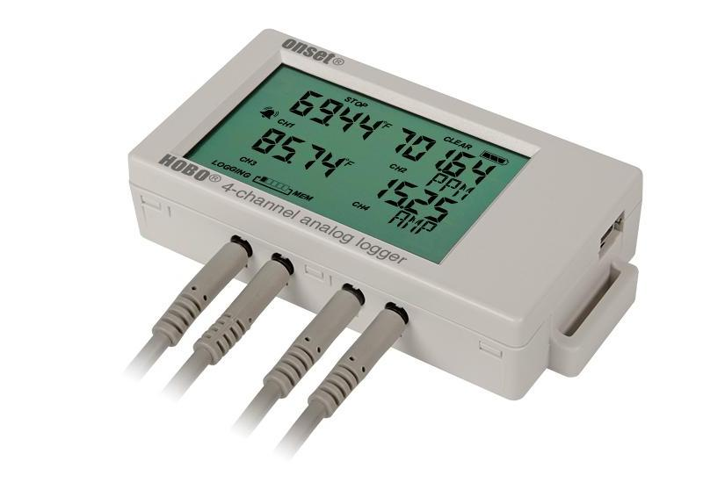

a b

Figure 1.2 – Hobo

Note - Compiled by the source [77]

The HOBO, a data logger for thermocouples, is among the many commercially available options (Figure 1.2). It enables the connection of multiple thermocouple wires to its box, which is installed outside the concrete. The standard logger records data for later processing on a computer, while the wireless logger can send temperature data via Bluetooth to a mobile device.
Meanwhile, Maturix sensors were utilized during the expansion of the University of York in England, which included constructing a new building for the Faculty of Arts [22, р. 1-12]. With up to 15,000 m2 of space for teaching, research, offices, and social areas in the 8-story building, the project was designed by Feilden Clegg Bradley Studios, and construction was carried out by Bowmer + Kirkland. CCL developed a solution to replace steel beams with concrete to transform reinforced plates into post-tensioned ones. This approach aims to lower costs and reduce material consumption, as less material is required with post-tensioning (figure 1.3).

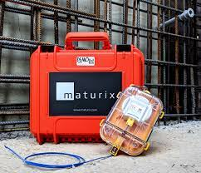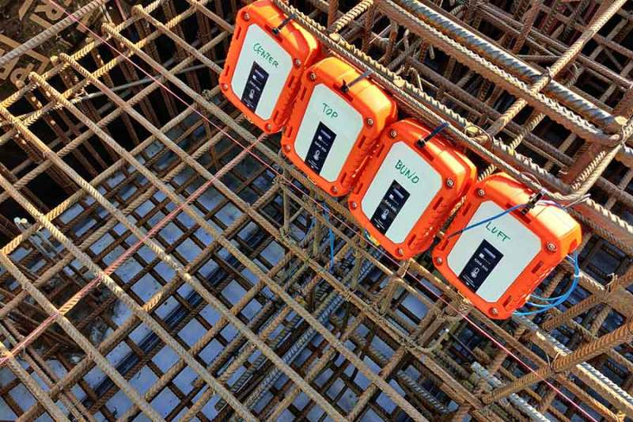

a b

Figure 1.3 – The construction site of the University of Warwick

Note - Compiled by the source [80]

Before CCL integrated a maturity system, concrete curing on construction sites was simulated through test specimens. However, this approach only provided a retrospective understanding and did not accurately reflect the behavior during curing of large elements.
The typical practice involved casting additional test cubes for each element, which were then tested for compressive strength in an external laboratory. This additional work was time-consuming and the measured compressive strength differed from the actual strength of the element on the site.
Thanks to Maturix and real-time strength monitoring, CCL now knows exactly when to start the post-tensioning process. This allows them to optimize their schedule and reduce unnecessary waiting time. Since CCL can reduce the number of test specimens required, there is less manual work required on site. Real-time information improves CCL's ability to effectively coordinate tasks and maintain concrete integrity.
Workers automatically receive alerts via SMS and/or email, and the status can be checked on a web platform from a computer or smartphone.
The ability to add an unlimited number of users to the software has allowed CCL to improve communication between workers on site, project managers, and the concrete quality control team [39, р. 40-47].
By receiving real-time information on the curing process, the contractor can optimize the post-tensioning time. Based on monitoring data, the CCL team is confident that the required strength has been achieved and post-tensioning can begin without risk of damage.
Overall, CCL uses Maturix as a tool to improve project management on site, as they can optimize their schedule based on real-time measurements. Since they specialize in the time-sensitive post-tensioning method, they save a lot of manual work that would otherwise be required to obtain information on the curing process.
The process of installing sensors in Denmark (train bridge) involved placing thermocouples at three different levels, followed by inserting cables on the side that transmitted temperature data wirelessly to the software. The data was recorded on a computer from the data logger (figure 1.4).

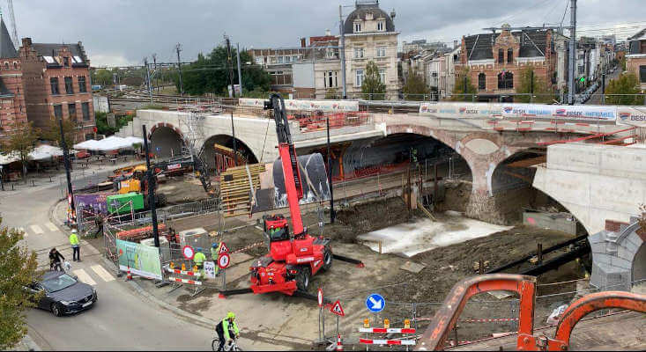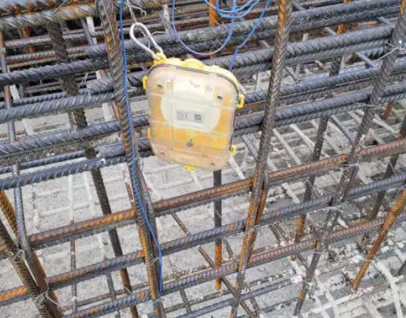

a b

Figure 1.4 – The construction site in Denmark is a bridge for trains

Note - Compiled by the source [80]

The Command Center system, created by Transtec Group Inc., proved to be a valuable tool for monitoring concrete temperature and maturity during the construction of the Mercedes-Benz Stadium in Atlanta. With a massive 150,000 cubic yards of concrete used in the stadium's construction, which boasts a whopping 2 million square feet of total area and a roof spanning more than 14 acres, capable of accommodating over 71,000 people, construction crews relied on Command Center's sensors to determine the concrete's required strength with accuracy and speed.
The Command software is capable of displaying temperature differentials, generating calibrated maturity curves based on user input, and calculating and displaying concrete maturity and corresponding strength data on site as the concrete sets. The user-friendly interface streamlines the process, allowing for quick and reliable determination of when the concrete has reached the desired strength. This technology proves to be a valuable asset to large-scale construction projects, where the precise monitoring of concrete maturity is critical to the project's success. The Command Center system is yet another example of how technology is revolutionizing the construction industry (figure 1.5).



a b

Figure 1.5 – Mercedes-Benz Stadium in Atlanta

Note - Compiled by the source [70]

S.T. Wooten Corporation has implemented the COMMAND Center system [26] for a project commissioned by the North Carolina Department of Transportation (NCDOT) in Havelock, North Carolina. This project entailed the placement of two foundations with dimensions of 20' x 20' x 6', necessitating temperature monitoring. The COMMAND Center system was utilized to monitor and provide reports on temperature increases in the sizeable foundations.
The maintenance of proper temperatures and temperature ranges within a concrete mass is crucial to ensure its strength and durability. Elevated concrete temperatures or substantial temperature differences between the hottest internal point and the surface and/or edge can lead to temperature-related damage.
S.T. Wooten employed the COMMAND Center system to ensure that the concrete in their project remained within acceptable temperature ranges. Self-writing sensors are placed within the concrete at a reasonable price, recording and storing temperature data within the concrete at predetermined intervals. The teams can access data from the sensors wirelessly via Bluetooth communication or through a direct connection, depending on the project's requirements. The free COMMAND Center software can then be used to analyze and view the collected data (figure 1.6).
The construction of a large monolithic segmental bridge over Lake Kreve-Kyor was built using the balanced cantilever method, which provided opportunities to study the benefits of concrete maturity testing in various applications. The Con-Cure system was employed to determine early strength, enabling the contractor to begin tensioning work and move formwork once sufficient strength was achieved. The lead engineer noted that the "maturity testing method" is ideal for conditions that require high early strength to facilitate partial removal of forms for cyclic equipment movement or application of post-tensioning forces to the structure. The testing method is crucial for achieving reliable strength assessment and monitoring temperature variations throughout the hardening process, ensuring that the concrete attains the required strength for the specific project conditions [73].
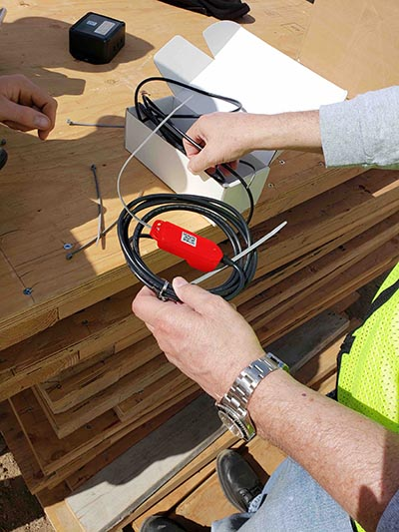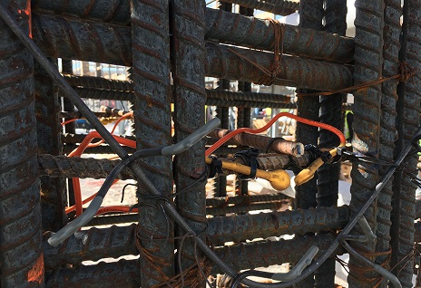

a b

Figure 1.6 – NCDOT project

Note - Compiled by the source [70]

The application of concrete maturity testing during the construction of the AT&T Stadium in Dallas, TX resulted in considerable cost and time savings, impressing even the most experienced construction workers. The tests showed that it was possible to significantly decrease the amount of cement used while still meeting the required strength standards within the specified time frame. By implementing this small modification, the manufacturer was able to save "one load of Portland cement in just the first week of operation." In fact, the Con-Cure system quickly paid for itself within the first 7 days of operation at this facility, solely through the cost savings achieved through reduced cement usage (figure 1.7).



a b

Figure 1.7 – Stadium, Dallas, Texas

Note - Compiled by the source [73]

The use of wired Con-Cure maturity loggers, similar to the Command Center, involves embedding them into the concrete. These loggers emerge from the concrete and can be connected either to a handheld device for downloading data recorded on Con-Cure maturity sensors, or to a wireless node that transmits data to the cloud via cellular network or stores it on an SD card [70].
In the CEMEX Headquarters project [31, р. 659-665], IntelliRock maturity meters were utilized. With a floor area of 325,000 square feet, the CEMEX Headquarters is one of the largest green buildings in Houston (figure 1.8). Prior to each pour, the team had intelliRock sensors available to track the concrete temperature and calculate the influence of elevated temperatures on strength gain. By monitoring the data transmitted by the sensors, the intelliRock software converts maturity data into actual strength values. The use of these sensors played a significant role in saving time and ensuring the on-time completion of the project without any delays [78].



a b

Figure 1.8 – CEMEX Headquarters

Note - Compiled by the source [78]

The "Sound Transit" initiative, which is a transportation project, has been established to connect the Capitol Hill station located in the downtown Seattle region to the University of Washington campus. According to the project manager [32, р. 492-508], using maturity loggers has provided additional essential information about the data. This is particularly important since the contract specifies that the formwork cannot be removed until the concrete reaches 90% strength. To ensure that the concrete is of high quality, it is equally important to gather data on temperature and ensure that the laid concrete sections are not below 145°F. The system also enables the project team to monitor and verify the thermal control plan's progress.
The utilization of intelliRock maturity meters has proven to be effective, particularly in situations where the temperature becomes excessively high. The team can take prompt corrective action to ensure that the integrity of the concrete is not compromised. In the current phase of the project, data from the logger is being recorded on an intelliRock Reader, and graphs are being created to illustrate concrete maturity, temperature levels and differentials, as well as comparisons between data such as maximum and differential temperatures. All these are crucial factors that need to be checked to ensure the concrete's quality and integrity on-site. This approach has demonstrated the importance of leveraging technology in enhancing the quality and efficiency of infrastructure projects (figure 1.9).

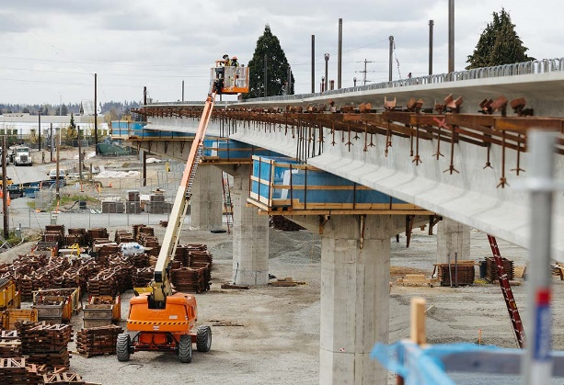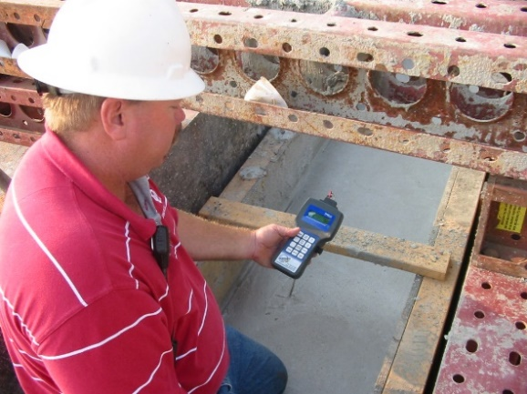

a b

Figure 1.9 – Construction object Sound Transit

Note - Compiled by the source [78]

The intelliRock maturity meters were initially designed by Engius and later acquired by Flir. These wired meters are placed inside concrete, and the wire protruding from the concrete can be connected to a portable device for data analysis and downloading or to a wireless transmitter for cloud data transmission.
The Muskrat Falls hydroelectric project, located on the Lower Churchill River in Labrador, is one of the largest hydropower facilities in Canada.
This project entails building a power station with various components to produce 824 MW of electricity for Newfoundland and Labrador residences and enterprises. To address the challenges of constructing such a complex project, Astaldi Canada Inc. partnered with Doka, a reliable formwork solutions provider.
The concrete mix and formwork used in the construction of the Muskrat Falls project are exposed to a wide range of temperatures, which increases the risk of freezing and thermal cracking. This poses a serious threat to the durability and longevity of the concrete structure, resulting in costly repairs. Therefore, monitoring the concrete's strength and maturity is crucial to ensure it meets the design requirements. Doka Concremote, a smart formwork add-on, was selected by Astaldi Canada Inc. to measure the concrete's temperature and strength on-site.
Concremote technology provides real-time data automatically, eliminating the need for manual calculations and saving time and money for Astaldi Canada Inc. Moreover, 32 Concremote sensors were installed for continuous monitoring of temperature and strength measurements of concrete (figure 1.10). The use of such technology is essential for ensuring the quality and durability of infrastructure projects, particularly for those located in regions with harsh weather conditions.

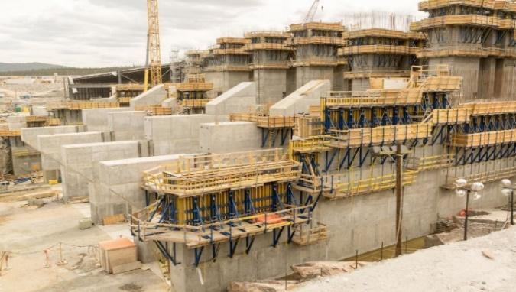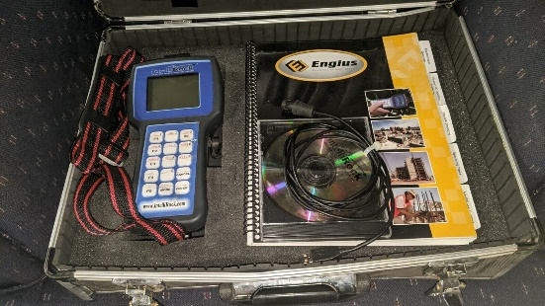

a b

Figure 1.10 – Construction object Sound Transit

Note - Compiled by the source [71]

The use of Concremote sensors in the construction of a residential tower in London exemplifies how this technology can help to reduce construction time [34, р. 1-11]. The project involved the pouring of 2350 m³ of concrete for a 155-meter high monolithic shaft, which will serve 457 apartments upon completion (figure 1.12). The use of Concremote sensors significantly reduced the building's construction cycle time by saving a full workday on each floor cycle. This resulted in a total of 47 workdays saved during construction. The sensors were embedded in the Doka SCP formwork and lifting systems to collect real-time data.
The application of Concremote sensors in construction projects has demonstrated their ability to optimize construction time, reduce costs, and enhance the quality and durability of structures. The London residential tower project serves as an excellent example of how these sensors can be used to monitor the strength and maturity of concrete in real-time, enabling the project team to take prompt corrective measures if necessary. The data provided by the sensors helped to optimize the concrete's curing process and ensure that it met the design specifications.
Leveraging technology in construction endeavors can enhance efficiency, curtail expenses, and guarantee that buildings meet the stipulated quality benchmarks. The adoption of technologies like Concremote sensors demonstrates the construction industry's commitment to leveraging innovation to enhance project outcomes. These sensors offer a reliable and cost-effective solution for monitoring concrete strength and maturity, enabling construction teams to optimize the curing process and reduce the overall construction time (figure 1.11).

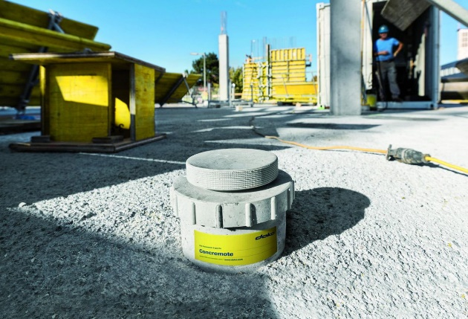

a b

Figure 1.11 – Concremote sensors installation

Note - Compiled by the source [71]

Black Friars is a 52-story residential building in London (figure 1.12), designed by award-winning architects, with a unique and stunning design and breathtaking views of the city. This building was created with the intention of providing its residents with the best that London has to offer. The project was complex because of the need to maintain the formwork and SCP lifting system's shine before closing the main building.

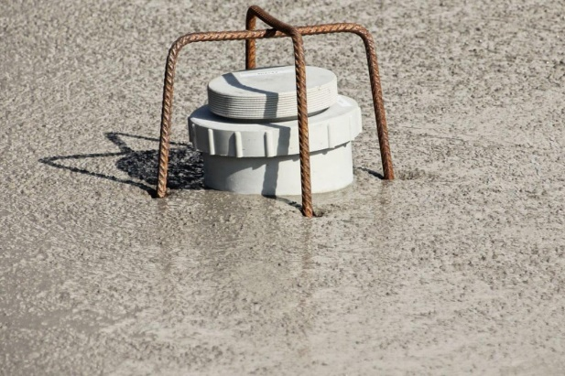

a b

Figure 1.12 – High-rise tower in London

Note - Compiled by the source [71]

The use of Concremote sensors in the construction of the Black Friars building is a testament to the construction industry's commitment to leveraging technology to enhance project outcomes. The sensors played a critical role in real time monitoring, providing the project team with the data needed to take prompt corrective measures if necessary. This helped to optimize the concrete's curing process and ensure that it met the design specifications, while also minimizing the risks associated with over-curing or under-curing.
The complexity of the Black Friars project necessitated the use of advanced technologies to achieve the desired outcome. The Concremote sensors were utilized in real-time monitoring, for both impact and lifting applications, thereby ensuring that the formwork and SCP lifting system's shine were maintained before the main building was closed. This application of technology helped to minimize the risk of delays, reduce costs, and enhance the quality and durability of the final product. The Black Friars building in London serves as an excellent example of how technology can be used in the construction industry to achieve optimal outcomes. The use of Concremote sensors helped to ensure that the concrete met the design specifications and that the construction project was completed on time and within budget. By leveraging technology in this way, the construction industry can continue to improve the quality and efficiency of its projects.
The Concremote sensors are a useful tool that has been employed in various construction projects, including the Tottenham Hotspur stadium in England. These digital sensors measure the real-time maturity of concrete, using temperature and time indicators to calculate concrete strength in the period of starting hardening. Concrete sensors come in different formats, including an option to install the Concremote sensor on the surface of the concrete or embedding wired sensors inside the concrete with a transmitter for wireless data transmission.
The Principal Tower in London, a prominent residential building, used Concremote sensors during its construction. Situated on an ancient Roman cemetery site, the tower enriches the area's historical essence. To hasten the floor slab cycle to seven days, Carey's Civil Engineering incorporated real-time concrete monitoring. Traditional methods using cubes to confirm concrete strength can cause delays. Initial and final stresses for post-tensioning are contingent upon achieving specific strength thresholds. If a cube doesn't meet the required strength, it can cause half-day delays before testing another, prolonging the process.
To address these problems, Converge sensors were employed. These sensors are embedded in the concrete and monitor strength on-site, transmitting data in real-time to the cloud for remote viewing. Carey's engineers received email or text notifications for each pour, informing them that each strength stage had been achieved. Instead of waiting for cube results, PT subcontractors and crews could begin work every morning without delay. These sensors also prevented additional delays caused by insufficient cube performance, resulting in significant time savings in many cases. Detailed strength development data obtained during the current and previous pours helped engineers forecast concrete performance for the next pour, aiding in daily planning of actions and resources on site. Overall, the Concremote and Converge sensors are useful tools that have improved construction processes and helped to reduce delays in project completion (figure 1.13).
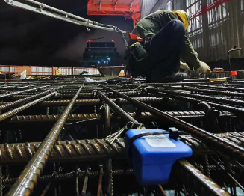

a b

Figure 1.13 – Principal Tower construction site

Note - Compiled by the source [74]

The South Lambeth district in London encountered difficulties during project implementation due to delays in laboratory testing, which took up to 4 days to deliver results. As a result, the construction program was already 2 weeks behind schedule for the 2nd level of the building. To address this issue, Converge sensors were utilized, which were embedded in the slabs after post-tensioning. This allowed the team to receive email or text notifications as soon as each slab reached the required strength for post-tensioning, enabling them to start work every morning. With each subsequent use of the sensors, the team was able to better predict the schedule.
Despite the sensor user's initial unfamiliarity with Converge, training was completed in just 3 hours, including the time taken to install the first set of sensors. The cycle time was reduced from the first level and continued to improve throughout the program, with the project being completed ahead of schedule by the 10th level. Additionally, on-site strength monitoring using Converge sensors revealed significant variability in concrete performance throughout the year, with fluctuations in concrete strength of up to 700% between cold and warm months. Traditional methods of determining concrete strength, such as using cubes cured at 20°C, were shown to be unreliable, leading to unnecessary delays during summer and potentially dangerous situations during winter. In contrast, Converge technology provided an accurate estimate of concrete strength at any time of the year, thus enhancing safety and efficiency on-site. Ultimately, the South Lambeth Road project successfully transitioned from a 7-day cycle per floor to a 5-day cycle based solely on the use of Converge sensors.
Converge, a company dedicated to providing solutions for measuring the temperature and maturity of concrete, has developed a range of innovative products to facilitate these processes. Their flagship product, Converge Mesh, comprises of wired sensors connected to wireless nodes that can transmit data wirelessly to a local node for further transmission to the cloud. However, their latest offering, Converge Signal, is a wireless sensor that can be embedded completely within concrete. This wireless sensor records data and transmits it wirelessly either to a mobile device or to a local node, and then to the cloud via cellular network. The use of Converge sensors has yielded successful results in various other projects, making it a reliable and trusted solution for measuring concrete temperature and maturity.
The Gordie Howe International Bridge is a monumental infrastructure project, part of a bilateral initiative to enhance border infrastructure, and is one of the longest bridges in North America, connecting Canada and the United States. The bridge, anchored on both ends by A-shaped towers, forms a continuous curve and suspends the deck with cables across the river. The side spans, each measuring 1,049 feet in length, are supported by 27 supporting cables and three pairs of auxiliary piers that transmit loads directly to the ground. The application of Exact Technology sensors in this project aims to monitor all the massive concrete elements to ensure compliance with thermal requirements at maximum temperature and temperature gradient, thus ensuring the longevity and safety of the bridge (figure 1.14).

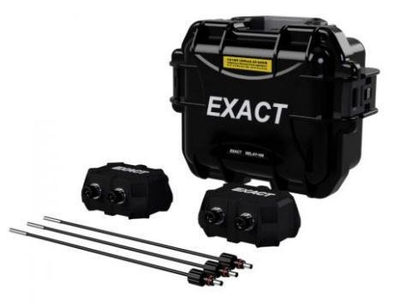

a b

Figure 1.14 – Gordie Howe International Bridge Project

Note - Compiled by the source [75]

Canadian Imperial Bank of Commerce (CIBC) Square in downtown Canada consists of two significant office towers, 81 Bay Street (completed in 2020) and 141 Bay Street (expected in 2024), covering a combined area of 3 million square feet. Both towers feature state-of-the-art office and collaborative spaces on their upper floors, with the 49th and 50th floors being highlighted. A one-acre park linking the towers provides panoramic views of Lake Ontario and adds to the site's array of amenities.
To ensure the structural integrity of the buildings, Exact Technology sensors were utilized during the construction phase to monitor and control CIBC Square project in Toronto. These precise sensors have the ability to accurately determine the concrete's strength as it approaches the threshold of 16Mpa [42, р. 254-260], which is the point at which self-moving formwork can be safely moved. Furthermore, they can provide real-time readings of the formwork pressure during the self-compacting mix loads, ensuring that the building is constructed in a safe and efficient manner. The use of these sensors exemplifies the innovative approach taken in the development of CIBC Square, which has resulted in a landmark construction project that is sure to leave an indelible mark on the Toronto skyline (figure 1.15).



a b

Figure 1.15 – CIBC Square construction site

Note - Compiled by the source [75]

At the core of the Exact sensor, which is designed for monitoring concrete maturity and temperature, are relays, recorders, and probes. Temperature sensors and data transmission devices fixed onto the reinforcing bars are subjected to initial tests and calibrations in lab environments, confirming a precision range of ±1°F. The utilization of these sensors has demonstrably added value to the construction sector. The control of the concrete curing process is critical during construction, and as a result, Shimmick Construction Co. opted not to use wired sensors and waste additional time waiting for curing to construct the new TransBay Transit Center in San Francisco. Instead, they adopted a Radio Frequency Identification (RFID) solution, provided by Wake, Inc. Without adequate time for curing, cracks can form when laying the next slab, which can undermine the entire section's structural integrity. Typically, temperature recorders that use wires extending into the concrete are utilized since concrete releases heat during the curing process. However, wired sensors can be too unwieldy for large projects. In such cases, the concrete consultant usually determines a traditional curing period based on the material used and other factors. This often entails allocating additional time in the project schedule to ensure that all poured concrete is entirely cured before proceeding to the next phase. Shimmick laid 100,000 cubic yards of concrete for the lower structure of the new transit complex in San Francisco (figure 1.16). The company subsequently utilized Wake Inc.'s wireless solution for concrete maturity and temperature control, also known as HardTrack, when laying the concrete piles for the bridge associated with this project [43, р. 15-18]. The project involved 16 concrete slabs that form the foundation of the building. Each slab was fully cured before the next was poured, preventing it from cracking under any stress from the subsequent slab. Charlie Marrow, an engineer at Shimmick Construction, explained that "RFID technology provides data on the temperature of the concrete after it is poured," and Wake's software determines the maturity date of the poured concrete. According to him, these data significantly reduce the time required to cool and cure the concrete before laying the next slab.
The implementation of the HardTrack system facilitated the gathering of temperature data on a daily basis by Shimmick, which could then be transmitted to the company's internal system and visualized in a Microsoft Excel spreadsheet [76]. The system allowed the company to monitor the curing progress of concrete at various points on each slab and share the curing history information based on temperature data with agencies or owners. The software developed by Wake utilizes differential strength measurements to determine the concrete maturity. Following each collection, the data is transferred to a portable computer or laptop via a USB port. The adoption of HardTrack sensors enabled the determination of the appropriate curing time of the concrete, leading to a time savings of approximately twice the duration that would have been required without the use of the sensors. This technological solution allowed for more efficient and precise management of the curing process, ultimately leading to a better quality construction outcome (figure 1.16).



a b

Figure 1.16 – San Francisco Transit Complex construction site

Note - Compiled by the source [76]

The HardTrack sensor is a versatile device that is available in different formats. It consists of a cable for measuring temperature, which is connected to a reader. The tag can be embedded in the concrete or placed outside for future use. The recorded data can be easily extracted by users through the reader or transmitted wirelessly to the cloud via a local hub. The sensors have been successfully employed in the construction of an oncology center, providing reliable temperature data to ensure proper curing. The use of such sensors in construction projects has proven to be an effective means of enhancing the quality of the final product while also reducing construction time and costs. With the continuous advancements in sensor technology, there is a growing need for the development of more sophisticated sensors that can provide even greater accuracy and reliability in monitoring the curing process of concrete [76].
AOMS provides devices capable of measuring temperature at multiple predetermined locations along a cable [79]. The end of the cable protruding from the concrete is connected to a wireless transmitter, which sends the data to a local node and then to the cloud for further interpretation of results and determination of concrete maturity in compliance with regulatory requirements. Moreover, AOMS is developing its own resources to work with the obtained results on mobile devices. The Concrete Sensor, developed by Structural Health Systems Inc., is a fully embedded sensor that records concrete temperature and humidity. Data can be obtained and analyzed at any time using the Concrete Sensor mobile app via Bluetooth. Additionally, an alternative version of this sensor is available that connects directly to a local gateway for data transfer to the cloud.
Concor Construction (PTY) LTD, being one of the leading construction firms in South Africa, embarked on the construction of a wind power complex in Roggeveld in 2019 [46, р. 158]. This 147 MW facility is expected to have a positive impact on South Africa's carbon emissions, with a reduction in carbon dioxide emissions of approximately 24,000 tons annually as a result of electricity production. The wind energy facility is comprised of 47 AW125/3150 and AW125/3000 turbines, each with a foundation of approximately 19 meters in diameter and 2.35 meters in height. The construction site is located in Karoo, at the border of the Western and Northern Cape provinces, a remote and rugged, semi-desert area covering approximately one-third of South Africa's territory, or 153,000 square miles. The climate in this area is extreme, with temperatures ranging from -15°C/-27°F in winter to over 40°C/104°F on the plains in summer, which creates significant challenges for extensive concrete work, especially during the hot summer months. To ensure that the concrete temperature on site does not exceed 70°C/158°F, temperature control is constantly required. To this end, SmartRock sensors [16, р. 847-849] were utilized, with additional sensors placed under the concrete surface to measure the coldest temperature of the concrete element, given that temperature differentials were also a concern. The SmartRock sensors, being a fully wireless solution, could collect data even if there was no Internet connectivity, which was critical given the remote location of the wind farm. The SmartRock sensors provided real-time temperature and strength data, which were easily and quickly attached to the concrete reinforcement (figure 1.17).
P.J. Hegarty & Sons U.C. has been a leading player in the construction and civil engineering industry in Ireland since its inception in 1925. With a long-standing reputation for innovation and excellence, the company has established itself as one of the most progressive and dynamic firms in the field.
One of the key factors contributing to P.J. Hegarty & Sons' success has been its commitment to quality management. In fact, the company was the first construction firm in Ireland to achieve ISO 9002 status, a globally recognized standard for quality management systems.

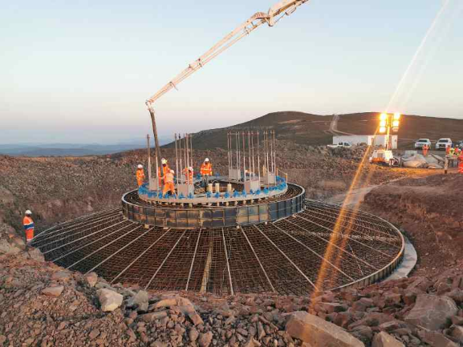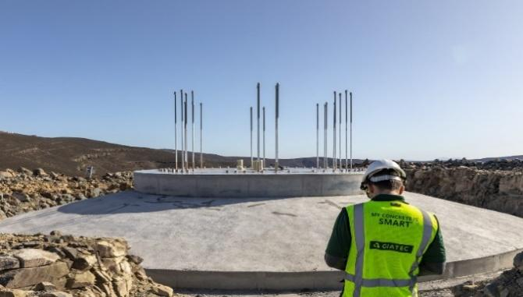

a b

Figure 1.17 – Wind power complex in Roggeveld

Note - Compiled by the source [81]

In 2017, P.J. Hegarty & Sons was selected as the main contractor for the redevelopment of the Electricity Supply Board (ESB) building on Fitzwilliam Street in Dublin. This prestigious project involves the transformation of a 45,000 square meter facility into a near-zero energy building, making it one of the most efficient and environmentally friendly commercial office complexes in the city.
The redevelopment of the ESB building is a testament to P.J. Hegarty & Sons' expertise in sustainable construction and their commitment to delivering cutting-edge solutions that align with the latest industry standards. As a leading player in the construction and civil engineering sector, P.J. Hegarty & Sons is poised to continue delivering innovative and sustainable solutions that drive progress in Ireland's built environment.
Accurate temperature monitoring during concrete curing is crucial for ensuring the long-term durability of structures. The use of Giatec's SmartRock sensors was deemed appropriate for this project due to several factors. Firstly, the sensors provided instant wireless connectivity to mobile devices [48, р. 105034], allowing for quick and efficient data transmission. Additionally, the user-friendly application available on IOS and Android displayed real-time temperature, strength, and maturity information, mix calibration, data history, and other features. Moreover, the sensors themselves were durable, waterproof, and easy to use.
During the ESB project, 20 slabs were poured with two sensors, on average, used per pour. The sensors were strategically placed to measure temperature values at two locations within each slab - midway up and close to the surface. According to the project lead, SmartRock sensors performed exceptionally well in obtaining temperature values for each slab [47, р. 197-205].
The purpose of this test was to explore the concept that maturity can be an alternative method for accurately measuring the strength of a structure without relying heavily on cube sample testing. Pour number 8's results were notable, with maturity sensors providing more consistent strength values than the unusually high compression tests. This finding highlights the reliability and accuracy of the maturity method and the SmartRock technology. Overall, this project demonstrates the importance of accurate temperature monitoring during concrete curing, and the potential benefits of using innovative technologies such as SmartRock sensors for efficient and accurate data collection (figure 1.18).

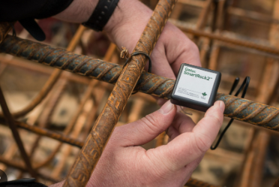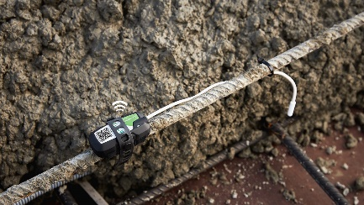

a b

Figure 1.18 – Sensor installation process

Note - Compiled by the source [81]

The comparison of cube testing results with SmartRock sensor data was conducted using 13 pours. The temperature data recorded by SmartRock sensors were found to be almost identical to each other. This indicates that the use of SmartRock sensors can provide users with information that is not only more accurate but also more useful compared to traditional destructive testing methods. Analytics demonstrated in table 1.2.
Analytics demonstrate the effectiveness of using SmartRock sensors in monitoring concrete strength. Unlike traditional methods, which involve destructive testing and are time-consuming, SmartRock sensors provide real-time data on concrete strength, which can be used to optimize curing conditions and ensure the long-term durability of the concrete structure. The use of SmartRock sensors has several advantages, such as being non-destructive, providing continuous monitoring, and delivering instant and reliable data. These benefits make SmartRock sensors a valuable tool for construction professionals who need to ensure the quality and longevity of their concrete structures.
Overall, this study underscores the importance of leveraging advanced technologies like SmartRock sensors to improve construction processes and outcomes. By providing accurate, real-time data on concrete strength, SmartRock sensors can help ensure that construction projects are completed on time, within budget, and to the highest standards of quality and safety. As such, SmartRock sensors are poised to become an increasingly essential component.
A comparative analysis was conducted between laboratory tests and the maturity method. The purpose of this analysis was to evaluate the effectiveness of the maturity method in accurately predicting concrete strength compared to traditional laboratory testing methods. The results of this analysis were presented in table 1.2 and showed that the maturity method was able to predict concrete strength with a high degree of accuracy. In fact, the results obtained from the maturity method were found to be almost identical to those obtained through laboratory testing.
The maturity method is a non-destructive method for estimating concrete strength that is based on the principle that the strength of concrete is directly proportional to its maturity. Maturity is defined as the product of time and temperature, and it is an indicator of how much the concrete has cured. By monitoring the temperature of the concrete and calculating its maturity, estimation not need destructive testing.
The results of this analysis suggest that the maturity method is a reliable and effective alternative to traditional laboratory testing methods for estimating concrete strength. This method is non-destructive, which means that it does not damage the concrete structure, and it provides real-time data, which allows for timely and accurate decision-making. Additionally, the maturity method is cost-effective, as it eliminates the need for expensive and time-consuming laboratory testing (table 1.2).

Table 1.2 – Comparative analysis of laboratory tests with the maturity method

Laboratory tests of sample cubes | The method of maturity
1 | 2
Data is collected by molding cube samples at the construction site, followed by their testing on a press in a laboratory. However, the reliability of this method may be compro mised by several factors such as improper handling of the samples on site or during transportation, as well as poor workmanship in the laboratory. As a result, the accuracy of the obtained results may be affected, making this method less than ideal for assessing the quality of concrete structures. | The measuring devices record consecutive measurements of both temperature and the gain in concrete strength. The accuracy of these measurements is contingent upon the preset time interval. In order to obtain precise and reliable data, it is essential to adhere to the prescribed time intervals for measurements. This ensures that the collected data is representative of the actual conditions and allows for accurate monitoring of the curing process.
Variations in temperature during the curing process can cause different rates of strength gain in the concrete, which can result in low or high breaks. These variations in tempera ture may be attributed to differences in curing conditions, such as humidity or temperature control. Therefore, it is crucial to carefully monitor and regulate the curing process to ensure that the concrete achieves the desired strength and durability characteristics. | Early-age concrete strength assessment is crucial for accurately gauging its true strength and ensuring it meets performance specifications. This enables adjustments in curing or mix composition and identifies defects early, facilitating timely remediation to maintain long-term durability and prevent structural compromises.
Continuation of the table 1.2

1 | 2
The determination of concrete strength through laboratory testing necessitates the transportation of samples, which can result in additional financial costs and time expenditures. This method may also be subject to certain limitations, such as the potential for sample damage during transportation or improper sample handling in the laboratory. Therefore, it is important to consider alternative methods for assessing concrete strength that can minimize these limitations and provide a more accurate and efficient evaluation of concrete performance. | The data is systematically and consistently recorded at the precise moment of strength gain. This approach ensures that the data accurately reflects the actual conditions of the concrete curing process, and allows for the identification of any deviations or irregularities that may impact the strength and durability of the concrete structure. Recording data systematically allows for more accurate analysis, offering insights into concrete behavior and helping optimize the curing process.
The expenses associated with concrete testing and sample preparation can be significant, making it necessary to carefully consider the costs and benefits of various testing methods. Factors such as the required sample size, the complexity of the testing procedures, and the level of accuracy required can all impact the overall cost of testing. Additionally, it is important to consider the potential for sample damage or loss during transportation and handling, as this can lead to additional costs and delays in the testing process. Through meticulous assessment of testing expenses and sample preparation outlays, one can pinpoint the most economical and effective method for determining concrete strength, thereby guaranteeing the prolonged resilience of concrete constructions. | The ability to remotely monitor the strength of concrete structures allows for greater flexibility and efficiency, as specialists are not required to be present at the worksite at all times. This can result in significant time savings, as the specialist can monitor the concrete strength from a remote location and make adjustments to the curing process or the composition of the concrete mixture as needed. Additionally, re mote monitoring can help to identify any poten tial issues or defects in the concrete in a timely manner, allowing for prompt remediation to prevent any compromise in the long-term durability of the structure. By enabling remote monitoring of concrete strength, it becomes possible to streamline the construction process and optimize the use of resources, resulting in more cost-effective and sustainable concrete structures.
The process of waiting for the results of cube tests and associated reports is typically slower than other methods for assessing concrete strength. This delay can be attributed to several factors, including the time required to transport and prepare the samples, the duration of the testing process, and the time needed to generate and distribute the reports. As a result, this method may not be ideal for situations where a rapid and accurate evaluation of concrete strength is required. Alternative methods, such as remote monitoring or the use of sensors, may be more suitable in these cases, as they provide real-time data and enable more efficient and timely decision-making. | Quick data transfer in concrete strength assessment methods enhances communication among project participants, leading to faster decisions and necessary adjustments. This efficiency not only streamlines the construction process and ensures quality but also minimizes delays, reducing costs and ensuring timely project completion.

Table 1.3 – Technical characteristics of the sensors

Name (country) |  | Wireless network | Measurements | Temperature range | Accuracy | Measurement interval | Transmission range | Battery life
1 |  | 2 | 3 | 4 | 5 | 6 | 7 | 8
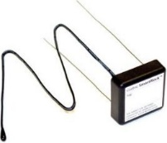 | SmartRock (Canada) | Bluetooth, GPS | T, R | -30 to +60°C | T: ±1 °C | 30 min | < 8 m | up to 4 months
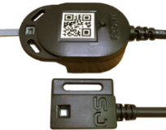 | Concrete Sensors (USA) | Bluetooth, GPS | T, W, R | -40 to +85°C | T: ±0,4°C, W: ±3% | 30 min | < 20 m | up to 2 years
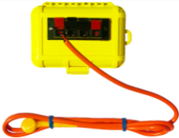 | Command Center (USA) | Bluetooth in the module | T, R | -30 to +85°C | T: ±1 °C | customizable | < 9 m | up to 10 years
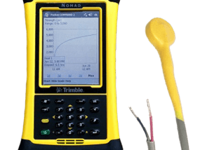 | Con-Cure Nex (USA) | GPS,  SD-card | T | -20 to +70° C | T: ±0.1 °C | 10 min | < 100 m | chargable
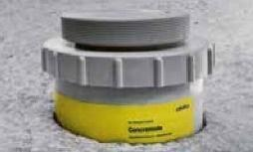 | Conemote (Germany) | Bluetooth in the module | T, R | -40 to +20°C | T: ±0.1 °C | 10 min | < 10 m | up to 4 months
 | Converge Signal (UK) | Bluetooth | T, W, R | -20 to 80°C. | T: ±0.2 °C | 20 min | < 15 m | 2 years
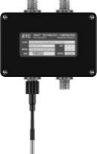 | Exact (Canada) | Bluetooth, GPS | T, W, R | -20 to +85°C | T: ±0.5 °C | customizable | < 45 m | 2 years
Continuation of the table 1.3

1 |  | 2 | 3 | 4 | 5 | 6 | 7 | 8
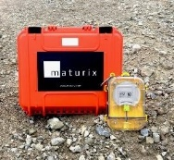 | Maturix (Denmark) | Sigfox Connecti vity, cloud connecti vity, radio network | T, W | -40 to + 50℃ | T: ±1.5 °C | 10 мин | < 100 m | up to 5 years
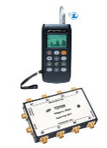 | Terem 4.0, 4.1 (Russia) | USB / GSM | T, W | -10 to +50°C | T: ±0.1 °C |  | < 20 m
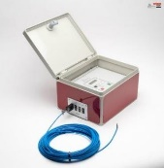 | MCR-21 (Netherlands) | GPRS | T, W, R | -10 to +110°C | T: ±1.0 °C | 10 мин | < 150 m | chargable
Note - Compiled by the source [91-100]

The collection and analysis of data is becoming increasingly important in the construction industry, particularly in the field of concrete quality control. Many companies have developed monitoring systems and sensors to assist in this process (table 1.3).

Results and Discussions
Thanks to the development of new technologies, different projects is continuously taking place today. However, during the winter season, careful control of the quality of the erected buildings is required. The strength control of concrete lies at the heart of any construction cycle, especially in the first few days. One of the most important indicators during the solidification of concrete is temperature. On-site monitoring of the condition of the structure should be carried out, and measures taken for heating, if necessary. However, it is impossible to plan everything, and in construction, unforeseen circumstances may arise where heating and concrete supply are not available. Therefore, a range of additional measures have been proposed today to avoid such situations, which can lead to failure and delay in deadlines. Systems are designed to provide prompt control of concrete strength and data collection. The methodology assumes a comprehensive scheme with a clear algorithm of actions and reaction for monolithic housing construction. Determining the temperature of concrete, which depends on many factors, is a primary task. Temperature-strength control is carried out using specialized equipment and a regulated methodology, which takes into account the heating time, the interval of data received, conditions for early stripping, and the location of monitoring systems in different positions. The strength of concrete is dependent on the time of curing of monolithic structures, as presented in figure 1.19. The consideration of zones of positive and negative temperatures and the rise in temperature during thermal treatment is presented in figures 1.19, 1.20, 1.21.

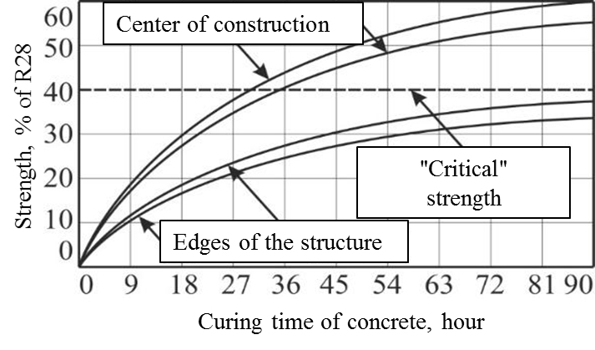

Figure 1.19 – Critical strength

Note - Compiled by the source [101]

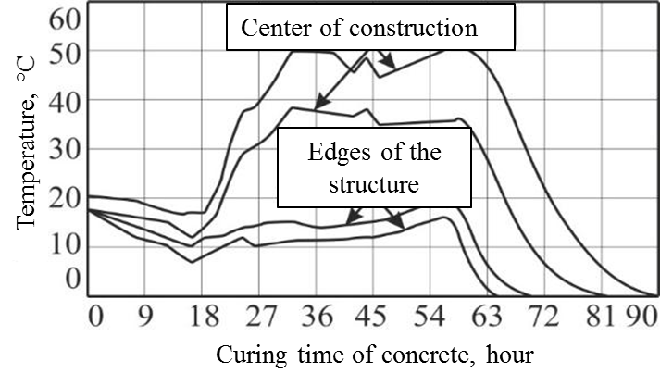

Figure 1.20 – Critical strength

Note - Compiled by the source [101]

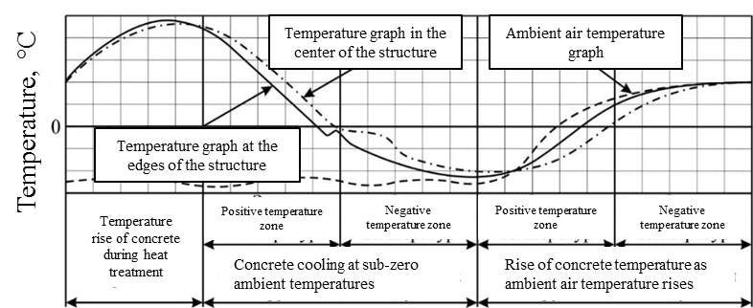

Figure 1.21 – Accounting for features in winter time

Note - Compiled by the source [101]

In the construction industry, it is essential to ensure that the concrete being used meets the required standards of strength and durability. To this end, modern measuring systems and devices have been developed that can accurately determine the expected strength of concrete on the construction site. These systems include measuring instruments, recording devices, temperature sensors, and concrete maturity meters, which are specifically designed to provide detailed information about the concrete's properties.
One of the most critical factors in determining the strength of concrete is its maturity. Concrete maturity is a measure of how much the material has hardened over time and is a critical factor in determining its ultimate strength. Measuring concrete maturity requires specialized equipment and techniques, including temperature sensors and concrete maturity meters, which are designed to provide accurate and reliable data about the material's properties.
The use of modern measuring systems and devices has revolutionized the construction industry by providing a way to accurately assess the strength and durability of concrete on the construction site. These systems are user-friendly and dependable, enabling construction workers to swiftly gather data to verify the concrete meets the necessary standards.
The operation of these systems and devices is regulated by various norms and standards that are designed to ensure that they provide accurate and reliable data. These norms and standards are presented in Table 1.4 and cover various aspects of the systems, including their design, calibration, and operation. By adhering to these norms and standards, construction workers can be sure that the data they obtain from these systems is accurate and reliable, allowing them to make informed decisions about the quality of the concrete they are using (table 1.4, figure 1.22).

Table 1.4 – Sensor types

Sensor type | Standard
Giatec SmartRock2 (Canada) | ASTM C1074-17
Concrete Sensors (USA) | ASTM C1074-17
COMMAND Center Wireless (USA) | ASTM C1074-17
ConCure NEX (USA) | ASTM C1074-17
Exact Technology (Canada) | ASTM C1074-17
HOBO box thermocouple USA) | ASTM C1074-17
Converge Signal (UK) | ASTM C1074-17
HardTrack Cloud Sensor (USA) | ASTM C1074-17
AOMS Lumicon concrete sensor (Canada) | ASTM C1074-17
intelliRock III Maturity Logger (USA) | ASTM C1074-17
Sensohive Maturix sensor (Denmark) | ASTM C1074-17
vOrb sensors (USA) | ASTM C1074-17
H-2680 & H-2682 Humboldt (USA) | ASTM C1074-17
Concremote (Germany) | DIN EN 13670  ASTM C 1074
Terem 4.0,4.1 (Russia) | ST-NP SRO UCC
Maturity computer MC(R)-21 (Netherlands) company Verboom | DIN EN 13670  NEN 5970
Note - Compiled by the source[91; 92; 93; 94; 95; 96; 97; 98; 99; 100; 101; 102-108]

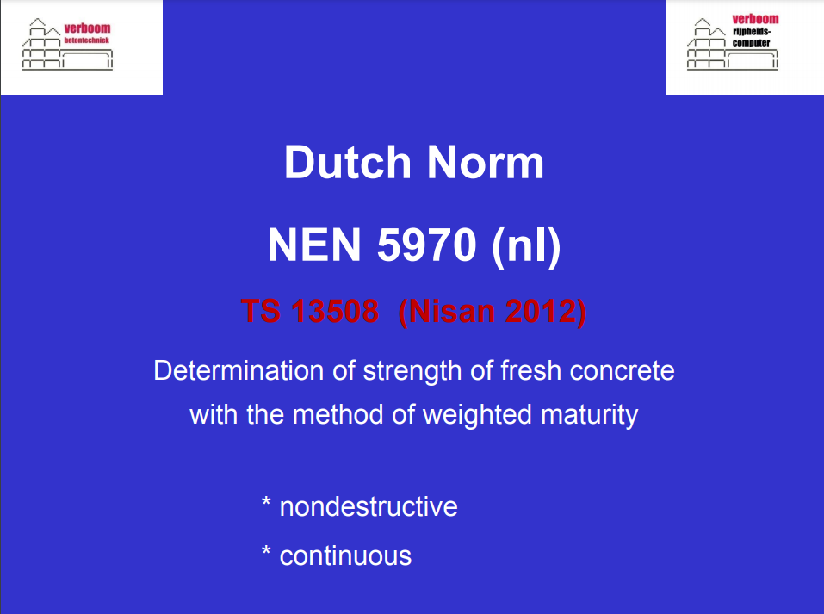

a b

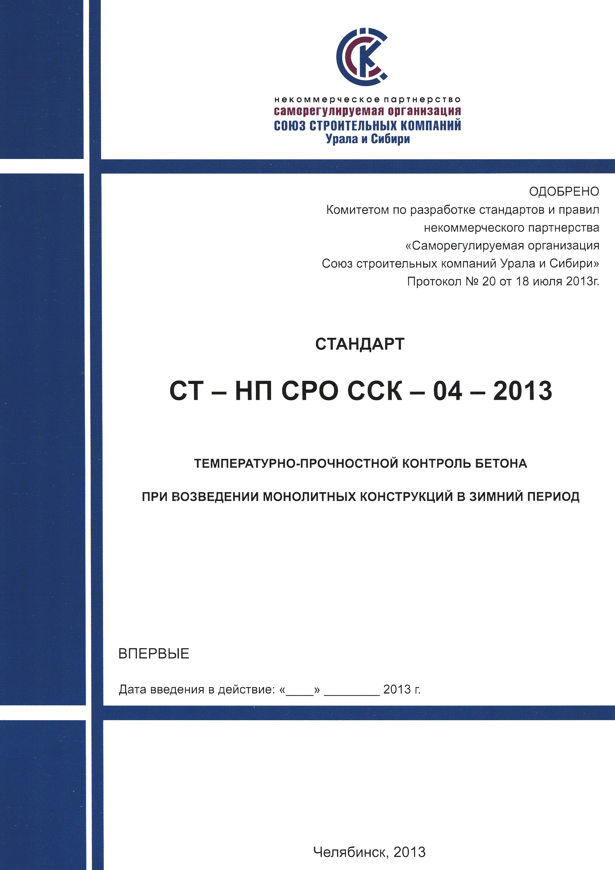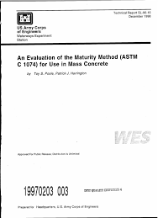

c d

a – Denmark; b – Germany; c – Russia; d – ASTM

Figure 1.22 – Standards

Note - Compiled by the source [101; 102; 107; 108]

The construction industry emphasizes the importance of concrete quality in terms of strength and durability. The [101] sets guidelines for early-stage concrete strength testing, advocating both wired and wireless methods. One key method this standard recommends is the use of temperature graphs based on experimentally obtained isotherm data for specific concrete mixes. These graphs, provided by laboratories, plot isotherms at specific temperatures, as illustrated in figure 1.23. This data must be unique to each concrete composition and can't be sourced from existing literature. Adhering to this standard ensures that concrete quality is consistently monitored and meets established criteria.

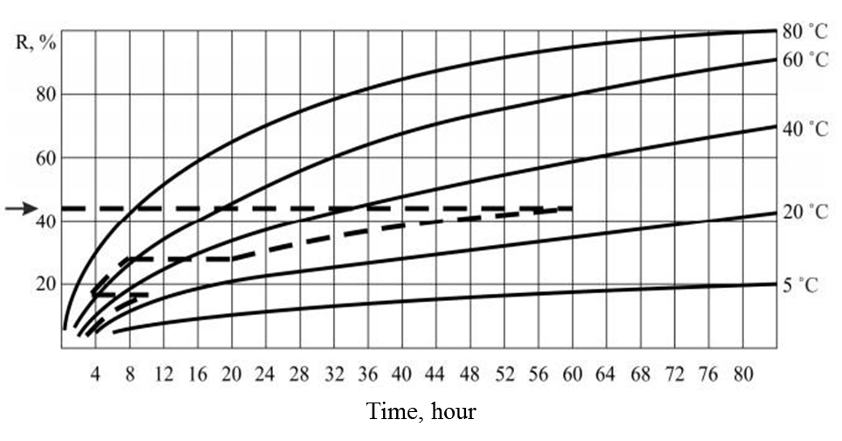

Figure 1.23 – Graph of temperature and R%

Note - Compiled by the source [101]

Evaluating concrete strength is essential in construction to ensure the safety of a structure. While the maturity method, which gauges the concrete's curing progress through temperature measurements, offers valuable insights, it shouldn't be the only assessment. There are inherent limitations, and factors like structural design and concrete quality also impact load-bearing readiness. Hence, combining methods like temperature monitoring, strength tests, and non-destructive testing is advisable. Using an integrated approach helps professionals make better decisions about a structure's safety and compliance with durability standards. Determining concrete strength involves various techniques.
Calculation of concrete strength is carried out by means of:
а) determining the maturity of concrete [101]:

$ЗР_{б}=\sum_{i=1}^{m}{t_{i}∙τ_{i}}$ (1.1)

b) determining the time of concrete curing equivalent to its curing at 20°C [101]:

$τ_{экв}=\frac{ЗР_{б}}{20}$ (1.2)

Numerous techniques exist for estimating concrete strength, with analytical correlations being among them. Yet, owing to the intricate nature of the math computations and the need for specific software, this approach isn't extensively employed in hands-on applications.
International standards like [102] and [109] outline the temperature-strength control of concrete using the "maturity index", derived from monitoring concrete temperature changes during curing. The index is determined via the temperature-time factor (TTF) or equivalent age at 20°C. Though the analytical dependency method is less prevalent, the maturity concept is a recognized and standardized method for assessing concrete strength. It offers a reliable prediction of concrete strength, and when combined with other methods, ensures structural safety. Complying with these standards guarantees that construction meets safety and quality benchmarks.
The Nurse-Saul formula is used to calculate the temperature-time factor [102]:

$M \left(t\right)= Σ_{0}^{t}(T_{a}-T_{0})∆t$ (1.3)

where M(t) is the temperature-time factor at age t, expressed in degree-days or degree-hours (ºC-days or ºC-hours);
T_{a} – the average temperature during a given time interval Δt, ºC;
T_{o} – the base or datum temperature, ºC;
Δt – the time interval can be measured in days or hours.
Concrete strength is closely related to the datum temperature, which indicates when cement hydration is dormant. Factors affecting this temperature include cement type, additives, and curing temperature. According to American standards, for Type I cement without admixtures, the datum temperature is set at 0°C, with curing temperatures ranging from 0 to 40°C [110].
Proper measurement and control of the curing temperature are crucial to ensure the desired strength of concrete is achieved. The temperature-time factor is a useful tool for predicting concrete strength based on the curing temperature and time. It is widely used in the construction industry to monitor the curing process and ensure the quality of the finished product. Figure 1.24 illustrates the calculation of the temperature-time factor [58, р. 3-68], which is an essential factor to consider when determining the strength of concrete. By accurately measuring and controlling the curing temperature and utilizing the temperature-time factor, construction professionals can ensure the structural integrity and durability of the concrete.

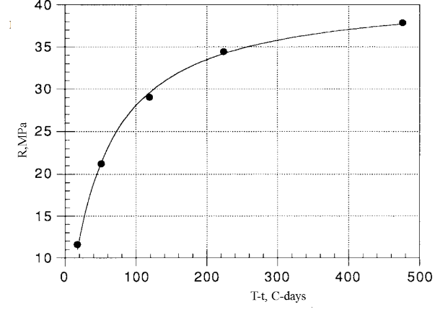

Figure 1.24 – TTF

Note - Compiled by the source [102]
The standard also includes another maturity index known as the equivalent age of concrete. The calculation is based on the Arrhenius formula [102]. Figure 1.25 shows the graph obtained using this formula.

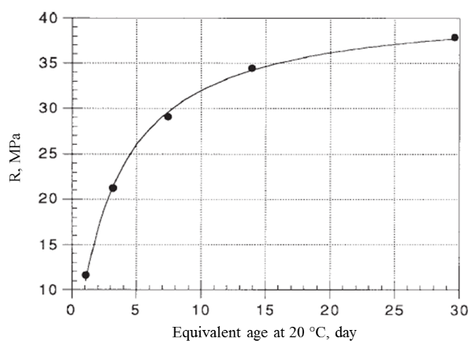

Figure 1.25 – Accounting for equivalent age

Note - Compiled by the source [111]

The concept of the "equivalent age" of concrete provides a nuanced understanding of its strength development, particularly accounting for temperature's role during the curing phase. This metric offers a distinct advantage: construction experts can ascertain the robustness of concrete at a specific age, irrespective of the actual duration since its pouring. Such a measurement system greatly aids in standardizing assessments across varied environmental conditions and curing practices.
The renowned Arrhenius formula stands as a testament to the industry's reliance on tried-and-tested methodologies. Predominantly utilized to forecast the potency of concrete under diverse curing scenarios, this formula is more than just an equation; it's a crucial instrument that ensures the integrity, quality, and safety of concrete edifices. When builders and engineers adhere strictly to internationally recognized standards and guidelines, they elevate the credibility of their work, ensuring that the resulting structures are both top-notch in quality and safe for use.
In 1979, the "Weighted Maturity" method was pioneered as per source [112]. This innovative approach, based on thorough research, set the groundwork for the [108] standard mentioned in source [113]. This method involves specific calculations that provide detailed insights into concrete maturity and strength.

$M_{w}=ΣtTC^{n}$ (1.4)

where Mw – weighted maturity, °C·hours or °C·days;
t – age of the concrete / curing time, hours or days;
T – average temperature of the concrete over a time interval, Δt (°C);
n – temperature-dependent parameter;
C – constant for which the strength curves for isothermal strength testing at 20 and 65°C coincide, or the specific value of the cement.
Nevertheless, the parameter labeled as "C" is inherently tied to the particular cement type. While its primary use revolves around determining the strength of the cement, it's versatile enough to accommodate the inclusion of additives. This flexibility ensures that the cement's inherent properties and the benefits of any added substances are considered in tandem.
On the other hand, the parameter "n" introduces a layer of complexity by accounting for the nonlinear impacts of temperature on the evolution of concrete's strength. Its role is to ensure that temperature-induced variations, which might not follow a straightforward path, are adequately represented. The intricacies of how temperature influences strength development, especially in a nonlinear fashion, can be deciphered using a specific equation that takes into account various factors and constants. This mathematical representation offers a deeper insight into the nuanced relationship between temperature and strength maturation [114]:

$n=0.1∙T-1.245$ (1.5)

The term "weighted coefficient" is rooted in the mathematical expression Cn. When observing the behavior of "C", especially when its values exceed one, there is a notable and steep increase in this coefficient as temperatures surpass 12.45°C. This pattern indicates the sensitivity of the coefficient to temperature fluctuations within specific ranges.
Official standards and guidelines provide stipulated "C" values for various scenarios. For instance, a standard C value assigned could be C = 1.25 for certain predefined categories or types. But how is this "C" value determined in a practical sense? The process typically involves creating ten concrete cubes with dimensions of 150 mm or, alternatively, forty mortar cubes that measure 40 mm each. The compressive strengths of these cubes are then assessed at two distinct temperatures: 20°C and 65°C. By comparing the compressive strengths obtained at these temperatures, one can derive insights into the behavior and properties of the material [115].
The primary objective of determining the ideal "C" value is to ensure there's a harmonious correlation between the measured compressive strengths and those computed using the concept of weighted maturity. When these values align, it provides construction professionals with a reliable benchmark to evaluate the quality and strength of their concrete, ensuring that structures built with this material meet the highest standards of safety and durability [108].
Korea has its guideline for temperature-strength control in concrete. The maturity method [102] is a popular technique for forecasting early concrete strength development, relating concrete strength to cement hydration temperature. This method helps in decisions like formwork removal timing, especially in colder temperatures that slow concrete strength development. It's also useful for refining the concrete mix and adjusting curing conditions for different weather scenario [116].

Summary of chapter one
Modern construction projects are significantly enhanced by the advent of sophisticated technologies that guarantee the strength and quality of concrete. This is particularly vital during the winter season when temperature plays a pivotal role in the curing process. The initial days after pouring concrete are crucial for establishing its strength. Facing unpredictable challenges such as the unavailability of heating or concrete supplies, industry professionals have innovated systems for timely monitoring of concrete strength and efficient data collection. These advancements enable the anticipation of potential setbacks, ensuring that projects proceed without unnecessary delays.
The employment of advanced equipment, coupled with rigorously defined methodologies, facilitates precise control over the temperature-strength relationship of concrete. The curing time and the maturity of concrete, a measure of the duration over which the material has been hardening, are significant factors influencing its strength. Nowadays, modern measuring devices are available that allow construction professionals to quickly and accurately verify the concrete's quality, aiding in the decision-making process for further construction activities.
To guide these critical processes, various international standards and norms, such as ASTM C1074-17 and DIN EN 13670, are in place. These standards provide a framework for the use of specific sensors and methodologies in measuring concrete properties, ensuring the reliability and accuracy of the data collected on-site.
One widely recognized technique employed across the globe, including in countries like South Korea, is the "maturity method." This standardized approach is instrumental in predicting the strength of concrete effectively. When combined with other evaluation methods, such as non-destructive testing and strength tests, it ensures that constructed structures are both safe and durable.
Several mathematical formulas play a key role in this context. The Nurse-Saul and Arrhenius formulas, for example, are utilized to calculate and predict the strength of concrete. These formulas highlight the critical importance of temperature in relation to the material's maturity and ultimate strength. By accurately gauging these factors, construction professionals can ensure the structural integrity and longevity of their projects, adhering to the highest standards of safety and quality.

2 ASSEMBLING OF WIRELESS SENSING DEVICES TO MONITOR THE INTERNAL AND EXTERNAL PARAMETERS

Given the technical parameters of the existing sensors, a technical specification was developed to enable monitoring and the following specifications were established (table 2.1):
- achieve measurement accuracy of ±1% for two parameters;
- transmit data remotely to a central server, which processes and sends results to a pc;
- operate for up to a month, considering temperature monitoring may last 28 days;
- comprise temperature, humidity, and ph sensors, memory, switch, battery, and a protective sealed housing.
The housing should:
- be sized within 50×50×20 mm;
- ensure IP68 protection against dust, high-temperature water jets, and moisture;
- resist aggressive alkaline conditions;
- be durable and impact-resistant;
- feature external clamp mounting or holes for clamping;
- have a clamp for securing to reinforcement or designated clamp holes.

Table 2.1 – Sensor requirements

Details | Requirements
1 | 2
Temperature sensor cable | Length 300-1000 m
Temperature sensor cable | Connection to controller and temperature sensor
Temperature sensor cable | Range -50 to +100C
Temperature sensor cable | Uninterrupted data transfer
Temperature sensor cable | Pressure withstand 0.2 MPa
Temperature sensor | Operate within a temperature range of -50°C to +100°C
Temperature sensor | Transmit measurements to controller
Temperature sensor | Resist mechanical influences, aggressive media
Temperature sensor | Measure concrete temperature
Humidity sensor | Measure humidity
Humidity sensor | Operate in temperatures from -40 to +100°C
Humidity sensor | Prevent penetration of moisture and dust
pH sensor | Measure pH
pH sensor | Work at temperatures from -40 to +100°C
pH sensor | Prevent moisture and dust from entering
Controller | LED indicator
Controller | Dimensions must be to fit inside sensor housing
Controller | Sealed against all kinds of influences
Memory module | Be built into the enclosure
Memory module | Appropriate dimensions for the device inside the enclosure
Memory module | Memory to accumulate information of temperature, humidity for 30 days
Continuation of the table 2.1

1 | 2
 | Link with controller
 | Linked to controller
Power supply | Built in cabinet
Power supply | Run uninterruptedly for at least 30 days
Switch | Linked to controller
Data acquisition station | Transferable remotely from one job site to another
Data acquisition station | Have an auxiliary program to retrieve measurements from sensors
Data acquisition station | Have cloud connectivity
Data acquisition station | Ability to connect from battery and mains power
Data acquisition station | Quickly disconnect and switch over
Data acquisition station | Plenty of memory for storing data
Data acquisition station | Wi-Fi connection
Data acquisition station | Enclosure appropriate and secure storage
Software | Use on a personal computer
Software | Interpretation of measurement results into concrete strength
Software | Retention time of the measurements
Software | Sensor location information and identification
Software | Ability to download reports
Software | Possibility of registration in the database under different users and access to changing settings
Software | Readability of graphic data

2.1 Prototyping of a concrete maturity sensor with a hermetically sealed housing
Concrete strength is pivotal for a structure's resilience. To compute concrete's strength using the maturity method, as standards dictate, four steps are required: lab establishment of the maturity-strength relationship, sensor embedding at the site, concrete maturity readings, and data interpretation. Initially, a wireless sensor's housing is crafted.
Product enclosure design follows universal principles. The process includes:
- Conceptualization: Evaluating commercial potential, competitor products, and technical parameters. This phase yields a complete product.
- Technical Development: Combining design and analysis to produce a tested prototype.
- Device Development: Detailing components, crafting circuits, finalizing enclosure design, and software.
- Prototyping: Conducting performance evaluations, making necessary design tweaks, and then arriving at a refined prototype.
- Device Categorization and Examination: Establishing the device's classification, securing relevant certifications, and undertaking possible design changes if needed.
- Trial Run Production: Authenticating the feasibility of production, pinpointing previously overlooked flaws, and fine-tuning the design accordingly.
- Ongoing Developer Assistance: Providing unwavering support for the finalized product.
Using the ASTM C1074 maturity method, the software's functionality is ascertained.
Enclosure design often follows internal assembly. Plastic enclosures are commonly crafted via injection molding machines (IMMs). Mold creation emphasizes insert design, with steel quality impacting mold lifespan. While Chinese molds are affordable, they often lag in delivery and quality compared to European counterparts. Plastic is the primary material for electrical enclosures due to its versatility, appearance, and durability. Materials like ABS plastic, polystyrene, and polycarbonate are standard.
While plastic injection molding has become more accessible, it may lack efficiency, making alternative molds like silicone and polyurethane viable. Silicon molds, crafted from liquid silicone and a hardener, offer a simple molding process.
The wireless sensor system's enclosure was developed using computer-aided design (CAD) software. After selecting suitable software, the device's main components and board underwent 3D modeling, followed by the enclosure. Accurate measurements during the modeling phase are crucial to avoid design adjustments later on (figure 2.1).

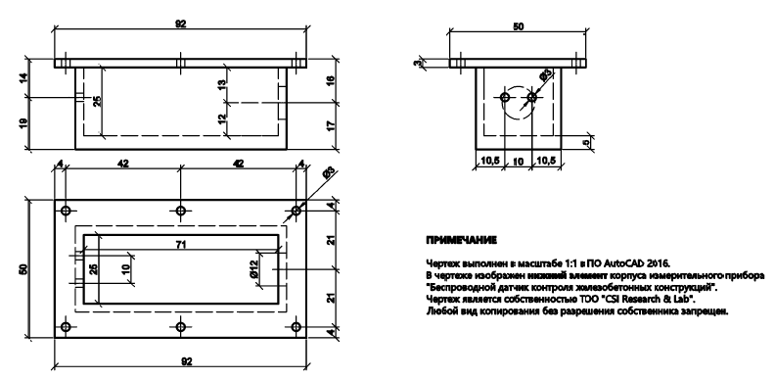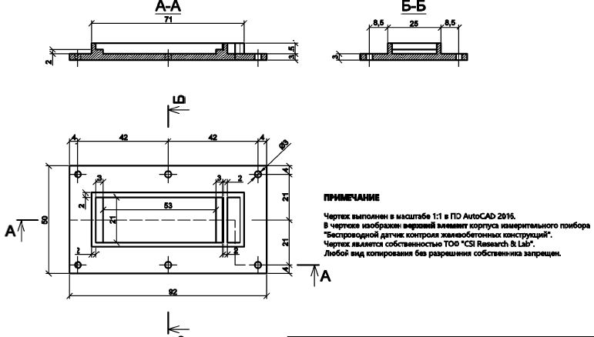

a b

Figure 2.1 – 2D sketch of the upcoming model, illustrating the top and bottom views of the enclosure

Figure 2.2 shows a 2D sketch printed on sturdy paper, serving as a physical template to ensure accurate measurements and detect any inconsistencies, facilitating smoother design progression.



Figure 2.2 – Initial 2D design template for the enclosure

Using Blender software, the sensor housing's 3D model is crafted, starting with the main dimensions around the circuit board and then refining smaller details (figure 2.3). This step-by-step approach ensures a thorough design that results in an optimized sensor housing.

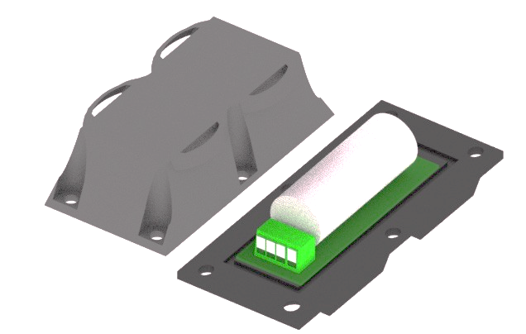

Figure 2.3 – Initial 3D design template for the enclosure

Based on the initial design, the enclosure has an activation mechanism and a cable entry on top. A ridge is added for a clamp attachment, ensuring the transducer stays in place. Rubber gaskets (figure 2.4a) and a cable gland ensure a watertight seal. The cable gland, detailed in figure 2.4b, is made up of various parts, including a body, gaskets, and nuts, made from materials like neoprene and nylon. A pipe wrench is used for the cable gland's installation, ensuring a sturdy assembly.

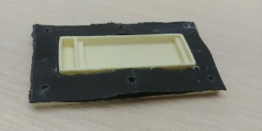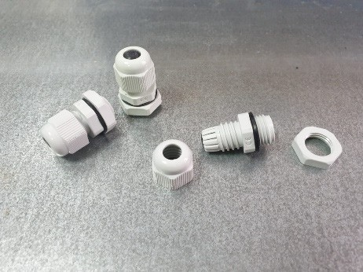

a b

a – a rubber gasket, which serves as a sealing barrier to prevent the ingress of water or other contaminants; b – a PG7 cable gland, specifically designed to maintain a secure and sealed connection for the cable as it enters the enclosure

Figure 2.4 – Components utilized for ensuring the enclosure's watertight integrity

The STL 3D model is loaded into the 3D printer software, where users can set its position. The software then adds any needed elements, calculates required materials, and estimates the print time (figure 2.5). This pre-planning guarantees the precise creation of the sensor enclosure.

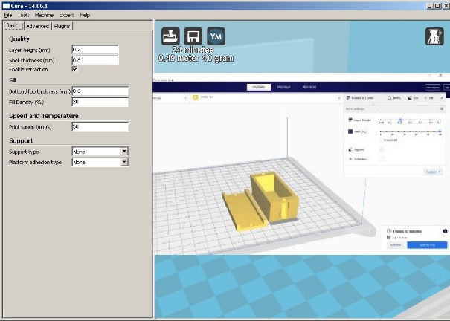

Figure 2.5 – The 3D printer software

Before printing, the software divides the model into layers and determines the printhead's path. The 3D printer then melts plastic filament through a heated nozzle, depositing it layer by layer based on the 3D model's design to create the sensor enclosure (figure 2.6).

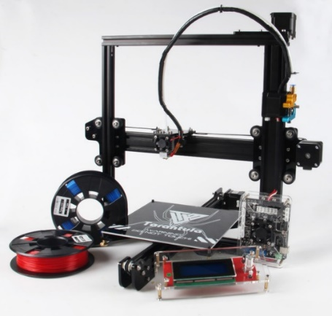

a b

Figure 2.6 – The creation of 3D objects from a digital file by adding material layer by layer

After 3D printing, any supporting structures are removed. The printed model is examined for design flaws, like insufficient wall rigidity. To address these issues, the model can be modified using materials like liquid plastic or cardboard to enhance its structure. By producing multiple prototypes and making adjustments, a final, refined product is achieved (figure 2.7).

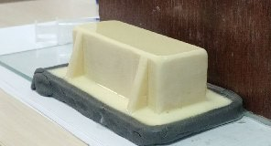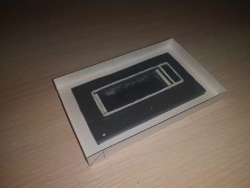
а b

a – adding plastic reinforcements to the upper body edges for stability; b – increasing the bottom body rim's height with paper for a better fit

Figure 2.7 – Improvements made to the printed model include

To ensure a successful silicone mold, the mold halves must align perfectly, with the first half having holes and the second with matching protrusions. After 3D printing, the plastic cures in about 20 minutes. Throughout the design and casting phases, several adjustments were made to the enclosure to enhance its quality and function. In the digital model, the enclosure's edges were widened for a better fit, and after printing, reinforcing ribs were added for increased stability (figure 2.8). These continuous improvements result in a stronger and more effective end product.

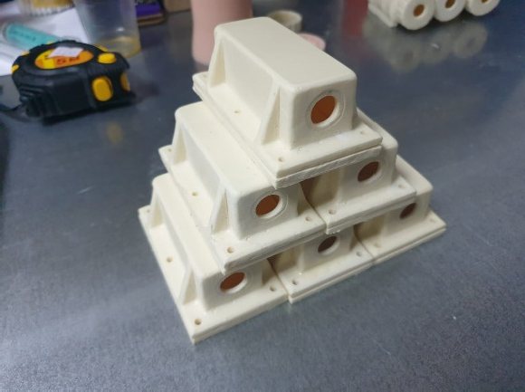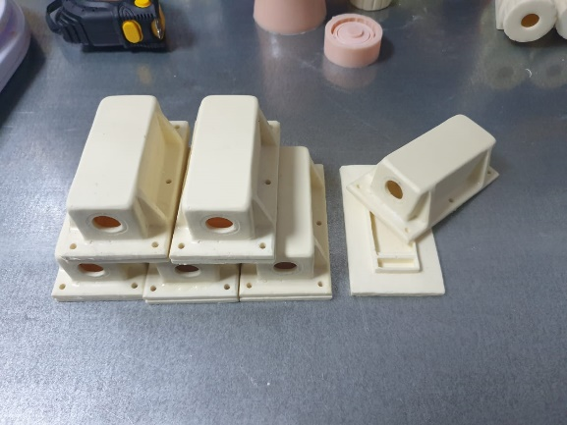

a b

Figure 2.8 – The results of the iterative design and 3D printing process

2.2 Developing of the concrete maturity sensor housing
Two configurations of maturity sensor housings were fabricated, consisting of rectangular housings with two parts and keg-shaped cylindrical housings. The construction of these housings was based on a two-component liquid plastic produced by Kimpur - Kimteks Kimya Tekstil Ürünleri ve Ticaret A.Ş., a company based in Turkey. The plastic's two components are available in packaging sizes ranging from 2 to 200 kg, and are known for their high level of hardness, resistance to mechanical stresses, and short setting time. The plastic's components are mixed in a 1:1 ratio by weight, resulting in a homogeneous mixture that can be easily shaped into the desired housing form [117].
Initially, the maturity sensor housing was designed as a combined, rectangular housing featuring six screw connections and rubber for waterproofing. The construction process involved multiple iterations of molding silicone formwork, pouring liquid plastic, and polishing each housing component. The formworks were constructed using the two-component silicone HY-520, manufactured by Shenzhen Hong Ye Jie Technology Co. [118], with a hardener-to-silicone weight ratio of 1:40. These components are produced in China and are available in packaging sizes ranging from 1 to 5 kg. To mold the silicone formwork, various tools and materials were employed.
Following the pouring of each mold, the components were kept at a constant temperature of 20°C and 95% humidity until the formwork was fully set, typically taking one day per iteration. The liquid plastic used to fill the formwork had a setting time of approximately 30 minutes, after which the housing was polished with abrasive paper to achieve a smooth surface. The resulting master model of the housing was then utilized to mold a master formwork made of silicone. The final formwork was then used to replicate the housing components, as depicted in figure 2.9.

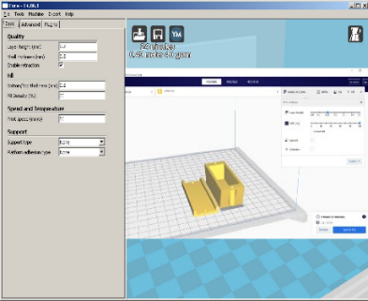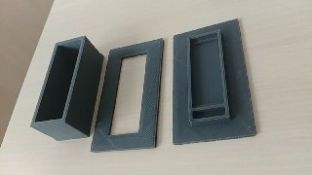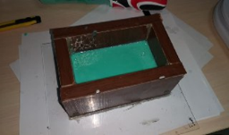
a b c
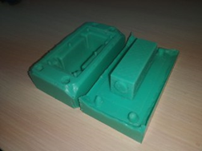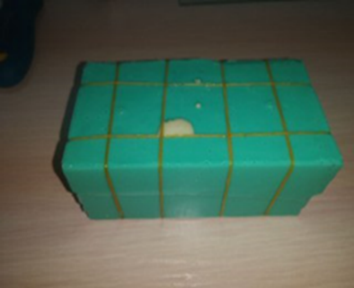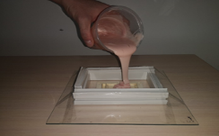
d e f

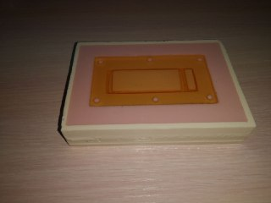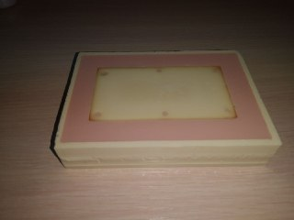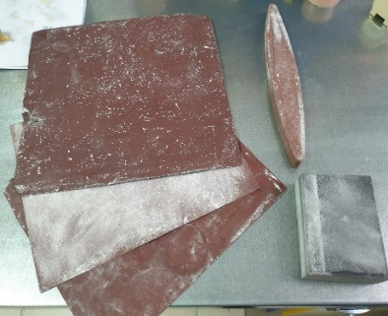
g h i

Figure 2.9 – Stages of design and fabrication of a silicone mold for a rectangular housing
The assembly process for the rectangular housing design was found to be complicated due to the presence of various elements, including metal screws, washers, nuts, and a rubber gasket. In response to this challenge, a cylindrical housing design based on the screw-cap keg concept was developed. This alternative housing design aimed to simplify the assembly process and reduce overall costs. The fabrication process for the cylindrical housing followed similar stages to those employed for the rectangular housing, as illustrated in figure 2.10. By streamlining the design and assembly process, the development of the cylindrical housing provides a more cost-effective solution that is also simpler to construct and maintain.

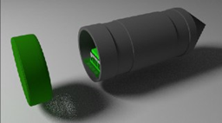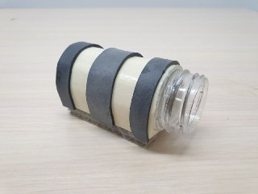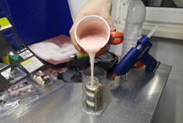
a b c
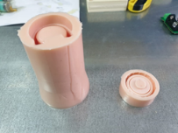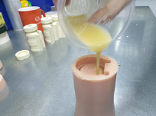
d e f

a – 3D design; b – prototype; c – the pouring of silicon for master-form; d – prepared silicone master-form; e – pouring of plastic; f – polishing tools

Figure 2.10 – Design and fabrication of a silicone mold for the cylindrical housing

Following the successful creation and verification of the project data, the user proceeds to add the necessary quantity of temperature gauges for monitoring. Subsequently, the specific concrete composition to be monitored on-site is chosen. Each concrete composition is associated with a unique strength-maturity curve, derived from concrete tests performed in accordance with the [102] maturity method. The administrator responsible for overseeing the wireless sensor system enters this particular dependency into the database. This streamlined process ensures efficient data input and management, ultimately contributing to the reliable operation of the wireless sensor measurement suite.
User engagement with the wireless sensor measurement system commences through the accompanying software interface (figure 2.11). Upon entering the software, users have the option to either select an existing project or create a new one, specifying its name, location, and any relevant supplementary information.

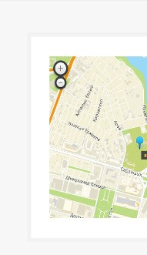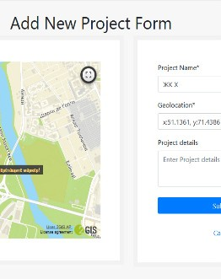

Figure 2.11 – The "New Project Creation" page within the wireless sensor measurement system's software interface

2.3 Testing of the concrete maturity sensor housing
Upon completion of the enclosure, it is crucial to conduct thorough testing to evaluate its performance and effectiveness. This process may include a series of tests, such as:
- Environmental testing: Evaluate the enclosure's resilience to elements like temperature changes, moisture, and exposure to water or dust, ensuring protection of its contents.
- Structural integrity testing: Test the enclosure's durability by applying physical stresses like impact and vibration to confirm its reliability in real-world conditions.
- Compatibility testing: Verify that the enclosure properly accommodates all necessary internal components, allowing for adequate space, ventilation, and ease of access for maintenance or adjustments.
- Electromagnetic interference (EMI) testing: Evaluate the enclosure's ability to shield the internal components from external electromagnetic interference, ensuring reliable performance of the sensor system.
By conducting these tests, any potential issues can be identified and addressed, ultimately leading to a more reliable and efficient final product.
To evaluate the water resistance of both types of housings, a tissue paper was inserted inside each housing to serve as an indicator of waterproofness. The housings were then sealed and submerged in a water tank for a period of one month. To prevent them from floating to the surface, weights were added to the housings, as depicted in figure 2.12. The use of tissue paper as an indicator of waterproofness enabled a straightforward and objective evaluation of each housing's performance in preventing water ingress. This testing approach provides valuable insights into the effectiveness of the housing design and informs potential improvements to enhance its performance in challenging environmental conditions.

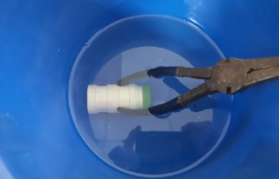

a b

a – rectangular housing; b – cylindrical housing

Figure 2.12 – Water resistance tests

In order to evaluate the integrity of the housings, a testing procedure involving free-fall from different heights (1m, 1.5m, and 2m) was carried out, in accordance with established guidelines [119]. Three samples of each housing type were subjected to this testing procedure. Given the complexity of the technical evaluation process following the free-fall test, a visual determination of each sample's condition was performed based on principles outlined in previous studies [120]. Through this testing process, the ability of each housing type to withstand impact forces was evaluated, with the visual indicators providing valuable insights into potential areas for design improvement (figure 2.13).

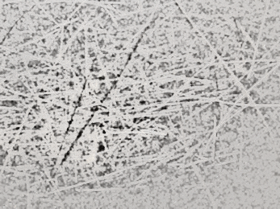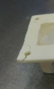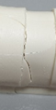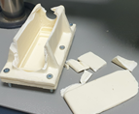
a b c

а – scratches; b – cracks; c – spalls

Figure 2.13 – Potential breaches or damage to the housing structure or components

The load resistance of the maturity sensor housing structure was evaluated using an electromechanical press-machine UNIFRAME 70-T1182, which has a load capacity of up to 50 kN and a displacement speed range of 0.05 to 51 mm/min [121]. During the testing process, loads were applied to the sides of the housings, and these loads were marked with capital letters for ease of reference, as depicted in figure 2.14. By subjecting the housing structure to a range of loads, it was possible to evaluate its resistance to external forces and identify potential areas for improvement in the housing design. Through these load resistance tests, valuable insights into the durability and strength of the housing structure were obtained, providing important information for the design and development of future iterations of the maturity sensor housing.

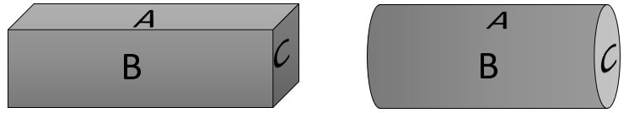

a b

a – rectangular housing; b – cylindrical housing

Figure 2.14 – Side compression loading identifications

During compression testing of the maturity sensor housing structure, a total of three rectangular housing samples (figure 2.15) and three cylindrical housing samples (figure 2.16) were destroyed. In order to obtain accurate and reliable compression results, the differing nozzle area of the press piston was taken into account during the testing process. These destructive tests provided critical data regarding the load capacity and structural integrity of the housing samples under extreme external forces. Upon closely examining the outcomes of the compression tests, pinpointed specific areas that could benefit from design enhancements. This in-depth analysis allowed us to make informed decisions to improve the housing structure, not just in terms of its design but also to augment its overall durability. The findings offered insights into optimizing the structure's ability to withstand and distribute weight, thereby elevating its load-bearing potential. Such methodical evaluations ensure that the final structure is not only more resilient but also meets higher standards of safety and longevity. Also these tests have important implications for the design and development of future iterations of the maturity sensor housing, with the goal of producing a more robust and reliable product that can withstand even the most challenging environmental conditions.

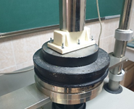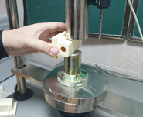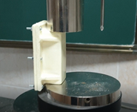
a b c

a – side A; b – side B; c – side C

Figure 2.15 – Rectangular shape compression test

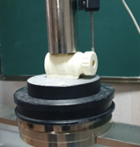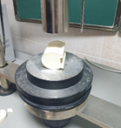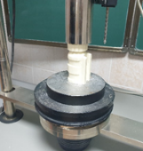

a b c

a – side A; b – side B; c – side C

Figure 2.16 – Cylindrical shape compression test

Results and Discussions
The creation of the multisensory device (MSD) occurred in stages. Firstly, its IT-architecture was constructed, encompassing a microcontroller, multiple sensors, a real-time clock module, a micro-SD card module, and two parallel-connected Li-ion batteries. This structure is depicted in figure 2.17.
Next, a protective housing was designed, ensuring it shielded the device from environmental threats and maintained a compact size (50×50×30 mm), while adhering to the IP68 standard.
The third phase entailed prototyping and assembling the MSD, during which the device's functionality was tested, potential design errors were addressed, components were acquired, and software was adjusted.
In the final stage, the MSD's software was validated, and its ability to gauge the "strength-maturity" of specific concrete compositions was assessed using the ASTM C1074 maturity method. Deployed at the construction site, the MSD monitored concrete maturity and temperature, transmitting the collected data wirelessly for analysis.

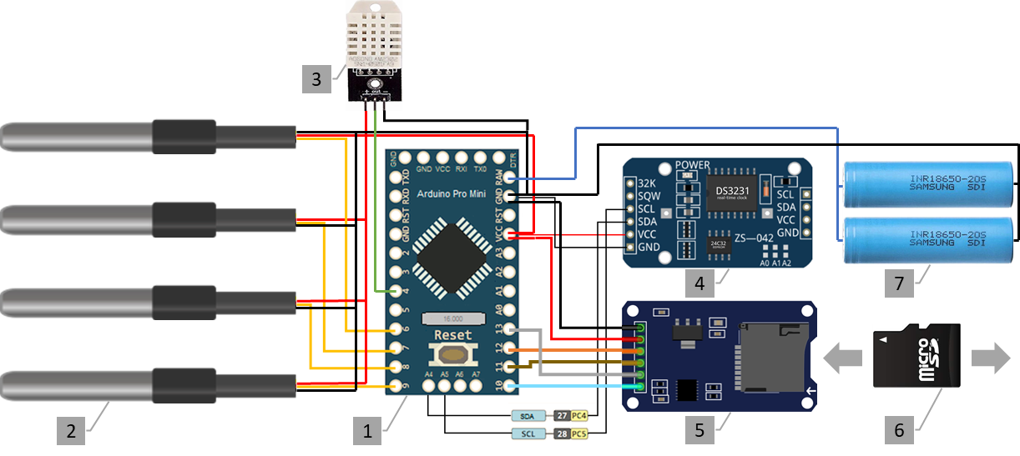

Figure 2.17 – MSD IT-architecture

Note - Compiled by the source [122]
The subsequent phase in the development of the multisensory device (MSD) involved the soldering of the electronic components in accordance with the connections specified in the IT-architecture, which was accomplished using an electric soldering iron. Thereafter, the microcontroller was programmed in "C" language through the utilization of an open-source Arduino integrated development environment (IDE). The subsequent procedures entailed conducting measurement tests and validating the measurement interval, saving the data to the SD card, and organizing the structure and content of the measurement data. The final stage involved the encasing of the electronic components in a secure housing, with the selection of a standard plastic case measuring 15×10×5 cm (figure 2.18).

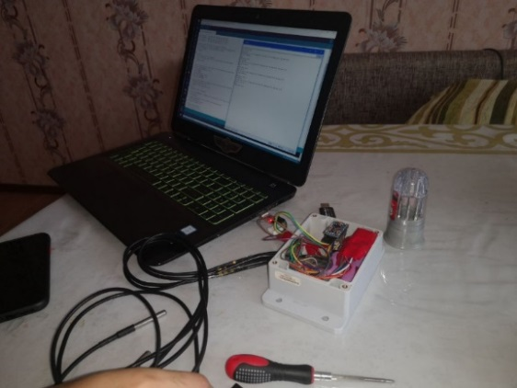

Figure 2.18 – Programming the microcontroller of MSD

The water-resistance and integrity of the maturity sensor housing were evaluated through visual inspection. The results of the water-resistance test indicated that the rectangular housing was the weaker of the two designs, failing the test after just three days of submerging. This failure was confirmed through the blotting of the tissue paper inside the housing. In contrast, the cylindrical housing proved to be completely waterproof, remaining in the water tank for a full month without any signs of water ingress. This was confirmed through visual inspection of the tissue paper, which remained dry after the inspection (figure 2.19).

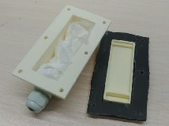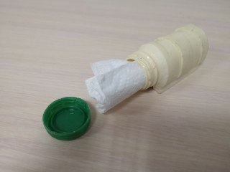
a b

a – wet tissue paper inside housing; b – dry tissue paper inside housing

Figure 2.19 – Water-resistance

These findings highlight the importance of rigorous testing and evaluation in the development of housing designs and demonstrate the significant impact that design choices can have on product performance and durability in challenging environmental conditions. By carefully considering the results of these tests, it is possible to identify areas for improvement and refine the housing design to enhance its water-resistance and integrity in a range of demanding applications.
The integrity tests conducted on both types of maturity sensor housings did not result in significant damage, as indicated in table 2.2. Minor scratches were observed on the surface of both housing types, while a single crack was detected in the rectangular housing sample № 2 following a fall from a height of 2 m. The crack occurred at the screw connection part of the housing, which may be attributed to the fact that the screw holes are located close to the edge of the housing. Overall, the results of the integrity tests suggest that both housing designs are capable of withstanding a range of external forces and stresses, with only minor damage observed under testing conditions. By carefully analyzing the results of these tests, it is possible to identify areas for further improvement in the design and construction of future iterations of the maturity sensor housing, with the aim of producing a more durable and reliable product for use in a range of demanding applications.

Table 2.2 – Integrity test results of different shape of the housing

Sample № | Height, m | Visual identification of shape integrity
Sample № | Height, m | rectangular |  |  | cylindrical
Sample № | Height, m | scratches | сracks | spalls | scratches | сracks | spalls
1 | 1
1 | 1.5
1 | 2
2 | 1
2 | 1.5
2 | 2
3 | 1
3 | 1.5
3 | 2

The findings of the compression tests conducted on the maturity sensor housings are presented in the diagrams below, which illustrate the maximum uniaxial compression load in kPa for each side of the housings (figures 2.20, 2.21). Notably, the load was applied with the same displacement speed and duration for all tests. These results provide critical insights into the load-bearing capacity of the housing structures and can inform the ongoing development and refinement of the housing design to enhance its performance and durability under a range of external stresses and forces. By carefully analyzing the data from these compression tests, it is possible to identify potential areas for improvement and optimize the design of the housing structure to ensure that it is capable of meeting the demands of a range of challenging applications.

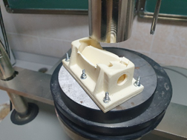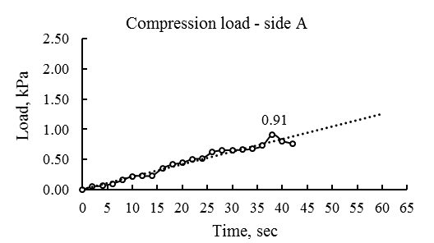

а

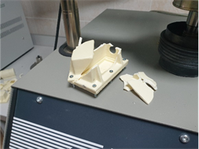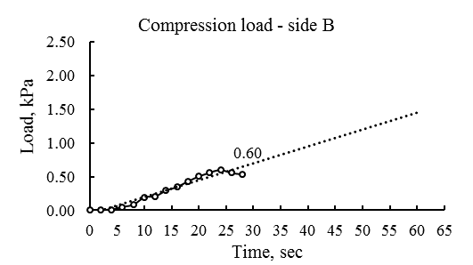

b

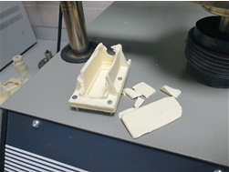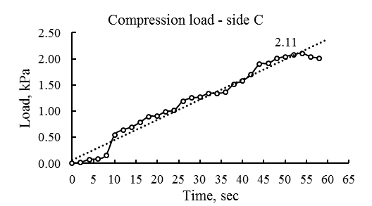

c

a – side A; b – side B; c – side C

Figure 2.20 – Compression load diagram of the rectangular shape

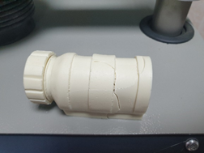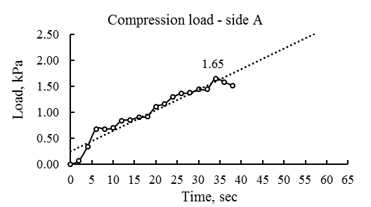

а

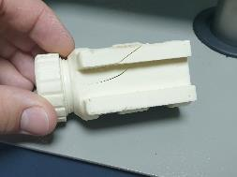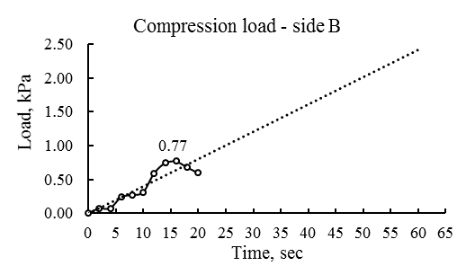

b

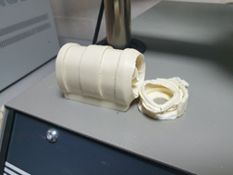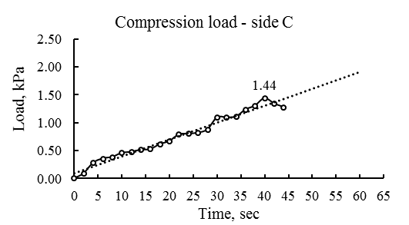

c

a – side A; b – side B; c – side C

Figure 2.21 – Compression load diagram of the cylindrical shape

According to the results of tests of rectangular and cylindrical-shaped housings, the B-side of both types of housings turned out to be the most sensitive to the loads. Whereas the C-side of the rectangular and the A-side of the cylindrical housings withstood the maximum loads. Thus, the sides of the housing when ranked by bearing load may be given the following comparison: B < A < C for the rectangular shape, B < C < A for the cylindrical shape.
To sum up, both housings demonstrated fairly acceptable durability. However, the cylindrical housing turned out to be more reliable since its average resistance deviation on three sides deviate from the average resistance to 26%, as opposed to rectangular housings of 49% (the difference is almost twice). Moreover, the keg-shaped housing turned out to be 100% waterproof according to the test results, less cost and labor-intensive due to the exclusion of screw connections and rubber for waterproofing.
One notable characteristic of the cylindrical housing was its cap's internal structure, which eliminated the need for gaskets to ensure hydro insulation (as seen in plastic bottle caps). Refer to figure 2.22 for a visualization of this unique design element.

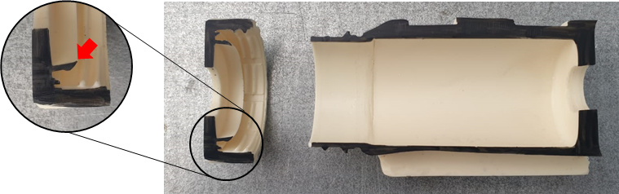

Figure 2.22 – The Unique internal structure in the cap of the cylindrical housing

Through the experimental observations, it has been determined that the primary mode of water ingress occurs at the interstices between the rubber gasket and the two components of the rectangular enclosure, which are secured using screws and nuts. This could be attributed to the potential deformation of the plastic material during the tightening process, resulting in the formation of gaps. Nevertheless, this observation underscores the lack of dependability in the design of the rectangular enclosure, particularly at its junctions. In comparison, the cylindrical enclosure possesses fewer interconnections, consequently reducing the likelihood of water infiltration. Furthermore, the efficacy of the capping mechanism has been substantiated by its successful performance.
The outcomes of the shock resistance assessment can be observed in figure 2.23, presented below.

Figure 2.23 – The shock resistance test outcomes

As evident from the aforementioned figure, the testing procedures did not result in significant damage to any samples across both housing types; no instances of destruction were observed. Post-testing, the overall quality of the housings remained satisfactory. Minor surface abrasions were detected on the sample housings, in addition to an isolated crack on a rectangular housing sample that was subjected to a 2-meter drop. The crack appeared at the screw joint region, potentially due to the proximity of the screw holes to the housing's edge.
The outcomes of the compression tests for the housings are illustrated in the subsequent figure (figure 2.24).

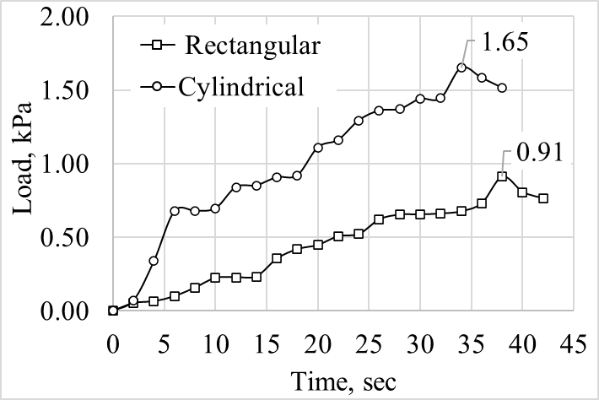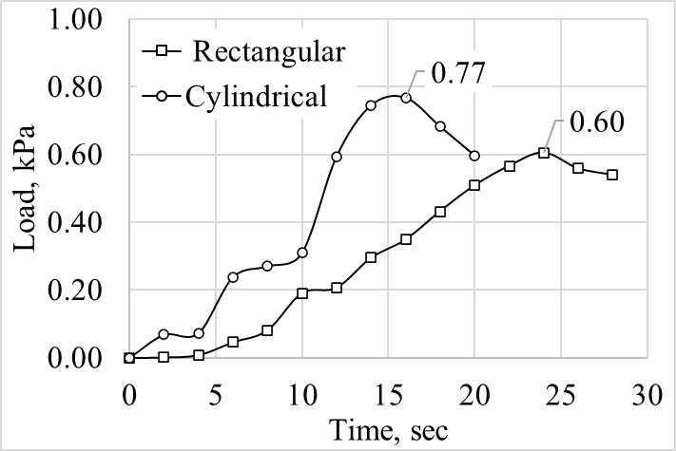

a b

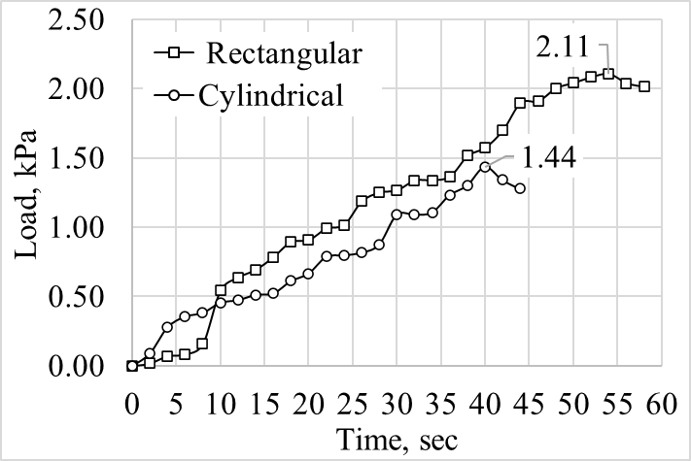

c

a – A-sides; b – B-side; c – C-side

Figure 2.24 – Compression test results of the housings

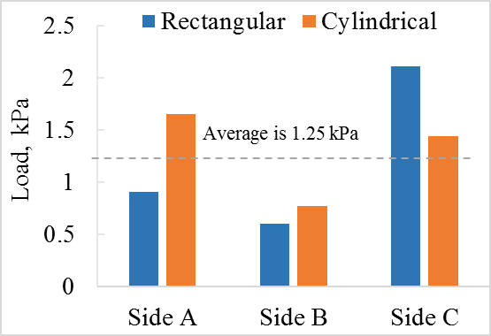

Figure 2.25 – Comparison of Compression test results

The Figure 2.25 show that the cylindrical housing generically may bear more loads than those of rectangular one. It was ahead on the sides A and B of the housings, but lower in side C. The latter was predictable due to the thinness of wall thickness in the threaded part. The maximum loads that the rectangular and cylindrical housings could bear for sides A, B, and C are arranged in the following order: 0.91, 0.6, 2.11 kPa and 1.65, 0.77, 1.44 kPa respectively. While the average load amounted 1.25 kP, only side A and C of the cylindrical, and side C of rectangular housing could exceed this level. Thus, the sides of the housings when ranked by bearing load may be given the following comparison: B < A < C for the rectangular shape, B < C < A for the cylindrical shape.
To sum up, both housings demonstrated fairly acceptable performance. However, the cylindrical housing turned out to be more reliable. Moreover, the keg-shaped cylindrical housing turned out to be 100% waterproof according to the test results, less cost and labor-intensive due to the exclusion of screw connections and rubber for waterproofing.
It seen from the results of the study that the small changes of the structure and shape of the housings may significantly affect their physical and mechanical properties. For example, as it turned out, when using plastic materials to develop the housing, the hydro insulation with rubber and the screw tightening may be omitted. This eases the structural schema of the housing and saves the resources. In this regard, the proposed keg-shaped cylindrical housing with the screw cap may have some advantages with those of the housing of its existing analogues.
The workflow formed for versatile testing and used to custom designs of the maturity sensors housings may be applicable for some other small-scaled electronic devices that are exposed to submergence and various loads, including homemade and (or) professional ones.

Summary of chapter two
The chapter provides comprehensive analysis and testing of the multisensory device (MSD) housing designs concluded with significant findings related to their structural integrity, water resistance, and load-bearing capacities. The development process encompassed several critical stages, from IT-architecture creation to protective housing design, prototyping, assembly, and extensive performance testing under various conditions.
Key Numerical Results and Conclusions:
- Water Resistance:
The cylindrical housing was confirmed to be 100% waterproof after undergoing a rigorous one-month submersion test, demonstrating superior water resistance compared to the rectangular housing, which failed after just three days.
- Integrity Testing:
Integrity tests resulted in minor damages to both housing designs, with the rectangular housing suffering a crack at the screw connection after a 2-meter fall, highlighting a design vulnerability. Conversely, the cylindrical design showed greater resilience to physical impacts.
- Compression Testing:
Compression tests revealed that the cylindrical housing could bear more loads effectively compared to the rectangular one. The maximum uniaxial compression load for the cylindrical housing sides A, B, and C were measured at 1.65, 0.77, and 1.44 kPa, respectively, versus 0.91, 0.6, and 2.11 kPa for the rectangular housing. This indicates the cylindrical housing's superior load-bearing capacity and structural uniformity.
- Design Efficiency:
The cylindrical housing's design, which eliminates the need for screw connections and rubber waterproofing, was found to be less labor-intensive and more cost-effective. Its cap's internal structure, similar to that of plastic bottle caps, provides effective hydro insulation without additional components.
- Reliability:
The study demonstrated that the cylindrical housing is more reliable due to its consistent resistance deviation across three sides (26%), which is significantly lower than the rectangular housing's 49%. This reliability is further supported by its complete waterproofness and enhanced load-bearing capabilities.
The findings from the development and testing of the MSD housing designs underscore the impact of housing shape and structural details on the device's performance and durability. The cylindrical housing emerged as the superior design, offering exceptional water resistance, higher load-bearing capacity, and greater overall reliability. This study illustrates the crucial role of meticulous design and testing in creating durable, efficient, and reliable electronic device housings. It also suggests that even small changes in the structure and shape of the housings can significantly affect their physical and mechanical properties, advocating for a design approach that minimizes complexity while maximizing performance and durability.

3 CONDUCTING LABORATORY AND FIELD TESTS BASED ON TRADITIONAL METHODS AND SENSOR-BASED MEASUREMENTS

These Sensor-based measurements provide accurate and real-time information, enhancing the understanding of material behavior, structural performance, and environmental conditions. Here are some key aspects of laboratory and field testing with sensor-based measurements:
- Laboratory Testing: In controlled laboratory settings, sensors are employed to monitor and analyze different characteristics of materials and structures. These tests aim to investigate material properties, structural responses, and durability under controlled conditions. Sensor-based measurements enable researchers to obtain precise data on parameters such as temperature, strain, displacement, load, moisture content, and pH.
- Field Testing: Field testing involves the application of sensors in real-world scenarios, typically in existing structures or construction sites. This allows for the assessment of performance, safety, and environmental conditions in real-time. Field measurements provide insights into the actual behavior of structures, considering factors such as varying loads, environmental effects, and long-term durability.
- Structural Health Monitoring: Sensor-based measurements play a crucial role in structural health monitoring (SHM). SHM involves continuous or periodic monitoring of structures to detect any changes, damage, or deterioration that may occur over time. Sensors are strategically placed on critical structural elements to capture data on factors such as vibrations, strains, deformations, and environmental conditions. This information helps identify potential issues, assess structural integrity, and facilitate timely maintenance or repair interventions.
- Large datasets from sensor readings necessitate advanced analysis techniques. Techniques like statistical analysis, signal processing, and machine learning help decipher data, recognize patterns, and derive insights. These sophisticated algorithms aid in identifying irregularities, forecasting structural tendencies, and guiding decisions.
- Advancements in Sensor Technology: Continuous advancements in sensor technology have expanded the capabilities of measurements in laboratory and field testing. Sensors now offer improved accuracy, increased durability, wireless connectivity, and integration with data management systems. These advancements enable real-time data acquisition, remote monitoring, and efficient data processing.
Sensor-based measurements have revolutionized the field of structural engineering and construction by providing valuable insights into the behavior and performance of materials and structures. They enhance the understanding of complex phenomena, support informed decision-making, and contribute to the development of safer and more sustainable infrastructure.

3.1 Pilot and prototyping testing of the multisensory device
The research undertook a sequence of experimental investigations to assess the quality of commercial concrete produced by LLP "Temirbeton-1" located in Almaty, Kazakhstan. For the experiments, B25 M350 grade concrete was freshly mixed, resulting in 15 small cubic samples each with a rib measurement of 10 cm and 2 more substantial cubic samples, each measuring 50 cm at the rib. A state-of-the-art MSD, guaranteeing a measurement precision of ±0.1ºC for temperature and 1% for relative humidity, facilitated the accurate recording of temperature and humidity during the tests. The equipment array also included a hydraulic press, offering an accuracy of ±1%, and a sclerometer IPS-MG4.03, accurate to ±8%.
The small cubic samples underwent compression testing with the hydraulic press at intervals of 1, 3, 7, 14, and 28 days. Strength assessments for the larger samples took place on the side surfaces, utilizing the sclerometer and employing the shock pulse method, timed at identical curing intervals. The mean strength values extracted from both sample types were then earmarked for deeper analysis. In addition to this, every 0.5 hours, data collection covered the curing temperature of the larger samples and the surrounding temperature and relative humidity during the curing process. The entirety of the experimental process was meticulously executed, ensuring the dependability of the outcomes, as illustrated in figure 3.1.

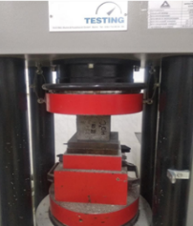 | 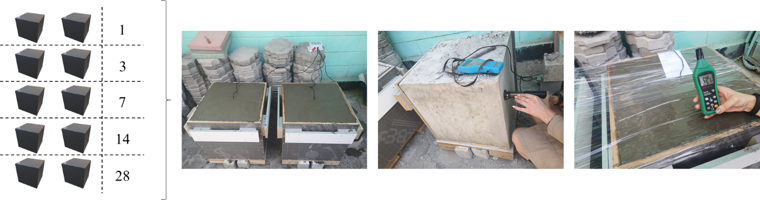
a | b | c

а – compression test; b – shock pulse test; c – temperature and humidity monitoring

Figure 3.1 – Testing setup

The strength values of the small and large specimens were tested and recorded at 1, 3, 7, 14, and 28 days of curing. These results were used to plot strength gain curves for both the compression and shock pulse tests. To accurately determine the confidence curve for the strength gain curves, the curves were superimposed on a single diagram, and their crossings were identified. The confidence curve was then determined by selecting the lowest value obtained from the compression and shock pulse tests with an accuracy of 99.9%.
To further refine the results, trend lines were constructed for both the compression and shock pulse tests. These trend lines provided the equations and approximation reliabilities (coefficients of determination) that were used to calculate the strength values for every 0.5 hours. The confidence curve values were then determined for each 0.5 hour by selecting the lowest value from the trend lines of both tests.
The daily correlation coefficients between the values of the parameters of curing temperature, ambient temperature, and relative humidity were determined using equation (3.1), in conjunction with the confidence curve values obtained. These daily correlation coefficients were used to measure the degree of influence that these parameters had on the concrete strength gain, as determined by equation (3.2). The accuracy and precision of these calculations ensured that the results obtained were reliable and could be used for further analysis. Overall, the experimental study was conducted with a high degree of precision and rigor to ensure that the results obtained were both accurate and reliable [123].

$r_{i,t}=\frac{\sum_{t=\frac{1}{48}}^{1}{(P_{i}-\overline{P_{i}})∙(S-\overline{S})}}{\sqrt{\sum_{t=\frac{1}{48}}^{1}{{(P_{i}-\overline{P_{i}})}^{2}}∙\sum_{t=\frac{1}{48}}^{1}{{(S-\overline{S})}^{2}}}}$, (3.1)

where i – there are three parameters being analyzed which have an impact on the strength gain of concrete: the temperature during curing, the ambient temperature, and the relative humidity. These parameters are important factors in determining the strength of the concrete;
t – a range of curing times for concrete, which vary from 1/48 day (i.e., half an hour) to 28 days. This indicates that the study is examining the effect of different curing times on the properties of the concrete;
$P_{i}$ and $\overline{P_{i}}$ – i a specific parameter and its average value at a given time point (measured in days), which are expressed in units of either one parameter or another. This suggests that the study is analyzing how this parameter changes over time and its relationship to other parameters in the system;
$S$ and $\overline{S}$ – a given time point t (measured in days), the study examines the strength of a material and its average value, which is expressed in MPa. This indicates that the study is investigating the changes in material strength over time and how it relates to other factors being analyzed.

$γ_{i,t}=\frac{\left|r_{i,t}\right|}{\sum_{i=1}^{3}{\left|r_{i,t}\right|}}$, (3.2)

It is important to mention that the total degrees of influence should add up to one. This means that when considering multiple factors that affect a system, the combined effect of all factors must equal one, indicating a complete explanation of the system's behavior equation (3.3).

$\sum_{i=1}^{3}{γ_{i,t}}=1$ (3.3)

The correlation coefficients and degrees of influence calculated in the study were presented using various visualization methods, such as color gradations, petal diagrams, and bar charts. These representations have the potential to be used as monitoring tools and integrated into a software interface of a multisensory device, allowing for easy interpretation of the results.

3.2 RSSI testing of the maturity sensor
The extensive application of radio-frequency identification (RFID) for object interaction necessitates a stable and dependable connection both among the objects themselves and with the surrounding environment. To address this need, numerous Low Power Wide Area Networks (LPWAN) have been developed. These networks are specifically designed to facilitate long-range communication while minimizing power consumption, making them an ideal solution for implementing RFID technology across a broad spectrum of use cases. By ensuring a robust and energy-efficient connection, LPWANs enable seamless integration of RFID systems, ultimately enhancing their overall performance and utility in various applications [124]. Among these networks is LoRaWAN (or LoRa), a rapidly expanding product of the LoRa Alliance. The creators of this technology emphasize several notable benefits of this system in comparison to alternatives such as Wi-Fi and Bluetooth. These advantages include longer range communication capabilities, lower power consumption, and enhanced network scalability. As a result, LoRaWAN offers a more versatile and efficient solution for implementing radio-frequency identification and other wireless communication technologies across a diverse array of applications and settings. By capitalizing on these inherent strengths, LoRaWAN continues to gain traction as a preferred choice for ensuring reliable and energy-efficient connectivity [125]. M2M connectivity offers communication up to 20 km, with data speeds of 50 kbit/s and low power use, making it ideal for many applications. SIGFOX aims to build an energy-efficient, cost-effective global network similar to GSM and GPRS. Meanwhile, NB-IoT stands out with easy network upgrades and a 10-year battery life guarantee. Ubiik's Weightless standard is leading in LPWAN networks with a unique approach to user segmentation. The Weightless suite comprises three distinct variants – Weightless-H, Weightless-W, and Weightless-P – each tailored to specific applications and industries. Weightless-H is designed for the oil and gas sector, while Weightless-W and Weightless-P cater to operational one-way and two-way communications, respectively. This clear delineation of protocols enables the Weightless standard to address the unique requirements of each user segment, thereby enhancing its overall appeal and utility in the LPWAN landscape [126]. The latter protocol, Weightless-P, accommodates a more extensive array of devices compared to its Weightless-H and Weightless-W counterparts. LPWAN networks, like SIGFOX, have a wider 30-50 km coverage in rural areas, but this shrinks to 3-10 km in urban settings due to environmental factors. This disparity in coverage range highlights the need for network providers to consider the distinct challenges posed by different environments, such as the increased signal interference and attenuation experienced in densely populated urban settings. By understanding and addressing these factors, LPWAN networks can be optimized for various scenarios, ensuring reliable and efficient communication across a diverse range of applications, regardless of their geographical context [124, р. 33-47]. A comprehensive overview of the attributes associated with the aforementioned wireless technologies can be found in table 3.1. This detailed comparison provides valuable insights into the specific features, capabilities, and limitations of each technology, enabling a more informed assessment of their respective suitability for different applications and scenarios. By examining these characteristics, researchers, developers, and end-users can make better-informed decisions when selecting the most appropriate wireless technology to meet their unique requirements and objectives.

Table 3.1 – Comparison of technical characteristics of LPWAN networks

Parameter | Wireless communication technologies
Parameter | LoRa | SIGFOX | NB-IoT | Weightless P
Modulation method | CSS | – | OFDMA/DSSS | FDMA/TDMA
Frequency range | ISM | ISM | Licensed | ISM
Data transfer speed | 0,3–50 kb/s | 100 kb/s | UL: 1–144 kb/s  DL: 1–200 kb/s | 0,2–100 kb/s (adaptive)
Bandwidth | Wideband up to 500 kHz | Narrowband up to 100 kHz | Narrowband up to 200 kHz | Narrowband up to 12,5 kHz
Battery life | < 10 years | – | < 10 years | 3–5 years
Operating frequency | 868,8 MHz (Europe) 915 MHz (USA)  433 MHz (Asia) | 868,8 MHz (Europe)  915 MHz (USA) | 700 / 800 / 900 MHz | 169 / 433 / 470 / 780 / 868 / 915 / 923 MHz
Security features | AES-64 & 128 bit | AES, HMACs | – | AES-128 / 256
Communication range | within a range of 2.5 km in an urban area,  within a radius of 45 km beyond the city limits | within a range of 10 km in an urban area,  within a radius of 45 km beyond the city limits | – | within a range of 2 km in an urban area
Support and compatibility | LoRa Alliance, IBM, Cisco… | SigFox, Samsung | 3GPP, Nokia, Huawei, Intel… | Ubiik Weightless SIG
Note - Compiled by the source [124, р. 33-46]

The table's technical specs showcase fundamental features for IoT devices [35, р. 214-231]. Notably, only LoRa technology fits the Asian region's frequency requirements, influencing its selection for the maturity sensor. LoRa's long-range, low-power benefits make it optimal for IoT devices in isolated or power-scarce areas. Hence, the maturity sensor's design leans heavily on LoRa's benefits, underlining the need for region-specific tech choices in IoT [127].
Post data collection, verifying the "Received Signal Strength Index" (RSSI) was vital (figure 3.2, 3.3). The RSSI, measured in dBm, gauges signal strength against a 1 mW benchmark, with values closer to zero being stronger [128-132]. Validating RSSI ensures data reliability from the Maturity sensor, allowing for signal issues to be detected and resolved. This parameter is crucial for dependable wireless communication [133].
To validate the maturity sensor signal strength in real-world conditions, the typical field environment by embedding the sensor in concrete for testing signal strength at different distances were created. Urban obstacles could affect signal strength, so the study focused on LoRa protocol wireless communication quality, specifically data transmission interval and signal strength.

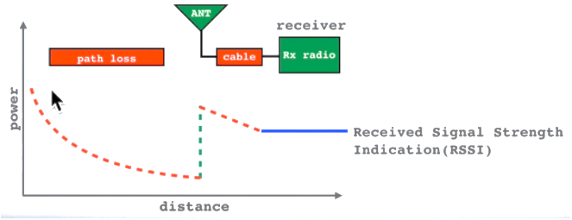

Figure 3.2 – The behavior of the RSSI

Note - Compiled by the source [128, р. 1-7]

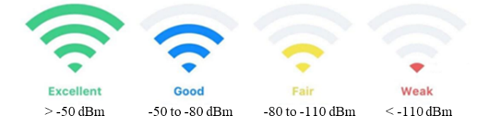

Figure 3.3 – The range of the RSSI

Note - Compiled by the source [133, р. 012012]

Experiments took place in monitoring stations, laboratories, and urban settings, requiring careful preparation. The study aimed to assess wireless communication reliability and robustness in maturity sensors, considering potential disruptions. Accurate data from the experimental setup and methodology informed conclusions and recommendations.
The monitoring station with a stable power supply and internet connection facilitated data transmission from the maturity sensor to the base station and computer. A server software displayed the collected data via an internet browser. Communication was established through a virtual project, including the maturity sensor's serial number. Successful data transmission was verified, as seen in figure 3.3.
The monitoring station's stable power and internet connection were essential in ensuring uninterrupted communication between the components and reliable data collection. The virtual project and communication verification process were critical in setting up the system and ensuring that data transmission was successful. The server software's visualization capabilities were instrumental in enabling researchers to monitor and analyze the data obtained from the Maturity sensor in real-time, providing valuable insights into the sensor's performance under different conditions. Overall, the setup and methodology employed in this study were essential in obtaining accurate and reliable data (figure 3.4).

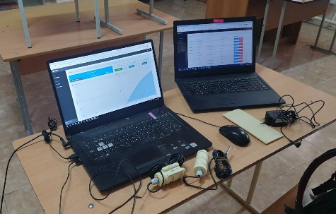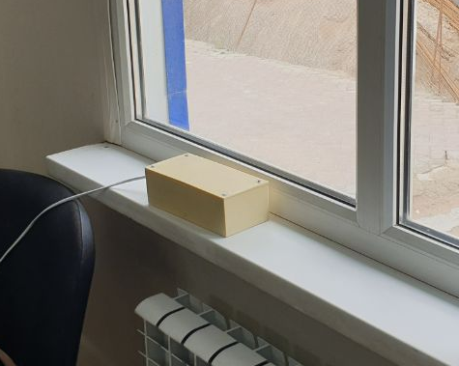

a b

Figure 3.4 – Monitoring work station

To faithfully replicate real-world conditions for the Maturity sensor, precise 20x20x20 cm formwork dimensions were used in the lab, ensuring a distance of over 5 cm between the LoRa chip inside the sensor and the sample walls, aligning with foreign manufacturer recommendations. This safeguarded the sensor from excessive immersion in concrete, preventing potential damage or malfunctions. The sensor was affixed at the formwork center, secured to a reinforcing bar with tying wire (figure 3.5). This setup faithfully mimicked real-world sensor installation conditions, enabling precise measurement of signal strength and data transmission interval. The tying wire and reinforcing bar ensured the sensor's secure attachment to the concrete, yielding accurate data that provided valuable insights into sensor performance under various conditions, allowing researchers to make well-informed conclusions and recommendations [134-136].

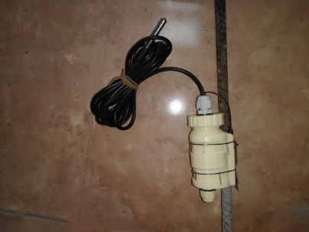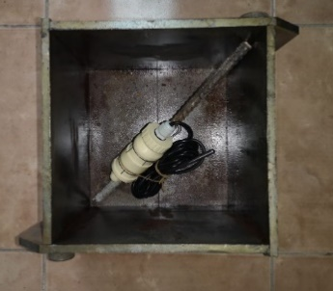

a b

Figure 3.5 – Installation process of the maturity sensor in the formwork
Installing a maturity sensor in formwork is vital for precise measurement of concrete maturity. The sensor is securely placed at the formwork's center, adhered to a reinforcing bar using tying wire before pouring concrete. Manufacturer-specified distances ensure proper sensor placement, optimizing performance and preventing damage.
Correct installation is crucial for reliable maturity data, which informs decisions regarding formwork removal and structural loads. The complete construction cycle followed, including batching and compacting the concrete. A vibrating table achieved the target density, similar to commercial concrete B25 M350, with the sensor designed for densities of 1800 to 2500 kg/m³.
Testing included subjecting the sensor to vibration loads, assessing groove joint reliability, casing tightness, and durability. Vibro-compacting, as depicted in figure 3.6, ensured the sensor's performance remained unaffected by common construction site vibrations. This rigorous testing and compaction processes yielded precise, dependable data on the sensor's real-world performance, offering valuable insights for informed conclusions and recommendations.

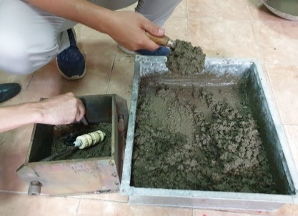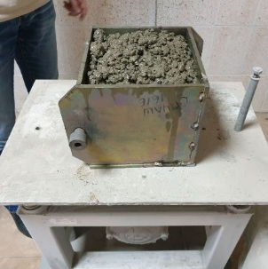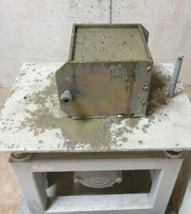
a b c

Figure 3.6 – Pouring and vibro-compacting process during sensor installation

Pouring concrete into the formwork consists of filling it with a precisely balanced blend of cement, aggregates, and water, subsequently permitting it to solidify and become firm. During the pouring process, it is essential to ensure that the mixture is evenly distributed and compacted to prevent any voids or air pockets from forming in the concrete.
Vibro-compacting is a process that involves the use of a vibrating table to consolidate and densify the concrete mixture in the formwork. This process is crucial in ensuring that the concrete achieves the required density and strength and that any potential voids or air pockets are eliminated. Vibro-compacting is commonly used in large-scale construction sites to ensure the quality and consistency of the concrete used in the construction process.
Together, concrete pouring and vibro-compacting are critical processes in ensuring the quality and strength of the concrete used in construction projects. The accurate measurement of the concrete's maturity level through the use of sensors, such as the Maturity sensor, is essential in ensuring that the concrete has achieved the required strength and is safe for use. The combination of accurate sensors, proper installation techniques, and effective concrete pouring and vibro-compacting processes is essential in ensuring the reliability and safety of concrete structures.
To monitor curing concrete temperature using the Maturity sensor, data collection started after the vibration compaction process, lasting 16 days. The first 11 days involved laboratory storage at 20°C and natural humidity. The subsequent 5 days simulated outdoor summer conditions, with the sample moved to various distances from the monitoring station. Signal strength was assessed every 30 meters until it was lost in both obstructed and unobstructed scenarios. This assessment was vital for evaluating the Maturity sensor's real-world performance, effective range, and signal strength in diverse settings.
The research methodology involved careful monitoring of the Maturity sensor 's performance, taking into account various environmental factors that could potentially affect its signal transmission and reception. By monitoring the temperature of the curing concrete and evaluating the signal strength and effective range of the sensor in different settings, obtained valuable insights into the sensor's performance under different conditions.

3.3 Maturity Sensor's Role in Analyzing Temperature's Effect on Concrete Strength via Isotherms
The use of the sensor in concrete testing requires three essential steps. The first step involves creating standard concrete specimens through the manufacturing process. Once these specimens are prepared, the next step is to subject them to isothermal conditioning until the time of testing. This conditioning process ensures that the concrete reaches a uniform temperature and moisture level throughout its volume. By following these three critical steps, the sensor can accurately assess the quality and properties of the concrete specimens under investigation [137].
The process of creating concrete specimens is a crucial step in determining the strength of the material.
In this research, 105 cubic concrete samples of 10 cm side length were produced at the Almaty-based concrete supplier, LLP "Temirbeton-1". They were crafted using a B25 grade commercial concrete with a strength of M350, as supplied. The manufacturing process was closely monitored to ensure that the specimens met the required specifications for the study.
In accordance with reference [138], the samples were collected from a single batch of concrete. After forming the specimens, they were kept at the supplier's site for 24 hours and then moved to the LLP "NIISTROMPROEKT" lab in Almaty. The specimens were stored at 20±2°C with 95±5% humidity, adhering to standards from reference [138, с. 2-27]. Proper storage ensures consistent specimen properties, ensuring accurate test results.
The concrete samples were heated in a specific chamber (figure 3.7) for one hour at temperatures ranging from 10 to 70°C equally to achieve a consistent internal temperature. The isothermal conditioning process is essential as it allows for the concrete to reach thermal equilibrium, ensuring that the properties of the material are consistent throughout the specimen. The specialized environmental chamber used in this study was designed to provide precise temperature control, and its performance was verified before use to ensure the accuracy of the results. The isothermal conditioning process was carried out in accordance with the guidelines set forth in reference [138, с. 3-27], and the temperature conditions used were selected based on industry standards and previous research.

Figure 3.7 – Climate chamber

Through the use of a carefully designed environmental chamber and following standardized temperature control procedures, the researchers ensured proper conditioning of the concrete samples, resulting in precise and dependable test outcomes.
The study used a precise environmental chamber to regulate temperature and humidity for concrete samples, preventing moisture loss. This cabinet-style chamber featured heat exchangers, a door with a window, and freeze protection for consistent testing.

Figure 3.8 – Determination of the compressive strength of concrete cube specimens

The concrete strength determination by compression was carried out using a hydraulic press, as depicted in figure 3.8, in accordance with standardized testing procedures. The hydraulic press used in this study was a reliable and widely-used testing apparatus designed to measure the compressive strength of concrete specimens accurately. The testing was carried out at specific intervals during the concrete curing process, which allows for the evaluation of the concrete's strength development over time. The test results obtained from this destructive testing method provide valuable information on the quality and properties of the concrete specimens, which is essential for assessing the overall performance and durability of the material in practical applications [137, с. 2-34].
In the study, 105 concrete samples underwent tests during their curing at intervals of 1, 3, 7, 14, and 28 days to gauge strength progression. Each test day saw 21 samples tested. They were pre-heated in a chamber to temperatures between 10°C and 70°C, with three samples at each temperature. This controlled heating process ensured that the specimens reached a uniform temperature throughout their volume, facilitating accurate and reliable testing. By testing the specimens at different intervals, the researchers were able to monitor the concrete's strength development over time, which is critical for understanding its long-term performance in practical applications.

3.4 On-site pilot testing of maturity sensors in conjunction with ambient condition monitoring device
A trial of sensor devices took place at the "New Line" residential complex in Astana, Kazakhstan. A maturity sensor was placed on the raft foundation's rebar and another on a pillar's rebar, as depicted in figure 3.9. Another device monitoring environmental conditions was positioned nearby. Readings were taken every hour.

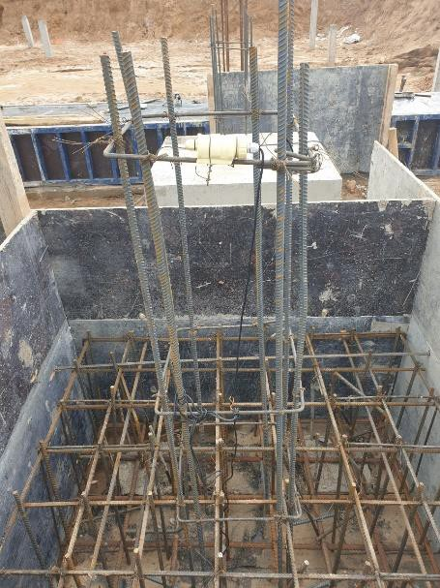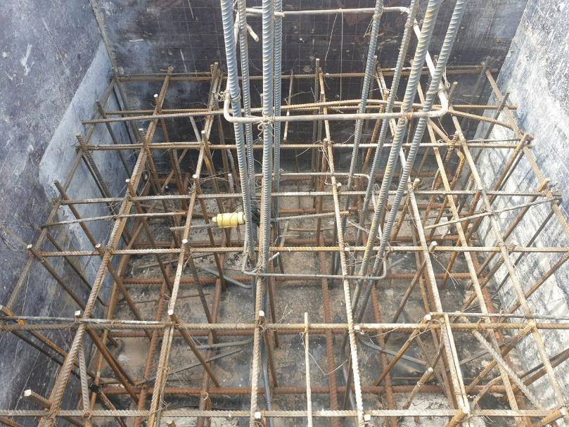

a b

Figure 3.9 – Maturity sensors rebar installation, sheet 1

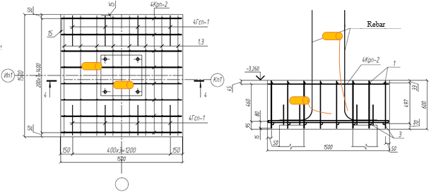
c

Figure 3.10, sheet 1

For quality assurance of concrete structures, 14 cube samples were tested for compressive strength before pouring the M350 concrete mix into the formwork (figure 3.10). This monitoring process was carried out over a period of one week. Daily compression tests were conducted on two cubic specimens each day following the guidelines outlined in reference [8, p. 184-198]. The resulting compressive strength values were then averaged for each day to provide a more accurate representation of the concrete's strength and quality. The monitoring and testing process is an essential aspect of concrete construction to ensure that the final product meets the necessary quality and safety standards.

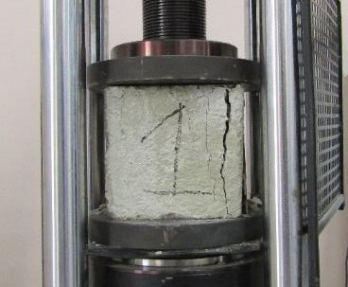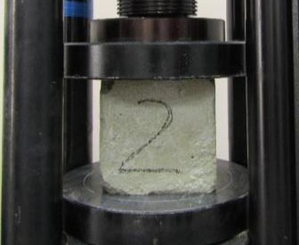

a b

Figure 3.11 – Compression test of concrete specimens

3.5 Performance of maturity method for estimation of concrete strength based on cubic specimens
The study comprised several stages, each aimed at evaluating concrete structure strength and establishing necessary functional relationships to adjust the temperature-strength correlation.
The first stage involved preparing large standard samples (LS) exceeding 50x50x50 dimensions, installing temperature sensors for monitoring, and assessing LS strength using non-destructive ultrasonic methods. Temperature-strength correlations were determined using standardized procedures.
The second stage involved creating small samples (SS) with 15x15x15 dimensions of the same composition, also equipped with temperature sensors. Both SS and LS underwent continuous temperature monitoring and daily strength assessment using non-destructive ultrasonic methods. Additionally, on days 3, 7, 14, 21, and 28, the compressive strength of selected cylinders was measured using destructive methods (three samples per day).
The final stage focused on establishing functional relationships for SS and LS to adjust the temperature-strength correlation (figure 3.11). This critical step allowed precise monitoring and control of the concrete curing process, optimizing conditions to maximize the final product's strength potential.

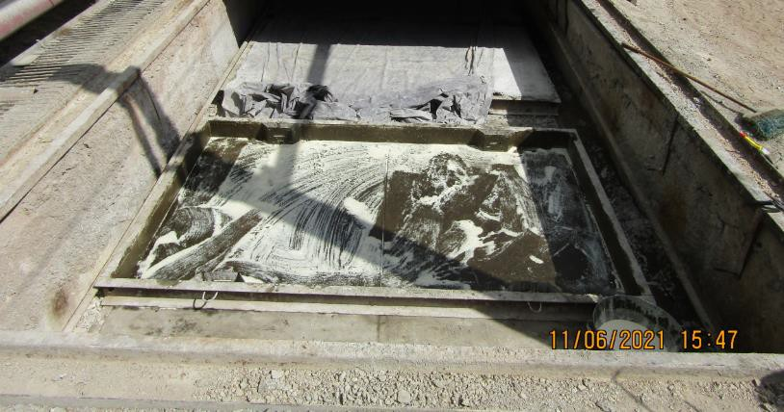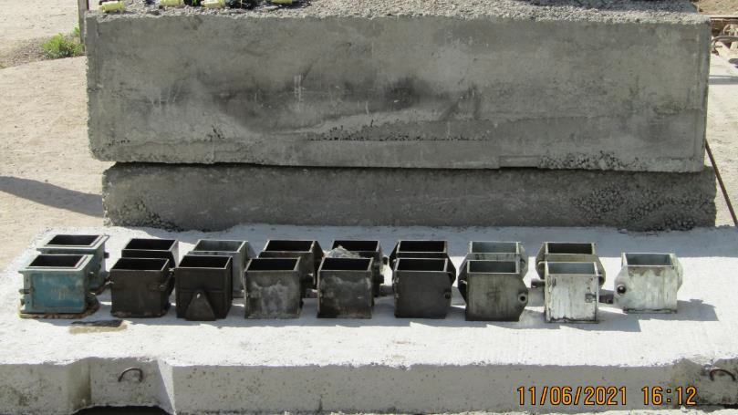

a b

a – LS; b – SS

Figure 3.12 – Sample preparation

Samples were tested for strength with the IPS MG-4 shock-pulse device. This fast method indirectly gauges strength and requires calibration using a test press for accuracy (figure 3.12).

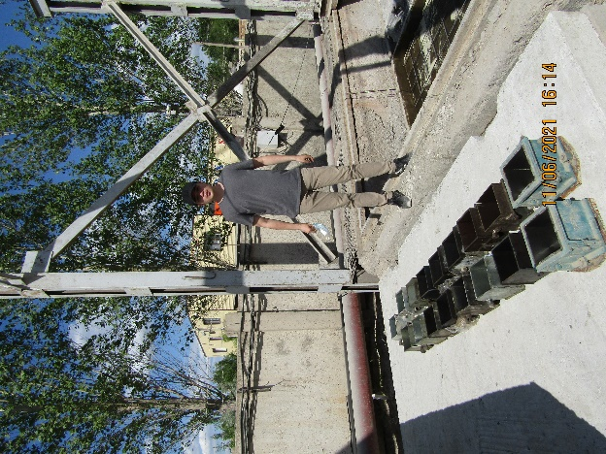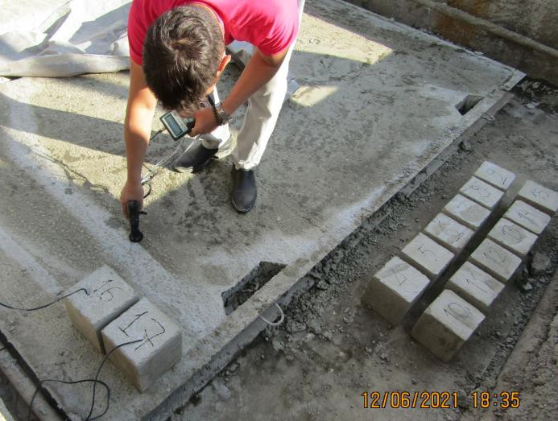

a b

Figure 3.13 – Operational control
Figure 3.13 displays concrete strength gain trends for a specific factory composition, illustrating proportional trends with consistent width between edge curves. This suggests a close relationship between measurement values and minimal variability.

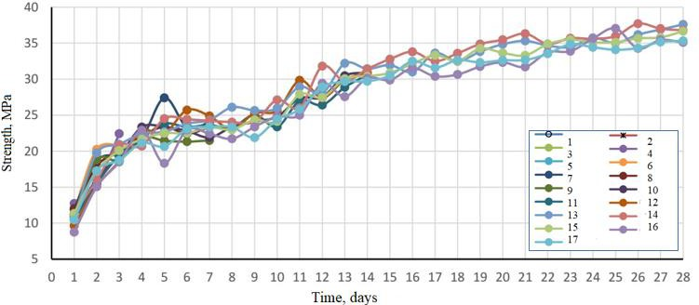

Figure 3.14 – Strength graphs for 17 samples

The non-destructive testing method used in this study offers an efficient and cost-effective means of monitoring and assessing concrete structure strength. Through calibration with the destructive method, it accurately estimates strength without requiring destructive testing. These findings provide valuable insights into concrete structure strength gain processes, aiding the development of more efficient monitoring and control strategies.
For monitoring concrete curing temperature, a custom-built device (figure 3.14) was utilized, comprising various components. This device includes four DS18B20 temperature sensors, two 3.7V lithium-ion batteries with a 3000mAh capacity, an Atmega328p microcontroller, an 8GB memory card for 28-day data storage, and a DS3231 time module.
The Atmega328p microcontroller, with an 8-bit AVR design and 32KB Flash memory, is cost-effective, compact (TQFP32 package), and offers temperature measurement accuracy within ±1ºC. It guarantees a month of continuous performance.
In operation, the microcontroller on the electronic board queries the temperature sensor inside the concrete via a cable at a set frequency, recording data on the SD card. The device can measure temperature, record data, and store it for up to 28 days.
Using standard methods, data was recorded, processed, and analyzed. Temperature sensors, calibrated with an error up to ±1°C, took readings every 30 minutes to closely monitor temperature changes during concrete curing.

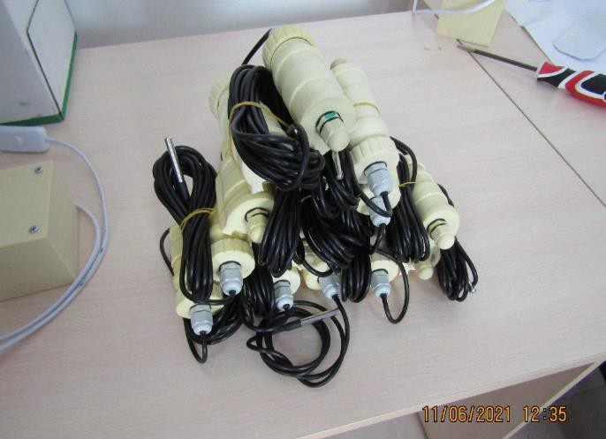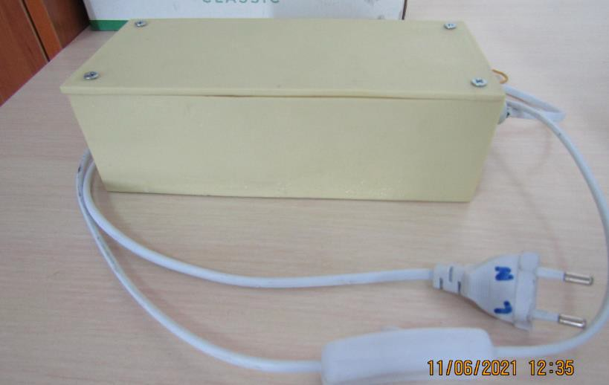
a b

a – Sensor; b – Data collection station

Figure 3.15 – Concrete strength control sensor

This process of drilling core samples is a critical step in assessing the strength characteristics of concrete structures and involves drilling cylindrical cores from the concrete for further laboratory testing (figure 3.15). The cylindrical compressive strength of the concrete is then determined by subjecting the core samples to compressive loading in a laboratory setting. This process allows for accurate and reliable assessment of the strength characteristics of concrete structures, enabling engineers and contractors to make informed decisions regarding the safety and durability of these structures.

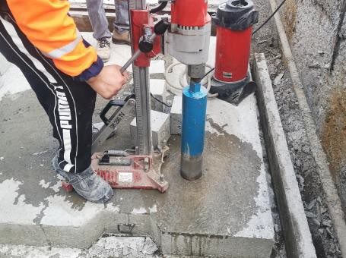

Figure 3.16 – Process of drilling core samples

Results and Discussions
The results of the strength gains for the two large samples, as measured using the shock pulse method, are presented in figure 3.16a. Upon examining the strength gain curves, it is evident that there is minimal variation between the two samples. Despite this, the mean values of their strength gains at 1, 3, 7, 14, and 28 days were utilized for further examination and analysis.
In figure 3.16b, the strength gain curve derived from compression testing on smaller samples is represented by cubic markers, while the triangular markers denote the average curve obtained using the shock pulse method. The bold line that appears within the graph signifies the confidence curve for the strength values.
This particular curve is comprised of the lowest strength values from both the compression test and the shock pulse method at each specified curing age for the concrete samples, which serves to incorporate a degree of redundancy. The confidence curve reveals that during the initial two days and the final ten days, it aligns with the average strength values curve obtained through the shock pulse method. However, between days 2 and 18, it corresponds to the strength values curve derived from the compression testing of the smaller samples.

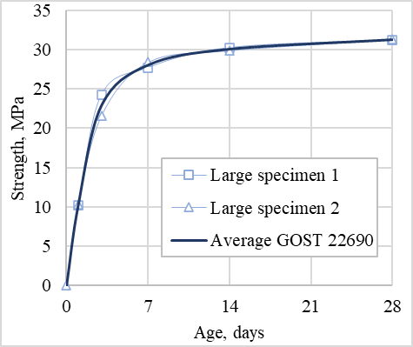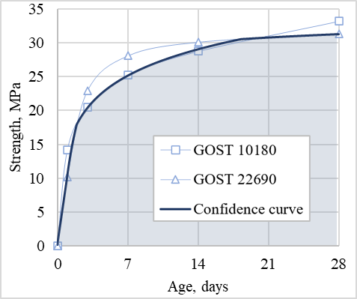

a b

a – shock pulse method; b – comparison and derivation of the confidence curve

Figure 3.17 – Strength gain charts

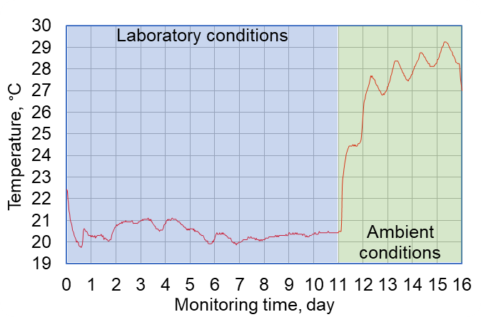 | 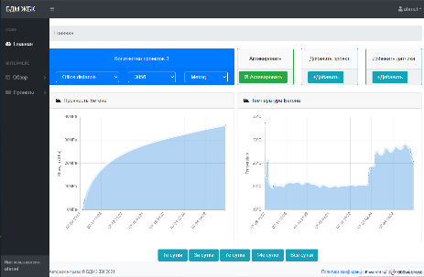
 | 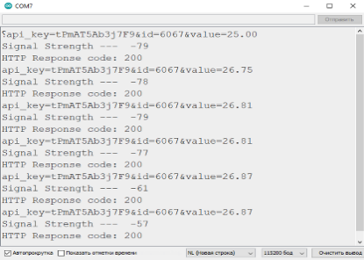
a b

Figure 3.18 – Curing temperature monitoring
The figure 3.17 presented in the study showcases the results of monitoring the curing temperature of concrete in a cubic sample. The data obtained from the study provides valuable insights into the behavior of concrete during the curing process, which can inform the development of more efficient and effective construction processes. By accurately monitoring the temperature of the concrete and evaluating its behavior over time, conclusions and recommendations for improving the quality and durability of concrete structures were demonstrated.

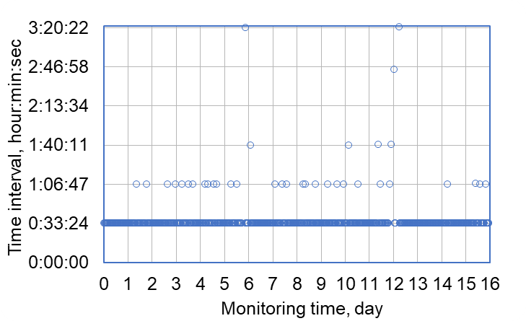

Figure 3.19 – Time interval between two consecutive instances of data transmission

Figure 3.18 displays a clear temperature pattern in the concrete sample's curing process, influenced by factors like day-night transitions and the concrete's heat-producing reactions. For the initial 11 days, temperatures fluctuated around 20±1°C. Upon moving to an urban environment, the temperature surged to 29°C, with 2-3°C variations due to summer conditions. Another temperature graph from server monitoring software is shown on the right, indicating signal arrival intervals calculated from the time data.
In addition, the graph displays data arrival intervals recorded during concrete curing temperature monitoring. The initially set 30-minute interval had an average deviation of 200 seconds, resulting in a range of approximately 33 minutes 20±10 seconds. There were also occasional deviations of over 1 hour.
Upon closer analysis, the deviations classified into four categories based on their magnitude. The first category had deviations greater than 0.5 hours, the second category had deviations greater than 1 hour, the third category had deviations greater than 2 hours, and the fourth category had deviations greater than 2.5 hours (figure 3.19).

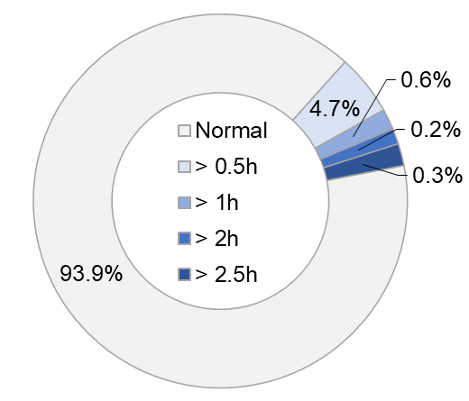

Figure 3.20 – Percentage of deviated reading intervals

These findings are significant as they highlight the need for accurate and reliable wireless communication systems in the monitoring of concrete curing temperature. The large deviations observed in the data arrival intervals can lead to inaccurate temperature readings, which can ultimately affect the quality and durability of the concrete structure. By identifying and categorizing these discrepancies, suggestions for enhancing the efficiency and reliability of the wireless communication system, ultimately improving safety and effectiveness in construction projects could be offered.
In the study, a pie chart displays the data arrival intervals during the monitoring of concrete curing temperature. It highlights that the majority of the data (93.9%) adhered to the standard 30-minute time interval.
However, the study also noted variations from this norm, with 4.7% of data arriving more than 0.5 hours late, 0.6% delayed by 1 hour, and 0.2% and 0.3% delayed by 2 and 2.5 hours, respectively. The deviations observed on days 11-12 can be attributed to transportation issues, but earlier variations raise questions and may be linked to the concrete's exothermic reaction. Figures 3.18 and 3.19 show consolidation of interval deviations from days 2-5, possibly influenced by the activation energy of the reaction affecting radiocommunication. Figure 3.20 presents a signal strength analysis of the maturity sensor, offering insights into wireless communication system reliability for temperature data transmission in construction.

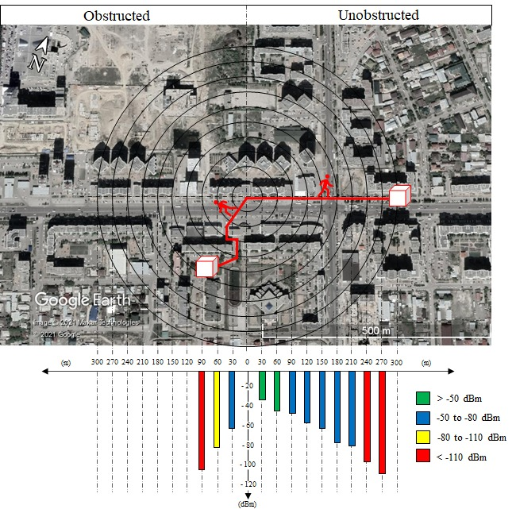

Figure 3.21 – Relationship between the received signal strength index (RSSI) and the distance between the transmitter and receiver in wireless communication

In the study, there is a figure depicting the transportation of concrete samples, comparing scenarios with and without obstructions. The signal reached a maximum distance of 270 meters in unobstructed conditions but was limited to 90 meters when obstacles were present. Another graph shows signal strength intervals corresponding to distances, indicating reliable connections within 30-60 meters when embedded in concrete and considering obstacles. This has implications for installing base stations on construction sites. Figure 3.21 provides signal strength dependencies on distance, aiding the development of reliable wireless communication systems for improved construction safety and efficiency.

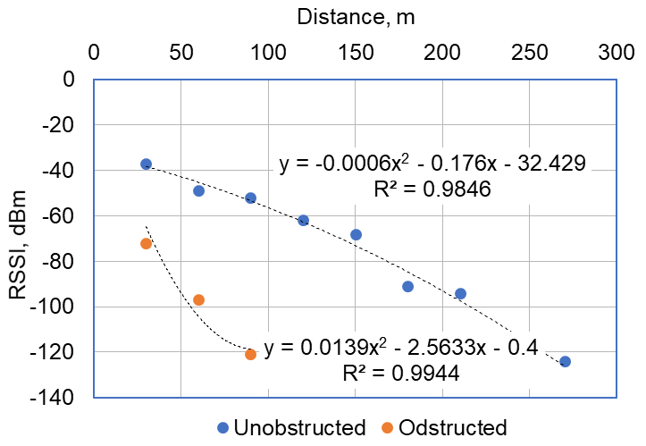

Figure 3.22 – Correlation between the received signal strength index (RSSI) and the distance between the transmitter and receiver in wireless communication

The study used a quadratic polynomial function to express the dependencies between RSSI and distance. The high coefficients of determination close to one suggest that the function is reliable and accurately represents the relationship between RSSI and distance.
The study underscores the necessity for future research. Upcoming investigations will delve into the influence of reaction activation energy on radio communication and signal quality from maturity sensors. Moreover, enhancements are planned for the wireless communication module of these sensors, involving antenna and electronic circuitry improvements.
This research has important implications for the development of more robust and reliable wireless communication systems in the construction industry, which can improve safety and efficiency on construction sites. By gaining a better understanding of the factors that affect wireless communication, construction professionals can make more informed decisions about the installation and use of maturity sensors and other wireless devices.

Table 3.2 – The results of the conducted experiments

Time of curring, days | The gain of concrete strength under different temperature regimes, MPa
Time of curring, days | 10°С | 20°С | 30°С | 40°С | 50°С | 60°С | 70°С
1 | 12,71 | 12,30 | 12,54 | 12,862 | 12,9 | 13,26 | 13,36*
3 | 17,53 | 20,44 | 22,15 | 22,26 | 22,8 | 23,51* | 23,22
7 | 23,2 | 24,22 | 24,3 | 24,86* | 24,2 | 24.2 | 24,24
14 | 31,54* | 26,74 | 25,1 | 24,5 | 26.01 | 26,86 | 28,12
28 | 34,7* | 34,03 | 34.01 | 33,96 | 33,9 | 33,08 | 33.1
* – maximum values of strength gain

The findings of the experiments are illustrated and summarized in two formats: a table 3.2 and a graph (figure 3.22), which are presented below. The table provides a comprehensive overview of the data collected during the experiments, while the graph offers a visual representation of the trends and patterns observed in the data. Both formats serve to facilitate the interpretation and analysis of the experimental results.

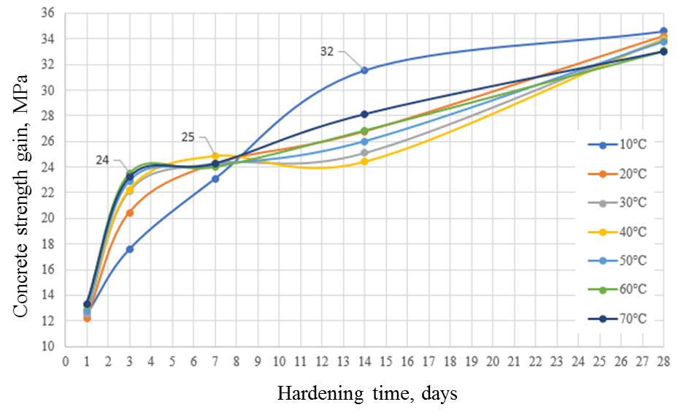

Figure 3.23 – Isothermal curves of concrete curing

The isotherms indicated that when concrete samples were subjected to different curing temperatures, they displayed varying strength gains at intervals of 1, 3, 7, 14, and 28 days. Notably, the most pronounced strength increases were observed at temperatures of 70, 60, 40, 30, 20 and 10°C, which corresponded to strengths of 13.352, 23.51, 24.854, 31.552, and 34.613 MPa respectively. This study centered on the typical concrete class B25 with a grade of M350. From this investigation, it was clear that the curing temperature plays a significant role in determining concrete strength, particularly in the first week. Elevated temperatures in this initial period are linked to remarkable strength improvements. Furthermore, when the concrete was cured at a temperature of 10°C, there was a consistent rise in strength from the 14th to the 28th day. Additionally, in the same period, there was a noticeable reduction in the variation of strength for samples cured across a temperature spectrum of 20 to 70°C.
Figures 4.18 show the observation outcomes of the concrete's curing temperature in both the raft foundation and the column. Given that both structures were cast using the same concrete blend at the same time, the average temperature from both maturity sensors was utilized for subsequent evaluation. This approach was essential in obtaining a more accurate representation of the temperature profile of the curing concrete in both structures. By analyzing the temperature profile of the curing concrete, it is possible to determine the optimal curing conditions and ensure that the concrete reaches its maximum strength potential. These results provide valuable insights into the curing process of concrete and can inform the development of more efficient and effective concrete construction practices.

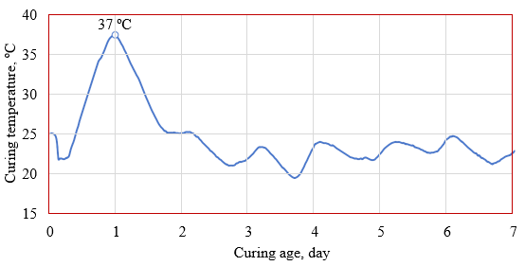

Figure 3.24 – Internal temperature monitoring results

The displayed graph (figure 3.23) shows the temperature trends of the curing concrete in both the raft foundation and the column. The findings indicate that the cement started setting around six hours post pouring the concrete mix into the structures. Following this, the curing temperature increased significantly, reaching a peak of 37ºC and remaining at this level for approximately three hours. The temperature then dropped sharply and began fluctuating within the range of 20 to 25ºC. These fluctuations can be attributed to the difference in ambient conditions between daytime and nighttime, as shown in figure 3.24 below. The impact of environmental factors on the curing process of concrete is a critical consideration in concrete construction, as it can significantly affect the strength and quality of the final product. The temperature fluctuations observed in this study underscore the importance of carefully monitoring the curing process to ensure optimal curing conditions and maximize the strength potential of the concrete.
The graphs showing the ambient temperature and relative humidity over a week reveal a noticeable connection with the curing concrete's temperature trend. The overall direction of the ambient temperature and humidity mirrors the curing temperature's trend. It's evident that as the ambient temperature goes up, the relative humidity decreases, and vice versa. During monitoring, outdoor temperatures varied between 10 to 25 ºC, and humidity levels fluctuated from 29 to 100%.

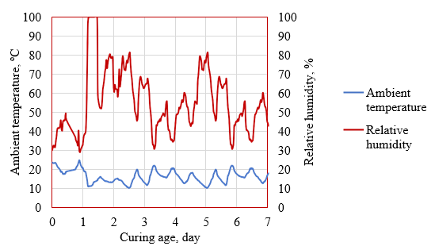

Figure 3.25 – Ambient conditions monitoring results

Figure 3.25 displays the compression test outcomes for cubic samples. These figures denote the mean compressive strength of two samples for every curing day. The compression test is an essential aspect of concrete construction, as it provides valuable insights into the strength and quality of the final product. These results can inform the development of more efficient and effective concrete construction practices and ensure that the final product meets the necessary quality and safety standards.

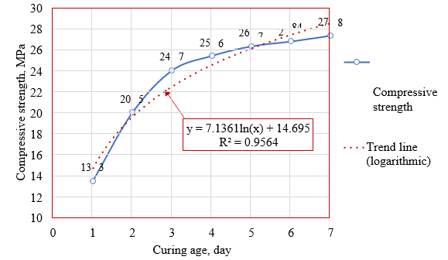

Figure 3.26 – Compression test results

The displayed graph emphasizes that in seven days, the concrete achieved a compressive strength surpassing 27 MPa, over 70% of the expected strength for M350 grade concrete. The rapid strength increases in the initial three days outpaced the subsequent days. For correlation analysis, hourly strength values were required. Thus, the trend line and strength function were derived from the available values for each day. This research employed a logarithmic function to portray the concrete strength gain trend, having the highest determination coefficient (R²=0.9564). Correlation analysis between all factors and compressive strength was performed using equation (4.1), as detailed in table 3.3. These results shed light on determinants of concrete strength growth, aiding the evolution of more optimized concrete building methods.

Table 3.3 – The similarity between two signals or time series data sets

Parameters | Compressive strength | Curing temperature | Ambient temperature | Relative Humidity
Compressive strength |  | -0.4654 | -0.2861 | 0.0464
Internal temperature | -0.4652 |  | 0.1152 | 0.1053
Ambient temperature | -0.2863 | 0.1152 |  | -0.8723
Relative Humidity | 0.0460 | 0.1051 | -0.8721
Degrees of influence on strength gain: |  | 58% | 36% | 6%

The color-coded cross-correlation analysis offers a distinct view of notable and minor correlations between the examined parameters. The green cells underscore a robust positive relationship between compressive strength and curing temperature, then ambient temperature, and relative humidity. This interrelation aligns with expectations, as curing releases heat, and elevated temperatures boost strength development. Additionally, the strong link between ambient temperature and relative humidity supports the previously discussed trend.
The table's final row, highlighted in blue, provides estimates on how much each factor influences concrete strength development. These estimates were determined by weighing the magnitude of each correlation coefficient. The data shows that curing temperature was the most influential on strength gain. Ambient temperature came next, representing 36% of the influence in this research. Conversely, relative humidity had a minimal impact on the strength development process.
The findings of this study provide valuable insights into the strength gain process of concrete structures and can inform the development of more efficient and effective monitoring and control strategies. The cross-correlation technique used in this study is easier to understand compared to previous studies, and the proposed estimations can be integrated into computer or mobile software for monitoring purposes. This approach offers a non-volatile and straightforward method for accurately monitoring and controlling the strength gain process of concrete structures, which is critical for ensuring the durability and long-term performance of the final product.
Based on the ASTM formula derived from equation (3.1), the strength gain of cylindrical concrete specimens can be graphed over time, which provides valuable insights into the curing process. Figure 3.26 depicts the strength gain vs. time of concrete curing (age of concrete) and showcases the progression of strength gain over time. This graph is a critical tool for monitoring and controlling the curing process of concrete structures, enabling engineers and contractors to make informed decisions regarding the safety and durability of these structures. The strength gain vs. time graph is derived from laboratory testing of cylindrical concrete specimens subjected to compressive loading and provides a reliable and accurate measure of the strength characteristics of concrete structures. Overall, the strength gain vs. time graph is an essential tool in the construction industry, providing critical information for ensuring the safety and longevity of concrete structures.

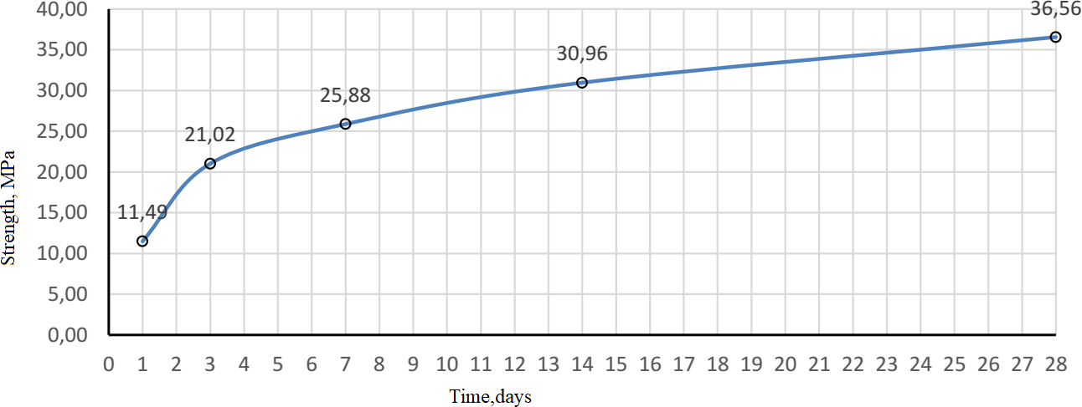

Figure 3.27 – Concrete strength gain graph

The strength gain in concrete structures typically follows a classical pattern, showing a steady and consistent increase in strength without sharp fluctuations. In this study, the partial strength values also display a smooth and uniform trend.
To delve deeper into the concrete's strength characteristics, the concept of indirect strength characteristics was employed. The resulting graduation relationship, illustrated in figure 3.27, depicts the connection between the indirect strength characteristic and the concrete specimen's compressive strength. This analytical relationship takes the form of a linear function, with a coefficient of determination of 0.9234, signifying a high level of reliability in this graduation relationship.
The graduation relationship offers valuable insights into the strength characteristics of concrete structures, empowering engineers and contractors to make informed decisions regarding the safety and durability of these structures. The linear function serves as a tool for indirectly estimating the compressive strength of concrete specimens, facilitating the monitoring and control of concrete structure strength characteristics.

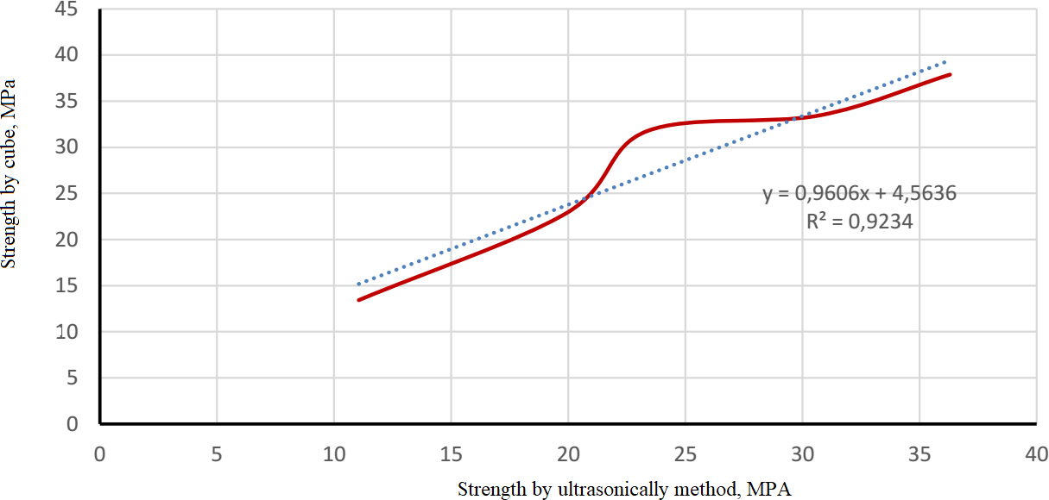

Figure 3.28 – Graduation relation

The study team further developed a correlation between temperature-driven strength monitoring methods using a comparable calculation method. The resulting chart, shown in figure 3.28, can be juxtaposed with the conventional graph detailing concrete strength progression based on the suggested optimal timeframe for strength maturity. Ideally, when the temperature is at 30°C, the standard strength increase should happen within 11 days, exceeding the targeted strength and attaining nearly 97% of the expected strength.

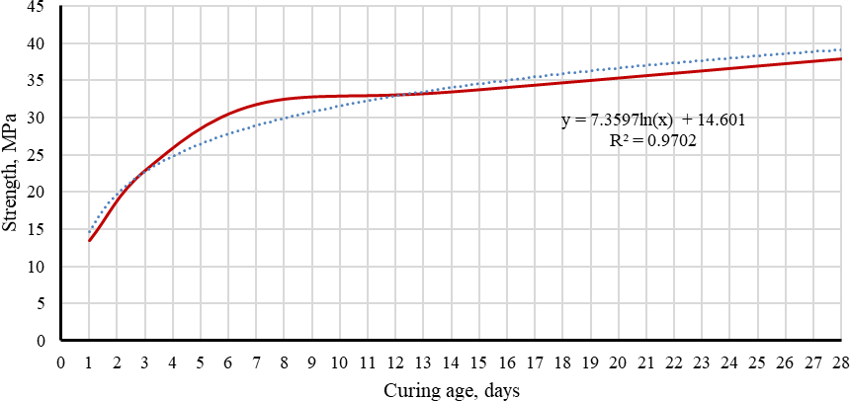

Figure 3.29 – Strength gain chart by maturity method

The logarithmic function was found to provide a more accurate description of the resulting trend line compared to other functions, with a coefficient of determination close to 1, signifying a high degree of reliability in this graduation relationship. This graduation relationship offers valuable insights into the connection between temperature and concrete strength gain, empowering engineers and contractors to make informed decisions about the optimal temperature and duration conditions for concrete curing.
The findings of the study support the importance and practicality of utilizing temperature-strength control in monitoring concrete strength gain. The results provide valuable insights into the relationship between temperature and concrete strength gain, which can assist engineers and contractors in optimizing the concrete curing process to achieve desired strength levels. Overall, this study highlights the significance of temperature-strength control as an effective tool for ensuring the quality and durability of concrete structures.
The outcomes of evaluating cylindrical concrete samples are depicted in figure 3.29, wherein the curing temperature of two cylinders was monitored over a 28-day period. At the conclusion of the measurements, the ambient temperature registered approximately 8°C.

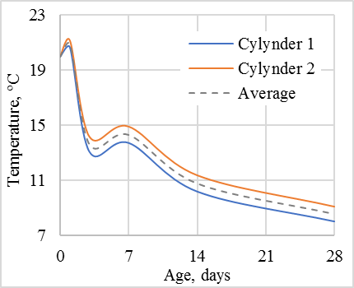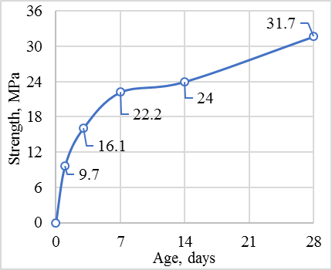
a b
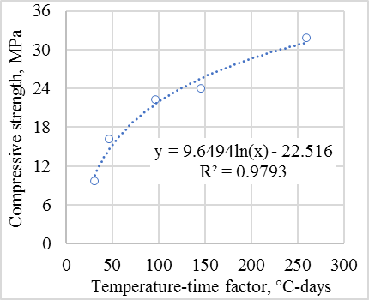
с

a – curing temperature profile; b – strength plot of cylindrical specimens; c – maturity-strength association

Figure 3.30 – Examination outcomes for compact samples
As depicted in figure 3.29a, the maximum curing temperature reaches 21°C in the first 3 days, then there's a noticeable drop, with a slight rise in temperature on the seventh day. By the 28th day, the curing temperature coincided with the ambient temperature, roughly 8°C.
Figure 3.29b presents a graph illustrating the strength augmentation in the cylinders. Consequently, a pronounced strength enhancement is discernible during the first 3 days, succeeded by a more gradual increase.
The maturity indices, ascertained in accordance with Equation 3.4 for days 1, 3, 7, 14, and 28, equated to 30.88, 47.24, 97.29, 145.53, and 260°C-days, respectively. Overlaying and graphing these values concurrently with the strength values for the corresponding curing days yielded the maturity-strength correlation portrayed in figure 3.29c. The derived dependency exhibits a considerably high coefficient of determination, 0.9793, signifying its potential applicability in determining the strength of actual structures, such as the large cubic samples employed in the present study, comprised of the same concrete composition.

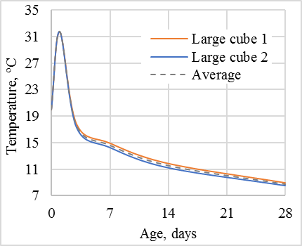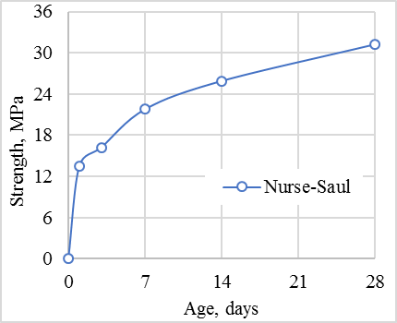
a b
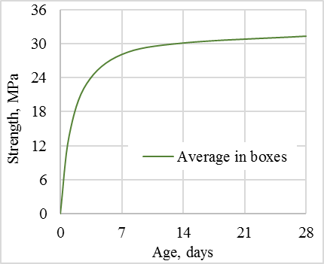
c

a – curing temperature profile; b – Nurse-Saul strength plot; c – Shock-pulse strength graph

Figure 3.31 – Examination outcomes for substantial samples

The examination outcomes for sizable samples are depicted in figure 3.30. The mean values of curing temperature, as illustrated in figure 3.30a, were employed to compute the in-situ maturity indices. These indices were subsequently utilized to estimate the strength values via the previously derived maturity-strength correlation (figure 3.30c), ultimately resulting in the Nurse-Saul strength plot (figure 3.30b). figure 3.30c presents the Shock-pulse strength graph.
Unlike the curing pattern of cylindrical samples, the larger specimens showed a sharper initial temperature rise, peaking at 32°C in the first 2 days and then slowly dropping to 8°C. This variation is due to the considerable size difference between the large and small specimens. Concrete maturity values for the larger specimens were computed at specific intervals: 1, 3, 7, 14, and 28 days. These values informed the strength values for the respective days, leading to the creation of the strength enhancement chart (refer to figure 3.30b).
The results of the Shock-pulse method for large specimen tests (Figure 3.30, c) showed a significant increase in concrete strength during the initial 7 days, followed by gradual stabilization. To compare these indirect method results with direct control methods, compression tests were conducted on small cubic specimens using a hydraulic press (figure 3.31).

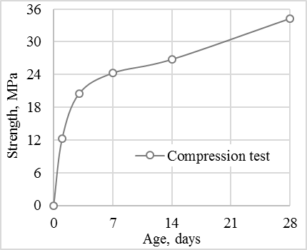

Figure 3.32 – Test results of small cubic specimens

The strength growth trend for the small cubic samples closely mirrors that determined by the maturity method. Yet, the strength at the 28-day point is significantly higher. In order to facilitate a visual comparison of the outcomes derived from indirect methods, such as the maturity method (Nurse-Saul, abbreviated as N-S) and the shock pulse method (S-P), as well as the direct method involving compression tests on cubic specimens (C), the respective strength gain curves were amalgamated into a singular graph. Consequently, the corresponding relationships between these methods were determined (figures 3.32, 3.33). This comprehensive illustration enables a more effective analysis of the correlations and discrepancies among the various methodologies employed in assessing the strength properties of the specimens.

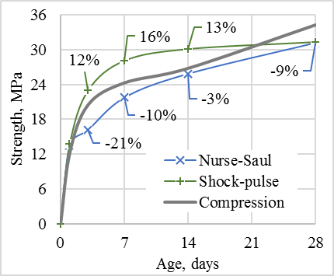

Figure 3.33 – Strength gain graphs

The above charts show that the strength results from the shock pulse method (S-P) are, on average, 13.5% higher than those from the compression tests on cubic samples (C). On the other hand, the Nurse-Saul maturity method (N-S) produces strength values about 11% less than the direct compression method (C). This discrepancy in results between the different methodologies highlights the importance of understanding the inherent variations and potential biases associated with each technique. By considering these distinctions, researchers and practitioners can more effectively select the most appropriate method for their specific objectives, ensuring accurate and reliable measurements of concrete strength properties in diverse applications.

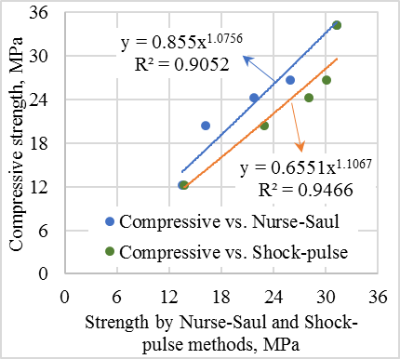

Figure 3.34 – Comparative examination of outcomes

Summary of chapter three
The chapter provides a comprehensive analysis of concrete strength gains, curing temperature monitoring, and the development of wireless communication systems for construction project management. It begins by comparing strength gains measured using the shock pulse method for two large samples, noting minimal variation between them. The study emphasizes the importance of monitoring curing temperature, showing a significant temperature increase when the environment shifts to an urban setting, highlighting the role of ambient conditions on concrete curing.
Key numerical results include:
Temperature fluctuations around 20±1°C for the first 11 days.
Temperature increase to 29°C with 2-3°C variations in an urban environment.
Data arrival interval deviations: average of 33 minutes 20±10 seconds; occasional deviations of over 1 hour.
Data arrival intervals: 93.9% on time, 4.7% more than 0.5 hours late, 0.6% delayed by 1 hour, 0.2% delayed by 2 hours, 0.3% delayed by 2.5 hours.
Signal strength: maximum distance of 270 meters in unobstructed conditions, limited to 90 meters with obstacles; reliable connections within 30-60 meters.
Concrete strength gains at various curing temperatures (in MPa) for 1, 3, 7, 14, and 28 days:
1 day: 12.71, 12.30, 12.54, 12.862, 12.9, 13.26, 13.36
3 days: 17.53, 20.44, 22.15, 22.26, 22.8, 23.51, 23.22
7 days: 23.2, 24.22, 24.3, 24.86, 24.2, 24.2, 24.24
14 days: 31.54, 26.74, 25.1, 24.5, 26.01, 26.86, 28.12
28 days: 34.7, 34.03, 34.01, 33.96, 33.9, 33.08, 33.1
Coefficient of determination (R2) for the logarithmic function: 0.9564.
Correlation coefficients between compressive strength, curing temperature, ambient temperature, and relative humidity: -0.4654, -0.2861, 0.0464; internal temperature: -0.4652, 0.1152, 0.1053; ambient temperature: -0.2863, -0.8723; relative humidity: 0.0460, -0.8721.
Degrees of influence on strength gain: curing temperature 58%, ambient temperature 36%, relative humidity 6%.
Curing concrete temperature peak: 37ºC.
Ambient conditions during monitoring: temperatures varied between 10 to 25 ºC, humidity levels fluctuated from 29 to 100%.
Concrete achieved compressive strength over 70% of the expected strength for M350 grade concrete in 7 days.
Maturity indices for days 1, 3, 7, 14, and 28: 30.88, 47.24, 97.29, 145.53, 260°C-days.
Coefficient of determination for the maturity-strength correlation: 0.9793.
Maximum curing temperature reaches 21°C in the first 3 days.
The difference in strength results between the shock pulse method and compression tests: 13.5% higher for the shock pulse method; 11% less for the Nurse-Saul maturity method compared to the direct compression method.
These numerical results encompass temperature readings, strength gains under different conditions, deviations in data transmission intervals, and correlations between various parameters related to concrete curing and strength development.

4 INVESTIGATING THE RELATIONSHIP BETWEEN INTERNAL AND EXTERNAL FACTORS AFFECTING THE CONCRETE STRENGTH GAIN

Grasping the effects of both internal and external elements on concrete's strength gain is essential for construction experts and researchers. Aspects such as temperature, moisture, and curing duration can affect concrete's resilience, prompting the demand for refined mix strategies and building methods to ensure safety.
One approach to studying this relationship is through maturity testing, which involves monitoring concrete's internal temperature over time and calculating maturity based on specific parameters. This data helps predict concrete strength and durability at different stages, aiding in the effective planning and maintenance of structures.
External factors like ambient temperature and humidity, which can affect concrete behavior significantly were monitored. Analyzing data from these sensors provides insights into the intricate interplay between internal and external factors impacting concrete strength gain, informing better mix designs and construction methods.
Overall, understanding the interplay of internal and external factors in concrete strength gain is pivotal for ensuring construction project safety and reliability, while also driving innovation and improvement in the industry.

4.1 Maturity Method for Concrete Strength Estimation: Factoring in Curing and Ambient Temperatures with Humidity
The suggested approach is derived from [139], using the Nurse-Saul maturity method to assess concrete strength. Previously, this method primarily considered temperature accumulation over time equation (4.1).

$$M\left(t\right)=\sum{(T_{a}-T_{0})∆t}$$ | (4.1)

where $M\left(t\right)$ - the temperature-time factor at age t, degree-days or degree-hours;
$∆t$ - a time interval, days or hours;
$T_{a}$ - average concrete temperature during time interval $∆t$, °C;
$T_{0}$ - datum temperature, °C.
The Nurse-Saul method for assessing concrete maturity has been enhanced by incorporating ambient temperature and humidity. This refinement makes it more representative of actual concrete conditions [139].
The updated formula considers internal temperature, ambient temperature, and relative humidity but overlooks gaseous internal humidity. Due to equilibrium, concrete pores usually remain saturated, adjusting through evaporation or condensation with temperature or pressure changes. Although this adds intricacy to maturity computations, it's essential for precise evaluations of strength and durability [140]. Essentially, this holistic method enhances predictions of concrete's durability, bolstering the safety of structures.
$$M_{c}=\sum{M_{i}}{\overline{γ}}_{i}$$ | (4.2)
where i – parameters affecting the concrete strength gain;
$M_{i}$ – maturity of i parameter that is calculated by analogy with equation (1);
${\overline{γ}}_{i}$ – average weight of i parameter for 28 days of curing that is calculated by equation (4.3).

$${\overline{γ}}_{i}=\frac{1}{28}\sum_{t=1}^{28}{γ_{i,t}}$$ | (4.3)

Here the particular value of the weight of i parameter at the age of t ($γ_{i,t}$) is calculated by equation (4.4) below.

$$γ_{i,t}=\frac{\left|r_{i,t}\right|}{\sum{\left|r_{i,t}\right|}}$$ | (4.4)

where $r_{i,t}$ – is a correlation coefficient between the i parameter and the strength of the concrete at curing age of t.
It should be noted that the sum of weights is always equal to 1 equation (4.5).

$$\sum{γ_{i,t}}=\sum{{\overline{γ}}_{i}}=1$$ | (4.5)

To accurately assess the strength of a specific concrete mix, a 28-day monitoring period is required, involving tracking internal and ambient temperature along with relative humidity. Compressive strength (CS) measurements are taken at each time point within this period. This process allows for the calculation of maturity for each factor influencing concrete strength and the creation of a trend line illustrating the intricate relationship between maturity and strength (table 4.1).
Using the logarithmic strength gain curve, correlation coefficients and parameter weights are calculated from hourly and daily strength estimates. The mean weight over 28 days is then used in equation (4.3) for overall concrete maturity. This relationship, factoring in internal and ambient temperatures and humidity, predicts the current concrete strength. Monitoring these parameters enables engineers and researchers to evaluate the concrete's long-term durability and make necessary adjustments to ensure it meets strength and safety standards.
To test the proposed idea, a B25, M350 grade concrete batch was sourced from a plant. From this, 17 cylindrical samples, 15 cubes, and 2 large boxes mimicking real structures were crafted. All were consistently exposed to the same temperature and humidity during the study.

Table 4.1 – A lab log template for mapping the link between maturity and strength for a particular concrete mix

Age, hours | i parameters |  |  | Compressive strength, MPa | Age, days | Maturity of i parameter |  |  | Correlation coefficients between i parameters and compressive strength |  |  | Weights of maturity of i parameters |  |  | Complex maturity, °C·days | Compressive strength, MPa
t | IT | AT | ARH | СS | t | M_{IT} | M_{AT} | M_{ARH} | |r_{IT}| | |r_{AT}| | |r_{ARH}| |  |  |  | M_{c} | CS
0.5 | … | … | … | … | 1 | … | … | … | … | … | … | … | … | … | … | …
1 | … | … | … | … | 2 | … | … | … | … | … | … | … | … | … | … | …
1.5 | … | … | … | … | 3 | … | … | … | … | … | … | … | … | … | … | …
… | … | … | … | … | … | … | … | … | … | … | … | … | … | … | … | …
672 | … | … | … | … | 28 | … | … | … | … | … | … | … | … | … | … | …
Mean value

Compression tests were conducted on the 1st, 3rd, 7th, 14th, and 28th days, with batches of three cylindrical and three cubic samples tested at a time. Additionally, temperature sensors were placed in the middle of two cylindrical samples and two boxes, with data collected every 30 minutes for 28 days (see figure 4.1).

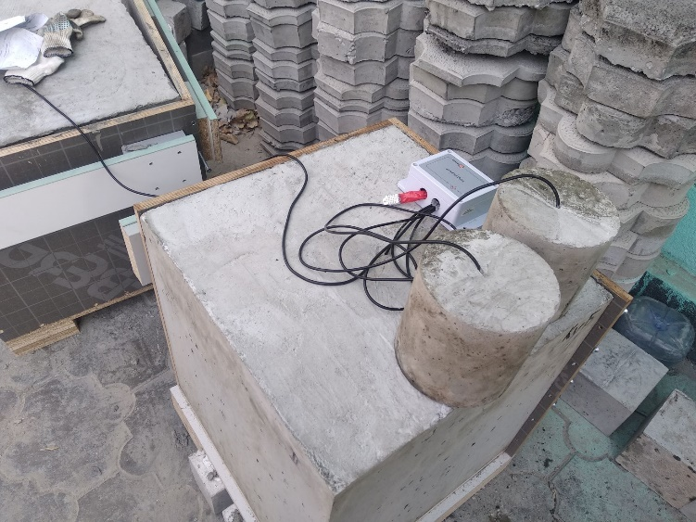

Figure 4.1 – Testing set for estimating the concrete strength

These experiments and data collection provide valuable insights into concrete behavior under different conditions and assess the proposed concept's accuracy. This information can guide the refinement and optimization of concrete mix designs for future construction projects.
Furthermore, aside from monitoring internal concrete temperature, two additional sensors simultaneously recorded ambient temperature and relative humidity. This approach offers a comprehensive understanding of concrete behavior under diverse environmental conditions. Analyzing these data alongside internal temperature measurements aids in assessing overall concrete strength and durability over time. Such insights are critical for ensuring the safety and reliability of structures like buildings and bridges and for optimizing concrete mix designs in future construction endeavors [141].
Concrete sample strength was tested using established methods [139] аor cylindrical and [142] for cubic samples. Tests were conducted on days 1, 3, 7, 14, and 28 after sample preparation to gauge average compressive strength over time (figure 4.2).

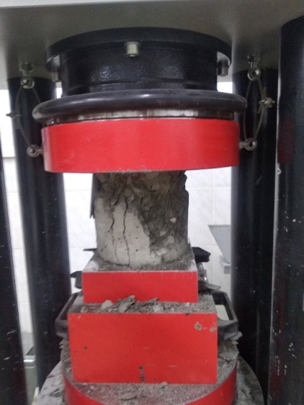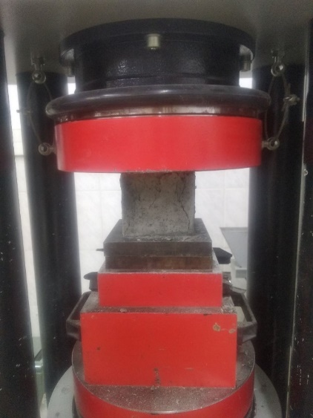
a b

Figure 4.2 – Cylindrical and cubic sample compression tests
on days 1, 3, 7, 14, and 28

To establish the relationship between concrete maturity and compressive strength, trend lines using the most appropriate equations to fit the data were drawn. This was done by plotting the compressive strength of the cylindrical concrete samples against the maturity calculated using the Nurse-Saul method's equation (4.1) and the proposed method's Equations (4.3)-(4.5). The resulting trend line was found to follow a logarithmic dependence, which can be expressed using the equation S=a·ln(M)+b (figure 4.3).

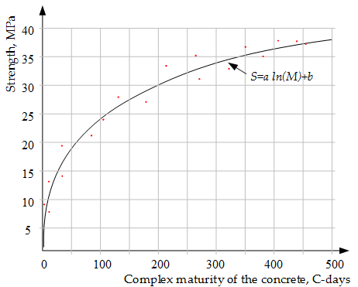

Figure 4.3 – Connection between concrete's maturity and its strength

Using recorded data from two simulated site structures (boxes), complex maturities were calculated based on specific equations. The trend line in figure 4.3 helped estimate the current strength of the concrete and the time needed to reach 70% of the desired strength, vital for construction scheduling.
Using the IPS-MG 4.01 sclerometer (figure 4.4), actual concrete strengths within the boxes were gauged and compared to estimated values. The device, featuring nonvolatile memory and computer data transfer capabilities, evaluates concrete strength from shock impulse parameters, determining hardness, elasticity, and related strength values [143].

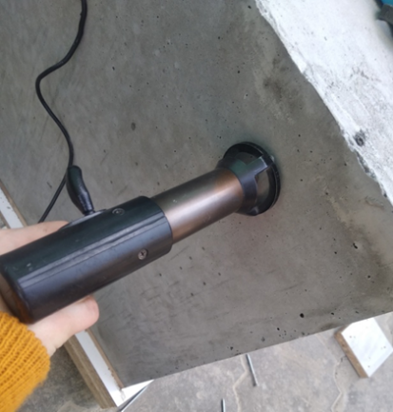

Figure 4.4 – IPS-MG 4.01 sclerometer in-situ test

Figure 4.5 presents the results of testing cylindrical concrete specimens using the maturity method. This data offers crucial insights into the concrete's compressive strength gain over time, enabling the estimation of concrete maturity and prediction of its strength development. Through the analysis of these trends, engineers and contractors can make well-informed choices regarding the ideal curing duration and conditions necessary for the concrete to attain the desired strength and durability.

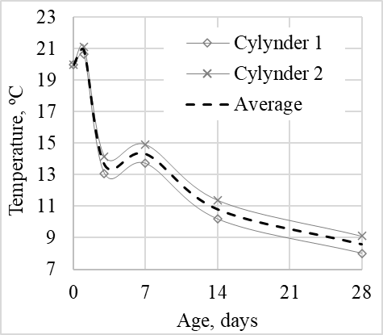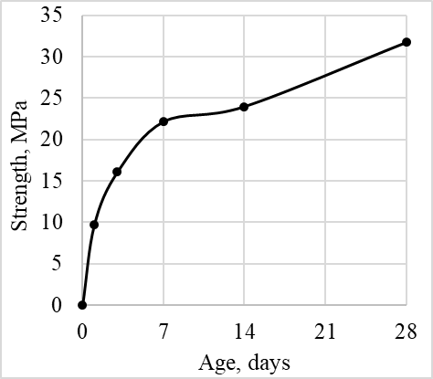

a b

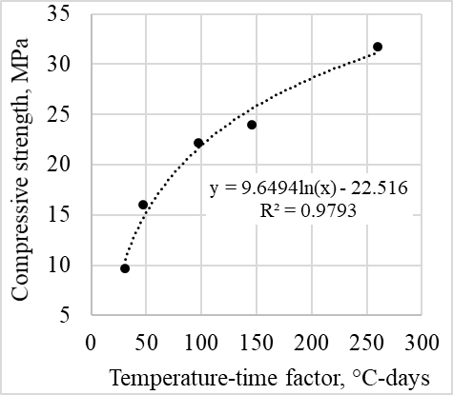

c

a – curing temperature trends; b – diagram showing concrete strength development; c – correlation between strength and maturity

Figure 4.5 – Test outcomes for cylindrical concrete samples include

The Nurse-Saul method tracked the temperature of two cylindrical concrete samples over 28 days. Figure 4.6, a shows the curing temperature, peaking at 21°C in the initial 3 days, then quickly dropping with a minor increase on day 7, and finally settling around 8°C by day 28. Figure 4.6b depicts the strength development, displaying a sharp growth in the first 3 days and then a slower ascent. Using the curing temperature history and Equation 4.1, maturity values were derived for days 1, 3, 7, 14, and 28. When these were plotted against the corresponding strength values, figure 4.6, c shows the strength-maturity correlation. With a high coefficient of determination (0.9793), this relationship confirms its reliability for predicting the strength of similar concrete structures. Additional results for the larger samples are showcased in figure 4.4.

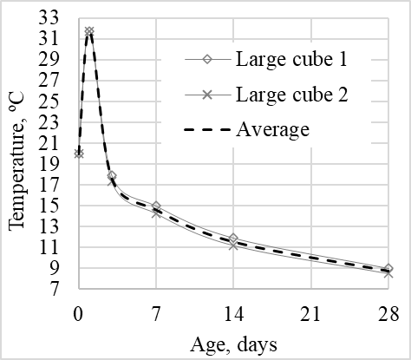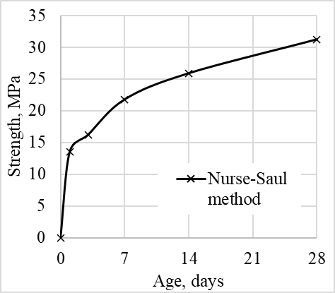

a b

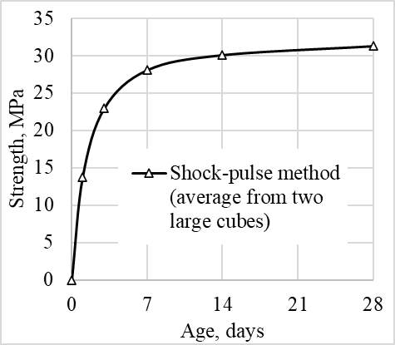

c

a – curing temperature patterns; b – strength development according to the Nurse-Saul method; c – strength increase based on the shock-pulse method

Figure 4.6 – Test outcomes for large cubic concrete samples show

The study utilized the Nurse-Saul method to monitor temperature and strength gain in both cylindrical and large cubic concrete specimens over a 28-day period. Curing temperatures for cylindrical specimens peaked at 21°C in the initial 3 days, then sharply declined with a slight uptick on the 7th day. Strength gain in cylinders exhibited a rapid increase in the first 3 days, followed by a more gradual rise. Equation (4.1), combined with obtained maturity values, yielded a strength-maturity relationship with a high coefficient of determination of 0.9793. In contrast, the curing temperatures of large cubic specimens had a more intense initial increase, reaching 32°C on the first day, then gradually decreasing to 8°C. Large specimen strength showed an intensive increase in the initial 7 days, followed by stabilization. Results were compared to direct testing using small cubic specimens in a hydraulic press, showing a similar strength gain trend. These findings highlight the effectiveness and relevance of the Nurse-Saul method for monitoring concrete temperature and strength gain compared with shock-pulse method and compression test (figure 4.7).

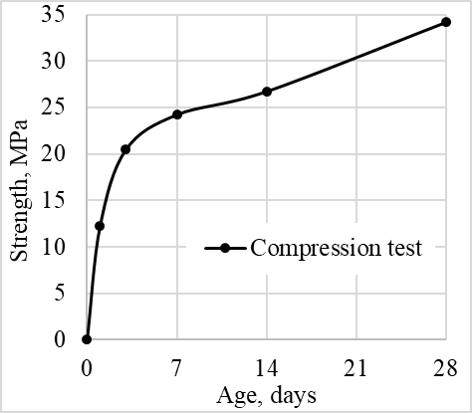

Figure 4.7 – Results of tests of small cubic specimens by compression

4.2 Advanced method for predicting concrete strength using curing temperature, surrounding temperature, and moisture levels
The proposed method for assessing the intricate connection between maturity and strength offers superior accuracy compared to existing approaches.
This method predicts early concrete strength, considering elements like ambient temperature and humidity, offering a deeper insight into concrete's long-term behavior. Plus, it accurately measures concrete strength during curing at construction sites, assuming pre-installed temperature sensors This data helps optimize curing, reducing wait times for concrete to achieve full strength, leading to enhanced efficiency and cost savings in construction.
Figure 4.8a illustrates data collected from internal temperature monitoring of concrete samples in vertical cylinder molds over 28 days. This data facilitates the establishment of a comprehensive maturity-strength relationship for concrete, enabling accurate predictions of strength and durability. Engineers and researchers can leverage this information to enhance concrete mix designs and construction practices for future projects, resulting in safer and more reliable structures.
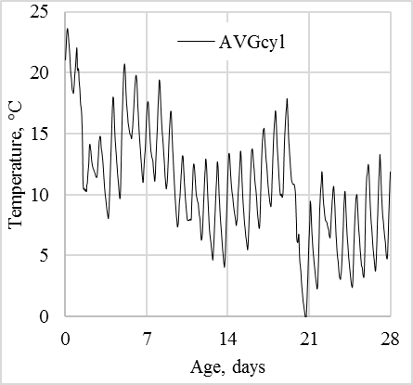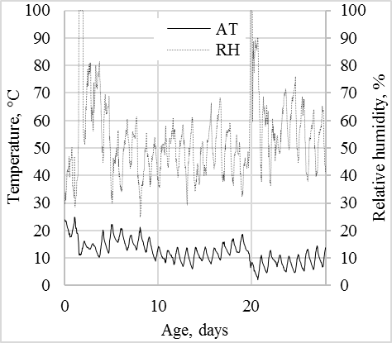
a | b

a – changes in internal temperature (average); b – external temperature and relative humidity

Figure 4.8 – Monitoring temperature and humidity in cylindrical concrete samples over time

The graph depicting daily temperature fluctuations during concrete curing displays a spiky pattern within a specific range, indicating the exothermic reaction occurring during this process. Ambient temperatures during curing ranged mainly from 3 to 25 °C, with fluctuations predominantly between 8-18°C. Ambient relative humidity generally remained in the 40-60% range, with two notable jumps over the 4-week curing period (figure 4.8b).
Cylindrical concrete samples showed a temporary strength gain slowdown after day seven, then continued to increase steadily. In comparison, the boxed concrete's strength plateaued, resulting in a mild upward curve. Figure 4.9a displays compression test results from days 1, 3, 7, 14, and 28. On non-testing days, strength was inferred from the trend in figure 4.9a. A natural logarithm was used for the best fit trend, resulting in a formula linking time and cylinder strength. Figure 4.9b demonstrates the standard strength-maturity correlation.
By analyzing these data sets and patterns, researchers and engineers can gain valuable insights into the behavior of concrete under various environmental conditions and optimize mix designs and construction processes for future projects accordingly. This information is crucial for ensuring the safety and reliability of buildings, bridges, and other structures, as well as for driving innovation and improvement in the construction industry.

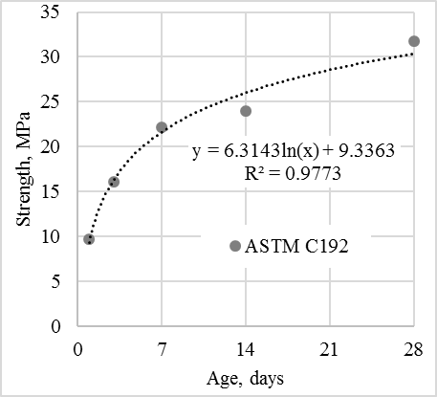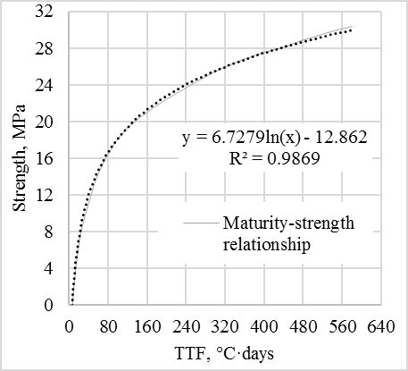
a | b

a – compressive strength; b – Maturity-strength relationship according to

Figure 4.9 – Concrete strength gained over time

Note - Compiled by the source [139]

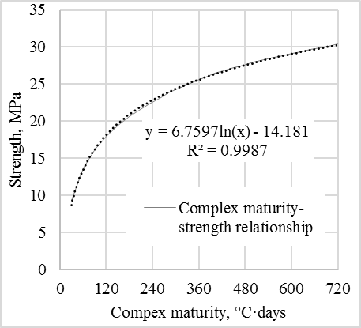

Figure 4.10 – The proposed method outlines a detailed relationship between maturity and strength

Figure 4.10 illustrates the correlation between the complex maturity values and the compressive strength of the concrete cylinders. The resulting trend line, based on natural logarithms, shows a strong match with an R² of 0.9987. This relationship is crucial for predicting concrete strength based on maturity for a specific mix. For example, for concrete class B25, a strength of 22.4 MPa (70% of the 28-day strength of 32.0 MPa) is the benchmark to progress with construction. While the temperature trends of both concrete boxes and cylindrical samples are similar due to the same testing environment, the larger box samples show steadier temperature patterns because of their greater heat capacity, as seen in figure 4.11. Analyzing temperature patterns in both the cylindrical samples and the concrete boxes provides valuable insights into concrete behavior under various environmental conditions, aiding in optimizing mix designs and construction processes for future projects.

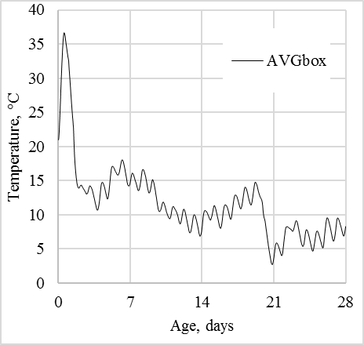

Figure 4.11 – Average value of internal temperature in the boxes

Utilizing maturity-strength relationships from figures 4.9 and 4.10, and temperature and ambient data from figures 4.8 and 4.11 the concrete boxes' strength was estimated using both Nurse-Saul and the proposed methods, based on average internal temperatures. Figure 4.12 displays the concrete strength from non-destructive tests using the IPS-MG 4.01 sclerometer. By comparing these with the estimated strengths, professionals can validate their calculations and deepen their grasp on factors influencing concrete strength. This information is crucial for optimizing mix designs and construction processes for future projects, ensuring the safety and reliability of structures, and driving innovation and improvement in the construction industry.

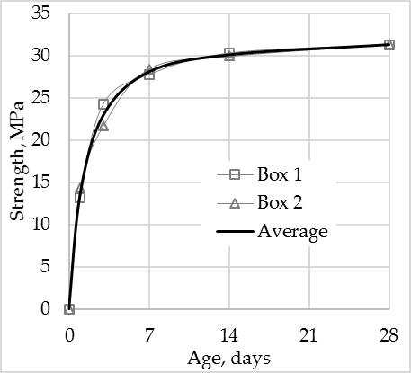

Figure 4.12 – Strength of concrete in boxes measured by IPS-MG 4.01 sclerometer

Table 4.2 – Results of strength tests determined by various methods

Age, day | Results of strength tests, MPa |  |  |  |  | Estimated strength, MPa
Age, day | ASTM C192 | GOST 10180 | GOST 22690 |  |  | ASTM C1074 | Proposed
Age, day | Cylinders (15x15 cm) | Cubes (10x10x10 cm) | Box 1 (50x 50x50 cm) | Box 2 (50x 50x50 cm) | Average in boxes | ASTM C1074 | Proposed
1 | 9.671 | 12.22 | 13.153 | 14.354 | 13.753 | 12.252 | 9.650
3 | 16.063 | 20.454 | 24.253 | 21.652 | 22.954 | 17.923 | 16.961
7 | 22.174 | 24.251 | 27.752 | 28.451 | 28.103 | 22.633 | 22.152
14 | 23.990 | 26.754 | 30.31 | 29.954 | 30.126 | 26.481 | 26.110
28 | 31.723 | 34.21 | 31.30 | 31.354 | 31.327 | 30.270 | 30.401

Table 4.2 provides a summary of strength testing results carried out at various intervals (1st, 3rd, 7th, 14th, and 28th days) during the concrete curing process. These tests were conducted using different methods to evaluate the concrete's strength under real construction site conditions. The primary measurement technique employed was the IPS-MG 4.01 sclerometer, and the results were also estimated using both the standard method and a proposed complex maturity method.
By comparing these diverse results, researchers and engineers gain valuable insights into concrete behavior under different conditions. This information facilitates the optimization of mix designs and construction processes. Such findings are indispensable for ensuring the safety and reliability of structures while advancing innovation and enhancement in the construction industry. Continuous refinement of these testing methods can contribute to safer, more efficient, and sustainable construction practices in the future.

4.3 Exploring the Impact of Initial Water pH on the Development of Concrete Strength
A study used B20 M250 grade concrete, composed of specific cement, stone, and sand ratios. The focus was on assessing concrete strength under three pH levels: acidic, neutral, and alkaline. Adjustments were made using additives in distilled water. Standard Portland cement and specific aggregates were employed, ensuring consistent proportions. After mixing, samples were set in metal formworks and observed for 28 days, adhering to GOST 22685-89 [144]. Cube-shaped samples were formed using 10 cm3 metal molds, as illustrated in figure 4.13.

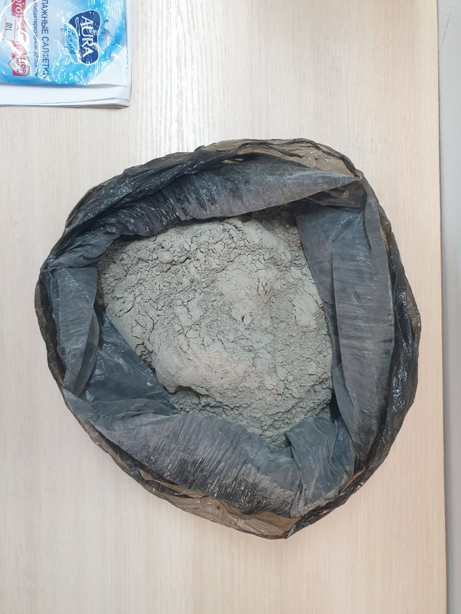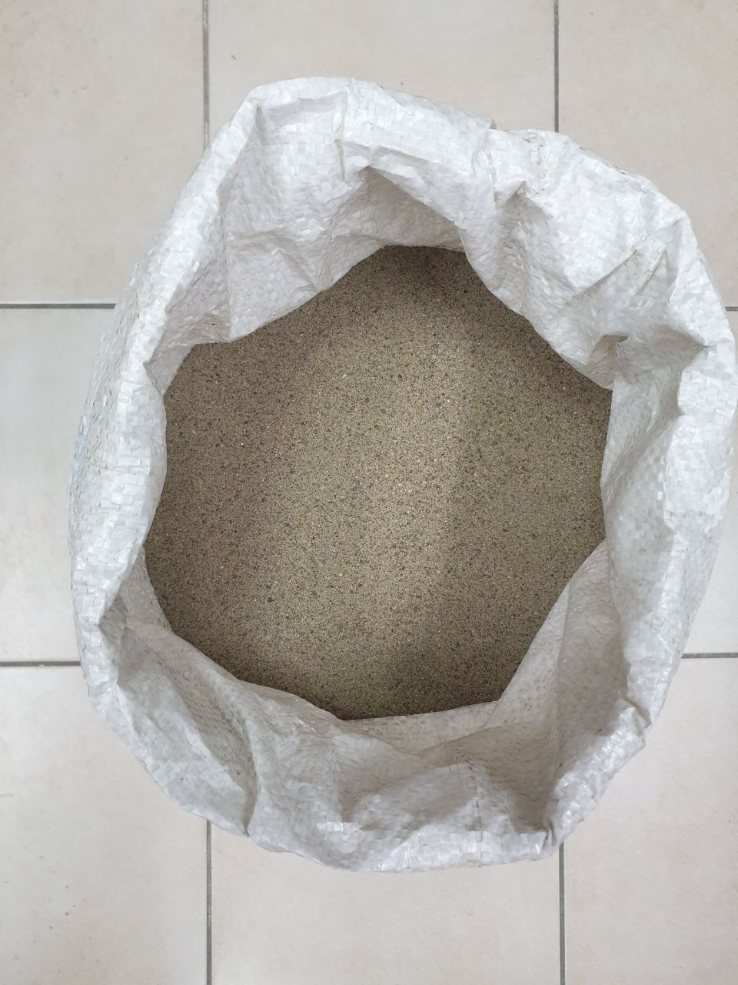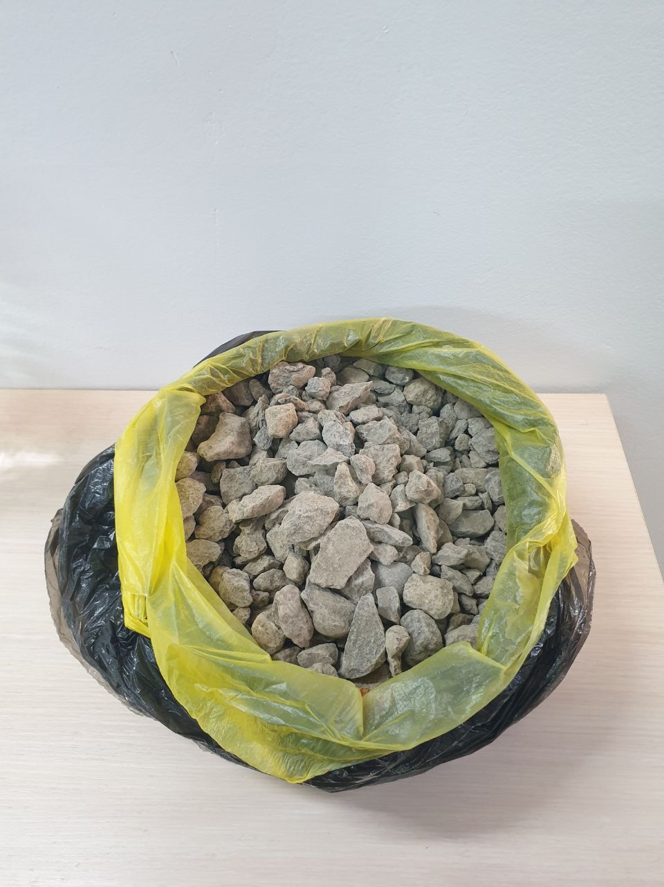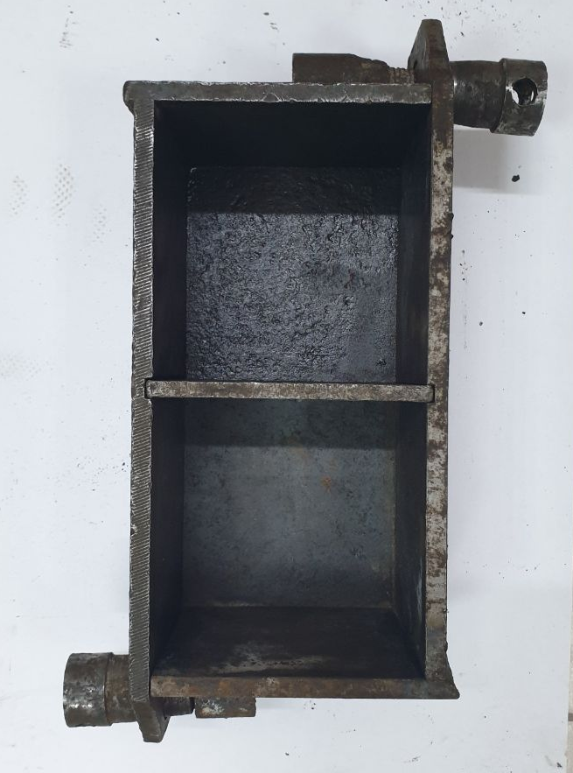
a b c d
a – Portland cement; b – sand; c – aggregates; d – metal formworks

Figure 4.13 – The study primarily used
Experiments were performed in a lab with a steady 20°C temperature. Using one computer, data from three pH sensors was simultaneously gathered (figure 4.14). The study comprised: Setting up tests and calibrating equipment; Making water with varied pH levels; Crafting three separate concrete mixes, each measuring 2×10-3 m^3, using specific equipment and materials; Shaping cubic specimens; Monitoring pH and temperature at half-hour intervals for 28 days; Daily concrete strength evaluations for each specimen using a nondestructive ultrasound test, averaging measurements from each cube side [145]; Calculating concrete strength using the Maturity method and averaging daily strength values [146]; Every 30 minutes, strengths were gauged using specific strength curves [145, р. 7578]; On day 28, concrete strength was measured for each specimen using a hydraulic press based on a designated destructive method [147].

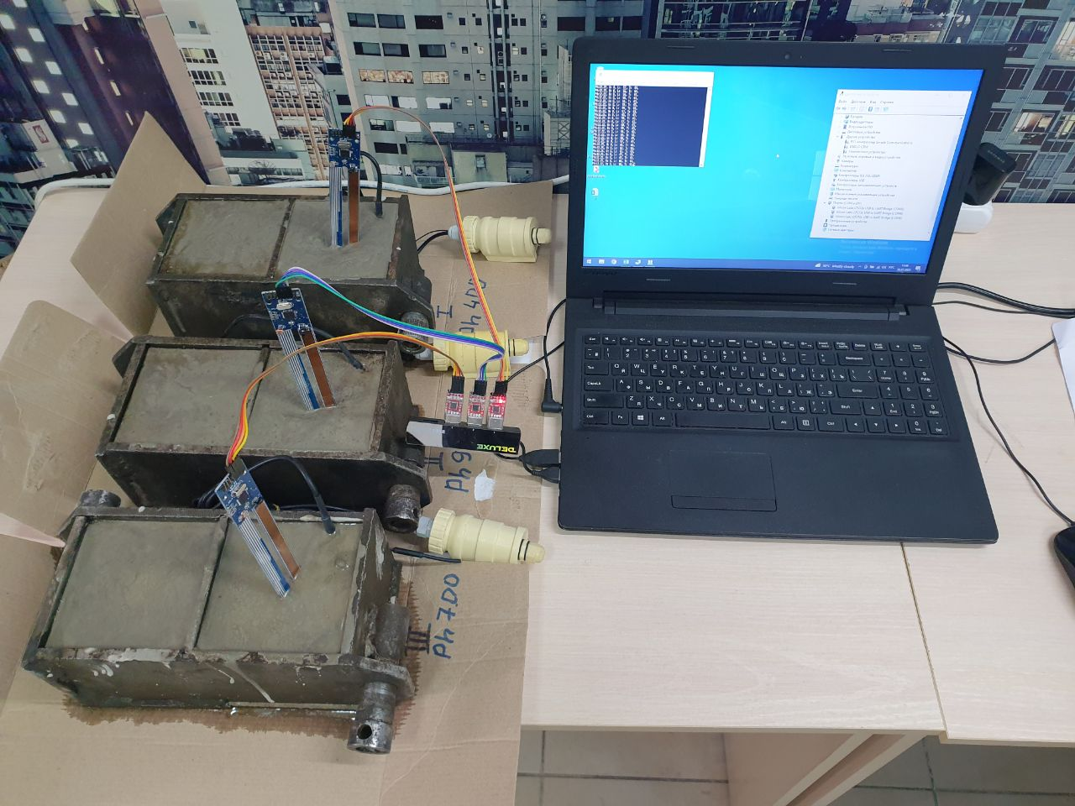  a | 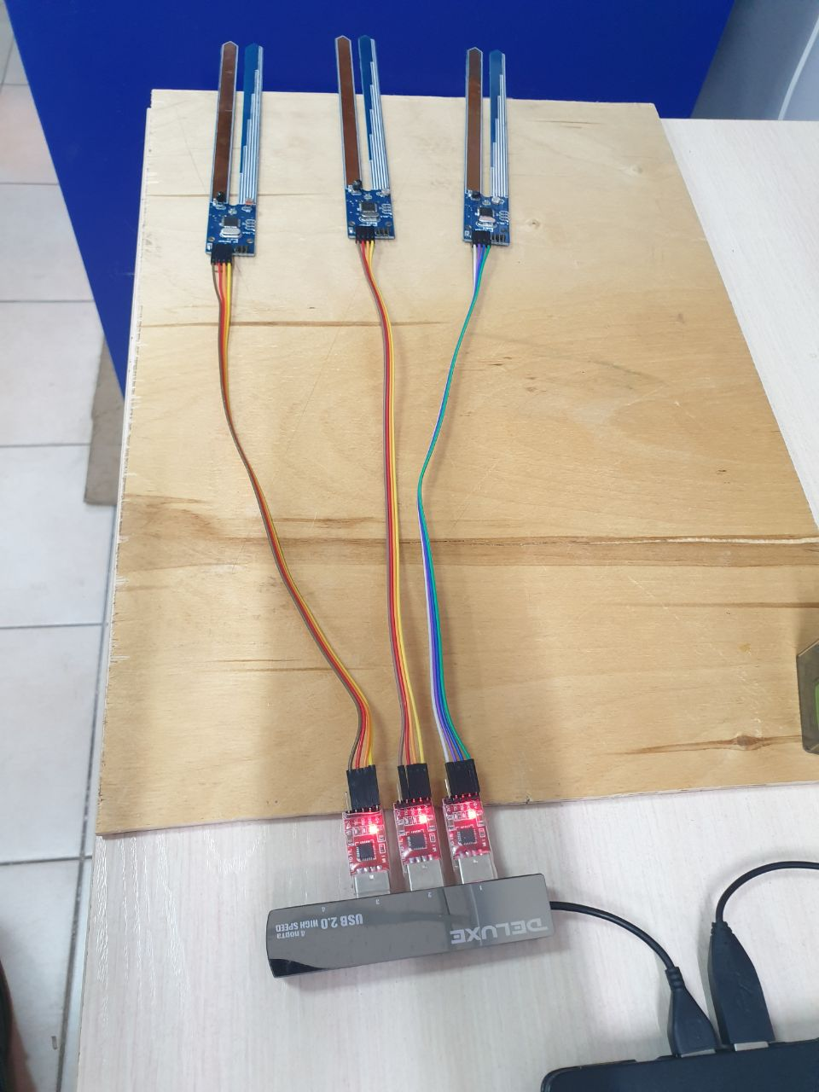  b

a general setup; b a closer look at the connections of the sensors

Figure 4.14 – Experimental setup

Correlation indices were pivotal for evaluating the parameters related to concrete strength gain. These indices showed the intensity of relationships between parameters, with high values suggesting strong links and low values suggesting weak ones. In this study, correlation strengths were grouped as "poor," "moderate," "strong," and "very strong" based on values from 0.3 to 1.
Box and whisker plots were used to assess data distributions of these parameters, highlighting data quartiles and showing distribution patterns through numerical skewness.
A one-factor ANOVA determined the statistical importance of variations in strength gain parameters. This involved comparing variation within parameter groups, with the p-values and a set alpha value (0.05) determining significance. Notably, the alpha value suggests the potential of mistakenly rejecting a true null hypothesis. If the p-value is greater than the alpha, the null hypothesis stands.
Moreover, this study employed Tukey's Honest Significance Test to spot statistically notable mean differences in the examined parameters, ensuring an overall controlled significance level.
The pH levels of the samples were continuously monitored using sensors after the mixing process to observe pH changes over time. Figure 4.15 visually illustrates these pH variations. Initially, there was a rapid increase in pH, followed by a gradual decline. It's important to note that concrete pH is typically high initially but tends to decrease over time due to interactions with substances having a pH lower than 7. These substances react with concrete alkalis, neutralizing its basic nature and causing a pH decrease. Fresh concrete can even rapidly react with acids, including atmospheric carbon dioxide, which counteracts the alkalis in the concrete.

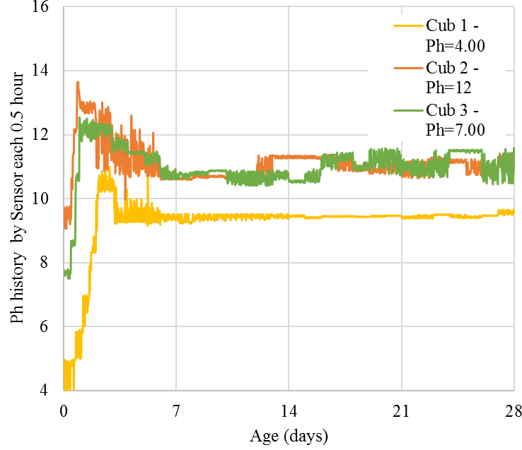

Figure 4.15 – Recorded pH data via sensor (30 min time interval)

The pH of concrete holds significant importance as it can have detrimental effects when it drops below a certain threshold, typically around 11. At this point, the chemical composition of the cement undergoes notable changes, leading to a weakened bond between the aggregate particles. Consequently, the concrete becomes susceptible to cracking. Initially, this damage is observed primarily on the outer layers of the concrete, resulting in flaking, chipping, or other forms of deterioration known as spalling [148]. However, as the surface of the concrete continues to deteriorate, deeper sections of the structure become more vulnerable to a process called carbonation. This occurs when the concrete's protective layer is compromised, allowing carbon dioxide to penetrate and react with the alkalis within the concrete. The effects of carbonation can be severe, potentially rendering the concrete beyond repair due to extensive damage. Emphasize that carbonation is a significant contributing factor to the deterioration of concrete structures, necessitating costly maintenance and conservation measures [149].
The temperature observed in the analyzed samples displayed a consistent pattern, characterized by an initial rapid rise followed by a gradual decline, as depicted in figure 4.16. This temperature trend is a consequence of the hydration reactions taking place within the cement, producing heat as the concrete undergoes early strength development. As the majority of the hydration process reaches completion, the concrete gradually cools down. It's worth emphasizing the significance of this initial cooling phase, as it renders the material susceptible to cracking. Even though the concrete's tensile strength is progressively increasing during this period, it remains relatively low. Moreover, due to internal constraints, internal tensile stresses within the concrete also intensify as it cools. If, at any point during this initial phase, the concrete's strength fails to surpass the generated tension, it is prone to cracking [150].

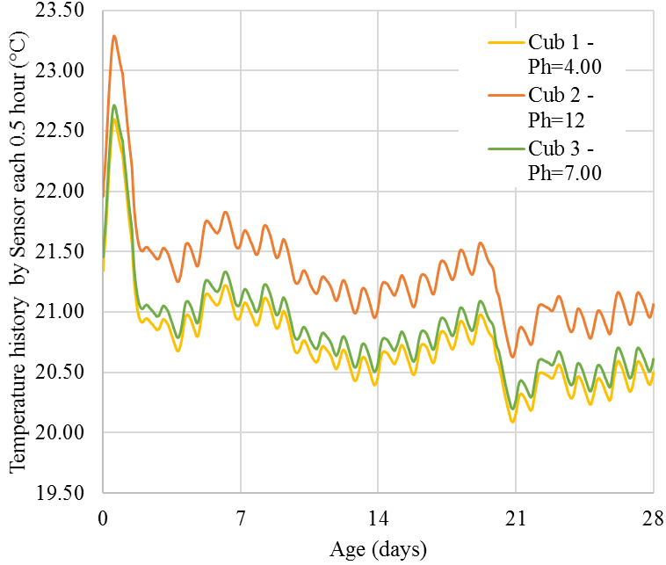

Figure 4.16 – Recorded Temperature data via sensor (30 min time interval)

Table 4.3 – Summary of the temperature data from the investigated pH values

Sample | pH | Min | Max | Median | Mean | STD
Cub 1 | 4.00 | 20.113 | 22.624 | 20.746 | 20.800 | 0.417
Cub 2 | 12 | 20.601 | 23.323 | 21.344 | 21.300 | 0.443
Cub 3 | 7.00 | 20.223 | 22.705 | 20.875 | 20.900 | 0.419

Table 4.3 delves into the temperature variations within the concrete samples, pinpointing that the highest temperatures were prevalent under alkaline conditions. In acidic environments, temperatures spanned between 20.1°C and 22.6°C, while under alkaline circumstances, they ranged from 20.6°C to a high of 23.3°C. In neutral settings, the temperatures were between 20.2°C and 22.7°C. Analyzing this data suggests that the concrete's thermal behavior is notably influenced by the pH level, with alkaline conditions inducing the highest temperature changes, potentially affecting the concrete's performance or curing process.

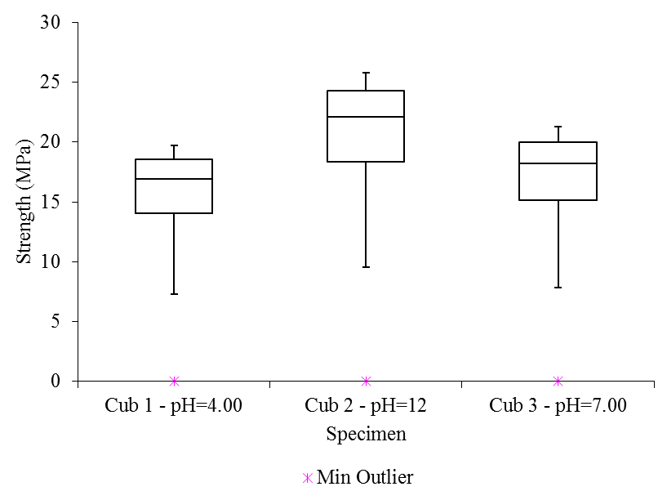

Figure 4.17 – Strength gain data distribution

Box and whisker plots in figure 4.17 were employed to visualize the data spread of strength gains across various pH levels. The plots displayed a leftward skew, with the median leaning towards the upper quartile (Q3). This implies that a majority of the concrete samples' strength data leaned towards the lower strength gain values. Moreover, the figure underscores that the samples achieved their peak strength gain under alkaline conditions at a pH of 12. Analyzing this information, it's evident that alkaline settings, specifically with a pH of 12, fostered optimal strength development in the concrete samples studied.
In figure 4.18, the data from strength gain sensors, collected at 0.5-hour intervals, illustrates substantial improvements in concrete strength during the initial 7 days of the curing process. Notably, the most rapid increase occurred within the first 3 days. Literature references [151, 152] suggest that concrete typically achieves strength gains of over 15% in a single day, approximately 40% within three days, 65% within seven days, 90% within fourteen days, and 99% within twenty-eight days. Consequently, the first two weeks following casting witness a remarkable surge in concrete strength, with a substantial 90% gain achieved in just 14 days. The use of sensors to monitor concrete strength involves continuous measurement of various parameters, including temperature and humidity. These sensors enable the examination of maturity and strength gain characteristics throughout the curing process, with concrete strength serving as a vital indicator of its quality. Therefore, strength plays a central role in assessing the overall quality of the concrete.
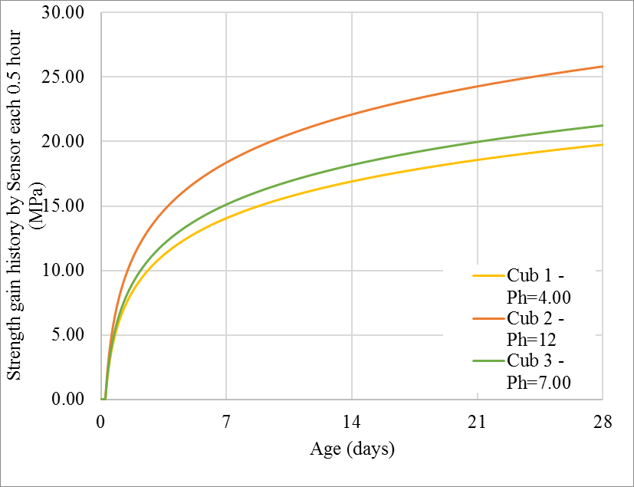

Figure 4.18 – Strength gain data recorded via sensor (30 min time interval)

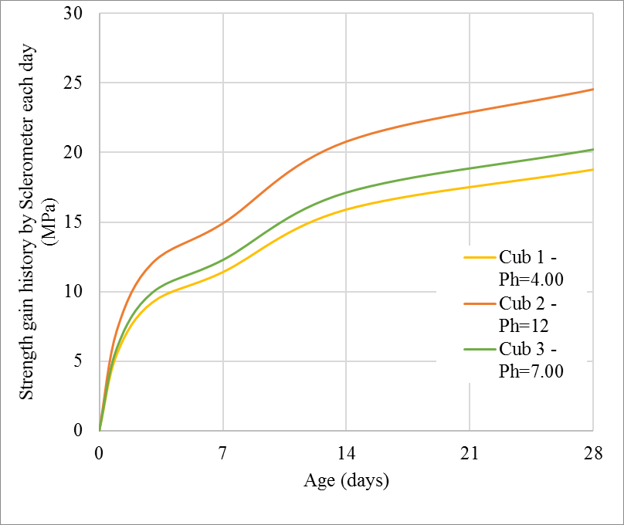

Figure 4.19 – Strength gain data with time retrieved from the Sclerometer each day

Figure 4.19 outlines the strength gain results from the Sclerometer. The chart shows a significant rise in concrete strength in the first week, especially within three days, aligning with sensor data. The Sclerometer, which links compressive strength to concrete hardness, uses a spring to release a hammer onto the concrete. The resulting rebound distance, or the rebound number, reflects the concrete's hardness and its compressive strength [153].

Results and Discussions
The high values of these coefficients indicate a reliable and strong approximation, as the majority of the derived linear and logarithmic equations have R² values equal to 1, with the sole exception being the segment spanning 1-28 days in the compression method curve. When expressed as a percentage, the average value of these coefficients amounts to an impressive 99.9%.
By utilizing the equations for each section, precise strength values were estimated at 0.5-hour intervals up to and including the 28-day mark for both the compression and shock impulse methods. This detailed analysis allows for a comprehensive understanding of the strength gain trends over time using both techniques (figure 4.20).

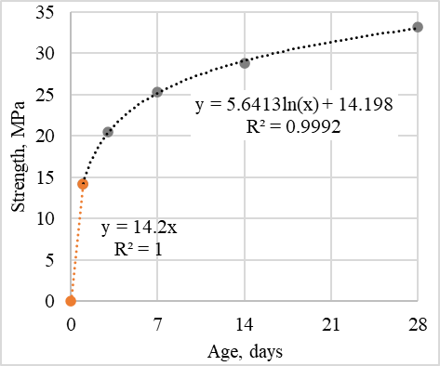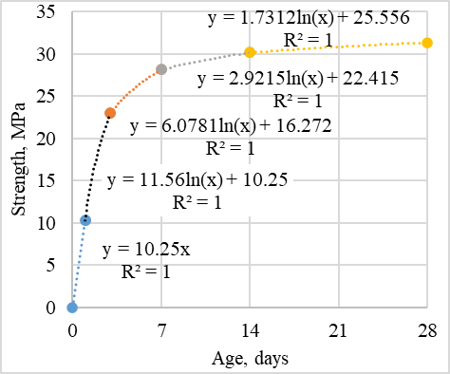
a b

a – compression method; b – shock pulse method

Figure 4.20 – Trend lines

Figures 4.21, a and b present the results of monitoring of the large concrete specimens (averaged from two samples) alongside the air temperature and relative humidity within the storage area of the specimens. These measurements were taken at 0.5-hour intervals over a 28-day period.
Figure 4.21, a reveals a sharp spike in temperature, reaching 36.7°C on the first and second day of the curing process, which can be attributed to the initial setting of the concrete. Following this initial increase, the temperature gradually declines, exhibiting fluctuations between day and night. By the end of the 28-day period, the minimum curing temperature drops to 2.65°C.
A similar trend can be observed in the ambient temperature curve (figure 4.21b), which suggests a notable influence on the concrete strength gain process, as well as on the exothermic reactions occurring within the concrete itself. The air temperature fluctuated between 2.2 and 24.8 °C over the course of the study.
As depicted in figure 4.21b, an inverse relationship exists between relative humidity and ambient temperature; when the temperature rises, the humidity decreases, and vice versa. The relative humidity ranged between 24.9 and 100%, with an average value of 53.2%. This information highlights the complex interplay between temperature and humidity during the curing process, which ultimately impacts the strength gain of the concrete specimens.

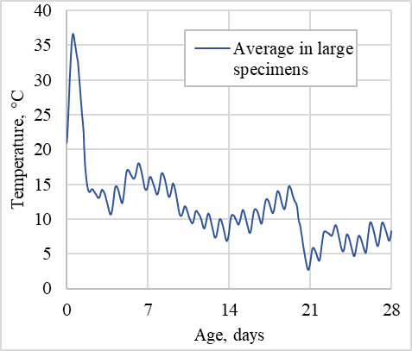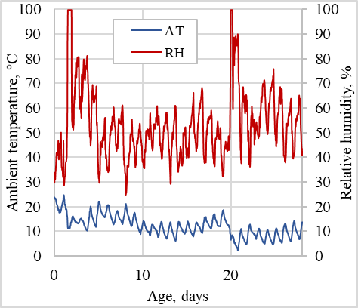
a b

a – curing temperature; b – ambient temperature and relative humidity

Figure 4.21 – Results of monitoring

After this analysis, the equation (4.1) used to determine the correlation coefficients between the three parameters (curing temperature, air temperature, and relative humidity) and the confidence curve's strength over the 28-day concrete curing phase. The outcomes of these estimates are depicted in figure 4.22 as a two-color gradation, ranging from white to green.
Each cell in the figure is assigned a specific shade based on the modulus value of the correlation coefficients for all three parameters. In essence, the cells with the lowest values among the total 84 (28 days multiplied by 3 parameters) are colored closer to white, while the cells with the highest values are shaded in green. This visual representation provides a clear and easily interpretable view of the correlation between the three parameters and the strength of the confidence curve during the curing process of the concrete specimens.

Figure 4.22 – Color gradation of correlation coefficients

In the aforementioned figure, a notably strong correlation between curing temperature and concrete strength gain can be observed, particularly on days 2, 4, 10, and 21. On these days, the correlation coefficients fall within the range of 0.9 to 1. Both relative humidity and ambient temperature exhibit a good correlation with strength on days 2, 9, 11, 20, and 23, with correlation coefficients ranging from 0.4 to 0.9.
The cumulative correlation of the examined parameters with strength is illustrated in red, representing the average between the three parameters for each day. This highlights the most significant correlations on days 2, 7, 9, 11, and 20. This pattern can be further employed to express the dependence (function) of strength on the considered parameters. It would be reasonable to select parameter values specifically on days 2, 7, 9, 11, and 20 as the initial data for this purpose.
The degrees of influence of the considered parameters on concrete strength gain, as calculated according to equations (4.2) and (4.3), are displayed using a similar color gradation in figure 4.23, which transitions from white to blue. This visual representation allows for a better understanding of how the different parameters impact the concrete strength gain over time.

Figure 4.23 – Color gradation of the influence degrees of parameters

The calculated degrees of influence for each of the 28 days exhibit a logical pattern, as demonstrated in the aforementioned figure. The impact of the curing temperature on the strength of the concrete is considerably more significant (γTmax = 0.9) when compared to the influences of the other two parameters (γRHmax = 0.4 and γATmax = 0.6). Nevertheless, on days 6, 9, 15, 20, 22, and 23, the external temperature and relative humidity exerted a greater influence on the concrete strength.

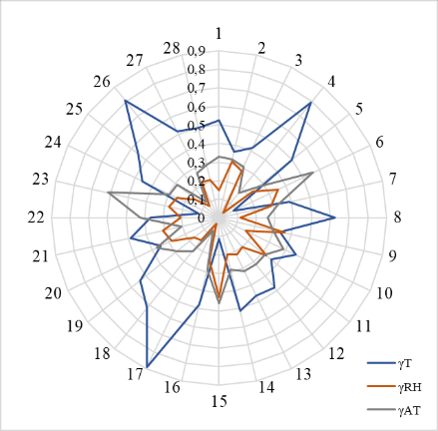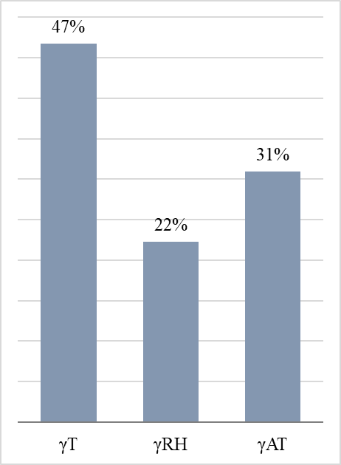

a b

a – as petal diagram (left); b – bar chart (right)

Figure 4.24 – Spatiotemporal representation of monitoring results

By referring to figure 4.24, it becomes apparent that on these particular days, the temperature and humidity conditions were especially critical for the large concrete specimens. This analysis highlights the importance of understanding the varying impacts of curing temperature, external temperature, and relative humidity on concrete strength gain over time, as well as the need to consider these factors when evaluating the performance of concrete structures.
An alternate depiction of the calculated degrees of influence can be seen in Figure 4.25a, which presents a three-color petal diagram. In this diagram, blue, orange, and gray colors represent the degrees of influence of curing temperature, relative humidity, and ambient temperature, respectively. Figure 4.25b illustrates the percentage ratio of the area occupied by these petals.
It can be observed that the ratio derived from this representation corresponds to the ratio achieved by averaging the degrees of influence for all 28 days for each parameter individually. Furthermore, the sum of these ratios consistently amounts to 100%. This visually striking and informative representation effectively conveys the relationship between the degrees of influence of the three parameters across the entire 28-day period, highlighting their varying impacts on the strength of the concrete.
The strength growth of small cubes follows the maturity method's trend, but the 28-day strength stands out as higher. To contrast indirect (like the maturity and shock pulse methods) and direct (cube compression) methods, their strength trends were merged into one graph, shown in figure 4.25. This helps in estimating the concrete's compressive strength at various ages and specimen sizes.

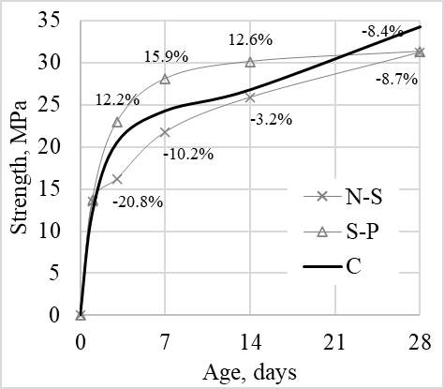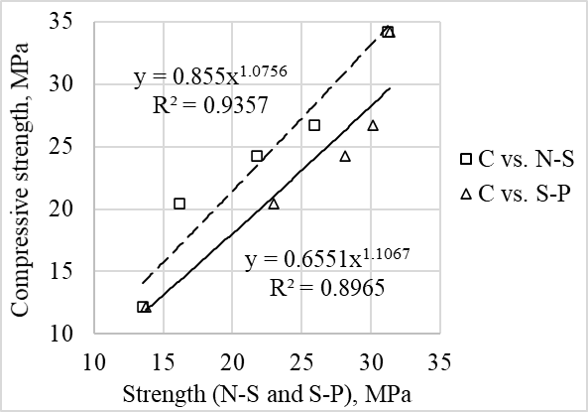
a b

a – trends in strength increase; b – calibration relationships, using Nurse-Saul, Shock-pulse methods, and Compression tests

Figure 4.25 – The comparison of results includes

In figure 4.25a, it's clear that there's no significant difference in strength gains on the first day between the shock-pulse method and compression tests. However, on days 3, 7, and 14, the shock-pulse method yields strength values that are, on average, 13.5% higher than compression tests. On day 28, the shock-pulse method results are 8.4% lower. Meanwhile, the maturity method from day 3 to day 28 provides values that are, on average, 10.7% lower than compression tests.
Figure 4.25, b displays calibration correlations between direct and indirect techniques. Each relationship has power functions and determination coefficients. The maturity method's correlation with compression tests has a coefficient of 0.9357, slightly more than the shock-pulse method's 0.8965, indicating better alignment with compression tests. These results impact how we gauge concrete strength across various ages and sample sizes.
Figure 4.26 offers a detailed comparison of multiple methods for gauging concrete strength increase over time. This includes compression tests on 10 cm cubes per [142, c. 2-34] (square markers), non-destructive tests on concrete boxes using the IPS-MG 4.01 sclerometer from [143, c. 2-22] (triangle markers the maturity-strength method by [139] (dashed line), and an enhanced maturity method based on [139] factoring in temperature and humidity (circle markers).

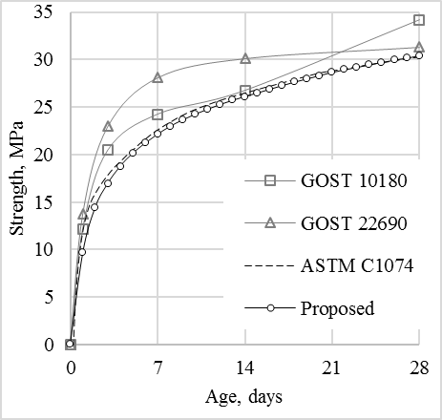

Figure 4.26 – Summary results of concrete strength determined by various methods

Figure 4.27 displays the calibration links between various concrete strength assessment methods concerning direct cube compression tests on the x-axis. Trend lines for each method are provided, backed by determination coefficients. Analyzing the data in figure 4.27 allows researchers and engineers to assess the precision and dependability of these testing methods, aiding them in selecting the most suitable approach for their specific requirements and objectives. This information is crucial for optimizing mix designs and construction processes for future projects, and for ensuring the safety and reliability of structures. By continuing to refine and improve these testing methods, researchers and engineers can work towards a future where construction is even safer, more efficient, and more sustainable.
The coefficients of determination obtained from these testing methods provide insights into how well each method aligns with cubic sample compression testing, indicating their reliability. The proposed complex maturity method demonstrated the highest coefficient of determination at R²=0.976, indicating strong reliability. Conversely, the non-destructive strength measurement method using the sclerometer exhibited the lowest coefficient of determination at R²=0.8929.
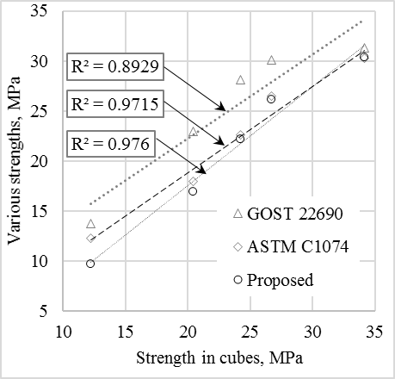

Figure 4.27 – Calibration relationships of these methods with respect to the compressive strength of cubic samples

Although the Nurse-Saul maturity method, which relies solely on internal temperature, displayed reasonable reliability for estimating current concrete strength, it's important to recognize that ambient factors like temperature and relative humidity significantly influence the concrete curing process. Therefore, the proposed complex maturity method, which considers both internal and ambient factors, may offer a more precise and dependable estimation of concrete strength.
In numerous cases, ANOVA is employed to compare datasets by examining the variances within individual groups, utilizing samples from each group [140, р. 318-323]. In this research, temperature data corresponding to pH levels of 4.0, 7.0, and 12.0 underwent single-factor ANOVA analysis. The p-values presented in table 4.4 indicate that the temperature data yielded a remarkably low p-value of 2.4×10^(-261), well below the alpha value of 0.05. This outcome confirms the statistical significance of the variations in the data.

Table 4.4 – ANOVA Findings Relating to Temperature

SUMMARY
Groups | Count | Sum | Average | Variance
Cub 1 - Ph=4.00 | 1344 | 27900.29 | 20.75915 | 0.174045346
Cub 2 - Ph=12 | 1344 | 28677.32 | 21.33729 | 0.196137086
Cub 3 - Ph=7.00 | 1344 | 28043.45 | 20.86566 | 0.175835924
ANOVA
Source of Variation | SS | df | MS | F | P-value | F crit
Between Groups | 254.4761 | 2 | 127.238 | 699.0865 | 2.4× 10⁻²⁶¹ | 2.997961
Within Groups | 733.3027 | 4029 | 0.182006
Total | 987.7787 | 4031

Strength data from samples with pH levels of 4.0, 7.0, and 12.0 underwent a Single-factor Analysis of Variance (ANOVA), with the results summarized in table 4.5. When the p-value drops below 0.05, it indicates the rejection of the null hypothesis, indicating a significant difference between means. In this case, the strength data at different pH levels yielded an extremely low p-value of 2.9×10^(-168), well below the alpha value of 0.05. Thus, the variations in strength data are considered statistically significant, as outlined in table 4.5.

Table 4.5 – ANOVA based on concrete strength data

SUMMARY
Groups | Count | Sum | Average | Variance
Cub 1 - Ph=4.00 | 1344 | 21075.79 | 15.6814 | 15.45128547
Cub 2 - Ph=12 | 1344 | 27560.65 | 20.50644 | 26.42261243
Cub 3 - Ph=7.00 | 1344 | 22697.01 | 16.88766 | 17.91983403
ANOVA
Source of Variation | SS | df | MS | F | P-value | F crit
Between Groups | 16948.61 | 2 | 8474.304 | 425.1769 | 2.9× 10⁻¹⁶⁸ | 2.997961
Within Groups | 80302.98 | 4029 | 19.93124
Total | 97251.59 | 4031

Scheffé's method, unlike Tukey-Kramer, comprehensively analyzes all potential mean differences among different factor levels instead of just pairwise comparisons. To assess the importance of average fluctuations in temperature and strength metrics across different pH values, the study employed Scheffé's multiple comparison procedures. This method allows for a robust examination of the variances between data sets. In table 4.6, the findings reveal notable statistical differences (with a significance level of p<0.01) when comparing pH 4.0 to pH 12, pH 4.0 to pH 7.0, and pH 12 to pH 7.0. By leveraging the Scheffé method, the research offers an in-depth exploration of the average differences, shedding light on the distinct impacts of varying pH levels on temperature and strength attributes. This analysis, therefore, provides enriched understanding and nuances related to how different pH values might affect the observed variables.

Table 4.6 – Analysis of variance using Scheffé method based on temperature data

Treatments pair | Scheffé TT-statistic | Scheffé p-value | Scheffé inference
pH 4.0 vs pH 12 | 35.1298 | 1.11× 10⁻¹⁶ | ** p<0.01
pH 4.0 vs pH 7.0 | 6.472 | 8.94× 10⁻¹⁰ | ** p<0.01
pH 12 vs pH 7.0 | 28.6578 | 1.11× 10⁻¹⁶ | ** p<0.01
** – statistically significant

In table 4.7, the data showcases significant disparities (with a significance level of p<0.01) when comparing the datasets associated with pH 4.0, pH 7.0, and pH 12. These pronounced differences highlight that the pH levels of the initial mixing water have a profound influence on the properties and behaviors of concrete over the duration of the investigation. The results underline that the pH value, a measure of acidity or alkalinity, plays a pivotal role in the concrete's performance and characteristics. This emphasizes the need for thorough consideration of water quality, especially its pH, when preparing concrete mixtures, as it can greatly influence the resultant structural and material attributes throughout its lifecycle.
In essence, the pH of the mixing water appears to play a vital role in shaping concrete's behavior and performance over time. As highlighted in [154], water, especially its pH, plays a critical role in concrete performance, impacting the durability through the cement hydration process. Comprehending pH's role in concrete is vital for ensuring long-term durability and performance of concrete structures.

Table 4.7 – Analysis of variance using Scheffé method based on concrete strength data

Treatments pair | Scheffé TT-statistic | Scheffé p-value | Scheffé inference
pH 4.0 vs pH 12 | 28.0168 | 1.11× 10⁻¹⁶ | ** p<0.01
pH 4.0 vs pH 7.0 | 7.0042 | 2.58× 10⁻¹¹ | ** p<0.01
pH 12 vs pH 7.0 | 21.0126 | 1.11× 10⁻¹⁶ | ** p<0.01
** – statistically significant

In this study, correlation analysis played a crucial role in examining relationships among the parameters of interest. Correlation studies are commonly used to uncover meaningful connections between multiple measures, offering insights into interdependencies and potentially revealing new perspectives [155]. Tables 4.8, 4.9 to 4.10 display correlation coefficients, indicating a consistent trend in parameter relationships, albeit with slight variations. Generally, a "strong" to "very strong" correlation was observed between temperature and pH. This can be explained by molecular vibrations; as temperature rises, molecular vibrations intensify, leading to ionization and increased H+ ion production, making the solution more acidic and lowering the pH [156]. These findings emphasize the intricate interplay between temperature and pH.

Table 4.8 – Correlation analysis results (pH = 4.0)

Parameters | pH | Temperature | Strength
pH | 1
Temperature | 0.705355 | 1
Strength | -0.86042 | -0.8354 | 1

Table 4.9 – Correlation analysis results (pH = 7.0)

Parameters | pH | Temperature | Strength
pH | 1
Temperature | 0.542362 | 1
Strength | -0.65684 | -0.8354 | 1
Table 4.10 – Correlation analysis results (pH = 12)

Parameters | pH | Temperature | Strength
pH | 1
Temperature | 0.60822 | 1
Strength | -0.69992 | -0.8354 | 1

Moreover, a pivotal finding from the research is the pronounced negative relationship between the pH levels and the strength of the concrete. The correlation coefficients, which range between -0.657 and -0.860, serve as compelling evidence of this relationship. In simpler terms, as the concrete becomes more acidic (lower pH), its inherent strength tends to decrease. Parallel to this, there exists a "very strong" inverse relationship between the temperature and the strength of the concrete. This suggests that as the temperature rises, the strength of the concrete is substantially compromised.
These relationships between pH, temperature, and concrete strength are not merely isolated interactions but are intricately intertwined. Elevated temperatures, coupled with variations in pH levels, can influence the structural integrity and durability of the concrete. Such insights are instrumental, underscoring the importance of meticulously considering these variables during the formulation and evaluation processes. The broader implication of these findings stresses the necessity for rigorous testing and monitoring when laying down concrete structures, especially in environments where temperature fluctuations and pH levels might be a concern. This ensures that the resultant infrastructure remains both durable and reliable over extended periods.

Summary of chapter four
The chapter delves deeply into understanding the relationship between numerous factors, such as temperature, relative humidity, and curing method, and how they affect the strength gain trends of concrete over time. Through their work, it was discovered that high coefficient values, particularly those with R² values equal to 1, suggest powerful approximations in the derived equations. This precision was evident as these equations accurately represented strength values for both compression and shock impulse methods, continuing up to a 28-day span.
In observing the concrete curing process, there was a notable temperature spike reaching 36.7 °C during the initial two days of curing. This peak was due to the concrete setting. Following this, the temperature showcased fluctuations, dwindling down to 2.65 °C by the culmination of the 28 days. An inverse relationship between humidity and temperature was also identified.
A subsequent examination provided a visual breakdown of the correlation amongst curing temperature, relative humidity, and ambient temperature in relation to the concrete's strength. A standout observation was the pronounced correlation between the curing temperature and strength gain, more so on particular days.
Delving into the degrees of influence, it was discerned that the curing temperature predominantly dictated the concrete strength. However, there were specific days when external temperature and humidity took precedence. These visual aids were instrumental in discerning these variations.
When observing the strength growth and various testing methods, a comparison was drawn between different methods like the maturity method and the shock pulse method against the standard compression tests. This juxtaposition underlined the distinct characteristics and efficacies of each testing method in evaluating concrete strength.
Furthermore, utilizing statistical methods like ANOVA and Scheffé's Method allowed for an in-depth evaluation of data disparities, predominantly focusing on factors such as pH levels, temperature, and strength. The study identified significant variations in temperature and strength characteristics across different pH levels.
The correlation analysis brought forth a compelling negative correlation between pH levels and the inherent strength of the concrete. Moreover, a pronounced inverse relationship was observed between the concrete's strength and temperature. This implies that as temperatures soar, concrete's strength diminishes considerably. These relationships signify the profound effects of pH levels and temperature on the structural integrity and resilience of concrete.
The ramifications of these findings emphasize the paramount importance of accounting for factors like temperature, relative humidity, and pH during concrete preparation and setting. Thorough assessments and rigorous testing are imperative to ascertain the durability and reliability of concrete infrastructures, more so in environments prone to environmental fluctuations.
Key numerical results include:
- Temperature Peaks: Cylindrical specimens peaked at 21°C, while large cubic specimens reached 32°C.
- Temperature Drops: For cylindrical specimens, the temperature dropped to 8°C by day 28. Large cubic specimens also dropped to 8°C.
- Strength Test Results: Provided for days 1, 3, 7, 14, and 28 across different sample types (cylindrical, cubes, and boxes) with varying MPa values.
- Temperature and Humidity Monitoring: Internal temperature ranged from 3°C to 25°C, with ambient relative humidity between 40-60%.
- Coefficients of Determination
Strength-Maturity Correlation: R²=0.9793.
Compressive Strength Trend: R²=0.9987.
- ANOVA Findings
Temperature Data: P-value = 2.4×10⁻²⁶¹
Strength Data: P-value = 2.9×10⁻¹⁶⁸
- Correlation Coefficients
For pH 4.0, temperature correlation = 0.70535, strength correlation = -0.86042.
For pH 7.0, temperature correlation = 0.54236, strength correlation = -0.65684.
For pH 12, temperature correlation = 0.60822, strength correlation = -0.69992.
​

5 DEVELOPING OF A METHOD STATEMENT FOR CONCRETE STRUCTURES WIRELESS MONITORING

Monitoring the strength of concrete using sensor-based devices can provide valuable insights into the curing and hardening process, ensuring the quality and durability of the concrete structure. Here are some recommendations for developing a monitoring system using sensor-based devices:
Selection of Sensors:
- Choose sensors capable of measuring key parameters such as temperature, humidity, and strain.
- Consider using embedded sensors or surface-mounted sensors based on the specific application and accessibility requirements.
- Ensure the sensors have the necessary accuracy, reliability, and durability for continuous monitoring over the desired time frame.
- Sensor Placement:
- Determine the optimal locations for sensor placement to capture representative data on the concrete's strength development.
- Consider factors such as concrete thickness, reinforcement placement, and potential areas of weakness or vulnerability.
- Install sensors in a manner that minimizes the impact on the structural integrity of the concrete.
- Data Acquisition and Communication:
- Establish a data acquisition system to collect sensor readings at regular intervals.
- Implement a reliable communication protocol to transmit data from the sensors to a central monitoring station.
- Consider wireless communication technologies such as Wi-Fi or Bluetooth for ease of installation and flexibility.
- Calibration and Validation:
- Calibrate the sensors before installation to ensure accurate and consistent measurements.
- Validate the sensor measurements against known standards or testing methods to ensure reliability and accuracy.
- Data Analysis and Interpretation:
- Develop algorithms or analytical models to process the sensor data and derive meaningful insights.
- Correlate sensor measurements with concrete strength test results to establish a reliable relationship.
- Establish threshold values or criteria for assessing the strength development and identifying potential issues or anomalies.
- Real-Time Monitoring and Alerts:
- Implement a real-time monitoring system that continuously analyzes the sensor data and provides timely alerts for any deviations from expected strength development.
- Set up alert mechanisms such as email notifications, SMS alerts, or visual indicators to notify relevant stakeholders of critical conditions or anomalies.
- Long-Term Data Storage and Analysis:
- Store the sensor data securely for future reference and analysis.
- Utilize data analytics techniques to identify trends, patterns, or potential areas for improvement in the concrete curing process.
- Maintenance and Calibration:
- Establish a regular maintenance schedule to ensure the sensors are functioning correctly and accurately.
- Conduct periodic calibrations to maintain measurement accuracy and reliability.
- Integration with Construction Processes:
- Integrate the sensor-based monitoring system with existing construction processes and workflows.
- Incorporate the sensor data into quality control procedures and decision-making processes for improved concrete construction practices.
- Documentation and Reporting:
- Maintain comprehensive documentation of the monitoring system, including sensor placement, calibration procedures, data analysis techniques, and any observed trends or anomalies.
- Generate regular reports summarizing the concrete strength development and any significant findings or recommendations.
Remember that these recommendations should be adapted and customized based on the specific project requirements, construction practices, and available sensor technologies. Consulting with domain experts and considering relevant industry standards or guidelines will further enhance the effectiveness and reliability of the monitoring system.

5.1 Scope of Application
This regulation outlines the framework and procedures for safe and high-quality work using a temperature sensor. The sensor is designed for wireless temperature monitoring during concrete curing and for controlling concrete strength in reinforced concrete structures according to the ASTM C1074 standard.
The key benefits of using this temperature sensor include:
- Real-time monitoring of concrete strength at multiple control points.
- Creation of strength gain and temperature regime graphs at these control points.
- Monitoring of objects in remote locations.
The sensor enables cost-effective decision-making during the construction of reinforced concrete elements by ensuring timely loading and operation, reducing time and overhead costs.
Data collected with the temperature sensor can assess the quality of concrete and reinforced concrete structures across geographically distant locations. However, it's essential to note that the sensor doesn't replace mandatory laboratory and field testing required by existing standards for both destructive and non-destructive concrete strength testing.

5.2 Regulatory documents
GOST 26633-2015. Heavy and Fine-Grained Concretes. Technical Conditions.
GOST 10180-2012. Concrete. Methods for Determination of Strength of Control Samples.
GOST 7473-2010. Concrete Mixes. Technical Conditions.
GOST 10181-2014. Concrete Mixes. Test Methods.
GOST 18105-2010. Concrete. Rules for Control and Evaluation of Strength.
GOST 22690-2015. Concrete. Determination of Strength by Non-Destructive Mechanical Methods.
ST-NP SRO UCC-04-2013. Temperature-Strength Control of Concrete During Construction of Monolithic Structures in Winter.
ASTM C192/C192M-18. Standard Practice for Making and Curing Concrete Test Specimens in the Laboratory.
ASTM C1074. Standard Practice for Estimating Concrete Strength by the Maturity Method.
GOST 427. Inter-State Standard. Metallic Measuring Rulers. Technical Conditions.
SNiP 12. Occupational Safety in Construction. General Requirements.
SP 63.13330. Code of Regulations. Concrete and Reinforced Concrete Structures. Basic Provisions.

5.3 Terms and definitions
Forming of samples – the process of producing samples of a specified geometric shape in accordance with established molding standards.
Concrete class – the compressive strength of concrete cubes (MPa) with a reliability (confidence level) of 0.95.
Compressive strength – a physical-mechanical property of a material that characterizes the strength limit of the material when compressed in a dry state.
Non-destructive method – the determination of concrete strength directly in the structure by local mechanical impact on the concrete (impact, detachment, chipping, indentation, pull-off with spalling, elastic rebound).
Maturity index – the duration of time that is calculated based on the chronology of temperature changes during the curing of concrete using the maturity function.
Maturity function – a mathematical expression using concrete temperature history to calculate a maturity index, which, combined with the strength-maturity relationship, estimates concrete strength [157].
Base temperature – the temperature below which cement hydration doesn't occur, impacting strength gain rate. Influenced by cement type, additives, and curing temperature.
Equivalent age – days or hours at a specific temperature to achieve maturity equivalent to curing at a different temperature.
Climate chamber – a chamber for accurately simulating environmental effects, equipped with instruments for humidity and air temperature control.

5.4 General provisions
This regulation has been developed for users of the temperature sensor and is applicable in situations where the user is required to use the temperature sensor. The purpose of this regulation is to provide guidance to users on how to effectively use the temperature sensor while meeting the required specifications.
The regulation covers the requirements that are imposed on users of the temperature sensor. These requirements include the conditions for using the temperature sensor, the installation of data DCS, and the use of server software. By following the guidelines set forth in this regulation, users of the temperature sensor will be able to effectively use the sensor to achieve the desired results.
This regulation includes laboratory methods for calculating the maturity of concrete, which formed the basis for the development of the temperature sensor. These methods are designed to ensure the quality and safety of concrete structures during their production and use.
The purpose of this regulation is to assist professionals in project design and construction organizations who are interested in reducing the cost of concrete work and enhancing their knowledge of concrete strength development. By following this regulation, they can obtain valuable insights into the use of the temperature sensor and how it can be used to optimize concrete production and increase efficiency.
This regulation was developed based on the experience of foreign construction companies that have successfully used wireless devices in concrete production. As a result, it reflects the latest technological advancements and best practices for using the temperature sensor, making it an essential resource for anyone involved in concrete construction.

5.5 Sensor description
The station of data collection consists of:
- square plastic housing;
- microcontroller;
- wireless network module;
- memory card;
- data transmission module;
- modem;
- uninterruptible power supply;
- server;
- power cable.
The LPWAN wireless network module with lora protocol is embedded in the microcontroller.
The memory card stores data received from the temperature sensor.
To transmit data, the module uses wi-fi network.
The modem is used to transmit the accumulated data from the memory card to the server over 3G/4G networks.
Data received from the station of data collection is stored in the database of the server programming software.
The high-capacity power source is used to provide uninterrupted power to the microcontroller.
The power cable of the station of data collection is connected to a 230v network.
The temperature sensor consists of:
- cylindrical plastic housing;
- microcontroller;
- wireless network module;
- cable;
- temperature sensor;
- power source;
- identification number of the instance.
The LPWAN wireless network module with lora protocol is embedded in the microcontroller.
The microcontroller is connected to the temperature sensor cable.
The power source ensures uninterrupted operation of the temperature sensor throughout its operation (i.e., 28 days).
The cylindrical housing meets the requirements of the ip68 standard.
To identify and track the temperature sensor, an identification number of the instance is stored on the server.
Server programming software:
- Provides interaction of all components of the temperature sensor.
- The server programming software has a web interface for the user.
- The server programming software is optimized to work on a personal computer.

5.6 User interaction with the temperature sensor
The interaction between the user and the temperature sensor measurement system begins with working with the software.
The user enters the server software through the browser of a mobile device or personal computer.
By following the link according to the used sensor, a page with access to the account opens, where there is also an opportunity to register a new user.
After entering the software, the user selects an existing or creates a new virtual project, indicating its name, location, and optionally additional information.
After the project is fully created and the project data is checked, the required number of temperature sensors is added to it by entering their identification number, where there is also an opportunity to enter user designations.
Then, the composition of the concrete, the temperature of which is planned to be monitored on the construction site, is selected.
It is worth noting that a specific "strength and maturity ratio" corresponds to a specific composition of concrete, which is obtained in advance through laboratory tests of the selected concrete composition, according to the ASTM C1074 maturity method.
The strength and maturity ratio is entered into the database by the administrator of the server software from the supplier of the temperature sensor.
On the construction site, the temperature sensor is attached to the reinforcement of the structural element before pouring the concrete mixture using plastic clips or binding wire (figure 5.1, 5.2).

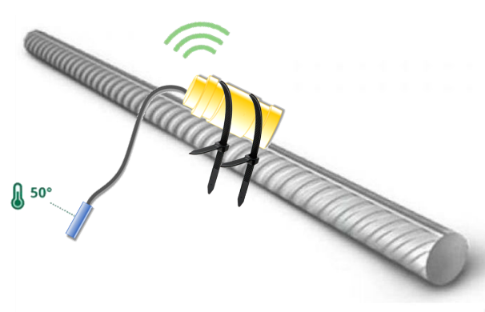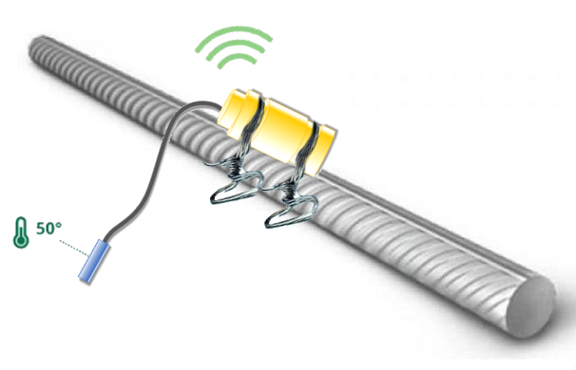

а b

a – using a clamp; b – using a wire

Figure 5.1 – Illustration of attaching the temperature gauge to the valve

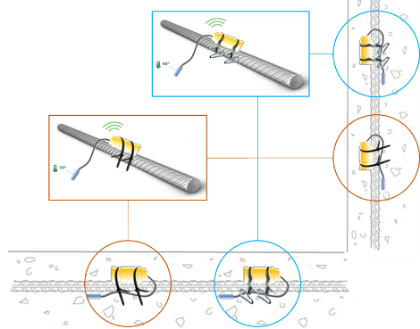

Figure 5.2 – Example of attaching the concrete maturity sensor to horizontal and vertical rebar

To ensure a reliable signal reception, the depth of immersion should not exceed 10 cm, measured from the surface of the temperature sensor housing to the surface of the laid concrete mix.
The housing of the temperature sensor is waterproof when the cover is tightly closed and prevents moisture from entering inside, so opening the cover is not allowed.
The temperature sensor cable should also be secured to the reinforcement using plastic clamps or self-binding, but the metal tip should not touch the reinforcement itself.
It should be understood that the device registers the temperature precisely at the point where the metal tip of the cable (i.e. the temperature sensor) is located [158] (Figure 5.3, 5.4, 5.5).
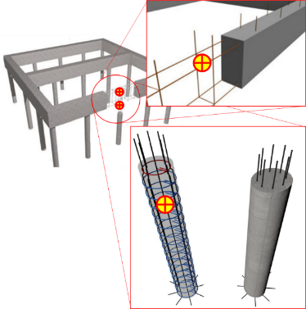

Figure 5.3 – Placement of sensors within the strip foundation on cast piles

Note - Compiled by the source [158, р. 2054-2058]

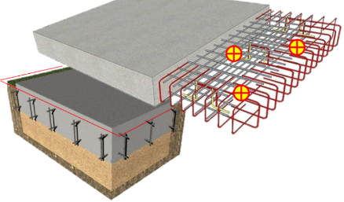

Figure 5.4 – Placement of sensors within the foundation slab

Note - Compiled by the source [158, р. 2054-2058]

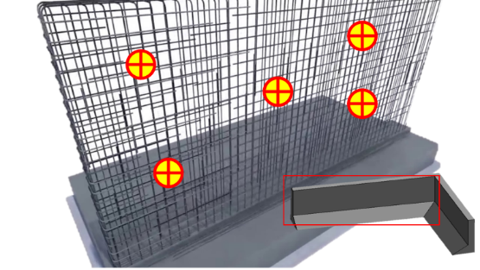

Figure 5.5 – Placement of sensors within the retaining wall

Note - Compiled by the source [158, р. 2054-2058]

To activate the temperature sensor, the user unscrews the seal cap from the opposite side of the housing, switches the switch to the on mode (towards the point marked on the switch), and tightly screws the cap back onto the seal to ensure a tight seal.
From the moment of activation, all temperature sensors begin to transmit measurement data at 30-minute intervals via a radio channel through DCS to the server. After all temperature sensors have been activated, the concrete is poured into the structure.
Monitoring of the structure starts only after pouring the concrete mix into the structure by selecting the temperature sensor and pressing the start button in the software.
The monitoring process cannot be stopped or repeated for the sensor.
The current monitoring results are displayed dynamically in the interface of the server software, continuously updating (Figure 5.6).
Each selected sensor displays only its own results.
The monitoring results can be viewed in sections of 1, 3, 7, 14, and 28 days.
The monitoring report can be printed or saved in PDF format using the "CTRL+P" key combination.

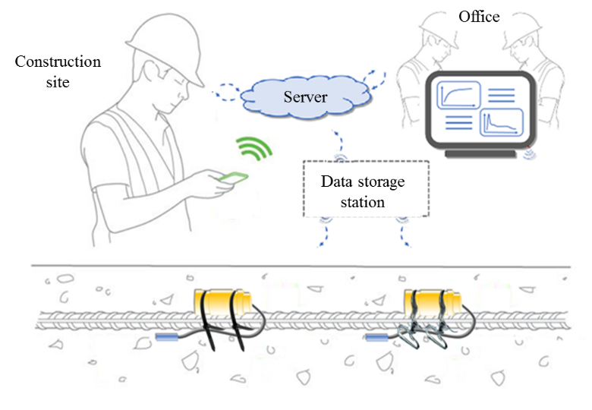

Figure 5.6 – Monitoring at the construction site

5.7 Participants of the technological process of monitoring
The number of participants in the technological process of monitoring may vary, and the participants themselves may combine several functions.
Four main participants are identified in the monitoring process:
- temperature sensor supplier;
- temperature sensor users;
- manufacturer of concrete mixes;
- construction laboratory.
The supplier is responsible for timely delivery, instruction, technical support, and maintenance of the temperature sensor provided to users.
Temperature sensor users can be any individuals or legal entities. End-users of the temperature sensor involved in the construction site, such as brigade leaders, section masters, or foremen, are considered users. They perform installation and monitoring in accordance with the temperature sensor operating instructions provided by the supplier.
The manufacturer of concrete mixes gives its consent to the laboratory to conduct tests of its concrete mixtures to derive the strength and maturity ratio.
The construction laboratory is an independent organization that collaborates with the user and the concrete plant. It conducts the necessary tests of concrete mixtures from the manufacturer to derive the strength and maturity ratio and transfers it directly to the supplier or through users, in agreement with the concrete plant manufacturer.

5.8 Laboratory tests
The objective of laboratory testing is to establish the correlation between the strength and maturity of concrete with a particular composition.
Laboratory testing is carried out by an accredited construction laboratory or, with the agreement of the user of the temperature sensor, can be carried out by a non-accredited laboratory.
The methodology for laboratory testing is regulated by the international standard ASTM C1074, which is based on methods of concrete maturity. With the agreement between the supplier and the user of the temperature sensor, tests may be conducted using the temperature-strength control method, regulated by the standard ST-NP SRO UCC-04-2013.
Prior to and during laboratory testing, the testing laboratory must undergo instruction from the supplier of the temperature sensor to prevent errors and inaccuracies in the results.
The user is responsible for covering the costs of laboratory testing, and the supplier of the temperature sensor is responsible for providing support.
Close collaboration between the testing laboratory and the supplier of the temperature sensor is necessary for interpreting the test results in a format that can be integrated into the software database.

5.9 Occupational safety when working with the temperature sensor
Only individuals who have undergone safety training and familiarized themselves with the present technical regulation are permitted to work with the temperature sensor. The device belongs to Class "0" in terms of protection against electric shock.
When working with the temperature sensor, the following hazardous and harmful production factors may occur:
- increased or decreased air temperature in the work zone;
- increased humidity in the air;
- increased noise level;
- increased level of vibration;
- the workplace is located at a considerable height relative to the ground (floor, ceiling);
- insufficient lighting of workstations;
- physical overloads.
The employee must be provided with special clothing, footwear, and other personal protective equipment.
If this regulation is not followed, the developer is not responsible for the temperature sensor and may not provide service and technical support.
The temperature sensor does not contain components that are dangerous to human life and health, provided that it is operated correctly and that the device's housing is not opened.
Safety requirements before starting work
Put on special clothing and personal protective equipment.
Check:
- completeness and reliability of fastening IT parts;
- operability of the temperature cable and its protective casing for mechanical damage;
- integrity of insulation parts of the IT housing;
- operability of the switch (its free turning on and off is checked before starting work);
- operability and connection of the DCS to the socket with a voltage of 230v (the bulb should light up);
- the DCS should be located in an inaccessible and difficult-to-pass area for safety and uninterrupted operation.
If at least one of the requirements listed in clause above of this regulation is not met, the temperature sensor is not issued (not accepted) for work.
In the case of installing the temperature measuring device in structures at height, the installation of scaffolds, flooring, or scaffolding with protective structures is necessary. Working with the temperature measuring device on extension ladders is not allowed.
Connecting the DCS to the power grid should only be done using plug connections that meet electrical safety requirements.
The cable of the DCS must be protected against accidental damage. To achieve this, the cable should be suspended. It is recommended to suspend cables or wires above workstations at a height of more than 2.5 meters from the surface accessible to workers.
Cables or wires should not come into contact with metallic, hot, wet, or oily surfaces or objects.
Tensioning and twisting of the cable of the DCS are not allowed. Subjecting them to loads, such as placing weight on them, is prohibited.
The DCS should only be switched on after it has been installed in the working position, and during use, one should monitor the device's operational functionality (the indicator light should be on).
It is prohibited to transfer the components of the temperature sensor to other workers who are not authorized to use it.
When moving the DCS or the temperature measuring device, it should be held by the housing and not by the cable or cord.
During any work breaks, the DCS should not be disconnected from the power supply.
The DCS should be protected from impacts, falls, dirt, and water.
In the event of any malfunction of the temperature sensor components, work should be immediately stopped, and it should be handed over to the supervisor for service by the supplier.
It is not permissible to operate the components of the temperature sensor when at least one of the following malfunctions occurs during operation:
- Damage to the plug connection, cable (cord), or its protective tubing.
- Damage to the IT cover.
- Malfunctioning of the switch.
- Appearance of smoke or a smell characteristic of burning insulation.
- Increased noise, knocking, or vibration.
- Breakage or cracks in the temperature measuring device housing or cables.
In the event of damage to the temperature measuring device during work, it should be replaced with a new one.
In the event of a sudden power outage, the DCS can operate autonomously for several hours. if the power outage lasts more than 3 hours, an alternative power source should be found and the DCS should be connected to it.
After disconnecting the DCS, it should be stored in a safe place until the start of the next concrete work.
Before subsequent use of the DCS and the acquisition of new temperature measuring devices, a technical inspection should be conducted, and if necessary, contact the supplier.

5.10 Closing Provisions
The use of the temperature sensor measurement system for concrete strength control does not replace the mandatory destructive and non-destructive testing prescribed by applicable standards.
Strength readings obtained using the temperature sensor measurement system are not allowed to be used for certification and acceptance of concrete structures based on their strength.
The temperature sensor should be used as an additional means for strength control and monitoring of concrete curing temperature in real-time, aiming to timely detect the concrete maturity point sufficient for making decisions regarding the loading and/or operation of the structure, provided that subsequent acceptance of the structure's strength is carried out using mandatory destructive and non-destructive control methods.

Results and Discussions
The study delved into the creation of a method statement tailored for the wireless monitoring of concrete structures for «CSI Research&Lab» LLP, which is included in the organization's standard STO CSI 001-2021 (Appendix A). Within the "Scope of Application," the focus was set on the wireless monitoring of such structures, underlining its importance in real-time tracking and preserving the structural integrity. To ensure the method statement was in sync with industry norms, the study consulted a collection of "Regulatory Documents." Recognizing the criticality of clear communication, distinct "Terms and Definitions" were laid out to prevent misinterpretation and offer a mutual comprehension of the monitoring operation.
In "General Provisions," foundational principles for the wireless monitoring application were set forth, stressing its relevancy in the modern construction milieu. A significant portion of the study was dedicated to the "Sensor Description," particularly the temperature sensor, elucidating its technical features, operational range, and precision. To cater to the end-users, the section titled "User Interaction with the Temperature Sensor" provided a thorough manual on its usage, aiming for user-friendly interaction and precise data gathering.
Mapping out the entire operational chain, "Participants of the Technological Process of Monitoring" section delineated the duties and roles of every individual involved, aiming for a fluid and efficient monitoring experience. Before the sensors' field deployment, they underwent stringent "Laboratory Tests" to confirm their reliability and accuracy under diverse scenarios.
Prioritizing the well-being of the personnel, the study emphasized "Occupational Safety," presenting detailed guidelines for safe practices while engaging with the temperature sensor and related equipment. Finally, "Closing Provisions" encapsulated the research's core findings, laying down a blueprint for its tangible implementation.
On the discussion front, this methodological advancement is timely, resonating with the construction sector's tilt towards automation and live monitoring. By meticulously defining terms and placing emphasis on the temperature sensor's role, the study accentuates the importance of precision and clarity in such technical endeavors. This streamlined approach, marked by distinct role allocations, aims to negate potential field misunderstandings that might culminate in setbacks. Moreover, with the potential hazards associated with sensors and related tools, the study's focus on occupational safety reinforces the commitment to the welfare of all stakeholders.

Summary of chapter five
A method statement for wireless monitoring of concrete structures using embedded maturity sensors was proposed and implemented as a standard of an organization “STO CSI 001-2021” in «CSI Research&Lab» LLP. The primary objective was real-time tracking and ensuring structural soundness. To align with established industry standards, the study consulted various regulatory documents. Clear terminologies were defined to ensure shared understanding.
The foundational principles of wireless monitoring were emphasized, highlighting its relevance in today's construction environment. Detailed attention was given to the temperature sensor's technical specifications and operational capabilities. Users were provided with a comprehensive guide for easy and accurate interaction with the sensor.
Roles and responsibilities for all involved in the monitoring process were clearly outlined to ensure an effective and smooth monitoring experience. The sensors, before their actual application, were rigorously tested for reliability and performance in different conditions.
A major focus was on the safety of personnel, with guidelines ensuring secure engagement with the temperature sensor and related tools. The study culminated with closing provisions that summarized the core findings and offered a practical implementation roadmap.
In essence, the study underscores the construction industry's shift towards automation and real-time monitoring, emphasizing precision, clarity, and safety. Through clear role definitions and focus on potential hazards, the approach minimizes misunderstandings and prioritizes stakeholder welfare.

CONCLUSION

1. Recent literature highlights diverse techniques for monitoring concrete strength, such as embedded sensors and the "Maturity method," depending on country regulations. However, emerging sensor-based solutions, particularly those offering wireless monitoring via Bluetooth, have limitations. These solutions often hinder concurrent measurements and may pose challenges for construction companies, including those in Kazakhstan, due to high sensor unit costs (e.g., $80) and additional software subscription fees. Additionally, most solutions lack a separate reusable device for deriving the Maturity-Strength logarithmic function for specific concrete mixtures, resulting in unnecessary expenditure on disposable sensors. While some offer adaptable Maturity-Strength functions based on historical data, their application to local concrete mixtures can yield misleading results.
2. Testing diverse microelectronic components and Application Programming Interfaces (API) has identified a cost-effective IT architecture for a concrete strength monitoring system. The proposed system integrates wireless embedded maturity sensors, a DCS, and a web-GIS. The physical devices, utilizing an Arduino microcontroller and Lora wireless module, come in molded plastic housings of 123×42×38 mm for the maturity sensors and 260×110×90 mm for the DCS. The web-GIS leverages the OpenLayers JavaScript API. Two versions of sensing devices are suggested: a reusable version for Maturity-Strength function derivation and a disposable version for on-site measurements.
3. Laboratory evaluations comparing the integrity, water-resistance, and durability properties of two maturity sensor housings indicate superior performance of the cylindrically shaped design over the rectangular counterpart. The cylindrical housing demonstrated resilience by withstanding immersion in water for a month without any water intrusion. Furthermore, it exhibited resistance to potential impact from a 2-meter fall and resisted crushing forces exceeding 1.5 times the average weight of an adult human.
4. Laboratory assessments of commercial concrete from "Temirbeton-1" (Almaty, Kazakhstan) and "ABK-Beton" (Astana, Kazakhstan) concrete mix plants, employing the Nurse-Saul Maturity method, indicate noteworthy disparities in the Maturity-Strength functions. Despite the use of the same B25 M350 concrete brands, distinct functions emerged, revealing variations in strength development: S=9.6494ln(M)-22.516 for "Temirbeton-1" and S=6.7279ln(M)-12.862 for "ABK-Beton".
5. During communication range testing of the utilized Lora module, it was observed that, despite the manufacturer's specified range of 2.5 km, the RSSI values exhibited a decline of -20 dBm per 30 m range in an urban environment with natural obstacles. This decline persisted until the signal was lost beyond 90 m from the reception point when the maturity sensor was embedded in a 200×200×200 mm concrete sample. In an unobstructed environment, the RSSI exhibited a more favorable performance, decreasing by a maximum of -10 dBm per 30 m range, with signal loss occurring beyond 270 m. Consequently, the developed maturity sensors can consistently transmit measurement data on a real construction site at distances ranging from 90 to 270 m when embedded in the concrete structure.
6. Field trials at residential complexes "Lake Town" (Almaty) and "New line" (Astana) validated the continuous functionality of the concrete strength monitoring system developed. This is supported by the approval of the proposed technology regulation by construction organizations' management. Subsequently, the technology regulation has been integrated as an organizational standard at "CSI Research&Lab" LLP, identified by the code STO CSI 001-2021.
7. The proposed Complex Maturity Method in this research enables an indirect consideration of internal and external factors impacting concrete strength. Analogous to the traditional Nurse-Saul method, it integrates ambient temperature and relative humidity in the concrete maturation process, offering a nuanced understanding of each factor's influence. Experimentally determined, that the cumulative effects of curing temperature, ambient temperature, and relative humidity for commercial B25 M350 concrete from the "Temirbeton-1" plant (Almaty, Kazakhstan) were 47%, 22%, and 31%, respectively. This observation is attributed to the tests being conducted in the summer time, with ambient temperatures maintained at around 20°C.
8. The strength curve derived from the Complex Maturity Method showed a 10.7% decrease compared to compression test results. In contrast to the variability observed in strength values from the impact-impulse method, the Complex Maturity Method exhibited greater consistency, as evidenced by coefficients of determination: 0.9357 for the Complex Maturity Method and 0.8965 for the impact-impulse method.
9. Subsequent research will explore the additional impact of pH levels on concrete strength development. Preliminary tests on concrete samples molded with mixtures where the initial pH levels were 4.0, 7.0, and 12.0, indicate that lower initial pH (alkaline environment) has a more pronounced influence on strength development than higher pH (acidic environment). The data analysis vividly demonstrates how pH levels critically affect concrete strength, backed by significant statistical evidence. A p-value of 2.9 × 10⁻¹⁶⁸ confirms these variances are not by chance, while the Scheffé method points out marked strength differences between pH 4.0, 7.0, and 12, highlighting pH's impact alongside temperature changes. Correlation studies show a strong to very strong linkage between temperature and pH, with coefficients between -0.657 and -0.860 indicating a notable negative correlation with concrete strength. This analysis categorizes correlation strengths from poor to very strong, offering insights into parameter interrelationships. Further, Single-factor ANOVA tests underline the significant role initial water pH plays in strength gain, evidenced by considerable differences in strength and temperature data across pH values. ANOVA findings and a striking p-value of 2.4 × 10⁻²⁶¹ for temperature data emphasize the importance of pH control in optimizing concrete's structural integrity, presenting a compelling case for meticulous pH management in construction practices.
10. Future work will focus on integrating a moisture sensor to enable continuous concrete curing process controlling its hydration rates, on implementing advanced data analytics and machine learning for real-time decision-making, as well as on improving RSSI and performance range via strengthening sensor’s antenna module.

REFERENCES

1 Golubeva T., Konshin S., Tailakov V. et al. Investigation of Sensors for Use in the Management System of Earthmoving and Construction Machines // Electrical Apparatus and Technologies (SIELA 2018): procced. internat. sympos. – Bourgas, 2018. – P. 1-4.
2 Golubeva T., Yakubov B., Konshin S. et al. Modeling the Mobile Signal Transmission Network of Earth-Moving and Construction Machines’ Sensors // Lecture Notes in Computer Science. – 2018. – Vol. 10995 – P. 86-98.
3 Golubeva T., Pokussov V., Konshin S. et al. Research of the Mobile CDMA Network for the Operation of an Intelligent Information System of Earth-Moving and Construction Machines // Lecture Notes in Computer Science. – 2017. – Vol. 10486. – P. 193-205.
4 Kalizhanova A., Kunelbayev M., Wojcik W. et al. Development of Fiber-Optic Sensors System, Based on Fiber Bragg Gratings // Journal of ecological engineering. – 2022. – Vol. 23, Issue 10. – P. 98-106.
5 Kashaganova G., Kozbakova A., Kartbayev T. et al. Research of a Fiber Sensor Based on Fiber Bragg Grating for Road Surface Monitoring // Electronics. – 2023. – Vol. 12, Issue 11. – P. 2491-1-24-91-17.
6 Kucukkececi C., Yazici A. Multilevel Object Tracking in Wireless Multimedia Sensor Networks for Surveillance Applications Using Graph-Based Big Data // IEEE ACCESS. – 2019. – Vol. 7. – P. 67818-67832.
7 Mekhtiyev A., Neshina Y., Kozhas A. et al. Monitoring reinforced concrete building structure technical conditions based on the use of quasi-distributed fiber-optic sensors // International Journal of geomate. – 2022. – Vol. 23, Issue 97. – P. 154-162.
8 Saginbekov S., Jhumka A. Many-to-many data aggregation scheduling in wireless sensor networks with two sinks // computer networks. – 2017. – Vol. 123. – P. 184-199.
9 Buranbayeva A., Zhussupbekov A., Sarsembayeva A. et al. Evaluation of the Structural Health Monitoring Results of the Applied Fiber Optics in the Pile-Raft Foundations of a High-Rise Building // Applied Sciences. – 2022. – Vol. 12, Issue 22. – P. 11728-1-11728-16.
10 Buranbayeva A.M., Zhussupbekov A.Zh., Omarov A.R. Numerical analysis and geomonitoring of behaviour of foundation of Abu-Dhabi Plaza in Nur-Sultan // Journal of Physics: Conference Series. – 2021. – Vol. 1928, Issue 1. – P. 012033.
11 Guptha K.G., Mohan T., Tejas G. et al. Manasi Study of Heat of Hydration in Mass Concrete // In book: Recent Developments in Sustainable Infrastructure. –Singapore: Springer, 2021. – Vol. 75. – P. 551-559.
12 Tareen N., Kim J., Kim W.-K. et al. Comparative Analysis and Strength Estimation of Fresh Concrete Based on Ultrasonic Wave Propagation and Maturity Using Smart Temperature and PZT Sensors // Micromachines. – 2019. – Vol. 10, Issue 9. – P. 559-1-559-17.
13 Kaming P.F., Olomolaiye P.O. et al. A framework for the strategic development of the construction industry in developing countries: Six strategic approaches to construction industry development in developing countries identified // Building Research & Information. – 1994. – Vol. 22, Issue 6. – P. 325-331.
14 YLai.-T., Wang W.-C., Wang H.-H. AHP- and simulation-based budget determination procedure for public building construction projects // Automation in Construction. – 2008. – Vol. 17, Issue 5. – P. 623-632.
15 Liu D., Wang H., Li H. et al. Hierarchical task network approach for time and budget constrained construction project planning // Technological and Economic Development of Economy. – 2019. – Vol. 25, Issue 3. – P. 472-495.
16 Liu Y.J., Ding L., Zhao Y.J. et al. Analysis of Temperature Control Mode of Concrete Construction in Winter // Applied Mechanics and Materials. – 2013. – Vol. 368-370. – P. 847-850.
17 Gamba O., Peña G., Pineda Y. Application of maturity method to estimate compressive strength of mass concrete // Journal of Physics: Conference Series. – 2019. – Vol. 1386, Issue 1. – P. 012060.
18 Guo J.B., Liu L., Wang Q. Application Self-Regulating Heating Cable Curing of Concrete in Winter // Applied Mechanics and Materials. – 2014. – Vol. 638-640. – P. 1531-1535.
19 Zhang H., Li J., Kang F. Real-time monitoring of humidity inside concrete structures utilizing embedded smart aggregates // Construction and Building Materials. – 2022. – Vol. 331. – P. 127317.
20 Valença J., Dias-da-Costa D., Gonçalves L. et al. Automatic concrete health monitoring: assessment and monitoring of concrete surfaces // Structure and Infrastructure Engineering. – 2014. – Vol. 10, Issue 12. – P. 1547-1554.
21 Paul Tikalsky P.E., Tepke D., Camisa S. Maturity method demonstration. – Washington: Federal Highway Administration, 2003. – 61 p.
22 Mi Z., Hu Y., Li Q. et al. Maturity model for fracture properties of concrete considering coupling effect of curing temperature and humidity // Construction and Building Materials. – 2019. – Vol. 196. – P. 1-13.
23 Sun B., Noguchi T., Cai G. et al. Prediction of early compressive strength of mortars at different curing temperature and relative humidity by a modified maturity method // Structural Concrete. – 2021. – Vol. 22, Issue S1. – P. E732-E744.
24 Ghahri Saremi S., Goulias D. Concrete strength gain monitoring with non-destructive methods for potential adoption in quality assurance // Construction and Building Materials. – 2020. – Vol. 260. – P. 120464.
25 Perry M., Fusiek G., Niewczas P. et al. Wireless Concrete Strength Monitoring of Wind Turbine Foundations // Sensors. – 2017. – Vol. 17, Issue 12. – P. 2928-1-2928-22.
26 Utepov Y., Aniskin A., Ibrashov A. et al. Maturity sensors placement based on the temperature transitional boundaries // Magazine of Civil Engineering. – 2019. – Issue 6(90). – P. 93-103.
27 Utepov Y., Aniskin A., Zharassov S. et al. Complex Maturity Method for Estimating the Concrete Strength Based on Curing Temperature, Ambient Temperature and Relative Humidity // Applied Sciences. – 2021. – Vol. 11, Issue 16. – P. 7712-1-7712-13.
28 Ebensperger L., Oyarzún J., Torres R. Determination of the datum temperature for applying maturity in cold weathers // Revista Ingeniería de Construcción. – 2020. – Vol. 35, Issue 1. – P. 84-99.
29 Boubekeur T., Ezziane K., Kadri E.-H. Estimation of mortars compressive strength at different curing temperature by the maturity method // Construction and Building Materials. – 2014. – Vol. 71. – P. 299-307.
30 Ferreira L., Branco F.G., Costa H.S.S. et al. Characterization of alkali-activated binders using the maturity method // Construction and Building Materials. – 2015. – Vol. 95. – P. 337-344.
31 Sofi M., Mendis P.A., Baweja D. Estimating early-age in situ strength development of concrete slabs // Construction and Building Materials. – 2012. – Vol. 29. – P. 659-666.
32 Taheri S.A review on five key sensors for monitoring of concrete structures // Construction and Building Materials. – 2019. – Vol. 204. – P. 492-509.
33 Teixeira S., Santilli A., Puente I. Demoulding vertical elements: Recommendations for apply maturity functions / // Construction and Building Materials. – 2017. – Vol. 145. – P. 392-401.
34 Yang K.-H., Mun J.-S., Cho M.-S. Effect of Curing Temperature Histories on the Compressive Strength Development of High-Strength Concrete // Advances in Materials Science and Engineering. – 2015. – Vol. 2015. – P. 1-12.
35 Zhang J., Maes K., De Roeck G. et al. Optimal sensor placement for multi-setup modal analysis of structures // Journal of Sound and Vibration. – 2017. – Vol. 401. – P. 214-232.
36 Yin H., Dong K., Pan A. et al. Optimal sensor placement based on relaxation sequential algorithm // Neurocomputing. – 2019. – Vol. 344. – P. 28-36.
37 Kibar H., Ozturk T. Determination of concrete quality with destructive and non-destructive methods // Computers and Concrete. – 2015. – Vol. 15, Issue 3. – P. 473-484.
38 Sophocleous M., Savva P., Petrou M.F. et al. A Durable, Screen-Printed Sensor for In Situ and Real-Time Monitoring of Concrete’s Electrical Resistivity Suitable for Smart Buildings/Cities and IoT // IEEE Sensors Letters. – 2018. – Vol. 2, Issue 4. – P. 1-4.
39 Rudeli N., Santilli A., Arrambide F. Striking of vertical concrete elements: An analysis using the maturity method // Engineering Structures. – 2015. – Vol. 95. – P. 40-48.
40 Hong S.Y., Liu Y. The New Energy-Saving Control Technique with Temperature Prediction in Airport Winter Construction // Advanced Materials Research. – 2013. – Vol. 805-806. – P. 482-485.
41 Anderson K.W., Uhlmeyer J.S., Kinne Ch. et al. Use of the Maturity Method In Accelerated PCCP Construction. – Washington, 2009. – 104 p.
42 Quirion M., Ballivy G. Concrete Strain Monitoring with Fabry-Pérot Fiber-Optic Sensor // Journal of Materials in Civil Engineering. – 2000. – Vol. 12, Issue 3. – P. 254-261.
43 Kim S., Kim S., Song S. et al. Strain Measurement of Concrete Using the Optical Speckle Imaging System // Journal of the Korean Society for Nondestructive Testing. –2019. – Vol. 39, Issue 1. – P. 15-19.
44 Feng J., Fu G., Belarbi D.J. Measurement of concrete internal strain using a three-dimensional transducer system // Experimental Mechanics. – 2005. – Vol. 45, Issue 5. – P. 467-475.
45 Islam M.A., Kharkovsky S. Detection and Monitoring of Gap in Concrete-Based Composite Structures Using Microwave Dual Waveguide Sensor // IEEE Sensors Journal. – 2017. – Vol. 17, Issue 4. – P. 986-993.
46 Özcan B., Schwermann R., Blankenbach J. A Novel Camera-Based Measurement System for Roughness Determination of Concrete Surfaces // Materials. – 2020. – Vol. 14, Issue 1. – P. 158-1-158-31.
47 McCarter W.J., Chrisp T.M., Starrs G. et al. Characterization and monitoring of cement-based systems using intrinsic electrical property measurements // Cement and Concrete Research. – 2003. – Vol. 33, Issue 2. – P. 197-206.
48 Bao Y., Hoehler M.S., Smith C.M. et al. Temperature measurement and damage detection in concrete beams exposed to fire using PPP-BOTDA based fiber optic sensors / // Smart Materials and Structures. – 2017. – Vol. 26, Issue 10. – P. 105034.
49 Akbarnezhad A., Kuang K.S.C., Ong K.C.G. Temperature sensing in microwave heating of concrete using fibre Bragg grating sensors // Magazine of Concrete Research. – 2011. – Vol. 63, Issue 4. – P. 275-285.
50 Wen S., Chung D.D.L. Cement-based thermocouples // Cement and Concrete Research. – 2001. – Vol. 31, Issue 3. – P. 507-510.
51 Rabone J., Borderie L.C. Steam flows in concrete cracks: Design of an experiment / // Nuclear Engineering and Design. – 2022. – Vol. 393. – P. 111807.
52 Wen S., Chung D.D.L. Rectifying and thermocouple junctions based on Portland cement // Journal of Materials Research. – 2001. – Vol. 16, Issue 7. – P. 1989-1993.
53 Dunstan M., Mitchell P. Results of a thermocouple study in mass concrete in the upper tamar dam // Proceedings of the Institution of Civil Engineers. – 1976. – Vol. 60, Issue 1. – P. 27-52.
54 John S.T., Roy B.K., Sarkar P. et al. An IoT Enabled Real-Time Monitoring System for Early-Age Compressive Strength of Concrete // Journal of Construction Engineering and Management. – 2020. – Vol. 146, Issue 2. – P. 05019020.
55 Garcia-Monzon H. Maturity of concrete-strengthent development. – Lubbock: Texas Tech University, 2003. – 218 p.
56 Determining Concrete Maturity with Temperature Monitoring // https://www.environmental-expert.com/articles/determining-concrete. 01.03.2022.
57 Kamkar S., Eren Ö. Evaluation of maturity method for steel fiber reinforced concrete // KSCE J of Civil Engineering. – 2018. – Vol. 22, Issue 1. – P. 213-221.
58 Concrete Maturity - From Theory to Application / GIATEC. – Ottawa: Giatec Scientific Inc., 2018. – 70 p.
59 Utepov Y., Khudaibergenov O., Kabdush Y. et al. Prototyping an embedded wireless sensor for monitoring reinforced concrete structures // Computers and Concrete. – 2019. – Vol. 24, Issue 2. – P. 95-102.
60 Glišić B., Simon N. Monitoring of concrete at very early age using stiff SOFO sensor // Cement and Concrete Composites. – 2000. – Vol. 22, Issue 2. – P. 115-119.
61 Ayranci C., Fahim A., Munro M. A Novel Strain Sensor for Reinforced Concrete Structures // Strain. – 2008. – Vol. 44, Issue 2. – P. 191-200.
62 Yu H., Caseres L. An embedded multi-parameter corrosion sensor for reinforced concrete structures: Embedded multi-parameter corrosion sensor // Materials and Corrosion. – 2012. – Vol. 63, Issue 11. – P. 1011-1016.
63 Yousef A.A., Pasupathy P., Wood S.L. et al. Resonant Sensors for Detecting Corrosion in Concrete Bridges // Transportation Research Record: Journal of the Transportation Research Board. – 2010. – Vol. 2201, Issue 1. – P. 19-26.
64 Lin M.W., Thaduri J. Structural Deflection Monitoring Using an Embedded ETDR Distributed Strain Sensor // Journal of Intelligent Material Systems and Structures. – 2006. – Vol. 17, Issue 5. – P. 423-430.
65 Pham Q.-Q., Dang N.-L., Kim J.-T. Smart PZT-Embedded Sensors for Impedance Monitoring in Prestressed Concrete Anchorage // Sensors. – 2021. – Vol. 21, Issue 23. – P. 7918.
66 Skibicki S. Optimization of Cost of Building with Concrete Slabs Based on the Maturity Method // IOP Conference Series: Materials Science and Engineering. – 2017. – Vol. 245. – P. 022061.
67 Srinivasan R., Phillips T.E. et al. Embedded micro-sensor for monitoring pH in concrete structures // Smart Structures and Materials 2000: Smart Systems for Bridges, Structures, and Highways. – 2000. – Vol. 3988. – P. 40-44.
68 Nguyen T.H., Venugopala T., Chen S. et al. Fluorescence based fibre optic pH sensor for the pH 10–13 range suitable for corrosion monitoring in concrete structures // Sensors and Actuators B: Chemical. – 2014. – Vol. 191. – P. 498-507.
69 Kang J.H., Gandhi J. Readibility test of RFID temperature sensor embedded in fresh concrete // Journal of civil engineering and management. – 2010. – Vol. 16, Issue 3. – P. 412-417.
70 Rozycki D. COMMAND CenterTM Concrete Monitoring // https://www.commandcenterconcrete.com/. 09.09.2023.
71 Concremote - Doka // https://www.doka.com/en/system. 09.09.2023.
72 Concrete Monitoring Systems - Hilti USA // https://www.hilti. 09.09.2023.
73 NEX® Monitoring System – ConCure, LLC // https://www.concure.com /products/nex-monitoring-system/. 09.09.2023.
74 Converge Signal // https://www.converge.io/sensors/converge. 09.09.2023.
75 EXACT Technology | Game Changing Concrete Monitoring Technology // https://exacttechnology.com. 09.09.2023.
76 Wireless Concrete Temperature Monitor HardTrack - Wake, Inc // https://www.wakeinc.com/index.php/products/industrial-wireless/. 09.09.2023.
77 Onset HOBO and InTemp Data Loggers // https://www.onsetcomp.com. 08.05.2023.
78 Support for intelliRock Maturity Logger | Teledyne FLIR // https://www.flir.com/products/intellirock-ii-maturity-. 09.09.2023.
79 Brickeye | Industrial IoT // https://www.aoms-tech.com. 09.09.2023.
80 Maturix | Concrete temperature, strength and maturity monitoring // https://maturix.com. 09.09.2023.
81 Giatec SmartRock Concrete Sensors // https://info.giatecscientific. 09.09.2023.
82 Регистраторы ТЕРЕМ-4 для мониторинга строительных конструкций (деформаций, трещин, тензоизмерений) // https://www.interpribor.ru. 9.09.2023.
83 Newa|Rijpheidscomputer Verboom MC21 // http://www.newa.nl. 09.09.2023.
84 Concrete Maturity Sensor System // https://www.humboldtmfg.com /humboldlt-concrete-maturity-sensor-system.html. 09.09.2023.
85 Temperature Monitoring During Concrete Curing|Tempcon Instrumentation // https://www.tempcon.co.uk/temperature-monitoring-concrete-curing. 11.12.2021.
86 Thiyagarajan K., Kodagoda S., Ranasinghe R. et al. Robust sensing suite for measuring temporal dynamics of surface temperature in sewers // Scientific Reports. – 2018. – Vol. 8, Issue 1. – P. 16020.
87 Vähä P., Heikkilä T, Kilpeläinen P. et al. Extending automation of building construction – Survey on potential sensor technologies and robotic applications // Automation in Construction. – 2013. – Vol. 36. – P. 168-178.
88 Hamooni M., Maghrebi M., Majrouhi J. et al. Kim Extending BIM Interoperability for Real-Time Concrete Formwork Process Monitoring // Applied Sciences. – 2020. – Vol. 10, Issue 3. – P. 1085.
89 Liu Y., Deng F., He Y. et al. Novel Concrete Temperature Monitoring Method Based on an Embedded Passive RFID Sensor Tag // Sensors. – 2017. – Vol. 17, Issue 7. – P. 1463.
90 Yikici T.A. et al. Use of maturity method to estimate compressive strength of mass concrete // Construction and Building Materials. – 2015. – Vol. 95. – P. 802-812.
91 SmartRock Concrete Sensors Prove Concrete Strength in Cold Weather // https://www.forconstructionpros.com/profit-matters/article/21103155. 12.04.2020.
92 Smart Sensor Allows for Quick, Real-time Strength Data // https://www.forconstructionpros.com/concrete/equipment-products. 12.04.2020.
93 COMMAND Center Sensor // https://www.commandcenterconcrete.com. 12.04.2020.
94 Overview The Wireless Concrete Monitoring System with a difference // https://www.concure.com/concure-nex. 12.04.2020.
95 Due to the low temperatures the formwork is completely enclosed and heated in the winter months // https://structurae.net/en/media/242993. 12.04.2020.
96 Converge Signal // https://converge.io/converge-signal. 12.04.2020.
97 Exact Concrete // https://www.exacttechnology.com. 12.04.2020.
98 Real-time monitoring of concrete Why use Maturix? // http://sensohive.com/maturix. 12.04.2020.
99 Терем 4.0 // https://www.interpribor.ru/monitoring-system. 12.04.2020.
100 MCR 21 Rijpheidscomputer van Verboom Techniek // https://www.youtube.com/watch?v=TvnNRjHypj4. 12.04.2020.
101 СТ-НП СРО ССК-04-2013. Температурно-прочностной контроль бетона при возведении монолитных конструкций в зимний период. – Введ. 2014-04-16. – Челябинск, 2013. – 27 с.
102 ASTM C1074-98. Standard Practice for Estimating Concrete Strength by the Maturity Method // https://www.astm.org/c1074-98.html. 10.02.2020.
103 HOBO UX100 Data Loggers // https://www.onsetcomp.com. 10.02.2020.
104 HardTrack Cloud Sensor // https://www.wakeinc.com/index. 10.02.2020.
105 intelliRock Maturity Logger // https://www.flir.com/products. 10.02.2020.
106 Humboldt Concrete Maturity Sensor System // https://www.humboldtmfg. com/humboldlt-concrete-maturity-sensor-system.html. 10.02.2023.
107 DIN EN 13670. Zusätzliche Technische Vertragsbedingungen und Richtlinien für Ingenieurbauten / // https://standards.globalspec.com/std. 10.02.2020.
108 NEN 59702001. Determination of strength of fresh concrete with the method of weighted maturity / // https://standards.globalspec.com/std/. 10.02.2021.
109 SHRP-C-376. Manual on Maturity and Pullout for Highway Structures / National Research Council. – Washington, 1993. – 84 p.
110 Zhao H., Li C., Ma L. et al. Ling Simple Empirical Temperature Gradient Prediction Model for Jointed Plain Concrete Pavements: Development and Validation // Journal of Transportation Engineering, Part B: Pavements. – 2020. – Vol. 146, Issue 3. – P. 04020030.
111 Standard Test Method for Temperature of Freshly Mixed Hydraulic-Cement Concrete // https://www.astm.org/c1064_c1064m-12.html. 10.02.2023.
112 De R.T. de, Tegelaar R. Vree Gewichtete reife des betons // Beton. – 1998. – Vol. 48. – P. 674-678.
113 Papadakis M., Bresson J. Contribution to the Study of the Maturity of Hydraulic Binders: application to the prefabricated concrete industry // Procced. Revue Mater Constr & Trav Pub 'Ciments & Betons'. – Paris, 2018. – Issue 678. – P. 18-22.
114 Soutsos M., Kanavaris F., Hatzitheodorou A. Critical analysis of strength estimates from maturity functions // Case Studies in Construction Materials. – 2018. – Vol. 9. – P. e00183.
115 Gunasekaran M., Palanisamy T. Effect of fly ash and bagasse ash on the mechanical properties of light weight concrete // Cement Wapno Beton. – 2022. – Vol. 27, Issue 2. – P. 72-101.
116 Manual of Concrete Practice 2000 / American Concrete Institute. – Detroit, 2000. – 172 р.
117 Kimteks - Kimya Tekstil Ürünleri Tic. A.Ş. // https://www.kimteks.com.tr/en. 13.09.2021.
118 Silicone Rubber for Rapid Prototyping http://www.szrl.net/a. 13.09.2021.
119 ГОСТ 15150-69. Машины, приборы и другие технические изделия. – Введ. 1971-01-01. – М., 2010. – 85 с.
120 Satorres Martínez S., Ortega Vázquez C., Gámez García J. et al. Quality inspection of machined metal parts using an image fusion technique // Measurements. – 2017. – Vol. 111. – P. 374-383.
121 UNIFRAME. Испытательный электромеханический пресс // http://bavcompany.ru/catalog/lab/asfaltoanalizatory/uniframe-50-kn/. 10.02.2020/
122 Utepov E.B., Tolkynbayev T.A., Zharassov Sh.Zh. et al. Assembling a multisensory device for monitoring and assessing concrete curing conditions // Eurasian Physical Technical Journal. – 2022. – Vol. 19, Issue 1. – P. 90-98.
123 Novak L., Novak D. Estimation of coefficient of variation for structural analysis: The correlation interval approach // Structural Safety. – 2021. – Vol. 92. – P. 102101.
124 Kumaritova D., Kirichek R. Overview and comparative analysis of LPWAN network // Telecom IT. – 2016. – Vol. 4, Issue 4. – P. 33-48.
125 Cabrera-Goyes E., Ordóñez-Camacho D. Indoors positioning with Android, Bluetooth and RSSI // Enfoque UTE. – 2018. – Vol. 9, Issue 1. – P. 118-126.
126 Chaudhari B.S., Zennaro M., Borkar S. LPWAN Technologies: Emerging Application Characteristics, Requirements, and Design Considerations // Future Internet. – 2020. – Vol. 12, Issue 3. – P. 46-1-46-25.
127 Gershenfeld N., Krikorian R., Cohen D. The Internet of Things // Scientific American. – 2004. – Vol. 10. – P. 76-81.
128 Gualda D., Urena J., Garcia J.C. et al. RSSI distance estimation based on Genetic Programming // Procced. internat. conf. on Indoor Positioning and Indoor Navigation. – Montbeliard, 2013. – P. 1-8.
129 Zheng J.G., Liu Y., Fan X.F. et al. The Study of RSSI in Wireless Sensor Networks // In book: Advances in Intelligent Systems Research. – Beijing, 2016. – P. 207-209.
130 Yoppy R.H. et al. RSSI Comparison of ESP8266 Modules // Procced. Electrical Power Electronics Communications Controls and Informatics semin. – Batu, 2018. – P. 150-153.
131 Jusoh M., Sabapathy T. et al. Adaptive beam steering: RSSI performance // Procced. 2015 internat. conf. on Computer, Communications, and Control Technology (I4CT). – Kuching, 2015. – P. 350-353.
132 Reduction of RSSI variation and position estimation error caused by human movements in an RSSI-based indoor localization system / T. Wattananavin, K. Sengchuai, N. Jindapetch, A. Booranawong // Suranaree Journal of Science and Technology. – 2019. – Vol. 26, Issue 3. – P. 266-277.
133 Tan Z.A., Rahman M.T.A., Rahman A. et al. Analysis on LoRa RSSI in Urban, Suburban, and Rural Area for Handover Signal Strength-Based Algorithm // IOP Conference Series: Materials Science and Engineering. – 2019. – Vol. 705. – P. 012012.
134 Walsh D. IoT Hero from Giatec Develops «SmartRocks» with Bluetooth // https://www.silabs.com/community/blog.entry.html/2016/01/18/iot_hero. 28.07.2021.
135 The World’s Leading Wireless Sensor for Temperature and Strength Monitoring // https://www.giatecscientific.com/products/concrete. 28.07.2021.
136 Help finish projects faster and under budget with Hilti Concrete Sensors // https://www.hilti.com/content/hilti/W1/US/en/services/tool-services. 27.07.2021.
137 ГОСТ 10180-2012. Бетоны. Методы определения прочности по контрольным образцам. – Введ. 2013-07-01. – М.: Стандартинформ, 2013. – 35 с.
138 ГОСТ 10181-2014. Смеси бетонные. Методы испытаний. – Введ. 2015-07-01. – М.: Стандартинформ, 2014. – 28 с.
139 ASTM C1074. Standard Practice for Estimating Concrete Strength by the Maturity Method // https://www.astm.org/c1074-19.html. 27.07.2021.
140 Tada S., Watanabe K. A Dynamic Method Determining Equilibrium Moisture Content of Porous Materials // Procced. 4th internat. sympos. on Humidity and Moisture. – Taipei, 2002. – P. 318-324.
141 Utepov Ye.B., Khudaibergenov O.A., Kabdush Ye.B. et al. Prototyping an embedded wireless sensor for monitoring reinforced concrete structures // Computers and Concrete. – 2019. – Vol. 24, Issue 2. – P. 95-102.
142 ГОСТ 10180-2012. Бетоны. Методы определения прочности по контрольным образцам. – Введ. 2013-07-01. – М., 2013. – 35 с.
143 ГОСТ 22690-2015. Бетоны. Определение прочности механическими методами неразрушающего контроля. – Введ. 2016-04-01. – М., 2016. – 23 с.
144 Shmidt I.V., Degtyareva A.S. Development and Testing of Concrete Mix for Machine Tool Base Elements // Procedia Engineering. – 2017. – Vol. 206. – P. 1215-1220.
145 Korolev A.S., Kopp A., Odnoburcev D. et al. Compressive and Tensile Elastic Properties of Concrete: Empirical Factors in Span Reinforced Structures Design // Materials. – 2021. – Vol. 14, Issue. 24. – P. 7578-17578-15.
146 Pehlivan A.O., Yazgan A.U. Testing of Maturity Methods for Concrete Quality Cured Using Various Temperatures // International Journal of Engineering Technologies IJET. – 2021. – Vol. 7, Issue 1. – P. 1-8.
147 Shcherban’ E.M., Stel’makh S.A., Beskopylny A. et al. Improvement of Strength and Strain Characteristics of Lightweight Fiber Concrete by Electromagnetic Activation in a Vortex Layer Apparatus // Applied Sciences. – 2021. – Vol. 12, Issue 1. – P. 104-1-104-19.
148 Mróz K., Hager I. Evaluation of nature and intensity of fire concrete spalling by frequency analysis of sound records // Cement and Concrete Research. – 2021. – Vol. 148. – P. 106539.
149 Pacheco Torgal F., Miraldo S., Labrincha J.A. et al. An overview on concrete carbonation in the context of eco-efficient construction: Evaluation, use of SCMs and/or RAC // Construction and Building Materials. – 2012. – Vol. 36. – P. 141-150.
150 Smith P.E. Design and specification of marine concrete structures // In book: Marine Concrete Structures. – Amsterdam: Elsevier Ltd., 2016. – P. 65-114.
151 Providakis C.P., Liarakos E.V., Kampianakis E. Nondestructive Wireless Monitoring of Early-Age Concrete Strength Gain Using an Innovative Electromechanical Impedance Sensing System // Smart Materials Research. – 2013. – Vol. 2013. – P. 1–10.
152 Ghahri Saremi S., Goulias D. Concrete strength gain monitoring with non-destructive methods for potential adoption in quality assurance // Construction and Building Materials. – 2020. – Vol. 260. – P. 120464.
153 Kowalski R., Wróblewska J. Application of a Sclerometer to the Preliminary Assessment of Concrete Quality in Structures After Fire // Archives of Civil Engineering. – 2018. – Vol. 64, Issue 4. – P. 171-186.
154 Chinmoy D. et al. Effect of mixing water pH on concrete // Procced. 5 th internat. conf. on Civil Engineering for Sustainable Development (ICCESD 2020). – Khulna, 2020. – P. 5262-1-5262-11.
155 Bujang M.A., Baharum N. Sample Size Guideline for Correlation Analysis // World J of Social Science Research. – 2016. – Vol. 3, Issue 1. – P. 37-1-37-11.
156 Oyebisi S.O., Owolabi E.F., Owamah H.I. et al. Strength Prediction of GPC using Alkali pH, Salinity, Temperature, and Conductivity as Continuous Predictors // IOP Conference Series: Materials Science and Engineering. – 2021. – Vol. 1107, Issue 1. – P. 012145.
157 Utepov Y., Tulebekova A., Kazkeyev A. et al. Normative regulation of methods of temperature and strength control of concrete // Herald of Kazakh-British technical university. – 2021. – Vol. 18, Issue 2. – P. 99-105.
158 Aniskin A., Zharassov S. Potential applications of maturity sensors for monitoring geotechnical structures and their setup methods // Smart Geotechnics for Smart Societies. – London: CRC Press, 2023. – P. 2054-2059.

APPENDIX A

Method Statement
