L.N Gumilyov Eurasian National University

UDK 624.139 Manuscript Copyright

ZHANKINA AIZHAN

Investigation of methods to improve soil bases in collapsible areas

8D07329 – Civil Engineering

Thesis for the Degree of
Doctor of Philosophy (PhD)

Domestic Scientific Advisor
PhD, Associate Professor
Tulebekova A.

Foreign Scientific Advisor
PhD, Professor
Masayuki Hyodo
(Yamaguchi Univercity,
Yamaguchi, Japan)

Republic of Kazakhstan
ASTANA, 2022
CONTENT

ABBREVIATIONS ...........................…………………………………..……… |  |  |  | 4
Introduction………………………………………………………….….. |  |  |  | 5
1 General information about collapsing soils……….…. |  |  |  | 8
1.1 |  |  | Nature, genesis, and distribution of loess soils………………………… | 8
1.2 |  |  | Engineering and geological characteristics of collapsible soils………... | 11
1.3 |  |  | Methods of investigation and improvement of collapsible soils………. | 14
1.3.1 |  |  | Indirect methods………………………………………………………... | 14
1.3.2 |  |  | Direct methods…………………………………………………………. | 18
1.3.3 |  |  | Soil improvement methods…………………………………………….. | 21
1.4 |  |  | Special features of the design of pile foundations in collapsing soils…. | 21
Section conclusions……………………………………………………………… |  |  |  | 24
2 FEATURES OF DESIGNING ON COLLAPSING SOILS ACCORDING TO THE STANDARDS………………………………………. |  |  |  | 26
2.1 |  | Design of buildings and structures on structurally unstable soils (NTP RK 07-01.2-2011)………………………………………………………. |  | 26
2.2 |  | Features of designing foundations on specific soils (SP RK 5.01-102-2013)……………………………………………………………………. |  | 32
2.3 |  | Rules for design of highways in difficult conditions (GOST 33149- 2014)…………………………………………………………….……… |  | 36
2.4 |  | Plate bearing test methods (GOST 20276.1-2020)…………………… |  | 38
2.5 |  | Soil Testing by Piles (GOST 5686-2020)………………………………. |  | 40
Section conclusions……………………………………………………………… |  |  |  | 42
3 RESEARCH OBJECT: THE GREAT ALMATY RING ROAD (BAKAD)............................................................................................................... |  |  |  | 44
3.1 |  | Section 8a (km 0+00 - km 8+38)……………………………………….. |  | 45
3.1.1 |  | Engineering and geological conditions………………………….……… |  | 45
3.2 |  | Section 8b (km 9+00 - km 45+00)……………………………………… |  | 48
3.2.1 |  | Engineering and geological conditions…………………………………. |  | 49
3.2.2 |  | Field tests conducted at the site. ……………………………………….. |  | 52
3.3 |  | Section 1 (km 45+00 - km 240+00)…………………………………….. |  | 54
3.3.1 |  | Engineering and geological conditions…………………………………. |  | 54
3.3.2 |  | Field tests conducted at the site.………………………………………… |  | 58
3.4 |  | Section 2 (km 240+00 - km 440+00)…………………………………… |  | 69
3.4.1 |  | Engineering and geological conditions…………………………………. |  | 70
3.4.2 |  | Field tests conducted at the site.………………………………………… |  | 72
3.5 |  | Section 3 (km 440+00 - km 470+20)…………………………………… |  | 79
3.5.1 |  | Engineering and geological conditions…………………………………. |  | 80
3.5.2 |  | Field tests conducted at the site.………………………………………… |  | 82
3.6 |  | Section 4 (km 470+00 - km 560+00)…………………………………… |  | 85
3.6.1 |  | Engineering and geological conditions…………………………………. |  | 85
3.6.2 |  | Field tests conducted at the site.………………………………………… |  | 87
3.7 |  | Section 9 (km 560+00 - km 660+00)…………………………………… |  | 92
3.7.1 |  | Engineering and geological conditions…………………………………. |  | 93
3.7.2 |  | Field tests conducted at the site.………………………………………… |  | 96
3.8 |  | Constructive solutions…………………………………………………... |  | 98
3.8.1 |  | Construction solution for the embankment……………………………... |  | 98
3.8.2 |  | Construction solution for Road Pavement……………………………… |  | 98
Section conclusions……………………………………………………………… |  |  |  | 99
4 VERIFICATION OF THE ADOPTED DESIGN AND TECHNOLOGICAL SOLUTION…………………………………………… |  |  |  | 105
4.1 | Numerical Modeling of Embankment in the Midas GTS NX Discussion |  |  | 105
4.2 | Assessment of reinforcement. Discussion……………………………… |  |  | 116
4.2.1 | Features of geosynthetic materials………………………………………. |  |  | 116
4.2.2 | Laboratory determination of the physical characteristics of soil………... |  |  | 120
4.2.3 | Experimental tests of quasi-collapsing soils performed in a uniaxial compression apparatus…………………………………………………... |  |  | 129
Section conclusions……………………………………………………………… |  |  |  | 138
5 RECOMMENDATIONS BY USING METHODS TO IMPROVE SOIL BASES IN COLLAPSIBLE AREAS…………………….…………………… |  |  |  | 139
CONCLUSION………………....………….…...……...………………………. |  |  |  | 141
LIST OF SOURCES USED ……………………………...…………………… |  |  |  | 142
APPENDIX A – Process of works at the laboratory and construction site……. |  |  |  | 149
APPENDIX B – Certificate of scientific online internship in «Korea Consultant Co.», Ltd.……………………....................................................……. |  |  |  | 153
APPENDIX C – Certificate of attendance of 20th ICSMGE in Australia…….. |  |  |  | 154
APPENDIX D – Certificate of authorship............................................................ |  |  |  | 155
APPENDIX E – Implementation act.................................................................... |  |  |  | 156

ABBREVIATIONS

c | - Intercept cohesion
c_{c} | - Compression index
c_{v} | - Coefficient of consolidation
Dr | - Relative density
e_{i} | - Initial void ratio
E_{s} | - Modulus of elastisity
W_{L} | - Liquid limit
I_{p} | - Plastisity index
P_{L} | - Plastic limit
$$I_{L}$$ | - liquidity index
e | - Coefficient of porosity
n | - Porosity
$$ρ$$ | - Density
$$ρ_{s}$$ | - Density of solid particles
$$ρ_{d}$$ | - Dry soil density
$$ρ_{w}$$ | - Water density
S_{r} | - Saturation ratio
ω | - Moisture content
μ_{s} | - Poisson's ratio
γ | - Unit weight
φ | - Angle of internal friction
φ' | - Angle of internal friction for modifed bearing capacity factors
$$ε_{sl}$$ | - Coefficient of relative collapsing
s | - Settlement of the structure
$s_{u}$ | - Ultimately allowable settlement
R | - Estimated resistance of the basement soil
E | - Modulus of elasticity
$γ_{sat}$ | - Unit weight at full water saturation
ξ | - Coefficient of lateral pressure

Introduction

The design and construction of civil and industrial buildings and structures on structurally unstable soils are one of the most important and difficult problems today. Such soils include collapsing soils, the feature of which is that these soils have a microporous structure and exhibit additional deformation, called collapsing when soaking. In this regard, in the design of buildings and structures, there is a need to study the bearing capacity and deformability of soils. Durability, cost, and terms of construction largely depend on the quality of determination of these properties. Incorrect assessment of the deformability of soils may lead to the construction of unreasonably large foundations or to their excessive collapsing, which may cause an emergency condition of the entire building or structure.
To determine the deformability and bearing capacity of soils there are methods of field soil testing with piles and plates used. In this regard, in the works, during the construction of buildings and structures on such soils, there are various construction measures to increase the load-bearing capacity of the collapsing soil base proposed. For example, tamping, ground piling, pre-soaking, and reinforcement with vertical elements.
Technological progress allows the use of artificial and man-made materials for reinforcement. Therefore, the search for new methods and techniques that meet all conditions of construction on collapsing soils is urgent.
The relevance of the study. Improving the quality and efficiency of construction on subsidence soils largely depends on properly assessing their properties. The choice of methods for improving subsidence foundations and making the appropriate structural and technological solution plays a key role in the design. Traditionally, in the construction of buildings and structures, as well as road structures on weak and collapsing soils, the priority belongs to pile foundations. The expediency of improving subsidence foundations with these foundations is due to the high load-bearing capacity, reliability, and economic and technological efficiency. The proper determination of the bearing capacity of piles is one of the most critical stages in the design of foundations on collapsing soil bases. This parameter is often set experimentally from the condition of the piles on the ground. It is also necessary to improve the mechanical properties of collapsible soils by reinforcing them with geotextile materials.
The development of reliable methods for improving soil foundations in subsidence areas is an urgent task today.
Purpose of Research
Improving the quality and efficiency of construction on collapsing soils, which depend on the correct assessment of their properties, the choice of foundations, the investigation of the bearing capacity of piles, and structural and technological solutions. Investigation of collapsing properties of loess soils and the dynamics of their change under the influence of various anthropogenic influences.
Research Problem
– analysis of existing methods for improving subsidence soils in design;
– investigation of the properties of collapsible soils by laboratory and field methods;
– development of design and technological solutions in the construction of road and bridge structures.
Research methods
Theoretical and experimental investigations of methods to improve collapsible soils (Appendix A).
Scientific novelty of Research
Obtaining the relationship between the characteristics of the composition, condition, and properties of loess soils, which will provide a preliminary assessment of the carrying capacity of pile foundations in difficult soil conditions in Kazakhstan, which can be used in other regions of the country with similar soil conditions, also the development of methods to improve soil embankments by applying reinforcing geotextile materials constitute the next novelty of this work.
Practical value of Research
As a result of the investigation, recommendations will be developed for designing structures on loess collapsible soils.
Approbation
The main results of this research work were presented in the following events:
1. Certificate of scientific online internship in «Korea Consultant Co.», Ltd. (Appendix B).
2. 20th International Conference on Soil Mechanics and Geotechnical Engineering (ICSMGE 2022), 1 - 5 May 2022. Sydney, Australia (Appendix C).
3. Certificate of record in the state register of rights to objects protected by copyright "Methodology for improving soil bases on collapsible areas," No. 28303 dated August 17, 2022 (Appendix D).
4. Implementation act (Appendix E).
Research Works and Publications:
1. The current state of technical regulation in construction // Science and Technology of Kazakhstan. – 2019. – No3. – P. 104-114.
2. Tests of soils on triaxial device // Key Engineering Materials. – 2020. – Vol. 857. – P. 228-233 (база данных Scopus, percentile – 19%).
3. Methods of testing pile by ASTM and GOST standards // Bulletin of L.N. Gumilyov ENU. – 2020. – No3. – P. 141-149 (КОКСОН МОН РК).
4. Methodology of pile soil testing // Bulletin of QazBSQA. – 2021. – No3. – Р. 104-111 (КОКСОН МОН РК).
5. Non-destructive testing of bored piles // Technobius. – 2021. – No1(3). – Р. 1-8.
6. Technical regulation in the construction // Bulletin of L.N. Gumilyov ENU. – 2021. – No3(136). – Р. 56-66 (КОКСОН МОН РК).
7. Practical experience with modified bitumen and bituminous binders // Technobius. – 2022. - 2(1). – Р.1-6.
8. Features of the bearing capacity estimation of the collapsing soil bases // International Journal of GEOMATE. – 2022. – Vol. 22, Issue 92. – P. 32-40. (база данных Scopus, percentile – 35%).
9. Experience in pile testing on different construction sites // Bulletin of L.N. Gumilyov ENU. – 2022. – No 1 (138), (КОКСОН МОН РК).
10. Design and technological solutions for construction on collapsing soils // Trudy universiteta. – 2022. – No2(87). – Р. 181-187, (КОКСОН МОН РК).
11. Field tests of soils during the investigation works // Bulletin of QazBSQA. – 2022. – No3. – Р. 136-142 (КОКСОН МОН РК).
12. Peculiarities of Complex Engineering-geological Surveys on Subsidence Soil // Trudy universiteta. - 2022. -No 3 (88). - Р. 199-207, (КОКСОН МОН РК).
Dissertation structure. The structure is based on the purpose and objectives of the study, and consists of an introduction, five sections, a conclusion, and a list of references.

Acknowledgements
This research was conducted under the supervision of Associate Professor Assel TULEBEKOVA. I would like to thank for her valuable guidance and support over the past few years.
The author would like to thank the foreign research advisor Professor Masayuki HYODO from Yamaguchi University, and Dr. Eun Chul SHIN from Incheon National University for helping to provide valuable materials for the dissertation.
Also, the author sincerely thanks the team of Alsim Alarko, especially QA-QC Manager Sait OZURT and QA-QC Chief Umit Kaan ARSLAN, for their friendly reception and a great help in the experimental work during the research fellowship and for providing the experimental data.
I would like to express my gratitude to the Ministry of Science and Higher Education of the Republic of Kazakhstan, which supported my expenses throughout my doctoral studies at L.N. Gumilyov Eurasian National University.
I would like to thank my senior colleagues and graduate students, as well as all the staff of the Geotechnical Institute, for their support and assistance.
My special appreciation and warmest gratitude go to Professor Askar ZHUSSUPBEKOV for his help and superb support over the past years.
Finally, my deepest gratitude to my family: my husband Kuanysh, my son Khakim and my Parents for their love and moral support during my education.

1 GENERAL INFORMATION ABOUT COLLAPSIBLE SOILS

1.1 Nature, genesis, and distribution of loess soils
A distinctive feature of collapsible soils is their ability when stressed by their weight or the foundation's external load, to give additional settlements, called collapses, when moisture increases – soaking [1].
Collapsible soils include loess, loess-like sand – clays, loams, and clays, some types of head loams and sand–clays, as well as, in some cases, fine and dusty sands with high structural strength, bulk clay soils, industrial wastes (grate dust, ash, ash deposits, etc.) [2-3].
Loess rocks (synonym of the term "dusty rocks") occupy a place between sandy and clayey rocks in the series of uncemented sedimentary rocks and, like them, have a polygenetic origin. The term "loess rocks" has two notions: "loess" and "loess-like" rocks [4].
Loess is a rock with collapsing under natural pressure and additional loads; it has a homogeneous (non-laminated) texture and weak water-resistant structural bonds; the structure is often dusty-filmy and granular-filmy.
The main features of loess soils are [5]:
1. Yellow-brown and pale-yellow coloration.
2. High dustiness (the content of dusty fraction (0.05-0.005 mm) over 50% with a small number of clay particles.
3. The raised porosity (40-55%) with a network of macropores in size 1-3 mm visible to the naked eye caused by the presence of thin vertical tubules.
4. Low natural humidity from 0.04 to 0.18 (S_{r} = 0.5).
5. Ability to keep a vertical slope of considerable height in a dry condition.
6. High carbonate content.
Loess-like soils are brown and red brown, with many fine-dust particles, fewer macropores, and granular-aggregate and aggregate structure.
Degraded loess - soaked and lost the ability to collapsing deformation rocks.
To this day, there are several hypotheses about the origin of loess. The first aeolian hypothesis, founded by F. Richthofen, is based on the idea that loess results from subaerial deposition, according to which loess material was deposited in drainless depressions by wind and rainwater, held by steppe vegetation 4. The followers of this hypothesis are V.A. Obruchev, P.A. Tutkovsky, F. Leverett, T. Chamberlin, A.I. Moskvitin, I.I. Trofimov, N.I. Krieger, etc 5-7. The second aqueous hypothesis considers the formation of the loess as a rock formed in an aqueous environment. That is, the formation of the dusty sequence was due to the action of temporary mountain flows and slope processes, lake, and river accumulation. Proponents of this hypothesis are P.A. Kropotkin, V.V. Dokuchaev, A.P. Pavlov, Y.A. Skvortsov, N.I. Tolstikhin, I.G. Glukhov, N.A. Dimo and others. Among the third soil-eluvial hypothesis are such scientists the supporters as L.S. Berga, N.M. Sibirtsev, B.B. Polynov, I.P. Gerasimov, and others should be noted. They believe that the dusty material can accumulate in any way, and the formation of loess rock occurs due to weathering and soil formation [4, с. 5-7].
The distribution of loess rocks occupies a considerable part of the land, particularly in the middle part of Central Europe, North, and South America, in some parts of New Zealand, northern China, Mongolia, and northern India (figure 1.1) [6-7].

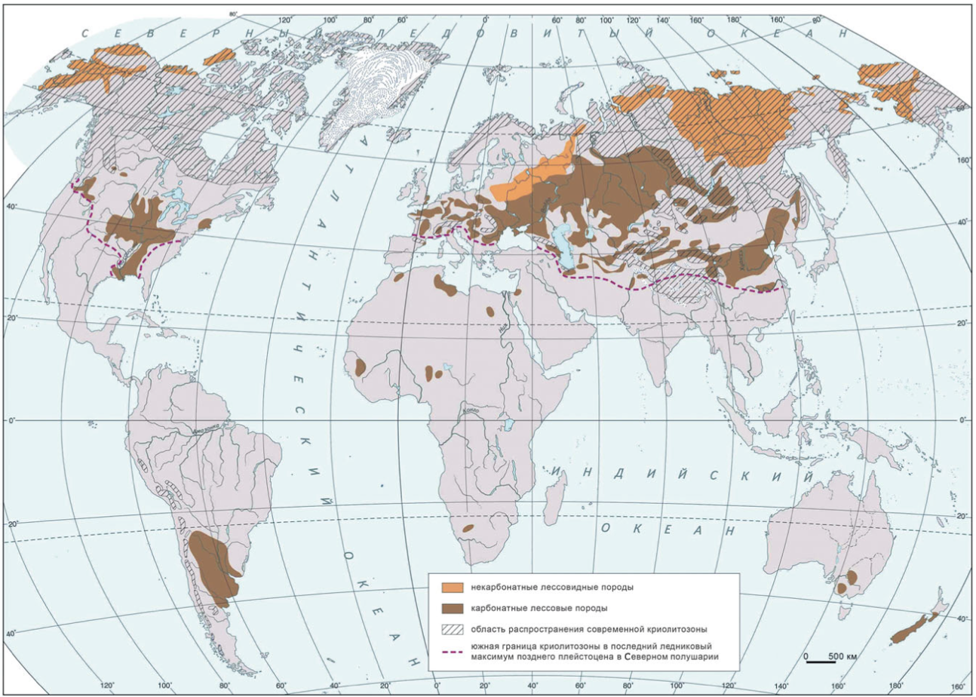

Figure 1.1 – Distribution of loess, loess-like rocks, modern and late Pleistocene cryolithozones

Note – Compiled according to the source [8]

In the Commonwealth of Independent States (CIS), loess soils occupy about 35% of the European and 7% of the Asian parts. In Kazakhstan, loess and loess rocks are distributed mainly in the south and east of the country, which were formed under the influence of cryogenesis processes in the periglacial conditions of the mountain glaciations of the Tien Shan and Pamir (figure.1.2) [9].

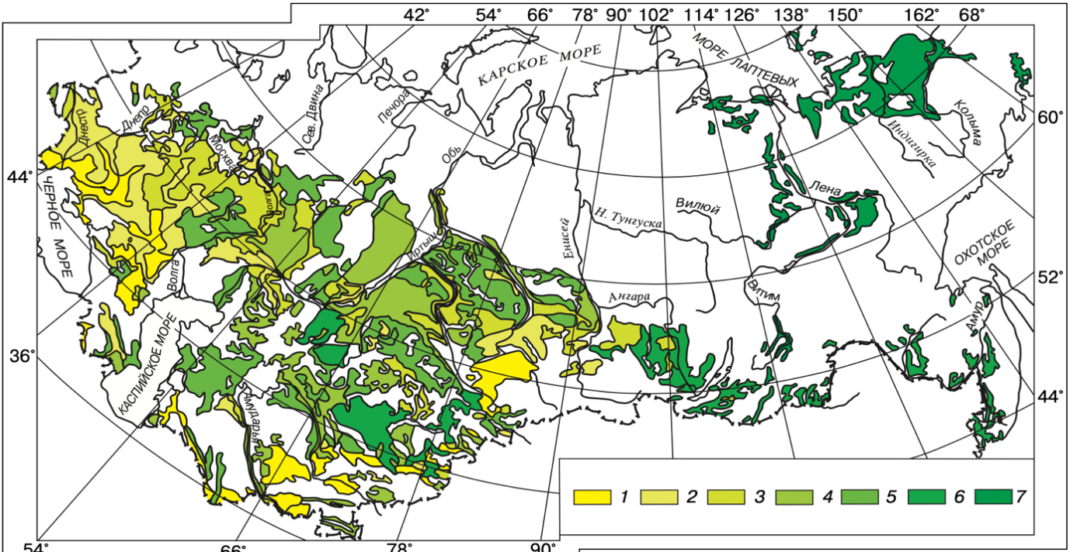

1 - loess and loess rocks of a high thickness (over 10 m) which exhibit collapsing under their weight; 2 - thick loess rocks and loess rocks (over 5 m) which exhibit significant collapsing deformations under additional loads; 3 - medium thickness loess rocks (5-10 m) which exhibit minor collapsing deformations under additional loads; 4 - loess rocks of discontinuous spreading (3-5 m), non-sagging; 5 - loess rocks of discontinuous and island spreading of variable thickness, nonuniform in their collapsing; 6 - loess-like and clayey cover rocks of island and discontinuous spreading, of low thickness, non-sagging; 7 - frozen cover dusty clayey rocks, thermal collapsing as a result of thawing

Figure 1.2 – Map of the development of loess rocks in the CIS

Note – Compiled according to the source [4, с. 50]

Prominent scientists made a significant contribution to the research of loess soils at different times in CIS, such as Y.M. Abelev, V.P. Ananyev, V.V. Askalonov, H.A. Askarov, S.K. Aliev, M.Y. Abelev, L.S. Berg, I.P. Boyko, N.Ya. Denisov, A.M. Drannikov, N.N. Frolov, I.P. Gerasimov, M.N. Goldstein, Y.D. Gilman, A.A. Grigorian, A.A. Kirillov, N.I. Krieger, S.N. Klepikov, V.I. Krutov, A.S. Kovalev, K.I. Lisitsyn, A.K. Larionov, G.M. Lomize, I.M. Litvinov, A.A. Mustafayev, A.V. Minervin, A.K. Musayelyan, I.V. Matveev, V. A. Obruchev, N.A. Ostashov, A.P. Pavlov, B.B. Polynov, G.P. Polyakov, A.L. Rubinstein, I.A. Rosenfeld, B.A. Rzhanitsyn, E.M. Sergeev, V.E. Sokolovich, V.K. Shevelev, N.A. Tsytovich, P.A. Tutkovsky, I.I. Trofimov, R.A. Tokar, A.S. Tregub, R.S. Ziangirov, N.L. Zotsenko [1–13].
The problem of loess and loess-like rocks of central and southern parts of Central Asia, their origin of genetic types, and peculiarities of their physical and mechanical properties were studied by G.A. Mavlyanov [6, с. 6].
A great input in the research of subsidence soils has been made by such foreign scientists as A. Andrieu, M.A. Biot, S.P. Bentley, A. Billard, E. Derbyshire, J. Feda, D.G. Fredlund, J.K.M. Gan, M.B. de Groot, R.L. Handy, S.L. Houston, W.N. Houston, I. Jefferson, B.E. Lofgren, J. Locat, G. Lefebvre, Z. Lin, B. Li, T.W. Mellors, H.H. Mahmoud, X. Meng, T. Muxart, J.D. Nieuwenhuis, A.W. Opukumo, J.W.A. Poesen, C.D.F. Rogers, A.J. Roberts, R.F. Scott, I.J. Smalley, N.K. Tovey, J.K. Torrance, J.T. Wang, B. Van Wesemael, Z. Zhou [14-19].

1.2 Engineering and geological characteristics of collapsible soils
The mineralogical composition of loess rocks is about 50 minerals, 15 of which form the rock itself, and the rest are clay and accessory minerals.
The clayey part (<0.005 mm fractions) of loess soils consists mainly of montmorillonite, kaolinite, and hydromica. The percentage and composition of clay minerals in loess soils divides them into montmorillonite, montmorillonite-hydrolide, and montmorillonite- kaolinite. These minerals, having high specific surface area, contribute to the collapsing properties of loess soils [7, с. 13].
Sandy-silty minerals such as feldspars, carbonates, and quartz (fractions of 0.1-0.005 mm) do not affect the collapsing properties of loess soils because most of them are inert to water.
The particle size distribution of loess soil is characterized by a content of more than 50% of dust particles ranging in size from 0.05 to 0.005 mm and a small content of fine and clay particles smaller than 0.005 mm [7, c.14].
The degree of collapsing in loess soils manifests itself differently depending on the nature of the destruction of aggregates of fine and clayey particles during water soaking. The qualitative and quantitative content of aggregates in loess rocks relates to the process of peptization during wetting. It determines the degree of variability of strength and stability of the soil after its wetting.
One of the distinctive features of loess rocks is their carbonativity. The carbonate content depends on the geographical location of loess rocks, so in arid areas, the carbonate content is higher than in areas with high humidity. In the loess of Central Asia, the number of carbonates is about 15-25% [20, с. 17].
The pH of loess rocks varies considerably, from 4.5 to 9.2, due to differences in their degree of leaching, the presence of simple salts, and the composition of exchangeable cations. In the loess proper, the pH varies from about 7 to 9. The pH of loess rocks varies zonally. In the loess rocks of the forest zone, carbonate salts are rare, and the pH value for them is 4.5-7. In the forest-steppe and steppe zones, the pH usually ranges from 7 to 8. pH value in the soil - СаСО₃ system usually does not exceed 8.3. In loess rocks pH reaches 8.5-9.2. Such high alkalinity is explained by the presence of Ka+ in the exchange complex and the appearance of sodium bicarbonate and carbonate in the solution [20, c.18].
There is a relationship between the pH value of loess rocks and the amount of precipitation. The highest pH value of soils is characteristic of areas with an arid climate. The higher the amount of precipitation, the more leached soils are.
At higher elevations, loess rocks are characterized by lower pH than at lower elevations. Pod deposits are also leached and have lower pH values than the adjacent loess rocks.
Silicic acid is the main component of loess-like soils, with a content of over 60% [9, c.59]. As a result of the microbiological process, loess rocks contain humus compounds in the amount of 0.1 to 0.9%, the presence of which causes the formation of microaggregates of fine fractions [7, c.15].
Depending on the location, loess soils contain water-soluble salts that form rock strength, such as calcium and magnesium carbonates, calcium sulfates, sodium carbonates, and chlorides. The presence of calcium carbonate influences the color of loess rocks; this substance also contributes to creating structural bonds, macropore stability, and microaggregation.
Such substances as gypsum and lime add strength and stability to loess rock. Being a cementing agent, these salts disrupt connectivity when dissolved. But low solubility in water does not affect the collapsing process in the first stage, so the long process of dissolution and leaching of salts from these soils has a significant impact.
The formation of structural bonds in soils occurs only in the places of their full convergence - contacts. The nature of individual contacts and their number are essential indicators of soil structure, determining its strength, deformation, and many other engineering and geological properties [21-24].
In soils, despite the diversity of mineral composition, sizes, and shapes of structural elements, as well as the nature and degree of filling of the pore space with solutions, there are four main types of contacts: phase; coagulation; transitional; connections resulting from mechanical entanglement of mineral grains. Thus, the following types of structures are distinguished in soils: coagulation; crystallization-cementation; transitional; separate-grain (unbound); mixed structures.
Loess and loess-like formations belong to soils with a transitional type of structure, in which transitional contacts predominate. The formation of such connections is mainly due to soil dehydration (desiccation) and ionic-electrostatic bonds in the course of regressive lithogenesis.
High porosity and abundance of macro voids, characteristic of loess soils with relatively deep groundwater tables due to limited precipitation in an arid climate, are the conditions for collapsing deformations in loess soils. The porosity of dry or slightly wetted loess soils is usually 40-60 % [7, c.18], lower values typical for non-collapsible and collapsible soils.
The natural moisture content of loess soils is insignificant and varies from 0.04 to 0.18 depending on climatic, geomorphological, and hydrogeological conditions. The degree of collapsing of loess strata largely depends on the natural humidity, so the lower the value of the natural humidity, the greater the degree of soil collapsing. The presence or absence of an underlying waterproof layer influences the character of natural humidity changes along with the depth [25].
The unit weight of loess soil, depending on the mineral composition of loess soil, its structure and water content vary from 13.3 to 20.3 kN/m³, and the specific weight of particles varies between 26.0-27.5 kN/m³ [7, c.19].
The plasticity of loess soils depends on the structure, mineralogical composition, dispersion, elasticity, and shape of its particles. The collapsing varieties of loess soils can be distinguished from non-collapsing soils by their plasticity limits. So, the low values of plasticity limits and plasticity index have collapsing loess-like loams than non-collapsing ones. Plasticity varies in the range IP = 0.11-0.27, and characteristic moisture content W_{L} = 0.20-0.48 (liquid limit); W_{P} = 0.15-0.23 (plastic limit) [5, c.9].
Soil density depends on its moisture content. In arid areas, it has a lower value compared to areas with high moisture content. The density of loess soils varies considerably from 1.33 to 2.09 g/cm³ [5, c.9].
Slackening is considered one of the characteristic features of loess soils. Moisture, cementitious content, and the number of clay particles are the main factors influencing the slackening rate. Usually, slackening of loess soils with undisturbed structure proceeds intensively with rapid release of bubbles and ends not more than in 1${ 1}/2$ - 2 min.
Loess soils have low deformability and good bearing capacity when naturally moist and undisturbed. These soils become highly compressible under compaction load since the strength is sharply reduced with increasing moisture content due to the destruction of the structure. The compaction resistance of loess soils of natural moisture is significant, i.e., the resulting settlement in these conditions is negligible. The compressibility coefficient of loess rocks changes in a wide range: their value varies from 0.005 to 0.067 kg/cm² in loads 1-2 kg/cm² [20, c.22].
Their physical condition determines the shear strength of loess soils at density and natural moisture content. Having high values of shear strength, wetting significantly reduces this property of these soils. Depending on the density-moisture of loess soils, strength values can vary widely. Friction force for dried samples (W=3 - 7%) can reach 0.25 - 0.3 MPa, and the angle of internal friction varies from 33 to 40% [7, c.24].
Large pores and low clay content make loess soil highly water permeable. However, a constant value of the permeability coefficient for loess soils can be achieved only after full compaction, i.e., after the collapsing process is complete in them. Due to their anisotropy, loess soils often have higher water permeability in a vertical direction (1.7-2.8 times more) than in a horizontal direction [7, c.26].
The main characteristic of loess soils is collapsibility [26-30]. Collapsibility is a rapidly developing collapsing caused by abrupt changes in the soil structure. Collapsibility is understood as rapid and irregular deformations caused by the weight of loess soils when their moisture content increases.
Collapsible soils are called soils that are characterized by additional relative collapsing - the relative collapsing ε_{sl} ≥ 0.01 when they are moistened.
Soil collapsibility is caused by the fact that loess strata are in an unconsolidated state caused by the peculiarities of formation and existence of these strata. If there is no moisture or load increase, the collapsing soil's unconsolidated condition may persist throughout the entire existence of the strata [31].
Under consolidation can be caused by various factors - the method of deposition and composition of sediments, the rate of buildup of the overlying strata, structural relations between mineral particles, and decompaction of sediments deposited in different ways as a result of changes in temperature regime and soil-forming processes [32].
Under densification of soils is expressed in their low degree of density, which is usually characterized by the density of soil in the dry state in the range of 1.2-1.5 t/m³, the porosity of 0.6-0.45, and the coefficient of soil porosity of 0.65-1.2. With depth, the degree of density most often increases [2, с.13].

1.3 Methods of investigation and improvement of collapsible soils

1.3.1 Indirect methods
Indirect methods [33] of determining collapsibility are used at the earliest stages of the investigation of loess soils in the territory under study to determine the propensity of soils to collapse. Based on their assessment of the choice of methods of further research of soils and justification of appointments of field and laboratory tests, the approximate evaluation of the volume of work. But unlike direct methods, they don't allow for estimating numerically collapsibility value of loess soils.
The indirect methods of investigation of collapsibility use the so-called "visual indicators" and indirect indicators [33, c.191].
Visual indicators include the following already mentioned signs:
1. Climate and topography. For collapsible loess, rocks are characterized, as a rule, by a dry climate.
2. Thickness of loess rocks. The low thickness of loess rocks on the site (less than 5 meters) may be a reason to classify these soils as non-sagging.
3. Depth of occurrence of ground waters. Loess soils under the non-collapsing category are loess soils with the occurrence of groundwater at a depth of fewer than 5 meters.
4. Loess rocks also have characteristic mineral and granulometric composition. They are characterized by the content in the sample of more than 50-80% of dusty particles, with the predominance of coarse dust of 0.01-0.05 mm in size [20, с.27]. Clay minerals in the loess are mainly represented by kaolinite and hydromica.
5. Appearance of rocks. The loesses have a relatively light pale color and often noticeable macroporosity. They are characterized by the presence of carbonate and gypsum or salt inclusions, including in the form of nodules. These features allow us to distinguish loess soils in the outcrop.
The indirect indicators (criteria) include calculated indicators. The main ones are the coefficient of soil porosity e, the dry density of the soil ρ_{d}, water saturation ratio S_{r}, collapsing index P, as well as the reduction coefficient of structural strength when wetting K_{c}, macroporosity index K_{u}, moisture deficit ratio K, collapsing Index И_{п.}
The coefficient of porosity: $e=\frac{ρ_{s}}{ρ_{d}}-1$ or $=\frac{n}{1-n}$ , where $ρ_{s}$ is the density of solid particles, $ρ_{d}$ are the dry density of the soil, g/cm³, and n is the soil porosity in fractions of one. Since one of the conditions of collapsibility is high porosity and a large volume of soil pores, the value of this coefficient can be used to estimate the possibility of soil collapse. Thus, the higher the coefficient, the more collapsibility the ground can be.
The dry soil density: $ρ_{d}=\frac{ρ}{1+w}$, where ρ is the natural density of soil in g/cm³, w is the natural moisture content of the soil in %. The lower the dry density of soil, the looser the soil is considered to be and the more prone it is to the phenomena of collapsing.
Based on the coefficient of porosity and dry density of soil suggested to divide loess soil into 3 groups: medium density - e < 0.7; $ρ_{d}$> 1.6 t/m³, loose - e from 0.7 to 1.0; $ρ_{d}$ from 1.35 to 1.6 t/m³, very loose - e > 1.0; $ρ_{d}$ < 1.35 t/m³.
According to this classification, soils that fit into the medium density category will not collapse under any other physical characteristics and load. On the other hand, very loose soils will almost always have collapsing properties with the highest relative collapsing rate. The category of loose soils is intermediate between the previous two types, so the collapsing of soils in this category will depend mainly on their moisture content.
Saturation ratio S_{r}: $S_{r}=\frac{wρ_{s}}{eρ_{w}}$, where w is the natural moisture content of the soil, $ρ_{s}$ is the density of soil particles t/m³, $ρ_{w}$ is water density, taken as 1 t/m³, e is a void ratio. The water saturation ratio is one of the main characteristics of loess soils. It is considered if S_{r} > 0.8, soils are collapsible. According to this Index more detailed classification of loess soils is offered, with a division of soils into the following three groups: low-moisture - S_{r} < 0.5; wet - S_{r} from 0.5 to 0.7; very wet - S_{r} > 0.7. Low-moistened soils have pronounced collapsible properties, especially if they are classified as loose or very loose. On the other hand, very wet soils are primarily non-collapsing because their structural bonds may have already been destroyed, and the soil is compacted. Based on porosity, dry density of soil, and degree of humidity, a generalized table of dependence of loess rock collapsibility on its coefficient of porosity, density, and water saturation ratio is compiled, dividing soils into five main categories from non-sagging to extremely sagging (table 1.1).

Table 1.1 – Relationship of loess collapsibility to its density and water saturation ratio

Types of soils according to the degree of collapsing | Coefficient of porosity (Dry soil density $ρ_{d}$, t/m³) | Saturation ratio S_{r}
Non-collapsible  "Conditionally collapsible" | 1)е≤ 0,7($ρ_{d}$ ≥1,6)  2) e > 0,7 ($ρ_{d}$ < 1,6)  3) e < 0,7 ($ρ_{d}$ > 1,6)  4) 0,7 < e ≤ 0,8 (1,6 >$ρ_{d}$≥ 1,5) | 1) S_{r}> 0,5  2) S_{r} ≥ 0,8  3) S_{r} <0,5  4) 0,5 <Sr ≤ 0,7
Weakly collapsible | 1) 0,7 ≤ e ≤ 0,8 (1,6>$ρ_{d}$ ≥ 1,5) 2) e> 0,8 ($ρ_{d}$≤ 1,5) | 1) S_{r} <0,7  2) S_{r}> 0,7
Medium collapsible | 1) 0,8 <e <0,9 (1,5>$ρ_{d}$ ≥ 1,4) 2) e> 0,9 ($ρ_{d}$ <1,4) | 1) S_{r} <0,5  2) S_{r}> 0,5
Highly collapsible | 1) 0,9 <e ≤ 1,05 (1,4> $ρ_{d}$ ≥ 1,3) 2) e> 1,5 ($ρ_{d}$< 1,3) | 1) S_{r} <0,3  2) S_{r}> 0,3
Extremely collapsible | e> 1,05 ($ρ_{d}$ <1,3) | S_{r} < 0,3
Note – Compiled according to the source [3, с. 60]

The classification presented in the table gives the most accurate understanding of the collapsibility of loess soils because it is based on three attributes characterizing the collapsing soils.
Index of collapsibility “П” (index П; compaction index П) [20, 34] characterizes the natural under compaction of loess rock: $П=\frac{e_{L}-e}{1+e}$, where e is the porosity factor of the soil of natural formation and moisture, $e_{L}$ is the porosity factor corresponding to the moisture at the yield point ($W_{L}$). $e_{L}=W_{L}×\frac{ρ_{s}}{ρ_{w}}$, where$ρ_{s}$ is the density of solid (mineral) soil particles, $ρ_{w}$ is the density of water, taken as 1. With the help of the collapsibility index and plasticity index ($I_{p}$, %), rocks with collapsible properties can be distinguished. Soils with the following combination of these characteristics are classified as collapsible soils: П < 0.1 at $I_{p}$ from 1 to 10; П < 0.17 at $I_{p}$ from 10 to 17; П < 0.24 at $I_{p}$ from 14 to 22.
N.Y. Denisov's macroporosity index [9, с. 24]: $K_{y}=\frac{e_{L}}{e}$, where e is the porosity coefficient of the soil of natural composition and moisture, $e_{L}$ is the porosity coefficient corresponding to the liquid limit. Soils with $K_{y}$ < 1 are considered to be collapsible soils. Denisov called the difference between the coefficients of porosity of soil of natural humidity and at the liquid limit е – $e_{L}$ macroporosity, in the presence of which the loess is prone to collapsing.
Prilonsky's compaction index [20, 35]: $K_{d}=\frac{e_{L}-e}{e_{L}-e_{p}}$, where $e_{p}$ is the porosity coefficient at the moisture content at the plastic limit ($W_{p}$): $e_{p}=W_{p}×\frac{ρ_{s}}{ρ_{w}}$. According to the K_d characteristic, rocks are divided into normally compacted with $K_{d}$ = 0, under compacted (collapsing) with $K_{d}$ <0, and over compacted with $K_{d}$ > 0 [9, с. 12].
Index of collapsibility “$И_{п}$” (by I.P. Ivanov) depends on humidity and porosity of soil. $И_{п}=\frac{w}{0.64\frac{n-0.28}{1-n}}$or $И_{п}=\frac{1.56w(1-n)}{n-0.28}$, where w is natural humidity and n is soil porosity at natural humidity. According to numerous studies, collapsing soils are characterized by the value of the Index of collapsibility $И_{п}$ <1 < 1, and for non-collapsing $И_{п}$ <1 ≥ 1 [36].
Moisture deficiency coefficient K proposed by A.K. Larionov is also based on porosity and volumetric moisture: $K=\frac{W_{0}}{n-W_{0}}$. Soils with a moisture deficit coefficient K> 1.1-1.2 are non-collapsing [35, с. 36].
On the basis of a considerable volume of the research spent on the definition of collapsing of loess soils by indirect and direct methods, in the works of I.P. Ivanov [36, с. 214], it is specified: "the disadvantage of all indirect ways of prediction of propensity to collapsing, based on an estimation of the physical state of loess rocks, is not taking into account a stressed state in which soaking and acceptance of the value of densifying load p=0.3 MPa are constant. This assumption reduces the risk of missing collapsing varieties but increases the scope of laboratory investigations by including some non-consolidated rocks in the test samples at pressures p<0.3 MPa. At the same time, he emphasizes that such an approach for preliminary assessment and prediction of soil collapsing is justified.
In this connection, as indicated above, it is necessary to determine the relative collapsing of soils by special laboratory and field methods (table 1.2) [20].

Table 1.2 – Summary table of characteristics required to calculate indirect indicators

Indirect indicator | Necessary physical and mechanical characteristics | Principle of classification | Distinguishing feature of the indicator
The coefficient of porosity е and  dry density of the soil $ρ_{d}$ | е ($ρ_{s}$, ρ, w); $ρ_{d}$ (ρ, w) | medium density– е < 0,7; $ρ_{d}$ > 1,6 т/м³,  loose– е from 0,7 to 1,0; $ρ_{d}$ from 1,35 to 1,6 т/м³,  very loose– е > 1,0; $ρ_{d}$ < 1,35 т/м³. | The classification is based on the previously selected physical indicators characteristic of collapsing soils, and using them in the aggregate to determine the propensity of the soil to collapse. That is, determining how close the presented soil in these indicators to the reference collapsing sample.
Coefficient of water saturation of rocks $S_{r}$ | $S_{r}$ (w, $ρ_{s}$, ρ, ρw) | low wet– $S_{r}$ <0,5 wet– $S_{r}$ from 0,5 to 0,7 very wet – $S_{r}$ > 0,7
е ($ρ_{s}$, ρ, w); $ρ_{d}$ (ρ, w); $S_{r}$ (w, $ρ_{s}$, ρ, ρw) | See Table 1.
Index of collapsing П | е ($ρ_{s}$, ρ, w);  $e_{L}$ ($W_{L}$, $ρ_{s}$, ρ, $p_{w}$) | Soils are collapsing at: П < 0,1 at $I_{p}$ from 1 to 10, П < 0,17 at $I_{p}$ from 10 to 14 П <0,24 at $I_{p}$ from 14 to 22 | This indicator characterizes the natural undercompaction of loess rocks. The value of the plasticity index is also necessary for classification.
Denisov's Index of macroporosity $K_{y}$ | е ($ρ_{s}$, ρ, w);  $e_{L}$ ($W_{L}$, $ρ_{s}$, ρ, $p_{w}$) | Soils are collapsing at $K_{y}$ <1 | It is based on the ratio of the coefficient of porosity at the liquid limit to the coefficient of porosity at the natural humidity of the soil. That is, the soil is considered to be collapsible at е>$e_{L}$.
Prilonsky's $K_{d}$ index of compaction | е ($ρ_{s}$, ρ, w);  еL ($W_{L}$, $ρ_{s}$, ρ, ρw) ep (Wp, $ρ_{s}$, ρ, ρw) | $K_{d}$ <0 – under-com pacted (collapsible) soil, $K_{d}$ = 0 –initial degree of compaction,  0 < $K_{d}$< 1 –corres ponds to the plastic state, $K_{d}$ = 1 –enters a semi-solid state,  $K_{d}$ > 1 – reconsoli dated, semi-solid. | The classification is based on the relationship between the values of porosity coefficients at natural moisture, liquid limit, and plastic limit. The Prilonsky's Index is similar in formula to the Index of collapsing P, but differs in the use of the coefficient of porosity at the plastic limit.
Index of collapsing $И_{п}$ | w; n ($ρ_{s}$, ρ, w) | Soils are collapsing at $И_{п}$ <1 | Represents a relationship involving multiple coefficients derived from numerous laboratory tests
Coefficient of humidity deficiency K | $W_{0}$ (ρ, w); n ($ρ_{s}$, ρ, w) | Soils are collapsing at К <1,1 – 1,2 | It is the ratio of the percentage of moisture in the pores to the gas that fills them. Thus, if there is less moisture in the pores of the ground than air and other gases, the ground is considered to be collapsible
1.3.2 Direct methods
Direct methods of investigating soils for collapsing are used to obtain numerical characteristics of collapsing. They are calculated by processing the data obtained in the course of specialized field or laboratory tests of soils.
Collapsible soils include loess-like soils that have a relative collapsing value $ε_{sl}$ > 0.01.
One of the direct methods of investigating soils is the laboratory method. To assess the collapsing of soils, tests on special compression apparatuses are to be performed. The characteristics of collapsing are determined by the relative strain obtained by testing samples of selected monolithic soils. Tests are carried out on soil samples by soaking them in water at a pressure increased in successive steps [37-41].
Tests of soils in compression devices can be carried out according to the schemes [42-45]:
1 curve - to determine the relative collapsing $ε_{sl}$ at one given pressure value.
2 curves for determining the relative collapsing $ε_{sl}$ at different pressures as well as the initial collapsing pressure $p_{sl}$.
The odometer diagram and the compression curve graph are shown in figures 1.3 and 1.4.

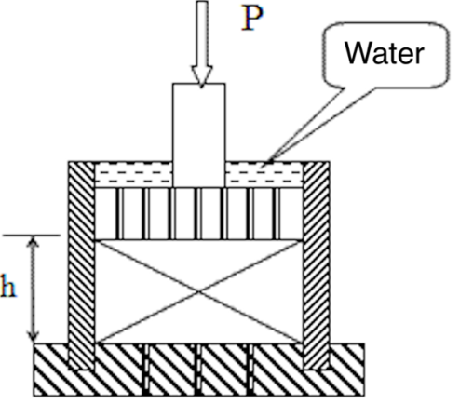

Figure 1.3 – Odometer diagram for performing compression tests on loess soil

Note – Compiled according to the source [1, с. 33]

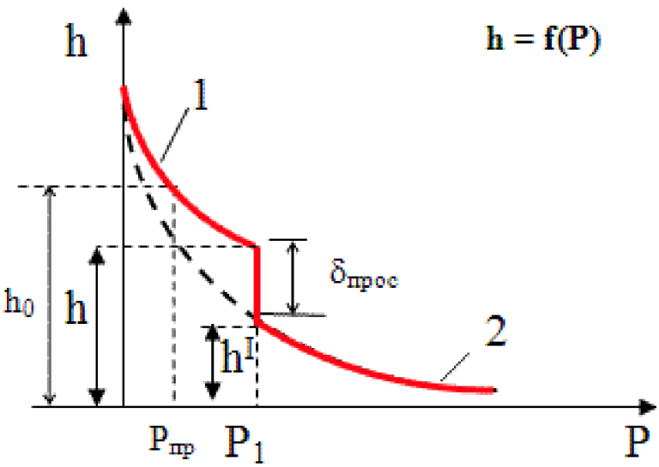

1 - compression curve of loess soil before soaking; 2 - after soaking with water

Figure 1.4 Graph of the compression curve of loess soil before and after soaking

Note – Compiled according to the source [1, с. 34]
The coefficient of relative collapsing is determined as follows:

$δ_{subs}=\frac{h-h^{1}}{h_{0}}$ (1.1)

where h – height (cm) of the sample of natural moisture compressed by the pressure Р₁ equal to the pressure of the whole structure and its own weight of the overlying soil;
h^{I} – height (cm) of the same soil sample after water passing through it while maintaining pressure Р₁;
h₀ – height (cm) of the same sample of soil with natural humidity compressed by pressure equal to natural pressure.
If according to test results $δ_{subs}$ < 0.01 - it is considered that loess is not subsided. If $δ_{subs}$ > 0.01 - the loess is subsided [46-48].
The second direct method is the field test. The most common is the method of determining collapsing by experimental stamps at a depth of the foundations [49-51].
Experiments can be conducted according to two schemes: "two curves" or "one curve". The test scheme is selected depending on the set of characteristics required for the design [52-55].
The "one curve" scheme, as in laboratory tests, is used in cases when it is sufficient to determine the strain modulus of soil at natural moisture E and relative collapsing $ε_{sl}$ at one given pressure $p_{3}$.
According to the results, the curve S = f (p) characterizing the soil settlement from pressure before and after soaking can be drawn (figure 1.5).

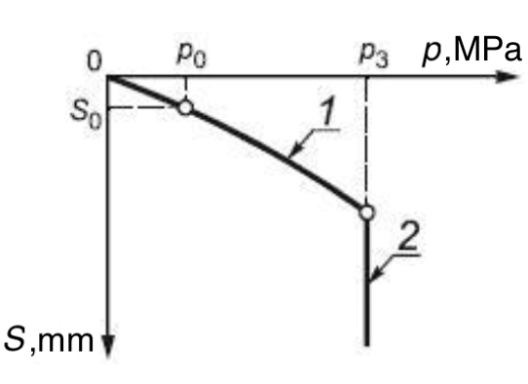

1 – settlement; 2 – collapsing at a given pressure

Figure 1.5 – Diagram of dependence of soil collapsing on pressure for test of collapsing soil with soaking by the stamp for "one curve" scheme

Note – Compiled according to the source [20, с. 4]

According to the results of "one curve" tests of collapsing soils, the strain modulus of the soil of natural moisture E and the relative collapsing $ε_{sl}$ at a given pressure $p_{3}$are determined. The soil collapse at the base of the die $S_{spl}$ for calculations $ε_{sl}$ at "one curve" tests is defined as the increment of die settlement due to soaking the soil at a given pressure $p_{3}$.
The second scheme requires conducting two experiments in two pits located next to each other in the same loess layer [56]. One test is carried out with preservation of natural moisture, and the second with soaking after the first loading step [57].
Tests according to the "two curves" scheme, as in laboratory tests, are performed to determine the full set of collapsing characteristics (natural moisture modulus of deformation E and in water-saturated state $E_{sat}$, initial collapsing pressure $p_{sl}$ and relative soil collapsing $ε_{sl}$ at different pressures) [58]. The soil collapsing at the base of the die $S_{spl}$ for calculations $ε_{sl}$ at tests according to this scheme is determined as a difference of the die collapsing on the soil in a water-saturated state and the soil of natural humidity at each pressure stage. Two curves S = f (p) is also plotted, by which optimal construction conditions can be selected. As a result of engineering surveys, reliable data for the construction of curves $ε_{sl}$ = f (p) for each layer of loess rocks should be obtained (figure 1.6).

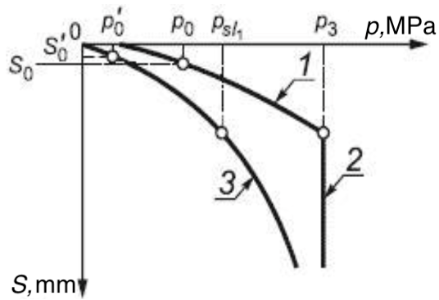

1 – settlement; 2 – collapsing at a given pressure; 3 – settlement after soaking

Figure 1.6 – Diagram of dependence of soil collapsing on pressure for the test of collapsing soil with soaking by stamp for "two curves" scheme

Note – Compiled according to the source [20, с. 41]

Based on the results of field and laboratory tests of soils for collapsing, the amount of collapsing of loess strata under the pressure of its own weight is calculated assuming its waterlogging or flooding. The collapsing is calculated according to the formula (1.2):

$S_{sl}=\sum_{i}^{n}{ε_{sli}×h_{i}×k_{sli}}$ (1.2)

where $ε_{sli}$ – relative collapsing of the i-th layer at the corresponding values of pressure in the i-th layer, determined from the diagram $ε_{sl}$ = f (p) for pressures from own weight acting in the middle of the calculated layer with thickness $h_{i}$;
$h_{i}$ – thickness of the i-th layer;
$k_{sli}$ – normative coefficient = 1;
n – number of layers in the collapsing strata. Calculation layers are distinguished in the part of the loess strata where $h_{i}$ > $p_{sl}$.
In accordance with normative documents [59], loess strata are divided into two types according to the collapsing of their own weight:
Type I – collapsing occurs mainly in the limit of the deformable zone of the foundation from the load of foundations or other external load, and collapsing from own weight of the soil is practically absent or does not exceed 5 cm;
Type II – collapsing of soil from its own weight is possible, occurring mainly in the lower part of the collapsing thickness and exceeding 5 cm.

1.3.3 Soil improvement methods
When planning new construction complexes, it is necessary to consider the complex engineering and geological conditions of collapsible soils [60].
Before erecting structures in such areas, it is necessary to apply various methods to increase the soil's bearing capacity and stability [61].
The bearing capacity of such soils is low, so before making foundations on them, applying different soil stabilization methods is necessary. Three groups of methods are used for the improvement of soil bases: constructive methods of base improvement; compaction of soil bases; and consolidation of soil bases [62-64].
Today the world practice different methods and ways of eliminating subsidence properties of soils by their compaction or consolidation; the device of soil cushions is used. To consolidate the subsidence soils, use the methods of one-solution silicification or thermal firing. The device of ground cushions creates a layer of non-subsidence soil in the foundation base. Another practice presented the construction of fixed soil columns and piles in weak dusty-clayey soils when combinations of jetting and boring methods or combination of jetting technology with the immersion of ready reinforced concrete elements are also promising. Also, one of the effective methods of designing structures on subsidence soils is the reinforcement of foundation soils. One of the basic concepts of soil reinforcement is reduced to the scheme when the weak soil mass is reinforced with high-strength elements and diaphragms placed in the ground. In this case, both vertical and horizontal reinforcement is possible, which in each case has a different effect on the stress-strain state of foundation soils and the operation of foundations. The improvement of ground and soil base reinforcement is directly related to the materials used for reinforcement [65-66].

1.4 Special features of the design of pile foundations in collapsing soils
The design is carried out depending on the type of collapsing soil conditions, the magnitude and character of the applied loads [67-76]. The pile foundations should be designed with cutting of collapsing strata and resting on low-compressible soil layers [32, с. 79].
When designing foundations in the soil conditions of type I in terms of collapsing, it is recommended to bury the lower ends of the piles by at least 0.5-1 m into non-collapsing dense and medium dense sands or clay soils with a liquidity index $I_{L}$ ≤ 0.6. Piles are sunk in non-collapsing clay soils with $I_{L}$ < 0.4 for driven piles and $I_{L}$ < 0.2 for bored piles if $s_{seg}$ ≤ $s_{u}$; $I_{L}$ < 0.2 for driven piles and $I_{L}$ ≤ 0 for bored piles if $s_{seg}$ > $s_{u}$ in soil conditions of the II types. Design characteristics R, E, φ, c must be determined when the soil is fully saturated, $I_{L}$ ≥ 0.4.
If a building of the III class is designed, the SP RK 5.01-103-2013 allows for incomplete penetration of the collapsing thickness by piles with their lower ends sunk no less than one meter into the soil with relative collapsing $ε_{sl}$ < 0.02 at p = 0.3 MPa [77]. It is not recommended to design pile foundations on soils of type II with collapsing from their own weight of more than 30 cm, since their bearing capacity will not be ensured.
The calculated allowable load on piles in soil conditions of type II on collapsing must be determined taking into account the additional load from the forces of negative friction arising from full water saturation of the soil:

$F_{n}=A_{s}∕H_{sl}\sum_{i=1}^{n}{({γsat}_{i}h_{i}-{psl}_{i})h_{i}}$ (1.3)

where $A_{s}$ – the area of the surrounding soil interacting with the pile;
$p_{sl}$ – the initial drawdown pressure of the i-th layer with thickness $h_{i}$;
$H_{sl}$ – the thickness of the collapsing zone.

$γ_{sat}=\frac{γ_{i}}{-1+ω}+\frac{e_{i}γ_{ω}}{1+e_{i}}$ (1.4)

where $γ_{sat}$ – the unit weight at full water saturation;
$h_{i}$ – the thickness of the i-th layer of soil into which the collapsing thickness is divided.
The area of the soil interacting with the pile is determined depending on the location of the piles [32, с. 80]:
- for a single pile

$A_{s}=π(0.4L)^{2}/4-A_{com}$ (1.5)

- for the average pile in the cluster

$A_{m}=a^{2}-A_{com}$ (1.6)

- for the corner pile in the cluster

$A_{cor}=π(0.5a+0.2L)^{2}/4-A_{com}$ (1.7)

- for the extreme pile in the cluster

$A_{p}=\left(0.5a+0.2L\right)a-A_{com}$ (1.8)
- for the average pile in a strip foundation

$A_{f}=0.2aL-A_{com}$ (1.9)

where a – the pitch of the piles;
$A_{com}$ – the area of compacted soil around the pile.

$A_{com}=0.25π(2.5d)^{2}$ (1.10)

where d – the diameter of the pile (cross-sectional size).
When calculating pile clusters, the largest of the values $A_{m}$, $A_{cor}$, $A_{p}$ is taken as the area of the soil interacting with the pile.
The depth of the collapsing soil thickness, within which the negative friction forces appear.

$H_{sl}^{'}=H_{sl}-s_{sl,g}/ε_{sl}$ (1.11)

where $s_{sl,g}$ – maximum permissible collapsing from own weight, taken 3 cm;
$ε_{sl}$ – relative collapsing of the lower layer of the collapsing zone.
Additional load must not exceed

$F_{n}≤F_{n}^{'}=γ_{c}u\sum_{i=1}^{n}{γ_{cf}f_{ni}h_{i}}$ (1.12)

where $γ_{c}$ and $γ_{cf}$ are coefficients of working conditions; u is the perimeter of the pile shaft;
$f_{ni}$ – the design force of loading friction on the pile side surface $f_{ni}$ = $f_{i}$at full water saturation of the soil [32, с. 81-82].
The bearing capacity of the pile in the development of negative friction can be found:

$F_{d}=γ_{c}\left(γ_{cR}RA+u\sum_{z_{0}}^{h}{γ_{cf}f_{i}h_{i}}\right)-γ_{ci}F_{n}$ (1.13)

where A – the cross-sectional area of the pile;
R – the estimated resistance under the pile tip;
$f_{i}$ – the estimated resistance of the i-th layer of height $h_{i}$ on the side surface of the pile;
$z_{0}$ – the depth of the zero point (where the soil displacement relative to the pile is 0, and above this point there is the negative friction below - the friction that holds the pile (below the boundary of the collapsing zone);
$γ_{ci}$ – the factor of working conditions, its value depends on the possible value of collapsing, at $s_{sl}$=5 cm, $γ_{c}$ =0 at $s_{sl}$ >2$s_{u}$, $γ_{c}$ =0,8.
When calculating the settlement of the pile foundation, the conditional foundation is assumed to be bounded from the sides by vertical planes that depart from the outer edges of the edge rows of piles at a distance $h_{mt}tg\frac{φ_{II,mt}}{4}$, where $h_{mt}$ is the distance from the bottom end of the pile to the depth $h_{sl}$; $φ_{II,mt}$ is within the layers to the depth $h_{mt}$.
When calculating the loads, negative friction forces have to be added to the own weight of the conditional foundation, which can be found either by formula (1.14) or

$F_{n}=u\sum_{0}^{h_{sl}}{τ_{i}h_{i}}$ (1.14)

where u – assumed to be equal to the perimeter of the cluster (for a conventional foundation) or the perimeter of the pile shaft section;
$h_{sl}$ – design depth to which negative friction forces are taken into account;
$τ_{i}$ – estimated resistance, kPa, determined to a depth of h = 6 m by the formula (1.15)

$τ_{i}=ξσ_{zg}{tgφ}_{I}+c_{I}$ (1.15)

where ξ – the coefficient of lateral pressure, equal to 0.7;
$φ_{I},$ $c_{I}$ – are depth-averaged $h_{sl}$.
The procedure for calculating pile foundations is as follows:
1. determining the pile bearing capacity (taking into account the forces of negative friction).
2. Determining the required number of piles and the design of the upstand.
3. Checking the pressure at the bottom of the conditional pile foundation and calculating the settlement.

Section Summary
A distinctive feature of collapsing soils is their ability to give additional settlements, called collapse, under the influence of external loads from the foundation and (or) the soil's weight when the humidity increases - soaking. Collapsible soils are commonly referred to as soils that, when wetting them, are characterized by relative additional collapsing - the coefficient of relative collapsing ε_{sl} ≥ 0.01.
Collapsible soils include loess, loess-like loams, sandy loams, and clays, less often, some types of clay cover soils.
The main features of loess soils are yellow-brown and pale-yellow color; high dustiness (the content of dusty fraction (0.05-0 005 mm) over 50%) with few clay particles; high porosity (40-55%) with a 1-3 mm macroporous network visible to the naked eye due to the presence of fine vertical channels; low natural humidity from 0,04 to 0,18 (S_{r}=0.5); ability to keep the vertical slope of considerable height in a dry state; high carbonate.
The main methods for investigating collapsible soils are indirect and direct investigation methods. Indirect methods of determining subsidence are used at the earliest stages of the study of loess soils in the studied area to determine the propensity of soils to collapsibility.
Direct methods of investigation of soils for subsidence are used to obtain numerical subsidence characteristics. They are calculated by processing the data obtained from the specialized field or laboratory tests of soils.
Pile foundations are designed based on the type of soil conditions in terms of subsidence, magnitude, and nature of the applied loads. Pile foundations should be designed with the cutting of collapsing thickness and resting on low-compressible soil layers.

2 FEATURES OF DESIGNING ON COLLAPSING SOILS ACCORDING TO THE STANDARDS

2.1 Design of buildings and structures on structurally unstable soils (NTP RK 07-01.2-2011)
Geotechnical designing in the conditions of the collapsing soils must be carried out taking into account their specific properties, that is that when humidity rises above a certain level, they develop rapidly proceeding additional collapsing deformations from external loads and own weight of soil.
In the geotechnical design of buildings and structures on collapsing soils, one should consider the possibility of increasing their moisture content due to [78]:
a) explicit waterlogging due to soaking of soils from above from external sources and (or) from below when the groundwater table rises;
b) implicit waterlogging due to the gradual accumulation of moisture in the soil due to surface water infiltration and screening of the surface of built-up areas.
When designing foundations composed of collapsing soils, their design state of moisture should be taken into account: if it is possible to flood them - full water saturation (S_{r} ≥ 0.8); if it is impossible to flood them - the established value of moisture W_{eq}, taken equal to the natural moisture W, if W≥ W_{p} and moisture at the rolling border, if W<W_{p}.
When designing buildings and structures for construction on collapsing and swelling soils, the following requirements shall be applied to the design:
1. For each geotechnical design situation, it must be verified that none of the limit states defined in SP RK EN 1990:2002+A1:2005/2011 [79] are exceeded.
2. When determining design situations and limit states, the following factors must be taken into account:
– the influence of the engineering and geological conditions of the site on the general stability and the character of the development of foundation soil displacements;
– type and size of the building or structure and its components, including special requirements such as design life;
– the situation in the surrounding area (e.g., the influence of nearby buildings or structures, transport, and the presence of utilities, vegetation, and hazardous chemicals);
– soil conditions;
– groundwater and its seasonal fluctuations, chemical composition, aggressiveness;
– regional seismicity;
– environmental influences (hydrology, surface water, collapsing, climatic conditions of the area, seasonal changes in temperature and moisture);
– planning of built-up areas;
– constructive measures of protection of buildings and structures.
When designing buildings and structures for construction on collapsing and swelling soils following the requirements of the project, the following should be provided [78, с. 8]:
– measures to reduce uneven settlements of foundations and to eliminate tilting of buildings and structures through the use of various methods of their alignment;
– water-protective measures in the areas formed by collapsing and swelling soils;
– constructive measures to protect buildings and structures from excessive ground settlement irregularities;
– engineering preparation of construction sites, reducing unevenness of foundation deformations;
– measures to ensure normal operation of external and internal utility networks, elevators, and other engineering and technological equipment during the period of uneven deformation of the foundation.
Implementing these protective measures does not exclude the possibility of the appearance in the load-bearing and enclosing structures of deformations and cracks allowed under operating conditions, correctable during the repair.
Geotechnical designs for buildings and structures erected on collapsing and swelling soils should be classified as Geotechnical Category 3 [80], including structures in areas with difficult soil conditions requiring separate investigations or special measures. Geotechnical category three usually includes rules and regulations that differ from SP RK EN 1997-1:2004/2011 [80, c.9].
The geotechnical designs of buildings and structures for construction on collapsing and swelling soils shall be made, taking into account the following design situations:
1. Both short-term and long-term situations shall be considered.
2. In geotechnical design, a typical detailed description of design situations shall include:
– impacts, their combinations, and loading cases;
– the suitability of the base of the structure in terms of overall stability and ground displacement;
– location and classification of the different zones of soil, rocks, or structural elements that are included in the calculation model;
– the slope of the underlying layers;
– mine workings, voids, and other underground structures;
– in the case of structures resting on or adjacent to the rocky ground:
– interbedded low- and high-compressible layers;
– fractures and cracks;
– possible instability of rock blocks;
– leaching voids such as fractures filled with loose material with ongoing dissolution processes;
– the nature of the environment of the project site, including:
– the effects of leaching, erosion, and excavation altering the geometry of the basement surface;
– the effects of chemical corrosion;
– the effects of weathering;
– consequences of freezing;
– effects of prolonged dry periods;
– changes in groundwater levels due to dewatering, possible flooding, accidents of drainage systems, water use, etc.;
– the presence of gases emitted from the ground;
– other temporal and spatial effects on the strength and other properties of materials, such as the occurrence of pits created by excavating animals;
– earthquakes;
– displacement of foundation soils due to collapsing from mining operations and other causes;
– sensitivity of the structure to deformations;
– the effect of a new structure on existing structures, utilities, or the environment;
– effects of land development.
Buildings and structures with new or improved design solutions, methods of leveling, and methods of preparation of foundations on collapsing and swelling soils shall be allowed for mass construction only after obtaining the positive results of the experimental verification in full-scale conditions.
Designs of buildings and structures in the cases established by the design organization should provide for the implementation of work related to instrumental observations of deformations of the earth's surface, as well as buildings and structures, including, if necessary, the period of their construction.
The design of the building or structure should be accompanied by a special passport, which should include [78, с. 10]:
– when building in conditions of collapsing and swelling soils - scheme of development of a microdistrict or quarter with the drawing of water carrying networks (water mains, sewerage, heating mains) and indicating the location of shut-off devices on water lines to disconnect individual routes or their sections in case of failure; location plan of fixed reference points used in observations of settlements of buildings and structures;
– in all cases, instructions on the organization and conduct of geotechnical monitoring, including instrumental observations of deformations of the building or structure and the earth's surface;
– the passports must be permanently kept in the operating and design organizations.
The geotechnical design shall assess the impact of environmental conditions on the durability of materials and provide for the protection or selection of materials with appropriate strength.
Design documentation for the construction of buildings and structures in conditions of collapsing and swelling soils should include a section "Durability," which provides for the prevention of the building's serviceability failure during its service life, as well as ensuring the uninterrupted operation of engineering equipment.
It is necessary to take the values of parameters of geotechnical impacts, if they are known before the calculation, these values may change.
In areas with collapsing soils settlement of the foundation of the designed foundations arising from soil compaction and collapsing shall be determined by summing the deformations of individual layers of the foundation.
The geotechnical effects that have to be additionally considered along with soil collapsing from foundation loading when designing buildings and structures on collapsing soils are the following types of deformations (Figure 2.1 and 2.2):
– absolute collapsing of an individual foundation S_{sl};
– average collapsing of the building foundation S_{sl};
– relative collapsing irregularity: ∆ S_{sl} /L of two adjacent foundations (skewness), i.e. difference in the collapsing of separate points of the foundation divided by the distance between them;
– collapsing slope of the foundation or the building as a whole i_{sl}, i.e., the ratio of the difference of collapsing of extreme points of the foundation to its width or length;
– relative drawdown deflection F_{sl}/L_{i} (the ratio of the deflection boom to the length of the bendable section of the structure), and in case of collapsing of soils from their weight, we should additionally consider:
– horizontal displacements of the ground at the base u_{sl};
– the slope of the ground surface at the base i_{s};
– curvature of the ground surface at the base P_{s}.
The character of soil collapsing development in depth can be explained by the existence of three zones within the collapsing thickness of the foundation (figure 2.1):
– zone I, within which ground collapsing occurs from the external load (foundation) and the soil's weight (deformable zone);
– II zone is neutral and, as a rule, there is no ground collapsing within it;
– III zone, within which the soil collapses, occurs only from its weight.
At soaking of collapsing thickness on the area of width B_{w}>H_{sl} (H_{sl} is the value of collapsing thickness), the ground surface collapsing from its weight is characterized by:
– a horizontal section of ground surface collapsing b_{w}, within which the ground collapsing S_{sl} develops to its higher value and varies less than ±10%;
– two curvilinear sections in which the ground collapsing varies from the higher value of S_{sl} to zero.
When soaking the collapsing thickness in width B_{w}<H_{sl}, the horizontal the ground collapsing section is practically not observed.
The peculiarities of soil collapsing deformation from its weight are characterized by slope i_{sl} and curvature, $ρ_{sl}$, as well as horizontal surface displacements. Such deformations are observed in the areas of irregular collapsing development.
When soaking collapsing soils from above, collapse within a part or rarely the entire collapsing thickness (when B_{w}<H_{sl}) and complete collapsing within the whole of collapsing thickness both from external load and the soil's weight (when B_{w}>H_{sl}) develop.

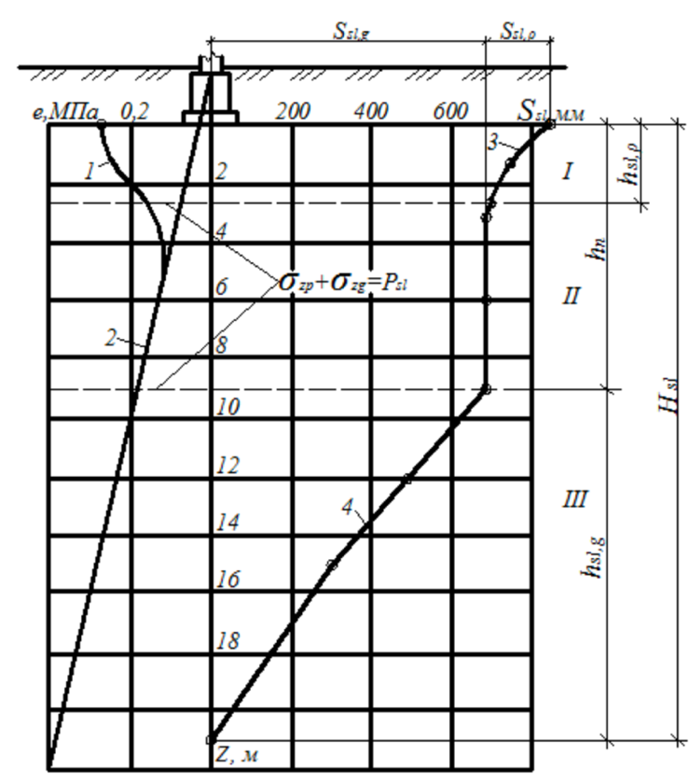

I - upper zone of soil collapsing (from external load and own weight of soil); II - neutral zone; III - lower zone of soil collapsing (from its weight); 1 - diagram of vertical stresses change along with the depth from the external load; 1 - diagram of vertical stresses change at depth by the external load; 2 - same diagram as for soil's weight; 3 - diagram of soil collapsing along with the depth from the external load; 4 - the same for the soil's weight; $σ_{zp}+σ_{zg}$ total pressures; P_{sl} - initial collapsing pressure; h_{sl,n} - thickness of the upper zone of collapsing (from external load); h_{n} - thickness of central zone; h_{sl,g} - thickness of the lower zone of soil collapsing (from its weight); H_{sl} - depth of collapsing thickness

Figure 2.1 – Typical zones of soil collapsing under the foundation

Note – Compiled according to the source [78, с. 13]

If soaking of collapsing thickness from above occurs from sources with width B_{w}<H_{sl}, then there is a wetted zone in the soil, the cross-section of which has the form of a truncated ellipse (Figure 2.2a).
Soaking of collapsing soil from above occurs over a long period as a result of process water leakage, and at B_{w}>H_{sl} a wetted zone of soil is formed, which has the shape of a trapezium (Figure 2.2b).
At that, the ground moisture condition within the wetted zone with width B_{w} (figure 2.2a) corresponds to full water saturation, and on the sections, L is estimated from full water saturation to natural moisture.
Input data for the selection of engineering solutions, as well as the composition and scope of structural and water protection measures when designing buildings and structures on collapsing soils, should include: materials of engineering-geological and hydrogeological surveys for the construction site; design solutions of the building or structure; master plan of the construction site; situation plan of the construction area; vertical layout project of the built-up area; water-bearing communication schemes; information on the methods of preparing the foundations used for the construction site.

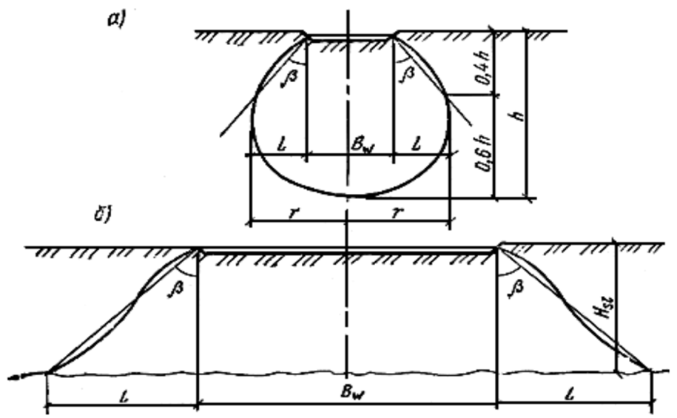

Figure 2.2 – Schemes of formation of moistened zones of soils during their Soaking

Note – Compiled according to the source [78, с. 14]

Depending on the expected deformation of the earth's surface on collapsing soils, areas on collapsing soils are divided into groups according to construction conditions, following table 2.1 for soil conditions of type I and table 2.2 for soil conditions of type II.

Table 2.1 – Construction conditions group for soil conditions of type I soil conditions

Construction conditions group | Foundation collapsing from the external load | Base deformations
Construction conditions group | Foundation collapsing from the external load | collapsing from the external load  $$S_{sl,p}$$ | the relative difference between collapsing from the external load  $$i_{sl,p}=∆S_{sl,p}/L$$
I | Not eliminated | $$S_{sl,p}^{max}$$ | $$i_{sl,p}^{max}$$
II | Partially eliminated | $$S_{sl,p}^{max}≥S_{sl,p}≥0$$ | $$i_{sl,p}^{max}≥i_{sl,p}≥0$$
III | Eliminated | $$S_{sl,p}=0$$ | $$i_{sl,p}=0$$
Note – L - the distance between the foundations of the building (structure)
Note – Compiled according to the source [78, с. 14]

Table 2.2 – Construction conditions group for type II soil conditions

Construction conditions group | Earth surface deformations, mm/m |  | Indicator, mm/m  $$K=S_{sl,p}/r$$
Construction conditions group | relative horizontal $ε$ | slope i | Indicator, mm/m  $$K=S_{sl,p}/r$$
0 | $ε$ >12 | $$i>18$$ | $$K>11$$
I | $$12≥ε>8$$ | $$18≥i>13.5$$ | $$11≥K>9$$
II | $$8≥ε>5$$ | $$13.5≥i>10$$ | $$9≥K>6$$
III | $$5≥ε>3$$ | $$10≥i>7.5$$ | $$6≥K>4$$
IV | $$3≥ε>0$$ | $$7.5≥i>0$$ | $$4≥K>0$$
Note – Compiled according to the source [78, с. 15]
2.2 Features of Designing Foundations on Specific Soils (SP RK 5.01-102-2013)
Foundations stacked with collapsing soils are designed considering their peculiarity: when humidity increases above a certain level, the soil loses its strength and gives additional deformation - collapsing - from external load and (or) the soil's weight.
In the design of foundations composed of collapsing soils, take into account the possibility of increasing their moisture content due to [59, с. 37]:
a) soaking of soils - from above from external sources and (or) from below when the groundwater level rises;
b) moisture accumulation in the soil due to surface water infiltration and surface screening.
Collapsing soils are characterized by relative collapsing and initial collapsing pressure. The normative values of ε_{sl} and p_{sl} are calculated as the average of the results of their determinations, and the calculated values are allowed to be taken equal to the normative values.
When designing bases composed of collapsing soils, the following shall be taken into account:
a) collapsing from the external load, $s_{sl,p}$ occurring within the upper zone of collapsing $h_{sl,p}$ measured from the bottom of the foundation to the depth where the total vertical stresses from the external load and own weight of soil are equal to the initial collapsing pressure or the sum of these stresses is minimal;
b) collapsing from its weight of soil $s_{sl,g}$ occurring in the lower collapsing zone $h_{sl,g}$ starting from the depth where the total vertical stresses exceed the initial collapsing pressure $p_{sl}$ or the sum of vertical stresses from the own weight of soil and external load is minimal, and to the lower boundary of the collapsing thickness;
c) non-uniformity of soil collapsing ${∆s}_{sl}$;
d) horizontal displacement of the base $u_{sl}$ within the curvilinear part of the sinkhole during collapsing of soils from their weight;
e) loss of stability of slopes and slopes;
f) additional loads due to the formation of water domes in soil strata.
Soil collapsing is taken into account if the relative is collapsing $ε_{sl}$ ≥ 0,01.
When determining the collapsing of soils and their unevenness, take into account: the nature of the planning area (the presence of excavations and cuts or embankments and backfill that affect the stress state of foundation soils and the type and size of collapsing); the possible types, sizes, and locations of sources of soaking soils; design features of the structure, in particular the presence of tunnels, basements under part of the structure, etc.; additional loads on deep foundations, compacted and consolidated masses from the negative friction forces arising from the negative friction forces, which are the main factors of the structure.
Moreover, one should take into account that when soaking large areas from above (the width of the soaking area Bw is equal to or exceeds the thickness of the collapsing layer - collapsing thickness H_{sl}) and when soaking from below due to the rise of groundwater table collapsing from its weight $s_{sl,g}$ will show up completely, and when soaking from above small areas B_{w} > H_{sl} only part of it will appear. When determining the nonuniformity of soil collapsing, the possible most unfavorable types and locations of the soaking sources in relation to the calculated foundation or the structure as a whole shall be considered.
The soil conditions of the sites formed by collapsing soils, depending on the possibility of soil collapsing from its weight, can be divided into two types:
– I type – soil conditions in which collapsing of soils from the external load is primarily possible, and the collapsing of soils from their weight is absent or does not exceed 5 cm;
– II type – soil conditions in which, in addition to the collapsing of soils from the external load, their weight is possible, and their size exceeds 5 cm.
When calculating the bases composed of collapsing soils, consider that the foundation's deformation is determined by summing the settlement and collapsing. Ground settlement is determined without considering. The established humidity value is assumed to equal the natural humidity w, if w ≥ w_{p}, and the humidity at the rolling border wp, if w < w_{p} [59, с. 38].
Also, take into consideration the settlement of soils underlying the collapsing strata, which can be caused by the change in the stressed state of soil mass due to the loads from buildings and structures, soil pads, backfill during vertical leveling, as well as the weight of water when water saturating the collapsing strata and so on.
The design resistance of foundation soils in case of possible soaking of collapsing soils is taken equal to:
– the initial collapsing pressure p_{sl}, when eliminating the possibility of soils collapsing from the external load by reducing the pressure at the bottom of the foundation;
– the value calculated by the formulas using design values of strength characteristics in the water-saturated state.
If soaking of collapsible soils is not possible, the calculated resistance of soil base is determined by formulas using the strength characteristics of these soils at steady-state moisture. When eliminating the collapsing properties of soils by compaction or consolidation, ensure that the total pressure on the roof of the underlying uncompacted or unanchored layer does not exceed the initial collapsing pressure p_{sl}.
Collapsing of foundation soils s_{sl}, cm, with an increase in their moisture content due to soaking from above large areas, as well as soaking from below at the rise of groundwater level is determined by the formula (2.1):

$S_{sl}=\sum_{i=1}^{n}{ε_{sl,i}×h_{i}×k_{sl,i}}$ (2.1)

where $ε_{sl,i}$ – relative collapsing of the i-th soil layer;
$h_{i}$ – the thickness of the i-th layer, cm;
$k_{sl,i}$ – coefficient;
n – the number of layers into which the collapsing zone $h_{sl}$ is divided.
Relative soil collapsing is determined based on soil tests in laboratory conditions according to the formula (2.2) [58, с. 39]:

$sl=\frac{h_{n.p.}-h_{sat.p}}{h_{n.g}}$ (2.2)

where $h_{n.p.},$ $h_{sat.p}$ – the height of the sample, cm, respectively in natural humidity and after its full water saturation at pressure P, kPa, equal to vertical stress at the considered depth from external load and soil's weight (р=σ_{zg}+σ_{zp}) when determining soil collapsing in the upper collapsing zone; when determining soil collapsing in the lower collapsing zone, additional load from negative friction forces is also taken into account;
$h_{n.g}$– height, cm, of the same sample of natural moisture at (р=σ_{zg}).
The value of ε_{sl} can also be determined by in situ soil tests with soaking.
Coefficient $k_{sl,i}$ included in the formula (2.1) when b≥12 m is taken equal to one for all soil layers within the collapsing zone; when b≥3 m is calculated according to the formula (2.3):

$k_{sl,i}=0.5+1.5(p-p_{sl,i})/p_{0}$ (2.3)

where p – average pressure under the foundation's underside, kPa;
$p_{sl,i}$ – initial collapsing pressure of the soil of the i-th layer, kPa;
$p_{0}$ – pressure equal to 100 kPa.
If 3 m < b < 12 m $k_{sl,i}$ is determined by interpolation.
When determining the collapsing of the soil from its weight take $k_{sl}$ = 1 at H_{sl} ≤ 15 m and $k_{sl}$ = 1.25 at H_{sl} ≥ 20 m, at intermediate values of H_{sl} coefficient k_{sl} is determined by interpolation.
The initial collapsing pressure is the pressure corresponding to:
– in laboratory tests of soils in compression devices - the pressure at which the relative collapsing equals 0.01;
– in field tests with pre-wetted soils with stamps, the pressure is equal to the limit of proportionality on the load-settlement diagram;
– when soaking soils in test pits - vertical stress from the own weight of soil at the depth starting from which the soil collapse from its weight.
The thickness of the collapsing zone is assumed to be equal to:
– the thickness of the upper zone of collapsing when determining the collapsing of soil from the external load, with the lower boundary of the specified zone corresponding to the depth where $σ_{z}=σ_{zp}+σ_{zg}=p_{d}$ or the depth where the value is minimal if $σ_{z,min}>p_{sl}$;
– the thickness of the lower zone of the collapsing strata, when determining the ground collapsing from its weight s_{sl,g}, i.e., starting from the depth where $σ_{z}$, or the value $σ_{z}$= $p_{sl}$ is minimal if $σ_{z,min}>p_{sl}$ and to the lower limit of the collapsing strata.
In the absence of experimental determinations of the initial collapsing pressure, summation according to formula (2.1) is performed up to the depth at which the relative is collapsing $ε_{sl}$ from pressure $P_{i}$ is equal to 0.01.
To calculate the soil collapsing from the foundation load, the collapsing strata are divided into separate layers by the lithological section and the definition horizons. In this case, the thickness of the layers is taken as not more than 2 m, and the change in the total stress within each layer does not exceed 200 kPa. When calculating collapsing according to the formulas, only the layers of soil whose relative collapsing at the actual stress ε_{sl} ≥ 0.01 are considered layers where ε_{sl} < 0.01 are excluded from consideration. The above requirements also apply to calculating maximum ground collapsing from its weight according to formula (2.1).
Possible collapsing of soil from its weight $s_{sl.g}^{'}$ cm, when soaking small areas from above (width of soaked area $B_{w}$ is less than the size of collapsing thickness H_{sl}) is determined by the formula (2.4):

${s_{sl.g}^{'}=s}_{sl.g}\sqrt{(2-\frac{B_{w}}{H_{sl}})B_{w}}/H_{sl}$ (2.4)

where $s_{sl.g}$ – the maximum value of soil collapsing from its weight, see.
When designing the bases formed by collapsing soils, in case of possible soaking, measures are provided to exclude or reduce to acceptable limits the collapse of foundations or reduce their impact on the serviceability of structures.
Suppose it is impossible to soak the foundations during the whole service life of the structure (taking into account its possible reconstruction). In that case, the collapsing properties of soils can be disregarded, but soils' physical and mechanical characteristics corresponding to the established moisture content are used in calculations.
The calculation of collapsing in soil conditions of type I is not made if, within the entire collapsing thickness, the sum of vertical stresses from external load and the weight of soil does not exceed the initial collapsing pressure p_{sl}.
If it is possible to soak the soils of the foundation to provide one of the following measures:
– elimination of collapsing properties of soils within the entire collapsing thickness;
– cutting through the collapsing thickness foundations, including piles and an array of fixed soil;
– a complex of measures including partial elimination of the collapsing properties of soils, water shielding, and structural measures.
The water protection measures are provided in the soil conditions of the II type, along with the elimination of the collapsing properties of soils or cutting through the collapsing thickness by deep foundations.
The choice of measures should be taken into account the type of soil conditions, the type of possible soaking, the calculated collapsing, and the relationship of the designed structures with neighboring facilities and communications.
- The elimination of collapsing properties of soils is achieved [59, с. 40]:
– within the upper zone of collapsing or its part by compaction with heavy ramming, arrangement of soil pads, ramming pits, including with the arrangement of an extension of rigid material (concrete, crushed stone, sand-gravel mixture), chemical or thermal fixation;
– within the entire collapsing thickness - by deep compaction with soil piles, preliminary soaking of foundation soils, including deep blasting, chemical or thermal consolidation.
The design of deep foundations shall take into account:
– in soil conditions of type I - the resistance of soil on the side surface of foundations;
– in soil conditions of the II types - the negative friction of soil on the side surface of the foundations arises from the collapsing of soil from its own weight.

2.3 Rules for design of highways in difficult conditions (GOST 33149- 2014)
Complex engineering and geological conditions for the design of highways should include areas with specific soils: 1) permafrost soils; 2) weak soils; 3) mobile sands; 4) saline soils; 5) artificial soils; 6) soils with collapsing; 7) swelling soils.
A set of engineering surveys should determine the following main characteristics of complex conditions: type; boundaries of the distribution area; dynamics of development; development forecast.
The following general design principles should be applied [81]:
– bypass in the tracing of areas with identified difficult conditions, completely excluding their negative impact on the road and road structures;
– crossing areas with difficult conditions with the adoption of one of the compared options for development in the design documentation (based on a feasibility study on the minimum present discounted costs during the road's life cycle).
When crossing the territory with difficult conditions, i.e., represented by specific soils, dangerous geological and hydrological processes, and special natural and technogenic conditions, must be made and provided for:
– calculations of the stability of earth bed structures and the strength of its foundation;
– protective measures and protective engineering structures on the road and/or adjacent territory that provide for the direct protection of structural elements of the road in the territory of the facility location.
Assessment of the roadbed and slopes' overall stability consists of comparing the calculated values of stability indicators with their normative values. Generalized stability coefficient should be taken as a normative indicator of overall stability, which is determined taking into account the following coefficients taking into account:
– reliability of the data on the strength and deformation characteristics of the soils of the massif in question;
– category of the highway;
– the degree of responsibility of the projected facility;
– compliance with the design scheme with the natural engineering and geological conditions;
– a type of soil and its designation;
– peculiarities of the calculation method.
The tasks of road design throughout the life cycle should be:
– development of design and technological solutions adapted to the conditions under consideration and ensuring the safety of these solutions;
– ensuring minimization of the possible negative impact of the designed road on the territory where it is located.
Protective measures and structures should be designed based on the following conditions
– provision of safe and uninterrupted movement of vehicles;
– preserving the required durability and stability of the structural elements of the freeway and road constructions when exposed to the specified external loads and natural-climatic factors.
According to the adopted design option, the technical and economic comparison shall be made at each step of the design (route plan, the bridge crossing, longitudinal profile, pavement, traffic intersection scheme, etc.), taking into account the level of responsibility of the structure [81, с. 6]. The level of responsibility of the design objects is established, if necessary, by the customer (developer) in terms of reference.
Assessment of compliance of the design documentation of highways in difficult conditions should meet the requirements:
– technical specifications and initial data of the customer;
– interstate standards and, in case of their absence - national (state) standards of countries that voted for this standard.
Design documentation shall be executed in full compliance with the materials of engineering surveys.
Conformity assessment and examination shall be carried out in accordance with the requirements of interstate and national Technical Regulations [81, c.9].
It is allowed to deviate from the rules of this standard without reducing the safety requirements of design solutions in cases of new innovative design methods and technologies, as well as if it is necessary to take into account the newly identified specific changes in natural-climatic and natural-technogenic conditions in the territory of the location of the facility.
The territory of specific soils should include the terrain formed by rocks that change their structure and properties as a result of external natural and artificial factors, which can lead to the failure of the integrity of the structural elements of roads and road structures, as well as reduce the safety of roads.
Collapsing soils include loess, loess-like, clayey soils, and fine and dusty sands. Eliminating collapsing properties of foundation soils can be achieved by: soil replacement, the destruction of the natural structure and consolidation of the soil; chemical or thermal consolidation of the soil; deep consolidation with ground piles; the preliminary soaking of foundation soils.
The waterlogged base of the embankment shall be drained, or the bottom layer of the embankment shall be filled with draining soil. Designing waterlogged embankments on collapsing soils should be avoided.
For the construction of embankments, the collapsing soils should be used on the condition that their natural structure is destroyed, clods are crushed, and the soil is thoroughly compacted in layers.
In dry, sagging soils, the excavations should be designed the same way as for standard conditions. In other cases, the same measures should be applied.
The steepness of slopes of embankments made of collapsing soils should be designed according to the general principles of designing equidistant slopes, considering the physical and mechanical properties of collapsing soils [81, с. 13].
The surfaces of the earth bed slopes, backfill shelves, ditches, and soil within the right-of-way should be carefully protected from erosion and water infiltration into the ground. If it is oblique and there is a possibility of water seepage to the excavation slope from the ground outside the protected zone, this water should be intercepted by drains.
It is necessary to provide such an arrangement of culverts and drainage structures in which the base of the earth bed and the adjacent area will not be exposed to prolonged wetting. If the road is intended to cross an active watercourse, it must preserve its bed. It is advisable to design drainage rollers instead of ditches. If it is necessary to design ditches, the indentation of the soil should be provided.

2.4 Plate bearing test methods (GOST 20276.1-2020)
Soil is tested by punching to determine the following characteristics of deformability of dispersed soils [82]:
– deformation modulus E of mineral, organic-mineral and organic soils;
– initial collapsing pressure and relative collapsing deformation for collapsing clay soils when tested with soaking.
Characteristics are determined by loading the soil with a vertical load in the bottom of the mine or an array of soil with a plate. The test results are presented in the form of diagrams of the dependence of plate settlement on the load.
Soaking of collapsing soils during testing in pits and dikes should be carried out to a water saturation factor >0.8 to a depth of at least two plate diameters below the base of the plate.
The structure of the facility for testing soil with a punch should include:
– a plate;
– a device for creating and measuring the load on the plate;
– an anchoring device (for installations without a load platform);
– a device for measuring the plate's settlements (deflection meters, displacement sensors).
The design of the installation must provide:
– the possibility of loading the plate in pressure steps of 0,01-0,1 MPa;
– centered transfer of load on the plate;
– consistency of pressure at each stage of loading.
The type and area of the plate are assigned depending on the type, subspecies, or variety of the tested soil. The plate is loaded with a jack or calibrated weight. The jacks must be calibrated beforehand. The load is measured with no more than a 5% error of the pressure step.
The deflectors for measuring the plate settlement must be fixed on the reference system. The plate shall be connected to the deflectometer by a steel wire string with a diameter of 0.3-0.5 mm. It is necessary to take into account the deformation of the wire from temperature effects and to introduce a correction into the readings of the deflectometer. The correction is determined according to the readings of the control deflectometer according to 5.3.7. The measuring system must provide a measurement of settlements with an error of not more than 0.1 mm. The plate settlement should be determined as an arithmetic mean value of readings of three deflectors, recording the plate settlement at three points located at an angle of 120° from the axis of the plate in the horizontal plane. To measure the plate settlement, it is possible to use other devices that measure settlements with an error of not more than 0.1 mm [82, c.4]
The pressure steps in table 2.3 should increase the load on the plate.

Table 2.3 – Pressure steps and time of conditional stabilization of deformation during plate testing for collapsing, organic-mineral and organic soils

Soils | Pressure level  $∆_{p}$, MPa | The time of conditional stabilization of the deformation  t, h
Collapsing of natural moisture | 0.05 | 1
Collapsing after soaking | 0.025 | 2
Organic-mineral and organic | 0.005-0.01 | 4
Note – Compiled according to the source [82, с. 5]

The total number of pressure steps after reaching the pressure corresponding to the effective vertical stress from the self-weight of the soil at the test point must be at least four. The first pressure stage should include the weight of the installation parts that affect the plate load.
Each pressure stage is to be held until the conditional stabilization of the ground deformation (plate settlement). The criterion for the deformation's conditional stabilization is a plate settlement rate not exceeding 0.1 mm in the time t.
Soak tests of collapsing soils should be carried out according to the scheme of "two curves" or "one curve". The test scheme is selected depending on the set of characteristics required for the design. Testing under the scheme of "two curves" should be performed when it is necessary to determine the full set of characteristics, the scheme of "one curve" - in cases where it is sufficient to determine the modulus of deformation of the soil of natural humidity and the relative drawdown under a given pressure.
At the end of the tests, the excavation should be deepened below the test mark to a depth of at least two plate diameters to control the homogeneity of the tested soil.
The test data are used to plot the dependence of plate settlement on pressure S=f(p). The deformation modulus is calculated in the range of pressures from p₀ to p_{п}. The initial value of p0 and S0 is the pressure equal to the effective vertical stress from the soil's weight at the test mark Q_{zg} and the corresponding draft; the final values of p_{п} and S_{п} are the values p_{i} and S_{i} corresponding to the fourth point on the graph in a rectilinear section. If at pressure p_{i} the increment of the draft is twice as significant as for the previous pressure stage p_{i-1}, and at the subsequent pressure stage p_{i+1} the increment of the draft is equal to or bigger than the increment of the draft at p_{i}, p_{п-1,} and S_{п-1} should be taken as final values p_{п-1} and S_{п-1}. At the same time, the number of points in the range in question should be at least three. Otherwise, when testing the soil, it is necessary to use smaller pressure stages.
The results of tests of collapsing soils determine [82, с. 7]:
– natural moisture soil deformation modulus E and relative collapsing $ε_{sl }$ at a given pressure $p_{3 }$- when tested according to the scheme "one curve";
– natural moisture soil deformation modulus E and in the water-saturated state $E_{sat }$ (after soaking), initial collapsing pressure $p_{sl }$ and relative collapsing $ε_{sl }$ at different pressures - when tested according to the scheme "two curves".

2.5 Soil Testing by Piles (GOST 5686-2020)
Field tests of soils with piles conducted during engineering surveys for construction shall be conducted taking into account the provisions of relevant federal, territorial, and industry regulatory documents to obtain the data necessary to justify the choice of the type of foundations, their parameters, and methods of installation, including [83]:
– determining the type and dimensions of piles and their bearing capacity;
– verifying the feasibility of pile driving to the planned depth, as well as a relative assessment of soils homogeneity in terms of their resistance to pile driving
– determining the dependence of pile movement in the soil on loads and time.
Tests of collapsing soils with soaking should be conducted at a specially designated experimental site located at a distance of at least 1.5H from the object under construction from the side of the site relief lowering (H - the total thickness of all the collapsing layers of soil).
The collapsing properties of the soils and the thickness of the collapsing layers of the soil at the experimental and the built-up sites must be identical.
If there is an appropriate justification, testing of collapsing soils is allowed to be carried out without soaking on the pilot and buildable sites. At that, the tests should include pile driving with the bottom part buried in the underlying non-sagging soils and with the top part isolated from the soil within the collapsing strata, as well as pile pulling test immersed to the full depth of the collapsing strata (to estimate the value of negative friction forces).
When testing soils with soaking, local soaking up to the water saturation coefficient S_{r} >0.8 in the volume of the soil around the tested pile, limited by the distance from the pile axis 5c/ for driven piles and 3d for packed piles (where d is the pile diameter or the largest size of the pile cross-section) is allowed.
The unit for testing soils with piles by static indenting, pulling out, or horizontal loads shall include [83, с. 4]:
– a device for loading the pile (jacks or calibrated weight);
– a thrust structure to absorb the reactive forces (a system of beams or trusses with anchored piles and/or a load platform);
– a device to measure pile displacements during the test (reference system with measuring instruments).
Conducting a static indentation test on soils. Testing soils with a driven pile should start after it has "rested." The tested pile (full-scale, reference, or probe pile) shall be loaded uniformly, without shocks, in steps of load, the value of which shall be determined by the test program but shall be taken not more than 1/10 of the maximum load on the pile specified in the program. When driving the bottom ends of the piles into coarse clastic soils, gravelly and compact sands, as well as clay soils of firm consistency, it is allowed to take the first three stages of loading equal to 1/5 of the maximum load.
At each stage of loading of the natural pile, readings are taken by all deformation measuring instruments in the following sequence: zero readout - before loading of the pile, the first readout - immediately after application of the load, then successively three readings at intervals of 30 minutes and then every hour until the conventional stabilization of the deformation (attenuation of movement).
The criterion for conditional strain stabilization in the natural pile test is the pile settlement in a given loading step not exceeding 0.1 mm in the last 60 minutes of observations if sandy soils or clay soils of the firm to refractory consistency under the lower end of the pile, or 2 hours of observations if clay soils of soft to flowable consistency under the lower end of the pile are encountered.
The load of the natural pile must be brought to a value at which the total settlement of the pile is at least 40 mm. The pile (natural, reference, or probe pile) shall be unloaded after reaching the maximum load in steps equal to twice the values of the loading steps, with each step lasting at least 15 minutes. Readings from the deformation measuring instruments are taken immediately after each unloading stage and after 15 min of observation.
After complete unloading (to zero), observations of the elastic displacement of the pile should be conducted for 30 minutes for sandy soils under the lower end of the pile and 60 minutes - for clay soils, with readings taken every 15 minutes.
Testing of soils with dynamic (shock or vibration) load is carried out with driven piles to check the possibility of pile immersion to the planned depth, to assess the carrying capacity of the pile determined by the value of failure, as well as a relative assessment of the homogeneity of soils by their resistance to immersion.
The average immersion depth from one hammer blow or the immersion depth from the vibroloader operation for 1 minute is taken as a pile failure.
Failure measurement devices (failure meters) must provide an error of their measurement of not more than 1 mm. When failures are less than 2 mm, the residual and elastic parts of the failure are recorded separately by means of a deflectometer [83, с. 7].
Soil tests with dynamic load to determine the carrying capacity of piles in collapsing soils with natural moisture are not carried out.
The piles to be tested are driven and finished with the same equipment that will be used to drive the piles as part of the foundation.
The dynamic load test of the pile shall include:
– when driving the pile - count the number of hammer blows for each meter of immersion and the total number of blows, and at the last meter - for each 10 cm of immersion;
– during pile vibro-loading - calculating the time for each meter of immersion, and at the last meter - the time for each 10 cm of immersion;
– determination of pile failures during pile driving after "rest", i.e. after the break between the end of pile driving and the beginning of pile driving.
The duration of the "rest" is set by the test program, depending on the composition, properties, and condition of the cut soils and soils under the bottom end of the pile, but not less than 3 days - for sandy soils, except for water-saturated shallow and dusty; 6 days - for clayey and heterogeneous soils.
Pile retaining is carried out by successive bails of three and five strokes. The drop height of the hammer blow must be the same for all blows. The highest average failure is taken as the calculated one.
The reference pile or probe pile is driven until it reaches the specified depth.
In driving the reference pile or probe pile, constantly monitor the verticality of the pile links and the boom of the rig. The deviation from the verticality of the submerged links should not exceed 0.5 cm per 1 m of submergence. The deviation of the pile-driving rig mast from the vertical shall not exceed 5°.
The test results shall be documented in graphs of changes in the failures by depth and dependence of the total number of impacts on the depth of pile driving.
The scale of the graphs is taken:
– vertically - 1 cm, equal to 1 m of pile driving depth;
– horizontally - 1 cm, equal to 1 cm of pile failure, 50 hammer blows during hammering; 1 minute - pile-driving [83, с. 8].

Section Summary
Design of buildings and structures according to the NTP RK 07-01.2-2011 [78, с. 1-113] on structurally unstable soils must be carried out, taking into account their specific properties. Settlements of the foundations being designed as a result of soil compaction and collapsing must be determined by summing up the deformations of the individual layers of the foundation.
When designing the bases formed by collapsible soils according to SP RK 5.01-102-2013 [59, с. 1-74], normative values ε_{sl} and p_{sl} are calculated as average values of the results of their determinations, and design values are allowed to be equal to the normative values.
Soil conditions of the sites formed by collapsing soils, depending on the possibility of soil subsidence from its weight, are divided into two types:
– type I – soil conditions in which subsidence of soils from the external load is possible mainly, and the subsidence of soils from their weight is absent or does not exceed 5 cm;
– type II – soil conditions in which, in addition to the subsidence of soils from the external load, their weight is possible, and their size exceeds 5 cm.
According to the rules for designing highways in difficult conditions (GOST 33149-2014) [81, с. 1-44], the over-watered base of the embankment must be drained, or the bottom layer of the embankment must be filled with draining soil. The design of waterlogged embankments should be avoided in subsidence soils.
To construct embankments, the subsidence soils should be used on the condition that their natural structure is destroyed, the clods are crushed, and the soil is thoroughly compacted in layers.
The excavations should be designed similarly to the regulatory conditions in dry, sagging soils. In other cases, similar measures should be applied.
Testing of soil with a plate [82, с. 1-10] is carried out to determine the characteristics of deformability of dispersed soils, such as the modulus of deformation E of mineral, organic and organic soils, the initial drawdown pressure, and the relative strain of subsidence for subsidence clay soils when tested with soaking.
Field tests of soils with piles performed during engineering surveys for construction are conducted to obtain the data necessary to justify the choice of foundation types, their parameters, and methods of installation, that is, to determine the type and dimensions of piles and their carrying capacity, to test the possibility of pile immersion to the planned depth, as well as a relative assessment of the uniformity of soils by their resistance to pile immersion, determine the dependence of piles in the soil from the loads and in time.

3 RESEARCH OBJECT: THE GREAT ALMATY RING ROAD (BAKAD)

The road passes through the territories of the Almaty region's Karasay, Ili, and Talgar districts [84]. The "Zero end of the survey" is located on the western side of Almaty city on the 23rd kilometer of the Alma-Ata-Uzyngash highway near the Kyrgauldy village. The end of BAKAD -on the eastern side of Almaty, on the 22nd kilometer of the Alma-Ata-Talgar-Yevgeniyevka highway (figure 3.1).

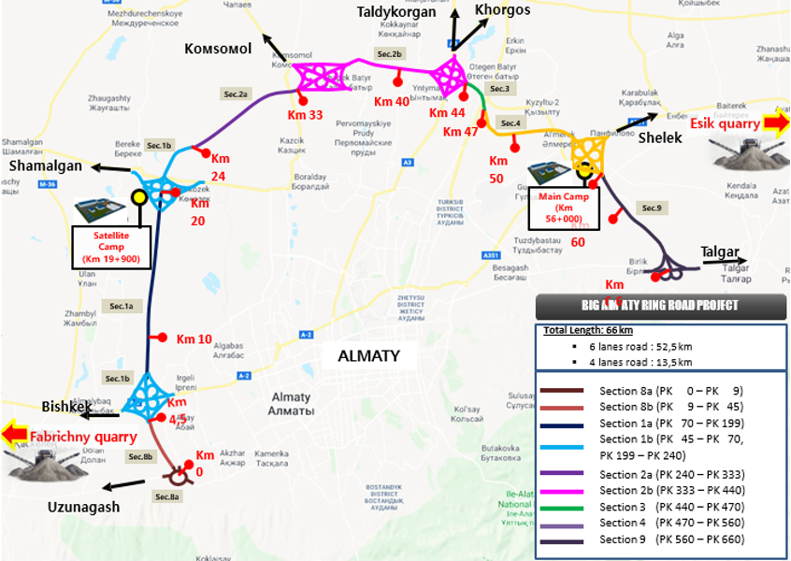

Figure 3.1 – Location map of BACAD’s, Kazakhstan

Note – Compiled according to the source [84, c.6]

The length of BAKAD is just over 66 kilometers. The route will consist of 21 bridges, 8 two-level interchanges, 18 overpasses, 2 elevated lines, etc. The road will have 4 to 6 lanes, designed for traffic speed up to 150 km/h. According to GOST 3.03.-101-103 [85] road belongs to category I a.
The project goal: to extend international projects outside Almaty. Reducing transport in the city will significantly improve the environmental situation in the region. Reducing the load on the transport system will relieve individual streets of the city from traffic jams at the entrance to Almaty. The decrease in the number of trucks will benefit the number of road accidents: accidents will become much less. And also, BAKAD will become a connecting element of the international transport corridor "Western Europe - Western China."

3.1 Section 8a (km 0+00 - km 8+38)
The planned section of the highway 8a launch complex is located in the Karasay district of the Almaty region. The initial point of the km 0 + 00 section begins from the Kyrgauldy village. The route ends with km 8 + 38 (figure 3.2).

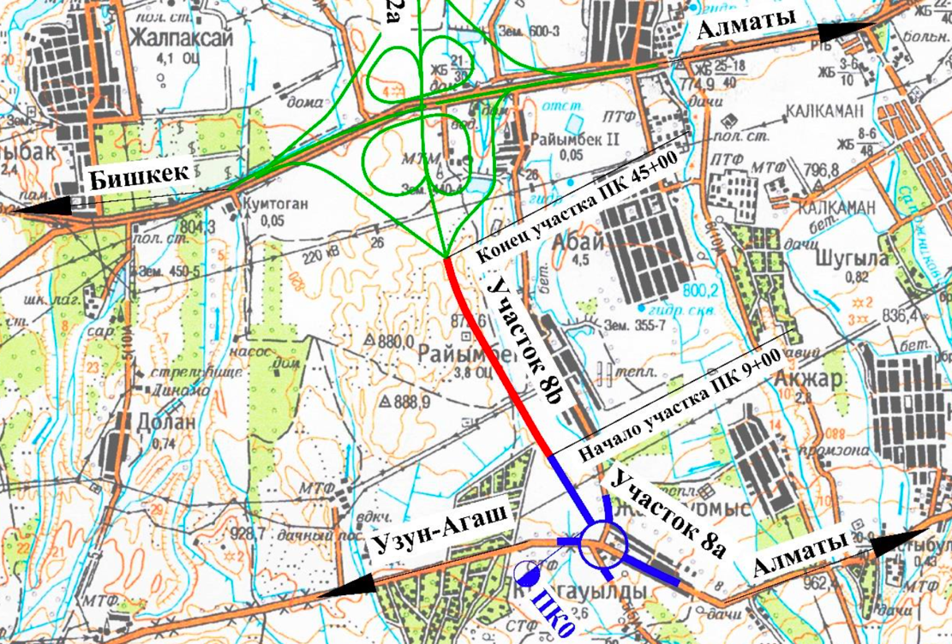

Figure 3.2 – Location scheme of section 8a in Almaty region, Kazakstan

3.1.1 Engineering and geological conditions
The section of the projected road is located within one geomorphological element – a piedmont alluvial-proluvial plain.
The district is located in the southwestern part of the Almaty region. The territory of the district occupies the foothills of the Zailiyskiy Alatau.
The hydrographic network is well developed in the area and belongs to the Balkhash water basin. The rivers of the mountain type include Kaskelen, Aksay, and Kargaly. The Kaskelen River and its feeders represent the hydrographic network. It is a mountain type of river. It originates from the northern slope of the Zailiysky Alatau ridge at an altitude of 3580 m. It is formed by feeding glacial waters and descends from the mountains to the foothill plain.
Absolute elevations of the ground surface within the design limits vary from 864.31 m in the southern part, with a decrease in the general plan to 840.30 m in the northern region.
The regional elevation difference in the planned area is 24.01 m. The territory’s surface is relatively flat, with a slope to the north.
Alluvial-proluvial deposits of Quaternary age (Q), represented by loams of different consistency, covered with a soil-plant layer, take part in the geological and lithological structure of the site. Below is a brief description of the engineering and geological conditions of artificial structures.
Section of the route: it is presented by a soil-plant layer from a surface, with a thickness of 0.2 m. Brown loams of dusty collapsible solid and semi-solid consistency interlay below, with the thickness of 5.8 m.
The drilled wells did not penetrate groundwater during the survey period.
According to SP RK 5.01-102-2013 (cl. 4.3.1.9) [59, с. 10], the projected section of the route belongs to a potentially non-flood-prone area by the nature of the man-made impact.
The spatial position of the identified engineering and geological elements is given in the geological passport for tolling and longitudinal profile.
Indicators of physical and mechanical properties, material composition, and salinity of soils identified by nomenclature type [86]. Engineering geological elements (EGE) of the local soils in Almaty region were obtained by laboratory methods (figure 3.3) [87]:
- EGE-1. Topsoil. It is found throughout the territory of the projected section of the highway.
- EGE-2. Asphalt concrete (pavement surfacing). It is found on the Almaty-Shamalgan highway and the highway in the Raiymbek village. Asphalt concrete thickness makes from 0.12 to 0.20 m.
- EGE-3. Filled soil. It is represented by gravel soil with sand aggregate. The layer has limited distribution in the form of a base for asphalt concrete on the roads listed above. Bulk soil thickness makes 0.4 m.
- EGE-3а. Filled soil. It is represented by solid loam containing gravel and pebbles. The layer has limited distribution at the beginning of the route at the junction with the Almaty-Shamalgan highway. Bulk soil thickness makes 0.5 m.
- EGE-4 – Loam, brown, light, solid, collapsing.

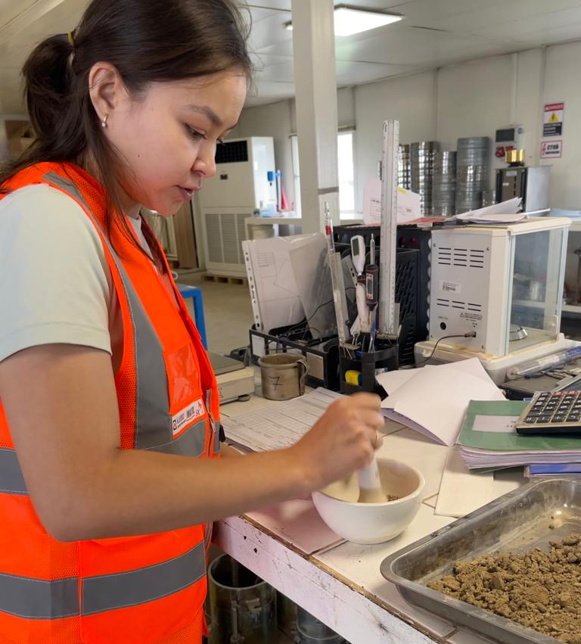

Figure 3.3 – Conducting laboratory tests
According to compression tests, the loams show collapsible properties from additional loads. Initial slumping pressure 0.495 kg/cm². Coefficient of relative collapsing at specific pressure 0.5 kg/cm² - from 0.008 to 0.011; at specific pressure 1.0 kg/cm² - from 0.012 to 0.020; at specific pressure 2.0 kg/cm² - from 0.017 to 0.028; at specific pressure 3.0 kg/cm² - from 0.021 to 0.028. Geotechnical profile in terms of collapsing belongs to type I (first):
- EGE-5 – Loam, brown, light, semi-solid, non-collapsing. Semi-solid loam thickness from 2.0 to 2.3 m.
- EGE-6 – Loam, brown, light, non-collapsing, high-plastic. The penetrated thickness of high-plastic loam makes 4.3 m.
Standard values of physical and mechanical parameters of the loam’s strength and deformation properties are given in tables 3.1 and 3.2.

Table 3.1 – Physical and mechanical properties of soils

Parameter name | EGE-4 | EGE-5 | EGE-6
Liquid limit, % | 25.7 | 26.9 | 25.4
Plastic limit, % | 16,3 | 17.4 | 17.0
Plasticity index, % | 9,6; | 9.5 | 8.4
Index of liquidity, % | <0 | 0.15 | 0.60
Natural humidity, % | 13,5 | 18.8 | 22.0
Soil particles density, g/sm³ | 2,70 | 2.70 | 2,70
Soil density, g/sm³ | 1,99 | 2.14 | 2.00
Dry soil density, g/sm³ | 1,75 | 1.80 | 1,64
Void ratio | 0,754 | 0.502 | 0.653
Soil resistance, kPа | 379 | - | 98

Normative and calculated values of the intercept cohesion (kPa), the angle of internal friction (degree), and the modulus of deformation (Mpa) are shown in table 3.2.
The calculated values of the characteristics are given, considering the coefficient of reliability on the ground.

Table 3.2 – Normative and calculated values of soil characteristics

EGE | Unit weight of soil, kN/m³ |  |  | Intercept cohesion, kPa |  |  | Angle of internal friction, deg. |  |  | Modulus of deformation, Mpa
EGE | norm | РII | PI | norm | СII | СI | norm | φII | φI | Modulus of deformation, Mpa
4 | 1.99 | 1.99 | 1.95 | 37.0  25.0* | 37.0  25.0* | 25.0  17.0* | 25  19* | 25  19* | 22  17* | 27.4*  17.0*
5 | 2.14 | 2.14 | 2.10 | 42.0  25.0* | 42.0  25.0* | 28.0  17.0* | 25  19* | 25  19* | 25  17* | 30.5*  17.0*
6 | 2.00 | 2.00 | 1.96 | 25.0 | 25.0 | 17.0 | 19 | 19 | 17 | 17.0*  12.2*
* – characteristics are given for soils in a water-saturated state

In terms of frost susceptibility: solid and semi-solid loam – practically not heaving, high-plastic loam – highly frost-susceptible.
According to SP RK 5.01-102-2013 (cl. 4.3.1.9) [59, с. 10], the projected section of the route belongs to a potentially non-heated area of the nature of the man-made impact.
Non-salinity of soils was detected. Degree of the aggressive impact of soils on concrete and reinforced concrete structures for concrete of W4 grade in terms of water resistance on portland cement as – from non-aggressive to slightly aggressive; on sulfate-resistant cement – non-aggressive; in terms of chloride content for concrete on portland cement, slag portland cement and sulfate-resistant cement – from non-aggressive to slightly aggressive.
Soils have EGE-4 collapsible properties. Engineering and geological conditions refer to type I (first) according to SP RK 5.01-102-2013 (item 5.1.10, item 5.1.12) [59, с. 38].
Corrosion activity of soils to carbon steel – from medium to high, to lead – from low to medium, to aluminum – from medium to high. Seismicity of the site and collapsing of soils are predicted from physical and geological processes and phenomena in the area of the projected development site. Excavations do not penetrate groundwater during engineering and geological surveys.
Seismic zoning maps seismicity of the work area is 9 (nine) points [88]. The type of soil conditions by seismic properties (item 6.2.2) is II (second). The seismicity of the construction site (item 6.3.2.a) will be 9 (nine) points. Design horizontal and vertical acceleration at the construction site ag – 0.535; agv – 0.482.

3.2 Section 8b (km 9+00 - km 45+00)
The projected section 8b, with a length of 3.6 km of the BAKAD highway, is located in the Karasay district of the Almaty region. The beginning of the highway is 900 m north of the meeting point of the national highway A-4 and the regional road KV-25 on the border of the settlements of the Kyrgauldy and Raiymbek village (figure 3.4).

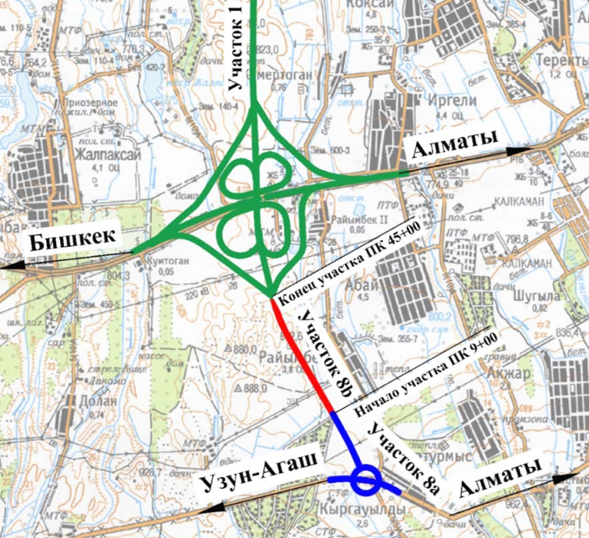

Figure 3.4 – Schematic location of section 8b, Almaty, Kazakshtan

3.2.1 Engineering and geological conditions
Geomorphologically, the surveyed area is located on the gently inclined plain of the Zailiskiy Alatau foothills. The general direction of the plain slope - is the north.
The climate of the district is sharply continental. The climate features of the district are determined by the latitude and the presence of orographic elements on its surface. The combination of climate forcing causes the transformation of hot, dry weather with sharp seasonal and daily fluctuations in air temperatures. Summers are hot, and winters are moderately cold and mild. There are shower rains in spring and summer.
Alluvial-proluvial deposits of Quaternary age (Q), represented by loams of different consistency and pebble soils covered with a soil-plant layer, take part in the geological and lithological structure of the site.
Below is a brief description of the engineering and geological conditions of artificial structures. Three wells up to 30.0 m deep were drilled to survey the soils of the overpass, 21 wells 36.0 m deep were drilled to explore the excavation soils, 13 wells 3.0 m deep, and 9 wells 6.0 m deep were drilled along the route axis.
Overpass bridge KM 20+80: from the surface, it is represented by topsoil with a thickness of 0.2 m. Below it is represented by solid brown loam, with a thickness of 12.4 m, underlying pebble soil, sandy aggregate, water-saturated, gray, penetrated with a thickness of 17.4 m.
Groundwater during the survey period was penetrated at a depth of 12.4 m. Oscillation amplitude 1.0-1.5 m.
Excavation KM 28+00-KM 34+00: from the surface, it is represented by topsoil with a thickness of 0.2 m. Below it is represented by solid brown loam penetrated with a thickness of 35.8 m.
Groundwater was not penetrated during the survey to a depth of 36.0 m.
The route section from the surface is represented by topsoil, with a thickness of 0.3-0.1 m. Loam of different consistency interlays below: from hard to high-plastic, penetrated up to 5.8 m thick, and coarse low-moisture sand.
Groundwater during the survey period was penetrated at a depth of 5.9 m and settled at a depth of 5.7-5.8 m. Amplitude of oscillations is 1.0-1.5 m.
Laboratory methods obtained the physical and mechanical properties, material composition, and salinity of the soils identified according to the nomenclature type [83, с. 15].
Excavation:
1. EGE-1 - Loam, light hard, brown.
According to compression tests, the loams show collapsing properties from additional loads. Initial collapsible pressure makes 0.062 kg/cm². Coefficient of relative collapsing at specific pressure 0.5 kg/cm² - from 0.018 to 0.081; at specific pressure 1.0 kg/cm² – from 0.041 to 0.130; at specific pressure 2.0 kg/cm² - from 0.045 to 0.151; at specific pressure 3.0 kg/cm² - from 0.079 to 0.164. Geotechnical profile поcollapsing относятся к первому типу.
Location line and Overpass bridge:
1. EGE-1 – Loam, light, solid, brown.
According to compression tests, the loams show collapsing properties from additional loads. Initial collapsible pressure makes 0.1 kg/cm². Coefficient of relative collapsing at specific pressure 0.5 kg/cm² - from 0.055 to 0.081; at specific pressure 1.0 kg/cm² - from 0.041 to 0.130; at specific pressure 2.0 kg/cm² - from 0.045 to 0.151; at specific pressure 3.0 kg/cm² - from 0.018 to 0.164. Geotechnical profile as to collapsing capacity belong to the first type.
- EGE-2 – Loam, light, low-plastic, brown.
- EGE-3 – Loam, light, high-plastic, brown.
- EGE-4 – Coarse, brown, low moisture sand.
- EGE-5 – Pebble soil with sand aggregate, water-saturated.
Standard values of physical and mechanical parameters of strength and deformation properties of loams are given in tables 3.3 and 3.4.

Table 3.3 – Physical and mechanical properties of soils
Parameter name | EGE-1 | EGE-1 | EGE-2 | EGE-3 | EGE-4 | EGE-5
Parameter name | recess | track and over bridge
Liquid limit, % | 25.0 | 24.1 | 26.4 | 24.7 | - | -
Plastic limit, % | 15.3 | 14.1 | 15.1 | 14.9 | - | -
Plasticity index, % | 9.7 | 9.0 | 11.3 | 9.8 | - | -
Index of liquidity, % | <0 | <0 | 0.38 | 0.53 | - | -
Natural humidity, % | 9.7 | 11.8 | 19.3 | 21.1 | - | -
Soil particles density, g/sm³ | 2.70 | 2.70 | 2,71 | 2.71 | - | -
Soil density, g/sm³ | 1.57 | 1.83 | 1.88 | 1.93 | 1.70 | 1.75
Dry soil density, g/sm³ | 1.43 | 1.65 | 1,58 | 1.61 | - | -
Void ratio | 0.883 | 0.64 | 0.718 | 0.686 | - | -
Soil resistance, kPа | 325 | 355 | 180 | 100 | 500 | 600

Normative and calculated values of the intercept cohesion (kPa), the angle of internal friction (degree), and the modulus of deformation (MPa) are shown in table 4.
The calculated values of the characteristics are given, considering the coefficient of reliability on the ground.

Table 3.4 – Normative and calculated values of soil characteristics

EGE | Unit weight of soil, kN/m³ |  |  | Intercept cohesion, kPa |  |  | Angle of internal friction, deg. |  |  | Modulus of deformation, MPa
EGE | norm | РII | PI | norm | СII | СI | norm | φII | φI | Modulus of deformation, MPa
1  Recess | 1.57 | 1.57 | 1.54 | 21.0  15.0* | 21.0  15.0* | 14.0  10.0* | 21  15* | 21  15* | 18  13* | 13.1  7.4*
1 | 1.83 | 1.83 | 1.79 | 31.0  25.0* | 31.0  25.0* | 20.6  16.7* | 24  19* | 24  19* | 21  16* | 22.6  18.0*
2 | 1.88 | 1.88 | 1.84 | 25.0 | 25.0 | 16.6 | 21 | 21 | 17 | 15.5
3 | 1.93 | 1.93 | 1.89 | 21.0 | 21.0 | 14.0 | 19 | 19 | 15 | 15.7
4 | 1.70 | 1.70 | 1.67 | - | - | - | 39  37* | 39  37* | 35  34* | 30.0
5 | 1.75 | 1.75 | 1.72 | - | - | - | 40  38* | 40  38* | 36  34* | 50.0*
* – characteristics are given for soils in a water-saturated state

In terms of frost susceptibility: hard loam - practically not heaving, stiff loam - medium heaving, soft plastic loam - strong heaving.
Low mineralized groundwater. The degree of aggressiveness to concrete and reinforced concrete structures of W4 grade on portland cement are non-aggressive to reinforced concrete structures (in terms of chloride content) - slightly aggressive during periodic wetting.
Non-salinity of soils was detected. In terms of the sulfate aggressiveness degree to concrete and reinforced concrete structures on portland cement of W4 grade are non-aggressive and slightly aggressive, to reinforced concrete structures (in terms of chloride content) are non-aggressive and somewhat aggressive.
Soils have EGE-1 collapsing properties. Engineering and geological conditions in terms of collapsing belong to type I (first).
Corrosion activity of soils to carbon steel is average.
Seismicity of the site, ravine erosion, and collapsing of soils are predicted by physical and geological processes and phenomena in the area of the planned development site.
Groundwater during the survey was penetrated at depths of 5.7-12.6 m. Amplitude of oscillations is 1.0-1.5 m.
The estimated maximum groundwater level, taking into account the amplitude of fluctuations in the groundwater level, the influence of irrigation networks during watering, and the flood period: the first end of February, the beginning of March, and the second end of March, the beginning of April, as well as atmospheric precipitation, should be taken above the measured groundwater level.
The area's seismicity following SP RK 2.03-30-2017 [88] is 9₂ points. The seismicity of the site is 9₂ points. Soil category by seismic properties is II (second).

3.2.2 Field tests conducted at the site
Study the bearing capacity of the artificial soil of the base under the Overpass bridge on km 20 + 81 [89].
The bearing capacity of the base soil under the Overpass bridge was studied at 2 points of plate-bearing tests. The tests were carried out at an air temperature of + 16. The values of E_{u}, U, K_{s} are determined as a result of office processing of load values and their corresponding settlements obtained during static plate tests (figure 3.5).

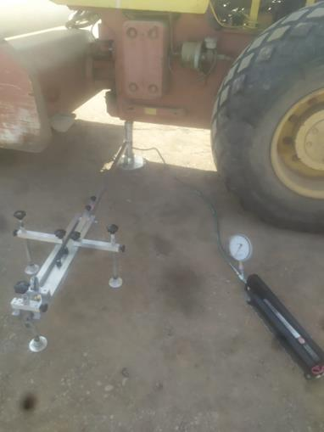

Figure 3.5 – Conducting plate-bearing tests on km 20+81

The plate-bearing tests are the most reliable method for determining the deformation modulus, modulus of elasticity, soil bed coefficient, natural bases, and structural layers of pavement surfacing. The stamping unit with a rotary console was used for testing, acting on the principle of a balance beam (figure 3.6).

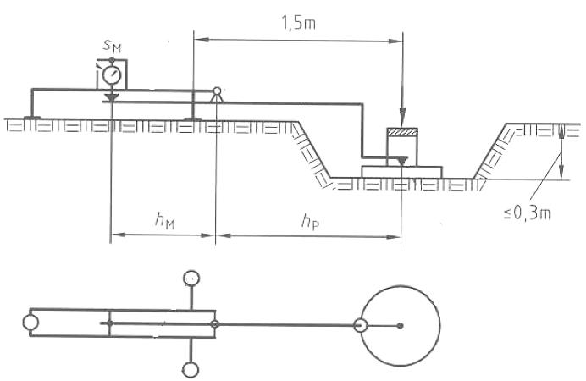

Figure 3.6 – Schematic diagram of the plate-bearing test, acting on the principle of the rocker scales
The calculation of the plate settlement according to the readings of the deflection meter took into account the ratio of the arms of the lever hp/hm:

$$\frac{h_{p}}{h_{m}}=\frac{1.64}{0.82}=2 (const)$$

The results of plate-bearing tests of the artificial base are given in table 3.5 and figures 3.7, 3.8.

Table 3.5 – Plate-bearing test results on 20+81

Soil | Deformation modulus, Е_{def}, MPa | Elastic modulus Е_{elas}, MPa | Coefficient of compaction, K
Point №1 | 25.74 | 80.84 | <0.95
Point №2 | 39.25 | 105.41 | 0.96

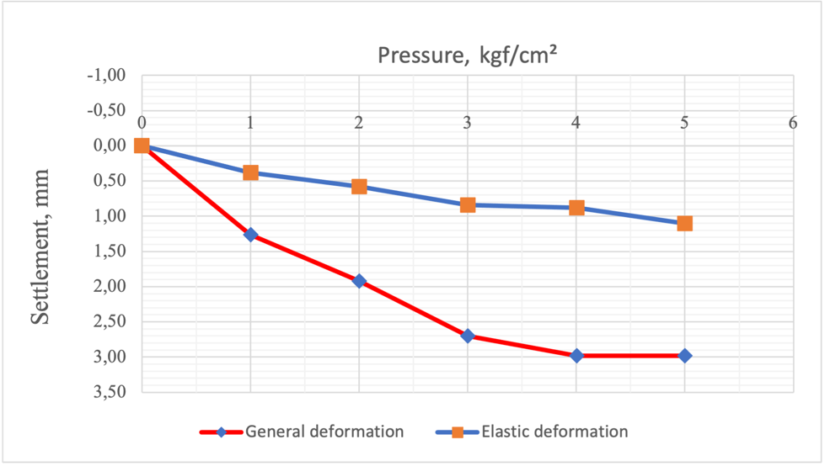

Figure 3.7 – Results of Point 1

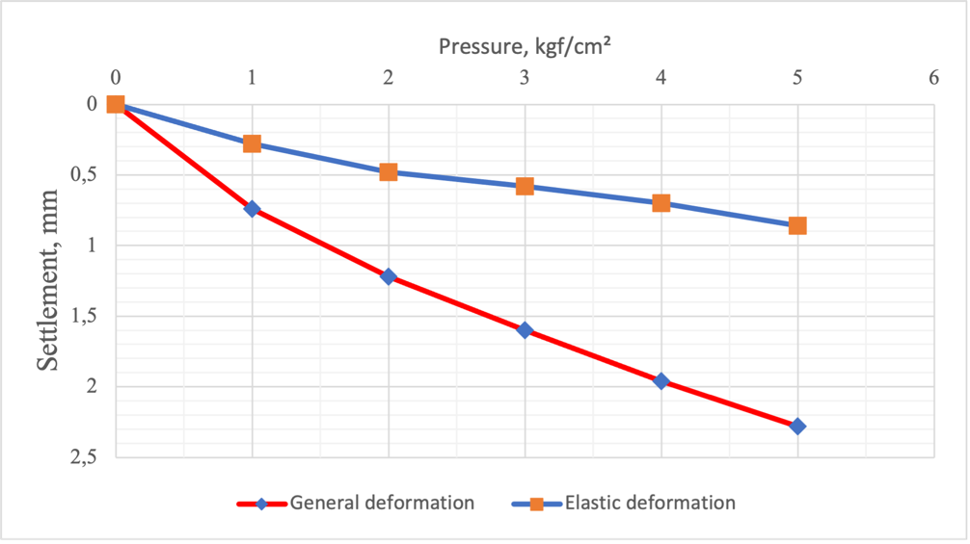

Figure 3.8 – Results of Point 2

The shape of the general deformations graph corresponds to the linear dependence of the general deformations increment on the increase in the load on the base.
3.3 Section 1 (km 45+00 - km 240+00)
The projected section of the BAKAD highway 1 launch complex is located in the Karasay district of the Almaty region. The initial point of the km 45 + 00 section begins from the Raiymbek village, and the end of the route ends on the territory of the Karasay district near the Isayevo village km 240 + 00 (figure 3.9).

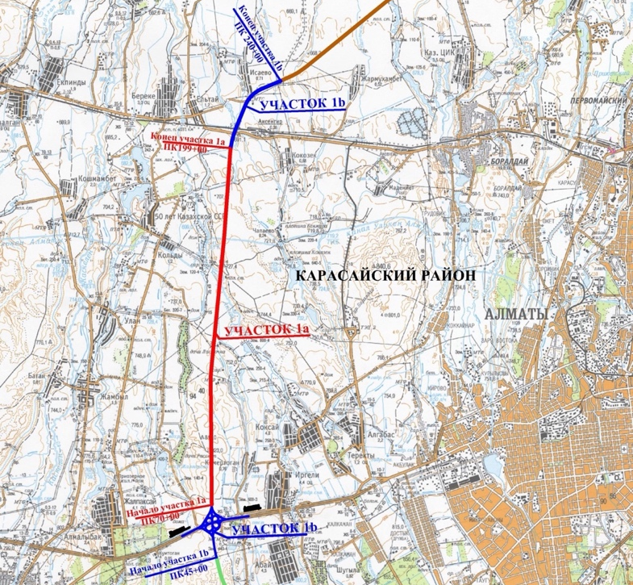

Figure 3.9 – Scheme of the section 1, Almaty, Kazakhstan

3.3.1 Engineering and geological conditions
The section [84, p. 6] of the designed road is located within one geomorphological element - a piedmont alluvial-proluvial clinoplain.
The district is located in the southwestern part of the Almaty region. The district's territory occupies the foothills of the Zailiskiy Alatau and the plain part of the Kopa-Iliskiy cavity.
Rivers are the mountain type, they are perennial, with nourishment, both due to melting glaciers and due to rain and spring discharges. They take off from the northern slopes of the Zailiskiy Alatau. The peculiarities of the natural and climatic conditions of the region predefine the formation of surface flow formation and the presence of a hydrographic network represented by the Kaskelen River, Aksay River, and Kargaly River.
The biggest artificial watercourses are the Big Almaty Canal (BAK), which is crossed by the route on km 171 + 50.0.
The waters of rivers and canals can be used as sources of technical water supply during the construction of the roadbed.
The territory's surface is hilly, with a slope to the north and northeast. Absolute elevations of the ground surface within the design limits vary from 824.39 m in the southern part, with a decrease in the general plan, to 678.16 m in the northern region. The regional elevation difference in the planned area is 146.23 m.
Modern technogenic Quaternary deposits (tQIV), in the form of bulk soils on crossed roads and alluvial-proluvial deposits of Upper Quaternary age (apQIV), represented by loams of different consistency, sands of different sizes, and gravel soils covered with a soil-plant layer, take part in the geological and lithological structure on the territory of the projected highway.
The territory of the work area is potentially non-flood-prone, except for the bridge over the river Aksay km 152 + 00 - km 156 + 00, the Overpass bridge through Aksenger km 207 + 00 - km 217 + 00, which belong to potentially flooded areas since groundwater is located close to the ground surface.
Below is a brief description of the engineering and geological conditions of artificial structures.
Route section: from the surface is represented by topsoil with a thickness of 0.2 m. There are loams of various consistency below: from solid to fluid penetrated with a thickness of up to 13.0 m, as well as solid loam with a thickness of 6.0 m. There are layers of gravelly sand penetrated below with a thickness from 0.2 m to 1.0 m.
Groundwater during the survey period was penetrated at a depth of 0.9-7.8 m. The amplitude of oscillations makes 1,0±1,5 m.
Overpass bridge through the Almaty-Bishkek highway: from the surface is represented by topsoil with a thickness of 0.2 m. It is represented below by solid brown loam with thickness up to 16.0 m, underlying by fluid loam with penetrated thickness up to 16.2 m.
Groundwater during the survey period was penetrated at a depth of 13.8-16.0 m. The amplitude of oscillations makes 1,0±1,5 m.
Overpass bridge through Aksay River: from the surface is represented by topsoil with a thickness of 0.2 m. There are solid collapsing loams and semi-solid loams with a thickness of up to 9.0 m on the sides of the river. Gravelly water-saturated sands with a thickness of 3.8-9.4 m lie in bed under fluid-plastic loams. Stiff loams lie below to a depth of 22.5-28.2 m. Coarse gray water-saturated sands with penetrated thickness up to 8.5 m serve as the underlying layer of the section.
Groundwater during the survey period was penetrated at a depth of 0.7-14.7 m. Oscillation amplitude is 1,0±1,5 m.
Overpass bridge through BAK: from the surface is represented by topsoil with a thickness of 0.2 m. It is represented by hard brown loam up to 12.3 m thick and soft plastic loam up to 5.8 m thick, replaced by stiff loams. Gravel gray water-saturated soil with penetrated thickness up to 6.5 m underlays on a depth of 23.5 m.
Groundwater during the survey period was penetrated at a depth of 11.6-16.0 m. Oscillation amplitude is 1,0±1,5 m.
Overpass bridge through Aksenger: from the surface is represented by topsoil with a thickness of 0.2 m. It is represented by solid loam with a thickness up to 3.2 m underlying by loams from semi-solid to fluid consistency with a thickness up to 16.0 m, and coarse water-saturated sands with a thickness up to 3.0 m. Coarse water-saturated sands with a penetrated thickness up to 13.5 m serve as the underlying layer of the section.
Groundwater during the survey period was penetrated at a depth of 0.6-5.2 m. The fluctuations amplitude is 1,0±1,5 m.
Fifteen (15) geotechnical elements (EGE) were identified within site to a depth of 30.0 m by nomenclature and physical and mechanical properties:
- EGE-1. Topsoil. It is found throughout the territory of the projected section of the highway.
- EGE-2. Asphalt concrete (pavement surfacing). All intersected routes of the designed road have asphalt concrete pavement with a gravel base. Asphalt concrete thickness is from 0.11 to 0.38 m.
- EGE-3. Filling soil. It is represented by gravel soil with sand aggregate. The layer has limited distribution on crossed roads.
- EGE-3а. Filling soil. It is represented by solid loam containing gravel and pebbles. The layer has limited distribution on crossed roads.
- EGE-4 – Loam, brown,loessoid,light, solid, collapsing.
According to compression tests, the loams exhibit collapsing properties. Initial drawdown pressure 0.050 kg/cm². Coefficient of relative collapsing at specific pressure 0.5 kg/cm² - from 0.012 to 0.056; at specific pressure 1.0 kg/cm² - from 0.025 to 0.095; at specific pressure 2.0 kg/cm² - from 0.030 to 0.112; at specific pressure 3.0 kg/cm² - from 0.058 to 0.132. Geotechnical profile as of collapsing belong to the first type.
- EGE-5 – Loam,brown, light, silt, semi-solid, non-collapsing.
- EGE-6 – Loam,brown, light, silt, stiff consistency.
- EGE-7 – Loam,brown, light soft plastic consistency.
- EGE-8 – Loam,brown, light fluid-plastic consistency.
- EGE-9 – Loam,brown, light fluid consistency.
- EGE-10 – Gray-brown sandy loam, sold.
- EGE-10а – Sandy loam коричневого цвета пластичная.
- EGE-11 – Medium density brown sand, water-saturated.
- EGE-12– Medium density gray sand, coarse water-saturated.
- EGE-13 – Low-moisture gravel sand with sand aggregate.
- EGE-14 – Low-moisture gravel soil with sand aggregate.
Normative values of physical and mechanical parameters of strength and deformation properties of loams are presented in tables 3.6 and 3.7.

Table 3.6 – Physical and mechanical properties of soils
Parameter name | EGE
Parameter name | 4 | 5 | 6 | 7 | 8 | 9 | 10 | 10a | 11 | 12
Liquid limit, % | 26.9 | 31.4 | 25.0 | 25.0 | 28.5 | 24.5 | 24.6 | 22.9 | - | -
Plastic limit, % | 18.1 | 21.5 | 15.1 | 17.3 | 19.2 | 17.0 | 18.7 | 17.9 | - | -
Plasticity index, % | 8.8 | 9.9 | 9.9 | 7.7 | 9.3 | 7.5 | 5.9 | 5.1 | - | -
Index of liquidity, % | <0 | 0.03 | 0.38 | 0.67 | 0.82 | 1.38 | <0 | 0.56 | - | -
Natural humidity, % | 12.8 | 21.8 | 18.9 | 22.4 | 26.8 | 27.4 | 11.3 | 20.6 | - | -
Soil particles density, g/sm³ | 2.71 | 2.72 | 2.72 | 2.71 | 2.71 | 2.71 | 2.70 | 2.71 | - | -
Soil density, g/sm³ | 1.89 | 1.94 | 1.88 | 1.95 | 1.91 | 1.82 | 1.77 | 2.10 | 2.04 | 2.07
Dry soil density, g/sm³ | 1.68 | 1.59 | 1.58 | 1.59 | 1.51 | 1.43 | 1.59 | 1.76 | - | -
Void ratio | 0.62 | 0.71 | 0.72 | 0.70 | 0.79 | - | 0.70 | 0.54 | - | -
Soil resistance, kPа | 362 | 341 | 160 | - | - | - | 294 | 70 | 400 | 500

Table 3.7 – Normative and calculated values of soil characteristics

EGE | Unit weight of soil, kN/m³ |  |  | Intercept cohesion, kPa |  |  | Angle of internal friction, deg. |  |  | Modulus of deformation, MPa
EGE | norm | РII | PI | norm | СII | СI | norm | φII | φI | Modulus of deformation, MPa
Track area
4 | 1.89 | 1.89 | 1.85 | 34.0  25.0* | 34.0  25.0* | 23.0  17.0* | 25  19* | 25  19* | 22  12* | 23.8  17.0*
5 | 1.94 | 1.94 | 1.90 | 28.0  22.0* | 28.0  22.0* | 19.0  16.7* | 23  18* | 23  18* | 20  16* | 19.0  14.0*
6 | 1.88 | 1.88 | 1.84 | 25.0  21.0* | 25.0  21.0* | 17.0  14.0* | 21  18* | 21  18* | 18  16* | 15.5  15.5*
7 | 1.95 | 1.95 | 1.91 | 22 | 22 | 15 | 18 | 18 | 16 | 14.5
10 | 1.77 | 1.77 | 1.73 | 14.0  12.0* | 14.0  12.0* | 9.0  8.0* | 26  22* | 26  22* | 23  19* | 13.0
The overpass over the Almaty-Bishkek highway
4 | 1.72 | 1.72 | 1.68 | 23.0  18.0* | 23.0  18.0* | 15.0  12.0* | 23  17* | 23  17* | 20  15* | 15,8  10,4*
Bridge crossing over the Aksai River
4 | 1.74 | 1.74 | 1.70 | 25.0  20.0* | 25.0  20.0* | 17.0  13.0* | 23  18* | 23  18* | 20  16* | 17.5  12.5*
5 | 2.02 | 2.02 | 1.98 | 34.0  25.0* | 34.0  25.0* | 23.0  17.0* | 24  19* | 24  19* | 21  17* | 24.5  17.0*
6 | 2.06 | 2.06 | 2.02 | 32.0  25.0* | 32.0  25.0* | 21.0  17.0* | 22  19* | 22  19* | 19  17* | 23.2  17.0*
7 | 1.92 | 1.92 | 1.88 | 20 | 20 | 13 | 18 | 18 | 16 | 12.0
12 | 2.07 | 2.07 | 2.03 | 1 | 1 | 0.7 | 40 | 40 | 36 | 38.0
Bridge crossing over the BAC
4 | 1.71 | 1.71 | 1.68 | 25.0  20.0* | 25.0  20.0* | 17.0  13.0* | 23  18* | 23  18* | 20  16* | 17.0  12.0*
6 | 1.91 | 1.91 | 1.87 | 25.0  22.0* | 25.0  22.0* | 17.0  15.0* | 21  18* | 21  18* | 18  16* | 15.5  13.5*
7 | 1.98 | 1.98 | 1.94 | 23 | 23 | 15 | 18 | 18 | 16 | 15.0
The Aksenger Roadpass
4 | 1.98 | 1.98 | 1.94 | 34.0  25.0* | 34.0  25.0* | 23.0  17.0* | 24  19* | 24  19* | 21  17* | 14.3  12.2*
5 | 2.05 | 2.05 | 2.01 | 34.0  25.0* | 34.0  25.0* | 23.0  17.0* | 25  19* | 25  19* | 22  17* | 12.0  10.2*
6 | 2.07 | 2.07 | 2.03 | 33.0  25.0* | 33.0  25.0* | 22.0  17.0* | 23  19* | 23  19* | 20  17* | 8.9  6.6*
7 | 2.00 | 2.00 | 1.96 | 44 | 44 | 29 | 17 | 17 | 15 | 2.6
9 | 1.85 | 1.85 | 1.81 | 41 | 41 | 27 | 19 | 19 | 17 | 2.8
10 | 2.13 | 2.13 | 2.09 | 53 | 53 | 35 | 22 | 22 | 19 | 8.5
10a | 2.10 | 2.10 | 2.06 | 43 | 43 | 29 | 22 | 22 | 19 | 7.8
11 | 2.04 | 2.04 | 2.00 | 1 | 1 | 0.7 | 35 | 35 | 32 | 30.0
12 | 2.09 | 2.09 | 2.05 | 1 | 1 | 0.7 | 40 | 40 | 36 | 38.0
* – Characteristics are given for soils in a water-saturated state

Normative and calculated values of the intercept cohesion (kPa), the angle of internal friction (degree), and the modulus of deformation (MPa) are shown in table 3.7.
The calculated values of the characteristics are given, considering the coefficient of reliability on the ground.
By degree of frost susceptibility: By the degree of frost hazard: solid loam and solid sandy loam - not heaving, semi-solid loam - slightly heaving, stiff loam - medium heaving, soft-plastic and fluid-plastic loam - strongly heaving.
According to SP RK 5.01-102-2013 (cl. 4.3.1.9) [59, с. 10], the projected route section belongs to the non-heated area by the nature of the technogenic impact, except for the bridge over the Aksay river km 152+00 - km 156+00, Overpass bridge through Aksenger km 207+00 - km 217+00, which belong to potentially flood-prone territories, since groundwater is located close to the surface of the earth.
Groundwater, by the degree of mineralization, is fresh to slightly saline by the degree of aggressiveness to concrete structures of grade W4 by the hydrogen parameter pH - from non-aggressive to somewhat aggressive.
Soils have EGE-4 collapsing properties. Engineering and geological conditions in collapsing belong to type II (second).
Seismicity of the site, ravine erosion, and collapsing of soils are predicted by physical and geological processes and phenomena in the area of the planned development site.
Groundwater during the survey was penetrated at depths of 0.6-16.0 m. Amplitude of oscillations is 1.0-1.5 m.
The seismicity of the work area is given following SP RK 2.03-30-2017 [88, p.9] according to seismic zoning maps, the seismicity of the work area is 9 (nine) points. Type soil conditions by seismic properties (item 6.2.2) - II (second). The seismicity of the construction site (item 6.3.2.a) will be 9 (nine) points except for the bridge over the Aksay River km 15 + 200 - km 156 + 00, Overpass bridge through Aksenger km 20 + 700 - km 21 + 700, where the type of soil conditions by seismic properties is III (third). The seismicity of the construction site in these areas will be 10 (ten) points.

3.3.2 Field tests conducted at the site
Work was carried out to investigate the bearing capacity of the embankment and excavation of the basement soil at km101+10, km102+20, km102+60. The study of the bearing capacity of the basement soil was carried out at 6 points of stamping tests. The tests were carried out at 3 points in dry condition and at 3 points in wet condition [52, p.35]. The study was conducted at 3 points in the dry state and 3 points in the wet state (Figure 3.10).
Tests were carried out at air temperature + 8C. Values of E_{u}, U, and K_{s} are defined as a result of the cameral processing of sizes of loadings and deposit corresponding to them received during static plate tests.
Plate-bearing tests are the most reliable method of the deformation module definition, module of elasticity, coefficient of soil bed, natural bases, and constructive layers of pavement surfacing.
The plate installation with the rotary console operating by the balance beam principle was used for tests.

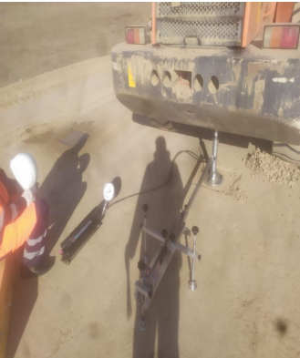

Figure 3.10 – Conducting plate-bearing tests

Table 3.8 and figure 3.11, 3.12, 3.13, 3.14, 3.15, 3.16 presented the compression ratio according to the results of plate-bearing testing.

Table 3.8 – Plate-bearing test results

Soil | Deformation modulus, Е_{d}, MPa | Elastic modulus Е_{e}, MPa | Coefficient of compaction, K
km - 10+260 | 46,74/ 10,75* | 39,65/ 39,65* | 0,99/ 0,94*
km - 10+220 | 30,64/ 5,54* | 37,08/ 37,08* | 0,99/ 0,9*
km - 10+110 | 25,05/ 5,42* | 41,18/ 31,15* | 0,99/ 0,9*
* – characteristics are given for soil at a water-saturated state

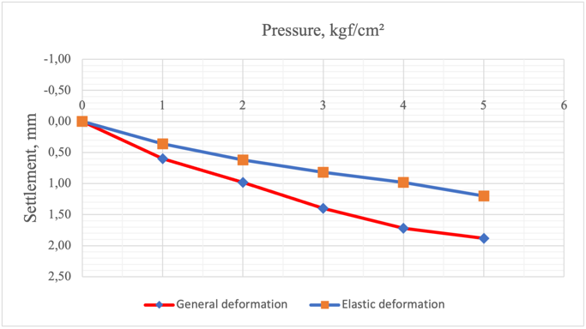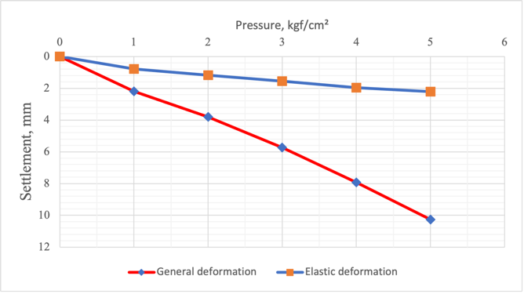

Figure 3.11 – Results of Point 1 Figure 3.12 – Results of Point 1.1
(dry soil) (km 10+260) (wet soil) (km 10+260)
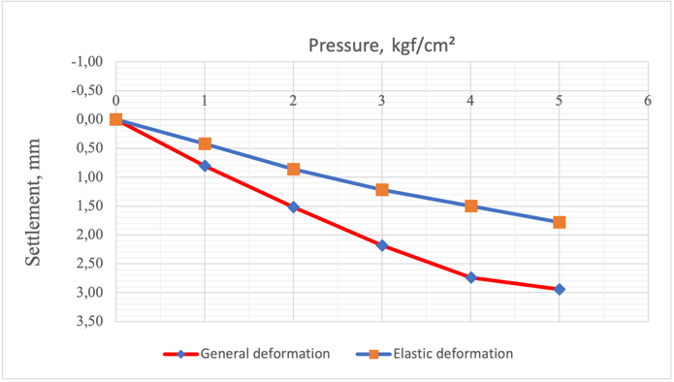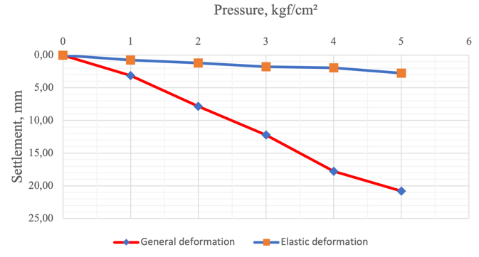

Figure 3.13 – Results of Point 2 Figure 3.14 – Results of Point 2.1
(dry soil) (km 10+220) (wet soil) (km 10+220)

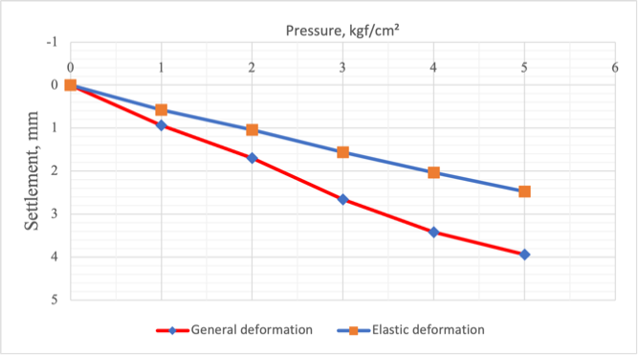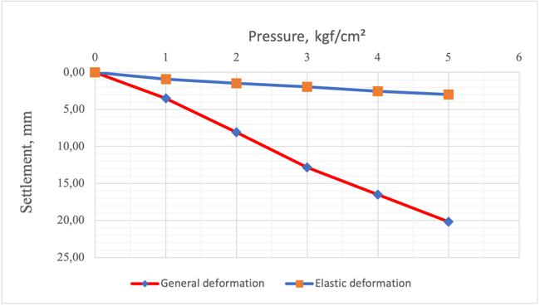

Figure 3.15 – Results of Point 3 Figure 3.16 – Results of Point 3.1
(dry soil) (km 10+110) (wet soil) (km 10+110)

On dry soil:
- average modulus of deformation of the structure for 3 points test is: E_{d} = 34.14 MPa;
- average modulus of elasticity of the structure for all 3 points test is E_{e} = 57.65MPa.
According to the tests carried out, the coefficient of compaction of soil layers the basis ranges from K ≈0.99.
On wet soil:
- average modulus of deformation of the structure for 3 points test is: E_{d} = 7.24 MPa;
- average modulus of elasticity of the structure for all 3 points test is E_{e} = 35.96 MPa.
According to the tests carried out, the coefficient of compaction of soil layers in the base fluctuates within K <0.9.
Static tests by the pressing load of boring pile No14 of support No8, No16 of support No5 of the road bridge km 153+89, and pile No3 on bridge support No1 through BAK (Big Almaty Canal) on km 171+53 were carried out for determination of bearing capacity and deformability of piles on soil with the establishment of movement dependence of pile in soil from loading (figure 3.17, 3.18, 3.19).
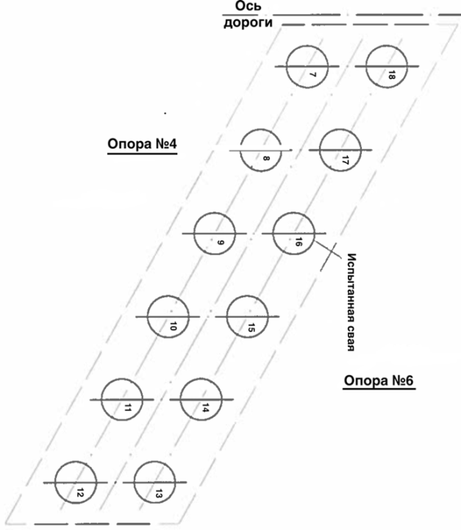

Figure 3.17 – Schematic diagram of the pile field of support No.5

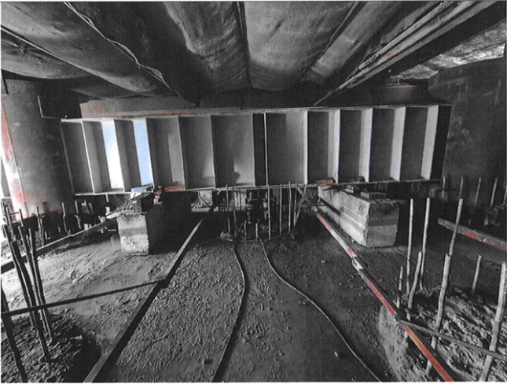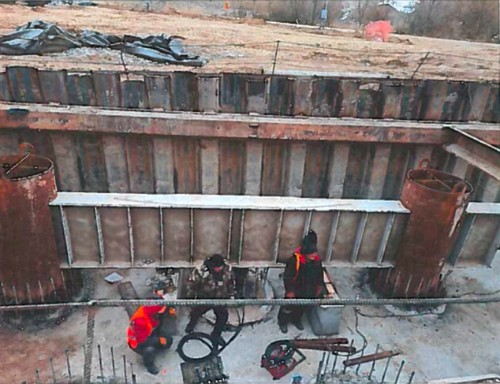
a b

a – pile No.14; b – pile No.16

Figure 3.18 – Measuring system of "experimental" and "anchored" piles No.14 and No.16

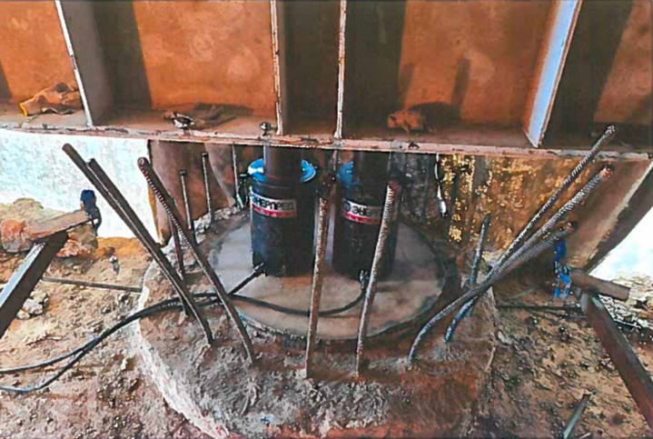

Figure 3.19 – Measuring system of "experimental" and "anchored" pile No.3

The loading and measuring devices consist of a power stand, DG200P250 jack, hydraulic pump, deflectometer 6PAO-0.01, roulette, and manometer.
In the carried-out static test of piles No. 14 of support No. 8, No. 16 of support No. 5, the pressing loadings showed that at the tenth step of loading the pressing loading, the equal 361.0 tf stabilization of deformation of piles was recorded, at the same time, average draft on the last average measurement of control devices (indicators) was 3.8 mm and 4.05 mm. There was a stabilization during the test of pile No3 on support No. 1 at the maximum load of 208.0 tf at the tenth step of loading, and the draft was 0.94 mm.
According to SP PK 5.01-103-2013 (paragraph 4.5.5) [77], when these conditions arise, 361.0 tf for piles No.14, 16 and 208.0 tf for pile No.3, should be taken as the ultimate resistance of the pile under the indentation loads according to the test results. The test results are given in table 3.9 and in figure 3.20, 3.21.

Table 3.9 – Results of static tests

Location | No. of support | No. of pile | Design load, tf | Maximum load, tf | Average settlement, mm
km 15+389 | 8 | 14 | project-wise | 361 | 3.8
km 15+389 | 5 | 16 | project-wise | 361 | 4.05
km 171+53 | 1 | 3 | project-wise | 208 | 0.94

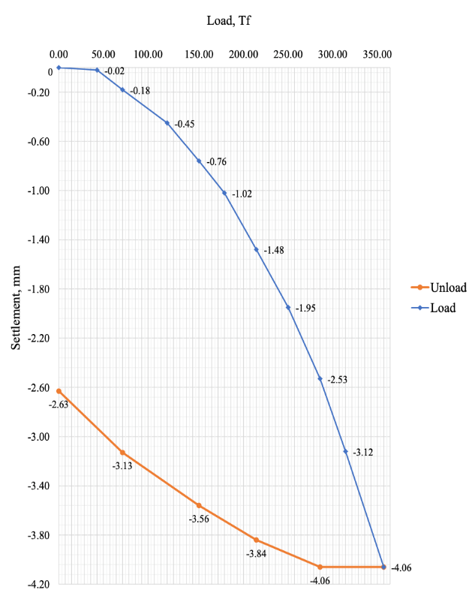

Figure 3.20 – Graph of results of the total settlement of the pile No. 16
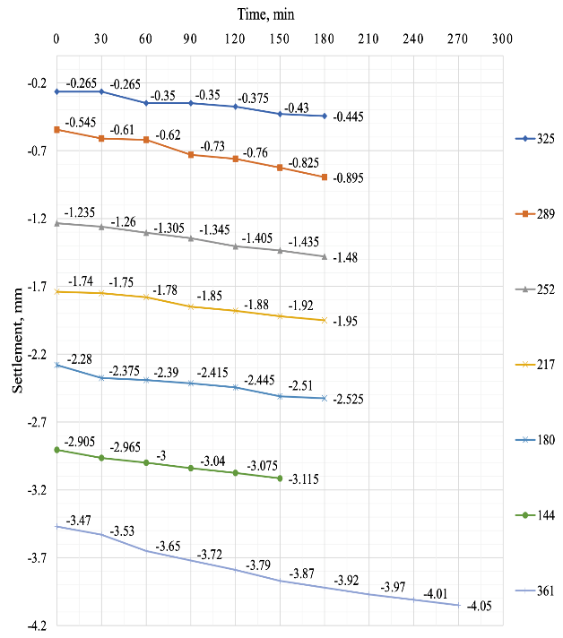

Figure 3.21 – Graph of results of the settlement of the pile No. 16 by loading stages

Integrity testing [90] of piles at the objects the Bridge through km 153+89 and the Bridge through BAK km 171+53 were carried out with a research objective of length and integrity of piles by carrying out natural the express of control of continuity of trunks of reinforced concrete boring piles by a nondestructive method of acoustic defectoscopy (figure 3.22, 3.23).

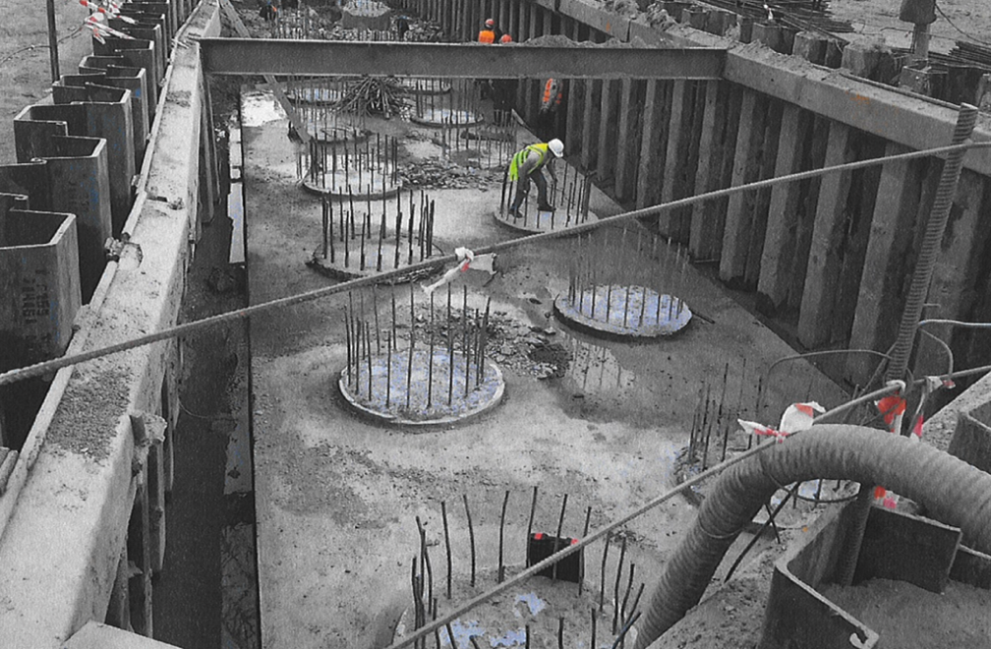

Figure 3.22 – General view of the pile support field at the time of the integrity test
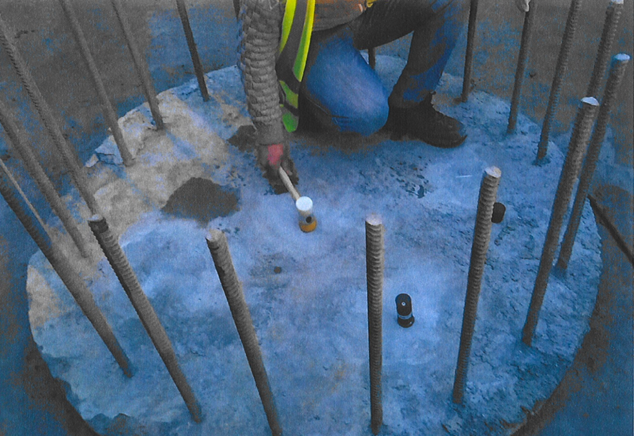

Figure 3.23 – Carrying out works on testing the piles for integrity

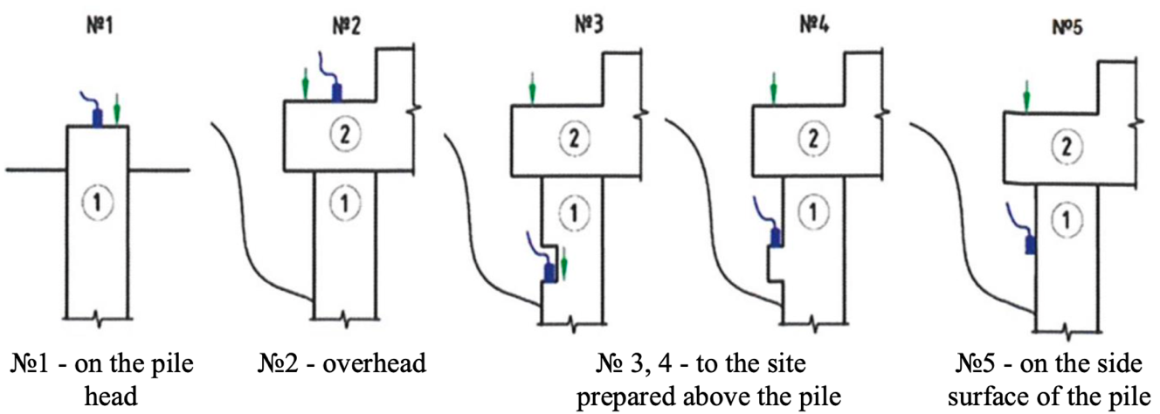

1 – pile, 2 – strut

Figure 3.24 – Principal schemes of tests

In the course of the study, preference was given to Scheme No1. The first stage included applying a series of blows, the second stage involved determining the speed of propagation of the acoustic wave rod in the pile concrete. The average velocity is taken in the range of 3600-4100 m/s, and the third stage - the cameral processing. The results of testing piles are shown in table 3.10 and figures 3.25, 3.26.

Table 3.10 – Pile integrity test result

Location | Support No. | Pile No. | Pile length, m | Test result
1 | 2 | 3 | 4 | 5
km 153+89 | 1 | 3 | 26.0 | satisfactorily
km 153+89 | 1 | 21 | 26.0 | satisfactorily
km 153+89 | 1 | 7 | 25.4 | satisfactorily
km 153+89 | 1 | 10 | 25.5 | satisfactorily
km 153+89 | 1 | 11 | 24.1 | satisfactorily
km 153+89 | 1 | 12 | 24.6 | satisfactorily
Table continuation 3.10

1 | 2 | 3 | 4 | 5
 |  | 13 | 24.4-25.6 | satisfactorily
 |  | 14 | 24.6 | satisfactorily
 |  | 15 | 25.6 | satisfactorily
 | 2 | 7 | 24.2 | The analysis of signals on piles No. 7 and 12 shows the existence of abnormal signals, which is possible to interpret as - broadening at various depths.
 | 2 | 12 | 25.7
 | 2 | 8 | 24.2 | satisfactorily
 | 2 | 9 | 24.3 | satisfactorily
 | 2 | 10 | 24.0 | satisfactorily
 | 2 | 11 | 23.9 | satisfactorily
 | 2 | 13 | 24.3 | satisfactorily
 | 2 | 14 | 23.8 | satisfactorily
 | 2 | 15 | 25.0 | satisfactorily
 | 2 | 16 | 24.5 | satisfactorily
 | 2 | 17 | - | The analysis of signals on pile No. 17 indicates an echo of signal from the end of the pile, making it impossible to determine pile length and standard processing methods.
 | 2 | 18 | 23.9 | satisfactorily
 | 2 | 20 | 23.2 | satisfactorily
 | 2 | 22 | 24.0 | satisfactorily
 | 3 | 14 | 24.0 | satisfactorily
 | 3 | 18 | 24.2 | satisfactorily
 | 3 | 1 | 23.6 | satisfactorily
 | 3 | 21 | 24.6 | satisfactorily
 | 3 | 22 | 24.0 | The abnormal signal at a depth of 15-16 m is revealed on boring pile No.22 of support No.3.
 | 3 | 23 | 24.6 | satisfactorily
 | 4 | 1 | 24.6 | satisfactorily
 | 4 | 2 | 24.2 | satisfactorily
 | 4 | 3 | 23.92 | satisfactorily
 | 4 | 4 | 23.65 | satisfactorily
 | 4 | 5 | 24.85 | satisfactorily
 | 4 | 6 | 24.32 | satisfactorily
 | 4 | 7 | 24.4 | satisfactorily
 | 4 | 8 | 23.55 | satisfactorily
 | 4 | 9 | 25.3 | satisfactorily
 | 4 | 10 | 25.12 | satisfactorily
 | 4 | 11 | 23.7 | satisfactorily
 | 4 | 12 | 23.92 | satisfactorily
 | 4 | 13 | 22.4 | The length of pile No. 13 is less than projected, even considering the maximum errors of the control method
Table continuation 3.10

1 | 2 | 3 | 4 | 5
 |  | 14 | 24.47 | satisfactorily
 |  | 15 | 24.67 | satisfactorily
 |  | 16 | 24.22 | satisfactorily
 |  | 17 | 25.3 | satisfactorily
 |  | 18 | 24.95 | satisfactorily
 |  | 19 | 25.45 | satisfactorily
 |  | 20 | 23.4 | satisfactorily
 |  | 21 | 23.9 | satisfactorily
 |  | 22 | 23.52 | satisfactorily
 |  | 23 | 23.7 | satisfactorily
 |  | 24 | 25.37 | satisfactorily
 | 5 | 1 | 26.7 | The analysis of signals on pile No. 1 shows defects like "neck" at a depth of 10-12 m.
 | 5 | 2 | 25.0 | satisfactorily
 | 5 | 3 | 24.5 | satisfactorily
 | 5 | 4 | 25.3 | satisfactorily
 | 5 | 5 | 25.6 | satisfactorily
 | 5 | 6 | - | The signal analysis shows defects like broadening at a depth of 15-17 m
 | 5 | 19 | - | The analysis of signals on pile No. 19 indicates a lack of acoustic contact in the hall of the interface of the head of the pile and grouting layer, making it impossible to process the obtained data as a result of signal control. Abnormal signals are revealed at a depth of 15 meters, pointing out the engineering-geological features creating an acoustic impedance on the media border
 | 5 | 20 | 24.6 | satisfactorily
 | 5 | 21 | 23.8 | satisfactorily
 | 5 | 22 | 23.8 | satisfactorily
 | 5 | 23 | 25.2 | satisfactorily
 | 5 | 24 | 24.7 | satisfactorily
 | 6 | 1 | 24.8 | satisfactorily
 | 6 | 2 | 23.8 | satisfactorily
 | 6 | 3 | 23.8 | satisfactorily
 | 6 | 4 | 24.2 | satisfactorily
 | 6 | 5 | 24.0 | satisfactorily
 | 6 | 6 | - | The analysis of signals by piles No. 6, 20, 23 and don't allow to authentically determine the length of boring piles due to the objective reason of the method restriction–
 | 6 | 20 | -
 | 6 | 23 | -
Table continuation 3.10

1 | 2 | 3 | 4 | 5
 |  |  |  | the existence of rigid jamming of the pile ends in dense soil without the creation of the reflecting layer
 |  | 7 | 24.5 | satisfactorily
 |  | 8 | 23.4 | satisfactorily
 |  | 9 | 24.2 | satisfactorily
 |  | 10 | 24.0 | satisfactorily
 |  | 11 | 24.7 | satisfactorily
 |  | 12 | 24.6 | satisfactorily
 |  | 13 | 24.5 | satisfactorily
 |  | 14 | 23.5 | satisfactorily
 |  | 15 | 24.8 | satisfactorily
 |  | 16 | 24.4 | satisfactorily
 |  | 17 | 23.4 | satisfactorily
 |  | 18 | 24.2 | satisfactorily
 |  | 19 | 24.2 | satisfactorily
 |  | 21 | 24.2 | satisfactorily
 |  | 22 | 24.4 | satisfactorily
 |  | 24 | 24.1 | satisfactorily
 | 7 | 1 | 23.9 | satisfactorily
 | 7 | 2 | 23.7 | satisfactorily
 | 7 | 3 | 23.6 | satisfactorily
 | 7 | 4 | 24.0 | satisfactorily
 | 7 | 5 | 24.6 | satisfactorily
 | 7 | 6 | 24.9 | satisfactorily
 | 7 | 19 | 23.5 | satisfactorily
 | 7 | 20 | 24.3 | satisfactorily
 | 7 | 21 | 23.6 | satisfactorily
 | 7 | 22 | 24.2 | satisfactorily
 | 7 | 23 | 24.0 | satisfactorily
 | 7 | 24 | 24.3 | satisfactorily
 | 8 | 1 | 23.5 | satisfactorily
 | 8 | 2 | 23.8 | satisfactorily
 | 8 | 3 | 23.8 | satisfactorily
 | 8 | 4 | 24.2 | satisfactorily
 | 8 | 5 | 23.7 | satisfactorily
 | 8 | 6 | 22.8 | satisfactorily
 | 8 | 7 | 23.1 | satisfactorily
 | 8 | 8 | 24.4 | satisfactorily
 | 8 | 9 | 23.6 | satisfactorily
 | 8 | 10 | 23.1 | satisfactorily
 | 8 | 11 | 23.3 | satisfactorily
 | 8 | 12 | 23.7 | satisfactorily
 | 8 | 13 | 24.3 | satisfactorily
 | 8 | 14 | 17.7 | As a result of the analysis of the received signals on boring pile No. 14, it is possible to formulate trace conclusions: The accurate amplitu
Table continuation 3.10

1 | 2 | 3 | 4 | 5
 |  |  |  | de signal is fixed in the range of depths from 17 to 18 meters. There are two main versions: the first - the actual length of the pile - doesn't exceed 18 m, and the second - a pile has a significant violation of column section continuity at a depth range from 17 to 18 m. All this is a deviation from the made design decision, and it is necessary to coordinate with the project's authors
 |  | 15 | 23.1 | satisfactorily
 |  | 16 | 24.2 | satisfactorily
 |  | 17 | 23.5 | satisfactorily
 |  | 18 | 24.3 | satisfactorily
 |  | 19 | 24.3 | satisfactorily
 |  | 20 | 23.6 | satisfactorily
 |  | 21 | 24.7 | satisfactorily
 |  | 22 | 23.1 | satisfactorily
 |  | 23 | 23.3 | satisfactorily
 |  | 24 | 23.4 | satisfactorily
 | 9 | 1 | 25.3 | satisfactorily
 | 9 | 2 | 25.7 | satisfactorily
 | 9 | 3 | 26.8 | satisfactorily
 | 9 | 4 | 26.2 | satisfactorily
 | 9 | 5 | 26.4 | satisfactorily
 | 9 | 6 | 25.6 | satisfactorily
 | 9 | 7 | 25.4 | satisfactorily
 | 9 | 8 | 25.0 | satisfactorily
 | 9 | 9 | 25.4 | satisfactorily
 | 9 | 10 | 25.5 | satisfactorily
 | 9 | 11 | 26.0 | satisfactorily
 | 9 | 12 | 25.0 | satisfactorily
 | 9 | 13 | 26.5 | satisfactorily
 | 9 | 14 | 26.2 | satisfactorily
 | 9 | 15 | 26.4 | satisfactorily
 | 9 | 16 | 25.4 | satisfactorily
 | 9 | 19 | 25.9 | satisfactorily
 | 9 | 20 | 26.3 | satisfactorily
 | 9 | 21 | 25.5 | satisfactorily
 | 9 | 22 | 25.9 | satisfactorily
 | 9 | 23 | 25.9 | satisfactorily
 | 9 | 24 | 26.6 | satisfactorily
 | 9 | 25 | 25.6 | satisfactorily
 | 9 | 26 | 25.1 | satisfactorily
 | 9 | 27 | 25.4 | satisfactorily
 | 9 | 28 | 26.1 | satisfactorily
Table continuation 3.10

1 | 2 | 3 | 4 | 5
 |  | 29 | 25.6 | satisfactorily
 |  | 30 | 25.3 | satisfactorily
 |  | 31 | 25.5 | satisfactorily
 |  | 32 | 25.3 | satisfactorily
 |  | 33 | 25.1 | satisfactorily
 |  | 34 | 26.5 | satisfactorily
 |  | 35 | 24.2 | satisfactorily
 |  | 36 | 26.8 | satisfactorily
km 171+53 | 1 | 5 | 28.0 | satisfactorily
km 171+53 | 1 | 6 | 27.9 | satisfactorily
km 171+53 | 1 | 7 | 28.3 | satisfactorily
km 171+53 | 1 | 8 | 28.3 | satisfactorily
km 171+53 | 1 | 9 | 28.3 | The abnormal signal at a depth of 19-20 meters is revealed.
km 171+53 | 1 | 10 | 28.0 | satisfactorily
km 171+53 | 2 | 6 | 24.5 | satisfactorily
km 171+53 | 2 | 10 | 29.3 | satisfactorily
km 171+53 | 2 | 1 | 23.27 | satisfactorily
km 171+53 | 2 | 2 | 23.5 | satisfactorily
km 171+53 | 2 | 3 | 25.17 | satisfactorily
km 171+53 | 2 | 4 | 24.32 | satisfactorily
km 171+53 | 2 | 5 | 24.1 | satisfactorily
km 171+53 | 3 | 13 | 24.0 | satisfactorily
km 171+53 | 3 | 19 | 24.0 | satisfactorily
km 171+53 | 3 | 9 | 29.9 | satisfactorily
km 171+53 | 4 | 3 | 30.2 | satisfactorily
Note – Compiled according to the source [91]

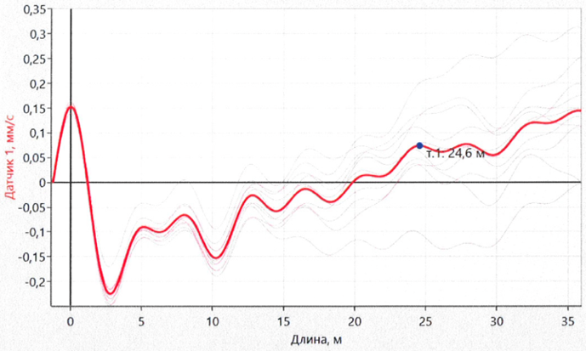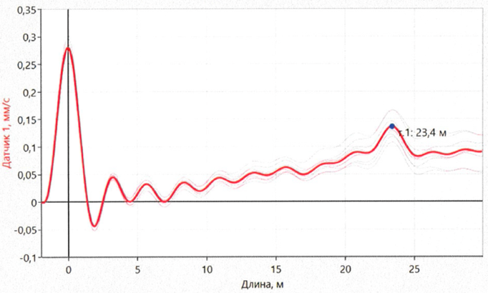

Figure 3.25 – Analysis of the wave Figure 3.26 – Analysis of the wave passage through the body of the pile №20 passage through the body of the pile №1
on support №5 (km 15+389) on support №2 (km 17+153)

3.4 Section 2 (km 240+00 - km 440+00)
The planned section of the road “BAKAD” (Almaty Main Ring Road)" 2 (km 240 + 00-km 440 + 00) is located in the Karasay and Ili districts of the Almaty region (figure 3.27).
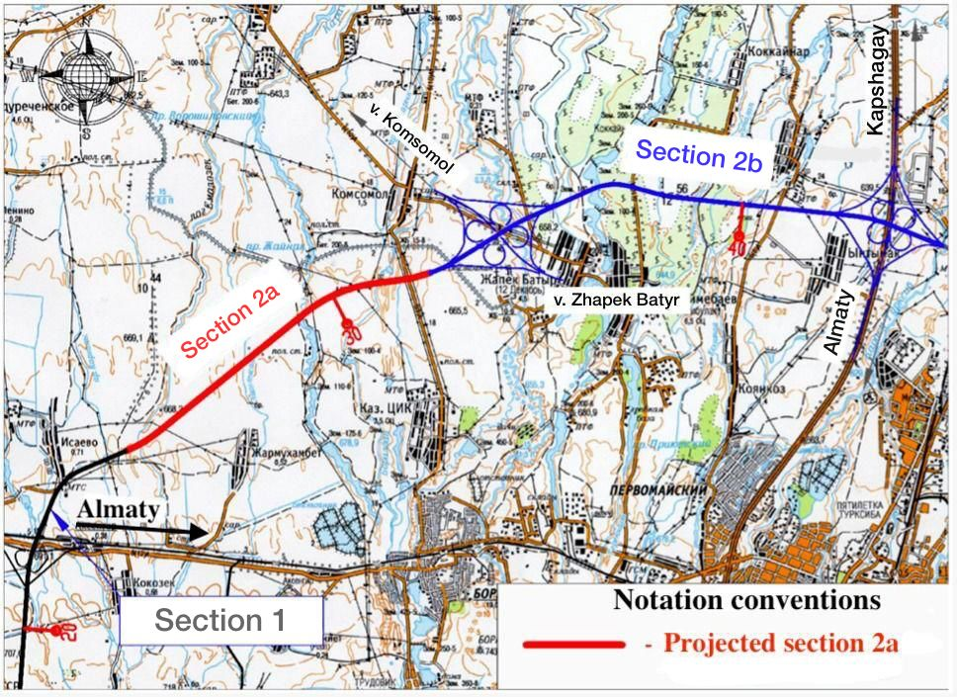

Figure – 3.27 Site location

3.4.1 Engineering and geological conditions
Geomorphologically, the construction site is located within the piedmont clinoplain extending north from the foothills of the Zailiskiy Alatau.
The climate of the district is sharply continental. The climate features of the region are determined by the latitude and presence of orographic elements on its surface. The combination of climate-forming factors causes the predominance of hot, dry weather with sharp seasonal and daily fluctuations in air temperatures. Summers are hot, and winters are moderately cold and mild. Heavy rains are noted in spring and summer.
The Tien Shan region is a complex mountain country formed due to repeated changes in tectonic conditions. The oldest geosynclinal stage of tectonic development continued from the Archaea in places to the Ordovician. Orographically, the region is represented by a complex system of ridges and cavities. Precambrian and Caledonian fold structures form the Tien Shan region. Alpine folding began in the Upper Cretaceous era and continues intermittently to the present.
There is a general relief slope to the north. The relief was formed due to mudflows and the intense activity of river waters. It is a weakly hilly plain with river valleys. The remains of the I and II floodplain terraces are observed on it.
Hydrographically, the investigated section is located between the Kaskelen and Talgar rivers, including their feeders, and the planned route passes through them.
The planned route directly crosses the network of watercourses. Because the route of the designed road passes through these streams, they will directly affect the formation of engineering and geological conditions of the projected facility.
The area's geological structure is characterized by loose Quaternary deposits lying on rocks of the Paleozoic bedrock. The indigenous sediments are represented by granitoid, granodiorite, and porphyrite intrusions in river basins crossing the Zailiskiy Alatau ridge. These rocks will not have a decisive impact on geotechnical profiteering, so a detailed description of the bedrock rocks is not given—soft deposits of medium- and modern-quaternary age form alluvial-proluvial complex of stones.
To detail the geological-lithological section along the axis of the route, 51 exploration wells were drilled to a depth of 6.0m. In total 199.0m were penetrated. Absolute elevations of wells are 631.59-680.70 m.
Route section from the surface is represented by topsoil with a thickness of 0.2 m. Lams from solid to fluid is penetrated with a thickness of up to 6.0 m below and sandy loams up to 1.5 m. There are layers of medium-grained sand and coarse penetrated with a thickness of 0.6 m below.
Filling soil is found on intersected existing roads. It is represented by semi-solid loam containing gravel and pebbles. Groundwater during the survey was penetrated at a depth of 1.0 - 7.8 m. The maximum penetrated power is 3.2 m.
The physical and mechanical properties of soils are given in tables 3.11 and 3.12.

Table 3.11 – Physical and mechanical properties of soils

Parameter name | EGE-2а | EGE-2b | EGE-2v | EGE-2d | EGE-3a | EGE-4v | EGE-4g
Liquid limit, % | 26.9 | 26.3 | 27.1 | 27.3 | 20.7 | - | -
Plastic limit, % | 18.8 | 18.7 | 18.9 | 19.0 | 16.9 | - | -
Plasticity index, % | 8.1 | 7.6 | 8.2 | 8.3 | 3.8 | - | -
Index of liquidity, % | <0 | 0.38 | 0.62 | 0.94 | <0 | - | -
Natural humidity, % | 12.2 | 21.6 | 24.0 | 26.7 | 4.6 | - | -
Soil particles density, g/sm³ | 2.71 | 2.70 | 2.71 | 2.71 | 2.69 | - | -
Soil density, g/sm³ | 1.61 | 1.91 | 1.94 | 1.84 | 1.61 | 1.62 | 1.88
Dry soil density, g/sm³ | 1.45 | 1.57 | 1.57 | 1.45 | 1.54 | - | -
Void ratio | 0.86 | 0.72 | 0.73 | 0.87 | 0.74 | - | -
Degree of humidity | - | - | - | 0.97 | - | - | -
Coefficient of permeability, m/d | - | - | - |  |  | 7.4 | -
The natural angle of slope in the dry state, deg. | - | - | - |  |  | 35 | 38
Soil resistance, kPа | 318.0 | 145 | 98 | 98 | 294 | 400 | 500

Table 3.12 – Normative and calculated values of soil characteristics

EGE | Unit weight of soil, kN/m³ |  |  | Intercept cohesion, kPa |  |  | Angle of internal friction, deg. |  |  | Modulus of deformation, MPa
EGE | norm | РII | PI | norm | СII | СI | norm | үII | үI | Modulus of deformation, MPa
1 | 2 | 3 | 4 | 5 | 6 | 7 | 8 | 9 | 10 | 11
2а | 1.61 | 1.61 | 1.58 | 22.0  16,0* | 22.0  16.0* | 15.0  11.0* | 22.0  16.0* | 22.0  16.0* | 19.0  14.0* | 13.7  7.8*
2b | 1.91 | 1.91 | 1.87 | 25.0 | 25.0 | 17.0 | 21.0 | 21.0 | 18.0 | 15.5*  13.5*
2v | 1.94 | 1.94 | 1.90 | 21.0 | 21.0 | 14.0 | 18.0 | 18.0 | 16.0 | 13.0*  12.2*
Table continuation 3.12

1 | 2 | 3 | 4 | 5 | 6 | 7 | 8 | 9 | 10 | 11
2d | 20.3 | 20.3 | 20.1 | 13.0 | 13.0 | 8.7 | 5.0 | 5.0 | 4.3 | 7.7
3a | 1.61 | 1.61 | 1.58 | 13.0  11.0* | 13.0  11.0* | 9.0  7.0* | 24.0  21.0* | 24.0  21.0* | 21.0  18.0* | 10.6  7.0*
4v | 1.62 | 1.62 | 1.59 | 1.0 | 1.0 | 0.7 | 35.0 | 35.0 | 32.0 | 30.0
4g | 1.88 | 1.88 | 1.84 | 1.0 | 1.0 | 0.7 | 38.0 | 38.0 | 34.0 | 30.0
* – the denominator shows the characteristics of soils in the water-saturated state

Calculated values of soil characteristics are given, considering the soil reliability factor.
Soils according to the degree of frost susceptibility: solid, semi-solid loam and solid sandy loam - not heaving, medium-grained sand, coarse sand - slightly heaving, stiff - medium-heaving loam, soft-plastic and fluid-plastic loam - strongly heaving.
Wells penetrated groundwater up to 6.0 m deep at a depth of 1.0-7.8 m. Seasonal amplitude of SWL + 1.0-1.5 m.
Groundwater - from fresh to slightly salty, hydro carbonate, sodium-calcium. The degree of sulfate aggressive action of groundwater on the W4 portland cement grade concrete is non-aggressive to highly aggressive. The degree of bold action of groundwater on reinforcement of reinforced concrete structures (in terms of chloride content) during dressing is slightly aggressive.
The corrosion activity of soils to carbon steel is low, to lead - from low to high, to aluminum - medium.
Soils EGE-2a (solid and semi-solid loam) and 3a (solid loam) have collapsing properties. Initial pressure of drawdown is 0.125 - > 3.0 kg/cm². Collapsing from own weight does not exceed 5 cm. The type of soil conditions by collapsing is I (first).
Erosion, seismicity of the site, salinity, frost heaving, and collapsing are predicted from physical and geological processes and phenomena in the area of the planned development site.
The area is located in the zone with seismic hazard (according to SP RK 2.03-30-2017) [88, с. 11] - 9 (nine) points according to seismic zoning maps of OSZ-2475 and OSZ-22475. Peak accelerations (in fractions of g) for rocky soils: OSZ-1475 - (agR (475)) - 0.38; And OSZ-12475 - (agR (2475)) - 0.73; Design horizontal and vertical acceleration at the construction site ag - 0.535; agv - 0.482.
The type of soil conditions along the route laying axis is II (second).
Design seismicity of the construction site is 9 (nine) points (according to SP RK 2.03-30-2017, p. 6.2) [88, с. 55].
The Route section being designed belongs to a non-heated area according to SP RK 5.01-102-2013 (cl. 4.3.1.9) [59, с. 10] by the nature of the man-made impact.

3.4.2 Field tests conducted at the site
The tests of soil piles were carried out according to the requirements of GOST 5686-2020 [83, с. 26]. The tests were carried out by the static pressing loads of 20 piles on this site (figure 3.28, 3.219, 3.30). Loading the tested piles was made evenly, without blows, by loading steps whose size was no more than 1/10 estimated bearing capacity.

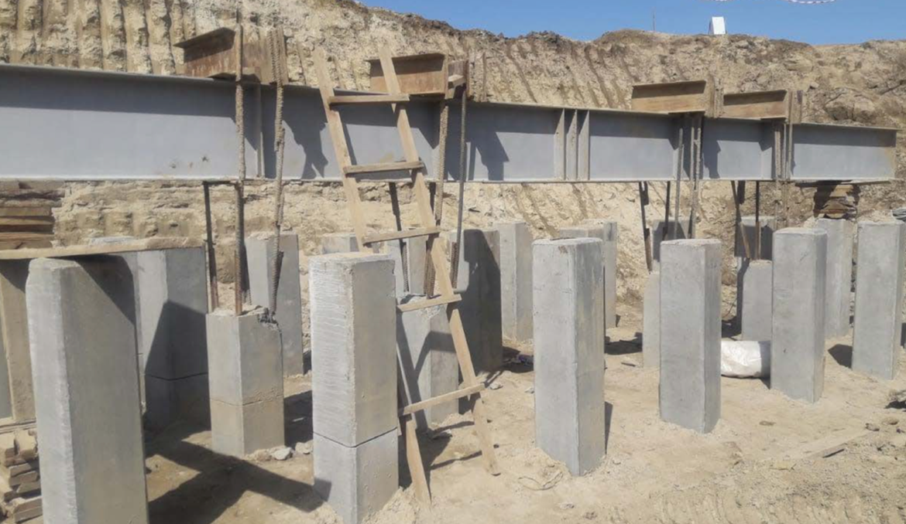

Figure 3.28 – General view of the support prepared for static tests

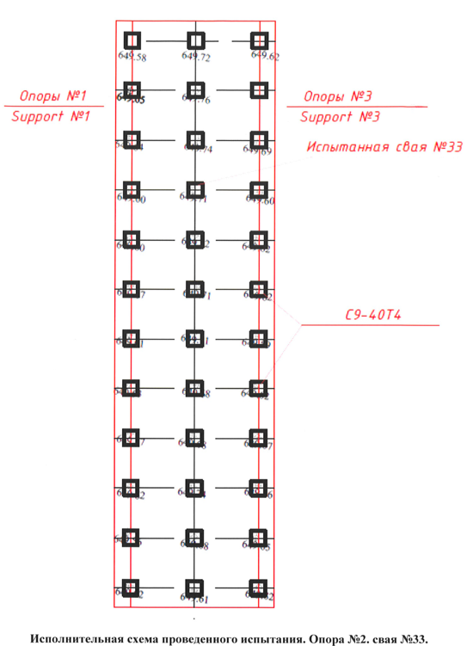

Figure 3.29 – Schematic diagram of the pile field of the bridge crossing at km 32+730

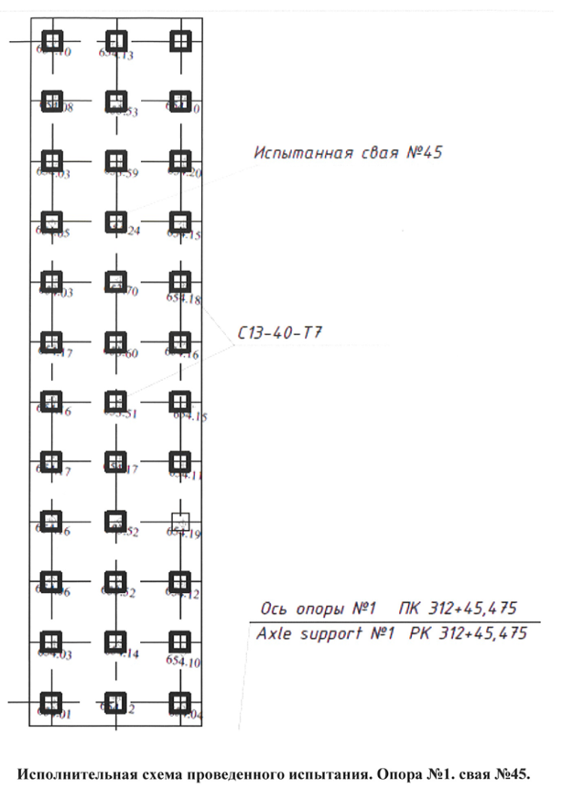

Figure 3.30 – Scheme of the pile field of the bridge crossing over the river Borolday 2 at km 31+265

The loading and measuring devices consist of a power stand, DG200P250 jack, hydraulic pump, deflectometer 6PAO-0.01, roulette, and manometer.
The reading of each device was taken at each step of a pile loading, the first hour with an interval of 15 min., further with an interval of 30 min, before attenuation of movement of the pile called stabilization. Observations were accepted for the conditional stabilization of a pile. Unloading of a pile was made by the steps equal to the doubled sizes of stages of loading, with the endurance of each step within 15 min. Counting on devices to measure deformations was removed after each unloading step and in 15 min observations. Observations of the movement of a pile were carried out within 60 min after complete unloading (to zero) with the removal of counting from devices every 15 min. According to the project, the movement speed in soil was no more than 0.1 mm in the last 60 min. The results of the tests are given in table 3.13.

Table 3.13 – Results of static tests of piles

Location | No. of support | No. of pile | Design load, tf | Maximum load, tf | Average settlement, mm
1 | 2 | 3 | 4 | 5 | 6
km 24+477 | 3 | 3 | project-wise | 239.0 | 1.48
km 29+240 | 1 | 33 | project-wise | 160.0 | 2.71
km 29+240 | 4 | 33 | project-wise | 135.15 | 2.58
km 31+245 | 3 | 43 | project-wise | 129.0 | 8.02
km 31+265 | 1 | 33 | 71.0 | 85.2 | 44.58
km 31+265 | 1 | 45 | 71.4 | 74.9 | 41.43
km 31+265 | 2 | 33 | 69.6 | 52.0 | 41,715
km 31+265 | 2 | 42 | 69.6 | 72.975 | 45.965
km 31+443 | 2 | 41 | 75.8 | 113.7 | 6.18
Table continuation 3.13

1 | 2 | 3 | 4 | 5 | 6
km 31+443 | 1 | 34 | project-wise | 83.0 | 24.78
km 32+730 | 1 | 67 | 55 | 83.0 | 29.8
km 32+730 | 2 | 33 | 100 | 102.0 | 38.32
km 34+169 | 3 | 56 | 71.7 | 107.6 | 16.49
km 34+650 | 1 | 158 | 109.8 | 165.0 | 6.31
km 35+622 | 2 | 5 | 168.3 | 252.5 | 0.96
km 35+622 | 4 | 10 | 167.1 | 250.7 | 3.37
km 40+100 | 1 | 24 | 118 | 177.0 | 5.16
km 40+131 | 2 | 9 | 117.8 | 176.7 | 1.33
km 40+620.37 | 2 | 11 | 115.8 | 174 | 6.20
km 40+620.37 | 1 | 19 | 115.8 | 174 | 5.22
Note – Compiled according to the source [92, 93]

Results of the test showed that the pile in the course of the test perceives the design load of the pile head to equal - 71.0 tf. By results of the carried-out static tests of pile No. 33 on support No. 1 (Overpass bridge through the Borolday river 2 on KM 31+265) at the tenth step of loading, the equal 106.5 tf recorded deformation (deposit) - 40.28 mm. Gain of deformations on 4.24 mm is recorded after additional endurance for 26 h. The total gain of deformations was 44.58 mm, while a stabilization deposit isn't recorded. They are objectively analyzing increment of deformations and overdue approach of stabilization to the 9th steps at the impact of efforts - 96.0 tf and schedules of the actual behavior of piles under loading perhaps reasonably to take for the extreme resistance of a pile of F_{u} at the pressing loadings the eighth step - 85.2 tf.
The carried-out static test of pile No42 on support No2 (Overpass bridge through the Borolday river 2 on personal computer 31+265), the pressing loadings showed that at the eighth step of loading, the equal 83.4 tf deformation - 45.965 mm was recorded that exceeds extreme size equal - 40 mm. According to SP RK 5.01–103–2013 (items 4.5.5), the pressing loadings take the loading of the seventh step for the extreme resistance of F_{u} pile- 72. 975 tf. The test results showed that the bearing capacity of pile No42 on support No2 on soil is sufficient to perceive design loading.
Static test of pile No33 of support No2 (Overpass bridge on personal computer 32+730) the pressing loading showed that at the eighth step of loading the equal 117 tf late stabilization (was recorded through - 34.5 hours) at the same time deformation was 38.32 mm. The seventh step loading for the extreme resistance of a pile of F_{u} - 102 tf is taken at the pressing loadings. The test results showed that the bearing capacity of pile No33 on support No2 on soil is sufficient to perceive a projected estimated pile load.
Test of pile No45 of support No1 (Overpass bridge through the Borolday river 2 on KM 31+265), the following result was issued by the pressing loadings: at the eighth step of loading 85.6 tf, 41.43 mm settlement was recorded, at the same time stabilization of deformation didn't happen. The results showed that the bearing capacity of pile No45 on support No1 on soil is insufficient to perceive the maximum pressing design load. The actual bearing capacity doesn't exceed 74.9 tf, which is less than the projected capacity.
Static test of pile No33 of support No2 by the pressing loadings showed that the deformation - 41.715 mm was recorded at the sixth step of loading equal to 62.4 tf, at the same time, stabilization of deposit was not registered. The fifth step, 52.0 tf is taken for the extreme resistance of pile F_{u} at the pressing loadings. The tests showed that the bearing capacity of pile No. 33 on support No. 2 on soil is insufficient to perceive the maximum pressing design load. The actual bearing capacity doesn't exceed 52.0 tf, and there is less than the projected capacity.
Plate-bearing tests were carried out in Section 2 to study the bearing capacity of the artificial base soil for the pipe at km 43 + 225.
The bearing capacity of the base soil under the Overpass bridge was studied at 3 points of plate testing. A stamping unit with a rotary console acting on the principle of a balance beam (figure. 3.31) was used to carry out the tests.

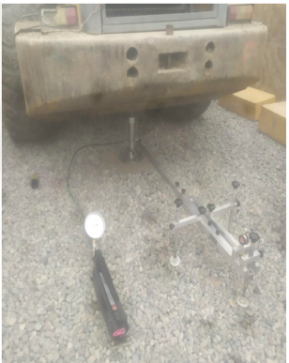

Figure 3.31 – Conducting plate-bearing tests

The following conclusions can be drawn based on the results of plate-bearing tests of artificial soil:
Point 1: Equivalent modulus of deformation of the structure E_{d} = 8.15 MPa.
The modulus of elasticity of the structure is not considered correctly due to extremely small elastic deformations and accumulation of residual deformations. No loss of bearing capacity occurs. Mean base modulus ratio E_{e}/E_{d} = 9.1 (figure 3.32).

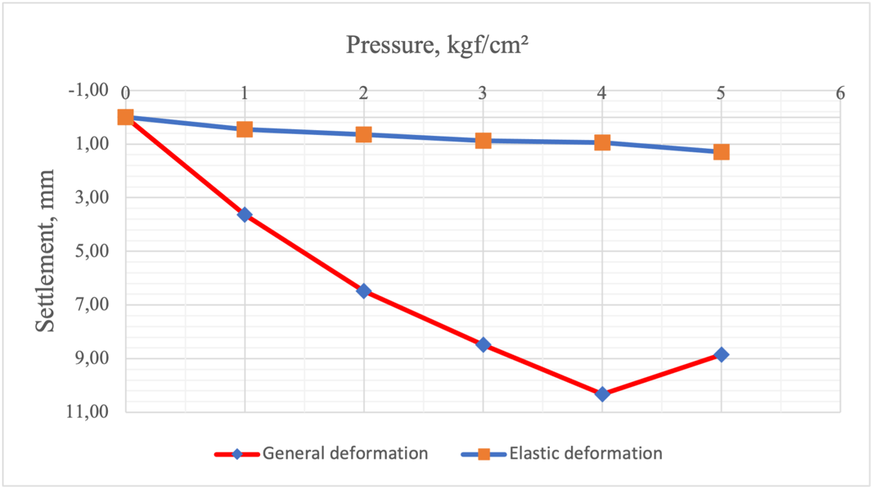

Figure 3.32 – Plate-bearing test results of point 1

Point 2: Equivalent modulus of deformation of the structure E_{d}= 7.81 MPa.
The modulus of elasticity of the structure is not considered correctly due to extremely small elastic deformations and accumulation of residual deformations. No loss of bearing capacity occurs. Mean base modulus ratio E_{e}/E_{d} = 8.19 (figure 3.33).

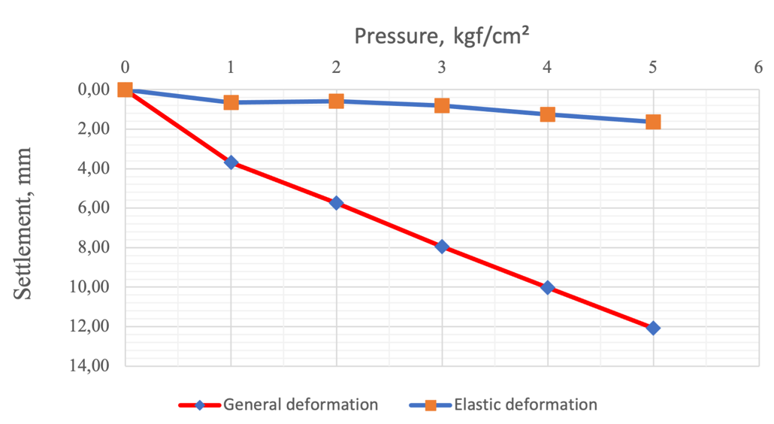

Figure 3.33 – Plate-bearing test results of point 2

Point 3: Equivalent modulus of deformation of structure E_{d} = 10.54 MPa.
The modulus of elasticity of the structure is not considered correctly due to extremely small elastic deformations and accumulation of residual deformations. No loss of bearing capacity occurs. Average base modulus ratio E_{e}/E_{d} = 6.85 (figure 3.34).

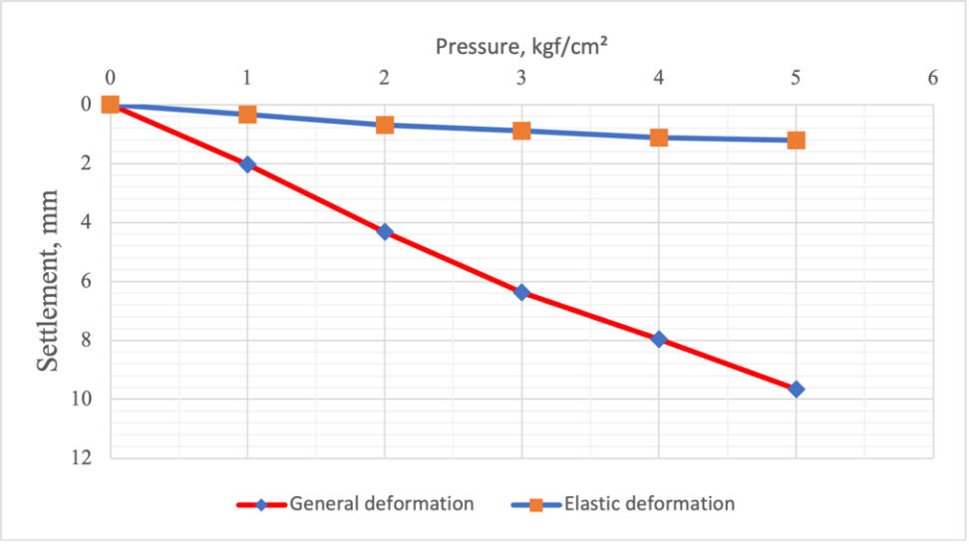

Figure 3.34 – Plate-bearing test results of point 3

Testing of piles for continuity at the Overpass bridge facility through the Kargaly River at km 244 + 77 was carried out to study the length and continuity of piles, by conducting a full-scale express control of the integrity (continuity) [94] of the shafts of reinforced concrete drilling piles by the non-destructive method of acoustic defectoscopy (figure 3.35).

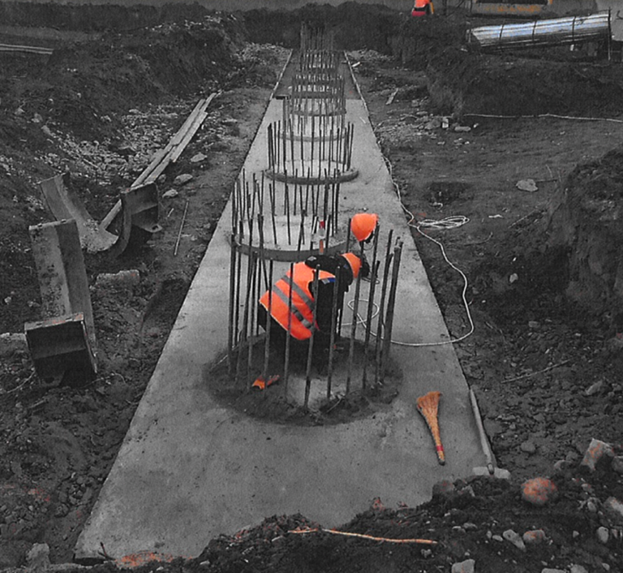

Figure 3.35 – Drilled piles for integrity testing

Results of piles integrity tests are presented in table 3.14 and figures 3.36, 3.37.

Table 3.14 – Test results

Location | Support No. | Pile No. | Pile length, m | Test result
1 | 2 | 3 | 4 | 5
ПК 244+77 | 1 | 1 | 21.4 | satisfactorily
ПК 244+77 | 1 | 2 | 21.6 | satisfactorily
ПК 244+77 | 1 | 3 | 21.0 | satisfactorily
ПК 244+77 | 1 | 4 | 21.3 | satisfactorily
Table continuation 3.14

1 | 2 | 3 | 4 | 5
 |  | 5 | 21.6 | satisfactorily
 |  | 6 | 21.6 | satisfactorily
 |  | 7 | 21.0 | satisfactorily
 |  | 8 | 21.6 | satisfactorily
 |  | 9 | 21.3 | satisfactorily
 |  | 10 | 21.5 | satisfactorily
 | 2 | 1 | 13.6 | satisfactorily
 | 2 | 2 | 13.5 | satisfactorily
 | 2 | 3 | 13.6 | satisfactorily
 | 2 | 4 | 13.5 | satisfactorily
 | 2 | 5 | 13.9 | satisfactorily

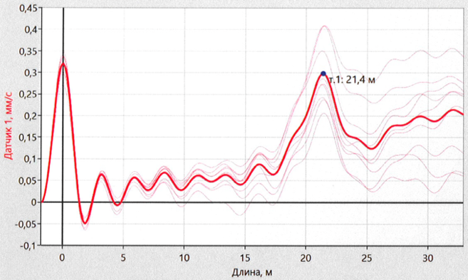

Figure 3.36 – Analysis of the wave passage passage through the body of the pile №1
on support №1

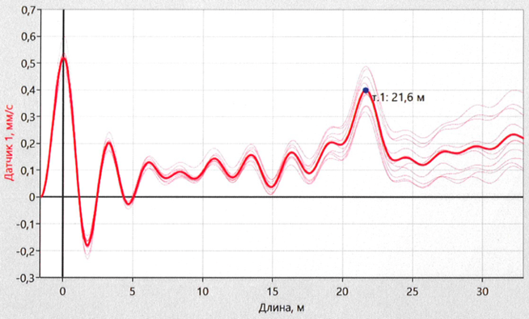

Figure 3.37 – Analysis of the wave passage through the body of the pile №2 on support №1

3.5 Section 3 (km 440+00 - km 470+20)
Section 3 of the launch complex is located in the Ili and Talgar districts of the Almaty region. There are mainly sowing fields and settlements adjacent to the highway along the highway (the Pokrovka village and Baiserke village) with one- and two-story houses (figure 3.38).

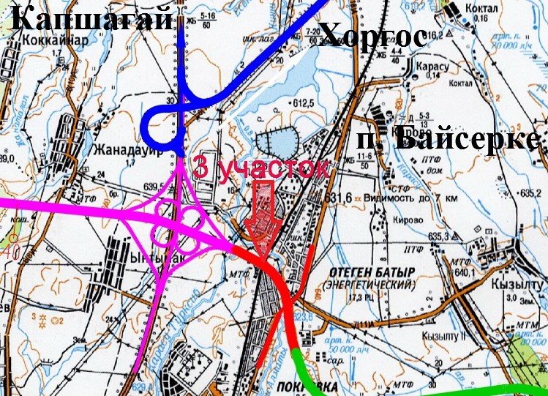

Figure 3.38 – Schematic diagram of the object location, Almaty, Kazakhstan

3.5.1 Engineering and geological conditions
The territory of the study is located on the northwestern slope of the Zailiysky Alatau ridge, and a piedmont graded alluvial cone.
The projected artificial structures are in the area according to the formation conditions, within the piedmont plain, and it is relatively flat, with the crossing of the courses, with a common slope in the north direction.
The relief surface is poorly divided: semi-contiguous hollows and shallow, shaped channelы prevail - rain rills of courses 0.5-3.0 m wide, with the main depth 0.3-1.0 m.
The area of the planned route is a desert (semi-desert) zone with ephemeral-wormwood sparse vegetation with low-productive pastures.
The area of the BAKAD route on the 3rd launch complex belongs to the steppe foothill landscapes, for the most part, they are cultivated. The refore, soils and vegetation cover are significantly changed from natural, characterized by great variety.
Soil formation occurs in extremely arid (dry) bioclimatic conditions. As a rule, the thickness of the topsoil is 0.20 m. The dense root system penetrates to a depth of 1.0-1.2 m in the areas occupied by thickets of reeds. Compositionally the soils are sierozemic, sandy loam, and loamy. The plant cover is scanty. There is saltwort and wormwood, the cover is developed everywhere, except for rocky-sandy beds of torrential ravines and dells.
Almost the entire river flow of the basin is formed in the mountainous and partially piedmont zones.
According to the results of drilling to depths of 25 meters, the groundwater level is set at depths from the low river courses from 0.2 m to 14.0 m. in sections of the projected bridges and Overpass bridges.
Sedimentation in the Quaternary occurred against the background of tectonic movements; the revival of erosion processes contributed to the intensive accumulation of coarse clastic material near the mountains, within the mountain valleys, and on the plains - the accumulation of its finer-grained differences. At the foot of the mountains and a short distance from them, the quaternary, proluvial deposits are represented by boulders and pebbles with loessoid loams and sandy loams overlapping them. Lithologically, these are mainly alluvial-proluvial sands, sandy loam, loam, Upper Quaternary age (apQIV), as well as alluvial-proluvial loams, sands, pebble, and gravel soils with sand filler of Middle and Upper Quaternary age (apQIII-IV)
According to the seismic zoning of the territory of the Republic of Kazakhstan, the surveyed areas belong to the 9-point seismic zone.
To establish the lithological structure, the wells No. 1 t - 10 t, with a depth of 3.0 meters each, and wells No11 t - 14 t, with a depth of 5.0 m to 8.0 m, were drilled at the site. The lithological structure along the route axis is shown in the lithological columns of the workings, as well as on the longitudinal profile.
The following types of soils were established based on the drilling results:
- The topsoil layer is 0.2 m thick, represented by light brown loam with plant roots. The density = 1.78 g/cm³.
- EGE 1. Light, solid, collapsing loams. Manual excavation group - 2 (35b). Penetrated by wells in the intervals of 0.2 - 8.0 m. The average thickness is 3.8 m. The relative collapsing is ε_{sl} = 0.011- 0.028, with an initial collapsing pressure of p_{sl} = 0.5 kg/cm². They belong to type 1 by collapsing properties.
- EGE 1.1. Stiff consistency loams. Manual excavation group - 2 (35b). Penetrated by well No. 3 t in the interval 0, 2-3.0 m.
Standard values of physical and mechanical parameters of strength and deformation properties of loams are given in tables 3.15 and 3.16.

Table 3.15 – Physical and mechanical properties of soils

EGE | Parameter name
EGE | Liquid limit, % | Plastic limit, % | Plasticity index, % | Natural humidity, % | Void ratio | Degree of humidity | Soil density, g/sm³
1 | 26.7 | 17.0 | 9.9 | 13.9 | 0.607 | 0.677 | 1.93
1.1 | 26.3 | 16.2 | 10.1 | 19.9 | 0.521 | 1.029 | 2.13

Table 3.16 – Normative and calculated values of soil characteristics

EGE | Intercept cohesion, kPa | Angle of internal friction, deg. | Modulus of deformation, MPa | Soil resistance, kPа
1 | 34* | 24* | 24.1* | 400*
1.1 | 35* | 23* | 26.8* | 275
* – Values of the characteristics of soils adopted by the normative documents

Soils are not saline, do not have sulfate aggression on the concrete of W4 grade, they are slightly aggressive in terms of chloride content, corrosion activity to carbon steel is medium, to lead shell is low, to the aluminum shell is low.
These wells did not penetrate groundwater along the route axis to a depth of 8.0 m. The area belongs to the degree of humidification in group 1.
The seismicity of the area is 9 points.
The following adverse processes and phenomena complicate the maintenance and operation of the designed structures
Erosion of base soils is observed in areas of designed artificial structures. Erosion of the bottom and sides of the channels is observed as a modern process and phenomenon:
Loams generally show collapsing properties. The type of soil conditions by collapsing is I (first). The total value of self-weight hollows is from 0.50 to 0.84 cm. Relative collapsing is εsl=0.012 -0.042, at initial collapsing pressure psl = 0.050 up to 1.11 kg/cm².

3.5.2 Field tests conducted at the site
Static tests of piles No17 on support No3 (Overpass bridge on km 46 + 470.72) and No26 on support No1 (Overpass bridge on km 44 + 801) were carried out with a pressing load (figures 3.39, 3.40) at average daily positive temperatures.

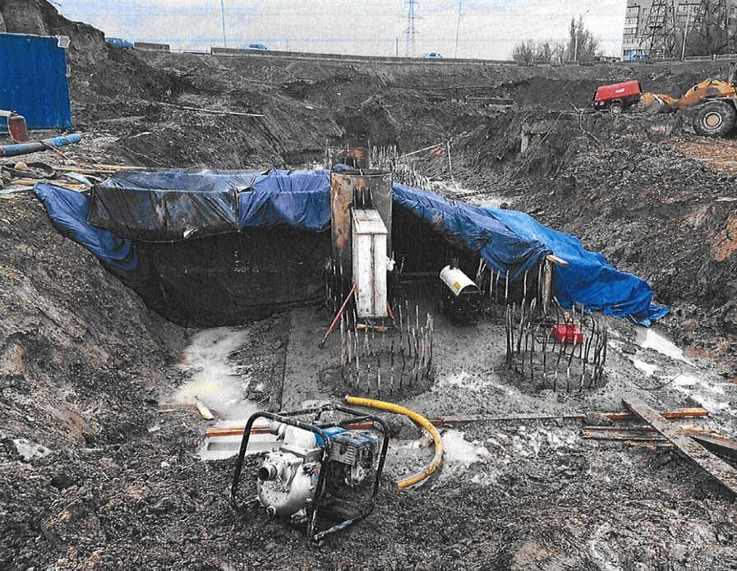

Figure 3.39 – General view of the support No3, prepared for the test work
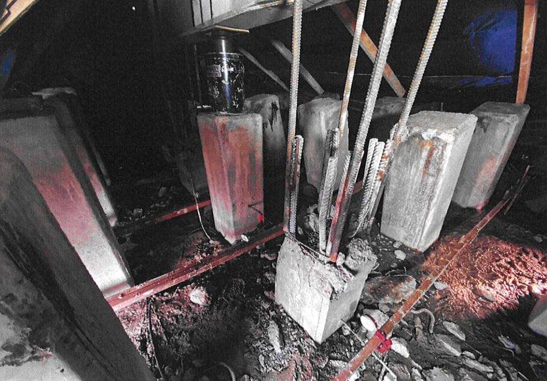

Figure 3.40 – General view of the support No1, prepared for the test work

Loading and measuring devices consist of a power stand, DG200P250 jack, hydraulic pump, 6PAO-0.01 deflectors, tape measure, and manometer.
Soil tests with piles were carried out according to GOST 5686-2020 [83, с. 30]. Loading of the tested pile was carried out uniformly, without impacts, by load stages, the value of which was not more than 1/10 of its expected bearing capacity. At each stage of pile loading, the readings were taken for all instruments, the first hour was with an interval of 15 minutes, then with an interval of 30 minutes until the pile movement called stabilization fades. According to the design, the conditional stabilization of the pile was assumed to be the speed of movement in the soil not more than 0.1 mm over the last 60 minutes of observations.
Pile unloading was carried out in stages equal to twice the loading stages' values, with each stage's exposure for 15 minutes. Readings by instruments for measuring deformations were taken immediately after each unloading stage and after 15 minutes of observations. After complete unloading (up to zero), the pile movement was monitored for 60 minutes, with readings taken from instruments every 15 minutes.
Stock welded I-beam installed above anchor piles is used as a power stand. Test results are given in table 3.17 and figures 3.41 and 3.42.

Table 3.17 – Results of static tests

Location | No. of support | No. of pile | Design load, tf | Maximum load, tf | Average settlement, mm
km 44+801 | 1 | 26 | 48 | 72 | 2.28
km 46+470.72 | 3 | 17 | 228.7 | 343 | 6.95

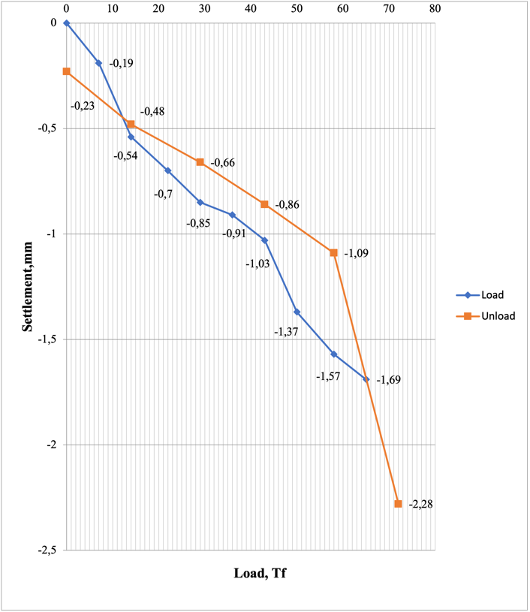
Figure 3.41 – Graph of results of the total settlement of the pile No. 26

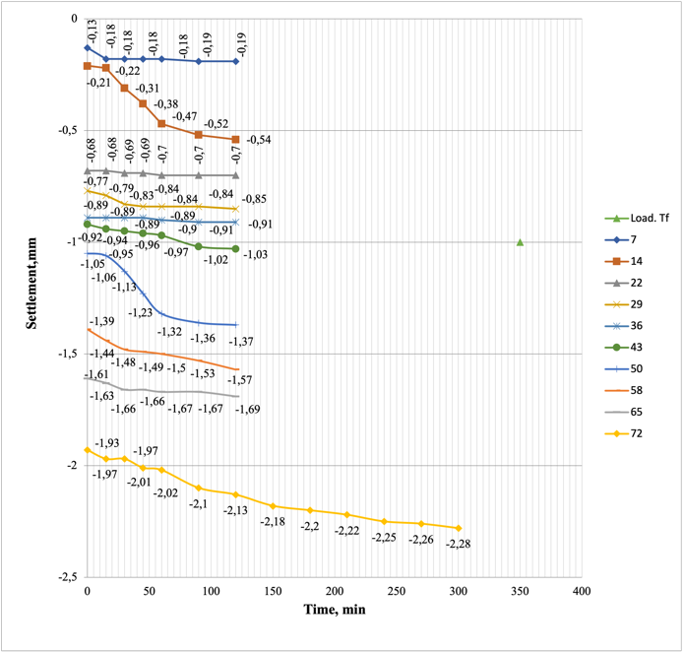
Figure 3.42 – Graph of results of the settlement of the pile No.26 by loading stages

Static testing of pile No. 26 of support No. 1 with pressing loads showed that stabilization of pile deformation was recorded at the tenth load stage at a maximum load equal to 72.0 tf, while the average settlement for the last measurement of control devices was about - 2.28 mm. Pile No. 17 of support No. 3 at the tenth load stage at the maximum load of 343 tf has given micronite stabilization equal to - 6.95 mm.

3.6 Section 4 (km 470+00 - km 560+00)
The planned section of the BAKAD highway 4 launch complex is located in the Talgar district of the Almaty region. The initial point of the section km 470+00.00 is a continuation of the BAKAD route of the 3rd launch complex. The beginning of the km 470+00.00 highway is located 515 meters from the existing Almaty-Baiserke highway. The end of the KM 570+00.00 route is a continuation of the BAKAD route of the 9th launch complex, and it is located 1,355 meters northeast of the existing Almaty-Khorgos highway (Kuldzhinsky tract) and 936 meters north of the intersection with the Big Almaty Canal.

3.6.1 Engineering and geological conditions
Alluvial-proluvial deposits of Quaternary age (Q), represented by loams of different consistency pebble soils covered with a soil-plant layer, take part in the geological and lithological structure of the site. Below is a brief description of the engineering and geological conditions of artificial structures. Below is a brief the 6 wells were drilled to examine soils of the Overpass bridges and bridge, 30.0 m deep, 43 wells were drilled along the axis of the routes, 3.0 m, and 16 wells were drilled 6.0 m deep.
Overpass bridge Kyzyltu: from the surface, it is represented by a soil-plant layer with a thickness of 0.2 m. Below is a stiff brown loam with a thickness of 3.3-6.3 m, underlain by pebble soil with the inclusion of boulders up to 70%, with sandy aggregate, water-saturated, gray, with a thickness of 4.0-4.9 m. Loams of different consistency occur from 10.5-11.4 m in depth: soft-plastic, fluid-plastic, and fluid, with thicknesses up to 16.0 m. Pebble soil with sand aggregate, water-saturated, penetrated thickness - 3.0 m was encountered at a depth of 27.0-27.5 m.
Groundwater during the survey period was penetrated at a depth of 6.5 m. The amplitude of oscillations makes 1,0±1,5 m.
Overpass bridge Kuldzha is represented by a soil-plant layer with a thickness of 0.2 m from the surface. A stiff and soft plastic brown loam is shown below, its thickness is 6.3-6.8 m, underlying by pebble soil with the inclusion of boulders up to 70%, with sandy aggregate, water-saturated, gray, 3.3-3.5 m thick. Loams of different consistency occur from 10.0-10.3 m in depth: soft-plastic, fluid-plastic, and fluid, with thicknesses up to 16.0 m. Pebble soil with sand aggregate, water-saturated, penetrated thickness - 4.0-4.7 m, was encountered at a depth of 25.3-26.0 m.
Groundwater during the survey period was penetrated at a depth of 6.5-7.0 m. Amplitude of oscillations is 1,0±1,5 m.
Bridge-spruit Almerek is represented by a soil-plant layer with a thickness of 0.2 m from the surface. Solid and fluid brown loam is presented below, 6.5-6.8 m thick, under pebble soil with boulders up to 70%, with sandy aggregate, water-saturated, gray, 10.2-10.8 m thick. There are loams of fluid and solid consistency up to 10.0 m thick from the depth of 17.2-17.5 m. Pebble soil with sand aggregate, water-saturated, penetrated thickness – 3.0 m was encountered at 27.0 m.
Groundwater during the survey period was penetrated at a depth of 2.5-3.0 m. Amplitude of oscillations is 1,0±1,5 m.
The route section it is represented by a soil-plant layer with a thickness of 0.2-0.7 m from the surface. Loam of different consistency interlays: from solid to fluid consistency, penetrated up to 6 m thick.
The route passes through swampy places (well No. 13,14,15,16,17.5 t, 18.6 t, 7t) on km 470 + 00 and km 497 + 00 according to km 510 + 00. The soils up to a depth of 0.5 m – are fluid-plastic, humus soils are to be replaced, and low-plastic loams (mineral bottom) interlay below.
Groundwater during the survey period was penetrated at a depth of 0.2-5.7 m. Amplitude of oscillations is 1,0±1,5 m.
The indicators of physical and mechanical properties, material composition, and salinity of soils identified by nomenclature type (GOST 25100-2011) (EGE) were obtained by the laboratory [86, с. 18]:
1. EGE-1 – Loam, light, solid and semi-solid, brown;
The initial drawdown pressure is 0.625 kg/cm2. Collapsing from own weight does not exceed 5 cm. The type of soil conditions by collapsing is I (first).
2. EGE-2 – Loam, light, stiff, brown.
3. EGE-3 – Loam, light, high-plastic, brown.
4. EGE-4 – Loam, light, fluid-plastic, brown.
5. EGE-5 – Loam, light, fluid, brown.
6. EGE-6а – Pebble soil with sand aggregate, water-saturated.
7. EGE-6б – Pebble soil with the inclusion of boulders up to 30% with sand aggregate, water-saturated.
Standard values of physical and mechanical parameters of strength and deformation properties of loams are given in tables 3.19 and 3.20.

Table 3.19 – Physical and mechanical properties of soils

Parameter name | EGE-1 | EGE-2 | EGE-3 | EGE-4 | EGE-5 | EGE-6 | EGE-6a
Liquid limit, % | - | - | - | - | - | - | -
Plastic limit, % | - | - | - | - | - | - | -
Plasticity index, % | 9.2 | 10.1 | 10.6 | 11.0 | 10.9 | - | -
Index of liquidity, % | <0 | 0.33 | 0.65 | 0.86 | 1.57 | - | -
Natural humidity, % | 17.8 | 22.6 | 25.7 | 29.3 | 36.6 | - | -
Soil particles density, g/sm³ | 2.7 | 2.71 | 2.71 | 2.71 | 2.71 | - | -
Soil density, g/sm³ | 1.96 | 1.95 | 1.94 | 1.99 | 1.98 | 1.75 | 2.0
Dry soil density, g/sm³ | 1.66 | 1.59 | 1.55 | 1.54 | 1.45 | - | -
Void ratio | 0.63 | 0.70 | 0.75 | 0.76 | 0.87 | - | -
Degree of humidity | 0.77 | 0.87 | 0.93 | 1.04 | 1.14 | - | -
Soil resistance, kPа | 360 | 181 | 98 | - | - | 980 | 980

Conditional resistance (R0) for EGE-6a (pebble soil with sand aggregate, water-saturated) and EGE-6b (pebble soil with the inclusion of boulders up to 30% with sand aggregate) was given according to SP RK 3.03-112-2013 Bridges and pipes [95].

Table 3.20 – Normative and calculated values of soil characteristics

EGE | Unit weight of soil, kN/m³ |  |  | Intercept cohesion, kPa |  |  | Angle of internal friction, deg. |  |  | Modulus of deformation, MPa
EGE | norm | РII | PI | norm | СII | СI | norm | үII | үI | Modulus of deformation, MPa
1 | 1,96 | 1,96 | 1,92 | 32,0  26,0* | 32.0  26.0* | 21.3  17.3* | 24  20* | 24  20* | 21  17* | 23,2  18,5*
2 | 1,95 | 1,95 | 1,91 | 26.0 | 26.0 | 17.3 | 22 | 22 | 19 | 19.5*  14.5*
3 | 1,94 | 1,94 | 1,90 | 20.0 | 20.0 | 13.3 | 18 | 18 | 16 | 4.3
4 | 1,99 | 1,99 | 1,95 | 19.0 | 19.0 | 12.0 | 17 | 17 | 15 | 3.6
5 | 1,98 | 1,98 | 1,94 | 16.0 | 16.0 | 10.0 | 15 | 15 | 10 | 2.5
6 | 1,75 | 1,75 | 1,71 | 27 | 27 | 24 | 36 | 36 | 34 | 68.0
6a | 2,00 | 2,00 | 1,96 | 27 | 27 | 24 | 36 | 36 | 34 | 68.0
* – the denominator shows the characteristics of soils in the water-saturated state

The estimated values of the characteristics are given, considering the soil's reliability factor.
By the degree of frost susceptibility: Loam, solid and semi-solid - practically non-frost-susceptible, Loam, stiff - medium frost-susceptible, Loam, high-plastic and fluid-plastic - highly frost-suspect, and Loam, fluid excessively swollen
Low mineralized groundwater. Concrete and reinforced concrete structures of W4 grade on Portland cement are non-aggressive by the degree of aggressiveness. Reinforced concrete structures (in terms of chloride content) are slightly aggressive with periodic wetting.
Unsalted and weakly salted soils. Corrosion activity of soils to lead is medium; to aluminum is medium. Corrosion activity of soils to carbon steel is from medium to high.
Seismicity of the site, ravine erosion, flooding of the territory, and collapsing of soils are predicted among the physical and geological processes and phenomena in the area of the planned development site.
Groundwater during the survey was penetrated at depths of 0.2-6.5 m. Vibration amplitude is 1.0+1.5 m.
Seismicity of the work area is 9 (nine) points. The type of soil conditions by seismic properties is III (third). The seismicity of the construction site) will be 10 (ten) points.

3.6.2 Field tests conducted at the site
Five plate-bearing and two static tests were carried out with a pressing load on this section of the road.
The bearing capacity of the artificial soil of the base under the pipe was tested at km 482 + 71. The bearing capacity of the base soil under the Overpass bridge was studied at 3 points of plate-bearing tests.
The stamp installation with a rotary console was used for testing, acting on the principle of a balance beam (figure. 3.43).

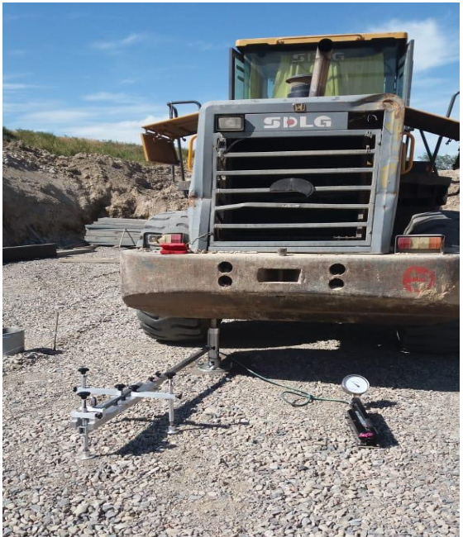

Figure 3.43 – Conducting plate-bearing tests

The results of the plate-bearing tests are shown in table 21 and figure 3.44. 3.45, 3.46.

Table 3.21 – Plate-bearing test results

Location | Soil | Deformation modulus, Е_{def}, MPa | Elastic modulus Е_{elas}, MPa | Coefficient of compaction, K
km 482+71 | Point 1 | 11.4 | 57.0 | ≈0.88
km 482+71 | Point 2 | 16.5 | 65.4 | ≈ 0.92
km 482+71 | Point 3 | 21.4 | 59.64 | ≈0.96
km 478+31 | Point 1 | 27.54 | 58.50 | ~ 0.98
km 478+31 | Point 2 | 22.85 | 70,76 | ~ 0.95
km 478+31 | Point 3 | 11.70 | - | <0.9
km 485+52 | Point 1 | 30.4 | 116.65 | 0.94-0.98
km 485+52 | Point 2 | 18.34 | 84.77 | <0.94
km 485+52 | Point 3 | 20.38 | 85.35 | 0.945–0.95
km 492+17 | Point 1 | 30.9 | 79.9 | ≈0.96
km 492+17 | Point 2 | 23.2 | 77.3 | <0.94
km 492+17 | Point 3 | 22.3 | 75.3 | 0.94-0.96
km 528+89.49 | Point 1 | 8.15 | 64.2 | 0.9527
km 528+89.49 | Point 2 | 8.4 | 66.4 | 0.9527
km 528+89.49 | Point 3 | 16.8 | 57.9 | 0.9527
km 528+89.49 | Point 4 | 11.2 | 45.8 | 0.9527
km 528+89.49 | Point 5 | 10.4 | 68.1 | 0.9527
* – characteristics are given for soil at a water-saturated state
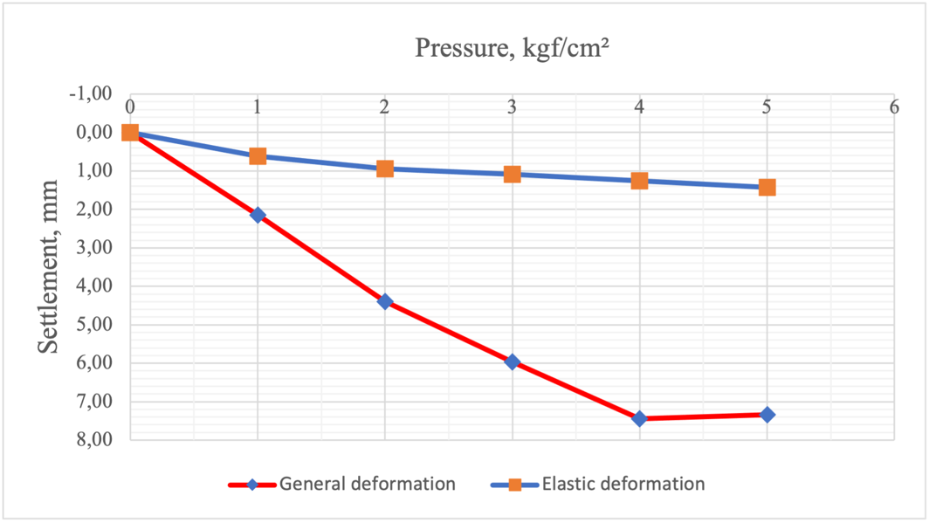

Figure 3.44 – Plate-bearing test results of point 1 (km 482+71)

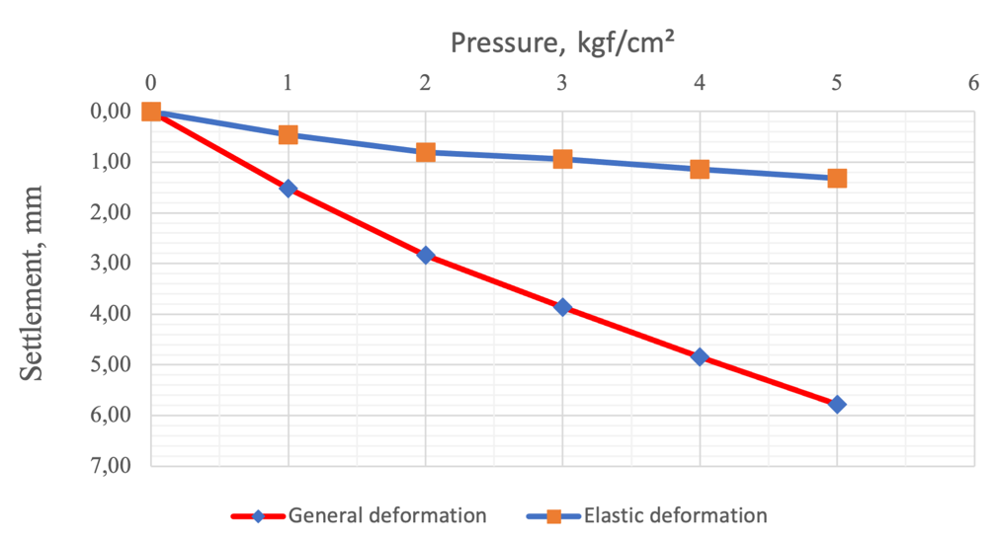

Figure 3.45 – Plate-bearing test results of point 2 (km 482+71)

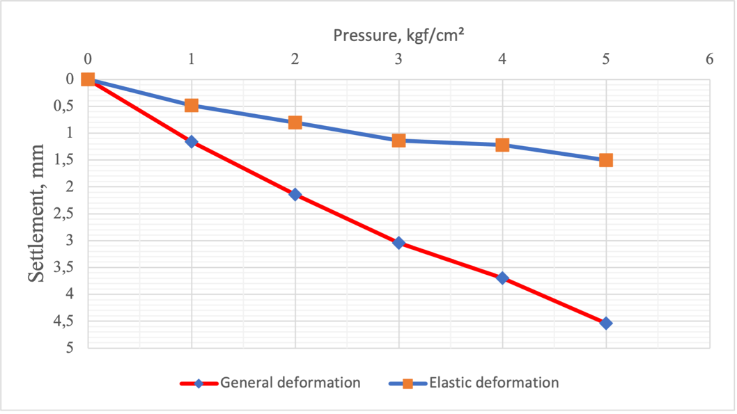

Figure 3.46 – Plate-bearing test results of point 3 (km 482+71)

The following conclusions can be drawn based on the results of tests carried out on km 482+71 on the study of the bearing capacity of the artificial soil of the base under the pipe:
- the average modulus of deformation of the structure at 3 test points makes the following: E_{d} = 16.43 MPa;
- the average modulus of elasticity of the structure at all 3 test points is: E_{e} = 60,68 МПа;
- the compaction factor of artificial base layers ranges from K≈ 0.88 - 0.99.
The following conclusions can be drawn based on the results of the tests carried out on km 478 + 31 on the study of the bearing capacity of the artificial soil of the base under the pipe:
About the 1st and 2nd points:
- the average modulus of deformation of the structure at 2 test points is following: E_{d} = 25.20 MPa;
- the average modulus of elasticity of the structure for 2 test points is following: E_{e} = 64.63 MPa;
- the average compaction factor of the structure for the 2nd test point follows K ~ 0.97.
About the 3rd point:
- structural deformation modulus E = 11.70 MPa.
The modulus of structure elasticity is not considered correctly in the 3rd point due to extremely small elastic deformations and accumulation of residual deformations. During the tests, it was seen that the 3rd point is located in the local depression area with standing water, respectively, due to the presence of standing water, friction forces and interlocking between crushed stone particles do not occur. This leads to a low compaction factor of the artificial base K < 0.9, extremely low elastic deformations, and an accumulation of residual deformations under the plate during testing.
The following conclusions can be drawn based on the results of the test for (km 485+52) on the study of the bearing capacity of the artificial base soil under the pipe:
- the average compaction factor of the natural base at 3 points varies within the range: at a depth of about 10-30 cm from the surface of the K plate of the soil ≈ 0.956. - at a depth of more than 40 cm from the plate surface, where K soil is < 0.945;
- the average modulus of structure deformation at 3 test points is following: E_{d}= 23.04 MPa;
- the average modulus of structure elasticity for all 3 test points is E_{e} = 95.57 MPa.
The following conclusions can be drawn based on the results of the tests performed (km 492 + 17) on the study of the bearing capacity of the artificial base soil under the pipe:
- the average compaction factor of the natural base at 3 points varies within the following: at a depth of about 10-30 cm from the surface of the K plate of the soil ≈ 0.955. - at a depth of more than 40 cm from the plate's surface, where K soil is < 0.945;
- the average modulus of structure deformation at 3 test points is following: E_{d} = 23.04 MPa;
- the average modulus of the structure elasticity for all 3 test points is E_{e} = 95.57 MPa.
The following conclusions can be drawn based on the results of the tests performed (km 492 + 17) on the study of the bearing capacity of the artificial soil of the base under the pipe:
- the average compaction factor of the natural base at 3 points varies within the following: at a depth of about 10-30 cm from the surface of the K plate of the soil ≈ 0.955. - at a depth of more than 40 cm from the plate surface, where K soil is < 0.945;
- the average modulus of structure deformation at 3 test points is following: E_{d} = 25.5 MPa;
- the average modulus of structure elasticity for all 3 points test is E_{e} = 77.5 MPa.
The following conclusions can be drawn based on the results of the tests carried out on CH 528 + 89.49 on the study of the bearing capacity of the soil of the road pavement base under the pipe:
- the average compaction factor of the natural base at 5 points varies within the following: K = 0.9527;
- the average modulus of structure deformation for 5 test points is following: E_{d} = 10.9 MPa;
- the average modulus of structure elasticity for all 5 test points is E_{e} = 60.47 MPa.
Static tests of piles No19 on support No. 1 and No23 on support No2 (Overpass bridge on km 55 + 645.3) were carried out with a pressing load at average daily positive temperatures (figure 3.47).

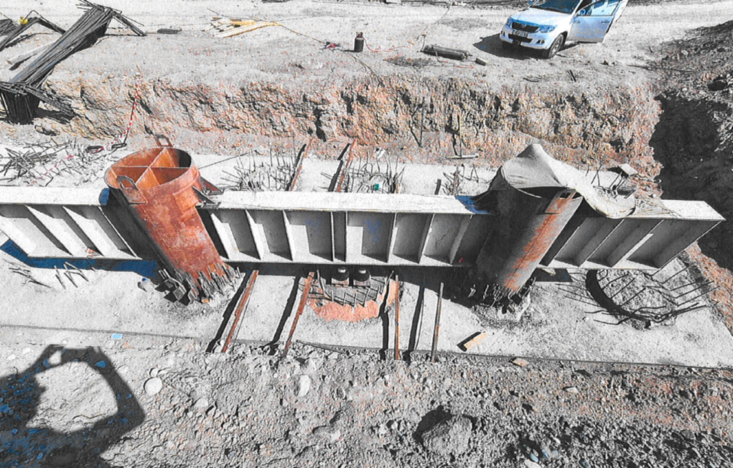

Figure 3.47 – Conducting static tests

Loading device and measuring devices consist of the power stand, DG200P250 jack, hydraulic pump, 6PAO-0.01 deflectometer, tape measure, and manometer.
Soil tests with piles were carried out according to GOST 5686-2020 [83, с. 40]. Loading of the tested pile was carried out uniformly, without impacts, by load stages, the value of which was not more than 1/10 of its expected bearing capacity. At each stage of pile loading, readings were taken for all instruments, the first hour with an interval of 15 minutes, then with an interval of 30 minutes until the pile movement decay called stabilization. According to the design, the conditional stabilization of the pile was assumed to be the speed of movement in the soil not more than 0.1 mm over the last 60 minutes of observations.
Pile unloading was carried out in stages equal to twice the loading stages' values, with each stage's exposure for 15 minutes. Readings by instruments for measuring deformations were taken immediately after each unloading stage and after 15 minutes of observations. After complete unloading (up to zero), the pile movement was monitored for 60 minutes, with readings taken from instruments every 15 minutes. The results are presented in table 3.22.

Table 3.22 – Static test results

Location | № support | № pile | Designed load, tf | Maximum load, tf | Average settlement, mm
km 55+645,3 | 1 | 19 | 251.1 | 376.7 | 2.06
km 55+645,3 | 2 | 23 | 254.9 | 382.4 | 4.19

Static testing of pile No19 of support No1 with pressing loads showed that stabilization of pile deformation was recorded at the tenth load stage at a maximum load equal to 376.7 tf, while the average micrinite for the last measurement of control devices was about - 2.06 mm. Pile No23 of support No2 at the tenth load stage at the maximum load of 382.4 tf has given micronite stabilization equal to - 4.19 mm.

3.7 Section 9 (km 560+00 - km 660+00)
The planned section of the BAKAD highway 9 launch complex is in the Talgar district of the Almaty region. The initial point of section km 570 + 00, end of section km 660 + 00 at the Almaty - Talgar highway intersection near Kyzylkairat settlement (figure 3.48).

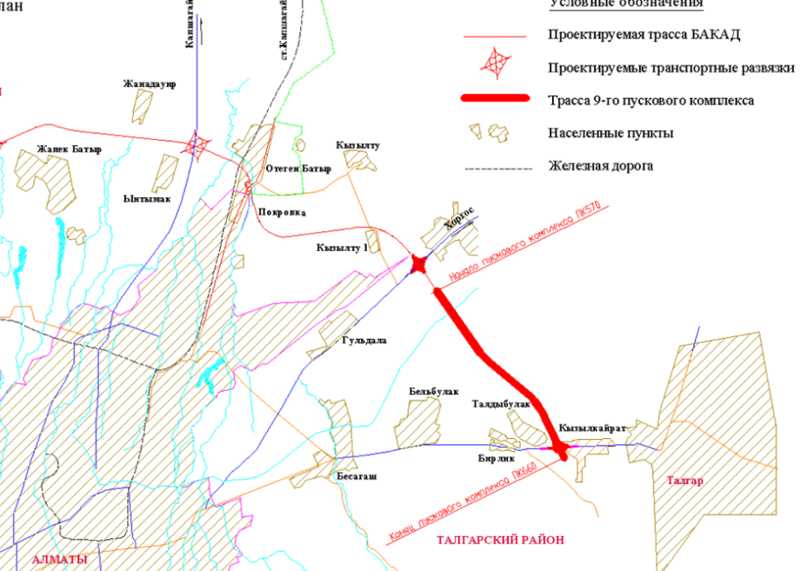

Figure 3.48 – Schematic location of the investigated section, Almaty, Kazakhstan

3.7.1 Engineering and geological conditions
The section of the designed road is located within one geomorphological element - a foothill inclined alluvial-proluvial plain. The district's territory occupies the foothills of the Zailiiskiy Alatau and the plain part of the Kopa-Iliskiy cavity.
Modern technogenic Quaternary deposits (tQIV), in the form of bulk soils on crossed roads and alluvial-proluvial deposits of Upper Quaternary age (apQIV), represented by loams of different consistency and pebble soils covered with a soil-plant layer take part in the geological and lithological structure on the territory of the projected highway [96].
The penetrated mining passages did not penetrate the ground waters. The site is potentially non-flood-prone since pebble soils are characterized by high filtration capacity (filtration coefficient 8-13 m/day).
Overpass bridge through BAK on km 579+50: it is represented by a soil-plant layer with a thickness of 0.4 m from the surface. It is characterized by light, solid, brown loam with a thickness of 2.7-5.6 m, plating pebble soil, low-moisture, sandy aggregate, with a content of boulders up to 10% penetrated with a thickness of 17.3 m.
The overpass bridge at the intersection of the Almaty-Talgar highway is represented by a soil-plant layer 0.3-1.2 m thick from the surface. Loams and sandy loams of different consistency underlay below, penetrated with a thickness of 4.95 m underlain by pebble soil, low moisture, and sandy aggregate, with the content of boulders up to 10% with a thickness of 16.6 m.
Route section: It is represented by a soil-plant layer 0.3-0.4 m thick from the surface. Loams from solid to stiff consistency underlay, penetrated up to 4.9 m thick, underlain by pebble soil, low moisture, sand aggregate, and boulder content up to 10% 4.4 m thick.
Indicators of physical and mechanical properties, material composition, and salinity of soils identified by nomenclature type (GOST 25100-2011) [83, с. 30] (EGE) were obtained by laboratory methods:
- EGE-1. Topsoil.
- EGE-2. Asphalt concrete (pavement surfacing). Asphalt concrete thickness is from 0,04 to 0,12 m.
- EGE-3. Filling soil. It is represented by gravel soil with sand filler.
- EGE-3а. Filling soil. It is presented by solid loam containing gravel and pebbles.
Track:
1. EGE-4 – Loam, loessoid, light, pulverescent, macropore, solid consistency.
According to compression tests, the loams show collapsing properties. Initial collapsible pressure is 0.062 kg/cm². Coefficient of relative collapsing at specific pressure is 0.5 kg/cm² from 0.016 to 0.076; at specific pressure 1.0 kg/cm² from 0.035 to 0.120; at specific pressure 2.0 kg/cm² from 0.040 to 0.142; at specific pressure 3.0 kg/cm² from 0.069 to 0.154. Geotechnical profile as of collapsing capacity belong to the first type.
2. EGE-5 – Loam, light, pulverescent, semi-solid consistency, non-collapsing.
3. EGE-6 – Loam, light, pulverescent, stiff consistency, non-collapsing.
4. EGE-7 – Sandy loam, solid consistency, non-collapsing.
5. EGE-8 – Pebble soil with sand aggregate, low moisture.
Overpass bridge and Overpass bridge:
1. EGE-4 – Loam, loessoid, light, pulverescent, macropore, solid consistency;
The loams show collapsing properties according to compression tests. Initial collapsible pressure 0.062 kg/cm². Coefficient of relative collapsing at specific pressure of 0.5 kg/cm² is from 0.016 to 0.076; at specific pressure 1.0 kg/cm² is from 0.035 to 0.120; at specific pressure 2.0 kg/cm² is from 0.040 to 0.142; at specific pressure 3.0 kg/cm² is from 0.069 to 0.154. Geotechnical profile as of collapsing belong to the first type.
2. EGE-5 – Loam, light pulverescent semi-solid consistency non-collapsing.
3. EGE-6 – Loam, light pulverescent stiff consistency non-collapsing.
4. EGE-8 – Pebble soil with sand aggregate, low moisture.
Standard values of physical and mechanical parameters of strength and deformation properties of loams are given in tables 3.23, 3.24, 3.25.

Table 3.23 – Physical and mechanical properties of soils (Track)

Parameter name | EGE 4 | EGE 5 | EGE 6 | EGE 7 | EGE 8
Liquid limit, % | 28.8 | 28.8 | 30.3 | 25.9 | -
Plastic limit, % | 19.7 | 20.8 | 19.9 | 20.2 | -
Plasticity index, % | 9.2 | 8.1 | 10.4 | 5.7 | -
Index of liquidity, % | <0 | 0.13 | 0.33 | <0 | -
Natural humidity, % | 12.6 | 21.8 | 23.5 | 13.1 | -
Soil particles density, g/sm³ | 2.71 | 2.71 | 2.71 | 2.70 | -
Soil density, g/sm³ | 1.68 | 1.96 | 1.96 | 1.88 | 2.17
Dry soil density, g/sm³ | 1.50 | 1.61 | 1.59 | 1.66 | -
Void ratio | 0.82 | 0.68 | 0.72 | 0.63
Soil resistance, kPа | 325 | 299 | 192 | 311 | 980
Table 3.24 – Physical and mechanical properties of soils (Bridge crossing and overpass)

Parameter name | EGE 4 | EGE 5 | EGE 6 | EGE 8
Liquid limit, % | 26.7 | 28.9 | 30.3 | -
Plastic limit, % | 18.8 | 19.3 | 19.9 | -
Plasticity index, % | 8.1 | 10.4 | 10.4 | -
Index of liquidity, % | <0 | 0.12 | 0.33 | -
Natural humidity, % | 11.5 | 20.4 | 23.5 | -
Soil particles density, g/sm³ | 2.70 | 2.71 | 2.71 | -
Soil density, g/sm³ | 1.65 | 1.96 | 1.96 | 2.17
Dry soil density, g/sm³ | 1.50 | 1.59 | 1.59 | -
Void ratio | 0.82 | 0.76 | 0.72 | -
Soil resistance, kPа | 325 | 283 | 192 | 980

Normative and calculated values of the intercept cohesion (kPa), the angle of internal friction (deg), and the modulus of deformation (MPa) are shown in table 3.25.
The calculated values of the characteristics are given, considering the coefficient of reliability on the ground.

Table 3.25 – Normative and calculated values of soil characteristics

EGE | Unit weight of soil, kN/m³ |  |  | Intercept cohesion, kPa |  |  | Angle of internal friction, deg. |  |  | Modulus of deformation, MPa
EGE | norm | РII | PI | norm | СII | СI | norm | φII | φI | Modulus of deformation, MPa
Track
4 | 1.68 | 1.68 | 1.65 | 29.0  24.0* | 29.0  24.0* | 19.3  16.0* | 22  16* | 22  16* | 19  14* | 15.0  9.0*
5 | 1.96 | 1.96 | 1.92 | 42.0  25.0* | 42.0  25.0* | 28.0  17.0* | 24  19* | 24  19* | 21  16* | 20.5  15.5*
6 | 1.96 | 1.96 | 1.92 | 24.0  21.0* | 24.0  21.0* | 16.0  14.0* | 21  18* | 21  18* | 18  16* | 15.5  13.5*
7 | 1.88 | 1.88 | 1.84 | 15.0  13.0* | 15.0  13.0* | 10.0  8.7* | 27  24* | 27  24* | 23  21* | 18.0  16.0*
8 | 2.17 | 2.15 | 2.13 | 27 | 25 | 24 | 36 | 35 | 34 | 68
Bridge crossing and overpass
4 | 1.65 | 1.65 | 1.62 | 23.0  17.0* | 23.0  17.0* | 15.0  11.3* | 22  16* | 22  16* | 19  14* | 15.0  9.0*
5 | 1.96 | 1.96 | 1.92 | 25.0  20.0* | 25.0  20.0* | 16.7  13.3* | 23  18* | 23  18* | 20  16* | 16.7  11.6*
6 | 1.96 | 1.96 | 1.92 | 24.0  21.0* | 24.0  21.0* | 16.0  14.0* | 21  18* | 21  18* | 18  16* | 15.5  13.5*
8 | 2.17 | 2.15 | 2.13 | 27 | 25 | 24 | 36 | 35 | 34 | 68
* – Characteristics are given for soils in a water-saturated state

Regarding frost susceptibility: Loam, solid – non-heaving, Loam, semi-solid – slightly swollen, Loam, low-plastic - medium frost-susceptible, Sandy loam solid – non-heaving.
The projected route section belongs to non-flood-prone territory by the nature of man-made impact according to SP RK 5.01-102-2013 (cl. 4.3.1.9) [59, с. 10].
The soils of the aeration zone are not saline and slightly saline. Corrosion activity of soils to carbon steel is low, leading from low to medium to aluminum from medium to high.
Soils have EGE-4 collapsing properties. Engineering and geological collapsing conditions belong to type I (first) following SP RK 5.01-102-2013 (item 5.1.10, item 5.1.12) [59, с. 16].
Degree of the aggressive impact of soils on concrete and reinforced concrete structures for concrete of W4 grade in terms of water resistance on portland cement is from non-aggressive to medium aggressive; on sulfate-resistant cement is non-aggressive; in terms of chloride content for concrete on portland cement, slag portland cement and sulfate-resistant cement is non-aggressive.
Seismicity of the site and collapsing of soils are predicted by physical and geological processes and phenomena in the area of the planned work site.

3.7.2 Field tests conducted at the site
The bearing capacity of artificial base soil at 3 points was studied at km 63 + 355. The stamp installation with a rotary console was used for testing, acting on the principle of a balance beam (figure 3.49).

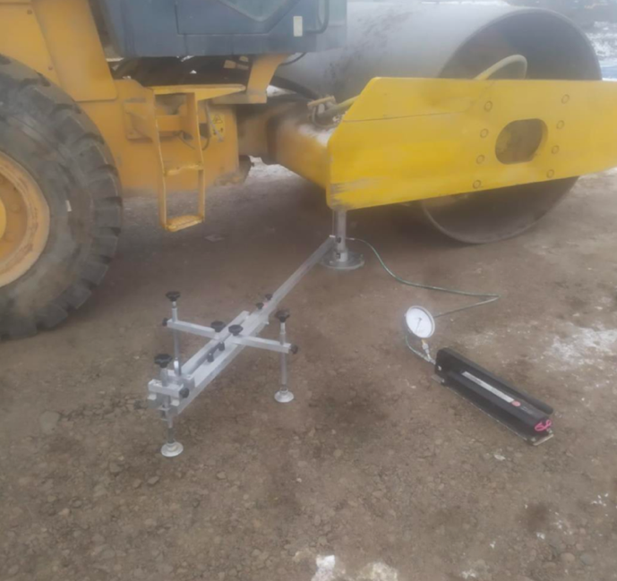

Figure 3.49 – Conducting plate-bearing test

The results of plate-bearing test of artificial foundation soil are presented in table 3.26 and figures 3.50. 3.51, 3.52.

Table 3.26. Plate-bearing tests results

Location | Soil | Deformation modulus, Е_{def}, MPa | Elastic modulus Е_{elas}, MPa | Coefficient of compaction, K
km 63+355 | Point 1 | 23.94 | 93.87 | ~ 0.95
km 63+355 | Point 2 | 40.93 | 141.33 | ~ 0.95
km 63+355 | Point 3 | 32.72 | 120.42 | ~ 0.95
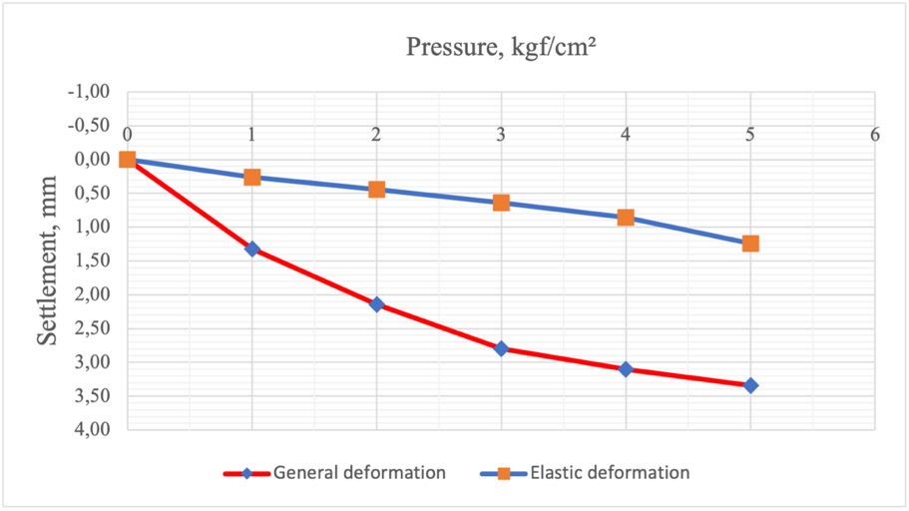

Figure 3.50 – Plate-bearing test results of point 1

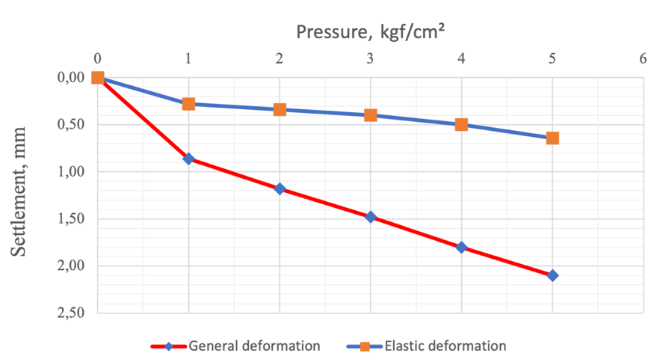

Figure 3.51 – Plate-bearing test results of point 2

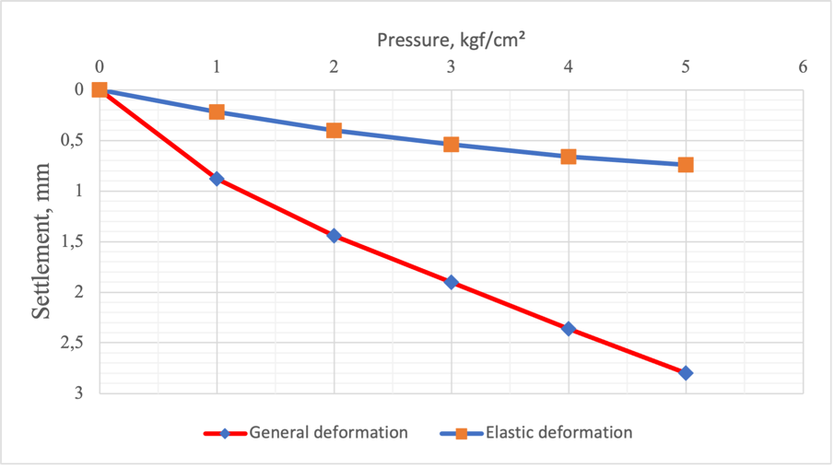

Figre 3.52 – Plate-bearing test results of point 3

The following conclusions can be drawn based on the results of the tests:
- the average modulus of the structure deformation at 3 test points: E_{d}=32.53 MPa;
- the average modulus of the structure elasticity for all 3 test points: E_{e}=118.53.
- the compaction factor of the foundation soil layers varies within K ~ 0.95 according to the performed tests.

3.8 Constructive solutions

3.8.1 Construction Solution for Embankments
Soil settlement is possible in some areas because EGE-4 soils have settled properties. Geotechnical conditions in terms of collapsing refer to type I (first) and II (second). All crossing routes of designed roadway has got asphalt-concrete pavement with gravel basement. The thickness of asphalt- concrete is from 0.11 till 0.38 m. The design of road pavement structures consists of two sequentially performed stages - design and calculation, which are interrelated and should not be opposed to each other. The design of the pavement consists of the selection of the most suitable materials based on local resources and the organization of the work, in the appropriate dimensioning of the individual layers and their placement in depth. Construction solutions for the embankment are presented in figure 3.53.

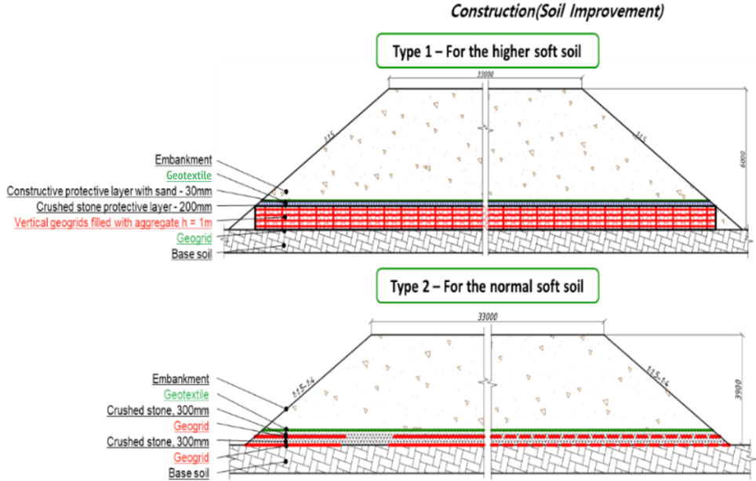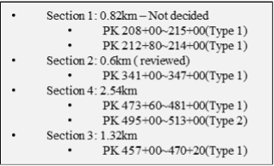

Figure 3.53 – General design solution

Note – Compiled according to the source [52, p. 34]

The drainage layer by the principle of volumetric absorption is built in a situation where water, which will enter the layer, will be able to be placed in its pores in full volume. In this case, no release is made from these layers, and the layers are placed only under the road pavement.
Water in the drainage layer with some reserve in its thickness for the height of capillary rise does not have a harmful effect on the road surface.
The choice of drainage design should be selected based on a technical and economic comparison of options. Geogrid provides a strong mattress foundation that significantly increases the stability of the soil. The effect of geogrid generated in the embankment body and the geogrid layer.

3.8.2 Construction Solution for Road Pavement
The pavement structure of the road consists of: polymer asphalt concrete, dense hot paving asphalt concrete, grade I, hot-laid asphalt concrete, porous, grade II, base layer, subbase layer. The pavement design is presented in figure 3.54.
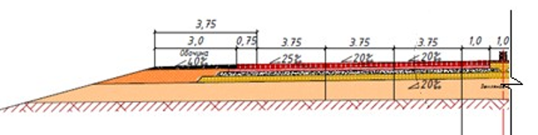
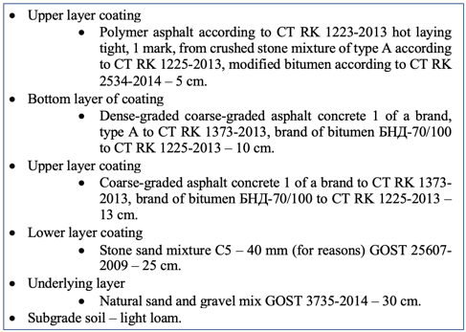

Figure 3.54 – Road pavement

Note – Compiled according to the source [52, p. 34]

This embankment and road clothing design will prevent and suspend the aging of the road structure and will be used mainly on highways of a high technical category.

Section conclusions
Conclusions for Section 3.1:
1. Complexity category for engineering and geological conditions - I.
2. Seven engineering-geological elements are allocated in the studied territory: EGE-1 is a soil-plant layer, EGE-2 - Asphalt concrete covering, EGE-3 - Gravel and sand soil, EGE-3a - the filling layer: Loam, solid with gravel and pebble, EGE-4 - Loam, light solid collapsing, EGE-5 - Loam, light semi-solid non-collapsing, EGE-6 - Loam, light high-plastic non-collapsing.
3. Groundwater during geotechnical surveys by drilled wells is not penetrated.
4. In terms of frost susceptibility: Loam, solid and semi-solid - practically non-heaving, Loam, high-plastic - highly frost-susceptible.
5. The designed route section belongs to the potentially non-flood-prone territory by the nature of the man-made impact, according to SP RK 5.01-102-2013 (cl. 4.3.1.9) [59, с. 10].
6. Freezing depth according to the following: for loams - 0.93 m; for coarse sands - 1.20 m; for macrofragmental soils - 1.36 m.
7. Soils have EGE-4 collapsing properties. Geotechnical profile by collapsing belongs to type I (first). Other loamy soils are not collapsing.
8. The corrosion activity of soils to carbon steel - from medium to high, to lead - from low to medium, to aluminum - from medium to high.
Conclusions for Section 3.2:
1. Category of difficulty for engineering and geological conditions - II.
2. Groundwater during the survey was penetrated at depths of 5.7-12.4 m. Amplitude of oscillations is 1.0-1.5 m.
3. Five engineering and geological elements are identified in the studied area: EGE-1 - Loam, light solid, EGE-2 -Loam, light, low-plastic, EGE-3 - Loam, light, high-plastic, EGE-4 - coarse low-moisture sand, EGE-5 - pebble soil water-saturated.
3. In terms of frost susceptibility: Loam, solid - practically non-heaving, Loam, low-plastic -medium frost-susceptible, Loam, high-plastic - highly frost-susceptible.
4. The projected route section belongs to a non-flooded area by the nature of the man-made impact, according to SP RK 5.01-102-2013 (cl. 4.3.1.9) [59, с. 16].
5. Freezing depth: for loams - 0.93m; for coarse sands - 1.20m; for coarse clastic soils - 1.36 m.
6. Soils have EGE-1 collapsing properties. Engineering and geological conditions of collapsing belong to types I (first) and II (second).
7. The base soil has no bearing capacity loss according to the plate-bearing tests. It is necessary to issue statistical processing at least three (five) points according to the data.
Conclusions for Section 3.3:
1. Fourteen engineering and geological elements have been identified in the studied area: EGE-1 - Topsoil, EGE-2 - Asphalt concrete (pavement surfacing), EGE-3 - Filling soil, EGE-3a - Filling soil, EGE-4 - Loam, brown, loessoid, light, solid, collapsing, EGE-5 - Loam, brown, light, dusty, semi-solid, non-collapsing, EGE-6 - Loam, brown, light, dusty, stiff consistency, EGE-7 - Loam, brown, light, high-plastic consistency, EGE-8 - Loam, brown, light fluid-plastic consistency, EGE-9 - Loam, brown, light, fluid consistency, EGE-10 - Gray-brown sandy loam, solid, EGE-13 - Low-moisture gravel sand with sand aggregate, EGE-14 - Low-moisture gravel soil with sand aggregate.
2. Groundwater during the survey period was penetrated at depths of 0.6-16.0 m. Amplitude of oscillations is 1.0-1.5 m.
3. In terms of frost impossibility: Loam, solid and sandy loam solid - not heaving, Loam, semi-solid, slightly swollen, Loam, low-plastic - medium-heaving, Loam, high-plastic and fluid-plastic, powerfully heaving.
4. The seismicity of the construction site in this area is 10 (ten) points.
5. Based on the results of the die tests the shape of the graph of general deformations corresponds to the linear dependence of the increment of total deformations on the increase in the load on the base. There is no loss of bearing capacity.
6. The results of the pile static test showed that the bearing capacity of the soil is sufficient for the maximum load.
7. According to the results of integrity tests of the piles, no facts of significant changes in the cross-sectional profile of the piles were revealed

Conclusions for Section 3.4:
1. The survey area is located within the IV road climatic zone.
2. Excavations with 25.0 m groundwater were penetrated at a depth from 0.4 m to 15.9 m from the day surface. The amplitude of seasonal variation of the groundwater level is + 1.0-1.2 m.
4. The standard depth of loam freezing is 0.79 m; loam, sandy, dusty and fine sands - 0.96 m; gravelly, coarse, and medium-grained sands - 1.03 m, coarse clastic sands - 1.17 m.
5. The area is located in the zone with seismic hazard (according to SP RK 2.03-30-2017) [88, с. 59] - 9 (nine) points.
6. The following conclusions can be drawn based on the results of the tests:
The average modulus of the structure deformation at 3 test points is following: E_{d} = 8.83 MPa.
It is incorrect to consider the average modulus of the structure elasticity for all 3 test points due to extremely small elastic deformations and accumulation of residual deformations.
It is recommended to perform more thorough compaction, following the average ratio of the base modules E_{e}/E_{d} = 9.09 at the 1st point; E_{e}/E_{d} = 8.19 at the 2nd point; E_{e}/E_{d} = 6.85 at 3rd point.
It is recommended to lay the fractionated crushed stone layer 20-40 by wedging per SNiP 3.05.03-85. the following material flows to carry out the installation of crushed stone bases and coatings by wedging (table 3.27), by item 7 of SNiP 3.06.03-85 "Motor Roads"

Table 3.27 – Material consumption by the wedging method

Crushed stone base fraction size, mm | The flow rate of wedging fraction, m³, per 1000 m² with their dimensions, mm
Crushed stone base fraction size, mm | 20-40 | 10-20 | 5-10
20-40 | - | - | 15
40-70 | - | 15 | 10
70-120 | 10 | 10 | 10

Thus, the wedging device for crushed stone fr. 20-40 is recommended to be carried out with crushed stone 5-10 mm with a consumption rate of 15 cubic meters of wedging fraction per 1000 sq.m. structure.
7. It is possible to draw the following conclusions based on the results of testing 15 drilling piles after processing and interpretation of the obtained spectrograms:
The facts of significant change in the profile of the section of piles in the direction of reduction were not revealed.
No areas of discontinuity and decompression of concrete were identified in the section of the drilling pile.
Stable signals from various soil strata and non-systemic "acoustic" roughness are observed.

Summary for Section 3.5:
1. The following types of soils were identified based on the drilling results: Layer 1. Light brown loams represent the topsoil with a thickness of 0.2 m with plant roots, EGE 1. Light, solid, collapsing loams, EGE 1.1. Stiff consistency loams.
2. The groundwater level is set at depths from the low reaches of rivers from 0.2 m to 14.0 m. in sections of designed bridges and overpass bridges, according to the results of drilling to depths of 25 meters.
3. Soil formation occurs in extremely arid (dry) bioclimatic conditions. Soils are sierozemic, sandy loam, and loamy in composition.
4. Loams are ubiquitous in collapsing properties. The type of soil conditions of collapsing is I (first).
5. The results of static tests showed that the bearing capacity of piles on the soil is sufficient to perceive the maximum pressing design load with a safety factor of 1.5.
Summary for Section 3.6:
1. Complexity category for engineering and geological conditions is II.
2. Seven engineering and geological elements are identified in the studied area: EGE-1 Loam, light, solid and semi-solid, EGE-2 Loam, light, low-plastic, EGE-3 Loam, high-plastic, EGE-4 Loam, fluid-plastic, EGE-5 Loam, fluid, EGE-6a pebble soil, EGE-6b pebble boulder soil.
3. Groundwater during the survey was penetrated at depths of 0.2-6.5 m. Vibration amplitude is 1.0 + 1.5 m.
4. In terms of frost susceptibility: Loam, solid and semi-solid -practically non-heaving, Loam, low-plastic - medium frost-susceptible, Loam, high-plastic and fluid-plastic - highly frost-susceptible and Loam, fluid excessively swollen
5. Freezing depth: for loams is 0.79 m, for coarse clastic soils is 1.17 m.
6. Soils have EGE-1 collapsible properties. Collapsing type is I (first) according to SP RK 5.01-102-2013 (item 5.1.10, item 5.1.12) [59, с. 39]. The initial drawdown pressure is 0.625 kg/cm2. Drawdown from own weight does not exceed 5 cm.
7. The shape of the graph of general deformations corresponds to the linear dependence of the increment of general deformations on the increase in load on the base, according to the results of plate-bearing tests. No loss of bearing capacity occurs.
8. It was shown that the bearing capacity of piles is sufficient to perceive the maximum pressing design load with a safety factor of 1.5, based on the results of static tests with a pressing load.
Summary for Section 3.7:
1. Complexity category for engineering and geological conditions is II.
2. The following types of soils were identified based on the drilling results: EGE-1. Soil-plant layer, EGE-2. Asphalt concrete (pavement surfacing), EGE-3. Filling soil, EGE-3a. They were filling soil, EGE-4 – Loam, loessoid, light, dusty macropore, solid consistency, EGE-5 – Loam, light, dusty, semi-solid consistency, non-collapsing, EGE-6 – Loam, light, dusty, stiff consistency non-collapsing, EGE-7 – Sandy loam, solid consistency, non-collapsing, EGE-8 – Pebble soil with sand aggregate, low moisture.
3. Groundwater is not penetrated during surveys and excavations.
4. The designed route section belongs to the non-flood-prone territory by the nature of the man-made impact, according to SP RK 5.01-102-2013 (cl. 4.3.1.9) [59, с. 10].
5. In terms of frost susceptibility: Loam, solid, non-heaving, Loam, semi-solid, slightly swollen, Loam, low-plastic, medium frost-susceptible, Sandy loam solid, non-heaving.
6. Standard depth of seasonal freezing is following: for loams is 0.93 m; for coarse sands is 1.20m; for coarse clastic soils is 1.36 m.
7. Soils have EGE-4 collapsing properties. Engineering and geological conditions of collapsing belong to type I (first).
8. The shape of the general deformations graph corresponds to the linear dependence of the general deformations increment on the increase in load on the base, according to the results of plate-bearing tests. No loss of bearing capacity occurs.
Summary for Section 3.8:
According to the research, it is necessary to follow recommendations, taking into account the specifics of collapsing soils:
1. Provide measures to prevent the penetration of surface and man-made water into the foundations.
2. Provide flow-regulating and training works and measures to prevent exudation and flooding adjacent to unregulated medium and small rivers and protect crossings under roads.
3. Provide waterproofing of foundations against soil aggressiveness. Perform joint corrosion protection. Water protection and structural measures. The possibility of increasing their humidity should be considered when designing structures on collapsing soils due to: soaking the soil from above from external sources (rain, meltwater, water from the arch network), leaks from industrial communications). Considering this, it is necessary to provide for a set of measures, including eliminating collapsible properties.
4. Brown, loessoid, light, solid, collapsing loam can be used as an artificial embankment with good compaction and not allowing a large amount of water to enter the body of the soil embankment. The groundwater elevation is low in this project, so that an artificial structure can play the role of waterproof for surface water.
5. It is possible to construct the road without the use of a "capping layer". This conclusion is justified by the fact that the height of the earth embankment and the road dressing in the project is sufficient for this region, and it ensures the stability of the roadbed and the earth embankment, as well as protects against the effect of frost penetration.
6. To determine the bearing capacity of the soil foundations of the road highway under construction, one should rely on the results of the field tests (plate-bearing test experience).
7. It is necessary to apply to the structure of the pavement «capping layer», in areas where the groundwater level is close to the bottom of the embankment for a more rigid resistance to loads from the structure located above. It also reduces the chance of differential settlement in the slab by supporting it more homogeneously than an unimproved subgrade. It is also much easier to compact a sub-base on a capping layer than it is to compact it on saturated clay, meaning that by installing a capping layer, delays in the construction of the sub-base due to wet weather can be reduced.
8. Lean clay can be used as an artificial embankment if it is well compacted, and a large amount of water is not allowed into the soil body.

4 VERIFICATION OF THE ADOPTED DESIGN AND TECHNOLOGICAL SOLUTION

Having investigated road construction experience in Kazakhstan and CIS countries, we can conclude that geosynthetic materials are widely used in road construction to strengthen the collapsing soils.
Since the object under investigation (BAKAD) is built on collapsing soils, the following experimental works were carried out for this purpose:
1. Calculation of the section of the road "BAKAD" 1 start-up complex using the software package GTS NX MIDAS.
2. Modeling of collapsing soils with "quasi-soil" using quicklime. Determining peculiarities of changes in strength and deformation properties by uniaxial compression of quasi-collapsing soil reinforced with geosynthetic materials.

4.1 Numerical Modeling of Embankment in the Midas GTS NX Discussion
To determine the stability of the road embankment simulation was performed in the software package GTS NX MIDAS [97, 98].
Midas GTS NX is a fully integrated system in the form of a single finite element software package, designed to perform complex geotechnical calculations, and covers the entire range of geotechnical engineering projects, including calculations of deep pits with different types of anchoring, tunnels with complex shapes, consolidation and filtration calculations, as well as dynamic impact and stability calculations.
In the program environment, all types of field conditions can be implemented using nonlinear calculation methods (linear/nonlinear static calculation, linear/nonlinear dynamic calculation, seepage and consolidation calculation, slope stability calculation) and various coupled calculation methods (seepage and stress-strain state, stress-strain state and slope stability, seepage and slope stability, and nonlinear coupled slope stability calculation).
The GTS NX interface provides easy access to simulation and calculation tools, creating an intuitive work environment for both the experienced engineer and the novice. Support for 64-bit operating systems and next-generation graphics platforms provides the best performance for finite element meshes and calculations, and the integrated 64-bit solver significantly reduces the time required to calculate large models.
According to the report, Engineering and geological surveys at the facility: "Section of the road "BAKAD" 1 start-up complex is located in the territory of Karasai district of Almaty region. The starting point of the section km 45+00 starts from Raiymbek settlement, the end of the route ends on the territory of Karasai district near Isayevo settlement km 240+00" was collected the calculation scheme of the engineering-geological well column No.4. Physical and mechanical properties of soils are presented in Chapter 3.3.
The road embankment and foundation were modeled as a continuous medium (within verifiable soil models).
The general design of the 33m long, 6m high embankment consists of locally compacted loam and a one-meter-high soil cushion. Take gravel soil with sand fill as the soil cushion material. As part of the gravel soil size of fractions from 80 to 150mm should be no more than 10%. The cushion ground should be laid and compacted in layers not more than 300 mm thick. 2 Control the quality of compaction-by-compaction factor (K=0.95) and the value of deformation modulus not less than E=40 MPa. In order to achieve the required deformation modulus in the composition of the soil cushion, a vertical geogrid is used, which is laid in the body of the soil cushion.
To calculate the road embankment and foundation composed of dispersed soils, the Linear Elastic model and the Elastic-Plastic model with the Mohr-Coulomb strength criterion were used.
The analysis of the calculation results was performed according to:
– displacement components of the soil mass and structural elements;
– components of stresses in a continuous medium (for the conditions of spatial and axisymmetric problem and plane deformation);
– dimensions of the limit state zones (plasticity zones);
– internal forces in the structures interacting with the base.
Calculation result in GTS NX MIDAS for the embankment is shown in figure 4.1.

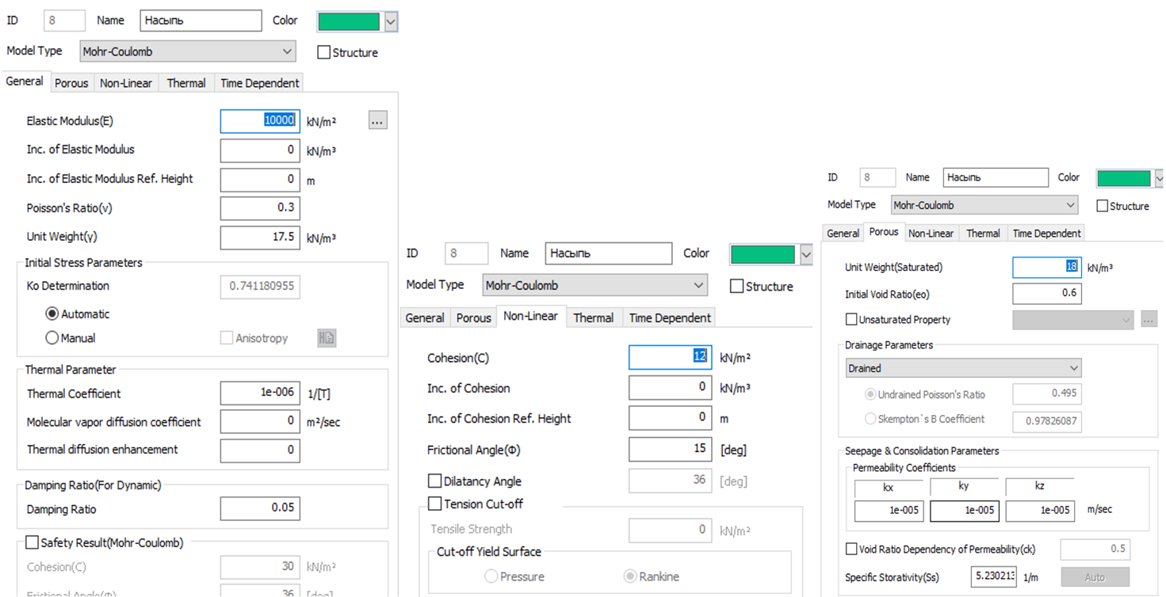

Figure 4.1 – Characteristics for embankment

Characteristics of the EGE 4, EGE 5, EGE 6, EGE 7 are shown in figures 4.2, 4.3, 4.4, 4.5.

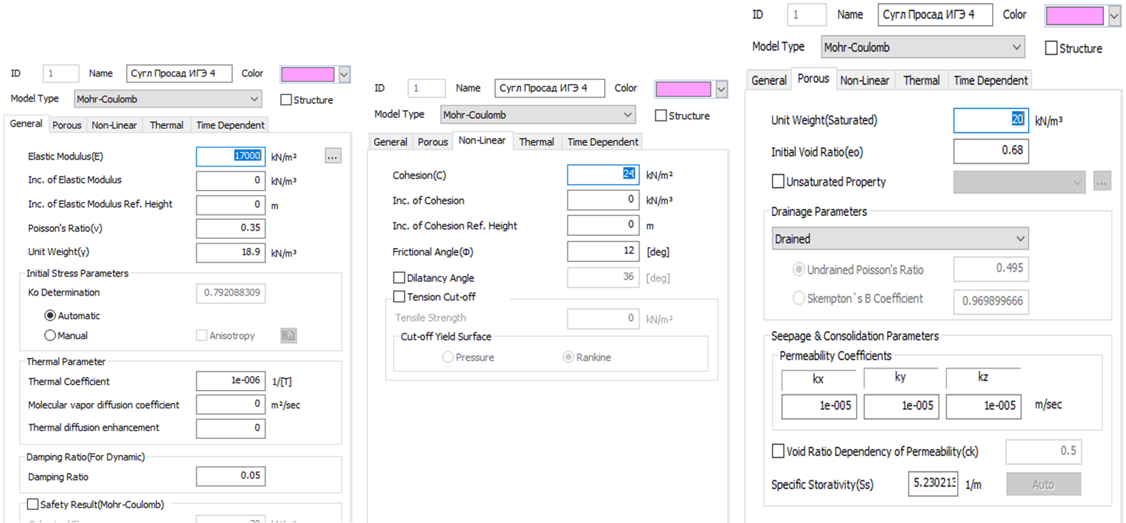

Figure 4.2 – Characteristics of the EGE 4

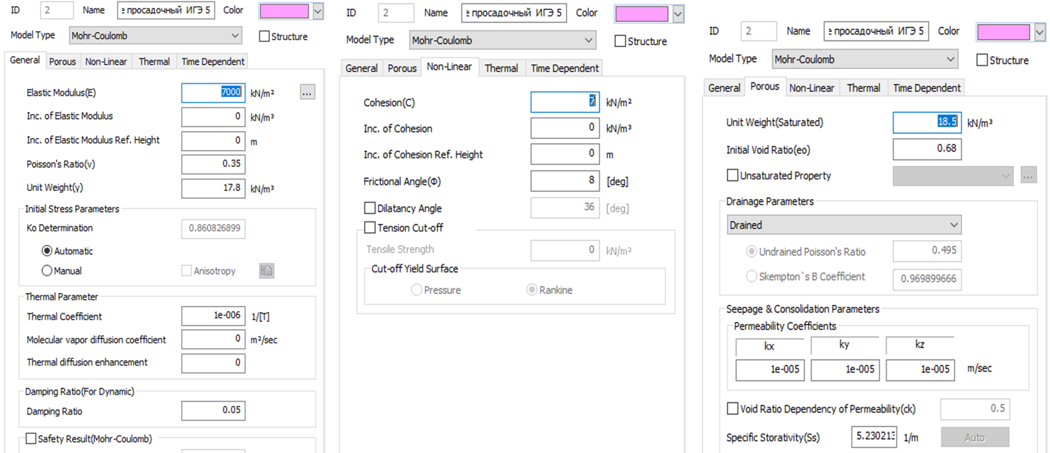

Figure 4.3 – Characteristics of the EGE 5

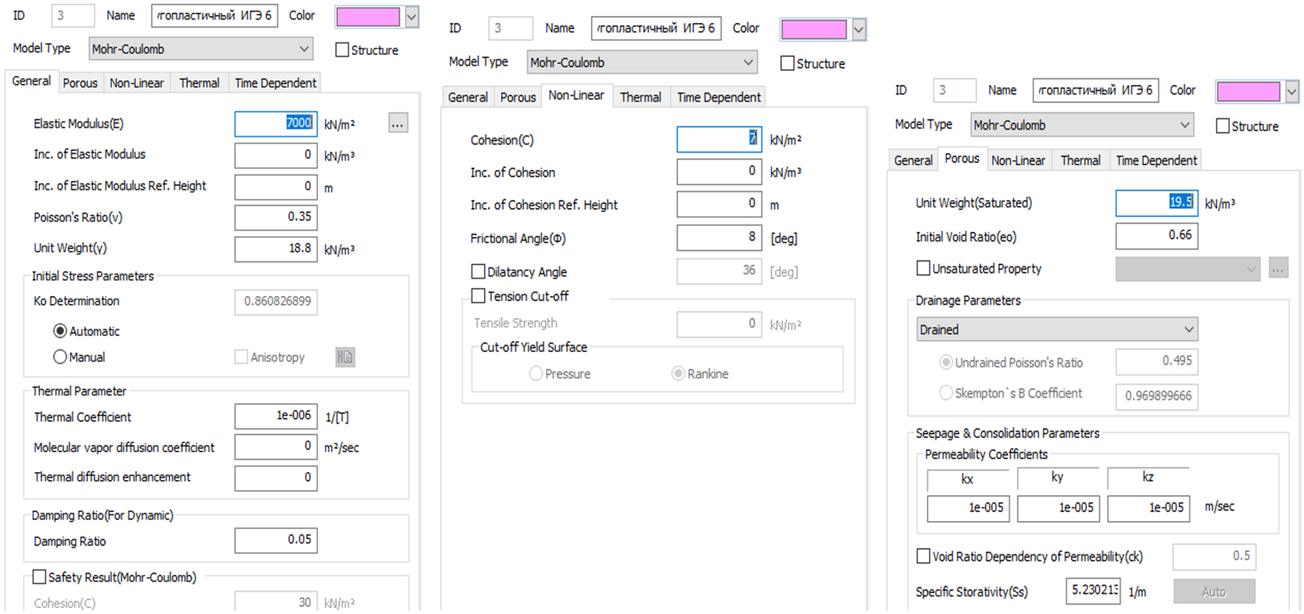

Figure 4.4 – Characteristics of the EGE 6

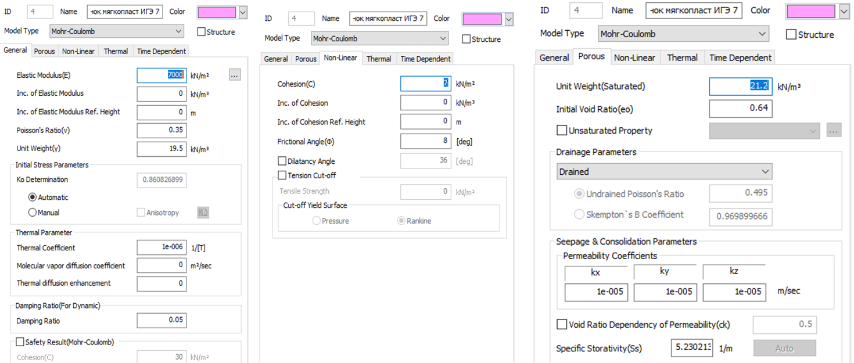

Figure 4.5 – Characteristics of the EGE 7

Characteristics for the asphalt pavement and road pillow are shown in figures 4.6, 4.7.

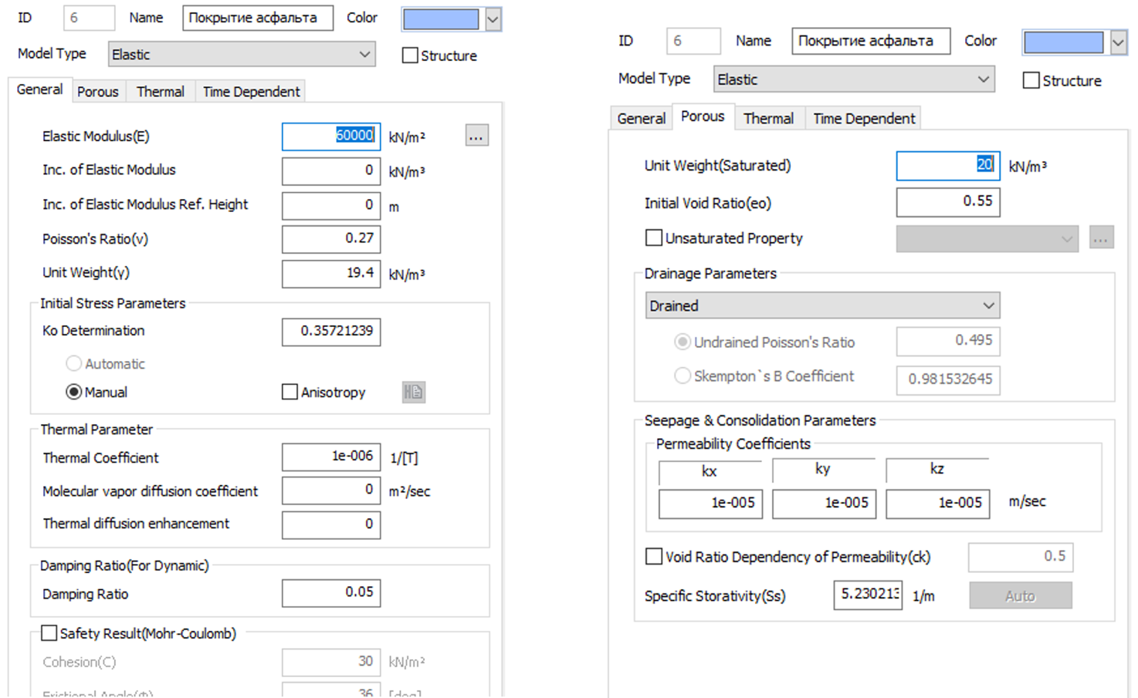

Figure 4.6 – Characteristics for asphalt pavement

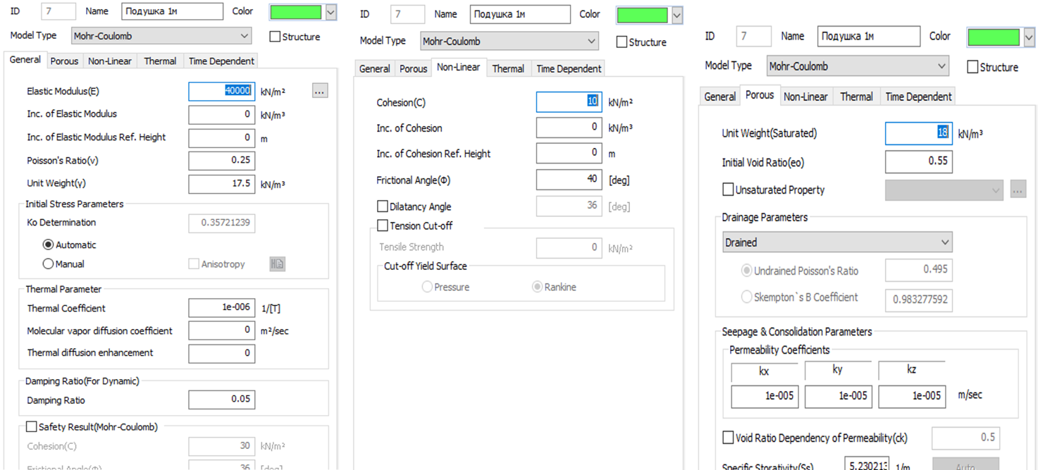

Figure 4.7 – Characteristics for the road pillow

Calculation 3D model presented in figures 4.8, 4.9.

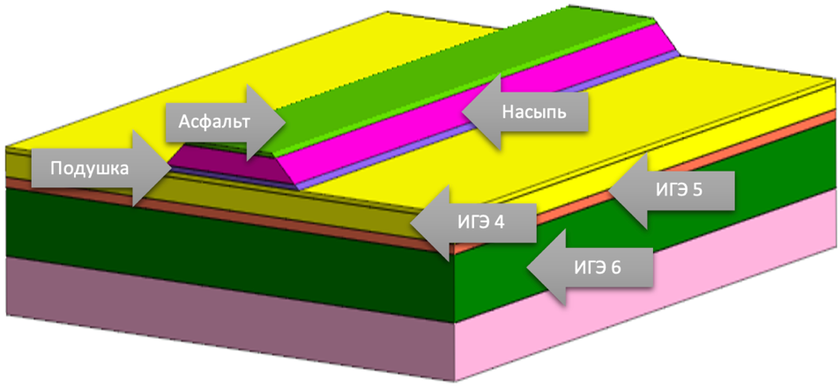

Figure 4.8 – Calculation model

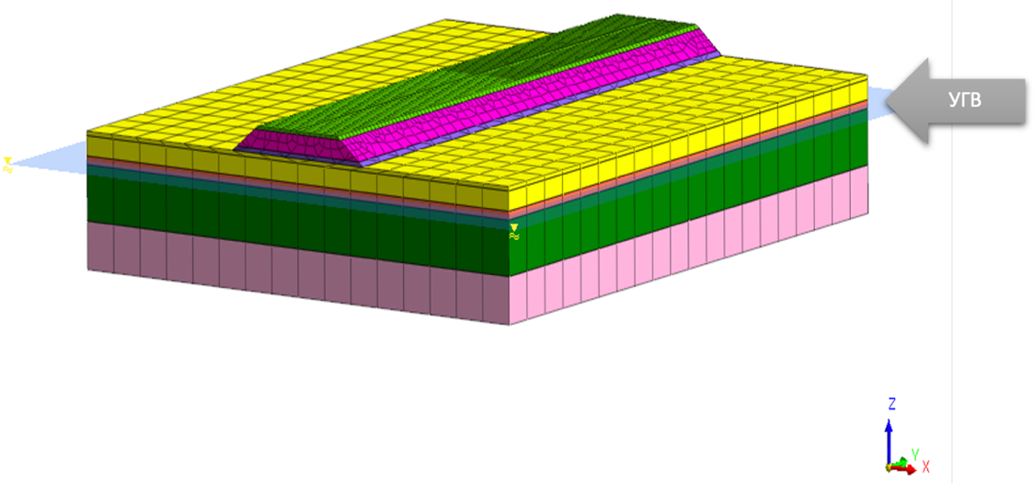
Figure 4.9 – Calculation model

An evenly distributed load of 5 kN/m² on the road embankment surface was set as the load from a transport vehicle (figure 4.10).

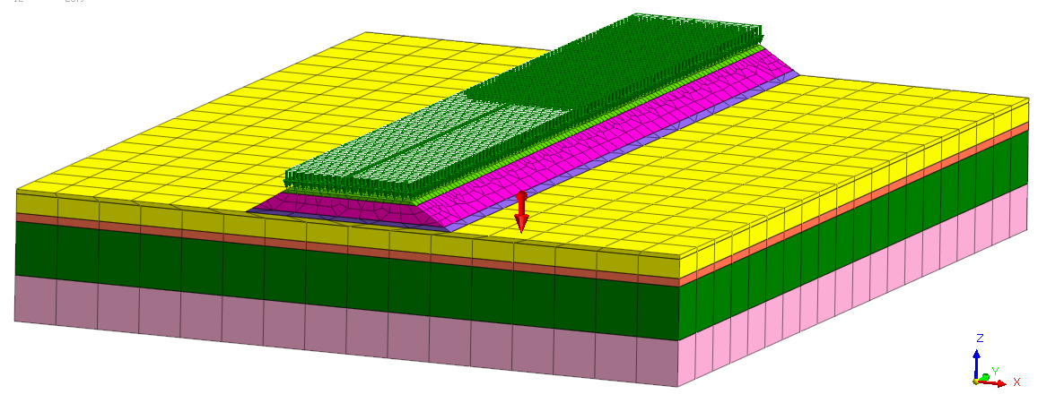

Figure 4.10 – The load from road transport is taken 5 kN/m² according to SP RK EN 1991-1-1:2002/2011

Note – Compiled according to the source [99]

The own weight of the soil mass was also considered. Volumetric ele-ments were used to simulate the behavior of the ground and massive structures: 4-node tetrahe-dron; 8-node hexahedron; 10-node tetrahedron; 20-node hexahedron (figure 4.11, 4.12, 4.13).

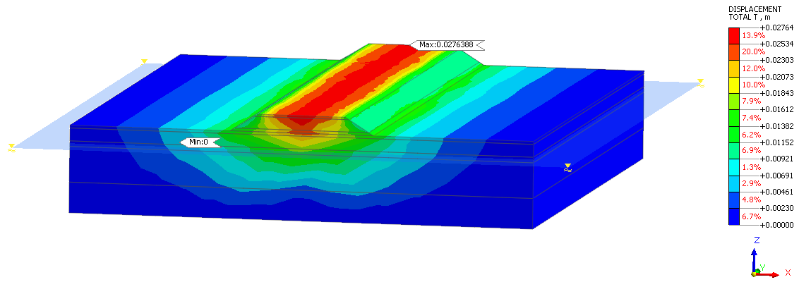

Figure 4.11 – General embankment movements

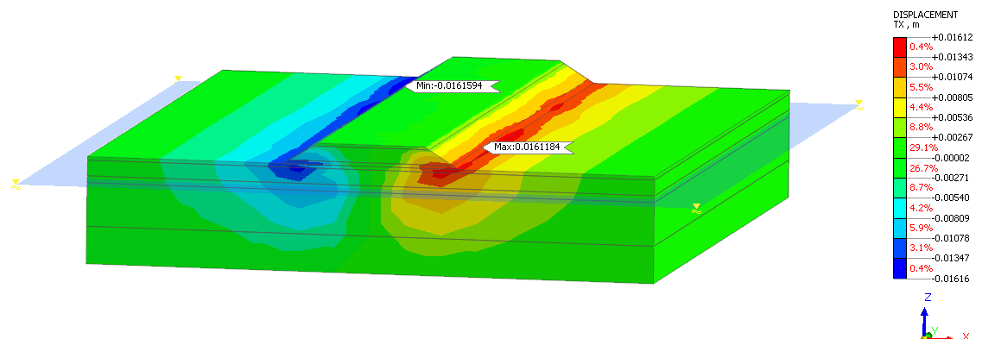

Figure 4.12 – Total embankment movements along the X axis

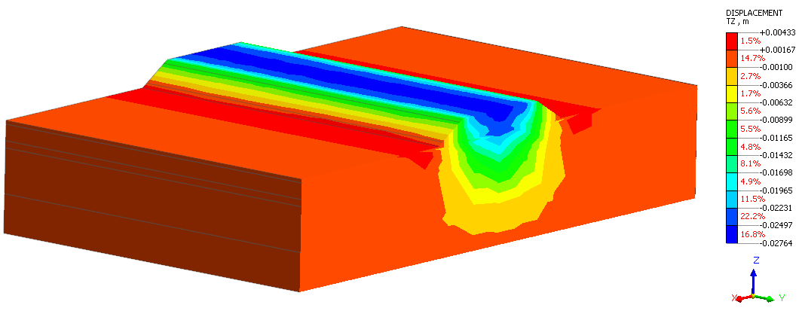

Figure 4.13 – Total embankment movements along the Y axis

Displacement of the embankment are presented in figures 4.14. 4.15, 4.16, 4.17, 4.18.
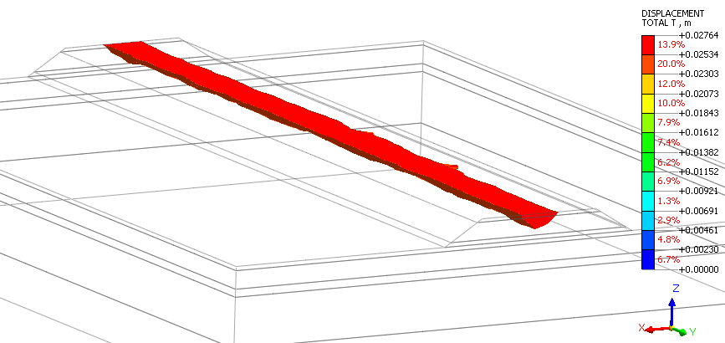

Figure 4.14 – Embankment displacements at 26 mm or more

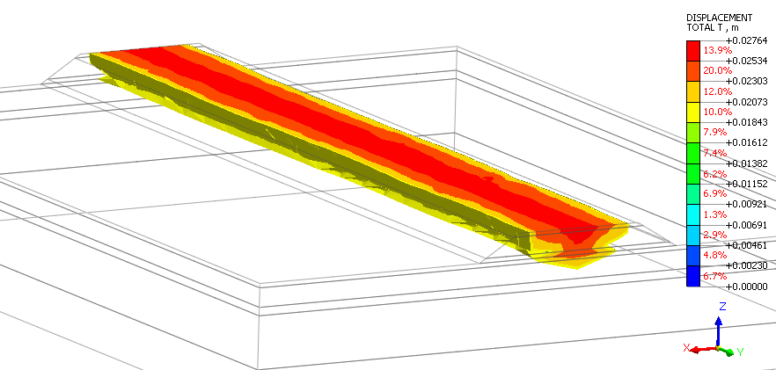

Figure 4.15 – Embankment displacements at 20 mm or more

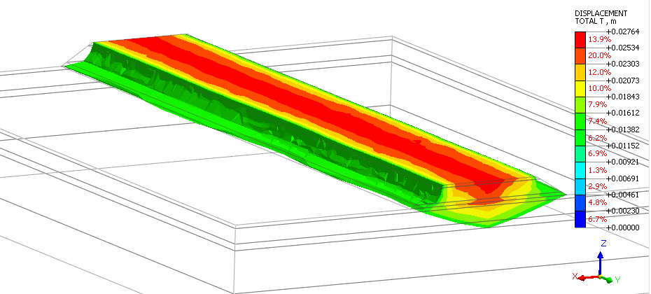

Figure 4.16 – Embankment displacements at 15 mm or more

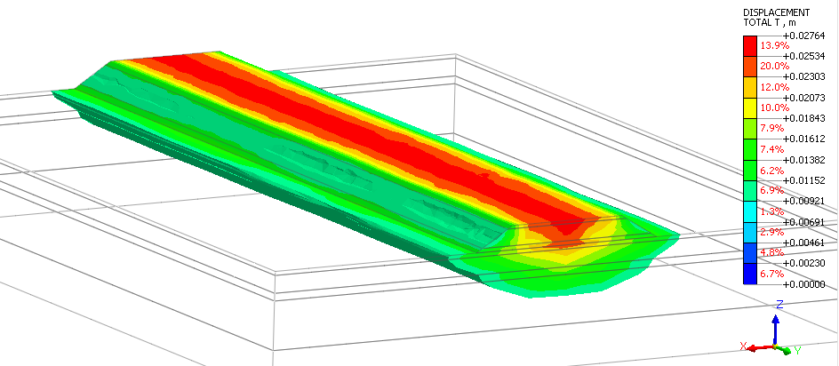

Figure. 4.17 – Embankment displacements at 10 mm or more
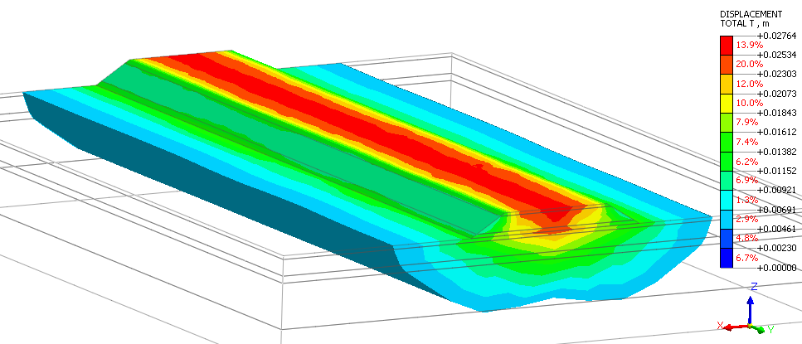

Figure 4.18 – Embankment displacements at 5 mm or more

Deformations and stresses of the pavement are illustrated in figures 4.19 to 4.20.
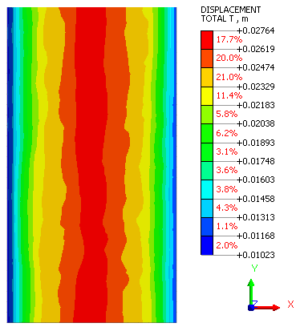
Figure 4.19 – General deformations of the pavement

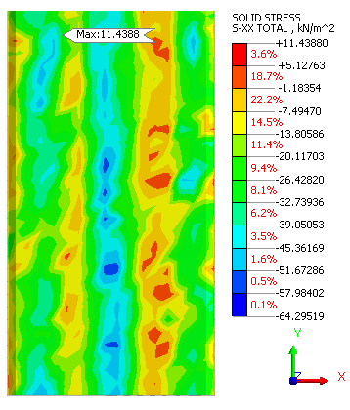
Figure 4.20 – Stresses of the pavement along the X-axis

Deformations and stresses of the pillow are represented in figures 4.21, 4.22, 4.23.
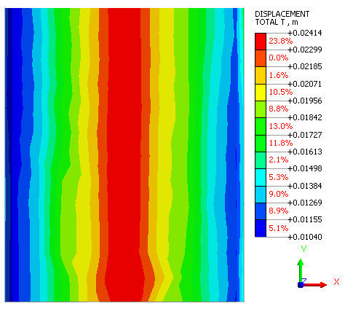

Figure 4.21 – General deformations of the pillow

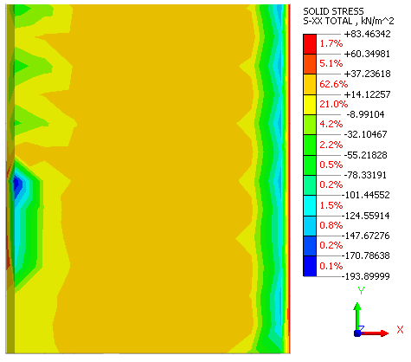

Figure 4.22 – Stresses of the pillow along the X-axis
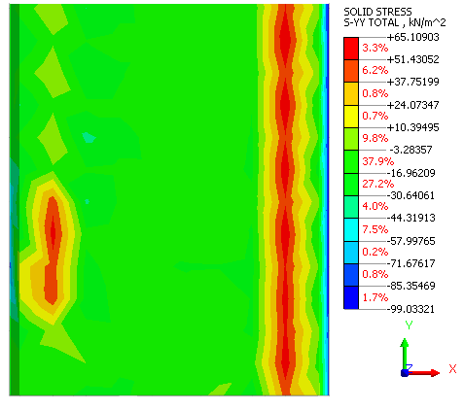

Figure 4.23 – Pillow stresses along the Y axis

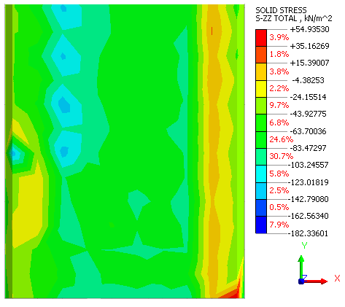

Figure 4.24 – Clothing cushion stresses along the Z axis

Total embankment movements and displacements along the X-axis Y-axis from the dynamics of road transport are shown in figure 4.25, 4.26, 4.27.

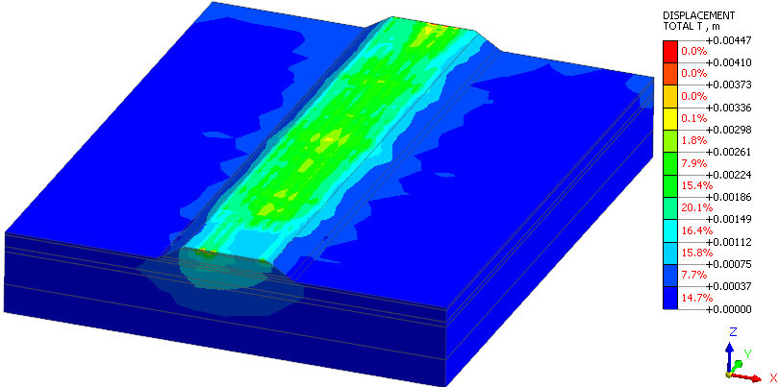

Figure 4.25 – Total embankment movements from the dynamics of road transport

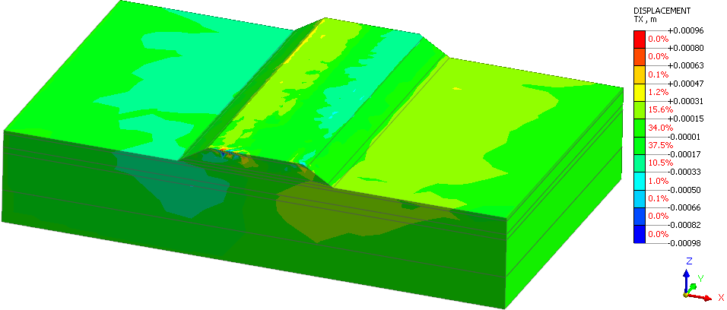

Figure 4.26 – Embankment displacements along the X-axis from the dynamics of road transport

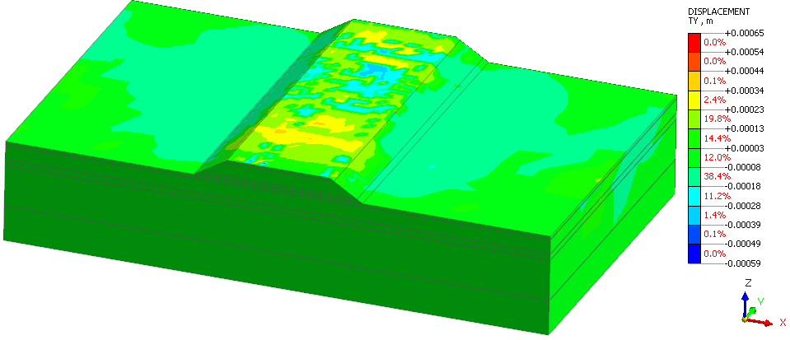

Figure 4.27 – Embankment displacements along the Y-axis from the dynamics of road transport

4.2 Assessment of reinforcement. Discussion

4.2.1 Features of geosynthetic materials
Geosynthetics is a common classification terminology for all kinds of synthetic materials used in various construction branches, including road construction [66, p. 1873]. This term includes geotextiles, geogrids, geonets, geomembranes, geocomposites.
Using geosynthetics opens new opportunities to solve various problems in the design and construction of roads and the most complex engineering structures. First, polymeric fabric helps evenly distribute the weight load on the whole area of the object. In addition, the material prevents liquid and moisture from penetrating the road base, thus saving it from destruction and erosion. Also, a multilayer construction of a road object constructed with geosynthetic materials is less subject to mechanical damages - potholes, holes, cracks, and ruts.
Geonets are filament meshes made of glass fiber to reinforce asphalt concrete pavements and weak subgrade soils (figure 4.28).

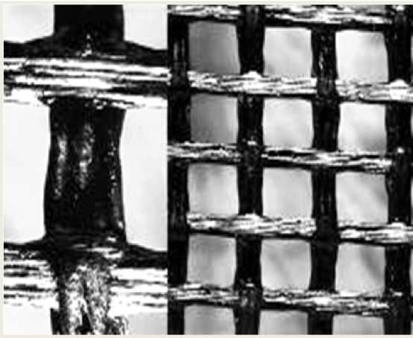

Figure 4.28 – Geonet

Note – Compiled according to the source [99]

Using geonets increases operational reliability and service life of road structures, improves work conditions and quality, simplifies construction technology, reduces construction time, reduces the consumption of traditional road-building materials, and uses local soil. Geonet is used to construct and reconstruct highways and temporary roads on weak substrates to strengthen slopes and inclines.
Geonets differ in the loads they can withstand and, respectively, are made of different materials. As a rule, the geonets are laid between the ground and gravel. The top layer of the road surface becomes more resistant to collapse. Meanwhile, the load is evenly distributed across the entire roadbed, preserving its long-term integrity.
A geogrid is a flexible, compact module consisting of plastic strips bonded together to form a spatial cellular structure in a stretched position (figure 4.29).

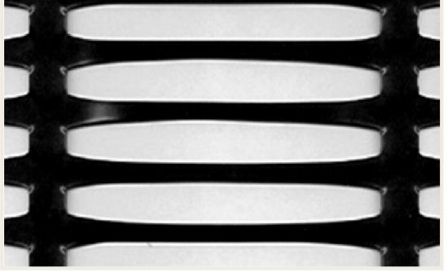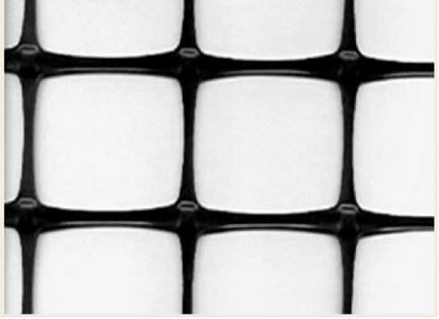
а b

a – uniaxial; b – biaxial

Figure 4.29 – Uniaxial (a) and biaxial (b) geogrid

Note – Compiled according to the source [99]

Geogrid creates a single structural mass that can withstand high pressure, limits shear strain, and strengthens the soil. It has strength, low material consumption, durability, and environmental safety.
Geogrids are resistant to ultraviolet radiation, fresh and salt water, the chemical effects of soil, and aggressive media. The material is durable, non-toxic, and environmentally safe.
It is used to strengthen slopes and inclines, rail and highway construction (reinforcement of weak soil bases); strengthening pipeline protective structures; construction site development with minimal costs, construction and erection of retaining walls (cost reduction of 20-60%); reinforcement of soils of the bearing base; - laying of covers of transitional type.
Geogrids are actively used nowadays to repair and construct highways in difficult geological conditions - in weak and clayey soils, in areas susceptible to erosion. The volumetric polymeric honeycomb-shaped bed is filled with gravel, sand mixture, and crushed stone mixed with concrete. Such road surface base reliably protects it from destruction, failure, and other defects.
Geomat is a three-dimensional mat having a waterproof chaotic structure of polymeric materials connected by a thermal method (figure 4.30).

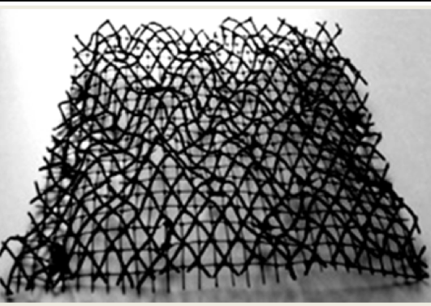

Figure 4.30 – Geomat

Note – Compiled according to the source [100]

Three-dimensional geomats are used to fix soil parts, grassroots, and small plants. Geomat is an effective material in the erosion control protection of slopes regarding technology and construction costs.
Geomembrane is a roll-fed waterproofing geosynthetic material made of high-density polyethylene (figure 4.31).

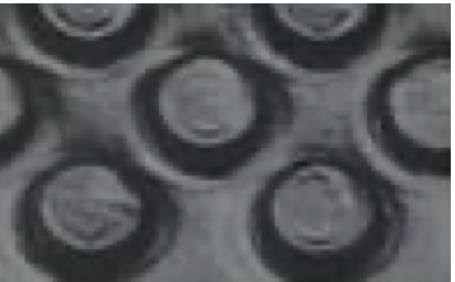

Figure 4.31 – Geomembrane

Note – Compiled according to the source [100]
Geomembrane is characterized by resistance to various substances and high strength; thanks to its numerous protrusions, it allows for ventilating the protected surfaces and diverting moisture from them. It is a multifunctional system of protection and waterproofing.
Geotextile refers to geosynthetics and is a woven or non-woven fabric made of high-strength polyamide fabrics (figure 4.32).

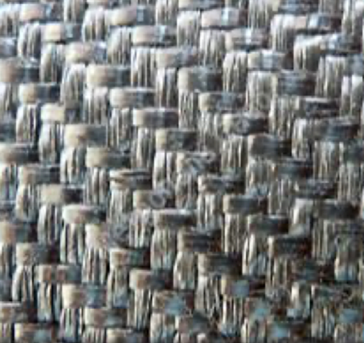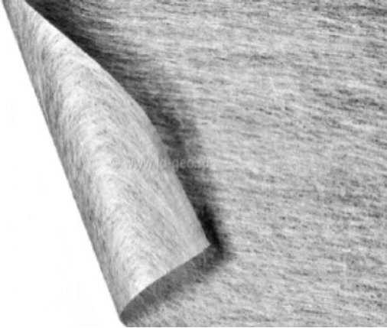
а b

a – woven; b – non-woven

Figure 4.32 – Woven (a) and non-woven (b) geotextiles

Note – Compiled according to the source [100]

Geotextile is used for the construction and strengthening of embankments of high steepness of loose materials; construction of retaining walls; protection of areas from landslide phenomena; separation of soil layers; strengthening of the bases of railways and roads; stabilization of weak soils (soil reinforcement).
Excellent performance characteristics of road geotextiles allow them to find more and more applications in constructing all types of roads. This material is elastic, resistant to various damages of mechanical and chemical nature, resistant to temperature changes, and has excellent water-transmitting properties.
Geotextiles and geogrids are placed between soil and gravel, preventing chips from penetrating the soil layer, strengthening the road, and reducing construction material consumption. Also, geotextile prolongs the object's life due to the waterproofing and drainage function. It prevents water from washing out the road base and the destruction of asphalt - the appearance of cracks and potholes.
Woven geotextiles are traditionally made by weaving yarns strictly at right angles, so the structure is ordered and has a high level of strength. The disadvantage of woven geotextiles is a lack of filtration capacity, which could lead to undesirable future consequences.
Non-woven materials are traditionally created by the mechanical binding of fibers, so the structure is chaotic and vulnerable to water. Microfiber structure provides good material elasticity at a thickness of up to 5 mm. It allows for moderate water permeability and reduces filtration, preventing the bulk layer's erosion.
The roadbed reinforced with non-woven geotextile has high operational properties - rutting is reduced, and the resistance of the bed to temperature deformation (freezing and thawing) is increased (figure 4.33).

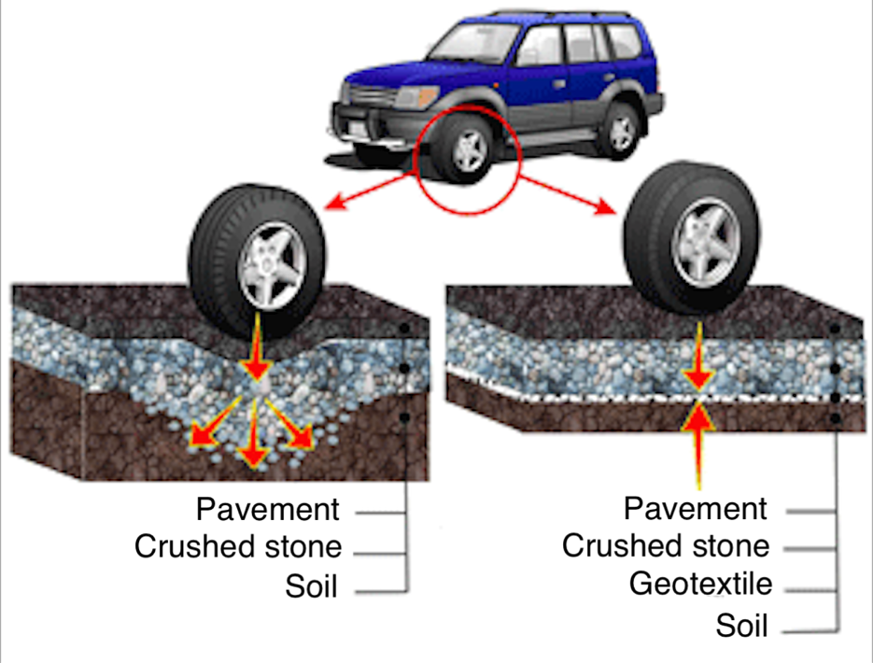

Figure 4.33 – Application of geotextiles in road construction

Note – Compiled according to the source [101]

The main advantages of geotextiles are good extensibility and excellent water-transmissibility, while their high strength and deformation resistance make it possible to initially reduce the roadbed's thickness. That is, thanks to geotextiles durability of the roadbed increases by 2-2.5 times. Due to an evenly distributed load, savings on other materials can reach 40%, significantly reducing road construction costs. All of the above advantages in the characteristics and properties of geotextiles influenced the choice of this material as study material and its application in the structural and technological solution.

4.2.2 Laboratory determination of the physical characteristics of soil
Determining particle size distribution (grain) composition using a sieve method (GOST 12536-2014) [102].
To determine the granulometric (grain) composition of soils by sieve method, the following apparatus and equipment were used:
– sieves with the size of holes 10; 5; 2; 1; 0,5; 0,25; 0,1 mm;
– laboratory scales;
– technical scales with a relative error of weighing of not more than 0.1%;
– porcelain mortar;
– pestle with a rubber tip;
– porcelain cup;
– rubber bulb;
– brush;
– sand bath;
– drying cabinet.
Conducting the test
The average sample of soil $g_{1}$was selected by quarting and then weighed on the scales.
The sieves were mounted by the column and placed on the pallet to increase the size of the holes (figure 4.34). The selected sample was transferred to the top sieve of the first set (diameter of holes from 10 to 0,5 mm), closed with a lid, and sieved with light lateral blows with the palms of his hands until the soil was completely sorted. Soil fractions lingering on the sieves were poured, starting from the upper sieve into a mortar, then were additionally grinded with a pestle with a rubber tip, again sieved on the same sieves.

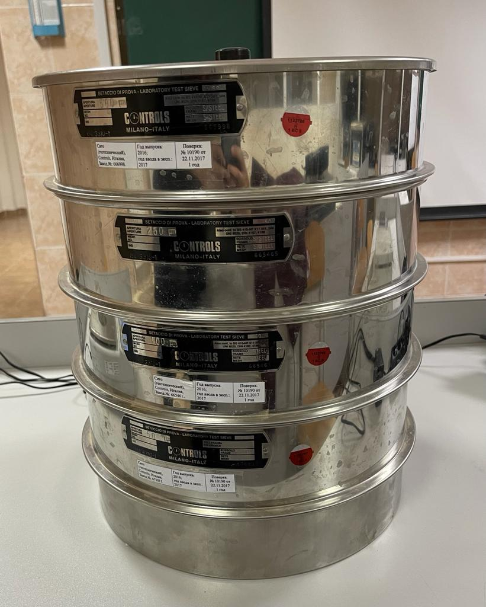

Figure 4.34 – Mounting the sieves

The completeness of the sieving of soil fractions was checked by shaking each sieve over a sheet of paper.
Each fraction of the soil trapped on the sieves was weighed separately (d_{f}). The soil loss during sieving was allocated to the fractions in proportion to their mass.
Processing of results.
Content in the soil of each fraction A, %, was calculated by the formula (4.1):

$A=\frac{g_{ф}}{g_{1}}×100$ (4.1)

where $g_{ф}$ – the mass of a given soil fraction, g;
$g_{1}$ – a mass of the average soil sample taken for analysis, g.
The results of soil grain composition by sieve method are presented (table 4.1).

Table 4.1 – Results of determining the grain size distribution of soil

No. of sieves | m_{sieve}, g | m_{sieve+soil}, g | m_{soil}, % | sieved soil, g
500 | 849,5 | 943,6 | 94,1 | 12,54
250 | 781,0 | 979,5 | 198,5 | 26,5
100 | 810,1 | 1256,4 | 446,4 | 59,52
50 | 803,5 | 813 | 9,5 | 1,27
>50 | 781,3 | 782,8 | 1,5 | 0,2

Determination of granulometric (grain) composition of soils by the areometric method
To determine the granulometric (grain) composition of the grounds, we used the following instruments, equipment, materials, and reagents:
– areometer with a scale of 0.995 - 1 - 1.030 and the division price of 0.001;
– a set of sieves with a pallet; sieves with the size of holes 10; 5; 2; 1.0; 0.5; 0.25; 0.1 mm;
– scales;
– mortar and pestle made of porcelain;
– pestle with a rubber tip;
– porcelain cup;
– a desiccator with a silica gel indicator;
– drying cabinet;
– conical flat-bottomed flask with a capacity of 500 cm3;
– funnels of about 4 and 14 cm in diameter;
– measuring cylinder with a capacity of 1 l and a diameter of (60 ± 2) mm;
– a thermometer with an accuracy of 0.5°С;
– stirrer for stirring the suspension;
– stopwatch;
– washer;
– 25 ml pipette;
– reflux condenser;
– 25% ammonia;
– 4 or 6.7% sodium pyrophosphate;
– sand bath.
Test execution
Without splashing out and foaming, the suspension has been shaken with a stirrer for 1 minute until sediments are completely stirred from the bottom of the cylinder.
The time of areometer reading was determined after the end of suspension shaking. Then for 10-12 seconds before measuring the density of the suspension, the areometer was carefully lowered into it, which should float freely without touching the walls and the bottom of the cylinder, and the reading was taken by the areometer R. The duration of areometer reading was not more than 10 s (figure 4.35, 4.36).

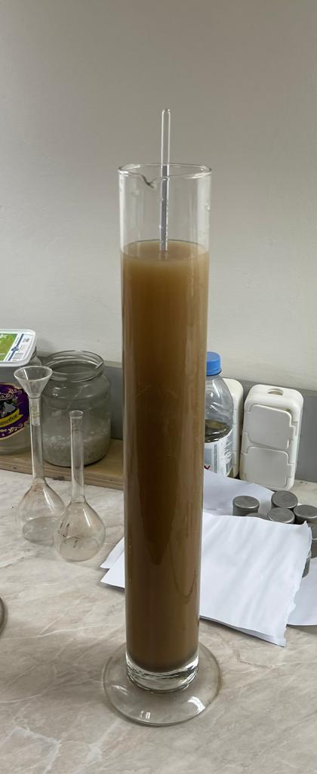

Figure 4.35 – Starting the measurement of slurry density

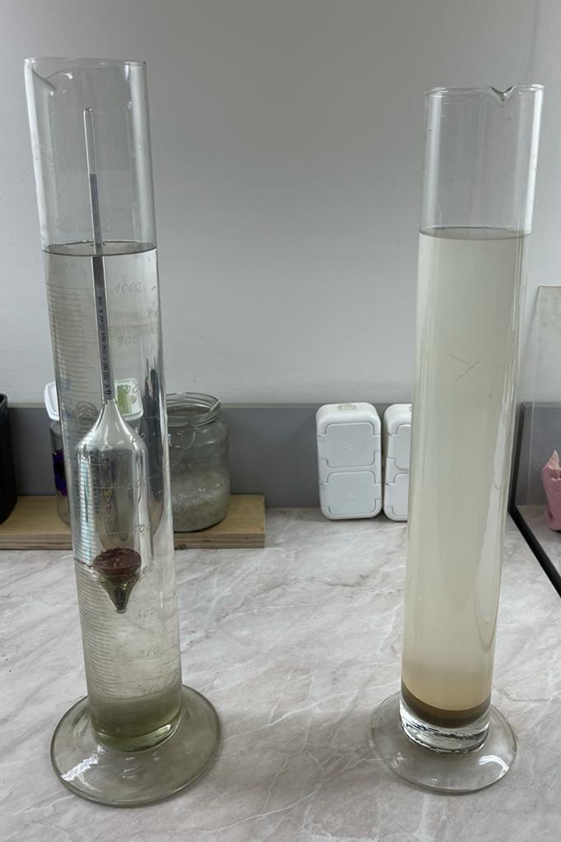

Figure 4.36 – End of slurry density measurement

The temperature of the suspension was controlled by temperature measurement with an error of up to 0.5°C during the first 5 min (before the experiment) and then after each measure of the density of the suspension with an areometer. If the temperature differed from 20°С, a temperature correction was added to the areometer readings. The data obtained by the areometer method are shown in table 4.2.
Table 4.2 – Obtained data in determining the grain composition of the soil by the areometric method

Time, min | Areometer | t, °С
1 | 10.04 | 23
30 | 9.98 | 23
180 | 9.98 | 23

The percentage of soil fractions larger than 10; 10-5; 5-2; 2-1 mm was calculated by the formula (4.1).
The mass of absolutely dry average soil sample g_0, g, was calculated taking into account the correction for hygroscopic humidity in the analysis of air-dry samples by the formula (4.2):

$g_{0}=\frac{g_{1}}{1+0,01W}=25.4$ (4.2)

where $g_{1}$ – a mass of the average soil sample in the air-dry state (or natural humidity), g;
W – hygroscopic (or natural humidity), %.
The content of soil fractions smaller than 0.5 mm X, %, was calculated by the formula (4.3):

$Х=\frac{g_{п}}{g_{0}}\left(100-K\right)=118.11$ (4.3)

where $g_{п}$ – the mass of a given fraction of the soil dried to constant mass, g;
$g_{0}$ – a mass of an absolutely dry average sample of soil (taken for the areometer), g;
K – the total content of the soil fractions larger than 1.0 mm, % (K=0).
After each areometer measurement, calculate the total content of all soil fractions less than a given diameter of soil X, %, by the formula (4.4):

$X=\frac{ρ_{s}×R_{п}}{\left(ρ_{s}-ρ_{W}\right)×g_{0}}(100-K)$ (4.4)

where $R_{п}$ – readings of the areometer with corrections;
$ρ_{s}$ – density of soil particles, g/cm³;
$ρ_{W}$ – water density equal to 1 g/cm³;
$g_{0}$ – a mass of absolutely dry average soil sample, g;
K – total content of the soil fraction larger than 1.0 mm, %, (K=0).
Having defined the total percentage content of the soil fractions with the help of an areometer, the percentage content of each fraction of the soil was calculated.
Coarse fraction - 1-0.25-66.6%.
Medium fraction - 0.25-0.05-66.1%.
Small fraction - 0.05-0.002-66.1%.
Methods of laboratory determination of physical characteristics (GOST 5180-2015) [103].
To determine the moisture content of the soil by drying to constant weight, the following equipment was used:
– drying cabinet;
– laboratory scales;
– Metal or glass beakers.
Preparation for the test
Samples of soil for moisture determination were selected from 15-50 g, then placed in a pre-dried, weighed (t) numbered beaker and sealed tightly with a lid. When sampling from a disturbed specimen, the soil was thoroughly mixed to ensure that the moisture was evenly distributed throughout the specimen.
Conducting the test
The soil sample in the buster was weighed. The open buster was placed in a heated desiccator. The soil was dried to a constant weight at (105±2)°С (figure 4.37).
After each drying, the closed bust was cooled to room temperature and weighed. The sample was dried until the difference in mass of the soil with the box at the next two weightings did not exceed 0.02 g.



Figure 4.37 – Drying the soil

Soil moisture w, %, was calculated by the formula (4.5):

$w=\frac{m_{1}-m_{0}}{m_{0}-m}×100$ (4.5)

where m₁ – a mass of wet soil with a box, g;
m₀ – a mass of dried soil with the box, g;
m – a mass of the empty box, g.
The results of determining the moisture content of the soil are presented in table 4.3.

Table 4.3 – Results of determining the moisture content of soil by drying to constant weight

No. of box | m, g | m₁, g | m₀, g | w, % | w_{ср}, %
8 | 5.4 | 18.9 | 16.8 | 18.4 | 18.24
19 | 5.2 | 19.0 | 17.7 | 10.4 | 18.24
12 | 5.2 | 18.3 | 16.4 | 17 | 18.24
5 | 5.4 | 20.1 | 16.9 | 27.8 | 18.24
504 | 5.1 | 15.8 | 14.2 | 17.6 | 18.24

Determination of the upper limit of plasticity - liquid limit by the balancing cone method
The liquid limit was defined as the moisture content of the paste prepared from the studied soil, at which the balancing cone is immersed under the action of its own mass for 5 seconds to a depth of 10 mm. Equipment used:
– drying cupboard;
– laboratory scales;
– metal boxes;
– Vasiliev's balancing cone with a cylindrical cup;
– metal box 7-8 cm in diameter;
– spatula;
– mortar with the pestle;
– sieve with a 1 mm hole;
– fine grater;
– petroleum jelly.
Preparation for the test
To determine the liquid limit, disturbed specimens were selected for which preservation of natural moisture is required.
When tested using an air-dry soil sample, it was ground in a porcelain mortar, not allowing the soil particles to be crushed and at the same time removing vegetation residues larger than 1 mm. It was sifted through a 1 mm mesh sieve. Soil passed through the sieve, moistened with distilled water to a thick paste, stirred with a spatula, and kept in a sealed glass jar.
Conducting tests
The prepared primer paste was thoroughly mixed with a spatula and placed in a cylindrical cup in small portions densely (without air cavities). The surface of the paste was smoothed with a trowel flush with the edges of the cup (figure 4.37).
A balancing cone lubricated with a thin layer of vaseline was brought to the surface of the ground paste so that its tip touched the paste. The cone is then gently released, allowing it to sink into the paste under its own weight.
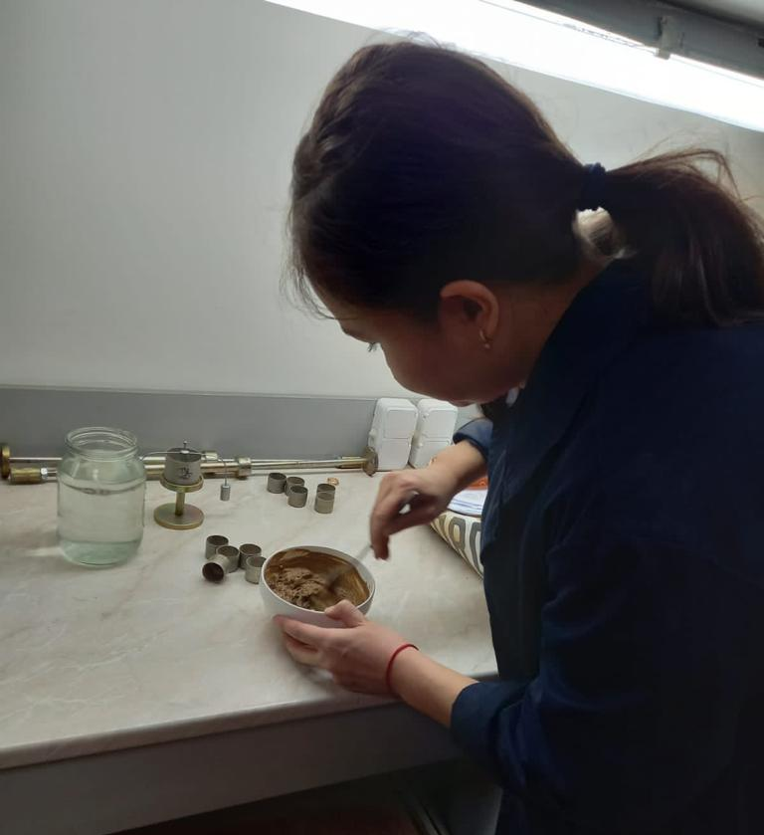

Figure 4.37 – Preparation of soil paste

Immersion of the cone in the paste for 5 s to a depth of 10 mm shows that the soil has moisture corresponding to the yield boundary (figure 4.38).

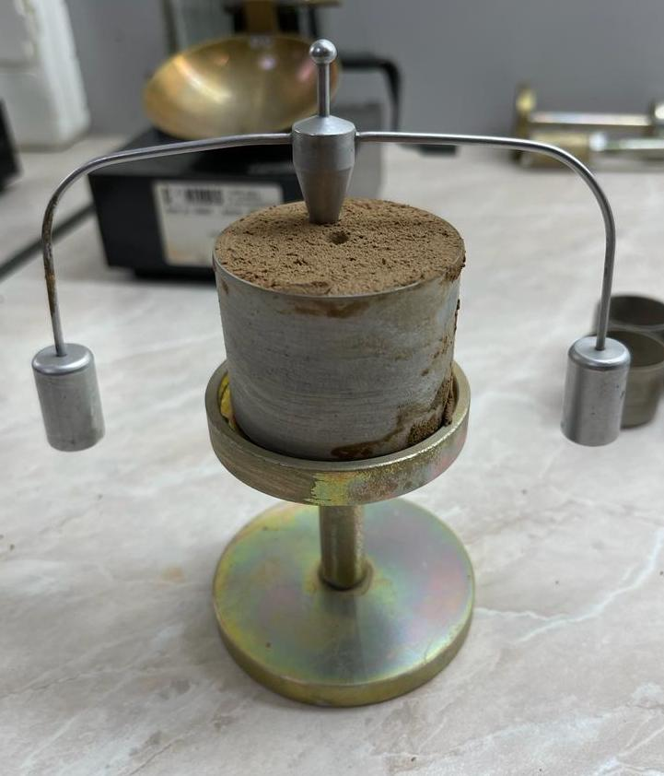

Figure 4.38 – Dipping the cone into the paste

After reaching the fluidity limit, samples of 15-30 g were taken from the paste to determine the moisture content in accordance with the requirements.
Results of determining the upper limit of plasticity are shown in table 4.4.

Table 4.4 – Results of determining the upper limit of plasticity

No. of box | m, г | m₁, г | m₀, г | w_{L}, % | w_{Lср}, %
19 | 5.2 | 20.2 | 17.4 | 22.95 | 23%
12 | 5.2 | 19.8 | 17.0 | 23.73 | 23%
5 | 5.4 | 17.4 | 15.2 | 22.45 | 23%
Determination of the lower limit of plasticity - plastic limit
The plastic limit (plasticity) should be defined as the humidity of the paste prepared from the studied soil, at which the paste rolled out in a roll with a diameter of 3 mm begins to break up into pieces of 3-10 mm. Equipment used:
– drying cabinet;
– laboratory scales;
– metal boxes;
– vasiliev's balancing cone with a cylindrical cup;
– porcelain or metal cup 7-8 cm in diameter;
– spatula
– mortar with the pestle;
– sieve with a 1 mm hole according to the current normative documentation;
– fine grater;
– vaseline.
Preparation for the tests
To determine the plastic limit, disturbed specimens were used, for which the preservation of natural moisture is required.
Conducting the tests
The prepared primer paste was thoroughly mixed, and then a small piece was taken and rolled out with the palm of the hand on a glass or plastic plate until the bundle of about 3 mm in diameter was formed (figure 4.39).

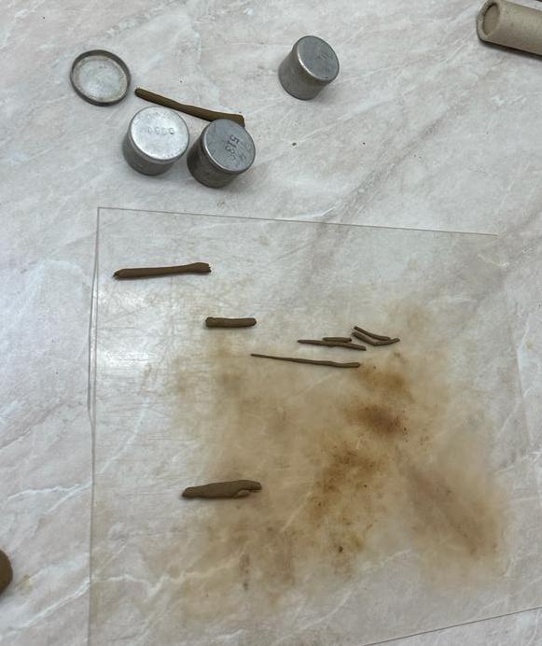

Figure 4.39 – Rolling out harnesses

Rolling continued until the bundle disintegrated along transverse cracks into 3-10 mm long pieces.
The pieces of the disintegrating bundle were collected in boxes covered with lids. When the weight of soil in the beakers reached 10-15 g, the moisture content was determined.
Results of determining the lower limit of plasticity number are represented in table 4.5.

Table 4.5 – Results of determining the lower limit of plasticity number

No. of box | m, г | m₁, г | m₀, г | w_{L}, % | w_{Lср}, % | I_{P}=W_{L}- W_{P}, %
8 | 5.4 | 13.8 | 12.7 | 15.06 | 15.1 | 7.9
504 | 5.1 | 13.0 | 11.9 | 16.18 | 15.1 | 7.9
17 | 5.5 | 14.0 | 14.0 | 14.12 | 15.1 | 7.9

Liquidity index I_{L}, d.e., is an indicator of the state of clay soils; the formula (4.6) determines it:

$I_{L}=\frac{w-w_{p}}{I_{p}}=$0.4 (4.6)

Based on GOST 25100-2011 83, this test soil in terms of plasticity index I_{P} and liquidity index $I_{L}$ refers to the tight plastic loam.

4.2.3 Experimental tests of quasi-collapsing soils performed in a uniaxial compression apparatus
The tests were conducted with a mechanical uniaxial compression device (odometer) [104, 105] (figure 4.40).

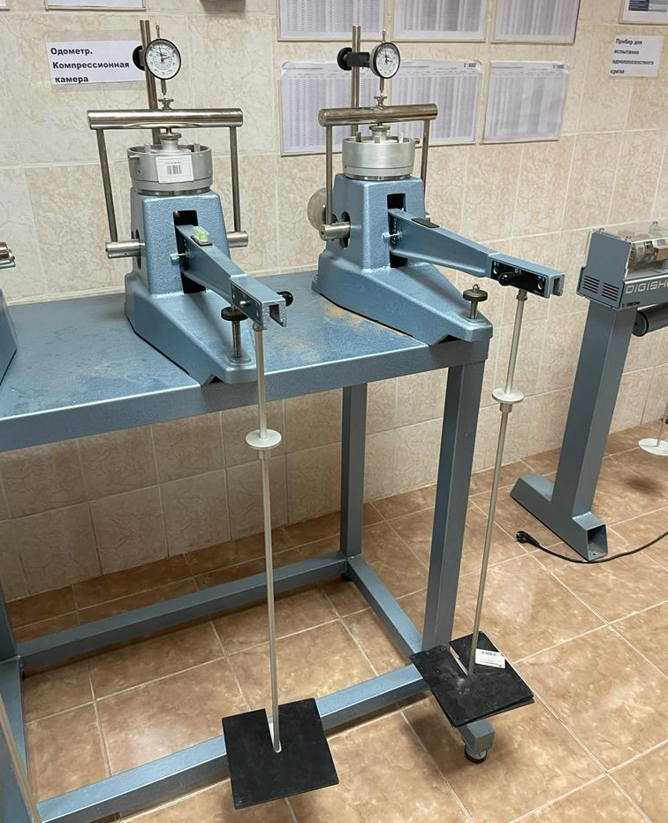

Figure 4.40 – General view of the odometer

In turn, the conducted research consisted of two parts [106]:
1) study of quasi-collapsing soil;
2) investigation of collapsing soil reinforced with geotextile.
When undisturbed sampling structure of collapsing soil, it is difficult to preserve its natural state. Therefore, there are errors in laboratory tests, which affect the reliability of the test results. In this regard, an attempt was made to simulate artificial soil that would be similar in its properties to the collapsing soil - "quasi-collapsing soil" ("quasi" means allegedly). Therefore, a method of making quasi- collapsing soil using quicklime was proposed. It was supposed that after soaking, quenching, and complete drying of samples of quicklime and soil of disturbed structure, pores and structurally unstable bonds formed, which were destroyed under repeated soaking and loading, which subsequently led to large deformation of samples (collapsing).
The first part of the test was conducted to determine the effect of the percentage of quicklime and disturbed soil on quasi-soil collapsing.
The second part was conducted to determine the effect of quasi-soil reinforcement by geotextile on collapsing. For this purpose, a nonwoven geotextile was selected (figure 4.41), the physical and mechanical characteristics of which are given in table 4.6.

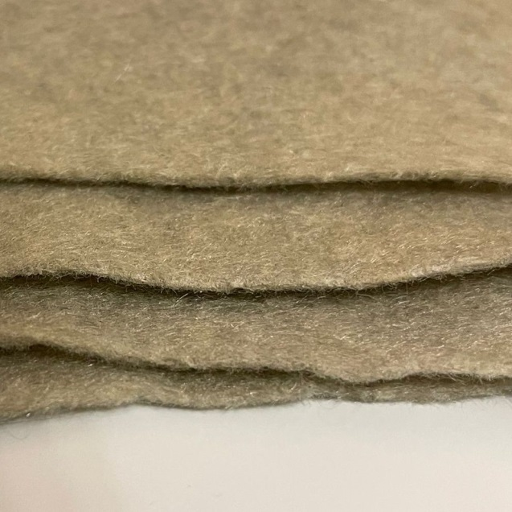

Figure 4.41 – Non-woven geotextile

Table 4.6 – Physical and mechanical characteristics of the geotextile fabric

Name of indicators |  | Geotextile
Surface density g/m² |  | 300
Breaking load, kN/m | lengthways | 6.7
Breaking load, kN/m | across | 7.6
Relative elongation  at break, % | lengthways | 80
Relative elongation  at break, % | across | 70
Coefficient of permeability,  m/day (at vertical  0,01 MPa),  not less, | in the direction of perpendicular  to the plan of the fabric | 60
 | in the plane of the fabric | 30
Thermal conductivity, W/ (m K), not more |  | 0.08
Unevenness by weight, %, not more |  | 4.0
The methodology of the odometer experiments with standard shear rings is as follows:
1. Preparation of the mixture.
A mixture of disturbed loam and air binder - quicklime (CaO) was used to prepare quasi-collapsing soil. At the same time, mixtures were made with the following dosages in ratios of quicklime-soil: 40%-60%, 50%-50%, 60%-40% (figure 4.42).

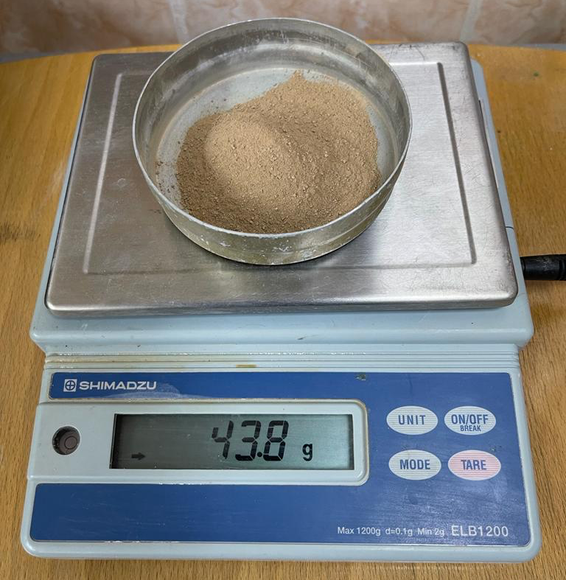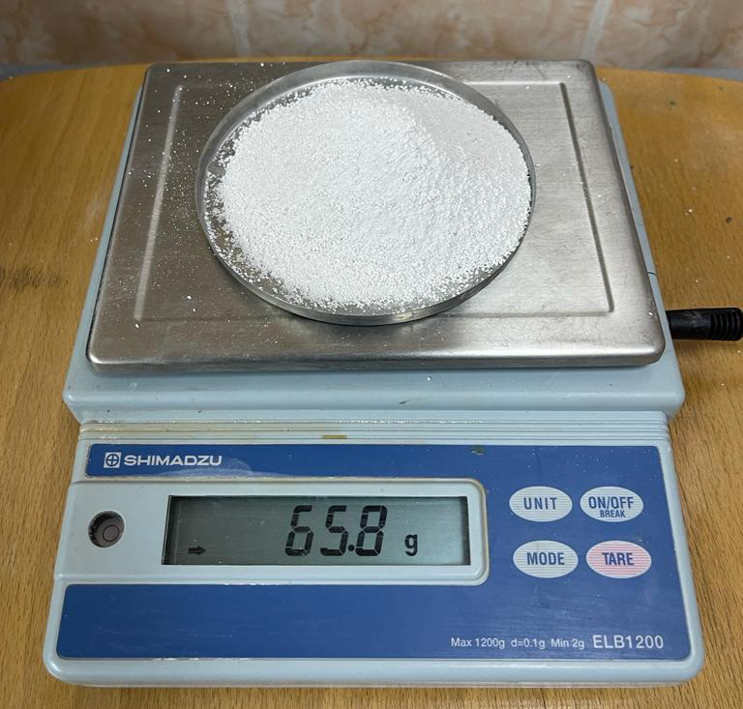
a b

a – loam; b – quicklime

Figure 4.42 – Components for making quasi-collapsing soil

2. Laying the mixture.
The mixture of these components in a dry state was placed in standard odometer shear rings (d=20 mm) (figure 4.43).

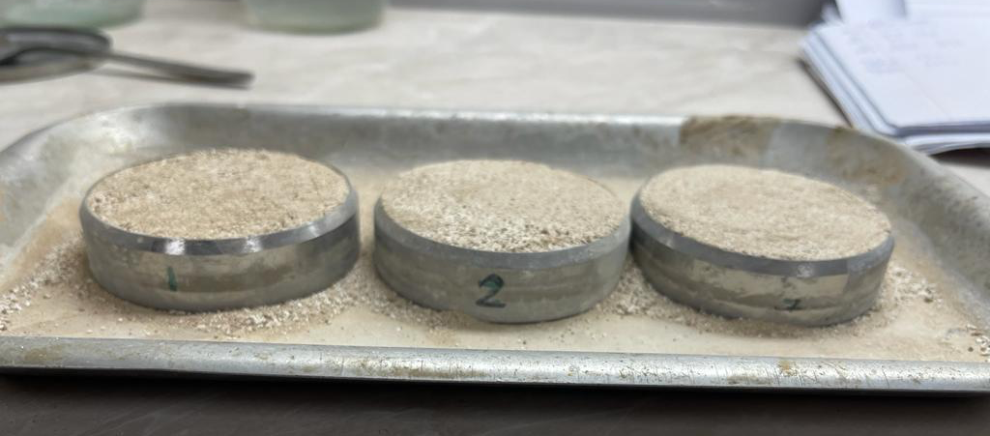

Figure 4.43 – Samples before soaking

3. Soaking the mixture.
Soaking until complete water saturation was carried out, and lime was quenched with a significant increase in the sample volume in the ring. The rise of volume of artificially made sample at quenching of lime was within 70-90% due to the formation of macropores (figure 4.44).

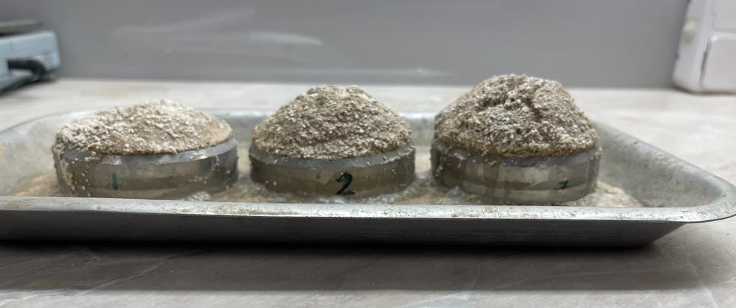

Figure 4.44 – Samples after soaking

4. Sample drying.
After complete quenching, the specimens were subjected to drying in heating furnaces. Then the protruding part of the quasi-soil was removed, and a layer of geotextile was placed on it so that the total height of the tested soil with the geotextile was the same height as the shear ring.
5. Installing the shear ring with the dried sample in the odometer.
6. Experimenting with the odometer (figure 4.45).

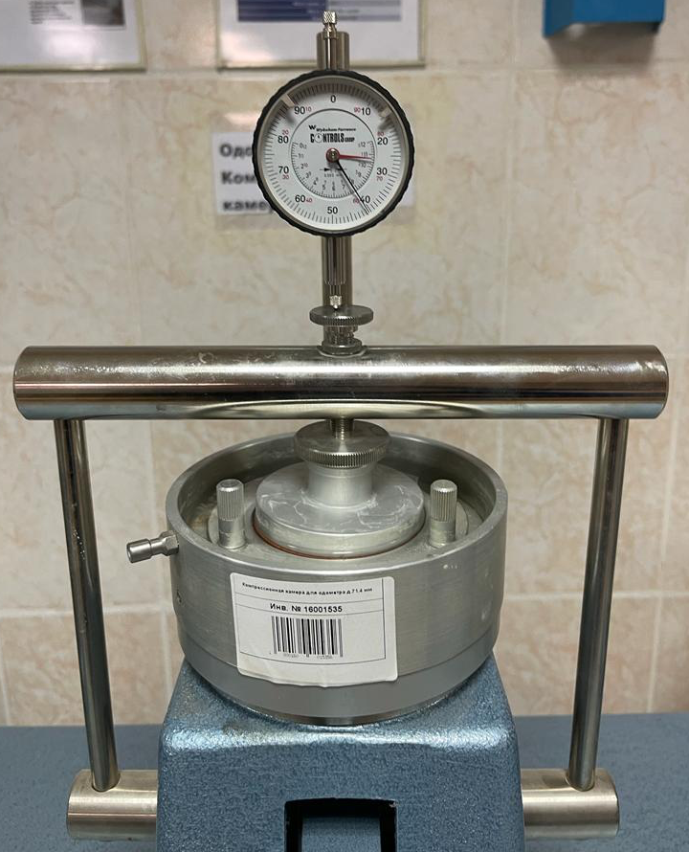

Figure 4.45 – Testing of quasi-soil samples on the device of uniaxial compression

After installing the rings in the odometer, the samples were subjected to uniaxial compression. At that, loading was performed in stages, and each loading was withheld until the settlements stabilized (stabilization condition of 0.01 mm/min).
The load was applied one kilogram at a time up to 5 kg. In order to obtain collapsing, the specimen was soaked at 3 kg during the experiment. After each loading, strain values were taken from watch-type indicators (WTIs).
A coefficient of relative collapsing was used to describe the degree of quasi-soil collapsing:

$ε_{sl}=\frac{h_{n.p.}-h_{sat.p.}}{h}$ (4.6)

Results of soil experiments (disturbed loam 60%- quicklime 40%) in an odometer with soaking are shown below in table 4.7 and figure 4.46.

Table 4.7 – Processed results after the test of quasi-collapsing soil (loam 60% - lime 40%)

Load, kg | Time, min | Indicator | $$∆h×0.002-h$$
1 | 15 | 40 | 19.92
2 | 15 | 146 | 19.708
3 | 15 | 280 | 19.44
3 (sat) | 45 | 582 | 18.836
4 | 15 | 703 | 18.594
5 | 15 | 790 | 18.42

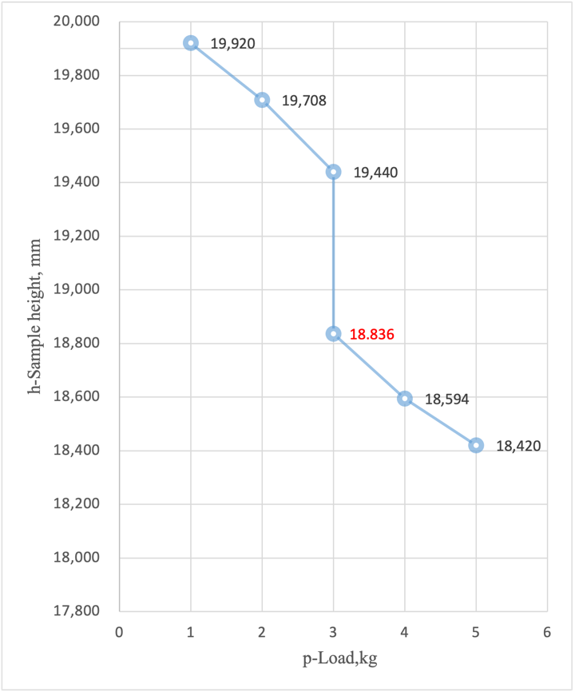

Figure 4.46 – Dependence of the sample height h on the load p with soaking at 3 kg for the ratio of soil 60% - lime 40% ($ε_{sl}=0.03>0.01$)

Experimental results of soil (disturbed loam 60%- quicklime 40%) in an odometer with soaking reinforced with geotextile are shown below in table 4.8 and figure 4.47.
Table 4.8 – Processed results after quasi-collapsing soil (loam 60% - lime 40%) reinforced with geotextile

Load, kg | Time, min | Indicator | $$∆h×0.002-h$$
1 | 15 | 193 | 19.614
2 | 15 | 375 | 19.25
3 | 15 | 511 | 18.978
3 (sat) | 45 | 721 | 18.558
4 | 15 | 846 | 18.308
5 | 15 | 993 | 18.014

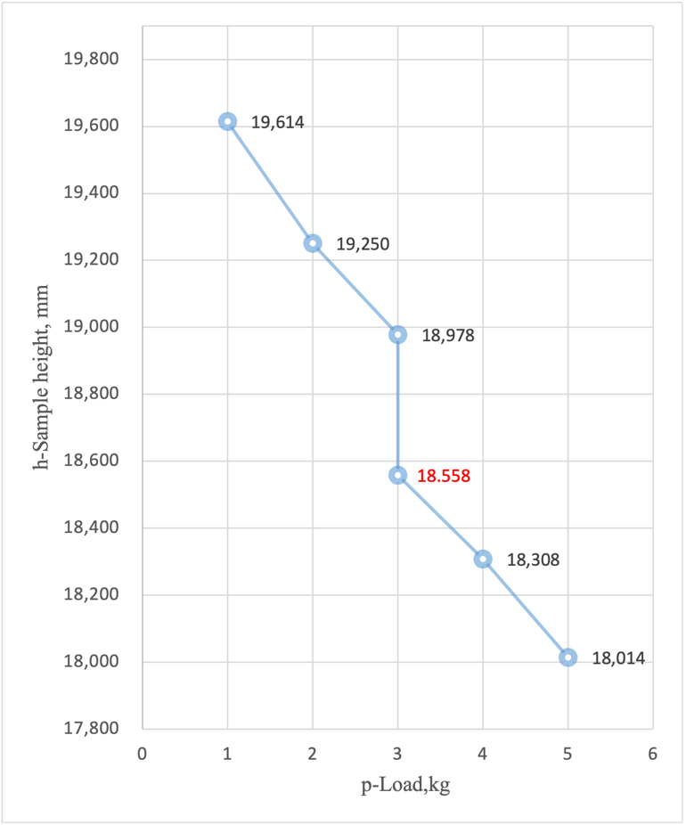

Figure 4.47 – Dependence of change of sample height h on load p with soaking at 3 kg for the ratio of soil 60% - lime 40% reinforced with geotextile
($ε_{sl}=0.021>0.01$)

Experimental results for soil (disturbed loam 50% - quicklime 50%) in an odometer with soaking are shown below in table 4.9 and figure 4.48.

Table 4.9 – Processed results after quasi-collapsing soil (loam 50% - lime 50%) test

Load, kg | Time, min | Indicator | $$∆h×0.002-h$$
1 | 15 | 8.5 | 19.983
2 | 15 | 44 | 19.912
3 | 15 | 122 | 19.756
3 (sat) | 45 | 478 | 19.044
4 | 15 | 675 | 18.65
5 | 15 | 895 | 18.21

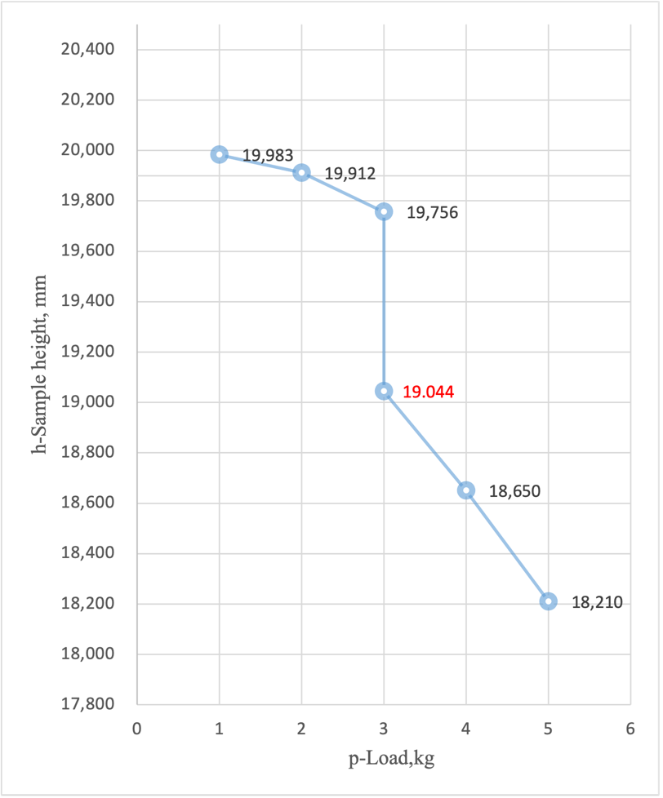

Figure 4.48 – Dependence of change of sample height h on load p with soaking at 3 kg for ratio soil 50% - lime 50% ($ε_{sl}=0.035>0.01$)

Experimental results for soil (disturbed loam 50% - quicklime 50%) in an odometer with geotextile reinforced soaking are shown below in table 4.10 and figure 4.49.

Table 4.10 – Processed results after quasi-collapsing soil (loam 50% - lime 50%) reinforced with geotextile

Load, kg | Time, min | Indicator | $$∆h×0.002-h$$
1 | 15 | 5 | 19.99
2 | 15 | 70 | 19.86
3 | 15 | 162 | 19.676
3 (sat) | 45 | 462 | 19.076
4 | 15 | 620 | 18.76
5 | 15 | 808 | 18.384

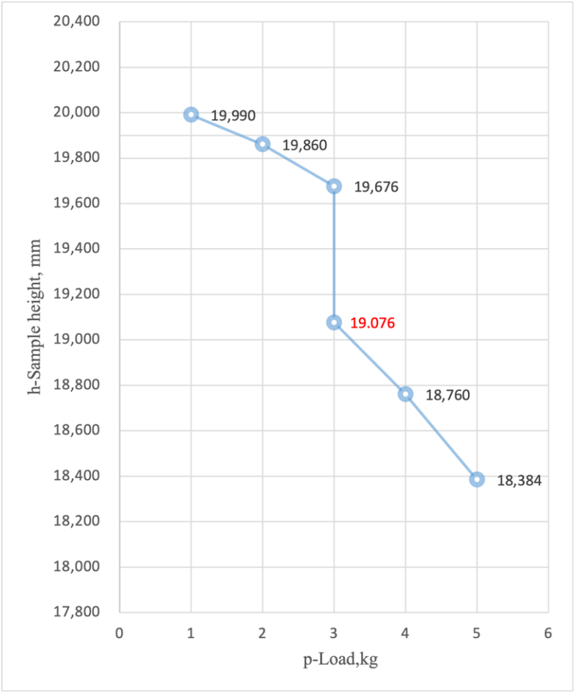

Figure 4.49 – Dependence of change of sample height h on load p with soaking at 3 kg for the ratio of soil 50% - lime 50% reinforced with geotextile
($ε_{sl}=0.03>0.01$)

Experimental results for soil (disturbed loam 40% - quicklime 60%) in an odometer with soaking are shown below in table 4.11 and figure. 4.49.

Table 4.11 – Processed results after quasi-collapsing soil (loam 40% - lime 60%)

Load, kg | Time, min | Indicator | $$∆h×0.002-h$$
1 | 15 | 21 | 19.958
2 | 15 | 187 | 19.626
3 | 15 | 286 | 19.428
3 (sat) | 45 | 666 | 18.628
4 | 15 | 833 | 18.334
5 | 15 | 966 | 18.068

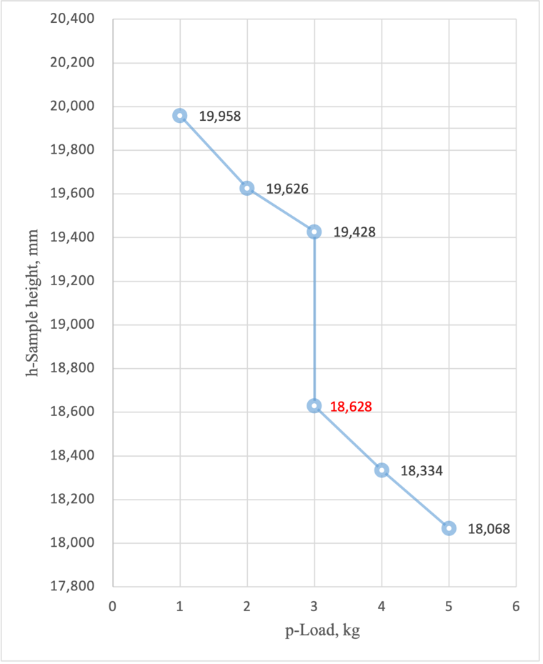

Figure 4.49 – Dependence of change of sample height h on load p with soaking at 3 kg for the ratio of soil 40% - lime 60%
($ε_{sl}=0.04>0.01$)

Experimental results for soil (disturbed loam 40% - quicklime 60%) in an odometer with soaking reinforced with geotextile are shown below in table 4.12 and figure 4.50.

Table 4.12 – Treated results from quasi-collapsing soil (40% loam - 60% lime) reinforced with geotextile

Load, kg | Time, min | Indicator | $$∆h×0.002-h$$
1 | 15 | 30 | 19.94
2 | 15 | 140 | 19.72
3 | 15 | 265 | 19.55
3 (sat) | 45 | 540 | 18.92
4 | 15 | 713 | 18.574
5 | 15 | 925 | 18.15
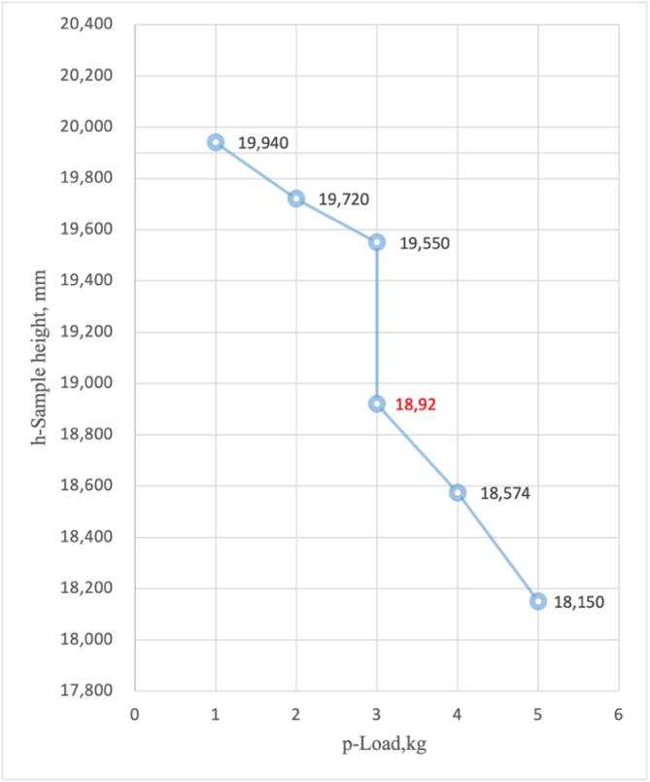

Figure 4.50 – Dependence of change of sample height h on load p with soaking at 3 kg for the ratio of soil 40% - lime 60% reinforced with geotextile
($ε_{sl}=0.0315>0.01$)

Section conclusions
1. According to the verification calculations in GTS NX MIDAS when the cushion device the maximum displacement of the embankment is 28 mm.
2. The maximum deformations are 4.5 mm in the case of vehicular traffic.
3. The graphs show that a rapid deformation of quasi-collapsing soil occurs during the wetting of quasi-collapsing soil, similar to the real process that occurs in collapsing soils during their soaking. According to the value of the coefficient of relative collapsing, we can conclude that in each case, quasi-soil turned out to collapse, and the collapsing of quasi-soil increases when the content of quicklime (CO) increases.
4. From the results on the graph, we can see that the geotextile-reinforced quasi-soil gives less spike-like collapsing under soaking than quasi-soil without geotextile. It makes us believe that reinforcement of quasi-collapsing soil by geomaterials, namely geotextile, allows for increasing the bearing capacity of soil and improving its deformation properties (table 4.13).

Table 4.13 – Change of quasi-soil coefficient of relative collapsing when changing the percentage ratio of components (soil - quicklime) with and without geotextile reinforcement

Percentage proportion of soil and lime in quasi-soil | Coefficient of relative collapsing without geotextile reinforcement, $ε_{sl}$ | Coefficient of relative collapsing with geotextile reinforcement, $ε_{sl}$
Soil 60% - Quicklime 40% | $$ε_{sl}=0.03>0.01$$ | $$ε_{sl}=0.021>0.01$$
Soil 50% - Quicklime 50% | $$ε_{sl}=0.035>0.01$$ | $$ε_{sl}=0.03>0.01$$
Soil 40% - Quicklime 60% | $$ε_{sl}=0.04>0.01$$ | $$ε_{sl}=0.0315>0.01$$
5 RECOMMENDATIONS BY USING METHODS TO IMPROVE SOIL BASES IN COLLAPSIBLE AREAS

When designing roads and road structures on collapsing soils, it is necessary to:
1. When designing structures on collapsing soils, the possibility of increasing their moisture content due to soaking the soil from external sources (rainwater, meltwater) from above should be considered. It is necessary to provide a set of measures, including the elimination of collapsible properties (water protection and structural measures).
2. Provide measures to prevent the penetration of surface and anthropogenic water into the foundations.
3. Provide runoff and channel-regulating structures and measures to prevent flooding adjacent to unregulated medium and small rivers and protect crossings under highways.
4. It is necessary to apply to the pavement «capping layer» structure in areas where the groundwater level is close to the bottom of the embankment for a more rigid resistance to loads from the above structure. It also reduces the chance of differential settlement in the slab by supporting it more homogeneously than an unimproved subgrade. It is also much easier to compact a subbase on a capping layer than on saturated clay, meaning that by installing a capping layer, delays in constructing the subbase due to wet weather can be reduced.
5. To determine the bearing capacity of the soil foundations of the road highway under construction, one should rely on the results of the field tests.
6. Аplication of a comprehensive approach to improving soil bases in collapsible areas.

CONCLUSION

The study presents the features of the design of structures on collapsible soils. It is important to consider the possibility of increasing their moisture content by soaking the soil from above from external sources (rainwater, meltwater). It is necessary to provide a set of measures, including the elimination of collapsible properties. The problem was studied using a combination of methods, including bearing capacity estimation, numerical modeling, and small-scale experiments of quasi-soils reinforced and unreinforced with geosynthetic material on a single-axis odometer compression device. The object of the study was a large ring road located in the south of Kazakhstan. On which the following results can be highlighted:
1 Review of the literature showed that one of the most difficult and critical tasks is designing and constructing structures on structurally unstable soils. Such soils also include collapsible soils. Pile foundations are a priority in the construction of road structures on weak and collapsible soils.
2. When designing collapsible soils to analyze the mechanical properties of the earth embankment soil, it is necessary to use the results of field tests as more reliable information on the mechanical properties of the soil. Regarding the investigation, the results of field tests are for soil with natural humidity - strain modulus E_{d} = 34.14 MPa, for water-saturated soil - strain modulus E_{d} = 7.24 MPa). According to the tests, the coefficient of compaction of soil layers in the base fluctuates within K < 0.9.
3. Experimental investigations to determine the bearing capacity of piles based on the results of field tests of static loads following the standard's requirements presented the accuracy and reliability of the results, as well as received comprehensive information about the testing process. The pile static test results showed that the soil's bearing capacity is sufficient for the maximum load (P_{max}=361 tf, S=4,05 mm).
4. To verify the integrity of the pile shaft, it is recommended to conduct a pile integrity test.
5. It is important to understand the physical state of the foundation mass and conduct calculations Construction Stage Analysis. Numerical simulation of the stability of the road embankment has shown that the maximum displacement of the embankment is 28 mm when the pillow is installed. The maximum deformations are 4.5 mm in the case of vehicular traffic.
6. It has been laboratory proven that reinforcement of the collapsing soil with geomaterials, namely geotextiles, increases the bearing capacity of the soil and improves its deformation properties. The coefficient of relative collapsing for samples with a ratio (soil 60% - 40% lime) is 𝜀_{sl}=0.03>0.01 (not reinforced with geotextile), 𝜀_{sl} =0.021>0.01 (reinforced with geotextile), for samples with a ratio (soil 50% - 50% lime) is 𝜀_{sl} =0. 035>0.01 (not reinforced with geotextile), 𝜀_{sl}=0.03>0.01 (reinforced with geotextile), for samples with the ratio (soil 40% - 60% lime) equal to 𝜀_{sl}=0.04>0.01 (not reinforced with geotextile), 𝜀_{sl}=0.031>0.01 (reinforced with geotextile).

LIST OF SOURCES USED

1 Крутов В.И. Основания и фундаменты на просадочных грунтах. – Киев, 1982. – 224 c.
2 Крутов В.И., Ковалев А.С., Ковалев В.А. Проектирование и устройство оснований и фундаментов на просадочных грунтах. – М.: АСВ, 2013. – 544 c.
3 Крутов В.И. Классификация просадочных лёссовых грунтов // Геоэкология. – 1998. – №3. – С. 55-64.
4 Сергеев Е.М., Ларионова А.К., Комиссарова Н.Н. Лёссовые породы СССР: в 2 т. – М.: Недра, 1986. – Т. 1. – 232 с.
5 Крупина Н.В. Методы повышения несущей способности и стабильности грунтов. – Кемерево, 2014. – 104 c.
6 Мустафаев А.А. Вопросы расчета зданий и сооружений на просадочных грунтах. – Баку, 1974. – 192 с.
7 Мустафаев А.А. Фундаменты на просадочных и набухающих грунтах. – М: Высшая школа, 1989. – 590 с.
8 Конищев В.Н. Лёссовые породы: новые возможности изучения их генезиса // Инженерная геология. – 2015. – №5. – С. 22-36.
9 Денисов Н.Я. О природе просадочных явлений в лессовидных суглинках. – М.: Советская наука, 1946. – 177 с.
10 Галай Б.Ф. О гранулометрической классификации лессовых пород: на примере Северного Кавказа // В кн.: Классификационные критерии разделения лёссовых пород. – М.: Наука, 1984. – С. 23-25.
11 Абелев Ю.М. Основы проектирования и строительства на просадочных грунтах. – М.: Стройиздат, 1979. – 271 с.
12 Абелев М.Ю., Ильичев В.А., Ухов С.Б. и др. Строительство зданий и сооружений в сложных грунтовых условиях. – М.: Стройиздат, 1986. – 104 с.
13 Ананьев В.П. Режим влажности и прочности лессовых грунтов в основании зданий и сооружений // Известия высш. уч. завед. Геология и раазведка. – 1969. – №10. – С. 123-126.
14 Opukumo A.W., Davie C.T., Glendinning S. et al. A review of the identification methods and types of collapsible soils // Journal of Engineering and Applied Science. – 2022. – Vol. 69, Issue 1. – P. 17-1-17-2.
15 Opukumo A.W., Davie C.T. et al. A simple laboratory method to simulate calcite-bonded loose-structured soil samples for collapsibility study // Journal of Engineering and Applied Science. – 2022. – Vol. 69, Issue 1. – P. 55-1-55-20.
16 Derbyshire E., Dijkstra T., Smalley I.J. Genesis and Properties of Collapsible Soils. – Dordrecht: Springer, 1995. – 413 p.
17 Murthy V.N.S. Geotechnical engineering principles and practices of soil mechanics and foundation engineering. – Boca Raton: CRC Press, 2002. – 1056 p.
18 Jian T., Kong L., Bai W. et al. Investigation on Compressibility and Microstructure Evolution of Intact Loess at Different Wetting States // Frontiers in Earth Science. – 2022. – Vol. 10. – P. 923358.
19 Wang X.-W., Xu Y.-S. Investigation on the phenomena and influence factors of urban ground collapse in China // Natural Hazards. – 2022. – Vol. 113, Issue 1. – P. 1-33.
20 Чеботарева Т.Н. Оценка инженерно-геологических особенностей лёссовых грунтов, как оснований для сооружений, на примерах строительных площадок Ростовской области. – СПб., 2016. – 146 с.
21 White J.L. Characteristics and Susceptibility of Collapsible Soils in Colorado: Results of a Statewide Study // GEO-Volution: procced. conf. – Denver, Colorado, 2006. – P. 86-98.
22 Houston S.L., Houston W.N., Lawrence C.A. Collapsible Soil Engineering in Highway Infrastructure Development // Journal of Transportation Engineering. – 2002. – Vol. 128, Issue 3. – P. 295-300.
23 Ruziev A.R. Compaction and deformation characteristics of collapsible soil in the hydroblasting method // Soil Mechanics and Foundation Engineering. – 1991. – Vol. 28, Issue 5. – P. 213-217.
24 Reznik Y.M. Influence of physical properties on deformation characteristics of collapsible soils // Engineering Geology. – 2007. – Vol. 92, Issue 1-2. – P. 27-37.
25 Методическое пособие по проектированию оснований и фундаментов на просадочных грунтах / ФАУ «Федеральный центр нормирования, стандартизации и технической оценки соответствия в строительстве». – М.: 2020. – 122 с.
26 Tamara A., Nina L. Methods to Increase Effectiveness of Injective Chemical Stabilisation of Loess Soils // Engineering Geology for Society and Territory. – 2015. – Vol. 5. – P. 1289-1292.
27 Trofimov V.T. On the results of engineering geological research of loess-soil massifs of Northern Eurasia // Moscow University Geology Bulletin. – 2016. – Vol. 71, Issue 6. – P. 457-461.
28 Shen N., Wang Z., Guo Q. et al. Soil detachment capacity by rill flow for five typical loess soils on the Loess Plateau of China // Soil and Tillage Research. – 2021. – Vol. 213. – P. 105159.
29 Zhi B., Yang L. Study on the Mechanical Properties of Lime-Cement-Treated Loess Soils // Applied Mechanics and Materials. – 2014. – Vol. 638-640. – Р. 1408-1413.
30 Jefferson I., Evstatiev D., Karastanev D. The Treatment of Collapsible Loess Soils Using Cement Materials // GeoCongress 2008: conf. – New Orleans, 2008. – P. 662-669.
31 Полканов В.Н. Фундаменты в просадочных грунтах. Основы проектирования и технология подготовки оснований. – Кишинев: ТУМ, 2010. – 94 с.
32 Антонов В.М., Леденев В.В., Скрылев В.И. Проектирование зданий в особых условиях строительства и эксплуатации: учеб. изд. – Тамбов: ТГТУ, 2002. – 239 с.
33 Кригер Н.И., Кузнецов А.Г., Мунц О.И. Косвенные методы оценки просадочных свойств лёссовых пород // Тр. ПНИИС. – М.: Стройиздат, 1971. – Т. 12. – С. 191-260.
34 Трофимов В.Т. Грунтоведение: учеб. – М.: МГУ, 2005. – 1023 с.
35 Иванов И.П., Тржцинский Ю.Б. Инженерная геодинамика. – СПб.: Наука, 2001. – 416 с.
36 Иванов И.П. О предварительной оценке просадочности лёссовых пород // Записки Горного института. – 1958. – Т. 34, №2. – P. 214-221.
37 Popescu M.E. A comparison between the behaviour of swelling and of collapsing soils // Engineering Geology. – 1986. – Vol. 23, Issue 2. – P. 145-163.
38 Liu X., Wang Y., Nam B.H. Characterizing undrained shear behavior of loess subjected to K loading condition // Engineering Geology. – 2022. – Vol. 302. – P. 106634.
39 Chindaprasirt P., Sriyoratch A., Arngbunta A. et al. Estimation of modulus of elasticity of compacted loess soil and lateritic-loess soil from laboratory plate bearing test // Case Studies in Construction Materials. – 2022. – Vol. 16. – P. e00837.
40 Tang H., Luo J., Duan Z. et al. Experimental investigation of the creep behaviour of remoulded loess under different levels of compactness // PLOS ONE. – 2022. – Vol. 17, Issue 1. – P. e0262456.
41 Li R., Zhang S., Li R. et al. Experimental Study on Mechanical Behaviors of Loess Based on Two Different Modes of Oil Contamination // Geofluids. – 2022. – Vol. 2022. – P. 6411520-1-6411520-11.
42 Mahmoudian H., Hashemi M., Ajalloeian R. et al. Investigating the effect of additives’ size on the improvement of the tensile and compressive strengths and deformation characteristics of collapsible soils // Environmental Earth Sciences. – 2020. – Vol. 79, Issue 13. – P. 328.
43 Tian T., Jiang Y., Yi Y. et al. Laboratory fatigue performance of the cement-stabilised loess fabricated using different compaction methods // https://www.tandfonline.com/doi/abs. 15.04.2021.
44 Zarei C., Wang F., Qiu P. Laboratory Investigations on Geotechnical Characteristics of Albumen Treated Loess Soil // KSCE Journal of Civil Engineering. – 2022. – Vol. 26, Issue 2. – P. 539-549.
45 Zhussupbekov A., Tulebekova A., Zhumadilov I. et al. Tests of Soils on Triaxial Device // Key Engineering Materials. – 2020. – Vol. 857. – P. 228-233.
46 Haeri S.M., Khosravi A., Ghazizadeh S. The Measurement of Suction Stress Characteristic Curve for a Highly Collapsible Loessial Soil // IFCEE 2015 conf. – San Antonio: American Society of Civil Engineers, 2015. – P. 2482-2491.
47 Yates K., Russell A.R. The unsaturated characteristics of natural loess in slopes, New Zealand // Géotechnique. – 2022. – Vol. 72, Issue 4. – P. 1-14.
48 Zhang W., Fan N., Li Y. Water-induced disintegration behaviour of Malan loess // Earth Surface Processes and Landforms. – 2022. – Vol. 47, Issue 8. – P. 1891-1901.
49 Ma J., Zeng R., Yao Y. et al. Characterization and quantitative evaluation of preferential infiltration in loess, based on a soil column field test // Catena. – 2022. – Vol. 213. – P. 106164.
50 Cheng X., Qi L., Zha W. Experimental Study on Cement Improved Loess // International Journal of Pavement Research and Technology. – 2022. – Vol. 15, Issue 2. – P. 384-394.
51 Chen J., Wang L., Wang P. Failure mechanism investigation on loess–mudstone landslides based on the Hilbert–Huang transform method using a large-scale shaking table test // Engineering Geology. – 2022. – Vol. 302. – P. 106630.
52 Zhussupbekov A. Features of the bearing capacity estimation of the collapsing soil bases // International Journal of GEOMATE. – 2022. – Vol. 22, Issue 92. – P. 32-40.
53 Kalantari B. Foundations on collapsible soils: a review // Proceedings of the Institution of Civil Engineers - Forensic Engineering. – 2013. – Vol. 166, Issue 2. – P. 57-63.
54 Li X., Li Y., Lv D. et al. Influence of Drilling Methods on the Results of Standard Penetration Test in Loess–Paleosol Sequence // Frontiers in Built Environment. – 2022. – Vol. 8, Issue 2. – P. 846815.
55 Zhussupbekov A., Omarov A. Modern Advances in the Field Geotechnical Testing Investigations of Pile Foundations // Procedia Engineering. – 2016. – Vol. 165. – P. 88-95.
56 Proceedings of the 16th International Conference on Soil Mechanics and Geotechnical Engineering / IOS Press. – Rotterdam: Millpress, 2005. – Vol. 1. – 322 p.
57 Yang H., Xie W., Liu Q. et al. Three-stage collapsibility evolution of Malan loess in the Loess Plateau // CATENA. – 2022. – Vol. 217. – P. 106482.
58 Zakaria W.A., Abbas H.O., Aljanabi Q.A. Vertical and Inclined Lime Injected Piles Under Footing Resting on Collapsing Soil // Journal of The Institution of Engineers (India). – 2020. – Vol. 101, Issue 3. – P. 513-521.
59 СП РК 5.01-102-2013. Основания зданий и сооружений. – Введ. 2014-12-29. – Астана: АО «КазНИИСА», 2015. – 76 с.
60 Hamdy D.B. A sustainable approach for improving the behavior of collapsible soil using marble dust // Innovative Infrastructure Solutions. – 2022. – Vol. 7, Issue 4. – P. 260.
61 Haeri S.M., Valishzadeh A. Evaluation of Using Different Nanomaterials to Stabilize the Collapsible Loessial Soil // International Journal of Civil Engineering. – 2021. – Vol. 19, Issue 5. – P. 583-594.
62 Niu L., Ren W., Zhang A. et al. Experimental study on the influence of soluble salt content on unsaturated mechanical characteristics of undisturbed Ili loess // Bulletin of Engineering Geology and the Environment. – 2021. – Vol. 80, Issue 9. – P. 6689-6704.
63 Hameedi M.K. Field study on soft soil improvement using continuous flight auger (CFA) piles // International Journal of GEOMATE. – 2021. – Vol. 21, Issue 86. – P. 159-166.
64 Seiphoori A., Zamanian M. Improving mechanical behaviour of collapsible soils by grouting clay nanoparticles // Engineering Geology. – 2022. – Vol. 298. – P. 106538.
65 Zhou J., Xiong J., Ni J. Structural changes and denitrification performance evaluation of bioretention cells with collapsible loess modified by coal gangue // Journal of Cleaner Production. – 2022. – Vol. 355. – P. 131740.
66 Ayeldeen M., Azzam W., Arab M.G. The Use of Fiber to Improve the Characteristics of Collapsible Soil Stabilized with Cement // Geotechnical and Geological Engineering. – 2022. – Vol. 40, Issue 4. – P. 1873-1885.
67 Кургузов К.В., Фоменко И.К., Сироткина О.Н. Оценка несущей способности свай. методы расчета и проблематика // Известия Томского политехнического университета. Инжиниринг георесурсов. – 2019. – Т. 330, №10. – С. 7-25.
68 Zhou Z., Wang K., Feng H. Centrifugal model test of post-grouting pile group in loess area // Soil Dynamics and Earthquake Engineering. — 2021. — Vol. 151. — P. 106985.
69 Cheng X., Cai X., Zha W. Engineering characteristics test on pile–net composite foundation in loess areas // Proceedings of the Institution of Civil Engineers - Geotechnical Engineering. – 2022. – Vol. 175, Issue 1. – P. 3-14.
70 Tulebekova A.S., Ashkey Ye., Zhankina A.K. Experience in pile testing on different construction sites // Bulletin of L.N. Gumilyov Eurasian National University. – 2022. – Vol. 138, Issue 1. – P. 76-82.
71 Zhussupbekov A., Tulebekova A., Zhankina A. Methods of testing pile by ASTM and GOST standards // Bulletin of L.N. Gumilyov Eurasian National University. – 2020. – Vol. 132, Issue 3. – P. 141-149.
72 Dong L. Numerical model for the settlement of loess subgrade in operation period reinforced by rotary jet grouting pile // Vibroengineering Procedia. – 2022. – Vol. 41. – P. 48-53.
73 Seregin N. Parametric Model of Cement Soil // Lecture Notes in Civil Engineering. – 2022. – Vol. 180. – P. 481-491.
74 Liu W., Yang X., Zhang S. et al. Analysis of Deformation Characteristics of Long-Short Pile Composite Foundation in Salt Lake Area, Iran // Hindawi. Advances in Civil Engineering. – 2019. –Vol. 2019. – P. 1-15.
75 Zhao Z., Ye S., Zhu Y. Scale model test study on negative skin friction of piles considering the collapsibility of loess // Acta Geotechnica. – 2022. – Vol. 17, Issue 2. – P. 601-611.
76 Tulebekova A., Zhankina A. Technical regulation in the construction // Bulletin of L.N. Gumilyov Eurasian National University. – 2021. – Vol. 136, Issue 3. – P. 56-66.
77 СП РК 5.01–103-2013. Свайные фундаменты. – Введ. 2014-12-29. – Астана: АО «КазНИИСА», 2015. – 86 с.
78 НТП РК 07-01.2-2011. Проектирование зданий и сооружений на структурно-неустойчивых грунтах. – Введ. 2014-12-29. – Астана: АО «КазНИИСА», 2015. – 115 с.
79 СП РК EN 1990:2002+A1:2005/2011. Еврокод – Основы проектирования несущих конструкций. – Введ. 2014-12-29. – Астана: АО «КазНИИСА», 2016. – 145 c.
80 СП РК EN 1997-1:2004/2011. Геотехническое проектирование. – Введ. 2014-12-29. – Астана: АО «КазНИИСА», 2016. – Ч. 1. – 15 c.
81 ГОСТ 33149-2014. Дороги автомобильные общего пользования. Правила проектирования автомобильных дорог в сложных условиях. – Введ. 2015-12-01. – М.: ФГУП «РОСДОРНИИ», 2015. – 46 c.
82 ГОСТ 20276.1-2020. Грунты. Метод испытания штампом. – Введ. 2021-01-01. – М.: Стандартинформ, 2020. – 13 c.
83 ГОСТ 5686-2020. Грунты. Методы полевых испытаний сваями. – Введ. 2021-01-01. – М.: Стандартинформ, 2020. – 44 c.
84 Technical report Recommendation about using «capping layer» in project Big Almaty Ring Road Construction (BAKAD) 1-part (startup facility) CH45+00 – CH240+00 / KGS LTD. – Nur-Sultan, 2020. – 21 p.
85 СП РК 3.03-101-2013. Автомобильные дороги. – Введ. 2019-02-19. – Астана: АО «КазНИИСА», 2015. – 74 с.
86 ГОСТ 25100-2020. Грунты. Классификация. – Введ. 2021-01-01. – М.: Стандартинформ, 2020. – 38 с.
87 Zhankina A., Tulebekova A., Akhazhanov S. Design and Technological Solutions for Construction on Collapsing Soils // Тр. КарГУ. – 2022. – №2(87). – С. 181-187.
88 СП РК 2.03-30-2017*. Строительство в сейсмических зонах. – Введ. 2021-10-21. – Астана, 2018. – 117 с.
89 Об исследовании несущей способности искусственного грунта основания под путепровод на ПК 20+81: отчет / ТОО «СтройКомплект-Астана». – Нур-Султан, 2020. – 21 с.
90 НТП РК 07-02.2-2011. Разработка тестирования свай на сплошность. – Введ. 2014-12-29. – Астана: АО «КазНИИСА», 2015. – 26 с.
91 Tulebekova A., Shakirova N., Zhankina A. et al. Non-destructive testing of bored piles // Technobius. – 2021. – Vol. 1, Issue 3. – P. 0002.
92 Zhussupbekov A.Zh., Tulebekova A.S., Zhankina A.K. et al. Methodology of pile-soil testing // Bulletin of Kazakh Leading Academy of Architecture and Construction. – 2021. – Vol. 81, Issue 3. – P. 104-111.
93 Zhankina A., Tulebekova A., Akhazhanov S., Shayakhmet T., Kydyrbayev R. Peculiarities of Complex Engineering-geological Surveys on Subsidence Soil // Тр. КарГУ. – 2022. – №3(88). – С. 199-207.
94 Технический отчет по результатам испытаний свай на сплошность в количестве 5 штук / ТОО «TestConstruction». – Алматы: 2021. – 25 c.
95 СП РК 3.03-112-2013. Мосты и трубы. – Введ. 2014-12-29. – Астана: АО «КазНИИСА», 2015. – 354 c.
96 Zhankina A.K., Zhussupbekov A.Zh., Tulebekova A.S., Tleubayeva A.K. Field tests of soils during the investigation works // Bulletin of Kazakh Leading Academy of Architecture and Construction. – 2021. – Vol. 85, Issue 3. – P. 136-142.
97 Song P.Y., Mao Y.L., Huang H.X. Numerical Simulation of the Influence of Cutting Slope Rate on the Stability of Highway Slope in Loess Area // IOP Conference Series: Earth and Environmental Science. – 2020. – Vol. 446, Issue 5. – P. 052023.
98 Luo Y., Chen J., Gao S. et al. Stability analysis of super-large-section tunnel in loess ground considering water infiltration caused by irrigation // Environmental Earth Sciences. – 2017. – Vol. 76, Issue 22. – P. 763.
99 СП РК EN 1991-1-1:2002/2011. Еврокод 1. Воздействия на несущие конструкции. – Введ. 2016-09-15. – Астана: АО «КазНИИСА», 2016. – Ч. 1-1. – 61 с.
100 Геоматериалы // https://geo-material.kz. 01.08.2022.
101 Аником // https://www.geoplenka.ru/articles/other/vydy. 01.08.2022.
102 ГОСТ 12536-2014. Грунты. Методы лабораторного определения гранулометрического (зернового) и микроагрегатного состава. – Введ. 2015-08-01. – М.: Стандартинформ, 2019. – 18 с.
103 ГОСТ 5180–2015 Грунты. Методы лабораторного определения физических характеристик. – Введ. 2016-04-01. – М.: Стандартинформ, 2019. – 19 с.
104 Garakani A.A., Haeri S.M., Desai C.S. et al. Testing and Constitutive Modeling of Lime-Stabilized Collapsible Loess. II: Modeling and Validations // International Journal of Geomechanics. – 2019. – Vol. 19, Issue 4. – P. 04019007.
105 Мащенко А.В., Пономарев А.Б. Анализ изменения прочностных и деформационных свойств грунта, армированного геосинтетическими материалами при разной степени водонасыщения // Вестник Пермского науционального исследовательского политехнического университета. Строительство и архитектура. – 2014. – №4. – С. 264-273.
106 Мустакимов В. Исследование просадочных грунтов, армированных вертикальными элементами. – М.: LAP, 2016. – 94 с.

APPENDIX A

Process of works at the laboratory and construction site

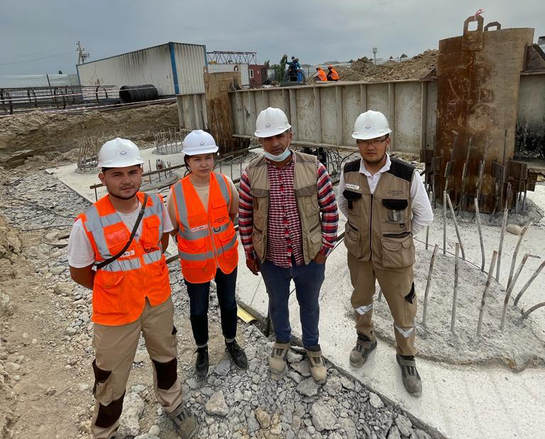

Figure A.1 – Conducting static load test of piles with the team of Alsim Alarko

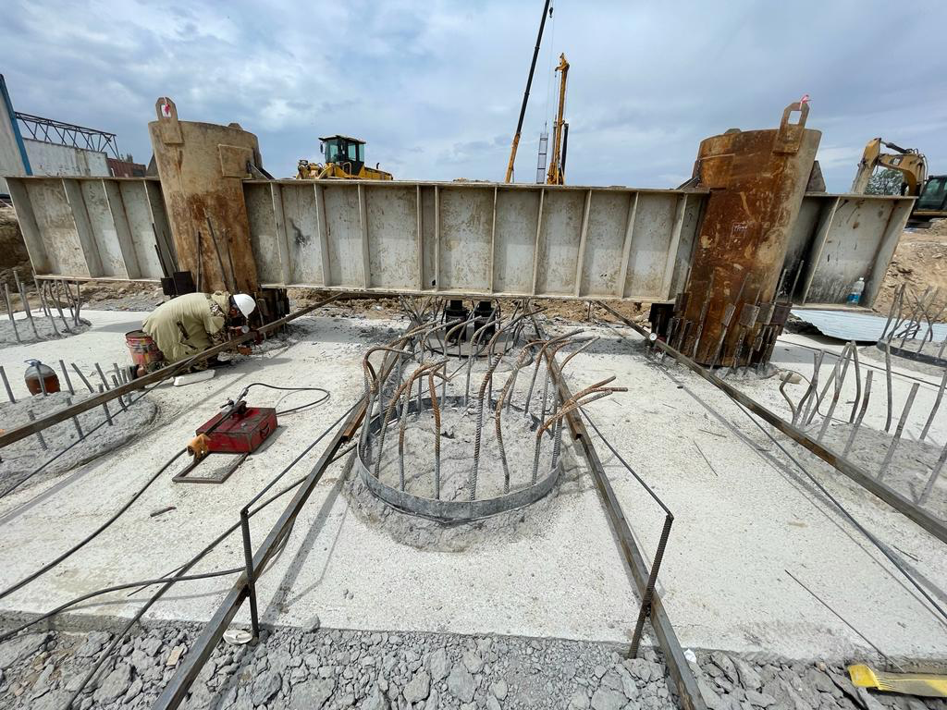

Figure A.2 – General view of the support prepared for the test work
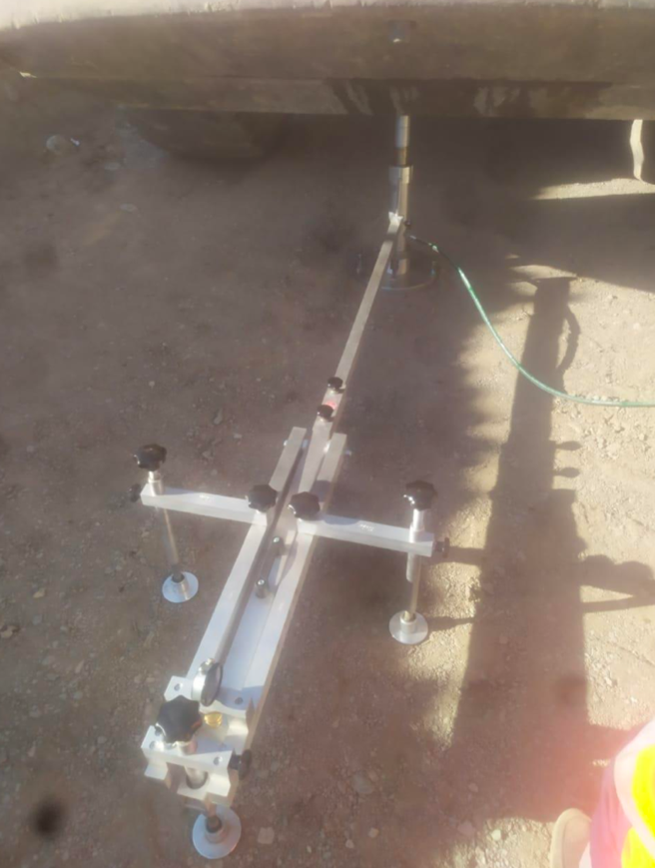

Figure A.3 – Plate-bearing test

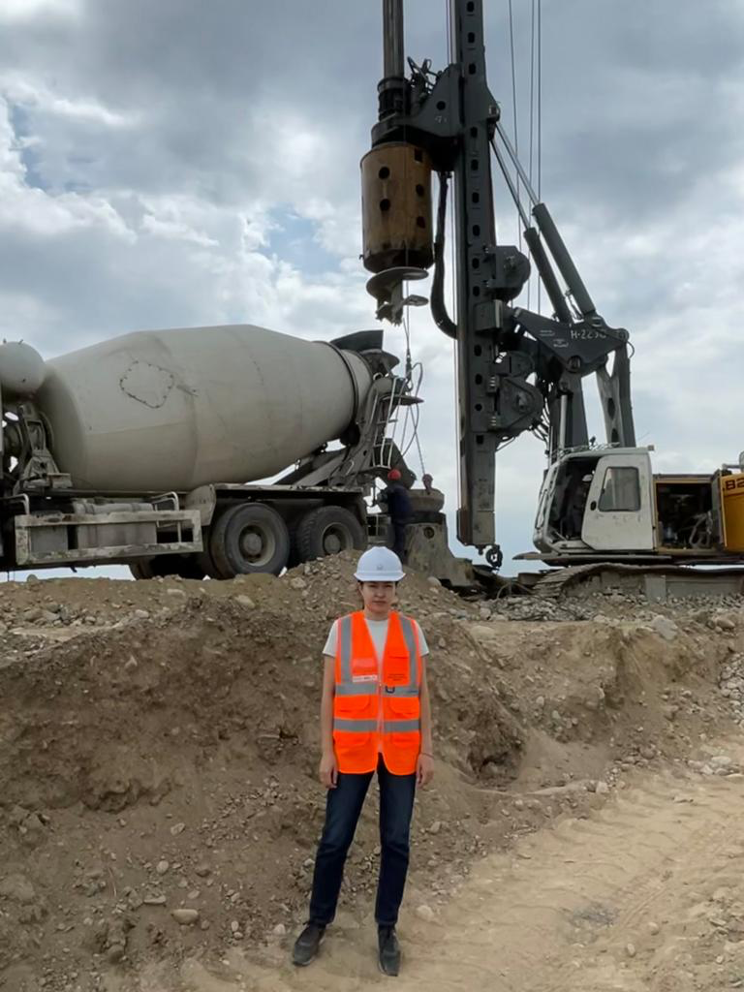

Figure A.4 – Participation in drilling and pouring of bored piles
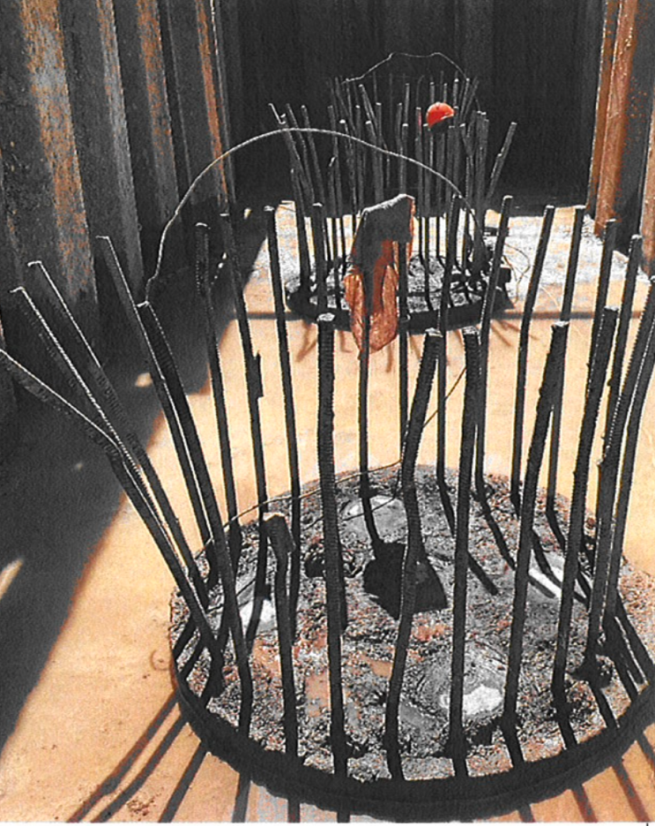

Figure A.5 – Pile integrity test

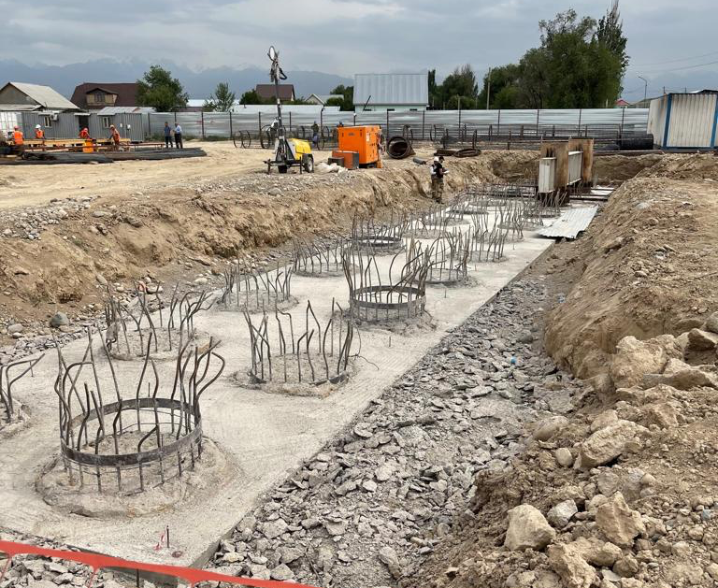

Figure A.6 – General view of the pile field
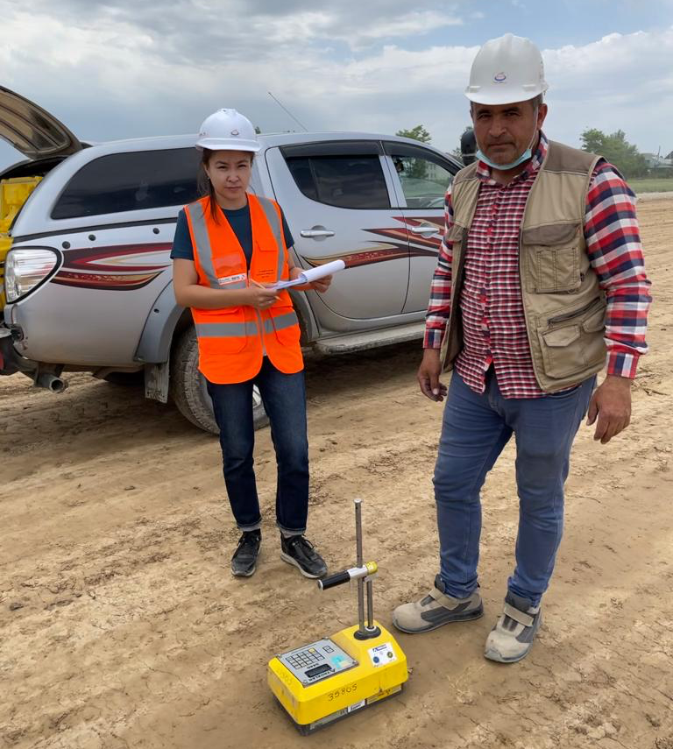

Figure A.7 – Measuring embankment density

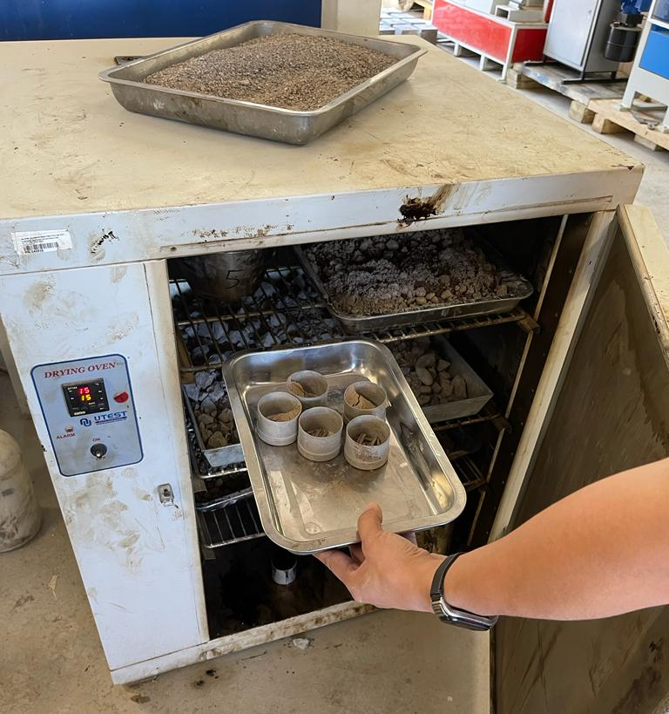

Figure A.8 – Determination of the mechanical properties of the soil

APPENDIX B

Certificate of scientific online internship in «Korea Consultant Co.», Ltd



APPENDIX С

Certificate of attendance of 20th ICSMGE in Australia

APPENDIX D

Certificate of authorship

APPENDIX E

Implementation act



