Al- FARABI KAZAKH NATIONAL UNIVERSITY

UDC: 32(581) (043) On Manuscript right

ZALAND FAIZ MUHAMMAD

Peace-building process in Afghanistan: Political power distribution and it’s future

8D03104- Political Science

Dissertation for the degree of Doctor of Philosophy (PhD)

Research Supervisor: Rakhimbekova Bakyt K,
Candidate of Historical Science

International Supervisor Sultan Barakat, PhD,
Prof. Qatar Foundation’s Hamad Bin Khalifa
University

Republic of Kazakhstan
Almaty, 2024
TABLE OF CONTENTS

DESIGNATIONS AND ABBREVIATIONS 3
INTRODUCTION 4
1LITERATURE REVIEW 9
1.1 Background and provisions 9
1.2 Theoretical Base of Prior Research 14
1.3 Methodology 15
1.4 Bibliometric analysis results 17
1.5 Network analysis and Co-Occurrence Analysis 23 1.6 Content analysis (Clusters) 27
1.7 Implications, Limitations and Future Research Directions 31
2 Theoretical FrameworkS 33
2.1 Linking to Theories 33
2.2 Concepts overview: peacebuilding, peacekeeping, and peace-making 36
2.3 Complexities of the peacebuilding process in Afghanistan 41
3 Empirical Results and DICUSSION 47
3.1 Research methods and Data collection 47
3.2 Ontology and Epistemology of the Study 49
  - Warlord Democratization in Afghanistan 60
3.4 Factors leading to the failure of US counterinsurgency efforts 74
3.5 The conflicting synthesis of the Taliban's religious and cultural identity 85
3.6. Way Forward and Recommendations 104
CONCLUSION 105
REFERENCES 108
APPENDIX 125

DESIGNATIONS AND ABBREVIATIONS:

CEO Chief Executive Officer
CIA Central Intelligence Agency
COIN Counter Insurgency
CT Counter Terrorism
DAIG Disbanding of Illegal Armed Groups
DDR Disarmament, Demobilization and Reintegration
DoD Department of Defense
EIT Islamic Movement of Easter Turkistan
EU European Union
GNP Gross National Product
IED Improvised Explosive Device
IHL International Humanitarian Law
ISIS-KP Islamic State Khurasan Province
NGO None Government Organization
PDPA The People’s Democratic Party of Afghanistan
PhD Doctor of Philosophy
PRT Provincial Reconstruction Team
MM Millimeter
MP Member of Parliament
MPVP Ministry for the Propagating of Virtue and the Prevention of Vice
NATO North Atlantic Treaty Organization
N/A Not Applicable
NRF National Resistance Front
PRISMA Preferred Reporting Items for Systematic Reviews and Meta-Analysis
SIGAR Special Inspector General for Afghanistan Reconstruction
SLR Systematic Literature Review
TTP Tahreek Taliban Pakistan
UAE United Arab Emirates
UN United Nation
UNAMA United Nations Assistance Mission in Afghanistan
USA The United States of America
USSR The Union of Soviet Socialist Republics
USIP United States Institute of Peace

INTRODUCTION

The relevance of the dissertation research. The long-term conflict in Afghanistan is exacerbating the socio-economic crisis in the country. This is a severe obstacle to the stable development of Afghan society and a challenge to regional and global security. The peace talks in Qatar in September 2020 between the Government of the IRA and the Taliban could contribute to ending the conflict and implementing measures for the peaceful construction and development of the country. But the events following the announcement of the withdrawal of international forces from Afghanistan and the coming to power of the Taliban government have once again put on the agenda the issue of finding ways to resolve the conflict as soon as possible by peaceful means.
Numerous radical changes have taken place in the current socio-economic and political situation in the peace-building process in Afghanistan due to the prolonged high level of violence, lack of political consensus and lack of trust between the various parties to the ongoing conflict, exacerbated by the hasty and chaotic withdrawal of US and NATO troops in August 2021. Moreover, unavoidable national, regional, and global disruptive factors have devastated the international community's peace-building efforts.
The international community, led by the United States, has yet to see opportunities for nation-building in Afghanistan. Its efforts have failed in all five sectors of the nation-building initiative, such as creating a secure environment, ensuring good governance and democracy in the country, establishing the rule of law, creating a sustainable economy, and improving the social well-being of Afghans.
Thus, the study's relevance relates to the fact that events in Afghanistan always directly affect the region's internal security and external relations. However, the central and much more critical of these consequences has been the escalation of religious extremism in and around Afghanistan, which threatens peace and stability throughout the region.
Numerous studies have focused on peacebuilding, which aims to reduce violence and destabilization worldwide. However, the systematic study of peacebuilding issues needs to be improved.
The purpose of the dissertation research is to identify the main factors, consequences of the peace-building process and the distribution of political forces (actors) in Afghanistan over the past two decades based on the application of theoretical and conceptual approaches of modern political science in the study of peace-building problems and the introduction of empirical data into scientific circulation, allowing us to imagine the complexity of the process of reconstruction of political and social stability in this country.
The objectives of the study are:
- identification of differentiation in the use of basic definitions in determining the complexity of the peace-building process in Afghanistan;
- study of ontological and epistemological aspects of theories of peace-building and post-conflict reconstruction;
- consideration of the historical context of the problem of peacebuilding in Afghanistan;
- identification of contradictions in the religious and ethnocultural identity of the Taliban movement;
- determining the level of scientific sophistication of the problem of peacebuilding in general, and in Afghanistan, in particular, using the methodologies of bibliometric research analysis (Meta-Analyses (PRISMA) and content analysis;
- analysis of the reasons for the ineffectiveness of the strategy of the United States and the international community to establish peace and stability in Afghanistan over the past two decades:
- assessment of the influence of internal political actors on the post-conflict reconstruction process in Afghanistan;
- conducting sociological and expert surveys to determine the attitudes of representatives of various social groups towards the prospects of peacebuilding and the distribution of political power in Afghanistan.
The object of the study is the peace-building process in Afghanistan in the period from 2001 to 2022; the distribution of political power and the influence of external and internal political actors in the peace-building process in Afghanistan.
Scientific novelty of the research:
1. the dissertation is the first research project devoted to the failure of the efforts of the United States and the international community to build peace in Afghanistan after the transition of power to the Taliban movement;
2. the study attempts to provide empirical data explaining the main factors that led to the failure of the U.S. government and the international community's peace-building efforts in Afghanistan;
3. the study analyzed empirical data on the ground in Afghanistan, as well as conducted interviews with experts throughout the country and abroad;
4. this scientific study provides specific recommendations for future peace-building efforts in Afghanistan and any other country facing attempts at external State-building through military invasion;
5. an extensive systematic analysis of scientific literature has been conducted in seven blocks, which focus on the psychological impact of wars and rebellions, as well as the effects of wars and revolutions on society and hybrid forms of the world, it presents the main bibliometric analytical descriptions, including the year of publication, journal, author, affiliation, keywords, and geographical location.
Research methods. The thesis was written using qualitative and quantitative research methods. To determine theoretical and conceptual approaches to the study of the peace-building process in general and in Afghanistan in particular, a systematic literary review was conducted using a bibliometric analysis of 2,291 articles using Bib-Excel and a content analysis.
An expert survey was conducted (using the Delphi method); the sample consisted of 86 experts in Afghanistan's conflict, peacebuilding, socio-political, and military context. Structured and unstructured methods of interviewing 507 respondents were carried out. The analysis also used secondary sources of data collection from various documented sources, reports from non-governmental organizations on the development of the peace-building process in Afghanistan and failures in state-building from SIGAR (Special Inspector General for Afghanistan Reconstruction), the United Nations, etc., analysis of periodicals, mass media, and social networks. Primary and secondary data sources were used to gain knowledge and answer the research questions: Why have peace-building efforts in Afghanistan failed? The supporting questions were: what were the main difficulties in the peace-building process in Afghanistan? How has the democratization of warlords affected the peace-building process in the country? Why have U.S. counterinsurgency efforts in Afghanistan failed? How much have the Taliban changed since they returned to power?
The theoretical significance of the study: the research paper is one of the first dissertations devoted to the study of external and internal factors that led to the failure of US and international peace-building efforts in Afghanistan after Kabul fell into the hands of the Taliban movement. The study summarizes the existing peacebuilding literature and presents future research prospects. The thesis proves that war and peacebuilding are not one-dimensional, and they are influenced by many factors, such as psychological and contextual. The dissertation examines both positive and negative forms of peace. It also sheds light on hybrid forms of peacebuilding and serves as a basis for future research.
The information in this study can be used to extract specific and applicable lessons on four interrelated theoretical topics: "the complexities of peacebuilding" in Afghanistan, "counterinsurgency," "democratization of warlords," and the failure of intra-Afghan peace negotiations.
The practical significance of the study. Previous studies have shown that many peace-building efforts need to achieve their goals. Civil conflicts always end, but they usually resume. Globally, during the first ten years after the end of the conflict, 31% of them continued the protracted conflict in Afghanistan is the embodiment of the unsuccessful efforts of the international peace-building community. Thus, the lessons learned from the situation in Afghanistan can help resolve regional and global disputes.
The study has implications for various stakeholders in peacebuilding, whether they are countries at war, residents, international organizations, or Governments. The results of this study also provide policymakers and political leaders with more information needed to promote peacebuilding in war-torn and conflict-prone countries such as Afghanistan. The results of this study also enable the international community to recognize essential factors critical to the success of peacebuilding in conflict and post-conflict situations.
The main questions of this research study are termed around the peacebuilding efforts of the United States since its invasion of Afghanistan in 2001 are as follows:
R1. What were the main complexities in the peacebuilding process in Afghanistan?
R2. How did warlords’ democratization hijack the peacebuilding process in the country?
R3. Why did U.S. counterinsurgency efforts fail in Afghanistan?
R4. How much Taliban have changed since they returned to power on August 15th, 2021?

The main assumptions submitted for thesis defense:
1. In the research literature, there is a differentiation of definitions related to the peace-building process in Afghanistan: peace-building refers to all efforts to strengthen sustainable peace by creating institutions that encourage non-violent settlement of tensions and disputes, peace-building differs from peacekeeping (maintaining the balance of power and separation of warring parties), as well as from peacemaking (conflict resolution by eliminating the source of tension).
2. Numerous studies confirm the positive relationship between maintaining peace and reducing violence. As a result, there is a movement towards new peace-building formats, such as liberal peacebuilding. It believes that liberal democracy and a market economy are the best ways to achieve and preserve peace (both domestically and internationally.
3. The complexity of the Afghan religious and traditional status depends on its participants and ideological preferences; historically, Afghanistan is known for its tribal and conservative national norms. However, due to foreign incursions in recent decades, this has strengthened the ideological forces of extremists within the country. The current ideological synthesis of the Taliban is a side effect of the actions of local and global jihadist groups.
4. An analysis of the factors contributing to the failure of the US strategy in Afghanistan leads to the conclusion that state-building begins with the population since a state's sovereignty depends on its people. Strengthening national unity is a crucial element missing in the U.S. efforts to create a viable State in Afghanistan.
5. Afghan civil society played a minimal role in the peace process mainly due to its lack of foresight and, in some cases, because critical players/actors pushed it into the background.
6. The international community has tried many strategies to deal with the new incumbent Taliban Government in Kabul, from neglecting them to isolating, appeasing, and interacting with them; they have not yet produced the desired results. The only strategy is a strategy of constructive interaction that can return the Taliban movement to its starting point - before the signing of the Doha Agreement; to the compromise side, which should respect the values of the international community - human rights and accept other Afghans as political partners to create a more inclusive government in Afghanistan.
So, this descriptive qualitative study aims to expose the ineffective strategies in Afghanistan's peacebuilding processes after the invasion of the United States in 2001. Knowledge of these efforts was vital in formulating a winning strategy to overcome an insurgency.
Besides, this research study will provide specific recommendations for future peacebuilding efforts in Afghanistan and any other country facing an external state-building effort through military invasion. This research project immensely investigates the main reasons for the peacebuilding efforts failure of the United States at the very beginning of the twenty-first century: what went wrong, how warlords hijacked the formation of a democratic state, how the war was lost to a very small insurgency by a superpower which was support by more than forty countries militaries.
The research study will focus on exposing the need to look at the peacebuilding process as a necessary responsibility of the warring sides during the conflict to find a win-win solution to the competition at the very beginning of it. Thus, it encompasses how the counterinsurgency efforts of the United States failed and how Afghan warlords hijacked the democratization efforts of the international community.
Approbation of the research results. The main provisions of the study are published in nine articles, two of them on the journal Review of Faith and International Affairs (Q1-Q2, percentile 66 in Sociology and Political Sciences), indexed in the Scopus database, two articles recommended by the Committee for Quality Assurance in Science and Higher Education of the Republic of Kazakhstan, as well as in reports of international conferences.
The study's structure is as follows: Section 1provides systematic literature review, Section 2 discusses the methodology, including protocols, inclusion-exclusion criteria, and the basic research profile of the literature. Section 3 provides descriptive statistics and results, includes a discussion of factors contributing to the success or failure of the peacebuilding process, followed by limitations, suggestions for future research, and a conclusion.

- Literature Review

1.1 Background and research provisions
Afghanistan has always been at the crossroads of at least four geopolitical and security spheres: Russia and Eurasia, Iran and the Middle East, the Gulf States, South Asia, and the Indian subcontinent, and finally, the tremendous trans-regional powers such as the United States and China. According to, landlocked Afghanistan lies in the heart of Asia and links three major geographic regions: the Indian subcontinent to the southeast, central Asia to the north, and the Iranian plateau to the West [1].
The protracted conflict in Afghanistan and its implication for regional and global security turned Iqbal's prophesy true. The conflict started with the invasion of the Red Army in late December 1979. What Moscow described back then as 'the Limited Contingent of Armed Forces of the Soviet Union' entered the territory of Afghanistan on December 25, 1979, when it knew that Western intelligence services would only have skeleton staff to monitor the invasion [2]. The Christmas Day invasion was planned masterfully and well executed. The Soviet 40th Army seized the government, killed President Amin, and installed its own man, Babrak Karmal, in his place. According to the Russian General Staff report, the Soviet Army's mission was to establish advantageous conditions to prevent possible actions by the governments of neighboring countries against Afghanistan [2].
The newly established regime in Kabul, backed by over 120,000 Soviet troops, struggled to maintain control over cities, larger towns, and key garrisons. The Soviet forces employed various tactics to crush the insurgency, but the guerrillas generally managed to evade their attacks. To destroy the Mujahideen's civilian support, the Soviets resorted to bombing and depopulating rural areas. These actions triggered a massive exodus from the countryside; by 1982, around 2.8 million Afghans had sought refuge in Pakistan, and another 1.5 million had fled to Iran [3].
The Soviet plan was to stabilize the situation, strengthen the Afghan Army, and withdraw the bulk of Soviet forces within three years. However, that was not to be the case; instead, the Soviet Army was cast into a bloody war that would last for nine years, one month, and 18 days [2]. Over 525,500 officers, sergeants, soldiers, and support staff of the Soviet armed forces served in Afghanistan. At the time of the Soviet withdrawal in 1989, the official statistics from the Soviet government were that 13,833 had been killed or died of wounds, and there were 50,296 wounded or missing in action [2]. Thus, one in every eight who served was killed or injured or was missing. More important, in many ways, was the corrosive impact of this failed war on Soviet society and the considerable geopolitical humiliation of the defeat on the reputation of the U.S.S.R.
Although the Soviet Army mainly relied on the air force, the Mujahideen eventually neutralized Soviet air power using shoulder-fired antiaircraft missiles supplied by the Soviet Union's Cold War adversary, the United States. The 40th Army began to withdraw in 1988 and completed its withdrawal early in 1989. The Soviet intervention killed 1.3 million people and forced 5.5 million Afghans (a third of the pre-war population) to leave the country as refugees [2].
After the Soviet Union invaded Afghanistan in 1979, the U.S.-led West, with the support of Muslim countries, compelled the Red Army to withdraw in 1988. The country became a battlefield of proxy wars among the regional and extra-regional powers, creating instability in the entire region [4]. Skinner (2010) believes that this post-Soviet conflict has resulted in the further militarization of the Afghan people and created more internal instability, making key factions resistant to nation-building efforts, and perpetuating internal fragmentation and instability [5].
As the Mujahedeen were fragmented politically into a handful of independent and semi-independent groups, the fall of Kabul in their hand did not bring about Peace and security in the country. Resistance against the Soviets was labeled as "Jihad" by the US-led anti-communist Western allies and all the Muslim countries [4]. With time, jihadi culture spread to other countries and regions of the world with long terms taunting effects.
Though Soviet forces pulled out from Afghanistan in 1989, civil war continued as various warlords and mujahedeen factions started fighting to fill the power vacuum. The country was thus left in the throes of chaos and anarchy [4]. In this lawlessness in 1994, the Taliban also entered the fray [6]. In no time, they swept through all of Afghanistan and brought under control over 90 percent of the country [4]. The movement, supported initially by a large percentage of the local population, captured Kabul in 1996.
In the aftermath of 9/11, Afghanistan again attracted the attention of the world powers. Then, President George W. Bush Jr. declared “war on terror” and later gained the support of NATO and the international community, which is defined by Kofi A. Annan (2002) [7] as governments, urged by civil society, working together to realize the long-held dream of an International Criminal Court for the prosecution of genocide and the most heinous crimes against humanity, that is the international community in the “war on terror” [8].
In December 2001, at the UN-led Bonn conference organized to discuss post-conflict "provisional arrangements" and "re-establishment of permanent government institutions" in Afghanistan, the coalition partners agreed to work toward installing democratic rights for the Afghan people, therein demonstrating a united determination to end the tragic conflict [9].
Consequently, the international community, led by the United States, had to address the conflict in Afghanistan, as its impact on global security had become too significant to ignore. This led to the invasion of Afghanistan and the removal of the Taliban, who were the de facto authorities at the time. The Taliban's offers of amnesty and peaceful reintegration into society were rejected, and bounties were placed on their leaders' heads. As a result, they had no choice but to flee to Pakistan, where they regrouped, retrained, and rearmed before returning to wage war in Afghanistan [10].
The American decision to remove the Taliban government from power suddenly opened a window of opportunity to resolve the long Afghan conflict [11]. Undoubtedly, development and peacebuilding were essential to the U.S.A.'s objectives by invading the country. The Petersburg conference near Bonn at the beginning of December 2001 and the donor conference held in Tokyo in mid-January 2002 defined the broad outlines for Peacebuilding and reconstruction in Afghanistan [12]. “Under the Bonn agreement, a loya jirga consisting of representatives from all the country's regions agreed to a new constitution” [13].
“The U.S. government has spent around $145 billion in 20 years trying to rebuild Afghanistan. The Department of Defense (D.O.D.) has also spent $837 billion on warfighting, during which 2,443 American troops and 1,144 allied troops have been killed and 20,666 U.S. troops injured” [14]. Despite the lessons of history, the international community has once again become involved in a conflict from which an exit would be hard to envisage and in which success would be difficult to define, let alone achieve [15]. "We have nothing to fear from Afghanistan, and the best thing to do is to leave it as much as possible to itself. It may not be very flattering to our amour propre, but I feel that the less the Afghans see of us, the less they will dislike us." – General Roberts, after the second British retreat from Kabul, 1880 [5].
History may or may not repeat elsewhere, but it certainly did in Afghanistan. The U.S. intervention in Afghanistan, which has lasted longer than [two] decades, has not brought about what was most hoped for: security for the Afghan people and stabilization of the entire region [14]. It was predictable from its very outset; the invasion of Afghanistan was doomed to fail. Wimmer and Schetter (2003) [12] then suggested revising the applied strategy of reconstruction and peacebuilding in Afghanistan concerning four points:
- the reconstruction program should have a clear strategic focus and be designed as a state-building project;
- a monopoly of power cannot be established only by building a central army and disarming or integrating local armed forces. Instead, the loyalty of the country's citizens must be won through a long-term process of providing them with equality before the law and protection from arbitrary violence in such a way as to make them independent of the 'protection' of local strong men or regional warlords;
- a democracy can only release the potential for political integration following successful political stabilization and institutional consolidation.
- a program of reconstruction and peacebuilding must necessarily take a long-term perspective [13].
Galád (2012) [15] posited that acknowledgment of the Afghan reality on the ground and preparation for peacebuilding missions could effectively improve the goals of efforts pursued and carried out by the international community, with a corresponding improvement in results.
As the war was taking its toll on the military and civilians, the United States and the new Afghan government recognized that an outright defeat of the Taliban was unlikely, if not impossible [16]. In the first ten years of the military intervention, the war claimed the lives of more than 2,000 NATO troops, including at least 1.228 Americans. It costs the U.S. taxpayers nearly $100 billion annually, roughly seven times more than Afghanistan's gross national product (G.N.P.) of $14 billion [17]. The fundamental question for the U.S. was how to withdraw its military forces and achieve some "peace with honor" in Afghanistan without reaching its core political objectives. For this reason, many thought that negotiations with the Taliban and other insurgent groups were necessary, despite the formal policy of the United States not to negotiate with terrorists.
The U.S. needed a withdrawal that was not a defeat and decided to increase the cost of war for the Taliban through a sharp rise of NATO air strikes against insurgents. President Obama ordered over 30,000 US forces to shake the Taliban enough to coax them into negotiations. The American pilots dropped 2,100 bombs on Taliban positions between June and September 2010, a near-50 percent increase in the same period in 2009 [17] The shortcomings of these missions mainly relate to civilian casualties and missteps that profoundly affect the cultural and religious sensitivities of the Afghan people [15] The policy failed to produce the desired result. Besides, once it turned out that the war could not be won only through military action, the U.S. government started to explore the options for peace talks with the Taliban.
The Afghan peace process was initiated by Obama during his second term, allowing the Taliban to open an office in Doha, Qatar, which Hamid Karzai vehemently opposed then the president of Afghanistan [18]. In December 2009, President Barack Obama set a target date of July 2011 to withdraw U.S. troops from Afghanistan and hand over responsibility for security to the Afghan forces [17]. The fighting fatigue and the cost of the war were the most critical drivers of this decision.
According to Coll (2018), the United States started contacting the Taliban in 2004 when President George Bush asked Zalmay Khalilzad, then the U.S. Ambassador to Kabul, to talk to the Taliban. Later, President Obama signed an official memo in September 20110, which officially authorized State Department officials to speak to the Taliban for the first time since the invasion of the United States of America in Afghanistan [19]. Reportedly, the first secret talks took place on May 07, 2011, in Germany, where the Taliban were asked for a prisoner exchange treaty and improved treatment of their comrades in custody, the abolishment of sanctions against the Taliban, and the opening of Taliban political office in the Gulf, while the U.S.A. objectives and priority was the isolation and destruction of Al Qaeda [19].
Although formal peace talks began after the Taliban's political office was established in Doha, Qatar, in 2013, it took nearly ten years to reach a final agreement and sign a peace accord between the United States and the Taliban. On February 29, 2020, following more than a year of official discussions between Taliban and U.S. representatives, both parties signed an agreement outlining the withdrawal of American troops and setting the stage for a post-war Afghanistan [16].
After the Trump administration, the Biden administration considered the full implementation of the Taliban and the United States peace accord. However, Afghan negotiations faced a deadlock from the outset and failed to achieve tangible results [23]. Despite this, President Joseph Biden announced that international forces would depart by the fall of 2021 (whitehouse.gov, 2021), leading to the collapse of intra-Afghan negotiations and a military triumph for the Taliban [21]. The Taliban began capturing district and provincial centers on August 10, and within 11 days, on August 15, Kabul fell to the Taliban, and President Ghani fled to the UAE [23]. U.S. and coalition forces, including those from fifty different countries at various points, completely withdrew from Afghanistan on August 30, 2021. This withdrawal marked the end of a nearly twenty-year conflict and an insurgent organization's military defeat of a formidable force [9].
As the August 15, 2021, event illustrated, the international community's efforts could have been better to achieve its stated objectives. After years of invasion and the Bonn Agreement to rebuild the country, the United States and the Afghan national government still need to meet the international community's and most Afghans' nation-building goals [5].
Literature provides many reasons why the U.S.A. and its Western allies were predestined to fail. Among others, Barfield (2010) [1] believes that to succeed in Afghanistan requires less reliance on a Kabul government and more emphasis on the country's key regions, which was a lost focus in the United States lead occupation in two decades. This failure is not simply a result of over-ambitious goals but rather a fundamental inability to understand the nature of the resistance to nation-building [5]. Dalrymple (2013) [23] posited that despite a dozen countries' efforts and thousands of agencies over more than [two] decades since 2001, the country was still a mess. Similarly, Ahmed Rashid (2008) [24] explained how the war against Islamic extremism was lost in Pakistan, Afghanistan, and Central Asia because the international community failed to coordinate its military and security strategy with its development architecture while facing a breakdown with the Afghan government.
Most recently, Special Inspector General for Afghanistan Reconstruction (2022) [14] identified six primary reasons for the failure of peacebuilding efforts in Afghanistan: First, the Afghan government should have acknowledged that the United States would withdraw, leaving it unprepared for the departure. Second, the exclusion of the Afghan government from U.S.-Taliban negotiations weakened its position, encouraging the Taliban to pursue a military victory. Third, the Afghan government's insistence during intra-Afghan negotiations that the Taliban be integrated into the Republic hindered progress. Fourth, the Taliban's unwillingness to compromise further obstructed the potential for a negotiated settlement. Fifth, President Ashraf Ghani's governance through a narrow circle of loyalists destabilized the government at a critical time. Finally, the Afghan government's high centralization, lack of legitimacy, and pervasive corruption were long-term issues that contributed to its eventual collapse, setting the stage for the Republic's downfall [13].
Gregg (2018) [25] investigated the reasons behind the failure and concluded that the international community, led by the United States, missed several opportunities for nation-building in Afghanistan. Gregg posited that the international community failed in all five sectors of the nation-building initiative: creating a safe and secure environment, establishing good governance and democracy, enforcing the rule of law, building a sustainable economy, and promoting social well-being.
This research will provide a comprehensive analysis of the reasons behind the failure of U.S. peacebuilding efforts in Afghanistan over the past 20 years. It will explore underlying principles, such as peacebuilding efforts and their role in Afghanistan's peace process.
Afghanistan's peacebuilding efforts have undergone significant changes in the current socio-economic and political climate due to ongoing violence, lack of political consensus, and mistrust among the conflicting parties. These challenges were worsened by the abrupt and disorderly withdrawal of U.S. and NATO troops in August 2021[13]. Furthermore, national, regional, and global spoilers have severely undermined international peacebuilding efforts. Although peacebuilding seeks to counteract the destructive impacts of violence or conflict, as Stephen Ryan (1990) [26] noted, it should prioritize conflict resolution over the issues dividing the parties. However, in Afghanistan, peacebuilding efforts have led to the Taliban's return to power in Kabul, causing further instability in the country. According to Gregg (2018), [25] the international community, led by the United States, missed opportunities for nation-building in Afghanistan, failing in all five sectors of the nation-building initiative: creating a safe and secure environment, establishing good governance and democracy, enforcing the rule of law, building a sustainable economy, and improving the social well-being of Afghans.
This research can draw specific and applicable lessons in four interrelated theoretical themes: the complexities of peacebuilding in Afghanistan, counterinsurgency, warlord democratization, and the failure of intra-Afghan peace negotiations. This chapter includes a background review of the problem and purpose statements and a description of the research's importance and significance to peacebuilding. It concludes with an overview of the study's research method and design.

1.2 Theoretical Base of Prior Research
Since the end of World War II, the number of inter-nation wars has decreased due to the establishment of the United Nations peace-building mechanisms and the collective security system. Powerful nations recognized the importance of maintaining peace [26]. As a result, Eriksson et al. (2003) [27] found that only seven interstate armed conflicts occurred between 1989 and 2003, following the end of the Cold War in 1989. Among these conflicts was the United States and coalition forces fighting insurgents and al-Qaeda agents in Iraq and Afghanistan. However, the recent Russian-Ukrainian war has disrupted this peace [28]. The president of the United Nations General Assembly recently highlighted that the Security Council, established in 1945 to ensure peaceful conflict resolution, has become "paralyzed and dysfunctional," emphasizing that the Ukraine war underscores the need for Security Council reform [13].
Few peace initiatives have been successful. Since 1945, only one-third of settlements reached in "identity civil wars" have resulted in sustainable, long-lasting peace [29]. Governments, academics, and the public often define peace as the absence of conflict and physical violence, but various parties to a dispute may have different interpretations. Johan Galtung differentiated between negative and positive peace [30]. Positive peace involves the absence of structural violence (such as deaths related to poverty) and cultural violence (factors that desensitize people to injustice or allow them to rationalize it). Negative peace, on the other hand, is merely the absence of direct violence (such as killings). J. Lewis Rasmussen argues that both positive and negative peace are necessary for lasting peace [31].
The failure to achieve lasting peace between warring factions is not only due to opposition to resolution but also often arises from the struggle for political power during the implementation of an agreement. Issues may also lie in the structure and conduct of official negotiations to end identity civil wars [32].
The current study contributes to this discussion within the context of the "pragmatic turn" in international conflict resolution, which is moving away from the ambitious goals of UN peace operations aimed at state formation using liberal democratic models, towards more modest efforts focused on achieving "good enough" governance and protecting civilians [33;34;35]. This pragmatic shift is underscored by increasing pressure from major financial contributors to the UN peacekeeping operations to reduce costs, downsize, and withdraw from long-standing missions [36].
Recent events, such as the Russian-Ukrainian war, have intensified the need to synthesize peacebuilding literature and evaluate the efficacy of peace interventions by the UN and its allies [37]. Despite the clear evidence that peacekeeping helps prevent violence, the UN's inability to deploy peacekeeping forces when needed undermines its credibility [38].
Thus, this investigation seeks to consolidate the understanding from past literature systematically. Transparency is crucial in a literature review; hence, explicit inclusion criteria for articles are established, and exclusions are justified based on evidence [39]. Systematic literature reviews encourage researchers to scrutinize research designs, analytical methods, and causal chains (Mohamed et al., 2021)[40] They also help maintain review quality by ensuring robust evidence and consistent findings [41;42].

1.3 Methodology
A literature review is essential for developing an original theoretical model and tracking the evolution of a specific subject over time. Systematic approaches to literature evaluation can reduce bias and yield reliable results [43]. Scholars increasingly recognize the importance of systematic reviews, with dedicated papers and discussions focusing on the structured review of scientific literature and other resources [44]. Systematic reviews concentrating on a particular domain are the most common type [45]. The author employed a methodical literature review technique to address the research gap in the literature. The study's research questions involve adopting or constructing a theoretical framework [46].
The study followed the Preferred Reporting Items for Systematic Reviews and Meta-Analyses (PRISMA) method. This method includes four main steps: "identification," "screening," "eligibility," and "inclusion [47]. The PRISMA method is widely used in review studies across various fields [48]. Below is a detailed explanation of each step:
Identification:
- Formulating the Research Question: Define the scope of the review and develop specific research questions or objectives.
- Search Strategy: Develop a comprehensive search strategy to identify relevant studies. This includes determining databases, keywords, and search terms.
- Study Selection: Execute the search strategy across selected databases. Retrieve and record search results.
Screening:
- Screening Process: Screen the search results based on pre-defined inclusion and exclusion criteria. Initially, screen titles and abstracts.
- Assessment of Full Text: Assess the full text of potentially relevant articles against inclusion and exclusion criteria.
Eligibility:
- Applying Inclusion Criteria: Apply detailed inclusion and exclusion criteria to identify articles that meet the research questions or objectives.
- Data Extraction: Extract relevant data from included studies. This typically comprises study characteristics, methodologies, and critical findings.
Inclusion:
- Synthesis of Results: Summarize and synthesize findings from the included studies. This involves organizing, analyzing, and presenting the data from the selected articles.
- Meta-Analysis (if applicable): Conduct meta-analysis if quantitative data synthesis is appropriate and feasible.[43]
The PRISMA method ensures a systematic and rigorous approach to conducting review studies, minimizing bias, and producing reliable outcomes. It is widely recognized and used across various fields for its structured and comprehensive approach to literature review.
“The author employed four criteria for selecting articles: keywords, database, timeframe, and article type. The first step involved defining search terms. Based on a review of related literature, the author identified the keywords "Peacebuilding," "Peacekeeping," "Peace process," and "Peacemaking," which were combined using Boolean operators (AND, OR). The Scopus database was utilized for the literature search, with a cut-off date set at January 17, 2023. The search terms were checked in the titles, keywords, and abstracts. Initially, 7,813 articles were identified. Following an initial screening, the author included only English articles from the last decade (2013-2023) published in peer-reviewed social science, economics, econometrics, finance, and decision sciences journals. This process identified 2,464 articles. We also provided the search syntax used in the initial query. The identified articles underwent further screening and manual analysis to finalize their selection” [43].

Table 1 Search syntex

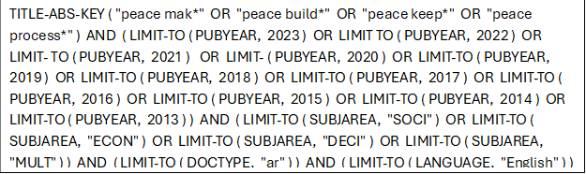
“The author reviewed articles' titles, abstracts, and keywords to determine if they aligned with the research objectives. Only journal articles were considered, while book reviews or conference papers were excluded. This rigorous screening process ensured that only high-quality papers were selected. As a result, 2,291 articles passed the initial screening and were subjected to further analysis. In subsequent sections, bibliometric and network analyses were conducted using Bib Excel and VOS viewer for comprehensive data analysis” [43].
Two thousand two hundred ninety-one articles underwent bibliometric analysis. Various tools, such as HistCite and Bib-Excel, are available for this purpose, and the author chose Bib-Excel due to its flexibility and ability to handle multiple database files. Data processed with Bib-Excel can also be exported to other software tools like VOS viewer and Gephi [49]. Bib-Excel requires a dataset in RIS format containing all bibliographic details of the documents for analysis [50].
After completing the bibliometric analysis, the author performed network analysis to identify clusters within the dataset. VOS viewer was used to create network diagrams, employing co-citation and bibliographic coupling analyses. Initially, a co-citation analysis was conducted with a threshold of five interlinkages, resulting in 244 articles segmented into seven clusters. Subsequently, bibliographic coupling was performed with a threshold of fifteen interlinkages, resulting in seven clusters comprising 240 articles. The author then selected seven clusters based on representative articles identified through co-citation and bibliographic analysis.
To further refine the dataset, the author manually analyzed the content of the 240 articles. Given the labor-intensive nature of this task and its potential impact on the quality of analysis, only the top 20% of articles from each cluster were selected for detailed manual analysis [50;51]. “As a result, the author used 52 papers for the final content analysis” [43].

1.4 Bibliometric analysis results
The study utilized bibliometric analysis as a quantitative method to manage the growing literature in a specific field [51]. However, existing literature suggests that bibliometric analysis alone cannot replace conventional literature review methods; it should be used as a supplementary approach [52]. Therefore, to ensure the study's robustness and generate valuable insights, the research also conducted content analysis to examine influential articles in the field [53]. “Bibliometric research examines data characteristics such as the year of publication, journal, author, affiliation, keywords, and geography (country)” [ 42].

Figure 1: A research framework

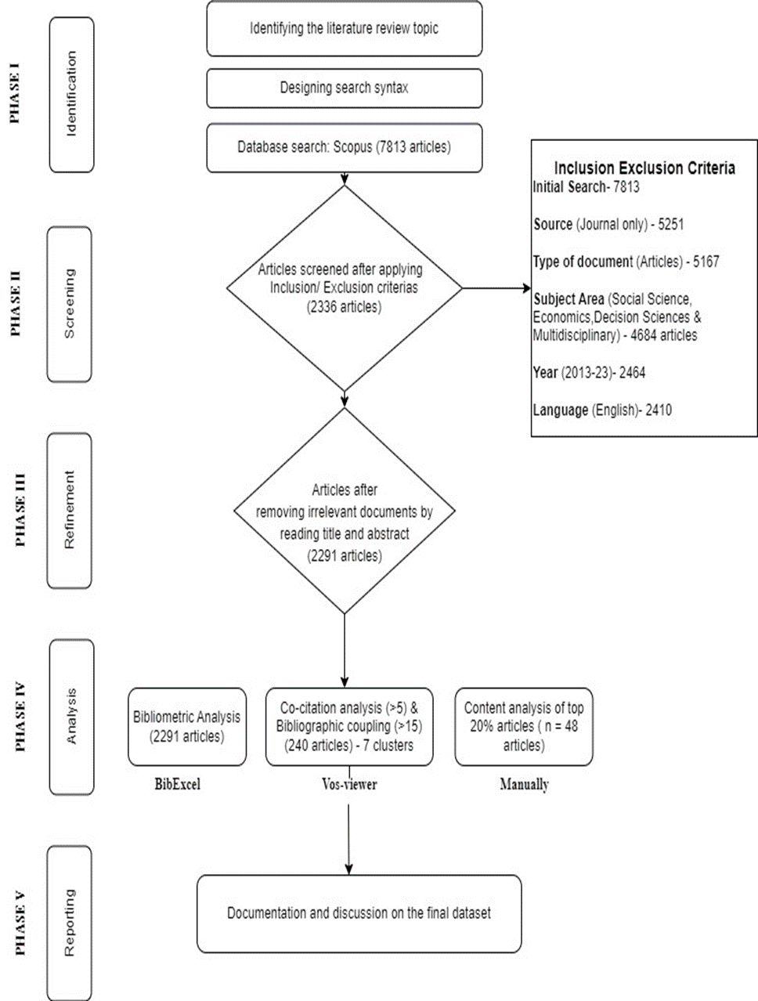

Figure 2: Publication Trend Documents by Year

Figure 2 displays the trendline of documents published in peacebuilding over the past decade. The frequency of papers published annually was obtained using Bib-Excel (tag PY). While the field itself is well-established, there has been exponential growth in publications over the last decade, indicating increasing scholarly interest. In 2022, 291 articles were published; as of early 2023, the field has already seen nine publications [43].

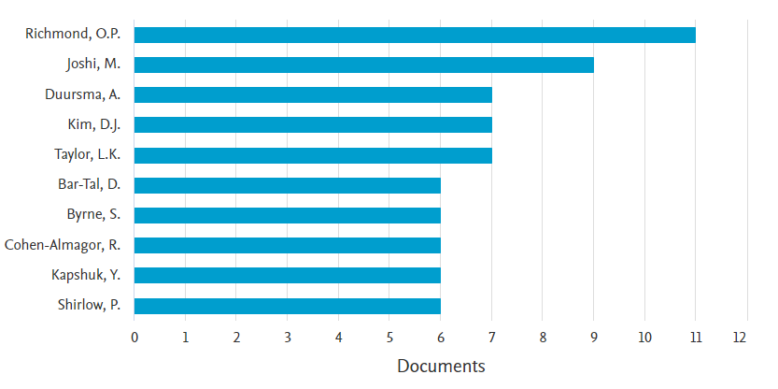
Figure 3: Documents by author

Figure 3 presents the Top 10 most influential authors in the peacebuilding literature. Numerous scholars, academics, and practitioners have extensively researched this domain. Using Bib-Excel, the frequency of documents published by different authors was analyzed (AU tag in Bib-Excel). The frequency was sorted in descending order to identify the field's Top 10 most influential authors. The criteria included both solo and co-authored papers. Oliver P. Richmond and Madhav Joshi emerged as the most influential authors in the domain (see Richmond, 2018; Joshi & Darby, 2013). [55; 56] Future researchers can use this data for collaboration and to synthesize the existing literature in the field [43].
Additionally, the documents in this domain were categorized and sorted based on annual publications in the Top 10 contributing journals. This analysis guides future researchers by identifying potential outlets for their studies. 2022 Peacebuilding Journal published the most articles, while Peace and Conflict Journal led in 2021, and Third World Quarterly had the most publications in 2020 [43].

Documents per year by source:

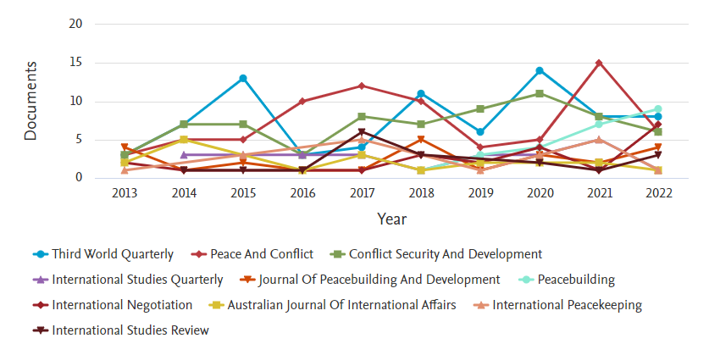
Figure 4: Publication trend in the Top 10 journals

“The journals with more publications indicate more significant interest in these journals for publishing articles relevant to the domain (Zaland, Sharma, & Pandey, 2023) “.[43]

Documents by Affiliation

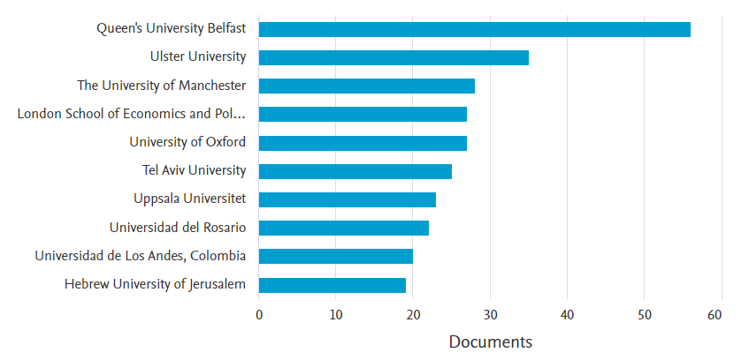

Figure 5: Top 10 affiliating institutes

“Figure 5 illustrates the most influential institutes publishing in peacebuilding. Using Bib-Excel, the analysis involved compiling a list of institutes affiliated with publishing authors and sorting them in descending order. Such an analysis helps scholars identify institutes actively supporting research in the domain and can guide future collaborations and studies. The analysis shows that Queen's University Belfast has supported the publication of the most articles in the field, followed by Ulster University and the University of Manchester” [43].
Documents by Country

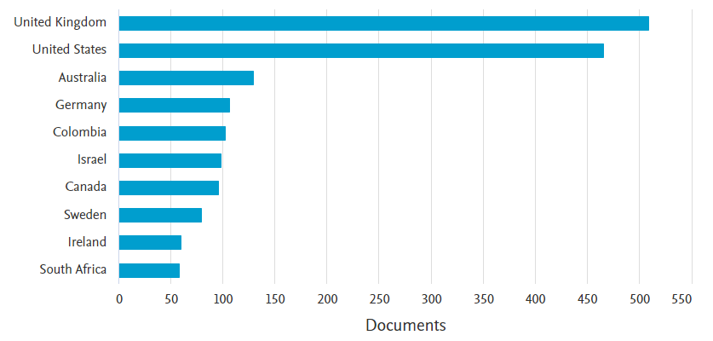
Figure 6: Top 10 contributing nations
“Every geographic region or country prioritizes economic growth, research, and development, essential for progress [56] Figure 6 illustrates that the United Kingdom leads with over 500 published articles, followed by the United States (466), Australia (136), and Germany (110). These figures underscore the dominance of developed nations in contributing to this field. This presents a significant opportunity for authors from developing nations to increase their contributions, potentially advancing both the field and their own countries' economic growth” [43].

Figure 7: Top contributing journals

“According to preliminary analysis using Bib-Excel, more than 186 journals have contributed to the domain of peacebuilding, collectively publishing around 2,291 articles from 2013 to 2023. Figure 6 identifies the top 10 contributing journals in this field. These journals have published a total of 372 papers, accounting for 16.24% of the total publications. Third World Quarterly leads with 77 articles, followed closely by Peace and Conflict with 75 articles, and Conflict, Security & Development with 69 articles. Authors and researchers aiming for greater manuscript acceptance can target these journals for publication” [43].

Frequently used keywords
“Keyword statistics have long been a cherished tool for analyzing datasets. Statistics is a scientific method for uncovering relationships between sub-fields within a particular domain [57]. The analysis was conducted using Bib-Excel. The author performed a comparative study of high-frequency keywords in documents related to peacebuilding. Figure 8 presents the top 20 keywords widely used in articles. "Peace process" emerges as the most frequently used keyword, appearing 976 times, followed by "peacekeeping" (276 times) and "peacebuilding" (190 times). The analysis also highlights keywords such as "war," "human rights," "women's status," and "religion," suggesting that articles in this domain frequently address topics related to women, religion, and wars in various regions “[43].

Figure 8 keywords

1.5 Network and co-occurrence analysis

Network analysis tools offer detailed insights into the connections between articles, citations, and co-citations, facilitating the identification of relevant research trends [59]. Various tools such as Pajek, Vos-viewer, Hist-Cite, and Gephi are available. Hist-Cite is specifically designed for Web of Science data, while Pajek exclusively uses the ".net" file format [60]. “In contrast, Vos-viewer imposes no such limitations and allows adjustments in network visualization. Therefore, Vos-viewer was chosen for this study. Each article contains distinct information fields essential for conducting the analysis. Data for the Vos-viewer analysis was collected from Scopus bibliographic data, specifically focusing on the list of references for each publication. This format was further utilized for citation and co-citation analysis” [43].
To gain insight into the content, the author conducted “a co-occurrence analysis of keywords in 2,297 articles. Co-occurrence analysis identifies frequently appearing keywords and maps the network of keywords distributed across the papers” [61]. “Figure 9 depicts the network visualization of 546 keywords that appeared at least five times. The most used keywords include "peace process," "peacebuilding," and "security” [43].
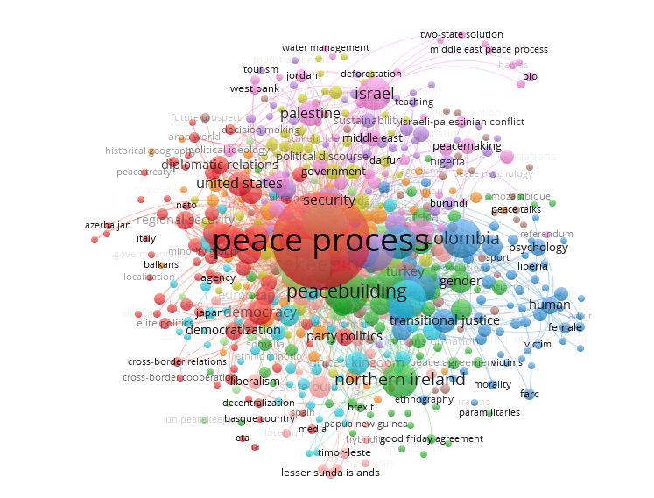

Figure 9 Co-occurrence analysis

Citation Analysis
The degree of connectedness between pairs of nodes in the network was investigated using citation analysis. Initial results from Vos-viewer indicated that out of 2,297 articles, 1,679 were connected, with articles as nodes and connections as edges. Among these, 816 articles were cited at least five times in the network.
Table 1 lists the top ten cited articles. Ginty (2013) [62] was the most cited article in the literature, with 524 citations, followed by Pettersson (2015) [63] with 304 citations. “It's important to note that citation analysis results may be biased towards older articles, which generally have more time to accumulate citations. Figure 10 provides the network visualization of the citation analysis, highlighting articles with higher citations. Following the citation analysis, the study proceeds to co-citation analysis”[43].

Table 2. Citation Analysis

Sr. No. | Article | Citations
1 | Ginty r.m. (2013) | 524
2 | Pettersson t. (2015) | 304
3 | Gready p. (2014) | 243
4 | Leonardsson h. (2015) | 157
5 | Mac Ginty r. (2015) | 145
6 | Karlsrud j. (2015) | 111
7 | Allison r. (2013) | 105
8 | Randazzo e. (2016) | 87
9 | Meskell l. (2015) | 84
10 | Wagner w. (2016) | 77

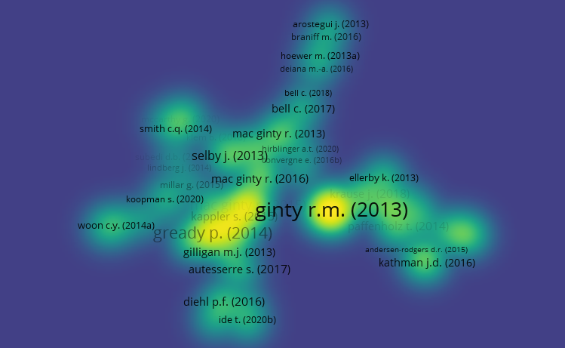

Figure 10. Citation analysis network visualization

Clustering: Classifying the Extant Literature
Nodes in a network can be classified into clusters or themes where the density of edges is higher between nodes within the same cluster compared to those between nodes of different clusters [64; 65]. In the context of research articles, nodes represent papers with connections to other papers within or across study areas. Data clustering using Vos-viewer serves as a method to group a set of provided articles, enabling the typological study of networks by identifying subjects, inter-relationships, and cooperation patterns [66].
The adoption of network analysis is driven by three main factors. First, it allows researchers to visualize dynamic knowledge areas based on connections and scientific advancements. Second, it provides a quantitative approach to charting the links between publications mathematically and statistically [66]. Researchers extensively use it to select relevant papers for content analysis [67;68;69;43].
“Hybrid analysis using co-citation and bibliographic coupling resulted in the identification of seven clusters (Table 2). Co-citation [70;71] and bibliographic coupling [72] systematically map citation linkages between publications. When papers cite or are cited by each other frequently, they are more likely to belong to the same clusters and approaches [73]. “A threshold of five interlinkages was used to extract typical articles for co-citation and bibliographic coupling analysis. Table 2 summarizes the themes of each cluster. Figures 11 and 12 present the network visualizations of the co-citation analysis and bibliographic coupling “[43].

Table 3 Themes of each cluster

CLUSTERS | No. of Articles
Cluster 1 | 68
Cluster 2 | 52
Cluster 3 | 38
Cluster 4 | 26
Cluster 5 | 21
Cluster 6 | 19
Cluster 7 | 16

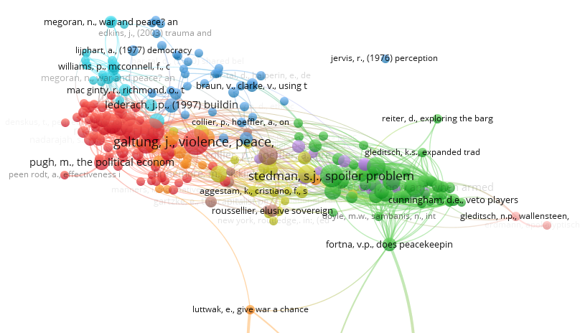

Figure 11 Network visualization (Co-citation analysis)

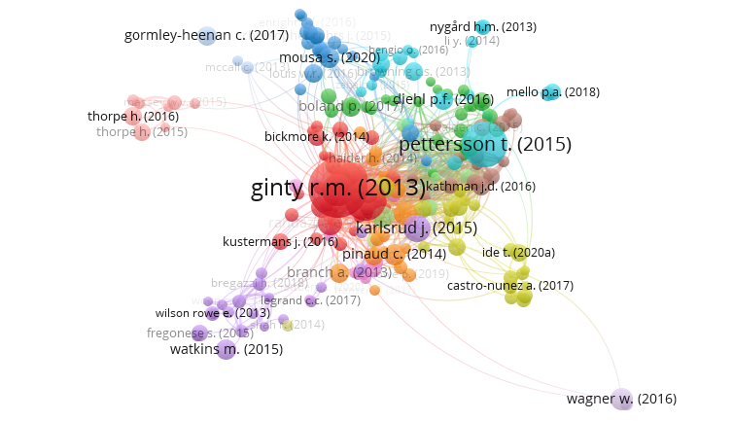

Figure 12 Network visualization (Bibliographic coupling)

1.6 Content analysis (Clusters)

Articles used in content analysis 1: Peace-building

“The current study focused on analyzing the top 20% of highly cited articles from each cluster out of 240 articles. Manual exploration of the content of all 240 articles would have been time-consuming and could potentially compromise the quality of the analysis, so 52 articles were manually analyzed [74]. The selection of highly cited articles ensured the inclusion of the most significant papers and contributed to the transparency of the review process [75] Table 3 presents the articles used in the final content analysis” [43].
This cluster focuses on the positive aspects of peacebuilding and explores various theoretical concepts underlying peace-building efforts. Notable authors, such as Vasilopoulos (2018),[76] emphasize the concept of positive peace, arguing that opportunities for peacebuilding exist during and after conflicts. Vasilopoulos distinguishes between negative peace, which is the absence of violence or war, and positive peace, which involves the integration of human society [76].
“According to South (2018),[77] external actors interested in "thinking and working politically" should move beyond conventional peacebuilding and development initiatives focusing solely on bolstering the state. South advocates for conflict-aware and context-sensitive strategies” [77].
Bureaucratic Process and Anthropological Sensitivity
The extant literature on peacebuilding often portrays it as a bureaucratic process [54] Hence, there is a growing need for anthropological and ethnographic sensitivity in peace-building efforts. Mason (2013) [78] argues that addressing trust, security, and economic dependencies at the grassroots level is crucial to preventing peace-building processes' failure.
Role of Civil Society and International Involvement
The success of peace-building efforts heavily relies on engagement with civil society and the extent of international involvement [79]. Local participation in peace-building processes is particularly significant [80; 81; 82]. However, there is ongoing debate regarding who should be considered "locals" [83].
Assumptions and Third-Party Involvement
Differing assumptions among the parties involved in peacebuilding often lead to the failure of these processes [84]. The literature emphasizes the importance of third-party involvement for successful peace-building negotiations [85].
Role of International Institutions
International institutions, such as the UN, play a crucial role in peace-building efforts, as stabilizing peace is more complex than simply achieving a consensus [86;87].
Cluster 2: Impact on Society & Geopolitics
Cluster 2 focuses on the impact of wars and insurgencies on society and the political situation of regions. Researchers such as Reuveni & Madigan (2019) [88] and Ide (2020) [89] argue that more attention should be paid to these impacts.
Wars and insurgencies cause tension and are financially and emotionally expensive [90] They often start due to extreme inequality, lack of political rights, or societal, racial, and religious divisions [91; 92] significantly influencing society negatively.
Tourism and Societal Peace
Several studies have shown how tourism can foster societal peace. Litvin (2020) [93] argues that for tourism to contribute to peace, significant structural factors must be addressed that determine civil society's strength, particularly reciprocity [94].
Conflict, Security, and Terror Issues
Since September 11, 2001, scholarship in and outside political geography has critically engaged with conflict, security, and terror issues [95;96;97]. War dominates the literature on peace and conflict, often abstracting peace into macro-level or isolated empirical occurrences [98;99].
Societal Transformation and Peacebuilding
Wars shift social values and contribute to societal transformation. Therefore, peacebuilding should be integrated into everyday practices [100,43]
Cluster 3: Hybrid forms of peace
In addition to the previously discussed literature, peace literature also finds its roots in political psychology and other less common domains. Peaceful conflict resolution is hindered by the ethos of conflict, collective memory, collective emotional orientation, and their components [100]. These obstacles, rooted in a culture of competition, inhibit individuals from processing information in a way that leads to new perspectives. Literature defines these barriers as "an integrated operation of cognitive, emotional and motivational processes, combined with a pre-existing repertoire of rigid conflict-supporting beliefs, world views and emotions that result in selective, biased and distorting information processing" [101; 102, 220].
Hybrid Peace
Hybrid peace emerges from the intersection of locally based peace initiatives with international support and indigenous, traditional, and customary practices. Mixed peace results from the interaction of local actors' abilities to offer and uphold alternative forms of peacemaking, as well as their capacities to reject, ignore, or adapt liberal peace approaches [103; 61].
Role of Technology in Peacebuilding
Technology is expected to be increasingly significant in peace-building processes [104;105]. It can assist in maintaining dialogues and cooperation. Emerging media, such as social media and technology-based news platforms, are also expected to have a broader impact [106].
Adaptation of Liberal Peace Initiatives
For peace to endure, local actors must resist, challenge, or adapt to liberal peace initiatives, while liberal peace agents, networks, and structures must incentivize compliance [62].

Cluster 4: Politics Behind War & Gender
To a greater extent, the politics before and after war play a significant role in sustaining peace. Researchers must carefully consider these contexts [107].
International Peace Interventions
Since the conclusion of the Cold War, there has been an increase in international peace interventions, with UN operations, non-governmental organizations, funders, diplomatic missions, and regional organizations becoming more prevalent and influential [104; 105;106]. Understanding the factors that influence the performance of these projects is crucial for academics, professionals, and citizens of post-war governments [108].
Success of Peace-Building Projects
A peace-building project, program, or intervention is successful when most involved parties believe it has promoted peace in the intervention area [109].These parties include the project's implementers (international interveners and local peacebuilders) and intended beneficiaries (local elites and ordinary citizens) [110].
Armed Conflict and Political Ecology
Armed conflict in the post-Cold War era is increasingly influenced by a specific political ecology connected to natural resources' geography and political economy ( [111;112].
Women's Involvement in Peace
The UN has actively worked to secure women's involvement in peace processes, particularly in fostering peace and post-conflict rehabilitation. This effort is reflected in the Security Council's recent statement on "women and peace and security" (Shepherd, 2011).[190]

Cluster 5: Strategies behind peacebuilding
This cluster focuses on “strategies that contribute to better and sustained peacebuilding” [40]. The consensus has been criticized for its liberal and apolitical approach, which often omits political components despite its strong emphasis on universal standards and generic solutions, both in theory and [113].
Inclusion as a Strategy
Inclusion has become a vital concept in promoting peace. However, its precise meaning and the assumptions about the connection between inclusiveness and peace could be clearer [114]. The literature identifies three main objectives of inclusion: building a more legitimate peace, empowering, and protecting certain actor groups, and changing the socio-political mechanisms that fuel conflict [115].
Mediation and Negotiation During Armed Conflicts
Some strategies in the literature focus on mediation and negotiation during armed conflicts [116].
Practices for Everyday Peace
The existing literature outlines eight practices that foster a culture of everyday peace: avoidance, watching/reading, ambiguity, shielding, civility, reciprocity, solidarity, and compromise [121].

Cluster 6: Resisting wars and settlements
This cluster examines the aftermath of war and explores how parties can resist wars and achieve settlements [117;1118;119].
Impact of Forced Recruitment
Contrary to predictions, empirical research findings indicate that forced recruitment increases postwar political engagement. Former abductees are 27% more likely to vote and double the possibility of serving as community leaders [120;121].
Disarmament, Demobilization, Reinsertion, and Reintegration (DDRR)
The disarmament, demobilization, reinsertion, and reintegration (DDRR) process of former combatants crucially impacts the transition from conflict to peace. The success or failure of DDRR strongly affects the long-term stability of post-conflict societies [122;123].
Ways to Protect Communities and Restore Peace
Literature suggests various ways for communities to protect themselves and restore peace [124] although these suggestions still require further empirical validation [43].

Cluster 7: Psychology of war & human security
This cluster provides insights into psychological factors that promote war and those that help prevent it. Evolutionary warfare has gained significant attention over the past two decades [125]. Rather than adaptationist interpretations of psychology, it focuses on ancestral influences, prevalence, and the evolution of weapons of war [43].
Norms in International Politics
Norms in international politics determine which ideas matter, to what extent, and for whom [126]. Constructivist theorists study situations where global norms triumph over local beliefs and practices [127].

Women's Political Demands
Drawing strength from shared experiences, women have realized that the political demands of millions carry more weight than the voices of a few [128;129].
Impact of Media on the Psychology of War
Media news significantly impacts the psychology of war [130;131;132]. When combined with human security, information takes on different forms and influences [133;134].
Local Politicians, Religion, Culture, and Ideology
The psychology behind war is often shaped by local politicians' religious ethos, culture, and ideology [135;136;137].
Peacebuilding as a Multi-dimensional Phenomenon
“Peacebuilding is a multi-dimensional phenomenon explored across various domains such as psychology, sociology, and history” [43].

  - Implications, Limitations and Future Research Directions
The current study synthesizes the existing literature on peacebuilding and proposes future research agendas. The literature is segmented into seven clusters, each providing detailed insights into various aspects of peacebuilding. The study has implications for various stakeholders in peacebuilding, including nations in conflict, local communities, international organizations, and governments [43].
- Summarizing and Collating Peacebuilding Literature: The study assists academics in summarizing and collating the literature on peacebuilding, identifying new areas that require further investigation.
- Multidimensional Nature of War and Peacebuilding: It highlights that war and peacebuilding are not uni-dimensional issues but are influenced by multiple factors, including psychological and contextual factors.
- Positive and Negative Forms of Peace: The study reviews both positive and negative forms of peace, shedding light on hybrid forms of peacebuilding and suggesting future research agendas.
After synthesizing the existing literature, the current study proposes directions for future research to investigate less explored areas. While the study makes significant contributions, it also has several limitations.
1. Limitations:
Keyword Selection: Choosing keywords for search queries may only be partially exhaustive. Future scholars could synthesize the literature using a broader range of keywords.
Content Analysis: The content analysis used the top papers from each cluster. Future researchers could use larger datasets for a more comprehensive understanding of the literature.
Temporal Scope: The review was restricted to literature from the last decade. Future scholars could undertake more extensive studies encompassing a broader timeframe.
2. Opportunities for Developing Nations:
Most existing studies originate from developed nations such as the USA, UK, Germany, and Australia. This provides significant opportunities for governments in developing regions, particularly in Asia, Africa, and Latin America, to contribute to the domain of peacebuilding.
Future Research Areas:
Impact of Technology: The study has explored various forms of peace, including hybrid peace [62]. However, the influence of increasing technology usage on the peacebuilding process requires further exploration.
Cross-National Studies: More studies that encompass multiple nations are needed to understand how peacebuilding and its sustainability differ across developed and developing countries.
Technological Turn: “Like the "local turn" observed in the literature [138;139] future research could investigate whether there is a "technological turn" influencing peacebuilding practices” [43].
Peacebuilding to reduce global bloodshed has been the subject of numerous studies. However, the systematic study of peacebuilding needs improvement. This article conducts a systematic review of the peacebuilding research body, organizing it into seven clusters. These clusters focus on the psychological effects of wars and insurgencies, the impact of wars and revolutions on society, and hybrid forms of peace. The study also includes essential bibliometric analysis details, such as publication year, journal, author, affiliation, keywords, and geographic location.
The study “concludes by proposing a new research agenda that prioritizes evaluation and provides policymakers with information on effective peacebuilding processes, mission compositions, and mandates” [43].

2 Theoretical FRAMEWORKS
2.1 Linking to theories
John Paul Liderach (1997) believed that Peacebuilding is a dynamic social construct requiring investment and materials, coordination of labor, laying of furcation, and detailed finishing work as continued maintenance [140]. Peacebuilding efforts involve a shift in focus from the warriors, who are the primary concern of pre-peacekeeping efforts, to the attitudes and socio-economic conditions of ordinary people. Therefore, “peacebuilding tends to concentrate on the context of the conflict rather than the issues dividing the warring parties” [43].
A key goal of peacebuilding is to build, reform, and strengthen local institutional capacity [141]. In peacebuilding, the focus is on understanding the structural and cultural causes of violence and the challenges of moving from conflict resolution (attitude - behavior - resolution) through outcome alternatives (withdrawal - compromise - transcendence) to future prevention (empathy - non-violence - creativity) [142]. Theoretically, peacebuilding efforts are political, structural, or social. Political peacebuilding involves high-level political or diplomatic agreements to end a protracted conflict or prevent an impending one [143].
Lederach suggests conceptualizing conflict transformation as involving three levels of work that are needed simultaneously in his pyramid: top (policy), middle-range (community), and grassroots piece. He argues that the key to practical and strategic Peacebuilding is coordinated relationships across the levels (i.e., horizontally) and, most importantly, coordinated, and responsive relationships between the groups [140;144].

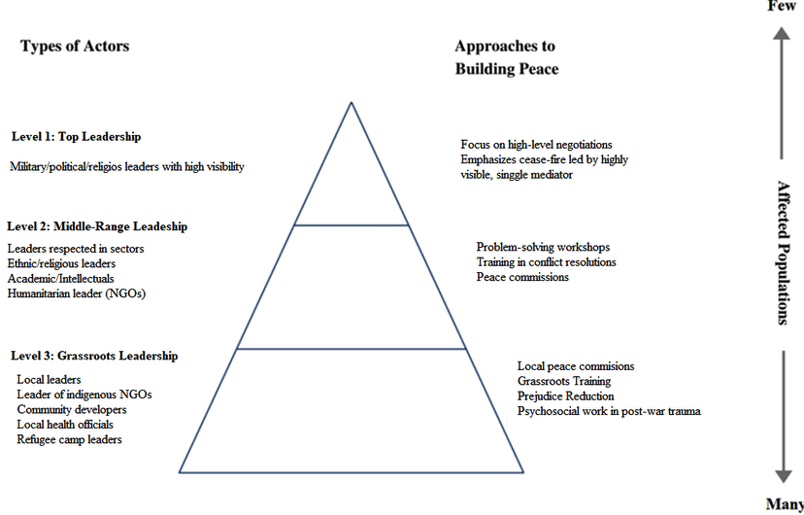

Figure13 Relationships across the levels
Heather Salma rightly points out that the U.S. needed to partner itself with the people of Afghanistan to do successful state-building in Afghanistan; state-building starts with population, as the state's sovereignty rests with its people [43]. The second key ingredient missing from U.S.-led efforts to create a viable state in Afghanistan is national-unity building [24].
Francis Fukuyama argues in his book on state-building that "only states can be deliberately constructed' and "if a nation arises from [state building], it is more a matter of luck than design"[145].
In fact, in the past twenty years, the international community led by the U.S. has failed to assist Afghanistan in stabilizing the country by providing security, humanitarian aid, and "technical assistance"; in addition, Afghanistan was not empowered enough to sustain its institutions that can survive the withdrawal of outside interventions. These two caveats caused a third failure of the state's capacity to enforce laws and provide public services evenly across the state [145]. Unfortunately, Afghanistan has seen little progress in the six pillars of stabilization: security, law, governance, economics, social well-being, and national unity [24]. Therefore, the only way out of the current failure is to grasp a peace-building process that can redraw the political power-sharing borders amongst groups inside the country.
On the other hand, since the work of peace researcher Johan Galtung, it has become common to distinguish between so-called 'negative' and 'positive' peace. The idea here is that peace is not merely the absence of armed conflict and violence but also the pursuit of social justice through equal opportunity, a fair distribution of power and material resources, and equal protection under the rule of law. Positive peace entails creating conditions under which individuals can benefit from coherent legal frameworks, public order, political stability, and economic opportunities. Peacebuilding refers to all efforts to foster sustainable peace by establishing institutions that promote and enable the non-violent resolution of tensions and disputes. Following Galtung (1976),[146] “peacebuilding is differentiated from peacekeeping (maintaining a balance of power and keeping the warring parties apart) as well as peacemaking (solving the conflict by addressing its underlying causes)” [43].
Historically, Afghanistan does not have a culture of democracy, at least not in the Western sense of the term. Barfield contends that political power in the country derived from three prominent sources: it was passed through family line from father to son within a ruling family, it was determined by the consensuses of elders in certain tribes, and, most recently, it was assumed through forces and establishing order, as was the case with the mujahedeen and the warlords and the mixture of coercion and the claim to uphold the true tenets of Islam, as was the case with the Taliban.
Through the research of the peacebuilding process, I will provide the causes of Afghanistan's conflicts before, during, and after the violence, as termed by Johan Galtung, the life cycle of a battle in Afghanistan [147].
Burnet Rubin (1995] rightly wrote that a generation of social scientists, meanwhile, had studied the determinants of democracy and the conditions necessary for its emergence; yet, those conditions have not been met in Afghanistan; almost twenty years have passed since the U.S. invasion (October 07, 2001) with a slogan of enduring freedom of Afghanistan while less is achieved in the sense of democratization, security, economic development, good governance, and nation building [148].
After decades of destructive war and harsh conflict, the only priority in life an average Afghan could have illustrated is having "peace" in the country; but how to describe "peace"? Afghans need help defining peace for themselves. In classic literature, peace is symbolized by harmony, tolerance, and understanding among people. Today, the concept of "peace" refers not only to reaching peace among individuals of society but also in a meditative, more prosperous, and more complex context, such as "Being in peace with yourself." This means achieving a state of tranquility and harmony with yourself [149].
Paul Rogers (2007) notes that "peace studies" developed in response to the carnage of the First and Second World Wars [150]. Many see war as naïve and utopian, if not dangerously unrealistic, against a logic that dictates that violence must be met with violence and that "peace" is achievable only through the force of arms [151]. For Mohammed Abu-Nimer (2000), Peace is the product of order and justice. From the perspective of Islam, “peace” is a state of physical, mental, spiritual, and social harmony [153].
In many cases, conflict is perceived as the incompatibility of goals between two or more parties or actors, leading to contention, contradiction, or dispute [153]. Then there is the idea of "peace" as the absence of organized collective violence, in other words, violence between major human groups, particularly nations, but also between classes and racial and ethnic groups because of the magnitude internal wars can have [154]. The latter situation - the absence of organized collective violence - is called "negative peace" by John Galtung (1967) [155]. In fact, "negative peace" uses the horrors of war to argue against war. Such arguments are not trying to achieve some condition but rather to prevent something else [154].
So, as there is "negative peace," there should be a positive format of "peace "as well, which is explained by John Galtung (1967) as "Positive Peace," which is a third concept of peace that is less clearly defined. This is "peace" as a synonym for all other good things in the world community, particularly cooperation, and integration between human groups, with less emphasis on the absence of violence.
The pursuit of positive peace nonetheless leads to certain agreed principles, one of which is a minimization of violence, not only the overt violence of war but also what has been called structural violence. This condition is typically built into many social and cultural institutions [155].
In the past four decades, Afghans have been looking for "negative peace" in the sense of not having "violence," mainly biological and physical violence [156]. Therefore, peacebuilding efforts have been considered the main priority of war-torn Afghanistan for the past four decades. Whereas "peacebuilding" generally refers to post-conflict interventions, based on this definition, all nation-building, state-building, political, reconstruction, and developmental work could be considered a peacebuilding effort in Afghanistan [143]. However, in post-conflict rebuilding, greater priority should be given to supporting post-war reconstruction efforts in a manner that addresses the underlying causes of conflict and creates the conditions for permanent peace [155].
For Ho-Won Jeon (2002), peacebuilding is a process based on the commitment of warring parties to resolve future conflict in political, not military, terms [156].
While Boutros Ghali (1992) referenced in his report "Agenda for Peace" Peacebuilding as the construction of a new "environment" to prevent the recurrence of violent conflict, in fact, after Boutros Ghali's (1992) "Agenda for Peace," peacebuilding concept entered to the mainstream studies [156]. Subsequently, the 2000 Brahimi Report identified a series of institutional adjustments to maximize internal UN support for more effective peacekeeping – and peacebuilding. (Gross, 2013) [141], which provided the United Nations with its first chance to implement the “integrated missions” proposed by Lakhdar Brahimi to exercise unified control over the UN's political, assistance, and peacekeeping functions [141].
In addition, John Paul Liderach (1997) [140] believed that peacebuilding is a dynamic social construct requiring investment and materials, coordination of labor, laying of furcation, and detailed finishing work as continued maintenance. Therefore, there is no agreed definition of "peacebuilding"[140]. A key goal of peacebuilding concerns the building, reforming, and strengthening of local institutional capacity [141].

2.2 Concepts overview: peacebuilding, peacekeeping , and peace-making

The problems of the definition of peacebuilding can be considered as its links with a nation or state building. Still, Matt Waldman believes that peacebuilding post-conflict interventions encompass all the efforts of nation-building and state-building [143].
In peacebuilding, the focus could be on understanding the structural and cultural causes of violence and on understanding the problems of moving from conflict modestly (attitude – behavior – contradiction) through outcome alternatives (withdrawal- compromise-transcendence) to future prevention (empathy – none-violence -creativity) [142].
Theoretically, peacebuilding efforts are political, structural, or social. Political peacebuilding involves high-level political or diplomatic agreements to end a protracted conflict or prevent an impending one [143]. This research will focus on the United States of America peace talks with the Taliban, which accomplished a peace agreement on 29 February 2020 in Doha, Qatar. Nevertheless, Rules and strategies for rebuilding a community differ from those of wartime when planning is inevitably focused on immediate survival [157].
The structural peacebuilding aspect focuses on the creation of structures, institutions, and systems that support a peace culture and often involves the promotion of an equitable and participatory system of governance; in this aspect, this research work will focus on the "democratization" efforts of the United States in Afghanistan in past two decades which failed due to many reasons [160]. However, this research will elaborate on the role of "warlords" in failing the "democratization" process as much as many other causes like corruption, not having political parties, rigged elections, and copy-paste democratic strategies from the West to Afghanistan.
The transition from peacemaking to peacebuilding is sometimes linear, given that the negotiated settlement of a long-term conflict brings challenges and opportunities for transforming conflict relationships [157]. Peace – on the other hand, conflict is a synonym for violence. Modern war is so expensive to continue (Barash, 2000) [155]. Peacekeeping, to decrease violence through the presence of peacekeepers trained in defensive military and police methods, nonviolence, mediation, and peacebuilding. It is rightly concluded that gaining peace by" utilizing stability and not utilizing war" is for the contending sides to reach a mutually acceptable agreement among themselves after the failure of the counterinsurgency [155].
Galtung (2000) points out that the war in Afghanistan involved (and continues to involve) extensive interference and intervention by outside parties [161]. This complicated the peace process in Afghanistan by having more external factors to the conflict than the mere first and second parties on the domestic level; to conclude as Gabriela Lucauta (2014) [162] elaborated that any peacebuilding activity that does not involve local traditional values and culture will not last, in the case of Afghanistan, the complexities of the peace process were more than only domestic problems like the Afghan republic fell because societal values were irreconcilable with democracy and the country was simply ungovernable, preventing a warning party to solve the conflict [162].
Therefore, the USA lost the moral justification for continuing the war in Afghanistan after claiming to defeat Al Qaeda [14]. As William Obrien (2000) stated, "To justify war, there must be a competent authority to declare war for a just cause and all peaceful alternatives must be exhausted." However, in Afghanistan, the question remains why even inadequate "negative peace," defined as the mere absence of war, has not yet been achieved [163].
Dr. Johan Galtung, one of the founders of the field of peace studies, played a crucial role in developing the concept of peacebuilding. In 1975, Galtung outlined three broad approaches to conflict interventions: peacemaking, peacekeeping, and peacebuilding [159]. The principles of the Charter must be applied consistently, not selectively, for if the perception should be the latter, trust will win and with it the moral authority, which is the instrument's most remarkable and unique quality.
John Galtung (1976) explains that "peacekeeping" means to keep the peace, which can be simplified as maintaining the absence of direct violence; he further elaborates that peacemaking and peacebuilding can proceed parallel to peacekeeping.” [165].
From the point of view of Johan Galtung (1976), peacemaking means getting rid of the source of tensions, but he considers it a conflict resolution approach. With peacemaking, the systems can eliminate or preserve incompatibility [165]. The United States, for example, tried through its counterinsurgent tactics to eradicate the Taliban insurgency, which failed drastically through its first decade of fighting the war in Afghanistan, so they considered the "fight and talk" strategy to preserve the incompatibility in its second decade of the war. [165] On the contrary, to simplify the three words, peacemaking is a pre-conflict approach that is meant to manage the conflict, peacemaking is a post-conflict approach to terminate the competition, while peacebuilding is the post-conflict approach to solve the conflict [141].
1: Peacemaking refers to activities promoting negotiation and a negotiated settlement at the leadership level.
Conflict management

Peace-making
Pre-conflict

2: Peacekeeping refers to monitoring the warring parties' compliance with the ceasefire or peace agreement.
Peacekeeping
Conflict termination
Post-conflict

3: Peacebuilding:
Peacebuilding
Conflict resolution
Post-conflict

John Galtung (1976) refers to "peacebuilding" as a self-supporting conflict resolution method; therefore, he elaborates that "structures of peace" must be found to remove causes of wars and can offer alternatives to war to be rejected by all parties involved in it [164]. In contrast, Eva Gross (2013) writes that peacebuilding is a broad concept that acknowledges the complexities of conflict and post-conflict settings and the various actors and operational requirements in implementing a comprehensive approach [141]. To extend the argument around the significance of the peacebuilding efforts, it also nurtures constructive human relationships in a society affected by conflict [167].
To conclude, peacebuilding seems an ambitious concept that enjoys broad support in post-conflict management efforts, as noticed by Charles-Philippe David (1999); through peacebuilding efforts, the presumption of hostilities is prevented, and lasting peace is established [168].
Afghanistan required a hybrid peace effort of peace-making and peacebuilding to bridge the polarities of mutual resistance between the United States, the Republic government of Afghanistan, and the Taliban, which could internalize the norms of peace over violence and lead to a compromise that could preserve everyday integrity, especially relating to rights and needs of Afghan people [169]. Peacebuilding should not be intended to revive social and political structures that have caused conflict in the first place, as in the case of Afghanistan. “Instead, it aims to put into place the facilities (if necessary, modified, or reformed systems) that will sustain peace in the aftermath of the post-war reconstruction” [40].
Peacebuilding is becoming an essential subject to understand and research as the most recent generation in global politics might be called the “age of peacebuilding.” Since 1988, the United Nations (UN) has undertaken peacebuilding operations in revolutionary number and frequency [170]. Peacebuilding strategies are based on assisting parties in joint interest-based negotiation or bringing a third party in to facilitate such a process [152].
In An Agenda for Peace, the Secretary-General defines "post-conflict peacebuilding as actions to identify and support structures that will strengthen peace to avoid a relapse into conflict." An Agenda for Peace envisages peacebuilding concerning other peace-nurturing measures: preventive diplomacy, peacemaking, and peacekeeping. Post-conflict peacebuilding comes at the end of the UN's spectrum of peace interventions because it must follow the logical order [171].
The UN peacebuilding model is very much geared towards technicalities and quick fixes. It starts with peacemaking peacekeeping and often ends after elections are held. A good example is Angola, where " the elections held in 1992 were seen as an end in themselves, which would prove a magic solution to the structural problems exposed and exacerbated by years of war and bitterness"[172].
John Paul Lederach and R. Scott Appleby (2010) also argue about the need for Strategic peacebuilding to resolve conflicts [166]. They denoted that strategic peacebuilding is an approach to reducing violence, resolving conflict, and building peace marked by a heightened awareness of and skillful adaptation to the complex and shifting material, geopolitical, economic, and cultural realities of our increasingly globalized and interdependent world. Due to their argument, peacebuilding that is strategic draws intentionally and shrewdly on the overlapping and imperfectly coordinated presences, activities, and resources of various international, transnational, national, regional, and local institutions, agencies, and movements that influence the causes, expressions, and outcomes of conflict.
In their argument of “Strategic Peacebuilding Concepts and Challenges,” they elaborated that strategic peacebuilders take advantage of emerging and established patterns of collaboration and interdependence to reduce violence and alleviate the root causes of deadly conflict. Peacebuilders encourage the deeper and more frequent convergence of mission, resources, expertise, insight, and benevolent self-interest that characterizes the most fruitful multilateral collaborations in the cause of peace [166].
Therefore, in approaches to peacebuilding, it can be add to the list the study of the “Strategic peacebuilding” approach as a crucial strategy to resolve a conflict, where strategic peacebuilding requires policies that enable people who must live with the outcomes and decisions of negotiations to have adequate and secure mechanisms to participate and influence the process and the decisions [166].
Conflicts are more likely to escalate into violence when inequalities exist [140]. When access to political and economic power is not equally available and distributed within a given society, conflicts are more likely to remain latent, generating hostilities and more complex problems with wider ramifications. Therefore, any attempt to end or prevent violent forms of competition must address power sharing and transparency of decision-making directly, including the vertical and horizontal power dimensions of intractable conflicts [166].
Peacebuilding becomes strategic when initiatives, from below, above, inside, or out, begin to link and coordinate with differentiated spaces and processes to affect the more comprehensive desired change. In a word, constructive transformation unfolds in relational areas. Strategic peacebuilding requires envisioning and encouraging the intentional confluence—the flowing together—of improbably related processes and people toward constructive change [167].
Mohammed Abu-Nimer (2000) elaborates on peacebuilding from the perspective of Islam; he explains that Communication and confrontation reduce the cost of an ongoing conflict and address all the parties' grievances [152]. The role of the third party, as an integral part of peacebuilding intervention, is mainly to facilitate communication, reduce tension, and assist in rebuilding relationships. Such interaction is functional and necessary to engage the parties in an accurate peacebuilding process. He insists that Islam encourages such an approach through an active intervention, particularly among Muslims.
The top-down technocratic focus on Afghan peacebuilding and reconstruction processes largely ignored local power dynamics. It failed to meet the most essential requirement of the population, creating the well-spring disenfranchisement that fueled the Taliban insurgency [173].
Each conflict is unique [174]. Therefore, the right mix of approaches was naturally necessary to end Afghanistan’s row over the past two decades. Through the research work it has been learned that scholars and thinkers have devised various methods to highlight different aspects of peacebuilding. For example, the top, middle, and grassroots approaches in peacebuilding processes identify the interlinkages among the three levels at which peacebuilding needs to be pursued for the best possible results [167].
On a different note, another approach emphasizes adopting an integrated, coordinated system for peacebuilding. The clear choice between peace and justice is the essence of another method. Similarly, the role and relevance of civil society and non-governmental organizations have become the prime concerns of some other systems [175]. Notably, however, these approaches have much in common. Hence, it may not be advisable to stress only one and reject other methods.
The multi-diplomacy model established by Ambassador John McDonald and Dr. Louise Diamond (1996) [175] also provides a valuable starting point that demonstrates that building peace requires the involvement of multiple sectors, organized into the following tracks:
1. Government, 2) NGO/professionals, 3) business, 4) private citizen, 5) research, training, and education, 6) activism, 7) religion, 8) funding, and 9) communications and the media [159].
In the end, two things distinguish peacebuilding from other similar activities. Firstly, it is an activity located in a post-conflict context [141]. Secondly, it seeks to address deep-rooted, underlying causes of conflict rather than deal only with visible violence. Therefore, a practical peacebuilding approach must be grounded on a deeper understanding of the parties to the conflict [176]. This requires peacebuilding efforts to be sensitive to and show an account of the feuding parties’ history, society, and political and strategic culture.
At the same time, successful peacebuilding requires national ownership on the one hand and a clear division of labor between national and international actors and agencies [175]. Given its evolutionary nature, it must also be innovative to keep evolving in the face of real-time challenges. This requires enormous staying power in terms of commitment, resources, and patience; peacebuilding processes will continue to be long-drawn and piecemeal as they seek to ensure sustainable peace [176].
In addition, practitioners of on-the-ground peacebuilding began to realize that deadly conflicts, if they are to be transformed, require multiple points of analysis and intervention to create sustainable change. Accordingly, peacebuilders began to seek strategic alliances and coordination over the longer term rather than “merely” a negotiated solution [167].

2.3 Complexities of the Peacebuilding Process in Afghanistan

“The prolonged conflict in Afghanistan has exacerbated the socio-economic crisis in the country, posing a severe obstacle to its stable development and regional security. The peace talks between the Government of Afghanistan and the Taliban in Qatar in September 2020 were seen as a potential opportunity to end the conflict and initiate measures for the peaceful reconstruction and development of the country.” [13]. However, the events following the announcement of the withdrawal of international forces from Afghanistan and the Taliban's assumption of power have once again underscored the urgent need to find peaceful resolutions to the conflict.

The role of national, regional, and international actors in establishing peace in Afghanistan is “explored based on content analysis, expert opinions (using the Delphi method), and observations by the author, who participated directly in the Doha negotiation process “[13].
The political and peacebuilding process in Afghanistan faces significant challenges, including ongoing violence, lack of political consensus in Kabul, a trust deficit on all sides, the hasty withdrawal of U.S. troops, the Taliban's conquering strategy, and interference from national and regional spoilers. Despite international efforts, the fall of Kabul on August 15 has not brought peace to Afghanistan. ISIS continues to attack the Taliban, targeting killings of the Shia minority persist, and there are uncertainties regarding the recognition of the Taliban's government by the US/EU and NATO. In this research paper, we will comprehensively analyze the complexities of the formal peace process in Afghanistan.
Expert assessment
Many experts had predicted that the withdrawal of U.S. and allied forces from Afghanistan could lead to a civil war. In contrast, others believed the Kabul government could withstand the Taliban's spring offensive for up to six months. Few, however, anticipated that Kabul would fall to the Taliban as swiftly as the rest of the country.
A well-known Kazakhstani expert, the author of a fundamental study on the history and politics of Afghanistan, Sultan Akimbekov, rightly notes the existence of problems associated with the American presence, primarily with the inability to ensure the stable functioning of state institutions and, of course, security problems inside the country[177].
Anthony H. Cordesman points out that peace in Afghanistan remains highly uncertain because the Kabul administration needs a more precise definition of the terms necessary for peace [176].
Concerns that the Afghan state might collapse are at an all-time high. Despite optimistic assessments by U.S. military officials and Afghan leaders, a report from the Special Inspector General for Afghanistan Reconstruction (SIGAR) describes the situation as "bleak," highlighting concerns that Afghan security forces were ill-prepared to mount any significant resistance. These fears were realized when Kabul fell swiftly to the Taliban in mid-August 2021 [13].
There is a pervasive public perception that the Afghan Republic has been reduced to an "oligarchic enterprise," eroding trust between political leaders, civil servants, and the public. However, the primary concern for Afghans has shifted from peace to the survival of the Afghan state. A June 2021 intelligence assessment reported by The Wall Street Journal predicted that the Afghan government could collapse within six to twelve months after complete US troop withdrawal. The subsequent rapid collapse of districts, provincial centers, and Kabul from August 1 to August 15, when former President Ashraf Ghani fled to the UAE, confirmed these fears [13].
The intra-Afghan peace negotiations, which began on September 12, 2020, quickly stalled. As noted by Wolfgang Minatti, the fundamental vision for Afghanistan's future between the opposing sides remains at odds. President Ghani and his inner circle meticulously controlled Kabul's negotiating team, ensuring it was subservient to the President, with no authority to make decisions independently. President Ghani's five-year term was a red line for the negotiating team, reflecting his controversial victory in the 2019 Presidential Election. Delays tactics stalled serious negotiations until after the 2020 US Presidential Election, banking on a new US administration altering the terms of the US-Taliban agreement to bolster Ghani's position, but these hopes were dashed.[178]
Afghanistan, anticipating the country's descent into civil war. Each nation is ready to protect its interests through armed groups and militias, worsening previous conflicts. Public optimism for peace has declined due to increasing violence and the lack of progress in peace negotiations. Trust in Afghan political leaders, civil society, and other influential figures has also eroded [179].
To sum up, the peace talks have little chance of success without a significant shift. The broader political leadership and parliament are paralyzed by risk aversion, disunity, and personal agendas. This inaction prevents them from alleviating the ongoing suffering of Afghans, mass migration, and the state's rapid decline if Afghanistan collapses, the repercussions for regional and neighboring countries, as well as the rest of the world, would be monumental. Already one of the largest producers of narcotics, the government could become a haven for terrorists and criminal networks with global reach [180].

Definitions:
The terms conflict, peacebuilding, and political consciences have multiple meanings in the literature. The deviation in meanings occurs in organizations, industries, and different environments related to the practical application within business scenarios [181]. The following definitions present the interpretations of terms used in this research study:
Peacebuilding is an activity that aims to resolve injustice in nonviolent ways and to transform the cultural and structural conditions that generate deadly or destructive conflict [182].
Conflict: An Active disagreement between people with opposing opinions or principles [183].
Counterinsurgency: David Galula's (1964) theory of "counterinsurgency" is not primarily military but a mixture of military, political, and social actions under the resilient control of a single authority [182].
Warlord: a military commander exercising civil power by force, usually in a limited area [183]. (Merriam-Webster, 2023)
Peace: For Mohammed Abu-Nimer (2000), “Peace is the product of order and justice. From the perspective of Islam, "peace" is a state of physical, mental, spiritual, and social harmony” [153].
Four key assumptions have been made in this qualitative research study. The first assumption is that the study participants will provide honest and expert opinions about the causes and importance of Peacebuilding in Afghanistan. The second assumption is that all participants in the study will participate voluntarily. The third assumption is that the selected participants in the survey exercise will be competent enough to effectively identify significant factors for the failed peacebuilding efforts in Afghanistan. Last, all participants will have an adequate understanding of the complexity of Afghanistan and the U.S.A.'s role in promoting Peacebuilding in Afghanistan.
The scope of the research study is limited by the opinions and knowledge of a sample of 86 persons who have participated in the survey. The study population will be selected from experts in conflict, Peacebuilding, and Afghanistan's socio-political and military context. Each participant will have over fifteen years of experience working in crises, competition, and post-conflict situations. The study's geographical coverage is Afghanistan, another conflict-ridden country with similar characteristics.
Creswell (2005) stated that study limitations are potential weaknesses or problems affecting internal validity [184]. Significant limitations of this research study are: (1) qualitative research conducts the inquiry subjectively; (2) the number of subjects is limited to 75 people only who have practical experience with conflict situations; (3) the experience of the participants is limited to a few conflict and post-conflict countries, and (4) the study participants may not comprehend the meaning of Peacebuilding in the same way.
Delimitations are elements researchers can control but choose not to do so because of limitations [185]. Delimitations raise concerns about external validity, limiting the ability to generalize study conclusions to a more significant population. Considering that a qualitative method will be used in this study, its results are difficult to generalize to a larger population because qualitative data cannot be tested for statistical significance [186]. However, the study's findings might apply to countries in conflict and post-conflict situations, like Afghanistan.
According to Neuman (2006), research questions focus the scope of the purpose statement on specific questions examined within a study. In this study, research questions serve as a guide to investigating experts' opinions to identify significant causes of the failed peacebuilding efforts of the United States Government in Afghanistan [186].
The main questions of this research study are termed around the peacebuilding efforts of the United States since its invasion of Afghanistan in 2001 are as follows:
R1. What were the main complexities in the peacebuilding process in Afghanistan?
R2. How did warlords’ democratization hijack the peacebuilding process in the country?
R3. Why did U.S. counterinsurgency efforts fail in Afghanistan?
R4. How much Taliban have changed since they returned to power on August 15th, 2021?
After consulting the literature review, the final research work identified some hypotheses (listed below) and framed them in the data (each in several questions) for each hypothesis. The following hypothesis was mainly considered the leading cause of the failure of the peacebuilding efforts in Afghanistan in the past two decades [43].
1. Improper Balance of power - Galtung, J. (1967). Theories of peace. A synthetic approach to peace thinking. Oslo: International Peace Research Institute.[187]
2. Stigmatization - Unfried, K., Diaz, M. I., & Restrepo-Plazaz, L. M. (2022).[188] Discrimination in post-conflict settings: Experimental evidence from Colombia. World Development, 154, 105877.
3. Hostility, International Capacity & Local capacity to change - Doyle, M. W., & Sambanis, N. (2000). International peacebuilding: A theoretical and quantitative analysis. American Political Science Review, 94(4), 779-801.[86]
4. Spoilers - Spoilers have been highly influential in academic and policy literature (Newman & Richmond, 2006; Menkhaus, 2006/7). [112;189] As literature defines spoilers, what has come to be known as "spoilers" in a peace process is an endemic problem. (Shepherd, 2010) In addition, spoilers are actors who view peace as a threat to their interests (Meehan, 2018) [192].
5. Local autonomy via socio-economic development & state legitimacy: Krampe, F. (2016). Empowering peace: Service provision and state legitimacy in Nepal's peacebuilding process. Conflict, Security & Development, 16(1), 53-73.[192].
6. Control over geography (Natural resources): Gr M. L. (2004). What do we know about natural resources and civil war? Journal of peace research, 41(3), 337-356.[194]
7. Civil Resistance: Chenoweth, E., Stephan, M. J., & Stephan, M. (2011). Why civil resistance works: The strategic logic of nonviolent conflict. Columbia University Press.[195]
8. Lack of effective mediation: Clayton, G., & Dorussen, H. (2022). The effectiveness of mediation and peacekeeping for ending conflict. Journal of Peace Research, 59(2), 150-16. [198]
9. Others: Poor governance and short-sighted vision.
The confrontation of world powers in Afghanistan consistently impacts the security situation in the region and globally [4]. Situated at the crossroads of South, Southwest, and Central Asia, the conflict in Afghanistan has had far-reaching consequences throughout the region over time. As a result, developments in Afghanistan always directly influence the region's internal security and external relations. However, the most critical outcome has been the escalation of religious extremism in and around Afghanistan, posing a threat to peace and stability in the entire region [198].
Past research studies have revealed that many peacebuilding efforts fail to achieve their objectives. Civil conflicts always end, but they usually restart. Globally, within the first ten years of the end of a dispute, 31% of them have resumed [199]. The protracted conflict in Afghanistan represents the epitome of failed peacebuilding efforts of the international community. Therefore, lessons learned from the Afghan case may help resolve regional and global disputes.
The findings of this study may also provide policymakers and political leaders with more information essential for promoting Peacebuilding in war-torn and pro-conflict countries such as Afghanistan. The results may also enable the international community to recognize significant factors critical for the success of Peacebuilding in conflict and post-conflict situations.
Summary of the Conceptual Model
Afghanistan has been a victim of protracted conflict for over four decades. The causes underlying the conflict in Afghanistan have varied fundamentally over this period.
The recent epoch of violence has mainly been associated with the rise of Islamic militancy, whose effects have transcended Afghanistan's borders. Situated at the crossroads of South, Southwest, and Central Asia, the Afghanistan conflict has manifested its ramifications throughout the region over time.
The U.S. intervention in Afghanistan, which has lasted almost two decades, has not brought about what was most hoped for: security for the Afghan people and stabilization of the entire region. It is predictable from its very outset that the invasion of Afghanistan was doomed to fail despite its significance.
So, the research study tries to provide empirical evidence to explain the main factors that led to the failure of the U.S. government and the international community's peacebuilding efforts in Afghanistan. The study will scientifically explain why U.S. peacebuilding efforts failed in Afghanistan. This descriptive qualitative study aims to expose the ineffective strategies in Afghanistan's peacebuilding processes after the invasion of the United States in 2001.
Qualitative research involves the researcher relying on participants' views, asking open-ended questions, and collecting data primarily in the form of words or text. The researcher then describes and analyzes these words to identify themes, conducting the inquiry subjectively [186,39]. Cooper and Schindler (2002) define qualitative as pertaining to the meaning, definition, analogy, model, or metaphor characterizing something. [200] Qualitative methods include the systematic collection, categorization, and interpretation of textual material obtained from conversations or observations [201].
The adopted qualitative method is appropriate for this research study. Qualitative research methods are appropriate when researchers try to identify a business problem accurately or assess information requirements properly [198]. Hohenthal (2006) posited that qualitative research methods generate rich data about observed phenomena [202]. The techniques enable investigators to obtain comprehensive knowledge concerning the context and history of the events. Besides, qualitative methods are economical and allow timely data collection [202].
Qualitative methods are applied when researchers plan to assess a broad spectrum of different viewpoints, perspectives, and opinions. One of the potential advantages of the methods is that they can facilitate more significant interaction with users [203]. According to Koro-Ljungberg and Douglas (2008) [204], qualitative research designs can capture the complexity of human behaviors in ways that are not possible when studies are based on prediction and randomized controls. Qualitative research enables investigators to thoroughly research people's behaviors related to cultural phenomena, socio-political influences, and processes. The analysis also permits participants to describe factors and emphasize consequences they find meaningful and essential to explain their life experiences [204].
Therefore, to comply with the earlier criteria, the sample size (number of interviewees) has been increased to 75 persons. The survey participants are selected based on their theoretical knowledge about the conflict, Peace, and Peacebuilding, as well as their practical knowledge about Afghanistan and the conflict context of the country. Thus, all participants in this research study are specialists in Peacebuilding and Afghanistan, as they were part of the Afghan peace process or observed it very closely in the past two decades.
Furthermore, secondary sources of data, such as research documents and written materials, were also employed in the analysis. This secondary data was obtained from various documented sources. I am attending relevant conferences and seminars on the Afghan Peacebuilding process in and out of Afghanistan.
N.G.O.s research documents and reports like U.S.I.P., U.N., or World Bank research papers and progress reports.
Recently written reports on the development of the Afghan peacebuilding process and nation-building failures from S.I.G.A.R., U.N., etc.
I read local newspaper news stories and watched the interviews with relevant people on media platforms.
The paper's bibliography lists many books, journal reports, and recent research papers.
Thus, primary, and secondary data sources are used to generate knowledge and answer the research question.

3 Empirical Results and DICUSSION

3.1 Research methods and Data Collection
This research study provides a qualitative analysis of the U.S. intervention in Afghanistan and explores the reasons behind the failure of the U.S. peacebuilding efforts. It is conducted through sixty-eight interviews with senior bureaucrats, ambassadors, political figures, and international experts.
Galtung (2000) points out that the war in Afghanistan involved (and continues to involve) extensive interference and intervention by outside parties [161]. This complicated the peace process in Afghanistan by having more external factors to the conflict than the mere first and second parties on the domestic level. Gabriela Lucauta (2014) elaborated that any peacebuilding activity not involving local traditional values and culture will not last [162]. In the case of Afghanistan, the complexities of the peace process went beyond domestic issues like the Afghan Republic fell because societal values were irreconcilable with democracy and the country was simply ungovernable preventing a warning party from solving the conflict [163].

Respondents Profile
“The research involved 507 interviews. The participants included educators, bureaucrats, journalists, politicians, and ordinary Afghans. The respondents were interviewed semi-structured through Google. All the questions were closed-ended” [40].
The survey participants are targeted randomly; most of them represent the youth of Afghanistan, as they have more access to the internet, understand the English language, and live mainly in urban Afghanistan and abroad. Their age ratio may differ from 20 to 35, but they are highly engaged and active in following their national political affairs on national and international levels.

Ontology and Epistemology of the Study
Ontology and epistemology are fundamental concepts in the philosophy of research that help define the nature of reality (ontology) and the nature of knowledge and how it can be obtained (epistemology)[205]. Ontology refers to the philosophical study of the nature of reality. Ontology deals with questions about what exists, what can be known, and how entities relate to each other. "Why did US peacebuilding efforts fail in Afghanistan while they were establishing peace?" the ontology can be understood as follows:
The reality of Peacebuilding Efforts: Ontologically, the research assumes that the US peacebuilding efforts and the establishment of peace in Afghanistan are real and tangible entities that can be studied and understood.
Existence of Causality: The research presupposes causal relationships between the actions of the US (peacebuilding efforts) actions and the outcome (failure to establish peace) in Afghanistan. It assumes that there is a reality behind these cause-and-effect relationships.
Epistemology deals with the nature of knowledge and how knowledge is acquired. Epistemology explores questions about knowledge's sources, methods, limits, and validity [205]. The epistemology can be understood as follows:
Sources of Knowledge: Epistemologically, the research question assumes that knowledge about US peacebuilding efforts and their impact on Afghanistan can be obtained through various sources such as historical records, interviews, policy documents, and scholarly analyses.
Methods of Inquiry: The research question suggests that methods of inquiry, such as qualitative and quantitative research, historical analysis, and case studies, can be employed to explore the reasons behind the failure of US peacebuilding efforts in Afghanistan.
Validity of Knowledge: Through rigorous research methods, reliable knowledge can be generated about the factors contributing to the loss of establishing peace.
In summary, the ontology of the research question acknowledges the reality of peacebuilding efforts and their outcomes. At the same time, epistemology recognizes that knowledge about these efforts and their failure can be obtained through systematic research methods and analysis, leading to a deeper understanding of the situation in Afghanistan.

Variables Specifications

Explanation of the parameters:
For all graphs, the following applies: the y-axis lists all the values or categories of the variable. The x-axis depicts percentages of the total, i.e., the percentage of a specific type in the dataset.
Here, to outline the main research questions and its variables explanation: "Why did US peacebuilding efforts fail in Afghanistan while they were establishing peace?" the independent and dependent variables can be identified as follows:

Independent Variable:
US Peacebuilding Efforts: The research manipulates or controls this variable. It examines various aspects of US peacebuilding strategies, policies, actions, or decisions in Afghanistan.

Dependent Variable:
Failure of Peacebuilding Efforts: This variable is measured or observed as the research outcome.

Characteristics of Independent Variable (US Peacebuilding Efforts):
Manipulation: This Research analyzes different components of US peacebuilding efforts, such as military interventions, diplomatic initiatives, development aid programs, or nation-building strategies.
Causality: The research investigates how variations in US peacebuilding efforts relate to the outcome of the peacebuilding process in Afghanistan.
Control: The researcher controls the variable by studying the different policies, decisions, and approaches implemented by the US government and military in Afghanistan over the past two decades.

Characteristics of Dependent Variable (Failure of Peacebuilding Effort):
- Response: The failure of peacebuilding efforts is a response or outcome observed based on the earlier indicators.
- Measurements: The research measures the failure of peacebuilding efforts using qualitative and quantitative data, such as reports on violence levels, political stability indices, or expert assessments.
- Effect: The failure of peacebuilding efforts is the effect or consequence influenced by the variations in US peacebuilding strategies and actions.
By examining the relationship between the independent variable (US peacebuilding efforts) and the dependent variable (failure of peacebuilding efforts), this research analyzes the factors and reasons contributing to the challenges encountered in establishing enduring peace in Afghanistan.
So, this Chapter of the research work outlines the qualitative research methodology employed in the study. The chapter emphasizes the significance of qualitative research methods in understanding human behavior, experiences, and social activities. It explores various aspects of qualitative research, including its definition, techniques, and applications.
The chapter delves into the research design's specifics, focusing on using structured interviews as the primary data collection method. The choice of structured interviews is justified for its flexibility and ability to gather in-depth qualitative data from participants. Furthermore, the chapter provides insight into the ontology and epistemology of the study, clarifying the assumptions made about the reality of peacebuilding efforts and the methods used to acquire knowledge. It explores the variables involved in the research, categorizing them into independent variables (such as US peacebuilding efforts) and dependent variables (such as the failure of peacebuilding efforts). The discussion highlights the meticulous approach to analyzing these variables, emphasizing causality, manipulation, control, response, measurements, and effect.
In summary, Chapter establishes the research's qualitative methodology, detailing the research design, data collection techniques, participant selection criteria, and the philosophical underpinnings guiding the study. It provides a comprehensive understanding of the research's methodological framework, setting the stage for the subsequent analysis of US peacebuilding efforts in Afghanistan and their implications.

3.2 Ontology and Epistemology of the Study
David Galula’s (1964) theory of “counterinsurgency” is not primarily military but a mixture of military, political, and social actions under the resilient control of a single authority. Galula proposes four "laws" for successful counterinsurgency campaigns:
- “It is necessary to win the people's support; counterinsurgency's main aim is to win public support to root out all the insurgents and stop further recruitment rather than conquering the territory.
- Such support is most readily obtained from an active minority. Those willing to actively support a counterinsurgency operation should be kept in their efforts to rally the relatively neutral majority and neutralize the hostile minority.
- It is imperative to consider that public support is conditional. What you do matters, and support can be lost if your actions are unfavorable to the population.
- The fourth and final law of counterinsurgency regards the "intensity of effort and massiveness of means." Counterinsurgency is a complex strategy requiring a significant focus of efforts, resources, and personnel; it is unlikely to be pursued effectively everywhere. Instead, action should be taken in select areas, and resources should be moved as needed” [206].
In essence, counterinsurgency encompasses governments' attempts to reinstate peace. The aim is to curtail civilian deaths while strengthening the influence of governments in the country. Therefore, no singular strategy exists. Counterinsurgent forces combine psychological, military, economic, and political techniques to defeat the insurgency and win the “hearts and minds” of the people. From the beginning, “Counterinsurgency” was conflated with counterterrorism in Afghanistan’s invasion by US forces. When the Taliban insurgency was launched in the spring of 2002, US forces were still conducting counterterrorism attacks nationwide, chasing Taliban affiliates and Al Qaeda members. Still, after the Obama Surge was announced in late 2009, counterinsurgency became the favored term for American Generals in their war against the Taliban in Afghanistan.
The Taliban insurgency was initiated in the southern provinces like Helmand and Kandahar; they started operating in small squad-size units while they launched more significant attacks at the very beginning of 2005, which provided them momentum in all Southern and southeastern provinces [207]. On the contrary, in 2006, the US Secretary of Defense Robert Gates asserted that the NATO/ISAF would not conduct long-term counterinsurgency operations in Afghanistan [208].
Insurgents cannot operate in an insurgency without the support of the local population and external support; violence against noncombatant civilians by security forces, whether intentional or accidental, is almost always counterproductive to provide more support [209].
Therefore, Counterinsurgency is defined as “those military, paramilitary, political, economic, psychological and civic actions taken by a government to defeat an insurgency.” Galula (2005) and Seth. G. Jones (2008) define counterinsurgency as destroying insurgent force and their political organization in a given geography over the long run [182;207].
For a long time in Afghanistan, U.S. forces only focused on the direct approach of their counterinsurgency strategy in which they chased their enemy and eliminated them. In contrast, after a decade of failed counterterrorism and straightforward counter-insurgency strategy, the US government launched an indirect counterinsurgency approach to tackle the Taliban insurgency problem in Afghanistan.
The Taliban’s insurgency was a typical case of the type defined by Fearon and Laitin (2003) as a technology of a military conflict characterized by small, lightly armed groups practicing guerrilla warfare from their rural bases. [210] Counterinsurgency operations are generally complex, demanding, and expensive; without sufficient military, economic, and political resources to establish security, it seems complicated to achieve the objective of “clear, hold, and expand” [207]. Roger Trinquier (1964) rightly argues that winning counterinsurgency campaigns requires a package of political, economic, psychological, and military actions that aim at the insurgents to be defeated and replaced with a legitimate government [211]. David Kilcullen (2022) illustrates the differences between the classic and modern counterinsurgency approaches, as differentiated in the table below:[209]

Table 3 The differences between the classic and modern counterinsurgency approaches
No | Classical Counterinsurgency |  | Modern Counter insurgency
1 | National Approach |  | International Approach
2 | Contained to the Border of the state |  | Spilling over to the neighboring countries
3 | Training Local Police |  | Evolving counterinsurgency strategy is required
4 | Improving Local Governance | Building legitimate civil governance
5 | Denying the insurgency and external support | Separating the insurgents from its support base
6 | Denying Outside sanctuary to the insurgents | Continuous detect and defuse is required (domestically and internationally)
7 | Supporting Local Administration to take lead in defeating the insurgency | International Community Cooperation

The indirect counterinsurgency approach aimed to win the “hearts and minds” on the ground, focusing more on a population-centric strategy [212].
US forces established Provincial Reconstruction Teams (PRTs) within their military bases to work with local administration to provide basic assessed projects like healthy drinking water, school buildings, health clinics, etc. [213]; PRTs were small, joint civilian-military organizations while PRTs were working in some cases as a parallel local administration [214]. Stapleton (2007) delegitimizing the Afghan Local Governor’s presence in the province or district as they could not provide such essential public services [215]. When David Petraeus was appointed as a commander in general in Afghanistan in July 2010, he reassured the counterinsurgency strategy to work by affirming denying the insurgency its sanctuary within the population. He started training Afghan Police and Army to hold the territory so the insurgents “Taliban” would not return while building local infrastructure. He promoted good governance by supporting the local administration in returning to the area and trying to eliminate political corruption [216].
Counterinsurgency requires both conventional war capabilities and the ability to shape the indigenous governments' power to run the country and fight the insurgency domestically. The United States had both capacities, the largest army in the world to fight its conventional wars anywhere in the world. However, how victorious this army is in combating the insurgency was tested in Afghanistan, where it failed to build the local capabilities [207].
Counterinsurgency not only enhances the capability of conventional war but also the capability to form the capacity of the indigenous government and its security forces.
To conclude, there are a few significant issues in conducting counterinsurgency operations that must be prevented or at least minimized to achieve the targeted goals; these issues are very succinctly articulated by David Kilcullen as follows:
“Counterinsurgent efforts usually attempt to enforce Western attitudes and values. Therefore, Ignoring the importance of cultural relativism, counterinsurgent forces lose the combat of winning “hearts and minds” on the floor.
- Counterinsurgency is costly in terms of both human life and resources. To kill insurgents, civilian lives are usually at risk; on the other hand, if protecting civilians, then more counterinsurgent casualties. Insurgents are often better off with their strategy of being decentralized and spread out over large areas, meaning they have the advantage of “hit and run” attacks.
- Counterinsurgency could be more effective in achieving the stated goal of stabilizing and supporting the indigenous government. The solution to unrest is usually political changes, not military intervention.
- Counterinsurgency often needs a clear end goal, or objectives may differ. The concepts of peace and stability may vary between the external counterinsurgent forces and indigenous government.
Therefore, to conduct and win a counterinsurgency strategy, it is significant to thoroughly describe the insurgency and ground realities and gain popular support for achieving the defined objectives” [209].

The Principals of Counterinsurgency
Kilcullen states that an insurgency is a structured, prolonged politico-military struggle organized to weaken the control and legitimacy of an established government, occupying power or other political authority while increasing insurgent control on the ground. Kilcullen adds that the US military field manual defines [209].
Counterinsurgency is the ‘military, paramilitary, political, economic, psychological, and civic actions a government takes to defeat the insurgency. Counterinsurgency, as defined above, is based on critical principles guiding an efficient strategy to eradicate the insurgency while protecting the local population, promoting good governance, eliminating enemy-safe sanctuaries, and training the locals to fight to the borders of a nation-state [212].
If we are still holding a classical approach to combat the insurgency, then we should limit our counterinsurgency doctrine to the borders of our country. Still, if we believe in the modern approach to eliminating the rebellion, we require international community support to fight the revolution in its cross-border sanctuaries [217].
Galula (2005) states that the population represents the new ground for winning or losing the war against insurgency. The insurgents will win the war if they dissociate the population from the counterinsurgent forces or indigenous government. Thus, the Revolutionary War's battle for the people is a significant characteristic. Counterinsurgency operations are somehow political; therefore, they must always be supported with domestic, regional, and global political decisions to succeed in a concerning country; otherwise, achieving the targeted results will be much more challenging [182].
Therefore, the first principle is to draw a long-term political strategy focused on creating viable, sustainable stability by building or supporting the local administration’s effectiveness and legitimacy while marginalizing the insurgents from its local population base. Davidson (2016) should be the priority to be considered to win the counterinsurgency campaign [218].
In addition, integrated civilian-military efforts, a genuine partnership with the indigenous government, population-centric operations, supporting the critical personnel on the ground, building compelling and legitimate local security forces to lead the counterinsurgency programs, and a region-wide approach to disrupt the safe havens of the insurgents across the border should be considered the far most significant principals of winning any counterinsurgency operations [218].
Consequently, the war to win the “heart and mind” of the Afghan people was lost due to the absence of a government people could trust and the presence of international forces they feared [219].

Counterinsurgency vs. Counter Terrorism in Afghanistan
Taliban resurgence took momentum by the summer of 2003, where every day, Taliban carried out one or two attacks; August of the same year proved to be the deadliest, with more than 220 soldiers and civilians killed nationwide [22]. As of 1994, the rise of the Taliban depended on Pakistani support but also on the failure of the mujahidin groups to establish a stable government once more, history repeated itself in Afghanistan with a minor change, this time; instead of the failure of mujahidin’s failed state formation, it was replaced with an ultimately unsuccessful attempt at democratization backed by the United States [220].
Jason Rineheart (2010) rightly explains the differences between counterinsurgency and counterterrorism, which are illustrated below in the table:[212]

Table 4 The differences between counterinsurgency and counterterrorism
 | Counterinsurgency | Vs | Counterterrorism
1 | Sole military solution is not possible | 1 | Complexed Strategy
2 | Dual Military – Political Solution | 2 | Lethal Form of unconventional warfare
3 | Population Centric, separating insurgency from their support base. | 3 | Insurgent Based, eliminating them everywhere
4 | Promoting Local Governance | 4
5 | Eliminating Sanctuaries | 5 | Eliminating Sanctuaries and alienating insurgents from their support base
6 | Training Locals to fight the insurgency | 6
7 | Confined to the borders of the country | 7

In the Summer of 2004, Lt. Gen. David Barno, the new commander of U.S. Forces in Afghanistan, launched new counterinsurgency tactics involving small bands of U.S. forces living in villages to win “hearts and Minds” and collect better intelligence from the ground [22].
In fact, in the case of Afghanistan’s counterinsurgency operations, the United States was most likely to be an external actor – an intervening third party – in a counterinsurgency campaign conducted in a foreign country, as stated in the U.S. Government Counterinsurgency Guide [218].
Unfortunately, after the United States invaded Iraq, Afghanistan became “the other war” under the Bush Administration, where resources were starved, attention was distracted, and these facts also assisted the beginning of the failure of the counterinsurgency campaign in Afghanistan [221]. The overall goal of a counterinsurgency campaign is to achieve control by
“ building popular public support for an indigenous government while delegitimizing and marginalizing the insurgents on the ground,” as stated by the government of the United States [222].
Until late 2006, the United States led all counterinsurgency campaigns, and the command and control shifted to NATO [207]. Foreign forces are effective only when the indigenous points lead the counterinsurgency operations; whenever The United States forces acted unilaterally, they posed stark civilian casualties and undermined the legitimacy of the Afghan government. The United States terrorized the population instead of working with them effectively, especially when the US and its allied forces committed war crimes in Afghanistan’s Southern and Southeastern provinces.
Ahmad Rashid (2008) indicates that the United States remained complacent about the Taliban as long as Pakistan continued to appear to chase al Qaeda; he reports that a senior CIA official told him that the Taliban were always considered a lower priority by the United States [22].
Counterinsurgency campaigns in Afghanistan aimed to “clear, hold and expand” Fields (Jones, 2008), spotted in contested parts of the south and east of Afghanistan [207]. In 2010, when General David Petraeus took over McChrystal, the rules of engagement in Afghanistan shifted from counterinsurgency to counterterrorism, where night raids, aerial bombardments, and drones were prioritized to fight the Taliban insurgency throughout the country therefore, such duplicity in reversing the strategies to fight the insurgency in Afghanistan has caused a lack of coordination with the indigenous government, a lack of cohesion with the regional countries to combat the terrorist hide-outs in Afghanistan and outside of Afghanistan has led the whole strategy of fighting Afghan insurgency to a failure [223].
The United States counterinsurgency strategy faced several challenges in Afghanistan; despite not having a strong, accountable indigenous government with incompetent police and military forces which crippled because of its vast corruption and counterfeit leadership, it faced a geographical (mountainous terrain) problem, ethnic division, tribalism, religious fissures and drastic economic conditions which all motivates insurgency in a weak state, [210] like in Afghanistan have all caused it much difficult for US forces to win its counterinsurgency struggle against Taliban’s insurgency during past two decades. Knowing better Afghanistan, Barnett Rubin, the academic expert, rightly illustrates that Afghanistan is not an agricultural country; its largest industry is war, then drugs, then services, while agriculture can be considered fourth or fifth down in the list [148].
Afghanistan never had a modern state, (Fukuyama, 2004); therefore, from the beginning of the United States’ invasion of Afghanistan, external state-building seemed daunting to achieve its goal of installing a stable democratic government. A senior State Department member told Craig Whitlock (2021) in a lesson-learned interview that after 9/11, the US invaded Afghanistan reflexively without knowing what they were trying to achieve [224]. As Thomas Barfield (2010) stated in premodern Afghanistan, whoever gained power and could hold it considered legitimate as long as he could provide security and fend off rivals seems correct even now, as the Taliban denied the sole authority of the United States-installed government in Kabul, which never gained a public legitimacy in past two decades [1].The chart below portrays the civilian casualties per year since 2009 as documented by UNAMA; it illustrates the rise in civilian casualties, which means that the United States counterinsurgency strategy was ineffective in protecting civilians through these years.

Chart Civilian casualties per year since 2009 as documented by UNAMA

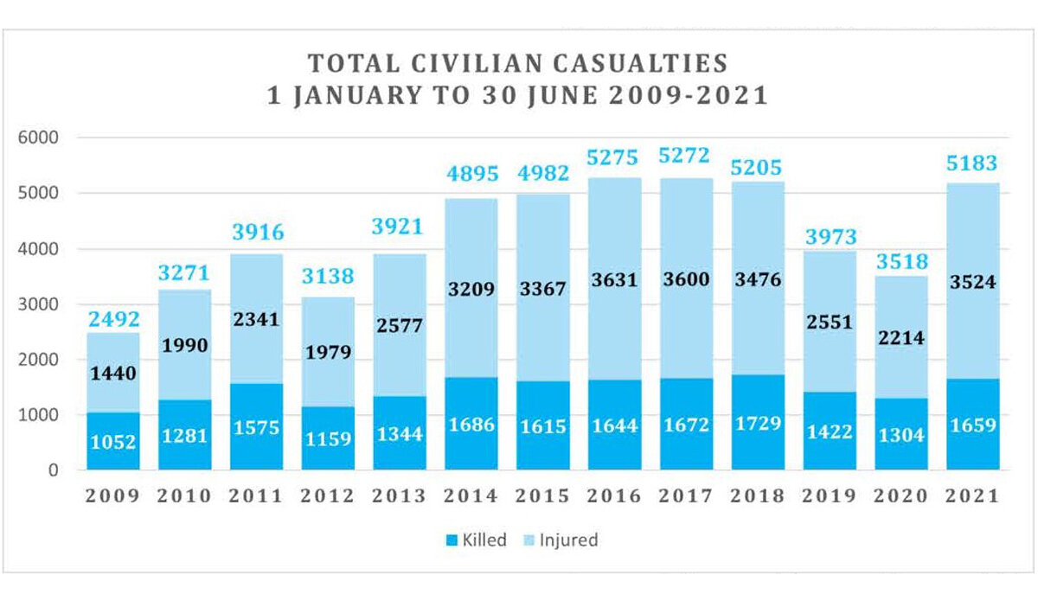
Afghanistan protection of civilians in armed conflict first quarter update:1 January to 31 March 2021
To understand the failure or success of the United States counterinsurgency campaign in Afghanistan, the relevant research scientist is required to understand the capabilities of the indigenous government in running the country: Political Legitimacy of the government, good governance capabilities, and capacity of the security forces in fighting the insurgency on the ground. Afghan warlords were another big challenge for winning counterinsurgency in Afghanistan; warlords and tribal militia posed a significant challenge to the counterinsurgency campaign during the past two decades [207].
Anand Gopal (2014) writes that the Afghan state became criminalized, ranking as one of the most corrupt in the world, as corrupt as the warlords it sought to outflank. Additionally, for the United States to win the counterinsurgency war against the Taliban, they must understand the Taliban’s political and military structure, as well as the population from which they draw support and recruits [225]. The US-led international community appeared to have failed on all three fronts. They contradicted themselves by supporting Pakistan's efforts to combat the Taliban while also funding a corrupt government in Kabul for the past two decades. In addition to their main hideouts in Pakistan and on the Durand Line, Afghanistan’s terrain was also helpful for the Taliban’s resurgence and fighting the US most protracted war in history. It is crucial for the success of any counterinsurgency campaign to have a long-term commitment on the political, economic, and military fronts. These efforts should be coordinated with relevant operations on the ground to defeat the insurgency and gain the trust and support of the local population [184].
History shows that most counterinsurgency campaigns are not won by external forces but by indigenous troops. Therefore, it is more important to build the capacity of local forces to fight the insurgency than to rely solely on occupying forces [207]. Since the US invasion of Afghanistan began, it seemed that the United States had underestimated the significance of the indigenous government’s capability to fight the insurgency on the ground; there was very little attention to support and create a trained, capable police and army in Afghanistan.
Unfortunately, this goal was not achieved in Afghanistan. The Taliban were able enough to fight the Afghan government on many levels, as the capability of the government forces was challenged by vast corruption on their leadership level, lack of battle training, a hit-and-run tactical war, lack of solid leadership, local strongmen or warlords led many; for example, in his two terms elected government, Hamid Karzai had only limited control over his government, many of his top officials led militias that had fought against Taliban with U.S. support and which lacked legitimacy and resources like ammunition, transportation capabilities and were politically divided which aggravated the problem of the lack of effective leadership on the ground to fight Taliban insurgency and win the war for their country [214].
The spread of corruption Jones (2008) defines it as the misuse of entrusted power for private gain - undermined all that could have been achieved by undermining public support for the government and increased support for the Taliban in the outskirts of the country's main cities. Endemic corruption hampered economic growth, undermined the rule of law, and vastly damaged the government's legitimacy nationwide [207].
As Francis Fukuyama (2004) defines, a good state institution must transparently and efficiently serve the needs of its citizens; the objective of installing such a good government in Afghanistan was never achieved [145]. Another factor undermining the United States counterinsurgency efforts in Afghanistan was external support for the Taliban in the region, directly correlating with the insurgents’ success [207].
External support can take two forms: first, foreign governments, diaspora, or international networks can directly assist the insurgents; second, the freedom to use unfamiliar territory as a sanctuary. The Pakistani state directly supported Taliban members to obtain training and medical treatment in Pakistan [207]. Meanwhile, Pakistani-sponsored Kashmir Jihadi groups supported by religion-political parties such as the Jamiat Ulema Islam (JUI) were able to recruit and maintain training bases in Afghanistan. Al Qaeda and Uzbek jihadist groups and the Islamic Movement of Easter-Turkistan (ETI) are also reported to have supported the Taliban across the Durand Line [22]. Afghan insurgency included a dangerous combination of local and transnational supportive groups [207].
Parvez Musharraf (2006) claimed that their support for the Taliban was for two reasons: first, the Taliban would bring peace to Afghanistan; second, the Taliban would defeat the anti-Pakistan Northern Alliance [226]. The general belief among strategists was that Pakistan wanted a stake in Afghanistan to ensure it did not end up with a pro-India government in Kabul [227]. In terms of sanctuary, the availability of a territorial base for insurgents outside of their home state is directly correlated with the failure of the counterinsurgency efforts [210]. The Taliban successfully gained the second type of external support by using Pakistan’s territory to rest, regroup, receive medical care, and recruit for their second war in Afghanistan during the past two decades.
JUI purposefully handed over Pushtunabad, a sizeable sprawling outskirt of Quetta, Baluchistan, to the Afghan Taliban; they forced or bought out the residents and soon owned every home, shot, tea stall, and even hotel in this area. New madrassas were built to recruit a new young generation for their war in Afghanistan [22].
The ISI and other Pakistan government agencies provided several types of crucial assistance to the Taliban:
- Medical care was provided to the injured Taliban who retreated from fighting in Afghanistan [207].
- Pakistan hosted several of the Taliban’s main training bases [221].
- They provided Taliban intelligence assistance to aim their targets inside Afghanistan [228].
- Pakistan also provided the Taliban with financial resources, liquidated their narco funds, and allowed them to collect local donations and receive donations from Gulf countries [22].
- Pakistan assisted the Taliban in logistics in crossing the Durand line on a timely basis despite having Border Management SoP agreements with the Afghan Government in the past two decades [228].
Ali Jalali (2006) adds to the above list of assistance that Pakistan provides Taliban staging areas, recruiting centers (madrassas), and safe havens to launch war inside Afghanistan [229] In addition, the Taliban’s economic resources are derived from networks to the Afghan Diaspora in Pakistan, the Gulf, and the Pakistani administration in Khyber Pakhtunkhwa and Baluchistan [220].
Governance Challenges, external support for the Taliban, and the weak capacity of indigenous security forces were critical factors in failing the United States' efforts in achieving its counterinsurgency efforts in Afghanistan.
External factors play a significant role in failed counterinsurgency efforts. Pakistan’s military establishment’s approach to the war is a function of its central institutional and national security interests [214].
An even more significant role was played by the failure to increase the capacity of the indigenous government. The United States should have focused more on the efforts to improve the performance and legitimacy of the Afghan Government and enhance the quality of police and other security forces rather than focusing solely on fighting the Taliban.
To sum up, winning a counterinsurgency campaign in any country requires transforming a weak state into a legitimate and stable one that gains acceptance from the population. This involves collaborating with indigenous forces, particularly the police, by training and mentoring them effectively and quickly. It is also necessary to temporarily support these forces with sufficient troops to achieve security objectives. A key lesson for future counterinsurgency operations is the importance of empowering local forces, such as the police, army, and local administrations, to maintain control of their territory long enough to rebuild close relationships with local communities and deny insurgents a haven. Ultimately, poor governance, widespread corruption, and the lack of legitimacy of the Afghan government led to the failure of the United States' counterinsurgency efforts in Afghanistan [180].

The Case of Warlord-Democratization in Afghanistan
The post-war reconstruction and peacebuilding process is complicated in a heterogenous country like Afghanistan, which has been affected by decades of conflict, causing it to remain amongst the world’s poorest and most underdeveloped countries [180]. Over the past two decades, substantial donor investment has been in Afghanistan's conflict resolution and peacebuilding programs. However, what has been called 'peacebuilding' in Afghanistan has occasionally been diverse and disconnected from ground realities. These projects embodied a range of objectives and approaches, including stabilization approaches aimed at ‘defeating’ the Taliban, community-based dispute resolution initiatives, various forms of support for civil society activism, Track II-style meetings before, and formal negotiations in Doha [230].
Despite its problems and challenges ahead, the country had a chance to have a new beginning with a new type of government after the US-led invasion at the beginning of the 21st century. As Ginty (2010) rightly states, a noticeable limitation of post-conflict state-building is getting to Denmark or converting societies evolving from violent conflict into stable democratic and economically open polities [62].
While warlords are not the only cause of the failure of peacebuilding and state-building in Afghanistan, warlordism was prominent in destabilizing the country, weakening democratization, and disturbing the US-led state-building process. Warlords are a common feature of the contemporary world and a byproduct of state weakness and strong traditions of local governance [231]). In Afghanistan, warlordism has had a long history, in some cases with traditional tribal leaders acting like modern warlords, as warlordism in some places of the country is used to express clan loyalty [62]. By the time of the 1989 Soviet withdrawal, some Afghan militia commanders had transformed themselves into powerful regional warlords who held considerable swaths of territory, maintained substantial standing armies, and had sustainable sources of income, mainly developed through the opium economy and some level of political capital in Afghanistan [13]. Mac Ginty (2010) rightly outlines the three phases of warlordism in Afghanistan. First, the immediate post-Taliban period reflected certain battlefield superiority of warlords. Second, it was a period in which the elected president, Hamid Karzai, attempted to oust the warlords of their strong position. Finally, the reinvigoration of the warlords once the threat of a resurgent Taliban became apparent. Each phase had destructive implications for the country's democratization and the elected government's legitimacy [62].
USIP expert analysis states that: for decades, Afghan warlords have committed gross human rights abuses, yet, partly due to these crimes, they have been mainly overlooked. After 2001, the United States encouraged warlords’ inclusion in crucial government positions during the transitional administration created by the Bonn Agreement and in the new government formed following the establishment of the 2004 constitution. The U.S. counterterrorism campaign against al-Qaida and the Taliban also saw massive military and intelligence resources supporting warlords and private contractors they controlled [232].
Therefore, the sporadic existence of violent warlords in Afghanistan who were supported in many cases by the US army to fight the resurgence of Taliban and al Qaeda in the country disrupted the democratization process in the past two decades [180].
The longstanding conflict in Afghanistan has exacerbated the socio-economic crisis in the country, creating significant obstacles to its stable development and posing a challenge to regional security [13]. The peace talks in Qatar in September 2020 between the Government of the Islamic Republic of Afghanistan (I.R.A.) and the Taliban movement were aimed at ending the conflict and promoting peaceful development. However, the situation became more complex following the withdrawal of international forces and the Taliban's rise to power, necessitating renewed efforts to resolve the conflict peacefully [13].
Further, the distinction between warlordism and state authority in Afghanistan is analyzed. Warlords represent localized groups based on kinship or ethnic ties, whereas the state claims sovereign authority over a territory, exercising a monopoly of coercive power. According to Banuazizi and Weiner (1986), the state is associated with a fixed territory and centralized power, while warlordism involves distributed power among individuals adhering to militia laws or tribal hierarchies [233].
Differences between state and warlordism are outlined in terms of power distribution and legal systems [234]. State power is centralized, while warlord power is distributed among individuals within a tribe or militia. The state's legal order is authoritative and hierarchical, whereas warlordism's legal order is based on personal power and tribal norms. Rubin (2006) highlights that the state demands loyalty to central authority, while warlordism emphasizes kinship and patrilineal ties [158].
Table 5 Comparison Warlordism & state
Characteristic | Warlordism | State
Structure | Homogenous, Egalitarian, and Segmentary | Heterogeneous, Stratified and Hierarchical
Power | Distributed among persons | Monopolized by a central government
System | Clan Based/Kinship | Public opinion
Legal Order | Horizontal | Vertical
Force | Networks | Monopoly of Force
Leadership | Leaderless, Egalitarian | Hierarchal
Sovereignty of Authority | NA | Sovereign authority
Professions | NA | Officers, ministers etc
Institutions | No formal institutions | Formalized structures like ministries
Policy applications | No policy – ad hoc actions | Formal policy and procedures

  - Warlord-Democratization in Afghanistan

As a modern state, Afghanistan has historically seen weak centralized governments whose legitimacy is locally challenged by tribal elders, religious leaders, or warlords. The period after 2001 was a chance to consolidate the center and its periphery in a state and peace-building processes. However, as ex-President Hamid Karzai and the international community quickly realized, the warlords served a purpose. They were a much-needed ally in the post-conflict period as they provided political and military stability in varying capacities [235]. This center-periphery relationship has been a dominant factor in the endurance and influence of warlords [236].
Almost all of Afghanistan’s significant warlords have come from military backgrounds and ruled through ethnic, linguistic, or regional cleavages. They were never expected to be Democrats. Some could transform themselves to participate in state-building without violence, as in democratizing the country [237].
This interaction between “warlord politics” and democracy can be called “war-lord democratization” — a struggle to transition warlords from fighters to politicians.
Discussions of state-building initiatives often posit that state formation should include the three interdependent types of resources: coercion, capital, and [158].
Historically, in Afghanistan, these three types of resources have been mobilized in various combinations and contexts to construct, destroy, or undermine its statehood by invaders in the past. Unfortunately, from the beginning of the US invasion 2001, local warlords were heavily relied upon to hunt down the al Qaeda and Taliban elements [235] So, it lost its way to initiating a state-building and peacebuilding process in Afghanistan. Dobbins (2008) noted that even from the beginning of the US/NATO intervention in Afghanistan, local warlords started competing for local territorial and polity control and came into conflict. Hence, they ruled their provinces as private fiefdoms [234]. The central government then had to stretch its power in the warlord's turf [238]. On the other side, the local warlords regularly tried to entice the US and its allies to come to their aid by accusing their rivals of cooperating with the Taliban [235].
Addressing conflict and ensuring positive security in Afghanistan required a more concerted effort to deal with local warlords, who often challenged the centralized government's monopoly of power. Unfortunately, this issue received less attention compared to the Taliban's resurgence in Afghanistan’s hinterlands, which was seen as directly linked to the state's weak control over the entire country.
Prevention of warlordism is essential in a post-war environment where a transition period must be used to benefit the central government to expand its control from the capital to the sub-national governance. However, in the case of Afghanistan, central government legitimacy was challenged by the local warlords who were empowered by the region, racial links, or remnants from the Soviet war to keep on the regime security phenomena. In the past twenty years in Afghanistan, warlords often manipulated the same opportunity of bridging people to the government to weaken the central government's authority.
Due to the failed peacebuilding process and continued focus on warlord democratization, ordinary Afghans, their country's real stakeholders, and changemakers, were neglected to live in peace and harmony. Progress and gains made — on education, women’s rights, and much more — over the last 20 years are highly fragile, and Afghanistan remains one of the world’s poorest countries [232].
Resurgent warlordism obstructed the steady progress of peacebuilding and state-building in Afghanistan, dismantling the systems and institutions that had been developed over two decades in partnership with the international community. The failure to neutralize warlordism cultivated widespread mistrust in government organizations, undermining the government's legitimacy in Kabul and facilitating the Taliban's return to power in August 2021. With reduced political and intelligence capabilities and no boots on the ground, it is now exceedingly difficult for the United States to control such entities [180].
Unfortunately, the US and the international community were not initially interested in finding an inclusive, peaceful solution to Afghanistan's problems in 2001. Over the next two decades, there was an opportunity to avoid reliance on militias through a negotiated political settlement with the Taliban, but this opportunity was not taken.
Persistent warlordism issues significantly undermined Afghanistan's peacebuilding and state-building efforts. Initiatives like DDR and DIAG's failure to dismantle warlord power structures left the state’s security sector heavily infiltrated by these figures, eroding public trust and governmental legitimacy.
The USA entered Afghanistan to wage the war against global terror. Despite this declared objective, their efforts were limited to the current geography of Afghanistan. Nevertheless, twenty years later, they left Afghanistan to the mercy of the Taliban. Many people view this as a failure of the U.S.A. to create a solid Afghan Government that could keep fighting the terror outfits and sustain a democracy [23;239;240]. The lesson learned may be helpful to world leaders and policymakers in their efforts to win the war against terror [43].
Lederach's pyramid on actors and approaches to peacebuilding, in which he divides actors into three categories, Top Leadership, middle-range Leadership, and Grassroots Leadership, is helpful when understanding and analyzing peacebuilding efforts. He provides proportional effectiveness of the three various types of leadership within a nation where the grassroots community leadership is placed at the base of the pyramid, indicating the significance of the communities in peacebuilding approaches [119].
Therefore, this research has collected evidence from 86 expert respondents (Afghans and international) who may represent the views on the top and middle-range leadership's involvement in the Afghan peace process designed by the United States in Afghanistan in the past two decades [43].
The U.S. government has spent around $145 billion in 20 years trying to rebuild Afghanistan. In addition to this, the Department of Defense (DOD) has spent $837 billion on warfighting, during which 2,443 American troops and 1,144 allied troops have been killed and 20,666 U.S. troops injured [241]. These factors included the Afghan government’s failure to adequately prepare for the U.S. withdrawal, exclusion from U.S.-Taliban talks, insistence on integrating the Taliban into the Republic during intra-Afghan negotiations, the Taliban's unwillingness to compromise, President Ashraf Ghani’s narrow governance through loyalists, and long-term issues such as high centralization, lack of legitimacy, and endemic corruption. This multifaceted failure highlights the complexities of governance and peacebuilding in Afghanistan.
Despite these operations, over 100,000 Afghan civilians and more than 60,000 security personnel died due to ongoing conflict (U.N. News, 2020; Al Jazeera, 2019). These casualties underscored the severe human cost of the U.S. peacekeeping mission, which ultimately failed to achieve lasting peace [242].
Analyzing the U.S.'s longest-running war reveals crucial lessons for future foreign interventions and regional security. The U.S.'s approach, marked by a divisive 'war on terror' rhetoric and labeling all insurgents as 'terrorists,' hindered meaningful dialogue and should have been avoided [244].
The interviews reveal a broad range of perspectives and insights into the failure of U.S. efforts in Afghanistan. A key theme is the lack of a coherent strategy aligned with Afghanistan's socio-political realities. The U.S. and its allies underestimated the resilience and adaptability of local power structures, particularly warlordism, which persisted despite attempts to dismantle it through initiatives like DDR and DIAG [214; 236]. These initiatives collected weapons but failed to disrupt the underlying power dynamics, allowing warlords to infiltrate the official security apparatus and maintain their influence.
Furthermore, the Afghan government's exclusion from the U.S.-Taliban negotiations significantly undermined its authority and legitimacy. This exclusion emboldened the Taliban, who viewed the U.S. withdrawal as an opportunity to seek a military victory rather than a negotiated settlement. The Afghan government's insistence on integrating the Taliban into the existing Republic framework during intra-Afghan talks also stalled progress, as the Taliban were unwilling to compromise on their vision for Afghanistan [234]
The persistence of warlordism further complicated efforts to establish a unified state, as local power brokers continued to wield significant influence, often at odds with the central government’s objectives [232].
The research underscores that a successful post-conflict approach in Afghanistan requires an inclusive, locally informed strategy that addresses the root causes of conflict and the socio-political realities on the ground [43] Future interventions should avoid the pitfalls of imposing external frameworks that do not resonate with local dynamics. Instead, fostering genuine dialogue, supporting grassroots peacebuilding efforts, and building institutions that reflect the diverse interests and identities within Afghanistan are crucial for sustainable peace.
In conclusion, the U.S. and international community's intervention in Afghanistan offers critical lessons on aligning peacebuilding efforts with local realities. The failure to do so not only undermined the Afghan government's legitimacy but also facilitated the Taliban's return to power, highlighting the need for more nuanced and inclusive approaches to peacebuilding in conflict-ridden regions.

Respondents Profile
This research study provides a qualitative analysis of the U.S. intervention in Afghanistan. It explores the reasons behind the failure of the U.S. peacebuilding efforts. The research is conducted through sixty-eight interviews with senior bureaucrats, ambassadors, political figures, and international experts (Zaland, Sharma, & Pandy, 2023) [43].
Table 1 provides the list of the expert respondents interviewed to analyze their perceptions of the factors leading to the failure of U.S. peacebuilding efforts in Afghanistan. Eighty-six (86) interviews were conducted with experts, educators, bureaucrats, interlocutors, ambassadors, political figures, journalists, and Afghan locals. The average interview time was between 1 to 1.5 hours, and the respondents were interviewed in a semi-structured manner. Primarily, the interviews were conducted in person, while few were conducted through phone conversations. Some of the questions were closed-ended, and some were kept open-ended (Zaland, Sharma, & Pandy, 2023) .[43]
Conflicts are more likely to escalate into violence when inequalities exist [140]. When access to political and economic power is not equally available and distributed within a given society, conflicts are more likely to remain latent, generating hostilities and more complex problems with wider ramifications. Therefore, any attempt to end or prevent violent forms of competition must address power sharing and transparency of decision-making directly, including the vertical and horizontal power dimensions of intractable conflicts. The balance of power was altered significantly by signing the Doha Agreement between the USA and the Taliban on February 29, 2020, in Doha, Qatar.
The descriptive analysis of the primary data supports the idea that the Republic government needed to be more empowered to fight the Taliban. The data shows that 36.76% of the participants agreed that the government of the Afghan Republic was not empowered enough (Chart 1); the balance of power was in favor of the Taliban:

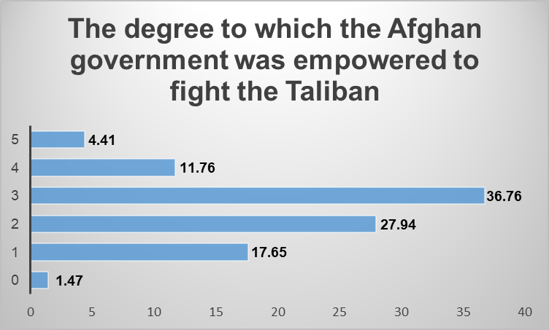

Chart 1
In the current study, many respondents share similar opinions. When asked for his opinion on US efforts in Afghanistan, one interviewee said, "Their non-balance support across the country was a huge cost to everyone. They have spent hundreds of billions of US Dollars to support the warlords, not the ordinary Afghan." Another respondent remarked, "In my opinion, US peacebuilding efforts were imbalanced. The Administration, particularly in the last stages, seemed fatigued, neglecting the suggestions of its army generals to keep at least 2500 to 3000 soldiers in the country until two sides set seriously on the table." [43]. Statements like these indicate that Afghan mid-range and top-level leaders perceived the US as creating an imbalance of power by negotiating their withdrawal with the Taliban, thus contributing to the failure of their peacebuilding efforts.
This approach neglected the intricate fabric of Afghan society, where warlords and local power brokers wield significant influence. By bypassing these local structures and failing to build a balanced and inclusive political framework, the US efforts. inadvertently strengthened the Taliban’s position. They weakened the central government’s authority, leading to the rapid collapse witnessed in August 2021.

Spoilers as a deterrent to peacebuilding
Spoilers have been highly influential in academic and policy literature [190;191]. What has come to be known as "spoilers" in a peace process is an endemic problem [192]. In addition, spoilers are actors who view peace as a threat to their interests [191]. Spoilers' motivations vary. They may believe that an emerging peace will threaten their power or worldview. Alternatively, they may be criminals who profit from chaos, terrorists who seek to demoralize the population, and even parties to the negotiations who want to shift the odds in their favor. It is cold comfort to know that spoilers in Afghanistan are a predictable reality [245].
Whether actual or potential, leaders of parties or movements, either within or outside a peace process, spoilers are typically thought to constitute themselves as deliberate obstacles to the peaceful settlement of conflicts and employ violence to achieve their objectives. At the same time, it is not clear whether the term "spoiler" is ascriptive or earned, whether they are homegrown or externally generated. My own experience suggests that today's spoilers can become the partners of peace tomorrow [246].
The interview data illustrates, as per Chart 2, that 35.29% of members believed that Pakistan, Taliban Ghani, Abdullah, his team, and the USA played a significant spoiler role in the Afghan peace process. While the second largest number of participants, 22.06%, blamed Pakistan for spoiling the Afghan peace process, 10.29% of respondents believed that the Taliban spoiled the process.
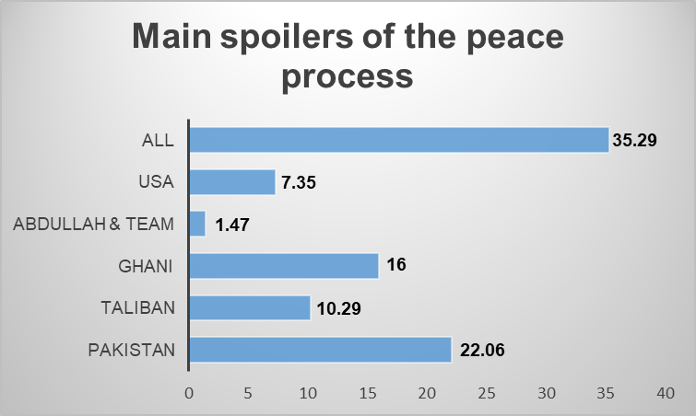

The role of Hostility, International Capacity, and local capacity to change
Even though peacebuilding strategies must be tailor-made to address particular conflicts, standard parameters can be identified [43]. Strategies should address the local roots of hostility, the local capacities for change, and the specific degree of international commitment available to assist sustainable peace [189]. The literature also suggests that these dimensions can substitute for one another; for example, fewer extreme hostilities can compensate for weak local capacity or minor international commitment [247].
The findings indicate that this mechanism played a role in the failure of the Afghan peace process. There was strong support among the respondents for the idea that an imbalance in these dimensions contributed to the loss of US peacebuilding efforts:

Hostility
When peace has been made or enforced, peacebuilding is an effort to address the root causes of the conflict and strengthen regional conflict resolution capabilities [248]. Effective peacebuilding often involves fostering a deeper civil society, strengthening state institutions, increasing political involvement, implementing land reforms, and respecting ethnic identities, all of which can increase the likelihood of peaceful administration [249].
This study analyzed the responses and found support for these principles. One respondent stated, “The US has not had strong support and good partnership to prevent insurgency. They have more trust in Pakistan rather than to help Afghans for sustainable economic growth, justice, peace, and other basic rights.” This comment highlights the lack of strategic support and partnership necessary for effective peacebuilding [43].
Another respondent provided that "The invasion of the US was not associated with any peacebuilding efforts; instead, their focus was tackling Al-Qaeda and defeating the then-Taliban regime. From the beginning, the US had no significant strategy for peacebuilding, and most of their presence in Afghanistan remained uncoordinated and mismanaged” [43]. This insight underscores the sentiment that the US intervention was primarily military and counterterrorist in nature, rather than focused on comprehensive peacebuilding.
These responses indicate several key issues:
- Lack of Comprehensive Strategy: The US intervention was not initially designed with a peacebuilding framework in mind. The primary objectives were counter-terrorism and the defeat of the Taliban, which did not necessarily align with the broader goals of sustainable peacebuilding.
- Misalignment of Trust and Partnerships: Relying on regional partners like Pakistan rather than fostering more profound and meaningful partnerships within Afghanistan was seen as a misstep. Effective peacebuilding requires trust and collaboration with local actors who are directly involved and affected by the conflict.
- Uncoordinated Efforts: The lack of coordination among various US and allied efforts led to fragmented and sometimes counterproductive actions. This lack of coherence hindered the establishment of a unified and effective peacebuilding strategy.
- Neglect of Local Dynamics: Significant oversight occurred in addressing the root causes of conflict specific to Afghanistan, such as local governance issues, economic disparities, and ethnic tensions. Effective peacebuilding requires a nuanced understanding of these local dynamics and a tailored approach to addressing them.
Thus, as evidenced by the respondents' insights, the hostility towards peacebuilding efforts contributed significantly to the disruption and ultimate failure of establishing a lasting peace in Afghanistan. The focus on military objectives and uncoordinated and misaligned strategies undermined the potential for sustainable peacebuilding in the region.

b) International capacity
According to Doyle and Sambanis (2000), achieving specific post-conflict results involves the interaction of pre-and postwar local capacities with current international capacities [86]. This framework underscores the importance of determining the most influential forms of foreign aid to maximize the room for peace given the local levels of capability and hostility. This study corroborated this view, highlighting that the right level of international assistance was often lacking [43].
Respondents pointed out, “When the talks began under the Trump administration, there was no effort to put solid, provable conditions on the Taliban, and when Biden took over, he made no effort to hold the Taliban accountable for failing to meet the terms of intra-Afghan talks and a durable ceasefire.” This sentiment illustrates a perceived deficiency in the international community's efforts to hold the Taliban accountable and enforce conditions critical for peacebuilding [43].
A respondent remarked, “The main problem was the warlords who were not interested in bringing peace where they would lose power. The international community was also not on the same page regarding peacebuilding in Afghanistan. Furthermore, neighboring countries played their cards in the process, thus opposing or even nullifying whatever was against their interest.” This statement reflects the perception that a lack of political will, consistency, and unified strategy hampered the international community's support for the peace process [43].

Key Findings and Insights:
- Lack of Conditional Accountability: The absence of enforceable and provable conditions in negotiations with the Taliban significantly undermined the peace process. Ensuring accountability and adherence to agreed terms is crucial for sustainable peacebuilding.
- Diverse Local Capacities: Different economic and social capacities levels in war-torn nations necessitate tailored reconstruction efforts. Nations with greater destruction require more robust international involvement to rebuild and stabilize.
- Fragmented International Efforts: The international community's lack of a unified approach led to inconsistent support for peacebuilding efforts. This fragmentation hindered the development of a coherent and effective peace strategy.
- Influence of Warlords and Regional Politics: Local warlords and regional players often had conflicting interests that opposed peace initiatives. The international community's inability to align these interests further complicated the peace process.
To conclude, the study reinforces that effective peacebuilding requires a nuanced understanding of local capacities and consistent, coordinated international support. Addressing the root causes of conflict, holding parties accountable, and fostering cooperation among international and regional actors are essential steps toward achieving sustainable peace in Afghanistan. The perceived failures in the US and international community's efforts highlight the need for a more strategic, inclusive, and accountable approach to peacebuilding in conflict zones.

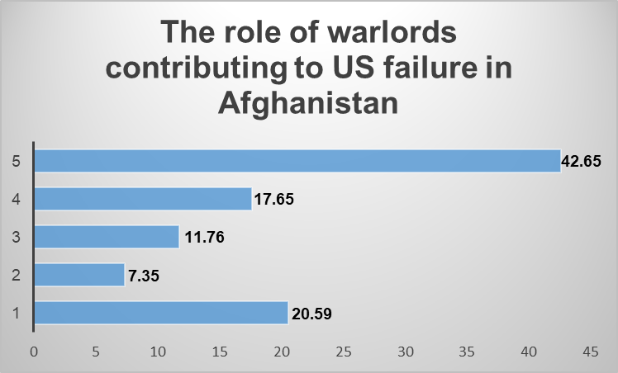

The research study illustrates, as in Chart 3, that 42.65% of the participants strongly agreed that warlords contributed to the failure of US peacebuilding efforts in Afghanistan [43]. The only way to establish sustainable peace is to look for the local roots of hostility and the local capacity to change [189]. Conflict often persists in regions with low economic growth and other deficiencies in local capabilities due to the low opportunity cost of conflict and potential private gains from violence [92]. Reconciliation is more challenging in these contexts because the experience of conflict increases hostility [43].
One respondent highlighted the local desire for peace by stating, "Peacebuilding process was the requirement of Afghan people, and it was an obligation to the USA, as they lost the war against Taliban». This indicates that Afghan locals were willing and ready for change and peace. Another respondent noted, "It is paradoxical that the US neglected realities on the ground and the role of regional actors in Afghanistan and claimed that they want to establish peace"[43]. These excerpts underscore the local capacity and desire for peace, which were not effectively harnessed by the US and international agencies, leading to the failure of peacebuilding efforts.
Key Insights and Findings:
Local Willingness for Peace: Afghan locals demonstrated a clear desire and readiness for peace. Their willingness to change and restore peace indicates a significant local capacity that could have been leveraged more effectively.
Neglect of Ground Realities: The US and international agencies needed to fully understand and integrate the local realities and dynamics, including the roles of regional actors. This neglect undermined peacebuilding efforts and contributed to the persistence of conflict.
Addressing the local roots of hostility and the capacity for change is crucial to establishing sustainable peace. The Afghan locals' readiness for peace presents a valuable opportunity that needs to be harnessed effectively. International peacebuilding efforts must prioritize understanding and integrating local realities and dynamics, including the roles of regional actors, to build a coherent and effective strategy for sustainable peace.

Local Autonomy Via Socio-economic Development State Legitimacy
Socioeconomic growth has strengthened local autonomy by promoting alternative local governance systems alongside local interactions. Understanding how local autonomy functions in ongoing peace processes, characterized by a delicate interaction between the state and the community [80], is crucial. However, limited knowledge exists about the local dynamics that play a role in peacebuilding [43]. The Afghan state struggled to establish legitimacy due to its dependence on external assistance, high levels of corruption, and limited control over international military responses and the reconstruction and development process [243]. This study found that peace can only be established by granting autonomy to locals and ensuring their active participation.
One respondent criticized the US, stating, "They have spent hundreds of billions of dollars to support the warlords, not the ordinary Afghans," indicating a lack of vision in supporting local communities. Another respondent added, "The Americans did not understand whom they should talk to—regional countries, powers, internal Afghan factions—because they did not have an accurate understanding of these actors from the beginning of their intervention in Afghanistan, so they lost their way to find a peaceful solution to the Afghanistan conflict." This lack of local knowledge exacerbated the situation.
Respondents consistently opined that "US peacebuilding efforts in Afghanistan were politicized and compromised by other factors, including maintaining their interests in the region, regardless of the price ordinary Afghans paid." Moreover, one respondent claimed that US efforts were "Not locally owned, ill-informed, and non-inclusive"[43].
Empowering local communities and ensuring their active participation in peacebuilding efforts is essential to establishing sustainable peace in Afghanistan. This requires a deep understanding of local dynamics and the inclusion of all relevant stakeholders, including regional powers and internal Afghan factions.
Control over Geography
This qualitative study supported the relationship between control over natural resources and conflict. One respondent stated, "They want to capture the Afghan region to gain control over it, to use it as a strategic resource to establish its control over the Middle East and not with an intent to support Afghans" [43]. The study found that sometimes it's not just about natural resources; the region acts as a resource. Hence, the US entered Afghanistan to gain strategic control over the area, but this objective needed to align with supporting the Afghan people, leading to substantial failure later.
Key Insights and Findings
Natural Resources and Conflict: The study supports the idea that control over natural resources can be a factor in perpetuating conflict. The pursuit of strategic control over regions rich in natural resources can be a motivation for external interventions.
Spurious Correlations: The correlation between natural resources and conflict can be spurious, as both may independently arise from broader factors like weak governance and poverty.
Geopolitical Interests: The study highlights those geopolitical interests, such as gaining strategic control over regions, can drive interventions, sometimes at odds with the interests of local populations.
To address conflicts exacerbated by natural resources and geopolitical interests, it is crucial for interventions to prioritize the needs and aspirations of local populations. Understanding the complex interplay between natural resources, conflict, and geopolitical interests is essential for designing effective strategies that contribute to peace and stability in conflict-affected regions [43].
Civil Resistance:
Evidence suggests that nonviolent opposition is approximately twice as successful as military combat in fighting against dictators and ending foreign occupations. Traditionally, scholars have focused solely on violent methods of civil resistance and largely ignored the capacity of nonviolent movements to organize supporters, resist regime crackdowns, develop innovative resistance techniques, and challenge and defeat repressive regimes to build durable democracies [194].
One of the respondents highlighted that Afghan civil society had a minimal role in the peace process, mainly due to a lack of vision and being sidelined by key actors, Another respondent mentioned, "There are thousands of organizations, groups as well as individuals across the country - rural and urban areas - in Afghanistan with views that are not necessarily in favor of any of the parties to the conflict [43]. " Thus, civil society actors in Afghanistan were perceived to be divided and pursuing their interests, playing only a minimal role in the peace process despite their attempts to engage [250].
Therefore, evidence suggests that the peacebuilding process in Afghanistan faced resistance from civil society. The fragmentation and divergent interests within Afghan civil society organizations and groups contributed to their limited impact on the peace process. This lack of cohesive engagement undermined efforts to leverage civil society's potential to influence peace negotiations and build sustainable peace in Afghanistan [43].

Key Insights and Findings
Nonviolent Opposition:
Nonviolent opposition is more successful than military combat in fighting against dictators and foreign occupations. This underscores the potential of nonviolent movements in achieving political change.
Challenges in Engagement: The fragmentation of civil society groups and their diverse interests challenged their cohesive engagement in the peace process, reducing their impact on peacebuilding efforts. Addressing the fragmentation within civil society and promoting their cohesive engagement in peace processes is crucial to enhancing the effectiveness of peacebuilding efforts in Afghanistan. This can be achieved through fostering dialogue, building consensus, and ensuring that the voices of diverse civil society actors are heard and integrated into peace negotiations.
Lack of effective mediation
Zartman argues that violent conflicts are ripe for negotiated resolution when they reach a mutually hurting stalemate—in other words when conflicting groups realize that further violence is too costly and can no longer help them achieve their goals. Other studies have focused more broadly on mediation and negotiations, arguing, for instance, that biased mediators are more likely than neutral mediators to produce agreements with elaborated ones. Conflict management techniques like mediation and peacebuilding are frequently employed. It is still being determined whether they are complementary and efficient means of putting a stop to violent disputes [197]. Peacebuilding strives to keep agreements from dissolving, whereas mediation seeks to enable mediated resolutions. However, peacebuilding and conciliation frequently co-occur [251;252].
Various studies presented the substantial impact of mediation and peacekeeping on the frequency of conflict. This study also supported the claim. One respondent stated, "There is a need, but this time, any talk must be mediated by an Islamic organization or a strong Muslim country; without such mediation, peace is impossible in Afghanistan." Thus, mandating the presence of an acceptable mediator. Further, it is provided by one of the respondents for the US stated that "They must have commentated to mediation, arbitration, and adjudication. No political will, warlords and the USA was looking after its regional interest rather than supporting Afghanistan". Thus, the evidence indicates that an effective mediator is needed in the US-led peacebuilding process in Afghanistan [43].
Poor Governance led to disruption
The US peacebuilding efforts in Afghanistan failed for several reasons, including a lack of mediation, civil resistance, or local autonomy [253]. The literature, as well as the interview excerpts, provided support for that. However, other factors, such as poor governance, are pertinent [254]. This study supports the importance of good governance for successful peace processes. One respondent provided "… no clarity on the purpose of their mission. Also, all actors and countries were not on the same page. Several competitions or wars were going on in Afghanistan. US-IRAN, US-China, US-Russia, US-Europe, Counter Narcotics, Counter Terrorism, bad governance and eventually building war economy which contributed to the failure of peacebuilding in Afghanistan." Also, some respondents provided that the US lacks a long-term vision for the people of Afghanistan. One respondent stated, "…. Short-sighted vision with American interests as the main driver: leaving Afghanistan ASAP and having an Afghan government which could handle their counter-terrorism objectives. Further, there is a need for more vision in the US to plan things. The study provided evidence that "…. It was neither well-planned nor well-executed. A decision was made quickly and mounted without making a proper arrangement. (Zaland, Sharma, & Pandy, 2023)"[43].

Lederach insists on the role of the grassroots in any peacebuilding process. However, as per the data in Chart 4 analysis, 27.94% of the participants denied any role of the Afghan grassroots in the peacebuilding efforts of the USA in the last two decades, while 29.41% of the participants agreed to the fact that Afghan Grassroots were somehow involved in the peacebuilding efforts of the United States. 26.47% of the participants strongly agreed that Afghan grassroots were allowed to enhance the peacebuilding process.

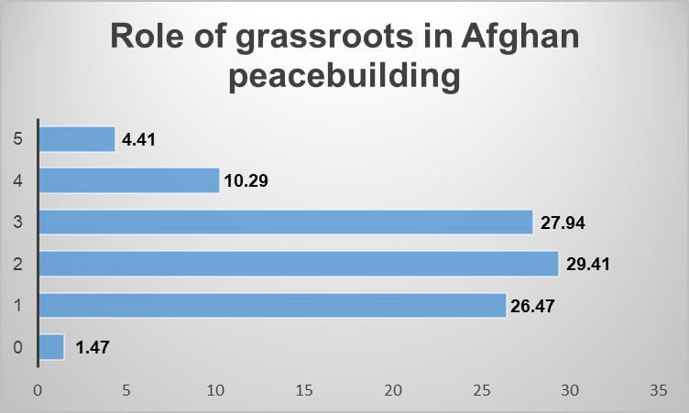

The US needed more planning and needed to be more focused [255]. This resulted in frequent changes in their strategy to tackle the region, creating chaos among the stakeholders. Thus, inviting other enemies to enter the area. Finally, the Afghans believed the US was also unwilling to establish peace. One of the respondents stated, "The USA did not have any kind of political will for peace in Afghanistan; the USA was trying to push the region into a regional conflict." Moreover, they also stated that "The Afghan-centric notion of peace involves independence and sovereignty of the Afghan nation. The US occupation was antithetical to the Afghan-centric idea of peace. Therefore, there could never be any real US effort toward peace as long as Afghanistan remained occupied [43].
The genuine peace efforts would have been an unconditional withdrawal. However, even after the withdrawal, we indirectly supported anti-peace elements, imposed economic sanctions, and froze Afghan funds to keep Afghanistan in a constant crisis. That reveals the ill intention of the US part even after withdrawal. Thus, all these factors together led to the failure of US peacebuilding efforts in Afghanistan [43].
The existing literature has outlined several factors that may negatively impact peacebuilding mechanisms. However, the understanding of the failure of the US peacebuilding efforts in Afghanistan remains limited. Moreover, the study indicates that the peacebuilding efforts failed because the US needed to adequately understand local culture and power dynamics, thus failing to gain the local population's support. Local structures were not given autonomy, and their role in peacebuilding could have been more extensive. Effective mediation and a long-term vision for the people of Afghanistan needed to be improved. As a result, the US had to withdraw from the region. This study will guide future leaders, bureaucrats, and other stakeholders in managing peacekeeping processes and ensuring sustainable peace. It underscores the importance of understanding local contexts, empowering local structures, and employing effective mediation strategies for successful peacebuilding efforts [43].
Empirical Analysis: Why did US Peacebuilding efforts fail in Afghanistan?
Besides Afghanistan, the US was simultaneously engaged in conflicts in Iraq, China, and Pakistan. However, the purpose here is not to contrast US involvement in Afghanistan with other interventions, such as the Iraq War, both of which are examples of extensive conflicts following 9/11 (As the Iraq conflict concluded, violence in Afghanistan escalated, resulting in a sharp increase in fatalities [266,15]. The USA's longest-running war in Afghanistan warrants careful consideration, particularly in understanding both its successes and failures within the broader context of legitimizing foreign intervention for the security of the state and region.
The significance of this research has heightened with recent shifts in US involvement and its military withdrawal, which led to the resurgence of the Taliban.
Theoretically, peacebuilding efforts entail political, structural, and social dimensions. The peacebuilding process is more complicated than peacemaking. At the same time, the transition from peacemaking to peacebuilding is sometimes linear, given that the negotiated settlement of a long-term conflict brings challenges and opportunities for transforming conflict relationships [157].
Peacekeeping intends to decrease violence by training peacekeepers in defensive military and police methods, nonviolence, mediation, and peacebuilding. Lederach's pyramid (1997) divided actors and approaches to peacebuilding into three categories: Top Leadership, Middle-range Leadership, and Grassroots Leadership. He provides proportional effectiveness of the three various types of leadership within a nation where the grassroots community leadership is placed at the base of the pyramid; it indicates the significance of the communities in the peacebuilding approaches [140].
This empirical research study provides a qualitative analysis of the US intervention in Afghanistan. It explores the reasons behind the failure of the US efforts. The qualitative research is conducted by interviewing 507 ordinary Afghans with internet access. Many of them are urban Afghans, and some are diaspora who were evacuated recently after the fall of Kabul to the hands of the Taliban on August 15, 2021.
Galtung (2000) [160] points out that the war in Afghanistan involved (and continues to involve) extensive interference and intervention by outside parties. This complicated the peace process in Afghanistan by having more external factors to the conflict than the mere first and second parties on the domestic level; to conclude as Gabriela Lucauta (2014) elaborated that any peacebuilding activity that does not involve local traditional values and culture will not last,[160] in the case of Afghanistan, the complexities of the peace process were more than only domestic problems like the Afghan republic fell because societal values were irreconcilable with democracy and the country was simply ungovernable preventing a warning party to solve the conflict. [163]
Respondents Profile
The research involved 507 interviews. The participants included educators, bureaucrats, journalists, politicians, and ordinary Afghans. The respondents were interviewed semi-structured through Google. All the questions were closed-ended [43] The survey participants are targeted randomly; most of them represent the youth of Afghanistan, as they have more access to the internet, understand the English language, and live mainly in urban Afghanistan and abroad. Their age ratio may differ from 20 to 35, but they are highly engaged and active in following their national political affairs on national and international levels.

3.4 Factors leading to the failure of US counterinsurgency efforts
The analyses of the research findings reveal the following factors that directly or indirectly contributed to the US failure in Afghanistan:
Improper Balance of Power in the Region
As the diagram below illustrates, more than 73 % of the survey participants strongly agreed or agreed that the withdrawal of the US forces shifted the power balance on the ground in favor of the Taliban. Only 17.8% believe otherwise. Therefore, the research study concludes that the improper balance of power in the signed agreement of Doha, Qatar, on 29th Feb 2020 between the Taliban and the USA made it difficult for the Government of the Republic of Afghanistan to encourage the Taliban to sit with them for a substantial peace talk.

Chart 4.1:
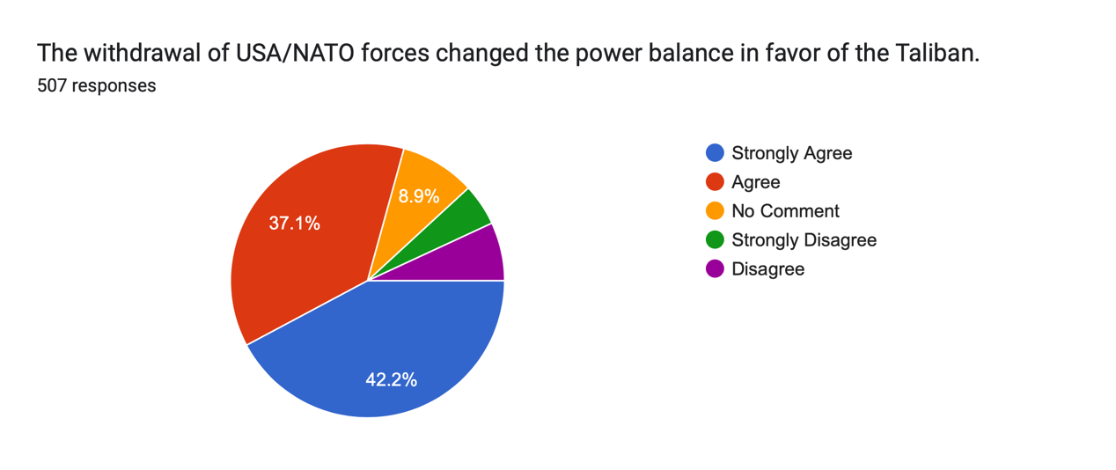

The fact that the Doha Peace agreement between the Taliban and the USA impacted the peacebuilding process negatively is vividly expressed in the diagram below:

Chart 4.2

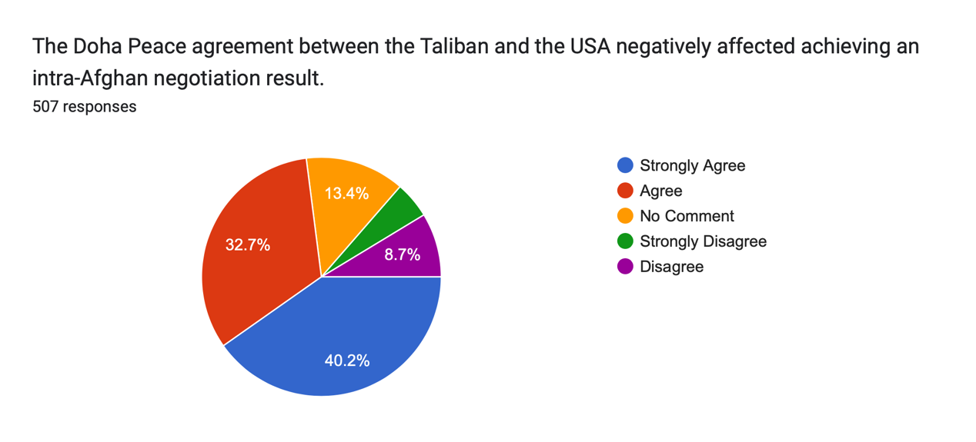
The diagram above shows that 72.9% of the correspondents believe or strongly believe that the Doha Peace Agreement between the Taliban and the USA negatively affected the reaching of any negotiated political settlement between the Government and the Taliban. This may be because the Agreement emboldened to defeat the government forces militarily [257]. While only 18.4% of the survey participants disagreed or strongly disagreed with this stipulation. To conclude, with the shift of the power balance in favor of the Taliban, they started believing in a military victory rather than an intra-Afghan peace process [43].
The Chart below illustrates that 71.8% of the survey members believed strongly or agreed that the Taliban never believed in a peace deal with other Afghan parties like the republic government in Kabul; instead, they were looking for a military victory.

Chart 4.3:
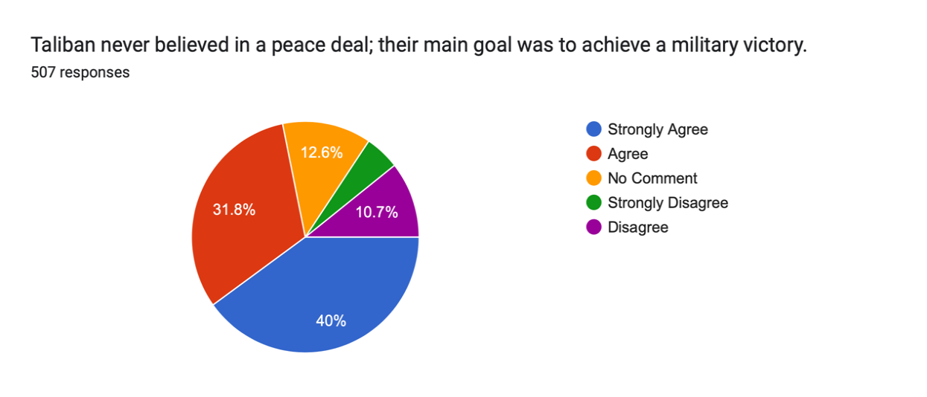

Stigmatization as a Deterrent to Peacebuilding
The literature suggests that reducing stigma is crucial for establishing peace [258]. In Afghanistan, local perceptions of the US were marred by strong stigmas. Many Afghans viewed the US as war-builders rather than peacebuilders; some saw them as power-hunters [259]. These negative perceptions and stigmas against the US significantly disrupted the peace process due to a lack of trust. This study found similar sentiments among respondents. Many Afghan people felt discriminated against by the US military, contributing to these negative perceptions and stigmas (Zaland, Sharma, & Pandy, 2023). [43]
These sentiments are illustrated in the responses gathered during this research. Reducing these stigmas and rebuilding trust between local populations and international stakeholders, particularly the US, is essential for future peacebuilding efforts in Afghanistan. Addressing these perceptions can help pave the way for more effective and inclusive peacebuilding initiatives.

Chart 4.4:

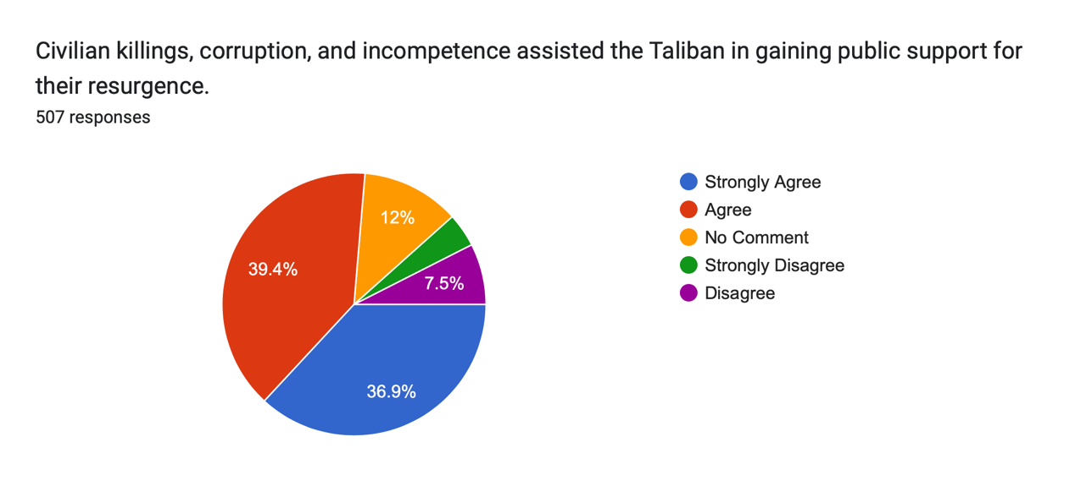

The survey results indicate that 36.9% of the survey participants strongly considered that grievances caused by civilian killing, corruption, and incompetence assisted the Taliban in attaining local support. Furthermore, 39.4% of the interviewees agreed to the role of grievances in the collapse of the government and the failure of the USA and NATO forces from Afghanistan in 2021. Thus, more than 76% of the respondents reported public grievances as a factor in peacebuilding in Afghanistan.
Patricia Grossman (2022) posited that the psychological impact of so many civilian deaths and injuries from air operations and the terror in rural Afghanistan inspired by the constant raids and special operations may have done far more significant damage in undermining support for the Afghan government than any military advantage gained which directly assisted the peacebuilding efforts failure [260].
The result of the survey below supports this fact:

Chart 4.5:
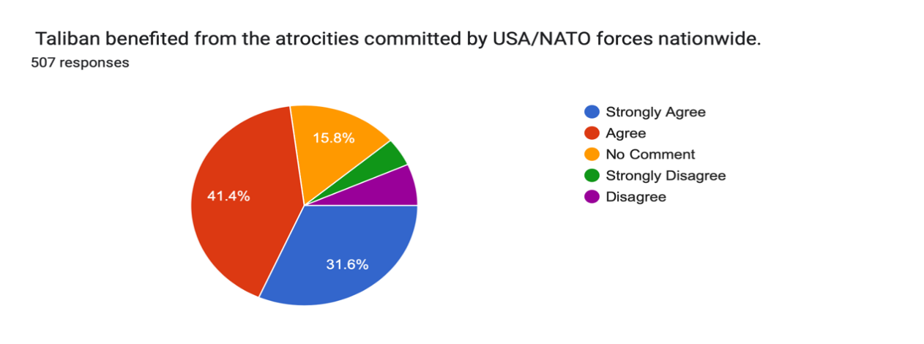

As illustrated in Chart 5, more than 31% of the interviewees strongly agree that the atrocities committed by the USA and NATO forces contributed to the revival of the Taliban and benefited the Taliban in attracting more sympathy from the Afghan population.
Similarly, supporting warlords who committed many atrocities in the civil war during 1992-1996 undermined the US peacebuilding efforts.

Chart 4.6:
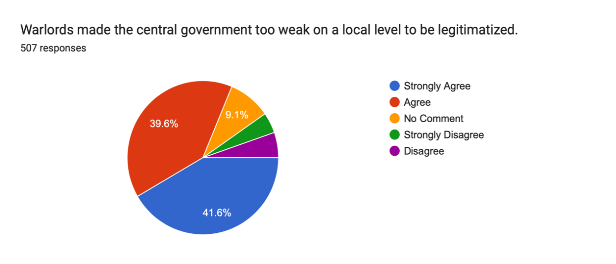

Afghanistan weakened the central government, making it difficult for it to gain legitimacy at the subnational level. Over 41% of correspondents strongly agreed with the hypothesis that warlords contributed to this situation. Abuses by prominent warlords and security officials such as Dostum, Sherzai, Khalid, and Raziq did not prevent the Taliban from gaining ground or legitimacy at the sub-national level, nor did they definitively weaken their forces. Patricia Grossman (2021) argues that successive U.S. administrations largely viewed human rights as an obstacle rather than an essential component in addressing Afghanistan's issues.[
These experts provide evidence of heightened stigmatization against the U.S. in Afghanistan, which could have been mitigated but was not adequately addressed. The inter-group contact theory suggests that increasing empathy and reducing anxiety are critical in lowering such prejudices (Paolini et al., 2021).[260] Therefore, promoting more positive attitudes and behaviors toward U.S. efforts through increased inter-group contact could have improved outcomes.
However, the failure to effectively reduce this stigma ultimately contributed to the failure of peacebuilding efforts in Afghanistan. Addressing these issues remains crucial for future peacebuilding endeavors in the region.

The Role of Hostility, International Capacity, and Local Capacity
This study also found strong support for these principles, highlighting critical factors contributing to the failure of U.S. peacebuilding efforts in Afghanistan.
1. Local Roots of Hostility: The Afghan conflict was deeply rooted in local grievances, power struggles, and historical dynamics that were not effectively addressed by U.S. interventions.
2. Local Capacities for Change: Afghan society has diverse local capacities and agencies that were often overlooked or undermined by external interventions, limiting the sustainability of peace efforts.
3. International Commitment: Despite significant international involvement, there were challenges in coordinating efforts and maintaining long-term commitments to Afghan peacebuilding.
This study identified complex interactions among these factors, contributing to Afghanistan's inability to achieve sustainable peace.
Moreover, the findings underscored the need for context-specific peacebuilding strategies that are responsive to local dynamics. Simply transplanting models from other contexts without considering these elements can lead to ineffectiveness and failure.
By focusing on these principles, future peacebuilding efforts can learn from past mistakes and work towards more sustainable outcomes in conflict-affected regions.

Chart 4.7:

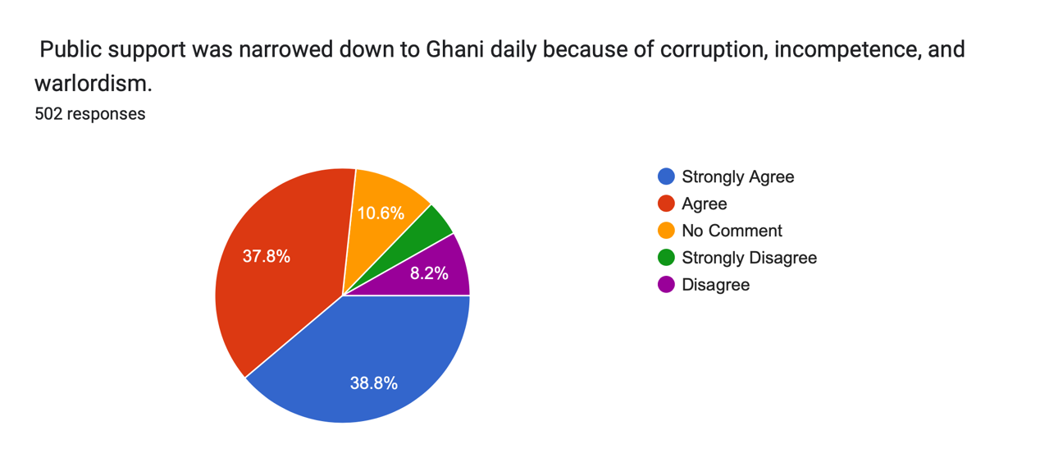

38.8% of the survey participants strongly agreed that the republic government was too corrupt and incompetent to secure the country, and 37.8% agreed with the same result. In addition to the incompetence and corruption, warlords deprived the government of public support, which directly benefited the Taliban on the battleground of gaining more public shelters, recruitment, and space on the ground to hit and run [169].
Hostility
A deeper civil society, more vital state institutions, increased political involvement, land reform, and regard for ethnic identities are all seen as methods to increase the likelihood of peaceful administration [249]. This research study confirms this fact by analyzing the responses supporting the same discourse [43].
Chart 4.8:
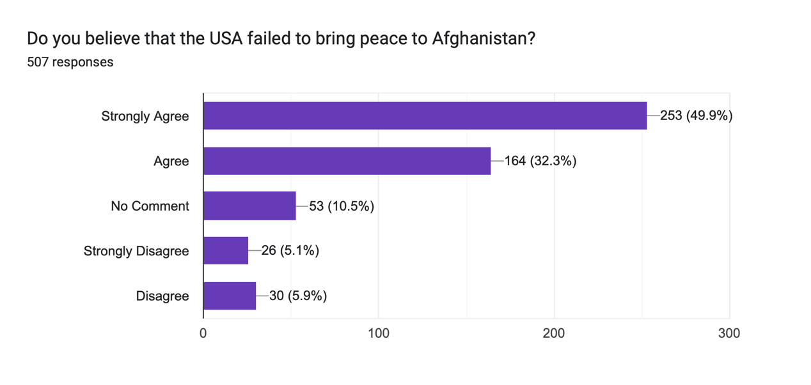
Most interviewees strongly agreed (49.9%) or (32.3%) that the US had no significant strategy for peacebuilding from the beginning, and most of its presence in Afghanistan needed to be coordinated and managed.
b) international capacity
The research work supports the fact that lack of capacity within the government expanded the grievance within the Afghan population, which benefited the Taliban from working with locals on the provision of justice and solving land disputes (Zaland, Sharma, & Pandy, 2023) [43].
Chart 4.9:
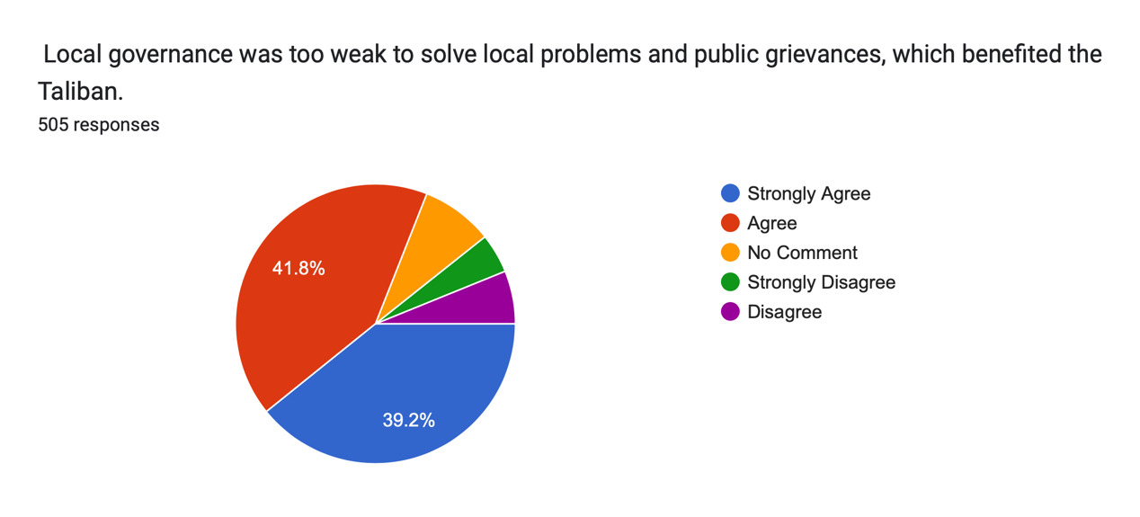

The survey results illustrate that 39.2% of the interviewees strongly agreed. In comparison, 41.8% supported the idea that local governments could not solve ordinary public problems, which created more distance between the government and the public.
The survey results show that the United Nations (UN) did not play a substantial role in mediating a peace deal between Afghan sides; 40.4% of the participants strongly agreed to the fact that the UN did not play a robust role in the mediation, while the 38.7% of the participants support this fact. Only a small number of the participants did not agree with this fact.

Chart 4.10:

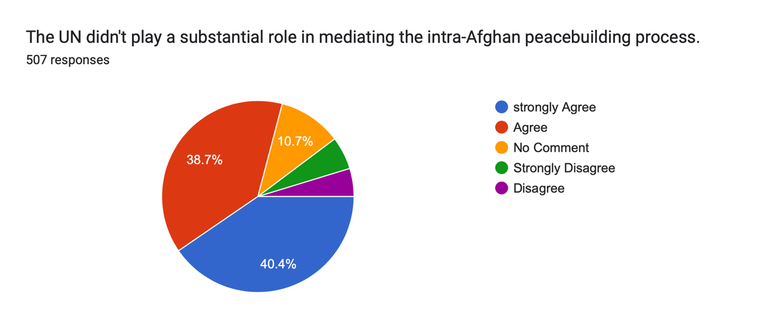

Grassroots capacity to change
The principle of indigenous empowerment suggests that conflict transition must actively envision, embrace, respect, and encourage human and cultural resources within a given setting. Lederach & Appleby, 2010 argue that the experience of conflict has increased hostility [166]. Grassroots support for any policy-making decision of the central government is vital. However, very little of such was considered in the prevailing peace in Afghanistan in the past two decade (Zaland, Sharma, & Pandy, 2023)s:
Chart 4.11:
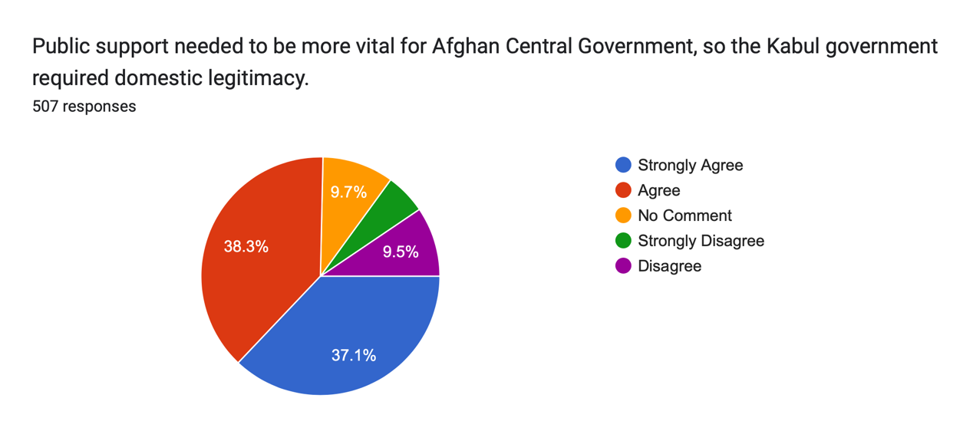
The Survey results illustrate that 75.4% of participants strongly agreed or agreed that the Government of the Islamic Republic of Afghanistan required public support to gain domestic legitimacy.
The grassroots of Afghanistan had their priorities, which differed from those of the international community and their central government. Over 77% of the survey participants, 36.3%, strongly agreed that poverty, illiteracy, joblessness, and drug cultivation all together assisted the Taliban insurgency to be strengthened on the grassroots level in the country. Likewise, Lederach and Appleby (2010) stated that the most significant weakness of far too many peace processes had been the gap between elite levels of decision-making and the communities that are the recipients and inheritors of those outcomes.[166]

Chart 4.12
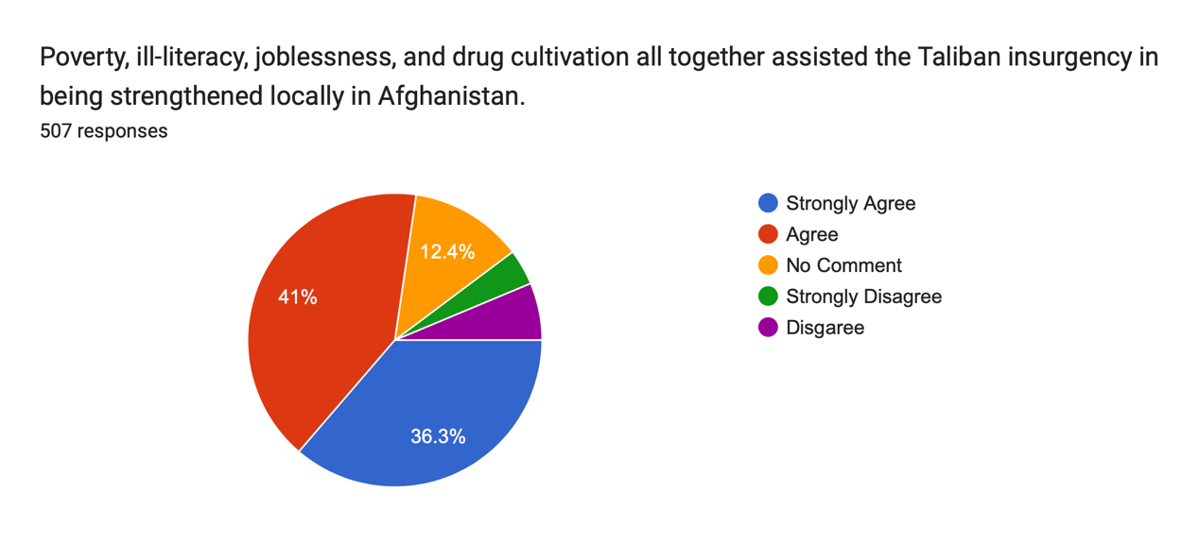
Local Autonomy Via Socio-economic Development State Legitimacy
36.1% of Survey participants strongly agreed, and 43.8% agreed that the central government has never contained the economic mafia, especially those looting Afghan mines. Afghanistan- one of the world’s poorest countries sits on at least $1 trillion of untapped mineral resources. (Hussein & Haddad, 2021) [261] Besides, poor security, weak legislation, and corruption have prevented the development of the mining sector.

Chart 4.13

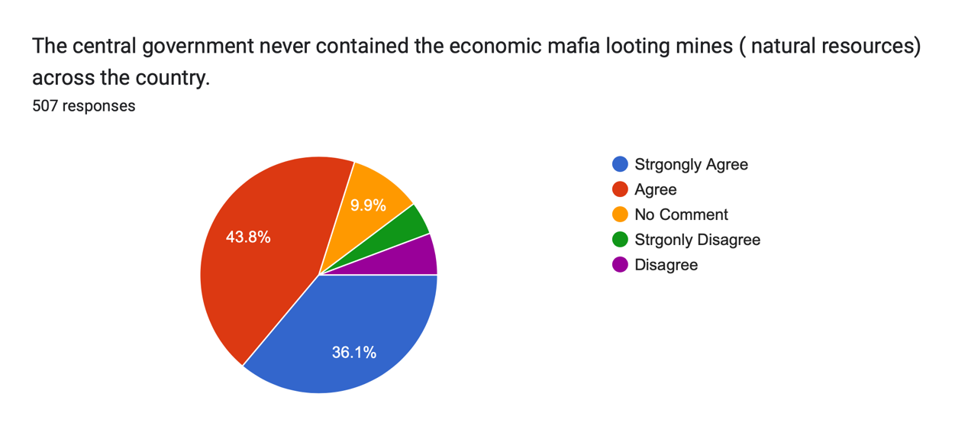
Civil Resistance
The survey results illustrate that 21.7% of participants strongly agreed that the Taliban’s resurgence was indigenous rather than a proxy, while this fact was supported by 42% of the participants. Only a tiny number of 7.7% of the participants disagreed with the fact; therefore, the result of the research survey also confirms the fact that civil resistance to the US and NATO invasion and bad governance of the incumbent government of the Republicans created more public grievance on the ground which supported the Taliban resurgence in the country.

Chart 4.14:

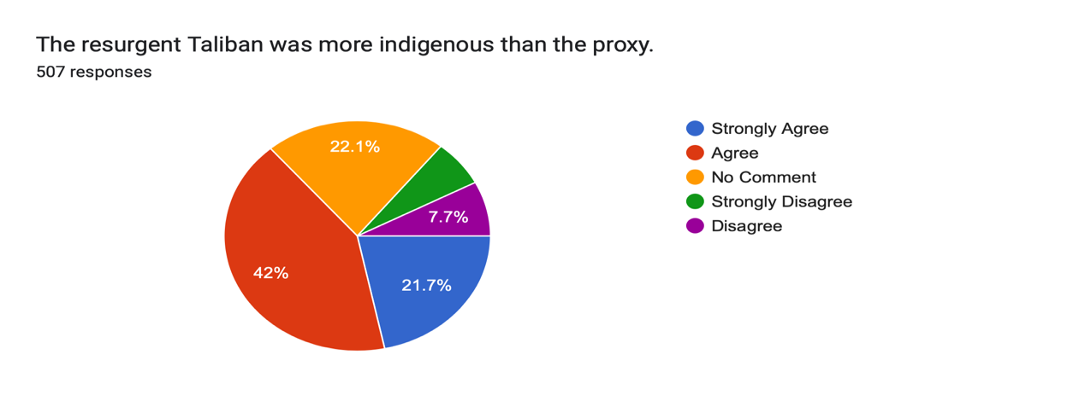
In addition, 35.1% of the participants strongly agreed that Civil Society in Afghanistan became a mafia governed by warlords and economic mafia and did not play a positive role in bridging the distance between the Government and the people.

Chart 4.15:
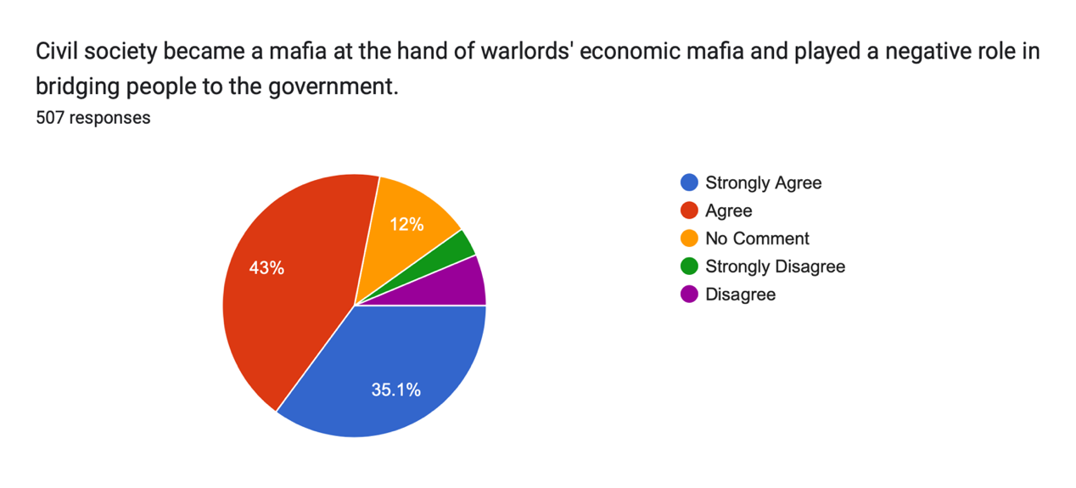

Lack of Effective Mediation

The survey results clearly illustrate that 30.6% of participants strongly supported a robust mediator. In comparison, this fact is supported by 43.8%, a more significant number of the participants, that the mediator's presence was essential to the successful Afghan peace process.

Chart 4.16:
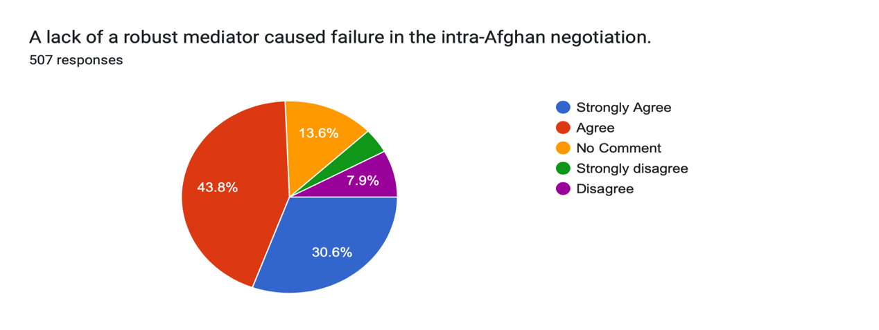

Chart 4.17:
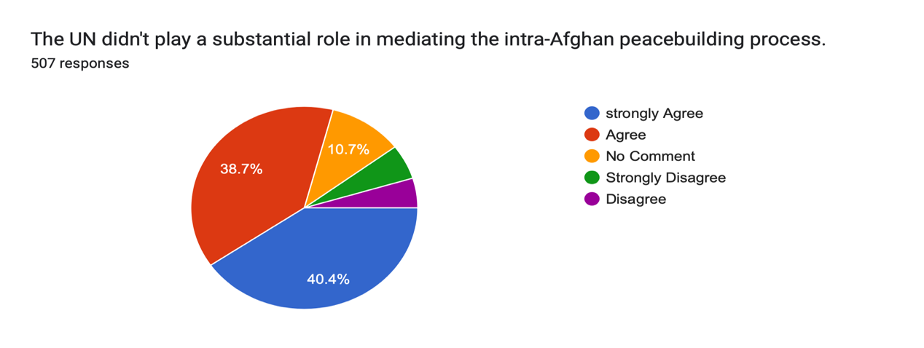

Chart 4.17 demonstrates that 40.4% of the participants strongly agreed that the UN did not play a significant role in mediating the intra-Afghan peace process, while 38.7% supported the mentioned fact.
Thus, the pieces of evidence indicate a lack of an effective mediator in the US peacebuilding process in Afghanistan. As a result, the efforts failed, and the Taliban took over the nation on 15 August 2021.

Poor Governance led to disruption
The central government's micromanagement led to the subnational government being disconnected from its center. In a survey, 26.2% of participants strongly agreed with this statement, while 45.6% agreed that centralization of governance diminished public value at the subnational level.

Chart 4.18:
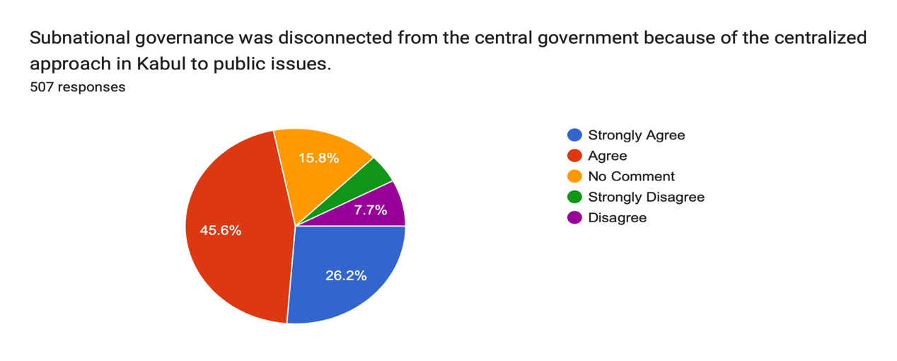
Also, replaying the failed democratization process, 40% of the participants in the survey strongly agreed with the failed democratization of the country with the lack of national strategy and inclusion of political parties into the strategy. In comparison, this result was supported by 42% of the participants in the survey.
Chart 4.19:

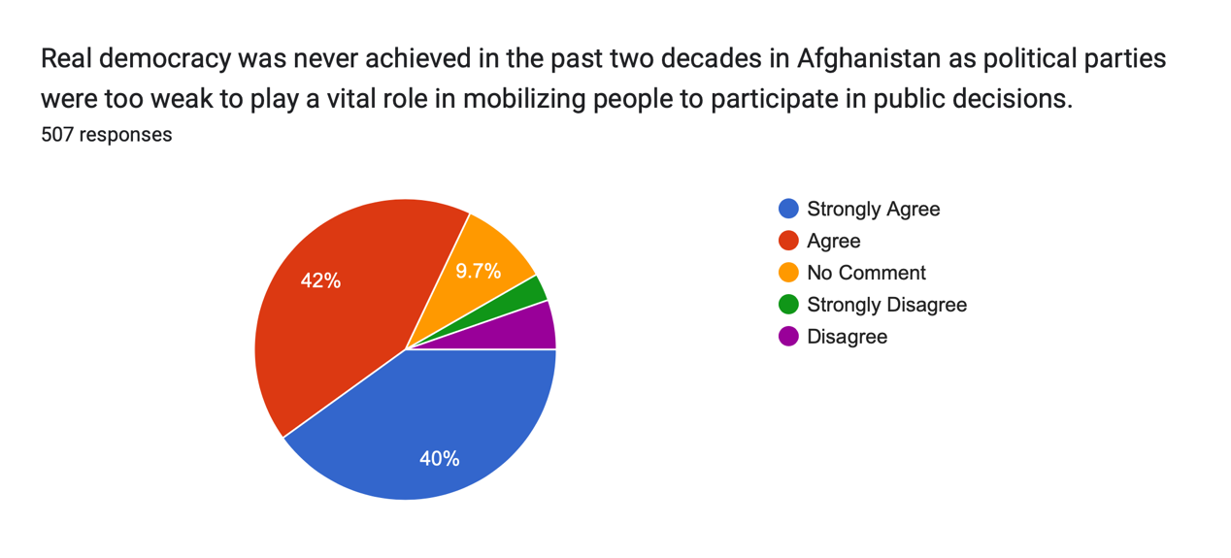

Strategic peacebuilding denotes an approach to reducing violence, resolving conflict, and building peace marked by a heightened awareness of and skillful adaptation to the complex and shifting material, geopolitical, economic, and cultural realities of our increasingly globalized, interdependent world [167].
This empirical research study aimed to review and analyze significant factors contributing to the failure of US peacebuilding efforts in Afghanistan. The study revealed over 19 significant factors that directly or indirectly contributed to the failure of peace efforts in Afghanistan and empowered the Taliban to take over again (Zaland, Sharma, & Pandy, 2023)[43]

3.5 The conflicting synthesis of the Taliban ‘s religious and cultural identity

The Afghanistan is in the heart of Asia, with over 99% of the population Muslims, most of whom are conservative and religious. Islam influenced governance and politics in Afghanistan from its establishment until the twentieth century [263]. Islam and traditional identities have been integral parts of politics in Afghanistan throughout its history. Islam and tradition (Pashtunwali) have always played an essential role in waving the social fabric and in the making of political decisions in Afghanistan, as stated by Asta Olesen (1995) in his book "Islam and Politics in Afghanistan," that the Afghan State from its inception in 1747 to the middle of the nineteenth century, Islam and Pashtunwali constituted the main ideological frame of reference of the ethnically heterogenous and divided society [263]. Whereas Islam plays a role as an all-encompassing way of life (Barfield, 2012), at least, it is not considered an ideology by most rural Afghans.
Historically, Sharia law governed the legal process of Afghanistan till 1925, when King Amanullah first began introducing a civil legal code and started training ulema (religious scholars) to become Qazis (Judges), Islamic judges [24].
Furthermore, Islam was not only part of society's legal and moral basis but mediated through and coexisting with tribal codes and local customs. For many centuries, all learning and education in the country had taken place within an exclusively religious framework [265]. While Barfield (2012) believes that Afghanistan is medieval, religion still plays a predominant role in culture and politics.
Afghan politicians (kings and equally others who were performing as Presidents of the governments) throughout history required legitimacy from tribal confederates or religious clergy domestically to govern the country, but as rightly stated by Olesen (1995), legitimacy, like beauty, 'lies in the eyes of the beholder '[265].
At the starting point, the Afghan State was a tribal confederacy resting on the tribal legitimacy of the ruler and religiously sanctioned by the culture [221]. In the reign of Amir Abdur Rahman, the 'Pious Sultan' paradigm was utilized to challenge and (partly) substitute the 'tribal model' [265]. This confirms that Islam and cultural identity are intrinsically fused; one should not be compromised for another [221].
To elaborate further, until the nineteenth century, religious authority was not ideologically constituted by the State but based on scriptural knowledge, sacred descent, and mystical association [265].
For the first time in Afghan political history, Amir Dost Mohammad had declared himself as Amir al-Muminin (Commander of the Faithful), and Amir Sher Ali had claimed the divine sanction of his rule to enhance the dichotomy of power legislation which added religion as an external factor of legitimacy to the internal tribal system of kingship [264].
Amir Abdur Rahman even claimed to be God-sent as an answer to the prayers of the Afghans to deliver the nation from the distress following the Second Anglo-Afghan War in 1879 [265]. At the same time, the Amir, to curtail the influence of tribalism, focused attention on the legal function of Islam for the first time. As Amir, by divine right and defender of the faith, imposed the shari'a in order [266].
Tribes, sub-units of ethnic groups, have become the building blocks of political alliances. Such tribal segmentary systems provide opportunities for building more extensive partnerships and a tendency towards segmentary division at their core [267].
Below are the two sketched approaches to gaining legitimacy to govern the country.

Figure 14 Two sketched approaches to gaining legitimacy to govern the country.

The model of the legitimation of the transmission of power in traditional Muslim societies is based on Mozaffari (1987). This is adopted by Asta Olesen (1995) in his book " Islam and Politics in Afghanistan. [262] Tribal solidarity, possession of power, Islam, and the nation itself are considered the main pillars of a legitimate government by Oliver Roy (1990) in Afghanistan [266]. However, Power in Afghan peasant society resides neither in a specific locality nor a person but in an elusive network that needs constant maintenance and reconstruction [221].
For the first time in Afghan history, political Islam was used as a tool to expand the authority of the Amir (King) through the establishment of fiqh-i Hanafiyya as the official creed of the country led to the active suppression of divergent religious practices, and the position of Jihad as the central concept in the political ideology of the Afghan State was given a practical meaning in connection with Amir's campaigns against Hazarajat by Amir Abdur Rahman Khan in (1891-1893) and in capturing the Kafiristan; the current Nuristan (1895-1896) [264].
The fiqh, the concrete application of the shari'a to society, is the product of a thousand years of commentary, a process of reading and re-reading. The text itself needs to be recovered, and the fiqh is usually taught by employing summaries of articles on other comments [266].
Amir Abdur Rahman Khan used Islam politically to galvanize the tribal tradition (Pashtunwali) under the control of the State. At the same time, his grandson, King Amanullah, initialized the pan-Islamism ideology of global governance with the assistance of Deobandi Scholars, Indian Muslims. He inherited the scripts from Said Jamal ud Din Afghan [264]. Amir Abdur Rahman Khan used tribal politics (Pashtuns), Islam, and Jihad as a feature of Afghan national identity and created modern Afghanistan to govern the country [221].
The reforms carried out by Abdurrahman were not based on any reformist ideology. In the process, the Amir linked elements of Islamic belief with Afghan tribal customs, convincing his illiterate population that the two were identical [221]. His conception of modernization was purely pragmatic: to rationalize the institutions of the State to make them more efficient without affecting traditional society. New techniques were adopted, and critical sectors were reformed, but something more than a simple Lashkar had become apparent piecemeal. Better to enforce state laws [266]. Finally, Abdurrahman Khan, the 'iron king,' revived Islam as a national political and war-fighting doctrine [268].
Furthermore, the role of religion in politics changed drastically after Afghanistan's independence from Britain. Amanullah Khan in 1919, and the reason was the reaction of some Mullahs and conservatives against Amanullah Khan's modernization policy and public reforms.
Article 4 of the 1923 Constitution of Afghanistan (Nizamnama-i Asasi- e Daulat-e Aliyah-e Afghanistan) stated: His King Amanullah Khan is the first to initiate a constitution in Afghanistan's political history; the Constitution granted specific concessions to Islam, as in Article 4: Given the extraordinary services rendered to the cause of progress and independence of the Afghan nation by His Majesty the King on ascending the throne will pledge to the nobles (afghan-web.com, 1923) and the people that he will rule following the principles enunciated in the Shari'a and this Constitution and that he will protect the independence of the country and remain faithful to his nation. (afghan-web.com, 1923)
Article 69 grants a further concession to the Sharia Law: in cases of conflict, the Constitution had precedence over Sharia. Moreover, in Article 16,' All subjects of Afghanistan have equal rights and duties to the country per Sharia and the laws of the State.(afghan-web.com, 1923) On the contrary, the 1923 Constitution of Amanullah plus many aspects of Hanafi Sharia of Sunni Islam and local customs, several of them contradicting the Sharia [ 269].
In the section on the judiciary, all references were made exclusively to Sharia. Whenever Sharia and statutory rules were mentioned, Sharia was generally mentioned first all together; at least 18 of the 110 articles stated adherence to Islam. In 1931, in the era of King Nadir Shah, the Jamiyatal-Ulama was created as the first national organization of Ulama in Afghanistan. It was entrusted with interpreting existing law, and all proposed governmental regulations and laws were to be submitted to the Ulama to ascertain their compatibility with Islam [264].
In the Muslim world, the 'ulama ̄,' scholars of religion and law, emerged as a professional class widely supported by state patronage. They shaped and increasingly controlled religious knowledge and its application. “Religious specialists were leading prayers (ima ̄m), interpreting Islamic law (mufti ̄ı) and administering justice (qa ̄d ̄ı), memorizing and chanting the Qur'an (ha ̄fiz, qa ̄ri')“ [267].
Altogether, this development was logical to the advisory board of ulama- the Mizanal-Tahqiqat – created under Amir Habibullah and King Amanullah. Nevertheless, while these boards had mainly consisted of hand-picked Ulama to endorse the official policy, the Jamiyat Ulama, as a comprehensive national organization, could better act as a pressure group for religious interests within the State.
Although a School of Administration (Dar ul-Hukkam) had been opened in the 1920s, until the early 1940s, only Sharia studies counted as educational credentials for entry into the bureaucracy. Although the influence of Deoband on the intellectual climate of Afghanistan had been very significant, King Amanullah favored connections to the modernist College of Aligarh and limited the links to Deoband. To restore and strengthen the old academic and educational ties with Afghani- stan, the Vice-Chancellor of Deoband visited Kabul to congratulate Zahir Shah on his ascent to the throne in 1933 and also to submit a memorandum to the Afghan Prime Minister on what services Dar ul- UlUm Deoband could offer Afghanistan regarding the educating of Afghan Ulama in the future. Deoband is named after the location of its head seminary, which is in the small town of Deoband in North India. Deoband was the second university created in the Muslim world after Al-Azhar. Deobandi madrasas centering on the Darul Ulum of Deoband in North India. They have branches in South Asia, Southeast Asia, South Africa, Britain, and North America [267].
The Deoband school rejected innovation (Jbid'at), kept to a strict orthodoxy, and would not permit the cult of the saints; nevertheless, it accepted Sufism, and many of the teachers were Naqshbandi or Qadri, which clearly shows how the Fundamentalism of the school is distinct from that of the Saudi Wahhabi. The Deobandis have seen Sufism as Inseparable from Islamic legal norms. (Ingram, 2018) Once again, the link between Fundamentalism and Sufism was to be the hallmark of the orthodoxy 6f the 'Ulama of the subcontinent, Afghanistan included [266].
On political matters, Deobandis preferred to protest their loyalty to the British. (Haqqani, 2006) They were against Jihad while they issued fatwa ̄s, raising high hurdles under which it would become legitimate to start Jihad to the extent it became almost impossible. The Deobandis were not a reactionary school of thought to British Colonialism in India but to reform and unite Muslim society by Mohammed Qasim Nanautawi (1833-77) and Rashid Ahmed Gangohi (1829-1905), who were the prominent ideologues of Deoband madrassa.[270]
The first signs of a new (political) trend in Islam in Afghanistan of questioning not only the modus vivendi with the State obtained after 1930 but also of established orthodoxy came from the Ulama (from religious scholars) outside its organized expression, the co-opted Jamiyat al-Ulama. Later, the religious opposition split into two directions, with intellectuals (rawshanfikran) rather than theologians (ru/:zanian) spearheading the most radical direction. This was the first time since Mahmud Tarzi and his 'modernist Islam' that religion and religious interpretations had been the point of focus for laymen in Afghanistan [264].
Here, too, signaled an unprecedented politicization of Islam in the form of the Ikhwan ul-Muslimin movement, founded in 1928 [271]. [ A subcontinental parallel could be found in Jamaat-i Islami, founded by Mawlana Maududi. While the initial inspiration in Afghanistan came from Egypt, Maududi's influence on the Afghan Islamist movement had increased dramatically since the 1970s, when several Afghan activists fled Pakistan. (Olesen, 1995) Maududi can be described as the first complete theoretician of the modern Islamic State [265].
An Islamic state must apply the tenets of Islamic doctrine, and above all, Sharia, to all aspects of social and economic life. For Maududi, Islam was not a religion but an ideology, a way of life [272]. Thus, for the traditional Ulama, the question of the legitimacy of power arose after the Ulama could apply Sharia to civil society [267].
The Islamists were equally condemning in respect of the governmental and the private madrasa system. The personal, tradition-oriented madrasas were criticized for depriving the students of acquiring political consciousness and modern education and, thus, of coming to know the world. In Madrasses, the reason for this state of affairs was, according to the Islamists, that the educational system was based on Greek philosophy more than on the science of Quranic interpretation. Within the field of fiqh, technical and scientific abilities were frozen, and no expansion of these laws was made to meet the requirements and needs of the changing times.
Islamic schools of thought from the fourth and fifth centuries blended with Greek philosophy were considered irrefutable facts. Hence, the staff of these private madrasas fought civilization and science in the name of Islam, neglecting physical and experimental sciences because these supposedly were anti-Islamic [265].
As in the 1964 Constitution, in cases where the law was not clearly defined, the courts would settle the cases following Sharia and the principles of democratic legality and justice (Article 56). Daud Khan ignored the ulema and tribes; he allied himself with the leftist educated and committed a coup in 1973, establishing an Afghan republic. (Barfield, 2012) Therefore, both Marxists and Islamists stepped up their recruiting efforts, seeking to replace Duad and committee a coup; the Marxists (Khalqis and Parchamis) were quick to a military coup against Daud in April 1978, which brought the People's Democratic Party of Afghanistan (PDPA) to power in t the newly democratic Republic of Afghanistan [221].
Considering the actual content of the PDPA's policy vis-a-vis Islam, it is first of all clear that, as far as the legitimacy of power is concerned, the 'PDPA model, according to the interim constitution of 21 April 1980, passed by Loya Jirga on 25 April 1985- did not seek recourse to any Islamic values [264].The three significant aspects of Khalq's policy were agrarian reform, eliminating illiteracy, and strengthening the state machine. The communist leaders have always been conscious that they have been creating a revolution by proxy, faced with a nebulous working class and an apathetic peasantry. (Roy O., 1990) They were Obsessed with Amanullah's precedent and thought it necessary to strike swiftly and ruthlessly before the "counter-revolution" could organize itself [265].
To achieve this, they adopted three means: repression, made possible by the existence of a loyal and well-equipped army; agrarian reform which, they thought, would win the support of the mass of the people; and the elimination of illiteracy, to rescue the people from the influence of the clergy and to spread the new ideology. The communist regime also rejected the country's traditional Islamic symbols of legitimacy by striking religious salutations from their speeches and decreasing and changing the tri-color flag to red. Among the tribal Pashtuns, rather than seeing the refugee situation as hijra, they conceived of it in terms of the milmastiya (hospitality), Nanawati (refuge), or Panah (asylum), obligations which Pashtunwali integrity and honor of the individual, since ownership of land (zaman), is an essential part of Pashtun identity.
Again, the invocation of zan, zar wa min (women, gold, and land) (Dupree, 1984) and nang wanamus, as well as the violation of the patriarchal order-which emancipation of women involves - also point to traditional values beyond a strictly religious discourse. The PDPA-led government failed to attain public legitimacy for their government; the party was split into two rival groups, Khalqi and Parchami, and failed to implement their new economic policies across the country [221].
The failure of the PDPA government invited the Soviets to invade Afghanistan and spark a new movement of liberation and resistance against the infidels in the country This time, the urban Islamists were joined by the rural traditionalists to defend their country against the invaders; the decade long Soviets occupation motivated a new wave of global Jihad; Afghanistan became the battlefield for global Jihadists across the globe whom CIA and Western countries supported to revenge the Soviet's support for Vietnams and apply the "Saigon syndrome" to revenge Soviets in Kabul [257]. The United States and Saudi Arabia were willing to bankroll dollars for the resistance, mujaheddin in Afghanistan, which reached a billion dollars a year in the mid-1080s.
The Afghan mujahideen were sucked into two more significant conflicts: the cold war struggle between the United States and the Soviet Union and a new struggle by Saudi Salafis who wanted to make the war in Afghanistan the vanguard of global jihad.
The civil war between the Islamists (mujaheddin) seems the turning point in Afghanistan's religious conflicts, which have been going on for the past four decades; the Taliban are merely the side-effect of this chaos, while now they are drastically confronted by The Islamic State – Khorasan Province (ISIS-KP), who is looking after a more prominent geographical approach than the Taliban in the region.
The Soviet Union's withdrawal in 1989 caused a gradual fall of Najibullah, which took only three more years to resist the mujahedin's surge and fall in April 1992 [214]. Once mujaheddin defeated their common enemy on the battlefield, they lost a goal to unite themselves under the shell of an Islamic government [221]. They started fighting each other to gain power in Kabul, which initiated a new era of civil war in Kabul.
The civil war did not result from a blood feud or tribal rivalries. However, this resulted from the division among Mujaheddin's divided parties funded by political-military factions in Pakistan. Mujahedeen started abusing the population, engaging in rape and pillage without any fear of punishment; therefore, no fiction was able to establish either political legitimacy or military hegemony, which staged the Taliban and spread in such a context [221].
In the 1990s, the Taliban movement emerged as an ultra-traditionalist network of madrassa students, many of whom fought on the frontlines in greater Kandahar against the Soviets [273]. The group came to be known collectively as the Taliban, which means "religious students" or "seekers of knowledge" (Taliban is the plural of "Talib") since most of them had religious training [274]. Taliban religious ideology is a crude mixture of Salafi Islam and traditionalism ( Pashtunwali]. [221]. The rise of the Taliban in Afghanistan is a clear example of what Roy has called 'fundamentalism' following the crisis of the Islamist political model [276].
Pashtunwali is very nicely defined by Roy (1989) as a set of values (honor, hospitality, shame, and revenge), an institutional framework {jirgah or the assembly of tribesmen, which is supposed to make crucial decisions by consensus, under the guidance of the khan and Malek (or 'elders'), and a common law which could sensibly differ from Shariat as far as revenge, marriage, inheritance and landowning are concerned.
The attempt to enforce traditionalist standards—meaning prioritizing dispute resolution and the cultivation of virtues resonant with rural Pashtun life—in a diverse society, the original Taliban sought to reject modernity [275] as well as the attempt to mold informal networks into the iron cage of a bureaucratic state, was an exercise fraught with contradiction [221].As rightly drawn down by Oliver Roy (1990), by traditionalism, the research mean the desire to freeze society to conform to the memory of what it once was: it is society as described by our grandfathers. Taliban have been trying to take Afghan society back to its origin by reversing the traditional decision-making process and interpreting the Islamic religion in very conventional and extreme ways. Mullahs are pushing for the adoption of Shariat as opposed to Pashtunwali [265].
The Taliban groups were somewhat set apart from the other mujahedeen, partly because they observed specific rules and habits, which some other fighters—in the exuberant freedom of the times—considered too strenuous or perhaps too strenuous even ascetic. Mujahedeen affiliated with the comparatively liberal Mahaz-e Milli party of Pir Gailani or Rabbani's Jamiat-e Islami say they viewed the Taliban units as naysayers and too strict by far [278].
To conclude, Afghan political Islam movements were the shadows of Islamic movements in Egypt and the Indian subcontinent, which were establishing social and political groups by some individuals as a reaction to the abolition of the caliphate in 1924 by Mustafa Kamal Ataturk, the new world order, and Muslim backwardness in various fields [263].
At the end of the twentieth century, political and cultural Islam took an upswing across the Muslim world, successfully challenging and ultimately unseating nationalism and socialism as the primary sources of political legitimacy, ideological mobilization, and cultural identification [267].
Furthermore, the war against the Soviets had three consequences: politicization, "Wahhabization," and enlisting a second generation of refugees in Pakistani madrasa [278].
Muslim Brotherhood of Egypt and Jamiat-e Islami of Mawdudi, known as predecessors of Islamist movements, influenced politics in Afghanistan after the 1960s. [279]. Hasan al-Banna's moderate ideas spread in the 1960s through Afghanistan Muslim Youth Organization's leaders who were educated in Al-Azhar and returned to the country with the influence of the Muslim Brotherhood's ideas about Islam, government, society, etc. Jamaat-e Islami of Mawdudi, which formed in the Indian subcontinent in 1941, is another Islamic movement that influenced Afghan Islamists. [263].
Mawdudi's ideas about the Islamic government became a basis for Afghan Islamists. Sayed Qutb influenced Afghan Islamists, especially radical Islamists, through his ideas expressed in his "ignorance" theory during the Afghan-Soviet battle in the 1980s. [276]. As stated above, Afghanistan has a long history of instability, political and tribal feuds, and foreign invasions. However, political Islam has proved to be one of the major players in destabilizing the country in its recent history.

Traditionalist Vs. Islamist in Afghanistan
The religious aspect of politics has been rooted in the invasions Afghanistan has faced throughout its recent history. At the same time, traditions were invested in the inception of the Afghan State in 1747 by Ahmad Khan (Shah), who became the King (Shah) through a Tribal Jirga; therefore, explaining traditional aspects of the political games versus the Islamist takes as to the historical events which have brought this distinction difficult enough to research [269].
The traditionalist is not only the tribal chieftain who led the country for more than 200 years but also has taken a new format once the Islamists started shaping the politics of Afghanistan. Throughout history, rural Afghanistan was traditionally the domain of an eclectic form of Islam, which mixed tribal practice with elements of Sufism, Deobandism, and indigenous folklore—the very type of parochial traditionalism that reformers and modernizing Islamists rail against [269].
Traditional fundamentalism- the will to have the Sharia and only the Sharia as the sole law- has been pervasive throughout modern Afghan history [276].
Modernist political Islam," on the other hand, was articulated by urban-based Afghan intellectuals in the 1960s and 70s. Influenced by the Muslim Brotherhood in Egypt, Afghan political Islam sought to revolutionize society, overturning old social relations while emphasizing social justice [279] Jamal ad-Din "al-Afghani" (1838-1897) Pioneered Islamic modernism, which sowed the seeds of Islam in the Middle East, south-eastern Asia, and Afghanistan [280].
Roy (1997) defines Islamism as something different: it is the perception of Islam more as a political ideology than a mere religion. For Islamists, the Sharia is just a part of the agenda. The Islamists think that a truly Islamic society could be established only through an 'Islamic State,' which presupposes a revolution or a struggle to gain political power. Fundamentalist mullahs rely on any de facto ability to implement Sharia.
Traditional Islamists represent the development of Islamic doctrines from the seventh century up to approximately the ninth century [281]. The Afghan Islamist movement dates back to the end of the 1960s, when it recruited mainly among university students (Faculty of Engineering, Polytechnic Institute, or the newly created State University of Theology) under the influence of professors of Islamic sciences (Gholam et al.), having returned from Al-Azhar in Cairo, where they came under the power of the Egyptian Muslim Brothers. The Pakistani Jama'at-I Islami supported the fledgling movement, which sent Qazi Husseyn Ahmad to advise it [267].
Oliver Roy (1990) divides Afghanistan into two geographical divisions: the town (shahr), the place of innovation {bid'at); this is the natural environment of the civil servant, the teacher, the soldier, and the communist, all "intellectuals" and "bare-heads" (sar- luck), held to be unbelievers and arrogant; and secondly, the province (atraf), the home of religion, tradition (sunnat) and values which stand the test of time. This division further draws a line between the traditionalists and Islamists in the 20th or 19th century and the beginning of the 21st century [266].
More generally, the research work finds a division into a more 'traditional' and an 'Islamist' format. 'Traditional' refers to local and popular institutions and learning methods that were common in that area earlier. Prominent examples would be many local schools of tribal, Pashtunwali (the way of Pushtun) [264] tradition Afghanistan's political or ethnographical history and the religious aspect it would take the more conservative element of the religion which is derived somehow from local madrassas, mainly adjacent to the village mosques where many teaching texts books would be the traditional 'yellow books' – the classics of Islamic thought in South East Asia. 'Islamist' would refer to a revised literalist curriculum that follows the traditions of al-Azhar, Deoband, or the Saudis in line with the concept of Sharia that seeks to reform Muslim society to bring it into conformity with the Islamic ideal of the founder generations of Islam (as-salaf). Among its components, profound differences persist in interpretation and ceremonial practice.
Deobandis are divided into three categories by Bashir Ansari in his book “The Genealogy of the Taliban” 2013) [281]. He writes that the first category of Deobandi is the pure, original Deobandi who founded this school in India; they are moderate in their beliefs. They were even against dividing Hinds into two countries; the second Deobandi category is Pakistan-based and is led by Mula Fazal Ruhaman (the head of Jamiat Ulema Islam). This group is highly politicized; they are looking to gain political power. This group believes in Pakistan's democratic government and participates in the elections, which are at the core of the Islamic state theory. The third category of the Deobandis is Afghan Deobandi, who look the same in appearance and follow the same Madrassa curriculum. At the same time, this group is practically different from the above two. Therefore, this category is closer in its thriving for power to Pakistani Deobandi and has attended the same Madrassa founded by Deobandi in Pakistan.
The Islamists have two movements that also influenced most of the Islamic countries. One is Deobandi Madrasas, built initially by Hanafi Muslims to fight against the British in India, and the second is the Muslim Brotherhood movement in Egypt. Both had their influences on the Afghan people as well [267].
To better differentiate or understand the Traditionalists and Islamists, the traditionalist focused on 'Islam, Nationalism and Democracy' as the basis of their philosophy, activities, and approach to the solution of internal problems, while the Islamists are the product of modernist enclaves within traditional society; their social origins are what the research work have termed the state bourgeoisie — products of the government education system which leads only to employment in the state machine [284].
Therefore, in this context, we should distinguish between the village mullah, the 'alim or Sheikh (Doctor of Law), the Sayyad (reputed to be a descendant of the Prophet), the pir or Sufi (a charismatic figure sometimes found at the head of a Sufi brotherhood) and finally the Islamist intellectual [266]. The charismatic mullah is a figure who provides an insight into the social milieu of the tribe when it is undergoing upheaval and suffering from disunity; he emerges at times of crisis when the ideology of Jihad transcends tribal divisions.
As in other Sunni countries, in Afghanistan, there is no such thing as an organized and hierarchical clergy. Nevertheless, there is an apparent distinction between the village mullahs and the more educated clergy. The most gifted Afghan Ulama used to go to India, particularly to the great madrasa of Deoband. After partition in 1947, Peshawar became the center where the traditionalist Ulama pursued advanced studies. While the primary goal of the Deoband School is to purify Islam [261].
It was the 'Ulama, in alliance with the tribes, which caused the downfall of King Amanullah in 1929. The 'Ulama also embody a principle of historical legitimacy: they have always been the ones to rally the people with a clarion call for Jihad and have always been at the forefront of the resistance to colonialism.
According to Anwar ul Haq Ahady (1997), the rise of the Taliban was undoubtedly a response to the anarchic conditions in the Pushtun-populated areas. Still, with Pakistan's support, the movement would have become more powerful to defeat significant warlords [285].
As Roy (1997) noticed that the Taliban movement embodied the resurgence of a traditional phenomenon in Afghanistan: the coming together of Pushtun tribe members in a time of crisis under a religious and charismatic leadership; this phenomenon has been evolving into a more strictly defined spiritual perspective than tribal or traditional recently [266].
As the Taliban have been in power since 15th August 2021 in Kabul, the Taliban are struggling to reinvent governance while inheriting the bureaucracy from the previous republic government. After 20 months of being in power, the Taliban are still calling their government an acting or caretaker government that is not recognized by States around the world; therefore, the way forward for establishing a state based on purification and Sharia seems a difficult task to achieve while having the same opponents of 1996s – the former Mujaheddin partis as National Resistance Front, with a new military group of Afghanistan's liberation front. In addition to the former Mujaheddin partis opposition, the Taliban are facing the harshest attacks and fight against the Islamic State of Khurasan (ISIS - KP), who are committing suicide and complex attacks to fight the Taliban and targeting Shia minorities across the country. The Islamic State for Iraq and al-Sham (ISIS) was founded in 2014, the same year they stormed across Iraq and Syria and bore down toward the gates of Baghdad.

Taliban Conflicting the Religion and Tradition in Afghanistan
As the Taliban was in government for the first time in Afghanistan, the religious leader chose to take power for himself (Mullah Omar was designated Amir ol Momumin, or Leader of the Believers, in December 1995) the Taliban movement emerged from religious networks from the 1978–89 resistance, i.e., it is a broader movement that saw itself as religiously motivated but without building any fundamental state apparatus. Historically, Before the Taliban, no religious cleric had ever ruled Afghanistan [286].
Taliban is the only example of a successful radical Islamic movement for which, after seizing power, national interests did not prevail over international solidarity [278]. Taliban is not a political movement; they are purely religious with a very narrow understanding of the religion [267]. They have stuck to a few old versions of Islamic literature, which seems odd to the current progressive world [283]. The Taliban's supra-tribal ideology, i.e., Islamism, keeps the door open for non-Pashtun elements to join the movement. This has allowed it to expand into non-Pashtun North and West areas systematically. The reference to 'Islam' provides an umbrella that creates cohesion in an otherwise – ethnically and politically – heterogeneous movement [287].
Islamic State is defined by Roy as an "Islamic state" in the sense that it should be based on Sharia and Islamic institutions [278]. In the beginning, The Taliban embodied two sets of logic: firstly, a neo-fundamentalism that is committed to implementing the sole Sharia and claims to bypass ethnic and national divides (hence the hospitality given to Bin Laden); secondly, a Pashtun legitimacy along a rather traditional pattern of uniting the tribes under a charismatic religious leader [278].
If this government of Sheiks is unusual in Afghan history, where does it fit in Islamic history? The closest model is Iran's wilayat al-faqih, or guardianship of the jurisprudence, in which Shia clerics oversee the State. In short, to answer this question, although Iran follows the notion of the "supremacy of the jurist" while remaining partially democratic, the Taliban is not inclined to follow that model [288].
To conclude, the Taliban does not have a blueprint. Nevertheless, their political program is minimal: implementation of Sharia and Jihad. They have no blueprint for an Islamic state and society, as did, for example, the Iranian Revolution. For them, to recreate a Muslim community presupposes the return to what they see as the true tenets of Islamic behavior among the faithful [278].
However, guardianship or custodianship is critical here; in Iran, the State operates in a secular sphere, with elections, a parliament, and a prime minister of considerable authority, with the clerics functioning to keep politics within certain prescribed limits. This is not the system of the new Emirate—in Afghanistan, the Amir governs directly. In other words, Amir's rule is not limited to veto power but positively shapes politics more now.
The Islamic Emirate and Its System are available as the written strategy of the group; judgment about the intellectual foundations of the Taliban has become more accessible. This book deals with various topics such as the sources of Islamic legislation, independence, the principles of politics, judiciary, economics, and so on. The purpose of this article is to analyze the rights of women in this book [289].
Hakim Haqani begins his book with the definition of the Islamic government; he writes that the Islamic government should only have a divine law, and there is no need for any other constitution. Professor Luftur Rahman Saed (2023), former Sharia Faculty at Kabul University, elaborates that the Madinah Constitution or the Charter of Medina was the first Constitution of an Islamic society that formalized the agreement between Muhammad, his followers, and the residents of Madinah [290]. The Charter of Madinah was created to end the rancorous intertribal fighting between the rival clans of Banu Aws and Banu Khazraj in Medina in 622.
Taliban defined themselves as Islam (Sharia) followers, not believing in any tribal codes or definition. At the same time, organizationally, the Taliban seems to be a network of networks, as noticed by Thomas Ruttig (2010). Taliban has many other military, sectarian organizations that learned from their practices, evolving themselves to meet the requirements of their time and environment, as at their inception was with being the members of the more traditionalist (lead by Mulvi Khalis, Mulvi Mohammad Nabi, and Mulvi Mansor) Mujaheddin groups during the war against Soviet occupation [285].
Marsden (2002) has termed them in their last era, while now many women groups term the Taliban's strict policies toward them as "Gender Apartheid Policies." Taliban are the same exclusive force of the past that does not believe in sharing power with any Afghan group, as they did in their last era of dominance [283].
Taliban are more Islamist than tribal because Roy (1990) defines the Islamic movements; Roy believes that Islamists and neo-fundamentalists. "Islamism" is the brand of modern political Islamic fundamentalism that claims to recreate a truly Islamic society, not simply by imposing Sharia or Islamic law, but by first establishing an Islamic state through political action. The fundamentalist is a modernist, responsible not merely for obeying the dictates of the faith but for ensuring that others do [ 291].
In rural Afghanistan, the Taliban have been raised in an inferior living situation; they need suitable accommodation. They should live in the mosque, beg for food, and have a uniform appearance. These all differentiate the Taliban from the rest of Afghans [292]. The Taliban movement's supra-tribal ideology, i.e., Islamism, keeps the door open for non-Pashtun elements. This has allowed it to expand into non-Pashtun North and West areas systematically. 'Islam' provides an umbrella that creates cohesion in an otherwise – ethnically and politically – heterogeneous movement [284].
Nevertheless, they are still struggling to find a core nucleolus within Tajik, Uzbek, or Hazara minorities; in the past twenty years, the Taliban has been successful in attracting Tajiks in Badakhshan to fight aligned with them, who were led by Fasihuddin, currently; he was appointed the army chief with the Defense Ministry, but more focus in North is still to imbed Southern Taliban commanders to look after Tajik, Uzbek, and Hazara; after the killing of Muzamil by ISIS KP in his office on March 09, 2923[293]. Haibatullah transferred his closest ally and tribal member, Yousaf Wafa, as the Governor of Mazar e Sharif. As noticed by Burnett Rubin (2022), Army Chief of Staff Qari Fasihuddin, who is from Badakhshan and is the highest-ranking Tajik in the Taliban leadership, is reported to have been sidelined in favor of commanders from Helmand and Kandahar [261].
In the case of women's presence in society, especially in the Urban community of Afghanistan, the Taliban do not have any women in their raising sites ( mosque, rural life, and in the past twenty years in their fighting mahaz), women are considered city witches; which brings sin, the devil and infidelity to life [289].
The same narrative as in the 1995s is applied to girls' education by Taliban in 2023; in 1995s, the Taliban were saying that soon an appropriate Islamic curriculum and environment for girls' schools will be founded where they can respect more Islamic culture to attend school is, the same rhetoric was applied today in December 2022. [287]. The decree issued by Haibatullah forbade girls from attending higher education while their semester exams were due on that date [290].
After taking over Kabul on August 15, 2021, the Taliban conducted house–to–house searches like they did the last time in September 1996 to disarm people; even the Taliban decapitated the horse's status in Mazar e Sharif in 2022 as they did in the previous take over in Herat as mentioned by Marsden (2002) in his book the Taliban [282].
There are more similar facts about the Taliban's reestablishment of their government with their previous terms as currently, once again, the long queues to the Iranian Consulate in 1998's Taliban rule in Herat as noticed by Marsden (2002) are back in 2023; as banning girls' schools, women work has been enforcing Herati and Western Afghans are trying to migrate to Iran admit their girls into schools and university there [283].
Hamkim Haqani ( the current Chief Justice of the Taliban, 2022) writes in his book that in an Islamic government, there is no political or social place for a woman; women must stay at home; they do not need to do even Baih ( taken an oath with the Amir by hand); they should obey the Amir by heart and accept him as the Amir ul Momin while staying at home; he denies any job for a woman in an Islamic government, he elaborates that woman should only be busy in raising her kids, politics, things out home are the primary duties of a man to look after. Haqani has extensively written about women's rights and writes in his book that women must stay at home, should not socialize with men, and must not go to any work [261].
Hakim Haqqani explains Emirate Islami as a religious aristocracy where a group of well-known Ulemas elects the Amir; as Haibatullah was elected in whereases, during the twenty years of the insurgency, all three amirs of Taliban were holding their position as aristocrats, who were having Quetta Shura ( Rahbari Shura) to consult almost all the decisions to be made; but after the fall of Kabul, on August 15, 2021; Haibatuallah has been slowly sliding from the aristocratic mode of the governance to more an autocratic manner; as he has kept the veto power of nullifying any decision made in Kabul by the Taliban cabinet; Haibatullah has been hiring and firing all levels of government employees from the story of the minister to the very district employee; I was once told be a cabinet member of Taliban; that having a cabinet meeting in Kabul; makes no sense, it is only waste of time; as the natural, de-facto capital of Afghanistan has been changed from Kabul to Kandahar. Taliban’s Amir during the Insurgency: A Religious Aristocratic Format: Allah (Shariah) – Rahbari Shura – Amir -Commissions (18 at every end)
Taliban’s Amir after the Take-over of Kabul on 15th August 2021: A More Religious Autocratic Format: Allah (Sharai)- Amir – Rais Ui Wazra (Haed of the Cabinet) – Cabinet [265].
The Taliban movement is the heir to most of the neo-fundamentalist activities in Afghanistan: most of its early members belonged to the war against the Soviet Army to the Harakat-i Inqilab and the Hizb-i Islami (Khale's faction).
Olivier Roy (2002) calls the Taliban neo-fundamentalists the networks of religious schools (madrasa), which have been active in Afghanistan and Pakistan for decades in their present shape and whose archetype is the Deobandi school of South Asia. This is the model advanced by Sheikh Abdul Hakim in his recent book on Islamic governance. There is no stipulation in his work that Amir should be a religious scholar, and he emphasizes the independence of the judiciary; the leadership likely believes themselves to be acting from the standard template of an Islamic state. However, the lines between the court, consultative ulema, and the Amir have blurred in practice. The existence of a clerical class that directly administers the commanding heights of the State is, therefore, an unusual development in Islamic history.
To criticize the very highly narrow definition of women's rights in Islam, Dr. Saleh (former Professor of Sharia Faculty, Mazar e Sharif University, 2022), who translated Hakim Haqani's book from Arabic to Dari, has criticized Haqani's narrowed definition of women's rights in Islam. Dr. Saleh mentioned that Prophet Mohammad's first job was to work for a businesswoman, Khadija, whom he married later [295].
According to Hakim Haqani, women have no use other than being wives and raising Dr. Saleh disagrees with Hakim Haqani's argument regarding the priority of Madrassa education over modern education and women's rights in Hanafi Fiqah. In addition, he criticizes Haqani for his narrowed and false definition of women's rights in Islamic literature; Dr. Saleh argues in his critics of Haqani's book that Islam orders its followers to modern education, and men and women must obtain an education there is no such division of religious and worldly education.[295]
Once, more Taliban conflicted the religion with its essence and manipulated the tribal code of conduct, Pashtunwali, to govern the country; the Taliban misinterpreted Hanafi Jurisprudence in many aspects., as they revolted military against Mujahideen's Government in 1994, any kind of rebellion against an Islamic government, even if the Government is weak to serve its people or corrupt in its core is forbidden in Hanafi Jurisprudence [284].
After taking over Kabul in August 2021, the Taliban are back to purifying Afghan society by enforcing the strict interpretation of Islam through the Ministry of Propagating the Virtue and Prevention of Vice (MPVPV) throughout the country. They have assigned Muhtasibs (PVPV Inspectors) across the country who have guns on their shoulders, stand on main roads in the cities, Muhtasibs are appointed in every part of the big cities across the country to preach and give advice to the ordinary people in religious matters. They look for women in public transportation, ask shaved men to have a beard, convince youngsters with pants on to replace them with Shalwar kameez, and have a turban to cover their bare heads.
The Hanafi school of jurisprudence that Sunni Ulama follows in Afghanistan considers tradition or 'urf as one of six permissible sources of shari'a, but it is a secondary or even tertiary source. The sources of shari'a recognized by Hanafi jurisprudence are the Quran and sunna (including hadith), which are the primary sources; ijma', the consensus of the Ulama, and qiyas, analogical reasoning, which are secondary sources; and 'urf and artisan, the use of discretion by the jurist, which are additional sources. The latter two are only valid if they are consistent with the primary sources.
Professor Burhani (2023) [297] criticizes how the Ministry of MPVPV is acting; he says that MPVP has hired ignorant and incompetent people who cannot prevent a vice, as they commit corruption by undermining the privacy of ordinary people. Secondly, they do not have a clear definition of what is a virtue and what is evil because some of the sins they prevent are not the vice with us Afghans in the city, like roaming around the bare head, not having a beard, or having our family member, a woman sitting on the passenger seat in the car with us, he adds that some of them are spreading hate towards the religion which may cause further damage to the social craft of the Afghan nation than bring unity and harmony [270].
The Taliban creed has received a second phase of defining themselves by fighting U.S. occupation and defeating the so-called puppet government of Ghani by August 15, 2021. Where is their first creed? The Taliban claimed to emancipate Afghanistan from the control of the corrupt Mujaheedin party, which governed from April 1992 to 1996 till the Taliban badly defeated them, while in their second creed, they claimed to emancipate Afghanistan from foreign occupation. There is one similarity in both end states; the claim of the Taliban is the same to install an Islamic, Sharia-based government in Afghanistan, to which they resort to the strict interpretation of Sharia.
Still, the Taliban contradict their definition as noticed by Thomas Ruttig (2010) individually; the Taliban are deeply rooted in their tribal societies. However, in their self-identification, the balance between being Pashtun and Muslim has changed [285].
The question is, how much are the Taliban following the Hanafi Fiqh? Professor Burhan [295] replies that in the Hanafi Fiqa, women's faces, hands, and feet are not to be covered, while the Taliban are imposing Burqa, in which a woman must protect all (face, hands, and feet); in Hanafi Fiha, women can be selected as a judge in a court, while Taliban have fired all the previous women judges, (Saed, 2019) they are against such employment. In addition, in Hanafi fiqh, anyone reciting the Kalema Shahadat becomes a Muslim and should not be killed or takfir, while the Taliban name Kafirs and anyone opposing their government [293].
In fact, In the Taliban's Government, Sharia law is regarded as the legal code to guide the actions of both the State and the individual in a clear parallel [288]. Similarly, the Taliban once again claim to have their Government only in the geography of Afghanistan; this time, they signed a peace agreement with the Government of the United States on February 29, 2020, in Doha, which makes them abide by their promise to fight the international terrorist groups and not allow any foreign terrorist groups to shelter in Afghanistan. Once again, the Taliban has no pan-Islam claim as the Brotherhood of Egypt [284].
The rigidity in Taliban leadership is kept the same; Mula Haibatullah is applying and issuing almost the same level of restriction on the country as Mula Omer. What a change in comradeship, Mula Omer; as a Mulla, he was more intent on hiring mullahs and keeping them close to himself. At the same time, Haibatullah was a sheikh who held more religious education and preferred to engage more sheiks concerning ministries and directorates to have the same level of obedience.
Recently, cutting off a thief's hand or stoning couples caught in adultery are infrequent events or kept away from public approach; just recently, on May 05, 2023, Deputy Chief Justice Abdul Malik Haqqani held a press conference in which he claimed that since August 15, 2021; they have convicted 175 visas, 37 people are convicted of being stoned for committing adultery, while four people are convicted for being gay to through a wall on them for saving the male adult, 79 cases are sentenced of paying diet, and 1562 people are convicted with minor and long-term prisoners.
Just three days after the Deputy Chief of the Taliban's announcement, UNAMA shared their latest report on corporal punishment and the death penalty in Afghanistan, which documented "a range of forms of corporal punishment" carried out by the Taliban since their return to power on August 15, 2021, after dislodging the democratically-elected Government, "including lashings or floggings, stoning, forcing people to stand in cold water, and forced head shaving." The reports mention that in the last six months alone, 274 men, 58 women, and two boys were publicly flogged. According to the UNAMA report, the legal system in Afghanistan is currently failing to safeguard minimum fair trial and due process guarantees [298].
UNAMA reports also object to the Taliban's policy of not hiring women judges and lack of access of women and girls to justice. To respond to the UNAMA's report, the Taliban officially denied corporal punishment and defended their legal systems [298].
To conclude, the return to the shari'ah is, thus, generally seen as a restoration of Islamic justice and a means of putting an end to the tyranny of the powerful in the past twenty years, as per the book of Hakim Haqqani. When they are dissatisfied, the peasants mainly complain that certain injustices continue to be practiced and that those in positions of responsibility often act in an authoritarian manner, not about the necessity of extending the application of the shari'a, except in areas where tribalism is still intense.
The complexity of the Afghan religious and traditional status has depended on its actors and their ideological inclination; historically, Afghanistan is known for its tribal and conservative national norms. However, due to foreign invasions in past decades, it has empowered the extremists' ideological forces within the country. Taliban's current ideological synthesis seems to be a side effect of the domestic and global Jihadi groups to the Soviet invasion and the atrocities committed by the civil war parties. Finally, it was embedded by the resistance to the 21st Century, the USA invasion.
Taliban seems a neo-fundamentalist group in its faith but on the traditional side, and it looks like a dominant southern tribal movement that believes that rural Afghan norms are close enough to the Shariah interpretation they believe.
Whereases, the segmentary characteristic of the social and political lives within tribes, as noticed by Ernest Gellner (1984), is not helpful to the Taliban's legitimation domestically; therefore, they are a far more religious traditionalist than tribal traditionalist in the sense of creating their governance strategy across the country. Recently, Afghanistan's ideological and political divisions have been exacerbated by the influence of the neighboring countries (Pakistan et al.), each of them playing both ideological and ethnic cards in the context of a decade-long competition of East-West through the numerous "regional conflicts" from Afghanistan to Kashmir and the Middle East.
The facts of girls' education or international engagement are less important than who is delivering those facts, what relations of trust they have, what authority they yield, and how these facts are framed. That means identifying individuals from this transnational madrassa world—Pashtun Deobandi mawlawis and sheiks. Even with impressive Islamic bona fides, individuals from other backgrounds will not be sufficient. For example, an April 2022 letter from Taqi Usmani (SunniOnline, 2022),[300] a noted Pakistani mufti, urging the Taliban to reopen girls' schools, was met with a backlash among sheiks linked to Haibatullah. Using such figures, international actors should seek to exploit tensions between Islamic and rural Pashtun conceptions of critical issues.
As landlocked, Afghanistan lies in the heart of Asia. It links three major geographic regions: the Indian subcontinent to the southeast, central Asia to the north, and the Iranian plateau to the West [1] Therefore, any turmoil, conflict, or failing state scenario can easily spill over to any of the regions it connects, which can destabilize not only the Asian continent but can be a threat to global security.
A transition from war to peace has always been of interest to peacebuilding scholars; it has been a complicated theme to follow in the case of Afghanistan. Historical Afghanistan has never had a strong centralized government that could coerce, control, and monopolize the power of its territorial sovereignty (Rubin, 1995); tribals have always defended their independence against the coercive power of the capital (Barfield, 2010); therefore, researching transition from war has always been the interest of the peacebuilding scholars [148].
Whereases, after the withdrawal of the Soviet forces in 1998, the Najib Government could not stay longer than four years in power (Cordovez, 1995)[3], and the state failed to grab a successful transition process from Soviet-backed government to a new democratic structure run by Mujaheddin and supported by international community lead by USA; as Diego Cordovez ( 1995 ) writes that the superpowers rivalry dominated the Cold War world but not by the superpowers where both superpowers treated Afghanistan as a pawn in their global struggle. In addition, Burnet Rubin (1995) extends the fact that the main obstacle to civic order is not the culture driven by ancient hatred but the weapons the superpowers have provided [148].
Thomas Barfield (2010) explores that for Afghanistan to be prosperous, it requires less reliance on a Kabul government and more emphasis on the country's key regions, which was a lost focus in the United States lead occupation in the past two decades; this fact is supported with William Dalrymple's (2013) assessment as he reiterates that in the historical perspective, there are striking parallels between the twenty-first-century occupation of Afghanistan and that of 1839-42. He noticed that despite a dozen countries' efforts and a thousand agencies over a decade since 2001, the government still needs to be fixed [23].
Twenty years ago, the overthrow of the Taliban regime in 2001 by the United States of America and the coalition forces confronted Afghanistan with a substantial new set of challenges [298].
Unfortunately, the Afghan peacebuilding process was neglected by many who have been writing, exploring, and researching Afghanistan's future since the beginning of the United States invasion of Afghanistan. As William Maley (2002-2009) wrote about the Afghanistan Wars, he pointed out post-Taliban Afghanistan's challenges, such as reconstructing the state, rebuilding trust and security, establishing foundations for reconstruction, and retaining international attention [301].
Similarly, when Ahmed Rashid (2008) was exploring the "Decent into Chaos" to elaborate on how the war against Islamic extremism was lost in Pakistan, Afghanistan, and Central Asia, he noted that the international community was failing to coordinate its military and security strategy with its development architecture while facing a breakdown with the Afghan government and Karzai; he is not pointing out the significance of launching a robust peacebuilding process where all that went wrong could be directed to a right pathway of "state-building" in Afghanistan [24].
As mentioned above, there needed to be more interest in investing time and resources in researching the Afghan Peace process. In contrast, on the opposite side, everyone was interested in studying the failure the international community was facing in securing Afghanistan. or winning the Afghan war.
The Afghan peace process was initiated by Obama in his second term, allowing the Taliban to open an office in Doha, Qatar, which was vehemently opposed by Hamid Karzai, the president of the Afghan government (Kuehn, 2018).[18]
To conclude, the Afghan peacebuilding process was only in the interest of many known expert analysts of Afghanistan's political philosophy once Obama's failed surge to defeat the Taliban on the battlefield. Heather Selma Gregg (2018) researched the causes of the failure and found out that the international community led by the United States missed opportunities of nation building in Afghanistan; she indicated that the international community failed in all five sectors of the nation-building initiative: creating a safe and secure environment, bringing good governance and democracy to the country, in establishing the rule of law, sustainable economy and social being [25].

3.6 Way Forward and Recommendations:
Afghanistan is entering its second year under the uncertainty and complete control of the Taliban, making it the only party to hold unilateral control over the country in recent history. However, French scholar Oliver Roy noted that Afghanistan's society is deeply divided, with a solid rural-urban divide. Despite being a predominantly rural movement, the Taliban now governs major cosmopolitan cities such as Kabul, Herat, Mazar, Kandahar, and Nangarhar. While there have been some compromises between the Taliban and the urban population, there are indications that these compromises may only last for a while.

Changing Dynamics:
In the past twenty months, the Taliban has shown some willingness to deviate from their strict interpretation of Sharia laws that they enforced during their previous rule from 1996 to 2001. They have allowed activities like taking pictures, owning televisions, and even popular games like Buzkashi. They have disregarded Afghans not adhering to strict grooming standards, such as having a beard or turban in central cities. However, there are signs that the Taliban is gradually reverting to their original governance style. They have been imposing requirements for public servants to have a beard and cover their heads, and those who fail to comply may face dismissal.

Regional Shifts:
There have also been exciting changes in the Taliban's regional partnerships. In 2023, their leading regional partner is Iran, with whom they had been at odds in 1998. Previously, the Taliban showed less tolerance towards Shia Afghans, particularly the Hazara community. However, they now seem to ignore developments in Hazara-populated areas and seek economic and political benefits from Iran. On the other hand, the Taliban are facing issues with Pakistan over the partnership of Tahrik Taliban Pakistan (TTP) who fought together with the Afghan Taliban for the past two decades; the comradeship is making it difficult for Afghan Taliban in Kabul to correspond to the need and wants of Pakistan's government.
Afghan Taliban are employing blackmailing diplomacy with its direct neighbors, keeping the trump cards with themselves to alert the neighbors and cooperate, not sheltering anti-Taliban forces like the National Resistance Front (NRF) or former Afghan forces. These warlords are teaming up against the Taliban in the North and West of the country. The policy does not seem sustainable, but for a short time, it seems an effective Taliban diplomacy with the region, which fears the Taliban at their doorstep.

The Role of the International Community:
The international community has a crucial role in Afghanistan's future and present, but its approach must be collective rather than selective. A fragmented system from the international community only makes Afghanistan rogue and exacerbates its instability and poverty. The international community tried many strategies to fight the Taliban's new acting government in Kabul, from neglecting them to isolating, appeasing, and engaging with them; they have yet to deliver any desired outcomes. The only strategy that is still missing the meaningful engagement strategy, which may bring the Taliban back to square one- before the Doha Agreement time; to a compromising party that should respect the international communities’ value- of human rights and accept other Afghans as political partners to create a more inclusive government in Afghanistan.
The international community should unite its messages instead of sending mixed signals to the de facto authority in Kabul. Clarity and consistency in messaging can encourage the Taliban to shape their policies according to the international community's expectations.

A Unified Agenda:
The international community should emphasize to the Taliban the importance of engaging in dialogue with all factions within Afghanistan. While determining whom to engage with can be a later agenda, intra-Afghan dialogue should be a primary goal for the international community to address the current challenges in Afghanistan. Discussions about recognizing the Taliban's de facto government, delisting them from security council lists, and freezing Afghan assets become more complicated without a unified international approach.

Afghan Ownership and Priorities:
Afghans themselves must strive for a platform where they can unite to secure the national interest of Afghanistan. Dialogue should be the preferred method for resolving the crisis rather than resorting to armed conflict against the Taliban. A dialogue system can also facilitate the Taliban's transformation from a military group to a political movement. It is essential to recognize that Afghan solutions are crucial for resolving the crisis, as the regional priorities differ from those of Western countries. The region prioritizes security, economic issues, and border management, while the West emphasizes women's rights, girls' education, and inclusive governance.

Conclusion

This research study aims to rationalize the causes and effects of the failure of the Afghan peacebuilding process. Despite the significant efforts from the U.S. government and international community in the past two decades to ensure Peace, security, and development in Afghanistan, the country slipped back to uncertainty on August 15, 2021, when the Taliban took over Kabul. This research study attempts to provide a scientific explanation for why U.S. peacebuilding efforts failed in Afghanistan.
The future of Afghanistan remains uncertain due to the complex dynamics at play. The Taliban's control raises concerns about human rights, particularly for women and minorities, and the potential for increased extremism and terrorist activities. The international community's role is crucial in shaping Afghanistan's future, but a lack of unity and clarity in their approach hampers effective engagement with the Taliban. Intra-Afghan dialogue is essential for resolving the crisis, and Afghans themselves should prioritize national interests through peaceful dialogue.
1. Strengthening the Justice System: Building an effective justice system is crucial to address the culture of impunity that often accompanies the influence of warlords. This involves enhancing the capacity and independence of the judiciary, promoting access to justice for all citizens, and ensuring accountability for human rights abuses and war crimes committed by warlords and their militias.
2. Addressing Socioeconomic Inequalities: Socioeconomic disparities and marginalization contribute to the power and influence of warlords. Addressing these inequalities through targeted development programs, job creation, and poverty reduction measures can help undermine the appeal of warlordism and provide alternative pathways for individuals to participate in society.
3. Countering Narcotics Trade: Warlords in Afghanistan have been heavily involved in the illicit narcotics trade, which fuels corruption, criminality, and instability. Combating drug production and trafficking requires a multi-dimensional approach, including interdiction efforts, alternative livelihood programs for farmers, and strengthening law enforcement and judicial systems to dismantle warlords' networks involved in this trade.
4. Supporting Civil Society and Women's Rights: Empowering civil society organizations and promoting women's rights is essential for countering the influence of warlords. Civil society is crucial in advocating for good governance, human rights, and social justice. At the same time, women's participation in decision-making processes helps ensure a more inclusive and sustainable peace.
5. Regional Cooperation: War proxies often extend beyond national borders, with regional actors supporting or undermining peace and stability.
6. Learning from Successful Examples: While the situation in Afghanistan is complex, there are examples from other countries where efforts to address warmongers have been relatively successful. Learning from these cases, such as those in Sierra Leone and Liberia, can provide valuable insights into practical disarmament, demobilization, reintegration, state-building, and peacebuilding strategies.
7. Flexibility and Adaptability: Recognizing that the dynamics of war proxies can evolve, interventions should be flexible and adaptable to changing circumstances. Regular assessments and course corrections are necessary to ensure that strategies remain relevant and responsive to the changing challenges.
By considering these additional points and implementing a comprehensive approach that addresses the multifaceted aspects of warmongers, future efforts in Afghanistan and similar contexts can increase their chances of success in countering the influence of warlords and building sustainable peace.

Lessons Learned and the Way Forward:
The failure of peacebuilding efforts in Afghanistan provides important lessons for future interventions in post-conflict contexts. Firstly, it underscores the need for a comprehensive approach that addresses the underlying causes of conflict, including the influence of warlords. This entails promoting inclusive governance, strengthening the rule of law, and creating economic opportunities for all segments of society.
Secondly, international actors must prioritize long-term institution-building and democratization over short-term stability. This requires sustained commitment, adequate resources, and a focus on building the capacity of state institutions to govern and provide security for their populations effectively.
Furthermore, it is crucial to engage in a process of disarmament, demobilization, and reintegration (DDR) that is not only limited to former combatants but also targets the militias and armed factions controlled by warlords. This process should be accompanied by comprehensive security sector reform, ensuring that the rule of law is upheld, and alternative livelihoods and political participation opportunities are provided for former warlords and their followers.
Efforts to address the insecurity failed state status quo and promote peace and stability in Afghanistan must be Afghan-led and supported by regional and international partners. Ownership and buy-in from the Afghan people are crucial for sustainable peace and development. This can be achieved through inclusive and transparent processes that involve local communities, civil society organizations, and marginalized groups.
International actors should prioritize coordination and cooperation among themselves to avoid contradictory policies and actions that inadvertently strengthen the position of warlords. Coherent strategies that integrate political, security, and development dimensions are essential to tackle warmongers and build a resilient state effectively.
The presence and influence of the Taliban have had a detrimental impact on peacebuilding efforts in Afghanistan. Their control over territories, resources, and populations has undermined the authority of the participatory and representative Afghan government, perpetuated violence, and hindered the establishment of effective governance and the rule of law. Addressing the current dilemma requires a comprehensive and Afghan-led approach prioritizing inclusive governance, rule of law, and economic opportunities. International actors must prioritize long-term institution-building and supporting Afghan-led efforts for sustainable peace and development. By learning from the failures and implementing these lessons, future interventions can strive to mitigate the influence of warmongers and pave the way for a more peaceful and stable Afghanistan.

REFERENCES

- T. Barfield, Afghanistan: A Cultural and Political History. Princeton Studies in Muslim Politics. - Princeton University Press, Princeton, N.J. – 2010. - 400 p.
- Dibb. The Soviet Experience in Afghanistan: Lessons to be learned? // Australian Journal of International Affairs. – 2010. - pp. 495-509.
- Cordovez, D. Out of Afghanistan. - New York: Oxford University Press. -1995.
- Karim, M. World Powers Rivalry in Afghanistan and Its Effects on Pakistan. Dialogue. -2017.- PP. 247-264.
- Skinner, A. Why Do They Fight? The Political Economy of the Failure of Peace and Nation-Building in Afghanistan. - Undercurrent. - 2010. – pp. 23-29.
- Rashid, A. Taliban. New York: I.B. Tauris. - 2000. – 276 p.
- Annan, K. A. (2002, October). columbia.edu. Retrieved from Foreign Policy: //https: ciaotest.cc.columbia.edu/olj/fp/fp_sepoct02_ank01.html
- Timor, Sovereign Actors in Afghanistan: The Strategic Calculus. // Journal of Liberty and International Affairs. - 2022.- pp. 320-337.
- Deshmukh, S. Assessing the Military Coalition: The Afghan Experience. The Fletcher Forum of World Affairs. – 2022.- pp. 97-106.
- Gopal, A. No Good Men Among the Living. New York: Henry Holt and Company. – 2014.- 320 p.
- Afsah, E & Guhr. Afghanistan: Building a State to Keep the Peace', Max Planck Yearbook of United Nations Law. -2005.- vol. 9.- pp. 373-456.
- Wimmer, A., & Schetter. C. Putting State-Formation First: Some Recommendations for Reconstruction and Peace-making in Afghanistan. Journal of International Development. - 2003. – pp. 525-539.
- Zaland, F. M., & Rakhimbekova, B. Why Peacebuilding Efforts Failed in Afghanistan? The Case of: Warlord-Democratization in Afghanistan. // Narxoz Student Research. – 2022 - pp. 644-653.
- SIGAR. What we need to learn; lessons from twenty years of Afghanistan reconstruction. Arlington: SIGAR. - 2022. – 140 p.
- Galad, A. Z. The Challenges and Role of Structures in the Reconstruction of Afghanistan. Connections. - 2012. http://doi.org/10.11610/ Connections.11.2.02. - pp. 5-35.
- Ellis, K. Negotiating with Terrorists: Power Sharing in a Post-Conflict Afghanistan. Temple International and Comparative Law Journal. – 2021. – pp. 195-227.
- Ayman, S. Reconciliation with the Taliban: Challenges and Prospects. Security Strategies journal. – 2013.- pp. 1-22.
- Kuehn, F. Taliban History of War and Peace in Afghanistan. Accord, 35-40. laetusinpraesens.org. (2018, April 18). Retrieved from laetusinpraesens.org: https://laetusinpraesens.org/ links/ clubrome.php.
- Coll, S. Ghost Wars. New York: Penguin Group. - 2004.
- Kissinger, H. Henry Kissinger on why America failed in Afghanistan. The Economist. - 2021, August 25.
- Thomas, C. Congressional Research Service. Retrieved from crsreports.congress.gov: https://crsreports.congress.gov/product/pdf /R/R45122(2022, December 01).
- Rashid, A. Taliban: Militant Islam, Oil and Fundamentalism in Central Asia. London: I. B. TAURIS. – 2008. – 344 p.
- Dalrymple, W. Return of a King. London: Bloomsbury Publishing Plc.- 2013. -608 p.
- Rashid, A. Descent into Chaos. London: The Penguin Group. – 2008. – 560 p;
- Gregg, S. Building the Nation: Missed Opportunities in Iraq and Afghanistan, 2018. 296 p.
- Ryan, S. Peacebuilding and Conflict Transformation. Dartmouth: Brookfield. -1995. – pp.129-152
- Eriksson, M., Wallensteen, P., & Sollenberg, M.Armed Conflict, 1989-2002. Journal of Peace Research, 40(05). - 2003. – pp. 593-607.
- Matveeva, A. Donbas: the post-Soviet conflict that changed Europe. European Politics and Society - 202). -23(3). - pp. 410–441.
- Honey, M. Tourism in the developing world: Promoting peace and reducing poverty. United States Institute of Peace, 2009. - Vol.233. //https://www.france24.com/en/france-24-1. (2021, 04 14). france24.com. Retrieved from France24: https://www.france24.com/en/asia-pacific/20210414-live-biden-announces-afghan-withdrawal-says-time-to-end-america-s-longest-war
- Grewal, B. S. Johan Galtung: Positive and negative peace. School of Social Science. - 2003. – pp.3-26.
- Lambourne, W. Post-Conflict Peacebuilding: Meeting Human Needs for Justice and Reconciliation// Peace Conflict and Development. – 2003. https://www.bradford.ac.uk/library/library-resources/journal-of-peace-conflict-and-development/
- Umar, A., Mohammed, A. A., & Uddin, M. S. Post-Conflict Peacebuilding and the Way Forward: The Impact of Insurgency of Boko Haram on the People of Yobe State, Nigeria // International Journal of Academic Research in Business and Social Sciences, 9 (6). - 2019.
- Cunningham, K. G., & Sawyer, K. Conflict negotiations and rebel leader selection. Journal of Peace Research. -2019. – pp. 619-634.
- De Coning, C. Adaptive peacebuilding. International Affairs 94 (2). - 2018. – pp. 301-317.
- Karlsrud, J. For the Greater Good? "Good States" Turning UN Peacekeeping Towards Counterterrorism. International Journal: Canada’s Journal of Global Policy. – 2019. – pp. 65-83.
- Wiuff Moe, L., & Stepputat, F. Introduction: Peacebuilding in an era of pragmatism Get. International Affairs. - 2018. 94(2). – pp. 293–299.
- Juma, J. Reimagining the International Legal Order in the UN Security Council in the Wake of the Ongoing Russia-Ukraine War. SSRN. -2022.
- Aubyan, F. K. Variation in police performance in United Nations peacekeeping operations and domestic policing in Ghana // Contemporary Journal of African Studies (CJAS). -2022.- pp. 14-25.
- Greyson, D., Rafferty, E. R., Slater, L., & MacDonald, S. E. Systematic review searches must be systematic, comprehensive, and transparent: A critique of Perman et al. BMC Public Health. - 2019.
- Mohamed Shaffril, H. A. (2021). The ABC of systematic literature review: the essential methodological guidance for beginners. . Quality & Quantity, p. 55, , 1319–1346.
- Lockwood, C. R., Munn, Z., & Porritt, K. Qualitative research synthesis methodological guidance for systematic reviewers utilizing meta-aggregation. International Journal of Evidence-Based Healthcare. -2015. - pp.179-187.
- Mallet, N., Micklem, B. R., Henny, P., Brown, T., M., Williams, C., Magil, P.J.(2012,0427).Cell Press.// Retrieved from https://www.cell.com/neuron/ pdf/S0896-6273(12)00424-2.pdf.
- Zaland, F. M., Sharma, H., & Pandey, S. K. Peacebuilding: A systematic literature review // Norwegian Journal of Development of the International Science. – 2023. pp. 60-75.
- Moher, D., Booth, A. C., Ghersi, D., & Petticrew, M.// An international registry of systematic-review protocols. The Lancet. - 2011. – 108 p.
- Furnunes, T. Reflections on systematic reviews: moving golden standards? // Scandinavian Journal of Hospitality and Tourism. - 2019). - 19 (3). – pp. 227-231.
- Paul, J., & Benito, G. R. A review of research on outward foreign direct investment from emerging countries, including China: what do we know, how do we know and where should we be heading? //Asia Pacific Business Review. - 2018. - 24 (1). – pp. 90-115.
- Moher, D., Liberati, A., Tetzlaff, J., & Altman, D. G. (2009, 06 05). Retrieved from https://d1wqtxts1xzle7.cloudfront.net/94240822/prisma_BMJ-libre.pdf? 1668454269= &response-content-disposition=inline%3B +filename%3DPreferred _Reporting_Items_for_Systematic.pdf&Expires=1708947593&Signature= C2Og54inFReBZ CwpQIQ~VoWvsEluBmKGRf-4qQj7O3hUgA7QJ0y
- Wicaksono, S. R., & Setiawan, R. Candlestick Pattern Research Analysis, Future, and Beyond A Systematic Literature Review Using PRISMA// Journal of Computer Science and Technology Studies - 2022. - 4(2).- pp. 157-164.
- Persson, O., Danell, R., & Schneider, J. W. How to use Bibexcel for various types of bibliometric analysis. In F. Astrom, R. Danell, B. Larsen, & J. W. Schneider// Celebrating Scholarly Communication Studies. - 2009. - pp. 39-47.
- Bankar, R., & Lihitkar, S. Science mapping and visualization tools used for bibliometric and scient metric studies: A comparative study// Journal of Advancements in Library Science. - 2019. – pp. 382-394.
- Shah, S. H., Lei, S., Ali, M., Doronin, D., & Hussain, S. T. Presumption: bibliometric analysis using HistCite and VOSviewer // Kybernetes. - 2020. - 49(3). – pp.1020-1045.
- Donthu, N., Kumar, S., Mukherjee, D., Pandey, N., & Lim, W. M. How to conduct a bibliometric analysis: An overview and guidelines// Journal of Business Research. - 2021. – pp.285-296.
- Feng, Z., Lugtenberg, M., Franse, C., Fang, X., Hu, S., Jin, C., & Raat, H. (2017). Risk factors and protective factors associated with incident or increase of frailty among community-dwelling older adults: A systematic review of longitudinal studies. PLOS.
- Krippendorf, S., Muia, F., & Quevedo, F. Moduli Stars// Journal of High Energy Physics. 2018. - Lahori, I. (1832). JAVID NAMA. London: Routledge. Retrieved from hashia.wordpress.com: https://hashia.wordpress.com /2011/05/15/‘afghanistan-the-heart-of-asia’-2/
- Richmond, O. P. Rescuing peacebuilding? Anthropology and peace formation// Global Society. - 2018. - 32(2). pp. 221–239.
- Joshi, M., & Darby, J. Introducing the Peace Accords Matrix (PAM): a database of comprehensive peace agreements and their implementation, 1989–2007. Peacebuilding. 2013.- pp. 256-274.
- Coulomb, F., & Bellais, R. War and Peace Issues in the History of Economic Thought: Introduction. Defense and Peace Economics 19 (5). – 2008. – pp.317-319.
- He, J. Computer Methods in Applied Mechanics, and Engineering, 178. Applied Mathematics 05(06), 1999. – pp. 257-262.
- Zupic, I., & Cater, T. Bibliometric methods in management and organization // Organizational Research Method. - 2015.- pp. 429-472.
- Sarkar, A. W., Rahman, A., Memon, W. H., & Qian, L. A bibliometric analysis of sustainable agriculture: based on the Web of Science (WOS) platform// Environmental Science and Pollution Research. – 2022. -29(26), pp.38928-38949.
- Bornmann, Lutz & Mutz, R. & Neuhaus, C. & Daniel, Hans-Dieter. (2008). Citation counts for research evaluation: Standards of good practice for analyzing bibliometric data and presenting and interpreting results. Ethics in Science and Environmental Politics. 8. 93-102.
- Ginty, R. M. (2010, August 19). tandfonline. Retrieved from doi.org: http:// dx.doi.org/10.1080/14678802.2010.500548
- Pettersson, T., & Wallensteen, P. Armed conflicts, 1946–2014// Journal of Peace Research. – 2015. - 52(4). - pp.536-550.
- Claust, F. G., Hricak, H., & Hattery, R. R. (2004, 10 01). published online. Retrieved from pubs.rsna.org: https://pubs.rsna.org/doi/abs/10.1148/24si045516
- Leydesdorff, L., & Bornmann, L. (2011). Integrated impact indicators compared with impact factors: An alternative research design with policy implications// Journal of the American Society for Information Science and Technology. pp. 2133-2146.
- Radicchi, F., Castellano, C., Cecconi§, F., Loreto, V., & Parisis, D. (2004, 01 05). Retrieved from https:/ /cgi.luddy.indiana.edu/ ~filiradi/ Mypapers/pnas101_2658_2004.pdf
- Si, G., Kanwal, J. K., Hu, Y., Tabone, C. J., Baron, J., Berck, M., Samuel, A. D. (2019, Jan 22). pubmed.ncbi.nlm. Retrieved from https://pubmed.ncbi.nlm.nih.gov/30683545/
- Merigó, J. M., & Yang, J.-B. (2017). A bibliometric analysis of operations research and management science. Elsevier, 73(C), 37-48. Retrieved from https://ideas.repec.org/a/eee/jomega/v73y2017icp37-48.html
- Yuan, X. The Chinese approach to peacebuilding: Contesting Liberal Peace? //Third World Quarterly. - 2022. - 43(7). – pp. 1798-1816.
- Wang, Y., Sung, H.‐Y., Yao, i., Lightwood, J., & Max, W. Factors associated with short‐term transitions of non‐daily smokers: Socio‐demographic characteristics and other tobacco product use //Addiction. - 2017. - 112(5), pp. 864-872.
- Marshakova, S. I. System of document connections based on references// Sociology of science and technology. – 2014. -Volume 5. – pp.38-48.
- Small, H. Co-citation in the scientific literature: A new measure of the relationship between two documents// Journal of the American Society for Information Science. – 1973. - 24 (4). – pp. 265-269.
- Kessler, M. M. Bibliographic coupling between scientific papers // American Documentation. -1963.- 14 (1). - pp. 10-25.
- Hirland, B. Theories of knowledge organization - Theories of knowledge // Knowledge organization. -2013. - 40(3).- pp. 169-181.
- Tranfield, D., Denyer, D., & Smart, P. Towards a Methodology for Developing Evidence-Informed Management Knowledge by Means of Systematic Review// British Journal of Management. - 2003. - 4(3). – pp. 207-222.
- Vasilopoulos, G., Romero, G. F., Shekarian, M., & Fleming, D. The practicality and relevance of peace in an EFL teacher training program: Applications and implications//Critical Inquiry in Language Studies. - 2019.- 16(1). – pp.10–29.
- South, A. "Hybrid governance" and the politics of legitimacy in the Myanmar peace process // Journal of Contemporary Asia. - 2018. - 48(1). – pp. 50–66.
- Mason, S., & Rychard, SConflict Analysis Tools. In T. Woodhouse, H. Miall, O. - 2015.
- Ashley South & Christopher M. Joll (2016) From Rebels to Rulers: The Challenges of Transition for Non-state Armed Groups in Mindanao and Myanmar, Critical Asian Studies, 48:2, 168-192, DOI: 10.1080/14672715.2016.1161963
- Leonardsson, H. Theorizing Local Peacebuilding. In Navigating the Local. Bristol University Press. - 2023. pp.- 15-31.
- Kappler, S. The dynamic local: Delocalization and (re) localization in the search for peace-building identity// Third World Quarterly. -2015.- pp. 875-889.
- Randazzo, E. The paradoxes of the 'everyday': Scrutinizing the local turn in peacebuilding// Third World Quarterly. - 2016. - 37(8). – pp.1351–1370.
- Philipsen, L. Three locals of peace: a typology of local capacities for peace// Third World Quarterly. - 2022. - 43(8). – pp. 1932-1949.
- Autesserre, S. International peace-building and local success: Assumptions and effectiveness // International Studies Review. – 2017. - 19(1). - pp.114-132.
- Beardsley, K. C., & White, P. B. Mediating, peacekeeping and the severity of civil war // Journal of Conflict Resolution. – 2019. - 63(7). – pp.1682-1709.
- Doyle, M. W., & Sambanis, N. Making war and building peace: United Nations peace operations. New York: Princeton University Press. - 2006. – 4324 p.
- Hartzell, C., Hoddie, M., & Rothchild, D. Stabilizing the peace after civil war: An investigation of some key variables// International organization. - 2001. - 55(1), pp. 183-208.
- Reuveni, G., & Madigan, E. The First World War and the Jews. The Jewish Experience of the First World War. - 2019. - pp. 1-16.
- Ide, T. The dark side of environmental peacebuilding// World Development, 2020. – p.127.
- Bar-Tal, D. Societal beliefs in times of intractable conflict: The Israeli case // International Journal of Conflict Management. -1998.
- Gethin, A., Martinez-Toledano, C., & Piketty, T. Political Cleavages, and social inequalities: A Study of fifty democracies. Harvard University Press. - 2021.- 656 p.
- Collier, P., & Hoeffler, A. Greed and grievance in civil war// Oxford Economic Papers. - 2008.- 56 (4).- pp. 563-595.
- Litvin, S. Review and commentary tourism and peace: a review and commentary //Tourism Review International. -2020. - 23(3-4). - pp.173-181.
- Scott, J. Tourism, civil society, and peace in Cyprus//Annals of Tourism Research. -2012). - 39(4). -pp. 2114–2132.
- Schenk, C. G., Gökarıksel, B., & Behzadi, N. E. Security, violence, and mobility: The embodied everyday politics of negotiating Muslim femininities//Political Geography.2022.- 94.- p. 102597.
- Dodds & Ingram. Counterterror Culture //https://doi.org/10.1068/ d2901int.
- Gregory, S. Finding overlapping communities in networks by label propagation. //New Journal of Physics. - 2010/https://doi.org/10.1088/1367-2630/12/10/103018p.
- Mac Ginty, R. Everyday peace: How so-called ordinary people can disrupt violent conflict. Lodon: Oxford University Press. - 2021.-255
- Williams, P., & McConnell, F. Critical Geographies of Peace// Antipode. - 2011.- 43(4). – pp. 927-931.
- Khedir, H. Not to mislead peace: on the demise of identity politics in Iraq// Third World Quarterly. - 2022. - 43(5.- pp. 1137-1155.
- Tallodi, T., & Tallodi, T. Exploring Foundational Concepts: Relationship, Interpersonal Conflict, and Mediation as an Intervention. How Parties Experience Mediation: An Interview Study on Relationship Changes in Workplace Mediation. 2019. – pp.31-87.
- Bar-Tal, Daniel & Sharvit, Keren & Halperin, Eran & Zafran, Anat. Ethos of Conflict: The Concept and Its Measurement. Peace and Conflict// Journal of Peace Psychology. - 2012. -18. -pp. 40-61. 10.1037/a0026860.
- Paalo, S. A., & Issifu, A. K. De-internationalizing hybrid peace: state-traditional authority collaboration and conflict resolution in Northern Ghana// Journal of Intervention and State building. - 2021. - 15(3). – pp. 406-424.
- Romanelli, M. We are advancing sustainable peace by technology. – 2021.- 64 p.
- Alcazar, F. Science and Technology for Peace. Dimensions of Peace and Security/- 2006.- 177 p.
- Adeshina, I. Peace Building and Social Media in a Cosmopolitan Society// Wukari International Studies Journal. – 2022.- 6 (2). – pp.11-11.
- De Coning, C. From peacebuilding to sustaining peace: Implications of complexity for resilience and sustainability. Strength. - 2016. - 56 (5). – pp.166-181.
- Dorussen, H. Mediation, political missions, and peacekeeping. In Peacekeeping and International Relations Edward Elgar Publishing. – 2022. - pp. 88-101.
- Autesserre, S. Construction peace: Collective understandings of peace, peacemaking, peacekeeping and peacebuilding. - 2011. https://doi.org/10.7916 /D81V5QJQ
- Paris, R., & D. Sisk, T. The Dilemmas of Statebuilding . London: Routledge. 2009.- 384 p.
- Autesserre, S. Introduction to Peaceland: Conflict Resolution and the Everyday Politics of International Intervention. -2014.- 360 p.
- Newman, E. A human security peace-building agenda//Third World Quarterly (2011). - 32(10). – pp. 1737-1756.
- Billon, P. L The political ecology of war: natural resources and armed conflicts. Elsevier. - 2001. – pp.561-584.
- Ide, T., Johnson, M. F., Barnett, J. K., Le Billon, P., Maertens, L., & Velez-Torres, I. The Future of Environmental Peace and Conflict Research// Environmental Politics. - 2022. – pp. 1-27.
- Westing, A. Global Resources and international Conflict: Environmental factors in strategic policy and action. Oxford: Oxford University Press. - 1986. – 280 p.
- Shepherd, B. lse.ac.uk. Retrieved from www.lse.ac.uk: https://www.lse.ac.uk/international-relations/ assets/documents/dinam/Dinam. Shepherd.Ben.Spoilers -conflict-and-politics.doc
- Aggestan, K. C., & Strombom, L. Towards agonistic peacebuilding? Exploring the antagonism-agonism nexus in the Middle East peace process? // Third World Quarterly. - (2015). – pp.1736-1753.
- Hirblinger, A. T., & Landau, D. M. Daring to differ? Strategies of inclusion in peacemaking // Sage Journals.- 2020. -51
- Wallensteen, P. (2010). Strategic Peacebuilding: Concepts and Chllanenges. In D. Philpott, & G. F. Powers, Strategies of Peace (pp. 45-64). Oxford: Oxford University Press.
- Lederach, J. P. The Moral Imagination: The Art and Soul of Building Peace. Oxford: Oxford University Press. - 2005. -217 p.
- Ware, A., Ware, V. A., & Kelly, L. M. Strengthening everyday peace formation after ethnic cleansing: operationalizing a framework in Myanmar’s Rohingya conflict// Third World Quarterly. - 2022.- 43(2). – pp. 289-308.
- Pechenkina, A. O., & Thomas, J. L. Battle Stalemates and Rebel Negotiation Attempts in Civil Wars // Security Studies. - 2020. - 29(1). – pp. 64-91.
- Toft, M. D. Ending civil wars: A case for rebel victory? // International Security. 2010. - 34(4). – pp.7–36.
- Walter, B. F. Committing to peace: The successful settlement of civil wars. London: Princeton University Press. - 2002. – 216 p.
- Gallegos, V. The Impact of Civil Society Engagement on Support for the Colombian Peace Accord. - 2021.
- Blatman, C. (261-284). From Violence to voting: War and political participation in Uganda// American Political Science Review. - 2009.
- Ansorg, N., & Gordon, E. Cooperation, contestation, and complexity in post-conflict security sector reform// Journal of intervention and state-building. - 2019.- 13 (1). pp. 2-24.
- Knight, M., & O Zerdem, A. Guns, camps, and cash: Disarmament, demobilization, and reinsertion of former combatants in transitions from war to peace. Journal of Peace Research. -2004. -41 (4). – pp.499-516.
- Kaplan, O. Resisting war: How communities protect themselves. London: Cambridge University Press. - 2017.-359 p.
- Lopez, A. The Evolutionary psychology of war: Offense and defense in the adapted mind //Evolutionary Psychology. - (2017). - 15(4).- p.2-17
- Acharya, A. Rethinking power, institutions, and ideas in world politics: whose IR. - 2014.- 272 p.
- Acharya, A. How ideas spread: Whose norms matter? Norm Localization and institutional change in Asian regionalism// International Organization. -2004-. 58(2). - pp. 239-275.
- Crenshaw, K. Mapping the margins: Intersectionality, identity politics and violence against women of color. The Public nature of private violence, Routledge. -2013. – pp. 93-118.
- Linden, S. v., & Roozenbeek, J. Psychological Inoculation Against Fake News. Basel: University of Basel. -2020.
- Wolfsfeld, G. Media and the Path to Peace. London: Cambridge University Press. -2009.
- Paris, R., & Sisk, T. D. Introduction: Understanding the contradictions of postwar state-building. In The Dilemmas of State building. Routledge. -2009.- pp.15-34.
- Williams, W. Josephus Daniels and the U.S. Navy's Shipbuilding Program During World War I //The Journal of Military History. - 1996.
- Cheshmhzangi, A., & al, e. (2022). Retrieved from https://systematicreviewsjournal.biomedcentral.com/articles/10.1186/s13643-022-02150-9
- Barrera, B. The Seventeenth Data Release of the Sloan Digital Sky Surveys: Complete Release of MaNGA, MaStar, and APOGEE-2 Data.//The Astrophysical Journal.- 2022.
- Lederach, J. P. Building peace: sustainable reconciliation in divided societies. Washington, D.C: United States Institute of Peace. - 1997.- 12 p.
- Gross, E. Peacebuilding in 3d: EU and US approaches. Paris: EU Institute for Security Studies. - 2013.
- Jacobsen, C. G. Peacemaking as Realpolitik, Conflict Resolution and Oxymoron: The Record; the Challenge. In J. Galtung, & C. G. Jacobsen, Searching for Peace London: Pluto Press. - 2000). - pp. 3-25.
- Waldman, M. Community Peacebuilding in Afghanistan. Boston: OXFAM International. 2008.- 144 p.
- Gawerc, M. Peacebuilding: Theoretical and Concrete Perspectives// Peace & Change. - 2006. – pp. 435-478.
- Fukuyama, F. State Building. London: Profile Books Ltd.- 2004. -194 p.
- Galtung, J. Three Approaches to Peace. Impact of Science on Society. - 1976. – pp. 282-304.
- Galtung, J. Conflict Theory and Practice. In T. Woodhouse, H. Miall, O. Ramsbotham, & C. Mitchell, The Contemporary Conflict Resolution Reader (pp. 33-41). Cambridge: Polity Press. - 2015.- 261 p.
- Rubin, B. R. The Fragmentation of Afghanistan. New York: Yale University Press. - 1995.-378 p.
- Baça, F. Philosophy of Peace as a Developmental Alternative of Society// European Journal of Social Sciences. - 2015.- pp. 101-105.
- Rogers, P. Peace Studies. In A. Collins, Contemporary Security Studies Oxford: Oxford University Press. - 2007. -pp. 35-52.
- Hardy, D. Places of peace// International Journal on World Peace. - (2019). -pp. 9-32.
- Browne, E. C., Gleiber, D. W., & Mashoba, C. S. Evaluating Conflict of Interest Theory: Western European Cabinet Coalitions, 1945-80// British Journal of Political Science. - 1984). – pp. 1-32.
- Abu-Nimer, M. A Framework for Nonviolence and Peacebuilding in Islam// Law and Religion. - 2000. -pp. 217-265.
- Vesilind, P. Engineering Peace and Justice, The Responsibility of Engineers to Society. 10.1007/978-1-84882-674-8.
- Barash, D. P. Approaches to Peace. New York: Oxford University Press. - 2000.-67 p.
- Jeon, H.-W. Approaches to peacebuilding. New York: Palgrave. - 2002.-197 p.
- Rubin, B. R. Peace Building and State-Building in Afghanistan: constructing sovereignty for whose security? // Third World Quarterly. - 2006. -pp. 175-185.
- Rubin, B. R. Afghanistan from The Cold War Through The War on Terror. Oxford: Oxford University Press. - 2013.
- Khan, F. The United States Approach to Peace building in Afghanistan; Problems and Prospects. International Journal of Research. - 2014. pp. 1371-1389.
- Galtung, J. Leaving the Twentieth Century, Entering the Twenty-first: Some Basic Conflict Formation. In J. Galtung, & C. G. Jacobsen, Searching for Peace London: Pluto Press. - 2000. - pp. 51-65.
- Murtazashvili, J. B. The Collapse of Afghanistan //Journal of Democracy. - 2022.- pp. 40-54.
- Lucuta, G. M. (2014, May 01). reliefweb.int. Retrieved from reliefweb: https://reliefweb.int/report/world/peacemaking-peacekeeping-peacebuilding-and-peace-enforcement-21st-century.
- Obrien, W. V. The Conduct of Just and Limited War. In D. P. Barash, Approaches to Peace New York: Oxford University Press. - 2000. - pp. 80-85.
- Subar, R. When to Talk and When to Fight: The Strategic Choice between Dialogue and Resistance. Oakland: PM Press. - 2021.- 208 p.
- Galtung, Johan Peace, War and Defense. Copenhagen: Chr. Ejlers Forlag. Essays in Peace Research. – 1976.
- Lederach, J. P., & Appleby, R. Strategic Peacebuilding: An Overview. In D. Philpott, & G. F. Powers, Strategies of Peace Oxford: Oxford University Press. -2010.-pp. 19-44.
- Zaland, F. M., & Rakhimbekova, B. Complexities of The Peacebuilding in Afghanistan// Journal of Philosophy, Culture and Political Science. - 2022. – 1(79). - p. 48-54.
- David, C.-P. Does Peacebuilding Build Peace? Liberal (Mis)steps in the Peace Process// Security Dialogue. - 2(1999). p. 5-41.
- Philpott, D. Introduction: Searching for Strategy in an Age of Peacebuilding. In D. Philpott, & G. Powers, Strategies of Peace Oxford: Oxford University Press. - 2010.- pp. 3-18.
- Boutros, B. G. An Agenda for Peace. New York: United Nations. -1992.-53 p.
- Duffield, M. Complex Emergencies and the Crisis of Developmentalism. IDS Bulletin.1994.-25 pp. 37-45. https://doi.org/10.1111/j.1759-5436.1994.mp25004006.x
- Theros, M., & Kaldor, M. Building Afghan Peace from the Ground Up. New York: The Century Foundation. - 2011.
- Balakrishnan, V. Real-life Dilemmas in Moral Education. The University of Malaya Press. - 2011.- 235 p.
- Machold, R., & Donais, T. From Rhetoric to Practice: Operationalizing National Ownership in Post-Conflict Peacebuilding. New York: UN's Peacebuilding Support Office. -2011.
- Zelizer, C. Integrated Peacebuilding: Innovative Approaches to Transforming Conflict. New York: Westview Press. -2013.- 360 p.
- Cordesman, A. H. (2019, August 20). Center For Strategic ad International Studies. Retrieved from CSIS.Org: www.csis.org
- Султан Акимбеков. История Афганистана. – Астана-Алматы: ИМЭП при фонде Первого президента, 2016. – 848 с.; Афганистан и «Талибан»: от модернизма к архаике, от сопротивления к признанию? / Kazakhstan Journal of Foreign Studies .- № 1–2 (3–4) . - 2022.- pp.6-22; «Афганистан стоит США очень дорого». [Electronic resourse].URL: https://eurasia.expert/afganistan-stoit-ssha-ochen-dorogo/ ?utm_source=google.com&utm_medium= organic&utm _campaign=google. com&utm_referrer=google.com
- Minatti, W. (2020, 11 28). euideas.eui.eu. Retrieved from EUIdeas: https://euideas.eui.eu/2020/09/28/the-challenges-of-the-afghan-peace-talks/
- Collier, P., & Hoeffler, A. Greed, and Grievance in civil war. // Oxford economic papers. - 2004). -56(4). – pp. 563-595.
- Riak, G. A., & Bill, D. B. The Role of Peacebuilding.//Journal of Social Sciences and Humanities Researches, (2022).- pp.68-88.
- Dictionary, C. dictionary.cambridge.org. Retrieved from https://dictionary.cambridge.org/dictionary/english/disagreement
- Galula, D. Counterinsurgency Warfare: Theory and Practice. St. Petersburg: Hailer Publishing. - 2005.- 143 p.
- Merriam-Webster. (2023, April 26). merriam-webster.com. Retrieved from https://www.merriam-webster.com/dictionary/warlord
- Creswell, J. // Educational research: Planning, Conducting and Evaluating Quantitative and Qualitative Research. Upper Saddle River, : NJ: Pearson. - 2005.
- Unfried, K. &., & Restrepo-Plazaz, L. M. Discrimination in post-conflict settings: Experimental evidence from Colombia. World Development, Elsevier .- 2022. vol. 154(C).
- Newman, E., & Richmond, O. P. Peace building and spoilers// Conflict, Security & Development. - 2006. – pp.101-110.
- Galtung, J. (1967). Theories of peace. - Oslo. -167 p.
- Unfried, K. &., & Restrepo-Plazaz, L. M. Discrimination in post-conflict settings: Experimental evidence from Colombia. World Development, Elsevier .- 2022. vol. 154(C).
- Menkhaus, K. Governance without Government in Somalia Spoilers, State Building, and the Politics of Coping// International Security/ - 2006/2007). – pp. 74-106.
- Shepherd, L. J. Sex, Security, and Superhero (in) es: From 1325 to 1820 and Beyond // International Feminist Journal of Politics. - 2011. -13(4). -pp. 504–521.
- Doyle, M. W., & Sambanis, N. International peacebuilding: A theoretical and quantitative analysis. American Political Science Review. (2000). - 94(4). - pp.779-801
- Meehan, P. (2018, August). Retrieved from https:// assets.publishing. service.gov.uk/government/uploads/system/uploads/attachment_data/file/766069/Elite_Bargains_and_Political_Deals_Literature_Review.pdf
- Krampe, F. Empowering peace: service provision and state legitimacy in Nepal’s peace-building process// Conflict, Security & Development. – 2016. -.16(1). – pp. 53-73.
- Ross, M. L. What do we know about natural resources and civil war?// Journal of peace research 41(3).- 2004. – pp. 337-356.
- Chenoweth, E. S. Why civil resistance works: The strategic logic of nonviolent conflict. Columbia: Columbia University Press. - 2011.-38 p.
- Ganaie, R., & Ganaie, M. India's Afghanistan Policy: A Quest for Strategic Space Post the U.S. Withdrawal// Humanities and Social Sciences Communications. -2022. – p.462.
- Cahill, L. S. Just War, Pacifism, Just Peace, and Peacebuilding //Theological Studies. - 2019. - pp. 169-185.
- Clayton, G. &. The effectiveness of mediation and peacekeeping for ending conflict// Journal of Peace Research. -2022. pp.- 150-165.
- Zartman, I. W. Negotiation and Conflict Management. London: Routledge .- 2008.-308 p.
- Bigombe, B., Collier, P., & Sambanis, N. Policies for Building Post-conflict Peace// Journal of African Economics. - 2000. – pp.323-348.
- Cooper, D., & Schindler, P. Business Research Methods (8Th Ed.). Boston: Irwin. - 2002.-857 p.
- Malterud, K. Qualitative Research: Standards, Challenges and Guidelines. The Lancet. - 2001. - pp.358-483.
- Hohenthal, J. Integrating Qualitative and Quantitative Methods in Entrepreneurship// Journal of International Entrepreneurship. -2006). -pp. 174-190.
- McNicol, S. The Value Toolkit: A framework for qualitatively evaluating electronic information services. VINE. - 2004.- pp.172-175.
- Koro-Ljungberg, M., & Douglas, E. State of Qualitative Research in Engineering Education // Journal of Engineering Education. - 2008. - pp. 163-175.
- Bryman, A. Social Research Methods. Oxford: Oxford University. -2008.- 16 p.
- Galula, David. Counterinsurgency Warfare: Theory and Practice, Praeger Security International, Westport, CT.- 1964.- 642 p.
- Jones, S. G. Counterinsurgency in Afghanistan. Arlington: RAND Corporation. 2008. – 177 p.
- Paliwal, A. My Enemy's Enemy. Noida: HarperCollins Publishers. - 2017).- 400 p.
- Kilcullen, D. (2022, May 03). fs.blog. Retrieved from Farnam Street Media Inc: https://fs.blog/counterinsurgency/
- Fearon, J. D., & Laitin, D. D. Ethnicity, Insurgency, and Civil War// Jstor.- 2003.- pp. 75-90.
- Trinquier, R. Modern Warfare: A French View of Counterinsurgency. Paris: Praeger Security International. - 1964. -115 p.
- Rineheart, J. Counterterrorism and Counterinsurgency// JSTOR. (2010). 31-47.
- O'Brien, P. (2003, September). Forcedimgrationreview.org. Retrieved from fmreview.org: https://www.fmreview.org/logistics/obrien
- Rubin, B. R. (2013). Afghanistan From the Cold War Through the War On Terror. Oxford: Oxford University Press.
- Stapleton, B. J. (2007). A means to what end? Why PRTS are peripheral to the bigger political challenges in Afghanistan. Journal of Military and Strategic Studies, 1-49.
- , R. (2011). The Obama administration’s strategy in Afghanistan. International Journal on World Peace, 7-52.
- Paul, C., Clarke, C. P., & Grill, B. (2010). Testing the Approaches to counterinsurgency. In C. Paul, C. P. Clarke, & B. Grill, Sources of Success in Counterinsurgency (pp. 31-82). Washington: RAND Corporation.
- Davidson, J. (2016, 06 08). Principles of Modern American Counterinsurgency: Evolution and Debate. Retrieved from brookings.edu: https://www.brookings.edu/wp-content/uploads/2016/06/0608_counterinsurgency_davidson.pdf
- Eide, K. (2012). Power Struggle Over Afghanistan. New York: Skyhorse Publishing.
- Rubin, B. R. (1995). The Fragmentation of Afghanistan. New York: Yale University Press. – 426 p.
- Barfield, T. Afghanistan: A Cultural and Political History. Princeton: Princeton University Press. - 2012. – 413 p.
- Lalwani, S. Pakistan's Counterinsurgency Strategy. In P. Bergen, Talibanistan New York: Oxford University Press. - 2013. - pp. 202-229.
- Goodhead, J., & Hakimi, A. (2013, December 18). usip.org. Retrieved April 2022, from United States Institute of Peace. org: https:// www.usip.org
- Whitlock, C. The Afghanistan Papers. New York: Simon and Schuster. - 2021. – 368 p.
- Kitson, F. Low Intensity Operations: Subversion, Insurgency and Peacekeeping. London: Faber and Faber. - 1971. – 220 p.
- Mushararaf, P. In The Line of Fire. London: Simon&Schuster. - 2006. – 386 p.
- Landale, J. (2021, September 03). British Broadcasting. Corporation. Retrieved from bbc.com: https://www.bbc.com/news/world-asia-58443839
- Jalali, A. A. The Future of Afghanistan// Parameters. - 2006. – pp. 4-19.
- Weigan, F., & Jackson, A. (2021, July 22). I4p.odi. Retrieved from ODI.Org: https://l4p.odi.org/blog/lessons-after-20-years-of-failed-peacebuilding
- McCormick, G. H., & Fritz, L. The Logic of Warlord Politics// Third World Quarterly. - 2009.- pp. 81-112.
- Pazhwak, B., Ebadi, A., & Ahmadi, B. (2021, June 25). usip.org. Retrieved from usip.org: https://www.usip.org/publications/2021/06/after-afghanistan-withdrawal-return-warlordism
- Banuazizi, & Weiner. The State, Religion, and Ethnic Politics. New York: Syracuse University Press. – 1986. – 404 p.
- Hager, N., & Stephenson, J. Hit and Run. Nelson: potton and burton. - 2017. – 159 p.
- Dobbins, J. F. After The Taliban: Nation Building in Afghanistan. Washington: Potomac Books. - 2008. – 179 p.
- Schetter, C., & Glassner, R. mei.edu. Retrieved from Middle East Institute: https://www.mei.edu/publications/peripheralization-center-warlordism-afghanistan. 2012, April 19.
- Rahmaty, S. (2014, October 26). thediplomat. Retrieved from thediplomat.com: https://thediplomat.com/2014/10/afghanistan-warlords-and-democracy/
- Bullock, T. Democracy in Afghanistan: The Warlord of Herat Kabul Government, Strongman Vie for Authority on Iranian Border. Herat: NPR.-2004.
- Tariq, M. R., & Ahmad, M. US Withdrawal from Afghanistan: Latest Development and Security Situation. //SJESR. - 2020. -3(2). - pp.290-297.
- Kolenda, C. D. Slow failure: Understanding America's quagmire in Afghanistan. Ending War, Routledge. - 2021.- pp. 104-126.
- SIGAR. Why the Afghan Government Collapsed. Arlington: SIGAR. - 2022.
- Collins, A. Contemporary Security Studies. Oxford: Oxford University Press. - 2007. – 479 p.
- Rubin, B. R. Afghanistan From The Cold War Through The War on Terror. Oxford: Oxford University Press. -2013.
- Barakat, S. London: The Recovery and Development Consortium// The Journal of Development Studies. - 2008. - 59(1). - pp. - 1-20.; Barakat, S., & Waldman, T. (2013). Conflict Analysis for the Twenty-First Century. Conflict Security and Development, 259–283.
- Pforzheimer, A., Hyde, A., Howk, & Criss, J. (2022, March 05). reliefweb.int. Retrieved from reliefweb.int: https://reliefweb.int/report/afghanistan/identifying-and-neutralizing-afghan-peace-spoilers
- Gambari, I. A. Peace Management and Conflict Resolution: A Practitioner’s Perspective. In T. McNamee, & M. Muyangwa, The State of Peacebuilding in Africa New York: Palgrave Macmillan. - 2013.- pp. 277-294.
- Mazarr, M. J.-M. Hostile social manipulation present realities and emerging trends. Washington.D.C.: RAND Organization. - 2019.
- Pukallus, S. Communication in Peacebuilding: Civil Wars, Civility and Safe Spaces. Springer Nature. -2021.- 267 p.
- Alvarez, R. M. The resurgence of nativism in California? The case of Proposition 187 and illegal immigration. Social Science Quarterly - 2000. – pp.167-179.
- Cahill, L. S. Just War, Pacifism, Just Peace, and Peacebuilding //Theological Studies. - 2019. - pp. 169-185.
- Greig & Diehl. The Peacekeeping–Peacemaking Dilemma// International Studies Quarterly. - 2005. - 49(4).- pp. 621 – 646.
- Diehl, P. F., & Regan, P. The interdependence of conflict management attempts// Conflict Management and Peace Science. - 2015.- 32(1). pp. 99–107.
- Stewart, R. The last days of intervention: Afghanistan and the delusions of maximalism// Foreign Affairs. - 2021. – 100.- p.60.
- Evans, O., & Kelikume, I. The impact of poverty, unemployment, inequality, corruption and poor governance on Niger Delta militancy, Boko Haram terrorism, and Fulani herdsmen attacks in Nigeria// International Journal of Management, and Economics. - 2019. - pp.25-46
- Lebovic, J. H. Planning to fail: The US wars in Vietnam, Iraq, and Afghanistan. Oxford: Oxford University Press. - 2019.- 315 p.
- Jacobson, G. A Tale of Two Wars: Public Opinion on the U.S. Military Interventions in Afghanistan and Iraq//Presidential Studies Quarterly.- 2010. -40(4). -pp. 585–610.
- Brooking, S. Why Was a Negotiated Peace Always Out of Reach in Afghanistan? Washington D.C.: USIP. - 2022. – 48 p.
- Unfried, K. D.-P. Discrimination in post-conflict settings: Experimental evidence from Colombia, World Development, Elsevier. - (2022). Vol. 154 (C), 154 (C).
- Aroussi, S. Strange bedfellows: interrogating the unintended consequences of integrating countering violent extremism with the UN's Women, Peace, and Security Agenda in Kenya. Politics & Gender. - 2021. – pp. 665–695.
- Paolini, Stefania & Harwood, Jake & Hewstone, Miles & Neumann, David. Seeking and avoiding intergroup contact: Future frontiers of research on building social integration// Social and Personality Psychology Compass. - 2018. - 12. 10.1111/spc3.12422.
- Hussein, M., & Haddad, M. Mapping Afghanistan’s untapped natural resources. Doha: Aljazeera. – 2021.
- İNAÇ, H., & Asefi, J. (2021). The Discussion of Political Islam and Democracy in Afghanistan// Turkish Journal of Policy Studies. – 2021.-pp. 1-12.
- Olesen, A. Islam and Politics in Afghanistan. London: Routledge. – 1995.- 368 p.
- Zaland, F. M. (2023). The Conflicting Synthesis of the Taliban's Religious and Cultural Identity //The Review of Faith and International Affairs. – 2023. -pp. 34-45.
- Olesen, A. (1995). Islam and Politics in Afghanistan. London: Routledge.
- Roy, O. Islam, and resistance in Afghanistan. New York: Cambridge University Press. -1990. – 259 p.
- Harpviken, K. B. The Taliban threat. Third World Quarterly, 1999. -pp. 861-870.
- Ahmed, D., & Abbasi, M. Z. (2023). Democracy under God: Constitutions, Islam and Human Rights in the Muslim World. New York: Cambridge University Press.
- Reetz, D. From Madrasa to University – the Challenges and Formats of Islamic Education. In A. S. Ahmed, & T. Sonn, The SAGE Handbook of Islamic Studies. – 2010. - pp. 106-139.- London: SAGE Publications.
- Aboul-Enein, Y. H. (2003). Akhuwan Al-Muslimeen: The Muslim Brotherhood. Military Review, 26-31.
- Haqqani, H. (2006). India's Islamist Groups. Current Trends in Islamist Ideology, 10-24.
- Gall, C. (2014). The Wrong Enemy. New York: Houghton Mifflin Harcourt.
- Zaeef, A. S. My life with the Taliban. - New York: Columbia University Press. - 2010.
- Giustozzi, A. (2019). The Taliban at war, 2001–2018. New York: Oxford University Press.
- Linschoten, A. S., & Kuehn, F. (2010). Kandaha: Portrait of a cite. In A. S. Zaif, My Life with the Taliban (pp. ix - xxv). New York: Columbia University Press.
- Rubin, B. R. Political elites in Afganistan: renter statebuilding, rentier state wrecking. Middle East Studies. – 1992.- pp. 77-99.
- Gopal, A., & Linschoten, A. S. (2017, June). afghanistan-analyst.org. Retrieved from Afghanistan Analysts Network: https://www.afghanistan-analysts.org/wp-content/uploads/2017/06/201705-AGopal-ASvLinschoten-TB-Ideology.pdf
- Van der Sluis, W. (2018). Islam and Modernity. Historisch Tijdschrift Groniek, 391-407.
- Cox, C., & Marks, J. (2003). The West, Islam and Islamism. London: Civitas.
- Roy, O. (1989). Afghanistan: Back to tribalism or on to Lebanon? Third World Quarterly, 70-82.
- Roy, O. (1989). Afghanistan: Back to tribalism or on to Lebanon? Third World Quarterly, 70-82.
- Dupree, L. Tribal Warfare in Afghanistan, and Pakistan. In A. S. Ahmed, & D. M. Hart, Islam in Tribal Societies. - 1984. - (pp. 266-286). New York: Routledge.
- Harman, C. The prophet and the proletariat// International Socialism Journal -. 1994.- 2 (64).
- Ansari, B. A. Mazhb the Taliban (The Genealogy of Talibanism).- 2013).
- Marsden, P. The Taliban: War and Religion in Afghanistan. London: Zed Books Ltd. - 2002. -283 p.
- Ruttig, T. How Tribal Are the Taliban. Berlin: Afghanistan Analysts Network. 2010. – 4 p.
- Abbas, H. The Return of The Taliban. London: Yale University Press. 2023).
- Ahdy, A.-u.-h. Saudi Arabia, Iran and the conflict in Afghanistan. In W. Maley, Fundamentalism Reborn New York: New York University Press. -1997. - pp. 117-132.
- Studies, E. (2022, July 11). East Studies. Retrieved from iess.ir: https://www.iess.ir/en/analysis/3149/
- Roy, O. (2002, January). Islamic Radicalism in Afghanistan and Pakistan. WriteNet. Paris: UNHCR.
- Maley, W. (1998). Fundamentalism Reborn? New York: New York University Press.
- Muzhda, W. (2003). Afghanistan wa Panj Sal-e Sultah-e Taleban [Afghanistan and the Five Years of Taliban Rule]. Kabul: Nashreney.
- Saed, L. R. (2023, March 17). Former Professor at Sharia Faculty, Kabul University. (F. Zaland, Interviewer)
- Ng, K., & Usher, B. P. (2023, March 09). bbc.com. Retrieved from BBC: https://www.bbc.com/news/world-asia-64899335
- Limaye, Y. (2022, December 21). bbc.com. Retrieved from BBC.Com: https://www.bbc.com/news/world-asia-64045497
- Saleh, M. S. Translated: Islamic Emirate of Taliban. Holland: Shamama .-2022.
- Burhani, O. (2023, April 18). Professor. (F. Zaland, Interviewer)
- UNAMA. Corporal Punishment and The Death Panelty in Afghanistan. Kabul: UNAMA Human Rights. - 2023.
- Affairs, D. G. Response from the De Facto Ministry of Foreign Affairs of the Islamic Emirate of Afghanistan. Kabul: UNAMA HUMAN RIGHTS.- 2023.
- Sunni Online. (2022, April 21). sunnionline.us. Retrieved from Sunni Online: http://sunnionline.us/english/2022/04/21/13162/
- Maley, William. The Afghanistan Wars. Palgrave. -2009. -351 p.

APPENDIXES
Annex 1

Interview Questionnaire

This Questionnaire is aimed At the Ph.D. Thesis: Why did the United States' peace-building efforts fail in Afghanistan?

Note: This Questionnaire will be used only for academic purposes.

Part One:

o Name:
o Age:
o Gender:
Education Background:
A. Bachelor
B. Master
C. PhD
- Occupation: Journalist
- Are you involved in global peace processes or Afghanistan ( years) (area)?
- Ethnicity:
- Country:
- Province:
- Place:
- Date:

Part one: 1-05 Scaling; 1 means strongly disagreeing, and 05 means strongly agree.

- Do you think any role the grassroots of Afghanistan played in the peace-building of Afghanistan?
- What about the political will for Afghan Peace in Ghani's government?
- What about the political will for Afghan peace in the Taliban's leadership?

- To what degree was the Afghan government empowered to fight the Taliban insurgency?
- Was the Republican team empowered to make substantive decisions to reach a deal with the Taliban?
- How do you evaluate the role of the warlords in failing the United States in Afghanistan?

Part two: Explanatory questions

- How do you characterize the United States’ peace-building efforts?

- How do you evaluate the role of Afghan Political Leaders ( Parties and influential like former President Karzai and Sayaf…) in the peace-building process?

- What was the role of Civil Society in the shortcomings of the peace process?

- How do you evaluate mainstream media's role (Tolo et al. of America…) in peace-building?

- What were the main complexities in the peace-building process of Afghanistan in the past decade?

- In your opinion, why did the United States military invasion and counter-insurgency operations in Afghanistan fail?

- Describe the US and international community's role in the peace-building process of Afghanistan.
.
- 12. What are the biggest challenges for the peace-building efforts?
- 13. What could have been done better in preparation for the intra-Afghan negotiation?

- How do you believe the United States peace-building failure played a role in the collapse of Ghani's government?

- To what degree were both sides ( Taliban and Afghan Government) empowered and independent in making decisions in the peace talks?

- Do you think there is still a need for new intra-Afghan negotiations? If so, what is the best format?

- Who were the main spoilers in the peace-building efforts:

- Pakistan?
- Taliban?
- Ghani and his government
- Abdullah and his team,
- USA?

- What are the main three failing agents of the United States peace-building efforts?

- How do you think the Taliban's return to power was possible?

You can send me the Questionnaire to my email: zaland1114@gmail.com

Best Regards,
Annex 2
Respondents Profile for the Expert Questionnaire

Respondent (s) |  | Age | Gender | Education | Occupation | Ethnicity
R-1 |  | 65 | Male | PhD | Educator | Persian
R-2 |  | 49 | Male | Masters | President (Society) | Pashtun
R-3 |  | 40 | Male | Masters | Ambassador | Pashtun
R-4 |  | 65 | Male | PhD | Retired EU Official | European
R-5 |  | 57 | Male | Masters | Peace activist | Pashtun
R-6 |  | 44 | Female | Ph.D. | Former diplomat | Pashtun
R-7 |  | 44 | Male | Ph.D. | Water Resource Management, Consultant | Afghan/ Australian
R-8 |  | 59 | Male | Ph.D. | Academic | Afghan
R-9 |  | 29 | Male | Ph.D. | Researcher | Pashtun
R-10 |  | 40 | Female | Masters | Former diplomat | Pashtun
R-11 |  | 38 | Female | Bachelors | Academic | N/A
R-12 |  | 48 | Male | Masters | N/A | Pashtun
R- 13 |  | 52 | Male | Masters | Humanitarian and peace activist | Pashtun
R-14 |  | 47 | Male | Ph.D. | Media/ Academia | Afghan
R-15 |  | 32 | Male | Masters | Business Advisor | Pashtun
R-16 |  | 61 | Male | Masters | Former diplomat & CEO | Pashtun
R-17 |  | 75 | Female | Bachelors | Former diplomat & Consultant | American
R-18 |  | 67 | Male | Ph.D. | Medical doctor | Afghan
R-19 |  | 65 | Male | Masters | Minister in the Government | Afghan
R-20 |  | 32 | Male | Masters | Business Advisor | Pashtun
R-21 |  | 67 | Male | Ph.D. | Medical doctor | Afghan
R-22 |  | 38 | Male | Masters | Research Analyst | American
R-23 |  | 35 | Male | Masters | Director of a Civil Society | Afghan
R-24 |  | 60 | Female | Ph.D. | N/A | Afghan
R-25 |  | 27 | Male | Masters | Journalist | Pashtun
R-27 |  | 61 | Male | Masters | Former Ambassador | Pashtun
R-28 |  | 37 | Male | Masters | Senior Analyst | American
R-29 |  | 63 | Male | Masters | Country director | Tajik
 | R-30 | 42 | Male | Masters | Intra Afghan Negotiation Member |  | N/A
 | R-31 | 34 | Male | N/A | Journalist |  | Sadat
 | R-32 | 45 | Male | Masters | Republican Member |  | Pashtun
 | R-33 | 57 | Male | Bachelors | Chairman of a Peace Institute |  | Afghan
 | R-34 | 41 | Female | Masters | Former MP |  | Mix
 | R-35 | 33 | Male | Masters | Director of a Civil Society |  | Afghan
 | R-36 | 50 | Male | Ph.D. | European |  | Afghan
 | R-37 | 27 | Male | Masters | Civil Society Member |  | Pashtun
 | R-38 | 65 | Male | Masters | Former Ambassador |  | Pashtun
 | R-39 | 34 | Male | Masters | Political Senior Analyst |  | American
 | R-40 | 53 | Male | Masters | NGO |  | Tajik
 | R-41 | 40 | Male | Masters | Intra Afghan Negotiation Member |  | N/A
 | R-42 | 36 | Male | N/A | Senior Journalist |  | Pashtun
 | R-43 | 35 | Male | Masters | Republican Member |  | Hazara
 | R-44 | 47 | Male | Bachelors | Chairman of a Peace NGO |  | Afghan
 | R-45 | 47 | Female | Masters | Former MP |  | Pashtun
 | R-46 | 45 | Male | Masters | Director of an NGO |  | Afghan
 | R-47 | 63 | Male | Ph.D. | N/A |  | Afghan
 | R-48 | 37 | Male | Masters | Journalist |  | Tajik
 | R-49 | 51 | Male | Masters | Former Diplomate |  | Pashtun
 | R-50 | 47 | Male | Masters | Senior Analyst |  | Afghan
 | R-51 | 4 | Male | Masters | Senior Analyst |  | Tajik
 | R-52 | 52 | Male | Masters | Intra Afghan Negotiation Member |  | N/A
 | R-45 | 47 | Male | Bachelor | Former MP |  | Pashtun
 | R-46 | 45 | Male | Masters | Taliban Doha Office member |  | Afghan
 | R-47 | 33 | Male | Master | Taliban Doha Office member |  | Afghan
 | R-48 | 37 | Male | Bachelor | Taliban Supporter |  | Pashtun
 | R-49 | 41 | Male | Masters | Taliban Doha Office Member |  | Pashtun
 | R-50 | 37 | Male | Masters | Taliban Doha Office Member |  | Afghan
 | R-51 | 42 | Male | Masters | Taliban Doha Office Member |  | Pashtun
 | R-52 | 50 | male | Bachelor | Intra Afghan Negotiation Member |  | Tajik
 | R-53 | 57 | Male | Bachelors | Peace Activist |  | Afghan
 | R-54 | 37 | Female | Masters | Former MP |  | Pashtun
 | R-55 | 35 | Male | Masters | Peace Activist |  | Afghan
 | R-56 | 53 | Male | Ph.D. | Senior Analyst |  | Afghan
 | R-57 | 27 | Male | Masters | Journalist |  | Tajik
 | R-58 | 41 | Male | Masters | Senior Journalist |  | Tajik
 | R-59 | 37 | Male | Masters | Senior Analyst |  | Tajik
 | R-60 | 43 | Male | Masters | Senior Analyst |  | Pashtun
 | R-61 | 42 | Male | Masters | Intra Afghan Negotiation Member |  | N/A
 | R-62 | 34 | Male | Bachelor | Taliban Negotiation Team Member |  | Pashtun
 | R-63 | 55 | Male | Masters | Taliban Doha Office member |  | Afghan
 | R-64 | 43 | Male | Master | Taliban Doha Office member |  | Afghan
 | R-65 | 47 | Male | Bachelor | Taliban Supporter |  | Pashtun
 | R-66 | 51 | Male | Masters | Peace Expert |  | American
 | R-67 | 57 | Male | Ph.D. | Afghanistan Expert |  | American
 | R-68 | 52 | Male | Masters | Senior Analyst |  | European

Annex 3

Research Questionnaire
From Afghan Grass Root’s point of view

Regarding:
The Peacebuilding Failure of the USA in Afghanistan

Part one: Demography:

Name:

Age:

Gender:

Province:

Part Two: Agree and Disagree questions:

Please write SA ( strongly Agree), A ( Agree), NC ( No comment), D( disagree), and SD( Strongly Disagree below table across each question:

No | Question | Strongly Agree (SA) | Agree (A) | No Comment (NC) | Disagree (D) | Strongly Disagree(SD) | Remarks
1 | Do you believe that USA failed in bringing peace to Afghanistan?
2 | The withdrawal of USA/NATO forces changed the power balance in the favor of Taliban.
3 | Taliban never believed in a peace deal; their main goal was to achieve a military victory.
4 | The resurgent of Taliban was more indigenous than proxy.
5 | Taliban benefited the atrocities committed by USA/NATO forces across the country.
6 | Civilian killings, corruption and incompetence assisted Taliban to gain public support for their resurgence.
7 | Afghan Republic Government was too much corrupt to gain public legitimacy across the country.
8 | Public support was getting narrowed down to Ghani day by day because of the corruption, incompetence and warlordism.
9 | Local governance was too weak to solve local problems and solve public grievance which benefited Taliban.
10 | Subnational governance was cut off from central government because of the centralized approach in Kabul to public issues.
11 | Economic development was too slow and selective across the country in two decades of USA/NATO presence.
12 | Poverty, illiteracy, joblessness, drug cultivation all together assisted Taliban insurgency to be strengthened on local level in Afghanistan.
13 | Warlords made the central government too weak on local level to be legitimatized.
14 | Economic mafia who was looting mines ( natural resources) across the country were never contained by central government.
15 | Natural resources were looted by local mafia and it assisted Taliban to join these mafia groups to challenge the central government.
16 | Real democracy was never achieved in past two decades in Afghanistan as political parties were too weak to play a vital role in mobilizing people to participate in public decisions.
17 | Civil society become a mafia at the hand of warlords, economic mafia and played a negative role in bridging people to government
18 | Four decades of violence added to the public grievance and impatience across the country.
19 | Public support was too weak for Afghan Central Government which means the government in Kabul lack public legitimacy.
20 | Political parties, Ghani and Pakistan played a spoiler role in the peace process
21 | Lack of a robust mediator caused failure in the intra Afghan negotiation.
22 | Doha Peace agreement between Taliban and USA played a negative role in achieving an intra Afghan negotiation result.
23 | UN didn’t play a strong role in mediating intra Afghan peacebuilding process.
24 | Afghanistan is still lacking a far-sighted future leadership which may further cause instability in the country.

Thanks, please!

The Questionnaire is Annex Two at the end of the research
Respondent’s Profile is added as an Annex 3
Explanation of the parameters: For all graphs, the following applies: the y-axis lists all the values or categories of the variable. The x-axis depicts percentages of the total, i.e., the percentage of a specific type in the dataset.

