Министерство высшего образования и науки Республики Казахстан
НАО «Костанайский региональный университет имени Ахмет Байтұрсынұлы»
8D09101 «Ветеринарная медицина»

Уахит Рабиға Сейтбатталқызы

Диссертационная работа из серии статей
на соискание степени доктора философии (PhD)

По теме диссертации: «Эпизоотологический мониторинг и молекулярно-генетический анализ гельминтов волков на территории северного и центрального Казахстана»

Научный консультант  Научный консультант | PhD, Ассоциированный профессор Киян В. С.  к.в.н., доцент Лидер Л. А.
Научный зарубежный консультант | PhD, MSc Dr. Anne Mayer-Scholl

Астана – 2025 год.

Содержание:

1 Epizootiological monitoring of wolf helminths in Northern and Central Kazakhstan | 3
2 Genetic identification of Trichinella species found in wild carnivores from  the territory of Kazakhstan | 14
3 Molecular identification of Baylisascaris melis (Gedoelst, 1920) from the Eurasian badger (Meles meles) and ascarids from other wild carnivores in Kazakhstan | 25
4 Genetic diversity of Echinococcus spp. in wild carnivorous animals in Kazakhstan | 40
5 First molecular identification of Dirofilaria repens found in a wolf heart in Kazakhstan | 52

- Epizootiological monitoring of wolf helminths in Northern and Central Kazakhstan

Abstract
Background and Aim: Wolves (Canis lupus) play a role in nature, including the regulation of the number of ungulates and the use of dead animals. In addition, wolves are a natural link and carrier for the spread of many parasitic invasions. Hence, the main task in preventing the spread of parasitic invasions is to regulate the wolf population. This study aimed to monitor the endoparasitological fauna of wild wolves inhabiting Northern and Central Kazakhstan.
Materials and Methods: Overall, 81 wolves were investigated for parasitic worms using the K. I. Scriabin method. Wolf intestinal materials were collected from the following six regions: North Kazakhstan, Pavlodar, Kostanay, Akmola, Ulytau, and Karaganda. The genetic diversity of the parasites was identified using a polymerase chain reaction with specific primers. After data collection, a comprehensive statistical analysis was performed.
Results: Several helminth types were identified in wolves, including Echinococcus granulosus, Taenia hydatigena, Mesocestoides spp., Toxascaris leonina, Trichinella nativa, Alaria alata, and Dirofilaria repens. Based on the results of this study, young male wolves aged 1–4 years were the most vulnerable to helminthiasis. Wolves living in steppe and semi-desert regions are often exposed to helminth infections. The prevalence of T. nativa in the wolves was 20.4%. This study also revealed the presence of echinococcosis among wolf populations in Karaganda and Kostanay, with prevalence rates of 4.1% and 4.7%, respectively. The overall prevalence of tapeworms in wolves was 54.3%.
Conclusion: This study highlights the significance of understanding the potential risks associated with helminth infections in wild carnivores because helminths can act as disease reservoirs and pose a threat to humans, livestock, and other wild carnivores. These results can contribute to the development of effective control and management strategies for helminth infections in wolves, which can infect humans and livestock.
Keywords: Echinococcus, epidemiology, helminth prevalence, Kazakhstan.
Introduction
The gray wolf (Canis lupus) is ubiquitous in Northern and Central Kazakhstan [1]. Wolves, which are large mammals and forest cleaners, have varied diets. Therefore, wolves are hosts of parasites that are transmitted among canids, including prey [2, 3]. Thus, wolf-parasite associations can influence the population dynamics and ecological functions of wolves and their prey [4]. Geographic host range, population density, and body size are general indicators of parasitic richness across a wide range of taxa [5]. Thus, the parasitic communities of grey wolves provide a valuable system for understanding the role of parasites in host regulation and predator-prey dynamics.
A literature review of the studies compiling the final list of wolf-parasitic helminths revealed a comprehensive picture. A total of 72 helminth species belonging to 40 genera have been reported to infect wolves, with 93% detected in the gastrointestinal tract during necropsy [6]. Among them, 28 species of nematodes, 27 species of cestodes, 16 species of trematodes, and one acanthocephalan have been identified [7–10]. The most prevalent helminth is the tapeworm, Taenia hydatigena, which occurs at a relative frequency of 30% in all zoogeographic regions. The related tapeworm Echinococcus granulosis also showed a high prevalence (>19%). In tundra wolf populations, the dominant helminth species (73.9%) is the roundworm Toxascaris leonina [11–14].
It is extremely important to understand that wolves play a special role in the conservation and spread of natural invasions [15]. Wolf worms undergo several stages of their lifecycle, including the egg, larval, and adult stages. Most worms leave their host bodies during reproduction and move to the external environment. Consequently, the soil becomes contaminated with helminth eggs, which is one of the factors contributing to the spread of the invasion. The soil has properties favorable for maintaining the viability and preserving the invasive character of these worms. This is a significant concern because it determines the possibility of the transmission of the infection to humans.
Therefore, epizootic monitoring is becoming increasingly important [16]. Epizootic surveillance was conducted on a regional scale in Northern and Central Kazakhstan, where wolf carcasses were obtained [17]. According to Kazakhstani legislation, wolves are considered a species of animal whose populations are subject to regulations [18]. Control measures have been introduced to protect public health from diseases that can affect farms and other domestic animals [19]. In addition, regulating the number of such animals helps prevent damage to the environment and avoids significant damage to agricultural activities.
Studies conducted in Kazakhstan on the invasion of wild carnivores confirm the data described above [20–23]. The previous studies have established infestations of wolves with roundworms Trichinella nativa and Dirofilaria repens [24, 25], trematode Alaria alata [26], and cestodes T. hydatigena and Echinococcus granulosus [27].
The goals of this study were as follows: (1) To determine the type of helminths infecting wolves in Northern and Central Kazakhstan and (2) to assess the level of invasion and prevalence of helminths. We achieved these goals using 5 years of material collection (2019–2024), a combination of field and laboratory methods, and statistical analyses. Finally, we evaluate our approach for the benefit of future studies and its application in other fields.
Materials and Methods
Ethical approval
The study was approved by the Animal Ethics Committee (protocol No.1, dated July 24, 2019). This study adhered to the World Medical Association Code of Ethics (Declaration of Helsinki) for Animal Experimentation (http://ec.europa.eu/environment/ chemicals/lab_animals/legislation_en.htm), which ensured that all animal procedures were performed ethically.
Study period and location
The study was conducted from January 2019 to April 2024. The samples were collected from different regions of the Republic of Kazakhstan. The projects involved the use of biomaterials obtained from wolves and were conducted in the Parasitological Laboratory of the Faculty of Veterinary Medicine at S. Seifullin Kazakh Scientific Research Agrotechnical University.
Parasitological studies
This study analyzed the digestive tracts of 81 wolves for the presence of parasites. Materials were collected from six regions: North Kazakhstan (97,993 km²), Pavlodar (124,755 km²), Kostanay (196,001 km²), Akmola (146,219 km²), Ulytau (188,936.61 km²), and Karaganda (239 045 km²). The geographic locations where the wolves were captured are shown in detail on the map in Figure-1. Full examination of the internal organs of wolves for the presence of parasitic worms was conducted using the K. I. Scryabin method [28]. To identify the taxonomy of these parasites based on their morphological characteristics, available guides and atlases were consulted [29, 30].
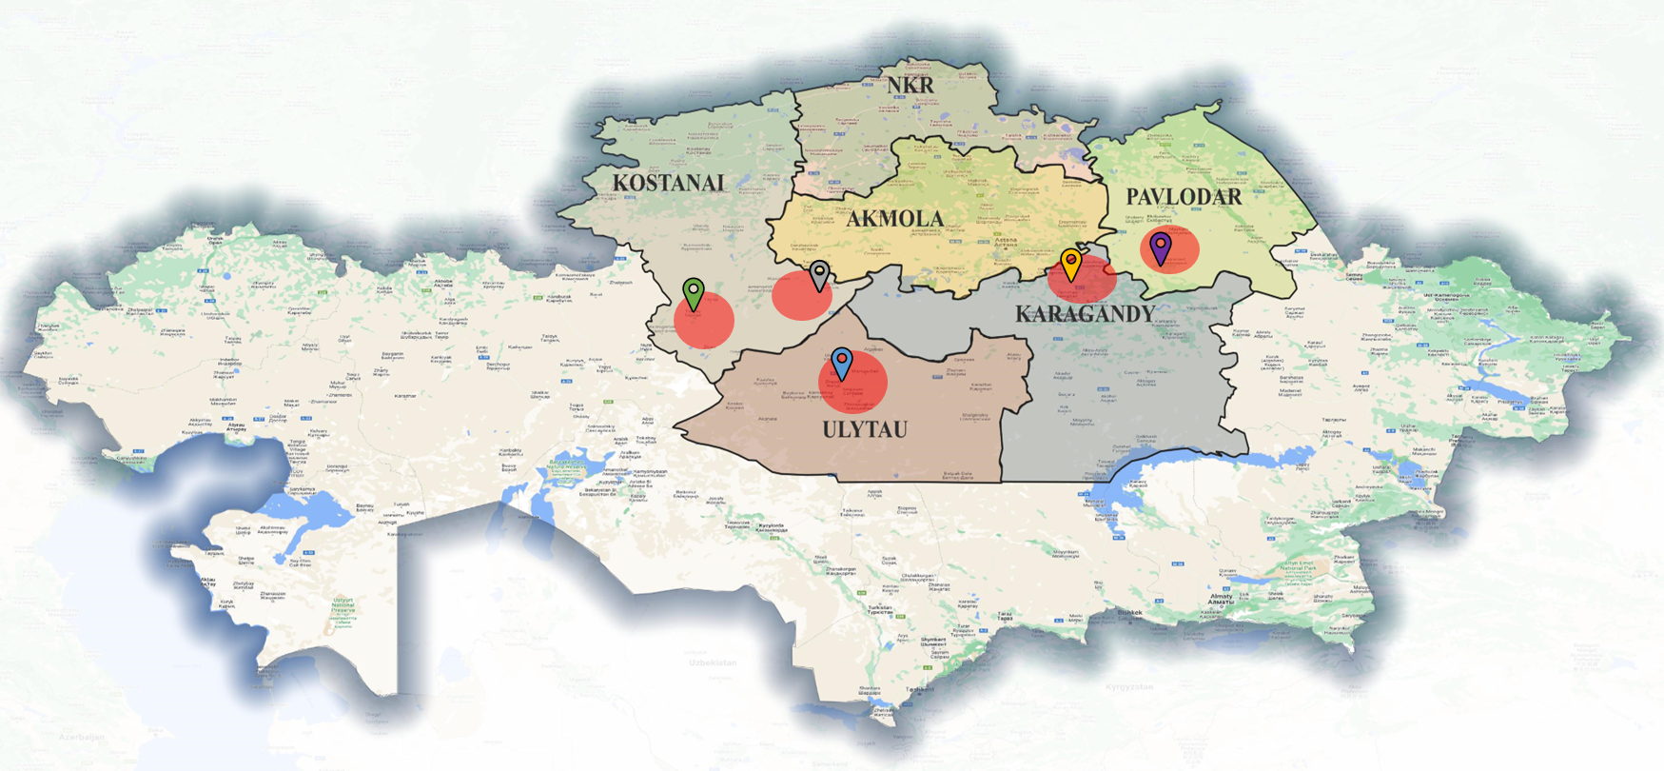
Figure-1: Map of the distribution of detected helminths in Northern and Central Kazakhstan [Source: The map was generated using the QGIS Version 3.18.0 program].

Molecular genetic studies
Molecular genetic studies were conducted at the Laboratory of Biodiversity and Genetic Resources of the National Center for Biotechnology to confirm the species’ identity. The genetic diversity of the parasites was determined using a polymerase chain reaction (PCR) with specific primers for each helminth species [31–34]. Sequencing was performed to validate PCR results. This process ensured the accuracy and reliability of the study.
After data collection, a comprehensive statistical analysis was conducted. A diversity index was utilized to better understand the abundance and composition of helminths, which factored in the number of species present and the extent of their dominance.
Results
This study considered several factors, including the age, sex, time of capture, and natural habitat of the wolves. Detailed information on the characteristics of the studied wolf samples is presented in Table-1.

Table-1: Characteristics of 81 studied wolves in northern and central Kazakhstan.
Table-1: Characteristics of 81 studied wolves in northern and central Kazakhstan.
Parameters | Description | Number of cases out of the total | Infected cases | Prevalence, % | CI, 95%
Age groups | 3-month-1 year | 12 | 3 | 25 | 0.25 ± 0.487  (−0.237–0.737)
 | 1–4 years | 25 | 22 | 88 | 0.88 ± 0.134  (0.746–1.01)
 | 5–8 years | 4 | 4 | 100 | 1 ± 0  (1–1)
 | Indeterminately | 40 | - | - | -
Gender | Male | 30 | 21 | 70 | 0.7 ± 0.192  (0.508–0.892)
 | Female | 29 | 11 | 37.9 | 0.37 ± 0.284  (0.086–0.654)
 | Indeterminately | 22 | - | - | -
Natural habitat | Forest-steppe | 21 | 13 | 71.4 | 0.61 ± 0.261  (0.349–0.871)
 | Steppe | 27 | 18 | 74 | 0.66 ± 0.217  (0.443–0.877)
 | Semi-desert | 33 | 19 | 63.6 | 0.57 ± 0.22  (0.35–0.79)
Season | Autumn | 3 | 2 | 66.6 | 0.66 ± 0.679  (−0.019–1.34)
 | Winter | 68 | 40 | 58.8 | 0.58 ± 0.146  (0.434–0.726)
 | Spring | 11 | 8 | 72.7 | 0.72 ± 0.305  (0.415–1.02)
CI=Confidence interval
The distribution of the average number of parasites from various families in the infected samples was calculated in relation to the capture time of year (Figure 2). This analysis provides valuable insights into the seasonal trends in parasite prevalence.

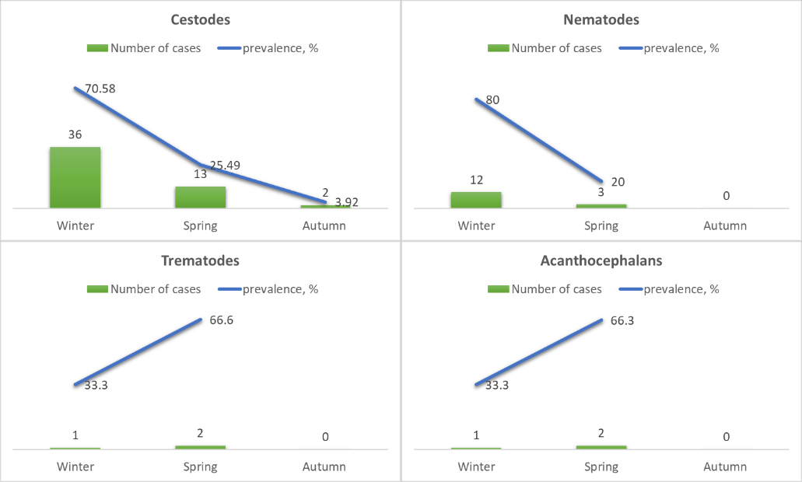
Figure-2: Distribution of the average number of parasites in the studied wolves.

Figure 2 shows the identified helminths from four distinct families: Cestodes, nematodes, trematodes, and acanthocephalans. Among these, cestodes were the most prevalent, followed by nematodes, trematodes, and acanthocephalans. The total number of helminths detected was the highest for cestodes, indicating their dominant presence in wolves.
During winter, the samples exhibited a higher prevalence of cestodes, accounting for 70.5% of the total number studied. In contrast, in spring, the percentage of cestodes was significantly lower (4%). Similarly, the prevalence of nematodes was also higher during the winter (80%). In contrast, no helminths of the nematode family were found in spring samples. Trematodes and acanthocephalans, on the other hand, were found in equal numbers, predominating in the spring samples. Data on the number of helminths detected and the level of infestation are presented in Table-2.

Table-2: Helminthes found in wolves.
Place of capture | Number of studied |  | Species of helminths | Prevalence,  % | Invasion, per sample
 | Investigated | Infected |  | Prevalence,  % | Invasion, per sample
Pavlodar region (Bayanaul district) | 3 | 1 | Taenia hydatigena | 33.3 | 6
Karagandy region (Bukhar-Zhyrau district Karkaraly district) | 48 | 30 | Taenia species | 62.5 | 7.5
Karagandy region (Bukhar-Zhyrau district Karkaraly district) |  | 5 | Trichinella nativa | 10.41 | 30
Karagandy region (Bukhar-Zhyrau district Karkaraly district) |  | 3 | Toxascaris leonina | 6.2 | 5.3
 |  | 2 | Echinococcus granulosus | 4.1 | 22.5
 |  | 2 | Acanthocephalans | 4.1 | 7.5
 |  | 1 | Alaria alata | 2 | 1
Ulytau region (Zheskagan district) | 9 | 5 | Taenia hydatigena | 55.5 | 7.6
Ulytau region (Zheskagan district) |  | 2 | Trichinella nativa | 22.2 | 32.5
 |  | 2 | Toxascaris leonina | 22.2 | 3.5
Kostanai region (Zhangeldy district, Turgai district) | 21 | 8 | Taenia hydatigena | 38.09 | 10
Kostanai region (Zhangeldy district, Turgai district) |  | 6 | Trichinella nativa | 28.57 | 25.5
 |  | 1 | Echinococcus granulosus | 4.7 | 20
 |  | 1 | Dirofilaria repens | 4.7 | 1
 |  | 4 | Toxascaris leonina | 19.04 | 3.75
 |  | 1 | Acanthocephalans | 4.7 | 4

Three samples from the Pavlodar region were analyzed, one of which was infected with the cestode
T. hydatigena. Forty-eight biomaterial samples from the Karaganda region were studied. Thirty of these samples were found to be infected with cestodes, five samples contained T. nativa nematodes, five samples contained T. leonina, two samples were infected with echinococcosis and acanthocephalans, and one sample tested positive for trematodes (A. alata). Nine samples from the Ulytau region were examined, five of which were positive for cestodes. The nematodes T. nativa and T. leonina were also found. Twenty-one biomaterial samples from the Kostanay region were examined. The following helminths were detected: T. hydatigena (8 positive), T. nativa (6 positive), T. leonina (4 positive), and one each of E. granulosus, D. repens, and Acanthocephalans.
The Shannon index was used to summarize the information on the abundance and species composition of helminths, considering the number of species and the degree of their dominance (Table-3). Based on the analysis of the diversity index, which was close to zero, we can infer that helminth species belonging to the cestode family are the most predominant among wolves in Northern and Central Kazakhstan. This indicates that these particular types of parasitic worms are more prevalent in this area than other helminth species.
Table-3: Shannon index on the number and species composition of helminths.
Species | Frequency | pi | ln (pi) | pi * ln (pi)
Cestodes
Taenia spp. Echinococcus spp. Mesocestoides spp. | 48 | 0.64 | −0.44 | −0.28
Nematodes
Trichinella nativa Trichinella britovi Toxascaris leonina Dirofilaria repens | 23 | 0.30 | −1.20 | −0.36
Trematodes
Alaria alata | 1 | 0.01 | −4.60 | −0.046
Acanthocephalans | 3 | 0.04 | −3.21 | −0.12
Shannon diversity index (H): |  |  | 0.834423
Shannon equitability index (EH): |  |  | 0.601909
Discussion
The investigation of the spread of parasitic worms in wolf populations identified several types of helminths, including the families E. granulosus,
T. hydatigena, Dipylidium spp., and Mesocestoides spp.; roundworms T. leonina, T. nativa, and D. repens; and trematode A. alata [24–27]. The extent of wolf infestation by helminths was relatively high in the western part of the region (96.5%), whereas it was significantly lower toward the north-central part (65.2%). The average number of helminths was high and some infected animals carried multiple parasites. The intensity of helminth infestation in wolves was
7.6 copies per infected host [35].
Based on the information presented in Table-1, it appears that wolves between the ages of 1 and 4 years are the most vulnerable to helminth invasion. Furthermore, the data indicated that male wolves were more likely to be infected than their female counterparts, which could be attributed to their dominant social status within the pack. In addition, this study revealed that wolves living in the steppe and semi-desert regions were more likely to be affected by helminth infections. Among these regions, the semi-desert Karaganda area had the highest prevalence of helminth infections, suggesting that the environment in this region is particularly conducive to the spread and circulation of helminths. Overall, these findings suggested that age, sex, and habitat are important factors to consider when studying helminth prevalence in wolf populations.
Trichinellosis
The prevalence of trichinellosis among wild predators in Northern and Central Kazakhstan is increasing. Of the 81 wolves examined, 17 (20.4%) were found to be infected with T. nativa. In this study,
T. nativa was detected in three regions: Karaganda, with five positive samples; Ulytau, with two positive samples; and Kostanay, with six positive samples [24].
Echinococcosis
Based on the findings of monitoring the prevalence of echinococcosis among wolf populations, positive samples indicated the presence of the disease in Karaganda (4.1%) and Kostanay (4.7%). Furthermore, the helminth infection rate per sample was 20 in the Kostanay region and 22.5 in Karaganda region. Sequence analysis of the cox1 and nad1 genes revealed that the type of echinococcosis present in the wolves was E. granulosus. Sequencing a portion of the mitochondrial genome enabled the determination of three haplotypes (Hp1, Hp2, and Hp3) of the pathogen in the studied sample. In addition, this study revealed that the dominant circulating E. granulosus genotype among wolves was G1, which is highly pathogenic to humans, livestock, and wild carnivores [27]. These findings suggest that wild carnivores, such as wolves, play a significant role as disease reservoirs [35].
Alariosis
A previous study by Smagulova et al. [26] demonstrated the spread of trematodes in wolves and revealed that wolves are susceptible to infection by helminths belonging to the A. alata trematode family. This study not only highlighted the vulnerability of wolves to this specific type of parasite but also underscored the potential risks associated with its spread. These parasites are found in various hosts, including red foxes, wolves, raccoon dogs, and animals of the Felidae family, and are transmitted through intermediate hosts such as snails and frogs. The detection of A. alata in meat is not mandated, posing a significant risk of food-associated parasitic infections, particularly with the increasing popularity of game and organic meats processed without proper heat treatment [36, 37].
Dirofilariasis
This is a rare case of helminth discovered in the heart cavity of a wolf and raises questions about its distribution in Kazakhstan. PCR was performed to identify the heartworm species found in the heart of a wild wolf using the species-specific primer SSU rRNA. A previous study by Uakhit et al. [25] showed that the nucleotide sequence of the studied species is D. repens. D. repens occurs only in the Commonwealth of Independent States and is common among the residents of Uzbekistan, Georgia, Armenia, Ukraine, Belarus, Russia, and Kazakhstan.
Ascariasis
The study investigated 81 wolf samples and discovered that 6 of them (13.8%) tested positive for toxocariasis. The presence of roundworms has been confirmed in the Karaganda, Kostanay, and Aktobe regions. Through molecular genetic analysis, the roundworm was identified as T. leonina. Studies conducted worldwide have indicated the global distribution of this parasite, particularly in wild animals, which are considered reservoirs for T. leonina [36, 38, 39].
Taeniasis
Our study revealed the significant prevalence of tapeworm helminths among wolves in Northern and Central Kazakhstan. This discovery is crucial, as it not only enhances our understanding of the health status of these canids but also provides a baseline for future ecological studies. This study showed that these parasites were found in four different areas and were commonly found in mixed infestations with other helminth types. The overall prevalence of tapeworms in wolves was 54.3%, indicating that many wolves in these regions were infected with these parasites. Interestingly, this study also found that wolves in the Karaganda and Ulytau regions were largely infested with taeniids, with prevalence rates of invasion of 81.7% and 90.9%, respectively.
Furthermore, this study underlines the vulnerability of wolves to helminth infections during winter, with infection rates 80% higher than those in other seasons. In other studies on wolf taeniasis, researchers have established a mixed infestation of cestodes by tapeworms in one individual. This study also detected five cestode species in wild wolves [12, 40].
This study revealed that wolves from different regions have varying degrees of susceptibility to helminth infections. For instance, in the Ulytau region, 27.27% of wolves were infected, with invasion intensities ranging from 1 to 45. In the Karaganda region, 20.4% of the wolves were infected, with an invasion intensity ranging from 2 to 63. In contrast, in the Kostanay region, the infection rate was 18.5%, with an invasion intensity ranging from 1 to 23. The percentage of infected wolves in the Pavlodar region was 33.3%, with an invasion intensity of 6.
Research on the prevalence of parasitic worms in wolf populations in various regions of Kazakhstan provides valuable insights into the factors that influence helminth infestation. This study underscores the importance of age, sex, and habitat when assessing the vulnerability of wolves to helminth invasions. The data indicate that wolves between the ages of 1 and 4 years are the most susceptible to helminth invasion, and male wolves exhibit a higher likelihood of infection, possibly due to their dominant social status within the pack.
Identifying specific helminth species such as E. granulosus and T. hydatigena provides essential knowledge for understanding the health risks of these parasites in wildlife and their potential transmission to humans and domestic animals.
Conclusion
Overall, this study emphasizes the significance of monitoring and understanding the dynamics of helminth infestation in wolf populations for wildlife conservation and public health concerns related to zoonotic parasite transmission. These findings can inform targeted interventions to mitigate the risks of helminth infections in wildlife and interconnected ecosystems.
A more in-depth genetic analysis of the identified helminth species could provide additional information regarding their transmission patterns and potential impact on human and animal health. Long-term monitoring of wolf populations and their helminth infections could provide insights into the dynamics of these parasites over time, including potential fluctuations in prevalence, emergence of new strains, and effectiveness of control measures. Addressing these areas would contribute to a more holistic understanding of helminth infections in wolf populations and have implications for wildlife conservation, veterinary medicine, and public health initiatives.
The findings of the present study provide valuable insights into the ecology and health of wolves in this region. These results can contribute to the development of effective control and management strategies for helminth infections in wolves, which can infect humans and livestock.
Authors’ Contributions
VK: Conception and design of the study, drafted, revised, and finalized the manuscript for submission, analysed the data, and performed statistical analyses. RU and AS: Performed DNA extraction and PCR, interpreted the data, and drafted the manuscript for submission. LL and SL: Collected samples and performed parasitological isolation and typing. All authors have read, reviewed, and approved the final manuscripT.
Acknowledgments
This study was funded by the Ministry of Science and Higher Education of the Republic of Kazakhstan under project AP14869645 for 2022-2024.
Competing Interests
The authors declare that they have no competing interests.
Publisher’s Note
Veterinary World remains neutral with regard to jurisdictional claims in published map and institutional affiliation.

References
1. Leontiev, S.V. (2018) Wolf situation as a biological resource in Kazakhstan. Bulletin. NSAU, 1: 80-87. (Russian)
2. Brandell, E.E., Jackson, M.K., Cross, P.C., Piaggio, A.J., Taylor, D.R., Smith, D.W., Boufana, B., Stahler, D.R. and Hudson, P.J. (2022) Evaluating noninvasive methods for estimating cestode prevalence in a wild carnivore popula- tion. PLoS One, 17(11): e0277420.
3. Stronen, A.V., Molnar, B., Ciucci, P., Darimont, C.T., Grottoli, L., Paquet, P.C., Sallows, T., Smits, J.E.G. and Bryan, H.M. (2021) Cross-continental comparison of para- site communities in a wide-ranging carnivore suggests asso- ciations with prey diversity and host density. Ecol. Evol., 11(15): 10338–10352.
4. Lider, L.A., Leontyev, S.V., Akibekov, O.S., Ussenbayev, A.E., Seytkamzina, D.M., Erzhanova, N. and Uakhit, R. (2019) Helminth Fauna of Wild Canidae in Kazakhstan. In: Materials of the International Scientific and Practical Conference “Intensification of Hunting and Development of National Types of Hunting”. Vol. 1, p54–57.
5. Kamiya, T., O’Dwyer, K., Nakagawa, S. and Poulin, R. (2014) What determines species richness of parasitic organ- isms? A meta-analysis across animal, plant and fungal hosts. Biol. Rev. Camb. Philos. Soc., 89(1): 123–134.
6. Craig, H.L. and Craig, P.S. (2005) Helminth parasites of wolves (Canis lupus): A species list and an analysis of pub- lished prevalence studies in Nearctic and Palaearctic popu- lations. J. Helminthol., 79(2): 95–103.
7. Bagrade, G., Kirjusina, M., Vismanis, K. and Ozoliņs, J. (2009) Helminth parasites of the wolf Canis lupus from Latvia. J. Helminthol., 83(1): 63–68.
8. Siyadatpanah, A., Pagheh, A.S., Daryani, A., Sarvi, S., Hosseini, S.A., Norouzi, R., Boundenga, L., Tabatabaie, F., Pereira, M.L., Gholami, S. and Nissapatorn, V. (2020) Parasitic helminth infections of dogs, wolves, foxes, and golden jackals in Mazandaran province, North of Iran. VeT. World, 13(12): 2643–2648.
9. Al-Sabi, M.N.S., Rääf, L., Osterman-Lind, E., Uhlhorn, H. and Kapel, C.M.O. (2018) Gastrointestinal helminths of gray wolves (Canis lupus lupus) from Sweden. Parasitol. Res., 117(6): 1891–1898.
10. De Macedo, M.R.P., Zanet, S., Bruno, S., Tolosano, A., Marucco, F., Rossi, L., Muller, G. and Ferroglio, E. (2019) Gastrointestinal helminths of wolves (Canis lupus Linnaeus, 1758) in Piedmont, North-Western Italy. J. Helminthol., 94: e88.
11. Erol, U., Danyer, E., Sarimehmetoglu, H.O. and Utuk, A.E. (2021) First parasitological data on a wild grey wolf in Turkey with morphological and molecular confirmation of the parasites. Acta Parasitol., 66(2): 687–692.
12. Macchioni, F., Coppola, F., Furzi, F., Gabrielli, S., Baldanti, S., Boni, C.B. and Felicioli, A. (2021) Taeniid cestodes in a wolf pack living in a highly anthropic hilly agro-ecosystem. [Cestodes Taeniidae dans une meute de loups vivant dans un agroécosystème vallonné hautement anthropique]. Parasite, 28: 10.
13. Juránková, J., Hulva, P., Bolfíková, B.Č., Hrazdilová, K., Frgelecová, L., Daněk, O. and Modrý, D. (2021) Identification of Tapeworm species in genetically char- acterised grey wolves recolonising central Europe. Acta Parasitol., 66(3): 1063–1067.
14. Shams, M., Khazaei, S., Naserifar, R., Shariatzadeh, S.A., Anvari, D., Montazeri, F., Pirestani, M. and Majidiani, H. (2022) Global distribution of Echinococcus granulosus genotypes in domestic and wild canids: A systematic review and meta-analysis. Parasitology, 149(9): 1147–1159.
15. Rojas, A., Germitsch, N., Oren, S., Sazmand, A. and Deak, G. (2024) Wildlife parasitology: Sample collection and process- ing, diagnostic constraints, and methodological challenges in terrestrial carnivores. ParasiT. Vectors, 17(1): 127.
16. Merriam-Webster. (2024) Epizootiology. Merriam-Webster. com Dictionary. Available from: https://www.merri- am-webster.com/dictionary/epizootiology. Retrieved on 14-03-2024.
17. Rules for Conducting Epizootic Monitoring. (2021) Available from: https://law.gov.kz/client/#!/doc/85875/rus. Retrieved on 14-03-2024.
18. About the Status of Wolves in Kazakhstan. (2022) Available from: https://www.acbk.kz/article/default/view?id=574. Retrieved on 14-03-2024.
19. Issuance of a Permit for the Seizure of Animal Species, the Numbers of Which are Subject to Regulation. (2020) Available from: https://adileT.zan.kz/rus/docs/ V2000022000. Retrieved on 14-03-2024.
20. Abdybekova, A.M. and Torgerson, P.R. (2012) Frequency distributions of helminths of wolves in Kazakhstan. VeT. Parasitol., 184(2–4): 348–351.
21. Shaikenov, B.S. (1992) Ecological border of distribution of Trichinella nativa Britov et Boev, 1972 and T. nelsoni Britov et Boev, 1972. Wiad. Parazytol., 38(3–4): 85–91.
22. Shabdarbaeva, G.S., Abdybekova, A.M. and Shapieva, Z. (2012) Zooanthroponoses and Measures for Their Prevention in the Republic of Kazakhstan. Monograph - Almaty, approved by the academic council of Kazakh Research Veterinary Institute on May 8, 2012, protocol No. 3, 104. (Russian).
23. Kenzhebaev, S.A., Ibragimov, D. and Zhumalieva, G.O. (2018) Epizootology (epidemiology) of helminthozoono- ses in the South-West of Republic of Kazakstan. Russ. J. Parasitol., 12(2): 27-32. (Russian)
24. Uakhit, R., Mayer-Scholl, A., Shin, C., Smagulova, A., Lider, L., Leontyev, S. and Kiyan, V. (2023) Genetic identi- fication of Trichinella species found in wild carnivores from the territory of Kazakhstan. FronT. VeT. Sci., 10: 1266561.
25. Uakhit, R.S., Lider, L.A., Smagulova, A.M., Leontyev, S.V., Abdrakhmanov, S.K. and Kiyan, V.S. (2021) First molecu- lar identification of Dirofilaria repens found in a wolf heart in Kazakhstan. Adv. Anim. VeT. Sci., 9(9): 1342–1346.
26. Smagulova, A.M., Uakhit, R.S., Lider, L.A., Lyalchenko А.S. and Kiyan, V.S. (2022) Distribution and genetic features of the causative agent of Alaria alatain wild carnivores of the steppe and forest-steppe zones of Kazakhstan. Eurasian J. Appl. Biotechnol., 2: 38–43.
27. Uakhit, R., Smagulova, A., Syzdykova, A., Abdrakhmanov, S. and Kiyan, V. (2022) Genetic diver- sity of Echinococcus spp. in wild carnivorous animals in Kazakhstan. VeT. World, 15(6): 1489–1496.
28. Scriabin, K.I. (1928) Method of Complete Helminthological Dissections of Vertebrates, Including Humans. MSU Press, Moscow, p40–48. (Russian)
29. Wallace, P.G., Pasvol, G.P. and Keith, B.A. (2002) Tropical medicine and parasitology, 5th edition. Clin. InfecT. Dis., 34(12): 1664.
30. Nabarro, L., Morris-Jones, S. and Moore, D.A.J. (2020) Peter’s Atlas of Tropical Medicine and Parasitology. 7th ed. Elsevier, Amsterdam, p345–357.
31. Sapp, S.G.H., Gupta, P., Martin, M.K., Murray, M.H., Niedringhaus, K.D., Pfaff, M.A. and Yabsley, M.J. (2017) Beyond the raccoon roundworm: The natural history of non-raccoon Baylisascaris species in the New World. InT. J.Parasitol. Parasites Wildl., 6(2): 85–99.
32. Jacobs, D.E., Zhu, X., Gasser, R.B. and Chilton, N.B. (1997) PCR-based methods for identification of potentially zoonotic ascaridoid parasites of the dog, fox and caT. Acta Trop., 68(2): 191–200.
33. Karadjian, G., Heckmann, A., Rosa, G., Pozio, E., Boireau, P. and Vallée I. (2017) Molecular identification of Trichinella species by multiplex PCR: New insight for Trichinella murrelli. Parasite, 24: 52.
34. Addy, F., Wassermann, M., Banda, F., Mbaya, H., Aschenborn, J., Aschenborn, O., Koskei, P., Umhang, G., de la Rue, M., Elmahdi, I.E., Mackenstedt, U., Kern, P. and Romig, T. (2017) Genetic polymorphism and population structure of Echinococcus ortleppi. Parasitology, 144(4): 450–458.
35. Uakhit, R., Smagulova, A., Lider, L., Leont’ev, S., Berber, A. and Kiyan, V. (2022) Species composition of wolf (Canis lupus) helminth fauna in Kazakhstan. Eurasian
J. Appl. Biotechnol., 1: 49–58.
36. Bindke, J.D., Springer, A., Janecek-Erfurth, E., Böer, M. and Strube, C. (2019), Helminth infections of wild European gray wolves (Canis lupus Linnaeus, 1758) in Lower Saxony, Germany, and comparison to captive wolves. Parasitol. Res., 118(2): 701–706.
37. Korpysa-Dzirba, W., Różycki, M., Bilska-Zając, E., Karamon, J., Sroka, J., Bełcik, A., Wasiak, M. and Cencek, T. (2021). Alaria alatain terms of risks to consum- ers’ health. Foods, 10(7): 1614.
38. Holland, C.V. (2023) A walk on the wild side: A review of the epidemiology of Toxocara canis and Toxocara cati in wild hosts. InT. J. Parasitol. Parasites Wildl., 22: 216–228.
39. Xie, Y., Li, Y., Gu, X., Liu, Y., Zhou, X., Wang, L., He, R.,Peng, X. and Yang, G. (2020) Molecular characterization of ascaridoid parasites from captive wild carnivores in China using ribosomal and mitochondrial sequences. ParasiT. Vectors, 13(1): 382.
40. Gori, F., Armua-Fernandez, M. T., Milanesi, P., Serafini, M., Magi, M., Deplazes, P. and Macchioni, F. (2015) The occur- rence of taeniids of wolves in Liguria (Northern Italy). InT. J. Parasitol. Parasites Wildl., 4(2): 252–255.

- Genetic identification of Trichinella species found in wild carnivores from
the territory of Kazakhstan

Abstarct
Trichinellosis, also called trichinosis, is a foodborne parasitic disease caused by eating raw or undercooked meat from animals infected with Trichinella spp. larvae and affects both animals and humans. Although on the territory of Kazakhstan, the species characteristics and prevalence of this helminth were studied back in the 90s, the data have not been updated since then. Given the above, our study was aimed at identifying Trichinella spp. using parasitological and molecular genetics methods. In our work, we studied 160 samples of muscle tissue of wild animals living in the natural zones of steppes and semi-deserts. Of the animals examined, 32 were positive for Trichinella spp., including 1 lynx (Lynx lynx), 17 wolves (Canis lupus), 11 foxes (Vulpes vulpes), 1 jackal (Canis aureus) and 2 corsac foxes (Vulpes corsac). Helminths were extracted using the digestion method. DNA was extracted using a Gene Jet commercial kit (Thermo Fisher Scientific, United Kingdom). For species identification a multiplex PCR, amplification of ESV, ITS1, and ITS2 genes regions was performed. After that, uniplex PCR was performed on the 5S rDNA and ITS1 genes region for sequencing analysis. The resulting sequences were subsequently used to construct a phylogenetic tree and the studied samples were identified as Trichinella nativa and Trichinella britovi. Thus, we can conclude that there is a circulation of two species of Trichinella in Kazakhstan, highlighting that constant control and monitoring of wild animals are necessary to prevent transmission and protect the health of people.
1. Introduction
Trichinellosis is a foodborne parasitic zoonotic disease caused by the consumption of raw or semi-raw meat of animals infected by larvae of this nematode. The disease is both a public health hazard and a food safety problem in many parts of the world (1, 2). Trichinella species have a wide range of hosts, but predators and omnivores are most affected (3, 4). After eating infected meat, larvae are released and penetrate the intestinal mucosa. They develop into adult worms within days. Males and females copulate and then females releasing newborn larvae after 1 week. These larvae travel via blood to the skeletal musculature where they either encapsulated or remain unencapsulated depending on the species (5). To date, according to the literature, Trichinella species are divided into two clades: encapsulated (T. spiralis, T. nativa, T. nelsoni, T. britovi, T. murrelli, T. patagoniensis, and T. chanchalensis, Trichinella T6, T8, and T9) and non-encapsulated (T. pseudospiralis, T. papuae, and T. zimbabwensis) (6, 7).
In Kazakhstan, the problem of trichinellosis has not been studied well enough. T. nativa, T. britovi, and T. pseudospiralis are reported in wolves, jackal, foxes and cats living mainly in Southern Kazakhstan (5). One of the early studies on the spread of Trichinella is the work of Shaikenov. Their studies show pathogen infection of predators with Trichinella spp. in the deserts of Kazakhstan. As they note, the lowest infestation in predators was found in the sandy desert (3.7%), while the highest infestation of animals is noted in the mountainous (17.8– 20.1%) and semi-desert (15.6–22.1%) zones (8).
Boev S.N. et al. described that the infestation of foxes (Vulpes vulpes) and corsac foxes (Vulpes corsac) in the steppe zone was 10.4 and 8.1%, respectively, and was inferior in terms of infestation of the same animals in the mountainous and semi-desert zones (9).
As was reported by Pozio (5), T. nativa and T. britovi circulate among foxes, wolves, jackals, martens, wild cats, lynxes, and wild boars in Kazakhstan. Also, T. pseudospiralis was recorded in corsac foxes, two rooks, and an eagle. Additionally, human trichinellosis has been documented following the consumption of meat from wild boars (10).
Wild carnivores such as wolves (Canis lupus), foxes (Vulpes vulpes), jackals (Canis aureus) and corsac foxes (Vulpes corsac) are native members of Canidae native to the Eurasia region (11). In Kazakhstan, the wild carnivore population is estimated to be around 14,000 animals (Unified Internet resource of the Ministry of Ecology, Geology and Natural Resources of the Republic of Kazakhstan, 2022)
(12). These carnivores, at the top of the food chain, are excellent predators but also scavengers, and thus play an important role as a reservoir host of Trichinella species in the wild (13, 14).
The purpose of this article is to describe the occurrence of Trichinella spp. in wild animals of Kazakhstan and to study the species affiliation of the detected Trichinella larvae based on molecular analysis.
2. Materials and methods
2.1. Trichinella larvae sample collection
Work with samples of muscle tissues of animals caught from nature was carried out in the parasitological laboratory of the Faculty of Veterinary Medicine and was approved by the Animal Ethics Committee of the S. Seifullin Kazakh Agrotechnical University (extract from protocol No. 1 dated July 24, 2019). We obtained permission from the Department of Natural Resources and Environmental Management to excavation of animals. The method that was used to remove them is through shooting. All procedures were in accordance with the World Medical Association Code of Ethics (Declaration of Helsinki) for animal experiments.1 The following animal species were studied: lynxes (Lynx lynx), wolves (Canis lupus), foxes (Vulpes vulpes), corsac foxes (Vulpes corsac), jackals (Canis aureus), mink (Mustela lutreola), ferret (Mustela putorius), sables (Martes zibellina), samples which were brought from 10 regions of Kazakhstan (Kostanay, Akmola, South Kazakhstan, Pavlodar, Karaganda, East Kazakhstan, West Kazakhstan, Aktobe, Atyrau and Ulytau regions), are shown in more detail in Figure 1. Animals were individually tested for the presence of Trichinella spp. larvae by the muscle compression method (15). Then, using artificial gastric juice, the muscle tissue (diaphragm and thigh muscle) was digested (16). The sediment was examined under a microscope, and Trichinella larvae were collected in test tubes with 70% ethanol. All morphological investigations were conducted using Micros Austria MCXI700.

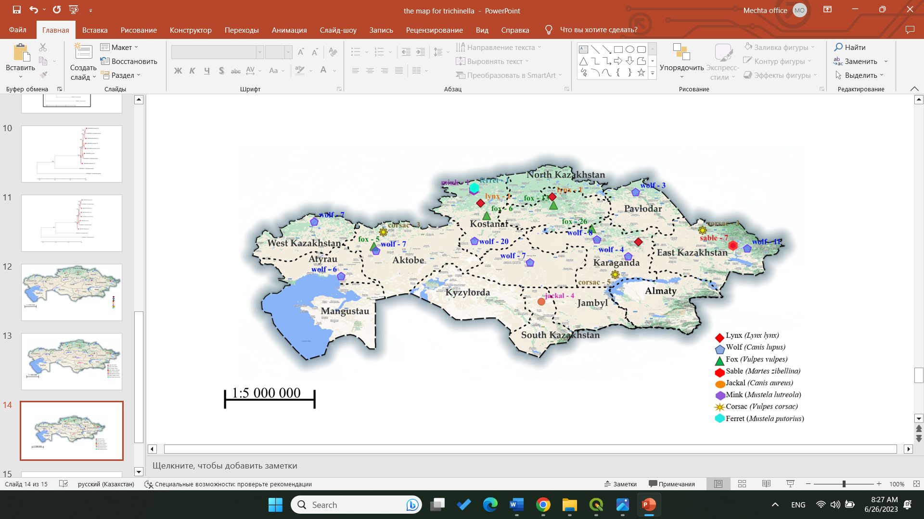
Figure 1. The region examined for Trichinella in animals. The numbers indicate the number of studied animals in a particular region.

2.2. DNA extraction
DNA was extracted from 310 larvae (as a pool of 10 larvae from each positive sample of an infected animal) using a GeneJet genomic DNA purification kit (Thermo Fisher, Cat.: K0701) with slight modifications.
Briefly, proteinase K was added to the larvae and incubated at 48°C for 60 min, followed by all steps according to the manufacturer’s protocol.
2.3. Multiplex and uniplex PCR
A multiplex PCR based on the use of five primer pairs amplifying the internal transcribed spacers ITS1 and ITS2, and the expansion segment V region (ESV) of the large subunit ribosomal DNA (17) was used. Uniplex PCR primers set (5 s rDNA, ITS1) for differentiating species by sequencing were utilized (18). Details of the ESV, ITS1, ITS2 and 5 s rDNA fragments produced by the PCR amplification are shown in Table 1.

Table 1. Multiplex and uniplex PCR fragment size of the studied taxa of the genus Trichinella.
Primer | Locus set | Sequence (5′ → 3′)
I | ESV | F: GTTCCATGTGAACAGCAGT R: CGAAAACATACGACAACTGC
II | ITS1 | F: GCTACATCCTTTTGATCTGTT  R: AGACACAATATCAACCACAGTACA
III | ITS1 | F: GCGGAAGGATCATTATCGTGTA  R: TGGATTACAAAGAAAACCATCACT
IV | ITS2 | F: GTGAGCGTAATAAAGGTGCAG R: TTCATCACACATCTTCCACTA
V | ITS2 | F: CAATTGAAAACCGCTTAGCGTGTTT R: TGATCTGAGGTCGACATTTCC
VI | 5S rDNA | F: GCGAATTCTTGGATCGGAGACGGCCTG R: GCTCTAGACGAGATGTCGTGCTTTCAACG
Reactions were performed in 15 μL 2X GoTaq Hot Start MasterMix, 9 μL nuclease-free water, 1 μL total primers, and 2.5 μL extracted DNA. The uniplex PCR was performed using the same mix as above but with the primer set II and VI for the ITS1 and 5 s rDNA locus. The PCR cycles for multiplex PCR were performed as detailed in Table 2.
Table 2. Thermocycler parameters for 5S rDNA and multiplex primers gene amplification.
 | Pre-denaturation |  | 40 cycles |  | Final elongation
 |  | Denaturation | Annealing | Elongation
 | Temp./Time
Multiplex | 95°C / 2 min | 95°C / 10 s | 55°C / 30 s | 72°C / 30 s | 72°C / 5 min
5 s rDNA | 94°C / 1,5 min | 94°C / 30 s | 48°C / 1 min | 72°C / 1 min | 72°C / 10 min

2.4. Electrophoresis and sequencing
Agarose gels (1.5%) were prepared in 1× TAE solution with 8 ng/ μL ethidium bromide (Sigma, E1510). Electrophoresis was performed using 10 μL PCR products with a DirectLoad 100 bp Low ladder ready- to-use (Sigma, D3687-1VL) for 50 min at 120 V. The PCR-amplified target gene fragment was purified using a QIAquick PCR Purification Kit (QIAGEN, Germany, Cat.: 28106), following the manufacturer’s protocols. Sequencing was performed according to the manual for Seq Studio Genetic Analyzer (Thermo Fisher Scientific Applied Biosystems). The resulting nucleotide sequences were visually checked by the Bio Capt program version 11.0. The nucleotide sequences of the studied species were compared with other sequences in the NCBI gene bank database by using the BLAST options. The nucleotide sequences of the studied species were deposited in NCBI GenBank database.
2.5. Bioinformatics analysis
Bioinformatic analysis of the obtained nucleotide sequences was carried out using computer software for statistical analysis of molecular evolution and construction of phylogenetic trees – MEGA
11. Multiple alignments were carried out using the CLUSTAL W program included in the MEGA software package. The evolutionary history and divergence between sequences was inferred by using the Maximum Likelihood method and Tamura-Nei model (19).
3. Results
Out of the 160 carnivores’ muscle tissue and diaphragm samples that were examined, 32 of them (20%, with a 95% confidence interval of 7.07–13.6) were found to be carriers of Trichinella larvae. Infection with Trichinella larvae was found in five out of the eight species that were examined. Specifically, 17 out of 83 wolves (20.5%), 11 out of 50 red foxes (22%), 2 out of 11 corsacs (18.2%), 1 out of 4 jackals (25%), and 1 out of 3 lynxes (33.3%) were infected, making a total of 32 samples. Examples of the detected helminths under the microscope can be seen in Figure 2. The specimens of ferret, sable, and mink that were examined were not infected with Trichinella. For more detailed information, please refer to Table 3.

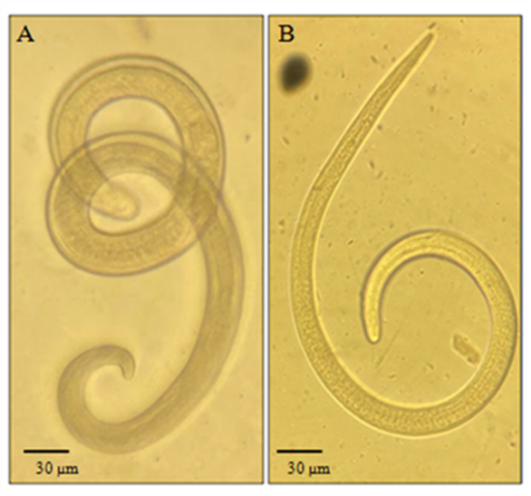
Figure 2. Trichinella larvae detected after digestion: (A) Specimen found in a lynx. (B) Specimen found in a fox. Magnification 10×.

During the multiplex PCR, positive samples were found for Trichinella nativa in lynx, wolves, foxes, and corsac foxes (identified by amplification of a 127 bp fragment), while a jackal tested positive for Trichinella britovi (identified by amplification of two fragments at 127 and 253 bp) (as shown in Figure 3). To identify the specific species, additional PCR was conducted using primer 5 s rDNA and ITS1. The resulting amplicons were purified and sequenced for their nucleotide sequences.

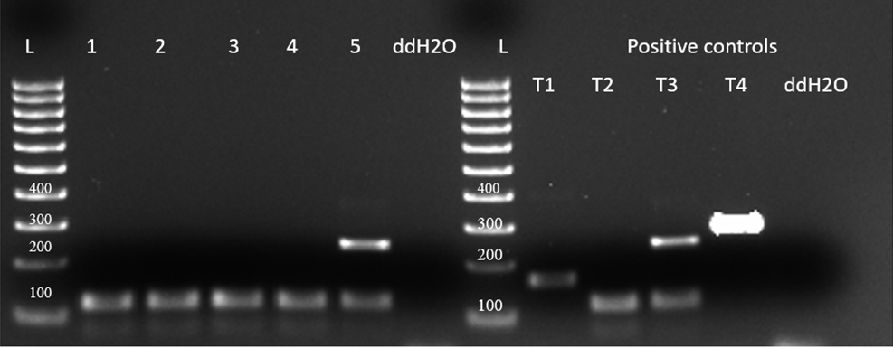
Figure 3. Electrophoretic profiles of Trichinella larva amplicons after multiplex PCR amplification: Lane L = 100 bp ladder, lane 1 – wolf, 2 – lynx, 3 – fox, 4 – corsac fox, 5 – jackal. Lane T1 – T. spiralis, T2 – T. nativa, T3 – T. britovi, T4 – T. pseudospiralis - positive control samples. K- – no-DNA control, ddH2O.

The resulting nucleotide sequences confirmed that all Trichinella samples were T. nativa and T. britovi, and were deposited in the international GenBank database (OP829907, OP829905, OP829906, OP829903, OP829904, OQ716806, OR159834). The tree with the highest log likelihood (−4977.99) is presented (Figure 4), and the initial tree was obtained using the Maximum Parsimony method. The tree is to scale, with branch lengths measured in the number of substitutions per site. The proportion of sites where at least 1 unambiguous base is present in at least 1 sequence for each descendant clade is shown next to each internal node in the tree.

Table 3. Trichinella infection, larval burden and species identification in wild animals in Kazakhstan.
Animal species | Examined (n) | Infected (n) | Infected (%) | grams of tissue examined for digestion (g) | 95% CI (%) | LPG ± SD | Trichinella  species
Lynx (Lynx lynx) | 3 | 1 | 33.3 | 5 | 20 (−12–52) | 8 ± 28.28 | T. nativa
Wolf (Canis lupus) | 83 | 17 | 20.5 | 5 | 12.59 (7.13–18.1) | 12.5 ± 25.38 | T. nativa
Fox (Vulpes vulpes) | 50 | 11 | 22 | 5 | 9.2 (4.24–14.2) | 9.5 ± 10.06 | T. nativa
Corsac fox (Vulpes corsac) | 11 | 2 | 18.2 | 5 | 3.8 (−1.1–8.7) | 3.5 ± 8.3 | T. nativa
Jackal (Canis aureus) | 4 | 1 | 25 | 5 | 11.25 (−7.85–30.4) | 9 ± 19.48 | T. britovi
Mink (Mustela lutreola) | 1 | 0 | 0 | 5 | - | - | -
Ferret (Mustela putorius) | 1 | 0 | 0 | 5 | - | - | -
Sable (Martes zibellina) | 7 | 0 | 0 | 5 | - | - | -
Total | 160 | 32 | 20 |  | 7.07–13.6 | 8.5 ± 21
Our analysis involved 15 nucleotide sequences. The final dataset had a total of 1800 positions. The tree was rooted with an outgroup of Trichosomoides crassicauda. We also included sequences from Trichinella spp. species to show how closely related they are. We made sure to include T. nativa species from countries bordering Kazakhstan, such as China and Russia, where these species have been identified.
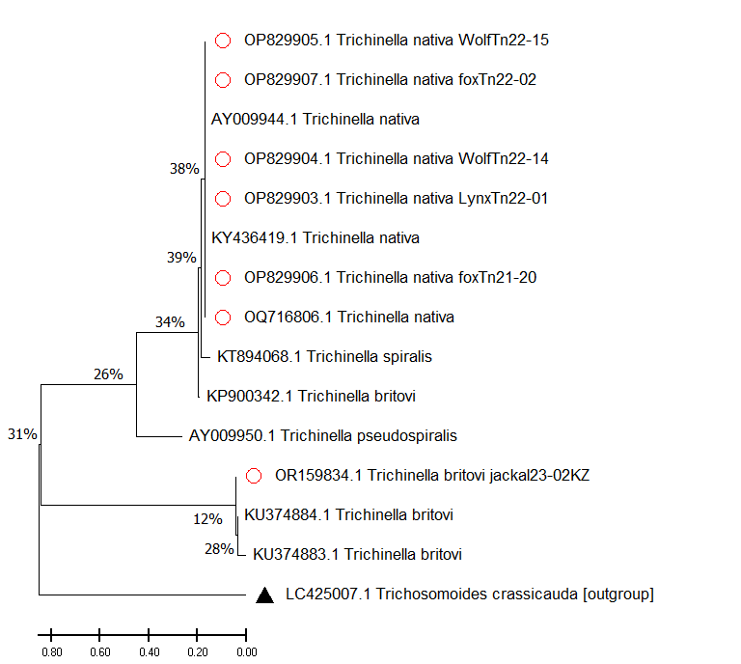
Figure 4. Maximum likelihood tree of Trichinella spp. A scale bar (divergence of 0.80) is shown. Sequences with red dots obtained in this study, outgroup marked with triangle, without any marks reference samples from GenBank.
Obtained sequence data were used to calculate a pairwise fixation index (Fst), which helped us determine the level of genetic differentiation between T. nativa and T. britovi samples collected from carnivorous animals in Kazakhstan. Our analysis showed that the Fst values ranged from 0 to 1.084045 (as shown in Table 4), with 0 indicating complete identity among the samples.

Table 4. Pairwise fixation index (Fst values) between T. nativa and T. britovi.
 | OP829905 | OP829904 | OP829907 | AY009944 | OP829906 | OQ716806 | OP829903 | KY436419 | KP900342 | KT894068 | AY009950 | LC425007 | OR159834 | KU374884 | KU374883
OP829905 T. nativa wolf
OP829904 T. nativa wolf | 0.00000
OP829907 T. nativa fox | 0.00000 | 0.00000
AY009944 T. nativa | 0.00000 | 0.00000 | 0.00000
OP829906 T. nativa fox | 0.00000 | 0.00000 | 0.00000 | 0.00000
OQ716806 T.nativa corsac-fox | 0.00000 | 0.00000 | 0.00000 | 0.00000 | 0.00000
OP829903 T.nativa lynx | 0.00628 | 0.00628 | 0.00628 | 0.00628 | 0.00628 | 0.00628
KY436419 T. nativa | 0.00628 | 0.00628 | 0.00628 | 0.00628 | 0.00628 | 0.00628 | 0.00000
KP900342 T. britovi | 0.01905 | 0.01905 | 0.01905 | 0.01905 | 0.01905 | 0.01905 | 0.02547 | 0.02547
KT894068 T. spiralis | 0.05872 | 0.05872 | 0.05872 | 0.05872 | 0.05872 | 0.05872 | 0.05871 | 0.05871 | 0.06592
AY009950 T. pseudospiralis | 0.37745 | 0.37745 | 0.37745 | 0.37745 | 0.37745 | 0.37745 | 0.37537 | 0.37537 | 0.36630 | 0.36492
LC425007 Trichosomoides crassicauda | 1.00884 | 1.00884 | 1.00884 | 1.00884 | 1.00884 | 1.00884 | 1.03736 | 1.03736 | 1.02709 | 1.039606 | 1.31151
OR159834 T.britovi jackal | 1.12977 | 1.12977 | 1.12977 | 1.12977 | 1.12977 | 1.12977 | 1.10229 | 1.10229 | 1.04405 | 1.123990 | 0.92394 | 1.07820
KU374884 T. britovi | 1.12977 | 1.12977 | 1.12977 | 1.12977 | 1.12977 | 1.12977 | 1.10229 | 1.10229 | 1.04405 | 1.123990 | 0.92394 | 1.07820 | 0.00000
KU374883 T.britovi | 1.12977 | 1.12977 | 1.12977 | 1.12977 | 1.12977 | 1.12977 | 1.10229 | 1.10229 | 1.04405 | 1.123990 | 0.92394 | 1.07820 | 0.00000 | 0.00000

4. Discussion
From 2020 to 2023, we conducted studies on the occurrence and species identification of Trichinella, common in wild animals of Kazakhstan. During the study, the muscle tissue and diaphragm of 160 animals were studied. Infection of animals with Trichinella larvae was 20%, i.e., 32 tests were positive. The greatest detection of helminths was in areas located in the zone of steppes and semi-deserts.
To genetically identify the detected Trichinella larvae using sequencing, analysis was performed on the 5 s rDNA large ribosomal subunit and ITS1 Internal transcribed spacer (18, 20–22). After conducting research on wild mammals in Kazakhstan, we found that the species T. nativa is predominantly distributed throughout the territory. However, in the southern region of the country, we discovered the presence of the species T. britovi.
The process of identifying differences between species involves building a phylogenetic tree using the maximum likelihood method. Trichosomoides crassicauda (LC425007) was used as an outgroup to create a rooted tree. It is important to note that the studied sequence of T. britovi (OR159834) with reference sequences was divided into a separate clade, as the sequences were obtained by the ITS1 gene. The studied sequences of T. nativa wolves, foxes, lynxes and corsac foxes (OP829907, OP829905, OP829906, OP829903, OP829904, OQ716806) show deviations from the most recent common ancestor. The most recent common ancestor is the reference sample of T. spiralis (KТ894068). The studied T. nativa sequences (Fst values of 0.00652%) are grouped together with reference samples (AY009944, KY436419), forming one subclade, with a difference between the last common ancestor of 38%.
In general, the use of the maximum likelihood method to create a phylogenetic tree with Trichosomoides crassicauda as an outgroup and reference specimens of T. spiralis, T. pseudospiralis, T. britovi, and T. nativa provided insight into the unique evolutionary history of these species. The distinction of T. nativa from wolves, foxes, and lynx from the most recent common ancestor highlights the importance of considering evolutionary relationships when studying the genetic makeup of a species.
Through the analysis of the pairwise fixation index, it was discovered that there were minor variations between T. nativa species extracted from a variety of animals such as wolves, foxes, corsac foxes, and lynxes. Additionally, there were variations in nucleotide sequences between T. nativa collected from foxes (OP829906) and lynxes (OP829903). These findings offer significant insights into the genetic diversity of these species and could assist researchers in comprehending the ecological and evolutionary aspects that determine their distribution in different animal populations.
According to the map data in Figure 1, the samples we studied were obtained from four natural zones in Kazakhstan: forest-steppe and steppe in the northern areas, and semi-desert and desert in the western, central, and southern regions. We believe that weather and natural conditions do not affect the distribution of Trichinella species among wild carnivores in Kazakhstan. Although fewer animal specimens were studied in the southern part of the country, we found the T. britovi species in only 1 out of 4 jackals from the South Kazakhstan region. However, in all other samples of muscle tissue from wild carnivores in regions such as Karaganda, Ulytau, Kostanay, East Kazakhstan, and West Kazakhstan, we identified the T. nativa species.
As reported by Pozio (10), T. nativa and T. britovi are present among various wild animals such as red and corsac foxes, wolves, jackals, martens, wild cats, lynxes and wild boars (8, 9, 23) in Kazakhstan. In 1975, T. pseudospiralis was found in corsac foxes, two ravens and an eagle from the Chimkent region (25, 26). In 2016, 20 cases of human trichinosis were detected in the Kyzylorda region reported by Kenzhebaev. Out of the 20 patients, two were children under 14 years old, 14 lived in urban areas and 6 in rural areas. This group infection outbreak was of an epidemiological nature (24). The source of the infection was wild boar meat killed by an amateur hunter. There are likely both “wild” and “synanthropic” foci of trichinosis in south-west Kazakhstan. These foci initially formed in local reservoirs where the infection accumulated and grew in wild animals due to the “predator–prey” principle, ultimately leading to a group human infection with Trichinella. The sources of infection for animals and humans with Trichinella in Kazakhstan are diverse, and the pathogen continues to circulate due to the population of various field rodents, predators, and wild omnivores (boars) in the region (27).
In reference to the current situation regarding trichinosis in border countries with Kazakhstan, recent research conducted in mainland China has revealed that out of the 16 isolates obtained, 13 were identified as T. spiralis. These samples were collected from pigs all across the country. The remaining two isolates were obtained from dogs and one from a cat, and these were identified as T. nativa. These were collected in northeast China. It is worth noting that Trichinella has been found in 15 different animal species, including but not limited to pigs, dogs, cats, rats, cows, foxes, and bears, and these are distributed throughout China (28). Furthermore, a study conducted in Russia by Glazunov YV et al. found that T. spiralis was present in 58.8% of badgers (Meles meles), 35.3% of brown bears (Ursusarctos), and 5.9% of wild boars (Susscrofa) (29).
In Kyrgyzstan, there have been reports of the discovery of T. nativa in red foxes (23). However, there is currently no information available regarding the infection of humans or domestic animals with Trichinella. In Uzbekistan, T. britovi was found in jackals (23), and there have been reports of a significant outbreak of trichinosis caused by consuming pork from a wild boar (Kairov, 1965; Nadzhimiddinov et al., 1965). However, there is no information available regarding cases of infection in domestic animals (10).
Our research findings revealed that Trichinella, a causative agent of a parasitic disease, is widely distributed among wild mammals in all provinces of our country. This indicates that the natural biocenoses of Kazakhstan are at risk of invasion by Trichinella. Even with a relatively small sample size of animals under study, the results demonstrate the wide distribution of this parasite. As such, there is a real risk of human infection with Trichinella in the territory where the animals were caught. The main cause of human infections is often related to the illegal hunting of wild animals such as wild boar and badger, where the meat of poached mammals is not subjected to veterinary and sanitary examination. This study is of utmost importance, as data on Trichinella prevalence in wildlife is scarce in our region. By gaining more information, we can develop strategies to prevent and control the spread of Trichinella in our natural biocenoses.
Data availability statement
The original contributions presented in the study are included in the article; further inquiries can be directed to the corresponding author. The datasets presented in this study can be found in online repositories. The names of the repository/repositories and accession number(s) can be found in the article.
Author Contributions
VK, RU and AMS: conceptualization, study design, data validation, and writing–original draft preparation. SL and VK: collection of biological material. RU, CSh, and AS: data curation and laboratory experiments. RU, LL, SL, AJ and VK: data analysis. VK: funding acquisition. RU, AMS, CSh, AS, LL, SL, and VK: revising and final approval of the manuscript. All authors contributed to the article and approved the submitted version.
Conflict of Interest
The authors declare that the research was conducted in the absence of any commercial or financial relationships that could be construed as a potential conflict of interest.
Funding
The research presented above was financially supported by the Ministry of Education and Science of the Republic of Kazakhstan to frame project AP08052252 for 2020-2022. The molecular genetics work also was supported by the Initiative Scientific Project # 0121PKI0192 for 2021-2024, Kazakhstan.
Acknowledgments
The authors are grateful to Nora Thaben, Sandy Kortebusch, Josephine Fleck, Peter Bahn and Annette Johne of the Federal Institute for Risk Assessment (Berlin, Germany). We thank Alexander Lyalchenko for collected some number of animals. We also want to thank our master students for their help in the detection and counting of the parasites.
References
1. Crisóstomo-Jorquera V, Landaeta-Aqueveque C. The genus Trichinella and its presence in wildlife worldwide: A review. Transboundary and Emerging Diseases. (2022) 69(5):e1269-e1279. doi: 10.1111/tbed.14554.1–11.
2. Ricchiuti L, Petrini A, Interisano M, Ruberto A, Salucci S, Marino L, et al. First report of Trichinella pseudospiralis in a wolf (Canis lupus italicus). Int J Parasitol Parasites Wildl. (2021) 15:195-198. doi: 10.1016/j.ijppaw.2021.05.002.
3. Gottstein B, Pozio E, Nöckler K. Epidemiology, diagnosis, treatment, and control of trichinellosis. Clinical Microbiology Reviews. (2009) 22(1):127-45. doi: 10.1128/CMR.00026-08.
4. Borhani M, Fathi S, Harandi MF, Simsek S, Ahmed H, Wu X, et al. Trichinella infections in animals and humans of Iran and Turkey. Front Med (Lausanne). (2023) 10:1088507. doi:10.3389/fmed.2023.1088507.
5. Pozio E. The impact of globalization and climate change on Trichinella spp. epidemiology. Food Waterborne Parasitol. (2022) 27:e00154. doi: 10.1016/j.fawpar.2022.e00154.
6. Ribicich MM, Fariña FA, Aronowicz T, Ercole ME, Bessi C, Winter M, et al. Reprint of: A review on Trichinella infection in South America. Vet Parasitol. (2021) 297:109540. doi: 10.1016/j.vetpar.2021.109540.
7. Zarlenga D, Thompson P, Pozio E. Trichinella species and genotypes. Res Vet Sci. (2020) 133:289-296. doi: 10.1016/j.rvsc.2020.08.012.
8. Shaikenov B, Tazieva ZC, Hörning B. The etiology of sylvatic trichinellosis in Switzerland. Acta Trop. (1977) 34(4):327-30. German.
9. Boev SN, Bondareva VI, Sokolova IB, Tazieva ZKh. Trichinosis in Kazakstan. Wiad. Parazytol. (1966) 12(5):519-25. Russian.
10. Pozio E. World distribution of Trichinella spp. infections in animals and humans. Vet Parasitol. (2007) 149(1-2):3-21. doi: 10.1016/j.vetpar.2007.07.002.
11. Feidas H, Kouam MK, Kantzoura V, Theodoropoulos G. Global geographic distribution of Trichinella species and genotypes. Infect Genet Evol. (2014) 26:255-266. doi: 10.1016/j.meegid.2014.06.009.
12. Bizhanova N., Grachev Y., Saparov K., Grachev A. Distribution, abundance and some features of the ecology of large carnivores in Kazakhstan: analytical review. Eurasian Journal of Ecology. (2017) 3(52):96-111. Russian.
13. Ch’ung-Sung F. Case of Trichinella infection caused by boar (Sus scrofa) meat in Kazakhstan. Med Parazitol (Mosk). (1958) 27(4):447-9. Russian.
14. Shaikenov BSh. Ecological border of distribution of Trichinella nativa Britov et Boev, 1972 and T. nelsoni Britov et Boev, 1972. Wiad Parazytol. (1992) 38(3-4):85-91. PMID: 1299068.
15. Barlow A, Roy K, Hawkins K, Ankarah AA, Rosenthal B. A review of testing and assurance methods for Trichinella surveillance programs. Food Waterborne Parasitol. 2021 Aug 9;24:e00129. doi: 10.1016/j.fawpar.2021.e00129. PMID: 34458599; PMCID: PMC8379475
16. Li F, Cui J, Wang ZQ, Jiang P. Sensitivity and optimization of artificial digestion in the inspection of meat for Trichinella spiralis. Foodborne Pathog Dis. 2010;7(8):879-885. doi:10.1089/fpd.2009.0445
17. Karadjian G, Heckmann A, Rosa G, Pozio E, Boireau P, Vallée I. Molecular identification of Trichinella species by multiplex PCR: new insight for Trichinella murrelli. Parasite. (2017) 24:52. doi: 10.1051/parasite/2017053.
18. Bilska-Zając E, Różycki M, Chmurzyńska E, Antolak E, Próchniak M, Grądziel-Krukowska K, et al. First case of Trichinella nativa infection in wild boar in Central Europe – molecular characterization of the parasite. Parasitol Res. (2017) 116(6):1705-1711. doi: 10.1007/s00436-017-5446-6.
19. Tamura, K., Stecher, G., Kumar, S. MEGA11: Molecular Evolutionary Genetics Analysis Version 11. Mol Biol Evol. (2021) 38(7):3022-3027. doi: 10.1093/molbev/msab120.
20. Wang ZQ, Li LZ, Jiang P, Liu LN, Cui J. Molecular identification and phylogenetic analysis of Trichinella isolates from different provinces in mainland China. Parasitol Res. (2012) 110(2):753-757. doi: 10.1007/s00436-011-2549-3.
21. Rombout YB, Bosch S, Van Der Giessen JW. Detection and identification of eight Trichinella genotypes by reverse line blot hybridization. J Clin Microbiol. (2001) 39(2):642-6. doi: 10.1128/JCM.39.2.642-646.2001.
22. Li LZ, Wang ZQ, Jiang P, Zhang X, Ren HJ, Cui J. Molecular identification of a Trichinella isolate from a naturally infected pig in Tibet, China. Korean J Parasitol. (2011) 49(4):381-4. doi: 10.3347/kjp.2011.49.4.381.
23. Kenzhebaev SA, Ibragimov D, Zhumalieva GO. Epizootology (epidemiology) of helminthozoonoses in the southwest of Republic of Kazakstan. Russian Journal of Parasitology. (2018) 12(2):27-32. Russian. doi: 10.31016/1998-8435-2018-12-2-27-32.
24. Shaikenov BS, Boev SN. Distribution of Trichinella species in the old world. Wiad. Parazytol (1983) 29: 595-608.
25. Pozio E, Christensson D, Steen M, Marucci G, La Rosa G, Brojer C, Morner T, Uhlhorn H, Agren E, Hall M. Trichinella pseudospiralis foci in Sweden. Vet. Parasitol (2004). 125:335-342.
26. Sharma R, Thompson P, Elkin B, et al. Trichinella pseudospiralis in a wolverine (Gulo gulo) from the Canadian North. Int J Parasitol Parasites Wildl. (2019);9:274-280. doi:10.1016/j.ijppaw.2019.06.005
27. Shaikenov BS. Landscape features of the formation of trichinosis foci in Kazakhstan [Landshaftnye osobennosti formirovanie ochagov trihinelleza v Kazahstane] // Izvestiya NAN RK, 2007, Biological series №3:57-65. Russian
28. Bai X, Hu X, Liu X, Tang B, Liu M. Current Research of Trichinellosis in China. Front Microbiol. 2017 Aug 2; 8:1472. doi: 10.3389/fmicb.2017.01472. PMID: 28824597; PMCID: PMC5539376.
29. Glazunov YV, Vinogradova YA. Epidemiology Study of Trichinella Spiralis Infection in Tyumen Region. Arch Razi Inst. 2023 Apr 30;78(2):515-521. doi: 10.22092/ARI.2022.359951.2522. PMID: 37396729; PMCID: PMC10314267.

- Molecular identification of Baylisascaris melis (Gedoelst, 1920) from the Eurasian badger (Meles meles) and ascarids from other wild carnivores in Kazakhstan

Abstract
Introduction: The presence of gastrointestinal nematodes, including zoonotic ascarids, in wild canids, felids and mustelids as definitive hosts in Central Asian countries has been documented in many studies based on traditional morphological methods. In contrast, relevant data for the badger are scarce. The aim of this study was the molecular identification of ascarid nematodes from five wild carnivore species in different regions of Kazakhstan.
Methods: A total of 211 adult ascarids were collected from gray wolves (Canis lupus, 8 of 83 infected with 2–6 Toxascaris leonina), red foxes (Vulpes vulpes, 26 of 53, with 2–8 Toxascaris leonina), corsac foxes (Vulpes corsac, 6 of 11, 3–6 Toxascaris leonina), lynx (Lynx lynx, 2 of 3, with 2–5 Toxocara cati) and badgers (Meles meles, 2 of 4, with 2–7 Baylisascaris melis). Genomic DNA was extracted from the worms and ribosomal DNA, including the first and second internal transcribed spacer genes, was amplified by polymerase chain reaction using specific oligonucleotide primers and then sequenced.
Results: Toxascaris leonina, but not Toxocara canis, was molecularly identified in the wild canids, Toxocara cati in the lynx and Baylisascaris melis in the badger. The maximum likelihood phylogenetic tree showed three distinct clades: the canid Toxascaris leonina was placed in one clade, Toxocara cati in another and Baylisascaris melis in a third.
Discussion: The study provides the world’s first molecular data and phylogenetic analysis of Baylisascaris melis, identified for the second time since its description over 100 years ago. This species was shown to be genetically distinct from other Baylisascaris spp. (B. columnaris, B. procyonis, B. transfuga, B. devosi). The possible zoonotic significance of ascarids from wild carnivores is discussed in the light of conditions in Central Asia.
1 Introduction
Members of the genera Toxocara, Toxascaris, and Baylisascaris comprise the spectrum of ascarid nematodes (order Ascaridida: family Ascarididae) of terrestrial mammals, including the carnivores Canidae, Felidae, and Mustelidae (1, 2). Their adult stages parasitize the small intestines of the definitive host, which contaminates the environment by excreting worm eggs in feces. The eggs embryonate, can survive for months or years, and are ingested by another animal. Paratenic hosts (e.g., in Toxocara spp.) or intermediate hosts (in Baylisascaris spp.) may be facultatively involved, e.g., prey rodents. After oral ingestion of infective eggs, larvae penetrate the intestinal mucosa and migrate to the liver and other tissues, including the brain (3, 4). The infection can also be transmitted to humans (known as ‘toxocariasis’) (5). For example, the seroprevalence of toxocariasis in humans has been reported to be 11% in eastern Kazakhstan (6) and up to 54% in western Siberian regions of Russia (7). Depending on the ascarid species and the number of eggs ingested, the infection may be latent, but may also cause clinical symptoms (larva migrans syndrome) (4, 8). Contamination of the environment with ascarid eggs by domestic and wild carnivores is known in principle (4, 9, 10), but its impact in Central Asia is still unknown.
A number of studies have documented the occurrence and prevalence of helminth infections, including ascarids, in wild canids and felids in Kazakhstan [e.g., (11–14)] and neighboring countries [e.g., (15–19)]. In these studies, for example, wolves and red foxes were infected with Toxocara canis in 39% and 8–30% respectively, and with Toxascaris (T.) leonina in 38% and 6–78% respectively; Toxocara cati was present in 86% of lynx. In contrast, there are only two reports on the helminth fauna of badgers from Uzbekistan (17, 18), but no data from Kazakhstan. All these studies were carried out using traditional morphological methods. However, in field studies where the species identification of roundworms is based solely on their morphological features, the diagnosis is sometimes at least questionable, e.g., in badger (18–20). These diagnostic problems can be solved using molecular methods that have been available for many years. Such methods confirm or modify the taxonomic classification and can also be used to study the phylogenetic relationships of parasites such as ascarids, detect their genetic diversity and explain epidemiological results [e.g., (2, 21–24)]. Therefore, the aim of the present study was to molecularly confirm the morphological species diagnosis of roundworms from five wild carnivore species in different regions of Kazakhstan, including wolf, red fox, corsac fox, lynx and badger, and to provide baseline data for future investigations.
2 Materials and methods
2.1 Ethical approval
The study had been approved by the local Animal Ethics Committee (extract from Protocol No. 1 dated 24 July 2019) prior to commencement and was conducted in accordance with the World Medical Association Code of Ethics (Declaration of Helsinki) for animal research.
2.2 Sample collection
Adult wild carnivores, including 83 gray wolves (Canis lupus), 53 red foxes (Vulpes vulpes), 11 corsac foxes (Vulpes corsac), 3 European lynx (Lynx lynx) and 4 badgers (Meles meles) were available for this study. They had been shot by hunters in different regions of Kazakhstan (Figure 1) between December 2019 and October 2023. The gastrointestinal tract of each animal, frozen until examination, was examined for helminths as described by Skrjabin (25). Adult roundworms were collected, washed in physiological saline, morphologically identified to species (26, 27) and preserved in 70% ethanol.

2.3 DNA extraction
Following morphological specification, one worm from each ascarid-positive animal was randomly selected for molecular analysis. A small piece of this specimen was cut off and homogenized, and the homogenate was subjected to the standard phenol-chloroform method supplemented with proteinase K, to extract genomic DNA (gDNA). The DNA was then precipitated with ethanol (28), purified, dissolved in ddH2O and stored at −70°C for subsequent analysis.
2.4 PCR analysis
First, a polymerase chain reaction (PCR) was performed using the universal NC13/NC2 primer pair to amplify worm gDNA (21). PCR was performed in a 25 μL reaction mixture containing 10× Taq buffer with (NH4)2SO4, 2.5 mM MgCl2, 1 U Taq DNA polymerase and 200 μM dNTPs (Thermo Scientific, Carlsbad, CA, USA), 10 pmol of each primer and 20 ng of extracted gDNA as a template. DNA segments were amplified using thermal cycling reactions for 30 cycles of denaturation (94°C for 30 s), annealing (55°C for 30 s) and extension (72°C for 30 s). The resulting amplification products were separated by electrophoresis on a 1.5% agarose gel prepared with 1× TAE buffer solution containing 8 ng/μL ethidium bromide. This was followed by species-specific PCR targeting the partial internal transcribed spacer 2 (ITS2) ribosomal DNA (rDNA) gene of Toxocara canis, Toxocara cati and T. leonina using the primer pairs Tcan1/NC2, Tcat1/NC2 and Tleo1/NC2, respectively, (21). All PCRs were performed as described by Jacobs et al. (21). For the identification of Baylisascaris sp. a primer pair targeting the ITS1-5.8S-ITS2 rDNA genes was used under the conditions described by Franssen et al. (29). The sequences of all primers used are shown in Table 1.

Table .1 List of primers used in this study.
Parasite | Target gene | Primer name | Primer sequence (5′–3′) | Reference
Universal nematode | 5.8S | NC13 | F: ATCGATGAAGAACGCAGC | (21)
 |  | NC2 | R: TTAGTTTCTTTTCCTCCGCT
Toxocara canis | ITS2 | Tcan1 | F: AGTATGATGGGCGCGCCAAT | (21)
 |  | NC2 | R: TTAGTTTCTTTTCCTCCGCT
Toxocara cati | ITS2 | Tcat1 | F: GGAGAAGTAAGATCGTGGCACGCGT | (21)
 |  | NC2 | R: TTAGTTTCTTTTCCTCCGCT
Toxascaris leonina | ITS2 | Tleo1 | F: CGAACGCTCATATAACGGCATACTC | (21)
 |  | NC2 | R: TTAGTTTCTTTTCCTCCGCT
Baylisascaris spp. | ITS1-5.8S-ITS2 | ITS1-5.8S-IT2-F | F: ATAGTGAGTTGCACACTAATGT | (29)
 |  | ITS1-5.8S-ITS2-R | R: TTATATGCTTAAATTCAGCGGG

2.5 Sequencing analysis and phylogeny
Two positive amplification products were randomly selected from each host species for sequencing and genotyping. The respective amplicons were purified using a Quick PCR Purification Kit (Invitrogen, Lithuania) according to the manufacturer’s protocols. Sequencing was performed according to the Seq Studio Genetic Analyzer manual (Thermo Fisher Scientific Applied Biosystems, USA). The nucleotide sequences were visually checked using the Bio Capt program (version 11.0) and then analyzed by BLAST search against the GenBank database.2 Finally, the nucleotide sequences were aligned using the Clustal W program, and the relationships of the taxa were analyzed with 1,000 bootstrap replicates by the maximum likelihood method with MEGA11 (30). For the inference method, the nearest neighbor Interaction (NNI) was used. The tree for Baylisascaris species was rooted by the outgroup Anisakis nascettii (JX486104).
2.6 Statistical analysis
Explorative data analysis was performed using the BIAS statistical software (31). The observed prevalence, mean intensity and abundance of each ascarid species were calculated as described by Bush et al. (32).
3 Results
A total of 211 adult ascarids were collected from 154 host animals. Based on morphology, three species were identified: wolves (9.6% infected), red foxes (49.1%) and corsac foxes (55%) were infected only with T. leonina, lynx (66%) and badgers (50%) were infected only with Toxocara cati and Baylisascaris (B.) melis, respectively. Their mean intensity and abundance were low (Table 2). Adult Toxocara canis were not found in any of the hosts.

Table 2. Prevalence, intensity and abundance of adult ascarid species on the basis of morphology in wild carnivores in Kazakhstan.
Host | N infected/N examined | % prevalence (95% CI) | N worms found | Range of intensity | Mean (SD) intensity | Mean (SD) abundance | Ascarid species identified
Wolf | 8/83 | 9.6 (4.3–18.1) | 34 | 2–6 | 4.3 (1.3) | 0.4 (1.3) | Toxascaris leonina
Red fox | 26/53 | 49.1 (35.1–63.2) | 134 | 2–8 | 5.1 (1.7) | 2.5 (2.9) | Toxascaris leonina
Corsac fox | 6/11 | 55 (23–83) | 27 | 3–6 | 4.5 (1.0) | 2.6 (2.5) | Toxascaris leonina
Lynx | 2/3 | 66 (9–99) | 7 | 2–5 | 3.5 (2.3) | 2.1 (2.5) | Toxocara cati
Badger | 2/4 | 50 (0.7–93) | 9 | 2–7 | 4.5 (3.5) | 2.3 (3.3) | Baylisascaris melis
The first PCR performed with the universal primer pair NC13/ NC2 showed that the length of the PCR products from the ascarids of canids (wolf, red fox, and corsac fox) was different from that of the PCR products from the worms of lynx and badger (Figure 2).

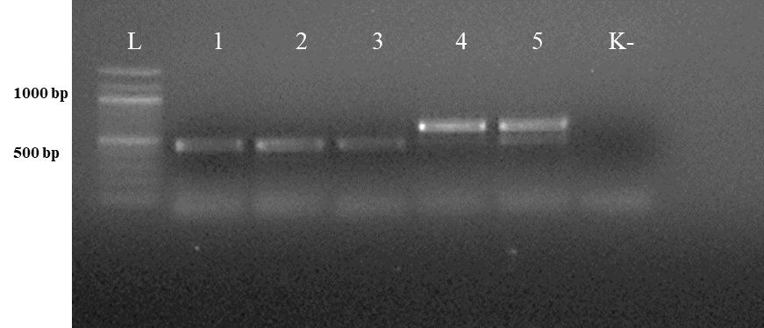
Figure 3. Electrophoresis of PCR products of gDNA from representative ascarid samples using the primer pairs Tleo1/NC2 (A) and Tcat1/NC2 (B), species-specific for Toxascaris leonina and Toxocara cati, respectively. Lane L: DNA marker; lanes 1–5: DNA from ascarids collected from red fox (1), wolf (2), corsac fox (3), lynx (4) and badger (5); lane K: negative control (ddH2O).

The second PCR, performed with the respective species-specific primer pairs targeting the ITS2 rDNA region, identified T. leonina in canids and Toxocara cati in lynx (Figure 3). The primer pair specific for Toxocara canis gave no results in any sample (data not shown). Ribosomal ITS2 amplicons were obtained from six T. leonina isolates (232–261 bp), two each from wolf, red fox and corsac fox, and from two Toxocara cati isolates (375 and 434 bp) from lynx. The badger ascarids were identified as Baylisascaris sp. using a primer on the ribosomal ITS1-5.8S-ITS2 region and by comparison of the nucleotide sequences obtained with references from the GenBank database. Ribosomal ITS1-5.8S-ITS2 amplicons of 511 bp and 842 bp in length were obtained from two B. melis isolates. Nucleotide sequence data for all isolates have been deposited in the NCBI GenBank database under the accession numbers shown in Table 3.

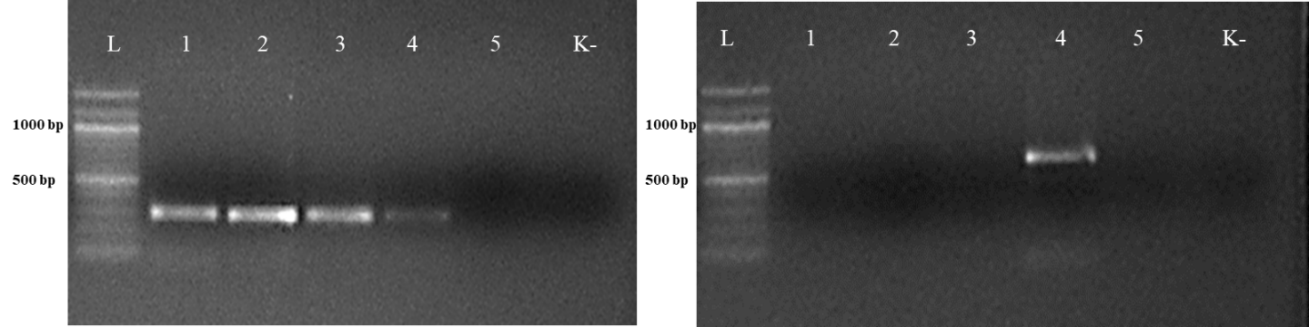
Figure 3. Electrophoresis of PCR products of gDNA from representative ascarid samples using the primer pairs Tleo1/NC2 (A) and Tcat1/NC2 (B), species- specific for Toxascaris leonina and Toxocara cati, respectively. Lane L: DNA marker; lanes 1–5: DNA from ascarids collected from red fox (1), wolf (2), corsac fox (3), lynx (4) and badger (5); lane K: negative control (ddH2O).

Table 3. GenBank accession no. and number of nucleotide base pairs of representative samples of adult ascarids from this study.
Species | Host | Accession no. | N bp
Toxascaris leonina | Wolf | OR647588 | 261
Toxascaris leonina | Wolf | OR647594 | 241
Toxascaris leonina | Red fox | OR647692 | 242
Toxascaris leonina | Red fox | OR647694 | 232
Toxascaris leonina | Corsac fox | OR647689 | 234
Toxascaris leonina | Corsac fox | OR647691 | 235
Toxocara cati | Lynx | OQ975261 | 434
Toxocara cati | Lynx | OQ975262 | 375
Baylisascaris melis | Badger | PP333110 | 842
Baylisascaris melis | Badger | PP333114 | 511
Nucleotide sequences from representative ascarid samples of the five host species were used to construct the maximum likelihood phylogenetic tree. Three distinct clades were identified: T. leonina from canids was placed in one clade with bootstrap values ranging from 46 to 96, Toxocara cati from lynx in another and B. melis from badgers in a third (Figure 4). Maximum tree analyses of the ribosomal ITS1-5.8S-ITS2 gene sequence showed that the two B. melis isolates formed a clade with the four reference species Baylisascaris columnaris, Baylisascaris procyonis, Baylisascaris transfuga, and Baylisascaris devosi. Both B. melis isolates showed slight genetic differences (Figure 5).

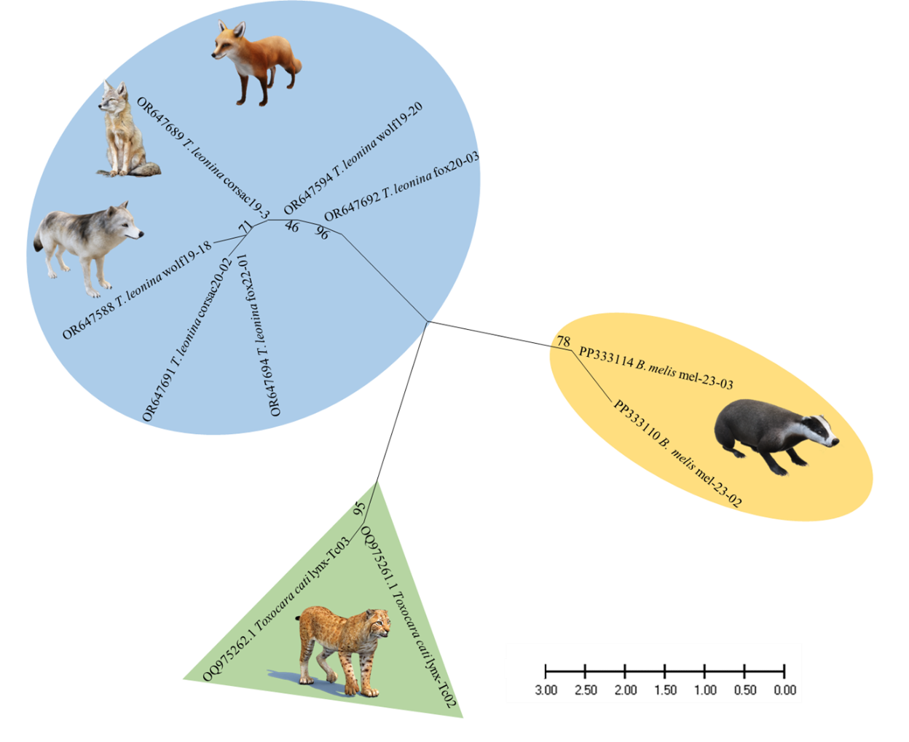
Figure 4. Maximum likelihood phylogeny constructed from nucleotide data of representative ascarid samples from wild carnivores in Kazakhstan. Numbers along the branches show bootstrap values resulting from different analyses in percent; scale: estimated number of nucleotide substitutions per site; species name and host species after the GenBank accession no.

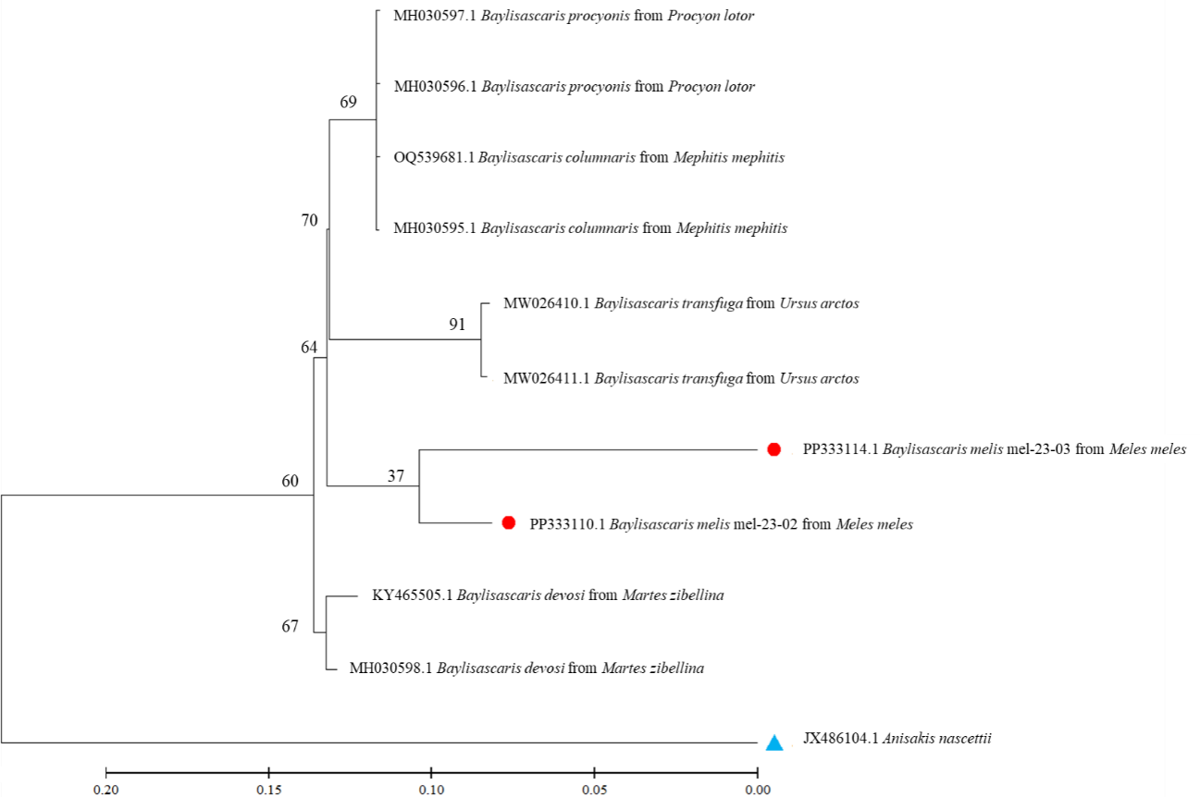
Figure 5. Maximum likelihood tree based on ribosomal ITS1-5.8S-ITS2 gene regions from several Baylisascaris spp. available in the GenBank and two isolates from this study. Numbers along the branches show bootstrap values resulting from different analyses in percent; scale: estimated number of nucleotide substitutions per site; species name and host species after the GenBank accession no.; red dots: isolates from this study; blue triangle: outgroup.

4 Discussion
In this study, five wild carnivore species in Kazakhstan were examined for their respective ascarid species. The species found, their prevalence, intensity and abundance partly differ from those of other Kazakh studies. This is not surprising as the regions of origin of the sampled hosts were different. It should also be noted that the data presented (as from previous studies) are not representative. They are based on a relatively small number of non-randomly selected hosts in a few regions of Kazakhstan, a large country of 2,725,000 km2, where, for example, the wolf and red fox populations are estimated to be 30,000 and 75,000, respectively, (33, 34). It is also well documented that the ascarid fauna of wild carnivores varies between landscapes (e.g., steppe, foothills, mountains) (19, 35, 36), which may be explained by local differences in prey availability (10). Furthermore, lynx are protected species and their killing requires justified exemptions. It is therefore quite difficult to study representative samples of these wild carnivores in such large countries.
Nevertheless, it is the first study to use molecular methods to identify ascarid nematodes from Central Asian countries. Phylogenetic analysis revealed three distinct species: Toxocara cati, T. leonina, and B. melis (Figure 4), confirming the morphological diagnosis.
In the three canid hosts, only T. leonina was identified, but not Toxocara canis. This is consistent with previous findings, based on traditional morphological methods, that T. leonina was the dominant ascarid species in corsac foxes in Kazakhstan (11), wild canids in southern Siberia (15), and stray dogs in Eurasian regions
(37). It may be due to the higher cold tolerance of T. leonina eggs compared to Toxocara canis eggs, which favors this roundworm species in colder regions (37). However, it should be noted that the worms in the present study were obtained from adult hosts. This may have biased the results, as Toxocara canis is known to be mainly found in young canids (1, 26). In fact, other studies in Kazakhstan and neighboring countries have reported that wolves, red foxes or corsac foxes are infected with both ascarid species (12–14, 16–18).
Toxocara cati was the only ascarid species found in lynx. This was consistent with most reports from different countries (10, 15, 18), although occasionally T. leonina was also reported from this felid species (2, 38).
Wild canids and felids (as well as their domestic relatives) infected with ascarids contaminate the environment by excreting worm eggs in feces. The embryonated eggs are a potential source of infection for domestic dogs and cats and for paratenic hosts, including humans, who may ingest these eggs (1, 9, 10). In the light of the results presented, this infection risk can be assessed as follows: (a) T. leonina is considered a negligible parasite from a veterinary and zoonotic point of view (37). (b) In contrast, Toxocara cati is pathogenic in its definitive feline host (39) and also in paratenic hosts: Experimental studies have shown that after ingestion of Toxocara cati eggs, larvae migrate into tissues, including the brain, causing pathomorphological alterations in mice and pigs and abnormal neurobehaviour in mice (40, 41). It should therefore be considered as a potential cause of neural larval migrans symptoms in humans (42). However, lynx are likely to be a negligible source of Toxocara cati infection to humans, at least in Central Asia. This is because the lynx prefers to live in forested areas, which provide sufficient cover for hunting and abundant prey without much contact with human settlements (43).
Toxocara canis may be present in wolves and red foxes (see above), although not in this study. These wild canids are more synanthropic than the lynx, and their range extends close to human settlements (10, 44). This increases the risk of successful transmission of their parasites, including the zoonotic Toxocara canis, to domestic animals and humans (1, 9, 10).
This study also presents the first molecular data and provides the first phylogenetic analysis of B. melis worldwide. The badger ascarid was shown to be genetically distinct from Baylisascaris spp. of other carnivores: B. columnaris (definitive host: skunk [Mephitis spp.]), B. procyonis (raccoon [Procyon lotor]), B. transfuga (bears [Ursus spp.]) and B. devosi (marten [Martes spp.], fisher [Pekania pennanti], wolverine [Gulo gulo]) (Figure 5). This also confirms the morphological differentiation by Sprent (45) and supports the hypothesis (46) that the ascarids found in North American badgers (Taxidea taxus), which have been described as B. columnaris, are in fact B. melis. The significance of the slight genetic differences between the two B. melis isolates analyzed remains to be investigated. The phylogenetic analysis also showed that B. procyonis and B. columnaris form a clade. This confirms previous results suggesting that they are closely related species or that the former is even a synonym of the latter (47, 48).
Interestingly, there is little information on the geographical distribution and prevalence of B. melis in badger populations in Eurasia. First described over 100 years ago in Belgium (49), this is the second unequivocal identification of this species. This nematode had not been mentioned in any relevant study in central, western or southern European countries. There are two studies from Italy and Switzerland reporting only unspecified “ascarid” eggs or worms in a few badgers (Table 4). In contrast, ascarids have been collected from badgers in Uzbekistan, Azerbaijan and Caucasian Russia and morphologically identified as Toxocara canis, B. columnaris or B. devosi (Table 4). However, it is most likely that these worms were misidentified and were actually B. melis; the molecular results support this assumption. Thus, data from the literature and the results presented here suggest that B. melis may occur primarily, if not exclusively, in badger populations of western and central Asia. The reasons for this are still unknown.

Table 4. Results of previous studies on intestinal helminths, including ascarids, in badgers in Eurasia.
Country | N ascarid positive/N examined | Method used | Reference
Uzbekistan | 0/19 | Nec | (17)
 | 4/25 “Toxocara canis” | Nec | (18)
Azerbaijan | 10/43 “B.  columnaris” | Nec | (20)
Azerbaijan | 4/43 “B. devosi” | Nec | (20)
Russia (Caucasus) | 3/60 “B.  columnaris” | Nec | (19)
Poland | 0/17 | Cop | (51)
Slovenia | 0/18 | Nec | (52)
Croatia | 0/13 | Nec | (53)
Austria | 0/20 | Nec | (54)
Germany | 0/16 | Nec | (55)
 | 0/84 | Nec | (56)
Switzerland | 2/249 “ascarids” | Nec | (57)
Italy | 0/19 | Nec | (58)
 | 1/43 “ascarid egg” | Cop | (59)
 | 0/18 | Nec | (60)
Spain | 0/85 | Nec | (61)
 | 0/26 | Nec | (62)
Portugal | 0/163 | Cop | (63)
Great Britain | 0/118 | Nec | (64)
Ireland | 0/50 | Cop | (65)
 | 0/289 | Nec | (66)
It should be noted that B. melis is able to infect rodents (facultative intermediate hosts) under experimental conditions: It was highly pathogenic and caused fatal neural larva migrans symptoms in the American ground squirrel (Urocitellus armatus); mice (Mus musculus) did not develop clinical symptoms, but their brains and other tissues contained B. melis larvae (50). Whether this can also occur in Central Asian ground squirrel species (Spermophilus spp.) or other rodents under natural conditions does not seem impossible and requires further study. In any case, based on the clinical and pathological findings in rodents, a zoonotic significance of B. melis cannot be excluded and should be further investigated.
This study concludes by identifying ascarid nematodes from five distinct wild carnivore species in Central Asia within the phylogenetic framework. The study also presents the world’s first molecular data on B. melis from badger. It provides further insights into the classification and genetic diversity of ascarids. It reiterates the need for molecular methods to complement traditional morphological methods as a basic diagnostic tool in the future, for example in studies of the fauna, diversity, ecology and epidemiology of wildlife parasites, especially potential zoonotic agents. For future research, we are also considering collecting feces from wild carnivores to detect roundworm infection, which would increase the sample size.

Data availability statement
The datasets presented in this study can be found in online repositories. The names of the repository/repositories and accession number(s) can be found at: https://www.ncbi.nlm.nih. gov/nuccore/OR647588, OR647588; https://www.ncbi.nlm.nih. gov/nuccore/OR647594, OR647594; https://www.ncbi.nlm.nih. gov/nuccore/OR647692, OR647692; https://www.ncbi.nlm.nih. gov/nuccore/OR647694, OR647694; https://www.ncbi.nlm.nih. gov/nuccore/OR647689, OR647689; https://www.ncbi.nlm.nih. gov/nuccore/OR647691, OR647691; https://www.ncbi.nlm.nih. gov/nuccore/OQ975261, OQ975261; https://www.ncbi.nlm.nih. gov/nuccore/OQ975262, OQ975262; https://www.ncbi.nlm.nih. gov/nuccore/PP333110, PP333110; https://www.ncbi.nlm.nih.gov/ nuccore/PP333114, PP333114.

Ethics statement
The animal study was approved by the local Animal Ethics Committee (extract from Protocol No. 1 dated 24 July 2019) prior to commencement and was conducted in accordance with the World Medical Association Code of Ethics (Declaration of Helsinki) for animal research (http://ec.europa.eu/environment/ chemicals/lab_animals/legislation_en.htm). The study was conducted in accordance with the local legislation and institutional requirements.

Author contributions
RU: Data curation, Formal analysis, Methodology, Software, Validation, Visualization, Writing – original draft, Writing – review & editing. ASm: Data curation, Formal analysis, Investigation, Methodology, Software, Validation, Visualization, Writing – original draft, Writing – review & editing. LL: Data curation, Formal analysis, Methodology, Validation, Writing – original draft, Writing – review & editing. ASh: Data curation, Formal analysis, Methodology, Software, Writing – original draft, Writing – review & editing. AAB: Data curation, Formal analysis, Visualization, Writing – original draft, Writing – review & editing. APB: Data curation, Investigation, Methodology, Software, Writing – original draft, Writing – review & editing. CB: Conceptualization, Formal analysis, Investigation, Methodology, Resources, Software, Supervision, Validation, Visualization, Writing – original draft, Writing – review & editing. VK: Conceptualization, Data curation, Formal analysis, Funding acquisition, Methodology, Project administration, Resources, Supervision, Writing – original draft, Writing – review & editing.
Funding
The author(s) declare that financial support was received for the research, authorship, and/or publication of this article. This research was financially supported by the Ministry of Education and Science of the Republic of Kazakhstan under project #AP08052252 for 2020– 2022. The molecular genetic work was also supported by the Initiative Scientific Project #0121PKI0192 for 2021–2024, Kazakhstan.

Acknowledgments
The authors are grateful to Alexander Lyalchenko for collecting a number of host animals. We also thank our master students for their help in identifying and counting the parasites.
Conflict of interest
The authors declare that the research was conducted in the absence of any commercial or financial relationships that could be construed as a potential conflict of interest.

Publisher’s note
All claims expressed in this article are solely those of the authors and do not necessarily represent those of their affiliated organizations, or those of the publisher, the editors and the reviewers. Any product that may be evaluated in this article, or claim that may be made by its manufacturer, is not guaranteed or endorsed by the publisher.

References
1. Otranto D, Deplazes P. Zoonotic nematodes of wild carnivores. Int J Parasitol Parasit Wildl. (2019) 9:370–83. doi: 10.1016/j.ijppaw.2018.12.011
2. Xie Y, Li Y, Gu X, Liu Y, Zhou X, Wang L, et al. Molecular characterization of ascaridoid parasites from captive wild carnivores in China using ribosomal and mitochondrial sequences. Parasit Vectors. (2020) 13:382. doi: 10.1186/ s13071-020-04254-4
3. Wu T, Bowman DD. Visceral larval migrans of Toxocara canis and Toxocara cati in non-canid and non-felid hosts. Adv Parasitol. (2020) 109:63–88. doi: 10.1016/bs. apar.2020.02.001
4. Kazacos KR. Baylisascaris larva Migrans. Reston: U.S. Geological Survey Circular 1412 (2016). 122 p.
5. Ma G, Rostami A, Wang T, Hofmann A, Hotez PJ, Gasser RB. Global and regional seroprevalence estimates for human toxocariasis: a call for action. Adv Parasitol. (2020) 109:275–90. doi: 10.1016/bs.apar.2020.01.011
6. Torgerson PR, Rosenheim K, Tanner I, Ziadinov I, Grimm F, Brunner M, et al. Echinococcosis, toxocarosis and toxoplasmosis screening in a rural community in eastern Kazakhstan. Trop Med Int Health. (2009) 14:341–8. doi: 10.1111/j.1365-3156.2009.02229.x
7. Akhmadishina LV, Ruzina MN, Lukasheva MA, Kyuregyan KK, Mikhailov MI, Lukashev AN. Seroprevalence and incidence of human toxocarosis in Russia. Adv Parasitol. (2020) 109:419–32. doi: 10.1016/bs.apar.2020.01.015
8. Auer H, Walochnik J. Toxocariasis and the clinical spectrum. Adv Parasitol. (2020) 109:111–30. doi: 10.1016/bs.apar.2020.01.005
9. Otranto D, Cantacessi C, Dantas-Torres F, Brianti E, Pfeffer M, Genchi C, et al. The role of wild canids and felids in spreading parasites to dogs and cats in Europe. Part II: helminths and arthropods. Vet Parasitol. (2015) 213:24–37. doi: 10.1016/j. vetpar.2015.04.020
10. Holland CV. A walk on the wild side: a review of the epidemiology of Toxocara canis and Toxocara cati in wild hosts. Int J Parasitol Parasit Wildl. (2023) 22:216–28. doi: 10.1016/j.ijppaw.2023.10.008
11. Tazieva ZK. Helminths of predatory mammals (Canidae and Mustelidae) of Kazakhstan. (PhD Biol. Sci. thesis [abstract]). Alma-Ata: University (1970). 24 p In Russian.
12. Abdybekova AM, Torgerson PR. Frequency distributions of helminths of wolves in Kazakhstan. Vet Parasitol. (2012) 184:348–51. doi: 10.1016/j.vetpar.2011.09.004
13. Abdybekova A. About helminth fauna of corsac foxes inhabiting the south of Kazakhstan. GISAP Biol Vet Med Agricult Sci. (2014) 3:39–41.
14. Abirova IM, Elsugalisva NZ, Zhumagalisva GK, Gusmanov MG. Helminthofauna of the fox (Vulpes vulpes) and corsac (Vulpes corsac). Biol Sci Kazakhstan. (2021) 3:28–35. In Kazakh
15. Bykova AM. Helminths of predatory mammals (Canidae, Felidae, Mustelidae) in the Omsk region and their ecological-faunistic analysis. (PhD Biol. Sci. thesis [abstract]). Tyumen: All-Russian Scientific Research Institute Veterinary Entomology and Arachnology (2007). 21 p In Russian.
16. Ziadinov I, Deplazes P, Mathis A, Mutunov B, Abdykerimov K, Nurgaziev R, et al. Frequency distribution of Echinococcus multilocularis and other helminths of foxes in Kyrgyzstan. Vet Parasitol. (2010) 171:286–92. doi: 10.1016/j.vetpar.2010.04.006
17. Safarov AA, Akramova FD, Turgunov SN, Saidova SO, Mirzaeva AU, Berdibaev AS, et al. Fauna of helminths of predatory mammals (Canidae, Mustelidae, Felidae) of Uzbekistan. Sci Rev Biol Sci. (2023) 4:39–52. doi: 10.17513/srbs.1340, In Russian
18. Shakarboev EB, Berdibaev AS. Ecological and faunistic analysis of helminths of wild mammals from the order Carnivora in Karakalpakstan. Adv Anim Vet Sci. (2023) 11:1801–9. doi: 10.17582/journal.aavs/2023/11.11.1801.180954
19. Itin GS, Kravchenko VM. Helminthic cenoses of the Eurasian badger (Meles meles, L., 1758) in the North-Western Caucasus. Theory Pract Combat Parasitic Dis. (2023) 24:195–8. doi: 10.31016/978-5-6048555-6-0.2023.24.194-198
20. Fataliyev GH. Helminthofauna of the badger (Meles meles L. 1758) and detection of new nematodes Trichocephalus sp. nov. Fataliyev, 2010 (Trichocephalata: Trichocephalidae) on the territory of the republic of Azerbaijan. For Chron. (2019) 4:7–11.
21. Jacobs DE, Zhu X, Gasser RB, Chilton NB. PCR-based methods for identification of potentially zoonotic ascaridoid parasites of the dog, fox and cat. Acta Trop. (1997) 68:191–200. doi: 10.1016/s0001-706x(97)00093-4
22. Li L, Lü L, Nadler SA, Gibson DI, Zhang LP, Chen HX, et al. Molecular phylogeny and dating reveal a terrestrial origin in the early carboniferous for ascaridoid nematodes. Syst Biol. (2018) 67:888–900. doi: 10.1093/sysbio/syy018
23. Fogt-Wyrwas R, Dabert M, Jarosz W, Rząd I, Pilarczyk B, Mizgajska-Wiktor H. Molecular data reveal cryptic speciation and host specificity in Toxascaris leonina (Nematoda: Ascarididae). Vet Parasitol. (2010) 266:80–3. doi: 10.1016/j. vetpar.2019.01.002
24. Fava NMN, Cury MC, Santos HA, Takeuchi-Storm N, Strube C, Zhu XQ, et al. Phylogenetic relationships among Toxocara spp. and Toxascaris sp. from different regions of the world. Vet Parasitol. (2020) 282:109133. doi: 10.1016/j.vetpar.2020.109133
25. Skrjabin KI. Method of complete helminthological dissection of vertebrates, including humans. Moscow: State University (1928) 40–48. In Russian.
26. Deplazes P, Eckert J, Mathis A, Samson-Himmelstjerna V, Zahner H. Parasitology in veterinary medicine. Wageningen: Academic Publishers (2016). 653 p.
27. Kontrimavičius VN. Helminths of mustelids and trends in their evolution. Moscow: Nauka (1969) 232–234. In Russian.
28. Bowles J, McManus DP. Genetic characterization of the Asian Taenia, a newly described taeniid cestode of humans. Am J Trop Med Hyg. (1994) 50:33–44.
29. Franssen F, Xie K, Sprong H, van der Giessen J. Molecular analysis of Baylisascaris columnaris revealed mitochondrial and nuclear polymorphisms. Parasit Vectors. (2013) 6:124. doi: 10.1186/1756-3305-6-124
30. Tamura K, Stecher G, Kumar S. MEGA11: molecular evolutionary genetics analysis version 11. Mol Biol Evol. (2021) 38:3022–7. doi: 10.1093/molbev/msab120
31. Ackermann H. BIAS für Windows. Version 9.05. Hochheim: Epsilon (2010).
32. Bush AO, Lafferty KD, Lotz JM, Shostak AW. Parasitology meets ecology on its own terms: Margolis Shostak AW revisited. J Parasitol. (1997) 83:575–83.
33. World Population Review. Gray wolf population by country. (2024). Available at: https://worldpopulationreview.com/country-rankings/gray-wolf-population-by- country (Accessed June 10, 2024).
34. World Population Review. Red fox population by country. (2024). Available at: https://worldpopulationreview.com/country-rankings/fox-population-by-country (Accessed June 10, 2024).
35. Fataliev GG. Helminthofauna of wild canids in Azerbaijan and ways of its formation. Parazitologiya. (2011) 45:129–39. In Russian
36. Ponamarev NM, Kostyukov MA. Study on helminths of red foxes in the Altai region. Bull Altay State Agrarian Univ. (2012) 1:57–9. In Russian
37. Bauer C, Lider LA, Ussenbayev AE, Seitkamzina DM, Zhanabayev AA, Maksimov P, et al. Toxascaris leonina in dogs – a nematode species of high prevalence in some regions of Eurasia. Vet Parasitol Reg Stud Rep. (2024) 48:100986. doi: 10.1016/j. vprsr.2024.100986
38. Kołodziej-Sobocińska M, Yakovlev Y, Schmidt K, Hurníková Z, Ruczyńska I, Bednarski M, et al. Update of the helminth fauna in Eurasian lynx (Lynx lynx) in Poland. Parasitol Res. (2018) 117:2613–21. doi: 10.1007/s00436-018-5953-0
39. Dillon AR, Tillson DM, Hathcock J, Brawner B, Wooldridge A, Cattley R, et al. Lung histopathology, radiography, high-resolution computed tomography, and bronchio-alveolar lavage cytology are altered by Toxocara cati infection in cats and is independent of development of adult intestinal parasites. Vet Parasitol. (2013) 193:413–26. doi: 10.1016/j.vetpar.2012.12.045
40. Janecek E, Waindok P, Bankstahl M, Strube C. Abnormal neurobehaviour and impaired memory function as a consequence of Toxocara canis- as well as Toxocara cati-induced neurotoxocarosis. PLoS Negl Trop Dis. (2017) 11:E0005594. doi: 10.1371/ journal.pntd.0005594
41. Poulsen CS, Yoshida A, Wellbrant TT, Leifsson PS, Skallerup P, Thamsborg SM, et al. Migratory pattern of zoonotic Toxocara cati and T. canis in experimentally infected pigs. Eur J Clin Microbiol Inf Dis. (2024) 43:587–96. doi: 10.1007/S10096-024-04753-7
42. Maciag L, Morgan ER, Holland C. Toxocara: time to let cati ‘out of the bag’. Trends Parasitol. (2022) 38:280–9. doi: 10.1016/j.pt.2021.12.006
43. Sidorovich V. Behaviour and ecology of the Eurasian Lynx. Minsk: Publishing House Four Quarters (2022). 344 p.
44. Poyarkov AD, Korablev MP, Bragina E, Hernandez-Blanco JA. Overview of current research on wolves in Russia. Front Ecol Evol. (2022) 10:869161. doi: 10.3389/ fevo.2022.869161
45. Sprent JFA. Notes on Ascaris and Toxascaris, with a definition of Baylisascaris gen. Nov. Parasitology. (1968) 58:185–98. doi: 10.1017/S0031182000073534
46. Sapp SGH, Gupta P, Martin MK, Murray MH, Niedringhaus KD, Pfaff MA, et al. Beyond the raccoon roundworm: the natural history of non-raccoon Baylisascaris species in the New World. Int J Parasitol Parasites Wildl. (2017) 6:85–99. doi: 10.1016/j. ijppaw.2017.04.003
47. Camp LE, Radke MR, Shihabi DM, Pagana C, Yang G, Nadler SA. Molecular phylogenetics and species-level systematics of Baylisascaris . Int J Parasitol Parasit Wildl. (2018) 7:450–62. doi: 10.1016/j.ijppaw.2018.09.010
48. Gu XH, Chen HX, Hu JJ, Li L. Morphology and ASAP analysis of the important zoonotic nematode parasite Baylisascaris procyonis (Stefahski and Zarnowski, 1951), with molecular phylogenetic relationships of Baylisascaris species (Nematoda: Ascaridida). Parasitology. (2024) 151:200–12. doi: 10.1017/S0031182023001312
49. Gedoelst CR. Sur une espece nouvelle d’ascaride, parasite du blaireau. C R Seances Soc Biol Fil. (1920) 83:1291–2.
50. Tiner JD. Fatalities in rodents caused by larval Ascaris in the central nervous system. J Mammal. (1953) 34:153–67. doi: 10.2307/1375616
51. Górski P, Zalewski A, Lakomy M. Parasites of carnivorous mammals in Białowieza primeval Forest. Wiad Parazytol. (2006) 52:49–53.
52. Brglez J. Some endohelminths in badgers, Meles meles L., in Slovenia. Zbornik Biotehniške Fakultete Univerze Edvarda Kardelja v Ljubljani, Veterinarstvo. (1988) 25:251–7. In Slovenian
53. Bujanić M, Martinković F, Štimac I, Škvorc N, Konjević D. Gastrointestinal parasites of wild badger (Meles meles) at Medvednica Nature Park – preliminary results. Proc Int Symp Anim Sci. (2019) 30.
54. Baumann T. Endoparasitenfauna des Dachses in Österreich. (MS Vet Med thesis). Vienna: University of Veterinary Medicine (2014). 61 p.
55. Stubbe M. Zur Biologie der Raubtiere eines abgeschlossenen Waldgebietes. Z Jagdwiss. (1965) 11:73–102.
56. Loos-Frank B, Zeyhle E. The intestinal helminths of the red fox and some other carnivores in Southwest Germany. Z Parasitenk. (1982) 67:99–113. doi: 10.1007/ BF00929518
57. Akdesir E, Origgi FC, Wimmershoff J, Frey J, Frey CF, Ryser-Degiorgis MP. Causes of mortality and morbidity in free-ranging mustelids in Switzerland: necropsy data from over 50 years of general health surveillance. BMC Vet Res. (2018) 14:195. doi: 10.1186/ s12917-018-1494-0
58. Magi M, Banchi C, Barchetti A, Guberti V. The parasites of the badger (Meles meles) in the north of Mugello (Florence, Italy). Parassitologia. (1999) 41:533–6.
59. Maestrini M, Berrilli F, Di Rosso A, Coppola F, Procesi IG, Mariacher A, et al. Zoonotic Giardia duodenalis genotypes and other gastrointestinal parasites in a badger population living in an anthropized area of Central Italy. Pathogens. (2022) 11:906. doi: 10.3390/pathogens11080906
60. Di Cerbo AR, Manfredi MT, Bregoli M, Ferro Milone N, Cova M. Wild carnivores as source of zoonotic helminths in North-Eastern Italy. Helminthologia. (2008) 45:13–9. doi: 10.2478/s11687-008-0002-7
61. Torres J, Miquel J, Motjé M. Helminth parasites of the Eurasian badger (Meles meles L.) in Spain: a biogeographic approach. Parasitol Res. (2001) 87:259263. doi: 10.1007/s004360000316
62. Millán J, Sevilla I, Gerrikagoitia X, García-Pérez AL, Barral M. Helminth parasites of the Eurasian badger (Meles meles L.) in the Basque Country (Spain). Eur J Wildl Res. (2004) 50:37–40. doi: 10.1007/s10344-003-0032-x
63. Rosalino LM, Torres J, Santos-Reis M. A survey of helminth infection in Eurasian badgers (Meles meles) in relation to their foraging behaviour in a Mediterranean environment in Southwest Portugal. Eur J Wildl Res. (2006) 52:202–6. doi: 10.1007/ s10344-006-0033-7
64. Jones GW, Neal C, Harris EA. The helminth parasites of the badger (Meles meles) in Cornwall. Mamm Rev. (1980) 10:163–4. doi: 10.1111/j.1365-2907.1980.tb00237.x
65. Stuart P, Golden O, Zintl A, De Waal T, Mulcahy G, McCarthy E, et al. A coprological survey of parasites of wild carnivores in Ireland. Parasitol Res. (2013) 112:3587–93. doi: 10.1007/s00436-013-3544-7
66. Byrne RL, Fogarty U, Mooney A, Marples NM, Holland CV. A comparison of helminth infections as assessed through coprological analysis and adult worm burdens in a wild host. Int J Parasitol Parasit Wildl. (2018) 7:439–44. doi: 10.1016/j. ijppaw.2018.11.003

- Genetic diversity of Echinococcus spp. in wild carnivorous animals in Kazakhstan

Abstract
Background and Aim: The study of Echinococcus infection among farm animals in Kazakhstan was carried out to monitor the invasion among livestock and map the data obtained. Unfortunately, there are only partial data on the study of echinococcosis among wild carnivores in Kazakhstan, which makes it difficult to conduct a comparative analysis of the epidemiological situation among wild animals. The present study aimed to estimate the genetic diversity of Echinococcus spp. (Leuckart, 1863) in Kazakhstan based on sequence analysis of cytochrome c oxidase subunit 1 (cox1) and dehydrogenase subunit 1 (nad1) of worms isolated from wild carnivorous animals wolf (Canis lupus), red fox (Vulpes vulpes) and corsac (Vulpes corsac).
Materials and Methods: DNA from parasite tissue was used as a template for the amplification of the two mitochondrial genes cox1 and nad1. Sequencing was performed according to the manual for the Seq Studio Genetic Analyzer. The multiple alignments of obtained sequences were performed using the ClustalW algorithm in Mega (v.11) software. Alignments were exported as a Nexus extension and used as input for TCS v1.21 for the identification of haplotypes. The phylogenetic analysis was constructed according to the neighbour-joining method using Mega (v.11) software.
Results: Analysis of the extensiveness of echinococcosis invasion showed that 6.3% were wolves, 18.2% were corsacs, and 85% were foxes. In total, 159 adults of Echinococcus spp. from the three species of animals in different parts of Kazakhstan were analyzed, and 17 individual biological samples were successfully sequenced. Sequence analysis of cox1 and nad1 genes revealed two types of echinococcosis – Echinococcus granulosus in red foxes and wolves, and Echinococcus multilocularis in corsaсs. Sequencing of a portion of the mitochondrial genome made it possible to determine seven haplotypes of the pathogen in the studied samples of E. granulosus. Molecular analysis of cox1 and nad1 genes of E. multilocularis revealed three new haplotypes, which have significant variability compared with other studied Asian haplotypes.
Conclusion: This study made it possible to fill the gaps in understanding the localization of the foci of the spread of the echinococcosis pathogen among the main wild carnivores and to determine the species reservoir of the pathogen in the greater territory of Kazakhstan.
Introduction
Echinococcosis is an animal-borne infection caused by tapeworms of the Echinococcus type [1]. Intermediate hosts for Echinococcus spp. are some herbivores (cattle, sheep, pigs, horses, etc.) and omnivores, such as small rodents, including rats and mice [2, 3]. The final hosts are carnivores whose intestines are inhabited by mature worms [4]. Based on the specificity of manifestation and distribution in the host’s internal organs, four types of Echinococcus are distinguished: Cystic (Echinococcus granulosus ), alveolar (Echinococcus multilocularis), polycystic (Echinococcus vogeli), and monocystic (Echinococcus oligarthrus) [5]. Cystic and alveolar echinococcoses are serious problems for medicine, public health, and animal husbandry. These two forms of echinococcosis are most common in wild animals [6, 7]. E. granulosus is endemic on all continents, while E. multilocularis has a more limited distribution [8]. In the Midwest, cystic echinococcosis (CE) is common in most countries, although the prevalence of alveolar echinococcosis has been reported in Iran, Iraq, and Tunisia [9]. In Asia, canine infections have been reported in dogs in Kazakhstan [10], Kyrgyzstan [11] and China [12]. The geographical distribution of alveolar echinococcosis is limited to the Northern Hemisphere. The cestode has been registered in the republics of Central Asia [13, 14, 15], Central Europe, the Middle East, Russia, and Alaska [14], and Northern Japan [16].
The study of Echinococcus infection among farm animals in Kazakhstan territory was carried out to monitor the invasion among livestock, and further map the data obtained [17, 18]. Unfortunately, there are only partial data on the study of echinococcosis among wild carnivores in Kazakhstan, which makes it difficult to conduct a comparative analysis of the epidemiological situation among wild animals.
This study aimed to study the level of echinococcal infection among wild carnivores in different regions of the country and to analyse the genetic characteristics of the echinococcosis pathogen in Kazakhstan.
Materials and Methods
Ethical approval
The study was approved by the Animal Ethics Committee (№1 dated July 24, 2019) of Saken Seifullin Kazakh Agrotechnical University.
Study period and location
This study was conducted from July 2020 to February 2021. In Parasitological Laboratory, Veterinary Medicine Faculty and Research platform of Agricultural Biotechnology, Saken Seifullin Kazakh Agrotechnical University, Nur-Sultan, Kazakhstan.
Sample collection
Echinococcus spp. were isolated from red foxes (Vulpes vulpes), corsacs (Vulpes corsac), and wolves (Canis lupus), (Linnaeus) that were captured in the different regions of Kazakhstan. Hunters conducted the extraction of wild animals in compliance with all legislative norms. The digestive tracts, livers, and lungs of 7 foxes, 11 corsacs, and 32 wolves were analyzed for the presence of parasites. The bowel scraping technique was performed as described by Deplazes and Eckert [19]. A total of 159 helminths were selected. All samples were isolated from the intestine.
DNA extraction and polymerase chain reaction (PCR) assay
For DNA extraction, one piece of the adult worm was homogenized in an Eppendorf centrifuge tube and subjected to the standard phenol-chloroform extraction method with proteinase K and subsequent ethanol precipitation [20]. The amount and purity of the extracted DNA were determined by measuring absorption at 260 nm and 280 nm in a NanoDrop 2000 (Thermo Scientific, Carlsbad, California, USA). DNA was dissolved in ddH2O and stored at −70°C.
PCR was carried out in a 25 μl reaction mixture containing 10× Taq buffer with (NH4)2SO4, 2.5 mM MgCl2, 1 U Taq DNA polymerase and 200 μM deoxy- nucleotide triphosphates (Thermo Scientific), 10 pmol of each primer and 20 ng of extracted trematode DNA from an adult specimen as a template. Thermal cycling reactions were performed for 35 cycles of denaturation (94°C for 60 s), annealing (50°C for 60 s), and extension (72°C for 60 s). The resulting amplification fragments were separated by electrophoresis on an ethidium bromide containing 1.5% agarose gel using 1× Tris-acetate-EDTA buffer solution.
Polymerase chain reaction (PCR) was applied to identify the genetic diversity of Echinococcus spp. using 2 primerpairstargetingcytochromecoxidasesubunit1(cox1: forward 5′-TTTTTTGGGCATCCTGAGGTTTAT-3′ and reverse 5′-TAAAGAAAGAACATAATGAAAATG-3′) and dehydrogenase subunit 1 (nad1: forward 5′-TGGAACTCAGTTTGAGCTTTACTA-3′andreverse 5′-ATATCAAAGTAACCTGCTATGCAG-3′) [21, 22].
Sequencing data and phylogenetic analysis
A PCR-amplified target gene fragment was purified using a Quick PCR Purification Kit (Invitrogen, Lithuania), following the manufacturer’s protocols. Sequencing was performed according to the manual for Seq Studio Genetic Analyzer (Thermo Fisher Scientific Applied Biosystems, USA). The resulting nucleotide sequences were visually checked by the Bio Capt program (version 11.0). The nucleotide sequences of the studied species were compared with other sequences in the National Center for Biotechnology Information (NCBI) GenBank database using the basic local alignment search tool options. The nucleotide sequences of the studied species were deposited in the NCBI GenBank database.
The genotypes of E. granulosus present in the isolates characterized in this study were identified based on of cox1 gene. The original reference sequences for the G-system genotypes of E. granulosus described by Bowles et al. [20] were used as references in alignments for comparison with the sequences acquired in the present study. Multiple alignments of the obtained sequences were performed using the ClustalW algorithm in MEGA (v.11) software [23] (https://www. megasoftware.net/). Alignments were exported as a Nexus extension and used as input for TCS v1.21 (Computational Science Laboratory, Barcelona, Spain) [24] for the identification of haplotypes, network construction, and estimation of diversity indices. The phylogenetic analysis was constructed according to the neighbor-joining (NJ) method using MEGA (v.11) software. For the comparison of a relevant outgroup sequence, a sequence of E. shiquicus was also selected.
Results
Parasitological study
All captured animals were dissected and examined for the presence of parasites. Figure 1 indicates the areas in which the capture of animals was carried out and depicts the species of animals that were studied in this area.
Echinococcosis was found in two corsacs in the Qaragandy region, and 15 specimens were isolated. Among the foxes, infected individuals were found in the Qaragandy (4 individuals) and Aqmola (2 individuals) regions. The total number of pathogens isolated from foxes was 137 specimens. Among the wolves infected with echinococcosis, two individuals from the Qostanay region were identified, and seven specimens of the pathogen were isolated from them.

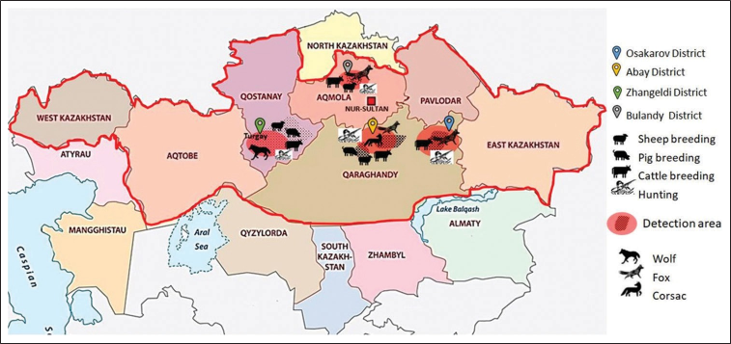
Figure-1: The areas in which the capture of animals was carried out and the species of animals studied from this area are depicted [Source: www.worldatlas.com/maps/kazakhstan].

The extensiveness of Echinococcus spp. in the Qaragandy region was 27.3% and was the highest compared to other regions in which studies have been conducted. In the Aqmola region, the extensiveness was the lowest, at 2.7%. In the present study, the exposure index values of echinococcosis were 6.3% for wolves, 18.2% for corsacs, and 85% for foxes.
Genetic profile of E. granulosus
Characterization of mtDNA haplotypes
As shown in Figure-2, seven haplotypes were detected in the E. granulosus isolates examined, which were designated Hp1 to Hp7. When compared with individual genes, the numbers of haplotypes were decreased to 3 in nad1 compared to 7 in cox1. The concatenation of the genes was effective in generating a phylogenetic tree. The nucleotide sequence of cox1 showed the highest frequency of substitution (14 substitution sites), followed by nad1 (5 substitution sites). Intraspecific variations were observed in both mitochondrial loci. Nucleotide exchanges could be observed at five and four sites in the cox1 and nad1 sequences, respectively, yielding 7 (cox1) and three (nad1) haplotypes (Figure-2). Most of these sites were parsimony informative. Nonsynonymous substitutions exceeded synonymous substitutions (3 vs. 1) in the nad1 coding region, while only one of the changes in the cox1 coding region was synonymous. Point mutation at sites 27 and 218 showed multiple evolutionary paths. Deletions were observed within both genes; hence, the nucleotide numbers were not stable.

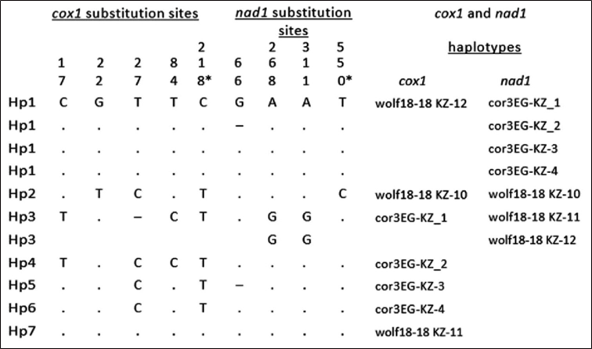
Figure-2: Nucleotide substitutions in the mitochondrial cox1 and nad1 genes, substitution sites are numbered from the initiation codon. *Synonymous substitution. Numbers are read vertically. The substitution sites are numbered from the initiation codon of each gene

In this study, samples of Echinococcus spp. from wild carnivorous animals were investigated. Data including the names of the samples, the accession numbers in GenBank, and from which animals they were isolated are presented in Table-1.

Table-1: Echinococcus granulosus genotypes and haplotypes obtained from cox1 and nad1 gene sequence analysis in different host species.
Haplotypes | Host | Genotype | Species | Accession number
Profile cox1
Hp1 | Canis lupus | G1 | Echinococcus granulosus | OM319836
Hp2 | Canis lupus | G1 | Echinococcus granulosus | OM319830
Hp3 | Vulpes corsac | G1 | Echinococcus granulosus | MZ506656
Hp4 | Vulpes corsac | G1 | Echinococcus granulosus | OM469938
Hp5 | Vulpes corsac | G1 | Echinococcus granulosus | OM470916
Hp6 | Vulpes corsac | G1 | Echinococcus granulosus | OM470963
Hp7 | Canis lupus | G1 | Echinococcus granulosus | OM319844
Profile nad1
Hp1 | Vulpes corsac | G1 | Echinococcus granulosus | OM640347, OM640348 OM640349, OM640350
Hp2 | Canis lupus | G1 | Echinococcus granulosus | OM640352
Hp3 | Canis lupus | G1 | Echinococcus granulosus | OM640353, OM640354

Parsimony network of mtDNA haplotypes
In general, polymorphism of the cox1 locus resulted in seven haplotypes from the three studied regions (Figure-3a). The nad1 locus yielded only three haplotypes, Hp1 from corsac cor3EG-KZ 1–4 in the Qaragandy region, Hp2 from one sample of a wolf in the Qostanay region (wolf18–18 KZ–10) and Hp3 from two samples from a wolf in the Qostanay region (wolf18–18 KZ–11, 12) (Figure-3b).
- 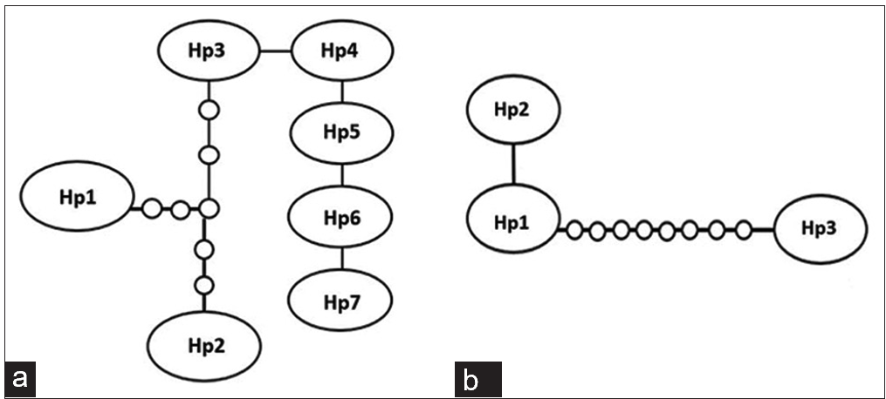
Figure-3: Haplotype network of the sequences of the cox1 (a) and nad1 (b) genes of the seven isolates from Echinococcus granulosus .

The haplotype diversity for cox1 was n = 0.577778, and that for nad1 was n = 0.644444; the number of segregating sites = 30, and Tajima’s D for cox1 was 1.92156, while that for nad1 was 2.06265. Large circles denote haplotypes found in this study, whereas small circles show hypothetical haplotypes.
The statistical parsimony network of the mtDNA haplotypes is illustrated in Figure-3. Among the participants in the network, nad1 gene haplotype 3 showed the largest out-group probability from the other two haplotypes. In the cox1 gene, haplotypes 3–7 were closely related to each other. The mutational steps within each gene clade were infrequent, and their maximum numbers were 6 in the cox1 gene and 8 in the nad1 gene. The network distance in the nad1 gene between haplotypes 1 and 3 was 8 mutational steps, which indicates a small genetic divergence in a relationship. There was no dominant haplotype of E. granulosus in the analyzed samples.

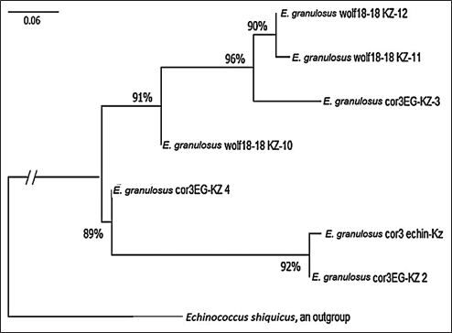
Figure-4: A neighbor-joining haplotype tree of Echinococcus granulosus constructed from the nucleotide dataset of mitochondrial nad1 and cox1 genes. Values on the tree nodes are bootstrap proportions (%). A scale bar (divergence of 0.06) is shown.
Genetic diﬀerentiation index
A pairwise fixation index (Fst) was computed using the mtDNA data to estimate the degree of genetic differentiation of E. granulosus samples obtained from carnivorous animals in Kazakhstan. The Fst index had a 0–1 value range, where 0 denotes the complete identity of the studied samples, and 1 denotes fixation. In our analysis, the Fst values ranged from 0.002 to 0.021 (Table-2).

Table-2: Pairwise fixation index (Fst values) between Echinococcus granulosus samples based on concatenated mtDNA sequences of cox1/nad1 genes (1159 bp).
Samples | 1 | 2 | 3 | 4 | 5 | 6 | 7
cor3EG-KZ_1
cor3EG-KZ_4 | 0.002
wolf18-18 KZ-10 | 0.005 | 0.002
wolf18-18 KZ-12 | 0.007 | 0.005 | 0.007
cor3EG-KZ-2 | 0.008 | 0.010 | 0.005 | 0.015
wolf18-18 KZ-11 | 0.015 | 0.016 | 0.007 | 0.002 | 0.021
cor3EG-KZ-3 | 0.018 | 0.001 | 0.002 | 0.005 | 0.017 | 0.005

The evolutionary history was inferred using the NJ method [25]. The optimal tree is shown in Figure-4. The evolutionary distances were computed using the maximum composite likelihood method [23] and are expressed in units of the number of base substitutions per site. All ambiguous positions were removed for each sequence pair (pairwise deletion option). There were a total of 1159 positions in the final dataset. Evolutionary analyses were conducted in Mega 11 [26].
To analyze and build a phylogenetic tree, the genomic regions of the cox1 and nad1 genes were used. The percentage of relatedness between the studied genotypes was high, and the statistical assessment of the reliability of the tree obtained by bootstrap analysis ranged from 89 to 96%, forming a paraphyletic clade among themselves. According to the distance matrix, an unrooted tree was first built. For rooting, the position of the root was determined using a representative out-group; in our case, E. shiquicus was chosen.
Genetic profile of E. multilocularis
The names of the E. multilocularis samples, the accession numbers in GenBank, and the types of animal parasites isolated are presented in Table-3. Phylogenic analysis was performed as described above.

Table-3: Echinococcus multilocularis genotypes and haplotypes obtained from cox1 and nad1 gene sequence analysis in different host species.
Haplotypes | Host | Species | Profile (accession number)
Hp1 | Vulpes vulpes | Echinococcus multilocularis | OM640355  foxEM-KZ 1 nad1
Hp2 | Vulpes vulpes | Echinococcus multilocularis | OM640356  foxEM-KZ 2 nad1
Hp3 | Vulpes vulpes | Echinococcus multilocularis | OM471710  fox21-34_KZ_5 cox1

The resulting samples were analyzed using the Asian haplotypes of E. multilocularis previously described by Nakao et al. [27]. The phylogenetic tree was inferred using the NJ method [25]. The optimal tree is shown in Figure-5. The evolutionary distances were computed using the maximum composite likelihood method [26] and are expressed in units of the number of base substitutions per site. There were a total of 1641 positions in the final dataset.
The phylogenetic analysis (Figure-5) shows that the samples we studied had low similarity with the previously described Asian haplotypes. Given that the sample size of the studied samples was small, the study of the genetic diversity of E. multilocularis will continue further.

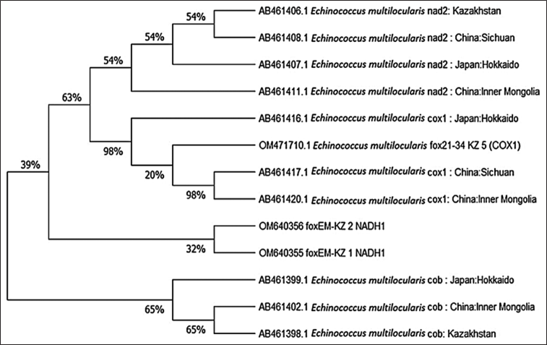
Figure-5: A neighbor-joining haplotype tree of Echinococcus multilocularis.

Discussion
In this work, a study was conducted in five regions of Kazakhstan: the Qostanay, Aqmola, Qaraganda, West Kazakhstan, and East Kazakhstan regions. The territories where outbreaks of echinococcal invasion of farm animals were registered were studied. On referencing a map, it can be noted that hunting for wild animals has developed in the areas of echinococcosis detection among farm animals. This indicates the circulation of the invasion in the ecosystem and the high risks of its transmission to humans [17, 28, 29]. Echinococcus spp. are widespread in Kazakhstan and are responsible for massive cases of CE in humans and animals, both in dogs and livestock [30].
Comparing our data to those of neighboring states according to Beiromvand et al. [31], the study of carnivore parasites in Iran by multiplex PCR revealed that
E. multilocularis was found in the feces of wild predators such as jackals, foxes, wolves, hyenas, and dogs (6.5%). E. granulosus was also found in fecal samples of dogs (16.9%), jackals and foxes, and wolves and hyenas (66.7%). In the Russian Federation, studies were carried out by Andrejanov [32] on the prevalence of alveolar echinococcosis among carnivores. Among the 242 animals studied, 24.5% of foxes, 50% of wolves, 18.7% of raccoon dogs, and 3.7% of domestic dogs were infested with E. multilocularis. Data from Rojas et al. [33] from Kyrgyzstan show molecular data from 43 dog samples (23 infected with E. multilocularis and 20 with E. granulosus). As a result of this study, samples of wolves and corsacs were found and established to be infected with E. granulosus. Foxes were infested exclusively with E. multilocularis. This incident is interesting and requires detailed study.
The previous studies have emphasized that the genetic variability of E. multilocularis is significantly limited compared to that of E. granulosus sensu lato, which shows significant genetic variability [21, 34, 35]. At present, ten different genotypes of E. granulosus, designated G1–G10, have been described worldwide based on genetic diversity associated with the nucleotide sequences of the mitochondrial nad1 and cox1 genes.
A total of 17 samples were sequenced and identified to the strain level in this study. Phylogenetic analysis revealed that seven isolates were identified as the G1 genotype and included seven different haplotypes (the GenBank accession numbers are shown in Table 1).
A study conducted in the territory of Kazakhstan revealed that the dominant circulating E. granulosus genotype was G1, which is highly pathogenic for humans and therefore for wild animals, which have the ability to easily adapt to various environmental conditions and could play a significant role as reservoirs [36].
For the first time in the territory of Kazakhstan, haplotypes of E. granulosus were studied. Ultimately, seven haplotypes were identified and deposited from the studied samples, which were obtained from wild carnivores. Of the two loci studied, the cox1 site showed greater variability, dividing the studied samples into seven haplotypes. The nad1 region, which divided the samples into only three haplotypes, was the least variable. This shows the need for further in-depth study of possible haplotypes of this species, not only those selected among wild carnivores but also domestic, farm animals, and humans.
The study of E. multilocularis requires more research. Using the methodology described by Nakao et al. [27] to analyze genetic variation within E. multilocularis allowed us to obtain datasets that are comparable with other sequences from different geographic regions. In our case, they were compared with Asian haplotypes. The haplotypes established by us had very low similarity with the compared samples, indicating that there is a difference and the possibility of determining a new Asian haplotype. It should also be noted that we cannot compare our dataset with different sequences, as shorter sections of mitochondrial genes were sequenced or the total lengths of different mitochondrial genes were very different.
Attempts were made to study a complete map of the distribution and transmission of invasion in the ecosystem and provide a detailed analysis and identification of all available haplotypes common in Kazakhstan. However, the work was not completed due to the lack of information available in the database. Studies of species specificity using molecular methods are practically not carried out due to the poor equipment, the technical base, and the lack of adapted expression protocols for the isolation and identification of parasites. These limitations negatively influence the objective assessment of the species of parasites, their identification and efficiency during analysis, etc.
The lack of an update in the direction of molecular identification of Echinococcus infection suggests that there is a huge gap that has implications for medicine, livestock, and hunting.
Conclusion
These studies made it possible to fill the gaps in understanding the localization of the foci of the spread of the echinococcosis pathogen among the main wild carnivores and to determine the species reservoir of the pathogen in the greater territory of Kazakhstan. The availability of the obtained data will make it possible to understand the main ways of transmission of echinococcosis between natural reservoirs, farm animals, and humans. Together, this will contribute to the development of preventive measures to prevent the spread of echinococcosis among people and domestic animals and reduce the epidemiological background of this infection.
Authors’ Contributions
VK: Conception and design of the study and drafted and revised the manuscript. RU: Performed DNA extraction and PCR, interpreted the data, performed phylogenetic analysis and drafted the manuscript. ASm and ASyz: Collected samples and performed parasitological isolation and typing. SA: Analyzed the data and performed the statistical analysis. All authors have read and approved the final manuscript.
Acknowledgments
The research presented above was financially supported by the Ministry of Education and Science of the Republic of Kazakhstan to frame project AP08052252 for 2020–2022. The molecular genetics work also was supported by the Initiative Scientific Project # 0121PKI0192 for 2021-2024, Kazakhstan.
Competing Interests
The authors declare that they have no competing interests.
Publisher’s Note
Veterinary World remains neutral with regard to jurisdictional claims in published map and institutional affiliation.

References
1. Higuita, N.I.A., Brunetti, E. and McCloskey, C. (2016) Cystic echinococcosis. J. Clin. Microbiol., 54(3): 518–523.
2. Torgerson, P.R., Shaikenov, B.S., Baitursinov, K.K. and Abdybekova, A.M. (2002) The emerging epidemic of echi- nococcosis in Kazakhstan. Trans. R. Soc. Trop. Med. Hyg., 96(2): 124–128.
3. Kardjadj, M. and Ben-Mahdi, M.H. (2019) Epidemiology of dog-mediated zoonotic diseases in Algeria: A one health control approach. New Microbes New Infect., 28: 17–20.
4. Romig, T., Deplazes, P., Jenkins, D., Giraudoux, P., Massolo, A., Craig, P.S., Wassermann, M., Takahashi, K. and de la Rue M. (2017) Ecology and life cycle patterns of Echinococcus species. Adv. Parasitol., 95: 213–314.
5. Manterola, C. and Otzen, T. (2016) Molecular epidemiol- ogy of cystic echinococcosis: Genotypic characterization in humans and different livestock. Int. J. Morphol., 34(4): 1472–1481.
6. Deplazes, P., Rinaldi, L., Rojas, C.A.A., Torgerson, P.R., Harandi, M.F., Romig, T. and Magambo, J. (2017) Chapter six global distribution of alveolar and cystic echinococcosis. In: Thompson, R.C.A., Deplazes, P. and Lymbery, A.J., edi- tors. Advances in Parasitology. Academic Press, Cambridge, Massachusetts. p315–493.
7. Possenti, A., Manzano-Román, R., Sánchez-Ovejero, C., Boufana, B., La Torre, G., Siles-Lucas, M. and Casulli, A. (2016) Potential risk factors associated with human cys- tic echinococcosis: Systematic review and meta-analysis. PLoS Negl. Trop. Dis., 10(11): e0005114.
8. Manterola, C., Totomoch-Serra, A., Rojas, C., Riffo-Campos, Á.L. and García-Méndez, N. (2021) Echinococcus granulosus sensu lato genotypes in differ- ent hosts worldwide: A systematic review. Acta Parasitol., 67(1): 161–185.
9. Oskouei, M.M., Mehrabani, N.G., Miahipour, A. and Fallah, E. (2016) Molecular characterization and sequence analysis of Echinococcus granulosus from sheep isolates in East Azerbaijan Province, Northwest of Iran. J. Parasit. Dis., 40(3): 785–790.
10. Stefanić, S., Shaikenov, B.S., Deplazes, P., Dinkel, A., Torgerson, P.R. and Mathis, A. (2004) Polymerase chain reaction for detection of patent infections of Echinococcus granulosus (“sheep strain”) in naturally infected dogs. Parasitol. Res., 92(4): 347–351.
11. Counotte, M.J., Minbaeva, G., Usubalieva, J., Abdykerimov, K. and Torgerson, P.R. (2016) The burden of Zoonoses in Kyrgyzstan: A systematic review. PLoS Negl. Trop. Dis., 10(7): e0004831.
12. Carmena, D., Benito, A. and Eraso, E. (2007) The immu- nodiagnosis of Echinococcus multilocularis infection. Clin. Microbiol. Infect., 13(5): 460–475.
13. Bartholomot, G., Vuitton, D.A., Harraga, S., Shi, D.Z., Giraudoux, P., Barnish, G., Wang, Y.H., MacPherson, C.N. and Craig, P.S. (2002) Combined ultrasound and serologic screening for hepatic alveolar echinococcosis in central China. Am. J. Trop. Med. Hyg., 66(1): 23–29.
14. Woolsey, I.D. and Miller, A.L. (2021) Echinococcus granu- losus sensu lato and Echinococcus multilocularis: A review. Res. Vet. Sci., 135: 517–522.
15. Abdybekova, A.M., Zhang, Z., Sultanov, A.A., Abdibayeva, A.A., Zhaksylykova, A.A., Junisbayeva, S.M., Aubakirov, M.Z., Akhmetova, G.D. and Torgerson, P.R. (2020) Genotypes of Echinococcus isolated from domestic livestock in Kazakhstan. J. Helminthol., 94: 69.
16. Irie, T., Yamada, K., Morishima, Y. and Yagi, K. (2019) High probability of pet dogs encountering the sylvatic cycle of Echinococcus multilocularis in a rural area in Hokkaido, Japan. J. Vet. Med. Sci., 81(11): 1606–1608.
17. Torgerson, P.R., Burtisurnov, K.K., Shaikenov, B.S., Rysmukhambetova, A.T., Abdybekova, A.M. and Ussenbayev, A.E. (2003) Modelling the transmission dynamics of Echinococcus granulosus in sheep and cattle in Kazakhstan. Vet. Parasitol., 114(2): 143–153.
18. Wu, C., Zhang, W., Ran, B., Fan, H., Wang, H.,
Guo, B., Zhou, C., Shao, Y., Zhang, W., Giraudoux, P., Knapp, J., Wen, H., Kuang, L. and Li, J. (2017) Genetic variation of mitochondrial genes among Echinococcus multilocularis isolates collected in Western China. Parasit. Vectors, 10(1): 265.
19. Deplazes, P. and Eckert, J. (1996) Diagnosis of the Echinococcus multilocularis infection in final hosts. Appl. Parasitol., 37(4): 245–252.
20. Bowles, J. and McManus, D.P. (1994) Genetic characteriza- tion of the Asian Taenia, a newly described taeniid cestode of humans. Am. J. Trop. Med. Hyg., 50(1): 33–44.
21. Hüttner, M., Nakao, M., Wassermann, T., Siefert, L., Boomker, J.D., Dinkel, A., Sako, Y., Mackenstedt, U., Romig, T. and Ito, A. (2008) Genetic characterization and phylogenetic position of Echinococcus felidis (Cestoda: Taeniidae) from the African lion. Int. J. Parasitol., 38(7): 861–868.
22. Addy, F., Wassermann, M., Banda, F., Mbaya, H., Aschenborn, J., Aschenborn, O., Koskei, P., Umhang, G., de la Rue, M., Elmahdi, I.E., Mackenstedt, U., Kern, P. and Romig, T. (2017) Genetic polymorphism and population struc- ture of Echinococcus ortleppi. Parasitology, 144(4): 450–458.
23. Tamura, K., Stecher, G. and Kumar, S. (2021) MEGA11: Molecular evolutionary genetics analysis version 11. Mol. Biol. Evol., 38(7): 3022–3027.
24. Clement, M., Posada, D. and Crandall, K.A. (2000) TCS: A computer program to estimate gene genealogies. Mol. Ecol., 9(10): 1657–1659.
25. Saitou, N. and Nei, M. (1987) The neighbor-joining method: A new method for reconstructing phylogenetic trees. Mol. Biol. Evol., 4(4): 406–425.
26. Tamura, K., Nei, M. and Kumar, S. (2004) Prospects for inferring very large phylogenies by using the neighbor-join- ing method. Proc. Natl. Acad. Sci. U. S. A., 101(30): 11030–11035.
27. Nakao, M., Xiao, N., Okamoto, M., Yanagida, T., Sako, Y. and Ito, A. (2009) Geographic pattern of genetic variation in the fox tapeworm Echinococcus multilocularis. Parasitol. Int., 58(4): 384–389.
28. Mustapayeva, A., Manciulli, T., Zholdybay, Z., Juskiewicz, K., Zhakenova, Z., Shapiyeva, Z., Medetov, Z., Vola, A., Mariconti, M., Brunetti, E., Budke, C.M., Khalykova, M. and Duisenova, A. (2020) Incidence rates of surgically managed cystic Echinococcosis in Kazakhstan, 2007–2016. Am. J. Trop. Med. Hyg., 102(1): 90–95.
29. Torgerson, P.R., Shaikenov, B.S., Rysmukhambetova, A.T., Ussenbayev, A.E., Abdybekova, A.M. and Burtisurnov, K.K. (2003) Modelling the transmission dynamics of Echinococcus granulosus in dogs in rural Kazakhstan. Parasitology, 126(Pt 5): 417–424.
30. Abdybekova, A., Sultanov, A., Karatayev, B., Zhumabayeva, A., Shapiyeva, Z., Yeshmuratov, T., Toksanbayev, D., Shalkeev, R. and Torgerson, P.R. (2015) Epidemiology of echinococcosis in Kazakhstan: An update.
J. Helminthol., 89(6): 647–650.
31. Beiromvand, M., Akhlaghi, L., Massom, S.H.F., Mobedi, I., Meamar, A.R., Oormazdi, H., Motevalian, A. and Razmjou, E. (2011) Detection of Echinococcus multilocularis in carni- vores in Razavi Khorasan Province, Iran using mitochondrial DNA. PLoS Negl. Trop. Dis., 5(11): e1379.
32. Andrejanov, O.N. (2005) Jehinokokkozy i Gidatidozy Zhivotnyh Central’noj Rossii. Vol. 41. VIGIS. p32.
33. Rojas, C.A.A., Kronenberg, P.A., Aitbaev, S., Omorov, R.A., Abdykerimov, K.K., Paternoster, G., Müllhaupt, B., Torgerson, P. and Deplazes, P. (2020) Genetic diversity of Echinococcus multilocularis and Echinococcus granulosus sensu lato in Kyrgyzstan: The A2 haplotype of E. multilocularis is the predominant variant infecting humans. PLoS Negl. Trop. Dis., 14(5): e0008242.
34. Rinder, H., Rausch, R.L., Takahashi, K., Kopp, H., Thomschke, A. and Löscher, T. (1997) Limited range of genetic variation in Echinococcus multilocularis. J. Parasitol., 83(6): 1045–1050.
35. Haag, K.L., Zaha, A., Araújo, A.M. and Gottstein, B. (1997) Reduced genetic variability within coding and non-cod- ing regions of the Echinococcus multilocularis genome. Parasitology, 115(Pt 5): 521–529.
36. Craig, P.S., Giraudoux, P., Wang, Z.H. and Wang, Q. (2019) Echinococcosis transmission on the Tibetan Plateau. Adv. Parasitol., 104 : 165–246.

5. First molecular identification of Dirofilaria repens found in a wolf heart in Kazakhstan

Abstract
The clinical manifestations of dirofilariasis are usually different and depend on the species: D. immitis is located on the right side of the heart and pulmonary artery. On the other hand, D. repens is localized in the subcutaneous tissue. According to the literature, dirofilariasis is a filaroid nematode present in animals and humans, which is mainly transmitted by mosquitoes. This is a rare case of finding helminths in the heart cavity of a wolf and raises questions about its distribution area in Kazakhstan. To determine the genotype of Dirofilaria spp. found in the heart of a wild wolf, identification was carried out by PCR using the species-specific primer SSU rRNA, as a result of which amplicons of 875 bp were obtained. The results of the study showed that the nucleotide sequence of the studied species was identified as D. repens, and this sequence was deposited in the NCBI GenBank database (accession number MT877205.1). The research results revealed the imperfection of the differential identification of Dirofilaria spp parasites only by their morphological structure and confirm the need to use molecular identification methods.
Introduction
Dirofilariasis is a zoonotic parasitosis that is caused by adult nematodes of the genus Dirofilaria (Simón et al., 2012). The most relevant are Dirofilaria immitis and Dirofilaria repens due to their high predominance, frequency, and severe pathological effects among all Dirofilaria species (Orihelet al., 1998). Parasites, as mentioned above, are the cause of dirofilariasis in dogs, cats, and wild carnivores (Simón et al., 2012). It is also assumed that the above helminths areetiological agents of zoonotic contamination in humans, which in turn are transmitted by carrier (Albonicoet al., 2014; Becker et al., 2010). The life cycle of Dirofilaria species consists of a vector and final host. Representatives of the diverse female mosquito species of the Culicidae family act as vectors (Becker et al., 2010). Domestic and wild dogs are the best reservoirs in association with mammalian hosts and are the most common human transmission source (Simón et al., 2012).
In animals, the clinical presentationsare usually different and are species-dependent: D. immitis localizes in the right part of the heart and lung artery, and D. repens localizes in the subcutaneous tissue (McCall et al., 2008; Simónet al., 2012). In humans, the clinical data are species-dependent: D. repens is essentially associated with subcutaneous nodules, and D. immitis is primarily accountable for lung nodules (Genchi et al., 2011).
Dirofilariasis is common on nearly all continents (Simón et al., 2012). Endemic foci have occurred across all of Europe, mainly in Italy and France, Greece, Spain and Russia (Avellis et al., 2011; Bargues et al., 2006; Ermakova et al., 2014). Several reports have identified the spread of dirofilariasis to the Republic of Kazakhstan, which date from the beginning of the last century (Ch’ung-Hsiung, 1959). There are no statistical data that document this spread into Kazakhstan, but in 2014, there were 2 cases of infection in Almaty (Seidulaeva et al., 2015). These reports do not allow us to understand the full picture of the epizootiology of Dirofilaria species. In addition, there are no molecular genetic studies.
The present study was conducted to distinguish the genotype of Dirofilaria spp. that was circulating in Kazakhstan and was found in a wild wolf heart.
Materials and methods
Sample collection
D. repens was isolated from a wild wolf heart (Canis lupus) (Linnaeus) that was captured in the Kostanay region of Kazakhstan. Hunters conducted extraction of wild animals in compliance with all legislative norms. Work with the animals was carried out in a parasitological laboratory of a Veterinary Medicine Faculty and was approved by the Animal Ethics Committee. All procedures complied with the Code of Ethics of the World Medical Association (Declaration of Helsinki) for animal experiments (http:// ec.europa.eu/environment/chemicals/lab_animals/ legislation_en.htm).
DNA extraction
For DNA extraction, 1.5 ml of one piece of the mature form of helminthes D. repens was homogenized in Eppendorf polypropylene centrifuge tubes, and the phenol-chloroform method was used. The volume and clarity of the obtained DNA were defined by measuring the absorption levels at 260 nm and 280 nm with a Nano Drop 2000 spectrophotometer (Thermo Scientific, USA). The obtained DNA was dissolved in ddH2O and stored at -70°C for long-term use.
PCR assays
Methods for species-specific Dirofilaria spp. DNA was analyzed by conducting a polymerase chain reaction (PCR) with small subunit ribosomal ribonucleic acid (SSU rRNA) (Albonico et al., 2014). The ribosomal SSU gene was amplified via the primer pair, namely, forward (5’-CCATGCATGTCTAAGTTCAA-3’) and reverse (5’- TCGCTACGGTCCAAGAATTT-3’). The primers were synthesized by DNA Synthesis LLC, Moscow, Russia.
Enlargement of the marker genes was conducted in a final reaction volume of 25 μl containing 10× Taq buffer with (NH4)2SO4, 2.5 mM MgCl2, 1 U Taq DNA polymerase, 200 μM dNTPs (Thermo Scientific, Carlsbad, California,
United States), 10 pmol of each primer and 20 ng of essential nematode DNA from an adult piece as a template. PCR was conducted as follows: denaturation at 94°C for 30 sec, annealing at 50°C for 30 sec, extension at 72°C for 40 sec, and a final extension for 5 min at 72°C. The resulting restriction fragments were subjected to electrophoresis and were separated by ethidium bromide with 1.5% agarose gel and using a 1× TAE buffer solution.
Sequencing data and phylogenetic analysis
The PCR-amplified target gene particles were purified with a Quick PCR Purification Kit (Invitrogen, Lithuania) according to the manufacturer’s protocols. Sequencing was performed in the Molecular Biology Laboratory of the Research Platform of Agricultural Biotechnology Sequencing at Saken Seifullin Kazakh Agrotechnical University, according to the manual for Seq Studio Genetic Analyzer (Thermo Fisher Scientific Applied Biosystems). The nucleotide sequencesobtained were analyzed with Bio Capt software version 11.0. The nucleotide sequences of the studied species were compared with other sequences in the NCBI GenBank database using BLAST options. These sequences were correlated with different sequences in GenBank by BLAST analysis. Phylogenetic analysis was accomplished with MEGA X software.
Results and discussion
Hunters captured a wolf (female) near Torgay village, Dzhangeldinsky district, in the Kostanay region of the Republic of Kazakhstan. A complete parasitological study revealed an adult Dirofilaria spp. worm in the wolf ’s heart (Figure 1). A total of 31 animals from various regions of the country were studied, and only one wolf was infected with the dirofilariasis pathogen (1 individual); the extent of invasion was 3.2±0.2%.

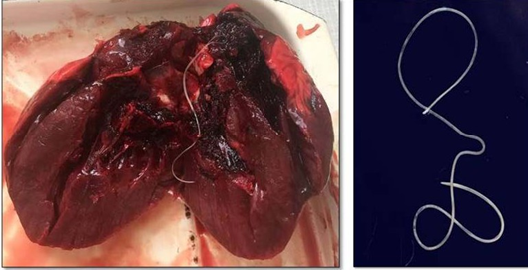
Figure 1: Dirofilaria spp. found in the wolf heart.

The Dirofilaria spp. individual detected had a length of 14.7 cm. Its cuticle had longitudinal ridges along the body and a filamentous body with a light-yellow color; it tapered toward both ends and was covered with a thin layer, striped cuticle.
The genomic DNA that was obtained fromthe helminth by applying the phenol-chloroform extraction method was analyzed by electrophoresis on 1% agarose gel. PCR was performed in a Simpli Amp thermo cycler (Applied Biosystems) under the conditions described above. The SSU area of the rRNA was amplified by species-specific primers, and the PCR product (with a size of 875 bp) was obtained (Figure 2).

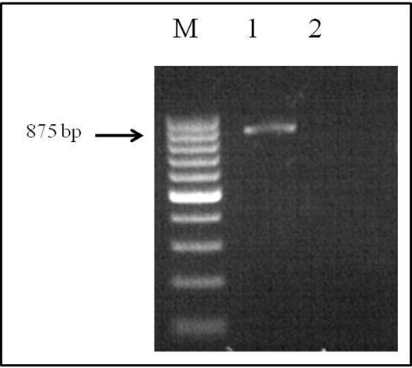
Figure 2: Electrophoretic analysis of PCR products: Lane M, DNA ladder (bp); lane 1, Dirofilaria spp. DNA; and lane 2, negative control.

Sequencing was performed by using a BigDye® Terminator v3.1 Cycle Sequencing Kit (Applied Biosystems). These sequences were compared with other sequences in GenBank by using BLAST analysis. The nucleotide sequence of the studied species was identified as D. repens and these data were deposited into the NCBI GenBank database (D. repens isolate 19-001-Kz, accession no. MT877205.1).
The SSU gene of Dirofilaria species in the current research paper was subjected to multiple sequence alignments with previously published studies of GenBank sequences using the MEGA X 10.2.0 program (Figure 3).

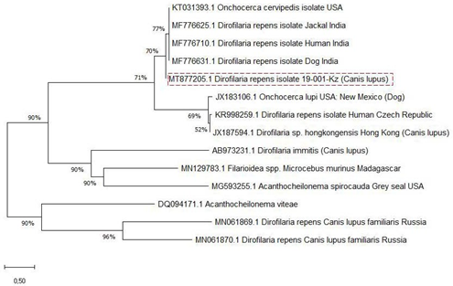
Figure 3: Phylogenetic analyses (tree) generated using
SSU primers.

Analysis of the nucleotide sequence the SSU area of rRNA the Kazakhstan Dirofilaria nematode showed 77% uniqueness with those of D. repens strains from India (MF776625.1; MF776710.1; MF776631.1), 69% with D. immitis, and Onchocerca lupi from the USA and Czech Republic ( JX183106.1; KR998259.1) but showed only 52% uniqueness with D. sp. hongkongensis from Hong Kong ( JX187594.1).
The genetic ranges among the identified D. repens of the Kazakh wolf strain and reference strains were calculated based on the MEGA X software parameter model (Table 1). The genetic distances that were intermediate to those of the D. repens strains were deficient and ranged from 0.000 to 0.18 (Table 1, No. 1-5). There were relatively high taxonomic genetic distances, which ranged from 1.05 to 0.11 between Dirofilaria spp. and the nematode O. lupi (Table 1, No. 1-5 vs. No. 6); 1.06 to 0.12 between D. repens and D. sp. hongkongensis; 3.61 to 5.81 among D. repens and D. immitis; and 3.86 to 3.44 between Dirofilaria spp. and Filarioidea spp. which was used for an out-group (Table 1, No. 9).
Table 1: Genetic distance of Dirofilaria strains.
 | Dirofilaria repens |  |  |  |  | Onchocerca lupi | Dirofilaria sp.  hongkongensis | Dirofilaria immitis | Filarioidea  spp
No. | 1 | 2 | 3 | 4 | 5 | 6 | 7 | 8 | 9
MT877205.1
MF776625.1 | 0,03
MF776631.1 | 0,03 | 0,01
KT031393.1 | 0,03 | 0,01 | 0,01
MF776710.1 | 0,04 | 0,01 | 0,00 | 0,01
KR998259.1 | 1,03 | 1,17 | 1,18 | 1,16 | 1,18
JX183106.1 | 1,05 | 1,18 | 1,20 | 1,18 | 1,20 | 0,11
JX187594.1 | 1,06 | 1,25 | 1,25 | 1,27 | 1,25 | 0,04 | 0,12
AB973231.1 | 3,61 | 3,90 | 3,99 | 3,98 | 3,77 | 6,37 | 6,51 | 5,81
MN129783.1 | 3,86 | 3,79 | 4,05 | 3,90 | 3,99 | 4,60 | 5,85 | 4,41 | 3,44

Identification of immature worms of filariid species by examining their morphology is complicated. Often, misidentification of Dirofilaria species is due to limited technical expertise, especially under poor sampling conditions. Usually, the parasitesare rarely intact; the diagnosis is based on the histological characteristics of helminths which limit identification to only the genus level. DNA-based molecular methods have more specificity than serological methods (Rishniw et al., 2006).
Correspondingly, the localization of the investigated parasite in a wolf heart should be noted in this work. According to the literature data, D. immitis is known as a “heartworm” which indicates that this helminth is localized in host hearts. On the other hand, D. repens largely predominates over pulmonary dirofilariasis cases (Orihel et al., 1998).
Females D. repens reach 15-17 cm in length, males up to 7 cm, with widths of 0.4-0.5 mm. Additionally, the female tail is blunt and slightly curved ventrally. Males have no ornamentation on their heads, and only four protruding submediant head papillae are visible. The tail end is bluntly rounded (Lopez et al., 2006).
Adult D. immitis are 12-20 cm long (males) and 25-31 cm (females) and 0.7-0.9 mm wide (males) and 1.0-1.3 mm (females). In males, the posterior end of the body is tapered and bent in a spiral shape; in females, the posterior end of the body is blunt.
In contemporary research, molecular characterization of the isolate of wolf Dirofilaria found in Kazakhstan was achieved by conducting phylogenetic analyses of partial nucleotide sequences of the SSU area of the rRNA ribosomal gene. The SSU gene sequence used for genetic identification in the current work was previously used to differentiate filarial species (Albonico et al., 2014).
The nucleotide sequence was identified as belonging to D. repens. Phylogenetic analysis showed that the two groups, D. repens and D. immitis, are distinguished as separate groups in the presence of Dirofilaria sp. hongkongensis and the out-of-group species, O. lupi (Figure 3). It can be observed that D. repens species are closely related.
Considering the data that indicate that subcutaneous dirofilariasis by D. repens occurs only in the CIS and is common among the residents of Uzbekistan, Georgia, Armenia, Ukraine, Belarus, Russia, and Kazakhstan (Yushchuk, 2009; Tumolskaya et al., 2016), the case we are studying has not only biological significance but is also related to socioeconomic status. Very few dirofilariasis cases have been detected in Kazakhstan. Dirofilariasis has mainly been reported by observations of D. repens in dogs; in some cases, the rate of infection is 42.6% (Ch’ung- Hsiung, 1959). There are no data on heartworm infections of wolves in Kazakhstan.
In conclusion, we report a case of dirofilariasis in a wolf heart that was caused by D. repens. Molecular methods confirmed the identification of the causal agent by sequencing the ribosomal 18S rRNA SSU gene. These results indicate the imperfection of differential identifications of parasites only by morphological structure and confirm the need to use molecular identification methods. Above all, this is the first reported case of D. repens being found in the cavity of a wolf heart, which raises questions about the localization of this species in host bodies and its distribution area in Kazakhstan. The data obtained will serve as an example for practical parasitology and will expand the understanding of the localization of various types of dirofilariasis in carnivores.
Acknowledgments
The research presented above was financially supported by the Ministry of Education and Science of the Republic of Kazakhstan to frame project AP08052252 for 2020–2022.
Novelty statement
The present study was show about the case of dirofilariasis caused by D. repens that found in a wolf heart circulating in Kazakhstan.
Authors’ contribution
All authors shared equally in designing, conducting the study, and writing the manuscript.
Conflict of interest
The authors have declared no conflict of interests.

References
• Albonico F, Loiacono M, Gioia G, Genchi C, Genchi M, Mortarino M (2014). Rapid differentiation of Dirofilaria immitis and Dirofilaria repens in canine peripheral blood by real-time PCR coupled to high resolution melting analysis. Vet. Parasitol., 24(1-2): 128-132. https://doi.org/10.1016/j. vetpar.2013.11.027
• Avellis FO, Kramer LH, Mora P, Bartolino A, Benedetti P, Rivasi F (2011). A case of human conjunctival dirofilariosis by Dirofilaria immitis in Italy. Vector Borne Zoonotic Dis., 11: 451-452. https://doi.org/10.1089/vbz.2010.0067
• Bargues MD, Morchón R, Latorre JM, Cancrini G, Mas- Coma S, Simón F (2006). Ribosomal DNA second internal transcribed spacer sequence studies of culicid vectors from an endemic area of Dirofilaria immitis in Spain. Parasitol. Res., 99: 205-213. https://doi.org/10.1007/s00436-005-
0107-6
• Becker N, Petric ́D, Zgomba M, Boase C, Madon M, Dahl C, Kaiser A (2010). Mosquitoes and their control. Berlin: Springer., pp. 25-42. https://doi.org/10.1007/978-3-540- 92874-4
• Ch’ung-Hsiung F (1959). Distribution of Dirofilaria repens in the Kazakhstan. Med Parazitol (Moscow), 28: 483. [Article in Russian].
• Ermakova LA, Nagorny SA, Krivorotova EY, Pshenichnaya NY, Matina ON (2014). Dirofilaria repens in the Russian Federation: current epidemiology, diagnosis, and treatment from a federal reference center perspective. Int. J. Infect. Dis., 23: 47-52. https://doi.org/10.1016/j.ijid.2014.02.008
• Genchi C, Kramer LH, Rivasi F (2011). Dirofilarial infections in Europe. Vector Borne Zoonotic Dis., 11: 1307-1317. https://doi.org/10.1089/vbz.2010.0247
• Lopez MC, Arjona AC, Orejuela RSN, Beltrán SD, Álvarez LIM, Harker PR, Toro GR (2006). Atlas De Parasitologia. Manual Moderno, 1st ed.: 105-107. ISBN: 9789589446621
• McCall JW, Genchi C, Kramer LH, Guerrero J, Venco L (2008). Heart-worm disease in animals and humans. Adv. Parasitol., 66: 193-285. https://doi.org/10.1016/S0065- 308X(08)00204-2
• Orihel TC, Eberhard ML (1998). Zoonotic filariasis. Clin. Microbiol. Rev., 11: 366-381. https://doi.org/10.1128/ CMR.11.2.366
• Rishniw M, Barr SC, Simpson KW, Frongillo MF, Franz M, Alpizar JLD (2006). Discrimination between six species of canine microfilariae by a single polymerase chain reaction. Vet. Parasitol., 135: 303-314. https://doi.org/10.1016/j. vetpar.2005.10.013
• Seidulaeva LB, Ergalieva AA, Shokalakova AK, Sadykova AM, Utezhanova GD (2015). Dirofilariasis. KazNMU Bulletin, 2: 72-74. [Article in Russian] UDC: 616.995.1-07
• Simón F, Siles-Lucas M, Morchón R, González-Miguel J, Mellado I, Carretón E, Montoya-Alonso JA (2012). Human and animal dirofilariasis: The emergence of a zoonotic mosaic. Clin. Microbiol. Rev., 25: 507-544. https://doi. org/10.1017/S1751731112001024
• Tumolskaya NI, Pozio E, Rakova VM, Supriaga VG, Sergiev VP, Morozov EN, Morozova LF, Rezza G, Litvinov SK (2016). Dirofilaria immitis in a child from the Russian Federation. Parasite, 23: 37. https://doi.org/10.1051/parasite/2016037
• Yushchuk ND (2009). Infectious diseases. National leadership. M.: GEOTAR Medicine., 1056. [Article in Russian] UDC:616.9 (083.13).

