Ministry of Education and Sciences of the Republic of Kazakhstan
L.N Gumilyov Eurasian National University

UDK 624.139 On the rights of the manuscript

MONTAYEVA AINUR SARSENBEKOVNA

Technology of pile foundation construction in winter season by using chemical anti frosty additives in soils

8D07329- Civil Engineering

A Thesis for the degree of Doctor of Philosophy (PhD)

Domestic Scientific Advisor
Dr.Tech.Sc., Professor
A. Zh.Zhussupbekov

Foreign Scientific Advisor
Dr.Tech.Sc., Professor
Yoichi Watabe
Hokkaido University, Sapporo, Japan

Republic of Kazakhstan
Nur-Sultan, 2022

ACKNOWLEDGMENTS

I wish to express my sincere gratitude to my research supervisor Dr. Askar Zhussupbekov who guided me throughout the research process with his knowledge, experience and encouragement. His biggest support and expertise helped me to put the research and dissertation together, and successfully complete my dissertation despite the pandemic around the world. He always filled me with confidence and believed in me like no one else. I learned a lot from Professor Askar Zhussupbekov, not only in the study but also in my life. I really enjoyed the research experience with him.
I wish to express my profound gratitude to my foreign scientific consultant Yoichi Watabe for his advice in writing my dissertation.
I also wish to thank the government of my country and Ministry of Education and Science of the Republic of Kazakhstan, who sponsored me throughout my doctoral program at L.N. Gumilyov Eurasian National University, including internships in Saint-Petersburg, Russia at St. Petersburg State University of Architecture and Civil Engineering, and Sapporo, Japan at Hokkaido University.
I also want to thank LLP “KGS” and “KGS-Astana” for their financial support in carrying out a plenty of tests at construction site and my participation in various foreign conferences including the 7th International Young Geotechnical Engineers Conference in Sydney, Australia, and Baltic Sea Geotechnical Conference in Helsinki, Finland, Eurasians - geotechnicians International Conference in Tashkent, Uzbekistan.
I would also like to thank all staffs of Geotechnical Institute and the Faculty of Engineering at L.N.Gumilyov Eurasian National University for their big help and support in conducting my research experiments.
I would also like to thank my parents and parents-in-law for their big love and support. They will be always my motivators.
It would not be possible for me to pursue my PhD without the emotional and financial support of my husband.

TABLE OF CONTENTS

ACKNOWLEDGMENTS 2
TABLE OF CONTENTS 3
NORMATIVE REFERENCES 5
ACRONYMS AND ABBREVIATIONS 6
LIST OF FIGURES 7
LIST OF TABLES 8
GENERAL INTRODUCTION 10
CHAPTER ONE 15
LITERATURE REVIEW 15
1.1 Frozen soils 15
1.2 Heat flow in soils 16
1.3 Thawing process of seasonal frozen soils 17
1.4 Pile installation methods in seasonally frozen soils 18
1.5 Design of pile foundation in seasonally frozen soils 23
1.6 The current state of the using chemical reagents for local thawing of seasonally frozen
soils 26
1.7 Theory of interaction of soil with chemical reagents 28
Summary of chapter one 29
CHAPTER TWO 30
2 METHODOLOGIES OF THE RESEARCH 30
2.1 Chemical reagent 30
2.2. Definition of freezing depth in seasonally frozen ground 32
2.3 Location, relief, and climate of construction site 33
2.4 The methodology of engineering and geological investigations 33
2.5 The results of engineering and geological investigations 35
2.6 Hydrogeological conditions 37
2.7 Physical and mechanical properties of soils 38
2.8 Static Load Test (SLT) 42
2.9 Determination of the bearing capacity of the piles according to the results of a field test 44
2.10 Pile Integrity Test (PIT) 45

2.11 The requirements and procedure of pile integrity test 46
Summary of chapter two 50
CHAPTER THREE 51
3 Experiments for preventing the soil from freezing and driving the piles into the frozen ground in winter and their results 51
3.1 Experiment with chemical additives 51
3.2 Model test 56
Summary of chapter three 59
CHAPTER FOUR 60
4 Results of laboratory and construction site experiments 60
4.1 Results of laboratory experiment 60
4.2 Results of site experiment 62
4.3 Results of static load tests using different methods of soil thawing 65
4.4 Pile Integrity test results (PIT) 69
Summary of chapter four 71
CHAPTER FIVE 72
5.1 Savings in budget 72
5.2 Sustainability 73
5.3 The effect of chemical reagent to the environment 73
5.4 Distribution performance of anti-frosty additives 74
Summary of chapter four 77
CONCLUSIONS 76
REFERENCES 79
APPENDIX A Process of works at the laboratory and construction site 89
APPENDIX B Certificate of scientific online internship in Hokkaido University 95
APPENDIX C Certificate of scientific internship in Saint Petersburg State University
of Architecture and Civil Engineering 96
APPENDIX D Implementation act 97
APPENDIX E Certificate of attendance of CAEST in Russia 98
APPENDIX F Certificate of attendance of NGM/BSGC in Finland 99
APPENDIX G Certificate of attendance of TASI in Uzbekistan 100
APPENDIX H Certificate of attendance of 7iYGEC in Australia 101
APPENDIX I Certificate of attendance of 20th ICSMGE in Australia 102
APPENDIX J Certificate of patent 103

NORMATIVE REFERENCES

- SP RK 1.02-102-2014 Engineering and geological surveys for construction
- SP RK 1.02-105-2014 Engineering surveys for construction. Basic provisions
- SP RK 2.04-01-2017 Construction climatology
- SN RK 5.01-02-2013 Foundations of buildings and structures
- SP RK 5.01-102-2013 Foundations of buildings and structures
- SN RK 5.01-03-2013 Pile foundations
- ST RK 1289-2014 Soils, packaging, transportation and storage of samples
- SN RK 2.01-01-2013 Protection of building structures against corrosion
- SP RK 2.03-30-2017 Construction in seismic areas
- ST RK 1273-2004 Soils. Method for laboratory determination of grain (granulometric) composition
- ST RK 1291-2004 Soils. Methods for laboratory determination of the filtration coefficient
- ST RK 1550-2006 Soils. Methods for laboratory determination of swelling and shrinkage characteristics
- SN RK 8.02-05-2002 Collections of estimated norms and prices for construction work
- GOST 25100-2011 Soils. Classification
- GOST 12248-2010 Soils. Methods for laboratory determination of strength and deformability characteristics
- GOST 19912- 2012 Soils. Field test methods: cone penetration test and dynamic probing
- GOST 20522-2012 Soils. Methods of statistical processing of test results

ACRONYMS AND ABBERVATIONS

SLT— static load test
DLT— dynamic load test
PIT— pile integrity test
EGE— engineering-geological element
GPS— global positioning system
GSM— global system for mobile communications
TNT— trinitrotoluene
FPDS— foundation pile diagnostic system sonic integrity testing
M_{t}— dimensionless coefficient
df_{n}— normative depth of seasonal soil
γg— ground safety factor
Fu,n — standard value of the ultimate resistance
ζ— coefficient of transition
Su,mt — the limit value of the average settlement of the foundation of the designed building or structure
E— modulus of elasticity
ρ— density of concrete

LIST OF FIGURES
Introduction
Figure 1. The map of seasonal freezing depth across Kazakhstan
Chapter one
Figure 2. Heat transfer in soils
Figure 3. Modeled soil temperature changes at 5 cm depth during freezing/thawing
Figure 4. Demonstration of how the heater machine works on frozen ground
Figure 5. The process of driving screw-pile foundation in winter
Figure 6. Explosive method of loosening the frozen ground
Figure 7. Predrilled method of driving pile
Figure 8. Distribution of chemical reagent ions on the ground surface
Chapter two
Figure 9. Chemical reagent
Figure 10. Chemical reagent on the frozen ground
Figure 11. Defining the physic-mechanical properties
Figure 12. Defining the physic-mechanical properties
Figure 13. Testing the pile for bearing capacity using antifreeze reagent
Figure 14. Testing the pile for bearing capacity using antifreeze reagent sawdust
Figure 15. Procedure of pile integrity test
Figure 16. Graphs show dependence amplitude/signal length
Chapter three
Figure 17. A fragment of measuring the temperature of heat release during the interaction of quicklime with water
Figure 18. Fragment of heat dissipation temperature measurement
Figure 19. Preparation of a laboratory sample of seasonally frozen soil at ambient temperature
T = -20 С
Figure 20. Preparation of samples for experiments
Figure 21. Thawing a laboratory sample of seasonally frozen soil using a chemical reagent based on quicklime
Figure 22. The moment of observation of the temperature of heat release and measurement of the depth of thawing
Figure 23. Dependence of the depth of thawing of a laboratory sample of seasonally frozen soil on time with the thickness of the layer of backfilling of a chemical reagent based on quicklime with a layer thickness of 1.0 cm
Figure 24. Dependence of the depth of thawing of a laboratory sample of seasonally frozen soil on time with the thickness of the layer of backfilling of a chemical reagent based on quicklime with a layer thickness of 2.0 cm
Figure 25. Dependence of the depth of thawing of a laboratory sample of seasonally frozen soil on time with the thickness of the layer of backfilling of a chemical reagent based on quicklime with a layer thickness of 3.0 cm
Figure 26. The size of the modeled pile
Figure 27. Plastic modeled piles
Figure 28. Process of printing the piles with 3D Printer
Figure 29. Experiment with modeled piles
Figure 30. Demonstration of driving model pile
Figure 31. Gibbs diagram for antifreeze reagent
Figure 32. The results of pile driving in the second box
Figure 33. The settlement of pile in the third box
Figure 34. The settlement of pile in the second box
Figure 35. The settlement of pile in the third box
Figure 36. Measuring the thawed depth
Figure 37. Driving the pile into the frozen ground
Figure 38. Pile installation without predrilled boring
Figure 39. Preparation work for SLT test
Figure 40. Static Load Test results in frozen ground
Figure 41. Static Load Test results in frozen ground
Figure 42. Static Load Test results in frozen ground
Figure 43. Static Load Test results in soils with chemical additives
Figure 44. Static Load Test results in soils with chemical additives
Figure 45. Static Load Test results in soils with chemical additives
Figure 46. The results of the PIT of pile 54
Figure 47. The results of the PIT of pile 46
Figure 48. Distribution of chemical reagent in dry method
Figure 49. Distribution of chemical reagent in wet method
Figure 50. The places where chemical reagent was spread

LIST OF TABLES

Chapter one
Table 1. Strength indicators of seasonally frozen soils, most common in the Republic of Kazakhstan at a temperature of -10 C.
Table 2. The temperature and concentration of the eutectic points of chemical de-icing additives.
Chapter two
Table 3. Physical and mechanical properties of Loam - aQ_{III-IV.}
Table 4. The standard and calculated values of the characteristics of Loam - aQ_{III-IV.}
Chapter four
Table 5. Estimation for predrilling works in winter.
Table 6. Estimation for using chemical additives.

GENERAL INTRODUCTION

Problem statement
Kazakhstan's construction industry, which is one of the important components of the country's economy, continues to be one of the most appealing for investors. It is one of the fields that has been expanding at a consistent rate over the past few years. Our nation is experiencing a period of rapid urbanization, as evidenced by the emergence of new territorial entities and the rollout of governmental initiatives designed to meet the housing needs of the populace.
Currently, more than six thousand infrastructure projects are being carried out within the framework of the state programs "Nurly Zhol", "Nurly Zher", and the roadmap. These projects have a total cost of 3.7 billion tenge, and 90% of the materials used in their construction were sourced from within the country [1]. Rapid industrial development and constant population growth in Kazakhstan necessitate year-round construction of buildings and other structures.
However, the construction of a building or other structure in wintertime is a laborious process. Consequently, many companies slow down or stop the construction process during the winter due to frozen ground.
Consequently, there is a need for the new scientific methods that ensures construction during the wintertime. When carrying out construction work in winter, the most important stage is the arrangement and selection of foundation type. Difficulties in arranging the foundation in winter are associated with the following factors:
- the development of pits and trenches in frozen ground require the use of powerful excavators which result in additional financial costs.
- the laying of monolithic concrete foundations requires the pouring of water; at freezing temperatures this results in the freezing of the concrete. Therefore, it is not always possible to perform work, especially in high negative temperatures.
- the need for heating a concrete structure using the convection method or electric heating through reinforcement laid in the foundation, which increases the complexity of the work and the energy costs.
Therefore, the most efficient method for the construction of buildings and other structures during wintertime is the use of prefabricated foundations made at the factory. The study aims to establish the possibility of using anti-freeze additives to eliminate soil freezing during the installation of pile foundations in winter.
In Kazakhstan, the winter period in the northern regions is almost six months, and in the southern regions is up to 3 months. At the same time, the depth of soil freezing in the northern regions reaches up to 2–2.5 meters, and in the southern regions on average up to 1 meter. Therefore, for construction work in the winter, for the immersion of piles, preparatory work is required before the freezing soil begins. Preparatory work for driving piles includes careful planning of the construction site, preparation work for storing piles and prefabricated elements of the underground part of the building. In addition, special work is carried out to warm up and thaw the soil, to drill leader wells. In this case, the selection of a specific method of work is carried out on the basis of technical and economic calculations at the stage of development of the project of work.
Pile driving in winter has its obstacles as the ions of water get crystalized during the long time of sub-zero temperatures making the soil thick and frozen. One of the widely adopted methods of driving pile in winter in Kazakhstan is drilling the frozen depth of pile places. There are many challenges when placing the piles in cold weather. For example, due to the frozen ground the number of impacts exceeds the requirements for driving the pile. Consequently, due to a lot of hard driving, concrete piles can develop horizontal cracks. Usually, head of concrete piles are vulnerable to the impacts. The head of a pile usually gets deformed or damaged by the high blow counts. These issues also lead to the penetration of water to the structure of concrete piles. Moreover, when the soil is thick and frozen, piles can be driven out of its accepted location which is not acceptable for pile foundations
It is important to know the methods of laying the foundation required in cold weather conditions, which can affect not only the design of precast concrete piles, but also the foundation itself as a whole.
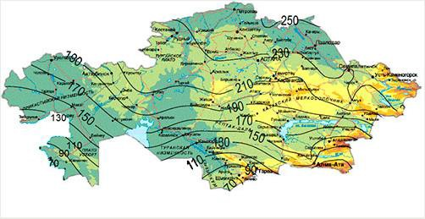
Figure 1. The map of seasonal freezing depth across Kazakhstan [2]

Main objective
Through the experiments conducted at the laboratory and construction site the research aims to: determine how the antifreeze reagent prevent and thaw the soil freezing and study the technology of pile foundations taking into account chemical additives in soils.

Subject objectives
- Analysis of the current state of domestic and foreign technologies for the device pile foundations in seasonally frozen soils;
- Selection of research methods for local thawing of seasonally frozen soil in places of pile foundation driving;
- Development of the composition of chemical reagents to ensure thawing of seasonally frozen soils, taking into account thermophysical, environmental and economic requirements;
- Studies of the thermophysical characteristics of seasonally frozen soil, depending on depth in order to determine the optimal thickness of the backfill of the chemical reagent in places of pile foundation driving;
- Studies of the regularity of changes in the depth of thawing of seasonally frozen soil in depending on the time and thickness of the filling of the chemical reagent;
- To develop the most effective technological methods for applying chemical reagent in places of pile foundation driving in seasonally frozen soils;
- Carrying out scientific and experimental work on the use of the developed compositions chemical reagent in the conditions of installation of a pile foundation in seasonally frozen soils during the construction of the facility in Nur-Sultan in winter;
- Carrying out tests on the effect of local thawing of seasonally frozen soil with application of the proposed composition of the chemical reagent for static load and integrity of the pile foundation;
- Calculation of the economic efficiency of the proposed composition of the chemical reagent for local thawing of seasonally frozen soils in places of pile driving foundations;

Scientific Novelty
- A new methodology to drive the piles in winter by preventing the soil from freezing using chemical additives.
- The results of experimental investigations of pile- ground interaction with using chemical additives.
- The recommendations on the use of the proposed chemical reagent for local thawing of seasonally frozen soils in places where pile foundations are driven.

Research methods
The following experimental research methods were used:
- Field pile testing methods
- Pile Integrity tests
- Standard design method of determining pile bearing capacity
- Static Load Tests

Approbation
The main results of this research work were presented in the following events:
- Civil, Architectural and Environmental Sciences and Technologies Conference (CAEST 2019), 19-20 November, 2019, Samara, Russian Federation. (Appendix G)
- International Baltic Geotechnical Conference – NGM / BSGC, 18-19 January 2020, Helsinki, Finland (Appendix H)
- Tashkent Institute of Architecture and Civil Engineering (TASI) scientific and practical international conference, 21-22 Oktober, 2021. Tashkent, Uzbekistan. (Appendix I)
- 7th International Young Geotechnical Engineers Conference (7iYGEC), 29 April-1 May, 2022, Sydney, Australia (Appendix J)
- 20th International Conference on Soil Mechanics and Geotechnical Engineering (ICSMGE 2022), 1 -5 May, 2022. Sydney, Australia (Appendix K)

Publications
The main results of this research work have been published in 10 scientific papers including: 3- in the editions recommended by the MES RK, 2- in the international editions with non-zero impact factor, 5-in the proceedings of overseas Conferences.
In the editions recommended by the MES RK:
- А.Ж.Жусупбеков, А.С.Монтаева, С.А.Монтаев. Исследования зависимости теплофизических свойств сезоннопромерзающего грунта под основания фундаментов от их влажности, плотности и глубины котлована. Журнал «Вестник Казахской головной архитектурно-строительной академии» — №4 (78) 2020, стр. 184-192. https://doi.org/10.51488/1680-080X/2020.4-26
- A.Montayeva, A.Zhussupbekov. Prevention method of soil freezing during pile driving in winter. Вестник. ЕНУ имени Л.Н. Гумилева. Серия технические науки и технологии, №4 (137) 2021, cтр. 76-85.
- A.C.Монтаева, А.Ж.Жусупбеков, Б.Т.Шакешев, Н.Б.Адилова. Исследование влияние негашенной извести в составе химического реагента на глубину локального оттаивания в сезенно-мерзлых грунтах. Журнал №1 «Труды университета» №1 (86) КарТУ, 2022, стр:148-154.
In the editions from the Scopus Database:
- A.Zh. Zhussupbekov, A.S. Montayeva, S.A. Montayev. The effect of antifreeze reagent on seasonal frozen soils. Periodicals of Engineering and Natural Sciences. — 2021. — Vol. 9, No. 3. — P.245-259. http://dx.doi.org/10.21533/pen.v9i3.2114
- A.Montayeva, A.Zhussupbekov, S. Montayev, Zh. Nashiraliyev. The use of quicklime for soil thawing in pile foundation setting. Periodicals of Engineering and Natural Sciences. — 2021.— Vol. 9, No. 4. — P.134-148. http://dx.doi.org/10.21533/pen.v9i4.2305
In the proceedings of overseas International Conferences:
- A. Montayeva, A. Zhussupbekov, V.N.Kaliakin, S Montayev. Analysis on technological features of pile foundations construction in frozen and seasonal thawing soils. IOP Conference Series Earth and Environmental Science.
- A. Zhussupbekov, A. Montayeva, S. Montaуev, N. S. Montayeva. Ensuring chemical resistance of pile foundations when they are installed in permanently and seasonally frozen soils with aggressive environments. IOP Conf. Series: Materials Science and Engineering 775 (2020)
- А. Монтаева. Новые вызовы и современные подходы к строительству свайных фундаментов. O’zbekiston respublikasi qurilish vazirligi. Toshkent arxitektura qurilishi institute-2021 y., 137 стр.
- A. Montayeva, A. Zhussupbekov, S. Iskakov, S. Montayev, A. Zhakulin. Analysis on the behavior of soils to anti-frost additives. Proceedings of the 7th International Young Geotechnical Engineers Conference (7YiGEC), 2022. Sydney Australia, pp. 173-176.
- Y. Iwasaki, A. Zhussupbekov, A. Montayeva, A. Bespaev & M. Averina. Unique characteristics of silty soils of loess soil in Kazakhstan, silty rock at Bamiyan in Afghanistan, and manmade platform mound in Angkor, Cambodia. Proceedings of the 20th International Conference on Soil Mechanics and Geotechnical Engineering (ICSMGE), 2022. Sydney, Australia, pp. 4725-4730.
- A.S. Montaeyva, A.Zh. Zhussupbekov, S.A. Montayev. The method of local thawing of seasonally frozen soil for driving up pile foundations. Utility model patent No. 5725 dated 07/25/2020
Volume and Structure
This dissertation consists of introduction and main body, which includes 5 chapters, conclusions, references and appendixes. List of references include 128 sources. The work is outlined on 103 pages of printed text and contains 50 Figures and 6 tables.
CHAPTER ONE
1. LITERATURE REVIEW
1.1 Frozen soils
The soil with the negative temperature is called frozen ground. The term “frozen ground” is entirely characterized on temperature regardless of water or ice in the soil. Frozen ground is made up from four component which include soil particles, ice, water, and air. The soil particles in frozen ground vary in size and form. Ice, water, and air fill the voids inside the ground.
The soil which gets frozen only during the winter season with temperatures below 0 C is called seasonally frozen ground.
The impacts of thawing frozen ground, seasonal frost heave and settlement are the engineering issues that necessitate to better know about the freezing process and how the engineer use those valuable characteristics of frozen ground. The stability, high strength, and impervious conditions are the useful aspects of frozen ground that can be used for the frozen earth structures for construction purposes.
Larger ice masses might emerge as a result of processes related to ice wedges and pingos. Frozen soil categorization entails identifying the soil phase, including frozen soil properties, and defining ice present in frozen ground.
The mechanical properties of frozen ground will be the same as an ice, because ice fills the majority of the pore space despite of unfrozen water existence. The behavior of a frozen soil under increased hydrostatic pressure is thought to be the consequence of a combination of mechanical and thermodynamic factors, with the former controlling stress sharing and the latter controlling pressure melting.
Perennially frozen ground can provide good bearing capacity for the sustaining of structural loads in cold climates. Some considerations are required for beneficial uses, the most obvious of which is to maintain the ground frozen.
Ground temperatures have a big impact on soil engineering behavior; thus, they have to be taken into account while designing frozen ground support systems and other cold-weather structures. Temperatures within, under, and around the building are affected by ground surface temperatures as well as the geothermal gradient in the area in these problems. Ground temperatures can be influenced by building activities as well as changing surface conditions, such as the controlled freezing of an earth support system. When time-dependent freezing occurs in the ground, soil latent heat, soil thermal conductivity, and heat capacity will all play a role [3-4].

1.2 Heat flow in soils
Several factors impact heat flow between air and the ground surface, including relative air and surface temperatures, wind velocity, and air turbulence which appears because of surface roughness.
Consider totally motionless air, with the earth being colder than the air. The air closest to the surface will be the densest, and the air profile will be steady. Heat transmission downhill occurs solely by conduction in this state. If the surface is warmer than the air above it, the air adjacent to it has a lower density than higher layers, and the warm air tends to ascend. This density profile is unstable, and convection currents will form if the temperature difference is significant enough. Heat is transmitted by both conduction and convection in these conditions. Figure 10.
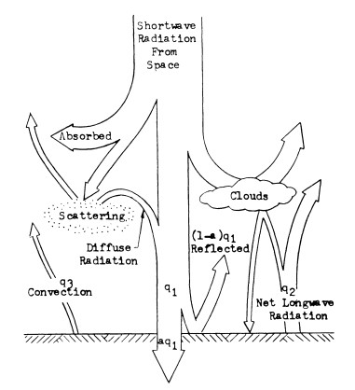

Figure 2. Heat transfer in soils [5]
Turbulence is created in the air by surface imperfections when the air is moving relative to the ground surface. The surface transfer coefficient varies greatly from steady circumstances to severe gusts. On a typical day, the temperature profile can be constant at night because long-wave radiation cools the ground surface. As the sky lightens before daybreak, the earth surface begins to receive diffuse short-wave radiation and begins to warm. When the surface temperature exceeds that of the surrounding air layers, the temperature profile becomes unstable once more. When the surface temperature exceeds that of the surrounding air layers, the temperature profile becomes unstable once more [5].
According to Scott (1964), a truly adequate mathematical form representing the relationship of wind velocity on height and thermal stability has yet to be discovered. Scott presents an approximation approach for determining the heat flow q3 using a heat transfer coefficient [6].
1.3 Thawing process of seasonal frozen soils
During the thawing process in frozen soil, the particles of ice will melt and the soil skeleton adjusts to a new equilibrium void ratio for the current overburden forces. The thaw settlement is very essential factor to consider not only during the designing of ground support systems but also building foundations, embankments in seasonally frozen ground.
The amount of extra volume change caused by drainage of the thawed soil depends on the degree of consolidation and soil structural changes that happened during the previous freezing cycle. Slow freezing allows local ice segregation in fine-grained soils (silts and clays), even in closed drainage circumstances. Because local soil consolidation occurs during ice segregation and is not reversible, more water is created upon thawing than can be absorbed by the soil skeleton.
Additional settling occurs as a result of the drainage of this water. The thaw settlement refers to the quantity of water collected over that absorbed by the soil. Silts and clayey silts are ice-rich, resulting in greater thaw settlements. In alluvial plains, certain till deposits, and glaciolacustrine basins, ice-rich permafrost is prevalent.
Some frozen sands may have minimal ice, but when thawed, they may be loose enough to allow for a major settlement.
The volume and distribution of ice in frozen ground is influenced by a number of elements, including stress, heat, and moisture change histories. The apparent thickness of ice lenses can be used to evaluate the degree of thaw settlement in ice-rich soils. Because this approach can lead to large mistakes, the best way to establish the thaw settlement properties of frozen soil is to conduct experiments on representative samples under field-like circumstances [7].
Since the 1930s, a lot of experiments have been carried out to investigate the freezing and thawing process in soils. More emphasis has been paid to laboratory and field investigations on soil freezing and thawing processes. The generalized Clausius-Clapeyron equation was developed by Edlefsen and Anderson (1943) to express the link between soil temperature and freezing soil water potential. Zhou et al. (2014) used gamma ray attenuation and the TDR technique to determine the water and ice content in a freezing soil column. Field studies were also carried out to investigate plot-scale or regional water, heat, and solute transfer during freezing and thawing from various perspectives. Beskow (1947), for example, noted the buildup of water at the freezing line, as well as the effects of water, soil, and solutes on freezing point depression and the resemblance between freezing and drying. The similarity of soil freezing curves and water retention curves was next examined by Koopmans and Miller (1966) [8-11].
Mousong Wu (2016) investigated the coupled processes in seasonal frozen soils and the effects of solute on soil freezing and thawing were also found in his modeling findings (Figure 3).
The simulated soil temperature had an evident continuous period during which the temperature displayed a positive-negative shift during freezing and a negative-positive shift during thawing. This suggested that as the soil began to freeze or thaw, continual phase transitions occurred. During these times, the available energy was mostly used for phase change, and the soil temperature remained constant at zero degrees Celsius [12].
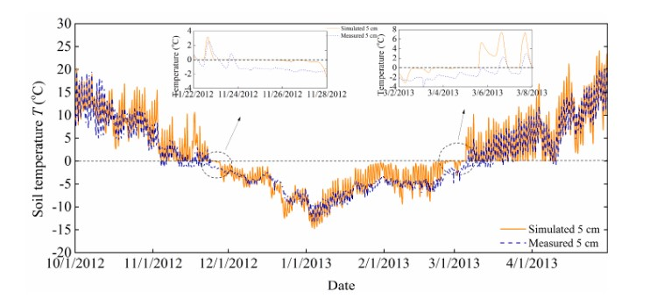
Figure 3. Modeled soil temperature changes at 5 cm depth during freezing/thawing [12]
1.4 Pile installation methods in seasonally frozen soils
Choosing a suitable foundation depth and protection of piles from effects of frost is very important in areas of seasonal frost, especially where there is frost– susceptible soil. According to the study driving pile on frozen soil arise harmful frost actions. The lenses of ice produce forces which lead to the displacement of all parts of the foundation [13]. Authors of the study claim that the soil should be prevented from freezing or replaced with a frost-stable material during the pile installation and designing foundation in winter. The research conducted by H. Vazari and Y. Han has noted the significant influence of a frozen layer on the dynamic response of piles even if the frozen layer is 0.5 m [14-17]. Also, the results of article have proved the impact of seasonal frozen soils on the dynamic behavior of bridges supported by pile foundations in cold regions. Authors have found the interrelation between the effects of salinity and temperature which affects the unfrozen underground water that influences on the behavior of soils. The ice crystals are formed from salt ions which during the temperature decrease they influence unfrozen soils [18]. The temperature of the soil has a significant effect on the strength and behavior of piles. The studies about the variation of ad freeze bond strength on frozen materials in different temperature have been shown in studies of J. Weaver and N. Morgenstern [19], and frozen materials in saline permafrost in research of Y. Velli and A. Karpunia [20]. Moreover, author of the research claims that frozen ground deforms under prolonged load and shows his lateral pile analysis on frozen soil. The results of study also have presented some notable differences between warm and frozen soils in displacement, effective stiffness, and maximum moment, shear demand during the experiment on bridge columns installed in warm and seasonally frozen soils [21-22]. Authors of a research have demonstrated information about the diversity and variety of frozen soil and presented approaches on how to deal with frozen soils in designing structure by summarizing the most recent studies [23-24].
Nowadays there are a lot of new technics to thaw the frozen ground in winter. One of them is hydronic heating technology which is designed by Nordic developers. The machine “HeatWork” is able to thaw frozen soil 40-80 centimeters in 24 hours, and 200 m² area in one day. The machine offers 100°C on new equipment and its boiler has with a maximum capacity of 103 kW. Furthermore, the machine comes with a greater pump capacity than other heater machines on the market.
The machine has the heating hoses that are laid out on frozen ground and starts to emit heat straight into the earth. Also, the heater has an isolation mat that cover the thawed ground to keep it warm and prevent heat loss. The machine runs unattended till the work is finished. It has GPS and a GSM control device that warns you of any possible errors [25].
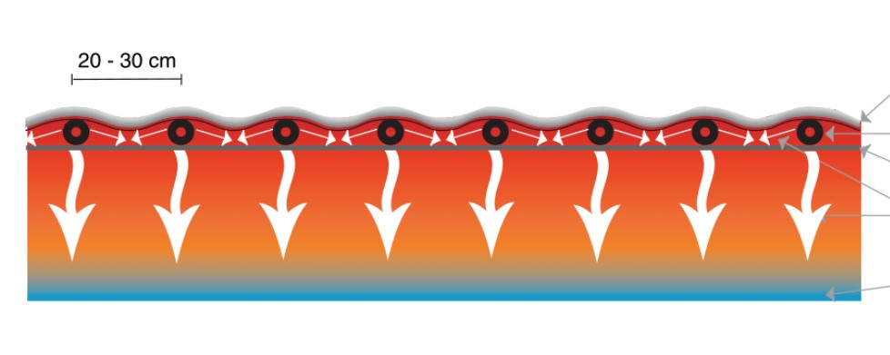Figure 4. Demonstration of how the heater machine works on frozen ground [25]
Another method of driving pile in winter is using a pile-screw foundation. The device of a pile-screw foundation is a good option for areas where constant sub-zero temperatures prevail. The installation of screw piles does not require earthworks and is completed in a couple of days. The use of driven piles in winter is not economically justified, as it requires high costs, however, the bearing capacity will be 1.5 higher than the screw type. The installation of the foundation is carried out in compliance with all technical standards and taking into account the depth of soil freezing [26].
The frozen soil is also loosened in an explosive way, which is considered the most effective. For the production of blasting, explosives and blasting agents are used. Explosives are chemical compounds or mechanical mixtures that, under the influence of an external impulse, are capable of rapid chemical transformations. The energy released in this process is capable of producing mechanical work. All explosives are divided into 3 groups: initiating, blasting and propelling. Most often in construction, blasting is used in the composition, which includes substances such as ammonium nitrate, nitroglycerin and oxyliquite [27].
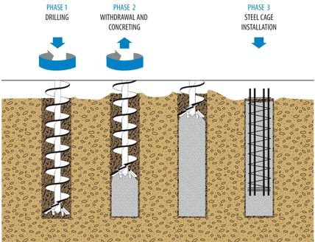
Figure 5. The process of driving screw-pile foundation in winter [26]
Brisant are divided into substances of increased, normal and reduced power. High explosives include explosives that have a high rate of explosive decomposition - dynamite, ammonites, TNT, etc. (the most widely used). The most commonly used TNT is light yellow or light brown. It is powdered, pressed and melted. Pressed and melted TNT does not lose its properties even after a long stay in water. Ammonium nitrate explosives are a white solid to thallic substance, very hygroscopic, highly soluble in water. They are subdivided into ammonites, dynamons, ammonals. At 3% humidity, explosives have failures.
Throwing explosives - have a low rate of explosive decomposition. These include black powder (a mechanical mixture of saltpeter, sulfur and coal) and smokeless powder (pyroxylin or nitroglycerin). Means and methods of blasting. For explosive charges embedded in the ground, fire and electric blasting methods are used [27].
Authors of a study [28] proposed a new technological solution which increases the efficiency of pile driving into seasonally frozen soils. The idea is to install a thermal vibrolider on the head of a pile hummer which decreases the density of frozen soil and allows the pile to drive into the frozen soil without drilling or other extra preparatory works. A new type of pile filed with porous material was suggested by Li and Xu [23]. The authors claimed that this new type of pile decreases the gradient of soil temperature fluctuations. However, the disadvantage of such solution is that the manufacture of such piles will be very costly. Also, there might be some difficulties in ensuring the quality of backfill when the piles are driven into the ground.

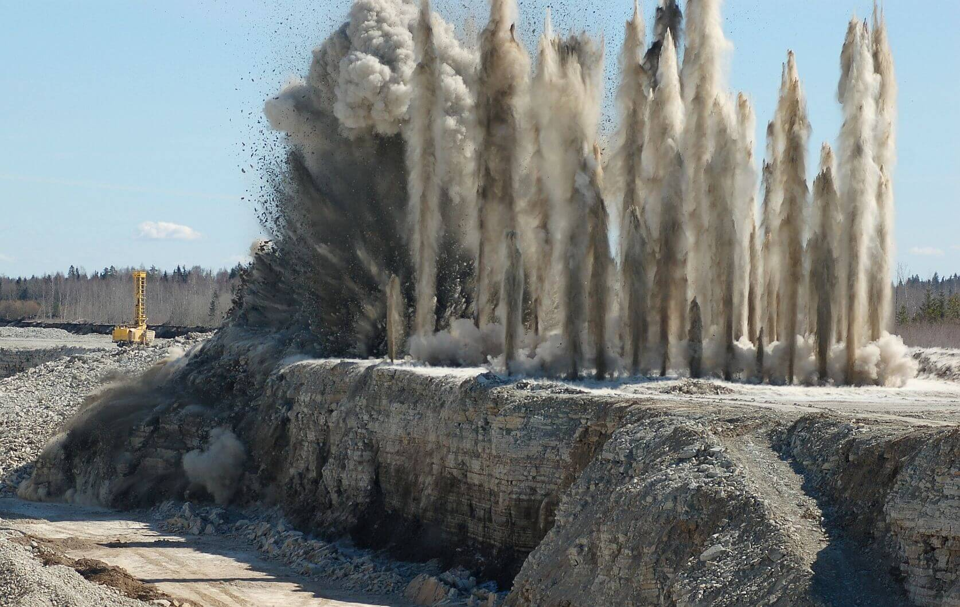
Figure 6. Explosive method of loosening the frozen ground [28]
The most common method in Nur-Sultan city in winter is drilling of leader wells to the full depth of freezing before installation of piles.
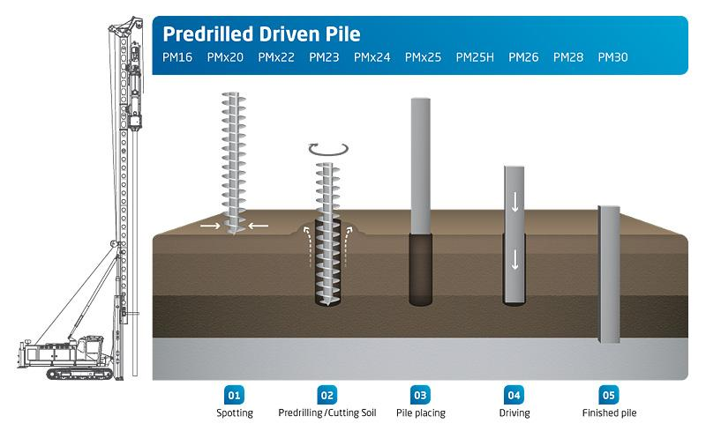
Figure 7. Predrilled method of driving pile [29]

The authors have done research on the effects of frozen soil characteristics on the bearing capacity and settlement of the pile foundation. In the article, authors have presented results of static load tests on model concrete piles that have been driven into frozen soils with 10 cm freezing depth below the ground at the different temperature -5C, - 20C [30-32]. Sri Sritharan et al. investigated the effects of seasonal freezing of soil on lateral load response of bridge column-foundation, and its interaction and implications with soil. The authors have demonstrated two outdoor column foundation system test examinations during summer and winter at ambient temperatures of 23°C and −10°C, respectively, and have observed significant changes in the column and foundation due to drastic changes in the properties of soil caused by seasonal freezing. Authors noted that the design of pile foundations in seismic areas does not consider the seasonally freezing soil effects [33]. Other studies on modeling the response of cyclically loaded bridge columns into unfrozen and seasonally frozen ground has shown comparison analysis of soil in warm and cold conditions. The experimental data presented the influence of temperature difference of soil on effective stiffness, maximum moment, moment location, shear demand and length of plastic region [34-37].
The population of the Republic of Kazakhstan has increased by 4.5% since 2015 and reached more than 18 million people by 2020. The urban population has amounted to 10.4 million, and the rural population – 7.7 million. The level of urbanization is about 57.4%. Therefore, in all cities of the Republic of Kazakhstan, multi-story residential complexes, large business centers, as well as industrial buildings and structures are being built. Currently, pile foundations are very often used in the construction of buildings and structures due to their high load-bearing capacity and cost-effectiveness. In the northern, eastern and western regions of the Republic of Kazakhstan, one of the most common problems is the immersion of piles in frozen soils during their seasonal freezing [38-40]. The problem is that seasonally frozen soils in an undisturbed state have high strength.
Notably, one of the important problems of immersion of piles in frozen soils is the inevitability of destruction of the head of the pile foundation, which leads to corrosion destruction of reinforcement and concrete. Analysis of pile foundation construction technologies in seasonally frozen soils allowed for the conclusion that even with a small depth of freezing, the accuracy of pile driving can be sharply reduced.
At the same time, the probability of deviation of the piles from the design position is up to 10-15 cm, which is not an acceptable value. In turn, this will lead to a decrease in their load-bearing capacity [41-42]. Practical observations of the condition of piles driven into a layer of frozen soil have shown that in more than 90% of cases, the body of the piles is damaged by hammer blows. Therefore, many scientists, based on the conducted scientific and experimental studies, have come to the consensus that at a frost depth of more than 0.4 m, the soil in the places of pile driving should be thawed and protected from freezing by various methods [43-44].
Table 1.
Strength indicators of seasonally frozen soils, most common in the Republic of Kazakhstan at a temperature of -10 C
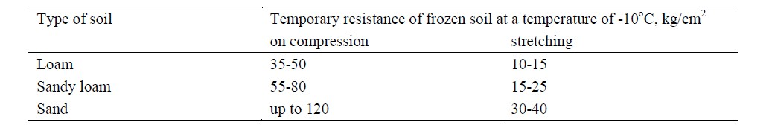
However, the analysis of conventional methods of thawing seasonally frozen soils showed their high labor intensity and significant economic expenses. Therefore, the driving of piles in winter requires additional work associated with the use of additional equipment and preliminary thawing of the soil. As a result, the labor intensity, duration, and cost of work increase [45]. Therefore, the main task when submerging piles in frozen soils is to avoid the destruction of the pile foundation using progressive methods of thawing the soil and protecting it from freezing.
1.5 Design of pile foundation in seasonally frozen soils
There are a lot of studies that investigated the effects of seasonal frozen soils on pile foundations. Authors of a research suggest replacing the soil with frost stable material or preventing the soil from freezing since the lenses of ice develop forces in soil ground that affect all parts of foundation. Pile driving in frozen soil can produce harmful frost actions [46]. The authors of a study [47] point out the problems of seasonal freezing ground on piles of solar power generation. Authors proposed a new approach of rehabilitation to address frost effects on piles as ground may rise in cold weather which leads to the upward displacement of piles.
Research in the line of foundation construction in frozen ground conditions considers many factors such as the behavior of frozen ground and the interaction of soil with piles during lateral loading. The results show that the deformation rate inside the seasonally frozen layer usually decreases with increasing depth and distance from the ground-pile interface. A change in the deformation rate by three to four orders of magnitude can occur inside the seasonally frozen layer. Such a large variation in the strain rate can have a significant impact on the characteristics of a side-loaded pile in the frozen state, and its impact should be taken into account [48-49]. The paper [50-51] describes the environmental aspects of pile foundations, including the parameters of the geological environment, depending on the performance characteristics. The main parameters are taken into account: thermal conductivity, heat diffusivity, specific heat capacity, and soil moisture. The influence of temperature and ground water is also considered, as well as recommendations for the design and installation of pile foundations. In the construction of monolithic pile foundations, the heat of cement hydration can cause an increase in ground temperature and a decrease in the load-bearing capacity of the pile foundation. The observed temperature data showed that the pile foundation for buildings and structures without any cooling measures took two years to reach natural freezing. In such cases, a cold-air refrigerant system is proposed to reduce the re-freezing time. As evidenced by the experiments in developed countries of the world, the most effective method was the thawing of soils at negative temperatures with the use of chemical reagents. The use of this method allows building facilities all year round, which significantly reduces duration of construction works. To achieve this goal, it is proposed to use the method of thawing frozen soils at negative temperatures as a basis for the construction of foundations in seasonally frozen soils of the Republic of Kazakhstan.
Previous studies [52-53] have shown the results of technology that improves the properties of permafrost soils by thawing it with chemical reagents. Frozen soils have been thawed by injecting concentrated aqueous solutions of salt to the soil. The results showed that anhydrous liquefied and gaseous chemicals are capable of actively thawing ice and protecting thawed soils from subsequent freezing.
The possibility of using chemical reagents for thawing frozen soils, in particular gravelly-sandy soils, by pouring forth into the soil without applying external pressure [54]. However, the rate of filtration of a chemical reagent in the soil decreases sharply.
The use of pile foundations in winter is associated with the following problems:
- In practice, the use of bored piles is a proven technology. However, the installation of bored piles requires a preparatory stage involving drilling. This is very difficult when the soil is frozen.
- The driving reinforced concrete piles into frozen soil have low efficiency and a high risk of destruction of the concrete protective layer.
- The installation of a screw foundation in frozen soil is characterized by a substantially greater amount of energy and requires the use of special mechanized equipment.
The technology of constructing pile foundations in permafrost and seasonally frozen soils is associated with additional construction processes, which increase the complexity and duration of the effort. In some cases, when the depth of frozen soil does not exceed 0.5–0.6 m, construction companies use powerful mechanical hammers and vibratory hammers to reduce additional operations. However, such pile driving techniques increase the likelihood of collapse of the pile head. The destruction of the pile head, in turn, leads to the potential seepage of water into the pile foundation.
The main aggressive factors that negatively affect reinforced concrete foundations are soil type, groundwater, and cold weather [55]. Physical damage during the installation of driven piles in frozen soils can also be caused by use of more powerful hammers. Such damage can lead to the corrosion of the reinforcement, which leads to the loss of bearing capacity of the pile foundation.
When choosing methods for driving piles in seasonally frozen soils, special attention must be paid to the thickness of the frozen soil. The thickness of frozen soil is the main criterion for choosing specific method for driving piles. [56-58]
Therefore, there are developed methods that to some extent prevent damage to reinforced concrete foundations.
This work describes some methods, such as: the correct choice of foundation depth, strengthening the foundations by using gravel and crushed stone, the construction of drainage systems, waterproofing and proper care of concrete hardening.
At the same time, the authors of research indicate the need for mandatory consideration of concrete exposure degree to external influences.
The paper also provides scientific information on the use of various additives providing water resistance and frost resistance.
Moreover, as an additional protection of the concrete surface, various coating chemicals can be used, such as: hydrophobic impregnation silica, epoxy resins, bituminous sealing or self-adhesive tapes, bitumen emulsions, synthetic films, and waterproofing cement mastics.
The author of the work emphasizes that when building foundations, special attention should be put to the thickness of the protective layer of concrete, as well as the choice of reinforcement resistant to corrosion.
The issue of protecting the foundations from corrosion is especially relevant in the construction of high-rise structures, where reinforced concrete with metal structural elements is combined as load- bearing structures. The work [59] provides case studies on the study of 51 defective bases of self- supporting and guided antenna towers. Based on the research results, the main factors that influence the durability of the supports and foundations of the towers are determined. These include corrosion of parts of the tower in direct contact with the ground, insufficient detailing of the foundations of the tower and insufficient design of the concrete composition against corrosion of the foundations.
Given that virtually no access to piles during operation of the facility for inspection and repair is excluded, ensuring chemical resistance and maintaining the integrity of pile foundations is a priority at the stages of their manufacture and immersion.
Recently, for the installation of pile foundations in the conditions of permafrost and seasonal frozen soils, they began to use antifreeze chemical additives to thaw them. The use of such technology for driving piles poses new challenges for the anticorrosive protection of pile foundations not only from the aggressive environment of soils, but also from the negative impact use of antifreeze chemical additives in soils.
The analysis of the studies shows that one of the effective methods of protecting reinforced concrete driven pile foundations is to optimize the material composition of concrete components at the stage of their manufacture. In [60-61], this problem was achieved by the correct choice of the type of cement and the use of chemically active aggregates that interact with the cement matrix by one mechanism or another and grow together with it, which reduces or completely eliminates the contact zone conductivity for aggressive environmental components.
Therefore, conducting scientific and experimental research in this direction is an urgent task, since the climatic conditions of construction, the physic mechanical properties of soils, the chemical composition of groundwater, and other factors are constantly changing factors. Moreover, for each building under construction, specific actual research is necessary, considering the factors above [62-70].

1.6 The current state of using chemical reagents for thawing of seasonally frozen soils
The analysis of the chemical composition of soils and groundwater in Kazakhstan showed that they contain soluble salts of various concentrations. Therefore, for the construction of underground structures in the conditions of salinization of soils and groundwater, it is necessary to carry out additional technological studies to ensure resistance and corrosion protection of the foundations of buildings and structures [71].
Therefore, one of the problematic tasks in constructing pile foundations for seasonally frozen soils with aggressive media is not only to ensure proper pile driving, but also to ensure their chemical resistance against soluble salts. The analysis of construction work on driving piles in winter in frozen ground with a depth of more than 0.3 m shows that when punching a frozen layer of considerable thickness, the pile body is in some cases damaged by hammer blows.
Therefore, there is a need to thaw the soil in order to exclude damage to the protective layer of concrete when driving a pile foundation. As a rule, soil thawing is currently carried out by electric heating with special devices. At the same time, to install the electric heating apparatus, it is necessary to pre-drill holes in frozen soil. To do this, use special equipment. As a result, when immersing piles in winter, soils need to perform construction operations that increase the complexity and duration of pile work [72].
The task of designing reinforced concrete pile foundations which are resistant to sulfate and chloride environments is relevant for foundations in aggressive soils and groundwater. In addition, it is also important for bridges, offshore structures, structures of various industrial buildings. One of the ways to increase the resistance of reinforced concrete pile foundations to chloride and sulfate environment is to use new unconventional aggregates and additives in concrete, which reduce the permeability of concrete and reduce the rate of corrosion processes in aggressive environment.
In the studies of scientists [73], it is argued that concrete and reinforcement used for the manufacture of reinforced concrete foundations can be subjected to various aggressive influences of soil environment. In result, reinforced concrete material is prone to destruction over time.
Research by Sarsembayeva [74] has shown the effect of de-icing chemicals on seasonal freezing of highway sub soil. Author stated that removal of snow from road pavements by spreading chemical de-icing reagents decreases the freezing point if the water in soils is made to be able migrate. When chemical reagents are applied into the ice, the salt in chemical reagents due to its hygroscopicity, begins to intensively adsorb ice moisture, forming a thin layer of a saturated solution on the surface. The solution obtained in this way has a lower freezing point than water, leads to loosening of the snow-ice mass and a decrease in its strength characteristics [75]. A solution with a concentration of C is in a liquid state until its temperature drops to a certain value, at which water begins to crystallize from the solution (ice formation). The concentration of the solution, which has a lower freezing point than water, increases as the amount of ice increases. With further decrease in temperature, the solution reaches a certain concentration and crystals, turning into a solid mixture of ice and salt. In this case, the temperature at which such a solid is formed is the eutectic temperature, and the corresponding concentration of the solution is called the eutectic concentration.
The chemical additives are widely used to combat with slipperiness on roads. Only way to remove the ice from the road surface is using chemical de-icing additives. In the research of Sarsembayeva A. [77], the temperature and concentration of the eutectic points of chemical de-icing additives have been presented.
Table 2.
The temperature and concentration of the eutectic points of chemical de-icing additives [76-77]
The name of chemicals | Chemical formula | Eutectic temperature te, degree | Eutectic concentration Сe, (%)
Sodium chloride | NaCl | -21,2 | 23,3
Magnesium chloride | MgCl | -33,6 | 20,6
Calcium chloride | СаСl2 | -49,8 | 30,5
Sodium sulfate | Na2SO4 | -1,2 | 4,0
Magnesium sulfate | MgSO4 | -4,8 | 18,6
sodium bicarbonate | NaHCO3 | -2,33 | 6,26
Sodium carbonate | Na2CO3 | -2,1 | 5,75
Ammonium acetate ("Antisneg-1") | CН3СООNН4 | -44,9 | 29,6
Potassium acetate ("Nordix") | СН3СООК | -59,8 | 50,1

1.7 Theory of interaction of soil with chemical reagents
In the event that a chemical reagent is dispersed across the top layer of soil, the sodium chloride that is contained inside the reagent will be taken up by the groundwater. Figure 2.1 examines the process by which ions become detached from the surface of salt crystals when those crystals come into contact with groundwater. This process is driven by the oscillatory motion of the microparticles themselves, in addition to the attraction exerted by the molecules of the solvent (water). As a consequence of this, the chemical reagents are able to dissolve, and at the same time, the salt ions are evenly distributed throughout the solvent, leading to the creation of a solution.
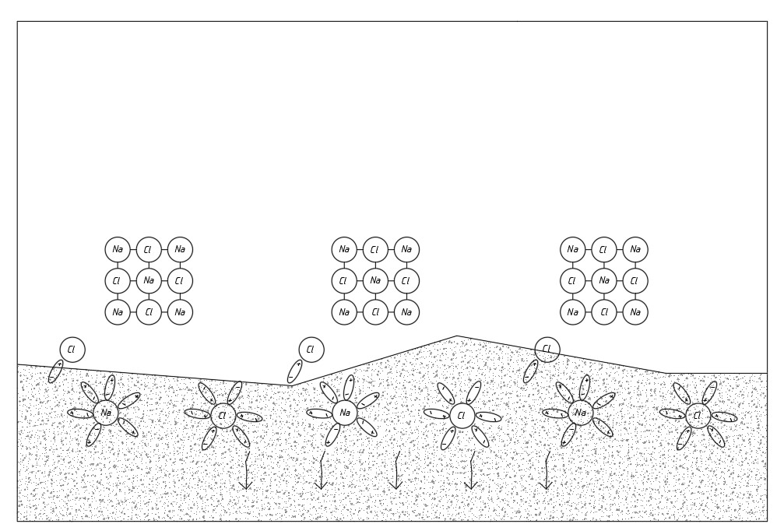
Figure 8. Distribution of chemical reagent ions on the ground surface.
The proposed antifreeze reagent can also serve as a thermal insulation for the soil when temperature drops below freezing in winter months. Moreover, it can provide an ideal condition to drive the piles on construction site without waiting for the springtime. To run the project on schedule, using an antifreeze reagent can offer significant advantages in wintertime. It is important to note that antifreeze reagent can also help to make fewer disturbances to the surrounding area since the ground is unfrozen and do not require any major excavation. Pile foundations can be easily placed in winter without additional and extra costly operations.

Summary of chapter one
The chapter one includes basic information about the frozen ground and literature review of authors who conducted research works in seasonally frozen ground and pile installation in winter.
The term “frozen ground” is entirely characterized on temperature regardless of water or ice in the soil. Frozen ground is made up from four component which include soil particles, ice, water, and air. The soil particles in frozen ground vary in size and form.
During the thawing process in frozen soil, the particles of ice will melt and the soil skeleton adjusts to a new equilibrium void ratio for the current overburden forces. The thaw settlement is very essential factor to consider not only during the designing of ground support systems but also building foundations, embankments in seasonally frozen ground.
Nowadays there are a lot of new technics to thaw the frozen ground in winter. One of them is hydronic heating technology which is designed by Nordic developers. This machine is able to thaw frozen soil 40-80 centimeters in 24 hours, and 200 m² area in one day.
In Kazakhstan, the most used method of drilling the piles in winter months is predrilled driven piles. The traditional methods of pile installation are not effective in terms of time and economy. They need a lot of additional works that slows down the process of pile foundation construction in winter.

CHAPTER TWO
2 METHODOLOGIES OF THE RESEARCH
2.1. Chemical reagent
For scientific and experimental work, a three-component mixture of chemical reagents of the following composition was chosen, wt.% - quicklime (CaO) - 75, - calcium chloride (CaCl) - 20, - sodium chloride (NaCl) - 5
The choice of this composition is justified taking into account their specific chemical properties and special reactions when interacting with water and frozen soil. The active constituents of quicklime (CaO) are converted into Ca(OH)₂ upon interaction with a humid environment or water. This process occurs with spontaneous heat release. The main idea of ​​this work is the use of this thermal energy for local thawing of seasonally frozen soil in places where pile foundations are driven.
A distinctive feature of the proposed composition of the chemical reagent is that for local thawing of seasonally frozen clay soil, spontaneously generated heat of quicklime is used when interacting with water. Under laboratory conditions, it has been established that the heat released as a result of the chemical reaction of quicklime reaches up to 100 ° C, despite the negative temperature of the outside air (t = -20 ° C). Scientific and experimental studies of the process of thawing a laboratory sample of seasonally frozen clay soil were carried out using the developed composition of a chemical reagent based on quicklime. At the same time, the main regularities of the change in the depth of thawing depending on the thickness of the backfill and time were studied at an ambient temperature of t= -20°C. It has been established that the intensity of thawing of a laboratory sample of seasonally frozen soil depends on the thickness of the filling of a chemical reagent based on quicklime. In this case, the most intensive and relatively fast thawing is observed at a thickness of the filling of the chemical reagent of 3.0 cm. The developed composition of a chemical reagent based on quicklime has advantages in terms of reducing energy costs for thawing seasonally frozen soil. Since, when interacting with water, the proposed chemical reagent spontaneously releases heat (t = 100 ° C;) and does not cool down for a long time, despite the negative temperature of the outside air. And the content of CaCl and NaCl in the composition excludes the re-freezing of clayey seasonally frozen soil.
Purpose and objectives of research. Development of the composition of chemical reagents for the purpose of thawing and freezing protection of seasonally frozen soil in places where pile foundations are driven in winter conditions.
To achieve this goal, it was necessary to solve the following tasks:
- study of the physical and mechanical properties of the soil in the places of pile foundation driving;
- choose chemical reagents that provide spontaneous heat generation and prevent soil freezing;
- carrying out laboratory scientific and experimental studies to study the kinetics of thawing frozen soil depending on the amount of chemical reagent introduced and time.
For further scientific and experimental work, a three-component mixture of chemical reagents of the following composition was chosen:
- quicklime (CaO) – 75%
- calcium chloride (CaCl) – 20%
- sodium chloride (NaCl) – 5%

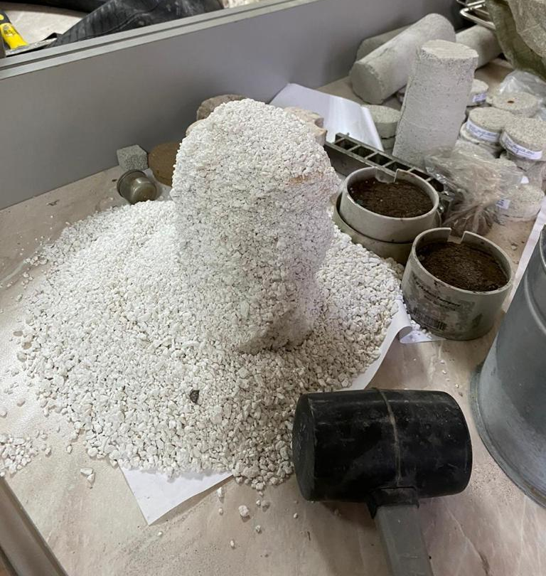
Figure 9. Chemical reagent.
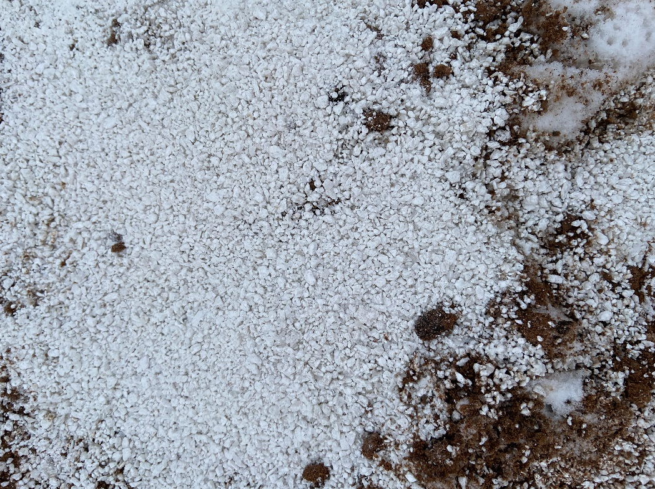
Figure 10. Chemical reagent on the frozen ground.
The choice of this composition is justified taking into account their specific chemical properties and special reactions when interacting with water and frozen soil.
Quicklime is the most common and affordable building material and is widely used not only in construction, but also in agriculture to improve soil fertility [78-83].
Its main active components - CaO turns into Ca(OH)₂ when interacting with a humid environment or water. This process occurs with spontaneous heat release. The main idea of our work is the use of this thermal energy for local thawing of seasonally frozen soil in places where pile foundations are driven.
For scientific and experimental work, standard powdered slow-extinguishing quicklime of the 1st grade was used according to GOST 9179-2018 “Building lime. Specifications” (EN 459-1:2010, NEQ). The content of active CaO + MgO, not less than 90%.

2.2. Definition of freezing depth in seasonally frozen ground
The depth of soil freezing is taken equal to the average of the annual maximum depths of seasonal soil freezing (according to observations for a period of at least 10 years) on an open, snow-free horizontal site at a groundwater level located below the depth of seasonal soil freezing.
The normative depth of seasonal soil freezing dfn, m., in the absence of long-term observational data, should be determined on the basis of thermal engineering calculations. For areas where the freezing depth does not exceed 2.5 m, its standard value can be determined by the formula:
dfn = d0 * √Mt (1)
where Mt is a dimensionless coefficient that is numerically equal to the sum of the absolute values of average monthly negative temperatures for the winter in a given area, as determined by SNiP for building climatology and geophysics, and in the absence of data for a particular point or area of construction, based on the results of observations made at a hydrometeorological station located in conditions that are comparable to those of the construction area;
d0 is the value taken equal, m, for:
loams and clays - 0.23;
sandy loam, fine and dusty sands - 0.28;
gravel sands, large and medium size - 0.30;
coarse clastic soils - 0.34.
The value of d0 for soils of inhomogeneous composition is determined as a weighted average within the freezing depth [116].
2.3 Location, relief, and climate of construction site
The engineering and geological investigation were performed by the KGS Ltd. at the construction site of: "Construction and operation of the united university hospital for 800 beds at NJSC "Astana Medical University" in Nur-Sultan city". The survey area is located on a land plot located on area on st. Barshyn on the right bank of the river. Esil. The site at the time of survey was free from construction. The site is characterized by absolute surface elevations soil within 342.22÷344.31m (along the wellheads).
The location of engineering-geological wells is indicated approximately from taking into account the situational placement plan. Breakdown of engineering-geological workings made using a measuring device with GPS positioning, according to scheme of the master plan and layout plan.
The climate of the region is sharply continental and arid. Winter is cold and long with stable snow cover. Summer is relatively short, but roast. The area belongs to the zone of insufficient and unstable moisture.
The annual course of air temperatures is characterized by persistent severe frosts in winter, an intense increase in heat in the short spring season and heat in during the short summer. Average annual wind speed (for heating season) is equal to 3.8 m/sec.
The normative freezing depth for the city of Nur-Sultan (Astana) is 205cm, according to SP RK 2.04-01-2017. The average depth of penetration "0" into the soil is 250 cm (the maximum penetration is usually in March). The absolute maximum was recorded in April - 3.5 m.

2.4 The methodology of engineering and geological investigations
According to the terms of reference, following are the purpose of work at this facility:
- study of the geological and hydrogeological conditions of the survey site through drilling;
- selection of engineering-geological elements in the survey area;
- determination of the physical and mechanical properties of soils and water based on the results
- a complex of laboratory tests;
- assessment of the aggressive impact of soils and groundwater on construction materials.
Drilling wells were carried out by a self-propelled drilling rig PBU-2-319 based on KAMAZ 5350-42 motor vehicles by shock-rope and rotary-column methods with a diameter of 168 mm. In the course of drilling operations, the appearance and restoration of the groundwater level, sampling of soil monoliths and samples was carried out ground water. Monoliths from wells were sampled with a GK-123 soil carrier, 123 mm in diameter. mm, soil samples with a disturbed structure were taken into bags, and to save natural humidity in bottles.
Based on the results of drilling operations in the survey area up to a depth of 20 m, a geological and lithological description of the workings was compiled and built engineering-geological sections.
Field tests of soils by static sounding were carried out for clarification of the geological and lithological structure and determination of the bearing capacity driven piles. At the survey site, 40 experiments of static sounding. The depth of the study was 6.6÷14.0 m.
Static sounding was performed by TEST-K4 equipment in accordance with GOST 5.01-103-2013 for a comprehensive assessment of the physical and mechanical properties of soils in accordance and evaluation bearing capacity of piles according to GOST 19912-2012 and SN RK 5.01-103-2013.
In static probing, a conical tip with a diameter the base of the cone is 35.7 mm and the angle at the top of the cone is 60 degrees.
As rods transmitting pressure to the tip, standard pipes with a diameter of 36 mm, the diameter of the coupling is 35.7 mm. The length of the friction clutch is 310 mm. Range measurements of soil resistivity to a cone 0.05-50 MPa. measurement range soil resistivity in the friction clutches 0.6-600 kPa. Basic error measurements of efforts - no more than 2.5%.
The strain gauge probe works as follows:
- when the probe is pressed into the ground, a force acts on the cone, which is transmitted to the lower part of the strain gauge, where the strain gauges are placed. Change the resistance of strain gauges is fixed by a measuring device. Effort through the widened part of the strain gauge and the threaded connection is transmitted directly on the probe body, while the upper part of the dynamometer, where the strain gauges are glued, is not loaded;
- under the action of friction forces on the probe sleeve, the force is transmitted through the protrusion to the upper part of the strain gauge, where the strain gauges are located;
- at the same time, the change in the resistance of the strain gauges is fixed by the measuring device, and this load is not transferred to the lower part of the strain gauge. Soil testing at each sounding point ends when limit forces on the probe, according to GOST 19912-2012.
Based on the results of static sounding, distribution graphs were constructed resistivity values for the probe cone on the side surface of the probe and calculation of the bearing capacity of driven piles with a section of 30x30 cm.
Laboratory studies of soils taken from wells during drilling, performed in the laboratory of soil mechanics, in accordance with the requirements
existing regulatory documents, instructions and guidelines.
The density of soil particles (specific gravity) is determined by the ratio of the mass of particles to their volume. Determination of the density of soil particles was carried out by the psychometric method on cohesive soils in accordance with the requirements of ST RK 1290-2004, paragraph 10.
The density (volumetric weight) of soils is determined by weighing paraffin samples in water in accordance with the requirements of ST RK 1290-2004, paragraph 7.
Laboratory determinations of the moisture content of clay soils (natural moisture content, moisture content at the boundaries of fluidity and rolling) were carried out in accordance with the requirements of ST RK 1290-2004, paragraphs 2, 4, 5.
Characteristics of the deformation properties of clay soils were determined by the method of laboratory determination of compressibility, performed on soils with their additional soaking, on the Odometer Controls Model 26-WF0302 device in accordance with the requirements of GOST 12248-2010. As a result of the experiments, particular values ​​of the modulus of deformation were obtained and graphs of the dependence of the relative compressibility of the soil on pressure were plotted.
The strength characteristics of clay soils were determined by the method of slow consolidated shear with preliminary compaction and soaking for two days on a Controls Model 27-WF2060 shear device in accordance with the requirements of GOST 12248-2010. As a result of the experiments carried out, particular values ​​of adhesion and the angle of internal friction for clay soils were obtained and graphs of the dependence of the shear force on pressure were plotted.
The granulometric composition (grain) of sandy and coarse-clastic soils was determined by the sieve method by the weight content of particles of various sizes in them, expressed as a percentage relative to the dry sample weight in accordance with the requirements of ST RK 1273-2004.
Coarse clastic and sandy soils at the survey site are characterized according to GOST 25100-2011 by the content of the determining fraction in the total mass of the sample taken from a certain interval during the drilling process.
Statistical processing of soil characteristics values ​​was performed in accordance with the requirements of GOST 20522-2012 [130].

2.5 The results of engineering and geological investigations
Based on the field visual survey of drilled wells and the results of laboratory studies of soils, it has been established that in the geological structure of the survey site there are alluvial deposits of the Middle Upper Quaternary age аQ_{II-III}, represented by clay soils (loam, sandy loam, clay), sands of various sizes (fine, medium, large and gravelly), as well as deposits of the Paleogene system of the Oligocene Pg33, represented by clay soils. From above, all the listed deposits are covered with a soil-vegetative layer.
The soil-vegetative layer Q_{IV} was exposed in all boreholes, 0.4÷0.6 m thick. According to the field description, dark brown loam with plant roots.
Loam аQ_{II-III} was discovered in all 40 wells. According to the field description, light brown loam, from hard to soft-plastic consistency, water-saturated from a depth of 1.0–3.0 m, with clay interlayers up to 20 cm thick. 7.8 m (well 57-20).

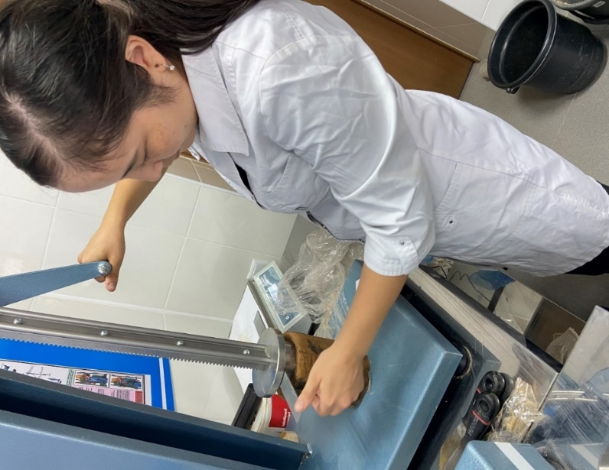
Figure 11. Defining the physic-mechanical properties

Figure 12. Defining the physic-mechanical properties
Sandy loam аQ_{II-III} – - opened in 22 wells. According to the field description, the sandy loam is light brown, plastic, water-saturated, with layers of gray clay. The thickness of the sandy loam ranges from 0.5 m (well 53-20) to 5.4 m (well 35-20).
Clay аQ_{II-III} – discovered in 5 wells. According to the field description, the clay is light brown in color, from hard-plastic to soft-plastic consistency, water-saturated, with lenses of dark gray sand. The thickness of the clay ranges from 0.7 m (well 26-20) to 2.6 m (well 43-20).
Fine sand аQ_{II-III} - uncovered in 13 wells. According to the field description, the sand is fine brown, light and dark brown, dark gray, water-saturated, medium density, polymictic composition, with interlayers of gray clayey soil up to 20 cm thick. The thickness of fine sand is from 0.5 m (well 30 -20) up to 2.5 m (well 39-20).
Sand of medium size аQ_{II-III} − was discovered in 23 wells. According to the field description, medium-sized sand of brown, light, dark and gray-brown colors, water-saturated, medium density, polymictic composition, with interlayers of clayey soil. The thickness of sands of medium size ranged from 0.3 m (borehole 29-20) to 3.7 m (borehole 30-20).
Coarse sand аQ_{II-III} – − was discovered in 7 wells. According to the field description, the sand is coarse, light and gray-brown in color, water-saturated, of medium density, polymictic composition. The coarse sand thickness ranged from 0.4 m (well 59-20) to 2.9 m (well 46-20).
Gravelly sand аQ_{II-III} – uncovered in 28 wells. According to the field description, the sand is gravelly, brown, light, dark and gray-brown in color, water-saturated, of medium density, polymictic composition, with interlayers of clay soil. The thickness of the gravelly sand ranges from 0.2 m (well 55-20) to 7.1 m (borehole 28-20).
Clay Pg₃³– was discovered in almost all wells. They lie under the sands. According to the field description, clay of various colors (dark gray, maroon gray, gray-green, dark purple with shades of yellow), hard consistency, loose in places. Penetrated at a depth of 7.2 m (well 63-20) to 15.6 m (well 28-20), the stripped thickness was 0.9÷12.1 m.

2.6 Hydrogeological conditions
Groundwater was discovered in all wells, without exception, at depths of 0.7÷3.0 m, established at a depth of 0.5÷2.85 m, the absolute marks of the established groundwater level are 340.72÷341.57 m.
The values of groundwater levels and absolute marks of their steady level are listed in Table 6.
The groundwater regime is subject to seasonal fluctuations: the minimum standing is observed in February, the maximum occurs at the end of May. The amplitude of groundwater level fluctuations is 1.0÷1.5 m.
The predicted maximum groundwater level rise is 1.0 m above the steady state.
Groundwater is fed mainly by precipitation infiltration. The feeding area is the distribution area of the aquifer. Groundwater is confined to alluvial deposits.
Water-bearing sediments are all soils exposed at the survey site.
Soil filtration coefficients are as follows:
- for clayey soils of the middle-upper Quaternary age - 0.01-0.13 m / day; - for fine sands - 8.61 m/day;
- for sands of medium size - 18.89 m / day;
- for coarse sands - 22.47 m/day;
- for gravelly sands - 23.83 m/day;
- for clay soils of the Paleogene system - 0.034 m/day.
Mineralization of underground waters is 1975÷3765 mg/l, which characterizes them as saline. According to the chemical composition of the water, sulfate-chloride calcium-magnesium and calcium-magnesium-sodium, the total hardness is 19.75÷46.5 mmol/dm3, the water is very hard.
In relation to concrete grade W4 on Portland cement, groundwater has medium carbon dioxide aggression and strong sulfate aggression, in relation to reinforced concrete structures with periodic wetting - medium aggressive, with constant immersion - non-aggressive.
The corrosive aggressiveness of groundwater in relation to the lead and aluminum sheaths of the cable is high.

2.7 Physical and mechanical properties of soils
Based on the field description of the soils and the results of laboratory tests, the soils were divided into engineering-geological elements (IGE) in the stratigraphic sequence of their occurrence. The following are the elements of the soil:
IGE-1. Topsoil - tQ_{IV}
IGE-2. Loam - aQ_{III-IV}
IGE-3. Sandy loam - aQ_{III-IV}
IGE-4. Clay - aQ_{II-III}
IGE-5. Fine sand - aQ_{II-III};
IGE-6. Sand of medium size - aQ_{II-III}
IGE-7. Coarse sand - aQ_{II-III};
IGE-8. Gravelly sand aQ_{II-III}
IGE-9. Clay - Pg33
For each allocated engineering and geological element are given specific values of indicators of physical and mechanical properties, given the movement and compression tests by laboratory methods and the consolidation of dredging.
EGE-1. Soil and vegetation layer. When the design decision is subject to removal.
EGE-2. Loam - aQ_{III-IV} - is characterized by the following indicators of physical and mechanical properties given in table 1.
Table 1.
Physical and mechanical properties of Loam - aQ_{III-IV}
№  п/п | The name of indicators | Unit  measurements | Number of definitions | Limit  values |  | Medium  (normative)  values
 |  |  |  | min. | max. | Medium  (normative)  values
1 | Natural humidity | % | 21 | 19,0 | 29,0 | 23,1
2 | Moisture at yield strength | % | 30 | 23,0 | 35,0 | 27,5
3 | Humidity at the limit of rolling | % | 30 | 13,0 | 23,0 | 16,6
4 | Plasticity number | % | 30 | 7,0 | 16,0 | 11,0
5 | Consistency |  | 21 | 0,28 | 0,81 | 0,60
6 | Ground density | g/cm³ | 15 | 1,89 | 2,08 | 1,99
7 | Soil particle density | g/cm³ | 15 | 2,72 | 2,73 | 2,72
8 | Porosity coefficient | shares of units. | 15 | 0,582 | 0,789 | 0,681
9 | Degree of humidity | shares of units | 15 | 0,812 | 1,033 | 0,918
10 | Specific adhesion | kPа | 6 | 13,0 | 20,0 | 17,0
11 | Angle of internal friction | degree | 6 | 10 | 18 | 13,8
12 | Deformation modulus (compressive compression at natural humidity) | МPа | 6 | 3,8 | 6,01 | 5,15

Particular values of the characteristics of the strength and deformation properties of alluvial loams were subjected to static processing in accordance with the requirements of GOST 20522-2012 and as a result, the standard and calculated values of the characteristics given in Table 8 were obtained.

Table 2.
The standard and calculated values of the characteristics of Loam - aQ_{III-IV}
№  п/п | Name of characteristics | Unit  measurements | Characteristic values
№  п/п | Name of characteristics | Unit  measurements | Normative | Estimated
 |  |  |  | On deformations α=0,85 | by bearing capacity α=0,95
1 | Ground density | g/cm³ | 1,99 | 1,97 | 1,96
2 | Specific adhesion | кPа | 17,0 | 7,9 | 2,3
3 | Angle of internal friction | degree | 13,8 | 11,6 | 10,2
4 | Deformation modulus (compressive compression at natural humidity) | МPа | 5,15 | 5,15 | -

The survey area is located on a land plot located on a plot on the street. Barshyn on the right bank of the river. Esil in the city of Nur-Sultan, next to a specialized public service center for car owners. The site was vacant at the time of survey. The site is characterized by absolute marks of the soil surface within 342.22÷344.31m (along the wellheads).
The location of engineering-geological wells is indicated approximately, taking into account the situational location plan. The breakdown of engineering-geological workings was carried out using a measuring device with GPS positioning, according to the scheme of the general plan and the layout plan, which was agreed with the Customer.
In the geological structure of the survey site, there are alluvial deposits of the Middle-Upper Quaternary age aQII-III, represented by clay soils (loam, sandy loam, clay), sands of various sizes (fine, medium, coarse) and gravel sands, as well as deposits of the Paleogene Oligocene system Pg33 represented by clay soils. From above, all the listed deposits are covered with a soil-vegetative layer.
Groundwater in all wells was tapped at depths of 0.7÷3.0 m, settled at a depth of 0.5÷2.85 m, the absolute marks of the steady level are 340.72÷341.57 m.
Measurement of the steady level of groundwater at the survey site was carried out in the month of May. The predicted maximum groundwater level rise is 1.0 m above the steady state. Water-bearing sediments are all soils exposed at the survey site.
Soil filtration coefficients are as follows:
- for clayey soils of the middle-upper Quaternary age - 0.01-0.13 m / day; - for fine sands - 8.61 m/day;
- for sands of medium size - 18.89 m / day;
- for coarse sands - 22.47 m/day;
- for gravelly sands - 23.83 m/day;
- for clay soils of the Paleogene system - 0.034 m/day.
Groundwater is fed mainly by precipitation infiltration. The feeding area is the distribution area of ​​the aquifer.
Mineralization of underground waters is 1975÷3765 mg/l, which characterizes them as saline. According to the chemical composition of the water, sulfate-chloride calcium-magnesium and calcium-magnesium-sodium, the total hardness is 19.75÷46.5 mmol/dm3, the water is very hard.
In relation to W4 concrete on Portland cement, groundwater has medium carbon dioxide aggression and strong sulfate aggression, in relation to reinforced concrete structures with periodic wetting - medium aggressive.
The corrosive aggressiveness of groundwater in relation to the lead and aluminum sheaths of the cable is high.
In relation to steel structures (according to Stabler), groundwater is corrosive.
According to the total content of easily and medium soluble salts, according to the requirements of GOST 25100-2011, the soils that make up the survey site are classified as non-saline.
The degree of soil aggressiveness (SP RK 2.01-101-2013) in relation to W4 concrete on Portland cement varies from non-aggressive to medium aggressive, in relation to reinforced concrete structures - from medium aggressive to medium aggressive (see Table 16).
The degree of corrosive aggressiveness of soils (SP RK 2.01-101-2013) in relation to steel structures is high.
The territory of the city of Nur-Sultan is located on the Kazakh shield, on which tectonic phenomena do not appear and therefore its territory is not seismically active.
According to clause 4.3.18, SP RK 5.01-102-2013, dangerous geological processes in the study area include groundwater flooding and frost heaving of soils in the seasonal freezing zone.
According to the nature of the flooding, the territory belongs to the flooded area in natural conditions.
When designing, the following measures should be taken into account: - protection of concrete and reinforced concrete structures from the aggressive effects of soils and groundwater;
- anticorrosive protection of underground structures made of steel, lead and aluminum cable sheaths from the aggressive effects of soils and groundwater.
When driving piles, it is recommended to take into account the presence of uneven-grained sands in the engineering-geological section, which contain lenses and interlayers of clay soil. Piles must cut through these soils and reach the design level, even if design failures are received in these soils.
The values ​​of the bearing capacity of piles, determined by the method of static sounding, are presented without taking into account the reliability factor. These values ​​should be specified based on the results of field tests of full-scale piles. The final choice of length and determination of the bearing capacity of piles must be based on the results of field studies in accordance with GOST 5686-2012 “Soils. Methods of field tests with piles.
For a more accurate determination of the bearing capacity of piles, it is necessary to perform static and dynamic tests of piles, in accordance with SNiP RK 5.01-01.2002.

2.8 Static Load Test (SLT)
Load bearing capacity tests were carried out according to the requirements of GOST 5686-2012 “Soils”. Test piles were installed in two different places. First one was driven into the ground where antifreeze reagent had been applied in the wet form. The second pile was installed into frozen soil.
The field tests were carried out when the piles came to rest, 10-16 days after driving into the ground. The piles were tested by using different types of soil protection methods. In the first case, driven piles were covered by dry sawdust in order to protect the pile from freezing. The thickness of the sawdust layer was 0.5 m. In the second case the reagent was used in an aqueous form (Figure 4).
The depth of thawed zone was determined by drilling the ground and by the speed of driving. As the tested piles were driven in two different zones, the range for both piles were different (first pile was driven into the ground where antifreeze was applied; another pile was driven into the frozen ground).
The load was applied to the piles through an Enerpac СLS2006 185-ton hydraulic jack that is pumped up to the loading platform from beam systems. A total weight of hydraulic jack, which is connected to the Enerpac P462 pumping station, is 150.0 tons. The applied load was recorded by a load cell digital dynamometer as part of the connected SLT2 monitoring system. The pressure is fixed by a manometer with a division price of 20 atm (kgf / cm2) to 1000 atm (kgf / cm2) of the MA100VU100 type.
The displacements of each pile were recorded by four digital electronic transducers (027DG1, 027DG2, 027DG3, 027DG4) that were connected to the monitoring system SLT2. The SLT2 static load test monitoring system is specially designed to monitor the static load tests and present data in accordance with Eurocode 7. This system makes it possible to monitor the static load test from a distance of up to 25 m, thus avoiding any potentially hazardous situations due to the heavy applied loads.
Piles were tested with static stepwise increasing loads. The first four steps consisted of 104 kN (40 atm) per step. This was followed by 52 kN (20 atm) and was then brought to 728 kN (280 atm) for pile No. 455, and to 520 kN (200 atm) for pile No. 134.With a maximum applied load on pile No. 455 and 134, their displacements were 3.99 and 16.65 mm, respectively.
The piles were unloaded in steps, with observation of elastic deformations at each step every 15 minutes. After complete unloading to 0 kN, observations of elastic displacements were made for one hour, taking data every 15 minutes.

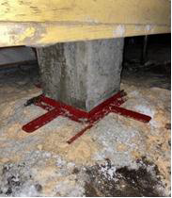
Figure 13. Testing the pile for bearing capacity using antifreeze reagent

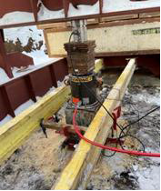

Figure 14. Testing the pile for bearing capacity using antifreeze reagent sawdust

2.9 Determination of the bearing capacity of the piles according to the results of a field test
Based on the results of testing piles with static loads, graphs of the dependence of pile displacement on load S=f(P) and changes in pile displacement under load over time S=f(P) were plotted. The bearing capacity Fd according to the results of field tests with static loads is determined according to /2/ by the formula:

(2)

In accordance with /2/, if the number of piles tested in the same soil conditions is less than six, the standard value of the ultimate resistance (Fu,n) of the pile in formula (1) should be taken equal to the smallest ultimate resistance obtained from the test results, i.e. Fu,n=Fu,min,, and the ground safety factor γg=1.
If the number of piles tested in the same soil conditions is six or more, the values ​​ Fu,n and γg should be determined based on the results of statistical processing of particular values ​​of the ultimate pile resistances Fu obtained from the data, guided by the requirements of GOST 20522-75.
For the partial value of the ultimate resistance of the pile to the pressing load Fu, one should take the load under the influence of which the tested pile will receive a settlement equal to S and determined by the formula:
S = ζSu ,mt (3)
where ζ is the coefficient of transition from the limiting value of the average settlement of the foundation of a building or structure Su,mt to the pile settlement obtained during static tests with conditional stabilization of settlement, according to the requirements /2/, the value of the coefficient should be taken as ζ=0.2;
Su,mt - the limit value of the average settlement of the foundation of the designed building or structure, set according to the instructions of SNiP.

2.10 Pile Integrity Test (PIT)
A version of the FPDS (Foundation Pile Diagnostic System Sonic Integrity Testing) approach - low-deformation dynamic pile testing - is utilized for pile testing. In recent years, this has become the most current method in world practice. It enables you to examine the continuity of all sorts of heaps and identify pile flaws.
Low strain tests are classified into numerous categories, including sound tests, frequency tests, echo tests, and so on.
Sound test. This approach involves striking the pile's head with a light special hammer and measuring the impact reaction using a transducer. Reflections from breaks and variations in the cross section of the pile modify the form of the signal. These modifications are used to understand the signal. The key flaws are identified with an indication of their depth of location [108].
Frequency analysis. This approach requires striking the pile head with a specific tool hammer. Response frequencies are evaluated by generating resonant peaks, which are then utilized to uncover underlying faults. This approach allows you to determine the pile head's integrity.
The signals in both systems are impacted not only by the geometry of the pile and its fractures, but also by the properties of the soil surrounding the pile, which can distort the signal. As a result, signal interpretation must be conducted by a particularly qualified and experienced operator who is well-versed in the pile and the geological conditions of the site.
The low strain test, unlike other types of continuity testing, is a non-destructive test that does not require additional training before or after pile construction; a sound-conducting pile head is necessary for hammering and sensor application.
Although low deformation testing may be done on driven, bored, bored, wood, and steel piles, the bulk of tests are performed on driven and bored concrete and reinforced concrete piles [108].

2.11 The requirements and procedure of pile integrity test
The primary prerequisite of an integrity test is the acquisition of a high-quality signal for interpretation.
The following are the main requirements:
- The pile must be cleansed to a sound-conducting substance, devoid of defects, delamination, and weak concrete.
- The pile's surface must be dry, somewhat smooth, and perpendicular to the pile's axis.
- Any structures or elements linked to the pile, such as sharply projecting reinforcement or framework, may return uninterpretable signals. Most of the time, the gadget filters out the impact of these components.
- Access to the pile's head should allow for several hammer strokes and space for the sensor to be mounted.
- Testing on "raw" concrete is not permitted. Bored piles take 3 to 7 days to reach the requisite strength for testing.
- Several hits to the pile head are required for dependability and an adequate signal.

The following are the procedures:
- cleaning the soil, snow, and ice off the pile head's concrete surface. Prepare 3 points of even, dry concrete pads on the pile head, if possible, with dimensions of about 100 mm by 100 mm, so that the sensor can be put in place and a special hammer can be used to hit the concrete surface of the pile;
- input the following settings into the device's memory: site name, pile number, length, and wave propagation speed in concrete;
- for improved signal registration, a sensor that registers reflected signals is put on a prepared site at the pile head using a specific paste. On a prepared location, three mild strikes are delivered with a specific hammer to the crown of the pile. After each impact, the device's display shows a graph (reflectogram) depicting the dependency of impact amplitude on pile length. If the operator determines that the graphs are acceptable, the result is stored in memory for subsequent processing. If the hit is too powerful or too faint, the gadget does not register a signal, and the impact must be repeated. Impacts are performed until the operator determines that the received reflectograms are enough for further investigation;
- when the tests are done, the data from testing the pile for continuity are put through a special program, and the results are shown as a graph of "signal amplitude" versus "pile length." Depending on the type of graph, the operator sorts the piles based on how well they were made;
- after the data is processed, intermediate test results are sent to the Customer as soon as possible;
- at the end of the whole set of tests, a final report with a detailed analysis is given to the customer on the piles' tests for continuity;
The time it takes for the wave to return to the pile describes its length and mechanical properties. T=2L/C, where T is the time from impact to return, L denotes the length of the pile, is the speed of wave propagation (с=√Eρ), E denotes the modulus of elasticity, and C denotes the density of concrete.
The speed of wave propagation in concrete can vary between 3200 and 4400 m/s depending on the time of concreting, the concrete's quality, and other variables. The average propagation speed of a stress wave in concrete of class B 20-25 is 3,600 meters per second.
The precision of the pile length measurement is dependent on the precision of the stress wave velocity. When the pile length is known, it is possible to match the wave propagation speed to the given length.

Explanation of graphical interpretation
If the graph has sharp clear fluctuations with further reflection of the signal, then we can talk about broadening or narrowing, the inclusion of foreign bodies, concrete delamination, a crack, or the influence of geology. Only the operator can give a correct interpretation.
If the curve contains little variations, then the pile is free of defects.
If the curve has a high, smooth leap up, followed by a drop down, followed by another repetition of the signal, then there is an expansion of the pile in this portion. If the graph shows a sharp, smooth drop followed by a rise, this indicates a constriction of the pile, the effect of geological circumstances (loose, water-filled soils), or a change in the density of soil or concrete.

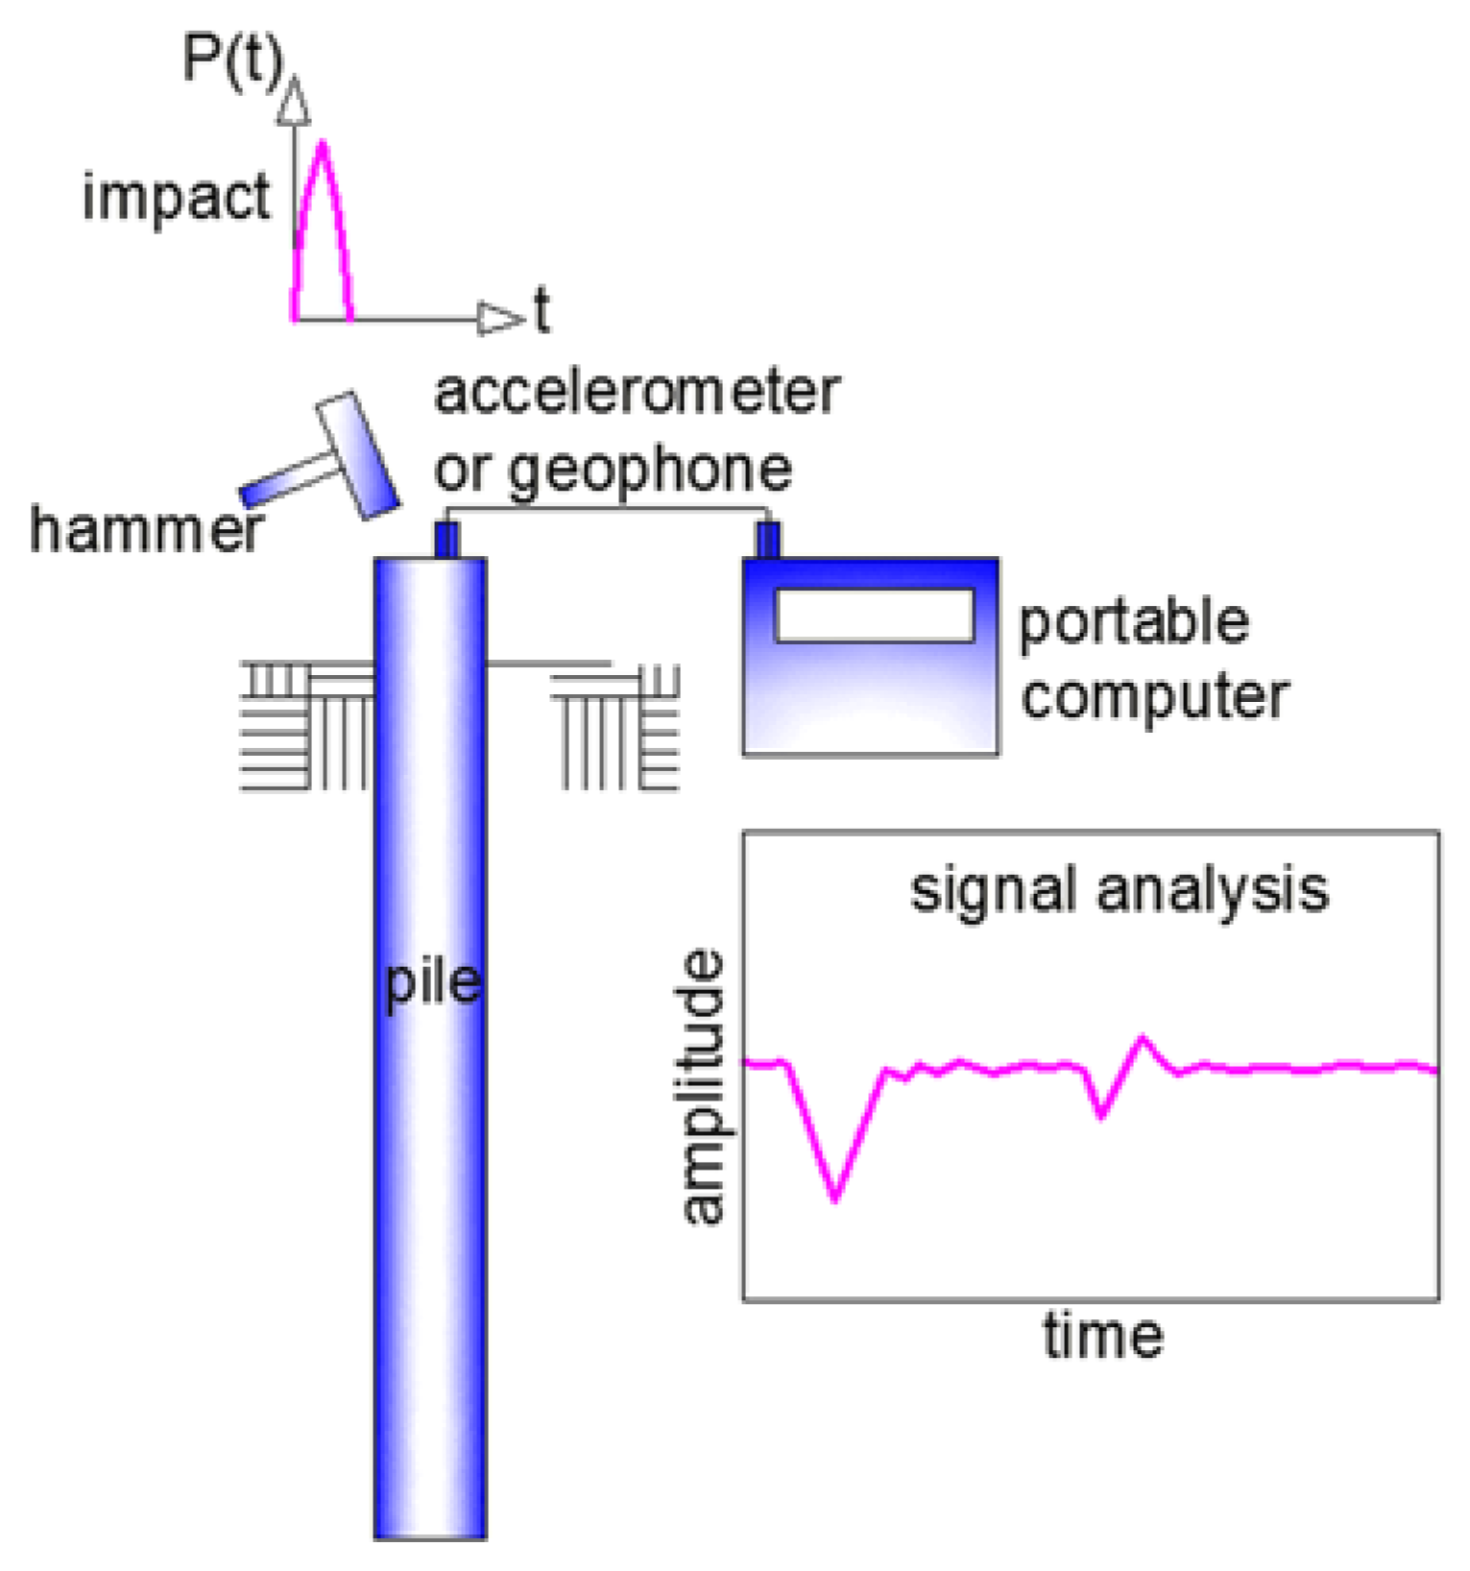
Figure 15. Procedure of pile integrity test [108]

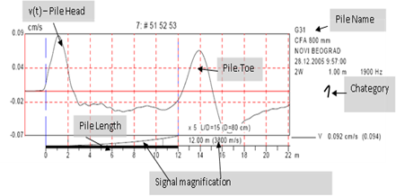
Figure 16. Graphs show dependence amplitude/signal length [108]

Summary of chapter two
The chapter 2 includes the methodology of the experiments conducted at the laboratory and tests on construction site of: "Construction and operation of the united university hospital for 800 beds at NJSC "Astana Medical University" in Nur-Sultan city".
At the laboratory of the LPP “KGS-Astana”, there have been identified the physical and mechanical properties of soils used at the laboratory experiment.
There is a methodology of Static Load Test that estimates the bearing capacity of piles. Load bearing capacity tests were carried out according to the requirements of GOST 5686-2012 “Soils”. Test piles were installed in two different places. First one was driven into the ground where antifreeze reagent had been applied in the wet form. The second pile was installed into frozen soil.
Pile Integrity Test is the modern method which allows to check the continuity of all types of piles and to identify defects in piles. The main requirement of integrity test is to obtain a high-quality signal for interpretation.

Chapter three
3 Experiments for preventing the soil from freezing and driving the piles into the frozen ground in winter and their results
3.1. Experiment with chemical additives
To establish the maximum temperature of the heat generated when interacting with water, laboratory studies were carried out according to the following method: quicklime in the amount of 100 g was poured into a glass chemical dish. Then water at room temperature (t = 20-22 C) was added to the dish with quicklime in the amount of 150 g. To measure the temperature of the heat generated in the center of the glassware, a thermometer was installed to a depth of half the height of the poured quicklime, as shown in Figures 13-14.

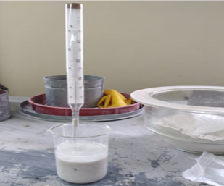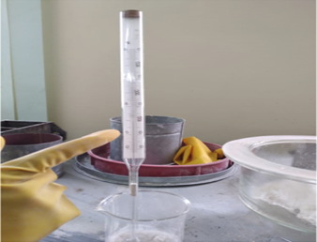

Figure 17. A fragment of measuring the temperature of heat release during the interaction of quicklime with water

Figure 18. Fragment of heat dissipation temperature measurement

As the results of the experiment showed, after the interaction of quicklime with water, a violent reaction was observed with the release of water vapor. It should be noted that the violent reaction did not start immediately, but after 5-7 minutes. At the same time, the heat dissipation temperature began to rise. After 20 minutes, the heat release temperature was 100°C.
This process is explained as follows.
In the process of interaction of not slaked lime with water, the following reaction occurs:
СаО+ Н2О= Са(ОН)₂ + 15,5 ккал., где 1 kcal = 4,1868 · 10³ J.
In this case, the reaction proceeds rapidly, with a large release heat - 15.5 kcal per gram-molecule or 277 kcal per 1 kg of lime.
Water, penetrating into the depths of the lime grains, enters into a chemical interaction with CaO, and the heat released in this case turns the water into a boiling state, which leads to the release of steam. It is this effect of heat release with steam release that is planned to be used for local thawing of seasonally frozen gunt.
Additional use of calcium chloride (CaCl) and sodium chloride (NaCl) as part of a chemical reagent is necessary to further intensify the process of thawing seasonally frozen soil and prevent their refreezing [92-101].
To study the effect of heat release of quicklime when interacting with water in real winter conditions, we prepared a laboratory sample of seasonally frozen soil at an ambient temperature of t = -20 ° C (Figures 15-16).

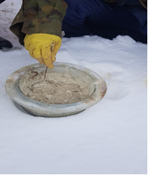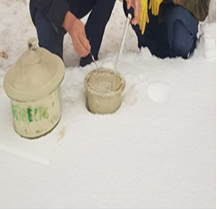

Figure 19. Preparation of a laboratory sample of seasonally frozen soil at ambient temperature t= -20 С
Figure 20. Preparation of samples for experiments
The dimensions of a laboratory sample of seasonally frozen soil are 30 cm in diameter and 20 cm deep.
At the initial stage of the study, chemical reagents were previously prepared based on quicklime of the following composition wt.%: quicklime (CaO) - 82, CaCl - 15, NaCl - 3.0
In order to carry out scientific and experimental work, a chemical reagent based on quicklime with a thickness of 1.0 cm, 2.0 cm and 3.0 cm was poured onto the surface of a laboratory sample of seasonally frozen soil.
To study the depth of thawing depending on the thickness of the filling of the chemical reagent and on time, experiments were carried out for each filling separately in the open air in winter. The outside air temperature was t= -20С. Water at room temperature (t = +22°C) was added to the surface of the chemical reagent.
After the addition of water, the time of the passage of a violent reaction was recorded, and in parallel, the heat release temperature was measured using a thermometer and the depth of thawing of seasonally frozen soil by the pitting method. The interval between measurements was 10 min. (Figure 17-18)

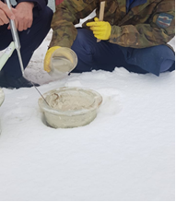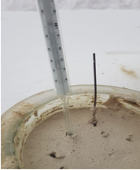

Figure 21. Thawing a laboratory sample of seasonally frozen soil using a chemical reagent based on quicklime
Figure 22. The moment of observation of the temperature of heat release and measurement of the depth of thawing

As the results of scientific and experimental studies show, with a thickness of the backfill of a chemical reagent of 1.0 cm, there is a gradual increase in the depth of thawing of the soil depending on time. After 5 min. the thawing depth was only 1.2 cm. At the same time, the reaction of quicklime is not strongly manifested.
However, the temperature at the defrosting site tends to rise to 100°C despite the low outdoor temperature (t= -20C.)
The most intensive thawing is observed starting from 40 min, where the thawing depth reaches 9.4 cm.
Increasing the thickness of the filling of the chemical reagent up to 2 cm, the intensive start of thawing begins already from 20 min. At the same time, the thawing depth reaches up to 11.6 cm. Further, the thawing process occurs more intensively and after a time of 60 minutes, the thawing depth is 19.3 cm.

Figure 23. Dependence of the depth of thawing of a laboratory sample of seasonally frozen soil on time with the thickness of the layer of backfilling of a chemical reagent based on quicklime with a layer thickness of 1.0 cm
The most intensive thawing of seasonally frozen soil is observed when the thickness of the backfill of the chemical reagent is 3.0 cm. the thawing depth is already 8.2cm.
Further, with an increase in time, an intensive thawing process is observed and after a time of 50 minutes it reaches a maximum mark of 20 cm.

Figure 24. Dependence of the depth of thawing of a laboratory sample of seasonally frozen soil on time with the thickness of the layer of backfilling of a chemical reagent based on quicklime with a layer thickness of 2.0 cm

Figure 25. Dependence of the depth of thawing of a laboratory sample of seasonally frozen soil on time with the thickness of the layer of backfilling of a chemical reagent based on quicklime with a layer thickness of 3.0 cm

3.2 Model test
Laboratory driving piles was conducted in three different boxes. The boxes were made from wood with dimensions of 150 (length) x 70mm (width) x 250 mm (height). The first box was filled up with soil and the second box was filled up with soil with antifreeze reagent on surface. These two boxes were put into the freezer for seven days where the temperature was -30°C. The third box was filled up with soil and kept for seven days at room temperature. The model piles were made from plastic and printed by 3D Printer. The size of piles was 10x10 mm (thickness) x 150 mm (length). The mass of each pile is 12 mg. The density of the plastic is 1.38 g/cm3. Piles were modeled from the piles with sizes 40x40 (thickness) and 600 m (length) in a ratio 1:40 (Figure 2).
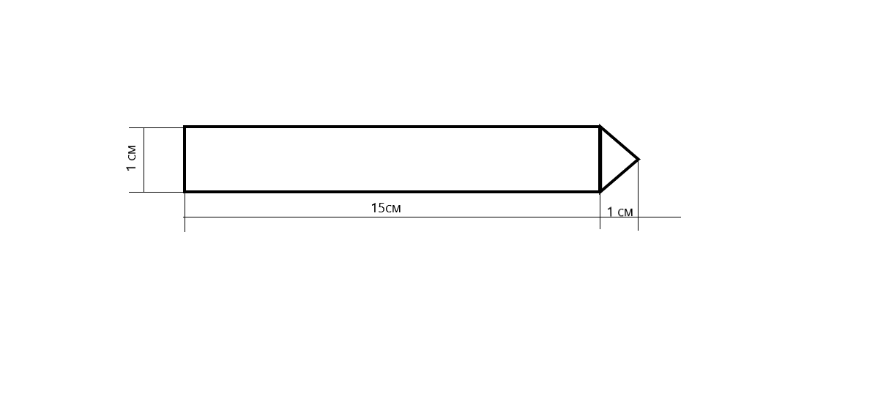
Figure 26. The size of the modeled pile
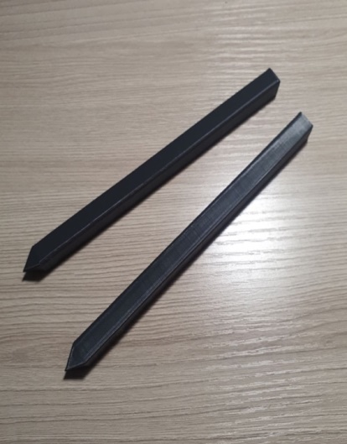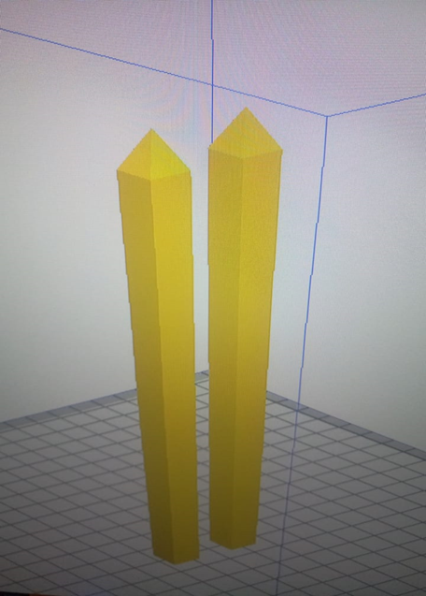

Figure 27. Plastic modeled piles
Figure 28. Process of printing the piles with 3D Printer

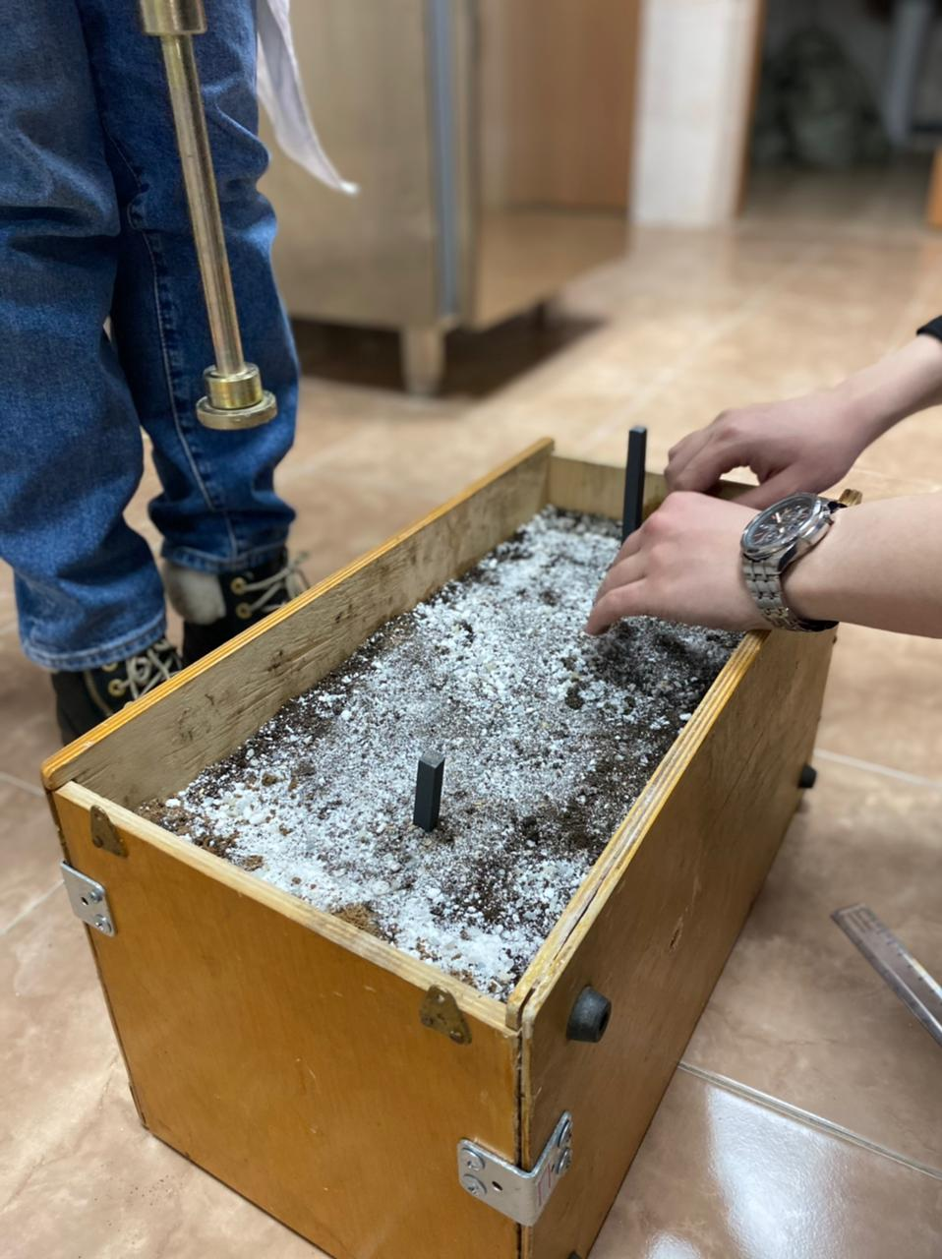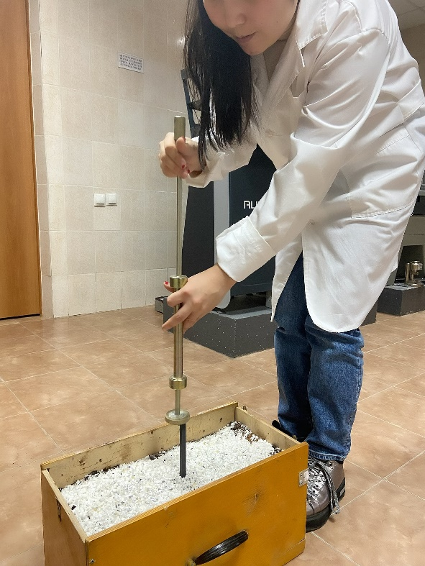

Figure 29. Experiment with modeled piles
Figure 30. Demonstration of driving model pile
The first step to test the antifreeze reagent was the calculation if its consumption. There was a task to calculate the mass of antifreeze reagent needed to prevent the soil freezing. In winter months, the chemical additives are usually used to thaw the ice and snow on roads. The studies [75-76], presents the equation for de-icing the roads by chemical reagents. Authors claim that the main characteristics for calculation of antifreeze reagent are density of soil, concentration of antifreeze reagent, and frozen depth of the ground.
Based on his works and equation, the mass of antifreeze regent needed for soil has been calculated. Since the antifreeze reagent is used on top of the soil, the characteristics of sandy loam has been taken into account.
In order to identify the concentration of reagent, the soil was tested at the refrigerator under different temperature and concentration. The results have been presented in Gibb’s diagram below (Figure 31).
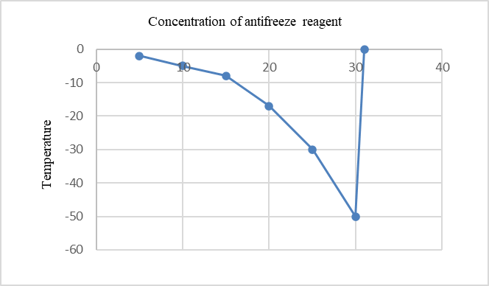
Figure 31. Gibbs diagram for antifreeze reagent [74]
According to the SNiP 2.04-01-2017 (Construction climatology) the average temperature of coldest five days in Nur-Sultan city is -37C. Normative frozen ground depth is 205 cm according to SP RK 2.04-01-2017. From the table it was calculated the mass of water in 1m³ soil, which was equal to 37 kg. It is important to determine the depth of the soil which should be prevented from freezing. In this experiment, the depth was calculated for 10 cm.
The mass of the antifreeze reagent will be equated as below:
$$m_{anti. r.}=\frac{C_{anti.r.}* M_{water}}{100\%-C} (4)$$

$C_{anti.r}=25\% at the temperature-30 C$
$$m_{anti. r.}=\frac{25\%*37 kg}{100\%-25\%}=12.3 kg (5)$$

Locally for each pile with the size of 40x40, the mass of antifreeze reagent will be as follows:
$$0,4*0,4=0,16 m^{2}$$
$$12,3 kg *0,16 m^{2}=1,79 kg$$

Summary of chapter three
In order to establish the maximum temperature of the heat generated from the chemical additives, it has been conducted an experiment at the laboratory. The results have shown that the maximum generated temperature hits 100 C after the interaction of quicklime with water in about 20 minutes and after that a violent reaction was observed with the release of water vapor. The formula of this reaction can be explained as following:
СаО+ Н2О= Са(ОН)2 + 15,5 kcal., where 1 kcal = 4,1868 · 10³ J.
The results of scientific and experimental studies show that when the thickness of the chemical agent filling is 1.0 cm, the depth of soil thawing gradually increases with time. The most intense thawing is observed from 40 minutes, when the thawing depth reaches 9.4 cm.
The results of the model test have shown the effectiveness of the chemical reagents in preventing the soil from freezing. Its effectiveness has been proven at the construction site during the winter with the number of hits.
The installation of two piles using two different ways was nearly identical, demonstrating the efficacy and economics of utilizing antifreeze reagent. The capacity to prevent the soil from freezing and the ease of the process are two distinct advantages of using antifreeze reagent. Many old procedures seek to melt or drill piles. Using antifreeze reagents is both cost effective and ecologically favorable. The suggested soil protection system allows for the high productivity of pumping reinforced concrete piles without the risk of their damage. Furthermore, it is not essential to use larger hammers to strike the piles on frozen soils.

CHAPTER FOUR
4 Results of laboratory and construction site experiments
4.1 Results of laboratory experiment
The first and second box were kept and had been monitored for 2 weeks in the freezing camera. The soil in the second box was unfrozen. The reagent has prevented the soil from freezing. The plastic pile was easily driven by the hummer in 13 hits (Figure 32).
Moreover, the piles were tested for static load test in the freezing camera under different load conditions and in constant loads (increasing in steps). The ruler was used to measure the settlements of the pile. As for loads, the dumbbells were used with different weights of 1 kg, 2 kg, 4kg, 5 kg, 6 kg, and 8 kg. The pile in the second box has started to settle from 4 kg for 0,1 mm, results of model static load test can be seen in Figure 34.
The third box which kept for room temperature +18 C also was tested for static load test. The pile was fully driven in 8 hits by hummer (Figure 33). The pile under 8 kg was totally went into the soil (Figure 35).
The first box which has no antifreeze reagent on surface was fully frozen. The pile could not be driven after 100 hits and even after boring the place of model pile for 5 cm. The head of the plastic pile was damaged by a lot of hits.

Figure 32. The results of pile driving in the second box

Figure 33. The settlement of pile in the third box

Figure 34. The settlement of pile in the second box

Figure 35. The settlement of pile in the third box

4.2 Results of site experiment
At the construction site, the method of doing experiment a little different as the soil ground was already frozen and covered by snow. The outdoor temperature was -25°C. The antifreeze reagent was put locally in places of two piles. The aim of this experiment is to see the effect of antifreeze reagent whether it thaws the already frozen soil. After putting the reagent, the places of piles were constantly monitored. At the first day of experiment, it has been noticed that the snow on the surface of the soil was fully melted. At the third day, the depth of thawing soil reached 3 cm (Figure 36).
It has been decided to drive one of the piles without drilling and the second one into the already predrilled hole. The differences in installation were defined by the number of blows of the hammer. The number of blows on a place where antifreeze reagent was applied was 200 hits, while the pile on drilled place was driven in 198 hits. Even if the method of driving those two piles was different, the number of hits in installation was almost similar that showed the effectiveness and profitability of using antifreeze reagent. Based on the test results, the antifreeze reagent has shown its effectiveness in protecting the soil in winter. The distinctive aspect of using the antifreeze reagent is the ability of protecting the soil from freezing and simplicity of the method. Many traditional methods are directed to thawing or drilling the places of the piles. From the economic perspective, the method is cost-effective and environmentally friendly. Implementation of the proposed method of protecting the soil provides the potential for high productivity driving of reinforced concrete piles without the risk of their destruction. At the same time, there is no need to use more powerful hammers for driving piles in frozen soils.
Moreover, based on the studies, the equation of calculating the mass of antifreeze reagent has been created. Since the consumption of the reagent depends on density and frozen depth of the soil, it is possible of using less reagent in other regions of Kazakhstan where the winter is not as cold and aggressive.

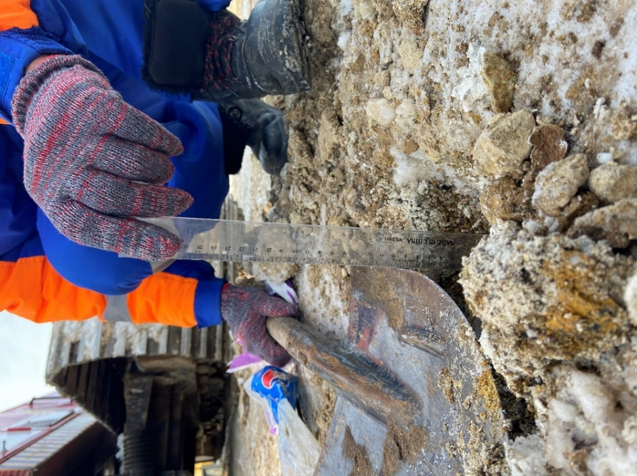
Figure 36. Measuring the thawed depth
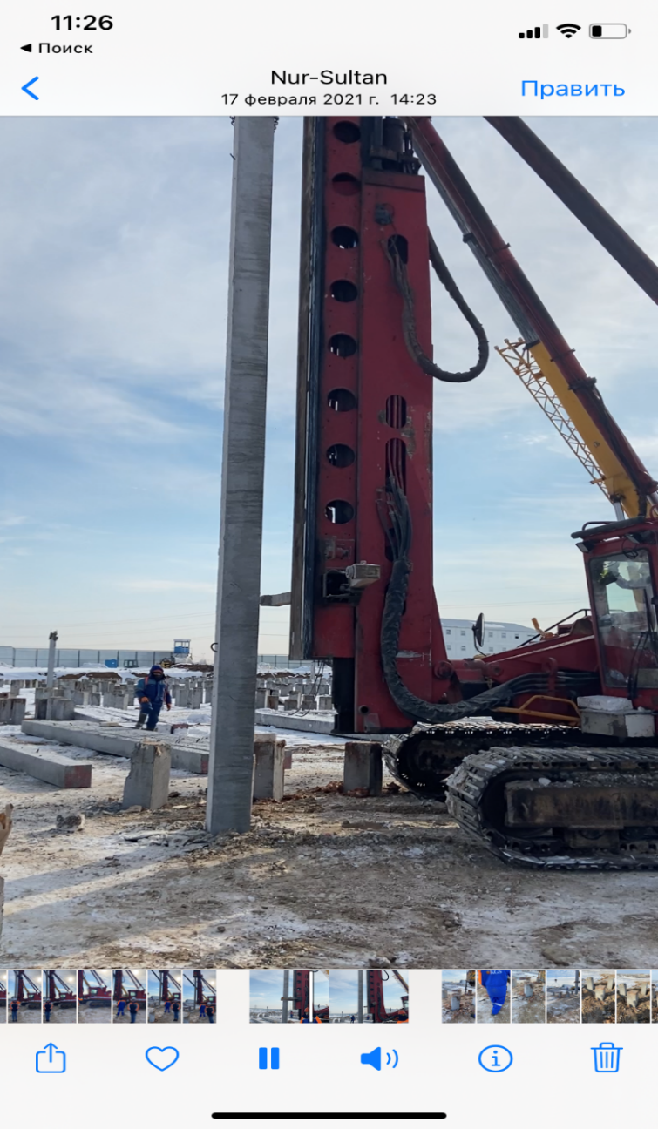
Figure 37. Driving the pile into the frozen ground
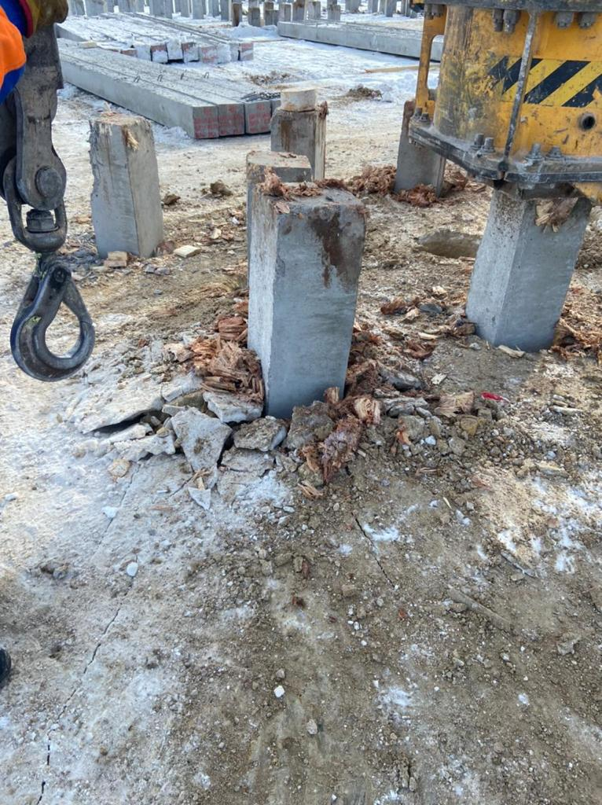
Figure 38. Pile installation without predrilled boring

4.3 Results of static load tests using different methods of soil thawing
A static load test (SLT) was performed on two piles. The first pile was in sawdust. Sawdust is used as an artificial soil while testing the piles in winter. The second pile was protected with antifreeze reagent. The results of SLT using sawdust at the fixed settlement 5.5 mm attained a maximum load 520 kN. The results of SLT using an antifreeze reagent at the fixed settlement of 5.5 mm, attained a maximum load 670 kN (Figure 5). These results are explained by the fact that sawdust decreases the adhesion of the soil to the pile. Consequently, the bearing capacity drops. The antifreeze reagent, on the other hand, helps to thaw the frozen soil and protects the soil from freezing in its natural form.

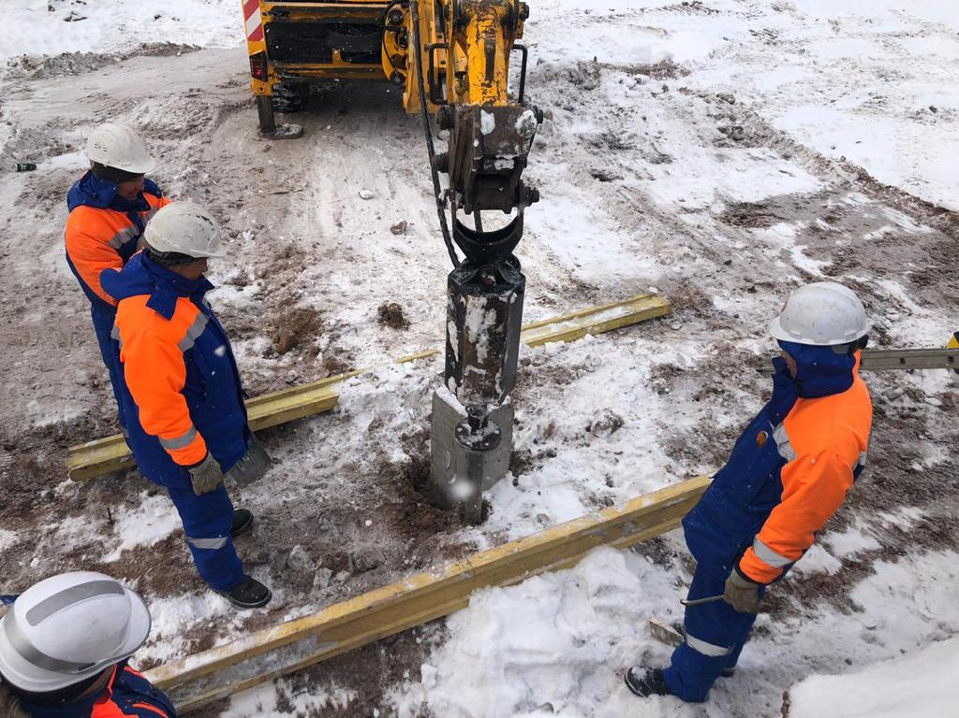
Figure 39. Preparation work for SLT test
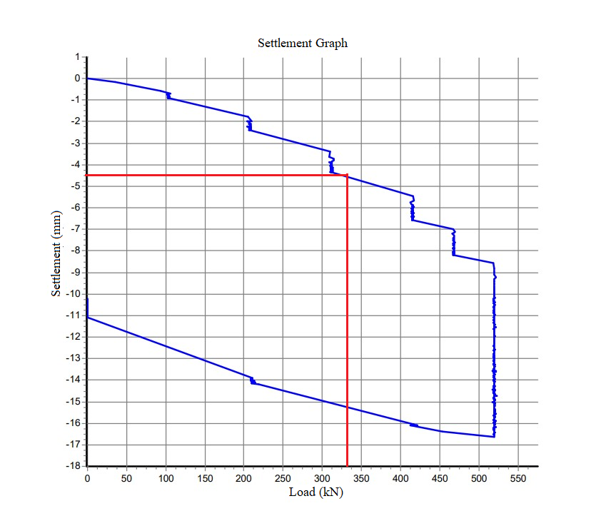
Figure 40. Static Load Test results in frozen ground
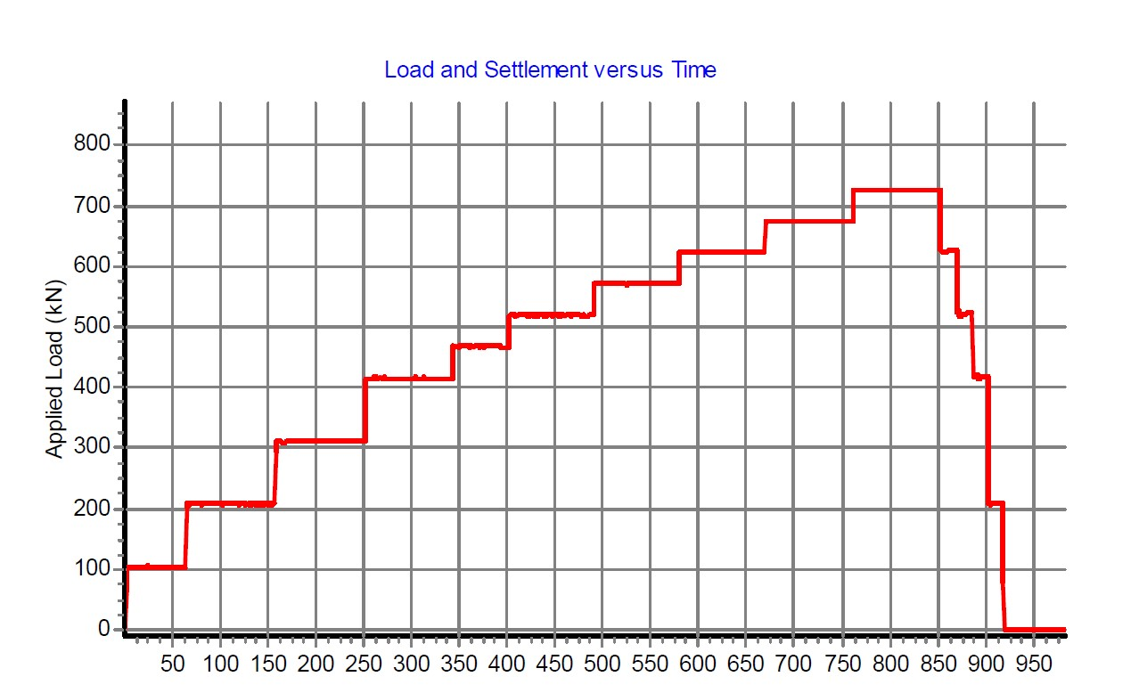
Figure 41. Static Load Test results in frozen ground

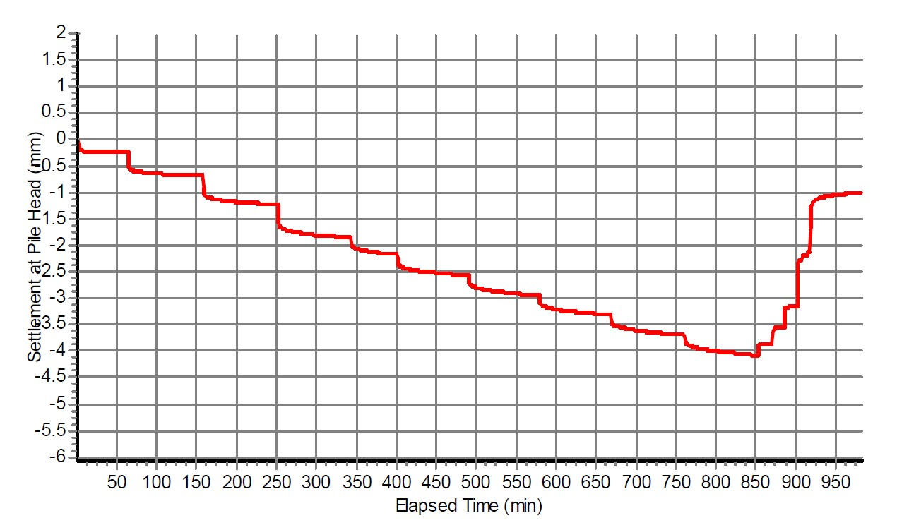
Figure 42. Static Load Test results in frozen ground
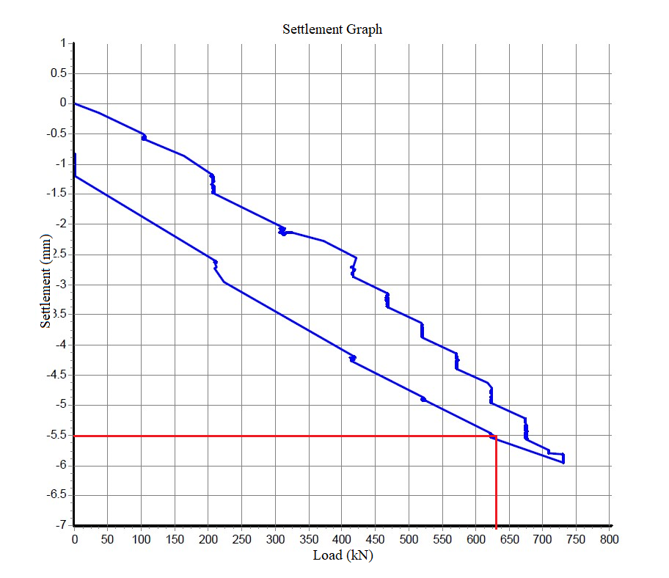
Figure 43. Static Load Test results in soils with chemical additives
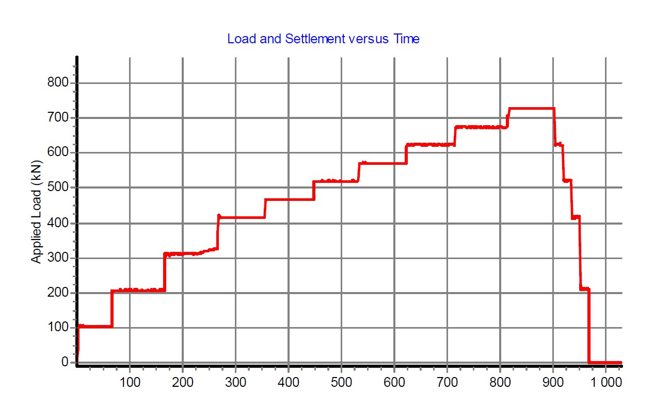
Figure 44. Static Load Test results in soils with chemical additives

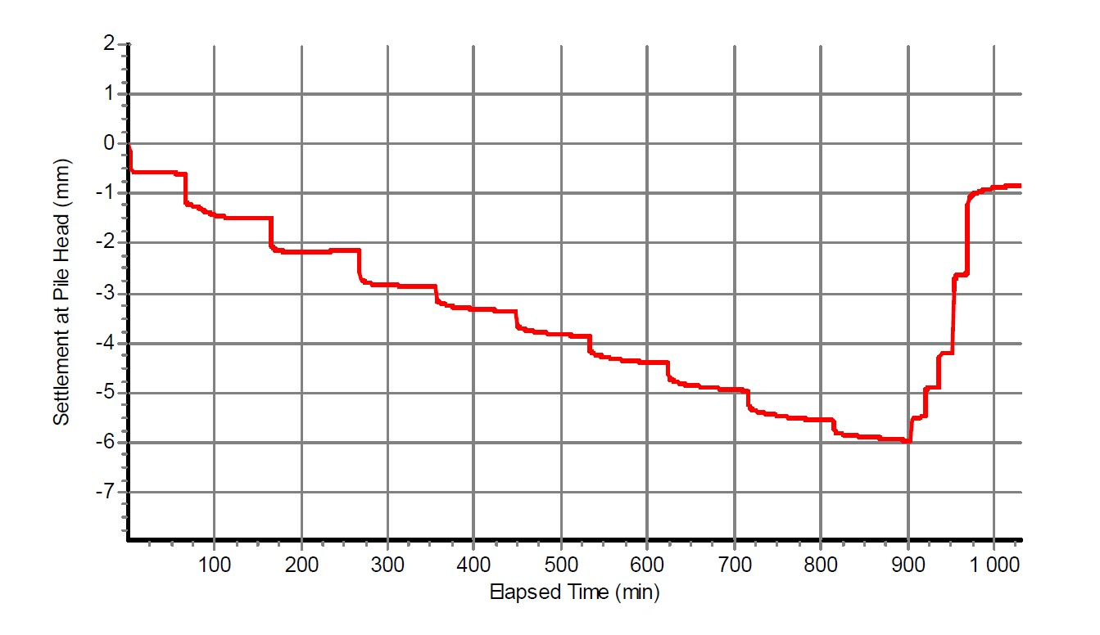
Figure 45. Static Load Test results in soils with chemical additives

4.4 Pile Integrity test results (PIT)
PIT is the most effective method for a qualitative assessment of bearing capacity of a pile in case of the possibility of its defects during the performance of work. PIT is considered as a non-destructive method for monitoring the continuity of composite piles that reveals pile defects that can reduce bearing capacity.
Pile integrity test has been conducted after driving the piles into the thawed ground by chemical additives. As the results have shown, in the pile which was driven without any bored holes and additional works there were not any cracks and problems in the structure of pile. The results of the PIT are given in the Figure 46.
To see some comparative analysis, the integrity test has been done in the pile which was driven into the frozen ground with predrilled holes. The results of the are shown in the Figure 47.

Figure 46. The results of the PIT of pile 54
Figure 47. The results of the PIT of pile 46

Summary of chapter four
The chapter three includes the results of this research from its main experiments at the laboratory and construction site.
To get some comparative analysis there has been conducted another experiment-static load test using sawdust and antifreeze reagent that was proposed in this research. These results are explained by the fact that the sawdust reduces the adhesion of the soil to the pile. Consequently, the carrying capacity decreases. The antifreeze reagent, on the other hand, helps to thaw frozen soil and prevents the soil from naturally solidifying.
To prove that using antifreeze reagent is safe and helps to prevent pile destruction in its structure there has been carried out a pile integrity test. The results of the pile integrity test have presented that there was not any cracks and destruction in the structure of piles.
Also, during the testing the method of using chemical reagents, there have been invented the way of distribution performance of those reagents. Manual distribution of chemical reagents has been recommended. Chemical reagent dispensers should be provided with gloves, chemical reagent containers and masks to prevent chemical reagent particles from entering the nose.

CHAPTER FIVE
5.1 Savings in budget
To compare the economic effect of the chemical reagent developed by us with bored work associated with pile driving per 1 m2 of the construction site area (table 1-9).
The consumption rate of antifreeze material was calculated according to the developed calculation algorithm based on the graphical-analytical method of fusibility diagrams for melting 100%, 60% and 20% frozen soil, 30 mm deep. Air temperature -25 0С. The calculation of the consumption rate of the chemical reagent is given in the appendix.
The cost of anti-icing chemicals: 1 kg = 500 tenge/t. (price is for Nur-Sultan city).
For the preparation of local estimates, the following composition of works and mechanisms was adopted (Table 1-3)
Table 5. Estimation for predrilling works in winter
№ | Type of work | Unit | Calculation |  | Total price  (KZT)
№ | Type of work | Unit | Volume of work | Price  (KZT) | Total price  (KZT)
1 | Drilling works with a volume of 10 running meters, 3 wells up to 2 m deep. | meter | 3 | 1309 | 3927
2 | Internal transport |  | 1 | 30000 | 30 000
3 | Equipment mobilization |  | 1 | 400 000 | 400 000
4 | Organization and liquidation of works |  | 1 | 350 000 | 350 000
 | Total: |  |  |  | 783 927
 | Total with winter coefficient: |  | 1.1 |  | 862 320
 | VAT 12% |  |  |  | 103 478
 | Estimated total: |  |  |  | 965 798

Table 6. Estimation for using chemical additives
№ | Type of work | Unit | Calculation |  | Total price
№ | Type of work | Unit | Volume of work | Price | Total price
1 | Backfilling of a chemical reagent | meter | 3 | 500 | 1500
2 | Сhemical reagent | kg | 10 | 500 | 5000
2 | Internal transport |  | 1 | 5000 | 5000
3 | Organization and liquidation of works |  | 1 | 100 000 | 100 000
 | Total: |  |  |  | 111 500
 | Total with winter coefficient: |  | 1.1 |  | 122 650
 | VAT 12% |  |  |  | 14 718
 | Estimated total: |  |  |  | 137 368

As the tables of estimation have shown, it has been found that using chemical reagents to prevent the freezing or thawing the frozen ground can be cheaper for about 85% than the predrilled method of pile installation.
5.2 Sustainability
Considering the climate change impacts, it is important to support the sustainability of environmental, social and economic domains by reducing waste and using less resources during the operations of constriction. Using reagent can be an innovative idea in building a sustainable future by reducing carbon emissions and have less negative impact on the environment.
Nowadays, energy use of construction industry is still considered very high. All the heavy machines that are used in construction still depend on fossil fuels. It is important to note that not always the machines and electricity are used efficiently which leads to an unnecessary burning of fossil fuels. According to the statistics, the worldwide energy usage of construction industry accounts for 36% whereas the production of CO2 emissions accounts for 40%.

5.3 The effect of chemical reagent to the environment
Chemical reagents, as well as composite materials, help to prevent soil freezing in winter in order to easily and quickly drive piles. Unfortunately, it is important to consider their negative impact on the environment, since the reagents can penetrate groundwater through the soil. Their penetration through the soil leads to direct destruction of plant tissue as the studies have shown [90].
Moreover, some studies claim that an increased content of chlorine ions in the composition of snow enters underground and groundwater and thereby reduces the taste of drinking sources [91].
Sodium and calcium chloride destroy cement concrete coatings. But studies show that the negative impact of sodium chloride and calcium chloride is much less than magnesium chloride. Our proposed reagent does not contain magnesium chloride.
Reducing water and soil pollution is possible if chemical reagents are used not to completely melt snow-ice formations (emergency method), but to prevent the formation of deposits (preventive method), or only loosening followed by the use of mechanical cleaning agents.
Our proposed method of pile driving using a chemical reagent, when used locally and only in the places of pile driving, does not pose a threat to the environment, since the chemical agent is used only once, while on the anti-slippery road it is used every year.

5.3 Distribution performance of anti-frosty additives
While the de-icing additives on road surface is carried out by special distributor vehicles for solid, liquid and wet anti-icing materials, the anti-frosty additives to prevent and thaw the frozen ground is carried out by workers at the construction site. As this method of preventing soil from freezing is considered as a new method, there is no ant mechanized machines which can distribute the chemical reagents on construction site. From the perspective of economy, it is recommended to distribute the chemical reagents by hand. Workers who distribute the chemical reagents should be equipped with gloves, containers for chemical reagents and masks to avoid getting the particles of the chemical reagents into the nose. In the following figures are shown how to distribute the wet and dry method of using chemical additives.

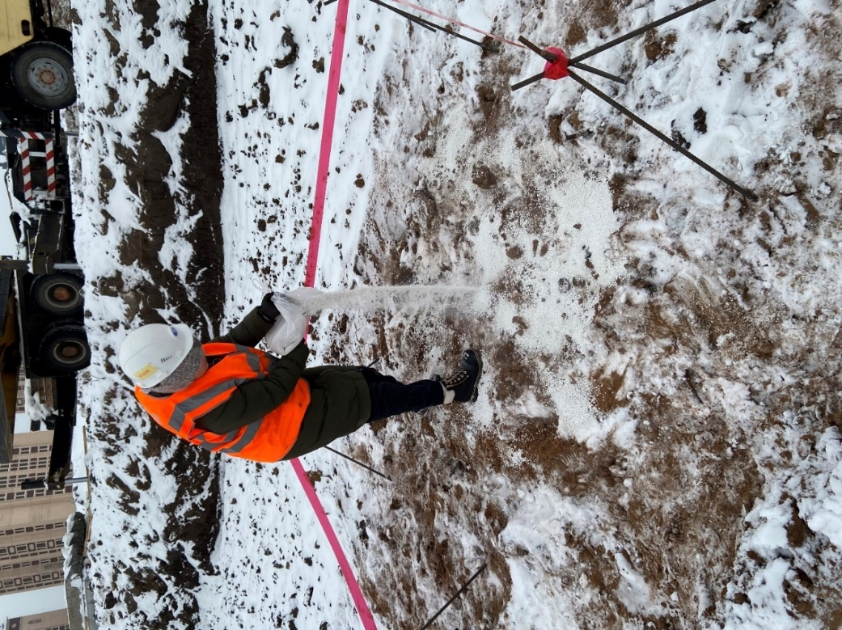
Figure 48. Distribution of chemical reagent in dry method
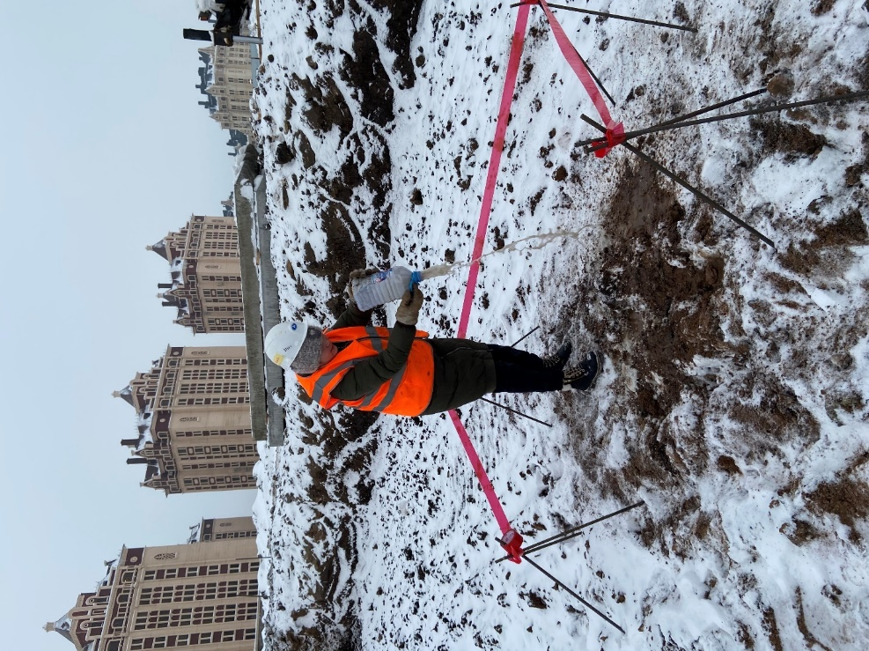
Figure 49. Distribution of chemical reagent in wet method
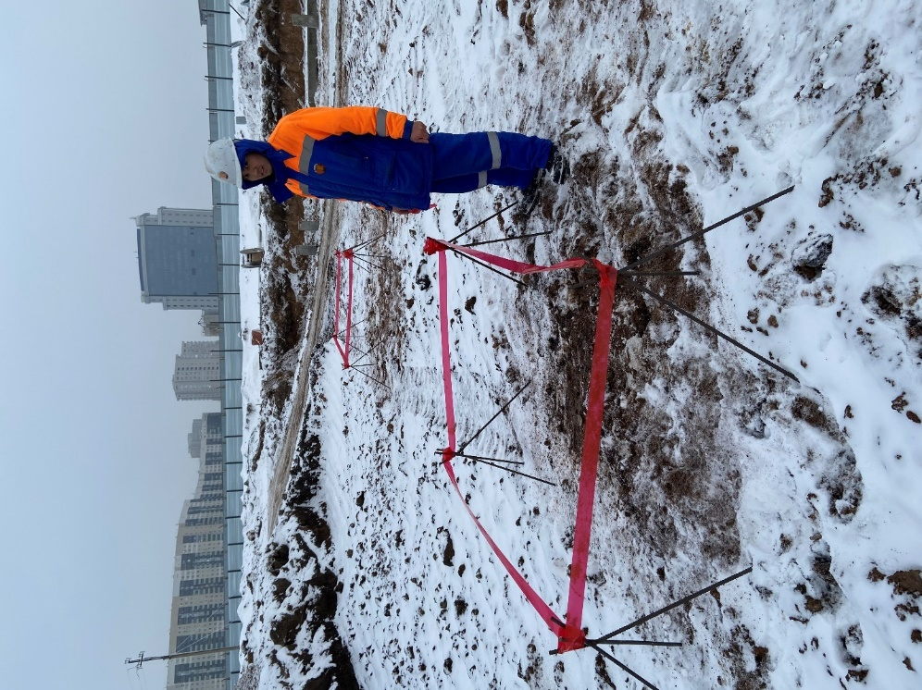
Figure 50. The places where chemical reagent was spread
Summary of chapter five
The chapter 4 includes the estimate calculation of using chemical additives in comparison with drilling works.
The cost of antifreeze reagent in Nur-Sultan city currently is 500 tenge per kilogram, while the predrilling works for one pile costs 3927 tenge not including the equipment mobilization. The use of chemical additives to freeze or thaw frozen soils can be 85% cheaper than the pre-drilling method of pile installation.
The use of reagents can be an innovative idea in creating a sustainable future by reducing carbon emissions and reducing the negative impact on the environment. All heavy machinery used in construction is still dependent on fossil fuels. It is important to note that machines and electricity are not always used efficiently, which leads to unnecessary burning of fossil fuels. According to statistics, the construction industry uses 36% of the world's energy and 40% of CO2 emissions. The use of reagents can be an innovative idea in creating a sustainable future by reducing carbon emissions and reducing the negative impact on the environment.
Our proposed method of piling- using a chemical reagent does not affect the environment when used locally only in piling sites, the chemical agent is used only once. Moreover, the reagents do not contain magnesium chloride which is more harmful than sodium chloride and calcium chloride.

Conclusions
1. The possibility of using the antifreeze reagent to eliminate frozen soil during the installation of driven piles during winter in the city of Nur-Sultan, Kazakhstan;
2. Simple methods have been proposed that are easily carried out in the field and do not require significant labor and financial costs;
3. It has been found the use of the wet method is the most effective when the outdoor temperature more than - 20 C, since this method provides deeper thawing of soil;
4. It has been found if the depth of frozen soil is no more than 50 cm, it is possible using the dry method of reagent, which does not require the preparation of a special aqueous solution;
5. Implementation of the proposed method of thawing frozen soil provides the potential for high productivity driving of reinforced concrete piles without the risk of their destruction. At the same time, there is no need to use more powerful (and thus more expensive) hammers for driving piles in frozen soils.
6. It has been established that the static load test, used in conjunction with antifreeze reagent, helps to obtain bearing capacity data during winter that is more accurate than without the reagent.
7. It has been identified that during the static load test, antifreeze reagent on frozen soil decreases its compressibility. This phenomenon is very important for pile installation in winter.
8. A new composition of a chemical reagent based on quicklime has been developed for local thawing and protection against freezing of seasonally frozen clay soil in places where pile foundations are driven. The proposed chemical reagent has the following composition wt.%: quicklime (CaO) - 82, CaCl - 15, NaCl - 3.0;
9. A distinctive feature of the proposed composition of the chemical reagent is that for local thawing of seasonally frozen clay soil, spontaneously generated heat of quicklime is used when interacting with water. Under laboratory conditions, it has been established that the heat released as a result of the chemical reaction of quicklime reaches up to 100 ° C, despite the negative temperature of the outside air (t = -20 ° C);
10. Under laboratory conditions, scientific and experimental studies of the process of thawing a laboratory sample of seasonally frozen clay soil were carried out using the developed composition of a chemical reagent based on quicklime. At the same time, the main regularities of the change in the depth of thawing depending on the thickness of the backfill and time were studied at an ambient temperature of t = -20 ° C;
11. It has been established that the intensity of thawing of a laboratory sample of seasonally frozen soil depends on the thickness of the filling of a chemical reagent based on quicklime. In this case, the most intensive and relatively fast thawing is observed at a thickness of the filling of the chemical reagent of 3.0 cm.
12. The developed composition of a chemical reagent based on quicklime has advantages in terms of reducing energy costs for thawing seasonally frozen soil, since when interacting with water, the proposed chemical reagent spontaneously releases heat (t = 100 ° C;) and does not cool down for a long time despite the negative outdoor temperature. And the content of CaCl and NaCl in the composition excludes the re-freezing of clayey seasonally frozen soil.

References
- Strategy 2050. Review and Analytical Portal. URL: https://strategy2050.kz/ru/news/stroitelnaya-otrasl-rk-obemy-mestnoe-soderzhanie-i-tsifrovizatsiya/?ysclid=l3trtgg7ix
- Nugmanova, А., Teltayev B. Measured temperature and moisture distribution in the subgrade of the “Almaty-Bishkek” highway, Proceedings of the 8th Asian Young Geotechnical Engineers Conference, Astana, Kazakhstan, 2016, pp. 57-60
- Teltayev B., Suppes E. Regularities for temperature variation in subgrade of highway. Geomechanics and Engineering, Vol. 13, No. 5 (2017) р. 793-807
- Andersland, O.B., Ladanyi, B. (1994). Frozen Ground. In: An Introduction to Frozen Ground Engineering. Springer, Boston, MA. https://doi.org/10.1007/978-1-4757-2290-1_1
- Andersland, O.B., Ladanyi, B. (1994). Heat Flow in Soils. In: An Introduction to Frozen Ground Engineering. Springer, Boston, MA. https://doi.org/10.1007/978-1-4757-2290-1_
- Scott, R. F. 1964. Heat Exchange at the Ground Surface. U.S. Army Cold Reg. Res. Eng. Lab. Monogr. II-A1.
- Andersland, O.B., Ladanyi, B. (1994). Thaw Behavior of Frozen Ground. In: An Introduction to Frozen Ground Engineering. Springer, Boston, MA. https://doi.org/10.1007/978-1-4757-2290-1_4
- Edlefsen, N.E., and Anderson, A.B.C. 1943. Thermodynamics of soil moisture, Hilgardia, 15(2): 31-298
- Zhou, X., J. Zhou, W. Kinzelbach, and F. Stauffer (2014), Simultaneous measurement of unfrozen water content and ice content in frozen soil using gamma ray attenuation and TDR, Water Resour. Res., 50, 9630–9655, doi:10.1002/2014WR015640.
- Beskow, G. 1947. Soil freezing and frost heaving with special applications to roads and railroads. In Historical perspective in frost heave research — the early works of S. Taber and G. Beskow. Edited by P.B. Black and M.J. Hardenberg. 1991. US Army Corps of Engineers Cold Regions Research and Engineering Laboratory, Hannover, N.H. pp. 37–157
- Koopmans, R.W.R. and R. D. Miller. “Soil Freezing and Soil Water Characteristic Curves.” Soil Science Society of America Journal 30 (1966): 680-685.
- Mousong W. (2016). Coupled processes in seasonally frozen soils: Merging experiments and simulations. 10.13140/RG.2.1.4667.1760.
- Vaziri H. and Han Y., "Full-scale field studies of the dynamic response of piles embedded in partially frozen soils", Canadian Geotechnical Journal, vol. 28, pp. 708-718, 1991.
- Xing Z., He D., Wang H., Ye Z. and S. Yang, "Study on soil mechanics and frost resistance of fly ash- metakaolin geopolymer", Arabian Journal of Geosciences, vol. 13, no. 18, article number 963, 2020.
- Xiao F., Chen G. S., Hulsey J.L., Davis D. and Yang Z., "Characterization of the viscoelastic effects of thawed frozen soil on pile by measurement of free response", Cold Regions Science and Technology, vol. 145, pp. 229-236, 2018.
- Yang Z. J., Zhang X. R., Yang R., Zhou X. and Niu F. "Shake table modeling of pile foundation performance in laterally spreading frozen ground crust overlying liquefiable soils", Journal of Cold Regions Engineering, vol. 32, no. 4, article number 04018012, 2018.
- Crowther G. S., "Lateral pile analysis frozen soil strength criteria", Journal of Cold Regions Engineering, vol. 29, no. 2, article number 04014011, 2015.
- Wotherspoon L. M., Sritharan S. and Pender M. J., "Modelling the response of cyclically loaded bridge columns embedded in warm and seasonally frozen soils", Engineering Structures, vol. 32, no. 4, pp. 933- 943, 2010.
- Weaver J. S. and Morgenstern N. R., "Pile design in permafrost", Canadian Geotechnical Journal, vol.18, no. 3, pp. 357-370, 1981.
- Velli Y. Y. and Karpunia A. A. Saline permafrost as bearing ground for construction, Washington: National Academy of Sciences, 1973.
- Yang Zh. H. J., Li Q., Marx E. E. and Lu J. Ch. "Seasonally frozen soil effects on the dynamic behavior of highway bridges", Sciences in Cold and Arid Regions, vol. 4, no. 1, pp. 13-20, 2012.
- Andersland O. B. and Ladanyi B. Frozen ground engineering, New York: John Wiley & Sons, 2004.
- Arenson L. U., Springman S. M. and Sego D. C. "The rheology of frozen soils", Applied Rheology, vol.17, pp. 1-14, 2007.
- Ogata N., Yasuda M. and Kataoka T., "Effects of salt concentration on strength and creep behavior of artificially frozen soils", Cold Regions Science and Technology, vol. 8, pp. 139-153, 1983.
- Thawing frozen soil. [Website]. 2022. URL: https://heatwork.com/en/products/thawing-frozen-soil/
- Junttan respecting ground: piling applications. URL: https://junttan.com/piling-specialist/piling-applications/
- Буровзрывные и свайные работы. URL: https://perekos.net/sections/view/65
- RS Trade. URL:https://www.rstradehouse.com/item?id=100210127588
- Junttan respecting ground: piling applications. URL: https://junttan.com/piling-specialist/piling-applications/
- Verstov V., Serebrennikov A., Khritankovi V. Effective modes of driving piles into seasonally frozen Soil. IOP Conf. Series: Materials Science and Engineering 953 (2020) 012032.
- Li N., Xu B. 2008 A new type of pile used in frozen soil foundation, Cold Regions Science and Technology 53(3) 355-368.
- Zhussupbekov A., Shin E.C., Shakhmov Z., Tleulenova G. Experimental study of model pilefoundations in seasonally freezing soil ground, International Journal of GEOMATE, Nov. -2018. - vol. 15, issue 51. -pp 85-90. DOI: 10 21660/2018 51 90835.
- Sritharan S., Suleiman M.T., White D.J. Effects of seasonal freezing on bridge column-foundation soil interaction and their implications. Earthq Spectra. -2007. vol. 23(1). -p. 199 -222.
- Zhou Y. and Zhang J., “A Novel Visualization Apparatus for Freezing Soils and Its Application in Freezing-Thawing Test,” Chinese Journal of Rock Mechanics and Engineering, vol. 39, no. 8, pp. 1671-1681, 2020.
- Loli M., Tsatsis A., Kourkoulis R. and Anastasopoulos I., “A Simplified Numerical Method to Simulate the Thawing of Frozen Soil,” Proceedings of the Institution of Civil Engineers: Geotechnical Engineering, vol. 173, no. 5, pp. 408-427, 2020.
- Verstov V. V., Gaido A. N. and Egorova N. A., “Features of Immersion of Piles in Frozen Soils,” Young Scientist, vol. 20, no. 206, pp. 135-138, 2018.
- Fei W., Yang Z. J. and Sun T., “Ground Freezing Impact on Laterally Loaded Pile Foundations Considering Strain Rate Effect,” Cold Regions Science and Technology, vol. 157, pp. 53-63, 2019.
- De Moel M., Bach P. M., Bouazza A., Singh R. M. and Sun J. O., “Technological Advances and Applications of Geothermal Energy Pile Foundations and Their Feasibility in Australia,” Renewable and Sustainable Energy Reviews, vol. 14, no. 9, pp. 2683-2696, 2010.
- Chen K., Q. - H. Yu, L. Guo and Z. Wen, “Artificial Cooling of Cast-in-Place Piles in Permafrost Regions,” China Journal of Highway and Transport, vol. 33, no. 9, pp. 104-114, 2020.
- Shang Y., Niu F., Wu X. and Liu M., “A Novel Refrigerant System to Reduce Refreezing Time of Cast-in-Place Pile Foundation in Permafrost Regions,” Applied Thermal Engineering, vol. 128, pp. 1151-1158, 2018.
- Litvinovich A., “The History of Soil Liming,” Agrophysics, vol. 2, no. 14, pp. 45-51, 2014.
- Yakushev V. P., Osipov A. I., Minnulin R. M. and Voskresensky S. V., “On the Issue of Liming Acidic Soils in Russia,” Agrophysics, vol. 2, no. 10, pp. 18-22, 2013.
- Samedov A. M. and Tkach D. V., “Strengthening Waterlogged Clayey Soils with Ground Quicklime or Burnt Magnesia,” Bulletin of the Tula State University. Earth Sciences, vol. 2, pp. 162-170, 2012.
- Shilnikov I. A., “Brief Results and Tasks of Scientific Research on the Problem of Soil Liming in the Russian Federation,” in I.A. Shilnikova, N.I. Akanova (Eds.), Soil Liming Issues, Agrokonsalt, Moscow, Russian Federation, pp. 4-8, 2002.
- Shilnikov I. A. and Lebedeva L. A., Soil liming, Moscow: Agropromizdat, 1987.
- Vaziri H., Han Y. Full-scale field studies of the dynamic response of piles embedded in partially frozen soils. Canadian Geotechnical Journal, -1991. -vol. 28, -p. 708-718.
- Tahir K. Rehabilitation Techniques to Address Frost Effects on Pile Foundations of Solar Power Generation Facilities in North America. International Journal of Applied Engineering Research ISSN 0973-4562. -2018. -Vol. 13, No. 10. -pp. 7333-7339.
- Blinov D. G., Prokopov V. G., Sherenkovskii Yu. V., Fialko N. M., and Yurchuk V. L., “Effective Method for Construction of Low-Dimensional Models for Heat Transfer Process,” International Journal of Heat and Mass Transfer, vol. 47, no. 26, pp. 5823-5828, 2004.
- Zhongyan Sh., Lina M. and Yongzhi L., “Some Tensile Creep Characteristics of Frozen Loess, Journal of Glaciology and Geocryology, vol.17, No.2, 1995
- Wei M., Ziwang W., Xiaoxiao C. et al., ‘Analysis of Microstructura1 Changes in Frozen Sandy Soil Undw Conjning Pressures Using Scanning Electron Microscope” Journal of Glaciology and Geocryology, vol.17, No.2, 1995
- Willis, W.O., Carlson, C.W., Alessi, J. & Hass, H.J. 1961. Depth of freezing and spring runoff as related to fall soilmoisture level. Soil Sciences Society of America Journal, 41: 115–123.
- Zhang, T., Heginbottom, J.A., Barry, R.G. & Brown, J. 2000. Further statistics on the distribution of permafrost and ground-ice in the Northern Hemisphere. Polar Geography, 24: 126–131
- Zhang, T., Barry, R.G., Gilichinsky, D., Bykhovets, S.S., Sorokovikov, V.A. & Ye, Jingping. 2001. An amplified signal of climatic change in soil temperatures during the last century at Irkutsk, Russia. Climatic Change, 49: 41–76
- Skogland, T., Lomeland, S. & Goksoyr, J. 1988. Respiratory burst after freezing and thawing of soil: experiments with soil bacteria. Soil Biol. Biochem., 20: 851–856.
- Zhang, T. & Armstrong, R.L. 2001. Soil freeze/thaw cycles over snow-free land detected by passive microwave remote sensing. Geophysical Research Letters, 28(5): 763–766.
- Cary, J.W., Davis, K.J. & Papendick, R.I. 1978. Is the soil frozen? An algorithm using weather records. Water Resources Research, 14: 1117–1122
- Tsytovlch, N.A. On unfrozen water in soils. Izv. AN SSSR, ser. geol., 1947, No. 3.
- Tsytovich, N.A. Soil mechanics. 3rd ed. Moscow-Leningrad, Gosstroiizdat, 1951.
- Tsytovich, N.A. Principles of the mechanics of frozen soils. Izd-vo AN SSSR, 1952.
- Zakharov A. E. The study of temperature fields in frozen soils in contact with hardening mortar layers. Scientific conf. (Saint Petersburg State University of Architecture and Civil Engineering), 2001.
- Nevzorov A. L., Krieger E. V., Sakharov I. I., Zakharov A. E., Paramonov V. N., and Kudryavtsev S.A. Assessment of soil deformation associated with freezing and thawing. Foundations and Foundations: Theory and Practice. Interuniversity thematic proceedings. pp 34-140, 2004.
- Guidance on the technology of physico-chemical strengthening of freezing and thawing soils. 1977. Stroyizdat (Moscow).
- Zoran B, Gordana T, Ćurčić N D, and Jelena S 2015 Damage of Concrete and Reinforcement of Reinforced-Concrete Foundations Caused by Environmental Effects Procedia Engineering. 117 pp 411-418
- Wenping F, Zhaohui J. Y., and Tiecheng S., Ground freezing impact on laterally loaded pile foundations considering strain rate effect Cold Regions Science and Technology 157 pp 53- 63, 2019.
- Zhussupbekov A., Shakhmov Z., Experimental investigations of freezing soils at ground conditions of Astana, Kazakhstan. Sciences in Cold and Arid Regions, 7(4) 0399–0406. DOI: 10.3724/SP.J.1226.2015.00399, 2015.
- Zhussupbekov A, Eun C S, Shakhmov Z, and Tleulenova G 2018 International Journal of GEOMATE, 15 pp 85-90, 2018.
- Abdalla Н. А. Construction and Building Materials (Nitherland: Elsever), 2002.
- Onoprienko N. N., Rahimbaev Sh. M., Tolypina N. M., Shatohina S. I., Application of carbonate additives in compositions of masonry mortars. International Journal of Applied Engineering Research, 22 15641–15647, 2014.
- Rakhimbayev Sh. M., Tolypina N. M., Khakhaleva E. N., Ways of strengthening filler coupling with cement concrete. Matrix International Journal of Applied Engineering Research 24 45069–45074, 2015.
- Grant, S. (2001). “Expected Cost Effect of Increasing the Size of a Frozen-Ground Waste Containment Project at Ft. Detrick, Maryland.” ERDC/CRREL TN-01-1 2001, 1-4.
- “Ground Freezing.” More Trench, (April 6, 2014).
- Han, S. and Goodings, D. (2006). “Practical Model of Frost Heave in Clay.” J. Geotech. Geoenviron. Eng.,132(1), 92–101.
- Hu, X. et al. (2010). “Safety Problem of Freezing Projects in Saline Soils.” Ground Improvement and Geosynthetics, 255-262.
- Sarsembayeva A., Collins P., Evaluation of frost heave and moisture/chemical migration mechanisms in highway subsoil using a laboratory simulation method. Cold Regions Science and Technology, -2016.
- Teltaev B.B., Kiyalbaev A.K., Erkibaeva A.S. The use of chemical reagents in determining the rate of consumption of chemical reagents in the fight against slipperiness on highways. //Intern. sci.-tech. conf. "Theoretical and experimental studies of building structures" - Almaty: KazGASA 2004, part 2, issue. 8– pp. 45-51.
- Kiyalbayev A. K. and Yerkibayeva A. S., "Technological features of the use of chemical reagents to combat slipperiness on highways when emergency distribution method", Science News of Kazakhstan, vol. 3, pp. 114-120, 2004.
- Sarsembayeva A. and Zhussupbekov A., Experimental study of dicing chemical redistribution and moisture mass transfer in highway subsoils during the unidirectional freezing, Transportation Geotechnics, vol. 26, article number 100426, 2021.
- Xu, X., Lai, Y., Dong, Y., and Qi, J. (2011). “Laboratory Investigation on Strength and Deformation Characteristics of Ice-Saturated Frozen Sandy Soil.” Cold Regions Sci. Technol., 69, 98-104.
- Yang, Y., Lai, Y., and Li, J. (2009). “Laboratory Investigation on the Strength Characteristics of Frozen Sand Considering Effect of Confining Pressure.” Cold Regions Sci. Technol., 60, 245-250.
- Yasufuku, N., Springman, S.M., Arenson, L.U., and Ramholt, T. (2003). “Stress-Dilatancy Behavior of Frozen Sand in Direct Shear.” Permafrost, Swets and Zeitlinger, Amsterdam, p. 1253.
- Zhu, Y., and Carbee, D.L. (1987). “Tensile Strength of Frozen Silt.” CRREL Report 87-15: Cold Regions Research and Engineering Laboratory, Hanover, NH.
- Guidelines for the Technology of Physical and Chemical Strengthening of Freezing and Thawing Soils, 1977.
- Ashrabova M.A. Problems of protection of reinforced concrete structures against corrosion in saline soils. Technique. Technologies. Engineering 2 106-108, 2017.
- Snarsky V.I., Aigumov M.M., Technology of building processes (Moscow: Stroiizdat), 2005.
- Zoran B, Gordana T.C, Vilan T., Nebojsa D., Nikolai V., Procedia Engineering (Nitherland: Elsevier), 2015.
- Литвинович А. В. История известкования почв. Агрофизика, 2014 № 2(14) С. 45-51.
- Якушев В.П., Осипов А.И., Миннулин Р.М., Воскресенский С.В. К вопросу об известковании кислых почв в России //Агрофизика. 2013. 2 (10) С. 18–22.
- Самедов А.М., Ткач Д.В., Укрепление переувлажненных глинистых грунтов молотой негашеной известью или жженой магнезией. Известия ТулГУ. Науки о Земле. 2012. Вып. 2 стр. 162-170.
- Шильников И.А. Краткие итоги и задачи научных исследований по проблеме известкования почв в Российской Федерации // Вопросы известкования почв. М., Агроконсалт. 2002. С. 4–8.
- Шильников И.А., Лебедева Л. А. Известкование почв. М., «Агропромиздат». 1987. 172 с.
- Егоров И.В. Использование молотой негашеной извести для устройства оснований и покрытий из переувлажненных глинистых грунтов. Л.:Изд-во Ленинградского дома научно-технической пропаганды, 1962.24с.
- Руководство по технологии физико-химического укрепления промерзающих и оттаивающих грунтов. М., Стройиздат, 1977.
- Wenping F., Zhaohui J.Y., Tiecheng S. Ground freezing impact on laterally loaded pile foundations considering strain rate effect. // Cold Regions Science and Technology. Volume 157, January 2019, Pages 53-63.
- Yunhu S., Fujun N., Xuyang W., Minghao L. A novel refrigerant system to reduce refreezing time of cast-in-place pile foundation in permafrost regions // Applied Thermal Engineering Volume 128, 5 January 2018, Pages 1151-1158.
- Орнатский Н.П. Автомобильные дороги и охрана природы. - М.: Транспорт, 1982 - c.176.
- Самолыга Т.С, Шаройкина Е.А. Влияние химических реагентов на окружающую среду и совершенствование экологических требований при зимнем содержании автомобильных дорог. //Межд. науч.-техн. конф. «Экология и ресурсосбережение в дорожно-транспортном комплексе»./Сб. научных статей, вып 16. – г.Минск: РУП «БелДорНИИ» - С.95-99.
- А.Ж.Жусупбеков, А.С.Монтаева, С.А.Монтаев. Исследования зависимости теплофизических свойств сезоннопромерзающего грунта под основания фундаментов от их влажности, плотности и глубины котлована. Журнал «Вестник Казахской головной архитектурно-строительной академии» — №4 (78) 2020, стр. 184-192 https://doi.org/10.51488/1680-080X/2020.4-26
- A.Montayeva, A.Zhussupbekov. Prevention method of soil freezing during pile driving in winter. Вестник. ЕНУ имени Л.Н. Гумилева. Серия технические науки и технологии, №4 (137) 2021, cтр. 76-85.
- A.C.Монтаева, А.Ж.Жусупбеков, Б.Т.Шакешев, Н.Б.Адилова. Исследование влияние негашенной извести в составе химического реагента на глубину локального оттаивания в сезенно-мерзлых грунтах. Журнал №1 «Труды университета» №1 (86) КарТУ, 2022, стр:148-154.
- A.Zh. Zhussupbekov, A.S. Montayeva, S.A. Montayev. The effect of antifreeze reagent on seasonal frozen soils. Periodicals of Engineering and Natural Sciences. — 2021. — Vol. 9, No. 3. — P.245-259. http://dx.doi.org/10.21533/pen.v9i3.2114
- A.Montayeva, A.Zhussupbekov, S. Montayev, Zh. Nashiraliyev. The use of quicklime for soil thawing in pile foundation setting. Periodicals of Engineering and Natural Sciences. — 2021.— Vol. 9, No. 4. — P.134-148. http://dx.doi.org/10.21533/pen.v9i4.2305
- A. Montayeva, A. Zhussupbekov, V.N.Kaliakin, S Montayev. Analysis on technological features of pile foundations construction in frozen and seasonal thawing soils. IOP Conference Series Earth and Environmental Science.
- A. Zhussupbekov, A. Montayeva, S. Montaуev, N. S. Montayeva. Ensuring chemical resistance of pile foundations when they are installed in permanently and seasonally frozen soils with aggressive environments. IOP Conf. Series: Materials Science and Engineering 775 (2020)
- А. Монтаева. Новые вызовы и современные подходы к строительству свайных фундаментов. O’zbekiston respublikasi qurilish vazirligi. Toshkent arxitektura qurilishi institute-2021 y. УДК: 624.042.7. 137 стр.
- A. Montayeva, A. Zhussupbekov, S. Iskakov, S. Montayev, A. Zhakulin. Analysis on the behavior of soils to anti-frost additives. Proceedings of the 7th International Young Geotechnical Engineers Conference (7YiGEC), 2022. Sydney Australia, pp. 173-176.
- Y. Iwasaki, A. Zhussupbekov, A. Montayeva, A. Bespaev & M. Averina. Unique characteristics of silty soils of loess soil in Kazakhstan, silty rock at Bamiyan in Afghanistan, and manmade platform mound in Angkor, Cambodia. Proceedings of the 20th International Conference on Soil Mechanics and Geotechnical Engineering (ICSMGE), 2022. Sydney, Australia, pp. 4725-4730.
- А.С. Монтаева, А.Ж.Жусупбеков, С.А. Монтаев. Способ локального оттаивания сезенномерзлого грунта для забивки свайного фундамента. Патент на полезную модель №5725 от 25.07.2020.
- Меренцова Г.С, Строганов Е.В., Физико-химические факторы, влияющее на улучшение технологических и экологических свойств пескосоляных смесей. Вестник ТГАСУ № 1, 2009.
- Мохаммад Али C. А. Х., Модификация и легирование поверхности кремния и стали компрессионными плазменными потоками и ионными пучками, 2014.
- Мусабаев Т.Т., Каюпов Т., Сарсенбеков Б.С. Общая методика испытания свай методом отраженной волны. Наука и инновационные технологии, 2017. Стр 173-176
- SP RK 1.02-102-2014 Engineering and geological surveys for construction.
- SP RK 1.02-105-2014 Engineering surveys for construction. Basic provisions.
- SP RK 2.04-01-2017 Construction climatology.
- SN RK 5.01-02-2013 Foundations of buildings and structures.
- SP RK 5.01-102-2013 Foundations of buildings and structures.
- SN RK 5.01-03-2013 Pile foundations.
- ST RK 1289-2014 Soils, packaging, transportation and storage of samples
- SN RK 2.01-01-2013 Protection of building structures against corrosion.
- SP RK 2.03-30-2017 Construction in seismic areas.
- ST RK 1273-2004 Soils. Method for laboratory determination of grain (granulometric) composition.
- ST RK 1291-2004 Soils. Methods for laboratory determination of the filtration coefficient.
- ST RK 1550-2006 Soils. Methods for laboratory determination of swelling and shrinkage characteristics.
- SN RK 8.02-05-2002 Collections of estimated norms and prices for construction work.
- GOST 25100-2011 Soils. Classification.
- GOST 12248-2010 Soils. Methods for laboratory determination of strength and deformability characteristics.
- GOST 19912- 2012 Soils. Field test methods: cone penetration test and dynamic probing
- GOST 20522-2012 Soils. Methods of statistical processing of test results.
- GOST 9179-2018 Building lime. Specifications.

APPENDIX A
Process of works at the laboratory and construction site

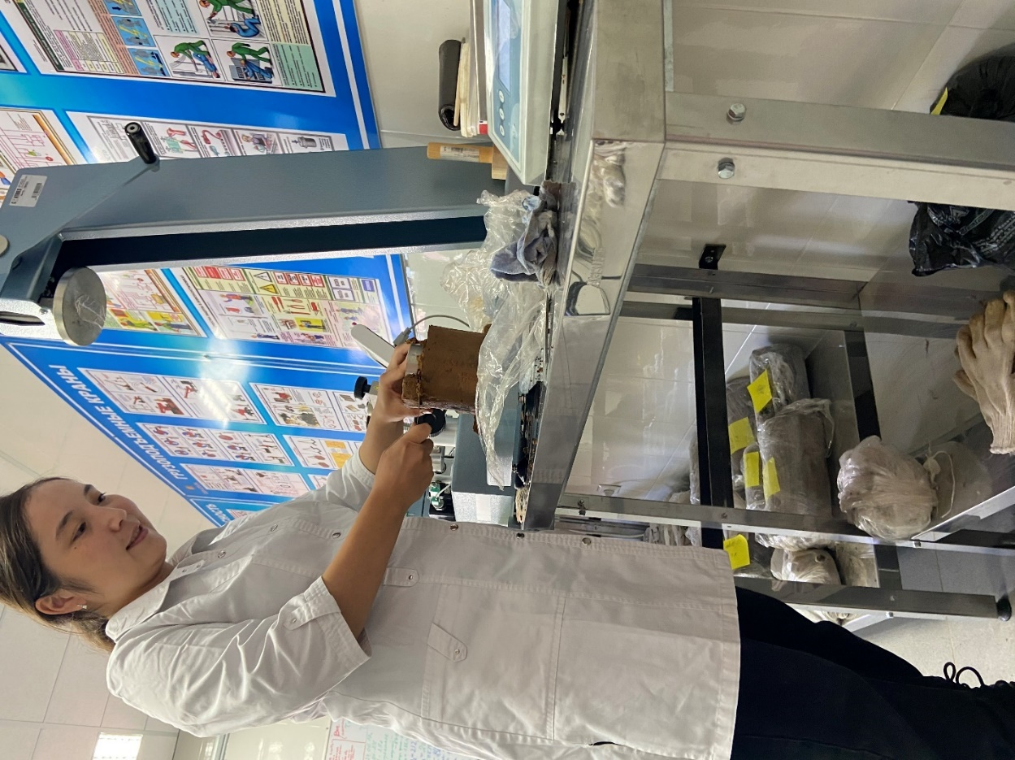
Figure 1. Determination of the mechanical properties of the soil
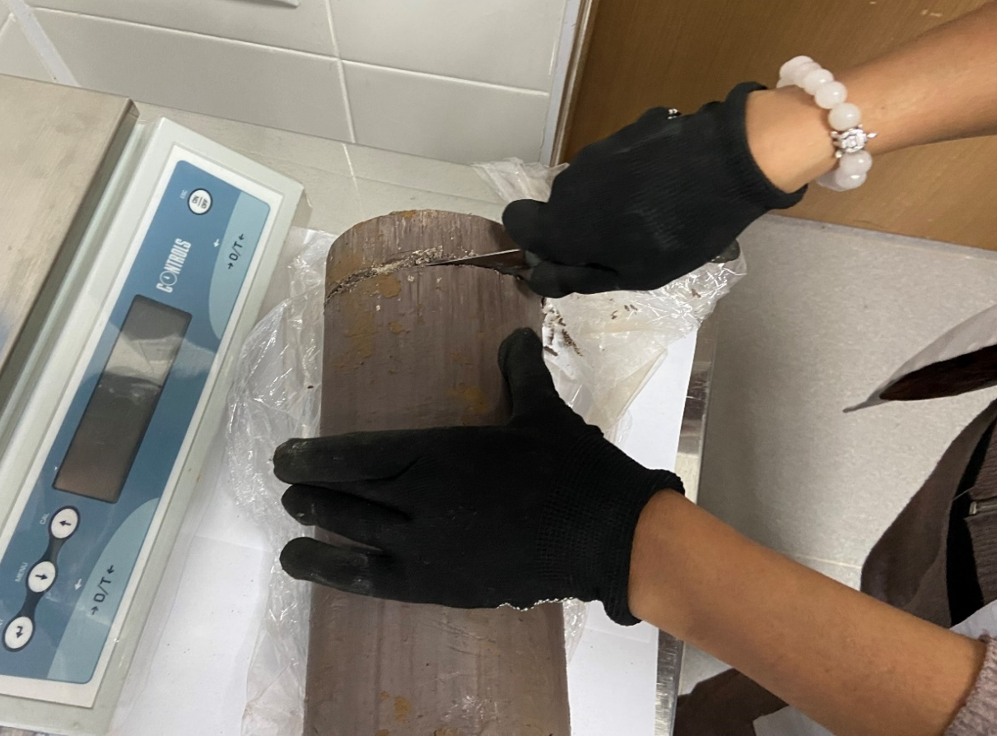
Figure 2. The process of cutting the soil for odometer
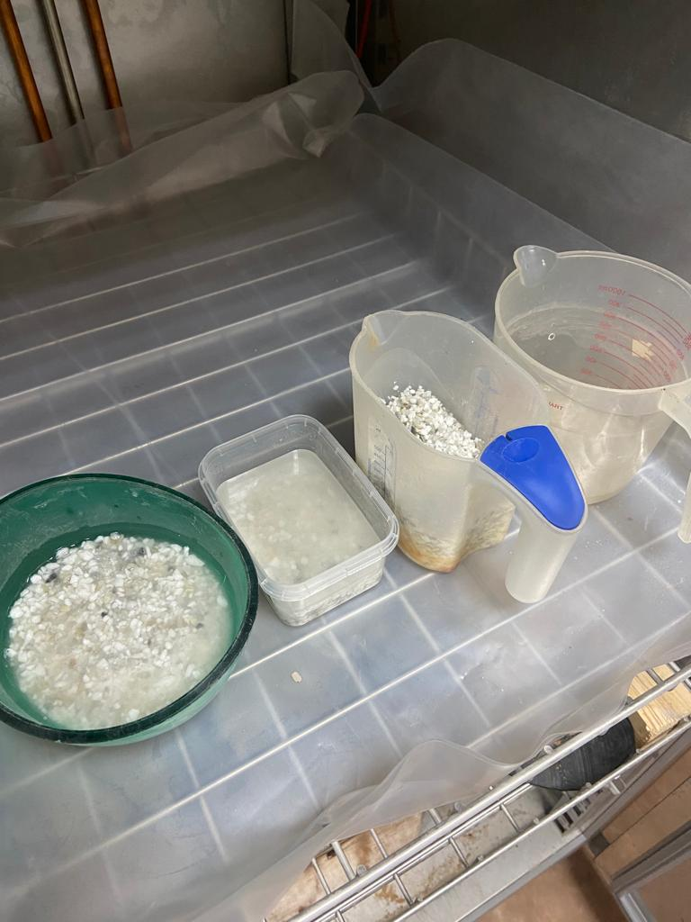
Figure 3. Determination of concentration of the chemical reagents
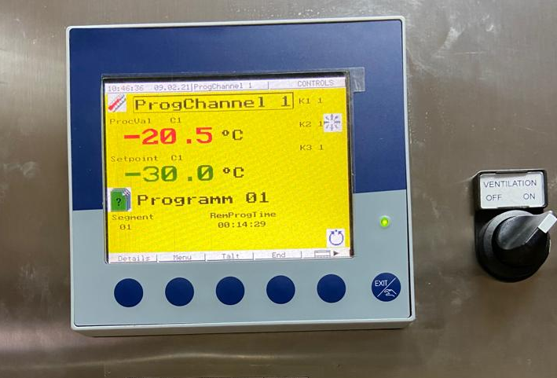
Figure 4. The temperature of the freezing camera
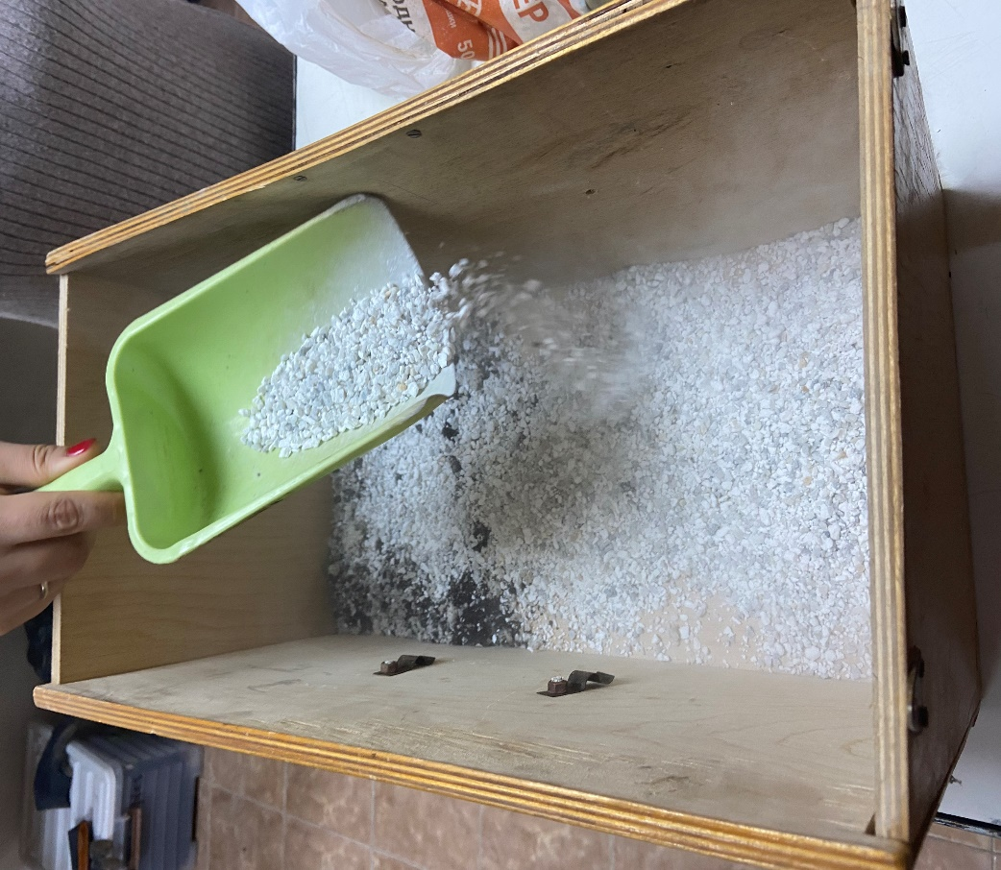
Figure 5. The model test preparation
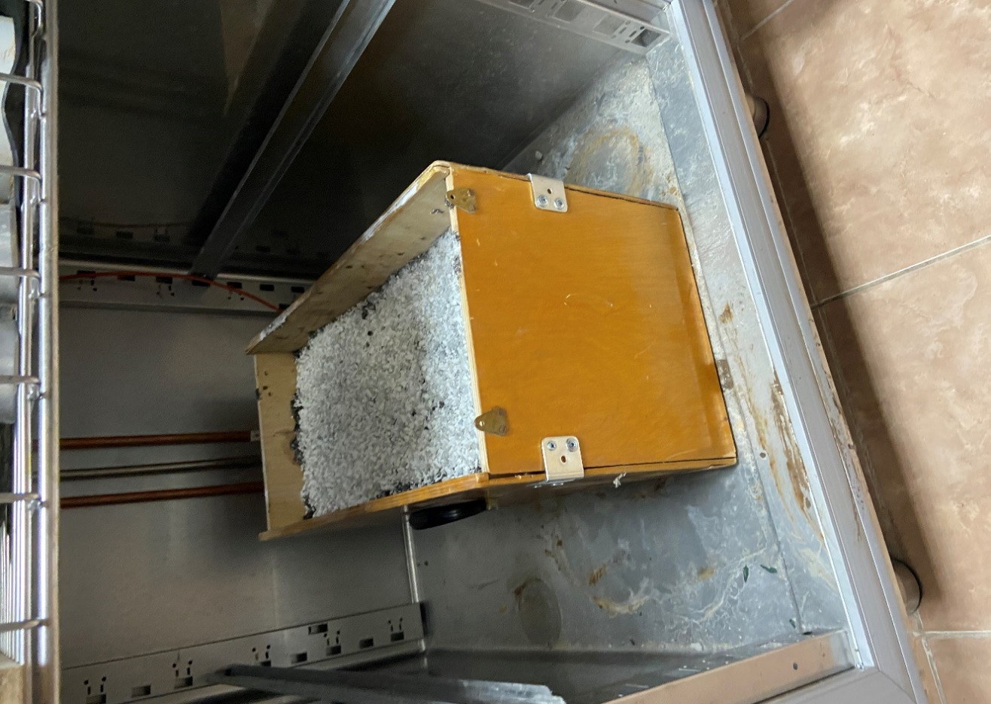
Figure 6. Testing the soil with chemical additives in the freezing camera

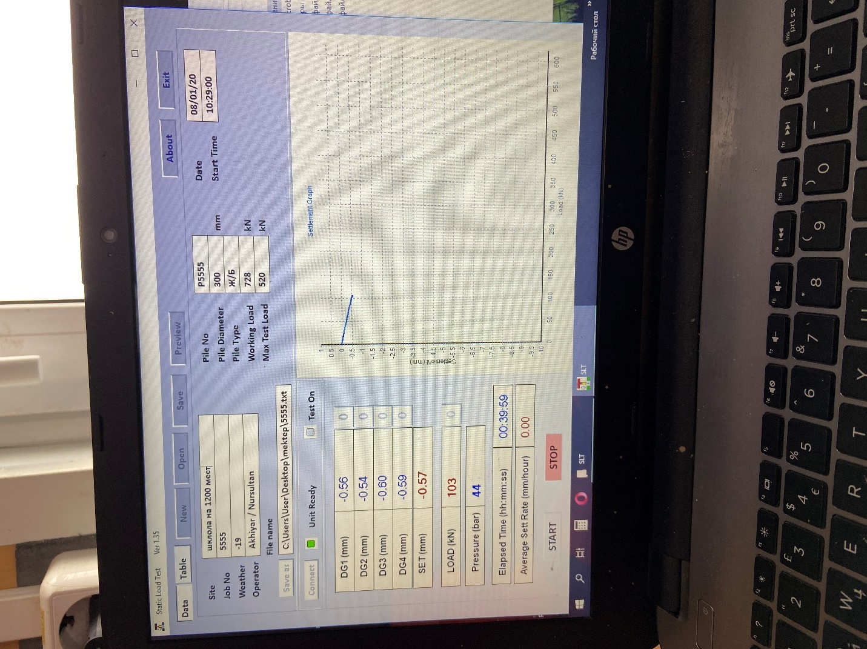
Figure 7. Controlling the process of SLT test
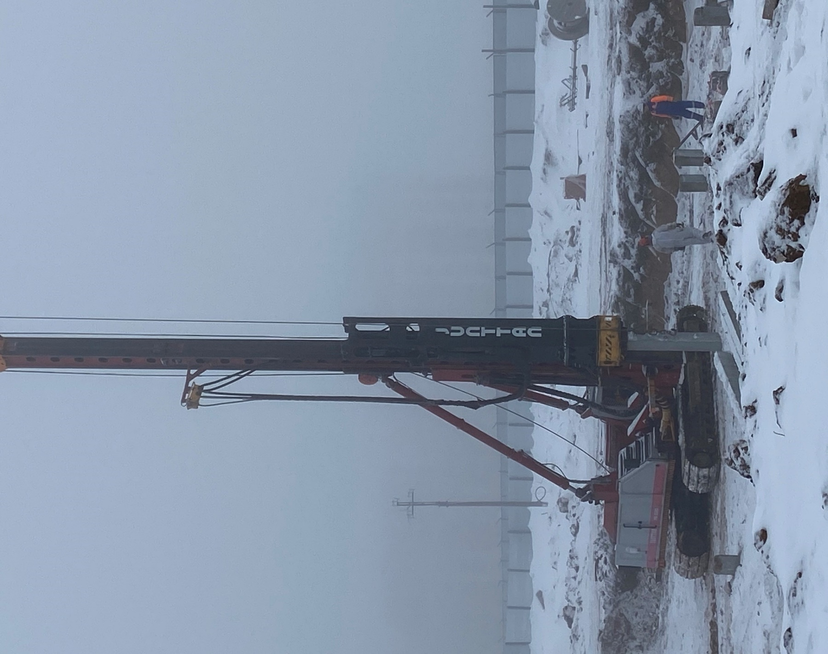
Figure 8. Implementing the proposed method with chemical additives

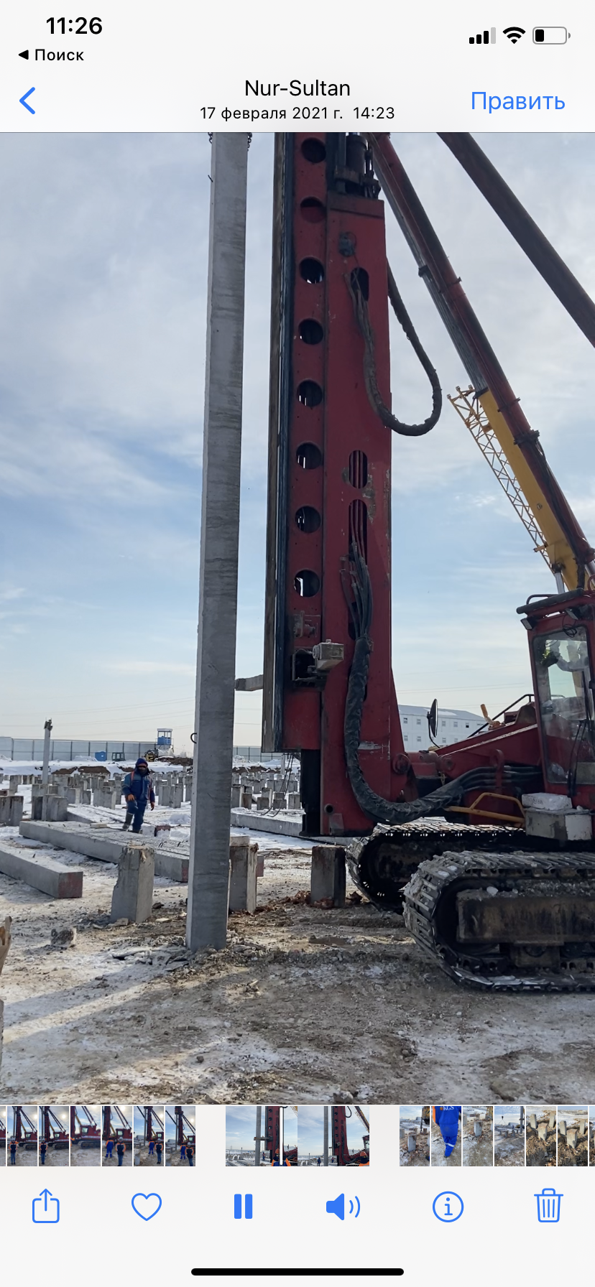
Figure 9. Driving the pile into the soil protected with antifreeze reagent

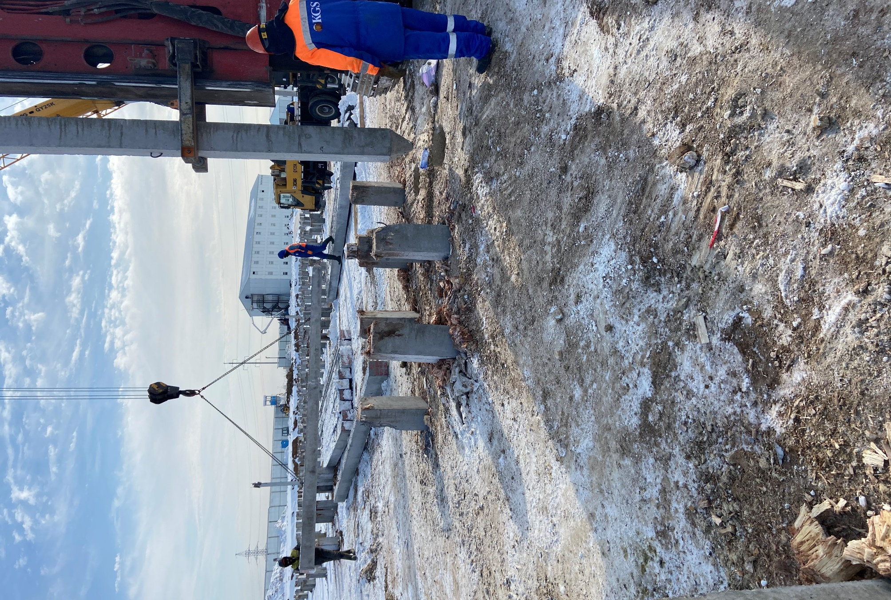
Figure 10. The driven piles into the ground in winter

APPENDIX B
Certificate of scientific online internship in Hokkaido University 

APPENDIX C
Certificate of scientific internship in Saint Petersburg State University of Architecture and Civil Engineering

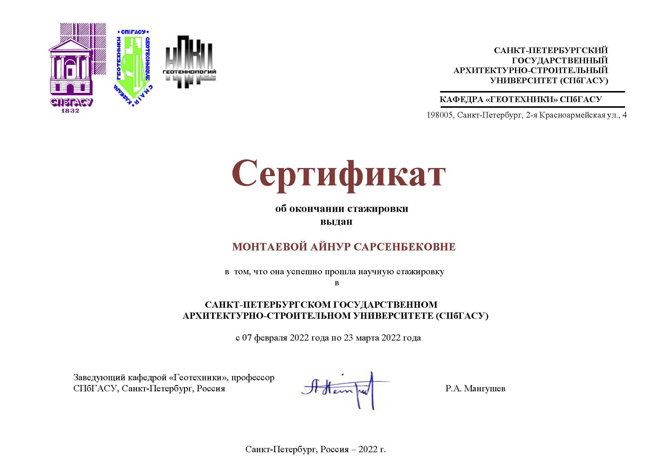

APPENDIX E
Implementation act

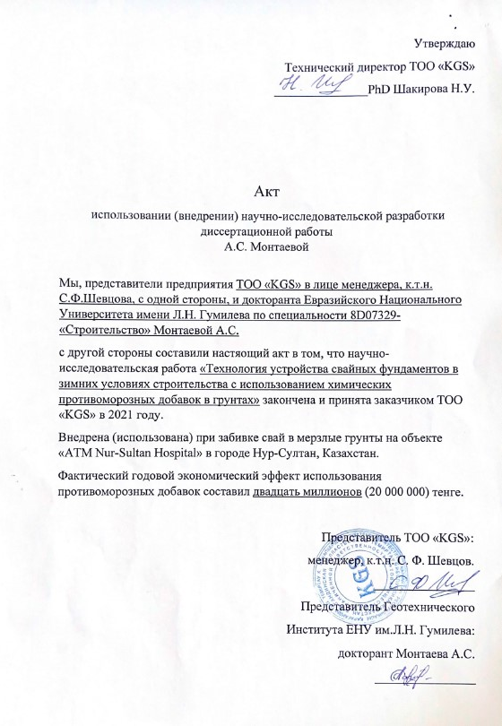

APPENDIX E
Certificate of attendance of CAEST in Russia

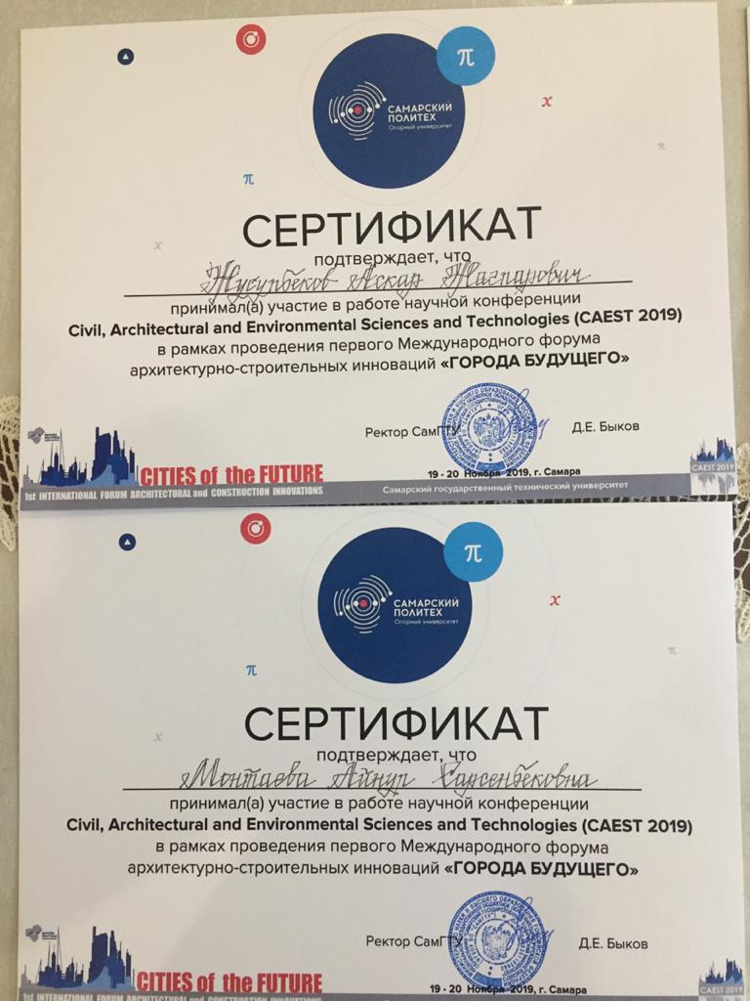

APPENDIX F
Certificate of attendance of NGM/BSGC in Finland



APPENDIX G
Certificate of attendance of TASI in Uzbekistan



APPENDIX H
Certificate of attendance of 7iYGEC in Australia



APPENDIX I
Certificate of attendance of 20th ICSMGE in Australia
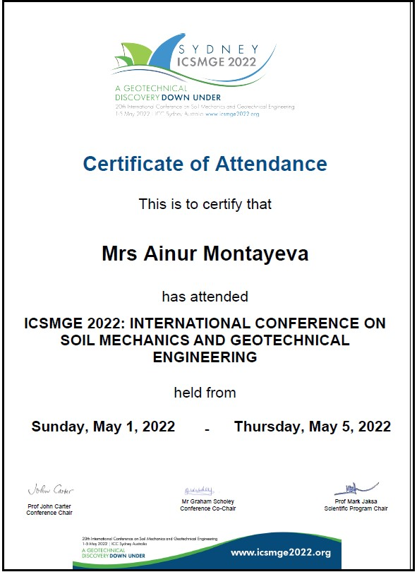

APPENDIX J
Certificate of patent

