Ministry of Education and Science of the Republic of Kazakhstan

L.N. Gumilyov Eurasian National University

UDK 627.8 On the rights of the manuscript

MKILIMA TIMOTH

Aspects of embankment dams stability considering the impact of land use changes and climatic conditions in catchments

8D07329 – Civil Engineering

Thesis for the degree of
Doctor of Philosophy (PhD)

Domestic Scientific Advisor
PhD, Associate Professor
Utepov Ye.B.

Foreign Scientific Advisor
Professor
Zbigniew Lechowicz
(Warsaw University of Life Sciences)

Republic of Kazakhstan
Nur-Sultan, 2022

ABSTRACT
Typically, dams are located in less developed areas of a catchment; however, due to factors such as population growth over time, these catchments get highly urbanized, leading to the alteration of the natural landscape. Also, all over the world, the climate has been observed to be changing, leading to extreme events. All these factors affect the catchments' hydrological pattern, posing a significant threat to the dams. Moreover, incorporating all these factors during the design phase of an embankment dam, in particular, has always been a challenge. This study investigated the potential influence of land use changes, extreme events, and loading conditions on the slope stability of an embankment dam. A combination of Geographical Information System approaches and numerical modeling investigated different case studies' problems. The Soil Conservation Services Curve Number (SCS-CN) method, was used to estimate flow conditions in the catchment. At the same time, numerical modeling was used to investigate the influence of the flow conditions on the slope stability of the study embankments. Virtual models and case studies (Msimbazi, Ndembera, Nura-Sarysu, Ural-Caspian, and Aral-Syrdarya) were investigated in this study.
From the Ndembera catchment, water, wetland, dense forest, developed low intensity, medium intensity, and high-intensity land use classifications were established as a result of the land use and land cover change analysis. Whereby wetlands covered most of the Ndembera catchment, accounting for approximately 56.57% of the total area in 1990. The area covered by the high-intensity development was just about 0.86% of the general area and 13.9% of medium intensity development. However, in 2011 the largest part of the catchment was covered by medium intensity development accounting for 54.7% of the total areas. A similar situation was witnessed in Kazakhstan's Aral-Syrdarya catchment, where a significant portion of the catchment had been changed into high-intensity development by 2011. As a result of the changes in land use/land cover and extreme events, the design flows and reservoirs’ depths changed significantly with time. Furthermore, as a result of flow variations in the catchments, this study demonstrated that long-term water levels and loading conditions had a substantial impact on the slope stability of embankment dams. Based on the facts, it is vital to evaluate the state of the catchment in terms of land surface cover and climatic variables during the design phase of an embankment dam to achieve safe and sustainable dams.

STATEMENT OF ORIGINAL AUTHORSHIP
The work presented in this thesis has never been submitted for a degree or diploma at another institution of higher learning. The thesis contains no content previously published or written by another individual unless an adequate citation is made.

Signature:

Date: 10.05.2022

ACKNOWLEDGMENTS
I would like to express my gratitude to Almighty God for the gift of life and good health that has allowed me to complete this research. A dissertation is a long and winding road. It's a long solo trek that's impossible to complete alone. Since I began my Ph.D. program at the L.N. Gumilyov Eurasian National University in October 2019, a large number of people have provided me with critical support. Family, friends, and acquaintances have been essential for this journey. The journey was even more difficult due to the global pandemic that started at the end of 2019. Nevertheless, my family provided a solid foundation for me to begin this adventure, and they later became a source of support.
Also, I would like to convey my heartfelt gratitude to Dr. Yelbek Utepov, my thesis supervisor, for his invaluable assistance and support throughout this research project. Without his advice and sympathetic support, it would have been incredibly challenging to continue the research and bring it to fruition. Furthermore, Dr. Utepov devoted significant time and effort during the study period to guarantee the thesis was completed successfully and on schedule. In light of the foregoing, his assistance is greatly appreciated and will always be remembered.
My heartfelt gratitude is rendered to Professor Zbigniew Lechowicz from the Warsaw University of Life Sciences, a foreign scientific advisor, for his invaluable technical and scientific assistance in achieving different objectives throughout my thesis research and writing. During the international internship program at the Warsaw University of Life Sciences, his assistance is likewise greatly valued. Dr. Zdzisław Skutnik of the Warsaw University of Life Sciences is also thanked for his technical assistance.
My gratitude is also due to Professor Askar Zhussupbekov, Professor in the Department of Civil Engineering at the L.N. Gumilyov Eurasian National University, for his guidance and mentoring throughout the Ph.D. program. The Civil Engineering Department entire staff's help is also greatly appreciated, including Dr. Shakhmov Zhanbolat (the Head of the Civil Engineering Department), Dr. Yerkebulan, and Mr. Sultan Iskakov.
The scientific support from Professor Victor N. Kaliakin of the University of Delaware's Department of Civil and Environmental Engineering, Professor Tadatsugu Tanaka of the University of Tokyo, and Dr. Assel Tulebekova of the Department of Civil Engineering at the L.N. Gumilyov Eurasian National University is significantly appreciated.
Also, I gratefully acknowledge the financial support received from the Government of Kazakhstan under the Bologna Process program that led to the successful completion of the Ph.D. program.
I also received tremendous support from the International Department at ENU, particularly from Dr. Akbota (Vice-Rector), Dr. Annastasiya (Head of the International Department), and Ms. Botagos.
I want to express my gratitude to my classmates in the Civil Engineering Department at the L.N. Gumilyov Eurasian National University for the beautiful moments we've had together. I am particularly thankful to Bibigul Abdrakhmanova, Ainur Montayeva, Gulzhan Khafizova, Aigerim Buranbayeve, Assel Akmakanova, and Kairat Khafiz.
I'll also remember the support I received from coworkers on many research projects in Nur Sultan, Kazakhstan, particularly from Mr. Shyngys Zharassov and Mr. Alizhan Kazkeyev.
Dr. Stephen Mbuligwe of the Department of Environmental Engineering at Ardhi University in Dar es Salaam, Tanzania, deserves special thanks for his invaluable assistance throughout the research internship at the university.
In addition, I'd like to express my heartfelt gratitude to all of my friends and colleagues who were not named here for their invaluable assistance during my Ph.D. program.
Academic careers are distinct in that academics spend most of their time pursuing knowledge, which is at the heart of the Ph.D. journey. A Ph.D. is more than just completing a large research project; it is the beginning of a lifelong quest for knowledge. It's as much about the love of discovering new ideas as it is about pursuing knowledge. Given the preceding facts, it’s clear that the voyage encompassed so many people and institutions that it would be impossible to list them all here. However, any individual, group of people, or institution that assisted in completing the study is greatly appreciated.

TABLE OF CONTENTS
ABSTRACT 2
STATEMENT OF ORIGINAL AUTHORSHIP 3
ACKNOWLEDGMENTS 4
LIST OF FIGURES 14
LIST OF TABLES 22
NORMATIVE REFERENCES 24
DEFINITIONS 25
SYMBOLS AND ABBREVIATIONS 27
INTRODUCTION 30
1 Literature review 37
1.1 Land use and land cover changes impacts on stormwater 37
1.2 Climatic impacts on stormwater 38
1.3 Stormwater-related issues on dams 38
1.3.1 Storm extreme event 38
1.3.2 Dam hazard potential 39
1.3.3 General dam failure mechanisms 39
1.4 Stormwater estimation methods 40
1.4.1 Rational formula approach 41
1.4.1.1 Rational Method calculation procedure 41
1.4.1.2 Assumptions used in the rational method 41
1.4.1.3 Limitations of the rational formula 42
1.4.1.4 Runoff coefficient 42
1.4.1.5 Soil characteristics 43
1.4.1.6 Selection of runoff coefficients 43
1.4.1.7 Rainfall Intensity 44
1.4.1.8 Drainage area 44
1.4.1.9 Time of concentration 44
1.4.2 Soil Conservation Service Method 45
1.4.2.1 General overview 45
1.4.2.2 Design Storm Data 47
1.4.2.3 Determination of Runoff Curve Number (CN) 47
1.4.2.4 The perspective of the Hydrologic Soil Group 47
1.4.2.5 Surface coverage and hydrologic pattern of a watershed 48
1.4.2.6 Antecedent Moisture Condition 48
1.4.2.7 Connected impervious areas 48
1.4.2.8 Unconnected impervious areas 48
1.4.2.9 Limitations on use of SCS method 51
1.4.2.10 Computer Modeling 51
1.5 Embankment dams 52
1.5.1 General overview 52
1.5.2 Design of earthen dam components 53
1.5.2.1 Top width 53
1.5.2.2 Free board 54
1.5.2.3 Cutoff trench 55
1.5.2.4 Central impervious core 56
1.5.2.5 Suitable core material 56
1.5.2.6 Casing or outer shell 57
1.5.2.7 Internal drainage system 57
1.5.2.8 Slope protection 58
1.5.2.9 Surface drainage 58
1.5.2.10 Impervious blanket 58
1.5.2.11 Design of spillway 59
1.5.2.12 Embankment slope stability 60
1.5.2.12.1 Causes of slope instability 60
1.5.2.12.2 The significance of embankment stability analysis in terms of slope 61
1.5.2.12.3 Types of slope failure 61
1.5.2.12.4 Assumptions for slope stability analysis 62
1.5.2.12.5 Factor of safety 62
1.5.2.12.6 Slope stability analysis methods 63
1.5.2.13 Dam safety 84
1.5.2.13.1 World declaration on dam safety 84
1.5.2.13.2 Dam safety management 88
1.5.2.13.3 Dam safety programs 88
1.5.2.13.4 Dam safety and flood evaluation 91
1.5.2.13.5 Dam internal erosion 91
1.5.2.13.6 Tropical residual soils as dam foundation and fill material 93
1.5.2.13.7 Summary of the sub-section 93
1.5.2.14 Modeling of embankment dam behavior 94
1.5.2.14.1 Dam modeling during construction 94
1.5.2.14.2 Dam modeling during first filling 95
1.5.2.14.3 Dam modeling during operation 96
1.5.2.14.4 Dam modeling during rapid drawdown 97
Summary of chapter one 99
2 Urbanization in catchments 100
2.1 Development of a geoprocessing tool 100
2.1.1 Overview 100
2.1.2 Integration of tools 100
2.2 Rapid urbanization analysis: A case of Msimbazi catchment in Dar es Salaam, Tanzania 101
2.2.1 Study area description 101
2.2.2 Datasets 102
2.2.3 Methodology 102
2.2.3.1 DEM preprocessing 102
2.2.3.2 Project development 104
2.2.3.3 Estimation of discharge 104
2.2.3.4 Land use/ land cover analysis 104
2.2.3.4.1 Land use classification 105
2.2.3.5 Dam site selection 105
2.2.3.6 Results and discussion 106
2.2.3.6.1 Results 106
2.2.3.7 Discussion 112
2.3 Ndembera catchment, Tanzania 114
2.3.1 Case study description 114
2.3.2 Topography 115
2.3.3 Geomorphology 115
2.3.4 Weather and hydrological conditions 116
2.3.5 Basin Characteristics Factors of Lugoda Catchment 116
2.3.6 Seismic conditions 117
2.3.7 Catchment delineation 117
2.3.8 Curve Number (CN) Grid Inputs Preparation 119
2.3.8.1 General overview 119
2.3.8.2 Land use and land cover analysis processes 120
2.3.8.2.1 Landsat data processing 120
2.3.8.3 Land use and land cover analysis results 120
2.3.8.3.1 Preparing Soil Data for CN Grid 124
2.3.8.3.2 Merging of Soil and Land Use Data 124
2.3.8.3.3 Creating CN Look-up Table 125
2.3.8.3.4 Curve Number Grid Generation 125
2.3.9 Curve Number grid 125
2.4 Chardara catchment, Kazakhstan 126
2.4.1 Case study description 126
2.4.1.1 Catchment delineation 127
2.4.1.2 Land use and land cover change analysis 128
Summary for chapter two 132
3 Stormwater modeling 134
3.1 Modeling approach 134
3.2 Ndembera catchment 134
3.3 Chardara catchment 137
Summary of chapter three 138
4 Seepage and slope stability analysis based on virtual models 139
4.1 Homogeneous case with water level: The potential effects caused by long-term water level changes on embankment slope stability under rapid drawdown 139
4.1.1 Materials and methods 139
4.1.1.1 General description of the numerical simulation 139
4.1.1.2 The geometry of the embankment 139
4.1.1.3 Seepage analysis 140
4.1.1.4 Slope stability analysis 140
4.1.1.5 Soil material characteristics 141
4.1.2 Results and discussion 142
4.1.2.1 Seepage analysis 142
4.1.2.1.1 Seepage analysis results from 10 m water level 142
4.1.2.1.2 Seepage analysis results from 8m water level 143
4.1.2.1.3 Seepage analysis results from 6m water level 144
4.1.2.2 Slope stability 145
4.1.2.2.1 Slope stability analysis results from 10 m water level 145
4.1.2.2.2 Slope stability analysis results from 8m water level 147
4.1.2.2.3 Slope stability analysis results from 6m water level 149
4.1.3 Summary of the sub-section 152
4.2 The potential effect of a toe-drain size on slope stability of a homogeneous embankment 152
4.2.1 Materials and methods 152
4.2.1.1 Description of the numerical simulation in general 152
4.2.1.2 The geometry of the embankment 153
4.2.1.3 Analyses of seepage and slope stability 153
4.2.1.4 Characteristics of the soil 154
4.2.2 Results and Discussion 154
4.2.3 Section summary 157
4.3 The effect of internal angle of friction on slope stability of homogeneous embankment under rapid drawdown 157
4.3.1 Materials and methods 157
4.3.1.1 Description of the numerical simulation in general 157
4.3.1.2 The geometry of the embankment 157
4.3.1.3 Analyses of seepage and slope stability 158
4.3.1.4 Characteristics of the soil 159
4.3.2 Results and discussion 159
4.3.2.1 Summary of the sub-section 165
Summary of chapter four 166
5 Slope stability analysis based on case studies 167
5.1 Samarkand dam in Kazakhstan 167
5.1.1 Materials and methods 167
5.1.1.1 Case study description 167
5.1.1.2 The historical perspective of the Samarkand dam 167
5.1.1.3 General modeling process 168
5.1.1.4 Seepage analysis through the embankment 169
5.1.1.5 Slope stability analysis 169
5.1.1.5.1 Material characteristics 170
5.1.2 Results and discussion 170
5.1.2.1 Seepage analysis 170
5.1.2.2 Slope stability 171
5.1.3 Summary of the sub-section 176
5.2 Ndembera dam in Tanzania 176
5.2.1 Materials and methods 176
5.2.1.1 Geological, hydrogeological, and geotechnical conditions 176
5.2.1.2 Design assumptions of the dam and materials used 177
5.2.1.3 The embankment geometry and soil characteristics 177
5.2.1.4 General modeling process 179
5.2.1.5 Embankment seepage analysis 179
5.2.1.6 Slope stability analysis 180
5.2.2 Results and discussion 181
5.2.2.1 At the normal operating level 181
5.2.2.1.1 Seepage analysis 181
5.2.2.1.2 Slope stability analysis 183
5.2.2.1.3 Analysis of variance (ANOVA) under normal operating reservoir level and 1 m per day drawdown rate 190
5.2.2.2 At the reduced operating level 192
5.2.2.2.1 Seepage analysis 192
5.2.2.2.2 Slope stability 195
5.2.2.3 At embankment height 198
5.2.2.3.1 Seepage analysis 198
5.2.2.3.2 Slope stability 201
5.2.2.3.3 Analysis of variance (ANOVA) from different operating levels. 204
5.2.2.4 Comparison of different slope stability methods 206
5.2.3 Summary of the sub-section 207
5.3 Aktobe dam in Kazakhstan 208
5.3.1 Materials and methods 208
5.3.1.1 Case study description 208
5.3.1.2 Embankment geometry and modeling process 209
5.3.1.3 Seepage analysis 209
5.3.1.4 Slope stability analysis 210
5.3.1.5 Material characteristics 211
5.3.2 Results and discussion 212
5.3.2.1 Seepage analysis 213
5.3.2.2 Slope stability analysis 214
5.3.2.3 Analysis of variance (ANOVA) 224
5.3.3 Summary of the sub-section 226
5.4 Chardara dam in Kazakhstan 226
5.4.1 Materials and methods 226
5.4.1.1 General construction materials and properties 226
5.4.1.2 Materials and Properties of Construction 227
5.4.1.3 Cases investigated 227
5.4.1.4 General modeling procedures 228
5.4.1.5 Seepage analysis procedures 229
5.4.1.6 Slope stability analysis procedures 229
5.4.1.7 General study approach 229
5.4.2 Results and discussion 231
5.4.2.1 Seepage analysis 231
5.4.2.1.1 Steady-state 231
5.4.2.1.2 Instantaneous drawdown 232
5.4.2.1.3 Rapid drawdown five (5) days 234
5.4.2.1.4 Rapid drawdown (10 days) 236
5.4.2.1.5 Rapid drawdown (1 m per day) 238
5.4.2.2 Slope stability 240
5.4.2.2.1 Steady-state 240
5.4.2.2.2 Instantaneous drawdown 242
5.4.2.2.3 Rapid drawdown (5 days) 245
5.4.2.2.4 Rapid drawdown (10 days) 249
5.4.2.2.5 Rapid drawdown (1 m per day) 253
5.4.2.2.6 Correlation analysis 257
5.4.2.2.7 Analysis of variance (ANOVA) 258
5.4.3 Summary of the sub-section 260
Summary of chapter five 262
CONCLUSIONS AND RECOMMENDATIONS 264
REFERENCES 267
Appendix A – Script for geoprocessing tool 288
Appendix B - Ndembera catchment land use and land cover data for water in 1995 291
Appendix C – Pore-water pressures from 1 m per day drawdown 295
Appendix D – Ndembera dam factor of safety values from 1 m per day drawdown: Morgenstern-Price method 296
Appendix E – Ndembera dam factor of safety values from 1 m per day drawdown: Bishop method 298
Appendix F – Chardara dam factor of safety values from instantaneous drawdown 300
Appendix G – Chardara dam factor of safety values from instantaneous drawdown 301
Appendix H – Chardara dam factor of safety values from 10 days drawdown 302

LIST OF FIGURES
Figure 1.1 – Curve for runoff equation application [92] 46
Figure 1.2 – Composite CN with Unconnected Impervious Areas and Total Impervious Areas Less than 30% [92] 50
Figure 1.3 – Composite CN with Connected Impervious Area [92] 50
Figure 1.4 – A typical example of an embankment dam [110] 52
Figure 1.5 – Overflow pipe description [112] 53
Figure 1.6 – Types of slope failure [142] 61
Figure 1.7 – Factor of safety definition diagram [146] 62
Figure 1.8 – Slope stability analysis using the Culmann method [151] 63
Figure 1.9 – Forces involved in slope stability calculation [153] 64
Figure 1.10 – Ordinary Method of Analysis [153] 64
Figure 1.11 – Stresses and forces acting on a slice in Bishop Method of analysis [153]. 65
Figure 1.12 – Morgenstern-Price approach (static scheme) [157] 65
Figure 1.13 – Function of half-sine [157] 66
Figure 1.14 Forces acting on a single slice [161] 69
Figure 1.15 Spencer's Method of Slices [161] 71
Figure 1.16 – Spencer method's static approach [163] 72
Figure 1.17 – Static approach - Janbu method [166] 74
Figure 1.18 – Static scheme - Sarma method [169] 75
Figure 1.19 – Static approach - Shahunyants method [170] 77
Figure 1.20 – ITF Method - Forces acting on a block [172] 80
Figure 1.21 – Pore pressure action on the block diagram [172] 81
Figure 1.22 – Existing dam social risk recommendations [209] 90
Figure 2.1 – Architecture of the developed geoprocessing tool 101
Figure 2.2 – Msimbazi catchment study area 101
Figure 2.3 – Flow chart 102
Figure 2.4 – Real scenarios of catchment delineation challenges 103
Figure 2.5 – Flow chart 105
Figure 2.6 – Catchment preprocessing steps: a) Raw DEM; b) Hydro filled; DEM c) Flow direction; d) Flow accumulation; e) Stream definition; f) Stream segmentation; g) Catchment grid delineation; h) Catchment polygon processing; i) Drainage line processing 107
Figure 2.7 – Main channel characteristics: a) general catchment elevation profile; b) mainstream cross-section (downstream); c) mainstream cross-section (upstream) 107
Figure 2.8 – Flow direction challenges: a) relatively flat surface at Jangwani sub-catchment; b) stream-bridge interception 108
Figure 2.9 – Classified land use within the catchment from 1998 to 2018 109
Figure 2.10 – Delineated subbasins for the selected dam sites: a) subbasin 5; b) subbasin 7; c) subbasin 9; d) subbasin 11; e) subbasin 13 110
Figure 2.11 – Land use/land cover distribution for each subbasin of the selected sites: a) land use/land cover for the combined selected sites; b) land use/land cover for Kisarawe sub-basin; c) land use/land cover for Magomeni sub-basin; d) land use/land cover for Kinyerezi sub-basin 11; e) land use/land cover for Jangwani sub-basin; f) land use/land cover for Pugu sub-basin 111
Figure 2.12 – Dam sites location: Streams only (left), streams with coverage (right) 112
Figure 2.13 – Case study map [255] 114
Figure 2.14 – Location of the Lugoda dam [255] 115
Figure 2.15 – Ndembera dam catchment boundary: a) clipped DEM; b) delineated catchment 119
Figure 2.16 – Land use and land cover analysis results from 1990: a) classified land cover; b) graph of classified land cover 121
Figure 2.17 – Land use and land cover analysis results from 1995: a) classified land cover; b) graph of classified land cover 122
Figure 2.18 – Land use and land cover analysis results from 2004: a) classified land cover; b) graph of classified land cover 123
Figure 2.19 – Land use and land cover analysis results from 2011: a) classified land cover; b) graph of classified land cover 124
Figure 2.20 – Curve Number grid 125
Figure 2.21 – Case study location 127
Figure 2.22 – Digital Elevation Model 127
Figure 2.23 – Delineated catchment 128
Figure 2.24 – Classified land use and land cover from 2000 datasets 128
Figure 2.25 – Land use and land cover coverage in 2000 129
Figure 2.26 – Raster to polygon: a) float type; b) integer type 129
Figure 2.27 – Classified land use and land cover from 2011 datasets 130
Figure 2.28 – Land use and land cover coverage in 2011 130
Figure 2.29 – Raster to polygon output from 2011 datasets 131
Figure 4.1 – General embankment geometry used in the numerical modeling 140
Figure 4.2 – Water total head function 140
Figure 4.3 – Functions: a) volumetric water content; b) hydraulic conductivity function 141
Figure 4.4 – Seepage results under 10 m water level: a) long-term steady-state; b) instantaneous drawdown; c) 5 days drawdown; d) 10 days drawdown 143
Figure 4.5 – Seepage results under 8m water level: a) long-term steady-state; b) 5 days drawdown 144
Figure 4.6 – Seepage results under 6m water level: a) long-term steady-state; b) 5 days drawdown 145
Figure 4.7 – Slope stability results for 10 m water level: a) long-term steady-state; b) instantaneous drawdown slip surface; c) 5 days drawdown slip surface; d) instantaneous drawdown graph; e) 5 days drawdown graph 146
Figure 4.8 – Slope stability results for 10 m water level and 10 days drawdown: a) slip surface; b) graph of factor of safety values 147
Figure 4.9 – Slope stability results for 8 m water level: a) long-term steady-state with slip surface; b) instantaneous drawdown slip surface; c) 5 days drawdown slip surface; d) instantaneous drawdown graph; e) 5 days drawdown graph. HRAF = hypothetical region after failure. 149
Figure 4.10 – Slope stability results for 6 m water level: a) long-term steady-state with slip surface; b) instantaneous drawdown slip surface; c) 5 days drawdown slip surface; d) instantaneous drawdown graph; e) 5 days drawdown graph 151
Figure 4.11 – General embankment geometry 153
Figure 4.12 – Pressure of pore-water at the upstream face 154
Figure 4.13 – The downstream toe's pore-water pressure 155
Figure 4.14 – The factor of safety with slip surfaces from 5 days drawdown rate: a) 5 m drain size; b) 10 m drain size; c) 15 m drain size 156
Figure 4.15 – The trend of the factor of safety values with time 156
Figure 4.16 – General embankment geometry 158
Figure 4.17 – Piezometric lines following the rapid drawdown 160
Figure 4.18 – Slip surfaces from 5 days drawdown rate; a) 20⁰ internal angle of friction; b) 25⁰ internal angle of friction; c) 30⁰ internal angle of friction; d) 35⁰ internal angle of friction 161
Figure 4.19 – Factor of safety values with time from 5 days drawdown rate and different internal angles of friction; (a) 20⁰; (b) 25⁰ (c) 30⁰ (d) 35⁰. 163
Figure 4.20 – The factor of safety values with time: a) instantaneous drawdown;(b) 5 days drawdown 164
Figure 4.21 – Minimum values of factor of safety from instantaneous and 5 days drawdown rate 164
Figure 5.1 – Embankment geometry 168
Figure 5.2 – Some of the defined functions (a) the boundary condition for 10 days drawdown rate (b) volumetric water content function from zone 1 169
Figure 5.3 – Seepage analysis (a) long-term steady-state (b) Instantaneous drawdown (c) 5 days drawdown (d) 10 days drawdown (e) 1m per day drawdown 171
Figure 5.4 – Steady-state slope stability 172
Figure 5.5 – Drawdown: 1 m per day drawdown rate; a) embankment with slip surface; b) graph of factor of safety values 172
Figure 5.6 – Drawdown:10 days drawdown rate; a) embankment with slip surface; b) graph of factor of safety values 173
Figure 5.7 – Drawdown: 5 days drawdown; a) embankment with slip surface; b) graph of factor of safety values 174
Figure 5.8 – Instantaneous drawdown; a) embankment with slip surface; b) graph of factor of safety values 175
Figure 5.9 – Summary of the minimum factor of safety values 175
Figure 5.10 – Trench pits at the dam site 177
Figure 5.11 – Embankment geometry 178
Figure 5.12 – Drawdown boundary conditions (a) 10 days drawdown rate (b) 1m per day drawdown rate 180
Figure 5.13 – Steady state seepage: a) k_{sat} = 5∙10⁻⁵ m/s; b) k_{sat} = 10⁻⁵ m/s; c) k_{sat} = 5∙10⁻⁶ m/s; d) k_{sat} = 10⁻⁶; e) k_{sat} = 5∙10⁻⁷ m/s; f) k_{sat} = 10⁻⁷ m/s 181
Figure 5.14 – A half drawdown (1m per day) seepage; a) k_{sat}=10⁻⁵ m/s; b) k_{sat}=10⁻⁵ m/s; c) k_{sat}=10⁻⁷ m/s 182
Figure 5.15 – Slope stability under k_{sat} = 5∙10⁻⁵ m/s; a) embankment with slip surface; b) graph of factor of safety values 183
Figure 5.16 – Slope stability under k_{sat}=10⁻⁵ m/s; a) embankment with slip surface; b) graph of factor of safety values 184
Figure 5.17– Slope stability under k_{sat} = 5∙10⁻⁶ m/s; a) embankment with slip surface; b) graph of factor of safety values 185
Figure 5.18 – Slope stability under k_{sat}=10⁻⁶ m/s; a) embankment with slip surface; b) graph of factor of safety values 186
Figure 5.19– Slope stability under k_{sat} = 5∙10⁻⁷ m/s; a) embankment with slip surface; b) graph of factor of safety values 187
Figure 5.20 – Slope stability under k_{sat}=10-7 m/s; a) embankment with slip surface; b) graph of factor of safety values 188
Figure 5.21 – Minimum values of factor of safety from the instantaneous, 5 days, and 10 days drawdown rates under 5∙10⁻⁵ m/s and 10⁻⁷ m/s saturated hydraulic conductivities: FS- factor of safety 189
Figure 5.22 – Steady-state seepage under the reduced operating water level 193
Figure 5.23 – Instantaneous drawdown seepage under the reduced operating water level 193
Figure 5.24 – Rapid drawdown (5 days) seepage under the reduced operating water level 194
Figure 5.25 – Rapid drawdown (10 days) seepage under the reduced operating water level 194
Figure 5.26 – Rapid drawdown (1 m per day) seepage under the reduced operating water level 195
Figure 5.27 – Steady-state slope stability under the reduced operating water level 195
Figure 5.28 – Instantaneous slope stability under the reduced operating water level 196
Figure 5.29 – Rapid drawdown (5 days) slope stability under the reduced operating water level; a) embankment with slip surface; b) graph of factor of safety values 197
Figure 5.30 – Rapid drawdown (10 days) slope stability under the reduced operating water level 197
Figure 5.31 – Rapid drawdown (1 m per day slope stability) under the reduced operating water level 198
Figure 5.32 – Steady-state seepage at embankment height operating level 198
Figure 5.33 – Instantaneous seepage at embankment height operating level 199
Figure 5.34 – Rapid drawdown (5 days) seepage at embankment height operating level 199
Figure 5.35 – Rapid drawdown (10 days) seepage at embankment height operating level 200
Figure 5.36 – Rapid drawdown (1 m per day) seepage at embankment height operating water level 200
Figure 5.37 – Steady-state slope stability at embankment height operating water level 201
Figure 5.38 – Instantaneous slope stability at embankment height operating water level 202
Figure 5.39 – Rapid drawdown (5 days) slope stability at embankment height operating water level 202
Figure 5.40 – Rapid drawdown (10 days) slope stability at embankment height operating water level 203
Figure 5.41 – Rapid drawdown (1 m per day) slope stability at embankment height operating water level 203
Figure 5.42 – Results from different slope stability analysis methods under steady-state conditions: a) Bishop method; b) Janbu; c) Morgenstern-Price; d) Sarma 207
Figure 5.43 – Embankment geometry 209
Figure 5.44 – Boundary conditions: a) 10 days drawdown rate; b) 1 m per day drawdown rate 210
Figure 5.45 – Volumetric water content and hydraulic conductivity functions for different zones 212
Figure 5.46 – Steady-state seepage 213
Figure 5.47 – Instantaneous seepage 214
Figure 5.48 – Steady-state slope stability 214
Figure 5.49 – Instantaneous slope stability: a) embankment with slip surface; b) factor of safety values graph 215
Figure 5.50 – Drawdown 5 days 216
Figure 5.51 – Drawdown 10 days 217
Figure 5.52 – Drawdown 1m per day 218
Figure 5.53 – Analysis results under reduced operating reservoir level: a) steady-state; b) instantaneous; c) 5 days; d) 10 days; e) 1 m per day 220
Figure 5.54 – Different drawdown rates under reduced operating level: a) instantaneous; b) 5 days drawdown; c) 10 days drawdown; d) 1 m per day drawdown 221
Figure 5.55 Steady-state results under embankment height operating reservoir level: a) steady-state; b) instantaneous; c) 5 days; d) 10 days; e) 1 m per day 223
Figure 5.56 Results from different drawdown rates embankment height operating level; a) instantaneous; b) 5 days drawdown; c) 10 days drawdown; d) 1 m per day drawdown 224
Figure 5.57 – Embankment geometry 228
Figure 5.58 – General workflow 230
Figure 5.59 – Steady-state seepage based on normal operating reservoir level 231
Figure 5.60 – Steady-state seepage based on the reduced operating level 232
Figure 5.61 – Steady-state seepage under embankment height level 232
Figure 5.62 – Steady-state seepage under overflow level 232
Figure 5.63 – Instantaneous drawdown seepage under normal operating reservoir level 233
Figure 5.64 – Instantaneous drawdown seepage under reduced reservoir operating level 233
Figure 5.65 – Instantaneous drawdown seepage under embankment height operating level 234
Figure 5.66 – Instantaneous drawdown seepage under overflow condition 234
Figure 5.67 – Rapid drawdown (5 days) seepage under normal operating level 235
Figure 5.68 – Rapid drawdown (5 days) seepage under reduced reservoir operating level 235
Figure 5.69 – Rapid drawdown (5 days) seepage under embankment height reservoir operating level 235
Figure 5.70 – Rapid drawdown (5 days) seepage under overflow reservoir operating level 236
Figure 5.71 – Rapid drawdown (10 days) seepage under normal operating level 236
Figure 5.72 – Rapid drawdown (10 days) seepage under reduced reservoir operating level 237
Figure 5.73 – Rapid drawdown (10 days) seepage under embankment height reservoir operating level 237
Figure 5.74 – Rapid drawdown (10 days) seepage under overflow reservoir operating level 238
Figure 5.75 – Rapid drawdown (1 m per day) seepage under normal operating level 238
Figure 5.76 – Rapid drawdown (1 m per day) seepage under reduced reservoir operating level 239
Figure 5.77 – Rapid drawdown (1m per day) seepage under embankment height reservoir operating level 239
Figure 5.78 – Rapid drawdown (1 m per day) seepage under overflow reservoir operating level 239
Figure 5.79 – Steady-state slope stability under normal operating reservoir level 240
Figure 5.80 – Steady-state slope stability under reduced reservoir operation level 241
Figure 5.81 – Steady-state slope stability under embankment height reservoir level 241
Figure 5.82 – Steady-state slope stability under overflow reservoir level 242
Figure 5.83 – Instantaneous slope stability under normal operating reservoir level: a) embankment with slip surface; b) graph of factor of safety values 242
Figure 5.84 – Instantaneous slope stability under reduced reservoir operating level: a) embankment with slip surface; b) graph of factor of safety values 243
Figure 5.85 – Instantaneous slope stability under embankment height operating level: a) embankment with slip surface; b) graph of factor of safety values 244
Figure 5.86 – Instantaneous slope stability under overflow level: a) embankment with slip surface; b) graph of factor of safety values 245
Figure 5.87 – Rapid drawdown (5 days) slope stability under normal operating reservoir level: a) embankment with slip surface; b) graph of factor of safety values 246
Figure 5.88 – Rapid drawdown (5 days) slope stability under reduced reservoir operating level: a) embankment with slip surface; b) graph of factor of safety values 247
Figure 5.89 – Rapid drawdown (5 days) slope stability at embankment height: a) embankment with slip surface; b) graph of factor of safety values 248
Figure 5.90 – Rapid drawdown (5 days) slope stability at the overflow: a) embankment with slip surface; b) graph of factor of safety values 249
Figure 5.91 – Rapid drawdown (10 days) slope stability normal operating level: a) embankment with slip surface; b) graph of factor of safety values 250
Figure 5.92 – Rapid drawdown (10 days) slope stability under reduced reservoir operating level: a) embankment with slip surface; b) graph of factor of safety values 251
Figure 5.93 – Rapid drawdown (10 days) slope stability at embankment height: a) embankment with slip surface; b) graph of factor of safety values 252
Figure 5.94 – Rapid drawdown (10 days) slope stability at the overflow: a) embankment with slip surface; b) graph of factor of safety values 253
Figure 5.95 – Rapid drawdown (1 m per day) slope stability normal operating level: a) embankment with slip surface; b) graph of factor of safety values 254
Figure 5.96 – Rapid drawdown (1 m per day) slope stability under reduced reservoir operating level: a) embankment with slip surface; b) graph of factor of safety values 255
Figure 5.97 – Rapid drawdown (1 m per day) slope stability at embankment height: a) embankment with slip surface; b) graph of factor of safety values 256
Figure 5.98 – Rapid drawdown (1 m per day) slope stability at the overflow: a) embankment with slip surface; b) graph of factor of safety values 257

LIST OF TABLES
Table 1.1 – Applicability of watershed size for peak runoff calculations [74] 40
Table 1.2 – C specific land uses and zoning [77] 43
Table 1.3 – Frequency Factor Multipliers for Runoff Coefficients [77] 43
Table 1.4 – Ready-computed runoff depths from some of the CNs and rainfall amounts [92] 46
Table 1.5 – Runoff Curve Numbers for urban areas [92] 48
Table 1.6 – Runoff CN for non-urban areas [92]. 49
Table 1.7 – Recommended values of freeboard [115] 54
Table 1.8 – Suitable soil for core construction [114] 56
Table 1.9 – Recommended side slopes of an earthen dam [124] 57
Table 2.1 – Land use/land cover classification 105
Table 2.2 Summary of the selected dam sites 112
Table 2.3 – Composite CN in the Ndembera catchment 126
Table 2.4 – General dimensions of the Chardara reservoir 126
Table 3.1 – Flow results 136
Table 3.2 – Depth results 136
Table 3.3 – Flow characteristics 137
Table 3.4 – Depth characteristics 137
Table 4.1 – General cases of the investigation 139
Table 4.2 – Soil properties 141
Table 4.3 – Different drawdown modes with their values of factor of safety. 152
Table 4.4 – Summary of the embankment geometry parameters 153
Table 4.5 – A maximum and a minimum factor of safety values from the instantaneous and 5 days drawdown rates 157
Table 4.6 – Summary of the embankment geometry parameters 158
Table 4.7 – Characteristics of the soil properties used in the study 159
Table 5.1 – Material properties of the embankment 170
Table 5.2 – Material properties 178
Table 5.3 – The minimum factor of safety values are based on the saturated hydraulic conductivity values in zone 1 under 1m per day drawdown rate 189
Table 5.4 ANOVA results from different hydraulic conductivity values, normal operating reservoir level, and instantaneous drawdown rate. 190
Table 5.5 ANOVA results from different hydraulic conductivity values, normal operating reservoir level, and 5 days drawdown rate. 191
Table 5.6 ANOVA results from different hydraulic conductivity values, normal operating reservoir level, and 10 days drawdown rate 191
Table 5.7 ANOVA results from different hydraulic conductivity values, normal operating reservoir level, and 1 m per day drawdown rate 192
Table 5.8 ANOVA results from different operating reservoir levels and instantaneous drawdown rate 204
Table 5.9 ANOVA results from different operating reservoir levels and 5 days drawdown rate 204
Table 5.10 ANOVA results from different operating reservoir levels and 10 days drawdown rate 205
Table 5.11 ANOVA results from different operating reservoir levels and 1 m per day drawdown rate 205
Table 5.12 – Material properties 212
Table 5.13 – Summary of the factor of safety values from the investigated drawdown rates 219
Table 5.14 ANOVA results from different operating reservoir levels under instantaneous drawdown rate 224
Table 5.15 ANOVA results from different operating reservoir levels under 5 days drawdown rate 225
Table 5.16 ANOVA results from different operating reservoir levels under 10 days drawdown rate 225
Table 5.17 ANOVA results from different operating reservoir levels under 1 m per day drawdown rate 226
Table 5.18 – General dimensions of the Chardara reservoir 227
Table 5.19 – General materials and properties 227
Table 5.20 – Cases used in the investigation process 228
Table 5.21 Correlation coefficients among different slope stability factors 257
Table 5.22 Summary of ANOVA results from instantaneous drawdown 258
Table 5.23 Summary of ANOVA results from 5 days drawdown 258
Table 5.24 Summary of ANOVA results from 10 days drawdown 259
Table 5.25 Summary of ANOVA results from 1 m per day drawdown 259
Table 5.26 Summary of ANOVA results from investigated operating water levels (instantaneous, 5 days, 10 days, and 1 m per day) 260

NORMATIVE REFERENCES
This thesis uses references to the following standards and guidelines:
The Republic of Kazakhstan's Water Code: Republic of Kazakhstan Code No. 481, dated 9 July 2003
The Russian Federation's Federal Law, No. 117-FL, on the Safety of Hydraulic Structures, was enacted on July 21, 1997.
Materials for core construction in zonal type earthen dams as recommended in Indian Standard (IS-8826-1978).
Tanzania Dam Safety Regulations GN 237 of 2013, as amended by GN 55 of 2020, were enacted under Part X, Sections 94 (1) and 111 (1) of the Water Resources Management Act No. 11 of 2009 to guide the construction of dams for any purpose.
Since October 2018, the provisions of Operational Policy (OP)/Bank Procedure (BP) 4.37: Safety of Dams have been replaced by Environmental and Social Standard 4 (ESS4): Community Health and Safety and its Annex 1 on Dam Safety.
Order No. 216 of the Republic of Kazakhstan's Acting Minister of Ecology, Geology, and Natural Resources, dated September 11, 2020. On September 14, 2020, No. 21194 was registered with the Ministry of Justice of the Republic of Kazakhstan.
Dam safety: Minister of Agriculture of the Republic of Kazakhstan No. 135 and No. 30 Minister of the Republic of Kazakhstan's National Economy issued a joint order on April 5, 2019. On May 2, 2019, No. 18616 was registered with the Ministry of Justice of the Republic of Kazakhstan.
Kazakhstan's Environmental Code: Code of the Republic of Kazakhstan No.212, dated 9 January 2007.

DEFINITIONS
Land use – refers to how humans use land. It depicts the economic and cultural activities (such as agricultural, residential, industrial, mining, and recreational uses) that take place in a given area.
Land cover – refers to the physical materials that cover the earth's surface. Examples include grass, asphalt, trees, bare ground, water, and other land covers.
Impervious surface area – Impervious surface area refers to any ground surface that significantly restricts or hampers natural water penetration into the soil is referred to as impervious surface area.
Rapid urbanization – refers to a process whereby a local area grows faster within a certain period. This process is associated with the increase in the number of people as well as changes to infrastructures and the natural landscape.
Stormwater – the term stormwater refers to the water that originates from intense precipitation (storm), such as heavy rain and hail, as well as snow meltwater.
Catchment – refers to the area from which surface runoff is transported away by a single drainage system.
Extreme event – refers to unexpected, uncommon, extreme weather or extreme climatic occurrences, including severe or unseasonal weather.
Seepage – the term seepage alludes to the descending and sidelong development of water from a source of supply, such as a store or water system canal, into soil or substrata.
Slope stability – slope stability is the technique of estimating and assessing how much stress a specific slope can handle before failing. Commercial highways, dams, excavated slopes, and soft rock walks in reservoirs, forests, and parks are examples of common slopes.
Embankment dam – an embankment dam is a massive artificial structure composed of a semi-plastic mound of varied soil or rock compositions. In many cases, an embankment dam has a solid, impenetrable core and a semi-pervious waterproof natural coating for its surface.
Numerical modeling – refers to a mathematical depiction of a physical (or other) behavior based on pertinent hypotheses and simplifying assumptions.
Curve Number – refers to a dimensionless parameter that describes a drainage basin's runoff response. This parameter is linked to land use, hydrological condition, hydrological soil group, and antecedent soil moisture condition in the drainage basin.
Geographic Information System (GIS) – a GIS is a database that contains geographic data as well as software tools for managing, analyzing, and visualizing it.
Digital Elevation Model – a Digital Elevation Model (DEM) is a three-dimensional computer graphics representation of elevation data used to depict topography.
A factor of safety – is a measure of how much stronger a system is than it needs to be for the weight it is designed to carry.
Pore water pressure – is the pressure of groundwater trapped in gaps between particles within a soil or rock. Piezometers are used to monitor pore water pressures below the groundwater's phreatic level.
The phreatic line – is the highest flow line of a saturated soil mass below which seepage occurs.
Cohesive soils – cohesive soils are defined based on the fact that particles of the same type, origin, and nature are attracted to each other in cohesive soil. As a result, cohesive soils are soils that adhere to one another. Cohesive soils are fine-grained soils like silts and clays.
The angle of internal friction – is defined based on the fact that the ability of a unit of rock or soil to endure a shear force is measured by the angle of internal friction.
Rapid drawdown is the evacuation of water from a reservoir at a much faster rate than the rate of drainage of the materials that make up the reservoir's exposed parts.
Volumetric water content – refers to the ratio of the volume of water to that of soil. For example, inches of water per foot of soil could be expressed as a ratio, a percentage, or a depth of water per depth of soil.
Hydraulic conductivity – is a property of vascular plants, soils, and rocks that indicates how easily a fluid may pass through pore spaces or cracks.
Soil's unit weight – refers to soil weight per cubic meter and is measured in kilonewtons per cubic meter (kN/m³).
Coefficient of volume compressibility – the ratio of unit volume change per unit increase in effective stress is known as the coefficient of volume compressibility.
Slip surface – from a variety of feasible surfaces, the slip surface is the place with the lowest value of factor of safety. The limit equilibrium idea with automatic critical slip surface estimation is used in a wide range of slope stability software.
Steady-state flow condition – a steady-state flow condition is one in which the pressure at any location in the reservoir remains constant across time.
Boundary conditions – in embankment seepage and slope stability analysis, boundary conditions relate to the inflow and outflow area of the model (embankment), which reflect locations in the model where external causes lead water to flow into or out of the model (embankment) region.

SYMBOLS AND ABBREVIATIONS
$τ$ – stands for the amount of shear stress that is delivered to the soil.
$σ_{n}$ – stands for the normal stress value.
$τ_{ff}$ – stands for the maximum shear stress that a soil can withstand.
c – stands for cohesion.
F_{c} – stands for the factor of safety in relation to cohesion.
F_{H} – stands for the factor of safety in relation to height.
H_{max} – stands for the embankment slope's maximal height.
H – stands for the actual height of the embankment slope.
HRAF – stands for hypothetical region after failure.
SCS – stands for Soil Conservation Service.
TR – stands for Technical Release.
USGS – stands for United States Geological Survey.
HEC-HMS – stands for Hydrologic Engineering Center - Hydrologic Modeling System.
Q – stands for the peak rate of runoff.
k_{i} – stands for adjustment multiplier for design storm recurrence interval.
C – stands for runoff coefficient.
I – stands for average rainfall intensity.
A – stands for an area that contributes to runoff at the point of design or the point under consideration.
t_{c} – stands for time of concentration.
t_{o} – stands for overland flow time (minutes).
t_{s} – stands for shallow concentrated flow time.
t_{t} – stands for channelized flow time.
P – stands for rainfall depth for the design storm.
S – stands for probable maximum retention after a runoff.
I_{a} – stands for an initial abstraction.
CN – stands for Curve Number.
AMC – stands for antecedent moisture condition.
USDA– stand for the Department of Agriculture of the United States of America.
NRCS – stands for Natural Resources Conservation Service.
HSG – stands for Hydrologic Soil Group.
USACE – stands for United States Army Corps of Engineers.
PVC – stands for Polyvinyl chloride.
W – stands for embankment width.
NORL – normal operating reservoir level.
MORL-EH – maximum operating reservoir level at embankment height.
MORL-OF – maximum operating reservoir level at overflow level.
RORL – reduced operating reservoir level.
m.a.s.l. – meters above sea level.
h – stands for reservoir head above the ground surface.
d – stands for depth of cutoff trench below ground surface.
IS – stands for Indian Standard.
W_{i} – stands for which is the block weight, includes a material surcharge with the character of weight.
K_{v} – stands for vertical earthquake coefficient.
M1_{i} – stands for is the moment of forces revolving around point M.
U_{i} – stands for is the resultant pore pressure on the i^{th} section of the slip surface.
φ_{i} – stands for the angle of internal soil friction on the slip surface section.
c_{i} – stands for the soil cohesiveness on the slip surface segment.
α_{i} – stands for the inclination of the slip surface section.
m_{α} – stands for the verification of the parameter.
Π – stands for pie.
FS – stands for the factor of safety.
δ_{i} – stands for the inclination of force.
E_{i} – stands for forces developed between blocks.
N_{i} – stands for normal forces acting on the slip surface.
T_{i} – stands for the shear forces that act on the slip surface.
X_{i} – stands for shear forces developed between blocks.
z_{i} – stands for locations of points of applications of forces.
l_{i} – stands for locations of points of applications of forces.
K_{h} – stands for a factor of the horizontal acceleration.
P_{yi} – stands for the resultant of vertical forces acting on a given block.
P_{xi} – stands for the resultant of horizontal forces on a given block.
N_{i} – stands for the reaction that occurs beneath the block normal to the slip surface segment.
T_{i} – stands for the friction force on the slip surface segment.
α_{i} – stands for the inclination of the slip surface segment.
l_{i} – stands for the length of the slip surface segment.
φ_{i} – stands for the angle of internal friction of soil on the slip surface segment.
c_{i} – stands for the soil cohesion on the slip surface segment.
ICOLD – stands for International Commission on Large Dams.
DEM – stands for Digital Elevation Model.
GIS – stands for Geographical Information System.
TMA – stands for Tanzania Meteorological Agency.
LULC – stands for land use and land cover.
RGB – stands for red, green, and blue primary colors of light.
b – stands for the width of the slice.
h – stands for the mean height of the slice.
α – stands for the slope of the base of the slice.
θ – stands for the slope of the resultant pair of interslice forces.
r_{u} – stands for the pore–pressure coefficient.
γ – stands for the bulk density.
H – stands for the height of the embankment.
φ' – stands for the angle of shearing resistance with respect to effective stress.
c' – stands for cohesion with respect to effective stress.
f(x) – stands for a function.
$λ$ – stands for percentage of the function used.
E – stands for interslice normal force.
X – stands for interslice shear force.

INTRODUCTION
General overview
Among the crucial factors of stormwater characteristics in catchments is a land surface cover. Changes in stormwater characteristics caused by changes in land surface cover are a major source of concern in catchments with dams. When the natural landscape is altered, it can have a significant impact on how rapidly water is absorbed into the ground or flows away from the dam [1] . Impervious surfaces, primarily from artificial structures such as roads, walkways, driveways, parking lots, rooftops, and industrial zones, are fast increasing as the land surface develops. The ground's ability to absorb precipitation falling on it rapidly deteriorates, and the runoff coefficient rises. Urbanized land surface usually leads to a decrease in lag time and greatly shortens the time at which the particular storm finds its way into a stream [2] and eventually towards a dam.
Preferably, dams are located in areas that are less occupied within a catchment and are characterized by natural landscapes. But, globally, the trend of land demand has always been increasing, resulting from population growth and development activities, according to Lanz et al. [3]. The phenomena have had a tremendous impact on catchment natural landscapes.
The most important and crucial factor in whether a dam will be subjected to failure is definitely determined by the amount of water that it has to retain [4]. The current approach of dam design and construction is based on the state of the watershed at the time at which the dam has to be constructed [5]. However, this approach ignores land surface cover as one of the crucial factors that have a high potential to determine the state of a watershed or catchment with time. Therefore, when the landscape is changed especially with the development of impervious surfaces, it can have a big impact on how quickly stormwater is either absorbed into the ground surface or runs off toward the dam located downstream. The use of the SCS-CN method in conjunction with remote sensing and Geographical Information System (GIS) technology can help to solve a problem with traditional methods for computing the quantity of water to be held in a dam because this approach considers land surface cover characteristics such as slope, vegetation cover, and the area of the watershed.
Rapid urbanization is a popular term describing a scenario in which less developed areas are invaded and subjected to development activities [6,7]. According to Fiscal et al. [8], this type of urbanization remains to be one of the crucial environmental challenges in developing countries. Therefore, with time the dam that was located within a less developed landscape finds itself within a highly developed and crowded environment. When the natural landscape is developed to structures such as parking lots, tarmac roads, rooftops as well as compacted grounds, the impervious surfaces also increase [9]. These impervious surfaces affect how the runoff is either absorbed or runs on the ground surface, whereby it becomes difficult for the precipitation to infiltrate into the ground leading to more runoff [10]. It becomes even more challenging when the impervious surfaces are combined with extreme events, such as extreme precipitation [11]. With more runoff running on the ground surface, it means more water reaches the nearby stream exceeding the carrying capacity, and eventually floods [12]. This also means that more water reaches the nearby dam, which is located downstream, surpassing the flow rate employed during the design phase of the structure, putting it at risk of failure [13,14]. There are already many cases where dams failed due to an increase in runoff, including; the Bilberry reservoir [15], which failed in 1852 in Holme Valley, West Yorkshire, England; Hauser Dam in the United States, which failed in 1908 [16]; Lower Otay Dam in the United States, failed in 1916 [17,18]; as well as the Banqiao and Shimantan Dams in China failed in 1975 [19]. In such a case, embankment dams are more prone to failure compared to concrete structures.
However, in some circumstances, the failure does not occur right away but is subjected to a change in the long-term design maximum water level [20]. It should also be noted that when the long-term maximum water level changes, the pattern of seepage within the embankment changes, resulting in a new pattern that was not anticipated during the design process [21]. Moreover, when the hydrological pattern in the catchment changes, the dam receives a new long-term water level that was not anticipated when the dam was designed. The dam may be subjected to progressive failure as a result of the new type of loading condition. The worst-case situation is when the dam is rapidly drained while the design long-term water level has changed [22].
It's also worth noting that, after a lengthy period of keeping a reservoir at a reasonably constant water surface height, seepage conditions within the embankment are likely to have stabilized. If the reservoir must be drained fast, the embankment's pore-water pressures may stay rather high while the reservoir's weight along the upstream side of the embankment acts as a stabilizing force. This is sometimes referred to as 'rapid drawdown,' and it might result in embankment instability on the upstream face [23]. As a result, investigating all of these variables during the design phase of an embankment dam is crucial.
Unfortunately, traditional dam design methodologies have a hard time accounting for both land use changes and climatic conditions throughout the design phase. As a result, combining Geographical Information System (GIS) approaches with numerical modeling provides a more advanced approach to incorporating these aspects into embankment dam design [24]. The SCS Curve Number (CN) method is among the effective method for estimating runoff after a rainfall event in a specific location [25]. The only parameters required for this procedure are rainfall and the CN. In hydrology, CN is an empirical measure used to forecast direct runoff or infiltration from surplus rainfall and is determined by the hydrologic soil group (HSG), as well as the land use, and hydrologic state of the area [26]. The SCS-CN method differs from the widely used Rational Method in the sense that when the drainage area is less than 50 acres, the rational method is used [27]; while when the drainage area exceeds 20 acres and the T_{c} (concentration period) is greater than 0.1 hours the SCS method is preferable [28].
Also, numerical modeling plays a significant role in investigating the slope stability of embankment dams under different loading conditions. Numerical modeling is a commonly used technique in geology that uses computational simulation to solve complicated geological problems [29]. These mathematical models employ numbers and equations to describe the physical features of geological scenarios. For many years, this method has been used to investigate complex problems involving embankment dams [30–32].
In general, investigation of how changes in land surface cover can be a significant threat to a dam located in an urbanizing catchment can help design highly sustainable dams in the future. Unfortunately, previous works have not comprehensively captured the combination of land use changes and extreme events on slope stability of embankment dams, making it difficult to appropriately incorporate these factors during the design phase of an embankment dam.
The impact of land use changes, extreme events, and loading conditions on the slope stability of an embankment dam is explored in this research. A combination of GIS-based approaches and numerical modeling is used to investigate the problem for different case studies. The Soil Conservation Services Curve Number approach is used to compute flow conditions in the study catchments, while numerical modeling is used to investigate the influence of the flow conditions on the slope stability of the embankment. Catchment delineation is achieved using the 30 m resolution Digital Elevation Model (DEM) in ArcGIS software. Land use/land cover analysis is accomplished using the combination of Landsat images and a supervised approach in ArcGIS.
Main objective
- Assessment of the potential influence of loading conditions on the stability of embankment dams as influenced by land use/land cover changes and extreme climatic events.
Specific objectives
- To assess the potential applicability of GIS methods for dam site characterization and selection.
- To assess the rate of urbanization based on the trend of land use coverage changes in the study catchments.
- To estimate stormwater runoff in the study catchments by applying the SCS CN approach with respect to the surface cover and extreme events.
- To assess the rate of runoff changes in the study catchments as influenced by the changes in land use/land cover.
- To assess the potential effects of runoff changes on the flow characteristics in the study dams.
- To assess the potential effect of the flow characteristics changes on the stability of the study embankment dams.
Problem statement
Failure of embankment dams is among the most catastrophic disasters in the world. A dam failure could result in the death or injury of people, damage to structures and infrastructure, the loss of services, and road closures due to water damage, fallen trees, and debris. There are already many cases whereby embankment dams failed due to changes in flow characteristics in the catchments [33–35]. It's also worth noting that most dams are built in less populated and urbanized locations to reduce the chance of dam failure causing catastrophic disasters [36]. However, changes in flow characteristics within any catchment are mainly determined by the two factors, which are; land surface cover [37] and climatic events [38]. With the rapid population growth, many catchments in the world have been invaded as a result of an increase in land demand for settlements and other development activities.
Moreover, most dams are constructed and built based on the state of the watershed at the time. This approach tends to ignore the potential effects that can be caused by the changes in flow characteristics as a result of the changes in land surface cover. As a result, changing the terrain can have a significant impact on how rapidly water is absorbed into the ground or rushes off toward the dam. For instance, the results of a water balancing conducted in Leipzig [39], using empirical methods, revealed that urbanization increased surface runoff while decreasing net recharge to groundwater due to surface sealing and lower evapotranspiration.
It's also worth noting that the amount of water a dam has to hold back is the most crucial aspect in determining whether it will fail or not [40–43]. Dams can also be strained by changing weather patterns, as some places get wetter while others become drier. All these facts have also been narrated by Prof. Norbert Delatte, a professor of civil engineering at Cleveland State University [44]. Furthermore, investigation of stability issues that may result from changes in flow characteristics in-situ during the design phase of a dam is among the difficult tasks due to a number of complex factors involved. Therefore, modeling provides a convenient approach for predicting potential problems associated with embankment dams from the design phase.
Unfortunately, previous studies have not adequately captured the potential relationship between shifting water levels and loading conditions on embankment dam stability.
Significance of the study
Land surface coverage change analysis is an important aspect of conservation and management of natural resources because it can reveal a region's pattern of human land use. Land use patterns must be studied in order to cope with global climate change and achieve sustainable development. On the other hand, stormwater system modeling is a useful approach for determining flooding susceptibility and identifying possible flood-reduction strategies. These phenomena are important in determining the flow characteristics of a watershed, as well as the stability of an embankment dam.
It's also worth noting that dam engineers' lack of awareness of land use and land cover issues has been connected to an increase in the number of embankment dam failures around the world. Civil Engineers must understand the nature and behavior of land cover change within a catchment, flow characteristics in relation to changes in surface of the land as well as the embankment stability problems related to flow characteristic issues in order to design highly sustainable dams.
The results derived in this study have a significant potential to bridge the knowledge gap that has been existing for a long time, leading to the many embankment stability issues resulting from changes in flow characteristics within a catchment as a function of land cover changes.
Thesis outline
Essentially, the framework of this thesis is based on that of the L.N. Gumilyov Eurasian National University's doctoral thesis. The study then goes on to outline the wide concept of slope stability analysis that leads to the research issue's focus. This problem definition is based on a conceptual framework that is supported by theory and literature, and it is empirically and conceptually validated. This session covers the thesis's basic outline and its organizational structure. The thesis is divided into the Introduction, five chapters, Conclusions and References; whereby, the content of each chapter is briefly highlighted as follows:
Introduction: It provides the research context, introduces the topic and objectives, and provides an outline of the research project.
Chapter one (Literature review): This chapter attempts to incorporate the perspectives of various literature sources on key points of the investigation, particularly the theories behind the software and models used in this study, as well as the major aspects considered in land use and land cover analysis, hydrological modeling, and slope stability analysis.
Chapter two (Land use and land cover analysis): This chapter works on categorizing or classifying human activities and natural features on the landscape across time using established scientific and statistical methods.
Chapter three (Stormwater modeling): In this chapter, a dynamic rainfall-runoff simulation is conducted based on single extreme events within the study catchments and land use data extracted from Chapter three.
Chapter four (Seepage and slope stability analysis based on virtual models): In this chapter, the study of probable failure mechanisms and their sensitivity to various triggering events such as changes in long-term steady-states and loading conditions is executed.
Chapter five (Seepage and slope stability analysis based on real case studies): In this chapter, the study of probable failure mechanisms and their sensitivity to various triggering events such as changes in long-term steady-states and loading conditions is executed.
General conclusions and recommendations: In this chapter, the summary of the report's main ideas as well as suggestions for actions to be taken in response to the study findings is provided.
Published papers
Articles in peer-reviewed scientific journals recommended by the Committee for Quality Assurance in the Sphere of Education and Science of the MES RK:
1. The potential effects caused by long-term water level changes on embankment slope stability under rapid drawdown / A.K. Aldungarova, Ye.B. Utepov, T. Mkilima, A.S. Tulebekova, Sh.Zh. Zharassov // Bulletin of Kazakh Leading Academy of Architecture and Construction. — 2022. — Vol. 83, No. 1. — P. 107–119. https://doi.org/10.51488/1680-080X/2022.1-01.
2. The influence of land use and land cover change on stormwater runoff in a highly urbanizing catchment. A case of Msimbazi catchment in Dar es Salaam city, Tanzania / T. Mkilima // Journal of Geography and Environmental Management. — 2021. — Vol. 63, No. 4. https://doi.org/10.26577/JGEM.2021.v63.i4.03
3. Defining the boundaries and area of the Samarkand Reservoir catchment based on digital elevation models / A. Aldungarova, Y. Utepov, T. Mkilima, A. Tulebekova, Sh. Zharassov, A. Abisheva // Journal of Geography and Environmental Management. — 2021. — Vol. 62, No. 3. https://doi.org/10.26577/JGEM.2021.v62.i3.03.
4. Linear interpolation effectiveness on Terzaghi’s bearing capacity factors for shallow foundations / Ye.B. Utepov, T. Mkilima, A.S. Tulebekova, A.B. Kazkeyev // VESTNIK KazNRTU. Ser. Technical Sciences. — 2020. — Vol. 141, No. 5. — P. 515–520.
5. Combination of GIS and remote sensing as a tool in civil engineering. A case of Maibalyk reservoir, Kazakhstan / T. Mkilima, Ye.B. Utepov // News of Kazakhstan Science. — 2020. — Vol. 147, No. 4. — P. 31–40.
Articles in the proceedings of international and national conferences held in Kazakhstan and abroad:
6. Development of GIS-based workflow on Dam design and analysis under changing land surface and climatic conditions / A.S. Tulebekova, T. Mkilima, Ye.B. Utepov // Proceedings of International Scientific and Methodological Conference MODERN TRENDS IN ARCHITECTURE AND CONSTRUCTION: ENERGY EFFICIENCY, ENERGY SAVING, BIM TECHNOLOGIES, PROBLEMS OF THE URBAN ENVIRONMENT. — Almaty, Kazakhstan: International Education Corporation, 2020. — P. 240–246.
7. Potential dam site characterization using geographical information system / T. Mkilima // Proceedings of 2. INTERNATIONAL TURKIC WORLD CONGRESS on SCIENCE and ENGINEERING. — Nur-Sultan, Kazakhstan: L.N. Gumilyov Eurasian National University, 2020. — P. 380–387.
8. Reservoir routing for a peak flow reduction in a floods-impacted catchment / T. Mkilima, Ye.B. Utepov // Proceedings of the XX Annual Republican Scientific Student Conference STUDENT AND SCIENCE: A LOOK INTO THE FUTURE: Vol. 2. — Almaty, Kazakhstan: Kazakh State Academy of Architecture and Civil Engineering, 2020. — P. 294–299.
Articles in international peer-reviewed scientific journals with a percentile by CiteScore of at least 25 (twenty-five) in the Scopus database:
9. Dynamics of Embankment Slope Stability under Combination of Operating Water Levels and Drawdown Conditions / Ye.B. Utepov, A.K. Aldungarova, T. Mkilima, I.M. Pidal, A.S. Tulebekova, Sh.Zh. Zharassov, A. Abisheva // Infrastructures. — 2022. — Vol. 7, No. 5. — P. 65. https://doi.org/10.3390/infrastructures7050065. CiteScore: 2.5, процентиль: 58%.
10. The influence of material characteristics on dam stability under rapid drawdown conditions / Y. Utepov, Z. Lechowicz, A. Zhussupbekov, Z. Skutnik, A. Aldungarova, T. Mkilima // Archives of Civil Engineering. — 2022. — Vol. LXVIII, No. 1. — P. 539–553. https://doi.org/10.24425/ACE.2022.140184. CiteScore: 1.0, процентиль: 25%.
11. Potential Impact of Land-Use Changes on River Basin Hydraulic Parameters Subjected to Rapid Urbanization / Ye.B. Utepov, A. Aniskin, T. Mkilima, Zh.A. Shakhmov, G. Kozina // Tehnicki vjesnik - Technical Gazette. — 2021. — Vol. 28, No. 5. — P. 1519–1525. https://doi.org/10.17559/TV-20200808134641. CiteScore: 1.5, процентиль: 51%.

Literature review

Land use and land cover changes impacts on stormwater
Land-use change is termed as the process by which humans alter the natural landscape. Some of these changes, such as urban growth, result in lasting destruction. High-resolution satellite images or large-scale statistical surveys are the most common methods for measuring land usage [45]. When it comes to studying land-use change, however, each of these techniques has its own set of drawbacks. Satellites may capture a lot of information about land use, but their archives are only a few decades old. Satellite-based estimates often overlook important aspects of land use, such as the distinction between uncontrolled grasslands and grazing regions [46].
Land use/land cover study is significant in general because the surface cover influences the water quality, hydrology, and ecology of the water bodies within a watershed. Runoff from agriculture and the developed environment (urban, suburban) can degrade water quality due to non-point source pollution such as sediments and fertilizers, but plant cover has a positive impact by reducing flooding and filtering pollutants. When vegetation is destroyed from the landscape during development, the watershed's ability to absorb nutrients and trap sediments is impaired, and more fertilizers, car emissions, industrial and sanitary wastes, and debris are washed into the surface and groundwater via stormwater runoff [47].
Parks and lawns, for example, soak up the majority of the rain that falls on them because they are undeveloped or grassy (pervious). As a result, locations with a lot of impermeable or non-porous surfaces have a lot more polluted stormwater runoff [48]. Stormwater runoff that is not regulated has a number of negative consequences for persons and the environment, including [48]:
- Flooding - public and private property damage.
- Streambanks that have been eroded - Sediment clogs waterways, fills lakes and reservoirs, and kills fish and other aquatic species.
- Loss of valuable property due to widened stream channels.
- Aesthetics - unpleasant scents, filthy water, rubbish, and waste.
- Fish and aquatic life have been harmed or eliminated.
- Impaired Swimming, fishing, and boating are examples of recreational activities.
- Threatens Contamination of drinking water, fish/shellfish, and public health.
- Threatens Drownings occur in floodwaters, which is a public safety concern.
- Economic Consequences — Fisheries, shellfish, tourists, and recreation-related companies will be harmed.
- Increased Water and Wastewater Treatment Costs - Stormwater pollution raises the cost of raw water treatment and lowers the capacity of water bodies to absorb nutrients.
- Stormwater runoff creates flooding and damage that is difficult and expensive to repair.

Climatic impacts on stormwater
Rainwater or melting snow runoff from roadways, lawns, and other locations is referred to as stormwater. Stormwater is filtered and eventually replenishes aquifers or runs into streams and rivers after being absorbed into soil. Stormwater flow can be increased as a result of climate change, which includes more frequent and severe storms as well as more extreme flooding occurrences [49].
Cities with mixed stormwater and wastewater drainage systems may face more frequent and powerful downpours. Large volumes of rain or snowfall can overload these systems, resulting in more combined sewer overflows into rivers. Sediment, nutrients, and other pollutants can be washed into water sources by stormwater runoff [50–53]. Sediment, nutrients, and other pollutants can degrade water quality, endanger drinking water supplies, and make water treatment more difficult. Drought and reduced streamflow can aggravate these issues by concentrating pollutants and restricting dilution [54].

Stormwater-related issues on dams
Dam and levee safety is becoming increasingly important as the globe struggles to adapt to climate change and its consequences. Extreme rainstorm events have the potential to seriously harm these structures. Dams play an important role in supplying a variety of services, including [55]:
- Irrigation.
- Availability of water.
- Hydro-electricity.
- Areas for recreation.
Many dams and levees are between 50 and 100 years old and were not built to withstand today's climate. In the worst-case scenario, the dam could break, resulting in widespread devastation and fatalities. Newly constructed dams are designed and regulated to withstand potential extreme events such as earthquakes and floods. However, the vast majority of dams around the world are at least half a century old. Many of the world's dams are vulnerable due to outdated designs mixed with wear and tear from years of operation [56].

Storm extreme event
Every year, storms occur in predictable patterns and seasons. The majority of these storms do minimal or no harm. However, there are times when the amount and intensity of rainfall are greater than our infrastructure or landscape can handle. The largest amount of rainfall expected in a given place over a certain period is known as the probable maximum precipitation (PMP) [57]. The PMP is designed to be the worst-case situation. It is frequently used by experts to determine the minimal building and operation standards for high-hazard dams and nuclear power facilities.
The phrase was later proven to be erroneous by meteorologists. There are simply too many variables to come up with a single, precise, and reliable maximum number. The PMP recognizes the relative nature of the probability factor. The 100-year flood, for example, does not happen only once every century [58].

Dam hazard potential
Normally, all dams in the system are assigned a classification depending on the amount and type of damage that would be likely to occur; the overall categorization can be summarized as follows [59]:
- High Hazard Potential - This rating is given to dams that are likely to result in the loss of human life if they fail.
- Significant Hazard Potential - If the loss of life is unlikely, but there would be a significant economic or environmental harm, this designation applies. It also covers scenarios that have the potential to interrupt services across a large area.
- Low Hazard Potential — A structure has low hazard potential if its failure or misoperation would solely cause damage to the dam owner's property. The danger classification does not indicate the likelihood of failure. Instead, it gives specialists an estimate of the severity of the disaster that will occur if the dam fails.

General dam failure mechanisms
Dam and levee safety may be jeopardized during extreme weather occurrences. Increased water flow boosts the reservoir level when an area gets a lot of rain in a short period. If all goes according to plan, the surplus water will be diverted via your spillway or gates. The dam is under increased weight and pressure due to the reservoir's rapid rising. The stress may exceed any previous levels, exposing and creating new weak areas [60]. Extreme pressure could lead to structural instability or even catastrophic failure. Dams can also fail as a result of earthquakes, landslides, equipment failure, structural damage, or sabotage. Dam failures can be avoided by having the proper knowledge at the right moment to make decisions [61].
When it comes to dam building, safety, maintenance, and operation, professionals must keep a few things in mind:
- Overtopping. Overtopping occurs when the water level rises above the dam’s and spillway’s capacity, whereby the water rushes over the top of the dam [62–65]. Water levels cover the top of the dam and then spill down the other side when it overflows. The water speeds rapidly, exerting an erosive force against the dam’s edge. This rapid flow outside of its confines has the potential to cause structural damage and failure. The dam’s entire structure could be destroyed by the force of the water [66].
- Seepage. Dams rarely stop all of the water flowing through them. Water may pass through the earth where it reaches the dam building in small amounts. The phreatic surface is the point at which the soil of an earth dam or levee is no longer wet. The water table usually coincides with this wet-dry line [67].
- Failure of the Piping. Pressure from the added water weight may reduce the phreatic surface as reservoir levels rise due to flash floods. The increased pressure may be enough to erode a channel from a reservoir to the downslope through the dam. This freshly carved path functions as a pipe. The greater surface area that the water passes over will be prone to saturation and erosion as it flows through this earthen pipe. The crack may widen, resulting in structural instability [68].
- Failure of the Slope. During a flood, the phreatic surface rises as the earth gets increasingly saturated. If the phreatic surface collides with the dam's downstream slope, the dam may fail partially or completely [69].

Stormwater estimation methods
In order to evaluate drainage design, it is necessary to investigate the peak flow rate and volume of stormwater runoff created in a watershed for a certain storm event. Storm drainage and flood control systems are sized, configured, and operated in large part by the size of the rainfall event, the type of flow condition, and the flow rate of the runoff. As engineering design choices, a variety of approaches for calculating runoff have been created and explored [70].
A variety of runoff computation methodologies and procedures are have been in application in the field of storm drainage and flood control systems, including:
- The Rational Method [27].
- Technical Release – 55 Synthetic Hydrograph Method [71].
- Regional Regression Equations from the USGS [72].
The two most frequent drainage methods are the Rational Method and the SCS. Generally, Rational formula is often employed when only the peak flow rate or total volume of runoff is required at a design point (e.g., storm sewer sizing or simple detention basin sizing). The SCS technique is employed for larger watersheds and when a hydrograph of the storm event is desired (e.g., sizing large detention facilities) [73]. Table 1.1 shows the watershed size limits and/or ranges for each analysis method.
Table 1.1 – Applicability of watershed size for peak runoff calculations [74]
Sise of the watershed in acres | Drainage methods that can be used
From 0 to 30 | Rational Method
From 30 to 2000 | SCS Method
From 2000 and more | Modeling using computers

Rational formula approach
This approach can be used to examine the design storm runoff in urban watersheds that are not complex and are often 30 acres or less in size. The Rational Method can give satisfactory results for the design of urban storm sewers and modest on-site detention facilities if properly understood and applied. The Rational Method is founded on the Rational Formula, which can be written using Equation (1.1) [75]:
 | $$Q=k_{i}×C×I×A$$ | (1.1)
Whereby:
Q – peak rate of runoff in.
k_{i} – adjustment multiplier for design storm recurrence interval.
C – runoff coefficient – accounting for the land surface properties.
I – average rainfall intensity, for some time equivalent to the critical time of complete contribution of the drainage area under consideration. The "time of concentration" t_{c}, is a term used to describe the critical period for the full contribution.
A – area in acres that contributes to runoff at the point of design or the point under consideration.

Rational Method calculation procedure
The following is the general technique for Rational Method calculations for a single watershed according to the City of Bella Vista drainage criteria manual [74]:
- Draw a line around the watershed's perimeter and calculate its area in acres.
- Define the flow channel from the watershed's hydraulically farthest point to the design point.
- Calculate the watershed's time of concentration, t_{c}.
- Using the computed t_{c} and the rainfall intensity-duration-frequency information, determine the rainfall intensity, I, for the design storm.
- Calculate C, the runoff coefficient.
- Calculate the watershed's peak flow rate.

Assumptions used in the rational method
The following are the basic assumptions that go along with using the Rational Method:
- The average rainfall rate for the watershed throughout the time of concentration determines the estimated peak rate of surface runoff to the design point.
- The time of concentration is the most important factor in establishing the design rainfall intensity, and it is equal to the entire period required by the water to move from the catchment's farthest point to the design point.
- Throughout the storm event, the runoff coefficient, C, remains constant.
- During a storm event, the rate of rainfall, or rainfall intensity, remains constant and is evenly distributed over the watershed.
- The rainfall depth considered is the amount that falls between the commencement of the storm and the moment of concentration. The average rainfall intensity for that period is derived from the design rainfall depth.
- When the entire region contributes to flow, the largest runoff rate occurs. In this case, a combination of high-intensity development and a shorter time of concentration within a section of a catchment always produces a higher rate of maximum runoff in comparison to the entire catchment with a long time of concentration; in that matter, this assumption must be updated.

Limitations of the rational formula
The Rational Method is appropriate for approximating the peak rate of runoff from a design rainstorm in a certain watershed zone. The Rational Method's biggest flaw is that it usually only produces one point on the runoff hydrograph. When areas grow complex, such as when sub-watersheds meet, the Rational Method tends to overestimate real flow, resulting in drainage facility oversizing. The Rational Method does not provide any direct information that would be required to route hydrographs through drainage infrastructure. For a variety of reasons, the Rational Method is confined to small areas. For example, good design practice demands the routing of hydrographs for larger watersheds in order to construct an economically effective design [75].
Moreover, in the Rational Method, it is commonly assumed that all design flow is collected at the design point, with no water bypassing or flowing overland to the next design point in the traditional design approach; this is another disadvantage. This, however, is a limitation of the design approach rather than the Rational Method. When studying an existing system that is under-built or the effects of a severe storm on a system planned for a moderate storm, the Rational Method must be changed, or another method of analysis must be utilized [73,75].

Runoff coefficient
The integrated impacts of infiltration, detention storage, evaporation, retention, flow routing, and an interception, all of which affect the period of distribution and peak rate of runoff, are represented by the runoff coefficient (C). The rainfall that runs off is influenced by:
- The ground surface's relative porosity or imperviousness.
- The slope of the ground.
- The ponding tendency of the surface.
Over 100 % drainage will occur after impervious surfaces, such as asphalt pavements and building roofs, have become sufficiently wet, independent of the slope. Aerial photographs and on-site inspections aid in defining the types of surfaces in the drainage zone, as well as computing the runoff coefficient [73].

Soil characteristics
The C, in the formula, is also influenced by the qualities of the surface soil. The type and condition of the soil determine its ability to absorb precipitation. When rain falls for a long time, the pace at which the soil absorbs it slows down. The rate of soil absorption or infiltration during a rainfall event is influenced by [76]:
- Before a rain, the level of soil saturation (antecedent moisture condition).
- One of the elements to examine is the quantity of precipitation as well as the proximity to groundwater.
- The porosity of the subsoil and the degree of soil compaction.
- Surface topography, vegetation, and ground slopes.

Selection of runoff coefficients
As briefely highlighted in the previous statements, the runoff coefficient (C) is a one-dimensional factor used to convert rainfall amounts to runoff (Table 1.2) [77]. It represents the sum of catchment losses, and its selection process is greatly affected by:
- The type of the land surface.
- Slope.
- Saturation level.
- Rainfall intensity.
Table 1.2 – C specific land uses and zoning [77]
Definition | Runoff Coefficient, C
A large open area | 0.40
Cultivated | 0.40
Residential Property | 0.45
Single-family residence | 0.55
Two-Family Residence | 0.65
Multi-Family Housing | 0.75
Manufactured Home, Residential | 0.70
Commercial District in the Neighborhood | 0.90
Commercial District (Light) | 0.90
Commercial District (Central) | 0.90
Table 1.3 presents some Frequency Factor Multipliers for Runoff Coefficients based on different return periods.
Table 1.3 – Frequency Factor Multipliers for Runoff Coefficients [77]
Recurrence Interval (years) | Adjustment Multiplier (k_{i})
1 to 10 | 1.0
25 | 1.1
50 | 1.2
100 | 1.25

Rainfall Intensity
Rainfall intensity (I), is the design rainfall rate for a specific drainage basin or sub-basin of a watershed. The intensity of rainfall, is calculated using an intensity-duration-frequency formula (IDF) chart for a given return period. The design intensity of rainfall can be interpolated using tabulated data after the moment of concentration is known [78].

Drainage area
When utilizing the Rational Method, the drainage area (A) is usually measured in acres [79]. Where topographic data has changed, or the contour interval is too great to distinguish the exact direction of overland flows, drainage areas should be computed using planimetric topographic maps, augmented by field surveys. Field surveys are sometimes used to confirm the flow of water through culverts and other drainage systems [80].

Time of concentration
The time of concentration (t_{c}) is best characterized as the time taken by water to flow from the farthest point within a watershed to the design point where peak runoff is sought [81]. The most important period of concentration (critical) is the time for the runoff hydrograph to reach its peak at the design point. When the entire watershed region is contributing to flow, runoff from a watershed usually reaches a peak. As a result, the flow time from the most remote region within a catchment or watershed to the design point is assumed to represent the crucial time of concentration [82–86]. Because the type of flow, ground slopes, soil types, surface treatments, and better conveyances all affect flow velocity and time of flow, a trial-and-error approach should be utilized to choose the most remote location of a watershed. One or a mix of these types of flow carry water across a watershed:
- Overland flow.
- A flow that is concentrated and shallow.
- Channelized flow (gutters, storm sewers, open channels).
For both urban and non-urban areas, the time of concentration (t_{c}), is described by the Equation [81].
 | $$t_{c}=t_{0}+t_{s}+t_{t}$$ | (1.2)
Whereby:
t_{c} – time of concentration (minutes); t_{o} – overland flow time (minutes); t_{s} – shallow concentrated flow time (minutes); t_{t} – channelized flow time (minutes).
Urban areas are defined as densely inhabited places in which the proximity of streets, parking lots, and rooftops create a condition in which the collective runoff area is more impervious than not. Farmland, open pastures, and woodlands make up the majority of non-urban areas, which are less inhabited and more rural. Because of the combination of agricultural land, the collective runoff region is always more pervious [87].

Soil Conservation Service Method

General overview
The synthetic hydrograph method (SCS Curve Number Method)- Technical Release – 55 Synthetic Hydrograph was created primarily for usage in urbanized and urbanizing areas [88]. This method can be used to analyze watersheds with several subareas and complex runoff patterns. The method is particularly effective for measuring changes in runoff volume as a result of development, as well as for evaluating and designing runoff control strategies [89]. In all circumstances where the watershed being developed is characterized by complicated runoff patterns and site characteristics and/or is bigger than 30 acres but less than 2000 acres, the SCS approach as specified above shall be applied. Areas with constantly shifting surface types, a collection of distinct flow types, multiple impediments interfering with the runoff's direction and flow type, and so on, are all examples of complex runoff patterns and site conditions. When two or more distinct interacting sub-basins are found in a watershed that fits the above criteria, the watershed is referred to as complex. As for the Rational Technique employs runoff curve numbers to directly relate runoff to rainfall levels, this method does as well (CNs). Equation (1.3) represents runoff, Q, using the SCS method [90].
 | $$Q=\frac{{(P-I_{a})}^{2}}{\left(P-I_{a}\right)+S}$$ | (1.3)
Whereby: Q – denotes runoff; P – denotes rainfall depth for the design storm; S – denotes probable maximum retention after a runoff; I_{a} – denotes initial abstraction.
All losses before runoff are accounted for in the initial abstraction (I_{a}). Although Ia is highly variable, it is often connected to soil and cover characteristics. USDA NRCS used research of numerous small agricultural watersheds to build a link between I_{a} and S [91]. In the SCS runoff formula, the empirical relationship is:
 | $$I_{a}=0.2×S$$ | (1.4)
Combining Equations (1.3) and (1.4):
 | $$Q=\frac{{(P-0.2×S)}^{2}}{(P+0.8×S)}$$ | (1.5)
S through the CN, is linked to the soil as well as all the cover characteristics. The range of CN is 0 to 100, and S is proportional to CN.:
 | $$S=\frac{1000}{CN}-10$$ | (1.6)
The above-highlighted Equations can be solved using Figure 1.1 and Table 1.4 for a range of CNs and rainfall.
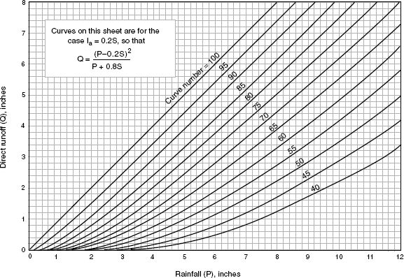
Figure 1.1 – Curve for runoff equation application [92]
An arithmetic interpolation can be used to calculate runoff depths for CNs, and other rainfall amounts not shown in Table 2.4.
Table 1.4 – Ready-computed runoff depths from some of the CNs and rainfall amounts [92]
Rainfall (P) (mm) | Curve Number (CN)
Rainfall (P) (mm) | 40 | 45 | 50 | 55 | 60 | 65 | 70 | 75 | 80 | 85 | 90 | 95 | 98
Rainfall (P) (mm) | mm
25 | 0 | 0 | 0 | 0 | 0 | 0 | 0 | 0 | 3 | 5 | 8 | 15 | 20
30 | 0 | 0 | 0 | 0 | 0 | 0 | 0 | 3 | 5 | 8 | 13 | 18 | 25
36 | 0 | 0 | 0 | 0 | 0 | 0 | 3 | 3 | 5 | 10 | 15 | 23 | 30
41 | 0 | 0 | 0 | 0 | 0 | 3 | 3 | 5 | 8 | 13 | 20 | 28 | 36
46 | 0 | 0 | 0 | 0 | 0 | 3 | 5 | 8 | 10 | 18 | 23 | 33 | 41
51 | 0 | 0 | 0 | 0 | 3 | 3 | 5 | 10 | 15 | 20 | 28 | 38 | 46
64 | 0 | 0 | 0 | 3 | 5 | 8 | 13 | 18 | 23 | 30 | 38 | 51 | 58
76 | 0 | 0 | 3 | 5 | 8 | 13 | 18 | 25 | 33 | 41 | 51 | 64 | 71
89 | 0 | 3 | 5 | 10 | 13 | 20 | 25 | 33 | 41 | 51 | 64 | 74 | 84
102 | 3 | 5 | 8 | 13 | 20 | 25 | 33 | 43 | 51 | 64 | 74 | 86 | 97
114 | 3 | 8 | 13 | 18 | 25 | 33 | 43 | 53 | 64 | 74 | 86 | 99 | 109
127 | 5 | 10 | 18 | 25 | 33 | 43 | 51 | 64 | 74 | 86 | 99 | 112 | 122
152 | 13 | 20 | 28 | 38 | 48 | 61 | 71 | 84 | 97 | 109 | 124 | 137 | 147
178 | 20 | 30 | 43 | 53 | 66 | 79 | 91 | 107 | 119 | 135 | 147 | 163 | 173
203 | 33 | 43 | 58 | 71 | 84 | 99 | 114 | 127 | 142 | 157 | 173 | 188 | 198
229 | 43 | 58 | 74 | 89 | 104 | 119 | 135 | 152 | 168 | 183 | 198 | 213 | 224
254 | 56 | 74 | 91 | 107 | 124 | 142 | 157 | 175 | 191 | 208 | 224 | 239 | 249
279 | 71 | 89 | 109 | 127 | 145 | 163 | 180 | 198 | 216 | 231 | 249 | 264 | 274
305 | 86 | 107 | 127 | 147 | 168 | 185 | 206 | 224 | 241 | 257 | 274 | 290 | 300
330 | 102 | 124 | 147 | 168 | 188 | 208 | 229 | 246 | 264 | 282 | 300 | 315 | 325
356 | 119 | 142 | 168 | 188 | 211 | 231 | 251 | 272 | 290 | 307 | 325 | 340 | 351
381 | 135 | 163 | 188 | 211 | 234 | 254 | 277 | 295 | 315 | 333 | 348 | 366 | 376

Design Storm Data
For various design storm recurrence intervals, the SCS approach is based on 24-hour rainfall levels (e.g., 1-year, 10-year, or 100-year storm events) [93].

Determination of Runoff Curve Number (CN)
The CN determines how much runoff will occur, given a particular amount of rainfall. The CN value for a watershed is determined by the HSG, cover type and hydrologic state, and antecedent moisture condition [94–96]. An area-weighted CN should be determined for watersheds with diverse soil types or land uses. For modeling reasons, the watershed should be divided into separate drainage zones where there are major changes in land use or natural control points. The sections that follow go through the components that contribute to determining CN values and their link to runoff [97].

The perspective of the Hydrologic Soil Group
- Soils are divided into four types based on their hydrologic properties (A, B, C, or D) (HSG). The HSG of soil reveals the bare-soil minimum rate of infiltration after prolonged wetness. Infiltration rates are highest in Group A soils and lowest in Group D soils. The pace of water penetration in the soil is governed by the type of cover on the soil surface. TR-55 defines the four HSGs as follows [98]:
- HSG A – Even when completely saturated, soils have minimal potential for surface runoff as well as possessing high rates of infiltration or permeability. They are primarily made up of deep, well-to-extremely well-drained sand or gravel with a high water transmission rate.
- HSG B – When thoroughly wetted, (silt loam or loam), these types of HSGs are known to possess moderate permeability rates and are primarily composed of sufficeintly-drained soils. The water transmission rate in these soils is moderate.
- HSG C – When thoroughly wetted, (sandy clay loam), these particular types of HSGs are well-known to be of low permeability rates and are mostly composed of soils with a surface that hinders water from moving downhill.
- HSG D – Have significant runoff potential. They are generally chronic as well as shallow soils over extremely impermeable material, and when thoroughly wetted, they have very poor infiltration rates. The rate of water transport in these soils is extremely low.
It should be remembered that any disturbance to a soil profile might alter infiltration properties dramatically. As a result, the HSG should be raised one level in places where the soil profile has been disrupted (i.e., from A to B, B to C, or C to D) [99].

Surface coverage and hydrologic pattern of a watershed
Field reconnaissance, aerial photography, and land use maps are some of the most frequent methods for assessing cover type. Predicted cover types should also be addressed in runoff analysis based on the current zoning and future land use plan [100].
The impacts of cover type on infiltration and runoff for a specific HSG are determined by plant density on sample sites, with higher plant density indicating higher infiltration rates. For that specific HSG and cover type, a "good" hydrologic condition means the soil has a low runoff potential [101].

Antecedent Moisture Condition
The gauge of surface runoff beforehand a storm is called the antecedent moisture condition (AMC). Because the AMC takes into consideration the degree of soil saturation at the start of a rainstorm, the CN must be altered to reflect more accurate runoff conditions. All of the numbers in Table 1.5 and Table 1.6 are AMC II (median moisture conditions) and should be used for design purposes. If necessary, AMC I (dry circumstances) and AMC III (wet conditions) adjustments can be made [102].

Connected impervious areas
If runoff from an impermeable region runs directly into the drainage system, it is considered linked. If runoff from the land occurs as a concentrated shallow flow that flows over an impervious area and subsequently into the drainage system, it is also termed linked.

Unconnected impervious areas
Sheet flow is the dispersion of runoff from unconnected impermeable regions over a pervious area. When the impervious land, in whole or in part, is not immediately connected to the drainage system, Figure 1.2 is used for runoff estimation (the total impervious area is less than 30%) or Figure 1.3 when the total impervious area is equal to or greater than 30%, because the remaining pervious areas' absorptive capacity will not significantly affect runoff [103].
As previously mentioned, Table 1.5 shows some estimated impervious area percentages for urban areas, while Table 1.6 shows some estimated impervious area percentages for non-urban areas [104].
Table 1.5 – Runoff Curve Numbers for urban areas [92]
Definition of cover |  | CN for Hydrologic Soil Group
Type of cover | Percentage of impervious area on average ³ | A | B | C | D
1 | 2 | 3 | 4 | 5 | 6

Continuation of table 1.5
1 | 2 | 3 | 4 | 5 | 6
Open Areas
Relatively poor condition (grass cover less than 50%) | - | 68 | 79 | 86 | 89
The surface occupied by grass cover ranging from 50% to 75% of the land is in fair condition | - | 49 | 69 | 79 | 84
75 % or more of the region has a decent grass cover ¹ | - | 39 | 61 | 74 | 80
Areas that are impervious
Paved parking lots, roofs, and driveways, among other things | - | 98 | 98 | 98 | 98
Streets and roads
Curbs and storm sewers are paved | - | 98 | 98 | 98 | 98
Paved roads with open ditches | - | 83 | 89 | 92 | 93
Gravel | - | 76 | 85 | 89 | 91
Dirt | - | 72 | 82 | 87 | 89
Urban Districts
Business and Commercial | 85 | 89 | 92 | 94 | 95
Industrial | 72 | 81 | 88 | 91 | 93
Residential Districts by Lot Size Average ²
A plot of land of no more than an eighth of an acre (townhouses) | 65 | 77 | 85 | 90 | 92
a quarter-acre | 38 | 61 | 75 | 83 | 87
One-third of an acre | 30 | 57 | 72 | 81 | 86
a half-acre | 25 | 54 | 70 | 80 | 85
One acre | 20 | 51 | 68 | 79 | 84
Two acres | 12 | 46 | 65 | 77 | 82
Developing Urban Areas
Areas that have recently been graded (pervious areas only, no vegetation) | - | 77 | 86 | 91 | 94
Note:
AMC II as well as I_{a} = 0.2*S
¹ Grazing is kept at bay, and litter and brush cover the soil.
² The curve numbers are calculated assuming that all runoff from the home and driveway is diverted to the street, with just a little amount of roof water being directed to lawns, where extra infiltration may occur.
³ For these curve numbers, the remaining pervious regions (lawn) are regarded to be in good pasture condition.
Table 1.6 – Runoff CN for non-urban areas [92].
Cover description |  | CN for Hydrologic Soil Group
Cover type and hydrologic condition |  | A | B | C | D
Idle Lands (not yet developed)
Pasture, Grassland, or Range: continuous  forage for grazing¹. | Poor | 68 | 79 | 86 | 89
 | Fair | 49 | 69 | 79 | 84
 | Good | 39 | 61 | 74 | 80
Meadow: continuous grass, protected from  grazing and generally mowed for hay. | - | 30 | 58 | 71 | 78
Brush: brush-weed-grass mixture². | Poor | 48 | 67 | 77 | 83
Brush: brush-weed-grass mixture². | Fair | 35 | 56 | 70 | 77
Brush: brush-weed-grass mixture². | Good | 30 3 | 48 | 65 | 73
Woods: grass combination (orchard or tree  farm)⁴ | Poor | 57 | 73 | 82 | 86
Woods: grass combination (orchard or tree  farm)⁴ | Fair | 43 | 65 | 76 | 82
Woods: grass combination (orchard or tree  farm)⁴ | Good | 32 | 58 | 72 | 79
Woods⁵ | Poor | 45 | 66 | 77 | 83
Woods⁵ | Fair | 36 | 60 | 73 | 79
Woods⁵ | Good | 30 3 | 55 | 70 | 77
Farmsteads: buildings, lanes, driveways, and surrounding lots. | - | 59 | 74 | 82 | 86
Note:
AMC II as well as I_{a} = 0.2*S
¹ Poor: approximately 50% ground cover or extensively grazed with no mulch.
Fair: ground cover of 50 to 75 % and not extensively grazed.
Good: >75% ground cover and only moderately or infrequently grazed.
² Poor: a ground cover of at least 50%.
Fair: between 50 and 75 % of the earth is covered.
Good: >75% of the ground is covered.
³ Use CN = 30 for runoff calculations if the actual CN is less than 30.
⁴ The CNs displayed were calculated for areas with 50% wood and 50% grass (pasture) cover. From the CNs for forests and pasture, other combinations of circumstances can be calculated.
⁵ Poor: heavy grazing or regular burning destroys forest trash, tiny trees, and bushes.
Fair: The woods are grazed but not burned, and the land is covered in forest litter.
Good: Grazing is prohibited in the woods, and litter and brush adequately cover the soil.

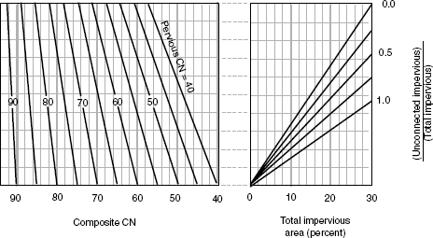
Figure 1.2 – Composite CN with Unconnected Impervious Areas and Total Impervious Areas Less than 30% [92]
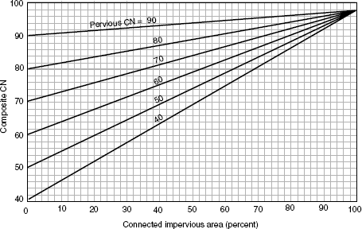
Figure 1.3 – Composite CN with Connected Impervious Area [92]

Limitations on use of SCS method
- When there are considerable differences in CN values between watershed subareas and runoff volumes are smaller for CN values less than 60, do not utilize the SCS approach.
- When runoff is less than 1/2-inch, the CN technique is less precise. When this happens, utilize another approach to determine runoff as a precaution.
- For watersheds with many subareas with concentration durations less than 6 minutes, the SCS approach should not be used. Subareas should be pooled in these circumstances to achieve a concentration time of at least 6 minutes (0.10 hours) for the combined areas.
- Curve numbers are used to describe average conditions for design purposes. When a historical storm is used as a rainfall event, the modeling accuracy suffers.
- While re-creating certain elements of a real storm, use caution when using the runoff curve number equation. Because the equation lacks a time expression, it is unable to account for rainfall duration or intensity.
- The USDA NRCS developed the initial abstraction relationship, I_{a} = 0.2*S (which covers interception, initial infiltration, surface depression storage, evapotranspiration, and other parameters) using data from agricultural watersheds (where S is the potential maximum retention after runoff begins). In actuality, different combinations of impervious and pervious areas, as well as different storage features, do not result in all watersheds (urban and non-urban) having the same I_{a}.
- These methods cannot be used to estimate runoff from snowmelt or rain on frozen ground.
- The techniques of the SCS approach are only applicable to direct surface runoff. Large sources of subsurface flow or high groundwater levels that contribute to runoff should not be overlooked. These circumstances are frequently linked to HSG A soils and forest regions with low CN values in Table 1.5 and Table 1.6. Adjusting CNs when conditions warrant requires good judgment and experience based on stream gauge information.
- Use a different approach to determine runoff when the weighted CN is less than 40.

Computer Modeling
For the drainage calculations/methods previously stated, the use of contemporary computer models by qualified engineers is allowed due to the high number of computations needed in runoff calculations and routing. The Hydrologic Engineering Center (HEC) of the United States Army Corps of Engineers (USACE) has developed computer programs that can be downloaded from the USACE hydrologic website (http://www.hec.usace.army.mil/) and applied to some of the drainage methods. The USACE offers a program called HEC-HMS [105]. The NRCS also offers versions of TR-20 and TR-55 that allow users to input rainfall distributions and execute appropriate detention and channel routing processes [106]. The HEC-HMS, TR-55, and TR-20 models are free to download from the organizations that created them. Commercial tools like StormCAD [107], StormNET [108], and others can be used to evaluate the drainage strategies discussed in this chapter. The design engineer is responsible for understanding the methodologies used in the commercial software and ensuring that the software's outcomes match and correspond to the approach.

Embankment dams

General overview
Dams should have a top width of at least 2.4 m to 3.7 m, depending on their height. Dams that are less than 3.7 m tall must have a 2.4 m top width. Dams between 3.7 m and 4.6 m tall require a 3 m top width, whereas those over 4.6 m tall require a 3.7 m top width. The dam should be at least 4.9 m wide at the top if it is to be used as a road [109].
Dams must be cored with clay to avoid seepage in various regions due to soil characteristics (Figure 1.4). On the waterside, the dam should have a slope of no more than 3:1. A 4:1 slope on the rear allows it to be mowed and maintained securely. A dam with a 3:1 slope, for example, will rise 0.3 m for every 0.9 m of horizontal measurement [109].
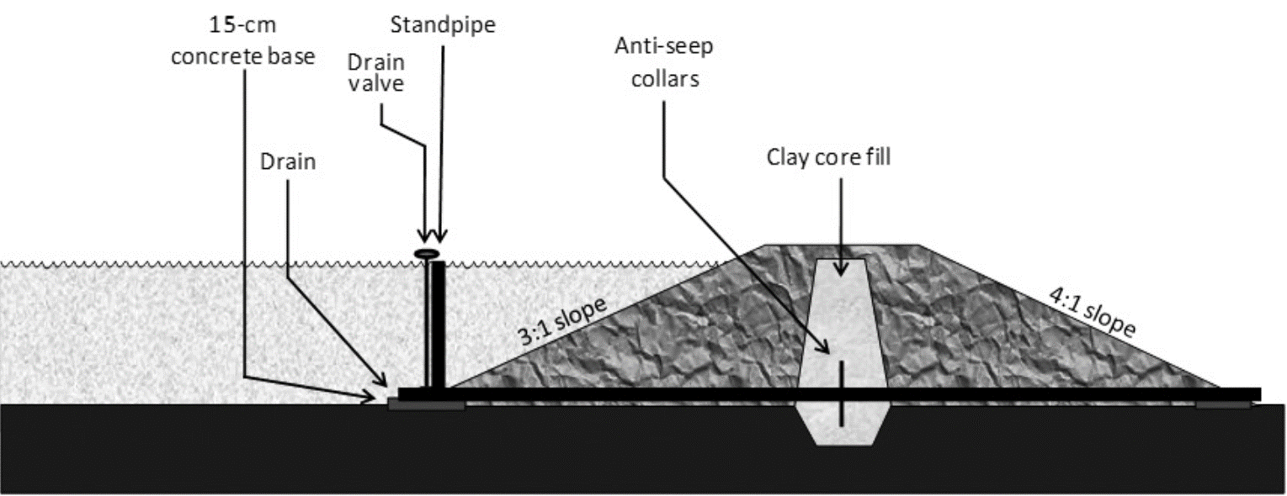
Figure 1.4 – A typical example of an embankment dam [110]
For proper management, a combination drain and overflow pipe, as well as an emergency spillway, are required. It is critical that the drainpipe be installed on the pond's bottom so that the pond may be entirely drained. A drain is required to effectively manage the pond. The overflow pipe is where the pond's typical water flow exits. The emergency spillway is an area on one side of the dam that is lower than the top of the dam and is used to safely release excess runoff from heavy rainfall [111]. Corrugated metal, aluminum, steel, or polyvinyl chloride can be used for overflow and drainpipes (PVC) (Figure 1.5). PVC pipe, for example, is affordable yet prone to breakage and vandalism [112].
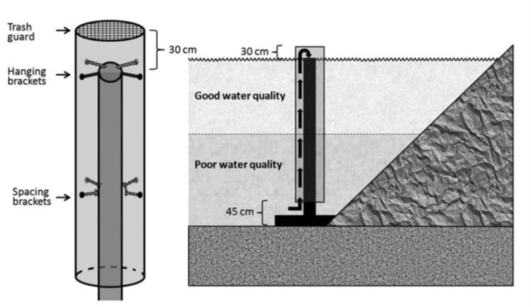
Figure 1.5 – Overflow pipe description [112]

Design of earthen dam components
An earthen dam's preliminary design is based on previous experience with comparable types of dams. For this aim, empirical formulae are also used. Prior to construction, the following components of an earthen dam are given top priority [113].
The following are the key components of the earth dam:
- Width at the top.
- Boarding is available for free.
- A trench that has been cut off.
- The impenetrable core in the center.
- Outer shell or casing.
- Foundations and internal drainage system.
- Surface drainage Slope protection.
- A blanket that is impenetrable.
- The spillway's design.

Top width
The following factors are used to determine the top width of an earthen dam:
- The type of fill material utilized in the construction of the embankment, as well as the maximum permissible percolation through the embankment at normal reservoir levels.
- The dam's height and significance.
- The dam's practicability.
- Shielding against earthquakes and tidal waves.
The dam's top width is determined by its height. At full reservoir capacity, the minimum top width should be able to produce a safe percolation gradient. The width of the embankment is calculated using the method below, which is based on the height of the dam [114].
Dams with a relatively low embankment:
 | $$W=\frac{H}{5}+3$$ | (1.7)
Dams having a height of less than 30 m are eligible:
 | $$W=0.55\sqrt{H}+0.2H$$ | (1.8)
Embankment dams with H>30:
 | $$W=1.65 ({H+1.5)}^{\frac{1}{3}}$$ | (1.9)
Whereby: W – Top width of the dam, m; H – Height of the dam, m. The top breadth of the dam should be at least 6 meters, according to Indian standards [114].

Free board
The freeboard can be defined as the vertical distance between the top of the embankment and the highest water level in the reservoir. Based on the water level, the freeboard is separated into two categories: normal freeboard and minimum freeboard. A normal freeboard is a difference in elevation between the top of the embankment and the ordinary reservoir level. The minimum freeboard is the elevation difference between the top of the embankment and the highest water level in the reservoir [115].
Surcharge head is the difference between the usual and the minimal freeboard. To reduce the risk of overtopping, a sufficient freeboard must be provided while determining the height of the dam [115].
Table 1.7 – Recommended values of freeboard [115] shows the recommended freeboard values based on the nature of the spillway and the height of the dam.
Table 1.7 – Recommended values of freeboard [115]
Nature of spillway | Height of dam | Freeboard
Free spillway | Any | Over the maximum flood level by a minimum of 2 m and a maximum of 3 m
Controlled spillway | 60 m or less | 2.5 meters above the gates' tops
Controlled spillway | More than 60 m | 3 m above the gates' tops

Cutoff trench
The main purpose of a cutoff trench in an earth-fill dam is to prevent the loss of stored water via seepage through the foundation and abutment. Furthermore, it prevents piping-related sub-surface erosion. Detailed geological investigations should be used to determine the sort of cut-off. It's preferable to have a positive cut-off point. If complete cut-off with or without an upstream impervious blanket is not achievable, partial cut-off with or without an upstream impervious blanket may be given. In any event, suitable drainage could be installed downstream. For the design of cut-offs, the following guidelines might be used [116]:
- The cut-off shall be located such that its centerline should be within the base of the impervious core and should be upstream of the centerline of the dam.
- The positive cut-off should be keyed at least to a depth of 0.4 m into continuous impervious sub-stratum or non-erodible rock formation.
- It is recommended that the bottom breadth be at least 4.0 meters.
- In the event of overburden, side slopes of at least 1:1 or flatter may be provided, while in soft rock and hard rock, 1/2:1 and 1/4:1 may be provided.
- The backfill material for the cut-off trench shall have the same properties as those specified for the impervious core.
- The cut-off in the flanks on either side should normally extend up to the top of the impervious core.
- If a cut-off trench ends in worn rock with cracks, joints, and crevices, and the percolation test shows a lugeon value of more than 10, the rock foundation beneath the cut-off trench bed should be grouted.
A cutoff reduces seepage while also enhancing stability [117]. Regardless of whether stable clay or another material is used, the cutoff trench must be dug to a depth that prevents any conceivable seepage. The cutoff trench should ideally be dug all the way down to solid rock that stretches to enormous depths. If the underlying rock is fissured or uneven, it can be cleaned and concreted to provide a solid foundation for the clay. Slush grouting, which is a thick slurry mix of cement and water injected and broomed into the bigger cracks and fissures before any concrete is set to fill the residual indentations and provide an eventual mostly flat surface, should be used for larger indentations or cracks [118–121]. For more equal surfaces with fewer fractures, a cement wash (a weaker combination of cement and water that forms a creamy texture) can be brushed across the surface to seal it and re-establish a broadly level surface layer.
Generally, minimum width of 4 m is recommended; however, an adequate width of a cut-off trench for small dams can be determined using the following formula [114]:
 | $$W=h-d$$ | (1.10)
Whereby:
W – cut-off trench bottom width; h – reservoir head above ground surface; and d – cutoff trench depth below ground level.
      - Central impervious core
Within the dam's body, the core forms an impenetrable barrier. In general, impervious soils are suited for the core. The following factors are used to design the central impermeable core of an earth dam [122]:
- The maximum amount of seepage loss that can be tolerated.
- Dam section width maximum, allowing correct construction of central impervious core.
- Materials that can be used in construction.
- The proposed filter's design criterion.
Because a thick shell provides more resistance to piping action and also increases the formation of cracks, a thinner shell gives comparatively more stability than a thick shell. The core might be located in the center or tilted upstream. A 3 m wide core is typically used at the dam's crest. To prevent seepage due to capillary action, the height of the core should be at least 1 m above the reservoir's maximum water level. The core thickness at any part must not be less than 30% (ideally not less than 50%) of the maximum head of water acting at that section [67].

Suitable core material
A soil with lower compressibility and a liquid limit is regarded as a good candidate for core building. On the other hand, soils with high compressibility and a higher liquid limit, as well as organic content, should be avoided because they are prone to swelling and crack formation. Table 1.8 lists the materials that Indian Standard (IS-8826-1978) recommends for core construction in zonal type earthen dams [114].
Table 1.8 – Suitable soil for core construction [114]
The soil type | Suitability
15 % of the material (D₈₅) is coarser than 50 mm, and 50% of the material (D₅₀) is coarser than 6 mm in very well-graded sand, gravel, and fines combinations. | Very good
D₈₅ coarser than 25 mm, a graded mixture of sand, gravel, and clayey fine. Fine materials made up of inorganic clay (with a plastic index greater than 12) or high plastic tough clay (with a plastic index greater than 20). | Good
D₈₅ is greater than 19 mm, and D₅₀ is between 0.5 and 3 mm, gravelly medium to coarse sand with cohesionless particles in a well-graded gravelly medium to coarse sand. Clay with a plastic index of more than 12 is considered medium plastic. | Fair
Low plasticity clay with a small coarse percentage. The plastic index is between 5 and 8, and the liquid limit is greater than 25.  Silts with a medium to high plasticity and a small coarse proportion with a plastic index greater than 10. | Poor

Casing or outer shell
The purpose of the shell is to provide stability and protection to the core. The casing can be made of reasonably pervious materials that do not break when exposed to the atmosphere directly. The dam's top width should be 4.5 meters (minimum). Berms of greater than 10 meters in height may be constructed for the dam. The minimum berm width should be 3 meters. The embankment's upstream and downstream side slopes are dictated by the features of available materials, foundation condition, dam height, and dam type [123]. Terzaghi's suggested upstream and downstream side slopes are indicated in Table 1.9.
Table 1.9 – Recommended side slopes of an earthen dam [124]
Soil type | u/s slope | d/s slope
Homogeneous well-graded material | 2.5:1 | 2:1
Homogeneous coarse silt | 3:1 | 2.5:1
Homogeneous silty-clay: height < 15 m | 2.5:1 | 2:1
>15 m | 3:1 | 2.5:1
Sand or sand gravel with clay core | 3:1 | 2.5:1
Sand or sand gravel with a reinforced concrete core | 2.5:1 | 2:1

Internal drainage system
It's vital to preserve the original soil particles in place and ensure the dam's stability by managing the seepage water in the dam. Some of the most common ways for safely disposing of seepage water through embankment dams are listed below [125]: Inclined or vertical filter (chimney filter); Horizontal filter; Rock toe; Toe drain.
Sand, gravel, and other locally available materials should be used whenever possible. Only the downstream slope of the core has an inclined or vertical filter. It is kept at least 1.0 m thick. The seepage from the chimney filter and foundation is collected by the horizontal filter and carried to the rock toe and toe drain. It is kept to a maximum thickness of 1.0 m. Filter and neighboring soil (casing or foundation) should meet the standard filter requirement. In dam sections with a water head of less than 3 meters, a chimney filter or a horizontal filter are not required. However, proper toe protection is required. The height of the rock toe is usually given as 0.2 H, where H is the embankment height. However, the minimal height of the rock toe is maintained at 1.0 m. A rock toe is not required when the embankment height is less than 3 meters [126].
The toe drain is located at the earth dam's downstream toe to collect seepage from the horizontal filter, rock toe, and foundation and discharge it into suitable surface or subsurface drains. The drain portion should be large enough to carry seepage. To divert seepage to natural drains, the bed of the toe drain should be sloped appropriately. Toe drains are typically 1.5 m deep, with a minimum bottom width of 1.0 m and 1:1 side slopes. With the base material, the filter material must meet the following characteristics [127]:
 | $$\frac{D_{15 (filter material}}{D_{15 (base material)}}=4 to 20$$ | (1.11)
 | $$\frac{D_{15 (filter material)}}{D_{25 (base material)}}<5$$ | (1.12)
Even if a filter meets all of the above criteria, it may still fail if it has an excess or shortage of specific sizes or if it is not graded equally. In such instances, the following requirements must be met [127]:
 | $$\frac{D_{50 (filter material)}}{D_{50 (base material)}}<25$$ | (1.13)

Slope protection
The protection of the upstream slope is ensured by the use of riprap. Up to the crest of the dam, a minimum of 300 mm thick riprap over a 150 mm thick filter layer may be installed. The protection of the downstream slope is provided by turfing or riprap. It is common practice to provide appropriate turfing on the entire downstream slope from top to bottom to protect the downstream slope from rain [128,129].

Surface drainage
At 50 m center to center, a system of open paved drains (chutes) along the sloping surface, finishing in longitudinal collecting drains at the intersection of berm and slope, shall be erected to drain rainwater for downstream slope surface drainage. The drain section could be trapezoidal, with a depth of 30 cm. Rainwater is collected in a longitudinal collecting drain and channeled through 15cm diameter pipes spaced 50 meters apart onto paved chutes on the downstream slope. The open paved drains should finish at the downstream rock toe or toe drain if no berm has been provided [130].

Impervious blanket
When full cutoff is not possible in a pervious foundation, the horizontal impermeable blanket is used to increase the path of the seepage. The impervious blanket must be attached to the dam's core. The material should not be excessively plastic to avoid crack formation. To avoid cracking due to exposure to the atmosphere, a 300 mm thick layer of random material should be placed over the blanket. Normally, within the process of a dam design and construction, an application of an impermeable layer of not less than 1 m thick is always recommended for better stability of an embankment [131]. This provides the embankment with a reliable level of capacity to withstand potential failure.

Design of spillway
Spillway design, which has vitally important dimensions and physical qualities, necessitates the estimation of peak floods. If a suitable spillway of enough size is not available at a particular location or would be too expensive, it is preferable to move on to a better alternative site where spillway conditions may be met. In larger catchments (>5-8 km²), rock spillways are practically required. Good solid rock with sufficient width must be available for all but the smallest dams. Something important to note is that, in a case of a proposed dam that has to be located within a catchment of around 5 km² coverage, it is recommended to provide not less than 15 m width in conjunction with a 1.5 m freeboard, subject to re-evaluation during the detailed design stage. Local engineers and knowledgeable local people should be consulted if hydrological data and/or design charts are not available. Poor spillway design is more likely than any other element to cause problems in earth dams in southern and western Africa. In some cases, the proposed dam site for an embankment dam does not contain sufficient rocks; in such a scenario, it is in the best interest not to consider further the site for dam construction [132].
Grass spillways, whether cut or natural, are best suited to small catchments (up to 5 km²) and low velocity flows, and even then, they may require ongoing care throughout the life of the dam to prevent erosion. Because the ability of vegetation or soil to withstand erosion is limited, it is critical to maintain an even surface and consistent cover. The overall stability of the channel is highly dependent on the stability of the most sparsely covered part; hence a good creeping grass cover should be established throughout [133].
The state of the grass cover will have a direct impact on the roughness coefficient of the channel, which is dependent on flow. A low flow meets substantial resistance, whereas a high flow flattens the grass and thus encounters much less resistance. In grass spillways planted to shorter creeping kinds like Kikuyu, couch, and star grasses, the maximum permissible non-erosive velocities are highest. These can provide a homogenous low cover with minimal flow resistance and maximum protection for the soil beneath. A drop-inlet overflow spillway should be planned and located at the opposite end of the embankment to the main spillway, at an elevation on the upstream side of the dam slightly lower (usually 50-100 mm) than the full supply level, where even normal flows are expected to pose an erosion risk. [134].
In the embankment type pond, a mechanical spillway is installed to allow water from the storage to be released in a controlled manner. An emergency spillway is constructed on one end of the embankment to prevent the embankment from overtopping owing to unexpected inflows into the storage. The highest flood level projected for the selected frequency of runoff into the pond should be the bottom elevation of the emergency spillway [135].
The flow via the emergency spillway for the agricultural pond determines its proportions. If there is sufficient storage capacity above the spillway, the peak flow for the design of the emergency spillway channels is reduced using the weir calculation previously mentioned. Permanent structures are built to function as agricultural pond mechanical spillways. Higher discharges can be handled by the drop spillway than by the drop-inlet [136,137].
The drop inlets, on the other hand, provide you with more control over the water in the pond. These structures have the same design and construction as gully control structures. When similar structures are utilized in farm ponds, small alterations are made to them. Surplus weir is a term used to describe the drop structures built into the pond's embankment. On the crest, a row of vertical pillars is sometimes built. When more water is needed, the earth is placed between the pillars to prevent the water from flowing through. A control valve or a sliding headgate is provided to manage the outflow of water in the drop inlet spillway, which is likewise built as a simple pipe culvert. In the case of ponds built for aquaculture, outlet structures are required to drain the water as needed [138].

Embankment slope stability
Slope stability analysis is critical in engineering practice to maintain structural stability and avoid human life and financial damage [139].
The Culmann Method, Ordinary Method of Slices, and Bishop Method of Slices are three typical approaches for analyzing the stability of a slope. Except for the Culmann approach, which assumes a plane surface of failure through the toe of the slope, the other mentioned slope stability analysis methods are based on the premise that the plane of failure is a circular arc [140].
The quantitative determination of slope stability is required for a variety of engineering projects, including the design of earth dams and embankments, the analysis of natural slope stability, the analysis of excavated slope stability, and the analysis of the deep-seated failure of foundations and retaining walls [141].

Causes of slope instability
- Rapid drawdown.
- By soaking the soil, the unit weight of the soil increases.
- Impact from the increased load as a result of external loading.
- Slopes that have been steepened by excavation or erosion.
- Shock loading.
- Impacts of vibrations and earthquakes.
- Elevated soil moisture content.
- Impacts of the freeze-thaw phenomenon.
- Elevated pore pressures in the embankment can also be linked to rapid drawdown.
- Cementing pressure loss.

The significance of embankment stability analysis in terms of slope
- Recognize how natural slopes evolve and take shape, as well as the mechanisms that cause various natural features.
- Evaluate the slope's stability in both short-term (typically during construction) and long-term situations.
- Assess the likelihood of landslides involving natural or manmade slopes.
- Analyze landslides and understand failure processes and the influence of environmental factors.
- If necessary, redesign failed slopes and plan for the design of preventive and repair measures.
- Research the effects of earthquakes on slopes and embankments.

Types of slope failure
- Circular slips.
- They are related to homogenous, isotropic soil conditions.
- Non-circular slips.
- Non-circular slips are associated with non-homogeneous soil conditions.
- Translational failure.
When the form of the failure surface is influenced by the existence of an adjacent stratum of differing strengths, and the adjacent stratum is relatively shallow, this type of failure occurs.
- Failure that is compounded.
It occurs when the existence of a neighboring stratum of various strengths affects the shape of the failure surface, and the adjacent stratum is relatively deep (Figure 1.6) [142].
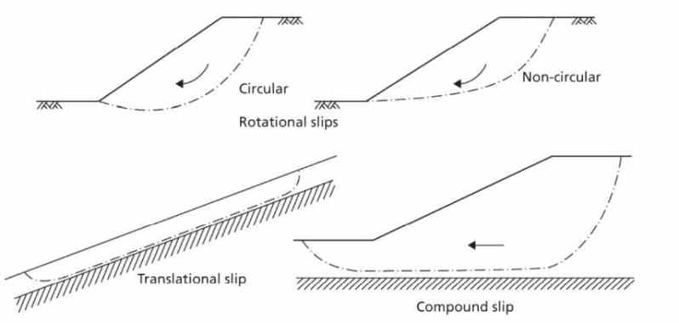
Figure 1.6 – Types of slope failure [142]

Assumptions for slope stability analysis
- There are problems that are two-dimensional.
- Coulomb's theory can be used to compute shear strength.
- The shear strength of the slip surface is thought to be uniform.
- The flow net can be drawn, and the seepage forces are estimated in the event of seepage.

Factor of safety
A number of safety criteria are taken into account when analyzing slope stability. Consider the safety factor in terms of strength, cohesion, friction, and height, for example. The former is quite well-liked [143].
(a) Factor of safety based on Strength
It's the ratio of a soil's maximum load or stress to the actual load or stress that's applied, and it's written like this [144]:
 | $$F=\frac{τ_{ff}}{τ}$$ | (1.14)
Equation (1.14) can be tweaked in the following way:
 | $$τ=\frac{c}{F}+\frac{σ_{n}tanθ}{F}$$ | (1.15)
Whereby:
$τ$ – the amount of shear stress that is delivered to the soil.
At the value of normal stress $σ_{n}$; $τ_{ff}$ is the shear stress that a soil can endure at its maximum (Figure 1.7) [145].
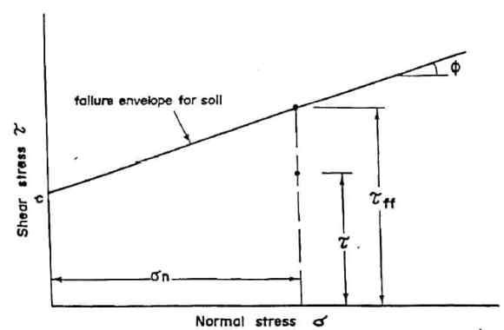
Figure 1.7 – Factor of safety definition diagram [146]
(b) The Factor of Safety in relation to cohesion
The factor of safety in relation to cohesion can be taken into account when the frictional component of strength is fully mobilized and as a result of dividing the real cohesion and the cohesiveness necessary for stability, as stated by Equation (1.16). In summary, is the ratio between actual cohesion and the cohesion required for stability [147,148]:
 | $$τ=\frac{c}{F_{c}}+σ_{n}tanθ$$ | (1.16)
(c) Friction-related factor of safety
The factor of safety in relation to friction can be taken into consideration when the cohesive component of strength is fully mobilized; and is therefore a result of dividing the tangent of the soil's shearing resistance angle to the tangent of the soil's mobilized shearing resistance angle (1.17) [149].
 | $$τ=c+\frac{σ_{n}tanθ}{F_{c}}$$ | (1.17)
(d) The Factor of Safety in relation to height
It is the ratio of a slope's maximal height to the actual height of the slope (1.18) [150].
 | $$F_{H}=\frac{H_{max}}{H}$$ | (1.18)

Slope stability analysis methods
(a) Culmann Method
It is not extensively utilized because it has been proved that planar sliding surfaces are only observed on very steep slopes and that curved sliding surfaces are most often observed on comparatively flat slopes (Figure 1.8) [151].
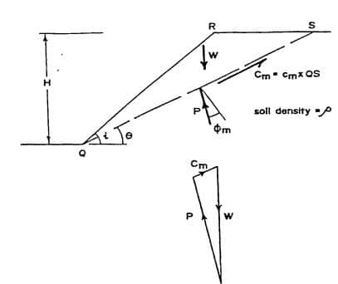
Figure 1.8 – Slope stability analysis using the Culmann method [151]
(b) Shearing Resistance Method at zero angle
The assumption behind this approach of slope stability analysis is that the plane of failure is in the shape of a circular arc. It's a useful technique for determining the short-term stability of wet clay slopes (Figure 1.9) [152].
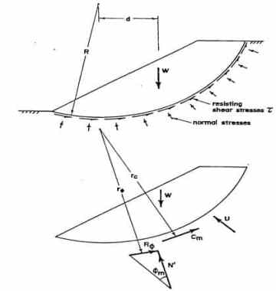
Figure 1.9 – Forces involved in slope stability calculation [153]
(c) Ordinary Method of Slices
When the effective angle of shearing resistance is not constant along the failure surface, as in zoned earth dams where the failure surface may pass through several distinct materials, it is taken into account (Figure 1.10) [154].
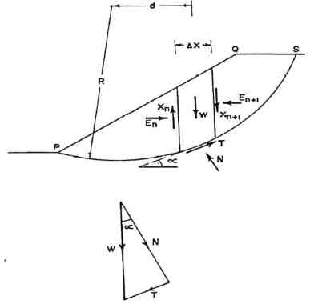
Figure 1.10 – Ordinary Method of Analysis [153]
(d) Bishop Method of Slices
The analysis in the Bishop technique of slices is done in terms of stresses rather than forces, as in the standard method of slices. The key difference between this method and the Ordinary Method of Slices is that the forces are resolved in the vertical direction rather than the arc's normal direction. The simplified Bishop method of slices yields a safety factor that is quite close to those calculated using more rigorous approaches (Figure 1.11) [155].
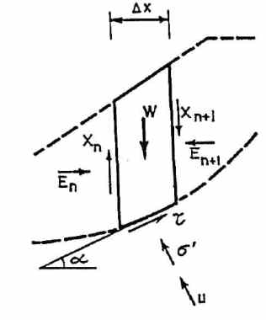
Figure 1.11 – Stresses and forces acting on a slice in Bishop Method of analysis [153].
(e) Morgenstern-Price
Morgenstern-Price is a general slice approach based on the principle of limit equilibrium. It necessitates a harmonious balance of forces and moments operating on individual blocks. By splitting the soil above the slip surface into dividing planes, the blocks are formed. The forces acting on individual blocks are depicted in the diagram below (Figure 1.12) [156]:
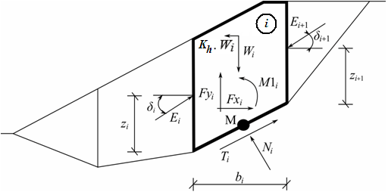
Figure 1.12 – Morgenstern-Price approach (static scheme) [157]
The Morgenstern-Price technique for calculating the limit equilibrium of forces and moments on individual blocks makes the following assumptions [158]:
- Between-block dividing planes are always vertical.
- The line of action of block Wi's weight runs via the center of the i^{th} slip surface segment, which is represented by point M.
- The standard force at point M, N_{i} is acting in the center of the i^{th} segment of the slip surface.
- The inclination of forces E_{i} acting between blocks is different on each block (δ_{i}) at slip surface endpoints is δ = 0.
The preceding set of assumptions shows the only difference between the Spencer and Morgenstern-Price methods. The Half-sine function is used to choose the inclination angles δ_{i} of forces E_{i} acting between the blocks - one of the functions in the following image is automatically picked. The shape of the function has little impact on the final results, but a good choice can increase the method's convergence. The value of inclination angle δ_{i} is obtained by multiplying the functional value of the Half-sine function f(x_{i}) at boundary point x_{i} by parameter λ (Figure 1.13) [157].
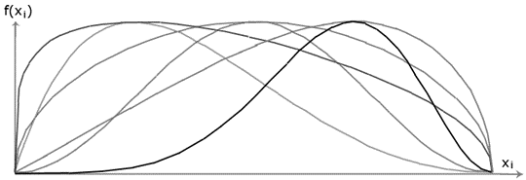
Figure 1.13 – Function of half-sine [157]
The Morgenstern-Price expressions are summarized in Equations (1.19) to (1.23):
 | $$N_{i}=N_{i}^{'}+U_{i}$$ | (1.19)
 | $$T_{i}=(N_{i}-U_{i})\tan{φ_{i}+c_{i}\frac{b_{i}}{\cos{α_{i}}}=N_{i}^{'}\tan{φ_{i}+c_{i}\frac{b_{i}}{\cos{α_{i}}}}}$$ | (1.20)
 | $$N_{i}^{'}+U_{i}-W_{i}\cos{α_{i}+K_{h}W_{i}\sin{α_{i}}+{Fy}_{i}\cos{α_{i}-{Fx}_{i}\sin{α_{i}+E_{i+1}\sin\left(α_{i}-δ_{i+1}\right)-E_{i}\sin\left(α_{i}-δ_{i}\right)=0}}}$$ | (1.21)
 | $$N_{i}^{'}\frac{\tan{φ_{i}}}{FS}+\frac{c_{i}}{FS}×\frac{b_{i}}{\cos{α_{i}}}-W_{i}\sin{α_{i}-K_{h}W_{i}\cos{α_{i}+{Fy}_{i}\sin{α_{i}+{Fx}_{i}\cos{α_{i}-E_{i+1}\cos\left(α_{i}-δ_{i+1}\right)+E_{i}\cos\left(α_{i}-δ_{i}\right)=0}}}}$$ | (1.22)

 | $$E_{i+1}\cos{δ_{i+1}\left(Z_{i+1}-\frac{b_{i}}{2}\tan{α_{i}}\right)-E_{i+1}\sin{δ_{i+1}}\frac{b_{i}}{2}}-E_{i}\cos{δ_{i}\left(Z_{i}-\frac{b_{i}}{2}\tan{α_{i}}\right)}+{M1}_{i}-K_{h}W_{i}\left(y_{M}-y_{gi}\right)=0$$ | (1.23)
- The total and effective values of the normal force acting on the slip surface are linked (1.19).
- On a particular section of the slip surface (N_{i}, T_{i}), the Mohr-Coulomb condition represents the relationship between normal and shear forces ((1.20)).
- Equilibrium force equation in the direction normal to the i^{th} slip surface segment ((1.21)).
- Along the i^{th} section of the slip surface, the force equation of equilibrium is ((1.22)).
- Moment equation of equilibrium about point M as presented in Equation 2.23.
The following recursive formula ((1.24)) is obtained by modifying force equations ((1.21)) and ((1.22)):
 | $$E_{i+1}=\frac{\left[\left(W_{i}-{Fy}_{i}\right)×\cos{α_{i}-\left(K_{h}W_{i}-{Fx}_{i}\right)}\sin{α_{i}-U_{i}}+E_{i}\sin{(α_{i}-δ_{i})}\right]×\frac{\tan{φ_{i}}}{FS}+\frac{c_{i}}{FS}×\frac{b_{i}}{\cos{α_{i}}}-}{\sin\left(α_{i}-δ_{i+1}\right)×\frac{\tan{φ_{i}}}{FS}+\cos{(α_{i}-δ_{i+1})}}$$  $$\frac{-(W_{i}-{Fy}_{i})\sin{α_{i}-(K_{h}W_{i}-{Fx}_{i})\cos{α_{i}+E_{i}\cos{(α_{i}-δ_{i})}}}}{\sin\left(α_{i}-δ_{i+1}\right)×\frac{\tan{φ_{i}}}{FS}+\cos{(α_{i}-δ_{i+1})}}$$ | (1.24)
For a set of given values of δ_{i} and FS, this formula can be used to calculate all forces Ei acting between blocks. This solution assumes that the value of E at the slip surface origin is known and equal to E₁ = 0.
From the moment equation of equilibrium ((1.23)), an additional recursive formula ((1.25)) follows:
 | $$Z_{i+1}=\frac{\frac{b_{i}}{2}\left[E_{i+1}(\sin{δ_{i+1}-\cos{δ_{i+1}×\tan{α_{i})}}}\right]+E_{i}Z_{i}\cos{δ_{i}-{M1}_{i}+K_{h}W_{i}(y_{M}-y_{gi}})}{E_{i+1}\cos{δ_{i+1}}}$$ | (1.25)
Knowing the value at the slip surface origin on the left, where z₁ = 0, we may use this method to determine all arms z_{i} of forces acting between blocks for a given value of δ_{i}.
The following iteration technique is used to find the factor of safety FS:
- The half-sine function (δ_{i} = λ*f(x_{i})) is used to set the starting value of angles δ_{i}.
- Equation (1.24) yields the factor of safety FS for a particular value of δ_{i} when E_{n+1} = 0 is assumed at the end of the slip surface.
- Equation (1.25) yields the value of δ_{i} by combining the values of E_{i} determined in the previous step with the requirement that the moment on the last block be zero. The functional values f(x_{i}) remain constant throughout the iteration; only the parameter is iterated. Because z_{n+1} is equal to zero, equation (1.25) does not offer a value for it. The equilibrium moment equation (1.23) must be satisfied for this value.
- Steps (1.20) and (1.21) are then repeated until the value of δ_{i} (resp. parameter λ) does not change.
For a good iteration process, unstable solutions must be avoided. Such instabilities develop at the sites where the formulas (1.24) and (1.25) divide by zero. For δ_{i}= π/2 or δ_{i} = -π/2, division by zero is encountered in equation (1.25). As a result, the value of angle δ_{i} must be obtained within the range (-π/2; π/2) [159].
In expression (6), division by zero appears when:
 | $$FS=\tan{φ_{i}\tan{(δ_{i+1}-α_{i})}}$$ | (1.26)
Verification of the parameter m_{α} is another check that prevents numerical instability; the following criterion must be met:
 | $$m_{α}=\cos{α_{i}+\frac{\sin{α_{i}\tan{φ_{i}}}}{FS}>0.2}$$ | (1.27)
As a result, before the iteration runs, the highest of the crucial values FS_{min} that satisfy the above-mentioned constraints must be found. Because values below FS_{min} are in an unstable solution area, iteration begins by setting FS to a value "just" above FS_{min}, and all FS result values from iteration runs are higher than FS_{min} [160].
(f) Spencer
Spencer invented the Spencer Method of Slices in 1967. Because it fulfills both force and moment equilibrium of the failure mass, it is one of the most theoretically rigorous Methods of Slices. As a result, more precise estimations of the Factor of Safety are possible. Both circular and non-circular failure surfaces can be analyzed using Spencer's approach [161].
It should be emphasized that every approach of slices necessitates some simplifications to account for the fact that the number of unknown parameters exceeds the number of equations available. While other approaches ignore interslice normal and/or shear forces, Spencer's method incorporates them by replacing them with an equivalent resultant force Q that acts at the midpoint of a slice's base M. The approach makes the assumption that the resulting forces' inclination is constant and equal to degrees. The slice forces considered in the Spencer Method are depicted schematically in Figure 1.14.
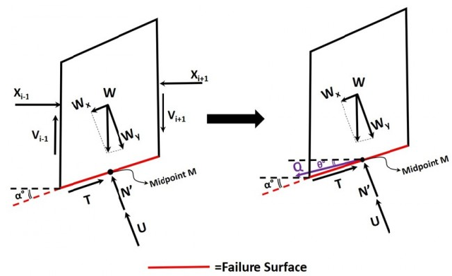
Figure 1.14 Forces acting on a single slice [161]
Estimation procedures
The interslice forces assumptions in Spencer's method provide a more complex system of equations that must be solved in order to obtain the FS of a failure surface.
Firstly, the two force equilibriums for each slice (parallel and perpendicular to the failure surface) yield the following equations:
 | $$\sum{F_{x}}=0, means: T_{i}-Q_{i}\cos\left(a_{i}-θ^{*}\right)-W_{i}\sin\left(a_{i}\right)=0$$ | (1.28)

 | $$\sum{F_{y}}=0, means: N_{i}^{'}-U_{i}+Q\sin\left(a_{i}-θ^{*}\right)-W\cos\left(a_{i}\right)=0$$ | (1.29)

The utilization of the Mohr-Coulomb failure criterion regarding the shear strength of the ground, hence, yields:
 | $$T_{ULT}=C_{i}×L_{i}+N_{i}^{'}\tan{φ_{i}}$$ | (1.30)

Whereby:
T_{ULT} – is the soil mass's shear strength; c – is cohesion; L – is the length of the slice's base, and φ – is the soil's friction angle.
T is the shear force at the base of each slice.
 | $$T_{i}=\frac{T_{ULT}}{FS}, means:FS=\frac{T_{ULT}}{T_{i}}$$ | (1.31)

Equations 2.28 to 2.31 are used to calculate the equivalent resultant interslice force Q:
 | $$Q_{i}=\frac{\frac{S_{i}}{FS}+S_{2}}{(1+\frac{S_{3}}{FS})×\cos{(a-θ)}}$$ | (1.32)
Whereby:
 | $$S_{1}=C_{i}×L_{i}+W_{i}\cos{(a_{i})}-U_{i}$$ | (1.33)

 | $$S_{2}=-W_{i}\sin{(a_{i})}$$ | (1.34)

 | $$S_{2}=\tan\left(φ_{i}\right)×\tan\left(a_{i}-θ\right)$$ | (1.35)

After that, the entire sliding mass equilibrium is considered. If the overall moment is zero with regard to the center of rotation, then the internal interslice forces Q must likewise be zero, resulting in:
 | $$\sum_{i=1}^{N}{Q_{i}×R_{i}×\cos\left(a_{i}-θ\right)=0}$$ | (1.36)

Whereby: R_{i} – is the distance between the rotation's center and each slice's midway. All radii are equivalent in a circular failure surface and can be ignored in Equation (1.36), but they must be considered in a non-circular surface.
The force equilibrium follows the same principle. To comply with the underlying conditions of the method, in both the vertical and horizontal directions, the composite internal forces of the entire sliding mass must be zero. As a result, two additional equations emerge:
 | $$\sum_{i=1}^{N}{Q_{i}×\cos\left(θ\right)=0}$$ | (1.37)

 | $$\sum_{i=1}^{N}{Q_{i}×\sin\left(θ\right)=0}$$ | (1.38)
Because the inclination of the corresponding interslice force Q is constant, equations 2.37 and 2.38 are theoretically equivalent and provide the same result:
 | $$\sum_{i=1}^{N}{Q_{i}=0}$$ | (1.39)
For a particular failure surface, solving Equations (1.36) and (1.39) yields two FS values, assuming an interslice force inclination of. However, because there is only one value that satisfies both moment and force equilibrium, an iterative approach is used to calculate this value and the accompanying FS.
In the hunt for an optimum iterative technique to calculate FS, many schemes have been proposed. The following are some frequent steps in a simple technique:
- Assume various different values of and calculate the FS values for Force and Moment equilibrium (FF and FM)
- Draw the FF and FM curves versus each other.
- Determine the intersection point of the curves corresponding to the real FS and the assessed surface. Figure 1.15 shows an illustration of the aforementioned curves as an example.
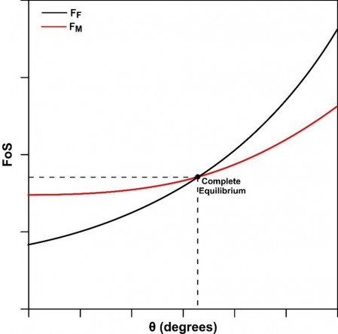
Figure 1.15 Spencer's Method of Slices [161]
Nonetheless, advanced techniques based on computer means, such as efficient iterative processes, have been developed over time. The Spencer Method takes longer than other methods (Bishop or Janbu); however, with the rapid advancement of computing capabilities, this is no longer a concern.
Spencer's method becomes equivalent to Bishop's simplified method when the inclination is adjusted to zero. As a result, Spencer's method might be thought of as a more advanced form of Bishop's method.
Some of the inferences that can be derived from the outcomes of Spencer's technique are as follows:
- When compared to Moment equilibrium FS (FM), Force equilibrium FS (FF) is altered more pronouncedly.
- The method's accuracy is determined by the number of slices used in the study. Increasing the number of slices, however, necessitates longer processing durations. Once the number of slices employed exceeds 32, according to Spencer (1967), the gain in accuracy is modest. In reality, with each case study being unique, even a lesser number of slices is sufficient to generate an accurate FS.
- The Spencer technique may or may not always converge to a single FS and. When the failure surface has steep parts, complex geometry, or jumps, convergence issues arise. A modest adjustment in the input data or the use of a simpler procedure is recommended in this scenario.
Moreover, the Spencer method is a generic slice approach founded on the concept of limit equilibrium. It necessitates a harmonious balance of forces and moments operating on individual blocks. By splitting the soil above the slip surface into dividing planes, the blocks are formed. The forces acting on individual blocks are depicted in the diagram below (Figure 1.16) [162]. It is important to note that, A Spencer analysis is the same as a Morgenstern-Price analysis with a constant function. Therefore, most of the steps and procedures discussed in the Morgenstern -price section are also applicable to Spencer’s static approach.
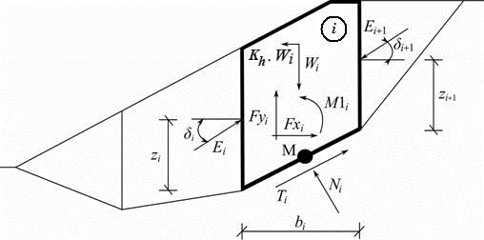
Figure 1.16 – Spencer method's static approach [163]
Due to the following forces, each block is estimated to contribute [162]:
- W_{i}, which is the block weight, includes a material surcharge with the character of weight, as well as the influence of the vertical earthquake coefficient K_{v}.
- The horizontal inertia force describing the influence of an earthquake is represented as K_{h}*W_{i}, Whereby K_{h} – is the horizontal acceleration factor during the earthquake.
- The normal force on the slip surface is N_{i}.
- The shear force on the slip surface is T_{i}.
- The forces exerted by nearby blocks, E_{i}, E_{i+1}, are inclined by the angle from the horizontal plane.
- The other horizontal and vertical forces operating on the block are Fx_{i} and Fy_{i}.
- M1_{i} is the moment of forces Fx_{i}, Fy_{i} revolving around point M, which is the center of the i^{th} slip surface segment.
- U_{i} is the resultant pore pressure on the i^{th} section of the slip surface.
The Spencer technique for calculating the limit equilibrium of forces and moments on individual blocks makes the following assumptions [162]:
- Between-block dividing planes are always vertical.
- The line of action of block W_{i}’s weight runs via the center of the i^{th} slip surface segment, M.
- The normal force N_{i} is acting in the center of the i^{th} segment of slip surface, at point M
- The inclination of forces E_{i} acting between blocks are constant for all blocks and equals to δ, only at slip surface endpoint is δ = 0.
The solution adopts the expressions in Equations (1.28) to (1.32):
Equation represents the relationship between the effective and total value of the normal force operating on the slip surface (2.19). The Mohr-Coulomb condition, which represents the relationship between normal and shear forces on a given section of the slip surface, is represented by equation (1.20). Equation (1.21) indicates equilibrium along the i^{th} segment of the slip surface, whereas Equation (1.22) represents equilibrium in the direction normal to the i^{th} segment of the slip surface. The safety factor (FS) is a tool for lowering soil characteristics. Equation (1.23) is the equilibrium moment equation about point M, whereby y_{gi} – is the vertical coordinate of the point of application of the block weight and y_{M} is the vertical coordinate of point M. The following recursive formula is obtained by modifying equations (1.21) and (1.22) [164]:
It is vital to avoid unstable solutions in order for the iteration process to be stable. Such instabilities develop at the sites where the formulas (1.24) and (1.25) divide by zero. For δ = π/2 or δ = -π/2, division by zero is encountered in Equation (1.25). As a result, the value of angle δ must be obtained within the range ((-π/2; π/2).
(h) Janbu
Janbu is another universal slice method based on the concept of limit equilibrium. It necessitates striking a balance between the pressures and moments acting on particular blocks (only moment equilibrium at last uppermost block is not satisfied). By splitting the soil above the slip surface into dividing planes, the blocks are formed. The forces acting on individual blocks are depicted in the diagram below (Figure 1.17) [165]:
Figure 1.17 – Static approach - Janbu method [166]
Due to the following forces, each block is estimated to contribute:
- Wi is the block weight, comprising material surcharges with the character of weight, as well as the influence of the vertical earthquake coefficient K_{v}
- K_{h}*W_{i} – is the horizontal inertia force describing the earthquake's influence, Whereby Kh is the horizontal acceleration factor
- N_{i} – is the normal force acting on the slip surface.
- T_{i} – is the shear force acting on the slip surface.
- E_{i}, E_{i+1} – are the forces exerted by neighboring blocks; they are inclined from the horizontal plane by an angle δ_{i} resp. δ_{i+1} and lie at the height zi resp. z_{i+1} above slip surface
- Fx_{i}, Fy_{i} – are the other horizontal and vertical forces acting on the block
- M1_{i} – is the moment from forces Fx_{i}, Fy_{i} rotating about point M, representing the center of the i^{th} slip surface segment.
- U_{i} – is the pore pressure resultant on the i^{th} segment of the slip surface
The Janbu technique for calculating the limit equilibrium of forces and moments on individual blocks makes the following assumptions:
- When splitting planes across blocks, the line of action of the block's weight is always vertical.
- W_{i} runs through the center of the i^{th} slip surface section, which is represented by point M.
- The force of nature Ni acts in the center of the i^{th} slip surface segment; at point M,
- Location zi of forces Ei acting between blocks is assumed; at slip surface endpoints, z = 0 is assumed.
The method's convergence can be influenced significantly by choice of position z_{i}. It can become impossible to satisfy the equilibrium conditions if we make an incorrect assumption about position z_{i} for a certain slope (the algorithm does not converge). The heights z_{i} above the slip surface are around one-third of the height of the block-to-block contact. If the equilibrium conditions aren't sufficient, the algorithm adjusts the height, for example, slightly higher in the passive zone near the toe and lower in the active zone towards the crest of the slope. The differences in Morgenstern-Price, Spencer, and Janbu's techniques are based on the fact that an arbitrary function is used to define the direction of the resulting interslice forces in Morgenstern-Price; In Spencer, the interslice forces that result have a constant slope throughout the sliding mass; and, In Janbu, the resulting interslice forces are horizontal.
(g) Sarma
The Sarma technique belongs to the category of general sliced limit state procedures. It is based on individual blocks meeting the force and moment equilibrium requirements. The blocks are made by separating the soil region above the potential slip surface into planes, each of which may have a varied slope in general. The forces acting on individual blocks are depicted in the diagram below (Figure 1.18) [167,168].
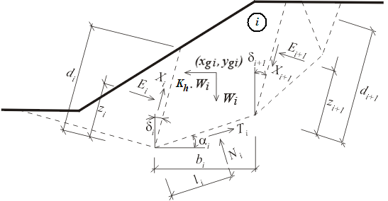
Figure 1.18 – Static scheme - Sarma method [169]
Between the blocks, the normal and shear forces are represented by E_{i}, X_{i}. On segments of a slip surface, N_{i} and T_{i} are normal and shear forces. The block weight is W_{i}, and the horizontal force used in the Sarma approach to reach the limit state is K_{h}*W_{i}. In most cases, an inclination fee can be added to each block. This surcharge, together with the surcharge owing to water having a free water table above the terrain and forces in anchors, is included in the analysis. All of these forces are projected horizontally and vertically, and the resulting components F_{xi} and F_{yi} are added together.
The factor of horizontal acceleration, or K_{h}, is a constant that is included in the analysis to satisfy the equilibrium on individual blocks. The safety factor can be calculated because of a link between K_{h} and the factor of slope stability FS. In most circumstances, the study begins with the value of K_{h} set to zero. To simulate a horizontal surcharge, such as that caused by an earthquake, a non-zero value of K_{h} is used.
The solution of 6n - 1 unknowns is required for the computation of limit equilibrium, whereby n is the number of blocks dividing the soil region above the potential slip surface. The blocks are as follows:
E_{i} | – between the blocks created forces
N_{i} | – typical forces acting on the surface of the slip
T_{i} | – slip surface shear forces
X_{i} | – represents shear forces between blocks
z_{i} | – positions where forces are applied
l_{i} | – positions where forces are applied
K_{h} | – a horizontal acceleration factor
For the required unknowns, 5n - 1 equations are available. We have:
- horizontal force equations of equilibrium on blocks:
 | $$T_{i}{\cos{α}}_{i}-N_{i}{\sin{α}}_{i}=K_{h}W_{i}-{Fx}_{i}+X_{i+1}\sin{δ_{i}-X_{i}\sin{δ_{i}+E_{i+1}\cos{δ_{i}-E_{i}\cos{δ_{i}}}}}$$ | (1.40)
- vertical force equations of equilibrium on blocks:
 | $$N_{i}{\cos{α}}_{i}-T_{i}{\sin{α}}_{i}=W_{i}-{Fy}_{i}+X_{i+1}\cos{δ_{i+1}-X_{i}\cos{δ_{i}+E_{i+1}\sin{δ_{i+1}+E_{i}\cos{δ_{i}}}}}$$ | (1.41)
- Equilibrium moment equations for blocks:
 | $$N_{i}l_{i}-X_{i+1}b_{i}\sec{α_{i}\cos\left(α_{i}+δ_{i+1}\right)+E_{i+1}\left[z_{i+1}+b_{1}\sec{α_{i}\sin\left(α_{i}+δ_{i+1}\right)}\right]-E_{i}z_{i}-W_{i}\left(x_{gi}-x_{i}\right)}+K_{h}W_{i}\left(y_{gi}-y_{i}\right)-{Fx}_{i}{γx}_{i}+{Fy}_{i}{γy}_{i}=0$$ | (1.42)
Whereby: Rx_{i} and ${γy}_{i}$ – are arms of forces Fx_{i} and Fy_{i}.
- According to the Mohr-Coulomb hypothesis, the normal and shear forces have the following relationship:
 | $$T_{i}=\left(N_{i}-U_{i}\right)\tan{φ_{i}+c_{1}b_{1}\sec{α_{i}}}$$ | (1.43)

 | $$X_{i}=\left(E_{i}-{PW}_{i}\right)\tan{{\overline{φ}}_{i}+{\overline{c}}_{i}d_{i}}$$ | (1.44)
Whereby:
P*W_{i} – resultant force on splitting planes due to pore pressure.
${\overline{φ}}_{i}$ – on a dividing plane, the average value of internal friction angle.
${\overline{c}}_{i}$ – on a dividing plane, the average value of cohesiveness.
It is self-evident that n - 1 must be chosen (calculated) in advance. There is a slight inaccuracy caused when estimating the points of application of forces E_{i}; as a result, the problem is then determined statically. The values of all remaining unknowns are finally determined by solving the ensuing system of equations. The determination of the horizontal acceleration factor K_{h} is the main conclusion of this investigation.
(i) Shahunyants
The Shahunyants method is a general slicing approach based on the concept of limit equilibrium. It necessitates a harmonious balance of forces and moments operating on individual blocks. By splitting the soil above the slip surface into dividing planes, the blocks are formed. The forces acting on individual blocks are depicted in the diagram below (Figure 1.19).
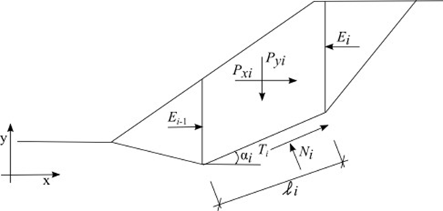
Figure 1.19 – Static approach - Shahunyants method [170]
Whereby: Py_{i} – is the resultant of vertical forces acting on a given block (block weight, block surcharge, earthquake, anchor forces); Px_{i} – is the resultant of horizontal forces on a given block (block surcharge, earthquake, anchor forces, geo-reinforcements); E_{i+1}, E_{i} – are the forces developed between blocks; N_{i} – is the reaction below the block normal to the slip surface segment; T_{i} – is the friction force on the slip surface segment; α_{i} – is the inclination of the slip surface segment; l_{i} – is the slip surface segment's length; φ_{i} – is the angle at which the soil's internal friction on the slip surface segment; c_{i} – is the soil cohesion on the slip surface segment.
The following assumptions are adopted in the Shahunyants method to calculate the limit state on a given block:
- Dividing planes between blocks are always vertical.
- The slope of the forces E_{i} acting between blocks is zero; forces act horizontally.
Procedure for resolving the problem:
Forces P_{yi} and P_{xi} are initially translated into force directions T_{i} and N_{i} using formulas (1.45) and (1.46). For a positive angle α_{i} (as in the schema), the force P_{Ni} acts in the opposite direction to N_{i}, while the force P_{Qi} acts in the opposite direction to T_{i}.
 | $$P_{Ni}=P_{xi}\sin{α_{i}+P_{yi}\cos{α_{i}}}$$ | (1.45)
 | $$P_{Qi}=P_{yi}\sin{α_{i}-P_{xi}\cos{α_{i}}}$$ | (1.46)
The following equations connect the forces acting along the slip surface segment:
 | $$T_{i}=(N_{i}-U_{i})\tan{φ_{i}+c_{i}l_{i}}$$ | (1.47)
Whereby:
U_{i} – The pore pressure on the slip surface section is denoted by.
The equilibrium condition in the direction normal to the slip surface section:
 | $$N_{i}=P_{Ni}+E_{i-1}\sin{α_{i}-E_{i}\sin{α_{i}}}$$ | (1.48)
The equilibrium condition in the direction parallel to the slip surface segment:
 | $$T_{i}=P_{Qi}+E_{i}\cos{α_{i}-E_{i-1}\cos{α_{i}}}$$ | (1.49)
Introducing Equation (2.42) into Equation (2.44) gives:
 | $$(N_{i}-U_{i})\tan{φ_{i}+c_{i}l_{i}=P_{Qi}+E_{i}\cos{α_{i}-E_{i-1}\cos{α_{i}}}}$$ | (1.50)
Next, substituting Equation (2.48) into Equation (2.50) gives:
 | $$(P_{Ni}+E_{i-1}\sin{α_{i}-E_{i}\sin{α_{i}-U_{i})\tan{φ_{i}+c_{i}l_{i}=P_{Qi}+E_{i}{\cos{α}}_{i}-E_{i-1}{\cos{α}}_{i}}}}$$ | (1.51)
After some algebra:
 | $$(P_{Ni}-U_{i})\tan{φ_{i}+(E_{i-1}-E_{i})\sin{α_{i}\tan{φ_{i}+c_{i}l_{i}=P_{Qi}+(E_{i}-E_{i-1})\cos{α_{i}}}}}$$ | (1.52)
 | $$(P_{Ni}-U_{i})\tan{φ_{i}+c_{i}l_{i}-P_{Qi}=(E_{i}-E_{i-1})(\sin{α_{i}\tan{φ_{i}+\cos{α_{i})}}}}$$ | (1.53)
Exploiting the following mathematical expression:
 | $$\cos{α+\sin{α\tan{β=\frac{\cos{α}\cos{β}+\sin{α}\sin{β}}{\cos{β}}}}}=\frac{\cos{(α-β)}}{\cos{β}}$$ | (1.54)
yields Equation (8) in the form:
 | $$\left(P_{Ni}-U_{i}\right)\tan{φ_{i}}+c_{i}l_{i}-P_{Qi}=\left(E_{i}-E_{i-1}\right)\frac{\cos{(α_{i}-φ_{i})}}{\cos{φ_{i}}}$$ | (1.55)
This can be modified as:
 | $$\left(P_{Ni}-U_{i}\right)\tan{φ_{i}}+c_{i}l_{i}-P_{Qi}+E_{i-1}\frac{\cos\left(α_{i}-φ_{i}\right)}{\cos{φ_{i}}}=E_{i}\frac{\cos{(α_{i}-φ_{i})}}{\cos{φ_{i}}}$$ | (1.56)
to provide the recurrent expression for E_{i} forces acting between blocks can be expressed as:
 | $$E_{i}=\frac{\left[\left(P_{Ni}-U_{i}\right)\tan{φ_{i}+c_{i}l_{i}-P_{Qi}}\right]\cos{φ_{i}}}{\cos\left(α_{i}-φ_{i}\right)}+E_{i-1}$$ | (1.57)
At this point, the analysis incorporates the safety factor, K_{u}. The value that brings the forces acting on particular blocks of soil into the state of limit states is known as the factor of safety. This is accomplished by multiplying active forces, that is to say, the forces that contribute to the soil mass sliding above the slip surface by the safety factor. In Equation (1.56), active forces are contained under the term P_{Qi}. On the one hand, this term contains active forces that contribute to sliding and, on the other hand, forces that resist sliding. The contributing forces will be denoted as P_{Qi,sd}, whereas the resisting forces as P_{Qi,ud}. Equation (1.57) then becomes:
 | $$E_{i}=\frac{\left[\left(P_{Ni}-U_{i}\right)\tan{φ_{i}+c_{i}l_{i}-K_{u}P_{Qi,sd}-P_{Qi,ud}}\right]\cos{φ_{i}}}{\cos{(α_{i}-φ_{i})}}+E_{i-1}$$ | (1.58)
If P_{Qi} has a positive value, it contributes to sliding and is thought to represent the active force P_{Qi, sd}. If the value of P_{Qi} is negative, it resists sliding and is considered to be the force P_{Qi,ud}. As a result, in Equation (1.58), deleting the negative value PQ_{i,ud} adds the positive value, and we may write:
 | $$E_{i}=\frac{\left[\left(P_{Ni}-U_{i}\right)\tan{φ_{i}+c_{i}l_{i}-K_{u}P_{Qi,sd}+\left|P_{Qi,ud}\right|}\right]\cos{φ_{i}}}{\cos{(α_{i}-φ_{i})}}+E_{i-1}$$ | (1.59)
E₀ = 0 at the origin of the slip surface. The value of E₁ is then calculated as follows:
 | $$E_{i}=\frac{\left[\left(P_{Ni}-U_{i}\right)\tan{φ_{i}+c_{i}l_{i}-K_{u}P_{Qi,sd}+\left|P_{Qi,ud}\right|}\right]\cos{φ_{i}}}{\cos{(α_{i}-φ_{i})}}$$ | (1.60)
The value of E₂ is then given by:
 | $$E_{2}=\frac{\left[\left(P_{N2}-U_{2}\right)\tan{φ_{2}+c_{2}l_{2}-K_{u}P_{Q2,sd}+\left|P_{Q2,ud}\right|}\right]\cos{φ_{2}}}{\cos{(α_{2}-φ_{2})}}+\frac{\left[\left(P_{N1}-U_{1}\right)\tan{φ_{1}+c_{1}l_{1}-K_{u}P_{Q1,sd}+\left|P_{Q1,ud}\right|}\right]\cos{φ_{1}}}{\cos{(α_{1}-φ_{1})}}$$ | (1.61)
Similarly, the values of all forces operating between blocks may be determined. It also holds at the end of the slip surface we've created, E_{n} = 0. Using the previous expressions, the following can be written:
 | $$E_{n}=\sum_{i=1}^{n}{\left[\left(P_{Ni}-U_{i}\right)\tan{φ_{i}+c_{i}l_{i}+\left|P_{Qi,ud}\right|}\right]\frac{\cos{φ_{i}}}{\cos\left(α_{i}-φ_{i}\right)}-K_{u}\sum_{i=1}^{n}{P_{Qi,sd}}\frac{\cos{φ_{i}}}{\cos\left(α_{i}-φ_{i}\right)}=0}$$ | (1.62)
This equation directly provides the factor of safety K_{u} in the form:
 | $$K_{u}=\frac{\sum_{i=1}^{n}{\left[\left(P_{Ni}-U_{i}\right)\tan{φ_{i}+c_{i}l_{i}+\left|P_{Qi,ud}\right|}\right]\frac{\cos{φ_{i}}}{\cos\left(α_{i}-φ_{i}\right)}}}{\sum_{i=1}^{n}{P_{Qi,sd}}\frac{\cos{φ_{i}}}{\cos\left(α_{i}-φ_{i}\right)}}$$ | (1.63)
(j) ITF Method (Imbalance Thrust Force Method)
It is based on the equation of equilibrium of forces operating on individual blocks without taking into account the moment equation of equilibrium. The following diagram illustrates the method's foundations and assumptions (Figure 1.20) [171].
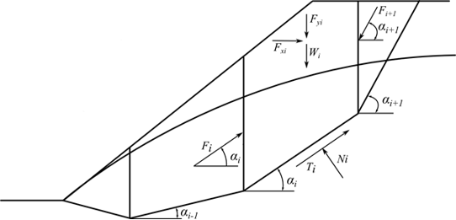
Figure 1.20 – ITF Method - Forces acting on a block [172]
Whereby: W_{i} represents the weight of the i^{th} block, whereby the saturated unit weight of soil (γ_{sat}) is used to determine the weight of the i^{th} block, as well as the weight of a portion of the block below groundwater; Fy_{i} – represents the remaining vertical load acting on the block; Fx_{i} – represents the remaining horizontal load acting on the block; F_{i}, F_{i+1} – are the forces acting between blocks along directions given by angles α_{i} and α_{i+1} (Figure 1.21); U_{i} – is the pore pressure resultant on slip surface segment; UV_{i}, UV_{i+1} – are the pore pressures that result from separating planes between blocks.
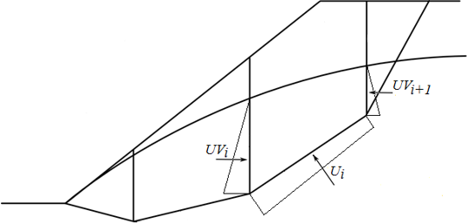
Figure 1.21 – Pore pressure action on the block diagram [172]
When computing horizontal forces Fx_{i}, the forces UV_{i} and UV_{i+1} are taken into account.
The force equation of equilibrium in the direction normal to the slip surface section is:
 | $$N_{i}=\left(W_{i}+{Fy}_{i}\right)\cos{α_{i}+{Fx}_{i}\sin{α}}+F_{i+1}\sin\left(α_{i+1}-α_{i}\right)-U_{i}$$ | (1.64)
The forces acting on a slip surface section are linked by;
 | $$T_{i}=N_{i}\tan{φ_{i}+c_{i}l_{i}}$$ | (1.65)

Whereby: φ_{i} – is the angle of internal friction of the soil; c_{i} – is the soil cohesion; l_{i} – represents the length of the segment of slip surface associated with the i^{th} block.
The force F_{i} acting between blocks is provided by the force equation of equilibrium in the direction of the i^{th} segment of the slip surface (given by angle α_{i):}
 | $$F_{i}=(W_{i}+{Fy}_{i})\sin{α_{i}-{Fx}_{i}\cos{α_{i}-T_{1}+F_{i+1}\cos{(α_{i+1}-α_{i})}}}$$ | (1.66)

When Equations 2.64 and 2.65 are combined in Equation 2.66, the following results are obtained:
 | $$F_{i}=(W_{i}+{Fy}_{i})\sin{α_{i}-{Fx}_{i}\cos{α_{i}-\left\{\left[\left(W_{i}+{Fy}_{i}\right)\cos{α_{i}+{Fx}_{i}\sin{α_{i}+F_{i+1}\sin\left(α_{i+1}-α_{i}\right)-U_{i}}}\right]\tan{φ_{i}+c_{i}l_{i}}\right\}+F_{i+1}\cos\left(α_{i+1}-α_{i}\right)}}$$ | (1.67)
Following some formal algebra, we arrive at the following form of the equilibrium equation:
 | $$F_{i}=\left(W_{i}+{Fy}_{i}\right)\sin{α_{i}-{Fx}_{i}\cos{α_{i}-\left\{\left[\left(W_{i}+{Fy}_{i}\right)\cos{α_{i}+{Fx}_{i}\sin{α_{i}+U_{i}}}\right]\tan{φ_{i}+c_{i}l_{i}}\right\}}}+F_{i+1}\left[\cos\left(α_{i+1}-α_{i}\right)-\sin\left(α_{i+1}-α_{i}\right)\tan{φ_{i}}\right]$$ | (1.68)
The equilibrium requirement will be met by inserting the safety factor FS into the study, which will divide the strength parameters of a given soil, c, and tanφ. Then Equation 2.67 becomes:
 | $$F_{i}=\left(W_{i}-{Fy}_{i}\right)\sin{α_{i}-{Fx}_{i}\cos{α_{i}-\frac{\left\{\left[\left(W_{i}+{Fy}_{i}\right)\cos{α_{i}+{Fx}_{i}\sin{α_{i}-U_{i}}}\right]\tan{φ_{i}+c_{i}l_{i}}\right\}}{FS}+\frac{F_{i+1}\left[\cos{{(α}_{i+1}-α_{i})-\sin{(α_{i+1}-α_{i})\tan{φ_{i}}}}\right]}{FS}}}$$ | (1.69)
Through the process of iteration, Equation (1.68) yields the sought-after safety factor FS. During this technique, a force of 0 kN is applied to the highest (end) point of the slip surface. Equation (1.68) is used to compute the forces F_{i} acting between blocks for a given value of the factor of safety FS. This phase is done for a variety of FS values until we discover one for which the force F₀ at the slope base equals 0 kN. There will be no stress along the slip surface. If the equilibrium condition requires a negative value for normal force N_{i}, showing that the soil is loaded in tension, this force's value is set to zero in the next iteration step, and the shear force T_{i} acting on a single segment is estimated exclusively using soil cohesion [173].
When it comes to the form of the slip surface, the ITF approach is extremely sensitive. When there are acute segment discontinuities on the slip surface, the resulting factor of safety is often higher than in reality. The slope difference between adjacent portions of the slip surface should be less than 10 degrees. The computer checks this automatically, and if the slope difference is determined to be bigger, the program warns that the results may be overstated [171]. This isn't normally a problem with a circular slip surface, but it's something to keep in mind with polygonal slip surfaces [174].
(k) ITF Method - explicit solution
The ITF method's explicit solution assumes a new approach to introducing the factor of safety into the analysis. The mathematical solution does not need to be iterated, and the resulting factor of safety can be derived in a single step. The resulting factor of safety is often higher using this approach, which may completely invalidate the solution, particularly in scenarios involving polygonal slip surfaces with considerable slope changes between adjacent segments [175].
The answer is based on Equation (1.73), to which the factor of safety FS is added, multiplying the active components of forces, i.e., those acting in the sliding direction. As a result, the equilibrium condition is:
 | $$F_{i}=\left[\left(W_{i}+{Fy}_{i}\right)\sin{α_{i}-{Fx}_{i}\cos{α_{i}}}\right]SF-\left\{\left[\left(W_{i}+{Fy}_{i}\right)\cos{α_{i}+{Fx}_{i}\sin{α_{i}-U_{i}}}\right]\tan{φ_{i}+c_{i}l_{i}}\right\}+F_{i+1}\left[\cos\left(α_{i+1}-α_{i}\right)-\sin\left(α_{i+1}-α_{i}\right)\tan{φ_{i}}\right]$$ | (1.70)
For clarity's sake, we'll refer to the component of active forces as:
 | $$A_{i}=\left(W_{i}+{Fy}_{i}\right)\sin{α_{i}-{Fx}_{i}\cos{α_{i}}}$$ | (1.71)
as well as the passive force component as:
 | $$P_{i}=\left[\left(W_{i}+{Fy}_{i}\right)\cos{α_{i}+{Fx}_{i}\sin{α_{i}-U_{i}}}\right]\tan{φ_{i}+c_{i}l_{i}}$$ | (1.72)
and an auxiliary function:
 | $${}_{i}=\cos\left(α_{i+1}-α_{i}\right)-\sin\left(α_{i+1}-α_{i}\right)\tan{φ_{i}}$$ | (1.73)
Equation (6) can then be written in a more compact form as:
 | $$F_{i}=A_{i}FS-P_{i}+F_{i+1}{}_{i+1}$$ | (1.74)
The next step assumes that the known force F_{n} = 0, resulting in force expressions between blocks F in the form:
 | $$F_{n-1}=A_{n-1}FS-P_{n-1}$$ | (1.75)
 | $$F_{n-2}=A_{n-2}FS-P_{n-2}+(A_{n-1}FS-P_{n-1}){}_{n-1}$$ | (1.76)
 | $$F_{n-3}=A_{n-3}FS-P_{n-3}+\left(A_{n-2}FS-P_{n-2}\right){}_{n-2}+(A_{n-1}FS-P_{n-1}){}_{n-1}{}_{n-2}$$ | (1.77)
And so on.
 | $$F_{0}=\left[A_{0}+\sum_{i-1}^{n-1}{\left(A_{i}\prod_{j-1}^{i}{{}_{j}}\right)}\right]FS-P_{0}-\sum_{i-1}^{n-1}{\left(P_{i}\prod_{j-1}^{i}{{}_{j}}\right)}$$ | (1.78)
Because the force on the slip surface's bottom origin should be 0 kN, we derive the final form of the factor of safety FS as:
 | $$FS=\frac{P_{0}+\sum_{i-1}^{n-1}{\left(P_{i}\prod_{j-1}^{i}{{}_{j}}\right)}}{A_{0}+\sum_{i-1}^{n-1}{\left(A_{i}\prod_{j-1}^{i}{{}_{j}}\right)}}$$ | (1.79)

Dam safety

World declaration on dam safety
Dams and associated storage reservoirs have brought substantial benefits to humanity throughout history through their construction, operation, and upkeep. Water storage behind dams regulates natural streamflow and provides benefits such as enhanced water availability, renewable energy production, and a reduction in the negative effects of natural extremes such as floods and drought [176].
Dams are essential infrastructure for meeting both basic human requirements and rising living standards. On the other hand, Dams provide additional threats to downstream communities, including the potential for detrimental effects on life, property, and the environment [177,178]. Dam safety issues, which could result in an uncontrolled or catastrophic release of stored water, are a major source of concern.
Dam engineers have a significant ethical responsibility to carry out their professional responsibilities in such a way that dams and reservoirs are designed, built, and operated most effectively and sustainably possible while also ensuring that new and existing dams are safe throughout their entire lifespan, from construction to decommissioning [179].
(a) International Commission on Large Dams (ICOLD) and Dam Safety
Dam safety has been one of the greatest organizational commitments of the International Commission on Large Dams (ICOLD) for more than a century, as stated in the ICOLD Mission statement: ICOLD is the industry leader in developing standards and recommendations to guarantee that dams are built and operated in a safe, efficient, and cost-effective manner that is both environmentally sustainable and socially equitable [180]. Prior to the establishment of ICOLD in 1928, there was a lack of understanding about dam safety, even though the need for water storage infrastructure was great and expanding. As a result, ICOLD made it a priority to share knowledge on dam design and operation based on experience within the global dam engineering community [181]. With this spread came a great emphasis on dam safety, which has continued into the present period. Through its efforts in collecting and evaluating the information on the lessons learned from past triumphs and failures, ICOLD has played a critical role in improving dam safety. Since its inception, ICOLD and its tens of thousands of professionals from member countries have worked to improve dam safety through the publication of scientific papers and the exchange of knowledge at Annual Meetings and Congresses.
The Technical Committees of ICOLD produce Bulletins that outline the present state of the practice for publication. Since the founding of ICOLD, the number of dam failures has decreased dramatically in comparison to the total number of dams in operation, which is a positive achievement that shows ICOLD's global influence in strengthening dam design and management standards. Nonetheless, to keep the global trend toward safer dams going, persistent awareness and commitment to dam safety are still essential. Dam professionals are extremely concerned about any dam incident [182].
(b) Changing Conditions of Dam Safety based on ICOLD
The overall number of dams worldwide continues to rise due to the critical need for water, food, energy, minerals, and flood control. Maintaining the current trend of lower dam failure rates is a never-ending problem for the industry. The importance of ICOLD's involvement in knowledge transfer and capacity building through the dissemination of best practices is undeniable [183,184]. With various shifting variables, science, technology, and human involvement in dam safety are always evolving [185]:
- Existing infrastructure is deteriorating, raising new concerns about the durability of construction materials and equipment, as well as the sedimentation of reservoirs.
- Some countries participating in dam construction lack experience in dam safety management and operations, necessitating the need for capacity building.
- In all countries, experienced personnel are retiring, resulting in a shortage of qualified engineers trained in dam design. As the private sector becomes more involved in dam development, cost and schedule pressures on developers, designers, contractors, and operators increase, and new governance conditions for dam safety are required.
- Extreme precipitation and drought occurrences are changing as a result of climate change, increasing hydrological risks. Climate change must be taken into account when planning and managing dams, including robust design and adaptive reservoir operation. This necessitates the raising of dams, the expansion of spillway capacity, the modification of reservoir operation techniques, and/or the construction of additional dams in some areas. As part of the planning, design, and operating phases, other climate-related hazards may need to be assessed and addressed.
Because the best dam sites have been taken, new dams must be erected in increasingly difficult areas, especially in terms of geological characteristics. Dam regulatory authority can be significantly impacted by changes in local, regional, and national governance [186]. As a recognized international organization of professionals in dam engineering, ICOLD urges governments and financial institutions to raise public awareness about dam safety [187]. The purpose of this ICOLD World Declaration on Dam Safety is to reaffirm what has been learned about dam safety over time [188]. Furthermore, all parties involved should be reminded that it is their responsibility to guarantee that these fundamentals are followed in order to reduce the dangers connected with dams and reservoirs [189,190].
(c) Pillars of Dam Safety
ICOLD acknowledges a number of overarching pillars of dam safety based on nearly a century of commitment to dam safety and the realization that there is no such thing as zero risk [191].
- Dam safety is dependent on the structural integrity of dams.
ICOLD bulletins have largely recorded best current practices in dam design and performance during hazardous events such as extreme floods and earthquakes, establishing a strong foundation on which existing and future dam structures should be designed, built, and operated in safe conditions.
- For early detection, a routine surveillance and maintenance program is required.
Inspection and maintenance are critical to reducing risk and ensuring dam safety in the long run. Periodic safety reviews by skilled engineers with extensive experience in dam safety evaluation are required. Dam monitoring should be based on the operator's self-supervision as well as periodic external safety inspections by a recognized authority or institution. Throughout the life of a dam, an instrumentation and monitoring program is required [192].
- Throughout the life of a dam, an instrumentation and monitoring program is required.
It is required to implement a comprehensive dam monitoring program in order to:
- Determine how people will act during construction.
- Evaluate performance during the initial reservoir fill.
When comparing real performance to the design, keep the following in mind:
- Describe long-term conduct.
- Offer information.
- Early detection of abnormalities.
- Capture and analyze responses to events such as big floods, earthquakes, and other natural disasters.
- Forecast future dam performance.
- How safe dam management to regulatory authorities.
- Intrinsic design hazards must be effectively addressed.
These risks are based on dam type, materials, age, foundations, hydraulic structures, and other factors, with good practices and surveillance being the most important factors for safety [193].
- Natural hazards evolve with time and should be assessed and updated on a regular basis.
Floods and earthquakes, for example, are external threats whose risks are acknowledged based on known science and the likelihood of occurrence.
- All dams must have a plan in place in case of an emergency.
To avert loss of life and minimize damage to property, infrastructure, and the environment as a result of a dam failure, emergency plans should be prepared. The first filling of the reservoir is a key phase during which the emergency plan must be ready to go as soon as possible. The emergency plan must be reviewed, updated, and practiced on a regular basis. A robust dam safety program includes adequate operator training [194].
- Adequate training of operators is part of a comprehensive dam safety program.
Dam malfunctions, particularly spillway gates, can result in accidents, downstream flooding, or potential dam overtopping. The industry as a whole benefit from sharing lessons learned, making all dams safer [195].
- Sharing lessons learned benefits the entire industry, making all dams safer.
Sharing learning from dam mishaps and failures is critical for improving state-of-the-art processes, according to ICOLD's experience. It is therefore critical that all data on dam incidents, including independent expert reports on the core causes of such incidents, be made publicly available to the international community for all parties concerned. Risks can be minimized with a thorough dam safety program.
- A comprehensive dam safety approach will allow the minimization of risks.
This is accomplished through the participation of national organizations to promote dam safety measures such as structural steps to improve the structure's integrity and stability, efforts to reduce the effects of failures, and dam education and public awareness. A complete dam safety approach must also take into account the fact that river basins, many of which are transboundary basins, sometimes contain many dams or dam complexes and levees [196].
- A dam owner has the ultimate responsibility for its dam.
The International Commission on Dam Safety (ICOLD) believes that the safety of all dams is essentially the responsibility and liability of their owners and operators. To meet this responsibility, adequate personnel and financial resources, as well as relevant know-how, are required. The importance of regulatory authorities in terms of safety cannot be overstated [197].
- The role of regulatory authorities is paramount for safety.
Regulatory agencies should play a key role in assuring proper site investigation, best-practice design standards, high-quality construction, contractual frameworks, emergency readiness, and operational compliance with established rules and standards. Developing norms, regulations, and safeguards is an important part of ensuring dam safety. A global perspective on dam safety can be instructive.
- An international perspective on dam safety can be enlightening.
International organizations, such as ICOLD, which establish guidelines based on global experience, can help designers, owners, and government officials better understand the current state of best practices for dam design and safety.
(d) Summary of the declaration
ICOLD, as the premier international organization dedicated to dam safety, calls on all concerned professionals and organizations to make a solid commitment to safety improvements and risk reductions at all dams, with the aspirational objective of working towards a continual reduction of dam safety events [198]. Furthermore, as part of their contribution to the development and regulation of dam infrastructure, governments, financial institutions, and other developers are urged to make a similar political and financial commitment to ensure that the critical safety recommendations for dams outlined in ICOLD Bulletins are disseminated to the appropriate parties and followed through [188,190,199].

Dam safety management
Dam safety rules and management systems provide dams the foresight they need to avoid catastrophic disasters [200,201]. Dam owners are accountable for their dams' safety. Certain controls, such as safety management systems, monitoring, and operational procedures, must be implemented.

Dam safety programs
Dam owners and dam engineers have various obligations when it comes to ensuring dam safety. The owner bears the primary responsibility for the dam's safety. As a result, dam owners are responsible for conducting investigations, design, construction, and safety reviews of their assets, as well as reporting on them. They must guarantee that operations and maintenance (O&M) manuals and dam safety emergency plans (DSEP) are prepared and updated (DSEP) [194].
Dam owners also conduct monitoring programs in order to collect operational and performance data, as well as commission dam safety checks. The dam's engineer's job is to help dam owners with their responsibilities by addressing technical issues like regional and site geology, structural soundness, design for all loading conditions, and material selection.
Dam safety programs include a variety of activities to offer, manage, and ensure dam safety in order to meet the goals outlined above. To begin, a comprehensive dam safety program should include an overall inspection and monitoring program, as well as clearly defined responsibilities for dam operators, training programs to prepare operators for incident management, and a system to validate operations and updates. Second, any incidents must be handled according to a detailed plan [202].
Finally, they should ensure that current standards are followed, that preventative maintenance is performed as planned, that risks are managed within acceptable limits, and that adequate funds and personnel are available. As briefly explained below, numerous dam safety activities and processes handle these issues simultaneously, albeit in different ways.
- Dam Safety Emergency Plans and Operation and Maintenance Manuals
A dam safety emergency plan (DSEP) is a constantly updated set of instructions and maps that address potential crises or odd occurrences at or near a dam or reservoir. It covers individual duties and responsibilities in an emergency, as well as emergency identification, evaluation, and notification protocols. For ease of reference during times of hardship, these are usually provided in flowchart format. The State Emergency Response Plan (DISPLAN), inundation maps, preventive activities, exercise training, and review history are also included [203].
Adopting appropriate Operation & Maintenance (O&M) techniques improve a dam's efficiency and effectiveness. An O&M Manual is a great approach to keeping track of such procedures. Drawings, operation instructions and procedures, safety surveillance features, maintenance schedules, and records are normally included in the dam manual [204].
- Dam surveillance
The continual examination and recording of the state of a dam and its related structures are known as dam surveillance. Instrumentation is utilized to measure factors such as pore water pressures, seepage flow, and movement, which aids in dam inspection and monitoring. The data from the instruments is collected and analyzed to see if deteriorating trends are occurring or are likely to develop. A study of the operating, maintenance and monitoring processes is also included. Surveillance reports document the outcomes. Every 5 to 10 years, an independent review of the surveillance program is conducted [205].
- Inspections of dams
In order of diminishing detail and increasing frequency, dam safety inspections are classed as comprehensive, intermediate, or routine visual. The regularity with which these inspections are carried out for various dams is determined by the dam's consequence category, as defined by the ANCOLD Guidelines on Dam Safety Management. Dams in the extreme consequence category, for example, must have comprehensive inspections every five years, annual intermediate inspections, and daily routine visual inspections.
Following inspections, dam safety reports are written to describe new findings, changes since prior inspections, and recommendations. They include a look at the dam's surveillance and monitoring data, as well as its general performance. Additional material is required at the comprehensive level, such as an assessment of the dam's flood management capacity, remarks about the structure's safety in comparison to current standards, and the overall adequacy of the dam safety program [206].
- Review of dam safety
Dam safety reviews differ from dam safety inspections in that they necessitate a thorough investigation of the dam's records and reports over a long period. They're a type of technical audit in which dam safety is reviewed by looking into and analyzing issues that haven't been addressed before or elements that are subject to new design criteria or prospective deterioration. Literature reviews, hydrological/geotechnical/seismological investigations, and engineering assessments of individual dam structures are among the additional technical information included in a dam safety review, in addition to those detailed in dam safety reports. Where necessary, engineering solutions for flaws discovered during dam safety inspections can be devised, designed, and built [207].
- Dam safety risk assessments
The likelihood or probability of negative effects occurring is defined as risk. All probable failure mechanisms, their probability of occurrence, and the magnitude of the resulting adverse event are considered in risk assessments. The risk assessment process entails analyzing and evaluating risks to determine whether they are tolerable (Figure 1.22) and whether current risk control measures are sufficient. If not, it investigates whether the implementation of alternative risk control measures is justified. Dam break simulations are carried out, resulting in a probability-based analysis of damage and loss of life. Further economic and model sensitivity analysis is also carried out, with remedial steps based on acceptable risks being recommended [208].

Figure 1.22 – Existing dam social risk recommendations [209]
In contrast to the engineering-focused outcomes of a dam safety review, the risk-based approach allows remedial actions to be either engineering or non-engineering solutions. Changes to operating rules or the installation of warning systems are examples of non-engineering solutions. Remedial actions can be employed to correct flaws, but that does not mean there is no danger after the steps are completed. Dam management is always fraught with inherent dangers.
Dam safety risk assessments can be done for a group of dams or a single dam. Regardless of the approach, risk assessments are used to identify critical assets and serve as a planning tool for addressing high-risk components by providing a foundation for investment optimization and stakeholder justification [210].

Dam safety and flood evaluation
Dams and hydrology are two fields that are intertwined. However, the majority of the analyses performed in a dam hydrological study are independent of the structure's type or characteristics. Its location is crucial in determining the quantity and variability of the water inflow available for useful purposes (irrigation, energy production), as well as the characteristics of the unusual hydrological events that threaten the dam (floods and their intensity). The hydrological studies, on the other hand, do not address the dam structure [211].

Dam internal erosion
Internal erosion occurs when the material is removed from the soil via seepage, resulting in the formation of voids. It is the second most prevalent cause of levee failure and one of the most common causes of earth dam failures, accounting for almost half of all embankment dam failures [212].
Moreover, internal erosion occurs when water seeping via pores and fractures in the dam and/or foundation exerts sufficient hydraulic forces to dislodge particles and transport them out of the dam structure. Internal erosion is particularly harmful because there may be no or only mild external evidence that it is occurring. A sand boil may usually be found, but it may be hidden underwater. After evidence of internal erosion becomes apparent, a dam may breach within a few hours [213].
Piping is a related phenomenon that is defined as the gradual development of internal erosion by seepage, manifesting downstream as a water-dispensing hole. Until a continuous pipe is constructed, regressive erosion of particles from downstream and along the upstream line towards an outside environment causes piping [68].
(a) Internal erosion and the piping system
The International Commission on Large Dams (ICLD) claims that internal erosion of embankment dams and their foundations has four general failure types [187]:
- Through the embankment.
- Through the foundation.
- Embankment-into-foundation.
- Associated with through-penetrating structures.
Internal erosion comprises four stages: the beginning of erosion, progressing to the formation of a pipe, surface instability, and finally, the beginning of a breach. Internal erosion is also divided into four types based on the failure path, how the erosion begins and progresses, and where it occurs [204]:
- Seeping water erodes and enlarges a fissure until it bursts in a concentrated leak. The erosion eventually generates a pipe or a sinkhole, even if the crack does not grow to the exit (collapse is still conceivable).
- Backward erosion: begins at the seepage path's exit point and happens when the hydraulic gradient is high enough to promote particle dissociation and transport; a pipe forms backward from the exit point until it is breached.
- Suffusion: is a phenomenon that happens in soils with a wide variety of particle sizes. The spaces between coarser soil particles allow finer soil particles to dissolve. Internally unstable soils are those that are subject to suffusion. Suffusion can only happen if the volume of the finer particles is smaller than the vacuum space between the coarse particles.
- Soil contact erosion: Sheet flow occurs at the interfaces between coarse and fine soils, causing soil contact erosion. Water penetrates through the interface between the two soils, eroding the finer layer's particles into the coarser layer.
(b) Internal Erosion fundamentals
Internal erosion is one of the most typical reasons for earth dam failure. It's possible that there's no outward evidence, or simply a sliver of evidence, that it's happening. After evidence of internal deterioration becomes apparent, a dam may breach within a few hours. Internal erosion can occur immediately after water is impounded behind a dam, or it can take years to develop. Internal erosion may be exacerbated or initiated by higher water surface elevations and pressure. You can't assume that your dam is safe from internal erosion just because it has been performing well for a long time. Dam "penetrations," such as outlet pipes buried in the embankment, rodent activity, and concrete spillways that traverse the embankment, are frequently linked to internal erosion failures. During normal periodic inspections, a skilled dam engineer may be able to detect minor indicators of internal erosion, but you should be aware of what signs to check for between inspections [214].
(c) Using filters to prevent erosion
With the use of filters, the internal erosion process can be slowed down. Filters capture eroded particles while permitting seepage, and they are often coarser and more permeable than filtered soil. The sort of filter needed and where it should be installed are determined by which areas of the dam are more vulnerable to internal erosion. Filters must meet five conditions per regulation [215]:
- Retention: The filter must prevent eroded soil particles from being transported.
- Self-filtration: the filter must be internally stable, which is also known as stability.
- No cohesion: the filter must be incapable of maintaining cracks or cementing them.
- Drainage: the filter must be porous enough to allow water pressure to escape.
- Strength: the filter must be able to transfer tension within the dam without crushing it.
When water seeps through an earth dam, soil particles are carried away from the embankment, filters, drains, foundation, or abutments of the dam, which is referred to as "piping" by dam engineers. If soil particles are carried downstream by the seepage, an elongated cavity or "pipe" may be eroded backward (working upstream) toward the reservoir via the embankment, foundation, or abutment. When a backward-eroding pipe reaches the reservoir, the dam can be catastrophically breached [216].
Depending on head and flow, internal erosion happens in phases of muddy water discharge interspersed with intervals of clean water discharge or no discharge at all. Even if there is no apparent water flow or if the water draining from the land downstream of a dam is not murky, internal erosion may be occurring. Chemicals, salts, dissolved and suspended particles, and dispersive clays can all degrade a dam's inside without being recognized [217].

Tropical residual soils as dam foundation and fill material
The term "tropical residual soil" refers to a soil that has been weathered in-situ, meaning that the underlying rock structure has been destroyed by weathering and the material has not been moved from its original site [218,219]. Tropical residual soils are defined differently in different parts of the world and different countries. According to [220], residual soil behavior has a structured soil bonding impact that can occur in a variety of settings. According to [221,222], residual soil is the consequence of chemical weathering, and engineering residual soil has numerous features, including climatic variables, raw materials, topography, flow, and age. The engineering characteristics of residual soil will be one of these variables. Soil behavior in situ is complicated since it is influenced by a variety of elements.

Summary of the sub-section
To reach a high level of resilience, people of the community and stakeholders, in general, must work together. Ideas and solutions that satisfy community needs and address community-identified resilience goals must be integrated and implemented. Those who are directly or indirectly impacted by a dam or levee failure have the opportunity to mitigate the effects of the failure through community physical and social changes, community growth planning, safe housing construction, and financial planning (including bonds and insurance), and the development of adaptability. Dam and levee safety experts, as well as other community members and stakeholders, will be most successful in improving resilience when they identify and manage risk cooperatively in ways that promote knowledge and communication of threats, shared needs, and opportunities.
Dam and levee professionals can use risk-informed approaches to improve their understanding of infrastructure-system operations, performance, vulnerabilities, and the consequences of potential failures, allowing them and the rest of the community to make better dam and levee infrastructure and resilience decisions.

Modeling of embankment dam behavior

Dam modeling during construction
The nonlinear behavior of the building material, the interaction between the structure and the underlying soil and rock strata, the effects of water saturation, as well as the influence of water stress on the structure and foundation bedrock all play a role in the deformation of an earth dam. The deformation process can be modeled using the finite element method in conjunction with a hyperbolic model of the material's nonlinear behavior [223].
Internal erosion of fine-grained soils from embankments, erosion under the foundation or abutment, stability issues caused by high pore pressures, hydraulic gradients, and dam or spillway overtopping are the most prevalent reasons for embankment dam failure. During earthquakes, the formation of high water pressures and probable liquefaction in the foundation or embankment is a less usual cause of failure.
The safety of earth dams is contingent on the correct design, building, and monitoring of actual behavior during the structure's construction and operation. Monitoring is also necessary for a better and safer design of future dams by confirming design parameters, with the geotechnical factors being the most significant [224]. It should also be noted that the geotechnical parameters can be determined either in situ or in the laboratory.
The selected samples in laboratory testing may differ from one place to the next, they may have been disturbed during collecting, or the laboratory loading conditions may differ from natural settings. As a result, comparing the monitored data with the projected data produced during the design process might provide crucial information on geotechnical factors [225]. Earth dams are typically designed using the finite element technique (FEM) [226]. Changeable loading or boundary conditions induce predicted displacements, strains, and stresses in the structure, which are analyzed using the FEM. The FEM values can be compared to measured values to get more information about the structure's actual behavior, boundary conditions, and unexpected loads [227].

Dam modeling during first filling
The first test of a dam's ability to execute the function for which it was constructed is the initial filling of a reservoir. A well-managed first filling is critical to a dam's long-term success. Approximately two-thirds of all dam failures and half of all dam incidents occur during the reservoir's first five years of operation, according to [228], a study done by the Bureau of Reclamation on internal erosion failure types.
Dams are usually constructed to hold and store a large amount of water. When constructing a new dam, diversion canals and cofferdams are utilized to keep water out of the construction zone. However, once the dam is built, water flow to the dam site continues, and the reservoir begins to fill. The increase in water level behind a dam from the time it is built until it reaches the appropriate operational level is referred to as initial filling.
The duration and rate of a dam's first filling might vary depending on its location, kind, size, and intended use. To limit the danger of failure, the first filling of a reservoir should be planned, managed, and continuously monitored, whether it takes several months, several years, or with the help of pumping units [229].
Based on the fact that the first filling of a reservoir is such a vital stage in a dam's life, dam operators and engineers must have as much control as possible over it, allowing ample time for effective surveillance, including the observation and interpretation of instrumentation data. After the dam and other essential appurtenances (i.e., spillways and outlet works) have been finished, as well as the installation of appropriate instruments, the initial filling should be scheduled [230]. Specifications for reservoir rise rate should be developed so that the dam can respond to the forces it will face as the water level behind it rises. A design memorandum should be used to document these plans, which may also include reservoir regulations during project construction [231].
- A water control plan,
- Project surveillance,
- Cultural site surveillance,
- Flood emergency planning,
- Public affairs,
- Safety planning and transportation
- Communications planning
In addition to dam failure, design, construction, and/or material flaws in new dams are frequently discovered during the initial filling. Seepage, cracking, and erosion are common when the reservoir is raised to new levels for the first time, for example. It may be essential to suspend filling or, in certain situations, decrease the reservoir before the required operational water level is reached to investigate indicators of seepage, erosion as well as cracking [232].
The consideration of collapse settlement of vulnerable rockfills and earth fills on wetness is an important part of embankment dam modeling. The initial impounding for the upstream dam abutment is more affected by collapse settlement, although the collapse settlement has always been documented in the downstream dam abutment after soaking due to rainfall, leakage, or tail-water impoundment [233]. Due to the dependence of collapse settlement on compacted water content, compacted density applied stress, and material properties, incorporating collapse settlement into constitutive models add additional complexity and uncertainty to the estimation of material parameters in laboratory and field conditions. Research works have presented strategies for including rockfill collapse settlement in constitutive models. According to Naylor [234], used finite element analysis to simulate the Beliche dam, central core earth, and rockfill dam, taking into account the upstream rockfill collapse settlement.
Some research works have tried to figure out how dams behave when they are first filled; among them is the collapse settlement of the first filling in a high rockfill dam researched by Mahinroosta et al., [235]. The strain hardening–softening (SS) model was used in FLAC with certain modifications for mechanical constitutive modeling, taking into account characteristics such as cohesion, friction angle, dilation angle, and tensile strength, which may harden or soften following the commencement of plastic yield. The Mohr-Coulomb yield function (Equations (1.80) and (1.81)) specified the failure envelopes of the model, which had constant elastic parameters:
 | $$f^{s}=σ_{1}-σ_{3}\frac{(1+sinφ_{m})}{1-sinφ_{m}}+2c\sqrt{\frac{1+sinφ_{m}}{1-sinφ_{m}}}$$ | (1.80)

 | $$f^{t}=σ^{t}-σ_{3}$$ | (1.81)
Whereby:
$f^{s}$ and $f^{t}$ – are shear and tensile failures, respectively; σ₁ and σ₃ – are major and minor principal stresses, and $c$, $φ_{m}$ and $σ^{t}$ – are cohesion, mobilized friction angle, and tensile strength, respectively.

Dam modeling during operation
The most frequent type of dam is an earth-fill (embankment) dam. Furthermore, when using locally accessible resources, they are regarded as the most cost-effective option. Furthermore, they have long been a common method for storing and controlling river water. Dams of this type are often constructed by placing and compacting a semi-plastic mound of varied soil, rock, sand, or clay compositions. In an earth dam, stability and seepage are critical because they have been identified as the primary causes of dam failure. Earth-fill dams lose water from the reservoir and the dam body through evaporation and seepage [236].
Evaporation losses are uncontrollable; however, seepage losses can be reduced with proper construction practices. Seepage is caused by the difference in water height upstream and downstream. The rate of seepage is determined by a number of elements, including the soil medium, the type of fluid, and the geometric parameters of the dams. A mixture of elements operating on the water can affect soil seepage; it is made up of the soil's hydraulic conductivity and the pressure gradient. The gradual percolation of water on the dam and its base causes seepage in both homogeneous and non-homogeneous earth-fill dams [237].
Inadequate seepage control has resulted in a number of seepage-related problems, including earth-fill dam failures. Seepage causes internal erosion and pipework in earth dams, which necessitates ongoing maintenance. Because internal erosion and leaking due to seepage are the most common causes of collapse in earth-fill dams, seepage management is critical in the dam's design, construction, and safe operation. Although all earth-fill dams have some seepage, the design of such dams should consider adequate seepage control to ensure that seepage does not compromise the dam's safety and long-term viability [238].

Dam modeling during rapid drawdown
Dam failure is considered one of the world's most disastrous calamities. Rapid drawdown scenarios have been identified as one of the contributing elements to embankment dam failure. A rapid drawdown situation occurs when the external water level of a slope submerged in water drops rapidly, resulting in the elimination of upstream water pressure [239].
In that case, the removal of the counterbalancing upstream water pressure has a considerable impact on the upstream slope. Due to rapid decline, the upstream shell usually finds it difficult to bear the hydrodynamic pressure in this situation. As a result of the rapid reduction of water, the internal pore pressures in the slope cannot decrease quickly enough. Furthermore, in the case of rapid drawdown, the soils inside the embankment remain moist, facilitating seepage from the embankment to the upstream slope [240].
The combination of hydrodynamic pressures and seepage from the embankment towards the upstream slope causes downward forces that destabilize the embankment, particularly on the upstream face [241]. The forces created are incompatible with stability and cause a catastrophic condition on the upstream slope [216].
Extreme flooding events, among many other factors, contribute significantly to rapid drawdown cases because river levels reach peak values, and when the extreme event subsides, the velocity of decreasing water levels tends to reach maximum values as well, resulting in dramatic reductions in water levels [242,243].
The permeability coefficient of the dam fills, the rate of drawdown, pore active volume, and upstream slope gradient can all affect the lag of the phreatic line or the rate of drawdown. The need to determine the maximum drawdown rate that may be safely carried out is critical, especially for dams located in extreme event zones, as various studies [11,12] have emphasized the possible impact of rapid drawdown in the case of upstream slope failures [236,244].

Summary of chapter one
The growing need for dams, as well as the need to build them in a variety of sites with varying geomechanical and hydrological circumstances, some of which are potentially unfavorable, has resulted in the building of each of these dams containing a unique experience. The value of behavioral analysis and long-term dam monitoring cannot be overstated.
Many dams are built in the upper reaches of communities or heavily inhabited cities, where their inadequacy may result in irreversible dangers and losses. Otherwise, because society and industry are so reliant on water, it is critical to ensure the ability to exploit the land on a regular and long-term basis, and any action to ensure their sustainability and efficiency is unavoidable because the failure of a dam not only destroys the capital invested in its construction but also abandons a large amount of water with no financial losses or casualties.
As a result, if dam behavior prediction can identify some of the possible occurrences before they occur, it can play a critical role in preventing dam failure and its repercussions. Given the gravity of the situation, a more thorough investigation and prediction of earth dam behavior is required.

Urbanization in catchments

Development of a geoprocessing tool

Overview
This part of the study used ArcGIS ModelBuilder as one of the promising programming languages that allowed the creation of geoprocessing workflows visually. The geographical analysis and data management procedures were automated and documented using geoprocessing models. The model is a diagram that connects process sequences and geoprocessing tools, using one process' result as the input to another.

Integration of tools
The geoprocessing tool proposed and designed in this study is a set of tools and a framework for working with geographic and related data. The extensive set of geoprocessing tools can be used to automate spatial analysis and Geographical Information Systems data management. The designed geoprocessing tool can delineate catchment and generate Curve Number Grid simultaneously based on Digital Elevation Model (DEM), clipped shapefile combining land use/land cover and soil data polygons as well as CNLookup table. The geoprocessing has been designed based on Python programming language to integrate different procedures in one unit.
When planning and implementing water quality and quantity-related protection and mitigation actions, watershed delineation assists users in identifying surface water features within a watershed and understanding downstream implications.
Many dams around the world may be accurately represented using a single basin. Many will, however, need to be separated into many sub-basins. The rainfall-runoff mechanism utilized, as well as numerous hydrologic parameters, influence the size and definition of the subbasins. Subdivision should also be considered if there are portions of the drainage basin that: have hydrologic characteristics that differ from the average hydrologic characteristics of the total basin and may contribute to flooding passage delays.
Any hydrological modeling, such as the rainfall-runoff model for predicting runoff volume and peak discharges, relies heavily on these Curve Numbers. Curve Numbers are calculated based on the ground cover and soil type and are used to approximate the infiltration, interception, and storage capacity of various land coverings.
Unfortunately, the available methods for catchment delineation and Curve Number generation are complex and time-consuming. The designed geoprocessing tool provides a more simplified approach for the computation of both catchment boundaries and the Curve Number grid (Figure 2.1).
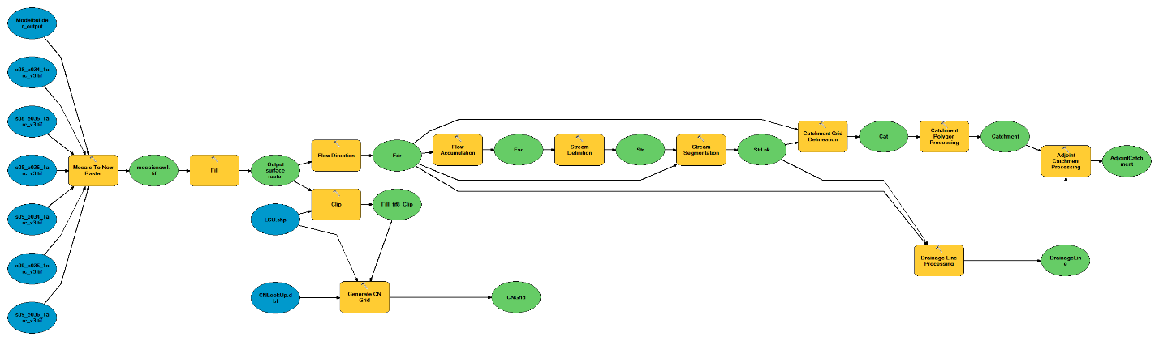
Input
Input
Input
Input
Input
Input
Input
Figure 2.1 – Architecture of the developed geoprocessing tool

Rapid urbanization analysis: A case of Msimbazi catchment in Dar es Salaam, Tanzania

Study area description
The study represents the Msimbazi catchment in Dar es Salaam city, Tanzania. The Msimbazi catchment, located near Dar es Salaam between latitudes 6°27' and 7°15 South of the Equator and longitudes 39° and 39°33' East of Greenwich, is one of the largest. The Msimbazi river flows across Dar es Salaam City from the higher areas of Kisarawe district (Kisarawe hills) in the Coastal region and discharges into the Indian Ocean. The ungauged catchment is a low-lying area (Figure 2.2) and one of the highly floods-impacted catchments in the city, with massive destruction almost every rainy season. As the catchment passes through the center of the city, it is subjected to significant land-use changes from development activities such as the establishment of settlements. The catchment is characterized by the tropical climate under average daily temperature varying from 17-33 ⁰C and two main rain seasons from November to January and March to May, with annual average precipitation amounting to 1,150 mm.

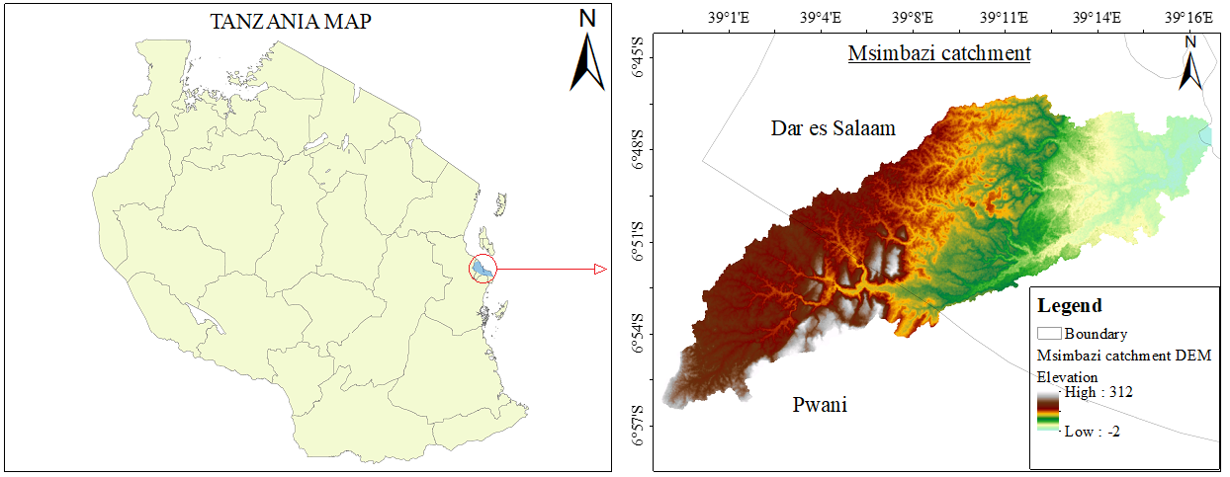
Figure 2.2 – Msimbazi catchment study area

Datasets
The Msimbazi river catchment was delineated based on GIS techniques by running the tools in HEC-GeoHMS of the ArcGIS 10.5. The HEC-GeoHMS developed by the US Army Corps of Engineers was freely accessed from their official website. Then the DEM was retrieved from the online open-source, under the management of the LP DAAC (NASA Land Processes Distributed Active Archive Center), ASTER GDEM with 30m resolution. The stream shapefile of the catchment developed from the Google maps was used for the DEM-Reconditioning, and the Google Earth-based investigation techniques were used to validate the boundaries and streams of the catchment. The high-resolution (4800 x 2718) Google Earth images were retrieved from the Google Earth Pro desktop version 7.3.2.5776 (64-bit). Landsat images downloaded from the official website of the United States Geological Survey (USGS) were used for the land use/land cover analysis. The Rational Method was used for the estimation of discharge for the individual sub-catchment and the total catchment. The 100-year extreme rainfall event recorded on December 20, 2011, as recorded by the Tanzania Meteorological Agency (TMA) was used as an input for the runoff discharge estimation.

Methodology

DEM preprocessing
The catchment layout generation and development of natural flow routes (drainage routes) were carried out in ArcGIS 10.5 by extracting the geomorphologic characteristics of the catchment and then the results were validated by overlying the output against some selected georeferenced shapefiles in ArcGIS. The complete process is summarized in Figure 2.3 below.

Figure 2.3 – Flow chart
The first step in the catchment delineation was the DEM-Reconditioning. Downstream of the Msimbazi catchment is relatively flat with a number of structures (such as bridges) crossing the streams (Figure 2.4), therefore the process of creating flow paths may encounter some challenges when it reaches the flat areas [245] as well as the areas where the streams are covered by structures as it may fail to identify the exact path to follow. Therefore, this study used the DEM-Reconditioning approach along with the available stream shape-file of the catchment to fix the delineated streams into their exact paths. Next, the Fill Sinks tool in HEC-GeoHMS tools was used to fill sinks in the DEM. This was done to ensure that if there are cells with higher elevation surrounding a cell with a lower elevation, it hinders the water from flowing and makes it trapped in the lower elevation cell; hence the water cannot flow out of the cell.
The other steps included; flow direction, flow accumulation, stream definition (where the stream threshold is defined), stream segmentation, catchment grid delineation, catchment polygon processing, drainage line processing as well as adjoint catchment processing. The sharpest descent from each cell determines the flow direction or the highest drop. Equation (2.1) shows how to compute the maximum drop.
 | Maximum_drop = $\frac{change_in_z-value }{distance * 100}$ | (2.1)

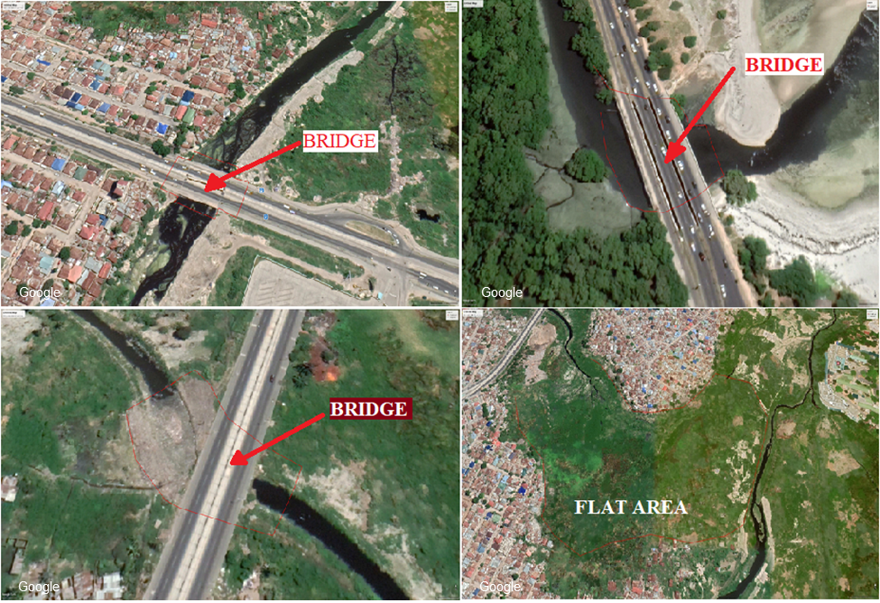
Figure 2.4 – Real scenarios of catchment delineation challenges

Project development
HEC-GeoHMS is designed with more advanced features for the generation of catchment boundaries and streams. After the DEM preprocessing, the Project Setup menus were used to develop the projects for the entire catchment and each of the individual sub-basins. The workflow included setting data using the Data Management tool, starting a project using the Start New Project tool as well as generating a project using the Generate Project tool.

Estimation of discharge
Finally, the discharge for each sub-catchment contributing to a potential dam site and the total catchment discharge for the whole catchment were computed using the Rational Method as described in Equation (2.2) below.
 | $$Q = CIA$$ | (2.2)
Whereby:
Q – the total discharge in cusec; I – rainfall intensity; A – catchment area; C – runoff coefficient.
The coefficient of rainfall is an important indicator of the soil type of the watershed.
The value of C ranges between 0 and 1; the value of C approaches 0 for sandy soil type and toward 1 for clayish soil type (NCDT, 2018). The runoff coefficients were assigned to each land-use class in the attributes table in ArcGIS. A number of parameters can be used to determine the Runoff coefficient, although the main ones are slope (e.g., steep and gentle slope), the type of the soil (such as sand, clay, and silty), and land surface cover (pervious and impervious surfaces). The spatial analysis for the surface land use/ land cover was accomplished using the Landsat images. In this study, land surface cover (degree of impervious surface) was taken as the main factor for runoff generation as the catchment is characterized by many flat surfaces. The rainfall intensity was extracted from the 100-year extreme rainfall event of December 20, 2011, as recorded by the Tanzania Meteorological Agency (TMA).

Land use/ land cover analysis
The land use/ land cover analysis was useful during the selection of the Runoff coefficient. With the help of having good knowledge of the study catchment, the Google Earth high-resolution images and the Interactive Supervised Classification approach in ArcGIS were used to analyze the land surface cover, which is defined from the current use of the land. The main five land use/land cover classes (Table 2.1) were selected during the analysis, and the impervious coefficients were assigned according to the National Land Cover Database 2011 (NLCD2011) Legend [247]. The results from the land use/land cover were then combined with the catchment delineation results for the dam site assessment and selection.
Table 2.1 – Land use/land cover classification
Class | Description
Water | Open Water- areas of open water, generally with less than 25% cover of vegetation or soil.
Developed, Low Intensity | A mixture of Areas with Barren Land, Grassland, Cultivated Crops, constructed materials, and vegetation.  Impervious surfaces 20% to 49% of the total cover.
Developed, Medium Intensity | A mixture of constructed materials and vegetation. Impervious surfaces 50% to 79% of the total cover.
Developed, High Intensity | High-density places where a large number of people live or work.  Impervious surfaces 80% to 100% of the total cover.
Forest | Areas dominated by trees generally greater than 5 meters tall

Land use classification
As previously mentioned, the Interactive Supervised Classification and the Maximum Likelihood Classification methods were used to perform the land use/land cover image classification. Five main categories of land use in the catchment were identified, namely, developed low intensity, developed medium intensity, developed high intensity, water bodies, and forest. The general summary of the procedures is presented in Figure 2.5.
Figure 2.5 – Flow chart

Dam site selection
The site selection for dams was made based on the sub-basin having a sufficient number of networks, land surface cover (validated by satellite images), and the catchment slope. Also, the focus of the dam site locations was to make sure that dams are located in places where the mainstream of the catchment is not directly intercepted by a dam. The idea is to keep the mainstream within the normal flow during the flooding period as the excess amount of runoff is either retained or detained by the dams. With a sufficient amount of runoff being held in the dams during the flooding period, the mainstream is given enough time to safely accommodate the remaining amount of runoff. This approach intends to mitigate flood risks as well as the extending flow in the mainstream for an intermittent river, especially in a catchment in which some other means for flood control are not sufficient.

Results and discussion

Results
With the help of the HEC-GeoHMS plugin in ArcGIS 10.5, the delineation of the case study was achieved. A number of geomorphological datasets were extracted from the DEM and analyzed, which include delineation of stream networks and catchment boundaries, delineation of sub-basins, slope profiles as well as the streams cross-sections. The HEC-GeoHMS generated well-drained and visible sub-basins and streams that were useful for the selection of potential dam site locations.
After the DEM processing, 151 small sub-basins covering 151 streams were obtained. The hydro-filled DEM shows the variations in elevation for the study catchment from 0 to 312 meters, with an indication that the catchment is part of the low-lying areas. The lowest elevation can be observed around the Indian Ocean coast, which is downstream of the catchment with its outlet discharging water into the Indian Ocean. The catchment is also characterized by a gradual change in slope (Figure 2.7). The presence of man-made structures such as bridges and flat areas (see Figure 2.7) is one of the challenges for accurate flow direction computation as they affect the proper trend of elevation (see Figure 3.8).
Using the Interactive Supervised Classification on selected Landsat images, the land use/land cover classes for the Msimbazi catchment were effectively classified. Five classes (see Figure 2.6 (a)), namely, water, developed high intensity, developed medium intensity, developed low intensity, and vegetation, of the land use/land cover for the Msimbazi catchment were selected. The land use/land cover analysis observed a trend of development intensity increasing towards downstream and decreasing towards upstream (Kisarawe hills) where the catchment originates. The developed, high-intensity scenario (see Figure 2.6 (a)) was more detected downstream of the catchment, with the developed, low-intensity scenario being more dominant upstream of the catchment.
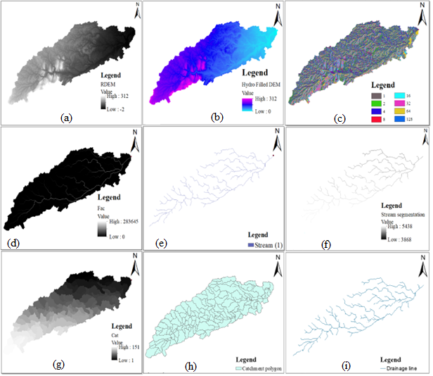
Figure 2.6 – Catchment preprocessing steps: a) Raw DEM; b) Hydro filled; DEM c) Flow direction; d) Flow accumulation; e) Stream definition; f) Stream segmentation; g) Catchment grid delineation; h) Catchment polygon processing; i) Drainage line processing

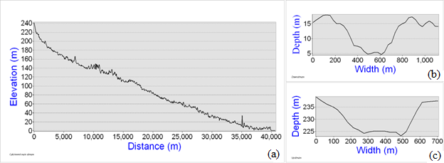
Figure 2.7 – Main channel characteristics: a) general catchment elevation profile; b) mainstream cross-section (downstream); c) mainstream cross-section (upstream)
Jangwani sub-basin is one of the biggest flood-plain within the catchment located downstream, characterized by relatively flat surfaces (see Figure 2.8 (a)). The slope profile extracted from the Digital Elevation Model reveals an almost uniform variation in elevation ranging from 0 m to 8 m for a distance of more than 2.5 km. Also, the elevation profile (see Figure 2.8 (b)) around the Selandar bridge, which was used as a case study, shows an unusual change in elevation, revealing the effect of man-made structures on the accuracy of the DEM, which in turn poses a significant challenge to the flow direction with the automatic catchment delineation techniques.
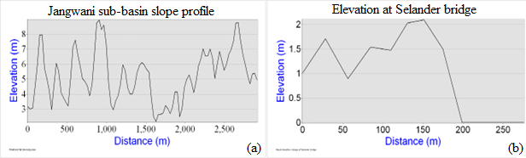
Figure 2.8 – Flow direction challenges: a) relatively flat surface at Jangwani sub-catchment; b) stream-bridge interception
In the catchment, five major land use/land cover classes were identified: water bodies, forest, developed high intensity, developed medium intensity, and developed low intensity. From the classified images (Figure 2.9), it can be observed that downstream of the catchment close to the Indian Ocean shore is highly developed, and the extent of urbanization (development) decreases as you move upstream towards the Kisarawe hills where the catchment originates; whereby, the trend moves from high-intensity development to medium intensity development followed by the low-intensity development. The whole phenomenon reflects the reality of the catchment, where forests are also more seen upstream, especially in the Kisarawe hills.
Furthermore, from the results, it was observed that the land-use coverage has been changing over time. In 1998 a large part of the catchment was occupied by the low-intensity developed areas covering about 61.67% of the total area. In 2009 the low-intensity developed areas decreased drastically to 21.13% of the total area and only 16.82% in 2018. The medium intensity developed areas have been increasing over time; whereby in 1998, the land surface occupied by the medium intensity developed areas was 25.97%, then increased to 50.49% in 2009 and to 61.12% in 2018. It was also observed that the trend of high-intensity development has been increasing; in 1998, the coverage of high-intensity development was about 3.82% which increased to 13.42% in 2009 and then to 19.77% in 2018.
From Figure 2.9, it can have observed that the red color presenting the highly developed areas has been increasing towards the upstream of the catchment over time, and the green color representing the medium level of development also increases towards upstream of the catchment; while the yellow color which represents the low developed areas has been reducing with time. The general phenomenon reflects the real situation within the catchment.
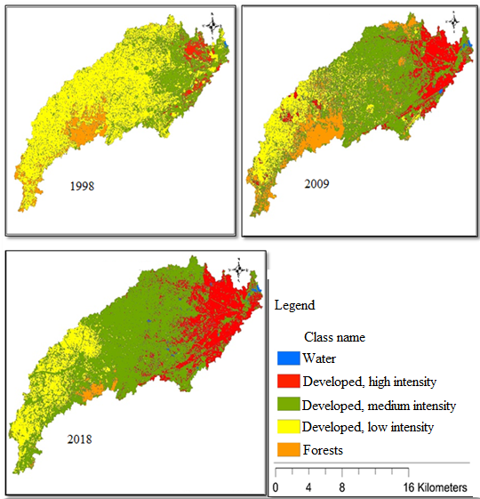
Figure 2.9 – Classified land use within the catchment from 1998 to 2018
Following the investigation from the combination of catchment delineation, land use/land cover analysis, and high-resolution Google Earth images; five potential dam site locations (see Figure 2.10), namely; Kisarawe sub-basin, Magomeni sub-basin, Kinyerezi sub-basin, Jangwani sub-basin, and Pugu sub-basin were identified in this study. The outlets of the dam sites are mainly located in the streams with a sufficient number of sub-streams before discharging water into the mainstream. The largest potential site is the Kisarawe sub-basin (see Figure 2.10 (b), Figure 2.11(b), and Figure 2.12) which is located the upstream (approximately 89.89 km² coverage of the sub-basin draining to the dam location), where the land is less occupied and less developed proving sufficient space for the construction of a dam and save the downstream from the recurring flood events.
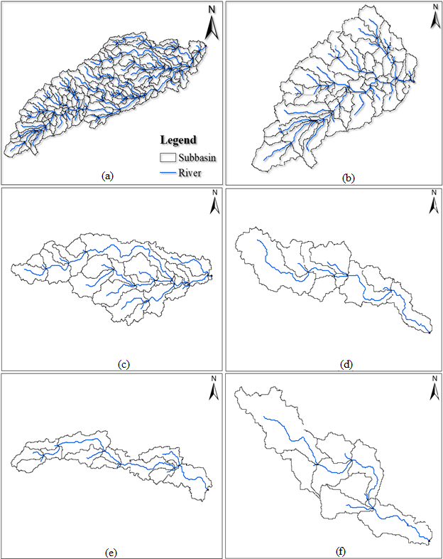
Figure 2.10 – Delineated subbasins for the selected dam sites: a) subbasin 5; b) subbasin 7; c) subbasin 9; d) subbasin 11; e) subbasin 13
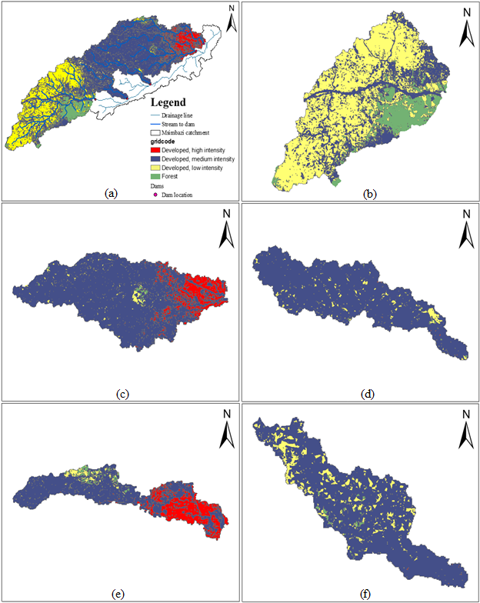
Figure 2.11 – Land use/land cover distribution for each subbasin of the selected sites: a) land use/land cover for the combined selected sites; b) land use/land cover for Kisarawe sub-basin; c) land use/land cover for Magomeni sub-basin; d) land use/land cover for Kinyerezi sub-basin 11; e) land use/land cover for Jangwani sub-basin; f) land use/land cover for Pugu sub-basin
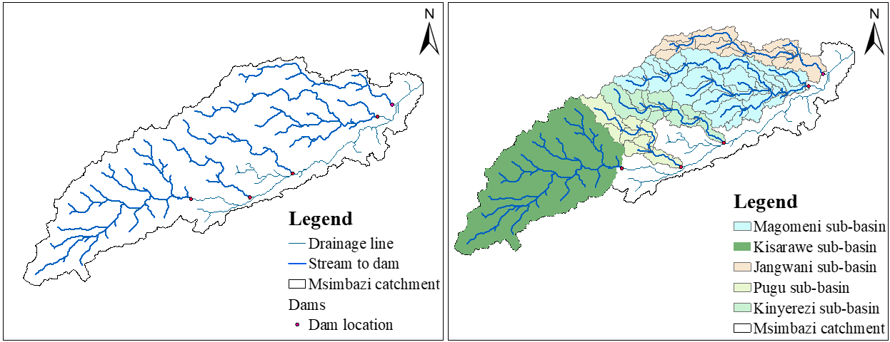
Figure 2.12 – Dam sites location: Streams only (left), streams with coverage (right)
The total discharge for the whole catchment covering about 66037.06 ha (267.24 km²) was estimated to be 284970.4 ft³/s (8069.5 m³/s). Despite the coverage of the Magomeni sub-basin being smaller than the Kisarawe sub-basin, it can be observed that the estimated discharge in the Magomeni sub-basin is higher than that of the Kisarawe sub-basin which can be more attributed to the effect of land properties. Kisarawe sub-basin is located upstream, where the land is less developed with more vegetation facilitating runoff interception. In contrast, the Magomeni sub-basin is located downstream of the catchment, where the land is highly developed with a high population density. The selected dam sites in total can capture about 6064.18 m³/s (Table 2.2) of the discharge, which is 75.15% of the total discharge generated in the catchment.
Table 2.2 Summary of the selected dam sites
Dam subbasin | Coverage (km²) | Discharge (m³/s)
Kisarawe sub-basin | 89.67 | 2019.49
Magomeni sub-basin | 59.32 | 2042.70
Kinyerezi sub-basin | 19.05 | 634.76
Jangwani sub-basin | 24.26 | 833.48
Pugu sub-basin | 16.68 | 533.75
Total | 208.97 | 6064.18

Discussion
The results derived in this study reveal that the combination of DEM and HEC-GeoHMS tools make up a promising approach for the assessment of potential dam sites within a catchment. In general, Remote Sensing (RS) and Geographical Information Systems (GIS) are very useful in terms of providing geospatial data for the assessment of potential dam sites. Also, having a prior understanding of the investigated area as well as the technical knowledge is important as it helps in providing a link between the theories and the real situation on the ground for easy identification of the potential dam sites.
Considering the studies conducted in some other parts of the world [248–250], GIS-based techniques provide a handy approach to extracting the geomorphological characteristics of a catchment. During the installation process, the HEC-GeoHMS was smart enough to detect the absence of Arc Hydro tools and then will give an option to automatically install Arc Hydro tools compatible with the ArcGIS version installed in the working machine.
Also, after the DEM preprocessing, the Project Setup section in HEC-GeoHMS provided more promising catchment delineation results with more detailed delineated streams. This methodology appears to be more effective because it avoids the difficulties of manually locating appropriate Arc Hydro tools and provides an efficient method for extracting, mapping, and interpreting watershed characteristics in order to identify potential dam site locations.
Despite the challenges associated with the open-source DEM with 30 m by 30 m resolution for the GIS-based approaches, the catchment delineation in this study provided an accurate reflection of the catchment characteristics on the ground supported by the prior understanding of the catchment and the Google Earth Pro visualization of the delineation results. However, a higher resolution DEM can be more useful to provide a piece of more detailed information ([251];[252]), especially when individual characteristics of a stream are needed.
From the land use/land cover analysis, three major land use/land cover classes were identified in the Msimbazi catchment. High development intensity is more evident downstream of the catchment towards the Indian Ocean coast, characterized by highly compacted residential and commercial houses, offices as well as industries. The medium development intensity is observed in the middle of the catchment, with the Kinyerezi sub-catchment as an example, driven by the enormous demand for residential housing. In comparison, the low development intensity is observed upstream of the catchment towards the Kisarawe hills. Therefore, the results derived from the land use/land cover analysis reflect the reality of the catchment.
The Msimbazi catchment is one of the highly floods-impacted catchments in Tanzania; therefore, the location of dam sites also considered the fact that they have to reduce the amount of water going to the mainstream at once during the time of heavy rains. The implementation of sufficient in-street stormwater control structures is also affected by the unplanned settlements in the catchment. Dams are part of the useful flood control structures used worldwide ([253];[254]). Apart from being flood control structures, dams provide a number of other potential benefits, such as an extension of river flow in flashy and intermittent rivers.
The findings of this study demonstrate the potential of combining multiple RS and GIS-based methodologies for extracting geomorphological information from a watershed in order to perform proper stormwater management practices, such as selecting sites for stormwater control dams.

Ndembera catchment, Tanzania

Case study description
The Rufiji River flows entirely within the middle of Tanzania (Figure 2.13). The river is formed by the convergence of the Kilombero and Luwegu rivers. It is approximately 600 km long, with its source in southwestern Tanzania and its mouth is on the Indian Ocean at a point of Mafia Island called Mafia Channel. This principal tributary is the Great Ruaha River. It is navigable for about 100 km.
The Rufiji River is about 200 km south of Dar-es-Salaam. The river's delta contains the largest mangrove forest in eastern Africa. The Rufiji Basin is 183,791 km² in size (about 20 % of Tanzania).
The Rufiji basin at the Lugoda dam site will locate between 33°55’ and 39°25’ east longitudes and 5°35’ and 10°45’ south latitudes.
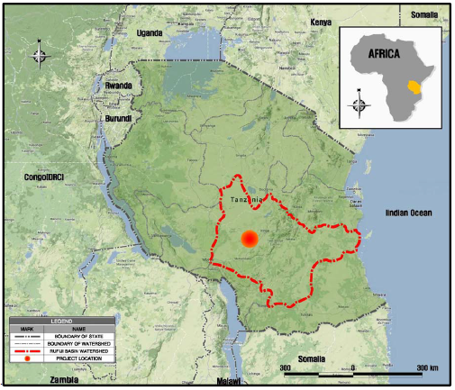
Figure 2.13 – Case study map [255]
The Lugoda dam is located on the Ndembera River in the Iringa region, the major tributaries of the Great Ruaha River, which is a source at high elevations and accounts for 85% of the total discharge from the Usangu Plains (Figure 2.14). 15% of the Average annual flows into the Usangu Plain is provided by the Ndembera River. The Ndembera watershed, relevant to the Lugoda dam site, has a total catchment area of about 1,223 km². The watershed elevations range from a minimum of about 1,640 m.a.s.l. (dam site) to a maximum approximately 2,600 m.a.s.l. The Lugoda dam is located approximately about 55 km upstream of the irrigation diversion weir along the Ndembera River (UTM WGS84: E 737 776 m; N 9 084 859 m).
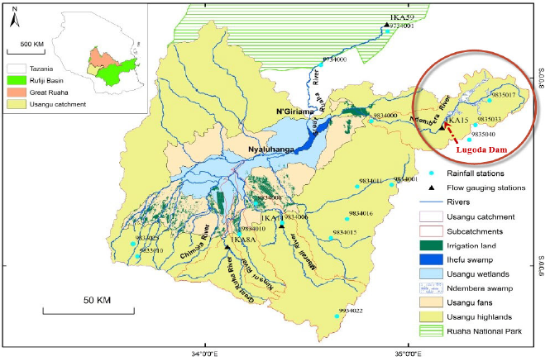
Figure 2.14 – Location of the Lugoda dam [255]

Topography
The basin's altitude ranges from 0 meters above sea level (m.a.s.l.) in the Indian Ocean to more than 2,960 meters above sea level (m.a.s.l.) in the Iringa and Mbeya Regions' highlands (Kipengere ranges and Poroto Mountains). The Rufiji Basin is easily recognizable by its physiology. The Lower Rufiji delta and flood plain form one portion of the basin, which gradually rises into a plateau of coastal territory into Tanzania's Southern Highlands and Central Plateau.

Geomorphology
The Rufiji's land surfaces are remnants of previous erosion cycles that were dissected or partially erased as a result of epeirogenic processes, such as crustal uplifts accompanied by tilting and faulting. Gondwanaland (late-Jurassic) surfaces in the Kipengere and Usagara Mountains, African (late-cretaceous) surfaces, African surfaces, and post-African (mid-tertiary) surfaces are the most common erosion surfaces (most dominant in the basin). Due to structural occurrences, changes in local base levels of erosion. The drainage patterns in the basin are heavily reliant on its geomorphology.

Weather and hydrological conditions
Tanzania has a predominantly tropical savanna climate with two distinct seasons. Coastal areas are typically hot and humid, although a sea breeze cools the air significantly on the beaches. The long rains in Tanzania last from late March to June, and the short rains last from November to February. Long rains bring huge downpours and are frequently accompanied by strong storms, whereas short showers are far less severe.
From July through October, the dry season is in effect. The hottest months are December to March, just before the heavy rains start, and the coolest months are June, July, and August when the weather is frequently gloomy. The following table highlights the project area's average weather parameters:
  - Mean Maximum Temperature: 26.6°C.
  - Mean Minimum Temperature: 14.6°C.
  - Relativity humidity (Time 0600 UTC): 65.9%.
  - Relativity humidity (Time 1200 UTC): 47.8%.
  - Wind velocity: 4.18 m/s.
  - Sunshine: 8.2 hours/day.
  - Mean evaporation: 170.5 mm.
  - Annual rainfall: 596.0 mm.
The Lugoda dam watershed is composed of 11 rivers, including the Ndembera Rive. The river flows at the Ilongo station (1KA15A; very close to the dam site) usually decreases from about 16.8 m³/s in March to around 0.5 m³/s from September to November. After this month, it rises slowly, reaching the value of 2.9 m³/s in December.
In January and February, the flow arrives at 9.2 m³/s and 12.8 m³/s, respectively. The highest monthly Average flow is always reached in March, around 16.8 m³/s. The mean annual flow is approximately 5.69 m³/s.

Basin Characteristics Factors of Lugoda Catchment
  - Basin area
The Ndembera River and its tributaries drain the entire geographical area, which is distinguished by all runoff being transported to the same exit. The drainage region is separated into two parts: the river area and other drainage areas.
  - Basin length
Basin Length along the main stream from the mouth of a stream to the farthest point on the drainage divide of its basin. Topographic maps and aerial photographs are used to determine the perimeter of the basin.
  - Effective basin width
Effective basin width is the ratio of the basin length (L), which is measured along a line aerially centered through the drainage-divide data layer from the basin outlet to where the main channel extended meets the basin divide, divided by the basin area (A).
  - Shape factor
The ratio of basin area to basin length squared is known as the shape factor. The value of the form factor would always be less than 0.754 (for a perfectly circular watershed). The smaller the value of the form factor, the more elongated the watershed will be. The watershed with high form factors has high peak flows of shorter duration, whereas the elongated watershed with low form factor ranges from 0.54, indicating them to be elongated in shape and flow for a longer duration.

Seismic conditions
The East African Rift zone includes a number of active as well as dormant volcanoes. As far as Tanzania is concerned, the country is geographically located in a seismic zone, and earthquakes occur periodically. The Ol Doinyo Lengai volcano is the only active volcano in Tanzania and is located in the north, close to Arusha.
There has been no record of earthquake incidents, volcanic eruptions, or landslides in the southwestern highlands of Tanzania during the last 100 years. However, minor mudslides on steep slopes as a consequence of heavy rains at the start of the rain season are anticipated but not of any major importance for the project activities. Tanzania is one of the nations traversed by EARS, the East African Rift System. Shallow earthquakes often occur in the EARS, which is part of the global divergent tectonic plate boundaries. Earthquakes of large and intermediate magnitude have been happening along the rift system as well as within the Tanzanian Craton, outside the rift.
Along with the EARS, the 1910 Lake Tanganyika earthquake had a magnitude of 7.3, making it the greatest earthquake during the instrumental period. Large and moderate earthquakes have wreaked havoc on the environment. Other seismic stations have since been established at Nairobi and Dodoma. Although there have been periods when some of these stations have not functioned, the seismic recording has generally been performed in east Africa throughout this last century.

Catchment delineation
As previously mentioned, for mapping and modeling natural hazards and risks impacted by topography, such as floods and landslides, digital elevation models (DEMs) are required. Elevation data is used to anticipate water flow and determine potential inundation zones in the case of floods because water only travels downhill and is funneled by objects higher than the water level.
The Digital Elevation Model used for the delineation of the Ndembera catchment was retrieved from the United States Geological Survey (USGS) official website [256]. Users can search catalogs of satellite and aerial imagery with the USGS Earth Explorer, which is similar to the USGS Global Visualization Viewer (GloVis). The new and enhanced version is the USGS Earth Explorer. The USGS Earth Explorer adds the following features: Data is downloaded in chronological order.
Knowing the limits and flow regimes of the stream channels within your project area is critical when planning a development project such as embankment dam construction. It is also worth noting that, when it comes to dams avoiding effects to stream channels is not always achievable; therefore, it is critical to execute accurate and reliable delineations to reduce mitigation costs. Figure 2.15 (a) presents the clipped Digital Elevation Model (DEM), while Figure 2.15 (b) presents the boundaries of the catchment with some delineated streams.
The followings are part of the step-by-step techniques employed in the catchment delineation in this study.
- Filling sinks
To fill sinks in the Digital Elevation Model, the fill sinks tool in ArcHydro tools was utilized. This was done to eliminate the flow hampering issues because if there are cells with higher elevations surrounding a cell with a lower elevation, the water will be hampered in its flow and confined in the lower height cell, preventing the water from flowing out. As a result, the fill sinks operation tends to modify the Digital Elevation Model.
- Flow direction
For each grid cell, the flow direction tool was utilized to determine the direction of the steepest fall to a neighbor cell. This function, in general, computes the flow direction for a given grid, where the values computed in the flow direction grid's cells reflect the direction of the steepest drop from that cell.
- Flow accumulation
The number of upstream cells draining into any given downstream cell in the grid is defined in this process. For each cell in the input grid of the given watershed, computes the flow accumulation grid, which contains the accumulated number of cells upstream of a cell.
- Stream definition
The stream network's grid cells were chosen based on a threshold number of grid cells draining into a given downstream grid cell.
- Stream segmentation
The stream segmentation tool creates streams by separating the stream at any junction as defined in the stream definition procedure.
- Catchment grid delineation
In the Arc Hydro Tools' Terrain Processing tool, the catchment delineation procedure was followed by catchment grid delineation. The relevant watershed is drawn and recorded in a grid file for each stream segment component established by the stream segmentation method.
- Catchment polygon processing
This technique employs the polygon generated from the catchment grid to outline the limits of each sub-basin.
- Drainage line processing
This function takes the output from the stream segmentation grid and converts it into a vector stream layer.
- Adjoint catchment processing
Because the upstream sub-basins were aggregated at any stream confluence during this process, any inaccuracy in adjoint catchment processing could cause problems with auto-extraction of a catchment of interest, especially if the DEM was not clipped to the catchment's size from the start.

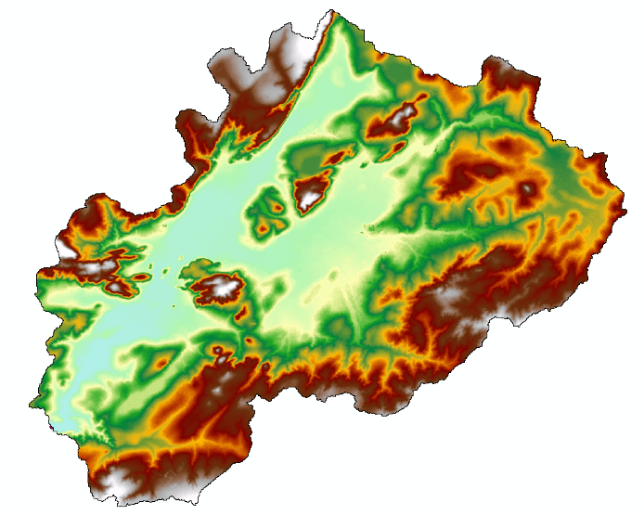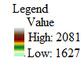 | 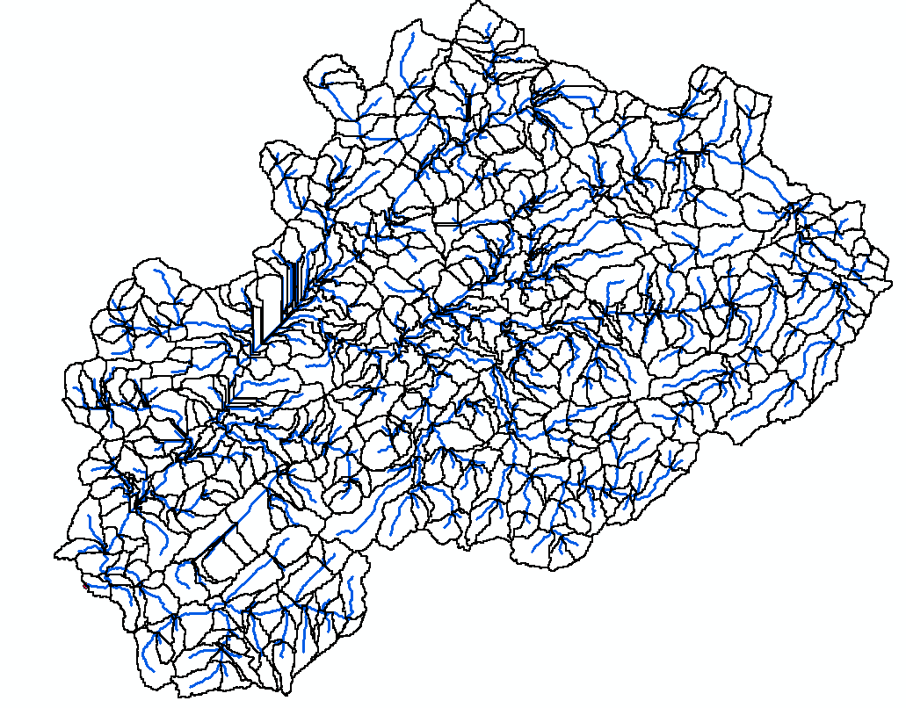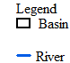
(a) | (b)
Figure 2.15 – Ndembera dam catchment boundary: a) clipped DEM; b) delineated catchment

Curve Number (CN) Grid Inputs Preparation

General overview
Several steps must be conducted prior to constructing the Curve Number (CN) Grid in order to prepare inputs for the Curve Number (CN) generation. As mentioned below, some of the methods involve processing Landsat images, producing soil data, combining land use/land cover data with soil data, and creating a CN Lookup table.

Land use and land cover analysis processes

Landsat data processing
- Combining bands
After loading all of the available satellite image bands into ArcMap 10.5, the Image Analysis tool was used to merge the bands using the composite bands' feature.
- Projection of the combined bands
After combining the Landsat images, they were then converted to the Universal Transverse Mercator (UTM) projection raster form by using the Project Raster tool in the Data Management tools and considering the study area's zone.
- Clipping landsat image
Using the case study's shapefile, the projected Landsat image was trimmed to the size of the catchment.
- Band color arrangement
Individual bands composited in a 1,2,3 (Red, Green, and Blue (RGB)) combination were altered to a 5,4,2 RGB combination in order to present the data in color for accurate visualization of the Landsat image. The colors can be arranged in a variety of ways, but the 5,4,2 RGB combination was chosen for this investigation because it provides a better visual representation of the image for classification.
- The land use classification method
The Image Classification program was used to classify land use/land cover images using the Interactive Supervised Classification and Maximum Likelihood Classification methods.

Land use and land cover analysis results
Land use and land cover change analysis is one of the most important approaches for understanding how the land has been used in the past, what types of detections can be expected in the future, and the underlying causes and processes that drive these changes [257,258]. This study divided the land use and land cover change analysis process into four different years (1990, 1995, 2004, and 2011). As for DEM, the Landsat images used in this study were retrieved from the United States Geological Survey (USGS) official website [256]. Following the land use and land cover change analysis, mainly six land use classes were identified: water, wetland, dense forest, developed low intensity, developed medium intensity, and developed high intensity. From Figure 2.16, it can be observed that the largest part of the Ndembera catchment was covered by wetlands, with approximately 56.57% coverage. The high-intensity development can be observed to cover only approximately 0.86% of the total area. This suggests that in 1990 most of the catchment area was covered by more natural and less developed surfaces. According to the study conducted by Akhtar et al. [257], Changes in land usage and land cover have been one of the most massive and apparent changes on the planet's surface, according to scientists. Evaluating LULC change at various geographical scales is crucial in a variety of situations, including environmental conservation.
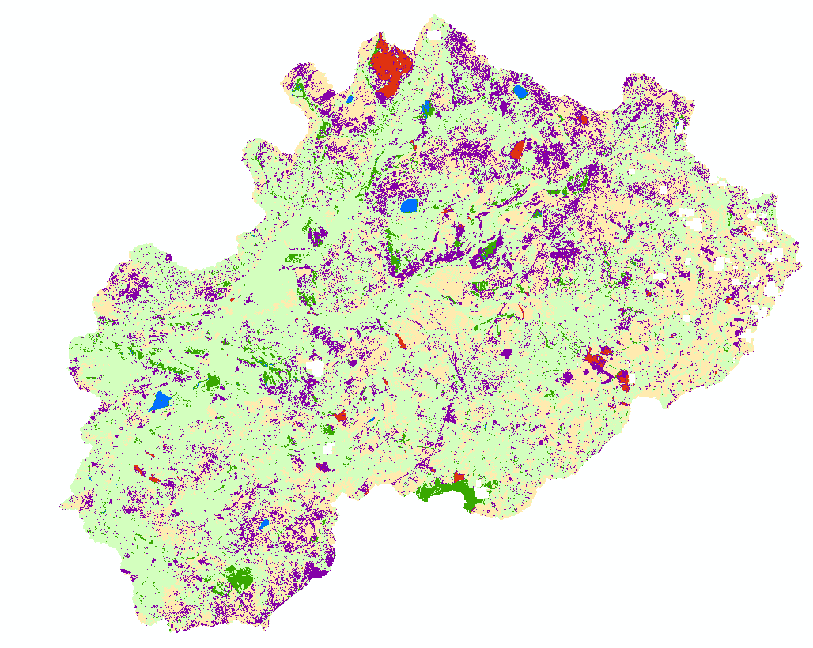 | 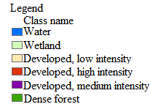
(a)
(b)
Figure 2.16 – Land use and land cover analysis results from 1990: a) classified land cover; b) graph of classified land cover
Figure 2.17 shows that low-intensity development covered the vast majority of the Ndembera catchment, accounting for 45.44% of the total area. The high-intensity development can still be seen as being comparatively low, as it was in 1990. This implies that in 1995, the majority of the catchment area was covered by a more natural and less built surface. However, the percentage of area covered by wetlands has decreased from 56.57% in 1990 to 23.52% in 1995.

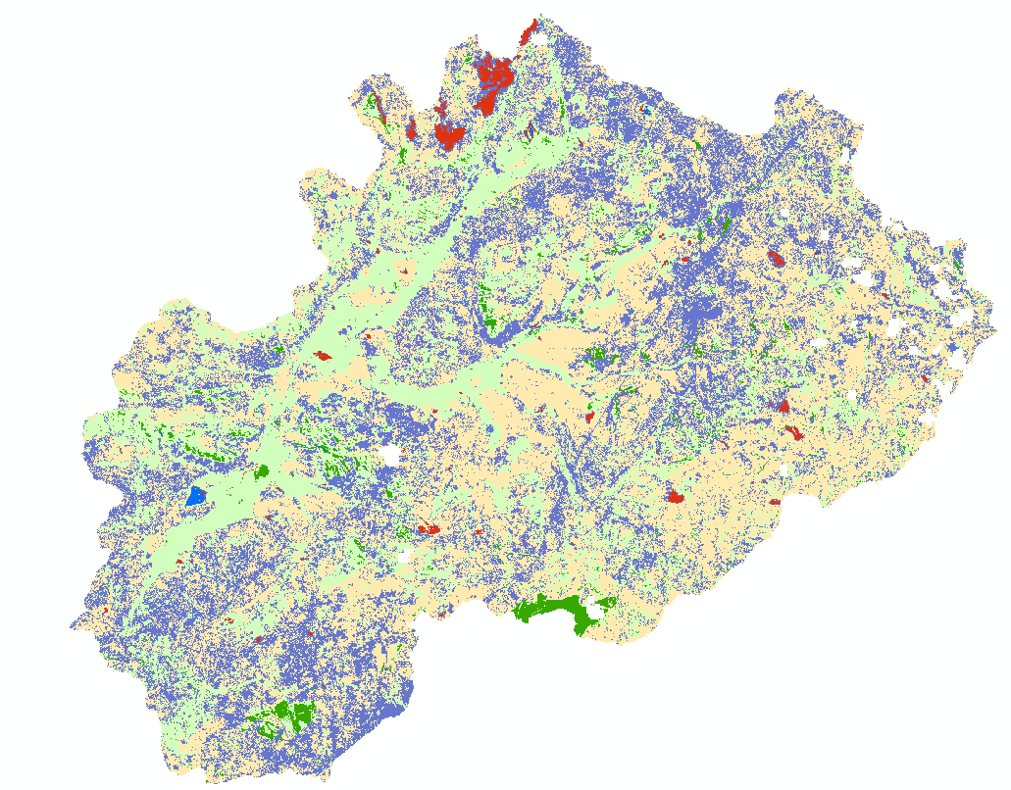
(a)
(b)
Figure 2.17 – Land use and land cover analysis results from 1995: a) classified land cover; b) graph of classified land cover
Also, Landsat images were collected for 2004 and successfully analyzed in terms of land use and land cover. From Figure 2.18, it can be observed that, despite the largest part of the catchment still being occupied by the low-intensity development, the coverage of high-intensity development increased a bit compared to 1995.
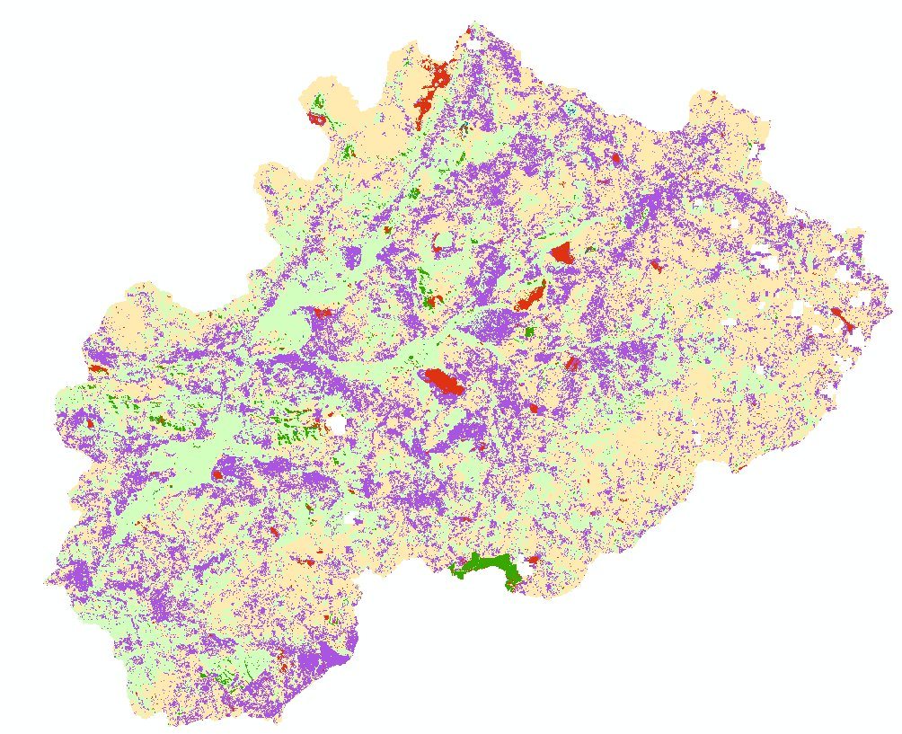
(a)
(b)
Figure 2.18 – Land use and land cover analysis results from 2004: a) classified land cover; b) graph of classified land cover
Moreover, Landsat images from 2011 were also retrieved and analyzed for land use and land cover. From Figure 2.19, it can be observed that there is a significant change in terms of land surface cover as compared to the one in 2004. The medium intensity development has significantly increased to approximately 54.71% within seven years compared to 25.91% in 2004. The literature highlights that environmental elements such as soil composition, climate, topography, and vegetation limit land use [259]. The proximate sources of change are human activities that make use of land cover features and hence change or sustain them.
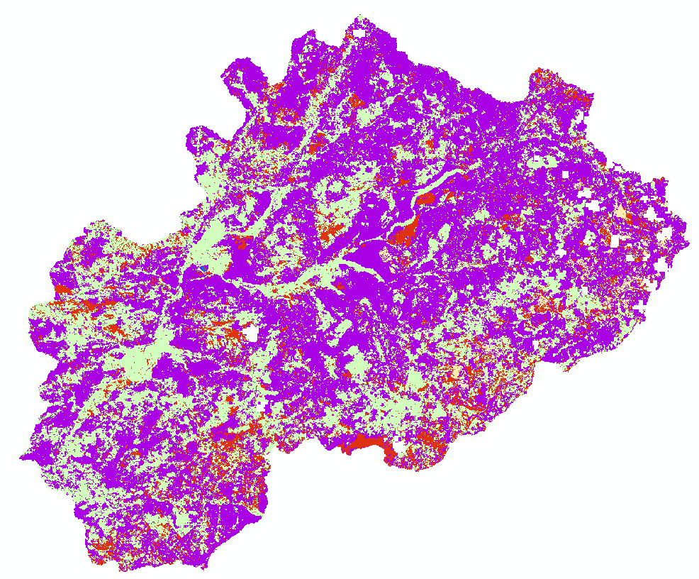 | 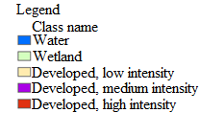
(a)
(b)
Figure 2.19 – Land use and land cover analysis results from 2011: a) classified land cover; b) graph of classified land cover

Preparing Soil Data for CN Grid
According to the classification of (USDA, 1986), there are four types of soil hydrologic groups: A, B, C, and D. High infiltration rates are associated with group A soil types; moderate infiltration rates are associated with group B soil types; slow infiltration rates are associated with group C soil types; extremely slow infiltration rates are associated with group D soil types. Different sorts of hydrological groups were identified in the soil maps used in this study.

Merging of Soil and Land Use Data
Because the CN grid requires both soil and land use data, both the land-use class and soil class of the research region were prepared in shape file format, as previously mentioned. The two datasets are critical for generating curve numbers (CNs). The two shape files have to be united using the union function in the Analysis Tools of the Arc GIS 10.5 software package in order to use the data for Curve Number creation. The land use and soil feature classes are both used as inputs to the union function. The integrated features' output included attribute values from both land use and soil data.

Creating CN Look-up Table
As an input table for CN grid generation, the curve number look-up table is critical. Curve Numbers for each of the relevant soil groups for each land use category are stored in the table's columns A, B, C, and D.

Curve Number Grid Generation
The following are the inputs required by the HEC-Geo HMS to generate the Curve Number Grid: Merged land use and soil data; The sink-filled DEM; CN lookup table.
All of the above-mentioned datasets were prepared in their requisite formats in the previous phases, and the files were utilized as inputs to generate the CN grid using the Create CN Grid tool in the HEC- Geo HMS extension's utility function.

Curve Number grid
The use of a curve number grid allows one to extract curve numbers for any area in the watershed without having to perform any computations. It has to be noted that the Curve Number (CN) approach is among the reliable approaches for estimating precipitation excess/loss that takes land use and soil types into account. The CN techniques were developed through empirical research on small agricultural watersheds. The CN value is usually lumped as an average of the subbasin or watershed in most uses of the CN method [260]. Figure 2.20 presents the CN grid for the Ndembera catchment from 1990 datasets.
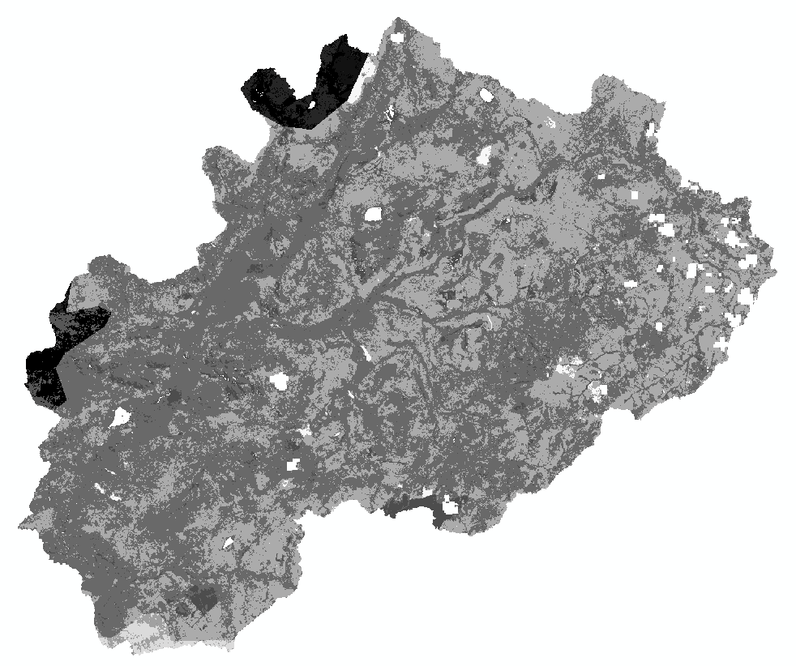
Figure 2.20 – Curve Number grid
The weighted average of the initial Curve Number (CN) values of the vegetation, impervious surface, and soil fractions yields the composite CN. Surface runoff is then simulated using this composite CN approach under the specified precipitation for the research area. Table 2.3 presents the composite CN and percent change for the four years investigated in this study.
Table 2.3 – Composite CN in the Ndembera catchment
Year | Composite CN | Percent change (%)
1990 | 34.15 | 0
1995 | 36.22 | 6.08
2004 | 42.56 | 24.65
2011 | 53.96 | 58.028

Chardara catchment, Kazakhstan

Case study description
The Chardara dam, which encompasses the Golodniy steppe, the Arnasay depression, and the Syrdariya valley, is located in Kazakhstan's South-Kazakh region, at the end of the middle stream of the Syrdariya river, to the north of the Turkestan mountains (Figure 2.21). The Kyzyl-Kum canal receives agricultural water from the dam. The reservoir at the dam has a storage capacity of 5.7 billion m³ (4,600,000 acreft) and a surface area of 900 km² (350 sq mi). The Central Asia department of Tashkent's "Hydroproject" Institute designed the dam between 1955 and 1967. The reservoir was entirely impounded in 1968, after construction was completed in October 1967.
The Chardara dam is made up of a hydraulic fill embankment, a channel-type power station with two sluices on the left and right sides of the power station, and a Kyzylkum regulator on the river's left bank (Figure 2.21). The dam was built by filling it with hydraulic fluid from two sides. Reinforced concrete slabs were put on a gravel-sandy bed to enhance the embankment's upstream slope. A double-layer of the inverted filter was put at the concrete facing joints. Local silty-gravel material reinforces the downstream slope. At the bottom of the downstream slope, a pipe drain with a triple-layered inverted filter was built. There are relief wells and a drainage water conduit at the downstream toe. There is a 6m wide asphalt road at the dam crest. Table 2.4 presents the dimensions of the Chardara reservoir.
Table 2.4 – General dimensions of the Chardara reservoir
Parameter | Source | Unit | Value
Total storage capacity | Design | mm³ | 5700
Total storage capacity | 1977 Survey | mm³ | 5197
Active storage capacity | Design | mm³ | 4700
Active storage capacity | 1977 Survey | mm³ | 4230
Dead storage capacity | Design | mm³ | 1000
Dead storage capacity | 1977 Survey | mm³ | 967
Full storage level | Survey | m.a.s.l.. | 252
Maximum water level | Survey | m.a.s.l.. | 253
Dead storage level | Survey | m.a.s.l.. | 244
The surface level at FSL | Design | km² | 900
The surface level at FSL | 1977 Survey | km² | 783.4
The purpose of the water reservoir is:
- Distribution of winter runoff of Syrdariya river for summertime needs for irrigation of the area about 370 thousand hectares.
- Prevent dangerous summer and winter floods that cause flooding of populated areas, irrigated areas, and the railway line in Syrdariya valley.
- Generation of electric power.
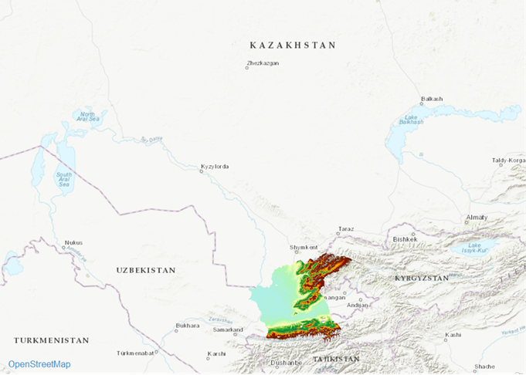
Figure 2.21 – Case study location
      - Catchment delineation
The USGS website [256] provided the Digital Elevation Model used to outline the Chardara watershed. Users can search satellite and aerial image collections using the USGS Earth Explorer, which is similar to the USGS Global Visualization Viewer (GloVis); the USGS Earth Explorer is an updated and improved version of the previous version. Figure 2.22 presents the clipped DEM for the Chardara catchment.
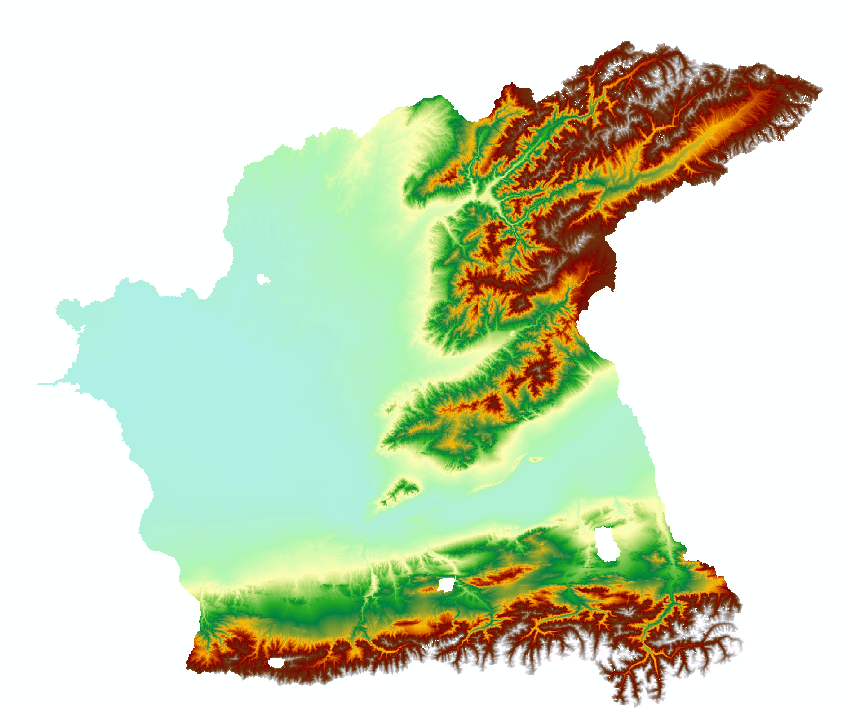
Figure 2.22 – Digital Elevation Model
By determining the flow direction using a combination of ArcHydro and Spatial Analyst tools in ArcGIS, the catchment boundaries and streams were identified from DEM. The Flow Direction tool was used to build a raster reflecting the flow direction to identify the contributing area. Figure 2.23 presents the delineated Chardara catchment from DEM.
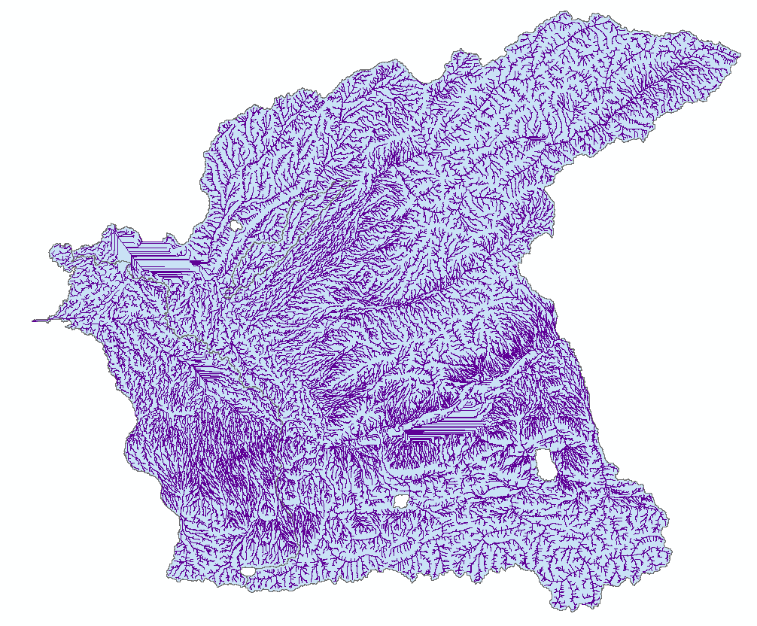
Figure 2.23 – Delineated catchment
      - Land use and land cover change analysis
As previously mentioned, a land-use classification is a categorization that provides information on the land cover as well as the sorts of human activity that take place in that area. It may also make assessing environmental consequences on land, as well as possible or alternative uses of land, easier [261]. Water, vegetation, developed low intensity, developed medium intensity, and developed high-intensity land use classifications were established as a result of the land use and land cover change analysis (Figure 2.24).
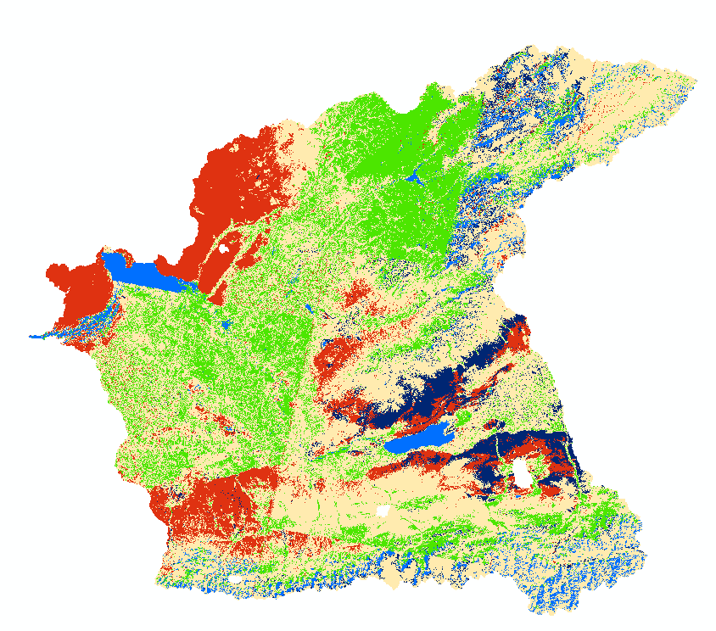 | 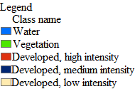
Figure 2.24 – Classified land use and land cover from 2000 datasets
Figure 2.25 shows that low-intensity development covered the majority of the Chardara catchment in 2000, accounting for approximately 36482.77 km² of the catchment, followed by a relatively large area covered by vegetation cover (Figure 2.25). It is also interesting to note that there were more areas covered by high-intensity development compared to that of medium-intensity development. The phenomenon suggests that the convention of the natural surface into high-intensity development is relatively high in the catchment.

Figure 2.25 – Land use and land cover coverage in 2000
It is also important to highlight that the cell is the fundamental unit of the raster data model. Cells store information about the conditions at a specific spot on the planet's surface. Cell values can be integers (whole numbers) or floating points, depending on the type of data being stored (numbers with decimals). Continuous data is stored in the form of a raster with floating-point cell values. Nondiscrete data, field data, and surface data are all terms used to describe this type of data. The data is well stored to allow a large number of significant digits as well as a wide range of values. Therefore, in this study, the classified map from the 2011 datasets was then stored in float type (Figure 2.26 (a)) and integer type (Figure 2.26 (b)).
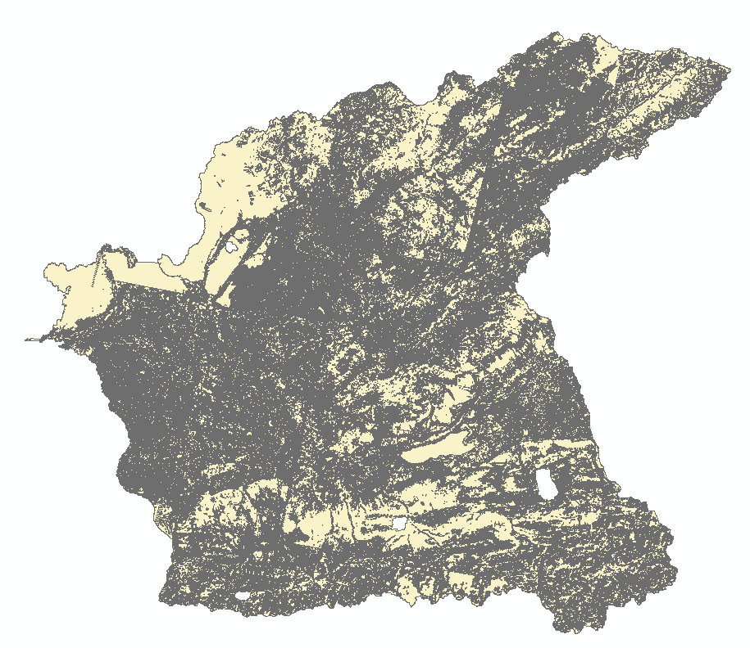  (a) | 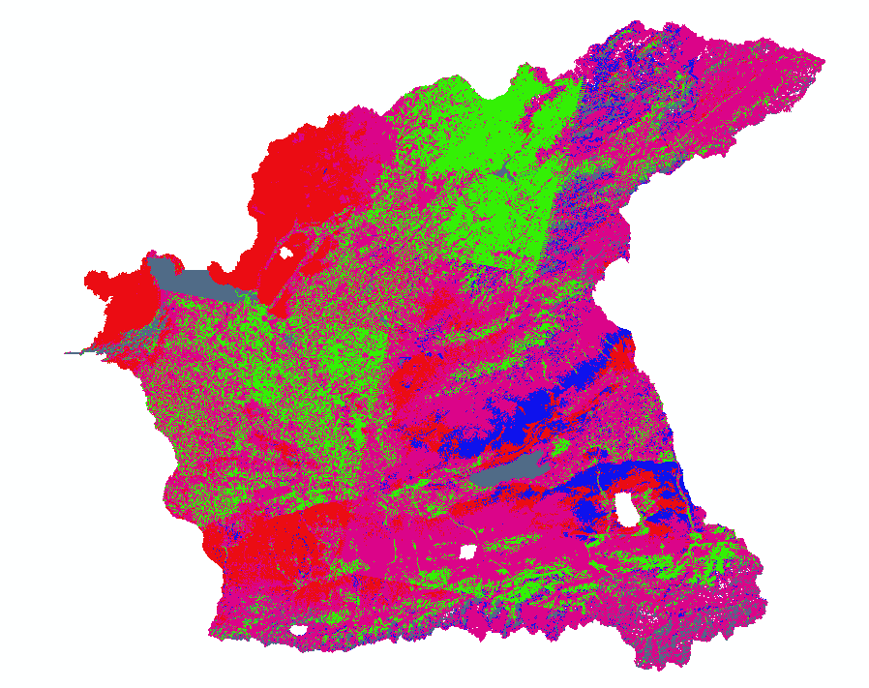  (b)
Figure 2.26 – Raster to polygon: a) float type; b) integer type
Also, water, vegetation, developed low intensity, developed medium intensity, and developed high-intensity land use classifications were established as a result of the land use and land cover change analysis for 2011 datasets (Figure 2.27). Moreover, from the 2011 datasets, 56.28 was achieved as a composite curve number (CN56.28).
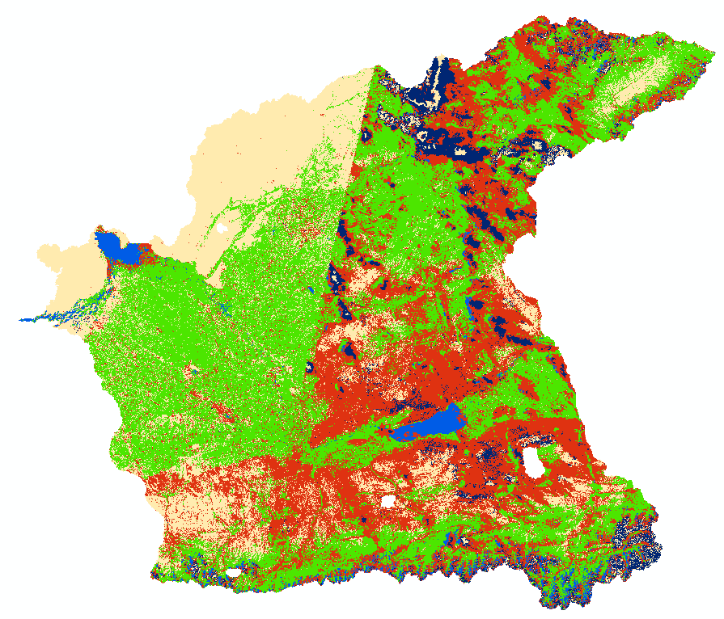
Figure 2.27 – Classified land use and land cover from 2011 datasets
From Figure 2.28, it can be observed that despite an increase in the areas covered by vegetation, there is a significant increase in the medium intensity development and high-intensity development compared to 2000.

Figure 2.28 – Land use and land cover coverage in 2011
The classified map based on the identified land use and land cover types was then converted to polygon (Figure 2.29). Polygons were extracted from units in a raster map using the Raster to Polygons technique. The output polygon map had the same domain as the input raster map, which means that the polygons in the output polygon map had the same class names or identifications as the input raster map.
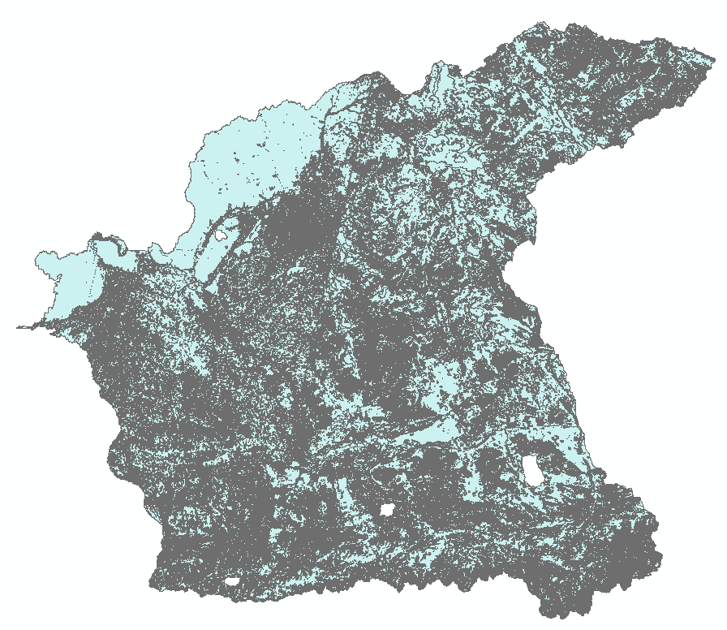
Figure 2.29 – Raster to polygon output from 2011 datasets

Summary for chapter two
- The purpose of this research was to integrate the use of DEM, Land use/land cover attributes, and HEC-GeoHMS as a plugin in the ArcGIS interface for watershed delineation and identifying prospective dam sites in a flood-affected catchment to see how GIS and RS may help with various engineering tasks. For the watershed delineation and development of a base map for candidate dam sites as flood control structures, this study used GIS-based methodologies using a 30m resolution DEM.
- A total area of 267.24 km² has been defined. The study used Landsat and Google Earth pictures to assess the land surface features of the study catchment for runoff affecting elements, as well as to identify potential physical barriers on the ground for precise catchment delineation. A total of five land-use classes were chosen (water, developed high intensity, developed medium intensity, developed low intensity, and vegetation). The degree of development intensity increases downstream and decreases upstream of the catchment. This occurrence reflects the catchment's true state.
- The Rational Method for Runoff Discharge Estimation was used to calculate the total possible runoff discharge in the watershed, as well as the discharge for each subbasin contributing to the potential dam sites. The total discharge from December 20, 2011, heavy rainfall event was predicted to be 8069.5 m³/s. This study's findings reveal the importance of RS and GIS-based approaches in the evaluation of potential dam sites as part of engineering, catchment management, and decision-making operations. The dam locations chosen could capture around 75.15% of the runoff generated in the watershed, which would then be released at a controlled pace based on the capacity and other needs of the downstream receiving stream.
- Wetlands covered the majority of the Ndembera catchment in 1990, accounting for 56.57% of the total area. The area covered by high-intensity development is just about 0.86 % of the overall area. This indicates that the majority of the catchment area was covered by more natural and less developed areas in 1990. In addition, photos from the Landsat satellite from 2011 were obtained and evaluated for land use and land cover. In just seven years, the medium intensity development rate has risen to over 54.71%, up from 25.91% in 2004.
- The majority of the Chardara catchment was covered by low-intensity development in 2000, accounting for approximately 36482.77 km² of the catchment, followed by a comparatively substantial amount covered by a vegetative cover. It's also worth noting that areas covered by high-intensity development were larger than those covered by medium-intensity development. The phenomena show that in the watershed, the natural surface is rather well-suited to high-intensity development.
- Dams, when appropriately positioned and engineered, can play a vital engineering role in flood control. Dams in urban locations can also be used for recreation, micro-scale hydropower generation, soil erosion management, and extending river flow while preserving the ecosystem for intermittent flashy rivers.
- In general, based on the methodologies and findings of this study, a number of conclusions can be drawn:
- Using HEC-GeoHMS to install ArcHydro tools is also more efficient than manually searching for and installing ArcHydro tools.
- The HEC-GeoHMS integrated work environment's catchment delineation appears to be robust and efficient.
- HEC-GeoHMS delivers extensive information during project development (creation of catchment border and streams).
- Another effective method for dam site assessment and selection is to combine watershed delineation, land use/land cover research, and high-resolution, up-to-date imagery investigations.

Stormwater modeling

Modeling approach
This chapter aims to use the Soil Conservation Service Curve Number (SCS-CN) approach in conjunction with Geographic Information Techniques to determine runoff depth. It is also worth noting that a rainfall-runoff model is a mathematical representation of a catchment area's, drainage basin's, or watershed's rainfall-runoff relationships. Equations (3.1) to (3.5) summarize the modeling approach used in this study.
The first Equation (3.1) is an empirical equation rather than a physically-based equation because it is based on trends detected in data from collected sites. The initial abstractions, I_{a}, might be determined as a percentage of S after additional empirical examination of the trends in the database (3.2). With this assumption, the equation (3.3) might be reduced to just having three variables. The parameter CN is a transformation of S that is used to make operations like interpolation, averaging, and weighting more linear (3.4).
 | $$Q=\frac{{(P-I_{a})}^{2}}{\left(P-I_{a}\right)+S}$$ | (3.1)
Whereby:
Q – is the runoff, P – is the precipitation, S – is the potential maximum retention after the runoff begins, and I_{a} – accounts for the initial abstractions.
 | $$I_{a}=0.2S$$ | (3.2)

 | $$Q=\frac{{(P-0.2S)}^{2}}{P+0.8S}$$ | (3.3)

 | $$S=\frac{1000}{CN}-10$$ | (3.4)
 | $$\frac{{P-0.2 (\frac{1000}{CN}-10)}^{2}}{P+0.8(\frac{1000}{CN}-10)}$$ | (3.5)

Ndembera catchment
Impervious surfaces have the disadvantage of preventing rainwater from naturally soaking into the ground and gently seeping into streams. Instead, rainwater collects and quickly runs into storm drains. This causes significant harm to streams in three ways. Storm drains send huge volumes of water to streams much faster than would normally occur, resulting in flooding and bank erosion.
In wooded watersheds, a considerable part of rainfall is absorbed into soils (infiltration), stored as groundwater, and slowly discharged to streams via seeps and springs. Flooding is less of a concern in these circumstances because some of the storm runoff is absorbed into the ground, reducing the amount of runoff into a stream. As watersheds become more urbanized, impermeable surfaces replace most of the vegetation, reducing the area where groundwater infiltration can occur. As a result, there is greater stormwater runoff, which requires substantial drainage systems that incorporate curbs, storm sewers, and ditches to transport stormwater runoff straight to streams.
Simply said, in a developed watershed, a stream receives much more water much faster, resulting in a higher likelihood of more frequent and severe floods. Flooding is an issue for households as well as the local government, which is responsible for cleaning up the sand and debris left behind after a flood.
Stream gages are used to measure stage and are made up of a structure that houses the equipment that are needed to measure, store, and transmit stream-stage data. Stage, also known as gage height, can be measured in a number of ways. A stilling well in the riverbank or attached to a bridge pier is a frequent method. Water from the river enters and exits the stilling well via underwater pipes, allowing the stilling well's water surface to be at the same elevation as the river's. The stage is then measured using a float or a pressure, optic, or acoustic sensor inside the stilling well. The measured stage value is saved in an electronic data recorder on a regular basis, usually every 15 minutes.
In this study, the observed flow from streamflow measurement was used to validate the modeled flow. The observed or measured flow within the Ndemebera catchment is approximately 0.179 bcm/year, as seen in Table 3.1. However, based on the modeling, a flow of about 0.115 bcm/year was retrieved from 1990, which is equivalent to 36% less than the observed flow. This phenomenon is due to the fact that the land surface in 1990 was covered by a more natural landscape that allowed much of the precipitation to infiltrate to the ground, which in turn produced less runoff at a time. In Guzha's et al. investigation, a similar occurrence was discovered as well [262], on the evidence from East Africa on the effects of land use and land cover change on surface runoff, discharge, and low flows; whereby the authors observed that forest cover loss is estimated to increase annual flows and surface runoff by 16% and 45%, respectively, according to modeling studies. Also, according to the study, peak flows increased by an average of 10%, while low flows declined by an average of 7.3%; annual flows and surface runoff are reduced by 13% and 25.5%, respectively, when forest cover is increased.
Climate factors that affect stream flows include air temperature, precipitation type, and precipitation and snowmelt timing. However, over the last three decades, human land and water resource management have had a greater impact on stream flows than climate change. Whereby in this study, it is revealed further that there are more effects when the changes in land surface cover are combined with extreme climatic conditions. From Table 3.1, it can be seen that when the modeling process combined the 98 composite curve number (CN98) and the extreme event, a flow of approximately 5.36 bcm/year was retrieved, which is equivalent to a 2884.821% increase from the observed or measured flow.
Table 3.1 – Flow results
Parameter | Occurrence | Flow (bcm/year) | Percent difference (%)
Observed flow | 2011 | 0.179 | 0
Modeled flow | 1990 | 0.115 | -36.049
Modeled flow | 1995 | 0.122 | -32.160
Modeled flow | 2004 | 0.143 | -20.285
Modeled flow | 2011 | 0.181 | 1.06
Modeled at CN98 | CN98 | 0.319 | 77.915
Modeled at extreme event | Extreme event | 3.042 | 1595.448
Modeled at CN98 and extreme event | Extreme event and CN98 combined | 5.356 | 2884.821

The water level in naturally formed reservoirs is frequently observed by placing a monitoring system in a stilling tube positioned in an instrument tower near the water extraction pump. This instrument tower will be constructed with the least amount of water extraction possible or permissible. In this study, the Modeled reservoir depth from the 1990 datasets is approximately 17.8 m which is 10.03 less than the measured depth (Table 3.2). Based on the mathematical modeling, the Modeled water depth retrieved from the 1990 datasets is a result of the computed runoff. However, the depth value obtained from the 1990 datasets can be highly affected by the fact that the SCS CN method is an event-based rainfall-runoff simulation method, whereby, over a long run during the entire year, can result in different depths.
Most notably, when the projected CN was combined with the extreme precipitation event, it resulted in roughly 830.68 m depth at a time, which might indicate a potential failure when such a depth is subjected to the dam embankment.
Table 3.2 – Depth results
Parameter | Occurrence | Depth (m)
Current | Measured | 27.83
Modeled flow | 1990 | 17.797
Modeled flow | 1995 | 18.880
Modeled flow | 2004 | 22.185
Modeled flow | 2011 | 28.125
Modeled at CN98 | CN98 | 49.5138
Modeled at extreme event | Extreme event | 471.843
Modeled at CN98 and extreme event | Extreme event and CN98 combined | 830.676

Chardara catchment
From Table 3.3, it can be observed that the observed or measured flow within the Chardara catchment is approximately 1180 m³/s. However, based on the modeling, a flow of about 1209.382 m³/s was retrieved from 2011 (CN56.28), which is equivalent to a 2.49% difference from the observed flow. This phenomenon is due to the fact that the land surface in 1990 was covered by a more natural landscape that allowed much of the precipitation to infiltrate to the ground, which in turn produced less runoff at a time.
Table 3.3 – Flow characteristics
Parameter | Occurrence | Flow (m³/s) | Percent change (%)
Observed flow | Measured | 1180 | 0
Modeled at CN = 56.28 | 2011 | 1209.382 | 2.49
Modeled at CN98 | Projected | 2041.423 | 73.002
Modeled at extreme event | Extreme event | 1798.095 | 52.381
Modeled at the extreme event and CN98 | Extreme event and CN98 combined | 3035.164 | 157.217

It is also important to highlight that, during the wet season, the reservoir holds storm-generated runoff and releases it during low-flow regimes or dry spells. The reservoir/dam scheme's implementation and construction both necessitate precise engineering planning and precision. Despite the fact that the dam structure is being planned with engineering caution, it may face an acceptable risk of failure. From Table 3.4, it can be seen that the Modeled depth at CN98 is 43.8877 m which is approximately 68.8% more compared to the current reservoir depth. Moreover, following a combination of extreme events and CN98, the Modeled reservoir depth becomes 105.94% more than the measured depth. In such a scenario, there is a high chance that the embankment will be subjected to runoff resulting from CN98 and extreme event due to both overtopping and slope failure under rapid drawdown scenarios.
According to Xiajing Lin et al.[263], the accompanying water erosion and corrosion have increased the vulnerability of aging dams in the United States in recent years as a result of increasingly intense rainstorm events.
Table 3.4 – Depth characteristics
Parameter | Depth (m)
Observed flow | 26
Modeled at CN98 | 43.888
Modeled at extreme event | 31.721
Modeled at the extreme event and CN98 | 53.544

Summary of chapter three
In this chapter, the Soil Conservation Service Curve Number (SCS-CN) method was employed for the estimation of runoff depth within two study catchments (Ndembera in Tanzania and Chardara in Kazakhstan).
The results then observed that the measured flow within the Ndemebera catchment is approximately 0.179 bcm/year. However, based on the modeling, a flow of about 0.115 bcm/year was retrieved from 1990, which is equivalent to 36% less than the observed flow. This phenomenon is due to the fact that the land surface in 1990 was covered by a more natural landscape that allowed much of the precipitation to infiltrate to the ground, which in turn produced less runoff at a time. Also, from the modeling process that combined the CN98 and the extreme event, a flow of approximately 5.36 bcm/year was retrieved, which is equivalent to a 2884.821% increase from the observed or measured flow.
Moreover, it was observed that the measured flow within the Chardara catchment is approximately 1180 m³/s. However, based on the modeling, a flow of about 1209.382 m³/s was retrieved from 2011, which is equivalent to a 2.49% difference from the observed flow. This phenomenon is due to the fact that the land surface in 1990 was covered by a more natural landscape that allowed much of the precipitation to infiltrate to the ground, which in turn produced less runoff at a time.

Seepage and slope stability analysis based on virtual models

Homogeneous case with water level: The potential effects caused by long-term water level changes on embankment slope stability under rapid drawdown

Materials and methods

General description of the numerical simulation
To investigate the influence of a rapid drawdown on the slopes, FEM analyses were performed for three different cases as determined by the initial maximum water levels (Table 4.1). The modeling process in this study was achieved using the GeoStudio software packages (GeoStudio 2018 R2 v9.1.1.16749). Mainly SEEP/W and SLOPE/W sub-units were used for the seepage analysis and slope stability analysis, respectively.
Table 4.1 – General cases of the investigation
Study | Maximum water level (m) | Freeboard (m)
Case I | 10 | 3
Case II | 8 | 5
Case III | 6 | 7

The geometry of the embankment
While modifying the starting maximum water levels in the reservoir, the shape of the embankment was kept constant in all three primary experiments. The embankment width was approximately 59 m wide at the base and 7 m at the top, and 13 m high (Figure 4.1). Also, the embankment was provided with a toe drain to prevent water from exiting along the downstream slope face. The heads in the reservoir before drawdown were 10 m, 8 m, and 6 m.
To simulate the toe drain, a zero-pressure head boundary condition was applied to the toe drain region. The results from steady-state Parent Analysis were used as the initial conditions for the Instantaneous drawdown and the 5-day drawdown.
The top width is an important parameter when designing an earthen dam and is a function of its height. Normally, the minimum top width should be designed in such a way that it can provide a safe percolation gradient at full reservoir operating conditions. Equation (4.1) provides a summary of the formula used in the estimation of the minimum top width of the study embankment.
 | $$W={1.65(H+1.5)}^{\frac{1}{2}}$$ | (4.1)
Whereby:
W – Top width of the dam, m; H – Height of the dam, m.

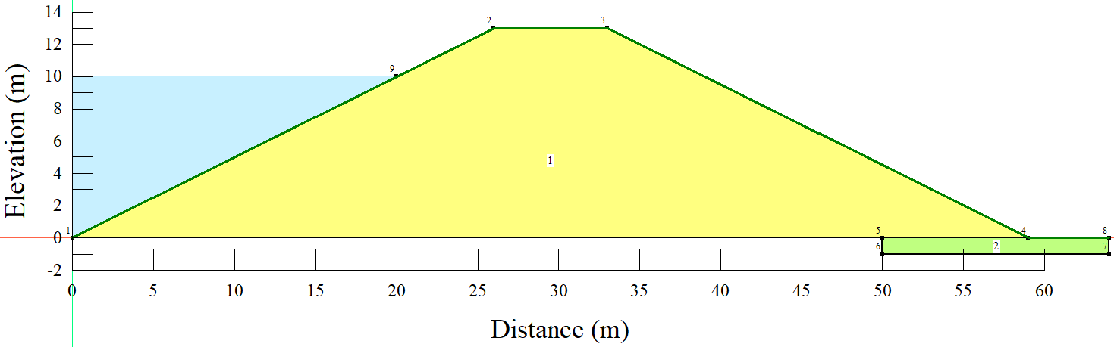
Figure 4.1 – General embankment geometry used in the numerical modeling

Seepage analysis
The SEEP/W water transfer analysis was used to evaluate changing pore-water pressure conditions after the reservoir had been drained. It was in the interest of this study to investigate the worst case where the reservoir is drained instantaneously. However, more realistically, the reservoir was drained over 5 days (Figure 4.2). Initially, a transient seepage analysis is done to get seepage-induced pore pressures and free groundwater surface for various drawdown rates and drawdown ratios in the modeling of slope drawdown behavior.
Figure 4.2 – Water total head function

Slope stability analysis
The stability analysis was performed using the SLOPE/W unit of the GeoStudio with the help of the Spencer method. According to slope stability analysis, if the forces resisting embankment movement are larger than the forces causing the movement, the embankment slope is considered stable. When analyzing slope stability, a factor of safety (FS) is derived by dividing the resistance by the driving forces. A factor of safety larger than one indicates that the slope is steady in this circumstance. The Spencer approach, which was utilized in this study, allows for unrestricted slip plains and, as a result, can be used to calculate the FS along any slip surface. According to the literature, rigid equilibrium and an unrestricted slip surface produce more exact safety factors than the other approaches [162].

Soil material characteristics
In terms of soil parameters, the embankment evaluated in this study is believed to be homogeneous. In addition, the soil material specifications for the embankment were held constant during all three study sessions to eliminate any fluctuation in the data that was not caused by variations in beginning maximum water levels. Table 4.2 provides a summary of the main soil material properties used in this study.
Table 4.2 – Soil properties
Soil material properties | Symbol | Unit | Value
Saturated water content | $$θ_{s}$$ | $$\%$$ | 43
Coefficient of volume compressibility | $$M_{v}$$ | $$m^{2}/kN$$ | $${2×10}^{-4}$$
Saturated conductivity | $$K_{sat}$$ | $$m/s$$ | $${1×10}^{-6}$$
Residual water content | $$θ_{r}$$ | $$\%$$ | 5.5
Soil unit weight | $$γ$$ | $${kN/m}^{3}$$ | 20
Cohesion | $$c^{'}$$ | $${kN/m}^{2}$$ | 5
Internal friction angle | $$∅^{'}$$ | $$degrees$$ | 25

Under saturated/unsaturated scenarios, the volumetric water content and hydraulic conductivity functions were important inputs defining the soil characteristics in the model (Figure 4.3). This was achieved using built-in functions that required only fundamental information such as saturated hydraulic conductivity, water content, and coefficient of volume compressibility.
(a) | (b)
Figure 4.3 – Functions: a) volumetric water content; b) hydraulic conductivity function

Results and discussion

Seepage analysis
Seepage analysis was conducted for the steady-state, instantaneous, and 5 days drawdowns for all three water levels, and the pore-water pressures from the seepage analysis were then used as inputs to the slope stability analyses.

Seepage analysis results from 10 m water level
The long-term steady-state analysis was successfully performed. Figure 4.4a shows the long-term, steady-state conditions established in the reservoir from the 10m long-term water level, while Figure 4.4b and Figure 4.4c show phreatic lines after the instantaneous and 5 days drawdown, respectively. It can be observed that the design of the embankment allows for most of the seepage water to be collected in the toe drain downstream. From the piezometric lines, it can be observed that, after the two rapid drawdown scenarios (instantaneous and 5 days), water stored within the embankment gradually drains from areas of high pore-water pressure [264]. This means the position of the piezometric line changes over time during the drawdown process, as shown in Figure 4.4, with the seepage face also reducing as the water goes down. It is of significant necessity that seepage through the embankment is controlled and safely carried away to prevent instability of the downstream slope [265]. Therefore, the phreatic line should not intersect the downstream slope, and the design should be in such a way that the line is a distance greater than the capillary rise below the downstream sloping face to eliminate the chances of the sloughing or piping [266].
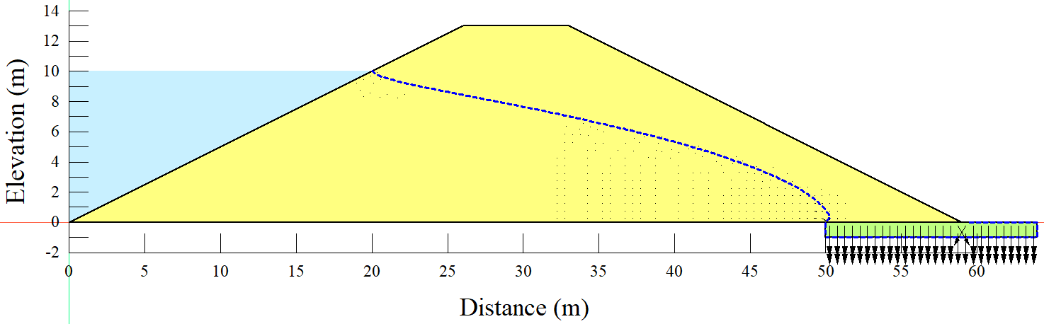
(a)
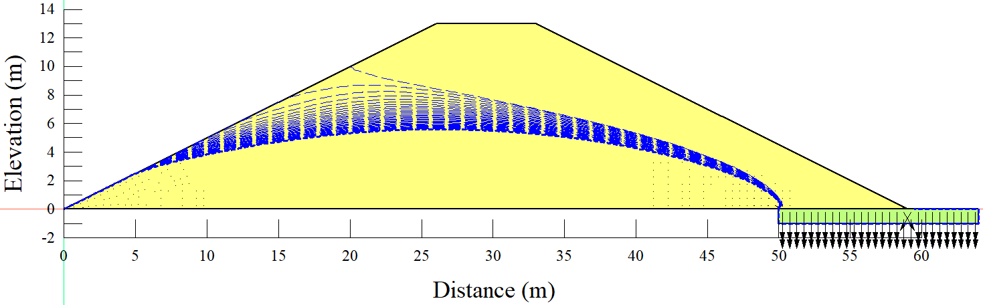
(b)
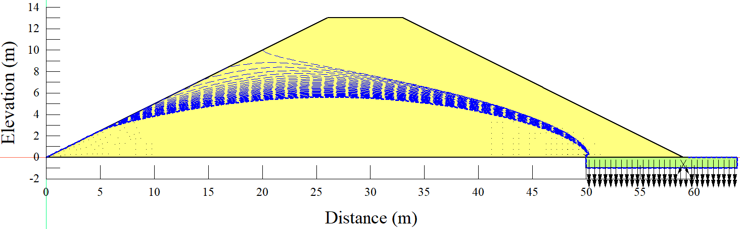
(c)
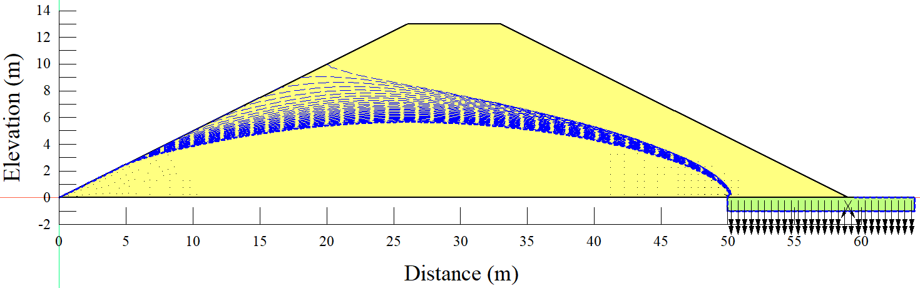
(d)
Figure 4.4 – Seepage results under 10 m water level: a) long-term steady-state; b) instantaneous drawdown; c) 5 days drawdown; d) 10 days drawdown

Seepage analysis results from 8m water level
The water level in the reservoir was then reduced to 8m and then subjected to the long-term steady-state before drawdown. The level of the piezometric line from the steady-state analysis starts from the maximum reservoir level (8 m) towards the toe drain downstream. As for the 10 m water level, it can be observed from the piezometric lines that the water stored in the embankment gradually drained from areas of high pore-water pressure, and the seepage face decreased with time following the rapid drawdown scenarios (Figure 4.5).

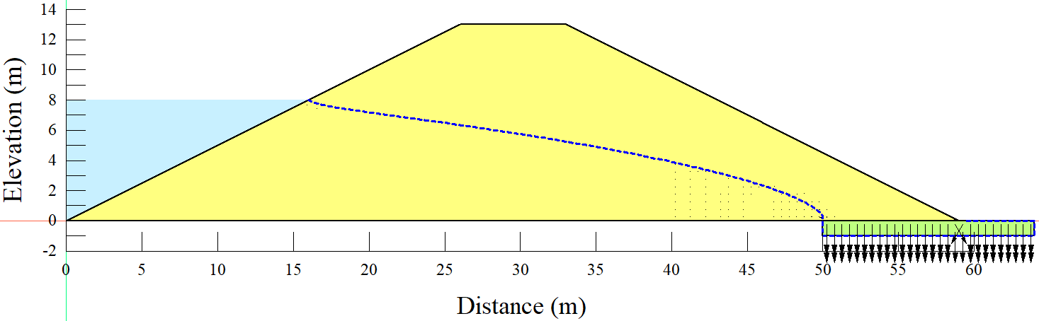
(a)
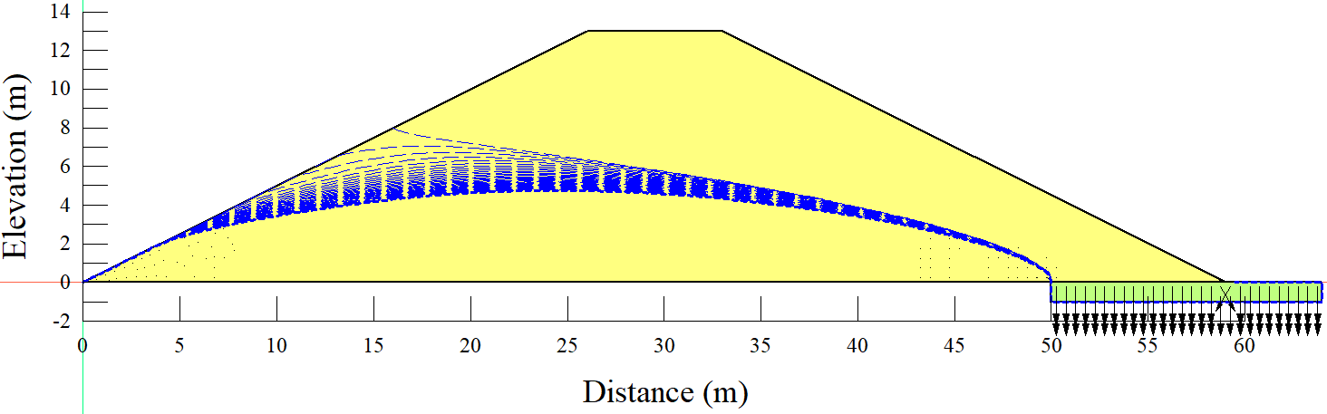
(b)
Figure 4.5 – Seepage results under 8m water level: a) long-term steady-state; b) 5 days drawdown

Seepage analysis results from 6m water level
Then the water level in the reservoir was further reduced to 6m, and the long-term steady-state was established. In this case, the maximum water level was almost half of the embankment height.
A similar phenomenon as observed from the 10 m and 8 m water levels in terms of piezometric lines and size of the seepage face can be seen in Figure 4.6. The level of the piezometric line from the steady-state analysis starts from the maximum reservoir level towards the toe drain downstream. While from the 5 days drawdown, 30 different piezometric lines were drawn over 30 days of the analysis duration from the upstream face to the toe drain downstream. The lines are more scattered at the upstream face and more concentrated as they move towards the toes drain.
The scattering of the piezometric lines on the upstream face is more evident within the 5 days of the rapid drawdown and more compacted as the water has been completely drawn from the reservoir (Figure 4.6).

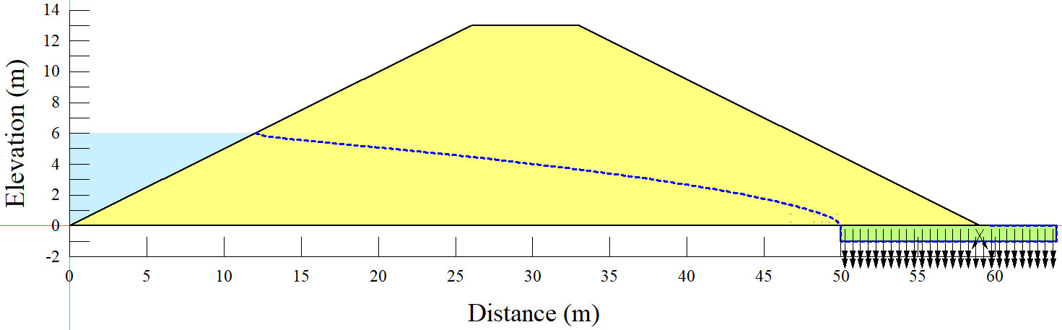
(a)
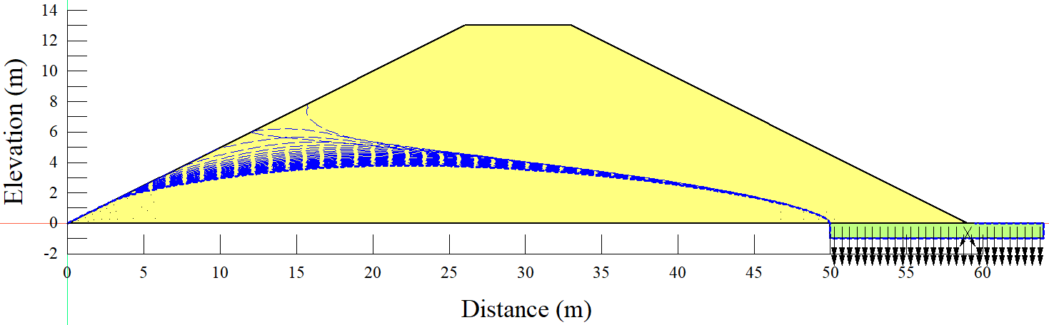
(b)
Figure 4.6 – Seepage results under 6m water level: a) long-term steady-state; b) 5 days drawdown

Slope stability
The slope stability analysis was accomplished using The Draw Slip Surface command in SLOPE/W. Finally, the plots of Factor of Safety versus time were created given the rapid drawdown scenarios as shown in the Figures below.

Slope stability analysis results from 10 m water level
From Figure 4.7, it can be observed that a factor of safety of 1.562 was achieved from the steady-state slope stability analysis, which is above the minimum value recommended by different regulatory agencies [267,268]. However, the values of the factor of safety are observed to drop below 1.0 immediately following the instantaneous (Figure 4.7) drawdown. The factor of safety declined to around 0.8 on the first day of the instantaneous drawdown, and the lowest factor of safety value of approximately 1.04 was reached on the fourth day of the 5-day drawdown rate. In the literature [243,269], when it comes to embankment dams, rapid drawdown situations have been reported to be particularly risky, with the higher the rate of drawdown, the greater the chance of failure. Furthermore, as a result of the dissipation of the excess pore-water pressure within the embankment, the factor of safety values from both instantaneous and 5-day drawdowns tend to recover over time.
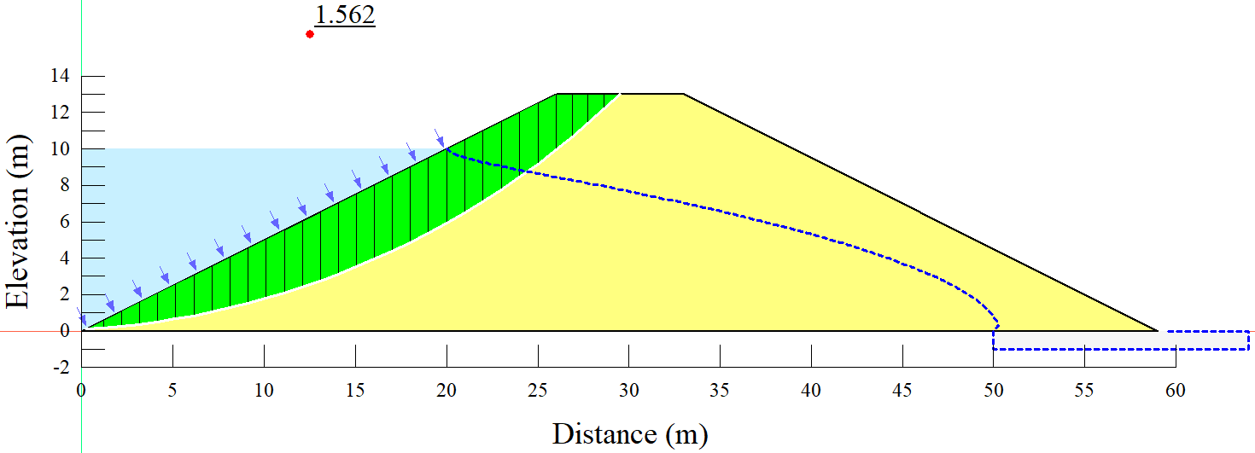
(a)
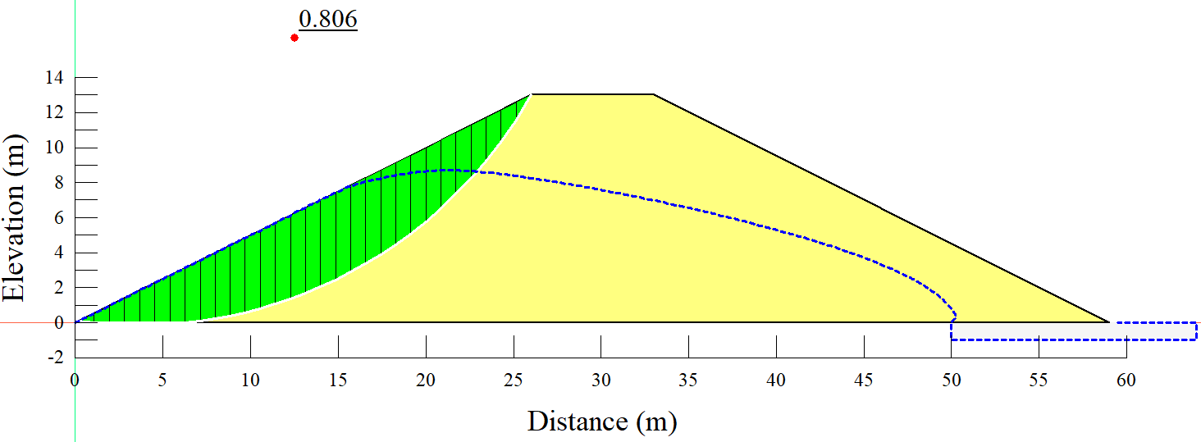
(b)
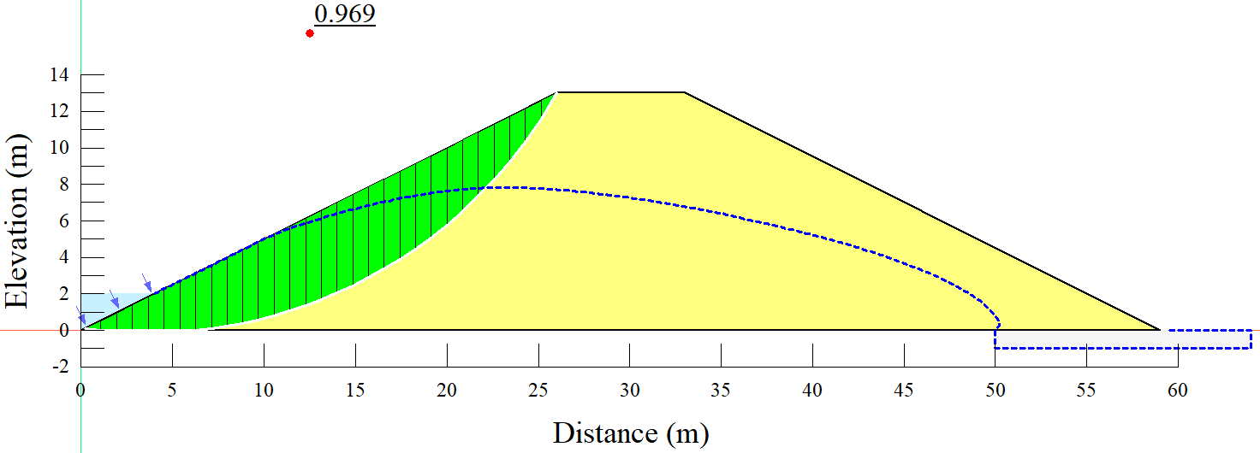
(c)
HRAF: Min FS = 0.8  (d) | HRAF: Min FS = 0.97  (e)
Figure 4.7 – Slope stability results for 10 m water level: a) long-term steady-state; b) instantaneous drawdown slip surface; c) 5 days drawdown slip surface; d) instantaneous drawdown graph; e) 5 days drawdown graph
From Figure 4.8, it can be observed that a minimum factor of safety of 1.009 was achieved from the 10 m water level and 10 days drawdown rate. Still, the retrieved factor of safety does not provide a high confidence level in terms of slope stability.
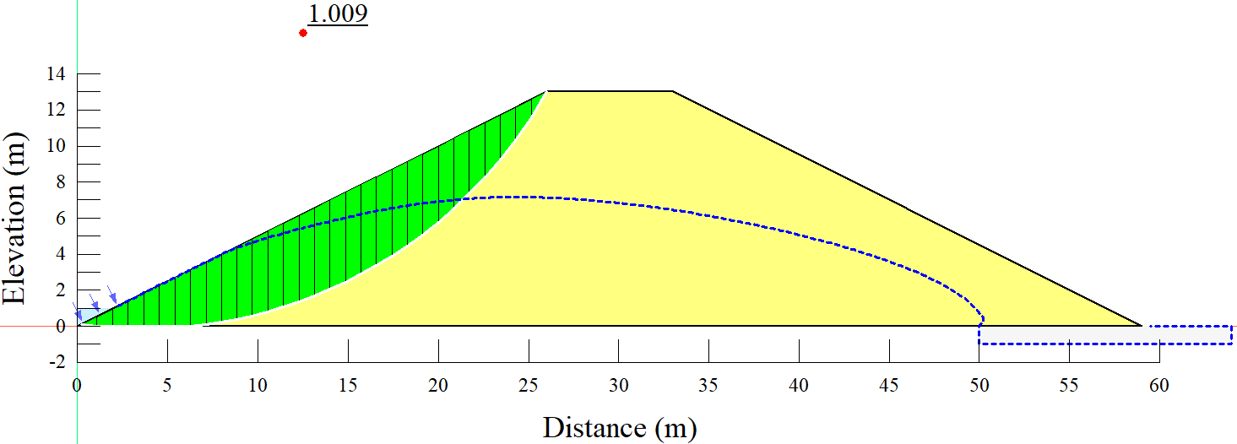
(a)
(b)
Figure 4.8 – Slope stability results for 10 m water level and 10 days drawdown: a) slip surface; b) graph of factor of safety values

Slope stability analysis results from 8m water level
After subjecting the same embankment to an 8 m water level, the steady-state factor of safety was reduced to 1.441 (Figure 4.9) from 1.562 achieved from the 10 m water level. The reduction in the factor of safety is equivalent to 7.75%.
The factor of safety declined to roughly 0.93 one day after the immediate drawdown, and it was noted that the factor of safety began to recover the second day after the instantaneous drawdown.
Also, from the 5 days drawdown, even though the factor of safety values kept on decreasing within the first five days, they were still above 1.0 and started recovering from the 6th day. However, recovery from both immediate and 5 days drawdowns is a more protracted process that appears to be getting more sluggish with time.
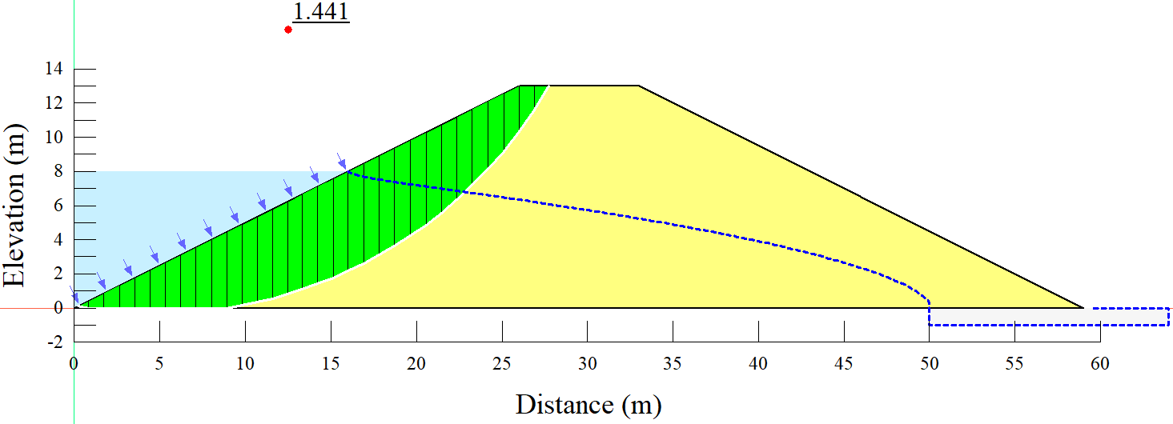
(a)
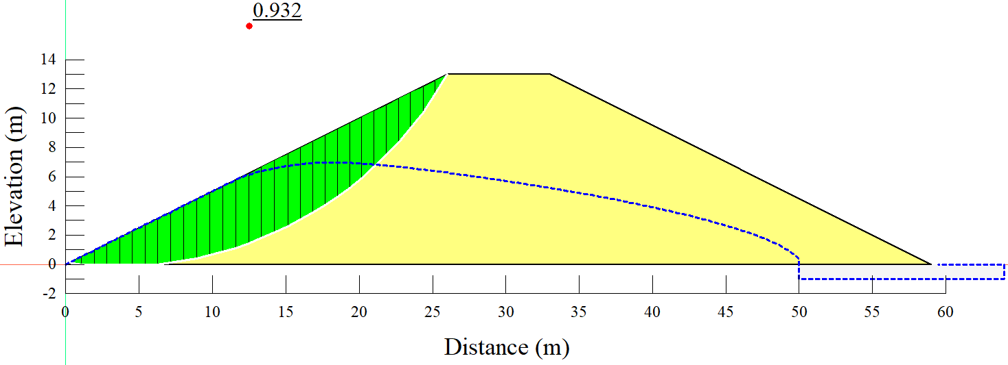
(b)
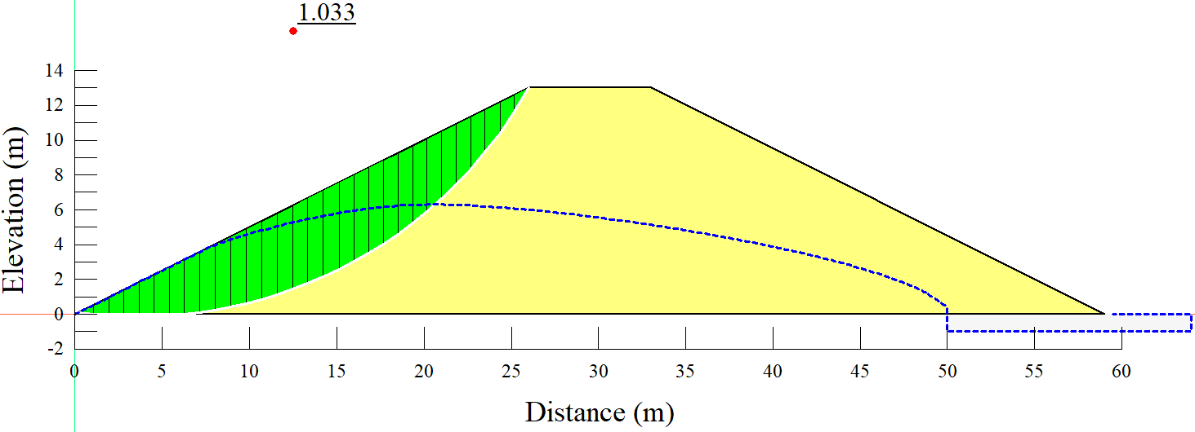
(c)
HRAF: Min FS = 0.932  (d) | (e)
Figure 4.9 – Slope stability results for 8 m water level: a) long-term steady-state with slip surface; b) instantaneous drawdown slip surface; c) 5 days drawdown slip surface; d) instantaneous drawdown graph; e) 5 days drawdown graph. HRAF = hypothetical region after failure.

Slope stability analysis results from 6m water level
The steady-state factor of safety was also reduced to 1.352 after the same embankment was subjected to a 6m water level (Figure 4.10); this equates to a 6.18 % reduction in the 8 m water level steady-state factors of safety and a 13.44 % reduction in the 10 m water level steady-state factors of safety. Again, the phenomenon is consistent with what has been documented in the literature; according to Alonso and Pinyol [270], a drawdown may be a crucial component in slope stability, not just for slopes that are entirely submerged at first but also for those that are partially submerged.
However, something interesting from Figure 4.10 is that, unlike the 10 m and 8 m water levels, the 6m water level never observed the factor of safety dropping below 1.0 for both instantaneous and 5 days drawdowns. But the trend of decrease and recovery of the factor of safety was more similar to the ones of 10 and 8 m. The general phenomenon suggests that the significant risk of a drawdown scenario is within the drawdown timeframe, and the recovery in terms of the factor of safety starts immediately as the drawdown process ends. Another important note from Figure 4.10 is that the factor of safety value drops faster with a high drawdown rate, and the trend of the factor of safety recovery is faster with instantaneous drawdown than the 5 days drawdown. This is yet another indicator that the rate at which the reservoir is drawn down significantly impacts the degree of pore-water pressure dissipation.
In general, all of the phenomena can be linked to the impacts of water level reductions, which lower the stabilizing exterior hydrostatic pressure due to the unloading effect of removing water, as well as the interior pore water pressure being altered [271].

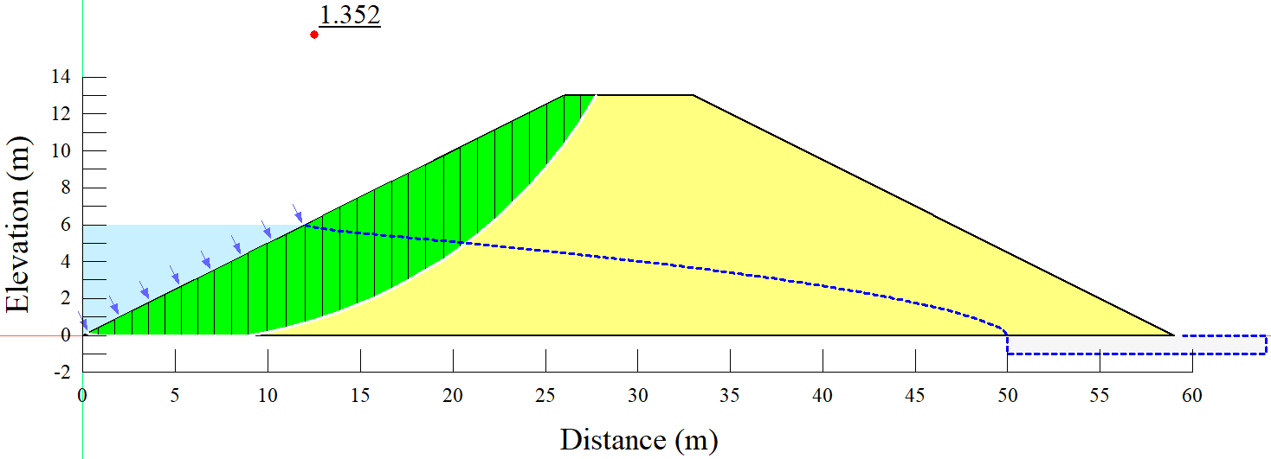
(a)
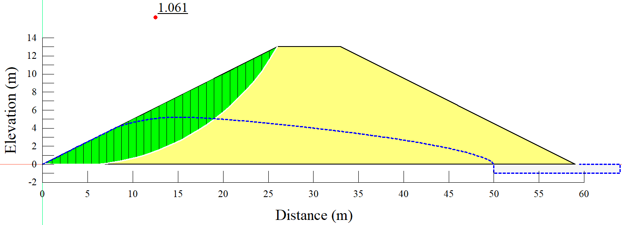
(b)
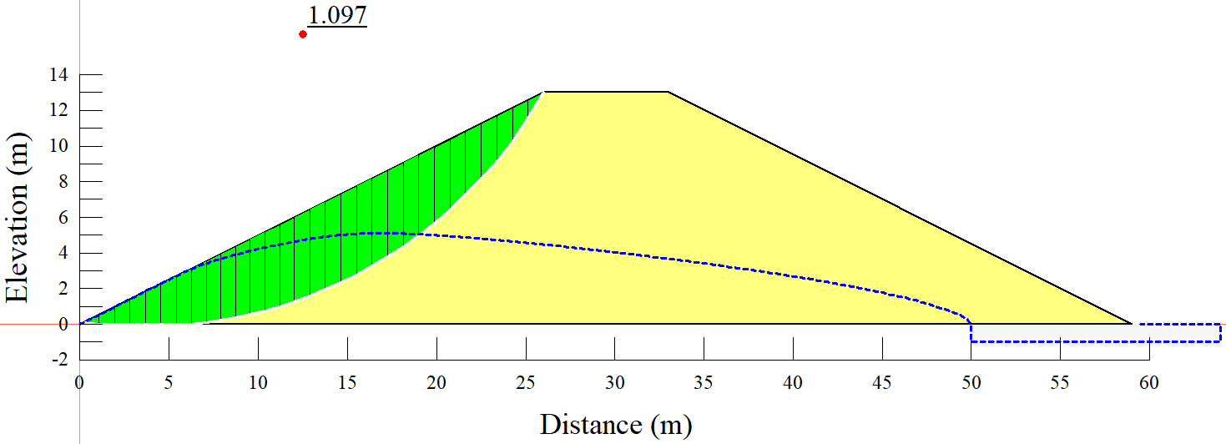
(c)
(b) | (c)
Figure 4.10 – Slope stability results for 6 m water level: a) long-term steady-state with slip surface; b) instantaneous drawdown slip surface; c) 5 days drawdown slip surface; d) instantaneous drawdown graph; e) 5 days drawdown graph
From Table 4.3, it can be shown that changes in the long-term operational water level had a considerable impact on the factor safety minimum and maximum values. The 6 m water level with a 5 days drawdown rate has the highest maximum factor of safety value. Under both instantaneous and 5 days drawdown rates, the lowest maximum value of the factor of safety is seen at the 8m water level.
Also, from Table 4.3, it is observed that the lowest minimum factor of safety value was achieved from the combination of 10m water level and instantaneous drawdown scenario. At the same time, the highest minimum factor of safety value was observed from the combination of 6m water level and 5 days drawdown rate. When the reservoir's water level was reduced from 10 to 8 m, both the minimum and maximum factor of safety values decreased, then increased when the water level was reduced further to 6 m.
While for the instantaneous drawdown scenario, the minimum values of the factor of safety were observed to be increasing with the decrease in water levels, but the maximum values were observed to be linearly decreasing with the decrease in water levels. The phenomenon suggests that the relationship between water level and the factor safety may be highly unpredictable at some point and thorough investigation is of great importance when designing earth-fill dams.

Table 4.3 – Different drawdown modes with their values of factor of safety.
Water level | Drawdown mode | The factor of safety (minimum) | Steady-state factor of safety
6m | Instantaneous | 1.061 | 1.352
6m | 5 days drawdown | 1.097 | 1.352
8m | Instantaneous | 0.932 | 1.441
8m | 5 days drawdown | 1.033 | 1.441
10m | Instantaneous | 0.806 | 1.562
10m | 5 days drawdown | 0.977 | 1.562
10m | 10 days drawdown | 1.009 | 1.562

Summary of the sub-section
With the use of numerical modeling, the possible impact of changes in long-term water level on the slope stability of an embankment under rapid drawdown conditions has been explored. Three different long-term water levels (10 m, 8 m, and 6 m) were taken into consideration. According to the findings of the investigation, as the long-term operational water level changes, the factor of safety values changes as well. The values of the steady-state factor of safety were observed to be decreasing with the reduction in water level, in which the steady-state factor of safety reduced by approximately 13.44 % when the water level was reduced from 10 m to 6 m for a 13 m high embankment. In comparison, the upstream slope was observed to gain more stability with the decrease in the long-term water level subjected to the rapid drawdown scenarios. The results in this study revealed further that an embankment freeboard might have a significant impact on the steady-state factor of safety. The values of the factor of safety were also affected by the changes in the long-term operating water levels, with the highest minimum factor of safety value observed from the 6 m water level under 5 days drawdown rate and the lowest factor of safety value was achieved from the combination of 10 m water level and instantaneous drawdown scenario. It should also be noted that an instantaneous drawdown scenario is a conservative approach for assessing embankment slope stability when a reservoir is being drawdown, and it was a representation of the worst drawdown scenario.

The potential effect of a toe-drain size on slope stability of a homogeneous embankment

Materials and methods

Description of the numerical simulation in general
The impact of the toe drain size and rapid drawdown rates on the embankment's slope stability was investigated using finite element technique calculations. Three separate scenarios were considered, each determined by the size of the toe drain. The GeoStudio software was used to complete the numerical modeling process (GeoStudio 2018 R2 v9.1.1.16749). The GeoStudio's SEEP/W and SLOPE/W sub-units were primarily employed for seepage and slope stability analyses, respectively.

The geometry of the embankment
While modifying the toe drain size, the geometry of the embankment was kept constant in all three main research. The embankment is roughly 59 meters wide at the base and 7 meters wide at the top, with a height of 13 meters, as illustrated in Figure 4.11. The length of the toe drain at the downstream end of the embankment ranged from 5 to 15 meters. The reservoir's maximum water level is 10 meters. The embankment geometry parameters are summarized in Table 4.4.
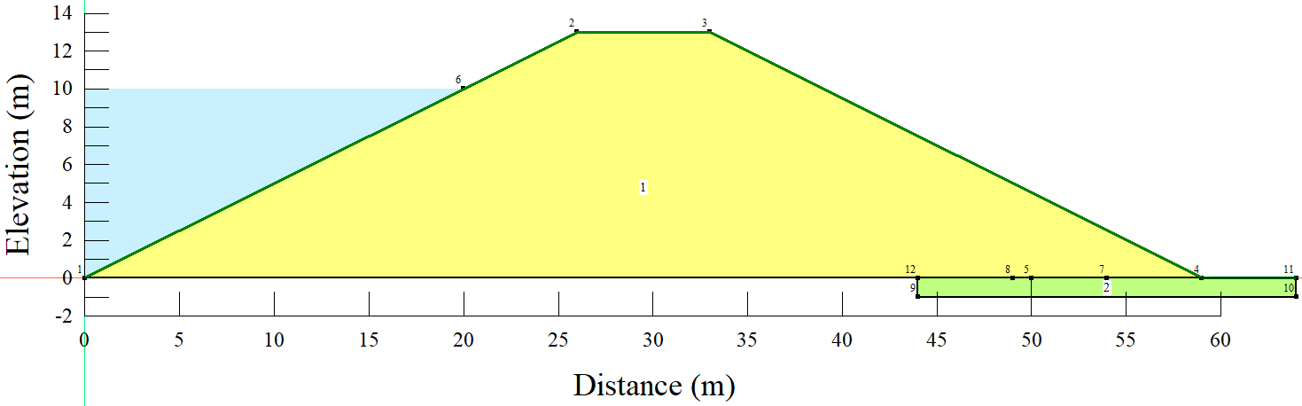
Figure 4.11 – General embankment geometry
Table 4.4 – Summary of the embankment geometry parameters
Parameter | Unit | Value
Bottom width | m | 59
Top width | m | 7
Embankment height | m | 13
Maximum water level | m | 10
Slope, H:V | - | 2:1
Toe drain | m | 5, 10, 15

Analyses of seepage and slope stability
To analyze changing pore-water pressure conditions, the SEEP/W water transfer-based analyses were used in general. The worst-case scenario was chosen as the instantaneous drawdown, and the rate was increased to 5 days (Figure 4.2). The transient seepage analysis was used to derive seepage-induced pore pressures and free groundwater surface for varied drawdown rates in order to model the slope's drawdown behavior in this study.
The slope stability analyses, on the other hand, were carried out using the GeoStudio's SLOPE/W sub-unit, which was based on the Spencer approach.

Characteristics of the soil
To avoid any fluctuation and capture the influence of variations in the toe drain diameters, the soil material parameters for the embankment were kept constant for all of the examples analyzed. The seepage and slope stability analyses employed soil material parameters identical to those listed in Table 4.2.

Results and Discussion
Using a combination of the finite element approach and numerical modeling, the seepage and slope stability analyses were completed successfully. The size of the toe drain increased the water pressure at the downstream toe of the embankment, according to the seepage analysis. Figure 4.12 shows that the 15 m drain size has larger pore pressures than the 10 m and 5 m drain sizes. Drains have been noted to be key aspects of the stability of embankments in general in the literature.

Figure 4.12 – Pressure of pore-water at the upstream face
In contrast to the downstream toe, pore water pressures on the embankment's upstream face decreased as the toe-drain size increased. The pore-water pressures from the 15 m drain size were marginally greater than those from the 10 m and 5 m drain sizes, as shown in Figure 4.13. The occurrence shows that as the size of the toe drain grows, seepage is more easily conveyed through the embankment, allowing pore-water pressures in the embankment to dissipate following the drawdown.

Figure 4.13 – The downstream toe's pore-water pressure
Similarly, the slope stability study revealed that changing the size of the toe drain had an impact on the factor of safety. In comparison to the 10 m and 5 m toe drain sizes, the 15 m length toe drain size had a slightly higher factor of safety, as shown in Figure 4.14. The minimum size for a 5 m drain was 0.959, the minimum factor of safety for a 10 m drain was 0.968, and the minimum factor of safety for a 15 m drain was 0.976.

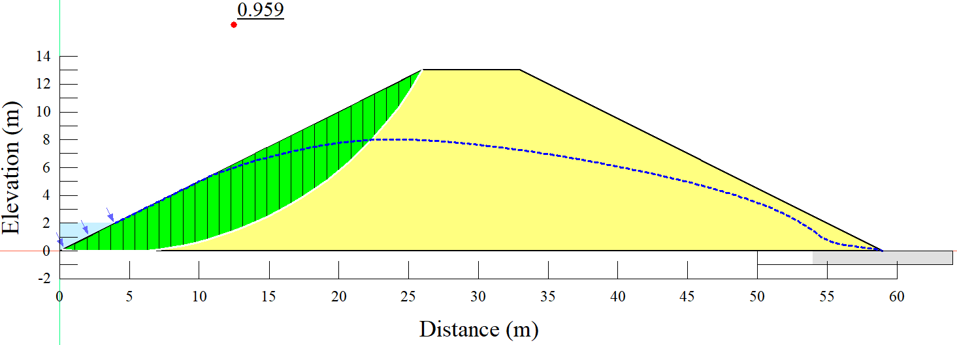
(a)
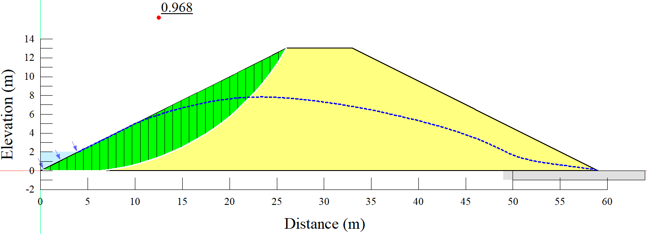
(b)
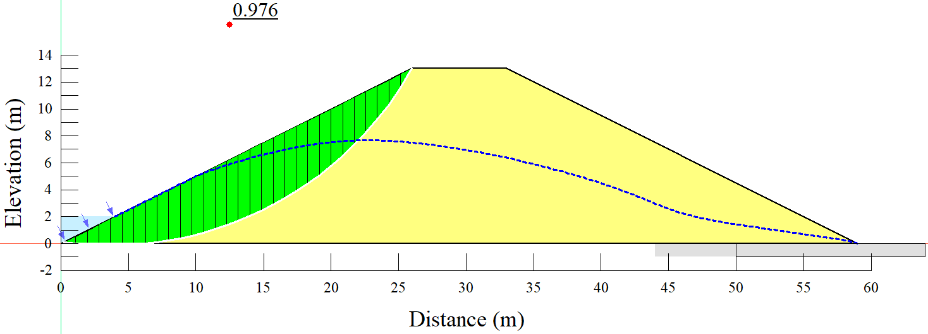
(c)
Figure 4.14 – The factor of safety with slip surfaces from 5 days drawdown rate: a) 5 m drain size; b) 10 m drain size; c) 15 m drain size
Figure 4.15 shows that the lowest factor of safety values were attained near the end of the drawdown. During the drawdown phase, the factor of safety values declined significantly, then gradually increased after the drawdown.

Figure 4.15 – The trend of the factor of safety values with time
Table 4.5 presents a summary of the factor of safety's minimum values based on the instantaneous and 5-day drawdown rates. It can be seen from both drawdown examples that the factor of safety values increased as the toe drain size increased.
Table 4.5 – A maximum and a minimum factor of safety values from the instantaneous and 5 days drawdown rates
Drawdown rate | Toe drain size | Steady-state factor of safety | The factor of safety value (minimum)
Instantaneous | 5m | 1.548 | 0.799
Instantaneous | 10m | 1.561 | 0.805
Instantaneous | 15m | 1.571 | 0.811
5 days | 5m | 1.548 | 0.959
5 days | 10m | 1.561 | 0.968
5 days | 15m | 1.571 | 0.976

Section summary
The impact of the size of a toe drain on the slope stability of an embankment dam during rapid drawdown conditions has been studied. According to the findings, pore-water pressures at the upstream face of the embankment decreased as the toe drain size increased, whereas pore-water pressures at the downstream toe increased. Changes in the toe drain size were also discovered to alter the factor of safety values. This research work demonstrated that when an embankment is subjected to a rapid drawdown situation, there is a substantial potential association between toe drain size and factor of safety.

The effect of internal angle of friction on slope stability of homogeneous embankment under rapid drawdown

Materials and methods

Description of the numerical simulation in general
Using the finite element approach, the effect of the internal angle of friction and rapid drawdown rates on the slope stability of a homogeneous embankment was examined. Different cases as determined by the internal angle of friction (20⁰ to 35⁰ at an interval of 5⁰), were taken into consideration. The numerical modeling process was done using the GeoStudio software suite (GeoStudio 2018 R2 v9.1.1.16749). The GeoStudio's SEEP/W and SLOPE/W sub-units were primarily employed for seepage and slope stability analyses, respectively.

The geometry of the embankment
To avoid variations that could be led by other factors, the geometry of the dam embankment was maintained in all the investigated cases while changing the internal angle of friction. The width of the embankment is approximately 59 m at the base as well as 7 m at the top, while the height of the embankment is 13 m, as shown in Figure 4.16. The reservoir's highest water level is 10 meters. The embankment geometry parameters are summarized in Table 4.6.
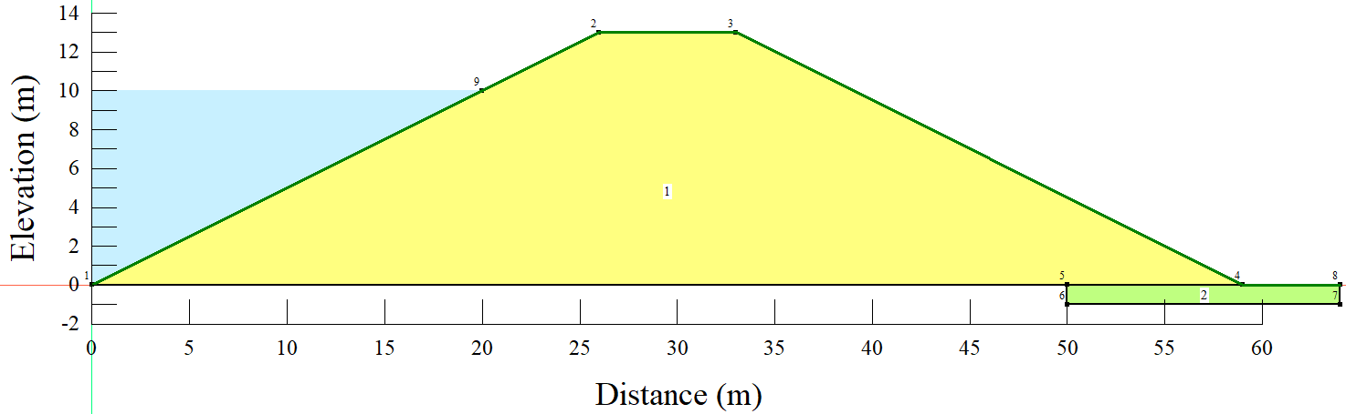
Figure 4.16 – General embankment geometry
Table 4.6 – Summary of the embankment geometry parameters
Parameter | Unit | Value
Bottom width | m | 59
Top width | m | 7
Embankment height | m | 13
Maximum water level | m | 10
Slope, H:V | - | 2:1

Analyses of seepage and slope stability
To analyze changing pore-water pressure conditions, the SEEP/W water transfer-based analyses were used in general. The transient seepage analysis was used to generate seepage-induced pore pressures and free groundwater-surface for varied drawdown rates in this study to model the slope's drawdown behavior.
The slope stability analyses, on the other hand, were carried out using the GeoStudio's SLOPE/W sub-unit, which was based on the Spencer approach. The Spencer approach, in general, allows for unconstrained slip plains [272].
Equation (4.2) is typically used to derive the resultant of a pair of interslice forces (Q) using the Spencer approach.
 | $$Q=γHb\left[\frac{\frac{c^{'}}{FγH}+\frac{htanφ^{'}}{2HF}\left(1-2r_{u}+cos2α\right)-\frac{hsin2α}{2H}}{cosαcos⁡(α-θ)\left[1+\frac{tanφ'}{F}\tan{(α-θ)}\right]}\right]$$ | (4.2)
Whereby:
b, h – width and mean height of slice; α – a slope of base of the slice; F – safety factor; θ – a slope of resultant of pair of interslice forces; r_{u} – pore-pressure coefficient; γ – bulk density; H – the height of embankment; φ' – the angle of shearing resistance with respect to effective stress, c' – cohesion with respect to effective stress.
Moreover, to capture the saturated/unsaturated scenarios in the modeling process, the volumetric water content and hydraulic conductivity functions were important inputs in defining the soil characteristics (Figure 4.3). The definition of the two functions was achieved with the help of the built-in functions that required only fundamental information such as saturated hydraulic conductivity, water content, and coefficient of volume compressibility.
The worst-case scenario was chosen as the instantaneous drawdown, and the rate was increased to 5 days (Figure 4.2).

Characteristics of the soil
To avoid any fluctuation and capture the influence of variations in the internal angle of friction, the soil material parameters for the embankment were kept constant for all of the examples analyzed. The soil material properties used in slope stability and seepage assessments are summarized in Table 4.7.
Table 4.7 – Characteristics of the soil properties used in the study
Parameter | Character | Unit | Value
Saturated water content | $$θ_{s}$$ | $$\%$$ | 43
Coefficient of volume compressibility | $$M_{v}$$ | $$m^{2}/kN$$ | $${2×10}^{-4}$$
Saturated conductivity | $$K_{sat}$$ | $$m/s$$ | $${1×10}^{-6}$$
Residual water content | $$θ_{r}$$ | $$\%$$ | 5.5
Soil unit weight | $$γ$$ | $${kN/m}^{3}$$ | 20
Cohesion | $$c^{'}$$ | $${kN/m}^{2}$$ | 5
Internal friction angle | $$∅^{'}$$ | $$degrees$$ | 20, 25, 30, 35

Results and discussion
A horizontal toe drain was provided to lower the phreatic line and dissipate the excess pore water pressure in the embankment. From Figure 4.17, it can be observed that the phreatic lines are all within the embankment body. The position of the phreatic line has a considerable impact on the embankment's stability. This is because the position of a phreatic line is linked to potential piping due to excessive exit gradient and sloughing, both of which are caused by softening and weakening of the soil mass, particularly if the phreatic line contacts the downstream face.
Normally, some measures are taken when there is a problem with the permeability of the downstream zone, including the provision of a horizontal drainage blanket with the purpose of keeping the phreatic line well within the embankment body [273]. Furthermore, from Figure 4.17, it can be observed that the phreatic lines are highly scattered at the upstream zone while well combined towards the toe drain.
Nevertheless, once the capillary fringe touches the downstream face of the embankment, the pressure within tends to change from negative (suction) to the so-called atmospheric pressure. Therefore, in such a phenomenon, the downstream slope is associated with the potential to become a seepage face leading to slope failure [264]. In that matter, the phreatic line should always be kept within without intersecting the downstream face as well as being located at a distance greater than capillary rise. The entire phenomenon keeps the phreatic line below the sloping face to nullify the chances of the sloughing or piping.
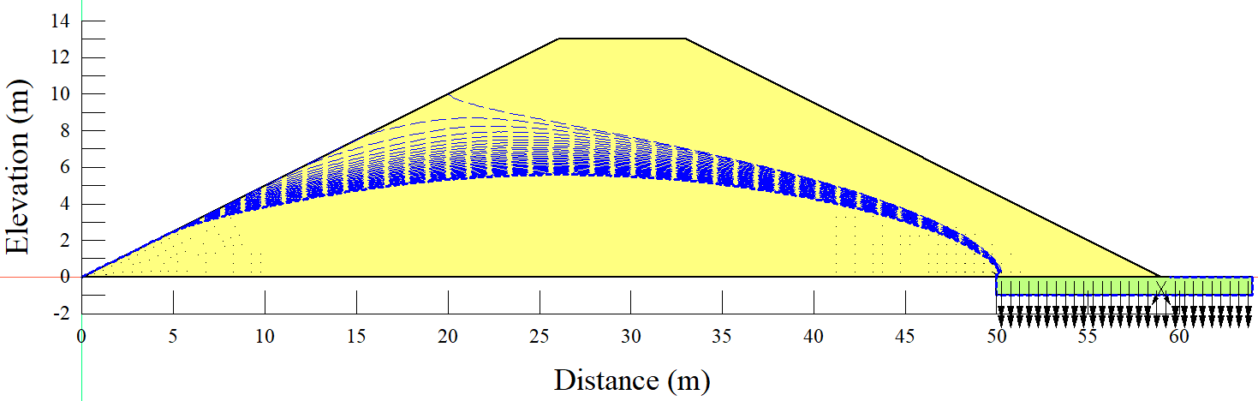
Figure 4.17 – Piezometric lines following the rapid drawdown
The slope stability analysis was successfully executed. Figure 4.18 shows the critical slip surfaces for the 20⁰ angle of friction (Figure 4.18(a)) and 35⁰ angle of friction (Figure 4.18(b)). From Figure 4.18, it can be observed that when the embankment was subjected to an internal angle of friction of 20⁰, it was associated with a potential total failure of the embankment. It has to be noted that, in any bank of homogeneous earth, normally, the failure slip surface nearly follows the arc of a circle that crosses the bank's toe. Therefore, the stability of the structure depends upon fixing the position of the center of rotation of the slip surface. Specifically, fixing the surface along which the greatest shearing resistance is a significant requirement for equilibrium, of which for an embankment dam, the upstream zone in contact with the reservoir has to be properly designed to avoid potential failure.
However, higher stability can be observed when the embankment was subjected to 35⁰ as an internal angle of friction, with a higher minimum factor of safety value compared to when the embankment was subjected to 20⁰ as an angle of friction. In general, the embankment critical slip surface possessing the minimum factor of safety is the one that is always assumed to be the most likely slip or failure surface. The combination of slip surface and a minimum factor of safety is normally used as the failure slip surface during the analysis and design phases of slope stabilization activities [274].
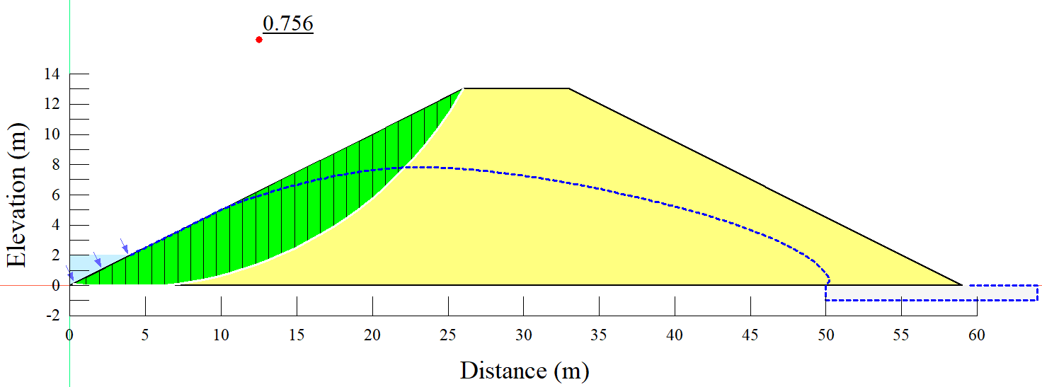
(a)
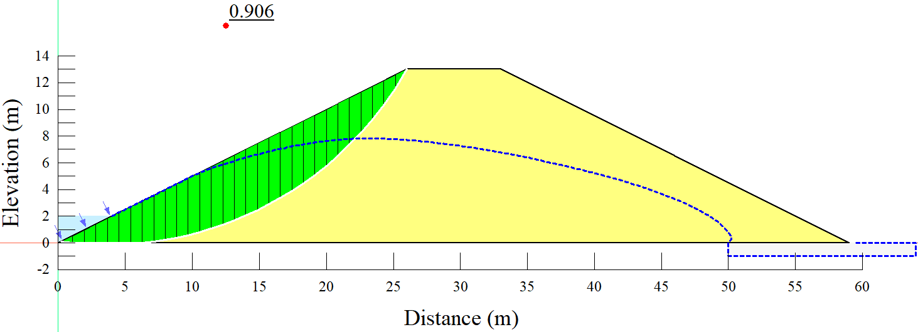
(b)
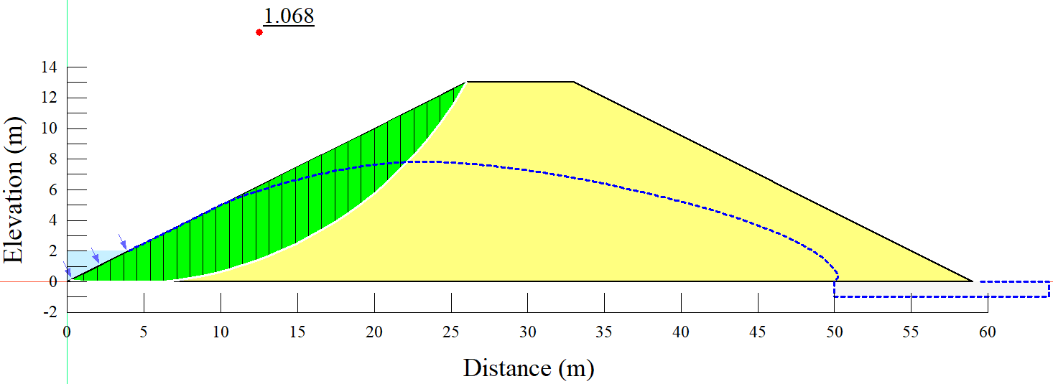
(c)
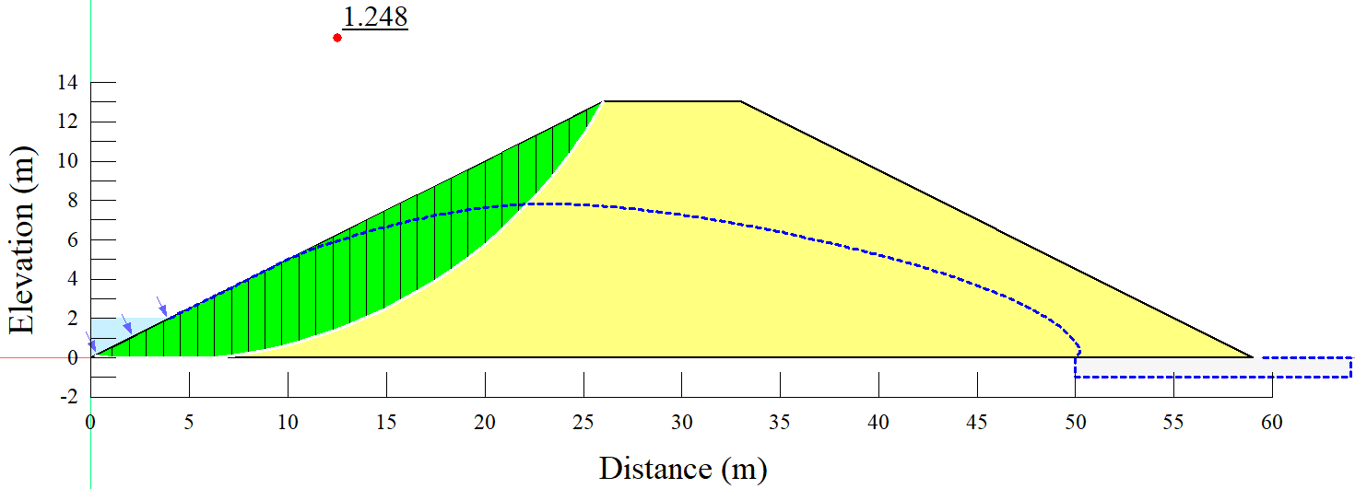
(d)
Figure 4.18 – Slip surfaces from 5 days drawdown rate; a) 20⁰ internal angle of friction; b) 25⁰ internal angle of friction; c) 30⁰ internal angle of friction; d) 35⁰ internal angle of friction
Figure 4.19 displays the slope stability analysis results after the embankment was subjected to a 5-day drawdown rate and various angles of internal friction. From Figure 4.19, it can be observed that the factor of safety values for all the investigated cases, as determined by the internal angles of friction, dropped rapidly within the 5 days of draining the reservoir. However, the minimum values of the factor of safety increased with the increase in the internal angle of friction. The lowest factor of safety can be observed from 20 degrees and the highest from 35 degrees. As previously noted, the stability of an embankment is highly determined by the available balance between shear stress and shear strength. Therefore, if the forces available to resist movement are sufficient enough and greater than the forces driving movement, the slope of the embankment can be considered stable. In that matter, the computation of the factor of safety is achieved by dividing the forces resisting movement by the forces driving movement.
Also, the capacity of the embankment to regain the factor of safety after the drawdown and reach the minimum factor of safety was highly affected by the internal angle of friction supplied. From 20⁰ (Figure 4.19(a)), it can be observed that the embankment completely failed to regain stability of the minimum factor of safety, with the capacity increasing with the increase in the internal angle of friction.
HRAF: Min FS = 0.8  (a) | HRAF: Min FS = 0.9  (b)
(c) | (d)
Figure 4.19 – Factor of safety values with time from 5 days drawdown rate and different internal angles of friction; (a) 20⁰; (b) 25⁰ (c) 30⁰ (d) 35⁰.
HRAF = hypothetical region after failure.
From Figure 4.20, it can be observed that the minimum factor of safety values from the instantaneous drawdown were obtained within the first day of draining the reservoir. From the five-day drawdown rate, the minimum factor of safety values were obtained somewhere around the fifth day of draining the reservoir.
(a)
(b)
Figure 4.20 – The factor of safety values with time: a) instantaneous drawdown;(b) 5 days drawdown
Figure 4.21 summarizes the minimum values of factor of safety from both instantaneous and five-day drawdown rates. It can be observed that when the angle of internal friction was 20⁰, the minimum value of factor of safety for instantaneous drawdown was almost similar to the five days drawdown rate. From the phenomenon, we can understand that when the angle of internal friction is small, the influence of a drawdown rate on the slope stability becomes relatively low. Moreover, it can be observed that the minimum factor of safety values were increasing with the increase in the internal angle of friction.

Figure 4.21 – Minimum values of factor of safety from instantaneous and 5 days drawdown rate

Summary of the sub-section
The potential effect of an internal angle of friction on the slope stability of a homogeneous embankment dam under rapid drawdown loading conditions has been investigated. From the results, it was observed that when the embankment was subjected to 35⁰ as an internal angle of friction in conjunction with the five days drawdown rate, a relatively high minimum factor of safety value of 1.25 was achieved (higher than that when the embankment was subjected to 20⁰ as an internal angle of friction). In general, the phenomenon suggests that the embankment is relatively stable with a higher internal angle of friction than lower values when the embankment is subjected to the rapid drawdown scenarios. The findings of this research also showed that throughout the design and operation phases of embankment dams, it is critical to analyze shear strength parameters in conjunction with rapid drawdown situations.

Summary of chapter four
In this chapter, several slope stability aspects related to homogeneous embankments have been investigated, including the effects of long-term water level on slope stability when subjected to a rapid drawdown scenario and the effect of internal angle of friction on slope stability of an embankment.
With the use of numerical modeling, the potential impact of changes in long-term water level on the slope stability of an embankment under rapid drawdown conditions was explored. Three possible long-term water levels (ten, eight, and six meters) were considered. The findings of the investigation show that as the long-term operational water level changes, the factor of safety values changes as well. When the water level was dropped from 10 m to 6 m for a 13 m high embankment, the steady-state factor of safety was shown to be decreasing with the reduction in water level, with the steady-state factor of safety reducing by roughly 13.44%. While the upstream slope became more stable as the long-term water level dropped under rapid drawdown scenarios, the downstream slope became more unstable. The results suggest that embankment freeboard can have a big impact on the steady-state factor of safety. Changes in long-term operating water levels also influenced the minimum values of the factor of safety, with the highest minimum factor of safety value obtained from a 6m water level under a 5-day drawdown rate and the lowest minimum factor of safety value obtained from a combination of 10 m water level and instantaneous drawdown scenario. An immediate drawdown scenario is a cautious strategy for analyzing embankment slope stability when a reservoir is being drawn down, and it represents the worst drawdown scenario.
The impact of the size of a toe drain on the slope stability of an embankment dam during rapid drawdown conditions has been studied. According to the findings, pore-water pressures at the upstream face of the embankment decreased as the toe drain size increased, whereas pore-water pressures at the downstream toe increased. Changes in the toe drain size were also discovered to alter the factor of safety values. Whereby the findings demonstrated that when an embankment is subjected to a rapid drawdown situation, there is a substantial potential association between toe drain size and factor of safety.
Under fast drawdown loading conditions, the influence of an internal angle of friction on the slope stability of a homogeneous embankment dam was also examined. In comparison to when the embankment was subjected to 20⁰ as an internal angle of friction and the 5-day drawdown rate, the results showed that when the embankment was subjected to 35⁰ as an internal angle of friction and the 5-day drawdown rate, a relatively high minimum factor of safety value of 1.25 was achieved. When the embankment is subjected to fast drawdown situations, the phenomena show that the embankment is relatively stable with a larger internal angle of friction than lower values.

Slope stability analysis based on case studies

Samarkand dam in Kazakhstan

Materials and methods

Case study description
Samarkand dam is located in the Nura-Sarysu catchment in Karaganda region, Kazakhstan with the region font code of Eastern Europe. In DMS (Degrees Minutes Seconds), its coordinates are 50°5'54" N and 73°0'55" E, or 50.0983 and 73.0153. (in decimal degrees). CR55 is its UTM position, and NM43-04 is its Joint Operation Graphics reference.
The climate in Karaganda is humid continental, with pleasant summers and bitterly cold winters. Throughout the year, precipitation is generally low, with a modest increase from May to July. During the winter period, the region is characterized by snow, but it is only light. The lowest temperature ever recorded was 42.9 °C in 1938, and the highest temperature ever recorded was 40.2 °C (104.4 °F) in 2002.
The geology of Kazakhstan includes extensive basement rocks from the Precambrian and widespread Paleozoic rocks, as well as sediments formed in rift basins during the Mesozoic. Small synclines in the Karaganda Foredeep Basin show Deepwater limestone and shale 450 meters thick from the Carboniferous and Permian, as well as 4.5-kilometer-thick coal-bearing molasse. Within the Tengiz Basin, deposits are never more than two kilometers thick and grow thicker to the south. The Chu Basin is filled with undeformed Middle Devonian through Permian red molasse and carbonate deposits. Calc-alkaline magmatism was extensive in the southeast Kazakh Uplands and the Tien Shan Mountains.

The historical perspective of the Samarkand dam
The construction of the Samarkand hydroelectric complex was done in 5 years, from 1934. When the construction started, people became the main labor force; it was with their hands that the dam was constructed because the first excavator appeared on the construction site only in 1936. Mainly, during the time, the main labor force was the prisoners of KarLAG, two departments of which were specially transferred closer to construction to the village of Samarkand. It should be emphasized, however, that the Samarkand dam is not the only artificial dam on Nura; it is, however, the largest of these artificial reservoirs.
From 1934, the construction process was completed in 1939, which turned out to be arid, and therefore, the dam was able to be under full operation in 1941, which for this reason is mistakenly considered the year of completion of its construction. The dam erected on Nura was 20 meters high and 300 meters wide. The process of filing an area of 8000 hectares with water lasted a lot - 22 years, until 1961, when the reservoir mirror was formed.
After the construction of the Samarkand dam, it became the most significant artificial reservoir in Central Kazakhstan. According to the Kazakh Academy of Sciences, the total length of the reservoir was 20 kilometers, the width was 6.5 kilometers, and the maximum depth was 17 meters.
Then later, in 1982, a new hydroelectric complex started to be constructed and was delayed for various reasons. In 1988, the facility was put into operation, but its technical re-equipment and bringing into line with modern standards became possible today when the construction was transferred to the balance of the state. The old dam is currently associated with a number of geotechnical issues, making the operation of the hydroelectric complex of more significance. However, the fact that people used to live on the site of the dam has been producing a lot of mysterious rumors, to the extent that people believe that there is an old cemetery at the bottom of the reservoir. However, local historians cannot confirm this information since there is no official data on any burials in this area.

General modeling process
The potential influence of the rapid drawdown scenarios on the stability of the embankment dam was investigated with the help of the finite element method. The other parameters in the analyses were kept constant while changing the drawdown rates. The embankment geometry (as shown in Figure 5.1) is composed of four different zones, with zones 1a and 1b being similar. The inquiry was divided into five categories based on the drawdown rates: steady-state, instantaneous drawdown, 5-days drawdown, 10-days drawdown, and one-minute drawdown rate. In all the investigated cases, the stability factors were investigated at the end of the modeling processes. In this study, the instantaneous drawdown was considered the most extreme condition (worst scenario).
Moreover, the analyses were accomplished using the SEEP/W [275], which is mainly for seepage analysis, and SLOPE/W [276], which is mainly for stability analysis. The modeling processes in the two sub-units of the GeoStudio used slip surfaces, pore-water pressure conditions, soil properties, and loading conditions as inputs.
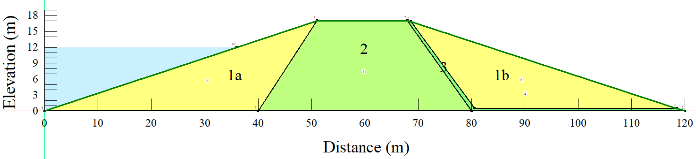
Figure 5.1 – Embankment geometry

Seepage analysis through the embankment
Before the simulation of the transient conditions based on the drawdown rates, the model was subjected to a long-term steady-state simulation using the Steady-state analysis method. The seepage-induced pore-pressures generated from the long-term steady-state were used in the transient flow modeling. The boundary condition approach was used to specify the extent of the water level variations during the rapid drawdown process (as shown in Figure 5.2); Moreover, in the study, the transient seepage analyses were used as parents to the slope stability analyses.
(a) | (b)
Figure 5.2 – Some of the defined functions (a) the boundary condition for 10 days drawdown rate (b) volumetric water content function from zone 1

Slope stability analysis
On the other hand, the help of the SLOPE/W of the GeoStudio accomplished the investigation of the embankment slope stability. The Morgenstern–Price [277] analysis method under the general limit equilibrium (GLE) [278] was used in the slope stability modeling.
To be more specific, the Morgenstern–Price is a general method of slices that works based on limit equilibrium with the sustaining equilibrium of forces and moments acting on individual blocks. To create the blocks, the soil above the slip surface has to be divided by dividing planes [279]. It is also important to be noted that the interslice shear forces used in the general limit equilibrium methodology are dealt with in an equation developed by Morgenstern and Price [156] (Equation (5.1))
 | $$X=Eλf(x)$$ | (5.1)
Whereby:
f(x) – represents a function; $λ$ – represents the percentage (in decimal form) of the function used; E – represents the interslice normal force, and X – represents the interslice shear force.

Material characteristics
The dam embankment is divided into different zones based on the material properties; zone 1 (a and b) is more of coarse materials mixed with fine materials (mainly silt and clay) and liquid limit (w_{L}) ranging from 25% up to 45%. Zone 2 (core) is composed of cohesive material and fine-grained material (clay). While Zone 3 is more of non-cohesive soil and filter material (sand and gravel). Table 5.1 provides a summary of the material characteristics.
Table 5.1 – Material properties of the embankment
Parameter | Zone
 | Zone 1a,b | Zone 2 | Zone 3
Saturated hydraulic conductivity (ksat), m/s | 4.69 ∙ 10⁻⁵ | 10⁻⁸ | 10⁻⁴
Diameter at passing 10% (mm) | 0.1 | 0.002 | 0.2
Diameter at passing 60% (mm) | 40 | 0.05 | 0.8
Liquid limit (%) | 25 to 45 | 50
Unit weight (kN/m³) | 20.5 | 20 | 18.5
Saturated water content (%) | 29.6 | 36.8 | 40.1
Internal angle of friction (degree) | 40 | 28 | 38
Cohesion (kPa) | - | 15 | -

Results and discussion

Seepage analysis
The numerical modeling was successfully executed; from Figure 5.3, it can be observed that the seepage within the embankment was safely carried away through zone 1a and zone 2. The general setup shows that the embankment was properly designed to not allow seepage along the downstream face of the embankment. The phenomenon was similar to all the investigated drawdown cases.
Generally, based on the phreatic lines, the seepage within the embankment can be observed to be evenly distributed (more of linear flow), while due to change in soil properties in zone 2 a more parabolic flow can be observed. In the instantaneous drawdown case, it can be observed that most of the phreatic lines are concentrated somewhere close to the foundation of the embankment. The distribution of phreatic lines becomes more evenly when the drawdown rate is reduced from fast to slow.
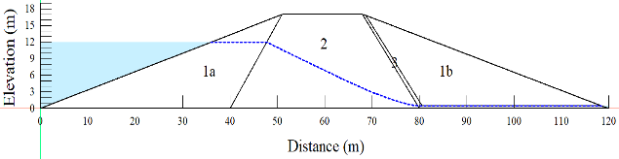  (a) | 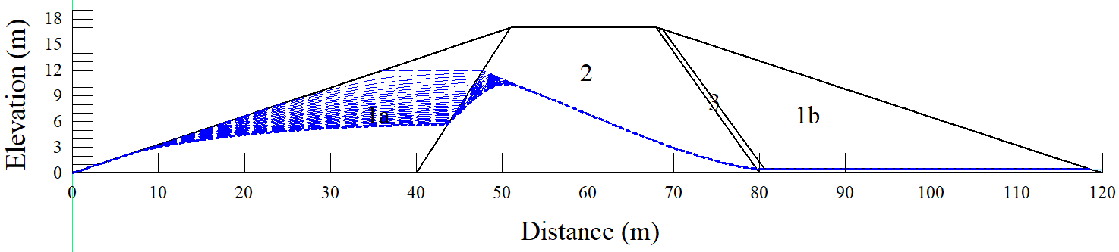  (b)
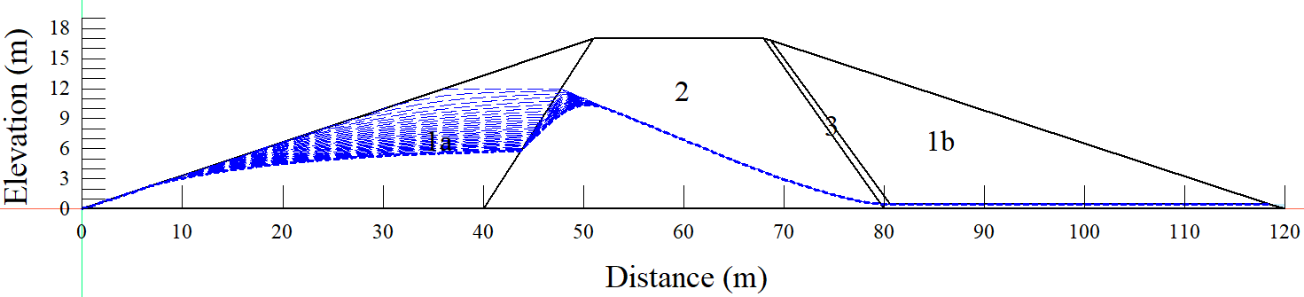  (c) | 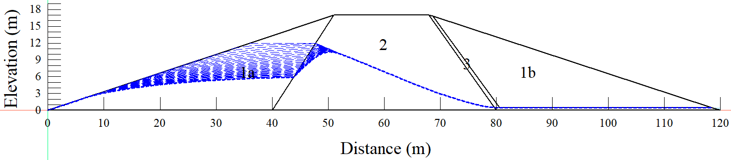  (d)
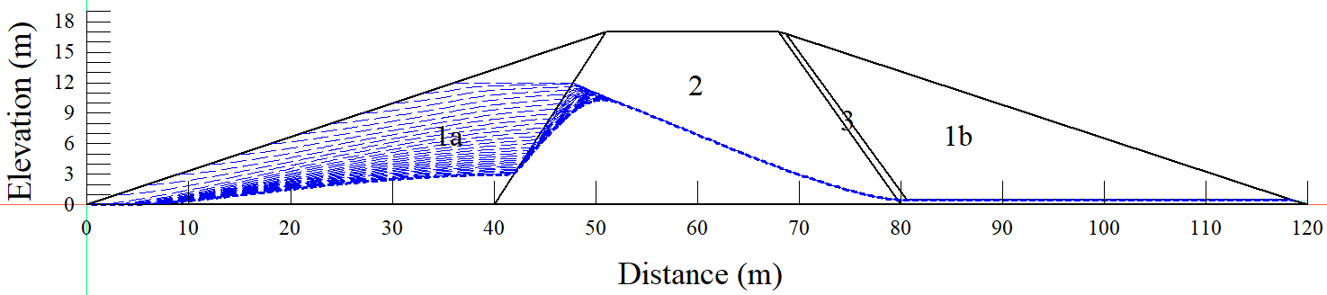
(e)
Figure 5.3 – Seepage analysis (a) long-term steady-state (b) Instantaneous drawdown (c) 5 days drawdown (d) 10 days drawdown (e) 1m per day drawdown
Normally, embankment dams are characterized by seepage as the impounded water seeks paths of least resistance through the dam and its foundation. However, seepage must be controlled to prevent erosion of the embankment [280]. If the seepage forces are relatively large enough within the embankment, there is a high chance that soil will be eroded, affecting the stability of the embankment with time. It should also be noted that the seepage control requirement is highly dependent on the quantity, content, and location of the seepage problem. Moreover, reducing the extent of the seepage problem when the embankment is already constructed is difficult and expensive; and it is in most cases not attempted unless the seepage has been threatening the stability of the embankment.
During the process of solving the seepage problems in embankment dams, regular monitoring is significantly essential to detect seepage and prevent a potential dam failure. The monitoring activities should include having a clear knowledge of the dam's history; this helps to determine the condition of the seepage [281].

Slope stability
Firstly, the embankment was subjected to the long-term steady-state slope stability analysis, whereby a factor of safety of 2.344 was achieved (Figure 5.4). A steady-state flow condition is one in which the pressure at any location in the reservoir remains constant across time. It is also worth noting that the long-term reservoir steady-state plays a significant role in the embankment stability.
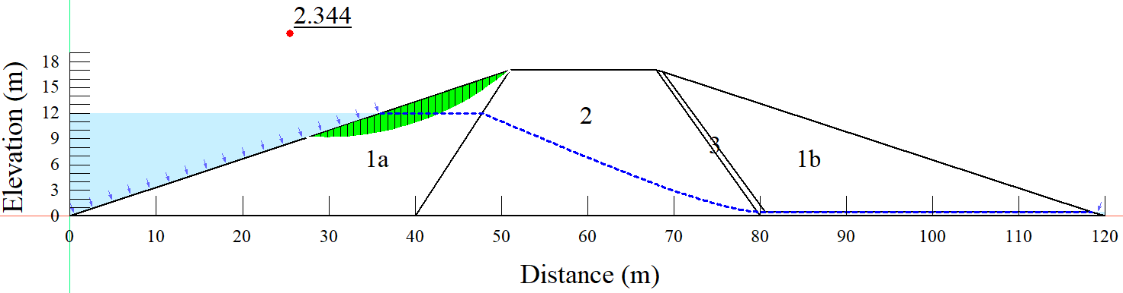
Figure 5.4 – Steady-state slope stability
Figure 5.5 presents the results when the embankment was subjected to the 1 m per day drawdown rate. The embankment began to lose stability during the first four days and began to restore stability on day five, as shown in the Figure. A minimal factor of safety of 2.149 was also obtained when the embankment was subjected to the 1 m per day drawdown rate; the minimum factor of safety value was attained on the fourth day of the drawdown. The retrieved factor of safety from the 1 m per day drawdown rate is equivalent to 8.32% less than the one retrieved from the long-term steady-state condition.
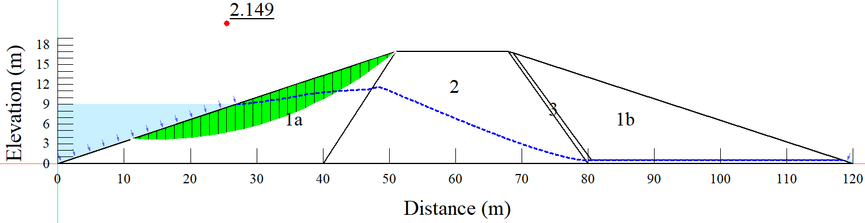
(a)
(b)
Figure 5.5 – Drawdown: 1 m per day drawdown rate; a) embankment with slip surface; b) graph of factor of safety values
Figure 5.6 presents the results when the embankment was subjected to the 10 days drawdown rate, and it can be observed that the embankment was losing stability within the nine first days of the drawdown. Whereby a minimum factor of safety of 1.804 was achieved from the 9th day of the drawdown. Moreover, it can be observed that the embankment started regaining stability from the 10th day.
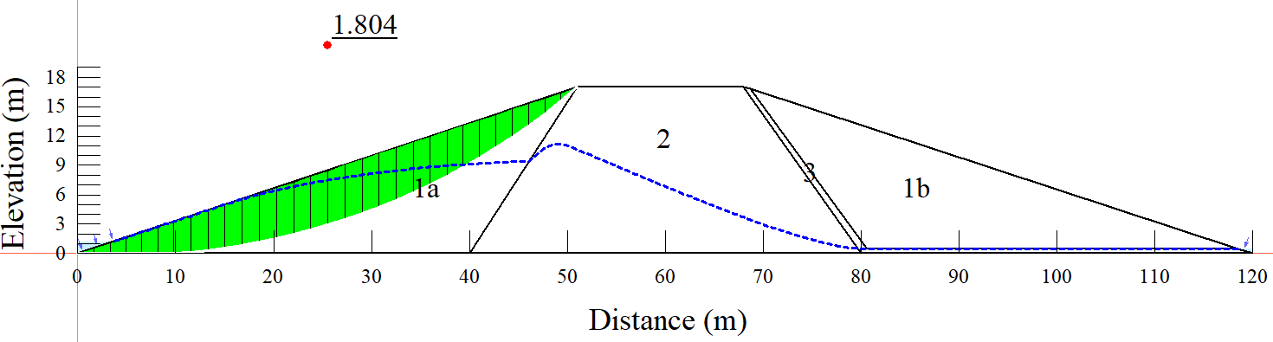
(a)
(b)
Figure 5.6 – Drawdown:10 days drawdown rate; a) embankment with slip surface; b) graph of factor of safety values
Figure 5.7 presents the results from the 5 days drawdown rate, and it can be observed that the embankment was losing stability within the five days of the drawdown process, whereby it started regaining stability from the 5th to 6th day. Also, it can be observed that the minimum factor of safety of 1.706 was obtained within the 5th day of the reservoir draining.
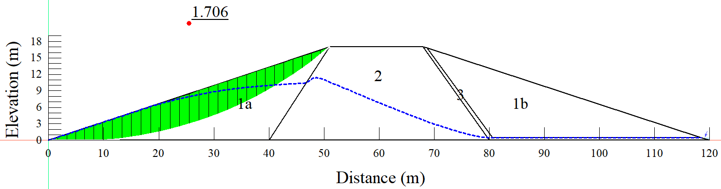
(a)
(b)
Figure 5.7 – Drawdown: 5 days drawdown; a) embankment with slip surface; b) graph of factor of safety values
Figure 5.8 presents the results when the embankment was subjected to the worst scenario of rapid drawdown (instantaneous), and it can be observed that the embankment lost stability from approximately 2.5 factors of safety to 1.574 within the same day of drawdown. Moreover, it can be observed that the embankment started regaining stability within the same day; however, it was not able to reach the 2.5 initial factor of safety, which is an indication of a potential failure. The obtained factor of safety from the instantaneous drawdown rate is equivalent to 32.85% less than the factor of safety retrieved from the long-term steady-state conditions.
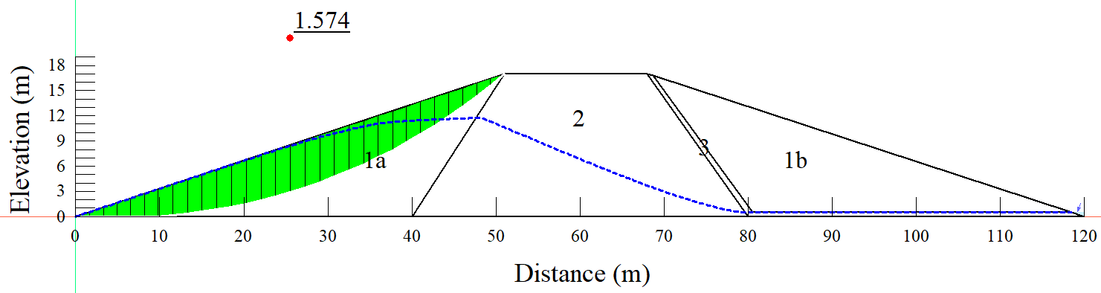
(a)
(b)
Figure 5.8 – Instantaneous drawdown; a) embankment with slip surface; b) graph of factor of safety values
Figure 5.9 provides a clearer overview of the potential influence of the rapid drawdown loading conditions on the slope stability of the embankment. It can be seen that as the drawdown rate has increased, the minimum factor of safety has decreased.

Figure 5.9 – Summary of the minimum factor of safety values
According to the literature, a minimum factor of safety of 1.3 for temporary or low-risk slopes and 1.5 for permanent slopes is appropriate for a static two-dimensional (2D) slope [282]. However, in most cases, when a factor of safety is below 1, then it is considered a total embankment failure.

Summary of the sub-section
The potential effect of rapid drawdown scenarios on the stability of old dams for the case of Samarkand in Kazakhstan has been investigated. The dam has a maximum depth of 12 m and a length of 25 km; located in Karaganda province in Kazakhstan that was put into operation in 1941. Both seepage and slope stability with the help of numerical modeling were investigated based on steady and transient (rapid drawdown) flow conditions. The finite element method-based modeling is achieved using SEEP/W and SLOPE/W of the GeoStudio software. The embankment was first subjected to a long-term steady-state slope stability analysis, which resulted in a factor of safety of 2.344. In a steady-state flow scenario, the pressure at any location in the reservoir remains constant across time. It's also worth noting that the reservoir's long-term stable state has a significant impact on the stability of the embankment. When the embankment was subjected to a 1 m per day draw-down rate, a minimum factor of safety of 2.149 was obtained; the minimum factor of safety value was reached on the fourth day of the drawdown. The factor of safety recovered from the 1 m per day drawdown rate is 8.32% lower than the one retrieved from the long-term steady state. Moreover, the factor of safety determined from the instantaneous drawdown rate is 32.85% lower than the factor of safety obtained from long-term steady-state conditions.

Ndembera dam in Tanzania

Materials and methods

Geological, hydrogeological, and geotechnical conditions
In the Lugoda dam Project, most of the structure is located on rock formations as the direct foundation and fault, and the fracture zone is partially located in the local area. In the case of this situation, problems with the bearing capacity and settlement of structures are expected. Hence, the analyses on the bearing capacity and settlement were carried out to secure the foundation stability of structures. The reservoir region in the Ndembera catchment is a geologically incoherent superficial material area (yellow hue) made up of gravel, sand, silt, and clay that is alluvial or lacustrine. While the area around the dam is made up of foliated crystalline rock such as gneiss and schist, amphibolites granularities, and meta-dolerites, the surrounding area is made up of foliated magmatic granites, gneiss, schist, amphibolites granularities, and meta-dolerites (Figure 5.10).
Moreover, the Paleoarchean era yellowish-brown granite gneiss formation is scattered at the dam site, and topsoil is used to cover the bedrock. The topsoil is made up of silty sand and boulder stone. Milky white silt and fine-grained sand are visible along the river. Whereby because of the heavy weathering, the rock outcrops are rarely visible. Also, differential weathering leads to the large bedrock dispersion on the dam's left side. The small-scaled fault runs from the dam's left side to its center.
To investigate the geological condition of the study catchment, several trench pits were excavated; this was an important aspect of having a full view of the rock.
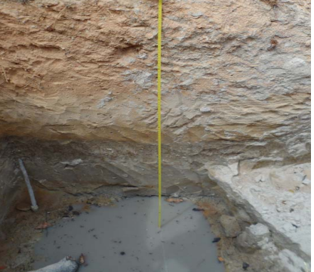 | 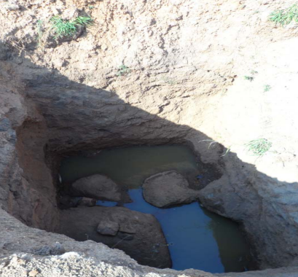
Figure 5.10 – Trench pits at the dam site

Design assumptions of the dam and materials used
The geometrical dimension of the LUGODA dam has the following:
- Total length: 721 M.
- Maximum height: 60 M.
- Upstream and downstream embankment slope: 1.5:1 (H: V).
- Maximum width (based on the fundamental triangle): 190 M.
- Crest road width: 8M.
Operating water levels are:
- Minimum operating level (low water level): EL. 1663.0.
- Maximum operating level (normal high-water level): EL. 1677.0.
- Maximum flood level (maximum water level): EL. 1678.6.

The embankment geometry and soil characteristics
The embankment geometry (Figure 5.11) is divided into five zones, with zones 3a and 3b having similar material characteristics. Zone 1 of the embankment was assigned diverse material properties, with coarse material combined with fine materials (silt and clay percentage) and saturated hydraulic conductivities (k_{sat}) as well as liquid limit ranging (from 25% to 45%). Cohesive material, fine-grained material, and clay with varying ksat values characterize Zone 2. Zones 3a and 3b are distinguished by non-cohesive soil and filter material (sand and gravel), whereas Zone 4 is distinguished by coarse material with a low fines concentration.
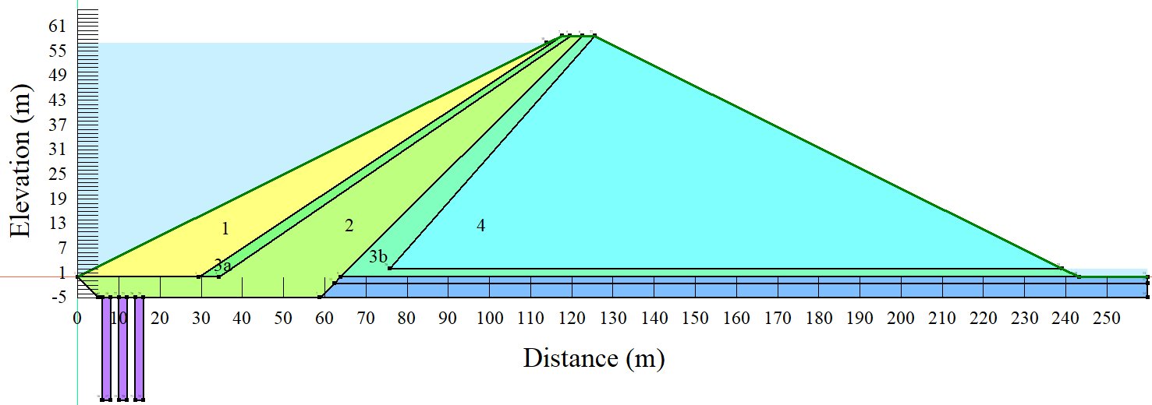
Figure 5.11 – Embankment geometry
Table 5.2 provides a summary of the material characteristics for each zone of the embankment investigated in this study. The geotechnical parameters were derived both from laboratory tests and previous testing.
Table 5.2 – Material properties
Parameter | Zone
 | Zone 1 | Zone 2 | Zone 3a,b | Zone 4
Saturated hydraulic conductivity (k_{sat}), m/s | 5 ∙ 10⁻⁵ | 10⁻⁸ | 10⁻⁴ | 5x10⁻⁵
Saturated hydraulic conductivity (k_{sat}), m/s | 10⁻⁵ | 10⁻⁸ | 10⁻⁴ | 5x10⁻⁵
Saturated hydraulic conductivity (k_{sat}), m/s | 5 ∙ 10⁻⁶ | 10⁻⁸ | 10⁻⁴ | 5x10⁻⁵
Saturated hydraulic conductivity (k_{sat}), m/s | 10⁻⁶ | 10⁻⁸ | 10⁻⁴ | 5x10⁻⁵
Saturated hydraulic conductivity (k_{sat}), m/s | 5 ∙ 10⁻⁷ | 10⁻⁸ | 10⁻⁴ | 5x10⁻⁵
Saturated hydraulic conductivity (k_{sat}), m/s | 10⁻⁷ | 10⁻⁸ | 10⁻⁴ | 5x10⁻⁵
Diameter at passing 10% (mm) | 0.1 | 0.002 | 0.2 | 0.1
Diameter at passing 10% (mm) | 0.05 | 0.002 | 0.2 | 0.1
Diameter at passing 10% (mm) | 0.032 | 0.002 | 0.2 | 0.1
Diameter at passing 10% (mm) | 0.015 | 0.002 | 0.2 | 0.1
Diameter at passing 10% (mm) | 0.01 | 0.002 | 0.2 | 0.1
Diameter at passing 10% (mm) | 0.005 | 0.002 | 0.2 | 0.1
Diameter at passing 60% (mm) | 40 | 0.05 | 0.8 | 40
Diameter at passing 60% (mm) | 36 | 0.05 | 0.8 | 40
Diameter at passing 60% (mm) | 32 | 0.05 | 0.8 | 40
Diameter at passing 60% (mm) | 28 | 0.05 | 0.8 | 40
Diameter at passing 60% (mm) | 24 | 0.05 | 0.8 | 40
Diameter at passing 60% (mm) | 20 | 0.05 | 0.8 | 40
Liquid limit (%) | 25 to 45 | 50
Unit weight (kN/m³) | 20.5 | 20 | 18.5 | 20.5
Saturated water content (%) | 29.6 | 36.8 | 40.1 | 29.6
Internal angle of friction (degree) | 40 | 28 | 38 | 40
Cohesion (kPa) | - | 15 | - | -

General modeling process
The possible influence of a dam's quick drawdown on slope stability of an earth-fill embankment with soil parameters specified by hydraulic conductivity was investigated using finite element technique analysis. Five different cases were investigated; steady-state, instantaneous drawdown, 5-days drawdown, 10-days drawdown, and 1m per day drawdown rate to a half of the maximum water level. However, the transient drawdown cases stand to be the main focus of this study. For the second case, it is assumed that water in the dam or reservoir is drawn instantaneously, and the stability factors were investigated at the end of the modeling process. For cases, three, four, and five, a specific time of 5, 10, and 28.5 days, respectively, were assigned to investigate how the stability factors respond to the different drawdown rates. The instantaneous case represents the extreme situation or worst scenario. The seepage analyses were carried out concurrently with stability analysis.
A combination of SEEP/W [275] and SLOPE/W [276] GeoStudio sub-software was used to investigate the problem. Specifically, the seepage analysis was accomplished using SEEP/W in two-dimensional sections, which is based on FEM, while SLOPE/W was used for the slope stability analysis of the embankment based on slip surfaces pore-water pressure conditions, soil properties, and loading conditions. To capture the effect of the hydraulic conductivity values, other parameters such as the geometry of the embankment were kept constant in all the drawdown cases while changing the hydraulic conductivity values in zone 1. In that matter, each case had a combination of seepage analysis (steady-state and transient) and slope stability analysis.

Embankment seepage analysis
The simulation of the drawdown behavior of a slope started by establishing a long-term steady-state using the Steady-state type of analysis. The established steady-state was then used as a parent to the transient flow analysis, in which the transient flow analyses used seepage-induced pore pressures from the initially performed steady-state analysis. As noted before, the analyses comprised of different drawdown rates and isotropic hydraulic conductivity values. The variation of water level during the drawdown process was modeled using a linear function that was specified as a boundary condition (Figure 5.12) on the upstream face of the embankment during the transient seepage analyses. The transient seepage analyses were used as parents to the slope stability analyses. The established flow parameters such as pore water pressures during the transient flow analyses were later used as significant inputs to the stability analysis with SLOPE/W.
(a) | (b)
Figure 5.12 – Drawdown boundary conditions (a) 10 days drawdown rate (b) 1m per day drawdown rate

Slope stability analysis
The GeoStudio software's SLOPE/W sub-unit was used for slope stability analyses. To do so, the Morgenstern–Price [277] analysis approach was used under the general limit equilibrium (GLE) [278]. The approach is based on two factors of safety equations with the following perspectives since the generic limit equilibrium formulation allows for a variety of interslice shear-normal force circumstances.
- In the first equation, the factor of safety is computed with respect to moment equilibrium (F_{m}).
- The second equation computes the factor of safety with respect to horizontal force equilibrium (F_{f}).
However, the applicability of the two equations in the computations of a factor of safety was initially published by Spencer [283]. Spencer's method can be termed as a modified and extended version of Bishop's simplified method. Referring to Bishop's simplified method, a factor of safety (F) is calculated as the ratio of total strength available (S) on the slip surface to the total shear strength mobilized (S_{m}) [162], as summarized in (5.2).
 | $$F=\frac{S}{S_{m}}$$ | (5.2)
Moreover, in Spencer's analysis, the derived resultant of pair of interslice forces (Q) is computed using Equation (4.2).

Results and discussion
Both the seepage and slope stability analyses were mainly divided into five categories determined by the type of drawdown rate. However, in this study, the main interest was in the 1 m per day drawdown rate, where the reservoir was drained to half of the maximum water level. The analyses were accomplished for both steady-state and transient flow conditions, while among many other parameters, the nature of piezometric lines and pore water pressures were investigated.

At the normal operating level

Seepage analysis
Figure 5.13 presents the steady-state seepage analysis results with different hydraulic conductivity values applied in zone 1. As indicated by the piezometric lines, the nature of seepage is observed to be sharply moving downward through zone 2 towards the drainage zone.
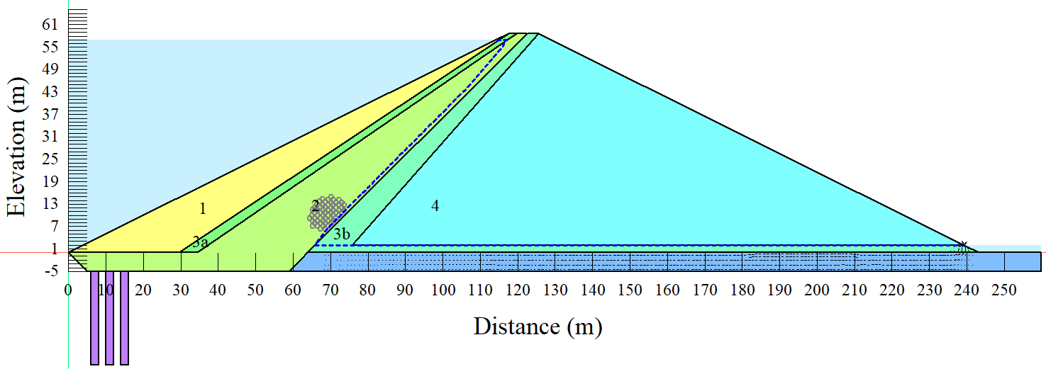  (a) | 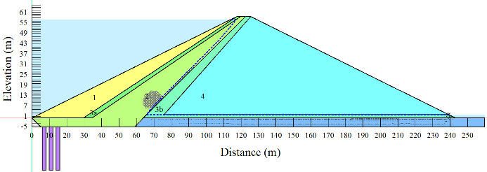  (b)
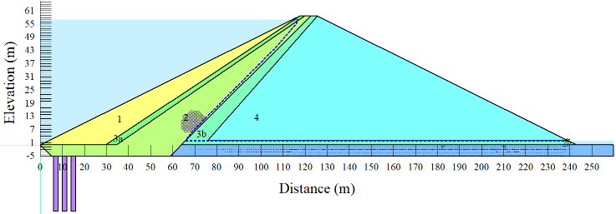  (c) | 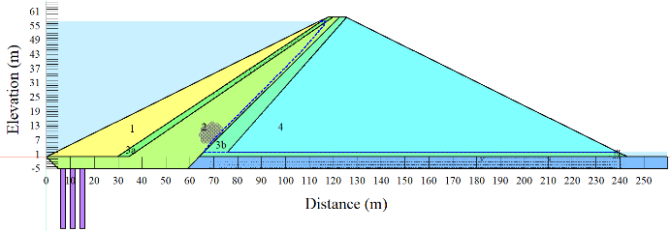  (d)
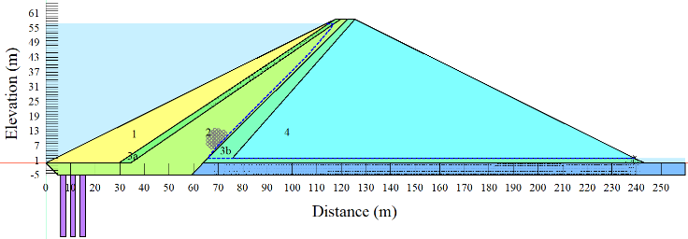  (e) | 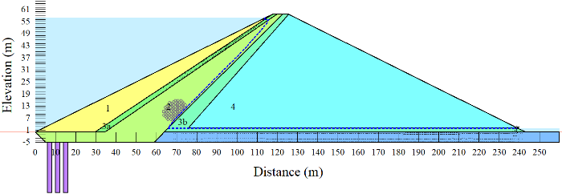  (f)
Figure 5.13 – Steady state seepage: a) k_{sat} = 5∙10⁻⁵ m/s; b) k_{sat} = 10⁻⁵ m/s; c) k_{sat} = 5∙10⁻⁶ m/s; d) k_{sat} = 10⁻⁶; e) k_{sat} = 5∙10⁻⁷ m/s; f) k_{sat} = 10⁻⁷ m/s
As previously mentioned, the drawdown rate of 1m per day to half of the maximum water level was the main interest of this study. Figure 5.14 presents the seepage analysis results with k_{sat} = 10⁻⁵ and 10⁻⁷ m/s in zone 1. It can be observed that, as the hydraulic conductivity reduces in zone 1, making it less permeable, it has a significant effect on the dissipation of pore water pressures after the drawdown. The curves of the piezometric lines in Figure 5.14(a) are flatter than the ones in Figure 5.14(b). The phenomenon reveals further that, under rapid drawdown scenarios, zone 1 has to be more permeable to allow easy dissipation of water pressure and reduce the risk of failure.
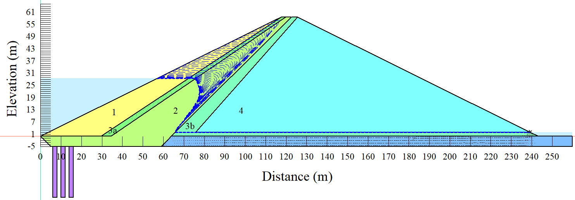
(a)
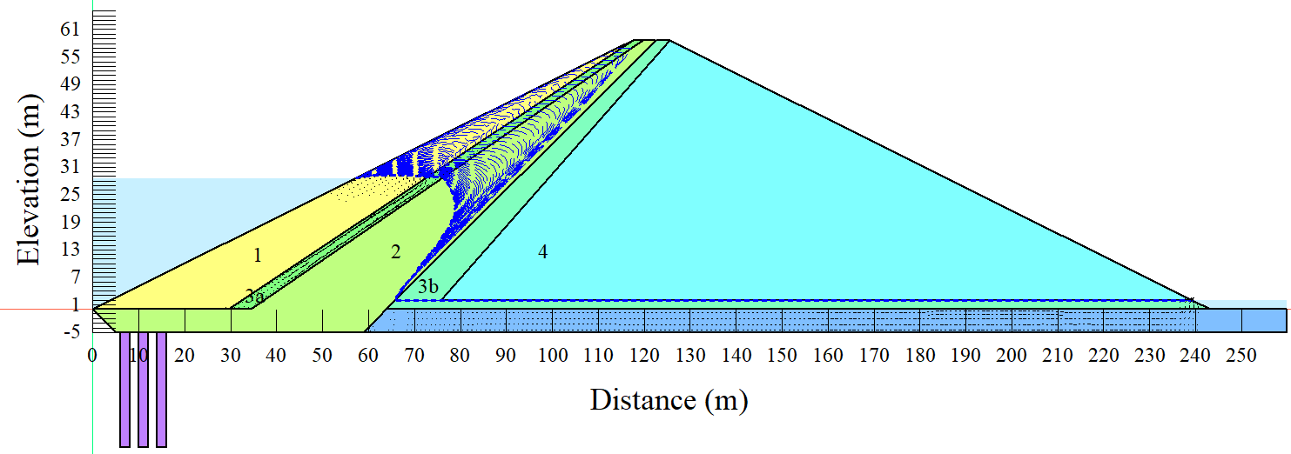
(b)
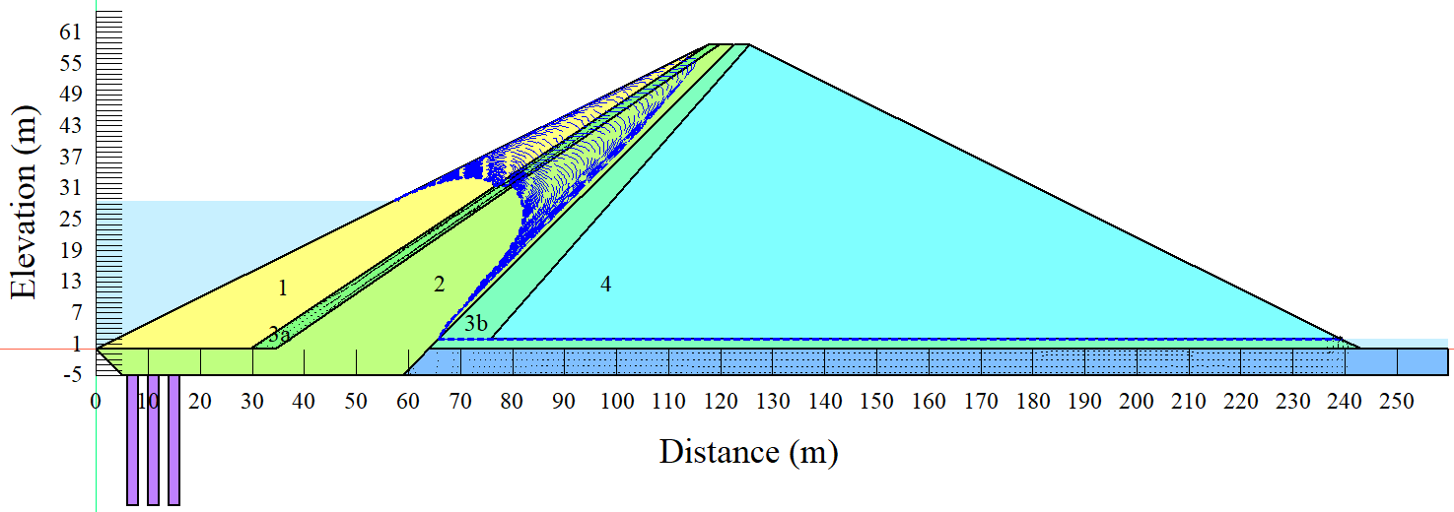
(b)
Figure 5.14 – A half drawdown (1m per day) seepage; a) k_{sat}=10⁻⁵ m/s; b) k_{sat}=10⁻⁵ m/s; c) k_{sat}=10⁻⁷ m/s

Slope stability analysis
The slope stability analysis cases were mainly determined by the saturated hydraulic conductivities (permeabilities) in zone 1 and the drawdown rates. However, this study’s interest was in the 1m per day drawdown rate as the most realistic case.
Figure 5.15 presents the slope stability analysis results when zone 1 was subjected to the hydraulic conductivity of 5∙10⁻⁵ m/s. Likewise, it can be observed that the minimum factor of safety (1.355) was retrieved from the last day of the drawdown (28th day).

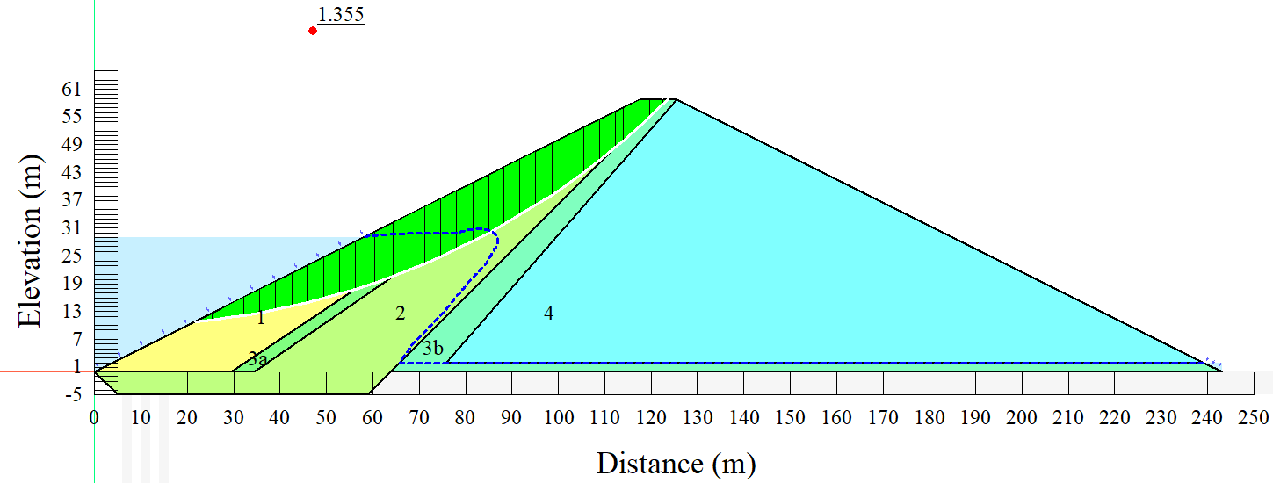
(a)
(b)
Figure 5.15 – Slope stability under k_{sat} = 5∙10⁻⁵ m/s; a) embankment with slip surface; b) graph of factor of safety values
Figure 5.16 presents the slope stability analysis results when zone 1 was subjected to the hydraulic conductivity of 10⁻⁵ m/s. From Figure 5.16, it can be observed that the minimum factor of safety equal to 1.321 was retrieved from the last day of the drawdown (28th day). Also, the factor of safety started dropping immediately after the reservoir drawdown and kept on dropping to the 28th day of the drawdown and slowly started regaining stability as the pore-water pressures kept on dissipating in the embankment. However, after a while, the factor of safety value remains almost constant at a value of approximately 1.4 for the entire remaining period of the simulation.
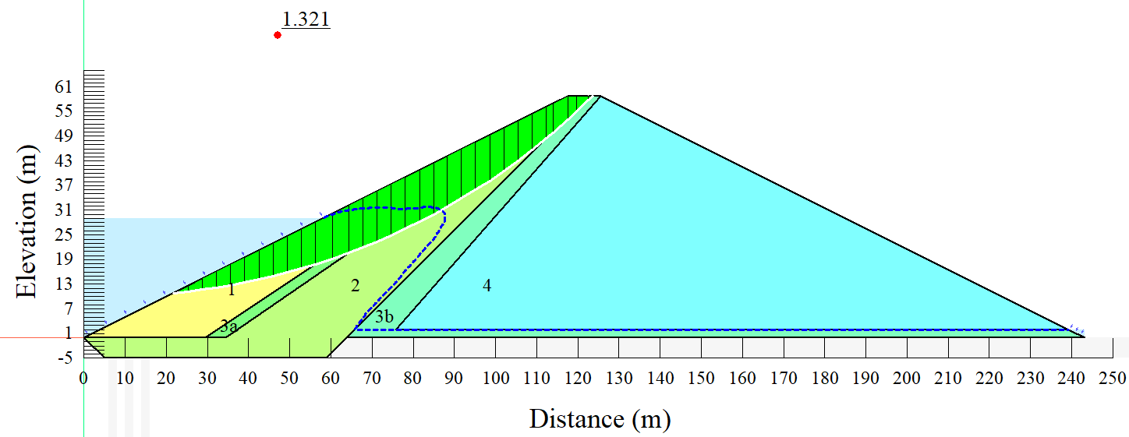
(a)
(b)
Figure 5.16 – Slope stability under k_{sat}=10⁻⁵ m/s; a) embankment with slip surface; b) graph of factor of safety values
Figure 5.17 presents the slope stability analysis results when zone 1 was subjected to the hydraulic conductivity of 5∙10⁻⁶ m/s. Whereby, Figure 5.17 shows that the minimum factor of safety was retrieved during the last day of the drawdown with a value of 1.296.
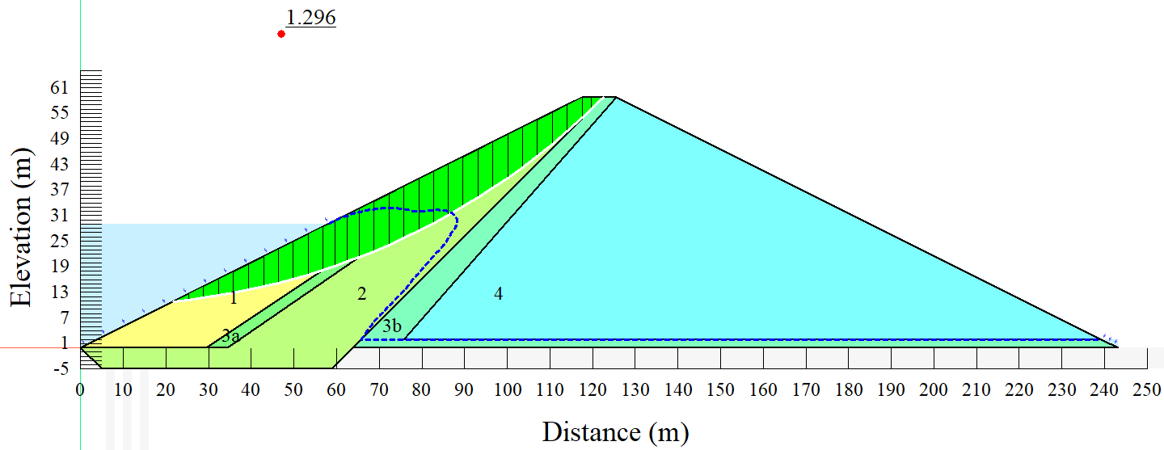
(a)
(b)
Figure 5.17– Slope stability under k_{sat} = 5∙10⁻⁶ m/s; a) embankment with slip surface; b) graph of factor of safety values
Figure 5.18 shows the slope stability analysis results when zone 1 was subjected to the hydraulic conductivity of 10⁻⁶ m/s. Similarly, as observed from the 10⁻⁵ m/s, the factor of safety tends to drop immediately after the beginning of the reservoir drawdown process and kept on dropping to the 28th day (last day) of the drawdown and slowly started regaining stability as the pore-water pressures kept on dissipating in the embankment. Contrary to the 10⁻⁵ m/s, the trend of regaining stability for the hydraulic conductivity of 10⁻⁶ m/s is a bit sharper than the 10⁻⁵ m/s, with the factor of safety increasing from approximately 1.2 to 1.4, taking more time than the 10⁻⁵ m/s.
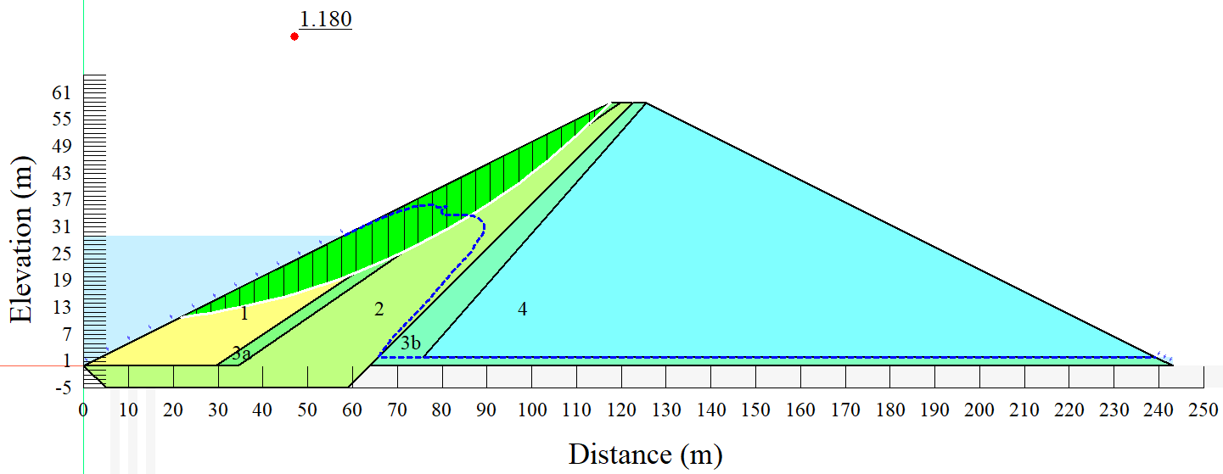
(a)
(b)
Figure 5.18 – Slope stability under k_{sat}=10⁻⁶ m/s; a) embankment with slip surface; b) graph of factor of safety values
Figure 5.19 presents the slope stability analysis results when zone 1 was subjected to the hydraulic conductivity of 5∙10⁻⁶ m/s. From Figure 5.19, a minimum factor of safety value of about 1.108 was retrieved during the 28th day of the rapid drawdown.
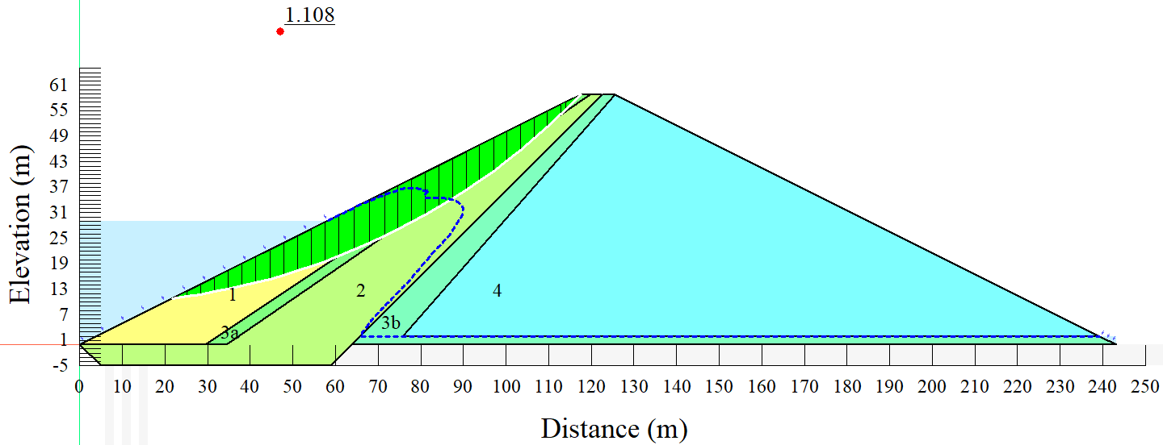
(a)
(b)
Figure 5.19– Slope stability under k_{sat} = 5∙10⁻⁷ m/s; a) embankment with slip surface; b) graph of factor of safety values
Figure 5.20 presents the slope stability analysis results when zone 1 was subjected to the hydraulic conductivity of 10⁻⁷ m/s. As previously observed, the factor of safety values started reducing following the reservoir drawdown process and kept on reducing to the 28th day (last day) of the drawdown and slowly started regaining stability as the pore-water pressures kept on dissipating in the embankment. However, for the 10⁻⁷ m/s, the factor of safety values went all the way to below 1 with an alarm of a potential failure. In this phenomenon, it is noticed that, for a combination of the embankment material properties and the drawdown rate of 1m per day, the zone 1 hydraulic conductivity should be higher than 10⁻⁷ m/s.
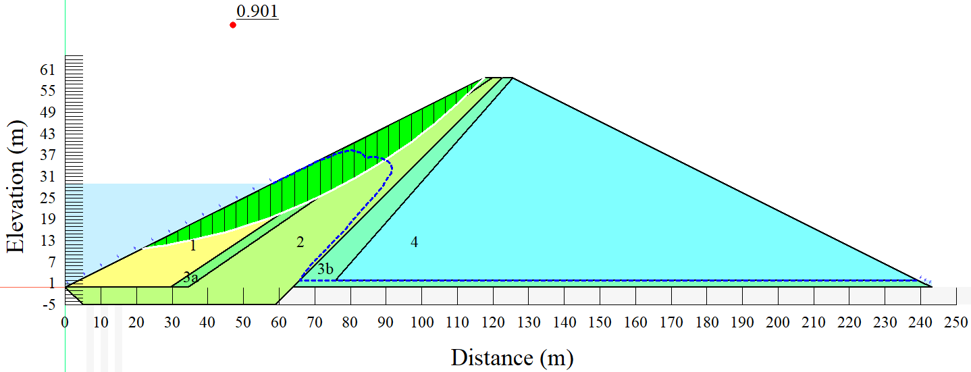
(a)
Hypothetical region after failure: Minimum FS = 0.901
(b)
Figure 5.20 – Slope stability under k_{sat}=10-7 m/s; a) embankment with slip surface; b) graph of factor of safety values
From the minimum values of factor of safety (Table 5.3), it is revealed further that, as Zone 1 becomes more impervious following the reduction of saturated hydraulic conductivity, the embankment is subjected to a potential failure. From Table 5.3, it can be observed that the lowest minimum factor of safety value of 0.901 corresponds to the 10⁻⁷ m/s saturated hydraulic conductivity.
According to [284], if the factor of safety is near or below 1, then severe erosion or shallow slumping is a phenomenon likely to occur. This observation shows the general potential risk of an embankment failure when the factor of safety is below 1. As a slope stability improvement approach, the application of vegetation on the slope can also be useful to reduce such a problem with the fact that the vegetation roots improve soil cohesion [285]. In general, from Table 5.3, it can be seen that the highest minimum value of factor of safety was achieved from the 5∙10⁻⁵ m/s and reduces towards 10⁻⁷ m/s as the lowest hydraulic conductivity value in the list.
The steady-state factor of safety values is inversely proportional to the rapid drawdown factor of safety values, as shown in Table 5.3. This means that, whereas the steady-state factor of safety values increases as embankment permeability decreases, the rapid drawdown factor of safety values decreases as embankment permeability decreases. In that regard, it is worth noting that, based on the findings, it is critical to consider rapid drawdown situations during the design phase of an embankment dam in order to optimize the factor of safety values.
Table 5.3 – The minimum factor of safety values are based on the saturated hydraulic conductivity values in zone 1 under 1m per day drawdown rate
Sat. hydraulic conductivity (m/s) | Steady-state factor of safety | Minimum values of factor of safety
5∙10⁻⁵ | 1.665 | 1.355
10⁻⁵ | 1.669 | 1.321
5∙10⁻⁶ | 1.674 | 1.296
10⁻⁶ | 1.716 | 1.180
5∙10⁻⁷ | 1.746 | 1.108
10⁻⁷ | 1.972 | 0.901

Moreover, in a real situation is almost difficult to achieve an instantaneous drawdown, but, it is always preferable to include potential worst scenarios in a slope stability analysis. Figure 5.21 highlights the minimum values of factor of safety from the instantaneous, 5 days and 10 days drawdown rates for the highest (5∙10⁻⁵ m/s) and lowest (10⁻⁷ m/s) saturated hydraulic conductivities. It can be observed that all the factor of safety values are below 1.0, revealing further that for the embankment material properties, the drawdown rate should not be below 1m per day.

Figure 5.21 – Minimum values of factor of safety from the instantaneous, 5 days, and 10 days drawdown rates under 5∙10⁻⁵ m/s and 10⁻⁷ m/s saturated hydraulic conductivities: FS- factor of safety

Analysis of variance (ANOVA) under normal operating reservoir level and 1 m per day drawdown rate
The retrieved factor of safety values from the normal operating reservoir level, and different hydraulic conductivity values were subjected to the analysis of variance (ANOVA) in order to investigate the significance level of differences in the factor of safety values.
Table 5.4 presents a summary of the ANOVA results when the different hydraulic conductivity values were applied under normal operating reservoir levels and instantaneous drawdown rate. The combination of the hydraulic conductivity values, normal operating reservoir level, and instantaneous drawdown rate yielded a p-value of 4.64× 10⁻⁷. The p-value obtained was less than 0.05, indicating that the variations in factor of safety values from the combination of hydraulic conductivity values, normal operating reservoir level, and instantaneous drawdown rate were statistically significant.
Table 5.4 ANOVA results from different hydraulic conductivity values, normal operating reservoir level, and instantaneous drawdown rate.
ANOVA: Single Factor
SUMMARY
Groups | Count | Sum | Average | Variance
5 ×10⁻⁵ | 31 | 38.467 | 1.241 | 0.185
10⁻⁵ | 31 | 35.430 | 1.143 | 0.187
5 ×10⁻⁶ | 31 | 34.370 | 1.109 | 0.190
10⁻⁶ | 31 | 33.519 | 1.081 | 0.095
5 ×10⁻⁷ | 31 | 37.077 | 1.196 | 0.063
10⁻⁷ | 31 | 49.579 | 1.599 | 0.099
ANOVA
Source of Variation | SS | df | MS | F | P-value | F crit
Between Groups | 5.644252 | 5 | 1.12885 | 8.276115 | 4.64× 10⁻⁷ | 2.26431
Within Groups | 24.55175 | 180 | 0.136399
Total | 30.196 | 185

The ANOVA results when the varied hydraulic conductivity values were applied under normal operating reservoir level and 5 days drawdown rate are summarized in Table 5.5. A p-value of 0.000302 was obtained by combining the hydraulic conductivity measurements, normal operating reservoir level, and 5 days drawdown rate. The calculated p-value was less than 0.05, showing that the differences in factor of safety values resulting from the combination of hydraulic conductivity values, normal operating reservoir level, and 5 days drawdown rate were statistically significant.
Table 5.5 ANOVA results from different hydraulic conductivity values, normal operating reservoir level, and 5 days drawdown rate.
ANOVA: Single Factor
SUMMARY
Groups | Count | Sum | Average | Variance
5 ×10⁻⁵ | 31 | 40.076 | 1.293 | 0.193
10⁻⁵ | 31 | 37.327 | 1.204 | 0.203
5 ×10⁻⁶ | 31 | 36.347 | 1.172 | 0.209
10⁻⁶ | 31 | 33.324 | 1.075 | 0.069
5 ×10⁻⁷ | 31 | 27.289 | 0.880 | 0.087
10⁻⁷ | 31 | 30.063 | 0.970 | 0.140
ANOVA
Source of Variation | SS | df | MS | F | P-value | F crit
Between Groups | 3.692272 | 5 | 0.738454 | 4.920757 | 0.000302 | 2.26431
Within Groups | 27.01247 | 180 | 0.150069
Total | 30.70474 | 185

Table 5.6 presents a summary of the ANOVA results when the different hydraulic conductivity values were applied under normal operating reservoir levels and 10 days drawdown rate. Moreover, it can be observed that a p-value of 8.78× 10⁻⁶ from the investigated parameters is less than the alpha value of 0.05, indicating a high level of statistical significance from the factor of safety values among the investigated parameters.
Table 5.6 ANOVA results from different hydraulic conductivity values, normal operating reservoir level, and 10 days drawdown rate
ANOVA: Single Factor
SUMMARY
Groups | Count | Sum | Average | Variance
5 ×10⁻⁵ | 31 | 40.085 | 1.293 | 0.272
10⁻⁵ | 31 | 42.420 | 1.368 | 0.250
5 ×10⁻⁶ | 31 | 39.241 | 1.266 | 0.282
10⁻⁶ | 31 | 29.131 | 0.940 | 0.093
5 ×10⁻⁷ | 31 | 33.677 | 1.086 | 0.131
10⁻⁷ | 31 | 26.440 | 0.853 | 0.167
ANOVA
Source of Variation | SS | df | MS | F | P-value | F crit
Between Groups | 6.71568 | 5 | 1.343136 | 6.739369 | 8.78× 10⁻⁶ | 2.26431
Within Groups | 35.87346 | 180 | 0.199297
Total | 42.58914 | 185
When the different hydraulic conductivity values were used under normal operating reservoir level and 10 days drawdown rate, the ANOVA results are summarized in Table 5.7. Furthermore, the studied parameters have a p-value of 3.41× 10⁻⁹, which is less than the alpha value of 0.05, showing a high level of statistical significance from the factor of safety values among the investigated parameters.
Table 5.7 ANOVA results from different hydraulic conductivity values, normal operating reservoir level, and 1 m per day drawdown rate
ANOVA: Single Factor
SUMMARY
Groups | Count | Sum | Average | Variance
5 ×10⁻⁵ | 61 | 94.760 | 1.553 | 0.093
10⁻⁵ | 61 | 95.168 | 1.560 | 0.091
5 ×10⁻⁶ | 61 | 93.723 | 1.536 | 0.085
10⁻⁶ | 61 | 84.505 | 1.385 | 0.063
5 ×10⁻⁷ | 61 | 87.745 | 1.438 | 0.052
10⁻⁷ | 61 | 77.295 | 1.267 | 0.101
ANOVA
Source of Variation | SS | df | MS | F | P-value | F crit
Between Groups | 4.134524 | 5 | 0.826905 | 10.24486 | 3.41× 10⁻⁹ | 2.23906
Within Groups | 29.05709 | 360 | 0.080714
Total | 33.19161 | 365

At the reduced operating level
In this study, the long-term water level was reduced to almost half of the embankment and then subjected to both seepage and slope stability analysis. The operating water level reduction was made to capture the effect of the rapid drawdown when the long-term operating reservoir water level has significantly reduced in the reservoir, whereby land use and land cover change, and climatic conditions are among the crucial factors leading to such a phenomenon.

Seepage analysis
From Figure 5.22 (presenting the long-term steady-state results under reduced operating level), we understand that the first three zones of the embankment are subjected to excess pore-water pressure as the long-term operating reservoir waster was reduced to almost a half of the embankment. The pore water pressure is critical for distinguishing total stress from effective stress in soil. For precise field calculations, a reliable depiction of soil stress is required. The phenomenon observed in Figure 5.22 may suggest that when the reservoir operating water level is reduced, then the upstream zone of the embankment should be of more non-cohesive materials.
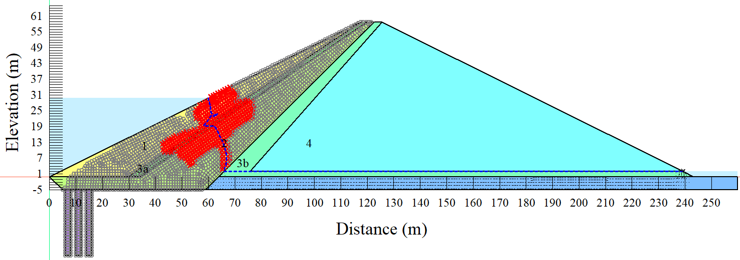
Figure 5.22 – Steady-state seepage under the reduced operating water level
Figure 5.23 presents the results of the instantaneous (worst assumed scenario) drawdown seepage under the reduced operating water level. Even after the water in the reservoir has been completely drained, the pore-water pressures in the embankment remain quite high, as seen by the piezometric lines in the figure. If an embankment is erected over a high cohesive material foundation, the material may experience a temporary situation of excess pore pressure, according to the literature. The extra pore pressure within the soil cannot easily disperse due to its low permeability. The higher pore pressure can therefore lead to decreased safety factors and probable failure in a non-steady-state condition [286].
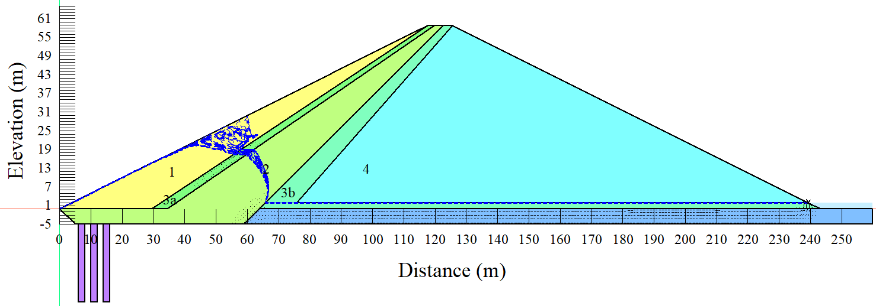
Figure 5.23 – Instantaneous drawdown seepage under the reduced operating water level
After the instantaneous drawdown scenario, the drawdown rate was then reduced to 5 days, whereby the results of the 5 days drawdown seepage under reduced operating water level are shown in Figure 5.24. A similar phenomenon can also be observed that, even after the water in the reservoir has been completely drained, the pore-water pressures in the embankment remain quite high, as seen by the piezometric lines in the figure. According to the literature, permeable non-cohesive soils have a high sensitivity to stress variations induced by construction and reservoir level fluctuations, as well as rapid dissipation, while excess pore pressures in clay dissipate much more slowly [287].
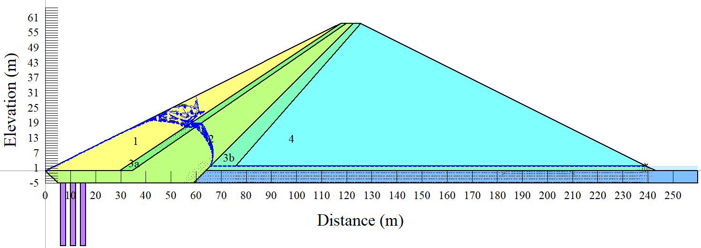
Figure 5.24 – Rapid drawdown (5 days) seepage under the reduced operating water level
The drawdown rate was reduced further to 10 days following the instantaneous drawdown and 5 days drawdown rates, with the results of the 10 days drawdown rate seepage under reduced operating water level displayed in Figure 5.25. The piezometric lines in the Figure still show a similar phenomenon as observed from the instantaneous and 5 days drawdown rates, whereby, even after the water in the reservoir has been fully drained, the pore-water pressures in the embankment remain relatively high. This phenomenon reveals further that there is a potential threat to the stability of the embankment even when the drawdown rate is reduced to 10 days.
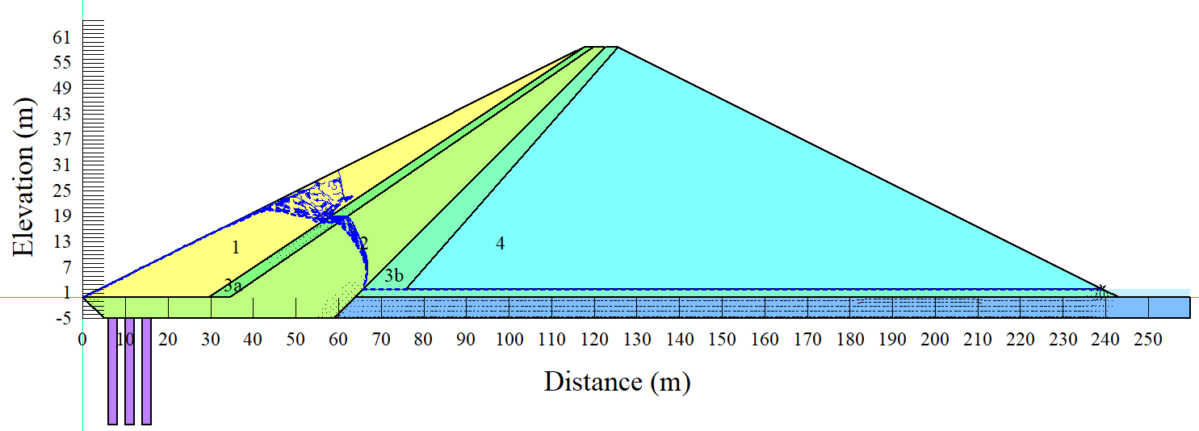
Figure 5.25 – Rapid drawdown (10 days) seepage under the reduced operating water level
Despite some improvements in terms of pore-water pressure dissipation when the drawdown rate was reduced further to 1 m per day, it can be observed in Figure 5.26 that there is a significant struggle in terms of pore-water pressure dissipation after the drawdown. It has to be noted that, as the soil becomes increasingly saturated, the pore water pressure rises, lowering the soil's shearing resistance. The slope's factor of safety is reduced as a result of this circumstance. The constant rise in water level raises pore water pressure in the soil, causing considerable slope model slide [288].
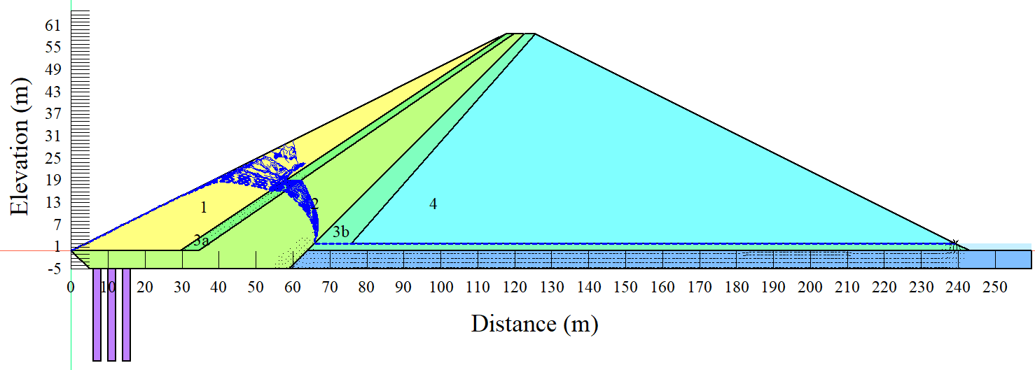
Figure 5.26 – Rapid drawdown (1 m per day) seepage under the reduced operating water level

Slope stability
Under the reduced operating water levels, the embankment was also subjected to slope stability analysis. For embankment slope stability, a minimum factor of safety of 1.5 is always suggested [289]. From Figure 5.27, it can be observed that the steady-state achieved a minimum factor of safety of 1.62; however, this value is too close to the minimum recommended value, signifying that the embankment will fail under a rapid drawdown scenario. It is also worth noting that a steady-state flow condition is one in which the pressure at any location in the reservoir remains constant across time. In that matter, if the water level in the embankment is high enough to provide balance, it is expected that the factor of safety value should be relatively high. However, the observed low factor of safety value under the reduced reservoir operating level can be highly linked to the combination of the material properties and slope of the upstream face of the embankment. Based on these results, we understand that there is a significant influence of the reservoir's long-term operating level on the embankment slope stability.

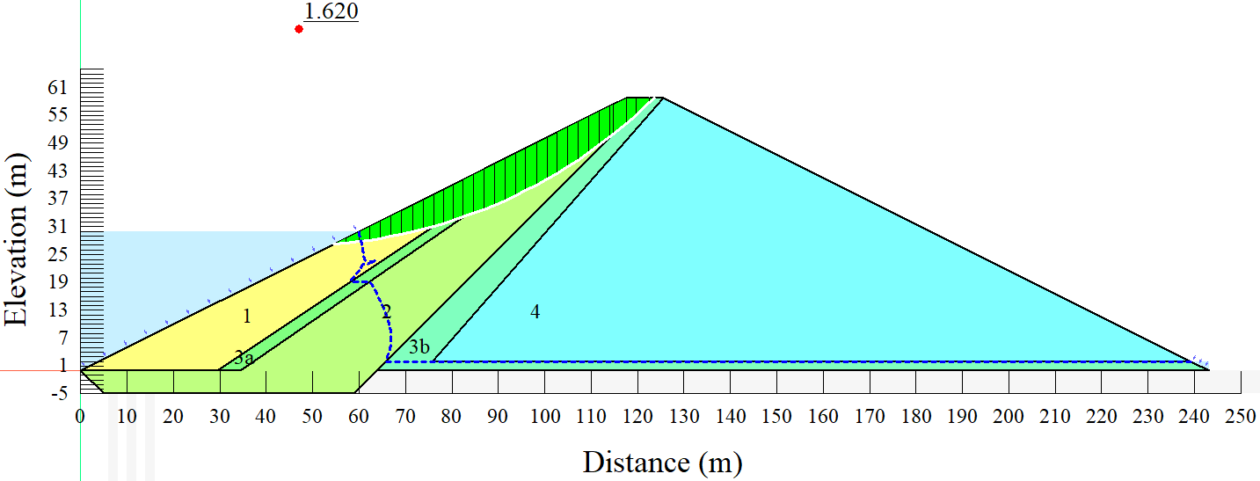
Figure 5.27 – Steady-state slope stability under the reduced operating water level
Figure 5.28 presents the assumed worst scenario of the drawdown rate where the reservoir is drained instantly. With the long-term reservoir operating level being almost at the middle of the embankment height, the embankment completely fails under an instantaneous drawdown rate. Safety factors are a measure of how reliable geotechnical structures like embankment dams and soil slopes are. The safety factor accommodates for design load uncertainties as well as input value inconsistencies. In that matter, it is worth noting that a larger safety factor from a well-investigated system can provide an indication that the embankment is relatively stable and less prone to failure under different operating conditions.

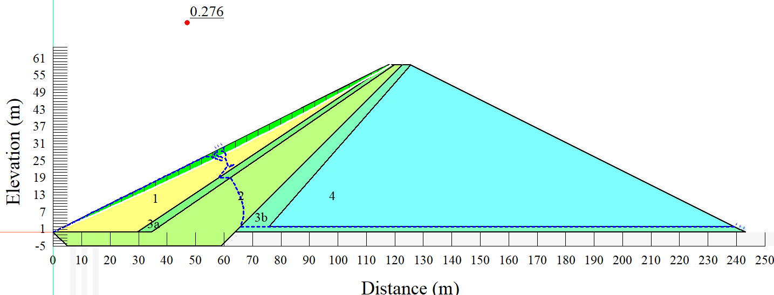
Figure 5.28 – Instantaneous slope stability under the reduced operating water level
Figure 5.29 depicts the results from the 5 days drawdown rate, in which the reservoir is completely drained within 5 days. However, from the minimum obtained factor of safety value, we can understand that the embankment fully breaks under the specified drawdown rate with the long-term reservoir operating level almost at the midpoint of the embankment height.

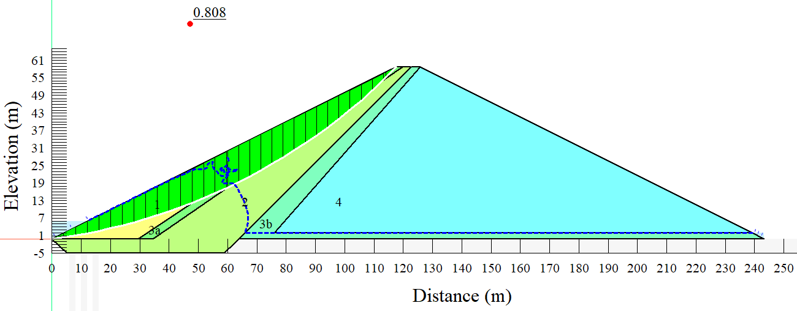
(a)
Hypothetical region after failure: Minimum FS = 0.901
(b)
Figure 5.29 – Rapid drawdown (5 days) slope stability under the reduced operating water level; a) embankment with slip surface; b) graph of factor of safety values
The results of the 10 days drawdown rate, in which the reservoir is drained in 10 days, are shown in Figure 5.30. However, the embankment breaks under the required drawdown rate, with the long-term reservoir operating level almost at the midway of the embankment height, as shown by the minimal obtained factor of safety value.
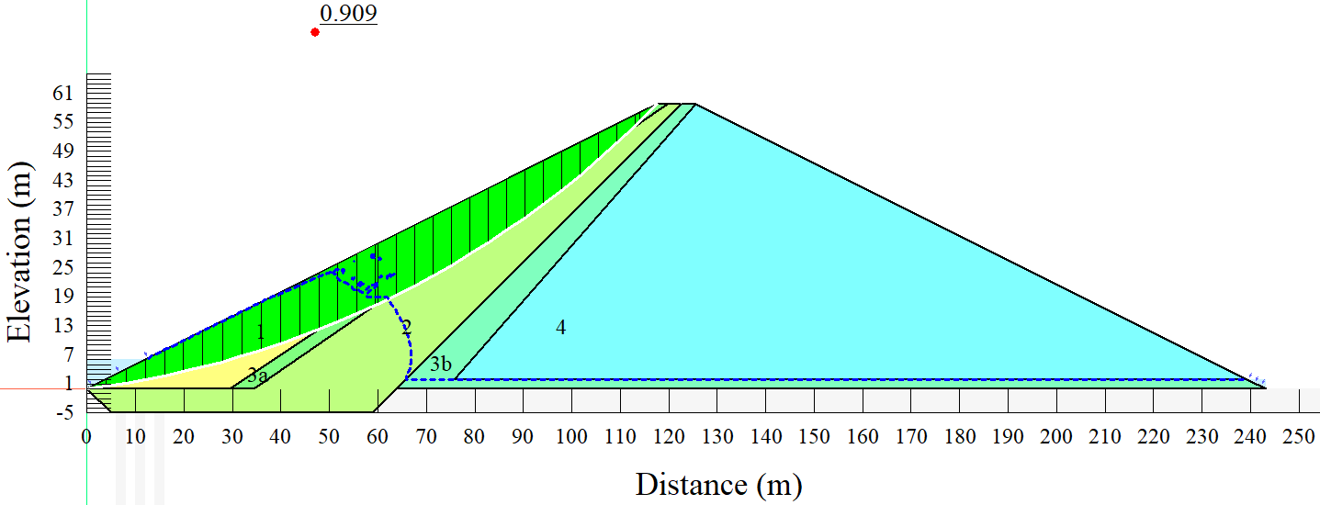
Figure 5.30 – Rapid drawdown (10 days) slope stability under the reduced operating water level
Despite the improvement in terms of the factor of safety value when the embankment was subjected to the 1 m per day drawdown rate, still the 1.107 (as shown in Figure 5.31) minimum factor of safety value is not sufficient enough to guarantee the safety of the embankment.
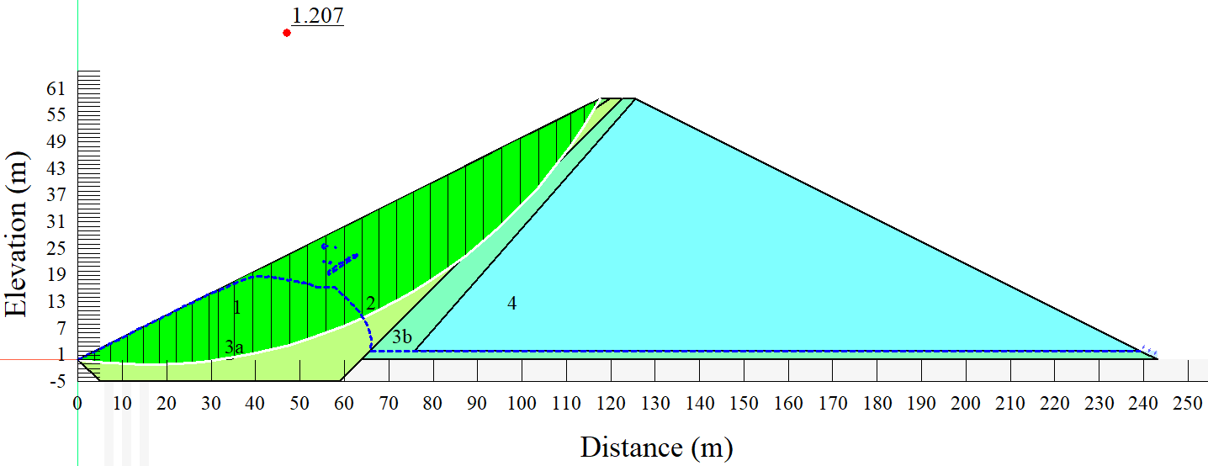
Figure 5.31 – Rapid drawdown (1 m per day slope stability) under the reduced operating water level

At embankment height
The long-term water level was increased to the maximum height of the embankment in this study, and then seepage and slope stability analyses were performed. This was done to capture the effect of rapid drawdown when the long-term operating reservoir water level has increased in the reservoir. It is also worth noting that land use and land cover change, as well as climatic conditions, are among the key elements that can contribute to a substantial increase in the reservoir's long-term operating level.

Seepage analysis
We can see from Figure 5.32 that the buildup of pore-water pressures had greatly decreased as compared to when the long-term water level was reduced to half of the embankment; whereby, in the analysis, it was observed that the first three zones of the embankment were subjected to excess pore-water pressure. As previously stated, the pore water pressure is crucial for separating total stress from effective stress in soil; thus, a correct depiction of soil stress is required for exact field calculations.
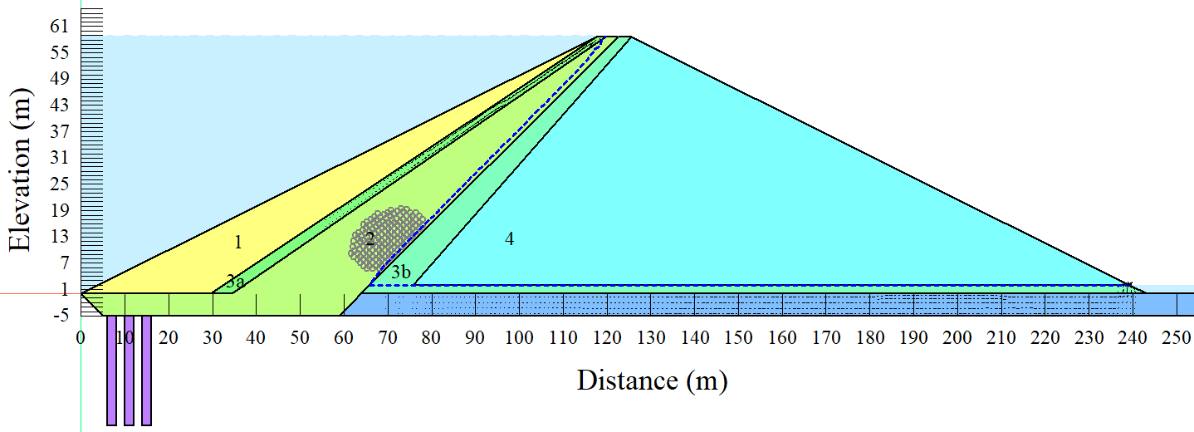
Figure 5.32 – Steady-state seepage at embankment height operating level
The results of the instantaneous (worst-case scenario) drawdown seepage under increased operating water levels are shown in Figure 5.33. Even after the water in the reservoir has been completely drained, the pore-water pressures in the embankment remain quite high, as seen by the piezometric lines in the figure. According to the literature, if an embankment is erected over a high cohesive material foundation, the material may experience a temporary situation of excess pore pressure. Due to the soil's limited permeability, the increased pore pressure cannot easily dissipate. In a non-steady-state scenario, greater pore pressure can lead to lower safety factors and possible failure.
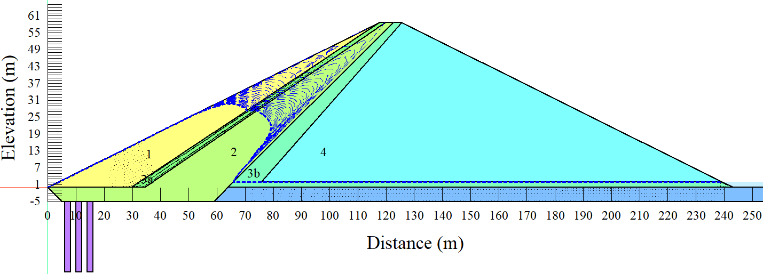
Figure 5.33 – Instantaneous seepage at embankment height operating level
The drawdown rate was reduced to 5 days after the instantaneous drawdown scenario, with the outcomes of the 5 days drawdown seepage under reduced working water level displayed in Figure 5.34. The piezometric lines in the picture show a similar phenomenon: even after the water in the reservoir has been fully drained, the pore-water pressures in the embankment remain relatively high. As previously mentioned, permeable non-cohesive soils have been shown in the literature to have a high sensitivity to stress variations produced by construction and reservoir level fluctuations, as well as fast dissipation [290].
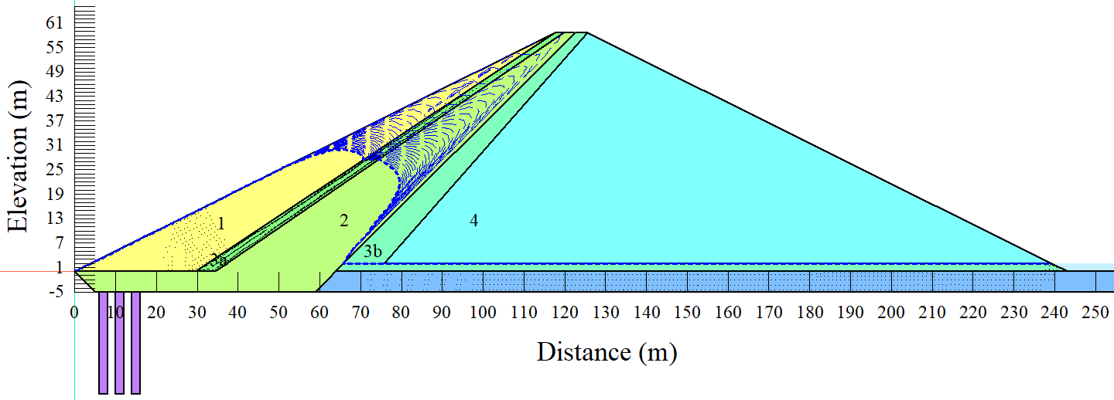
Figure 5.34 – Rapid drawdown (5 days) seepage at embankment height operating level
Following the immediate and 5 days drawdown rates, the drawdown rate was reduced to 10 days, with the results of the 10 days drawdown rate seepage under increasing operating water level shown in Figure 5.35. The piezometric lines in the Figure still demonstrate the same phenomenon as the instantaneous and 5 days drawdown rates, namely that pore-water pressures in the embankment remain relatively high even after the reservoir has been completely drained. This event also demonstrates that even when the drawdown rate is lowered to 10 days, the embankment's stability may be jeopardized.
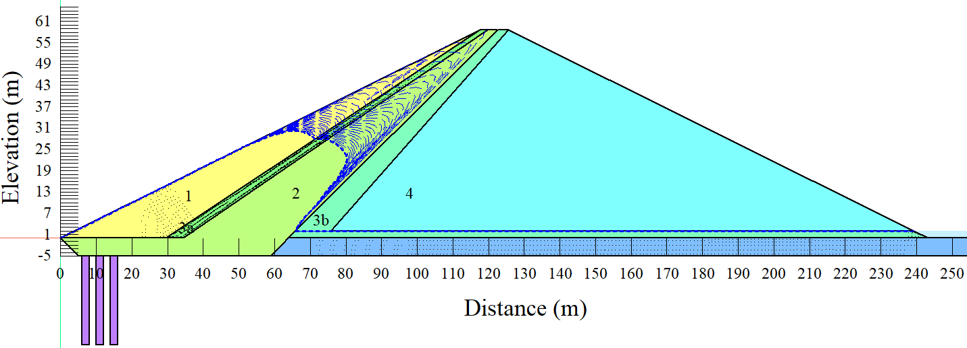
Figure 5.35 – Rapid drawdown (10 days) seepage at embankment height operating level
Despite modest gains in terms of pore-water pressure dissipation when the drawdown rate was reduced further to 1 m per day, Figure 5.36 shows that pore-water pressure dissipation after the drawdown is a substantial challenge. It's worth once again noting that as the soil becomes more saturated, the pore water pressure rises, lowering the shearing resistance of the soil. As a result of this condition, the slope's factor of safety is diminished. The level of permeability rate in the upstream zone of the embankment enhances pore water pressure.
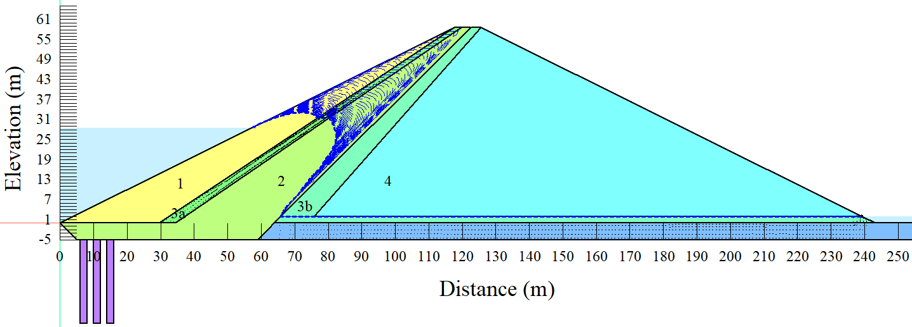
Figure 5.36 – Rapid drawdown (1 m per day) seepage at embankment height operating water level

Slope stability
A slope stability study was also performed on the embankment when operating water levels were increased to the maximum embankment height. With the fact that normally a minimum factor of safety of 1.5 is recommended to ensure that the embankment is relatively safe from failure, the factor of safety value of 1.795, as observed in Figure 5.37, is considered to be safe under steady-state operating conditions. However, as previously stated that in a steady-state flow condition, the pressure at any point in the reservoir remains constant over time.
The design of this study intended to investigate the potential effect of the rapid drawdown conditions on the embankment slope stability when the reservoir is operating at the maximum embankment height. The retrieved factor of safety value from the steady-state under increased operating level is approximately 10.8% higher than that of 1.62 factor of safety value observed when the operating level was reduced to half of the embankment.
The water level in the embankment appears to be sufficient in this situation to maintain a balance between the reservoir and the embankment, a phenomenon that may be required to obtain a high factor of safety value.

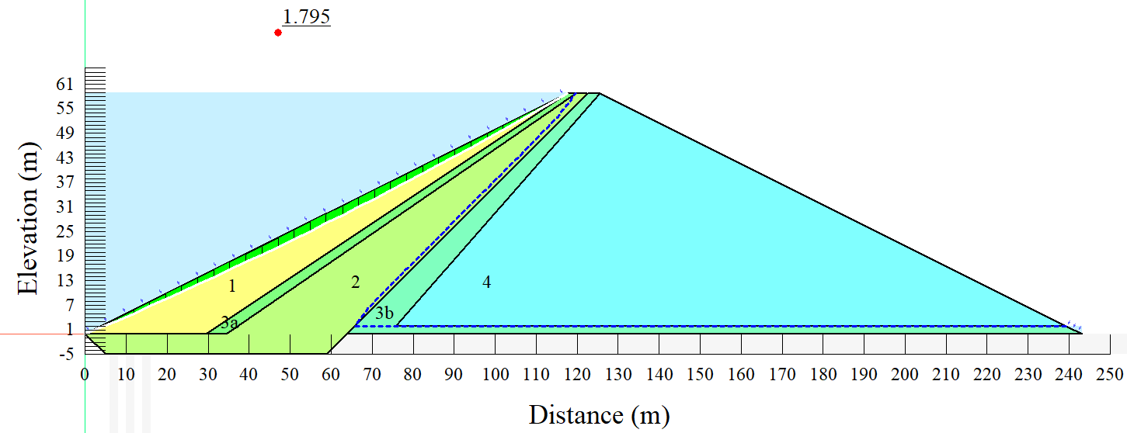
Figure 5.37 – Steady-state slope stability at embankment height operating water level
Figure 5.38 depicts the worst-case drawdown rate, in which the reservoir is completely drained within a very short period. Based on the minimum factor of safety value, we understand that the embankment immediately fails under instantaneous drawdown with the long-term reservoir operating level almost at the maximum embankment height; this is due to the fact that safety factors measure the reliability of geotechnical structures such as embankment dams and soil slopes. Whereby it should also be highlighted that the safety factor accounts for design load uncertainties.
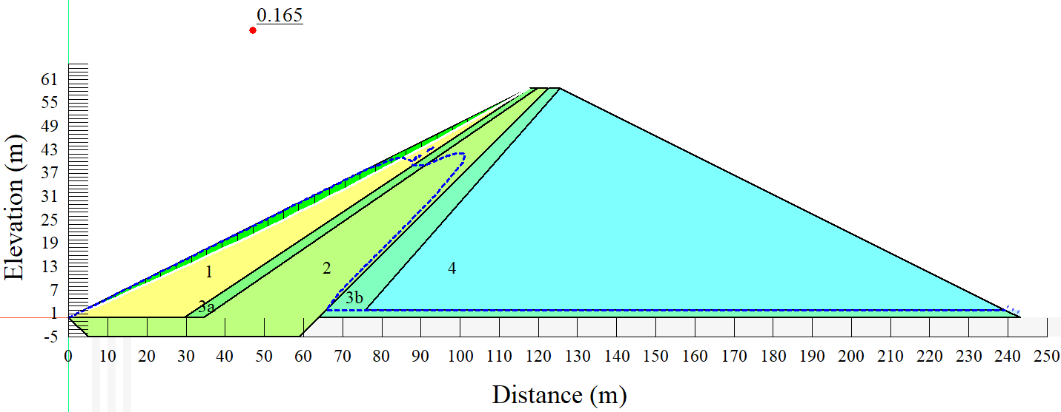
Figure 5.38 – Instantaneous slope stability at embankment height operating water level
The results of the 5 days drawdown rate, in which the reservoir is drained in 5 days, are shown in Figure 5.39. However, the embankment completely fails under the assigned drawdown rate, with the long-term reservoir operating level almost at the maximum height of the embankment height, judging from the minimal obtained factor of safety value. The minimum factor of safety value of 0.210 is way far below the recommended values.
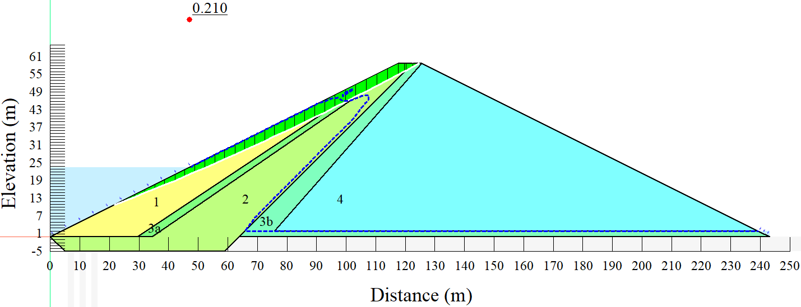
Figure 5.39 – Rapid drawdown (5 days) slope stability at embankment height operating water level
Furthermore, the required factor of safety increased to some extent from 0.206 (5 days drawdown) to 0.290 (Figure 5.40) when the embankment was subjected to a 10-day drawdown rate. However, the 10-day drawdown rate's minimal factor of safety value is still significantly below the specified minimum factor of safety value for slope stability in embankments. Apart from the 1.5 recommended minimum factor of safety value, some other literature sources use 1.0 as the threshold for the factor of safety values; whereby, according to the other sources, when the factor of safety is less than 1.0, a slope is considered unstable [291].
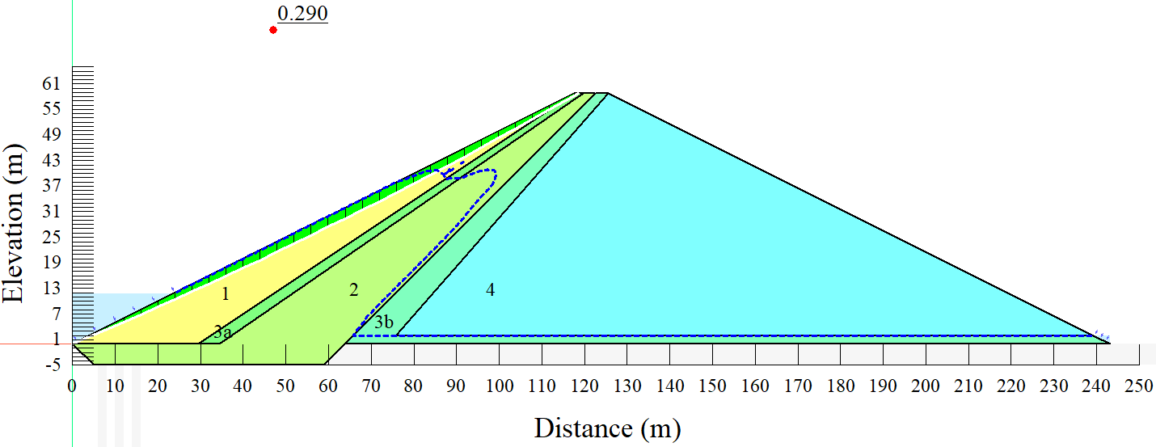
Figure 5.40 – Rapid drawdown (10 days) slope stability at embankment height operating water level
The drawdown rate was then reduced to 1 m per day. Whereby, the minimum factor of safety value of 0.875 was retrieved from the 1 m per day drawdown rate, as shown in Figure 5.41. The recovered minimal factor of safety value for embankment slope stability is still below the recommended minimum factor of safety value. The general phenomenon shows that the embankment will completely fail if it is subjected to a rapid drawdown while it is operating under the maximum height water level. When evaluating the stability of man-made or natural slopes, however, it is significantly important to choose the most critical surface, which means the critical surface with the lowest factor of safety value. Following the selection of this surface, it is also necessary to decide whether the slope should be reinforced to satisfy the minimum required factor of safety. Slope stability problems have forced projects to be dramatically revised in the past, according to the literature [292].
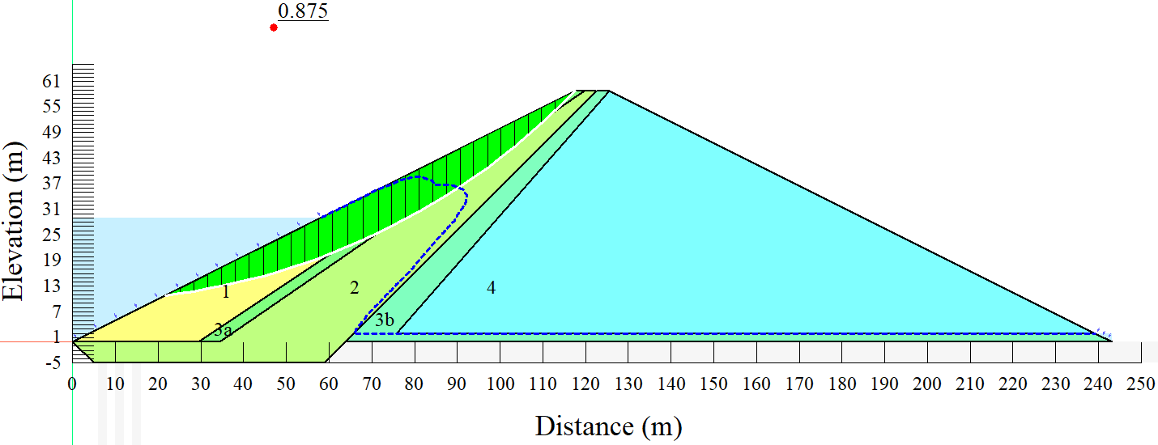
Figure 5.41 – Rapid drawdown (1 m per day) slope stability at embankment height operating water level

Analysis of variance (ANOVA) from different operating levels.
When the different operating water levels were used under instantaneous drawdown rate, the ANOVA results are summarized in Table 5.8. It can be observed that the studied parameters yielded a p-value of 2.37× 10⁻⁵, which is less than the alpha value of 0.05, showing a high level of statistical significance from the factor of safety values.
Table 5.8 ANOVA results from different operating reservoir levels and instantaneous drawdown rate
ANOVA: Single Factor
SUMMARY
Groups | Count | Sum | Average | Variance
Normal | 31 | 49.579 | 1.599 | 0.099
Reduced | 31 | 39.537 | 1.275 | 0.075
Maximum | 31 | 49.181 | 1.586 | 0.086
ANOVA
Source of Variation | SS | df | MS | F | P-value | F crit
Between Groups | 2.085776 | 2 | 1.042888 | 12.01519 | 2.37× 10⁻⁵ | 3.097698
Within Groups | 7.811768 | 90 | 0.086797
Total | 9.897544 | 92
Table 5.9 presents the results from the ANOVA when the different operating reservoir levels were applied under the 5 days drawdown rate. It can be seen that a p-value of 0.01071 was retrieved, which is less than the alpha value of 0.05. The obtained p-value also shows a high level of statistical significance in the differences in terms of factor of safety values.
Table 5.9 ANOVA results from different operating reservoir levels and 5 days drawdown rate
ANOVA: Single Factor
SUMMARY
Groups | Count | Sum | Average | Variance
Normal | 31 | 30.063 | 0.970 | 0.140
Reduced | 31 | 33.600 | 1.084 | 0.047
Maximum | 31 | 24.289 | 0.784 | 0.262
ANOVA
Source of Variation | SS | df | MS | F | P-value | F crit
Between Groups | 1.42528 | 2 | 0.71264 | 4.773089 | 0.01071 | 3.097698
Within Groups | 13.43733 | 90 | 0.149304
Total | 14.86261 | 92

The findings of the ANOVA when the varied operational reservoir levels were applied under the 10 days drawdown rate are shown in Table 5.10. As can be seen, a p-value of 4.81× 10⁻⁵ was found, which is lower than the alpha value of 0.05. In terms of variations in factor of safety values, the calculated p-value likewise reveals a high level of statistical significance.
Table 5.10 ANOVA results from different operating reservoir levels and 10 days drawdown rate
ANOVA: Single Factor
SUMMARY
Groups | Count | Sum | Average | Variance
Normal | 31 | 26.440 | 0.853 | 0.167
Reduced | 31 | 34.797 | 1.122 | 0.056
Maximum | 31 | 22.041 | 0.711 | 0.141
ANOVA
Source of Variation | SS | df | MS | F | P-value | F crit
Between Groups | 2.708766 | 2 | 1.354383 | 11.12675 | 4.81× 10⁻⁵ | 3.097698
Within Groups | 10.95508 | 90 | 0.121723
Total | 13.66385 | 92

Table 5.11 presents the results from the ANOVA from the factor of safety values when the different operating reservoir levels were applied under the 1 m per day drawdown rate. It can be seen that a p-value of 0.090534 was retrieved, which is less than the alpha value of 0.05 (statistically significant).
Table 5.11 ANOVA results from different operating reservoir levels and 1 m per day drawdown rate
ANOVA: Single Factor
SUMMARY
Groups | Count | Sum | Average | Variance
Normal | 61 | 77.295 | 1.267 | 0.101
Reduced | 61 | 74.580 | 1.223 | 0.035
Maximum | 61 | 69.833 | 1.145 | 0.153
ANOVA
Source of Variation | SS | df | MS | F | P-value | F crit
Between Groups | 0.467745 | 2 | 0.233872 | 2.434373 | 0.090534 | 3.046148
Within Groups | 17.29276 | 180 | 0.096071
Total | 17.7605 | 182

Comparison of different slope stability methods
Figure 5.42 presents the results from different slope stability analysis methods under steady-state conditions; it can be observed that, except for the Bishop method, which produced 1.971 as a long-term steady-state factor of safety value, all the other methods produced the same long-term steady-state factor of safety value. However, the difference between the factor of safety retrieved from the Bishop method and the other methods (Spencer, Janbu, Morgenstern-Price, and Sarma) is relatively small to make a significant impact. According to the study conducted by Wen-Jie Niu [293] that worked on the analytical solution for slope safety factor determination, a similar phenomenon was observed; whereby the minimum safety factor for the example slope using the Ordinary approach was 1.328. The lowest safety factor for the example slope using the Bishop approach was 1.390. The minimum safety factor for the example slope using the Janbu approach was 1.316. The minimum safety factor for the example slope using the Morgenstern-Price approach was 1.389. The lowest safety factor for the example slope using the Spencer technique was 1.389. The variation in terms of factor of safety values recovered from different slope stability analysis methodologies was relatively minimal, according to the findings. The lowest safety factor for the example slope using the GLE approach was 1.389. After solving and evaluating the problem with the Janbu generalized technique using the SLOPE/W program, a safety factor of 1.389 was retrieved.
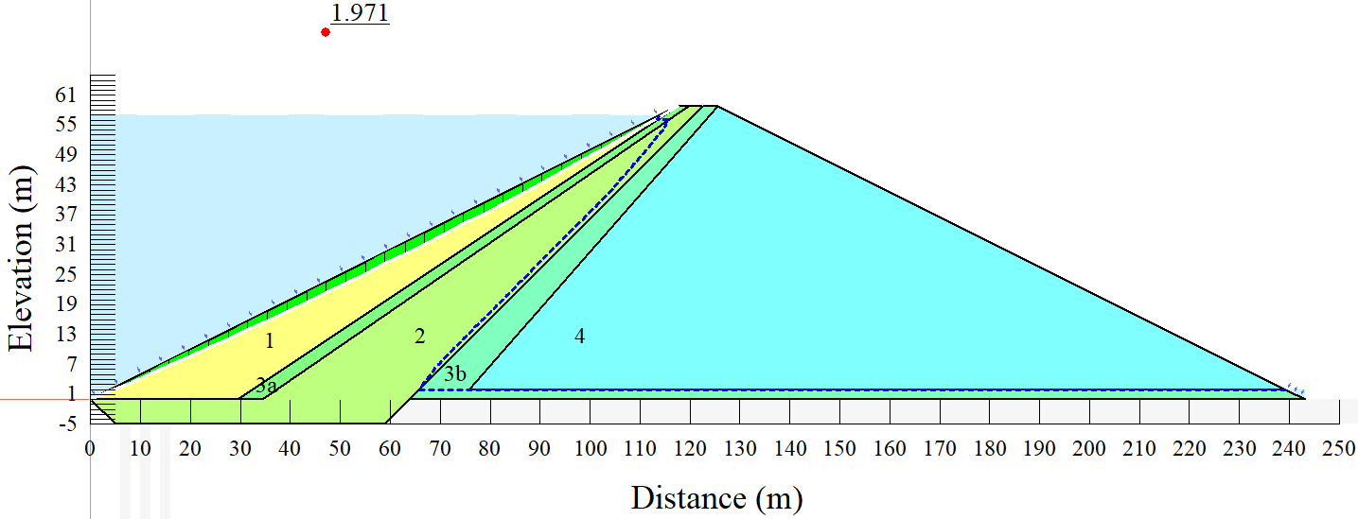
(a)
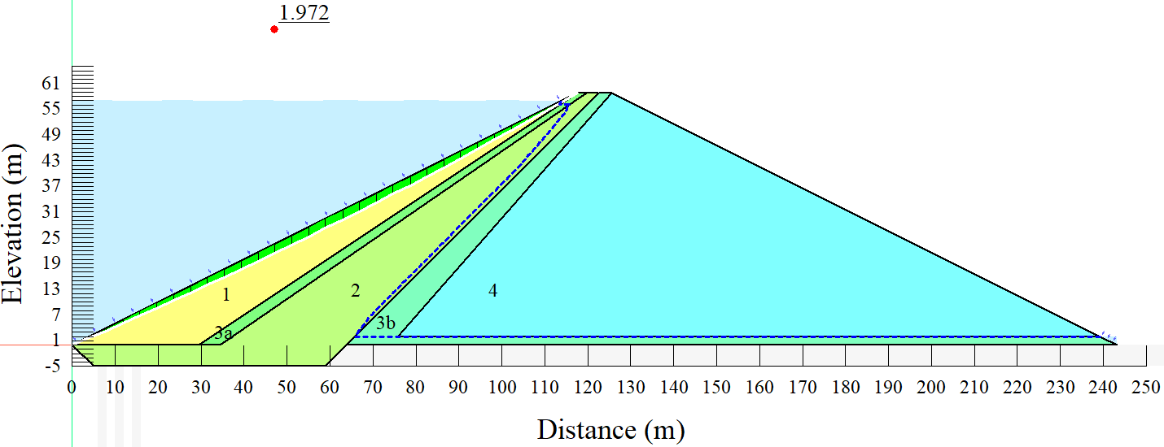
(b)
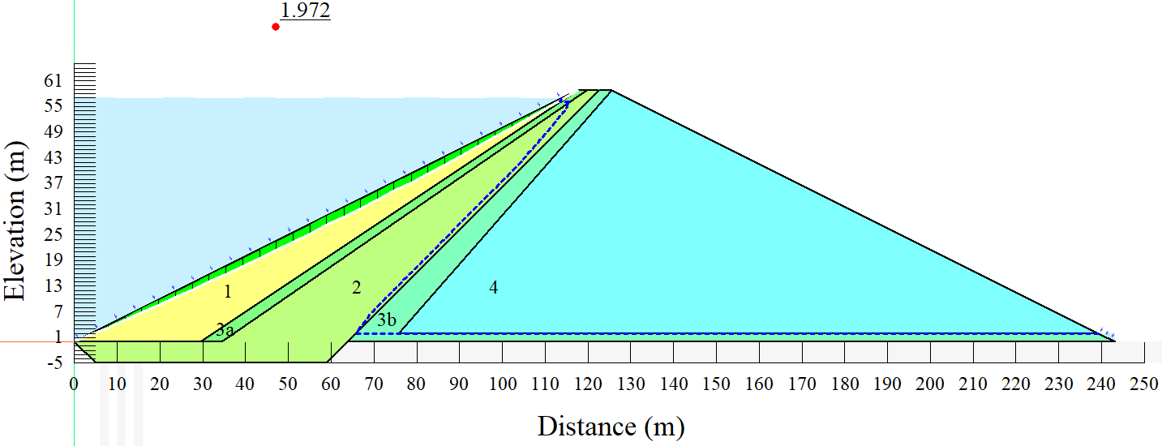
(c)
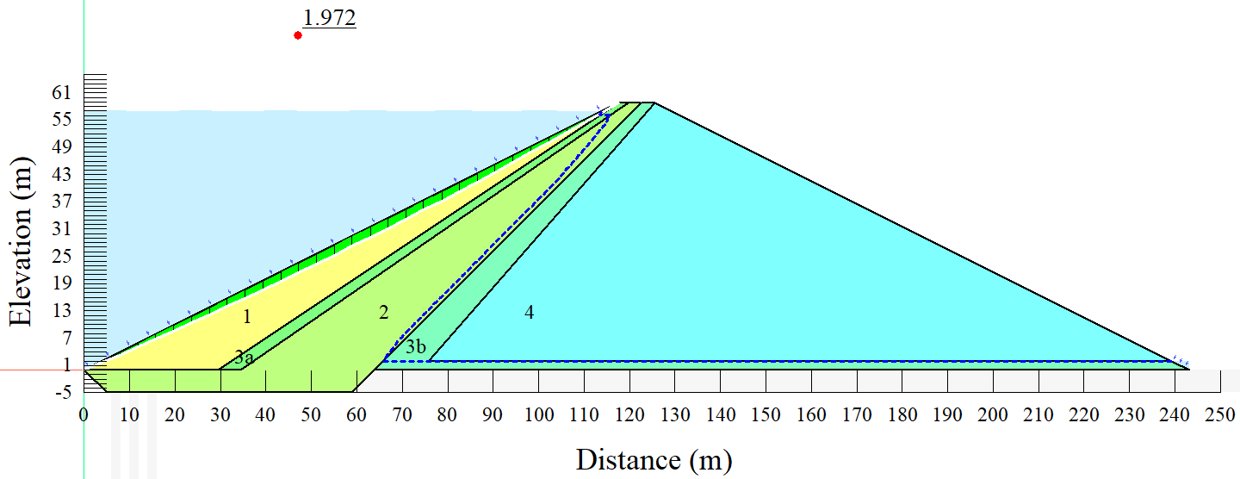
(d)
Figure 5.42 – Results from different slope stability analysis methods under steady-state conditions: a) Bishop method; b) Janbu; c) Morgenstern-Price; d) Sarma

Summary of the sub-section
The potential influence of material characteristics on the slope stability of an embankment dam under rapid drawdown conditions has been investigated. The influence of material characteristics on slope stability was investigated mainly based on the different hydraulic conductivity values assigned to zone 1 of the embankment. The investigation was achieved using the finite element method for the case of the Lugoda dam in the Ndembera catchment in Tanzania. Because impermeability affects pore-water pressure dissipation, pore-water pressures in the embankment remain rather high after the drawdown, according to the conclusions of the investigation. Also, the lowest minimum factor of safety value is obtained when the hydraulic conductivity value drops to 10⁻⁷ m/s, with a value of 0.901 which is below 1. The phenomenon indicates that, at a drawdown rate of 1m per day to a half of the maximum water level, there will be a potential failure of the embankment if the hydraulic conductivity value is below 10⁻⁶ m/s. Alternatively, if the hydraulic conductivity value has to be below 10⁻⁶ m/s, then a lower drawdown rate has to be applied to eliminate the potential failure. The results in this study revealed further that there is a significant relationship between slope stability and the combination of a drawdown rate and embankment material properties. Therefore, the phenomenon has to be carefully investigated and considered during the design phase of an embankment dam. When the embankment was investigated under a reduced reservoir level, a minimum factor of safety of 0.868 was retrieved from 5 days drawdown rate, but with the same drawdown rate under an increased water level, a minimum factor of safety value of 0.206 was obtained. The most interesting part is that, at a reduced reservoir operating level, the steady-state factor of safety value was lower than that obtained from an increased operating reservoir level.

Aktobe dam in Kazakhstan

Materials and methods

Case study description
The Aktobe dam is located approximately 10 km from the Aktobe City center in Western Kazakhstan; latitude: 50°12'23.26"N and longitude: 57°18'36.18"E. The reservoir with a volume of approximately 245 million m³ was put into operation in 1988. The Aktobe region is known to be among the largest regions in terms of area coverage in Kazakhstan, with an approximate area of 300,629 km² occupying approximately 11 % of the entire country.
Several rivers are decorating the Aktobe region, including the Kargaly river, which discharges its water into another river (Ilek River). One of the tributaries of the Ilek (left tributary) passes through the center of the Aktobe region. Sazdy River is another important river that passes within the city, whereby large entertainment centers, shopping malls, and other social buildings are located along the river banks.
In terms of climatic conditions, the Aktobe region is characterized by a humid continental climate with significantly high seasonal variation levels in terms of temperature. The region is also characterized by strong winters like many other parts of the country, with temperatures dropping as low as -48 °C, whereas the daily average minimum temperature is −16 °C. Also, the Aktobe region s characterized by strong summers with the temperature reaching 43 °C, whereas the average maximum temperature is 30 °C. However, it is also worth pointing out that the levels of weather changes are extremely high in the region in spring and autumn, especially during the windiest days of March. Moreover, the rainy seasons are generally during early spring and a bit of late autumn (the period when winter starts), characterized by heavy snows during the winter. On average, the annual precipitation in the Aktobe region is approximately 330 mm.
Like many other parts of Kazakhstan, the geological condition in the Aktobe region is characterized by significantly extensive basement rocks resulting from the Precambrian and relatively high widespread Paleozoic rocks. Based on some studies, it has been observed that the groundwater of some parts of the region is characterized by high concentration levels of petroleum products [294].

Embankment geometry and modeling process
In this study, finite element method analyses were used to evaluate the potential influence of rapid drawdown loading conditions on slope stability of an earth-fill dam for the case of the Aktobe dam. The general modeling process is characterized by two main types of analyses, namely, seepage analysis and slope stability analysis. The seepage analysis was executed using the SEEP/W unit of the GeoStudio, while the slope stability was executed using the SLOPE/W of the GeoStudio 2018 R2 (version 9.1.1.14749). Mainly, five different drawdown cases were used, namely; steady-state, instantaneous drawdown, 5-days drawdown, 10-days drawdown, and 1m per day drawdown rate. It is also worth noting that the seepage analyses were carried out concurrently with slope stability analyses. The Aktobe dam embankment is characterized by a maximum water depth of 18.5 m, with an embankment height of 22.7 m (Figure 5.43). The embankment is mainly divided into five different zones based on material properties (discussed in the materials properties section).

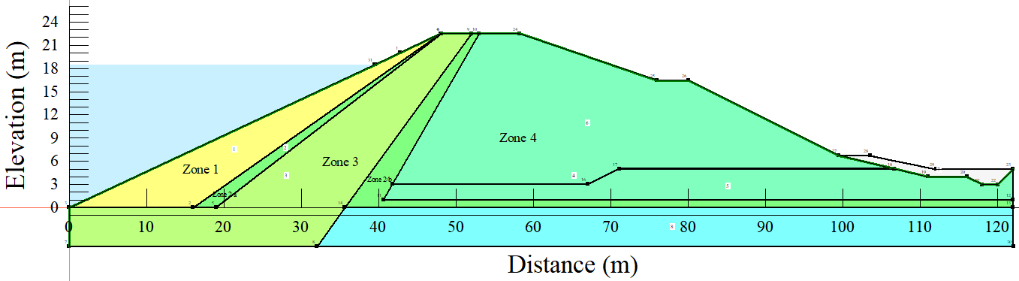
Figure 5.43 – Embankment geometry

Seepage analysis
In the seepage analysis, it was important to establish a long-term steady-state using the Steady-state type of analysis before subjecting the embankment to the transient analysis. In that matter, the developed long-term steady conditions were used to feed pore-water pressures to the transient seepage analyses through the “parent” approach. This was a crucial stage or procedure because, as a result of the lengthy storage of any embankment dam, the water penetrating through the embankment will form a steady-state condition of seepage, which must be taken into account during numerical modeling [167].
However, as previously mentioned, the numerical modeling process consisted of several drawdown rates (instantaneous, 5 days drawdown, 10 days drawdown, and 1 m per day drawdown rate) and isotropic hydraulic conductivity values. To model the transient flow through varying water levels as the reservoir was being drained, linear functions were specified as a boundary condition on the upstream face of the embankment. It is also worth highlighting that the transient flow analyses received pore-water pressures from seepage analyses. Figure 5.44 presents the summary of the drawdown boundary conditions for the 5 days drawdown, 10 days drawdown, and 1 m per-day drawdown rates.
(a) | (b)
Figure 5.44 – Boundary conditions: a) 10 days drawdown rate; b) 1 m per day drawdown rate

Slope stability analysis
As previously mentioned, the slope stability models received their pore-water pressures from the seepage analysis models. The slope stability modeling is generally based on the Morgenstern–Price approach, which is a general method of slices established based on the limit equilibrium. Its application requires the fulfillment of equilibrium of forces and moments acting on individual blocks. To generate the blocks, the soil above the slip surface has to be divided by dividing planes [279]. Generally, the method is a limit equilibrium approach used to assess the factor of safety value of the potential failure mass based on satisfaction of both force and moment equilibrium [160].
In this study, the Morgenstern–Price approach was selected due to the fact that it is capable of satisfying the equilibrium conditions and involves the least numerical difficulty [158]. Furthermore, the Morgenstern–Price technique assumes that the ratio of normal to shear interslice forces through the sliding mass is described by an interslice force function that is the product of a given function f (x) and an unknown scaling factor λ.
Several assumptions were incorporated in the formulation of the Morgenstern-Price method to compute the limit equilibrium of forces and moment on individual blocks [158]:
- The planes that divide one block and another are always vertical.
- The action line of the weight of the block passes through the center of the particular segment of slip surface represented by a point.
- The normal force is acting in the center of the particular segment of the slip surface at a point.
- The inclination of forces acting between blocks is different on each block at slip surface endpoints.

Material characteristics
The embankment was divided into different zones, and each zone was assigned a specific type of material based on the heterogeneity of the Aktobe dam. Zone 1 was composed of more non-cohesive materials (coarse materials) mixed with some fine materials with fixed hydraulic conductivity based on the dam material characteristics. Zones 2 (a) and (b) were also characterized by non-cohesive soil (filter materials) with more sand and gravel. On the other hand, Zone 3 was mainly composed of relatively high cohesive soil material, including fine-grained materials (clay). Moreover, Zone 4 was mainly composed of coarse material with relatively very little content of fines materials. In general, the liquid from all the zones ranged from 18% to 52%. From Table 5.12, it can be observed that some other parameters such as diameter at passing 10%, diameter at passing 60%, internal angle of friction (degree), as well as unit weight were specified in the model. Figure 5.45 presents the summary of the volumetric water content and hydraulic conductivity functions assigned to the model from Zone 1 and 2.

(a) | (b)
(c) | (d)
Figure 5.45 – Volumetric water content and hydraulic conductivity functions for different zones
Table 5.12 – Material properties
Parameter | Zone
 | Zone 1 | Zone 2 | Zone 3a, b | Zone 4
Saturated hydraulic conductivity (k_{sat}), m/s | 1.2 ∙ 10⁻⁵ | 1.42 x 10⁻⁸ | 1.1 x 10⁻⁴ | 5.2 x10⁻⁵
Diameter at passing 10% (mm) | 0.1 | 0.002 | 0.2 | 0.1
Diameter at passing 60% (mm) | 40 | 0.05 | 0.8 | 40
Liquid limit (%) | 25 to 45 | 50
Unit weight (kN/m³) | 20.5 | 20 | 18.5 | 20.5
Saturated water content (%) | 29.6 | 36.8 | 40.1 | 29.6
Internal angle of friction (degree) | 40 | 28 | 38 | 40
Cohesion (kPa) | - | 15 | - | -

Results and discussion
Both seepage and slope stability analyses were successfully executed. As previously mentioned, the investigation process is based on the different drawdown rates to investigate their influence on the stability of a heterogeneous embankment. Each investigated case started with seepage analysis followed by slope stability, whereby the seepage model acted as a parent to the slope stability model. Also, both steady-state and transient flow conditions were taken into consideration.

Seepage analysis
Generally, seepage flow within an embankment is the movement of water from the upstream side of the dam (where the reservoir is located) to the downstream side, crossing the dam body, preferably below the foundation. Due to the potential stability issues that can be associated, it is of significant importance to control seepage in earth-fill dams, especially during the design and construction phases of the dam.
From Figure 5.46, it can be observed that, based on the material arrangements from the Aktobe dam, the modeling revealed that under long-term steady-state conditions, the seepage within the embankment is safely carried without crossing the downstream face of the embankment. Seepage flow via earth-fill embankments has been identified as the primary cause of failure due to causes such as eroding, scouring, and piping, according to the literature [295].
Moreover, it is also important to investigate the long-term steady-state seepage because when the reservoir is filled, immediately water starts seeping through the body of the embankment. Whereby, after a certain time, the seepages reach steady conditions, and a distinct phreatic line is generated; that means the embankment soil under the distinct phreatic line is relatively saturated and is under seepage pressure. According to Perri et al., [296] an increase in embankment pore water pressures, which is linked to the development of the long-term steady-state seepage condition, can also result in a decrease in effective stress in the soil, which leads to a reduction in the available effective strength of the soil.

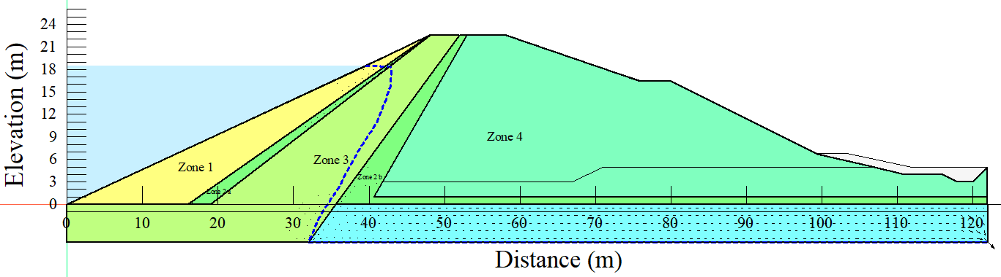
Figure 5.46 – Steady-state seepage
From Figure 5.47, it can be observed that the seepage line heights keep on decreasing with the decrease in water levels in the reservoir. It is also important to be noted that the first seepage line indicates the initial water level in the reservoir. Then when the reservoir drawdown was simulated by instantaneously removing all the water, the water level was relatively sustained at the level of the toe of the slope, making more of the seepage lines to be concentrated at the embankment toe [297].

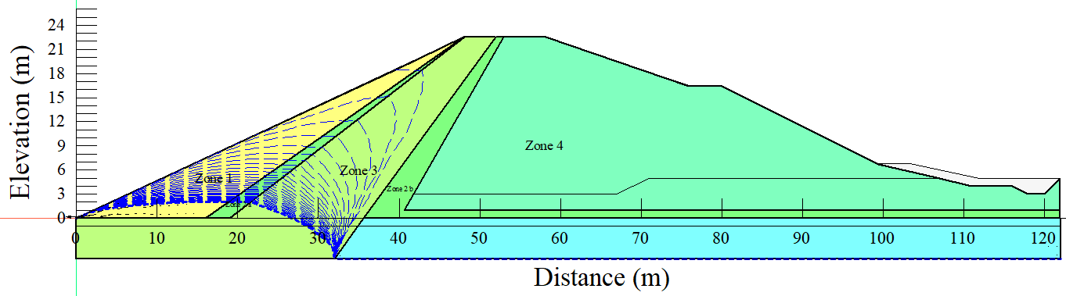
Figure 5.47 – Instantaneous seepage

Slope stability analysis
- Normal operating water level
The evaluation of slope stability is mainly based on the factor of safety values. From Figure 5.48, it can be seen that the long-term steady-state factor of safety value is 1.784, which is highly acceptable in terms of slope stability.
According to the Geotechnical Design Manual of the Washington State Department of Transportation [298], it is recommended that for slope stability analysis of permanent cuts, fills, and landslide repairs, 1.25 is adopted as the minimum safety factor value. Furthermore, it is recommended that larger safety factors must be adopted in a case when there is a potential uncertainty in the analysis input parameters. Also, according to Jiri H. et al. [289], some other authorities recommend a minimum factor of safety of 1.5 for slope stability analysis of embankments.
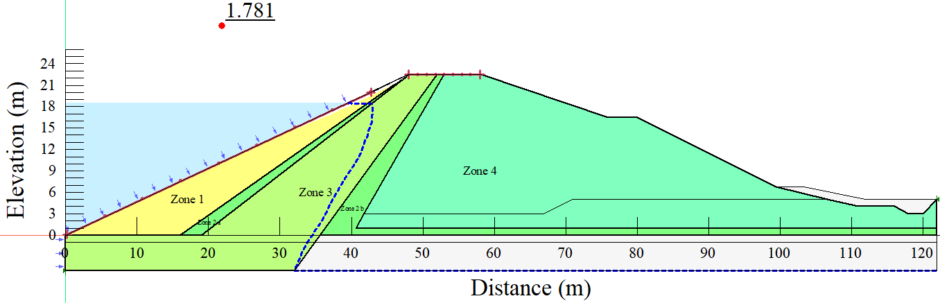
Figure 5.48 – Steady-state slope stability
When the embankment was subjected to the instantaneous, a minimum factor of safety of 1.164 was retrieved, whereby, based on the recommendation of some authorities, the obtained factor of safety is an indication of a potential failure. Also, from Figure 5.49(b) it can be observed that the lowest factor of safety value was obtained within the first day of the instantaneous drawdown; that means the potential failure is of immediate effect when the embankment is subjected to an instantaneous drawdown.

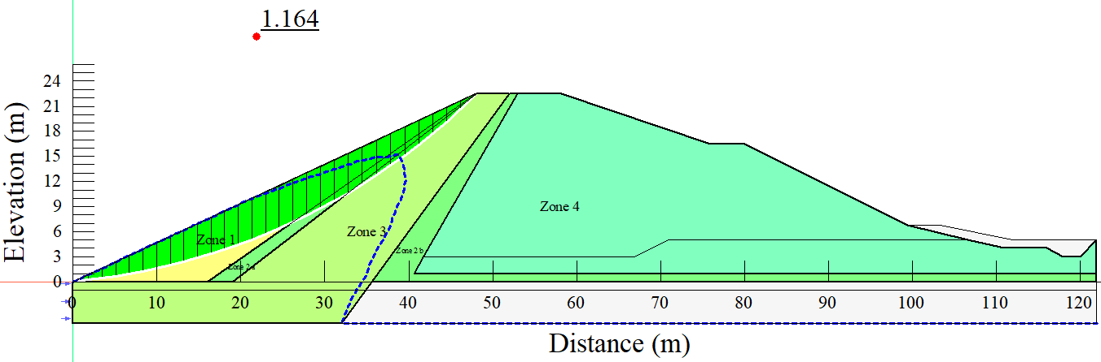
(a)
(b)
Figure 5.49 – Instantaneous slope stability: a) embankment with slip surface; b) factor of safety values graph
Also, when the embankment was subjected to 5 days drawdown rate, a factor of safety of 1.372 was achieved, which is a bit higher than the instantaneous drawdown (equivalent to a 17.9% increase). However, with the fact that some other authorities recommend a minimum factor of safety of 1.5 to consider an embankment safe during loading, the 1.372 factor of safety value may also signify a potential failure. From Figure 5.50, it can be observed that the minimum factor of safety value is obtained within the fourth and fifth day of the drawdown.

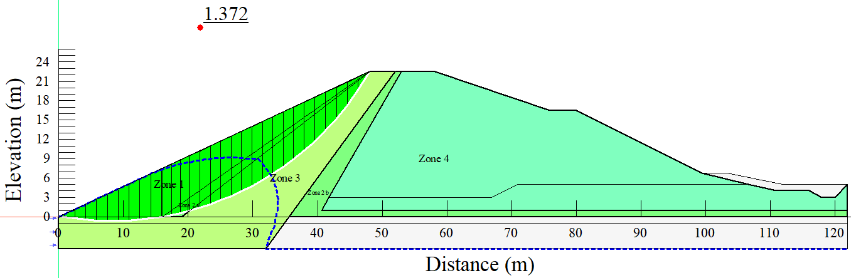
(a)
(b)
Figure 5.50 – Drawdown 5 days
Moreover, when the embankment body was subjected to 10 days drawdown rate, a minimum factor of safety of 1.433 was achieved, equivalent to a 4.4% increase from the 5 days drawdown rate and 23.1% from the instantaneous drawdown rate. From Figure 5.51, it can be observed that the minimum factor of safety value is obtained within the 9th day of the reservoir draining.
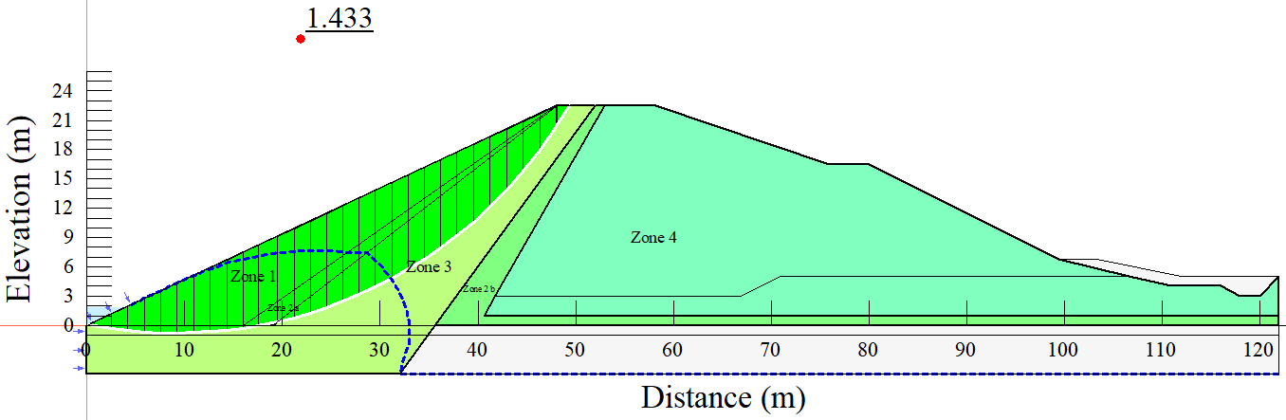
(a)
(b)
Figure 5.51 – Drawdown 10 days
Another case that was taken into account in this study is the 1 m per day drawdown rate (Figure 5.52); whereby, when the embankment was subjected to the 1 m per day drawdown rate, a minimum factor of safety value of 1.486 was retrieved from computations. The factor of safety value is equivalent to a 3.7% increase from the 10 days drawdown rate and 8.3% from the 5 days drawdown rate, and 48.6% from the instantaneous drawdown.
Furthermore, in the literature, rapid reservoir draining has been noted to be among the critical factors in the stability of embankment slopes that were initially submerged from the upstream face. Therefore, the reduction process of water level leads to two main consequences; firstly, a decrease in terms of the external stabilizing hydrostatic pressure due to the unloading effect of removing water, and secondly, alteration of the internal pore water pressure [270].

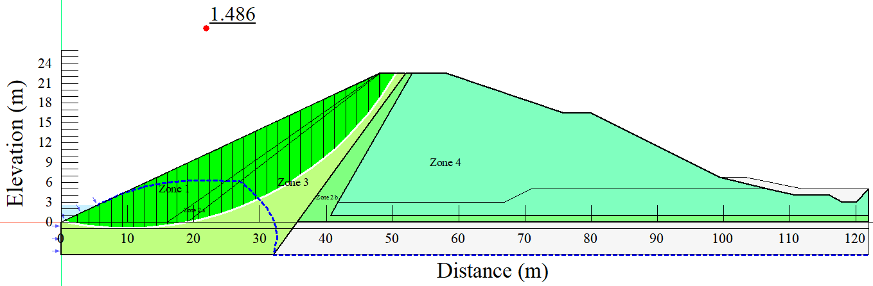
(a)
(b)
Figure 5.52 – Drawdown 1m per day
From Table 5.13, it can be observed that the minimum (min) factor of safety values were increasing with the decrease in drawdown rates. A similar phenomenon can be observed from the median, arithmetic mean (mean), and standard deviation (STD). However, the maximum (max) factor of safety values remained constant as they are determined by the long-term steady state.
As previously mentioned, the minimum factor of safety when the embankment was subjected to the instantaneous drawdown case was 1.164, while the same embankment was subjected to the 1 m per day drawdown rate, the minimum factor of safety was 1.49; which is equivalent to 48.6% % increase.
The minimum factor of safety is of interest in most cases because, in geotechnical engineering, for example, a factor of safety provides an overall picture of how much stronger a structure is than it needs to be for a specific type of loading; it is also expressed as the ratio of the structure's capacity to the appropriate demand [299,300]. Another key aspect to note is that these values are normally computed using detailed analysis due to the fact that comprehensive testing can be associated with feasibility issues on many engineering projects. However, the structure's ability to sustain potential loading conditions should be well checked in principle to resolute to a sensible accurateness. Moreover, well-designed with a sufficient value of factor of safety has the potential to increase the safety of people that in turn reduces the risk of failure of the particular structure [301–303].
Table 5.13 – Summary of the factor of safety values from the investigated drawdown rates
Drawdown type | Steady-state | The factor of safety value (minimum)
Instantaneous | 1.781 | 1.164
Drawdown-5 days | 1.781 | 1.372
Drawdown-10 days | 1.781 | 1.433
Drawdown-1 m per day | 1.781 | 1.486

In summary, the observed effects of the rapid drawdown loading conditions can be again linked to the fact that when the water in the reservoir is removed relatively fast, the sustaining water load from the embankment's upstream face, combined with changes in pore water pressure, causes an undrained unloading condition in which total stresses fall, causing shear stresses to rise within the embankment [304].
- Reduced operating water level
Figure 5.53 presents the results from the long-term steady state conditions and rapid drawdowns under reduced operating reservoir level. From the Figure 5.53, it can be observed that, a factor of safety value of 1.734 was retrieved from the long-term steady state conditions when the operating water level was reduced to almost half of the embankment. The retrieved factor of safety value is approximately 2.8% less than that was retrieved from the normal operating reservoir level.
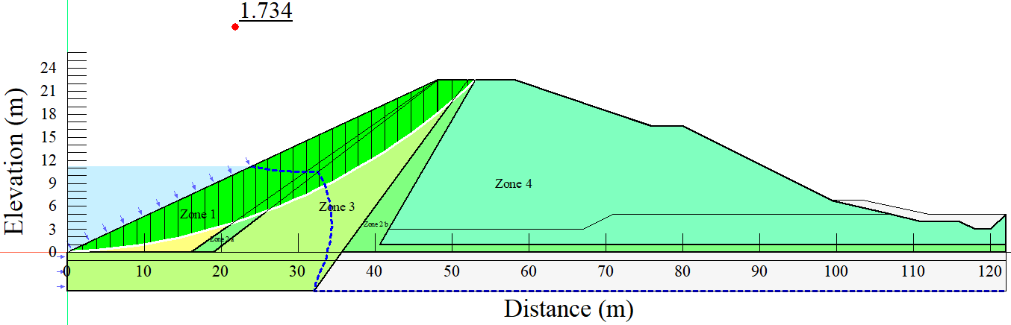
(a)
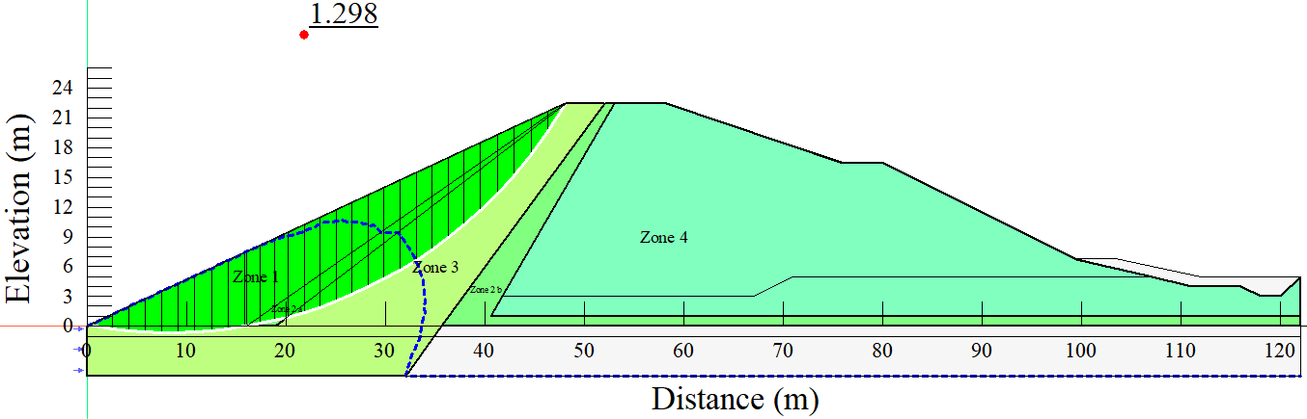
(b)
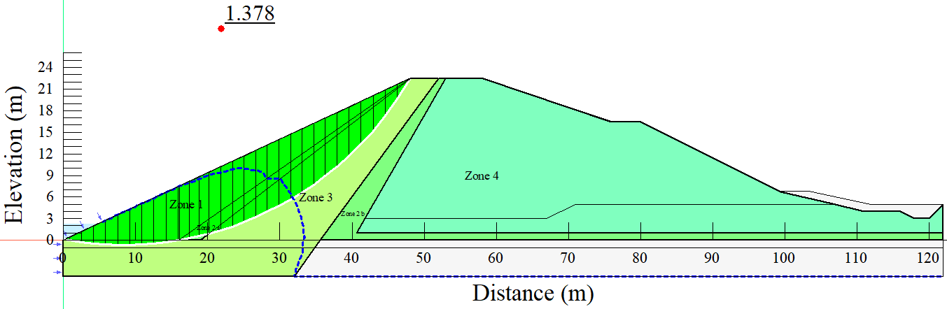
(c)
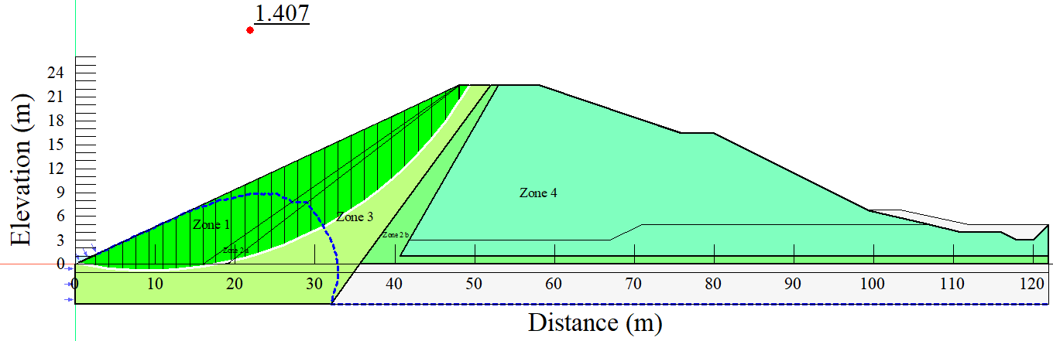
(d)
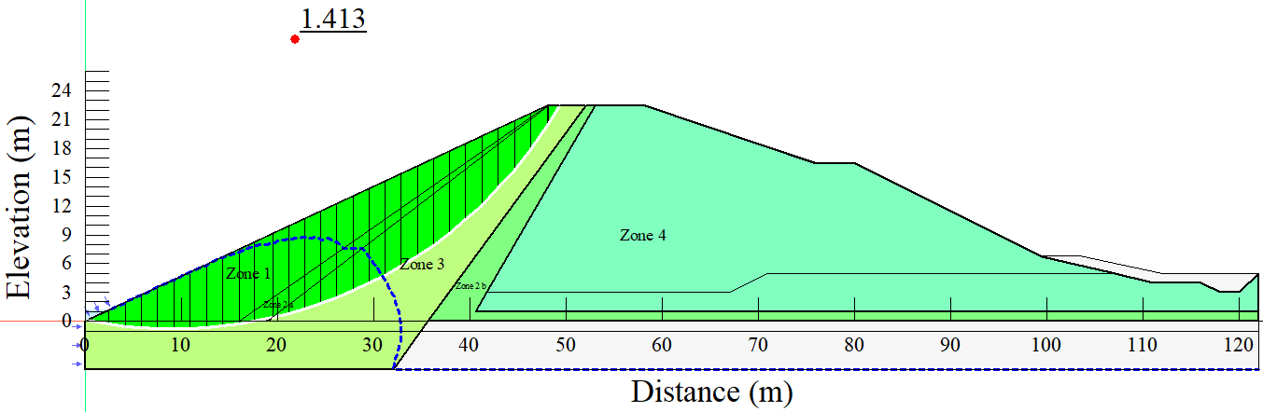
(e)

Figure 5.53 – Analysis results under reduced operating reservoir level: a) steady-state; b) instantaneous; c) 5 days; d) 10 days; e) 1 m per day

Figure 5.54 presents the results from different drawdown rates under reduced operating reservoir level. Generally, from the Figure 5.54 it can be seen that, the minimum factor of safety values are increasing with the decrease in the drawdown rate. For instance, a minimum factor of safety value of 1.298 was retrieved, 1.378 from the 5 days drawdown rate, 1.407 from 10 days drawdown rate, and 1.418 from 1 m per day.
(a) | (b)
(c) | (d)
Figure 5.54 – Different drawdown rates under reduced operating level: a) instantaneous; b) 5 days drawdown; c) 10 days drawdown; d) 1 m per day drawdown

- Embankment height operating reservoir level
The results of the long-term steady-state under embankment height operational reservoir level are shown in Figure 5.55. When the operational water level was dropped to approximately half of the embankment, a factor of safety value of 1.984 was obtained from the long-term steady-state conditions, as shown in Figure 5.55. The retrieved factor of safety value is around 11.21% higher than the one obtained from the normal operational reservoir level.
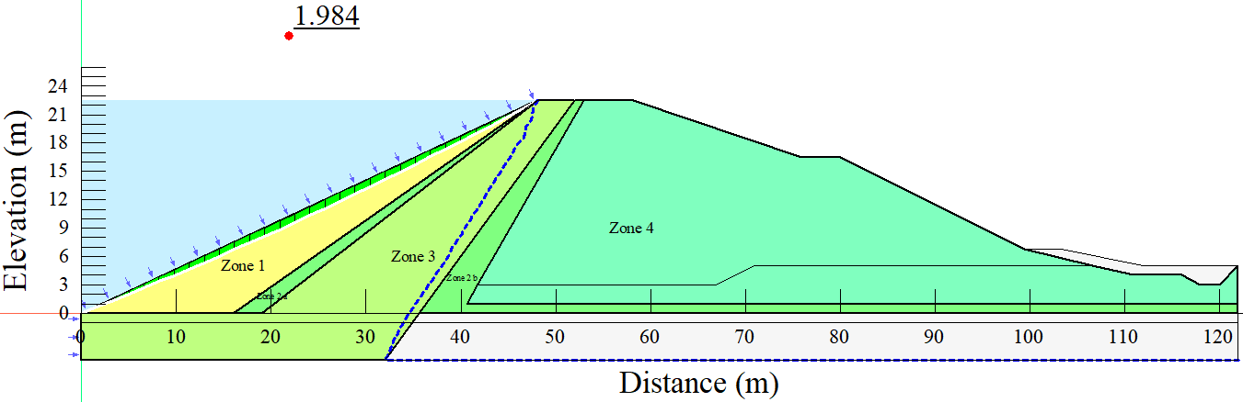
(a)
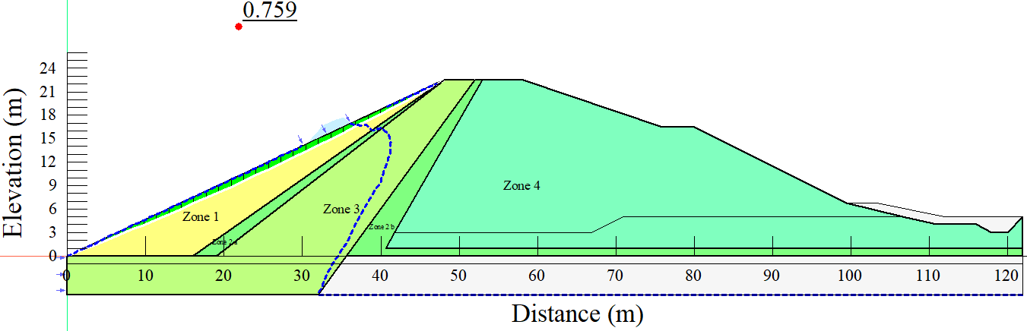
(b)
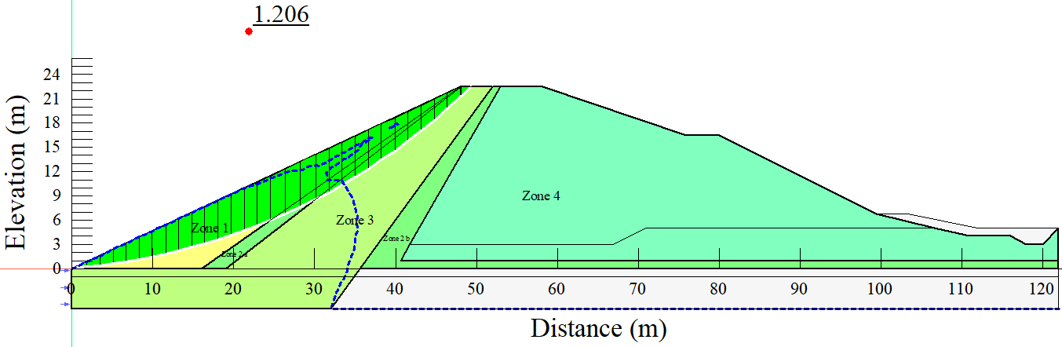
(c)
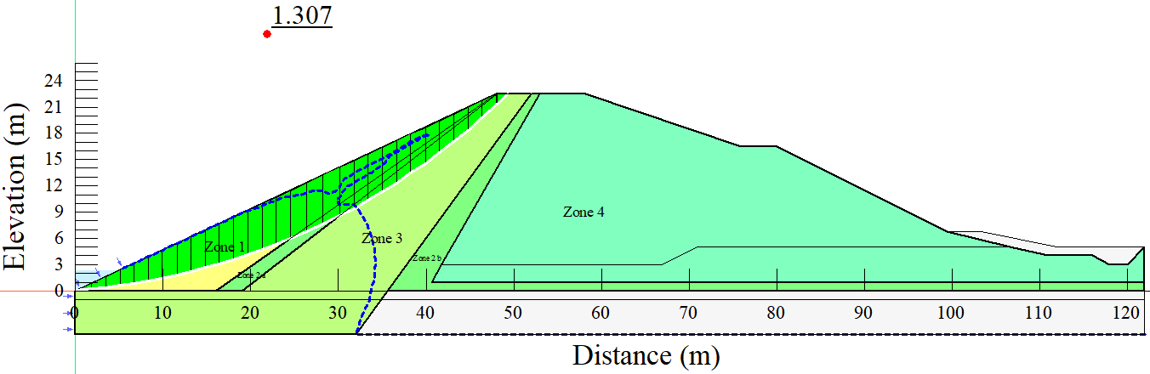
(d)
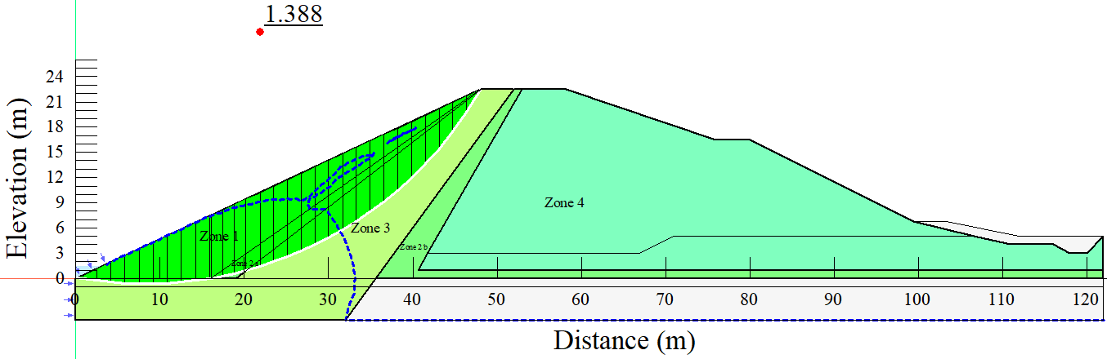
(e)
Figure 5.55 Steady-state results under embankment height operating reservoir level: a) steady-state; b) instantaneous; c) 5 days; d) 10 days; e) 1 m per day
Figure 5.56 presents the slope stability analysis results from the different drawdown rates under embankment height reservoir operating level. Similarly, from the results it can be understood that, the minimum factor of safety values were increasing with the decrease in the drawdown rates. Whereby, from the instantaneous drawdown rate, a minimum factor of safety of 0.759 was retrieved which is an indication of a total failure.
Hypothetical region after failure: Minimum FS = 0.76  (a) | (b)
(c) | (d)
Figure 5.56 Results from different drawdown rates embankment height operating level; a) instantaneous; b) 5 days drawdown; c) 10 days drawdown; d) 1 m per day drawdown

Analysis of variance (ANOVA)
It was also significantly important to investigate the significance levels of the differences in terms of factor of safety values under different operating levels. This was an important aspect for justifying further whether the investigated parameters had significant influence in the retrieved factor of safety values or not.
Table 5.14 presents the ANOVA results when different operating reservoir levels were subjected to the instantaneous drawdown rate. From Table 5.14 it can be seen that p-value of 1.36× 10⁻⁷ was retrieved which is less than alpha value of 0.05; signifying that the differences in factor of safety values from the investigated operating levels and instantaneous drawdown rate were statistically significant.
Table 5.14 ANOVA results from different operating reservoir levels under instantaneous drawdown rate
ANOVA: Single Factor
SUMMARY
Groups | Count | Sum | Average | Variance
Normal | 31 | 53.4791 | 1.725 | 0.041
Reduced | 31 | 45.344 | 1.463 | 0.008
Embankment | 31 | 46.589 | 1.503 | 0.0495
ANOVA
Source of Variation | SS | df | MS | F | P-value | F crit
Between Groups | 1.239 | 2 | 0.619 | 18.946 | 1.36× 10⁻⁷ | 3.098
Within Groups | 2.942 | 90 | 0.033
Total | 4.181 | 92
Table 5.15 presents the ANOVA results when different operating reservoir levels were subjected to the 5 days drawdown rate. From the 5 days drawdown rate, it can be observed that a p-value of 0.0127 was retrieved from the combination of 5 days drawdown rate and the different operating water levels. Furthermore, the obtained p-value is less than 0.05, indicating that the differences in factor of safety values between the investigated operating levels and instantaneous drawdown rate were statistically significant.
Table 5.15 ANOVA results from different operating reservoir levels under 5 days drawdown rate
ANOVA: Single Factor
SUMMARY
Groups | Count | Sum | Average | Variance
Normal | 31 | 49.97246 | 1.612015 | 0.041934
Reduced | 31 | 45.67487 | 1.473383 | 0.007394
Embankment | 31 | 46.75203 | 1.50813 | 0.056109
ANOVA
Source of Variation | SS | df | MS | F | P-value | F crit
Between Groups | 0.322588 | 2 | 0.161294 | 4.589306 | 0.0127 | 3.097698
Within Groups | 3.16311 | 90 | 0.035146
Total | 3.485699 | 92

Table 5.16 presents the ANOVA results when different operating reservoir levels were subjected to the 10 days drawdown rate. From the 10 days drawdown rate, it can be observed that a p-value of 0.0247 was retrieved from the combination of 10 days drawdown rate and the different operating water levels. Still, the obtained p-value is less than 0.05, indicating that the differences in factor of safety values between the investigated operating levels and instantaneous drawdown rate were statistically significant.
Table 5.16 ANOVA results from different operating reservoir levels under 10 days drawdown rate
ANOVA: Single Factor
SUMMARY
Groups | Count | Sum | Average | Variance
Normal | 31 | 50.5886 | 1.63189 | 0.053649
Reduced | 31 | 46.0159 | 1.484384 | 0.007959
Embankment | 31 | 48.08922 | 1.551265 | 0.069913
ANOVA
Source of Variation | SS | df | MS | F | P-value | F crit
Between Groups | 0.338228 | 2 | 0.169114 | 3.857478 | 0.0247 | 3.097698
Within Groups | 3.945646 | 90 | 0.043841
Total | 4.283874 | 92
Table 5.17 presents the ANOVA results when different operating reservoir levels were subjected to the 1 m per day drawdown rate. The combination of the 1 m per day days drawdown rate and the varying operating water levels yielded a p-value of 0.00268. Nonetheless, the p-value obtained was less than 0.05, indicating that the variations in factor of safety values between the tested operating levels and instantaneous drawdown rate were statistically significant.
Table 5.17 ANOVA results from different operating reservoir levels under 1 m per day drawdown rate
ANOVA: Single Factor
SUMMARY
Groups | Count | Sum | Average | Variance
Normal | 31 | 52.44189 | 1.691674 | 0.076134
Reduced | 31 | 46.15626 | 1.488911 | 0.00794
Embankment | 31 | 55.3746 | 1.786277 | 0.254961
ANOVA
Source of Variation | SS | df | MS | F | P-value | F crit
Between Groups | 1.431052 | 2 | 0.715526 | 6.331431 | 0.00268 | 3.097698
Within Groups | 10.17106 | 90 | 0.113012
Total | 11.60211 | 92

Summary of the sub-section
The influence of rapid drawdown loading conditions on the stability of the embankment dam has been investigated with the help of numerical modeling for the case of the Aktobe dam in Kazakhstan. From the investigation results, it was observed that when the embankment was subjected to the 1 m per day drawdown rate a minimum factor of safety value of 1.486 was retrieved from computations. The factor of safety value is equivalent to a 3.7% increase from the 10 days drawdown rate and 8.3% from the 5 days drawdown rate, and 48.6% from the instantaneous drawdown. However, some authorities recommend a minimum factor of safety of 1.5 for an embankment to be regarded as safe enough in terms of slope stability. The results in this study revealed further that even a heterogeneous dam supplied with a core in the embankment can be highly susceptible to failure when subjected to rapid drawdown loading conditions. To minimize potential collapse when the dam is in operation, it is critical to evaluate the reaction of an embankment dam when subjected to a rapid drawdown condition during the design phase of the embankment.

Chardara dam in Kazakhstan

Materials and methods

General construction materials and properties
A silty sandy layer 1.5 m to 2.5 m deep underpins a layer of fine sands 12 m to 17 m thick in the flood plain river portion, where the embankment axis is located. The intake construction is built on siltstones, marly clay, sand, and sandstone with conglomerate as bedrock. The base of the Arnasay embankment is made up of a silty sand layer 8 to 10 meters deep, which is overlain by a clay layer 2 to 5 meters thick or a thick layer of fine silty sand. In these places, the groundwater table lies between 0.5 and 2 meters below the surface. The concrete is being attacked by sulfate in this water. The dam is situated in earthquake zone VI. The embankment and its buildings, on the other hand, were meant to be of intensity VII [305]. Some more general characteristics are presented in Table 5.18.
Table 5.18 – General dimensions of the Chardara reservoir
Parameter | Unit | Value
Crest length | m | 5300
Crest level | m.a.s.l. | 254.5
Parapet level | m.a.s.l. | 255.5
Height of Embankment | m | 28.5
Crest width | m | 12.6
Upstream slope and downstream slopes | Upper berm | 1:4
 | Lower berm | 1:4.5

Materials and Properties of Construction
Table 5.19 lists the physical and mechanical qualities of the construction materials used in the design, as well as the material used in the embankment foundations.
Table 5.19 – General materials and properties
Material | Dry density t/m³ | Strength parameters
Material | Dry density t/m³ | tan φ | kg/cm²
Foundations
Clay | 1.5 | 0.51 | 0.15
Silt | 1.5 | 0.51 | 0.03
Sand | 1.6 | 0.56 | 0.158
Construction material
River Bed | 1.39 | 0.547 | 0.122
Flood-plain area | 1.39 | 0.544 | 0.124
Lacustrine area | 1.50 | 0.536 | 0.117

Cases investigated
Table 5.20 presents the different cases investigated in this study. In general, four (4) different cases were investigated based on the reservoir operating level. It has to be noted that one of the significant effects of the land use/land cover and climatic changes in the catchments is the changes in the reservoirs operating levels. When the catchment becomes more impervious, the streams receives more surface runoff than the underground flow. In such a phenomenon, there is a higher chance that the catchment will receive highly varied flows (high flows and low flows) while increasing the risk of the reservoir being subjected to long-term reduced operating water levels and long-term increased operating water level.
Table 5.20 – Cases used in the investigation process
Case number | Name | Description
1 | Normal operating level | Modeling is done based on the current reservoir operating level
2 | Reduced operating level | Modeling done with the long-term water level at the half of the embankment height
3 | Maximum operating level | Modeling is done based on the embankment's maximum height
4 | Maximum exceeded the operating level | Modeling is done based on the overflowing reservoir level

General modeling procedures
The embankment geometry (Figure 5.57) is divided into five zones, with zones 2a and 2b having material qualities that are similar. Each zone of the embankment was assigned distinct material properties, with zone 1 primarily consisting of coarse material mixed with fine materials (silt and clay fraction) under various saturated hydraulic conductivities (k_{sat}) and liquid limits (w_{L}) ranging from 25% to 45 %. Cohesive material, fine-grained material, and clay with varying k_{sat} values characterize Zone 2. Zones 2a and 2b are distinguished by non-cohesive soil and filter material (sand and gravel), whereas Zone 4 is distinguished by coarse material with a low fines concentration.
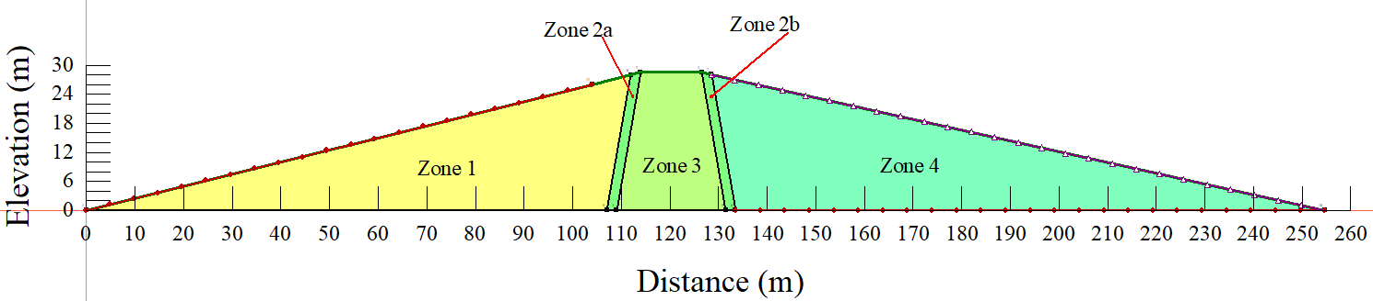
Figure 5.57 – Embankment geometry
The possible influence of a dam's quick drawdown on slope stability of an earth-fill embankment with soil parameters specified by hydraulic conductivity was investigated using finite element technique analysis. The steady-state, instantaneous drawdown, 5-days drawdown, 10-days drawdown, and 1m per day decline rate to half of the maximum water level was also tested. The transitory drawdown examples, on the other hand, are the study's main focus. The stability variables were evaluated at the end of the modeling procedure in the second instance, where it is assumed that water in the dam or reservoir is extracted instantly. Particular times of 5, 10, and 13 days were assigned to examples three, four, and five, respectively, to study how the stability parameters respond to the varying drawdown rates. The extreme situation or worst-case scenario is represented by the instantaneous case. The seepage tests were done at the same time as the stability tests.
The topic was investigated using a combination of GeoStudio sub-software SEEP/W [275] and SLOPE/W [276]. SEEP/W, which is based on FEM, was utilized for the seepage analysis in two-dimensional sections, while SLOPE/W was used for the embankment slope stability study based on slip surfaces, pore-water pressure, soil parameters, and loading conditions. Other parameters such as the geometry of the embankment were kept constant in all the drawdown instances while modifying the hydraulic conductivity values in zone 1 to capture the effect of the hydraulic conductivity values. In that situation, seepage analysis (both steady-state and transient) and slope stability analysis were used in tandem.

Seepage analysis procedures
The simulation of a slope's drawdown behavior began with the establishment of a long-term steady-state utilizing Steady-state analysis. The established steady-state was then employed as a parent for the transient flow analysis, which utilized seepage-induced pore pressures from the previously completed steady-state study. As previously stated, the analysis included a variety of drawdown rates as well as isotropic hydraulic conductivity values. Throughout the transient seepage assessments, the variation in water level during the drawdown process was modeled using a linear function that was given as a boundary condition on the upstream face of the embankment. The slope stability assessments were utilized as parents to the transient seepage analyses. During the transient flow assessments, established flow parameters such as pore water pressures were used as key inputs to the stability analysis with SLOPE/W.

Slope stability analysis procedures
The slope stability analysis in this section of the study was likewise performed using the SLOPE/W sub-unit of the GeoStudio software, as previously mentioned. To do so, the Morgenstern–Price analysis approach was employed to establish a separate analysis for each of the slope stability studies under the general limit equilibrium (GLE).

General study approach
Unlike the normal approach of a dam design that focuses on the available current flow characteristics, the developed workflow in this study considers some of the factors that may affect the flow characteristics sooner or later. The combination of the Digital Elevation Model (DEM), Landsat images as well as soil data, offers an opportunity to comprehensively integrate the catchment characteristics in the process of stormwater runoff quantification. At the same time, the relationship between climate and precipitation offers an opportunity to integrate the climatic factors into the model.
From Figure 5.58, it can be observed that the land use/land cover map is merged with the soil properties to form a land use-soil map which is then used for Curve Number computations. The developed Curve Number is an important input in the workflow (model) as the developed approach uses the SCS-Curve Number method for runoff quantification. Then from the quantified runoff, the dam capacity configuration and design of its associated structures such as retain wall, spillway as well as weir are achieved.
Also, stability analysis according to the design load is an integral part of the developed workflow. Generally, through this approach, a dam is designed to be adaptable to the change in land surface characteristics and climatic conditions.
Figure 5.58 – General workflow

Results and discussion
In this section, the results retrieved from the seepage and slope stability analysis of the Chardara dam embankment are presented.

Seepage analysis
During impoundment and operation, all types of embankment fill dams are confronted with seepage bodies. As a result, seepage control is critical during the design phase to avoid uplift pressures, downstream slope instability, plumbing through the embankment and/or foundation, and probable suffusion and erosion processes.

Steady-state
This is a condition in which the pressure at any location in the reservoir remains constant across time. Therefore, in this section, the steady-state seepage results are presented from the four different investigated cases based on reservoir operating levels.
- Normal operating level
Figure 5.59 presents the seepage results under steady-state flow conditions when the embankment was subjected to the normal operating reservoir level. It can be observed that the seepage line is safely carried away from the first zone to the downstream toe. It is important to note that the seepage line or saturation line, or phreatic line, is formed when water stands against an earth-fill embankment, whereby it is the point below which positive hydrostatic pressures exist. Moreover, Seepage forces, pore water pressures, and hydraulic gradients are all caused by seepage through the dam and foundation. If these stresses are not confined to permitted levels, piping and embankment sloughing or sliding can occur, resulting in dam failure [280].
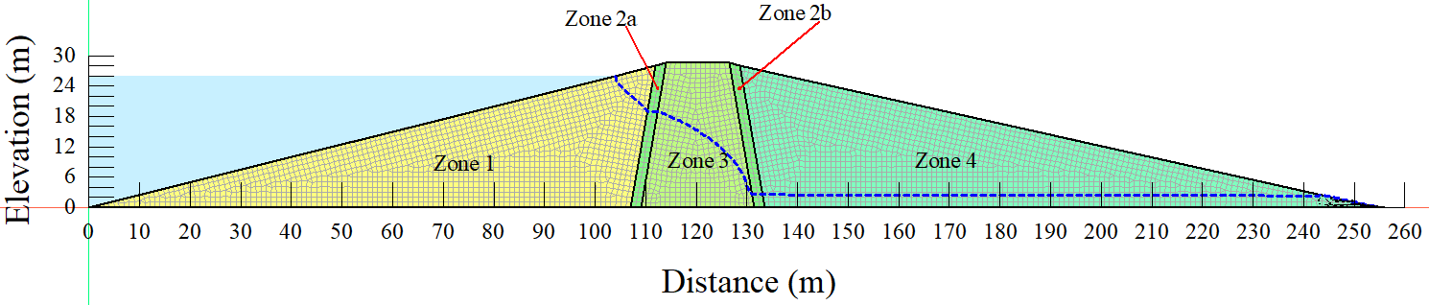
Figure 5.59 – Steady-state seepage based on normal operating reservoir level
- Reduced reservoir operating level
Apart from the seepage analysis based on the current (normal) operating reservoir level, the embankment was also subjected to a long-term seepage analysis, with the reservoir level operating at approximately half of the embankment. Figure 5.60 shows the seepage results when the embankment was subjected to the reduced operating reservoir level under steady-state flow circumstances. From the Figure, it can also be observed that the embankment was also able to safely carry the seepage line to the downstream toe under the specified conditions.
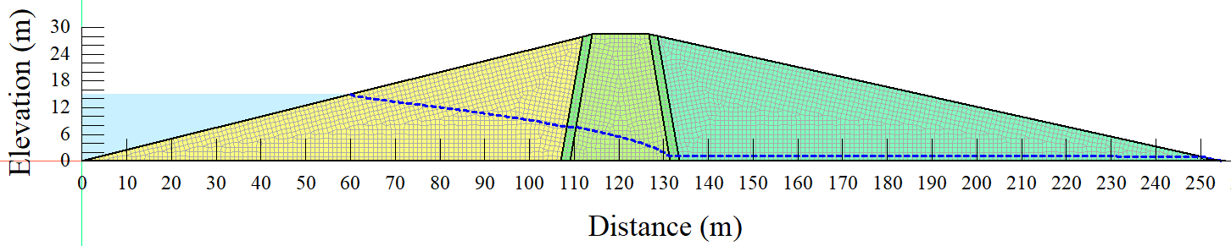
Figure 5.60 – Steady-state seepage based on the reduced operating level
- Reservoir operating at embankment height
The embankment was also subjected to a long-term seepage analysis with the reservoir level operating at the maximum embankment height. The passage of seepage water below the phreatic line lowers the effective weight of the soil, lowering its shear strength as a result of increasing intergranular pressure in earth fill material [306]. Figure 5.61 depicts seepage outcomes under steady-state flow conditions when the embankment was subjected to the reservoir at the embankment height.
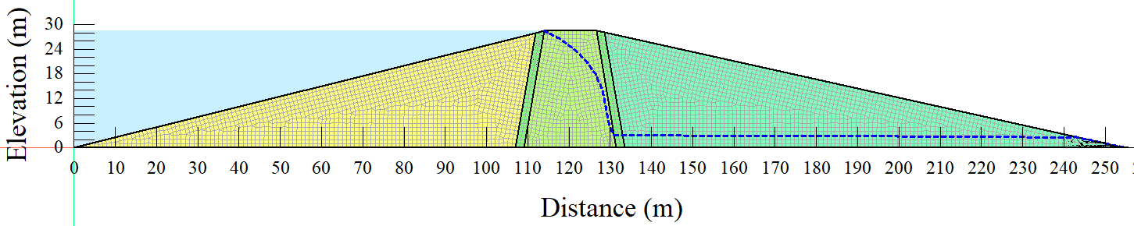
Figure 5.61 – Steady-state seepage under embankment height level
- Reservoir operating under overflow condition
With the reservoir level functioning at the overflow position, the embankment was also subjected to a long-term seepage analysis. Figure 5.62 shows seepage results when the embankment was exposed to the reservoir operating under steady-state overflow conditions. The long-term steady-state seepage line enters the embankment through the third zone in this case, skipping the first two zones.
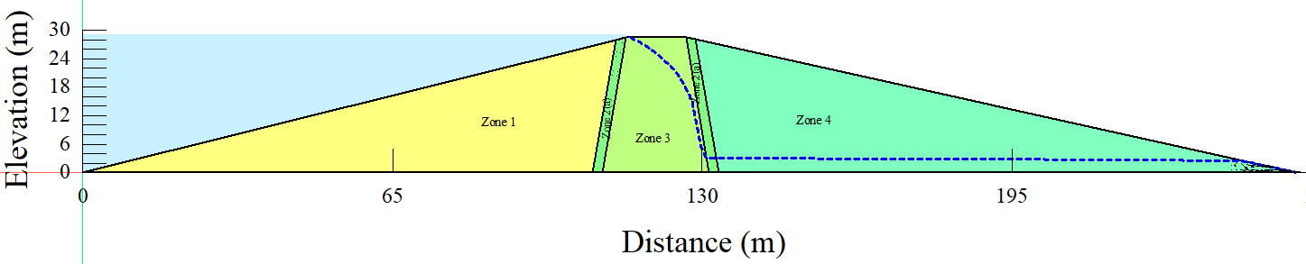
Figure 5.62 – Steady-state seepage under overflow level

Instantaneous drawdown
A zero-pressure head boundary condition at the toe of the upstream slope and a potential seepage face boundary condition down the upstream slope to the height of the original reservoir level were used to mimic the instantaneous drawdown.
- The normal operating reservoir level
The embankment was also subjected to an instantaneous drawdown seepage analysis while the reservoir was at the normal operating level. Figure 5.83 depicts seepage outcomes when the embankment was exposed to a reservoir that was running at instantaneous flow conditions and normal operating reservoir level. Even after the water in the reservoir has been completely drained, the pore-water pressures in the embankment remain quite high, as seen by the piezometric lines in Figure 5.63.
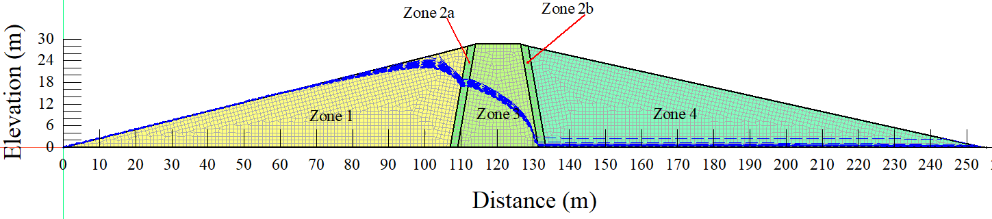
Figure 5.63 – Instantaneous drawdown seepage under normal operating reservoir level
- Reduced reservoir operating level
From the instantaneous drawdown rate, the water level in the reservoir was also reduced to approximately half of the embankment and analyzed in terms of seepage flow. Figure 5.64 displays seepage results when the embankment was exposed to a reservoir that was operating at a reduced operational reservoir level and instantaneous flow conditions. The embankment was able to securely transmit the seepage to the downstream toe despite the comparatively high pore-water pressures following the drawdown as determined by the phreatic lines.
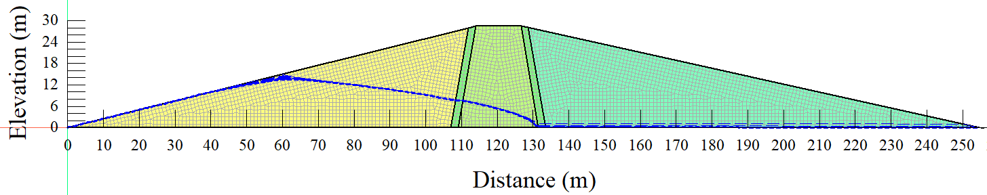
Figure 5.64 – Instantaneous drawdown seepage under reduced reservoir operating level
- Reservoir operating at embankment height
The water level in the reservoir was likewise adjusted to match the embankment height and then examined in terms of seepage flow using the five (5) days drawdown rate. Figure 5.65 displays seepage results when the embankment was exposed to a reservoir that was operating at embankment height reservoir level and instantaneous flow condition. From Figure 5.65, it can be observed that there was a significant struggle of the embankment to dissipate the pore-water pressure after the drawdown, especially in the first zone of the embankment as depicted by the phreatic lines.
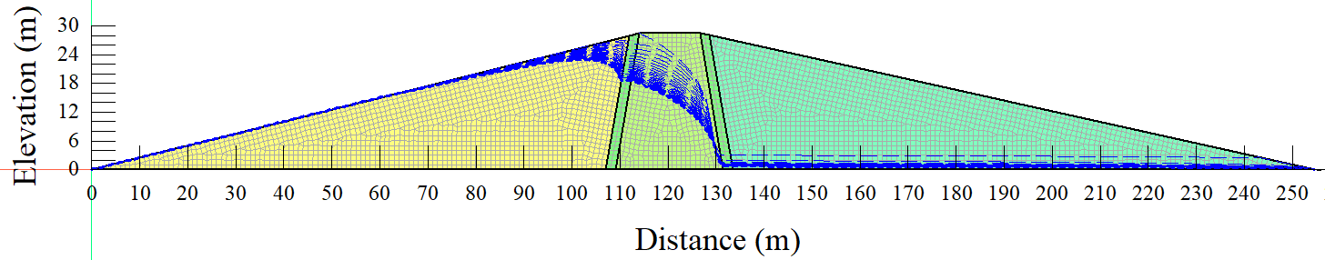
Figure 5.65 – Instantaneous drawdown seepage under embankment height operating level
- Reservoir operating under overflow condition
The reservoir's water level was raised to an overflow condition, and the seepage flow was measured using the instantaneous drawdown rate. Figure 5.66 depicts seepage outcomes when the embankment was exposed to a reservoir that was running at instantaneous flow conditions and overflow operating reservoir level. A similar phenomenon can be observed; whereby, Figure 5.66 shows that the embankment struggled to dissipate the pore-water pressure following the drawdown, particularly in the first zone as represented by the phreatic lines.
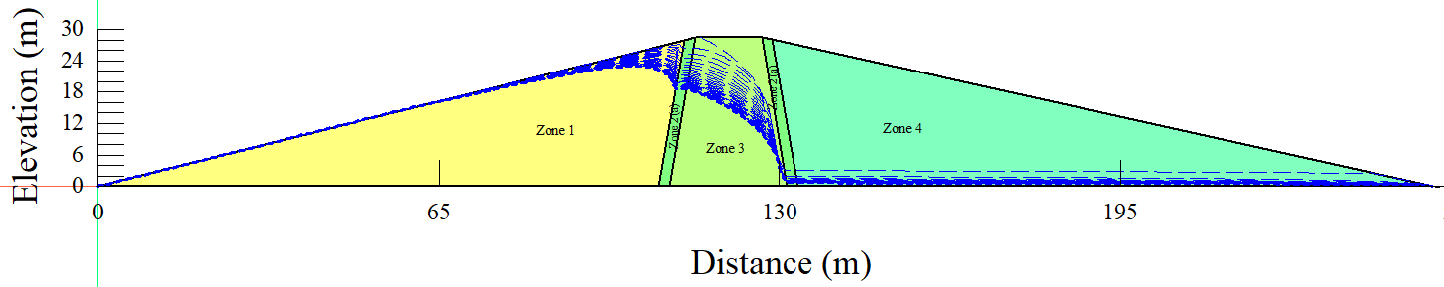
Figure 5.66 – Instantaneous drawdown seepage under overflow condition

Rapid drawdown five (5) days
In this part of the study, 5 days head function boundary condition was used to define the changing water level of the reservoir. This boundary condition was applied to the embankment's upstream slope to the point signifying the reservoir's highest level. To allow flow to exit the upstream side of the domain, the potential seepage face review option was also enabled.
- The normal operating reservoir level
While the reservoir was at the normal operating levels, five (5) days drawdown rate seepage analysis was performed on the embankment. When the embankment was exposed to the reservoir that was running under normal operating reservoir level and 5 days drawdown rate, seepage results are depicted in Figure 5.67. From Figure 5.67, it can be observed that the phreatic lines cross the first, second, and third zones of the embankment while safely carrying the seepage within the embankment to the downstream toe. Moreover, based on Figure 5.67, there was a significant struggle in terms of pore-water pressure dissipation after the reservoir drawdown within five (5) days.
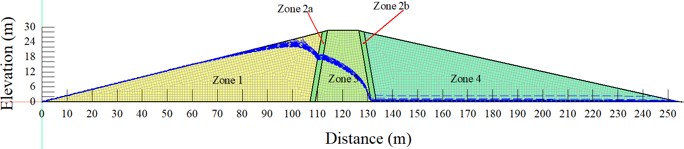
Figure 5.67 – Rapid drawdown (5 days) seepage under normal operating level
- Reduced reservoir operating level
Five (5) days drawdown rate seepage analysis was done on the embankment while the reservoir was at decreased operational levels (half of the embankment). Figure 5.68 shows the seepage results when the embankment was exposed to a reservoir with a reduced operational reservoir level and 5 days drawdown rate. Despite the relatively high pore-water pressures following the drawdown as measured by the phreatic lines, the embankment was able to securely convey the seepage to the downstream toe under the 5 days drawdown.
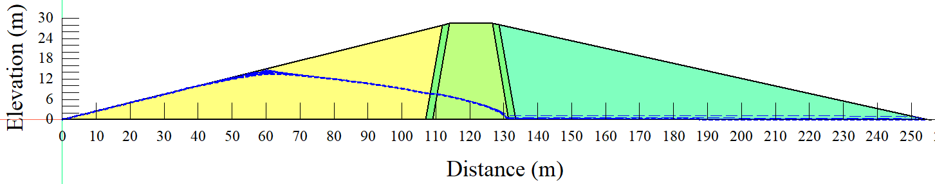
Figure 5.68 – Rapid drawdown (5 days) seepage under reduced reservoir operating level
- Reservoir operating at embankment height
The reservoir's water level was also altered to match the embankment height, and the seepage flow was measured using the five (5) days drawdown rate. Figure 5.69 depicts the seepage results when the embankment was exposed to a reservoir with a 5 days drawdown rate and an embankment height operating reservoir level. Figure 5.69 shows that the embankment struggled to dissipate the pore-water pressure following the drawdown, particularly in the first zone, as represented by the phreatic lines. However, because the drawdown rate was reduced from instantaneous to 5 days, the pore-pressure dissipation process was improved, notably during the early days of the reservoir decline.
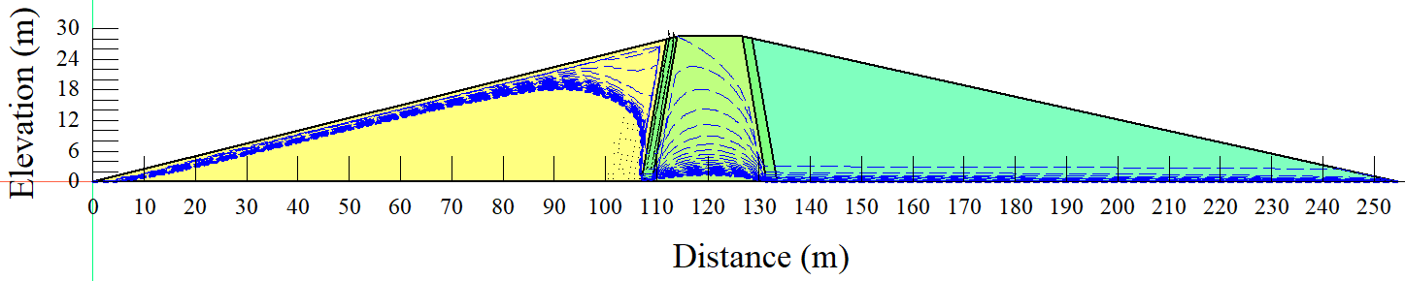
Figure 5.69 – Rapid drawdown (5 days) seepage under embankment height reservoir operating level
- Reservoir operating under overflow condition
The reservoir's water level was raised until it overflowed, and the seepage flow was computed using a five-day drawdown rate. Figure 5.70 shows the seepage results when the embankment was exposed to a reservoir with 5 days drawdown rate and overflow operating reservoir level. Figure 5.70 depicts a similar phenomenon, in which the embankment struggled to disperse pore-water pressure following the drawdown, particularly in the first zone, as depicted by the phreatic lines.
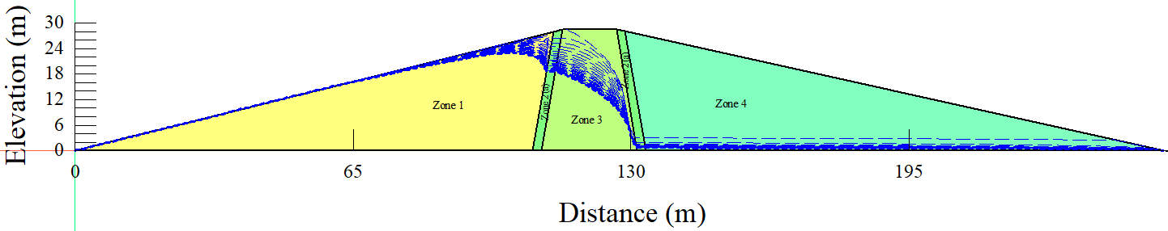
Figure 5.70 – Rapid drawdown (5 days) seepage under overflow reservoir operating level

Rapid drawdown (10 days)
A head function boundary condition of 10 days was employed to determine the changing water level of the reservoir in this section of the study. This boundary condition was applied to the upstream slope of the embankment to the point when the reservoir's greatest level was reached. The prospective seepage face review option was also activated to allow flow to depart the upstream side of the domain.
- The normal operating reservoir level
Moreover, on the embankment, a ten (10) day drawdown rate seepage analysis was done when the reservoir was at normal operating levels. The seepage results when the embankment was exposed to a reservoir with a 10 days drawdown rate and normal operating reservoir level are shown in Figure 5.71. The phreatic lines cross the first, second, and third zones of the embankment while safely transporting the seepage within the embankment to the downstream toe, as shown in Figure 5.71. Furthermore, the figure shows that there was a substantial struggle in terms of pore-water pressure dissipation when the reservoir was drawdown in ten (10) days. In this case, it can also be observed that the struggle in terms of pore-water pressure dissipation was experienced in all the first three zones.
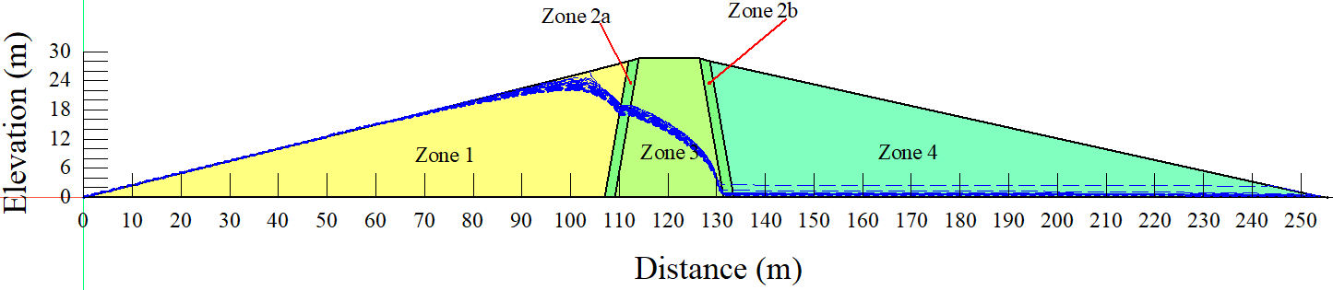
Figure 5.71 – Rapid drawdown (10 days) seepage under normal operating level
- Reduced reservoir operating level
While the reservoir was at reduced operational levels, ten (10) days drawdown rate seepage analysis was performed on the embankment (half of the embankment). Figure 5.72 depicts the seepage results after the embankment was exposed to a reservoir with a 10 days drawdown rate and reduced operational reservoir level. A similar phenomenon is observed (as for 5 days drawdown rate) in the sense that, despite relatively high pore-water pressures as determined by the phreatic lines following the drawdown, the embankment was able to securely transmit the seepage to the downstream toe under the ten (10) days drawdown.
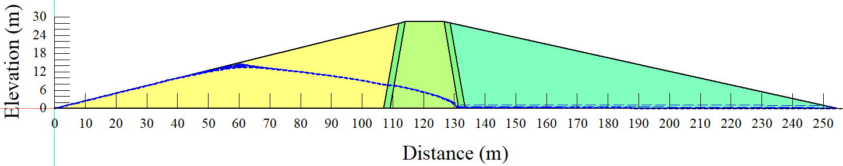
Figure 5.72 – Rapid drawdown (10 days) seepage under reduced reservoir operating level
- Reservoir operating at embankment height
The reservoir's water level was also changed to match the embankment's height, and the seepage flow was computed using a ten-day decline rate. Figure 5.73 shows seepage after the embankment was exposed to a reservoir with 10 days drawdown rate and embankment height operating reservoir level. Based on the phreatic lines, we can understand that the dissipation of pore-water pressures from the third zone of the embankment was much easier than that of the first zone. The phenomenon is thought to be linked to changes in permeability rates between embankment zones.
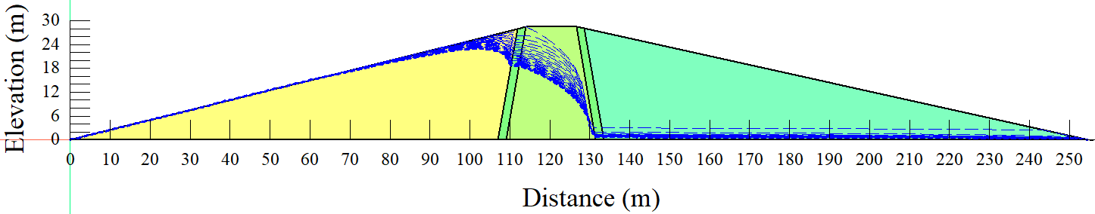
Figure 5.73 – Rapid drawdown (10 days) seepage under embankment height reservoir operating level
- Reservoir operating under overflow condition
Furthermore, the reservoir's water level was raised until it overflowed, and the seepage flow was computed using a ten (10) day decline rate. Figure 5.74 shows seepage after the embankment was exposed to a reservoir with a 10 days drawdown rate and overflow operating reservoir level. Figure 5.74 displays a similar phenomenon in which the embankment struggled to disperse pore-water pressure following the drawdown, especially in the first zone, with some improvements in the third zone as depicted by the phreatic lines.
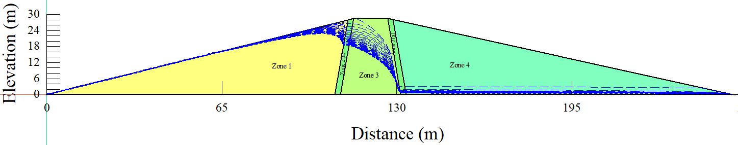
Figure 5.74 – Rapid drawdown (10 days) seepage under overflow reservoir operating level

Rapid drawdown (1 m per day)
In this section of the study, a 1 m per day head function boundary condition was used to determine the changing water level of the reservoir. This boundary condition was applied to the embankment's upstream slope until the reservoir's maximum level was attained. To allow flow to leave the upstream side of the domain, the potential seepage face review option was also enabled.
- The normal operating reservoir level
The first case under the 1 m per day drawdown rate was to subject the embankment to a normal operating reservoir level. Figure 5.75 depicts the seepage results when the embankment was exposed to a reservoir with a 1 m per day drawdown rate and the normal operational reservoir level. As illustrated in Figure 5.75, the phreatic lines cross the first, second, and third zones of the embankment, safely delivering seepage within the embankment to the downstream toe. Furthermore, the figure demonstrates that when the reservoir was drained using a 1 m per day drawdown rate, there was a significant struggle in terms of pore-water pressure dissipation. In this scenario, it's also worth noting that the first three zones all struggled with pore-water pressure dissipation as observed from instantaneous, five (5), ten (10) days drawdown rates.
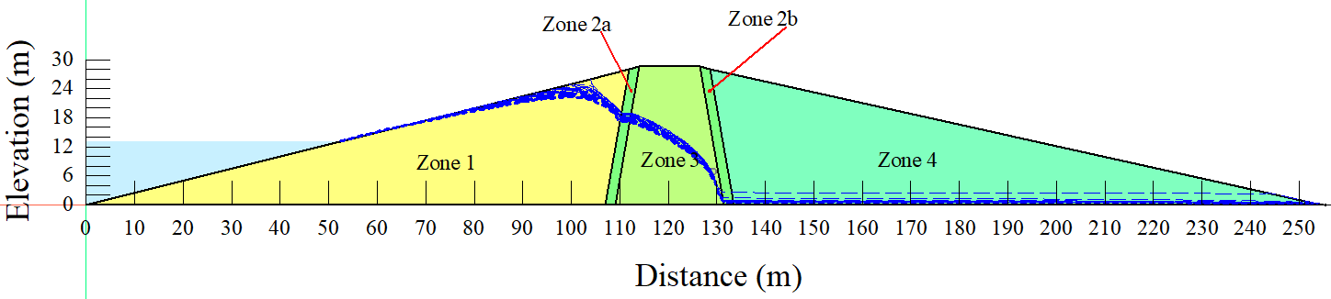
Figure 5.75 – Rapid drawdown (1 m per day) seepage under normal operating level
- Reduced reservoir operating level
The second case under the 1 m per day drawdown rate was to subject the embankment to a reduced operating reservoir level. Figure 5.76 depicts the seepage results after the embankment was exposed to a reservoir with a 1 m per day drawdown rate and reduced operational reservoir level. Under the 1 m per day drawdown, the embankment was able to securely convey the seepage to the downstream toe despite relatively high pore-water pressures as indicated by the phreatic lines following the drawdown (as for the instantaneous, 5 days, and 10 days drawdown rates).
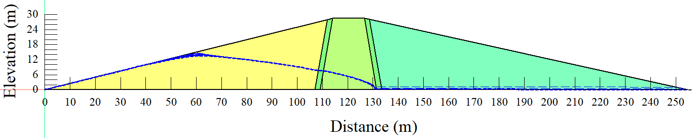
Figure 5.76 – Rapid drawdown (1 m per day) seepage under reduced reservoir operating level
- Reservoir operating at embankment height
The third case under the 1 m per day drawdown rate was to subject the embankment to an operating reservoir level similar to the embankment height. Figure 5.77 shows seepage after the embankment was exposed to a reservoir with a 1 m per day drawdown rate and embankment height operating reservoir level. As observed from the 1o days drawdown rate, the dissipation of pore-water pressures from the third zone of the embankment was easier than that of the first zone, based on the phreatic lines; whereby, this phenomenon is once again thought to be linked to changes in permeability rates between embankment zones.
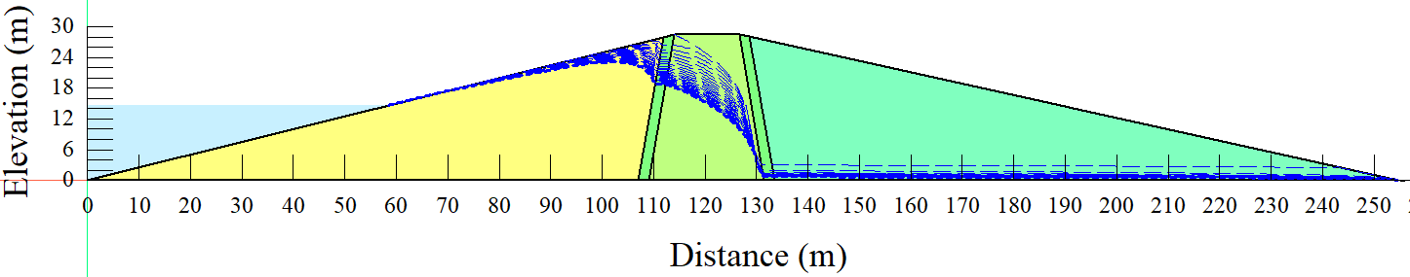
Figure 5.77 – Rapid drawdown (1m per day) seepage under embankment height reservoir operating level
- Reservoir operating under overflow condition
The fourth case under the 1 m per day drawdown rate was to subject the embankment to an overflow operating reservoir level. Figure 5.78 shows seepage after the embankment was exposed to a reservoir with a 1 m per day drawdown rate and overflow operating reservoir level. The embankment did not have enough time to disperse pore-water pressures from the embankment following the drawdown, as can be seen in the picture.
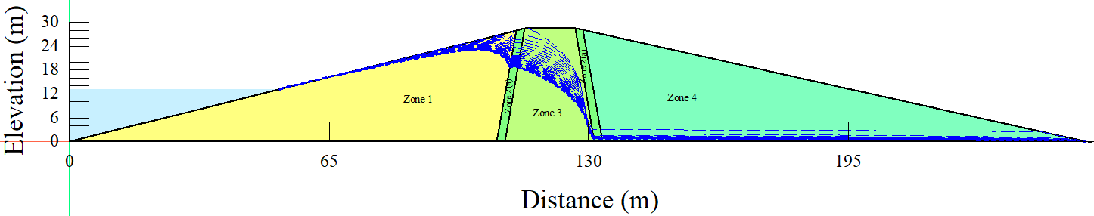
Figure 5.78 – Rapid drawdown (1 m per day) seepage under overflow reservoir operating level

Slope stability
In this part of the study, different aspects of slope stability are investigated based on the operating reservoir levels. It is also worth noting that slope stability can be termed as the inclined slope's capacity to resist its weight as well as external forces without shifting. To maintain slope stability, soil/rock mechanics, geotechnical engineering, and engineering geology principles are applied. The creation of complex constitutive models, awareness of laboratory and in-situ testing constraints, and the development of new equipment techniques to assess the slope's response have all emerged from slope behavior case studies. When the slope's stability conditions are not met, the slope's soil or rock mass may experience gradual or catastrophic downhill movement. A landslide can be triggered by an earthquake, heavy rains that exceed pore water pressure or deterioration of the ground's mechanical properties. Slope failures wreak havoc on human infrastructure each year, resulting in a wave of casualties.

Steady-state
In this part of the study, the embankment slope stability analysis was carried out under long-term steady-state conditions at different operating levels of the reservoir (normal or current level, reduced level, embankment height level, as well as the overflow level).
- The normal operating reservoir level
Based on the steady-state condition slope stability analysis, the first case was to subject the reservoir to a normal operating level and investigate the retrieved factor of safety values. Figure 5.79 shows slope stability results after the embankment was exposed to a long-term steady-state and normal operating reservoir level. From Figure 5.79, it can be observed that a factor of safety value of 3.576 was achieved. The retrieved factor of safety value suggests that under steady-state and normal water level operating conditions, the embankment is relatively safe from potential slope failure. This judgment is based on the fact that many guidelines would recommend 1.5 as a minimum factor of safety value to ensure that the embankment is safe from potential failure.
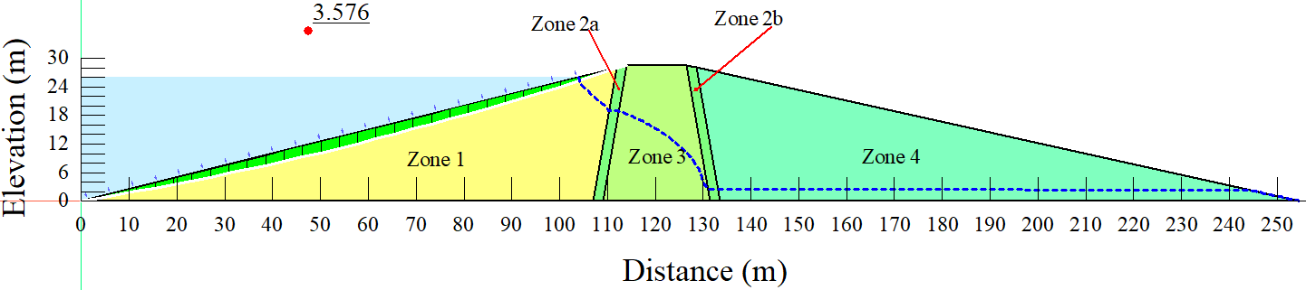
Figure 5.79 – Steady-state slope stability under normal operating reservoir level
- Reduced reservoir operating level
Another important slope stability case investigated in the study was when the reservoir's long-term water level has reduced to half of the embankment. After the embankment was exposed to a long-term steady-state and reduced operating reservoir level, the slope stability results are shown in Figure 5.80. From Figure 5.80, we can see that the 3.259 factor of safety value was achieved from the combination of reduced water level and long-term steady-state operating conditions. The retrieved factor of safety from reduced water level is approximately 8.9% less than that was achieved from the normal operating water level. These results reveal further that when reservoir long-term water level reduces, then the long-term factor of safety value under long-term steady-state conditions also reduces.
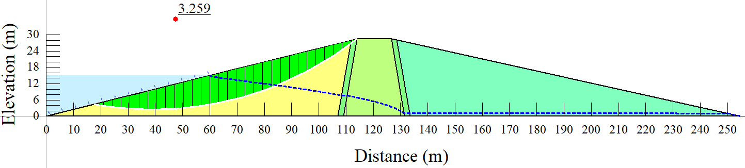
Figure 5.80 – Steady-state slope stability under reduced reservoir operation level
- Reservoir operating at embankment height
Then the reservoir water level was increased to match the embankment height and investigate the state of slope stability under the long-term steady-state scenario. After the embankment was exposed to a long-term steady-state and embankment height operational reservoir level, the slope stability results are shown in Figure 5.81. From Figure 5.81, we can see that a 3.369 factor of safety value was retrieved from the long-term steady-state conditions. The retrieved factor of safety value is equivalent to 5.8% less than the 3.576 retrieved from the normal operating reservoir level.
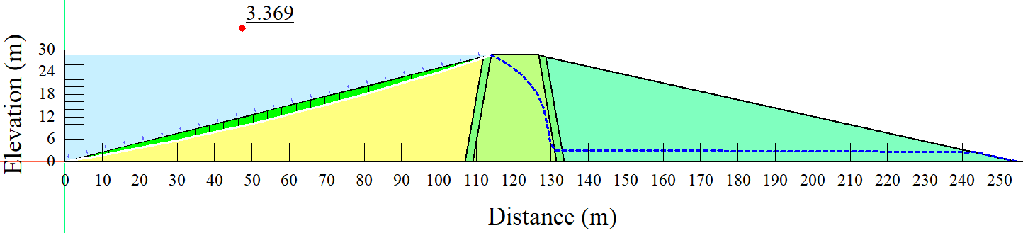
Figure 5.81 – Steady-state slope stability under embankment height reservoir level
- Reservoir operating under overflow condition
The reservoir water level was then adjusted to an overflow level, and the state of slope stability was investigated in a long-term steady-state condition. After the embankment was exposed to a long-term steady-state and overflow operational reservoir level, the slope stability results are shown in Figure 5.82. Figure 5.82 shows that the long-term steady-state conditions yielded a factor of safety value of 3.369. The calculated factor of safety value is 5.8% lower than the 3.576 calculated from the usual operational reservoir level.
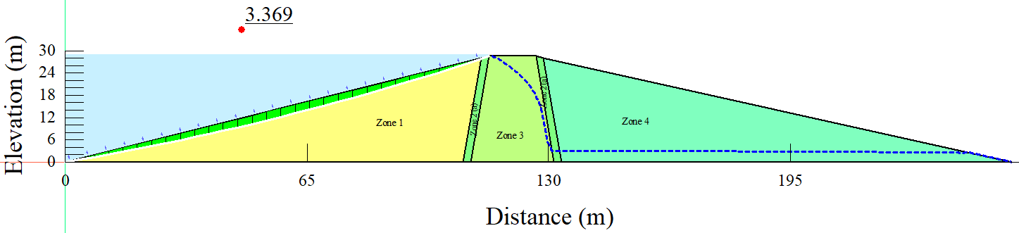
Figure 5.82 – Steady-state slope stability under overflow reservoir level

Instantaneous drawdown
After the slope stability analysis under the steady-state condition, the embankment was subjected to rapid drawdown loading conditions, including the instantaneous drawdown case under different reservoir operating levels.
- The normal operating reservoir level
After the embankment was exposed to an instantaneous drawdown rate and normal operational reservoir level, the slope stability findings are shown in Figure 5.83. It can be observed that a minimum factor of safety value of 0.979 was retrieved from the combination of instantaneous drawdown and normal operating reservoir level. From the minimum factor of safety value, it is definitely that the embankment fails after the drawdown. As previously mentioned, a minimum factor of safety value of 1.5 is always recommended to ensure the embankment is safe enough from potential failure.
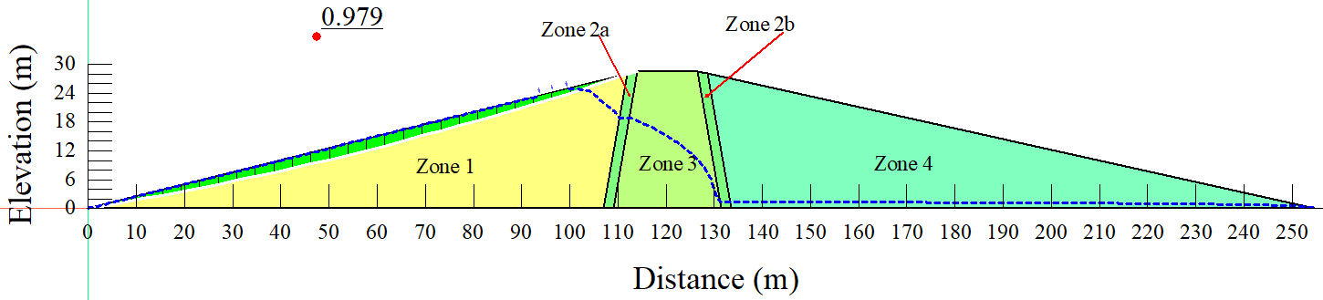
(a)
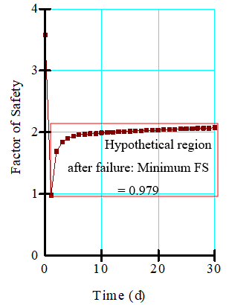
(b)
Figure 5.83 – Instantaneous slope stability under normal operating reservoir level: a) embankment with slip surface; b) graph of factor of safety values
- Reduced reservoir operating level
The slope stability results are displayed in Figure 5.84 after the embankment was exposed to an instantaneous drawdown rate and reduced operational reservoir level. The instantaneous drawdown rate from the lowered operational water level resulted in a minimal factor of safety value of 2.318, which is roughly 28.9% lower than the 3.259 factor of safety value obtained from the combination of steady-state condition and reduced reservoir water operating level. The phenomenon proves further that there is a significant relationship between the loading condition and the state of slope stability of an embankment.
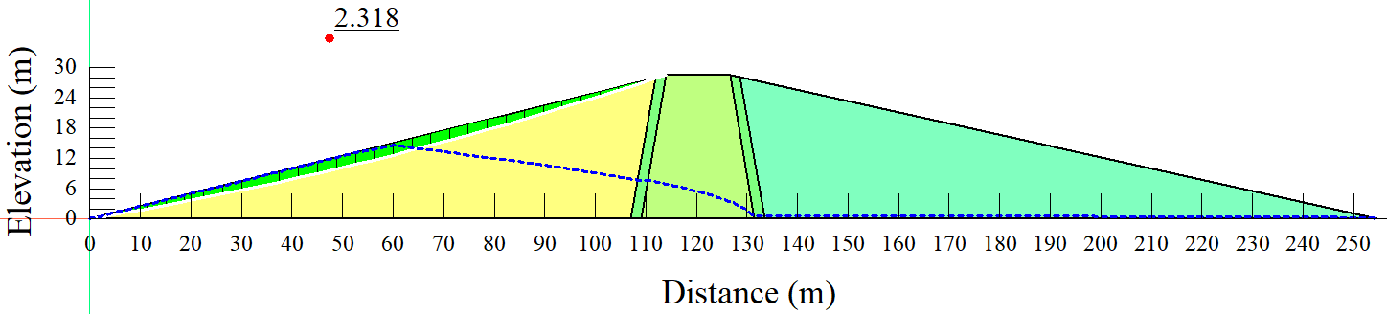
(a)
(b)
Figure 5.84 – Instantaneous slope stability under reduced reservoir operating level: a) embankment with slip surface; b) graph of factor of safety values

- Reservoir operating at embankment height
Figure 5.85 shows slope stability results after the embankment was exposed to an instantaneous drawdown rate and embankment height operating reservoir level. The combination of instantaneous drawdown and operating reservoir level embankment height generated a minimal factor of safety value of 0.612, as can be observed. Based on the minimum factor of safety value, the embankment will surely fall fully after the drawdown. Furthermore, because a minimum factor of safety of 1.5 is always recommended to ensure that an embankment is safe against future failure, the returned minimal factor of safety is a symptom of total failure.
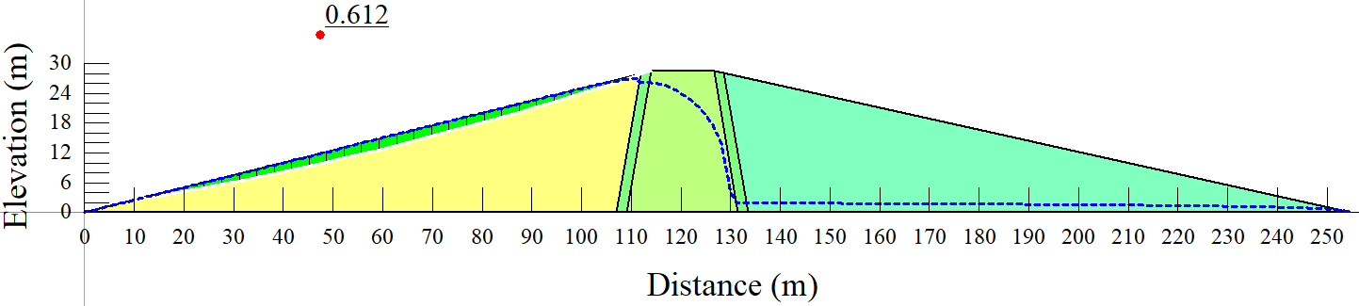
(a)
Hypothetical region after failure: Minimum FS = 0.901
(b)
Figure 5.85 – Instantaneous slope stability under embankment height operating level: a) embankment with slip surface; b) graph of factor of safety values
- Reservoir operating under overflow condition
Figure 5.86 shows slope stability results after the embankment was exposed to an instantaneous drawdown rate and overflow operating reservoir level. The combination of instantaneous drawdown and reservoir operating under overflow conditions generated a minimal factor of safety value of 0.56, as can be observed. Based on the minimum factor of safety value, the embankment will surely fall fully after the drawdown. Furthermore, because a minimum factor of safety of 1.5 is always recommended to ensure that an embankment is safe against probable failure, the retrieved minimal factor of safety is a signal of total failure; whereby it is 8.5% less than the minimum factor of safety obtained from the reservoir operating at the embankment height.
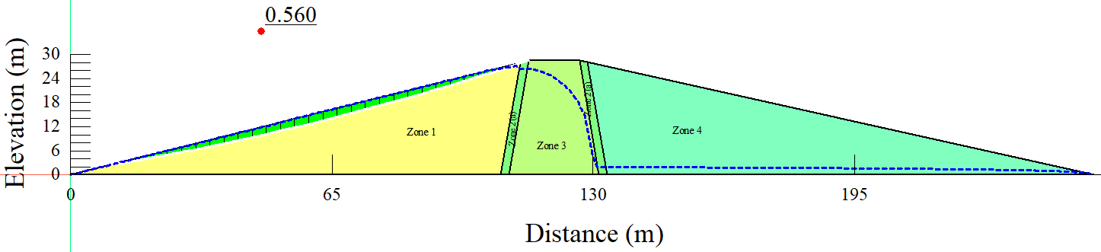
(a)
Hypothetical region after failure: Minimum FS = 0.56
Figure 5.86 – Instantaneous slope stability under overflow level: a) embankment with slip surface; b) graph of factor of safety values

Rapid drawdown (5 days)
Moreover, the embankment was subjected to a five (5) days drawdown rate which is a slight reduction of drawdown compared to the instantaneous one. Also, the analysis of slope stability under five (5) days' drawdown was then subjected to different water levels.
- The normal operating reservoir level
Figure 5.87 shows slope stability results after the embankment was exposed to 5 days drawdown rate and normal operating reservoir level. The combination of a five (5) day drawdown rate and the usual operational reservoir level resulted in a minimal factor of safety value of 1.876, as shown in the figure. The factor of safety value recovered from the 5 days rapid drawdown rate under normal operating reservoir level is around 47.54 % lower than the factor of safety value obtained from the long-term steady-state condition under normal operating reservoir level.
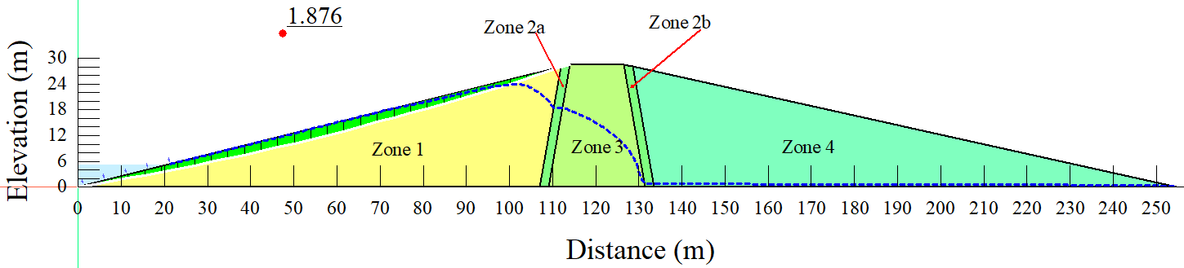
(a)
(b)
Figure 5.87 – Rapid drawdown (5 days) slope stability under normal operating reservoir level: a) embankment with slip surface; b) graph of factor of safety values
- Reduced reservoir operating level
Figure 5.88 shows slope stability results after the embankment was exposed to 5 days drawdown rate and reduced operating reservoir level. The minimum factor of safety value obtained from the combination of five (5) days drawdown rate and reduced reservoir water operating level was 2.497, which is roughly 23.4% lower than the 3.259 factor of safety value obtained from the combination of steady-state condition and reduced reservoir water operating level. The phenomena further demonstrate that there is a link between the loading situation and the state of an embankment's slope stability.
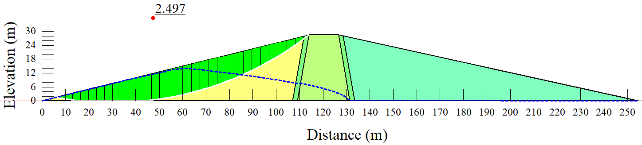
(a)
(b)
Figure 5.88 – Rapid drawdown (5 days) slope stability under reduced reservoir operating level: a) embankment with slip surface; b) graph of factor of safety values
- Reservoir operating at embankment height
Figure 5.89 shows slope stability results after the embankment was exposed to 5 days drawdown rate and embankment height operating reservoir level. The combination of a five (5) days drawdown rate and embankment height operating reservoir level generated a minimal factor of safety value of 0.129, as can be observed. Based on the minimum factor of safety value, the embankment will surely fall fully after the drawdown. Furthermore, because a minimum factor of safety of 1.5 is always recommended to ensure that an embankment is safe against probable failure, the retrieved minimal factor of safety is a signal of total failure.
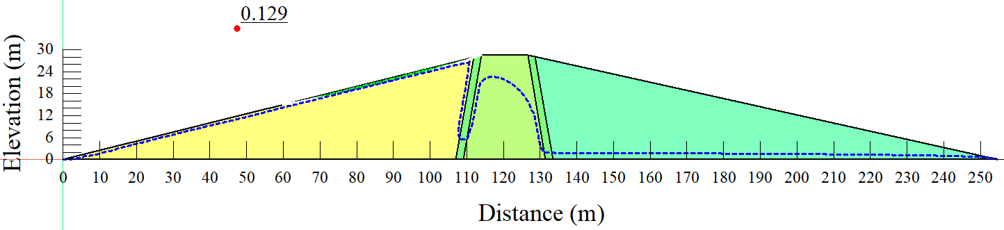
(a)
Hypothetical region after failure: Minimum FS = 0.129
(b)
Figure 5.89 – Rapid drawdown (5 days) slope stability at embankment height: a) embankment with slip surface; b) graph of factor of safety values
- Reservoir operating under overflow condition
Figure 5.90 shows slope stability results after the embankment was exposed to 5 days drawdown rate and overflow operating reservoir level. The minimum factor of safety value obtained from a combination of five (5) days drawdown rate and overflow water operating level was 1.536, which was 54.4% lower than the 3.369 factor of safety value obtained from a combination of steady-state condition and overflow reservoir water operating level.
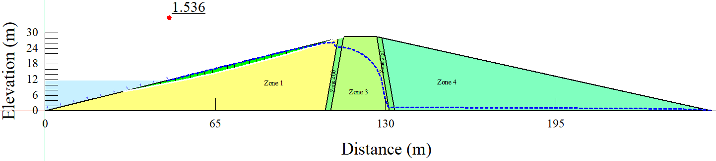
(a)
(b)
Figure 5.90 – Rapid drawdown (5 days) slope stability at the overflow: a) embankment with slip surface; b) graph of factor of safety values

Rapid drawdown (10 days)
Furthermore, the embankment was subjected to 10 days drawdown rate, which is a modest drop from the instantaneous and 5 days drawdown rates. The slope stability analysis was also conducted to varying water levels under 10 days drawdown rate.
- The normal operating reservoir level
Figure 5.91 shows slope stability results after the embankment was exposed to 10 days drawdown rate and normal operating reservoir level. The combination of ten (10) days' drawdown rate and the usual operational reservoir level resulted in a minimal factor of safety value of 1.986, as shown in the Figure. The factor of safety value recovered from the 10 days rapid drawdown at the normal operational reservoir level is around 44.5% less than the factor of safety value recovered from the long-term steady-state condition at the normal operating reservoir level.
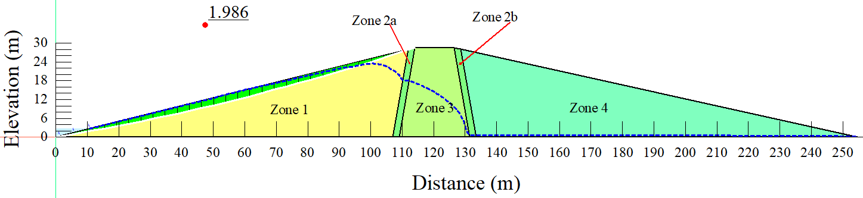
(a)
(b)
Figure 5.91 – Rapid drawdown (10 days) slope stability normal operating level: a) embankment with slip surface; b) graph of factor of safety values
- Reduced reservoir operating level
Figure 5.92 shows slope stability results after the embankment was exposed to 10 days drawdown rate and reduced operating reservoir level. The minimum factor of safety value obtained from the combination of 10 days drawdown rate and reduced reservoir water operating level was 2.497, which is approximately 23.4% less than the 3.259 factor of safety value obtained from the combination of steady-state condition and reduced reservoir water operating level. The phenomenon also shows that there is a link between the loading situation and the slope stability of an embankment.
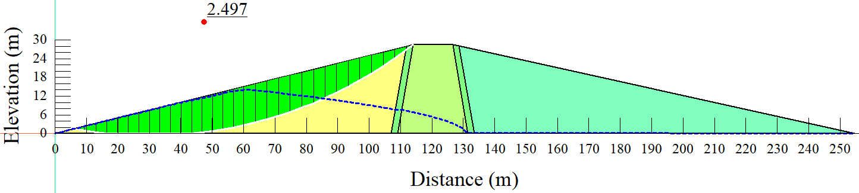
(a)
(b)
Figure 5.92 – Rapid drawdown (10 days) slope stability under reduced reservoir operating level: a) embankment with slip surface; b) graph of factor of safety values
- Reservoir operating at embankment height
Figure 5.93 shows slope stability results after the embankment was exposed to 10 days drawdown rate and embankment height operating reservoir level. As can be seen, the combination of ten (10) days' drawdown rate and the operating reservoir level at embankment height resulted in a minimal factor of safety value of 1.881. The minimum factor of safety value obtained is approximately 44.2% less than the 3.369 factor of safety value obtained from the combination of steady-state condition and reservoir operating at embankment height. The phenomenon also shows that there is a link between the loading situation and the slope stability of an embankment.
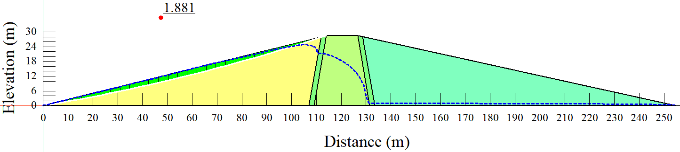
(a)
(b)
Figure 5.93 – Rapid drawdown (10 days) slope stability at embankment height: a) embankment with slip surface; b) graph of factor of safety values
- Reservoir operating under overflow condition
Figure 5.94 shows slope stability results after the embankment was exposed to 10 days drawdown rate and overflow operating reservoir level. The minimum factor of safety value obtained from the combination of ten (10) days drawdown rate and overflow water operating level was 1.878, which is approximately 44.3% lower than the 3.369 factor of safety value obtained from the combination of steady-state condition and overflow reservoir water operating level.
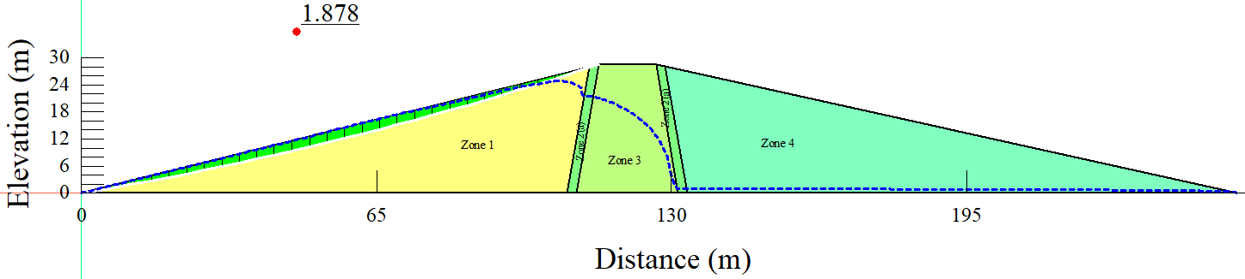
(a)
(b)
Figure 5.94 – Rapid drawdown (10 days) slope stability at the overflow: a) embankment with slip surface; b) graph of factor of safety values

Rapid drawdown (1 m per day)
The embankment was also subjected to a 1 m per day drawdown rate, which is a slight reduction from the instantaneous, 5 days and 10 days drawdown rates. Under a 1 m per day drawdown rate, the slope stability study was also performed at various water levels.
- The normal operating reservoir level
Figure 5.95 shows slope stability results after the embankment was exposed to a 1 m per day drawdown rate and normal operating reservoir level. The lowest factor of safety value of 2.221 was obtained by combining a 1 m per day drawdown rate with the normal operational reservoir level, as shown in the Figure. The factor of safety value recovered from the 1 m per day rapid drawdown at the normal operational reservoir level is approximately 37.9% lower than the factor of safety value recovered from the long-term steady-state condition at the normal operational reservoir level.
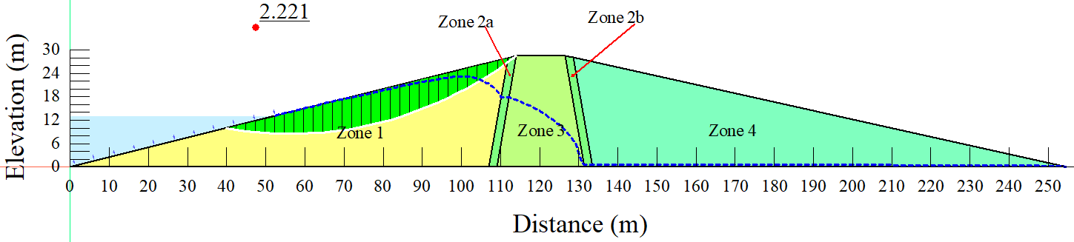
(a)
(b)
Figure 5.95 – Rapid drawdown (1 m per day) slope stability normal operating level: a) embankment with slip surface; b) graph of factor of safety values
- Reduced reservoir operating level
Figure 5.96 shows slope stability results after the embankment was exposed to a 1 m per day drawdown rate and reduced operating reservoir level. The lowest factor of safety value obtained from the combination of 1 m per day drawdown rate and reduced reservoir water operating level was 2.5, which is about 23.3% less than the 3.259 factor of safety value obtained from the combination of steady-state condition and reduced reservoir water operating level.
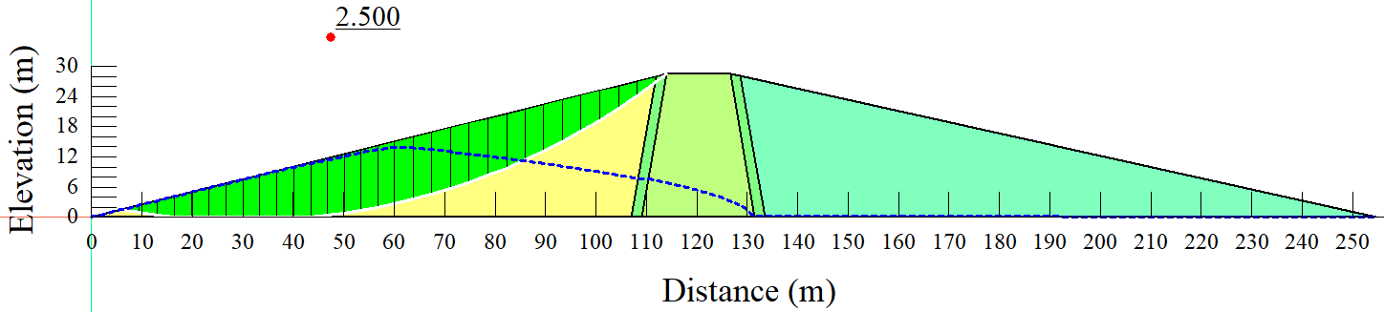
(a)
(b)
Figure 5.96 – Rapid drawdown (1 m per day) slope stability under reduced reservoir operating level: a) embankment with slip surface; b) graph of factor of safety values
- Reservoir operating at embankment height
Figure 5.97 shows slope stability results after the embankment was exposed to a 1 m per day drawdown rate and embankment height operating reservoir level. The combination of 1 m per day drawdown rate and operational reservoir level at embankment height resulted in a minimal factor of safety value of 2.133, as can be shown. The minimum factor of safety value obtained is approximately 36.7% less than the 3.369 factor of safety value obtained from the combination of steady-state condition and reservoir operating at embankment height obtained from the combination of steady-state condition and reservoir operating at embankment height.
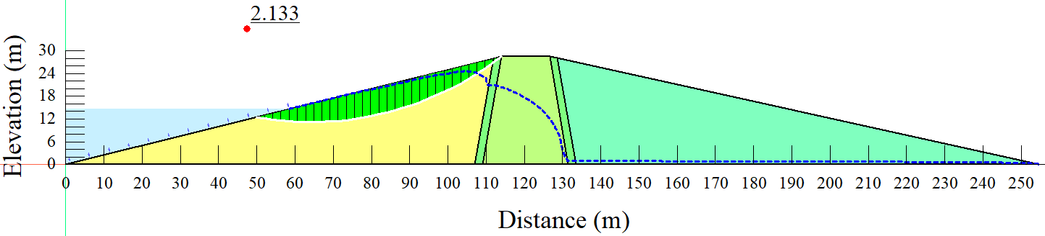
(a)
(b)
Figure 5.97 – Rapid drawdown (1 m per day) slope stability at embankment height: a) embankment with slip surface; b) graph of factor of safety values
- Reservoir operating under overflow condition
Figure 5.98 shows slope stability results after the embankment was exposed to a 1 m per day drawdown rate and overflow operating reservoir level. The minimum factor of safety value obtained from a combination of 1 m per day drawdown rate and overflow water operating level was 2.09, which was 38% lower than the 3.369 factor of safety value obtained from a combination of steady-state condition and reduced reservoir water operating level.
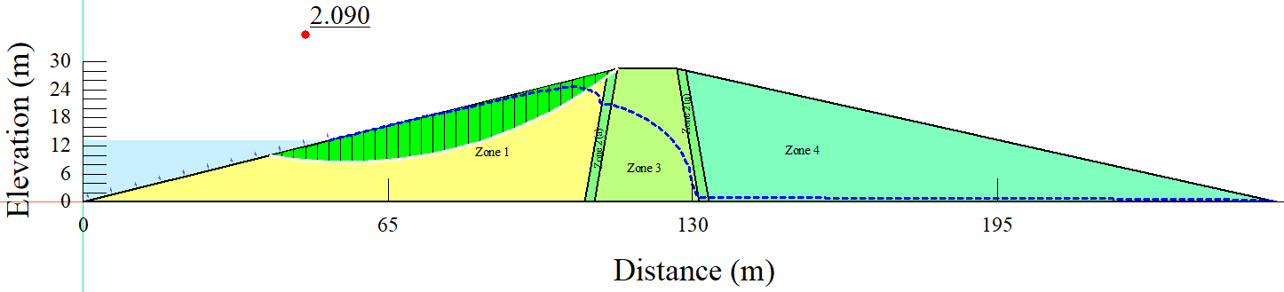
(a)
(b)
Figure 5.98 – Rapid drawdown (1 m per day) slope stability at the overflow: a) embankment with slip surface; b) graph of factor of safety values

Correlation analysis
Four slope stability variables were used in the correlation study (drawdown days, minimum factor of safety values, and pore-water pressures). Table 5.21 shows that there was a strong correlation among the components studied, with correlation values ranging from 0.794 to 0.997. The minimum factor of safety values and pore-water pressures have the strongest correlation of -0.997; this occurrence can be attributed to the fact that the degree of pore-water pressure dissipation within the embankment has a significant impact on embankment stability. The phenomenon is reinforced by some results observed in the literature; whereby, according to the study conducted by Mukhlisin and Naam [307], it was observed that the slope might become less stable when the pore water pressure rises. The negative correlation is an indication that when the other factors were increasing, the pore-water pressures in the embankment were decreasing and vice versa.
Table 5.21 Correlation coefficients among different slope stability factors
 | Drawdown days | Minimum FS | Pore-water pressures
Drawdown days | 1
Minimum FS | 0.794 | 1
Pore-water pressures | -0.807 | -0.997 | 1
FS = factor of safety

Analysis of variance (ANOVA)
A single-factor ANOVA with an alpha value of 0.05 was performed on the investigated operational water levels under instantaneous drawdown rate; the findings of the ANOVA are summarized in Table 5.22. The factor of safety values based on the investigated operational water levels generated a p-value of 6.81× 10⁻¹³, as shown in the table. The resulting p-value (alpha value) is less than 0.05, showing the statistical significance of the differences. This was an important component of the research since it allowed the researcher to assess if the differences in factor of safety values throughout the operational water levels studied were substantial [308].
Table 5.22 Summary of ANOVA results from instantaneous drawdown
ANOVA: Single Factor
SUMMARY
Groups | Count | Sum | Average | Variance
NORL | 31 | 62.513 | 2.017 | 0.123
MORL- EH | 31 | 60.708 | 1.958 | 0.144
MORL-OF | 31 | 60.576 | 1.954 | 0.149
RORL | 31 | 79.869 | 2.576 | 0.023
ANOVA
Source of Variation | SS | df | MS | F | P-value | F crit
Between Groups | 8.448 | 3 | 2.816 | 25.654 | 6.81× 10⁻¹³ | 2.680
Within Groups | 13.173 | 120 | 0.1098
Total | 21.621 | 123
Also, a single-factor ANOVA with an alpha value of 0.05 was performed on the investigated operating water levels under a 5-day drawdown rate; the findings of the ANOVA are summarized in Table 5.23. The factor of safety values based on the investigated operational water levels generated a p-value of 6.56× 10⁻¹⁴, as shown in the table. The resulting p-value (alpha value) is less than 0.05, showing the statistical significance of the differences.
Table 5.23 Summary of ANOVA results from 5 days drawdown
ANOVA: Single Factor
SUMMARY
Groups | Count | Sum | Average | Variance
NORL | 31 | 64.305 | 2.074 | 0.086
MORL- EH | 31 | 74.388 | 2.4 | 0.156
MORL-OF | 31 | 62.149 | 2.005 | 0.080
RORL | 31 | 80.894 | 2.609 | 0.029
ANOVA
Source of Variation | SS | df | MS | F | P-value | F crit
Between Groups | 7.4598 | 3 | 2.487 | 28.298 | 6.56× 10⁻¹⁴ | 2.680
Within Groups | 10.545 | 120 | 0.0879
Total | 18.005 | 123
In addition, the analyzed operating water levels were subjected to a single-factor ANOVA with an alpha value of 0.05 and a 10 days drawdown rate; the results of the ANOVA are described in Table 5.24. The factor of safety values based on the investigated operational water levels generated a p-value of 1.06× 10⁻¹⁰, as shown in the table. The resulting p-value (alpha value) is less than 0.05, showing the statistical significance of the differences.
Table 5.24 Summary of ANOVA results from 10 days drawdown
ANOVA: Single Factor
SUMMARY
Groups | Count | Sum | Average | Variance
NORL | 31 | 67.217 | 2.168 | 0.121
MORL- EH | 31 | 64.373 | 2.077 | 0.101
MORL-OF | 31 | 64.376 | 2.077 | 0.103
RORL | 31 | 80.117 | 2.584 | 0.034
ANOVA
Source of Variation | SS | df | MS | F | P-value | F crit
Between Groups | 5.469 | 3 | 1.823 | 20.285 | 1.06× 10⁻¹⁰ | 2.680
Within Groups | 10.785 | 120 | 0.0899
Total | 16.255 | 123
Moreover, the examined operating water levels were submitted to a single-factor ANOVA with an alpha value of 0.05 and a 1 m per day drawdown rate; the ANOVA findings are shown in Table 5.25. As indicated in the table, the factor of safety values based on the investigated operational water levels gave a p-value of 0.309. The resulting p-value (alpha value) is higher than 0.05, indicating that the differences were not statistically significant.
Table 5.25 Summary of ANOVA results from 1 m per day drawdown
ANOVA: Single Factor
SUMMARY
Groups | Count | Sum | Average | Variance
NORL | 31 | 78.839 | 2.543 | 0.228
MORL- EH | 31 | 76.693 | 2.474 | 0.187
MORL-OF | 31 | 75.654 | 2.440 | 0.204
RORL | 31 | 81.278 | 2.622 | 0.042
ANOVA
Source of Variation | SS | df | MS | F | P-value | F crit
Between Groups | 0.600 | 3 | 0.200 | 1.210 | 0.309 | 2.680
Within Groups | 19.837 | 120 | 0.165
Total | 20.437 | 123

The factor of safety values from the drawdown rates, on the other hand, were subjected to a single-factor ANOVA from each of the water levels studied in this investigation, as shown in Table 5.26. The recovered p-values were then assessed against the alpha value of 0.05 to see if they were smaller than the alpha value. The normal operating reservoir level, maximum operating reservoir level at embankment height, and maximum operating reservoir level at overflow level all showed p-values less than 0.05, indicating that the variations in factor of safety values from the drawdown rates were statistically significant. The p-value for the reduced operating reservoir level, on the other hand, was higher than the alpha value, indicating that the differences were not statistically significant. The results show that the impact of operational reservoir level on slope stability reduces as the reservoir drawdown rate slows. It is acceptable to conclude that reservoir drawdown has a greater impact on slope stability than reservoir level in this situation.
Table 5.26 Summary of ANOVA results from investigated operating water levels (instantaneous, 5 days, 10 days, and 1 m per day)
OP | Source of Variation | SS | MS | F | P-value | F crit | Status (is P-value<0.05)
NORL | Between Groups | 5.215 | 1.738 | 12.444 | 3.84× 10⁻⁷ | 2.680 | TRUE
MORL- EH | Between Groups | 5.754 | 1.918 | 13.050 | 1.96× 10⁻⁷ | 2.680 | TRUE
MORL-OF | Between Groups | 4.506 | 1.502 | 11.192 | 1.58× 10⁻⁶ | 2.680 | TRUE
RORL | Between Groups | 0.042 | 0.014 | 0.437 | 0.726762 | 2.680 | FALSE

Generally, from the results, it has been observed that rapid drawdown from the slope of the reservoir is a key condition for the slope stability of an earth dam. When the reservoir level drops, there is no discernible change in the water level inside the dam body if the soil has a low permeability. As the water pressure that was working on the slope to balance this weight has been abruptly withdrawn, the weight of water that is still present in the soil slope tends to cause the wedge to slide. From another perspective, the soil's shear strength is much reduced due to pore pressure created in the soil, while the destabilizing force due to the saturated weight of the soil stays the same.

Summary of the sub-section
The effect of long-term water level variations and loading conditions on the slope stability of the embankment dam was studied. In the case of the Chardara dam in Kazakhstan's Syrdarya basin, the problem was investigated using numerical modeling. Based on the piezometric lines, it was discovered that the pore-water pressures in the embankment remain rather high long after the reservoir has been emptied. The long-term steady-state factor of safety values were, on average, higher than those from the rapid drawdown conditions, with a difference of up to 54.4 %. As a result, the findings imply that it is critical to study the potential impact of drawdown scenarios on slope stability at various embankment heights. It is also worth noting that, part of the results in this sub-section of the research were published in Infrastructures journal [309].

Summary of chapter five
In this chapter, different slope stability aspects have been investigated based on real case studies (Samarkand dam, Ndembera, Aktobe, and Chardara). As previously mentioned, embankment dams are dams made of soil, rock or a combination of the two. Embankment dams are also regarded to be the most cost-effective when local materials can be used to build the embankment with little or no processing.
For the case of Samarkand in Kazakhstan, the possible influence of rapid drawdown scenarios on the stability of historic dams was explored. The dam, which is located in Kazakhstan's Karaganda province and has a maximum depth of 12 meters and a length of 25 kilometers, was completed in 1941. The effects of steady and transient (rapid drawdown) flow conditions on seepage and slope stability were examined using numerical modeling. The GeoStudio software's SEEP/W and SLOPE/W are used to perform the finite element method-based modeling. A long-term steady-state slope stability analysis was performed on the embankment first, yielding a factor of safety of 2.344. A steady-state flow scenario maintains pressure at any location in the reservoir over time. The reservoir's long-term stable condition has a significant impact on embankment stability. A minimal factor of safety of 2.149 was obtained when the embankment was subjected to a 1 m per day draw-down rate; the minimum factor of safety was reached on the fourth day of the drawdown. The factor of safety obtained with a 1 m per day drawdown rate is 8.32 % lower than that obtained from a long-term steady state. Furthermore, the factor of safety calculated using the immediate drawdown rate is 32.85% less than the factor of safety calculated using long-term steady-state conditions.
The impact of material qualities on the slope stability of an embankment dam during a quick drawdown has been investigated for the Ndembera or Lugoda dam in Tanzania. The impact of material features on slope stability was evaluated using varying hydraulic conductivity values assigned to zone 1 of the embankment. The investigation was carried out utilizing the finite element method for the Lugoda dam in Tanzania's Ndembera watershed. Because impermeability affects pore-water pressure dissipation, as zone 1 becomes more impermeable, pore-water pressures in the embankment remain relatively high after the drawdown, according to the conclusions of the investigation. When the hydraulic conductivity value drops to 10⁻⁷ m/s, the lowest minimal factor of safety value is attained, with a value of 0.901, which is less than 1. The phenomena suggest that if the hydraulic conductivity value is less than 10⁻⁶ m/s, the embankment could fail at a pace of 1 meter per day to half of the maximum water level. If the hydraulic conductivity value must be less than 10⁻⁶ m/s, a lower drawdown rate must be used to avoid the possibility of failure. Moreover, the results demonstrate further that slope stability and the combination of a drawdown rate and embankment material qualities have a strong link. As a result, the phenomenon must be thoroughly researched and considered during the design process of an embankment dam. A 5-day decline rate gave a minimal factor of safety of 0.868 when the embankment was evaluated at a lower reservoir level; however, the same drawdown rate at a higher reservoir level yielded a minimum factor of safety of 0.206. The fact that the steady-state factor of safety value obtained at a lower reservoir operating level was lower than that obtained at a higher reservoir operating level is particularly fascinating.
Moreover, different slope stability aspects were also investigated in the case of the Aktobe dam in Kazakhstan. The impact of fast drawdown loading circumstances on embankment dam stability was explored using numerical modeling. According to the findings of the analysis, when the embankment was subjected to a 1 m per day drawdown rate, a minimum factor of safety value of 1.486 was calculated. The factor of safety value is 3.7% higher than the 10 days drawdown rate, 8.3 % higher than the 5 days drawdown rate, and 48.6% higher than the instantaneous drawdown rate. However, some agencies require that an embankment have a minimum factor of safety of 1.5 in order to be considered safe in terms of slope stability. Furthermore, it can be stated that when subjected to fast drawdown loading conditions, even a heterogeneous dam provided with a core in the embankment can be highly prone to failure. To minimize potential collapse when the dam is in operation, it is critical to evaluate the reaction of an embankment dam when subjected to a rapid drawdown condition during the design phase of the embankment.
The effect of long-term water level variations and loading circumstances on the slope stability of an embankment dam was studied for the Chardara dam in Kazakhstan. Likewise, in the case of the Chardara dam in Kazakhstan's Syrdarya basin, the problem was investigated using numerical modeling. Based on the piezometric lines, it was discovered that the pore-water pressures in the embankment remain rather high even after the reservoir has been completely emptied. With a difference of up to 54.4%, the factor of safety values from long-term steady-state settings were generally greater than those from fast drawdown conditions. As a result of the findings of this study, it is critical to evaluate the potential influence of drawdown scenarios on slope stability at various heights of the embankment.

CONCLUSIONS AND RECOMMENDATIONS
Conclusions
The potential influence of land-use changes, extreme events, and loading conditions on the slope stability of an embankment dam has been investigated. For several case studies, a combination of Geographical Information System techniques and numerical models were employed to analyze the problem. The Soil Conservation Services Curve Number (SCS-CN) method, also known as the Natural Resources Conservation Service curve number (NRCS-CN), was used to estimate flow conditions in the catchment, while numerical modeling was used to investigate the impact of flow conditions on the embankment's slope stability. This research looked at virtual models and case studies (Msimbazi, Ndembera, Samarkand, Aktobe, and Chardara).
As a consequence of the land use and land cover change analysis in the Ndembera catchment, land use classifications for water, wetland, dense forest, developed low intensity, developed medium intensity, and developed high intensity were produced. In 1990, wetlands constituted the bulk of the Ndembera watershed, accounting for around 56.57% of the entire area; however, high-intensity development covered just about 0.86% of the total area, while medium-intensity development covered 13.9%. However, in 2011, medium intensity development encompassed the majority of the catchment, accounting for 54.7% of the total area. A similar phenomenon was also observed in the Chardara catchment in Kazakhstan, whereby a large part of the catchment by 2011 was transformed into high-intensity development.
As a result of the changes in land use/land cover and extreme events, the catchment modeled flows and reservoirs’ depths changed significantly with time. Furthermore, as a result of flow variations in the catchments, this study demonstrated that long-term water levels and loading conditions had a substantial impact on the slope stability of embankment dams.
With the help of numerical modeling, the possible impact of changes in long-term water level on the slope stability of an embankment under rapid drawdown conditions was explored in the first virtual model. Three possible long-term water levels (ten, eight, and six meters) were considered. The findings of the investigation show that as the long-term operational water level changes, the factor of safety values changes as well. When the water level was dropped from 10 m to 6 m for a 13 m high embankment, the steady-state factor of safety was shown to be decreasing with the reduction in water level, with the steady-state factor of safety reducing by roughly 13.44 %. While the upstream slope became more stable as the long-term water level dropped under rapid drawdown scenarios, the downstream slope became more unstable. The research work also demonstrated that an embankment freeboard can have a significant impact on the steady-state factor of safety. Changes in long-term operating water levels also influenced the minimum values of the factor of safety, with the highest minimum factor of safety value obtained from a 6 m water level under a 5 days drawdown rate and the lowest minimum factor of safety value obtained from a combination of 10 m water level and instantaneous drawdown scenario.
In the second virtual model, the impact of the size of a toe drain on the slope stability of an embankment dam during rapid drawdown conditions has been studied. According to the findings, pore-water pressures at the upstream face of the embankment decreased as the toe drain size increased, whereas pore-water pressures at the downstream toe increased. Changes in the toe drain size were also discovered to alter the factor of safety values. The derived results in this study revealed that when an embankment is subjected to a rapid drawdown situation, there is a substantial potential association between toe drain size and factor of safety.
From the Samarkand dam, a minimum factor of safety of 2.149 was found when the embankment was subjected to a 1 m per day draw-down rate; the minimum factor of safety value was reached on the fourth day of the drawdown. The factor of safety calculated from a 1 m per day drawdown rate is 8.32% lower than that calculated from a long-term steady state. Furthermore, the factor of safety calculated using the instantaneous drawdown rate is 32.85% smaller than that calculated using long-term steady-state conditions.
From the Ndembera or Lugoda dam, when the hydraulic conductivity value changed to 10⁻⁷ m/s, the lowest minimal factor of safety value was attained, with a value of 0.901, which is less than 1. The phenomenon suggests that if the hydraulic conductivity value is less than 10⁻⁶ m/s, the embankment could fail at a pace of 1 meter per day to half of the maximum water level. If the hydraulic conductivity value must be less than 10⁻⁶ m/s, a lower drawdown rate must be used to avoid the possibility of failure. The derived results in this study demonstrated that slope stability and the combination of a drawdown rate and embankment material characteristics have a strong relationship.
From the Aktobe dam in Kazakhstan, when the embankment was subjected to a 1 m per day drawdown rate, a minimum factor of safety value of 1.486 was calculated. The factor of safety value is 3.7 % higher than the 10 days drawdown rate, 8.3 % higher than the 5 days drawdown rate, and 48.6% higher than the instantaneous drawdown rate.
In the case of the Chardara dam in Kazakhstan's Syrdarya basin, the effect of long-term water level variations and loading circumstances on the slope stability of an embankment dam was studied. Based on the piezometric lines, it was discovered that the pore-water pressures in the embankment remain rather high even after the reservoir has been completely emptied. With a difference of up to 54.4%, the factor of safety values from long-term steady-state settings were generally greater than those from fast drawdown conditions. As a result, the findings imply that it is critical to study the potential impact of drawdown scenarios on slope stability at various embankment heights.
In that matter, it is significantly important to investigate the state of the catchment in terms of land surface cover and climatic variables during the design phase of an embankment dam in order to achieve safe and sustainable dams.
Recommendations
- The application of GIS-based techniques along with high spatial resolution imageries to extract geomorphological characteristics of a catchment can be a highly useful tool for dam site characterization and selection. This approach provides decision-makers with a useful and very inexpensive tool for identifying stream networks and land surface cover patterns as well as determining areas with severe limitations or less appropriate sites; while concentrating on those with the fewest restrictions or more suitable sites for dam construction.
- It is of significant importance to investigate the state of land surface cover in a catchment before the design and construction of embankment dams. Land surface cover analysis helps to project key probable issues that are likely to affect the stability and sustainability of the dam in the future. Furthermore, land-cover statistics are utilized as basic information for the sustainable management of natural resources, and they are becoming increasingly important for assessing the environmental implications of economic development.
- In this study, it has been observed that stormwater modeling plays an important role in understanding and predicting different flow characteristics in a catchment. It's also worth mentioning that when a projected volume estimate is necessary, a stormwater model becomes significantly useful as it is also relatively less expensive compared to physical measurements. Moreover, in many circumstances, the conditions to be examined do not exactly match the monitoring conditions, necessitating modeling.
- As shown in this study, flow parameters have a substantial impact on the stability of embankment dams. In that matter, it is critical to investigate the likely flow characteristics that will be applied to the embankment in the future; in particular, the embankment slope stability should be assessed based on various potential long-term water levels as well as their potential responses when subjected to a rapid drawdown loading condition.
- Because this study concentrated on the slope stability of the embankment's upstream face with different operational conditions, future studies could focus on the slope stability of the embankment's downstream face and stability during the reservoir's first filling.

REFERENCES
1. Influence of land development on stormwater runoff from a mixed land use and land cover catchment / M.A. Paule-Mercado, B.Y. Lee, S.A. Memon, S.R. Umer, I. Salim, C.-H. Lee // Science of The Total Environment. — 2017. — VOL. 599–600. — С. 2142–2155. DOI: 10.1016/j.scitotenv.2017.05.081
2. The effect of land use/cover change on surface runoff in Shenzhen region, China / P.-J. Shi, Y. Yuan, J. Zheng, J.-A. Wang, Y. Ge, G.-Y. Qiu // CATENA. — 2007. — VOL. 69, № 1. — С. 31–35. DOI: 10.1016/j.catena.2006.04.015
3. GLOBAL POPULATION GROWTH, TECHNOLOGY, AND MALTHUSIAN CONSTRAINTS: A QUANTITATIVE GROWTH THEORETIC PERSPECTIVE / B. Lanz, S. Dietz, T. Swanson // International Economic Review. — 2017. — VOL. 58, № 3. — С. 973–1006. DOI: 10.1111/iere.12242
4. Moraine dam breach and glacial lake outburst flood generation by physical and numerical models / S. Begam, D. Sen, S. Dey // Journal of Hydrology. — 2018. — VOL. 563. — С. 694–710. DOI: 10.1016/j.jhydrol.2018.06.038
5. Dams and Barrages / P. Breeze // HydropowerElsevier, 2018. — С. 23–33. DOI: 10.1016/B978-0-12-812906-7.00003-X
6. Effects of rapid urbanization on ecological functional vulnerability of the land system in Wuhan, China: A flow and stock perspective / Y. Wang, X. Li, F. Zhang, W. Wang, R. Xiao // Journal of Cleaner Production. — 2020. — VOL. 248. — С. 119284–119284. DOI: 10.1016/j.jclepro.2019.119284
7. Impacts of rapid urbanization on characteristics, sources and variation of fecal coliform at watershed scale / X. Zhang, L. Chen, Z. Shen // Journal of Environmental Management. — 2021. — VOL. 286. — С. 112195–112195. DOI: 10.1016/j.jenvman.2021.112195
8. A Strategic and Smart Environmental Assessment of Rapid Urbanization in Beijing / P.R. Fiscal, R. Taratori, M.A. Pacho, C.S. Ioakimidis, S. Koutra // Energies. — 2021. — VOL. 14, № 16. — С. 5138–5138. DOI: 10.3390/en14165138
9. Mapping and Characterizing Spatiotemporal Dynamics of Impervious Surfaces Using Landsat Images: A Case Study of Xuzhou, East China from 1995 to 2018 / H. Li, L. Li, L. Chen, X. Zhou, Y. Cui, Y. Liu, W. Liu // Sustainability. — 2019. — VOL. 11, № 5. — С. 1224–1224. DOI: 10.3390/su11051224
10. Time series monitoring of impervious surfaces and runoff impacts in Metro Vancouver / B. Hamilton, N.C. Coops, K. Lokman // Science of The Total Environment. — 2021. — VOL. 760. — С. 143873–143873. DOI: 10.1016/j.scitotenv.2020.143873
11. Effects of urbanization and climate change on surface runoff of the Brussels Capital Region: a case study using an urban soil-vegetation-atmosphere-transfer model / R. Hamdi, P. Termonia, P. Baguis // International Journal of Climatology. — 2011. — VOL. 31, № 13. — С. 1959–1974. DOI: 10.1002/joc.2207
12. Assessing catchment scale flood resilience of urban areas using a grid cell based metric / Y. Wang, F. Meng, H. Liu, C. Zhang, G. Fu // Water Research. — 2019. — VOL. 163. — С. 114852–114852. DOI: 10.1016/j.watres.2019.114852
13. The formation and breaching of a short-lived landslide dam at Hsiaolin Village, Taiwan — Part II: Simulation of debris flow with landslide dam breach / M.-H. Li, R.-T. Sung, J.-J. Dong, C.-T. Lee, C.-C. Chen // Engineering Geology. — 2011. — VOL. 123, № 1–2. — С. 60–71. DOI: 10.1016/j.enggeo.2011.05.002
14. Quality analysis of the Earth remote sensing data in the surface runoff modeling for failure prediction at the tailing dumps / P. Rybnikov, A. Smirnov // E3S Web of Conferences. — 2020. — VOL. 177. — С. 06002–06002. DOI: 10.1051/e3sconf/202017706002
15. A historical perspective on reservoir safety legislation in the United Kingdom / J.A. Charles // Reservoirs in a Changing WorldThomas Telford Publishing, 2002. — С. 494–509. DOI: 10.1680/riacw.31395.0039
16. A Case Study on Seepage Failure of Hauser Lake Dam / T. TANAKA, S. NAGAI // Journal of Groundwater Hydrology. — 1998. — VOL. 40, № 1. — С. 33–42. DOI: 10.5917/jagh1987.40.33
17. The Construction of the Sweetwater Dam / J.D. Schuyler // Transactions of the American Society of Civil Engineers. — 1888. — VOL. 19, № 2. — С. 201–218. DOI: 10.1061/TACEAT.0000675
18. Stemming the Flow: The Sweetwater Dam / B. Hansen // Civil Engineering Magazine Archive. — 2007. — VOL. 77, № 6. — С. 36–37. DOI: 10.1061/ciegag.0000799
19. Lessons from Catastrophic Dam Failures in August 1975 in Zhumadian, China / Y. Xu, L. Zhang, J. Jia // GeoCongress 2008. — Reston, VA: American Society of Civil Engineers, 2008. — С. 162–169. DOI: 10.1061/40971(310)20
20. Failure models of a loess stacked dam: a case study in the Ansai Area (China) / J. Xu, W. Wei, H. Bao, K. Zhang, H. Lan, C. Yan, W. Sun // Bulletin of Engineering Geology and the Environment. — 2020. — VOL. 79, № 2. — С. 1009–1021. DOI: 10.1007/s10064-019-01605-z
21. Embankment dam seepage evaluation from resistivity monitoring data / P. Sjödahl, T. Dahlin, S. Johansson // Near Surface Geophysics. — 2009. — VOL. 7, № 5–6. — С. 463–474. DOI: 10.3997/1873-0604.2009023
22. Rapid Drawdown in Homogeneous Earth Dam Considering Transient Flow and Suction / G.R. Llanque Ayala, F. Chagas da Silva Filho, R. Ferreira Leme, M. Do Carmo Reis Cavalcanti, C. Fernando Mahler // Ingeniería e Investigación. — 2020. — VOL. 40, № 1. — С. 17–26. DOI: 10.15446/ing.investig.v40n1.80002
23. GEO-SLOPE International Ltd. Rapid Drawdown: 2018 R2 / GEO-SLOPE International Ltd. — Calgary, AB, Canada: GEO-SLOPE International Ltd, 2002.
24. VECTOR-SPATIAL ANALYSIS OF GIS APPLICATION LAYERS FOR PLACING STRATEGIC POINTS IN DAM DESIGN / S. Rodríguez Vázquez, N.V. Makrova // Construction and industrial safety. — 2021. — № 20(72). — С. 43–51. DOI: 10.37279/2413-1873-2021-20-43-51
25. Soil Conservation Service Curve Number (SCS-CN) Method: Current Applications, Remaining Challenges, and Future Perspectives / K.X. Soulis // Water. — 2021. — VOL. 13, № 2. — С. 192–192. DOI: 10.3390/w13020192
26. Improved Curve Number Estimation in SWAT by Reflecting the Effect of Rainfall Intensity on Runoff Generation / D. Zhang, Q. Lin, X. Chen, T. Chai // Water. — 2019. — VOL. 11, № 1. — С. 163–163. DOI: 10.3390/w11010163
27. Estimating Peak Runoff Rates Using the Rational Method / D.A. Chin // Journal of Irrigation and Drainage Engineering. — 2019. — VOL. 145, № 6. — С. 04019006–04019006. DOI: 10.1061/(ASCE)IR.1943-4774.0001387
28. A review of the USDA SCS curve number method / W. Boughton // Soil Research. — 1989. — VOL. 27, № 3. — С. 511–511. DOI: 10.1071/SR9890511
29. Engineering geology investigation and numerical modelling design of the Ramp 12 highwall / B. Roache, A. Johnstone // Proceedings of the 2020 International Symposium on Slope Stability in Open Pit Mining and Civil EngineeringAustralian Centre for Geomechanics, Perth, 2020. — С. 927–936. DOI: 10.36487/ACG_repo/2025_61
30. Seismic Deformation Analysis of Embankment Dams Using Simplified Total-Stress Approach / K.Z.-Z. Lee, N. Jensen, D.R. Gillette, D.T. Wittwer // Journal of Geotechnical and Geoenvironmental Engineering. — 2019. DOI: 10.1061/(asce)gt.1943-5606.0002135
31. Numerical modelling of transverse cracking in embankment dams / K. He, C. Song, R. Fell // Computers and Geotechnics. — 2021. — VOL. 132. — С. 104028–104028. DOI: 10.1016/j.compgeo.2021.104028
32. Toe drain size and slope stability of homogeneous embankment dam under rapid drawdown. / T. Mkilima // Technobius. — 2021. — VOL. 1, № 3. — С. 0001–0001. DOI: 10.54355/tbus/1.3.2021.0001
33. Failure of a geomembrane lined embankment dam – Case study / S. Messerklinger // Geotextiles and Geomembranes. — 2014. — VOL. 42, № 3. — С. 256–266. DOI: 10.1016/j.geotexmem.2013.12.004
34. Breaches of embankment and landslide dams - State of the art review / Q. Zhong, L. Wang, S. Chen, Z. Chen, Y. Shan, Q. Zhang, Q. Ren, S. Mei, J. Jiang, L. Hu, J. Liu // Earth-Science Reviews. — 2021. — VOL. 216. — С. 103597–103597. DOI: 10.1016/j.earscirev.2021.103597
35. Overtopping Protection Systems for Overflow Earth Dams / O. Pourabdollah, M. Misaghian // World Academy of Science, Engineering and Technology International Journal of Civil and Environmental Engineering. — 2019.
36. A basin-wide approach for water allocation and dams location-allocation / R. Roozbahani, B. Abbasi, S. Schreider, Z. Hosseinifard // Annals of Operations Research. — 2020. — VOL. 287, № 1. — С. 323–349. DOI: 10.1007/s10479-019-03345-5
37. Impact of Land Use Land Cover (LULC) Change on Surface Runoff in an Increasingly Urbanized Tropical Watershed / I.S. Astuti, K. Sahoo, A. Milewski, D.R. Mishra // Water Resources Management. — 2019. — VOL. 33, № 12. — С. 4087–4103. DOI: 10.1007/s11269-019-02320-w
38. Analyses of extreme precipitation and runoff events including uncertainties and reliability in design and management of urban water infrastructure / T.T. Hailegeorgis, K. Alfredsen // Journal of Hydrology. — 2017. — VOL. 544. — С. 290–305. DOI: 10.1016/j.jhydrol.2016.11.037
39. The impact of urbanisation and stormwater management practices on water balances and nutrient pathways in areas of high groundwater: a review of recent literature / C. Ocampo // Cooperative Research Centre for Water Sensitive Cities. — 2018.
40. Breach mechanism and numerical modeling of barrier dam due to overtopping failure / Q. ZHONG, S. CHEN, Z. DENG // SCIENTIA SINICA Technologica. — 2018. — VOL. 48, № 9. — С. 959–968. DOI: 10.1360/N092017-00213
41. Numerical model for homogeneous cohesive dam breaching due to overtopping failure / Q. Zhong, S. Chen, Z. Deng // Journal of Mountain Science. — 2017. — VOL. 14, № 3. — С. 571–580. DOI: 10.1007/s11629-016-3907-5
42. Physical modeling into outflow hydrographs and breach characteristics of homogeneous earthfill dams failure due to overtopping / K. Kouzehgar, Y. Hassanzadeh, S. Eslamian, M. Yousefzadeh Fard, A. Babaeian Amini // Journal of Mountain Science. — 2021. — VOL. 18, № 2. — С. 462–481. DOI: 10.1007/s11629-020-6177-1
43. Experimental Study of a Tailings Impoundment Dam Failure Due to Overtopping / T. Wu, J. Qin // Mine Water and the Environment. — 2018. — VOL. 37, № 2. — С. 272–280. DOI: 10.1007/s10230-018-0529-x
44. 4 Hidden Causes of Dam Failures / National Geographic Society — 2015.
45. Integrating elevation data and multispectral high-resolution images for an improved hybrid Land Use/Land Cover mapping / M. Sturari, E. Frontoni, R. Pierdicca, A. Mancini, E.S. Malinverni, A.N. Tassetti, P. Zingaretti // European Journal of Remote Sensing. — 2017. — VOL. 50, № 1. — С. 1–17. DOI: 10.1080/22797254.2017.1274572
46. Detecting Large-Scale Urban Land Cover Changes from Very High Resolution Remote Sensing Images Using CNN-Based Classification / C. Zhang, S. Wei, S. Ji, M. Lu // ISPRS International Journal of Geo-Information. — 2019. — VOL. 8, № 4. — С. 189–189. DOI: 10.3390/ijgi8040189
47. Effects of urbanization on water quality in a watershed in northeastern Brazil / T.C. Cerqueira, R.L. Mendonça, R.L. Gomes, R.M. de Jesus, D.M.L. da Silva // Environmental Monitoring and Assessment. — 2020. — VOL. 192, № 1. — С. 65–65. DOI: 10.1007/s10661-019-8020-0
48. Urban stormwater characterization, control, and treatment / C.M. Rodak, T.L. Moore, R. David, A.D. Jayakaran, J.R. Vogel // Water Environment Research. — 2019. — VOL. 91, № 10. — С. 1034–1060. DOI: 10.1002/wer.1173
49. Impact of climate change on stormwater drainage in urban areas / S. Kumar, A. Agarwal, A. Ganapathy, V.G.K. Villuri, S. Pasupuleti, D. Kumar, D.R. Kaushal, A.K. Gosain, B. Sivakumar // Stochastic Environmental Research and Risk Assessment. — 2022. — VOL. 36, № 1. — С. 77–96. DOI: 10.1007/s00477-021-02105-x
50. Impacts of Urbanization and Development on Estuarine Ecosystems and Water Quality / Lauren A. Freeman, D. Reide Corbett, Allison M. Fitzgerald, Daniel A. Lemley, Antonietta Quigg, Cecily N. Steppe // Estuaries and Coasts. — 2019. — VOL. 2019, № 42. — С. 821–1838. DOI: https://doi.org/10.1007/s12237-019-00597-z
51. The seasonality of nutrients and sediment in residential stormwater runoff: Implications for nutrient-sensitive waters / J.S. Smith, R.J. Winston, R.A. Tirpak, D.M. Wituszynski, K.M. Boening, J.F. Martin // Journal of Environmental Management. — 2020. — VOL. 276. — С. 111248–111248. DOI: 10.1016/j.jenvman.2020.111248
52. Preliminary investigation into the pollution reduction performance of swales used in a stormwater treatment train / M.A. Kachchu Mohamed, T. Lucke, F. Boogaard // Water Science and Technology. — 2014. — VOL. 69, № 5. — С. 1014–1020. DOI: 10.2166/wst.2013.822
53. Effectiveness of Riparian Vegetated Filter Strips in Removing Agricultural Nonpoint Source Pollutants in Agricultural Runoff from the Liao River Area, China / J. Tang, Y. Zhu, Z. Wei, L. Feng, N. Yang, Z. Sun, Q. Luo // Polish Journal of Environmental Studies. — 2021. — VOL. 30, № 5. — С. 4709–4718. DOI: 10.15244/pjoes/133720
54. A Framework for Stormwater Quality Modelling under the Effects of Climate Change to Enhance Reuse / B. Wijesiri, E. Bandala, A. Liu, A. Goonetilleke // Sustainability. — 2020. — VOL. 12, № 24. — С. 10463–10463. DOI: 10.3390/su122410463
55. Role of dams in reducing global flood exposure under climate change / J. Boulange, N. Hanasaki, D. Yamazaki, Y. Pokhrel // Nature Communications. — 2021. — VOL. 12, № 1. — С. 417–417. DOI: 10.1038/s41467-020-20704-0
56. Dam break analysis of Old Aswan Dam on Nile River using HEC-RAS / A.M. Helwa, M.H. Elgamal, A.H. Ghanem // International Journal of Hydrology Science and Technology. — 2020. — VOL. 10, № 6. — С. 557–557. DOI: 10.1504/IJHST.2020.110568
57. Probable maximum precipitation and climate change / K.E. Kunkel, T.R. Karl, D.R. Easterling, K. Redmond, J. Young, X. Yin, P. Hennon // Geophysical Research Letters. — 2013. — VOL. 40, № 7. — С. 1402–1408. DOI: 10.1002/grl.50334
58. Efficient and effective? The 100-year flood in the communication and perception of flood risk / H. BELL, G. TOBIN // Environmental Hazards. — 2007. — VOL. 7, № 4. — С. 302–311. DOI: 10.1016/j.envhaz.2007.08.004
59. Dam Safety and Dams Hazards / N. Adamo, N. Al-Ansari, V. Sissakian, J. Laue, S. Knutsson // Journal of Earth Sciences and Geotechnical Engineering. — 2020.
60. Recent Advances in Stability and Failure Mechanisms of Landslide Dams / H. Zheng, Z. Shi, D. Shen, M. Peng, K.J. Hanley, C. Ma, L. Zhang // Frontiers in Earth Science. — 2021. — VOL. 9. DOI: 10.3389/feart.2021.659935
61. RESEARCH ON CAUSE OF DAM FAILURE FROM VIEWPOINT OF HYDRAULIC FRACTURING – CASE STUDY OF A DAM FAILURE IN VIETNAM / D.Q. Tran // International Journal of GEOMATE. — 2018. — VOL. 14, № 41. DOI: 10.21660/2018.41.57454
62. Hydrological risk analysis of dam overtopping using bivariate statistical approach: a case study from Geheyan Reservoir, China / Z. Liu, X. Xu, J. Cheng, T. Wen, J. Niu // Stochastic Environmental Research and Risk Assessment. — 2018. — VOL. 32, № 9. — С. 2515–2525. DOI: 10.1007/s00477-018-1550-0
63. Case Study of Dam Overtopping from Waves Generated by Landslides Impinging Perpendicular to a Reservoir’s Longitudinal Axis / N.N. Tessema, F.G. Sigtryggsdóttir, L. Lia, A. Kemal Jabir // Journal of Marine Science and Engineering. — 2019. — VOL. 7, № 7. — С. 221–221. DOI: 10.3390/jmse7070221
64. Quantitative Vulnerability Model of Earth Dam Overtopping and its Application / C.-X. Mo, G.-Y. Mo, L. Peng, Q. Yang, X.-R. Zhu, Q.-L. Jiang, J.-L. Jin // Water Resources Management. — 2019. — VOL. 33, № 5. — С. 1801–1815. DOI: 10.1007/s11269-019-2195-6
65. Analysis of Dam Overtopping Failure Risks Caused by Landslide-Induced Surges Considering Spatial Variability of Material Parameters / K. Dong, Z. Li, X. Lu, C. Chen, J. Sheng, J. Chen, Z. Wu // Frontiers in Earth Science. — 2021. — VOL. 9. DOI: 10.3389/feart.2021.675900
66. Evaluation of dam overtopping probability induced by flood and wind / Y.-C. Hsu, Y.-K. Tung, J.-T. Kuo // Stochastic Environmental Research and Risk Assessment. — 2011. — VOL. 25, № 1. — С. 35–49. DOI: 10.1007/s00477-010-0435-7
67. Experimental and Numerical Analysis for Earth-Fill Dam Seepage / A.M.S. Al-Janabi, A.H. Ghazali, Y.M. Ghazaw, H.A. Afan, N. Al-Ansari, Z.M. Yaseen // Sustainability. — 2020. — VOL. 12, № 6. — С. 2490–2490. DOI: 10.3390/su12062490
68. Numerical modeling of earthen dam breach due to piping failure / S. Chen, Q. Zhong, G. Shen // Water Science and Engineering. — 2019. — VOL. 12, № 3. — С. 169–178. DOI: 10.1016/j.wse.2019.08.001
69. Natural dam failure in slope failure mode triggered by seepage / X. Jiang, Z. Zhanyuan, H. Chen, M. Deng, Z. Niu, H. Deng, Z. Zuyin // Geomatics, Natural Hazards and Risk. — 2020. — VOL. 11, № 1. — С. 698–723. DOI: 10.1080/19475705.2020.1746697
70. Evaluating the Accuracy of Common Runoff Estimation Methods for New Impervious Hot-Mix Asphalt / R.A. Brown, M. Borst // Journal of Sustainable Water in the Built Environment. — 2016. — VOL. 2, № 2. — С. 04015010–04015010. DOI: 10.1061/JSWBAY.0000806
71. Modelling surface runoff using the soil conservation service-curve number method in a drought prone agro-ecological zone in Rwanda / D. Uwizeyimana, S.M. Mureithi, S.M. Mvuyekure, G. Karuku, G. Kironchi // International Soil and Water Conservation Research. — 2019. — VOL. 7, № 1. — С. 9–17. DOI: 10.1016/j.iswcr.2018.12.001
72. Generation of Natural Runoff Monthly Series at Ungauged Sites Using a Regional Regressive Model / D. Pumo, F. Viola, L. Noto // Water. — 2016. — VOL. 8, № 5. — С. 209–209. DOI: 10.3390/w8050209
73. Limitations in using runoff coefficients for green and gray roof design / L.A. Schärer, J.O. Busklein, E. Sivertsen, T.M. Muthanna // Hydrology Research. — 2020. — VOL. 51, № 2. — С. 339–350. DOI: 10.2166/nh.2020.049
74. DRAINAGE CRITERIA MANUAL CHAPTER 3 . DETERMINATION OF STORM WATER RUNOFF / City of Bella Vista // DRAINAGE CRITERIA MANUAL2020.
75. Rational Hydrograph Method for Small Urban Watersheds / J.C.Y. Guo // Journal of Hydrologic Engineering. — 2001. — VOL. 6, № 4. — С. 352–356. DOI: 10.1061/(ASCE)1084-0699(2001)6:4(352)
76. The impact of vegetative cover type on runoff and soil erosion under different land uses / A.G. Mohammad, M.A. Adam // CATENA. — 2010. — VOL. 81, № 2. — С. 97–103. DOI: 10.1016/j.catena.2010.01.008
77. The rational formula from the runhydrograph / M. Parak, G. Pegram // Water SA. — 2007. — VOL. 32, № 2. DOI: 10.4314/wsa.v32i2.5257
78. Uncertainty in Rainfall Intensity Duration Frequency Curves of Peninsular Malaysia under Changing Climate Scenarios / M. Noor, T. Ismail, E.-S. Chung, S. Shahid, J. Sung // Water. — 2018. — VOL. 10, № 12. — С. 1750–1750. DOI: 10.3390/w10121750
79. A rational runoff coefficient for a revisited rational formula / G. Baiamonte // Hydrological Sciences Journal. — 2020. — VOL. 65, № 1. — С. 112–126. DOI: 10.1080/02626667.2019.1682150
80. Intensity-duration-frequency curve derivation from different rain gauge records / A. Saad Al-Wagdany // Journal of King Saud University - Science. — 2020. — VOL. 32, № 8. — С. 3421–3431. DOI: 10.1016/j.jksus.2020.09.028
81. A history of the concept of time of concentration / K.J. Beven // Hydrology and Earth System Sciences. — 2020. — VOL. 24, № 5. — С. 2655–2670. DOI: 10.5194/hess-24-2655-2020
82. Assessing the Performance of Different Time of Concentration Equations in Urban Ungauged Watersheds: Case Study of Cartagena de Indias, Colombia / Á. González-Álvarez, J. Molina-Pérez, B. Meza-Zúñiga, O.M. Viloria-Marimón, K. Tesfagiorgis, J.A. Mouthón-Bello // Hydrology. — 2020. — VOL. 7, № 3. — С. 47–47. DOI: 10.3390/hydrology7030047
83. Comparative Analysis of Some Existing Models for Estimating the Time of Concentration for Watersheds in Anambra State, Nigeria / J.C. Agunwamba, N.C. Mmonwuba // Journal of Engineering Research and Reports. — 2021. — С. 64–75. DOI: 10.9734/jerr/2021/v20i517314
84. Performance of methods for estimating the time of concentration in a watershed of a tropical region / I. Kaufmann de Almeida, A. Kaufmann Almeida, S. Garcia Gabas, T. Alves Sobrinho // Hydrological Sciences Journal. — 2017. — VOL. 62, № 14. — С. 2406–2414. DOI: 10.1080/02626667.2017.1384549
85. Estimating time of concentration in large watersheds / E.T. Salimi, A. Nohegar, A. Malekian, M. Hoseini, A. Holisaz // Paddy and Water Environment. — 2017. — VOL. 15, № 1. — С. 123–132. DOI: 10.1007/s10333-016-0534-2
86. Model for Estimating the Time of Concentration in Watersheds / I.K. de Almeida, A.K. Almeida, J.L. Steffen, T. Alves Sobrinho // Water Resources Management. — 2016. — VOL. 30, № 12. — С. 4083–4096. DOI: 10.1007/s11269-016-1383-x
87. Spatio-temporal critical source area patterns of runoff pollution from agricultural practices in the Colombian Andes / N. Uribe, R. Srinivasan, G. Corzo, D. Arango, D. Solomatine // Ecological Engineering. — 2020. — VOL. 149. — С. 105810–105810. DOI: 10.1016/j.ecoleng.2020.105810
88. Estimation of CN Parameter for Small Agricultural Watersheds Using Asymptotic Functions / T. Kowalik, A. Walega // Water. — 2015. — VOL. 7, № 12. — С. 939–955. DOI: 10.3390/w7030939
89. Mapping and Prediction of Surface Run-off using SCS-CN Method / Anupam K Singh, Sudhakar B Sharma, Akshay O Jain // Landscape and Urban Planning. — Ajmer, India: Geomatics-2011 National Conference, 2011. — P. 10.
90. Urban Flood Depth Estimate With a New Calibrated Curve Number Runoff Prediction Model / L. Ling, Z. Yusop, M.F. Chow // IEEE Access. — 2020. — VOL. 8. — С. 10915–10923. DOI: 10.1109/ACCESS.2020.2964898
91. Comparative evaluation of models to estimate direct runoff volume from an agricultural watershed / K.S. Rawat, S.K. Singh, S. Szilard // Geology, Ecology, and Landscapes. — 2021. — VOL. 5, № 2. — С. 94–108. DOI: 10.1080/24749508.2020.1833629
92. Urban Hydrology for Small Watersheds TR-55NRCS. (1986). Urban Hydrology for Small Watersheds TR-55. USDA Natural Resource Conservation Service Conservation Engeneering Division Technical Release 55. http://doi.org/Technical Release 55 / NRCS1986.
93. Simulation of Urban Drainage System Using a Storm Water Management Model (SWMM) / V.A. Rangari, S. Sai Prashanth // Asian Journal of Engineering and Applied Technology. — 2018. — VOL. 7, № 1. — С. 7–10. DOI: 10.51983/ajeat-2018.7.1.872
94. Determination of Watershed Characteristics and Curve Number (CN) for Ponnaniyaru Dam Catchment Area / S. R, N. N, S. C R // International Journal of Engineering & Technology. — 2018. — VOL. 7, № 3.12. — С. 558–558. DOI: 10.14419/ijet.v7i3.12.16179
95. Curve Number Estimation for Ungauged Watershed in Semi-Arid Region / D.S. Krisnayanti, W. Bunganaen, J.H. Frans, Y.A. Seran, D. Legono // Civil Engineering Journal. — 2021. — VOL. 7, № 6. — С. 1070–1083. DOI: 10.28991/cej-2021-03091711
96. Runoff Curve Numbers for 10 Small Forested Watersheds in the Mountains of the Eastern United States / N.H. Tedela, S.C. McCutcheon, T.C. Rasmussen, R.H. Hawkins, W.T. Swank, J.L. Campbell, M.B. Adams, C.R. Jackson, E.W. Tollner // Journal of Hydrologic Engineering. — 2012. — VOL. 17, № 11. — С. 1188–1198. DOI: 10.1061/(ASCE)HE.1943-5584.0000436
97. Understanding the Basis of the Curve Number Method for Watershed Models and TMDLs / R.H. Hawkins, F.D. Theurer, M. Rezaeianzadeh // Journal of Hydrologic Engineering. — 2019. — VOL. 24, № 7. — С. 06019003–06019003. DOI: 10.1061/(ASCE)HE.1943-5584.0001755
98. Classification of Soils into Hydrologic Groups Using Machine Learning / S. Abraham, C. Huynh, H. Vu // Data. — 2019. — VOL. 5, № 1. — С. 2–2. DOI: 10.3390/data5010002
99. Reassessment of the hydrologic soil group for runoff modelling / K. Auerswald, Q.-L. Gu // Soil and Tillage Research. — 2021. — VOL. 212. — С. 105034–105034. DOI: 10.1016/j.still.2021.105034
100. CN Modeling for Predicting Discharge in Lesti Sub-watershed / A.A. Hoesein, M. Bisri, L.M. Limantara, E. Suhartanto // International Journal of Innovative Technology and Exploring Engineering. — 2019. — VOL. 8, № 12. — С. 4890–4896. DOI: 10.35940/ijitee.L3544.1081219
101. The effect of land cover change on duration and severity of high and low flows / K.-H. Ahn, V. Merwade // Hydrological Processes. — 2017. — VOL. 31, № 1. — С. 133–149. DOI: 10.1002/hyp.10981
102. Assessment of antecedent moisture condition on flood frequency: An experimental study in Napa River Basin, CA / J. Kim, L. Johnson, R. Cifelli, A. Thorstensen, V. Chandrasekar // Journal of Hydrology: Regional Studies. — 2019. — VOL. 26. — С. 100629–100629. DOI: 10.1016/j.ejrh.2019.100629
103. Urban Runoff in the U.S. Southwest: Importance of Impervious Surfaces for Small-Storm Hydrology / G. Schoener // Journal of Hydrologic Engineering. — 2018. — VOL. 23, № 2. — С. 05017033–05017033. DOI: 10.1061/(ASCE)HE.1943-5584.0001610
104. Implication of Directly Connected Impervious Areas to the Mitigation of Peak Flows in Urban Catchments / J. Hwang, D.S. Rhee, Y. Seo // Water. — 2017. — VOL. 9, № 9. — С. 696–696. DOI: 10.3390/w9090696
105. Evaluation of satellite precipitation products using HEC-HMS model / A. Belayneh, G. Sintayehu, K. Gedam, T. Muluken // Modeling Earth Systems and Environment. — 2020. — VOL. 6, № 4. — С. 2015–2032. DOI: 10.1007/s40808-020-00792-z
106. ACCURACY AND PRECISION OF NRCS MODELS FOR SMALL WATERSHEDS1 / L.A.J. Fennessey, A.C. Miller, J.M. Hamlett // JAWRA Journal of the American Water Resources Association. — 2001. — VOL. 37, № 4. — С. 899–912. DOI: 10.1111/j.1752-1688.2001.tb05521.x
107. Evaluating the Impact of Urban Growth on the Design of Storm Water Drainage Systems / H.F. Abd-Elhamid, M. Zeleňáková, Z. Vranayová, I. Fathy // Water. — 2020. — VOL. 12, № 6. — С. 1572–1572. DOI: 10.3390/w12061572
108. Fuzzy Neural Network for Flow Estimation in Sewer Systems During Wet Weather / J. Shen, W. Shen, J. Chang, N. Gong // Water Environment Research. — 2006. — VOL. 78, № 2. — С. 100–109. DOI: 10.2175/106143005X89553
109. Earth and Rock-Fill Dams -- General Design and Construction Considerations / shano // Em 1110-2-2300. — 1994.
110. Power Generation Technologies / P. BreezeElsevier, 2019. DOI: 10.1016/C2017-0-03267-6
111. Dam spillways and the SPH method: two case studies in Portugal / A. Moreira, A. Leroy, D. Violeau, F. Taveira-Pinto // Journal of Applied Water Engineering and Research. — 2019. — VOL. 7, № 3. — С. 228–245. DOI: 10.1080/23249676.2019.1611496
112. Advances in Rockfill Structures / E. Maranha Das Neves. — Dordrecht: Springer Netherlands, 1991. DOI: 10.1007/978-94-011-3206-0
113. Design, Construction, and Destruction in the Classroom: Experiential Learning with Earthen Dams / B. MacVicar, A. Clow, C. Muirhead, R. Al-Hammoud, J. Craig // Journal of Hydraulic Engineering. — 2020. — VOL. 146, № 6. — С. 04020037–04020037. DOI: 10.1061/(ASCE)HY.1943-7900.0001745
114. IS 1893:Part-I-2016 Criteria for Earthquake resistant design of structures,Part 1:General Provisions and buildings / Bureau of Indian Standards // Bureau of Indian Standards, New Delhi. — 2016.
115. Indian Standard (IS 8826): Guidelines for design of large earth and rockfill dams [WRD 9: Dams and Spillways] / M. Kisan, S. Sangathan, J. Nehru, S.G. Pitroda1978.
116. Pomme de Terre Dam of Earth and Rockfill / L.G. Elser, D.E. Schuster // Journal of the Soil Mechanics and Foundations Division. — 1963. — VOL. 89, № 1. — С. 67–94. DOI: 10.1061/JSFEAQ.0000494
117. The Slurry Trench Cut-off for the Duncan Dam / D.R. Duguid, D.J. Forbes, J.L. Gordon, O.K. Simmons // Canadian Geotechnical Journal. — 1971. — VOL. 8, № 1. — С. 94–108. DOI: 10.1139/t71-008
118. Real-time grouting monitoring and visualization analysis system for dam foundation curtain grouting / G. Fan, D. Zhong, B. Ren, B. Cui, X. Li, P. Yue // Transactions of Tianjin University. — 2016. — VOL. 22, № 6. — С. 493–501. DOI: 10.1007/s12209-016-2794-8
119. Permeation grouting for remediation of dam cores / D. Park, J. Oh // Engineering Geology. — 2018. — VOL. 233. — С. 63–75. DOI: 10.1016/j.enggeo.2017.12.011
120. Using Observational Method to Manage Safety Aspects of Remedial Grouting of Concrete Dam Foundations / J. Spross, F. Johansson, L.K.T. Uotinen, J.Y. Rafi // Geotechnical and Geological Engineering. — 2016. — VOL. 34, № 5. — С. 1613–1630. DOI: 10.1007/s10706-016-0069-8
121. Simulation of Grouting Process in Rock Masses Under a Dam Foundation Characterized by a 3D Fracture Network / S. Deng, X. Wang, J. Yu, Y. Zhang, Z. Liu, Y. Zhu // Rock Mechanics and Rock Engineering. — 2018. — VOL. 51, № 6. — С. 1801–1822. DOI: 10.1007/s00603-018-1436-y
122. Modeling the effect of central impervious core and downstream filter geometry on seepage through earth dams / S. Kumar, A.K. Sahu, M. Kumar // Ain Shams Engineering Journal. — 2022. — VOL. 13, № 1. — С. 101510–101510. DOI: 10.1016/j.asej.2021.05.024
123. Concrete core wall as a element of reconstruction of an earth dam / L.N. Rasskazov, A.S. Bestuzheva, M.P. Sainov // Hydrotechnical Construction. — 1999. — VOL. 33, № 4. — С. 201–207. DOI: 10.1007/BF02764507
124. The effect of side slope and clay core shape on the stability of embankment dam: Southern Ethiopia / D.G. Shole, M.Z. Belayneh // International Journal of Environmental Science and Technology. — 2019. — VOL. 16, № 10. — С. 5871–5880. DOI: 10.1007/s13762-019-02228-3
125. A new numerical method for the analysis of monolithic seepage problems with complex drainage systems in a groundwater recharge area for a hydropower station in China / Y. Jun, L. Si-hong, W. Ying-qi, J. Song-li, C. Hong, X. Jian-zhang // Geologia Croatica. — 2019. — VOL. 72, № Special issue. — С. 47–56. DOI: 10.4154/gc.2019.24
126. Effect of different parameters of heterogeneous dams on safety factor using the neural network. Case study: Marvan dam / B. Beiranvand, A. Mohammadzade, M. Komasi // Nexo Revista Científica. — 2019. — VOL. 32, № 02. — С. 126–138. DOI: 10.5377/nexo.v32i02.9263
127. Erosion in Relation to Filter Design Criteria in Earth Dams / K. Arulanandan, E.B. Perry // Journal of Geotechnical Engineering. — 1983. — VOL. 109, № 5. — С. 682–698. DOI: 10.1061/(ASCE)0733-9410(1983)109:5(682)
128. Review and Improvement Direction of the Riprap Design Standard for Fill Dams in Korea / T.J. Kim, D.G. Kim, J.H. Jeon, Y.H. Son // KSCE Journal of Civil Engineering. — 2021. — VOL. 25, № 8. — С. 2865–2875. DOI: 10.1007/s12205-021-1078-6
129. METHODOLOGY FOR CALCULATION OF RIGIDITY IN EARTH DAM SLOPE PROTECTION UNDER CONDITIONS OF WAVE IMPACT / E.I. Mikhnevich // Science & Technique. — 2018. — VOL. 17, № 2. — С. 100–105. DOI: 10.21122/2227-1031-2018-17-2-100-105
130. Study on mechanism of seepage drainage facilities affecting saturated-unsaturated seepage flow field of high tailings dam / Q. Bi, Y. Wang, Y. Li // Journal of Physics: Conference Series. — 2020. — VOL. 1549, № 4. — С. 042083–042083. DOI: 10.1088/1742-6596/1549/4/042083
131. Effect of upstream semi-impervious blanket of embankment dams on seepage / F. Salmasi, M. Nouri // ISH Journal of Hydraulic Engineering. — 2019. — VOL. 25, № 2. — С. 143–152. DOI: 10.1080/09715010.2017.1381862
132. A methodology for the design of dam spillways with wedge shaped blocks based on numerical modeling / J. San Mauro, M. Toledo, F. Salazar, F.J. Caballero // Revista Internacional de Métodos Numéricos para Cálculo y Diseño en Ingeniería. — 2018. — VOL. 35, № 1. DOI: 10.23967/j.rimni.2018.11.001
133. Recent examples of reinforced grass spillways on embankment dams based on CIRIA Report 116 / R. Freer — 1992.
134. Minimum energy design using grassed spillways / B. Lewis // Association of State Dam Safety Officials Annual Conference 2005, Dam Safety 20052005.
135. Methods of reducing the erosion from cells in a concrete block spillway / R. Baker, N. Bessaih // Proceedings of the Institution of Civil Engineers: Water and Maritime Engineering. — 1996. DOI: 10.1680/iwtme.1996.28688
136. ENGINEERING AND DESIGN: Hydraulic Design of Spillways [Текст]: VOL. EM 1110-2-1603 / Department of the Army, U.S. Army Corps of EngineersUS Army Corps of Engineers, 1992.
137. Three-Dimensional Flow of a Vortex Drop Shaft Spillway with an Elliptical Tangential Inlet / Z. Yang, J. Yin, Y. Lu, Z. Liu, H. Yang, G. Xu // Water. — 2021. — VOL. 13, № 4. — С. 504–504. DOI: 10.3390/w13040504
138. Seeded spillways: a cheaper option? / R. Wiseman // WORLD WATER. — 1985.
139. Analysis of Slope Stability / S. Harabinová, K. Kotrasová, E. Kormaníková, I. Hegedüsová // Civil and Environmental Engineering. — 2021. — VOL. 17, № 1. — С. 192–199. DOI: 10.2478/cee-2021-0020
140. A BRIEF REVIEW OF THE SLOPE STABILITY ANALYSIS METHODS / S. Ullah, M.U. Khan, G. Rehman // Geological Behavior. — 2020. — VOL. 4, № 2. — С. 73–77. DOI: 10.26480/gbr.02.2020.73.77
141. Slope stability analysis based on the Coupled Eulerian-Lagrangian finite element method / X. Chen, L. Zhang, L. Chen, X. Li, D. Liu // Bulletin of Engineering Geology and the Environment. — 2019. — VOL. 78, № 6. — С. 4451–4463. DOI: 10.1007/s10064-018-1413-4
142. Three-dimensional stability of compound slope using limit analysis method / L. Wang, D. Sun, L. Li // Canadian Geotechnical Journal. — 2019. — VOL. 56, № 1. — С. 116–125. DOI: 10.1139/cgj-2017-0345
143. Factor of safety of strain-softening slopes / H. Rafiei Renani, C.D. Martin // Journal of Rock Mechanics and Geotechnical Engineering. — 2020. — VOL. 12, № 3. — С. 473–483. DOI: 10.1016/j.jrmge.2019.11.004
144. Study on the influence of slope height and angle on the factor of safety and shape of failure of slopes based on strength reduction method of analysis / H.M. Shiferaw // Beni-Suef University Journal of Basic and Applied Sciences. — 2021. — VOL. 10, № 1. — С. 31–31. DOI: 10.1186/s43088-021-00115-w
145. The Maximum Stress Failure Criterion and the Maximum Strain Failure Criterion: Their Unification and Rationalization / S. Li // Journal of Composites Science. — 2020. — VOL. 4, № 4. — С. 157–157. DOI: 10.3390/jcs4040157
146. Factor of safety of slope stability from deformation energy / S. Xiao, W.D. Guo, J. Zeng // Canadian Geotechnical Journal. — 2018. — VOL. 55, № 2. — С. 296–302. DOI: 10.1139/cgj-2016-0527
147. Impact of shear strength parameters on slope stability / S. Harabinová, E. Panulinová // MATEC Web of Conferences. — 2020. — VOL. 310. — С. 00040–00040. DOI: 10.1051/matecconf/202031000040
148. Determination of safety factor value of PIT design based on cohesion and friction angle / E.D. Sibala, R. Langkoke // IOP Conference Series: Earth and Environmental Science. — 2019. — VOL. 235. — С. 012084–012084. DOI: 10.1088/1755-1315/235/1/012084
149. Analysis of unsaturated shear strength and slope stability considering soil desalinization in a reclamation area in China / W. Hongde, S. Dongli, S. Xiaoqin, T. Shengqiang, Z. Yipeng // CATENA. — 2021. — VOL. 196. — С. 104949–104949. DOI: 10.1016/j.catena.2020.104949
150. A relation between safety factors with respect to strength and height of slopes / R. Baker // Computers and Geotechnics. — 2006. — VOL. 33, № 4–5. — С. 275–277. DOI: 10.1016/j.compgeo.2006.07.001
151. Slope Stability of Loess Revisited / R.A. Lohnes, B.H. Kjartanson // Transportation Research Record: Journal of the Transportation Research Board. — 2002. — VOL. 1786, № 1. — С. 76–81. DOI: 10.3141/1786-09
152. Local Geology, Shear Strength Properties and Bearing Capacity of Coastal Plain Sands in Uyo Metropolis, Akwa-Ibom State, Southeastern Nigeria / A.O. Ilori, C.E.A. Uko, I.C. Umoh // Journal of Engineering Research and Reports. — 2019. — С. 1–23. DOI: 10.9734/jerr/2019/v8i416996
153. Slope stability-causes of instability, analysis methods and assumptions / The Constructor — 2021.
154. A Simple Analytical Model for Bamboo Reinforced Slope Using Ordinary Method of Slices / P. Kumar, P. Chakrabortty // Lecture Notes in Civil Engineering2020. — С. 269–283. DOI: 10.1007/978-981-15-6086-6_22
155. Application analysis of slope reliability based on Bishop analytical method / Z.B. Peng, J. Li, W.X. Peng // Zhongnan Daxue Xuebao (Ziran Kexue Ban)/Journal of Central South University (Science and Technology). — 2010.
156. The Analysis of the Stability of General Slip Surfaces / N.R. Morgenstern, V.E. Price // Géotechnique. — 1965. — VOL. 15, № 1. — С. 79–93. DOI: 10.1680/geot.1965.15.1.79
157. Online Help-GEO5:Morgenstern-Price / Fine spol. s r.o. — 2021.
158. The Analysis of The Stability of General Slip Surfaces / V.E. Price, N.R. Morgenstern // Géotechnique. — 1968. — Vol. 18, No. 3. — P. 393–394. DOI: 10.1680/geot.1968.18.3.393
159. A Numerical Method for Solving the Equations of Stability of General Slip Surfaces / N.R. Morgenstern, V.E. Price // The Computer Journal. — 1967. — VOL. 9, № 4. — С. 388–393. DOI: 10.1093/comjnl/9.4.388
160. A concise algorithm for computing the factor of safety using the Morgenstern–Price method / D.Y. Zhu, C.F. Lee, Q.H. Qian, G.R. Chen // Canadian Geotechnical Journal. — 2005. — VOL. 42, № 1. — С. 272–278. DOI: 10.1139/t04-072
161. Slope Stability: The Spencer Method of Slices / Geoengineer.org — 2021.
162. A Method of analysis of the Stability of Embankments Assuming Parallel Inter-Slice Forces / E. Spencer // Géotechnique. — 1967. — VOL. 17, № 1. — С. 11–26. DOI: 10.1680/geot.1967.17.1.11
163. Online Help- GEO5: Spencer / Fine spol. s r.o — 2021.
164. Correspondence / E. Spencer // Géotechnique. — 1962. — VOL. 12, № 4. — С. 351–352. DOI: 10.1680/geot.1962.12.4.351
165. Slope stability computations: In Embankment-dam Engineering / N. Janbu1975.
166. Online Help- GEO5: Janbu / Fine spol. s r.o. — 2021.
167. Stability analysis of embankments and slopes / S.K. Sarma // Géotechnique. — 1973. — VOL. 23, № 3. — С. 423–433. DOI: 10.1680/geot.1973.23.3.423
168. Stability Analysis of Embankments and Slopes / S.K. Sarma // Journal of the Geotechnical Engineering Division. — 1979. — VOL. 105, № 12. — С. 1511–1524. DOI: 10.1061/AJGEB6.0000903
169. Online Help- GEO5:Sarma / Fine spol. s r.o. — 2021.
170. Online Help- GEO5: Shahunyants / Fine spol. s r.o. — 2021.
171. Effect of weakening of sliding zone soils in hydro-fluctuation belt on long-term reliability of reservoir landslides / K. Liao, Y. Wu, F. Miao, L. Li, Y. Xue // Bulletin of Engineering Geology and the Environment. — 2021. — VOL. 80, № 5. — С. 3801–3815. DOI: 10.1007/s10064-021-02167-9
172. Online Help- GEO5: ITF Method (Imbalance Thrust Force Method) / Fine spol. s r.o. — 2021.
173. Discussion on Slope Stability Analysis Method of Abandoned Dreg Site Based on Spatial Effect / C. Sun, C. Chen, Y. Zheng, Z. Lu, Y. Deng // Xinan Jiaotong Daxue Xuebao/Journal of Southwest Jiaotong University. — 2019. DOI: 10.3969/j.issn.0258-2724.20170607
174. Improved Transfer Coefficient Method for Stability Analysis of a Landslide with Polyline Slip Surface / S. Xiao // Indian Geotechnical Journal. — 2019. — VOL. 49, № 6. — С. 595–602. DOI: 10.1007/s40098-018-0331-5
175. Optimization calculation of design thrust for landslide / Y.Q. Chen, Q.C. Wang // Zhejiang Daxue Xuebao (Gongxue Ban)/Journal of Zhejiang University (Engineering Science). — 2018. DOI: 10.3785/j.issn.1008-973X.2018.07.012
176. Dams and Floods / F. Lempérière // Engineering. — 2017. — VOL. 3, № 1. — С. 144–149. DOI: 10.1016/J.ENG.2017.01.018
177. Hydrological Risk Analysis of Dams: The Influence of Initial Reservoir Level Conditions / I. Gabriel-Martin, A. Sordo-Ward, L. Garrote, I. Granados // Water. — 2019. — VOL. 11, № 3. — С. 461–461. DOI: 10.3390/w11030461
178. Catastrophic tailings dam failures and disaster risk disclosure / J.R. Owen, D. Kemp, É. Lèbre, K. Svobodova, G. Pérez Murillo // International Journal of Disaster Risk Reduction. — 2020. — VOL. 42. — С. 101361–101361. DOI: 10.1016/j.ijdrr.2019.101361
179. Advances in Dam Engineering / M.A. Hariri-Ardebili, J. Salamon, G. Mazza, H. Tosun, B. Xu // Infrastructures. — 2020. — VOL. 5, № 5. — С. 39–39. DOI: 10.3390/infrastructures5050039
180. At the international commission on large dams / A.N. Semenov // Gidrotekhnicheskoe Stroitel’stvo. — 1993.
181. International Commission on Large Dams // Nature. — 1947. — VOL. 160, № 4075. — С. 784–784. DOI: 10.1038/160784c0
182. Lessons learned about the diagnosis of pathologies in concrete dams: 30 years of research and practice / A. Blanco, F. Pardo-Bosch, S. Cavalaro, A. Aguado // Construction and Building Materials. — 2019. — VOL. 197. — С. 356–368. DOI: 10.1016/j.conbuildmat.2018.11.143
183. ICOLD Dam Decommissioning - Guidelines [Текст]CRC Press, 2018. DOI: 10.1201/9781351033664
184. Proceedings of the 14th ICOLD International Benchmark Workshop on Numerical Analysis of Dams / R. Malm, M. Hassanzadeh, R. Hellgren2018.
185. IMPROVING MODIFIED ICOLD METHOD WITH LOSS OF LIFE INDEX FOR DAM SAFETY RISK ASSESSMENT / A. Henrianto, R.W. Triweko, D. Yudianto // Journal of Civil Engineering, Science and Technology. — 2020. — VOL. 11, № 2. — С. 79–93. DOI: 10.33736/jcest.2615.2020
186. Australian dams and reservoirs within a global setting / T.A. McMahon, C. Petheram // Australasian Journal of Water Resources. — 2020. — VOL. 24, № 1. — С. 12–35. DOI: 10.1080/13241583.2020.1733743
187. The Role of ICOLD // Position Paper Dam Safety and Earthquakes (2017–2020)CRC Press, 2021. — С. 8–8. DOI: 10.1201/9781351035941-8
188. The new ICOLD Bulletin on RCC Dams / F. Ortega // WASSERWIRTSCHAFT. — 2019. — VOL. 109, № 5. — С. 166–169. DOI: 10.1007/s35147-019-0084-9
189. UK participation at ICOLD 2019, Ottawa, Canada / S. Loughrey // Dams and Reservoirs. — 2020. — VOL. 30, № 3. — С. 105–113. DOI: 10.1680/jdare.20.00018
190. Geomembrane sealing systems for dams: ICOLD Bulletin 135 / A. Scuero, G. Vaschetti // Innovative Infrastructure Solutions. — 2017. — VOL. 2, № 1. — С. 29–29. DOI: 10.1007/s41062-017-0089-0
191. Dam safety and risk governance for hydroelectric power plants in the Amazon / A. Furtado Louzada, N. Ravena // Journal of Risk Research. — 2019. — VOL. 22, № 12. — С. 1571–1585. DOI: 10.1080/13669877.2018.1501595
192. Do you really know your Surveillance and Monitoring Program? / R.M. Rudolph, A.J. Hughes // Association of State Dam Safety Officials - Dam Safety 2006, Proceedings from the 2006 Annual Conference2006.
193. Dam-break risk analysis of the Attabad landslide dam in Pakistan and emergency countermeasures / X. Chen, P. Cui, Y. You, Z. Cheng, A. Khan, C. Ye, S. Zhang // Landslides. — 2017. — VOL. 14, № 2. — С. 675–683. DOI: 10.1007/s10346-016-0721-7
194. Challenges in Preparation and Implementation of Dam Safety Emergency Plan for Hydroelectric Plants in Sarawak / F.H.B. Tipol // Water Resources Development and Management2020. — С. 1–9. DOI: 10.1007/978-981-15-1971-0_1
195. Assessing the potential impacts of dam operation on daily flow at ungauged river reaches / A. Mailhot, G. Talbot, S. Ricard, R. Turcotte, K. Guinard // Journal of Hydrology: Regional Studies. — 2018. — VOL. 18. — С. 156–167. DOI: 10.1016/j.ejrh.2018.06.006
196. Towards preparedness for dam failure: An evidence base for risk communication for downstream communities / A.M. Mehta, C.S. Weeks, E. Tyquin // International Journal of Disaster Risk Reduction. — 2020. — VOL. 50. — С. 101820–101820. DOI: 10.1016/j.ijdrr.2020.101820
197. Meeting report: ICOLD Annual Meeting and Congress 2015, Stavanger / T. Williamson, A. Hughes, I. Hope, P. Mason, R. Bridle, K. Grubb, S. Tudor // Dams and Reservoirs. — 2015. — VOL. 25, № 3. — С. 93–110. DOI: 10.1680/jdare.16.00009
198. ICOLD technical tours / T. Williamson, A. Hughes, I. Hope, R. Monroy // Dams and Reservoirs. — 2017. — VOL. 27, № 1. — С. 2–7. DOI: 10.1680/jdare.16.00050
199. Neue ICOLD-Bulletins / M. Wieland // WASSERWIRTSCHAFT. — 2017. — VOL. 107, № 2–3. — С. 87–87. DOI: 10.1007/s35147-017-0019-2
200. Dam safety management for sustainable farming businesses and catchments / J.D. Pisaniello, R.L. Burritt, J. Tingey-Holyoak // Agricultural Water Management. — 2011. — VOL. 98, № 4. — С. 507–516. DOI: 10.1016/j.agwat.2010.10.001
201. Development of dam safety management system / J. Jeon, J. Lee, D. Shin, H. Park // Advances in Engineering Software. — 2009. — VOL. 40, № 8. — С. 554–563. DOI: 10.1016/j.advengsoft.2008.10.009
202. The Cemented Material Dam: A New, Environmentally Friendly Type of Dam / J. Jia, M. Lino, F. Jin, C. Zheng // Engineering. — 2016. — VOL. 2, № 4. — С. 490–497. DOI: 10.1016/J.ENG.2016.04.003
203. New directions for bia dam safety program / J. Byers // Association of State Dam Safety Officials - Dam Safety 20122012.
204. Dam Surveillance Guide [Текст]CRC Press, 2018. DOI: 10.1201/9781351035781
205. Bulletin 158: Dam Surveillance Guide / ICOLD (International Committee on Large Dams) // ICOLD Bulletin. — 2003.
206. Dams Safety: Inspections, Safety Reviews, and Legislations / N. Adamo, N. Al-Ansari, V. Sissakian, J. Laue, S. Knutsson // Journal of Earth Sciences and Geotechnical Engineering. — 2020. — С. 109–143. DOI: 10.47260/jesge/1114
207. Dam Safety: Monitoring of Tailings Dams and Safety Reviews / N. Adamo, N. Al-Ansari, V. Sissakian, J. Laue, S. Knutsson // Journal of Earth Sciences and Geotechnical Engineering. — 2020. — С. 249–289. DOI: 10.47260/jesge/1117
208. Dam safety risk assessment with uncertainty analysis / S.S. Chauhan, D.S. Bowles // Proceedings of the Australian Committee on Large Dams Risk Workshop. — 2003.
209. Safety management of dams – the Australian practice / Gamini Adikari, Natalie Kho // Water Power and Dam Construction. — 2021.
210. The practice of dam safety risk assessment and management: Its roots, its branches and its fruit / D.S. Bowles, L.R. Anderson, T.F. Glover // Eighteenth USCOLD Annual Meeting and Lecture. — 1998.
211. Flood Evaluation and Dam Safety [Текст]CRC Press, 2018. DOI: 10.1201/9781351031103
212. Internal erosion in dams / L. Caldeira // Soils and Rocks. — 2018. DOI: 10.28927/SR.413237
213. Internal erosion in dams and dikes: a comparison / A.R. Koelewijn, R. Bridle // EWGIE 20172017.
214. Bulletin 164: Internal Erosion of Existing Dams, Levees and Dikes, and their Foundations / ICOLD2017.
215. Assessing Embankment Dam Filters That Do Not Satisfy Design Criteria / M. Foster, R. Fell // Journal of Geotechnical and Geoenvironmental Engineering. — 2001. — VOL. 127, № 5. — С. 398–407. DOI: 10.1061/(ASCE)1090-0241(2001)127:5(398)
216. Hydraulic failures of earthen dams and embankments / P. Talukdar, A. Dey // Innovative Infrastructure Solutions. — 2019. — VOL. 4, № 1. — С. 42–42. DOI: 10.1007/s41062-019-0229-9
217. The Effects of Grout Curtain Parameters on Uplift and Piping Phenomenon; Case Study: Sattarkhan Dam / K. Meshkabadi, Y. Zandi // Hydrology. — 2019. — VOL. 6, № 3. — С. 71–71. DOI: 10.3390/hydrology6030071
218. Encyclopedia of Engineering Geology / P.T. Bobrowsky, Brian Marker // Encyclopedia of Engineering Geology. — 2017.
219. Organic Soils and Peats / S. Kazemian2018. — С. 691–695. DOI: 10.1007/978-3-319-73568-9_214
220. Engineering properties of the Bukit Timah Granitic residual soil in Singapore / W.G. Zhang, R.H. Zhang, L. Han, A.T.C. Goh // Underground Space. — 2019. — VOL. 4, № 2. — С. 98–108. DOI: 10.1016/j.undsp.2018.07.001
221. Effect of cementation on the small-strain stiffness of granite residual soil / X. Liu, X. Zhang, L. Kong, X. Li, G. Wang // Soils and Foundations. — 2021. — VOL. 61, № 2. — С. 520–532. DOI: 10.1016/j.sandf.2021.02.001
222. Influence of Burrow Holes in Residual Soil Slope Infiltration / Z. Abu Talib, A. Kassim, G.H. Yusak, M.F. Mohd Yusof, F.L. Ngee Leh // International Journal of Integrated Engineering. — 2019. — VOL. 11, № 2. DOI: 10.30880/ijie.2019.11.02.030
223. Numerical Modeling of Zoned Rockfill Dam during Construction Considering Granular Interface Behavior / B. Pardoen, J.-M. Konrad // Journal of Geotechnical and Geoenvironmental Engineering. — 2019. — VOL. 145, № 3. — С. 04018111–04018111. DOI: 10.1061/(ASCE)GT.1943-5606.0001997
224. Assessing the Efficiency of Seepage Control Measures in Earthfill Dams / A. Torabi Haghighi, A. Tuomela, A.A. Hekmatzadeh // Geotechnical and Geological Engineering. — 2020. — VOL. 38, № 5. — С. 5667–5680. DOI: 10.1007/s10706-020-01371-w
225. A statistical model of deformation during the construction of a concrete face rockfill dam / Y. Shi, J. Yang, J. Wu, J. He // Structural Control and Health Monitoring. — 2018. — VOL. 25, № 2. — С. e2074–e2074. DOI: 10.1002/stc.2074
226. Re-Assessment of an Earth fill Dam using Finite Element Method and Limit Equilibrium Method (Case study of Latamber Dam, Pakistan) / A. Ahmad, S. Ali, M. Khan, I.S.H. Harahap, M.S. Aslam // Journal of Advanced Research in Fluid Mechanics and Thermal Sciences. — 2020. — VOL. 71, № 2. — С. 87–102. DOI: 10.37934/arfmts.71.2.87102
227. Random finite element method for the seismic analysis of gravity dams / M.A. Hariri-Ardebili, S.M. Seyed-Kolbadi, V.E. Saouma, J. Salamon, B. Rajagopalan // Engineering Structures. — 2018. — VOL. 171. — С. 405–420. DOI: 10.1016/j.engstruct.2018.05.096
228. Failure of Teton Dam: A Report of Findings / Wi.F. Eikenberry, H.G. Arthur, N.F. Bogner, F.P. Lacy, R.L. Schuster, H.B. Willis // US Department of the Interior Teton Dam Failure Review Group. — 1977.
229. Evaluation of Seepage, Internal Erosion, and Remedial Alternatives for East Branch Dam, Elk County, Pennsylvania / B.H. GREENE, J. CROCK, L. MOSKOVITZ, J.W. PREMOZIC // Environmental and Engineering Geoscience. — 2010. — VOL. 16, № 3. — С. 229–243. DOI: 10.2113/gseegeosci.16.3.229
230. Investigation of Sabalan Earth Dam Settlement at First Filling by Finite Difference Method / R. Tarinejad, O. Alizadeh-Arasi, M. Isari, R. Sobhkhiz Foumani // Transportation Infrastructure Geotechnology. — 2021. — VOL. 8, № 3. — С. 473–490. DOI: 10.1007/s40515-020-00147-2
231. Quantitative Risk-Informed Design of Levees / H.M. Sibley, N.D. Vroman, S.E. Shewbridge // Geo-Risk 2017. — Reston, VA: American Society of Civil Engineers, 2017. — С. 76–90. DOI: 10.1061/9780784480717.008
232. Colorado parks and wildlife screening level risk analysis completed by consultant, owner, regulator / J.P. Clark, B. McCormick, V.J. Scharnhorst // Association of State Dam Safety Officials Annual Conference 2014, Dam Safety 20142014.
233. Numerical Modelling of the Thermo-Mechanical Behavior of Concrete Arch Dams During the First Filling of the Reservoir / N.S. Leitão, E. Castilho2019. — С. 238–253. DOI: 10.1007/978-981-13-2405-5_20
234. Finite Element Methods for Fills and Embankment Dams / D.J. Naylor // Advances in Rockfill Structures. — Dordrecht: Springer Netherlands, 1991. — С. 291–340. DOI: 10.1007/978-94-011-3206-0_12
235. Simulation of collapse settlement of first filling in a high rockfill dam / R. Mahinroosta, A. Alizadeh, B. Gatmiri // Engineering Geology. — 2015. — VOL. 187. — С. 32–44. DOI: 10.1016/j.enggeo.2014.12.013
236. Modeling assessment of seepage and slope stability of dam under static and dynamic conditions of Grindeho Dam in Ethiopia / M.B. Hailu // Modeling Earth Systems and Environment. — 2021. — VOL. 7, № 4. — С. 2231–2239. DOI: 10.1007/s40808-020-01006-2
237. Review on applications of artificial intelligence methods for dam and reservoir-hydro-environment models / M.F. Allawi, O. Jaafar, F. Mohamad Hamzah, S.M.S. Abdullah, A. El-shafie // Environmental Science and Pollution Research. — 2018. — VOL. 25, № 14. — С. 13446–13469. DOI: 10.1007/s11356-018-1867-8
238. Unified egg ellipse critical threshold estimation for the deformation behavior of ultrahigh arch dams / E. Zhao, C. Wu // Engineering Structures. — 2020. — VOL. 214. — С. 110598–110598. DOI: 10.1016/j.engstruct.2020.110598
239. Rapid drawdown on earth dam stability after a strong earthquake / S. Sica, L. Pagano, F. Rotili // Computers and Geotechnics. — 2019. — VOL. 116. — С. 103187–103187. DOI: 10.1016/j.compgeo.2019.103187
240. Reliability analysis of slope stability in earthen dams following rapid drawdown / Z. Kahot, R. Dkiouak, A. Khamlichi // International Review of Applied Sciences and Engineering. — 2019. — VOL. 10, № 1. — С. 101–112. DOI: 10.1556/1848.2018.0011
241. Failure of infrastructure embankments induced by flooding and seepage: a neglected source of hazard / M. Polemio, P. Lollino // Natural Hazards and Earth System Sciences. — 2011. — VOL. 11, № 12. — С. 3383–3396. DOI: 10.5194/nhess-11-3383-2011
242. A review of floodwater impacts on the stability of transportation embankments / I. Johnston, W. Murphy, J. Holden // Earth-Science Reviews. — 2021. — VOL. 215. — С. 103553–103553. DOI: 10.1016/j.earscirev.2021.103553
243. Effect of repeated rise and fall of water level on seepage-induced deformation and related stability analysis of Princeville levee / R. Jadid, B.M. Montoya, V. Bennett, M.A. Gabr // Engineering Geology. — 2020. — VOL. 266. — С. 105458–105458. DOI: 10.1016/j.enggeo.2019.105458
244. Total stress rapid drawdown analysis of the Pilarcitos Dam failure using the finite element method / D.R. Vandenberge // Frontiers of Structural and Civil Engineering. — 2014. — VOL. 8, № 2. — С. 115–123. DOI: 10.1007/s11709-014-0249-7
245. Environmental Applications of Digital Terrain Modeling / J.P. Wilson. — Chichester, UK: John Wiley & Sons, Ltd, 2018. DOI: 10.1002/9781118938188
246. Level III Design of Erosion & Sediment Control Plans / North Carolina Department of Transportation. — North Carolina: North Carolina State University,
247. The National Land Cover Database / C. Homer, J. Fry // US Geological Survey Fact Sheet. — 2012. DOI: 10.3133/fs20123020
248. Catchment area delineation using GIS technique for Bekhma Dam Catchment area delineation using GIS technique for Bekhma Dam / M. Abdulla // Spatial Information Processing. — 2011.
249. How large is the Upper Indus Basin? The pitfalls of auto-delineation using DEMs / A. Khan, K.S. Richards, G.T. Parker, A. McRobie, B. Mukhopadhyay // Journal of Hydrology. — 2014. — VOL. 509. — С. 442–453. DOI: 10.1016/j.jhydrol.2013.11.028
250. Delineation of groundwater potential zones in Theni district, Tamil Nadu, using remote sensing, GIS and MIF techniques / N.S. Magesh, N. Chandrasekar, J.P. Soundranayagam // Geoscience Frontiers. — 2012. — VOL. 3, № 2. — С. 189–196. DOI: 10.1016/j.gsf.2011.10.007
251. Effects of Digital Elevation Model Accuracy on Hydrologic Predictions / T. Kenward // Remote Sensing of Environment. — 2000. — VOL. 74, № 3. — С. 432–444. DOI: 10.1016/S0034-4257(00)00136-X
252. The relationship between DEM resolution, accumulation area threshold and drainage network indices / J. Chen, G. Lin, Z. Yang, H. Chen // 2010 18th International Conference on GeoinformaticsIEEE, 2010. — С. 1–5. DOI: 10.1109/GEOINFORMATICS.2010.5567513
253. Assessing Alternatives for Sustainable Management of A Flood Control Dam / M. Yang, X. Qian, Y. Zhang, J. Sheng, D. Shen // Procedia Environmental Sciences. — 2010. — VOL. 2. — С. 98–110. DOI: 10.1016/j.proenv.2010.10.014
254. Flood prevention dams for arid regions at a micro-scale sub-catchment, case study: Tabuk, Saudi Arabia / E. Abushandi // Water Science and Technology. — 2016. — VOL. 74, № 11. — С. 2523–2533. DOI: 10.2166/wst.2016.341
255. Consultancy services for preparation of feasibility study, detailed design for lugoda dam and Maluluma hydropower on Ndembera river: Interim report. Hydrological report. / Beomhan Engineering & Architects in association with Hankuk Engineering Co. — Dar es Salaam, Tanzania: 2014.
256. EarthExplorer / U.S. Department of the Interior — 2019.
257. Using Landsat satellite data for assessing the land use and land cover change in Kashmir valley / A. Alam, M.S. Bhat, M. Maheen // GeoJournal. — 2020. — VOL. 85, № 6. — С. 1529–1543. DOI: 10.1007/s10708-019-10037-x
258. Land Use and Land Cover Change Detection and Prediction in the Kathmandu District of Nepal Using Remote Sensing and GIS / S.W. Wang, B.M. Gebru, M. Lamchin, R.B. Kayastha, W.-K. Lee // Sustainability. — 2020. — VOL. 12, № 9. — С. 3925–3925. DOI: 10.3390/su12093925
259. Mapping land limitations for agricultural land use planning using fuzzy logic approach: a case study for Marinduque Island, Philippines / A.R. Salvacion // GeoJournal. — 2021. — VOL. 86, № 2. — С. 915–925. DOI: 10.1007/s10708-019-10103-4
260. Grid‐Based Application of Runoff Curve Numbers / D. White // Journal of Water Resources Planning and Management. — 1988. — VOL. 114, № 6. — С. 601–612. DOI: 10.1061/(ASCE)0733-9496(1988)114:6(601)
261. Land-Use Classification Using Convolutional Neural Networks / A.M. Stepchenko // Automatic Control and Computer Sciences. — 2021. — VOL. 55, № 4. — С. 358–367. DOI: 10.3103/S0146411621040088
262. Impacts of land use and land cover change on surface runoff, discharge and low flows: Evidence from East Africa / A.C. Guzha, M.C. Rufino, S. Okoth, S. Jacobs, R.L.B. Nóbrega // Journal of Hydrology: Regional Studies. — 2018. — VOL. 15. — С. 49–67. DOI: 10.1016/j.ejrh.2017.11.005
263. Risk Assessment of Dam-Breach Flood Under Extreme Storm Events / X. Lin, G. Huang, G. Wang, D. Yan, X. Zhou // Frontiers in Environmental Science. — 2021. — VOL. 9. DOI: 10.3389/fenvs.2021.742901
264. Phreatic line calculation and stability analysis of slopes under the combined effect of reservoir water level fluctuations and rainfall / G. Sun, Y. Yang, S. Cheng, H. Zheng // Canadian Geotechnical Journal. — 2017. — VOL. 54, № 5. — С. 631–645. DOI: 10.1139/cgj-2016-0315
265. Failure analysis of a geomembrane lined reservoir embankment / R. Bhowmik, J.T. Shahu, M. Datta // Geotextiles and Geomembranes. — 2018. — VOL. 46, № 1. — С. 52–65. DOI: 10.1016/j.geotexmem.2017.10.005
266. Flow through a Tailings Pond Embankment / C.D. Kealy, R.E. Williams // Water Resources Research. — 1971. — VOL. 7, № 1. — С. 143–154. DOI: 10.1029/WR007i001p00143
267. Numerical analysis and geophysical monitoring for stability assessment of the Northwest tailings dam at Westwood Mine / Y. Coulibaly, T. Belem, L. Cheng // International Journal of Mining Science and Technology. — 2017. — VOL. 27, № 4. — С. 701–710. DOI: 10.1016/j.ijmst.2017.05.012
268. Discussion on the Safety Factors of Slopes Recommended for Small Dams / J. Vrubel, J. Říha // Acta Universitatis Agriculturae et Silviculturae Mendelianae Brunensis. — 2017. — VOL. 65, № 2. — С. 569–576. DOI: 10.11118/actaun201765020569
269. Distribution of pore water pressure in an earthen dam considering unsaturated-saturated seepage analysis / K. Venkatesh, S.R. Karumanchi // E3S Web of Conferences. — 2016. — VOL. 9. — С. 19004–19004. DOI: 10.1051/e3sconf/20160919004
270. Numerical analysis of rapid drawdown: Applications in real cases / E.E. Alonso, N.M. Pinyol // Water Science and Engineering. — 2016. — VOL. 9, № 3. — С. 175–182. DOI: 10.1016/j.wse.2016.11.003
271. Effects of Water Table Level on Slope Stability and Construction Cost of Highway Embankment / R.H. Latief, A.K.E. Zainal // Engineering Journal. — 2019. — VOL. 23, № 5. — С. 1–12. DOI: 10.4186/ej.2019.23.5.1
272. Study on the limit equilibrium slice method considering characteristics of inter-slice normal forces distribution: the improved Spencer method / S. Wu, L. Han, Z. Cheng, X. Zhang, H. Cheng // Environmental Earth Sciences. — 2019. — VOL. 78, № 20. — С. 611–611. DOI: 10.1007/s12665-019-8621-5
273. A Simplified Calculation Method of Seepage Flux for Slope-Wall Rock-Fill Dams with a Horizontal Blanket / G. Li, Z. Shen, C. Yang // Applied Sciences. — 2020. — VOL. 10, № 11. — С. 3848–3848. DOI: 10.3390/app10113848
274. Determination of critical slip surface and safety factor of slope using the vector sum numerical manifold method and MAX-MIN ant colony optimization algorithm / Y. Yang, W. Wu, J. Zhang, H. Zheng, D. Xu // Engineering Analysis with Boundary Elements. — 2021. — VOL. 127. — С. 64–74. DOI: 10.1016/j.enganabound.2021.03.012
275. Numerical Analysis of Drawdown in an Unconfined Aquifer due to Pumping Well by SIGMA/W and SEEP/W Simulations / I. Arshad, M.M. Babar, N. Javed // Advances in Science, Technology and Engineering Systems Journal. — 2016. — VOL. 1, № 1. — С. 11–18. DOI: 10.25046/aj010102
276. Slope Stability Analysis of Granitic Residual Soil Using SLOPE/W, Resistivity and Seismic / R. Omar, I. Baharuddin, H. Taha, R. Roslan, H. NK, M. MF // International Journal of Engineering & Technology. — 2018. — VOL. 7, № 4.35. — С. 172–172. DOI: 10.14419/ijet.v7i4.28.22355
277. Probabilistic slope stability analysis for practice / H. El-Ramly, N.R. Morgenstern, D.M. Cruden // Canadian Geotechnical Journal. — 2002. — VOL. 39, № 3. — С. 665–683. DOI: 10.1139/t02-034
278. A general limit equilibrium model for three-dimensional slope stability analysis / L. Lam, D.G. Fredlund // Canadian Geotechnical Journal. — 1993. — VOL. 30, № 6. — С. 905–919. DOI: 10.1139/t93-089
279. Evaluate Reliability of Morgenstern–Price Method in Vertical Excavations / S. Atashband // Numerical Methods for Reliability and Safety Assessment. — Cham: Springer International Publishing, 2015. — С. 529–547. DOI: 10.1007/978-3-319-07167-1_20
280. A Review on Effects and Control of Seepage through Earth-fill Dam / O. Omofunmi, J. Kolo, A. Oladipo, P. Diabana, A. Ojo // Current Journal of Applied Science and Technology. — 2017. — VOL. 22, № 5. — С. 1–11. DOI: 10.9734/CJAST/2017/28538
281. Causes of Failure of Earthen Dams and Suggested Remedial Measures / I. Singh Saluja ZHCET, A. Mohammad Athar ZHCET, A.A. Sarfaraz Ansari ZHCET // Prof. Sarfaraz A. Ansari International Journal of Computer & Mathematical Sciences IJCMS. — 2018.
282. Selecting Minimum Factors of Safety for 3D Slope Stability Analyses / T.D. Stark, D.G. Ruffing // Geo-Risk 2017. — Reston, VA: American Society of Civil Engineers, 2017. — С. 259–266. DOI: 10.1061/9780784480700.025
283. Slope Sensitivity Analysis Using Spencer’s Method in Comparison with General Limit Equilibrium Method / M.W. Agam, M.H.M. Hashim, M.I. Murad, H. Zabidi // Procedia Chemistry. — 2016. — VOL. 19. — С. 651–658. DOI: 10.1016/j.proche.2016.03.066
284. WSDOT Geotechnical Design Manual M 46-03.08. Chapter 7: Slope Stability Analysis / D.W. Fleck — 2013. — № October. — С. 522–624.
285. Desirable plant root traits for protecting natural and engineered slopes against landslides / A. Stokes, C. Atger, A.G. Bengough, T. Fourcaud, R.C. Sidle // Plant and Soil. — 2009. — VOL. 324, № 1–2. — С. 1–30. DOI: 10.1007/s11104-009-0159-y
286. Failure of an Embankment on Soil-Cement Column–Improved Clay Deposit: Investigation and Analysis / J. Chai, S. Shrestha, T. Hino // Journal of Geotechnical and Geoenvironmental Engineering. — 2019. — VOL. 145, № 9. — С. 05019006–05019006. DOI: 10.1061/(ASCE)GT.1943-5606.0002118
287. Predicted and measured behaviour of a test embankment on Ballina clay / Y. Gong, Y.H. Chok // Computers and Geotechnics. — 2018. — VOL. 93. — С. 178–190. DOI: 10.1016/j.compgeo.2017.06.003
288. Numerical Analysis of the Effects of Crack Characteristics on the Stress and Deformation of Unsaturated Soil Slopes / L. Yang, E. Liu // Water. — 2020. — VOL. 12, № 1. — С. 194–194. DOI: 10.3390/w12010194
289. Factor of Safety? Do we use it correctly? / J. Herza, M. Ashley, J. Thorp // Proceedings Australian National Congress on Large Dams, Hobart. — 2018.
290. Permeability coefficient tests in non-cohesive soils / G. Wrzesiński // Scientific Review Engineering and Environmental Studies (SREES). — 2020. — VOL. 29, № 1. — С. 72–80. DOI: 10.22630/PNIKS.2020.29.1.7
291. Slope Stability: Critical Failure Surface & Design Factor of Safety / Geoengineer.org // Slope Stability. — 2019.
292. Reliability-Based Performance of Embankments Improved with Deep Mixing Considering Spatial Variability of Material Properties / M. Wijerathna, D.S. Liyanapathirana // ASCE-ASME Journal of Risk and Uncertainty in Engineering Systems, Part A: Civil Engineering. — 2018. — VOL. 4, № 4. — С. 04018035–04018035. DOI: 10.1061/AJRUA6.0000987
293. Determination of Slope Safety Factor with Analytical Solution and Searching Critical Slip Surface with Genetic-Traversal Random Method / W. Niu // The Scientific World Journal. — 2014. — VOL. 2014. — С. 1–13. DOI: 10.1155/2014/950531
294. Monitoring studies of the ecological state of springs in the aktobe region in Western Kazakhstan / G.Z. Idrissova, K.M. Akhmedenov, I.V. Sergeeva, A.L. Ponomareva, E.S. Sergeeva // Journal of Pharmaceutical Sciences and Research. — 2017.
295. Analysis of Seepage through Earth Dams with Internal Core / Mohamed N. Salem, zagazig university // International Journal of Engineering Research and. — 2019. — Vol. V8, No. 08. — P. IJERTV8IS080168. DOI: 10.17577/IJERTV8IS080168
296. Steady State Seepage Pore Water Pressures’ Influence in the Slope Stability Analysis of Levees / J.F. Perri, S.E. Shewbridge, D.A. Cobos-Roa, R.K. Green // GeoCongress 2012. — Reston, VA: American Society of Civil Engineers, 2012. — С. 604–613. DOI: 10.1061/9780784412121.063
297. Rapid drawdown in slopes and embankments / N.M. Pinyol, E.E. Alonso, S. Olivella // Water Resources Research. — 2008. — VOL. 44, № 5. DOI: 10.1029/2007WR006525
298. Geotechnical Design Manual M46-03.08 / Washington State Department of Transportation — 1996. — № October. — С. 103–110.
299. Distribution of the factor of safety, in geotechnical engineering, for independent piecewise linear capacity and demand density functions / A.I. Sofianos, P.P. Nomikos, G. Papantonopoulos // Computers and Geotechnics. — 2014. — VOL. 55. — С. 440–447. DOI: 10.1016/j.compgeo.2013.09.024
300. Factor of Safety and Reliability in Geotechnical Engineering / C. Cherubini, J.T. Christian, G.B. Baecher, R.A. Failmezger, J.A. Focht, J.A. Focht, D.C. Koutsoftas, C.C. Ladd, G.D. Re, K.S. Li, J. Lam, Y. Moriwaki, J.A. Barneich, J.H. Schmertmann, J.M. Duncan // Journal of Geotechnical and Geoenvironmental Engineering. — 2001. — VOL. 127, № 8. — С. 700–721. DOI: 10.1061/(ASCE)1090-0241(2001)127:8(700)
301. Stability Analysis of Jointed Rock Slope by Strength Reduction Technique considering Ubiquitous Joint Model / R. Lu, W. Wei, K. Shang, X. Jing // Advances in Civil Engineering. — 2020. — VOL. 2020. — С. 1–13. DOI: 10.1155/2020/8862243
302. Slope Stability of Embankments on Soft Soil Improved with Vertical Drains / F. Kassou, J.B. Bouziyane, A. Ghafiri, A. Sabihi // Civil Engineering Journal. — 2020. — VOL. 6, № 1. — С. 164–173. DOI: 10.28991/cej-2020-03091461
303. Safety Criteria and Standards for Bearing Capacity of Foundation / Y. Li, W. Fan, X. Chen, Y. Liu, B. Chen // Mathematical Problems in Engineering. — 2017. — VOL. 2017. — С. 1–8. DOI: 10.1155/2017/3043571
304. Rapid drawdown analysis using strength reduction / D.R. Van Den Berge, J.M. Duncan, T.L. Brandon // 18th International Conference on Soil Mechanics and Geotechnical Engineering: Challenges and Innovations in Geotechnics, ICSMGE 20132013.
305. Aral Sea Basin Program Water & Environmental Managment Project, Component C: Dam Safety and Reservoir Managment, Nurek Dam Safety Assessment Report. / GIBB // cawater-info. — 2000. — № March. — С. 42–42.
306. Performance Evaluation of Internal Drains of Earthen Dams / M. Calamak, A.N. Yilmaz, A.M. Yanmaz // Journal of Performance of Constructed Facilities. — 2018. — VOL. 32, № 6. — С. 04018085–04018085. DOI: 10.1061/(ASCE)CF.1943-5509.0001232
307. Effect of rock fragments on pore water pressure and slope stability at a hillslope / M. Mukhlisin, S.I. Naam // Journal of the Geological Society of India. — 2015. — VOL. 86, № 3. — С. 337–343. DOI: 10.1007/s12594-015-0320-6
308. Real-time water quality monitoring through Internet of Things and ANOVA-based analysis: a case study on river Krishna / P.M. Pujar, H.H. Kenchannavar, R.M. Kulkarni, U.P. Kulkarni // Applied Water Science. — 2020. — VOL. 10, № 1. — С. 22–22. DOI: 10.1007/s13201-019-1111-9
309. Dynamics of Embankment Slope Stability under Combination of Operating Water Levels and Drawdown Conditions / Y.B. Utepov, A.K. Aldungarova, T. Mkilima, I.M. Pidal, A.S. Tulebekova, S.Z. Zharassov, A.K. Abisheva // Infrastructures. — 2022. — Vol. 7, No. 5. — P. 65. DOI: 10.3390/infrastructures7050065

Appendix A – Script for geoprocessing tool
# -*- coding: utf-8 -*-
# ---------------------------------------------------------------------------
# Script_lugoda.py
# Created on: 2022-02-15 01:40:22.00000
# (generated by ArcGIS/ModelBuilder)
# Description:
# ---------------------------------------------------------------------------

# Import arcpy module
import arcpy

# Local variables:
s09_e036_1arc_v3_tif = "C:\\Users\\user\\Desktop\\Lugoda\\s09_e036_1arc_v3.tif"
mosaicnew1_tif = s09_e036_1arc_v3_tif
s09_e035_1arc_v3_tif = "C:\\Users\\user\\Desktop\\Lugoda\\s09_e035_1arc_v3.tif"
s09_e034_1arc_v3_tif = "C:\\Users\\user\\Desktop\\Lugoda\\s09_e034_1arc_v3.tif"
s08_e036_1arc_v3_tif = "C:\\Users\\user\\Desktop\\Lugoda\\s08_e036_1arc_v3.tif"
s08_e035_1arc_v3_tif = "C:\\Users\\user\\Desktop\\Lugoda\\s08_e035_1arc_v3.tif"
s08_e034_1arc_v3_tif = "C:\\Users\\user\\Desktop\\Lugoda\\s08_e034_1arc_v3.tif"
Modelbuilder_output = "C:\\Users\\user\\Desktop\\Work-lugoda\\Modelbuilder_output"
Output_surface_raster = "C:\\Users\\user\\Documents\\ArcGIS\\Default.gdb\\Fill_tif8"
Fdr = "C:\\Users\\user\\Desktop\\Work-lugoda\\Layers\\fdr"
Fac = "C:\\Users\\user\\Desktop\\Work-lugoda\\Layers\\fac"
Str = "C:\\Users\\user\\Desktop\\Work-lugoda\\Layers\\str"
StrLnk = "C:\\Users\\user\\Desktop\\Work-lugoda\\Layers\\strlnk"
DrainageLine = "C:\\Users\\user\\Desktop\\Work-lugoda\\ModelBuilderTrial2.gdb\\Layers\\DrainageLine"
Cat = "C:\\Users\\user\\Desktop\\Work-lugoda\\Layers\\cat"
Catchment = "C:\\Users\\user\\Desktop\\Work-lugoda\\ModelBuilderTrial2.gdb\\Layers\\Catchment"
AdjointCatchment = "C:\\Users\\user\\Desktop\\Work-lugoda\\ModelBuilderTrial2.gdb\\Layers\\AdjointCatchment"
Fdr__2_ = "Fdr"
Fdr__3_ = "Fdr"
Fdr__4_ = "Fdr"
Catchment__2_ = "Catchment"
LSU_shp = "C:\\Users\\user\\Desktop\\Work-lugoda\\LSU.shp"
Fill_tif8_Clip = "C:\\Users\\user\\Documents\\ArcGIS\\Default.gdb\\Fill_tif8_Clip"
CNLookUp_dbf = "C:\\Users\\user\\Desktop\\Work-lugoda\\CNLookUp.dbf"
CNGrid = "C:\\Users\\user\\Desktop\\Work-lugoda\\Layers\\cngrid"
Fil = "Fil"
SoilLUPoly = "SoilLUPoly"
CNLookUp = "CNLookUp"
# Process: Mosaic To New Raster
arcpy.MosaicToNewRaster_management("C:\\Users\\user\\Desktop\\Lugoda\\s09_e036_1arc_v3.tif;C:\\Users\\user\\Desktop\\Lugoda\\s09_e035_1arc_v3.tif;C:\\Users\\user\\Desktop\\Lugoda\\s09_e034_1arc_v3.tif;C:\\Users\\user\\Desktop\\Lugoda\\s08_e036_1arc_v3.tif;C:\\Users\\user\\Desktop\\Lugoda\\s08_e035_1arc_v3.tif;C:\\Users\\user\\Desktop\\Lugoda\\s08_e034_1arc_v3.tif", Modelbuilder_output, "mosaicnew1.tif", "PROJCS['WGS_1984_UTM_Zone_37S',GEOGCS['GCS_WGS_1984',DATUM['D_WGS_1984',SPHEROID['WGS_1984',6378137.0,298.257223563]],PRIMEM['Greenwich',0.0],UNIT['Degree',0.0174532925199433]],PROJECTION['Transverse_Mercator'],PARAMETER['False_Easting',500000.0],PARAMETER['False_Northing',10000000.0],PARAMETER['Central_Meridian',39.0],PARAMETER['Scale_Factor',0.9996],PARAMETER['Latitude_Of_Origin',0.0],UNIT['Meter',1.0]]", "32_BIT_FLOAT", "", "1", "LAST", "FIRST")

# Process: Fill
arcpy.gp.Fill_sa(mosaicnew1_tif, Output_surface_raster, "")
# Process: Flow Direction
arcpy.FlowDirection_archydro(Output_surface_raster, Fdr, "")
# Process: Flow Accumulation
arcpy.FlowAccumulation_archydro(Fdr, Fac)
# Process: Stream Definition
arcpy.StreamDefinition_archydro(Fac, "322194", Str, "309.679522")
# Process: Stream Segmentation
arcpy.StreamSegmentation_archydro(Str, Fdr, StrLnk, "", "")
# Process: Drainage Line Processing
arcpy.DrainageLineProcessing_archydro(StrLnk, Fdr, DrainageLine)
# Process: Catchment Grid Delineation
arcpy.CatchmentGridDelineation_archydro(Fdr, StrLnk, Cat)
# Process: Catchment Polygon Processing
arcpy.CatchmentPolyProcessing_archydro(Cat, Catchment)
# Process: Adjoint Catchment Processing
arcpy.AdjointCatchment_archydro(DrainageLine, Catchment, AdjointCatchment)
# Process: Clip
arcpy.Clip_management(Output_surface_raster, "73959.1283518013 9076606.75805134 125300.391817845 9119633.12718286", Fill_tif8_Clip, LSU_shp, "-3.402823e+38", "NONE", "MAINTAIN_EXTENT")
# Process: Generate CN Grid
arcpy.GenerateCNGrid_geohms(Fill_tif8_Clip, LSU_shp, CNLookUp_dbf, CNGrid)

Appendix B - Ndembera catchment land use and land cover data for water in 1995
OBJECTID | gridcode | Shape_Length | Shape_Area | Class_name | Area
1 | 2 | 3 | 4 | 5 | 6
2918 | 3 | 179.9789 | 1799.578 | Water | 0.0018
2960 | 3 | 119.9859 | 899.7889 | Water | 0.0009
3090 | 3 | 179.9789 | 1799.578 | Water | 0.0018
3118 | 3 | 113.1729 | 616.0529 | Water | 0.000616
3202 | 3 | 112.4817 | 576.2144 | Water | 0.000576
3335 | 3 | 179.9789 | 1799.578 | Water | 0.0018
3463 | 3 | 179.9789 | 1799.578 | Water | 0.0018
3516 | 3 | 545.1984 | 10375.9 | Water | 0.010376
3550 | 3 | 119.9859 | 899.7889 | Water | 0.0009
3564 | 3 | 112.4817 | 576.2144 | Water | 0.000576
3591 | 3 | 449.5233 | 6622.103 | Water | 0.006622
4144 | 3 | 119.9859 | 899.7889 | Water | 0.0009
4209 | 3 | 179.9789 | 1799.578 | Water | 0.0018
4247 | 3 | 2510.529 | 81775.81 | Water | 0.081776
4442 | 3 | 119.9859 | 899.7889 | Water | 0.0009
4479 | 3 | 395.639 | 6143.871 | Water | 0.006144
5443 | 3 | 746.2693 | 20567 | Water | 0.020567
5644 | 3 | 299.9648 | 3599.155 | Water | 0.003599
5756 | 3 | 179.9789 | 1799.578 | Water | 0.0018
6251 | 3 | 570.8975 | 13548.74 | Water | 0.013549
6357 | 3 | 119.9859 | 899.7889 | Water | 0.0009
6458 | 3 | 1404.025 | 71353.29 | Water | 0.071353
6565 | 3 | 493.9497 | 10807.98 | Water | 0.010808
6752 | 3 | 172.6313 | 1045.715 | Water | 0.001046
7055 | 3 | 471.1541 | 11305.99 | Water | 0.011306
7199 | 3 | 179.9789 | 1799.578 | Water | 0.0018
7412 | 3 | 119.9859 | 899.7889 | Water | 0.0009
7665 | 3 | 299.9648 | 3599.155 | Water | 0.003599
7957 | 3 | 119.9859 | 899.7889 | Water | 0.0009
8654 | 3 | 112.4808 | 576.2076 | Water | 0.000576
8888 | 3 | 419.9507 | 5398.733 | Water | 0.005399
9205 | 3 | 113.1739 | 616.0636 | Water | 0.000616
9572 | 3 | 119.9859 | 899.7889 | Water | 0.0009
9627 | 3 | 277.0495 | 3599.155 | Water | 0.003599
9963 | 3 | 200.1896 | 2365.886 | Water | 0.002366
13648 | 3 | 119.9859 | 899.7889 | Water | 0.0009
15402 | 3 | 112.4808 | 576.2076 | Water | 0.000576
15473 | 3 | 119.9859 | 899.7889 | Water | 0.0009
15622 | 3 | 113.1739 | 616.0636 | Water | 0.000616
16957 | 3 | 359.9578 | 4498.944 | Water | 0.004499
17012 | 3 | 112.4808 | 576.2076 | Water | 0.000576
17060 | 3 | 119.9859 | 899.7889 | Water | 0.0009
18474 | 3 | 112.4808 | 576.2076 | Water | 0.000576
1 | 2 | 3 | 4 | 5 | 6
18640 | 3 | 179.9789 | 1799.578 | Water | 0.0018
22277 | 3 | 112.4808 | 576.2076 | Water | 0.000576
22344 | 3 | 771.0789 | 23261 | Water | 0.023261
23324 | 3 | 217.0566 | 2699.367 | Water | 0.002699
23327 | 3 | 119.9859 | 899.7889 | Water | 0.0009
23405 | 3 | 179.9789 | 1799.578 | Water | 0.0018
23596 | 3 | 473.1325 | 7482.027 | Water | 0.007482
23652 | 3 | 119.9859 | 899.7889 | Water | 0.0009
24042 | 3 | 113.1739 | 616.0636 | Water | 0.000616
26487 | 3 | 179.9789 | 1799.578 | Water | 0.0018
26641 | 3 | 170.1918 | 1214.578 | Water | 0.001215
26706 | 3 | 119.9859 | 899.7889 | Water | 0.0009
26791 | 3 | 119.9859 | 899.7889 | Water | 0.0009
26872 | 3 | 119.9859 | 899.7889 | Water | 0.0009
26889 | 3 | 311.6473 | 4138.142 | Water | 0.004138
26948 | 3 | 119.9859 | 899.7889 | Water | 0.0009
27136 | 3 | 112.4808 | 576.2076 | Water | 0.000576
29057 | 3 | 119.9859 | 899.7889 | Water | 0.0009
29482 | 3 | 304.9806 | 4137.849 | Water | 0.004138
29560 | 3 | 113.1735 | 616.0589 | Water | 0.000616
29741 | 3 | 113.1735 | 616.0589 | Water | 0.000616
29814 | 3 | 112.4808 | 576.2076 | Water | 0.000576
30053 | 3 | 119.9859 | 899.7889 | Water | 0.0009
30054 | 3 | 112.4808 | 576.2076 | Water | 0.000576
30118 | 3 | 119.9859 | 899.7889 | Water | 0.0009
30119 | 3 | 119.9859 | 899.7889 | Water | 0.0009
30121 | 3 | 119.9859 | 899.7889 | Water | 0.0009
31261 | 3 | 179.9789 | 1799.578 | Water | 0.0018
31447 | 3 | 179.9789 | 1799.578 | Water | 0.0018
31526 | 3 | 232.7884 | 1504.032 | Water | 0.001504
31722 | 3 | 112.4808 | 576.2076 | Water | 0.000576
31770 | 3 | 113.1735 | 616.0589 | Water | 0.000616
32128 | 3 | 211.8957 | 2084.578 | Water | 0.002085
32129 | 3 | 113.1735 | 616.0589 | Water | 0.000616
32288 | 3 | 119.9859 | 899.7889 | Water | 0.0009
32344 | 3 | 119.9859 | 899.7889 | Water | 0.0009
32409 | 3 | 119.9859 | 899.7889 | Water | 0.0009
32508 | 3 | 119.9859 | 899.7889 | Water | 0.0009
32514 | 3 | 169.7458 | 1228.577 | Water | 0.001229
32605 | 3 | 119.9859 | 899.7889 | Water | 0.0009
32816 | 3 | 119.9859 | 899.7889 | Water | 0.0009
32950 | 3 | 112.4808 | 576.2076 | Water | 0.000576
33047 | 3 | 179.9789 | 1799.578 | Water | 0.0018
33199 | 3 | 119.9859 | 899.7889 | Water | 0.0009
33201 | 3 | 119.9859 | 899.7889 | Water | 0.0009
33805 | 3 | 119.9859 | 899.7889 | Water | 0.0009
34325 | 3 | 239.9718 | 2699.367 | Water | 0.002699
34326 | 3 | 112.4808 | 576.2076 | Water | 0.000576
36644 | 3 | 119.9859 | 899.7889 | Water | 0.0009
37419 | 3 | 119.9859 | 899.7889 | Water | 0.0009
37517 | 3 | 119.9859 | 899.7889 | Water | 0.0009
38127 | 3 | 113.1743 | 616.0683 | Water | 0.000616
44180 | 3 | 330.3337 | 5207.424 | Water | 0.005207
44264 | 3 | 359.9578 | 4498.944 | Water | 0.004499
44266 | 3 | 119.9859 | 899.7889 | Water | 0.0009
44347 | 3 | 179.9789 | 1799.578 | Water | 0.0018
44514 | 3 | 112.4808 | 576.2076 | Water | 0.000576
44602 | 3 | 119.9859 | 899.7889 | Water | 0.0009
46646 | 3 | 162.9747 | 1255.388 | Water | 0.001255
48229 | 3 | 112.4808 | 576.2076 | Water | 0.000576
48330 | 3 | 179.9789 | 1799.578 | Water | 0.0018
48427 | 3 | 119.9859 | 899.7889 | Water | 0.0009
50397 | 3 | 119.9859 | 899.7889 | Water | 0.0009
50797 | 3 | 304.7119 | 4020.492 | Water | 0.004021
51027 | 3 | 112.4817 | 576.2144 | Water | 0.000576
52570 | 3 | 113.1729 | 616.0529 | Water | 0.000616
52788 | 3 | 284.4991 | 2510.171 | Water | 0.00251
52900 | 3 | 986.6578 | 20668.53 | Water | 0.020669
53288 | 3 | 113.1739 | 616.0636 | Water | 0.000616
53383 | 3 | 113.1739 | 616.0636 | Water | 0.000616
53384 | 3 | 112.4808 | 576.2076 | Water | 0.000576
53583 | 3 | 113.1739 | 616.0636 | Water | 0.000616
53587 | 3 | 113.1735 | 616.0589 | Water | 0.000616
54064 | 3 | 112.4817 | 576.2144 | Water | 0.000576
54399 | 3 | 112.4808 | 576.2076 | Water | 0.000576
54914 | 3 | 113.1739 | 616.0636 | Water | 0.000616
55011 | 3 | 381.747 | 6710.255 | Water | 0.00671
55121 | 3 | 359.9578 | 4498.944 | Water | 0.004499
55123 | 3 | 119.9859 | 899.7889 | Water | 0.0009
55125 | 3 | 384.8694 | 5837.042 | Water | 0.005837
55214 | 3 | 239.9718 | 3599.155 | Water | 0.003599
55551 | 3 | 479.9437 | 8098.1 | Water | 0.008098
55642 | 3 | 113.1739 | 616.0636 | Water | 0.000616
55653 | 3 | 169.7455 | 1228.569 | Water | 0.001229
55655 | 3 | 299.9648 | 3599.155 | Water | 0.003599
55761 | 3 | 119.9859 | 899.7889 | Water | 0.0009
55776 | 3 | 503.1617 | 11197.92 | Water | 0.011198
55891 | 3 | 172.7787 | 1295.424 | Water | 0.001295
56106 | 3 | 397.0355 | 5398.733 | Water | 0.005399
56205 | 3 | 394.439 | 6899.168 | Water | 0.006899
56314 | 3 | 320.1749 | 4165.45 | Water | 0.004166
56498 | 3 | 113.1739 | 616.0636 | Water | 0.000616
56599 | 3 | 113.1739 | 616.0636 | Water | 0.000616
56600 | 3 | 212.9883 | 2131.723 | Water | 0.002132
57437 | 3 | 112.4808 | 576.2076 | Water | 0.000576
57631 | 3 | 112.4808 | 576.2076 | Water | 0.000576
57891 | 3 | 179.9789 | 1799.578 | Water | 0.0018
57898 | 3 | 291.0274 | 3029.777 | Water | 0.00303
57902 | 3 | 239.9718 | 2699.367 | Water | 0.002699
58274 | 3 | 119.9859 | 899.7889 | Water | 0.0009
58456 | 3 | 200.2636 | 2261.292 | Water | 0.002261
58556 | 3 | 113.1739 | 616.0636 | Water | 0.000616
58763 | 3 | 113.1739 | 616.0636 | Water | 0.000616
58765 | 3 | 113.1735 | 616.0589 | Water | 0.000616
58861 | 3 | 112.4808 | 576.2076 | Water | 0.000576
58870 | 3 | 113.1735 | 616.0589 | Water | 0.000616
58956 | 3 | 113.1739 | 616.0636 | Water | 0.000616
58957 | 3 | 113.1739 | 616.0636 | Water | 0.000616
58965 | 3 | 119.9859 | 899.7889 | Water | 0.0009
59077 | 3 | 179.9789 | 1799.578 | Water | 0.0018
59292 | 3 | 113.1739 | 616.0636 | Water | 0.000616
59735 | 3 | 113.1739 | 616.0636 | Water | 0.000616
59831 | 3 | 169.7448 | 1228.556 | Water | 0.001229
60004 | 3 | 349.6957 | 5689.796 | Water | 0.00569
60006 | 3 | 119.9859 | 899.7889 | Water | 0.0009
60224 | 3 | 289.6068 | 4632.507 | Water | 0.004633
64426 | 3 | 5962.25 | 674231 | Water | 0.674231
67830 | 3 | 299.9648 | 3599.155 | Water | 0.003599
69447 | 3 | 112.4808 | 576.2076 | Water | 0.000576
70709 | 3 | 200.224 | 2514.345 | Water | 0.002514
70822 | 3 | 169.7453 | 1228.562 | Water | 0.001229
73699 | 3 | 119.9859 | 899.7889 | Water | 0.0009
73792 | 3 | 119.9859 | 899.7889 | Water | 0.0009
75040 | 3 | 112.4808 | 576.2076 | Water | 0.000576
78784 | 3 | 239.9718 | 2699.367 | Water | 0.002699
79176 | 3 | 239.9718 | 2699.367 | Water | 0.002699
82302 | 3 | 113.1747 | 616.073 | Water | 0.000616
82406 | 3 | 119.9859 | 899.7889 | Water | 0.0009
82596 | 3 | 113.1747 | 616.073 | Water | 0.000616
82644 | 3 | 169.749 | 1228.605 | Water | 0.001229
90038 | 3 | 113.1747 | 616.073 | Water | 0.000616
90431 | 3 | 113.1747 | 616.073 | Water | 0.000616
90657 | 3 | 112.4808 | 576.2076 | Water | 0.000576
90689 | 3 | 112.4808 | 576.2076 | Water | 0.000576
90745 | 3 | 169.7454 | 1228.571 | Water | 0.001229

Appendix C – Pore-water pressures from 1 m per day drawdown
 | Node 2854 (92.125285, 44.573326)
Time (d) | Water Pressure (kPa)
0 | 118.3085
1 | 22.76251
2 | 7.059753
3 | 0.094214
4 | -0.78334
5 | -1.03243
6 | -1.23217
7 | -1.35448
8 | -1.46683
9 | -1.57624
10 | -1.6856
11 | -1.79657
12 | -1.91025
13 | -2.02744
14 | -2.14877
15 | -2.27482
16 | -2.40616
17 | -2.54343
18 | -2.68725
19 | -2.83828
20 | -2.99718
21 | -3.16455
22 | -3.34098
23 | -3.52714
24 | -3.72375
25 | -3.93161
26 | -4.15152
27 | -4.38402
28 | -4.62946
29 | -4.88812
30 | -5.16027

Appendix D – Ndembera dam factor of safety values from 1 m per day drawdown: Morgenstern-Price method
 | Slip Surface 92
Time (d) | Factor of Safety
0 | 2.2557301
1 | 2.1396803
2 | 2.0540603
3 | 1.9774132
4 | 1.9068394
5 | 1.8363791
6 | 1.7700639
7 | 1.7121454
8 | 1.6551086
9 | 1.5969275
10 | 1.5402653
11 | 1.4843074
12 | 1.4265584
13 | 1.3727258
14 | 1.3237317
15 | 1.2778911
16 | 1.2342372
17 | 1.192138
18 | 1.1529951
19 | 1.1135613
20 | 1.08046
21 | 1.0484254
22 | 1.0174445
23 | 0.99070328
24 | 0.9657851
25 | 0.94601683
26 | 0.92581362
27 | 0.91306434
28 | 0.90063951
29 | 0.91921703
30 | 0.95450819
31 | 0.98429815
32 | 1.0098644
33 | 1.0318914
34 | 1.0513563
35 | 1.0675651
36 | 1.082209
37 | 1.0954798
38 | 1.1074696
39 | 1.1183855
40 | 1.1287547
41 | 1.1381106
42 | 1.145865
43 | 1.1538777
44 | 1.1616998
45 | 1.1690312
46 | 1.1754462
47 | 1.1816636
48 | 1.1873037
49 | 1.1927574
50 | 1.1981501
51 | 1.2030206
52 | 1.2077744
53 | 1.2124921
54 | 1.2171431
55 | 1.2213738
56 | 1.2254502
57 | 1.2295263
58 | 1.2336017
59 | 1.2376432
60 | 1.2413526

Appendix E – Ndembera dam factor of safety values from 1 m per day drawdown: Bishop method
 | Slip Surface 92
Time (d) | Factor of Safety
0 | 2.25573
1 | 2.13968
2 | 2.05406
3 | 1.977413
4 | 1.906839
5 | 1.836379
6 | 1.770064
7 | 1.712145
8 | 1.655109
9 | 1.596928
10 | 1.540265
11 | 1.484307
12 | 1.426558
13 | 1.372726
14 | 1.323732
15 | 1.277891
16 | 1.234237
17 | 1.192138
18 | 1.152995
19 | 1.113561
20 | 1.08046
21 | 1.048425
22 | 1.017445
23 | 0.990703
24 | 0.965785
25 | 0.946017
26 | 0.925814
27 | 0.913064
28 | 0.90064
29 | 0.919217
30 | 0.954508
31 | 0.984298
32 | 1.009864
33 | 1.031891
34 | 1.051356
35 | 1.067565
36 | 1.082209
37 | 1.09548
38 | 1.10747
39 | 1.118386
40 | 1.128755
41 | 1.138111
42 | 1.145865
43 | 1.153878
44 | 1.1617
45 | 1.169031
46 | 1.175446
47 | 1.181664
48 | 1.187304
49 | 1.192757
50 | 1.19815
51 | 1.203021
52 | 1.207774
53 | 1.212492
54 | 1.217143
55 | 1.221374
56 | 1.22545
57 | 1.229526
58 | 1.233602
59 | 1.237643
60 | 1.241353

Appendix F – Chardara dam factor of safety values from instantaneous drawdown
 | Slip Surface 1
Time (d) | Factor of Safety
0 | 3.576209
1 | 0.978591
2 | 1.684646
3 | 1.839911
4 | 1.902818
5 | 1.935414
6 | 1.953739
7 | 1.966192
8 | 1.975571
9 | 1.982726
10 | 1.989019
11 | 1.994827
12 | 2.000354
13 | 2.005613
14 | 2.010486
15 | 2.01534
16 | 2.020178
17 | 2.024979
18 | 2.029722
19 | 2.032798
20 | 2.036404
21 | 2.039824
22 | 2.043344
23 | 2.046819
24 | 2.050406
25 | 2.054039
26 | 2.057609
27 | 2.061155
28 | 2.064619
29 | 2.068057
30 | 2.071392

Appendix G – Chardara dam factor of safety values from instantaneous drawdown
 | Slip Surface 1
Time (d) | Factor of Safety
0 | 3.576209
1 | 3.016615
2 | 2.715774
3 | 2.505238
4 | 2.346025
5 | 2.223648
6 | 2.134525
7 | 2.067169
8 | 2.015612
9 | 1.986174
10 | 1.980428
11 | 1.988477
12 | 1.994898
13 | 2.000618
14 | 2.005973
15 | 2.010979
16 | 2.015937
17 | 2.020817
18 | 2.025658
19 | 2.02965
20 | 2.032774
21 | 2.03642
22 | 2.039901
23 | 2.043448
24 | 2.047009
25 | 2.050604
26 | 2.054247
27 | 2.057856
28 | 2.061417
29 | 2.064891
30 | 2.068303

Appendix H – Chardara dam factor of safety values from 10 days drawdown
 | Slip Surface 182
Time (d) | Factor of Safety
0 | 4.016025
1 | 3.701572
2 | 3.468909
3 | 3.267874
4 | 3.087711
5 | 2.925586
6 | 2.780518
7 | 2.652244
8 | 2.541119
9 | 2.445255
10 | 2.366843
11 | 2.303195
12 | 2.254281
13 | 2.220652
14 | 2.243819
15 | 2.254653
16 | 2.261295
17 | 2.266364
18 | 2.270753
19 | 2.274603
20 | 2.278122
21 | 2.281493
22 | 2.28475
23 | 2.28801
24 | 2.291238
25 | 2.294342
26 | 2.297501
27 | 2.300579
28 | 2.303609
29 | 2.306469
30 | 2.309298

