Kazakh-British Technical University

UDC 662.767(043) Manuscript copyright

**MANABAYEVA ALUA MUSLIMOVNA**

**“Development of the environmentally friendly catalytic reforming of renewable natural raw materials – biogas for production of modern highly efficient hydrogen-containing fuel mixtures”**

8D07107 Petrochemistry

A thesis submitted for the degree of Doctor of Philosophy (PhD)

Scientific supervisors:

Dr. Chem. Sci., Professor,

Tungatarova S.А.

D.V. Sokolsky Institute of fuel, catalysis and electrochemistry

Dr. Chem. Sci., Professor,

Murzin D.Yu.

Åbo Akademi University,

Finland

The Republic of Kazakhstan

Almaty, 2025

**CONTENTS**

|  |  |  |
| --- | --- | --- |
| **NORMATIVE REFERENCES.............................................................** | | 3 |
| **DEFINITIONS…………………………………………………………** | | 4 |
| **SIGNS AND ABBREVIATIONS..........................................................** | | 5 |
| **INTRODUCTION……………………………………………………..** | | 6 |
| **1 LITERATURE REVIEW…………………………………………...** | | 11 |
| 1.1 | Use of biogas as feedstock for synthesis gas production…………. | 11 |
| 1.2 | Processes of methane conversion for synthesis gas production……………………………………………………….. | 12 |
| 1.3 | Catalysts and its components of dry reforming of methane………. | 14 |
| 1.4 | Catalyst synthesis and pre-treatment methods before dry reforming of methane…………………………………………… | 25 |
| 1.5 | Influence of reaction conditions on catalytic activity…………….. | 28 |
| 1.6 | Reaction mechanism of dry reforming of methane……………….. | 30 |
| 1.7 | Thermodynamics of dry reforming of methane…………………... | 32 |
| 1.8 | Catalyst deactivation during dry reforming of methane………….. | 33 |
| 1.9 | Methods to decrease carbon formation…………………………. | 34 |
| 1.10 | Methods of biogas production in laboratory scale……………… | 38 |
| **2 EXPERIMENTAL PART…………………………………………….** | | 42 |
| 2.1 | Methods of catalyst preparation………………………………… | 42 |
| 2.2 | Dry reforming of methane………………………………………… | 43 |
| 2.3 | Analysis of gases by chromatographic method…………………… | 45 |
| 2.4 | Catalyst characterization by different physicochemical methods… | 50 |
| **3 RESULTS AND DISCUSSION………………………………………** | | 52 |
| 3.1 | Study of Ni-Fe-Al catalysts prepared by SCS in DRM………… | 52 |
| 3.1.1 | Study of physicochemical characteristics of Ni-Fe-Al catalysts…. | 52 |
| 3.1.2 | Study of catalytic activity of Ni-Fe-Al catalysts………………….. | 60 |
| 3.2 | Study of Ce- and La-promoted Ni catalysts prepared by SCS…… | 69 |
| 3.2.1 | Study of physicochemical characteristics of Ce- and La-promoted Ni catalysts………………………………………….................... | 69 |
| 3.2.2 | Study of catalytic activity of Ce- and La-promoted Ni catalysts…. | 78 |
| 3.3 | Study of Mg- and Mn-promoted Ni catalysts prepared by SCS….. | 86 |
| 3.3.1 | Study of physicochemical characteristics of Mg- and Mn-promoted Ni catalysts………………………………………….. | 86 |
| 3.3.2 | Study of catalytic activity of Mg- and Mn-promoted Ni catalysts | 97 |
| 3.4 | Study of catalysts prepared by SCS and impregnation methods…. | 107 |
| 3.4.1 | Study of physicochemical characteristics of catalysts prepared by SCS and impregnation methods………………………………… | 107 |
| 3.4.2 | Study of catalytic activity of catalysts prepared by SCS and impregnation methods………………………………………….. | 110 |
| 3.5 | Calculation part of the work………………………………………. | 113 |
| **CONCLUSION………………………………………………………….** | | 115 |
| **REFERENCES………………………………………………………….** | | 116 |

**NORMATIVE REFERENCES**

The following reference was used in the proposed dictation work:

GOST 6.38–90 Unified systems of documentation. System of managerial documentation. Requirements for presentation of documents.

GOST 7.32–2001 System of standards on information, librarianship and publishing. The research report. Structure and rules of presentation.

GOST 7.9-95 System of standards on information, librarianship and publishing. Informative abstract and indicative abstract. General requirements.

GOST 8.315-97 State system for ensuring the uniformity of measurements. Certified reference materials of composition and properties of substances and materials. Basic principles.

ST RKISO/IEC 17025-2007 General requirements for the competence of testing and calibration laboratories.

GOST 8.563-2009 State system for ensuring the uniformity of measurements. Procedures of measurements.

GOST25336-82 Laboratory glassware and equipment. Basic parameters and dimensions.

GOST 1770-74 Laboratory volumetric glassware. Cylinders, beakers, measuring flasks, test tubes. General specifications.

GOST 20292-74. Laboratory volumetric glassware. Burettes, pipettes.

GOST2922-91 Laboratory glassware. Graduated pipettes. Part 1. General requirements.

GOST 13646-68 Glass mercury thermometers for precise measurements. Specifications.

GOST 6709-72 Distilled water. Specifications

GOST 26703-93 Analytical gas chromatographs. Specifications and testing methods.

GOST 31610.30-1-2017 Explosive atmospheres. Part 30-1. Electrical resistance trace heaters. General and testing requirements.

**DEFINITIONS**

The following definitions are used in this dissertation:

**Synthesis-gas (syngas)** – a mixture of carbon monoxide and hydrogen used for the synthesis of various chemical compounds, modern synthetic fuels.

**Catalyst** – a chemical substance that affects the rate of a chemical reaction and helps the process to proceed efficiently, but remains in its original state at the end of the reaction.

**Biogas**– is a renewable energy source produced from the anaerobic digestion of biomass, agricultural waste, solid domestic and sewage waste. Basically, the composition of biogas consists of two main components: about 50-60% methane and between 40-50% carbon dioxide and additional small amounts of H2, O2, N2, H2O, H2S, siloxanes, chlorides and volatile organic compounds.

**SIGNS AND ABBREVIATIONS**

DRM - dry reforming of methane

SRM - steam reforming of methane

POM - partial oxidation of methane

SCS - solution combustion synthesis

CB - carbon balance

X – conversion

Y – yield

h – hour

min – minute

s – second

nm – nanometer

μm – micrometer

l – liter

ml – milliliter

GHSV - gas hourly space velocity

T – temperature

CFU – continuous flow installations

XRD - X-ray diffraction

TPR - temperature programmed reduction

TPD - temperature programmed desorption

TPO - temperature programmed oxidation

SEM - Scanning Electron Microscopy

EDX - Energy Dispersive X-Ray Analysis

TEM - Transmission electronic microscopy

BET - Brunauer-Emmett-Teller

GC - gas chromatography

TGA - thermogravimetric analysis

CHNS – carbon, hydrogen, nitrogen, sulfur

RWGS - reverse water gas shift

Arbitrary unit - a.u.

**INTRODUCTION**

**General description of work.** The thesis is dedicated to the development of catalysts synthesized by solution combustion and impregnation methods for dry reforming of methane and reforming of biogas into hydrogen-containing fuels.

**Relevance of work.** The combustion of fossil fuels generates most industrial heat. In recent years, in order to reduce CO2 emissions into the environment, the world community has been advancing the decarbonization idea - restructuring the systems of energy and economy. It is already possible to increase the efficiency of using new technologies to reduce emissions, but the existing technology level does not allow to abandon the application of conventional energy sources.

As a result of the signing of the Paris Agreement by leading countries, the global economy seeks to keep global warming within 2 degrees Celsius, for which it has formed a macrotrend for decarbonization and, thereby, set a new trajectory for economic development. It is known that the European Union intends to introduce the Euro-7 environmental standard for harmful emissions into the atmosphere by 2025. This standard will lead to a ban on the sale, and, accordingly, on the production of cars with internal combustion engines.

Hydrogen as a carrier of environmentally friendly energy will make it possible to most rationally solve pressing environmental problems: reduce the amount of greenhouse gases, reduce urban pollution and dependence on oil-based fuels. It became clear that we needed our own production, our own developments, our own science. On May 27, 2020, the President of Kazakhstan at a meeting of the National Council of Public Trust said that “it is necessary to direct efforts and resources to such areas as green technologies, agro-industrial science, biomedical study, energy efficiency and artificial intelligence”.

Waste-based technologies, in particular anaerobic digestion of various wastes such as domestic sewage and landfill solid waste and animal manure, have played a substantial role in recent decades in the production of methane-rich gas, commonly known as raw biogas.

Biogas contains mainly CH4 and CO2. The concentration of other admixtures varies depending on the raw material. After proper processing, biogas can be applied for the heat and electricity production, as well as other energy applications.

However, there is growing interest in searching other applications for raw biogas. These applications include: apply as a raw material for the obtaining environmentally friendly, sustainable and alternative biofuels, as well as industrial important chemicals, for instance, synthesis gas (CO+H2) via dry reforming processes, which has been extensively suggested because of the direct use of both CH4 and CO2. Synthesis gas is a valuable source of organic synthesis, applied as an initial material for the manufacture of ammonia, methanol, dimethyl ether, acetic acid, high molecular weight alcohols and aldehydes, Fischer-Tropsch synthesis, oxo-synthesis and other large-scale processes.

In this regard, this scientific work is important for environmental protection, the results of which make it possible to reduce greenhouse gas emissions into the atmosphere and use them for the synthesis of new generation fuels.

**The goal of the work** is to develop effective thermally stable catalyst compositions for environmentally friendly dry reforming of methane and a model mixture of biogas, to determine optimal reaction conditions, physicochemical characteristics of catalysts using a complex of methods and to establish their relationship with catalytic properties.

The main **tasks** allow reaching the goal:

- Preparation of catalysts using the conventional method of impregnation and modern method of solution combustion, study and comparison of their features during the reforming process;

- Determination of optimal conditions for the reforming process by changing parameters (content of the active phase and ratio of elements, temperature, feed gas ratio, space velocity), which allows obtaining the highest product yield;

- Studying the features of catalysts using a complex of physicochemical methods and comparing them with the catalytic activity and stability results in a continuous mode;

- Study of activity and stability of catalysts in the catalytic reforming process;

- Identification of the relationship between physicochemical and catalytic features of catalysts.

**Objects of research**: carbon dioxide, methane, synthesis gas, catalysts prepared by incipient wetness impregnation and solution combustion synthesis.

**Subject of research:** catalytic dry reforming of methane (catalytic conversion of biogas) to obtain hydrogen-containing fuel mixtures.

**Research methods**: Tests were carried out on an automated fixed-bed installation on prepared catalysts. Fresh catalysts were studied by temperature-programmed desorption by carbon dioxide and ammonia (TPD), temperature-programmed reduction by hydrogen (TPR), only spent catalysts: thermogravimetric analysis (TGA), temperature-programmed oxidation with oxygen (TPO), CHNS analysis. A gas chromatograph (GC) was used to analyze the feed gas mixture and gaseous products.

**Scientific novelty**. Active and thermally resistant catalysts with new compositions have been developed, prepared by impregnation incipient wetness impregnation and solution combustion synthesis, to produce synthesis gas from methane and CO2 and a model mixture of biogas.

- For the first time, the stability of a 15Ni-15Mg-20Al catalyst has been established under optimal conditions for a process prepared by solution combustion, which is the result of the formation of not massive, but filamentary carbon with a reduced form of the active metal at the ends.

- For the first time, it was found that a 15Ni-5Fe-30Al catalyst with 5% Fe, containing both the Ni3Fe alloy and NiAl2O4 spinel, is significantly more active compared to samples with a higher Fe/Ni ratio, for which the formation of inactive spinel was established FeAl2O4 and increase in particle size.

- It has been established that the simultaneous presence of reduced Ni0 and oxide forms of metals (spinels, perovskites) is an important component of the stable operation of the catalysts under study, associated with the activation of methane by nickel, as well as the inhibition of carbon deposition and sintering of the sample with magnesium aluminate.

- It has been shown that the catalyst synthesis by the impregnation is inferior to the solution combustion, in which higher raw material conversion and hydrogen yield values are obtained.

- For the first time, the presence of filamentary carbon in catalysts with active nickel particles at the ends was demonstrated. The presence of such carbon did not reduce the activity of the catalysts.

- The reaction conditions of dry reforming methane and biogas into hydrogen-containing environmentally friendly fuel using the developed catalysts have been established.

- The composition of the developed catalyst is defended by 2 patents for an utility model of the Republic of Kazakhstan.

**Relationship between the topic and the research plan and various government programs.** The thesis work was carried out within the framework of the following grant projects funded by the Ministry of Education and Science of the Republic of Kazakhstan: AP08855562 “Development of fundamental aspects of catalytic reforming of renewable natural raw materials - biogas for the development of environmentally friendly, highly efficient fuels” (state registration No. 0120RK00479, 2020-2022); AP08052090 “Formation of catalytic systems with controlled properties for the synthesis of valuable commercial products” (state registration No. 0120РК00141, 2020-2022); AP14869966 “Development of theoretical aspects of catalytic synthesis of “blue” hydrogen for the upcoming transition to carbon neutrality” (state registration No. 0122RK00561, 2022-2024); AP19677006 “Catalytic processing of renewable raw materials based on bioalcohols - biomethanol, bioethanol and biopropanol into valuable gas and petrochemical products” (state registration No. 0123RK00259, 2023-2025).

**Main provisions submitted for defense.**

1. Catalysts with the optimal composition, prepared by the solution combustion method for dry reforming of methane, as well as biogas reforming, demonstrated high activity, which was achieved as a result of using the combustion method of the initial solution in the process of catalyst synthesis, resulting in the production of highly dispersed materials and the formation of NiAl2O4 spinel for 15Ni-35Al, Ni3Fe alloy and NiAl2O4 spinel for 15Ni-5Fe-30Al, perovskite CeAlO3 15Ni-15Ce-20Al. It was shown that for the 15Ni-35Al and 15Ni-5Fe-30Al catalysts, the methane conversion at 800 °C was 76% and 88%, and the CO2 conversion was 82% and 94%, respectively. The conversion values of both methane and CO2 at 850°C for 15Ni-15Ce-20Al samples were 90%.

2. The SCS 15Ni-15Mg-20Al catalyst showed higher activity compared to the reduced sample 12 wt.% Ni-5.6 wt.% Mg/γ-Al2O3 synthesized by impregnation method and having higher dispersion, which is associated with a stronger interaction between the metal and the support, which makes it difficult to reduce the catalyst.

3. The role of spinels and metallic nickel in catalysts prepared by the solution combustion method, playing an important role in the formation of a certain type of coke, shown by the methods of XRD, TPO, TGA and CHNS, was established. The active 15Ni-15Mg-20Al catalyst contains an insignificant amount of filamentary carbon formed at 590°C with nickel particles at the ends. The presence of this type of carbon does not reduce the activity of the developed catalysts.

4. No significant sintering was observed in the 15Ni-5Fe-30Al, 15Ni-15M-20Al (M = Ce, La, Mn, Mg) and 12 wt.% Ni-5.6 wt.% Mg/γ-Al2O3 catalysts since the catalysts did not lose activity during temperature cycling after the temperature was returned back to 600°C.

**Theoretical and practical significance of the study.** Based on the analyses performed, thermally stable catalysts were synthesized for the selective synthesis gas production from methane and a model mixture of biogas.

The development of new effective catalysts and optimal technological conditions for producing synthesis gas in the process of dry methane reforming and biogas reforming is a contribution to petrochemistry and fundamental catalysis. In addition, the practical significance of the study lies in the use of cheap catalysts without noble metals and valuable synthetic supports to produce environmentally friendly synthesis gas. It should be noted that in comparison with traditional methods of preparing catalysts, which involve long-term preliminary heat treatment (2 h drying and 5 h calcination), the process under study is much cheaper, which leads to a reduction in energy consumption when preparing catalysts in just a few minutes without the need for high-temperature processing.

The research results make a significant contribution to the study of the mechanism of dry methane reforming and the development of the theoretical foundations for the preparation of catalysts for the production of environmentally friendly, highly efficient fuel and reforming of hydrocarbon raw materials. The acquired knowledge will lead to the commercialization of the results, which in the future will help solve the problems of air pollution and environmental cleanup.

The promising results obtained in this study pave the way for further in-depth research and development. Studying catalyst modifications, process optimization, and scalability will be essential to unlocking the full potential of dry reforming in practical applications. The relevance of the dissertation work meets the sustainable development goals.

**Approbation of practical results of work.** The main results of the thesis were presented in scientific conferences: Chemical technologies of functional materials: Proceedings of the VII International Russia-Kazakhstan scientific-practical conference, April 28-30 2021, Novosibirsk, Russia; 24th Conference on Process Integration, Modelling and Optimisation for Energy Saving and Pollution Reduction - PRES'21, 31 October – 3 November 2021, Brno, Czech Republic; 26th International Congress of Chemical and Process Engineering CHISA 2022, 21-25 August 2022, Prague, Czech Republic;Chemical technologies of functional materials: Proceedings of the VIII International Russia-Kazakhstan scientific-practical conference, April 28-29, 2022, Almaty, Kazakhstan; International scientific and practical conference “Modern problems of development of fundamental and applied chemistry and technology of low- and high-molecular compounds in solving industrial and environmental problems”, dedicated to the 70th anniversary of the honored Kazakh scientist, professor, academician, member of the American Chemical Society Jumadilov T.K., May 2022, Almaty, Kazakhstan; IV International Conference and School of Young Scientists “Advanced High Entropy Materials”, September 26-30, 2022, Chernogolovka, Russia; Chemical technologies of functional materials: Proceedings of the IX International Russia-Kazakhstan scientific-practical conference, May 25-27, 2023, Novosibirsk, Russia; International Conference “Current problems in catalysis”, September 25-29, 2023, Kyiv, Ukraine; V International Conference and School of Young Scientists “Advanced High Entropy Materials”, October 9-13, 2023, Saint Petersburg, Russia, 15th European Congress on Catalysis. Prague, Czech Republic, August 27-September 1, 2023, 28th North American Catalysis Society Meeting NAM28, 2023.

**Publications.** The main results of the thesis were published in co-authorship in 22 publications, involving 5 articles in international scientific publications included in the Scopus and Web of Science databases; in 3 articles in journals recommended by the Committee for Quality Assurance in the Field of Science and Higher Education of the Ministry of Science and Higher Education of the Republic of Kazakhstan; in 12 proceedings of international scientific conferences. Based on the results of the co-authored work, 2 patents for a utility model of the Republic of Kazakhstan was also received.

**The author's personal contribution** includes analysis of the literature, implementation of the experimental part of the work, analysis of physicochemical methods, generalization and explanation of the obtained experimental data and conclusions.

**Structure and scope of the dissertation.** The dissertation contains an introduction, 3 chapters, a conclusion and a list of references. The thesis is presented on 137 pages, contains 35 tables and 60 figures. The bibliography includes 251 sources.

**Acknowledgments.** The author expresses deep gratitude to the scientific supervisors, Doctor of Chemical Sciences, Professor Tungatarova Svetlana Aleksandrovna and Doctor of Chemical Sciences, Professor Murzin Dmitry for their constant support in carrying out this work, useful advice and consultations. The author also thanks the employees of the oxidative catalysis sector of the Institute of Fuel, Catalysis and Electrochemistry named after. D.V. Sokolsky (Almaty), and Grigor’eva V.P. and Yaskevich V.I. – for carrying out physical and chemical research and analysis, assoc. Professor Mäki-Arvela Päivi and employees of the Laboratory of Industrial Chemistry and Reaction Engineering, Åbo Akademi University, (Turku, Finland) for assistance in conducting experiments and analyzes and physicochemical data.

1 LITERATURE REVIEW

1.1 Use of biogas as feedstock for synthesis gas production

The current usage of fossil fuels accounts for approximately. 80% of the energy is produced each year. The oxidation of fossil fuels, which results in energy consumption and CO2, leads to significant environmental problems like climate change. Hence, much attempt has been made to provide renewable and sustainable energy through carbon-free sources such as tide, photovoltaic and wind, which can produce heat and electricity, although they cannot produce products of high importance, for instance, organic chemicals based on carbon and gaseous or liquid fuels [1].

Biogas production is achieved through the utilization of waste-based technologies. Methane-rich gas, so called biogas, can be produced through anaerobic digestion of cattle manure, urban wastewater and municipal solid waste [2].

Biogas consists mainly of CH4 and CO2, even though other admixtures (ammonia, hydrogen sulfide, hydrogen, oxygen, nitrogen and carbon monoxide) can be present [3]. Starting materials and bacteria, which participate in the anaerobic fermentation of substrates, can influence the concentration of these gasses. Properly processed biogas provides heat and electricity by its direct combustion [4, 5]. However, there is growing interest in searching other applications for raw biogas. These applications include: apply as a raw material for the obtaining environmentally friendly, sustainable and alternative biofuels, as well as industrial important chemicals, for instance, synthesis gas (CO+H2) via dry reforming processes, which has been extensively suggested because of the direct use of both CH4 and CO2 [6]. Besides these applications, biogas also can be used as fuel for vehicles [3, р. 12] and CO2 of biogas can be used for the production of algal biomass [7].

The biogas composition from different sources is shown in Table 1. Biogas produced from agricultural and landfill gas sources contains 45–75% methane, 25–55% CO2, and trace amounts of CO [8]. Biogas from wastewater and sludge has lower CO2 concentrations, ranging from 27 to 44% [9]. Biogas obtained from organic and industrial wastes is also composed of water vapor [10, 11].

The biogas reforming is called dry reforming of methane (DRM), because methane and CO2 are constituents of biogas. According to bibliometric data based on Scopus database, DRM is widely used for utilization of greenhouse gases and production of synthesis gas (Figure 1). Many articles have been publishing until 2022, moreover the citation index increases every year, which confirms the necessity of DRM in the research area.

The mitigation of greenhouse gases is the main issue, which the world society has been solving from 2000s. CO2 is inactive gas, in this regard, it remains stable in the atmosphere. Methane is ca. 80 times more potential in comparison with CO2. CH4 is the main reason of global warming, since it can leave the atmosphere being converted to CO2. Thus, the amounts of the latter gas are growing faster. Methane is able to trap the heat in the Earth, and its larger emissions can lead to climate deterioration, such as melting of glaciers on Arctic ocean. To save the current temperature at ± 1-2ºC DRM can be the most promising method.

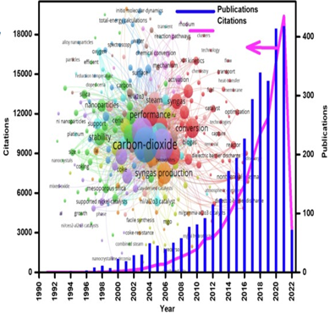

Figure 1. The bibliometric data concerning DRM based on Scopus database

**1.2 Processes of methane conversion for synthesis gas production**

The steam reforming of natural gas became a basis for a new industry in 1970-s [12]. In addition to steam reforming (equation (1)), there are two methods of reforming processes used to produce hydrogen i.e. dry reforming of methane (equation (2)) and partial oxidation of methane (equation (3)) [13].

Table 1 – Proximate composition of biogas obtained from different sources

|  |  |  |  |  |  |  |
| --- | --- | --- | --- | --- | --- | --- |
| Biogas sources | CH4, % | CO2, % | N2, % | O2, % | Other traces | Reference |
| Agricultural gases and landfill gas | 45‒75 | 25‒55 | 0‒25 | 0.01‒5 | H2S and NH3 | [8, р. 11] |
| Sewage, sludge, landfill or industry | 55‒70 | 27‒44 | Trace | trace | < 1% of H2, < 3% of H2S, NH3, siloxanes, haloxygenates | [9, р. 11] |
| Organic waste | 50‒70 | 30‒50 | - | - | NH3, H2S, organic sulfur, water vapor | [10, р. 11] |
| Agriculture, industrial, and municipal | 55‒70 | 30‒45 | 1 | - | H2, H2S, water vapor | [11, р. 11] |

In all processes an oxidizing agent oxidizes CH4 to CO and H2. The oxidant type influences the H2/CO ratio in the synthesis gas. Hydrogen is the clean fuel of the future due to the absence of greenhouse gas emissions. Hydrogen production technologies using renewable resources are beginning to develop to ensure a sustainable energy cycle, but because of economic and technical limitations, about 80–85% of H2 is mainly produced in the SRM process [14]. Nevertheless, the large heat was consumed for evaporation of water due to its phase transition. Water used in the steam reforming must be deionized to protect the catalyst from degraded performance and shortened life, as well as additional equipment and energy costs must be considered [14, р. 11].

CH4 (g) + H2O (g) → CO (g) + 3H2 (g) (1)

CH4 (g) + CO2 (g) → 2CO (g) + 2H2 (g) (2)

CH4 (g) + 0.5 O2 (g) → CO (g) + 2H2 (g) (3)

SRM is the most widely used industrial process for the synthesis gas production among other methane conversion processes. SRM is an endothermic reaction (equation (2)) between steam and methane at elevated temperature (750–950°C) and high pressure (14–20 atm.). During the process, a parallel reverse water-gas shift reaction (RWGS, equation (4)) can proceed, increasing the yield of H2, hence H2/CO increased to 3 [15, 16].

The catalytic POM has garnered a significant interest due to its ability to produce a favorable H2/CO ratio equal to 2.0 ideal for methanol manufacture and the Fischer-Tropsch reaction.

H2O + CO ↔ CO2 + H2 (4)

Conversely, there has been considerable focus on efficiently generating hydrogen. While SRM demands a substantial energy input, catalytic POM releases energy and necessitates less energy to yield an equivalent amount of hydrogen [17]. However, using pure oxygen as an oxidizer has disadvantages due to economic and technical problems, hence in the industry commonly a mixture of oxygen, and/or CO2, and steam is used. POM is an exothermic reaction, and it is thermodynamically favorable. One of the reactions parallel to POM is the complete oxidation of methane (CH4 (g) + 2O2 (g) → CO2 (g) + 2H2O (l)), generating high heat supply. The optimal conversion of methane is commonly reached at high temperature, when partial oxidation is targeted [18].

In this regard, DRM is a viable method for generating syngas. This process is of significant industrial importance and has been found to be suitable for producing syngas with an equimolar ratio of H2 and CO [19]. Such a syngas composition is particularly advantageous for applications like the Fischer-Tropsch synthesis. Furthermore, the DRM reaction aligns with the environmental protection and the principles of green chemistry, as it transforms greenhouse gases (specifically, CH4 and CO2) into valuable feedstock or intermediate products for industry [20]. This reaction requires robust basic catalysts, and many studies have been dedicated to advancing catalysts, which demonstrate high performance and stability. Supported metal catalysts are commonly employed in hydrocarbon reforming and are typically prepared through impregnation of various supports. However, in such method full reproducibility is challenging because metal can be distributed irregularly on the surface of the catalyst, leading to inconsistencies. Additionally, the fine metal particles obtained from this process tend to sinter at elevated temperatures, ultimately deactivating the catalyst. It is widely acknowledged that most group VIII metals display selectivity to syngas and optimal conversion (CH4 and CO2) [21].

A detailed description of the optimal catalysts, active components, promoters and carriers used in DRM, advantages and disadvantages, as well as the effect of varying the reaction mixture, flow rate and duration of the experiment on DRM will be presented in other sections.

**1.3 Catalysts and its components of dry reforming of methane**

From a standpoint of manufacture, catalytic performance is a crucial factor, but catalyst price of the cannot be disregarded. Base metals (Ni, Co) are the favored metals of selection in the implementation of DRM in the manufacture. The catalytic activity in dry methane reforming is affected by following factors: reducibility and particle size of the active metal; kind of support, oxygen storage capacity, basicity, acidity and surface area of the support, as well as interactions between metal and support [22].

Active metals of dry methane reforming catalysts can be divided into two classes:

* non-noble metals, for instance, nickel, cobalt, and iron;
* noble metals, for instance, rhodium, ruthenium, platinum, etc.

The substitution of noble metals by transition (i.e. Ni, Fe or Co) metals is a well-known approach from industrial and economical perspectives [10, р. 12]. In comparison with cobalt, nickel has been more studied as an active metallic phase in DRM because of its high activity.

In many studies, noble metals were incorporated into Ni-based catalysts to build bimetallic or multimetallic sites. However, such catalysts are not cost-effective. Along with Pt, Pd, etc. Co is capable as active bimetallic site in nickel catalysts. The catalytic performance can be advanced and problems of monometallic sites in DRM can be solved by incorporating another or active metals toward Co or Ni catalysts.

Some bimetallic Ni–Co catalysts did not exhibit good activity compared to monometallic nickel or cobalt as active centers, in spite of deep investigation of the favorable Ni/Co ratio. Coke assembled on the cobalt and bimetallic nickel-cobalt surface was burnt easier than the coke assembled on the nickel surface, according to high oxophilicity of cobalt and bimetallic nickel-cobalt surface. Substantially stable nickel–cobalt nanoalloy hindered RWGS reaction. With increase in reaction temperature Co usually migrates from the catalyst surface to the bulk phase, whereas Ni moves to the Ni-Co alloy surface. After gradually completion of cobalt and nickel migration as methane reforming temperature increased to 540°C, the stabilization of nanoalloy occurred. The catalyst possessing nanoalloy phase containing nickel and cobalt exhibited activity at 350°C and 800°C, which indicates the perspective of this alloy in dry methane reforming [10, р. 12].

Recently, the activity of iron is started to be studied, because Fe is available and very inexpensive (approximately 250 times cheaper than nickel or cobalt). Studies have reported the use of iron dispersed on ZrO2, MgAl2O4, or Al2O3 oxides for methanation reactions, showing encouraging results. Additionally, researchers have investigated Fe-based catalysts for various processes, including standard DRM (with equimolar inlet feed), ethylene reforming, CO methanation, and CO2 hydrogenation. Fe is still rarely used in the model biogas reforming, although it is economically attractive. It exhibited the lowest catalytic activity among other catalysts depicted in Table 2. However, Fe can be a very good promoter for Ni-based catalysts [10, р. 12].

Table 2 demonstrates the influence of promoting effect of noble metal and Co on Ni-based catalysts. 5Ni-10Co-0.25/MgO-Al2O3 catalyst calcined at 650ºC shows a very stable performance during 24 h [23]. Zhang studied Ni-Co/θ-Al2O3 catalyst synthesized via the impregnation and tested it in DRM 2 h and 12 h at 700°C. Initial methane conversion was high, decreasing after 12 h from 75% to 49% [24]. Similar deactivation was observed for CO2 conversion.

Table 2 – The impact of Ni/M ratio on catalytic activity

|  |  |  |  |  |
| --- | --- | --- | --- | --- |
| Catalyst | Synthesis method | Metal particle size, nm | CH4/CO2 Conversion  H2/CO | Reference |
| Fe10%Al2O3 | Evaporation-induced self-assembly | - | 10%/30%  0.8 | [10, р. 11] |
| Pt(-cl)/Al2O3 | Wet impregnation | - | 23%/15% | [25] |
| NiAl2:1 | Combustion | - | 99%/-  1.0 | [27] |
| 5% Ni- 5% Co/θ-Al2O3 | Wet impregnation | 22 nm (17 nm for spent) | 75% (49%)/82% (59%)  - | [24, р. 15] |
| Pt25Ni75/CeO2 | Co-impregnation | - | 53%/51%  0.7 | [25, р. 15] |
| 5Ni-10Co-0.25/MgO-Al2O3 | Two-solvent impregnation, 650ºC for 2 h | - | 90%/90%  - | [23, р. 15] |
| 1.0-Pt-12Ni/Mg-Al | Impregnation | 0.4 | -/62%  - | [26, р. 16] |

The presence of a small NiO amount resulted in high initial activity, however, causing deactivation of catalyst. The mean size of metal particle was 22 nm in the fresh catalyst decreasing for the used one. Ni and Pt were impregnated onto CeO2 support [25, p. 15]. The catalytic performance of Pt25Ni75/CeO2 was conducted for 24 h at 650°C. The catalytic activity became higher with time-on-stream and no deactivation was observed. Araiza also studied Pt/Al2O3 catalysts with H2PtCl6 precursor [25, р. 15]. The initial CH4 and CO2 conversion has been started from 65‒70%, decreasing to 25‒30% and remaining stable at low values. The influence of the precursor used in the Pt/Al2O3 system became evident in the spent catalysts. The Pt(-cl)/Al catalyst displayed a higher quantity of carbon deposits and larger Pt particle sintering, which were both responsible for the enhanced deactivation observed in the DRM. Noticeably, Ni-Pt catalysts possess lower catalytic activity in comparison with Ni-Co catalysts. The particle size of 1.0Pt-12Ni/Mg-Al was 0.4 nm. Catalytic effectiveness can be improved by metal particle sizes lower than 20 nm, however, in [26], the catalyst was not highly active and a slight decrease in activity occurred [26, р. 16]. The Ni-Al catalyst has the best performance with CH4 conversion of 99%, in addition H2/CO ratio is close to unity [27, p. 15].

The catalyst structure can be enhanced by the promoter, which influences the kind of the active sites.

As a result, promoters are extensively employed to improve the catalyst durability and activity. Promoters can be distinguished by three major groups [28]:

- rare earth metals;

-alkali earth metals;

- other elements like Bi, Au, Ag, Sn, As, and Cu.

Ni/SBA-15 catalysts promoted by cerium and lanthanum have been researched in DRM. The results of the investigation demonstrated the improvement of coking resistance by promotion of La2O3 and CeO2 and the small metal particle size in these catalysts. When using a 10 wt.% Ni/SBA-15 catalyst promoted by Ce, a reduce in feedstock conversion and H2 yield was observed. The La-introduced catalyst proved to be a good material in terms of activity. H2/CO ratio of smaller than unity for promoted catalysts indicates a parallel side reaction, i.e. an RWGS reaction that consumes hydrogen to produce more CO gas [28, р. 16].

CaO can inhibit particle sintering, which results in better catalyst performance. Sintering primarily leads to catalyst deactivation. The Ca loading affects conversion of CO2 and CH4 during DRM [29]. Thus, a lower Ca content formed more ionic oxides and boosted CO2 conversion, boosting CH4 conversion as CO2 is attracted to the catalyst surface. Conversely, higher concentrations of Ca increased the electron density of Ni, which then led to a reduction in the conversion of CH4 and CO2.

Magnesia has been noticed to increase the amount and strength of the base providing supplementary oxygen species on the surface and promotes CO2 adsorption and activation. After calcination creation of NiO-MgO solid solution occurred. However, it did not increase the total reducibility, after reduction the nickel nanoparticles from the solid solution formed a close cooperation with MgO, preventing the Ni nanoparticles from sintering, contributed to improve enough surface of the support containing metal conducive to CO2 activation and enhance the long-term performance of the catalyst [30].

For instance, for the 10 wt.%Ni/Al2O3 catalyst, the methane conversion reached 60.8% at 750°C with GHSV of 50,000 ml·g-1 h-1. With the addition of MgO, 15MgNi/Al2O3 showed the best promoting effect and methane conversion reached 83.7% at 750°C. In addition, the 15MgNi/Al2O3 sample also showed the highest CO2 conversion [31].

Catalysts based on nickel supported on alumina with the addition of cerium as a promoter were studied. The role of ceria addition in the catalyst was noted by insufficient NiAl2O4 spinel of promoted catalyst, which can reduce catalytic activity [32]. In another work, NiAl2O4 plays a role of inhibitor of sintering, hence, improving catalytic performance and long-term stability of Ce-modified Ni catalysts [33].

The formation of cerium aluminate substantially improves the stability in dry reforming and hinders carbon deposition. The low amount of carbon (2.9 wt. %) is evidence of this. CeAlO3 is able to dissociate CO2, forming active oxygen from the surface, reducing deactivating risk by carbon deposition. Strong interactions were observed between nickel and nanofibered alumina in NiCe/NFA catalyst, confirming the lower nickel particle size, which improves their stability towards sintering [34].

The significant influence of cerium, zirconium and iron on the catalytic efficiency of Co-M/AC-N catalysts was studied. The reaction was carried out in the absence of an inert gas with an equivalent feed gas ratio fed with a total flow rate of 120 ml·min-1. In comparison with the non-modified catalyst, the Ce promoted catalyst exhibited higher effectiveness, while the iron and zirconia modified ones were less active. It is worth noting that the uniform dispersibility of cobalt and cerium on the catalyst surface helps to enhance the catalyst stability. Nevertheless, the strong oxidation of zirconium and iron was provided by lower catalytic performance of the 3Co-1Fe/AC-N and 3Co-1Zr/AC-N, leading to the oxidation mostly of Co2+ to Co3+. A higher Co3+ content reduces the rate of electron transfer during DRM, decreasing the yield of products [35].

In [36] conversion of CO2 and CH4 was 68% and 60%, respectively for 0.5Ni-Fe-Al. In addition, in comparison with other catalysts (Table 3), this catalyst has the lowest surface area and metal particle size. In [37] modification of an alkaline-earth metal to Ni/Al2O3 enhanced nickel dispersion, thus, improving catalyst stability.

The catalyst was steady for 200 h during DRM with no visible deactivation. The possible DRM mechanism in the presence of Ni-Fe-Mg(Al)O was suggested [38]: adsorbed methane was dissociated on active centers of nickel, while CO2 was activated at the iron sites and metal-support interface. Thus, coke deposition can be hindered by a formation of a Ni-Fe alloy also inhibiting CH4 cracking. The addition of 15 wt.% lanthanum to the support makes catalyst more basic improving catalytic activity (Table 3) [39]. Increase in La content to 20 wt.% decreased the surface area leading to the loss in activity in DRM.

In any reaction, the support alone cannot possess catalytic activity. However, it can alter the properties of the active phase. As a result, the support is employed to achieve desirable results. It has been observed by numerous researchers that the activity of oxide catalysts is enhanced as a result of oxygen storage capacity, better metal dispersion, and the interactions between the support and the metal.

Alumina is well-known, necessary ceramic materials having a number of distinguished features such as enhancement of catalytic activity, thermal conductivity, chemical inertness, high heat and wear resistance, high melting point, good dielectric features, low friction coefficient and large optical band gap. γ-alumina is produced by thermal dehydration of large boehmite particles at temperatures above 400–450°C. The resulting oxide possesses a large surface area (250 m2·g-1). In addition, the stability of alumina is strongly affected by steam, which accelerates the conversion of γ-form to α-form, followed by a noticeable reduce in the surface area resulting in sintering [40].

Table 3 ‒Influence of promoters on catalytic activity

|  |  |  |  |  |  |  |
| --- | --- | --- | --- | --- | --- | --- |
| Catalyst | Reaction conditions | CH4/CO2 conversion  H2/CO | SBET, m2·g-1 | Metal particle size, nm | TOS, h | Reference |
| 0.5Ni-Fe-Al | CH4:CO2 = 1:1, 700°C, GHSV = 24000 ml·g-1·h-1 | 60%/68%  0.9 | 86 | 7 | 6 | [36, p. 17] |
| Ni-Mg/Al2O3 | CH4:CO2:N2 = 10:20:20 sccm., 550‒850°C | 90%/99%  1.2 | 153 | 14.5 | 200 | [37, p. 1] |
| Ni-Fe/Mg(Al)O | CH4:CO2:N2 = 1:1:2, 500‒800°C, GHSV = 60000 ml·g-1·h-1 | 92%/98%  0.9 | 138 | 8 | 25 | [38, p. 17] |
| Ni-La/Al2O3 | CH4:CO2:N2 = 1:1:0.3, 700°C, GHSV = 42000 ml·g-1·h-1 | 64%/79%  1.0 | 162 | 14 | 8 | [39, p. 17] |

Alumina exists in different transition phases, for instance, γ, δ, θ, and α-alumina [41]. Different disposition and occupation of Al3+ ions in octahedral and tetrahedral locations affect the crystal structure of transition alumina forms. The structure of alumina based on the face-centered cubic packing of oxygen involves γ (cubic or tetragonal), θ (monoclinic) and δ (tetragonal or orthorhombic) phases, while the hexagonal closest packed involves α (trigonal) phase. γ-alumina is thermally resistant at temperatures above 900°C, however upon annealing at higher temperatures it irreversibly transforms into the highly stable α-alumina through intermediate phase transformations: γ → δ → θ→ α.

XRD results demonstrate a thermodynamically determined phase transition from aluminum hydroxide to different phases of alumina during calcination at 150–1150°C. The sample treated at 1150°C shows the formation of the main and stable α-alumina, as well as traces of θ- and δ-alumina.

Thus, the structural transformations occur during calcination of aluminum hydroxide (equation (5)). As can be seen, aluminum hydroxide began to undergo changes only at 400°C.

Al(OH)3+AlOOH Al(OH)3+AlOOH ( Al2O3

( Al2O3  ( Al2O3  (Al2O3

Al2O3-Al2O3 (5)

At 600‒950°C aluminum oxide contains two phases, not being pure. It is probable that pure α-Al2O3 is formed at 1150°C [41, р. 18].

The calcined Al2O3 support showed a very sharp hysteresis loop, which indicates that cylindrical mesopores with an average diameter of ca. 7 nm are evenly spaced. With increasing nickel content, such aspect is more accented, which is the result of pore expansion, exposing larger but slightly ordered mesopores. For Ni20%Al2O3, the main hydrogen reduction peak is noted at about 570°C because of the presence of highly oxidized nickel species that interact with the support, in the mixed spinel phases. Well-dispersed active NiO nanoparticles are reduced by spinels [42].

Another well-known support for DRM is SBA-15. It is a mesoporous strainer made of silica on the basis of homogeneous hexagonal narrow pores with the diameter of 5–15 nm. The greater mechanical durability of silica compared to MCM-41 is led by the thickness of the frame wall in the range of ca. 3–6 nm. A large surface area (ca. 400–900 m2·g-1) allows to obtain a suitable material for a variety of applications. For instance, SBA-15 can be applicable in modern optics and as a support component in catalysis [43].

The Ni/Fibrous SBA-15 catalysts produced via the nickel impregnation method were tested in DRM. Judging by the characteristics, F-SBA-15 with a stick kernel shape possessed an external filamentary stratum, while the dendriform DFSBA-15 contains a hard kernel with radially protruding fibers. In addition, Ni/F-SBA-15 acquires a non-rigid NiO size, while Ni/DFSBA-15 possess a rigid dispersion of NiO. It is stated that formation of fine filaments and nickel deposition did not influence the original features of SBA-15, although its surface features were markedly declined. The strength of interaction between the support (silica) and the metal (nickel) can be estimated as follows: Ni/DFSBA-15 > Ni/F-SBA-15 > Ni/SBA-15. Two Ni/fibrous SBA-15 catalysts show a large fraction of medium basicity promoting carbon removal by the reverse Boudouard reaction [44].

It was stated that the surface area of pure Mobil Composition of Matter-41 (MCM-41) was 1358 m2·g-1, whereas surface area of 0.3PdNi/MCM-41 was 514 m2·g-1. The metal particle size in the fresh catalyst was ca. 8 nm, increasing in the spent catalyst to 11 nm due to Ni sintering. In addition, Ni/Si ratio of 0.3 was observed for 0.3PdNi/MCM-41, which exhibited high catalytic performance in DRM [45].

Silica has a low acidity, thus, it contributes to a low accumulation rate of carbon. However, synthesis of the catalyst strongly influences the metal dispersion on SiO2, since the structures formed by this oxide prevent dispersion of the metal. For example, satisfactory metal distribution was achieved at a low metal content (approximately 5 wt.% Ni) through the use of hexagonal mesoporous silica (HMS). Limitation of Ni sintering due to stronger interactions between nickel and the silica was suggested. 7wt. % Ni/HMS catalyst was prepared by “direct synthesis”. At higher contents, the HMS structure was not formed anymore along with thermally unsteady solid. This preparation method possesses the advantage that at a low nickel content, it allows formation of Ni clusters that are small in size compared to clusters obtained using the initial moisture method [46].

A relatively new type of catalyst employed for DRM is metal carbides namely β-Mo2C and WC. It was reported that activity of β-Mo2C and the noble metals is equal, while the cost of molybdenum is lower than that of the latter. In addition, Mo2C possesses higher stability due to improved coking resistance unlike nickel catalysts [47].

It should be noted that the type of monometallic carbides displays stable activity solely at relatively high pressure. Nevertheless, at atmospheric pressure, these carbides rapidly deactivated due to their CO2 oxidation. As a result, active carbides were converted into inefficient oxides. Thus, carbides and oxides could be cycled under CO2 and CH4 flows, indicating that metal carbides can act as redox catalysts for DRM [48].

Although methane is able to interact with the surface of the carbide, it cannot prevent oxidation of Mo2C, while CO and H2 can stabilize the carbide through reversible redox reactions shown in equations (6-8) [49]:

Mo2C + 5CO2 ↔ 2MoO2 + 6CO (6)

Mo2C + 5H2O ↔ 2MoO2 + CO + 5H2 (7)

2MoO2 + 5CH4 → Mo2C + 4CO + 10H2 (8)

However, carbonization of MoO2 under the action of CH4 (equations (8)) is irreversible and is not observed in the presence of more reactive gasses of reforming. Therefore, it can be concluded that at atmospheric pressure the adsorption of CO2 onto carbides proceeds more favorably than the adsorption of CH4 onto oxides, which leads to the final oxidation of carbide catalysts.

It is interesting that mixed oxides are used as supports, such as MgAl2O4, Ce1–xZrxO2, LaMO3 (M = Al, Co, Ni, Fe, Cr), La2NiO4, etc.

By cause of its moderate acidity and capability to protect the active phase from sintering, MgAl2O4 has been extensively studied a support for catalysts in DRM. Reduced with hydrogen, the catalyst incorporated onto MgAl2O4 strengthen catalytic properties towards DRM making the catalysts active, durable and recyclable.

Sol-gel method is usually used for preparation of high purity spinel. Ni was impregnated via incipient wetness impregnation technique on MgAl2O4, synthesized by SCS [50]. Produced catalyst was tested in POM. It was stated that the metal-support interactions were strong due to a wide reduction peak at 486‒700ºC. The catalytic experiments demonstrated that Ni/MgAl2O4-0.5 and Ni/MgO-4 displayed huge catalytic activity and selectivity at GHSV of 157500 l kg-1 h-1 and 800°C while Al2O3 supported catalysts demonstrated lower selectivity and activity at these conditions.

MgAl2O4 synthesized via the co-precipitation method possessed high purity, according to XRD [31, р 17]. The BET surface areas were 108 m2·g-1 and 78.5 m2·g-1 for 1 wt.% and 15 wt.% Ni/MgAl2O4, respectively. The higher was Ni loading, the lower was the surface area, because Mg decreases it. Activity of supported Ni catalysts with distinct concentrations: Ni/MgO-Al2O3 and Ni/MgAl2O4, was tested at 750ºC with equimolar initial gas ratio without diluents. The highest catalytic activity was observed for 15 wt.% Ni/MgAl2O4 with CH4 and CO2 conversion of 83.7% and 93.5%, respectively. Ni/MgAl2O4 catalysts have a large coke amount (38%) with Ni content lower than 15%, because Ni particle size was large, but deactivation did not occur during 10 h TOS.

The analogy of catalysts adopting distinct supports was demonstrated in Table 4. The highest catalytic activity was observed for Ni0.025AlO2-δ [51] and 25Ni-MgAl2O4 [52].

However, the most stable and active was Ni0.025AlO2-δ for 50 h with a small metal particle size, regardless of absence of basic elements used as coke formation inhibitors. 10NiOMgO [53] and 12.5 wt.% Ni/CeO2 [54] exhibited the minimum activity (CH4 conversion of 60%). [5Ni/SiO2-S1](mailto:6Ni@SiO2-S1) [55] and 5Ni/La2O3 [56] exhibited similar activity at 700°C during 50 h, although the size of metal particle and specific surface areas were different. Accordingly, catalytic performance of 10Ni3Mn/Al2O3 was rather lower [57]. High dispersion leads to an improvement in catalytic activity.

It is worth noting that when selecting an optimal support, an interplay between the support and the metal should be considered.

Two types of interactions occur during DRM:

- the interaction of the support with the metal;

- the combined interactions between the support and two metals.

The kinds of interactions affected by the quantity of metals on a support. For instance, the first type corresponds to the monometallic Ni/Al2O3. While addition of Mg as promoter to Ni/Al2O3 gives the second type, because MgO easily interacts with alumina.

Metal-support interactions (MSI) increase metal dispersion and prevent sintering, thereby maintaining small-sized active metal particles. The synergistic effect of bimetals improves dispersion further leading to additional active sites. MSI can also enhance thermal stability of the catalyst, as otherwise high temperatures can result in metal sintering [58].

Dispersion of the active metal and the metal–support interactions heavily depend on the temperature of calcination. It was stated that high calcination temperature gives the NiAl2O4 improving the interplay between nickel and alumina. The catalyst displayed high catalytic activity after the complete reduction of spinel [59].

The MSI of Co/Al2O3 obtained by pyrolysis using flame spray was also studied [60]. The regulation of the interplay between the cobalt metal and alumina comprised adjusting the Co:Al ratio. The preparation of materials containing 30 mol.% cobalt in Co3Al7 facilitated development of cobalt particles that were easily reducible and well-dispersed. This, along with a pronounced relative surface basicity, played a crucial role in empowering Co3Al7 giving high and enduring activity in dry reforming reactions. However, in the catalyst with a larger cobalt content, specifically 50 mol.% in Co5Al5 and 70 mol.% in Co7Al3, formation of Co3O4 spinel particles with limited interplays with the support led to rapid catalyst deactivation due to coking. In addition, the metal-support interactions were not efficient because Co loading is excessive, giving the lower catalyst activity.

Development of a mixed-oxide phase consisting of NiO and MgO, characterized by robust Ni-Mg interactions, plays a significant role in substantially reducing carbon formation for oxidative DRM.

Table 4 – Comparison of catalysts impregnated on different supports of DRM

|  |  |  |  |  |  |  |
| --- | --- | --- | --- | --- | --- | --- |
| Catalyst | Surface area, g-1 | Metal particle size, nm* | Reaction conditions | CH4/CO2 Conversion | TOS, h | Reference |
| Ni0.025AlO2-δ | 105 | 7.9 | 800°C,  CH4:CO2:Ar = 1.5:1.5:7, GHSV = 108000 ml·gcat-1·h-1 | 90%/97%  0.9 | 50 | [51, р. 21] |
| 25Ni-MgAl2O4 | 115 | - | 550°C, CH4:CO2:Ar = 1:1:8,  GHSV = 20000 h-1 | 89%/92%  0.9 | 24 | [52, р. 21] |
| 10NiOMgO-PACS | 139 | 15 | 600°C,  CH4:CO2:Ar = 2:2:6, GHSV = 72000 ml·gcat-1·h-1 | 60%/-  0.85 | 24 | [53, р. 21] |
| 12.5 wt.% Ni/CeO2 | 66.9 | - | 700°C,  CH4:CO2:Ar = 1:1:1, GHSV = 24000 ml·gcat-1·h-1 | 60%/70%  0.9 | 50 | [54, р. 21] |
| [5Ni/SiO2-S1](mailto:6Ni@SiO2-S1) | 401 | 2.9 | 700°C,  CH4:CO2:Ar = 1:1:2, GHSV = 750 l·gcat-1·h-1 | 70%/80%  0.8 | 28 | [55, р. 21] |
| 5Ni/La2O3 | 23 | 13.8 | 700°C,  CH4:CO2:N2 = 15:15:70, GHSV = 60000 ml·gcat-1·h-1 | 71%/79%  0.9 | 50 | [56, р. 21] |
| 10Ni3Mn/Al2O3 | 166 | - | 700°C,  CH4:CO2 = 1:1, GHSV = 12000 ml·gcat-1·h-1 | 65%/75%  0.9 | 20 | [57, р. 21] |
| *Note: Metal average particle size obtained by TEM analysis | | | | | | |

Additionally, the coke-resistant feature of the MgAl2O4 support is attributed to its low acidity, thermal stability and high reducibility [61]. Mg-Al support is abandoned due to these features.

PdO–NiO impregnated into two distinct oxide supports e.g. Y2O3 and Al2O3 was tested in bi-reforming of methane (O2+CH4+CO2) [62]. The catalytic activities of PdO-NiO/Y2O3 and PdO-NiO/Al2O3 are high because they generate metal-support interactions. Specifically, Pd interacts with Y2O3 in the PdO-NiO/Y2O3 catalyst forming PdxOyYz. Meanwhile, NiAl2O4 phase was produced from the reaction of Ni with Al2O3 in the PdO-NiO/Al2O3.

Comparison of activities and phases is not enough sometimes. In this regard, coke deposition was also taken into account. The quantity of carbon accumulation on the PdO-NiO/Y2O3 catalyst after reaction is rather low compared to that of the PdO-NiO/Al2O3. This observation can be as ascribed to the presence of oxygen species in the surface and the ability of yttria to generate oxycarbonate species. Consequently, the PdO-NiO/Y2O3 catalyst maintains a stable performance without significant deactivation throughout the reaction. These surface oxygen species split C-H bonds in methane, whereas the oxycarbonate species have the ability to oxidize the deposited carbon. The particular mechanisms contribute to the sustained stability of PdO-NiO/Y2O3 [62, р. 22].

The active metal is incorporated into oxides, for example, perovskites, hydrotalcites or pyrochlores. During reduction of such catalysts, the active metal migrates from the bulk to the surface improving high metal dispersion on the oxide surface.

Perovskites are related to a group of crystalline oxides, being served as common formula of ABO3. A cations can be either alkali, alkaline earth, rare earth or Bi3+ and Pb2+, which involved into the dodecahedral sites of the structure whilst B ions are cations of transition metals occupied the octahedral sites in ABO3 type materials. Proper selection of A and B cations can help to obtain perovskites with good properties [63].

High calcination temperatures are required for perovskite synthesis providing small surface area of ~ 10 m2·g-1. Nevertheless, highly dispersed metal species are produced in pre-treated perovskites bringing about efficient catalytic performance. Preparation method and metal precursors used control the features of the perovskites [63, р. 23]. In conjunction with the steadiness of structure, replaced perovskites possess good oxygen mobility, which act like a coke eliminating agent during reforming processes, particularly DRM.

Perovskites can be used as catalyst precursors in DRM. The metals can be substituted on A- or B-site. For example, Ce substitution on A-site strengthen catalytic activity, meanwhile Ce3+ possesses more oxygen vacancies by activating the B-site cations. Cerium is highly soluble in the perovskite structure under reaction conditions, whereas the solubility of Ce in LaMO3 (M is transition metals) is very low. Ni substitution in B-site makes perovskites to be active, however, they tend to deactivation. In this regard Fe, La and Ce were added (LaCe)(NiFe)O3 tends to improve catalytic activity [63, р. 23].

The cubic perovskite structure can be formed by linking of BO6 octahedral at the corners in 3D, therefore it is called an ideal cubic packing. The perovskite family includes compounds that have structures based on an ideal perovskite type, but with some atoms removed or slight distortions in the lattice. These types of perovskite compounds can have A cations with distinct valences (A+ or A2+), that can also introduce trivalent elements. The B cation in these compounds can be pentavalent, tetravalent, or trivalent. The B cation has a smaller size compared to the A cation. At room temperature the structure of bulk LaAlO3 is rhombohedral, which structure is transformed to a pseudo-cubic structure at the critical temperature above 540ºC. Cubic perovskites, such as LaAlO3, have the ability to undergo transformations into various crystal structures. When specific pressure and temperature thresholds are reached, the perovskite LaAlO3 undergoes a phase change, however, perovskites remain stable at elevated temperatures. In processes other than methane reforming A and B cations can be substituted, which could be a reason, for which perovskites can be almost ideal for heterogeneous catalysis [64]. For example, LaAlO3 catalyst compound was discovered for the oxidative coupling of methane by Imai and Tagawa in 1986 [65].

The tolerance factor t (or Goldschmidt factor), which is equal to unity gives an ideal cubic structure of perovskite determined from equation (9):

$t=(r_{A}+r_{O})\sqrt{2(r_{B}+r_{O})}$ (9)

where, rA, rB and rO are ionic radii of A, B, and oxygen, respectively.

The physicochemical features of perovskite oxides can be finely tuned because of the broad range of metals incorporated into their structures. As a result, perovskite oxides have extensive applications in catalysis, including processes such as DRM, SRM, bioglycerol, toluene and ethanol; partial oxidation of lignin, as well as valorization of biomass and bio-oil [66].

A surface layer and lanthanum species are strongly interacted and present in limited “active sites” of octahedral alumina involving to form LaAlO3. Lanthanum species that are located on other sites of alumina are precipitated as La2O3 due to the decline in the active site amount caused by agglomeration occurring during calcination above 500ºC [67].

The reduced Ni/Al2O3 catalyst possess the largest surface area, whilst this value for the Ni/LaAlO3 was relatively lower. Because to form the LaAlO3−Al2O3 phase La was incorporated into the support. The decline in the surface area was inevitably induced by the existence of LaAlO3 crystallites in the Ni/LaAlO3 catalyst, when La is involved into the alumina. The lowest surface area is observed for reduced Ni/La2O3 catalyst. Ni particle sizes in catalysts are put in the next order: Ni/Al2O3 < Ni/LaAlO3 < Ni/La2O3. As a surface area decreased metal particle sizes became larger in the catalyst. Ni/Al2O3 has the lowest mean nickel particle size because of the surface interactions, which form the amorphous NiAl2O4 structure. Among all the catalysts Ni/La2O3 possesses a large average nickel particle size as a result of its narrowest surface area [68].

XRD revealed that it consisted of cerium aluminate (CeAlO3) with a perovskite-like structure, characterized by a tetragonal unit cell and space group P4/mmm. However, when the ceramic powder was treated at 900°C in the presence of air, it underwent a transformation into a material composed of cerium oxide (CeO2) phase. The cerium oxide exhibited a cubic unit cell and the space group FM-3m. No indications of the presence of alumina or aluminum-containing composites were detected alongside the ceria [69].

Table 5 demonstrates a comparison between different perovskites used in DRM. A perovskite catalyst synthesized by auto-combustion exhibited relatively good performance [70]. The perovskite-typed catalysts obtained by the sol-gel method allowing to display a better performance, unlike catalysts obtained by a different method. For example, conversion of CH4 and CO2 is ~ 40–45% for LaNi0.95Rh0.05O3 prepared via co-precipitation [71], while conversion of CH4 and CO2 was ~ 85–87% for [LaNi0.9Ru0.1O3](mailto:6Ni@SiO2-S1) prepared via the sol-gel method [72]. It is also worth to note that the catalytic performance is influenced by calcination temperature. Formation of perovskites requires higher temperatures, which is obviously observed from Table 5. Conversion was lower for La0.8Sr0.2Ni0.8Fe0.2O3 perovskite produced at 700°C [73], compared to [LaNi0.9Ru0.1O3](mailto:6Ni@SiO2-S1), the calcination temperature of which was 1000°C. Ca- and Sr-substituted perovskites are highly active among investigated catalysts [74‒76]. In addition, narrow surface areas are obtained by at elevated calcination temperatures, which also improves catalytic activity.

**1.4 Catalyst synthesis and pre-treatment methods before dry reforming of methane**

The metal dispersion and surface area can be enhanced by selection of suitable preparation method for supports. Moreover, involving active metal into support or building core–shell structures to prohibit metal sintering in DRM are actively studied.

The way, how a catalyst was obtained substantially influences its physicochemical features and functionality. Two universal classical approaches of producing catalyst are co-precipitation and impregnation. However, when comparing the sol-gel approach to these conventional approaches, the sol-gel method brings about a catalyst with certain advantages, comprising excellent purity, a fine size placement, a slower deactivation rate, and excellent thermal counteraction contrary to agglomeration [77].

The pretreatment involving calcination brings about modifications in the structures of the support materials. Lower temperatures of calcination can lead to partial disintegration of the metal precursor, thus declining in the active composite. Conversely, higher temperatures can induce sintering of these active composites, leading to a decline in deformation of the support structure and surface area. For example, 5 wt.% Ni/ZrO2 was produced by impregnation, underwent calcination at 600°C, 700°C, and 800°C. The sample, which underwent this step at 800°C exhibited high conversion (CH4 – 75%, CO2 – 60%), respectively. It was noted that surface area is declined at higher temperatures [78].

Another method of preparation is microemulsion, where Ni is deposited onto SiO2, calcined at different temperatures e.g. 550ºC, 650ºC, 750ºC, 850ºC, 950ºC [79]. The calcination temperature affects the mean metal particle size as follows: the higher is calcination temperature the higher is mean metal particle size. The surface area calculated by BET method for Ni@SiO2-823 (550ºC) was equal to 112 m2·g-1, elevated for Ni/SiO2-923 (650ºC) to 203 m2·g-1. Thereafter, the surface area reduced, when treating temperature increased, for Ni/SiO2-1023 (750ºC), Ni/SiO2-1123 (850ºC) and Ni/SiO2-1223 (950ºC) catalysts being 150 m2·g-1, 130 m2·g-1 and 29 m2·g-1, respectively.

Methane rates decreased from 42 mmolCH4·gNi-1·s-1, 37 mmolCH4·gNi-1·s-1 to 32 mmolCH4·gNi-1·s-1 for the catalysts calcined at 750ºC, 850ºC, 950ºC, respectively. The CO2 rates were almost the same as those of methane. The stability was performed over Ni/SiO2-T (T = 550‒950ºC). The most stable catalysts were the catalysts synthesized at higher temperatures (T = 750‒950ºC) being correlated with helping by strong MSI. Other catalysts exhibited worse stability. The H2/CO ratios were stable in the range of 0.84‒0.88, being below unity.

Table 5 – Correlation of perovskites used as catalysts in DRM

|  |  |  |  |  |  |  |
| --- | --- | --- | --- | --- | --- | --- |
| Perovskite | Surface area, m2·g-1 | Catalyst synthesis and calcination conditions | Reaction conditions | CH4/CO2 Conversion H2/CO | TOS, h | Reference |
| LaNi0.9Mg0.1AlO3-δ | 10 | Auto-combustion, 700°C for 6-10 h in air | 800°C, CH4:CO2 = 1:1, GHSV = 600 l·gcat-1·h-1 | 56%/67%  0.47 | 15 | [70, р. 25] |
| LaNi0.95Rh0.05O3 | 8 | Co-precipitation, 750°C for 5h in air | 550°C, CH4:CO2:Ar = 1:1:8, GHSV = 20000 h-1 | 45%/40%  0.9 | 25 | [71, р. 25] |
| [LaNi0.9Ru0.1O3](mailto:6Ni@SiO2-S1) | 1.9 | Thermal decomposition of citrate precursors, 1000°C for 4h in air | 750°C,CH4:CO2 = 1:1, GHSV = 72 l·gcat-1·h-1 | 85%/87%  0.65 | 14 | [72, р. 25] |
| La0.8Sr0.2Ni0.8Fe0.2O3 | 13.9 | Sol-gel, 700°C for 5h in air | 700°C, CH4:CO2:N2 = 1:1:1 | 80%/80%  - | 24 | [73, р. 25] |
| SrTi0.85Ru0.15O3 | 17 | Sol-gel, 750°C in air | 900°C,CH4:CO2:N2 = 1:1:1, GHSV = 28.8 h-1 | 93%/96%  1.0 | 100 | [75, р. 25] |
| CaZr0.8Ni0.2O3-δ | 13.2 | Sol-gel, 750°C for 6h in air | 800°C, CH4:CO2:N2 = 1:1:1, GHSV = 28.8·h-1 | 95%/96%  1.0 | 500 | [76, р. 25] |

Tuning of catalyst properties was significantly influenced by calcination temperature and atmospheric atmosphere. The pre-treatment can be required as a prerequisite step before the DRM reaction using reducing agents (usually H2) to form the metallic phase, because in the most of the fresh catalysts metal oxide is existed as the phase [77, р. 25].

Comparably uncharted method of obtaining catalyst is solution combustion synthesis (SCS). In this approach, solution with nitrates and fuel undergoes combustion at 300–600°C. Therefore, by SCS certain more kinds of materials, for instance, luminescent nanospheres, quasi-conductors, bioceramics, distinct kinds of nanooxides can be manufactured [80]. The catalyst obtained by this way can be effective in DRM because of its narrow particle size, elevating catalytic activity [81].

Catalysts obtained with the help of SCS are supported and bulk ones. Catalysts of the first class are froth-like materials applied for numerous catalytic reactions. Pristine metals, oxides and alloys can be prepared. For example, LaFeO3 perovskites are applicable for autothermal reforming of hydrocarbons with good performance. Catalysts related to the second class can be obtained at high temperature by precipitation of active metals into support. In the literature [82, 83] the temperature of pre-ignition (300–600°C) started a quick elevated-temperature combustion. Water evaporation and gel formation occurred in a few seconds is the first stage of burning. Thereafter, gels combustion in air medium with blaze occurred, forming highly dispersed nickel with particles of 5 nm (equation (10)). The reaction of fuel with nitrates proceeds in different ways depending on what fuel is used. Combustion gasses (COx and NOx) and heat are released during microexplosion. Furthermore, the flame temperature is higher compared to pre-ignition temperature. Pre-ignition temperature below 300°C cannot start the burning of solution. Higher temperature decreases explosion time and enhances crystallinity of catalysts [84].

An exothermic reaction of urea and Al(NO3)3·9H2O is demonstrated further:

2Al(NO3)3·9H2O +5CH4N2O = Al2O3 + 8N2 + 5CO2 + 28H2O (10)

Finally, solely metals with different oxide forms, for instance, oxide, alloy, perovskite, spinel remained.

In this regard, this method of preparation is called the synthesis of catalysts by the combustion of solution or solution combustion synthesis. In the other case, gel is obtained by thoroughly stirring of fuel and nitrate, followed by placing this mixture into the furnace. This method is called the combustion method. In other case fuel and nitrate are mixed in water at 90°C on a heater. Obtained gel was burnt at temperature of 500°C or higher.

It is documented that nickel aluminate is generated during preparation by SCS at high temperatures [85]. When distinct pre-ignition temperatures, particularly 500ºC, 700ºC and 900ºC were applied the generation of NiAl2O4 was confirmed. In the furnace, the solution was ignited fast. Generating the powder-like catalyst, thereafter when the ignition fuel point was spread to the mixture. According to [85, р. 27] XRD findings demonstrated that along with NiO NiAl2O4 was detected as well, although alumina was totally missing, in accordance with [86].

Table 6 displays the difference between various catalyst preparation methods. All catalysts were reduced prior to the reaction. The findings affirmed that adding Mg did not improve dispersion of nickel within the La2O3 pattern. Instead, the size of Ni particle increased with the added modifier in contrast with Ni–La2O3, which is assigned to a weakening of MSI caused by the introduction of the promoter. Ni–La2O3 and Mg-Ni–La2O3 affirmed a slow increase in the conversion with time on gas stream [87]. The partial reduction of nickel oxide species throughout the pre-treatment process induced, the rise in activity over time. On the contrary, this improvement observed in the initial conduction period is linked to the gradual attainment of the La2O2CO3 equilibrium concentration. Lanthanum dioxycarbonate is formed by carbonation of La2O3. Following the steady state, conversion remained constant during 100 h operation period, while a decline in activity can be observed in conversion for Ni–La2O3 and Li–Ni–La2O3. For all catalysts, conversion of CO2 was higher in comparison with conversion of CH4, therefore the H2/CO ratio was close to unity during DRM. The fact that the RWGS reaction occur can explain previous statement. It is seen that Mg improve catalytic activity [88]. Al2O3-CeO2 support [89] in Ni-containing catalyst also tends to strengthen catalytic performance, however, conversion of CH4 is lower in comparison with that of Ni/Mg-Al.

Table 6 – Comparison of catalysts prepared by different synthesis methods

|  |  |  |  |  |  |
| --- | --- | --- | --- | --- | --- |
| Catalyst | Synthesis | Conversion  H2/CO | Surface area, m2·g-1  d, nm | TOS, h | Reference |
| Ni-La2O3 | SCS | 60%/70%  0.75 | 37.3  10.3 | 100 | [87, р. 27] |
| Mg-Ni-La2O3 | SCS | 80%/90%  0.9 | 54.5  14.8 | 100 | [87, р. 27] |
| Ni/Mg-Al | Sol-gel, 650ºC | 95%/97%  - | 184  5 | 8 | [88, р. 28] |
| Ni-Al2O3-CeO2 | Sequential impregnation | 85%/87%  0.6 | 65  44 | 24 | [89, р. 28] |

Thus, combination of a novel catalytic material and the preparation method would strengthen the long-term performance of the catalyst in dry reforming.

The scheme of production of pristine Ni-Al catalyst by two methods is demonstrated below (Figure 2):

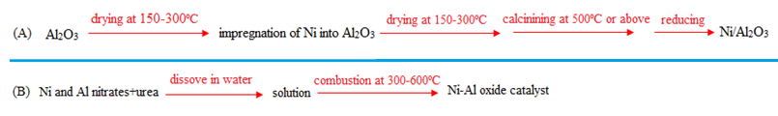

(A) - wet impregnation method, (B) – solution combustion synthesis.

Figure 2 – Scheme of preparation methods (wet impregnation and SCS)

It is obvious that wet impregnation requires many steps during preparation, while in SCS method two steps are enough to obtain an efficient, stable and well-dispersed catalyst with a low surface area. SCS is in no way inferior to impregnation, but on the contrary, has a number of advantages over the latter method [90].

**1.5 Influence of reaction conditions on catalytic activity**

The residence time, during which catalyst particles interact with reactants within the catalyst bed, is linked to the gas hourly space velocity (GHSV). An optimal GHSV can enhance reactant conversions by ensuring favorable catalyst-reactant interactions.

It was reported that CH4 conversion exhibited growth as the GHSV increased until it reached the optimal point; however, any additional increase in the GHSV value led to a decline in CH4 conversion [91]. This was also connected to the influence of residence time introduced by GHSV, which resulted in a shorter contact period for the interaction between reactants and the catalyst, consequently decreasing its catalytic activity. Moreover, it was observed that conversion of CH4 declined more significantly in contrast with conversion of CO2. This can be attributed to the challenge of breaking the comparably steady C-H bonds in CH4 for its activation.

A high GHSV was found to be unfavorable for both reactant conversions and product yield referring to the shorter constant time under reaction conditions. Conversely, a lower GHSV was preferred for enhancing activity, allowing for a longer contact time for the catalyst to influence behavior of the reactants. Under these conditions, mass transfer plays a dominant role, and the kinetic control becomes the determining factor in achieving reactant conversions up to thermodynamic equilibrium points.

For the 15 wt.% Ni/Al2O3 with weight hourly space velocity of 15 l·gcat-1·h-1, CH4 conversion was stable [92].

The findings demonstrated that a larger quantity of catalyst at the slowest flow of gases in the reactor improved conversion of methane. On the whole, a higher flow of gases was undesired for CH4 conversion because catalyst bed length was small. An opposite behavior for CO2 conversion was noticed. The increase on weight space velocity favored carbon dioxide conversion over the 15 wt.% Ni/Al2O3 catalyst, revealing that adsorption of CO2 was not consumed in the final elementary steps.

Formation of coke is decreased, when CH4/CO2 ratio decreased, indicating that CH4 decomposition (CH4 → C + 2H2) is elevated to inhibit the carbon formation with a larger CH4/CO2 ratio above 900ºC. In DRM CO2 acts as an oxidant, as in case of POM and SRM, the oxidants are air or oxygen and steam, accordingly. Under oxidant-rich conditions (CH4 < CO2), where an excess supply of CO2, CH4 conversion can be enhanced even more in contrast with the lower CO2 conversion observed in the oxidant-rich scenario. Furthermore, increasing the feed gas ratio from 0.5 to 1.0 in the oxidant-rich case, there was a significant increase in H2 production, from 45% to 60% [93].

However, it is important to note that the RWGS reaction consumes the produced H2, resulting in a decrease in H2 yield, thus, leading to lower H2/CO ratio. When CO2/CH4 ratios are less than unity, H2 production increases across the entire range of temperatures studied. This is because CO2, being the limiting reactant, prevents the RWGS reaction from simultaneously improving alongside the partial oxidation of methane. As CH4/CO2 ratio is increased (0.25‒2.33) the CO2 conversion is also increased, but the CH4 conversion decreased. A high CH4 content in the initial gas mixture enables carbon deposition, leading to loss in the catalyst stability. In situations, where the feedstock consists of equal amounts of CH4 and CO2, the coke removal rate through CO2 is lower compared to the rate of coke formation through CH4 cracking. It can be inferred that feedstock ratios of CH4/CO2 equal to unity appear to be the most favorable for achieving optimal catalytic performance, while also minimizing such issues as low coke deposition and metal sintering. However, biogas consists of feedstock, where CH4 is more than CO2.

For 0.5 wt.% Ru/Al2O3, the effect of the CH4/CO2 ratio = 1:2, 1:1, and 2:1 on process indicators at 785°C and constant GHSV of 18000 ml·gcat-1·h-1 was investigated [94]. Conversion of CH4 (97%) close to equilibrium (98%) was observed in the case of an equimolar ratio of feedstock for 0.5 wt.% Ru/Al2O3 catalyst. When CH4/CO2 was 1:2, CH4 conversion for catalyst was stable in time-on-stream and near the equilibrium values (99%). When methane was 2 times higher than CO2, for Ru/Al2O3 methane conversion was lower in comparison with equilibrium, being 60% (equilibrium was 90%), however, there was no any significant deactivation for 7 h. When CH4/CO2 ratios were 1:1 and 2:1, conversion of carbon dioxide was close to equilibrium and remained unchanged with time. When CH4/CO2 equal to 1:2, CO2 conversion increased from 63% to 71% (the equilibrium value) after 7 h, resulting in an increase in the relative rate of RWGS with time over this catalyst [94, р. 30].

The calculated H2/CO ratio was obviously equal and stable in the equimolar starting materials. H2/CO ratio should expectably increase with increasing in CH4 conversion. Nevertheless, it was proposed that for Ru/Al2O3 carbon monoxide was obtained in a result of other reaction parallel to DRM. On the other hand, hydrogen can be consumed in other reaction. It is possible that hydrogen was continuously used for RWGS, reducing in the H2/CO ratio. Not only RWGS was responsible in the observation of parallel reactions, because CO2 consumption should be reduced. On the contrary, CO2 conversion was unchanged throughout DRM. This demonstrates that the Boudouard reaction produces CO2, which can interpret the reason of relative constant H2/CO ratio and CO2 conversion [94, р. 30].

**1.6 Reaction mechanism of dry reforming of methane**

The effectiveness of DRM depends on the catalyst structure, involving the selection of active metal, its particle size and stability, features of the support, and operation conditions. Consequently, it is difficult to describe the mechanism of DRM, because the rate-defining stage and prevailing surface species can alter. Langmuir–Hinshelwood mechanism assumes that the rate-limiting step of DRM is the methane dissociation [95, 96]. CH4 activation occurs on the active metal surface.

For demonstration, the reaction mechanism of DRM over Pt/CeO2 was considered [97] (equations (11-12)).

CH4 decomposition on Pt: CH4 (g)→ CH4(Pt) (11)

Diffusion of H species in 4 steps: CH4(Pt) → CH4−*x*(Pt) + *x*H(Pt) (12)

In this stage carbon is generated from high decarbonation rates of CHx* integrated with low oxidation rates of CHx* by surface oxygen (O*). Methane can be adsorbed as CO with forming oxygen vacancy Vox (equation (13)):

C(Pt) + O(lattice) → CO + Vox (13)

Since metallic Ni possesses a higher tendency to produce oxides in comparison with Pt and other noble metals, Ni catalysts prefer dissociation of CO2, while CO2 adsorption without dissociation was favorable in Pt-based catalysts. For Ni-based catalysts adsorbed CO2* dissociates by assistance of H* or C* without producing O*. In a same manner, the existence of rare-earth, alkaline earth or alkaline additives can improve CO2 chemisorption forming largely reactive species like carbonate, which consequently interplay with carbon deposits arisen from methane cracking (equation (14)):

CO2 adsorption: CO2(g) + O(lattice) + Vox → CO3(CeO2) (14)

Obtained CO3(CeO2) is hydrogenated (equation (15)):

CO3(CeO2) + H(Pt, CeO2) → HCO3(CeO2) (15)

Carbonaceous species undergo desorption (equation (16)):

HCO3(CeO2) + H(Pt, CeO2) → CO(g) + H2O(g) + O(lattice) + Vox (16)

Oxygen vacancy is refilled (equation (17)):

Vox + H2O → O(lattice) + 2H(CeO2) (17)

Further H2 is formed from the support and the metal (equations (18 and 19)):

2H(CeO2) → H2(g) (18)

2H(Pt) → H2(g) (19)

In this case the carbon is oxidized to CO. This stage can be rate-limiting. The direct decomposition of HCOO into CO and O is easier compared to the undesired decomposition into CHO and O [98].

Other reforming processes share almost similar steps as DRM, however, instead of CO2, H2O or O2 can be replaced.

The dependence of DRM mechanism on the non-complete substitution of Ni by Fe in perovskite catalysts was investigated [98, р. 31]. Here, CH4 dissociation occurs on metallic nickel centers to generate complex CHx-M (where x = 3 to 0, M is metal site) intermediate forms. La2O3 support adsorbs CO2 and activates it to La2O2CO3 form. The latter compound reacts with the CHx-M complex to regenerate La2O3 and form CO. After B-site of the perovskite involves Fe in its position during reduction the properties of the active metal and chemical state are substantially changed.

**1.7 Thermodynamics of dry reforming of methane**

The generation of substantial carbon deposits, resulting in the quick loss of catalyst activity deactivation along with the substantial energy input and complexity of reaction system needed to overcome the kinetic barrier for its operation leads to the enormous constraints of DRM [99].

A study [100] was engaged in thermodynamic modelling of DRM, where the reactants are equimolar, and pressure was kept at 1 atm. at 100‒1000°C. It was stated that low temperatures are especially conducive to the generation of water and the formation of solid carbon as secondary products [99, р. 32; 100, р. 32]. Substantial amounts of H2 and CO emerge only at temperatures surpassing 250°C and 450°C, respectively. The equilibrium levels of CH4 and CO2 peak around 350°C and 550°C, respectively, due to the exothermicity of the Boudouard and water-gas-shift reactions. This results in a minimum conversion of CH4 and CO2 at these temperatures.

Elevated temperatures, exceeding 850°C, prove particularly advantageous for converting CH4 and CO2 and promoting the production of H2 and CO. Additionally, these temperatures significantly reduce the presence of by-products. Biogas typically contains a higher proportion of CH4 compared to CO2, with the CH4 content reaching up to 70% and CO2 content remaining below 50%. When the CH4 fraction increased to 66.7%, higher temperatures primarily result in increased H2 production. Temperatures above 850°C facilitate a significant transformation of this gas mixture. However, solid carbon is consistently present across the investigated temperature range due to the methane cracking reaction, posing a drawback to the system. To mitigate carbon formation, it is strongly recommended to introduce other oxidants such as CO2, H2O, or O2 into the biogas reforming medium [100, р. 31].

In another work, the influence of the GHSV on the process indicators was considered [101]. The contact time of initial gas mixture with the catalyst increased by decreasing the GHSV until conversion achieve a maximum value and do not increase further.

A thermodynamic model was developed, including the main and all side reactions [102]. According to the model, consumption of the reactants commences at around 327°C, and as anticipated, the concentration of both reactants diminishes with rising temperature, mirroring the pattern observed in the data. Complete consumption of both CH4 and CO2 occurs at approximately 727°C.

At elevated reaction temperatures, cracking of methane during DRM is feasible. Above 827°C, disproportionation of carbon monoxide and RWGS reactions is significant. Carbon deposits, stemming from methane cracking and the Boudouard reaction can occur at elevated temperatures spanning from 547 to 707°C. Carbon deposition is primarily induced by the high-temperature cracking of methane. There are two main approaches for thermodynamic investigation of complicated systems, i.e. the Gibbs free energy minimization and the equilibrium permanent calculation methods [103]. For instance, the dependence of free Gibbs energy on temperature was studied [104]. A smaller ΔG, characterized by negative values or ΔG < 0, indicates a larger likelihood of a spontaneous reaction [104, р. 32; 105]. An absence of ΔG denotes that reaction occurs without a conversion. In the synthesis gas formation, elevating the reaction temperature will induce the spontaneous occurrence of the DRM. Simultaneously, the Boudouard reaction occurs at lower reaction temperatures. Beyond 900°C, the DRM proceeds more spontaneously compared to the RWGS reaction, Boudouard reaction, and CH4 decomposition.

Simulations of ΔG minimization established the molar composition of CO2, CH4 and H2, CO in an equimolar mixture of reacting gasses, products, carbon, and H2O in gaseous phase considered as constituents in the equilibrium mixture. The inclusion of RGWS results in a ca. 50% reduction in a CO2 amount particularly at temperatures lower than 800°C, attributable to significant CO2 consumption. In a system excluding RWGS reaction, a large CO2 content resulted in fewer carbon deposits, ascribed to the more effective carbon gasification by CO2 compared to gasification using steam generated from RWGS. The absence of RWGS also led to a higher methane composition due to the lack of H2 consumption, which would otherwise shift the equilibrium towards the forward reaction, resulting in less CH4 conversion [104, р. 31].

The thermodynamic calculations were utilized to establish the equilibrium constitutions under distinct temperatures and feedstock ratios. At 1000°C, with a surplus of methane (CH4/CO2 = 2:1), the results indicated a favorable reaction. Complete conversion of initial gasses occurred in the absence of water in the outlet, effectively inhibition of the reverse water gas shift reaction. Additionally, with the rise in the feed ratio from unity to 2, the proportion of H2 to CO surpassed 1:1, albeit accompanied by an increase in the content of carbon species. Efficient conversion into syngas, along with the generation of separable stoichiometric solid carbon, addressed the issue of carbon deposition. This process was achieved using a catalyst containing a metallic alloy in the bubble column reactor [106, 107].

Thermodynamic calculations are valuable in aiding the choice of metal catalyst [107, р. 33]. Considering the metal oxidation by CO2 and the subsequent reduction of the metal oxide by CH4 as integral components of the reaction mechanism, the metals in the melt must meet three criteria at the specified operating temperature range of 1000–1100°C:

- one (or both) of the metals should be susceptible to oxidation by CO2;

- the metal oxide species formed should be reducible by CH4;

- under the reaction conditions, it is essential that the metals do not produce stable carbides.

Finally, thermodynamic research can determine the main pathways of DRM and an optimal catalyst.

**1.8 Catalyst deactivation during dry reforming of methane**

Deposition of coke on the catalyst surface is anticipated by elevated temperatures sufficient to break the C-H bounds in CH4 [96, р. 30]. The essential issue of nickel supported catalysts is their acceleration of reactions of carbon generation, thus, causing a decrease of catalytic activity. Amorphous (Cα), filamentous (Cβ) and graphitic carbon forms (Cγ) occurred in the treating processes of organic compounds and methane reforming processes. Amorphous coke in the form of carbide can be hydrogenated at temperatures low temperatures. Filamentous type of carbon is usually formed at temperatures above 500°C occurring at most processes, while graphite formation was generally observed during treating of heavier hydrocarbons at ca. 650°C. At this temperature ethylene is obtained by the cracking of long-chained hydrocarbons, which can be a result of a deposition of graphite on the catalyst. Graphite totally encapsulates the catalyst particles therefore causing deactivation. Amorphous coke being polymerized during treating by hydrocarbons can be transformed to pyrolytic coke and contain thin hydrocarbons films. Nevertheless, unique explanation for generating carbon species in a catalyst was not provided. Strong filaments were created by coke diffusion occurred during the decomposition reactions through the nickel particle on the unexposed side. Generation of filaments grows nickel particle, therefore ultimately pushes the nickel particle away of the catalyst structure. The growth of filamentous carbon is shown in the mechanism as:

- hydrocarbons or carbon monoxide adsorption on the surface;

- dissociation of carbon monoxide or hydrocarbons to generate adsorbed carbon. Metal is formed at the tips of carbon filaments in the rear interface, where coke diffusion and dissolution occurred [96, р. 29].

As metal particle become larger, the strength of carbon fibers grows and pushes out fragments of the active metal particle. Fiber can destroy pores of particles, when fiber attains it. Filamentous carbon can also lead to breakage of the catalyst pellets. Therefore, reactor can face the catastrophic aftermath from reduction of activity to blockage and damage of reactor in the case of steam reforming by hot spots [96, р. 29].

As a result, carbon growth depends on the combination of temperature and concentration gradient. While conducting the mixed steam and carbon dioxide reforming even in low amounts of CO2 has a drastic influence on the carbon generation. Increase of CO2 concentration in the feedstock at temperatures below 727°C increases the steam/carbon ratio to maximal avoid carbon accumulation. Nevertheless, at temperatures higher than 727°C decrease of steam/CO2 enlarged coke formation.

Low metal particles diminish carbon accumulation. Proper operating conditions and high catalyst dispersion avoid the deactivating of catalyst because of coke formation [96, р. 29]. In addition, a NiAl2O4 spinel phase forms in the Ni/Al2O3 system upon calcination at high temperatures. Although the nickel aluminate phase is not active for the DRM, arguing that it has an inert, stabilizing or deactivating effect on the Ni/Al2O3 system. On the other hand, it was reported that formation of a surface spinel phase can effectively reduce coke deposition [51, р. 21].

For instance, in [108] Ni/MgO catalyst was investigated above 500°C. Coke is high soluble in metal resulting in encapsulation of carbon filaments Ni particles sized in the range of 5–20 nm. Otherwise, large nickel particles facilitate the development of carbon deposits plugging the pores of the support and blocking the active centers. Ni/MgO and solid solutions supported on alumina are good catalysts due to high resistance to carbon formation and stability.

**1.9 Methods to decrease carbon formation**

Essentially, coke influences catalyst effectiveness across two primary mechanisms: either by coating active sites, thereby hindering the reactant access to active sites and causing poisoning or by obstructing pores. The specific kind of coke produced depends on the catalyst composition and the process parameters leading to diverse regeneration approaches depending on the catalytic procedures [109]. The coke can be reduced via oxidation with oxygen and ozone, CO2 and steam gasification, pyrolysis under inert gas, as well as hydrocracking with H2 and alkanes. However, in this chapter only several methods will be discussed.

Deactivation of catalysts because of coke buildup is generally reversible. Moreover, the coke can be readily burnt by oxygen. The interaction between Pt and Sn was assessed using TPR, while cyclohexane dehydrogenation evaluated the catalytic activity. The Pt-Sn/γ-Al2O3 catalysts were subjected to coke deposition by cyclopentane at 500°C therefore subsequently either partially or completely decoked at 450°C using O2. The coke deposition was estimated using TPO, which revealed that optimal coke combustion occurred at 500°C [110].

Another challenge arises from the fact that the residual coke has the potential to shift from being aliphatic in nature to aromatic coke as it undergoes oxidation. This change adds to the intricacy of the regeneration process. For example, ZSM-5 catalysts with coke deposits can be rejuvenated, using ozone at lower temperatures. To align with the principles of “green carbon science” the integration of catalyst regeneration by gasification of carbon using either H2O or CO2 was explored [109, р. 35]. These procedures are designed to generate synthesis gas as the primary output during the regeneration phase, diverging from the usual production of CO2.

Oxidation of coke is exothermal process that results in the production of H2O or oxides of carbon as the primary components of the flue gas. When considering a coke content of 1.5% on HY, carbon oxidation initiates at 250°C, resulting in the removal of ca. 5%. Nevertheless, the majority of carbon is effectively eliminated at 450°C, and this trend persists even at 500°C, leading to the removal of approximately 70%. In cases of larger coke contents, coke oxidation only initiates at 350°C, with the most significant portion of carbon (ranging from 50% to 60%) being removed at 450°C. Additionally, a noticeable pattern emerges: the greater the coke content, the lower the proportion of carbon that necessitates oxidation at 500°C for its removal. The authors [111] also discussed the type of coke depending on coke amount. Thus, the higher is carbon content on the catalyst surface, the more aromatic rings are present, indicating its aromatic nature.

Moreover, it was determined [111, р. 35] that regardless of coke and catalyst properties, the ignition of the combustion process consistently commenced by eliminating hydrogen. This led to the formation of water and oxygenated intermediate compounds. These intermediates either break down into CO and CO2, or undergo complete oxidation to form CO2 and H2O. This observation was validated by identifying the evolution of H2O and carbon oxides during a gradual temperature ramp in the presence of oxygen (TPO). Temperatures below 300°C yielded a notable quantity of water production, whereas temperatures surpassing 500°C only revealed CO2 and CO presence.

However, oxidation of coke constitutes an extremely damage response, and the heat exceeded in this procedure might lead to an irreversible damage to the catalyst. This includes the creation of areas with elevated temperatures (hot spots), localized intense temperature variations, and the overall degradation of the catalyst. Furthermore, eliminating coke positioned close to the metal is relatively simpler in comparison to coke situated on the matrix of support. This demands longer regeneration periods and elevated temperatures to accomplish successful elimination.

To counteract the potential for thermal damage while restoring coke, maintaining control over the temperature becomes paramount. One effective strategy is to introduce alterations to the catalyst metal component. This can aid in the management of the regeneration process [109, р. 35].

Since ozone possesses strong oxidizing features, it can diminish carbon from catalysts at 50–200°C during regeneration by a mixture of ozone and oxygen (O3/O2 mole ratio = 0.04) [112]. The deactivated after methanol conversion, H-ZSM-5 catalyst performance was restored by this regenerating mixture at 150°C for 90 min. In comparison to reactivating with oxygen, the use of ozone for regeneration resulted in a slightly longer catalyst lifespan but a decrease in the initial methane yield. In addition, restoration by ozone at low temperatures proves to be an effective method that carries a minimal risk of metal sintering, dealumination and hydrothermal degradation. The main disadvantages of regeneration by ozone lie in its rapid dissociation, limitation in pore diffusion and stringent regulations on O3 emissions, with a maximum permissible limit of 75 parts per billion to prevent atmospheric damage.

An alternative method for catalyst regeneration involves employing CO2 gasification, since carbon dioxide can serve as a gentle oxidizing agent during its reaction with carbon [113]. The reverse Boudouard reaction is more preferred in this case and depicted in equation (20):

C + CO2 → 2CO + 172 kJ·mol-1 (20)

The regeneration of coke-fouled catalysts through CO2 gasification offers the advantage of reducing CO2 to CO, thus contributing to a more favorable carbon footprint. However, CO2 gasification is an extremely energy-consuming reaction that typically occurs at temperatures exceeding 700°C. These high temperatures can potentially lead to catalyst structure damage and/or metal sintering. Hence, the requirement for elevated reaction temperatures and the limited reactivity of CO2 represent the primary constraints for catalyst regeneration through CO2 gasification. It also offers some advantages over steam gasification. Unlike steam, CO2 is already in the gaseous state and does not require vaporization prior to the gasification process. Furthermore, steam potentially react with the Al-O bond in the catalyst at elevated temperatures, which can result in the structural breakdown of the catalyst. In contrast, CO2 gasification does not exhibit this detrimental effect on the catalyst structure.

Higher temperatures positively influenced the gasification rate [113, р. 36]. However, as the coke conversion surpassed 50%, the rate notably decreased. The removal of coke deposits occurred in two stages: initially, the coke located on the catalyst surface was eliminated, thereafter coke located within the pores was removed. In this scenario, as the reaction progresses, Knudsen diffusion gradually becomes the dominant factor, resulting in a decline of the gasification rate.

CO2 gasification is applied for regenerating Ni catalysts for reforming of hydrocarbons with steam. The temperature of coke combustion was above 327ºC. Furthermore, the long-term performance of regenerated catalysts declined slowly, when the number of reaction-regeneration cycles increases. A study revealed that CO2 gasification could partially remove the coke deposits on deactivated Ni/Y2O3-La2O3-ZrO2 catalysts utilized in steam reforming of ethanol guided by an incomplete restoration of catalyst activity [114]. In the case of Ni/12Zr29Y13La among binary oxide supports such as Ni/35Zr14La and Ni/36Zr14Y, a substantial production of H2 and minimal presence of disordered carbon residues at the lowest coke combustion temperature of 327ºC were observed.

Three consecutive cycles and subsequent regeneration were executed. The restoration phase involved examination of two distinct gasifying media: CO2 (21% CO2/N2) and air. The primary objective was to assess the catalyst capacity for restoration across diverse atmospheric conditions at 700°C [115]. The catalyst demonstrated consistent performance for both atmospheres with minor deactivation. Irreversible loss of activity between cycles was due to the development of structures of core-shell carbon and nickel particle agglomeration during reaction. However, following agglomeration, the nickel particles exhibited a spherical morphology and small sizes (ca. 10–50 nm), which hindered additional carbon accumulation. Despite the modest decline in reactant conversion, the syngas selectivity remained stable, implying that deactivation had no impact on selectivity. These outcomes underscore the potential for convenient in-situ Ni/Ca-HA1-S regeneration under varying atmospheres, rendering it a strong contender for DRM. Additional experimentation is necessary to fine-tune the regeneration process and diminish the deposits of core-shell carbon. In [116] only 20 vol.% O2/80 vol.% Ar was used as a regeneration agent after DRM. The regeneration influenced catalytic activity, not decreasing it.

The utilization of steam in regeneration offers the advantage of reducing accumulation of CO2 while generating syngas consisting of H2 and CO. However, at high temperatures, it can lead to the catalyst structural damage and result in stable deactivation. The steam gasification can be represented by the equation (21):

C + H2O (g) → CO + H2 (21)

Measuring the H/C ratio in the remaining carbon in the used SAPO-34 catalyst presents challenges. However, the combination of TGA and GC-MS techniques can be employed to examine the qualitative shift in the H/C ratio in the residual coke. During TGA analysis, coke portions with a deficiency in hydrogen, indicating lower H/C ratios, tend to undergo combustion at higher temperatures (TG,max) [117].

The coke gasification (including bituminous coal chars, commercial coke and lignite) using H2O is approximately 2‒5 times faster compared to gasification with CO2 [118]. However, steam gasification of coke species with a less interactive or graphitic nature demands elevated temperatures, typically within the range of 700‒900°C. Combination of elevated temperatures and the catalyst hydrothermal instability restricts the applicability of steam gasification for diminishing coke in industrial processes.

Coke elimination can also be achieved through non-oxidative method such as hydrocracking using hydrogen [119]. After the USHY zeolite was coked during transformation of m-xylene at 350ºC under N2 flow it underwent regeneration with H2 at 500ºC for 15 h [119, р. 38]. The coke content was equal to 2.7%. The regenerated catalyst almost entirely reverted to its original catalytic activity, and the deactivation pattern with respect to time on stream closely resembles that of the fresh sample. Nevertheless, the removal of coke from the catalyst is not fully achieved after H2 regeneration. The coke content was reduced from an initial 2.7% to 1.74% following H2 treatment. The low coke content could account for the comparable catalytic performance of the regenerated zeolite compared to the fresh zeolite. Thus, the hydrogenation of coke can be described by equation (22).

Pt-based catalysts are commonly used in propane dehydrogenation processes, but they tend to experience rapid deactivation due to coke accumulation. Sun et al. [120] conducted a comparison of various gases (H2, N2, and air) for regenerating coked Pt-based catalysts, and it was found that catalysts regenerated by reduction with H2 exhibited the highest level of stability. The H2 regeneration process not only effectively removed the more resistant coke deposits but also resulted in an increase in the H/C ratio in the remaining coke.

C (s) + 2H2 (g) → CH4 (g) – 75 kJ·mol-1 (22)

In industrial processes, elimination of coke deposits on catalysts is commonly achieved through oxidation, gasification, or hydrogenation. Among these methods, air regeneration is often preferred due to its ability to operate at moderate temperatures. Although ozone and oxynitride have the potential to lower the regeneration temperature, their use is restricted due to their harmful nature and strict emission control. Gasification of coke using CO2 or steam offers the advantage of transforming low-value coke into important syngas by simultaneous decline in CO2emissions. Nevertheless, coke gasification is an energy-intensive process that requires high temperatures, posing a risk of catalyst structure damage. Hydrogenation at higher pressures or temperatures is good approach for coke removal.

**1.10 Methods of biogas production in laboratory scale**

It was mentioned in Section 1.1 that biogas consists of a mixture of gasses, which obtained during the anaerobic digestion. Nevertheless, the content of these gasses can fluctuate based on the characteristics and kind of the feedstock, the design and size of the digester, manufacture levels, retention time, plant capacity, temperature, and other bio-digester operational states. Technologies of anaerobic digestion can be categorized in distinct manners however, the primary differentiation lies in distinguishing between dry and wet systems on the basis of the concentration of total solids (TS) utilized during the digestion. Wet anaerobic digestion employs a total solid content (TS) of ≤ 15%, involving the mixing of feedstock with water. On the other hand, dry anaerobic digestion employs TS concentrations of ≥ 15%. In comparison to wet anaerobic digestion, the practice of dry anaerobic digestion results in a smaller reactor volume, reduced wastewater production, and avoiding sedimentation foaming, and formation of surface crust. Furthermore, dry anaerobic digestion serves as a more adaptable technology, which potentially offers benefits such as reduced usage of freshwater, enhanced marketability of the final digestion product and a more favorable energy balance [121].

It was reported that the anaerobic digestion in the deficiency of oxygen includes 4 phases [121, р. 37]. Hydrolysis is the first phase, where complex organic substance is transformed to easily soluble compounds with help of hydrolytic microorganisms. In the second stage called acidogenesis, where volatile fatty acids (VFA) and CO2 are obtained from soluble organic compounds by acidogenic bacteria. Subsequently, during the acetogenesis phase, VFA undergo oxidation to become the substrate for methanogenic reactions. Finally, in the methanogenesis phase, methanogenic bacteria, which are highly sensitive to changing conditions, convert acetate, CO2, and H2 into CH4 to sustain their growth. Maintaining specific environmental parameters (pH, temperature, alkalinity, and toxicity) is essential for enabling anaerobic microorganisms to effectively carry out their metabolic processes. The capacity of methanogenic bacteria, in particular, relies heavily on factors, for instance, inoculation, pH levels, temperature, carbon-nitrogen ratio (C/N), the loading rate of organic matter, the existence of VFA, alkalinity, total amount of volatile solids, the concentration of essential nutrients, and hydraulic detention time. The scheme of anaerobic digester is depicted in Figure 3.

Biogas was obtained from distinct materials: wastes of vegetables in Akdeniz University, Turkey [122]. Pre-processing of wastes was conducted. The mechanism includes following devices: a fermenter, 2 mechanic stirrers, channel for water applied for heating system, tank, where material is prepared and board for control. Fermentation was carried out at 35ºC and 45ºC. Detention time is ranged from 30 to 40 days. Productivity of biogas production was approximately 1000‒1200 l·day-1 depending on four different experiment conditions. Concentrations of gases in biogas varied: CH4 = 47‒55%, CO2 = 42‒50%, O2 = 0.5‒1.6% and H2S = 450–526 ppm.

The primary goals of utilizing methane by inartificial fertilizers fermentation in agriculture are application of methane and fuel production [123]. A study was conducted during two months. The incubation temperature is 37°C. The materials were used in fermentation: husbandry of pig and cattle. As a result, 54% of CH4 was obtained, and H2S concentration was 216 ppm.

Currently, 13 plants for treatment of sewage have been built in Albania [124]. The duration of experiment was also 30 days under mesophilic condition at 35ºC ± 1ºC. The pretreatment of organic waste was not carried out. The composition of the dry and organic matter of the substrates affects production of biogas. For instance, since the dry matter possesses lower concentration of ca. 10%, from primary sludge the biogas yield is lower (average 0.75 Nm3·t-1) compared to the other samples. For sample 3 containing co-substrate of sludge and olive waste, the largest biogas yield of 54 Nm3·t-1 was observed due to the largest amount of volatile solid of 85% and dry matter of 83%. The concentration of biogas increases in following order: 16% (dry matter) < 98% (volatile solid) from sludge and caw manure co-substrate with biogas capacity of 18 Nm3·t-1. For sludge and chicken manure co-substrate dry matter amount in biogas is higher (83%) than organic one (37%) with biogas productivity of 29 Nm3·t-1. The different behavior of various substrates depends on degradability of various substrate throughout co-digestion.

In [125] anaerobic digestion was carried out in 5 distinct manners, binding waste products of cow manure (CM) and spent tea waste (STW) with different masses (50:50, 60:40, 70:30, 80:20, and 100:0). It can be inferred that, waste with CM:STW of 70:30 possesses a high methane concentration of ca. 70%, content of CO2 is the lowest among others being approximately 19%.

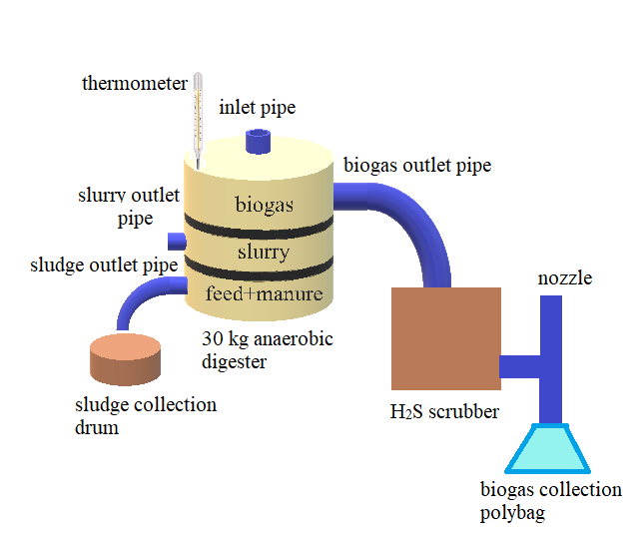

Figure 3 – Model of dry anaerobic digestion

Biogas obtained from cow manure consists of 50‒70% of methane and 25‒30% of CO2, impurities are oxygen = 0‒3% and N2 = 0‒10%. The lower CH4 concentration in biogas, the higher concentration of CO2. The lowest content of CH4 was overseen for waste with CM:STW ratio of 50:50 being 61%, and the highest CO2 content was 28%. Mixtures with CM:STW ratios of 60:40 and 80:20 were close to each other (67% and 68% of CH4, respectively, 23% of CO2). Production of biogas was defined by water dilution for 25 digestion days in an interval of 24 h.

Kazakhstan has exploitative biogas factories [126]:

- In the Zhambyl region, the productivity of biogas obtained from organic waste is 5300 m3 per day.

- In the Kostanay, a biogas factory has been exploited since 2011. The biogas factory, constituting of two reactors with volume of each reactor is 2400 m3, provides full productiveness generating electrical power of 360 kW. Annually from biogas 3 million kWh of electricity is expected to consume using near 5000 cows.

- In the East Kazakhstan, a biogas factory gives possibility to manufacture 10 t·day-1 of manure and 400 m3 of gas.

- In the Aktobe region, a biogas factory produces 2 m3 of biogas per day.

Nowadays, a biogas is not produced in Kazakhstan. Furthermore, it is difficult to utilize biogas directly for reforming process. It is a new challenge for researchers to develop this approach.

Analysis of the literature revealed that at the present stage, a comparison has been made of a number of catalysts synthesized differently, under different reaction conditions, the reasons for the formation of coke and methods for its reduction, the reaction mechanism and thermodynamics have been considered. However, it is difficult to create a correct model of the DRM mechanism. In this regard, from the many proposed models, one can only find a more suitable mechanism. Based on a study of the literature, catalysts based on nickel with and without the promotion of iron, alkaline earth, non-ferrous, rare earth and metals were selected for dry reforming of methane.

Nickel catalysts are able to activate methane molecules by breaking strong C-H bonds. Alumina creates a strong interaction with nickel, forming nickel aluminate spinel NiAl2O4, which has a beneficial effect on the activity of the catalyst. Since this catalyst tends to coking and sintering at optimal reaction temperatures, the effect of added promoters is studied.

Thus, magnesium is a good modifier for dry methane reforming catalysts due to its strong basic nature. Its ability to interact with alumina leads to the formation of magnesium aluminate, which has a number of excellent properties: increased activity and stability during the reaction, thermal stability, strong interaction with the metal, improved mobility of oxygen vacancies, increased metal dispersion, reduced carbon deposition and sintering to almost a minimum. Although manganese is not widely used in DRM, it is also used as a promoter and has a good effect on the catalyst. It also forms manganese aluminate, which increases the basicity and, thus, increases the activity. This spinel stabilizes the catalyst under reaction conditions, reducing carbon formation. In addition, it is resistant to high reaction temperatures and increases the dispersion of nickel, preventing sintering.

The addition of rare earth metals, especially cerium and lanthanum, enhances the mobility of oxygen vacancies. Ceria and lanthana are reduced by reacting with alumina, forming a perovskite-like phase and simultaneously reducing coke formation. Modification of catalysts with cerium and lanthanum can increase nickel dispersion, activity and stability. The addition of iron in small quantities promotes the formation of nickel-iron alloy Ni3Fe, reducing metal particles and coke and increasing activity and stability. Iron is a popular element that has been intensively studied in recent years at DRM.

Solution combustion synthesis is a fairly fast and effective method of preparing catalysts by self-propagating combustion of fuel using oxidizing agents, i.e. metal nitrates. This method helps to obtain catalysts, although with a smaller surface area, but with high dispersion, activity and stability at high reaction temperatures, is carried out at a closer molecular level (ingredients are dissolved in a solvent - water) in contrast to the combustion of a mixture of dry salts. As a result of combustion, defective structures are formed, highly active in catalysis.

2 EXPERIMENTAL PART

In this chapter methods used for catalyst preparation and its characteristics are shown, installation used for study the catalytic activity, as well as physicochemical methods are described.

2.1 Methods of catalyst preparation

For catalyst preparation, chemical reagents were used, as given in Table 7.

Table 7 –Used reagents and their characteristics

|  |  |  |
| --- | --- | --- |
| Reagents | Formula | Purity degree, % |
| Nickel (II) nitrate hexahydrate | Ni(NO3)2·6H2O | 97 |
| Aluminum nitrate nonahydrate | Al(NO3)3·9H2O | 99 |
| Iron (III) nitrate nonahydrate | Fe(NO3)3·9H2O | 99 |
| Magnesium nitrate hexahydrate | Mg(NO3)2·6H2O | 99 |
| Lanthanum (III) nitrate hexahydrate | La(NO3)3·6H2O | 99 |
| Cerium (III) nitrate hexahydrate | Ce(NO3)3·6H2O | 99.5 |
| Manganese nitrate hexahydrate | Mn(NO3)2·6H2O | 99.9 |
| Urea | CO(NH2)2 | 99.5 |

Catalysts 15Ni-35Al, 15Ni-5Fe-30Al, 15Ni-15Fe-20Al, 15Ni-25Fe-10Al, 15Ni-35M, 15Ni-15M-20Al (M = Ce, La, Mg, Mn) were synthesized by the solution combustion method. During the preparation of the catalysts, 50% urea (initiator, combustion source) was added to all the initial mixtures. Further, the composition was designated without urea. 3 g (15 wt.%) Ni(NO3)2 6H2O, 7 g (35 wt.%) Al(NO3)3 9H2O and 10 g urea were weighed on an analytical balance. Then the mixture of salts and urea was placed in a heat-stable beaker. The volume of deionized water added to the beaker was 15 ml, it was heated to 80°C. After all the salts had completely dissolved, the beaker with the obtained mixture was put in a heated muffle furnace heated to 500°C. Figure 4 shows a beaker with the initial reaction mixture prepared for high-temperature synthesis in a muffle furnace, as well as a sample just removed from the furnace after synthesis. Literally 10-15 minutes later the 15Ni-35Al catalyst was synthesized, cooled in a fume hood to room temperature, and then placed in glass weighing bottles. The remaining catalysts were prepared in a similar manner, taking into account the ratio of elements in the catalyst.

To prepare 12 wt.% Ni/α-Al2O3 and 12 wt.% Ni-5.6 wt.% Mg/γ-Al2O3 catalysts by the incipient wetness impregnation method, metal nitrate solutions were used, and α- and γ-Al2O3 were used as carriers. α-Al2O3 was obtained from γ-Al2O3 by calcination at 1150°C for 2 hours. The carriers dried at 250°C were stored in a sealed container. Before preparing the catalysts, their moisture capacity was determined for complete absorption without residues of active components. The catalysts were prepared by co-deposition of the elements on α-Al2O3 (granule size 0.4–0.8 μm, SBET = 5 m2 g-1) and γ-Al2O3 (granule size 0.4–0.8 μm, SBET = 155 m2 g-1) from aqueous solutions of metal salts, such as Ni(NO3)2 6H2O and Mg(NO3)2 6H2O, followed by drying in air at 250°C for 1.5 h and calcination at 650°C for 3 h for complete decomposition of the metal salt nitrates. The obtained catalysts were cooled, weighed and placed in weighing bottles.

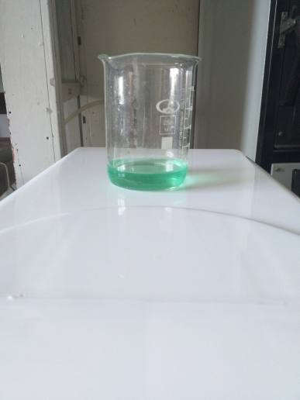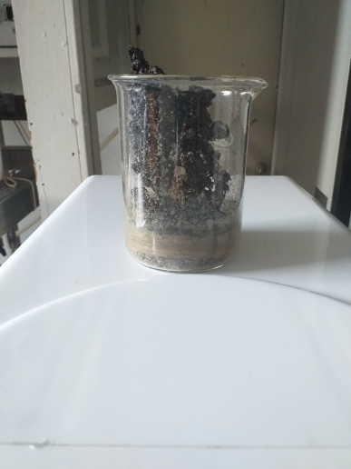

Figure 4 – The initial reaction mixture for the catalyst preparation and the catalyst sample after combustion

2.2 Dry reforming of methane

Catalytic flow unit (CFU-1) was used for the investigation of the catalytic performance of the obtained catalysts (Figure 5).

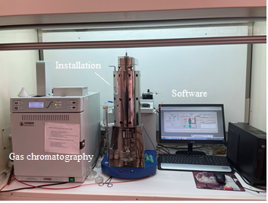

Figure 5 – Catalytic flow unit (CFU-1)

The experiments were conducted at 600–900°C increasing by 50°C. The catalysts were hold during 30–40 min at the nominal temperature under reacting gas flow. Thereafter the chromatographic detection of the gas products was conducted. Then, the temperature of the reaction raised followed by the analysis process in a same way. The temperature was reduced step-by-step back to 600°C to reveal catalytic performance. The gas hourly space velocity of the gas mixture (GHSV) changed in the range of 2000–5000 h-1 (67–167 ml·min-1). The ratio of the components of the initial gas mixture (CH4:CO2:Ar) varied within the following limits: 0.5:1:1.5 (17% CH4:33% CO2:50% Ar, vol.), 0.67:1:1.3 (22% CH4:33% CO2:45% Ar, vol), 1:1:1 (33% CH4:33% CO2:34% Ar, vol), 1:0.67:1.33 (33% CH4:22% CO2:45% Ar, vol) and 1:0.5:1.5 (33% CH4:17% CO2:50% Ar, vol). The Ar content the gas mixture varied at constant CH4/CO2 ratio of 2, from 0% to 50% in dependence of GHSV values. In this case, the initial gas mixtures were obtained in volume fractions: 67% CH4:33% CO2, 60% CH4:30% CO2:10% Ar and 47% CH4:23% CO2:30% Ar, 33% CH4:17% CO2:50% Ar. For a model gas mixture close in composition to biogas, the following ratio was used: 67% CH4:33% CO2. The stability examination was done at 850°C during 10 h, 20 h and 200 h. In long-term tests increase of temperature was carried out as follows: at 650°C it was kept for 2 min, then rising to 750°C keeping for 2 min. The gas samples were analyzed at 850°C after 10–60 min (10 min for 30 min TOS, 60 min for 20 h TOS).

Figure 6 demonstrates a scheme of catalytic reactor used for DRM.

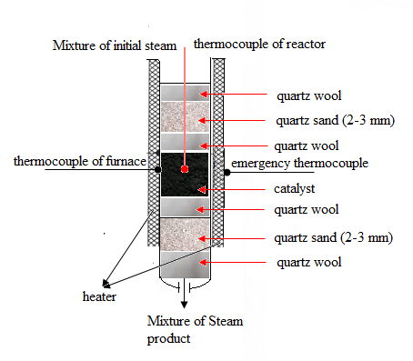

Figure 6 – A scheme of the catalytic reactor

The catalyst with volume of 2 ml (200–1000 mg) was put in a quartz tube reactor with further characteristics: length was 410 mm and diameter was 20 mm. Non-diluted catalyst (grain size was 0.21‒0.42 mm) was put between a quartz wool layer. The catalytic layer was of the height of 5.0 mm.

The mass thermal gas flow regulators were used. Source gases are supplied to them from cylinders at a pressure of 5 MPa. The output of the regulators is connected to each other and has a common outlet, through which a gas or a mixture of gases is supplied to the inlet of the evaporator. If only one of the regulators is turned on, the corresponding gas flow flows out.

If several regulators are turned on, a gas mixture flow is supplied to the output. This mixture is called the gas-initial reaction mixture. The quartz reactor, in the middle of which a catalyst is located, is placed vertically. The furnace heats the catalyst coat in the reactor to the nominal reaction temperature, warming up the steam-initial gas mixture flow. The furnace is mounted with two thermocouples ‒ working and emergency. The junctions of these thermocouples are located in the middle of the chamber. The construction of the furnace ensures the necessary isothermal reactor in the area, where the catalyst sample is located. A control thermocouple, indicating the temperature in the layer of catalyst, is installed through the lower part of the reactor. The flow of mixture of the vapor-gas is guided from the reactor outlet to the separator, whilst flow through the “Commutator” valve and heated line can be supplied to a chromatographic detector for analysis of the vapor-gas constituent element. For this goal, a tee is built into the line, dividing the flow of the output mixture. When the reactor is empty, the stream leaving the reactor represents a steam-initial reaction mixture. If a catalyst is loaded into the reactor, the stream exiting the reactor is a stream of the final reaction mixture. Since in catalytic experiments only a part of the starting substances is converted into reaction products, the final reaction mixture stream consists of gas products and non-reacted initial compounds. A special software was used to control the setup. When the control program is launched, the main program window with an image of the installation mnemonic diagram is displayed on the PC monitor.

**2.3 Analysis of gases by chromatography method**

Reacting components and gaseous products were examined with help of gas chromatograph “Chromos GC-1000” with corresponding software. Methane, carbon monoxide and carbon dioxide were detected using FID with a capillary column, whereas oxygen, hydrogen and nitrogen–with TCD by a packed column. TCD temperature was put to 200°C, whilst the temperature of vaporizer was 280°C, as well as the column temperature was set to 40°C. The argon was fed with 10 ml·min-1. The chromatographic peaks computation was conducted in accordance with the calibration curves built for the fitting gas products with the software taking into account pure compounds. Accurately defined pure compound quantities or admixtures with known concentrations were entered into the gas chromatograph with help of a syringe.

The calibration coefficients were defined in accordance with equation (23):

$K_{i}=\frac{C_{i}}{S_{i}}∙\frac{Volume}{Dilution}$ (23)

Where Кi – calibration coefficient, Сi – known concentration of compound, Si–compound area (or height), Volume, Dilution – fields from the chromatogram passport.

The quantity of a component during calibration is determined in (equation (24)):

$Q_{i}=C_{i}∙\frac{Volume}{Dilution}$ (24)

where Qi – quantity of the substance throughout calibration.

Referring to the measured peak areas fitting with the quantity of an injected component, a calibration curve was designed, where peak area (cm2) depends on quantity of compound (ml): V = f(S). These curves defined the gaseous product concentrations. The balance of regulatory constituents and gaseous products was determined as ± 3.0%. The accuracy of the measurements was ± 5%.

Equations (25-33) determined conversion of reacting gasses(X), transformation rates (r), space-time yields of gaseous products (STY), and H2/CO ratio:

$X_{CH4}=\frac{F_{CH4,in}-F_{CH4,out}}{F_{CH4,in}}∙100\%$ (25)

$X_{CO2}=\frac{F_{CO2,in}-F_{CO2,out}}{F_{CO2,in}}∙100\%$ (26)

$r_{CH4}=\frac{{F_{CH4,in}-F}_{CH4,out}}{m_{Ni}}$ (27)

$r_{CO2}=\frac{{F_{CO2,in}-F}_{CHO2,out}}{m_{Ni}}$ (28)

$Y_{H2}=\frac{F_{H2,out}}{{2F}_{CH4,in}}∙100\%$ (29)

$Y_{CO}=\frac{F_{CO,out}}{{2F}_{CH4,in}+F_{CO2,in}}∙100\%$ (30)

${STY}_{H2}=\frac{F_{H2,out}}{m_{Ni}}$ (31)

${STY}_{CO}=\frac{F_{H2,out}}{m_{Ni}}$ (32)

$H_{2}/CO=Y_{H2}/Y_{CO}$ (33)

Where Fi,in and Fi,out mark i compound molar flow in the inlet and output, respectively.

Turn-over-frequency was defined [127] (equation (34)):

${TOF}_{CH4}=\frac{F_{CH4,in}-F_{CH4,out}}{n_{Ni,surface}}∙100\%$ (34)

in which the FCH4 is the methane molar flow, nNi (surface) is the exposed Ni moles number (equation (35)):

$n_{Ni,surface}=m_{cat}\frac{C_{Ni}D_{Ni}}{{Mr}_{Ni}}$ (35)

where mcat is the catalyst mass, cNi denotes the nickel concentration found by EDX analysis, MrNi is the nickel molecular weight, and DNi is Ni distribution. Ni dispersion was calculated by equation (36) using the formula described in [128] supposing Ni spherical forms:

$D_{Ni}=101/d_{Fe,Ni}$ (36)

where dFeNi is the Ni particle size defined by TEM.

Equation (37) defined the carbon balance (CB) [129]:

$CB=\frac{F_{CH4,out}+F_{CO2,out}+F_{CO,out}}{F_{CH4,in}+F_{CO2,in}}$ (37)

To calculate the Weisz-Prater parameter 𝜑 following data were defined: the binary diffusivity for carbon dioxide and methane DAB = 1.69⋅10-4 m2·s-1 for 15Ni-15Ce-20Al and 15Ni-15Mg-20Al (for 15Ni-5Fe-30Al 1.56⋅10-4 m2·s-1 at 800°C), based on the Chapman-Enskog equation [130]; Knudsen diffusivity DK = 6.90⋅10-6 m2·s-1 for CH4 in 15Ni-15Ce-20Al and 15Ni-15Mg-20Al catalysts with the pore radius of 8.5 nm and 10 nm, respectively (found by BJH method). Knudsen diffusivity DK = 2.86⋅10-6 m2·s-1 for CH4 in 15Ni-5Fe-30Al catalyst with the pore radius of 3.6 nm. The effective diffusion coefficient was determined from the Bosanquet equation: De of 6.63⋅10-6 m2·s-1 for 15Ni-15Ce-20Al, (for 15Ni-5Fe-30Al – 3.0·10-6 m2·s-1, for 15Ni-15Mg-20Al – 0.42⋅10-6 m2·s-1). Effective diffusivity was obtained from equation (38):

$D_{eff}=\frac{ε}{τ}D$ (38)

where $\frac{ε}{τ}$ is the value for porosity equal to 0.1 providing Deff = 6.63⋅10-7 m2·s-1 (for 15Ni-5Fe-30Al – 3.0·10-7 m2·s-1, for 15Ni-15Mg-20Al – 0.42⋅10-7 m2·s-1).

The Weisz-Prater parameter 𝜑 was determined (equation (39)) indicating the performance of the experiments in the conductions of absence of external mass transfer limitations:

$φ=\frac{r_{obs}r_{P}^{2}RT}{p_{CH4}D_{eff}}≤1$ (39)

The internal limitations of mass transfer can be neglected during the stability test over 15Ni-15Ce-20Al catalyst at 850°C and atmospheric pressure (for 15Ni-5Fe-30Al – 0.26 at 800°C, for 15Ni-15Mg-20Al – 0.72 at 850°C), because 𝜑 was equal to 0.14 [86, p. 27; 90, p. 28].

**Calculation of the error of measurement results.** The calculation of the measurement error is mainly divided into gross, systematic and random errors.

*A gross error* occurs due to a sharp violation of measurement conditions during individual measurements. It is due to unexpected external influences, impact or breakage of the device, etc. depending on the circumstances, it is the result of errors caused by gross errors of the experimenter.

*Systematic error* is a component of measurement error, which remains constant during repeated measurements of a quantity and changes systematically. Systematic errors, for example, in measuring the volume of a liquid or gas, temperature, etc., occur if one does not take into account the fact that the amount of heat released during a slow change affects the temperature increase.

*Random error* is an error, which consists of a random change in the measurement value during repeated measurements of the same value. Some inconsistencies in measurement results when repeatedly measuring a quantity, which does not vary carefully and consistently under the same conditions indicate the presence of random components of error in them.

The accuracy of the analysis is expressed as the total sum of systematic (δsys.) and reduced random (δcase) errors (equation (40)).

Systematic measurement error is described as the ratio of the absolute measurement error to the actual or measured value of the quantity being measured.

δ = δsys.+δcase (40)

The fraction or percentage of systematic error is calculated based on the following relationships (equation (41)):

$δ_{sys.}=\frac{∆Х}{{\overline{Х}}_{n}}*100\%$ (41)

where: ΔX – absolute measurement error; ${\overline{X}}_{n}$‒ is the average value of actual or measured values.

The random error in measuring the amount of reagents and reaction products was calculated using the equation (42):

$S= \sqrt{\frac{\sum_{i=1}^{N}{{(x_{i}-\overline{x})}^{2}}}{n-1}}$ (42)

where: S – partial standard deviation; n – parallel results number; xi – single result of analysis; $\overline{x }$– the arithmetic mean value of n units of the results of measuring a quantity.

The measurement error (∆Х) was defined in the following formula (equation (43)):

$∆X= \frac{S}{\sqrt{n}}∙t_{n,p}$ (43)

where: tn,p – Student's distribution coefficient of a specific level, determined from n measurements; p – actual level taken as 0.95; n – number of measurements.

The final formula for the measured quantity X is as follows (equation (44)):

$X=\overline{X}±∆X$ (44)

The relative measurement error (δ) can be expressed by the following formula (equation (45)):

$δ_{case}=\frac{∆Х}{{\overline{Х}}_{n}}*100\%$ (45)

The value of the relative error of chromatographic measurements for the following gases with the number of measurements n = 4 and a confidence level of 0.95 for methane, carbon dioxide, hydrogen and carbon oxides was as follows: methane – 2.062; carbon dioxide – 2.167; hydrogen – 0.96; carbon monoxide – 1.615.

The total (systematic + random) error (%) in the measurement of these gases was equal to: methane – 2.724; carbon dioxide – 2.459; hydrogen – 4.6; carbon monoxide – 2.373.

The total measurement error was calculated using equation (46), where $∆_{i}^{2}$ instrumental and $∆_{case}^{2}$ random errors [131]:

$∆ =\sqrt{∆_{i}^{2}+∆_{case}^{2}}$ (46)

The instrumental error was determined by equation (47):

$∆_{i} =t_{α,∞}∙\frac{δ_{n}}{3}$ (47)

where $δ_{n}$– confidence probability P; $t_{α,∞}$– Student coefficient at infinity of degrees of freedom. As a result of calculations made using equations (40–47), the following values were obtained, presented in Table 8, where F denotes frequency of the experiments.

Table 8 – Systematic and random errors of measurements carried out in the process of dry methane reforming

|  |  |  |  |  |  |  |  |  |  |  |
| --- | --- | --- | --- | --- | --- | --- | --- | --- | --- | --- |
| Component | F | $\overline{x}$, % | S | Р, % | t(P,f)  (tab.) |  | δsys. | Δcase | δ(sys.+case) | Δ |
| СН4 | 3 | 93.8 | 0.33 | 95 | 3.182 | 0.621 | 0.662 | 2.062 | 2.724 | 3.863 |
| Н2 | 3 | 74.6 | 1.45 | 95 | 3.182 | 2.718 | 3.64 | 0.96 | 4.6 | 3.405 |
| СО | 3 | 62.9 | 0.59 | 95 | 3.182 | 1.106 | 1.758 | 1.615 | 2.373 | 3.988 |
| СО2 | 3 | 96.2 | 0.15 | 95 | 3.182 | 0.281 | 0.292 | 2.167 | 2.459 | 3.92 |

Thus, the total error in the for conversion of СН4 and СО2 is ± 0.621% and 96.2±0.281, for yield of H2 and CO is ±2.718% and ± 0.281%, respectively.

2.4 Catalyst characterization by different physicochemical methods

The phase composition of the as-prepared and spent catalysts was described with the help of X-ray diffraction (XRD) on a DRON-4-0.7 diffractometer applying CoKα radiation and the powder method in 2θ equal to 5–100° (Institute of fuel, catalysis and electrochemistry, Almaty).

Temperature programmed reduction (TPR), oxidation (TPO) and desorption (TPD) measurements were performed employing MicrotracBelcat II technique (Åbo Akademi, Turku). The TPR was conducted in a further way: ca. 100 mg of the catalyst sample underwent pretreatment at 200°C during 2 h accompanied by cooling to 50°C. Heating of the sample to 800°C occurred with a rate of 10°C·min-1 under argon and hydrogen flows of 28.5 ml·min-1 and 1.5 ml·min-1, respectively (5 vol.% H2/95 vol.% Ar), kept at the aimed temperature for 20 min.

NH3-TPD was performed in the following way: ca. 60–100 mg sample was pretreated during 1 h at 500°C. Afterwards, it was cooled to 50°C prior to heating to 600°C using a 10°C min-1 rate under 5 vol.% ammonia and 95 vol.% helium atmosphere (1.5 ml min-1 of NH3 and 28.5 ml min-1 of He). The nominal temperature was kept for 20 min.

CO2-TPD was executed to define the basicity. At the initial stage the catalyst weighed ca. 200 mg was avoided from moisture during 30 min at 150°C under He, thereafter it was cooled to 100°C. CO2 adsorption on the catalyst surface lasted 30 min. CO2 was removed from the surface during 30 min at 100°C. Then, the catalyst was heated up to 700°C with the rate of 10°C·min-1.

For O2-TPO tests MicrotracBelcat II technique was connected to the mass spectrometer equipment. The catalyst (ca. 50 mg) underwent pretreatment during 2 h at 300°C, ensued by cooling to temperature of 50°C, thereafter sample was heated to 865°C using a rate of 2°C min-1 under 5 vol.% oxygen and 95 vol.% argon (1.5 ml min-1 of O2 and 28.5 ml min-1 of Ar). The aimed temperature was kept for 20 min.

NH3-TPD was executed in “Chemosorb” technique as follows: the test sample was put in a quartz tube, which is located in a tube furnace, the temperature of which was linearly programmed (Institute of fuel, catalysis and electrochemistry). When the sample was ready for TPD measurements, a gas mixture containing 5 vol.% NH3 and 95 vol.% Ar was passed through the reactor. The gas flow passed first through the comparison chamber of the catharometer, then through the reactor and entered the measuring chamber of the catharometer. The change in thermal conductivity was employed for recording the change in the concentration of ammonia in the gas stream caused by any desorption process.

CHNS analysis was conducted with the help of Thermo Fisher Scientific Flash 2000 Organic Elemental Analyzer supplied with TCD (Åbo Akademi, Turku). The heating temperature was 950oC. Four organic components: methionine, cystine, sulphanilimide and 2,5-bis(5-tert-butyl-benzoxazol-2-yl)thiophene were applied as reference materials.

SEM method was conducted with thehelp of Zeiss Leo Gemini 1530 Scanning Electron Microscope supplied with a Thermo Scientific UltraDry Silicon Drift Detector (Åbo Akademi, Turku and Institute of fuel, catalysis and electrochemistry).

For thermogravimetric (TGA) and differential thermal analysis (DTA) SDT Q600 apparatus (Åbo Akademi, Turku) operated under air with 100 ml·min-1 and at 100–800oC with 10oC min-1 heating rate.

TEM analysis was measured via Jeol JEM-1400 Plus with 120 kV speed-up voltage, 0.38 nm resolution and an OsisQuemesa 11 Mpix bottom-mounted digital camera to calculate the size of metal particles (Åbo Akademi, Turku). The catalysts underwent reduction process using the similar program as for the catalytic tests. Metal particle size was determined with help of the ImageJ software.

Textural properties were defined by employing Micromeritics 3Flex-3500 (Åbo Akademi, Turku). The samples weighed ca. 150 mg underwent the initial stage of pre-treatment, in which moisture was eliminated from the sample by ex-situ degassing under vacuum during 20 h at 180°C. The sample went afterwards through pre-treatment under vacuum during 5 h at 180°C, ensued by adsorption of liquid N2 at -196°C and distinct comparative pressures. The DFT and BET methods were employed to determine the volume of pore together with the distribution of pore size and the specific surface area.

**3 RESULTS AND DISCUSSION**

This section displays the experimental findings of investigating the catalytic activity in DRM to syngas over nickel-containing catalysts prepared via SCS and incipient wet impregnation by varying the temperature with decreasing temperature and switching to the second cycle, the gas hourly space velocity of gas mixture rate, the ratio of the initial reagents, and the time on stream, as well as characterization of catalysts. The influence of the active phase content and the addition of basic metals on DRM efficiency has been researched. Some experiments were conducted with the model biogas.

Series of catalysts with following compositions: 15Ni-35Al [132], Ni-Co-Al [133], Ni-Al-Mg [134‒137], Ni-Mn-Al [138], Ni-Mn-Mg [139], Ni-Al-Mg-Mn [140], Ni-Co-Zr [141], Ni-Co-Mg-Ce [142] La–Mg–Mn–Ni–Al [143], Ni-Cr-Mg-Al [144], 15Ni-5Fe-30Al, 15Ni-15Fe-20Al, 15Ni-25Fe-10Al [86, р. 27; 145, 146], 15Ni-35M, 15Ni-15M-20Al, 10% Ni–35% Al–5% M/50% urea (M = Ce, La, Mg, Mn) [90, р. 28; 147‒150] catalysts were studied. Among them Ni-Fe-Al, Ni-M and Ni-M-Al were presented in the current work.

**3.1 Study of Ni-Fe-Al catalysts prepared by SCS in DRM**

3.1.1 Study of physicochemical characteristics of Ni-Fe-Al catalysts

Previous research indicated that incorporating iron as a promoter enhances catalytic activity. In this chapter, trimetallic Ni-Fe-Al catalysts with different Fe loadings will be compared with bimetallic Ni-Al catalyst [86, р. 27].

Figure 7 depicts XRD patterns of the catalysts before (fresh) and after the reaction (spent). Metallic nickel [ASTM 4-850] and nickel aluminate spinel NiAl2O4 [ASTM 71-964] phases were identified in 15Ni-35Al (Figure 7a). The lattice parameter of NiAl2O4 defined was equal to 8.076 Å, as well as reflex positions and relative intensities are characteristic for spinel structure. The same is reported in [150]. In the spent catalyst the intensity of reflex at 45.2o (311), which corresponds to nickel aluminate, has decreased [152, 153]. On the contrary, the intensity of spinel reflex at 52º was lower than that of Ni0 [153, р. 52; 154, 155]. Distinctive reflexes for NiO [PDF 00-047-1049] at 2θ = 44°, 51°, 75o are not found in the fresh 15Ni-35Al and 15Ni-5Fe-30Al [156].

For the fresh 15Ni-5Fe-30Al, Ni0 phase was also identified at 2θ = 52° [157], disappearing after DRM. Reflexes at 52°, 61° and 92° correlate with Ni-Fe alloy (Ni3Fe), which was found in 15Ni-5Fe-30Al catalyst before the reaction [158].

Furthermore, in [158, р. 52] that formation of FeO during de-alloying (CO2 + Fe → CO + FeO) was discussed.

Carbon formed by CH4 cracking reacts with FeO obtained after de-alloying. Thus, coke can be eliminated from the catalyst surface and retain catalyst activity, forming CO and metallic iron (C + FeO → CO + Fe).

In the current study during temperature cycling Ni3Fe remained unchanged in 15Ni-5Fe-30Al. Moreover, Ni2+ reduced to Ni0 is formed as a result of NiAl2O4 decomposition occurred in DRM [152, р. 52; 159]. Additionally, in the 15Ni-5Fe-30Al after reaction Al3Ni2 alloy and Al2.667O4 also were formed [160–162]. The latter was identified at 37°, 79° [159, р. 52]. Furthermore, Al-Ni alloy possesses the reflexes at 31º, 36º and 79º. However, Ni0 was not appeared in this catalyst after reaction.

Fresh catalysts with higher iron amounts e.g. 15Ni-15Fe-20Al and 15Ni-25Fe-10Al, have hercynite (FeAl2O4) and NiO phases. In these both catalysts NiO peaks were existed at 42° and 75° [163]. The iron aluminate phase was determined at 36°, 42°, 52°, 60°, 65° and 76 in 15Ni-15Fe-20Al catalysts before and after the reaction, as well as in 15Ni-25Fe-10Al at reflexes 2θ = 30°– only spent, 35° ‒ fresh, 60°, 65° and 76° [164, 165]. In the spent 15Ni-15Fe-20Al one reflex corresponds to hercynite overlapped with Ni-Fe alloy.

Furthermore, in the spent 15Ni-15Fe-20Al and 15Ni-25Fe-10Al samples small reflexes of the Al3Ni2 found at 35°, while at this degree in the former sample this phase overlapped with hercynite. Moreover, two distinctive reflexes at 30° and 80° were identified, which not observed for the spent 15Ni-25Fe-10Al. Opposite to catalysts with high Fe loadings, 15Ni-5Fe-30Al does not have any FeAl2O4 before and after DRM.

At elevated temperatures Al3Ni2 can be produced. Formation of this alloy was observed at 880ºC, 940ºC and 1000ºC [166]. Reduction of nickel oxide into Al3Ni2 took place (equation (48)):

6NiO + 13Al→2Al2O3 + 3Al3Ni2 (48)

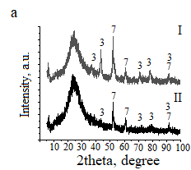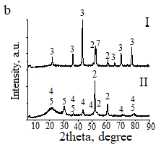

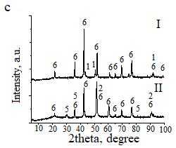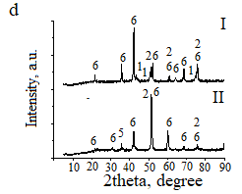

a - 15Ni-35Al, b - 15Ni-5Fe-30Al, c - 15Ni-15Fe-20Al, d - 15Ni-25Fe-10Al; 1 - NiO, 2 - Ni3Fe, 3 - NiAl2O4, 4 - Al2.667O4, 5 - Al3Ni2, 6 - FeAl2O4, 7 - Ni0; I - fresh, II - spent at 600‒900°C.

Figure 7 – XRD patterns of catalysts

The operational temperatures for the DRM reaction in the current study ranged between 600 and 900ºC. Furthermore, considering that nickel oxide was initially existed in the fresh 15Ni-15Fe-20Al and 15Ni-25Fe-10Al, it is conceivable that the reduction of nickel oxide occurred during DRM. Consequently, this could account for the presence of Al3Ni2 alloy in the spent catalysts. Effective dispersion within the catalyst structure attributed to the absence of nickel oxide in the fresh 15Ni-5Fe-30Al catalyst. Furthermore, XRD results of the catalyst tested in 20 h stability experiment displayed the existence of Ni3Fe and NiAl2O4 (Figure 8). The TEM results displayed (Figure 9) well-dispersed metal particles. The narrowest nickel particle size among other catalysts was seen for 15Ni-5Fe-30Al, explaining its better performance [36, р. 17].

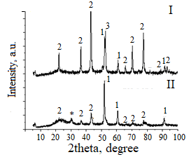

1 - Ni3Fe, 2 - NiAl2O4, 3 - Ni, * - SiO2 from sample holder; I - fresh, II – spent.

Figure 8 ‒ XRD patterns of the fresh and spent catalysts tested in a long-term test for 20 h in DRM

Carbon nanotubes were consistently detected in all spent catalysts, as reported in [167]. This observation suggests the formation of the coke on the catalyst surface, a finding further substantiated by TGA and TPO.

Moreover, in all used catalysts the size of metal particles stays under 15 nm. For 15Ni-5Fe-30Al and 15Ni-35Al nickel particle size at the tips of carbon nanotubes was determined to be 27 and 24 nm, while for 15Ni-15Fe-20Al and 15Ni-25Fe-10Al it was 15 and 18 nm, respectively. It is worth noting that carbon deposition becomes significant when nickel clusters exceed 9 nm in size, a critical factor for coke formation. In the case of the 15Ni-25Fe-10Al catalyst, larger nickel particles around 26 nm were observed, consistent with XRD data. Additionally, the FeAl2O4 phase, which was inactive in DRM, remained stable in the spent catalyst.

For 15Ni-5Fe-30Al, Ni3Fe was generated, in agreement with XRD, therefore the metal particle size reduced throughout DRM. There is a tendency for nickel to interact with iron, forming an alloy. Importantly, development of a Ni3Fe does not have an impact on the size of the metal particles, and conversely, the size of the metal particles does not affect the catalytic properties [168].

Figure 10 depicts the structural characteristics of the 15Ni-35Al and 15Ni-5Fe-30Al catalysts as examined through SEM. The SEM illustrations display the predominant exhibition of catalysts by erratic flaky structure with the dimensions ranging from 60 to 420 μm. These particles possess microporosity and display cracks on the catalyst surface. Notably, there were no significant distinctions observed in the morphology of the catalysts before and after the reaction.

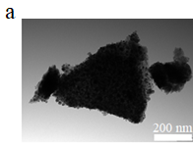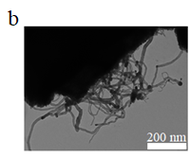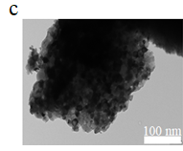

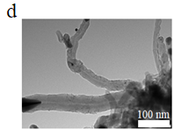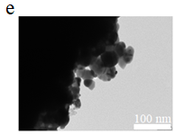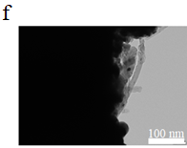

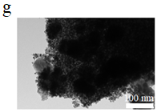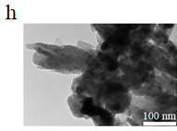

15Ni-35Al: a - fresh, b - spent; 15Ni-5Fe-30Al: c - fresh, d - spent; 15Ni-15Fe-20Al: e - fresh, f - spent; 15Ni-25Fe-10Al: g - fresh, h - spent.

Figure 9 – Transmission electron microscope images of the catalysts

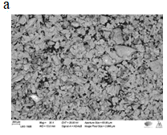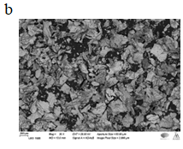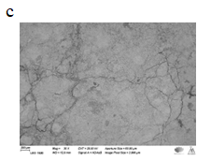

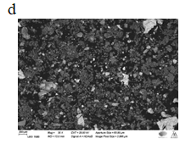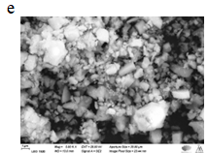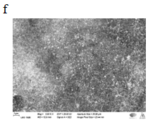

15Ni-35Al: a - fresh, b - spent; 15Ni-5Fe-30Al: c, e - fresh, d, f - spent.

Figure 10 – Scanning electron microscope images of catalysts

It is worth mentioning that, despite the apparently smooth surface of the 15Ni-5Fe-30Al catalyst before the reaction, it is actually comprised agglomeration of small particles 1‒3 μm in size. Furthermore, as the molar ratio of Fe/Ni reached or exceeded 0.7, there was a decrease in the reflex intensity, exhibiting lower crystallinity for the catalysts with a higher iron content [36, р. 17].

Nitrogen physisorption was used to analyze the textural properties of the catalysts (Table 9). The N2 adsorption/desorption isotherms correspond to hysteresis of type IV, which implies that the catalysts are mesoporous (Figure 11).

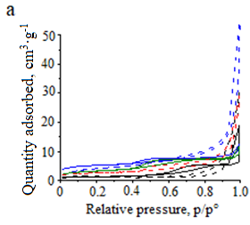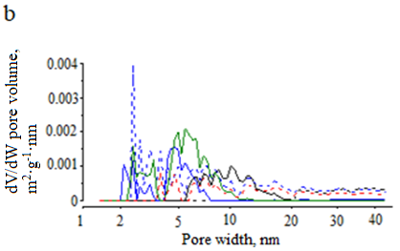

a - adsorption isotherms and b - the distribution of pore size of the catalysts; red - 15Ni-35Al, blue - 15Ni-5Fe-30Al, green - 15Ni-15Fe-20Al and black - 15Ni-25Fe-10Al; solid line corresponds to the fresh and the dashed line correspond to the spent catalyst.

Figure 11 – Results obtained from N2 physisorption

Table 9 – Summarize the results of TEM, SEM-EDX and BET

|  |  |  |  |  |  |  |  |
| --- | --- | --- | --- | --- | --- | --- | --- |
| Catalyst | Fresh/  Spent | Ni particle size, nm | Al/Ni weight ratio | Al/Fe weight ratio | Fe/Ni ratio | Surface area, m2·g-1 | Average pore diameter, nm |
| 15Ni-35Al | F | 13 | 0.67 | - | - | - | 9.2 |
| 15Ni-35Al | S | 12 | 0.44 | - | - | 8 | 16.3 |
| 15Ni-5Fe-30Al | F | 10 | 0.69 | 2.71 | 0.25 | 16 | 7.2 |
| 15Ni-5Fe-30Al | S | 9 | 0.83 | 3.45 | 0.24 | 14 | 8.0 |
| 15Ni-15Fe-20Al | F | 16 | 0.40 | 0.56 | 0.72 | 11 | 6.1 |
| 15Ni-15Fe-20Al | S | 11 | 0.45 | 0.64 | 0.70 | 9 | 12.2 |
| 15Ni-25Fe-10Al | F | 26 | 0.20 | 0.17 | 1.20 | 4 | 14.8 |
| 15Ni-25Fe-10Al | S | 15 | 0.24 | 0.21 | 1.17 | <4 | 25.7 |

A slight decline in BET surface area of the 15Ni-5Fe-30Al is observed: the surface area of the synthesized catalyst was 16 m2·g-1 not significantly changing after reaction. Fresh 15Ni-25Fe-10Al exhibited surface area of 4 m2·g-1 slightly decreasing after the reaction. These results were correlated with CHNS analysis, where the coke amount rises as the volume of N2 adsorbed increases for 15Ni-5Fe-30Al catalyst, which had the highest accumulation of coke, primarily due to its exceptionally high pore volume. Correlating with CHNS analysis, 15Ni-35Al possesses the second highest coke amount.

The behavior of the Ni-Fe-Al catalysts during reduction was investigated by H2-TPR (Figure 12). At the maximum peak of 470°C the levels of NiO interactions with Al2O3 support are different in agreement with the previous investigations [169]. The TPR profile of 15Ni-5Fe-30Al displayed a maximum peak around 467°C, accompanied by a minor hump at 403°C (Table 10).

Table 10 – Results from H2-TPR and NH3-TPD analyses of the fresh catalysts

|  |  |  |  |  |
| --- | --- | --- | --- | --- |
| Catalyst | Maximum temperature TPR peaks, °C | Relative area of consumed H2 | Maximum temperature TPD peaks, °C | Relative area of NH3 desorbed |
| 15Ni-35Al | 454/800 | 0.35 | 129/621 | 1.0 |
| 15Ni-5Fe-30Al | 403/467/800 | 0.57 | 129/621 | 0.82 |
| 15Ni-15Fe-20Al | 477/800 | 0.79 | 198/621 | 0.55 |
| 15Ni-25Fe-10Al | 417/500/630/800 | 1.0 | 173/621 | 0.33 |

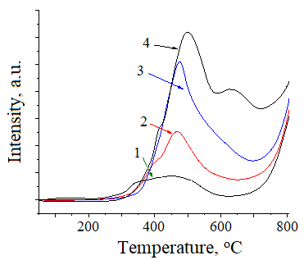

1 - 15Ni-35Al, 2 - 15Ni-5Fe-30Al, 3 - 15Ni-15Fe-20Al, 4 - 15Ni-25Fe-10Al.

Figure 12 – Temperature-programmed reduction profiles of Ni-Fe-Al catalysts

Reduction of NiAl2O4 in the fresh 15Ni-5Fe-30Al starts already at 742oC [68, р. 24; 169, р. 57]. This would clarify consumption of hydrogen at elevated temperatures. The TPR findings validate the existence of small nickel particles, ruling out the development of larger clusters on the catalyst, shifting reduction peak to lower temperatures [168, р. 54]. An additional peak of reduction became noticeable when catalysts contained a higher iron content [170].

An increase in iron loading is associated with a corresponding increase in the quantity of hydrogen uptake for the 15Ni-25Fe-10Al catalyst above 600°C. This observation might be attributed to the fact that hercynite, FeAl2O4, is reduced at 665°C [171].

NH3-TPD was used to determine acidity of Ni-Al and Ni-Fe-Al catalysts (Figure 13, Table 10) showing that with increase of Al content acidity also increased. High amounts of strong acid sites at maximum peak of NH3 adsorption were found at higher temperatures i.e. 400‒600°C, when Fe content was higher.

The CHNS data (Table 11) depicts that as the iron content raises, carbon formation decreases during DRM. This aligns with findings in [170, р. 57], suggesting that iron-enhanced Ni-based catalysts exhibit stronger resistance to coke formation.

Additionally, the quantity of formed carbon can serve as an indicator of the amount of active centers during DRM. Notably, the spent 15Ni-5Fe-30Al catalyst exhibited the largest carbon content, correlating with superior catalytic performance in DRM compared to other catalysts. Molar ratio of H/C increased with rising of Fe loading (0.08 for 15Ni-5Fe-30Al and 0.19 for 15Ni-25Fe-10Al), further underscoring differences in coke composition. Specifically, the former catalyst contained a higher proportion of graphitic coke compared to the latter.

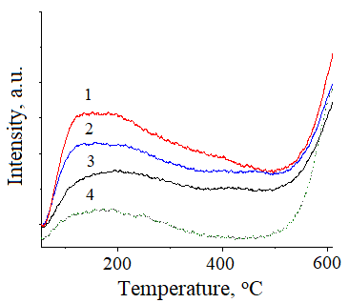

1 - 15Ni-35Al, 2 - 15Ni-5Fe-30Al, 3 - 15Ni-15Fe-20Al, 4 - 15Ni-25Fe-10Al.

Figure 13 – Ammonia temperature-programmed desorption profile of Ni-Fe-Al catalysts

Furthermore, conforming to TGA analysis 15Ni-25Fe-10Al has less carbon compared to 15Ni-15Fe-20Al attributed to lower acidity of the former sample (Figure 14, Table 11).

The results of thermal programmed oxidation revealed that for 15Ni-25Fe-10Al peak at 671°C was the largest, while in 15Ni-15Fe-20Al the carbon was burnt at 709°C (Figure 15, Table 11). It was noted [172] that release of coke occurred above 650°C conforming to the graphitic type of coke, which does not react with gases (inert). Notably, the intensity of coke combustion in 15Ni-5Fe-30Al was very high due to substantial heat generation, attributed to this catalyst's notably high coke content (44 wt.%) correlating with CHNS findings. Conforming to the TPO analysis, the relative area for CO2 formation equal to 0.41 for 15Ni-15Fe-20Al and 0.47 for 15Ni-25Fe-10Al. It was also mentioned that a high Fe loading diminishes the coke formation as well as reduces catalytic activity of the Fe promoted Ni-Al catalysts.

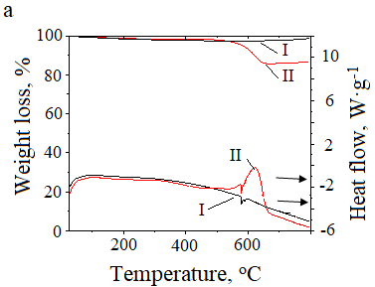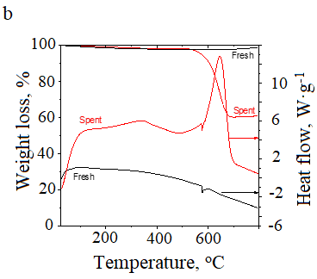

a - 15Ni-35Al, and b - 15Ni-5Fe-30Al; I - fresh, II - spent.

Figure 14 – The weight loss of catalysts during heat flow

Table 11 – Results from TGA, TPO and CHNS analyses of spent catalysts using GHSV of 3000 h-1, with CH4:CO2:Ar of 33%:33%:34%

|  |  |  |  |  |
| --- | --- | --- | --- | --- |
| Catalyst | *Weight loss by TGA, % | TPO, relative area | Carbon, wt.% | Hydrogen, wt.% |
| 15Ni-35Al | 14 | - | 19.3 | 0.2 |
| 15Ni-5Fe-30Al | 40 | 1.0 | 44.2 | 0.3 |
| 15Ni-15Fe-20Al | - | 0.41 | 16.5 | 0.2 |
| 15Ni-25Fe-10Al | - | 0.47 | 10.7 | 0.2 |
| *Between 100oC to 800oC | | | | |

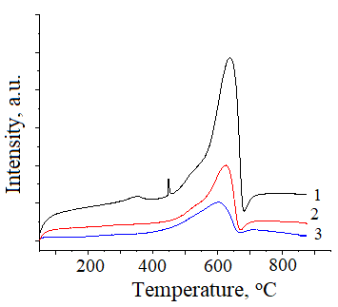

1 - 15Ni-5Fe-30Al, 2 - 15Ni-15Fe-20Al, 3 - 15Ni-25Fe-10Al.

Figure 15 – Results from temperature-programmed oxidation

15Ni-5Fe-30Al possesses the largest carbon content consistent with the TGA data. Conversely, the most notable weight loss being 12% for Ni/Al2O3 during DRM at temperatures between 650–800°C, whereas in the case of Ni-Fe/Al2O3, there was a mere 6% reduction in weight. It is worth noting a substantially higher excess of Ni compared to Fe. Similarly, Fe-Ni-Al catalyst (molar ratio of Fe/Ni is 0.5) could enhance resistance to coke compared to Ni/Al2O3 catalyst in DRM at 700°C [36, p. 17]. In the current work, a large content of coke could be taken into account by the molar ratio of Fe/Ni of 0.27 in 15Ni-5Fe-30Al.

Thus, adding iron in small amounts increased the dispersion of the catalyst. Phases such as nickel-iron alloy Ni3Fe and nickel aluminate were formed, which played an important role in increasing the conversion of gases and the yield of products. With an increase in the iron content, the activity of the catalysts decreased, as evidenced by the inactive phase of iron aluminate, large metal particles and weak interaction between nickel and alumina.

3.1.2 Study of catalytic activity of Ni-Fe-Al catalysts

Ni-Al catalysts synthesized via SCS were investigated in DRM. Catalytic effectiveness of the catalyst with different nickel loading was demonstrated at 800°C, 33% CH4: 33% CO2: 34% Ar and a GHSV of 3000 h-1 (Figure 16a). It was revealed that the methane conversion heightened for the 5Ni-45Al < 10Ni-40Al < 15Ni-35Al declining for 20Ni-30Al, while CO2 conversion heightened, however not notable. The largest CH4 and CO2 conversion was 76% and 82% for 15Ni-35Al. In [173] this value was equal to 69% over 10 wt.% Ni/ZrO2. The H2/CO ratio was near unity for 5Ni-45Al and 10Ni-40Al owing to RWGS, the Boudouard and CH4 cracking reactions as reported in [173, р. 60]. For 15Ni-35Al and 20Ni-30Al, the H2/CO ratio was 1.3 and 1.2, respectively. The largest yield of H2 and CO (Figure 16b) was obtained for 15Ni-35Al (75% and 58%).

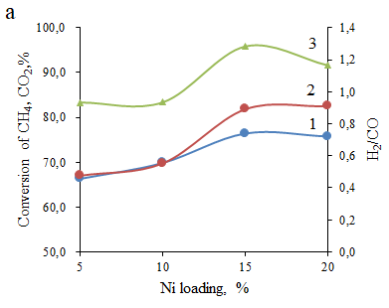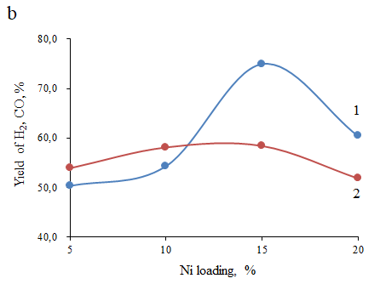

a: 1 - conversion of CH4, 2 - conversion of CO2, 3 - H2/CO, b: 1 - yield of H2, 2 - yield of CO; T = 800ºC.

Figure 16 – Influence of Ni loading in Ni-Al catalysts on process indicators in DRM

The impact of Fe content on catalytic performance was investigated at 700°C and shown in Figure 17. As Figure 17a illustrates, the 15Ni-35Al catalyst exhibits reduced conversions compared to the catalyst possessing the smallest Fe/Ni ratio. This outcome contradicts the findings [36, р. 17], where conversion of reactants rose as the Fe/Ni molar ratio achieved 0.7. Conversely, when the molar ratio of Fe/Ni reached 0.9, initial gas conversion decreased. This variation in activity could not be accounted by differences in the metal particle sizes, as they were approximately 7 nm for all studied catalysts. Nevertheless, in the case of [36, р. 17], as the Fe/Ni molar ratio increased, hydrogen uptake decreased.

Subsequently trimetallic Ni-Fe-Al catalysts outperformed their bimetallic Ni-Al analogues, with a specific emphasis on the role of the Ni-Fe alloy, which enhance the rate-determining step in DRM e.g. methane decomposition. When a substantial amount of iron is introduced into Ni-Fe-Al catalysts, only a portion of the iron species is incorporated into the alloy, which is actively involved in DRM. Additionally, it was noted that the concentration of surface iron increased during reduction. A catalyst possessed the lowest iron loading, i.e. 15Ni-5Fe-30Al, demonstrated large conversion at 700°C. Additionally, this catalyst gave larger amounts of synthesis gas compared to the 15Ni-15Fe-20Al and 15Ni-25Fe-10Al catalysts. In contrast, the 15Ni-25Fe-10Al catalyst displayed the lowest yields in comparison with other catalysts, as demonstrated in Figure 16b. The presence of nickel aluminate spinel improved activity of the 15Ni-5Fe-30Al, although this phase disappeared after the DRM. Although, XRD analysis indicated the presence of reflexes from Al2.667O4 and Al3Ni2.

In the previous studies [169, р. 57] coking was prevented by the presence of NiAl2O4 and low amounts of Ni0. In accordance with the results from TPO and CHNS analyses for 15Ni-5Fe-30Al, if this phase will be transformed farther, it would lead to more obvious coking.

In this particular scenario, conversion of methane consistently remained slightly lower in comparison with CO2 conversion (Figure 17a) aligning with findings from [36, р. 17]. The TEM data indicated the lower metal particle size in the 15Ni-5Fe-30Al compared to the 15Ni-35Al, accounting for the lower activity of the latter sample.

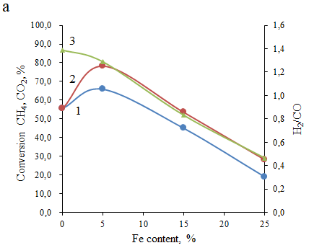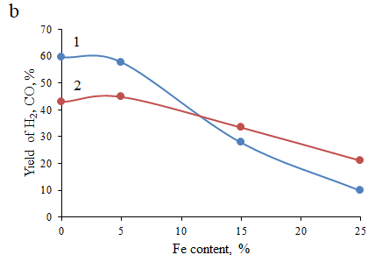

a: 1 - conversion of CH4, 2 - conversion of CO2, b: 1 - yield of H2, 2 - yield of CO, 3 - H2/CO; T = 700oC.

Figure 17 – Impact of the Fe content on process indicators in DRM

This observation is corroborated by [174], which states that a higher dispersion of metal can enhance catalytic activity. Additionally, it was [173, p. 60] suggested that high dispersed Fe promoted Ni-containing catalysts tend to have lower formation of coke. However, in the present work, the catalyst exhibited the best catalytic performance (15Ni-5Fe-30Al) among other Ni-Fe-Al samples, generated a significant quantity of coke despite its high activity.

The impact of temperature was examined by heating up the furnace in steps of 100°C, commencing from 600°C and reaching 900°C after 10 min of continuous operation. For the 15Ni-5Fe-30Al having the narrowest particle size compared to other Ni-Fe-Al catalysts, the stability test was also conducted. This test involved decreasing from 900°C back to 600°C (Figure 18c, d). The findings indicated the largest CH4 conversion at 600°C for 15Ni-5Fe-30Al, whilst for 15Ni-35Al catalyst this value was lower, but higher than that of Ni-Fe catalysts with larger concentrations of iron. On the contrary, catalysts with higher levels of iron showed lower efficiency due to their larger nickel particle size, as noted in [175, 176].

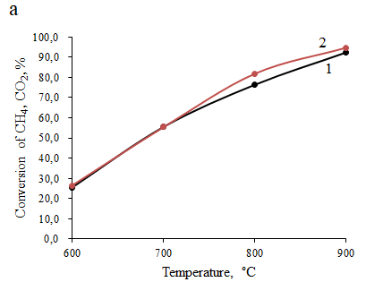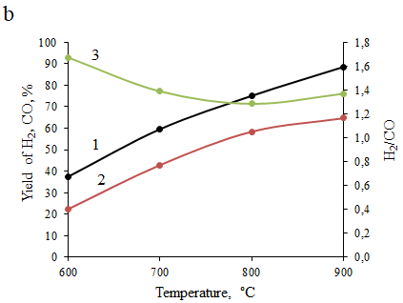

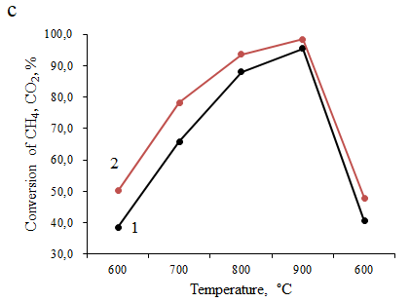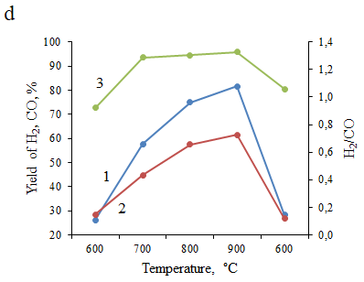

a, b - 15Ni-35Al, c, d - 15Ni-5Fe-30Al, e, f - 15Ni-15Fe-20Al. a, c, e: 1 - conversion of CH4, 2 - conversion of CO2, b, d, f: 1 - yield of H2, 2 - yield of CO, 3 - H2/CO; GHSV = 3000 h-1.

Figure 18 – The influence of temperature on process indicators in DRM, sheet 1

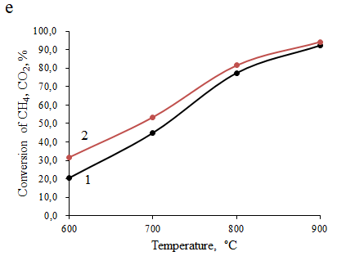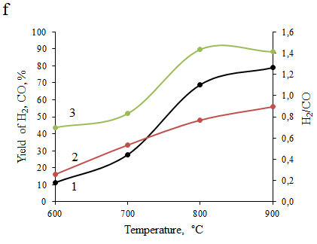

Figure 18 – The influence of temperature on process indicators in DRM, sheet 2

Notably, the 15Ni-5Fe-30Al catalyst showed significant stability, maintaining nearly the identical conversion of methane even after testing at 700°C‒900°C thereafter returning to 600°C, in spite of experiencing considerable coking, as depicted in Figures 18c and 18d. Additionally, for the 15Ni-15Fe-20Al the reacting gas conversion increased by 21% to 92% (methane) and 25% to 94% (carbon dioxide) within 600°C‒900°C (Figure 18e).

The H2 yield observed at 700oC increased in the following order: 10% for 15Ni-25Fe-10Al < 28% 15Ni-15Fe-20Al < 35% 15Ni-35Al < 57% 15Ni-5Fe-30Al. In comparison, at 800oC the yields of H2 over 15Ni-35Al, 15Ni-5Fe-30Al and 15Ni-15Fe-20Al were equal to 75%, 74% and 68%, respectively. This can result from an enlargement of the Ni particle size (Figures 18).

The highest H2/CO ratio of 1.4 obtained at 900oC for 15Ni-35Al, and at 800oC H2/CO ratio equal to 1.3. This indicator for the 15Ni-5Fe-30Al equal to 1.3 at 700‒900°C, and even after returning to the initial temperature, it remained nearly equal to 1 (Figure 18d). The RWGS reaction and possible hydrocarbon oxidation with carbon dioxide occurred, if H2/CO ratio is lower than unity (RWGS, CO2 + H2 → CO + H2O).

For 15Ni-5Fe-30Al catalyst, reacting gas conversion was 75% (CH4) and 79% (CO2), H2 yield – 65%, CO yield – 57% at 800oC, 33% CH4: 33% CO2: 34% Ar and a GHSV of 3000 h-1.

The energy of activation (EA) was determined by the Arrhenius equation ranging in 32‒51 kJ·mol-1 based on CH4 transformation [86, p. 27]. This range aligns with the activation energy values reported in [177‒180], in which they vary from 32 to 56 kJ·mol-1 for the Ni-containing catalysts used in DRM. This consistency proposes the absence of mass transfer limitations in the process. Moreover, this finding is supported by a low Weisz-Prater criterion value of 0.26. Additionally, it was noted in the study [177, р. 63], that no significant changes were observed in the conversion of methane, while increasing in the flow rate of gases.

To minimize coke formation, it is necessary to control the reaction kinetically by searching an optimal DRM condition: CH4/CO2 ratio, GHSV and temperature. The impact of the controlling conditions over the catalytic performance of a 15Ni-5Fe-30Al catalyst prepared by SCS was studied.

The GHSV varied keeping equimolar CH4/CO2 ratio. Figure 19 shows the changes of conversion and H2/CO ratio depending on GHSV. When the space velocity increased, the methane conversion reduced slightly. However, the CO2 conversion, CO and H2 yield showed an obvious rising tendency until GHSV reached to 3000 h-1. With further rising of the total flow rate, these parameters decreased.

An increase in CO yield can decrease the coke formation contributing to the occurrence of a Boudouard reaction (C + CO2 = 2CO) [181], which was observed at 3000 h-1. A high GHSV can reduce metallic sintering and increase the crystallite size during the reaction, but it provides a short contact time, thus, leading to a decline in catalytic activity (Figure 19).

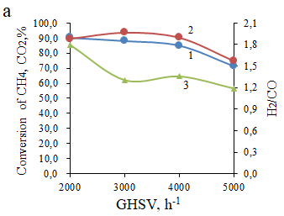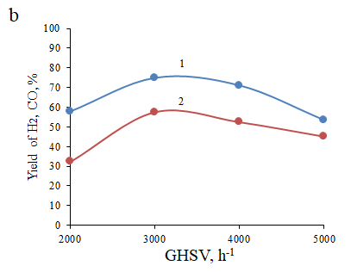

a: 1 - conversion of CH4, 2 - conversion of CO2, 3 - H2/CO, b: 1 - yield of H2, 2 - yield of CO; GHSV = 3000 h-1, T = 800°C, CH4/CO2 = 1.

Figure 19 – Influence of GHSV on process indicators in DRM

When CH4/CO2 ratio increased a decrease in CH4 conversion was observed (Figure 20). In the case of CH4/CO2 ratio < 1, because of lower concentration of methane in the feedstock its conversion appeared to be high. However, CO2 conversion was low. It was increased to 95%, when CH4/CO2 was between 1.0 and 1.5, decreasing with further rising of CH4/CO2 ratio to 2.0. In all CH4/CO2 ratios, H2/CO was higher than unity, which is opposite to [182], where H2/CO was lower.

The impact of the feedstock ratio on the yield of syngas was analyzed with three stoichiometric CH4/CO2 ratios: 0.67, 1, 1.5, 2 at 800°C. A rise in the feedstock ratio from 0.67 to 1.0 demonstrates a noticeable increase from 65% by 75% in the H2 production. At methane excess (feed ratio = 2), the H2 yield declined to 65%, meaning that H2 formation is unfavorable in methane excess. Decreasing trends are demonstrated in CO production over feed gas ratios of 0.67, 1, 1.5, 2. Moreover, larger coke is developed from methane cracking accounting for blockage of catalyst pores. The low H2 yield upon an excess CO2 can be explained with the occurrence of the RWGS [93, р. 29].

To evaluate the catalytic performance at conditions close to biogas, Ar content in the initial gas mixture differed from 0 to 50% (vol.) and the CH4/CO2 ratio was kept 2. It has been seen from Figure 21 that the absence of an inert gas led to higher conversion in comparison with those of 10% Ar.

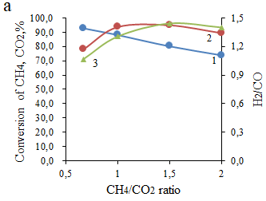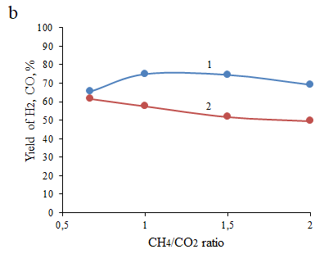

a: 1 - conversion of CH4, 2 - conversion of CO2, 3 - H2/CO, b: 1 - yield of H2, 2 - yield of CO; GHSV = 3000 h-1, T = 800°C.

Figure 20 – Influence of CH4/CO2 ratio on process indicators in DRM

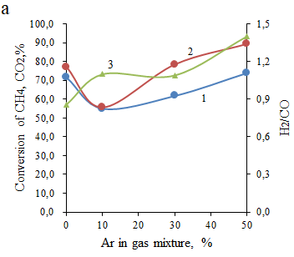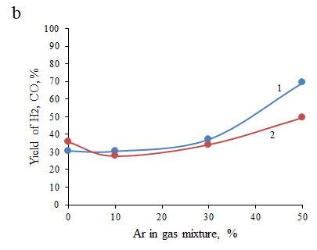

a: 1 - conversion of CH4, 2 - conversion of CO2, 3 - H2/CO, b: 1 - yield of H2, 2 - yield of CO; GHSV = 3000 h-1, T = 800°C.

Figure 21 – Influence of Ar dilution on process indicators in DRM

With higher content of Ar, reacting gas conversion increased. CH4 conversion at 50% Ar is 10% higher than that of 0% Ar. The difference in yield between 0%Ar and 30% Ar is not significant, while the yield of products increased rapidly at 50% Ar. CO yield is lower than H2 yield, however, the CH4/CO2 ratio used in feedstock is 2. The influence of temperature was studied at model biogas conditions (67% CH4:33% CO2) from 600 to 900°C (Figure 22).

With increasing temperature, the conversion increased. At 700°C H2/CO was close to unity, indicating that at this temperature the H2 and CO yields were similar. At other temperature CO yield was higher than the H2 yield.

For 15Ni-5Fe-30Al catalyst, initial gas conversion was 72% (CH4) and 77%(CO2), H2 yield – 31%, CO yield – 36% at 800oC, 67% CH4: 33% CO2 and a GHSV of 3000 h-1.

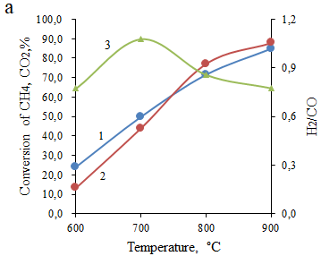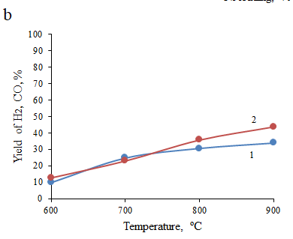

a: 1 - conversion of CH4, 2 - conversion of CO2, 3 - H2/CO, b: 1 - yield of H2, 2 - yield of CO; GHSV = 3000 h-1, T = 800°C.

Figure 22 – Influence of temperature on process indicators at model biogas conditions in DRM

The catalytic effectiveness was studied with 67% CH4:33% CO2 without dilution of the inert gas at GHSV of 3000 h-1 at 800°C. The volume of water varied from 15 ml to 90 ml. No significant changes were noticed (Figure 23). When the pre-ignition temperature therefore varied from 300°C to 600°C (Figure 24). Also no significant changes were observed. CH4 conversion decreased rapidly from 300°C to 400°C, then, slightly increased at pre-ignition temperatures of 500°C and 600°C.

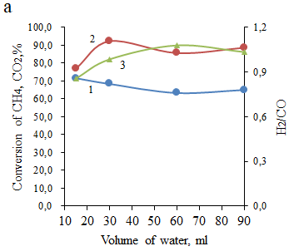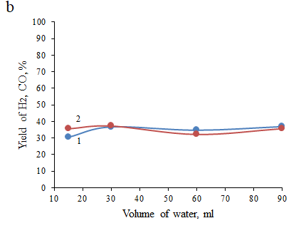

a: 1 - conversion of CH4, 2 - conversion of CO2, 3 - H2/CO, b: 1 - yield of H2, 2 - yield of CO; GHSV = 3000 h-1, T = 800°C.

Figure 23 – Influence of water volume varied during preparation of catalysts by SCS on the process indicators in DRM

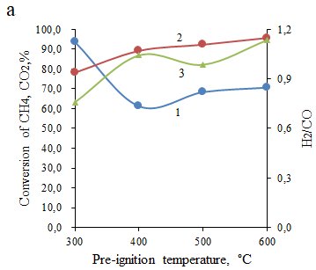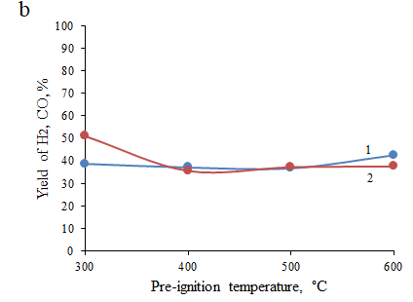

a: 1 - conversion of CH4, 2 - conversion of CO2, 3 - H2/CO, b: 1 - yield of H2, 2 - yield of CO; GHSV = 3000 h-1, T = 800°C.

Figure 24 – Influence of pre-ignition temperature varied during preparation of catalysts by SCS on the process indicators in DRM

The 15Ni-5Fe-30Al was examined at 800°C in DRM during 20 h at the similar reactant ratio and the flow rate. At the initial 5 h for the following catalyst CH4 conversion was 92% and CO2 conversion was 81% (Figure 25) being steady for all time-on-stream. For the 15Ni-5Fe-30Al catalyst the Fe/Ni molar ratio was 0.26.

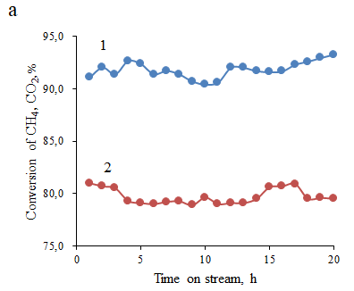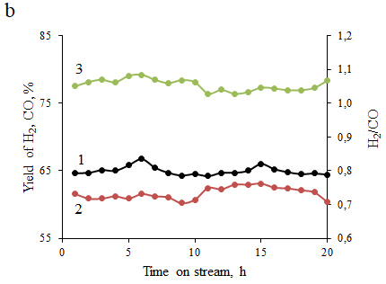

a: 1 - conversion of CH4, 2 - conversion of CO2, b: 1 - yield of H2, 2 - yield of CO, 3 - H2/CO; GHSV = 3000 h-1, T = 800°C.

Figure 25 – Behavior of 15Ni-5Fe-30Al in a long-term stability examination in DRM

The catalysts with the Fe/Ni molar ratio below 0.7 displayed stable performance [36, р. 17]. Furthermore, the yield of synthesis gas remained constant after 20 h of continuous operation, whereas the H2/CO ratio fluctuated within the range of 1.0 to 1.1 during the experiment. Typically, changes in this ratio are attributed to the RWGS reaction when a large amount of generated hydrogen reacts with carbon dioxide, as mentioned in [175, р. 62]. However, in the present study, with an increase in time-on-stream, variations in the yields of CO and H2 were not notably significant.

Table 12 shows comparison of the catalytic activity of 15Ni-5Fe-30Al [86, р. 27] with other catalysts obtained in [36, р. 17; 183, 184].

For instance, 0.3-FeNiAl catalyst experienced only a 0.41%·h-1 decline in CH4 conversion at 700°C [36, р. 17]. It is important to note that monometallic Ni catalysts with well-dispersed particles exhibited consistent performance in DRM, as seen in [98, р. 31; 183, р. 68]. Researchers [183, р. 68] featured a Ni impregnated into silica with small metal particles, prepared through citric acid chelation and subsequent calcination/carbonization. Conversely, Ni supported on HMS, loaded through self-assembly, demonstrated relatively stable activity at 700°C in DRM, despite sintering enlarged the metal particle size [184, р. 68].

Deactivation level was defined in equation (49) and used for comparison of different catalysts in Table 12:

$D_{deact}=\frac{X_{CO2,init}-X_{CO2, fin}}{X_{CO2,init}}∙100\%/ t, h$ (49)

Thus, Ni-Al and Ni-Fe-Al catalysts obtained in the SCS with distinct Fe concentrations were estimated in DRM. Based on XRD, 15Ni-35Al catalyst consisted of metallic nickel and NiAl2O4 phases. Apart from metallic nickel in 15Ni-5Fe-30Al, Ni3Fe alloy was identified likewise in as-prepared and spent catalysts.

Table 12 – Comparative catalytic results of different catalysts in DRM

|  |  |  |  |  |  |  |  |
| --- | --- | --- | --- | --- | --- | --- | --- |
| Catalyst | T, oC | Initial conversion, % | | Initial H2/CO | TOS, h | Deactivation degree, %·h-1 | Reference |
| CH4 | CO2 |
| 15Ni-5Fe-30Al | 800 | 92 | 81 | 1.0 | 20 | 0.25 | [86, р. 27] |
| 0.3-FeNiAl | 700 | 57 | 63 | - | 24 | 0.41 | [36, р. 17] |
| Ni/silica | 750 | 91 | 84 | 1.3 | 100 | 0.01 | [182, р. 68] |
| Ni-HMS | 700 | 72 | 83 | 0.83 | 100 | 0.03 | [183, р. 68] |

$D_{deact}=\frac{X_{CO2, t1}-X_{CO2,t2}}{X_{CO2,t1}}×100\%/t(h)$

Nickel aluminate was reduced to metallic nickel, generating Al2.667O4 oxide and Al3Ni2 alloy. It was demonstrated that for the 15Ni-35Al and 15Ni-5Fe-30Al catalysts, the methane conversion at 800°C was 76% and 88%, and the CO2 conversion was 82% and 94%, respectively. A decline in catalytic performance for materials with larger Fe concentrations agreed with XRD, featuring inert FeAl2O4 for these catalysts. TEM displays a higher Ni particle size. Catalyst acidity was elevated with higher Al content. Even though CHNS, TPO, and TGA reaffirmed large carbon precipitation on 15Ni-5Fe-30Al surface, no considerable drop in performance at second cycle (600°C) was seen. Throughout 20 h TOS stability examination conversion of methane stayed permanent, whereas a slight decline in conversion of CO2 was seen. The Ni3Fe phase reaffirmed by XRD improved catalyst stability. The pore volume and surface area and did not change while the average particle size of metals declined throughout DRM.

**3.2 Study of Ce- and La-promoted Ni catalysts prepared by SCS in DRM**

3.2.1 Study of physicochemical characteristics of Ce- and La-promoted Ni catalysts

Figure 26 demonstrated XRD results of Ce- and La-containing catalysts. Metallic nickel (referred to as Ni0) is observed as peaks around 52.5°, 61.4°, and 92.4° in the majority catalysts before and after the reaction [PDF 01-071-4655]. These Ni0 peaks result from the reduction of Ni2+ сompounds during the preparation of the catalyst [185‒188] and/or in the catalysts that have been used in the DRM [167, р. 54].

The La(OH)3 [PDF 01-083-4962] was formed in the fresh 15Ni-35La catalyst, disappearing during the reaction as evidenced by the XRD pattern [90, р. 28]. Ni0 phase was also present in the fresh catalyst. Lanthanum hydroxide disappeared in the spent catalyst (Figure 26c). Under inert or O2 atmosphere La(OH)3 can be decomposed to lanthana at 800oC [189]. Generally, lanthanum hydroxide is produced by hydroxylation of lanthana after calcination at 700oC (equation (50)). However, in the current study no reflexes of La2O3 were distinguished. The 15Ni-35La catalyst used for 30 min TOS contains only Ni0.

La2O3 + 3H2O → 2La(OH)3 (50)

The XRD pattern of the 15Ni-15La-20Al before the reaction did not show any essential crystalline phases. The minor peaks, just discernible from the background, might be associated with the perovskite structure of LaAlO3 [PDF 01-083-4233], appearing at 39.0º, 48.3°, 56.4°, 70.7°, and 83.8° (Figure 26b), as previously reported in [190]. In the used 15Ni-15La-20Al during short-term test the presence of the perovskite phase is more evident, along with the presence of Ni0. This phase was not changed during the temperature cycling test at 600‒900oC, while crystallinity of phases substantially increased.

For the fresh 15Ni-35Ce catalyst, the sole crystalline phase found could be CeO2 [PDF 00-067-0122] (Figure 26c). The crystallinity of the phases slightly increased during 30 min TOS in DRM. Moreover, metallic Ni0 is distinctly observable. Unlike 15Ni-35Ce the 15Ni-15Ce-20Al catalyst before reaction has more amorphous content, as well as extremely minimal crystalline phases. CeO2 phase was not identified in 15Ni-15Ce-20Al catalyst. Although it was difficult to carry out a reliable analysis [191], the few faint peaks might suggest the presence of the cubic CeAlO3 [PDF 00-028-0260]. The catalyst spent in 30 min TOS experiment is entirely amorphous, with Ni0 peaks barely discernible above the background.

During a prolonged stability test depicted in Figure 26d, where the temperature was raised from 600°C to 900°C, and turned back to 600°C, the catalyst exhibited the formation of the CeAlO3 phase (at 2θ = 25°, 39.2°, 48.5°, 56.6°) was observed alongside Ni0. CeAlO3 was formed during DRM at temperatures exceeding 600°C. Similarly, CeO2 was entirely transformed into CeAlO3 during reduction at 850°C [191, р. 69; 192, 193]. Otherwise, CeO2 is reduced to Ce2O3 above 800oC [186, р. 69] as indicated in equation (51). Thereafter, Ce3+ oxide interacting with alumina produces perovskite (equation (52)).

2CeO2 + H2 → Ce2O3 + H2O (51)

Ce2O3 + Al2O3 → 2CeAlO3 (52)

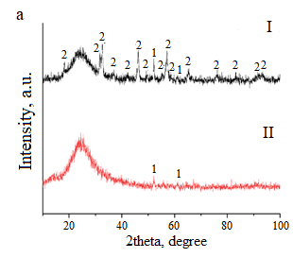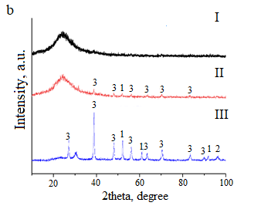

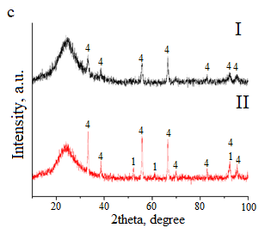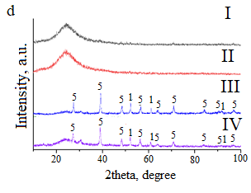

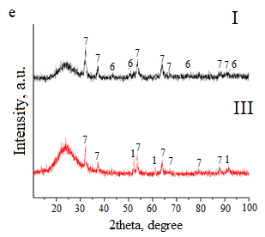

a - 15Ni-35La, b - 15Ni-15La-20Al, c - 15Ni-35Ce, d - 15Ni-15Ce-20Al, e - 15Ni-15Ce-20La; 1 - Ni0, 2 - La(OH)3, 3 - LaAlO3, 4 - CeO2, 5 - CeAlO3, 6 - NiO, 7 - La2Ce2O7; I - fresh, II - spent, 30 min TOS, III - spent, temperature cycling, IV - 20 h TOS; GHSV = 3000 h-1.

Figure 26 – XRD patterns La- and Ce-promoted catalysts

In contrast, before reaction 15Ni-15Ce-20La consisted of nickel oxide [PDF 04-006-6160] and La2Ce2O7 [PDF 01-084-4175] phases. Lanthanum cerate or pyrochlore type structure was stable, whilst NiO was reduced to metallic nickel during DRM. In [194] La2O3 and CeO2 are heated for several hours at 800°C to generate La2Ce2O7 phase, therefore suggesting that it might have been originated during the process of solution combustion.

X-ray diffraction results are demonstrated in Figure 27 for as-prepared catalysts after reduction at 850°C. Sharp reflexes are exhibited in the XRD patterns of the reduced catalysts, indicating high intensity. In contrast, it was challenging to visually observe any reflexes for the non-reduced 15Ni-15Ce-20Al and 15Ni-15La-20Al, as shown in Figure 26. In the reduced 15Ni-15Ce-20Al, it is apparent that NiO was not fully transformed, as some NiO species persisted; however, the NiO reflex intensity was low. In contrast, NiO was not detectable in the other catalysts, as shown in Figure 27.

There were minor reflexes indicating the presence of NiO transformed to Ni0 upon reduction of the 12 wt.% Ni/α-Al2O3 and 15Ni-15Ce-20La catalysts (depicted in Figure 27). On the other hand, Ce- and La-aluminates, as well as lanthanum cerate, remained stable after reduction. More information about 12 wt.% Ni/α-Al2O3 can be seen in Section 3.4.

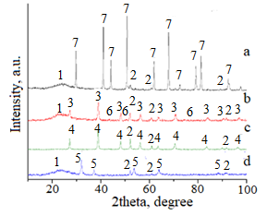

a - 12 wt.% Ni/α-Al2O3, b - 15Ni-15Ce-20Al, c - 15Ni-15La-20Al, d - 15Ni-15Ce-20La; 1 - amorphous phase, 2 - Ni0, 3 - CeAlO3, 4 - LaAlO3, 5 - La2Ce2O7, 6 - NiO, 7 - α-Al2O3.

Figure 27 – XRD patterns of the reduced catalysts

Ni content of ca. 17 wt.% was identified in the bimetallic catalysts (Table 13). The nickel amounts were in the range of 24‒26 wt.% in trimetallic catalysts. The Ni/La (Ce) molar ratio was equal to 1.3-1.4 for Ni-M-Al catalysts, whereas this ratio in bimetallic catalysts was in the range of 0.6‒0.8 remaining close in the catalysts before and after reaction, although nickel was situated at the edges of carbon nanotubes in certain catalysts.

The mean metal particle size and TEM micrographs of catalysts contain rare-earth metals are presented in Figure 28 and Table 14. The spent 15Ni-35Al possessed smallest metal particle size, whereas slightly larger particles were found in the Ce- and La-promoted catalysts. 15Ni-15Ce-20Al displayed narrower particles compared to 15Ni-15La-20Al.

Table 13 – Elemental analysis of different catalysts

|  |  |  |  |  |  |  |  |
| --- | --- | --- | --- | --- | --- | --- | --- |
| Catalyst | Ni, wt.% | M*, wt.% | Al, wt.% | O, wt.% | Ni/M* | Ni/Al | M*/Al |
| 15Ni-15Ce-20Al (F) | 24.08±0.28 | 42.62±0.34 | 12.26±0.09 | 21.05±0.16 | 0.6 | 2.0 | 3.5 |
| 15Ni-15Ce-20Al (S-30 min, 850oC) | 26.17±0.28 | 47.15±0.34 | 11.28±0.09 | 15.17±0.18 | 0.6 | 2.3 | 4.2 |
| 15Ni-15Ce-20Al (S-600-900oC) | 25.97±0.37 | 41.39±0.38 | 13.37±0.13 | 16.31±0.23 | 0.6 | 1.9 | 3.1 |
| 15Ni-15La-20Al (F) | 24.70±0.32 | 42.70±0.40 | 13.28±0.11 | 19.32±0.16 | 0.6 | 1.9 | 3.2 |
| 15Ni-15La-20Al (S-30 min TOS, 850oC) | 25.74±0.30 | 45.96±0.37 | 11.36±0.12 | 12.70±0.18 | 0.6 | 2.3 | 4.0 |
| 15Ni-15La-20Al (S-600-900-600oC) | 25.62 | 49.15 | 16.54 | - | 0.5 | 1.5 | 3.0 |
| 15Ni-35Ce(S-30 min, 850oC) | 16.65±0.28 | 64.81±0.38 | 0.47±0.06 | 17.34±0.22 | 0.6 | large | large |
| 15Ni-35La(S-30 min, 850oC) | 17.51±0.33 | 52.42±0.36 | 0.75±0.08 | 29.33±0.23 | 0.33 | large | large |
| *M = Ce, La | | | | | | | |

The spent 15Ni-35Al catalyst [86, р. 27] demonstrated the narrowest average nickel particle size (Figure 28), whereas the La- and Ce-modified catalysts displayed slightly larger particles. In addition, the particles in 15Ni-15Ce-20Al were found to be smaller than in 15Ni-15La-20Al indicating the higher activity of the former catalyst.

The carbon nanotubes were readily identifiable in the TEM micrographs of all catalysts used in DRM tests. During the experiment, where temperature increased to 900ºC with following decrease to 600ºC the mean particle size of the Ni-Ce-Al rose to 32 nm, implying probable sintering of metal. In addition, nickel species were fine-dispersed in the catalyst. The mean size of metal particles is similar (15 nm) for Ni-Ce catalysts with/without aluminum in line with the literature [195]. During temperature cycling test over 15Ni-15Ce-20Al nickel particle size was not substantially changed.

Volume of pores and surface areas were evaluated by the nitrogen physisorption (Table 15). The results were shown for spent catalysts at GHSV of 3000 h-1, 850oC 30 min TOS. The Ni-Ce and Ni-La catalysts obtained by SCS display very low BET surface areas.

The amount of mesopores is more in comparison with micropores. As a result of coke congestion the microporous/mesoporous volume ratio (Vμ/Vm) is reduced along with contemporaneous reduction of the spent catalyst surface area by 37‒58%. The spent 15Ni-35La possesses surface area solely 42% of as-prepared sample. Other Ni-M catalysts possessed lower difference of the fresh and spent surface areas in the following order: 15Ni-35Ce (50%) < 15Ni-15La-20Al (60%) < 15Ni-15Ce-20Al (63%) specifying that the last catalyst hold down majority of its surface area.

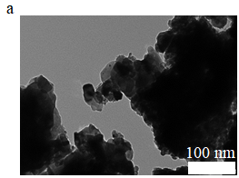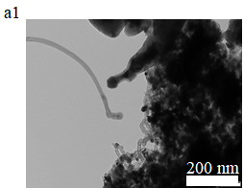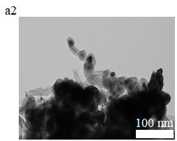

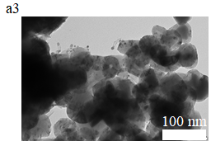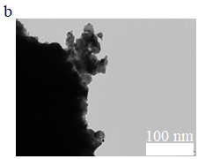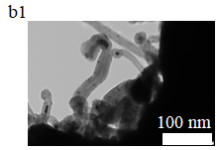

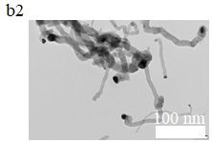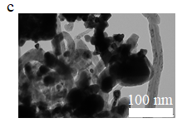

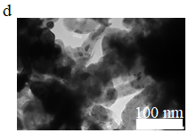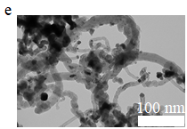

15Ni-15Ce-20Al: a - fresh, a1 - spent after 30 min TOS, a2 - spent after temperature cycling, a3 - spent after 20 h TOS; 15Ni-15La-20Al: b - fresh, b1 - spent after 30 min TOS, b2 - spent after temperature cycling; 15Ni-15Ce-20La: c - spent after temperature cycling, 15Ni-35Ce: d - spent after 30 min TOS; 15Ni-35La: e - spent after 30 min TOS.

Figure 28 – TEM images of Ce- and La-promoted catalysts

The NH3 TPD findings revealed that the 15Ni-35Al catalyst exhibited the anticipated highest level of acidity, primarily because of the substantial alumina content, as depicted in Figure 29 and Table 16. In comparison, the 15Ni-15La-20Al catalyst displayed 27% higher acidity than 15Ni-15Ce-20Al, which can be attributed to its marginally higher aluminum content. Each of the three catalysts possessed a higher number of robust acid sites, specifically those with NH3 desorption peaks near 600°C.

Table 14 ‒ Ni average particle size of catalysts

|  |  |  |
| --- | --- | --- |
| Catalyst | Ni average particle size of the fresh sample, nm | Ni average particle size of the spent sample, nm |
| 15Ni-15Ce-20Al | 15 | a15,b18,d23 |
| 15Ni-15La-20Al | 15 | а19, c32 |
| 15Ni-15Ce-20La | - | c26 |
| 15Ni-35Ce | - | а15 |
| 15Ni-35La | - | а20 |

Table 15 – Textural properties of the catalysts

|  |  |  |  |  |  |  |
| --- | --- | --- | --- | --- | --- | --- |
| Catalyst | F/S | SBET, m2·g-1 | Vtot, cm3·g-1 | Vμ (2 nm), cm3·g-1 | Vm (20 nm), cm3·g-1 | Vμ/Vm |
| 15Ni-15Ce-20Al | F | 8 | 0.011 | 0.003 | 0.007 | 0.43 |
| 15Ni-15Ce-20Al | S | 5 | 0.018 | 0.001 | 0.008 | 0.13 |
| 15Ni-15La-20Al | F | 5 | 0.008 | 0.002 | 0.006 | 0.33 |
| 15Ni-15La-20Al | S | 3 | 0.014 | 0 | 0.006 | 0 |
| 15Ni-35Ce | F | 10 | 0.024 | 0.002 | 0.011 | 0.18 |
| 15Ni-35Ce | S | 5 | 0.020 | 0.001 | 0.006 | 0.16 |
| 15Ni-35La | F | 12 | 0.050 | 0 | 0.004 | 0 |
| 15Ni-35La | S | 5 | 0.020 | 0.001 | 0.007 | 0.14 |

The strength of basic sites (Figure 28 and Table 16) is categorized as weak if CO2 was desorbed under 200°C, basic sites of medium strength were determined at 200‒400°C, strong ‒ for desorption at 400‒600°C, and highly strong ‒ above 600°C [196].

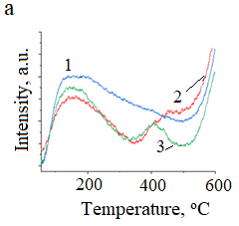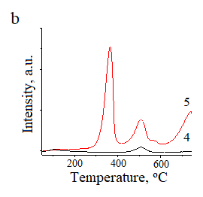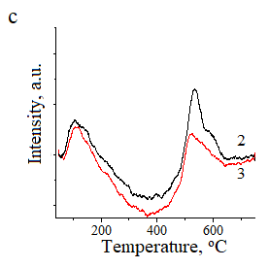

a - NH3 TPD, b, c - CO2 TPD profiles; 1 - 15Ni-35Al, 2 - 15Ni-15Ce-20Al, 3 - 15Ni-15La-20Al, 4 - 15Ni-35Ce, 5 - 15Ni-35La.

Figure 29 – Acidity and basicity of some catalysts prepared by SCS

Table 16 – Determination of acid and basic sites for some catalysts

|  |  |  |  |  |
| --- | --- | --- | --- | --- |
| Catalyst | Maximum temperature NH3 TPD peak, oC | Maximum temperature CO2 TPD peak, oC | Normalized area of NH3 adsorbed | Normalized area of CO2 adsorbed |
| 15Ni-15Ce-20Al | 159/401/622 | 101/528 | 0.54 | 0.04 |
| 15Ni-15La-20Al | 146/439/622 | 115/518 | 0.65 | 0.05 |
| 15Ni-35Al | 140/622 | - | 1.0 | - |
| 15Ni-35Ce | - | 106/508 | - | 0.07 |
| 15Ni-35La | - | 364/509/741 | - | 1.0 |

The 15Ni-35La catalyst possesses the highest level of basicity. This sample was found to contain the lanthanum hydroxide phase based on XRD analysis. This phase forms moderate basic sites formed at 364°C for 15Ni-35La, which is quite close to the peak observed in [197]. Regarding the trimetallic catalysts, the 15Ni-15La-20Al displayed a lower number of basic sites at elevated temperatures (around 528°C) compared to 15Ni-15e-20Al. Moreover, it demonstrated higher stability in DRM. This finding aligns with the literature [197, р. 75], where Ni/CeO2-Al2O3 showed basic sites with higher strength compared to Ni/Al2O3-La2O3.

Figure 30 illustrated hydrogen consumption of the Ni-based catalysts at 200‒800°C. According to TPR data, for 15Ni-15Ce-20Al reduction of Ni species occurred at 300‒400°C [198]. The initial peak was observed at 300°C signifies the reduction of Ni2+ i.e. NiO entities on the catalyst surface. This aligns with the XRD findings indicating the existence of Ni0. The robust interaction between nickel oxide and aluminum takes place in 15Ni-15La-20Al, when NiO species are reduced between 400–500°C (Table 17). It is worth noting that XRD pattern did not reveal the nickel oxide presence. In 15Ni-15Ce-20Al CeO2 species can be reduced to Ce3+ [186, р. 68]. Since the crystallinity of 15Ni-15Ce-20Al is fairly low (see XRD results), precise distinguishing various species based on TPR is challenging.

Table 17 – Data from hydrogen TPR

|  |  |  |  |  |
| --- | --- | --- | --- | --- |
| Catalyst | T1,max, oC | T2,max, oC | T≥3,max, oC | Normalized area |
| 15Ni-15Ce-20Al | 320 | 377 | 800 | 0.33 |
| 15Ni-15La-20Al | 380 | 542 | - | 1.0 |
| 15Ni-15Ce-20La | 372 | 527 | - | 0.19 |
| 15Ni-35Ce | 248 | 340 | 540 | 0.91 |
| 15Ni-35La | 194 | 363 | 397, 574, 620, 694 | 0.31 |
| 15Ni-35Al | 353 | 456 | 800 | 0.37 |

The CHNS analysis of the catalysts used during short-term examination at 850°C indicates a decline in the content of carbon per unit mass of nickel in the following order: 15Ni-15La-20Al > 15Ni-35La > 15Ni-15Ce-20Al > 15Ni-35Ce (Table 18). The Ni-Ce catalyst exhibited a lower normalized carbon content compared to the Ni-Ce-Al catalysts because of the presence of aluminum and the increased acidity in the latter catalyst. On the other hand, this can be explained by the addition of CeO2, which boosts CO2 adsorption of in the interfacial area, while simultaneously reducing the formation of coke [199].

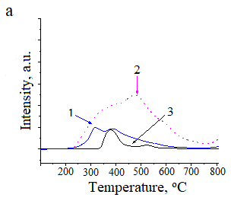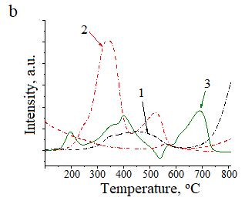

a: 1 - 15Ni-15Ce-20Al, 2 - 15Ni-15La-20Al, 3 - 15Ni-15Ce-20La; b: 1 - 15Ni-35Al, 2 - 15Ni-35Ce, 3 - 15Ni-35La.

Figure 30 – Hydrogen TPR of different catalysts

When reduction of ceria to CeO2-x and following reoxidation to the former species occurred, interacting with CO2, catalysts containing cerium promote the gasification of CHx and the CO formation [193, р. 70]. For comparison, carbon content in 15Ni-15Ce-20Al catalyst was likewise determined by CHNS analysis conducted under identical conditions for a total operating time of 20 h, and it was found to be 3.8 times higher than that of the catalyst used for only 30 min of total operating time. Furthermore, the H/C ratio for the 15Ni-15Ce-20Al was measured at 0.1, suggesting that the ratio of H/C reduced, when the sample was subjected to prolonged total operating time.

Table 18 – The normalized carbon content of the catalysts used for 30 min TOS at 850oC

|  |  |  |
| --- | --- | --- |
| Catalyst | Normalized carbon content, wt.%·gNi-1 | H/C, molar ratio |
| 15Ni-15Ce-20Al | 0.38 | 0.22 |
| 15Ni-15La-20Al | 1.0 | 0.13 |
| 15Ni-35Ce | 0.39 | 0.23 |
| 15Ni-35La | 0.61 | 0.25 |
| 15Ni-35Al | 0.12 | 0.26 |

The quantity of coke grew proportionally with the rise in the size of nickel particles of the used catalyst. Simultaneously, the molar ratio of H/C reached its lowest point. Particularly, Ni-La with larger metal particles displayed an exceptionally low H/C ratio. H/C ratio under 2 signifies the existence of aromatic coke, whereas a ratio under 1 indicates a more dehydrogenated form of coke.

Thermogravimetric analysis was performed at conditions similar to DRM conditions (shown in Figure 31). For instance, the heating of the catalyst was conducted up to 800°C with 100 ml·min-1 of gas flow.

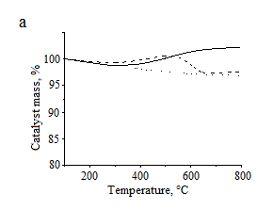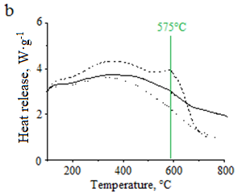

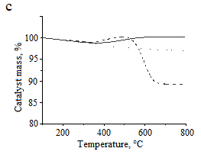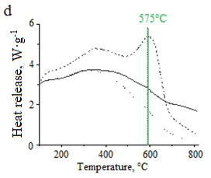

a, c - dependence of catalyst mass of 15Ni-15Ce-20Al and 15Ni-15La-20Al; b, d - heat release of 15Ni-15Ce-20Al and 15Ni-15La-20Al on temperature; fresh catalyst in N2 flow (dot-dot line), fresh catalyst in air flow (solid line), spent catalyst in air flow (dash-dash line).

Figure 31 – Thermogravimetric analysis results of the fresh and spent samples examined at 850oC in DRM for 30 min TOS

Based on the TGA results, for 15Ni-15La-20Al the calculated normalized carbon amount was 56 wt.%·gcat-1, reducing for 15Ni-15Ce-20Al to be 21 wt.%·gcat-1 in line with CHNS analysis. The heating peak release is observed at 575°C indicating the presence of filamentous carbon formation as noted in [200, 201]. Moreover, TGA examination of the catalysts before reaction in the presence of air exhibited phase changes, with 15Ni-15Ce-20Al displaying a weight percentage of 5.3% and 15Ni-15La-20Al showing 3.2%. The rise in weight observed in the TGA plot occurs as a result of the Ni0 and/or CeO2 oxidation similar to described in [202].

In a N2 atmosphere, the 15Ni-15La-20Al catalyst experienced a larger weight loss at 500°C, while oxidation took place when exposed to air. Nevertheless, this catalyst lost significantly lower mass at 800°C in nitrogen medium compared to that under oxidizing conditions.

Thermodynamic research of DRM was conducted. The equilibrium constitution of DRM reaction components was estimated using the Gibbs reactor modulus executed in ChemCAD software [203]. The non-ideality of the system was considered adopting the Soave-Redlich-Kwong equation of state [204]. The calculations were performed fixing an atmospheric pressure and a feed ratio of 1:1:1 CO2, CH4, Ar.

The gas composition was determined using molar fractions (Figure 32). Above 620°C hydrogen is already the main product. Methane decreased as temperature increased, indicating its full conversion. At elevated temperatures carbon monoxide fraction becomes larger [204, р. 78].

Thus, the catalyst with the addition of cerium showed higher activity due to cerium aluminate, and the carbon deposition was also small compared to the lanthanum promoted catalyst, which contained an unstable lanthanum hydroxide phase. According to the TGA data, 15Ni-15Ce-20Al and 15Ni-15La-20Al catalysts contain filiform-type coke, which has insignificant effect on the activity of the nickel surface.

For the 15Ni-35Ce, 15Ni-15Ce-20Al and 15Ni-15La-20Al catalysts, basic sites were determined at 400‒600°C, indicating moderate and strong basicity [90, p. 28].

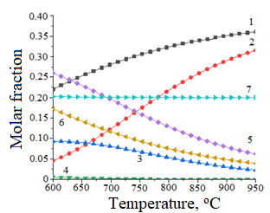

1 - H2, 2 - CO, 3 - CO2, 4 - CH4, 5 - carbon, 6 - H2O, 7 - Ar.

Figure 32 – The impact of temperature on equilibrium composition of the reaction mixture

15Ni-35La demonstrated moderate basicity. It is known that rare earth metals are good promoters for DRM catalysts.

3.2.2 Study of catalytic activity of Ce- and La-promoted Ni catalysts in DRM

Catalytic behavior at short-term examination (TOS = 30 min) was estimated over nickel based samples with various cerium content in DRM at 850°C (Figure 33). As cerium content increased to 15 wt.%, the reacting gas conversion slowly became larger, thereafter, declining with higher content of Ce. Syngas yield slightly reduced with larger Ce content, decreasing MSI. As shown in TPR profile the absence of aluminum leads to difficult reduction of Ni-Ce catalysts, therefore decreasing their catalytic performance, for instance, it is observed for 15Ni-35Ce [90, р. 28].

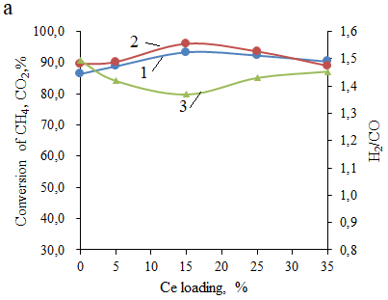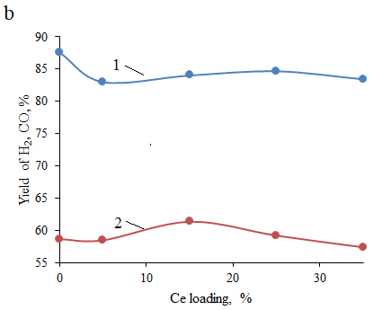

a: 1 - conversion of CH4, 2 - CO2, 3 - H2/CO; b: 1 - yield of H2, 2 -CO.

Figure 33 – Effect of Ce loading on process indicators in DRM

Information regarding catalytic activity of different catalysts after short-term test during DRM at 850°C is presented in Figure 34 and Table 19.

Table 19 – Catalytic results of catalysts from the 30 min test DRM at 850oC

|  |  |  |  |  |  |  |  |  |
| --- | --- | --- | --- | --- | --- | --- | --- | --- |
| Catalyst | Conversion, % | | TOF, s-1 | Yield, % | | CB, % | *Deactivation rate, %·min-1·gcat-1 | H2/CO |
| CH4 | CO2 | H2 | CO |
| 15Ni-15Ce-20Al | 93 | 96 | 0.23 | 84 | 59 | 67 | 0 | 1.5 |
| 15Ni-15La-20Al | 78 | 82 | 0.34 | 73 | 58 | 79 | 0.20 | 1.4 |
| 15Ni-35Ce | 89 | 90 | 0.18 | 83 | 59 | 68 | 0.1 | 1.6 |
| 15Ni-35La | 92 | 90 | 0.25 | 83 | 62 | 70 | 0.005 | 1.5 |
| 15Ni-35Al | 86 | 90 | 0.05 | 88 | 59 | 74 | 0.03 | 1.5 |
| *Note:Deactivation rate is defined during the decline in CH4 conversion per catalyst mass and time | | | | | | | | |

The methane conversion increased in the following sequence: 15Ni-15La-20Al (78%) < 15Ni-35Al (86%) < 15Ni-35Ce (89%) < 15Ni-35La (92%) < 15Ni-15Ce-20Al (93%). The 15Ni-15La-20Al possesses the lowest conversion of methane, however, it displayed the largest quantity of coke calculated per exposed Ni. However, H2 expenditure was substantial during TPR, unlike in [205]. Additionally, since La(OH)3 is not steady throughout DRM in accordance with XRD, the 15Ni-15La-20Al exhibited the highest generation of carbon.

Similarly to the present study, where the La-promoted catalyst had more deposition of carbon compared to the equivalent Ce-promoted samples, the La-Ni/halloysite demonstrated larger coking in comparison with the Ce-Ni/halloysite, as noted in [206]. In this instance, Ni/Ce molar ratio equal to 1.4 is observed for the Ce-promoted catalyst.

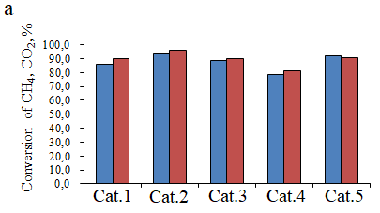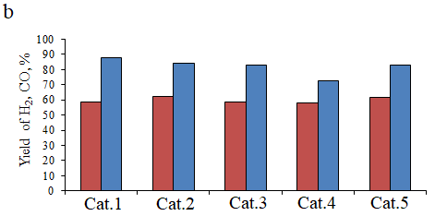

a – CH4 and CO2 conversion, b – H2 and CO yield; a – blue is CH4 conversion, red is CO2 conversion; b – blue is H2 yield, b – red is CO yield; a, b: Cat.1 - 15Ni-35Al, Cat.2 - 15Ni-15Ce-20Al, Cat.3 - 15Ni-35Ce, Cat.4 - 15Ni-15La-20Al, Cat.5 - 15Ni-35La, GHSV = 3000 h-1, T = 850oC after 30 min TOS in DRM.

Figure 34 – Catalytic data for different catalysts after short-term test during DRM

Furthermore, and coking was not found in the used Ni-Ce-alumina with particle size of 10 nm and Ni/Ce molar ratio of 1.6 at 800°C [33, р. 17].

Due to the robust MSI the 15Ni-35Al catalyst exhibited a high CH4 conversion of 86%. The large methane conversion of 88% for Ni-Ce catalyst is exhibited due to its high reducibility at low temperatures and the presence of the ceria, which likely contributed to coke suppression, resulting in a low amount of coke per nickel (TGA analysis). In contrast, high crystalline 15Ni-35Ce consumes high hydrogen compared to 15Ni-15Ce-20Al.

The 15Ni-35La bimetallic catalyst, one of the lanthanum catalysts, showed considerable conversion of methane (92%) in DRM as indicated in Table 19. However, it proved to be unstable at this temperature during DRM. The decomposition of lanthanum hydroxide confirmed by XRD occurred, decreasing the metallic nickel area. The 15Ni-35La catalyst exhibited low reducibility, comparable to 15Ni-35Al. Interestingly, this catalyst possesses high basicity, yet this did not substantially suppress coke development.

TOFs displayed a rise with larger metal particle sizes, in the case of 15Ni-15La-20Al. Conversely, when using 20 nm particles of Ni in 15Ni-35La catalyst, the TOF value declined. Additionally, there was an observed structure sensitivity in methane transformation. As reported in [206, р. 80], an increase in particle size of nickel led to a volcano-shape curve in turnover frequency.

15Ni-15La-20Al possessing the second largest metal particles among the used catalysts, exhibited the highest deactivation rate (as listed in Table 19). The normalized content of coke per exposed nickel amount rose with larger particle sizes in the used catalysts, except for 15Ni-35La.

Similar findings indicating substantial coke formation with larger nickel particles were observed in studies on Ni-supported silica catalysts in SRM at 800°C [207, 208]. Additionally, higher coke formation was noted over larger nickel particles, especially in Ni-CeO2 catalysts modified with different metals during DRM [209]. The image of the used 15Ni-15La-20Al obtained from transmission electron microscopy showed the enclosing of nickel species within carbon nanofibers, a contrast to the behavior observed in 15Ni-15Ce-20Al. Similarly, during DRM, nickel particles were trapped in filaments for the 8 wt.% Ni-Al-La catalyst, as reported in [210].

In the case of 15Ni-15La-20Al, the CO2 conversion was 81%, while methane conversion was lower, attributed to the presence of lanthanum, which improved catalyst basicity.

The 15Ni-15Ce-20Al demonstrated stable performance, maintaining constant conversion of CH4 and CO2 (see Table 19). 15Ni-15Ce-20Al along with 15Ni-35Ce possessed the smallest particle size amongst the catalysts tested for 30 min TOS. The high dispersion of metal minimized coke development, ensuring a performance for extended durations, primarily due to the presence of Ni-CeO2 [211]. Additionally, 15Ni-15Ce-20Al had a larger quantity of strong basic sites compared to 15Ni-15La-20Al, a factor known to enhance catalyst stability according to [196, р. 74].

Nevertheless, despite the stable state of 15Ni-15Ce-20Al, it stored the third-largest quantity of coke deposits per nickel after short-term examination, as reaffirmed by CHNS findings (Table 19). On the basis of XRD analysis, ceria and nickel with zero valence phases stayed unchanged, even though the catalyst had low crystallization degree. Notably, Ni0 particles were located at the tips of carbon nanofilaments and remained active [212]. According to [195, р. 72], CeO2 can enhance CO2 activation in Ni-based catalysts, following the reaction Ce2O3 + CO2 → 2CeO2 + CO. However, in the current study, Ce2O3 was not identified for the 15Ni-15Ce-20Al examined at 850ºC for 30 min TOS, however, it was found during the stability test.

The H2/CO ratio is a crucial indicator in DRM, where a value of one signifies stoichiometric reaction. A ratio above one indicates methane decomposition following by excess hydrogen production and during 30 min TOS in DRM. In this study, the H2/CO ratio ranged from 1.4 to 1.6, whereas 15Ni-15La-20Al demonstrates the lowest value. For instance, in the case of 15Ni-15Ce-20Al, this indicator was 1.5. In the present study, 15Ni-15Ce-20Al had a Ni/Ce molar ratio of 1.4. This indicates that the method of catalyst preparation, which leads to strong interactions between metals, combined with a favorable Ni/Ce molar ratio, significantly influences DRM outcomes.

The impact of temperature cycling was examined for Ni-Ce-Al, Ni-La-Al and Ni-Ce-La catalysts. The temperature was raised from 600 to 900°C after 10‒15 min of continuous operation, using increments of 50°C, and then reverted back to 600°C (Figure 35, Table 20). In parenthesis the final conversion at 600oC is given. Initially, the carbon balance dropped from nearly 100% to 66% (Ni-Ce-Al) and 78% (Ni-La-Al) at 900°C (Table 20). However, the carbon balance of 100% by 600°C, at second cycle, was restored.

15Ni-15Ce-20Al demonstrated a higher conversion of CH4 and a lower conversion CO2 compared to 15Ni-15La-20Al at 600°C. However, at 800°C, both reacting gas conversion were higher for 15Ni-15Ce-20Al than for 15Ni-15La-20Al. The initial TOFs for CH4 transformation increased in the following order for the catalysts: 15Ni-15Ce-20La < 15Ni-15Ce-20Al < 15Ni-15La-20Al, corresponding to H2 uptake observed in TPR experiments.

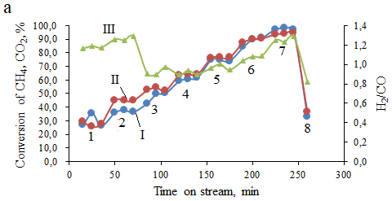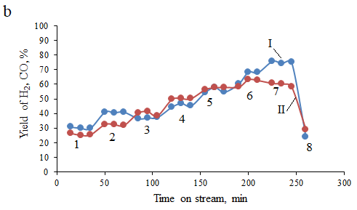

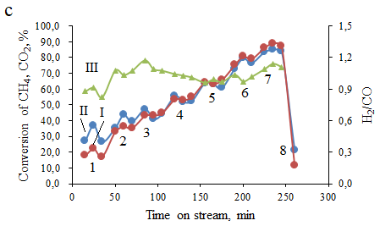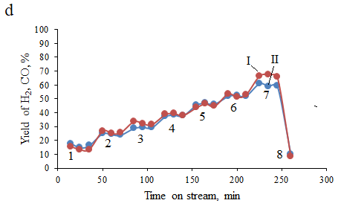

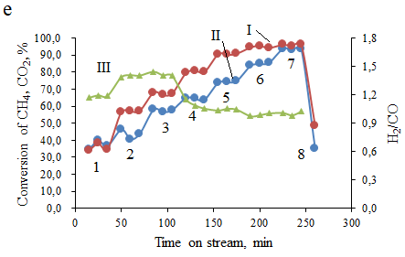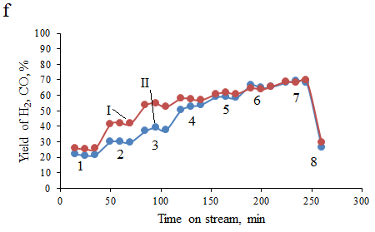

a, b - 15Ni-15Ce-20Al, c, d - 15Ni-15La-20Al, e, f - 15Ni-15Ce-20La; a, c, e: I - conversion of CH4, II - CO2, III - H2/CO ratio, b, d, f: yields of I - H2, II – CO in DRM at 600–900oC and return to 600oC; 1 - 600oC, 2 - 650oC, 3 - 700oC, 4 - 750oC, 5 - 800oC, 6 - 850oC, 7 - 900oC and 8 - 600oC; GHSV = 3000 h-1.

Figure 35 – Influence of temperature cycling on Ce- and La-promoted catalysts in DRM

The 15Ni-15Ce-20Al catalyst exhibited higher yield of synthesis gas compared to the 15Ni-15La-20Al. Notably, the H2/CO ratio at 800°C was almost equal, unlike the results observed at 850°C due to the formation of cerium and lanthanum aluminates during the treatment of the catalysts by increasing the temperature step-by-step. Interestingly, heating of these catalysts to 850°C did not induce the particular transformations of phase. The EA for CH4 transformation fell within 36-37 kJ·mol-1, which are similar to those reported in the literature [190, р. 69; 198, р. 75; 213].

Based on [186, р. 68], the existence of CeAlO3 restricts the formation of graphitic type of coke. Consequently, the 15Ni-15Ce-20Al stability can be attributed to the appearance of cerium aluminate during temperature cycling tests. Additionally, research [191, р. 69] proposed that cerium aluminate can react with carbon dioxide during DRM (equation (53)):

2CeAlO3 + CO2 → Al2O3 + 2CeO2 + CO (53)

CeAlO3 had been formed during reduction of catalyst at 900°C. The reduced catalyst had the CeAlO3 during 18 h test at 800°C [214]. In the present work, CeAlO3 appeared in the temperature cycling and the long-term experiments at a Ni/Ce molar ratio of 1.4. In comparison, the conversion of methane over the reduced 15Ni-15Ce-20La (reduction with H2 at 900°C with 40 ml·min-1 flow for 20 min) is higher at 900°C compared to 15Ni-15Ce-20Al and 15Ni-15La-20Al due to metallic Ni (Figure 35e, f, Table 20). A non-reduced 15Ni-15Ce-20La catalyst showed very low activity.

This outcome aligns with the low H2 uptake observed for 15Ni-15Ce-20La. Moreover, images obtained by TEM depicted the presence of huge nickel particles in the used catalyst clearly indicating that the performance of 15Ni-15Ce-20La catalyst did not match that of 15Ni-15Ce-20Al, despite previous claims in [215], where a mixture of La2O3 and La2Ce2O7 is advantageous in DRM by inhibiting formation of coke. However, in the current experiment, lanthana was not observed. For 15Ni-15Ce-20Al, the H2/CO ratio fluctuated between 1.0 and 1.4 over the course of the reaction, whereas for 15Ni-15La-20Al, it ranged from 0.9 to 1.2. The H2/CO value is 1.2 at 700oC over 15Ni-15La-20Al the same as those reported in [216]. The H2/CO ratio decreased to 0.8 at second cycle (600oC) because CH4 conversion at 900oC is lower compared to CO2 conversion, meaning that RWGS reaction occurred consuming more and resulting in low H2 yield and a lower H2/CO ratio. According to [199, р. 76], the equilibrium H2/CO ratio at 600oC was adjusted around 3.

For the most active catalyst (15Ni-15Ce-20Al) at 850°C in the temperature cycling test, conversions were 90% (CH4) and 90% (CO2), yield of H2 – 68%, yield of CO – 63%.

The stability of the 15Ni-15Ce-20Al catalyst was further examined at 850°C for 20 h maintaining GHSV of 3000 h-1, considering its relatively superior performance. According to Figure 36a, the CO2 and CH4 conversion was quite similar, remaining stable for 20 h. Simultaneously, the carbon balance was around 75%, and the H2/CO ratio ranged from 1.0 to 1.2, demonstrating excellent performance. In addition, the rates of coke accumulation were 13.8 wt.%·h-1 and 1.3 wt.%·h-1 for the 15Ni-15Ce-20Al catalysts at 30 min and 20 h TOS, respectively, calculated using CHNS analysis. This highlights that the initial carbon accumulation rate was over 10 times higher than longer stability duration, attributing to the adsorption of filamentous carbon deposited on acidic and metal sites and was available at the start of the reaction. The temperature, at which this type of coke is formed, was examined in relation to thermogravimetric analysis [217]. As demonstrated in Table 21 the catalyst effectiveness of 15Ni-15Ce-20Al was correlated with catalysts investigated in [90, р. 28; 218, 219] depicting starting TOFs and conversion. The values of conversion over 15Ni-15Ce-20Al were 45% (methane) and 70% (carbon dioxide).

Table 20 – Conversion of reacting gasses and the carbon balance at initial 600oC and at 850oC over different catalysts

|  |  |  |  |  |  |  |  |  |  |
| --- | --- | --- | --- | --- | --- | --- | --- | --- | --- |
| Catalyst | Conversion at 600°C, % | | TOF, s-1 | CB at 600°C, % | Conversion at 850°C, % | | CB at 850°C, % | H2/CO | EA, kJ·mol-1 |
| CH4 | CO2 | CH4 | CO2 |
| 15Ni-15Ce-20Al | 29 (37) | 27 (33) | 0.08 | 98 (99) | 90 | 90 | 77 | 1.0 | 38 (600-750°C)  23 (800-900°C) |
| 15Ni-15Ce-15La | 34 (49) | 35 (35) | 0.07 | 85  (84) | 95 | 84 | 77 | 1.1 | 39 (600-750°C)  6 (800-900°C) |
| 15Ni-15La-20Al | 18 (19) | 27 (21) | 0.1 | 100 (100) | 2.8.10-4 81 | 80 | 83 | 1.0 | 62 (600-750°C)  27 (800-900°C) |

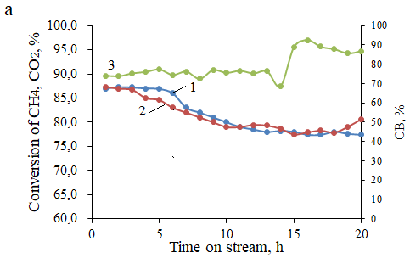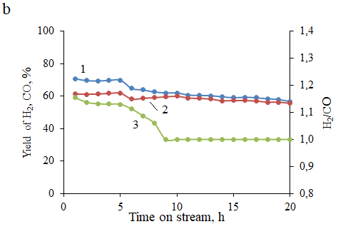

a: I - CH4, II - CO2 conversion, III - carbon balance and b: yields of I - H2, II - CO, III - H2/CO ratio; GHSV = 3000 h-1, T = 850°C.

Figure 36 – Stability examination of 15Ni-15Ce-20Al in DRM

Moreover, TOFs considered the exposed surface metal moles were comparable to [218, р. 84; 219, р. 84], which showcased excellent catalyst performance in DRM. In the present study catalysts have relatively huge size of metal particles ranging from 12 to 23 nm, because the surface areas of the SCS catalysts are very low (3–12 m2·g-1). Nonetheless, the TOF values still fell within the similar order of magnitude as those reported in [219, р. 84; 220]. However, it's worth noting that the TOF values determined in [220, р. 85] were significantly larger than those of other catalysts listed in Table 21.

Absence of aluminum can cause sintering as seen for Ni-Ce-La catalyst after DRM, which possesses the largest particles. The crystallinity of the Ni-Ce (La)-Al catalysts increased with prolonging experiment, therefore, Ni0 was formed during DRM. CeAlO3 and LaAlO3 appeared in the used Ni-Ce-Al and Ni-La-Al, respectively, contributing to improved catalyst stability.

In the preliminary short-term examinations, it was demonstrated that the highest rate of deactivation therefore is promoted by the largest methane transformation rate. The findings of temperature cycling test depicted that Ni-Ce-Al possessed the most stable effectiveness.

Table 21 – Comparison of turnover frequencies, conversions and deactivation rates

|  |  |  |  |  |  |  |
| --- | --- | --- | --- | --- | --- | --- |
| Catalyst | Conditions | TOF, s-1 | XCH4,% | XCO2,% | Deactivation in XCH4 %·min-1 | Reference |
| 15Ni-15Ce-20Al | 850oC, Vcat = 2 mL, GHSV =3000 h-1, 15957 ml·gcat-1·h-1, 20 h | 0.31 | 88 | 87 | 0.04 | [90, р. 28] |
| Ni/α-Al2O3 | 800oC, mcat = 100 mg, GHSV = 50000 ml·gcat-1·h-1, 100 h | 81.2 | 86 | 91 | 0.05 | [217, р. 84] |
| Ni-Ce-Al | 800oC, mcat = 100 mg, GHSV = 36000 ml·gcat-1·h-1, 80 h | 1.15 | 91 | 80 | Close to 0 | [218, р. 84] |
| 10Ni-1Al-1Ce | 700oC, mcat = 100 mg, GHSV = 120000 ml·gcat-1·h-1, 8 h | 4.0 | 82 | 91 | - | [219, р. 85] |

The higher activity was observed for 15Ni-15Ce-20Al catalyst, on which conversion values of methane and CO2 at 850°C were 88%. For all catalysts H2/CO ratio was 1.0-1.1.

No obvious deactivation for Ni-Ce-Al catalyst was observed during 20 h examinations showing that the SCS is the best alternative for DRM.

**3.3 Study of Mg- and Mn-promoted Ni catalysts prepared by SCS in DRM**

3.3.1 Study of physicochemical characteristics of Mg- and Mn-promoted Ni catalysts

The XRD patterns of the samples before (fresh) and after (spent) reaction are depicted in Figure 37. Metallic Ni [PDF 01-071-4655] found at 2θ of ca. 52.5°, 61.4° and 92.4º is present in the most of the XRD patterns with the exception of a few of the fresh catalysts [185, р. 68]. This indicates that nickel oxide is almost completely reduced to zero valent nickel in these catalysts during the catalyst synthesis [187, р. 69; 221]. The former was not present in any catalysts indicating the excellent dispersion of NiO nanoparticles across the prepared sample [222].

The fresh 15Ni-35Mn catalyst demonstrated very low crystallinity (Figure 36a), whereas peaks corresponding to MnO [PDF 04-007-3620] and Ni0 during DRM emerged [90, р. 28]. On the contrary, the galaxite MnAl2O4 phase [PDF00-010-0310], with peaks at 35.6°, 42.1°, 68.5° and 75.6° 2θ [223, 224] was formed in 15Ni-15Mn-20Al during synthesis by the solution combustion (Figure 37b).

It was also reported that MnAl2O4 phase was formed when the prepared catalyst was calcined at 850oC [225]. The intensity of these peaks, however, decrease during DRM while Ni0 peaks emerge in the spent catalyst while the low crystallinities of the samples both before and after reaction means that this analysis is rather speculative.

The crystallinity of the 15Ni-15Mn-20Al increased, moreover, in addition to increased intensity of the Ni0 peaks, set of peaks corresponding to three different Mn containing phases: MnAl2O4, MnO and Mn3O4 after temperature cycling. MnO appears when Mn3O4 is reduced [PDF 03-065-2776] in the presence of CO above 500oC [226] as follows (equation 54)):

Mn3O4 + CO → 3MnO + CO2 (54)

In contrast to 15Ni-35Mn, the bimetallic 15Ni-35Mg exhibited high crystallinity and intensive peaks of MgO [PDF 04-006-7451] in the fresh sample (Figure 37c). The presence of NiO cannot be completely ruled out on the basis of XRD results since the NiO and MgO phases possess very similar unit cell parameters. It was suggested the formation of a Mg0.7Ni0.3O phase [PDF 04–023–4643] in the fresh 15Ni-35Mg catalyst. The interaction between NiO and MgO can form the solid solution of NiO-MgO. However, the peaks were identified as the mixture of MgO and NiO phases.

XRD data for trimetallic 15Ni-15Mg-20Al showed that initially the fresh catalyst exhibited low crystallinity, NiAl2O4/MgAl2O4 and NiO/MgO [PDF 04-009-8312] phases were visible in the pattern (Figure 37d). However, when exposing this catalyst to DRM conditions for 30 min TOS peaks corresponding to Ni0, MgO and MgAl2O4 clearly emerge and, furthermore, the intensity of these peaks, in particular the peaks corresponding to the Ni0 phase, further increased during temperature cycling experiment. An analogous increase in the relative amount of the zero valent nickel in the used nickel based double hydrotalcite exposed to DRM conditions at 850oC occurred in [227]. The catalyst used in [37, р. 17] contained, however, the NiAl2O4 phase after DRM. It is important to note that the XRD patterns of the 15Ni-15Mg-20Al spent in thermal cycles as well as 10 h TOS both demonstrate broad peak at ca. 30° 2θ, which corresponds to the structure of carbon nanotube. Interestingly, this peak is not visible anymore in the 200 h TOS pattern.

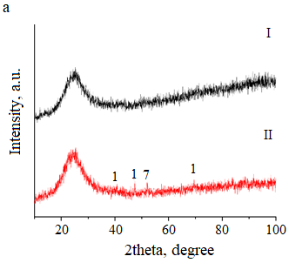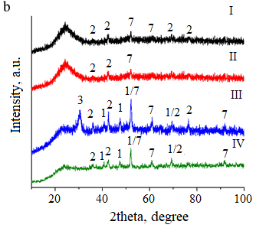

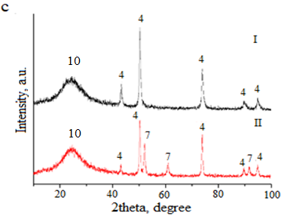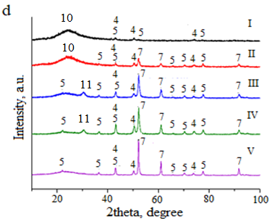

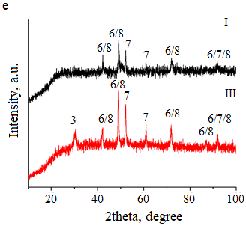

a - 15Ni-35Mn, b - 15Ni-15Mn-20Al, c - 15Ni-35Mg, d - 15Ni-15Mg-20Al, e - 15Ni-15Mn-20Mg; 1 - MnO, 2 - MnAl2O4, 3 - Mn3O4, 4 – NiO/MgO, 5 - NiAl2O4/MgAl2O4, 6 - Mn0.5Ni0.5, 7 - Ni0, 8 - Mg0.6Ni0.4, 9 - MnO4, 10 - amorphous phase, 11 - carbon nanotube; I - fresh, II - 30 min at 850oC, III - temperature cycling, IV - 20 h at 850oC, V - 200 h at 850oC; GHSV = 3000 h-1.

Figure 37 – XRD patterns of Mg- and Mn-promoted catalysts

The XRD pattern of 15Ni-15Mn-20Mg revealed that solid solutions containing Ni, Mg and Mn possess the halite structure. Phases of Mn0.5Ni0.5 [PDF 04-015-1624] and Mg0.6Mn0.4 [PDF 01-077-2379] solid solutions were found at the 2θ peaks of 42.2°, 49.1°, 72.0° with similar intensities both in the fresh and the spent samples (see Figure 37e). The lattice parameters of these solid solutions are same being a = 4.319 and 4.294 Å (Mg0.6Mn0.4 and Mn0.5Ni0.5). Reflexes of solid solutions and metallic nickel are overlapping at 92°. The reflexes determined at 85° in the spent catalyst is absent in the fresh one. As reported in [53, р. 21], the solid solutions of NiO and MgO with halite structure and same lattice parameters to be 4.178 and 4.212Å, respectively, tend to reduce metal sintering. Solid solutions can therefore appear in the patterns during catalyst synthesis via solution combustion [53, р. 21; 228]. Unfortunately, due to lack of literature based on Ni-Mn-Mg system, it is difficult to discuss about the presence of NiO-MnO solid solution deeply. Moreover, analysis with higher quality would be necessary to thorough determination of such solid solutions. Ni peaks were also identified. The widths were narrow, which denotes the largeness of crystallite size in the as-prepared and used samples. One reflex corresponds to Mn3O4, which was defined at 30° after test with thermal cycles.

The results from energy dispersive X-Ray analysis of catalysts (Table 22) reveal interesting findings. The Ni/Mn ratio started at 0.9 for the fresh 15Ni-15Mn-20Al and remained constant after 30 min of DRM. However, it increased to 1.6 after the temperature cycling experiment. The Ni/Mn ratio in 15Ni-35Mn was 3 times lower compared to 15Ni-15Mn-20Al. In the 15Ni-15Mg-20Al catalyst, the Ni/Mg ratio rose during the first 30 min of DRM but then decreased. In contrast, for 15Ni-35Mg, this ratio remained unchanged throughout the process.

Transmission electron microscopy results ascertain the average size of metal particles (Figure 38 and Table 23) in reduced catalysts and those used in short-term examination at 850°C, as well as in catalysts subjected to temperature cycling experiments and extended stability tests lasting 20 h.

Table 22 – Elemental analysis of the different catalysts

|  |  |  |  |  |  |  |  |
| --- | --- | --- | --- | --- | --- | --- | --- |
| Catalyst | Ni, wt.% | *M, wt.% | Al, wt.% | O, wt.% | Ni/*M | Ni/Al | *M/Al |
| 15Ni-15Mn-20Al (F) | 24.66±0.23 | 28.99±0.18 | 11.01±0.07 | 26.88±0.13 | 0.9 | 2.2 | 2.6 |
| 15Ni-15Mn-20Al (S) | 28.36±0.26 | 36.41±0.20 | 9.77±0.08 | 20.78±0.11 | 0.8 | 2.9 | 3.7 |
| 15Ni-15Mg-20Al (F) | 33.20±0.29 | 16.25±0.14 | 14.63±0.12 | 35.92±0.21 | 2.04 | 2.27 | 1.11 |
| 15Ni-15Mg-20Al (S) | 46.37±0.31 | 15.37±0.13 | 14.54±0.11 | 23.62±0.15 | 3.01 | 3.19 | 1.2 |
| 15Ni-35Mn (F) | 19.31±0.23 | 65.14±0.26 | 0.2±0.03 | 15.35±0.14 | 0.29 | - | - |
| 15Ni-35Mg (S) | 39.77±0.32 | 31.29±0.16 | - | 28.94±0.19 | 1.3 | - | - |
| 15Ni-35Mg (S) | 41.99±0.33 | 32.86±0.16 | - | 25.15±0.18 | 1.3 | - | - |
| 15Ni-15Mn-20Mg (S) | 26.24±0.30 | 15.47±0.11 (Mg) | 36.50±0.24 (Mn) | 21.25±0.23 | 1.7  (Ni/Mg) | 0.42  (Ni/Mn) |  |
| *M = Mn, Mg | | | | | | | |

In the case of the 15Ni-15Mg-20Al catalysts used in DRM, it was observed that the size of nickel particles decreased as the severity of the DRM conditions increased. Specifically, after short-term test at 850°C, the nickel particle size was 25 nm, whereas after 20 h of time on stream, it reduced further to only 20 nm. The 15Ni-15Mg-20Al catalyst exhibited the largest average particle size, measuring 36 nm, after undergoing temperature cycling. Furthermore, in the case of the spent catalyst from temperature cycling experiments, the metal particles in 15Ni-15Mn-20Al were smaller than those observed in the same catalyst tested over 30 min of time on stream. Similar results were obtained for 15Ni-15Mg-20Al, where the particle size in the used sample from temperature cycling was smaller compared to the 30 min TOS test.

Table 23 ‒ Ni average particle size of catalysts

|  |  |  |
| --- | --- | --- |
| Catalyst | Ni average particle size of the fresh sample, nm | Ni average particle size of the spent sample, nm |
| 15Ni-15Mg-20Al | 16 | а25, b36, c20, d30 |
| 15Ni-15Mn-20Al | 15 | a28, b25 |
| 15Ni-15Mn-20Mg | - | b28 |
| 15Ni-35Mg | - | a27 |
| 15Ni-35Mn | 11 | a21 |
| a30 min TOS, btemperature cycling, c20 h TOS, d200 h TOS | | |

The TEM image of 15Ni-35Mn displayed in Figure 40d did not reveal any carbon nanotubes. The coke was absent in the TEM image for this catalyst [229]. Furthermore, based on CHNS analysis, this catalyst had the second lowest amount of coke, following 15Ni-15Mg-20Al, as indicated in Table 23. Significant production of carbon nanotubes was noted in the used 15Ni-15Mn-20Al catalyst (Figure 38a1), as well as in the 15Ni-15Mg-20Al after short-term DRM (Figure 38b1) and after 20 h TOS (Figure 38b3).

It was intriguing to note that the diameter of carbon nanotubes was significantly smaller, measuring 17 nm, in the catalyst exposed for 20 h TOS, where a particle size of 20 nm was observed. In contrast, for the 15Ni-15Mg-20Al catalyst subjected to short-term DRM, the nickel particle size was 25 nm, and the corresponding carbon nanotube diameter was 33 nm. Additionally, larger nickel particles encourage coking, whereas smaller particles tend to accumulate less coke [209, р. 81; 230]. Furthermore, it was stated that CHx species, when distant from the Ni surface, exhibit low reactivity with CO2 and transform into stable coke. Moreover, the 15Ni-15Mn-20Mg catalyst underwent a temperature cycling, resulting in the development of substantial coke nanotubes having a maximum diameter equal to 28 nm (Figure 38c). After DRM the nickel particle size was measured to be approximately 30 nm.

This phenomenon occurs due to the formation of zero valent nickel during DRM, coinciding with an increase in the catalyst's crystallinity as confirmed by XRD analysis. Interestingly, in the 200 h stability examination of the 15Ni-15Mg-20Al catalyst, no visible carbon nanotubes were detected. Moreover, the size of metal particles increased once more, reaching 30 nm. However, nickel particles were encapsulated in the carbon layer. In the spent 15Ni-15Mn-20Mg catalyst, larger nickel particles were detected following the temperature cycling experiment during DRM compared to the corresponding spent 15Ni-15Mg-20Al catalyst. The catalyst with larger metal particles exhibited higher levels of coke deposition, a connection that is also supported by the results of TPO [211, р. 80].

The fresh and used catalysts were analyzed for their textural characteristics using N2 physisorption. The findings indicate that all the catalysts had minimal surface areas, as indicated in Table 24. The spent catalysts presented in Table 24 were used during 30 min TOS at 850oC and GHSV of 3000 h-1. A study revealed that the surface areas of catalysts vary based on the type of fuel used. Consequently, catalysts prepared through SCS can exhibit surface area fluctuations ca. 49‒153 m2·g-1, depending on the specific fuel source [231].

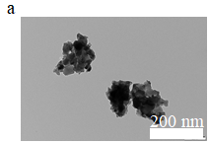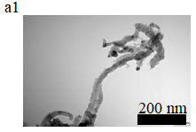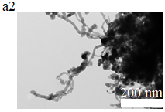

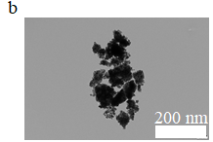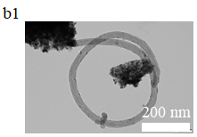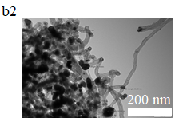

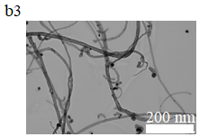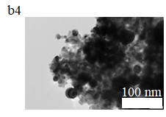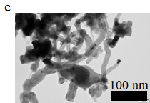

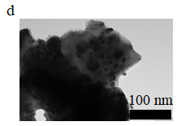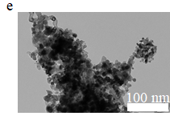

15Ni-15Mn-20Al: a - fresh, a1 - spent for 30 min TOS at 850oC, a2 - spent in temperature cycling; 15Ni-15Mg-20Al: b - fresh, b1 - spent for 30 min TOS at 850oC, b2 - spent in temperature cycling, b3 - spent for 20 h TOS at 850oC, b4 - spent for 200 h TOS at 850oC; 15Ni-15Mn-20Mg: c - spent in temperature cycling;15Ni-35Mn: d - spent for 30 min TOS at 850oC; 15Ni-35Mg: e - spent for 30 min TOS at 850oC.

Figure 38 – TEM images of Mg- and Mn-promoted catalysts

Certain catalysts commonly display limited surface areas (8‒10 m2·g-1), when glycine is used as a fuel source [232]. Similarly, for Ni-based catalysts prepared with urea, the surface area tends to be low, falling within the range of 9 to 20 m2·g-1 [233]. For instance, Figure 39 displays the N2 physisorption results of the 15Ni-15Mn-20Al samples before and after reaction. Following the IUPAC classification, catalysts exhibited the isotherms of type IV, featuring H3 hysteresis loops. This classification indicates mesoporous materials characterized by wedge-shaped pores.

Table 24 – Textural properties of the samples

|  |  |  |  |  |  |  |
| --- | --- | --- | --- | --- | --- | --- |
| Catalyst | F/S | SBET, m2·g-1 | Vtot, cm3·g-1 | Vμ, cm3·g-1 | Vm, cm3·g-1 | Vμ/Vm |
| 15Ni-15Mn-20Al | F | 11 | 0.014 | 0.004 | 0.010 | 0.46 |
| 15Ni-15Mn-20Al | S | < 4 (36*) | 0.007 | 0.001 | 0.005 | 0.24 |
| 15Ni-15Mg-20Al | F | 10 | 0.015 | 0.004 | 0.011 | 0.36 |
| 15Ni-15Mg-20Al | S | 9 (90*) | 0.017 | 0.002 | 0.015 | 0.13 |
| 15Ni-35Mn | F | <4 | 0.002 | 0.0 | 0.002 | 0 |
| 15Ni-35Mn | S | <4 (100*) | 0.003 | 0 | 0.003 | 0 |
| 15Ni-35Mg | F | 11 | 0.022 | 0.004 | 0.018 | 0.24 |
| 15Ni-35Mg | S | 11 (100*) | 0.020 | 0.004 | 0.016 | 0.27 |
| *Percentage of the retained surface area | | | | | | |

When comparing the surface areas, it was found that 15Ni-35Mg and 15Ni-35Mn showed no decrease in surface area. In contrast, approximately 90% of the surface area was preserved in the spent 15Ni-15Mg-20Al catalyst, whereas a significantly lower percentage of surface area was retained in the spent 15Ni-15Mn-20Al sample. It was observed that in certain instances, such as with 15Ni-15Mg-20Al and 15Ni-35Mn, the volume of pores increased. This is likely linked to the development of coke nanotubes on the catalyst external surface.

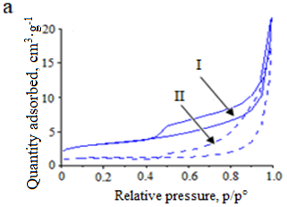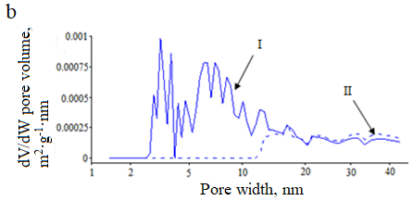

a - adsorption isotherm and b - pore size distribution of 15Ni-15Mn-20Al. I - fresh, II - spent.

Figure 39 – Results obtained from nitrogen physisorption

Ammonia TPD assessed the acidity of various catalysts. Among them, 15Ni-35Mg exhibited the highest normalized acidity, followed by 15Ni-15Mg-20Al. Conversely, 15Ni-15Mn-20Al and 15Ni-35Al demonstrated very low acidity levels (Figure 40, Table 25).

The acid sites with weak and medium strengh were also identified for MgO by ammonia TPD [234], performed at 440oC thus, the presence of medium acid sites could not be confirmed due to very small intensity of peaks. NH3 TPD at 440°C revealed the existence of weak and moderately strong acid sites on MgO [234, р. 91]. However, confirming the presence of medium acid sites was challenging due to the minimal intensity of peaks detected.

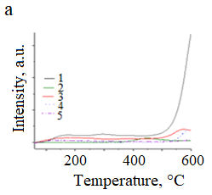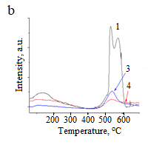

a - ammonia TPD, b - CO2 TPD profiles; 1 - 15Ni-35Mg, 2 - 15Ni-35Mn, 3 - 15Ni-15Mn-20Al, 4 - 15Ni-15Mg-20Al, 5 - 15Ni-35Al.

Figure 40 – Acidity and basicity of different catalysts

In the case of Ni/Al2O3, it displayed higher acidity in comparison to Ni/MgO. In [235] it was noted that three merged peaks are near 250°C, 300°C, and 450°C within a larger peak. The acid sites for this catalyst were determined to be strong (40%). Similarly, it was observed that Ni/MgO has strong acidity around 660°C [236], aligning with the findings of the present study.

The introduction of alkali metal modifiers typically reduces the acidity of catalysts. For instance, Ni-Mn/γ-Al2O3 compared to Ni/γ-Al2O3 a decrease in catalyst acidity was observed [237]. In the present study, the acidity of 15Ni-35Mn, with a larger manganese content was 50 times higher than that of 15Ni-15Mn-20Al [138, p. 52].

Weak basic sites were present in 15Ni-35Mg at a peak of 165°C in the CO2 TPD analysis. This finding aligns with the mild basicity observed in Ni/MgO [235, р. 92]. However, it is worth noting that TPD measurements concluded at 500°C, preventing the observation of the high-temperature maximum seen in the current research. Similarly, the 15Ni-15Mg-20Al catalyst displayed a peak of CO2 desorption at 160°C and a second peak at 540°C (refer to Figure 40b and Table 25). This observation aligns with [30, р. 16], where Ni-Mg/Al2O3 showed similarity to the values found for 15Ni-15Mg-20Al in the present investigation [134, p. 52].

Additionally, it was marked that the existence of strong basic sites increased as the Mg loading increased. Previous research on Ni/MgO specified an almost equal quantity of strong basicity and acidity [238]. It is intriguing to observe in the current study that both acic and basic sites are the largest for 15Ni-35Mg. Furthermore, the basicity of 15Ni-15Mn-20Al was relatively low, whereas it was higher for the Ni-Mn/γ-Al2O3 compared to Ni/γ-Al2O3 [239].

The H2 TPR peak occurring between 400‒500°C can be linked to the nickel oxide reduction, which well interacted aluminates of magnesium and manganese, as can be seen in cases like 15Ni-15Mg-20Al and 15Ni-15Mn-20Al (Figure 41). In the current study, NiO crystallites were not detected through XRD analysis.

Ni and Mn species are easy reducible in 15Ni-15Mn-20Al demonstrating the largest relative area of H2 consumed among the four studied Ni catalysts. At 363°C either NiO or Mn2O3 is reduced to Mn3O4 in the former sample. The second stage of reduction occurred at 475°C attributing to the transformation of Mn3O4 to MnO.

Table 25 – Results from NH3 and CO2 TPD

|  |  |  |  |  |
| --- | --- | --- | --- | --- |
| Catalyst | Maximum temperature peak in NH3 TPD, oC | Maximum temperature peak in CO2 TPD, oC | Normalized area of NH3 adsorbed | Normalized area of CO2 adsorbed |
| 15Ni-35Al | 140 | - | 0.01 | - |
| 15Ni-15Mn-20Al | 136/600 | 105/540 | 0.002 | 0.29 |
| 15Ni-15Mg-20Al | 160/380/572 | 93/536 | 0.34 | 0.47 |
| 15Ni-35Mn | 450 | traces | 0.08 | - |
| 15Ni-35Mg | 165/294/599 | 129/532/577 | 0.82 | 1.0 |
| 15Ni-15Mn-20Mg | 565 | - | 1.0 |  |

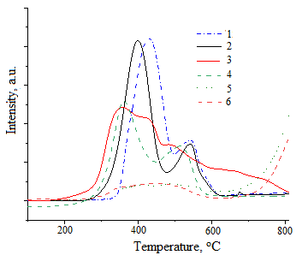

1 - 15Ni-35Mg, 2 - 15Ni-35Mn, 3 - 15Ni-15Mn-20Al, 4 - 15Ni-15Mn-20Mg, 5 - 15Ni-15Mg-20Al, 6 - 15Ni-35Al.

Figure 41 – Hydrogen TPR of different Ni catalysts

In [240] similar peaks were identified at 377°C and 452°C. Notably, the reduction of oxidized nickel species takes place at a lower temperature 15Ni-15Mn-20Al compared to 15Ni-35Al. Moreover, the quantity of consumed H2 was lower for the Ni-Al catalyst, which had a higher aluminum content [90, р. 28].

This outcome highlights the robust interactions between Ni and the supporting material. Previous findings [241] indicated that for 5Ni-15Mn/Al H2 consumption began at 230°C. In contrast, in the present study, for 15Ni-15Mn-20Al, H2 consumption initiated at 180°C. Additionally, reducing medium during DRM led to the presence of two manganese oxides, MnO and Mn3O4 (Figure 41b).

15Ni-35Mg exhibited the second highest consumption of hydrogen, indicating the easy reduction of nickel oxide on MgO as a support. In [242] H2 consumption for Ni/MgO started at 220°C, with the primary peak observed at 450°C. In the current study, the maximum hydrogen consumption was observed at 542°C (see Table 26). This can be due to the possible presence of NiO-MgO solid solution, because NiO interacts with MgO.

Table 26 – Results from hydrogen TPR

|  |  |  |  |  |
| --- | --- | --- | --- | --- |
| Catalyst | T1,max,oC | T2,max,oC | T3,max,oC | Normalized area |
| 15Ni-35Mg | 426 | 542 | - | 1.0 |
| 15Ni-35Mn | 399 | 542 | - | 0.89 |
| 15Ni-15Mn-20Al | 363 | 475 | - | 0.91 |
| 15Ni-15Mg-20Al | 306 | 384 | 484 | 0.52 |
| 15Ni-35Al | 306 | 384 | 800 | 0.27 |
| 15Ni-15Mn-20Mg | 360 | 508 | - | 0.88 |

In the case of 15Ni-15Mg-20Al, significantly reduced hydrogen consumption was observed within 280–600°C. This decline is assigned to the existence of aluminum specimens, strengthening the interplays betwixt Ni and the support.

The NiO-MnO solid solution in 15Ni-15Mn-20Mg was reduced at lower temperatures. Hydrogen uptake in the first reduction stage (MnO2 →Mn3O4) is larger compared to the second stage (Mn3O4 →MnO) as reported in [243].

The CHNS analysis was employed to quantitatively determine the carbon content normalized per gram of nickel in the catalysts used during 30 min at 850°C (Table 27). The 15Ni-15Mg-20Al catalyst, which had a Ni/Mg molar ratio equal 0.83, showed a relatively low normalized carbon content.

Table 27 – Normalized coke content and H/C molar ratio in the spent catalyst

|  |  |  |
| --- | --- | --- |
| Catalyst | Normalized coke content, wt.%·gNi-1 | H/C, molar ratio |
| 15Ni-35Mg, 30 min | 0.72 | 0.49 |
| 15Ni-35Mn, 30 min | 0.39 | 1.2 |
| 15Ni-15Mn-20Al, 30 min | 0.75 | 0.63 |
| 15Ni-15Mg-20Al, 30 min | 0.19 | 1.53 |
| 15Ni-35Al, 30 min | 1.0 | 0.26 |
| 15Ni-15Mg-20Al, 200 h | 0.04 | 1.42 |

The minimal carbon content is consistent with [244], rising in the carbon amount with higher nickel content in Ni-Mg-Al samples. In the present study, the catalyst possessing a Ni/Mg molar ratio of 0.5 demonstrated the lowest carbon content after DRM at 500‒700°C. According to [245], a high Mg/Al ratio in Ni-Mg-Al catalyst is preferable as it reduces coke formation. In our study, the catalyst had an excess of magnesium with Mg/Al molar ratio of 1.8. In contrast, the 15Ni-15Mn-20Al catalyst exhibited a 3.9 times higher normalized carbon content compared to the 15Ni-15Mg-20Al catalyst. The Ni/Mn molar ratio in the former catalyst was 0.8. In [228, р. 87] a Ni/MnO/γ-Al2O3 sample having a Ni/Mn molar ratio of 0.6 demonstrated minimal carbon deposition after DRM at 650°C. It is important to note that this result was achieved at a significantly lower temperature. For Ni-Mg-Al catalysts, we conducted DRM experiments for both 30 min and 20 h TOS, followed by CHNS analysis of the spent catalyst. The findings showed a nearly twelvefold increase in carbon accumulation when extending the catalyst exposure time from 30 min to 20 h TOS.

Additionally, during the shorter time on stream the rate of carbon accumulation was 0.04 wt.%·h-1. However, in the 20 h TOS DRM experiment, carbon species accumulated at a slower rate of 0.01 wt.%·h-1. This reduced carbon accumulation rate during the longer exposure time can be attributed to a decrease in available nickel and acidic sites, which are essential for the adsorption of carbonaceous species. Conversely, the molar ratio of hydrogen to carbon (H/C) of 0.13‒1.5, suggesting the presence of aromatic compounds in the coke. This inference is drawn from the fact that alkanes exhibit an H/C molar ratio of 2, while aromatics have a ratio close to unity. Consistent with the results from TGA mentioned below, the 15Ni-15Mg-20Al catalyst had the highest H/C molar ratio. This finding suggests that the coke formed on this catalyst is not entirely aromatic. In contrast, in the absence of alkali metal, bimetallic 15Ni-35Al catalyst produces aromatic coke, as reported in previous studies [86, р. 27].

Furthermore, CHNS analysis conducted on the 15Ni-15Mg-20Al catalyst after 20 h in DRM showed that the spent catalyst contained 25 wt.% carbon, indicating a carbon accumulation rate of 1.25 wt.%·h-1.

TGA analysis was conducted on the chosen catalysts utilized during 30 min at 850°C. TGA results depicted in Figure 42, where the carbon content decreased from 1.4 wt.% in 15Ni-15Mn-20Al to 0 wt.% in 15Ni-15Mg-20Al.

This order of carbon content was also confirmed by the CHNS analysis mentioned earlier. It was noted that the development of filamentous carbon at 450‒500°C. Additionally, TGA of the fresh samples under N2 or air atmospheres indicated phase transformations, with 15Ni-15Mn-20Al showing a higher weight percentage (5.6 wt.%) compared to 15Ni-15Mg-20Al (1.9 wt.%).

Furthermore, research [30, р. 16] highlighted the significant suppression of graphitic carbon formation during DRM at 850°C using Mg-Ni/Al2O3 sample having a Ni:Mg molar ratio of 1:1. In the current study, the Ni/Mg molar ratio for 15Ni-15Mg-20Al was 0.85.

Similarly, various Mn-Ni-Al2O3 catalysts possess large carbon accumulation. Nevertheless, it has been demonstrated that increasing the manganese content to an equimolar ratio can effectively inhibit coke formation [246]. The research also pointed out that manganese possessing moderate basicity aids in CO2 adsorption even on nickel and can eliminate carbonaceous species as stated in [225, р. 87]. Conversely, the presence of MnOx can obstruct Ni sites in Ni/γ-Al2O3 catalysts, promoted by MnO, leading to enhanced catalyst stability, as explained in [246, р. 95]. Additionally, at 600°C, the deposition of graphitic coke was observed in the 15Ni-35Al catalyst [86, р. 27].

The catalysts examined in temperature cycling were analyzed by O2-TPO. The coke amount burnt increased as further: 15Ni-15Mg-20Al (12 wt.%) < 15Ni-15Mn-20Al (27 wt.%) < 15Ni-15Mn-20Mg (29 wt.%), considering the quantities of CO and CO2 as burnt carbon (see Figure 43).

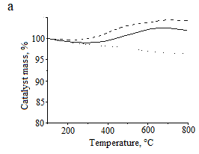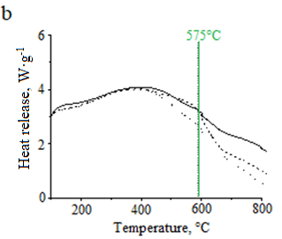

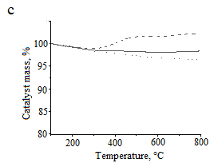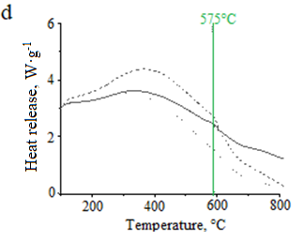

a, b - mass of the catalyst and heat release of15Ni-15Mn-20Al, c, d - mass of the catalyst and heat releaseof 15Ni-15Mg-20Al; fresh catalyst in N2 flow (dot-dot line), fresh catalyst in air flow (solid line), spent catalyst in air flow (dash-dash line). 200-800°C with 10°C·min-1 in 100 ml·min-1 of gas flow.

Figure 42 – Thermogravimetric analysis of catalysts

These findings suggest that 15Ni-15Mg-20Al performed the best among the catalysts, exhibiting lower coking. The respective peak maxima for carbon release decreased as follows: 622°C for 15Ni-15Mn-20Mg, 592°C – 15Ni-15Mg-20Al and 559°C – 15Ni-15Mn-20Al. Surprisingly, the TPO measurement revealed a higher amount of coke for 15Ni-15Mn-20Al compared to 15Ni-15Mg-20Al, even though the latter catalyst exhibited a higher maximum temperature for coke burning [134, p. 52].

In TPO analysis, previous studies [247, 248] have indicated that α-carbon usually generated in the initial stages of DRM is burnt at 600°C, while around 800°C β-carbon appears being less reactive with carbon dioxide compared to α-carbon corresponding to 15Ni-15Mn-20Al. Furthermore, the current results revealed that the former sample exhibited a less reactive and more stable carbon compared to other two catalysts [138, p. 52].

In this study, when carbonized catalysts were oxidized with oxygen within the temperature range of 559 to 622°C, water was eliminated at 300°C followed by the release of carbon oxides above 500°C. Therefore, an insignificant amount of filamentary carbon formed at 590°C in 15Ni-15Mg-20Al catalyst was observed. Moreover, nickel particles were located at the ends of the filaments. It was stated that little formation of this type of carbon did not decrease the performance of the developed catalysts.

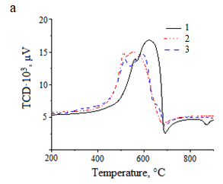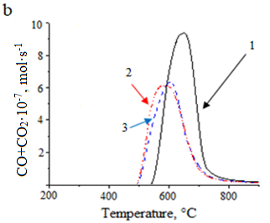

a - TPO curves and b - the dependence of amounts of the formed CO and CO2 on temperature;1 - 15Ni-15Mn-20Mg, 2 - 15Ni-15Mn-20Al, 3 - 15Ni-15Mg-20Al.

Figure 43 – Behavior of the catalysts used in temperature cycling test during burning of coke

Thus, fresh 15Ni-35Mn and 15Ni-35Mg catalysts contain manganese oxide and magnesia phases, while spent samples formed metallic nickel. The interaction between the metal and the carrier is stronger in catalysts with the addition of aluminum, which improved their activity in the reaction. The catalysts are basic, due to which coke formation is insignificant, which is confirmed by the CO2-TPD and CHNS methods.

3.3.2 Study of catalytic activity of Mg- and Mn-promoted Ni catalysts

The temperature-time profile of 15Ni-15Mg-20Al catalyst is presented in Figure 44. The combustion was carried out with thermocontrol connected to software. Three thermocouples were located in three positions: T1 – in the solution, T2 – above the solution and the T3 – in the upper side of the beaker. The water in aquous solution of metal nitrates and urea was evaporated at ca. 100°C. At ca. 200°C after evaporation gel formation occurred. When the ignition temperature reached the melting point of the urea, the latter component started to burn. The thermocouple located in the middle of the beaker (above the solution), the temperature was the highest being 1023°C, the lower thermocouple showed the lowest temperature of 695°C, and the thermocouple at the upper side of the beaker was 800°C. Compared to the catalyst prepared by conventional impregnation SCS catalyst was ready within ca. 15 min by burning at elevated temperature. Moreover, SCS-15Ni-15Mg-20Al catalyst exhibited higher activity than supported catalyst (Section 3.4.2).

The effectiveness of various catalysts (15Ni-15M-20Al, where M represents either Mg or Mg) was evaluated in a dry reforming reaction during 30 min at 850°C. The outcomes of these tests are presented in Table 28 and Figure 45 at following conditions: T = 850°C, CH4:CO2:Ar = 1:1:1, GHSV = 3000 h-1 for 30 min TOS [90, р. 28].

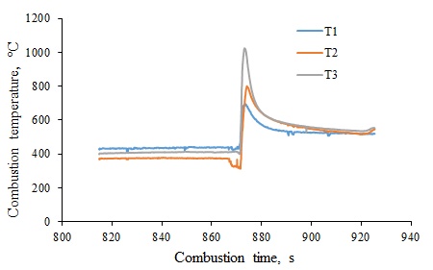

T1 - thermocouple in the solution, T2 - thermocouple above the solution, T3 – upper thermocouple.

Figure 44 – Temperature-time profile of 15Ni-15Mg-20Al catalyst

Table 28 – Comparison of the initial and output data 850°C

|  |  |  |  |  |  |  |  |  |
| --- | --- | --- | --- | --- | --- | --- | --- | --- |
| Catalyst | Conversion, % | | TOFCH4, s-1 | Yield, % | | CB, % | *Deactivation rate %·min-1·gcat-1 | H2/CO |
| CH4 | CO2 | H2 | CO |
| 15Ni-35Mg (27 nm) | 93 | 96 | 0.16 | 91 | 64 | 66 | 0 | 1.5 |
| 15Ni-35Mn (21 nm) | 61 | 72 | 0.41 | 59 | 51 | 85 | 0.33 | 1.3 |
| 15Ni-15Mn-20Al (28 nm) | 91 | 95 | 0.42 | 83 | 61 | 68 | 0.1 | 1.5 |
| 15Ni-15Mg-20Al (25 nm) | 94 | 95 | 0.13 | 72 | 65 | 69 | 0.13 | 1.1 |
| 15Ni-35Al | 86 | 90 | 0.006 | 88 | 59 | 74 | 0.03 | 1.5 |
| *Deactivation rate is defined by the decline in CH4 conversion per catalyst mass and time | | | | | | | | |

Methane conversion was lower than CO2 conversion for all catalysts. This means the occurrence of RWGS reaction consuming more CO2, especially for 15Ni-15Mn-20Al and 15Ni-35Mg catalysts, which exhibited the largest values of CO2 conversion of 95% and 96%, respectively. Ni particles in 15Ni-35Mg is optimal being 22 nm, which aligns with high activity of this catalyst. It is worth noting that due to its relatively high reducibility, it exhibited significant activity in DRM. This particular catalyst was also the most acidic and basic among all samples under examination.

The highest methane conversion is found for 15Ni-15Mg-20Al. The 15Ni-15Mg-20Al catalyst, despite having moderate acidity and basicity, contained a small quantity of carbon in the used sample. The Ni/Mg molar ratio was 0.85. Research [244, р. 94] indicated that a lower Ni loading leads to reduction of coke formation. Additionally, the XRD analysis revealed the presence of the MgAl2O4 phase in this catalyst. This phase could potentially enhance the collaboration between Ni and Mg.

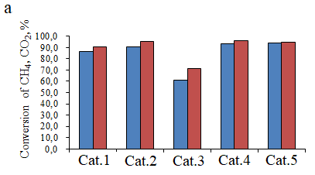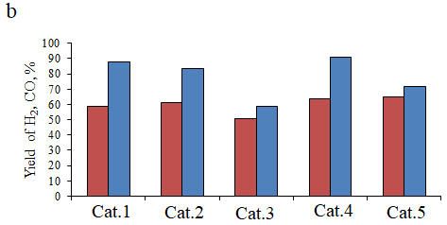

a – CH4 and CO2 conversion, b – H2 and CO yield; a – blue is CH4 conversion, red is CO2 conversion; b – blue is H2 yield, b – red is CO yield; a, b: Cat.1 - 15Ni-35Al, Cat.2 - 15Ni-15Mn-20Al, Cat.3 - 15Ni-35Mn, Cat.4 - 15Ni-35Mg, Cat.5 - 15Ni-15Mg-20Al; GHSV = 3000 h-1, T = 850oC, CH4:CO2:Ar = 1:1:1.cat.1

Figure 45 – Catalytic data for different catalysts after short-term test during DRM

The 15Ni-15Mn-20Al catalyst, ranked third in terms of methane conversion activity (Table 28), exhibited a relatively high level of carbon formation despite the limited availability of acid and basic sites. Initially, the fresh 15Ni-15Mn-20Al catalyst consisted of MnAl2O4 and metallic Ni0. However, the spinel phase underwent decomposition during DRM leading to significantly reduced crystallinity [138, p. 52].

Moreover, TEM analysis of the spent 15Ni-15Mn-20Al revealed the relatively large nickel particles. It was suggested that the incorporation of manganese could potentially decline the nickel particle size [225, р. 87]. However, in this case, the manganese oxide resulted in the larger nickel particle formation, likely due to its limited surface area.

The 15Ni-35Mn demonstrated the lowest initial methane conversion when the nickel particle size was 21 nm. Additionally, analysis of CHNS data indicated a minimal accumulation of coke on the 15Ni-35Mn sample.

The 15Ni-35Mg catalyst had the lowest carbon balance, and it remained stable throughout the 30 min without any deactivation. The CHNS analysis revealed that both the 15Ni-15Mn-20Al and 15Ni-15Mg-20Al catalysts exhibited low carbon balances. Despite the substantial generation of carbon nanosized fibers on the 15Ni-35Mg catalyst, there was no deactivation observed based on methane transformation. This suggests that the catalyst remains active, with metal particles located at the tips of the carbon filaments. 15Ni-35Mn catalyst showed the most significant deactivation. Interestingly, despite the absence of carbon nanofiber formation, this catalyst still contained certain carbon deposits (see Table 28).

After observing the initial short-term results of DRM, the study aimed to explore the impact of temperature cycling on three different catalysts: 15Ni-15Mg-20Al, 15Ni-15Mn-20Al, and 15Ni-15Mn-20Mg without Al, used for comparison. The temperature was started at 600°C for a specific duration, then gradually raised in increments of 50°C up to 900°C, before reverting back to 600°C (Figure 46). In parenthesis value after temperature cycling at 600oC given (Table 29).

Table 29 – Catalytic results at 600oC and 900oC over different catalysts

|  |  |  |  |  |  |  |  |  |  |  |
| --- | --- | --- | --- | --- | --- | --- | --- | --- | --- | --- |
| Catalyst | Conversion at 600oC, % | | TOF at 600oC, s-1 | CB at 600oC, % | Conversion at 850oC, % | | CB at 850oC,  % | H2/CO | EA, kJ·mol-1 | |
| CH4 | CO2 | CH4 | CO2 | 600-750oC | 800-900oC |
| 15Ni-15Mn-20Al | 16 (15) | 21 (26) | Trace amount | 94 (92) | 77 | 78 | 77 | 1.2 | 45 | 21 |
| 15Ni-15Mg-20Al | 37 (48) | 38 (50) | 0.006 | 94 (77) | 94 | 96 | 65 | 1.1 | 45 | 6 |
| 15Ni-15Mn-20Mg | 38 (47) | 38 (37) | 0.11 | 94 (85) | 95 | 93 | 72 | 1.1 | 36 | 4 |

The spent 15Ni-15Mg-20Al after temperature cycling experiment exhibited relatively small Ni particles and less carbon was accumulated on this catalyst in comparison to its two counterparts, 15Ni-15Mn-20Al and 15Ni-15Mn-20Mg. It is known from [249] that low particle size is reported to be effective in reducing in the carbon accumulation. In the current work, first, metal particle size did not increase significantly; second the activity was not reduced after arriving to 600°C, therefore metal sintering was also not observed.

The highest active 15Ni-15Mg-20Al showed CH4 and CO2 conversion of 94% and 96%, H2 and CO yields of 75% and 64%, respectively, at 850°C in the temperature cycling test.

Effect of reaction conditions on catalytic activity of 15Ni-15Mg-20Al. 15Ni-15Mg-20Al prepared by SCS was tested at different reaction conditions like 15Ni-5Fe-30Al in order to control the reaction kinetically and minimize coke formation by searching an optimal DRM conditions (GHSV and feed ratio). Figure 47 demonstrates the changes of conversions and H2/CO with an increase in GHSV at constant CH4/CO2 ratio (1:1).

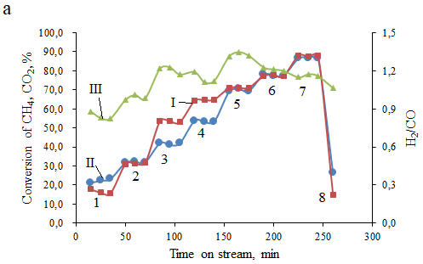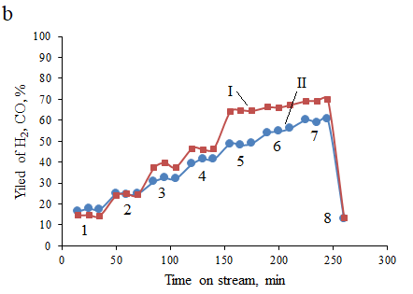

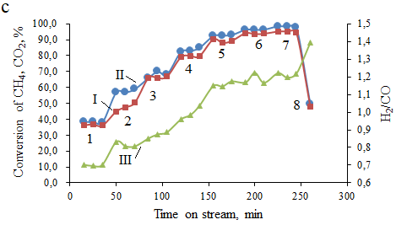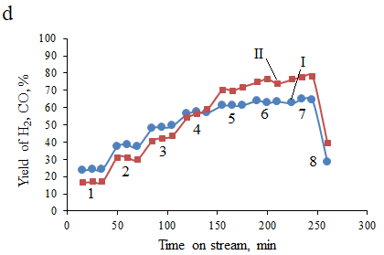

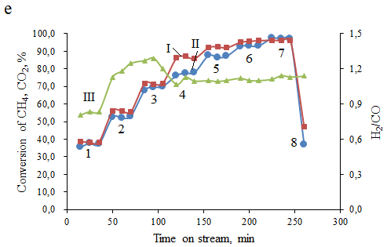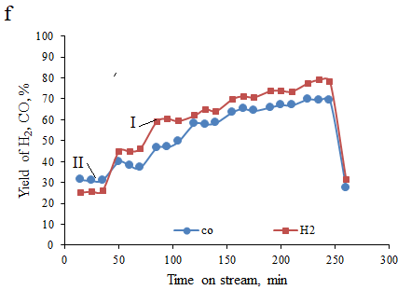

a, c, e: I - CH4, II - CO2 conversion and III - H2/CO ratio; b, d, f: yields of I - H2, II - CO; a, b - 15Ni-15Mn-20Al; c, d - 15Ni-15Mg-20Al; e, f - 15Ni-15Mg-20Mn; 1 - 600oC, 2 - 650oC, 3 - 700oC, 4 - 750oC, 5 - 800oC, 6 - 850oC, 7 - 900oC, 8 - 600oC; GHSV = 3000 h-1.

Figure 46 – Influence of temperature cycling on Mg- and Mn-promoted catalysts in DRM

However, the conversion, yield and H2/CO ratio exhibited an obvious rising tendency until GHSV reached to 3000 h-1. With further rising of total flow rate, these parameters reduced. However, values at 4000 and 5000 h-1 are almost the same. At total flow rate of 133 ml·min-1 (GHSV is 4000 h-1) СH4 conversion decreased and increased slightly at 167 ml·min-1 (GHSV is 5000 h-1).

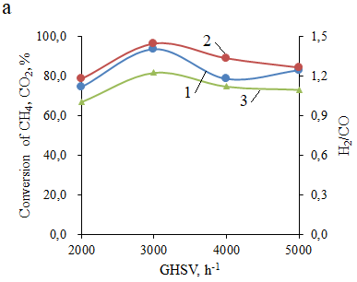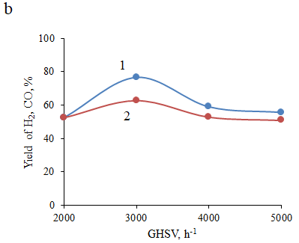

a: 1 - CH4, 2 - CO2 conversion, 3 - H2/CO ratio; b: 1 - H2, 2 - CO yield; T = 850°C, CH4/CO2 = 1.

Figure 47 – Influence of GHSV on Mg- and Mn-promoted catalysts in DRM

It was mentioned in one of previous sections that increase in yield of CO could reduce the formation of carbon, which indicates the presence of Boudouard reaction (C + CO2 = 2CO) observed at 3000 h-1. Furthermore, a high total flow rate can reduce Ni sintering and increase its crystallite size during DRM, however, this has disadvantages e.g. a short contact time, decreasing the catalytic performance (Figure 47).

The stoichiometric impact of feed ratio on process indicators was analyzed by using four different stoichiometric feed ratios CH4/CO2 = 0.67, 1, 1.5, 2 at temperature of 850°C (Figure 48). The CH4-rich initial gas mixture could decrease the conversion of methane. On the contrary, when CH4 content is lower than unity, its conversion could be high and CO2 conversion is low. The largest CO2 conversion (96%) was obtained, when CH4/CO2 was 1:1, decreasing to 78% and again increasing with further rising of CH4/CO2 ratio to 2.0. H2/CO was close to unity in CH4/CO2 ratio in the range of 1-2, therefore, the contribution of RWGS should be low.

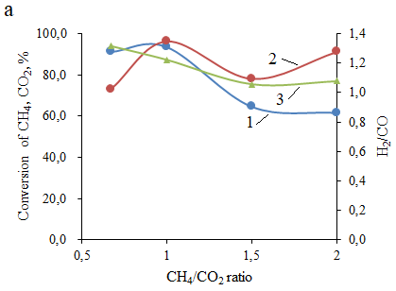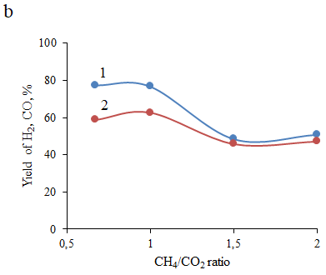

a: 1 - CH4, 2 - CO2 conversion, 3 - H2/CO ratio; b: 1 - H2, 2 - CO yield; GHSV = 3000 h-1, T = 850°C.

Figure 48 – Influence of CH4/CO2 ratio on Mg- and Mn-promoted catalysts in DRM

Increase in ratio of CH4/CO2 from 0.67 to 1.0 demonstrates a noticeable decrease in the hydrogen production (from 77% to 50%) and CH4 conversion (from 91% to 62%). Hydrogen formation is unfavorable in excess of CH4 supply. Production of CO over feed ratios also showed decreasing trends. For CH4-rich feed, more carbon can be developed from methane cracking resulting in the blocking the catalyst pores. As reported in [93, р. 29] low yield of H2 at excess CO2 can be explained with the occurrence of the RWGS, however, in the current case H2 production at this condition was high.

To study the catalytic activity in conditions close to biogas, Ar concentration in the feedstock varied from 0 to 50% (vol.), whereas the feed gas ratio was constant (CH4/CO2 ratio = 2) at 700-850ºC. It can be seen that the process indicators increased with increase of temperature (Figures 49).

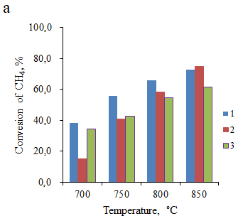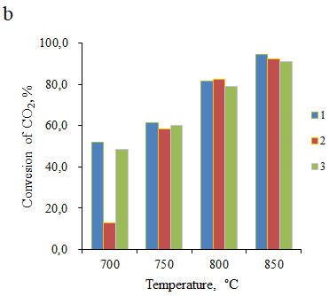

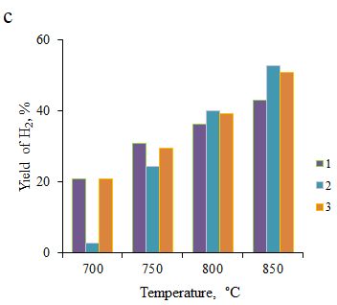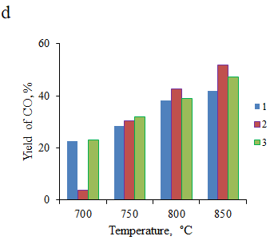

a - CH4, b - CO2 conversion, c - H2, d - CO yield; 1 - 0% Ar, 2 - 30% Ar, 3 - 50% Ar; GHSV = 3000 h-1, T = 700‒850°C.

Figure 49 – Influence of Ar dilution on Mg-promoted catalyst in DRM

The highest CH4 conversion of 56% and 65% was fixed for the mixture without Ar dilution (0% Ar) at 750°C and 800°C. However, at 850°C CH4 conversion at these conditions was 73%, while the 15Ni-15Mg-20Al exhibited higher conversion (75%) under the flow of 47%CH4:23%CO2:30%Ar mixture. For 47%CH4:23%CO2:30%Ar, H2/CO ratio increased from 0.7 to 1.0 at temperature range of 700‒850°C. When Ar dilution was 50% in the 33%CH4:17%CO2:50%Ar mixture, H2/CO ratio changed unsignificantly varing from 0.9 to 1.1. Similar values were observed for the catalyst tested at the conditions close to biogas. The yield of products was quite same under all mixtures at 750‒850°C. At 700°C, the activity of 15Ni-15Mg-20Al at 30% Ar dilution was the lowest (CH4 conversion was 15%).

The catalyst 15Ni-15Mg-20Al was subjected to a prolonged experiment lasting a total of 20 h TOS. Encouragingly, the results demonstrated stable conversion of CH4 and CO2 (Figure 50, Table 30). The carbon balance consistently stayed around 70%. The conversion of CH4 surpassed the conversion of CO2, as reflected in the H2/CO ratio ranging from 1.1 to 1.2. This outcome is highly encouraging, especially when contrasted with the findings detailed in [250], where a 1% deactivation was noted over 11 h at 800°C in DRM using 20Ni-Mg-Al-HT (Ni/Mg molar ratio = 0.3).

The 15Ni-15Mg-20Al catalyst was selected due to its minimal carbon formation and consistent performance over 20 h of operation. The stability of 15Ni-15Mg-20Al in the DRM was assessed through a catalytic test conducted over 200 h, using 33% CH4/33% CO2/34% Ar at a GHSV of 3000 h-1 (Figure 51).

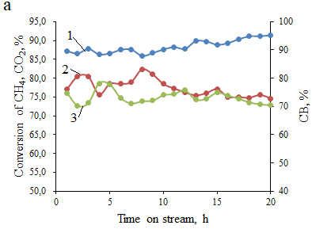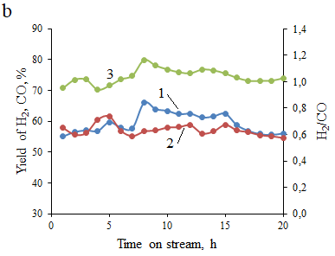

a: conversion of 1 - methane, 2 - CO2, 3 - carbon balance; b: yields of 1 - H2, 2 - CO, 3 - H2/CO ratio; GHSV = 3000 h-1, T = 850oC.

Figure 50 – Catalytic performance of 15Ni-15Mg-20Al in DRM for 20 h TOS

After 20 h, conversion of methane and CO2 was stable and unsignificantly fluctuated at 94‒96% and 84‒90%, respectively almost during entire experiment. Subsequently, CO2 conversion rose to ca. 90% after 40 h. The CO yield remained relatively stable throughout the 200 h test. Synthesis gas was produced, when a H2/CO ratio was equal to 1.2. The carbon balance varied between 69% and 80%. The steam of condensed water was detected in the final 24 h, suggesting a potential RWGS reaction; nevertheless, the CO2 conversion remained lower than that of CH4. Surprisingly, in the case of the 15Ni-15Mg-20Al catalyst, the coking rate, determined through CHNS analysis, decreased as the time on stream increased. Specifically, coking rates calculated for 30 min, 20 h, and 200 h TOS were in the order: 4.2 wt.% C·h-1 > 1.3 wt.% C·h-1 > 0.01 wt.% C·h-1. This trend indicates rapid initial coking, followed by subsequent carbon removal as the TOS increases [134, p. 52].

DRM long-terms test over 15Ni-15Mg-20Al catalyst were performed also in continuous mode at 850°C for 100 h (Figure 52). It can be seen that methane and CO2 conversion were ca. 88% and 93%, respectively, being relatively stable during 100 h TOS. Hydrogen yield was 70% for 24 h, then, decreased to ca. 62% by the end of 100 h. In this regard, regeneration was carried out using 40% O2/60% Ar mixture at 850°C for 20 min. After being regenerated catalyst demonstrated slightly higher values of process indicators. However, H2 yield value was not returned to the initial value of 70% being 66%.

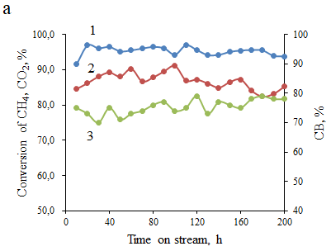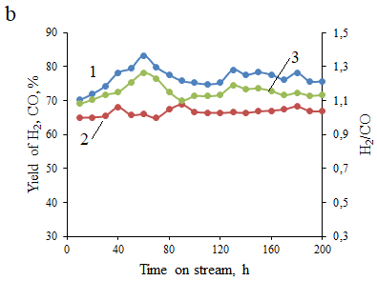

a: conversion of 1 - methane, 2 - CO2 and 3 - carbon balance; b: yields of 1 - H2, 2 - CO and H2/CO ratio; GHSV = 3000 h-1, T = 850oC.

Figure 51 – Catalytic performance of 15Ni-15Mg-20Al in in DRM for 200 h TOS

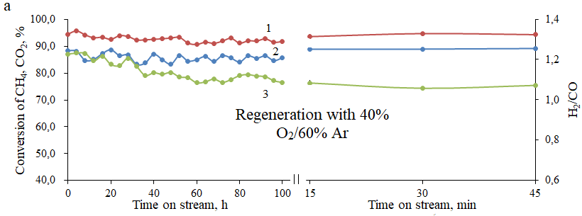

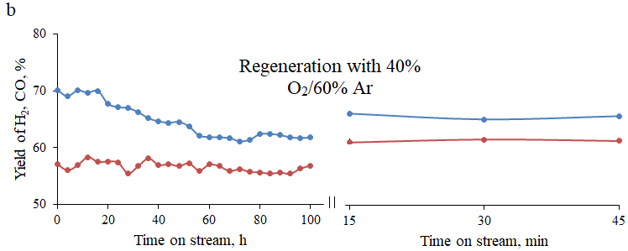

a: conversion for 1 - methane, 2 - CO2 and 3 - H2/CO ratio; b: yields of 1 - H2, 2 - CO; GHSV = 3000 h-1, T = 850oC.

Figure 52 – Catalytic performance of 15Ni-15Mg-20Al in in DRM for 100 h TOS in continuous mode

The test in the large-scale unit shown in the Figure 53 were carried out at 800°С, the gas mixture CH4:CO2:Ar with ratio of 1:1:1 and GHSV of 3000 h-1 over 15Ni-15Mg-20Al catalyst, prepared by solution combustion synthesis. Obtained results of experiments are demonstrated in Figure 54. The volume of the catalyst was 20 ml.

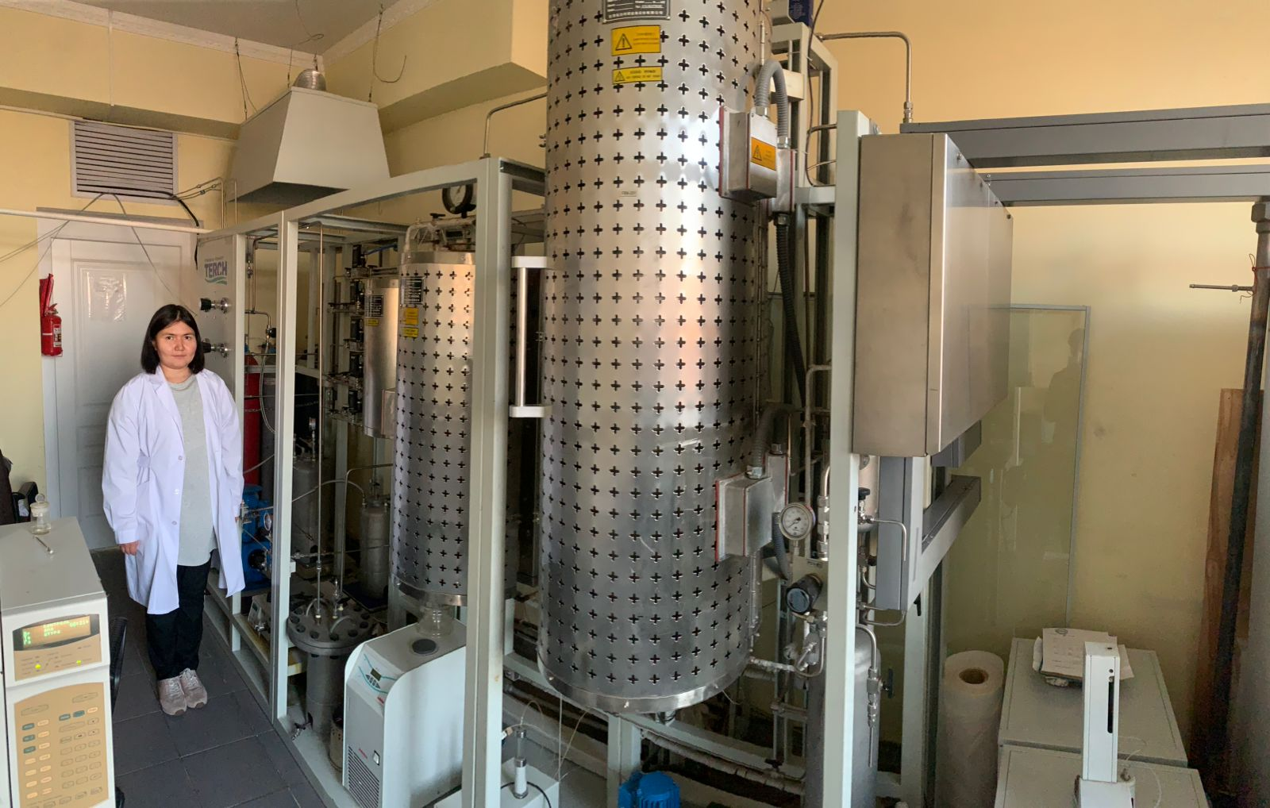

Figure 53 – The large-scale unit of reforming processes

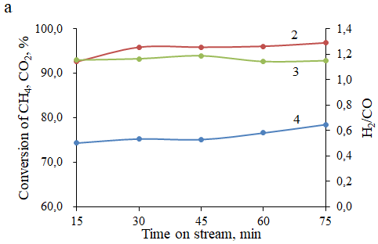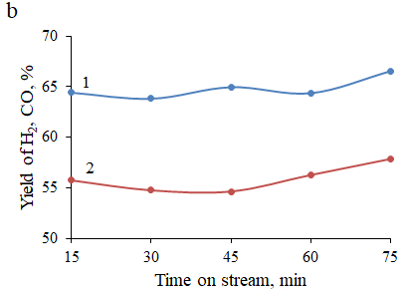

a: conversion for 1 - methane, 2 - CO2 and 3 - H2/CO ratio; b: yield of 1 - H2 and 2 -CO; for 15Ni-15Mg-20Al; GHSV = 3000 h-1, T = 800°C.

Figure 54 – The test of catalytic performance of the 15Ni-15Mg-20Al catalyst in the large-scale unit

At 800°C, the values of the indicators are close, particularly noticeable in the conversions. The yield of H2 is higher than the yield of CO. These results are very promising, since the conversion of reacting gasses obtained during the large-scale tests is similar to that in the in the laboratory scale. The syngas yielded lower in the tests with larger catalyst amount was slightly lower compared to the yield of syngas in the laboratory scale.

Thus, according to TEM analysis nickel particles became larger after short-term and temperature cycling tests. Nevertheless, with prolonging experiment, the nickel particle size decreased. Moreover, zero valent nickel led to the enhancement of catalytic activity. Ni-Mn-Al catalyst demonstrated larger performance than Ni-Mg-Al, however, more coke was formed on the latter sample. Lower activity in comparison with Ni-Mn-Al and Ni-Mg-Al is displayed for the Ni-Mn-Mg because Al was not present. Furthermore, it possessed the highest acidity among all catalysts despite its high reducibility.

The results of stability examination showed that 15Ni-15Mg-20Al exhibited enhanced performance during 20 h and 200 h. In addition, measurable deactivation did not occur in the large-scale test over 15Ni-15Mg-Al synthesized by solution combustion method.

**3.4 Study of catalysts prepared by SCS and impregnation methods**

3.4.1 Study of physicochemical characteristics of catalysts prepared by SCS and impregnation methods

XRD analysis was performed on a monometallic 12 wt.% Ni/α-Al2O3 catalyst (Figure 55). In the fresh sample, pure α-form of Al2O3 was primarily present [PDF 01-075-1862]. Nonetheless, NiO peaks were evident in the XRD pattern, with some of these peaks coinciding and overlapping with those of the α-alumina phase [90, р. 28].

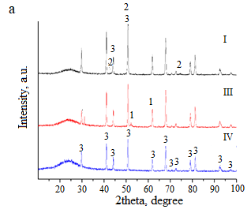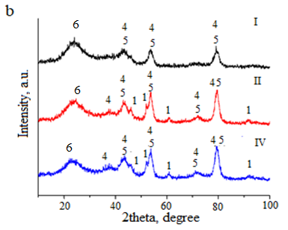

a - 12 wt.% Ni/α-Al2O3, b - 12 wt.% Ni-5.6 wt.% Mg/γ-Al2O3; 1 - Ni, 2 - NiO, 3 - α-Al2O3, 4 - NiAl2O4/MgAl2O4, 5 - γ-Al2O3, 6 - amorphous phase; I - fresh, II - temperature cycling, III - 10 h TOS, IV - α-Al2O3.

Figure 55 – XRD patterns of catalysts prepared by wet impregnation method

In [251] α-alumina was not pure, being mixed with certain amounts of θ-alumina indicating impurities in the support in contrast to the present study. Upon calcination at 700°C Ni/γ-Al2O3 transformed into α-form of alumina and nickel aluminate. However, this transformation was not found in [90, р. 28], likely due to the fact that there were not any interactions between NiO and Al2O3. During DRM Ni2+ ions underwent the reduction to metallic Ni.

As comparison to 15Ni-15Mg-20Al prepared by SCS, the 12 wt.% Ni-5.6 wt.% Mg/γ-Al2O3 catalyst synthesized by wet impregnation was also analyzed by XRD. Fresh unreduced catalyst exhibited MgAl2O4 and γ-Al2O3 phases. NiO phase is absent possibly due to its high dispersion in the support. After reduction followed by DRM tests cubic metallic Ni appeared, MgAl2O4 and γ-Al2O3 remained slightly increasing in crystallinity [134, p. 52].

Catalysts obtained by two distinct methods were considered. 15Ni-35Al was produced by SCS, whilst Ni/α-Al2O3 was obtained via the impregnation method. For the spent catalysts, the nickel particle sizes were 12 nm (15Ni-35Al) and 15 nm (12 wt.% Ni/α-Al2O3) as shown in Figure 56.

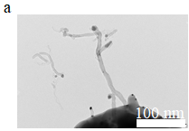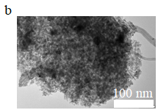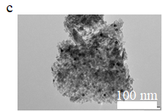

12 wt.% Ni/α-Al2O3: a - spent after 10 h TOS; 12 wt.% Ni-5.6 wt.% Mg/γ-Al2O3: b - spent after temperature cycling at 600-900-600ºC, c - spent after 10 h TOS at 850oC.

Figure 56 – Transmission electron microscopic images of the spent catalysts

In [214, р. 83] Ni/α-Al2O3 showed the metal particles of the size within 10–25 nm. Ni species sintering was induced by calcination at elevated temperatures (1150°C) [90, р. 28.]. The particle size of the spent Ni-based Mg promoted Al2O3 catalyst used in temperature cycling test is 13 nm, which rather small compared to Ni-Mg-Al sample prepared via SCS. Furthermore, after 10 h stability metal particles were smaller, being ca. 8 nm.

The surface area of 12 wt.% Ni-5.6 wt.% Mg/γ-Al2O3 catalyst calcined at 650°C is 113 m2·g-1, which is close to those of reported in [234, р. 90], where for Ni(20):Mg(80)/γ-Al2O3 calcined at 600°C catalyst surface area equal to 125 m2·g-1 (Table 30).

The oxidized nickel species in 15Ni-35Al are started to reduce at more elevated temperature compared to alkali earth promoted Ni-catalysts (Table 31). Reference 12 wt.% Ni-α/Al2O3 catalyst was reduced at lower temperatures, consuming low hydrogen (not shown in Figure 55). For 12 wt.% Ni-5.6 wt.% Mg/γ-Al2O3, hydrogen consumption was very low, and a broad peak was visible between 250‒580oC.

In accordance with [37, р. 17] magnesium prefers to interact with alumina to produce MgAl2O4 (shown in XRD), preventing the formation of NiAl2O4 species. The higher magnesium content in the latter case leads to a weaker interaction with alumina, causing the reduction of nickel species at lower temperatures (Figure 57).

Table 30 – Comparison of catalysts prepared by SCS and wet impregnation

|  |  |  |  |
| --- | --- | --- | --- |
| Catalyst | Fresh/Spent | Metal particle size, nm (TEM) | Surface area, m2·g-1 |
| 15Ni-35Al | F | 13 | - |
| 15Ni-35Al | S | 12 | 8 |
| 12 wt.% Ni/α-Al2O3 | F | 9 | 10 |
| 12 wt.% Ni/α-Al2O3 | S | 15 | 7 |
| 15Ni-15Mg-20Al | F | 16 | 10 |
| 15Ni-15Mg-20Al | S | a25, b36, d20, e30 | a9 |
| 12 wt.% Ni-5.6 wt.% Mg/γ-Al2O3 | F | - | 113 |
| 12 wt.% Ni-5.6 wt.% Mg/γ-Al2O3 | S | b13, c9 | - |
| a30 min TOS, btemperature cycling, c10 h TOS, d20 h TOS, e200 h TOS | | | |

Table 31 – Maximum temperature peaks and relative area of consumed H2 of different catalysts

|  |  |  |
| --- | --- | --- |
| Catalyst | Maximum temperature peaks, °C | Relative area of consumed H2 |
| 15Ni-35Al | 454/800 | 0.35 |
| 15Ni-15Mg-20Al | 306/384/484 | 0.52 |
| 12 wt.% Ni-α/Al2O3 | 375/527 | 0.02 |
| 12 wt.% Ni-5.6 wt.% Mg/γ-Al2O3 | 250‒580 | 0.03 |

The results from ammonia TPD showed that 15Ni-35Al catalyst has the lowest amount of alumina compared to other catalysts (Table 32). Because Mg-containing catalysts exhibit acid sites with all strength, while 15Ni-35Al displays only weak acid sites. Ammonia adsorption on 12 wt.% Ni-α/Al2O3 catalyst was almost similar to 15Ni-15Mg-20Al (Figure 58).

Table 32 – Ammonia TPD of different catalysts

|  |  |  |  |  |
| --- | --- | --- | --- | --- |
| Catalyst | T1,max,oC | T2,max,oC | T3,max,oC | Normalized area |
| 15Ni-35Al | 140 | - | - | 0.01 |
| 15Ni-15Mg-20Al | 160 | 380 | 572 | 0.34 |
| 12 wt.% Ni-α/Al2O3 | 175 | 350 | 500 | 0.07 |
| 12Ni-5.6Mg/γ-Al2O3 | 139 | - | - | 1.0 |

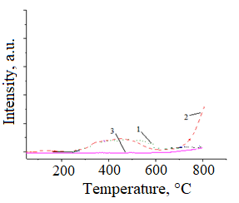

1 - 15Ni-15Mg-20Al, 2 - 15Ni-35Al, 3 - 12 wt.% Ni-5.6 wt.% Mg/γ-Al2O3.

Figure 57 – Behavior of different catalysts during reduction

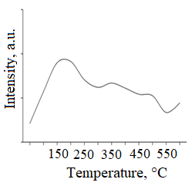

Figure 58 – Ammonia TPD of 12 wt.% Ni/α-Al2O3

For 12 wt.% Ni-5.6 wt.% Mg/γ-Al2O3, ammonia was desorbed at maximum temperature of 139°C, indicating that weak acid sites were predominantly present [134, p. 52]. In accordance with [235, р. 90] nickel catalysts supported on γ- and α-alumina exhibited Lewis acidity.

Thus, catalysts prepared by impregnation and combustion in solution were studied and compared. The results showed that SCS catalysts and samples synthesized by impregnation have a strong relationship between the metal and the support, but the latter has stronger metal-support interactions, which worsens the reducibility, reducing the activity.

3.4.2 Study of catalytic activity of catalysts prepared by SCS and impregnation methods

The catalytic activity of 12 wt.% Ni-5.6 wt.% Mg/γ-Al2O3 in temperature cycling test was studied (Figure 59). The initial conversion of CH4 was ca. 40% at 600°C for reduced 12 wt.% Ni-5.6 wt.% Mg/γ-Al2O3, which was higher than for 15Ni-15Mg-20Al (Table 29). However, at 800°C CH4 conversion (90%) was larger over 15Ni-15Mg-20Al compared to its reduced counterpart that demonstrates 80%. The reduced 12 wt.% Ni-5.6 wt.% Mg/γ-Al2O3 catalyst provided lower yields for hydrogen and CO to be 68% and 60%, respectively, at this temperature. After returning back to 600°C, the values of reacting gas conversion and yield of hydrogen decreased insignificantly indicating that sintering was not observed. The non-reduced catalyst exhibited very low activity at 850–900°C. At 600–800°C this catalyst without reduction was not active.

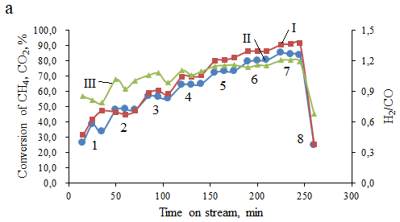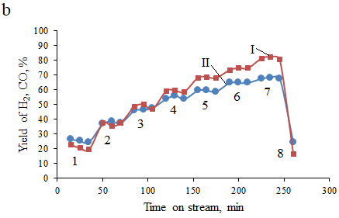

a: conversion of I - methane, II - CO2 and III - H2/CO ratio; b: yields of I - H2, II – CO;

1 - 600oC, 2 - 650oC, 3 - 700oC, 4 - 750oC, 5 - 800oC, 6 - 850oC, 7 - 900oC, 8 - 600oC; GHSV = 3000 h-1.

Figure 59 – Influence of temperature cycling on catalytic activity of 12 wt.% Ni-5.6 wt.% Mg/γ-Al2O3 in DRM

15Ni-35Al, 12 wt.% Ni/α-Al2O3 and 12 wt.% Ni-5.6 wt.% Mg/γ-Al2O3 catalysts were examined in DRM for 10 h stability at 850°C (Table 33 and Figure 60). In parenthesis, results after 10 h were shown (Table 33).

Table 33 – Comparison of catalytic activities of different catalysts at 850°C

|  |  |  |  |  |  |  |  |
| --- | --- | --- | --- | --- | --- | --- | --- |
| Catalyst | Conversion, % | | Yield, % | | H2/CO | TOFCH4, s-1 | *Deactivation rate, %·h-1 |
| CH4 | CO2 | H2 | CO |
| 15Ni-35Al | 94 (93) | 95 (96) | 74 (80) | 66 (66) | 1.1 | 0.08 | 0.13 |
| 12 wt.% Ni/α-Al2O3 | 93 (95) | 92 (92) | 68 (65) | 65 (64) | 1.0 | 0.09 | 0.02 |
| 15Ni-15Mg-20Al, 20 h | 88 (91) | 77 (75) | 55 (60) | 58 (55) | 1.0 | - | 0 |
| 12 wt.% Ni-5.6 wt.% Mg/γ-Al2O3 | 82 (86) | 73 (80) | 63 (69) | 60 (60) | 1.1 | - | 0 |
| *Deactivation rate was calculated using methane conversion | | | | | | | |

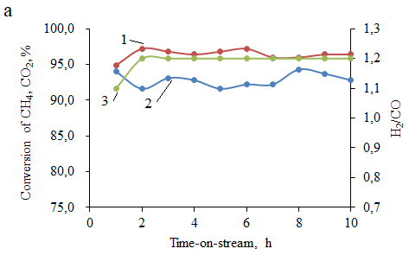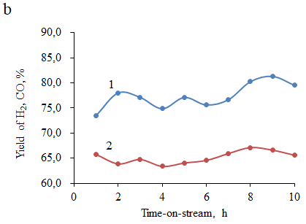

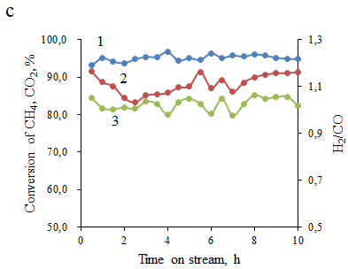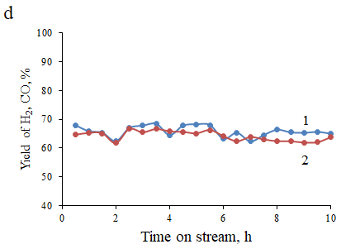

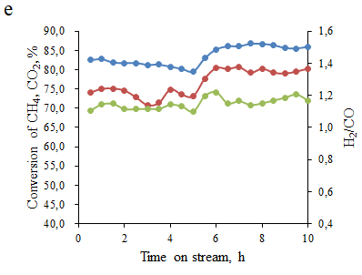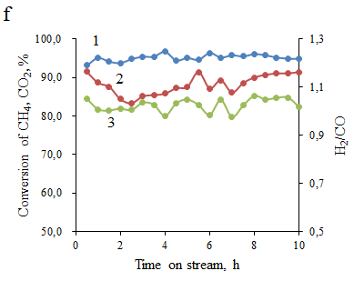

a, c, e: conversion for 1 - methane, 2 - CO2 and 3 - H2/CO ratio; b, d, f - yield of 1 - H2 and 2 -CO; a, b for 15Ni-35Al, c, d for 12 wt.% Ni/α-Al2O3, e, f for 12 wt.% Ni-5.6 wt.% Mg/γ-Al2O3; GHSV = 3000 h-1, T = 850°C.

Figure 60 - Long-term time-on-stream performance of the 15Ni-35Al, 12 wt.% Ni/α-Al2O3 and 12 wt.% Ni-5.6 wt.% Mg/γ-Al2O3 catalysts in DRM

In this regard the magnesia promotion could prevent development of coke, even though the catalytic activity was lower for both 15Ni-15Mg-20Al and 12 wt.% Ni-5.6 wt.% Mg/γ-Al2O3 catalysts [134, p. 52].

Interesingly, these catalysts showed increasing character with time on stream along with decrease of coke amount, which makes catalysts with Mg promotion promising. For all catalysts H2/CO ≥ 1, pointing to the probable occurrence of RWGS reaction. According to CHNS results for 12 wt.% Ni-5.6 wt.% Mg/γ-Al2O3 catalyst exposed for the 10 h test, 0.25 wt.%·gNi-1·h-1 coke was deposited on the catalyst surface, which is larger compared to 15Ni-15Mg-20Al after 200 h DRM.

The results during stability are very promising, showing stable conversion of both methane and CO2 for these catalysts (Table 33). The carbon balance remained also constant at ca. 70%. The monometallic 12 wt.% Ni/α-Al2O3 and bimetallic 12 wt.% Ni-5.6 wt.% Mg/γ-Al2O3 supported catalysts exhibited larger conversion of CH4 compared to the CO2 conversion. 12 wt.% Ni-5.6 wt.% Mg/γ-Al2O3 catalyst was less active than the three other catalysts, more probably due to strong MSI.

Thus, catalysts prepared by impregnation and solution combustion methods were investigated. According to XRD data, the 15Ni-35Al and 15Ni-15Mg-20Al catalysts containing nickel-aluminate spinel and magnesium-aluminate spinel showed higher conversion compared to their analogues. The reduced 12 wt.% Ni-5.6 wt.% Mg/γ-Al2O3 demonstrated higher hydrogen yield in the stability test in comparison with its SCS analogue due to reduction by H2 at 900°C. However, SCS-15Ni-15Mg-20Al was obtained at 1023°C during combustion. It is worthnoting that this catalyst did not undergo any pretreatment prior to the reaction. Moreover, SCS-15Ni-15Mg-20Al exhibited higher conversion and yields at 850°C in the temperature cycling test, in which the sample could be reduced in the reaction flow during stepwise temperature elevation. In terms of examination in thermal cycles, this catalyst was the highest active among all studied samples.

**3.5 Calculation part of the work**

Calculation of the material balance of dry reforming of methane. The calculation of the material balance was carried out based on experimental data for the 15Ni-15Mg-20Al catalyst at 850°C (Table 34). The material balance was compiled for hourly productivity. The feed conversion of and values were taken to be 94% (methane) and 96% (carbon dioxide), the flow rate of the source gas is 3000 m3·h-1. Composition of the gas mixture: 33% CH4: 33% CO2: 34% Ar. The initial feed consists of methane, carbon dioxide and argon, while product contains not only main synthesis gas but also unreacted methane, carbon dioxide. Argon flowing to the reactor and flows away without any changes.

Table 34 – The material balance of dry methane reforming for the 15Ni-15Mg-20Al catalyst at 850°C

|  |  |  |  |  |  |
| --- | --- | --- | --- | --- | --- |
| Initial feed | | | Product | | |
| Component | Mass flow, kg·h-1 | Volume flow, m3·h-1 | Component | Mass flow, kg·h-1 | Volume flow, m3·h-1 |
| CH4 | 707 | 990 | CH4 | 42 | 59 |
| СО2 | 1945 | 990 | СО2 | 78 | 40 |
| Ar | 1819 | 1020 | Ar | 1819 | 1020 |
|  |  |  | СО | 2350 | 1980 |
|  |  |  | Н2 | 182 | 1980 |
| Total: | 4471 | 3000 | Total: | 4471 | 5079 |

Economic calculation of the dry reforming of methane process. Approximate financial calculations of dry methane reforming are given without taking into account prices for equipment (Table 35), various components and other important components (gas purification, storage, etc.) that affect pricing. The calculation was carried out taking into account the following factors: the mass of the catalyst prepared by impregnation is 1 kg. The installation operating time is 20 h.

Table 35 – Calculation of costs for raw materials and energy resources

|  |  |  |  |  |
| --- | --- | --- | --- | --- |
| Name of materials | Item consumption | | Cost per item item, tenge | Amount spent on the required quantity of each item, tenge |
| Per item name | For the required number of items |
| Feed: | | | | |
| СН4, l | 40 | 990 | 80000 | 79200000 |
| СО2, l | 40 | 990 | 40000 | 39600000 |
| Ar, l | 40 | 1020 | 10000 | 10200000 |
| Catalyst: | | | | |
| Nickel nitrate hexahydrate, kg | 1 | 0.15 | 3000 | 450 |
| Magnesium nitrate hexahydrate, kg | 1 | 0.15 | 4000 | 600 |
| Aluminum nitrate nonahydrate, kg | 1 | 0.2 | 1000 | 200 |
| Urea, kg | 1 | 0.5 | 2690 | 1345 |
| **Total:** |  |  |  | 129002595 |
| Energy costs: | | | | |
| Electricity, kWh | 85 | b1700 | 19 | 32300 |
| a – in the range of 60‒90 kWh electricity consumption tariff according to “Astanaenergosbyt” LLP.  b - on average, 85 kWh per month is spent according to the “D.V. Sokolsky Institute of Fuel, Catalysis and Electrochemistry” for February 2024. | | | | |

For DRM in larger scale gas tanks are needed. Their price is controlled with Kazakhstan market.

The catalyst is composed from hydrated nitrates of nickel, magnesium and alumina. The cost of each component in Kazakhstan market was taken into account.

The price electroenergy was calculated using information from “Astanaenergosbyt” LLP and D.V. Sokolsky Institute of Fuel, Catalysis and Electrochemistry electricity demand. The month demand of electricity in institute is 18000 kWh in February 2024. For required 20 h of operation time 1700 kWh of electroenergy is required. Taking into consideration that for electricity power is 85kWh, its cost equal to 19 tenge, the cost for 20 h is 32300 tenge.

Thus, for carbon dioxide conversion of methane, 129,002,595 tenge can be spent on 3000 l of raw materials and 1 kg of catalyst, and 641,036 tenge on electricity.

**CONCLUSION**

1. Catalysts were prepared by impregnation and solution combustion methods for the dry reforming process of methane and a model biogas mixture. It was found that compared with the 12%Ni/α-Al2O3 catalyst prepared by impregnation, the SCS 15Ni-35Al catalyst showed higher activity due to the active phase of nickel-aluminate spinel formed at high temperature, which was caused by microexplosion during catalyst preparation.

2. Optimal conditions for the reforming process have been determined:

- for 15Ni-5Fe-30Al at 33%CH4:33%CO2: 34% Ar and temperature of 800°C: conversion of methane was 88%, conversion of CO2 – 94%, yield of Н2 ‒ 75% and yield of СО – 58%;

- for 15Ni-5Fe-30Al at 67%CH4:33%CO2 and temperature of 800°C: conversion of methane equal to 72%, conversion of CO2 – 77%, yield of Н2 – 31% and yield of СО – 36%;

- for 15Ni-15Ce-20Al at 33%CH4:33%CO2:34%Ar and temperature of 850°Cin the temperature cycling test: conversion of methane was 90%, conversion of CO2 – 90%, yield of Н2 – 68% and yield of СО – 63%;

- for 15Ni-15Mg-20Al at 33%CH4:33%CO2:34%Ar and temperature of 850°C: conversion of methane was 94%, conversion of CO2 – 96%, yield of Н2 – 75% and yield of СО – 64%;

- for 15Ni-15Mg-20Al at 67%CH4:33%CO2 and temperature of 850°C: conversion of methane equal to 73%, conversion of CO2 – 95%, yield of Н2 – 43% and yield of СО – 42%.

3. The properties of the catalysts were studied using XRD, CO2-TPD, TGA, TPO and CHNS methods, which confirmed the role of metallic nickel and metal aluminates, which consists in activation, stabilization, inhibition of carbon deposition and sintering of catalysts in long-term tests.

4. The activity and stability of the catalysts in the catalytic reforming process were investigated in 20 and 200 h tests, including a large-scale pilot plant, during which methane conversion remained constant, a slight decrease in CO2 conversion and no measurable deactivation were observed. During 100 h DRM test performed in continuous mode H2 yield insignificantly reduced, however, methane and CO2 conversion, as well as CO yield were stable.

5. The interrelations of catalytic and physicochemical properties of catalysts were revealed. In addition to establishing the forms of active elements in the form of alloys and metals, as well as aluminates, the presence of acid and basic sites in catalysts was shown, playing a crucial role in catalysis, depending on the composition of the catalysts and the processing conditions.

6. Substitution of magnesium in the Ni-Mn-Mg catalyst with Al increases its activity, reduces acidity, and leads to the formation of a large amount of coke.

**REFERENCES**

1 Weiland P. Biogas production: current state and perspectives // Appl. Microbiol. Biotechnol. – 2010. –Vol. 85. – P. 849−860.

2 Angelidaki I., Treu L., Tsapekos P., Luo G., Campanaro S., Wenzel H., Kougias P.G. Biogas upgrading and utilization: current status and perspectives // Biotechnol. Adv. – 2018. – Vol. 36. – P. 452−466.

3 Sun Q., Li H., Yan J., Liu L., Yu Z., Yu X. Selection of appropriate biogas upgrading technology-a review of biogas cleaning, upgrading and utilization // Renewable and Sustainable Energy Reviews. – 2015. – Vol. 51. – P. 521–532.

4 Papadopoulou C., Matralis H., Verykios X., Guczi L., Erdôhelyi A. Catalysis for Alternative Energy Generation. Chapter 3. Utilization of Biogas as a Renewable Carbon Source: Dry Reforming of Methane // Catalysis for Alternative Energy Generation. Springer Science+Business Media New York – 2012. – 538 p.

5 Sinha D., Banerjee S., Mandal S., Basu A., Banerjee A., Balachandran S., Mandal N.C., Chaudhury S. Enhanced biogas production from Lantana camara via bioaugmentation of cellulolytic bacteria Debasree // Bioresource Technology. – 2021. – Vol. 340. – P. 125652-125661.

6 Jung S., Lee J., Moon D.H., Kim K.H., Kwon E.E. Upgrading biogas into syngas through dry reforming // Renewable and Sustainable Energy Reviews. – 2021. – Vol. 143. – P. 110949 - 110959.

7 Sharifzadeh M., Wang L., Shah N. Integrated biorefineries: CO2 utilization for maximum biomass conversion // Renewable and Sustainable Energy Reviews. – 2015. – Vol. 47. – P. 151-161.

8 Chen X., Jiang J., Li K., Tian S., Yan F. Energy-efficient biogas reforming process to produce syngas: The enhanced methane conversion by O2 // Applied Energy. – 2016. – Vol. 185, № 1. – P. 687-697.

9 Vita A., Italiano C., Fabiano C., Laganà M., Pino L. Influence of Ce-precursor and fuel on structure and catalytic activity of combustion synthesized Ni/CeO2 catalysts for biogas oxidative steam reforming // Materials Chemistry and Physics. – 2015. – Vol. 163. – P. 337-347.

10 Jabbour K., Saad A., Inaty L., Davidson A., Massiani P., El Hassan N. Ordered mesoporous Fe-Al2O3 based-catalysts synthesized via a direct “one-pot” method for the dry reforming of a model biogas mixture // International Journal of Hydrogen Energy. – 2019. – Vol. 44, № 29. – P. 14889 – 14907.

11 Rosset M., Féris L.A., Perez-Lopez O.W. Biogas dry reforming over Ni-Al catalyst: Suppression of carbon deposition by catalyst preparation and activation // International Journal of Hydrogen Energy. – 2020. – Vol. 45, № 11. – P. 6549 - 6562.

12 Rostrup-Nielsen J. Steam reforming of hydrocarbons. A historical perspective // Natural Gas Conversion VII, Proceedings of the 7th Natural Gas Conversion Symposium. – 2004. – P. 121-126.

13 Zhao X., Joseph B., Kuhn J., Ozcan S. Biogas Reforming to Syngas: A Review // iScience. – 2020. – Vol. 23, № 5. – P. 101082.

14 Su B., Wang Y., Xu Z., Han W., Jin H., Wang H. Novel ways for hydrogen production based on methane steam and dry reforming integrated with carbon capture // Energy Conversion and Management. – 2022. – Vol. 270. – P. 116199-116215.

15 Zhang H., Sun Z., Hu Y.H. Steam reforming of methane: Current states of catalyst design and process upgrading // Renewable and Sustainable Energy Reviews. – 2021. – Vol. 149. – P. 111330-111354.

16 Gangadharan P., Kanchi K.C., Lou H.H. Evaluation of the economic and environmental impact of combining dry reforming with steam reforming of methane // Chemical Engineering Research and Design. – 2012. – Vol. 90, № 11. – P. 1956–1968.

17 Li L., MD Dostagir N.H., Shrotri A., Fukuoka A., Kobayashi H. Partial Oxidation of Methane to Syngas via Formate Intermediate Found for a Ruthenium–Rhenium Bimetallic Catalyst // ACS Catalysis. – 2021. – Vol. 11, №7. – P. 3782–3789.

18 Lavoie J.M. Review on dry reforming of methane, a potentially more environmentally-friendly approach to the increasing natural gas exploitation // Frontiers in Chemistry. – 2014. – Vol. 2. – P. 1-17.

19 Parsapur R.K., Chatterjee S., Huang K.W. The Insignificant Role of Dry Reforming of Methane in CO2 Emission Relief // ACS Energy Letters. – 2020. – Vol. 5, № 9. – P. 2881–2885.

20 Arora S., Prasad R. An overview on dry reforming of methane: strategies to reduce carbonaceous deactivation of catalysts // RSC Advances. – 2016. – Vol. 6, № 110. – Р. 108668–108688.

21 Abdelsadek Z., Köten H., Gonzalez-Cortes S., Cherifi O., Halliche D., Masset P.J. Lanthanum-Promoted Nickel-Based Catalysts for the Dry Reforming of Methane at Low Temperatures // Journal of Minerals. – 2023. – Vol. 75, № 3. – Р. 727 – 738.

22 Wittich K., Schunk S.A., Krämer M., Bottke N. Catalytic Dry Reforming of Methane: Insights from Model Systems // ChemCatChem. – 2020. – Vol. 12, № 8. – Р. 2130-2147.

23 Aramouni N.A.K., Zeaiter J., Kwapinski W., Leahy J.J., Ahmad M.N. Trimetallic Ni-Co-Ru catalyst for the dry reforming of methane: Effect of the Ni/Co ratio and the calcination temperature // Fuel. – 2021. – Vol. 300. – P. 120950-120961.

24 Zhang X., Vajglova Z., Mäki-Arvela P., Peurla M., Palonen H., Murzin D.Yu., Tungatarova S.A., Baizhumanova T.S., Aubakirov Y.A. Mono‐ and Bimetallic Ni−Co Catalysts in Dry Reforming of Methane // ChemistrySelect. – 2021. – Vol. 6, № 14. – Р. 3424 – 3434.

25 Araiza D.G., Arcos D.G., Gómez-Cortés A., Díaz G. Dry reforming of methane over Pt-Ni/CeO2 catalysts: Effect of the metal composition on the stability // Catalysis Today. – 2021. – Vol. 360. – P. 46-54.

26 Niu J, Wang Y., Liland S.E., Regli S.K., Yang J., Rout K.R., Luo J., Rønning M., Ran J., Chen D. Unraveling Enhanced Activity, Selectivity, and Coke Resistance of Pt–Ni Bimetallic Clusters in Dry Reforming // ACS Catalysis. – 2021. – Vol. 11. – P. 2398-2411.

27 Ribeiro N.F.P., Neto R.C.R., Moya S.F., Souza M.M.V.M., Schmal M. Synthesis of NiAl2O4 with high surface area as precursor of Ni nanoparticles for hydrogen production // International Journal of Hydrogen Energy. – 2010. – Vol. 35, № 21. – P. 11725–11732.

28 Omoregbe O., Danh H.T., Abidin S.Z., Setiabudi H.D., Abdullah B., Vu K.B., Vo Dai-Viet N. Influence of Lanthanide Promoters on Ni/SBA-15 Catalysts for Syngas Production by Methane Dry Reforming // Procedia Engineering. – 2016. – Vol. 148. – P. 1388–1395.

29 Abdullah B., Abd Ghani N.A., Vo Dai-Viet N. Recent Advances in Dry Reforming of Methane over Ni-based Catalysts // Journal of Cleaner Production. – 2017. – Vol. 162. – Р. 170–185.

30 Jin B., Li S., Liang X. Enhanced activity and stability of MgO-promoted Ni/Al2O3 catalyst for dry reforming of methane: Role of MgO // Fuel. – 2021. – № 284. – P. 119082–119090.

31 Guo J., Lou H., Zhao H., Chai D., Zheng X. Dry reforming of methane over nickel catalysts supported on magnesium aluminate spinels // Applied Catalysis A: General. – 2004. – Vol. 273, № 1-2. – P. 75–82.

32 Weber D., Wadlinger K.M., Heinlein M.M., Franken T. Modifying Spinel Precursors for Highly Active and Stable Ni-based CO2 Methanation Catalysts // ChemCatChem. – 2022. – Vol. 14. – P. 1-8.

33 Marinho A.L.A., Toniolo F.S., Noronha F.B., Epron F., Duprez D., Bion, N. Highly active and stable Ni dispersed on mesoporous CeO2-Al2O3 catalysts for production of syngas by dry reforming of methane // Applied Catalysis B: Environmental. – 2021. – Vol. 281. – P. 119459–119471.

34 Gonzalez J.J., Da Costa-Serra J.F., Chica A. Biogas dry reforming over Ni-Ce catalyst supported on nanofibered alumina // International Journal of Hydrogen Energy. – 2020. – Vol. 45, № 40. – P. 20568-20581.

35 Sun Y., Zhang G., Xu Y., Zhang Y., Lv Y., Zhang R. Comparative study on dry reforming of methane over Co-M (M = Ce, Fe, Zr) catalysts supported on N-doped activated carbon // Fuel Processing Technology. – 2019. – Vol. 192. – P. 1-12.

36 Li B., Luo Y., Li B., Yuan X., Wang X. Catalytic performance of iron-promoted nickel-based ordered mesoporous alumina FeNiAl catalysts in dry reforming of methane // Fuel Proc. Techn. – 2019. – Vol. 193. – P. 348-360.

37 Abbas M., Sikander U., Mehran M.T., Kim S.H. Exceptional stability of hydrotalcite derived spinel Mg(Ni)Al2O4 catalyst for dry reforming of methane // Catalysis Today. – 2022. – Vol. 403. – P. 74-85.

38 Wan C., Song K., Pan J., Huang M., Luo R., Li D., Jiang L. Ni-Fe/Mg(Al)O alloy catalyst for carbon dioxide reforming of methane: Influence of reduction temperature and Ni-Fe alloying on coking // Int. J. Hydrogen Energy. – 2020. – Vol. 45. – P. 33574-33585.

39 Al-Mubaddel F.S., Kumar R., Sofiu M.L., Frusteri F., Ibrahim A.A., Srivastava V.K., Kasim S.O., Fakeeha A.H., Abasaeed A.E., Osman A.I., Al-Fatesh A.S. Optimizing acido-basic profile of support in Ni supported La2O3-Al2O3 catalyst for dry reforming of methane // Int. J. Hydrogen Energy. – 2021. – Vol. 46. – P. 14225-14235.

40 Trueba M., Trasatti S.P. γ-Alumina as a Support for Catalysts: A Review of Fundamental Aspects // European Journal of Inorganic Chemistry. – 2005. – Vol. 17. – P. 3393–3403.

41 Kaur P., Khanna A., Kaur N., Nayar, P., Chen B. Synthesis and structural characterization of alumina nanoparticles // Phase Transition. ‒ 2020. ‒ Vol. 93, № 6. – P. 596–605.

42 El Hassan N., Jabbour K., Fakeeha A.H., Nasr Y., Naeem M.A., Alreshaidan S.B., Al-Fatesh A.S. Production of carbon nanomaterials and syngas from biogas reforming and decomposition on one-pot mesoporous nickel alumina catalysts // Alexandria Engineering Journal. – 2023. ‒ Vol. 63. – P. 143-155.

43 Thielemann J.P., Girgsdies F., Schlögl R., Hess C. Pore structure and surface area of silica SBA-15: influence of washing and scale-up // Beilstein Journal of Nanotechnology. – 2011. – Vol. 2. – P. 110–118.

44 Chong C.C., Cheng Y.W., Bukhari S.N., Setiabudi H.D., Jalil, A.A. Methane dry reforming over Ni/fibrous SBA-15 catalysts: Effects of support morphology (rod-liked F-SBA-15 and dendritic DFSBA-15) // Catalysis Today. – 2021. – Vol. 375. – P. 245–257.

45 Damyanova S., Pawelec B., Arishtirova K., Fierro J.L.G., Sener C., Dogu T. MCM-41 supported PdNi catalysts for dry reforming of methane // Applied Catalysis B: Environmental. – 2009. – Vol. 92, № 3-4. – P. 250–261.

46 de la Cruz-Flores V.G., Martinez-Hernandez A., Gracia-Pinilla M.A. Deactivation of Ni-SiO2 catalysts that are synthesized via a modified direct synthesis method during the dry reforming of methane // Applied Catalysis A, General. – 2020. – Vol. 594. – P. 117455 – 117469.

47 Du X., France L.J., Kuznetsov V.L., Xiao T., Edwards P.P., Almegren H., Bagabas A. Dry reforming of methane over ZrO2-supported Co–Mo carbide catalyst // Applied Petrochemical Research. – 2014. – Vol. 4, № 1. – P. 137–144.

48 Yao Z., Jiang J., Zhao Y., Luan F., Zhu J., Shi Y., Gao H., Wang H. Insights into the deactivation mechanism of metal carbide catalysts for dry reforming of methane via comparison of nickel-modified molybdenum and tungsten carbides // RSC Adv. – 2016. - Vol. 6, № 24. – P. 19944–19951.

49 LaMont D.C., Thomson W.J. Dry reforming kinetics over a bulk molybdenum carbide catalyst // Chemical Engineering Science. - 2005. – Vol. 60, № 13. – P. 3553–3559.

50 Özdemi̇r H., Faruk Öksüzömer, M.A. Synthesis of Al2O3, MgO and MgAl2O4 by solution combustion method and investigation of performances in partial oxidation of methane // Powder Technology. – 2020. – Vol. 359. – P. 107–117.

51 Zhang S., Ying M., Yu J., Zhan W., Wang L., Guo Y., Guo Y. NixAl1O2-δ mesoporous catalysts for dry reforming of methane: The special role of NiAl2O4 spinel phase and its reaction mechanism // Applied Catalysis B: Environmental. – 2021. – Vol. 291. – P. 120074-120091.

52 Dębek R., Motak M., Duraczyska D., Launay F., Galvez M.E., Grzybek T., Da Costa P. Methane dry reforming over hydrotalcite-derived Ni-Mg-Al mixed oxides: The influence of Ni content on catalytic activity, selectivity and stability // Catal. Sci. Technol. – 2016. – Vol. 6. – P. 6705–6715.

53 Danghyan V., Kumar A., Mukasyan A., Wolf E.E. An active and stable NiOMgO solid solution based catalysts prepared by paper assisted combustion synthesis for the dry reforming of methane // Applied Catalysis B: Environmental. – 2020. – Vol. 273. – P. 19056.

54 Kim S.B., Eissa A.A.-S., Kim M.-J., Goda E.S., Youn J.-R., Lee K. Sustainable Synthesis of a Highly Stable and Coke-Free Ni@CeO2 Catalyst for the Efficient Carbon Dioxide Reforming of Methane // Catalysts. – 2022. – Vol. 12. – P. 423.

55 Xu S., Slater T.J.A., Huang H., Zhou Y., Jiao Y., Parlett C.M.A., Guan S., Chansai S., Xu S., Wang X., Hardacre C., Fan X. Developing silicalite-1 encapsulated Ni nanoparticles as sintering-/coking-resistant catalysts for dry reforming of methane // Chemical Engineering Journal. – 2022. – Vol. 446, № 5. – P. 137439.

56 Li X., Li D., Tian H., Zeng L., Zhao Z.-J., Gong J. Dry reforming of methane over Ni/La2O3 nanorod catalysts with stabilized Ni nanoparticles // Applied Catalysis B: Environmental. – 2017. – Vol. 202. – P. 683–694.

57 Ramezani Y., Meshkani F., Rezaei M. Promotional effect of Mg in trimetallic nickel-manganese-magnesium nanocrystalline catalysts in CO2 reforming of methane // International Journal of Hydrogen Energy. – 2018. – Vol. 43, № 49. – P. 22347-22356.

58 Ranjekar A.M., Yadav G.D. Dry reforming of methane for syngas production: A review and assessment of catalyst development and efficacy // Journal of the Indian Chemical Society. – 2021. – Vol. 98. – P. 100002-100023.

59 He L., Ren Y., Yue B., Tsang S.C.E., He H. Tuning Metal–Support Interactions on Ni/Al2O3 Catalysts to Improve Catalytic Activity and Stability for Dry Reforming of Methane // Processes. – 2021. – Vol. 9. – P. 706-721.

60 Horlyck J., Sara M., Lovell E. C., Amal R., Scott J. A. Effect of metal‐support interactions in mixed Co/Al catalysts for dry reforming of methane // ChemCatChem. – 2019. – Vol. 11. – P. 3432-3442.

61 Shen J., Reule A.A.C., Semagina N. Ni/MgAl2O4 catalyst for low-temperature oxidative dry methane reforming with CO2 // International Journal of Hydrogen Energy. ‒ 2019. – Vol. 44, № 10. – P. 4616-4629.

62 Oemar U., Hidajat K., Kawi S. Role of catalyst support over PdO–NiO catalysts on catalyst activity and stability for oxy-CO2 reforming of methane // Applied Catalysis A: General – 2011. – Vol. 402, № 1-2. – P. 176–187.

63 Wang M., Zhao T., Dong X., Li M., Wang H. Effects of Ce substitution at the A-site of LaNi0.5Fe0.5O3 perovskite on the enhanced catalytic activity for dry reforming of methane // Applied Catalysis B: Environmental. – 2018. – Vol. 224. – P. 214-221.

64 Rizwan M., Gul S., Iqbal T., Mushtaq U., Farooq M.H., Farman M., Bibi R., Ijaz M. A review on perovskite lanthanum aluminate (LaAlO3), its properties and applications // Mater. Res. Express. – 2019. – Vol. 6. - P. 112001 - 112016.

65 Imai H., Tagawa T. Oxidative coupling of methane over LaAlO3 // Journal of the Chemical Society-Chemical Communications. – 1986. – Vol. 1. – P. 52–53.

66 Tran Nguyen Q.N., Martinovic F., Ceretti M., Esposito S., Bonelli B., Paulus W., Di Renzo F., Deorsola F.A., Bensaid S., Pirone R. Co-doped LaAlO3 perovskite oxide for NOx-assisted soot oxidation // Applied Catalysis A: General. – 2020. – Vol. 589. – P. 117304.

67 Muñoz H.J., Korili S.A., Gil A. Progress and Recent Strategies in the Synthesis and Catalytic Applications of Perovskites Based on Lanthanum and Aluminum // Materials. – 2022. – Vol. 15, № 9. – P. 3288 - 3331.

68 Kathiraser Y., Thitsartarn W., Sutthiumporn K., Kawi S. Inverse NiAl2O4 on LaAlO3 –Al2O3: Unique Catalytic Structure for Stable CO2 Reforming of Methane // The Journal of Physical Chemistry C. – 2013. – Vol. 117, № 16. – P. 8120–8130.

69 Venâncio S.A., de Miranda P.E.V. Synthesis of CeAlO3/CeO2–Al2O3 for use as a solid oxide fuel cell functional anode material // Ceramics International. – 2011. – Vol. 37, № 8. – P. 3139–3152.

70 Gallego G.S., Batiot-Dupeyrat C., Barrault J., Florez E., Mondragón F. Dry reforming of methane over LaNi1-yByO3±δ (B = Mg, Co) perovskites used as catalyst precursor // Applied Catalysis A: General. ‒ 2008. – Vol. 334. – P. 251–258.

71 Rivas M.E., Fierro J.L.G., Goldwasser M.R., Pietri E., Pérez-Zurita M.J., Griboval-Constant A., Leclercq G. Structural features and performance of LaNi1-xRhxO3 system for the dry reforming of methane // Applied Catalysis A: General. – 2008. – Vol. 344. – P. 10–19.

72 de Araujo G.C., de Lima S. M., Assaf J.M., Peña M.A., Fierro J.L.G., do Carmo Rangel M. Catalytic evaluation of perovskite-type oxide LaNi1-xRuxO3 in methane dry reforming // Catalysis Today. – 2008. – Vol. 133-135. – P. 129-135.

73 Sutthiumporn K., Maneerung T., Kathiraser Y., Kawi S. CO2 dry-reforming of methane over La0.8Sr0.2Ni0.8M0.2O3 perovskite (M = Bi, Co, Cr, Cu, Fe): Roles of lattice oxygen on C-H activation and carbon suppression // International Journal of hydrogen energy. – 2012. – Vol. 37. – P. 11195-11207.

74 Khalesi A., Arandiyan H.R., Parvari M. Effects of Lanthanum Substitution by Strontium and Calcium in La-Ni-Al Perovskite oxides in Dry Reforming of Methane // Chinese Journal of Catalysis. – 2008. – Vol. 29, № 10. – P. 960-968.

75 Gurav H.R., Bobade R., Das V.L., Chilukuri S. Carbon dioxide reforming of methane over ruthenium substituted strontium titanate perovskite catalysts // Indian Journal of Chemistry. – 2012. – Vol. 51A. – P. 1339-1347.

76 Dama S., Ghodke S.R., Bobade R., Gurav H.R. Chilukuri S. Active and durable alkaline earth metal substituted perovskite catalysts for dry reforming of methane // Applied Catalysis B: Environmental. – 2018. – Vol. 224. – P. 146-158.

77 Zhou R., Mahinpey N. A review on catalyst development for conventional thermal dry reforming of methane at low temperature // The Canadian Journal of Chemical Engineering. – 2023. – Vol. 101. – P. 3180-3212.

78 Ibrahim A.A., Fakeeha A.H., Lanre M.S., Al-Awadi A.S., Alreshaidan S.B., Albaqmaa Y.A., Adil S.F., Al-Zahrani A.A., Abasaeed A.E., Al-Fatesh A.S. The Effect of Calcination Temperature on Various Sources of ZrO2 Supported Ni Catalyst for Dry Reforming of Methane // Catalysts. – 2022. – Vol. 12, № 4. – P. 361 – 373.

79 Han B., Zhao L., Wang F., Xu L., Yu H., Cui Y., Zhang, J., Shi W. Effect of calcination temperature on performance of Ni@SiO2 catalyst in methane dry reforming // Industrial & Engineering Chemistry Research. – 2020. – Vol. 59, № 30. – P. 13370 – 13379.

80 Manukyan K.V., Cross A., Roslyakov S., Rouvimov S., Rogachev A.S., Wolf E.E., Mukasyan A.S. Solution combustion synthesis of nano-crystalline metallic materials: Mechanistic studies // J. Phys. Chem. – 2013. – Vol. 117. – P. 24417-24427.

81 Xanthopoulou G., Thoda O., Boukos N., Krishnamurthy S., Dey A., Roslyakov S., Vekinis G., Chroneos A., Levashov E. Effects of precursor concentration in solvent and nanomaterials room temperature aging on the growth morphology and surface characteristics of Ni–NiO nanocatalysts produced by dendrites combustion during SCS // Appl. Sci. – 2019. – Vol. 9. – P. 4925-4945.

82 Manukyan K.V. Solution combustion synthesis of catalysts. In Concise Encyclopedia of Self-Propagating High-Temperature Synthesis // Elsevier. – 2017. – P. 347-348.

83 Novitskaya E., Kelly J.P., Bhaduri S., Graeve O.A. A review of solution combustion synthesis: an analysis of parameters controlling powder characteristics // Int. Mat. Rev. – 2020. – Vol. 66, № 3. – P. 188-214.

84 Varma A., Mukasyan A. S. Rogachev A. S. Manukyan K. V. Solution Combustion Synthesis of Nanoscale Materials // Chem. Rev. – 2016. – Vol. 116. – P. 14493–14586.

85 Nandana B., Dedhila D., Baiju V., Sajeevkumar G. NiAl2O4 Nanocomposite via combustion synthesis for sustainable environmental remediation // Nanosistemi, Nanomateriali, Nanotehnologii. – 2022. – Vol. 20, № 2. – P. 459–472.

86 Manabayeva A.M., Mäki-Arvela P., Vajglová Z., Martinez-Klimov M., Tirri T., Baizhumanova T.S., Grigor’eva V.P., Zhumabek M., Aubakirov Y.A., Simakova I., Murzin D., Tungatarova S.A. Dry reforming of methane over Ni-Fe-Al catalysts prepared by solution combustion synthesis // Ind. Eng. Chem. Res. – 2023. – Vol. 62, № 29. – P. 11439-11455.

87 Ahmad Y.H., Mohamed A.T., Kumar A., Al-Qaradawi S.Y. Solution combustion synthesis of Ni/La2O3 for dry reforming of methane: tuning the basicity via alkali and alkaline earth metal oxide promoters // RSC Adv. – 2021. – Vol. 11. – P. 33734 – 33743.

88 González A.R., Asencios Y.J.O., Assaf E.M., Assaf J.M. Dry reforming of methane on Ni–Mg–Al nano-spheroid oxide catalysts prepared by the sol–gel method from hydrotalcite-like precursors // Applied Surface Science. – 2013. – Vol. 280. – P. 876–887.

89 Hassani Rad S.J., Haghighi M., Alizadeh Eslami A., Rahmani F., Rahemi N. Sol–gel vs. impregnation preparation of MgO and CeO2 doped Ni/Al2O3 nanocatalysts used in dry reforming of methane: Effect of process conditions, synthesis method and support composition // International Journal of Hydrogen Energy. – 2016. – Vol. 41, № 11. – P. 5335 – 5350.

90 Manabayeva A.M., Mäki-Arvela P., Vajglová Z., Martinéz-Klimov M., Yevdokimova O., Peuronen A., Lastusaari M., Tirri T., Kassymkan K., Baizhumanova T.S., Zhumabek M., Sarsenova R.N., Zheksenbaeva Z.T., Murzin D. Yu., Tungatarova S.A. Dry reforming of methane over rare-earth metal oxide Ni-M-Al (M = Ce, La) catalysts // Industrial & Engineering Chemistry Research. – 2023. – Vol. 62, № 48. – P. 20588‒20607.

91 Ayoub M., Chong C.C., Zamir A., Cheng Y.W., Farrukh S., Naqvi S.R., Setiabudi H.D., Riaz N., Ramzan N. Effects of operating parameters for dry reforming of methane: A short review // Web of Conferences. – 2021. – Vol. 287. – P. 04015.

92 Schwengber C.A., da Silva F.A., Schaffner R.A., Fernandes-Machado N.R.C., Ferracin R.J., Bach V.R., Alves H.J. Methane dry reforming using Ni/Al2O3 catalysts: Evaluation of the effects of temperature, space velocity and reaction time // Journal of Environmental Chemical Engineering. – 2016. – Vol. 4, № 3. – P. 3688-3695.

93 Osazuwa O.U., Cheng C.K. Stoichiometric effects of feed ratio on syngas production from CO2 reforming of methane over SmCoO3 perovskite catalyst // Malaysian Journal of Catalysis. –2017. – Vol. 2. – P. 12-17.

94 Gaur S., Pakhare D., Wu H., Haynes D., Spivey J. CO2 Reforming of CH4 over Ru-Substituted Pyrochlore Catalysts: Effects of Temperature and Reactant Feed Ratio // Energy and Fuels. – 2012. – Vol. 26, № 4. – P. 1989-1998.

95 Sandoval-Diaz L.E., Shlögl R., Lunkenbein T. Quo Vadis Dry Reforming of Methane? – A Review on Its Chemical, Environmental, and Industrial Prospects // Catalysts. – 2022. – Vol. 12, № 5. – P. 465–528.

96 Aramouni N.A.K., Touma J.G., Tarboush B.A., Zeaiter J., Ahmad M.N. Catalyst design for dry reforming of methane: Analysis review // Renewable and Sustainable Energy Reviews. – 2018. – Vol. 82, № 3. – P. 2570-2585.

97 Nakano N., Torimoto M., Sampei H., Yamashita R., Yamano R., Saegusa K., Motomura A., Nagakawa K., Tsuneki H., Ogo S., Sekine Y. Elucidation of the reaction mechanism on dry reforming of methane in an electric field by in situ DRIFTs // RSC Adv. – 2022. – Vol. 12. – P. 9036-9043.

98 Das S., Bhattar S., Liu L., Wang Z., Xi S. Spivey J. J., Kawi S. Effect of partial Fe substitution in La0.9Sr0.1Ni0.5Fe0.5O3 perovskite-derived catalysts on reaction mechanism of methane dry reforming // ACS Catalysis. – 2020. – Vol. 10, № 21. – P. 12466–12486.

99 Jensen C., Duyar M. S. Thermodynamic Analysis of Dry Reforming of Methane for Valorization of Landfill Gas and Natural Gas // Energy Technology. – 2021. – Vol. 9, № 7. – P. 2100106-2100117.

100 Minh D.P., Pham T.S., Grouset D., Nzihou A. Thermodynamic Equilibrium Study of Methane Reforming with Carbon Dioxide, Water and Oxygen // Journal of Clean Energy Technologies. – 2018. – Vol. 6, № 4. – P. 309-313.

101 Moradi Gh., Hemmati H. Theoretical and Empirical Equilibrium Concentration for the Dry Reforming of Methane // Iranian Journal of Chemical Engineering. – 2021. – Vol. 18, № 2. – P. 31-47.

102 Rakhi G.V., Mauss F. Insights into dry reforming of methane over nickel catalyst using a thermodynamic model // Reac Kinet Mech Cat. – 2023. – Vol. 136. – P. 1197–1210.

103 Xia Y., Wang S., Shi C., Xu J., Xia R., Xu H., Xing S. Research Progress of Thermodynamic Simulation for Methane Dry Reforming //Academic Journal of Engineering and Technology Science. – 2020. – Vol. 3, № 1. – P. 101-109.

104 Abdulrasheed A. A., Jalil A. A., Siang T. J., Hambali H. U. Thermodynamic sensitivity analysis of CO2 reforming of methane based on equilibrium predictions // IOP Conference Series: Materials Science and Engineering. – 2020. – Vol. 808. – P. 012001 – 012008.

105 Sophiana I.C., Adhi T.P., Budhi Y.W. Simulation of Dry Reforming of Methane to Form Synthesis Gas as Feed Stock for Acetic Acid Production // MATEC Web Conf. – 2021. – Vol. 333. – P. 06002-06007.

106 Yuan B., Zhu T., Han Y., Zhang X., Wang M., Li C. Deactivation Mechanism and Anti-Deactivation Measures of Metal Catalyst in the Dry Reforming of Methane: A Review // Atmosphere. – 2023. – Vol. 14. – P. 770.

107 Palmer C., Upham D. C., Smart S., Gordon M. J., Metiu H., McFarland E. W. Dry reforming of methane catalysed by molten metal alloys // Nature Catalysis. – 2020. – Vol. 3, № 1. – P. 83–89.

108 Benrabaa R., Löfberg A., Rubbens A., Bordes-Richard E., Vannier R.N., Barama A. Structure, reactivity and catalytic properties of nanoparticles of nickel ferrite in the dry reforming of methane // Catalysis Today. – 2013. – Vol. 203. – P. 188–195.

109 Zhou J., Zhao J., Zhang J., Zhang T., Ye M., Liu Z. Regeneration of catalysts deactivated by coke deposition: A review // Chinese Journal of Catalysis. – 2020. – Vol. 41, № 7. – P. 1048–1061.

110 Pieck C.L., Vera C.R., Querini C.A., Parera J.M. Differences in coke burning-off from Pt–Sn/Al2O3 catalyst with oxygen or ozone // Applied Catalysis A: General. – 2005. – Vol. 278, № 2. – P. 173–180.

111 Magnoux P., Guisnet M. Coking, ageing and regeneration of zeolites: VI. Comparison of the Rates of Coke Oxidation of HY, H-Mordenite and HZSM-5 // Applied Catalysis. – 1988 – Vol. 38, № 2. – P. 341–352.

112 Copperthwaite R.G., Hutchings G.J., Johnston P., Orchard, S.W. Regeneration of pentasil zeolite catalysts using ozone and oxygen // Journal of the Chemical Society, Faraday Transactions 1: Physical Chemistry in Condensed Phases. – 1986. – Vol. 82, № 3. – P. 1007–1017.

113 Tian G., Wang G., Xu C., Gao J. Coproduction of Syngas during Regeneration of Coked Catalyst for Upgrading Heavy Petroleum Feeds // Industrial & Engineering Chemistry Research. – 2013. – Vol. 52, № 47. – P. 16737–16744.

114 Bednarczuk L., Ramírez de la Piscina P., Homs N. Efficient CO2-regeneration of Ni/Y2O3-La2O3-ZrO2 systems used in the ethanol steam reforming for hydrogen production // International Journal of Hydrogen Energy. – 2016. – Vol. 41, № 43. – P. 19509-19517.

115 Rego de Vasconcelos B., Pham Minh D., Sharrock P., Nzihou A. Regeneration study of Ni/hydroxyapatite spent catalyst from dry reforming // Catalysis Today. – 2018. –Vol. 310. – P. 107 - 115.

116 Jin B., Shang Z., Li S., Jiang Y., Gu X., Liang X. Reforming of methane with carbon dioxide over cerium oxide promoted nickel nanoparticles deposited on 4-channel hollow fibers by atomic layer deposition // Catalysis Science & Technology. – 2020. – Vol. 10. – P. 3212-3222.

117 Zhou J., Zhang J., Zhi, Y., Zhao J., Zhang T., Ye M., Liu Z. Partial Regeneration of the Spent SAPO-34 Catalyst in the Methanol-to-Olefins Process via Steam Gasification // Industrial & Engineering Chemistry Research. ‒ 2018. – Vol. 57, № 51. – P. 17338-17347.

118 Zhang Y., Yu D., Li W., Wang Y., Gao S., Xu G. Fundamentals of Petroleum Residue Cracking Gasification for Coproduction of Oil and Syngas // Industrial & Engineering Chemistry Research. – 2012. – Vol. 51, № 46. – P. 15032–15040.

119 Benamar A., Bechket Z., Boucheffa Y., Miloudi A. Transformation of m-xylene over an USHY zeolite: Deactivation and regeneration // C. R. Chimie. – 2009. – Vol. 12, № 6-7. – P. 706–715.

120 Sun C., Luo J., Cao M., Zheng P., Li G., Bu J., Cao Z., Chen S., Xie X. A comparative study on different regeneration processes of Pt-Sn/γ-Al2O3 catalysts for propane dehydrogenation // Journal of Energy Chemistry. – 2018. – Vol. 27, № 1. – P. 311 – 318.

121 Alam M., Sultan M. B., Mehnaz M., Fahima C. S. U., Hossain S., Anik A. H. Production of biogas from food waste in laboratory scale dry anaerobic digester under mesophilic condition // Energy Nexus. – 2022. – Vol. 7. – P. 100126-100136.

122 Kucukkara B., Yaldiz O., Sozer S., Ertekin C., Makinaları T., Dergisi B. Biogas Production from Agricultural Wastes in Laboratory Scale Biogas Plant // Journal of Agricultural Machinery Science. – 2011. – Vol. 7, № 4. – P. 373-378.

123 Borek K., Romaniuk W., Roman K., Roman M., Kubón M. The Analysis of a Prototype Installation for Biogas Production from Chosen Agricultural Substrates // Energies. – 2021. – Vol. 14. – P. 2132 - 2152.

124 Prifti H., Floqi T. Biogas Production in Laboratory Scale from Different Organic Wastes Using Primary Sludge as Co-substrate // European Journal of Engineering and Technology Research. – 2018. – Vol. 6, № 3. – P. 109 - 111.

125 Khayum N., Anbarasu S., Murugan S. Biogas potential from spent tea waste: A laboratory scale investigation of co-digestion with cow manure // Energy – 2018. – Vol. 165. – P. 760-768.

126 Yerassyl D., Yu J., Sugirbaeva Z., Kazambayeva A., Yessengaliyeva S. The Current Status and Lost Biogas Production Potential of Kazakhstan from Anaerobic Digestion of Livestock and Poultry Manure // Energies. – 2022. – Vol. 15, № 9. – P. 3270-3280.

127 Barroso Quiroga M.M., Castro Luna A.E. Kinetic analysis of rate data for dry reforming of methane // Ind. Eng. Chem. Res. – 2007. – Vol. 46, № 16. – P. 5265-5270.

128 Scholten J.J.F., Pijpers A.P., Hustings A.M.L. Surface characterization of supported and nonsupported hydrogenation catalysts // Catal. Rev. – 1985. – Vol. 27, №1. – P. 151-206.

129 Ferrandon M.S., Byron C., Celik G., Zhang Y., Ni C., Sloppy J., McCormick R.A., Booksh K., Teplyakov A.V., Delferro M. Grafted nickel-promoter catalysts for dry reforming of methane identified through high-throughput experimentation // Appl. Catal A: Gen. 2022. - Vol. 629. – Р. 118379 - 118393.

130 Murzin D.Yu. Chemical Reaction Technology, 2nd Ed., De Gruyter, Berlin. - 2022. – 625 p.

131 Repkin N.M., Levanova S.V., Druzhinina Yu.A. Methods for processing the results of a chemical experiment // textbook allowance – Samara, 2012. – 107 p. ISBN 978-5-7964-1559-7.

132 Tungatarova S.A., Xanthopoulou G., Manabayeva A.M., Mäki-Arvela P., Murzin D.Yu., Baizhumanova T.S. Ni-Al SHS Catalysts in Dry Reforming of Methane to Hydrogen-Enriched Fuel Mixtures // 28th North American Catalysis Society Meeting NAM28. – 2023. – P. 62.

133 Baizhumanova T.S., Zhang X., Kaumenova G.N., Manabayeva A., Tungatarova S.A., Zheksenbaeva Z.T. Catalytic reforming of biogas to produce environmentally friendly high-effective fuels // 26th International Congress of Chemical and Process Engineering CHISA 2022. Prague. – 2022. – P1.29.

134 Manabayeva A.M., Mäki-Arvela P, Vajglová Z, Martinéz-Klimov M., Yevdokimova O., Peuronen A., Lastusaari M., Tirri T., Tungatarova S.A., Baizhumanova T.S., Kassymkan K., Kaumenova G.N., Zhumabek M., Zhumadullaev D.A., Shoganbek D., Murzin D. Mg-modified Ni-based catalysts prepared by the solution combustion synthesis for dry reforming of methane // Catalysis Today. – 2025. – Vol. 453. – P. 115261-115275.

135 Tungatarova S., Xanthopoulou G., Vekinis G., Baizhumanova T., Zhumabek M., Kotov S., Manabayeva A. Production of hydrogen-containing clear fuel from biogas // Chemical Engineering Transactions. – 2021. – Vol. 88. – P. 1093-1098.

136 Tungatarova S., Xanthopoulou G., Vekinis G., Baizhumanova T., Zhumabek M., Kotov S., Manabayeva A. Production of hydrogen-containing clear fuel from biogas // 24th conference on Process Integration, Modelling and Optimisation for Energy Saving and Pollution Reduction - PRES'21. Brno in the Czech Republic. 31 October – 2021. Paper ID: PRES21.0303.

137 Tungatarova S.A., Xanthopoulou G., Baizhumanova T., Murzin D.Yu., Zhumabek M., Kaumenova G.N., Kotov S., Manabayeva A.M. Method for preparing a catalyst for producing synthesis gas // RK patent for utility model. Publ. in Bul. No. 43. – 2022. – № 7538.

138 Manabayeva A.M., Mäki-Arvela P., Vajglová Z., Martinez-Klimov M., Yevdokimova O., Peuronen A., Lastusaari M., Tirri T., Baizhumanova T.S., Kassymkan K., Kaumenova G.N., Brodskiy A.R., Sarsenova R.O., Shorayeva K.A., Murzin D.Y., Tungatarova S.A. Dry reforming of methane over Mn-modified Ni-based catalysts // Catalysis Letters. – 2024. – Vol. 154. – P. 4780–4794.

139 Tungatarova S., Baizhumanova T., Zhumabek M., Kaumenova G., Manabayeva A. Production of “blue” hydrogen from methane on catalysts prepared by the SHS method // 26th International Congress of Chemical and Process Engineering CHISA 2022. Prague. – 2022. – P1.27.

140 Zhumabek M., Kaumenova G.N., Manabayeva A., Sarsenova R.O., Kotov S.O. Ni-Al-Mg-Mn composite catalysts for partial oxidation of natural gas // News of the National Academy of Sciences of the Republic of Kazakhstan. Series Chemistry and Technology. – 2021. – Vol. 4, № 448. – P. 19-26.

141 Zhumabek M., Tungatarova S.A., Kaumenova G.N., Manabayeva A., Kotov S.O. Ni-Co-Zr composite catalysts for partial oxidation of natural gas // News of the National Academy of Sciences of the Republic of Kazakhstan. Series Chemistry and Technology. – 2022. – Vol. 4, № 453. – P. 26-36.

142 Tungatarova S., Manabayeva A., Murzin D., Mäki-Arvela P., Baizhumanova T. Biogas reforming on solution combustion synthesis catalysts //15th European Congress on Catalysis. Prague, Czech Republic. – 2023. – P. 49.

143 Kaumenova G.N., Xanthopoulou G., Aubakirov Y.A., Sarsenova R.O., Sovetbek Y.K.., Kazybekkyzy N., Manabayeva A., Tungatarova S.A., Baizhumanova T.S. Composite materials based on La–Mg–Mn–Ni–Al in catalytic oxidative reforming of methane // Chemical technologies of functional materials: Proceedings of the VIII International Russia-Kazakhstan scientific-practical conference. Novosibirsk. - 2021. – P. 63-65.

144 Manabayeva A.M., Kaumenova G.N., Tungatarova S.A. Catalytic reforming of biogas to obtain synthesis-gas // Advanced High Entropy Materials. Abstracts of the IV International Conference and School of Young Scientists “Advanced High Entropy Materials”. Chernogolovka, Russia. – 2022. – P. 85.

145 Manabayeva A., Kaumenova G.N., Murzin D.Yu., Tungatarova S.A., Zhumabek M., Talasbayeva N.S. Dry reforming of methane on Ni-Al and Ni-Fe-Al catalysts // Chemical technologies of functional materials: Proceedings of the VIII International Russia-Kazakhstan scientific-practical conference. Almaty. – 2022. – P. 183-185.

146 Manabayeva A.M., Kaumenova G.N., Zhumabek M., Murzin D.Yu., Tungatarova S.A. CO2 conversion of methane in the presence of Ni-Al and Ni-Fe-Al catalysts // International scientific and practical conference “Modern problems of development of fundamental and applied chemistry and technology of low- and high-molecular compounds in solving industrial and environmental problems”, dedicated to the 70th anniversary of the honored Kazakh scientist, professor, academician, member of the American Chemical Society Jumadilov T.K. – Almaty. - 2022. – P. 111-114.

147 Manabayeva A., Tungatarova S., Sarsenova R., Murzin. D., Xanthopoulou G. Effect of Ce promotion on catalytic activity of Ni-Al catalysts in dry reforming of methane // Горение и плазмохимия. – 2023. – Vol. 21, № 4. – P. 249–255.

148 Manabayeva A.M., Tungatarova S.A., Murzin D.Yu. Ni-M-Al catalysts (M = Ce, Mg) of dry reforming of methane // Chemical technologies of functional materials: Proceedings of the VIII International Russia-Kazakhstan scientific-practical conference. Novosibirsk. – 2023. – P. 64-67.

149 Manabayeva A.M., Tungatarova S.A., Murzin D.Yu. Еffect of temperature cycling on Ni-M (La-, Mn-) catalysts in CO2 conversion of methane // Proceedings of the International Conference “Current Problems in Catalysis” CPC-2023. Kyiv: Akademperiodyka. – 2023. – P. 84-85.

150 Manabayeva A.M., Tungatarova S.A., Murzin D.Yu. Ni-Al-based catalysts prepared by solution combustion synthesis for dry reforming of methane // Proceedings of the V International Conference and School “Advanced High Entropy Materials”. Saint Peterburg: Zanevskaya ploschad. – 2023. – P. 76.

151 Han Y.S., Li J.B., Ning X.S., Yang X.Z., Chi B. Study on NiO excess in preparing NiAl2O4 // Mater. Sci. Eng. A. – 2004. – Vol. 369, № 1-2. – P. 241-244.

152 Ray K., Deo G. A potential descriptor for the CO2 hydrogenation to CH4 over Al2O3 supported Ni and Ni-based alloy catalysts // Appl. Catal. B: Env. – 2017. – Vol. 218. – P. 525-537.

153 Rahman M.A., Ahamed E., Faruque M.R.I., Islam M.T. Preparation of NiAl2O4-based flexible substrates for metamaterials with negative dielectric properties // Scientific Reports. – 2018. – Vol. 8, № 1. – P. 14948-14961.

154 Wang H., Kou X., Zhang J., Li J. Large scale synthesis and characterization of Ni nanoparticles by solution reaction method // Bull. Mater. Sci. – 2008. – Vol. 31, № 1. – P. 97–100.

155 Das S., Jangam A., Du Y., Hidajat K., Kawi S. Highly dispersed nickel catalysts via a facile pyrolysis generated protective carbon layer // Chem. Commun. – 2019. – Vol. 55. – P. 6074—6077.

156 Martínez R., Romero E., Guimon C., Bilbao R. CO2 reforming of methane over coprecipitated Ni–Al catalysts modified with lanthanum // Appl. Catal. A: Gen. – 2004. – Vol. 274. – P. 139–149.

157 Marinca T.F., Chicinaş H.F., Neamţu B.V., Isnard O., Chicinaş I. Structural, thermal and magnetic characteristics of Fe3O4/Ni3Fe composite powder obtained by mechanosynthesis-annealing route // J. Alloys and Comp. – 2015. – Vol. 652. – P. 313-321.

158 Theofanidis S.A., Galvita V.V., Poelman H., Marin G.B. Enhanced carbon-resistant dry reforming Fe-Ni catalyst: Role of Fe // ACS Catal. – 2015. – Vol. 5. – P. 3028−3039.

159 Bhattacharyya A., Chang V.W. CO2 reforming of methane to syngas: deactivation behavior of nickel aluminate spinel catalysts // Stud. Surf. Sci. Catal. – 1994. – Vol. 88. – P. 207-213.

160 Sivkov A.A., Ivashutenko A.S., Rakhmatullin I.A., Shanenkova Yu.L., Zimmermann A.I. Study of the phase composition and structure of the nanodispersed Al–O powder produced by a plasmodynamic method // Nanotechnol. in Russia. – 2018. – Vol. 13, № 1-2. – P. 76–83.

161 International Centre for Diffraction Data. Powder Diffraction File (PDF): Inorganic Phases. Alphabetical indexes. JCPDS. In International Centre for Diffraction Data // American Ceramic Society: Florida, U.S.A. – 1999. – 1044 p.

162 Krasnowski M., Gierlotka S., Kulik T. Al3Ni2–Al composites with nanocrystalline intermetallic matrix produced by consolidation of milled powders // Adv. Powder Techn. – 2014. – Vol. 25, № 4. – P. 1362–1368.

163 Qiao H., Wei Z., Yang H., Zhu L., Yan X. Preparation and characterization of NiO nanoparticles by anodic arc plasma method // J. Nanomat. – 2009. – Vol. 479, № 1-2. – P. 1-5.

164 Szczerba J.J., Błachowski A., Stoch P. Structure and microstructure evolution of hercynite spinel (Fe2+Al2O4) after annealing treatment // Eur. J. Mineral. – 2017. – Vol. 29. – P. 63–72.

165 Paesano Jr.A., Matsuda C.K., da Cunha J.B.M., Vasconcellos M.A.Z., Hallouche B., Silva, S.L. Synthesis and characterization of Fe-Al2O3 composites // J. Magnetism and Magnetic Mat. – 2003. – Vol. 264, № 2-3. – P. 264–274.

166 Parsa M.R., Soltanieh M. On the formation of Al3Ni2 intermetallic compound by aluminothermic reduction of nickel oxide // Materials characterization. – 2011. – Vol. 62, № 7. – P. 691–696.

167 Bian Z., Zhong W., Yu Y., Wang Z., Jiang B., Kawi S. Dry reforming of methane on Ni/mesoporous-Al2O3 catalysts: Effect of calcination temperature // Int. J. Hydrogen Energy. – 2021. – Vol. 46, № 60. – P. 31041-31053.

168 Zhang T., Liu Z., Zhu Y.A., Liu Z., Sui Z., Zhu K., Zhou X. Dry reforming of methane on Ni-Fe-MgO catalysts: Influence of Fe on carbon-resistant property and kinetics // Appl. Catal. B: Env. – 2020. – Vol. 264. – P. 118497 - 118558.

169 Ray K., Sengupta S., Deo G. Reforming and cracking of CH4 over Al2O3 supported Ni, Ni-Fe and Ni-Co catalysts // Fuel Proc. Techn. – 2017. – Vol. 156. – P. 195-203.

170 Mutz B., Belimov M., Wang W., Sprenger P., Serrer M.A., Wang D., Pfeifer P., Kleist W., Grunwaldt J.D. Potential of an alumina supported Ni3Fe catalyst in the methanation of CO: impact of alloy formation on activity and stability // ACS Catal. – 2017. – Vol. 7, № 10. – P. 6802–6814.

171 Raso R., García L., Ruiz J., Oliva M., Arauzo J. Aqueous phase hydrogenolysis of glycerol over Ni/Al-Fe catalysts without external hydrogen addition // Appl. Cat. B: Env. – 2021. – Vol. 283. – P. 119598-119611.

172 Rogers J.L., Mangarella M.C., D’Amico A.D., Gallagher J.R., Dutzer M.R., Stavitski E., Miller J.T., Sievers C. Differences in the nature of active sites for methane dry reforming and methane steam reforming over nickel aluminate catalysts // ACS Catal. – 2016. – Vol. 6, № 9. – P. 5873-5886.

173 Azeem S., Aslam R., Saleem M. Dry Reforming of Methane with Mesoporous Ni/ZrO2 Catalyst // International Journal of Chemical Engineering. – 2022. – P. 1-13.

174 Chareonpanich M., Teabpinyok N., Kaewtaweesub S. Effect of nickel particle size on dry reforming temperature // Proceedings of the World Congress on Engineering and Computer Science. – 2008. – P. 2173.

175 Kim J.H., Suh D.J., Park T.J., Kim K.L. Effect of metal particle size on coking during CO2 reforming of CH4 over Ni–alumina aerogel catalysts // Appl. Cat. A: Gen. – 2000. – Vol. 197, № 2. – P. 191–200.

176 Han J.W., Park J.S., Choi M.S., Lee H. Uncoupling the size and support effects of Ni catalysts for dry reforming of methane // Appl. Cat. B: Env. – 2017. – Vol. 203. – P. 625-632.

177 Yusuf M., Beg M., Ubaidullah M., Shaikh S. F., Keong L. K., Hellgardt K., Abdullah B. Kinetic studies for DRM over high-performance Ni–W/Al2O3–MgO catalyst // Int. J. Hydrogen Energy. – 2022. – Vol. 47. – P. 42150-42159.

178 Takano A., Tagawa T., Goto S. Carbon dioxide reforming of methane on supported nickel catalysts // J. Chem. Eng. Japan. – 1994. – Vol. 27, № 6. – P. 727-731.

179 Wang S., Lu G.Q. A comprehensive study on carbon dioxide reforming of methane over Ni/γ-Al2O3 catalysts // Ind. Eng. Chem. Res. – 1999. – Vol. 38, № 7. – P. 2615-2625.

180 Özkara-Aydınoğlu Ş., Aksoylu A.E. A comparative study on the kinetics of carbon dioxide reforming of methane over Pt–Ni/Al2O3 catalyst: Effect of Pt/Ni ratio // Chem. Eng. J. – 2013. – Vol. 215. – P. 542-549.

181 Xu J., Zhou W., Li Z., Wang J., Ma J. Biogas reforming for hydrogen production over a Ni–Co bimetallic catalyst: Effect of operating conditions // Int. J. of Hydrogen Energy. – 2010. – Vol. 35, № 23. – P. 13013–13020.

182 Serrano-Lotina A., Daza L. Influence of the operating parameters over dry reforming of methane to syngas // International Journal of Hydrogen Energy. – 2014. – Vol. 39, № 8. – P. 4089–4094.

183 Wang M., Zhang Q., Zhang T., Wang Y., Wang J., Long K., Song Z., Liu X., Ning P. Facile one-pot synthesis of highly dispersed Ni nanoparticles embedded in HMS for dry reforming of methane // Chem. Eng. J. – 2017. – Vol. 313. - 1370–1381.

184 Romano P.N., de Carvalho Filho J.F.S., de Almeida J.M.A.R., Sousa-Aguiar E.F. Screening of mono and bimetallic catalysts for the dry reforming of methane // Catalysis Today. – 2022. – Vol. 394–396. – P. 348-356.

185 Joviċ V.D., Maksimoviċ V.M., Pavloviċ G.K., Popov I. Morphology, internal structure and growth mechanism of electrodeposited Ni and Co powders // J. Solid State Electrochem. – 2006. – Vol. 10. – P. 373–379.

186 Luisetto I., Tuti S., Battocchio C., Lo Mastro S., Sodo A. Ni/CeO2–Al2O3 catalysts for the dry reforming of methane: The effect of CeAlO3 content and nickel crystallite size on catalytic activity and coke resistance // Appl. Catal. A: Gen. – 2015. – Vol. 500. – P. 12–22.

187 Tang G., Gong D., Liu H., Wang L. Highly loaded mesoporous Ni–La2O3 catalyst prepared by colloidal solution combustion method for CO2 methanation // Catalysts. – 2019. – Vol. 9, № 5. – P. 442–453.

188 Gates-Rector S., Blanton T. The powder diffraction file: a quality materials characterization database. Powder Diffr. – 2019. – Vol. 34, № 4. – P. 352–360.

189 Zhou X., Vovk E.I., Liu Y., Guan C., Yang Y. An in-situ temperature-dependent study of La2O3 reactivation process // Frontiers in Chem. – 2021. – Vol. 9. – P. 373 - 383.

190 Moradi P., Parvari M. Preparation of lanthanum-nickel-aluminium perovskite systems and their application in methane-reforming reactions // Iran. J. Chem. Eng. – 2006. – Vol. 3, № 3. – P. 29-43.

191 Chen W., Zhao G., Xue Q., Chen L., Lu Y. High carbon-resistance Ni/CeAlO3-Al2O3 catalyst for CH4/CO2 reforming // Appl. Catal. B: Env. – 2013. – Vol. 136-137. – P. 260–268.

192 Kim T.Y., Kim S.M., Lee W.S., Woo S.I. Effect and behavior of cerium oxide in Ni/γ-Al2O3 catalysts on autothermal reforming of methane: CeAlO3 formation and its role on activity // Int. J. Hydrogen Energy. – 2013. – Vol. 38, № 14. – P. 6027–6032.

193 Charisiou N.D., Siakavelas G., Papageridis K.N., Baklavaridis A., Tzounis L., Avraam D.G., Goula M.A. Syngas production via the biogas dry reforming reaction over nickel supported on modified with CeO2 and/or La2O3 alumina catalysts // J. Natural Gas Sci. Eng. – 2016. – Vol. 31. – P. 164-183.

194 Zhang F.X., Tracy C.L., Lang M., Ewing R.C. Stability of fluorite-type La2Ce2O7 under extreme conditions // J. Alloys Comp. 2016. – Vol. 674. – P. 168–173.

195 Chen J., Wang R., Zhang J., He F., Han S. Effects of preparation methods on properties of Ni/CeO2–Al2O3 catalysts for methane reforming with carbon dioxide // J. Mol. Catal. – 2005. – Vol. 235, № 1-2. – P. 302–310.

196 Farooqi A.S., Al-Swai M., Farida H.R., F.H., Zabidi N.A.M.R., Saidur R., Muhammad S.A.F.S., Abdullah B. Catalytic conversion of greenhouse gases (CO2 and CH4) to syngas over Ni-based catalyst: Effects of Ce-La promoters // Arab, J. Chem. – 2020. – Vol. 13, № 6. – P. 5740-5749.

197 Singh A., Palakollu V., Pandey A., Kanvah S., Sharma S. Green synthesis of 1, 4-benzodiazepines over La2O3 and La(OH)3 catalysts: Possibility of Langmuir–Hinshelwood adsorption // RSC Adv. – 2016. – Vol. 6, № 105. – P. 103455-103462.

198 Yang R., Xing C., Lv C., Shi L., Tsubaki N. Promotional effect of La2O3 and CeO2 on Ni/γ-Al2O3 catalysts for CO2 reforming of CH4 // Appl. Catal. A: Gen. – 2010. – Vol. 385, № 1-2. – P. 92–100.

199 Valentini A., Carreño N.L.V., Leite E.R., Gonçalves R.F., Soledade L.E.B., Maniette Y., Longo E., Probst L.F.D. Improved activity and stability of Ce-promoted Ni/γ -Al2O3 catalysts for carbon dioxide reforming of methane // Latin Am. Appl. Res. – 2004. – Vol. 34. – P. 165-172.

200 Sahraei O.A., Desgagnés A., Larachi F., Iliuta M.C. Ni-Fe catalyst derived from mixed oxides Fe/Mg-bearing metallurgical waste for hydrogen production by steam reforming of biodiesel by-product: Investigation of catalyst synthesis parameters and temperature dependency of the reaction network // Appl. Catal. B-Env. – 2020. – Vol. 279. – P. 119330.

201 Vajglová Z., Gauli B., Mäki-Arvela P., Simakova I.L., Kumar N., Eränen K., Tirri T., Lassfolk R., Peurla M., Doronkin D.E., Murzin D.Yu. Co-processing of fossil feedstock with lignin-derived model compound isoeugenol over Fe-Ni/HY-5.1 catalysts // J. Catal. – 2023. – Vol. 421. – P. 101-116.

202 Zhu T., Flytzani-Stephanopoulos M. Catalytic partial oxidation of methane to synthesis gas over Ni–CeO2 // Appl. Catal. A: Gen. – 2001. – Vol. 208, № 1-2. – P.403-417.

203 Chemstations Engineering Advanced. ChemCAD modelling portal v.8, [www.chemstations.com](http://www.chemstations.com). 20.09.2023.

204 Le Saché E., Reina T.R. Analysis of dry reforming as direct route for gas phase CO2 conversion. The past, the present and future of catalytic DRM technologies // Progress in Energy and Combustion Science. – 2022. – Vol. 89. – P. 100970.

205 Sagar T.V., Padmakar D., Lingaiah N., Rama Rao K.S., Reddy I.A.K., Sai Prasad P.S. Syngas production by CO2 reforming of methane on LaNixAl1-xO3 perovskite catalysts: influence of method of preparation // J. Chem. Sci. – 2017. – Vol. 129. – P. 1787-1794.

206 Bakhtiari K., Shahbazi Kootenaei A., Maghsoodi S., Azizi S., Tabatabaei Ghomsheh S.M. Synthesis of high sintering-resistant Ni-modified halloysite based catalysts containing La, Ce, and Co for dry reforming of methane // Ceram. Int. – 2022. – Vol. 48, № 24. – P. 37394–37402.

207 Suo C., Liu Y., Zhang X., Wang H., Chen B., Fang J., Zhang Z., Chen R., Chen R., Shi C. Embedded structure of Ni@PSi catalysts for steam reforming of methane // Eur. J. Inorg. Chem. – 2022. – Vol. 23. – P. 202200182.

208 Zhang Y., Wang W., Wang Z., Zhou X., Wang Z., Liu C.J. Steam reforming of methane over Ni/SiO2 catalyst with enhanced coke resistance at low steam to methane ratio // Catal. Today. – 2015. – Vol. 256. – P. 130-136.

209 Luisetto I., Tuti S., Romano C., Boaro M., Di Bartolomeo E., Kesavan J.K., Kumar S.M.S., Selvakumar K. Dry reforming of methane over Ni supported on doped CeO2: New insight on the role of dopants for CO2 activation // J. CO2 Util. – 2019. – Vol. 30. – P. 63-78.

210 Gao N., Cheng M., Quan C., Zheng Y. Syngas production via combined dry and steam reforming of methane over Ni-Ce/ZSM-5 catalyst // Fuel. – 2020. – Vol. 273. – P. 117702–117714.

211 Lanre M.S., Abasaeed A.E., Fakeeha A.H., Ibrahim A.A., Al-Awadi A.S., Jumah A.B., Al-Mubaddel F.S., Al-Fatesh A.S. Lanthanum–cerium-modified nickel catalysts for dry reforming of methane // Catalysts. – 2022. – Vol. 12. – P. 715 - 730.

212 Aghamohammadi S., Haghighi M., Maleki M., Rahemi N. Sequential impregnation vs. sol-gel synthesized Ni/Al2O3-CeO2 nanocatalyst for dry reforming of methane: Effect of synthesis method and support promotion // Mol. Catal. – 2017. – Vol. 431. – P. 39-48.

213 Karam L., Armandi M., Casale S., El Khoury V., Bonelli B., Massiani P., El Hassan N. Comprehensive study on the effect of magnesium loading over nickel-ordered mesoporous alumina for dry reforming of methane // Energy Conv. Manag. – 2020. – Vol. 225. – P. 113470–113486.

214 Fleming P., Farrell R. A., Holmes J.D., Morris M.A. The rapid formation of La(OH)3 from La2O3 powders on exposure to water vapor // J. Am. Ceram. Soc. – 2010. – Vol. 93, № 4. – P. 1187-1194.

215 Ramon A.P., Li X., Clark A.H., Safonova O.V., Marcos F.C., Assaf E.M., van Bokhoven J.A., Artiglia L., Assaf J.M. In situ study of low-temperature dry reforming of methane over La2Ce2O7 and LaNiO3 mixed oxides // Appl. Catal. B: Env. – 2022. – Vol. 315. – P. 121528 – 121545.

216 Figueredo G.P., Medieros R.L.B.A., Macedo H.P., de Oliveira A.A.S., Braga R.M., Mercury J.M.R., Melo M.A.F., Melo D.M.A. A comparative study of dry reforming of methane over nickel catalysts supported on perovskite-type LaAlO3 and commercial α-Al2O3 // Int. J. Hydrogen Energy. – 2018. – Vol. 43, № 24. – P. 11022-11037.

217 Ginsburg J.M., Piña J., El Solh T., de Lasa H.I. Coke Formation over a nickel catalyst under methane dry reforming conditions: Thermodynamic and kinetic Models // Ind. Eng. Chem. Res. – 2005. – Vol. 44, № 14. – P. 4846–4854.

218 Li S., Fu Y., Kong W., Pan B., Yuan C., Cai F., Zhu H., Zhang J., Sun Y. Dually Confined Ni nanoparticles by room-temperature degradation of AlN for dry reforming of methane // Appl. Catal. B: Env. – 2020. – Vol. 277. – P. 118921 – 118932.

219 Wang N., Shen K., Huang L., Yu X., Qian W., Chu W. Facile route for synthesizing ordered mesoporous Ni–Ce–Al oxide materials and their catalytic performance for methane dry reforming to hydrogen and syngas // ACS Catal. – 2013. – Vol. 3. – P. 1638-1651.

220 Liang T.Y., Chen H.H., Tsai D.H. Nickel hybrid nanoparticle decorating on alumina nanoparticle cluster for synergistic catalysis of methane dry reforming // Fuel Proc. Techn. – 2020. – Vol. 201. – P. 106335 - 106347.

221 Netskina O.V., Dmitruk K.A., Paletsky A.A., Mukha S.A., Pochtar A.A., Bulavchenko O.A., Prosvirin I.P., Shmakov A.G., Ozerova A.M., Veselovskaya J.V., Mazina O.I., Komova O.V. Solvent-free synthesis of nickel nanoparticles as catalysts for CO2 hydrogenation to methane // Catalysts. – 2022. – Vol. 12. – P. 1274 – 1294.

222 Djaidja A., Libs S., Kiennemann A., Barama A. Characterization and activity in dry reforming of methane on NiMg/Al and Ni/MgO catalysts // Catal. Today. – 2006. – Vol. 113. – P. 194–200.

223 Saputra E., Muhammad S., Sun H., Ang H.M., Tadé M.O., Wang S. Manganese oxides at different oxidation states for heterogeneous activation of peroxymonosulfate for phenol degradation in aqueous solutions // Appl. Catal. B: Env. – 2013. – Vol. 142-143. – P. 729–735.

224 Padmapriya G., Sivachandiran M. Green synthesis, optical and magnetic characterization studies of spinel MnAl2O4 nanoparticles // Malaya J. Matem. – 2020. – Vol. 2. – P. 1081-1083.

225 Seok S.H., Hwan S.H., Lee J.S. The role of MnO in Ni/MnO-Al2O3 catalysts for carbon dioxide reforming of methane // Appl. Catal. A: Gen. – 2001. – Vol. 215, № 1-2. – P. 31–38

226 Dankwah J.R., Koshy P. Effect of HDPE addition on the pre-reduction of Mn3O4 to MnO by metallurgical coke // High Temperature Materials and Processes. – 2014. – Vol. 33, № 4. – P. 345-353.

227 Tripathy S., Bhattacharya D. Rapid synthesis and characterization of mesoporous nanocrystalline MgAl2O4 via flash pyrolysis route // J. Asian Ceram. Soc. – 2013. – Vol. 1, № 4. – P. 328–332.

228 Venkateswara Rao K., Sunandana C.S. XRD, microstructural and EPR susceptibility characterization of combustion synthesized nanoscale Mg1−xNixO solid solutions // Journal of Physics and Chemistry of Solids. – 2008. – Vol. 69, № 1. – P. 87-96.

229 Najfach A.J., Almquist C.B., Edelmann R.E. Effect of manganese and zeolite composition on zeolite-supported Ni-catalysts for dry reforming of methane // Catal. Today. – 2021. – Vol. 369. – P. 31 – 47.

230 Habibi N., Wang Y., Arandiyan H., Rezaei M. Effect of substitution by Ni in MgAl2O4 spinel for biogas dry reforming // International Journal of Hydrogen Energy. – 2017. – Vol. 42, № 38. – P. 24159-24168.

231 Kurmashov P., Ukhina I., Manahov A., Ishchenko A.V. Solution combustion synthesis of Ni/Al2O3 catalyst for methane decomposition: Effect of fuel // Appl. Sci. – 2023. – Vol. 13, № 6. – P. 3962 – 3974.

232 Alvarez-Galvan C., Falcon H., Cascos V., Troncoso L., Perez-Ferreras S., Capel-Sanchez M., Campos-Martin J.M., Alonso J.A., Fierro J.L.G. Cermets Ni/(Ce0.9Ln0.1O1.95) (Ln = Gd, La, Nd and Sm) prepared by solution combustion method as catalysts for hydrogen production by partial oxidation of methane // Int. J. Hydrogen Energy. – 2018. – Vol. 43, № 35. – P. 16834 – 16845.

233 Abu-Zied B., Asiri A.M. Urea-based combustion process for the synthesis of nanocrystalline Ni-La-Fe-O catalysts // J. Nanomat. – 2012. – P. 1–7.

234 Cimino S., Lisi L., Romanucci S. Catalysts for conversion of ethanol to butanol: Effect of acid-base and redox properties // Catal. Today. – 2018. – Vol. 304. – P. 58-63.

235 Silva O.C.V., Silveira E.B., Rabelo-Neto R.C., Borges L.E.P., Noronha F.B. Hydrogen Production Through Steam Reforming of Toluene Over Ni Supported on MgAl Mixed Oxides Derived from Hydrotalcite-Like Compounds // Catalysis Letters. – 2018. – Vol. 148, № 6. – P. 1622–1633.

236 Mohan V., Venkateshwarlu V., Pramod C.V., Raju B.D, Rao K.S.R. Vapour phase hydrocyclisation of levulinic acid to γ-valerolactone over supported Ni catalysts // Catal. Sci. &Techn. – 2014. – Vol. 4, № 5. – P. 1253-1259.

237 Franz R., Pinto D., Uslamin E.A., Urakawa A., Pidko E.A. Impact of promoter addition on the regeneration of Ni/Al2O3 dry reforming catalysts // ChemCatChem. – 2021. – Vol. 13, № 23. – P. 5034-5046.

238 Zhu Q., Shen C., Wang J., Tan T. Upgrade of solvent-free acetone butanol ethanol mixture to high-value biofuels over Ni-containing MgO SiO2 catalysts with greatly improved water-resistance // ACS Sust. Chem. – 2017. – Vol. 5. – P. 8181-8191.

239 Xu H.L., Shen W., Yang Y.T. Characterization and activity of MnO/γ‐Al2O3 for hydrogenation of methyl benzoate to benzaldehyde // Chin. J. Chem. – 2001. – Vol. 19, № 7. – P. 647-651.

240 Tamimi K., Alavi S. M., Rezaei M., Akbari E. Preparation of the Mn-promoted NiO–Al2O3 nanocatalysts for low temperature CO2 methanation // J. Energy Inst. – 2021. – Vol. 99. – P. 48-58.

241 Kim S.C., Park Y.K., Nah J.W. Property of a highly active bimetallic catalyst based on a supported manganese oxide for the complete oxidation of toluene // Powder Techn. – 2014. – Vol. 266. – P. 292-298.

242 Yao L., Galvez M.E., Hu C., Da Costa, P. Synthesis gas production via dry reforming of methane over manganese promoted nickel/cerium-zirconium oxide catalyst // Industrial & Engineering Chemistry Research. – 2018. – Vol. 57. – P. 16645-16656.

243 Zhang Y., Qin Z., Wang G., Zhu H., Dong M., Li S., Wu Z., Li Z., Wu Z., Zhang J., Hu T., Fan W., Wang J. // Applied Catalysis B: Environmental. – 2013. – Vol. 129. – P. 172-181.

244 Perez-Lopez O.W., Senger A., Marcilio N.R., Lansarin M.A. Effect of composition and thermal pretreatment on properties of Ni–Mg–Al catalysts for CO2 reforming of methane // Appl. Catal. A: Gen. – 2006. –Vol. 303, № 2. – P. 234–244.

245 Zhu Y., Zhang S., Chen B., Zhang Z., Shi C. Effect of Mg/Al ratio of NiMgAl mixed oxide catalyst derived from hydrotalcite for carbon dioxide reforming of methane // Catal. Today. – 2015. – Vol. 264. – P. 163-170.

246 Seok S.H., Choi S.H., Park E.D., Han S.H., Lee J.S. Mn-Promoted Ni/Al2O3 Catalysts for stable carbon dioxide reforming of methane // J. Catal. – 2002. – Vol. 209, № 1. – P. 6–15.

247 Liu B.S., Au C.T. Carbon deposition and catalyst stability over La2NiO4/γ-Al2O3 during CO2 reforming of methane to syngas // Appl. Catal. A: Gen. – 2003. – Vol. 244, №1. – P.181-195.

248 Nagaoka K., Seshan K., Aika K.I., Lercher J.A. Carbon deposition during carbon dioxide reforming of methane—comparison between Pt/Al2O3 and Pt/ZrO2 // J. Catal. – 2001. – Vol. 197, № 1. – P. 34-42.

249 Gao X., Ge Z., Zhu G., Wang Z., Ashok J., Kawi S. Anti-coking and anti-sintering Ni/Al2O3 catalysts in the dry reforming of methane: Recent progress and prospects // Catalysts. – 2021. – Vol. 11. – P. 1003-1021.

250 Kalai D.Y., Stangeland K., Jin Y., Yu Z. Active and stable hydrotalcite derived Ni catalysts for CO2 reforming of methane: Comparison with catalysts by incipient wetness // J. CO2 Util. – 2018. – Vol. 25. – P. 346-355.

251 Liu Y., Gao J., Liu Q., Gu F., Lu X., Jia L., Xu G., Zhong Z., Su F. Preparation of high-surface-area Ni/α-Al2O3 catalysts for improved CO methanation // RSC Adv. – 2015. – Vol. 5, № 10. – P. 7539–7546.

**APPLICATION A**

Implementing research during scientific internship regarding topic of the dissertation, implementing research during scientific internship

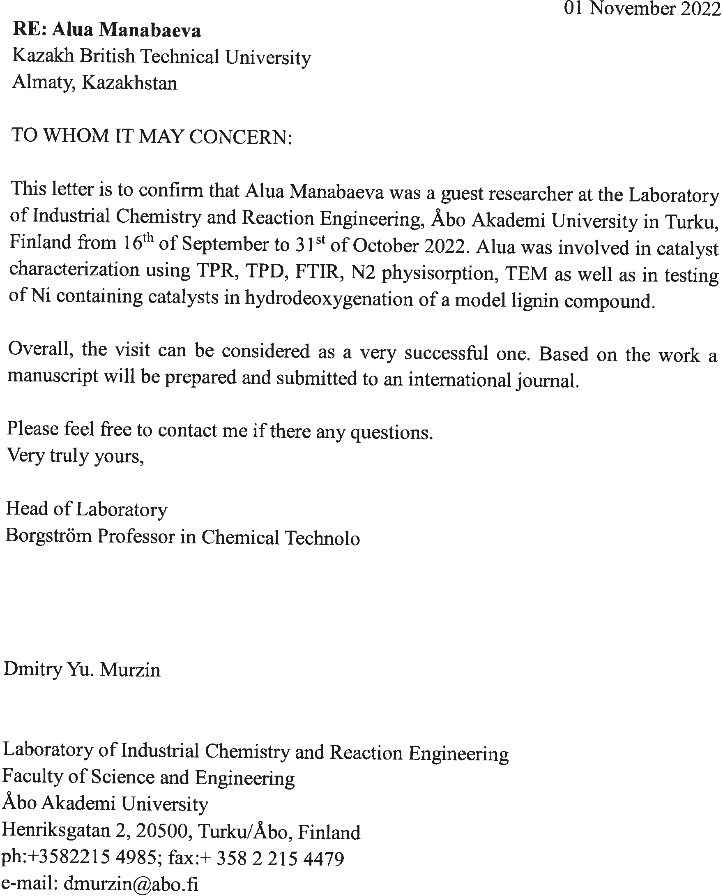

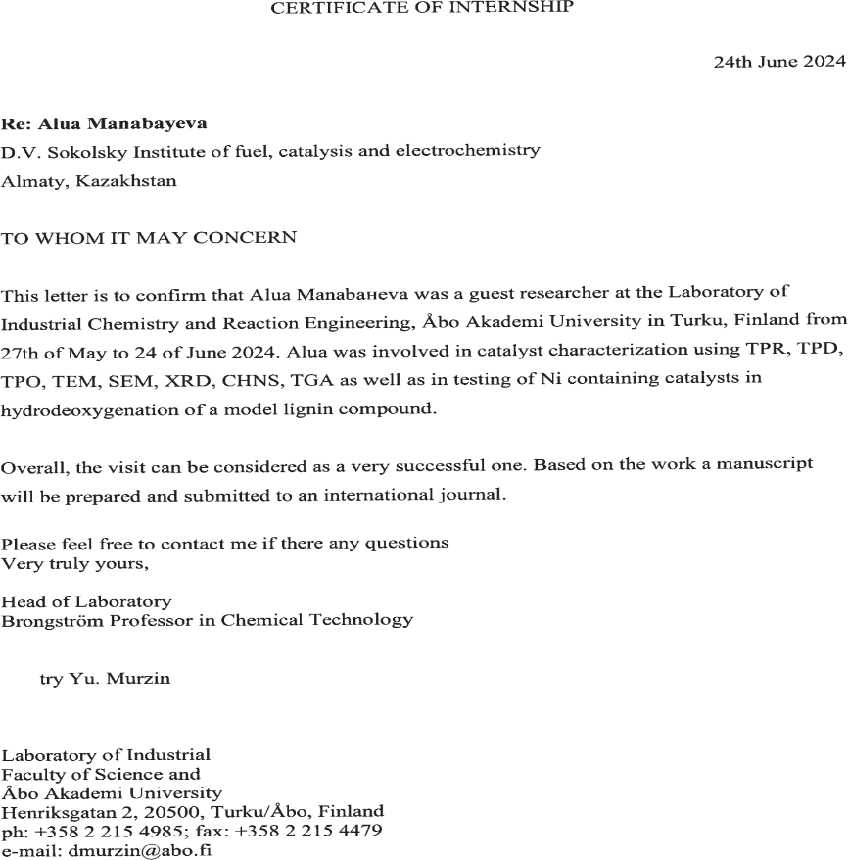

Attendance in the competition “Best student – 2022”

