AL-FARABI KAZAKH NATIONAL UNIVERSITY

UDC 544-971 On manuscript rights

KALIYEVA ASSEM MUKHTARKHANOVNA

Obtaining and investigating composite materials for the flameless heater

6D073400 – Chemical technology of explosives and pyrotechnics
Dissertation submitted in fulfillment of the requirements for the degree of Doctor of Philosophy (PhD)

Scientific supervisors:
Ye.Tileuberdi
PhD, ass.prof. of KazNPU
named after Abay,
Almaty, Kazakhstan

L.Galfetti

Full Professor of Milan

Polytechnic University,

Milan, Italy

Republic of Kazakhstan
2024

CONTENTS
 | NORMATIVE REFERENCES | 5
 | SYMBOLS AND ABBREVIATIONS | 6
 | INTRODUCTION | 7
1 | LITERATURE REVIEW | 12
1.1 | Modern and perspective energetic materials (EMs) | 12
1.2 | Flameless heaters based on exothermic reactions of pyrotechnics | 14
1.2.1 | Air activated heating systems: effects of oxygen and pressure | 14
1.2.2 | Heat releasing water-activated pyrotechnic powders for flameless heater | 16
1.2.3 | Exothermic compositions based on metals | 17
1.2.4 | Alkali metal based exothermic powder mixtures | 19
1.3 | Applications of flameless heaters | 21
1.3.1 | Military flameless heaters on the exothermic mixtures | 21
1.3.2 | Use of the flameless heater as a field-expedient means of warming in medicine | 23
1.4 | Aluminum and its alloys as a propellant, explosive and pyrotechnic substance | 25
1.5 | Effect of mechanical activation on the reactivity of energy-intensive materials | 31
1.6 | Setting Research tasks | 36
2 | METHODS OF CONDUCTING THE EXPERIMENT | 37
2.1 | Characterization of ingredients of the investigated pyrotechnic composite | 37
2.1.1 | Aluminum powder, their mechanical and physical properties | 37
2.1.2 | The basic oxidizer components | 38
2.2 | Mechanical activation of the powder | 38
2.3 | Thermodynamic calculation method performed using the NASA-CEA program | 39
2.4 | Physico-chemical research methods | 41
2.4.1 | SEM investigation | 42
2.4.2 | Laser granulometry distribution size measurement | 43
2.4.3 | Thermo-gravimetrical analysis | 43
2.4.3.1 | Simultaneous Thermal Analyzer (STA) 6000 (Thermogravimetric analyzer | 43
2.4.4 | X-ray Diffraction (XRD) System - SmartLab (Rigaku) | 44
2.4.5 | Differential Scanning Calorimetry (DSC) | 45
2.5 | Investigation the metal content and aging effects of the powders | 46
3 | DETERMINATIONS OF EFFECTIVE STRUCTURAL RATIOS OF PYROTECHNIC COMPOSITION (Al_{S}-Al_{F}-MnO₂-SiO) FOR AUTONOMOUS FLAMELESS HEATERS. DETERMINE THE OPTIMAL CONDITIONS FOR CONDUCTING MECHANICAL ACTIVATION OF ENERGY-INTENSIVE ALUMINUM-BASED COMPOSITES | 48
3.1 | The results of the study of the physico-chemical properties of aluminum powder (µAl) | 48
3.1.1 | Results of mechanical processing of aluminum powders and electron microscopy of their morphology and structure | 48
3.1.2 | Results of study of the aging process of Al powder | 50
3.2 | Determination of the optimal composition of the Als-Al_{F}-MnO₂-SiO system and its mechanical activation and study of physicochemical properties | 54
3.2.1 | Powder formulation and results of their mechanical activation | 54
3.2.2 | Results of study specific surface area (SSA) of Al-based composites | 56
3.2.3 | Size distribution of powder particles and composites after mechanical activation | 56
3.2.4 | Thermo-gravimetrical analysis. Non-isothermal oxidation at low-heating rate | 58
3.2.5 | Studies of metal content of the selected tested powders | 59
3.2.6 | Preliminary combustion tests | 60
4 | OBTAINING WATER-ACTIVATED EXOTHERMIC MIXTURE FOR FLAMELESS HEATERS ON THE SYSTEM Al-Cao-Na₂CO₃ WITH THE REQUIREMENTS OF AUTONOMOUS HEATERS FOR MEDICAL PURPOSES | 63
4.1 | The results of theoretical and experimental investigations of exothermic reactions in the system Al-Al₂O₃-CaO-Na₂CO₃ | 63
4.1.1 | Results of experimental studies of the system Al-Al₂O₃-CaO-Na₂CO₃ with water | 64
4.1.2 | Conducting thermodynamic calculations of the system Al-Al₂O₃-CaO-Na₂CO₃ using the NASA-CEA program | 68
4.1.3 | The results of differential scanning calorimetry (DSC) analysis of the system Al-Al₂O₃-CaO-Na₂CO₃ | 70
5 | OBTAINING OF A NEW EXOTHERMIC COMPOSITION Al-Al₂O₃-CaO-Na₂CO₃-SiO₂ FOR FLAMELESS HEATERS WITH THE ADDING OF SILICON DIOXIDE INTO THE INITIAL EXOTHERMIC COMPOSITE BY MECHANO-CHEMICAL ACTIVATION TO PROVIDES HEATING DEVICES IN THE FIELD | 72
5.1 | Optimization of composite ratios to obtain effective powder mixtures of the system Al-Al₂O₃-CaO-Na₂CO₃-SiO₂ and the effect of mechanical activation on their reactivity | 72
5.2 | Results of experimental studies of the interaction of activated mixtures of the system with water | 76
5.3 | Thermodynamic studies of the exothermic reactions of the system Al-Al₂O₃-CaO-Na₂CO₃-SiO₂ | 80
5.4 | Results of diffractometric studies of the system Al-Al₂O₃-CaO-Na₂CO₃-SiO₂ | 82
 | СOMPARATIVE DATA TABLE | 87
 | CONCLUSIONS | 88
 | REFERENCES | 89
 | APPENDIX A  List Of Published Works | 101

NORMATIVE REFERENCES

In the present thesis, the following references have been used:
GOST 3885-73. Reagents and highly pure substances. Sampling, packing, packaging and labeling.
GOST 24104-88. Laboratory scales.
GOST 50431-92. Thermocouples. Nominal static conversion characteristics.
GOST 8.417-81. Government system for ensuring the measurements uniformity. Physical quantities units.
GOST 7.32-2001. Report on scientific - research work. Structure and rules for formulation.
GOST 7.1-2003. Bibliographic record. Bibliographic description.
General requirements and compilation rules.
GOST 50431-92. Thermocouples. Nominal static characteristics of the conversion.
GOST 6058-73 Aluminum powders PA-4. TU 25.06.590-76.
GOST 9500-75. Dynamometers are exemplary portable.
GOST 8.417-81. The state system of ensuring the uniformity of measurements. Units of physical quantities.
GOST 12.1.003-83 System of occupational safety standards. Noise. General safety requirements
GOST 12.1.004-91 System of occupational safety standards. Fire safety. General requirements.
GOST 12.1.005-88 System of occupational safety standards. General sanitary and hygienic requirements for the air of the working area
GOST 12.4.021-75 System of occupational safety standards. Ventilation systems. General requirements
GOST 17.2.3.02.-78 Nature protection. Atmosphere. Rules for permissible emissions of harmful substances by industrial enterprises
GOST 2874-82 Drinking water. Hygienic requirements and quality control
GOST 29329-92 Scales for static weighing. General technical requirements
GOST 9179-2018 Lime. Technical conditions
GOST 6058-202 Aluminum powder. Technical conditions

SYMBOLS AND ABBRIVIATIONS

EMs | Energetic Materials
PC | Pyrotechnic composition
FH | Flameless Heater
FRH | Flameless Ration Heater
MRE | Meal, Ready-to-Eat
ALEX | Al produced by electrical explosion of wires (EEW, air-passivated)
RH | Relative humidity, %
C_{Al} | Active Al content, wt%
BM | Ball milling
MM | Mechanical milling
MA | Mechanical activation
MCP | Mechanochemical process
PCA | Process control agents
BPR | Ball-to-powder weight
μAl | micron-sized Al powder
Al_{S} | Spherical Al
Al_{F} | Fakes Al
μAl-7.5 | μAl with nominal size of 7.5 μm
μAl-30 | μAl with nominal size of 30 μm
D₃₂ | Surface-based mean diameter, μm
D₄₃ | Mass-based mean diameter, μm
DTA | Differential thermal analysis
DSC | Differential scanning calorimetry
TEM | Transmission electron microscopy
SEM | Scanning electron microscopy
TG | Thermogravimetry
XRD | X-ray diffraction
NASA/CEA | Computer program for thermodynamic calculations
O/F | The ratio of oxidizer to fuel

INTRODUCTION
Assessment of the current state of a scientific or scientific and technical problem. Energy materials are materials that emit heat during a chemical reaction, having a high amount of accumulated internal energy. Among the energy materials are: hydrocarbon fuel, rocket fuel, explosives, pyrotechnic compositions, etc. Pyrotechnic compositions indeed play a crucial role in various industries due to their ability to release intense energy through chemical reactions. These compositions are used in fireworks, flares, airbags, and even in some military applications. Their significance lies in their controlled release of energy, which can be tailored for specific purposes, whether for entertainment, signaling, safety, or defense.
One of the key attributes of pyrotechnic compositions is their energy intensity, which refers to the amount of energy they release per unit volume or mass during combustion. This characteristic determines their effectiveness for different applications. For example, in fireworks displays, pyrotechnic compositions with high energy intensity create vibrant colors and dramatic effects, while in airbags, compositions with controlled energy release ensure rapid inflation without causing harm to vehicle occupants. The development of new pyrotechnic compositions with enhanced energy intensity, stability, and safety features is an ongoing area of research and innovation. Scientists and engineers continuously strive to improve the performance and versatility of these materials to meet the evolving needs of various industries while prioritizing safety and environmental concerns.
Pyrotechnic formulations are widely used in pyroautomatics tools, pyrotechnic heaters, airbags, rocket engines as igniters, fireworks products, precipitation-causing formulations, products for extinguishing fires, etc.
In recent years, flameless heaters used in conditions where it is impossible to light a fire, use an electric source and blue gas, in open ground, in field conditions, or when the use of these sources of heat generation is limited due to natural and various adverse conditions, have become quite popular. To equip such autonomous heating devices, pyrotechnic powders based on energy metals (magnesium, calcium, iron, aluminum, etc., or their mixtures) are used, which are prone to carrying out an exothermic reaction. Classic types have been widely used in military places to warm up food or prepare it.
Formulations for flameless heaters are also widely used in the medical field. Due to the intense heating effect, thermo-heaters based on flame-free heating formulations are an indispensable first aid tool in order to relieve unpleasant and painful sensations in rheumatism, arthritis, osteochondrosis, bruises and fractures. Such heaters play an important role in providing first aid to various closed injuries, electric burners and field injuries that are difficult to obtain physiotherapy procedures.
Pyrotechnic compositions for such flameless heaters have a number of advantages: economy, ease of use, ease of management, fire safety, environmental friendliness, small size.
The prospects for the use of such heating elements are very wide.
The issue of their use in centralized production requires further continuous research. Modern technologies do not stand still, and even more so the question arises of the use of new formulations, which have more advantages, are cost-effective and safe for its transportation or long-term storage. In this regard, one of the urgent problems is the creation of environmentally friendly pyrotechnic compositions that have targeted characteristics.
Justification and initial data for the development of the thesis. Today, the use of flameless heaters for heating various liquids or solids in field conditions by activating chemical (exothermic) materials with water or air is becoming widespread.
The powder mixture for conducting an exothermic reaction is based mainly on magnesium, iron and additives based on them. In addition, the basic composition of these composites can also be replaced or supplemented with powders of calcium carbonate, sodium carbonate, calcium oxide and aluminum.
Based on literary sources and studying the existing pyrotechnic powders, one can also notice a number of their shortcomings.
The main part of the composition of existing flameless heaters consists of large particles, therefore, it interferes with the uniform distribution of intense heat at the stage of exposure to the redox process. The oxidation of coarse powder is intense only at the initial stage of the reaction, which inhibits the process of heat exchange with the substance to be heated, thus indicating a significant disadvantage. Another disadvantage is that a heating device that produces heat as a result of oxidation by an exothermic reaction can be flammable or prone to corrosion. That is, there is a high probability of limiting the expiration date.
Taking into account all the shortcomings of the previously studied flame retardant heaters, in this dissertation work, in order to improve these shortcomings, scientific research is carried out and the creation of new composites that meet modern requirements is envisaged.
Justification of the need to conduct this research work. The dissertation work is aimed at obtaining flameless heat sources with high energy efficiency. In order to implement an exothermic reaction, it is aimed at obtaining a new powder mixture of chemical composites based on aluminum, calcium oxide, as well as studying its effect on the reactivity and energy efficiency of a new exothermic composite using the mechanochemical processing method.
Data on patent studies and their conclusions on the planned scientific and technical level of development. During the implementation of the dissertation work, a review of the scientific, technical and patent literature was carried out, as a result of the analysis of the patent literature, it can be seen that the composition of currently existing flameless heaters consists only of magnesium, calcium, iron or their impurities. The size dimensions of these traditional formulations are large microns. It can be noted that no data on highly dispersed composites and the use of activation or composition modification methods were found in the patent literature.
Metrological support of the dissertation. In the course of research work, Metrological support was covered by the use of modern physicochemical methods of analysis performed using 9 certified methods, measuring instruments, equipment and instruments tested by the state standard bodies of the Republic of Kazakhstan.
Relevance of the research topic. It is envisaged to conduct research on the development of new energy-efficient materials, primarily in connection with the importance of their practical application in various fields. Research in the field of creating such materials includes volumetric synthesis, engineering and materials science, as well as microscopic research in the field of molecular dynamics and structure formation. Although Energy Materials began to be used practically from the early period, modern pyrotechnic mixtures, explosives require a lot of research and scientific updates.
Aluminum powders indeed have several advantages over other materials, as you've pointed out. Their high combustion enthalpy per unit mass makes them highly efficient in energy systems, as they can produce a lot of energy relative to their weight. This high performance is particularly beneficial in applications where weight is a critical factor, such as in aerospace or automotive industries. Moreover, aluminum powders are generally more affordable than other high-performance materials, providing cost savings without compromising on performance. Their safety in use, transportation, and storage is a significant advantage, as it minimizes the risk of accidents or mishaps during handling.The ability to easily obtain aluminum powders in various dispersed sizes allows for greater flexibility in the design and optimization of energy systems. This characteristic is particularly valuable in industries where precise control over particle size distribution is crucial for the system's performance.
Additionally, the extended shelf life of aluminum powders ensures their usability over an extended period, reducing the need for frequent replacements and maintenance. However, it is important to note that poor mixing of solid components in energy systems can lead to inefficiencies and compromised performance. Proper mixing techniques and thorough understanding of the system's requirements are essential to ensure optimal performance and safety. Poor mixing of solids components in energy systems, small contact surface areas, strong diffusion resistance make it difficult for solid-phase reactions to occur, they pass at a very slow speed and require long-term maintenance at high temperatures. Therefore, the next important direction of the doctoral dissertation is the use of the process of mechano – chemical processing (MCP) for the synthesis of highly dispersed flameless heaters. After all, it allows you to effectively manage the process of forming new structural compositions, which ensures an increase in the energy capacity of the system.
Scientific novelty of the work:
- For the first time, the Al_{S}-Al_{F}-MnO₂-SiO system for flameless heaters activated by air was obtained by mechanochemical activation, and was determined, that the maximum combustion temperature of the system is 886.4°C, the uniform combustion rate is 0.22 mm/s;
- The composite material Al-Al₂O₃-CaO-Na₂CO₃ was obtained, providing temperatures in the range of 28-55°C during the exothermic reaction, calculated thermodynamic characteristics: combustion temperature (T=859K) and enthalpy (∆G=21140.5 kJ/mol);
- The addition of SiO₂ to the Al-Al₂O₃-CaO-Na₂CO₃ system and the mechanochemical activation of the composite material made it possible to increase the temperature of the exothermic reaction with water to 101°C. It was calculated, that the combustion temperature of the system is 2134 K, and the value of ∆H is -9947.5 kJ/mol.
The research objective of the thesis is to obtain and study new energy-efficient composites based on highly dispersed aluminum powders, calcium oxide and silicon dioxide by mechanochemical activation for flameless heaters.
The object of the study is aluminum powders obtained by mechanochemical processing and high-energy pyrotechnic dispersed powders based on magnesium and calcium.
The subject of the study is the study of the influence of mechanochemical activation on the reactivity and structural stability of composite materials for flameless heaters.
To achieve the set goal, the following tasks were set:
- Development of air-activated flameless heater composites based on Al and SiO for autonomous heat sources and study of their energy and thermodynamic characteristics;
- Study of the influence of mechano-chemical treatment conditions and parameters on the reactivity of the composition of an air-activated flameless heater based on Al and SiO;
- Development of exothermic composites of water-activated flameless heaters based on calcium oxide and mechanically activated aluminum for flameless heaters for medical purposes;
- Development of a method for increasing the energy efficiency of a water-activated flameless heater based on CaO, Al by introducing SiO₂ into the composite system by mechano-chemical activation in order to expand the range of applications of the resulting composites.
Methodological base of scientific research. To conduct scientific research on the topic of the dissertation, the following modern laboratory tools and equipment were used: planetary mill "Retsch PM100", electron microscope "Pulverisette 5" Fritsch, Germany, Quanta 3D 200i, laser granulometer MALVERN MASTERSIZER 2000, for differential thermal analysis – NETZSCH 449f3a-0372-M.
Basic principles to be protected:
- Obtained air-activated composite material for a flameless heater by mechanochemical activation of the system Al_{S}-Al_{F}-MnO₂-SiO for 50 minutes, which is characterized by an Al content of 67.8%, a maximum combustion temperature of 886.4⁰С and a speed of combustion 0.22mm/s.
- Determined optimal composition of the water-activated system 40% CaO-30% Al₂O₃-15% Al-15% Na₂CO₃ for flameless heaters for medical purposes, which release heat up to 55⁰С, according to thermodynamic calculations, composite system gives an energy of 21140.5 kJ/mol at 859 K and in accordance with it, determined the compositions of the combustion product;
- Obtained water-activated composite material for flameless heaters for food heating purposes with adding 15% SiO₂ to the system Аl-Al₂O₃-CaO-Na₂CO₃ by mechanochemical modification of 15 min, which gives a temperature of up to 101⁰С, according to thermodynamic calculations, the combustion process of this system gives an energy of 9947.5 kJ/mol at temperature of 2134K.
The practical significance of the work is that on the basis of the results obtained, approaches were proposed to obtain composites for autonomous flameless heaters based on dispersed aluminum powders and their modification by mechano – chemical activation. The proposed methods can be used to replace metal impurities such as traditional magnesium, iron used in flameless heaters with a simpler and more affordable metal, as well as to improve the operational characteristics and shelf life of composites.
The personal participation of the author in obtaining the results of the dissertation consists in setting research goals, reviewing and analyzing domestic and foreign scientific and technical literature, performing a complex of experimental studies on the preparation of dispersed aluminum powders by preliminary mechano-chemical processing, obtaining composites for flameless heaters and converting them by mechano-chemical activation. It consists in analyzing the composition and properties of the obtained composites and products, processing and summarizing the results obtained, as well as identifying ways to solve the practical and theoretical problems posed, writing articles based on the results obtained.
Publications. The main results of the dissertation work were published in 7 printed works, of which 1 article was included in the Scopus and Thomson Reuters databases, 3 publications were published in publications recommended by the committee for control in the field of Education and science of the Republic of Kazakhstan, 3 printed works were published in collections of international scientific and practical conferences and symposiums.
Approbation of the work. The results of the dissertation were reported and discussed at the following international scientific conferences:
- Materials of the conference of students and young scientists dedicated to the 30th anniversary of the Institute of combustion problems (Almaty, November 30, 2017);
- X International Symposium “Physics and chemistry of carbon and Nanoenergy materials” (Almaty, September 12-14, 2018);
- International Conference of students and young scientists “Farabi Alemi”, April 8-11, 2019, Almaty, Kazakhstan.
The structure and content of the dissertation. The dissertation work is presented on 101 pages of machine-printed text and includes 34 Figures, 22 Tables. The work consists of an introduction, a review of the literature, a description of objects and research methods, results and their discussion, a conclusion and a list of 161 sources of literature used.

1 LITERATURE REVIEW
  - Modern and perspective Energetic Materials (EMs)

Energetic materials (EMs) are a class of material that can release chemical energy stored in their molecular structure. Upon external stimulations, such as heat, shock, or electrical current, these materials will emit energy in a short time [1-4].
EMs typically contain fuel and oxidizer, and do not require atmospheric oxygen to sustain the exothermic reaction. Upon decomposition EMs rapidly release large quantities of gaseous products, heat and pressure. There are three classes of energetic materials: pyrotechnics, propellants and explosives. Pyrotechnics are energetic mixtures that contain reducing agents (i.e. metal powders) and oxidizers (i.e. nitrates or perchlorates) in a composition rather than on the chemical structure of one molecule. The energy released by the non-detonative exothermic transition of pyrotechnics is accompanied by light, sound, gas, smoke, or a combination of these effects. Typically, pyrotechnic reactions proceed more slowly than explosive detonations and produce larger quantities of solid residue than gaseous products. Propellants are energetic materials that violently burn and do not explode. After initiation, propellants transition from solid to large volumes of gaseous products in millisecond or longer timeframes and exhibit a spark or flash. [5,6].
Propellants and pyrotechnics are designed to burn slowly through a process known as deflagration, where the reaction propagates through the material at subsonic speeds. This slow combustion process allows for controlled release of energy over a longer period, making propellants suitable for applications such as rocket propulsion and fireworks where a sustained release of energy is required [7].
The distinction between deflagration and detonation is crucial in understanding the behavior and applications of energetic materials. Proper selection of the type of material and understanding of the respective processes are essential in ensuring safe and efficient utilization of propellants, pyrotechnics, and explosives in various applications. Despite these differences, explosives, propellants, and pyrotechnics share several chemical similarities. In fact, explosive and propellant mixtures often share the same ingredients, although in different quantities. Energetic materials have numerous military and industrial applications. The vast majority of energetic materials are used by industry. There is a continuing need for improved energetic materials. In developing new energetic systems, one seeks optimal tradeoffs in energy content, safety, and cost. This is achieved through formulation, that is, combining known chemical compounds, and/or synthesis, producing new compounds. There are significant costs associated with either of these activities. In recent years, the demand for industrial and defense applications for energetic materials, including pyrotechnics, explosives, and propellants, inspired new developments in this field. The occurrence of advanced energetic materials in particular offers a unique new opportunity to improve the performance of energetic formulations [8].
The most important component of energy materials are pyrotechnic compositions (PC) containing in certain proportions combustible, oxidizing agents and other components in the form of highly dispersed powders. PC are one of the types of energy materials, the chemical energy of which is released under the action of an external pulse and converted into other types of energy. The peculiarity of PC is that chemical transformations in them occur mainly in the form of combustion - a self-propagating exothermic process that proceeds with relatively low linear velocities in the range from fractions of millimeters to meters per second. PC are widely used in various fields of technology to produce thermal, light, dynamic and many other useful effects. The fields of application of PC and their based products are constantly expanding, which is facilitated by the study of the mechanisms of their ignition and combustion, the creation of more and more effective compositions with desired properties, as well as the improvement of technological processes for processing pyrotechnic materials into products [9].
Traditionally pyrotechnics have been made from the fuel and oxidant in the form of finely-divided powders. Fuels have ranged from metals, such as aluminum, magnesium and iron, to non-metals, such as silicon, carbon, sulfur and some organic compounds. Oxidants have included oxides, peroxides and oxysalts. Various additives may be included to promote particular properties important to the manufacture or application of the pyrotechnics. Of more recent origin has been the development of bimetallic alloying pyrotechnics and the use of resin-bonded and polymeric materials [10-12].
Pyrotechnic compositions are used in military affairs and the national economy. Among the pyrotechnic compositions used in the national economy, it is necessary to distinguish: fireworks, thermite for exposure to supercooled clouds and mists, gas-generating, pesticide, for producing refractory metals, heating food, protecting gardens, match compositions to reduce shrinkage and shell formation during the cooling of molten metal, etc. They are also divided into plasma, aerosol-forming, thermal, and gas-generating. According to the technological properties, pyrotechnic compositions are divided into powdered, granular, thermoplastic and injection. Classification of pyrotechnic devices and compositions PС are traditionally divided into the following categories according to their use in pyrotechnic devices: lighting; photo-illuminating; tracing; compositions of night signal lights; compositions of colored signal lights; high-temperature, incendiary compositions; compositions of masking and protective fumes; flammable; infrared radiation; compositions of the signaling effect (imitation, dynamic, whistling, etc.); gas-generating; SHS systems – self–expanding high-temperature synthesis; gunpowder and mixed rocket fuels. Pyrotechnic compositions can also be subdivided depending on the nature of the processes occurring during their combustion into: 1) flame; 2) thermal; 3) smoke; 4) compositions burning due to oxygen in the air. The division of PC into these categories is purely conditional, because several categories of the same pyrotechnic compositions can be used in different pyrotechnic products [7,13].
One of the promising areas of application of pyrotechnic compositions and means are systems of various versions of autonomous heat and energy sources used to equip autonomous heating devices and vessels for heat transfer based on exothermic reactions (flameless heaters), because gas, electricity and other energy sources are not required for the operation of such heaters [14,15].

  - Flameless heaters based on exothermic reactions of pyrotechnics

Pyrotechnic compositions are incredibly versatile, and their effects can be customized by adjusting the types and proportions of chemicals used. Here's a brief overview of some common effects achieved through pyrotechnic compositions: different metal salts are often added to pyrotechnic compositions to produce vibrant colors when ignited. For example, strontium compounds produce red flames, copper salts produce blue or green flames, and barium compounds produce green flames. Metal powders, such as aluminum or magnesium, are commonly used to create sparkling effects. When these metals are ignited, they rapidly oxidize, releasing bright sparks. Some pyrotechnic compositions are designed to produce large volumes of colored smoke when ignited. This effect is achieved by incorporating specific chemicals that generate non-toxic smoke upon combustion [16-18].
One of the fairly new and promising types of pyrotechnic compositions are composites based on flameless exothermic mixtures, in which a large amount of heat is released. This makes it possible to use such mixtures as heat sources to heat vessels or to power heating devices .
An important advantage of flameless composites is their safety in use, since they do not emit flammable gases or open flames. In addition, they have a high energy density, which allows them to be efficient and compact heat sources.
However, when using composites based on flameless exothermic mixtures, their storage and handling must be taken into account, since they can be dangerous if used incorrectly. In addition, the selection of the optimal mixture and its dosage should be based on the requirements of a particular application in order to achieve the desired level of thermal energy.
In general, composites based on flameless exothermic mixtures represent a promising technology for various applications where efficient and safe heat sources are required. Their use can be especially useful in situations where it is necessary to provide autonomous heating or flameless heating, for example, on a hike, in space research or in industrial processes [19-21].

    - Air activated flameless heating systems: effects of oxygen and pressure
Flameless air-activated heating systems are innovative technologies that rely on the use of oxygen and pressure to provide heating. These systems have a number of advantages over traditional burner devices, such as gas- or electric-heated stoves.
One of the key advantages of using oxygen in flameless heating systems is the efficiency of combustion. Oxygen has a higher oxygen concentration than air, which contributes to the complete combustion of fuel. This increases energy efficiency and reduces emissions of harmful substances into the environment. In addition, the use of pressure in these systems allows for an even distribution of oxygen and fuel in the heating device. This contributes to more efficient combustion and uniform heating without flame formation. This technology eliminates the need for constant control and regulation of the flame size, which makes flameless heating systems safer and more convenient to use [22-27].
Flameless heating systems with air activation have found application in various industries, including industry, construction, agriculture and even household needs. They can be used for water heating, room heating, material handling and many other tasks. Due to their efficiency and environmental friendliness, flameless heating systems with air activation are one of the promising areas of development in the field of energy and heating.
Air-activated heaters and chemical warming devices utilize exothermic chemical reactions to generate heat for various purposes, including therapeutic applications.
The device typically has a peel-away layer that, when removed, allows air to penetrate the holes of the outer foil layer. This step initiates the activation process by exposing the reactive components to oxygen in the air. Once the peel-away layer is removed, air can enter the device and come into contact with the reactive components inside. The air reacts with the materials inside the device, which typically include activated carbon, electrolytes, and a rate-controlling binder. These components are carefully selected and combined to facilitate a controlled exothermic reaction.
The reaction between the air and the reactive components generates heat. In the case of air-activated chemical warming devices, one common mechanism involves the rapid oxidation of iron. This oxidation process releases energy in the form of heat, raising the temperature of the device. The heat generated by the exothermic reaction is then utilized for therapeutic purposes, such as providing warmth to the user's body or helping to alleviate muscle soreness or discomfort. These devices are designed to provide a controlled and safe source of heat, making them valuable for a variety of applications, including outdoor activities, medical treatments, and emergency situations [23-25]. The precise formulation of the reactive components and the design of the device play critical roles in ensuring optimal performance and safety.Placing these products in a hyperbaric oxygen environment greatly increases the supply of oxidant and thus increases the rate of reaction and maximum temperature. Testing for auto-ignition and maximum temperatures attained by ThermaCare Heat Wraps, Playtex Heat Therapy, and Heat Factory disposable warm packs under ambient conditions and under conditions similar to those encountered during hyperbaric oxygen treatments in monoplace and multiplace hyperbaric chambers (3 atm> 95% oxygen) revealed a maximum temperature of 269 F (132ºC) with no spontaneous ignition. The risk of thermal burn injury to adjacent skin may be increased significantly if these devices are used under conditions of hyperbaric oxygen [26].
The inscribed involves a portable flameless heating apparatus made from a flexible porous substrate. This substrate contains a reducing agent that undergoes an exothermic reaction upon oxidation, along with a promoter for oxygen reduction and a binding agent. Once an electrolyte is added, the apparatus generates heat through the reaction with ambient oxygen.
By utilizing ambient oxygen for the exothermic reaction, this flameless heating apparatus eliminates the manual addition of reagents, making it a convenient and environmentally friendly heating solution. The incorporation of a promoter for oxygen reduction and a binding agent further enhances the efficiency of heat generation. This innovative design presents a practical and effective alternative for portable heating devices, offering a streamlined manufacturing process and utilizing easily available atmospheric oxygen for operation.
The authors of the work [27] have investigated and developed an air-activated flameless heater based on Zn. An air-activated, flameless ration heater that harnesses the energy of oxidation of Zinc to heat an MRE entrée pouch in a reasonably simple, practical and cost-effective way has been achieved. The electrochemical heater is entirely self-contained, requiring only exposing the heater pouch to air. The rate of reaction or “cooking” time has been adjusted by controlling air permeation and heater configuration. The heater meets the Army specification of increasing the temperature of an eight-ounce water pouch from 40 °F to 140 °F (+100 °F) in less than 12 minutes.
The heater is based on the exothermic oxidation reaction of Zn:

Zn + O₂ → 2ZnO ∆H_{f} = -1.28 kcal/g Zn [27]

This electrochemical reduction of oxygen readily takes place on activated carbon. To achieve the reaction, Zn powder and activated carbon are embedded into a flexible binder substrate. This substrate is then rolled into sheets which can be cut, wrapped or folded into the desired form.
Air-activated reactions that utilize common metals, have been categorized as “difficult to control”, “produces extreme temperatures”, and “requires special handling procedures”. For these reasons, air-activated heaters have found niche markets at each end of the spectrum: slow reactions (hand warmers, medical heating pads) and very aggressive reactions (infrared countermeasures). No air- activated reactions have been demonstrated to operate safely, affordably, and fast enough to provide the time/temperature profile required for heating of the MRE. However, the application of this technology within combat rations extends far beyond only the MRE. The flexibility of the heater sheets provides for application to commercial beverages, soups, and other platforms.

1.2.2 Heat releasing water-activated pyrotechnic powders for flameless heater

Exothermic mixtures activated by water with the release of heat are a special type of chemical reactions in which heat is released. This is due to specially selected components of the mixture, which react with water with high reaction energy. When an exothermic mixture interacts with water, an exothermic reaction occurs, resulting in a significant amount of heat being released. The heat released during the reaction can be used for various purposes, such as heating, heating water, or powering technical systems.
The most common example of an exothermic reaction with water is the reaction between aluminum and water. Aluminum reacts with water, releasing heat and forming an aluminum hydroxide mixture. This reaction can be used to generate heat, for example, to heat water in a heating system or generate steam.
Another example of an exothermic reaction with water is the reaction between calcium and water. When calcium interacts with water, calcium hydroxide is formed and a large amount of heat is released.
Activating the mixture with water is a simple and effective way to turn on the reaction. It is enough to add water to the exothermic mixture, and the reaction will begin, accompanied by the release of heat. This makes it possible to widely use exothermic mixtures with water activation in various industries, including construction, industry, firefighting and others [28-30].

1.2.3 Exothermic compositions based on metals

Most of the works presented compositions for flameless heaters, the main components of which are involving metals from the group Fe, Mg, Al, Zn, and oxides of metals with variable valences such as MnO₂, PbO₂, Ni₂O₃, for carrying out exothermic oxidation-reduction reactions [14,20]. These reactions are often utilized for various applications, including the production of hydrogen and heat generation. One specific example mentioned is a magnesium-iron alloy prepared through a "mechanical mixture" method. This alloy, containing up to 10% iron by weight, is produced in a ball mill by mixing magnesium and iron powder in an inert solvent. After solvent evaporation and excess iron separation, the resulting alloy exhibits high reactivity with water, especially in the presence of sodium chloride, with a specific heat of reaction up to 5.6 kJ/g (Mg) [14,31].
However, the rapid reaction rate of this mixture with water limits its efficiency in heat exchangers, making it more suitable for hydrogen production devices. To address this limitation, methods for producing magnesium alloys with various metals including iron, iron oxide, zinc, chromium, aluminum, and manganese, are of interest. These alloys aim to form a phase interface between magnesium and the respective metal, promoting micro electrochemical cell formation [14].
In works [32-37], a heating device is presented in which heat is generated by oxidizing an exothermic composition of aluminum, copper sulfate, potassium chlorate, and calcium sulfate activated by adding water. The reaction of the mixture produces gases, which can be flammable or corrosive [14].
The work [29] describes various methods and compositions used for flameless heating, particularly focusing on devices utilizing magnesium alloys reacting with water to generate heat:

Mg(s) + 2H₂O(l) → Mg(OH)₂(s) + H₂(g) + heat [ΔH = –351 kJ/(mol Mg)] [29]

The electrochemical heater pads rely on a reaction triggered by the addition of water [14,30]. When water is added to the electrochemical heater pad, it initiates the reaction between the components inside. The reaction between the magnesium anode and iron cathode produces various reaction products. In this case, the main product is a nontoxic residue composed of magnesium hydroxide [Mg(OH)₂] dissolved in a saline solution [14,29,30].
The activation of electrochemical heater pads by water triggers a series of reactions between the magnesium anode and iron cathode, ultimately producing heat and generating a nontoxic residue consisting primarily of magnesium hydroxide dissolved in a saline solution. These heater pads are commonly used for applications where a portable and safe source of heat is required, such as outdoor activities, emergency situations, or medical treatments. The electrochemical heater pads are activated by the addition of water. After reacting with water, a nontoxic residue is produced which consists of a weak solution of magnesium hydroxide [Mg(OH)₂] in a saline solution. The reactions and reaction products between the magnesium anode and iron cathode are divided into three types [14,30]:

- Electrochemical Reaction:
Air Cathode: O₂ + 2H₂O + 4e → 4 0H⁻ Anode: 2Mg →2Mg⁺² + 4e⁻
Net Electrochemical Reaction:
2Mg + 0₂ + 2H₂0 → 2Mg(OH)₂
Corrosion Reaction:
Mg + H₂0 → Mg(OH)₂
Mg²⁺ + 2Сl⁻ → MgСl₂
- Hydrolysis Reaction:
MgCl₂ + H₂O + OH⁻→Mg(OH)Сl⁻(H₂O) + Cl⁻ [14,30]

This new flameless electromagnetic heater sounds like an innovative solution, especially for military field conditions where traditional heating methods might not be feasible or safe. Using hysteresis and vortex thermal power in solid iron, along with thermal short-circuit power in short copper rods, to generate heat is quite clever. Developing a mathematical model based on the inverse problem of temperature increase and losses in electric machines seems like a rigorous approach [14,33,34]. It allows for a deeper understanding of how the heater functions and how to optimize its efficiency and performance.
The finite element analysis mentioned in the study is crucial for understanding the distribution of magnetic fields, eddy currents, and short-circuit currents within the heater. This analysis likely provides valuable insights into how these factors interact and affect the overall heating process. Regarding magnesium-based compositions, the article discusses several disadvantages associated with their use. Magnesium's interaction with water releases heat, but this reaction is limited to a pH below 8.5. Increasing the pH leads to passivation of the magnesium surface, hindering further interaction with water. To regulate the reaction rate, additional compounds that affect pH must be introduced. Acid anhydrides, free acids, and salts of strong bases and weak acids are examples of such compounds [14,29,30].
However, these additional compounds decrease the magnesium content in the mixture, reducing the overall heat release efficiency. To enhance heat release, magnesium alloys with metal catalysts are utilized, creating micro-galvanic elements. Despite these improvements, magnesium-based compositions still exhibit uneven heat release, primarily at the beginning of oxidation-reduction reactions. This unevenness poses challenges for efficient heat exchange with heated objects [14,30].
Moreover, the nature of oxidation-reduction reactions necessitates complex, multi-compartment designs for heaters and compresses. Proper mixing of components is required to initiate the reaction, which can be inconvenient for practical use [14].
In summary, while magnesium-based compositions offer potential for heat generation, they face challenges related to reaction control, heat release efficiency, and storage stability. Research continues to address these limitations and improve the practicality of such compositions for various applications.

1.2.4 Alkali metal based exothermic powder mixtures

Since the early 1900s, there has been interest in utilizing alkali metal carbonates for heating purposes. One notable application was in self-heating canned goods, which were initially designed for mountain expeditions and exploration. For instance, American balloonist Alan Ramsey Howley mentioned using self-heating soup cans during his 1910 Gordon Bennett Cup balloon race victory. Similarly, archaeologist Hiram Bingham documented using self-heating canned food during his travels through South America from 1909 to 1915 [14,38].
Despite these early uses, self-heating packaging did not become widely adopted. During wartime, self-heating canned goods were primarily reserved for military use and only returned to civilian shelves six years later. However, even after their reintroduction, they did not gain mass popularity due to their high prices. Consequently, self-heating technology remained predominantly associated with military applications for a long time.
In more recent times, there has been renewed interest in self-heating technology, particularly in packaging. Matthew Searle, who currently leads the company Steam to Go, was involved in the development of self-heating technology for Nescafe coffee in 2002 as the director of development at Thermotic Developments [14,39]. This technology involved placing a thermos-block containing water and calcium oxide (quicklime) within standard 330ml drink cans. Upon activation, the quicklime would react exothermically with water, heating the contents of the can.
The history of self-heating technology demonstrates its evolution from early military applications to contemporary commercial use, with ongoing innovation driving its development in various industries.
The composition of the heat source, consisting of a dry powdered mixture of alkaline earth peroxide, alkali carbonate, and a reducing agent, is intriguing [14,40]. This combination likely facilitates the controlled release of thermal energy when water is added, triggering exothermic reactions between the components. The process by which the alkaline earth peroxide and alkali carbonate produce peroxide in solution, which then reacts with the reducing agent to generate thermal energy, sounds efficient and straightforward [14]. This mechanism likely ensures a reliable and consistent source of heat for heating meal-ready-to-eat packages.
Key components of the invention may include [38].
- Alkaline Earth Peroxide: This compound likely serves as one of the primary sources of oxygen for the exothermic reaction. It contributes to the production of peroxide in solution when water is added.
- Alkali Carbonate: The alkali carbonate likely plays a role in adjusting the pH of the solution and possibly acts as a catalyst for the reaction between the alkaline earth peroxide and the reducing agent.
- Reducing Agent: This component is crucial as it reacts with the peroxide produced in solution to generate thermal energy. The choice of reducing agent is likely carefully considered to ensure efficient heat production without unwanted byproducts.
The invention's ability to generate heat without the need for an external flame or electricity makes it particularly suitable for meal-ready-to-eat packages, where portability and simplicity are essential. It could prove invaluable for military personnel, outdoor enthusiasts, or emergency preparedness situations where access to traditional heating methods is limited. The proposed reaction involves the interaction of these components upon the addition of water, resulting in a controlled exothermic reaction without the substantial emission of hydrogen gas. The specific chemical reactions involved in this process are not provided in the excerpt, but the described components are intended to facilitate a safe and efficient heat generation mechanism suitable for meal-ready-to-eat packages [39]:

3CaO₂+3Na₂CO₃+2Al=3CaCO₃+2NaAlO₂+4NaOH [39]
In these work, discusses various methods and compositions used for generating heat through exothermic chemical reactions, particularly for heating food.
Indeed, a wide range of reactants, both liquid and solid, can undergo exothermic reactions, producing heat as a result. Here are some examples of such reactants: Quicklime (Calcium Oxide, CaO)-reacts exothermically with water to form calcium hydroxide (slaked lime), releasing heat in the process, sodium Hydroxide (NaOH)-an alkaline compound that releases heat when dissolved in water, a highly exothermic reaction. Each of these substances has its unique properties and reactivity, which can be harnessed for various applications requiring heat generation. Depending on the specific requirements of the application, different reactants may be chosen to achieve the desired outcome efficiently and safely. Additionally, the choice of reactants may also depend on factors such as cost, availability, and environmental considerations [39,40].
Various reactants, both liquid and solid, are investigated for their ability to produce heat through exothermic reactions. Examples include quicklime (CaO), sodium hydroxide, metallic elements like cobalt, chromium, iron, magnesium, manganese, molybdenum, tin oxide, titanium, and sodium, as well as compounds like calcium hydroxide, sulfuric acid, and nitric acid. These reactants typically generate oxides that react with oxygen at room temperature, producing heat [38,41].
Container Design for Exothermic Reactions, Consideration is given to the design of containers to facilitate exothermic reactions. Special containers, such as disposable trays with compartments separated by watertight partitions, are designed to allow controlled mixing of reactants upon activation. These containers may include tearing elements or control knobs for user activation.
The analysis of literature highlights the importance of studying and determining exothermic compositions for food heating, emphasizing the need for both high heat generation and controlled release for practical applications [14,38].

1.3 Applications of flameless heaters

Flameless heating systems have a wide range of applications in various fields. Here are some examples of using such systems [38-51]:
1. Heating: Flameless heaters can be an effective solution for space heating. They work on the basis of special technologies, such as infrared radiation or ceramic or graphite-based heating elements. These systems provide fast and uniform heating, do not require gas or fuel connections, and are highly energy efficient.
2. Industrial processes: Flameless heaters are widely used in industry to heat various materials or media. They can be used for preheating materials in production lines, for drying or surface treatment, as well as for heating liquids in tanks or containers.
3. Agriculture: Flameless heaters can be useful tools in agriculture. They can be used to maintain optimal temperatures in greenhouses or greenhouses, to heat water for animals or birds, as well as to combat frost or icing in fields or crops.
4. Medical industry: Flameless heaters are used in the medical industry to maintain a certain temperature in medical instruments or equipment, to warm up liquids or solutions, as well as to heat rooms in medical institutions.
5. Automotive industry: Flameless heaters can be used in the automotive industry to heat the interior of cars or trucks, as well as to warm up the engine or fuel heating.
6. Military Applications: Flameless heaters also find application in military applications. They can be used to heat living quarters, canteens or shelters, as well as to heat food or water in field operations.
So, depending on the specific needs and conditions, they can be adapted and used in a variety of other industries and fields of activity.

1.3.1 Military flameless heaters

Flameless ration heaters first of all used for the flameless cooking of a self-heating meal known as Meals, Ready to Eat (MRE). The technology behind flameless ration heaters is based on a combination of food grade iron and magnesium. When salt water is added to the iron-magnesium combination, the mixture results in an exothermic reaction, reaching temperatures of up to about 100°C in a relatively short amount of time. This rapid rise in temperature is used to then cook the MRE. They are used extensively by the military as a method of providing meals to soldiers while in the field; however, they are finding their way into other uses, and are now being used by campers, boaters, disaster response teams, etc [52].
The need for hot meal rations for military personnel resulted in an investigation into the design of a flameless heating device. The criteria for an optimal heating system, as outlined in the initial studies, are indeed critical considerations, especially for military applications where lightweight, safety, convenience, and efficiency are paramount. The U.S. Army's Natick Research, Development, and Engineering Center (Natick) recognized these requirements and sought innovative solutions to meet them [14,30]. Studies concluded that the pad would require certain modifications in order to be utilized. In 1980 the Navy conducted research on electrochemical reactions, based on powder metallurgy, for use in certain devices. Natick provided additional funds for the ongoing research since the products would be more cost-effective. The research resulted in the development of a portable electrochemical heater, referred to as the Dismounted Ration Heating Device (DRHD). The DRHD consisted of chemical heating pads composed of magnesium-iron alloy attached to the inside surfaces of the insulated pouch, and a separate pouch containing saline solution. The DRHD was considered too bulky and fragile to use in an operational environment. The principal inventor of the chemical heating pad used in the DRHD formed a corporation called ZestoTherm Inc., soon after filing a patent for the device. ZestoTherm modified the heating pad and developed the flameless Combat Ration Heater (CRH) by 1986. In 1989, the Food Engineering Directorate (FED) initiated a program to provide a more convenient and effective method of heating the MRE entree. The result of the program was the development of the Flameless Ration Heater (FRH) which is now used to heat MRE entrees [45].
This heat of reaction is utilized to warm soldier meal rations in the field. This heater consists of magnesium, iron, polyethylene powder, salt, surfactants and buffering agents blended together and sintered' into a 3.5" by 4.5" by 0.125" flexible pad. Magnesium was chosen as the anodic material because of its relatively high energy density, cost and availability. In the presence of salt water, magnesium oxidizes slowly and energy is not produced at a usable rate. However, when anodic magnesium and cathodic iron materials are electrically connected, forming an electrochemical cell, the system sufficiently liberates energy (heat) for use as shown in the following equation [45]:
Mg + 2H₂О Mg(OH)₂ + H₂ + Q H = -86.6 kcal/mole [45]

One by-product of the magnesium-to-magnesium hydroxide conversion is the production of hydrogen gas. Hydrogen is a small molecule and the lightest of all gases. It is considered flammable in air within the concentration range of 4.0 to 74.2 volume percent and detonable within 18.3 to 59.0 volume percent. The auto-ignition temperature for hydrogen is 550° C, thus making hydrogen very difficult to ignite under ordinary circumstances. Hydrogen burns cleanly producing water as the by-product with very little radiation. The FRH product weighs about 36 grams. It consists of a heater pad weighing approximately 20 grams, a heater cover weighing 8.8 grams and a high-density polyethylene outer bag weighing about 7 grams. The heater requires approximately 2 ounces of activating water for the reaction to go to completion. The amount of hydrogen produced during the reaction is approximately 0.7 grams. This information is based on the reaction above which states for every gram mole of magnesium reacted one gram mole of hydrogen is produced. Therefore, 8 grams of magnesium (0.33-gram moles) will react with water to form 0.33-gram moles of hydrogen or 0.66 grams [43-45].
Today it is considered very popular to use flameless heaters designed for fast heating of liquids or solid food products through exothermic reactions in the field, by mixing a chemical reagent with water. In recent years, the scope of application of flameless heaters has expanded significantly in various industries, due to the lack of the need for a fire, the use of open flame, the absence or impossibility of using electric and gas heating devices. Thermo-packaging has been known for a long time, which contains a mixture of chemicals for the exothermic reaction. The heating element in contact with water generates heat. In this case, the hermetically sealed product is heated due to contact with the heating element. Classical examples are provided by the military to heat ready-to-eat portioned meals (“MRE”). In addition to the military, there are many other consumers, such as emergency rations for shelters, for a field athlete, and for heating non-food items [46-51].

1.3.2 Use of the flameless heater as a field-expedient means of warming in medicine
The proposed compositions are used in medicine as a warming compress on any part of the body, near the focus of pain. This is a new solution in the field of warming in the cold season. They are recommended for use by lovers of winter holidays or for those who have been in the cold for a long time. The thermal package will help you quickly and effortlessly warm up for skiers, hunters, fishermen, fans, builders, military, motorists, etc. Warming bags are an environmentally friendly source of heat that retains warmth and comfort in all cold conditions [52-55].
Thermo-bags have also found a wide range of applications in the field of medicine. Such heaters play a vital role in the application of first aid for various injuries, injuries in the field, where it is difficult to get electric heaters or physiotherapy. Due to the intense warming effect, body heating pads based on flameless heaters relieve unpleasant and painful sensations during rheumatism, arthritis, osteochondrosis, bruises and sprains. Increases the effectiveness of therapeutic ointments (dry heat accelerates the healing process) [52].
These heat packs are an economical, safe, and reliable way of delivering heat to bruises to relieve muscle pain. It is important that there is a constant change (improvement) of the compositions and structure of the mixtures through the use of new components, as well as changes in technological methods and manufacturing conditions, as a rule, in the direction of their intensification and / or "tightening" [53].
Heat packs also used to treat stiff muscles as they recover from overexertion. A patient suffering from Bell's Palsy or other facial ailments may also benefit from them. Other typical uses of these items are personal hand warming, preparation for scuba diving and hypothermia treatment. They may also be found in food containers designed to transport casserole dishes or other hot meals [54].
Also studied [55-67], that the study outlined addresses a critical issue in prehospital medical care: the prevention and management of hypothermia, particularly in trauma victims. The ability to efficiently heat intravenous fluids (IVF) in cold environments is crucial for preventing further core cooling and improving patient outcomes. The study highlights the limitations of current IVF heating systems, particularly in terms of their weight, energy efficiency, and battery life. Flameless ration heaters (FRHs) from meals ready to eat (MREs) are identified as a potential solution due to their portability and ease of use. However, existing models lack standardization, making it challenging to consistently deliver warmed IVF.
The aim of the study is to establish a reliable method for heating IVF to recommended temperatures across a range of ambient conditions using an insulated pouch and commercially available FRHs. This research is valuable for forward-deployed medical units that lack the capability to warm IV fluids before administration.
By demonstrating a field-expedient means of warming IV fluids using the flameless heater available in MREs, the study aims to prevent hypothermia and improve patient outcomes in challenging environments where resources are limited. This research could have significant implications for prehospital care, especially in situations where hypothermia is a common risk factor. Room-temperature and refrigerated lactated Ringer's solution were organized into three data collection groups using either one or two MRE heaters. The temperature change of the fluid was recorded. Average temperature increases ranged from 15.8 to 31.2⁰C in times ranging from 8 to 20 minutes. Therefore, they conclude that the flameless MRE heater provides a simple, field-expedient means of warming IV fluids before their administration [56].
The cited study investigates the use of air-activated thermal devices (AATD) as a means of providing thermal support for laboratory mice, particularly focusing on their susceptibility to hypothermia in various conditions. Laboratory mice are prone to hypothermia, especially during anesthesia, illness, and exposure to environmental stressors [57]. Maintaining their body temperature within a suitable range is crucial for their health and well-being. While there are many thermal support devices available for small mammals, they often require a power source and may not be practical for use in cages on racks, which are common in laboratory settings. AATDs are chemical mixtures that undergo an exothermic reaction, generating heat without the need for external power sources. They offer a potentially convenient and efficient solution for providing thermal support to laboratory animals.
The study examines the environmental effects of AATD on internal cage temperatures without the need for additional equipment. It found that AATD raised temperatures inside the cage, with peak temperatures reaching 35.6 ± 2.5 °C, significantly higher than control cages [58,59].
The study also investigates the physiological effects of AATD as postoperative thermal support for mice. It found that mice with AATD showed less marked drops in body temperature during the initial hours after surgery compared to those without AATD. The physiological results suggest that AATD can provide extended thermal support for mice housed in static micro-isolation cages, helping to maintain their body temperature post-surgery. This finding has implications for improving postoperative care and recovery in laboratory animal research [57-59].
The amount of heat produced by AATD and its temporal distribution were found to be dependent on cage and rack types, highlighting the importance of considering environmental factors when using such device. Overall, the study demonstrates the potential utility of AATD in providing localized and clinically relevant thermal support for laboratory mice, both in environmental and physiological contexts. This could have significant implications for improving the welfare and outcomes of research involving small mammal models [60-67].

1.4 Aluminum and its alloys as a propellant, explosive and pyrotechnic substance
The description provided highlights some key properties of aluminum that make it a preferred choice for energetic materials:
- High Density-Aluminum possesses a high energy density, making it an efficient fuel for energetic systems. The enthalpy of oxidation in oxygen (31.0 kJ/g Al) indicates the amount of heat released when aluminum undergoes combustion, showcasing its potential as a source of energy [68,69].
- Low O₂-Demand-Aluminum has a relatively low demand for oxygen during combustion compared to other materials, which contributes to its effectiveness as an energetic material. This characteristic can enhance the efficiency of combustion reactions.
- Cost-Effectiveness-Aluminum is comparatively inexpensive, making it an attractive option for use in condensed energetic systems. Its affordability contributes to its widespread utilization in various applications [70].
Additionally, the mention of aluminum particles being passivated by air and having a layered structure with a metal core surrounded by an amorphous Al₂O₃ shell highlights the importance of surface chemistry and structure in controlling the reactivity and stability of aluminum-based energetic materials [71,72,77]. The presence of the oxide shell helps to prevent uncontrolled reactions and can influence the kinetics of combustion processes. These characteristics make aluminum a versatile and practical choice for use in a range of energetic systems, from propellants and explosives to pyrotechnics and power generation.
The provided information delves into the controlled generation of the Al₂O₃ layer on aluminum powder during production and its significance in preventing rapid reaction with the surrounding environment [72,73]. The intentional application of an aluminum oxide layer to the surface of aluminum powder is an essential manufacturing process that helps to stabilize the metal and prevent further oxidation. This protective coating is created through controlled exposure to oxygen during the manufacturing process, forming a barrier around each individual aluminum particle that shields it from corrosion. The thickness of the oxide layer on aluminum particles, typically around 4-5 nanometers at temperatures up to 673K, remains relatively stable, regardless of the particle morphology or size [72,73]. This is due to the diffusion of oxygen into the aluminum core, which helps to maintain the stability of the oxide. However, when the temperature exceeds 673K in the presence of oxygen, the thickness and crystal structure of the oxide can change, leading to temperature-dependent behavior that affects the stability and reactivity of the powder.
Industrial aluminum powders are usually micrometer-sized particles that have been passivated in air and contain a high percentage of aluminum (typically more than 95%). They have a specific surface area of less than 1 square meter per gram, making them suitable for applications that require precise reactivity control. It is worth noting that aluminum powders on the nanoscale have increased reactivity when compared to those of micrometer sizes. This increased reactivity is due to their higher specific surface area (typically ≥ 10 m²/g) and reduced aluminum content (typically < 90 wt%) [73,74]. Nano-sized powders are often used in applications where rapid and controlled reactions are necessary, such as in energetic materials or catalysts.
Understanding the properties and behavior of aluminum powders, including the formation and stability of the oxide layer, is crucial for optimizing their performance in various applications, from industrial processes to advanced materials development. Aluminum can act as a water-splitting agent for hydrogen production. The reaction of aluminum with water yields hydrogen gas, with a gravimetric hydrogen capacity of 3.7 wt% and a volumetric capacity of 46 g H₂/l [75].
The reaction between an aluminum particle and water at neutral pH forms a core-shell structure, with the aluminum core surrounded by a hydroxide shell. This structure facilitates the diffusion of ions or water molecules through the hydroxide layer to reach the aluminum core, where the reaction occurs at the interface between the core and the shell [76].
The diffusion of aluminum-containing ions outward to the surface of the oxide/hydroxide shell is a crucial step in the reaction of aluminum with water, particularly at neutral pH [77]. Despite the negligible solubility of aluminum ions in water, they react with water molecules on the shell's surface to form compounds such as aluminum hydroxide (Al(OH)₃) or aluminum oxyhydroxide (AlOOH), contributing to the thickness of the shell. The diffusion of these ion species or water molecules through the hydroxide layer is considered the rate-limiting step for the reaction between aluminum and water. As the hydroxide layer thickens and densifies, the diffusion process slows down, leading to a decrease in the rate of hydrogen generation [78,79].
To enhance the efficiency of the reaction and promote hydrogen generation, scientists have conducted extensive research. This research aims to develop strategies to overcome the limitations imposed by the diffusion process, such as modifying the structure or composition of the aluminum particles, optimizing the conditions of the reaction, or introducing catalysts to facilitate the reaction kinetics.
Ball milling (BM) of aluminum powders, either monolithic or mixed with various other materials, has been explored as a method to activate the reaction of aluminum with water. These additional materials can include low melting point (LMP) metals such as gallium (Ga), indium (In), bismuth (Bi), mercury (Hg), and zinc (Zn), as well as water-soluble salts like sodium chloride (NaCl) and potassium chloride (KCl), and ceramic powders such as aluminum oxide (Al₂O₃), titanium dioxide (TiO₂), carbon (C), silicon dioxide (SiO₂), and aluminum hydroxide (Al(OH)₃) [80-82].
The research aims to understand how BM influences the microstructure and reactivity of aluminum particles in the context of the aluminum-water reaction. This understanding is crucial for optimizing the performance of aluminum-based systems for hydrogen generation, particularly in fuel cell applications [83].
The approach outlined for discussing the crystallography of aluminum and its alloys is indeed structured and comprehensive. This aspect involves understanding the basic crystal structure of pure aluminum. It includes identifying the arrangement of atoms in the crystal lattice and any deviations from ideal crystal symmetry. The analysis of the crystal lattice parameter, which is the distance between the points in the crystal structure, allows us to gain valuable insights into the coefficient of linear thermal expansion for aluminum. This parameter reveals the changes in the arrangement of atoms within the crystal as temperature fluctuates [84-89]. Understanding the extent of atomic vibrations within the lattice as temperature varies is essential, as these vibrations significantly influence the mechanical and thermal characteristics of the material. Interatomic bonds play a fundamental role in determining the crystallographic characteristics of a material, allowing us to understand the nature of interactions between atoms in a crystal structure. This knowledge is essential for understanding the behavior of materials under different conditions and predicting their responses to external stimuli, such as mechanical and thermal stresses. By studying these bonds, researchers gain insight into the structural stability, strength, and thermal properties of materials, such as aluminum [85]. Analyzing the nature of the bonds between aluminum atoms is essential, as it drives all other aspects of material properties. By thoroughly examining these aspects of the crystallography of pure aluminum, researchers can develop a comprehensive understanding of its structure and behavior. This understanding serves as the foundation for discussing aluminum alloys.
This hierarchical approach ensures a systematic and thorough exploration of the crystallography of aluminum and its alloys. By following this approach, researchers can establish a solid foundation for understanding the properties and behavior of these materials, which is essential for various engineering and industrial applications. The face-centered cubic (fcc) crystal structure of pure aluminum is indeed a close-packed arrangement of atoms, representing one of the densest geometric packings of spheres possible [86]. In the fcc structure, each atom is surrounded by twelve nearest neighbors arranged at the corners of an octahedron, with additional six neighbors located at the centers of the faces of the cube.
The layer sequence in the fcc structure follows an ABCABC... pattern, where each layer (starting from the bottom) consists of three planes of atoms: A, B, and C. This sequence repeats indefinitely, creating a highly symmetric and efficient packing arrangement.
In summary, the fcc crystal structure of pure aluminum features atoms arranged in a closely packed manner, with a repeating ABCABC... Layer sequence, as illustrated in Figure 1. This structure provides aluminum with its characteristic properties, such as high ductility, conductivity, and corrosion resistance.
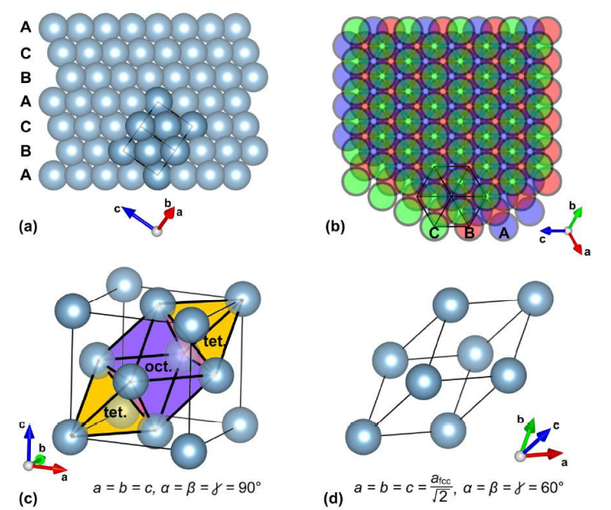

Figure 1 – The face-centered cubic crystal structure of pure aluminum [86]

The description in Figure 1 [86] provides a visual representation of the face-centered cubic (fcc) crystal structure of aluminum, emphasizing key aspects of its atomic arrangement. (a) In the fcc crystal structure of aluminum viewed from above, there is a dense packing of atoms in an A-B-C-A-B-A pattern. Each layer of atoms is represented by a different color: blue for A, red for B, and green for C. Atoms within a single unit cell are darkly colored, and the boundaries of the cells are indicated for reference. (b) From the perspective of, it is clear that the layers are arranged in the A-B-C order, but they do not align exactly with the direction. (c) To prevent atoms from overlapping, a smaller-sized atomic model is provided, which allows a more accurate representation of their positions. (d) Densely packed structures, such as fcc, contain twice as many tetrahedral gaps as octahedral gaps. The figure shows an octahedral internode located between two tetrahedral nodes, forming a primitive rhombohedral unit cell. This unit cell, containing only one atom, effectively describes the crystal structure. Additionally, for reference, the relationships between the lattice parameters of face-centered cubic and primitive units are provided, which help to understand the geometric properties of the crystal lattice [86,87].
So, Figure 1 provides a comprehensive visual understanding of the face-centered cubic crystal structure of aluminum and its key features, including atomic arrangement, interstitial spaces, and cell representations.
Understanding this relationship is crucial for understanding the spatial distribution of atoms and internodes in crystalline materials, which makes it possible to predict their properties and behavior based on their crystal structure. Since this cell repeats periodically to describe the entire fcc structure, the ratio of tetrahedral to octahedral interstices remains constant throughout the material. Understanding these ratios and the arrangement of interstices is fundamental for studying the properties and behavior of materials with close-packed structures like fcc. It provides insights into their mechanical, thermal, and electronic properties, contributing to various fields such as materials science, metallurgy, and solid-state physics [88].
The limitations imposed by the internal structure of crystals are important when considering the introduction of alloying atoms into metallic systems, such as aluminum and its alloys. These limitations include the maximum size of spheres that can be accommodated within the crystal lattice, which depends on the type of interstitial site. For octahedral interstitial sites, the largest sphere that can fit without causing deformation has a radius equal to 0.593 angstroms (Å). This means that alloying atoms aiming to occupy these sites must have a radius less than or equal to this value in order to avoid deformation. Similarly, for tetrahedral interstitial sites, the maximum radius of a sphere that fits without causing distortion is 0.322 Å [86-88].
Therefore, alloying atoms seeking to occupy these positions must have radii smaller than this value to ensure compatibility with the host lattice.These limitations highlight the challenges associated with the incorporation of alloying atoms into the crystal structure of metal systems, such as aluminum. The narrow range of acceptable radii for these atoms emphasizes the importance of carefully selecting alloying elements to avoid structural distortions and maintain the desired properties of the material [89].
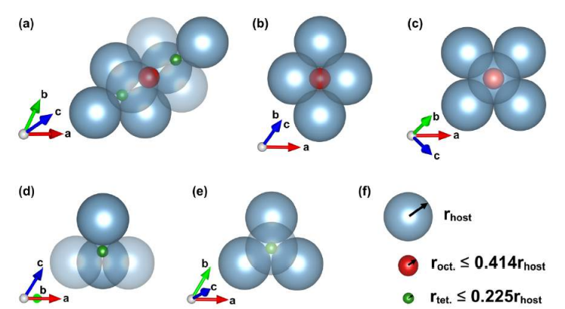

Figure 2 – “Rules of thumb” for a close-packed elemental structure’s ability to accommodate atoms of different elements within its interstices

In densely (Figure 2) packed structures, such as aluminum, the size of octahedral and tetrahedral gaps determines the ability of other atoms or ions to fit into the gaps of the crystal lattice. Octahedral gaps, designated as a, b, and c, can accommodate atoms or ions with a radius not exceeding 0.414 times the radius of the host atom. In a rhombohedral cell made from aluminum, these octahedral gaps appear as spaces where additional atoms or ions can fit tightly. Since these gaps are larger than tetrahedral ones, they can accommodate larger atoms compared to the host atom. Tetrahedral gaps, denoted as a, d, and e, are significantly smaller than octahedral ones. These tetrahedral spaces can only accommodate particles with a radius less than 0.225 times that of the host particle.In a rhombohedral crystal, green tetrahedral voids represent smaller spaces within the crystal structure where atoms can be located. These voids are limited by the smaller size of the atoms compared to the larger octahedral voids. Understanding these size restrictions is crucial for understanding the atomic structure in densely packed materials such as aluminum. The ability of atoms or ions to occupy these voids affects the properties and behavior of the material, influencing its mechanical, electrical, and chemical characteristics [86-89].
As most solid solutions in alloys are substitutional for aluminum, the varying solubility of different elements in the solid state adds to the complexity of understanding the structure of aluminum alloys. Accurate characterization techniques are essential to study these systems thoroughly and ensure the quality and integrity of aluminum and its alloys.
Aluminum-containing composites are highly valued for their exceptional thermal conductivity properties, making them ideal for use in flameless heaters. These materials efficiently transfer heat and ensure uniform heating of surfaces, making them suitable for heating devices requiring high efficiency and safety. These composites find applications in various fields, including industry, household appliances, electronics, and more, where they can be integrated into heating elements, panels, films, and other devices. However, when aluminum is in a molten state, it comes into contact with refractory materials used in the lining of heating furnaces and casting equipment. This contact interaction can lead to the accumulation of impurities in the primary metal, impacting its physical and mechanical properties. Thermodynamic analysis of the reaction in the Al-SiO₂ system suggests the possibility of silicon reduction from its oxide with molten aluminum, which can be undesirable when silicate refractory materials are used [90-95].
Additionally, thermodynamic calculations indicate the potential recovery of iron, manganese, and titanium from their oxides through interactions with molten aluminum [91,92]. Such interactions may lead not only to silicon saturation in the melt but also to gradual refractory destruction, particularly when quartz sand is involved.
Moreover, quartz's high thermal conductivity enables effective heat distribution within systems, ensuring thermal equilibrium and overall system efficiency. These properties collectively make quartz an essential component in creating dependable and effective thermodynamic systems for various applications.In addition, quartz has good chemical resistance and is resistant to corrosion, which makes it an excellent material for contact with chemically aggressive environments. In general, the use of quartz in thermodynamic systems ensures the reliability, durability and high efficiency of these systems, which makes it an indispensable component in various industrial and technical applications [93-96].
Aluminum matrix composites (AMCs) reinforced with ceramic particles have garnered significant attention and are extensively utilized in the automotive and aerospace industries owing to their exceptional mechanical properties. Studies have focused on analyzing the role of reinforcement with various particles on the properties of the final product. For instance, the addition of an appropriate amount of Al₂O₃ or SiC significantly enhances the wear resistance of aluminum alloys. Researchers have investigated the impact of factors such as volume fraction, porosity, and particle size of SiC on the wear resistance of aluminum alloy matrix composites, particularly those obtained through powder metallurgy methods. Experimental findings have consistently demonstrated that an increase in the SiC content correlates with improved wear resistance of the aluminum alloy [97-99]. Moreover, the mechanical characteristics of metal matrix composites (MMCs) are influenced by factors such as the size and volume percentage of reinforcement, as well as the type of matrix-reinforcement contact. To enhance the durability of the material, it is crucial to incorporate small and stable reinforcements with strong interfacial connections that are evenly distributed throughout the matrix. The optimization of reinforcement parameters and interface properties plays a pivotal role in enhancing the mechanical properties and performance of aluminum matrix composites, making them highly sought-after materials in various industrial applications.

1.5 Effect of mechanical activation on the reactivity of energy-intensive materials
Mechanochemical processing, a novel and cost-effective method, is utilized for producing a wide range of nano-powders. This method involves using a high-energy ball mill to initiate chemical reactions and induce structural changes in materials. "High Energy Ball Milling: Mechanochemical Processing of Nano-powders" explores the latest techniques in mechanochemistry and their applications in synthesizing and processing various high-tech materials [100-103].
In mechanical milling (MM), a suitable powder charge, typically a blend of elemental powders, is placed in a high-energy mill along with a milling medium. The primary objective of milling is to reduce particle size and blend particles to form new phases. Different types of ball milling can be employed for synthesizing nanomaterials, where balls impact the powder charge. These balls may roll down the chamber surface in parallel layers or fall freely, impacting the powder and balls below them. For large-scale production with nano-sized grains, mechanical milling is more economically viable. The kinetics of mechanical milling or alloying depend on the energy transferred to the powder from the balls during milling. This energy transfer is influenced by various parameters such as the type of mill, milling speed, size and distribution of the balls, dry or wet milling, milling temperature, and duration [104]. The choice of milling media, such as dense materials like steel or tungsten carbide, and optimizing their size and distribution are crucial for efficient milling. Dense packing of balls reduces ball motion's mean free path, while a dilute distribution minimizes collision frequency. The milling temperature affects powder diffusivity, defect concentration, and phase transformations induced by milling.
Higher temperatures are conducive to phases requiring higher atomic mobility (intermetallic), while lower temperatures favor the formation of amorphous phases or nanocrystalline phases. During milling, high strain-rate deformation and cumulative strain lead to particle fracture, with competing fracture and coalescence events continuing throughout processing. A suitable balance between these events is crucial for successful alloying, often resulting in an approximate steady-state powder size distribution.
High-energy ball milling is a versatile method that can alter the reactivity and properties of materials in various ways. One of the major benefits is the mechanical activation that occurs during the grinding process, which enhances the kinetics of reactions and reduces the energy barrier for chemical transformations. This mechanical activation can result in new reaction pathways and products not achievable through conventional methods. The mechanochemical reactions that occur during high-energy bead milling are fascinating, as chemical reactions take place directly within the grinding process [105]. This innovative approach allows for the synthesis of compounds and materials under different conditions compared to traditional synthesis techniques. The ability to initiate mechanochemical reactions provides opportunities for creating novel materials with unique properties.
In addition, high-energy ball milling promotes phase transformations in starting powders, such as the amorphization of crystalline materials or the polymorphic transformations of compounds. It can also lead to the disordering of ordered alloys, resulting in the formation of metastable phases with different properties. These transformations play a crucial role in adapting the microstructure and properties of materials for specific applications. The choice of milling device, whether an attritor, planetary mill, or horizontal ball mill, depends on the specific needs of the alloying process. Each mill type has unique advantages that make it suitable for different scales of operation [106-108]. The planetary ball mill, for instance, is ideal for laboratory research because it can process small amounts of powder and generate the high-energy impact necessary for mechanical alloying. In a planetary ball mill, the rotation of the rotary disc and bowls creates a dynamic environment that is conducive to efficient mixing and grinding of powders. This environment is created by the centrifugal forces generated by the counter-rotation of the disc and bowls, which increase the grinding efficiency and ensure thorough mixing of the powders. Such a controlled environment is essential for achieving uniform alloying and ensuring the desired phase transformations in the materials being crushed. High-energy ball milling, which is a powerful tool used by researchers to explore new directions in material synthesis and modification, allows for precise control over the parameters and conditions of the grinding process [109,110]. This control enables the adaptation of material properties at the nanoscale, leading to the development of advanced functional materials with unique properties for various applications. This works describes the process of mechanical alloying or grinding using high-energy balls. The forces generated by the rotation of the rotary disc cause high-energy impacts on the powder mixture and the grinding balls located in the mill bowls. These impacts result in the destruction of the powder and cold welding. Destruction occurs when high-energy impacts break down powder particles, creating smaller particles or new surfaces. On the other hand, cold welding occurs when newly exposed powder surfaces come into contact and stick together under pressure without the application of high temperatures. This process is facilitated by the large surface area and high energy present in the powder during grinding. The combination of fracture and cold-welding processes during high-energy ball milling is essential to achieve desired material properties, such as grain size reduction and homogenization of the alloy composition, as well as the synthesis of new phases or compounds. This technique is widely used in the field of materials science and metallurgy to create modern materials with specific properties [111,112].
Theoretical investigations and analyses of the planetary milling process have been extensively conducted to enhance our understanding and interpretation of this concept. Notably, [113] work stands as the initial report to examine the shock kinematics of a "satellite milling machine." This study focused on determining milling parameters optimized for shock energy. Various parameters were geometrically determined, and theoretical predictions were experimentally validated using a specifically designed planetary mill.
In [82] work emphasized the crucial roles played by the mill's geometry and the ratio of angular velocities of the planetary to the system wheel from a macroscopic perspective. In a specific ductile-brittle Mg-Si system, they found that the milling efficiency of the planetary ball was significantly influenced by the ratio of angular velocity of the planetary wheel to that of the system wheel, as well as the amount of sample load. Furthermore, in works [114,115] investigated the impact of rotational direction and rotation-to-revolution speed ratio in planetary ball milling, contributing to a deeper understanding of the process. Subsequent studies have delved into more theoretical issues and kinematic modeling of the planetary ball mill, providing further insights into its operation. However, despite these advancements, mechanical alloying processes remain complex and dependent on various factors, such as physical and chemical parameters like precise dynamical conditions, temperature, nature of the grinding atmosphere, chemical composition of the powder mixtures, and the chemical nature of the grinding tools. Some theoretical challenges, such as predicting nonequilibrium phase transitions under milling, continue to be subjects of debate and ongoing research.
The strategy of ball milling is a mechanical approach to decreasing the size of particles of materials, such as powders and suspensions. This strategy is notable since the usage of these materials appears to be sustainable. A ball mill is additionally utilized to grind and combine materials, commonly with spherical or cylindrical-shaped grinding media such as balls or rods. Numerous researchers have effectively used ball milling to produce nanostructures of various materials or to investigate structural changes in materials during ball milling. Moreover, planetary ball mills are the most popular mills used in MA and MM processes for synthesizing almost all types of metastable and composite materials. In mills of this type, the milling media possess significantly high energy due to the movement of the milling stock and balls against the inner wall of the vial (milling bowl or jar). As a result, the effective centrifugal force can reach up to twenty times the acceleration due to gravity. The ball mill typically consists of a cylindrical shell that spins around its axis and the grinding medium is placed inside the shell. As the shell rotates, the grinding medium is lifted and dropped onto the material being processed, resulting in particle size reduction, as shown in Figure 3 [116].
Indeed, the grinding time is a crucial parameter in ball milling processes, influencing both the degree of particle grinding and the level of material homogenization achieved. Typically, an increase in grinding time results in a decrease in particle size due to continuous mechanical forces on the powder. This prolonged grinding process facilitates the conversion of larger particles into finer ones and enhances mixing and material homogeneity. However, there is a practical limit to the duration of the grinding operation. After a certain point, known as the "saturation point," further grinding may yield diminishing returns or even adverse consequences [116]. When particles become excessively small, they may become unstable, causing issues such as agglomeration, excessive deformation, or phase transformations that can adversely affect material properties. Optimizing the grinding time is essential to achieve the desired particle size distribution and uniformity of the material. It is important to avoid the negative effects associated with excessive grinding, such as particle instability and changes in material properties. Balancing the need to homogenize the particles with the risk of these negative effects is a crucial part of the optimization process. Experimental studies and characterization techniques are often used to determine the optimal grinding time for different materials and desired outcomes. For instance, Eskandarany et al. [117] investigated the impact of milling time on the particle size distribution and morphology of MgH₂ powders and reported that prolonged milling led to the formation of agglomerated particles, which adversely affected the hydrogen desorption kinetics.
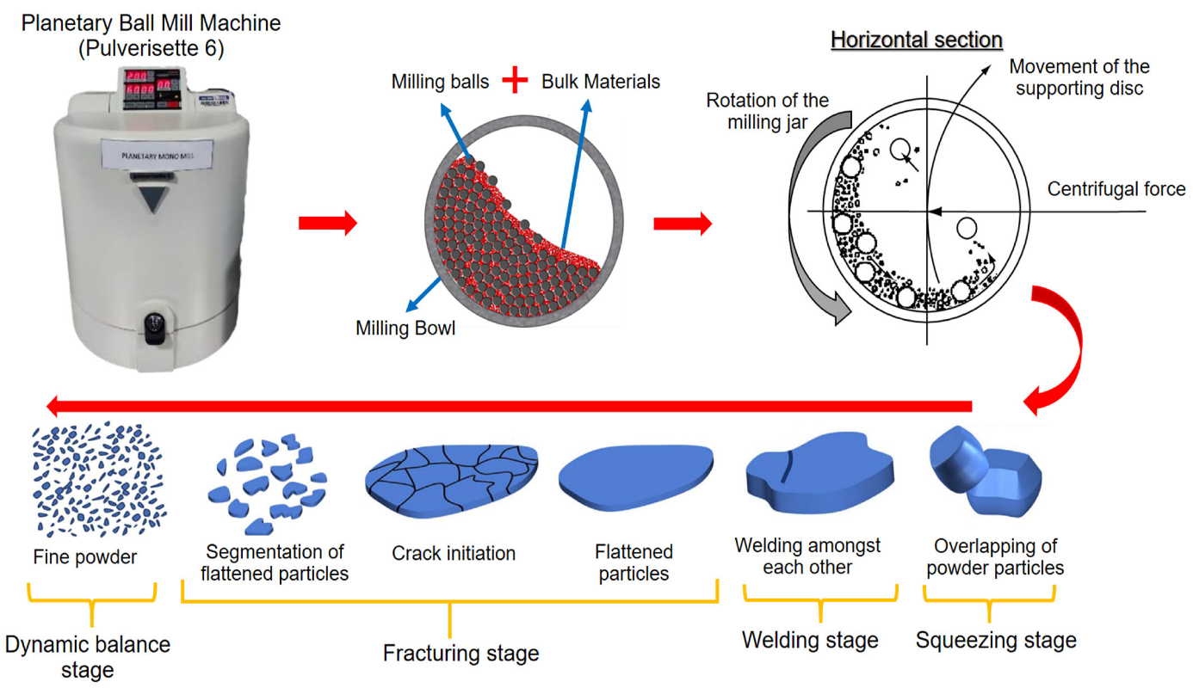

Figure 3 – Principles of the ball milling method for reducing powder particle size [116].

The milling duration affects the degree of mechanical activation and particle size and distribution, as well as the final structure and qualities of the product. Longer milling times typically result in smaller particle sizes, higher surface areas, and increased defects, with no phase change occurring during the milling process. Similarly, Salur et al. [118] conducted a study to examine the morphological transformation of AA7075-0.5 wt% Y₂O₃ (Yttrium oxide) composites during planetary ball milling for up to 10 h. As the milling time was prolonged, the specific surface area of the milled composites gradually increased owing to the reduction in particle size.
The grinding speed describes the rotation speed of the grinding container, which affects the kinetic energy of the grinding balls and the effect energy of the powder. Hussain et al. [119] extensively investigated the impact of different ball milling speeds while keeping the milling time constant at 30 h on the particle size of Ni₇₀Mn₃₀ samples. They observed a gradual decrease in particle size when the samples were milled at 200 and 300 rpm, attributing it to the collisions between the balls and alloy particles during milling. However, at a milling speed of 400 rpm, a noticeable increase in particle size was observed due to the simultaneous occurrence of cold welding and micro forging processes. When the milling speed was further increased to 500 and 600 rpm, there was only a slight reduction in grain size, likely resulting from particle fracturing caused by the higher speeds. The variation in average grain size with increasing milling speed is clearly depicted in Figure 4. Higher milling speeds lead to higher impact energies, resulting in smaller particle sizes and increased defects. However, very high speeds will lead to excessive heating and thermally induced reactions. Relatively, to obtain a homogeneous distribution and dispersion of nanofillers within the matrix, relatively high grinding energy is required. Wet milling is less effective due to the presence of a solvent, while high-energy milling during dry milling can reduce the crystal size. Therefore, many researchers attempted to optimize the ball milling process of Al-CNT powder mixtures with varied milling regimes. In work [120] reported that lower ball milling speed led to slower flattening of Al and less damage to CNTs. When the flattening of Al continued for several hours, CNTs could be uniformly dispersed onto the Al flakes.
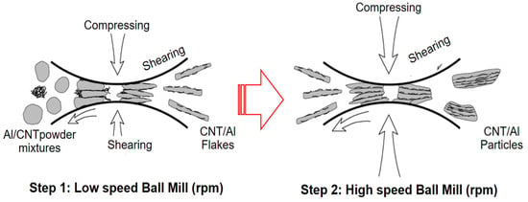

.Figure 4 – The co-deformation and dispersion mechanisms of CNT/Al powders [120].
Thus, mechanochemical processing is a promising method for the synthesis and modification of new composites for various applications. Changes in the structure and physico-chemical properties of the product eventually lead to the desired properties of the material, including increased mechanical strength and thermal conductivity. More environmentally friendly approaches and assessment of metal particle recycling processes can improve recycling efficiency and expand the scope of application of raw materials.
  - Setting Research tasks

The components of pyrotechnic compositions for flameless heaters and the effect of mechanochemical activation on the physicochemical characteristics of these components have been studied in detail, as well as the exothermic reaction of aluminum-based composites. Based on the above, the objectives of this work are:
- Development of air-activated flameless heater composites based on Al and SiO for autonomous heat sources and study of their energy and thermodynamic characteristics;
- Study of the influence of mechano-chemical treatment conditions and parameters on the reactivity of the composition of an air-activated flameless heater based on Al and SiO;
- Development of exothermic composites of water-activated flameless heaters based on calcium oxide and mechanically activated aluminum for flameless heaters for medical purposes;
- Development of a method for increasing the energy efficiency of a water-activated flameless heater based on CaO, Al by introducing SiO₂ into the composite system by mechano-chemical activation in order to expand the range of applications of the resulting composites.

2 METHODS OF CONDUCTING THE EXPERIMENT

2.1 Characterization of ingredients of the investigated pyrotechnic composite

2.1.1 Aluminum powder, their mechanical and physical properties

Experimental work involved the utilization of both chemically pure compounds and natural mineral compounds. The primary raw material utilized was aluminum powder of the PA-4 grade, comprising approximately 95.9% metallic aluminum. The average particle size was determined to be D₄₃=50 microns. As a rule, aluminum particles are often passivated by air, forming a protective oxide layer consisting mainly of aluminum oxide (Al₂O₃). This layer has a layered structure with a metallic aluminum core surrounded by an amorphous shell of Al₂O₃. This oxide shell acts as a barrier preventing the rapid reaction of aluminum with the environment, especially with oxygen and moisture, which can lead to corrosion or oxidation of the metal. The thickness of the oxide shell is mainly determined by the diffusion of oxidizing particles, in particular oxygen (O₂), to the metal coren . This diffusion process occurs over time when aluminum particles are exposed to air, which leads to the gradual formation of an oxide layer [72,73]. The thickness of the oxide shell plays a crucial role in determining the stability and reactivity of aluminum particles in various media. Thicker oxide layers provide better corrosion protection, while thinner layers can promote faster oxidation under certain conditions. In general, the formation of an Al₂O₃ shell by passivation with air is important for stabilizing aluminum particles and ensuring their long-term integrity and functionality in practical use [73] .
During the experiment in the presence of air, two aluminum powders with different structures were used (Table 1).

Table 1 – Ingredients used for the present work

Ingredients | Supplier | Declared Size, µm | Declared  Purity, %
Al (Spherical) | Alpoco | 30.0 | N. Av.
Al (Flake) | Metalpolveri | 50.0 | N. Av.
MnO₂ | Sigma Aldrich | < 10.0 | > 90.0 %
SiO | ALFA AESAR | < 10.0 | 99.8 %

2.1.2 The basic oxidizer components

Silicon oxide has been employed as an oxidizer during solid-phase interactions to enhance the dispersion of aluminum and to disrupt or eliminate the oxide layer present on the surface of aluminum particles. Essentially, it serves as a modifier in the process of grinding aluminum in a mechanical reactor [121]. On the other hand, manganese oxides have garnered significant attention due to their noteworthy physical properties. They find applications as catalysts in various fields such as high-density magnetic recording, electrochemical devices, and the chemical industry. The special properties of manganese-containing mixed oxides are the addition of oxygen in a certain temperature range, that is, a change in the oxidation state of manganese ions [122]. Due to such unique properties, it was chosen as the main oxidizing component in the work. Table 1 provides a physical description of the main components used in the process of obtaining energy composites.
In the process of obtaining composite materials for flameless heaters that are activated by interaction with water, CaO, Na₂CO₃ and Al powder were selected as the main components. The next basic component was silicon dioxide (quartz). Quartz was used as an abrasive in the process of grinding aluminum in a mechanical reactor to increase the degree of dispersion of aluminum and the destruction of the oxide layer on the surface of the particles. The characteristics of these reagents are given in Table 1.
2.2 Mechanical activation of powder

Mechanical treatment of powders, such as through the use of planetary mills like the "Retsch PM100" and "Pulverisette 5," induces a process known as mechanical activation (MA) (Figure 5). This process disrupts the equilibrium state of the powder materials, leading to the emergence of unusual properties. The platform rotation rate of the mills typically ranges from 100 to 650 rpm for the "Retsch PM100" and up to 400 rpm for the "Pulverisette 5." This rotation rate influences the intensity of mechanical activation and the degree of disruption to the powder materials. The disruption of the equilibrium state results in the emergence of unusual properties in the powder materials. These properties may include increased reactivity, altered surface morphology, changes in crystallinity, and enhanced mechanical properties.
Mechanical activation, achieved through methods like high-energy ball milling, kinetic energy into a system, disrupting its equilibrium and creating active sites in solid materials. These active sites provide opportunities for increased reactivity and accelerated chemical reactions between solid particles. By breaking up particle agglomerates, creating microstructural defects, and increasing surface area, mechanical activation facilitates better contact between reactants and promotes diffusion, thus accelerating chemical reactions [74,123]. In general, mechanical activation is a powerful tool that can be used to adapt the properties of materials, making them more suitable for new applications. This process increases the reactivity of the materials and facilitates the synthesis of new materials with desired properties. Additionally, they enable the synthesis of materials in highly nonequilibrium states, which may exhibit unique properties and behaviors.
Mechanical activation through processes such as milling plays a crucial role in modifying the properties of powder materials, offering opportunities for tailoring their characteristics for various applications, including in materials science, catalysis, and chemical synthesis.
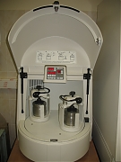
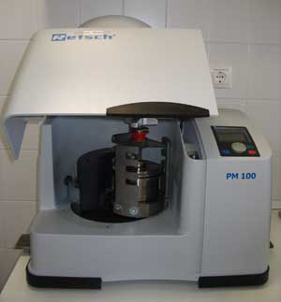
a b

Figure 5 – (a) Planetary Ball Mill “Retsch PM100” (Retsch Technology GmbH, Germany) and (b) ”Pulverisette 5” (Fritsch, Germany)

2.3 Thermodynamic calculation method performed using the NASA-CEA program

Theoretical and computational studies of the equilibrium composition and properties, chemical and phase features, theoretical and computational studies of complex thermodynamic systems studied in the dissertation work-NASA Glenn Research Center – were carried out using the chemical equilibrium and application (CEA) software complex (Figure 6) [124]. The NASA Chemical Equilibrium with Applications (CEA) program boasts a wide scope that enables it to calculate the characteristics of rocket engines, analyze processes in shock waves, determine the parameters of the Chapman-Zhuge point, and explore various equilibrium states of thermodynamic systems. Developed by NASA over the past 50 years, CEA represents the latest advancement in programs designed to calculate equilibrium composition and properties. The program offers convenience through its ability to utilize independent databases containing transport properties and thermodynamic properties of individual substances. With data on the thermodynamic properties of over 1900 substances, CEA provides a comprehensive platform for analysis. Written in standard ANSI FORTRAN by Bonnie J. McBride and Sanford Gordon, the CEA program is widely utilized for solving problems in aerodynamics and thermodynamics, making it a valuable tool in scientific and engineering applications.
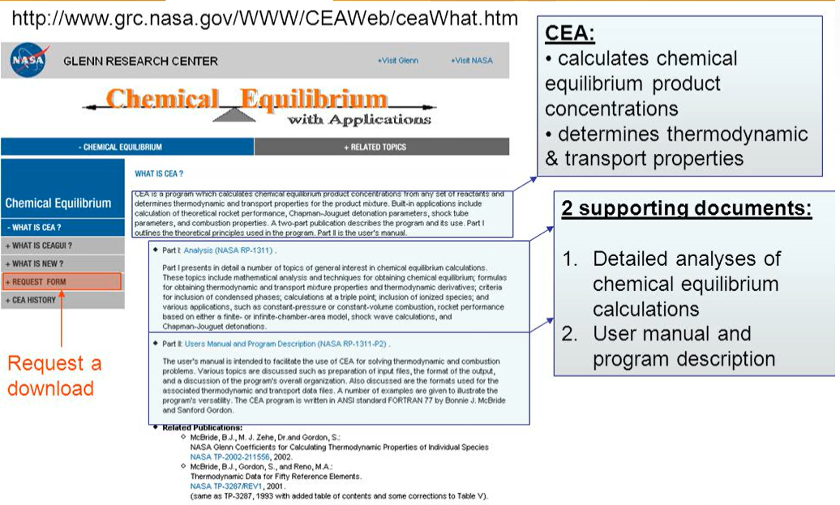

Figure 6 – The interface of the NASA-CEA code program

The program allows to determine the nature of the interaction between the components of the system, the conditions for the formation of compounds, the composition and properties of the resulting compounds, as well as all thermodynamic characteristics. The following standard thermodynamic quantities are used for calculations: Enthalpy (H), entropy (S), free energy or Gibbs energy (G), heat capacity (Cp). The basic formulas used for thermodynamic calculations and analysis of chemical equilibrium in the system are given below:
The formula for calculating the composition of the mixture according to chemical equilibrium [123]:
n_i = n*Y_i/k_i (1)

where: n_i -is the number of moles of the i-th substance in the mixture,
n- the total number of moles in the mixture,
Y_i - the activity coefficient of the i-th substance,
k_i - the equilibrium constant of the i-th chemical reaction.

The formula for calculating the enthalpy of the reaction:

ΔH = ∑ (v_i*ΔHf_i) (2)

where: ΔH - the enthalpy of the reaction,
v_i -the stoichiometric coefficient of the i-th substance in the reaction,
ΔHf_i - the standard educational enthalpy of the i-th substance.

The formula for calculating the entropy of the reaction:

ΔS = ∑ (v_i * ΔSf_i) (3)

where: ΔS - the entropy of the reaction,
v_i is the stoichiometric coefficient of the i-th substance in the reaction,
ΔSf_i is the standard entropy of the i-th substance.

The formula for calculating the free energy of the reaction:

ΔG = ΔH - T*ΔS (4)
where: ΔG - the free energy of the reaction,
ΔH - the enthalpy of the reaction,
T - the temperature,
ΔS - the entropy of the reaction.

All of the above functions are of great importance for metallurgical processes. They make it possible to predict the direction of the process, to assess the implementation and completeness of a reaction under certain conditions, the formation of a product [123].

2.4 Physical and chemical research methods

In the analysis, different features of various powders (passivated by air or organic compounds, and eventually coated by hydrocarbons and fluor hydrocarbons) are investigated focusing on the application in energetic systems. Scanning electron microscopy (SEM) and transmission electron microscopy (TEM) are important tools for the comprehensive characterization of powder materials. These techniques allow us to obtain detailed information about the morphology, structure, composition, oxidative reactivity, and behavior of mixtures for flameless heaters applications [73,124].
SEM provides high-resolution images of the surface morphology of powder particles and can reveal information about their size, shape, and texture. TEM, on the other hand, provides even higher-resolution images that allow us to study the internal structure of powder particles at the nanoscale, including crystal structure, defects, and particle boundaries. Specific surface area measurement methods allow us to quantify the surface area of powder particles per unit mass or volume. This information is crucial for understanding the reactivity and adsorption properties of powder materials. Using these characterization techniques, it is possible to gain a comprehensive understanding of the morphology of a powder (particle size, shape, and texture), its structure, and composition (including the content of active metals). This information is essential for optimizing powder production processes, predicting material properties, and designing advanced materials with tailored properties for various applications.

2.4.1 SEM investigation

The surface morphology of the obtained samples was examined using a QUANTA 3D 200i microscope (FEI, USA) operating at an accelerating voltage of 30 kV. For local analysis of the chemical composition, a microscope equipped with an EDAX energy dispersive X-ray spectrometer was utilized. The semiconductor detector used had an energy resolution of 128 eV (polymer, window d = 0.3 mm) [74,124].
.

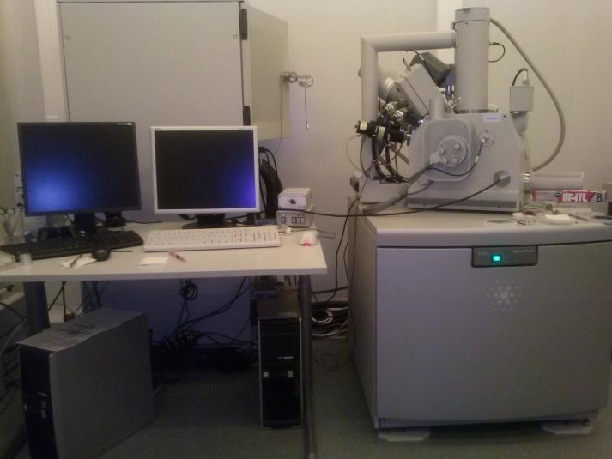

Figure 7 – The surface morphology of the obtained samples was investigated using a QUANTA 3D 200i microscope (FEI, USA)

2.4.2 Laser granulometry distribution size measurement

Powder granulometry has been tested through a MALVERN MASTERSIZER 2000 laser granulometer employing the dry unit SCIROCCO (Figure 8). Three measurements for each samples have been carried out and averaged [74,124].
Malvern Mastersizer can process various types of dispersion, including dry powders, as well as samples ground in liquid. A computer system is a stand-alone computer that runs the Malvern software. The software controls the optical unit and the powder collection units, and analyzes the raw data from the optical unit to determine the particle size.
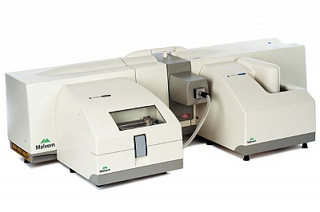

Figure 8 – Laser granulometry distribution size measurement by MALVERN MASTERSIZER 2000

2.4.3 Thermo-gravimetrical analysis

Thermal analysis (thermogravimetry - TG, differential scanning analysis - DSC and differential thermal analysis - DTA) was carried out on a NETZSCH 449F3A-0372-M instrument. All samples were tested in nitrogen with a purity of 99.99%. Thermal measurements were carried out in the temperature range 30–1000 ° C and at a heating rate of 10 K / min. Other characteristics of the device: sample holder - DSС / TG / StdS / S; crucible - DSС / TG pаn Аl2О3; DTA / TG / StdS / S; crucible - DSC / TG from Al2O3; corr. / range limits Meas. - TG, 000/35000 mg, DSC - 000/5000 μV [125].

2.4.3.1 Simultaneous Thermal Analyzer (STA) 6000 (Thermogravimetric analyzer)
The STA 6000 combines two analytical techniques together. It combines TGA and DSC. Simultaneously the STA 6000 collects DSC heat flow data and TGA weight loss data [126]. DSC Heat Flow is measured in Joules/gram and milliwatts. The STA 6000 measures the change in temperature (relative to a reference) and weight of a sample as a function of temperature and/or time.Applications from the TGA include: compositional analysis, decomposition temperatures, engine oil volatility, flammability studies, lifetime predictions, measurement of volatiles, oxidative and thermal stabilities, catalyst and coking studies, and hyphenation to identify out-gassing products.
Application from the DTA/DSC include: melting and crystallization behavior, glass transition temperatures, specific heat capacity, kinetic studies and transition and reaction enthalpies [127].
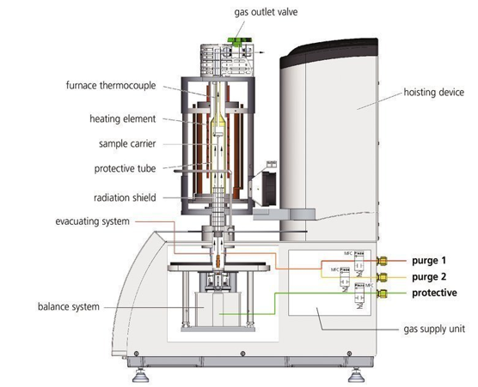

Figure 9 – Simultaneous Thermal Analyzer (STA) 6000 (Thermogravimetric analyzer (TGA)). [126]
2.4.4 X-ray Diffraction (XRD) System - SmartLab (Rigaku)

The SmartLab is the most novel high-resolution X-ray diffractometer available today. Perhaps its most novel feature is the SmartLab Guidance software, which provides the user with an intelligent interface that guides you through the intricacies of each experiment [128]. It is like having an expert standing by your side. The RIGAKU Smartlab XRD X-Ray Diffractometer delivers a guided user experience, multi detection in a single instrument, without the need to swap detectors for different applications. X-ray Diffraction, used for quantitative analysis of crystalline phases, is non-destructive and can be on all kinds of matter from liquids to crystals to powders for a versatile method of characterization and quality assurance. This diffractometer partners a high-resolution closed-loop goniometer drive, and cross beam optics with the fully automated reflection and transmission. The RIGAKU Smartlab XRD machine covers all your bases, from thin films, nanomaterials, powders, or liquids, letting you get the measurements you need, even from textile samples. Stages and optical components for this X-Ray Diffractometer are interchangeable, permitting a large range of x-ray techniques including x-ray reflectivity measurements for thin-film thickness, roughness, and density determinations, automated X-Y mapping of wafers, stress measurements, and much more.

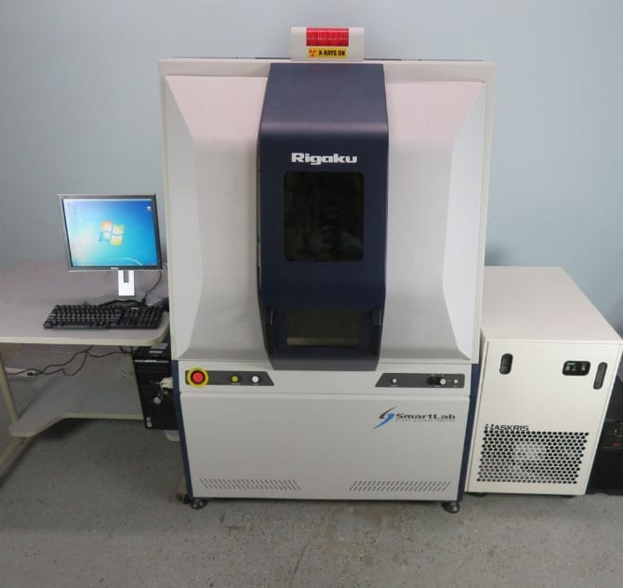

Figure 10 – RIGAKU Smartlab XRD X-Ray Diffractometer

The RIGAKU Smartlab XRD X-Ray Diffractometer is designed to simplify user interaction and hardware complexity with a computer-controlled alignment system and automated optical system. The suite of included software covers you from measurement to analysis and includes security and validation protocols.

2.4.5 Differential Scanning Calorimetry (DSC)

The DSC method makes it possible to quantify endothermic or exothermic enthalpy changes in the sample under study, that is, to study the phase transitions of the substance under study. The scheme of the device for DSC looks like this: two crucibles are installed on the heater, one with a sample, the other is an empty reference. The crucibles are heated at a preset program rate, usually 10 K per minute [127]. The heating rate should remain exactly the same throughout the experiment. Due to the presence of an additional substance in one of the crucibles, more heat will be required in order for the temperature of the sample crucible to increase at the same rate as in the reference crucible. The time dependence of the temperature difference between the sample cell and the comparison cell is experimentally measured. The following effects may be observed during the experiment:
- there is a transfer of latent heat (heat given away or absorbed by a substance at a constant temperature) during a phase transition of the first kind;
- there is a change in heat capacity, but there is no latent heat, that is, the phase transition is a transition of the second kind. In the DSC method, heat is determined through the heat flux – the derivative of heat over time. Based on the measurement results, a graph of the dependence of the heat flow on temperature changes is plotted.
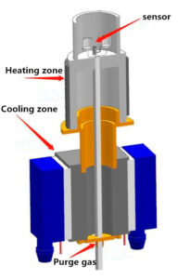
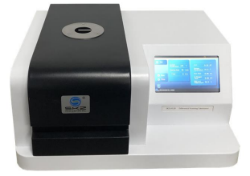

Figure 11 – SKZ1052B Differential Scanning Calorimeter and it’s furnace structure

2.5 Investigation the metal content and aging effects of the powders

The aging behavior of metal powders and mixtures is a key parameter in determining the service life of an energetic system. The effects of aging on chemical reactions rates of the mixtures is an understudied topic in the open literature. Studies performed for the North Atlantic Treaty Organization (NATO) addressed service life times of solid propellant systems by means of accelerated thermal aging techniques. After that, several further studies have correlated the thermal aging techniques to the natural aging; their usefulness was validated by measurements of chemical, mechanical, and physical properties [73,129,130].
The surface layer of the mixture and the bulk of the mixture undergo similar aging processes, but it has to be considered that the aging at the surface of the mixture occurs at a faster rate due to higher concentrations of air and water stemming from direct ambient exposure.
Variations in the properties are highly dependent upon the mixture formulation and storage conditions (atmospheric composition, temperature, pressure, humidity). Aging can lead to changes in the thermal diffusivity, heat of combustion, thermal decomposition behavior, impact and friction sensitivity, aluminum reactivity, ignition delay time, and reaction rate [73].
Aging processes are generally chemical in nature, and their reaction rates can be modeled through Arrhenius equations. Accordingly, accelerated thermal aging experiments are utilized to approximate the conditions of an energetic material during its service life. The approximated service life of an energetic material, t _{life}, is given by:

t _{life} = t _{hT} * f ^{(T}_{h} ^{– T}_{s} ^{/ ΔT}_{R}⁾ [73].

where T_{hT} is the time interval during which the material is kept at elevated temperature, f is a reaction rate factor, T_{h} is the high temperature, T_{s} is the storage temperature, and ΔT_{R} is the change in temperature that results in a doubling of the reaction rate.

3 DETERMINATIONS OF EFFECTIVE STRUCTURAL RATIOS OF PYROTECHNIC COMPOSITION (Al_{S}-Al_{F}-MnO₂-SiO) FOR AUTONOMOUS FLAMELESS HEATERS. DETERMINE THE OPTIMAL CONDITIONS FOR CONDUCTING MECHANICAL ACTIVATION OF ENERGY-INTENSIVE ALUMINUM-BASED COMPOSITES

3.1 The results of the study of the physico-chemical properties of aluminum powder (µAl)

Aluminum (Al) parts have several features that make them interesting for energy applications. During the analysis, different features are studied, focusing on the use of different powders (passivated by air or organic compounds and finally coated with hydrocarbons and fluorocarbon) in energy systems. For a broad description of the morphology (particle size, shape and structure), structure and composition of the powder, scanning electron microscope (SEM), transmission electron microscope (TEM), and active metal composition determination methods are considered [74,131]. Al reactivity is studied at low and high heating rates. The presented results provide a comprehensive understanding of the relationships between the structure of nanoscale mixtures, oxidative reactivity and the behavior of mixtures for the use of flameless heaters.

3.1.1 Results of mechanical processing of aluminum powders and electron microscopy of their morphology and structure

It is known that mechanical grinding of aluminum is difficult due to its ductility, therefore, to facilitate the grinding process, surfactants (surfactants), such as hexane, toluene, etc., are added, which contribute to both grinding and processing. A wide range of composite systems is synthesized by mechanochemical method [132]. Energy composite systems, which combine metal and organic materials such as aluminum/Teflon, and magnesium/Teflon, are being developed for a variety of applications, particularly in the field of energy storage [74,133]. These composite materials take advantage of the unique properties of both metal and organic components to create materials with desirable performance characteristics. In these systems, the way metal particles like aluminum or magnesium are dispersed within an organic matrix like Teflon is critical. The dispersion of these metal particles and their structural characteristics significantly affect the activity of metal catalysts in subsequent combustion reactions. Mechanical-chemical processing (MСHP) techniques play a crucial role in achieving the desired dispersion and structural characteristics of metal particles within an organic matrix. The selection of an organic blend during the MСHP is essential, as it influences various aspects, such as the compatibility between metal and organic constituents, the level of mixing, and the mechanical activation of the composite system [134]. By carefully choosing the organic blend and optimizing MСHP parameters, researchers can regulate the distribution of metal particles and tailor the structural properties of the composite material to enhance its reactivity and effectiveness in combustion processes. This approach allows for the development of advanced energy composites with improved characteristics for use in internal combustion engines, pyrotechnics, and other energy-related applications. Electron microscope analysis is commonly used to study the structure and morphology of highly dispersed particles. This method allows you to study the change in the surface layers of processed aluminum parts and visually trace the entire path of creating composite systems with the participation of organic and inorganic materials [135].
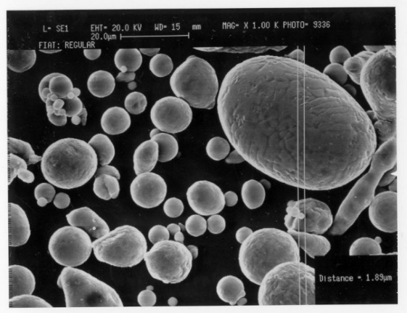
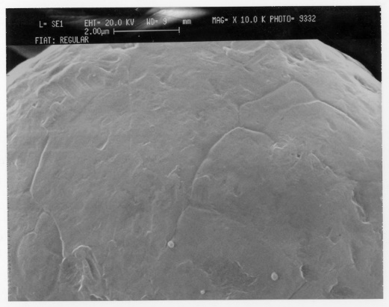
At the first stage of the research on the dissertation work, mechanical processing of aluminum powder to a highly dispersed state was carried out. At the second stage, the features of changes in the structure of aluminum particles by grinding together with inorganic silicon oxide and manganese oxide in a mechanical reactor were studied. Aluminum MCP studies were conducted on spherical aluminum (Al_{S}) and Flake aluminum (Al_{F}) powders [135,136]. The studied scanning electron microscope images show that Al particles have a spherical and scaly shape. According to particle size analysis, the average particle size is about 50 microns. Powder particles have a metallic sheen, are gray in color and do not contain foreign impurities (Figure 12 and 13).
a b

Figure 12 – SEM micrographs of spherical Al powder at increasing magnifications: (a) 10K x; (b) 1K x

The work utilized aluminum powder ranging from micron to submicron particle sizes. The aluminum powders processed by the MA exhibit high reactivity and a low flash point. The utilization of activated powders offers several advantages, including improved sintering characteristics of particles, early ignition, high overall rate of thermal evolution, and enhanced combustion rate for functional particles. The analysis is centered on exploiting various properties of powders in energy systems. For a comprehensive characterization, the morphology (particle size, shape, and structure), structure, and composition of the powder are thoroughly examined [74].

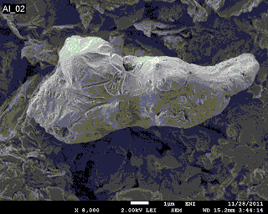
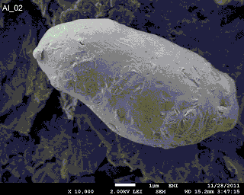

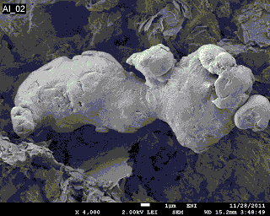
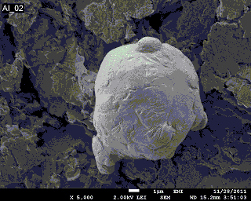
a b
c d

Figure 13 – SEM micrographs of the flakes μ-Al powder (~ 50 μm), at increasing magnifications: (a)4 x, (b) 5x, (c) 8x, (d) 10x.

3.1.2 Results of study of the aging process of Al powder

Although attractive in terms of improved performance in combustion environments, the high reactivity of Al can cause aging-related issues during storage. In particular, powders can lose C_{Al} during storage. As a result, their combustion effects change (that is, a decrease in enthalpy, a different reaction mechanism) [73]. The analysis of the aging process is based on the measurement of the volume of hydrogen formed by the interaction of aluminum and water.
Water is classified as a single energy source, which is not formed in the process of its absorption, such as CO and CO₂-gas. There are various measures to obtain water, including gasification, electrolysis of water, steam reforming of gas, expansion of water and hydride chemical reactions. One way or another, these methods have their advantages, such as high cost, low efficiency, connection with the surrounding environment and the need for external energy sources, which are obtained from the selected top. The reaction of hydrolysis between metal and water is one of the most significant features of obtaining pure and economic water [137].
This method was thoroughly studied in the last few decades. Certain metals, determined for obtaining water, include aluminum, magnesium and zinc. Last year, the technology of renewable energy sources on the basis of aluminum was studied as an alternative to the high level of energy source in the country. Aluminum deposits are accessible to the population, which makes this method more ecological. Energy, which is contained in aluminum, can be obtained as a result of the reaction with water with heating and water. Therefore, aluminum can potentially be a more effective source of water for comparison with other metals. At the combined temperature of water education, as a result of the reaction of aluminum–water, the oxide of aluminum (Al₂O₃) increases the yield of aluminum, which provides direct contact between water and aluminum. This is a kind of passivation [138]. For resolution of this problem, used methods, including the addition of NaAlO₂ for the inhibition of Al₂O₃ education and the introduction of nut promoters/catalysts, hydroxide materials, as well as splices or alloying additives in the process of hydrolysis. The addition of catalysts does not serve only for the release of Al₂O₃, but also for the reduction of energy activation and recovery of the reaction. With specially used catalysts in the reaction of aluminum-water hydroxide catalysts, such as NaOH and KOH, NaOH has more support from its economic efficiency when obtaining analog results in water. It is noteworthy that NaOH and NaAlO₂ are used to improve the efficiency of aluminum and its compounds, in particular for plasma electrolysis. The process comes from the stability of the nut rack, with the help of which the addition of the NaOH in the rack of the NaAlO₂ can be made to the education of the stable rack, i.e. for the absorption of aluminate ions (Al(OH)₄⁻) for the breakdown of Al(OH)₃. As it is true, aluminum in the nut rack reacts with the following reactions (1,2) and figure 14 [139]:
2Al + 6H₂O + 2NaOH → 2NaAl(OH)₄ + 3H₂ (1)
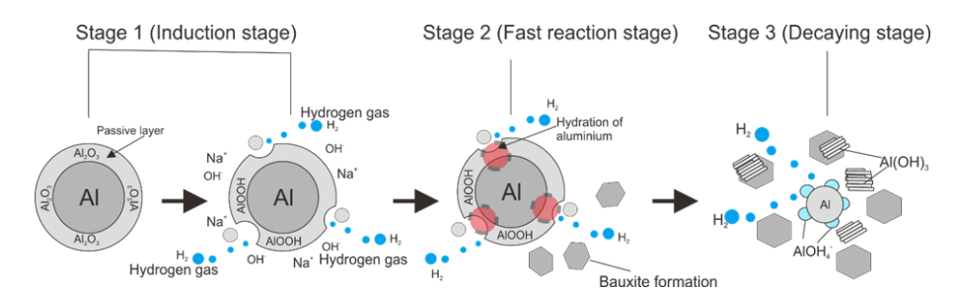
NaAl(OH)₄ → NaOH + Al(OH)₃ (2)

Figure 14 – Mechanism of hydrogen formation from aluminum–water in the three phases of aluminum hydration kinetics [139]

The first reaction (1) suggests that hydrated sodium aluminate forms when hydrogen is released. When the concentration of the aluminate exceeds its saturation limit, this hydrated sodium aluminate decomposes into NaOH and Al(OH)₃, as can be seen in the second reaction (2).
The main challenge in controlling hydrogen generation lies in understanding the second reaction, as the equilibrium is not easily achieved. The main goal of this study is not to enhance the deposition of Al(OH)₃ but to regenerate NaOH through promoting sufficient quantities of aluminate, which will lead to further decomposition.
Since hydrogen is generated as a result of the first reaction, it's crucial to control the second reaction. The equilibrium constant varies as a result of a rise in temperature, causing an increase in the equilibrium concentration of NaAl(OH)₄. This rise in the equilibrium concentration of NaAl(OH)₄ creates a higher equilibrium concentration of NaOH. As a result, the concentration of sodium hydroxide is significantly higher, leading to an increase in the consumption of hydrogen. According to the Le Chatelier principle, when the equilibrium conditions of a reaction change, the position of the equilibrium shifts in order to compensate for the change and restore the original equilibrium. When applying this principle to the reaction (2), if sodium hydroxide (NaOH) is removed, the equilibrium will shift to the right, towards the formation of more Al(OH)₃. At the same time, the amount of NaOH formed will decrease. The effect of catalysts on the kinetics of this reaction can be approximately estimated using mathematical modeling techniques [140,141].
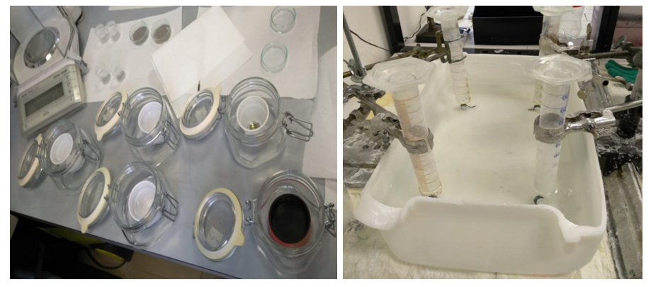
The powder is poured into a NaOH/water solution and measured using the separated hydrogen (Figure 15).
Figure 15 – Research experiment on the aging process of Al powders

The aging process described in the study involved a carefully controlled procedure to expose the powder samples to specific environmental conditions. Here's a breakdown of the key steps involved. Approximately 1g of powder was placed in glass weighing bottles with a diameter of 30 mm [73,74]. The use of glass bottles ensured compatibility with the test environment and allowed for accurate measurement of the sample weight. The relatively small amount of material (1g) ensured uniform exposure of the powder samples to the test environment. This uniform exposure is essential for obtaining consistent and reliable experimental results. The open-weight glass weighing bottles were then placed inside small plastic jars. This arrangement served to prevent direct contact between the glass bottles and the test media, potentially avoiding contamination or interference with the aging process.
Subsequently, the plastic jars containing the weighing bottles were placed in pre-prepared sealed glass containers. These sealed containers provided a controlled environment for the aging process, maintaining the desired test temperature of 333 K (60°C). The sealed glass containers with the test samples were prepared and stored at the test temperature of 333 K for a duration of 24-48 hours before the start of the experiments. This pre-conditioning period ensured that the samples reached thermal equilibrium and stabilized before further testing. The study focused on investigating the aging process under a single temperature condition of 333 K (60°C) [73,142,74]. This approach allowed for a systematic analysis of the effects of temperature on the aging behavior of the powder samples.
The described procedure provided a controlled and standardized method for studying the aging process of the powder samples under specific temperature conditions. By carefully controlling experimental variables and ensuring uniform exposure of the samples, could obtain reliable data to analyze the effects of aging on the properties of the powder materials. As shown in Table 2, there is an increase in the mass of the tested powders. It can be assumed that the high sensitivity of powders to aging is due to the presence of a submicrometric part of the particles, which gives high reactivity [74].

Table 2 – Aging rate of Al powders

FRESH POWDERS Active Al content
Al type | Sample mass, mg | H₂ volume, ml | Metal Content, %
Spherical | 53,1±0,7 | 78±2 | 101±1,6
Flakes | 68,0±12,2 | 91±13,5 | 94,5±5,1
Tests carried out 14 days later show a similar trend between Al_{S} and Al_{F} powders. The powder mass does not change almost within 14 days, regardless of the dispersion of the powder. This is due to limited gas-type adsorption on the powder surface and damage to the Al-core during storage [73,74]. The presence of relatively low H₂O in the aging environment limits the destruction of the Al₂O₃ shell and its conversion to a hydrated form [as Al(OH)₃]. In the cases under study, the alumina layer exhibits an effective passivation action on Al [73,142]. During the 14-day obsolescence period, Al_{S} and Al_{F} do not decrease. This result suggests the existence of a threshold condition for the destruction of the Al content by oxidizing species as H₂O vapor and a good protective action of the Al₂O₃ passivation layer (Table 3) [73,74].
Table 3 – Aging rate of Al powders after 14 days
AGED POWDERS Active Al content
Aging conditions: 10 days, H₂O+NaCl solution, 75% relative humidity, 60 °C
Al type | Sample mass, mg | H₂ volume, ml | Metal Content, %
Spherical | 50,8±0,01 | 66,5±2,5 | 91,3±3,4
Flakes | 50,8±0,15 | 65,5±3,5 | 90,0±5,1

Thus, it was studied that the effect of aging on the reactivity of Al powders does not occur significantly. Al → Al(OH)₃ (t) of micron-sized powders, taking into account storage in wet conditions, is observed with a step-by-step decrease in the active metal content (and a corresponding increase in conversion) [73,142]. These powder modifications are mainly due to the formation of various aluminum hydroxide polymorphs [73,74].

3.2 Determination of the optimal composition of the Als-Al_{F}-MnO₂-SiO system and its mechanical activation and study of physicochemical properties

3.2.1 Powder formulation and results of their mechanical activation

The reference formulation is inspired to the powder “F” reported in [143] (Table 4). The original material is characterized by the highest burning rate among the proposed alternatives. The purpose of SiO is to act as a “flame retardant”. The list of the ingredients used for the work can be found in Table 4.

Table 4 – Formulation selected for mechanical activation (the reference powder is reported for comparison purposes.

Powder | Orig. Formulation [143] | Modified Ref. Formulation
Al (spherical) | 5% | 5%
Al (Flake) | 70% | 70%
MnO₂ | 25% | 15%
SiO | 0% | 10%

Studies on the mechanical activation of aluminum were carried out on powder grade PA 4. Figure 16 shows the process of preparing the initial powders for grinding.

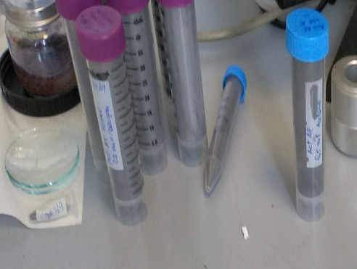
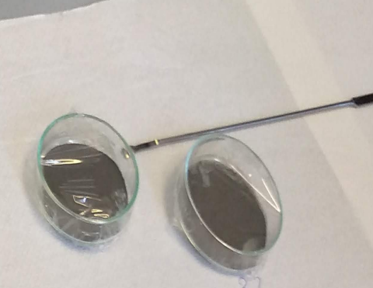
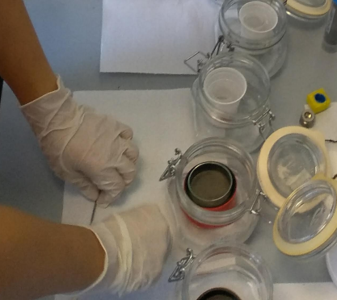
Figure 16 – The process of preparing experimental samples for grinding (Space Propulsion Lab, Politecnico di Milano, Italy)
The mechanical activation (MA) of aluminum-based powders was conducted for durations of 50, 65, and 150 minutes. The selection of the optimal MA modes was based on the findings of previous studies [73], as summarized in Table 5. To prevent the oxidation of aluminum particles by atmospheric oxygen after MA and to evaluate the changes specifically associated with mechanical action, samples of the dispersed mixture were passivated with toluene [74,135,136].
Table 5 – Mechanical activation parameters used for the work [74,136]

Parameter | Formulation
Mill | Planetary (RETSCH PM 100)
Milling Time, min | 50 for powder Al_{S}-Al_{F}-MnO₂-SiO-50
Milling Time, min | 65 for powder Al_{S}-Al_{F}-MnO₂-SiO-65
Milling Time, min | 150 for powder Al_{S}-Al_{F}-MnO₂-SiO-150
Milling Speed | 500 rpm
BPR (ball-to-powder weight ratio) | 20:1
PCA (process control agent) | Toluene
Sphere Material | Stainless Steel
Vessel Material | Stainless Steel
Vessel Volume | 125 ml

3.2.2 Results of study specific surface area (SSA) of Al-based composites

The information provided indicates that the powders obtained from ball milling underwent significant changes in their characteristics compared to the original material mixture. Various parameters were analyzed to understand these changes, including apparent density, absorbed PCA (toluene), granulometry, metal content, and oxidation behavior at a low heating rate. One key observation was the distinct color change in the activated powders, suggesting a notable incorporation of MnO₂ and SiO into the Al matrix. This color change likely resulted from a reduction in particle size, as indicated by the changes in apparent density and absorbed toluene [74,136]. The incorporation of these elements into the matrix could have influenced the overall properties of the powders. Furthermore, the challenges of extracting toluene from very small particles with significant SSA were highlighted, indicating the complexity of working with materials with high specific surface area. Standard drying procedures may not have been sufficient for efficient extraction in this case.
Interestingly, it was noted that longer milling times were associated with lower apparent density and a darker powder color. These changes were particularly noticeable in powders activated through the innovative technique, suggesting that the method of activation could play a significant role in the final characteristics of the powders.
These findings emphasize the intricate relationship between processing parameters, material composition, and final powder properties. Further analysis and exploration of these characteristics could provide valuable insights into optimizing the ball milling process for specific applications (Table 6).

Table 6 – List of the activated powders and main properties

Powder Label | Color | Absorbed PCA, % w.t. | Apparent density, g/cm³
Al_{S}-Al_{F}-MnO₂-SiO-MM | Brown | - | 1.18
Al_{S}-Al_{F}-MnO₂-SiO-50 | Grey | 0.0 | 0.62
Al_{S}-Al_{F}-MnO₂-SiO-65 | Dark Grey | 6.3 | 0.50
Al_{S}-Al_{F}-MnO₂-SiO-150 | Dark Grey | 16.7 | 0.38

3.2.3 Size distribution of powder particles and composites after mechanical activation
Powder granulometry has been tested through a MALVERN MASTERSIZER 2000 laser granulometer employing the dry unit SCIROCCO. Three measurements for each samples have been carried out and averaged [73,74]. Results are reported in Table 7 and Figure 17.

Table 7 – Main particle size parameters for the five tested powders

Powder Label | d (0.1), µm | d(0.5), µm | d(0.9), µm | D[4,3], µm
Al_{S}-Al_{F}-MnO₂-SiO-MM | 4.96 | 51.53 | 149.81 | 67.12
Al_{S}-Al_{F}-MnO₂-SiO-50 | 1.05 | 20.23 | 71.88 | 29.28
Al_{S}-Al_{F}-MnO₂-SiO-65 | 1.34 | 17.46 | 90.19 | 33.57
Al_{S}-Al_{F}-MnO₂-SiO-150 | 1.39 | 13.35 | 61.04 | 24.85
Mechanical activation led to a notable decrease in the average particle size, as evidenced by both Table 7 and Figure 17. The mass-weighted mean diameter (D[4,3]) showed a progressive reduction with increasing activation intensity (i.e., milling time). However, the powder activated for 65 minutes exhibited the highest D[4,3] among the activated materials, which is an exception to the trend. It is important to note that particle size is not directly correlated with time in an activation process due to the unique phenomena that occur during milling [74,136].
In Figure 17, the red line identifies the reference material. Its distribution is characterized by a single peak near 70 µm, with a relatively long tail towards small diameter values (lower than 10 µm). This feature is related to the presence of a significant mass fraction of nanometric metal oxides. After the mechanical activation, the peak becomes less evident and moves towards lower particle size value increasing the milling time.

Figure 17 – Particle size distributions of the four tested powders.

3.2.4 Thermo-gravimetrical analysis. Non-isothermal oxidation at low-heating rate
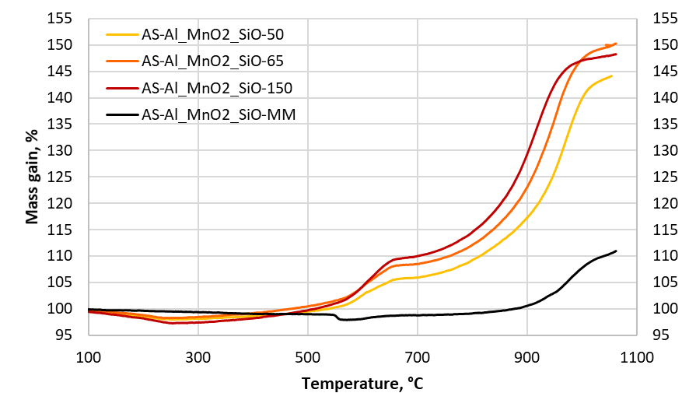
The non-isothermal oxidation behavior of the powders was carefully monitored using a SEIKO EXTAR II simultaneous thermal analysis machine. The testing process involved ramping up the temperature from ambient to 1150°C at a rate of 10°C/min in an air atmosphere. The analysis focused on thermogravimetry data to understand the oxidation characteristics of the samples. In the study, it was noted that the mechanical mixture, acting as the reference material, exhibited a prominent mass loss of approximately 1.1% starting at 548.6°C, which was identified as the onset temperature. This mass loss was linked to the presence of MnO₂ in the mixture undergoing transformation into Mn₂O₃, which is in line with findings reported by previous researchers [74,136]. Interestingly, the reference material displayed a distinct pattern compared to the activated powders. The activated powders showed two distinct mass gain steps instead of a single step seen in the reference material. Additionally, all activated samples exhibited an initial mass loss attributed to the desorption of excess PCA, with this loss becoming more pronounced with longer milling durations. An exception was noted with the sample Al_{S}-Al_{F}-MnO₂-SiO-65, likely due to its larger granulometry leading to a lower specific surface area. The mass loss observed in the reference material was once again linked to the presence of manganese dioxide. Notably, with varying milling times, all activated powders displayed a substantial increase in reactivity compared to the reference material. This heightened reactivity was evident from the progressive anticipation of the second temperature onset, indicating an enhanced oxidation behavior in the activated powders compared to the baseline material (Figure 18 and Table 8) [74,136].
Figure 18 – TG traces of the tested powders

The reader should note that the first temperature onset appears to be unaffected by the milling time, while the second mass gain is significantly influenced by the metal content of the powder. Indeed, more intense activation may result in a reduction of the metal content, leading to lower mass gain during thermal analysis (indicating less aluminum available for oxidation) [74,136]. In this regard, an activation period of 150 minutes may be considered overly intense.

Table 8 – Relevant TG data of the four tested powders

Powder Label | Δm₀₋₂₅₀,  % | Δm₂₅₀₋₇₀₀, % | Δm₇₀₀₋₁₀₅₀, % | Δm_{TOT}, °C | T_{ON-1}, °C | T_{ON-2}, °C
Al_{S}-Al_{F}-MnO₂-SiO | -0.50 | -0.72 | +11.62 | +10.40 | N.Av. | 917.3
Al_{S}-Al_{F}-MnO₂-SiO-50 | -1.87 | +7.93 | +37.85 | +43.91 | 554.9 | 886.4
Al_{S}-Al_{F}-MnO₂-SiO-65 | -1.72 | +10.21 | +41.21 | +49.70 | 560.1 | 864.7
Al_{S}-Al_{F}-MnO₂-SiO-150 | -2.77 | +12.71 | +38.05 | +47.99 | 555.1 | 839.2

3.2.5 Studies of metal content of the selected tested powders

The powder metal content has been evaluated by a hydrolysis technique. A small amount of powder is placed into a NaOH/water solution and the evolved hydrogen is measured through a graduated device. The alkaline solution dissolves particle oxide layer allowing the reaction of Al with water [73], according to the following equation:

𝑨𝒍+𝟑𝑯_{𝟐}𝑶 →𝑨𝒍(𝑶𝑯)_{𝟑}+𝟑/𝟐𝑯_{𝟐}+𝟒𝟓𝟗.𝟏 𝒌𝑱 [73]
Results are reported in Table 9 The activation is responsible for a progressive decrement of the metal content depending on the activation intensity.
Table 9 – Metal content of the selected tested powders. The baseline is reported for comparison purposes.

Powder Label | Al content, %
Al_{S}-Al_{F}-MnO₂-SiO-MM | 74.2
Al_{S}-Al_{F}-MnO₂-SiO-50 | 67.8
Al_{S}-Al_{F}-MnO₂-SiO-65 | 63.6
Al_{S}-Al_{F}-MnO₂-SiO-150 | 57.3

3.2.6 Preliminary combustion tests

The four selected samples were preliminarily characterized in terms of combustion speed. Approximately 0.3 g of powder was placed on an aluminum plate, forming a stripe 4 cm long, and ignited in air using a hot wire. The experimental setup is illustrated in Figure 19. The tests were recorded and post-processed using digital techniques to determine the powder burning rate. The presence of a flame was verified.
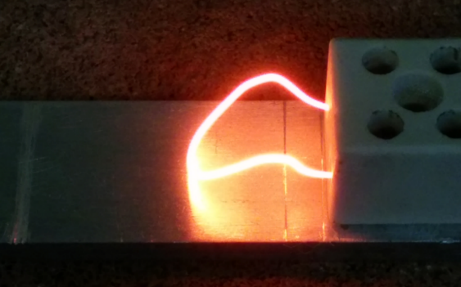

Figure 19 – Experimental set-up used for preliminary evaluation of powder combustion
The results are reported in Table 10. The reference material does not ignite, while the activated powders can be ignited without problems. The burning rate of the powders is related to the activation intensity, that is increasing the milling time it is possible to enhance the burning velocity (from 0.22 mm/s to 0.40 mm/s) [74,136].

Table 10 – Burning rate of the tested samples

Powder Label | Ignition | Burning time, s | Burning rate, mm/s | Flame
Al_{S}-Al_{F}-MnO₂-SiO-MM | No* | - | - | -
Al_{S}-Al_{F}-MnO₂-SiO-50 | Yes** | 15.60** | 0.22** | No
Al_{S}-Al_{F}-MnO₂-SiO-65 | Yes | 14.08 | 0.28 | No
Al_{S}-Al_{F}-MnO₂-SiO-150 | Yes | 10.00 | 0.40 | No

* the wire has been kept incandescent for 12 s before aborting the test (3 repetitions)
** only 3.35 cm / 4.00 cm of powder burnt (quenching

Figure 20 exhibits some representative combustion video frames of the selected powders. Tall the activated powders are flameless and relatively slow. The sample Al_{S}-Al_{F}-MnO₂-SiO-150 features the most regular combustion, while the sample Al_{S}-Al_{F}-MnO₂-SiO-50 is the less regular. The batch AS- Al_{S}-Al_{F}-MnO₂-SiO-65 is a midway solution between the other two powders

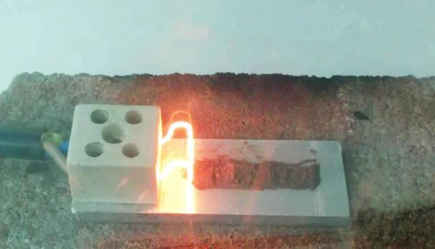
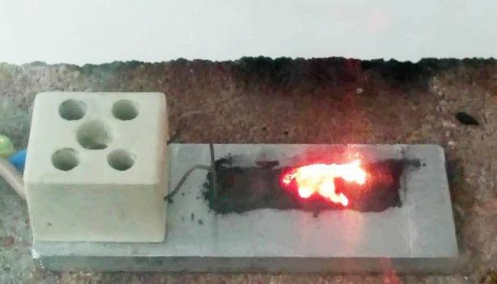

a) Al_{S}-Al_{F}-MnO₂-SiO-MM b) Al_{S}-Al_{F}-MnO₂-SiO-50

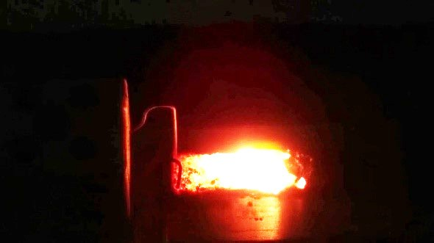
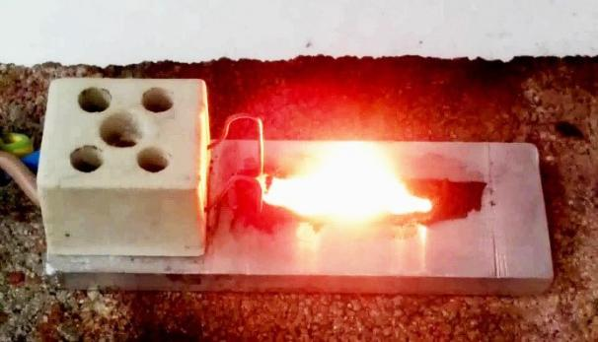

c) Al_{S}-Al_{F}-MnO₂-SiO-65 d) Al_{S}-Al_{F}-MnO₂-SiO-150
Figure 20 – Preliminary combustion tests of the selected activated samples: representative frames [74,136].

The work deals with the activation of metal powder mixtures suitable for the application in FRHs. The literature survey evidenced different possibilities to warm up emergency rations both for military and civil applications. For safety concerns, a powder suitable for the flameless burning in air has been selected. The original formulation was modified to promote a slower burning rate guaranteeing a longer combustion process. Four activated powders have been manufactured starting from the reference material using a standard technique (3 powders) and an innovative activation process (1 powder). The samples and the reference material have been characterized to evaluate both performance and the possibility to add a small amount of magnesium into the formulation. In the meanwhile, the raw materials and a candidate Mg powder have been characterized as well. The raw ingredients have been tested also in terms of aging properties.
The activated powders showed a significant increase in reactivity compared to the reference mixture, but also a decrease in metal content depending on the intensity of activation. Combustion tests revealed burning rates ranging from 0.22 mm/s to 0.40 mm/s for samples activated using the standard technique. All these powders are suitable for use in a flameless heater. However, the sample Al_{S}-Al_{F}-MnO₂-SiO-MM exhibited a noticeable flame during combustion. The sample Al_{S}-Al_{F}-MnO₂-SiO-150 has the lowest metal content but also the most regular burning propagation. The powder Al_{S}-Al_{F}-MnO₂-SiO-50 has the highest metal content but the least regular burning propagation. All the powders appeared stable and safe to handle, suggesting the possibility of partially replacing Al with Mg, with special attention to the sample Al_{S}-Al_{F}-MnO₂-SiO-50 (highest metal content). Generally, highly intense activation processes should be avoided to prevent a significant reduction in metal content and the generation of flames during powder burning due to the inclusion of PCA into the powder. The sample Al_{S}-Al_{F}-MnO₂-SiO-50 should be considered as the baseline for further studies. Introducing a small amount of Mg (up to 50%) into the formulation is a potential solution to enhance ignition, prevent premature quenching of the powder, and slightly boost both combustion speed and enthalpy release [74,136]. This adjustment could optimize the performance of the powder in the flameless heater application.

4 OBTAINING WATER-ACTIVATED EXOTHERMIC MIXTURE FOR FLAMELESS HEATERS ON THE SYSTEM Al-CaO-Na₂CO₃ WITH THE REQUIREMENTS OF AUTONOMOUS HEATERS FOR MEDICAL PURPOSES

4.1 The results of theoretical and experimental investigations of exothermic reactions in the system Al-Al₂O₃-CaO-Na₂CO₃

Exothermic mixtures based on CaO-Al refers to reactive composite materials and is commonly used in pyrotechnics and other applications where intensive heat generation and gaseous reaction products are required [149]. The main components of this mixture are calcium oxide (CaO) and aluminum (Al). When these two components interact, an exothermic reaction occurs, accompanied by the release of large amounts of heat and the formation of gaseous products such as nitrogen and aluminum oxides. The exothermic reaction between CaO and Al occurs at elevated temperatures, which is usually achieved by igniting the mixture. Various ways of activating the reaction can be used, for example, using flammable mixtures or an electric discharge. Pyrotechnic mixtures based on CaO-Al have high energy performance and a wide range of applications. They can be used in the production of pyrotechnic devices such as fireworks, fireworks, rockets and other effects [144-146].
However, it should be noted that handling exothermic mixtures requires special care and experience, as they can be dangerous and cause undesirable consequences if used incorrectly. When working with such materials, all appropriate safety measures must be observed and the manufacturer's instructions must be followed. Determining the optimal composition and quantity of system components based on CaO-Al depends on the specific task or application.
Thus, the purpose of this study is to obtain flameless burners based on an Al-CaO mixture. Sodium carbonate (Na₂CO₃) was introduced in order to enhance the properties of the mixture characteristic of heaters. As shown in some literature, Na₂CO₃ is used as an additional reagent necessary for efficient energy distribution of the system, in order to regulate the direction of the exothermic reaction and to prevent excessive temperature rise of the system [147].
At the initial stage of the research, a mechanochemical treatment of the aluminum powder was conducted in order to increase its reactivity. At the next stage, experimental work took place in order to determine the optimal ratio of the components in the system. Furthermore, the thermodynamic properties of the system were investigated, demonstrating the theoretical feasibility of an exothermic reaction within the Al-Al₂O₃-CaO-Na₂CO₃ framework.

4.1.1 Results of experimental studies of the system Al-Al₂O₃-CaO-Na₂CO₃ with water

Experimental work was carried out using chemically pure compounds: Al, Al₂O₃, CaO, Na₂CO₃, H₂O. The main raw material was aluminum powder of the PA-4 brand, the amount of pure metall aluminum is 95.9%.
At the first stage of the research in this area, mechanochemical processing of aluminum powder has been carried out. Figure 21 shows an electron microscopic image, the energy dispersion spectrum and the mass fraction of the elements of the initial aluminum powder. It follows from the presented image that the Al particles have a spherical shape. According to granulometric analysis, the average particle size is about 50 microns.
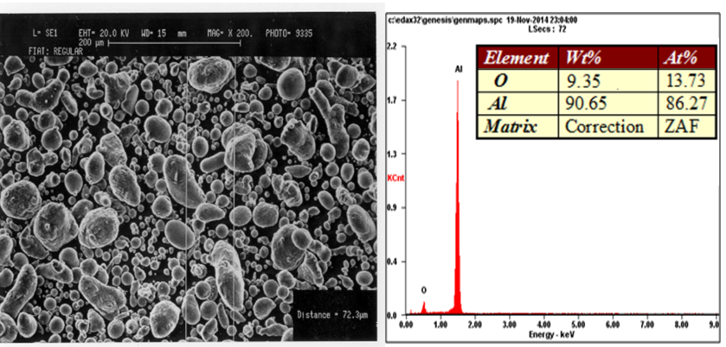
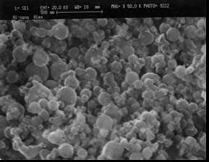
a b c

Figure 21 – Characteristics of the initial and dispersed powder of Al grade PA-4 (a – electron microscopic image of Al; b - energy dispersion spectrum and mass fraction of Al; c – electron microscopic image of Al after MA with toluene)

From the results of the energy dispersion analysis of the initial powder, it follows that the amount of metallic aluminum is 90.65 wt. %, and oxygen contains 9.35 % by weight. The presence of oxygen atoms indicates the presence of a sufficiently dense layer of an oxide film on top of the particles [135,147,148]. The powder particles have a gray color with a metallic sheen and do not contain foreign inclusions. Preliminary mechanical processing was carried out to increase the reactivity of aluminum. The optimal conditions of the MА were determined by the results of previous studies. As a result of processing aluminum powder with organic matter, aluminum particles are encapsulated in a denser organic film, which prevents their oxidation by atmospheric oxygen. In this case, aluminum particles have a higher degree of dispersion [74,136].
The homogenization process of a mixture of fine aluminum, calcium oxide and sodium carbonate were carried out using the mortar abrasion method.
The rate of the exothermic reaction of the mixture is determined either in the Dewar vessel or in the device. To assemble the device, a 200-250 ml beaker is placed in a larger glass. The space between the bottom and the walls of the glasses is filled with thermal insulation material (asbestos or slag). The Dewar vessel or the inner glass of the device is tightly closed with a stopper in which there is a hole for a thermometer (the thermometer is taken with a division price of 1 K and a long tail). It is installed so that the mercury ball is 5-10 mm above the bottom of the device. A powder mixture is placed in the device and 100 ml of water with a temperature of 293 K is poured, the device is closed with a stopper, shaken and left standing, noting the temperature of the reaction mixture every 30 seconds. The observation is carried out until the maximum temperature is set and its fall begins. The time from the moment of adding water to the moment of reaching the maximum temperature is taken as the rate of the exothermic reaction. The percentage of the selected components and the results of experiments are presented in the Table 11.

Table 11 – The percentage of the selected components and the results of exothermic reaction experiments of the system Al-Al₂O₃-CaO-Na₂CO₃ [148]

Number of samples | Percentage of the components (%)  Al-Al₂O₃ -CaO-Na₂CO₃ | T_{max}, ⁰C | τ, min
1 | 10:30:45:15 | 35 | 7
2 | 15:30:40:15 | 55 | 10
3 | 20:30:40:10 | 28 | 4
4 | 20:30:35:15 | 25 | 5

As can be seen from the table 11, a higher temperature (55⁰C) and a long duration of heat release time (10 min) are observed in a mixture with a composition of 15% Al, 30% Al₂O₃, 40% CaO, 15% Na₂CO₃ (sample № 2). This is probably due to the reactivity of calcium oxide (CaO) and sodium carbonate (Na₂CO₃). Since alkali metal compounds react vigorously with water, the first stage of the exothermic reaction may look like this [144-148]:

CaO+Na₂CO₃+ H₂O $→$ CaCO₃ + 2NaOH

CaCO₃ → CaO + СО₂

It can also be assumed that an increase in the concentration of OH⁻ ions may be observed in the solution during hydration of sodium carbonate due to the formation of a soluble sodium carbonate salt. The hydrolysis of sodium carbonate proceeds by anion, in two stages [143]:
1 stage: Na₂CO₃ + HOH = NaOH + NaHCO₃
2Na⁺ + CO₃²⁻ + H₂O = Na⁺ + OH⁻ + Na⁺+ HCO₃
CO₃²⁻ + H₂O = OH⁻ + HCO₃
Products of the first stage - NaHCO₃ and NaOH
2 stage: NaHCO₃ + HOH = NaOH + H₂CO₃
Na⁺ + HCO₃ + H₂O= Na⁺ + OH⁻ + Na⁺+ H₂CO₃
HCO₃ + H₂O= OH⁻ + H₂CO₃
Products of the second stage - NaOH and H₂CO₃

Thus, the concentration of OH ions in the solution increases, and the solution medium is alkaline. In addition, during the hydration of calcium oxide, calcium bicarbonate Ca(OH)₂ is also formed, which can also affect the concentration of OH-ions in solution.
The presence of an excess hydroxyl group in the solution may contribute to the oxidation of aluminum powder. The oxidation of aluminum oxide (Al₂O₃) leads to the rupture of the oxide film and the retention of the aluminum matrix (Al) in a liquid for further chemical transformation. Suspected oxidation reactions of aluminum oxide:

- The interaction of aluminum oxide with a solution of sodium hydroxide:

Al₂O₃ + 2NaOH + 3H₂O$→$ 2Na[Al(OH)₄]

- Or mixing aluminum and sodium hydroxides:

Al(OH)₃ + NaOH $→$ Na[Al(OH)₄]

- The aluminum matrix then reacts with the alkaline liquid as follows:

2Al + 2NaOH + 6H₂O $→$ 2Na[Al(OH)₄] + 3H₂ $↑$

- At 800°C, sodium tetrahydroxoaluminate (Na[Al(OH)₄]) completely decomposes into sodium aluminate (NaAlO₂) and water:

Na[Al(OH)₄] $→$ NaAlO₂ + 2H₂O

Also, direct reactions can occur as:
2NaOH+ Al₂O₃ $\underset{→}{{700}^{0}C}$ 2NaAlO₂ + H₂O

2(NaOH∙H₂O) + 2Al $\underset{→}{{400}^{0}C}$2NaAlO₂+3H₂

Thus, a sample of composite mixtures No. 2, consisting of metal oxides and sodium carbonate, can completely enter into a chemical reaction, such as electrochemical decomposition of water with the release of hydrogen, which is exothermic. It can be noted that with such component ratios as in this sample, a full-fledged, regulated exothermic reaction is carried out with sufficient heat release, which ensures the optimal composition of the flameless heater (Figure 22)
a

τ, min
T, ⁰C
τ, min
a
b

Figure 22 – Time dependence graph of temperatures of exothermic reactions performed by adding water to samples of the system Al-Al₂O₃-CaO-Na₂CO₃: a – sample №1 (10:30:45:15); b – sample №2 sample (15:30:40:15).
τ, μιν

Sample № 1 has a low temperature (35⁰C) and a lower rate of exothermic reaction (7 min) compared to composition № 2. This is probably due to the fact that sample № 1 includes a smaller amount of activated aluminum (10%), which initiates the duration of the exothermic reaction and contributes to an even distribution of heat transfer in the system [148].
The decrease in the chemical activity of the mixtures in samples № 3 (T = 28⁰C, τ = 4 min) and № 4 (the reaction did not occur) may be partly due to an excess of aluminum particles purified from oxide films in the solution, as well as a decrease in the percentage of active substances such as calcium oxide and sodium carbonate in the system This led to sufficient formation of highly reactive and short-lived hydroxyl groups (OH⁻).
From the presented data, it should be extracted that with an increase in the content of activated aluminum, and a decrease in calcium oxide below 40%, and sodium carbonate below 15% in the Al-Al₂O₃- CaO-Na₂CO₃ composite system, the reaction system as a whole decrease.

4.1.2 Conducting thermodynamic calculations of the system Al-Al₂O₃-CaO-Na₂CO₃ using the NASA-CEA program

The thermodynamic calculation of the exothermic reaction of an aqueous solution of the Al-Al₂O₃-CaO-Na₂CO₃-H₂O system was performed on a computer using the NASA Chemical equilibrium and application (CEA) program for calculating chemical equilibrium. The necessary initial data for calculations are presented in the form of standard sets of tables of thermodynamic functions in the database of the NASA CEA Code program (Table 12).

Table 12 – Standard thermodynamic values of simple substances of the Al-CaO-Na₂CO₃ system

Simple substances | ${∆_{f}H}_{298}^{0},$  kJ/mol | $S_{298}^{0}$, J/(mol∙K) | ${∆_{f}G}_{298}^{0}$,  kJ/mol | $C_{P, 298}^{0},$ J/(mol∙K)
Al (cr.) | 0 | 28,3 | 0 | 24,3
Al₂O₃ (corund) | - 1675,7 | 50,9 | -1582,3 | 79,0
CaO (cr.) | - 635,1 | 38,1 | -603,5 | 42,0
Na₂CO₃ | -1130,8 | 138,8 | -1048,2 | 111,3
H₂O (liquid) | -285,8 | 69,9 | -237,2 | 75,3

Calculations were carried out on the effect of the content of component compositions on the reactivity of the Al-Al₂O₃-CaO-Na₂CO₃-H₂O system. The pressure value in the combustion chamber varies from 1 to 2 bar. The Table 13 presents the used calculation parameters of theoretical calculations for the system.

Table 13 – Calculated parameters used in thermodynamical research

Reagents % | Mass, % | Initial  temperature, K
Fuel, Al₂O₃ | 30.0 | 298.0
Fuel, Al | 15.0 | 298.0
Fuel, CaO | 40.0 | 298.0
Fuel, Na₂CO₃ | 15.0 | 298.0
Oxidizer, H₂O(l) | 100.0 | 298.0
Ratio of oxidizer to fuel, O/F = 1:1

Calculations performed for the Al-Al₂O₃-CaO-Na₂CO₃-H₂O system showed that the selected components of the system enter into a chemical reaction completely without special conditions. The enthalpy in the calculations has negative values (with a minus sign "-"), which indicates that the reaction of the interaction of the system components is exothermic, that is, it proceeds with the release of heat (Table 14). The very value of the amount of enthalpy indicates that the amount of energy obtained is sufficient to convert into heat at a given set temperature (298 K) and pressure (0.1- 0.2 MPa).

Table 14 – Results of thermodynamic calculations of the exothermic reaction of the Al-Al₂O₃-CaO-Na₂CO₃-H₂O system

Pressure  Р, bar | T, K | $${∆_{f}H}_{298}^{0},$$  kJ/mol | $S_{298}^{0}$, J/(mol∙K) | ${∆_{f}G}_{298}^{0}$, kJ/mol | $C_{P, 298}^{0},$ J/(mol∙K)
1.0132 | 859.0 | -12470.7 | 10.0 | -21140.5 | 2.4
2.0265 | 862.7 | -12470.7 | 9.8 | -20964.7 | 2.2

According to thermodynamic calculations (Table 15), the final product will consist of 10.100% Al₂O₃, 5.336% NaAlO₂, 2.739% CaCO₃ (cr), 7.666% CaO (cr), 73.546 H₂O and emitted gases in the amount of 0.386% H₂, 0.225% CO₂, 0.002% CO.

Table 15 –Products formed as a result of the exothermic reaction of the system Al-Al₂O₃-CaO-Na₂CO₃ with water and their mass contributions

Products formed as a result of the reaction | Mass fraction, %
α -Al₂O₃ | 10,1
NaAlO₂ | 5,3
CaCO₃ (cr) | 2,7
CaO (cr) | 7,6
H₂ | 0,3
H₂O | 73,5
CO₂ | 0.2
CO | 0.002

Thus, according to thermodynamic calculations, it was found that the components of the Al-Al₂O₃-CaO-Na₂CO₃-H₂O system can carry out an exothermic reaction with positive results for their use in flameless heaters.
Based on the data provided, a reaction with heat release is observed in the Al-Al₂O₃-CaO-Na₂CO₃-H₂O system. The enthalpy change (ΔH) is negative, indicating that the reaction is exothermic. This means that heat is released as a result of the reaction. It should be noted that, with increasing pressure and temperature, Δ_{f}H remains constant. This suggests that the reaction does not depend on changes in conditions. Additionally, values for entropy (ΔS) and Gibbs free energy (ΔG) indicate that the reaction would be favorable from a thermodynamic standpoint, as ΔG is less than zero under these conditions at 298 K. Therefore, it is concluded that the reaction observed in this system is exothermic and favorable from a thermodynamics perspective. It is important to note that no harmful substances CO₂ and CO are released in significant quantities during the reaction, which is a positive aspect from an environmental point of view.
Thus, the Al-Al₂O₃-CaO-Na₂CO₃-H₂O system has good thermodynamic properties, which can be useful for the composition of flameless heaters.

4.1.3 The results of differential scanning calorimetry (DSC) analysis of the system Al-Al₂O₃-CaO-Na₂CO₃

To assess changes in the microstructure of powder compositions during their heat treatment, enthalpy curves were obtained using the device – calorimeter "SKZ1052 Differential Scanning Calorimeter", which provided heating of powder samples to 500° C at a heating rate of 20 ° C/min (Figure 23)
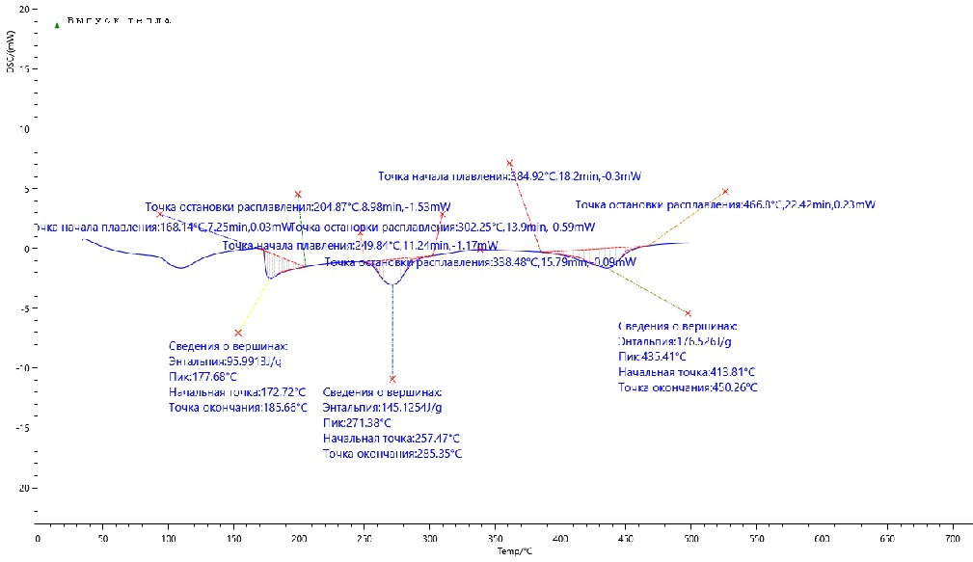

Figure 23 – Dependence of the heat flux on the heating temperature in the calorimeter of the powder sample Al-Al₂O₃-CaO-Na₂CO₃

4 endothermic peaks are observed on thermograms (Figure 23): the first, in the range from 172 to 185° C, the second, at 177.68°C, the third, in the range from 257 to 285°C, and the last, from 413°C to 450°C. The observed endothermic peaks indicate heat absorption during phase changes or chemical transformations.
The first three peaks on the thermogram may correspond to phase transitions or chemical reactions that occur in certain temperature ranges. For example, the first peak, in the range of 95-120°C, may indicate the release of water or other volatile substances, the second peak, at 177.68°C, may be associated with thermal decomposition or desorption, and the third peak, in the range of 257-285°C, may reflect deeper chemical transformations or phase transitions. The thermal effect (∆H) is 95.9913 J/g and 115.1251 J/g for the second and third peaks.
The last peak, marked in the range from 413 to 450°C, indicates a transition from the original amorphous or crystalline structure to a plastic or molten state with heat absorption (∆H=176.52 J/g). This can be important for molding or material processing processes.
In addition, the experimental results confirm that the powder composition cannot spontaneously react at room temperature and that the exothermic reaction occurs only when water is added. This is of great importance for the safety and control of production processes, as well as for assessing the stability of the composition.
In general, the results of the analysis indicate that powdered formulations exhibit stable thermal properties at room temperature and their chemical and physical characteristics remain largely unchanged during heating.

5 OBTAINING OF A NEW EXOTHERMIC COMPOSITION Al-Al₂O₃-CaO-Na₂CO₃-SiO₂ FOR FLAMELESS HEATERS WITH THE ADDING OF SILICON DIOXIDE INTO THE INITIAL EXOTHERMIC COMPOSITE BY MECHANO-CHEMICAL ACTIVATION TO PROVIDES HEATING DEVICES IN THE FIELD

5.1 Optimization of composite ratios to obtain effective powder mixtures of the system Al-Al₂O₃-CaO-Na₂CO₃-SiO₂ and the effect of mechanical activation on their reactivity

To conduct experimental studies on the Al-Al₂O₃-CaO-Na₂CO₃-SiO₂ system in order to create composites based on aluminum and calcium oxide with a highly effective exothermic reaction, optimal proportions of components in the system were selected based on the results of previous experimental studies, taking into account the required content of Al₂O₃ and CaO in the range of 50-60% of the total weight [155] (Table 16).

Table 16 – The optimal percentage composition of the system Al-Al₂O₃-CaO-Na₂CO₃-SiO₂
Reagents | Optimal mass fraction, %
CaO | 20
Аl | 20
Al₂O₃ | 30
Na₂CO₃ | 15
SiO₂ | 15

As can be seen from Table 16, silicon dioxide (SiO₂) was introduced into the matrix of the composite. The presence of silicon dioxide in the matrix of the exothermic composite leads to an improvement in the mechanical properties and heat resistance of the material [149]. In addition, SiO₂ can also participate in chemical reactions, contributing to an increase in the efficiency of the exothermic reaction and an increase in the heat transfer of the material.
The mixing and dispersion of the starting materials according to the specified proportions was carried out using mechanochemical activation (MA). The mechanochemical method of preparing materials for energy systems is the most promising, since it allows the most productive management of the process of forming new structural compositions that increase the energy intensity of the system. During the MA process, not only dispersion occurs, but also accumulation and redistribution of defects in the volume of particles, increasing their chemical activity in subsequent processes. This method also makes it possible to obtain highly dispersed modified material in a large volume, which is effective from a technological point of view [150-152].

Choosing the optimal MA time is an important step to achieve the desired material properties. Different processing time intervals can lead to different structural and chemical changes in the material, affecting its quality and characteristics. To study the effective MA time, the processing time interval of 10, 15 and 20 minutes was selected (Table 17).

Table 17 – Mechanical activation options used for the preparation of powders

Formulation of the activated samples | Activation time, min
Al-Al₂O₃-CaO-Na₂CO₃-SiO₂ -10 | 10
Al-Al₂O₃-CaO-Na₂CO₃-SiO₂ -15 | 15
Al-Al₂O₃-CaO-Na₂CO₃-SiO₂ -20 | 20
Activation speed 400 rpm
Mill ball to powder ratio 2:1

After processing in the mill, the dispersion of the powder was determined by the optical method. Measurements showed that after grinding the powder mixture for 10 minutes, dispersion is uneven, large particles ranging in size from 30 to 50 microns are found (Figure 24).

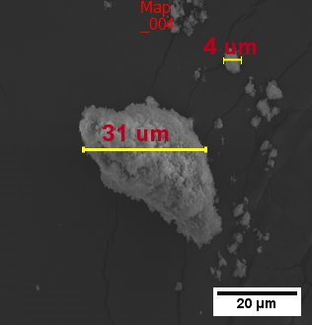
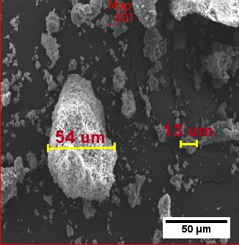

Figure 24 – SEM pictures after 5 min MA of the system Al-Al₂O₃-CaO-Na₂CO₃-SiO₂

Uneven dispersion of the powder can lead to undesirable results and heterogeneity in the final product. Moreover, with an increase in the grinding time from 10 to 15 minutes, the number of particles of the specified dispersion increases from 50 to 80 microns. Hence, the initial state (i.e. the degree of crystallization) and the purity of the material are reflected in its ability to grind in the MA process (Figure 25).

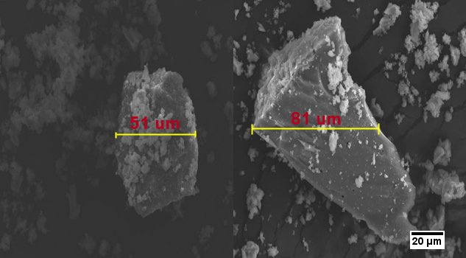

Figure 25 – SEM pictures after 15 min MA of the system Аl-CaO-Na₂CO₃ -SiO₂

During mechanical activation or dispersion of the Al-CaO-Na₂CO₃-SiO₂ system, an increase in the dispersion time does not always lead to a decrease in particle size. In some cases, prolonged grinding can cause particles to sinter, especially if the system has a high thermal sensitivity. As a result of sintering, particles can combine, which will lead to the formation of larger particles (Figure 26) [153].
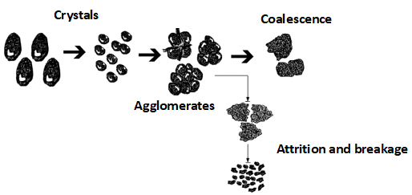
Figure 26 – Graphical illustration of the mechanochemical crushing mechanism [153]

When silicon dioxide is used in the system, aggregates of aluminum particles with quartz particles embedded in the metal surface and encapsulated in a shell are also formed. The obtained characteristics indicate complex structural changes in the obtained compositions after the formation of the composite both in the volume of particles and on the surface.
An increase in the MA time by another 5 minutes led to a decrease in the particle size of the powder mixture and an improvement in their dispersion, which in turn responds to the uniformity of the system (Figure 27).

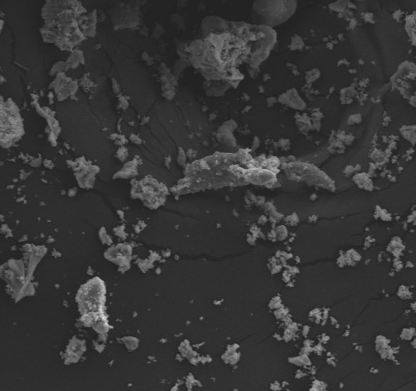
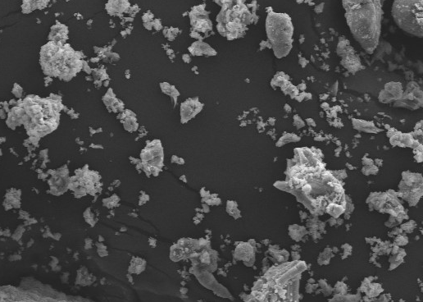
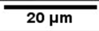

Figure 27 – SEM pictures after 20 min MA of the system Аl-CaO-Na₂CO₃ -SiO₂

Thus, the use of mechanical action to alter the structure, state of a material and its energy level is an effective method of influencing the process of an exothermic reaction and obtaining materials with specific properties and intended function. The use of pre-treatment by mechanical means will contribute to the creation of diverse phase structures. By adjusting the parameters of this treatment and the state of activated reagents, it is possible to control reaction pathways during subsequent reactions, purposefully altering the thermal impact of reactions and producing products with a specified morphology and size of structural elements. [81,96,111].

5.2 Results of experimental studies of the interaction of activated mixtures of the system with water

The experimental work was carried out according to the description of the previous chapter (3.1.1). The data obtained are shown in the Table 18 and Figure 28. The results of the experiment show that sample № 2 with mechanical activation for 15 minutes has the most effective characteristics (Tmax=101⁰C, τ= 12 min) when interacting with water. This may be due to the optimal activation time, which makes it possible to achieve optimal structure and properties of the mixture. It is also possible to note the role of silicon dioxide (quartz) in the composition of the composite.

Table 18 – Results of exothermic reaction experiments of the system Al-Al₂O₃-CaO-Na₂CO₃-SiO₂ -H₂O

Number of samples | Activated time, min | Теmperature  T_{max}, ⁰C | Duration of heat dissipation, min
1 | 10 | 58 | 5
2 | 15 | 101 | 14
3 | 20 | 45 | 4

As it was shown in [90,96], quartz is characterized by good dispersibility, i.e., the production of a highly dispersed powder as a result of grinding in a mechanical reactor. Since it has high hardness values, the crushed particles can serve as a good abrasive material when simultaneously processing quartz with soft and ductile aluminum. In addition, quartz is a piezoelectric. The deformation of the lattice caused by mechanical stress leads to a redistribution of electric charges in the presence of polar directions (negative electric charges arise on the negative edges of the hexagonal prism zone, positive ones on the positive edges). There is also an inverse piezoelectric effect, which consists in the fact that in an electric field, internal stresses arise in crystals, proportional to the stress fields. All these factors were taken into account at this stage of the work on the mechanochemical processing (activation and modification) of aluminum in the presence of quartz. Quartz particles present in the processing process can play the role of an abrasive that wears away the surface of aluminum particles. This process leads to a change in the surface structure of aluminum particles and the destruction of the oxide layer on their surface. As a result of reducing the particle size and increasing the active surface, intensive interaction of the system components occurs, which contributes to an increase in reactivity. Also, the crushed particles of the oxide components are embedded in the surface of the deformable aluminum particles, helping to accelerate the reaction between aluminum and other substances involved in the process. Thus, the introduction of oxide components and the effect of quartz particles during aluminum processing can effectively enhance mechanochemical reactions and increase the reactivity of components, as proved by the data in the Figure 28.
Figure 28 – Time dependence graph of the temperature of the system Al-Al₂O₃-CaO-Na₂CO₃-SiO₂ when interacting with water

This approach may be useful in developing new formulations for flameless heaters or improving the properties of existing materials in order to increase the efficiency of reaction processes.
It should be noted that the amount of aluminum in the composite is 50% [90]. Oxygen is a part of both silicon dioxide (quartz) and the oxidized surface layer of aluminum particles. This can contribute to the sintering of aluminum particles and quartz.
The process of an exothermic reaction in a system with water can be described by the following chemical reaction equations [158]:

CaO+Na₂CO₃+ H₂O $→$ CaCO₃ + 2NaOH (1)
2Al + 2NaOH + 6H₂O $→$ 2Na[Al(OH)₄] + 3H₂ $↑$ (2)
CaCO₃ → CaO + СО₂ (3)
2SiО₂ + 6Al + 9/2О₂ → 3А1₂О₃•2SiО₂ (4)
SiО₂ + Al₂O₃ → А1₂О₃•SiО₂ → Al₂SiO₅ (5)
Thus, when quartz is added to the composite after an exothermic reaction, a material containing corundum, mullite, calcium oxide, sodium hydroxide, water, hydrogen, and in small amounts carbon dioxide is formed [93-95].
As can be seen from Table 18 and Figure 28, the reaction with water and samples № 1 and № 3 proceeds with the release of temperature in a small amount, this may mean that the reaction is not very intense, that the amount of heat released is small. That is, with a lesser or greater degree of activation of powder mixtures of this system, it leads to a decrease in the reactivity of composites.
The limited time for the dispersion of systems in the early stages of mechanochemical activation may lead to insufficient destruction of the protective layers of particles, and also does not lead to the accumulation and redistribution of defects in the volume of particles, which contribute to an increase in their chemical activity. This can limit the availability of active centers and slow down reaction processes, since an increase in the surface and a change in the structure of particles contribute to an increase in the rate of chemical reactions [90-92] .
Prolonged mechanochemical activation of particles, as can be seen from Table 18, leads to less release of temperature and heat. In fact, indeed, prolonged mechanochemical activation of particles can sometimes lead to less heat generation and a decrease in system temperature compared to shorter activation periods. This may be due to several different factors, including excessive particle dispersion. One of the reasons for the decrease in heat generation may be spraying or even deactivation of active centers as a result of excessive mechanical processing. With intensive particle dispersion and prolonged mechanochemical activation, effects associated with wear or destruction of the material structure may occur, which can reduce the efficiency of the reaction and, consequently, reduce thermal emission [150-153]. Moreover, the dispersion of particles can lead to an increase in the contact area between the components of the system, which in turn can contribute to a more intense reaction and, as the data obtained prove (Figure 29).
This phenomenon can also be explained by the sintering process, which is a spontaneous process that occurs below the melting point of the material and reduces the free energy in the system. During sintering, there is usually a decrease in porosity and an increase in strength, which makes it a more energy-efficient process compared to solid-phase sintering.
Liquid-phase sintering uses lower firing temperatures than solid-phase sintering and therefore requires less energy input. However, both processes result in a reduction in porosity and improvement in strength. Different components of a mass have different melting points. The liquid phase, formed as a result of the contact between solid particles, spreads over the surface of the solid through two mechanisms: surface diffusion and capillary action [154,155]. The sintering process, in which solid particles fuse together under the influence of heat and pressure, is most effective when the solid particles are immersed in the liquid phase and the liquid has low viscosity. Once a certain level of liquid phase has been reached, a thin film of liquid forms around each solid particle. Capillary forces between the particles and the liquid layer draw the particles together, filling the spaces between them with molten liquid. Processes such as dissolution and crystallization take place in the liquid, strengthening the bonds between the particles. During sintering, sealing can be achieved through various mechanisms, such as viscous flow or volumetric diffusion, which depend on the composition of the materials involved. Regardless of the specific mechanism, the main stages of sintering typically include the following stages [156]:
1) Baking, where contact between particles develops, but the grain boundaries remain intact (Figure 29a) [156];
2) Sintering - the main stage is the separation of "matter phase" and "empty phase", particles merge with each other, but closed pores haven't formed yet, local sintering occurs ] (Figure 29b) [156];
3) Continuation of sintering, crumbling of the "empty phase" - formation of closed, closed pores [153] (Figure 29c) [156];
4) Removal of closed pores due to diffusion processes, formation of non-porous or low-porous materials.
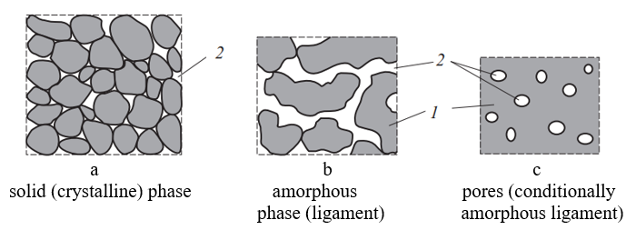
5) Formation of a thermodynamically stable distribution pattern of condensed phases [156].
Figure 29 – Stages of the sintering process: a - baking; b - sintering; c - formation of closed pores and their overgrowth; 1 - solid phase; 2 - pores [156]

After sintering, the material's structure typically consists of a solid phase and pores. The solid phase includes large particles known as filler, as well as an amorphous phase called the binder. The sintering process relies on the free energy of the system. Larger particles do not sinter on their own. To bond larger particles during sintering, a fine dispersed phase with extra free energy is needed. Diffusion within this phase contributes to particle bonding. Pores formed during sintering can be categorized as open or closed. Open pores allow liquids to flow through them, while closed pores do not have an opening to the outside. Open pores can be further divided into permeable and impermeable types. Permeable pores allow liquids to penetrate, whereas impermeable pores do not allow liquids to enter. The degree of sintering is typically assessed based on factors such as density, water absorption, and porosity. A higher density, lower water absorption, and lower porosity generally indicate a more complete sintering process, resulting in a denser, more homogeneous final product. These properties are essential for determining the mechanical strength, durability, and other characteristics of the sintered material. They are therefore important considerations when optimizing the sintering process to achieve the desired properties [153-156].
Thus, it follows from the presented data that by conducting mechanochemical activation of the components of mixtures, it is possible to purposefully influence the process of exothermic reaction and the formation of a dense or porous structure with finely dispersed phases, which in turn ensure the reactivity of the synthesizing material. The use of a mechanical activation process (the initial powder mixture of components is ground within a short time with a given frequency and impact energy) leads to the formation of new active materials. Mechanical activation allows theoretically to increase the rate of chemical reactions and increase heat generation by several times compared with the classical value obtained under the same conditions of interaction of the components. In addition, in the case of using mechanically activated powdered mixtures, the maximum rate of thermal heating, measured during the chemical reaction process, is significantly increased, also by increasing the contact surface between the components of different names, it allows to intensify the exothermic reaction compared with the classical process [157,158].

5.3 Thermodynamic studies of the exothermic reactions of the system Al-Al₂O₃-CaO-Na₂CO₃-SiO₂

Calculations were carried out on the effect of the content of activated component compositions on the reactivity of the Al-Al₂O₃-CaO-Na₂CO₃-SiO₂ system with water. The pressure value in the combustion chamber varies from 1 to 2 bar. The Table 19 shows the calculated parameters used for theoretical calculations for the system.

Table 19 – Calculated parameters used in the research

Reagents % | Mass, % | Initial temperature, K
Fuel, Al₂O₃ | 30.0 | 298.0
Fuel, Al | 20.0 | 298.0
Fuel, CaO | 20.0 | 298.0
Fuel, Na₂CO₃ | 15.0 | 298.0
Fuel, SiO₂ | 15.0 | 298.0
Oxidizer, H₂O(l) | 100.0 | 298.0
Ratio of oxidizer to fuel, O/F = 1:1

The Table 20 presents the obtained data of theoretical calculations of the Al-Al₂O₃-CaO-Na₂CO₃-SiO₂ -H₂O system.

Table 20 –Results of thermodynamic calculations of the exothermic reaction of the system Al-Al₂O₃-CaO-Na₂CO₃-SiO₂ with water

Pressure Р, bar | T, K | ${∆_{f}H}_{298}^{0},$ kJ/mol | $S_{298}^{0}$, J/(mol*K) | ${∆_{f}G}_{298}^{0}$, kJ/mol | $C_{P, 298}^{0},$ J/(mol*K)
1.0132 | 2134.1 | -9947.5 | 10.2 | -31727.7 | 1.03
2.0265 | 2139.1 | -9947.5 | 10.0 | -31355.1 | 1.02

As can be seen from the Table 20, the results of thermodynamic calculations for the compositions of the Al-Al₂O₃-CaO-Na₂CO₃-SiO₂ system, where they are in satisfactory agreement with the data in Figure 25, which proves the possibility of an exothermic reaction with water, releasing a large amount of heat (P=1 bar, T=2134.15K).
The significant coincidence of the data obtained on possible reaction products using the NASA program (Table 21) indicates and confirms the correctness of theoretical assumptions about the course of the chemical reaction of the Al-Al₂O₃-CaO-Na₂CO₃-SiO₂ system with water.

Table 21 –Products formed as a result of the exothermic reaction of the system Al-Al₂O₃-CaO-Na₂CO₃-SiO₂ with water and their mass contributions

Products formed as a result of the reaction | Mass fraction, %
α -Al₂O₃ | 17,4
Al₂SiO₅ | 16,6
NaOH | 1,7
CaO (cr) | 8,1
H₂ | 0,8
H₂O | 51,4
CO₂ | 0.01
CO | 0.006

For a more detailed analysis, diffractometric studies of samples № 1, № 2, № 3 of the Al-Al₂O₃-CaO-Na₂CO₃-SiO₂ system were carried out after an exothermic reaction.

5.4 Results of diffractometric studies of the system Al-Al₂O₃-CaO-Na₂CO₃-SiO₂
As a result of diffractometric analysis, it was found that the phase composition of the product is mainly represented by sillimanite (Al₂SiO₅), corundum (α -Al₂O₃) and residual quartz (SiO₂).The main component of the product sillimanite has a chemical composition of 37.02% SiO₂ and 62.98% ); sometimes Al is partially replaced by Fe. It forms shaggy and fibrous aggregates composed of colorless, yellowish-gray, brownish and indivisible rhombic systems [159-163].
Figure 30 shows an X-ray of the product of an exothermic reaction with water of a mixture of Al₂O₃+Al+CaO+Na₂CO₃+SiO₂ activated for 10 minutes. As can be seen, after 10 min MA, partial sintering of the oxide components occurs, forming aluminosilicate compounds (mullite 3Al₂O₃∙2SiO₂, sillimanite Al₂SiO₅, aluminosilicate Al₂O₃∙21SiO₂), corundum α -Al₂O₃, residual quartz (SiO₂) and calcium oxide. Peaks of the original aluminum, silicon dioxide and calcium oxide are also visible.
A comparison of the experimental diffractogram (Figure 30) and the standard radiograph of mullite and corundum (Figure 31 [161]) allows to conclude, that the experimental picture contains pronounced mullite and corundum peaks.
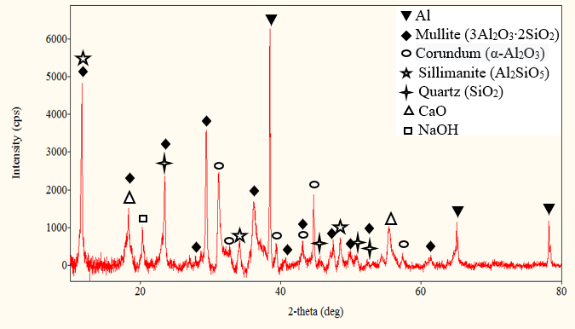

Figure 30 – Diffractogram of the system Al-Al₂O₃-CaO-Na₂CO₃-SiO₂ -10 after the reaction with water
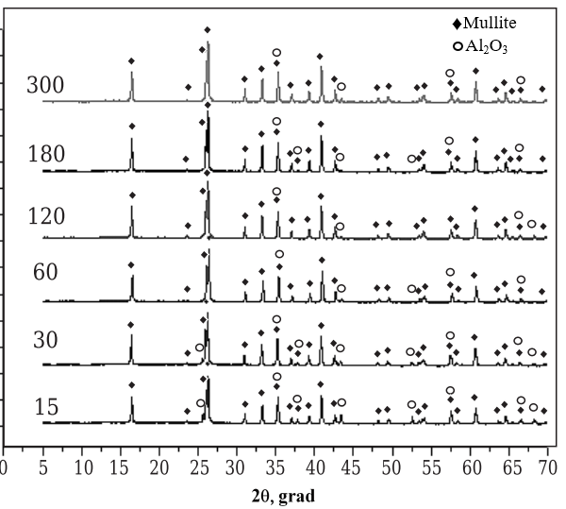
Figure 31 – Diffractogram obtained on an X-ray diffractometer at 1600 °C is a mixture of clay and calcined alumina [161]

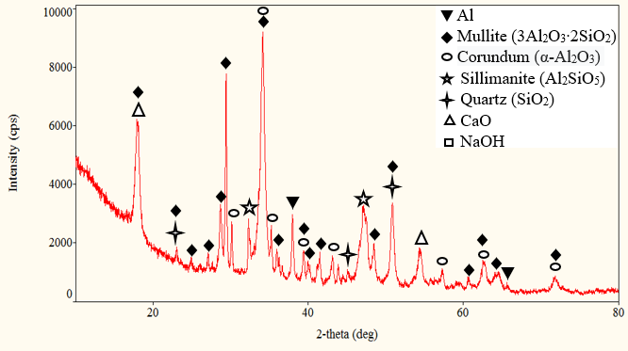
Weaker sillimanite peaks were also detected on the diffractograms of the 3 samples (Figures 30, 32 and 33). These data suggest the formation of sillimanite and mullite Al-Si-O microaggregates during melting. The weak intensity of these peaks [160,161] is associated with the extremely small size of the aggregates.

Figure 32 – Diffractogram of the system Al-Al₂O₃-CaO-Na₂CO₃-SiO₂ -15 after the reaction with water
Also, in the latest diffractograms, a decrease in the peaks of the starting materials, such as aluminum and silicon dioxide, can be noticed, probably due to the fact that the sintering of the particles consumes the starting materials. A significant decrease in their size and expansion of the peak zone may be associated with grain crushing and accumulation of internal stresses as a result of cold deformation [160].
The change in the size of the crystallites of individual peaks is also associated with microdeformation in the crystal lattice. It is also possible to observe an increase in the peak of corundum and sillimanite, as well as a decrease and expansion of the peak of mullite.
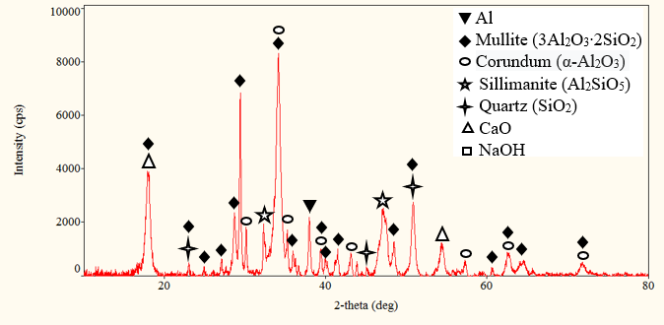
Figure 33 – Diffractogram of the system Al-Al₂O₃-CaO-Na₂CO₃-SiO₂ -20 after the reaction with water

The formation of mullite, a key ceramic phase in quartz-containing materials, can be hindered by several factors, including the composition of the mixture. This process usually occurs through a reaction between aluminum oxide (Al₂O₃) and silicon dioxide (SiO₂), which are commonly found in materials like kaolin clay and raw materials rich in alumina. In mixtures that contain quartz, the formation of mullite may be difficult due to insufficient aluminum oxide content. Aluminum oxide not only bonds with silica to form mullite but also interacts with other components like calcium oxide (CaO), which may be present in the mixture [161]. The presence of calcium oxide during firing can lead to the formation of calcium carbonate (CaCO₃), preventing the formation of mullite. When calcium carbonate forms in a mixture, it competes with aluminum oxide for silicon dioxide, reducing the chances of mullite forming. Additionally, the presence of calcium carbonate may introduce impurities or alter the firing atmosphere, further affecting mullite formation. To ensure successful mullite formation in mixtures containing quartz, careful control of the composition is essential, particularly the ratio of aluminum oxide to silica. Additionally, firing conditions such as temperature, atmosphere, and duration must be optimized to promote mullite formation while minimizing the formation of unwanted phases like calcium carbonate.
Weak peaks of mullite and sillimanite on the diffractogram (Figure 33) are observed for the initial samples at room temperature, as well as at temperatures above the melting point. These two modifications of crystals have similar characteristics in their chemical structure. It is important to note that the c parameter of the mullite cell is 2 times less than that of sillimanite. The rest of the cell parameters are quite similar. Thus, it is impossible to accurately determine the type of ordering in microaggregates in this study.
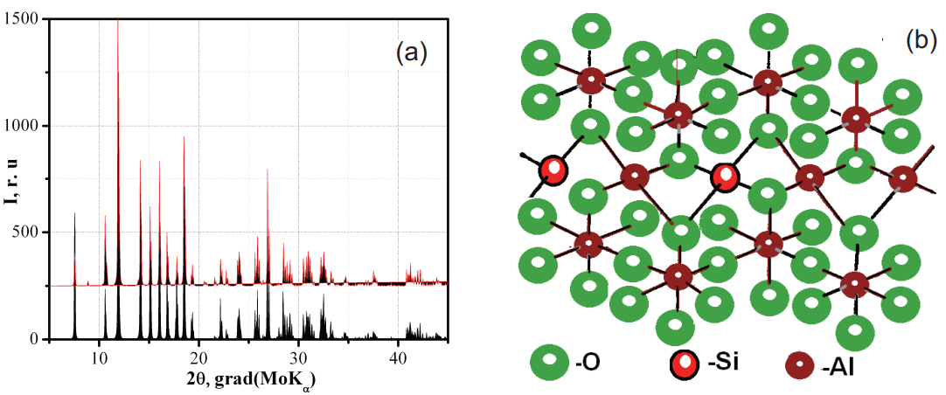
The ideal mullite cell is shown in Figure 34 [159]. Extremely high CaO values indicate that calcium does not play a role in the formation of microaggregates in the melt.

Figure 34 – Diffractograms of mullite (black) and sillimanite (red); ideal mullite cell (b) [159].

The short-circuit parameters for the coordination bonds of SiO and AlO remain unchanged and are close to the characteristic values obtained earlier or presented in the literature on silicate data.
The above characteristics can be interpreted as follows. The features of the diffraction data obtained in the experimental data should be attributed to the inhomogeneous microstructure of the material containing microparticles. The liquid component is an unordered matrix. Randomly distributed aluminosilicate microparticles are in diffusion equilibrium with a liquid disordered matrix. Calcium cations are located on the surface of aluminosilicate microcrystallites, partially compensating for the negative surface charge of oxygen ions crystallite.
Oxygen ions in the disordered matrix, in turn, neutralize a small excess positive charge of calcium cations. Thus, the core of the microparticle can be assumed to consist of microcrystallite mullite-sillimanite surrounded by calcium ions. The core is also surrounded by oxygen ions from the disordered matrix, thus forming a diffuse layer around the filler. Microparticles interact intensively with a liquid disordered matrix. Presumably, the microaggregate is an aluminosilicate of the type of mullite and/or sillimanite. It is difficult to predict the type of microaggregate, since its structure depends on the composition and temperature. It was reported in the literature [159] that sillimanite decomposes at approximately 1823 K to form mullite in accordance with equation (1):
3Al₂SiO₅ → Al₆Si₂O₁₃ + SiO₂ (1)

The possibility of continuous transformation depending on the composition and temperature should not be excluded.
Thus, the X-ray data show that with an increase in the activation time of the mixtures, the starting materials are completely consumed with the formation of aluminosilicate compounds and corundum. The peaks of residual quartz and calcium oxide formed as a result of the decomposition of calcium carbonate also expand.

Table 22 – Сomparative Data Table

Type | Contents | Disadvantages | Literature | Advantages of our samples
Air-activated | Zn, Al, Mg | This reaction release with contacting an electrolyte, Q_{Mg}=5,6 kJ/g | [22] | Alloy metals replaced to mechano-activated aluminum,  reaction release with contacting air,  Q_{Al}=31,0 kJ/g
Air-activated | Zn, O₂,  Carbon (C) as promoter for the reduction of oxygen;  an alkaline electrolyte | The difficulty of the production stages and in the control of the composite,  produces extreme temperatures | [22] | With the addition of SiO allow to regulation and control of uniform combustion
Water-activated | Mg/Fe mixture | hard-to-reach, expensive metals, sensitive to corrosion | [28] | Replacement of aluminum is associated with the cheapness and corrosion stable of the metal
Water-activated | Electrolyte NaCl | pH=4-7, | [28,32] | Replacement of Na₂CO₃ allow to regulate the pH of the medium (⁓7).
Water-activated | Mg+H₂O | Mg(OH)₂ strong alkali, does not react without oxidation of iron,  addition of an acid or acid salt [AlCl₃, H₃BO₃, food grade adipic acid, and Fe(NO₃)₃] to neutralize pH near 7. T_{max} =75-82⁰C, heating time - 8 min | [32] | without the use of alkalis, T_{max} = 101⁰C, increased heating time to 12 min with addition of SiO₂
Water-activated | CaO₂, Na₂CO₃, Al | High oxidative potential of calcium peroxide, unstable | [39] | CaO stable, easily accessible
Water-activated | CaO, NaOH, MgCO₃, SrCO₃, BaCO₃ | complex composition, NaOH strong alkali | [45-48] | NaOH synthesized in intermediate reactions

CONCLUSION

1. The optimal conditions of mechanical activation of the composition of the system Als-Al_{F}-MnO₂-SiO for air-activated flameless heaters and its maximum combustion temperature is 886.4⁰C, providing a uniform combustion rate of 0.22 mm/s were determind. It was found that, the aging of the powders did not significantly affect their reactivity. The metal content decreases with increasing activation time: the Als-Al_{F}-MnO₂-SiO composite without MA contains 74.2% of the metal content, and with a time of 150 min MA, the metal content is 57.3%.
2. Obtained the percentage composition of the Al-Al₂O₃-CaO-Na₂CO₃-H₂O system, which meets the requirements for autonomous medical heaters activated by water, covering a temperature range 28-55°C during an exothermic reaction.
3. Thermodynamic characteristics have shown, that at a given temperature (298 K) and pressure (0.1-0.2 MPa), the reaction in Al-Al₂O₃-CaO-Na₂CO₃-H₂O occurs spontaneously, since ∆G < 0 under the specified conditions. The enthalpy value ${∆_{f}H}_{298}^{0}$ = -12470.7 kJ/mol indicates that the reaction in the system is exothermic, and releases a sufficient amount of heat (T=859.05 K) and energy (${∆_{f}G}_{298}^{0}$= -21140.5 kJ/mol). Determined that the final product consist of 10.1% Al₂O₃, 5.3% NaAlO₂, 2.7% CaCO₃ (cr), 7.6% CaO (cr), 73.5 H₂O and emitted gases in the amount of 0.3% H₂, 0.2% CO₂, 0.002% CO.
4. The results of DSC indicate partial oxidation of aluminum oxide and calcium oxide in the range from 172°C to 185°C. The observed endothermic peaks indicate in the range from 257 to 285°C, and from 413°C to 450°C heat absorption during phase changes or chemical transformations. The thermal effects (∆H) are 95.9913 J/g and 115.1251 J/g for the first and second peaks. The last peak, marked in the range from 413 to 450°C, indicates a transition from the original amorphous or crystalline structure to a plastic or molten state with heat absorption (∆H=176.52 J/g).
5. Obtained a new composition by adding silicon dioxide to the system Al-Al₂O₃-CaO-Na₂CO₃ system by mechanochemical processing (15min), which can give the required maximum (T=101⁰C) temperature and maximum time (τ=14 min) during an exothermic reaction in accordance with the requirements for flameless heaters, activated by water.
6. Determined the thermodynamic characteristics which prove, that in the system Al-Al₂O₃-CaO-Na₂CO₃-SiO₂ -H₂O the reaction releases a significant amount of heat. Thermodynamic parameters such as enthalpy change (${∆_{f}H}_{298}^{0}$= -9947.48 kJ/mol) and Gibbs energy (${∆_{f}G}_{298}^{0}$=-31727.7 kJ/mol) indicate that the reaction occurs with a high temperature (T=2134.15K).

REFERENCES

- Siegert B., M. Comet, and D. Spitzer, Safer energetic materials by a nanotechnological approach // Nanoscale. – 2011. – Vol. 3. № 9. – P. 3534 – 3544.
- Klapötke, Thomas M. Chemistry of High-Energy Materials, Berlin, Boston: De Gruyter Textbook, 6th edition. –2022., ISBN-10: 3110536315. – 385pp.
- Torres Perla, Gomez Lewis, Hernández-Rivera Samuel, Lareau Richard, Chamberlain R., Castro Miguel. Synthesis and characterization of high-energy nanoparticles // Proc SPIE. –2004. –Vol.5403. –P.288-296.
- Marc Comet, Cédric Martin, Fabien Schnell, Denis Spitzer. Energetic nanocomposites for detonation initiation in high explosives without primary explosives // Appl. Phys. Lett. – 2015. – Vol.107, P.243-249.
- Millar, D. I. A., Energetic Materials at Extreme Conditions. Publisher: Springer Berlin, Heidelberg: 2012, 2012; ISBN 978-3-642-23131-5. –222p.
- Marc Comet, Cédric Martin, Fabien Schnell, Denis Spitzer. Energetic Nanoparticles and Nanomaterials for Future Defense Applications // Human Factors and Mechanical Engineering for Defense and Safety. – 2019. –P.5-13.
- J. Akhavan. The Chemistry of Explosives. The Royal Society of Chemistry, Textbook, 4th edition. –2022. ISBN: 978-1-83916-446-0. – 194pp.
- Badgujar DM, Talawar MB, Asthana SN, Mahulikar PP. Advances in science and technology of modern energetic materials: an overview // J Hazard Mater. –2008. –Vol.151. –P.289-305.
- Hosseini, S. G.; Eslami, A. “Investigation on the Reaction of Powdered Tin as a Metallic Fuel with Some Pyrotechnic Oxidizers”; Propellants, Explos., Pyrotech. 2011, 36, 175-181.
- Ivаnоv Yu.F., Оsmоnоliеv M.N., Sеdоi V.S., Аrkhipоv V.А., Bоndаrсhuk S.S., Vоrоzhtsоv А.B., Kоrоtkikh А.G., Kuznеtsоv V.T. Prоduсtiоns оf ultrа-finе pоwdеrs аnd thеir usе in high еnеrgеtiс соmpоsitiоns // Prоpеllаnts, Ехplоsivеs, Pyrоtесhniсs. – 2003. – Vоl. 28, № 5. – P. 319-333.
- Pourmortazavi SM, Hajimirsadeghi SS, Kohsari I, Fathollahi Hosseini SG. Thermal decomposition of pyrotechnic mixtures containing either aluminum or magnesium powder as fuel // Fuel. – 2008. – Vol. 87. – P. 44-51.
- Fathollahi M, Pourmortazavi SM, Hosseini SG. The effect of the particle size of potassium chlorate in pyrotechnic compositions // Combust Flame. –2004. –Vol.138(3). –P.304–306.
- C. Woodley, R. Claridge, N. Johnson and A. Jones, Ignition and combustion of pyrotechnics at low pressures and at temperature extremes // Defence Technology. – 2016. – Vol. 13. № 3. – P. 119-126.
- Kaliyeva A.M., Tileuberdi Ye., Ongarbayev Ye.K, Mansurov Z.A. Powdered mixtures for flameless heaters // Gorenie i Plazmohimija [Combustion and Plasmachemistry]. – 2018. – Vol.16, №1. –P.53-59.
- K.A. Monogarov, D.B. Meerova, Yu.V. Frolova, N. Pivkina. Combustion Features of Nanothermites in Pyrotechnic Heaters // Russian Journal of Physical Chemistry. – 2019, Vol. 13, No. 4. –P. 610–614.
- Dominykas Juknelevicius, Per Alenfelt, Arunas Ramanavicius. The Performance of Red Flare Pyrotechnic Compositions Modified with Gas Generating Additives. // Propellants, Explosives, Pyrotechnics. –2020. –Vol.45. № 4. –P.671-679.
- Anirudha Ambekar, Minsung Kim, Woong-Hyun Lee, Jack J. Yoh. Characterization of display pyrotechnic propellants: Burning rate // Applied Thermal Engineering. – 2017. – Vol.121. – P.761-767.
- Ambekar Anirudha, Kim Minsung, Yoh Jack. Characterization of Display Pyrotechnic Propellants: Colored Light // Applied Thermal Engineering. –2016. –Vol.110. –P.1066-1074.
- Shukang Ch., Lei Ch., Yunpeng H., Wei Zh., Tao L., Fundamental research on flameless electromagnetic heater based on the reverse problem of temperature rise and loss in electrical machines // Vehicle Power and Pro-pulsion Conference, Harbin, China, VPPC '08. IEEEISSN. – 2008. – P. 1938-8756.
- Kaliyeva A.M. Flameless chemical heaters / Conference of young scientists dedicated to the 30th anniversary of the Institute of Combustion Problems. Almaty, Kazakhstan – 2017., P.29.
- Ishrat Majid, Gulzar Ahmad Nayik, Shuaib Mohammad Dar, Vikas Nanda, Novel food packaging technologies: Innovations and future prospective // Journal of the Saudi Society of Agricultural Sciences. – 2018. – Vol. 17. – P. 454-462.
- L.Tinker, R. Kainthla, C. Sesock, B. Patel. Oxygen Activated Heater and Method of Manufacturing Same. Patent Application Publication WO 2008/022044 (Feb. 21, 2008).
- Guidotti RA, Masset P. Thermally activated (‘‘thermal’’) battery technology—Part I: an overview. J Power Sources. 2006; 161(2):1443–9. doi:10.1016/j.jpowsour.2006.06.013.
- Jonathan Isserow, Laura Isserow. Heating device using exothermic chemical reaction. Patent Application WO2014116558A1. 31.07.2014.
- Stanley A. Sergius S., James F. Super corroding Galvanic Cell Alloys for Generation of Heat and Gas // USP. – 1985. 4,522,190.
- Raleigh G, Rivard R, Fabus S. Air-activated chemical warming devices: effects of oxygen and pressure // Undersea Hyperb Med. –2005. –Vol.32(6). –P.445-449.
- Della Rocca Paul, Kainthla Ramesh, Sesock Charles, Tinker Lawrence. Air-Activated Ration Heaters // DTIC_ADA504227. –2008. –7p.
- Taub., Irwin A.,Kustin., Kenneth. Water-activated chemical heater with suppressed hydrogen. Patent Application PublicationUS5517981A (May 21, 1996).
- Masahiro Suzuki, Yasaka, Kakegawa, Shizuoka. Magnesium composites and mixtures for hydrogen generation and method for manufacture thereof. Patent Application Publication US4072514A (Feb. 7, 1978).
- Lauren E. Oleksyk, D. Pickard, R. Trottier. Development of the flameless ration heater for the. meal, ready-to-eat. – Report of USA Army, – 1993. – 100p.
- Kyaw Ye Aung, Dr.Maung Maung Myint. Synthesis and Characterization of Aluminium-Magnesium-Iron based Water Activated Ration Heater // International Advanced Research Journal in Science, Engineering and Technology. –2021. –Vol.8. –P.162-168.
- Dwight D. Back, P. Pines, Lawrence R. Grzyll, D. Stewart, Robert P. R. Paul Roth. Apparatus and method for self-heating and self-hydrating foods and beverages. Patent Application Publication US 8062528 B2 (Nov. 22, 2011).
- Izabela Klarzak, Ewa Ura-Bińczyk, Magdalena Płocińska, Magdalena Jurczyk-Kowalska, Effect of temperature and humidity on heat effect of commercial chemical warmers based on iron powder // Thermal Science and Engineering Progress. – 2018. – Vol. 6. –P. 87-94.
- Dale H. Huang, Thanh N. Tran, Bao Yang. Investigation on the reaction of iron powder mixture as a portable heat source for thermoelectric power generators // Journal of Thermal Analysis and Calorimetry. – 2014. – Vol. 116. –P.1047-1053.
- Stanley A. Black, James F. Jenkins. Powdered metal source for production of heat and hydrogen gas. Patent Application Publication US4017414A (Apr. 12, 1977).
- Stanley A. Black, James F. Jenkins. Sandwiched structure for production of heat and hydrogen gas. Patent Application Publication US3942511A (Mar. 9, 1976).
- Toshiaki Okamoto, Tomoji Sunagawa, Shun'ichi Sato. Self-heating container. United States Patent. Patent Number: 4,819,612 Date of Patent: Apr. 11, 1989.
- Anusha V, Rita Narayanan. Self-Heating Packaging - An Active Packaging Technology: A Review // Journal of Emerging Technologies and Innovative Research (JETIR). – 2023. – Vol.10. –P.522-526.
- Richard J., Pollock A. Flameless heating composition. Patent Application Publication US9150772B2. – 2014. Oct. 23.
- Kolb, K.W., U.S. Patent 7,004,161: Insertable thermotic module for self-heating cans. United States Patent and Trademark Office, 2006.
- Serikbayeva, A D; Dilmukhambetov, E E; Myrzabek, K A; Amangeldi, N R; Kusherbayeva, A B. The exothermic flameless heaters of canned meat products // International Multidisciplinary Scientific GeoConference: SGEM; Sofia, – 2019. – Vol. 19. – P. 123-128.
- Son H.Ho, Muhammad M.Rahman, Aydin K.Sunol. Analysis of thermal response of a food self-heating system //Applied Thermal Engineering. – 2010. – Vol. 30. –P. 2109-2115.
- Petunin D.V., Druzhkov A.V. Powder mixture for carrying out an exothermic reaction. Patent Application PublicationWO2008020782A1. – 2006. Nov. 07.
- S. H. Ho, M. M. Rahman, A. K. Sunol, Modelling of the thermal response of a multi-tray food self-heating unit // Transactions on Engineering Sciences. – 2010. – Vol. 68. –P. 1743-3533.
- Timothy R. Hilgeman, Julia A. Fields. Disposal Methods for Flameless Ration Heaters and Meals, Ready-To-Eat for The Food Service Program. Approved for Public Release; Distribution Unlimited, September. –2000. –146p.
- G. Charvin. Autonomous devices for heating food containers. Patent Applcation PublicationUS4809673A (Mar. 7, 1989).
- Oliver-Hoyo, M.T., Pinto, G. & Llorens-Molina, J.A., The chemistry of self-heating food products – an activity for classroom engagement // J. Chem. Educ., – 2009. – Vol. 86. –P. 1277–1280.
- Bhavesh Bohra, Ritesh Chavan, Nitin Gawit, Rahul Ahire, An Eco-friendly and Reusable Heat Source for Self-Heating Food Packaging // International Journal of Engineering Research & Technology (IJERT). – 2015. – Vol. 4. –P. 365-368.
- Fred Fulcher, Package for flameless heating and heater for the package. Patent Application Publication US 6,341,602 B1, Jan. 29, 2002.
- Sergius S. Sergev., Stanley A. Black., James F. Jenkins. Portable diver heat generating system. Patent Application Publication US4223661A (Sep. 23, 1980).
- Son H. Ho, Muhammad M. Rahman, Aydin K. Sunol, Prediction of Temperature Distribution in a Food Self-Heating System, // 14th International Heat Transfer Conference, Washington, USA, August 8–13. – 2010. – P. 831-838.
- E. Labrousse. Single-use heat transfer packaging for drinks, foodstuffs and medicaments. Patent Application PublicationUS4753085A (Jun. 28, 1988).
- Yuri Lee, Jinhee Woo, Hyung-pil Jun, Effect of Pre-Exercise Heat Pack Treatment on Markers of Muscle Damage After Resistance Exercise // Exercise Science. – 2021. – Vol. 30. – P. 221-228.
- Eisuke Hiruma, Masako Uchida, Hiroshi Sasaki, Masakazu Umimura, Heat pack treatment does not attenuate repeated muscle damage in collegiate females // Medical Express. – 2015. – Vol. 2. – P. 1-7.
- Matthieu P. De Clerck, Grant S. Lipman, Dennis A. Grahn, Vinh Cao; Mark Wieland; Tom Troxel; H. Craig Heller, A Chemical Heat Pack–Based Method for Consistent Heating of Intravenous Fluids // Wilderness & environmental medicine. – 2015. – Vol. 26. –P. 412–416.
- George D. Garcia, Victor L. Modesto, Kerry T. Lee, Avoiding Hypothermia in Trauma: Use of the Flameless Heater Pack, Meal Ready to Eat, as a Field-Expedient Means of Warming Crystalloid Fluid // Military Medicine, – 2000. – Vol. 165. –P. 903–904.
- Corinna N Beale, Michael Y Esmail, Ariel M Aguiar, Lily Coughlin, Anne L Merley, Tania M Alarcon Falconi, Scott E Perkins. Use of Air-activated Thermal Devices during Recovery after Surgery in Mice // Journal of the American Association for Laboratory Animal Science. –2018. –Vol.57. –P. 392–400.
- Timothy F., Platts-Mills, Eric Stendell, Matthew R. Lewin, Micheal N. Moya, Kulraj Dhah, Geoff Stroh, Marc Shalit, An Experimental Study of Warming Intravenous Fluid in a Cold Environment // Wilderness and Environmental Medicine. – 2007. – Vol. 18. –P. 177 – 185.
- David Roxby, Magdalena Sobieraj-Teague, Jacoba von Wielligh, Romi Sinha, Bryone Kuss, Anne-Louise Smith, Mark McEwen, Warming blood prior to transfusion using latent heat //Emergency Medicine Australasia. – 2020. – Vol. 32. № 4. – P. 604-610.
- Allen P.B., Salyer S.W., Dubick M.F., Preventing hypothermia: comparison of current devices used by the US Army in an in vitro warmed fluid model // The Journal of Trauma: Injury, Infection, and Critical Care. – 2010. – Vol. 69. № 1. – P. 154-161.
- J.Satoh, M. Yamakage, S.I.Wasaki, A.Namiki. Performance of Three Systems for Warming Intravenous Fluids at Different Flow Rates //Anaesth Intensive Care. – 2006. – Vol. 34. – P. 46-50.
- Elizabeth Bridges, Joseph Schmelz, Karen Evers, Efficacy of the Blizzard Blanket or Blizzard Blanket plus Thermal Angel in Preventing Hypothermia in a Hemorrhagic Shock Victim (Sus scrofa) under Operational Conditions // Military Medicine. – 2007. – Vol. 172. – P. 17-23.
- Greif R, Rajek A, Laciny S, Bastanmehr H, Sessler D.I., Resistive heating is more effective than metallic-foil insulation in an experimental model of accidental hypothermia: a randomized controlled trial //Annals of Emergency Medicine. – 2000. – Vol. 35. – P. 337-345.
- Dan Funk, Ann M., Swank, Kent J., Adams, Dwayne Treolo, Efficacy of Moist Heat Pack Application Over Static Stretching on Hamstring Flexibility //Journal of Strength and Conditioning Research. – 2001. – Vol. 15. № 1. – P. 123-126.
- Changchun Liu, Michael G.Mauk, Robert Hart, Xianbo Qiua, Haim H. Bau, A self-heating cartridge for molecular diagnostics // Lab on a Chip. – 2011. – Vol. 11. № 4. – P. 2686-2692.
- Dubick M.A., Brooks D.E., Macaitis J.M., Bice T.G., Moreau A.R., Holcomb J.B., Evaluation of commercially available fluid-warming devices for use in forward surgical and combat areas // Military Medicine. – 2005. – Vol. 170. – P. 76-82.
- Lorne H. Blackbourne, Kurt W. Grathwohl, Paul Barras, Brian Eastridge, Maximizing Patient Thermoregulation in US Army Forward Surgical Teams // U.S. Army Medical Department Journal. – 2008. – ISSN 1524-0436. – P. 60-66.
- Sundaram Dilip, Yang Vigor, Zarko Vladimir. Combustion of Nano Aluminum Particles (Review) // Combustion Explosion and Shock Waves. –2015. –Vol.51. –P.173-196.
- Rosenband, V.; Gany, A. Application of activated aluminum powder for generation of hydrogen from water // Int. J. Hydrogen Energy. –2010. –Vol.35. –P.10898–10904.
- T. Matsuda, Takaaki Maruko, T. Ogura, T. Sano, A. Hirose, Self-heating bonding of A5056 Aluminum alloys using exothermic heat of combustion synthesis // Materials & Design. – 2017. – Vol. 113. – P. 109-115.
- Qingzhao Chu, Baolu Shi, Lijuan Liao, Xiangrui Zou, Kai H Luo, Ningfei Wang. Reaction Mechanism of the Aluminum Nanoparticle: Physicochemical Reaction and Heat/Mass Transfer // The Journal of Physical Chemistry C. – 2020. –Vol.124 (6). –P.3886-3894.
- DeLuca, L.T., Maggi, F., Dossi, S., Fassina, M., Paravan, C., Sossi, A. Prospects of Aluminum Modifications as Energetic Fuels in Chemical Rocket Propulsion. In book: Chemical Rocket Propulsion. Edition: 1st Chapter: 8 Publisher: Springer International Publishing Switzerland. –2017. – pp.191-233.
- Christian Paravan, Alberto Verga, Filippo Maggi, and Luciano Galfetti. Aging Effects on Nano-sized Aluminum Reactivity / 7th European Conference For Aeronautics And Space Sciences (EUCASS). – 2017. DOI: 10.13009/EUCASS2017-469.
- A. Kaliyeva, Ye. Tileuberdi, L. Galfetti, Ye. Ongarbayev. Effect of mechanical activation on the reactivity of composites for flameless heaters // The Eurasian Chemico-Technological Journal. – 2020. – Vol.22, №2. –P.141-147.
- Mathieu Digne, Philippe Sautet, Pascal Raybaud, Hervé Toulhoat, Emilio Artacho. Structure and Stability of Aluminum Hydroxides: A Theoretical Study // J. Phys. Chem. –2002. –Vol.106. –№ 20. –P.5155–5162.
- M.W. Kendig, R.G. Buchheit. Corrosion Inhibition of Aluminum and Aluminum Alloys by Soluble Chromates, Chromate Coatings, and Chromate-Free Coatings // Corrosion. –2003. –Vol.59. –№5. –P.379-400.
- Qingzhao Chu, Lijuan Liao, Baolu Shi, Kai H Luo, Ningfei Wang. A molecular dynamics simulation on the oxidation of core-shell aluminum nanoparticles in oxygen and water environments / 12th Asia-Pacific Conference on Combustion. Fukuoka International Congress Center, Fukuoka, Japan. 1 st -5 th July 2019.
- Young Ik Seo, Young Jung Lee, Dae-Gun Kim, Kyu Hwan Lee, Young Do Kim. Mechanism of aluminum hydroxide layer formation by surface modification of aluminum // Applied Surface Science. –2010. –Vol.256. –P.4434-4437,
- Jeurgens, L.P.H., Sloof, W.G., Tichelaar, F.D., Mittemeijer, E.J. 2002. Structure and morphology of aluminium oxide films formed by thermal oxidation of aluminium. Thin Solid Films, 418, pp. 89–101.
- E. Dagasan, E. Gercekcioglu, S. Unalan. Characterization of Ball Milled Al-Al₂O₃ sub-micron Composites / IOP Conf. Series: Materials Science and Engineering. – 2018. (295)
- Mаnsurоv Z.А., Mоfа N.N., Sаdykоv B.S., ShаbаnоvаT.А. Асtivаtiоn оf thе tесhnоlоgiсаl соmbustiоn prосеss оf охidе systеms by diffеrеnt mоdifying аdditivеs // Аdvаnсеs in Сеrаmiс Sсiеnсе аnd Еnginееring (АСSЕ). – 2013. – Vоl. 2, Issuе 3. – Р. 106-112.
- Zhiwen Liu, GuanWang, JieYi, Study on heat transfer behaviors between Al-Mg-Si //Journal of Materials Research and Technology. – 2020. – Vol. 19. – P. 1918–1928.
- Kaliyeva A.M., Tileuberdi Ye., Galfetti L., Ongarbayev Ye.K, Mansurov Z.A. Al-based mixtures for flameless ration heaters / X International Symposium «The physics and chemistry of carbon and nanoenergetic materials», 12-14 September 2018, Almaty, Kazakhstan.

- Epperson, J.E.; Hendricks, R.W.; Farrell, K. Studies of voids in neutron-irradiated aluminum single crystals. 1. Small-angle X-ray-scattering and transmission electron microscopy // Philos. Mag. – 1974. – Vоl.30, № 4. – Р. 803-817.
- J. Gjønnes , V. Hansen , S. J. Andersen , C. D. Marioara and X. Z. Li. Electron crystallography of aluminum alloy phases //Zeitschrift für Kristallographie - Crystalline Materials. – 2009. Published Online: https://doi.org/10.1524/zkri.218.4.293.20745
- Nakashima, Philip N.H., "The Crystallography of Aluminum and Its Alloys" in Encyclopedia of Aluminum and Its Alloys ed. George E. Totten, Murat Tiryakioğlu and Olaf Kessler (Boca Raton: CRC Press,16 Nov.2018), P.488 – 586.
- Koichi Kitahara, Hiroyuki Takakura, Yutaka Iwasaki, Kaoru Kimura. Crystal structures of five compounds in the aluminium–ruthenium–silicon system //Crystallographic Communications. – 2023. – Vоl.79, № 10. – Р. 946-951.
- Daniele Schilirò. Structural change and models of structural analysis: theories, principles and methods // Journal of Advanced Research in Law and Economics. – 2012. – Vоl. IIII, № 2(6). – Р. 31-48.
- Radovan Cerny, Matteo Brighi, Fabrizio Murgia. The Crystal Chemistry of Inorganic Hydroborates // Chemistry. – 2020. – Vоl.2, № 4. – Р. 805-826.
- Apakashev, R.A., Davydov, S.Y. Study of the Interaction of Molten Aluminum with the Contact Surface of a Quartz Refractory // Refract Ind Ceram. –2015. –Vol. 56. –P.194–196.
- Amery Haniyeh, Azizi Mohammad Hossein. Utilization of Al/SiO₂ Reaction in Self-Heating Cylinder to Warm up Beverages // Iran. J. Chem. And Chem. Eng. –2023. –Vol.42. –№128. –P. 1977-1986.
- Abhijit Pattnayak, N. Madhu, Aum Sagar Panda, Manas Kumar Sahoo, Kalyani Mohanta. A Comparative study on mechanical properties of Al-SiO₂ composites fabricated using rice husk silica in crystalline and amorphous form as reinforcement // Materials Today: Proceedings. –2018. –Vol.5. –P. 8184-8192.
- Zhu Heguo, Dong Kang, Huang Jiewen, Li Jianliang, Wang Gui, Xie Zonghan. Reaction mechanism and mechanical properties of an aluminum-based composite fabricated in-situ from Al–SiO₂ system // Materials Chemistry and Physics. –2014. –Vol.145. –P.334–341.
- K. Prabriputaloong, M. R. Piggott. Reduction of SiO₂ by Molten Al // Journal of the American Ceramic Society. – 2006. – Vоl.56, № 4. – Р. 184-185.
- E. Grambálová, P. Vadász, J. Petrík. Interaction of molten salts in the systems SiO₂ -Al₂O₃ // Cerâmica. – 2013. – Vоl. 59. – Р. 570-575.
- Mansurov Z.A., Mofa N.N., Shabanova T.A. Mechanochemical processing, structural features, properties and reactivity of SHS systems based on natural materials. Part 1: Mechanochemical synthesis of highly dispersed nanostructured quartz-based systems // Engineering Physics Journal. – 2013. – Vol. 86, № 4. –P.793-800.
- Rathinavelu Ravichandaran, Saminathan Selvarasu, Senthilkumar Gopa, Ravisankar Ramachandran. Investigation on impact and wear behavior of Al6061 (SiC + Al₂O₃) and Al₇0₇₅ (SiC + Al₂O₃) hybrid composites // Scientific and Technical Journal of Information Technologies, Mechanics and Optics. – 2023. – Vоl. 23. – Р. 68-78.
- Wan-Li, G. Bulk Al-SiC nanocomposite prepared by ball milling and hot pressing method // Trans. Nonferrous Met. SOC. China, 2006. 16:398-40
- Tan M., Xin Q., Li Z., Zong B.Y. Influence of SiC and Al₂O₃ particulate reinforcements and heat treatments on mechanical properties and damage evolution of Al-2618 metal matrix composites // Journal of Materials Science. – 2001. – Vоl. 36, № 8. – Р. 2045–2053.
- Edward L. Dreizin. Mechanochemically Prepared Reactive and Energetic Materials / High Energy Materials: Demilitarization, Antiterrorism and Civil Application: Abstracts book of the XII International Workshop HEMs-2016., Tomsk, Russia. –2016., September 7–9, 198 р.
- Suryanarayana, C. Mechanical alloying and milling // Progress in Materials Science. – 2001. – Vоl. 46. – Р. 1-184.
- Selyutin A.G., Shmakov A.N., Kuznetsov V.L., Moiseenkov S.I., Dudina D.V., Lomovsky O.I. Diagnostics of alumocarbon composites obtained by chemical activation of aluminum and carbon nanotubes // Izvestiya RAS, series physical. - 2013. – vol. 77, No. 2. – pp. 184-187. (in Russion).
- Suryanarayana, C., 2008. Recent developments in mechanical alloying. Reviews on Advanced Materials Science. – 2008. – Vоl. 18. – Р. 203-211. Cambronero, L.E.G., Sánchez, E., Ruiz-Roman, J.M., Ruiz-Prieto, J.M., 2003. Mechanical characterisation of Al₇0₁₅ aluminium alloy reinforced with ceramics, Journal of Materials Processing Technology. – 2003.- Issue 143–144: P.378–383.
- Sarah Balqis, Y.; Nor Hafiez, M.N.; Hazran, H. Characterisation of recycled aluminium swarf into fine powder for MIM applications via ball milling // J. Mech. Eng. –2019. – Vol.8. –P.164–175.
- Zhang, F.L.; Zhu, M.; Wang, C.Y. Parameters optimization in the planetary ball milling of nanostructured tungsten carbide/cobalt powder // Int. J. Refract. Met. Hard Mater. – 2008. –Vol.26. – P. 329–333.
- Abu-Oqail, A.; Wagih, A.; Fathy, A.; Elkady, O.; Kabeel, A.M. Effect of high energy ball milling on strengthening of Cu-ZrO₂ nanocomposites // Ceram. Int. –2018. –Vol.45. –P.5866–5875.
- Tavoosi, M., Karimzadeh, F., Enayati, M.H., Heidarpour, A. Bulk Al–Zn/Al₂O₃ nanocomposite prepared by reactive milling and hot pressing methods // Journal of Alloys and Compounds. – 2009. – Vol.475 – P.198-201.
- Cambronero, L.E.G., Sánchez, E., Ruiz-Roman, J.M., Ruiz-Prieto, J.M., 2003. Mechanical characterisation of Al₇0₁₅ aluminium alloy reinforced with ceramics, Journal of Materials Processing Technology. – 2003.- Issue 143–144: P.378–383.
- Prabhu B., Suryanarayana C., An L., Vaidyanathan R., Synthesis and characterization of high-volume fraction Al-Al₂0₃ nanocomosite powders by high-energy milling. Materials Science and Engineering A. – 2006. – Vol.425. – P.192-200.
- Prem kumar G, Ragu M, Sivakumar R , Sasidharan S. Characterization of Cu Chips Producing Through High Energy Ball Milling // International Journal of Innovative Research in Science, Engineering and Technology. – 2015. – Vol.4. – P.1675-1679.
- Mansurov Z. A., Mofa N.N. Mechanochemical synthesis of composite materials. - Almaty: Kazakh University, 2016. - 316p.
- Grigоriеvа T.F., Bаrinоvа А.P., Lyаkhоv N.Z. Mесhаnоsynthеsis оf nаnосоmpоsitеs // Jоurnаl оf nаnоpаrtiсlе rеsеаrсh. – 2003. – № 5. – P. 439-453.
- Jiang, X., Trunov, M.A., Schoenitz, M., Dave, R.N., Dreizin, E.L., 2009. Mechanical alloying and reactive milling in a high energy planetary mill. Journal of Alloys and Compounds 478:246-251.
- E. Dagasan, E. Gercekcioglu, S. Unalan. Characterization of Ball Milled Al-Al2O3 sub-micron Composites / IOP Conf. Series: Materials Science and Engineering. – 2018. (295).
- Kubota, M., 2010. Solid state reaction in mechanically milled and spark plasma sintering Al-B₄C composite materials // Journal Of Alloys And Compounds. – 2008. – Vol.504. – P.319-322.
- Wei, L.K.; Abd Rahim, S.Z.; Al Bakri Abdullah, M.M.; Yin, A.T.M.; Ghazali, M.F.; Omar, M.F.; Nemeș, O.; Sandu, A.V.; Vizureanu, P.; Abdellah, A.E.-h. Producing Metal Powder from Machining Chips Using Ball Milling Process. // A Review. Materials. – 2023. –Vol.16. –Published online: doi: 10.3390/ma16134635.
- El-Eskandarany M.S., Shaban E., Aldakheel F., Alkandary A., Behbehani M., Al-Saidi M. Synthetic nanocomposite MgH₂/5 wt.% TiMn₂ powders for solid-hydrogen storage tank integrated with PEM fuel cell // Sci. Rep. – 2017. –Vol.7. Published online:13296.
- Salur E., Aslan A., Kuntoğlu M., Acarer M. Effect of ball milling time on the structural characteristics and mechanical properties of nano-sized Y₂O₃ particle reinforced aluminum matrix composites produced by powder metallurgy route // Adv. Powder Technol. –2021. –Vol.32. –P.3826–3844.
- Hussain I. et al. Effect of milling speed on the structural and magnetic properties of Ni 70 Mn 30 alloy prepared by Planetary Ball Mill method //Korean Journal of Materials Research. – 2018. – V. 28. – №.10. – P. 539-543.
- Xu R. et al. Balanced strength and ductility in CNT/Al composites achieved by flake powder metallurgy via shift-speed ball milling //Composites Part A: Applied Science and Manufacturing. – 2017. – V. 96. – P. 57-66.
- Il’in А.P. Grоmоv А.А., Vеrеshсhаgin V.I. Соmbustiоn оf ultrаfinе аluminum in аir // Соmbustiоn, Ехplоsiоn, аnd Shосk Wаvеs. – 2001. – Vоl. 37, № 6. – Р. 664-668.
- J. Wei, N. Nagarajan, I. Zhitomirsky. Manganese oxide films for electrochemical supercapacitors // Journal of Materials Processing Technology. – 2007. – Vol.186. –P.356-361.
- McBride, B.J., M. J. Zehe, Dr.and Gordon, S. NASA Glenn Coefficients for Calculating Thermodynamic Properties of Individual Species. NASA TP-2002-211556. – 2002. 86pp.
- Dоssi S., Pаrаvаn С., Mаggi F., Gаlfеtti L. Еnhаnсing miсrоmеtriс аluminum rеасtivity by mесhаniсаl асtivаtiоn // АIАА. – 2015. – P. 4206-4221.
- Sravanthi Loganathan, Ravi Babu Valapa, Raghvendra Mishra, G. Pugazhenthi, Sabu Thomas. Thermogravimetry Analysis for Characterization of Nanomaterials. Thermal And Rheological Measurement Techniques for Nanomaterials Characterization. Edition: 1.– 2017. ISBN 9780323461399.
- Schindler A., Neumann G., Rager A., Füglein E., Blumm J., Denner T. A novel direct coupling of simultaneous thermal analysis (STA) and Fourier transform-infrared (FT-IR) spectroscopy. J. Therm. Anal. Calorim. 2013;113:1091–1102.
- Antonyraj Arockiasamy, Randall M. German, Paul Wang, Mark F. Horstemeyer, Pavan Suri, S. J. Park. DSC analysis of Al6061 aluminum alloy powder by rapid solidification // J Therm Anal Calorim. –2010. –Vol.100. –P.361-366.
- Maurice Gonon. Case Studies in the X-ray Diffraction of Ceramics // Encyclopedia of Materials: Technical Ceramics and Glasses. – 2021. – Vol.1. – P. 560-577.
- Kwok, Q.S.M., Fouchard, R.C., Turcotte, A.M., Lightfoot, P.D., Bowes, R., Jones, D.E.G. Characterization of aluminum nanopowder compositions // Propellants, Explos., Pyrotech. – 2002. – Vol.27. – P.229–240.
- Ilyin, A.P., Gromov, A.A., An, V., Faubert, F., de Izarra, C., Espagnacq, A., Brunet, L. 2002. Characterization of aluminum powders I. Parameters of reactivity of aluminum powders. Propellants Explos. Pyrotech., Vol. 27, No. 6, pp. 361–364.
- Khinа B.B., Fоrmаnеk B. Оn thе physiсосhеmiсаl mесhаnism оf thе influеnсе оf prеliminаry mесhаniсаl асtivаtiоn оn sеlf-prоpаgаting high tеmpеrаturе synthеsis // Sоlid stаtе phеnоmеnа. – 2008. – Vоl. 138. – P. 159-164.
- Соhеn N.S. А mоdеl fоr аluminium аgglоmеrаtiоn in соmpоsitе prоpеllаnts // АIАА. – 1983. – Vоl. 21. – Р. 720-725.
- Jones, D.E.G., Turcotte, R., Fouchard, R.C., Kwok, Q.S.M., Turcotte, A.M., Abdel-Qader, Z. 2003. Hazard characterization of aluminum nanopowder compositions. Propellants Explos. Pyrotech. Vol. 28, No. 3, pp. 120–131.
- Kwon, Y.S., Gromov, A.A., Strokova, J.I. 2007. Passivation of the surface of aluminium nanopowders by protective coatings of the different chemical origin. Appl. Surf.Sci. Vol. 253, pp. 5558–5564.
- Tadahiro Wada, Junsuke Fujiwara. Surface of Aluminium Alloys // Materials Science Forum. –2006. –Vol.519-521. –P.765-770.
- Kaliyeva A. Kydyrali, L. Galfetti, E. Tileuberdi, E. Ongarbayev. Study of the effect of mechanochemical activation in the production of composite materials for flameless heaters // Combustion and Plasmachemistry. – 2019. –Vol.17. –P.173-177.
- Chen, J., Wang, L., Cheng, Z., Lu, L., Guo, L., Jin, H., Zhang, D., Wang, R., Liu, S. Performance simulation and thermodynamics analysis of hydrogen production based on supercritical water gasification of coal // International Journal of Hydrogen Energy. – 2021. – Vol.46. – P. 28474 – 28485.
- Osman, A.I., Mehta, N., Elgarahy, A.M., Hefny, M., Hinai, A. Al, Muhtaseb, H. Al, Rooney, D.W. Hydrogen production, storage, utilisation and environmental impacts : A review // Environmental Chemistry Letters. – 2022. – Vol.20. – P. 153–188.
- Nur Fadhilah, Maktum Muharja, Doty Dewi Risanti1, Ruri Agung Wahyuono, Dendy Satrio, Achri Isnan Khamil, Siska Nuri Fadilah. Kinetic Study of the Aluminum–Water Reaction Using NaOH/NaAlO₂ Catalyst for Hydrogen Production from Aluminum Cans Waste // Bulletin of Chemical Reaction Engineering & Catalysis. – 2023. – Vol.18. – P.615-626.
- Inna A. Yamanovskaya, Tatyana V. Kusova, Anton S. Kraev, Alexander V. Agafonov, Gulaim A. Seisenbaeva, Vadim G. Kessler. Formation of mesoporous structure in Al₂O₃–NaAlO₂-based materials produced by template synthesis // Journal of Sol-Gel Science and Technology. – 2019. – Vol.92. – P.293-303.
- Irankhah, A., Seyed Fattahi, S.M., Salem, M. Hydrogen generation using activated aluminum/water reaction // International Journal of Hydrogen Energy.– 2018. – Vol.43. – P. 15739– 15748.
- Cerri, S., Bohn, M.A., Menke, K., Galfetti, L. Ageing behavior of HTPB-based rocket propellant formulations // Cent. Eur. J. Energ. Mater. – 2009. – Vol.6. – P. 149-165.
- Coffey Brendan, Kainthla Ramesh C., Sesock Charles Edward. Portable Heating Apparatus and Metal Fuel Composite for use with same. United States Patent Application 20100146849. Publication Date: 06.17.2010.
- Rui Han, Jihui Gao, Siyu Wei, Yanlin Su, Chengzhi Su, Junfeng Li, Qingling Liu, Yukun Qin. High-performance CaO-based composites synthesized using a space-confined chemical vapor deposition strategy for thermochemical energy storage // Solar Energy Materials and Solar Cells – 2020. – Vоl. 20. – ISSN 0927-0248.
- Yupeng Feng, Xuhan Li, Haowen Wu, Chaoran Li, Man Zhang, Hairui Yang. Critical Review of Ca(OH)₂/CaO Thermochemical Energy Storage Materials // Energies. – 2023. 16(7), 3019.
- D. Asmi, I.M. Low, B.H. O’Connor, C. Buckley. Phase compositions and depth-profiling of calcium aluminates in a functionally-graded alumina/calcium-hexaluminate composite // Journal of Materials Processing Technology. –2001. – Vol. 118. –P.219-224.
- Junxiang Wang, XianJun Lyu, Lingyun Wang, Xiaoqiang Cao, Qing Liu, Haoyu Zang. Influence of the combination of calcium oxide and sodium carbonate on the hydration reactivity of alkali-activated slag binders // Journal of Cleaner Production. –2018. – Vol. 171. –P.622-629.
- Kaliyeva A., Tileuberdi E. Obtaining an exothermic composite using nanostructured metallic aluminum // Chemical Journal of Kazakhstan, -2020. No. 3 (71). – P. 181-188. (in Kazakh).
- Smagorinski, M.E., Tsantrizos, P.G., Grenier, S., Cavasin, A., Brzezinski, T., Kim, G. The properties and microstructure of Al-based composites reinforced with ceramic particles // Materials Science and Engineering. –1998. – V.244 (1). –P.86–90.
- Mofa N.N., Shabanova Т.А., Кaliyeva А.М. Sabayev Zh. Zh., Sadykov B.S., Mansurov Z.A. Mechanochemical treatment and production of nanocomposite mixtures based on silicon dioxide // Proceedings of the IX International Conference "Efficient Use of Resources and Environmental Protection – key issues in the development of the mining and metallurgical complex" and the XII International Scientific Conference "Promising technologies, Equipment and Analytical systems for materials Science and Nanomaterials". May 20-23, Ust-Kamenogorsk. – 2015. –P.298-304.
- Szczęśniak Barbaram, Choma Jerzy, Jaroniec Mietek. Recent advances in mechanochemical synthesis of mesoporous metal oxides // Materials Advances. –2021. –Vol. 2. –P. 2510–2523.
- Shingisbek D., Kaliyeva A.M. Effect of mechanical activation on the reactivity of composites for flameless heaters / International Conference of students and young scientists "Farabi Alemi", April 8-11, 2019, Almaty, Kazakhstan (in Kazakh).
- Elementary process in SiO2–Al termite reaction activated and induced by mechanochemical treatment / G. T. Hida, I. J. Liu // Amer. Ceram. Soc. Bull. ― 1988. ― Vol. 67, № 9. ― P. 1508.
- Nguyen Van Chung, Sistla Sree, van Kempen Stanley. A comparative study of different sintering models for Al₂O₃. // Journal of the Ceramic Society of Japan. – 2016. –Vol.124. – P. 301-312.
- H. Riedel, B. Blug. A comprehensive model for solid state sintering and its application to silicon carbide // Multiscale Deformation and Fracture in Materials and Structures, Springer Netherlands. – 2002. – P. 49-70.
- I.A. Pavlova, K.G. Zemlyanoi, E.P. Farafontova. Fundamentals of technology of refractory non-metallic and silicate materials, textbook: Recommended by the Methodological Council of the Ural Federal University for university students, in the field of 18.03.01-Chemical technology; scientific editor I. D. Kashcheev; Ministry of Science and Higher Education of the Russian Federation, Ural Federal University named after the first President of Russia B. N. Yeltsin. — Yekaterinburg: Ural University Publishing House, 2020. – 92 p. (in Russian).
- K. Wieczorek-Ciurowa, 12-Mechanochemical synthesis of metallic–ceramic composite powders. Editor(s): Rajat Banerjee, Indranil Manna. In Woodhead Publishing Series in Composites Science and Engineering. Ceramic Nanocomposites, Woodhead Publishing. –2013. –P.399-430.
- L Takacs, V Soika, P Baláž. The effect of mechanical activation on highly exothermic powder mixtures // Solid State Ionics. –2001. –Vol.141–142. –P.641-647.
- Sokol'skii, Vladimir & Pruttskov, D.V. & Busko, V.M. & Kazimirov, V.P. & Roik, O.s & Chyrkin, Anton & Galinich, V.I. & Goncharov, Igor. Investigation of the structure of CaO-Al₂O3-SiO₂ melts as a basis for the development of new agglomerated welding fluxes and industrial refractories // Journal of Mining and Metallurgy, Section B: Metallurgy. –2018. –Vol.54. –P. 133 – 141.
- Podbolotov K.B., Dyatlova E.M., Popov R.Y. Ceramic Refractory SHS-Coatings on Base of Al‒SiO₂ System// Novye Ogneupory (New Refractories). – 2013. –Vol.10. – P.31-36. (in Russian).
- Moreno, A.X., Lombardi, M.B. & Scian, A.N. Production and Quantification of High-Purity Mullite at 1600°C from Kaolinitic Clay and Calcined Alumina // Refract Ind Ceram. –2015. –Vol. 56. –P.351–357.

APPENDIX A

List of publications on the theme of the dissertation

- A. Kaliyeva, L. Galfetti, Ye. Tileuberdi, Ye. Ongarbayev, Z. Mansurov. Effect of mechanical activation on the reactivity of composites for flameless heaters // The Eurasian Chemico-Technological Journal. –2022. –Vol.22. –P.141‒147.
- Kaliyeva A. Kydyrali, L. Galfetti, E. Tileuberdi, E. Ongarbayev. Study of the effect of mechanochemical activation in the production of composite materials for flameless heaters // Combustion and Plasmachemistry. – 2019. –Vol.17. –P.173-177. (in Russian).
- Kaliyeva A.M., Tileuberdi Ye., Ongarbayev Ye.K, Mansurov Z.A. Powdered mixtures for flameless heaters // Горение и плазмохимия, 16, 2018, -С.53 -59.
- Shingisbek D., Kaliyeva A.M. Effect of mechanical activation on the reactivity of composites for flameless heaters / International Conference of students and young scientists "Farabi Alemi", April 8-11, 2019, Almaty, Kazakhstan (in Kazakh).
- Kaliyeva A., Tileuberdi E. Obtaining an exothermic composite using nanostructured metallic aluminum // Chemical Journal of Kazakhstan, -2020. No. 3 (71). – P. 181-188. (in Kazakh).
- Kaliyeva A.M. Flameless chemical heaters / Conference of young scientists dedicated to the 30th anniversary of the Institute of Combustion Problems, 2017, Almaty, Kazakhstan.
- Kaliyeva A.M., Tileuberdi Ye., Galfetti L., Ongarbayev Ye.K, Mansurov Z.A. Al-based mixtures for flameless ration heaters / X International Symposium «The physics and chemistry of carbon and nanoenergetic materials», 12-14 september 2018, Almaty, Kazakhstan.

