Al-Farabi Kazakh National University

UDC 602.3: 579.8; 606:622.75 Presented as manuscript

Huma Balouch
Study of biodiversity of microalgae of Almaty region and prospecting for biotechnological valuable strains

6D070100 – Biotechnology

Dissertation for Doctor of Philosophy (PhD) degree

Scientific advisor:
Zayadan B. K.
Academician, Professor,
Doctor of Biological Sciences,
Foreign scientific advisor:

Zihni Demirbağ,
PhD, Professor

Republic of Kazakhstan
Almaty, 2021

Table of Contents
Definitions 4
Notations and Abbreviation 5
Introduction 6
1. | Literature Review | 12
1.1 | Microalgae | 12
1.1.1 | Microalgal cultivation | 12
1.1.2 | Occurrence and Biodiversity of Green Microalgae | 14
1.1.3 | Adaptation to Extreme Environment | 14
1.1.4 | Assessing Diversity and its Importance | 16
1.2 | Microalgae Bio-prospecting | 17
1.3 | Microalgae as a Source of Biodiesel | 18
1.3.1 | Advantages of Using Microalgae for Biodiesel Production | 18
1.3.2 | Microalgal Lipids | 19
1.4 | Microalgae as Bioindicators | 21
1.5 | Antibacterial Potential of Microalgae | 22
1.5.1 | Antibacterial resistance | 23
1.5.2 | Discovery of antibacterial compounds | 23
1.5.3 | Extraction of Antimicrobials from microalgae | 24
1.6 | Molecular Identification | 25
1.6.1 | Effectiveness of ITS-based markers | 26
1.6.2 | Databases and Phylogenetic trees | 26
2 | Materials and Methods | 33
2.1 | Study sites description | 33
2.2 | Microscopic Examination of Freshwater Samples | 35
2.2.1 | Light Microscopy | 35
2.2.2 | Scanning Electron Microscopy | 35
2.3 | Growth Medium | 35
2.4 | Isolation of Pure Microalgal Strains | 35
2.4.1 | Cleaning and Sterile Techniques | 36
2.4.2 | Cell Density Evaluation | 36
2.5 | Molecular Identification of the Strains | 37
2.5.1 | Extraction of DNA | 37
2.5.2 | Standard Polymerase Chain Reaction and optimization | 37
2.5.3 | Gel Electrophoresis | 38
2.5.4 | PCR Purification | 38
2.5.5 | Cloning of PCR product | 39
2.5.6 | Colony PCR | 39
2.5.7 | DNA purification (Plasmid) | 39
2.5.8 | Sequencing | 40
2.5.9 | Phylogenetic tree construction | 40
2.6 | Lipid Extraction and Determination | 40
2.6.1 | Lipid Extraction | 40
2.6.2 | GC/MS Fatty Acids Methyl Esters (FAMEs) analysis | 41
2.6.3 | Assessment of Fuel-derived properties on the basis of fatty acid profile | 41
2.7 | Antibacterial Assay | 41
2.7.1 | Crude Extract Preparation | 41
2.7.2 | Disk Diffusion assay | 42
2.7.3 | Minimum Inhibitory Concentration analysis | 42
2.8 | Determination of the influence of Cadmium | 42
2.8.1 | Electron Microscopy | 42
2.8.2 | Fluorescence Measurements | 43
2.8.3 | Electron Microscopy | 44
3 | Results and Discussion | 45
3.1 | Microalgae diversity profiling of Environmental sample | 45
3.2 | Morphological & Molecular Characterization of biotechnological valuable strains | 50
3.2.1 | Morphological identification of microalgal isolates | 50
3.2.2 | Molecular characterization | 56
3.2.3 | Phylogenetic analysis | 56
3.3 | Evaluation of biofuel potential | 61
3.3.1 | Growth evaluation of selected microalgal strains | 61
3.3.2 | Effect of temperature | 61
3.3.3 | Effect of light | 62
3.3.4 | Effect of CO₂ | 63
3.3.5 | Effect of cultivation medium | 63
3.3.6 | Lipid profiling and FAMEs analysis | 63
3.3.7 | Biofuel feedstock opportunity | 66
3.4 | Examination of antimicrobial activity | 66
3.5 | Effect of Cadmium exposure on microalgae growth, physiology and morphology | 71
3.5.1 | Selection of a microalgae strain characterized by high sensitivity to heavy metals | 71
3.5.2 | Effect of Cadmium on the Dynamics of Microalgae Growth | 72
3.5.3 | Effect of Cadmium on Light Reactions of Photosynthesis in Microalgae | 74
3.5.4 | Influence of Cadmium on the Ultrastructure of Microalgae | 78
CONCLUSION 82
References 84

Definitions

In this dissertation, the following terms are used with the corresponding definitions:

- Saprobic index is a ratio of the sum of products of abundance, saprobic value, and the indication weight of individual species, and the sum of products of their abundance and indication weight.
- Internal transcribed spacer (ITS) refers to a piece of non-functional RNA situated between structural ribosomal RNAs (rRNA) on a common precursor transcript. ITS region includes the ITS1 and ITS2 regions, separated by the 5.8S gene, and is situated between the 18S (SSU) and 28S (LSU) genes in the nrDNA repeat unit.
- Bioindication is the observation or experimental investigation of living organisms for providing qualitative or quantitative information on the state of the environment with special reference to trace metals.

Notations and Abbreviations
DNA — Deoxyribonucleic Acid
PCR — Polymerase chain reaction
DW — Dry Weight
EDTA — Ethylenediaminetetraacetic Acid
MUSCLE — Multiple Sequence Comparison by Log-Expectation
NOx — Mono-nitrogen Oxides
PCR — Polymerase Chain Reaction
SSU — Small Subunit Ribosomal DNA
TEM — Transmission Electron Microscope
SEM — Scanning Electron Microscope
TAE — Tris-acetate-EDTA
mg — Milligram (s)
% — Percentage
°C — Centigrade
μg — Microgram (s)
mg — Milligram (s)
ml — Millilitre (s)
g — Gram (s)
kb — Kilobase (s)
M — Molar
MW — Molecular weight
min — Minute (s)
OD — Optical density
Bp — Base pair (s)
FAMEs — Fatty Acid Methyl Esters
GCMS — Gas chromatography–mass spectrometry
ITS — Internal Transcribed Spacer
SSU — Small subunit
rbcL — ribulose-bisphosphate carboxylase gene (rbcL)
PUFA — Polyunsaturated fatty acid

Introduction

General description of the research.
The overarching purpose of this Ph.D. dissertation is studying the diversity of microalgae from different freshwater habitats of Almaty region, selection, isolation and identification of the most promising strains of microalgae, which have good potential for use as source of biofuel feedstock, antibacterial compound and bio-indicators.
The relevance of the research.
Heavy reliance of developing countries on fossil and imported fuels to meet the growing energy needs has become a significant impediment to their socio-economic development. Combustion of the fossil fuel is by far the largest source of atmospheric pollution, and major factor responsible for climate change and global public health concern [1]. The need for transitioning away from fossil fuels has been on the national priority agenda of developing countries, beginning with the recognition of bioenergy as an alternate and sustainable method for producing carbon-neutral energy source. This is further viewed as a crisis because of the recognition that biomass-based bioenergy and biofuel will exert pressure come of exploiting agricultural lands for growing biofuel crops [2]. Research is being directed towards exploring ways and harnessing alternate, local or indigenous sources for biomass and biofuel without negatively impacting food security. With the current trend towards conservation and sustainable resource management, there is renewed interest in exploring microalgae for biofuel production, bioremediation, value-added industrial and biodegradable products.
Antimicrobial resistance (AMR) poses a severe, ongoing, and global risk to population and environment health. Recent estimate provided by World Health Organziation (WHO) suggest that more than a half a million deaths globally are attributable to the drug-resistant bacterial infections [3]. Extensive efforts are underway to find novel and unusual antibacterial compounds which expand beyond the known antibacterial motifs. Owing to their extraordinary physiological, ecological, molecular and regulatory mechanisms, microalgae can be found in number of environments and capable of surviving in extreme conditions. Thus, the novel natural products with diverse biological activities, notably antibacterial, are expected to be obtainable from microalgae, thriving in extreme conditions.
Ecological monitoring is fundamental to our understanding of how the above mentioned human interventions, particularly persistent metal pollution or contamination, impact key species and ecosystem functions. Understanding the specific changes to freshwater biota following exposure, bioaccumulation and toxicity of heavy metals pollutant is vital to assess the functional status of ecosystem. The identification of specific molecular, biochemical, physiological and behavioral changes in highly sensitive species can be used as tool to build the resilience of degrading ecosystem [4]. Recent decades have witnessed an increased appreciation of the role of microalgal diversity in ecosystem function and their significant value as source for bioindicators of water quality. However, thus far there has been limited success with restricted set of indicator species.
The comprehensive understanding of the afore mentioned ecological role and deeper exploration of biotechnological potential of microalgae in areas of basic, applied and industrial research requires the accurate identification of species. There have been few systematics investigations of microalgae species from unusual or extreme habitats thereby limiting our knowledge of their biodiversity, function and their potential as source of biotechnologically important bioactive compounds. The lack of basic information on microalgal species diversity at different taxonomic levels has significant implications for many aspects of ecosystem monitoring, conservation biology, and evolutionary biology [5]. Recent advancements in molecular biology, biomolecular engineering, informatics, and other related sciences has greatly facilitated scientists for tapping the maximum potential of microalgae with applications ranging from drug development, agriculture, industry, to bioenergy and sustainable environment.
The purpose of the research:
In the present study, investigations were focused on finding promising strain of microalgae from freshwater habitats of Almaty region, able to demonstrate biofuel potential, antimicrobial activity and bioindication.
The main tasks of the research:
- To investigate the diversity of microalgae species in the Almaty region with the aim of providing baseline information needed for the assessment of changes in microalgae biological diversity in the Almaty region.
- To develop approaches for accurate identification of isolated monoculture microalgae strains based on light and scanning microscopy, ITS amplicon sequencing, and rbcL-gene primer.
- To isolate microalgae species with high biomass, high lipid content and suitable fatty acids, desired for producing biofuel.
- To study the antimicrobial potential of microalgae isolates and to determine the zone of inhibition of methanol extracts against different pathogenic bacteria.
- To assess the utilization of microalgae strain as bioindicators of heavy metal pollution in freshwater bodies.
The research objects and materials: Microalgae isolates including Monoraphidium griffithii ZBD-01, Nephrochlamys subsolitaria ZBD-02, Ankistrodesmus falcatus ZBD-03, Parachlorella kessleri ZBD-04, and Desmodesmus pannonicus ZBD-05, Monoraphidium sp. ZBD-06, and Ankistrodesmus sp. B-11.
Research methods.
Cultivation methods, lipid extraction, trans-esterification, Gas Chromatography Mass spectrometry - Fatty Acids Methyl Esters (FAMEs) analysis, agar disk-diffusion assay, minimum inhibitory concentration (MIC), DNA extraction, Polymerase Chain Reaction, DNA cloning, sanger sequencing, fluorescence assays.
The scientific novelty of the research.
The study resulted in identifying a psychrophilic new strain of green microalgae Monoraphidium sp. ZBD-06, isolated from the Big Almaty Lake. For Monoraphidium sp. ZBD-06, for which no information was available in GenBank. The molecular analysis of this study highlighted the on-going challenge in identification of microalgae strains due to lack of availability of taxonomically curated DNA databases.
Our results illustrated the potential of green microalgae strains as valuable sources of fatty acid methyl esters for biodiesel. P. kessleri and A. falcatus were identified as species with the highest productivity of fatty acids and components were mainly palmitic acid, stearic acid and oleic acid, which are known to be the highest predominant components of biodiesel. The presence of higher quantities of saturated fatty acids (C16 - C18), biomass and lipid productivity, and the estimated biodiesel properties of P. kessleri, and A. falcatus found somewhat similar to that of palm oil biodiesel which support their promising application in biofuel replacing crops.
This study demonstrated the potential effectiveness of the crude extract of microalgae as the antibacterial agent. Isolates were able to inhibit growth of pathogenic Gram positive as well as Gram negative bacteria. Very few studies have successfully reported the efficacy of antimicrobial activity of green microalgae against gram negative bacteria. However, in this study, it is noteworthy that the green microalgae isolates possess good potential in screening bio-control agents and discovery of natural products with new structures.
Theoretical and practical significance of the research.
Our research group used a targeted multi-marker based approach for sequence-based identification of microalgae in Almaty region, the Republic of Kazakhstan. With ever-increasing worldwide collection of environmental samples along with the availability and usage of sequence datasets, we were able to explore deeper into the molecular novelties of this remarkably diverse eukaryotic group with more accuracy in recent years. At the same time, the types of microalgae communities identified by marker-based approach that may be impacted in response to environmental changes can be used as bioindicators of the state of aquatic ecosystems. Determining such microalgal community composition can lead further to ascertaining the sustainability of aquatic ecosystems when exposed to natural and anthropogenic factors.
Analysis of fatty acid composition of microalgae isolates showed close similarity with the results of most common microalgae investigated in theprevious studies but comparatively more interesting values. The obtained result invokes the necessity of further exploring this great potential and specific action of the microalgae isolates by screening biotechnologically appealing bioactive molecules, investigating its source in the cell (chloroplast, cytoplasm, mitochondria, etc.) and deciphering the main biosynthetic pathways of the bioactive molecules. Antimicrobial activity against gram –ive bacteria have, to our knowledge, not previously been much reported for the studied strains, the identification of novel bioactive metabolites may be possible in these strains, which probably either independently or synergistically act together against the bacterium.
Studying the microalgal biodiversity, taking into consideration its pivotal role in ecological processes, and widespread applications of its biomass, including natural products industry, biofuel, and contamination detection, this study has practical significance of utmost importance. Having the right analytical tools and approach using classical as well as modern analysis for species identification as well as to assess their role in the environment is of fundamental importance. The ability to compare the environmental optima of species and its ecological responses to any changes and interventions to assess environmental condition would be a useful advance.
The main provisions for the defence:
This study reveals that the majority of species, making up the phytoplankton community in freshwater bodies of Almaty region, were diverse and showed significant variations among different taxa.
In this study, six microalgal species based on parameters for fast growth were cultivated and their total lipid and specific fatty acid methyl ester (FAME) profiles indicated their high potential of two strains Parachlorella kessleri ZBD-04, and Ankistrodesmus falcatus ZBD-03 for use as feedstock for biofuel based on their calculated biodiesel properties (Cetane number 50 and 48, Iodine Value 103.6 and 83.4), more than the required limit (CN >47.0) in accordance with the EN14214 biodiesel standards.
The study showed high potential of microalgal isolated strains for biotechnological application in many fields, including their use as raw-material for the production of bio-active compounds and antibiotics.
The accumulation of heavy metals in cells of Ankistrodemus sp. and the observed ultrastructural changes indicated their sensitivity to the presence of potentially toxic heavy elements in the environment, thus indicative of water pollution.
Key research findings and conclusion:
These results obtained in this study have broadened the scope of finding biotechnologically valuable strains of microalgae from the freshwater habitats of Almaty region and these isolates, which have been maintained as stock cultures, could be vital source for the discovery of industrially useful bioactive compounds. The microscopy results of the study gave an idea of the detailed morphological characteristics of the isolated strains namely, Monoraphidium griffithii, Nephrochlamys subsolitaria, Ankistrodesmus falcatus, Parachlorella kessleri, and Desmodesmus pannonicus, Monoraphidium sp., and Ankistrodesmus sp. B-11, which would also aid in the identification and characterization of the studied microalgal strains in future.
The ITS region and rbcL gene was examined in six species namely, Monoraphidium griffithii ZBD-01, Nephrochlamys subsolitaria ZBD-02, Ankistrodesmus falcatus ZBD-03, Parachlorella kessleri ZBD-04, and Desmodesmus pannonicus ZBD-05, Monoraphidium sp. ZBD-06, which has successfully provided additional sequence data in Genbank databases and has resolve better the debate on their taxonomic status.
The fatty acid compositions of four isolates were studied and the major fatty acids were palmitic acid, oleic acid and stearic acid comprising of 10-45%, 5- 34% and 5-30% of the total fatty acids. Collectively these fatty acids accounted for up to 30-70% of the total fatty acids in two strains Parachlorella kessleri ZBD-04 and Ankistrodesmus falcatus ZBD-03 with Cetane number more than 47, which is an ideal component and number to be considered for biodiesel, hence, this study suggest that the studied isolates represent valuable resources for future research for microalgae-based biofuels.
The present study has shown the promising antimicrobial activities of methanol extracts of four strains against gram positive and gram negative bacteria. The preliminary (agar disk-diffusion) and secondary (minimum inhibitory concentration (MIC)) antimicrobial assays displayed significant antibacterial activity of methanol extract of Parachlorella kessleri against Bacillus subtilis (maximum zone of inhibition 0,8 mm), Staphylococcus aureus and Klebsiella pneumoniae, Nephrochlamys subsolitaria against Bacillus subtilis (maximum zone of inhibition 0,6 mm), Pseudomonas aeruginosa and E. coli, Monoraphidium griffithii against Klebsiella pneumoniae and E. coli, and Ankistrodesmus falcatus against Klebsiella pneumoniae and E. coli.
Study of the effect of low concentrations of cadmium ions on growth, photosynthetic activity and ultrastructure of cells of the microalga Ankistrodesmus sp. B-11 revealed a high sensitivity of the strain to cadmium concentrations of 0.005-0.02 mg / l in the nutrient medium.
Relationship of the research with the scientific project.
The dissertation research work was undertaken under the framework of three projects including ‘AP08052402- Development of technology for obtaining bio-fertilizers based on nitrogen-fixing cyanobacteria’; AP08052481- Development of a technology for producing biodiesel based on active strains of microalgae’; ‘AP05131743- Development of scientific and methodological foundations for biomonitoring technology and forecasting the state of polluted aquatic ecosystems using phototrophic microorganisms.
Research approbation.
The main results and observations are presented and discussed at international conferences and symposiums:
- at the International Scientific Conference of Students and Young Scientists “Farabi alemi” (Almaty, Kazakhstan, April 2019);
- at the European Biotechnology Congress (Prague, Czech Republic September 2020);
- at the International scientific and practical conference on ‘Aspects and Innovations of Environmental Biotechnology and Bioenergy’ (Almaty, Kazakhstan, February, 2021);
- 5th Symposium on EuroAsian Biodiversity (SEAB-2021) – Online – (Muğla, Turkey, July 2021).
Publications.
The majority of this dissertation was published in 6 scientific works, including 1 research article with impact factor, indexed in Web of Science (WoS) and SCOPUS, 4 articles in scientific journals recommended by Education and Scientific monitoring Committee of Ministry of Education and Science of the Republic of Kazakhstan (CCESF MES RK), 4 abstract in the materials of international conferences. Two articles are under process of publication in reputable international peer reviewed scientific journals.
Dissertation structure: This dissertation is written in 98 pages, containing notations and abbreviations, and describes, in detail, introduction, literature review, materials and methods, results and discussion, conclusion, supported by 287 citations to technical literature (references), and contains 11 tables and 18 figures.

1. Literature Review

1.1 Microalgae
Microalgae are one of the potential biotechnologically valuable group of photosynthetic microorganisms and represent most promising resource for new products and applications. Cyanobacteria (Cyanophyceae) are prokaryotic microalgae whereas green algae (Chlorophyta) and diatoms (Bacillariophyta) are eukaryotic microalgae [6]. Microalgae, which represent a wide range of organisms in a range of environments, occur in all current earthly habitats, not only marine, but also terrestrial [7]. More than 50,000 species are estimated to be available, but only a small number of about 30,000 species are believed to have been have been studied and described [8]. The main requirements for growing algae are water, arable soil, sunlight and nutrients. Microalgae can fix CO₂ using solar energy in more sustainable, efficient and environmentally friendly way than terrestrial power plants with several additional technical advantages [9]. Microalgae make use of sunlight more effective than land plants, absorb harmful toxins, have limited resource requirements and are not competing for precious resources with food or agriculture [10].
Microalgae holds promising future as natural and synthetic resources for novel products and applications and one of the possible biotechnologically important clusters of photosynthetic micro-organisms. Over billions of years of growth, microalgae, with ancient origin, have adapted exclusively to extreme environments [11]. Between 22,000 and 26,000 species are known to exist, only a few of which were classified as valuable for commercial use [12]. The importance of micro-algae diversity as a source of important biological materials such as antibiotics, medicines, enzymes, biopesticides, growth promoters and energy sources has been increasingly appreciated over the last few decades [13], The researchers use the full potential of microalgae to provide solutions to address the various global problems of the 21st century as a step towards a new and sustainable bio-based economy. A viable alternative source of energy to substitute fossil fuels [14-15], a precious additive for feed and food products [16], used as raw ingredients for amino acids, vitamins and production of valuable bioactive compounds [17-18], and so on, the unique characteristics of microalgae have expanded to include efficient nutrient recycling in modem farming and waste water processing systems [19].

    - Microalgal cultivation
The photosynthetic microorganisms obtain energy from sunlight or artificial light sources, within the spectral range of radiation between 400 and 700 nm in wavelength [20]. Photosynthesis also requires additional inorganic carbon source, such as dissolved CO₂ and essential mineral major nutrients, like Nitrogen, Phosphorus, Sulphur, and micronutrients such as Magnesiumg, Calcium, Mangangese, Copper and others. Also important are medium conditions that are optimal for microalgae growth, including pH, temperature, and dissolved oxygen [21]. Thus to optimize the microalgae cultivation, the main factors that seem to majorly influence the generation of microalgae biomass are physical conditions such as light, pH, temperature, and biological contamination; and will vary with the relative different concentration of compounds in a liquid phase such as dissolved inorganic carbon, dissolved oxygen, and growth mineral nutrient [22].
The type of medium required for growth of microalgae strain vary from species to species owing to their ability to tolerate acidity or alkalinity stresses. Some of the species occurred over the whole pH range while for species from fresh water habitats, algal media is confined to low salinity to moderate and highly concentrated in salt ions [23]. Nitrogen, phosphorus, and carbon are the three major nutrients that influence microalgal growth, biomass, and biochemical composition. Lack of these nutrients has a significant impact on microalgae metabolism. [24]. Two kinds of growth medium are used for microalgae cultivation, liquid culture media and solid media (agar) for isolation of microalgae as pure culture [25]. The most generally used approach for solid media is streaking, which can be accomplished by spreading microalgae across the surface of an agar plate in a petri dish or in a test tube with nutrient agar placed slantly. Agar cultures have the advantage of being able to quickly separate pure culture from contaminants, but they also have drawbacks, such as scale-up challenge. A batch or continuous culture can be done with a liquid culture, with batch culture being the most prevalent. Batch culture is carried out by inoculating microalgae inoculum into a culture vessel and adding a small amount of culture medium with axenic or co-culture treatments, which is then incubated in a favourable growth environment to increase biomass production [26].
Continuous flow-culture, on the other hand, is carried out in a photo-bioreactor, where microalgae development differs both qualitatively and quantitatively when the culture is harvested at the same rate every time new culture material is added. The culture can stay in the exponential phase indefinitely using this strategy [27]. Microalgae culture can take place on a variety of scales, including plates, shake flasks, and photo-bioreactors. For preliminary research, plates and shaking flasks are chosen to determine the most advantageous growth conditions, such as nutrient medium composition. Culture media of various compositions can be used in plates or flasks. Generally, large scale cultivation of microalgae is achieved by using two methods, i.e. closed and open. Microalgae are cultivated in a closed pond by bubbling it with air or CO2 in a photo-bioreactor in a closed system. It produces dry microalgae with high specifications and is less likely to be contaminated during production since it provides highly controlled conditions. Meanwhile, the open method, which is typically used for commercial and mass production, will grow microalgae in a pond with free and continuous air contact. In comparison to closed systems, open systems are less omplicated to work with [28].
Microalgae can fix carbon dioxide from three separate sources: atmospheric CO₂; heavy industry CO₂ discharge; and soluble carbonate CO₂. Microalgae capture CO₂ from the air under normal growth conditions. In most microalgae the amount of CO₂, up to 150,000 ppmv, can be significantly high [29]. As a result, CO₂ from external sources such as power stations [30], as soluble CO₂ such as Na₂CO₃ and NaHCO₃ are supplied in the algae growth media in common production units [31]. Nitrogen, phosphorus and silicon are other inorganic nutrients essential for algae development. Although some algae species can determine air-based nitrogen in the form of NO_{x} [32-33], most micro algae need urea to be the best source in soluble form [24]. Phosphorus, which is less essential during the algal growth cycle, is needed at smallest amounts but must be provided above basic requirements, for this reason not every additional P is bioavailable [35]. Phosphate ion binds to metal ions in very small amounts. Silicon is only essential to produce certain algae groups such as diatoms [36].

1.1.2 Occurrence and Biodiversity of Green Microalgae
Microalgae are extremely diverse, with approx 200,000-800,000 estimated species, of which only about 35,000 are described [37]. Traditionally, morphological findings and pigment profiles have discriminated against microalgal types. Methods of molecular discrimination are often very successful for their identification, especially for those pico-sized fractions with few morphological characters to identify [38]. The collection of appropriate genetic markers to identify, quantify, analyse diversity and isolate genomic DNA from environmental samples are factors which need to be addressed. Current approaches do not emphasise the quantity of microalgal cells, but cell enumeration plays a key role in field evaluation. On the other hand, routine molecular techniques and advanced technology such as next generation sequence technology (NGS) should concentrate on molecular quantification, typically a repetitive procedure, and also large-scale environmental microalgal detection [39].
The selection of microalgae can only be carried out for biotechnological applications in various ecosystems and environmental conditions. In ponds, rivers, tanks, other fresh and marine ecosystems or habitats, Microalgae live in abundance [40]. The microalgae's diversity profile shows the anthropogenic activity and level of contamination in water systems. Freshwater environments are commonly known as lentic ecosystems, and temple ponds are more susceptible to man's activities. Thus, large and diverse microalgae in temple ponds are more likely to be found or recorded.

1.1.3 Adaptation to extreme environment
With exceptional physiological, ecological, molecular and regulatory mechanisms, microalgae are located and can survive in extreme conditions in a variety of environments [41]. It is ubiquitous in the biosphere and has evolved to survive under a wide range of environmental stresses, such as extreme temperatuire fluctuations, drought, saline, pHO, anaerobiosis, osmotic pressure and UV radiations [42] and may therefore develop under all available conditions from freshwater to extreme salination. This broad range of environments helps to synthesise the myriad of chemical compounds, thereby taking into account the specific ability of those involved in Blue Biotechnology [43].
The snow, seas (psychrophaloids), hot springs (thermophiles), and salt lakes (Halophiles) occupy a wide range of freshwater, aquatic and terrestrial ecosystems, including extreme conditions [44]. About 30 000 phytoplankton species are described, of which approximately 90% are eukaryotic. As regards organisms, the majority of microalgae (>50 percent) comprise diatoms [45], but the numbers are estimated to be much greater than those currently described. The secret to the success of microalgae is their evolution, allowing them to adapt to many different conditions. High and fluctuating nutrient concentrations, turbulsion and low light conditions are characterized in coastal and estuarine regions. Turbulent conditions lead to sediment suspension and high concentrations of nutrients in the column of water [46]. Those countries are dominated by diatoms et prasinophytes [47] which are adapted to the acquisition of nitrate and phosphate [48] with high peak absorption and high growth rates [49].
The open ocean consists of water, low nutrients and high levels of radiation. It contains a number of micro algae including coccolithophores, prasinophytes, dinos and pelagophytes [50]. Affinity strategists like coccolithophores have low saturation constants that allow them to compete for low-concentration nutrients. A high affinity to phosphates but not nitrate is present in the major pelagic coccolithopher Emiliania huxleyi [51] which gives it benefits under phosphate-limiting conditions.
In aquatic polar systems, a number of extreme conditions are present in microalgae: cold temperatures, high summer radiation and complete winter obscuration. Freezing of surface water often contributes to high levels of salt and oxygen and small exchanges of gas for sea ice [52]. Polar oceans are dominated by pennate diatoms, as well as by haptophytes and dinoflagellates [53], indicating the adaptation of chromalveolates to polar marine ecosystem environmental conditions.
Through microalgae, which thrive under extremes, it is expected that new natural produce with various biological activities, especially antibacterial, will grow. To use their biochemical, ecological, evolutionary and industrial potential, it is crucial to understand the molecular and regulatory mechanisms of such microalgae. Via various cultural dependence and independents approaches to new biologically active molecules, new strains of microalgae surviving in extreme conditions have therefore been extensively explored over the past couple of decades [54].
Examples of Microalgae growing in extreme environments: Mastigocladus laminosus is a morphologically complex thermophilic cyanobacterium which grows at 55ºC and can survive at temperatures of 64ºC. It also has high freezing and drying resistance [55]. Among the most known thermophile eukaryotic algae known to live at temperatures between 45 and 60ºC are cyanidium caldarium and its families. It also grows in habitats of less than pH 5 [56]. A mixotrophic organism, Galdieria sulphuraria, found in extreme environments such as hot sulphur springs, with pH levels less than 4 and up to 56°C [57]. The high concentrations of heavy metals in many of these environments often needed adjustments to withstand these conditions. One of the known form of "snow algae," Chlamydomonas nivalis is which typically has a growth temperature of about 0ºC and causes pink snow. Spores that resist subzero temperatures in winter generally have high reserves of lipids, sugars and polyols. In cosmetic extracts, C. nivalis is already commercially used [58].
Phaeocystis maritima is well under Antarctic and Arctic ice and is krill's favourite feed. The existence of antifreeze molecules adapted to the cold means living at 0°C and occasionally below. The oils rich in polyunsaturated fatty acids such as arachidonic acid (ARA), eicosapentaenoic acid (EPA), and docosahexaenoic acid (DHA) accumulate up to 40 percent of their weight [59]. Aphanothece halophytica is a colonial alkaliphylic halotolerant cyanobicide that is able to develop or grow in a wide salinity range between 14.5 to 170 g/l NaCl and with alkali pH conditions of a higher pH than pH 11. Betaine is also used to accumulate as an osmoprotective substance [60].
Dunaliella salina has an optimal level of salt at approximately 120 g/l and increases in NaCl concentration to 300 g/l. It has been documented that D. viridis is optimally grown at about 60 g/l of NaCl and tolerated up to 230 g/l (NaCl is 35 g/l) [61]. For beta-cartotene production D. salina is commercially used [62]. Nostoc communal develops extracellularly excreted and accumulated glycosylated mycosporin-like amino acids (MAAs) for protection from UV. Scytonemine, the rare alkaloid in the sheet around Nostoc cells, colours yellow-brown the cells and provides light absorption about 390 nm. An additional sunscreen pigment also found [63].

1.1.4 Assessing Diversity and its Importance
The term ‘Microalgae’ is being broadly defined for the long time as those algae where the individual organisms generally require a microscope to be recognized. However, given the enormous diversity of taxonomically unrelated microbial eukaryotes existing in unicellular, colonial and filamentous forms [64], possessing higher-level taxonomic placement in three kingdoms including Bacteria, Chromista, and protozoa [65], it requires significant rethinking to provide an absolute and acceptable definition which may differentiate microalgae from the macroalgae.
Sustaining natural biological structural and functional attributes of aquatic ecosystems is of great concern for the last few decades. Currently, the monitoring and assessment of pollutants of the aquatic environment are mainly based on the determination of some chemical parameters. However, due to high costs of complex chemical analyses, nature, sources, distribution and level of emissions of pollutants, chemical analysis is not the only feasible way to obtain information for effective environmental monitoring. More recently, much attention has been given to use of algal flora biodiversity as bioindicators to manage an aquatic ecosystem according to the habitat requirements [66-67].
By biological diversity, it is often understood as number of microalgal species in a particular habitat, and how relatively abundant each of the species is. It is believed that the more number of species (greater variety) present in a particular ecosystem, they will be more likely to be naturally resilient. Some species are much more vulnerable than others to the change in environment (for example, as a result of anthropogenic impact), that leads to the increased richness for the dominating species, occupying the newly created ecological niches [68]. Biodiversity thus not only affected by change in the number of species, but it also takes into the account all aspects relevant to species dominance and rarity. Moreover, the biodiversity illustrates the uniqueness of the community, thus can serve as a bio-indicator to assess ongoing ecological or environmental changes. Microalgae play the most vital role in the sustaining and formation of aquatic ecosystems, because they form the first level of aquatic trophic chains and foundation of interspecific relationships.
Despite their importance, much of the information on clear description, characterization of microalgal communities and strains designation is somewhat inaccessible. The number of species of algae is very large, estimates figures in excess of over a million species [69], of which between 40,000 to 60,000 have been identified to date [70]. Since, according to some estimates, hundreds of thousands to millions of microalgal species are still unknown, thus the role of many species for processes and functions of ecosystems is still not understood [71]. A better knowledge of microlgal biodiversity and its interrelation with the environment is crucially important.
The lack of basic information on microalgal species diversity at different taxonomic levels has significant implications for many aspects of ecosystem monitoring, conservation biology, and evolutionary biology [72-74]. The multilevel analysis of microlagal biodiversity will provide a system to understand the mechanism contributing to generate diversity, assess the way diversity is organized, and confer the value it may have to the structure and function of entire community in a given area [75]. This is particularly important for microalgal species and strains of economic value or environmental concern. The isolation, identification of indigenous microalgal strains with promising properties is a key to improving the feasibility of bio-prospecting for microalgal-derived high value products [76-78].

1.2 Microalgae Bioprospecting
Recent decades have witnessed an increased appreciation of the role of microalgal diversity in ecosystem function and their significant value as source for important biological materials such as antibiotics, drugs, enzymes, herbicides, growth promoters and source of energy [79]. For transition toward a modern and sustainable bio-based economy, the researchers are harnessing the maximum potential of microalgae for providing solutions for addressing the diverse global challenges of the twenty-first century. Being instrumental for efficient nutrient recycling for modern agriculture and wastewater treatment systems [80], a viable alternative source of energy to replace the fossil fuels [81], valuable additive for food and animal feed products [82], serving as a raw material for amino acids, vitamins and productions of valuable bioactive compounds [83-84], the unique attributes of microalgae has widened the scope of their utilization in nearly every research field.
Despite the widely acknowledged value of microalgae virtually in all fields of biotechnology, the studies about their diversity, various ecological functions and properties from understudied environment are still scarce. Speculation that the numbers of still undiscovered microalgal specie exceed the known species has led researchers globally to search and collect new strains of microalgae, preserve, and explore their biotechnological potentials [85].
Owing to their extraordinary physiological, ecological, molecular and regulatory mechanisms, microalgae can be found in number of environments and capable of surviving in extreme conditions [86]. Thus, the novel natural products with diverse biological activities, notably antibacterial, are expected to be obtainable from microalgae, thriving in extreme conditions. It is important to understand the molecular and regulatory mechanism of such microalgae in order to use their biochemical, ecological, evolutionary and industrial potential. Therefore, over the past few decades, new strains of microalgae thriving in extreme conditions have been extensively studies through various culture-dependent and independent approaches in pursuit of novel biologically active molecules [87-88].

1.3 Microalgae as a Source of Biodiesel
Depending on the microalgae strain, the content of the culture media, and experimental or physical circumstances such as temperature, pH, CO₂, and energy absorbed from light, microalgal cells can accumulate lipids up to 80% of their mass [89-90]. Finding a good strain that grows well and produces as much lipid as feasible across a wide range of temperature and pH throughout its culture is one of the primary obstacles in mass culturing microalgae for biodiesel. Another difficulty facing the microalgae large scale cultivation is developing a low-cost photobioreactor that reduces contamination hazards while promoting rapid growth. Another issue is ensuring a steady supply of nutrients, as well as the high expense of extracting oil from microalgae.
Microalgae can be employed economically and environmentally friendly for the production of biofuels. These biofuels can be manufactured in combination with carbon dioxide reduction, wastewater treatment and high-value chemical processing. Efficiency is poor, but much can be improved. At least part of the climate change and energy crisis is viewed with the use of microalgae [91]. Many microalgae are extremely rich in the use of the current technologies to turn into biodiesel. Over 50% of their biomass is very popular as lipids, often up to 80%, and oils about 5-20% [92].
A normal pathway for evaluating the biofuel potential of microalgal starin, as illustrated in figure 1, involve: selection of microalgal strain based on growth rate and lipid content; selection of appropriate measuring and monitoring methods and instruments for observing microalgae growth; developing a technique for harvesting microalgae, cost-effective downstream process of acquiring dry biomass of microalgae, oil extraction and biodiesel conversion, optimize designe and construction of a laboratory scale PBR, and developing a multi-factorial kinetic model of microalgae growth [93].

1.3.1 Advantages of Using Microalgae for Biodiesel Production
Many research publications [94-95] have discussed the advantages of employing microalgae for biodiesel synthesis over other existing feedstocks (first and second generation biofuels). Microalgae are simple to cultivate and can be grown on non-cultivable land, hypersaline water, and waste water with little or no care. Furthermore, unlike traditional forest or crop production/farming, microalgae may grow in any environment using water and sunlight to reproduce through photosynthesis, by an essential conversion of solar energy into chemical energy comparatively fast growth rate. In comparison to crop plants, estimates of microalgae's maximal photosynthetic efficiency range from 5 to 10%. [96-97]. Some microalgae species can survive in adverse environments as high salinity and temperature fluctuations. Additionally, through rapid carbon capture and efficient usage in photosynthesis, microalgae can reduce greenhouse gas emissions from the atmosphere and industrial combustion gaseous products.
Heavy metals can be removed from the environment while also producing valuable bioactive compounds using microalgae biomass [98-99]. After oil extraction, the leftover biomass fraction can be used as a protein-rich livestock feed. It also includes sugars that can be utilised to make bioethanol.

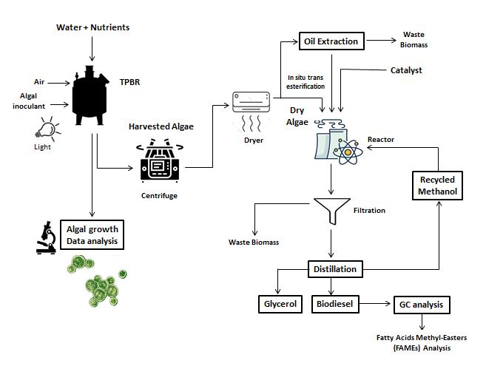

Figure 1: Process of making Biofuel from Microalgae [100]

1.3.2 Microalgal Lipids
The lipid, ubiquitous group of organic compounds, is commonly assumed as fats. However, fat is a group or subgroup of lipid molecules known as triglycerols or triglycerides, with long hydrocarbon chain terminated with carboxylic acid group. While virtually several fields of biotechnology are generally recognized as having a benefit of microalgae, the molecular, biochemical, and computational modeling analysis of microalgal microalgal from the understudied environment with potential diverse ecological functions and properties are still scarce. The researchers have been leading the world to explore and harvest new microalgae strains, to conserve and explore their biotechnological potential, given the fact that there is an even greater number of still undiscovered microalgae organisms.
There are global interests currently in search of latest, safe antioxidants, like plant materials, from natural sources for the prevention of oxidative food degradation and to protect living cells from oxidative harm [101]. Microalgae are photosynthetic micro-organisms that are able to quickly produce solar, CO₂ and nutrient biomass in water bodies. This biomass is made up of major metabolites like carbohydrates, oil and lipids for which high-quality goods, like animal and human nutritional supplements, pharmaceuticals, industrial chemicals and transport fuels can be manufactured. A vast range of possible applications from aquaculture to health products, animal feed and human nutrition is available from Algal biomass and algae-derived products. Some algae are thought to be abundant in natural antioxidants [102]. In addition, through use of clean nutrient media to grow the microalgae it is possible to monitor the quality of microalgae cells, which do not contain any herbicides and pesticides, or any other harmful material [103].
Lipid metabolism and photosynthetic performance of microalgal cells can be strongly influenced by culture conditions such as temperature, light and medium composition. Few studies [104-105] demonstrated that cells of high plants acquire the ability to accumulate relatively considerable amount of fatty acids (FAs) during their growth cycle in low temperatures, allowing the microalgae to adapt extreme environmental temperature. It can be interpolated for photosynthetic microbes that efficiency of lipd metablosim would be increased at low temperatures. A study reported that the amount of lipid in algae is solely determined by the algal strain, growth medium, and light intensity. [106]. In addition, another study [107] revealed the effects of changing culture medium concentrations and composition on algal lipid content and predominant prescence of specific fatty acid; for instance, efficacy of nitrogen source in culture media in modifying fatty acids (lipid) composition in Chlorella cells.
Microalgae contain essential fatty acids (EFAs) such as ARA and linoleic acids etc. that are considered to be of critical importance in nutrition for healthy development. Normally the body's ability to naturally synthesise these acids quickly enough to meet demand is limited. [108]. The structural components of many lipids are fatty acids, which differ considerably between algae in their types and quantities. In recent years, Fatty acid compositions have piqued the interest of researchers working on large-scale microalgae production in general, and marine algae in particular. This primarily is due to the health effects and other potential valuable impacts of mono- and polyunsaturated fatty acids (MUFA and PUFA).
In addition, polyunsaturated Fatty Acids (PUFAs), including membrane fluid control, the transport of electron, oxygen and thermal adaptation, perform important functions in cellular and tissue metabolism [109]. A sequence of reactions can be separated in two separate steps to create a biosynthesis of EPA. First, oleic acid synthesis from acetate, accompanied by linoleic acid conversion and α-linolenic acid. The following measures of slackening and elongation form a ínter-3 PUFA. Within the cell, EPAs are usually esterified to form complex lipid molecules (by cyclooxygenase and lipooxygenase) and majorly contributing to the developmental and regulatory physiology of higher trophic levels as the precursor in a series of eicosanoids, a hormonelike component like prostaglandins, thromboxans or leucotrienes [110].
Many health supplement stores are therefore currently selling the preparation, packaged with capsules or caplets, of microalgae, including spirulina and chlorella and also in food or beverages which have known treatment values for hypercholesterol, hyperlipidemia and atherosclerotics [111]. Microalgae's fatty acid content is determined by the climate and culture selected for growth [112]. Heterotrophic, photoautotrophic, nitrogen deficiency or relaxation are some of the environmental factors. While some microalgae are grown as sources of such fatty acids, genetically modiefied algae, including transgenic oil seed plants that are engineered to produce EPA may provide a sustainable alternative oil source for human consumption [113]. However, continued market antipathy to transgenic food products currently limits the prospect of deploying transgenic organisms nutritionally improved by EPA. The use of EPA obtained from genetically modified algae as a high potential alimentary supplier in aquaculture is a considerable option. In this way, the major health benefits of these fatty acids could be incorporated into the human nutrition, without the need of direct consumption of food that is synthetically prepared.

1.4 Microalgae as Bioindicators
Bioindicators are of course used to evaluate the health of the population as well as being an effective instrument for the detection of positive or negative environmental changes and their resulting impact on sustainability of human’s environment and ecosystem as a whole. As said before, the key environmental factors affecting the efficacy of phtoplankton for bioindication including the transmission and intensity of light, water sediment, temperature and suspended solids. Bioindicators can be used to assess a region's natural state or the extent and severity of contamination [114].
Because microalgae contain chlorophyll and must survive and grow throughout the day, they are similar to terrestrial plants. The bulk of them are light and prefer to swim near the surface of the water. Development and photosynthesis are closely linked with each other, as light and food supplements are used. Algae are very susceptible to pollution, and this can be expressed in population or photosynthesis levels. In most cases, algae are as sensitive to contamination as other species, affects population development or photosynthesis. If the diversity of the plantoplankton species changes, it may indicate potential adverse effects of pollution on marine ecosystem.
It is estimated that marine waters and freshwater account for more than 90% habitable space on earth. These ecosystems are regarded as the mean for vast array of bio-productive resources, and most of the primary productivity are result of tremendous microbial activity by the microalgae, in particular the pico-phytoplankton (0.2 – 2.0 µm), nano-phytoplankton (2.0 – 20 µm) and micro-phytoplankton (20 – 200 µm) [115]. The microalgal abundance and diversity in the aquatic systems can vary greatly from one aquatic ecosystem to another because of the variation in environmental variables. Therefore, the type and the increasing level of microalgae are used as indicators of the ecological conditions and water quality of their ecosystems.
Microalgae can be utilized as bioindicator organisms in studying the status of aquatic ecosystems, including those polluted by heavy metals. Microalgae represent a convenient material widely used in biomonitoring because they are more sensitive to pollution than multicellular organisms. The high specific surface area of ​​microalgal cells promotes the rapid intracellular accumulation of toxicants [116]. The commonly used test functions of microalgae are based on integral characteristics, such as death rates, growth increments, and changes in ultrastructure and photosynthesis. The advantage of photosynthesis as a test function results from its sensitivity to numerous pollutants.
Fluorescence assays provide detailed information on the activity of photosynthetic apparatus under the action of toxic substances [117-118]. Such methods provide real-time information on physiological condition of microalgae. The emergent techniques for evaluating photosynthetic activity of higher plants and algal cultures comprise measurements of chlorophyll fluorescence induction curves with a high temporal resolution (starting from 10 μs) upon excitation with powerful flashes [119-120]. The high-resolution measurements of fluorescence induction curves take only a few seconds and are accomplished with devices like PAM (pulse-amplitude modulated fluorometers) and PEA (plant efficiency analyzers). Some recently developed devices allow concurrent measurements of chlorophyll fluorescence and the redox conversions of photosystem I (PSI) carriers; i.e., they allow simultaneous monitoring of individual reactions in PSII and PSI [121-122].
Although the action of heavy metals on plants was a matter of numerous studies, the influence of this metal salts on individual light reactions of photosynthesis and ultrastructure of algal cells remains insufficiently understood.

1.5 Antibacterial Potential of Microalgae
Proteins, amino acids, polysaccharides, polyunsaturated fatty acids (PUFAs), and antioxidants (polyphenolic compounds, flavonoids, and carotenoids) are among the key bioactive elements of microalgae
Among the major bioactive constituents of microalgae, proteins, polysaccharides, polyunsaturated fatty acids (PUFAs), amino acids, and antioxidants (polyphenols, flavonoids, and carotenoids) have been significantly coorelated with antimicrobial activity potential of microalgae [123-124]. Although the importance of microalgae as a source of unique bioactive compounds with antimicrobial activity is growing, determining the constituents that are directly responsible for antagonistic action of microalgae against specific pathogen remains an underrepresented field of research.
Besides their estblished antioxidant activity, high content of polyphenols, carotenoids, and flavonoids in microalgae constitute a valuable source of natural and wide range antibacterial agents [125]. These antioxidants protect the human body from damage caused by reactive oxygen species (ROS), as well as providing a mechanism to counteract or prevent neurological illnesses and inflammatory diseases with substantial tissue damage. [126].
Antimicrobial activities of microalgae have found to be resulted from compounds belonging to several chemicals groups for example, the antimicrobial activity of supercritical extracts acquired from the microalgae Chaetoceros muelleri was linked to its lipid content and composition [127]. The antimicrobial activity is attributed to compounds belonging to several chemical classes [128]. However, not only various fatty acids, but also such combinations as -ionone, –cyclocitral, neophyltadiene and phytol can explain the antimicrobial activity detected in several Dunaliella salina pressurized extracts [129]. Efforts are ongoing, but are still relatively starting due to new groups of compounds that are specifically responsible for certain antibiotical functions. To substitute or replace synthetically produced antimicrobial compounds being currently used — including subtherapeutic dosages of antibiotics utilized as prophilatory action in livestock breeding, microalgal free-cell extracts are also being investigated as food and feed additives.

1.5.1 Antibacterial resistance
In light of the rise in antibiotic resistance among bacteria, the researchers are experiencing an unprecedented push for the discovering natural and alternative sources for antibacterial bioactive compounds. The new line of secondary metabolites of antibacterial potential should also accomplish further objective to simplify the production process and significantly decrease the production costs. Subsequently, freshwater and marine microalgae are emerging as a most viable source of promising and novel ingredients at massive scale with major applications in health industry other than antifungal, and broad range antimicrobial activities [130-131].
Although significant research into algae's antimicrobial potential has only performed in the previous two decades, the majority of studies to date have focused on their therapeutic and antimicrobial properties, as well as the degree of their capacity to inhibit pathogenic bacteria. [132-134].
The majority of studies have focused on the study of antibiotic resistance in bacteria for developing various understandings: i) bacterial infections are responsible for the majority of nosocomial and community infections; ii) the wider and increasing number of classes of antibiotics are also a reason for causing wide variety of resistance to antibacterial agents; and iii) further studies of the underlying molecular mechanisms are provided by the possibility to transfer the determinants of bacterial resistance to normal, characterized bacterial strains. [135].

1.5.2 Discovery of antibacterial compounds
A mixture of fatty acids, chlorellin, has been shown to have been responsible for cytotoxic activity in both the Gram+ and Gram- bacteria [36], isolated the first antibacterial compound from a microalgae, Chlorella. In the mean time there has been a boom in research into antibacterial active mechanism developed by the microalgae [137]. This has arisen, for example, from the risk of many MRSA strains, which have caused an increasing concern at worldwide health care institutions – because they are not susceptible to most traditional antibiotics.
It is therefore urgent that new antibacterial compounds can be discovered according to different biochemical action mechanisms. The complex, multi-layered cellular wall-structuring of Gram -ive bacteria usually makes it less effective to prevent antibiotics from penetrating Gram –ive bacteria [138]. This is the reason why the supernatant and solvent based extracts' antibacterial activity is more effective. The specific mechanism of action of fatty acids is still unclear: it may affect most probably the cell membranes, as the damage to the membrane is likely to result in cellular leakage and a decrease in the absorption of the nutrient, besides the inhibition of cell breath. Compounds synchronised with Scenedesmus costatum and partially extracted with organic solvents, exhibited activity against aquaculture bacteria, which appears to induce lysis of bacterial protoplasts as a result of their fatty acids longer than 10 carbon atoms [139]. Fatty acids have been well-known for some time to interfere with bacterial growth and survival, but recent structure-functional relation research suggests that this capacity depends on both its chain length and its insaturation level. Cholesterol-like compounds can antagonise antimicrobial traits [140] to take account of both the composition and the free lipid concentration [141]. The antibacterial activity of polyunsaturated aldehydes deserves a special ention from microalgal-derived oxylipins. Diatoms such as S. costatum and Thalassiosira rotula synthesise these compounds. Moreover, it degrades the growth of various sea bacteria, such as (Gram-) Aeromonas hydrophila and (Gram +) Planokoccus citreus and Micrococcus luteus [142], such as Alteromonas haloplankti.

1.5.3 Extraction of Antimicrobials from microalgae
Novel extraction technologies and chemical extraction procedures are used to obtain a variety of extracts from microalgae in order to obtain required functional bioactive compounds and antimicrobial chemicals [143]. Various conventional and advanced solid–liquid extraction techniques for generating crude extracts from seaweed have been developed since the late 1970s, generally by mixing organic solvents, such as [chloroform: methanol] combinations or acetone. Some other methods, such as ultrafiltration techniques, are used in addition to improve specificity or selectivity. Other procedures start with ethanol to precipitate protein, then followed by extraction with hexane, butanol, or ethyl acetate in the second stage. Based on the high solubility of the compounds, recent studies showed that three solvents in proportion of ethanol–hexane–water (77:17:6) forming a homogeneous solution, can be used with the advantage of significantly increasing the extraction yield and purity of the compounds, involving less number of procedural steps [144]. The antibacterial potential of these crude extracts is determined by the solvent's capacity to extract specific bioactive chemical, as well as the pathogen’s sensitivity to these compounds [145]. Traditional extraction techniques including Soxhlet, solid–liquid extraction (SLE), and liquid–liquid extraction (LLE) are time-consuming procedures that need large amounts of solvent and produce less viable extract.
Growing needs to come up with advanced and sustainable technologies to extract bioactive compounds from viable living cells have prompted the international scientific community and decision makers to invest in technologies such as supercritical fluid extraction, extraction using high intensity pulsed electric fields (PEFs), ultrasonically assisted extraction (USE) [146], microwave-assisted extraction (MAE), and accelerated solvent extraction (ASE) [147] to keep the extract’s chemical purity and bioactivity as high as possible. Enzymes-based extraction which involve enzymatic specific action causing degradation or penetration in cell walls has also been used in microalgal treatment (e.g. in Chlorella vulgaris), but it is still not financially feasible to be applied widely in industry [148].
Another modern and feasible approach for extracting functional or bioactive constituents from microalgae is supercritical fluid extraction with CO₂. Although it is a highly efficient and quick process for generating crude extracts with a high concentration of the relevant functional components, it is nonetheless quite cost bearing on an industrial scale [149].
Ultrasonically aided extraction (USE) involved the pore formation in microalgal algal cell walls with the help of the mechanical effects of acoustic waves. The efficacy of the extraction procedure at room temperature is a real plus, and hence no detrimental heating effect on bioactive chemicals during extraction, is one of its key advantages. Ultrasound is already being intensively employed in the field of microalgae, with promising results [150].
The employment of high-intensity electrical pulses (PEFs) is a technique in which high-voltage pulses break cellular content, allowing proteins, chlorophylls, and carotenoids, among other things, to be released. Extensive studies have been conducted using t his method for obtaining bioactive extracts from Spirulina and Chlorella species [151-152]. The approach is based on the electroporation theory, which states that variations in cell membrane conductivity and permeability allows the production of microscopic pores that led to the release of internal components into the external environment.
Microwave-Assisted Extraction (MAE) has treated a variety of Dunaliella genus microalgal species for the extraction of carotenoids. This methods aids extraction by providing uniform heating and even temperature distribution. The application of this method to the species Dunaliella tertiolecta and Cylindrotheca closterium resulted in a process that included quick extraction, with high resultant extract yield, as well as generating other additional potential antibacterial compounds [153].

1.6 Molecular Identification
Recent advances in molecular biological techniques and bioinformatics have undoubtedly enabled the discovery and comprehensive assessment of thus-far-undiscovered forms of microbial life, including microalgae, in situ, without isolation into pure cultures. New species of microalgae are now being described and characterized combining morphological traits with molecular sequence data, utilizing either DNA sequence data and/or secondary structure of ribosomal DNA for phylogenetic applications. In particular, high-throughput amplicon sequencing of environmental DNA and/or RNA proved to be far more powerful and robust technique, when applied to characterize microbial diversity [154-156]. Gene-based biodiversity discovery has become an important application for biomonitoring diagnostic development and majority of the biodiversity studies have used this approach to not only improve the efficiency of biomonitoring, but also to expands its relevance for habitats and biota groups which have not been fully studied due to insufficient taxonomic knowledge or technical competency [157-159].
The DNA-based approach for the comprehensive assessment of microalgal communities at genus-, species- and strain-level utilizes various sequencing technologies to identify species provided as individual specimens or in environmental samples such as water, sediment or soil [160-1162].

1.6.1 Effectiveness of ITS-based markers
Multi Marker-based is increasingly being considered for revealing the entire gene repertoire of the community. This genetic analysis of genomes, by using high-throughput sequencing (HTS) of unpurified template DNA, has become the dominant source of publicly available sequence data. Marker gene based identification is viable method to determine a taxonomic distribution or fingerprint profile through PCR amplification and sequencing of evolutionarily conserved and variable regions in 18S rRNA or 18S rDNA [163-164].The DNA of individual specimens is typically analyzed using the Sanger sequencing platform, whereas the amplicon-based metagenome from environmental samples is analyzed using high-throughput next-generation DNA sequencing platforms such as the Illumina Miseq sequencing and 454-Roche pyrosequencing platform. Another important initiative towards understanding the dynamics, ecology and environmental distribution of microalgae belonging to Chlorophyta in marine ecosystems is by [165]. The authors reviewed and summarized current knowledge on the phylogenetic, morphological and ecological diversity of unicellular marine and halo-tolerant Chlorophyta. Around 9,000 Chlorophyta 18S rRNA gene sequences from culture and environmental samples deposited in public databases were examined with the aim of assessing the extent of diversity and exploring their oceanic distribution based on a subset of 2,400 sequences for which geographical information is available. The study also evaluated the utility of using of the large subunit ribosomal rRNA (LSU) or ITS as potential suitable marker for explore microdiversity at the species level or below.
As exemplified throughout this review, the sequenced-based analysis of microalgae can be accomplished by one of the following methodological strategies: (i) High-throughput DNA sequencing of a clone library developed from PCR products of environmental DNA generated with a phylogenetic marker indicating the potential taxonomic origin (ii) sequenced based screening of random fragments to find a particular sequence or gene of interest, followed by sequencing of the adjacent regions to locate markers with improved taxonomic specificity. Currently, the distinction of microalgal individuals below the species level employ either shotgun metagenome sequencing or by focusing on intragenomic heterogeneity within phylogenetic (e.g., 18S rRNA or 18S rDNA) or functional gene targets.

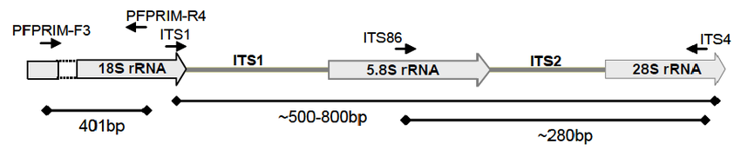

Figure 2 - Schematic representation of Microalgal ITS region [166]

The first approach refers to reconstructing large fragments or even entire genome without selecting any particular gene, alleviating biases from primer choice and enables the characterization of coding as well as non-coding components that can be used as phylogenetic markers [167-168]. In the later approach, specific internal conserved regions of DNA can be retrieved using taxonomical informative primer targets such as intergenic transcribed spacers (ITS) or the large ribosomal subunit (LSU) gene [169-170].
The research question enables the researchers to compare and determine the appropriate approach between assembly-based analyses and direct taxonomic classification of reads. The sequence conservation of regions of few genes has become an unprecedented resource for taxonomy in addition to being a phylogenetic anchor that requires no prior knowledge of full gene sequence [171-172]. In some cases, the sequence homology of most genes of practical importance is often most difficult to be identified by PCR or hybridization due to their far too divergent nature. However, the nucleotide sequence for a few classes of genes is well-conserved to facilitate their identification by sequence instead of function.
Several recent studies have addressed the use of the 18S-ribosomal-DNA (rDNA), 18S-ribosomal-RNA (rRNA), 28S-ribosomal-DNA and its variable regions as taxonomic markers for the classification of Eukaryotes [173-175] and the validity and limitations of using them in the taxonomic profiling of metagenomes have already been discussed [176]. An extensive effort is being put to establish similar universal molecular markers for microalgal taxa [177].
Since the early 1990s, there was a progressive shift towards molecular taxonomic studies for microalgae [178]. Beside genes and spacer sequences, the past studies relied heavily on exploring ribosomal operon (e.g., actin, psba, rbcL, tufA, RUBISCO spacer, and other chloroplast genes [179-180]. However, while the SSU and LSU has proven efficient for delineation at high taxonomic levels, they are not considered as good for intraspecific differentiation. The suitability of marker based on ITS regions were increasingly recognized for microalgal phylogenetic and taxonomic studies due to their high degree of interspeciﬁc variability, conserved primer sites, and multicopy nature in the genome [181-182]. The former study proposed 5.8S + ITS-2 fragment as ideal candidate marker for microalgae owing to its broad taxonomic range (figure 2). The utilization of multiple markers based on four gene loci and their combined data was formalized by [183]. The study tested the efficiency of multiple markers based on four gene loci and their combined data (rbcL + tufA + ITS + 16S, rbcL + tufA and ITS + 16S), with three combined data having better resolution than single genes for higher intraspecific and interspecific divergence. Few studies reported tufA gene applicability most suitable for DNA barcoding and phylogenetic reconstruction based on its wide coverage and sequencing success [184-186]. A comparison of metataxonomic (marker gene-based) and metagenomics profiling is described in table 1.

1.6.2 Databases and Phylogenetic trees
Significant advances in next-generation sequencing technology have facilitated genome sequencing with high throughput at low costs. NGS technologies hold great potential to have profound impact in various areas of research, including several that, so far, have mainly used approaches based on de novo sequencing i.e., sequencing novel genomes where no reference sequence is available for alignment, and resequencing i.e., genomes sequencing from a species for which a reference genome is already available.
Although the technological advances in nucleotides sequencing has led to a substantial increase in the release rate of sequenced genomes at unprecedented scales and rates but it is computationally challenging. All these complex and comprehensive raw data are useless without utilization of correct tools for analysis, annotation, storage, integration and translation. Resource integration and standardizing annotations are relevant for better understanding genetic diversity and deciphering complex mechanisms associated with microbial ecology, evolution, and diversity [187].
Since the publication of the first microalgal genome, red extremophile Cyanidioschyzon merolae in 2004 [188], over 100 microalgal genome projects have been launched and complete genome sequences of over 60 microalgal species been brought publicly available including green, and red microalgae as well as diatoms, dino-flagellates, nano-flagellates, and some uncommon species from underrepresented evolutionary branches (DOE Joint Genome Institute, http://genome.jgi-psf.org/; [189-191]; GOLD database, http://www.genomesonline.org/ [192]; Cyanobase, http://genome.kazusa.or.jp/cyanobase). During the last two decades, next-generation sequencing technology have greatly contributed to increasing number of sequenced microalgal genomes in public databases along with EST (expressed sequence tag) and transcriptome data sets and the breadth and depth of sequence assemblies and annotations are continuing to expand, with projects dedicated to filling in less characterized microalgal taxonomic groups [193-195].
The rapid expansion of genomic sequence data available and accessible in the afore-mentioned public repositories, and advances in databases analytic tools, makes it a daunting task for researchers to access, integrate, sort out and compare the best sequencing, specialized annotation and analysis strategies for microalgae. Fortunately, development of various customizable web-based genome browsers, model organism databases (MODs), molecule- or process-specific databases, and others has helped the researcher to find the needles in the haystack. A number of online databases are available for information on algal diversity and taxonomic studies, each with their own focus and limitations. Numerous relevant studies have been done to date describing the microalgal genome sequences and this provides an opportunity to review what we have learned so far from sequencing the genomes of microalgae. At present, multiple data sets are available for ongoing more than 60 algae genome projects at the Department of Energy Joint Genome Institute (JGI), including status. Assembles, and annotations of sequenced genomes (http://www.algaeu.com/strains-of-algae-publications.html).
EST data from many microalgal species are available at the EST sequence databases of the National Center for Biotechnology Information (NCBI) (http://www.ncbi.nlm.nih.gov/genbank/dbEST/), a special division of Genbank, and the Taxonomically Broad EST Database (TBestDB), http://tbestdb.bcm.umontreal.ca/searches/welcome.php). Sequencing of mitochondrial and chloroplast genomes has been performed with even more microalgal species than in the EST or genome sequencing projects [196], which are available at the NCBI organelle database (http://www.ncbi.nlm.nih.gov/genome/ organelle/) and the Organelle Genome Database (GOBASE, http://www.bch.umontreal.ca/gobase/gobase.html).
Concerted efforts have been made to sequence complete organelle genomes on a large scale through the Organelle Genome Megasequencing Program (OGMP, http://gobase.bcm.umontreal.ca/). Furthermore, the genomic sequence information of various microalgal species has been updated in the Phytozome, a hub for genomic data from a few green microalgae (phytozome.jgi.doe.gov/pz/portal.html); the Greenhouse, largest eukaryotic algal genome collection available online
Table 1 - Comparison of Metataxonomic (marker gene-based) and Metagenomics profiling [197]

Technique | Method principle | Advantage and Challenges | Main applications
Meta-taxonomics | Using amplicon sequencing of 18S-ribosomal-DNA (rDNA);  18S-ribosomal-RNA (rRNA);  28S-ribosomal-DNA;  or ITS or rbcL or tufA or 23S universal plastid amplicon (UPA) | + Faster, cost-effective and more reliable identification to species level  + accessible to non-specialists  - inability to quantify taxon abundance  - Amplification bias  - more than one primer sets needed for maximizing diversity coverage and to offset primer biases  - lack of comprehensively cured reference databases for assigning taxon to the OTUs | Biodiversity monitoring;  Molecular phylogeny;  Microbial ecology
Meta-genomics | Random shotgun sequencing of DNA or RNA (Sanger and 454/Roche sequencing)  or  long-read sequencing (Illumina/Solexa, SOLiD, PacBio SMRT System) | + investigate uncultivable complete microbial communities in situ  + No amplification bias  + generated sequence reads do not require homology to known sequences (de novo profiling)  - requires reference database of genes to classify sequence reads  - requires high-quality DNA  - requires more reads count for higher sensitivity | Structural and functional genomic screening contributing to discovery of novel genes;  Phylogenetic profiling;  Monitoring the biodiversity and the ecological status

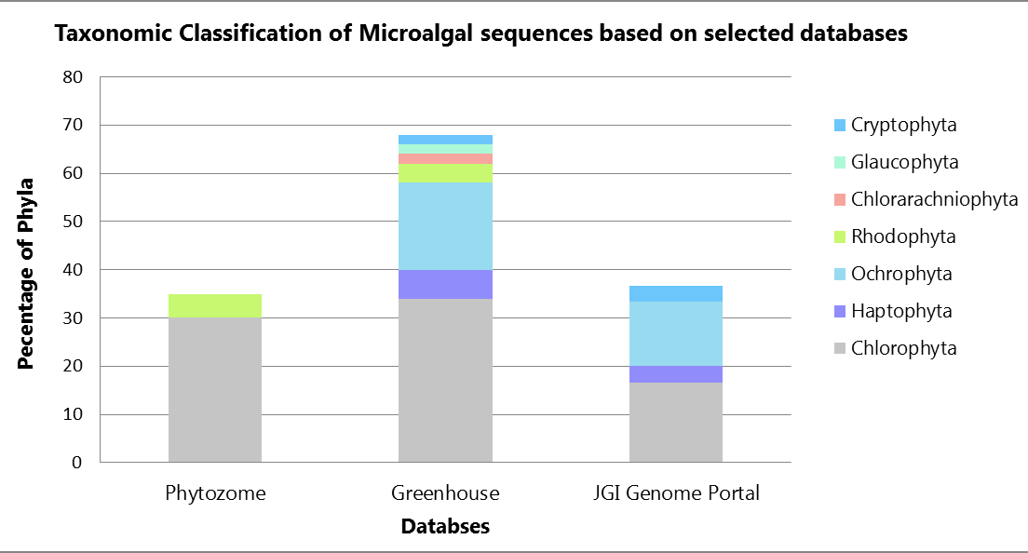

Figure 3 - Proportion of publicly available sequences of Microalgae

(https://greenhouse.lanl.gov/greenhouse/); realDB, a genome resource for red algae (http://realDB.algaegenome.org); pico-Plaza 2.0 (http://bioinformatics.psb.ugent.be/plaza/versions/pico-plaza/); CoGe database, which utilize the genomics comparison tools to analyze algal genomes of interest (https://genomevolution.org/coge/); Ensembl Plant database (http://plants.ensembl.org); EnergyAlgaeDB, functional genomics database for energy microalgae (http://www.bioenergychina.org:8989/); and EUKREF, reference database of 18S sequence barcodes that correctly represent algal lineage (http://eukref.org/).
Figure 3 shows the proportion of sequences from different phyla of microalgae in some of the above-mentioned databases. Chlorophyta (green microalgae) and Ochrophyta (heterokonts) are the most represented in all databases, and together they constitute more than 65% of the sequences publicly available. In the future, mass of unculturable genomes likely to be generated from metagenomic samples and next-generation sequencing in the next few years continue to make their way into the international databases, the distribution of the phyla and number of species will likely change.
A number of online databases are available for information on algal diversity and taxonomic studies, each with their own focus and limitations, such as Barcode of Life Data Systems (BOLD), a taxonomically curated database (http://www.barcodinglife.org); ITSoneDB (http://itsonedb.cloud.ba.infn.it/); and ITS2 Database (http://its2.bioapps.biozentrum.uni-wuerzburg.de/); and R-Syst::diatom (http://www.rsyst.inra.fr/en). The range of software tools being used in major steps of metagenomic data processing, Sequence Mapping; taxonomic profiling, sequence assembly and gene prediction has already been provided in detail [198-199].
A number of recent published studies has resulted in exponential rise in the microalgal genome datasets (table 2) and this provides an opportunity to review what we have learned so far from sequencing the genomes of microalgae. In the future, mass of unculturable genomes likely to be generated from metagenomic samples and next-generation sequencing in the next few years continue to expand the international databases interrelating genomic datasets to ecological data, the distribution of the phyla and number of microalgal species will likely change.
Table 2 - Characteristics and frequency of used sequencing platforms among genomes of microalgae published until 2018 [197, p. 12]

Platforms | Sequencing Principle | Read Length | Accuracy Reads % | Time run | Output data/run | No of genomes | % total number of genomes
Sanger | Dideoxy sequencing | 400∼900 bp | 99.999 | 20 mins∼3 hrs | 1.9∼84 Kb | 10 | 18.86%
454 GS FLX+/Roche | Pyrosequencing | 600∼800 bp | 99.9% | 24 hrs | 0.7 Gb | 4 | 7.54%
Solexa GAIIx/Illumina | Sequencing by synthesis | 36∼100 bp | 98% | 3∼10 Days | 600 Gb | 18 | 33.96%
SOLiD4/Life Technologies | Sequencing by ligation | 75 bp | 99.94% | 7 days | 120 Gb | - | -
Ion Torrent (316 chip)/Life Technologies | synthesis | 200∼400 bp | 98∼99% | 2 hrs | 1 Gb | 1 | 1.88%
PacBio/Pacific Biosciences | synthesis | Up to 60 kb | 90% | 10 hrs | 1-10 Gb | 3 | 5.66%
Sequencing platforms used in combination
Combination of Sanger Sequencing and Roche/454 | - | - | - | - | - | 2 | 3.77%
Combination of Sanger Sequencing and Illumina/Solexa | - | - | - | - | - | 2 | 3.77%
Combination of Sanger Sequencing and PacBio | - | - | - | - | - | 1 | 1.88%
Combination of Roche/454 and Illumina/Solexa | - | - | - | - | - | 8 | 15.09%
Combination of Illumina/ Solexa and PacBio | - | - | - | - | - | 4 | 7.54%

To validate its use for bioassessment purposes, requires the researcher to place greater emphasis on data mining tools and statistical analysis and interpretation and illustrate the biologically significant patterns in the datasets. While it may be possible to align traditional morphological taxonomy‐based approaches with DNA‐based biomonitoring approaches, the metagenomic methods and reference genome libraries need further validation to be complementary source of information for biomonitoring programs on a large scale.

2 Materials and Methods

2.1. Study Site Descriptions
The research covered five freshwater reservoirs of Almaty region: Issyk Lake (IL), Big Almaty Lake (BAL), Kolsay Lake (KL), Alakol Lake (AL) and Balkhash Lake (BL), the largest lake in the Central Asia (Figure 4, and Table 3). The Almaty region is located in southeastern part of Kazakhstan, commonly referred to as ‘Seven Rivers’: Zhetisu in Kazakh or Semirechie in Russian, because of the area’s numerous lake, wetlands and streams coursing through the long range of mountains in the south and east part, and across the northern side of the region.
Alakol lake, a salt-water reservior, is semi-enclosed basin with surrounding cliffs of Terskey-Alatau range, strectched along the eastern border of Kazakhstan with Xinjiang Uyghur Autonomous Region (XUAR), China. Alakol lake is best-known for its clay minerals with therapeutic properties, and high water quality.
Kolsay lake is a system of three high lakes in the northern Tien Shan, in gorge Kolcaj. Algoflora of the Kolsay Lakes has not yet been practically thoroughly studied. With the appearance of an anthropogenic load on the lake during last few years, this area has become popular for tourism and camping.
Lake Issyk is an endorheic lake, which has its source glacial headwaters on the northern slope of the Trans-Ili Alatau mountain range, the Issyk river and its tributaries. The average maximum and minimum water temperature of Issyk Lake has been found to occur between 8°C in summers to below 4°C in winters, one of the limiting factor in the lack of lake’s biodiversity.
Balkhash lake is one of the largest natural inland water reservoir in the south-eastern part of Kazakhstan. The eastern part of the lake is characterized by narrow, deep and high saline water, low and sandy shore, while the western side is high, rocky, wide with shallow freshwater. Four major rivers Aksu, Karatal, Lepsi and Ayaköz drain the eastern part of the lake while more than two-third of the total influx of Balkhash lake is received from snow and glacial fed Ile river, which originates from Tian Shan mountain range.
High-altitude (alpine) freshwater reservior originated as result of tectonic phenomena, Big Almaty Lake is located in the Trans-Ili Alatau mountains, on south of Almaty, a city in the southeastern region of Kazakhstan. The lake stands out for its distinctive turquoise color as streams draining the lake flow over the glaciofluvial deposits overlying the igneous and porphyritic rocks.

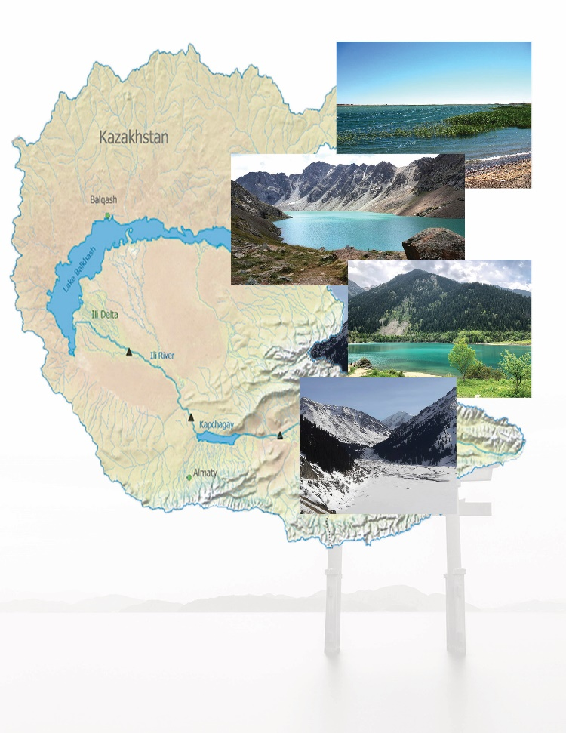


Figure 4 - Sampling sites – freshwater reservoirs of Almaty region.

Table 3 - Characteristics of sampling sites
Site code | Latitude | Longitude | Altitude (m) | pH | MAT (°C) | Lake area (km²) | Sample type
IL | 43°21'34.1496" | 77°27'57.3084" | 1760 | 6-6.7 | 12-14°C | 0.70 | Water
BAL | 43°3'3.726" | 76°59'7.4148" | 2511 | 5.8-6 | 8-10°C |  | Water, Wet sediments,
AL | 46°7'0.5376" | 81°36'48.3624" | 347 | 7-7.5 | 18-20°C | 2650 | Mats, water
BL | 45°55'35.8824" | 73°56'12.9876" | 4221 | 8.33 | 18-20°C | 16,996 | Wet sediments, water
KL | 42°56' 8.1564" | 78°19'33.4164" | 2254 | 7 | 15-18°C |  | Wet sediments, water

All samples were evaluated for temperature, pH, conductivity and salinity, measured with Thermo Scientific PCTestr 35 multiparameter. Clean bottles were used to collect a volume of 0.5 to 1 litre of freshwater sample at a depth of 0.5 m near shore, which was then stored in cold boxes for transfer to the laboratory. The samples were collected from freshwater bodies from September 2018 to June 2019.

2.2 Microscopic Examination of Freshwater Samples
2.2.1.Light Microscopic Examination
The preliminary morphological identification of freshwater samples was done to assess the preliminary biodiversity of microalgae of Almaty region. The samples were observed under the light microscope, with a system of image capturing (MicroOptix OPTIX C600, Austria). Morphological identiﬁcation was carried out based on some prominent morphological features for differentiation such as cell size (length to width ratio) and shape, solitary or colonial, presence or absence of mucilage etc., mentioned in the guidelines of description keys, taxonomic literature, manuals, manuscript and photo gallery available for microalgae species identiﬁcation.
2.2.2. Sample preparation for Scanning Electron Microscopy
Following the identification of the isolates to the genus level, the Scanning Electron Microscope (SEM) technique was carried out at Electron Microscope Laboratory, Gazi University, Ankara, Turkey, as following: washing with phosphate buffered saline (PBS), centrifugation at 1000xg for 5 min, fixation with 5% glutaraldehyde, dehydration in ascending concentrations of ethanol, Critical Point Drying with CO₂ (Polaron CPD 7501), gold coating in a Polaron SC 502 sputer coater. The coated specimen was examined with JEOL JSM 6060 LV at accelerating voltage 10kV and SEM images were recorded.

2.3 Growth Medium
Fresh samples were maintained in liquid cultures of BG-11 and Bold’s Basal Medium (BBM). BBM and BG-11 are generic medium designed to support the growth of a wide variety of green microalgae species. The composition of the medium and added microelements are described in Table 4. Liquid mediums were autoclaved and allowed to gas exchange for 24 hours before being used to cultivate microalgae. The liquid cultures containing the accumulative microalgae strains were incubated for two weeks at 25°C under continuous irradiation of 40 μmol photons m⁻² s⁻¹.

2.4 Isolation of Pure Microalgal Strains
To enumerate the growth of microalgae strains after successful direct isolation procedure using micropipette method and observable growth, the microalgae culture was transferred to separate 250-mL flask containing 100 mL of liquid BG-11 medium. The enrichment culture was kept at 22°C ±2 for about 20 days under fluorescent light with a photoperiod of 12 h, with shaker speed 100±10 rpm.

Table 4 - BBM and BG-11 Media Composition in g/L [200-201]

 | BBM | BG-11 |  | BBM | BG-11
Nutrients |  |  | Trace Metals
KH₂PO₄ | 0.175 |  | ZnSO₄*7H₂O | 1.43 | 0.222
CaCl₂*2H₂O | 0.025 | 0.036 | MnSO₄*4H₂O | 1.20
MgSO₄*7H₂O | 0.075 | 0.076 | CuSO₄*5H₂O | 1.24 | 0.08
NaNO₃ | 0.75 | 0.5 | (NH₄)6Mo₇O₂₄*4H₂O | 1.84 | 1
K₂HPO₄ | 0.075 | 0.04 | CoSO₄*7H₂O | 1.40
Na₂CO₃, |  | 0.02 | MnCl₂*4H₂O |  | 1.81
NaCl | 0.025 | - | MoO₃ |  | 0.015
citric acid, |  | 0.006 | NaBO₃.4H₂O |  | 2.63
FeSO₄ | 0.005 | 0.006 | Co(NO₃)₂•2H₂O, |  | 0.02
EDTA | 0.05 | 0.001 |  |  | 10
 |  |  | CaCl₃•2H₂O, 1.2;
 |  |  | FeSO₄.7H₂O, 2.3;
 |  |  | H₃BO₃ | 3.09 | 2.86
 |  |  | Deionized water | 1.0 L

2.4.1 Cleaning and Sterile Techniques
Later the microalgae were plated onto BG-11 agar medium (supplemented with antibiotics), which was placed at 22°C ±2 until single colonies of same size and similar appearance appeared. Each cell culture was centrifuged up to one ml in 1.5ml eppendorf tube, and washed thrice with sterile liquid medium. Aliquot of cell suspensions were spread or sprayed aseptically onto BG-11 (Marine where appropriate) agar plates containing combination of antibiotic including azithromycin, cycloserin, kanamycin, and streptomycin at 100 μg ml-1 and incubated at 25°C under continuous irradiance (40 μmol photons m-2 s-1) for 2 to 2.5 weeks. Axenic growth of microalgae culure was confirmed by keeping the microalgae cultures plates in the dark at ambient air temperature of 23-25°C for 1 week. The isolate was further purified by selecting a single colony and re-streaked, followed by microscopic examination, and individual pure colony was placed in autoclaved liquid medium to obtain axenic monoculture.

2.4.2 Cell Density Evaluation
The growth of microalgae strains was continuously monitored during cultivation using an absorbance microplate reader (EL800) at 630 nm as reference wavelength. Before taking the optical density readings, agitation was doen for the microplates spanning 25 minutes on a mini-orbital shaker. Growth of microalgae at varying cultural conditions and media composition was noted by cell counting using a hemocytometer. Growth parameters (growth rate, doubling time, and doublings per day) to monitor the growth microalgae were calculated using the generated data of the cell counts. Specific growth rates (μ, day⁻¹) of microalgae strains at the exponential stage were calculated using the equation μ = L_{n} (X₁ − X₀) / (t₁ − t₀), where X₀ and X₁ are the initial number of cells at the start (t₀) and number of cell after specific time or end (t₁) of the exponential phase. Doublings per day (k) and doubling time (T₂) were computed using the equations k = μ / Ln ₂ and T₂ = Ln ₂ / μ respectively. Biomass productivity and lipid productivity was calculated using the formula [202-203]:

Biomass productivity (g L⁻¹day⁻¹) = biomass density (g L⁻¹) × μ (day⁻¹)
Lipid productivity = biomass productivity × lipid content (%)

2.5. Molecular Identification of Microalgal Species
2.5.1. DNA Extraction and Polymerase Chain Reaction
The microalgal cell suspension was collected (approximately 30mg) by centrifugation at 6,000 rpm for 10 min and genomic DNA of strain was extracted using Quick-DNA™ Fungal/Bacterial Miniprep Kit (Zymo Research, D6005), as per the manufacturer's instructions. Microalgal cells weighing 50 – 100 mg (wet weight) that have been resuspended in up to 200 µl of water or isotonic buffer (e.g., PBS) was transferred to a ZR BashingBead™ Lysis Tube (0.1 mm & 0.5 mm). 750 µl BashingBead™ Buffer was added to the tube. The mixture held in a bead beater closed with a 2 ml tube holder arrangement was runned at maximum speed for ≥ 10 minutes. The ZR BashingBead™ Lysis Tube (0.1 & 0.5 mm) was centrifuged in a microcentrifuge at 10,000 x g for 1 minute. The supernatantmeasuring up to 400 µl was poured into a Zymo-Spin™ III-F Filter in a Collection Tube and centrifuged at 8,000 x g for 1 minute. 1,200 µl of Genomic Lysis Buffer was added to the filtrate from the previous step in the Collection Tube. This was followed by transfer of 800 µl of the mixture to a Zymo-Spin™ IICR Column3 in a Collection Tube and centrifuged at 10,000 x g for 1 minute. The resultant liquid part was discarded through from the Collection Tube and was again performed for the rest of the remain over. 200 µl DNA Pre-Wash Buffer was added to the Zymo-Spin™ IICR Column in a new Collection Tube and centrifuged at 10,000 x g for 1 minute. Following pre-washing, 500 µl g-DNA Wash Buffer was poured into to the Zymo-Spin™ IICR Column and centrifuged at 10,000 x g for 1 minute. The Zymo-Spin™ IICR Column was transferred to a clean 1.5 ml microcentrifuge tube and 100 µl (35 µl minimum) DNA Elution Buffer was added directly to the column matrix. The column mixture was centrifuged at 10,000 x g for 30 seconds to elute the DNA.
Following the DNA concentration measurements with the Spectrophotometer Thermo Scientific™ NanoDrop 2000, DNA extracts of each sample were stored at − 20 °C.

2.5.2 Standard Polymerase Chain Reaction (PCR) and Optimization
Nine different protocols including control were performed using a set of Four pairs of Universal primer, targeting the conserved regions of 18S, ITS1-5.8S-ITS2, 5.8S rDNAs and rbcL gene, since these are better suited for the identification of eukaryotes and green microalgae in particular (Table 5).

Table 5 - Primer Sequences used for amplification of microalgal rbcL and ribosomal ITS regions

Primer | Sequence (5′-3′) | Type | Source
ITS1 | TCCGTAGGTGAACCTGCGG | Forward | [204]
ITS4 | TCCTCCGCTTATTGATATGC | Reverse
ITS1 | AGGAGAAGTCGTAACAAGGT | Forward | [204]
ITS4 | TCCTCCGCTTATTGATATGC | Reverse
ITS5 | GGAAGTAAAAGTCGTAACAAG | Forward | [204]
ITS4 | TCCTCCGCTTATTGATATGC | Reverse
rbcL | GCTGGWGTAAAAGATTAYCG | Forward | [205]
 | TCACGCCAACGCATRAASGG | Reverse

Each 50 μL PCR reaction mixture contained 27.75 μL of dH2O, 10 μL of GoTaq 5X PCR buffer, 6 μL MgCl2 25 mM, 1 μL dNTPs 10 mM, 0.25 μL of GoTaq DNA polymerase (5 U/μL) (Promega, USA), 1 μL of each primer (10 μM) and 3.0 μl of DNA template (30–50 ng/μL). The PCR programme was 95°C for 2 min, followed by 35 cycles of 95°C for 50 sec, primer-annealing temperature 49°C for 30 sec and 72°C for 1 min, with a final step of 10 min at 72°C.

2.5.3. Gel Electrophoresis
Amplification products were electrophorsed on 0.8 % agarose cast gels in Tris-acetate-EDTA (TAE) buffer. The gel mix was stained with Ethidium bromide to a concentration ranging 0.2-0.4 µg/ml, and samples were mixed with Gel loading dye at 6X concentration (0.25 % w/v bromophenol blue and 40 % w/v sucrose). Ten µl of 100 bpDNA ladder with 10 fragments were loaded onto the agarose gel to evaluate band sizes and the electrophoresis was performed at lower voltage 80-100 V for 30 to 45 min (BRL-Model 250, Life Technologie). Bands were viewed with a UV cabinet dark box and Fotodyne Foto/Prep UV Transilluminator.

2.5.4. PCR Purification
DNA fragments were excized from the agarose gel with the help of a clean and sharp scalpel. All excess agarose was removed. The weight of the gel slice was measured and transferrred to a clean tube. For each 100 mg of agarose gel slice < 2 % content, 200 μL Buffer NTI was added. The sample was incubated for 5–10 min at 50 °C. Every 2–3 minutes, the sample was agitated or vortexed until the gel slice was entirely dissolved. NucleoSpin® Gel and PCR Clean-up Column was placed into a Collection Tube (2 mL) and loaded up to 700 μL sample. Sample was centrifuge for 30 s at 11,000 x g. The liquid content collected in the tube was discarded and the column was placed back into the collection tube. 700 μL Buffer NT3 was added to the NucleoSpin® Gel and PCR Clean-up Column. Mixture was centrifuged for 30 s at 11,000 x g. Again the liquid residue was discarded and the column was placed back into the collection tube. The collection tube was centrifuged for 1 min at 11,000 x g to remove Buffer NT3 completely. During this step, it was made sure that the spin column does not touch the liquid residue, carefully removing it from the centrifuge and the collection tube, otherwise the step was performed again. The NucleoSpin® Gel and PCR Clean-up Column containing the DNA fragments was placed into a new 1.5 mL microcentrifuge tube. 15–30 μL Buffer NE was poured, incubated at room temperature (23–25°C) for 1 min and centrifuge for 60 s at 11,000x g.

2.5.5. Cloning of PCR Products
Each PCR product underwent ligation process, with composition of 50 μL PCR reaction mixture containing YμL of dH₂O, 1 μL of 10 ligation buffer, 1 μL PEG, 1 μL of vector (pGEM‐T Easy Vector System (Promega) / pUCm-T Cloning Vector Kit (Bio Basic), XμL purified PCR product), 1 μL of T4 DNA ligase. The mixture was kept for 1 hour to overnight at 16-23°C. For transformation 100 μL of competent cells (Escherichia coli competent cells - JM101), were thawed on ice. 5 μL of ligation mixture was added and was kept on ice for 30 min. Then heat shock of 42°C s given on water bath for 1 min, followed by placing on ice for 2 min. 400 μL SOC culture was added and were place on shaker at 37 °C, 200-250 rpm for 1 hr. the mixture was centrifuged at 4000 rpm for 5 min. 400 μL of mixture was discarded from top using micropipette and cells were re-suspended with the culture. Bacteria were placed at Amp+plater which had been plated with 20 μL 100mM IPTG and 100 μL 20mg/ml X-gal. the suplus liquid was discarded after putting the late upward for 1 hr at 37°C. The plate was then placed downward for overnight. Three white colonies were chosen from each plate after 18 hours of incubation. Each colony was cultured overnight at 37°C in 3 ml of Luria Broth medium containing 50 ug/ml ampicilin with shaking at 250 RPM.

2.5.6 Colony PCR
To verify successful cloning of desired DNA fragment, Colony PCR was performed using Gene Direx protocol. Each 25 μL PCR reaction mixture contained, 2.5 μL of PCR buffer, 2.5 μL MgCl₂ 25 mM, 0.5 μL dNTPs 10 mM, 0.25 μL of GoTaq DNA polymerase (5 U/μL) (Promega, USA), 0.5 μL of each primer (10 μM), single transformed colony and rest of dH2O to complete reaction mixture. The PCR programme was 94°C for 4 min, followed by 35 cycles of 94°C for 40 sec, primer-annealing temperature 49°C for 1 min and 72°C for 2 min, with a final step of 5 min at 72°C.

2.5.7 DNA purification (plasmid) and Sequencing
The plasmids were purified using Wizard® Plus SV Minipreps DNA Purification Systems kits (Promega). First step involved production of cleared bacterial lysate by pelletting 1–10ml of overnight bacterial culture for 5 minutes. Pellet was completely resuspended by pipetting with 250µl of Cell Resuspension Solution. 250µl of Cell Lysis Solution was added to each sample and inversion for four 4 times was carried out to ensure mixing. 10µl of Alkaline Protease Solution was add; inverted again 4 times to mix and then the mixture was incubated for 5 minutes at room temperature. 350µl of Neutralization Solution was added and mixed immediately by inverting the content four to six times. The content was centrifuged at maximum speed for 10 minutes at room temperature. The lysate was cleared into Spin Column by centrifugation at maximum speed for 60 sec, to ensure the efficient binding of Plasmid DNA. Flow through was discarded, and place column back into Collection Tube. The binding Column was washed twice with 750µl and 250µl of Wash Solution (with ethanol added) and each time centrifuged at full speed for 1-2 minute.
For elution of DNA for sequencing purpose, Spin Column was placed in a clean 1.5ml microcentrifuge tube, being careful not allowing any contact between the Column Wash Solution with the Spin Column. 100µl of Nuclease-Free Water was added to the Spin Column and centrifuged at full speed for 60 sec. The column was discarded, and DNA was stored at –20°C.

2.5.8. Sequencing
The products were sequenced in both directions by Sanger sequencing using the universal M13F/M13R primer pair. The purified plasmid DNA containing DNA fragments of six studied isolates was sent out for sequencing to the Macrogen Europe, in Amsterdam, Netherland. The obtained sequences were compared against the database sequences in the GenBank nucleotide collection through the Basic Local Alignment Search Tool (BLAST) available on the National Center for Biotechnology Information (NCBI) website (www.ncbi.nlm.nih.gov/). Sequencing was done twice to minimize the probability of any procedural errors that could have occurred during the amplification or purification process.

2.5.9 Phylogenetic analysis
The resulting ITS1/ITS4, ITS5/ITS4 and rbcL forward and reverse DNA sequences of microalgae 18S were aligned using sequence alignment editor Bioedit version 6.0 and search was carried out for similar sequences with the Basic Local Alignment Search Tool in the GenBank database of the National Center for Biotechnology Information (NCBI). Six sequences having the highest similarity to each query sequence were obtained and used for phylogenetic analyses with Isochrysis galbana strain (JX393298) as an outgroup. Multiple sequence alignment was carried out using the MUSCLE program with default parameters integrated in Molecular Genetics Analysis (MEGA) 6.06. The Phylogenetic tree was built by the Neighbor-Joining method (Kimura-2-Parameter algorithm) using bootstrap value (n = 1000 replicates) to determine the statistical reliability of the obtained topologies. The resulting sequences were deposited in the GenBank database for accession number. Living axenic cultures of all isolates were deposited in the Collection for Microalgae Cultures at the Biotechnology Lab, Al-Farabi Kazakh National University.

2.6. Lipid Extraction and Profiling
2.6.1 Lipid Extraction
For the conventional extraction method [206-207], 30-35 mg of wet biomass (D. pannonicus, P. kessleri, M. griffithii, N. subsolitaria, and Ankistrodesmus falcatus) was collected by centrifugation at 5,000 rpm for 5 min and blended with 6 mL solvent mixture of methanol and chloroform (2:1, v/v). The mixtures were shaken at 200 rpm on an orbital shaker for 3 h at 37°C. 2 mL of KCl (0.9%) and centrifuged at 3500 rpm for 5 min. the lower chlorophorm phase was transferred into a pre-weighed test tube and dried with air flow. After that, the extracted mixture was resuspended in 2.5 mL Hexane. Acid-catalyzed trans-esterification of lipid content was done by adding 2 mL of methanolic H₂SO₄ (1% v/v). The reaction mixture was heated in a tightly closed tube at 85°C for 2.5 h. After the sample had cooled down, 2 mL of KCl was added and subsequently the supernatant was transferred to 1.5 mL vial. The extraction solvent was evaporated with help of rotary evaporator in 15 min. Finally, centrifugation at 12000 for 5 min was performed and the supernatant containing FAMEs was collected in GC tube.

2.6.2 GC/MS analysis
GC-MS analysis for FAMEs profiling was performed on 7000 Series Triple Quad Mass Spectrometer (MS) system, coupled to a gas chromatograph equipped with UV detector and an auto-sampler, runned with pure Helium gas for carrier purpose. All standards and samples were introduced into the injector in the split mode (split/column flow ratio 60:1) with injector temperature at 250°C and the oven temperature at 120°C. The scan range was set to 50–650 m/z and mass spectrometer facilitated fragmentation using electron impact (EI) mode at 70 eV [208]. The temperature of MS source and MS Quad was set to a value of 230 and 250°C, respectively. The injection sample volume was 1.8 μL. Quantitaive analysis program Mass Hunter software (Agilent) was used. Peak identification of compounds of interest was performed by comparison with relative retention times and the mass spectra obtained compared with those already reported in the Wiley and NIST libraries (Wiley Registry TM, 10th Edition Mass Spectral Library, and 2008 version of NIST/EPA/NIH Mass Spectral Library) based on an acceptance requirement of a match over an 80 percentile critical factor.

2.6.3. Assessment of Fuel-derived properties on the basis of fatty acid profile
To test the fuel quality of microalgae strains, biofuel parameters such as iodine value and cetane number (CN) were examined, based on their fatty acid methyl esters (FAMEs) profile. Followig equations [209] were used to calculate saponification value, iodine value, and Cetane Number:
SV = Σ (560 × F)/MW
IV = Σ (254 × F × D)/MW
CN = (46.4 + 5458/SV) − (0.225 × IV)
Where SV is the Saponification Value, F = % of each fatty acid, MW= molecular weight of each fatty acid [210], IV is the iodine value, CN is the Cetane Number.

2.7 Antibacterial Assay
2.7.1. Preparation of crude extract
The cell density was calculated with a hemocytometer for quantifying the biomass. The Samples were centrifuged at 3500 rpm for 30 min to harvest the microalgal cells from 30 mL. The biomass (6 g wet weight) were suspended in 15 mL of Phosphate-buffered saline (PBS) cold buffer and disintegrated according to the previously reported procedure [211]. Sonication was performed (twenty cycles of 30 s each) with a Soniprep Ultrasonicator (Sartorius Labsonic), and the homogenates were re-centrifuged at 3500 rpm for 30 min to discard cell debris. The cultures’ supernatant was then cast-off and 60% aqueous methanol was added to each pellet in 1:5 w/w ratio of the initial biomass concentration. The solutions were vortexed vigorously for 30 s, and then centrifuged at 3500 rpm for 20 min. The resulting supernatants were used to determine the antimicrobial activity of each strain.

2.7.2. Evaluation of antimicrobial activity
The Disk diffusion technique was employed to examine the antibacterial activity of Microalgae crude extracts against eleven bacterial strains, namely, Gram-positive (Bacillus subtilis ATCC 6633, Enterococcus faecalis ATCC 29212, Staphylococcus aureus ATCC 25923, Staphylococcus epidermidis ATCC 12228) and Gram-negative (Escherichia coli ATCC 25922, Klebsiella pneumoniae ATCC 13883, Pseudomonas aeruginosa ATCC 27853, Proteus vulgaris ATCC 13315, Salmonella typhimurium ATCC 14028, Yersinia pseudotuberculosis ATCC 911, and Enterobacter cloacae ATCC 13047). Pure colonies of test bacteria were obtained from the Microbiology Laboratory, Karadeniz Technical University. The Mueller-Hinton agar (pH = 7.2–7.4) plates were inoculated with broth cultures diluted to 0.5 turbidity (~1.5 × 10⁸ cells·mL−1). Filter paper discs impregnated with 10 μL of methanol extract of the isolate, along with negative control disc of only methanol and antibiotic (rifampicin), were placed on the surface of an agar plate, pre-inoculated with bacterial suspension to be tested. Finally, the plates were incubated at 37°C for 16-24 hours and the diameter of zones of inhibition were measured in millimeter. All experiments were repreated three times for each strain.

2.7.3. Determination of Minimum Inhibitory Concentration (MIC)
The MIC was determined by adding crude extract in serial dilution (10 fold) to Mueller-Hinton Broth culture in sterile test tubes and bacterial strains were inoculated at the same concentration used for disk diffusion method. The tubes were incubated at 37°C for 24–48 h and were visually examined for bacterial growth. The MIC values were recorded as the dilution tube with lowest concentration of the extract that inhibited bacterial growth. The MIC is expressed as microalgal cells/mL at the onset of the extraction process as 6g wet weight of isolate was used for crude extraction [212].

2.8 Determination of the influence of Cadmium
2.8.1 Assay of cadmium influence on culture growth
Stock solutions of CdSO₄ · 8H₂O (OAO Reaktiv, Russia) were used for experiments. The stock solution was diluted with sterilized distilled water to a final concentration and added to the culture once per experiment. The examined cadmium concentrations were 0.002, 0.005, 0.02, 0.05, and 0.2 mg/L. Prior to experiments, the cells of an actively growing culture were sampled and inoculated into 500-mL flasks filled with 200 mL of medium without additions (control) or with the addition of cadmium. The cultures were grown for 2–10 days under round-the-clock illumination. The culture growth was assessed by counting cell numbers in a Goryaev hemocytometer.

2.8.2 Biophysical indicator assays
The induction curves of prompt and delayed chlorophyll fluorescence, as well as redox conversions of PSI components, primarily P700, were measured simultaneously using a Multi-function Plant Efficiency Analyzer (M-PEA-2, Hansatech Instruments, United Kingdom). Prompt and delayed fluorescence were recorded under alternating red light pulses (intensity 1500 μE/(m2s), 625 nm) and short dark intervals sufficient for recording delayed fluorescence. The dynamics of delayed fluorescence reflected changes in post-illumination light emission in the time range of 0.1–0.9 ms in the intervals between actinic light pulses. Changes in absorbance at a wavelength of 820 nm reflect the redox state of the PSI components, mainly P700, in the PSI reaction center. The intensity of modulated light at a wavelength of 820 ± 25 nm was 1000 μE/(m₂s). The data obtained were normalized to the value at t = 0.7 ms (MRO). Characteristics of M-PEA-2 and the measurement protocol were described in detail earlier. Since measurements of P700 redox state require the increased algal concentrations, the cells were concentrated on a membrane filter and kept in the dark for 10 min in a wet condition. Control measurements of S. quadricauda fluorescence using an Aqua-Pen САР–С 100 fluorometer (Photon Systems Instruments, Czechia) and cell suspensions put into cuvettes showed that the procedure of cell enrichment on filters did not affect the physiological condition of analyzed cells. In short-term toxicological experiments using M-PEA-2, a diluted (10%) Prat medium was employed to prevent the binding of toxicants.
The primary photosynthetic processes were quantified by means of OJIP kinetic curves and the socalled JIP test. The JIP test exploits the following parameters of the fluorescence induction curve: fluorescence intensities at 20 μs (FO), 2 ms (FJ) 30 ms (FI), and 6 s (F6s) as well as FP (FM, maximum fluorescence intensity) and M0 (area above the OJIP kinetic curve and below the FM level). These measured values were used to calculate the following parameters:
- FV = FM – FO, the maximal variable fluorescence;
- FV/FM, the maximal quantum yield of the primary photochemical reaction in open reaction centers of PSII: FV/FM = ϕPo;
- VJ is the relative amplitude of the O-J phase (recorded at 2 ms of illumination). This parameter reflects the number of closed reaction centers with respect to the total number of reaction centers that can be closed; VJ = (FJ – FO)/(FM – FO);
- (VI is the relative amplitude of the O-I phase (determined at 30 ms of illumination). It reflects the ability of PSI and its acceptors to oxidize the plastoquinone pool; VI = (FI – FO)/(FM – FO);
- ϕEo is the quantum yield of electron transport beyond (at t = 0): ϕEo = [1 – (FO/FM)]*(1 – VJ), where VJ = (FJ – FO)/FV;
- DI0/RC = (ABS/RC) – M0·(1/VJ), the total amount of energy dissipated per reaction center (RC) as heat, fluorescence, and energy transfer to PSI at t = 0;
- ABS/RC, energy flux absorbed per active reaction center (RC); it characterizes the relative size of the antenna (ABS): ABS/RC = M0/VJ(1/ϕPo) = (M0/VJ)/[(FM – FO)/FM)];
- PIABS, performance index, an indicator of the functional activity of PSII, normalized to the absorbed energy: PIABS = [1 – (FO/FM)]/(M0/VJ)*[(FM – FO)/FO]*[(1 – VJ)/VJ];
- qE is the capacity of generating the pHinduced nonphotochemical fluorescence quenching: qE = (FM – F6s)/FV.

All measurements were made in at least five replicates. Data in figures represent mean values.

2.8.3. Electron Microscopy
The ultrastructure of microalgae was analyzed by means of transmission electron microscopy. Samples of Ankistrodesmus sp. B-11 were obtained by centrifugation at room temperature for 30 min at 3000 rpm on a Rotina 380R centrifuge (Hettich, Germany) and fixed with 2% glutaraldehyde in 0.1 M cacodylate buffer (pH 7.2) for 2 h. The samples were triply washed in the same buffer and fixed at 4°С in 1% OsO4. After dehydration in ethanol and acetone, the samples were stained with 2% aqueous solution of uranyl acetate (pH 5.0). Finally, the samples were embedded in Spurr epoxy resin. Ultrathin sections (90 nm) were cut with a diamond knife using an Ultracut ultramicrotome (Leica, Germany). Cell structures were analyzed using a Jem 1200 EXII electron microscope (JEOL, Japan). This part of the work was performed in the laboratory of electron and confocal microscopy at the Adam Mickiewicz University in Poznan (Poland).

3. Results and Discussion

3.1 Microalgae diversity profiling of environmental sample
Assessment of the species diversity of aquatic ecosystems is of growing importance for environmental monitoring. In view of the special attributes of phototrophic microorganisms, such as first level of aquatic trophic chain, short generation time, sensitivity to environmental change, microalgae serve as an important biomarker for assessing the quality of aquatic and marine ecosystem as well as an indicates the deterioation of water quality [213-214]. Besides this, many types of phototrophic microorganisms are highly resistant to various types of anthropogenic action and their increased biomass generation cause rapid eutrophication of water bodies [215]. By virtue of this they are particularly powerful bioindicator to assess the viability of anthropogenic measures (e.g. reclamation, remediation, and reintroduction).
Owing to their extraordinary physiological, ecological, molecular and regulatory mechanisms, microalgae can be found in number of environments and are capable of surviving in extreme conditions [216]. In the present study, the Algoflora of the Balkhash Lake comprised of 92 microalgae, represented by various varieties and forms related to 4 divisions, 9 classes, 9 orders, 17 families and 32 genera. The main biomass of microalgae identified in this lake was represented by green algae, with 35% share in total number of species. Then diatom species predominated in number, the number of which accounted for 29%. Cyanobacteria were found in third place and accounted for 27%, and about 9% of certain species of microalgae belonged to euglenophyta. The most frequently encountered species are: Ankistrodesmus minutissimus, Chlorella vulgaris, Coelastrum microporum, Merismopedia minima, Gomphosphaeria lacustris, Phormidium foveolarum. The saprobic index values indicated microalgae as the most dominant group of organisms, 50% of water capacity. The obtained data allowed us to relate the lake Balhash to "contaminated" by α-meso-probable type, and index value ranged from 3.51 to 2.5.
The second site studied was Lake Alakol. This is a salt free lake, located at a height of 347 m above the sea level ​​in the Balkhash-Alakol lowland. Lake Alakol and small lakes located nearby, such as Sacykkol, Yyaly and others, form the Alakol Lake system [217]. Along the coast of the lake is located many capes, and bays, area 2652 km², and water mineralization ranges from 1.2 to 11.6 g / kg. As part of territorial recreational systems, these lakes are located on the coast near the villages Akshi, Koktyma, Kabanbai, Koktal, and are subjected to the great anthropogenic driving. Identified microalgae species in this lake were higher than in all investigated lakes. Main biomass was created by phytoplankton of the taxon Chlorophyta (39.32%). In Lake Alakol, there were 89 types of microalgae, which were related to the main five taxons (Bacilariophyta - 24, Cyanaprocaryota - 22, Chlorophyta - 35, Euglenophhyta - 7, Cryptophytfa - 1), belonging to 12 classes, 36 families and 55 kinds [218]. Cryptophytic algae were encountered less frequently, which shows their low adaptability to mineralization conditions. Presence of three divisions Chlorophryta, Bacilariophyta, and Cyanoprocaryota in all the study sites indicates the high ecological relevance of species, and predetermines their ability to survive in salty conditions [219]. Bioindication of water quality was observed in β-mesosaprobic saprobic phase, thus Alakol lake was classified as weakly contaminated, with saprobic coefficient ranges within 1.5-2.5.
The algoflora composition of Kolsay Lake was found poor than Balkhash and Alakol. The composition of Algoflora in this lakes was furnished with 42 types, referring to 4 taxons: Bacillariophyta - 21 species, Cyanophyta - 7, Chlorophyta - 11, Dinophyta -3 (Table 6). The most abundant and varied in the form were diatom (Bacillariophyta), with 14 genera and 7 families. Diatoms including Cymbella, Cyclotella and Gomphonema were frequently found (figure 5).
The species from order Desmidiales, Chlorococcales were also encountered. The most frequently found genera included Cosmarium, Scenedesmus, Closterium Staurastrum, Pediastrum. Epiphytic microalgae species were also sampled along with filamentous algae Spirogira and Ulotrix. In the result of the analysis of the indicator-proof species of the lake microflora, we identified the presence of 20 species and variety of indicator species, of which oligo-xenos probes (x-o) - 8, oligos probes (o) - 6, xenos (x) - 4, meso probes (m) – 2 [220]. The assessment of the water condition of the lake by the indicator species of the phytoplankton showed it belonging to the category oligospecial. Saprobity index calculated by the method of Pantle-Bukka was equal to 1.5.
Another investigated lake named Issyk, in the Issyk gorge in Zailiyskiy Alatay, which is located at 40km east of Almaty, in Enbekshikazakh district of the Almaty region [221]. According to geologists, the lake formed about 8-10 thousand years ago as result of collapse of large mountain, which subsequently formed a water reservoir with a height of 300 meters [222]. The algological survey of Lake Issyk indicated 6 divisions and 29 genera. The largest number of types is represented by the taxa Bacillariophyta - 17, 50% of the total species composition. Representatives of Cyanoprokaryota included 9 species, the division Chlorophyta was represented by 5 types. Xanthophytes and Euglenophytes represented by 3 species. Main species diversity of lake algae Issyk are diatomaceous, blue-green and green algae, which account for 91% from the general species composition. Diatoms belonged to 14 genera in 7 families, out of which 3 families and 5 genera constitute the main part of the family and genus spectra. Cyanoprokaryotes were represented by 9 species, 7 genera, and 6 families, occupy the second position by the magnitude of bioformation and represent 26.5% of the total number of species.

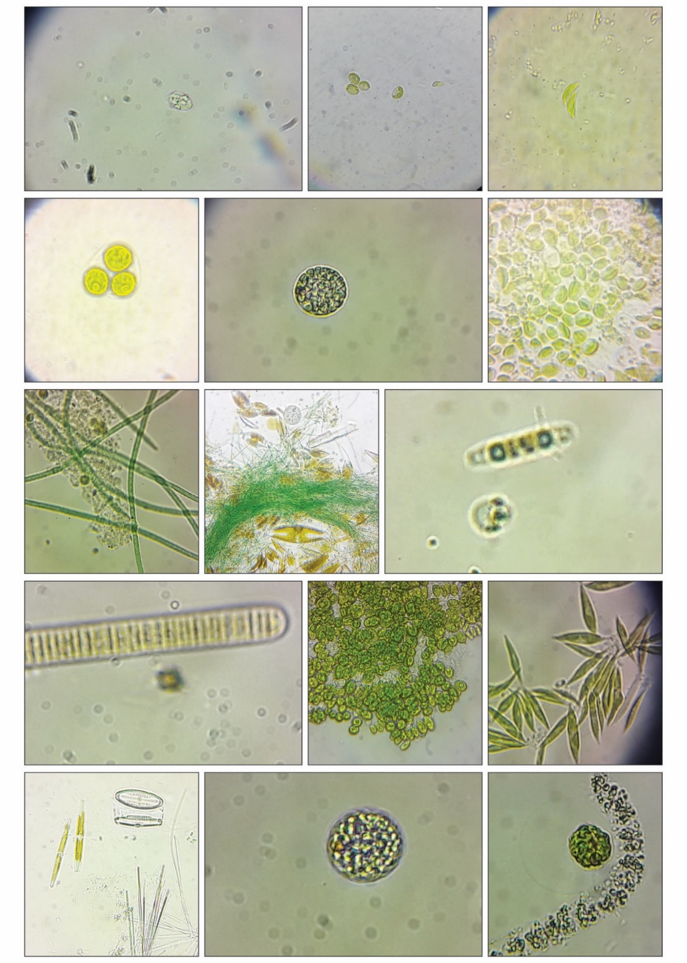
Figure 5 - Light Micrographs of different strains of microalgae from freshwater bodies of Almaty region
Figure 5: Diversity assessment of microalgae from freshwater bodies of Almaty region
Nanochloropsis sp. Oscillatoria sp
Chlamydomonadales sp
Chlorococcum sp.
Tolypothrix sp. spThalassiosira
Bellerochea sp.
Monoraphidium sp. sp.
Oscillatoria sp. spsp. Oscillatoria sp
Scendesmus sp.
Phormidium sp. Tolypothrix spThalassiosira
Graesiella sp. Tetraselmis
Tetraselmis sp. Oscillatoria sp
Pseudoisochrysis sp.
Thalassiosira sp.
Chlorella sp. Tolypothrix spThalassiosira
Haslea sp.
The lowest species diversity was recorded for green algae - 5 species belonging to 3 genera and 2 families. Also in Algoflore of Issyk there was an insignificant species variety of yellow-green algae (xanthophytes) - 1 species, gold and red algae - 1. It should be noted that these types of microalgae were not found in the rest of the explored water bodies. Analysis of the composition of indicative-probable microalgae showed the highest number of xenocaprobiotics, the most represented by the smallest radiation mesospecimens, and are sufficiently widespread types of intermediate level of contamination, which occupy an intermediate position between xenos-proof and oligos-proof zones. Evaluation of water state of Lake Issyk by indicator species of phytoplankton showed its necessity to the category oligocapable. Solid water index of Lake Issyk by the Pantle and Bukka method is equal to 1.25.
The lowest species diversity of microalgae was observed in the Big Almaty Lake (BAO). This high water reservoir is located in Zailiyskiy Alatay, at a distance of 15 km to the south the city of Almaty, at a height of 2510 m above the level sea [223]. The length of the cauldron of the lake, which has tectonic pass is 1.6 km, width - from 0.75 to 1 km. This is a small lake with a coastline length of 3 km, with a depth of about 40 m, while the volume of water is about 14 km³ [224]. By comparison with others studied lakes, significantly less types of microflora are equipped in samples water discharged to the BAO.
When investigating BAO phytoplankton sample, we found 26 species microalgae belonging to seven taxons. Three species from the Cyanophyta division were identified, 2 species from Chrysophyta, 8 species from Bacillariophyta, 7 species of green algae of the Chlorophyta division, 4 representatives of Cryptophyta, and the smallest number are Dinophyta and Euglenophyta, 1 species each, respectively (Table 6). Diatom algae numerically predominated including: Navicula, Pinnularia, Gomphonema, Cymbella, Achnanthes (34.4%), which is characteristic a feature of the phytoplankton of cold lakes, so most of the representatives of this taxon microalgae are cold-tolerant species. The indicator types of microalgae were oligo-, xenocaprobes zone, of which xenos-proof microflora dominated, such as Gloeocapsa sanguinea, Cyclotella comta, Pinnularia nobilis, Navicula graclis. Capability index by the Pantle - Bukka method was equal to 0.5 (figure 6).
The Algological pure cultures of Nephrochlamys sp. and Parachlorella sp. were isolated from the lake Balkhash, Ankistrodesmus falcatus and Monoraphidium griffthii from Lake Issyk, Ankistrodesmus sp. B-11 from Kolsay Lake and Monoraphidium sp from BAO. The smallest species diversity microflora was registered in Big Almaty Lake and the most rich Algoflora was observed in Lake Balkhash. According to the results of the work on extraction of pure cultures from samples taken from Lake Almati region, we obtained 7 Algological pure cultures (Nephrochlamys subsolitaria, Parachlorella kessleri, Monoraphidium sp., Ankistrodesmus falcatus, Ankistrodesmus sp., Desmodesmus pannonicus, and Monoraphidium griffthii) for further use in biotechnology.

Table 6 - Diversity of Microalgae in freshwater bodies of Almaty region

Species composition | Balkhash | Issyk | Alakol | Kolsay | BAO
 | Number of species observed
Bacillariophyta | 27 | 17 | 24 | 21 | 8
Cyanophyta | 25 | - | - | 7 | 3
Cyanoprocaryota | - | 9 | 22 | - | -
Chlorophyta | 32 | 5 | 35 | 11 | 7
Euglenophyta | 8 | - | 7 | - | 1
Cryptophyta | - | 1 | 1 | - | 4
Chrysophyta | - | - | - | - | 2
Dinophyta | - | - | - | 3 | 1
Xantophyta | - | 1 | - | - | -
Rhodophyta | - | 1 | - | - | -
Total | 92 | 34 | 89 | 42 | 26

Figure 6 - Saprobic indices value of freshwater reservoir of Almaty region

Lakes Balkhash and Alakol had overall more balanced proportions and the highest diversity of microalgae, with more Chlorophyta and Bacilariophyta than other microalgae. The prescence of microalgae varied almost synchronously, which is suggestive of taxonomic diversity and stable structure of phytoplankton community. Various environmental conditions significantly influence the richness and dimensional relations of photosynthetic microbes. Therefore, the information on the average prescence of microalgal can be used to evaluate the ecological state or disturbance in an aquatic environment. The higher the number of small-sized organisms, the more likely will be degrdaded water quality. In this study, the average composition of microalgae community found lower in BAO and Issyk Lake. This may partially explain the decrease in the involvement of small-sized species of microalgae and also of the improvemnt in their ecological state. This conclusion is supported by the lower value in saprobic index.

  - Morphological & Molecular Characterization of biotechnological valuable strain
3.2.1 Morphological identification of microalgal isolates
A total of 25 algal mixed cultures were collected from the five different lakes, of which seven green microalgal isolates (Nephrochlamys sp., Parachlorella sp., Monoraphidium sp., Ankistrodesmus falcatus, Ankistrodesmus sp., Desmodesmus pannonicus, and Monoraphidium griffthii) were selected based on the ease with isolation and cultivation of pure culture under our test conditions, species abundance, morphological homogeneity, and prescence of distinctive morphological features such as size, shape, colour, flagella, spines, mucilage presence etc. The cell morphology of seven microalgae isolates as observed under the light microscopy depicted in Figure 7 and 8. Although standardized morphological analysis is frequently used for taxonomic study of microalgae, however, it is not possible to accurately detail the identification at the species level, as the correlation and interaction between intra-specific variation of morphological characters and biological species boundaries have not been studied extensively in many micro-eukaryotes. The role of light microscopy was less obvious/efficient and more time consuming for precise identification at lower species level, however, microscopic analysis of the monocultures allowed preliminary identification of four isolates ZB-D01 & ZBD-06, ZBA-03 and B-11, ZBD-04, and ZBD-05 as genus Monoraphidium, Ankistrodemus, Chlorella/Parachlorella, and Desmodesmus, while the strain ZBD-02 was ranked to the genus Raphidocelis or Nephrochlamys, respectively, using extensive monographs available for microalgae identification. These genera are green microalgae that are placed in the division Chlorophyta, class Chlorophyceae and orders Chlorellales and Sphaeropleales.
The light microscopy and scanning electron microscopy visualization of single cell of microalgal strain ZBD-06 revealed the cell size (Figure 8) varying from 4–6 μm in length and 0.78–1.23 μm in diameter. Solitary cells were predominantly observed having croissant shape to crescent shape with varying degree of curvature, rounded ends, occasionally appearing colonial in irregular arrangement. Solitary cells exhibited mucilage and wrinkled cell surface but no mucilaginous colonies were observed. Chloroplast occupied the majority of the cell volume. Such cell morphology shows that the ZBD-06 resembles the characterization of genus Monoraphidium and Ankistrodesmus.
However, the strain was preliminarily identified as member of the genus Monoraphidium, for demonstrating cells dimensions and shape variations similar to Monoraphidium subclavatum as described in previous studies [225-226]. Both genus, classified under the family Selenastraceae, are similar in morphology, however the Ankistrodesmus differs by having larger cell dimensions, more or less straight cells, joined by mucilage to form colonies of various shapes, while cells of Monoraphidium are distinguished from other genera in the family being strongly curved and lacking mucilage [227]. By assessment of all the morphological characteristic of the isolated microalgae, as illustrated in the Microphotograph of the specimen under 40x magnifications (Figure 7) the suspected species was Monoraphidium subclavatum.
The strain ZBD-05 was observed to be small green unicellular, non-motile, colonial and oblong-shaped microalgae. About 80-90% of colonies was composed of 4 cells, and sometimes was seen as chained colonies of 8-16 cells. The individual cells approximately ranged from 7 to 10 μm in length and 2.4 to 3.5 μm in width, with short spines on medial cell (400 to 600 nm) and longer spines at terminal cells as great or greater than cell’s diameter (2 to 5.7 μm). The surface topology observation under SEM unveiled that the prescence of uninterrupted ribs, rosettes (circular structures) and warts on the outer cell wall layer confirming the strain to be Desmodesmus sp. as decribed previously in literature [228].
The strain ZBD-04 appeared to be coccoid green unicellular microalgae, 3-5 μm in diameter, spherical in shape, mantle-shaped chloroplast, with and without mucilage. From these morphological characteristics examined under the light and scanning electron microscopy, the isolate C1 was identified at genus-level as Chlorella/Parachlorella as depicted in previous literature [229].
In LM and SEM, the strain ZBD-01 tends to appear solitary falcate cells, about 18 to 24 μm in length, and less than 3 μm in width, with parietal chloroplast, distinctly sub-acute ends, usually straight over most of its length, only rarely the cells exhibited irregular shape, corresponding to the morphology of Monoraphidium genus [230]. The presence or absence of mucous lining appeared to be related to culture age and conditions.

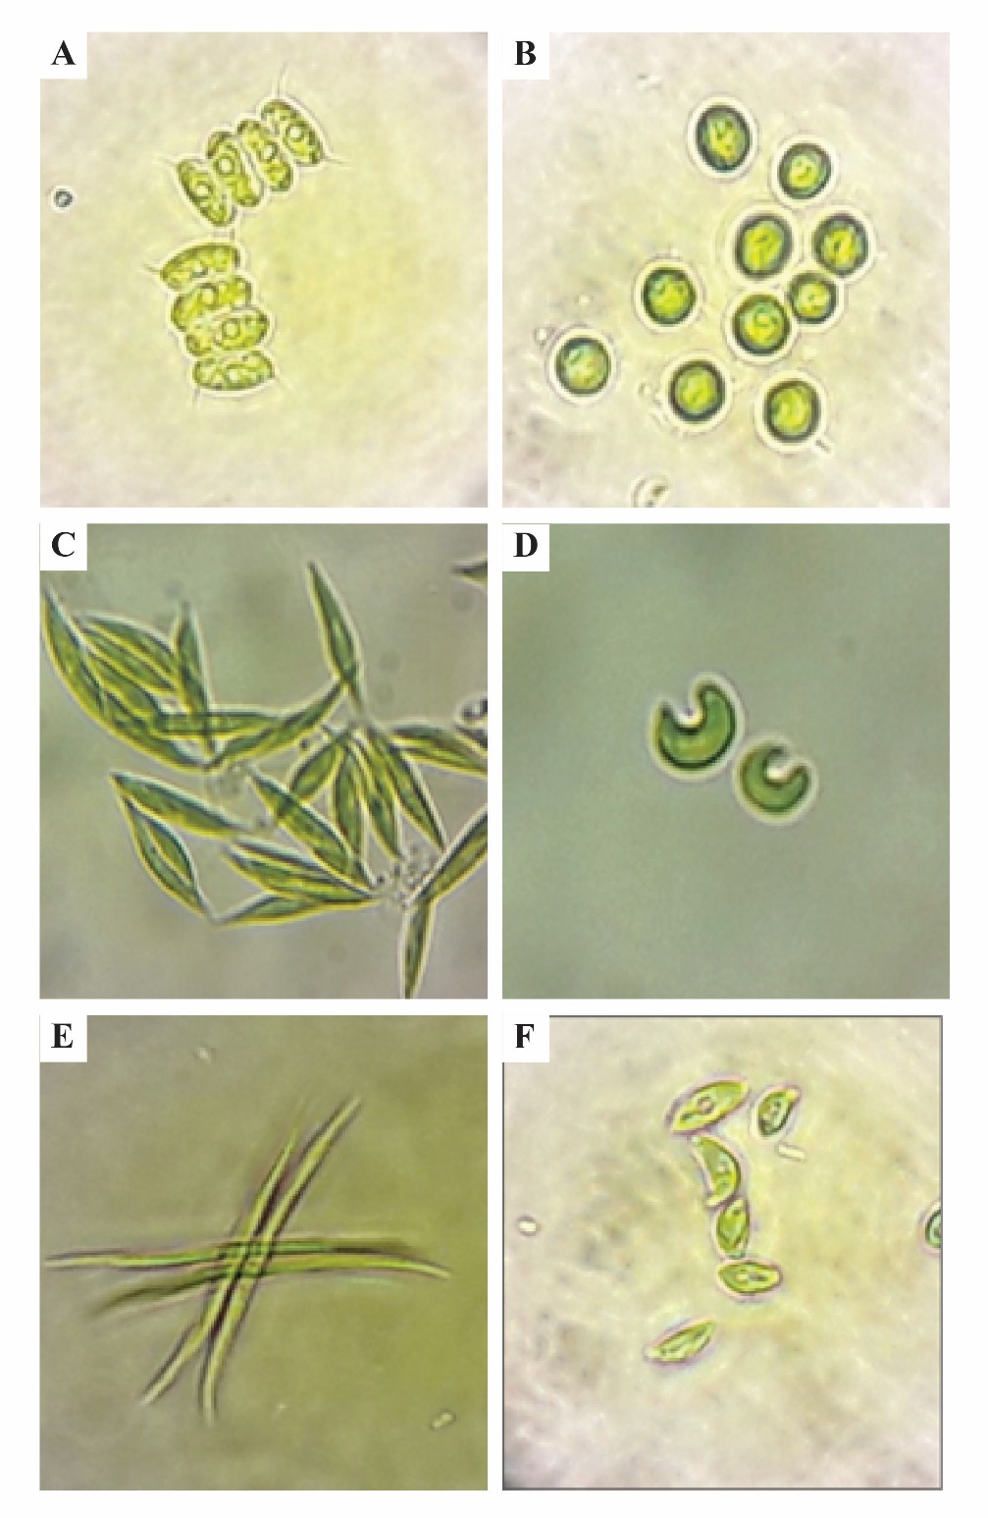

- Desmodesmus sp. (B) Parachlorella kessleri (C) Monoraphidium griffithi. (D) Nephrochlamys subsolitaria (E) Ankistrodesmus sp. (F) Monoraphidium sp

Figure 7 (a) - Micrograph (40x) of isolated microalgae strains
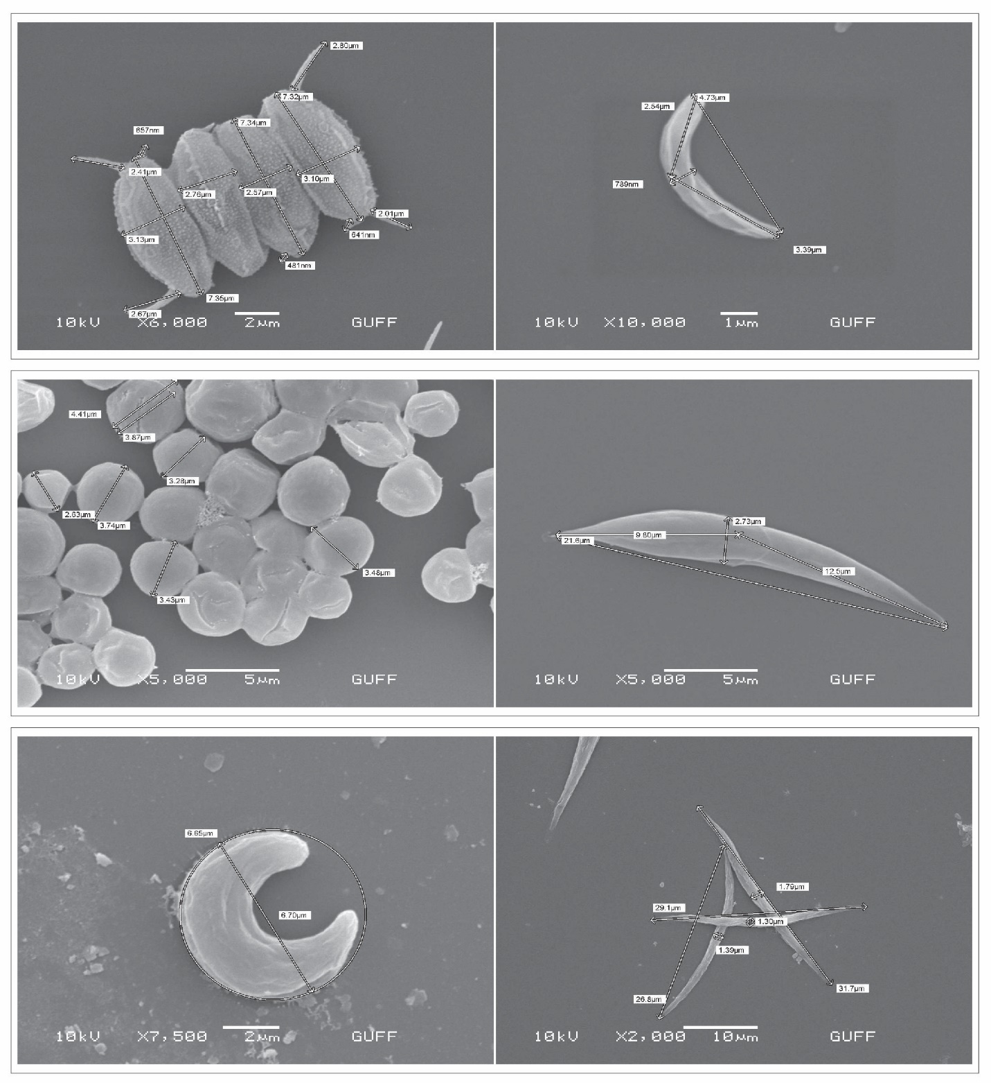
- Desmodesmus pannonicus (B) Monoraphidium sp. (C) Parachlorella kessleri (D) Monoraphidium griffithi (E) Nephrochlamys subsolitaria (F) Ankistrodesmus falcatus

Figure 7 (b) – Scanning Electron micrograph of isolated microalgae strains

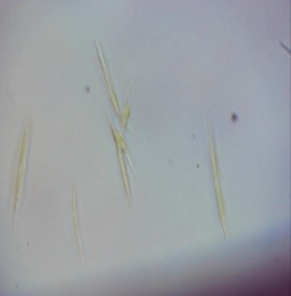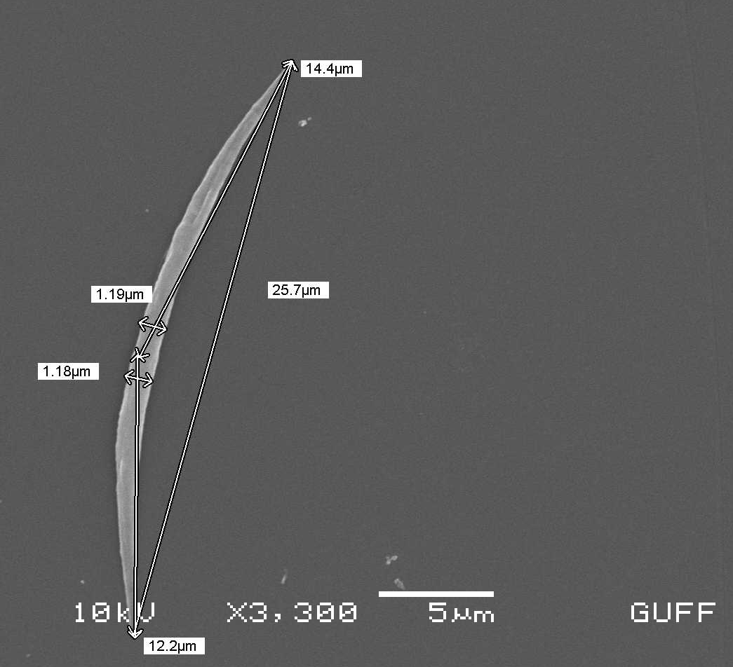
Figure 8 - Light (40x) and Scanning Electron Micrograph of Ankistrodesmus sp.

The strain ZBD-02 observed in this study was characterized by unicellular strongly curved (lunate) solitary cells, with ends rounded, attenuated and assymetric, cell diameter 5-7 μm, and slight mucilage secretion. These features appear morphologically similar to the genus Raphidocelis, Nephrochlamys, Selenastrum, Kirchneriella, and Tetranephris, however Selenastrum and Kirchneriella were excluded as cells rarely exists solitary in both genus [231].
The strain ZBD-03 exhibit elongated fusiform to needle-shaped cells, straight or slight curved, inclosed by mucilage, 1-3 x 20-40 μm in size, pointed ends, colonies of 2 or 4, rarely 8, radially arranged, shared features with the genus Ankistrodesmus [232]. The morphology of microalgae isolate B-11 was not differently observed from ZBD-03, except for abscence of colonial or radially arranged form, and cells slightly less wider as compared to ZBD-03.
Nevertheless, the morphological characteristics of the strains investigated in this study doesn’t completely fit with the typical description at species level and, therefore, species-level identification could not be achieved based merely on morphological and ultrastructural characters. The identification results of six strains (Monoraphidium griffithii ZBD-01, Nephrochlamys subsolitaria ZBD-02, Ankistrodesmus falcatus ZBD-03, Parachlorella kessleri ZBD-04, and Desmodesmus pannonicus ZBD-05, Monoraphidium sp. ZBD-06) from the cell morphology were then verified by molecular identification through sequencing of the rbcL genes, ITS1-5.8S-ITS2 and 18S rDNA targeted region and alignment with sequences from the Genbank (NCBI). However, the morphological characteristics of isolate B-11 and ZBD-03 were similar enough to accurately identify both species to same genus, thus specific PCR analysis for sequencing was only performed for isolate ZBD-03.

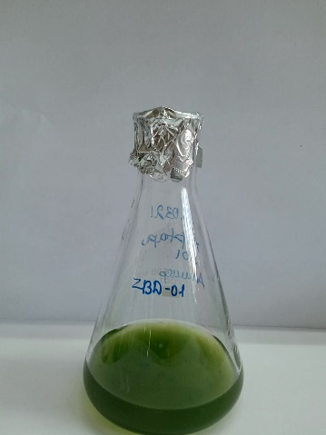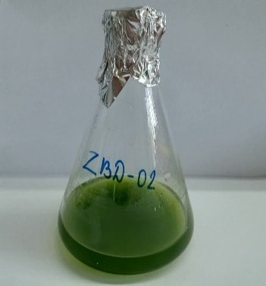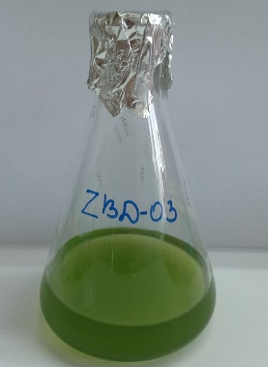
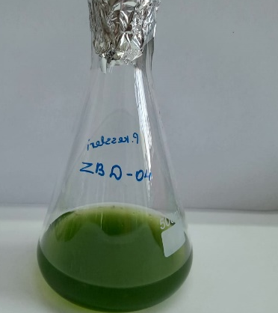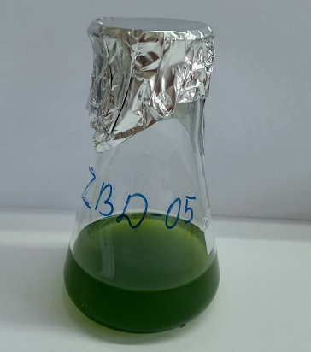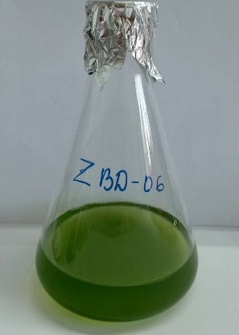
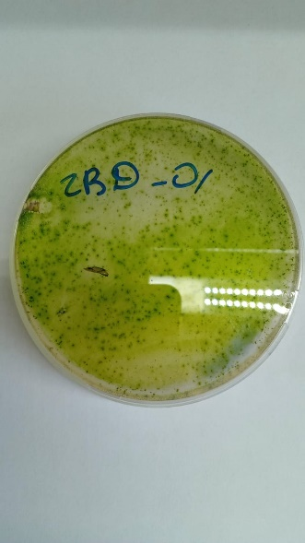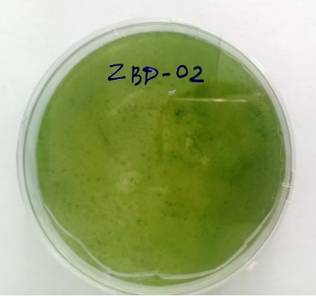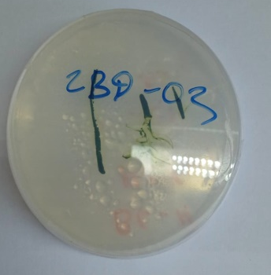
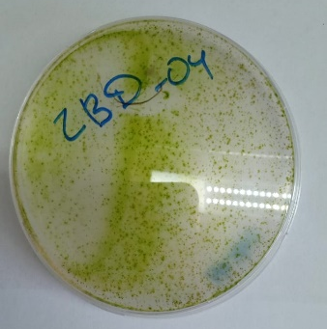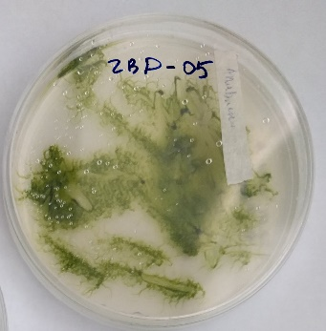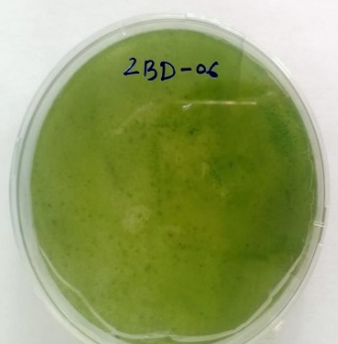
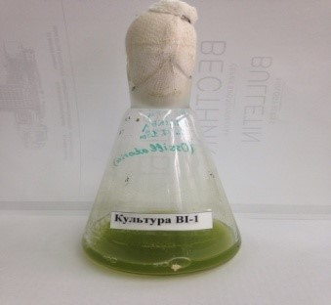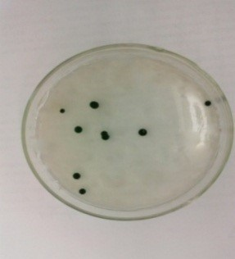

Figure 9 - Bacterial-free monoculture of seven strains of microalgae in liquid and agar medium

3.2.2 Molecular identification of microalgal isolates
The evolutionary, biogeographic, ecological, and conservation studies requires correct taxonomic identification of species and an expansion of knowledge on its true phylogenetic relationship. The phylogenetic inference of a species can also be utilizied for maximizing the probability of success in evaluating its closely related species for bioprsopsecting [233]. Among the various molecular and phylogenetic markers, which were identified, developed and optimized over the past few decades, Internal transcribed spacer (ITS) region of rDNA, particularly between 18S and 5.8 S and between 5.8 and 28 S rDNA subunits, is the most widely used region for accurately describing and restructuring phylogenies [234-235]. However, the species-level identification of few microalgae might not be possible using the ITS marker alone, therefore another reliable marker rbcL gene, based on the availability of large number of rbcL sequences for green microalgae at sequence databases such as the Barcode of Life Data (BOLD) System and National Center for Biotechnology Information (NCBI) System, was used in order to be discriminative enough for all tested isolates to reach species level.
In the present study, amplification of rbcL gene, 18S, ITS1-5.8S-ITS2, and 5.8S rDNAs partial sequence was carried out using universal primers. The PCR products of a unique single band varying in size from 550 bp to 800 bp were generated from all tested isolates with ITS and rbcL primers, with a exception where ITS5 primer failed to generate readable DNA sequence for strain ZBD-03 and rbcL primer failed to amplify ZBD-05 strain. Percentage similarity values obtained after pair-wise alignment of the rbcL gene and rDNA sequences of the isolates and qeuried against the NCBI database, with accession numbers indicated before the name of each strain, are listed in Table 7. The obtained sequences of four strains showed high degree of similarity (98-100%) with microalgae sequences deposited in GenBank database and the microalgal isolates ZBD-05, ZBD-04, ZBD-02, ZBD-03, and were identified up to species level as Desmodesmus pannonicus, Parachlorella kessleri, Nephrochlamys subsolitaria, Ankistrodesmus falcatus, and, based on 100%, 99%, 100%, and 98% sequence similarities, respectively, while sequence similarity between 89 - 93% was found for ZBD-01 with Monoraphidium griffithi. These sequence homology results strongly agree with the morphological findings in this study for these strains.

3.2.3 Phylogenetic Analysis
The ITS partial sequence-based phylogenetic analysis was performed for the five isolates of microalgae by comparing other published closest and related reference sequences (Figure 10). The identification of microalgae isolates ascertained by morphological and molecular analysis was supported by the phylogenetic results. The isolate ZBD-05 is strongly grouped in the same clade with Desmodesmus pannonicus with bootstrap value of 92% while ZBD-04 shared the same clade with Parachloella sp. and grouped with Parachlorella kessleri strains. The isolates ZBD-02 belonged to the clade of Nephrochlamys subsolitaria with percentage support value of 98%. The isolate ZBD-03 clustered with Ankistrodesmus falcatus with a bootstrap support value of 100%. Th phylogram clearly confirmed the identification of isolates ZBD-05, ZBD-04, ZBD-02, and ZBD-03 as Desmodesmus pannonicus, Parachlorella kessleri, Nephrochlamys subsolitaria, and Ankistrodesmus falcatus. The observed phylogenetic clustering is in agreement with our initial morphological and molecular findings. However, the isolate ZBD-01 is located in the group of Ankistrodesmus falcatus, differing from the morphological identification result for this strain. The results of BLAST sequences homology search for this isolate showed low similarity to the known sequences, clustering distinctly from Monoraphidium genera.
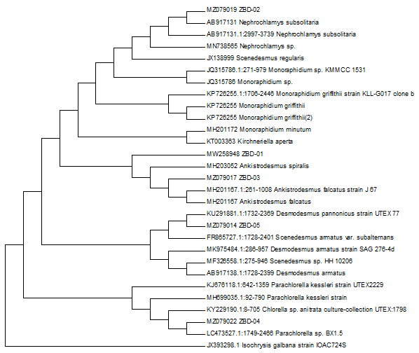

Figure 10 - Phenogram generated using the ITS1 region that includes five selected green microalgae isolates and homologous sequences with different similarity level.
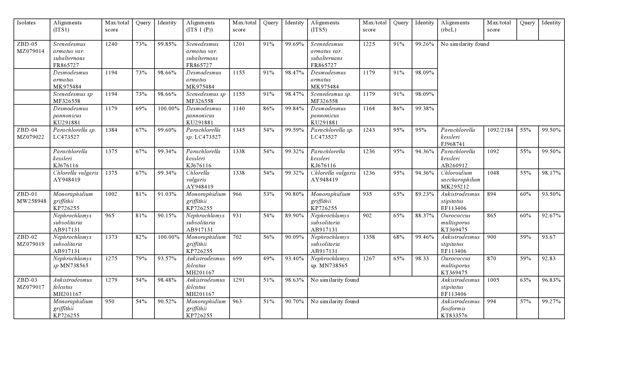
Table 7 - The accession numbers and % similarities between amplified sequences, and the closest relative sequences for five isolated strains microalgae.

To perform the molecular identification of the isolate, the desired DNA fragments (~600 - bp) of isolate, amplified with universal primers of rbcL gene and ITS region were compared with the similar sequences in the database using BLAST online (http://www.NCBI.nim.nih.gov/). The similarity searches of the obtained amplicon sequences in the GenBank database were observed for the universal primer sets of ITS1/ITS4 and ITS5/ITS4, whereas the amplicon sequences generated from rbcL could not retrieved any blast match.
The blast result of only first set of primer ITS1/ITS4 was supportive and useful in species discrimination, while second set of primer ITS1/ITS4 and ITS5/ITS4 resulted in database mismatches with macro algae, uncultured microorganism and microalgae completely conflicting with morphological description. As the results with the second set of primers were not satisfactory to infer generic identity, therefore, the phylogenetic analysis was performed only with the first set of ITS/ITS4 primer. This reduced success in retrieving accurate sequence matches can be attributed to the fact that the number of well-described microalgae species are still not significantly represented in Genbank. The limitations in molecular identification of some microalgae at the species-level implied that further work is required to establish efficient DNA barcode markers for revealing sufficient heterogeneity for species identification, maximizing the gene database, as well as employing combination of molecular and morphological methods for accurate identification of species with extreme morphological plasticity.
The fifteen sequence entries with highest similarity to the obtained sequence of isolate ITS region were observed and multiple alignment of the sequences were generated with the MUSCLE program. The phylogenetic tree was constructed with MEGA software version 6 based on the evolutionary distances that were calculated by the Neighbor-Joining method [236] using Kimura-2-Parameter algorithm [237]. Statistical evaluation of the tree topologies was performed by bootstrap analysis with 1000 re-samplings [238]. Isochrysis galbana strain (JX393298) was used as an outgroup. Figure 11 represents the Neighbour-Joining showing phylogenetic position of strain and related taxa based on ITS1-5.8S-ITS2 region sequence comparisons.
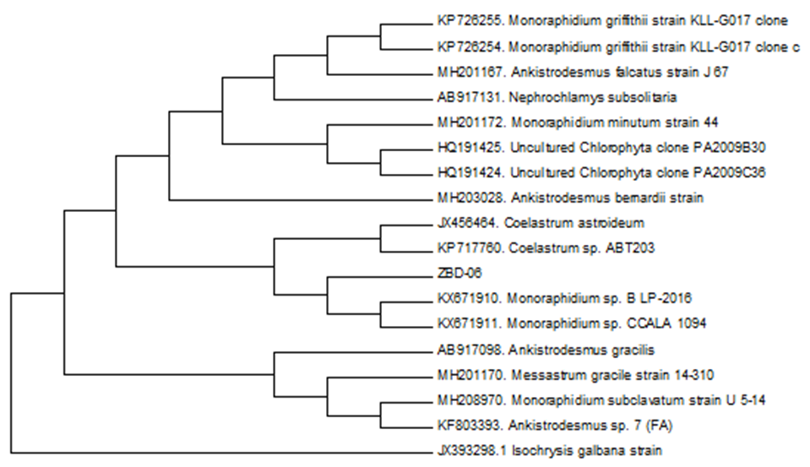

Figure 11 - Phylogenetic tree of the isolated microalgae and the closely related strains based on ITS1-5.8S-ITS2 region sequence comparisons

Phylogenetic tree consisted of basically three major clusters and one outgroup, each of which mostly contained different species of Genus Monoraphidium and Ankistrodesmus. The Phylogram (figure 11) shows that the ZBD-06 strain is closely related to Monoraphidium sp. B LP-2016 (score = 911; ident. = 93.33%), Monoraphidium sp. CCALA 1094 (score = 900, ident. = 93.28%) isolated from ice-covered lakes on James Ross Island (northeastern Antarctic Peninsula) [132, p. 19]. The clustering of Monoraohidium sp. from Almaty region with Monoaphidium sp. from Antarctic region determines the presence of closely related extermophilic species of microalgae in geographically far distinct location (continental level). The phylogram also depicts the relatedness of the newly isolated native strain to Coelastrum astroideum (JX456464), however, both strains are morphologically different [239]. Other closely related species were from the genus of Ankistrodesmus and Monoraphidium representing a polyphyletic group [240]. The overall morphological features and sequence-based phylogenetic analysis of ZBD-06 with one of the primers of ITS1 region presented a good correlation and served as important molecular target for identification and taxonomical position of the isolate to great extent based on the availability of sequence database. The obtained molecular result suggests the consideration of ZBD-06 strain as Monoraphidium sp. that was also based on light and SEM microscopic observation and the genus belongs to the family Selenastracaceae (Cholorophyceae). The ITS sequence of the isolate was submitted with accession number of MT178772 in NCBI database, respectively. The relative phylogenetic position based on the ITS1/ITS4 primer sequence might not determine species-level resolution for this species, but when matched with the results of morphological studies, it provided more reliable identiﬁcation of the isolate.

  - Evaluation of Biofuel potential
    - Growth evaluation of selected microalgal strains and Biomass productivity
Generally, growth rate, biomass yield, lipid content and fatty acid composition are important factors to consider in evaluation of microalgal strain as viable feedstock for biofuel production. An initial screening revealed lipid accumulation capacity of less than 20% of the cell biomass for all strains of this study, however D. pannonicus, P. kessleri, and N. subsolitaria, showed higher growth rate at 0.58 day⁻¹, 0.57 day⁻¹, and 0.42 day⁻¹, and biomass yield of 1.35 g, 1.42 g, and 1.21 g, respectively, per one Litre culture (Table 8). There was no significant difference between strains M. griffithi and A. falcatus (0.24 day⁻¹ and 0.21 day⁻¹). All strains were grown as monocultures at the same laboratory condition in view of their robustness towards a wide range of environmental conditions, however it may not necessarily be the optimal culturing conditions for all strains of this study, and performance in growth, biomass and lipids productivity may vary if other nutritional or environmental requirements were accounted [241].

Table 8 - Comparison of growth coefficient, biomass, lipid content, and lipid productivity of five microalgal isolate

Isolates | Growth  Coefficient | Average Biomass Concentration  (g L⁻¹) | Total Lipid Content  (% of dry weight) | Lipid Productivity  (mg L⁻¹ day¹)
Monoraphidium griffithi | 0.24 | 1.12 ± 0.05 | 13.82 ± 0.1 | 19.6 ± 0.5
Nephrochlamys subsolitaria | 0.42 | 1.21 ± 0.04 | 12.71 ± 0.4 | 22.4 ± 1.6
Ankistrodesmus falcatus | 0.21 | 1.09 ± 0.14 | 13.41 ± 0.1 | 19.2 ± 0.7
Parachlorella kessleri | 0.57 | 1.42 ± 0.08 | 16.43 ± 0.2 | 29 ± 1.2
Desmodesmus pannonicus | 0.58 | 1.35 ± 0.04 | 14.51 ± 0 | 26.7 ± 0.7

3.3.2 Effect of temperature
The optimum temperatures for the studied six isolate were between 22-25 °C, while the minimal and maximal temperatures for the activity of six isolates were found to be 11 to 13 °C, and 33 to 36 °C, respectively. Results showed that isolates exhibited a similar trend of decrease in its growth rate/cell density by 20% at more than 30 °C. No growth of isolates was noted at/above temperature of 36 °C which can be considered to be the result of the interruption of microalgal growth or large number of dead cells. Despite of being collected from different lakes with different environmental and physical conditions, the maximum growth rate for all strains was obtained at nearly same temperature. The studied strains exhibited better growth rate with BG-11 medium. The highest biomass yield was attained at 23±2 °C, after which the biomass of all isolates decreased or delayed with further increase in the temperature.
One of the most important factors impacting microalgae growth is temperature. Temperature greatly influences the biochemical composition, the uptake of essential micronutrients, rate of photosynthetic carbon fixation of nearly all species of microalgae [242]. It is known that phytoplankton potentially have optimal metabolic efficiency at specific temperature and growth rate will decrease drastically with increase or decrease in temperature.
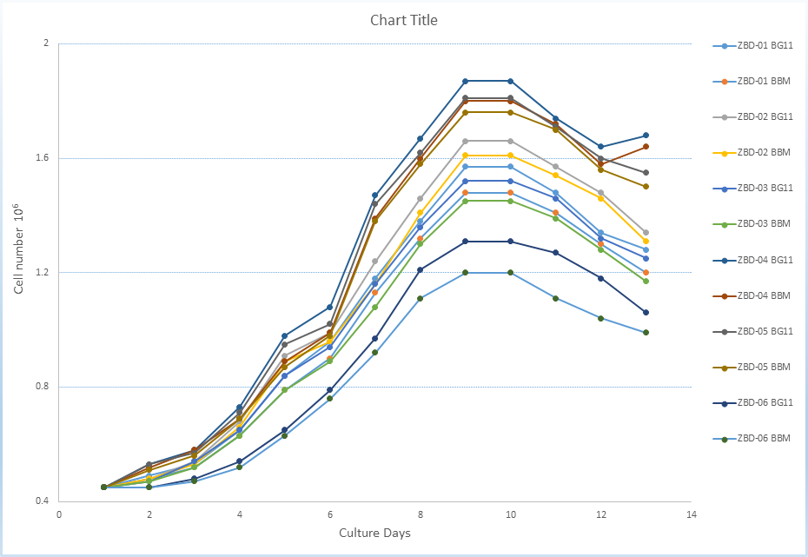
Figure 12 - Comparative Growth curve of Microalgae isolates in growth medium BG-11 and BBM

3.3.3 Effect of light
The effects of light quality (color) including white and yellow light and dark period was tested. The results indicated both light wavelengths are optimal for microalgae growth and no significant difference in results was noted. Our results also showed that optimal light wavelength along with the dark period are critical for microalgal growth. It was noted that growth of microalgae was negatively affected by prolong exposure to daylight without dark period.
There was relatively higher cell density (number of cells) when yellow and white light were alternatively used after 3 to 4 days of growth (light intensity 100 μmol/m²/s). One previous study [243] suggested the red light as most viable for biomass productivity in green microalgae, as Chlorophyte have high concentration of chlorophyll and hence absorbs much more strongly in the red wavelength area. However, another study [244] reported that red light was negatively associated with biomass growth of Ch. vulgaris biomass and violet, green and orange light (250 μmol/m2 /s) were found more efficient for the same strain.

3.3.4 Effect of CO₂ concentration
The cell density of all studied isolates were positively correlated with elevated concentrations of CO₂ from 0.5 % upto 5%, however their tolerance range for further higher carbon concentration was limited. Studying the effect of different concentration on these strains was not feasible for longer period due to time and equipment constraints. However, the results obtained slightly coincided wuth previous study [245], where the maximum growth rate of green microalgae was found in the culture of 10 % CO₂. Another study [246] reported that the highest biomass yield of Ch. vulgaris was found when the microalgal culture were supplied with air containing 8.5 % CO₂ and white light irradiance.

3.3.5 Effect of cultivation medium
The growth curves for all isolates cultured in two different media types, including BG11 and BBM, are shown in Figure 12. The isolate Parachlorella kessleri with the BG-11 media showed the highest overall growth rate in both medium comparatively to all other isolates. Desmodesmus and Nephrochlamys appeared to thrive in the BBM initially, but after 4 days of culture BG-11 enabled higher growth of these isolates. The growth coefficient and cell density were calculated to compare the growth of six species in the two mediums.
All isolates showed similar growth pattern in both mediums with provided same conditions of CO₂concentration, pH and temperature at specific time simultaneously. pH was noted to drop in first few days then gradually rise each day after that. The solubility of CO₂ in the liquid phase increases with increase in temperature, which lead to the change in pH and subsequently effect the growth of the microalgae.
3.3.6 Lipids profiling and Fatty Acid Analysis (FAMEs)
The derivatized fatty acid methyl esters (FAMEs) were analyzed for all strains, except for ZBD-02, using GC/MS. Consistently the Hexane extracts of four tested strains showed the prevalence of saturated fatty acids including palmitic acid, oleic acid and stearic acid as dominant fatty acids and low level of polyunsaturated fatty acids thus suggesting high potential of these strains for biodiesel feedstock consideration. Major fatty acid methyl esters observed in P. kessleri were grandiflorenic acid, palmitic acid, heptadecanoic acid, Oleic acid and stearic acid while the minor fatty acids were eicosapentaenoic acid (EPA), benzoic acid, lauric acid, tridecanoic acid, and 1-Phenanthrenecarboxylic acid. The largest peak area was noted for Octadecenoic acid (Stearic) at 16.86%, second largest peak area of 15.12% recorded due to the presence of n-Hexadecanoic acid (Palmitic) and the third peak was at 6.85% of Octamethyl cyclotetrasiloxane. Beside several saturated and unsaturated fatty acids ranging from C6 to C20, resin acids/diterpenoids such as abietic acid, palustric acid and callistric acid were also detected in P. kessleri, accounting for a percentage of 21.8% of the total fatty acids (Figure 13).
Monoraphidium griffithi and Ankistrodesmus falcatus also showed great potential as the sources of oleic acid, stearic acid and palmitic acid for renewable fuels such as biodiesel, as their prominent peaks were noted at 14.73%, 4.49% and 16.94%; and 33.27%, 7.26% and 30.08%, respectively. Fatty acids <C14 were found dominant in Desmodesmus pannonicus while n-Hexadecanoic acid (palmitic acid) and Hexadecanoic acid methyl ester are the only fatty acid present in considerable quantity with prominent peak of 20.03% and 11.59%. The GC/MS analysis (Table 9) revealed the fatty acids of four strains of this study which are known to be most common fatty acids for various biological activities such as antibacterial, antioxidant, medicinal applications and holds the potential as renewable chemical feedstocks in many industries such as biofuel, bio-plastic and bio-based products.

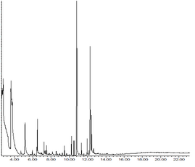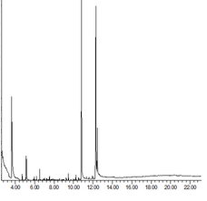
c
g
h
d
m
d
i
g
h
(i)
(ii)
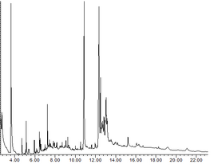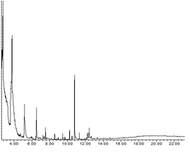
(iii)
(iv)
e
d

b
f
q
p
n
h
g
e
d
i) M. griffithii; ii) A. falcatus; iii) P. kessleri; iv) D. panonnicus. : a) 4-Phenyl-4H-1,2,4-triazole-3-thiol b) Tridecanoic acid C13:0, c) Pentadecanoic acid (C15:0), d) n-Hexadecanoic acid (C16:0), e) Hexadecanoic acid, methyl ester (C16:0), f) Heptadecanoic acid (C17), g) Octadecanoic acid (C18:0), h) 9-Octadecenoic acid (C18:1), i) 6-Octadecenoic acid, (Z)- (C18:1 cis-6), m) 3-Hydroxymandelic acid ethyl ester (C8), n) Abietic acid (C20), p) β-Pimaric Acid (C20), q) Callitrisic acid (C20).
Figure 13 - Gas chromatograms of fatty acid methyl esters from four studied species.
Cetane number (CN), Saponification value (SV), and Iodine value (IV), being an adequate criterion for estimating the properties of biodiesel, were calculated from the results of Fatty acid methyl ester (FAME) profiles (listed in Table 9). According to the ASTM D6751-02 and EN14214 standard for biodiesel, the required limit for CN is >47.0 and >51.0, respectively, whereas the maximum value of 120 g I2/100 g fat is recommended for IV. The calculated CNs for isolates P. Kessleri and A. falcatus were found to be 48 and 50, and comparable with the etimated values reported for biodiesel obtained from other microalgae in the previous literature [247]. The calculated IVs and SVs of P. Kessleri and A. falcatus were 83.4 and 103.6 which are also in accordance with the EN14214 biodiesel standards and strongly suggest good oxidative stability of the isolates and their possible suitability as a feedstock for biofuel. The CNs of M. griffithii (34) and D. pannonicus (25.5) were less than those required for the biodiesel standard requirement, and their high iodine values178.3 and 194.9 suggests the isolates’ low oxidative stability.

Table 9 - Comparison of fatty Acids Composition of selected four Microalgae isolates
FAs Composition | Fatty AcidsCompisition (% w/w)
 | Monoraphidium griffithi | Ankistrodesmus falcatus | Parachlorella kessleri | Desmodesmus pannonicus
Hexadecanoic (palmitic, C16:0), | 16.94% | 30.08%, | 15.12% | 20.03%
Hexadecanoic acid, methyl ester | ND | ND | 6.72% | 11.59%
Octadecanoic acid (stearic, C18:0), | 4.49% | 7.26% | 16.86% | ND
9-Octadecenoic acid (oleic, C18:1) | 14.73% | 33.27% | ND | ND
Diterpenoids such as abietic acid, palustric acid and callistric acid | ND | ND | 21.08% | ND
Others  (3-Hydroxymandelic acid, Dimethyl phthalate, Hexa and octamethylcyclotetrasiloxane, Lauric acid, Capric acid, Eicosapentaenoic acid (EPA), Tricosylic acid, 2,4-Di-tert butylphenol) | 63% | 30% | 40% | 68%
SV | 195.4 | 199.5 | 260.8 | 236.4
IV | 178.3 | 103.6 | 83.4 | 194.9
CN | 34 | 50.3 | 48.4 | 25.5

Producing efficient and cost-effective microalgal biodiesel requires primarily optimizing genetic and regulatory processes in the potential strains of microalgae. Our study identified promising microalgae candidates for biodiesel generation, strain of Parachlorella kessleri and Ankistrodesmus falcatus, which showed content of suitable fatty acids and biodiesel properties under normal cultivation conditions of BG-11 medium. As the current study was conducted on microalgae strains collected from cold conditions, together with other limiting factors (e.g nutreints availability, and high solar irradiation) further research should be conducted to investigate tolerance to extreme environments by differentiating the growth medium and environmental conditions, particularly the differential effect of elements such as Iron, Nitorgen and Phosphorus on biomass production and lipid accumulation in different microalgal strains.

3.3.7 Biofuel feedstock opportunity
Microalgal lipid content and compositions directly influence the biodiesel properties. The FFAs composition of the lipid (rate of unsaturated FAs to saturated FAs) affects the biofuel and other related properties of the resulting FAMEs. The biochemical composition of the biomass of microalgae towards higher lipids content and desirable fatty acids can be regulated by varying the cultivation conditions. The obtained peaks of fatty acid methyl esters and their relative percentages in GC/Ms results of this study indicates that lipid content of P. kessleri and A. falcatus of saturated and monounsaturated fatty acids. The saturation level of fatty acids considerably effects the storability and stability of biofuel. The lipid profile of M. griffithi also showed the presence of Fatty acids with chain lengths from C16 to C18 to C21-24, however polyunsaturated methyl esters were recovered from this isolate in relatively higher amount (63%) comparatively to combine percent relative weight of saturated and monounsaturated fatty acids (34%), which resulted in low cetane number and high Iodine value.
As per the EN14214 biodiesel standards, biodiesel with iodine value within the maximum limit of 120 g l₂ 100 g⁻¹ is a better quality one. The iodine value of P. kessleri and A. falcatus of < 120 g l₂ 100 g⁻¹ demonstrate good quality of potential fuel with possibly high heat combustion. The combustion of biofule is also determined by the abovementioned parameters. Fatty acids with higher ratio of saturated and monounsaturated fatty acids are expected to have higher heat of combustion as lower degree of unsaturation is directly related to ratio of hydrogen to carbon. The presence of unsaturated bonds in the FAMEs of M. griffithi lowered the cetane number and increased the iodine value considerably that reflects its proness to be oxidizied when exposed to air. Hence despite the prescence of unique and desirable fatty acids methyl esters in microalgae, the inclusion of unsaturated FAMEs reduces the quality of the biodiesel.

3.4 Examination of antimicrobial activity
Our results revealed the existence of valuable constituents, such as saturated fatty acids and terpenoids in microalgae strains, that also provide additional value other than obtaining biofuel and contribute to interesting biological activities, including antibacterial activity. Green microalgae have been reported to produce several pharmacologically important bioactive compounds such as anti-inflamatory n-3 fatty acids (Eicosapentaenoic acid (EPA), cytotoxic fucosterol, anticancer borophycin, antiviral cyanovirin, and nutraceutical β-carotene [248].
To comprehensively asses the antibacterial potential of green microalgae, the methanolic extracts of all microalgae isolates were tested for their antibacterial activity against eleven bacterial strains, namely, Gram-positive (Bacillus subtilis ATCC 6633, Enterococcus faecalis ATCC 29212, Staphylococcus aureus ATCC 25923, Staphylococcus epidermidis ATCC 12228) and Gram-negative (Escherichia coli ATCC 25922, Klebsiella pneumoniae ATCC 13883, Pseudomonas aeruginosa ATCC 27853, Proteus vulgaris ATCC 13315, Salmonella typhimurium ATCC 14028, Yersinia pseudotuberculosis ATCC 911, and Enterobacter cloacae ATCC 13047) by disk diffusion assay. As shown in figure 14, four strains of microalgae exhibited diverse inhibitory effect on two gram +ive bacteria (B. subtilis, S. Aureus) and three gram -ive bacteria (E, coli, K. pneumonia, and P. aeruginosa). Parachlorella kessleri and Nephrochlamys subsolitaria showed highest antibacterial activity against B. subtilis, as appeared from the inhibition zone of 0,6 mm in diameter, respectively. The antagonistic effect of Parachlorella kessleri was also noted against S. aureus and K. pneumonia. Isolated strains of Monoraphidium griffithi and Ankistrodesmus falcatus exhibited moderate antibacterial action against only gram negative bacteria (E. coli and K. pneumonia). Nephrochlamys subsolitaria also displayed active inhibitory effect against E. coli followed by lesser inhibitory action against P. aeruginosa.

Table 10 - Antimicrobial activity of Microalgal isolates against selected bacterial pathogens by disk diffusion method

Isolates | Species | B. subtilis | S. aureus | E. coli | P. aeruginosa | K. pneumonia | MIC values  (microalgal cells/mL)
ZBD-05 | D. pannonicus | − | − | − | − | − | 0.75 × 10⁸ cells/mL
ZBD-04 | P. kessleri | +++ | ++ | − | − | + | 1.2 × 10⁸ cells/mL
ZBD-01 | M. griffithi | − | − | + | − | + | 0.90 × 10⁸ cells/mL
ZBD-02 | N. subsolitaria | +++ | − | ++ | + | − | 0.70 × 10⁸ cells/mL
ZBD-03 | A. falcatus | − | − | + | − | + | 0.45 × 10⁸ cells/mL
−: no antibacterial activity.
+: diameter of inhibition zone < 0,2 mm
++: diameter of zone of inhibition ≥ 0,4 mm.
+++: diameter of zone of inhibition ≥ 0,6 mm.

The methanol extracts of the same four strains, ZBD-01, ZBD-02, ZBD-03, and ZBD-04 were able to inhibit the growth of same tested bacterial strains in minimum inhibitory concentration (MIC) assay. The highest antibacterial activity was recorded of Parachlorella kessleri against B. subtilis, S. aureas and lower activity was recorded for K. pneumonie. Nephrochlamys subsolitaria minimum inhibitory concentration against B. subtilis, E. coli, and P. aeruginosa was observed in second dilution tube, respectively. Whereas, the lowest activity was showed by Ankistrodesmus falcatus against E. Coli and K. pneumoniae with MIC observed in first dilution tube. The MIC value of Monoraphidium griffithi was also observed against E. coli and k. pneumoniae in first dilution tube. Table 10 illustrates the minimum inhibitory concentration of methanol extract of four microalgae strains observed in dilution tubes.
A range of microalgal species are known for its antibacterial potential, owing to to their metabolic potential to produce a large variety of bioactive molecules such as proteins, polysaccharides, polyunsaturated fatty acids (PUFAs), vitamins, sterols and antioxidants (polyphenols, alkaloids, phycobilins, flavonoids, terpens, tannins, saponins and carotenoids). Until now, considerable number of studies on bioactive compounds from freshwater and marine microalgae exhibiting antimicrobial activity have been published in past three decades. Despite these findings, the data about specific antibiotic properties of these bioactive constituents and their mechanism of inhibitory action are still scarce.

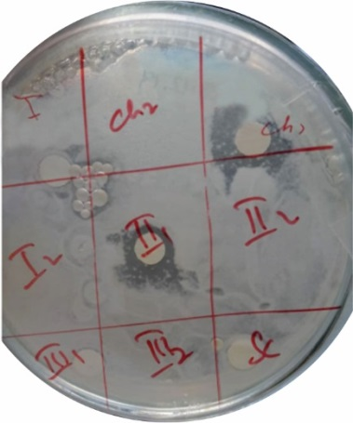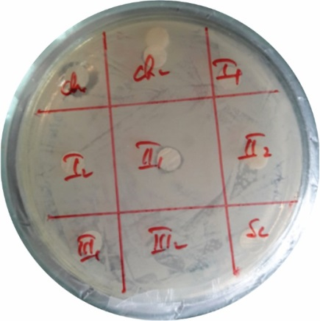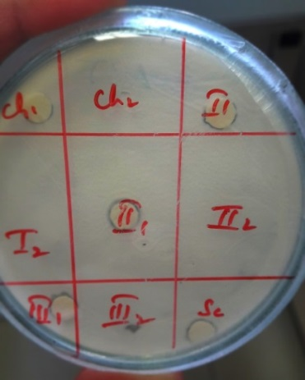
(C)
(A)
(B)

(D)
(E)

(F)
(E)
ZBD-02
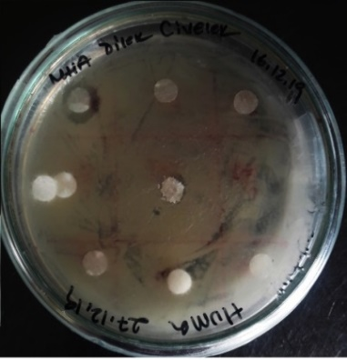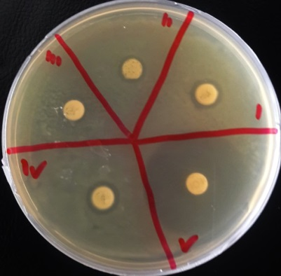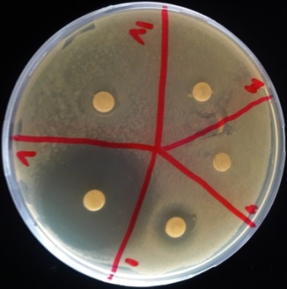
(F)
(D)
(E)
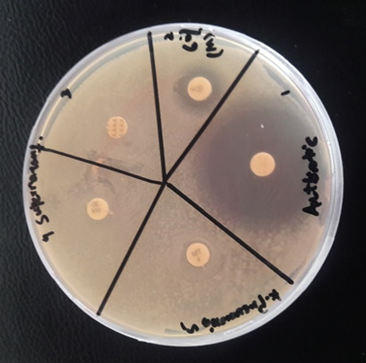
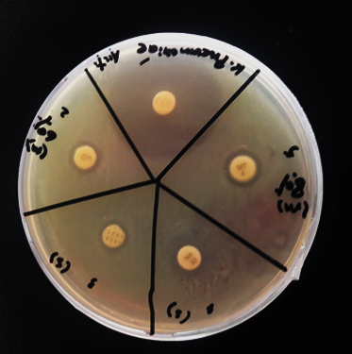

(G-2)
(G-1)
(G-2)

- against B. subtilis; (B) against S. aureaus; (C&D) against E. Coli; (E) against K. pneumonia; (F) against P. aeruginosa; (G-1) 10 μL of extract against K. pneumonia; (G-2) 30 μL of extract against K. pneumonia.

Figure 14 - The antibacterial activity of methanol extracts of microalgae strains (agar disc-diffusion method):

Few studies demonstrated that microalgae respond to the presence of bacteria by production and secretion of membrane‐derived Free Fatty Acids (FFAs) as defense strategy [249]. The bacteriostatic (growth-inhibiting) or bactericidal (killing) potency of poly-and mono-unstaurated fatty acids, predominantly palmitic acid, oleic acid, linoleic acid, myristic acid, arachidonic acid, docosahexaenoic acid (DHA) and eicosapentaenoic acids (EPA) of microalgae, frequently produced under environemtal stress conditions, has been investigated extensively against a wide range of bacteria [250]. To the best of our knowledge, there have not been many reports regarding the possible antibacterial potential of microlagae strains of the present study. Thus, the aim of the present study was to investigate the ability of crude methanol extract of these microalgae strains isolated from Almaty region to inhibit the growth of various pathogenic bacteria.
The strongest antibacterial activity with maximum zone of inhibition was observed with methanolic extract of Parachlorella kessleri. Few studies have been conducted on the fatty acid composition and bioactive compounds of P. kessleri and reported that it consists predominantly of C13:0, C14:0, C16:0, C16:1, C18:0, C18:1 [251]. Considering that these unsaturated fatty acids have been found to have antimicrobial activity in previous literature, these compounds can be supposed to be responsible for the antibacterial property of P. kessleri. This study also suggests N. subsolitaria as a rich source of bioactive compounds chemically varied in nature with broad spectrum antibacterial potential. The genus Nephrochlamys is generally enriched with monounsaturated and saturated fatty acids and α-linolenic, oleic, palmitic, and hexadecatetraenic have been identified as characteristic fatty acids [252]. The possible prescence of these fatty acids in our strain Nephrochlamys subsolitaria, can be made accountable for the remarkable antimicrobial properties demonstrated against B. subtilis, E. coli and P. aeruginosa.
Ankistrodesmus falcatus and Monoraphidium griffithii are reported to contain saturated and unsaturated FFAs and PUFAs with omega groups, notably myristic acid (C14:0), palmitic acid (C16.0), oleic acid (C18:1), linoleic (C18:2), and linolenic acid (C18:3) [253-254], and most of these well-known metabolites for enormous potential of inhibiting several bacterias have been profiled in these strains in this study. The antibacterial and MIC assay of the present study suggests that A. falcatus and M. griffithii are of great importance as potential antibacterial source for production of bioactive compound specifically effective against gram negative bacteria (E. coli and K. pneumonia). The difference in sensitivity of gram positive and gram negative bacteria to antibacterial effect of bioactive compound or secondary metabolite is generally attributed to differences in cell wall structure of Gram-positive and Gram-negative bacteria [255]. Few studies allow to state that flavonoids show more potent antibacterial activity against gram negative bacteria as comparaed to gram positive bacteria [256]. One study also demonstrated the specific inhibitory effect of lectin extracts from the red alga Solieria filiformis against several Gram-negative bacteria including K. pneumoniae with no inhibition against Gram-positive Staphylococcus aureus and Bacillus subtilis, possibly because of binding of lectin from the extract with mannan (linera polymer of mannose sugar) on the cell surface of Gram-negative bacteria, stimulating an immune response [257]. In this context, extensive screening studies are needed in order to identify the responsible bioactive compound in these two strains and to elucidate the mechanism of its antibacterial action.
The most susceptible microbes to specimen methanol extract of ZBD-06 were Gram-positive bacteria than Gram-negative bacteria. However, surprisingly the methanol extracts of Monoraphidium sp. ZBD-06 exhibited the notable antibacterial activity against Klebsiella pneumoniae ATCC 13883. The strain showed a positive response in an inhibition zone assay (0,4±2 mm with 10ul and 0,6±2 mm in diameter with 30uL) against Gram-negative bacteria Klebsiella pneumoniae ATCC 13883, Fig.14. (G 1-2). In order to confirm the antimicrobial action of strain, the Minimum Inhibitory Concentration (MIC) of the methanol extract was performed against the same bacterial isolate. The MIC value of the extract of ZBD-06 was observed at the first well (2-1).
The FAMEs results showed that these isolates contain several metabolites in lower concentration such as Phenols, alkaloids, terpenes, and flavonoids which could be potentially responsible for antibacterial activity of the extract against Gram negative bacteria. One previous study on assessment of antimicrobial potential of marine green microalgae Desmococcus olivaceus (D. olivaceus) and Chlorella vulgaris (C. vulgaris), revealed that the solvent choice influences the physical and chemical properties of the extract, such as high phenol content was only found in methanol extract, and amount of falvonoids, terpenes, carbohydrates and alkaloids differed when extracted with different solvents such as ethanol, methanol and chloroform and diethyl ether extract [258].
The multilayered and complex cell envelope of the Gram-negative bacteria is one of the major obstacles, which restrict the entrance of antibacterial agents [259]. However, certain biomolecules can damage the bacterial membrane component, such as terpenoid and phenolic compounds [260]. Antibacterial action of Monoraphidium sp. ZBD-06 against Klebsiella pneumoniae is possibly related with presence of high content of key molecule, which was specific in action for growth inhibition of the bacterium. Taking into account the isolation of the strain from the freezing lake and continued growth at 24°C retaining optimal functionality of their macromolecules suggests that adaptation to extreme environment (low temperature) in this strain confers a particular ability to produce unique antifreeze proteins, intracellular molecule or membrane structure to protect the cell from freezing damage, and bioactive compounds of potential antibacterial activity [261]. Another possible explanation of the antimicrobial activity of the studied microalgal extract can be attributed to its potential contents of fatty acids, as the psychrophilic microalgae maintain their membrane fluidity at low temperature by incorporating a higher level of polyunsaturated fatty acids (PUFAs) in membrane lipids [262], thereby making them a potential source of polyunsaturated fatty acids for antibacterial product.
The obtained result invokes the necessity of further exploring this great potential and specific action of the Monoraphidium sp. strain ZBD-06 by screening biotechnologically appealing bioactive molecules, investigating its source in the cell (chloroplast, cytoplasm, mitochondria, etc.) and deciphering the main biosynthetic pathways of the bioactive molecules. Because antimicrobial activity against Klebsiella pneumoniae have, to our knowledge, not previously been reported for Monoraphidium genus, the identification of novel bioactive metabolites may be possible in this strain, which probably either independently or synergistically act together against the bacterium.
Five strains of the investigated microalgae appeared as highly valuable species for possessing borad spectrum antibacterial activity while Desmodesmus panonicus ZBD-01 did not exhibit any antibacterial activity. The nature of solvent used for extraction and cultural conditions (temperature, pH, light, and medium constituants) influence the antibacterial activity of microalgae. Recent years have witnessed an increased interest in exploring various properties of microalgae for antibiotic production. However, in view of the limited amount of knowledge on the antibacterial and biotechnological potential of the strains used in this study, further studies need to be performed for screening bioactive compounds, evaluating their efficacy and mechanism of action against pahogenic bacterias.

3.5 Effect of heavy metals on the growth, biophysical parameters and ultrastructure of microalgae cells
Microalgae can be used as test organisms for studying the state of aquatic ecosystems, including those contaminated with various heavy metals. They are a convenient material widely used in biomonitoring because they are more sensitive to contamination than multicellular organisms. The high specific surface area of ​​microalgae cells contributes to the rapid intracellular accumulation of toxic substances and, accordingly, gives a quick response of the living system to pollution. Commonly used test functions of microalgae are based on integral characteristics such as mortality rates, increments and changes in ultrastructure and photosynthesis. The advantage of photosynthesis as a test function is due to its sensitivity to numerous pollutants. New methods for assessing the photosynthetic activity of higher plants and algal cultures include measuring the fluorescence induction curves of chlorophyll with a high temporal resolution (starting from 10 μs) upon excitation by powerful flashes. The purpose of this section was to study changes in the growth, photosynthesis and ultrastructure of microalgae under the influence of different concentrations of metals in the medium and to select the most sensitive parameters of chlorophyll fluorescence for their prospective use in biotesting.

3.5.1 Selection of a microalgae strain characterized by high sensitivity to heavy metals
Viability of of most suitable strain among three isolates Monoraphidium griffithii ZBD-01, Parachlorella kessleri ZBD-04, and Ankistrodesmus sp. B-11, in waters polluted with Cadmium, and Chromium ions were assessed by studying the influence of various concentrations of these metal on growth (cell number/cell density) of microalgae in model experiments. The strain demonstrating sensitivity to these metals at small lethal concentration was further investigated based on parameters characterizing strain growth dynamics, cell ultrastructure, and changes in photosynthetic parameters of cell cultures).
Overall, the prescence of Cd, and Cr limited the growth rate of all studied isolates, however no striking promoting or declining effect was noted in growth rate of Monoraphidium griffithii ZBD-01 and Parachlorella kessleri ZBD-04, for initial 12-14 days. Later, the observed metal tolerance in these strains reduced gradually. However, Ankistrodesmus sp. B-11 was found overly sensitive to small concentration of Cd in initial days of cultural growth. This was further supported by examining the changes in photosynthetic activity and cell ultrastructure of Ankistrodemus sp. B-11. Therefore, Ankistrodemsu sp. B-11 was selected for further extensive studies to analyze the influence of heavy metal Cadmium on this isolate (figure 15).

3.5.2 Effect of Cadmium on the Dynamics of Microalgae Growth
Figure 16 shows growth curves of Ankistrodesmus sp. B-11 in the presence of various concentrations of cadmium in the medium. The number of cells at the beginning of the experiment was 400 000 cells/mL. The examined culture of Ankistrodesmus sp. B-11 was able to grow in media containing 0.002–0.005 mg/L cadmium. The lowest concentration of 0.002 mg/L for this metal was close to the maximal permissible concentration (MPC) for water bodies. At this given concentration, the total number of algal cells was kept at the control level throughout the experiment. At a cadmium concentration in the medium of 0.005 mg/L, the number of cells was 36% lower than in untreated culture; nevertheless, the cadmium-treated culture exhibited sustained growth throughout the entire experiment, i.e., over 8 days of cultivation, similarly to the untreated (control) culture. Later on, the growth rates decreased, like in the control experiments.
An increase in cadmium concentration up to 0.02 mg/L caused a sharp decrease in the relative number of cells compared to the control values, already after the first day of cultivation. This finding indicates a high sensitivity of the Ankistrodesmus sp. B-11 to the given concentration of cadmium. On the sixth day of cultivation at this cadmium level, the total number of cells (maximum record) was only 38% of the control value.

(A), Chromium (B) on growth dynamics of microalgae Monoraphidium griffithi (ZBD-01), Parachlorella kessleri (ZBD-05), and Ankistrodesmus sp. B-11: (a) 0.002 mg/L; (b) 0.005 mg/L
Figure 15 (A-B) - Influence of various concentrations of Cadmium on studied three microalgae strains

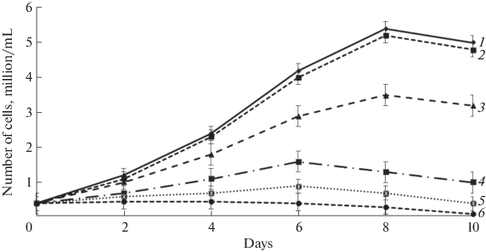
- control; (2) 0.002 mg/L Cd2+; (3) 0.005 mg/L Cd2+; (4) 0.02 mg/L Cd2+; (5) 0.05 mg/L Cd2+; (6) 0.2 mg/L Cd2+
Figure 16 - Influence of various concentrations of cadmium on growth dynamics of microalgae Ankistrodesmus sp. B-11:
At cadmium concentrations of ≥0.05 mg/L, the number of cells increased even slower or did not increase at all (Figure 16). It should be noted that, unlike the continuous increase in cell number over 8 days in the control culture, the number of cells in the culture grown at the initial cadmium concentration of 0.2 mg/L remained almost unchanged for the first 3 days, after which the bleaching of microalgal cell culture began. The gradual retardation of cell culture growth after 8 days of cultivation in the control experiments and in the treatments with cadmium concentrations of 0.002–0.005 mg/L was probably caused by the nutrient depletion and by the accumulation of metabolites inhibiting growth of microalgae [263].

3.5.3 Effect of Cadmium on Light Reactions of Photosynthesis in Microalgae
The maximum quantum yield of primary photochemical reactions FV/FM (φPo) in control Ankistrodesmus sp. B-11 cells was 0.6 (Table 11). In the presence of cadmium salt at concentrations of 0.05 and 0.2 mg/L, this value decreased already on the day following incubation. It should be noted that the absorption spectra of algal suspensions remained almost unchanged during short-term (24 h) incubation of algae with cadmium (data not shown), which indicates that cadmium ions had no influence on the pigment apparatus in this period.
Changes in photosynthetic activity of Ankistrodesmus sp. B-11 were characterized in detail by simultaneous measurements of the induction parameters of prompt and delayed fluorescence as well as the redox state of PSI electron carriers (mainly P700). Figure 17a shows the kinetic curves of fluorescence induction (OJIP) normalized to the FO level. In the control culture, the kinetics of fluorescence induction in response to high-intensity light comprised several stages known as O-J-I-P transients. The initial O-level corresponds to the intensity of chlorophyll fluorescence under “open” reaction centers of PSII (FO), when all QA acceptors are oxidized. The O-J phase reflects the light-induced reduction of QA, whereas the subsequent phases reflect mainly further accumulation of reduced QA due to the decelerated reoxidation of QA along with the reduction of QB acceptors and the plastoquinone pool (PQ).

Table 11 - Mean values of OJIP test parameters determined from the kinetics of fluorescence induction in the microalga Ank-istrodesmus sp. B-11 after 24-h incubation at various concentrations of cadmium

Parameters | Control | 0.05 mg/L | 0.2 mg/L
F_{V}/F_{M} | 0.6 ± 0.02 | 0.52 ± 0.03* | 0.46 ± 0.02*
F_{V}/F_{O} | 1.73 ± 0.05 | 1.44 ± 0.06* | 1.24 ± 0.04*
V _{J} | 0.65 ± 0.03 | 0.67 ± 0.02 | 0.73 ± 0.03*
V _{I} | 0.86 ± 0.03 | 0.86 ± 0.04 | 0.89 ± 0.04
φ_{Eo} | 0.21 ± 0.01 | 0.17 ± 0.02* | 0.12 ± 0.02*
PI_{ABS} | 0.24 ± 0.02 | 0.12 ± 0.02 * | 0.06 ± 0.03 *
ABS/RC | 3.2 ± 0.4 | 4.48 ± 0.03 * | 5.1 ± 0.2 *
DI₀/RC | 1.29 ± 0.04 | 2.14 ± 0.05 * | 2.75 ± 0.05*
q _{E} | 1.63 ± 0.04 | 1.86 ± 0.03 * | 1.89 ± 0.04*
* Asterisks mark significant differences between the treatment and the control culture at P < 0.05.
Characteristics of primary photosynthetic processes were quantified by means of the JIP test based on the parameters of the O-J-I-P kinetic curve of chlorophyll fluorescence (Table 11). In the presence of cadmium salt in the medium, the shape of the O-J-I-P curve was altered and the extent of the J-I-P photochemical phase was decreased, which indicated the disturbance of electron flux from PSII to the quinone pool [264]. The quantum yield of PSII-driven electron transport (φEo) in algal cells was diminished in the presence of cadmium ions. Hence, one of the main targets of cadmium impact was the acceptor side of PSII. An increase in the OJ phase corresponding to elevation in parameter Vj indicated the increased fraction of QB-nonreducing reaction centers in PSII. The JI phase (3–30 ms) corresponds to the reduction of the PQ pool, and the parameter VI is a suitable indicator of the PQ pool redox state in the dark [265]. The presence of cadmium ions had no influence on this parameter, indicating that the extent of oxidized plastoquinone molecules at the QB site in algae was unaffected by this heavy metal.

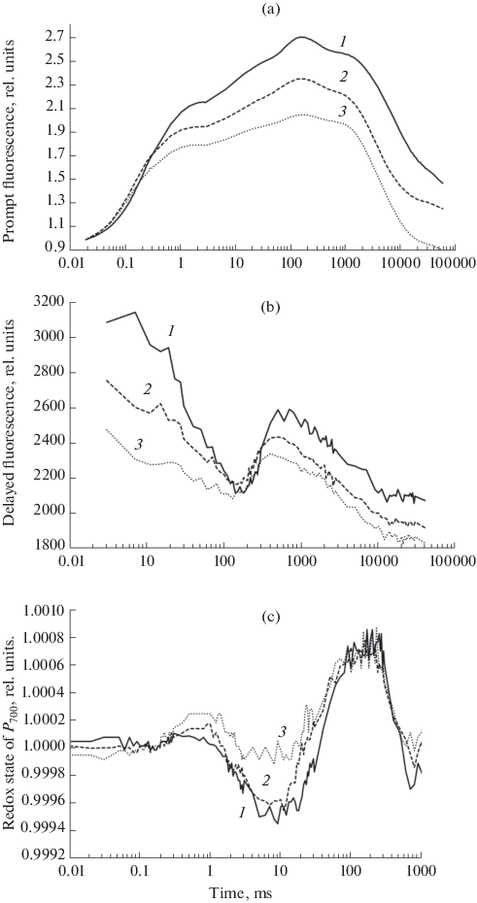
(a), delayed fluorescence (b), changes in reflection at a wavelength of 820 nm (c) in Ankistrodesmus sp. B-11 microalgae under the action of various concentrations of cadmium: (1) untreated culture, (2, 3) after 24-h incubation of cells in the presence of cadmium at concentrations of 0.05 and 0.2 mg/L, respectively. Prompt fluorescence was normalized to the FO level. The intensity of actinic red light was 1500 μE/(m2 s). Simultaneous measurements of all three signals were performed with an M-PEA-2 analyzer.

Figure 17 - Induction curves of prompt fluorescence
The parameter ABS/RC reflecting the size of light-harvesting antenna per reaction center in algal cells was higher in the presence of cadmium than in untreated samples; these changes resulted from the decreased proportion of active reaction centers due to disorders in protein D1 biosynthesis [266].
The performance index PIABS is a generalized indicator of PSII functional activity [267]. It was higher in the control cells than in the cadmium-treated cells. Low PIABS values for cadmium-treated algae indicated a low functional activity of PSII, mainly due to the decreased content of active reaction centers and the enhanced quenching of excitations in the antenna. The decline in efficiency of excitation energy transfer from the light-harvesting complex to the reaction center should be accompanied by the increased dissipation of unutilized light energy. Indeed, the dissipated energy per reaction center (DI0/RC) in cadmium-treated cells was at a high level. These changes correlated with an increase in ΔpH-dependent non-photochemical quenching qE, as calculated from the fluorescence decline after the peak (qE = (FM – F6s)/FV). The increase in non-photochemical quenching was also noted by the PAM fluorometry method [268].
The millisecond component of delayed fluorescence arises as a result of secondary recombination of charges in PSII reaction centers; its intensity depends on the magnitude of the proton electrochemical gradient across the thylakoid membrane that lowers the activation energy for the reverse reaction (recombination) [269]. Therefore, the delayed fluorescence parameters provide the means to monitor the proton gradient changes across the thylakoid membrane in whole cells. The experimentally observed peak of the delayed fluorescence in the millisecond time range coincided with the J-I rise on the induction curve of prompt fluorescence (Fig. 17b). This peak originates from the accumulation of radiative redox states responsible for the backward recombination of charges and the emission of delayed fluorescence (emitting states); it also reflects the enhancement of delayed fluorescence due to the electric potential ∆ψ formed at the thylakoid membrane. The peak of the delayed fluorescence in the time range of seconds is supposedly related to photo-induced formation of the transmembrane proton gradient ∆pH that also reduces the activation energy for radiative transitions (emission of delayed fluorescence) in PSII reaction centers [270]. In cells exposed to cadmium ions, the intensity of delayed fluorescence on the induction curve was significantly reduced at 10–50 ms and 1 s (Fig. 17), which was probably determined by the suppression of noncyclic electron transport and the consequent deenergization of thylakoid membranes.
Measurements of modulated reflection at 820 nm provide the means to monitor redox transitions of plastocyanin and, particularly, P700 in PSI reaction centers. Switching on the light caused the initial oxidation of P700 followed by its subsequent reduction (Fig. 17 c). The fluorescence signal reflecting QA reduction and the reduction of P700 attained the plateau levels almost synchronously. The parallel accumulation of reduced P700 and QA reflected the reduction of electron carriers in the entire intersystem segment of the electron-transport chain; this reduction resulted from the absence of electron efflux on the acceptor side of PSI under conditions when ferredoxin–NADP reductase (FNR) was inactivated by dark incubation. Under prolonged illumination (~1–10 s), a second wave of P700 oxidation was observed, which can be explained by the outflow of electrons from PSI upon the activation of FNR and Calvin cycle enzymes [271].
The algal cells treated with low cadmium concentrations retained the ability of P700 photo-oxidation (Fig. 17c). However, the rate of P700 reduction by electrons arriving from PSII was decelerated in these cells. This is consistent with the analysis of the induction curves of prompt fluorescence. High concentrations of cadmium were found to suppress P700 oxidation reactions in PSI.

3.5.4 Influence of Cadmium on the Ultrastructure of Microalgae
The ultrastructure of microalgal cells was studied using transmission electron microscopy after 4-day cultivation, when the cells were in the phase of active growth. The concentration of cadmium ions in the medium was 0.05 mg/L. Ankistrodesmus sp. B-11 cells grown under optimal conditions were collected at the phase of rapid growth and used as control samples.
Inspection of ultrathin sections of untreated Ankistrodesmus sp. B-11 cells revealed the organelles, structures, and inclusions characteristic of this species (Fig. 18 a). The cell wall was smooth, thin, and colorless; its structure was typical of green microalgae and comprised the outer cellulose–pectin layer adjacent to the plasmalemma. The cytoplasm was perforated by the unevenly distributed system of tubules. On cell micrographs, the nucleus region and a large electron-dense nucleolus were distinctly visible. The intracellular inclusions comprised starch grains. Each cell had one chloroplast adjoining the cell wall. The chloroplast occupied almost the entire cell periphery and had no pyrenoid. The thylakoids occupied the entire stroma and were aligned typically of Ankistrodesmus: from the periphery to the cell center. In the plane of the cross section, the thylakoid contours lay parallel to each other and were curved. The thylakoid membranes were tightly pressed against each other.
Electron microscopic examination of Ankistrodesmus sp. B-11 cells exposed for 96 h to 0.05 mg/L cadmium revealed ultrastructural changes in the photosynthetic apparatus (Fig 18 b). Specifically, the arrangement of thylakoids within the stroma was altered. We noted the increased distances between thylakoids, the disintegration of thylakoids, and swelling of the intrathylakoid spaces (Figs. 18 c, 18 d). In addition, electron-dense inclusions of an unidentified nature noted in some cells.
The increased activity of the Golgi apparatus in cadmium-treated cells should be noted: the number of excretory vacuoles was substantially higher in almost all the treated cells than in the control algae. In many cells, we noticed swelling of chloroplasts, the loss of tight connections between the membranes, vacuolization, and the enlargement of the interthylakoid spaces (Fig. 18 b). Furthermore, slight detachments of the cell wall from the protoplast were observed as well as the deformations of the original cell shape. These changes were apparently caused by the altered permeability of the cytoplasmic membrane (Fig. 18 b).
According to the published data, microalgae are very sensitive to the presence of metals in the medium [272]. The responses of algae to additions of lethal and sublethal concentrations of heavy metals may differ significantly. Different sensitivities of microalgae from various taxonomic groups are attributed to diverse mechanisms of heavy metal toxicity and to variations in metabolic features and morphology of algal cells. Our study revealed that the presence of cadmium in the nutrient medium at concentrations of ≥0.005 mg/L significantly decreased the number of Ankistrodesmus sp. B-11 cells with respect to the control values.
Current concepts of electron flow along the photosynthetic electron transport chain imply the sequential participation of two photosystems (PSII and PSI), at which the electron carriers reduced by PSII serve as electron donors for PSI. The interconnection of PSII and PSI is manifested in chlorophyll fluorescence whose level depends on the redox state of quinone acceptor Q_{A}. The photoreaction of PSII reduces Q_{A}, thus increasing the fluorescence level, whereas the PSI activity oxidizes Q_{A} and leads to the fluorescence decrease]. The kinetics of light induction of variable fluorescence in the millisecond time range reflects changes in electron transport within the PSII complex and between PSII and PSI [273].

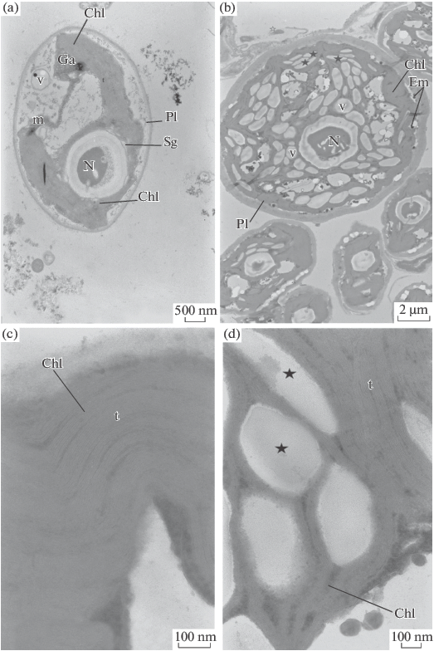
- ultrastructure of control cells, (b) changes in cell ultrastructure in the presence of 0.5 mg/L cadmium salt, (c) chloroplast of the control cell, (d) swollen chloroplasts with enlarged interthylakoid spaces. Designations: v—vacuole; Chl—chloroplast; t—thylakoids; Pl—plasmalemma; N—nucleolus; m—mitochondrion; Ga—Golgi apparatus; Sg—starch grain; Em—electron-dense material. Asterisks indicate the area with an expanded interthylakoid space. Scale: (a) ×10 000, (b) ×4000, (c) ×75 000, (d) ×50 000.

Figure 18 - Ultrastructure of Ankistrodesmus sp. B-11 cells
Evaluation of the PSII functional activity using conventional indicators, such as F_{V}/F_{M} (maximum quantum yield of PSII reaction) and PI_{ABS} (performance index), proved that cadmium inactivates PSII, which is consistent with the toxic effects of cadmium on PSII observed earlier with other photosynthetic materials.
Simultaneous recordings of the induction curves for prompt and delayed fluorescence, as well as kinetics of P700 redox state using an M-PEA-2 device, revealed the primary targets of cadmium impact on photosynthetic reactions in the alga Ankistrodesmus sp. B-11. Analysis of the induction curves showed that one of the primary targets of cadmium action is located on the acceptor side of PSII, between Q_{A} and Q_{B}. The decrease in the quantum yield of electron transport in PSII led to a drop in the performance index (PI_{ABS}). This parameter, compared to F_{V}/F_{M}, was found to be more sensitive to cadmium toxicity and can be recommended in biotesting the water quality of natural and artificial reservoirs. The decrease in the number of active reaction centers and changes in electron transport promoted the enhanced nonphotochemical losses, which was evident from the elevation in quantum efficiency of energy dissipation (DI₀/RC) and in ΔpH-dependent nonphotochemical quenching (q_{E}). Experiments with higher plants showed that cadmium salts can affect the oxygen-evolving complex of PSII [274]. In our work, the F_{V}/F_{O} parameter related to changes at the donor side of PSII was found to decrease at cadmium concentration of 0.05 mg/L; these observations corroborate the possibility that cadmium compounds also affect the donor side of PSII. The decrease in the F_{V}/F_{O} parameter under the action of cadmium was previously noted on the green microalga Scenedesmus obliquus [275].
Unlike the reactions of PSII, photo-oxidation of P₇₀₀ in the alga Ankistrodesmus sp. B-11 was less sensitive to cadmium. The inhibition of photosynthetic electron transport by heavy metals may possibly result from changes in ultrastructure of chloroplasts, the damage to thylakoids in particular.
The metals are known to have a strong influence on the ultrastructure of microalgae. The action of metals may lead to the formation of atypical cell shapes, nuclear inclusions, and changes in the composition of storage products. In addition, heavy metals cause disorders of chloroplasts' ultrastructure, which might be an important factor for the decrease in pigment content and the net rate of photosynthesis [276].
Our results suggest that cadmium induces ultrastructural changes that primarily occur in the photosynthetic apparatus. Specifically, the arrangement of thylakoids within the stroma was impaired, the interthylakoid distances enlarged, the thylakoids underwent disintegration, and the interthylakoid spaces were expanded. These complex alterations inhibited the photosynthetic activity. In addition, the extent of cellular vacuolization increased significantly due to structural changes of the cytoplasmic membrane. The cadmium-induced changes in cell structure observed in our study are consistent with the results of other authors [277]. For example, the cultivation of cyanobacteria in the presence of heavy metal salts was accompanied by changes in the ultrastructure of cyanobacterial cells. Some authors reported that heavy metal ions promoted cell wall thickening, plasmolysis (detachment of the cell wall from the protoplast), and destruction of thylakoid membranes. The nucleoplasm became enriched with polyphosphate granules that apparently play a key role in binding the metal ions and their detoxification. It was noted that the cytoplasm lost its characteristic granularity, and extensive light areas appeared on cell cross sections [278].
Similar changes in cell ultrastructure in the cyanobacterium A. flos-aquae were observed in the presence of 0.05 mM copper: the authors noted a significant expansion of interthylakoid spaces and the accumulation of polyphosphate granules [279]. The treatment of Synechocystis sp. PCC 6803 with cadmium and mercury impaired the cell ultrastructure, which was evident from the disturbed integrity of chloroplasts, disordering of thylakoids, and the increased number and size of polyphosphate granules [280]. In particular, the exposure to cadmium affected the structure of the chloroplast envelope and thylakoid membranes. The curving and stretching of these membranes might result from the altered proportions of saturated and unsaturated fatty acids in membrane phospholipids as well as from hydrolysis of lipids and the release of fatty acids [281]. In addition, the number of grana was reduced and their shape was distorted in the presence of heavy metals. The grana lost their regular shape and became composed of fewer thylakoids [282]. The treatment of green microalgae Chlamydomonas reinhardtii and Dunaliella salina with selenium and catamine was accompanied by intense formation of destructive vacuoles: the degradation of these algal cells was caused by the release of the vacuolar contents into the cytoplasm and nucleus [283]. Nishikawa et al. [284] observed similar ultrastructural changes in Chlamydomonas acidoph-ila cells exposed to cadmium, copper, and mercury. The authors noted that the largest ultrastructural changes in microalgal cells were caused by cadmium ions. They stated the abundance of excretory vacuoles, enlargement of starch granules, and the decreased dimensions of pyrenoids and mitochondria [285].
Similar changes in the murein layer were demonstrated in various strains incubated with a variety of heavy metals, e.g., upon the exposure of A. flos-aquae to Cd²⁺, after treating A. variabilis and Synechococcus with Zn²⁺, and after adding Ca²⁺ and Sr²⁺ to Bacillus stearothermophilus. The cell wall is known to represent the first barrier to heavy metals [286]. At the primary stage, the metals are adsorbed on the cell surface and then enter the cell by means of passive or active transport. When the metals reach the cell membrane and bind to various ligands and functional groups occurring at the plasma membrane, such as –COOH, –SH, –NH₂, and –P₃O₄, they perturb the plasma-membrane permeability, thus causing the release of intracellular Na⁺ and K⁺. Such a leakage of Na⁺ and K⁺ ions as an indicator of membrane permeability changes was observed in Nostoc muscorum cells after their exposure to Ni²⁺, Cr²⁺, Pb²⁺, and Ag²⁺ [287].
Generally, our experimental data demonstrate the effect of 0.05 mg/L cadmium on growth rates and the ultrastructure of Ankistrodesmus sp. B-11. The observed disorders in the structure of chloroplasts inactivate the oxygen-evolving centers of PSII and, consequently, decelerate electron transport. These changes suppress the photosynthetic activity of algae, which can be readily diagnosed by measuring the induction curves of chlorophyll fluorescence. The results of this work can be used for assessing the ecological status of aquatic ecosystems contaminated with heavy metal ions.

CONCLUSION

1. The diversity of microalgae in Lake Issyk, Lake Balkhsash, Lake Kolsai, Lake Alakol and Lake Bolshoye Almatinskoe, located in the Almaty region, was preliminarily studied using light microscopy and various microalgae descriptors and identified at the genus level. The result showed that representatives of the divisions Bacillariophytes, Cyanophytes, and Chlorophytes dominated almost all freshwater bodies, and their maximum diversity was observed in lakes Balkhash and Alakol.
2. Seven new isolates of microalgae were isolated from the lakes of the Almaty region. The morphology visualized by light microscopy (LM) and scanning electron microscopy (SEM) has led to the identification of seven strains of green microalgae, Monoraphidium griffithii, Nephrochlamys subsolitaria, Ankistrodesmus falcatus, Parachlorella kessleri, Desmodesmus pannonicus. Ankistrodesmus sp. B-11 (morphologically), which were later confirmed by PCR-based sequence analysis. Sequence analysis of the internal transcribed ribosomal DNA spacer part (18S, ITS1-5.8S-ITS2, 5.8S) and the ribulose bisphosphate carboxylase (rbcL) gene made it possible to identify seven microalgae up to the species level, Monoraphidlamium griffithii ZBD-01 (accession number MW258948), Nephrochlamys subsolitaria ZBD-02 (accession number MZ079019), Ankistrodesmus falcatus ZBD-03 (accession number MZ079017), Parachlorella kessleri ZBD-04 (accession no. MZ079022), Desmodesmus pannonicus ZBD-05 (accession no. MZ079014). Monoraphidium sp. (accession number MT178772).
3. It was found that of the isolated strains P. kessleri has the highest biomass production (1.42 ± 0.08, g / l), lipid productivity (29 ± 1.2 g / l) and the content of fatty acids C16 - C18 (90%), followed by A. falcatus and M. griffithi.
4. Gas chromatography / mass spectrometric analysis showed that the dominant fatty acids in P. kessleri, A. falcatus and M. griffithi. were palmitic acid (C16: 0), stearic acid (C18: 0) and oleic acid (C18: 1), with saturated fatty acids being at a higher concentration than unsaturated fatty acids. acid. Our results indicate that P. kessleri and A. falcatus are promising strains for biodiesel production due to their high lipid productivity and relatively high oleic acid content.
5. The results of studying the antibacterial activity of the biomass of the isolated strains showed a significant antibacterial activity of the methanol extract of Parachlorella kessleri against B. subtilis (highly active), S. aureus and K. pneumonia; Nephrochlamys subsolitaria against B. subtilis (highly active), P. aeruginosa and E. coli; Monorafidium sp. against K. pneumonia; Monoraphidium griffithii and Ankistrodesmus falcatus against K. pneumoniae and E. coli.
6. The potential of the isolated microalgae in the biomonitoring of the aquatic environment was assessed by studying the effect of low concentrations of heavy metals Cd, Zn and Cu on cell survival in Monoraphidium griffithii ZBD-01, Parachlorella kessleri ZBD-04, and Ankistrodesmus sp. B-11. The high sensitivity to the data of TM Ankistrodesmus sp. B-11.
7. The influence of cadmium ions on the growth, photosynthesis and ultrastructure of cells of the microalga Ankistrodesmus sp. B-11. The addition of cadmium to the nutrient medium at a concentration of 0.005–0.02 mg / l led to a significant decrease in the abundance of Ankistrodesmus sp. B-11. The addition of cadmium at a concentration of> 0.05 mg / L completely stopped cell growth.
8. It was found that cadmium ions caused ultrastructural changes in the location of thylakoids inside the stroma, detachment of thylakoid membranes with the formation of void intertilakoid spaces and a significant increase in vacuolization of microalgae cells. Simultaneous measurements of fluorescence induction curves and redox transformations of the components of photosystem I on a microsecond time scale using an M - PEA-2 fluorometer showed that cadmium ions inhibit electron transfer in photosystem II (PSII). It was found that the quantum yield of electron transport in PSII (φEo) and the efficiency index (PIABS) decrease; photoreduction of P700 pigment was slowed down, while energy dissipation (DI0 / RC) and ΔpH-dependent non-photochemical quenching (qE) were significantly increased by cadmium.

REFERENCES

- Perera F. Pollution from fossil-fuel combustion is the leading environmental threat to global pediatric health and equity: Solutions exist // International journal of environmental research and public health. ‒ 2018. ‒ V. 15, № 1. ‒ P. 16.
- Beringer T.I.M., Lucht W., Schaphoff S. Bioenergy production potential of global biomass plantations under environmental and agricultural constraints // Gcb Bioenergy. ‒ 2011. ‒ V. 3, № 4. ‒ P. 299‒312.
- Abadi A.T.B., Rizvanov A.A., Haertlé T., Blatt N.L. World Health Organization report: current crisis of antibiotic resistance // BioNanoScience. ‒ 2019. ‒ V. 9, № 4. ‒ P. 778‒788.
- Zaghloul A., Saber M., Gadow S., Awad F. Biological indicators for pollution detection in terrestrial and aquatic ecosystems // Bulletin of the National Research Centre. ‒ 2020. ‒ V. 44, № 1. ‒ P. 1‒11.
- Barra L., Chandrasekaran R., Corato F., Brunet C.. The challenge of ecophysiological biodiversity for biotechnological applications of marine microalgae // Marine drugs. ‒ 2014. ‒ V. 12, № 3. ‒ P. 1641‒1675.
- El Gamal A.A. Biological importance of marine algae // Saudi pharmaceutical journal. ‒ 2010. ‒ V. 18, № 1. ‒ P. 1‒25.
- Metting F.B. Biodiversity and application of microalgae // Journal of industrial microbiology. ‒ 1996. ‒ V. 17, № 5. ‒ P. 477‒489.
- Mostafa S.S. Microalgal biotechnology: prospects and applications // Plant science. ‒ 2012. ‒ V. 12. ‒ P. 276‒314.
- Sayre R. Microalgae: the potential for carbon capture // Bioscience. ‒ 2010. ‒ V. 60, № 9. ‒ P. 722‒727.
- Khan M. I., Shin, J. H., Kim J. D. The promising future of microalgae: current status, challenges, and optimization of a sustainable and renewable industry for biofuels, feed, and other products // Microbial cell factories. ‒ 2018. ‒ V. 17, № 1. ‒ P. 1‒21.
- Sathasivam R., Radhakrishnan R., Hashem A., Abd_Allah E.F. Microalgae metabolites: A rich source for food and medicine // Saudi journal of biological sciences. ‒ 2019. ‒ V. 26, № 4. ‒ P. 709‒722.
- Raja R., Hemaiswarya S., Kumar N. A., Sridhar S., Rengasamy, R. A perspective on the biotechnological potential of microalgae // Critical reviews in microbiology. ‒ 2008. ‒ V. 34, № 2. ‒ P. 77‒78.
- Liu J., Sun Z., Gerken H. Recent advances in microalgal biotechnology. Potential applications of microalgae in wastewater treatments. ‒OMICSGroup‒eBooks: USA, 2014.
- Markou G., Nerantzis E. Microalgae for high-value compounds and biofuels production: a review with focus on cultivation under stress conditions // Biotechnol. Adv. ‒ 2013. ‒ V. 31. ‒ P.1532‒1542.
- Priyadarshani I., Rath B. Commercial and industrial applications of micro algae–a review // Algal Biomass Utln. ‒ 2012. ‒ V. 3. ‒ P. 89‒100.
- Larkum A.W.D., Ross I.L., Kruse O., Hankamer B. Selection, breeding and engineering of microalgae for bioenergy and biofuel production // Trends Biotechnol. ‒ 2011. ‒ V. 30. ‒ P. 198‒205.
- Muñoz-Ochoa M., Murillo-Álvarez J.I., Zermeño-Cervantes L. A., Martínez-Díaz S., Rodríguez-Riosmena R. Screening of extracts of algae from Baja California sur, Mexico as reversers of the antibiotic resistance of some pathogenic bacteria // Eur. Rev. Med. Pharmacol. Sci. ‒ 2010. ‒ V. 14. ‒ P.739‒747.
- Pane G., Cacciola G., Giacco E., Mariottini G., Coppo E. Assessment of the antimicrobial activity of algae extracts on bacteria responsible of external otitis // Mar. Drugs. ‒ 2015. ‒ V. 13. ‒ P. 6440‒6452.
- Brennan L, Owende P. Biofuels from microalgae—a review of technologies for production, processing, and extractions of biofuels and co-products // Renew Sustain Energy Rev. ‒ 2010. ‒ V. 14, № 5. ‒ P. 57-77.
- Nürnberg D.J., Morton J., Santabarbara S., Telfer A., Joliot P., Antonaru L.A., Ruban A.V., Cardona T., Krausz E., Boussac A., Fantuzzi A. Photochemistry beyond the red limit in chlorophyll f–containing photosystems // Science. ‒ 2018. ‒ V. 360, № 6394. ‒ P. 1210‒1213.
- Lage S., Toffolo A., Gentili F.G. Microalgal growth, nitrogen uptake and storage, and dissolved oxygen production in a polyculture based-open pond fed with municipal wastewater in northern Sweden // Chemosphere. ‒ 2021. ‒ V. 276. ‒ P. 130122.
- Slegers P., Van Beveren P., Wiffels R., Van Straten G., Van Boxtel A. Scenario analysis of large scale algae production in tubular photobioreactors // Appl. Energy. ‒ 2013. ‒ V. 105. ‒ P. 395‒406.
- Almutairi A.W., El-Sayed A.E.K.B., Reda, M.M. Evaluation of high salinity adaptation for lipid bio-accumulation in the green microalga Chlorella vulgaris // Saudi Journal of Biological Sciences. ‒ 2021. ‒ V. 28, № 7. ‒ P. 3981‒3988.
- Suh I.S., Lee C.G. Photobioreactor engineering: design and performance // Biotechnology and Bioprocess Engineering. ‒ 2003. ‒ V. 8, № 6. ‒ P. 313–21.
- Duong, V.T., Li, Y., Nowak, E. and Schenk, P.M., 2012. Microalgae isolation and selection for prospective biodiesel production // Energies. ‒2012. ‒ V. 5, № 6. ‒ P. 1835‒1849.
- Richmond, A. Handbook of microalgal culture: biotechnology and applied phycology. ‒John Wiley–&Sons, 2008.
- González J.F., Cuello T.B., Calderón A.J., Calderón M., González, J., Carmona, D. 2021. Cultivation of Autochthonous Microalgae for Biomass Feedstock: Growth Curves and Biomass Characterization for Their Use in Biorefinery Products // Energies. ‒ 2021. ‒ V. 14, № 15. ‒ P. 4567.
- Yuarrina W.P., Pradana Y.S., Budiman A., Majid A.I., Suyono E.A. Study of cultivation and growth rate kinetic for mixed cultures of local microalgae as third generation (G-3) bioethanol feedstock in thin layer photobioreactor // In Journal of Physics: Conference Series. IOP Publishing. ‒ 2018. ‒ V. 1022, № 1. ‒ P. 012051.
- Brennan L., Owende P. Biofuels from microalgae—a review of technologies for production, processing, and extractions of biofuels and co-products // Renewable and sustainable energy reviews. ‒ 2010. ‒ V. 14, № 2. ‒ P. 557–577.
- Brown LM. Uptake of carbon dioxide from flue gas by microalgae // Energy Conversion and Management. ‒ 1996. ‒ V. 37, № 6–8. ‒ P. 1363–7.
- Emma Huertas I., Colman B., Espie G.S., Lubian L.M. Active transport of CO2 by three species of marine microalgae // Journal of Phycology. ‒ 2000. ‒ V. 36, № 2. ‒ P. 314–20.
- Welsh D.T., Bartoli M., Nizzoli D., Castaldelli G., Riou S.A., Viaroli P. Denitrification, nitrogen fixation, community primary productivity and inorganic-N and oxygen fluxes in an intertidal Zostera noltii meadow // Marine Ecology Progress Series. ‒ 2000. ‒ V. 208. ‒ P. 65–77.
- Moreno J., Vargas M.A´., Rodrı´guez H., Rivas J., Guerrero M.G. Outdoor cultivation of a nitrogen-fixing marine cyanobacterium, Anabaena sp. ATCC 33047 // Biomolecular Engineering. ‒ 2003. ‒ V. 20, № 4–6. ‒ P. 191–7.
- Hsieh C.H., Wu W.T. Cultivation of microalgae for oil production with a cultivation strategy of urea limitation // Bioresource Technology. ‒ 2009. ‒ V. 100, № 17. ‒ P. 3921–6.
- Celekli A., Yavuzatmaca M., Bozkurt H. Modeling of biomass production by Spirulina platensis as function of phosphate concentrations and pH regimes // Bioresource Technology. ‒ 2009. ‒ V. 100, № 14. ‒ P. 3625–9.
- Chisti Y. Biodiesel from microalgae. Biotechnology Advances. ‒ 2007. ‒ V. 25, № 3. ‒ P. 294– 306.
- Cheng K.C. and Ogden K.L. Algal biofuels: the research // American Institute of Chemical Engineers (AICHE). Cheng K.C., Ogden, K.L. Algal biofuels: The research // Chemical Engineering Progress. ‒ 2011. ‒ V. 107, № 3. ‒ P. 42– 47.
- Not F., Gausling R., Azam F., Heidelberg J.F., Worden A.Z. Vertical distribution of picoeukaryotic diversity in the open ocean // Environ Microbiol. ‒ 2007. ‒ V. 9. ‒ P. 1233–1252.
- Ebenezer V., Medlin L.K., Ki J.S. Molecular detection, quantification, and diversity evaluation of microalgae // Marine biotechnology. ‒ 2012. ‒ V. 14, № 2. ‒ P. 129-142.
- Metting F.B. Biodiversity and application of microalgae // Journal of industrial microbiology. ‒ 1996. ‒ V. 17, № 5. ‒ P. 477‒489.
- López-Rodas V., Marvá, F., Costas E., Flores-Moya A. Microalgal adaptation to a stressful environment (acidic, metal-rich mine waters) could be due to selection of pre-selective mutants originating in non-extreme environments // Environmental and Experimental Botany. ‒ 2008. ‒ V. 64, № 1. ‒ P. 43‒48.
- Tandeau de Marsac N., Houmard J. Adaptation of cyanobacteria to environmental stimuli: new steps towards molecular mechanisms // FEMS microbiology reviews. ‒ 1993. ‒ V. 10, № 1-2. ‒ P. 119‒189.
- Boukhris S., Athmouni K., Hamza-Mnif I., Siala-Elleuch R., Ayadi H., Nasri M., Sellami-Kamoun A. The potential of a brown microalga cultivated in high salt medium for the production of high-value compounds // BioMed research international. ‒ 2017. ‒ P. 1-10.
- Rothschild L.J., Mancinelli R.L. Life in extreme environments // Nature. ‒ 2001. ‒ V. 409, № 6823. ‒ P. 1092–1101.
- Guiry M. D. How many species of algae are there? // J. Phycol. ‒ 2012. ‒ V. 48. ‒ P. 1057-1063.
- Smetacek V.S. Role of sinking in diatom life-history cycles: ecological, evolutionary and geological significance // Marine Biology. ‒ 1985. ‒ V. 84, № 3. ‒ P. 239–251.
- Rodrigues S.V., Marinho M.M., Jonck C.C.C., Gonçalves E.S., Brant V.F., Paranhos, R., Curbelo M.P. and Falcão A.P. Phytoplankton community structures in shelf and oceanic waters off southeast Brazil (20–25 S), as determined by pigment signatures // Deep Sea Research Part I: Oceanographic Research Papers. ‒ 2014. ‒ V. 88. ‒ P. 47–62.
- Litchman E., Klausmeier C.A., Schofield O.M., Falkowski P.G. The role of functional traits and trade-offs in structuring phytoplankton communities: scaling from cellular to ecosystem level // Ecology Letters. ‒ 2007. ‒ V. 10, № 12. ‒ P. 1170–1181.
- Kwon H.K., Oh S.J., Yang H.S. Growth and uptake kinetics of nitrate and phosphate by benthic microalgae for phytoremediation of eutrophic coastal sediments // Bioresource Technology. ‒ 2013. ‒ V. 129. ‒ P. 387–395.
- Hopes A., Mock, T. Evolution of microalgae and their adaptations in different marine ecosystems // eLS. ‒ 2015. ‒ P.1-9.
- Riegman R., Stolte W., Noordeloos A.A., and Slezak D. (2000) Nutrient uptake and alkaline phosphatase (EC 3: 1: 3: 1) activity of Emiliania huxleyi (Prymnesiophyceae) during growth under N and P limitation in continuous cultures // Journal of Phycology. ‒ 2000. ‒ V. 36, № 1. ‒ P. 87–96.
- Mock T., Thomas DN. Microalgae in polar regions: linking functional genomics and physiology with environmental conditions // In: Psychrophiles: From Biodiversity to Biotechnology, Berlin Heidelberg: Springer. ‒ 2008. ‒ P. 285–312.
- Kauko H.M., Olsen L.M., Duarte P., Peeken I., Granskog M.A., Johnsen G., Fernández-Méndez M., Pavlov A.K., Mundy C.J., Assmy P. Algal colonization of young Arctic sea ice in spring // Frontiers in Marine Science. ‒ 2018. ‒ V. 5. ‒ P. 199.
- Varshney P., Mikulic P., Vonshak A., Beardall J., Wangikar P. P. Extremophilic micro-algae and their potential contribution in biotechnology. Bioresource technology. ‒ 2015. ‒ V. 184. ‒ P. 363‒372
- Miller S.R., Castenholz R.W., Pedersen D. Phylogeography of the thermophilic cyanobacterium Mastigocladus laminosus // Applied and Environmental Microbiology. ‒ 2007. ‒ V. 73, № 15. ‒ P. 4751–4759.
- Copeland, J.J. Yellowstone thermal myxophyceae // Annals of the New York Academy of Sciences. ‒ 1936. ‒ V. 36, № 1. ‒ P. 4–223.
- Saini N., Pal K., Deepak B., Mona S. Thermophilic algae: A new prospect towards environmental sustainability // Journal of Cleaner Production. ‒ 2021. ‒V. 324. ‒ P. 129277.
- Zheng Y., Xue C., Chen H., He C., Wang Q. Low-temperature adaptation of the snow alga Chlamydomonas nivalis is associated with the photosynthetic system regulatory process // Frontiers in Microbiology. ‒ 2020. ‒ V. 11. ‒ P. 1233.
- Lauritano C., Rizzo C., Lo Giudice A., Saggiomo M. Physiological and Molecular Responses to Main Environmental Stressors of Microalgae and Bacteria in Polar Marine Environments // Microorganisms. ‒ 2020. ‒ V. 8, № 12. ‒ P. 1957.
- Laloknam S., Tanaka, K., Buaboocha T., Waditee R., Incharoensakdi A., Hibino T., Tanaka Y., Takabe T. Halotolerant cyanobacterium Aphanothece halophytica contains a betaine transporter active at alkaline pH and high salinity // Applied and Environmental Microbiology. ‒ 2006. ‒ V. 72, № 9. ‒ P. 6018‒6026.
- Oren A. The ecology of Dunaliella in high-salt environments // Journal of Biological Research-Thessaloniki. ‒ 2014. ‒ V. 21, № 1. ‒ P. 1-8.
- Borowitzka L.J., Borowitzka M.A. Commercial production of β-carotene by Dunaliella salina in open ponds // Bulletin of marine science. ‒ 1990. ‒ V. 47, № 1. ‒ P. 244-252.
- Singh S.P., Kumari S., Rastogi R.P., Sinha R., Sinha R.P. Photoprotective and biotechnological potentials of cyanobacterial sheath pigment, scytonemin // African Journal of Biotechnology, ‒ 2010. ‒ V. 9, № 5. ‒P. 581‒588
- Pulz O., Gross W. Valuable products from biotechnology of microalgae // Applied microbiology and biotechnology. – 2004. – V. 65, № 6. – P. 635–648.
- Ruggiero M.A., Gordon D.P., Orrell T.M., Bailly N., Bourgoin T., Brusca R.C., Cavalier-Smith T., Guiry M.D., Kirk P.M. A higher-level classification of all living organisms // PloS one. – 2015. – V. 10, № 6. – P. 1–54.
- Omar W.M. Perspectives on the use of algae as biological indicators for monitoring and protecting aquatic environments, with special reference to malaysian freshwater ecosystems // Tropical life sciences research. – 2010. – V. 21, № 2. – P. 51–67.
- Cid A., Prado R., Rioboo C., Suarez-Bregua P., Herrero C. Use of Microalgae as biological indicators of pollution: Looking for new relevant cytotoxicity endpoints. In: Johnsen, M. N. (ed.) Microalgae: Biotechnology, Microbiology and Energy. –New–York: Nova Science Publishers, 2012. – P. 311–323.
- Hooper D.U., Chapin F.S., Ewel J.J., Hector A., Inchausti P., Lavorel S., Lawton J.H., Lodge D.M., Loreau M., Naeem S., Schmid B., Setälä H., Symstad A.J., Vandermeer J., Wardle D.A. Effects of Biodiversity on Ecosystem Functioning: A Consensus of Current Knowledge // Ecological Monographs. – 2005. – V.75, № 1. – P. 3–35.
- Groendahl S., Kahlert M., Fink P. The best of both worlds: A combined approach for analyzing microalgal diversity via metabarcoding and morphology-based methods // PLoS One. – 2017. – V. 12, № 2. – P. e0172808.
- Fuentes-Grünewald C., Garcés E., Alacid E., Sampedro N., Rossi S., and Camp J. Improvement of lipid production in the marine strains Alexandrium minutum and Heterosigma akashiwo by utilizing abiotic parameters // Journal of industrial microbiology & biotechnology. – 2012. – V. 39, № 1. – P. 207–216.
- Raja R., Hemaiswarya S., Kumar N.A., Sridhar S., Rengasamy R. A perspective on the biotechnological potential of microalgae // Critical reviews in microbiology. – 2008. – V. 34, № 2. – P. 77–88.
- Tilman D., Knops J., Wedin D., Reich P., Ritchie M., Siemann E. The influence of functional diversity and composition on ecosystem processes // Science, – 1997. – V. 277, № 5330. – P. 1300–1302.
- Johnson P.L., Slatkin M. Inference of population genetic parameters in metagenomics: a clean look at messy data // Genome research. – 2006. – V. 16, № 10. – P. 1320–1327.
- Mayfield M.M., Bonser S.P., Morgan J.W., Aubin I., McNamara S., Vesk P.A. What does species richness tell us about functional trait diversity? Predictions and evidence for responses of species and functional trait diversity to land-use change // Global Ecology and Biogeography. – 2010. – V. 19, № 4. – P. 423–431.
- Cadoret J. P., Garnier M., Saint-Jean B. Microalgae, functional genomics and biotechnology // In Advances in Botanical Research, Academic Press. – 2012. – V. 64. – P. 285–341.
- Kennedy J., O’leary N.D., Kiran G.S., Morrissey J.P., O’Gara F., Selvin J., and Dobson A.D.W. Functional metagenomics strategies for the discovery of novel enzymes and biosurfactants with biotechnological applications from marine ecosystems // Journal of applied microbiology. – 2011. – V. 111, № 4. – P. 787–799.
- Mutanda T., Ramesh D., Karthikeyan S., Kumari S., Anandraj A., and Bux F. Bioprospecting for hyper-lipid producing microalgal strains for sustainable biofuel production // Bioresource technology. – 2011. – V. 102, № 1. – P. 57–70.
- Merchant S.S., Kropat J., Liu B., Shaw J., and Warakanont J. TAG, you’re it! Chlamydomonas as a reference organism for understanding algal triacylglycerol accumulation // Current opinion in biotechnology. – 2012. – V. 23, № 3. – P. 352–363.
- Raja R, Hemaiswarya S, Kumar NA, Sridhar S, Rengasamy R. A perspective on the biotechnological potential of microalgae // Crit Rev Microbiol. – 2008. – V. 34. – P. 77–88.
- Brennan L, Owende P. Biofuels from microalgae—a review of technologies for production, processing, and extractions of biofuels and co-products // Renew Sustain Energy Rev. – 2010. – V. 14. – P. 557–77.
- Markou G., Nerantzis E. Microalgae for high-value compounds and biofuels production: a review with focus on cultivation under stress conditions // Biotechnol. Adv. – 2013. – V. 31. – P. 1532–1542.
- Larkum A. W. D., Ross I. L., Kruse O., Hankamer B. Selection, breeding and engineering of microalgae for bioenergy and biofuel production. Trends Biotechnol. – 2011. – V. 30. –P. 198–205.
- Muñoz-Ochoa M., Murillo-Álvarez J.I., Zermeño-Cervantes L.A., Martínez-Díaz S., Rodríguez-Riosmena R. Screening of extracts of algae from Baja California Sur, Mexico as reversers of the antibiotic resistance of some pathogenic bacteria // Eur. Rev. Med. Pharmacol. Sci. – 2010. – V. 14, № 9. – P. 739–747.
- Pane G., Cacciola G., Giacco E., Mariottini G.L., Coppo E. Assessment of the antimicrobial activity of algae extracts on bacteria responsible of external otitis // Marine drugs. – 2015. – V. 13, № 10. – P. 6440–6452.
- Guiry M. D. How many species of algae are there? // J. Phycol. ‒ 2012. ‒ V. 48. ‒ P. 1057-1063.
- Pradhan, J., Das, S. and Das, B.K., 2014. Antibacterial activity of freshwater microalgae: A review // African Journal of Pharmacy and Pharmacology. – 2014. – V. 8, № 32. – P. 809-818.
- Sydney E.B., Schafranski K., Barretti B.R.V., Sydney A.C.N., Zimmerman J.F.D.A., Cerri M.L. and Demiate I.M. Biomolecules from extremophile microalgae: From genetics to bioprocessing of a new candidate for large-scale production // Process Biochemistry. – 2019. – V. 87. – P. 37-44.
- Heidari F., Shariatmadari Z., Riahi H. Screening of Extremophile Microalgae Isolated from High Background Radiation Areas as Source of Bioactive Materials // Current Bioactive Compounds. – 2020. – V. 16, № 4. – P. 407-414.
- Sun X.M., Ren L.J., Zhao Q.Y., Ji X.J., Huang H. Microalgae for the production of lipid and carotenoids: a review with focus on stress regulation and adaptation // Biotechnology for biofuels. – 2018. – V. 11, № 1. – P. 1-16.
- Chisti Y. Biodiesel from microalgae // Biotechnology advances. ‒ 2007. ‒ V. 25, № 3. ‒ P. 294-306.
- Merl, S., Gabarrell Durany X., Pedroso Tonon A., Rossi S. Marine Microalgae Contribution to Sustainable Development // Water. ‒ 2021. ‒ V. 13. ‒ P. 1373.
- Khan S., Siddique, R., Sajjad W., Nabi, G., Hayat K.M., Duan P. and Yao L. Biodiesel production from algae to overcome the energy crisis // HAYATI Journal of Biosciences. ‒ 2017. ‒ V. 24, № 4. 163-167.
- Tan X.B., Lam M.K., Uemura Y., Lim J.W., Wong C.Y., Lee K.T. Cultivation of microalgae for biodiesel production: a review on upstream and downstream processing // Chinese Journal of Chemical Engineering. ‒ 2018. ‒ V. 26, № 1. ‒ P. 17-30.
- Bošnjaković M., Sinaga N. The perspective of large-scale production of algae biodiesel // Applied Sciences. ‒ 2020. ‒ V. 10, № 22. ‒ P. 8181.
- Mata T.M., Martins A.A., Caetano N.S. Microalgae for biodiesel production and other applications: A review // Renew. Sustain. Energy Rev. ‒ 2010. ‒ V. 14. ‒ P. 217–232.
- Hindersin, S. Photosynthetic efficiency of microalgae and optimization of biomass product in photobioreactors (Doctoral dissertation, Staats-und Universitätsbibliothek Hamburg Carl von Ossietzky, 2013). ‒ V. 30. ‒ P. 555‒573.
- Masojídek J., Ranglová K., Lakatos G.E., Silva Benavides A.M., Torzillo, G. Variables Governing Photosynthesis and Growth in Microalgae Mass Cultures // Processes. ‒ 2021. ‒ V. 9, № 5. ‒ P. 820.
- Al-Jabri H., Das P., Khan S., Thaher M., AbdulQuadir M. Treatment of Wastewaters by Microalgae and the Potential Applications of the Produced Biomass—A Review // Water. ‒ 2021. ‒ V. 13, № 1. ‒ P. 27.
- Sarker P.K., Kapuscinski A.R., McKuin B., Fitzgerald D.S., Nash H.M., Greenwood C. Microalgae-blend tilapia feed eliminates fishmeal and fish oil, improves growth, and is cost viable // Scientific reports. ‒ 2020. ‒ V. 10, № 1. ‒ P. 1-14.
- González-Delgado A.D., García-Martínez J.B., Barajas-Solano A.F. Evaluation of Algae-Based Biodiesel Production Topologies via Inherent Safety Index (ISI) // Applied Sciences. ‒ 2021. ‒ V. 11, № 6. ‒ P. 2854.
- Anwar H., Hussain G., Mustafa I. Antioxidants from natural sources // Antioxidants in foods and its applications. ‒ 2018. ‒ P. 1‒27.
- Sansone C., Brunet C. Promises and challenges of microalgal antioxidant production // Antioxidants. ‒ 2019. ‒ V. 8, № 7. ‒ P. 199.
- Thomas M.C., Flores F., Kaserzon S., Fisher R., Negri A.P. Toxicity of ten herbicides to the tropical marine microalgae Rhodomonas salina // Scientific reports. ‒ 2020. ‒ V. 10, № 1. ‒ P. 1‒16.
- Barrero-Sicilia C., Silvestre S., Haslam R.P., Michaelson L.V. Lipid remodelling: Unravelling the response to cold stress in Arabidopsis and its extremophile relative Eutrema salsugineum // Plant Science. ‒ 2017. ‒ V. 263. ‒ P. 194‒200.
- Nokhsorov V.V., Dudareva L.V., Senik S.V., Chirikova N.K., Petrov K.A. Influence of Extremely Low Temperatures of the Pole of Cold on the Lipid and Fatty-Acid Composition of Aerial Parts of the Horsetail Family (Equisetaceae) // Plants. ‒ 2021. ‒ V. 10, № 5. ‒ P. 996.
- Aratboni H.A., Rafiei N., Garcia-Granados R., Alemzadeh A., Morones-Ramírez J.R. Biomass and lipid induction strategies in microalgae for biofuel production and other applications // Microbial Cell Factories. ‒ 2019. ‒ V. 18, № 1. ‒ P. 1‒17.
- Cho S.J., Lee D.H., Luong T.T., Park S.R., Oh Y.K., Lee T.H. Effects of carbon and nitrogen sources on fatty acid contents and composition in the green microalga, Chlorella sp. 227 // Journal of microbiology and biotechnology. ‒ 2011. ‒ V. 21, № 10. ‒ P. 1073‒1080.
- Kaur N., Chugh V., Gupta A.K. Essential fatty acids as functional components of foods-a review // Journal of food science and technology. ‒ 2014. ‒ V. 51, № 10. ‒ P. 2289-2303.
- De Carvalho C.C., Caramujo M.J. The various roles of fatty acids // Molecules. ‒ 2018. ‒ V. 23, № 10. ‒ P. 2583.
- Calder P.C. Omega-3 fatty acids and inflammatory processes // Nutrients. ‒ 2010. ‒ V. 2, № 3. ‒ P. 355‒374.
- Mostafa S.S. Microalgal biotechnology: prospects and applications // Plant science. ‒ 2012. ‒ V. 12. ‒ P. 276‒314.
- Teoh M.L., Chu W.L., Marchant H., Phang S.M. Influence of culture temperature on the growth, biochemical composition and fatty acid profiles of six Antarctic microalgae // Journal of Applied Phycology. ‒ 2004. ‒ V. 16, № 6. ‒ P. 421‒430.
- Betancor M.B., Sprague M., Usher S., Sayanova O., Campbell P.J., Napier J.A., Tocher D.R. A nutritionally-enhanced oil from transgenic Camelina sativa effectively replaces fish oil as a source of eicosapentaenoic acid for fish // Scientific reports. ‒ 2015. ‒ V. 5, № 1. ‒ P. 1‒10.
- Stevenson J. Ecological assessments with algae: a review and synthesis // Journal of Phycology. ‒ 2014. ‒ V. 50, № 3. ‒ P. 437‒461.
- Kyewalyanga M. Phytoplankton primary production // In The regional state of the coast report: Western Indian Ocean. Nairobi: UNEP-Nairobi Convention (pp.). ‒ 2016. ‒ P. 213‒230.
- Piccardi R., Materassi R., Tredici M. Algae and human affairs in the 21st century // (Abstr Int Conf Appl Algol) Universita degli Studi di Firenze, Firenze, 1999.
- Powell C. A., Michels H. T. Copper nickel alloys for seawater corrosion resistance and antifouling a state of the art review. NACE International Corrosion. ‒Houston‒TX, 2000. – V. 90.
- Pulz O., Scheibenbogen K. Photobioreactors: Design and performance with respect to light energy input // Adv. Biochem. Eng. Biotechnol. ‒ 1998. ‒ V. 59. ‒ P. 123‒151.
- Pulz O., Gross W. Valuable products from biotechnology of microalagae // Appl. Microbiol. Biotechnol. ‒ 2004. ‒ V. 65. ‒ P. 635‒648.
- Radmer R. J. Algal diversity and commercial algal products // Biosci. ‒ 1996. ‒ V. 46. ‒ P. 263‒270.
- Raja R., Hemaiswarya S., Balasubramanyam D. Rengasamy R. Protective effect of Dunaliella salina (Volvocales, Chlorophyta) against experimentally induced fibrosarcoma on wistar rats // Microbiol. Res. ‒ 2007. ‒ V. 162. ‒ P. 177‒184.
- Raja R., Hemaiswarya S., Rengasamy R. Exploitation of Dunaliella for β carotene production // Appl. Microbiol. Biotechnol. ‒ 2007. ‒ V. 74. ‒ P. 517‒523.
- de Morais M.G., Vaz B.D.S., de Morais E.G., Costa, J.A.V. Biologically active metabolites synthesized by microalgae // BioMed research international. ‒ 2015. ‒ V. 2015, ‒P. 835761.
- Harun R., Singh M., Forde G.M., Danquah M.K. Bioprocess engineering of microalgae to produce a variety of consumer products // Renewable and sustainable energy reviews. ‒ 2010. ‒ V. 14, № 3. ‒ P. 1037‒1047.
- Bule M.H., Ahmed I., Maqbool F., Bilal M., Iqbal H.M. Microalgae as a source of high-value bioactive compounds // Front. Biosci. ‒ 2018. ‒ V. 10 ‒ P. 197‒216.
- Barbalace M.C., Malaguti M., Giusti L., Lucacchini A., Hrelia S., Angeloni, C. Anti-inflammatory activities of marine algae in neurodegenerative diseases // International journal of molecular sciences. ‒ 2019. ‒ V. 20, № 12. ‒ P. 3061.
- Mendiola J.A., Torres C.F., Toré A., Martín-Álvarez P.J., Santoyo S., Arredondo B.O., Señoráns F.J., Cifuentes A., Ibáñez E. Use of supercritical CO 2 to obtain extracts with antimicrobial activity from Chaetoceros muelleri microalga. A correlation with their lipidic content // European Food Research and Technology. ‒ 2007. ‒ V. 22, № 4. ‒ P. 505‒510.
- Alsenani F., Tupally, K.R., Chua E.T., Eltanahy E., Alsufyani H., Parekh H.S., Schenk P.M. Evaluation of microalgae and cyanobacteria as potential sources of antimicrobial compounds // Saudi Pharmaceutical Journal. ‒ 2020. ‒ V. 28, № 12. ‒ P. 1834‒1841.
- Herrero M., Ibáñez E., Cifuentes A., Reglero G., Santoyo S. Dunaliella salina microalga pressurized liquid extracts as potential antimicrobials // Journal of food protection. ‒ 2006. ‒ V. 69, № 10. ‒ P. 2471‒2477.
- Barros de Medeiros V.P., da Costa W.K.A., da Silva R.T., Pimentel T.C., Magnani M. Microalgae as source of functional ingredients in new-generation foods: challenges, technological effects, biological activity, and regulatory issues // Critical Reviews in Food Science and Nutrition. ‒ 2021. ‒ P. 1‒22.
- Buono S., Langellotti A.L., Martello A., Rinna F., Fogliano V. Functional ingredients from microalgae // Food & function. ‒ 2014. ‒ V. 5, № 8. ‒ P. 1669-1685.
- Balouch, H., Demirbag, Z., Zayadan, B.K., Sadvakasaova, A.K., Bolatkhan, K., Gencer, D. and Civelek, D. Isolation, identification, and antimicrobial activity of psychrophilic freshwater microalgae Monoraphidium sp. from Almaty region // International Journal of Biology and Chemistry. ‒ 2020. ‒ V. 13, № 1. ‒ P. 14‒23.
- Salem O. M. A., Hoballah E. M., Ghazi S. M., Hanna S. N. Antimicrobial activity of microalgal extracts with special emphasize on Nostoc sp. // Life Sci. J. ‒ 2014. ‒ V.11. ‒ P. 752‒758.
- Najdenski H.M. Gigova L. G., Iliev I.I., Pilarski P. S., Lukavský J., Tsvetkova I.V., Kussovski V.K. Antibacterial and antifungal activities of selected microalgae and cyanobacteria // J. Food Sci. Technol. ‒ 2013. ‒ V.48. ‒ P. 1533‒1540.
- Munita J.M., Arias C.A. Mechanisms of antibiotic resistance // Microbiology spectrum. ‒ 2016. ‒ V. 4, № 2. ‒ P.4‒2.
- Pratt R., Daniels T.C., Eiler J.J., Gunnison J.B., Kumler W.D. Chlorellin, an antibacterial substance from Chlorella // Science. ‒ 1944. ‒ V. 99, № 2574. ‒ P. 351‒352.
- Raygada J.L., Levine D.P. Methicillin-resistant Staphylococcus aureus: a growing risk in the hospital and in the community // American health & drug benefits. ‒ 2009. ‒ V. 2, № 2. ‒ P. 86.
- Breijyeh Z., Jubeh B., Karaman R. Resistance of Gram-negative bacteria to current antibacterial agents and approaches to resolve it // Molecules. ‒ 2020. ‒ V. 25, № 6. ‒ P. 1340.
- Imada N., Kobayashi K., Isomura K., Saito H., Kimura S, Tahara K., Oshima Y. Isolation and identification of an autoinhibitor produced by Skeletonema costatum // Nippon Suisan Gakkaishi. ‒ 1992. ‒ V. 58. ‒ P. 1687‒1692.
- Mendiola J.A., Torres C.F., Toré A., Martín-Álvarez P.J., Santoyo S., Arredondo B.O., Señoráns F.J., Cifuentes A., Ibáñez E. Use of supercritical CO2 to obtain extracts with antimicrobial activity from Chaetoceros muelleri microalga. A correlation with their lipidic content // European Food Research and Technology. ‒ 2007. ‒ V. 224, № 4. ‒ P. 505‒510.
- Benkendorff K., Davis A.R., Rogers C.N., Bremner J.B. Free fatty acids and sterols in the benthic spawn of aquatic molluscs, and their associated antimicrobial properties // Journal of Experimental Marine Biology and Ecology. ‒ 2005. ‒ V. 316, № 1. ‒ P. 29‒22.
- Smith V.J., Desbois A.P., Dyrynda E.A. Conventional and unconventional antimicrobials from fish, marine invertebrates and micro-algae // Marine Drugs. ‒ 2010. ‒ V. 8. ‒ P. 1213‒1262.
- Joana Gil‐Chávez G., Villa J.A., Fernando Ayala‐Zavala J., Basilio Heredia J., Sepulveda D., Yahia E.M., González‐Aguilar G.A. Technologies for extraction and production of bioactive compounds to be used as nutraceuticals and food ingredients: an overview // Comprehensive Reviews in Food Science and Food Safety. ‒ 2013. ‒ V. 12, № 1. ‒ P. 5‒23.
- Pina-Pérez M.C., Rivas A., Martínez A., Rodrigo D. Antimicrobial potential of macro and microalgae against pathogenic and spoilage microorganisms in food // Food chemistry. ‒ 2017. ‒ V. 235. ‒ P. 34‒44.
- Marrez D.A., Sultan Y.Y., Naguib M.M., Higazy A.M. Antimicrobial Activity, Cytotoxicity and Chemical Constituents of the Freshwater Microalga Oscillatoria princeps // Biointerface Research in Applied Chemistry. ‒ 2021. ‒ V. 12, № 1. ‒ P. 961‒977.
- Grosso C., Valentão P., Ferreres F., Andrade P.B. Alternative and efficient extraction methods for marine-derived compounds // Marine Drugs. ‒ 2015. ‒ V. 13, № 5. ‒ P. 3182-3230.
- Pasquet V., Chérouvrier J.R., Farhat F., Thiéry V., Piot J.M., Bérard J.B., Kaas R., Serive B., Patrice T., Cadoret J.P., Picot L. Study on the microalgal pigments extraction process: Performance of microwave assisted extraction // Process Biochemistry. ‒ 2011. ‒ V. 46, № 1. ‒ P. 59‒67.
- Canelli G., Martínez P.M., Hauser B.M., Kuster I., Rohfritsch Z., Dionisi F., Bolten C.J., Neutsch L., Mathys A. Tailored enzymatic treatment of Chlorella vulgaris cell wall leads to effective disruption while preserving oxidative stability // LWT. ‒ 2021. ‒ V. 143. ‒ P. 111157.
- Michalak I., Dmytryk A., Wieczorek P.P., Rój E., Łęska B., Górka B., Messyasz B., Lipok J., Mikulewicz M., Wilk R., Schroeder G. Supercritical algal extracts: a source of biologically active compounds from nature // Journal of Chemistry. ‒ 2015.
- Carreira-Casais A., Otero P., Garcia-Perez P., Garcia-Oliveira P., Pereira A.G., Carpena M., Soria-Lopez A., Simal-Gandara J., Prieto M.A. Benefits and drawbacks of ultrasound-assisted extraction for the recovery of bioactive compounds from marine algae // International Journal of Environmental Research and Public Health. ‒ 2021. ‒ V. 18, № 17. ‒ P. 9153.
- Carullo D., Abera B.D., Casazza A.A., Donsì F., Perego P., Ferrari G., Pataro G. Effect of pulsed electric fields and high pressure homogenization on the aqueous extraction of intracellular compounds from the microalgae Chlorella vulgaris // Algal Res. ‒ 2018. ‒ V. 31. ‒ P. 60–69.
- Martí-Quijal F.J., Ramon-Mascarell F., Pallarés N., Ferrer E., Berrada H., Phimolsiripol Y., Barba F.J. Extraction of Antioxidant Compounds and Pigments from Spirulina (Arthrospira platensis) Assisted by Pulsed Electric Fields and the Binary Mixture of Organic Solvents and Water // Applied Sciences. ‒ 2021. ‒ V. 11, № 6. ‒ P. 7629.
- Mäki‐Arvela P., Hachemi I., Murzin D.Y. Comparative study of the extraction methods for recovery of carotenoids from algae: extraction kinetics and effect of different extraction parameters // Journal of Chemical Technology & Biotechnology. ‒ 2014. ‒ V. 89, № 11. ‒ P. 1607‒1626.
- Sweeney B.W., Battle J.M, Jackson J.K., and Dapkey T. Can DNA barcodes of stream macroinvertebrates improve descriptions of community structure and water quality? // J. North Am. Benthol. Soc. – 2011. – V 30. – P. 195–216.
- Baird D.J., Hajibabaei M. Biomonitoring 2.0: a new paradigm in ecosystem assessment made possible by next-generation DNA sequencing // Molecular Ecology, – 2012. – V. 21. – P. 2039–2044.
- Fierer N., Leff J.W., Adams B.J., Nielsen U.N., Bates S.T., Lauber C.L., Owens S., Gilbert J.A, Wall D.H., Caporaso J.G. Cross-biome metagenomic analyses of soil microbial communities and their functional attributes // Proc Natl Acad Sci USA. – 2012. – V. 109. – No. 52. – P. 21390–5.
- Sogin M.L., Morrison H.G., Huber J.A., Welch D.M., Huse S.M., Arrieta J.M. , and Herndl G.J. Microbial diversity in the deep sea and the under-explored “rare biosphere” // Proceedings of the National Academy of Sciences of the United States of America. – 2006. – V. 103. – P. 12115–12120.
- Chariton A. A., Court L.N., Hartley D.M., Colloff M.J., Hardy C.M. Ecological assessment of estuarine sediments by pyrosequencing eukaryotic ribosomal DNA // Frontiers in Ecology and the Environment. – 2010. – V. 8. – P. 233–238.
- Creer S., Fonseca V.G., Pozarinska D.L., Giblin-Davis R.M., Sung W., Powers D.M., Packer M., Carvalho G.R., Blaxter M.L., Lambshead P.J.D., Thomas W.K. Ultra-sequencing of the meiofaunal biosphere: practice, pitfalls and promises // Molecular Ecology. –2010. – V. 19, № 1. – P. 4–20.
- Zinger L., Amaral-Zettler L.A., Fuhrman J.A., Horner-Devine M.C., Huse S.M., Welch D.B.M., Martiny J.B.H., Sogin M., Boetius A., Ramette A. Global patterns of bacterial beta-diversity in seafloor and seawater ecosystems // PLoS One. –2011. – V. 6. – P. 24570.
- Stern R.F., Horak A., Andrew R.L., Coffroth M.A., Andersen R.A., Küpper F.C., Jameson I., Hoppenrath M., Véron B., Kasai F., Brand J. Environmental barcoding reveals massive dinoflagellate diversity in marine environments // PLoS One. –2010. – V. 5, № 11. – P. 13991.
- Piganeau G., Eyre-Walker A., Grimsley N., Moreau H. How and why DNA barcodes underestimate the diversity of microbial eukaryotes // PLoS One. – 2011. – V. 6, № 2. P. 16342.
- Vaulot D., Lepere C., Toulza E., De la Iglesia R., Poulain J., Gaboyer F., Moreau H., Vandepoele K., Ulloa O., Gavory F., Piganeau G. Metagenomes of the picoalga Bathycoccus from the Chile coastal upwelling // PLoS One, –2012. – V. 7, № 6. – P. 39648.
- Moon-van der Staay S.Y., R. De Wachter, and D. Vaulot. Oceanic 18S rDNA sequences from picoplankton reveal unsuspected eukaryotic diversity // Nature. –2001. – V. 409, №. 6820. – P 607.Luo C., Tsementzi D., Kyrpides N.C., Konstantinidis K.T. Individual genome assembly from complex community short-read metagenomic datasets // The ISME journal. – 2012. – V. 6, № 4. – P. 898.
- Tragin M., Lopes dos Santos A., Christen R., Vaulot D. Diversity and ecology of green microalgae in marine systems: an overview based on 18S rRNA gene sequences. // Perspect. Phycol. – 2016. – V. 3. – P. 141–154.
- Desai C., and Madamwar D. Extraction of inhibitor-free metagenomic DNA from polluted sediments, compatible with molecular diversity analysis using adsorption and ion-exchange treatments. Bioresource technology. – 2007. – V. 98, № 4. – P. 761–768.
- Reigstad L.J., Bartossek R., and Schleper C. Preparation of high-molecular weight DNA and metagenomic libraries from soils and hot springs // In Methods in enzymology. Academic Press. – 2011. – V. 496. – P. 319‒344.
- Buchheim M.A., Keller A., Koetschan C., Förster F., Merget B., Wolf M. Internal transcribed spacer 2 (nu ITS2 rRNA) sequence-structure phylogenetics: towards an automated reconstruction of the green algal tree of life // PloS one. –2011. – V. 6, № 2. – P. 16931.
- Sharpton T. J. An introduction to the analysis of shotgun metagenomic data // Front, Plant Sci. – 2014. – V. 5. – P. 209.
- Von Mering C., Hugenholtz P., Raes J., Tringe S.G., Doerks T., Jensen L.J., Ward N., Bork P. Quantitative phylogenetic assessment of microbial communities in diverse environments // Science. – 2007. – V. 315, № 5815. – P. 1126–1130
- Delmont T. O., Malandain C., Prestat E., Larose C., Monier J.M., Simonet P., and Vogel T.M. Metagenomic mining for microbiologists // The ISME Journal. – 2011. – V. 5, № 12. – P. 1837.
- Gupta S., Chikara S.K. Metagenomics Analysis of Eukaryotic Community in Soil using 18S and 28S rRNA Gene High Throughput Sequencing // International Journal of Genetics. – 2015. ISSN: 0975-2862 & E-ISSN: 0975-9158. – V. 7, № 1. – P. 161–164.
- Searle D., Sible E., Cooper A., and Putonti C. 18S rDNA dataset profiling microeukaryotic populations within Chicago area nearshore waters // Data in brief. – 2016. – V. 6. – P. 526‒529.
- Hino A., Maruyama H., and Kikuchi T. A novel method to assess the biodiversity of parasites using 18S rDNA Illumina sequencing; parasitome analysis method // Parasitology international. – 2016. – V. 65, №. 5. – P. 572–575.
- Suenaga, H. Targeted metagenomics: a high-resolution metagenomics approach for specific gene clusters in complex microbial communities // Environmental Microbiology. – 2012. – V. 14, № 1. – P. 13–22.
- Lin G.M., Lai Y.H., Audira G., Hsiao C.D. A Simple Method to Decode the Complete 18-5.8-28S rRNA Repeated Units of Green Algae by Genome Skimming // International journal of molecular sciences. – 2017. – V. 18, № 11. – P. 2341.
- De Clerck O., Guiry M.D., Leliaert F., Samyn Y., Verbruggen H. Algal taxonomy: a road to nowhere? // Journal of Phycology. – 2013. – V. 49, № 2. – P. 215–225.
- Medlin L.K., Metfies K., John U., Olsen J.L. Algal molecular systematics: a review of the past and prospects for the future // Unravelling the algae: the past, present, and future of algal systematics. – 2007. –V. 75. – P. 341.
- Hall J.D., K. Fucikova, C. Lo, L.A. Lewis, K.G. Karol. An assessment of proposed DNA barcodes in freshwater green algae // Cryptogamie, Algologie. – 2010. – V. 31, № 4. – P. 529–555.
- Moniz M.B., I. Kaczmarska. 2009. Barcoding diatoms: is there a good marker? // Molecular Ecology Resources, – V. 9. – P. 65–74.
- Stern R.F., Andersen R.A., Jameson I., Küpper F.C., Coffroth M.A., Vaulot D., Le Gall F., Véron B., Brand J.J., Skelton H., Kasai F., Lilly E.L., Keeling P.J. Evaluating the ribosomal internal transcribed spacer (ITS) as a candidate dinoflagellate barcode marker // PLoS One. –2012. – V. 7, №. 8. – P. 42780.
- Zou S., Fei C., Wang C., Gao Z., Bao Y., He M., Wang C. How DNA barcoding can be more effective in microalgae identification: a case of cryptic diversity revelation in Scenedesmus (Chlorophyceae). Scientific reports. – 2016. – V. 6. – P. 36822.
- Famà P., Wysor B., Kooistra W.H., Zuccarello G.C. – 2002. Molecular phylogeny of the genus Caulerpa (Caulerpales, Chlorophyta) inferred from chloroplast tufA gene1 // Journal of phycology. – V. 38, № 5. – P 1040–1050.
- O’Kelly C.J., Wysor B., Bellows W.K. Gene sequence diversity and the phylogenetic position of algae assigned to the genera Phaeophila and Ochlochaete (Ulvophyceae, Chlorophyta) // Journal of Phycology. – 2004. – V. 40, №. 4. – P. 789–799.
- Wynne M.J., Verbruggen H., Angel D.L. The recognition of Caulerpa integerrima (Zanardini) comb. et stat. nov.(Bryopsidales, Chlorophyta) from the Red Sea // Phycologia. – 2009. – V. 48, №. 4. – P. 291–301.
- Raes, J., Letunic I., Yamada T., Jensen L.J., and Bork P. Toward molecular trait-based ecology through integration of biogeochemical, geographical and metagenomic data // Molecular systems biology. – 2011. – V. 7, № 1. – P. 473.
- Matsuzaki, M.O., Misumi T., Shin-I, Maruyama S., Takahara M., Miyagishima S.Y., Mori T., Nishida K., Yagisawa F., Nishida K., Yoshida Y.. Genome sequence of the ultrasmall unicellular red alga Cyanidioschyzon merolae 10D // Nature. – 2004. – V. 428. – P. 653–657.
- Radakovits R., Jinkerson R.E., Fuerstenberg S.I., Tae H., Settlage R.E., Boore J.L., and Posewitz M.C. Draft genome sequence and genetic transformation of the oleaginous alga Nannochloropsis gaditana // Nature communications. – 2012. – V. 3. – P. 686.
- Alonso E., Rubiolo J.A. Therapeutics of marine toxins. In: Botana L.M., Alfonso A., editors. Phycotoxins: Chemistry and Biochemistry. John Wiley & Sons Ltd. ‒New‒York, USA, 2015. – P. 181–195.
- Gan S.Y., Lim P.E., Phang S.M. Genetic and metabolic engineering of microalga // In Algae Biotechnology, Springer, Cham. – 2016. – P. 317–344.
- Pagani, I.., K. Liolios, J. Jansson, I.M.A. Chen, T. Smirnova, B. Nosrat, V.M. Markowitz, N.C. Kyrpides. The Genomes OnLine Database (GOLD) v. 4: status of genomic and metagenomic projects and their associated metadata // Nucleic acids research. – 2011. – V. 40, № 1. – P. 571–579.
- Grossman A.R. Paths toward algal genomics // Plant physiology. – 2005. – V. 137, № 2. – P. 410–27.
- Radakovits, R., R.E. Jinkerson, A. Darzins, M.C. Posewitz. Genetic engineering of algae for enhanced biofuel production // Eukaryotic cell. – 2010. – V. 9, № 4. – P 486–501.
- Tirichine L., Bowler C. Decoding algal genomes: tracing back the history of photosynthetic life on Earth // The Plant Journal. – 2011. – V. 66. № 1. – P. 45– 57.
- Hallmann A. Algae biotechnology–green cell-factories on the rise // Current Biotechnology. – 2015. – V. 4, № 4. – P. 389–415.
- Toulza E., Blanc-Mathieu R., Gourbière S., Piganeau G. Environmental and evolutionary genomics of microbial algae: power and challenges of metagenomics // In Advances in Botanical Research. Academic Press. – 2012. – V. 64. – P. 383– 427.
- Demirbağ Z., Zayadan K. B., Balouch H., Sadvakasova A. K., Bolatkhan K., Karabekova A. N., Kozhan D. A Review on Metagenomic Approaches to Assess Microalgal Diversity: Options & Challenges // Eurasian Journal of Ecology. ‒ 2019. ‒ V. 59, № 2. ‒ P. 4‒22
- Zhang X., Acencio M.L., Lemke N. Predicting essential genes and proteins based on machine learning and network topological features: a comprehensive review // Front. Physiol. – 2016. – V.7. – P. 75.
- Breitwieser F.P., Lu J., Salzberg S.L. A review of methods and databases for metagenomic classification and assembly. Briefings in bioinformatics. – 2017. – P. 1–15.
- Andersen, R. A. Algal culturing techniques. –Amsterdam–The Netherlands: Elsevier, 2005.
- Bischoff H. W., Bold H. C. Phycological studies IV. Some soil algae from enchanted rock and related algal species. –Austin–TX: University of Texas.,1963.
- Gonçalves A.L., Pires J.C., Simões M. Biotechnological potential of Synechocystis salina co-cultures with selected microalgae and cyanobacteria: Nutrients removal, biomass and lipid production // Bioresour. Technol. – 2016. – V. 200. – P. 279–286.
- Alam M.M., Mumtaz A.S., Russell M., Grogger M., Veverka D., Hallenbeck P.C. Isolation and Characterization of Microalgae from Diverse Pakistani Habitats: Exploring Third-Generation Biofuel Potential // Energies. – 2019. – V. 12. – P. 2660.
- White T.J., Bruns T., Lee S.J.W.T., Taylor J. Amplification and direct sequencing of fungal ribosomal RNA genes for phylogenetics // PCR protocols: a guide to methods and applications. – 1990. – V. 18, № 1. – P. 315–322.
- Saunders G.W., Kucera H. An evaluation of rbcL, tufA, UPA, LSU and ITS as DNA barcode markers for the marine green macroalgae // Cryptogamie Algologie. – 2010. – V. 31, № 4. – P. 487.
- Ranjith Kumar R., Hanumantha Rao P., Arumugam, M. Lipid extraction methods from microalgae: a comprehensive review // Frontiers in Energy Research. ‒ 2015. ‒ V. 2. ‒ P. 61.
- Montes D’Oca M.G., Viêgas C.V., Lemões J.S., Miyasaki E.K., MorónVillarreyes J.A., Primel E.G., Abreu P.C. Production of FAMEs from several microalgal lipidic extracts and direct transesterification of the Chlorella pyrenoidosa // Biomass Bioenergy. – 2011. – V. 35. –P. 1533–1538.
- Musharraf S.G., Ahmed M.A., Zehra N., Kabir N., Choudhary M.I., Rahman A.U. Biodiesel production from microalgal isolates of southern Pakistan and quantification of FAMEs by GC-MS/MS analysis // Chemistry Central Journal. – 2012. – V. 6, № 1. – P. 1–10.
- Ramos M.J., Fernandez C.M., Casas A., Rodriguez L., Perez A. Influence of fatty acid composition of raw materials on biodiesel properties // Bioresour Technol. ‒ 2009. ‒ V. 100. ‒ P. 261–268.
- Pane G., Cacciola G., Giacco E., Mariottini G.L., Coppo E. Assessment of the antimicrobial activity of algae extracts on bacteria responsible of external otitis // Marine drugs. ‒ 2015. ‒ V. 13, № 10. ‒ P. 6440–6452.
- Senhorinho G.N., Laamanen C.A., Scott J.A. Bioprospecting freshwater microalgae for antibacterial activity from water bodies associated with abandoned mine sites // Phycologia. ‒ 2018. ‒ V. 57, № 4. ‒ P. 432–439.
- Wu N., Dong X., Liu Y., Wang C., Baattrup-Pedersen A., Riis T. Using river microalgae as indicators for freshwater biomonitoring: Review of published research and future directions // Ecological Indicators. ‒ 2017. ‒ V. 81. ‒ P. 124–131.
- Yong W.K., Tan Y.H., Poong S.W., Lim, P.E. Response of microalgae in a changing climate and environment // Malaysian Journal of Science, 35(2), pp.169-191. ‒ 2016. ‒ V. 35, № 2. ‒ P. 169–191.
- Míguez L., Esperanza M., Seoane M., Cid Á. Assessment of cytotoxicity biomarkers on the microalga Chlamydomonas reinhardtii exposed to emerging and priority pollutants // Ecotoxicology and Environmental Safety. ‒ 2021. ‒ V. 208. ‒ P. 111646.
- Varshney P., Mikulic P., Vonshak A., Beardall J., Wangikar P.P. Extremophilic micro-algae and their potential contribution in biotechnology // Bioresource technology. ‒ 2015. ‒ V.184. ‒ P. 363–372.
- Suganya T., Varman M., Masjuki H. H., Renganathan S. Macroalgae and microalgae as a potential source for commercial applications along with biofuels production: A biorefinery approach // Renew. Sustain. Energy Rev. ‒ 2016. ‒ V. 55. ‒ P. 909–941.
- Ronga D., Biazzi E., Parati K., Carminati D., Carminati E., Tava A. Microalgal Biostimulants and Biofertilisers in Core required budgetpProductions // Agronomy. ‒ 2019. ‒ V. 9. ‒ P. 192.
- Balouch H., Bauenova M. O., Sadvakasova A. K., Sarsekeeva F. K., Kirbaeva D. K., Bolatkhan K., Mustapaeva J. O. Comparative characteristics of the species the diversity of the algal flora of the lakes of the Almaty region // Eurasian Journal of Ecology. ‒ 2020. ‒ V. 2, №. 63. ‒ P. 72–82.
- Costa A. J., De Morais M. G. An Open Pond System for Microalgal Cultivation. In Biofuels from Algae. –Oxford, UK: Elsevier., 2014. ‒ V. 9. ‒ P. 1–22.
- Cinar S. O., Chong Z. K., Kucuker M. A., Wieczorek N., Cengiz U., Kuchta K. Bioplastic production from microalgae: A review // Int. J. Environ. Res. Public Health 2020. ‒ 2020. ‒ V. 17. ‒ P. 3842.
- Fang J., Zhan L., Ok Y. S., Gao B. Mini review of potential applications of hydrochar derived from hydrothermal carbonization of biomass // J. Ind. Eng. Chem. ‒ 2018. ‒ V. 57. ‒ P. 15‒21.
- Li Y., Song S., Xia L., Yin H., García Meza J. V., Ju W. Enhanced Pb(II) removal by algal-based biosorbent cultivated in high-phosphorus cultures // Chem. Eng. J. ‒ 2019. ‒ V. 361. ‒ P. 167‒179.
- Zhu B., Chen G., Cao X., Wei D. Molecular characterization of CO2 sequestration and assimilation in microalgae and its biotechnological applications. Bioresour. Technol. ‒ 2017. ‒ V. 244. ‒ P. 1207‒1215.
- Bellinger E.G., Sigee D.C. Freshwater algae: identification, enumeration and use as bioindicators. John Wiley & Sons. ‒ 2015.
- Hindák, F. A contribution to the systematics of the family Ankistrodesmaceae (Chlorophyceae) // Algological Studies/Archiv für Hydrobiologie, Supplement Volumes. ‒ 1970. ‒ V. 1. ‒ P. 7‒32.
- Nygaard, G. New or interesting plankton algae with a contribution on their ecology // Kongl. Danske Vidensk. Selskab, Biol. Skr. ‒ 1977. ‒ V. 21, № 1. ‒ P. 1‒107.
- Ramos G.J.P., Bicudo C.E.D.M., Góes Neto A., Moura C.W.D.N. Monoraphidium e Ankistrodesmus (Chlorophyceae, Chlorophyta) do Pantanal dos Marimbus, Chapada Diamantina, BA, Brasil // Hoehnea. ‒ 2012. ‒ V. 39, № 3. ‒ P. 421‒434.
- Vanormelingen P., Hegewald E., Braband A., Kitschke, M., Friedl, T., Sabbe, K. and Vyverman, W. The systematics of a small spineless Desmodesmus species, D-costato-granulatus (Sphaeropleales, Chlorophyceae), based on ITS2 rDNA sequence analyses and cell morphology. Journal of phycology. ‒ 2007. ‒ V. 43, № 2. ‒ P. 378‒396.
- El-Sheekh M., Abu-Faddan M., Abo-Shady A., Nassar M.Z., Labib W. Molecular identification, biomass, and biochemical composition of the marine chlorophyte Chlorella sp. MF1 isolated from Suez Bay // Journal of Genetic Engineering and Biotechnology. ‒ 2020. ‒ V. 18, № 1. ‒ P. 1‒0.
- Ramos G.J., Bicudo C.E., Góes Neto A., Moura C.W. Monoraphidium e Ankistrodesmus (Chlorophyceae, Chlorophyta) do Pantanal dos Marimbus, Chapada Diamantina, BA, Brasil //Hoehnea. ‒ 2012. ‒ V. 39, № 3. ‒ P. 421‒34.
- Krienitz L., Bock C., Nozaki H., Wolf M. SSU rRNA gene phylogeny of morphospecies affiliated to the bioassay alga “selenastrum capricornutum” recoevered the polyphyletic origin of crescent-shapoed chlorophyta 1 // Journal of Phycology. ‒ 2011. ‒ V. 47, № 4. ‒ P. 880‒93.
- Biolo S., Algarte V.M., Rodrigues L. Taxonomy of common taxa of Chlorophyceae (Chlorophyta) and Zygnematophyceae (Streptophyta) from periphyton of a Neotropical floodplain // Acta Scientiarum. Biological Sciences. ‒ 2020. ‒ V. 42. ‒ P. 1-0.
- Saslis-Lagoudakis C.H., Savolainen V., Williamson E.M., Forest F., Wagstaff S.J., Baral S.R., Watson M.F., Pendry C.A., Hawkins J.A. Phylogenies reveal predictive power of traditional medicine in bioprospecting // Proceedings of the National Academy of Sciences. ‒ 2012. ‒ V. 109, № 39. ‒ P. 15835‒40.
- Bakker F.T., Olsen J.L., Stam W.T., van den Hoek C. Nuclear ribosomal DNA internal transcribed spacer regions (ITS1 and ITS2) define discrete biogeograohic groups in Cladophora Albida (Chlorophyta) 1 // Journal of Phycology. ‒ 1992. ‒ V. 28, № 6. ‒ P. 839‒45.
- Stern R.F., Andersen R.A., Jameson I., Küpper F.C., Coffroth M.A., Vaulot D., Le Gall F., Véron B., Brand J.J., Skelton H., Kasai F. Evaluating The Ribosomal Internal Transcribed Spacer (ITS) as a Candidate Dinoflagellate Barcode Marker. PLoS one. ‒ 2012. ‒ V. 7, № 8. ‒ P. 42780.
- Saitou N., Nei, M. The neighbor-joining method: a new method for reconstructing phylogenetic trees // Molecular biology and evolution. ‒ 1987. ‒ V. 4, № 4. ‒ P. 406‒425.
- Kimura M. A simple method for estimating evolutionary rate of base substitutions through comparative studies of nucleotide sequences // Journal of Molecular Evolution. ‒ 1980. ‒ V. 16, № 4. ‒ P. 111‒120.
- Felsenstein, J. Confidence limits on phylogenies: an approach using the bootstrap // evolution. ‒ 1985. ‒ V. 39, № 4. ‒ P. 783‒791.
- Hentschke G.S., Prado J.F. Chlorococcales sl (Chlorophyceae) e Zygnematales (Zygnematophyceae) em um açude do Balneário do Lérmen, Rio Grande do Sul, Brasil. Iheringia // Série Botânica. ‒ 2012. ‒ V. 67, № 1. ‒ P. 59‒74.
- Krienitz L., Bock C., Dadheech P.K., Pröschold, T. Taxonomic reassessment of the genus Mychonastes (Chlorophyceae, Chlorophyta) including the description of eight new species // Phycologia. ‒ 2011. ‒ V. 50, № 1. ‒ P. 89‒106.
- Musa M., Ayoko G.A., Ward A., Rösch C., Brown R.J., Rainey T.J. Factors affecting microalgae production for biofuels and the potentials of chemometric methods in assessing and optimizing productivity // Cells. ‒ 2019. ‒ V. 8, № 7. ‒ P. 851.
- Sharma K.K., Schuhmann H., Schenk P.M. High lipid induction in microalgae for biodiesel production // Energies. ‒ 2012. ‒ V. 5. ‒ P. 1532–1553.
- Katsuda T., Lababpour A., Shimahara K., Katoh S. Astaxanthin production by Haematococcus pluvialis under illumination with LEDs // Enzyme Microb. Technol. ‒ 2004. ‒ V. 35. ‒ P. 81‒86.
- Mohsenpour S.F., Richards B., Willoughby N. Spectral conversion of light for enhanced microalgae growth rates and photosynthetic pigment production // Bioresource technology. ‒ 2012. ‒ V. 125. ‒ P. 75‒81.
- Blinová L., Bartošová A., Gerulová K. Cultivation of microalgae (Chlorella vulgaris) for biodiesel production // Faculty of Materials Science and Technology in Irnava Slovak University of Technology in Bratislava. ‒ 2015. ‒ V. 23. ‒ P. 36.
- Rendón S.M., Roldan G.J.C., Voroney R.P. Effect of carbon dioxide concentration on the growth response of Chlorella vulgaris under four different LED illumination // International Journal of Biotechnology for Wellness Industries. ‒ 2013. ‒ V. 2, № 3. ‒ P. 125‒131.
- Mostafa S.S., El-Gendy N.S. Evaluation of fuel properties for microalgae Spirulina platensis bio-diesel and its blends with Egyptian petro-diesel // Arabian journal of chemistry. ‒ 2017. ‒ V. 10, № 3. ‒ P. 2040‒2050.
- Galasso C., Gentile A., Orefice I., Ianora A., Bruno A., Noonan D.M., Sansone C., Albini A., Brunet C. Microalgal derivatives as potential nutraceutical and food supplements for human health: A focus on cancer prevention and interception // Nutrients. ‒ 2019. ‒ V. 11, № 6. ‒ P. 1226.
- Desbois A.P., Smith V.J. Antibacterial free fatty acids: activities, mechanisms of action and biotechnological potential // Applied microbiology and biotechnology. ‒ 2010. ‒ V. 85, № 6. ‒ P. 1629‒42.
- Alsenani F., Tupally K.R., Chua E.T., Eltanahy E., Alsufyani H., Parekh H.S., Schenk P.M. Evaluation of microalgae and cyanobacteria as potential sources of antimicrobial compounds // Saudi Pharmaceutical Journal. ‒ 2020. ‒ V. 28, № 12. ‒ P. 1834‒41.
- Wang Y., Chen T., Qin S. Differential fatty acid profiles of Chlorella kessleri grown with organic materials // Journal of Chemical Technology & Biotechnology. ‒ 2013. ‒ V. 88, № 4. ‒ P. 651‒7.
- Maltsev Y., Maltseva I., Maltseva S., Kociolek J.P., Kulikovskiy M. A new species of freshwater algae Nephrochlamys yushanlensis sp. nov. (Selenastraceae, Sphaeropleales) and its lipid accumulation during nitrogen and phosphorus starvation // Journal of Phycology. ‒ 2021. ‒ V. 57, № 2. ‒ P. 606‒18.
- Sajjadi B., Chen W.Y., Raman A.A., Ibrahim S. Microalgae lipid and biomass for biofuel production: A comprehensive review on lipid enhancement strategies and their effects on fatty acid composition // Renewable and Sustainable Energy Reviews. ‒ 2018. ‒ V. 97. ‒ P. 200‒32.
- Santhakumaran P., Kookal S.K., Ray J.G. Biomass yield and biochemical profile of fourteen species of fast-growing green algae from eutrophic bloomed freshwaters of Kerala, South India // Biomass and bioenergy. ‒ 2018. ‒ V. 119. ‒ P. 155‒65.
- Tamboli D.P., Lee D.S. Mechanistic antimicrobial approach of extracellularly synthesized silver nanoparticles against gram positive and gram negative bacteria // Journal of hazardous materials. ‒ 2013. ‒ V. 260. ‒ P. 878‒84.
- Adamczak A., Ożarowski M., Karpiński T.M. Antibacterial activity of some flavonoids and organic acids widely distributed in plants // Journal of clinical medicine. ‒ 2020. ‒ V. 9, № 1. ‒ P. 109.
- Holanda M.L., Melo V.M., Silva L.M., Amorim R.C., Pereira M.G., Benevides N.M. Differential activity of a lectin from Solieria filiformis against human pathogenic bacteria // Brazilian Journal of Medical and Biological Research. ‒ 2005. ‒ V. 38, №. 12. ‒ P. 1769‒73.
- Martínez-Francés E., Escudero-Oñate C. Cyanobacteria and microalgae in the production of valuable bioactive compounds. Microalgal Biotechnol. ‒ 2018. ‒ V. 6. ‒ P. 104-128.
- Costerton J.W., Cheng K.J. The role of the bacterial cell envelope in antibiotic resistance. Journal of Antimicrobial Chemotherapy. ‒ 1975. ‒ V. 1. №. 4. ‒ P. 3636‒377.
- Teixeira B., Marques A., Ramos C., Neng N.R., Nogueira J.M.F., Saraiva J.A., Nunes M.L. Chemical composition and antibacterial and antioxidant properties of commercial essential oils. Ind. Crops Prod. ‒ 2013. ‒ V. 43. ‒ P. 587‒595.
- Morgan-Kiss R.M., Priscu J.C., Pocock T., Gudynaite-Savitch L., Huner N.P. Adaptation and acclimation of photosynthetic microorganisms to permanently cold environments // Microbiology and molecular biology reviews. ‒ 2006. ‒ V. 70, №. 1. ‒ P. 222‒252.
- Cid-Aguero P., Cuello J.L., Ruiz S., Sanchez, G. Growth and lipid profiles of the Antarctic snow microalga Chlamydomonas sp. in response to changes in temperature, photoperiod, salinity and substrate // In Anales del Instituto de la Patagonia. ‒ 2017. ‒ V. 45, №. 3. ‒ P. 45‒48.
- Joshi M.K. Mohanty, P., Chlorophyll a fluores- cence as a probe of heavy metal ion toxicity in plants, in Chlorophyll a Fluorescence // Advances in Photosynthesis and Respiration, Papageorgiou G.C. and Govindjee, Eds., Dordrecht: Springer. ‒ 2004. ‒ V. 19. ‒ P. 637.
- Faller, P., Kienzler, K., and Krieger-Liszkay, A., Mechanism of Cd2+ toxicity: Cd2+ inhibits photoactiva- tion of photosystem II by competitive binding to the es- sential Ca2+ site // Biochim. Biophys. Acta. ‒2005. ‒ V. 1706. ‒ P. 158.
- Xue Z., Gao, H., Zhao S., Effects of cadmium on the photosynthetic activity in mature and young leaves of soybean plants, Environ. Sci. Pollut. Res. Int. ‒2014. ‒ V. 21. ‒ P. 4656.
- Kumar K.S., Dahms H.U., Lee J.S., Kim H.C., Lee W.C., Shin, K.H., Algal photosynthetic re- sponses to toxic metals and herbicides assessed by chlorophyll a fluorescence, Ecotoxicol. Environ. Saf. ‒ 2014. ‒ V. 104, ‒ P. 51.
- Zayadan B.K., Sadvakasova A.K., Matorin D.N., Akmukhanova N.R., Kokocinski M., Timofeev N.P., Balouch K., Bauenova M.O. Effect of Cadmium Ions on Some Biophysical Parameters and Ultrastructure of Ankistrodesmus sp. В-11 Cells // Russian Journal of Plant Physiology, ‒ 2020. ‒ V. 67, №. 5. ‒ P. 845.
- Kasimov N.S., Ekogeokhimiya gorodskikh landshaftov (Ecogeochemistry of Urban Landscapes), Moscow: Mosk. Gos. Univ., 1995.
- Zayadan, B.K. and Matorin, D.N., Biomonitoring vod- nykh ekosistem na osnove mikrovodoroslei (Biomonitor- ing of Aquatic Ecosystems by Microalgae). ‒ Moscow: Al’teks, 2015.
- Matorin D.N., Todorenko D.A., Seifullina N.Kh., Zayadan B.K., and Rubin A.B. Effect of silver nanoparticles on the parameters of chlorophyll fluores- cence and P700 reaction in the green alga, Chlamydomonas reinhardtii // Microbiology. ‒ 2013, ‒ V. 82, ‒ P. 809.
- Strasser R.J., Tsimilli-Michael M., Srivastava A. Analysis of the chlorophyll a f luorescence transient, in Chlorophyll a Fluorescence: A Signature of Photosynthesis. Advances in Photosynthesis and Respiration, Papageor- giou, G. and Govindjee // Eds., Dordrecht: Springer. ‒ 2004, ‒ V. 19, ‒ P. 321.
- Matorin D.N., Rubin, A.B., Fluorestsentsii khloro- filla vysshikh rastenii i vodoroslei (Chlorophyll Fluores- cence of Higher Plants and Algae), Moscow–Izhevsk, 2012.
- Gol'tsev V.N., Kaladzhi M.Kh., Kuzmanova M.A., Allakhverdiev, S.I., Peremennaya i zamedlennaya fluorestsentsiya khlorofilla a - teoreticheskie osnovy i prakticheskoe prilozhenie v issledovanii rastenii (Variable and Slow Fluorescence of Chlorophyll a—Theoretical Basic and Practical Application in Plant Research) // Moscow–Izhevsk. ‒ 2014.
- Lazár D., Schansker G., Models of chlorophyll a f luorescence transients, in Photosynthesis // In Silico, Dordrecht: Springer. ‒ 2009. ‒ P. 85.
- Strasser R.J., Tsimilli-Michael M., Qiang S., Goltsev, V., Simultaneous in vivo recording of prompt and delayed f luorescence and 820-nm reflection changes during drying and after rehydration of the res- urrection plant Haberlea rhodopensis // Biochim. Biophys. Acta, ‒2010. ‒ V. 1797. ‒ P. 1313.
- Oukarroum A., Goltsev V., Strasser R.J. Temperature effects on pea plants probed by simultaneous measurements of the kinetics of prompt fluorescence, delayed fluorescence and modulated 820 nm reflection // PLoS One. ‒ 2013, ‒ V. 8. ‒P. e59433.
- Zayadan B.K., Akmukhanova N.R., Sadvakasova A.K., Katalog kollektsii kul’tur mikrovodoroslei i tsia- nobakterii (Catalogue of Microalgae and Cyanobacteria Cultures Collection), Almaty: Abzal-Ai, 2017.
- Spurr A.R., A low-viscosity epoxy resin embedding medium for electron microscopy, J. Ultrastruct. Res., ‒1969. ‒V. 23. ‒P. 31.
- Akira S., Litiana Q.V., Norihide K., Shigetoh, M. Evaluation of the sensitivity of marine microalgal strains to the heavy metals, Cu, As, Sb, Pb and Cd // Environ. Int., ‒ 2005, ‒V. 31, ‒ P. 713.
- Mallick N. Mohn F.H., Use of chlorophyll fluorescence in metal-stress research: a case study with the green microalga Scenedesmus, Ecotoxicol. Environ. Saf. ‒2003. ‒V. 55, ‒P. 64.
- Ji Y., Xie X., Wang G. Effects of the heavy metal cadmium on photosynthetic activity and the xanthophyll cycle in Phaeodactylum tricornutum // J. Oceanol. Limnol. ‒2018, ‒V. 36, ‒P. 2194.
- Naorbe M.C., Serrano, A.E., Effects of heavy metals on cell density, size, specific growth rate and chloro- phyll a of Tetraselmis tetrathele under controlled laboratory conditions, AACL Bioflux. ‒ 2018. ‒ V. 11. ‒P. 589.
- Plekhanov S.E., Chemeris Yu.K., Early toxic ef- fect of action of zinc, cobalt, and cadmium on photo- synthetic activity of green algae Chlorella pyrenoidosa Chick S-39 // Izv. Akad. Nauk, Ser. Biol. ‒ 2003. ‒V. 5, ‒P. 610.
- Ipatova V.I. Adaptatsiya vodnykh rastenii k stressovym abioticheskim faktoram sredy (Adaptation of Aquatic Plants to Stressful Abiotic Factors of the Environment). ‒Moscow: Grafikon-print., 2005.
- Huang B., Xu S., Miao A., Xiao L., Yang L. Cadmium toxicity to Microcystis aeruginosa PCC 7806 and its microcystin-lacking mutant // PLoS One. ‒2015. ‒V. 10: e0116659.
- Reunova Yu.A., Aizdaicher N.A., Khristoforova N.K., Reunov, A.A. Effects of selenium on growth and ul- trastructure of the marine unicellular alga Dunaliella salina (Chlorophyta) // Russ. J. Mar. Biol. ‒ 2007. ‒ V. 33. ‒P. 125.
- Nishikawa K., Yamakoshi, Y., Uemura I., Tominaga N. Ultrastructural changes in Chlamydomonas acidophila (Chlorophyta) induced by heavy metals and polyphosphate metabolism // FEMS Microbiol. Ecol. ‒ 2003. ‒ V. 44. ‒P. 253.

