al-Farabi Kazakh National University

UDC: 542.943 On manuscript rights

Anas Houbi

Creating and studying new composite materials for microwave absorption in the range of 8.8-12 GHz

8D07104 Chemical technology of inorganic substances

Dissertation submitted in partial fulfillment of the requirements for the degree of Doctor of Philosophy (Ph.D.)

Scientific supervisors:
Doctor of Technical Sciences, Professor, National Center on Complex Processing of Mineral Raw Materials, kazakhstan
Zharmenov Abdurassul Aldashevich;

Doctor of Physical Chemistry, Professor, Higher Institute for Applied Sciences and Technology, Syria,
Yomen Atassi;

Republic of Kazakhstan
Almaty, 2022
Contents
List of Abbreviations 4
INTRODUCTION 5
1 Chapter 1: Literature review 10
1.1 Significance of microwave absorbent materials 10
1.2 Microwaves 11
1.3 Mechanisms of EM wave absorption 11
1.4 Microwave absorption materials 12
1.4.1 Magnetic loss materials 13
1.4.2 Ferrites 13
1.4.3 Carbonyl iron powder (CIP) 16
1.4.4 Dielectric loss materials 17
1.4.5 Conductive polymers (CPs) 17
1.4.6 Carbonaceous substances 18
1.4.7 Hybrid materials 19
1.5 Composite absorbent materials with graded impedance 19
1.6 Characteristics of an ideal microwave absorption material. 19
1.7 Absorbent ferrites nanoparticles for microwave 19
1.8 Incorporation of CPs with ferrite nanoparticles to absorb microwaves 21
1.9 MA behavior of carbon-based nanomaterials 22
2 Chapter 2: Practical part 26
2.1 Chemicals, raw and commercial materials 26
2.2 Tools and equipment used for sample preparation 27
2.3 Characterization devices 28
2.4 Sample preparation 30
2.4.1 Preparation of ferrite powders 30
2.4.2 Preparation of microwave nanocomposites 37
2.4.3 Preparation of hybrid nanocomposites 40
3 Chapter 3: Results and discussion 43
3.1 XRD patterns 43
3.1.1 X-ray diffraction of undoped ferrites 43
3.1.2 X-ray diffraction of doped ferrites samples prepared by the ceramic sintering technique 44
3.2 FTIR spectra 55
3.2.1 FTIR spectra of ferrites prepared by the ceramic sintering technique 55
3.2.2 FTIR spectra of ferrite samples prepared by citrate precursor and self-combustion technique 56
3.2.3 FTIR spectra of carbon black, activated carbon, graphite and carbonyl iron 59
3.2.4 FTIR spectra of PANI-based nanocomposites 59
3.3 Energy-dispersive X-ray spectroscopy (EDX) analysis 60
3.3.1 EDX analysis for some spinel ferrites and hexagonal ferrite 60
3.3.2 EDX analysis of PANI-based nanocomposites 62
3.4 Morphology investigations 66
3.4.1 Morphology investigations for some spinel ferrites and hexagonal ferrite 66
3.4.2 Morphology investigations of PANI-based nanocomposites 67
3.5 TGA analysis 70
3.5.1 TGA analysis of PANI-based nanocomposites 70
3.6 Microwave absorption properties of prepared samples 72
3.6.1 Microwave absorption properties of ferrite samples prepared by the ceramic sintering technique 72
3.6.2 Microwave absorption properties of ferrite samples prepared by citrate precursor technique 82
3.6.3 Microwave absorption properties of ferrite samples prepared by the self-combustion technique 84
3.6.4 Microwave absorption properties of ferrite nanocomposites 88
3.6.5 Microwave absorption properties of PANI-based nanocomposites 100
Conclusion 110
References 112

List of Abbreviations
$${SE}_{A}$$ | Absorption shielding
Z₀ | Air impedance
AC | Activated carbon
BW | Bandwidth
CB | Carbon black
CF | Carbon fibre
CNTs | Carbon nanotubes
$$ε_{r }$$ | Complex relative permittivity
$$µ_{r }$$ | Complex relative permeability
EDX | Energy-dispersive X-ray spectroscopy
EMI | Electromagnetic interference
ER | Epoxy resin
F | Ferrite
FTIR | Fourier Transform IR
f_{m} | Matching frequency
ε" | Imaginary part of permittivity
μ" | Imaginary part of permeability
$$p_{in}$$ | Incident electromagnetic waves
Z | Matching impedance characteristic
Z₁ | Material impedance
MA | Microwave absorption
RL_{min} | Minimal reflection loss
SE_{max} | Maximum shielding efficiency
MAMs | Microwave absorption materials
NC | Nanocomposite
NSFs | Nano spinel ferrites
NHFs | Nano hexagonal ferrites
PANI | Polyaniline
PVA | Polyvinyl alcohol
RAMs | Radar absorbing materials
$${SE}_{R }$$ | Reflection shielding
$$p_{ref}$$ | Reflected power
ε' | Real part of permittivity
μ' | Real part of permeability
SEM | Scanning electron microscope
SD | Surface density
TGA | Thermogravimetric analysis
$$p_{T}$$ | Transmitted power
XRD | X-ray diffractometer

INTRODUCTION
General description of the work
This work focuses on preparing microwave absorbent materials (MAMs) characterized by lightweight, strong absorption, and wide absorption bandwidth under -10 dB (BW)_{-10 dB} in the range of 8.8-12 GHz. Spinel ferrites and hexagonal ferrites were prepared by the ceramic sintering method. The effect of ferrite type, substitution with several metal ions, the concentration of metal ions, and loading percentage of ferrite in the host matrix on electromagnetic interference (EMI) and microwave absorption (MA) properties were studied. The best result obtained at this stage was by using Ni³⁺_{0.25}Ni²⁺_{0.375}Zn²⁺_{0.25}Fe₂O₄. A minimal reflection loss (RL_{min}) indicated -13.3 dB at 9.8 GHz and absorption BW_{-10 dB} was 1.3 GHz for a thickness of 3 mm. Also, the maximum shielding efficiency (SE_{max}) attained 15.9 dB at 10.2 GHz. In the second stage of this research, the effect of the preparation method, calcination temperature, molar ratio of metal ions to citrate acid, and solution of polyvinyl alcohol (PVA) on EMI and MA properties were investigated. The best result was obtained by using the Ni_{0.5}Zn_{0.5}Fe₂O₄ nanoparticles with a loading percentage of 60% at a constant calcination temperature of 650° C prepared by the citrate precursor method. It was figured out from the above-mentioned studies that the defects of these prepared absorbers are that they have a limited absorption BW_{-10 dB} and high loading percentage. This necessitated working to decrease the loading percentage and increase the absorption BW_{-10 dB} of the absorbers to cover most of the frequency band of 8.8–12.0 GHz by incorporating magnetic loss and dielectric loss materials. As a result, MA nanocomposites were prepared. The effect of nanocomposite type, weight ratios of nanocomposites, spinel ferrite type used within the nanocomposite, and absorbent layer thickness on EMI and MA properties were investigated. The results showed that the absorption BW_{-10 dB} increased from 1.1 GHz to 3.2 GHz and the loading percentage decreased from 65% to 45% compared with the aforementioned studies. To enhance the RL value and obtain 99.9% absorption (attenuation) to the microwave with improving SE and SD. This required working on using conductive polymers such as polyaniline (PANI). According to that, hybrid nanocomposites were prepared. The effect of hybrid nanocomposite type, loading percentage, and weight ratios of PANI/F nanocomposite on EMI and MA properties were investigated. The results showed at this stage of the research that the RL and SE improved by obtaining 99.9% absorption to the microwave and decreasing the loading percentage from 45% to 25% which means obtaining lightweight absorbers with distinguished properties.

Actuality of the theme
EMI is a well-known critical problem in radar and antenna systems and electronic devices [1,2]. EMI is an unwanted Electromagnetic (EM) wave that works as a noise that disturbs the natural operation of electronic devices. This noise arises from electronic devices that release EM waves, such as mobile phones, wireless devices, television/computer screens and cordless microphones in halls. Generally, EMI would be regarded as an unwanted result of modern technology that has dangerous effects on human health, intelligent devices, telecommunication devices, and military industries. Consequently, the effective disposal of EM waves from EMI is so important for public protection security and electronic safety [3–8]. The development of radar or microwave absorbing materials technology has had a great impact on the military field. Radar absorbing materials (RAMs) are significant tools in electronic warfare, as they can be used to hide targets and protect them from radar detection [9,10]. EM shielding materials and RAMs have been produced by international companies at high prices. In this regard, the relevance of the research topic of the doctoral dissertation is paving the way for putting the methodology and scientific bases for the manufacture of MAMs in the laboratory with the required international quality. As well as competing with commercial absorbers mentioned in the literature in terms of weight, reflection loss, absorption bandwidth, and shielding efficiency.
Purpose of the work: to find optimum parameters for producing new RAMs characterized by strong Rl_{min}, high SE_{max}, broad absorption BW _{-10 dB} and low SD in the range of 8.8–12.0 GHz.
Tasks of the work:
- Detecting the effect of molar ratios of metal ions to citrate acid (1:1, 2:1, and 3:1), and aqueous solutions of PVA (1%, 4%, and 6%) on the RL_{min}, f_{m}, and SE_{max}.
- Figuring out the effect of adding the dielectric loss and magnetic loss materials on the nano ferrite properties and determining the weight ratios of nanocomposites, which has the greatest positive impact on the RL_{min}, f_{m}, BW_{-10 dB}, SD and SE_{max}.
- Revealing the effect of the loading percentage of hybrid nanocomposite in the host matrix, and weight ratios of PANI/Ni³⁺_{0.25}Ni²⁺_{0.375}Zn²⁺_{0.25}Fe₂O₄, and PANI/BaNiZnFe₁₆O₂₇ on the EMI shielding and MA properties.
- Detecting the effect of adding carbon black (CB) and carbonyl iron (CI) to hybrid nanocomposites on the RL_{min}, BW_{-10 dB}, SD and SE_{max}.
The main provisions for the defense of the thesis:
- Increasing the metal ions to citrate acid and PVA concentration in the ferrite leads the RL attenuation peaks of samples to shift to lower frequencies. This allows the position of the f_{m} to be controlled.
- The synergistic incorporation of magnetic loss and dielectric loss materials leads to decreasing the loading percentage of the absorber in the host matrix, increasing the absorption BW_{-10 dB}, and enhancing the SE_{max} of the absorbers to cover most of the frequency band of 8.8–12.0 GHz.
- The reflection loss peaks of nanocomposites lead to moving to higher frequencies by increasing the PANI in the nanocomposites. This allows for controlling the absorption bandwidth, reflection loss, and matching the frequency of the absorbers.
- Adding CB and CI to the hybrid nanocomposites leads to improving SE and SD. This allows for obtaining 99.9% absorption to the microwave.
The object of the research is microwave absorbers incorporated from magnetic loss and dielectric loss materials.
The subject of research is obtaining microwave absorbers prepared by different physical and chemical methods. Evaluating the characteristics of the absorbers by measuring RL, SE, absorption BW_{-10 dB} and SD.
The scientific novelty of the research results obtained is ascertained by the fact that for the first time:
- Creating new absorbents by incorporating magnetic loss and dielectric loss materials that can decrease the loading percentage, increase the absorption BW_{-10 dB}, and enhance the SE_{max} of the absorbents to cover most of the frequency band of 8.8–12.0 GHz.
- A low loading percentage of PANI/Ni³⁺_{0.25}Ni²⁺_{0.375}Zn²⁺_{0.25}Fe₂O₄ nanocomposite in the host matrix of 25% was reached, which is one of the lowest published loading percentages globally.
- New absorbers have been revealed that can exceed the -10 dB threshold and cover the entire frequency band of 8.8–12.0 GHz by adding CB and CI to the hybrid nanocomposites. These absorbers are competitive with commercial absorbers.
Research methods
The prepared samples were structurally characterized using XRD, FTIR, TGA, and EDX. SEM was utilized to define the morphology of the powders. Finally, the prepared samples were functionally characterized utilizing the horn antenna connected to an oscilloscope.
Theoretical significance: The results of the dissertation research expanded the known knowledge in the field of producing EMI shielding materials and MAMs to suppress EMI and improve the effectiveness of electronic devices.
The practical significance.
- This project (the first of its kind in the Republic of Kazakhstan as an academic attempt to prepare radar absorption materials) constitutes a nucleus for subsequent research at the Al-Farabi Kazakh National University and the other universities in Kazakhstan in the preparation field of radar absorption materials.
- The optimal parameters for the fabrication of microwave absorber nanocomposites at the whole frequency band of 8.8–12.0 GHz with low SD obtained from magnetic loss and dielectric loss materials were determined.
- It was revealed that PANI/spinel ferrite (SF)/hexagonal ferrite (HF) and PANI/SF/HF/CB nanocomposites obtained from in-situ polymerization had the best results to absorb microwaves. The absorption percentage of microwaves reached about 99.9% with a loading percentage of 30%.
Relation to the plan of state research programs
This dissertational work was carried out without any framework.
The personal contribution of the author of the work consists of the collection, processing and analysis of literature data on the topic of the thesis, direct planning and implementation of the experimental part. The applicant took part in the analysis, interpretation and presentation of the obtained research results and their discussion, as well as in the preparation of scientific articles.
Approbation of thesis
The materials of the thesis were reported and discussed at various international conferences:
- International Scientific Conference оf Students and Young Scientists "CHEMICAL PHYSICS AND PHYSICAL CHEMISTRY" (Al-Farabi Kazakh National University, Almaty, Kazakhstan, 6-8 April 2021).
- 11th INTERNATIONAL BEREMZHANOV CONGRESS ON CHEMISTRY AND CHEMICAL TECHNOLOGY "FUNDAMENTAL AND APPLIED MATERIALS SCIENCE", Almaty, Kazakhstan, 19-20 November 2021.
- YOUTH CHEMISTRY CONFERENCE (Nazarbayev University, Astana, Kazakhstan, November 20, 2021).
- International Scientific Conference оf Students and Young Scientists"CHEMICAL PHYSICS AND PHYSICAL CHEMISTRY" (Al-Farabi Kazakh National University, Almaty, Kazakhstan, 6-8 April 2022).
Publications
The main research results on the topic of the dissertation are presented in 10 published works, including:
- One scientific article, published in a journal has an impact factor according to the Scopus database.
- Two scientific articles, published in a journal indexing to the Web of Science database.
- One scientific article, published in a journal recommended by the Committee for Control in the Sphere of Education and Science of the Ministry of Education and Science of the Republic of Kazakhstan.
- Four abstracts at international conferences.
- Two scientific articles at international journals.
Volume and structure of the thesis. The thesis consists of an introduction, five chapters, and a list of references. The work is presented on 122 pages, contains 83 figures, 40 tables, and 137 bibliographical references.

Chapter 1: Literature review

Significance of microwave absorbent materials
Lately, the accelerated progress of the smart age is connected with the backing of intelligent devices. Particularly, with the coming of the 5G age or future 6G or 7G age, intelligent EM devices in high-frequency are getting growing consideration because of the absolute supremacy in long-range, wireless, and great-speed response, etc. They allow connecting the countries with each other with stunning unusual convenience (Figure 1.1) [11–14]. These problems have received serious consideration from researchers various EM shielding materials and RAMs have been produced to absorb EM waves with high efficiency over a wide range of frequencies. Furthermore, RAMs have been used extensively to cover the walls of anechoic halls and to prevent or reduce electromagnetic reflections from large bodies [15]. RAMs can be produced in different forms, such as paints, thin films, sheets, and sponges [16]. These products are obtained by dispersing one or more types of absorbent materials in a polymeric matrix and applying them to a substrate or surface. Understanding the techniques for producing microwave absorbent composites by incorporating components, additives, and a matrix type is crucial to the final usage of the resulting absorbent material [15].

Figure 1.1 – Schematic design for smart living, involving intelligent house, intelligent clinic, intelligent market, intelligent plant, etc., illustrating that in the future, we enable to use intelligent electromagnetic apparatus (for example, electromagnetic screen (up 1), detector (up 2), microsensor (MS) (up 3), communicator (down) and power connector (up 4)) to collect the whole sides of our livelihoods together and design more intelligent models with stunning unusual comfortable

Microwaves
Microwaves are EM waves ranging from about 0.3 GHz to 300 GHz with corresponding wavelengths ranging from 1 m to 1 mm [17]. EM waves have two perpendicular components, the electric and the magnetic field. Microwaves are used in the following applications:
- Antennas.
- Radars.
- Telecommunications.
- Satellites.
- Industrial applications.
The frequency bands of microwaves are shown in Table 1.1.
Table 1.1 – Frequency bands of microwaves [18]
Frequency bands | f (GHz) | λ (cm)
L-band | 1.0-2.0 | 15.0-30.0
S-band | 2.0-4.0 | 7.5-15.0
C-band | 4.0-8.0 | 3.75-7.5
X-band | 8.0-12.0 | 2.5-3.75
Ku-band | 12.0-18.0 | 1.67-2.5

Mechanisms of EM wave absorption
Microwave absorption and electromagnetic interference shielding are two general approaches to resisting the interference of incident electromagnetic waves. They are usually estimated via various analysis models due to their distinct interests. For a EMI shielding model.
The incident wave undergoes reflection, transmission, and absorption. The reaction of the EM power with the substance's electronic and molecular structure generates heat inside the substance because of power squandering, which turns the incident EM wave into heat or other shapes of power [19]. The electromagnetic shielding efficiency (SE) is measured in terms of a reduction in the income power/field size upon transition across the shield. SE can be expressed in the following equation:
$SE=R+T+M$ 1.1)
Where R, T, and M are the reflection loss, the absorption loss, and the multiple reflection loss, respectively [20].
In this state, elevated reflectivity is so convenient to the shielding efficiency, and almost all incoming waves have reflected on the surface of shielding substances. The physical importance of RL in electromagnetic interference shielding is the variation between the primary incoming waves and those waves entering the shielding substances (Figure 1.2a). For the model of microwave absorption (MA) (Figure 1.2b), though, a mineral substance is put to reflect the transmission waves. As a consequence, the transmission waves are constantly negligible in MA. Here, RL indicates the variation between the primary incident and the final reflected waves.
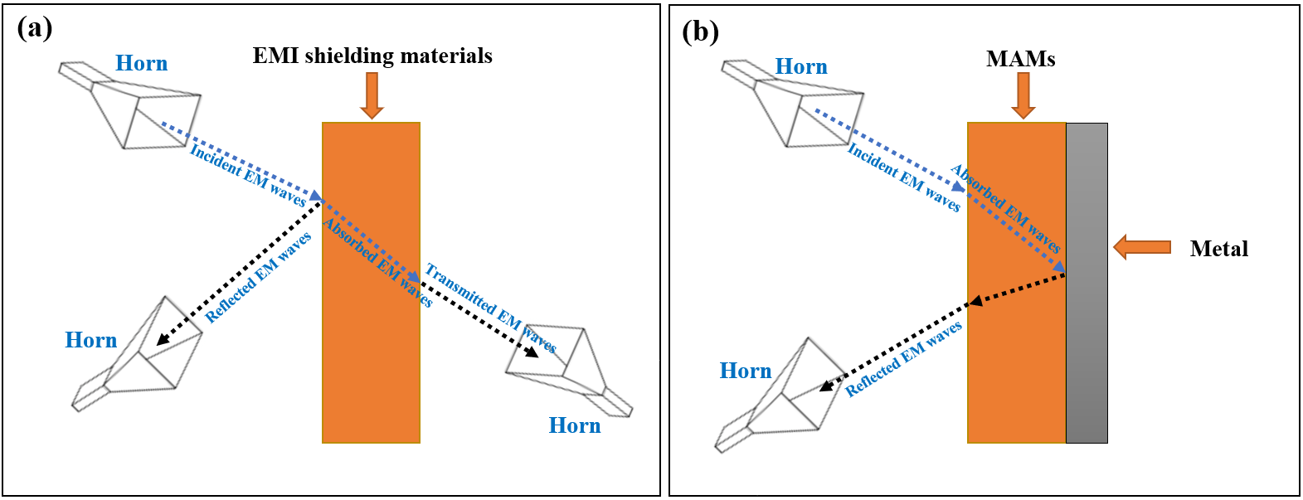
Figure 1.2 – Diagram of the estimated models of (a) EMI and (b) MA [21]
In order to get effective electromagnetic wave absorption, there should be material impedance (Z₁) close/equal to air impedance (Z₀), and the electromagnetic wave should be quickly attenuated inside the substance [22]. The model's impedance matching characteristic (Z) can be determined as shown in equation (1.2).
$z=\frac{z_{1}}{z_{0}}$ 1.2)
The EM characteristics of a substance, i.e., the complex relative permittivity ($ε_{r })$ and permeability ($µ_{r })$ are defined by equations (1.3 and 1.4) [17,23–25].
$ε_{r }= {ε_{ }}^{' }-i{ε_{ }}^{'' }$ 1.3)
$µ_{r }= µ^{' }-i{µ_{ }}^{'' }$ (1.4)
The real part of permittivity and permeability (ε' and μ') describes the ability to store the energy in the pattern. In contrast, the imaginary parts (ε" and μ") describe the energy loss of the electric and magnetic [26–28].

Microwave absorption materials
Many materials can be used to absorb microwaves, and they are generally divided into three main types:
- Magnetic loss materials.
- Dielectric loss materials.
- Hybrid materials.

Magnetic loss materials
These materials have high complex relative permeability. Many magnetic materials can absorb microwaves. The most important of these are ferrites and carbonyl iron.

Ferrites
Ferrites are magnetic ceramic materials, the main component of which is iron (III) oxide, in addition to other metallic elements (Ba, Mn, Co, Cu, Ni) [29].

Classification of ferrites according to their crystal structure
According to the crystal structure, ferrites can be divided mainly into three main sections:
(a) Spinel ferrites
The metal cations in this type of ferrite are located in a cubic structure. The spinel lattice comprises an arrangement of close-packed oxygen ions, where 32 oxygen ions shape the unit cell. These ions are located in a face-centered cubic arrangement (FCC), leaving two types of spaces between the ions through which metal cations can be located, which are as follows:
- Tetrahedral sites: These sites are surrounded by 4 oxygen ions.
- Octahedral sites: These sites are surrounded by 6 oxygen ions.
In the unit cell, there are 64 tetrahedral sites and 32 octahedral sites, but metal cations can occupy 8 tetrahedral sites and 16 octahedral sites [30].
(b) Hexagonal ferrites
They are ferrites consisting of magnetic iron oxides with a hexagonal structure. This type of ferrite has several general formulas indicated by letters such as (M, U, Y, etc.), the most important of which is MFe₁₂O₁₉, where M is elements such as barium, lead, or cobalt. Table 1.2 shows the most important structures of ferrites with a hexagonal structure. This type of ferrite is used as a permanent magnet, which is used at very high frequencies. The lattice of these ferrites is similar to spinel ferrite, with oxygen ions distributed according to the specific patterns.
Table 1.2 – Types of hexaferrite
Hexaferrite type | Chemical formula
M | MFe₁₂O₁₉
Y | M₂Me₂Fe₁₂O₂₂
W | MMe₂Fe₁₆O₂₇
Z | M₃Me₂Fe₂₄O₄₁
X | M₂Me₂Fe₂₈O₄₆
U | M₄Me₂Fe₃₆O₆₀
(c) Garnet ferrites
This ferrite type has the general formula 3M₂O₃.5Fe₂O₃, where M is a trivalent metal ion (Yttrium, Gadolinium, Samarium, etc.). These ferrites have a cubic crystal structure where the divalent cations are located in the tetrahedral sites and the trivalent cations in the octahedral and hexahedral sites [30].

Classification of ferrites according to magnetic properties
According to their magnetic properties, ferrites can be classified into soft and hard.
a) Soft ferrites
Ferrites with spinel and garnet crystal structures are soft magnetic materials characterized by a low coercivity field, such as NiZn ferrite and MnZn ferrite.
b) Hard ferrites
This ferrite type is characterized by high coercivity and remanent magnetization, such as hexagonal ferrites [31].

Applications of ferrites
Magnetic materials are characterized by their high resistance, low cost, easy manufacturing methods, and super magnetic properties. Ferrites are widely used in many applications such as radar, magnetic shielding, microwave absorption, audio, telecommunications, power transformer cores, amplifiers, small motor cores, magnetic sensors, automobiles, etc.

Methods of preparing ferrites
The preparation method is considerably significant to acquiring the desired outcome where properties of different types of nano ferrites change, particularly with varying ways of preparation. For instance, the of the properties of nano ferrites, which are managed by the preparation method. Nano ferrites can be fabricated via different methods as follows:
- Ceramic sintering method.
- Co-Precipitation method.
- Hydrothermal method.
- Sol-gel method.
- Microemulsions method.

Ceramic sintering method
This method involves mixing the raw materials (metallic oxides or carbonates) using a ball mill. The prepared ferrites are sintered in the temperature range (900–1250 °C).

Co-Precipitation method
Absorption is achieved by gradually decreasing the impedance starting from the dielectric layer, whose impedance is close to the impedance value of air, to secure the entry of most of the incident waves into the material and reduce reflection. Then the absorbent layers are graded with increasing impedance [32–35].
MAMs should be lightweight, prepared in various shapes, waterproof, chemically resistant, have good mechanical and physical properties, be easy to prepare, low cost, have a wide absorption field, and are strong absorption.

Hydrothermal method
. The development of radar or microwave absorbing materials technology has had a great impact on the military field. Radar absorbing materials are significant tools in electronic warfare, as they can be used to hide targets and protect them from radar detection. EM shielding materials and RAMs have been produced by international companies at high prices. In this regard, the relevance of the research topic of the doctoral dissertation is paving the way for putting the methodology and scientific bases for the manufacture of MAMs in the laboratory with the required international quality. As well as competing with commercial absorbers mentioned in the literature in terms of weight, reflection loss, absorption bandwidth, and shielding efficiency [36–39].

Sol-Gel method
RAMs have been used extensively to cover the walls of anechoic halls and to prevent or reduce electromagnetic reflections from large bodies. RAMs can be produced in different forms, such as paints, thin films, sheets, and sponges. These products are obtained by dispersing one or more types of absorbent materials in a polymeric matrix and applying them to a substrate or surface. Understanding the techniques for producing microwave absorbent composites by incorporating components, additives, and a matrix type is crucial to the final usage of the resulting absorbent material [40–42]..
Absorption is achieved by gradually decreasing the impedance starting from the dielectric layer, whose impedance is close to the impedance value of air, to secure the entry of most of the incident waves into the material and reduce reflection. Then the absorbent layers are graded with increasing impedance.

Microemulsion method
The microwave absorbing materials technology has had a great impact on the military field. Radar absorbing materials are significant tools in electronic warfare, as they can be used to hide targets and protect them from radar detection. EM shielding materials and RAMs have been produced by international companies at high prices. In this regard, the relevance of the research topic of the doctoral dissertation is paving the way for putting the methodology and scientific bases for the manufacture of MAMs in the laboratory with the required international quality. As well as competing with commercial absorbers mentioned in the literature in terms of weight, reflection loss, absorption bandwidth, and shielding efficiency [43].

Factors impacting characteristics of nano ferrites
The difference in nano ferrites properties can be adjusted by dominating the various preparation factors, such as the components, annealing temperature, and pH value.

Carbonyl iron powder (CIP)
CIP is a type of magnetic loss material of EM waves. CIP has a low electrical conductivity, high saturation magnetization, and Curie temperature. However, the increased density and insufficient stability restrain their practical uses.

Applications of carbonyl iron powder
CIP is widely used in many applications such as radar, magnetic shielding, radar absorption, stealth jets, drones, vehicles, telecommunications, power transformer cores, amplifiers, small motor cores, magnetic sensors, vehicles, etc.
Table 1.3 – Summary of the features and limitations of the main synthesis techniques
Technique | Nanomaterial | Calcination temperature (°F) | Size (nm) | Features | Limitations | Ref.
Ceramic sintering | Ni_{0.5}Zn_{0.5}Fe₂O₄ | 2282 | 74*10³ | Simple method.  Used raw materials are cheap. | Not obtaining a high-purity product.  Consumption of grinding equipment. | [44]
Hydrothermal | Mn_{1–x}Zn_{x}Fe₂O₄ | 338 | 15 | Controlled size.  High yield.  Scalable. | Previous information on solubility is wanted.  High pressure. | [45]
Mechano–  Thermal | ZnFe₂O₄ | 248 | 9–20 | Fine particle size.  Accumulation of ferric oxide. | Time-consuming.  Existence of impurities.  Poor yield. | [46]
Mechano–  Thermal | MgFe₂O₄ | 752–1292 | 5–8 | Fine particle size.  Accumulation of ferric oxide. | Time-consuming.  Existence of impurities.  Poor yield. | [47]
Mechano–  Thermal | ZnFe₂O₄ | 752–1022 | 3–20 | Fine particle size.  Accumulation of ferric oxide. | Time-consuming.  Existence of impurities.  Poor yield. | [48]
Microwave –  Thermal | BiFeO₃ | 356 | 130 | Rapid operation.  Cost-effective.  They obtained a crystalline structure. | Exaggerated growth existence of impurities. | [49]
Microwave –  Thermal | BiFeO₃ | 752–1112 | 20–160 |  | Exaggerated growth existence of impurities. | [50]
Microwave –  Thermal | CoFe₂O₄ | 1112–1472 | 11–12 |  | Exaggerated growth existence of impurities. | [51]
Combustion | Zn_{1–x}Co_{x}Fe₂O₄ | 1742 | 30–40 | Cost-effective process.  Low-temperature wanted.  Potentially of multi-component.  Nanoparticle forming. | Opportunity for impurity forming.  High temperature  is wanted. | [52]
Combustion | CdFe₂O₄ | 1742 | 12–27 |  |  | [53]
Combustion | MgFe₂O₄ | 932 | 12–25 |  |  | [54]
Combustion | BaNi₂Fe₁₆O₂₇ | 1292–1832 | 10–70 |  |  | [55]
Sol-Gel | Sm_{1–x}Ca_{x}FeO_{3–y} | 1292–1832 | 100 | Controlled size and form.  Better homogeneity.  Low cost. | Expensive process.  Requests complete monitoring. | [56]
Sol-Gel | Sr_{0.7}Nd_{0.3}Fe_{x}Co_{0.3}O₁₉ | 2012 | 40-50 | Controlled size and form.  Better homogeneity.  Low cost. | Expensive process.  Requests complete monitoring. | [57]
Sol-Gel | Mn_{1–x}Zn_{x}Fe₂O₄ | 1292–2012 | 500 | Controlled size and form.  Better homogeneity.  Low cost. | Expensive process.  Requests complete monitoring. | [58]
Sol-Gel | NiFe₂O₄ | 842 | 11–16 | Controlled size and form.  Better homogeneity.  Low cost. | Expensive process.  Requests complete monitoring. | [59]
Co-precipitation | NiFe₂O₄ | * | >50 | Decrease in the reaction temperature.  Aqueous media.  Symmetric sized. Nanoparticle forming. | The solubility of interactivity materials impacts the precipitation ratio.  Poor crystallinity.  Time-consuming. | [32]
Co-precipitation | Mg_{0.5}Ni_{0.5}Fe₂O₄ | * | 290–340 |  |  | [33]
Co-precipitation | CoCr_{x}Fe_{2–x}O₄ | * | 15–23 |  |  | [34]
Co-precipitation | NiFe₂O₄ | * | 8–20 |  |  | [35]
Micro Emulsion | CoFe₂O₄ | 1112 | 28 | Single-phase nano-particles.  Regular crystalline structure.  Cost-effective. | Temperature-dependent.  Existence of impurities.  Less yield. | [43]
Micro Emulsion | SrFe₁₂O₁₉ | 752–1832 | 60 |  |  | [60]
Micro Emulsion | Ni _{0.5}Zn _{0.5}Fe₂O₄ | 1112 | 50 |  |  | [61]

Dielectric loss materials
These materials have high complex relative permittivity. Many dielectric materials can absorb microwaves, These products are obtained by dispersing one or more types of absorbent materials in a polymeric matrix and applying them to a substrate or surface. Understanding the techniques for producing microwave absorbent composites by incorporating components, additives, and a matrix type is crucial to the final usage of the resulting absorbent material.

Conductive polymers (CPs)
CPs are organic polymers that conduct electricity, usually indicated as “synthetic metals” because of their capability to integrate polymers' chemical and mechanical characteristics with the electrical characteristics of metals and semiconductors. CPs combine moderate conductivity, ease of fabrication, low cost, corrosion resistance, low density compared to metals, and the ability to absorb electromagnetic waves [15,62].

Polyaniline
PANI is one of the most studied conductive polymers due to its ease of fabrication and good electrical conductivity. PANI consists of monomer units built from reduced (y) and oxidized (1-y) blocks: where 0 ≤ y ≤ 1. The redox state of the polymer is defined by the value of y, which may vary continuously from zero to unity. Figure 1.3 shows the general chemical formula of polyaniline [63].

Applications of conductive polymers
CPs seem to be one of the few substances qualified to show dynamic MA conduct, called “smart stealth substances”, because of the reversible electrical characteristics of CPs. Their benefit can also be expanded to high-tech fields such as space, military defense, navigation/communication control, or as a RAM in solar cells, computers, biosensors, etc.
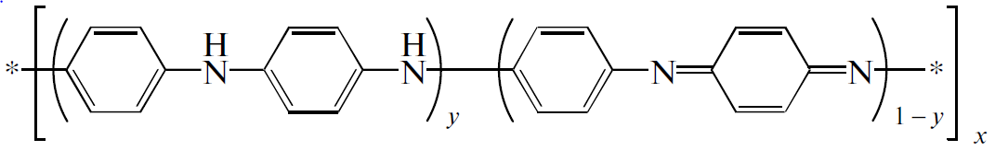
Figure 1.3 – General chemical formula of polyaniline

Carbonaceous substances
Carbon is considered the 4th most existing chemical element in the world by mass. It is the element that earth selected as a base for the environment under the circumstances conformable to Earth's. Pure carbon has many forms involving diamond, graphite, graphene, buckminsterfullerene, nanotube, etc.

Carbon black
CB is a shape of paracrystalline carbon that has a high surface area to volume ratio, albeit lower than that of activated carbon. CB has been used for electronics, RAMs, photocopiers, laser printer toners, and paints.

Activated carbon
AC has small, low-volume pores that increase the surface area for adsorption or chemical reactions. AC has been used for air purification, water purification, medicine, sewage treatment, and RAMs.

Graphite
C is a crystalline form of the element carbon. It consists of weakly bound layers of graphene stacked into a hexagonal structure. C occurs naturally and is the most stable form of carbon under standard conditions. Graphite has been used in batteries, solar panels, electrodes, and RAMs.

Hybrid materials
Hybrid materials are composites made via the incorporation of organic and inorganic components.

Composite absorbent materials with graded impedance
Absorption is achieved by gradually decreasing the impedance starting from the dielectric layer, whose impedance is close to the impedance value of air, to secure the entry of most of the incident waves into the material and reduce reflection. Then the absorbent layers are graded with increasing impedance.

Characteristics of an ideal microwave absorption material.
MAMs should be lightweight, prepared in various shapes, waterproof, chemically resistant, have good mechanical and physical properties, be easy to prepare, low cost, have a wide absorption field, and are strong absorption [64].

Absorbent ferrites nanoparticles for microwave
The researchers designed the absorbent ferrites of the EM waves to use them in civilian and military applications. According to this, the Ni_{0.7}Zn_{0.3}Y_{x}Fe_{2–x}O₄ was Chen et al. The sol-gel technique synthesized the absorbents. The results displayed that the RL_{min} peaks of absorbents shifted absorbent thickness (t_{m}), as shown in Figure 1.4 [65]. This case may be determined, as indicated in formula (1.5) [66–68].
${t_{m}=\frac{nc}{4f_{m}\sqrt{\left|µ_{r}\right|\left|ε_{r}\right|}} (n=1, 3, 5,…)}_{ }$ 1.5)
Where c is the velocity of light.
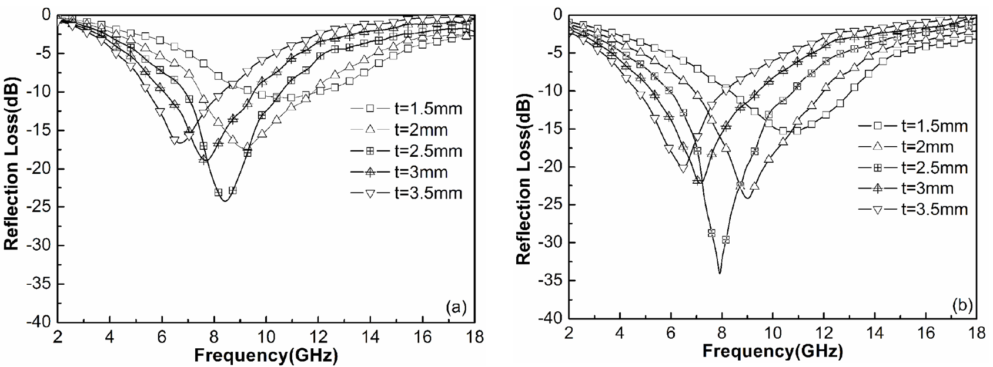
Figure 1.4 – RL curves of Ni _{0.7}Zn_{0.3}Y_{x}Fe _{2–x}O₄ ferrite (x = 0, (a); x = 0.2, (b)) at different thicknesses
The Cu_{0.2}Ni_{0.4}Zn_{0.4}Fe₂O₄ was studied by Gregori et al. The absorbents were prepared by the citrate precursor. The absorbents were synthesized by dispersing Cu_{0.2}Ni_{0.4}Zn_{0.4}Fe₂O₄ powder within the wax matrix of 80 % w/w. The results displayed that BW_{-10 dB} for the absorbent reached 2.4 GHz [69]. Malas et al. prepared the Cu_{0.2}Ni_{0.4}Zn_{0.4}Fe₂O_{4,} too but with a different technique, which was the co-sedimentation technique. The absorbents were synthesized by dispersing ferrite nanoparticles within the ER matrix of 30 % w/w. The results displayed that BW_{-10 dB} for the absorbent reached 4.1 GHz [70]. The changes in MA characteristics were observed with the variation of the synthesis method. Zhang et al. designed the These products are obtained by dispersing one or more types of absorbent materials in a polymeric matrix and applying them to a substrate or surface. Understanding the techniques for producing microwave absorbent composites by incorporating components.
As well as competing with commercial absorbers mentioned in the literature in terms of weight, reflection loss, absorption bandwidth, and shielding efficiency. According to this, the [Ni_{0.4}Cu_{0.2}Zn_{0.4}](Nd_{x}Y_{x}Fe_{2-2x})O₄ (0.0 ≤ x ≤ 0.05) was designed by Chen et al. The absorbents were synthesized by the citrate sol-gel technique [72]. The results displayed that the RL_{min} peaks of absorbents shifted to higher frequencies by increasing the substitution with several cations on ferrite. Zubar et al. designed the Ni_{0.4}Cu_{0.2}Zn_{0.4}Tb_{x}Fe_{2-x}O₄ (0.0 ≤ x ≤ 0.10) by sonochemical method. The outcomes exhibited that the substitutions rate significantly influences MA properties, as shown in Figure 1.5 [73]. Kostishyn et al. designed the Ni_{0.4}Cu_{0.2}Zn_{0.4}Eu_{x}Fe_{2-x}O₄ (0.0 ≤ x ≤ 0.10) by sol-gel method. The effect of Eu³⁺ ion substitution on the MA properties was studied [74]. The results displayed that the RL_{min} peaks of absorbents shifted to higher frequencies with increasing the Eu³⁺ contents. Trukhanov et al. designed the [Ni_{0.5}Co_{0.5}](Dy_{x}Fe_{2-x})O₄ (x ≤ 0.08) by citrate gel technique. The effect of Dy³⁺ ion substitution on the MA properties was studied [75]. The results displayed that the RL_{min} peaks of absorbents shifted to higher frequencies with increasing the Dy³⁺ contents. From these researches, it was noted that the unsubstituted ferrites were known for their poor capability to absorb EM waves, which required the study of the impact of the cations substituted and cations content in ferrite through which the MA properties were enhanced. Garg et al. studied the impact of Nd³⁺ doping on the MA properties of barium hexaferrite. The results displayed that RL_{min} was −33.17 dB at 9.5 GHz for a thickness of 2.2 mm and the absorbing BW_{-10 dB} was 2.94 GHz for BaNd_{0.04}Fe_{11.96}O₁₉ [76]. Ghasemi et al. studied the Mn–Co–Sn doped on barium ferrite. The barium ferrite was synthesized by the sol-gel method. The results displayed that by changing the substituted elements in barium ferrite, the absorbing BW_{-10 dB} reached 8 GHz with unique RL_{min} [77]. These investigations illustrated the substantial impact of the synthesis technique, the kind of ferrite, the influence of the cations substituted and cations content in absorbent ferrite, the absorbent ferrite thickness, and the impact of elements doping on MA properties of absorbent ferrite.
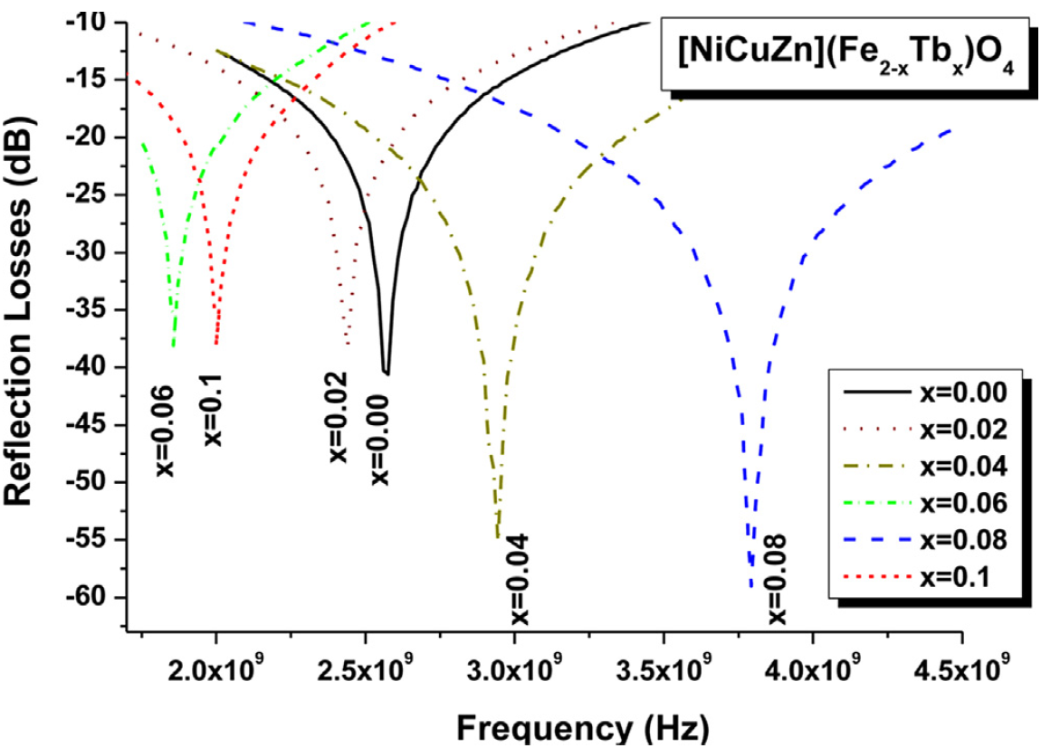
Figure 1.5 – RL as a function of the EM wave frequency of Ni_{0.4}Cu_{0.2}Zn_{0.4}Tb_{x}Fe_{2-x}O₄ (0.0 ≤ x ≤ 0.10)

Incorporation of CPs with ferrite nanoparticles to absorb microwaves
The development of radar or microwave absorbing materials technology has had a great impact on the military field. Radar absorbing materials are significant tools in electronic warfare, as they can be used to hide targets and protect them from radar detection. EM shielding materials and RAMs have been produced by international companies at high prices. In this regard, the relevance of the research topic of the doctoral dissertation is paving the way for putting the methodology and scientific bases for the manufacture of MAMs in the laboratory with the required international quality. As well as competing with commercial absorbers mentioned in the literature in terms of weight, reflection loss, absorption bandwidth, and shielding efficiency.
The results obtained in the framework of this thesis can be suggested for producing microwave absorbers synthesized based on ML and DL materials. An advantage of the work is that obtained absorbers can attenuate the EM waves with low surface density and wide bandwidth. These microwave absorbers can be used to cover the walls of anechoic chambers and to prevent or reduce electromagnetic reflections from large bodies such as stealth aircraft, submarines, carriers, and so on.
RAMs have been used extensively to cover the walls of anechoic halls and to prevent or reduce electromagnetic reflections from large bodies. RAMs can be produced in different forms, such as paints, thin films, sheets, and sponges. These products are obtained by dispersing one or more types of absorbent materials in a polymeric matrix and applying them to a substrate or surface. Understanding the techniques for producing microwave absorbent composites by incorporating components, additives, and a matrix type is crucial to the final usage of the resulting absorbent material.
Absorption is achieved by gradually decreasing the impedance starting from the dielectric layer, whose impedance is close to the impedance value of air, to secure the entry of most of the incident waves into the material and reduce reflection. Then the absorbent layers are graded with increasing impedance.
MAMs should be lightweight, prepared in various shapes, waterproof, chemically resistant, have good mechanical and physical properties, be easy to prepare, low cost, have a wide absorption field, and are strong absorption.
However, in various cases, the PANI/F nanocomposites can be incorporated with carbon materials as well, e.g. core-shell F/GO/PANI [90], Fe3O4@C@PANI [[91], F/G/PANI [92], and so on. These nanocomposites can possess special MA performance due to the connection absorbent mechanism in each part. From the above of these studies, we can summarize that the PANI-based nanocomposites are the premium RL of PANI-based nanocomposites produced essentially from the impacts of conduction, magnetic, and dielectric losses. Where combining PANI and other waste substances can improve the absorption BW_{-10 dB} and enhance the RL values. The EM wave attenuation performance of PANI-based nanocomposites can also be developed by adjusting their architectures.
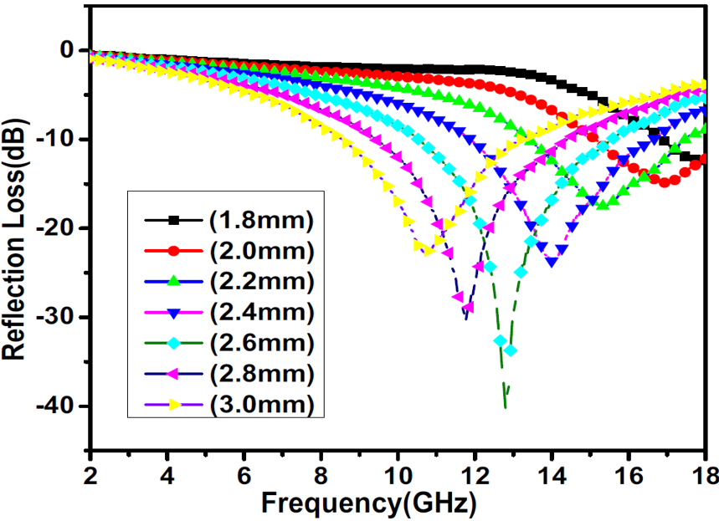
Figure 1.6 – RL as a function of the EM wave frequency of PANI/NiZn (1:2) nanocomposites with different thicknesses

MA behavior of carbon-based nanomaterials
RAMs have been used extensively to cover the walls of anechoic halls and to prevent or reduce electromagnetic reflections from large bodies. RAMs can be produced in different forms, such as paints, thin films, sheets, and sponges. These products are obtained by dispersing one or more types of absorbent materials in a polymeric matrix and applying them to a substrate or surface. Understanding the techniques for producing microwave absorbent composites by incorporating components, additives, and a matrix type is crucial to the final usage of the resulting absorbent material.
Absorption is achieved by gradually decreasing the impedance starting from the dielectric layer, whose impedance is close to the impedance value of air, to secure the entry of most of the incident waves into the material and reduce reflection. Then the absorbent layers are graded with increasing impedance.
MAMs should be lightweight, prepared in various shapes, waterproof, chemically resistant, have good mechanical and physical properties, be easy to prepare, low cost, have a wide absorption field, and are strong absorption.
On the other hand, Chakradhary et al. [96] designed strontium ferrite epoxy (SrF) NC and CB-loaded (CBSrF) NC. The RL_{min} for the SrF NC is -25.19 dB at 13.32 GHz for 10.5 mm thickness, whereas for (CBSrF) NC the RL_{min} is -31.15 dB at 10.32 GHz for 9.5 mm thickness. Therefore, the CB-loaded (SrF) NC displays higher attenuation efficiency than the (SrF) NC. On the other hand, Peng et al. prepared a collection of CNTs filled with Fe, which induced a rise in the reaction with EM radiation from the absorber substance. The amount of normal carbon permeability exceeds 1. The outcome of this conjugation was that the amount of RL was -24.8 dB at 10.9 GHz for a thickness of 1.2mm, and the absorption (BW)_{-10 dB} was 16.0 GHz [97]. Zhu et al. prepared the carbon nanotubes/iron nanowires compounds and the maximum reflection loss (RL_{m}) of the compounds was -22.73 dB [98]. The carbon nanotubes/cobalt nanoparticles compounds were manufactured and the symmetric cobalt nanoparticles were well scattered on the carbon nanotubes surface [99]. The RL_{m} of the compounds was -36.5 dB. Several magnetic metal alloy compounds, like rod-like FeCo/CNTs were studied [100]. The RL_{m} of FeCo/CNTs compounds was -46.5 dB at 12.56 GHz and the active absorption (BW)_{-10dB} reached 3.92 GHz. The RL_{m} of carbon nanotubes/ carbonyl iron particle compounds was -33.3 dB at 11.4 GHz.
On the other hand, many scientists have studied the impact of CF on ferrite. For example, Hou et al. [101] studied carbon fiber@cobalt iron oxide and carbon fiber@cobalt iron oxide@manganese(iv) oxide composites by the sol-gel method. Carbon fiber@cobalt iron oxide@manganese(iv) oxide composite exhibits excellent MA performance due to reasonable EM matching, and its RL_{m} value equals -34 dB with a sample thickness of 1.5 mm. Figure 1.7 illustrates RL shapes of carbon fiber (a), carbon fiber@cobalt iron oxide (b), and carbon fiber@cobalt iron oxide@manganese(iv) oxide composites (c) at different thicknesses, the efficient absorption BW of carbon fiber@cobalt iron oxide@manganese(iv) oxide composite (d) [78]. The insert of impurities into the carbon fibers scope in several states created diversities in the magnetic reaction to EM wave via the nanomaterial, [102] for example, by ferromagnetism, [103] although some cases, like the Fe₃O₄/mineral-coated by carbon fibers, [104] the examined substance only showed perversion in response to the electronic reaction of the substance, appearing in an essential electronic loss role compared to a small magnetic loss [104].
From the above of these studies, we can summarize that the carbon-based nanocomposites are the premium reflection loss of carbon-based nanocomposites produced from the impacts of conduction, magnetic, and dielectric losses. Combining carbon and other waste substances can improve the absorption BW_{-10 dB} and enhance the RL values. Carbon-based nanocomposites' electromagnetic wave attenuation performance can be developed by adjusting their architectures.
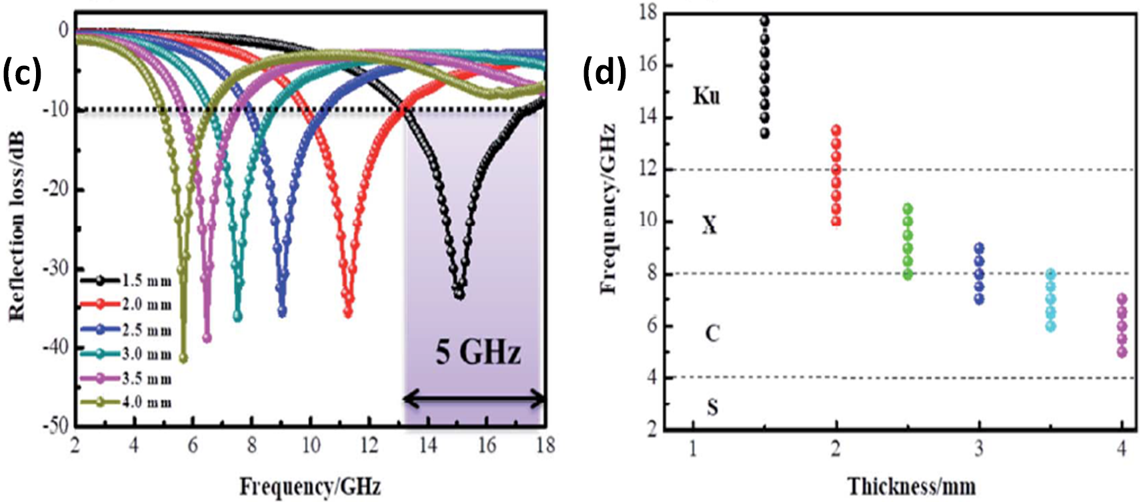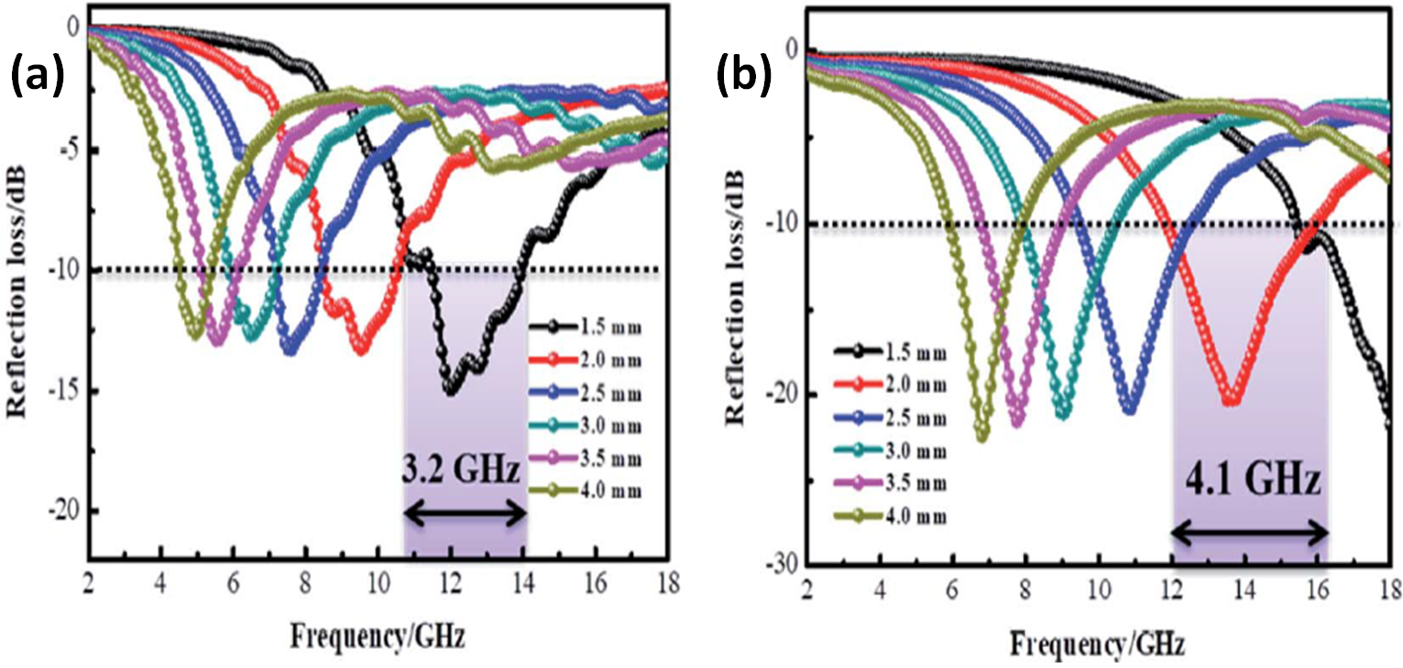
Figure 1.7 – RL shapes for carbon fiber (a), carbon fiber@cobalt iron oxide (b) and carbon fiber@cobalt iron oxide@manganese(iv) oxide composites (c) at different thicknesses the efficient absorption (BW)_{-10dB} of carbon fiber@cobalt iron oxide@manganese(iv) oxide composite (d) [78]
From the above of these studies, we can summarize that the carbon-based nanocomposites are the premium reflection loss of carbon-based nanocomposites produced from the impacts of conduction, magnetic, and dielectric losses. Combining carbon and other waste substances can improve the absorption BW_{-10 dB} and enhance the RL values. Carbon-based nanocomposites' electromagnetic wave attenuation performance can be developed by adjusting their architectures.

Chapter 2: Practical part

Chemicals, raw and commercial materials
Ferrites were prepared in this research by different methods (physical and chemical), starting from metal oxides (physical method) and metal salts (chemical methods: citrate precursor, self-combustion). The preparation of the nanocomposite (PANI/SF, PANI/HF, PANI/CI, PANI/CB, etc.) required different chemicals (monomers, oxidizers, and various chemicals). Table 2.1 shows the specifications of the chemicals used to accomplish this research.
Table 2.1 – Chemicals used in laboratory work and their specifications
Chemicals | Formula | molar mass (g/mole) | Purity (%) | Melting point (°C) | Appearance | Source
Iron(III) oxide | Fe₂O₃ | 159.69 | 98.7 | 1565 | Solid | Mosreactive company
Zinc(II) oxide | ZnO | 81.380 | 78.3 | 1975 | Solid | Mosreactive company
Nickel(II) oxide | NiO | 74.6928 | 77.6 | 1955 | Solid | Mosreactive company
Nickel(III) oxide | Ni₂O₃ | 165.390 | 77.2 | 600 | Solid | Mosreactive company
Copper(II) oxide | CuO | 79.545 | 78.5 | 1326 | Solid | Mosreactive company
Manganese(II) oxide | MnO | 70.937 | 80.7 | 1945 | Solid | Mosreactive company
Paraffin wax | _ | _ | Commercial | _ | Solid | Market
Iron(III) nitrate nonahydrate | Fe(NO₃)₃.9H₂O | 403.95 | 98.3 | 47 | Solid | TRADING COMPANY ANT
Nickel(II) nitrate hexahydrate | Ni(NO₃)₂⋅6H₂O | 290.81 | 98.3 | 56 | Solid | TRADING COMPANY ANT
Zinc nitrate hexahydrate | Zn(NO₃)₂⋅6H₂O | 297.5 | 98.7 | 36.4 | Solid | TRADING COMPANY ANT
Manganese(II) chloride tetrahydrate | MnCl₂ .4H₂O | 197.90 | 97.5 | 87.5 | Solid | TRADING COMPANY ANT
Polyvinyl alcohol | [-CH₂CHOH-]_{n} | MW: 70000 | 92.4 | 200 | Solid | TRADING COMPANY ANT
Sucrose | C₁₂H₂₂O₁₁ | 342.3 | Commercial | _ | Solid | Market
Sodium dodecyl sulfate (SDS) | C₁₂H₂₅NaO₄S | 288.38 | 92.2% | 206 | Solid | TRADING COMPANY ANT
Ethanol | C₂H₅OH | 46.07 | Commercial | _ | Liquid | Market
Hydrochloric acid | HCl 37% | 36.46 | Commercial | _ | Liquid | Market
Aniline | C₆H₅NH₂ | 93.13 | 99.5% | _ | Solid | Sigma Aldrich Company
Ammonium persulfate (APS) | (NH₄)₂S₂O₈ | 228.20 | 95.3% | _ | Solid | TRADING COMPANY ANT
Citric acid | C₆H₈O₇ | 192.12 | 99.0% | _ | Solid | Sigma
Ammonium hydroxide | NH₄OH | 35.05 | 99.8% | _ | Liquid | Commercial
Carbonyl iron | CI |  | 99.6% | 1538 | Solid | Cabot Norit Company
Carbon black | CB | 12.011 | 99.5% | 3550 | Solid | Cabot Norit Company
Activated carbon | AC | 12.011 | Commercial | 3500 | Solid | Market
Graphite | C | 12.011 | Commercial | 3652 | Solid | Market

Tools and equipment used for sample preparation
Table 2.2 shows the laboratory's tools and equipment used to prepare microwave absorbers.
Table 2.2 – Tools and equipment used for sample preparation
Tool/Equipment | Manufacture Company
Sensitive scale | Hochoice electronic
Sieve shaker | Fritsch
Ball mill | Fritsch
Glassware | _
Homogenizer | Fritsch
Vacuum pump | jinteng
Büchner funnel | _
Digital magnetic hot plate stirrer | CAPPRondo
Heat treatment oven | GIMA
Digital pH meter | Benchtop
Dryer | Henan Touch

Characterization devices
The prepared samples were structurally characterized using XRD, FTIR, TGA, and EDX. The X-ray diffraction patterns of the prepared samples were recorded at 2θ =10 - 90°. Fourier Transform IR (FTIR) spectra of the prepared samples were recorded on a Perkin Elmer 65 FTIR spectrometer in the 400–4000 cm⁻¹. Thermogravimetric analysis (TGA) curve of the prepared samples were recorded on a thermal analyzer (NETZSCH 449F3A-0372-M) under a nitrogen atmosphere, from room temperature to 1000°C under a constant heating rate of 10 °C/min. Energy-dispersive X-ray spectroscopy (EDX, Quanta 200 3D) was used to know the chemical composition of some of the prepared samples. Absorption is achieved by gradually decreasing the impedance starting from the dielectric layer, whose impedance is close to the impedance value of air, to secure the entry of most of the incident waves into the material and reduce reflection. Then the absorbent layers are graded with increasing impedance.
These products are obtained by dispersing one or more types of absorbent materials in a polymeric matrix and applying them to a substrate or surface. Understanding the techniques for producing microwave absorbent composites by incorporating components, additives, and a matrix type is crucial to the final usage of the resulting absorbent material. EM waves are detected by using a waveguide microwave detector circuit (Figure 2.1), which is attached to the pyramidal horn antenna. The measurement results in this method are verified by using a reference sample, which is an aluminum plate with previously known microwave properties. The results obtained in the framework of this thesis can be suggested for producing microwave absorbers synthesized based on ML and DL materials. An advantage of the work is that obtained absorbers can attenuate the EM waves with low surface density and wide bandwidth. These microwave absorbers can be used to cover the walls of anechoic chambers and to prevent or reduce electromagnetic reflections from large bodies such as stealth aircraft by equation (2.1) [105]:
$SE (dB)={SE}_{R }+{SE}_{A}+{SE}_{M}=10 log\frac{p_{in}}{p_{T}}$ (2.1)
These products are obtained by dispersing one or more types of absorbent materials in a polymeric matrix and applying them to a substrate or surface. Understanding the techniques for producing microwave absorbent composites by incorporating components, additives, and a matrix type is crucial to the final usage of the resulting absorbent material [105]:
$SE (dB)={SE}_{R }+{SE}_{A}+{SE}_{M}=10 log\frac{p_{in}}{p_{T}}$ (2.2)
EM shielding materials and RAMs have been produced by international companies at high prices. In this regard, the relevance of the research topic of the doctoral dissertation is paving the way for putting the methodology and scientific bases for the manufacture of MAMs in the laboratory with the required international quality by equation (2.3).
${SE}_{R }\left(dB\right)=-10\log\left(1-R\right)=-10\log\left(1-\frac{p_{ref}}{p_{in}}\right)$ (2.3)
Absorption is achieved by gradually decreasing the impedance starting from the dielectric layer, whose impedance is close to the impedance value of air, to secure the entry of most of the incident waves into the material and reduce reflection by equation (2.4) [106,107]:
${SE}_{A} \left(dB\right)=-10\log\left(\frac{T}{1-R}\right)= -10\log\left(\frac{p_{T}}{p_{in}-p_{ref}}\right)$ (2.4)
EM shielding materials and RAMs have been produced by international companies at high prices. In this regard, the relevance of the research topic of the doctoral dissertation is paving the way for putting the methodology and scientific bases for the manufacture of MAMs in the laboratory with the required international quality by equation (2.5) [106,107]:
$Rl (dB)=10log\frac{p_{in}}{p_{ref}}$ (2.5)
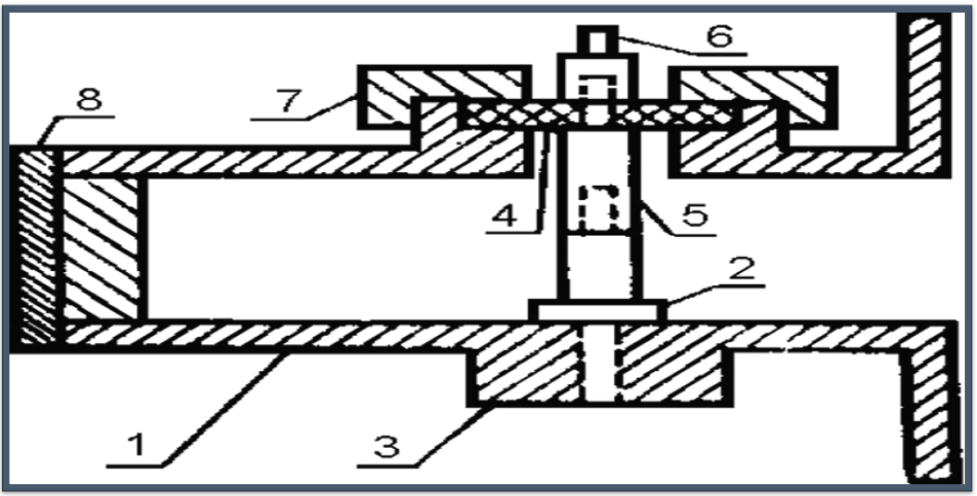
Figure 2.1 – Waveguide microwave detector circuit consists of: (1) waveguide segment, (2) cathode of the microwave diode, (3) bronze bushing, (4) dielectric sleeve, (5) rod, (6) output terminal signal, (7) coupling nut and (8) piston
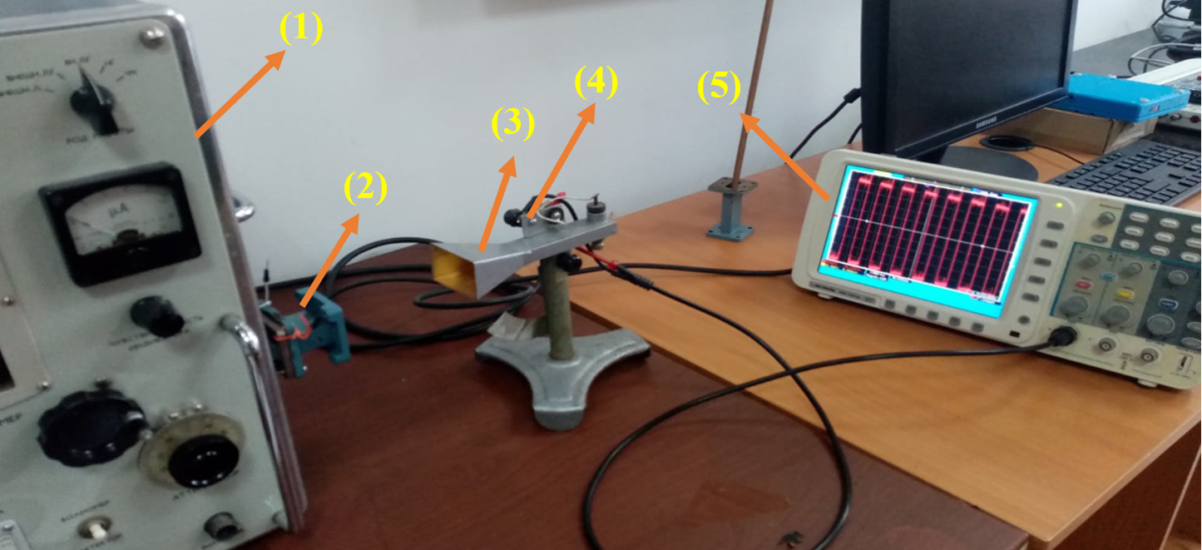
Figure 2.2 – Experimental setup for studying the EMI and MA properties of the prepared samples by the free-space technique. From left to right: (1) microwave generator, (2) waveguide instrument, (3) horn antenna, (4) waveguide microwave detector circuit and (5) oscilloscope
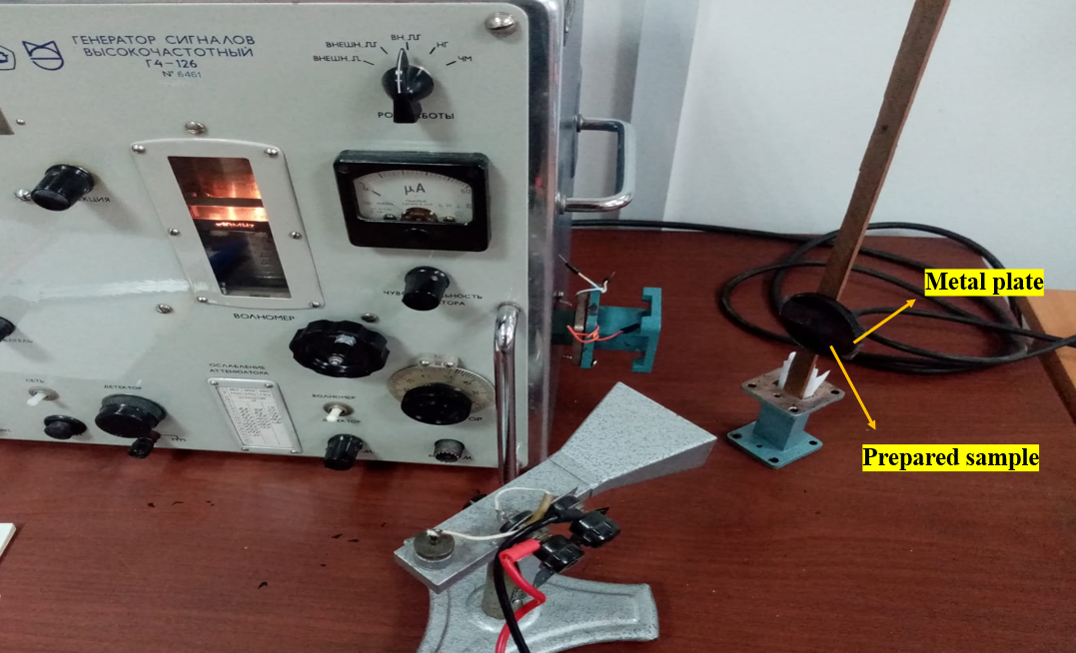
Figure 2.3 – Experimental setup for measuring the reflected power of the EM waves for the microwave absorption model

Sample preparation
Different methods have prepared ferrite powders and ferrite-based composites:

Preparation of ferrite powders

Preparation of ferrite powders by the ceramic sintering method
RAMs have been used extensively to cover the walls of anechoic halls and to prevent or reduce electromagnetic reflections from large bodies. RAMs can be produced in different forms, such as paints, thin films, sheets, and sponges. These products are obtained by dispersing one or more types of absorbent materials in a polymeric matrix and applying them to a substrate or surface. Understanding the techniques for producing microwave absorbent composites by incorporating components, additives, and a matrix type is crucial to the final usage of the resulting absorbent material.
Absorption is achieved by gradually decreasing the impedance starting from the dielectric layer, whose impedance is close to the impedance value of air, to secure the entry of most of the incident waves into the material and reduce reflection. Then the absorbent layers are graded with increasing impedance. Table 2.3 and equations (2.6-2.12) show the prepared ferrites and the raw materials included in the preparation of these ferrites.
Table 2.3 – Prepared ferrites by the ceramic sintering technique
 | Ferrite | Composition
 | 1 | NiFe₂O₄
 | 2 | ZnFe₂O₄
 | 3 | MnFe₂O₄
 | 4 | CuFe₂O₄
 | 5 | Mn_{0.3}Zn_{0.7}Fe₂O₄
 | 6 | Mn_{0.6}Zn_{0.4}Fe₂O₄
 | 7 | Mn_{0.9}Zn_{0.1}Fe₂O₄
 | 8 | Ni_{0.25}Zn_{0.75}Fe₂O₄
 | 9 | Ni_{0.5}Zn_{0.5}Fe₂O₄
 | 10 | Ni_{0.75}Zn_{0.25}Fe₂O₄
 | 11 | Ni_{0.5}Zn_{0.4}Mn_{0.1}Fe₂O₄
 | 12 | Ni_{0.6}Zn_{0.3}Mn_{0.1}Fe₂O₄
 | 13 | Ni_{0.7}Zn_{0.2}Mn_{0.1}Fe₂O₄
 | 14 | Ni³⁺_{0.25}Ni²⁺_{0.375}Zn²⁺_{0.25}Fe₂O₄
 | 15 | Cu²⁺_{0.1}Ni³⁺_{0.15}Ni²⁺_{0.225}Zn²⁺_{0.45}Fe₂O₄
 | 16 | BaNiZnFe₁₆O₂₇
MO + Fe₂O₃ →MFe₂O₄ (M: Mn, Ni and Zn) 2.6)
xMnO + (1-x)ZnO + Fe₂O₃ → Mn_{x}Zn_{(1-x)}Fe₂O₄ (x= 0.3, 0.6 and 0.9) 2.7)
xNiO + (1-x)ZnO + Fe₂O₃ → Ni_{x}Zn_{(1-x)}Fe₂O₄ (x= 0.25, 0.5 and 0.75) (2.8)
0.1MnO + (0.4+x)NiO + (0.5-x)ZnO + Fe₂O₃ → Mn_{0.1}Ni_{(0.4+x)}Zn_{(0.5-x)}Fe₂O₄ (x= 0.1, 0.2 and 0.3) 2.9)
0.125Ni₂O₃ + 0.375NiO + 0.25ZnO + Fe₂O₃ → Ni³⁺_{0.25}Ni²⁺_{0.375}Zn²⁺_{0.25}Fe₂O₄ 2.10)
0.1CuO + 0.075Ni₂O₃ + 0.225NiO + 0.45ZnO + Fe₂O₃ → Cu²⁺_{0.1}Ni³⁺_{0.15}Ni²⁺_{0.225}Zn²⁺_{0.45}Fe₂O₄2.11)
BaCO₃ + NiO + ZnO + 8Fe₂O₃ → BaNiZn Fe₁₆O₂₇ + CO₂ 2.12)

Preparation of NiZn ferrite nanoparticles by citrate precursor method
Ferrite nanoparticles were prepared by citrate precursor method. The effect of the different molar ratios of the metal ions to citrate acid (1:1, 2:1, and 3:1) and the different calcination temperatures (650, 800, and 950 °C) were studied on the ferrite properties. The flow chart for ferrite synthesis using a citrate precursor technique is shown in Figure 2.4. In this method, citric acid played the role of a chelating agent (chemical compound that reacts with metal ions to form stable, water-soluble metal complexes). The symbols of ferrite nanoparticle samples are detailed in Table 2.4.
Table 2.4 – Symbols of ferrite nanoparticle samples
Ferrite | Citric acid: cation | Calcination temperature (°C) | Sample symbol
Ni_{0.5}Zn_{0.5}Fe₂O₄ | 1:1 | 650 | NZ₁₁ ₋ 650
Ni_{0.5}Zn_{0.5}Fe₂O₄ | 1:2 | 650 | NZ₁₂ ₋ 650
Ni_{0.5}Zn_{0.5}Fe₂O₄ | 1:3 | 650 | NZ₁₃ ₋ 650
Ni_{0.5}Zn_{0.5}Fe₂O₄ | 1:1 | 800 | NZ₁₁ ₋ 800
Ni_{0.5}Zn_{0.5}Fe₂O₄ | 1:2 | 800 | NZ₁₂ ₋ 800
Ni_{0.5}Zn_{0.5}Fe₂O₄ | 1:3 | 800 | NZ₁₃ ₋ 800
Ni_{0.5}Zn_{0.5}Fe₂O₄ | 1:1 | 950 | NZ₁₁ ₋ 950
Ni_{0.5}Zn_{0.5}Fe₂O₄ | 1:2 | 950 | NZ₁₂ ₋ 950
Ni_{0.5}Zn_{0.5}Fe₂O₄ | 1:3 | 950 | NZ₁₃ ₋ 950
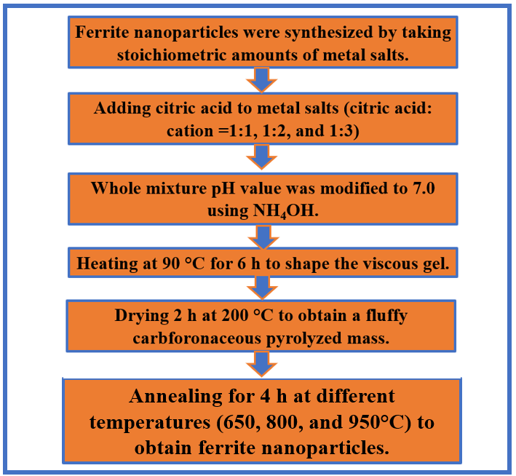
Figure 2.4 – Flow chart for the synthesis of ferrite utilizing a citrate precursor technique
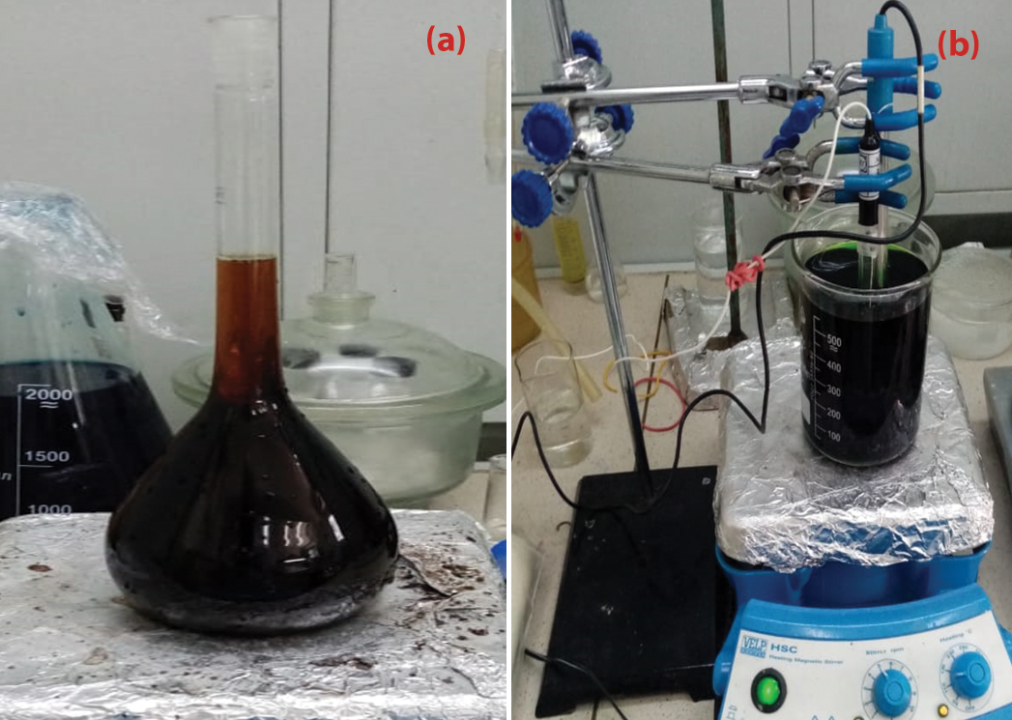
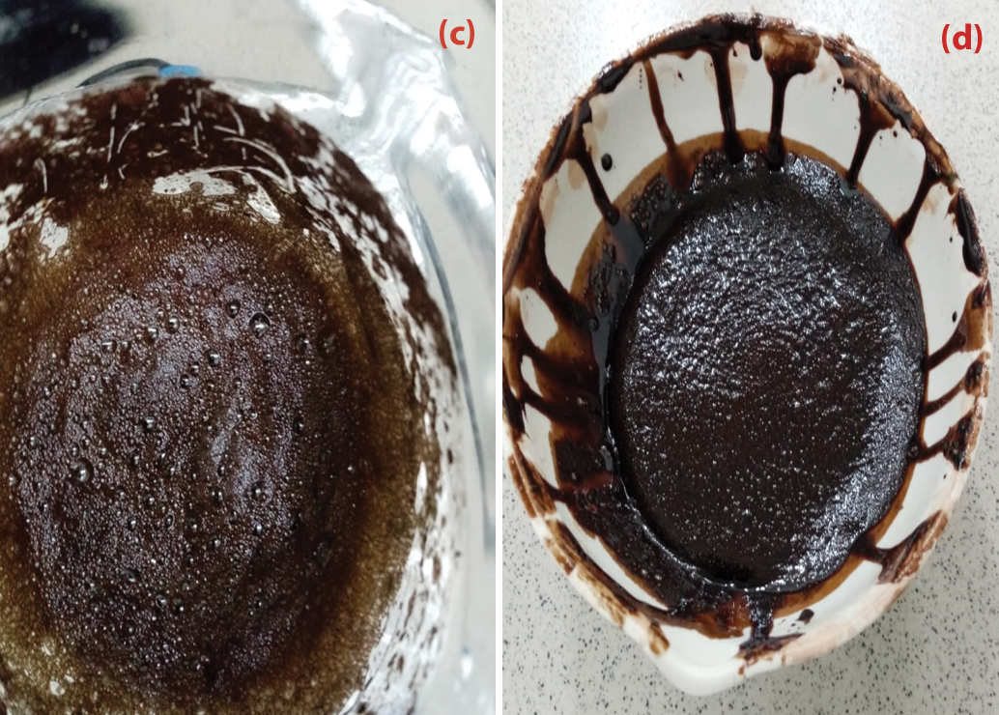
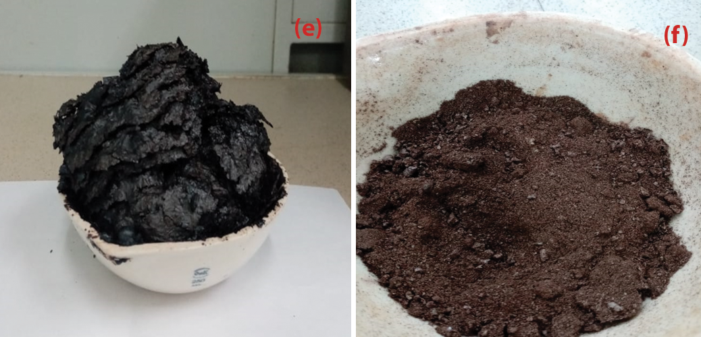
Figure 2.5 – Synthesis of Ni_{0.5}Zn_{0.5}Fe₂O₄ nanoparticles by citrate precursor method: (a) the metal salts aqueous solution in the flask, (b) using NH₄OH to maintain the pH of the solution at 7, (c) heating the solution at 90 °C for 6 h, (d) formation the viscous gel, (e) formation a fluffy carbonaceous pyrolyzed mass and (f) obtaining nanoparticles ferrite

Preparation of NiZn ferrite nanoparticles by self-combustion method
Ni_{0.5}Zn_{0.5}Fe₂O₄ nanoparticles were prepared by self-combustion method. Ferrite nanoparticles were synthesized by taking stoichiometric amounts of metal salts. Metal salts were blended with an aqueous sucrose solution (2 moles per metal ion). The effect of the different aqueous solutions of PVA (1%, 4%, and 6%) and the different calcinates (650, 800, and 950°C) was studied on the MA properties. The flow chart for ferrite synthesis using a self-combustion technique is shown in Figure 2.6. In this method, sucrose played the role of fuel. The symbols of ferrite nanoparticle samples are detailed in Table 2.5.
Table 2.5 – Symbols of ferrite nanoparticle samples
Ferrite | PVA concentration (%) | Calcination temperature (°C) | Sample symbol
Ni_{0.5}Zn_{0.5}Fe₂O₄ | 1 | 650 | NSC₁₁ ₋ 650
Ni_{0.5}Zn_{0.5}Fe₂O₄ | 4 | 650 | NSC₁₂ ₋ 650
Ni_{0.5}Zn_{0.5}Fe₂O₄ | 6 | 650 | NSC₁₃ ₋ 650
Ni_{0.5}Zn_{0.5}Fe₂O₄ | 1 | 800 | NSC₁₁ ₋ 800
Ni_{0.5}Zn_{0.5}Fe₂O₄ | 4 | 800 | NSC₁₂ ₋ 800
Ni_{0.5}Zn_{0.5}Fe₂O₄ | 6 | 800 | NSC₁₃ ₋ 800
Ni_{0.5}Zn_{0.5}Fe₂O₄ | 1 | 950 | NSC₁₁ ₋ 950
Ni_{0.5}Zn_{0.5}Fe₂O₄ | 4 | 950 | NSC₁₂ ₋ 950
Ni_{0.5}Zn_{0.5}Fe₂O₄ | 6 | 950 | NSC₁₃ ₋ 950

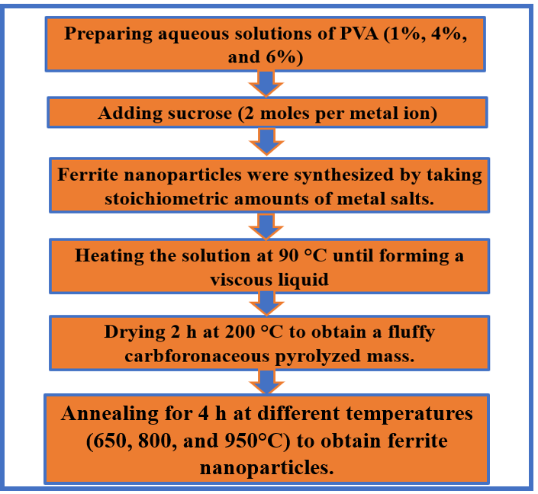
Figure 2.6 – Flow chart for the synthesis of ferrite utilizing self-combustion method
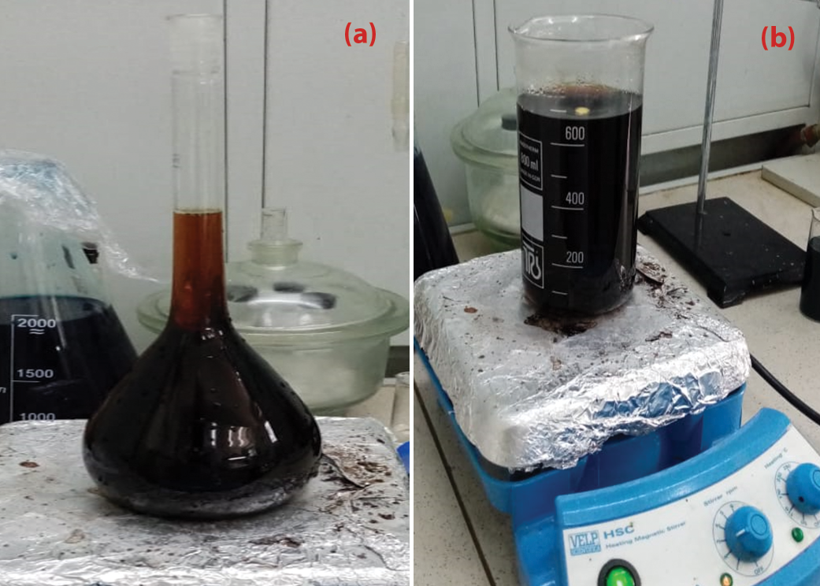
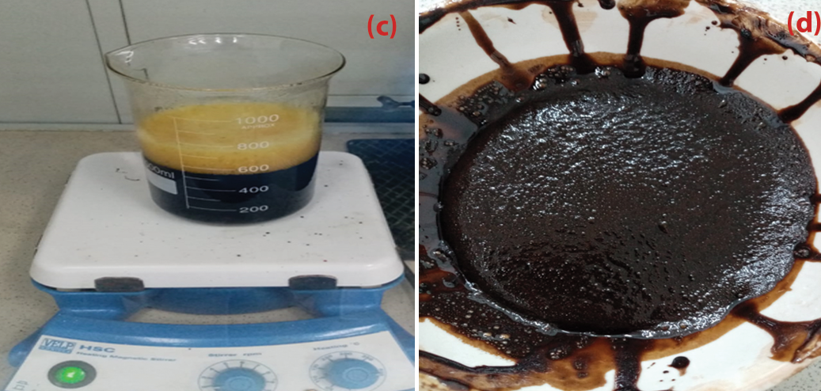
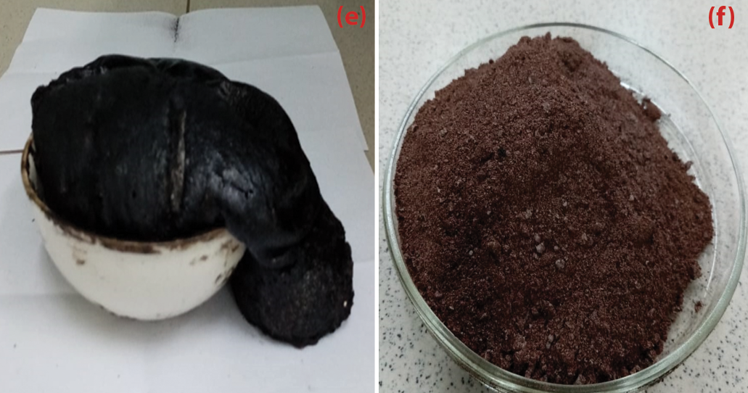
Figure 2.7 – Synthesis of NiZn ferrite nanoparticles by self-combustion method: (a) the metal salts aqueous solution in the flask, (b) blending the whole mixture, (c) heating the solution at 90 °C, (d) formation of a viscous liquid, (e) formation a fluffy carbonaceous pyrolyzed mass, and (f) obtaining nanoparticles ferrite

Preparation of microwave nanocomposites

Preparation of CB/F nanocomposites
Ni_{0.5}Zn_{0.5}Fe₂O₄ and Mn_{0.1}Ni_{0.5}Zn_{0.4}Fe₂O₄ nanoparticles were synthesized by citrate precursor and self-combustion method. Nanocomposites were synthesized by mixing ferrite nanoparticles with carbon black using a ball mill. Three different weight ratios of CB/Ni_{0.5}Zn_{0.5}Fe₂O₄ and CB/Mn_{0.1}Ni_{0.5}Zn_{0.4}Fe₂O₄ (1:1, 2:1, and 3:1) were prepared. The practical steps of preparing the CB/F samples are shown in Figure 2.9.
Table 2.6 – Symbols of nanocomposite samples
Nanocomposite | CB: F | Calcination temperature for ferrite (°C) | Sample symbol
CB/Ni_{0.5}Zn_{0.5}Fe₂O₄ | 1:1 | 650 | CB/F-11
CB/Ni_{0.5}Zn_{0.5}Fe₂O₄ | 2:1 | 650 | CB/F-21
CB/Ni_{0.5}Zn_{0.5}Fe₂O₄ | 3:1 | 650 | CB/F-31
CB/Mn_{0.1}Ni_{0.5}Zn_{0.4}Fe₂O₄ | 1:1 | 750 | CB/MF-11
CB/Mn_{0.1}Ni_{0.5}Zn_{0.4}Fe₂O₄ | 2:1 | 750 | CB/MF-21
CB/Mn_{0.1}Ni_{0.5}Zn_{0.4}Fe₂O₄ | 3:1 | 750 | CB/MF-31

Preparation of CI/F nanocomposites
Ni_{0.5}Zn_{0.5}Fe₂O₄ nanoparticles were synthesized by self-combustion method. Nanocomposites were synthesized by mixing ferrite nanoparticles with carbon black using a ball mill. Three different weight ratios of CI/Ni_{0.5}Zn_{0.5}Fe₂O₄ (1:1, 2:1, and 3:1) were prepared. Table 3.8 shows the symbols of nanocomposite samples.
Table 2.7 – Symbols of nanocomposite samples
Nanocomposite | CI: F | Calcination temperature for ferrite (°C) | Sample symbol
CI/Ni_{0.5}Zn_{0.5}Fe₂O₄ | 1:1 | 650 | CI/F-11
CI/Ni_{0.5}Zn_{0.5}Fe₂O₄ | 2:1 | 650 | CI/F-21
CI/Ni_{0.5}Zn_{0.5}Fe₂O₄ | 3:1 | 650 | CI/F-31

Preparation of F/CI/CB nanocomposites
Ni_{0.5}Zn_{0.5}Fe₂O₄ nanoparticles were synthesized by self-combustion method. Nanocomposites were synthesized by mixing ferrite nanoparticles and carbonyl iron with carbon black using a ball mill. Three different weight ratios of F/CI/CB (1:1:1, 1:1:2, and 2:1:1) were prepared. Table 2.8 shows the symbols of nanocomposite samples.
Table 2.8 – Symbols of nanocomposite samples
Sample symbols | Weight ratio
 | Ni_{0.5}Zn_{0.5}Fe₂O₄ | CI | CB
F/CI/CB-111 | 1 | 1 | 1
F/CI/CB-112 | 1 | 1 | 2
F/CI/CB-211 | 2 | 1 | 1
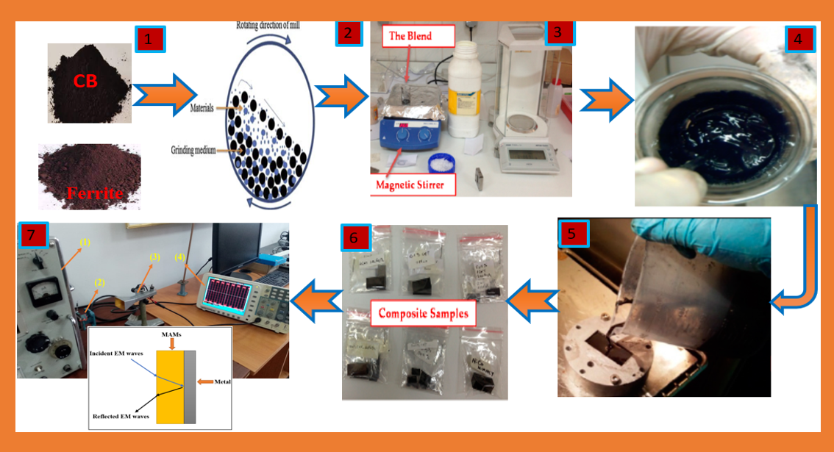
Figure 2.8 – Experimental steps of preparing the CB/F samples. From left to right: (1) preparing CB and F nanopowders, (2) mixing CB and F through ball mills, (3) blending CB and F with paraffin wax by a magnetic stirrer, (4) preparing mixture, (5) pouring the prepared mixture into the special mold (22.86 mm * 10.16 mm), (6) prepared samples, and (7) measuring the MA properties of the prepared samples

Preparing double-layer of AC/F
These products are obtained by dispersing one or more types of absorbent materials in a polymeric matrix and applying them to a substrate or surface. Understanding the techniques for producing microwave absorbent composites by incorporating components, additives, and a matrix type is crucial to the final usage of the resulting absorbent material.
Absorption is achieved by gradually decreasing the impedance starting from the dielectric layer, whose impedance is close to the impedance value of air, to secure the entry of most of the incident waves into the material and reduce reflection. Then the absorbent layers are graded with increasing impedance.
MAMs should be lightweight, prepared in various shapes, waterproof, chemically resistant, have good mechanical and physical properties, be easy to prepare, low cost, have a wide absorption field, and are strong absorption.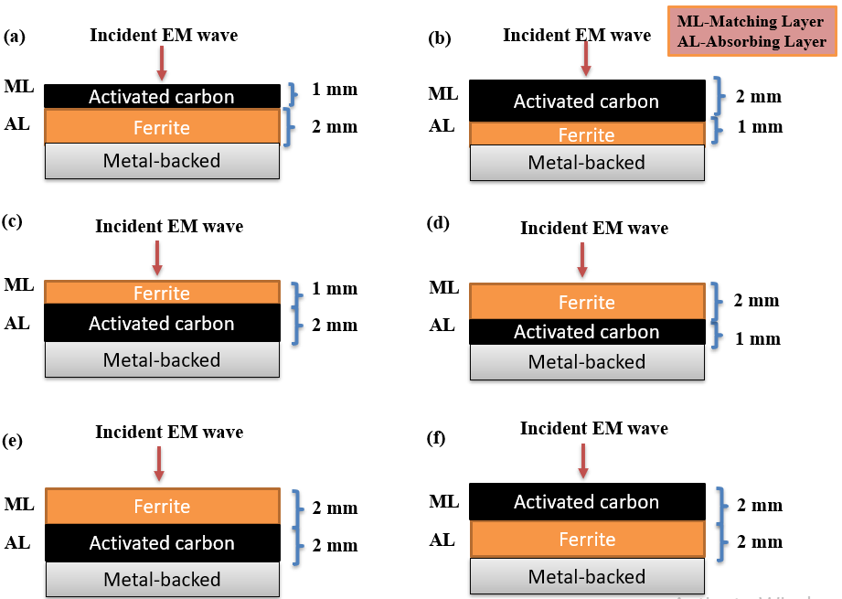
Figure 2.9 – DL structure of AC/F Cs with (a) 1 mm AC/1 mm F (AC/F-11), (b) 2 mm AC/1 mm F (AC/F-21), (c) 1 mm F/2 mm AC (F/AC-12), (d) 2 mm F/1 mm AC (F/AC-21), (e) 2 mm F/2 mm AC (F/AC-22), and (f) 2 mm AC/2 mm F (AC/F-22) thickness
Table 2.9 – Specifics on the DL structure of AC/F Cs
Sample symbols | ML | T(mm) | AL | T(mm)
AC/F-11 | Activated carbon | 1 | Ni_{0.5}Zn_{0.4}Mn_{0.1}Fe₂O₄ | 1
AC/F-21 | Activated carbon | 2 | Ni_{0.5}Zn_{0.4}Mn_{0.1}Fe₂O₄ | 1
F/AC-12 | Ni_{0.5}Zn_{0.4}Mn_{0.1}Fe₂O₄ | 1 | Activated carbon | 2
F/AC-21 | Ni_{0.5}Zn_{0.4}Mn_{0.1}Fe₂O₄ | 2 | Activated carbon | 1
F/AC-22 | Ni_{0.5}Zn_{0.4}Mn_{0.1}Fe₂O₄ | 2 | Activated carbon | 2
AC/F-22 | Activated carbon | 2 | Ni_{0.5}Zn_{0.4}Mn_{0.1}Fe₂O₄ | 2

Preparation of graphite/ferrite nanocompsoites
Ni³⁺_{0.25}Ni²⁺_{0.375}Zn²⁺_{0.25}Fe₂O₄ has been produced by international companies at high prices. In this regard, the relevance of the research topic of the doctoral dissertation is paving the way for putting the methodology and scientific bases for the manufacture of MAMs in the laboratory with the required international quality. As well as competing with commercial absorbers mentioned in the literature in terms of weight, reflection loss, absorption bandwidth, and shielding efficiency..
Table 2.10 – Symbols of nanocomposite samples
Nanocomposite | C: F | Heat treatment for ferrite (°C) | Sample symbol
C/ Ni³⁺_{0.25}Ni²⁺_{0.375}Zn²⁺_{0.25}Fe₂O₄ | 1:1 | 1100 | C/F-11
C/ Ni³⁺_{0.25}Ni²⁺_{0.375}Zn²⁺_{0.25}Fe₂O₄ | 2:1 | 1100 | C/F-21
C/ Ni³⁺_{0.25}Ni²⁺_{0.375}Zn²⁺_{0.25}Fe₂O₄ | 3:1 | 1100 | C/F-31

Preparation of hybrid nanocomposites

Coating NiZn spinel nanoferrite with PANI
The The development of radar or microwave absorbing materials technology has had a great impact on the military field. Radar absorbing materials are significant tools in electronic warfare, as they can be used to hide targets and protect them from radar detection. EM shielding materials and RAMs have been produced by international companies at high prices. In this regard, the relevance of the research topic of the doctoral dissertation is paving the way for putting the methodology and scientific bases for the manufacture of MAMs in the laboratory with the required international quality. As well as competing with commercial absorbers mentioned in the literature in terms of weight, reflection loss, absorption bandwidth, and shielding efficiency.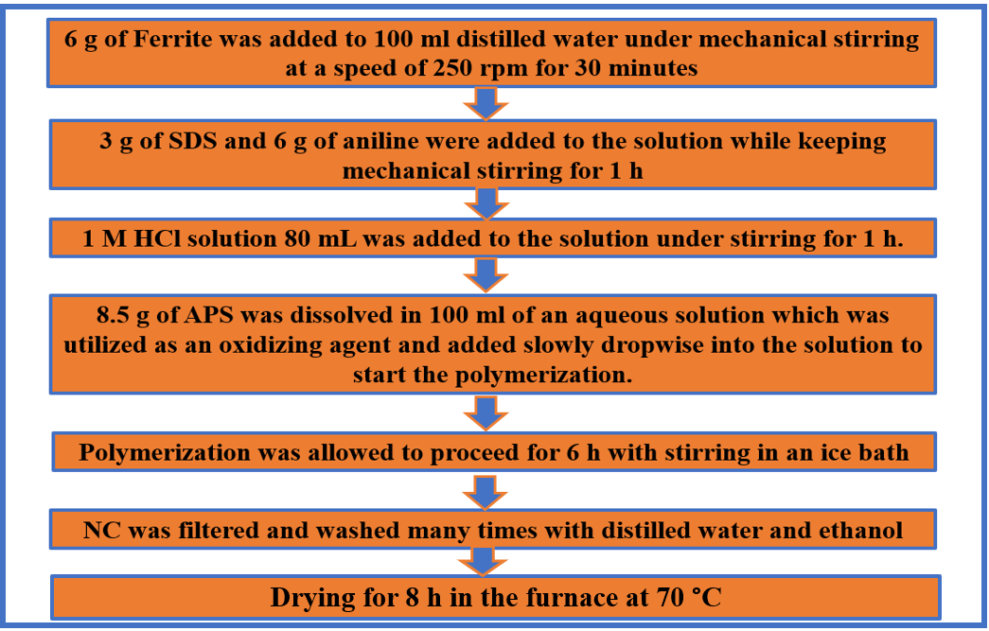
Figure 2.10 – Flow chart for the synthesis of PANI/F utilizing in-situ polymerization technique
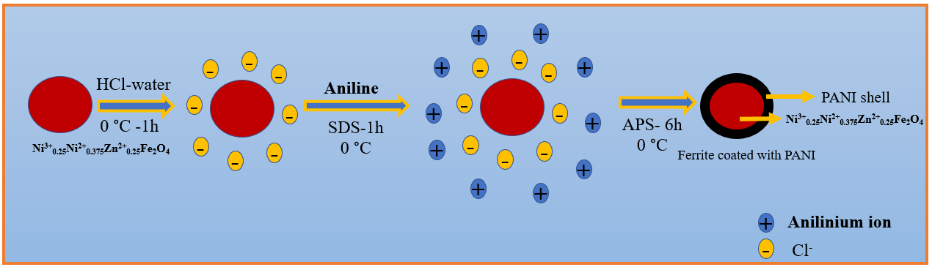
Figure 2.11 – Schematic diagram of a polyaniline/NiZn ferrite by the in-situ polymerization technique

Preparation of PANI/CI and PANI/F/CI
PANI/CI nanocomposites were prepared using in-situ polymerization technique of PANI in the CI. The weight ratio of aniline/CI (1/1) was synthesized. On the other hand, Ternary composites of polyaniline/NiZn ferrite/carbonyl iron (PANI/F/CI) were prepared in two stages: Firstly, Ni_{0.5}Zn_{0.5}Fe₂O₄ were prepared using citrate precursor method. After that, PANI/90%F/10%CI composites were prepared using in-situ polymerization technique of PANI in the Ni_{0.5}Zn_{0.5}Fe₂O₄ and CI. The weight ratio of aniline/(F-CI) (1/1) was synthesized.
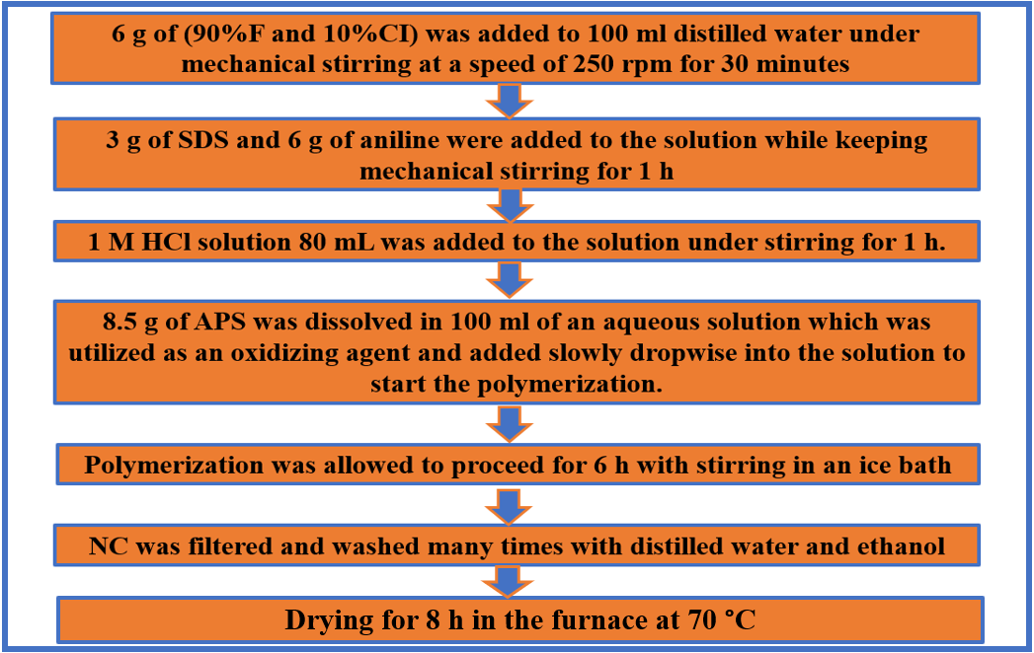
Figure 2.12 – Flow chart for the synthesis of PANI/F/CI utilizing in-situ polymerization technique

Preparation of PANI/CB and PANI/F/CB
PANI/CB nanocomposites were prepared using in-situ polymerization technique of PANI in the existence of the CB. The weight ratio of aniline/CB (1/1) was synthesized. On the other hand, Ternary composites of polyaniline/NiZn ferrite/carbon black (PANI/F/CB) were prepared via two stages: Firstly, Ni³⁺_{0.25}Ni²⁺_{0.375}Zn²⁺_{0.25}Fe₂O₄ was prepared using a ceramic sintering method. After that, PANI/F/CB composites are prepared using in-situ polymerization technique of PANI in the existence of the Ni³⁺_{0.25}Ni²⁺_{0.375}Zn²⁺_{0.25}Fe₂O₄ and CB. The weight ratio of aniline/ (90%,70% and 50%F-10%,30% and 50%CB) (1/1) was synthesized.

Coating BaNiZnFe₁₆O₂₇ hexagonal nano ferrite with PANI
BaNiZnFe₁₆O₂₇ have been used extensively to cover the walls of anechoic halls and to prevent or reduce electromagnetic reflections from large bodies. RAMs can be produced in different forms, such as paints, thin films, sheets, and sponges. These products are obtained by dispersing one or more types of absorbent materials in a polymeric matrix and applying them to a substrate or surface. Understanding the techniques for producing microwave absorbent composites by incorporating components, additives, and a matrix type is crucial to the final usage of the resulting absorbent material.
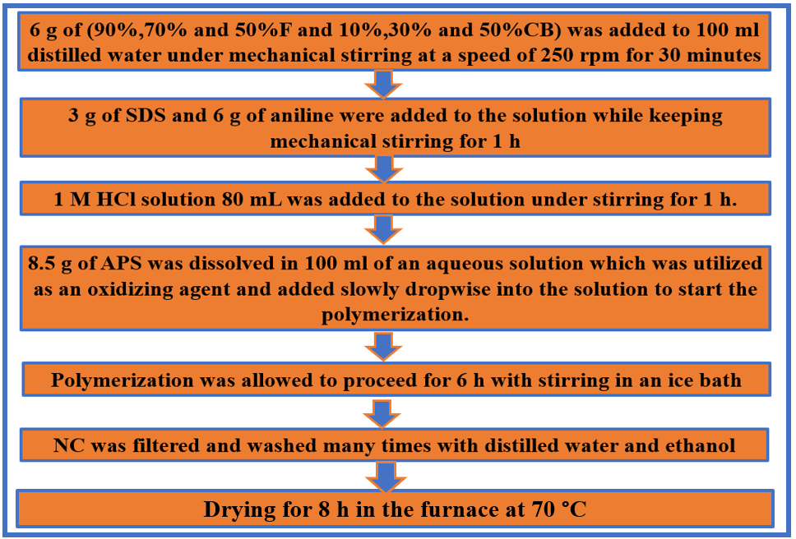
Figure 2.13 – Flow chart for the synthesis of PANI/F/CB utilizing in-situ polymerization technique

Preparation of PANI/SF/HF and PANI/SF/HF/CB
Ternary composites of polyaniline/Ni³⁺_{0.25}Ni²⁺_{0.375}Zn²⁺_{0.25}Fe₂O₄/BaNiZnFe₁₆O₂₇ (PANI/SF/HF) were prepared via two stages: Firstly, Ni³⁺_{0.25}Ni²⁺_{0.375}Zn²⁺_{0.25}Fe₂O₄ and BaNiZnFe₁₆O₂₇ were prepared using the ceramic sintering method. After that, PANI/50%SF/50%HF nanocomposites were prepared using in-situ polymerization technique of PANI in the existence of the Ni_{0.5}Zn_{0.5}Fe₂O₄ and BaNiZnFe₁₆O₂₇. The weight ratio of aniline/(SF-HF) (1/1) was synthesized. On the other hand, PANI/45%SF/45%HF/10%CB was also prepared using in-situ polymerization technique. The weight ratio of aniline/(SF-HF-CB) (1/1) was synthesized.

Chapter 3: Results and discussion

XRD patterns

X-ray diffraction of undoped ferrites
Figure 3.1 shows the XRD patterns of the NiFe₂O₄, ZnFe₂O₄, MnFe₂O₄ and CuFe₂O₄. For undoped ferrites pattern, six diffraction peaks were detected, which conform to (hkl) planes of (220), (311), (400), (422), (511) and (440), respectively. The XRD figures of ferrites showed the formation of a single-phase cubic spinel structure with no impurity peaks. The XRD patterns of undoped ferrites were totally matched with the reference XRD patterns (JCPDS, PDF no. 01-086–2267, JCPDS, PDF. no. 00-022-012, and JCPDS, PDF. no. 00-010–0319).
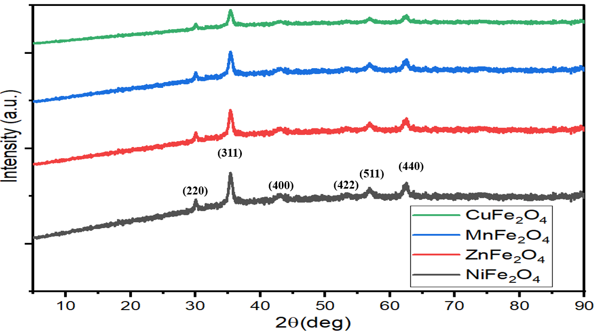
Figure 3.1 – XRD patterns of the NiFe₂O₄, ZnFe₂O₄, MnFe₂O₄ and CuFe₂O₄

X-ray diffraction of doped ferrites samples prepared by the ceramic sintering technique
Figure 3.2 shows the XRD patterns of the Mn_{x}Zn_{(1-x)}Fe₂O₄ (x= 0.3, 0.6, 0.9), Ni_{x}Zn_{(1-x)}Fe₂O₄ (x= 0.25, 0.5, 0.75), Mn_{0.1}Ni_{(0.4+x)}Zn_{(0.5-x)}Fe₂O₄ (x= 0.0, 0.1, 0.2), Ni³⁺_{0.25}Ni²⁺_{0.375}Zn²⁺_{0.25}Fe₂O₄, Cu²⁺_{0.1}Ni³⁺_{0.15}Ni²⁺_{0.225}Zn²⁺_{0.45}Fe₂O₄ and BaNiZnFe₁₆O₂₇. For Mn_{x}Zn_{(1-x)}Fe₂O₄ and Ni_{x}Zn_{(1-x)}Fe₂O₄ pattern, six diffraction peaks were detected. On the other hand, for Mn_{0.1}Ni_{(0.4+x)}Zn_{(0.5-x)}Fe₂O_{4,} Ni³⁺_{0.25}Ni²⁺_{0.375}Zn²⁺_{0.25}Fe₂O₄ and Cu²⁺_{0.1}Ni³⁺_{0.15}Ni²⁺_{0.225}Zn²⁺_{0.45}Fe₂O₄ patterns, nine diffraction peaks were noticed. The XRD figures of spinel ferrites indicated the formation of a single-phase cubic spinel structure with no impurity peaks. All the observed peaks of the spinel ferrites were matched. For the BaNiZnFe₁₆O₂₇ pattern, eleven diffraction peaks were noticed. The hexagonal ferrites' observed peaks were matched. The size of the ferrite grains (hkl (311)) has been evaluated with Scherrer’s equation, D=0.9 λ/β cosθ, where D is the crystallite size (nm), λ is the X-ray wavelength, β is the bandwidth at half-height, and θ is the diffraction angle in degree. Table 3.1 displays the calculated crystallite size of Ni_{0.5}Zn_{0.5}Fe₂O₄. 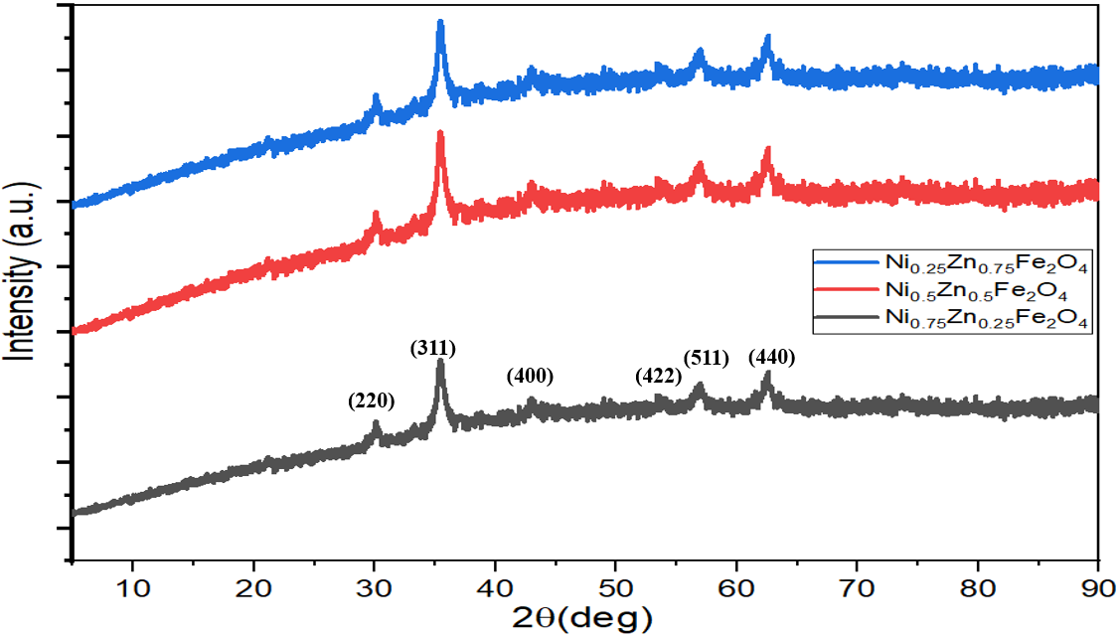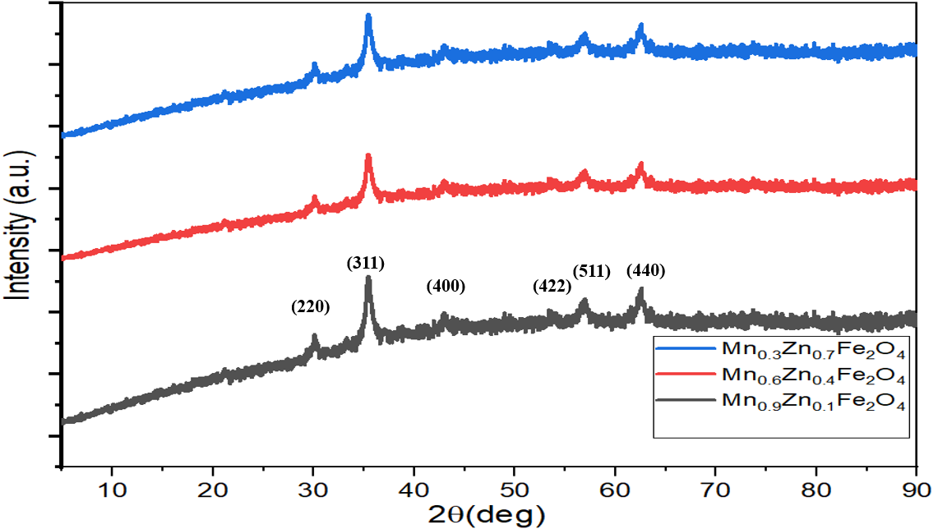
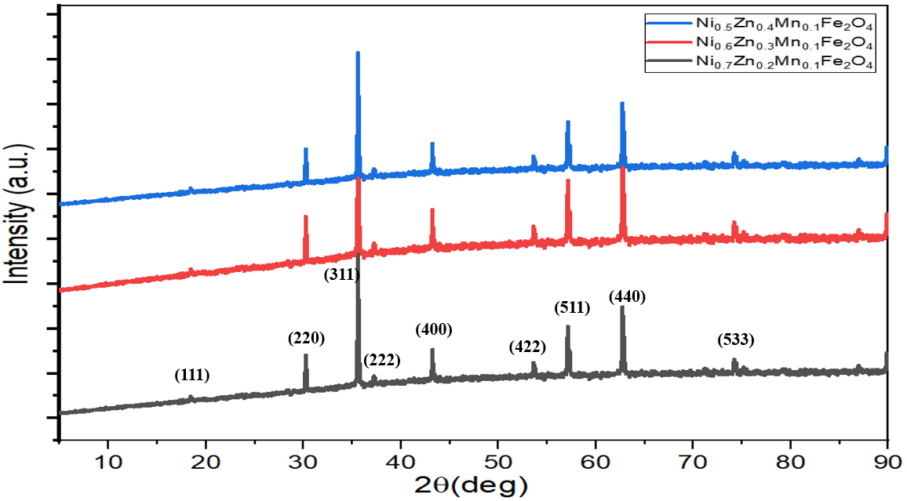
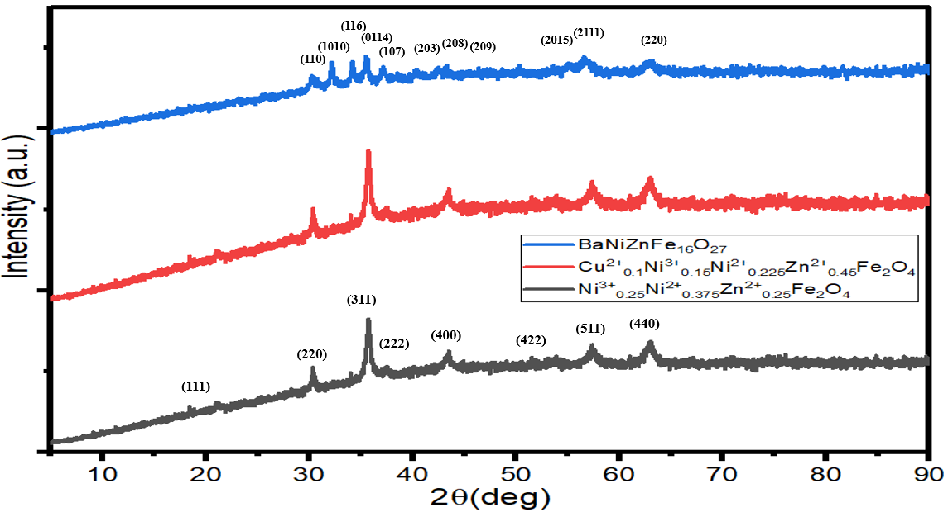
Figure 3.2 – XRD patterns of the Mn_{x}Zn_{(1-x)}Fe₂O₄ (x= 0.3, 0.6, 0.9), Ni_{x}Zn_{(1-x)}Fe₂O₄ (x= 0.25, 0.5, 0.75), Mn_{0.1}Ni_{(0.4+x)}Zn_{(0.5-x)}Fe₂O₄ (x= 0.1, 0.2, 0.3), Ni³⁺_{0.25}Ni²⁺_{0.375}Zn²⁺_{0.25}Fe₂O₄, Cu²⁺_{0.1}Ni³⁺_{0.15}Ni²⁺_{0.225}Zn²⁺_{0.45}Fe₂O₄ and BaNiZnFe₁₆O₂₇
Table 3.1 – Crystallite size of doped ferrites
Sample | K | λ (A) | 2ϴ (°) | FWHM (°) | Crystallite size (nm)
Ni_{0.25}Zn_{0.75}Fe₂O₄ | 0.94 | 1.54178 | 35.41 | 0.16447 | 52.9
Ni_{0.5}Zn_{0.5}Fe₂O₄ | 0.94 | 1.54178 | 35.45 | 0.16842 | 51.7
Ni_{0.75}Zn_{0.25}Fe₂O₄ | 0.94 | 1.54178 | 35.51 | 0.17931 | 48.6
Mn_{0.3}Zn_{0.7}Fe₂O₄ | 0.94 | 1.54178 | 35.62 | 0.18421 | 47.3
Mn_{0.6}Zn_{0.4}Fe₂O₄ | 0.94 | 1.54178 | 35.42 | 0.16362 | 53.2
Mn_{0.9}Zn_{0.1}Fe₂O₄ | 0.94 | 1.54178 | 35.61 | 0.15834 | 55.1
Ni_{0.5}Zn_{0.4}Mn_{0.1}Fe₂O₄ | 0.94 | 1.54178 | 35.65 | 0.16379 | 53.2
Ni_{0.6}Zn_{0.3}Mn_{0.1}Fe₂O₄ | 0.94 | 1.54178 | 35.43 | 0.17027 | 51.2
Ni_{0.7}Zn_{0.2}Mn_{0.1}Fe₂O₄ | 0.94 | 1.54178 | 35.55 | 0.16447 | 53.1
Ni³⁺_{0.25}Ni²⁺_{0.375}Zn²⁺_{0.25}Fe₂O₄ | 0.94 | 1.54178 | 35.48 | 0.17471 | 49.9
Cu²⁺_{0.1}Ni³⁺_{0.15}Ni²⁺_{0.225}Zn²⁺_{0.45}Fe₂O₄ | 0.94 | 1.54178 | 35.53 | 0.16323 | 53.4

X-ray diffraction of ferrite samples prepared by citrate precursor technique
Figure 3.3 displays the XRD patterns of Ni_{0.5}Zn_{0.5}Fe₂O₄. The effect of the different molar ratios of the metal ion/citrate acid (1:1, 2:1 and 3:1) and the different calcination temperatures (650, 800 and 950°C) was investigated on the ferrite properties. The XRD Figures of ferrites showed the formation of a single-phase cubic spinel structure with no impurity peaks [108]. One can observe that the crystallite size of nickel-zinc ferrite increased by increasing the metal ion concentrations during the preparation process of the ferrite, regardless of the calcination temperature, which will impact its EMI shielding and MA properties, as will be clarified later.
Table 3.2 – Crystallite size of Ni_{0.5}Zn_{0.5}Fe₂O₄
Sample | K | λ (A) | 2ϴ (°) | FWHM (°) | Crystallite size (nm)
NZ₁₁ ₋ 650 | 0.94 | 1.54178 | 35.44 | 0.31603 | 27.5
NZ₁₂ ₋ 650 | 0.94 | 1.54178 | 35.43 | 0.28904 | 30.1
NZ₁₃ ₋ 650 | 0.94 | 1.54178 | 35.62 | 0.21431 | 40.7
NZ₁₁ ₋ 800 | 0.94 | 1.54178 | 35.37 | 0.27702 | 31.5
NZ₁₂ ₋ 800 | 0.94 | 1.54178 | 35.54 | 0.25410 | 34.3
NZ₁₃ ₋ 800 | 0.94 | 1.54178 | 35.62 | 0.19422 | 44.9
NZ₁₁ ₋ 950 | 0.94 | 1.54178 | 35.46 | 0.26351 | 33.1
NZ₁₂ ₋ 950 | 0.94 | 1.54178 | 35.41 | 0.23678 | 36.8
NZ₁₃ ₋ 950 | 0.94 | 1.54178 | 35.56 | 0.17982 | 48.5
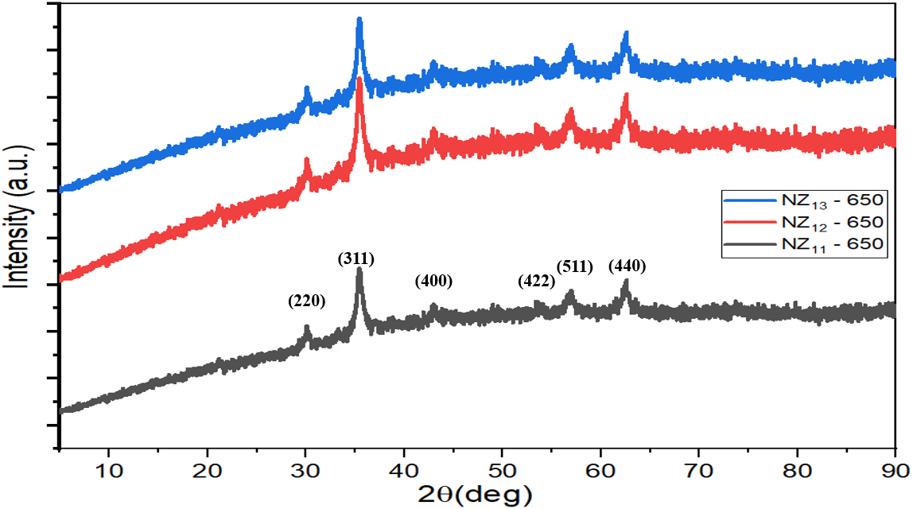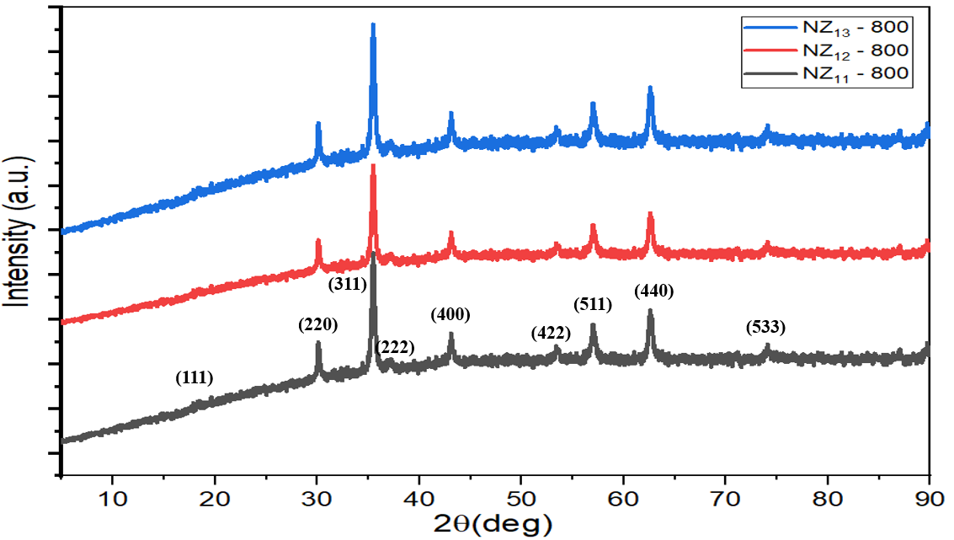
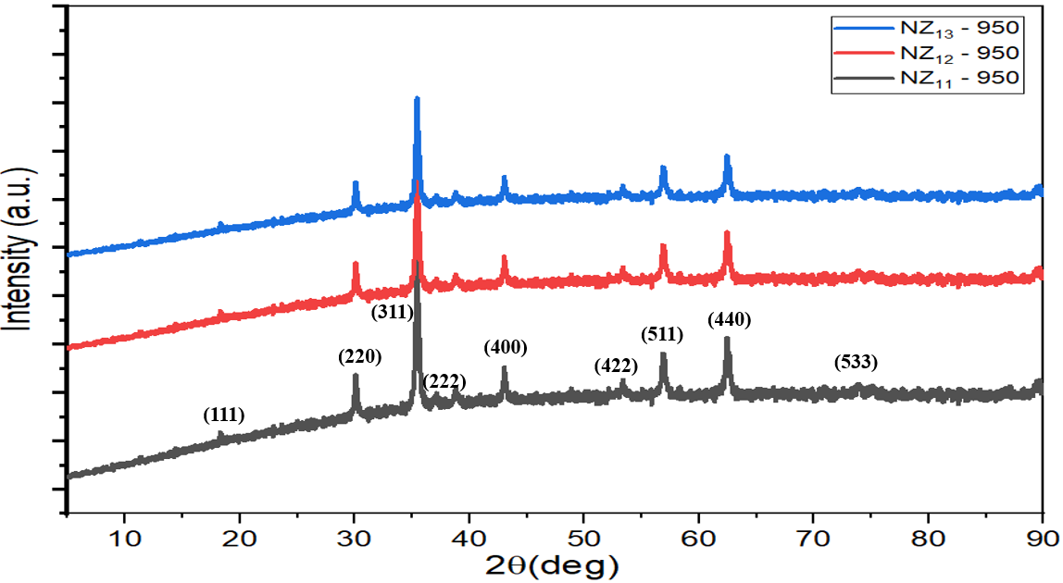
Figure 3.3 – XRD patterns at Ni_{0.5}Zn_{0.5}Fe₂O₄ of the different molar ratios of the metal ion/citrate acid (1:1, 2:1, and 3:1) at the different calcination temperatures (650, 800, and 950°C)
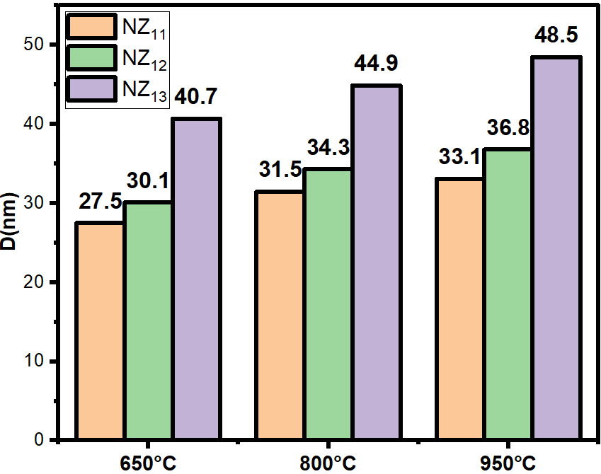
Figure 3.4 – Change of crystallite size of nickel-zinc ferrite prepared by citrate precursor method by changing the preparation conditions (calcination temperatures, metal ion concentrations)

X-ray diffraction of ferrite samples prepared by the self-combustion technique
Figure 3.5 displays the XRD patterns of Ni_{0.5}Zn_{0.5}Fe₂O₄. The effect of the different aqueous solutions of PVA (1%, 4% and 6%) and the different calcination temperatures (650, 800 and 950°C) were studied on the ferrite properties. The XRD Figures of ferrites showed the formation of a single-phase cubic spinel structure with no impurity peaks [108]. The XRD patterns results showed that the crystallite size of nickel-zinc ferrite increased by increasing the calcination temperature, as shown in Table 3.3 and Figure 3.6. One can notice that the crystallite size of nickel-zinc ferrite increased by increasing the PVA concentrations during the preparation process of the ferrite, regardless of calcination temperature, which will affect its EMI shielding and MA properties, as will be explained later.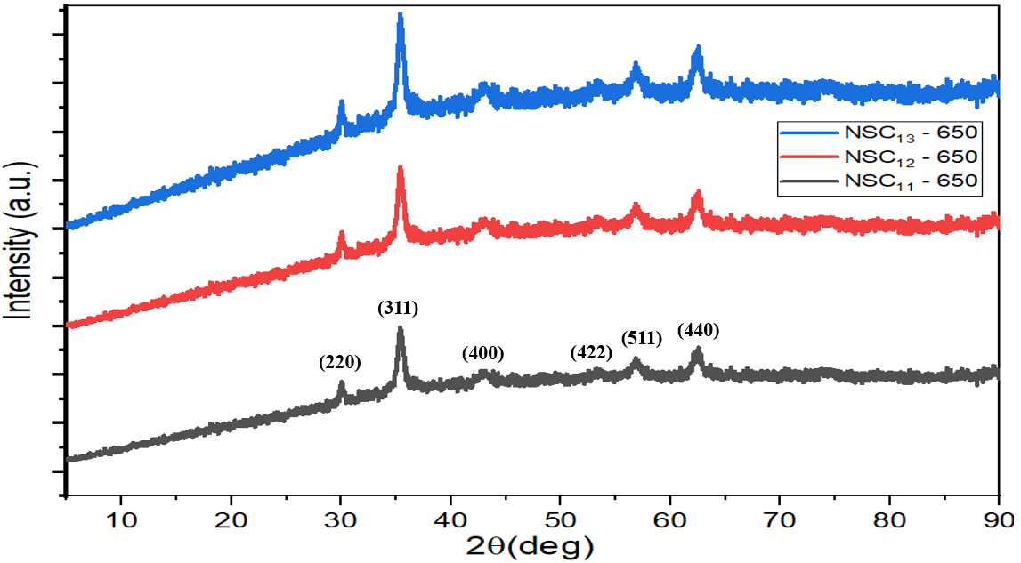 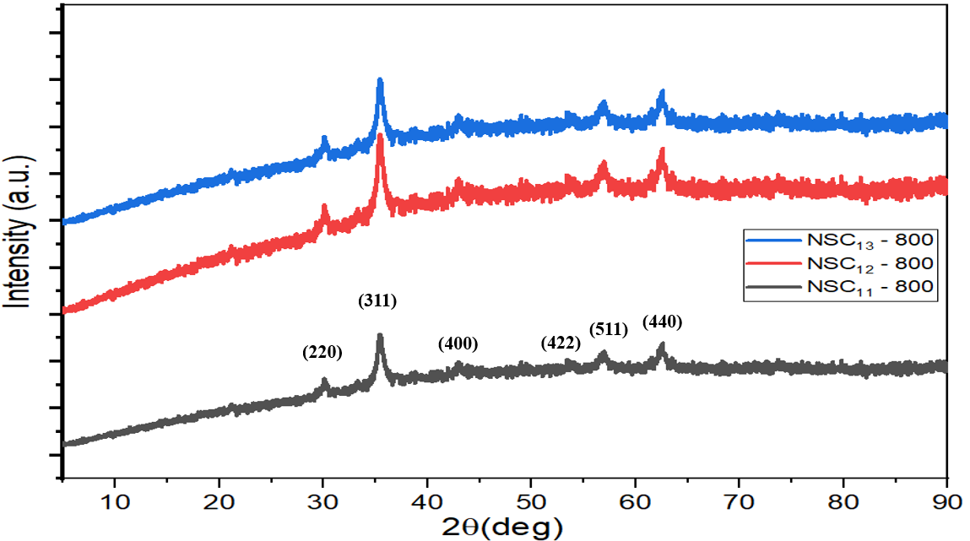
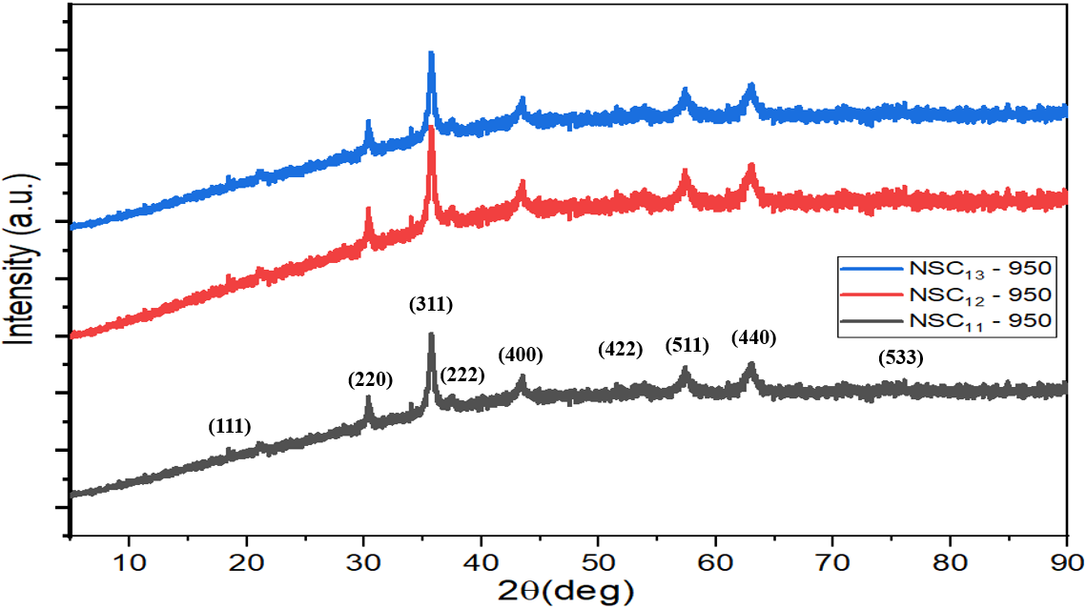
Figure 3.5 – XRD patterns of Ni_{0.5}Zn_{0.5}Fe₂O₄ at the different aqueous solutions of PVA (1%, 4%, and 6%) at the different calcination temperatures (650, 800, and 950°C)
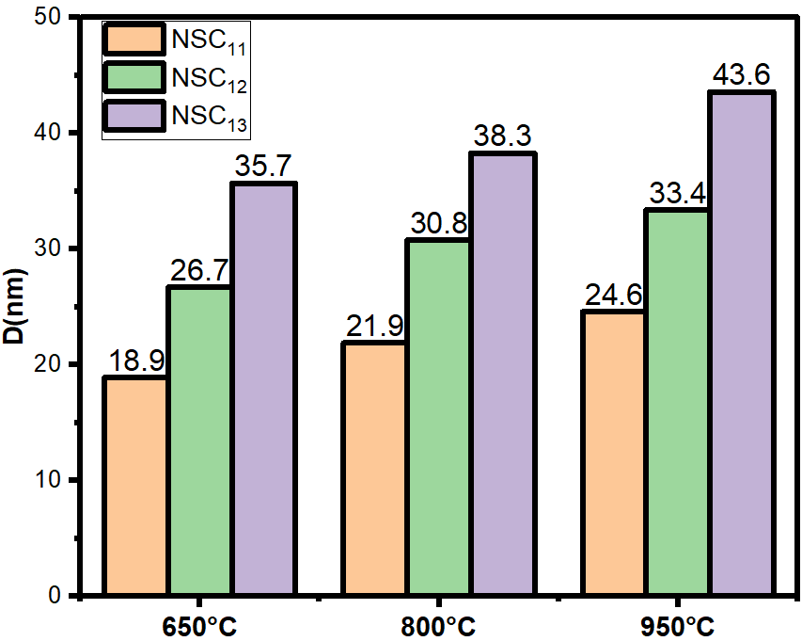
Figure 3.6 – Change of crystallite size of ferrites prepared by self-combustion method by changing the preparation conditions (calcination temperatures, PVA concentrations)
Table 3.3 – Crystallite size of Ni_{0.5}Zn_{0.5}Fe₂O₄
Sample | K | λ (A) | 2ϴ (°) | FWHM (°) | Crystallite size (nm)
NSC₁₁ ₋ 650 | 0.94 | 1.54178 | 35.46 | 0.46131 | 18.9
NSC₁₂ ₋ 650 | 0.94 | 1.54178 | 35.49 | 0.32637 | 26.7
NSC₁₃ ₋ 650 | 0.94 | 1.54178 | 35.51 | 0.24416 | 35.7
NSC₁₁ ₋ 800 | 0.94 | 1.54178 | 35.47 | 0.39641 | 21.9
NSC₁₂ ₋ 800 | 0.94 | 1.54178 | 35.61 | 0.28230 | 30.8
NSC₁₃ ₋ 800 | 0.94 | 1.54178 | 35.52 | 0.22735 | 38.3
NSC₁₁ ₋ 950 | 0.94 | 1.54178 | 35.45 | 0.35471 | 24.6
NSC₁₂ ₋ 950 | 0.94 | 1.54178 | 35.48 | 0.26129 | 33.4
NSC₁₃ ₋ 950 | 0.94 | 1.54178 | 35.49 | 0.19521 | 43.6

X-ray diffraction of carbon black, activated carbon, graphite and carbonyl iron
These products are obtained by dispersing one or more types of absorbent materials in a polymeric matrix and applying them to a substrate or surface. Understanding the techniques for producing microwave absorbent composites by incorporating components, additives, and a matrix type is crucial to the final usage of the resulting absorbent material.
Absorption is achieved by gradually decreasing the impedance starting from the dielectric layer, whose impedance is close to the impedance value of air, to secure the entry of most of the incident waves into the material and reduce reflection. Then the absorbent layers are graded with increasing impedance.
MAMs should be lightweight, prepared in various shapes, waterproof, chemically resistant, have good mechanical and physical properties, be easy to prepare, low cost, have a wide absorption field, and are strong absorption.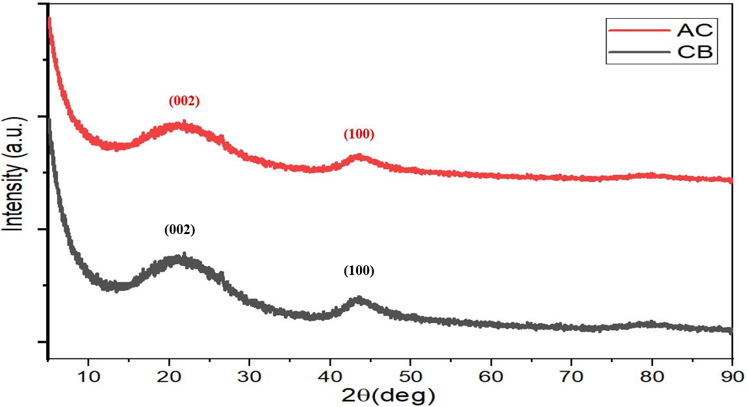
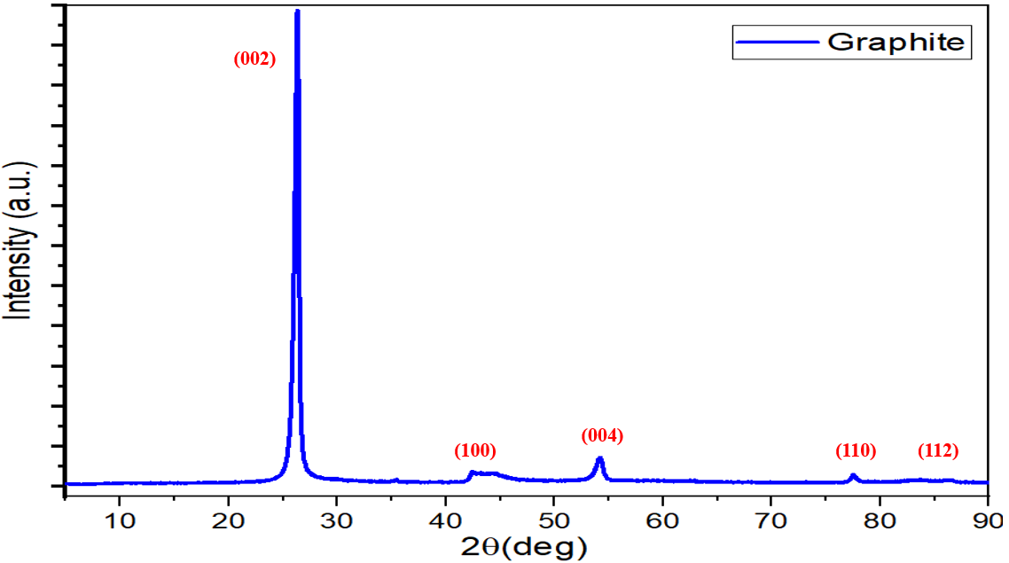
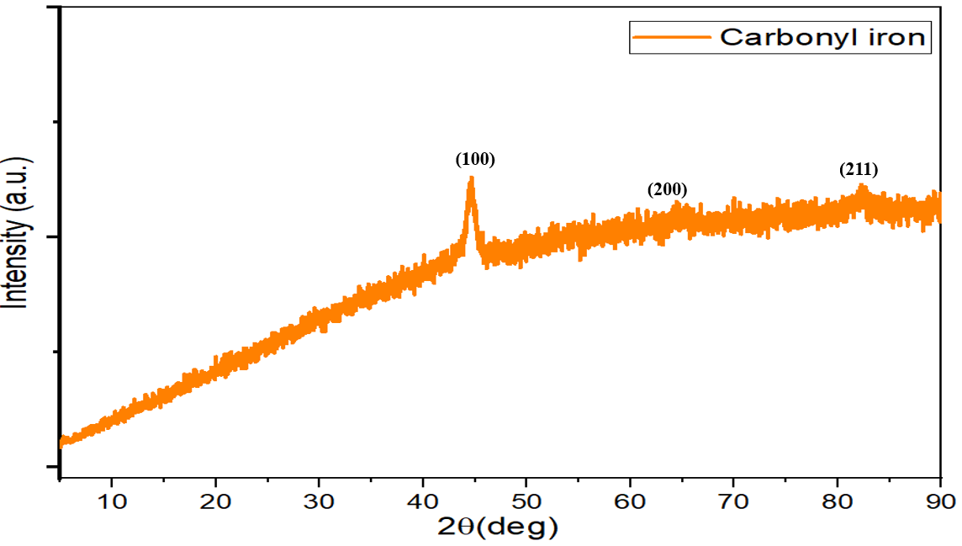
Figure 3.7 – XRD patterns of CB, AC, C and CI

X-ray diffraction of PANI-based nanocomposites
Figure 3.8 EM shielding materials and RAMs have been produced by international companies at high prices. In this regard, the relevance of the research topic of the doctoral dissertation is paving the way for putting the methodology and scientific bases for the manufacture of MAMs in the laboratory with the required international quality. As well as competing with commercial absorbers mentioned in the literature in terms of weight, reflection loss, absorption bandwidth, and shielding efficiency [111,112].
The results obtained in the framework of this thesis can be suggested for producing microwave absorbers synthesized based on ML and DL materials. An advantage of the work is that obtained absorbers can attenuate the EM waves with low surface density and wide bandwidth. These microwave absorbers can be used to cover the walls of anechoic chambers and to prevent or reduce electromagnetic reflections from large bodies such as stealth aircraft, submarines, carriers, and so on [113,114].
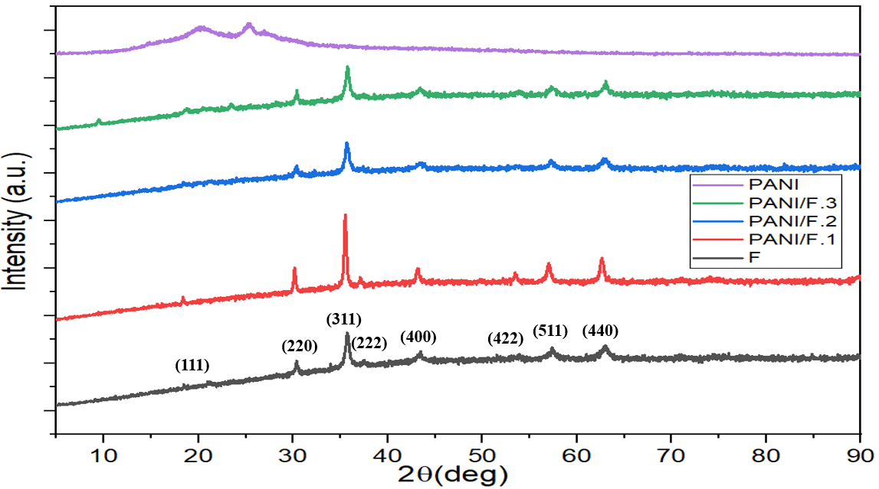
Figure 3.8 – XRD patterns of Ni³⁺_{0.25}Ni²⁺_{0.375}Zn²⁺_{0.25}Fe₂O_{4,} PANI/Ni³⁺_{0.25}Ni²⁺_{0.375}Zn²⁺_{0.25}Fe₂O₄ nanocomposites and pure PANI
The XRD patterns of Ni_{0.5}Zn_{0.5}Fe₂O₄, CI, PANI/CI and PANI/F/CI nanocomposite are shown in Figure 3.9. The characteristic peaks of the PANI/F/CI hybrid nanocomposite showed matching the characteristic peaks of Ni_{0.5}Zn_{0.5}Fe₂O₄ as cited above. The XRD patterns of the PANI/F/CI hybrid nanocomposite showed crystalline peaks because of the existence of NiZn ferrite in this composite.
Figure 3.10 displays the XRD patterns of the PANI/CB, PANI/90%F/10%CB, PANI/70%F/30%CB and PANI/50%F/50%CB hybrid nanocomposite. For the PANI/F/CB patterns, eight diffraction peaks were detected. The characteristic peaks of PANI/F/CB nanocomposites matched the characteristic peaks of Ni³⁺_{0.25}Ni²⁺_{0.375}Zn²⁺_{0.25}Fe₂O₄ as mentioned above. For PANI/CB pattern, two diffraction peaks were noticed. The characteristic peaks of PANI/CB nanocomposites matched the characteristic peaks of carbon black, as cited above.
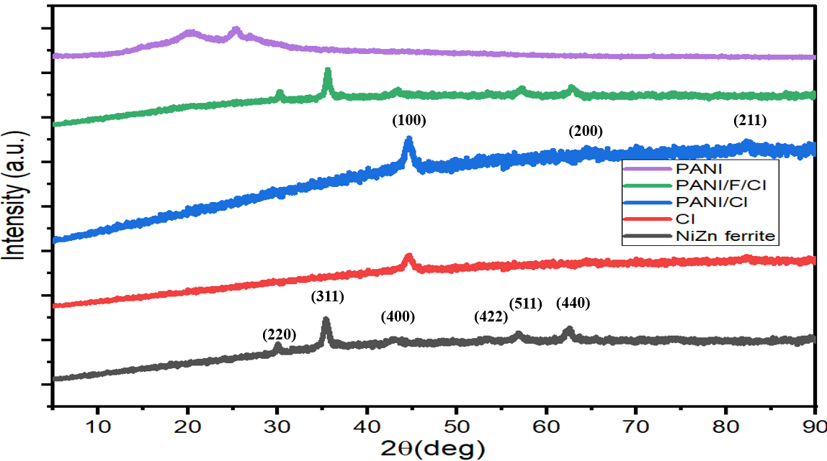
Figure 3.9 – XRD patterns of Ni_{0.5}Zn_{0.5}Fe₂O_{4,} CI, PANI/F/CI, PANI/F/CI nanocomposites and pure PANI
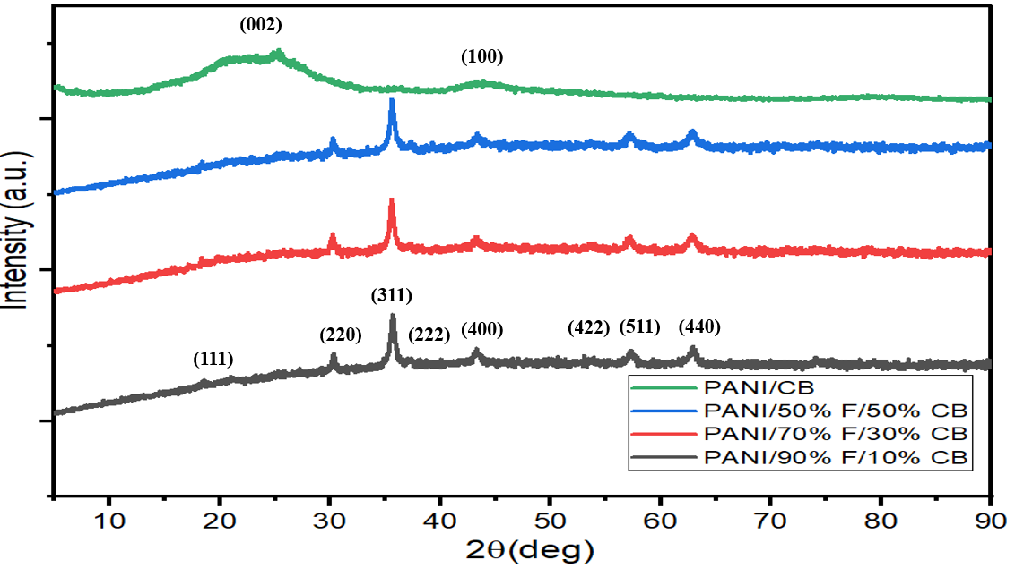
Figure 3.10 – XRD patterns of PANI/F/CB and PANI/CB hybrid nanocomposites
Figure 3.11 shows the XRD patterns of the HF and PANI/HF nanocomposites. The characteristic peaks of PANI/HF nanocomposites showed matching the characteristic peaks of the BaNiZnFe₁₆O₂₇ core as cited above. This was shown when the BaNiZnFe₁₆O₂₇ magnetic core was coated with PANI. The hexagonal structure of the BaNiZnFe₁₆O₂₇ magnetic core remained intact. The XRD patterns of the PANI/BaNiZnFe₁₆O₂₇ nanocomposites displayed crystalline peaks because of the existence of BaNiZnFe₁₆O₂₇ in these nanocomposites. The XRD patterns of PANI/SF/HF and PANI/SF/HF/CB hybrid nanocomposite are shown in Figure 3.11. For the PANI/SF/HF and PANI/SF/HF/CB patterns, eleven diffraction peaks were detected, which conform to (110), (1010), (116), (0114), (107), (203), (208), (209), (2015), (2111) and (220), respectively.
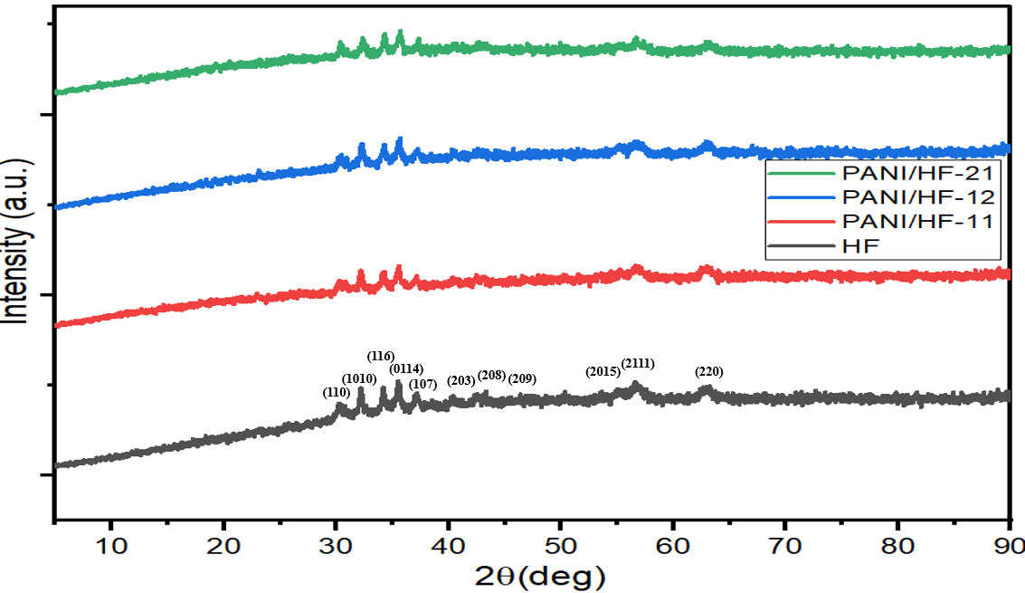
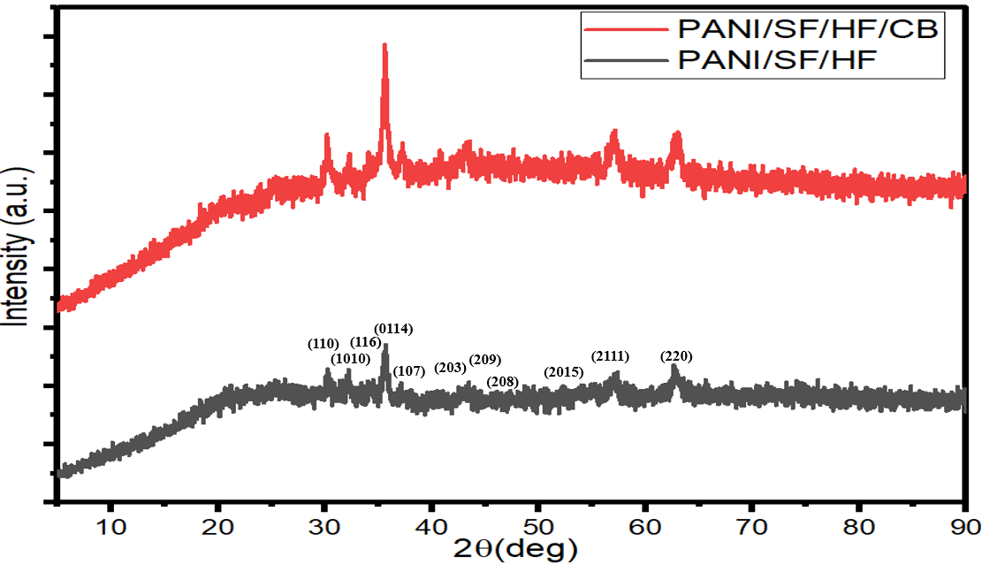
Figure 3.11 – XRD patterns of HF, PANI/HF, PANI/SF/HF and PANI/SF/HF/CB

FTIR spectra

FTIR spectra of ferrites prepared by the ceramic sintering technique
Figure 3.12 displays the FTIR spectra of the undoped and doped ferrites. The peaks within the range (550–590 cm⁻¹) were due to the stretching vibration of (Fe-O) at the tetrahedral sites, while the peaks located in the sites less than 460 cm⁻¹ were due to the stretching vibration of (Fe-O) at the octahedral sites [115].
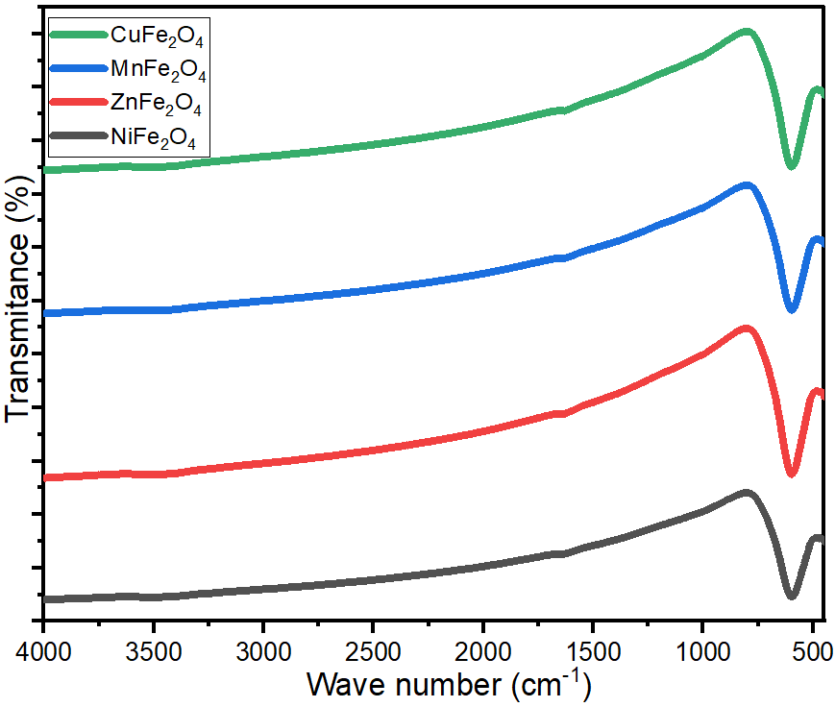
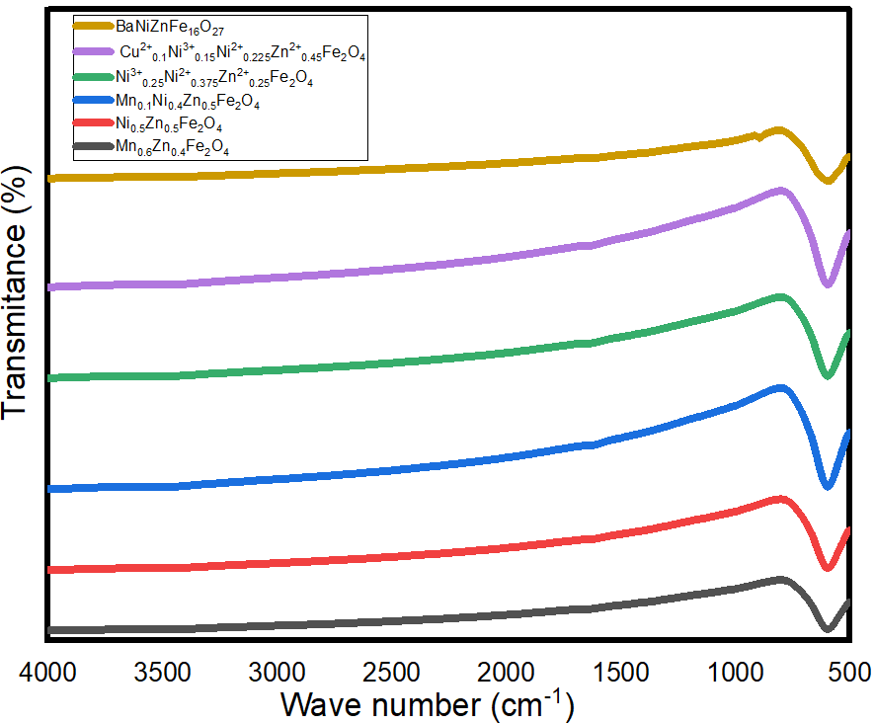
Figure 3.12 – FTIR spectra of undoped and doped ferrites

FTIR spectra of ferrite samples prepared by citrate precursor and self-combustion technique
Figure 4.13 and Figures 4.14 show the FTIR spectra of Ni_{0.5}Zn_{0.5}Fe₂O₄ prepared by citrate precursor and self-combustion technique. The peaks within the range (560–590 cm⁻¹) were due to the stretching vibration of (Fe-O) at the tetrahedral sites, while the peaks located in the sites less than 460 cm⁻¹ were due to the stretching vibration of (Fe-O) at the octahedral sites [115]. In addition, the peaks within the range (1630–1640 cm⁻¹) were due to the stretching vibration of C=O and the peaks at 2348 cm⁻¹ and 3452 cm⁻¹ referred to O-H stretching vibration [116,117].
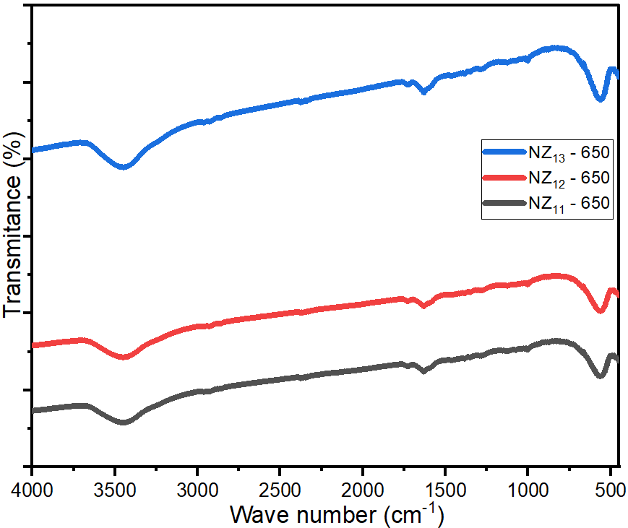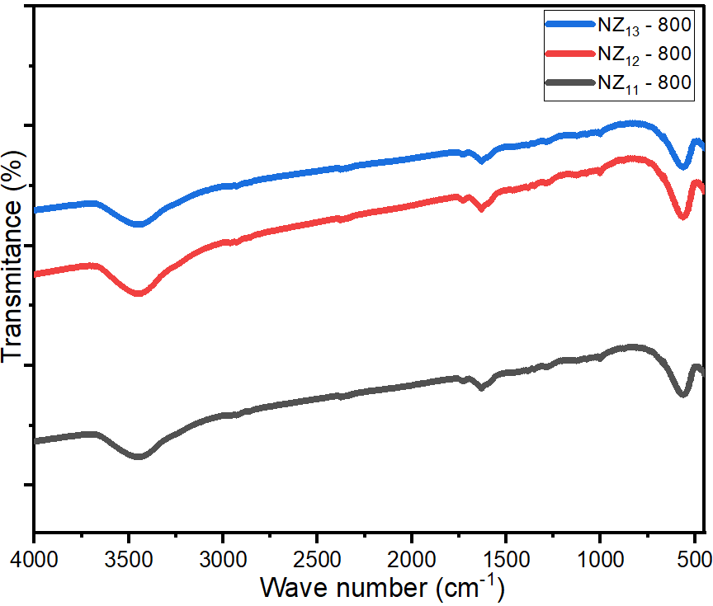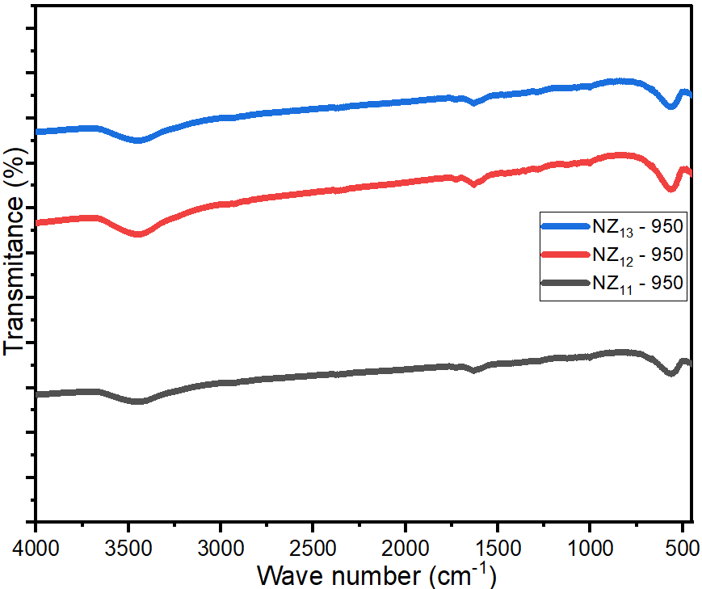
Figure 3.13 – FTIR spectra of Ni_{0.5}Zn_{0.5}Fe₂O₄ at the different molar ratios of the metal ion/citrate acid (1:1, 2:1 and 3:1) at the different calcination temperatures (650, 800 and 950°C)
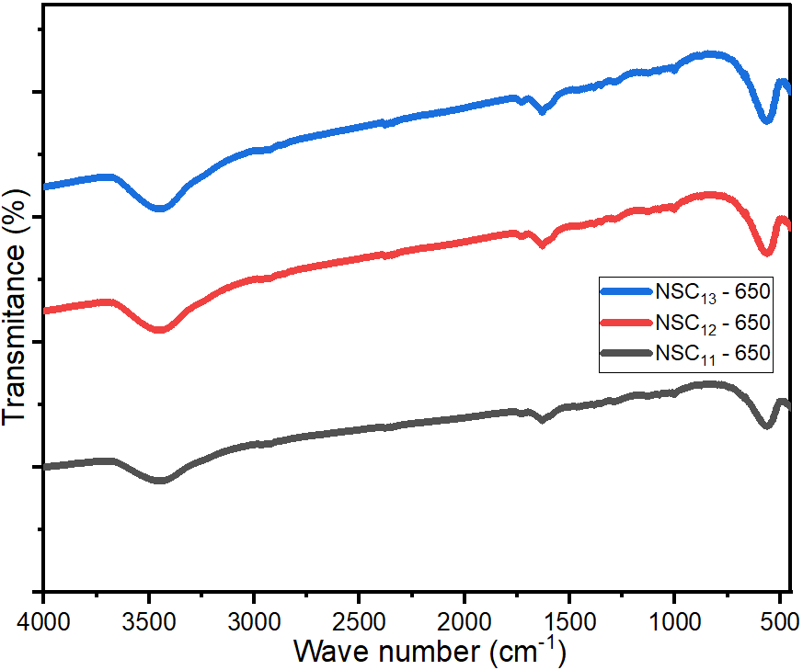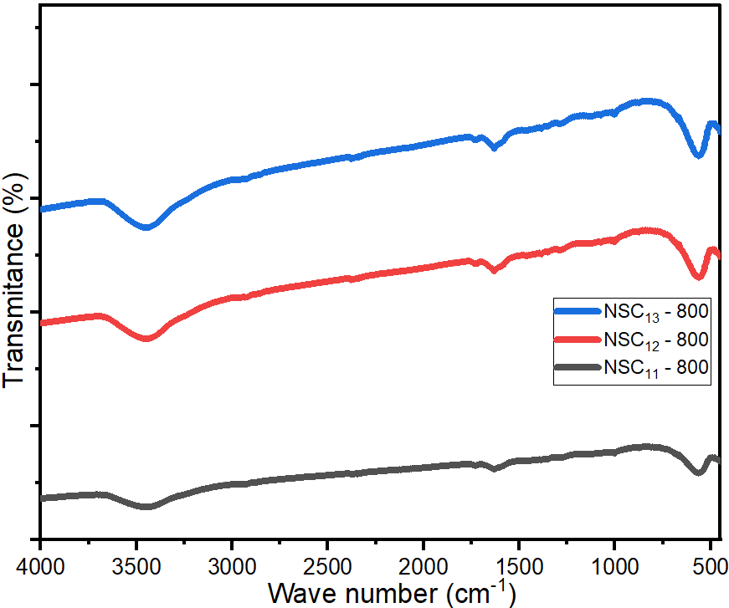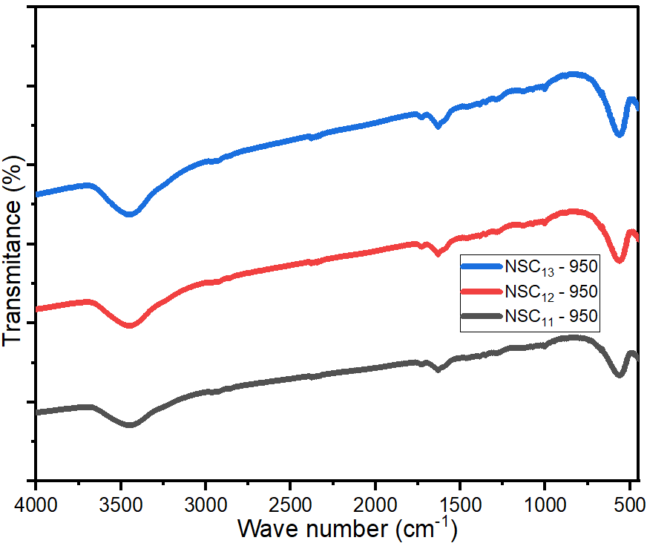
Figure 3.14 – FTIR spectra of Ni_{0.5}Zn_{0.5}Fe₂O₄ at the different aqueous solutions of PVA (1%, 4% and 6%) at the different calcination temperatures (650, 800 and 950°C)

FTIR spectra of carbon black, activated carbon, graphite and carbonyl iron
Figure 3.15 exhibits the FTIR spectra of CB, AC, C and CI. The peak at 1630.4 cm⁻¹ was due to the stretching vibration of C=O, while the peaks at 2348 cm⁻¹ and 3452 cm⁻¹ were due to the stretching vibration of O-H [116,117].
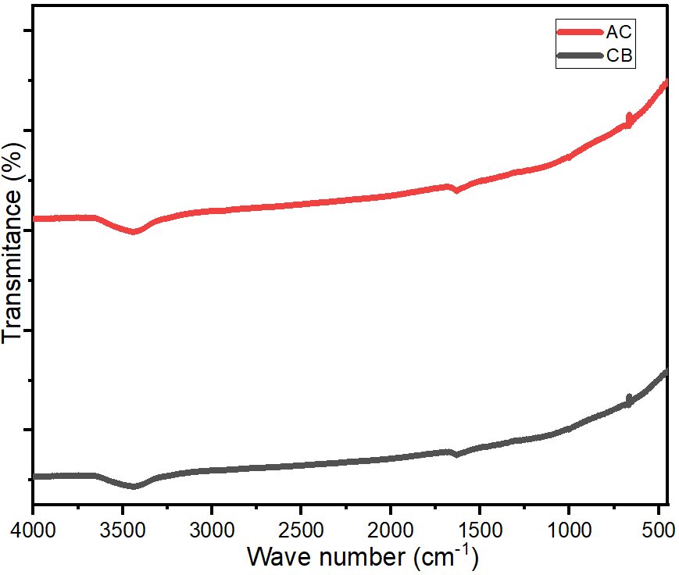
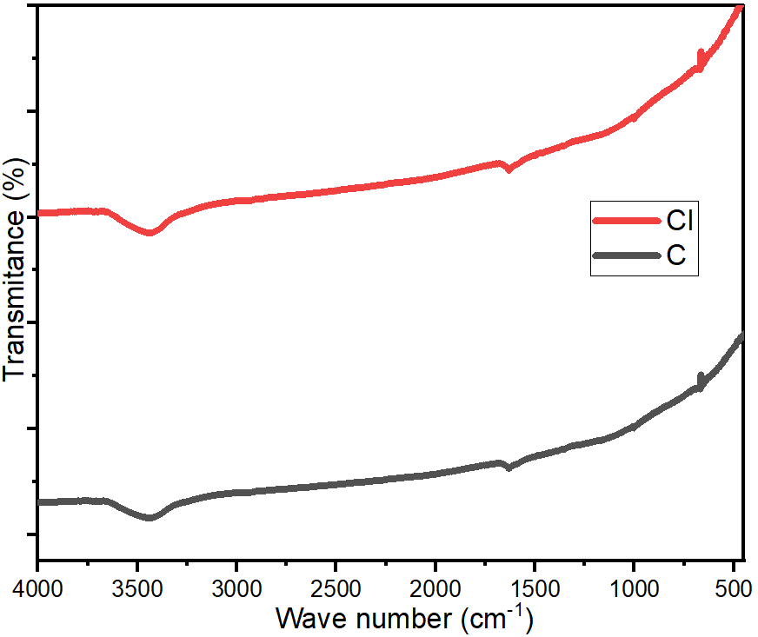
Figure 3.15 – FTIR spectra of CB and AC, C and CI

FTIR spectra of PANI-based nanocomposites
Figures 3.16 exhibits the FTIR spectra of the PANI-based nanocomposites. The peaks within the range (1568–1580 cm⁻¹) and (1475–1489 cm⁻¹) were due to the C=N and C=C stretching modes of vibration for the quinonoid and benzenoid units of the polymer, while the peaks within the range (1290 –1298 cm⁻¹) and (1475–1489 cm⁻¹) [118,119]. Finally, the peaks within the range (1113 –1125 cm⁻¹) and (790–800 cm⁻¹) were due to N-H bending and asymmetric C-H stretching of the benzenoid ring, respectively [87,113]. In addition, the characteristic peaks within the range (563–585 cm-1) of the PANI-based nanocomposites matched the characteristic peak of ferrite.
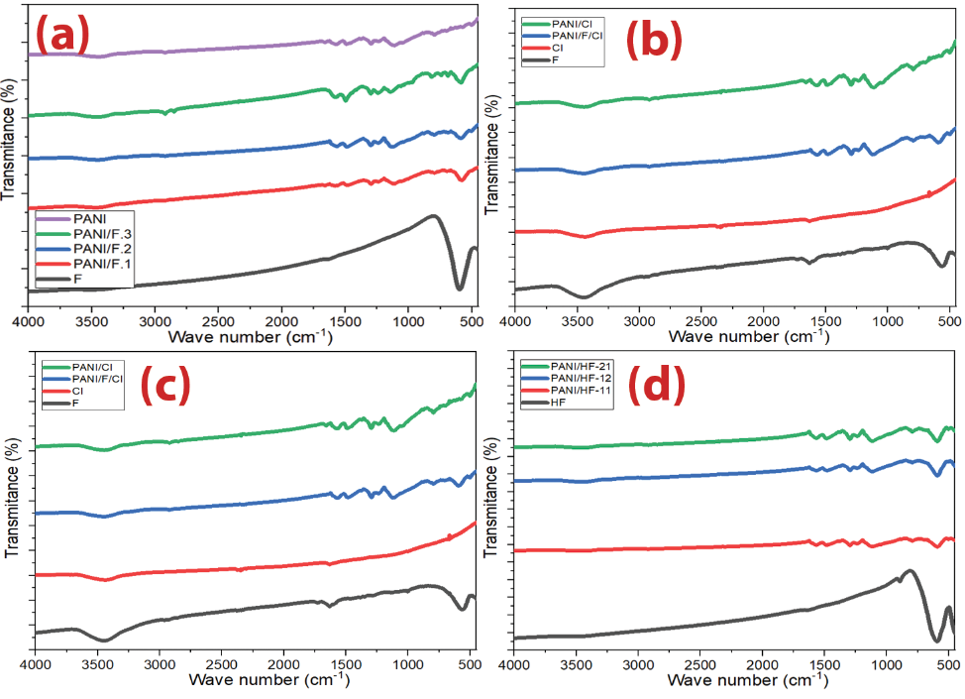
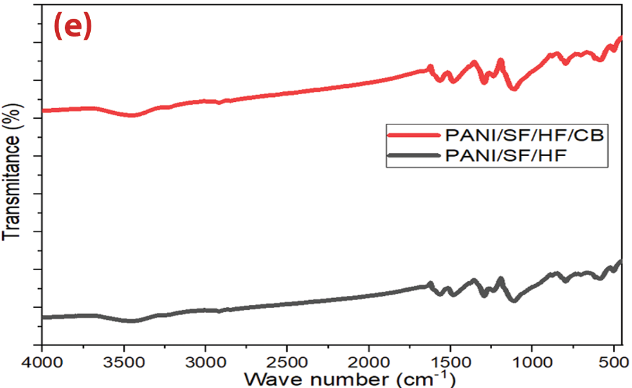
Figure 3.16 – FTIR spectra of (a) Ni³⁺_{0.25}Ni²⁺_{0.375}Zn²⁺_{0.25}Fe₂O_{4,} PANI/Ni³⁺_{0.25}Ni²⁺_{0.375}Zn²⁺_{0.25}Fe₂O₄ nanocomposites and pure PANI, (b) Ni_{0.5}Zn_{0.5}Fe₂O_{4,} CI, PANI/CI and PANI/F/CI nanocomposites, (c) PANI/CB and PANI/F/CB nanocomposites, (d) HF and PANI/HF nanocomposites and (e) PANI/SF/HF and PANI/SF/HF/CB hybrid nanocomposites

Energy-dispersive X-ray spectroscopy (EDX) analysis

EDX analysis for some spinel ferrites and hexagonal ferrite
EDX analysis of Ni³⁺_{0.25}Ni²⁺_{0.375}Zn²⁺_{0.25}Fe₂O₄, Ni_{0.5}Zn_{0.5}Fe₂O₄ nanoparticles prepared by citrate precursor and self-combustion methods and BaNiZnFe₁₆O₂₇ nanoparticles is shown in Figure 3.17 and Table 3.4. Absorption is achieved by gradually decreasing the impedance starting from the dielectric layer, whose impedance is close to the impedance value of air, to secure the entry of most of the incident waves into the material and reduce reflection. Then the absorbent layers are graded with increasing impedance. 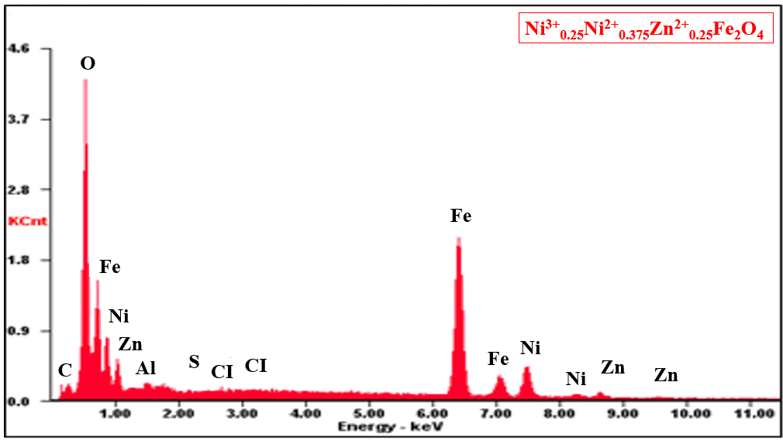
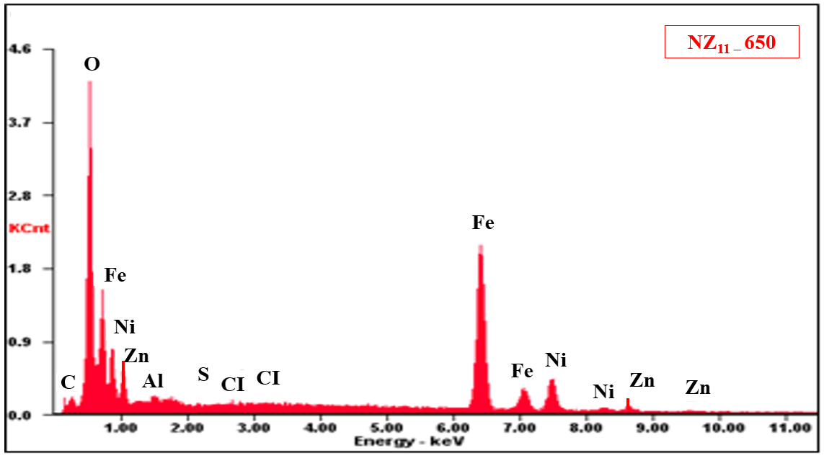
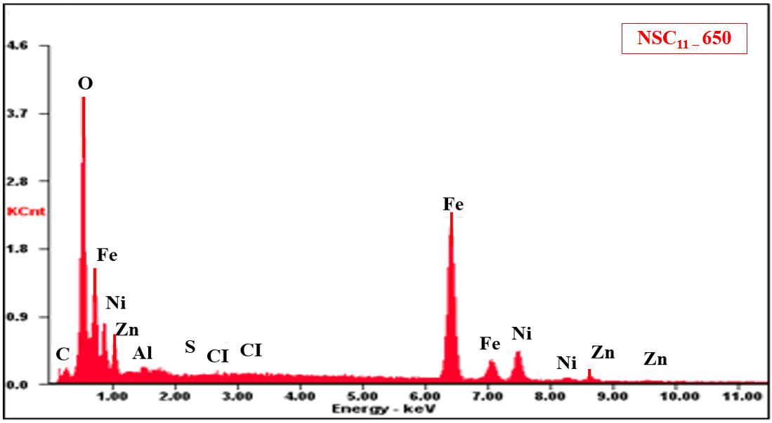
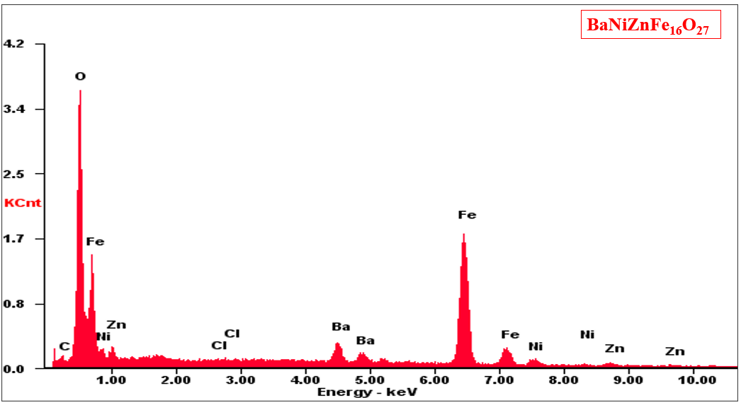
Figure 3.17 – EDX of spinel ferrites and hexagonal ferrite
Table 3.4 – EDX element composition of spinel ferrites and hexagonal ferrite
Element | C | Cl | O | S | Ba | Al | Fe | Ni | Zn
Ni³⁺_{0.25}Ni²⁺_{0.375}Zn²⁺_{0.25}Fe₂O₄ (wt%) | 3.28 | 0.15 | 19.28 | 0.03 | - | 0.39 | 53.04 | 18.02 | 5.81
NZ_{11 –} 650 (wt%) | 3.30 | 0.13 | 19.26 | 0.02 | - | 0.41 | 53.02 | 13.04 | 10.82
NSC_{11 –} 650 (wt%) | 3.50 | 0.17 | 18.92 | 0.01 | - | 0.39 | 54.01 | 12.79 | 10.21
BaNiZnFe₁₆O₂₇ (wt%) | 1.8 | 0.16 | 20.72 | - | 9.88 | - | 59.34 | 4.24 | 3.86

EDX analysis of PANI-based nanocomposites
EDX analysis of PANI and PANI-based nanocomposites are shown in Figures (3.18-3.19) and Table 3.5. These products are obtained by dispersing one or more types of absorbent materials in a polymeric matrix and applying them to a substrate or surface. Understanding the techniques for producing microwave absorbent composites by incorporating components, additives, and a matrix type is crucial to the final usage of the resulting absorbent material. Absorption is achieved by gradually decreasing the impedance starting from the dielectric layer, whose impedance is close to the impedance value of air, to secure the entry of most of the incident waves into the material and reduce reflection. Then the absorbent layers are graded with increasing impedance.
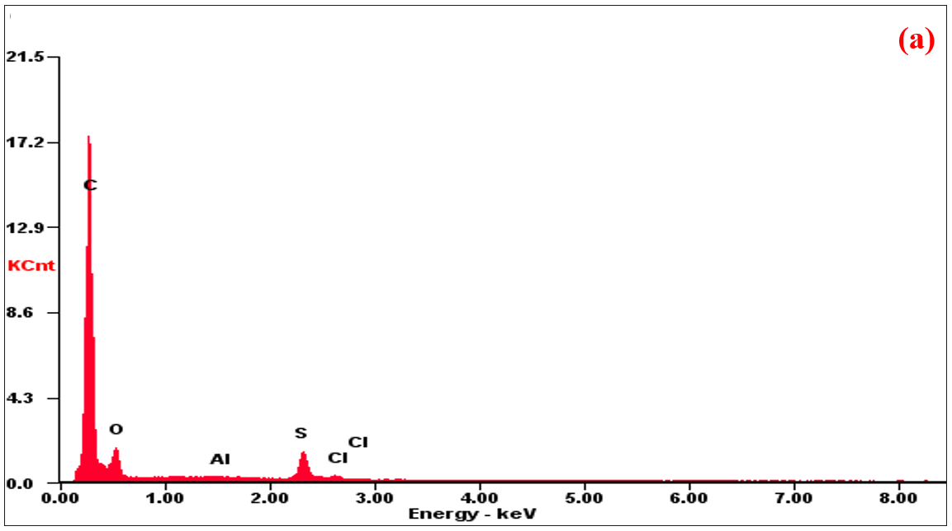
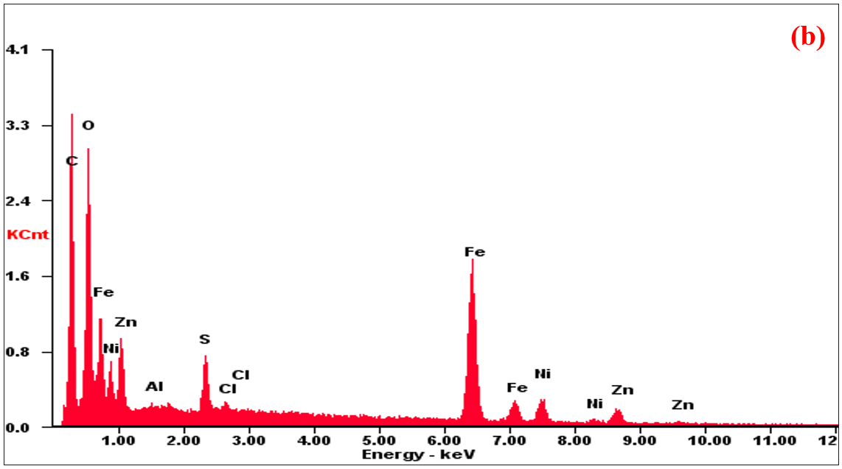
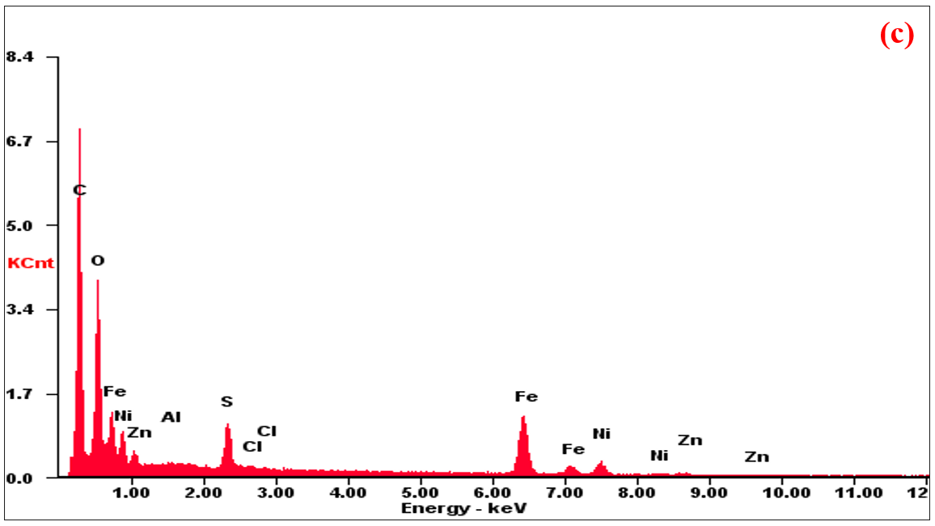
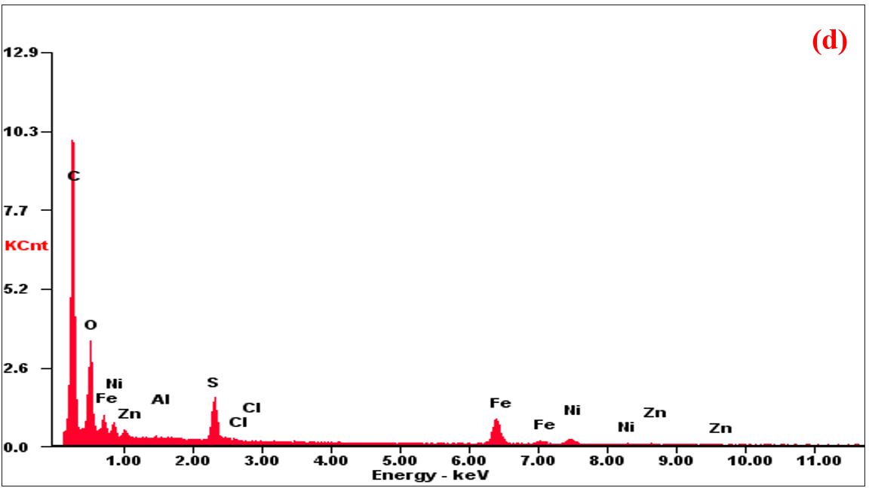
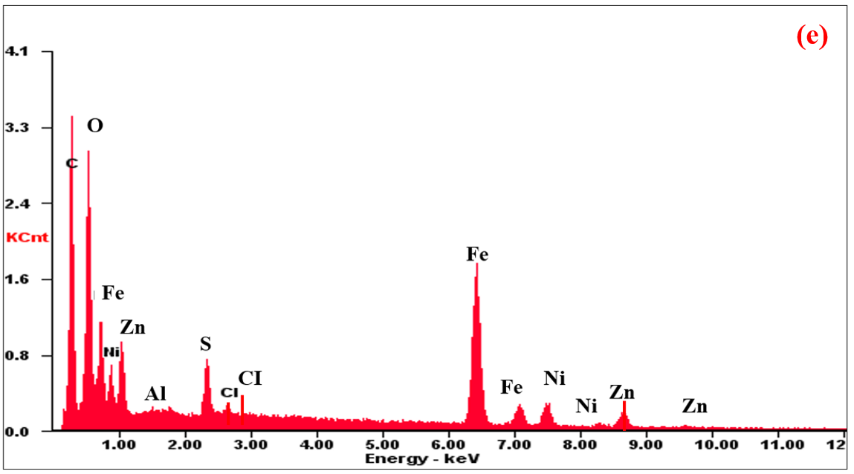
Figure 3.18 – EDX of (a) PANI, (b) PANI/F.1, (c) PANI/F.2, (d) PANI/F.3 and (e) PANI/F/CI hybrid nanocomposites
Table 3.5 – EDX element composition of PANI and PANI-based nanocomposites
Element | C | Cl | O | S | Al | Fe | Ni | Zn | Ba
PANI (wt%) | 84.52 | 0.45 | 11.81 | 3.17 | 0.05 | 0 | 0 | 0 | 0
PANI/F.1 (wt%) | 37.29 | 0.32 | 15.2 | 1.75 | 0.12 | 28.6 | 7.67 | 9.05 | 0
PANI/F.2 (wt%) | 51.76 | 0.22 | 19.27 | 2.42 | 0.08 | 17.95 | 6.32 | 1.98 | 0
PANI/F.3 (wt%) | 63.01 | 0.18 | 17.30 | 2.93 | 0.08 | 11.17 | 3.96 | 1.37 | 0
PANI/F/CI (wt%) | 51.72 | 0.51 | 19.23 | 2.02 | 0.08 | 17.15 | 5.32 | 3.97 | 0
PANI/HF.1 (wt%) | 53.44 | 0.30 | 14.63 | 2.63 | 0 | 21.02 | 2.63 | 1.60 | 3.75
PANI/HF.2 (wt%) | 59.02 | 0.67 | 15.31 | 3.14 | 0 | 15.69 | 2.29 | 1.09 | 2.79
PANI/HF.3 (wt%) | 66.91 | 0.18 | 15.94 | 2.91 | 0 | 9.65 | 1.61 | 0.59 | 2.21
PANI/SF/HF (wt%) | 61.27 | 0.73 | 12.42 | 4.51 | 0 | 13.97 | 4.64 | 1.42 | 1.04
PANI/SF/HF/CB (wt%) | 75.44 | 0.85 | 12.44 | 3.65 | 0 | 4.45 | 2.31 | 0.47 | 0.39
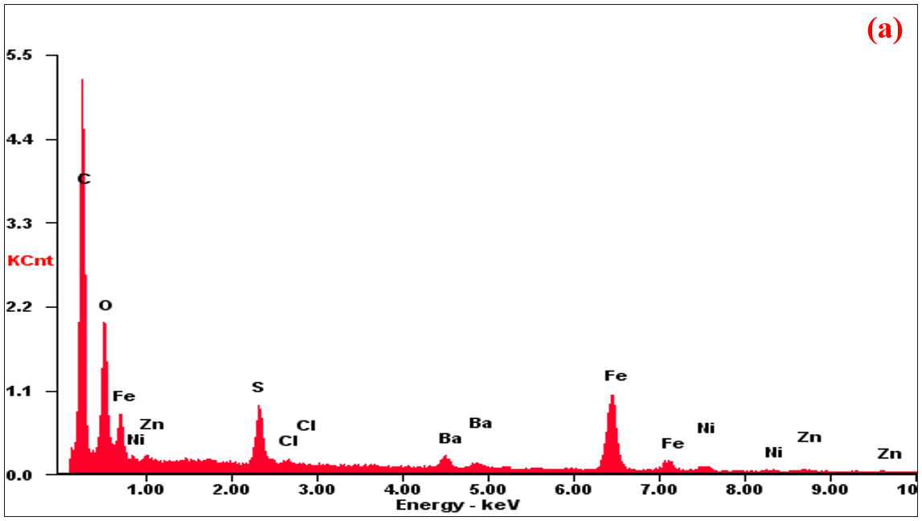
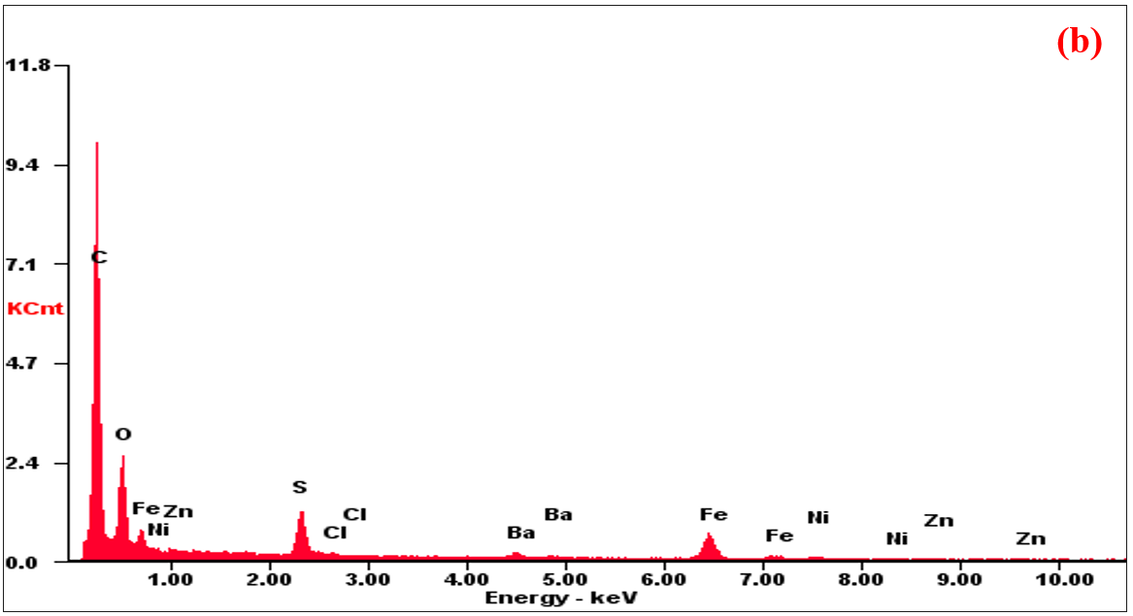
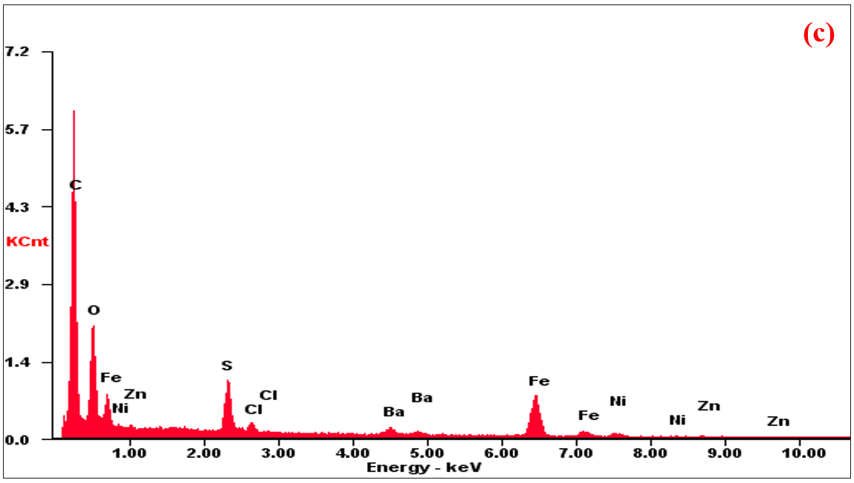
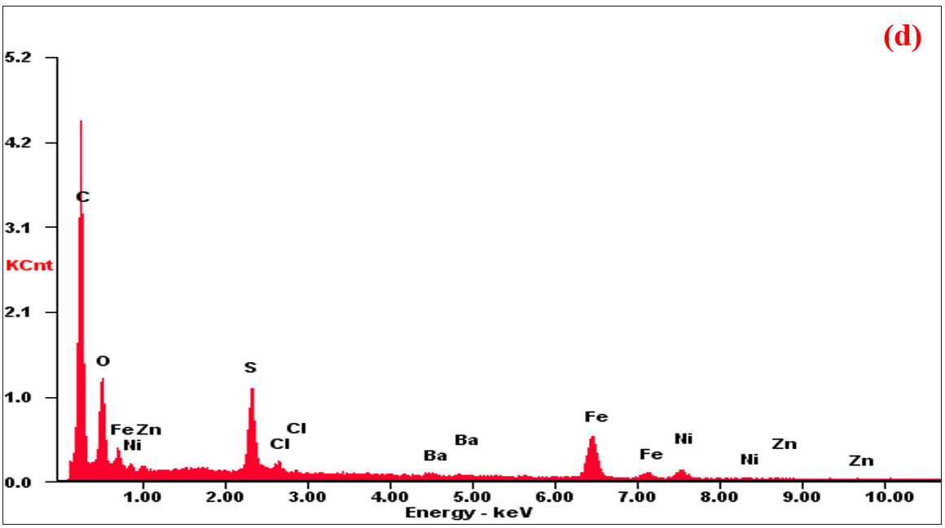
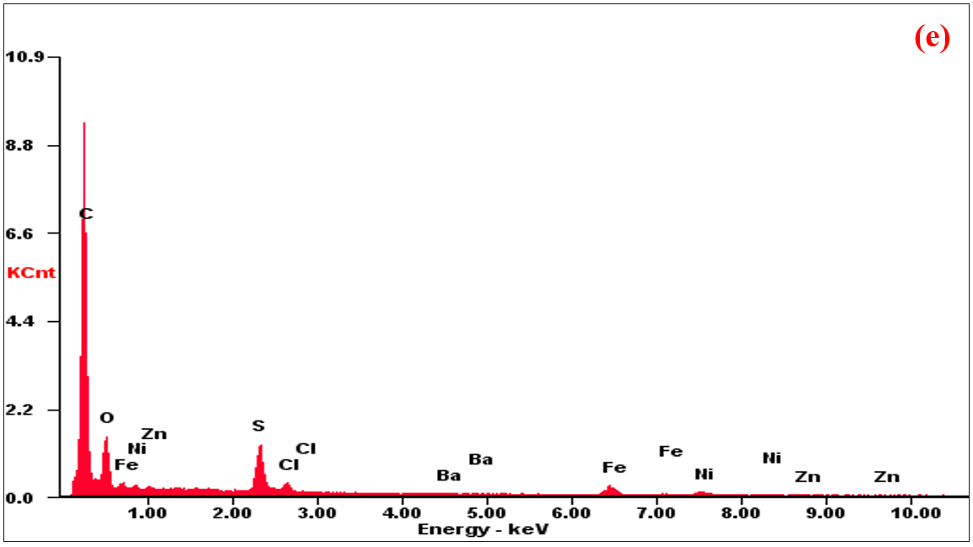
Figure 3.19 – EDX of (a) PANI/HF-11, (b) PANI/HF-21, (c) PANI/HF-12, (d) PANI/SF/HF and (e) PANI/SF/HF/CB hybrid nanocomposites

Morphology investigations

Morphology investigations for some spinel ferrites and hexagonal ferrite
The morphology of the Ni³⁺_{0.25}Ni²⁺_{0.375}Zn²⁺_{0.25}Fe₂O_{4,} NZ_{11 –} 650, NSC_{11 –} 650 and BaNiZnFe₁₆O₂₇ are shown in Figure 3.20. The agglomerated spherical particles of spinel and hexagonal ferrites are noticed. The Ni³⁺_{0.25}Ni²⁺_{0.375}Zn²⁺_{0.25}Fe₂O_{4,} NZ_{11 –} 650, NSC_{11 –} 650 and BaNiZnFe₁₆O₂₇ to be ranging between 18–93 nm, 27–63 nm, 18–52 nm, and 15-110 nm, respectively.

Morphology investigations of PANI-based nanocomposites
The development of radar or microwave absorbing materials technology has had a great impact on the military field. Radar absorbing materials are significant tools in electronic warfare, as they can be used to hide targets and protect them from radar detection. EM shielding materials and RAMs have been produced by international companies at high prices. In this regard, the relevance of the research topic of the doctoral dissertation is paving the way for putting the methodology and scientific bases for the manufacture of MAMs in the laboratory with the required international quality. As well as competing with commercial absorbers mentioned in the literature in terms of weight, reflection loss, absorption bandwidth, and shielding efficiency.
The results obtained in the framework of this thesis can be suggested for producing microwave absorbers synthesized based on ML and DL materials. An advantage of the work is that obtained absorbers can attenuate the EM waves with low surface density and wide bandwidth. These microwave absorbers can be used to cover the walls of anechoic chambers and to prevent or reduce electromagnetic reflections from large bodies such as stealth aircraft, submarines, carriers, and so on.
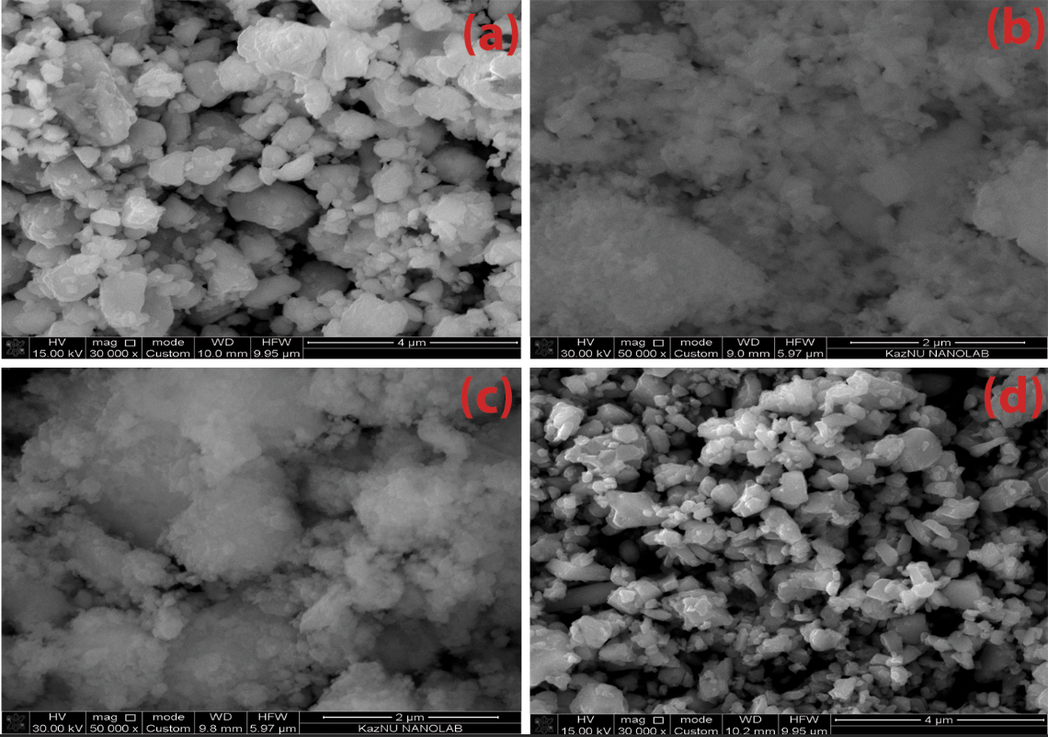
Figure 3.20 – SEM images of (a) Ni³⁺_{0.25}Ni²⁺_{0.375}Zn²⁺_{0.25}Fe₂O₄, (b) NZ_{11 –} 650, (c) NSC_{11 –} 650, and (d) BaNiZnFe₁₆O₂₇
MAMs should be lightweight, prepared in various shapes, waterproof, chemically resistant, have good mechanical and physical properties, be easy to prepare, low cost, have a wide absorption field, and are strong absorption.
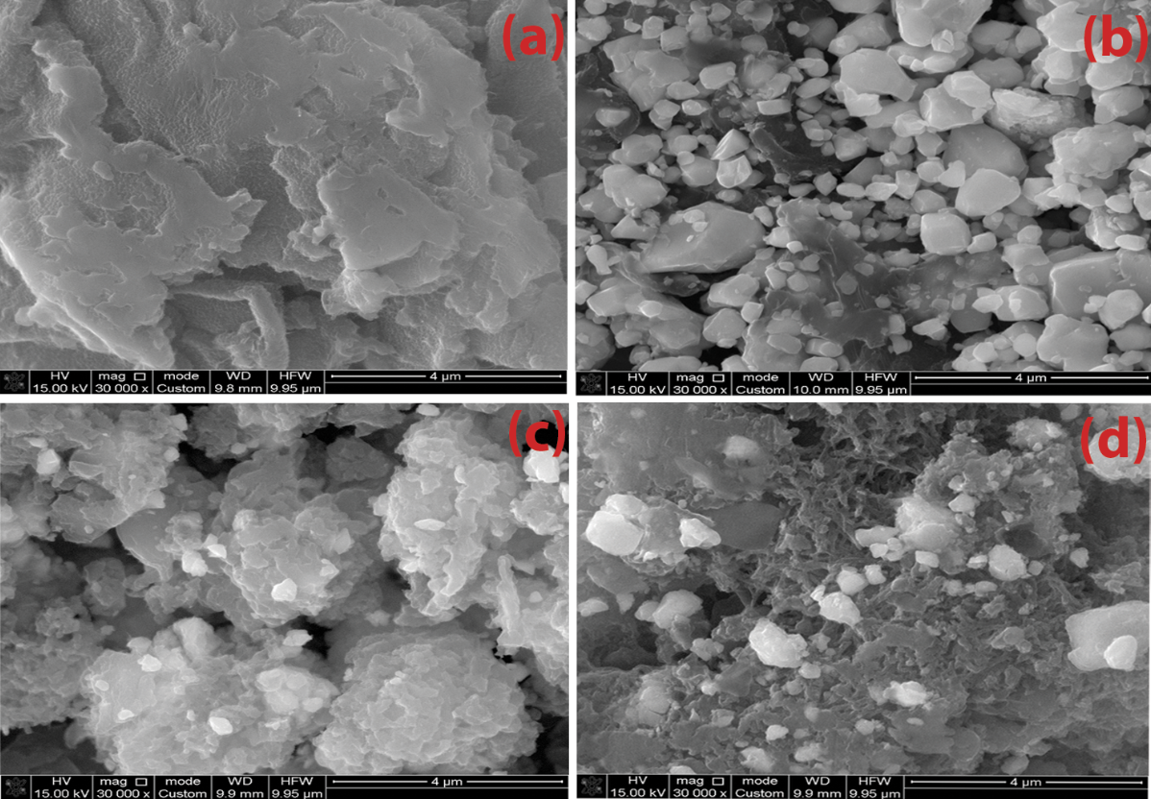
Figure 3.21 – SEM images of (a) PANI, (b) PANI/F.1, (c) PANI/F.2 and (d) PANI/F.3
These microwave absorbers can be used to cover the walls of anechoic chambers and to prevent or reduce electromagnetic reflections from large bodies such as stealth aircraft, submarines, carriers, and so on. RAMs have been used extensively to cover the walls of anechoic halls and to prevent or reduce electromagnetic reflections from large bodies. RAMs can be produced in different forms, such as paints, thin films, sheets, and sponges. These products are obtained by dispersing one or more types of absorbent materials in a polymeric matrix and applying them to a substrate or surface. Understanding the techniques for producing microwave absorbent composites by incorporating components, additives, and a matrix type is crucial to the final usage of the resulting absorbent material..
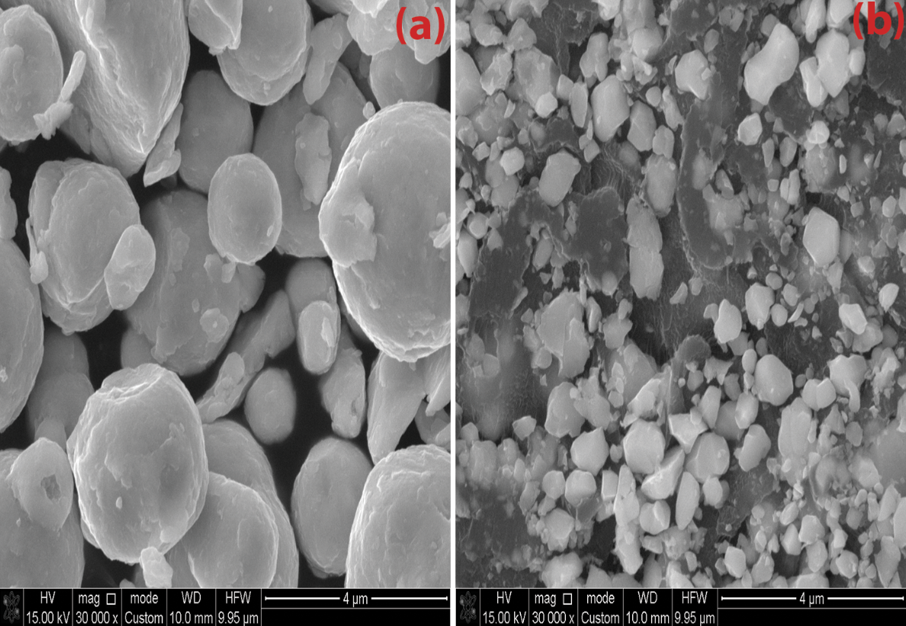
Figure 3.22 – SEM images of (a) CI and (c) PANI/F/CI composite
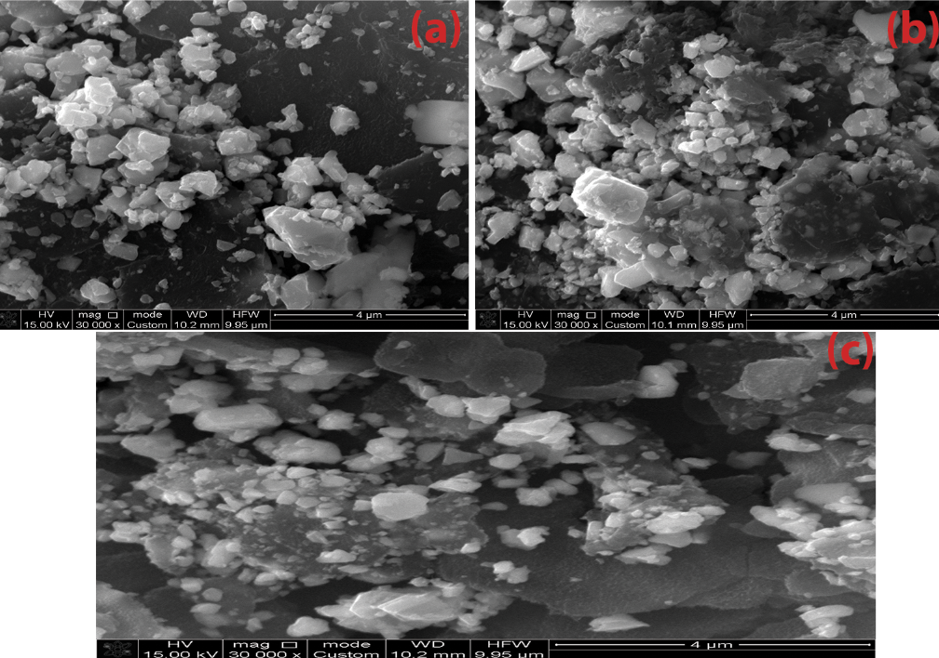
Figure 3.23 – SEM images of PANI/HF.1, PANI/HF. 2 and PANI/HF.3 nanocomposites
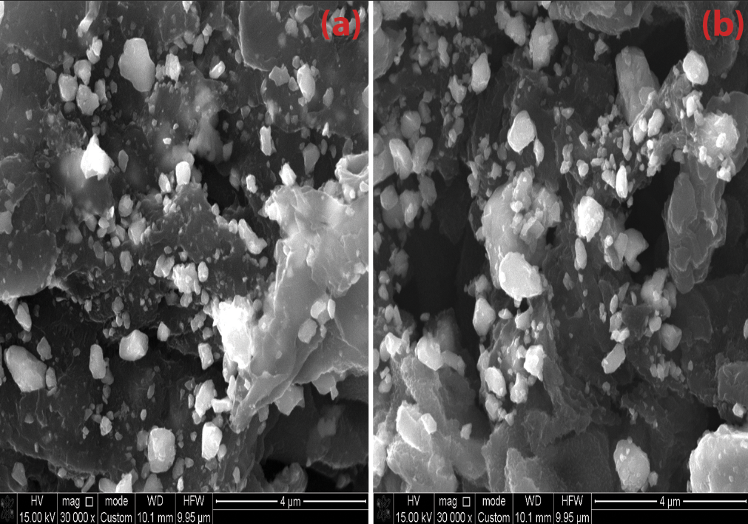
Figure 3.24 – SEM images of PANI/SF/HF and PANI/SF/HF/CB nanocomposites

TGA analysis

TGA analysis of PANI-based nanocomposites
The TGA curves of the Ni³⁺_{0.25}Ni²⁺_{0.375}Zn²⁺_{0.25}Fe₂O₄, Ni_{0.5}Zn_{0.5}Fe₂O₄, BaNiZnFe₁₆O₂₇, PANI/Ni³⁺_{0.25}Ni²⁺_{0.375}Zn²⁺_{0.25}Fe₂O₄, PANI/CB, PANI/F/CB, PANI/F/CI, PANI/BaNiZnFe₁₆O₂₇, PANI/SF/HF and PANI/SF/HF/CB are shown in Figure 3.25. Ni³⁺_{0.25}Ni²⁺_{0.375}Zn²⁺_{0.25}Fe₂O₄The development of radar or microwave absorbing materials technology has had a great impact on the military field. Radar absorbing materials are significant tools in electronic warfare, as they can be used to hide targets and protect them from radar detection. EM shielding materials and RAMs have been produced by international companies at high prices. In this regard, the relevance of the research topic of the doctoral dissertation is paving the way for putting the methodology and scientific bases for the manufacture of MAMs in the laboratory with the required international quality. As well as competing with commercial absorbers mentioned in the literature in terms of weight, reflection loss, absorption bandwidth, and shielding efficiency. The results obtained in the framework of this thesis can be suggested for producing microwave absorbers synthesized based on ML and DL materials. An advantage of the work is that obtained absorbers can attenuate the EM waves with low surface density and wide bandwidth. These microwave absorbers can be used to cover the walls of anechoic chambers and to prevent or reduce electromagnetic reflections from large bodies such as stealth aircraft, submarines, carriers, and so on.
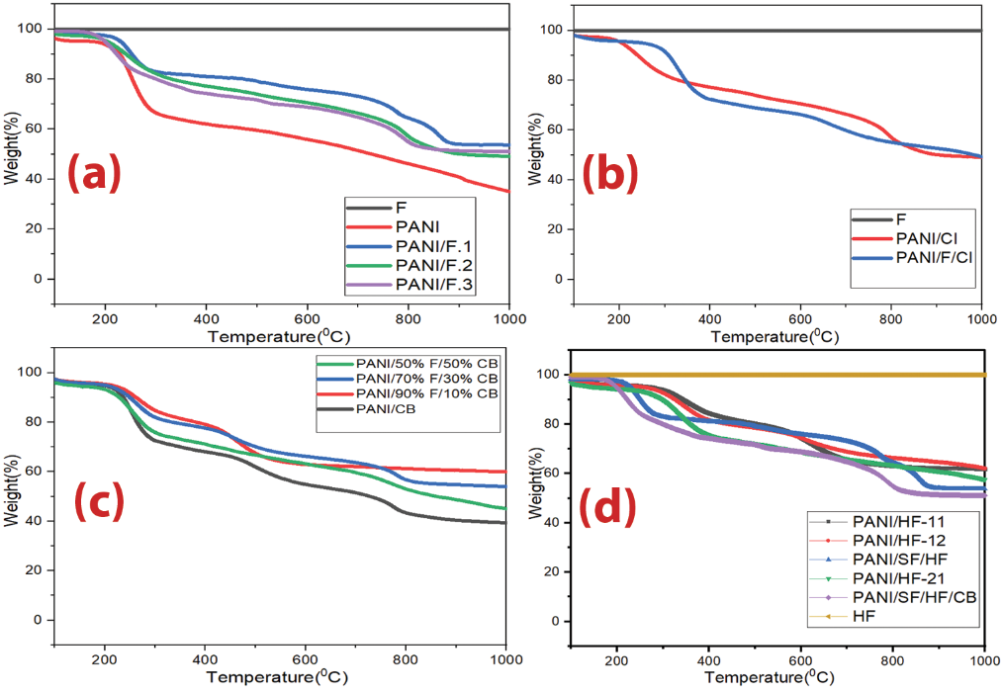
Figure 3.25 – TGA thermograms of (a) Ni³⁺_{0.25}Ni²⁺_{0.375}Zn²⁺_{0.25}Fe₂O_{4,} PANI/Ni³⁺_{0.25}Ni²⁺_{0.375}Zn²⁺_{0.25}Fe₂O₄ nanocomposites and pure PANI, (b) Ni_{0.5}Zn_{0.5}Fe₂O₄, PANI/CI and PANI/F/CI nanocomposites, (c) PANI/CB and PANI/F/CB hybrid nanocomposites and (d) HF, PANI/, PANI/SF/HF and PANI/SF/HF/CB nanocomposites
Table 3.6 – TGA measurements of the PANI-based nanocomposites
Sample | Calculated PANI percentage | Evaluated PANI percentage utilizing TGA
PANI/F.1 | 50% | 53.8%
PANI/F.2 | 66.7% | 49.5%
PANI/F.3 | 75% | 51.2%
PANI/CI | 50% | 49.0%
PANI/F/CI | 50% | 49.5%
PANI/CB | 50% | 39.7%
PANI/90%F/10%CB | 50% | 45.4%
PANI/70%F/30%CB | 50% | 54.3%
PANI/50%F/50%CB | 50% | 60.1%
PANI/HF-11 | 50% | 61.7%
PANI/HF-12 | 33.3% | 62.4%
PANI/HF-21 | 66.7% | 58.5%
PANI/SF/HF | 50% | 53.8%
PANI/SH/HF/CB | 50% | 51.3%

Microwave absorption properties of prepared samples

Microwave absorption properties of ferrite samples prepared by the ceramic sintering technique
Several variables that affect MA properties were studied, as follows: effect of ferrite type, substitution with several metal ions, the concentration of metal ions, absorbent layer thickness, and loading percentage of ferrite in the paraffin matrix.

Microwave absorption properties of undoped ferrites
EMI shielding and MA properties of NiFe₂O₄, ZnFe₂O₄, MnFe₂O₄ and CuFe₂O₄ were studied. Absorption is achieved by gradually decreasing the impedance starting from the dielectric layer, whose impedance is close to the impedance value of air, to secure the entry of most of the incident waves into the material and reduce reflection. Then the absorbent layers are graded with increasing impedance.

Microwave absorption properties of doped ferrites
EMI shielding and MA properties of Mn_{x}Zn_{(1-x)}Fe₂O₄ (x= 0.3, 0.6 and 0.9), Ni_{x}Zn_{(1-x)}Fe₂O₄ (x= 0.25, 0.5 and 0.75), Ni_{(0.4+x)}Zn_{(0.5-x)}Mn_{0.1}Fe₂O₄ (x= 0.1, 0.2 and 0.3), Ni³⁺_{0.25}Ni²⁺_{0.375}Zn²⁺_{0.25}Fe₂O₄, Cu²⁺_{0.1}Ni³⁺_{0.15}Ni²⁺_{0.225}Zn²⁺_{0.45}Fe₂O₄ and BaNiZnFe₁₆O₂₇ were investigated at a constant loading percentage of 65% w/w within a paraffin matrix with different thicknesses (3, 5 and 7 mm). The results obtained in the framework of this thesis can be suggested for producing microwave absorbers synthesized based on ML and DL materials. An advantage of the work is that obtained absorbers can attenuate the EM waves with low surface density and wide bandwidth. These microwave absorbers can be used to cover the walls of anechoic chambers and to prevent or reduce electromagnetic reflections from large bodies such as stealth aircraft, submarines, carriers, and so on. RAMs have been used extensively to cover the walls of anechoic halls and to prevent or reduce electromagnetic reflections from large bodies. RAMs can be produced in different forms, such as paints, thin films, sheets, and sponges. These products are obtained by dispersing one or more types of absorbent materials in a polymeric matrix and applying them to a substrate or surface. Understanding the techniques for producing microwave absorbent composites by incorporating components, additives, and a matrix type is crucial to the final usage of the resulting absorbent material.. The results displayed weak RL and low SE for Ni_{0.25}Zn_{0.75}Fe₂O₄. As well, the results displayed that Ni_{0.5}Zn_{0.5}Fe₂O₄ and Ni_{0.75}Zn_{0.25}Fe₂O₄ exceeded the -10 dB threshold, as shown in Figure 3.29, which demonstrates that the RL attenuation peaks of samples moved to lower frequencies with increasing sample thickness. The results also indicate that the RL_{min} shifted to higher frequencies by increasing the substitution with several metal ions on ferrite. The SE_{max} was 13.7 dB at 10.4 GHz for Ni_{0.5}Zn_{0.5}Fe₂O₄.
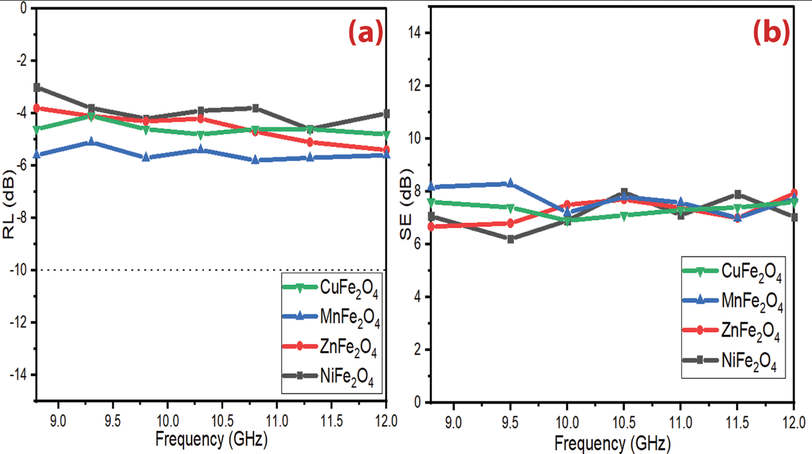
Figure 3.26 (a, b) – RL and SE curves of NiFe₂O₄, ZnFe₂O₄, MnFe₂O₄ and CuFe₂O₄ at 6 mm thickness
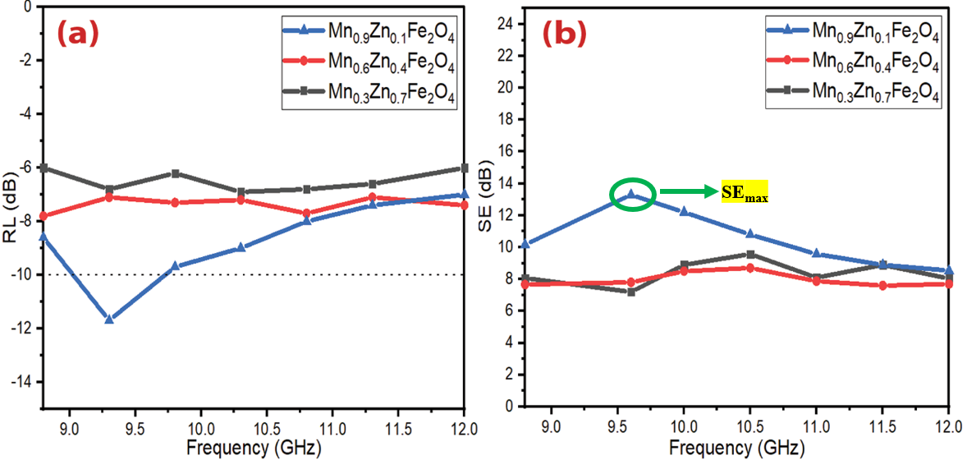
Figure 3.27 (a, b) – RL and SE curves of Mn_{x}Zn_{(1-x)}Fe₂O₄ (x= 0.3, 0.6 and 0.9) at 5 mm thickness
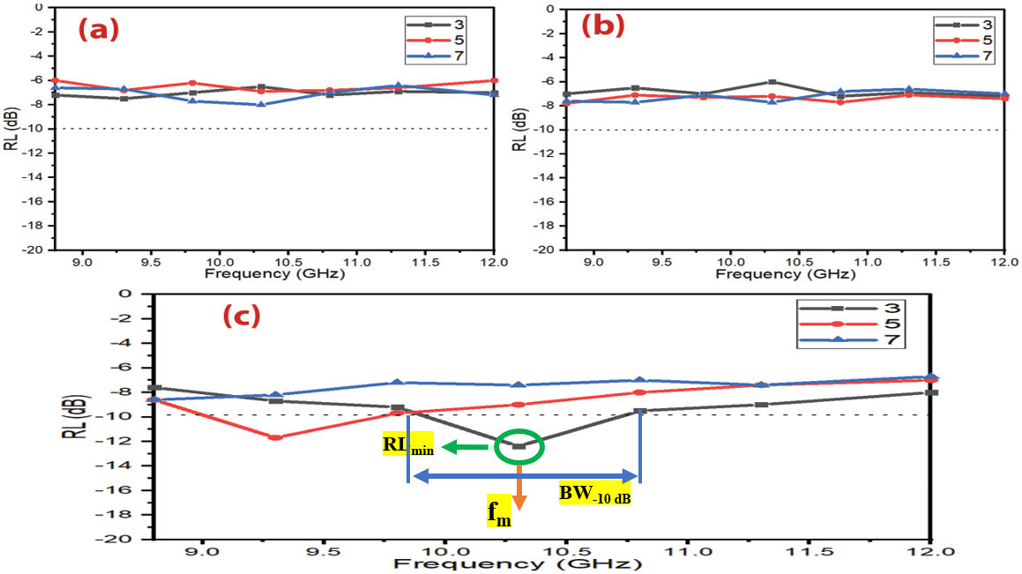
Figure 3.28 – RL curves of (a) Mn_{0.3}Zn_{0.7}Fe₂O₄, (b) Mn_{0.6}Zn_{0.4}Fe₂O₄ and (c) Mn_{0.9}Zn_{0.1}Fe₂O₄ at different thicknesses
Table 3.7 – MA behavior of doped ferrites at different thicknesses
Samples | t (mm) | RL_{min} (dB) | f_{m} (GHz) | BW_{-10 dB} (GHz)
Mn_{0.3}Zn_{0.7}Fe₂O₄ | 3 | -7.5 | 9.2 | 0
Mn_{0.3}Zn_{0.7}Fe₂O₄ | 5 | -6.9 | 10.3 | 0
Mn_{0.3}Zn_{0.7}Fe₂O₄ | 7 | -7.7 | 9.8 | 0
Mn_{0.6}Zn_{0.4}Fe₂O₄ | 3 | -7.2 | 10.2 | 0
Mn_{0.6}Zn_{0.4}Fe₂O₄ | 5 | -7.8 | 8.2 | 0
Mn_{0.6}Zn_{0.4}Fe₂O₄ | 7 | -7.5 | 9.3 | 0
Mn_{0.9}Zn_{0.1}Fe₂O₄ | 3 | -12.4 | 10.3 | 0.9
Mn_{0.9}Zn_{0.1}Fe₂O₄ | 5 | -11.7 | 9.2 | 0.7
Mn_{0.9}Zn_{0.1}Fe₂O₄ | 7 | -8.6 | 8.8 | 0
Ni_{0.25}Zn_{0.75}Fe₂O₄ | 3 | -7.5 | 11.0 | 0
Ni_{0.25}Zn_{0.75}Fe₂O₄ | 5 | -7.4 | 12.0 | 0
Ni_{0.25}Zn_{0.75}Fe₂O₄ | 7 | -8.2 | 11.4 | 0
Ni_{0.5}Zn_{0.5}Fe₂O₄ | 3 | -11.5 | 10.1 | 0.5
Ni_{0.5}Zn_{0.5}Fe₂O₄ | 5 | -12.2 | 9.6 | 0.8
Ni_{0.5}Zn_{0.5}Fe₂O₄ | 7 | -8.4 | 8.8 | 0
Ni_{0.75}Zn_{0.25}Fe₂O₄ | 3 | -12.3 | 11.1 | 0.7
Ni_{0.75}Zn_{0.25}Fe₂O₄ | 5 | -13.5 | 10.0 | 0.8
Ni_{0.75}Zn_{0.25}Fe₂O₄ | 7 | -11.4 | 9.5 | 0.8
Ni_{0.5}Zn_{0.4}Mn_{0.1}Fe₂O₄ | 3 | -12.2 | 10.7 | 0.9
Ni_{0.5}Zn_{0.4}Mn_{0.1}Fe₂O₄ | 5 | -11.8 | 10.2 | 0.8
Ni_{0.5}Zn_{0.4}Mn_{0.1}Fe₂O₄ | 7 | -11.1 | 9.4 | 0.8
Ni_{0.6}Zn_{0.3}Mn_{0.1}Fe₂O₄ | 3 | -11.4 | 11.3 | 0.7
Ni_{0.6}Zn_{0.3}Mn_{0.1}Fe₂O₄ | 5 | -13.7 | 10.6 | 1.0
Ni_{0.6}Zn_{0.3}Mn_{0.1}Fe₂O₄ | 7 | -12.5 | 10.2 | 1.3
Ni_{0.7}Zn_{0.2}Mn_{0.1}Fe₂O₄ | 3 | -11.7 | 12.0 | 1.0
Ni_{0.7}Zn_{0.2}Mn_{0.1}Fe₂O₄ | 5 | -12.5 | 11.3 | 0.9
Ni_{0.7}Zn_{0.2}Mn_{0.1}Fe₂O₄ | 7 | -11.8 | 10.7 | 0.5
Ni³⁺_{0.25}Ni²⁺_{0.375}Zn²⁺_{0.25}Fe₂O₄ | 3 | -13.3 | 9.8 | 1.3
Ni³⁺_{0.25}Ni²⁺_{0.375}Zn²⁺_{0.25}Fe₂O₄ | 5 | -12.7 | 10.3 | 1.2
Ni³⁺_{0.25}Ni²⁺_{0.375}Zn²⁺_{0.25}Fe₂O₄ | 7 | -12.5 | 10.7 | 1.3
Cu²⁺_{0.1}Ni³⁺_{0.15}Ni²⁺_{0.225}Zn²⁺_{0.45}Fe₂O₄ | 3 | -11.6 | 11.0 | 0.8
Cu²⁺_{0.1}Ni³⁺_{0.15}Ni²⁺_{0.225}Zn²⁺_{0.45}Fe₂O₄ | 5 | -12.1 | 10.5 | 0.8
Cu²⁺_{0.1}Ni³⁺_{0.15}Ni²⁺_{0.225}Zn²⁺_{0.45}Fe₂O₄ | 7 | -11.8 | 11 | 0.7
BaNiZnFe₁₆O₂₇ | 3 | -8.4 | 12.0 | 0
BaNiZnFe₁₆O₂₇ | 5 | -8.0 | 12.0 | 0
BaNiZnFe₁₆O₂₇ | 7 | -8.8 | 12.0 | 0
Table ‎3.8 illustrates a comparison of MA characteristics of some lately informed ferrite absorbers with different preparation methods and loading percentages. The results of the literature show these ferrites are good in the C-band and Ku-band frequencies and weak in the X-band frequency. The presently prepared ferrites display in this research better MA in the X-band frequency. The distinct of these prepared ferrites have a lower loading percentage and thickness of the absorbers compared with the other literature.
Table 3.8 – Comparison of MA properties of the present prepared ferrites with similar ferrites in the other research
Sample | Preparation method | t (mm) | f_{m} (GHz) | BW_{-10 dB} (GHz) _{(C-band)} | BW_{-10 dB} (GHz) _{(X-band)} | BW_{-10 dB} (GHz) _{(Ku-band)} | Loading percentage (%) | Ref
Ni_{0. 5}Zn_{0.5}Fe₂O₄ | Combustion | 5.92 | 3.16 | 1.65 | 0 | 0 | 80 | [120]
Ni_{0. 5}Zn_{0.5}Fe₂O₄ | Iron oxide catalysts | 5.5 | 6.1 | 3.2 | 0 | 0 | 70 | [121]
Ni_{0. 5}Zn_{0.5}Fe₂O₄ | Combustion | 5.0 | 5.82 | 1.6 | 0 | 0 | 80 | [122]
Mn_{0. 5}Zn_{0.5}Fe₂O₄ | Sol-gel | 20 | 6.0 | 1.2 | 0 | 0 | 66.66 | [123]
Ni_{0. 5}Zn_{0.5}Fe₂O₄ | - | 7.10 | 2.19 | 6.0 | 2.0 | 0 | 73 | [78]
Ni_{0. 5}Zn_{0.5}Fe₂O₄ | nitrate-citrate precursor | 5.0 | 8.52 | - | 0.41 | - | 80 | [69]
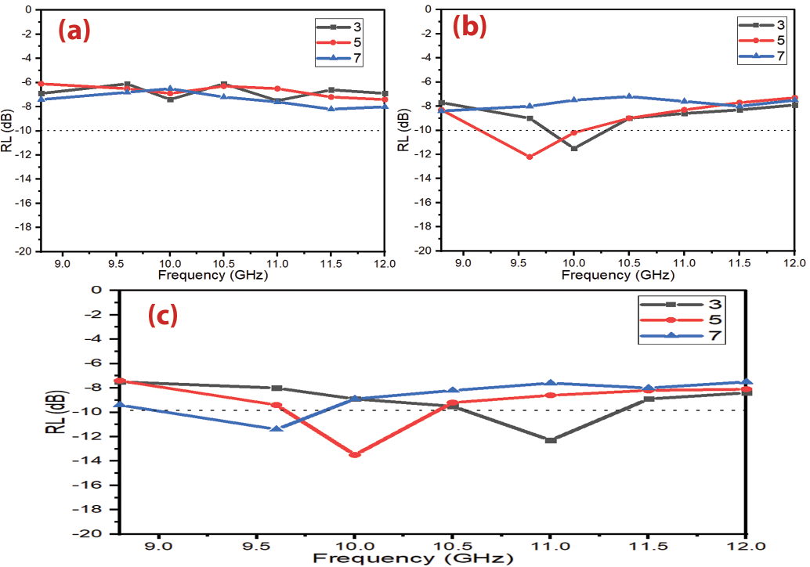
Figure 3.29 – RL curves of (a) Ni_{0.25}Zn_{0.75}Fe₂O₄, (b) Ni_{0. 5}Zn_{0.5}Fe₂O₄ and (c) Ni_{0.75}Zn_{0.25}Fe₂O₄ at different thicknesses
On the other hand, Ni-doped manganese zinc ferrite (Ni_{(0.4+x)}Zn_{(0.5-x)}Mn_{0.1}Fe₂O₄ (x= 0.1, 0.2 and 0.3)) was studied. Table 3.9 demonstrate the MA properties of the prepared samples. Figure 3.30 displays a comparison of the MA and EMI properties of the prepared samples at a thickness of 5 mm. The results indicated that the Ni_{(0.4+x)}Zn_{(0.5-x)}Mn_{0.1}Fe₂O₄ exceeded the -10 dB threshold, as shown in Figure 3.31, which illustrates that the RL attenuation peaks of samples moved to lower frequencies by increasing sample thickness. The results also demonstrated that the RL_{min} shifted to higher frequencies by increasing the substitution with several metal ions on ferrite. The SE_{max} was 14.8 dB at 11.3 GHz for Ni_{0.6}Zn_{0.3}Mn_{0.1}Fe₂O₄ as shown in Figure 3.32.
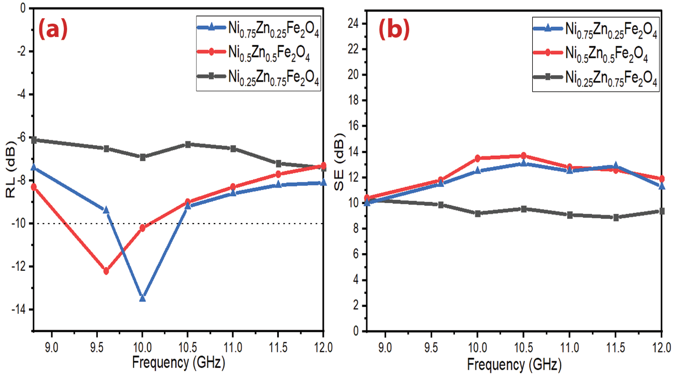
Figure 3.30 (a, b) – RL and SE curves of Ni_{x}Zn_{(1-x)}Fe₂O₄ (x= 0.25, 0.5 and 0.75) at 5 mm thickness.
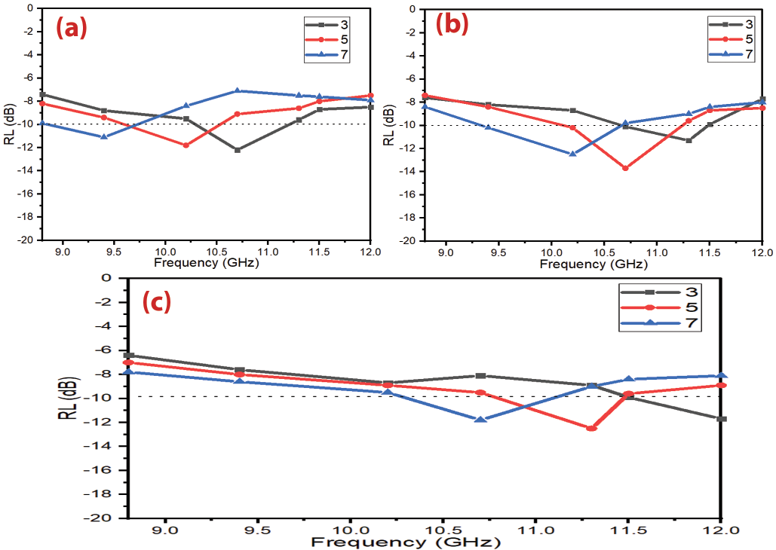
Figure 3.31 – RL curves of (a) Ni_{0.5}Zn_{0.4}Mn_{0.1}Fe₂O₄, (b) Ni_{0.6}Zn_{0.3}Mn_{0.1}Fe₂O₄ and (c) Ni_{0.7}Zn_{0.2}Mn_{0.1}Fe₂O₄ at different thicknesses
The effect of the triple nickel (Ni³⁺) ion substitution on the EMI shielding and MA properties was investigated. Table 3.9 shows the prepared samples' MA properties. Figure 3.33 illustrates a comparison of the MA curves with different loading percentages (60% w/w, 65% w/w and 70% w/w) at 5 mm thickness and shows the SE_{R} and SE_{A} of Ni³⁺_{0.25}Ni²⁺_{0.375}Zn²⁺_{0.25}Fe₂O₄ with a thickness of 5 mm at the frequency of 11.5 GHz. The absorption results demonstrate that the MA properties improved by entering the triple nickel into the nickel-zinc ferrite composition. This substitution process increased the absorption BW_{-10 dB} of the Ni-Zn ferrite and improved the RL_{min} and SE_{max}. The results indicated that exceeded the -10 dB threshold, which illustrates that the RL attenuation peaks of samples moved to lower frequencies by increasing sample thickness and loading percentage of absorber within a paraffin matrix. On the other hand, the substitution process increased the SE_{max}, as shown in Figure 3.33.
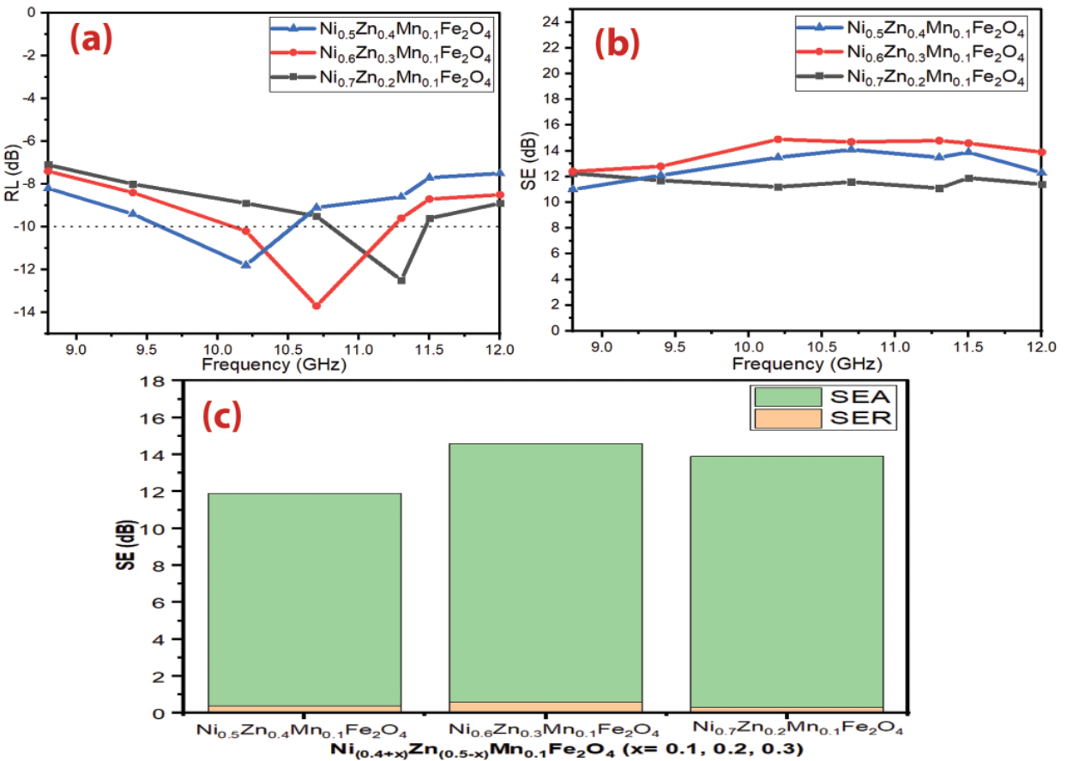
Figure 3.32 (a, b) – RL and SE curves of Ni_{(0.4+x)}Zn_{(0.5-x)}Mn_{0.1}Fe₂O₄ (x= 0.1, 0.2 and 0.3) at 5 mm thickness and (c) Bar plot for individual components of SE_{R} and SE_{A} of Ni_{(0.4+x)}Zn_{(0.5-x)}Mn_{0.1}Fe₂O₄ (x= 0.1, 0.2 and 0.3) with a thickness of 5 mm at the frequency of 11.5 GHz
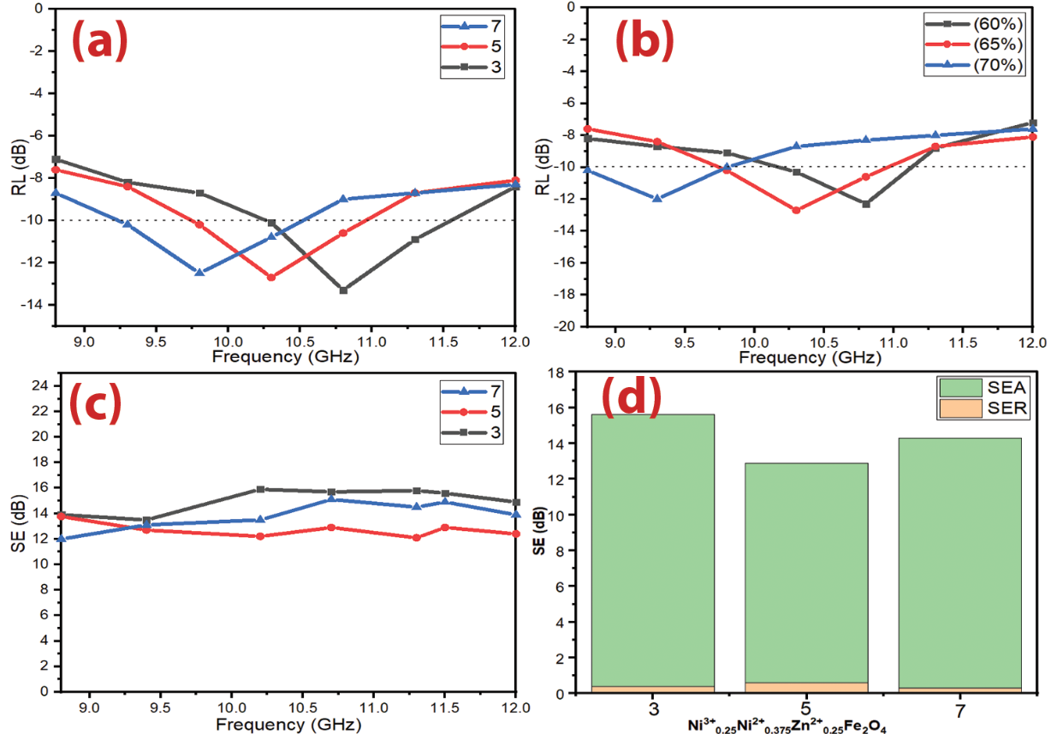
Figure 3.33 (a,b) – RL curves of Ni³⁺_{0.25}Ni²⁺_{0.375}Zn²⁺_{0.25}Fe₂O₄ at different thicknesses and different loading percentages (60% w/w, 65% w/w and 70% w/w mm) at 5 mm thickness, (c) SE curves of Ni³⁺_{0.25}Ni²⁺_{0.375}Zn²⁺_{0.25}Fe₂O₄ at different thicknesses and (d) bar plot for individual components of SE_{R} and SE_{A} with a thickness of 5 mm at the frequency of 11.5 GHz
On the other hand, Cu-doped nickel zinc ferrite (Cu²⁺_{0.1}Ni³⁺_{0.15}Ni²⁺_{0.225}Zn²⁺_{0.45}Fe₂O₄) was studied. Table 3.9 shows the prepared samples' MA properties. Figure 3.34 also shows a comparison of the MA curves with different loading percentages (60% w/w, 65% w/w and 70% w/w) at 5 mm thickness. Finally, Figure 3.34 shows the SE_{R} and SE_{A} of Cu²⁺_{0.1}Ni³⁺_{0.15}Ni²⁺_{0.225}Zn²⁺_{0.45}Fe₂O₄ with a thickness of 5 mm at the frequency of 11.5 GHz. The results show that the MA properties decreased by entering the Cu²⁺ into Ni³⁺_{0.25}Ni²⁺_{0.375}Zn²⁺_{0.25}Fe₂O₄. This substitution process decreased the absorption bandwidth of Ni³⁺_{0.25}Ni²⁺_{0.375}Zn²⁺_{0.25}Fe₂O_{4,} as shown in Table 3.9. The results indicated that the Cu²⁺_{0.1}Ni³⁺_{0.15}Ni²⁺_{0.225}Zn²⁺_{0.45}Fe₂O₄ exceeded the -10 dB threshold, as shown in Figure 3.34, which illustrates that the RL attenuation peaks of samples moved to lower frequencies by increasing sample thickness and loading percentage. On the other hand, the substitution process decreased the SE_{max}, as shown in Figure 3.34.
Table 3.9 – MA behavior of Ni³⁺_{0.25}Ni²⁺_{0.375}Zn²⁺_{0.25}Fe₂O₄ and Cu²⁺_{0.1}Ni³⁺_{0.15}Ni²⁺_{0.225}Zn²⁺_{0.45}Fe₂O₄ with different loading percentages (60% w/w, 65% w/w and 70% w/w mm) at 5 mm thickness
Samples | Loading percentage (%) | RL_{min} (dB) | f_{m} (GHz) | BW_{-10 dB} (GHz)
Ni³⁺_{0.25}Ni²⁺_{0.375}Zn²⁺_{0.25}Fe₂O₄ | 60 | -12.3 | 10.7 | 1.1
Ni³⁺_{0.25}Ni²⁺_{0.375}Zn²⁺_{0.25}Fe₂O₄ | 65 | -12.7 | 10.3 | 1.2
Ni³⁺_{0.25}Ni²⁺_{0.375}Zn²⁺_{0.25}Fe₂O₄ | 70 | -12.0 | 9.2 | 1.0
Cu²⁺_{0.1}Ni³⁺_{0.15}Ni²⁺_{0.225}Zn²⁺_{0.45}Fe₂O₄ | 60 | -11.1 | 11.5 | 0.8
Cu²⁺_{0.1}Ni³⁺_{0.15}Ni²⁺_{0.225}Zn²⁺_{0.45}Fe₂O₄ | 65 | -12.1 | 10.5 | 0.9
Cu²⁺_{0.1}Ni³⁺_{0.15}Ni²⁺_{0.225}Zn²⁺_{0.45}Fe₂O₄ | 70 | -11.8 | 10.0 | 0.9
EMI Absorption is achieved by gradually decreasing the impedance starting from the dielectric layer, whose impedance is close to the impedance value of air, to secure the entry of most of the incident waves into the material and reduce reflection. Then the absorbent layers are graded with increasing impedance.
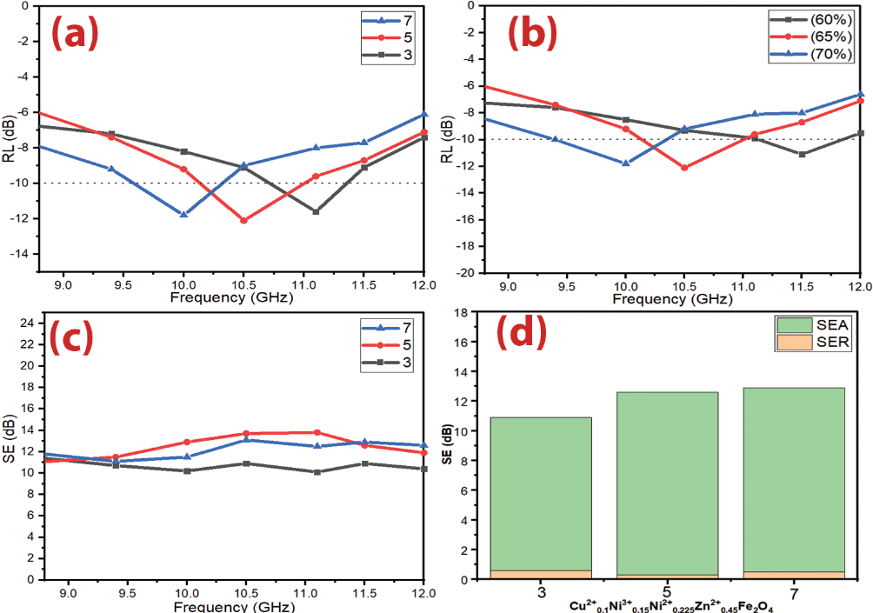
Figure 3.34 (a,b) – RL curves of Cu²⁺_{0.1}Ni³⁺_{0.15}Ni²⁺_{0.225}Zn²⁺_{0.45}Fe₂O₄ at different thicknesses and different loading percentages (60% w/w, 65% w/w and 70% w/w mm) at 5 mm thickness, (c) SE curves of Cu²⁺_{0.1}Ni³⁺_{0.15}Ni²⁺_{0.225}Zn²⁺_{0.45}Fe₂O₄ at different thicknesses and (d) bar plot for individual components of SE_{R} and SE_{A} with a thickness of 5 mm at the frequency of 11.5 GHz. 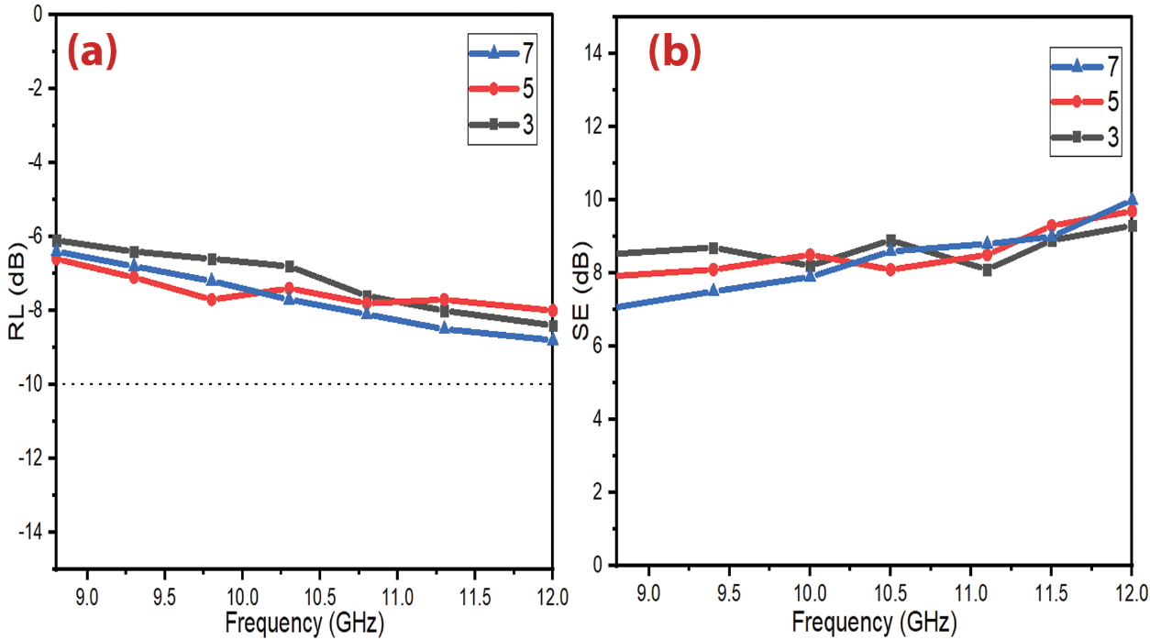
Figure 3.35 (a,b) – RL and SE curves of BaNiZnFe₁₆O₂₇ at different thicknesses
Table ‎3.10 illustrates a comparison of MA characteristics of some lately informed ferrite absorbers with different preparation methods and loading percentages. The results of the literature show these ferrites are good in the C-band and Ku-band frequencies and weak in the X-band frequency. The presently prepared ferrites display in this research better MA in the X-band frequency. The distinct of these prepared ferrites have a lower loading percentage and thickness of the absorbers compared with the other literature. The best result obtained at this stage was by using Ni³⁺_{0.25}Ni²⁺_{0.375}Zn²⁺_{0.25}Fe₂O₄. A RL_{min} indicated -13.3 dB at 9.8 GHz and bandwidth BW_{-10 dB} was 1.3 GHz for a thickness of 3 mm. Also, the SE_{max} attained 15.9 dB at 10.2 GHz.
Table 3.10 – Comparison of MA properties of the present prepared ferrites with similar ferrites in the other research
Sample | Preparation method | t (mm) | BW_{-10 dB} (GHz) _{(C-band)} | BW_{-10 dB} (GHz) _{(X-band)} | BW_{-10 dB} (GHz) _{(Ku-band)} | Loading percentage (%) | Ref
Mn_{0. 5}Zn_{0.5}Fe₂O₄ | Sol-gel | 20 | 1.2 | 0 | 0 | 66.66 | [123]
Cu_{0.2}Ni_{0.45}Zn_{0.35}Fe₂O₄ | Co-Precipitation | 7.35 | 1.1 | 0 | 0 | 100 | [124]
Cu_{0.3}Ni_{0.2}Zn_{0.5}Fe₂O₄ | Nitrate-citrate precursor | 6.2 | 0 | 0.6 | 0 | 70 | [125]
Ni_{0. 4}Zn_{0.4}Mn_{0.2}Fe₂O₄ | Nitrate-citrate precursor | 5.0 | - | 0.8 | - | 80 | [69]
Ni_{0. 4}Zn_{0.4}Cu_{0.2}Fe₂O₄ | Nitrate-citrate precursor | 5.0 | - | 1.2 | - | 80 | [69]
Ni_{0. 4}Zn_{0.4}Mg_{0.2}Fe₂O₄ | Nitrate-citrate precursor | 5.0 | - | 0.7 | - | 80 | [69]
Ni_{0.4}Cu_{0.2}Zn_{0.4}Tb_{0.8} Fe_{1.2}O₄ | Sonochemical | 8.0 | 2.1 | - | - | 70 | [73]
Ni_{0.4}Cu_{0.2}Zn_{0.4}Eu_{0.8}Fe_{1.2}O₄ | Sol-gel | 7.0 | 1.5 | - | - | 70 | [74]
Cu_{0.2}Ni_{0.4}Zn_{0.4}Fe₂O₄ | Ceramic | 9.2 | 1.5 | 0 | 0 | 85 | [44]

Microwave absorption properties of ferrite samples prepared by citrate precursor technique
Several variables that affect MA properties were studied: molar ratio of the metal ion to citrate acid, calcination temperature, absorber thickness and loading percentage.

Microwave absorption properties of Ni_{0.5}Zn_{0.5}Fe₂O₄ nanoparticles
RAMs have been used extensively to cover the walls of anechoic halls and to prevent or reduce electromagnetic reflections from large bodies. RAMs can be produced in different forms, such as paints, thin films, sheets, and sponges. These products are obtained by dispersing one or more types of absorbent materials in a polymeric matrix and applying them to a substrate or surface. Understanding the techniques for producing microwave absorbent composites by incorporating components, additives, and a matrix type is crucial to the final usage of the resulting absorbent material. Absorption is achieved by gradually decreasing the impedance starting from the dielectric layer, whose impedance is close to the impedance value of air, to secure the entry of most of the incident waves into the material and reduce reflection. Then the absorbent layers are graded with increasing impedance.
Table 3.11 – MA behavior of Ni_{0.5}Zn_{0.5}Fe₂O₄ nanoparticles
Samples | T (°C) | RL_{min} (dB) | f_{m} (GHz) | BW_{-10 dB} (GHz)
NZ₁₁ ₋ 650 | 650 | -12.9 | 10.5 | 1.3
NZ₁₂ ₋ 650 | 650 | -12.3 | 10.0 | 0.8
NZ₁₃ ₋ 650 | 650 | -11.7 | 9.5 | 1.2
NZ₁₁ ₋ 800 | 800 | -12.2 | 10.1 | 1.1
NZ₁₂ ₋ 800 | 800 | -12.0 | 9.5 | 0.9
NZ₁₃ ₋ 800 | 800 | -8.4 | 11.4 | 0
NZ₁₁ ₋ 950 | 950 | -11.9 | 9.6 | 0.8
NZ₁₂ ₋ 950 | 950 | -7.9 | 9.9 | 0
NZ₁₃ ₋ 950 | 950 | -7.7 | 110.4 | 0

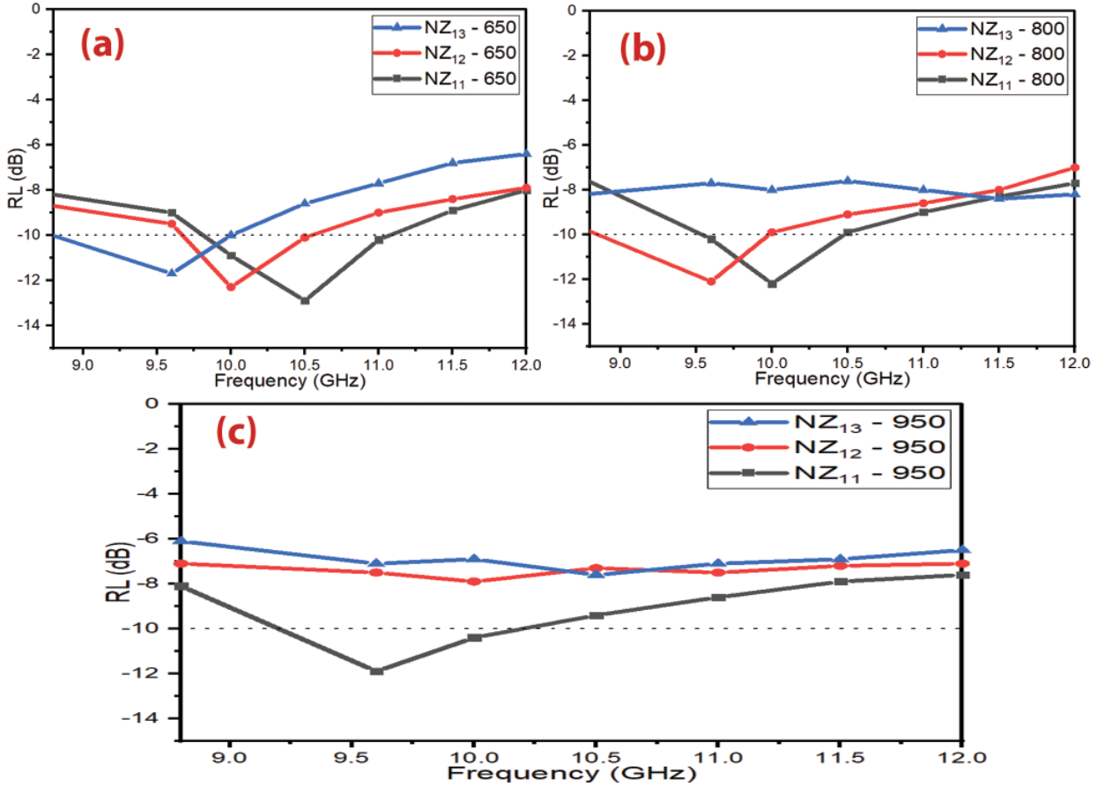
Figure 3.36 – RL curves of Ni_{0.5}Zn_{0.5}Fe₂O₄ nanoparticles at (a) 650 °C, (b) 800 °C and (c) 950 °C
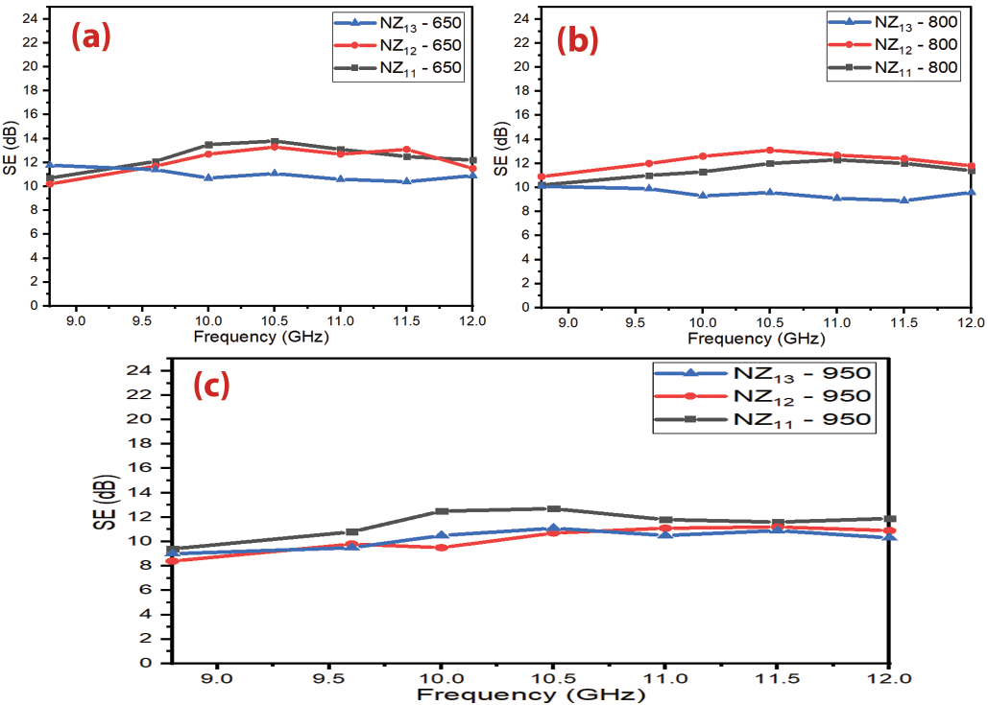
Figure 3.37 – SE curves of Ni_{0.5}Zn_{0.5}Fe₂O₄ nanoparticles (a) 650 °C, (b) 800 °C and (c) 950 °C.

Influence of sample thickness and loading percentage on the f_{m}
The development of radar or microwave absorbing materials technology has had a great impact on the military field. Radar absorbing materials are significant tools in electronic warfare, as they can be used to hide targets and protect them from radar detection. EM shielding materials and RAMs have been produced by international companies at high prices. In this regard, the relevance of the research topic of the doctoral dissertation is paving the way for putting the methodology and scientific bases for the manufacture of MAMs in the laboratory with the required international quality. As well as competing with commercial absorbers mentioned in the literature in terms of weight, reflection loss, absorption bandwidth, and shielding efficiency.
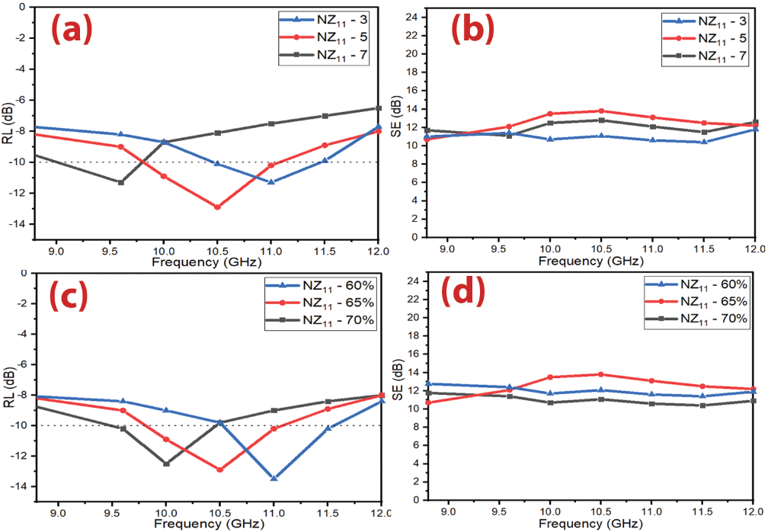
Figure 3.38 (a,b) – RL and SE curves of Ni_{0.5}Zn_{0.5}Fe₂O₄ nanoparticles at different thicknesses and (d,c) RL and SE curves of Ni_{0.5}Zn_{0.5}Fe₂O₄ nanoparticles with varying percentages of loading (60% w/w, 65% w/w and 70% w/w mm) at 5 mm thickness

Microwave absorption properties of ferrite samples prepared by the self-combustion technique
Several variables that affect MA properties were studied: PVA concentration, calcination temperature, absorber thickness and loading percentage of ferrite in the host matrix.

Microwave absorption properties of Ni_{0.5}Zn_{0.5}Fe₂O₄ nanoparticles
The effect of the different aqueous solutions of PVA (1%, 4%, and 6%) and calcination temperatures (650, 800, and 950°C) on the properties of Ni_{0.5}Zn_{0.5}Fe₂O₄ was studied. Samples were prepared with a thickness of 5 mm and a loading percentage of 65%. The results indicated that the RL attenuation peaks of samples shifted to lower frequencies with increasing PVA concentration and calcination temperature as shown in Figure 3.39. This may be due to the change in the crystallite size of the ferrite nanoparticles. The results of XRD patterns indicated that the crystallite size of nickel-zinc ferrite increased by increasing the calcination temperature and PVA concentration. The best result obtained was by using NSC₁₁ – 800 as shown in Figure 3.40 and Table 3.12.
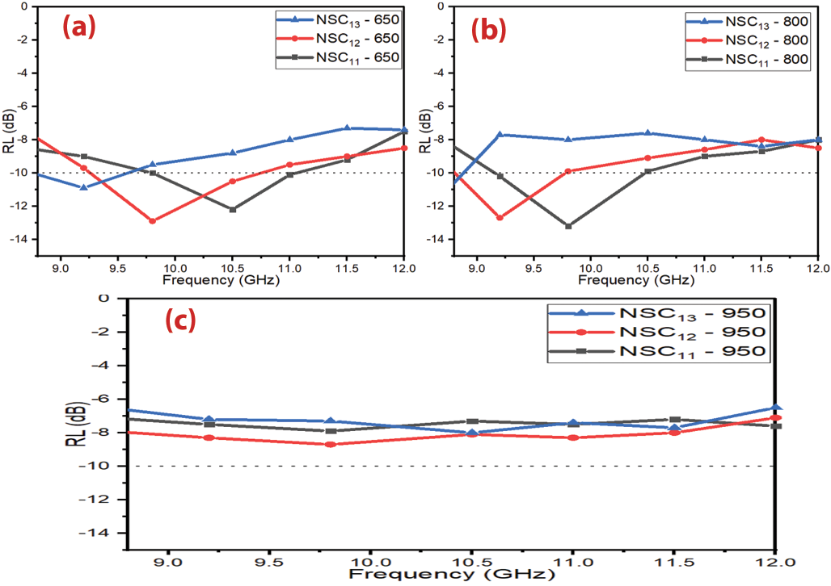
Figure 3.39 – RL curves of Ni_{0.5}Zn_{0.5}Fe₂O₄ nanoparticles at (a) 650 °C, (b) 800 °C and (c) 950 °C
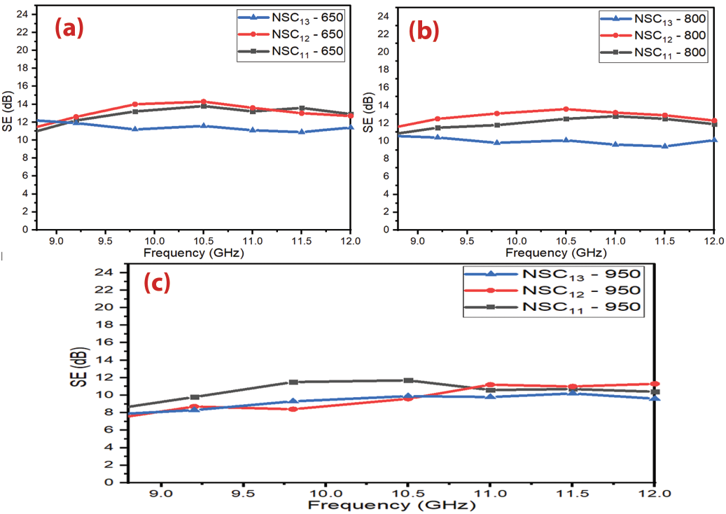
Figure 3.40 – SE curves of Ni_{0.5}Zn_{0.5}Fe₂O₄ nanoparticles at (a) 650 °C, (b) 800 °C and (c) 950 °C
Table 3.12 – MA behavior of Ni_{0.5}Zn_{0.5}Fe₂O₄ nanoparticles
Samples | T (°C) | RL_{min} (dB) | f_{m} (GHz) | BW_{-10 dB} (GHz)
NSC₁₁ ₋ 650 | 650 | -12.2 | 10.5 | 1.3
NSC₁₂ ₋ 650 | 650 | -12.9 | 9.8 | 1.5
NSC₁₃ ₋ 650 | 650 | -10.9 | 9.2 | 0.8
NSC₁₁ ₋ 800 | 800 | -13.2 | 9.7 | 1.2
NSC₁₂ ₋ 800 | 800 | -12.7 | 9.3 | 1.0
NSC₁₃ ₋ 800 | 800 | -11.3 | 8.8 | 0.2
NSC₁₁ ₋ 950 | 950 | -7.9 | 9.5 | 0
NSC₁₂ ₋ 950 | 950 | -8.0 | 11.0 | 0
NSC₁₃ ₋ 950 | 950 | -8.1 | 10.5 | 0

Influence of sample thickness and loading percentage on the f_{m}
The influence of the different loading percentages (60, 65 and 70% w/w) and thicknesses (3, 5 and 6 mm) on NZ11 – 650 properties were investigated. Figure 3.41 shows that the RL moved gradually to a lower frequency with the increased loading percentage. Also, the same phenomenon was noticed by increasing the thickness of an absorber. The results indicated a RL_{min} of -12.9 dB at 10.0 GHz and absorption BW_{-10 dB} of 0.7 GHz for 5 mm thickness for NSC₁₁ – 70%. The SE_{max} was 14.4 dB at 8.8 GHz. From the above studies, we found the f_{m} position controllability of ferrite nanoparticles prepared with the self-combustion.
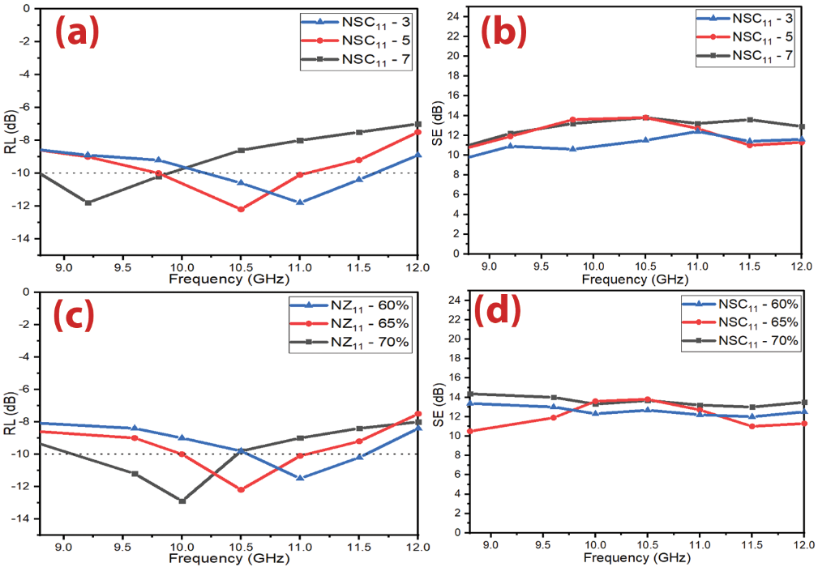
Figure 3.41 (a,b) – RL and SE curves of Ni_{0.5}Zn_{0.5}Fe₂O₄ nanoparticles at different thicknesses and (c,d) RL and SE curves of Ni_{0.5}Zn_{0.5}Fe₂O₄ nanoparticles with different loading percentages (60% w/w, 65% w/w and 70% w/w mm) at 5 mm thickness
From the above studies, One can notice that MA properties were changed with the variation of the synthesis method. The best result was obtained by using the Ni_{0.5}Zn_{0.5}Fe₂O₄ nanoparticles with a loading percentage of 60% at a constant calcination temperature of 650° C prepared by the citrate precursor method. This improvement is due to the fact that these processes will affect the MA capacity by changing the complex permeability and permittivity. However, the defects of these prepared absorbers are that they have a limited absorption BW_{-10 dB} and high loading percentage. This necessitated working to decrease the loading percentage and increase the absorption BW_{-10 dB} of the absorbers to cover most of the X-band frequency by incorporating magnetic loss and dielectric loss materials.

Microwave absorption properties of ferrite nanocomposites
Several variables that affect MA properties were studied, as follows: ferrite nanocomposite type, the weight ratio of CB/Ni_{0.5}Zn_{0.5}Fe₂O₄, CB/Mn_{0.1}Ni_{0.5}Zn_{0.4}Fe₂O₄, C/Ni³⁺_{0.25}Ni²⁺_{0.375}Zn²⁺_{0.25}Fe₂O₄ and Ni_{0.5}Zn_{0.5}Fe₂O₄/CI/CB, and loading percentage.

Microwave absorption properties of carbon black/NiZn ferrite nanocomposites
RAMs have been used extensively to cover the walls of anechoic halls and to prevent or reduce electromagnetic reflections from large bodies. RAMs can be produced in different forms, such as paints, thin films, sheets, and sponges. These products are obtained by dispersing one or more types of absorbent materials in a polymeric matrix and applying them to a substrate or surface. Understanding the techniques for producing microwave absorbent composites by incorporating components, additives, and a matrix type is crucial to the final usage of the resulting absorbent material. Absorption is achieved by gradually decreasing the impedance starting from the dielectric layer, whose impedance is close to the impedance value of air, to secure the entry of most of the incident waves into the material and reduce reflection. Then the absorbent layers are graded with increasing impedance. MAMs should be lightweight, prepared in various shapes, waterproof, chemically resistant, have good mechanical and physical properties, be easy to prepare, low cost, have a wide absorption field, and are strong absorption.
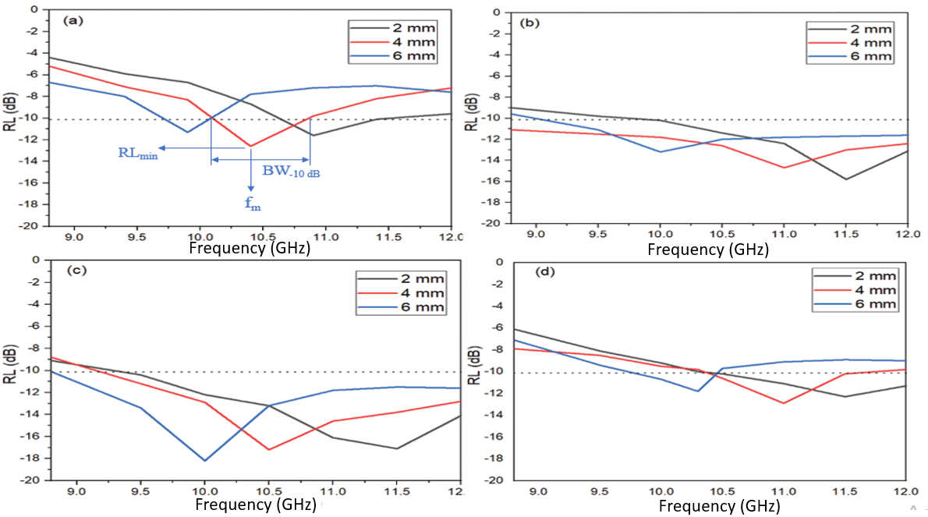
Figure 3.42 – RL curves of (a) pure CB nanopowder, (b) CB/F-11 nanocomposite, (c) CB/F-21 nanocomposite and (d) CB/F-31 nanocomposite at different thicknesses (2–4–6 mm)
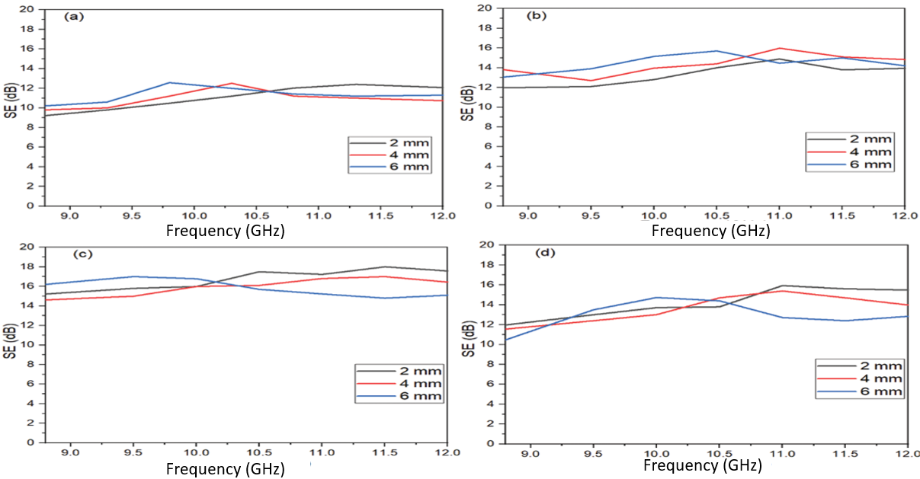
Figure 3.43 – SE curves of (a) pure CB nanopowder, (b) CB/F-11 nanocomposite, (c) CB/F-21 nanocomposite and (d) CB/F-31 nanocomposite at different thicknesses (2–4–6 mm)
Table 3.13 – MA behavior of CB/Ni_{0.5}Zn_{0.5}Fe₂O₄ nanocomposites and pure CB nanopowder at different thicknesses (2–4–6 mm)
Nanocomposite samples | t (mm) | RL_{min} (dB) | f_{m} (GHz) | BW_{-10 dB} (GHz) | SD (kg/m²)
CB | 2 | -11.6 | 10.9 | 0.7 | 2.91
CB | 4 | -12.5 | 10.4 | 0.8 | 2.92
CB | 6 | -11.3 | 9.8 | 0.3 | 2.94
CB/F-11 | 2 | -15.8 | 11.6 | 2.1 | 3.72
CB/F-11 | 4 | -14.7 | 10.9 | 3.2 | 3.74
CB/F-11 | 6 | -13.2 | 10.2 | 2.8 | 3.75
CB/F-21 | 2 | -17.1 | 11.4 | 2.6 | 3.49
CB/F-21 | 4 | -17.2 | 10.5 | 2.8 | 3.50
CB/F-21 | 6 | -18.2 | 9.9 | 3.2 | 3.52
CB/F-31 | 2 | -11.9 | 11.6 | 1.6 | 3.18
CB/F-31 | 4 | -11.8 | 11.1 | 1.8 | 3.20
CB/F-31 | 6 | -11.2 | 10.3 | 2.3 | 3.21

Microwave absorption properties of carbon black/MnNiZn ferrite nanocomposites
The development of radar or microwave absorbing materials technology has had a great impact on the military field. Radar absorbing materials are significant tools in electronic warfare, as they can be used to hide targets and protect them from radar detection. EM shielding materials and RAMs have been produced by international companies at high prices. In this regard, the relevance of the research topic of the doctoral dissertation is paving the way for putting the methodology and scientific bases for the manufacture of MAMs in the laboratory with the required international quality. As well as competing with commercial absorbers mentioned in the literature in terms of weight, reflection loss, absorption bandwidth, and shielding efficiency.
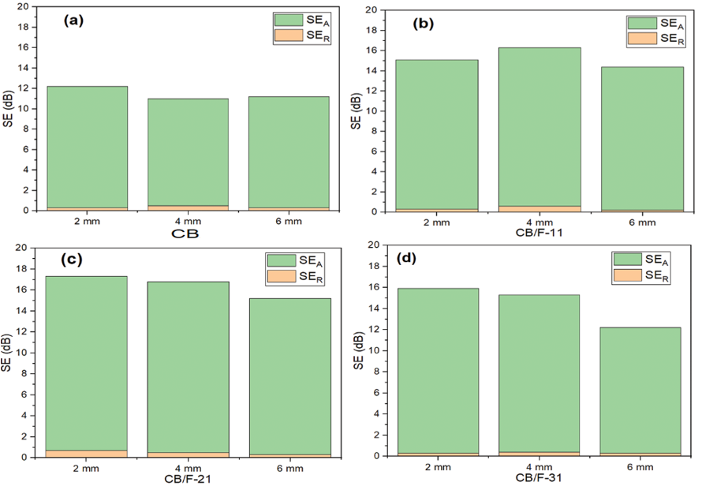
Figure 3.44 – Bar plot for individual components of SE_{R} and SE_{A} of (a) pure CB nanopowder, (b) CB/F-11 nanocomposite, (c) CB/F-21 nanocomposite and (d) CB/F-31 nanocomposite with different thicknesses (2–4–6 mm) at the frequency of 11 GHz
From the above studies, One can notice that the RL_{min}, SE_{max}, and BW_{-10 dB} were changed with the variation of the ferrite type used with carbon black. The best result was obtained by using the CB/Mn_{0.1}Ni_{0.5}Zn_{0.4}Fe₂O₄ nanocomposite (1:1) with a thickness of 2 mm. This improvement is due to the fact that these processes will affect the MA capacity by changing the complex permeability and permittivity.
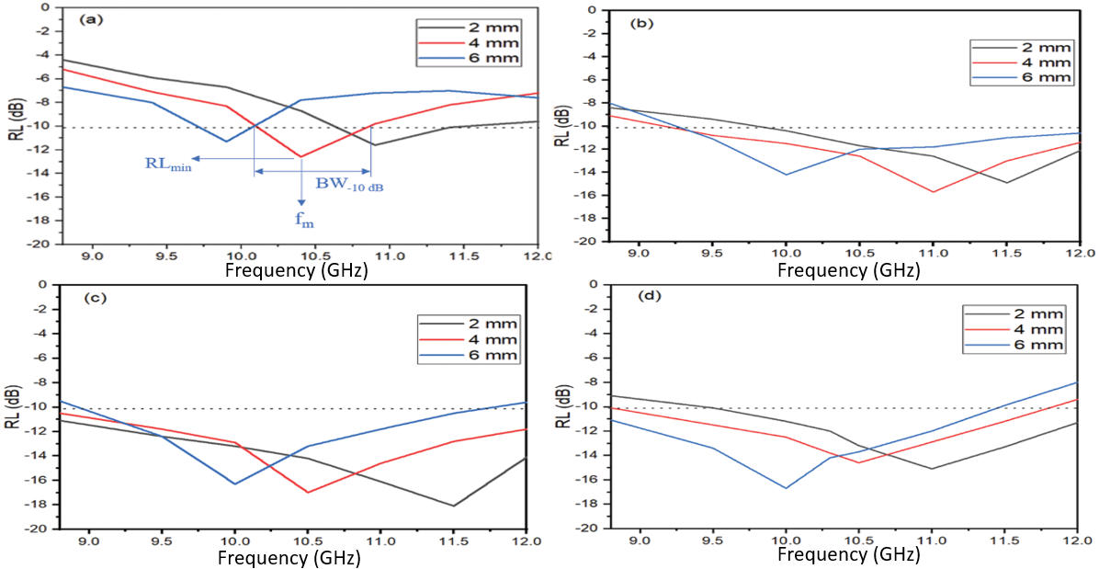
Figure 3.45 – RL curves of (a) pure CB nanopowder, (b) CB/MF-11 nanocomposite, (c) CB/MF-21 nanocomposite, and (d) CB/MF-31 nanocomposite at various thicknesses (2–4–6 mm)
Table 3.14 – MA behavior of CB/Mn_{0.1}Ni_{0.5}Zn_{0.4}Fe₂O₄ nanocomposites at various thicknesses (2–4–6 mm)
Nanocomposite samples | t (mm) | RL_{min} (dB) | f_{m} (GHz) | BW_{-10 dB} (GHz) | SD (kg/m²)
CB | 2 | -11.6 | 10.9 | 0.7 | 2.91
CB | 4 | -12.5 | 10.4 | 0.8 | 2.92
CB | 6 | -11.3 | 9.8 | 0.3 | 2.94
CB/MF-11 | 2 | -14.7 | 11.5 | 2.0 | 3.63
CB/MF-11 | 4 | -15.8 | 11.0 | 3.2 | 3.65
CB/MF-11 | 6 | -13.9 | 10.1 | 2.9 | 3.66
CB/MF-21 | 2 | -18.3 | 11.4 | 3.2 | 3.40
CB/MF-21 | 4 | -17.2 | 10.5 | 3.2 | 3.41
CB/MF-21 | 6 | -17.1 | 10.0 | 2.8 | 3.43
CB/MF-31 | 2 | -15.1 | 11.0 | 2.5 | 3.09
CB/MF-31 | 4 | -14.6 | 10.6 | 2.9 | 3.11
CB/MF-31 | 6 | -16.7 | 9.9 | 2.6 | 3.12

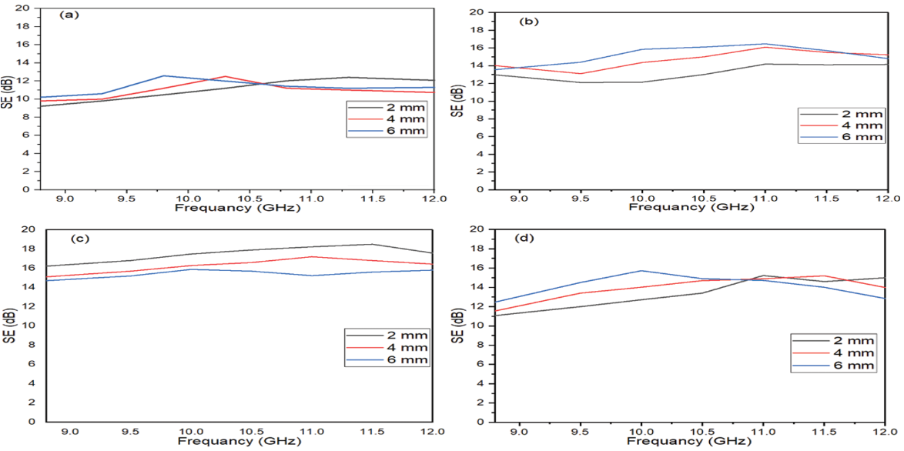
Figure 3.46 – SE curves of (a) pure CB nanopowder, (b) CB/MF-11 nanocomposite, (c) CB/MF-21 nanocomposite and (d) CB/MF-31 nanocomposite at various thicknesses (2–4–6 mm)

Microwave absorption properties of graphite/NiZn ferrite composites
These products are obtained by dispersing one or more types of absorbent materials in a polymeric matrix and applying them to a substrate or surface. Understanding the techniques for producing microwave absorbent composites by incorporating components, additives, and a matrix type is crucial to the final usage of the resulting absorbent material. Absorption is achieved by gradually decreasing the impedance starting from the dielectric layer, whose impedance is close to the impedance value of air, to secure the entry of most of the incident waves into the material and reduce reflection. Then the absorbent layers are graded with increasing impedance.

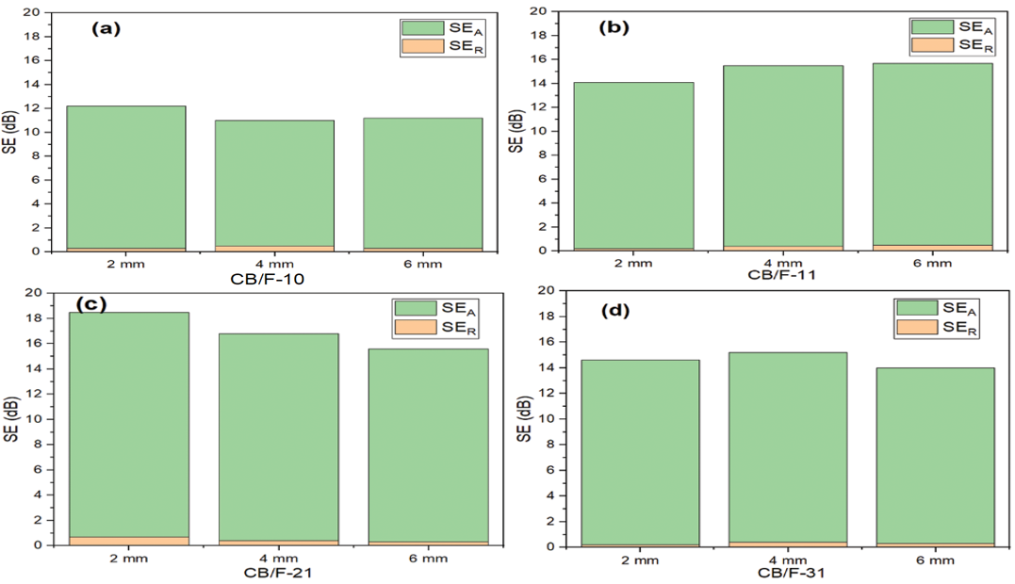
Figure 3.47 – Bar plot for individual components of SE_{R} and SE_{A} of (a) pure CB nanopowder, (b) CB/MF-11 nanocomposite, (c) CB/MF-21 nanocomposite and (d) CB/MF-31 nanocomposite with various thicknesses (2–4–6 mm) at the frequency of 11.5 GHz
Table 3.15 – MA behavior of C/Ni³⁺_{0.25}Ni²⁺_{0.375}Zn²⁺_{0.25}Fe₂O₄ composites at different thicknesses (2–4–6 mm)
Nanocomposite samples | t (mm) | RL_{min} (dB) | f_{m} (GHz) | BW_{-10 dB} (GHz) | SD (kg/m²)
C/F-11 | 2 | -13.8 | 11.5 | 1.1 | 3.71
C/F-11 | 4 | -12.7 | 11.0 | 1.8 | 3.73
C/F-11 | 6 | -11.2 | 9.8 | 1.3 | 3.74
C/F-21 | 2 | -13.1 | 11.0 | 1.9 | 3.51
C/F-21 | 4 | -12.7 | 10.6 | 1.6 | 3.52
C/F-21 | 6 | -14.8 | 10.1 | 2.2 | 3.54
C/F-31 | 2 | -15.1 | 11.5 | 1.6 | 3.17
C/F-31 | 4 | -15.2 | 10.5 | 2.3 | 3.19
C/F-31 | 6 | -16.2 | 10.0 | 2.0 | 3.21
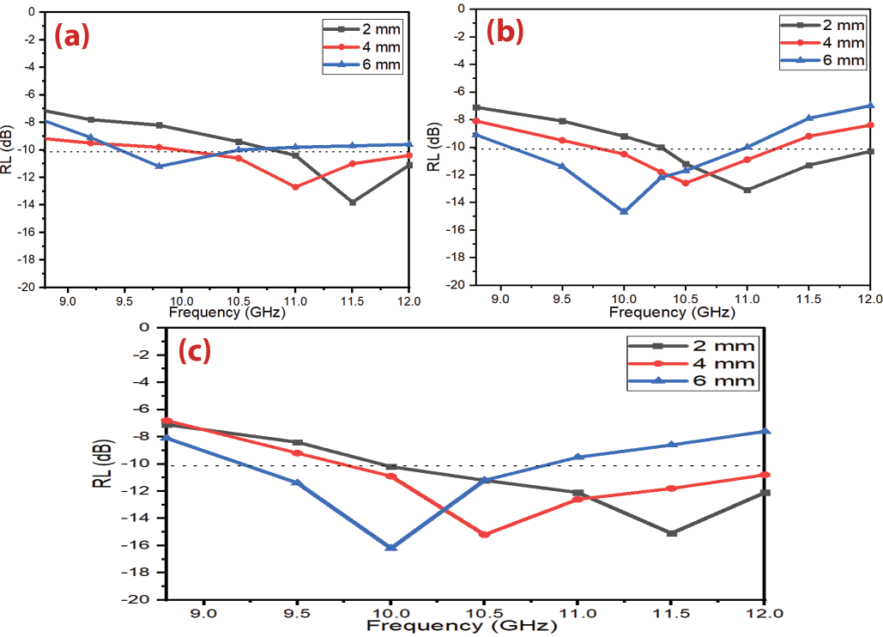
Figure 3.48 – RL curves of (a) C/F-11 composite, (c) C/F-21 composite, and (d) C/F-31 composite at various thicknesses (2–4–6 mm)
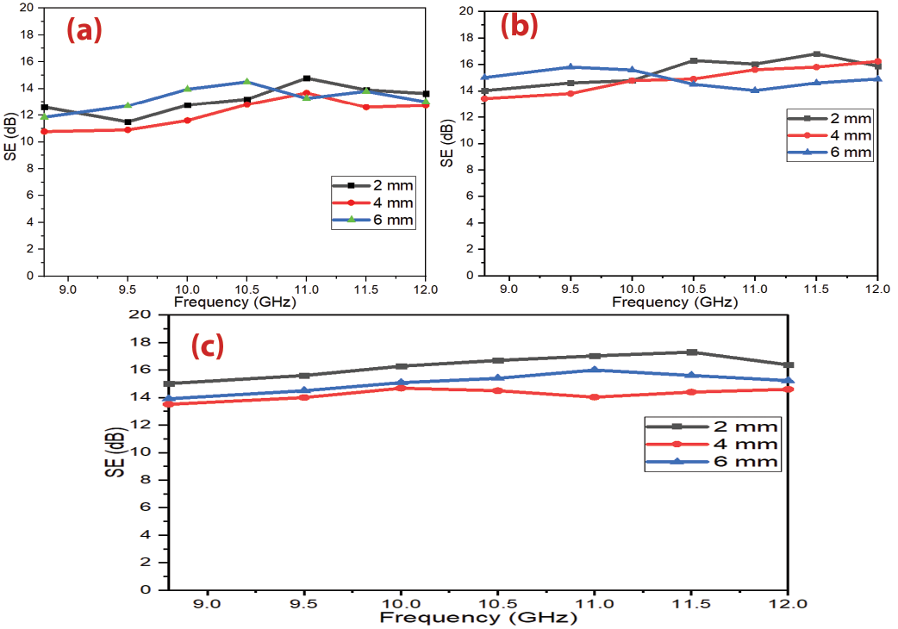
Figure 3.49 – SE curves of (a) C/F-11 composite, (b) C/F-21 composite, and (c) C/F-31 composite at various thicknesses (2–4–6 mm)

Microwave absorption properties of carbonyl iron/NiZn ferrite nanocomposites
EMI shielding and MA properties of CI/Ni_{0.5}Zn_{0.5}Fe₂O₄ nanocomposites were investigated at a loading percentage of 45% w/w with the different weight ratios of C/Ni³⁺_{0.25}Ni²⁺_{0.375}Zn²⁺_{0.25}Fe₂O₄ (1:1, 2:1, and 3:1). The development of radar or microwave absorbing materials technology has had a great impact on the military field. Radar absorbing materials are significant tools in electronic warfare, as they can be used to hide targets and protect them from radar detection. EM shielding materials and RAMs have been produced by international companies at high prices. In this regard, the relevance of the research topic of the doctoral dissertation is paving the way for putting the methodology and scientific bases for the manufacture of MAMs in the laboratory with the required international quality. As well as competing with commercial absorbers mentioned in the literature in terms of weight, reflection loss, absorption bandwidth, and shielding efficiency. The results obtained in the framework of this thesis can be suggested for producing microwave absorbers synthesized based on ML and DL materials. An advantage of the work is that obtained absorbers can attenuate the EM waves with low surface density and wide bandwidth.
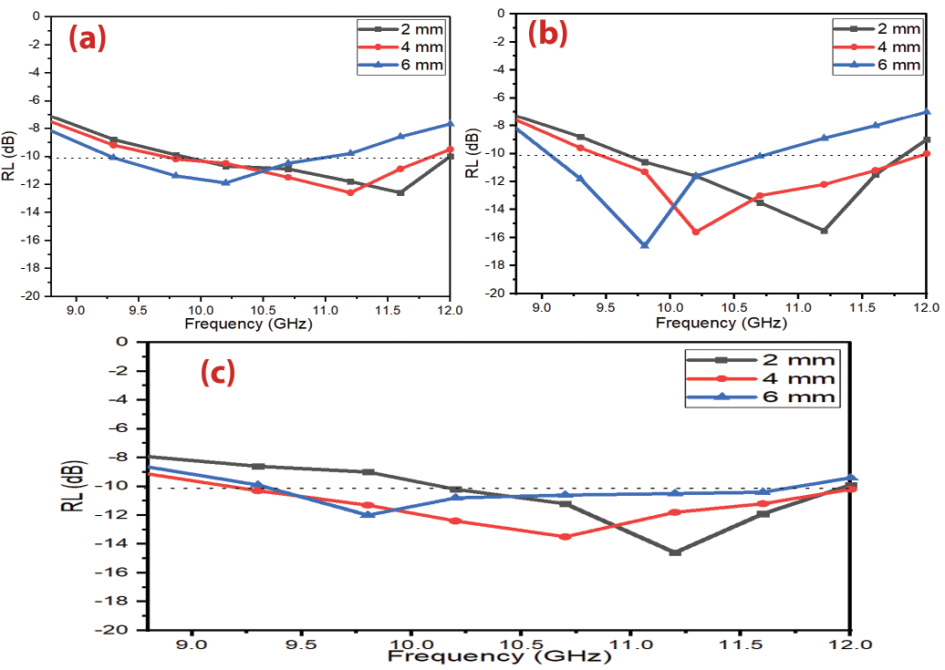
Figure 3.50 – RL curves of (a) CI/F-11 nanocomposite, (b) CI/F-21 nanocomposite and (c) CI/F-31 nanocomposite at different thicknesses (2–4–6 mm)
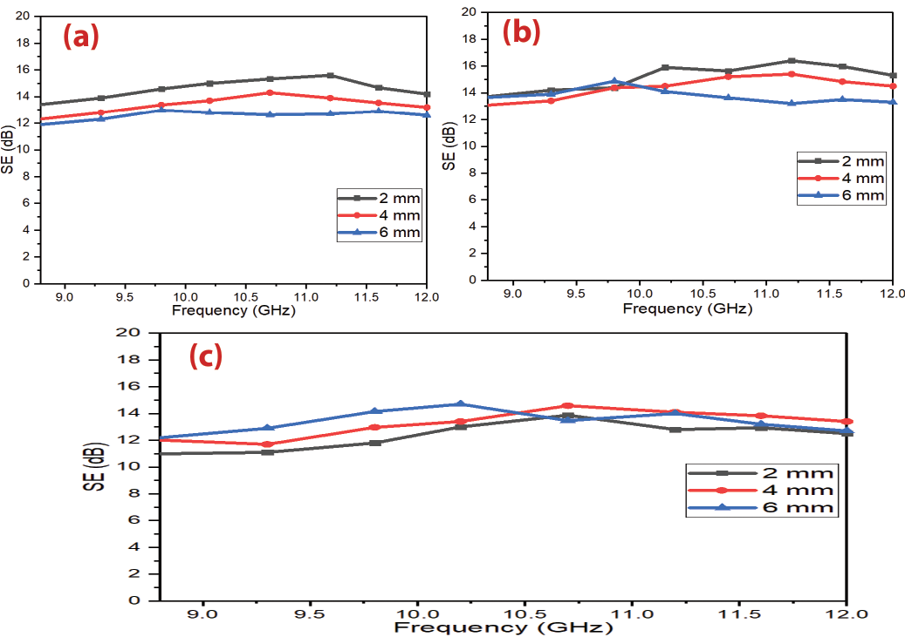
Figure 3.51 – SE curves of (a) CI/F-11 nanocomposite, (b) CI/F-21 nanocomposite and (c) CI/F-31 nanocomposite at different thicknesses (2–4–6 mm)
Table 3.16 – MA behavior of CI/Ni_{0.5}Zn_{0.5}Fe₂O₄ nanocomposites at different thicknesses (2–4–6 mm)
Nanocomposite samples | t (mm) | RL_{min} (dB) | f_{m} (GHz) | BW_{-10 dB} (GHz) | SD (kg/m²)
CI/F-11 | 2 | -12.6 | 11.6 | 2.2 | 4.52
CI/F-11 | 4 | -12.5 | 11.2 | 2.0 | 4.54
CI/F-11 | 6 | -11.9 | 10.2 | 1.8 | 4.55
CI/F-21 | 2 | -15.5 | 11.2 | 2.1 | 4.76
CI/F-21 | 4 | -15.6 | 10.2 | 2.5 | 4.77
CI/F-21 | 6 | -16.1 | 9.8 | 1.8 | 4.79
CI/F-31 | 2 | -14.6 | 11.2 | 1.8 | 4.91
CI/F-31 | 4 | -13.5 | 10.7 | 2.8 | 4.92
CI/F-31 | 6 | -12.0 | 9.8 | 2.2 | 4.94

Microwave absorption properties of ternary nanocomposites of NiZn ferrite/carbonyl iron/carbon black
The development of radar or microwave absorbing materials technology has had a great impact on the military field. Radar absorbing materials are significant tools in electronic warfare, as they can be used to hide targets and protect them from radar detection. EM shielding materials and RAMs have been produced by international companies at high prices. In this regard, the relevance of the research topic of the doctoral dissertation is paving the way for putting the methodology and scientific bases for the manufacture of MAMs in the laboratory with the required international quality. As well as competing with commercial absorbers mentioned in the literature in terms of weight, reflection loss, absorption bandwidth, and shielding efficiency. The best result was obtained by using the F/CI/CB-211 nanocomposite sample. In order to evaluate the beneficial impact of adding CB to the F/CI on the microwave properties, Table 3.18 shows a comparison of the radar absorption properties of some lately reported carbon-based nanomaterials. The results of the literature show these composites are good in the C-band and Ku-band frequencies and limited in the X-band frequency. The presently prepared nanocomposites display in this research better MA in the X-band frequency. The distinct of these prepared nanocomposites have a lower loading percentage and thickness of the absorbers compared with the other literature.
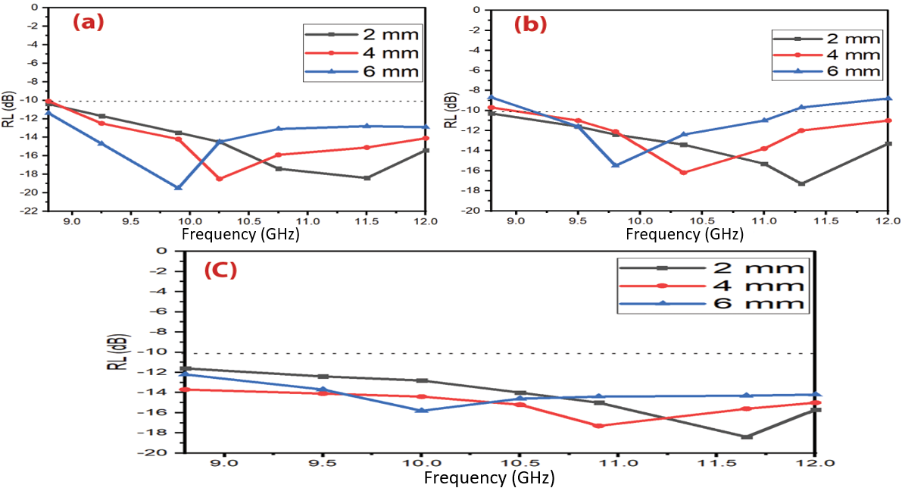
Figure 3.52 – RL curves of (a) F/CI/CB-111 composite, (b) F/CI/CB-112 composite and (c) F/CI/CB-211 composite at various thicknesses (2–4–6 mm)
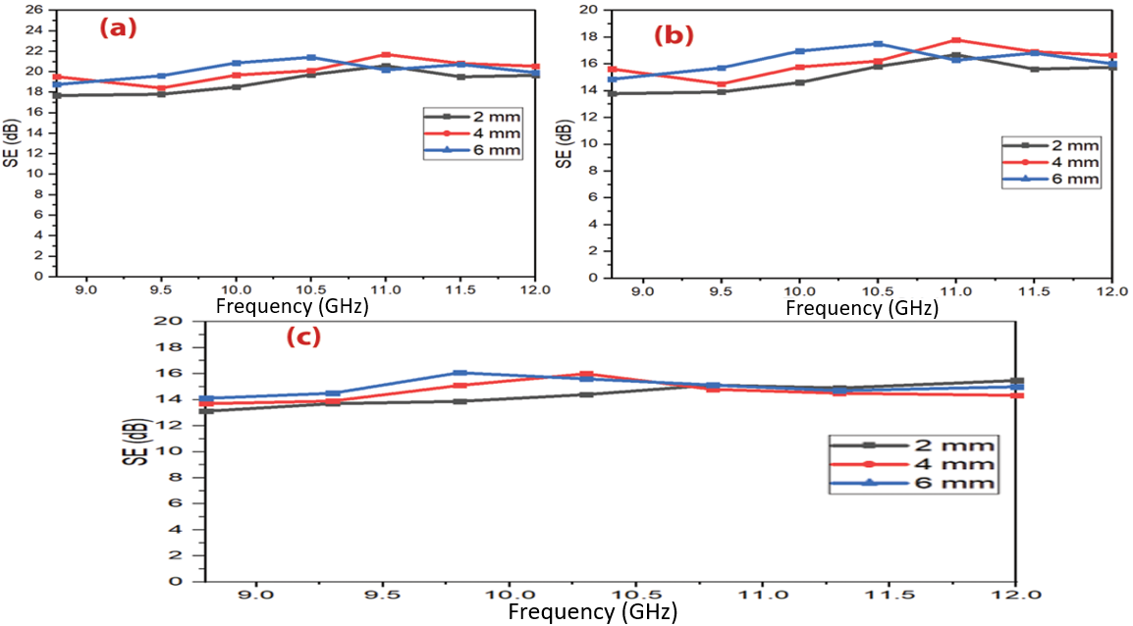
Figure 3.53 – SE curves of (a) F/CI/CB-111 composite, (b) F/CI/CB-112 composite and (c) F/CI/CB-211 composite at various thicknesses (2–4–6 mm)
Table 3.17 – MA behavior of Ni_{0.5}Zn_{0.5}Fe₂O₄/CI/CB composites at various thicknesses (2–4–6 mm)
Nanocomposite samples | t (mm) | RL_{min} (dB) | f_{m} (GHz) | BW_{-10 dB} (GHz) | SD (kg/m²)
F/CI/CB-111 | 2 | -18.3 | 11.5 | 3.2 | 3.86
F/CI/CB-111 | 4 | -18.5 | 10.3 | 3.2 | 3.87
F/CI/CB-111 | 6 | -19.4 | 9.9 | 3.2 | 3.89
F/CI/CB-112 | 2 | -17.3 | 11.3 | 3.2 | 3.62
F/CI/CB-112 | 4 | -16.3 | 10.4 | 2.9 | 3.64
F/CI/CB-112 | 6 | -15.5 | 9.8 | 2.8 | 3.65
F/CI/CB-211 | 2 | -18.4 | 11.7 | 3.2 | 4.01
F/CI/CB-211 | 4 | -17.3 | 10.9 | 3.2 | 4.02
F/CI/CB-211 | 6 | -15.8 | 10.0 | 3.2 | 4.04

Microwave absorption properties of double-layer of AC/F
Microwave absorption characteristics were studied for double-layer activated carbon/paraffin wax (AC) and Mn_{0.1}Ni_{0.5}Zn_{0.4}Fe₂O₄/paraffin wax (F) nanocomposites as shown in Figure 3.54. Radar absorbing materials are significant tools in electronic warfare, as they can be used to hide targets and protect them from radar detection. EM shielding materials and RAMs have been produced by international companies at high prices. In this regard, the relevance of the research topic of the doctoral dissertation is paving the way for putting the methodology and scientific bases for the manufacture of MAMs in the laboratory with the required international quality. As well as competing with commercial absorbers mentioned in the literature in terms of weight, reflection loss, absorption bandwidth, and shielding efficiency.
Table 3.18 – Radar absorption properties of carbon-based nanomaterials
Sample | t (mm) | f (GHz) | BW_{-10 dB} (GHz) _{(C-band)} | BW_{-10 dB} (GHz) _{(X-band)} | BW_{-10 dB} (GHz) _{(Ku-band)} | Ref
ZnFe₂O₄/rGO | 2.5 | 9.3 | 1.6 | 1.0 | 0 | [126]
NiFe₂O₄/rGO | 1.9 | 14.5 | 0 | 1.4 | 3.8 | [127]
CoFe₂O₄/rGO | 1.6 | 14.7 | 0 | 0 | 4.5 | [128]
MWCNT/Ni _{0.5}Zn_{0.5} Fe₂O₄ | 2 | 10.40 | 0.08 | 0 | 0 | [129]
CF/Fe₃O₄/BN | 3.0 | 12.5 | 0 | 0.8 | 3.4 | [130]
Ni/MWNT | 4 | 7.2 | 2.2 | 1.2 | 0 | [131]
Sm₂O₃/MWCNT | 2 | 9.4 | 1.1 | 0.5 | 0 | [132]
Fe/Fe₃C/MWCNT | 2 | 9 | 1.6 | 0.8 | 0 | [133]
Fe/Fe₃C/MWCNT | 3.5 | 4.6 | 2.3 | 0 | 0 | [133]
Fe/CNTs | 3.5 | 11.4 | 0 | 2.9 | 0 | [134]
CoNC/CNTs | 4.7 | 5.2 | 2.2 | 0 | 0 | [135]
FeCo@CFs | 1.6 | 16.6 | 0 | 3.5 | 0.9 | [136]
An advantage of the work is that obtained absorbers can attenuate the EM waves with low surface density and wide bandwidth. These microwave absorbers can be used to cover the walls of anechoic chambers and to prevent or reduce electromagnetic reflections from large bodies such as stealth aircraft, submarines, carriers, and so on. RAMs have been used extensively to cover the walls of anechoic halls and to prevent or reduce electromagnetic reflections from large bodies. RAMs can be produced in different forms, such as paints, thin films, sheets, and sponges.
Table 3.19 – Radar absorption properties of double-layer of AC/F nanocomposites
Sample symbols | t (mm) | RL_{min} (dB) | f_{m} (GHz) | BW_{-10 dB} (GHz)
AC/F-12 | 3 | -13.1 | 11.0 | 1.9
AC/F-21 | 3 | -21.4 | 10.35 | 2.3
AC/F-22 | 4 | -13.6 | 11.2 | 1.4
F/AC12 | 3 | -16.2 | 10.2 | 1.9
F/AC-21 | 3 | -6.5 | 10.8 | 0
F/AC-22 | 4 | -6.9 | 9.6 | 0
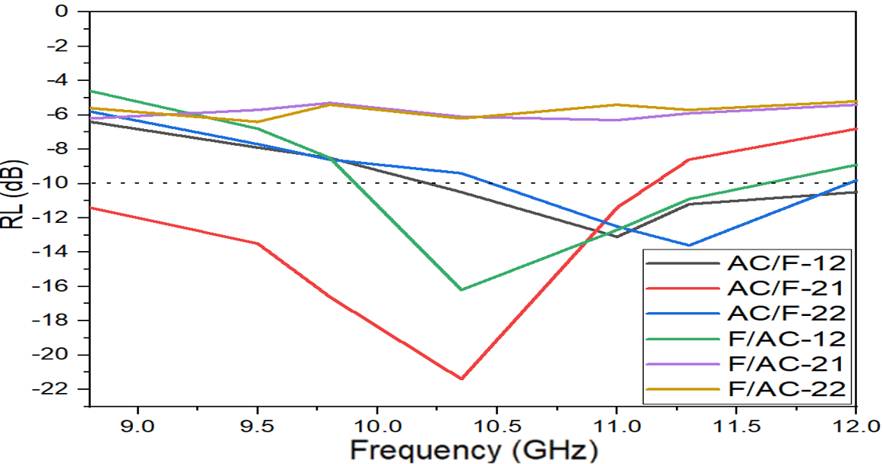
Figure 3.54 – RL curves of double-layer of AC/F nanocomposites at the frequency range of 8.8 to 12 GHz

Microwave absorption properties of PANI-based nanocomposites
Several variables that affect microwave absorption properties were studied, as follows: PANI-based nanocomposites type, weight ratios of PANI/Ni³⁺_{0.25}Ni²⁺_{0.375}Zn²⁺_{0.25}Fe₂O₄, and PANI/BaNiZnFe₁₆O₂₇, and adding CB and CI to hybrid nanocomposites.

Effect of PANI/Ni³⁺_{0.25}Ni²⁺_{0.375}Zn²⁺_{0.25}Fe₂O₄ hybrid nanocomposites morphology on the RL and the SE
EMI These microwave absorbers can be used to cover the walls of anechoic chambers and to prevent or reduce electromagnetic reflections from large bodies such as stealth aircraft, submarines, carriers, and so on. RAMs have been used extensively to cover the walls of anechoic halls and to prevent or reduce electromagnetic reflections from large bodies. RAMs can be produced in different forms, such as paints, thin films, sheets, and sponges. These products are obtained by dispersing one or more types of absorbent materials in a polymeric matrix and applying them to a substrate or surface. Understanding the techniques for producing microwave absorbent composites by incorporating components, additives, and a matrix type is crucial to the final usage of the resulting absorbent material.
Absorption is achieved by gradually decreasing the impedance starting from the dielectric layer, whose impedance is close to the impedance value of air, to secure the entry of most of the incident waves into the material and reduce reflection. Then the absorbent layers are graded with increasing impedance. MAMs should be lightweight, prepared in various shapes, waterproof, chemically resistant, have good mechanical and physical properties, be easy to prepare, low cost, have a wide absorption field, and are strong absorption The development of radar or microwave absorbing materials technology has had a great impact on the military field. Radar absorbing materials are significant tools in electronic warfare, as they can be used to hide targets and protect them from radar detection. EM shielding materials and RAMs have been produced by international companies at high prices.

Effect of sample thickness on the RL
Absorption is achieved by gradually decreasing the impedance starting from the dielectric layer, whose impedance is close to the impedance value of air, to secure the entry of most of the incident waves into the material and reduce reflection. Then the absorbent layers are graded with increasing impedance.
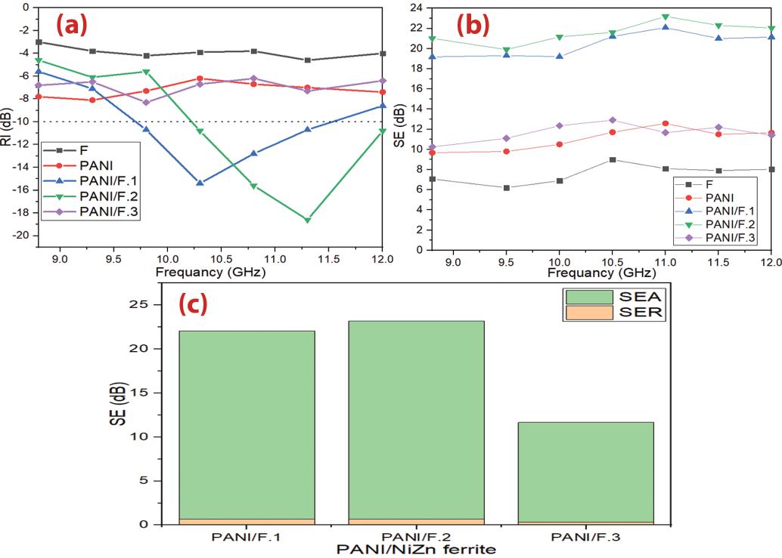
Figure 3.55 (a,b) – RL and SE curves of Ni³⁺_{0.25}Ni²⁺_{0.375}Zn²⁺_{0.25}Fe₂O_{4,} PANI/Ni³⁺_{0.25}Ni²⁺_{0.375}Zn²⁺_{0.25}Fe₂O₄ nanocomposites and pure PANI at 2.9 mm thickness and (c) bar plot for individual components of SE_{R} and SE_{A} with a thickness of 2.90 mm at the frequency of 11.0 GHz
Table 3.20 – MA behavior of Ni³⁺_{0.25}Ni²⁺_{0.375}Zn²⁺_{0.25}Fe₂O_{4,} PANI/Ni³⁺_{0.25}Ni²⁺_{0.375}Zn²⁺_{0.25}Fe₂O₄ nanocomposites and pure PANI at 2.9 mm thickness
Samples | RL_{min} (dB) | f_{m} (GHz) | BW_{-10 dB} (GHz) | SD (kg/m²)
Ni³⁺_{0.25}Ni²⁺_{0.375}Zn²⁺_{0.25}Fe₂O₄ | -4.2 | - | - | 4.53
PANI | -8.1 | - | - | 2.21
PANI/F.1 | -15.4 | 10.2 | 1.9 | 3.22
PANI/F.2 | -18.6 | 11.3 | 1.8 | 3.04
PANI/F.3 | -8.3 | - | - | 2.96
The results obtained in the framework of this thesis can be suggested for producing microwave absorbers synthesized based on ML and DL materials. An advantage of the work is that obtained absorbers can attenuate the EM waves with low surface density and wide bandwidth.
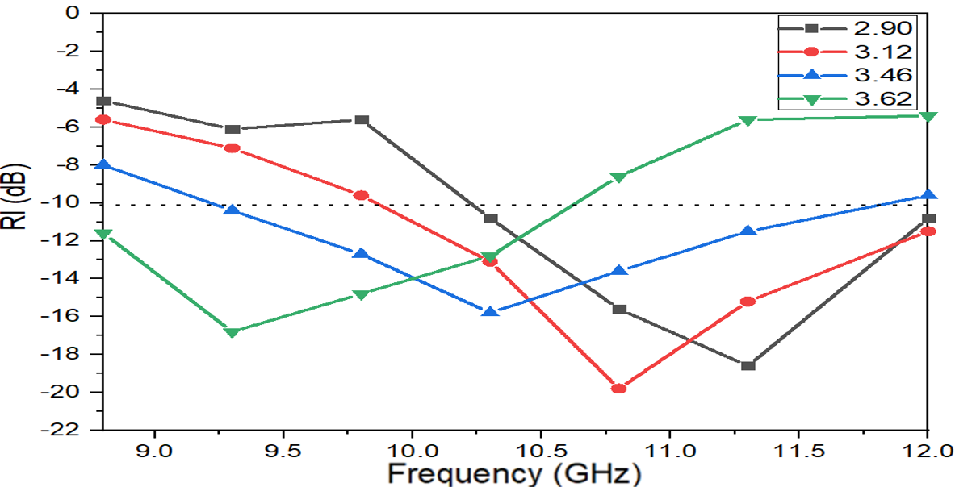
Figure 3.56 – RL curves of PANI/F.2 hybrid nanocomposite at various thicknesses
Table 3.21 – MA behavior of PANI/F.2 hybrid nanocomposite at various thicknesses
PANI/F.2 | t (mm) | RL_{min} (dB) | f_{m} (GHz) | BW_{-10dB} (GHz) | SD (kg/m²)
PANI/F.2 | 2.90 | -18.6 | 11.3 | 1.8 | 3.04
PANI/F.2 | 3.12 | -19.8 | 10.8 | 2.2 | 3.07
PANI/F.2 | 3.46 | -15.7 | 10.2 | 2.7 | 3.09
PANI/F.2 | 3.62 | -16.9 | 9.3 | 1.7 | 3.12

Influence of the incorporation of Ni_{0.5}Zn_{0.5}Fe₂O₄, CI and PANI on the RL and the SE
EMI shielding and MA properties of the Ni_{0.5}Zn_{0.5}Fe₂O₄, CI, PANI, PANI/CI and PANI/F/CI nanocomposite were investigated. The development of radar or microwave absorbing materials technology has had a great impact on the military field. Radar absorbing materials are significant tools in electronic warfare, as they can be used to hide targets and protect them from radar detection. EM shielding materials and RAMs have been produced by international companies at high prices. In this regard, the relevance of the research topic of the doctoral dissertation is paving the way for putting the methodology and scientific bases for the manufacture of MAMs in the laboratory with the required international quality. As well as competing with commercial absorbers mentioned in the literature in terms of weight, reflection loss, absorption bandwidth, and shielding efficiency. The results obtained in the framework of this thesis can be suggested for producing microwave absorbers synthesized based on ML and DL materials. An advantage of the work is that obtained absorbers can attenuate the EM waves with low surface density and wide bandwidth. These microwave absorbers can be used to cover the walls of anechoic chambers and to prevent or reduce electromagnetic reflections from large bodies such as stealth aircraft, submarines, carriers, and so on.
Table 3.22 – MA behavior of Ni_{0.5}Zn_{0.5}Fe₂O₄, CI, PANI, PANI/CI and PANI/F/CI composite at 3.2 mm thickness
Samples | RL_{min} (dB) | f_{m} (GHz) | BW_{-10 dB} (GHz) | SD (kg/m²)
Ni_{0.5}Zn_{0.5}Fe₂O₄ | -4.6 | - | - | 4.56
CI | -6.5 | - | - | 5.21
PANI | -8.5 | - | - | 2.25
PANI/CI | -21.3 | 10.2 | 2.7 | 3.36
PANI/F/CI | -25.7 | 11.3 | 2.6 | 3.31

Influence of sample thickness and loading ratio of the absorption material within paraffin on the RL
Figure 3.58 illustrates the RL of PANI/F/CI composite with various thicknesses (3.2, 3.4 and 3.6 mm) at the various loading percentages (30% w/w and 35% w/w). Figure 3.58 shows that the RL attenuation peaks of samples moved to lower frequencies with increasing sample thickness.

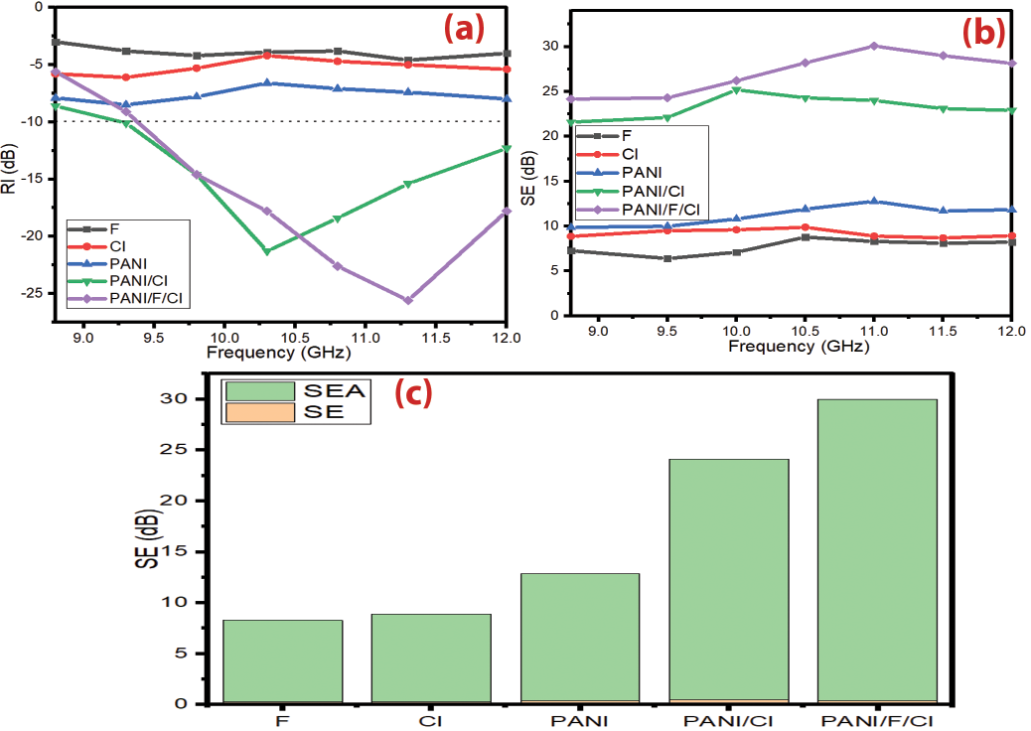
Figure 3.57 (a,b) – RL and SE curves of Ni_{0.5}Zn_{0.5}Fe₂O₄, CI, PANI, PANI/CI and PANI/F/CI composite at 3.2 mm thickness. SE curves of Ni_{0.5}Zn_{0.5}Fe₂O₄, CI, PANI and PANI/F/CI composite at 3.2 mm thickness and (c) bar plot for individual components of SE_{R} and SE_{A} of Ni_{0.5}Zn_{0.5}Fe₂O₄, CI, PANI and PANI/F/CI composite with a thickness of 3.2 mm at the frequency of 11.0 GHz
On the other hand, one can notice the RL_{min} moves gradually to a lower frequency with the increase in the loading percentage within a paraffin matrix (Figure 4.124). Furthermore, Table 3.23 shows the PANI/F/CI composites have reasonable SD, ranging from 3.31 to 3.40 kg/m², and wide BW_{-10dB} extending from 2.5 to 3.0 GHz. The absorption percentage of microwaves reached about 99.9% with a loading percentage of 30%. One can conclude that optimal absorption can be accomplished by modifying the absorber thickness and the loading percentage.
Table 3.23 – MA behavior of PANI/F/CI composite at various thicknesses and various loading ratios within a paraffin matrix
Loading ratio % | t (mm) | RL_{min} (dB) | f_{m} (GHz) | BW_{-10dB} (GHz) | SD (kg/m²)
30% | 3.2 | -25.7 | 11.3 | 2.6 | 3.31
30% | 3.4 | -28.5 | 10.8 | 3.0 | 3.35
30% | 3.6 | -26.8 | 9.8 | 2.9 | 3.37
35% | 3.2 | -28.6 | 10.8 | 2.5 | 3.33
35% | 3.4 | -30.8 | 10.3 | 2.8 | 3.38
35% | 3.6 | -28.4 | 9.3 | 2.6 | 3.40
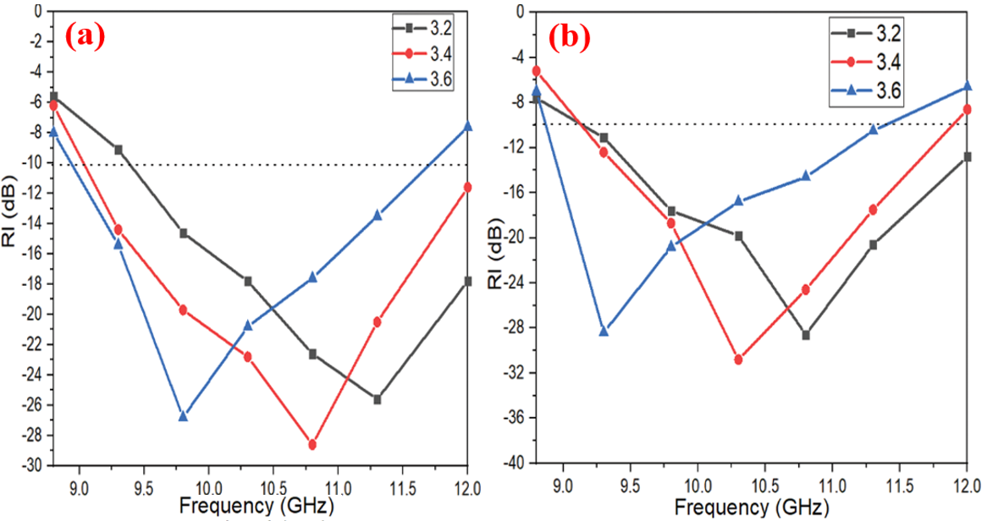
Figure 3.58 – RL curves of PANI/F/CI composite with various thicknesses (3.2, 3.4, 3.6 mm) at the various weight ratios of the absorber within a paraffin matrix (a) 30% and (b) 35%

Influence of the incorporation of Ni³⁺_{0.25}Ni²⁺_{0.375}Zn²⁺_{0.25}Fe₂O₄, CB and PANI on the RL and the SE
These products are obtained by dispersing one or more types of absorbent materials in a polymeric matrix and applying them to a substrate or surface. Understanding the techniques for producing microwave absorbent composites by incorporating components, additives, and a matrix type is crucial to the final usage of the resulting absorbent material.
Absorption is achieved by gradually decreasing the impedance starting from the dielectric layer, whose impedance is close to the impedance value of air, to secure the entry of most of the incident waves into the material and reduce reflection [82]. MAMs should be lightweight, prepared in various shapes, waterproof, chemically resistant, have good mechanical and physical properties, be easy to prepare, low cost, have a wide absorption field, and are strong absorption.
Table 3.24 – MA behavior of PANI/CB and PANI/F/CB nanocomposites at 3.0 mm thickness
Samples | RL_{min} (dB) | f_{m} (GHz) | BW_{-10 dB} (GHz) | SD (kg/m²)
PANI/CB | -8.4 | 10.5 | 0 | 2.62
PANI/50%F/50%CB | -15.6 | 11.0 | 2.8 | 2.91
PANI/70%F/30%CB | -17.2 | 9.9 | 2.8 | 3.02
PANI/90%F/10%CB | -15.1 | 10.5 | 3.2 | 3.15
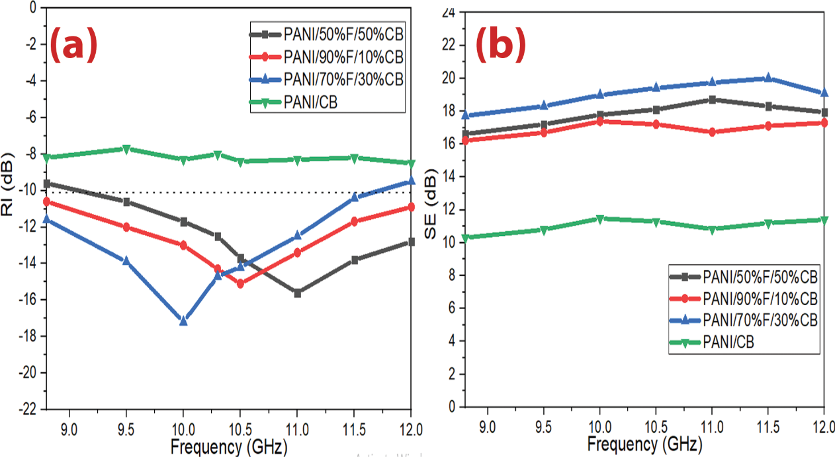
Figure 3.59 (a,b) – RL and SE curves of PANI/CB and PANI/F/CB nanocomposites at 3.0 mm thickness

Effect of PANI/BaNiZnFe₁₆O₂₇ hybrid nanocomposites morphology on the RL and the SE
EMI shielding and MA properties of the HF and PANI/HF nanocomposites were investigated. The results of this investigation are exhibited in Figure 3.60 and Table 3.25. The development of radar or microwave absorbing materials technology has had a great impact on the military field. Radar absorbing materials are significant tools in electronic warfare, as they can be used to hide targets and protect them from radar detection. EM shielding materials and RAMs have been produced by international companies at high prices. In this regard, the relevance of the research topic of the doctoral dissertation is paving the way for putting the methodology and scientific bases for the manufacture of MAMs in the laboratory with the required international quality. As well as competing with commercial absorbers mentioned in the literature in terms of weight, reflection loss, absorption bandwidth, and shielding efficiency. The results obtained in the framework of this thesis can be suggested for producing microwave absorbers synthesized based on ML and DL materials. An advantage of the work is that obtained absorbers can attenuate the EM waves with low surface density and wide bandwidth. These microwave absorbers can be used to cover the walls of anechoic chambers and to prevent or reduce electromagnetic reflections from large bodies such as stealth aircraft, submarines, carriers, and so on.
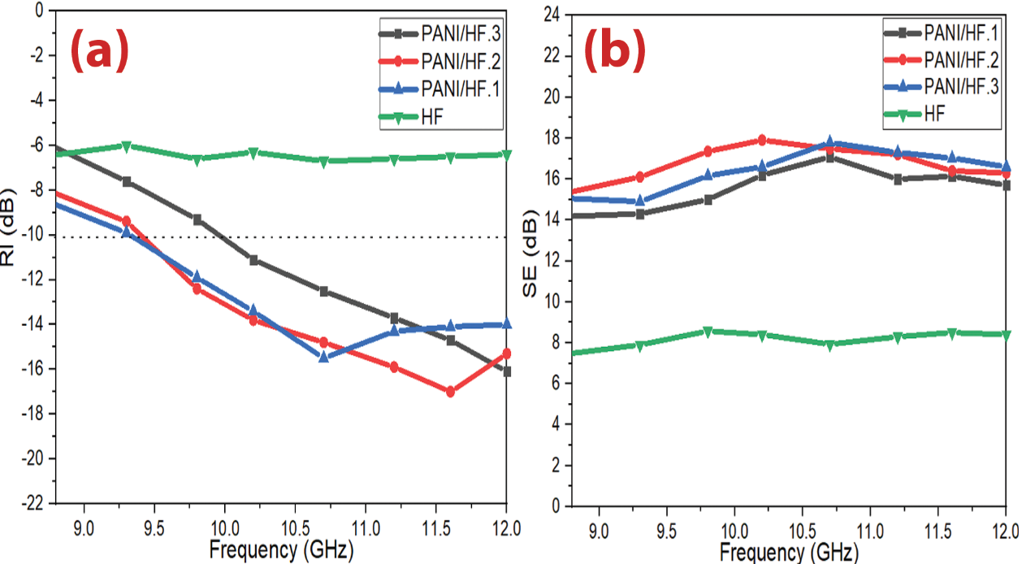
Figure 3.60 (a,b) – RL and SE curves of PANI/HF nanocomposites at 3.0 mm thickness. SE curves of PANI/HF nanocomposites at 3.0 mm thickness
Table 3.25 – MA behavior of HF and PANI/HF nanocomposites at 3.0 mm thickness
Samples | RL_{min} (dB) | f_{m} (GHz) | BW_{-10 dB} (GHz) | SD (kg/m²)
HF | -6.7 | 10.6 | 0 | 4.61
PANI/HF.1 | -15.6 | 10.7 | 2.7 | 3.74
PANI/HF.2 | -17.0 | 11.6 | 2.6 | 3.57
PANI/HF.3 | -16.1 | 12.0 | 2.5 | 3.16

Microwave absorption properties of PANI/SF/HF and PANI/SF/HF/CB nanocomposites
EMI shielding and MA properties of the PANI/SF/HF and PANI/SF/HF/CB nanocomposites were studied. The results of this investigation are exhibited in Figure 3.61 and Table 3.26. Figure 3.61 illustrates the changing of the RL and SE as a function of the EM wave frequency for PANI/SF/HF and PANI/SF/HF/CB nanocomposites at the loading percentage of 30% w/w. As illustrated in Figure 3.61, the results illustrate that the PANI/SF/HF with a RL_{min} of -27.1 dB at 11.5 GHz with the SD 3.21 kg/m². The SE_{max} was 29.0 dB at 10.2 GHz for a thickness of 3 mm. On the other hand, the results illustrate that the PANI/SF/HF/CB with a RL_{min} of -25.2 dB at 10.5 GHz with the SD 3.14 kg/m². The SE_{max} was 26.1 dB at 10.2 GHz for a thickness of 3 mm. This refers to the MA and EMI shielding properties related to the nanocomposite morphology. As a result, this improvement is due to the fact that this incorporation will affect the MA capacity by changing the complex permeability and permittivity. This incorporation leads to an effective and low-thickness absorber with a wide BW_{-10dB}.
Table 3.26 – MA behavior of PANI/SF/HF and PANI/SF/HF/CB nanocomposites at 3.0 mm thickness
Samples | RL_{min} (dB) | f_{m} (GHz) | BW_{-10 dB} (GHz) | SD (kg/m²)
PANI/50%SF/50%HF | -27.1 | 11.5 | 3.2 | 3.21
PANI/45%SF/45%HF/10%CB | -25.2 | 10.5 | 3.2 | 3.14
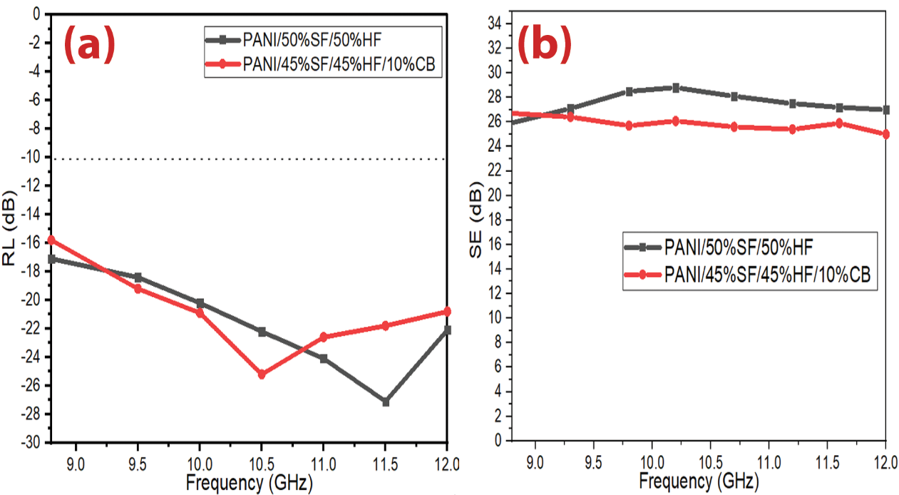
Figure 3.61 (a,b) – RL and SE curves of PANI/SF/HF and PANI/SF/HF/CB nanocomposites at 3.0 mm thickness
On the other hand, one can notice the RL_{min} moves gradually to a lower frequency with the increase in loading percentage. Furthermore, Table 3.27 shows the PANI/SF/HF nanocomposites have low SD, ranging from 3.21 to 3.26 kg/m². The absorption percentage of microwaves reached about 99.9%. One can conclude that optimal absorption can be accomplished by modifying the absorber thickness and the loading percentage. The best result was obtained by using the PANI/SF/HF nanocomposite sample. Figure 3.63 shows the relationship between the number of research that studied the radar absorption properties of PANI/F within the range of 8.0-12.0 GHz and the absorption bandwidth under -10 dB. It turns out that the number of these research (22), and only four research were able to cover most of the range (8.0-12.0 GHz). In order to evaluate the beneficial impact of the combination of PANI with SF/HF on the radar absorption properties, Table 3.28 shows a comparison of radar absorption properties of some lately reported PANI/NiZn ferrite absorbers with various loading ratios of the composites in the host matrix. The results of the literature show these composites have an elevated loading percentage in the host matrix. This leads to a high surface density and heavy weight of the absorbents. This confirms the distinctiveness of prepared nanocomposites in terms of lower loading percentage compared with this literature.
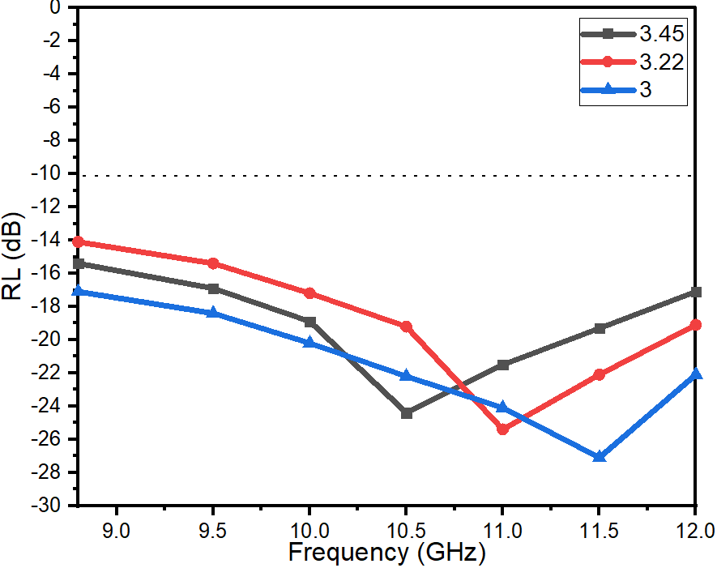
Figure 3.62 – RL curves of PANI/SF/HF with various thicknesses (3.0, 3.22, 3.45 mm)
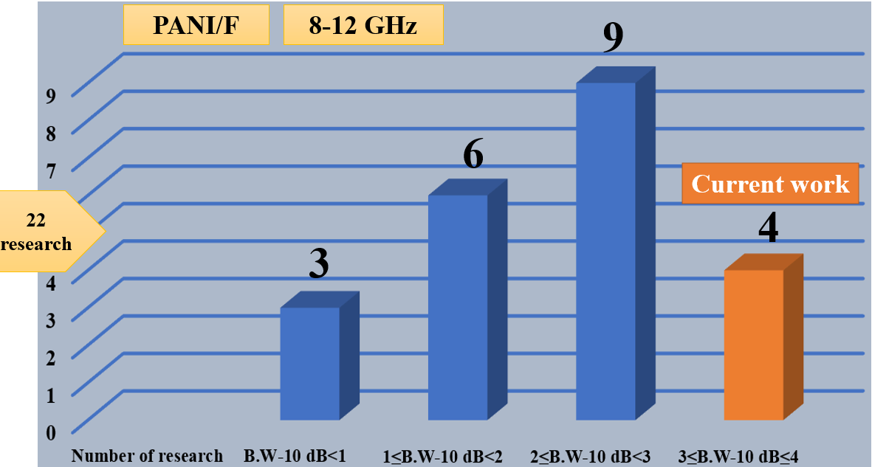
Figure 3.63 – Relationship between the number of research that studied the radar absorption properties of PANI/F and the absorption bandwidth under -10 dB
Table 3.27 – MA behavior of PANI/SF/HF nanocomposites at various thicknesses (3.0, 3.22, 3.45 mm)
Loading ratio % | t (mm) | RL_{min} (dB) | f_{m} (GHz) | BW_{-10dB} (GHz) | SD (kg/m²)
30% | 3.0 | -27.1 | 11.5 | 3.2 | 3.21
30% | 3.22 | -25.4 | 11.0 | 3.2 | 3.23
30% | 3.45 | -24.3 | 10.6 | 3.2 | 3.26
Table 3.28 – Radar absorption properties of PANI-based nanomaterials
Specimen (relative weight ratio)/host matrix | Loading percentage  (%) | t (mm) | RL_{min} (dB) | f_{m} (GHz) | BW_{-10dB} (GHz) | Ref
NiZn ferrite-PANI(50:50)/Epoxy | 67 | 2.00 | -14 | 11.0 | 2.6 | [85]
NiZn ferrite-PANI(35:65)/Epoxy | 20 | 2.00 | -20 | 9.1 | 0.5 | [137]
NiZn ferrite-PANI(1:3)/Paraffin | 75 | 3.50 | -32 | 9.5 | 3.8 | [87]
NiZn ferrite-PANI(2:1)/Paraffin | 70 | 2.00 | -27.5 | 6.0 | 3.0 | [86]
NiZn ferrite-PANI/Epoxy | 67 | 3.00 | -17 | 11.1 | 2.8 | [88]

Conclusion
According to the results of the dissertation research, the following conclusions are made:
- Received ferrite absorbers from magnetic loss materials. It was found that the RL attenuation peaks of samples were shown to move to lower frequencies with increasing the metal ions to citrate acid, PVA concentration and calcination temperature. This may be due to the change in the crystallite size of the ferrite nanoparticles. The results of XRD patterns indicated that the crystallite size of nickel-zinc ferrite increased by increasing the calcination temperature. As well, the XRD patterns results revealed that the crystallite size of nickel-zinc ferrite increased by increasing the metal ions and PVA concentrations during the preparation process of the ferrite, regardless of the calcination temperature.
- The effect of CB, CI, AC, and C on the ferrite on the MA and EMI properties were displayed. The best result obtained was by using F/CI/CB-211 composite. A RL_{min} indicated -18.4 dB at 11.7 GHz and BW_{-10 dB} was 4.0 GHz for a thickness of 2 mm with a SD of 4.01 kg/m².
- The results of the hybrid nanocomposites revealed that the RL_{min} and SE_{max} improved by obtaining -19.8 dB and 23.18 dB, respectively for PANI/F.2 nanocomposite with loading percentage from 25% which means obtaining lightweight absorbers with distinguished properties.
- It was detected that PANI/SF/HF and PANI/SF/HF/CB nanocomposites had the best results to absorb EM waves. The absorption percentage of EM waves reached about 99.9% with a loading percentage of 30%.
Assessment of the results of the work
The tasks set in the work are completely reached. Microwave absorbers are obtained competing with commercial absorbers mentioned in the literature in terms of weight, RL, SE, and absorption BW₋₁₀. The results are reliable and reasonable since all measurements were carried out on calibrated instruments using standard methods. The prepared samples were structurally characterized using XRD, FTIR, TGA, and EDX. A powder X-ray diffractometer (XRD, Rigaku Miniflex 600, Cu-Ka) was used to define the crystal structures of the powders. The X-ray diffraction patterns of the prepared samples were recorded at 2θ =10 - 90°. Fourier Transform IR (FTIR) spectra of the prepared samples were recorded on a Perkin Elmer 65 FTIR spectrometer in the 400–4000 cm⁻¹. Thermogravimetric analysis (TGA) curve of the prepared samples were recorded on a thermal analyzer (NETZSCH 449F3A-0372-M) under a nitrogen atmosphere, from room temperature to 1000°C under a constant heating rate of 10 °C/min. Energy-dispersive X-ray spectroscopy (EDX, Quanta 200 3D) was used to know the chemical composition of some of the prepared samples. A scanning electron microscope (SEM, FEI Quanta 200 3D) was utilized to define the morphology of some of the prepared powders. The prepared samples were functionally characterized using the free-space technique.
Assessment of technical efficiency proposed in the thesis
The results obtained in the framework of this thesis can be suggested for producing microwave absorbers synthesized based on magnetic loss and dielectric loss materials. An advantage of the work is that obtained absorbers can attenuate about 99.9% of EM waves with low SD and wide absorption BW₋₁₀. These microwave absorbers can be used to cover the walls of anechoic chambers and to prevent or reduce EM reflections from large bodies.
Assessment of the scientific level and economic efficiency of the work
Nowadays, most international companies work to fabricate MAMs for reducing the noise produced by electronic circuits and smartphones, removing the noise from the original images on screens and manufacturing protective shields in microwave ovens. As well as fabricating these materials for military applications to reduce the radar cross-section of some military systems in order to keep them away from the eyes of hostile radars. MAMs consider expensive materials from a commercial point of view (1 Kg of MAMs costs between 900-1200$). This work opens up prospects for the production of effective absorbers in the laboratory as affordable, cheap (e.g., 1 Kg of raw materials of CB/Mn_{0.1}Ni_{0.5}Zn_{0.4}Fe₂O_{4,} PANI/Ni³⁺_{0.25}Ni²⁺_{0.375}Zn²⁺_{0.25}Fe₂O₄/CB and PANI/SF/HF cost between 25-40 $, 75-100$, and 90-110$, respectively) with the required international quality. The results obtained are of practical interest for obtaining new improved nanocomposites for absorbing EM waves at the X-band frequency. In addition, the scientific level of the presented thesis complies with international standards for research conducted in the selected field. This is evidenced by a good level of publications, the presentation and the discussion of the results of work at international conferences.

References
1. Zhang J. et al. Preparation and Microwave Absorbing Characteristics of Multi-Walled Carbon Nanotube/Chiral-Polyaniline Composites // Open J. Polym. Chem. 2014. Vol. 04, № 03. P. 62–72.
2. Hosseini S.H., Asadnia A., Moloudi M. Preparation and electromagnetic wave absorption hard-soft Ba ferrite/polypyrrole core-shell nanocomposites // Mater. Res. Innov. 2015. Vol. 19, № 2. P. 107–112.
3. Lv H. et al. A Flexible Microwave Shield with Tunable Frequency-Transmission and Electromagnetic Compatibility // Adv. Funct. Mater. 2019. Vol. 29, № 14. P. 1–8.
4. Liang C. et al. Ultra-light MXene aerogel/wood-derived porous carbon composites with wall-like “mortar/brick” structures for electromagnetic interference shielding // Sci. Bull. Science China Press, 2020. Vol. 65, № 8. P. 616–622.
5. Chen X. et al. Capacitive behavior of MoS2 decorated with FeS2@carbon nanospheres // Chem. Eng. J. 2020. Vol. 379, № July.
6. Chen S. et al. Asymmetric alicyclic amine-polyether amine molecular chain structure for improved energy storage density of high-temperature crosslinked polymer capacitor // Chem. Eng. J. Elsevier B.V., 2020. Vol. 387. P. 123662.
7. Cheng C. et al. Simultaneously improving mode I and mode II fracture toughness of the carbon fiber/epoxy composite laminates via interleaved with uniformly aligned PES fiber webs // Compos. Part A Appl. Sci. Manuf. Elsevier Ltd, 2020. Vol. 129. P. 105696.
8. Xu H. et al. Lightweight Ti 2 CT x MXene/Poly(vinyl alcohol) Composite Foams for Electromagnetic Wave Shielding with Absorption-Dominated Feature // ACS Appl. Mater. Interfaces. 2019. Vol. 11, № 10. P. 10198–10207.
9. Xie X.B. et al. Spinel structured MFe2O4 (M = Fe, Co, Ni, Mn, Zn) and their composites for microwave absorption: A review // Chem. Eng. J. Elsevier B.V., 2022. Vol. 428, № May 2021. P. 131160.
10. Bera P. et al. Solution combustion synthesis, characterization, magnetic, and dielectric properties of CoFe2O4and Co0.5M0.5Fe2O4(M = Mn, Ni, and Zn) // Phys. Chem. Chem. Phys. 2020. Vol. 22, № 35. P. 20087–20106.
11. Shu J.C. et al. Molecular Patching Engineering to Drive Energy Conversion as Efficient and Environment-Friendly Cell toward Wireless Power Transmission // Adv. Funct. Mater. 2020. Vol. 30, № 10. P. 1–10.
12. Cao M.S. et al. Variable-Temperature Electron Transport and Dipole Polarization Turning Flexible Multifunctional Microsensor beyond Electrical and Optical Energy // Adv. Mater. 2020. Vol. 32, № 10. P. 1–8.
13. Ma M. et al. Development, applications, and future directions of triboelectric nanogenerators // Nano Res. 2018. Vol. 11, № 6. P. 2951–2969.
14. Li G. et al. Dynamical Control over Terahertz Electromagnetic Interference Shielding with 2D Ti3C2Ty MXene by Ultrafast Optical Pulses // Nano Lett. 2020. Vol. 20, № 1. P. 636–643.
15. Folgueras L. de C., Alves M.A., Rezende M.C. Microwave absorbing paints and sheets based on carbonyl iron and polyaniline: Measurement and simulation of their properties // J. Aerosp. Technol. Manag. 2010. Vol. 2, № 1. P. 63–70.
16. Af B.A. ADVANCES IN COMPOSITE MATERIALS ECODESIGN AND ANALYSIS Edited by Brahim A tt af. 211AD.
17. Ari Adi W. et al. Metamaterial: Smart Magnetic Material for Microwave Absorbing Material // Electromagn. Fields Waves. 2019. P. 1–18.
18. Griffiths H. et al. Radar spectrum engineering and management: Technical and regulatory issues // Proc. IEEE. IEEE, 2015. Vol. 103, № 1. P. 85–102.
19. Adebayo L.L. et al. Investigation of the broadband microwave absorption of citric acid coated Fe3O4/PVDF composite using finite element method // Appl. Sci. 2019. Vol. 9, № 18.
20. McDowell A.J., Hubing T.H. Analysis and comparison of plane wave shielding effectiveness decompositions // IEEE Trans. Electromagn. Compat. 2014. Vol. 56, № 6. P. 1711–1714.
21. Wang Y. et al. Recent advances in conjugated polymer-based microwave absorbing materials // Polymers (Basel). 2017. Vol. 9, № 1.
22. Zhao B. et al. Recent Advances on the Electromagnetic Wave Absorption Properties of Ni Based Materials // Eng. Sci. 2018. P. 5–40.
23. Drab M. et al. Electric double layer and orientational ordering of water dipoles in narrow channels within a modified Langevin Poisson-Boltzmann model // Entropy. 2020. Vol. 22, № 9.
24. Raju G. Dielectric Loss and Relaxation—I // Dielectrics in Electric Fields, Second Edition. 2016. 83–136 p.
25. Mohamed M.A. et al. The field of an electric dipole and the polarizability of a conducting object embedded in the interface between dielectric materials // Prog. Electromagn. Res. B. 2009. № 16. P. 1–20.
26. Green M. et al. Dielectric, magnetic, and microwave absorption properties of polyoxometalate-based materials // J. Magn. Magn. Mater. Elsevier B.V., 2020. Vol. 497, № September 2019. P. 165974.
27. Pratap V. et al. Electromagnetic and microwave absorbing properties of U-type barium hexaferrite / polyaniline-epoxy composites Electromagnetic and Microwave Absorbing Properties of U- type Barium Hexaferrite / Polyaniline-Epoxy Composites. 2020. Vol. 080003, № May. P. 1–6.
28. Du S., Chen H., Hong R. Preparation and electromagnetic properties characterization of reduced graphene oxide/strontium hexaferrite nanocomposites // Nanotechnol. Rev. 2020. Vol. 9, № 1. P. 105–114.
29. Srivastava R., Yadav B.C. Ferrite materials: Introduction, synthesis techniques, and applications as sensors // Int. J. Green Nanotechnol. Biomed. 2012. Vol. 4, № 2. P. 141–154.
30. Jadhav V. V. et al. Properties of ferrites // Spinel Ferrite Nanostructures for Energy Storage Devices. Elsevier Inc., 2020. № M. 35–50 p.
31. Arora A. Optical and electric field control of magnetism // Univ. Potsdam. 2018. P. 11–20.
32. Dehghan R., Seyyed Ebrahimi S.A., Badiei A. Investigation of the effective parameters on the synthesis of Ni-ferrite nanocrystalline powders by coprecipitation method // J. Non. Cryst. Solids. Elsevier B.V., 2008. Vol. 354, № 47–51. P. 5186–5188.
33. Hankare P.P. et al. Synthesis, characterization and effect of sintering temperature on magnetic properties of MgNi ferrite prepared by co-precipitation method // J. Alloys Compd. 2009. Vol. 475, № 1–2. P. 926–929.
34. Vadivel M. et al. Synthesis, structural, dielectric, magnetic and optical properties of Cr substituted CoFe2O4 nanoparticles by co-precipitation method // J. Magn. Magn. Mater. Elsevier, 2014. Vol. 362. P. 122–129.
35. Jacob B.P. et al. Influence of preparation method on structural and magnetic properties of nickel ferrite nanoparticles // Bull. Mater. Sci. 2011. Vol. 34, № 7. P. 1345–1350.
36. Padmanaban R. et al. Recent Trends in Materials Science ( RTMS-2011 ) // Recent Trends Mater. Sci. Appl. 2017. № October. P. 2011.
37. Ding Z. et al. Synthesis and Characterization of Co-Zn Ferrite Nanoparticles by Hydrothermal Method: A Comparative Study // IEEE Trans. Magn. 2015. Vol. 51, № 11. P. 2–5.
38. Zalite I. et al. Hydrothermal synthesis of cobalt ferrite nanosized powders // IOP Conf. Ser. Mater. Sci. Eng. 2015. Vol. 77, № 1.
39. Praveena K. et al. Microwave absorption studies of magnetic sublattices in microwave sintered Cr3+ doped SrFe12O19 // J. Magn. Magn. Mater. Elsevier, 2017. Vol. 426, № July 2016. P. 604–614.
40. Mallesh S. et al. Structure and magnetic properties of ZnO coated MnZn ferrite nanoparticles // J. Magn. Magn. Mater. Elsevier, 2016. Vol. 418. P. 112–117.
41. Jia P.Y. et al. Sol-gel synthesis and characterization of SiO2@CaWO 4,SiO2@CaWO4:Eu3+/Tb3+ core-shell structured spherical particles // Nanotechnology. 2006. Vol. 17, № 3. P. 734–742.
42. Sulaiman N.H. et al. Superparamagnetic calcium ferrite nanoparticles synthesized using a simple solgel method for targeted drug delivery // Biomed. Mater. Eng. 2015. Vol. 26. P. S103–S110.
43. Panchal N.R., Jotania R.B. Cobalt ferrite nano particles by microemulsion route // Nanotechnology. 2010. Vol. 1, № 1. P. 17–18.
44. Zhao D.L., Lv Q., Shen Z.M. Fabrication and microwave absorbing properties of Ni-Zn spinel ferrites // J. Alloys Compd. 2009. Vol. 480, № 2. P. 634–638.
45. Zhuang L. et al. Temperature sensitive ferrofluid composed of Mn 1-xZn xFe 2O 4 nanoparticles prepared by a modified hydrothermal process // Powder Technol. 2012. Vol. 217. P. 46–49.
46. Fan G. et al. Nanocrystalline zinc ferrite photocatalysts formed using the colloid mill and hydrothermal technique // Chem. Eng. J. 2009. Vol. 155, № 1–2. P. 534–541.
47. Goodarz Naseri M. et al. Superparamagnetic magnesium ferrite nanoparticles fabricated by a simple, thermal-treatment method // J. Magn. Magn. Mater. Elsevier, 2014. Vol. 350. P. 141–147.
48. Milutinović A. et al. The cation inversion and magnetization in nanopowder zinc ferrite obtained by soft mechanochemical processing // Mater. Res. Bull. 2013. Vol. 48, № 11. P. 4759–4768.
49. Biasotto G. et al. A novel synthesis of perovskite bismuth ferrite nanoparticles // Process. Appl. Ceram. 2011. Vol. 5, № 3. P. 171–179.
50. Li S. et al. Ultrafast microwave hydrothermal synthesis of BiFeO3 NANOPLATES // J. Am. Ceram. Soc. 2013. Vol. 96, № 10. P. 3155–3162.
51. Ibrahim A.M., El-Latif M.M.A., Mahmoud M.M. Synthesis and characterization of nano-sized cobalt ferrite prepared via polyol method using conventional and microwave heating techniques // J. Alloys Compd. Elsevier B.V., 2010. Vol. 506, № 1. P. 201–204.
52. Manikandan A. et al. Synthesis, optical and magnetic properties of pure and Co-doped ZnFe 2O4 nanoparticles by microwave combustion method // J. Magn. Magn. Mater. Elsevier, 2014. Vol. 349. P. 249–258.
53. Kaur H., Singh J., Randhawa B.S. Essence of superparamagnetism in cadmium ferrite induced by various organic fuels via novel solution combustion method // Ceram. Int. Elsevier, 2014. Vol. 40, № 8 PART A. P. 12235–12243.
54. Kaur N., Kaur M. Comparative studies on impact of synthesis methods on structural and magnetic properties of magnesium ferrite nanoparticles // Process. Appl. Ceram. 2014. Vol. 8, № 3. P. 137–143.
55. Sharma R., Chandra Agarwala R., Agarwala V. A study on the heat-treatments of nanocrystalline nickel substituted BaW hexaferrite produced by low combustion synthesis method // J. Magn. Magn. Mater. 2007. Vol. 312, № 1. P. 117–125.
56. Huízar-Félix A.M. et al. Sol-gel based Pechini method synthesis and characterization of Sm 1-xCa xFeO 3 perovskite 0.1≤x≤0.5 // Powder Technol. Elsevier B.V., 2012. Vol. 229. P. 290–293.
57. Jacobo S.E., Herme C., Bercoff P.G. Influence of the iron content on the formation process of substituted Co-Nd strontium hexaferrite prepared by the citrate precursor method // J. Alloys Compd. Elsevier B.V., 2010. Vol. 495, № 2. P. 513–515.
58. Martins M.L. et al. Mechanisms of phase formation along the synthesis of Mn-Zn ferrites by the polymeric precursor method // Ceram. Int. Elsevier, 2014. Vol. 40, № 10. P. 16023–16031.
59. Nikolić A.S. et al. Carboxylic acids and polyethylene glycol assisted synthesis of nanocrystalline nickel ferrites // Ceram. Int. 2013. Vol. 39, № 6. P. 6681–6688.
60. Drmota A., Drofenik M., Žnidaršič A. Synthesis and characterization of nano-crystalline strontium hexaferrite using the co-precipitation and microemulsion methods with nitrate precursors // Ceram. Int. 2012. Vol. 38, № 2. P. 973–979.
61. Uskoković V., Drofenik M. A mechanism for the formation of nanostructured NiZn ferrites via a microemulsion-assisted precipitation method // Colloids Surfaces A Physicochem. Eng. Asp. 2005. Vol. 266, № 1–3. P. 168–174.
62. Saini P., Aror M. Microwave Absorption and EMI Shielding Behavior of Nanocomposites Based on Intrinsically Conducting Polymers, Graphene and Carbon Nanotubes // New Polym. Spec. Appl. 2012.
63. Boeva Z.A., Sergeyev V.G. Polyaniline: Synthesis, properties, and application // Polym. Sci. - Ser. C. 2014. Vol. 56, № 1. P. 144–153.
64. Yusuf J.Y. et al. Recent advances and prospect of cobalt based microwave absorbing materials // Ceram. Int. Elsevier Ltd and Techna Group S.r.l., 2020. Vol. 46, № 17. P. 26466–26485.
65. Chen N., Gu M. Microstructure and Microwave Absorption Properties of Y-Substituted Ni-Zn Ferrites // Open J. Met. 2012. Vol. 02, № 02. P. 37–41.
66. Wang S. et al. Synthesis of porous nitrogen-doped graphene decorated by γ-Fe2O3 nanorings for enhancing microwave absorbing performance // Ceram. Int. Elsevier Ltd and Techna Group S.r.l., 2020. Vol. 46, № 1. P. 1002–1010.
67. Shu R. et al. Facile synthesis of nitrogen-doped reduced graphene oxide/nickel-zinc ferrite composites as high-performance microwave absorbers in the X-band // Chem. Eng. J. Elsevier, 2020. Vol. 384, № July 2019. P. 123266.
68. Jaiswal R. et al. EMI and microwave absorbing efficiency of polyaniline-functionalized reduced graphene oxide/γ-Fe2O3/epoxy nanocomposite // Soft Matter. 2020. Vol. 16, № 28. P. 6643–6653.
69. Bueno A.R., Gregori M.L., Nóbrega M.C.S. Microwave-absorbing properties of Ni0.50-xZn0.50-x Me2xFe2O4 (Me=Cu, Mn, Mg) ferrite-wax composite in X-band frequencies // J. Magn. Magn. Mater. 2008. Vol. 320, № 6. P. 864–870.
70. Zinc N. et al. Synthesis and Microwave Absorbing Properties of Cu-Doped. 2013. Vol. 2013.
71. Chen B.Y. et al. Preparation and microwave absorption properties of Ni-Co nanoferrites // J. Alloys Compd. Elsevier B.V., 2015. Vol. 618. P. 222–226.
72. Almessiere M.A. et al. Effect of Nd-Y co-substitution on structural, magnetic, optical and microwave properties of NiCuZn nanospinel ferrites // J. Mater. Res. Technol. Korea Institute of Oriental Medicine, 2020. Vol. 9, № 5. P. 11278–11290.
73. Almessiere M.A. et al. Microstructure, dielectric and microwave features of [Ni0.4Cu0.2Zn0.4](Fe2−xTbx)O4 (x ≤ 0.1) nanospinel ferrites // J. Mater. Res. Technol. Korea Institute of Oriental Medicine, 2020. Vol. 9, № 5. P. 10608–10623.
74. Almessiere M.A. et al. Impact of Eu3+ ion substitution on structural, magnetic and microwave traits of Ni–Cu–Zn spinel ferrites // Ceram. Int. Techna Group S.r.l., 2020. Vol. 46, № 8. P. 11124–11131.
75. Almessiere M.A. et al. Strong correlation between Dy3+ concentration, structure, magnetic and microwave properties of the [Ni0.5Co0.5](DyxFe2-x)O4 nanosized ferrites // J. Ind. Eng. Chem. The Korean Society of Industrial and Engineering Chemistry, 2020. Vol. 90. P. 251–259.
76. Goel S. et al. Effect of neodymium doping on microwave absorption property of barium hexaferrite in X-band // Mater. Res. Express. IOP Publishing, 2020. Vol. 7, № 1.
77. Ghasemi A. et al. Microwave absorption properties of Mn-Co-Sn doped barium ferrite nanoparticles // IEEE Trans. Magn. 2009. Vol. 45, № 6. P. 2456–2459.
78. Houbi A. et al. Microwave absorbing properties of ferrites and their composites: A review // J. Magn. Magn. Mater. Elsevier B.V., 2021. Vol. 529, № September 2020. P. 167839.
79. Harris V.G. Modern microwave ferrites // IEEE Trans. Magn. 2012. Vol. 48, № 3. P. 1075–1104.
80. Cui G. et al. Excellent microwave absorption properties derived from the synthesis of hollow fe 3 o 4 @reduced graphite oxide (RGO) nanocomposites // Nanomaterials. 2019. Vol. 9, № 2. P. 1–12.
81. Luo J. et al. Excellent microwave absorption properties by tuned electromagnetic parameters in polyaniline-coated Ba0.9La0.1Fe11.9Ni0.1O19/reduced graphene oxide nanocomposites // RSC Adv. Royal Society of Chemistry, 2017. Vol. 7, № 58. P. 36433–36443.
82. Ali N.N. et al. Lightweight broadband microwave absorbers of core–shell (polypyrrole/NiZn ferrite) nanocomposites in the X-band: insights on interfacial polarization // J. Mater. Sci. Mater. Electron. Springer US, 2019. Vol. 30, № 7. P. 6876–6887.
83. Hosseini S.H., Asadnia A. Synthesis, characterization, and microwave-absorbing properties of polypyrrole/MnFe 2O 4 nanocomposite // J. Nanomater. 2012. Vol. 2012.
84. Mostafa N.Y., Hessien M.M., Shaltout A.A. Hydrothermal synthesis and characterizations of Ti substituted Mn-ferrites // J. Alloys Compd. 2012. Vol. 529. P. 29–33.
85. Ting T.H., Yu R.P., Jau Y.N. Synthesis and microwave absorption characteristics of polyaniline/NiZn ferrite composites in 2-40 GHz // Mater. Chem. Phys. 2011. Vol. 126, № 1–2. P. 364–368.
86. Wang C.P. et al. Novel one-dimensional polyaniline/Ni0.5Zn0.5Fe 2O4 hybrid nanostructure: Synthesis, magnetic, and electromagnetic wave absorption properties // J. Nanoparticle Res. 2014. Vol. 16, № 3.
87. Wang M. et al. Controlled synthesis and microwave absorption properties of Ni0.6Zn0.4Fe2O4/PANI composite via an in-situ polymerization process // J. Magn. Magn. Mater. Elsevier, 2015. Vol. 377. P. 52–58.
88. Wang C. et al. Synthesis of novel NiZn-ferrite/Polyaniline nanocomposites and their microwave absorption properties // Mater. Sci. Semicond. Process. Elsevier, 2013. Vol. 16, № 1. P. 77–82.
89. Ma R.T., Zhao H.T., Zhang G. Preparation, characterization and microwave absorption properties of polyaniline/Co0.5Zn0.5Fe2O4 nanocomposite // Mater. Res. Bull. 2010. Vol. 45, № 9. P. 1064–1068.
90. Sun J. et al. Preparation of copper-cobalt-nickel ferrite/graphene oxide/polyaniline composite and its applications in microwave absorption coating // Prog. Org. Coatings. Elsevier, 2020. Vol. 141, № October 2019. P. 105552.
91. Manna K., Srivastava S.K. Fe3O4@Carbon@Polyaniline Trilaminar Core-Shell Composites as Superior Microwave Absorber in Shielding of Electromagnetic Pollution // ACS Sustain. Chem. Eng. 2017. Vol. 5, № 11. P. 10710–10721.
92. Xiong P., Huang H., Wang X. Design and synthesis of ternary cobalt ferrite/graphene/polyaniline hierarchical nanocomposites for high-performance supercapacitors This work is dedicated to Professor MIN Enze on the occasion of his 90th birthday. // J. Power Sources. Elsevier B.V, 2014. Vol. 245. P. 937–946.
93. Mondal K. et al. Carbon Nanostructures for Energy and Sensing Applications // J. Nanotechnol. 2019. Vol. 2019. P. 10–13.
94. Kwiatkowski M. et al. Evaluation of CO2 interactions with S-doped nanoporous carbon and its composites with a reduced GO: Effect of surface features on an apparent physical adsorption mechanism // Carbon N. Y. 2016. Vol. 98. P. 250–258.
95. Anh L.T.Q., Van Dan N. A microwave-absorbing property of super-paramagnetic zinc–nickel ferrite nanoparticles in the frequency range of 8–12 GHz // Appl. Phys. A Mater. Sci. Process. Springer Berlin Heidelberg, 2020. Vol. 126, № 1. P. 1–6.
96. Ri E. et al. ) Huulwh Dqg & Duerq % Odfn % Dvhg 1Dqrfrpsrvlwhv Iru. P. 0–3.
97. Che R. et al. Microwave Absorption Enhancement and Complex Permittivity and Permeability of Fe Encapsulated within Carbon Nanotubes // Adv. Mater. 2004. Vol. 16, № 5. P. 401–405.
98. Lin H. et al. Investigation of the microwave-absorbing properties of Fe-filled carbon nanotubes // Mater. Lett. 2007. Vol. 61, № 16. P. 3547–3550.
99. Wu N. et al. Strengthened electromagnetic absorption performance derived from synergistic effect of carbon nanotube hybrid with Co@C beads // Adv. Compos. Hybrid Mater. Advanced Composites and Hybrid Materials, 2018. Vol. 1, № 1. P. 149–159.
100. Yang B. et al. Surface-oxidized FeCo/carbon nanotubes nanorods for lightweight and efficient microwave absorbers // Mater. Des. Elsevier Ltd, 2017. Vol. 136. P. 13–22.
101. Feng A. et al. Synthesis of a hierarchical carbon fiber@cobalt ferrite@manganese dioxide composite and its application as a microwave absorber // RSC Adv. Royal Society of Chemistry, 2020. Vol. 10, № 18. P. 10510–10518.
102. Gholampoor M., Movassagh-Alanagh F., Salimkhani H. Fabrication of nano-Fe3O4 3D structure on carbon fibers as a microwave absorber and EMI shielding composite by modified EPD method // Solid State Sci. Elsevier Masson SAS, 2017. Vol. 64. P. 51–61.
103. Liu Y. et al. Preparation and properties of cobalt oxides coated carbon fibers as microwave-absorbing materials // Appl. Surf. Sci. Elsevier B.V., 2011. Vol. 257, № 17. P. 7678–7683.
104. Meng X. et al. The electrochemical preparation and microwave absorption properties of magnetic carbon fibers coated with Fe 3 O 4 films // Appl. Surf. Sci. Elsevier B.V., 2011. Vol. 257, № 24. P. 10808–10814.
105. Verma P. et al. Electromagnetic interference shielding performance of carbon nanostructure reinforced, 3D printed polymer composites // J. Mater. Sci. Springer US, 2021. Vol. 56, № 20. P. 11769–11788.
106. Bayat M. et al. Electromagnetic interference shielding effectiveness of hybrid multifunctional Fe3O4/carbon nanofiber composite // Polymer (Guildf). 2014. Vol. 55, № 3. P. 936–943.
107. Hong Y.K. et al. Method and apparatus to measure electromagnetic interference shielding efficiency and its shielding characteristics in broadband frequency ranges // Rev. Sci. Instrum. 2003. Vol. 74, № 2. P. 1098–1102.
108. El Nahrawy A.M. et al. Crystallographic and magnetic properties of Al3+co-doped NiZnFe2O4 nano-particles prepared by sol-gel process // Egypt. J. Chem. 2019. Vol. 62, № 3. P. 925–932.
109. Hu E. et al. The role of soot particles in the tribological behavior of engine lubricating oils // Wear. Elsevier, 2013. Vol. 304, № 1–2. P. 152–161.
110. Bahri-Laleh N. et al. Microwave Absorption Properties of Polyaniline/Carbonyl Iron Composites // Silicon. Silicon, 2018. Vol. 10, № 4. P. 1337–1343.
111. Ezzati S.N. et al. Conducting, magnetic polyaniline/Ba0.25Sr0.75 Fe11(Ni0.5Mn0.5)O19 nanocomposite: Fabrication, characterization and application // J. Alloys Compd. Elsevier Ltd, 2015. Vol. 646. P. 1157–1164.
112. Meng X. et al. Facile synthesis of shell-core polyaniline/SrFe12O19 composites and magnetic properties // RSC Adv. Royal Society of Chemistry, 2016. Vol. 6, № 6. P. 4946–4949.
113. Ali N.N. et al. Comparative study of microwave absorption characteristics of (Polyaniline/NiZn ferrite) nanocomposites with different ferrite percentages // Mater. Chem. Phys. Elsevier B.V., 2018. Vol. 211. P. 79–87.
114. Elsayed A.H. et al. Synthesis and Properties of Polyaniline / ferrites Nanocomposites. 2011. Vol. 6. P. 206–221.
115. Kondawar S.B., Nandapure A.I. Magnetic and electrical properties of zinc-substituted nickel ferrite reinforced conducting polyaniline nanocomposites // J. Chinese Adv. Mater. Soc. 2014. Vol. 2, № 3. P. 186–198.
116. Figueroa Ramírez S.J., Miranda-Hernánde M. Carbon film electrodes as support of metallic particles // Int. J. Electrochem. Sci. 2012. Vol. 7, № 1. P. 150–166.
117. Kim S.Y. et al. Core-shell-structured cross-linked poly(glycidyl methacrylate)-coated carbonyl iron microspheres and their magnetorheology // J. Mater. Sci. 2014. Vol. 49, № 3. P. 1345–1352.
118. Gairola S.P. et al. Enhanced microwave absorption properties in polyaniline and nano-ferrite composite in X-band // Synth. Met. Elsevier B.V., 2010. Vol. 160, № 21–22. P. 2315–2318.
119. Li G. et al. Preparation of magnetic and conductive NiZn ferrite-polyaniline nanocomposites with core-shell structure // Colloids Surfaces A Physicochem. Eng. Asp. 2006. Vol. 276, № 1–3. P. 40–44.
120. Peng C.H. et al. Microwave-absorbing characteristics for the composites of thermal-plastic polyurethane (TPU)-bonded NiZn-ferrites prepared by combustion synthesis method // Mater. Sci. Eng. B Solid-State Mater. Adv. Technol. 2005. Vol. 117, № 1. P. 27–36.
121. Hwang Y. Microwave absorbing properties of NiZn-ferrite synthesized from waste iron oxide catalyst // Mater. Lett. 2006. Vol. 60, № 27. P. 3277–3280.
122. Kim D.Y. et al. Dependence of microwave absorbing property on ferrite volume fraction in MnZn ferrite-rubber composites // IEEE Trans. Magn. 1996. Vol. 32, № 2. P. 555–558.
123. Diniz V.C.S. et al. Effects of Mn1-xZnxFe2O4 Nanoparticles Concentration in a Silicone Matrix on Complex Permeability and Permittivity in the 1-10 GHz Range // Mater. Res. 2022. Vol. 25. P. 1–9.
124. Lee J. et al. Absorber for 1 GHz Application // October. 2009. Vol. 45, № 10. P. 4230–4233.
125. Lima U.R. et al. Synthesis of NiCuZn ferrite nanoparticles and microwave absorption characterization // Mater. Sci. Eng. B Solid-State Mater. Adv. Technol. 2008. Vol. 151, № 3. P. 238–242.
126. Shu R. et al. Synthesis and high-performance microwave absorption of reduced graphene oxide/zinc ferrite hybrid nanocomposite // Mater. Lett. Elsevier B.V., 2018. Vol. 215. P. 229–232.
127. Zong M. et al. One-step hydrothermal synthesis and microwave electromagnetic properties of RGO/NiFe2O4 composite // Ceram. Int. Elsevier, 2014. Vol. 40, № 5. P. 6821–6828.
128. Zong M., Huang Y., Zhang N. Reduced graphene oxide-CoFe 2 O 4 composite: Synthesis and electromagnetic absorption properties // Appl. Surf. Sci. Elsevier B.V., 2015. Vol. 345. P. 272–278.
129. Mustaffa M.S. et al. An investigation of microstructural, magnetic and microwave absorption properties of multi-walled carbon nanotubes/Ni0.5Zn0.5Fe2O4 // Sci. Rep. 2019. Vol. 9, № 1. P. 3–9.
130. Ye W. et al. Preparation and properties of CF-Fe3O4-BN composite electromagnetic wave-absorbing materials // RSC Adv. Royal Society of Chemistry, 2020. Vol. 10, № 19. P. 11121–11131.
131. Zou T. et al. Electromagnetic and microwave absorbing properties of multi-walled carbon nanotubes filled with Ni nanowire // J. Alloys Compd. 2010. Vol. 496, № 1–2. P. 22–24.
132. Zhang L., Zhu H. Dielectric, magnetic, and microwave absorbing properties of multi-walled carbon nanotubes filled with Sm2O3 nanoparticles // Mater. Lett. Elsevier B.V., 2009. Vol. 63, № 2. P. 272–274.
133. Xu P. et al. A study of the magnetic and electromagnetic properties of γ-Fe2O3-multiwalled carbon nanotubes (MWCNT) and Fe/Fe3C-MWCNT composites // Mater. Chem. Phys. 2009. Vol. 114, № 2–3. P. 556–560.
134. Zhao D.L., Li X., Shen Z.M. Preparation and electromagnetic and microwave absorbing properties of Fe-filled carbon nanotubes // J. Alloys Compd. 2009. Vol. 471, № 1–2. P. 457–460.
135. Xu X. et al. Cactus-Inspired Bimetallic Metal-Organic Framework-Derived 1D-2D Hierarchical Co/N-Decorated Carbon Architecture toward Enhanced Electromagnetic Wave Absorbing Performance // ACS Appl. Mater. Interfaces. 2019. Vol. 11, № 14. P. 13564–13573.
136. Xiang J. et al. Synthesis and characterization of FeCo/C hybrid nanofibers with high performance of microwave absorption // Mater. Res. Bull. Elsevier Ltd, 2014. Vol. 60. P. 589–595.
137. Didehban K. et al. Radar Absorption Properties of Ni0.5Zn0.5Fe2O4/PANI/epoxy Nanocomposites // J. Chinese Chem. Soc. 2015. Vol. 62, № 9. P. 826–831.

