Academy of Public Administration
under the President of the Republic of Kazakhstan

UDC 35.071.2 Manuscript Copyright

AMIROVA AIGERIM KAIRATOVNA

Management of transformation processes towards an innovative civil service
of Kazakhstan (case-study of remuneration by results project)

6D051000 – Public and local administration

Thesis for the degree
of Doctor in professional area

Research advisors
doctor of economics, Professor
F.N. Zhakypova

doctor PhD
Panos Liverakos

The Republic of Kazakhstan
Nur-Sultan, 2021
CONTENT

normative references…................................................................... | 4
INTRODUCTION…........................................................................................ | 5
1 Theoretical perspectives oN innovative Civil Service and transformational management……………. | 12
1.1 Definition, key approaches and models…………….…………………….. | 12
1.2 Major tendencies of civil service transformation in foreign countries…… | 21
1.3 Research model conceptualization and methodology…..…..…………….. | 27
1.3.1 Research design and operationalization………………………….…….. | 27
1.3.2 Strategy for survey data analysis…………………………………….….. | 34
1.3.3 Organizational diagnostics procedures…………………………………. | 36
2 Kazakhstani experience of Civil Service Transformation………………………………………………..……... | 41
2.1 Retrospective analysis of civil service reform in Kazakhstan..………….. | 41
2.2 Case study of new remuneration pilot project………………………..…… | 47
2.2.1 Pilot project background………………………………………………... | 48
2.2.2 Conceptual model testing………………………………………………. | 50
2.2.2.1 Data screening………………………………………………………… | 51
2.2.2.2 Demographic profile of the sample…………………………………… | 51
2.2.2.3 Descriptive statistics…………………………………………………... | 52
2.2.2.4 Scales reliability testing……………………………………………….. | 52
2.2.2.5 Factor analysis………………………………………………………… | 52
2.3 Organizational diagnostics of pilot authorities………….………………… | 54
2.3.1 Diagnostics of the Agency for Civil Service Affairs……………………. | 54
2.3.1.1 Structural harmony of the state body…………………………………. | 54
2.3.1.2 Comparative analysis with similar foreign authorized bodies………... | 55
2.3.1.3 Organization’s life cycle………………………………………………. | 55
2.3.1.4 Survey of employees………………………………………………….. | 56
2.3.1.5 Cost-effectiveness analysis……………………………………………. | 61
2.3.2 Diagnostics of the Nur-Sultan Akimat………………………………….. | 63
2.3.2.1 Structural harmony of the state body…………………………………. | 63
2.3.2.2 Comparative analysis with similar foreign authorized bodies……….. | 63
2.3.2.3 Organization’s life cycle……………………………………………… | 64
2.3.2.4 Survey of employees and stakeholders………………………………. | 65
2.3.2.5 Cost-effectiveness analysis…………………………………………… | 73
2.3.3 Summarizing the diagnostics results………………………...………….. | 75
3 Key directions of civil service transformation in the Republic of Kazakhstan……………..………………..… | 79
3.1 Scientific and practical recommendations of change management integration in state apparatus…...……….…………………………………..… | 79
3.2 Transformation methodology (lessons learnt from pilot authorities)…….. | 90
CONCLUSION…............................................................................................. | 98
REFERENCES…............................................................................................. | 101
annex A – Certificates of participation ……................................................. | 111
annex B – Acts on the research results implementation…………………… | 114
annex C – Main Models of Transformational Management……………….. | 120
annex D – Civil service systems’ features and visions worldwide………… | 122
annex E – Expert Interview Format………………………………………... | 128
annex f – Conceptual model operationalization…………………………... | 131
annex G – Survey Questionnaire Format………………………………….. | 135
annex H – Survey Questionnaire Format………………………………….. | 141
annex I – Survey Questionnaire Format…………………………………… | 148
annex J – Civil Service Systems in the CIS and Caucasus countries at a Glance…………………………………………………………………………. | 152
annex K – Factor analysis results (Conceptual model testing)…………….  annex L – Recommendations of the capital residents on improving the efficiency of Nur-Sultan Akimat……………………………………………… | 153  154
annex M – The best research projects of 2021 of the National School of Public Policy at the Academy of Public Administration under the President of the Republic of Kazakhstan……………………………………………………  annex N – Methodological recommendations……………………………... | 159  160

normative references

The references to the following main standards are used in the thesis:
Law of the Republic of Kazakhstan “On civil service”: adopted on July 23, 1999, №453 (no longer in force).
Law of the Republic of Kazakhstan “On public services”: adopted on April 15, 2013, №88-V.
Law of the Republic of Kazakhstan “On the civil service of the Republic of Kazakhstan”: adopted on November 23, 2015, № 416.
Decree of the President of the Republic of Kazakhstan “On some measures for further administrative reform”: approved March 29, 2007, № 304.
Decree of the President of the Republic of Kazakhstan “On the system of annual assessment of the effectiveness of the central state and local executive bodies of regions, cities of republican significance, the capital”: approved on March 19, 2010, № 954.
Decree of the President of the Republic of Kazakhstan “On approval of the National Development Plan of the Republic of Kazakhstan until 2025 and invalidation of certain decrees of the President of the Republic of Kazakhstan”: approved February 15, 2018, № 636.
Decree of the President of the Republic of Kazakhstan “On the Concept of public administration development in the Republic of Kazakhstan until 2030: building a “human-centered” model – “People first”: approved February 26, 2021, № 522.
Decree of the President of the Republic of Kazakhstan “On National priorities of the Republic of Kazakhstan until 2025”: approved February 26, 2021, № 520.
The National Plan – 100 concrete steps to implement the five institutional reforms of the Head of State Nursultan Nazarbayev: approved May 20, 2015.
Address of the President of the Republic of Kazakhstan – Leader of the nation N.A. Nazarbayev to the people of Kazakhstan “Strategy” Kazakhstan-2050”: a new political course of the established state”: approved December 14, 2012.
Address of the President of the Republic of Kazakhstan Kassym-Jomart Tokayev “Kazakhstan in a new reality: Time for action”: approved September 1, 2020.
Address of the President of the Republic of Kazakhstan Kassym-Jomart Tokayev “Unity of the people and systemic reforms are a solid foundation for the nation’s prosperity”: approved September 1, 2021.
Decree of the Government of the Republic of Kazakhstan “On approval of the basic structure of local government of the Republic of Kazakhstan and recognition of certain decisions of the Government of the Republic of Kazakhstan invalid”: approved June 18, 2013, №608.
Decree of the Government of the Republic of Kazakhstan “On approval of the state program “Digital Kazakhstan”: approved December 12, 2017, №827.

INTRODUCTION

The relevance of the research. Nowadays we live in a circumstance where not only technologies, but also communication methods are changing rapidly. Citizens demand the timely and immediate response of the state apparatus to external and internal challenges. Therefore, any delay from authorities is perceived by the population very acutely. Earlier a law enforcement system and the work of the front offices of state bodies were mainly criticized. But today, taking into account the quarantine regime, the transition to distance learning and work, and the deterioration of the health of citizens, criticism of civil service has increased. In this regard, the importance of transformation of public authorities in the prism of a VUCA (Volatility, Uncertainty, Complexity, Ambiguity) world rises. This should be based on the belief that “there are better ways to serve the interests of the country’s citizens than the current and generally accepted ones” [1].
Citizens and, especially, private sector employees assume that civil service is a slow-moving bureaucracy. However, if we consider the evolution of the public sector within the past 30 years, it is more innovative that it seems. Digital services, new management approaches, including delegation of power and functions to low level of administration, introduction of project management, advanced strategic planning, government and citizens collaboration as main public innovation drivers have changed the modus operandi of public authorities. The Organization for Economic Cooperation and Development (hereafter – OECD) identifies five global trends of embracing innovation in government: Innovative Covid-19 Responses, Seamless Government, Focusing on the Overlooked, Public Provider versus Big Brother, Upskilling and Investing in People. Each report includes case studies and global trends in innovation and rapid change in the public sector [2].
According to the World Economic Forum “the complex, transformative and distributed nature of the Fourth Industrial Revolution demands a new type of governance to address the interlinked dynamics of a pace and synergistic nature of emerging technologies” [3]. An integral principle of Good Governance is also government openness, which is based on “innovative and sustainable public policies and practices and principles of transparency, accountability and participation that promote democracy and inclusive growth” [4]. Thus, the World Bank has reported that the quality of public administration in Kazakhstan has improved over the past ten years. However, despite achieving better indicators than in neighboring countries, Kazakhstan lags behind OECD countries in terms of government performance, reflected in the quality of public services, civil service and its degree of independence from political pressure, the Rule of Law, and the quality of legislation and other parameters [5].
In response to global challenges and new realities, new strategic programs for the country’s development were approved. The task of entering the top 30 developed countries of the world is revealed by new opportunities according to the National priorities, the National Development Plan and Concept of the Development of the Public Administration System until 2025.
The citizen-oriented civil service is one of the key targets of Kazakhstan-2050 Strategy: “creating a professional state apparatus, for which…service to the people and State is paramount”, as well as development of a “New system of interaction between the state apparatus and business community” by providing “…business with confidence in the future” [6]. “Quality” should become a new lifestyle of civil servants, and personal growth – their main principle. And the new kind of civil servants should shorten the gap between the state and society [7].
One of the measures of the reform package is a transition to remuneration of civil servants based on results (grading and bonus system). The pilot project was launched in 2018, and the issue of scaling up will be considered if the structure, number and expenses of state bodies and subordinate organizations will be optimized. The first pilot authorities were the Agency for Civil Service Affairs and Anti-Corruption (nowadays – Agency for Civil Service Affairs (hereafter – ACSA) and Anti-Corruption Agency), the Ministry of Justice, akimats of Nur-Sultan and Mangistau region. Then the akimats of Almaty, Shymkent, Atyrau, Karaganda and Pavlodar regions were included to the project during its piloting.
At the same time, as repeatedly noted by the country’s leadership and Head of the ACSA, this project involves not only increasing the salaries of civil servants, but also launching transformational processes [8-10]. Therefore, the topic is dictated by the need for a thorough analysis and launch of transformations. Thus, the quality of the pilots’ activity and their interaction with the population should be improved. However, no one has conducted such an assessment. The essence of the analysis of the effectiveness of the project in the reports of representatives of the public sector is mainly reduced to changes in the indicators of the personnel system: increasing the competition, reducing personnel turnover, attracting competitive specialists, etc.
In this regard, this study is relevant, because of an integrated approach to evaluating the effectiveness of initiative implementation, taking into account strategic priorities. One of these priorities is a transition to an innovative and client-oriented civil service focused on the needs of society. In addition to the assessment of human capital, a wider range of aspects is covered. This will allow getting a multiplicative effect, as factors will be used to stimulate transformation by involving both managers and each individual employee in the change processes, starting with the formulation of strategy and ending with structural transformations and behavioral changes. The author hopes that this study will be useful in practical terms for those who are directly engaged in civil service transformation in the Republic of Kazakhstan, as well for those who will explore it is a topic of academic interest.
The degree of research elaboration of the problem. Numerous studies are conducted on issues of civil service transformation which is inextricably linked to public administration system modernization. According to Peters (1999) civil service reforms implemented in developed, developing and countries in transition were considered as a part of the wider public sector reform agenda. There are three types of reform, i.e. civil service, administrative, and governance. Civil service reform mainly concentrated on strengthening the administrative capacity of the government to perform its core activities and to serve the social and economic needs of the public as well. Administrative reform dealt with addressing the rationalization of the structures in governments, such as coordination of and improvements in service delivery. The governance reform concerned improvements in legal and policy framework such as improving accountability and transparency in governments [11].
Innovation and transformation definitions are key aspect in the evolution of public administration systems. Thus, the term innovation itself is given special attention in the research papers of Rogers, Schumpeter, Kuznets, Kondratieff, Galbraith and Freeman. Beside this, Glor, Borins, Behn, Bloch, Sørensen, Kusumasari, and Mohr shifted to in-depth study of public sector innovation features.
Transformational management models are considered by different scholars. Nowadays, there are at least 50 different models of change management that are used mostly by private companies. There is no universal model, as well as there is no special model for civil service. Currently, most of recent studies refer to international best practices based on business transformation models (IBM model, SPOIT model, Agile transformation, etc). Overall these models are divided by two major approaches according to the form of transformation (Kotter, Beckhard and Harris, Nadler and Tushman) and its content (Kübler-Ross, Adizes).
An issue of civil service transformation is being actively developed in Russian scientific literature. Egorov, Kalinin, Menning and Parison determined the role of civil service in public administration system modernization [12-14]. Motivation as a key factor for organizational transformation of public authority is considered in research papers of Vasilyeva and Fomichev. The studies identify attitudes that drive civil servants performance [15, 16]. Among Kazakhstani researchers a practice of studying individual components of subject area (personnel motivation, increase labor efficiency) became widespread.
In general the researchers present various models and case studies of different countries. One of the main reasons is understanding, acceptance and contribution to change processes by key stakeholders. From a theoretical perspective, content analysis and case studies, the paper aims to contribute in responding to different calls for research and to explore the model of public authorities’ transformation in order to improve the effectiveness of the state apparatus.
The significance of the study lies in the fact that in addition to human capital assessment (which has been repeatedly stated by the authorized body), a wider range of aspects is covered. Therefore the study aims to develop and test a conceptual model for further conduct of organizational diagnostics of new remuneration project pilot authorities in order to provide policy suggestions towards an innovative civil service. To address this purpose the study suggests the following research questions:
1. What kind of factors are involved in the innovative transformation of public authorities?
2. What has changed during implementation of the project in the pilot bodies? What is the effect?
3. How to manage the transformation processes towards an innovative civil service of Kazakhstan?
All three research questions logically reflect the internal structure of the dissertation. To answer these questions, the following research tasks are distinguished:
1) analyze theoretical aspects of innovative civil service and transformational management;
2) study in depth major tendencies of civil service transformation in foreign countries;
3) develop a conceptual model based on factors derived from previous two tasks;
4) test and enhance the conceptual model based on interviews and surveys of new remuneration project participants;
5) analyze results of pilot project implementation;
6) study the current status of Kazakhstani civil service transformation thru reflection from previous reforms;
7) identify main directions of civil service transformation in Kazakhstan by providing scientific and practical recommendations, as well as methodology.
Object of the study: pilot authorities of new remuneration system for civil servants. Subject of the study: transformational process in pilot authorities. As a unit of analysis the pilot organizations are chosen, such as the Agency for Civil Service Affairs and Nur-Sultan local authority (akimat).
General research methodology. When conducting research it is necessary to determine which approach is being implemented, because “scientific inquiry in practice typically involves alternating between deduction and induction. Both methods involve interplay of logic and observation. And both are routes to the construction of social theories” [17].
The study is based on a deductive approach. It is concerned with developing a hypothesis (or hypotheses) based on existing theory, and then designing a research strategy to test the hypothesis. To obtain verified results in the course of the study, a set of methodological tools was used. Thus, within the framework of the theoretical part of the dissertation, methods of content and critical analysis of the existing concepts of transformational management and innovative development were used to determine the list of factors contributing to the transformation, as well as the specifics of innovation activity in the public sector.
A comparative analysis of foreign practice allowed identifying the key trends in the transformation of the civil service. In turn, retrospective, PEST and SWOT analyses of Kazakhstani practice revealed weaknesses and growth factors for building a new model of public administration, taking into account the country’s strategic and program documents.
The practical part of the dissertation includes verification of the conceptual model, evaluation of the effectiveness of the new system of remuneration for civil servants project implementation, as well as determining the main directions for further improvement of the civil service system, taking into account the interests of citizens. This is ensured by conducting expert interviews, two-stage questionnaires of both civil servants (project recipients) and residents of the capital (stakeholders), as well as testing a new methodology for organizational diagnostics, which includes cost-effectiveness assessment.
The research methodology in more detail is described in the corresponding part of the dissertation.
The source base of the study includes but is not limited to scientific works of leading domestic and foreign researchers in the field of public administration, public innovation, personnel management and transformational management. Special attention was paid to regulatory legal acts of foreign countries and Kazakhstan in the field of civil service, strategic plans of state bodies, regulatory documents, and instructions of HR departments.
Also, it includes monographic materials, articles of Kazakhstani and foreign researchers in periodicals, materials published on the websites of leading scientific institutions. The information base of the dissertation was also provided by the data of the ACSA, analytical materials of the Academy of Public Administration under the President of the Republic of Kazakhstan, JSC “Institute of Economic Research” of the Ministry of National Economy, reports of international organizations (UNDP, OECD, World Bank, etc).
The empirical base of the study consists of interview and survey results received from respondents: civil servants of pilot authorities, Nur-Sultan residents, as well as project manager (Hay Group company).
Novelty of the research results. The novelty of the dissertation research lies in an integrated approach to the issue of innovative transformation of the civil service. This topic is poorly studied in the context of the public sector not only in Kazakhstan, but also in foreign literature. In this regard, an attempt to systematize and develop unified conceptual approaches to the analysis of the readiness of state bodies for changes is noteworthy.
Based on the theoretical research of foreign authors, a conceptual model of the study was developed, which was tested on the two pilot bodies (participants of the new remuneration project). This made possible developing informed decisions not only to improve their activities, but also to apply similar methodological approaches for the entire civil service system.
Key research results to defend:
1. The definition of innovation in the civil service, which is a multi-faceted aspect of the continuous effort to adopt new approaches or programs in order to significantly improve public authorities’ activities.
2. The vision of innovative civil service as a proactive, transformative, digital, initiative and forecasting activity of public sector institutions and stakeholders.
3. A conceptual model of the study was developed (based on literature review and expert interview results), which was tested with the participation of respondents from the Nur-Sultan Akimat and the Agency for Civil Service Affairs. The results of factor analysis using SPSS confirmed the validity of the conceptual model.
4. Based on diagnostics results none of the pilot bodies showed a cumulative improvement in performance.
5. Recommendations to improve “Accessibility and openness”, “Effectiveness”, “Collaboration (Citizen Centricity)”, and “Innovation, adaptability, flexibility” principles of state apparatus based on a new model of public administration were provided.
6. Identification of the “bottlenecks” and directions for improving the effectiveness of pilot bodies based on the results of surveys, expert interviews and organizational diagnostics.
7. Methodological recommendations for conducting organizational diagnostics were developed, agreed with the study participants, and approved by the Agency for Civil Service Affairs.
Theoretical and practical significance of the research. The results obtained in the course of the study, presented in the form of theoretical provisions, scientific and practical recommendations, can serve as a basis for the development of such topical areas in science as transformational management, strategic HR, innovative model of public administration.
The conclusions and recommendations obtained from surveys, expert interviews, organizational diagnostics can contribute to the implementation of the guidelines of the Concept for Development of the Public Administration System until 2030, the effective implementation of a new system of remuneration of civil servants.
Theoretical and practical conclusions can be used in the training and advanced training of civil servants at the Academy of Public Administration and its regional branches.
The attached acts indicate the high potential of research results implementation in the practice of state bodies, including pilot bodies and on a system-wide scale for central and local executive bodies for further development of the public administration system.
Testing the study results. The main results of the dissertation were discussed at the following research initiatives:
- “Evaluation of the effectiveness of state bodies on personnel management: results of testing and ways to improve the methodology” discussion table (Nur-Sultan, Kazakhstan, November 2, 2018).
- International Research Conference “State of the Future: New Technologies and Public Administration” (Nur-Sultan, Kazakhstan, November 28, 2018).
- International Conference on Recent Developments in Social Science and Business Management (Seoul, South Korea, March 18-19, 2019).
- International Scientific Conference “The Landmarks of Kazakhstan’s Socio-Political Modernization” (Nur-Sultan, Kazakhstan, May 23, 2019).
- “Change Management in Organization” training sessions led by BCPD of AIFC as a part of Leadership Capital Lab initiative (Nur-Sultan, October 26, 2019).
- “Senior Professional in Human Resources – International” course led by HRCI and BCPD of AIFC (Nur-Sultan, Kazakhstan, February 15 – March 7, 2020).
- Quality of Government Expert Survey 2019-2020 (online by University of Gothenburg, Sweden, February 18, 2020).
- ENA internship (online, March 1-11, 2021) (Annex A).
On the topic of the dissertation research the author published 8 articles, including an article in “The Innovation Journal: The Public Sector Innovation Journal” included in the Scopus database, four articles in scientific publications recommended by the Committee for Control in the Field of Education and Science of the Ministry of Education and Science of the Republic of Kazakhstan, and three articles in collections of international conferences.
Various research aspects, including the conceptual model were tested during the internships, conducted expert interview and surveys at the Agency for Civil Service Affairs, the Hay Group company’s branch in Kazakhstan and Nur-Sultan Akimat.
As a result, key recommendations were implemented in the activity of the Agency, and the Nur-Sultan Akimat, as well as specified in the project reports of Hay Group company, such as:
- “Development and introduction of a position factor and point scale (grading system) and determination of pay scales for Corps “A” and “B” administrative civil service positions of the Republic of Kazakhstan” project (beneficiary – Agency for Civil Service Affairs).
- “Assistance in Improving the System of Public Administration in the Republic of Kazakhstan” (beneficiary – Ministry of National Economy). The acts of dissertation results implementation are given (Annex B).
As an additional result, the researcher was awarded an international certification in the personnel management field – Senior Professional in Human Resource International (Annex A).
The structure of the dissertation. The dissertation consists of the introduction, three sections, conclusion, references, and annexes.

Acknowledgments. This dissertation reflects my journey to academic “adulthood”. Throughout this journey, I have been blessed with guidance from numerous wise people. I want to thank them all from the bottom of my heart, and hope that one day I will be able to repay them. Knowing how much time reading and giving comments takes and how precious that time is, I truly appreciate their contribution.
I am forever indebted to my thesis supervisors Professor Zhakypova and Professor Liverakos. Some of my professors gave me knowledge and I am very thankful to them. But my advisors are giving me more than knowledge. It is more about a way of life. Such value I will transfer to my colleagues in my organization and outside its boundaries. They have tolerated me going through a slow start and a long search for a path and voice of my own. Even if our formal relationship ends now, I hope our friendship does not.
This work would not be the same if I had not been able to co-operate with so many talented professors from the Academy of Public Administration under the President of the Republic of Kazakhstan (Professors: Abdykalikova, Bokayev, Ismailova, Nuraliyev, Zholdybalina, etc.), as well as with experts from the Agency for Civil Service Affairs, Nur-Sultan akimat, Korn Ferry Hay Group company, ENA Program. I’m thankful for their contribution in this dissertation and the opportunity to have internships and conduct the interviews and surveys.
My deep and sincere thanks go also to our methodologists and assistants from the National School of Public Policy for their help during the EDPM-2018 Program.
I also want to express my warmest thanks to my mother Asem for her support and staying by my side throughout this journey. At the end, I would like to express my deep gratitude to the civil service of Kazakhstan and, particularly, to the Agency for Civil Service Affairs for this life changing opportunity.
1 Theoretical perspectives oN innovative Civil Service and transformational management

1.1 Definition, key approaches and models
In the light of the topic and the first research question, the following aspects are considered in this part of the section by means of the deductive method:
– innovation, approaches to its definition, as well as models of public administration and civil service development;
– transformational management as a component of public sector changes;
– factors of civil service transformation on the way to its innovativeness.
Governments around the world are increasingly transforming civil service systems through digitalization, enactment of new legislation, increasing oversight over the administration and encouraging engagement of citizens [17, р.38]. Elaboration of the literature and foreign experience shows that the concept of an innovative state apparatus as a phenomenon does not exist. However, the OECD identifies innovative civil service model beside professional and strategic types [18]. These models can be synchronized with the stages of public administration development: Weber’s model of bureaucracy, New Public Management, and New Public Governance (Service State model, Good Governance, Collaborative Governance) (figure 1).

Public Administration | Civil Service
Collaborative, learning oriented civil service
Citizen centered civil servants
Collaborative and adaptive leaders
Agile, competencies based civil service
Proactive civil servants
Transformational leaders
Merit-based civil service
Qualified and values driven civil servants
Effective transactional managers

Figure 1 – Models of public administration and civil service development

Note – Compiled from source [18, р. 92]

According to figure 1 a transition from one administration model to another is mostly related to paradigm shift in state and population interaction. A more advanced level involves collaboration and policy decision making with public interest in mind. Institutional changes that occurred in public administration in the twentieth century, led to a system of transformation of institutions of public administration bureaucratic type (Public Administration) to a system of interrelated institutions of managerial type (Public Management) and subsequently to its modification – the model of social coordination (Public Governance) [19].
Thus, the Weber model of bureaucracy is characterized by a hierarchy of decisions, command and control, isolation from citizens. At the same time, civil servants adhere to professionalism with a high degree of accountability and centralization. This resonates with the professional model of civil service.
In contrast, the New Public Management approaches involve adapting the best corporate practices in the public sector with an emphasis on “doing more with less”. Decentralization of decision-making functions, implementation of result-based budgeting, focus on strategic development are key elements of this system [20]. However, critique of the New Public Management’s market nature led to the emergence of another theory – New Public Governance.
According to this approach citizens are placed at the forefront of reforms by participating in policy decision making. This contrasts with the New Public Management, in which the relationship between public managers and clients reflects individual interests and is based on market principles. It also differs from Weber’s bureaucratic model, where citizens are seen as passive recipients of the results of vertical policies and public services delivery mechanisms [20, р. 80].
Citizen-centric and innovative approaches through a clear understanding of service needs examine service delivery issues from a citizen’s point of view, join up government based on citizen needs organize services around the needs of the citizen ensure that citizens receive all of their entitlements, no matter how complex their needs [21, 22]. The context and environment of public services are becoming increasingly complex and the management of change and innovation is now a core task for the successful public manager [23].
Based on the theoretical framework of historical institutionalism “actors involved in public sector innovation deal with different and sometimes conflicting concepts of innovation as constructed by the three governance logics” (table 1) [20, р. 78].

Table 1 – Constituents of innovation in public sector governance logics

Aspect | Weber’s model of bureaucracy  (up to early 1980s) | New Public Management  (from the 1980s) | New Public  Governance  (from the 2000s)
1 | 2 | 3 | 4
System | Bureaucracy | Market | Network
Principle of governance | Hierarchy | Competition | Collaboration
Focus | Public service provision and quality | Public service efficiency  Managerial processes | Solve multidimensional problems
Knowledge | Political  Professional | Managerial  Private sector | Multiple: political, professional, private sector, civil society, etc.
Continuation of table 1

1 | 2 | 3 | 4
Role  of politicians | Visionary entrepreneurs  Commanders | Metagovernors | Metagovernors  Orchestrating interests
Role of public managers | Implement and refine political ideas as experts | Develop, refine, and implement ideas from private sector as “hybrid” managers | Manage interaction in networks and participate as experts
Role of citizens | Clients – participate in procedures | Customers – express individual preferences on public service | Co-creators of public services
Note – Source [20, р. 78] with author’s modification

According to table 1 historical institutionalism implies a sequence of change when “the original institutions are left in place, but new elements are added alongside the old system, elements that have transformative potential in the long run” [24]. Thus, the Service State model is built on the foundation of qualitative transformations of the public sector, taking into account previous stages of development. In this logic the public innovation is “an intentional and proactive process that involves the generation and practical adoption and spread of new and creative ideas, which aim to produce a qualitative change in a specific context” [25].
The innovation suggests collaboration and networking among key stakeholders. The politicians are constituted as meta-governors who are to facilitate the creation of self-governing networks. The professionals serve as experts in these networks, but they also manage the interaction between the multiple participants. The ideal citizen is active and takes part in different network activities as a resourceful co-creator or co-producer of public services [20, р. 82]. Beside government and citizens’ collaboration the new civil service model assumes putting the work of the state apparatus on an innovative track. Innovation in the public sector is a multi-faceted aspect of the continuous effort to adopt new approaches or programs in order to significantly improve public sector activities [26]. In relation to the state apparatus innovation is practically not studied despite that different research attempts were made almost a century and a half ago. Schumpeter, Rogers, Galbraith, Freeman and other researchers interpret this concept depending on the scale of innovation, lifecycle parameters, factors, and regularities of the implementation process (table 2).

Table 2 – The key features of “innovation” definition

Author | Description
1 | 2
Rogers E. | - Relative advantages.  - Compatibility.  - Complexity vs. simplicity.  - Trialability.  - Observability.
Continuation of table 2

1 | 2
Schumpeter J. | Defined innovation as a “development”. According to his theory of economic development, innovation is divided into five types:  - launch of a new product or a new species of already known product.  - Application of new methods of production or sales of a product (not yet proven in the industry).  - Opening of a new market (the market for which a branch of the industry was not yet represented).  - Acquiring of new sources of supply of raw material or semi-finished goods.  - New industry structure such as the creation or destruction of a monopoly position
Kuznets S. | Institutional and ideological adjustments must be made to affect the proper use of innovations generated by the advancing stock of human knowledge.  He distinguished epochal, technological, social, legal and institutional innovations
Kondratieff N. | Theory of waves, where wave is a long-term economic cycle born out of technological innovation, which results in a long period of prosperity.
Twiss B. | Innovation is a process that combines science, technology, economics and management, as it is to achieve novelty and extends from the emergence of the idea to its commercialization in the form of production, exchange, consumption
Galbraith J. | According to the STAR Model an innovating organization consists of combination of factors that reinforce each other, such as:  - Strategy (direction).  - Structure (power).  - Processes (information).  - People (skillsets, mindsets).  - Rewards (motivation)
Freeman C. | Emphasis on understanding innovation processes in firms and their interaction with the social, institutional and economic surroundings.
Lazarev V. | - Novelty.  - Potential for improving the efficiency of processes as a whole or in parts.  - Ability to give a long-term beneficial effect that justifies the cost of effort and means of implementation.  - Consistency with other innovations
Note – Compiled by the author based on sources [27-35]

In general, two approaches to the theory of innovation could be distinguished: classic and alternative. The first approach aimed at forming the direct content of innovation, the relationship and mutual influence of innovation and economics in their historical sequence. Alternative theories assume that the content of innovations is transferred to other spheres of life – political and social [36]. The majority of theories are based on the fact that innovation is inventing something new by introducing changes through specific obstacles (table 3).

Table 3 – Innovation parameters

Definition | Dissemination | Obstacles | Solutions
– inventing something new;  – generating new ideas only;  – improving something that already exists;  – attracting innovative people. | – performing an existing task in a new way;  – spreading new ideas;  – adopting something that has been successfully tried elsewhere;  – seeing something from a different perspective;  – introducing changes. | – shared jurisdiction (central government legislates and local government is respon sible for the most important and expen sive program areas;  – lack of will (political, managerial);  – top-down and bure aucratic management;  – cultural dilemmas (fear of innovation, the fire-fighting trap);  – motivational dilemmas;  – global external factors (ideology, politics, external support, state of the economy, resources available);  – potential internal factors (fiscal situation, resources accessed, internal support, orders of change, whether an efficacious program model was used) | – create an environment conductive to social network formation and exploitation;  – create incentives for public sector entrepre neurial action;  – create an institutional structure that mimics competitive market forces: ability to sunset outdated infrastructure, feedback loops, frame innovations as informed choices for end users.
Note – Сompiled by the author based on sources [25, р. 852; 37, 38]

Innovation helps private companies to cut costs, improve their products and open new markets. When it comes to the public sector there is a lot of skepticism with regard to the capacity for innovating public policies, organizations and services [39]. Therefore, public sector innovation is a relatively new research niche in the public administration literature, which has been thoroughly studied within various fields of scientific knowledge. A Google Scholar search in January 2021 found references to 235 million publications, of which public sector innovation constituted about 1.4% (or 3.3 million articles). Researchers cover various aspects of this concept, including but not limited to innovation itself, current management system, transformation models and advanced information technology.
The literature review identified a cohort of researchers (Glor, Rogers, Borins, Behn, Kamarck, Waldorff, Jacques, Amri, Mohr, Merritt, Bloch, Grady, Sørensen, Walker, Osborne, Harley, Arundel, Gow, Kusumasari, Agolla, etc) that explain the determinants of public sector innovation [19, р. 35; 20, р. 76; 25, р. 852; 40-71]. Their studies are separated into three main categories.
The first group of research on public sector innovation has paralleled with organizational change management and case studies [20, р. 84; 25, р. 848; 46, р. 92; 48, р. 283; 50, р. 19; 51, р. 116; 52, р. 13; 53, р. 168]. Glor in “A Gardener Innovator’s Guide to Innovating in Organizations” (2006) emphasizes that in this kind of literature innovation is “often portrayed as teaching universal lessons, but little is learned about how innovation can be encouraged as a regularly-used method for adapting an organization to changing reality” [37, р. 148].
The focus of the second group of theories shifted to a more in-depth study of factors shaping public sector innovation (table 4).

Table 4 – Main drivers of public sector innovation

Author | Factors | Sub-factors
De Vries et al. (2016) | Environmental | Environmental pressures, inter-organizational relations, relations, competition
De Vries et al. (2016) | Organizational | Organizational structure, leadership style, organizational learning, incentives, conflict, and resources
De Vries et al. (2016) | Individual | Employee autonomy, skills and knowledge, creativity, demographic aspect, and commitment
Amri (2015) | Individual | Leadership and entrepreneurialism (leaders are seen as entrepreneurs striving to create public value)
Amri (2015) | Structural | Organizational resources such as the number of staff and ICT facility are able to drive the creation of innovation
Bloch and Bugge (2013) | Internal management
Bloch and Bugge (2013) | Internal staff
Bloch and Bugge (2013) | Political driving forces
Bloch and Bugge (2013) | Public organizations
Bloch and Bugge (2013) | Business (supplier, user)
Bloch and Bugge (2013) | Citizens
Arundel et al. (2015) | Top-down | Innovations are created by leaders, managers, and politicians
Arundel et al. (2015) | Bottom-up | Innovation can also be created by incentivedriven employees
Agolla and Lill (2013) | Internal | Within the organization: strategy, climate, leadership, entrepreneurship, and resource
Agolla and Lill (2013) | External | From outside the organization: political, economic, social, technological, ecological, and legal factors
Glor (2001, 2008) | Motivation of individual members of an organization | Extrinsic – “arbitrary goals and rewards”.  Intrinsic – self-determined, and relate to the interest of the work, the desire to participate in its orientation and personal ethics
Glor (2001, 2008) | Organization and its culture | Top-down or bottom-up
Glor (2001, 2008) | Challenge | Characteristics or attributes of the innovation itself, the strategies for its introduction (incremental or more global), the degree of change introduced and the degree of power necessary to achieve it
Note – Сompiled by the author based on sources [41, р. 7; 42, р. 35; 45, р. 22; 68, р. 230; 69, р. 141; 70, р. 1279; 71, р. 172; 72]

Based on a series of Glor’s research dedicated to a longitudinal relationship between the innovations and the mortality of organizations, as well as their “capacity for fitness”, the following correlates of innovation were identified, starting from maximum to minimum:
– incremental innovation (or “quick wins”) (Rogers, Jacques, Mohr, Merritt, Yin et al., etc);
– availability of resources (Jacques, Mohr, Merritt, Borins, etc);
– personal and organizational objectives (Jacques, Mohr, Yin et al., Grady, etc) [40; 45].
The combination of these drivers from table 4 leads to the identification of eight patterns of innovation: reactive, active, necessary, imposed, proactive, buy-in, transformational, and continuous innovation [41, р. 13].
And finally, the third group of studies reflects a new wave of research on public value and collaborative governance. Helle and Bason define public sector innovation as the process of creating new ideas and turning them into values for the public [73]. The innovations in the public sector are designed to provide more efficient government and citizens’ collaboration through enhancing the quality of public services delivery [69, р. 138]. Other researchers (Stevens, Sørensen, Helle, Bason, Waldorff) argue that collaborative policy innovation requires the involvement of various stakeholders to work together in order to enrich policy solutions for societal challenges. The synergy effect to boost innovation is achieved by more knowledge, information, resources and experiences that are involved in decision making [20, р. 84; 25, р. 853; 73, р. 14; 74].
Therefore, innovation in the public sector is a multi-faceted aspect of the continuous effort to adopt new approaches or programs in order to significantly improve public sector activities [20, р. 84]. Tables 2, 3 and 4 show different approaches to the innovation description. They are either a separate field (economic, social), or they focus on principles and processes. Among these approaches the STAR model by J. Galbraith is the most related to the research topic due to its factor-based nature. The “Strategy”, “Structure”, “People”, “Processes” and “Rewards” factors complement each other and contribute to the launch of innovative changes. Also, as Glor suggests the organizational objectives, resources, and individual (leadership) drivers are very important for any public authority or private company to survive by being innovative. Ability to change is a key aspect in organizational transformation.
The literature review identifies about 50 different models of transformation, such as Kotter’s theory, Nudge theory, ADKAR model, Bridges’ model, Kübler-Ross model, etc (Annex C). Some models are based on individual aspects, such as decision-making process, human capital or IT. There are two approaches to group these models (figure 2).
The first approach assumes that all change management models can be divided into four groups:
1) contextual – broader strategic or macro models that can be helpful in understanding a context of change, or support for change (Nadler and Tushman, congruence model being an example);
2) high level – change specific models, but at a broader, sometimes even conceptual level (Carnall, change management model as an example);
3) actionable – detailed, with defined stages and actions (for example, Accelerating Implementation Methodology, Change Management Methodology);
4) supportive – models that underpin our approach to change, they can apply to specific elements of change or help to understand certain elements (for example, Beckhard and Harris, change formula) [75].

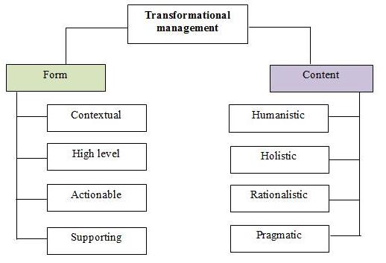

Figure 2 – Main approaches of transformational management

Note – Compiled by the author based on sources [75; 76, 77]

The second approach presents four concepts of corporate change management:
1) southern (humanistic) that implies a transition from competitive strategy to strategic renewal through transformational flows;
2) eastern (holistic) – transformation of organizational development into cultural dynamics through trans-cultural, including cross-cultural efforts;
3) northern (rationalistic) – intensive development of research and development (R&D) through interdisciplinary areas;
4) western (pragmatic) – improvement of the company’s management functions, introduction of interpersonal functions [76, р. 132; 77, р. 92].
Transformational management often acts as an integrated science of various individual disciplines, such as strategic management, project management, risk management, management of organizational change in an organization, competence management, etc. “Change for transformation implies moving on to something better than before, an enhanced outcome, from better performance already achieved to win a customer to a state of excellence where the customer is delighted” [78]. Therefore, one of the main factors for rapid change is the existence of transformational leadership within an organization, which is associated with “professionals’ understanding of professional quality” [52, р. 14; 79].
Kazakhstani researchers have also addressed the issue of transformational factors. Thus, the aspects of strategy, leadership, and human capital are widely studied and disclosed in the publication of Zhakypova, Abdykalikova and Kazbekova (2017). The authors consider the synergy of leadership and strategy, which leads to the concept of “strategic leader” under conditions of transformation. The main goals of a strategic leader, according to these researchers, are:
– strategic productivity – daily activities of civil servants aimed at the result and its quality;
– analysis of current activities and their compliance with the growing needs of society [80].
A new paradigm of citizen-centricity suggests that government will provide their citizens services and resources tailored to the actual service and resource needs of citizens [81]. Therefore, most of the governmental initiatives were focused on “rebuilding” the majority of high volume services to make them “digital by default”. The next stage of digitally-enabled transformation has three broad components:
1) transforming whole citizen-facing services – to continue to improve the experience for citizens, businesses, and users within the public sector;
2) full department transformation – affecting complete organizations to achieve their policy objectives in a flexible way, improve citizen service across channels and improve efficiency;
3) internal government transformation, which might not directly change policy outcomes or citizen-facing services but which is vital if government is to collaborate better and deliver digitally-enabled change more effectively [82].
Other researchers look at organizational structures and culture, as well as the characteristics of individual decision-makers as factors that might account for managers’ willingness to engage in innovative practices (Wise, 1999) [83].
From the literature review we can conclude that:
1) there is no such concept as innovative civil service. The OECD suggests a description of an innovative model by introducing basic characteristics. However, in the academic studies the public sector innovation and historical institutionalism are prevalent.
Investigation of previous research elaborations makes us believe that an innovative civil service is a model of civil service in which policy decisions are made based on collaboration with main stakeholders by taking into account their needs, and developing and implementing innovative solutions for further socio-economic prosperity;
2) there is an absence of a practically proven model of transformational management for the public sector. According to the McKinsey Center for Government Transformation around 80% of government efforts to transform fail to meet their objectives [84, 85]. This usually happens due to the lack of a clear strategy for change, sufficient support for managers, and support from main beneficiaries;
3) there is an ocean of variables that represent different models and theories on public sector innovation and transformational management. These two concepts were studied for decades separately from another. But the interesting part is that introduction of innovations often requires capacity for change. And the effective factors for both concepts are mostly similar. They are leadership, strategic vision, organizational objectives, personal drivers, resources, etc.
About 5 main factors to successful innovative transformation were identified during the literature review process. They are: Leadership, Strategy, Human Capital, Organization, and Resources. The variables relevant to this research come from contextual transformation theory and publications on factor based public sector innovations. The dimensions of the proposed conceptual model have been adapted from these theoretical studies by conducting an interview with experts from the public and private sectors of Kazakhstan. The results of the interview processes are provided in the appropriate chapter of the thesis. Thus, the lack of elaboration in theory and practice on the issue of civil service transformation towards its ability and capacity to innovate was the impetus for this study.

1.2 Major tendencies of civil service transformation in foreign countries
Starting from the literature review, this paper proceeds with international benchmarking in order to identify a comprehensive response for the first research question. The main principles of selecting countries for comparative analysis are:
– correlation according to the OECD of this country to states with an innovative model of civil service (for example, Singapore, United Kingdom, etc);
– presence of a predominantly career system of civil service (Canada, etc).
The analysis of foreign countries’ experience has shown that there is an absence of a unified approach to the civil service transformation. Moreover, different governments also promote and evaluate the innovation effects in different ways. Depending on the initial historical features and potentials, countries pay more attention to development of IT, human capital, collaboration, adaptive management and other components of public sector improvement. Therefore, this section examines countries with the best practices in civil service transformation and innovation without a specific sample.
Transformation is a continuous activity. And the alchemy of successful civil service reform is a long-standing endeavor. Hence, the features of a reform event are:
1) change gap – where it is obvious that what a system is capable of doing falls short of what is required or expected to do, there is a change gap;
2) change readiness – any system has a threshold for how much change it can handle. Picking a reform moment requires an understanding of the appetite for change and the capacity for the system to take on change at that time;
3) triggering crisis or opportunity – even if a civil service has a clear change gap and a degree of change readiness, a specific trigger crisis or opportunity creates a catalyst for change and the potential to focus on building reform momentum;
4) reform leadership – to break with past practice and take the risk of doing things differently [86].
Lack of convergence in reform processes across countries may make the task of identifying trends in civil service reform rather difficult, however, not impossible; as despite the many differences, it is plausible to identify some similarities and discern some trends at the global and regional levels [86, р.168]. The comparative analysis of public management reforms determined the following elements:
– making savings (economies) in public expenditure;
– improving service quality;
– making government operations more efficient;
– increasing the likelihood that the chosen policies will be effective [87].
The Astana Civil Service Hub in cooperation with the UNDP Global Centre for Public Service Excellence defined twelve key global trends based on extensive case-studies (figure 3). According to these trends, as well as McKinsey & Company research there are five implications for the public sector:
1) government must be more productive. Governments are being asked to do more, do it better, and do it with the same amount of taxes;
2) a new relationship between government and the citizen is needed:
– put people at the heart of public services;
– increase public accountability;
– work with constituents by encouraging “co-production”
3) organizational landscape of the public sector must be redrawn, namely boundaries within government, between the public, private, and nonprofit sectors;
4) governments should transform the way they employ data in policy making and management practices: a greater focus on long-term planning; a step change in the use of data to inform decisions;
5) public sector must improve its ability to compete for talent [88].

Interrelated
and interdependent reforms
Widely ranging reforms
Diverse civil service systems
Changing public sector labour markets
Contractual versus lifelong employment in the public sector

Career-based versus position-based recruitment

Senior versus unified civil service

Managing talent in the public sector
Competencies-based personnel recruitment, assessment
Centralised versus decentralised personnel management

Agencifi-cation
The political and administrative nexus dimension

Figure 3 – Global trends of civil service transformation

Note – Compiled by the author based on source [86, р. 168]

Also, innovation is rapidly moving to the top of the political and administrative agenda in many advanced countries. According to the European Union’s Innobarometer survey as many as 66% of governmental organizations in the EU27 countries had implemented innovations in public services. The most common forms are: creation of ministerial innovation units, publication of white papers on innovation, formation of innovation labs, increasing the quality of public services delivery, a growing expectation that public managers and employees will assume responsibility for fostering innovation, and the proliferation of training programs that aim to qualify them to do so [39, р. 142; 61, р. 15; 67, р. 441].
Therefore many countries approve and apply new strategies and a vision for mid and longterm transformation: Government Transformation Strategy and Government Technology Innovation Strategy of the United Kingdom (hereafter – UK), Vision of Innovative Civil Service of Singapore, Abu Dhabi Strategy 2030, National Strategy for Advanced Innovation of UAE, etc. Advanced countries are shifting the locus of value creation not only by adopting new innovative strategies, but rethinking the vision, mission, values and competencies of government officials (Annex D) provides such examples [89-96].
For example, the portal of the UK Government has a range of blog posts illustrating the vision of “A brilliant Civil Service” that helps “to keep the country prosperous and secure, supporting the governments we serve in implementing their commitments and delivering high-quality services for the public” [97, 98]. According to Dowden (Parliamentary Secretary for the Cabinet Office of the UK) one of the strategic approaches to government innovation is emerging technologies, such as AI. Therefore along with the Strategy they adopted a Guide to Using AI in the Public Sector that helps everyone in government work better and smarter. The Strategy and the Guide are based around three themes: People, Process, and Data with Technology [99]. Key directions for the UK civil service transformation are:
1) diversity and inclusion: inclusive culture, talent management;
2) “reshaping” careers – reshape the next generations of civil servants around new career pathways that build professional expertise in key disciplines, the core government functions, while giving them the chance to broaden their practical experience (15 different schemes for new and existing civil servants, from Digital, Data and Technology, to Project Delivery and Commercial);
3) modern workplaces – creating around 20 strategic hubs. This program will reduce the number of government buildings from around 800 to 200 by 2023. Hubs will allow to locate teams from different departments in the same offices, enabling greater collaboration and a smarter, one-Civil-Service approach, using mobile technology and focusing operations at a local and regional level;
4) modern services – deploying technology to modernize public services, saving time and money for users (40 major government transformation programs, including virtual hearings, GOV.UK Notify for sending emails and texts, a secure payment service);
5) modern leaders – leaders who can explain the goal of transformation, who are confident beyond their own professional area, and whose first instinct is to collaborate, defying the silo mentality [98].
Another example is Singapore. The Public Service Division of Singapore has a Transformation Office and Innovation Lab that is “charged with building innovation capabilities and mindsets across the entire public service”. The transformation work is focused on:
– improving service delivery: more customer-centric (“Life project” digital application);
– building a digital government as part of Singapore’s vision to be a Smart Nation (Digital Government Blueprint);
– working with citizens closely;
– preparing every officer for the future: every public officer will learn and reskill, and adapt to changes. Every officer will pursue innovation and be open to new ways of working. The Civil Service College has launched LEARN, a mobile platform to enable officers to learn anytime, anywhere [100]. The Public Sector Innovation Process Framework includes principles from a range of fields, including design thinking, behavioral insights, and organizational development (figure 4).
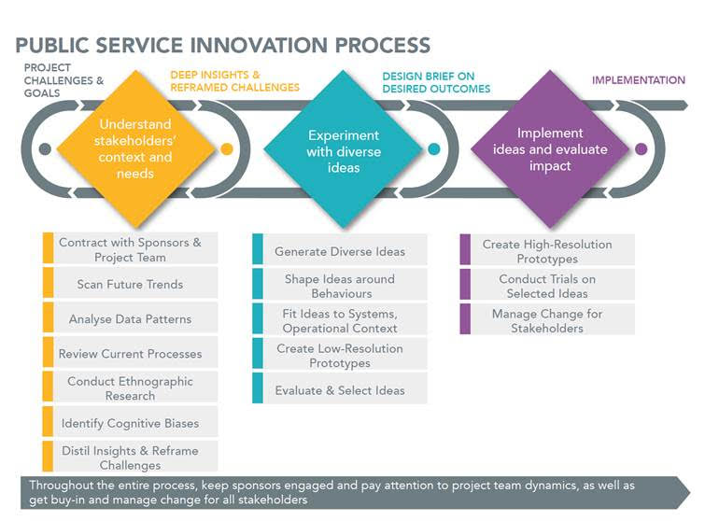

Figure 4 – Public Sector Innovation Process Framework

Note – Compiled by the author based on source [101]

The Transformation Office’s Innovation Lab spreads the culture of innovation in three key ways:
1) teaching individual public officers to be innovative through training sessions (innovative mindset) and “makeathons” (less tech-focused, public officers collaborate with citizens to identify challenges, user-test and come up with solutions);
2) public Sector Transformation Awards;
3) coaching agencies to deliver innovation projects.
The next example is the UAE government, which approved the National Strategy for Advanced Innovation (updated version of the National Innovation Strategy) in 2018 that aims to:
- establish a national platform for innovation, communication and learning;
- encourage the community to take the spirit of initiative;
- try out new models of government for serving society;
- test advanced economic patterns and lay the groundwork to create new sectors;
- achieve scientific breakthroughs that focus on the welfare of people;
- collaborate with leading international institutions and companies specialized in the field of innovation [102].
The overview of results of foreign civil service transformation is summarized in figure 5.

Failure causes
Positive impact
1. Opportunities to accelerate, refresh and embed positive impacts further were routinely missed, because senior officials and ministers do not see it as worth their while to support a reform agenda associated with their predecessors.
2. There is no permanent function in government responsible for absorbing learning and building on what has gone before.
3. A change in leadership at the official or political level.
1. A stronger sense of personal responsibility and accountability for delivery policies, projects, programs or services.
2. The use of objectives, performance indicators and measurement to make progress transparent.
3. More open competition for senior roles and greater diversity of the civil service.
4. Greater value placed on the quality of leadership and management.
5. Learning and adopting new ways of working, which outlasted the reform that introduced them.

Figure 5 – Results of civil service transformation

Note – Compiled by the author based on sources [86, р. 132; 87, р. 39]

Governments are facing a growth in citizens’ expectations. Citizens tend to expect increasingly better and faster services from the public sector [103, 104]. Changes of traditional management procedures inevitably entail qualitative and quantitative transformations. This is a reboot process. Results supposed to be measured not by quantitative, but mostly by qualitative objectives. Thus, in the past decade Commonwealth and European governments have been developing methodological frameworks for producing national indices of innovation and productivity [61, р. 6].
Abouchakra and Khoury proposed 20 points of a transformation program for all countries that covers issues from changing a mindset to proactive provision of public services [1, с. 137]. Also, Şandor suggested several methods and attempts to measure public sector innovations:
1) research on specific innovations through case studies;
2) best practices or Innovation Awards;
3) managers’ surveys asking about the use of some innovative practices and technologies;
4) innovation surveys that measure the innovation state of an entire sector/country, asking about a wide range or all innovation activities and types of innovations implemented over a defined time period (Annex D) [105].
As we can see in tables D.1 and D.2 each country and region have their own features, which should be taken into account. For example, “the pattern of economic development, the nature of political leadership, the capability of the administrative system, the capacity of existing institutions, and the state of civil society…”[106]. According to Baimenov “international cooperation is one of the key determinants of success and sustainability of any public sector transformation” and countries such Kazakhstan should apply “peer-to-peer learning and exchanging knowledge and experience through multilateral platforms” [107].
Governments worldwide are striving to improve the civil service system of their countries. The findings of comparative analysis show that:
1) there is no universal or standard model of civil service. However, many countries are focused on strategic development and implementation of the citizen-centricity principle, collaboration, digitalization, different types of management (project, strategic, talent, change, etc). Key features of an effective civil service are: merit-based and neutral, well-structured and right “sized”, well-paid, accountable and professional, relatively autonomous, responsive and free of corruption, well-trained and performance oriented, relatively open and representative [108];
2) key trends in civil service development are:
– gradual shift towards using objective criteria in recruitment and promotion, although patronage is still an influential factor;
– use of competitive compensation schemes to attract competent individuals to the civil service and of incentives to encourage better levels of civil servants’ performance;
– recognition that training and capacity building of public human resources enables governments to improve policy formulation and implementation processes and delivery of public services [87, р.96];
– innovation is becoming an integral part in civil service. Thus, various methods of evaluating the implementation of innovations are used, including stimulation of civil servants’ innovative activity;
– civil service transformation is a permanent process. With this in mind, adaptive management is being introduced.
1.3 Research model conceptualization and methodology
This study is based on a multi-stage research design. It includes a conceptual model development and confirmation of its relevance through hypothesis testing, as well as a research model piloting through integration into the methodology of organizational diagnostics. For this purpose, expert interviews and two surveys of employees of the pilot bodies (in 2019-2020 years) were conducted.
Therefore, this subsection consists of the following parts:
1) based on the literature review, foreign experience and expert interviews, the factors will be selected, and their relationship will be established, and a conceptual model of the study will be built;
2) the conceptual model will be tested utilizing the data obtained from the results of the survey among the pilot bodies’ employees;
3) based on the final conceptual model’s factors, the format of the organizational diagnosis will be built for approbation in the pilot bodies.

1.3.1 Research design and operationalization
Following the literature review and the analysis of the experience of other countries, it appears that there is an absence of a concrete approach of how to build a holistic system of change management in public authorities towards the adoption of innovation. Numerous studies have been conducted on the topic of civil service transformation and public sector innovation by presenting various models and case studies from different countries. The case studies indicate the principle of “Quick wins”, the creation of a structural unit in the authorized body for civil service affairs on innovation issues, the establishment of annual awards and competitions, as well as the annual assessment of the innovativeness of public authorities. However, the literature review and benchmarking have shown fragmentation and lack of an integrated approach to the transformation of state apparatus in foreign countries.
This paper has potentially an exploratory nature. During the research phase any specified theory of change management will not be tested. This study will adapt a new approach to develop an empirically proven citizen-centric model of public authorities’ transformation. Consequently, a research framework has been developed following the literature review and the comparative analysis of case studies from other countries (figure 6). The variables and measurement items were developed mainly considering contextual change models (Annex C).
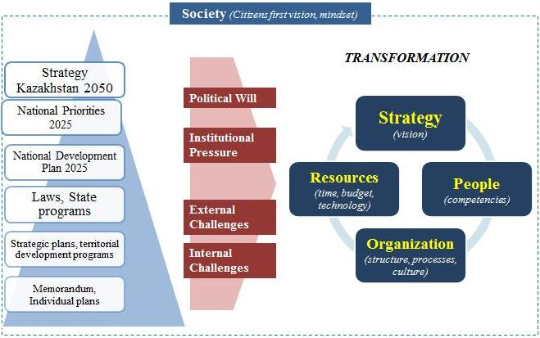

Figure 6 – Key factors for state apparatus innovative transformation

Note – Compiled by the author based on literature review and retrospective analysis

The study proposes a comprehensive model to identify an accurate group of driving forces that encourages civil servants to accept transformational processes towards building an innovative civil service. A multiple-stage design combining qualitative and quantitative research tools is used to confirm the proposed research model. In order to guide the current study and properly address assigned research questions, figure 7 provides an overview of the procedures that were followed to complete this research.
According to figure 7, each research question is reflected in a specific task with a corresponding set of research tools. Moreover, the research design meets the structural harmony of the dissertation.
In order to determine whether the variables selected are appropriate in the specific context and to identify what kind of additional variables could be included in the research model, the questionnaire pre-test and interview were used. Figures 8 and 9 reflect the unit of analysis. Mainly, the new remuneration pilot project is implemented at the central and local government levels. In order to ensure representativeness of pilot authorities the Agency for Civil Service Affairs and Nur-Sultan Akimat were selected for this study.

Task 1
Analyze theoretical aspects of innovative civil service and transformational management

Task 2
Study in depth major tendencies of civil service transformation in foreign countries
Task 3
Develop a conceptual model based on factors derived from the previous two tasks
Task 6
Study the current status of Kazakhstani civil service transformation through reflections of previous reforms
Task 4
Test and enhance the conceptual model based on interviews and surveys of the new remuneration project participants
Task 5
Analyze results of pilot project implementation
Task 7
Identify main directions of civil service transformation in Kazakhstan by providing scientific and practical recommendations, as well as a methodology
RQ1
What kind of factors are involved in the innovative transformation of public authorities?
RQ2
What has changed during implementation of the project in the pilot bodies?
What is the effect?
RQ3
How to manage the transformation processes towards innovative civil service of Kazakhstan?

Research tools
SWOT, PEST, retrospective analysis
Research tools
Literature review (analysis, summarization and critique), content analysis
Research tools
Comparative case studies
Research tools
Conceptualization, operationalization, hypothesis building, expert interviews
Research tools
Interviews, surveys, descriptive statistics, factor analysis

Research tools
Organizational diagnostics, including cost-effectiveness analysis

Research tools
Policy suggestions, methodological recommendations

Figure 7 – Research design

Figure 8 – Decomposition of the research focus

Note – Compiled by the author

Consulting company
Presidential administration

Office of Prime-Minister

Citizens

Other stakeholders
Civil servants of other state bodies
Agency for Civil Service Affairs’
civil servants
Capital
residents
Nur-Sultan Akimat’s civil servants

Figure 9 – Unit of analysis

Note – Compiled by the author

As figures 8 and 9 show the research focus is narrowed by selecting the two pilot authorities, the consulting company (Hay Group), and residents of the capital as parts of the new remuneration project, which is also considered a most important measure of civil service modernization [109]. This will allow us to comprehensively study the research questions. Therefore, the other project stakeholders are the object for future research endeavors. After testing the conceptual model testing and assessing the organization diagnostics methodology the study can be scaled through the Presidential Administration, the Prime-Minister Office, other central and local state bodies, and civil servants, as well as elicit citizens’ involvement.
The innovation in public sector is an individual activity [110]. And the transition to the New Public Governance (Service Governance) model involves changing the focus to research based on sociometry (correlation of individual or small groups’ opinions with the view of society). In order to detect the most important determinants expert interviews and two surveys were conducted. The researchers (Davis, Brynjolfsson, Jen-Her Wu and Wang) argue about usefulness and appropriateness of interview and survey methods as a type of investigation “to elicit a lot of data in a short period of time” [111-113]. Survey and interview professionals must protect each participant’s well-being to prevent harm and to get accurate information. Therefore, the ethical principles which guide data gathering are rooted in two inalienable human rights: free speech and privacy. The participation of respondents is voluntary. To ensure the voluntary participation and protection of individual data the researcher mentioned the appropriate notes in the interview and survey consent forms. The interview and survey were conducted in Russian, the interethnic common language in Kazakhstan.
Before proceeding with the survey, in order to ensure the feasibility of proposed research model and validity of questionnaire several expert interviews were conducted. Based on existing literature it was decided to choose the judgment sampling as a common nonprobability method for interviews and survey questionnaire pre-test. The interviewees were selected by researcher’s own judgment. However, in order to achieve representativeness of the target population, the features for selecting the sample were generalized as follows:
– interviewees should represent different parts of population (means various occupation, such as public officials, private sector employees, etc);
– interviewees from the public sector should represent central and local levels of administration;
– interviewees should be stakeholders in the implementation of the new remuneration system.
Based on these criteria four experts were interviewed. All interviewees represent stakeholders of the new remuneration by results project, but they also had different occupations. They were:
– head of the country office of Hay Group company (a consulting company which conducted the project);
– civil servants from central and local public authorities (participants of the pilot project, where organizational and other forms of transformation happened);
– project manager from the Agency for Civil Service Affairs. A profile of respondents is provided in the table 5 below.

Table 5 – Profile of interviewees

Parameter | Project manager from the public sector | Project manager from the private sector | Central government representative | Local government representative
Occupation | Deputy Director of the Civil Service Department at the Agency for Civil Service Affairs | General Director of the Hay Group company’s branch in Kazakhstan | Head of Division of the Public Services Delivery Department at the Agency for Civil Service Affairs | Head of the Unified service for personnel management of the office of Nur-Sultan Akimat
Date  of interview | November 4, 2019 | June 11, 2019 | November 5, 2019 | June 3,  2019
Age | 29 years | 35 years | 36 years | 30 years
Work experience total | 5 years  5 months | More than 10 years | 13 years | 8 years
Work experience in the occupied positions | 4 months | 2 years | 4 years | 1 year  6 months
Education | Master | Master | Bachelor | Bachelor
Note – Сompiled by the author based on the interview results

As we can see from the data in table 5, the interviewees have sufficient work experience. Most of these experts hold a Master degree, except for two.
Generally, the interview is divided into three phases. The first section involves brief review of the literature and foreign experience, as well as the available list of factors extracted. The experts were provided with the Conceptual model for making suggestions and comments. The second section includes studying the draft questionnaire for the pre-test. And the third section, the in-depth interview, includes the list of questions on transformational management and innovative civil service issues (Annex E). The results of the first two interview sections are provided in this part of the dissertation. The answers for the third section are analyzed in the second part of the research section.
The experts confirmed the importance of each of the proposed factors, and also stressed the relevance of the study on innovative transformation in the public sector. The principle of citizen centricity is one of the important aspects of a serving government as a potential mediating variable [114].
Beside this, interviewees proposed to add the “Leadership” factor to the list of four existing factors (Strategy, Organization, People, Budget), as well as rename the “People” factor to “Human Capital” factor.
Thus, a total of five independent variables (Leadership, Strategy, Human Capital, Organization and Resources) and one mediating variable (Citizen Centricity) were selected from existing literature, benchmarking, and expert interviews [79, р. 62; 115, 116]. The adjusted conceptual model is shown in figure 10.

Civil Service
Innovative Transformation
H5
H4
H3
H2
H1
Leadership
Strategy
Human Capital
Organization
Resources
Citizen Centricity

Figure 10 – Conceptual framework

Note – Adjusted based on expert interview results

Thus, the study incorporates five independent variables, one mediator, and one dependent variable. (Annex F) contains variables and operational definitions as identified in the research model. As a basic hypothesis this research assumes that group of four factors (Leadership, Strategy, Human Capital, Organization) will have more significant effect compared to the “Resource” factor. In order to support the basic hypothesis, a number of secondary hypotheses are proposed. Those hypotheses relate to the constructs built on the evidence derived from the literature review and the interviews’ outputs.
According to Annex F each independent and dependent variable consists of two to five sub-concepts. Let’s give an example of the “Leadership” factor. In many studies of change management, the leadership factor is one of the key aspects for transformation. Special attention is paid to such qualities of a leader as the ability to hear his/her subordinates when making decisions, as well as the willingness to change. Therefore, two sub-concepts: Transformational Leader and Listening Leader were identified for the purpose of this study.
In order to understand the factors that influence civil service transformation, the current study proposes several (empirical) hypotheses based on operationalization of conceptual model from the literature review and foreign case studies analysis. Returning to the example of the “Leadership” factor, the following hypothesis is formulated: “H1. Leadership will positively influence on civil servants intention to accept innovative transformation of the civil service” (figure 10). Annex F provides more examples for the relevant variables that have been incorporated into the model. It also provides brief explanations of the variables as well as the measurement scale employed to test the model. The remaining hypotheses are listed below:
1. H2. Strategy will have a positive effect on innovative transformation of civil service.
2. H3. Human Capital is positively related to innovative transformation of civil service.
3. H4. Organization will positively influence on civil servants intention to accept innovative transformation of civil service.
4. H5. Resources are less positively related to innovative transformation of civil service.
Next section of the expert interviews includes survey questionnaire pre-test. According to the Saha, there are different objectives of this activity in order to ensure the applicability, importance, understandability, clarity of research construction [117].
Based on the interviewees’ opinions, the wording of some questions was changed in the questionnaire and small changes were made regarding the order to match the context of the study to the questions of the survey questionnaire. The revised questionnaire is distributed among target population through the snowballing method and to be tested further in the quantitative study.

1.3.2 Strategy for survey data analysis
The main aim of the researcher in conducting the survey is to achieve the representativeness of the population by choosing an appropriate sampling method. Generally, sampling methods can be classified as probabilistic and non-probabilistic. According to Hair et al. probability sampling is used more commonly where issues of generalizability and/or drawing statistical conclusions are involved (e.g., random sampling, systematic sampling, and stratified sampling). And on the other hand, in terms of a non-probabilistic method, samples are selected from the population in some non-random manner (e.g., convenience sampling, judgment sampling, quota sampling, and snowball sampling) [118]. In order to achieve reliability and validity of the measures used, the study aims to cover:
1) a small sample during the first wave survey (2019) for conceptual model testing and confirmation; and
2) a large representative sample during the main survey (2020) for organizational diagnostics of pilot authorities.
Next step is formulation of a target population as a complete group of objects or elements relevant to the research project [119]. Thus, the target population of the study can be identified as follows: “Civil servants of pilot public authorities”.
For this purpose, a number of meetings were held with the management staff of individual state bodies, including visits to the regions, and the questionnaires for civil servants, both on paper and through an online platform were developed. In general, the study took place in 2019 and 2020, which allowed us to test the conceptual model of civil service transformation for its transition to “innovative rails” [120]. The Agency for Civil Service Affairs (including regional departments) and state institutions of Nur-Sultan Akimat were identified as the units of analysis (table 6).

Table 6 – Information about surveys conducted

Parameter | Survey (2019) |  | Survey (2020)
Parameter | Agency for Civil Service Affairs | Nur-Sultan Akimat | Agency for Civil Service Affairs | Nur-Sultan Akimat
Purpose | Hypotheses testing and confirmation of the conceptual model |  | Approbation of organizational diagnostics, identification of “bottlenecks” and development of recommendations
Structural unit | Central apparatus | Capital and its districts Akims’ apparatuses | 1) Central apparatus;  2) all territorial departments | 1) Capital and its districts Akims’ apparatuses;  2) all state institutions;  3) capital residents
Date | 23 April, 2019 | 3 June, 2019  (during internship) | 15-31 October, 2020 | 15-31 October, 2020
Format | Paper based | Paper based | Online | Online
Scope | 35 civil servants | 65 civil servants | 1) 19 civil servants;  2) 149  civil servants | 1) 44 civil servants;  2) 59 civil servants;  3) 109 capital residents
Total number | 100 civil servants |  | 271 civil servants and 109 citizens
Note – Сompiled by the author

The first survey was administered during January – June, 2019. A total of 100 answers were received. The second survey was conducted during October, 2020 and it covered 271 civil servants of pilot authorities, as well as 109 residents of the capital. Based on the results of the sociological study, data on negative stereotypes about the civil service of Kazakhstan, the attitude of the population to the state apparatus, as well as the opinions of public sector employees on the ongoing reforms and innovations in civil service were collected and then studied in the analytical part of the dissertation.
Different statistical methods can be used to make sense of collected data sets. According to Hair et al. two steps are involved in quantitative data analyses:
- descriptive statistics to obtain a descriptive overview of data;
- statistical tools to test proposed hypothesis [118].
In order to ensure that the collected data is useful, reliable, valid for testing a causal theory and ready to conduct further statistical analyses, it is necessary to go through the data screening process. The common method for this is to check for any missing data, which may cause several problems, with the most apparent problem is that there simply will not be enough data points to run the analyses.
After carefully screening the data, an Exploratory Factor Analysis (EFA) was conducted to determine the correlation among the variables included in the dataset, and provides a factor structure (a grouping of variables based on strong correlations). Factors analysis was performed to evaluate validity of constructs by using SPSS software. The reliability of the measurement was tested by using the Cronbach’s Alpha score test. As the score was over 0.6, it is implied that the construct measurement used in this study are reliable.
The next step was to determine the factor structure of the dataset through Confirmatory Factor Analysis (CFA) in order to establish a well-fitting CFA model that will result in successfully testing the relationships among construct measurements as well as in achieving the reliability and validity of the measurement model. In order to determine goodness of model fit, several specific measures were applied in that analysis stage, such as Chi-square, p-value for the model, CFI, GFI, AGFI, PCLOSE, etc.
The next step was to test the conceptual model by employing Structural equation modeling (SEM) techniques. Although, scholars consider the SEM as similar to multiple regression, it is more powerful, because it takes into account the modeling of interactions, nonlinearities, correlated independents, measurement error, correlated error terms, multiple latent independents each measured by multiple indicators, and one or more latent dependents also each with multiple indicators. Moreover, under the SEM umbrella one is also able to consider the mediation concept for analysis.
The questionnaires for both surveys consisted of three parts: demographic profile of respondents, basic research questions, and open-ended questions to elicit recommendations. The main research questions indicate to what extent a respondent agrees or disagrees with the listed statements, according to the five-point Likert-scale, where 1 means “Strongly Disagree”, 2 - “Disagree”, 3 – “Neutral or No opinion”, 4 – “Agree”, 5 – “Strongly Agree”. The questionnaires are provided (Annexes G, H and I). The questionnaires were approved by the Center for Applied Research and International Partnership of the Academy of Public Administration under the President of the Republic of Kazakhstan in January, 2019 and October, 2020. The results of these surveys are included to the second chapter of this thesis.

1.3.3 Organizational diagnostics procedures
This method is a part of major study that involves a collaboration of various research tools. Organizational diagnostics are defined as the collection of information about an organization in order to identify issues in its functioning, as well as ways and means to solve them [121].
This study tool includes a set of different methods based on qualitative and quantitative data. In particular, the analysis was carried out at the ACSA and Nur-Sultan Akimat through:
- examination of the structural harmony of these state bodies;
- comparison with similar foreign authorized bodies;
- organization’s life cycle;
- survey of employees and stakeholders;
- cost-effectiveness analysis.
The basis for the analysis is the conceptual model of the dissertation, which consists of five key transformational factors (Leadership, Strategy, Organization, Human Capital, Budget) and a mediating component – Citizen Centricity.
In this regard, for each type of analysis, these factors are represented by corresponding indicators. For example, to study the life cycle of an organization, the “Leadership” factor will be taken into account, to analyze the structural harmony of the organization. The “Strategy” factor is revealed through the analysis of the pilot authorities’ mission, vision and goals, and the “Organization” factor – through the structure of the state body [122].
Cost-effectiveness analysis and cost-benefit analysis are often used in such studies [123, 124]. Depending on the subject of research, a particular tool is used. At the same time, according to Levin and McEwan the first method is used if it is necessary to compare several alternatives with different units of measurement, which corresponds to the aim of the thesis [124, p. 27]. The cost-effectiveness analysis is widely used in developed countries for evaluating programs and projects in the social sphere, infrastructure, and construction. However, according to Johnson this tool is “currently underutilized in evaluations of governance and anti-corruption reforms in developing countries” [123, p. 4].
Since the project of a new remuneration system for civil servants has been launched in a pilot mode, a study using the cost-effectiveness analysis will determine the most effective solution and the necessary adjustments for the subsequent scaling up of the project throughout the country, which will be offered to the management of the state apparatus. For this purpose, each of the above-mentioned factors are compared to blocks of the assessment system of the Evaluation Center at the JSC “Institute of Economic Research” of the Ministry of National Economy (Goals achievement, Interaction with citizens and Organizational development) and indicators of ACSA’s statistics (“Net turnover” and “Quality of public services”) (table 7).

Table 7 – Indicators for cost-effectiveness analysis of the pilot project of a new remuneration system for civil servants

Factor | Indicators | Unit of measurement | References
Effects
Leadership | Evaluation of overall effectiveness of a state body | % | Evaluation Center database
Strategy | Goal achievement | % | Evaluation Center database
Organization | Organizational development | % | Evaluation Center database
Human Capital | Net turnover | % | ACSA database
Mediating effect
Citizen Centricity | Quality of public services delivery | % | ACSA database
Citizen Centricity | Interaction with citizens | % | Evaluation Center database
Costs
Resources | Budget of Payroll Fund | USD mln. | ACSA database
Note – Сomplied by the author based on official databases [125-130]

Performance evaluation includes not only measuring the performance of personnel, but also its mandatory linking with the strategic development goals of the country. Countries that have implemented such approaches include Canada, the United Kingdom, South Korea, Singapore, and others. For example, the UAE has developed a special Guide for evaluating the work of the government, which is conducted by the Office of the Prime Minister of the Ministry of Government Affairs and the Future (Prime Minister’s Office at the Ministry of Cabinet Affairs and the Future of the United Arab Emirates).
The evaluation indicators are linked to two general strategic objectives of government structures, namely: “ensuring the provision of administrative services based on standards of quality, efficiency and transparency” and “instilling a culture of innovation in institutional work”. For the latter, a separate innovation component is defined, which includes such indicators as: the percentage of readiness for innovation; the percentage of innovations based on employee proposals; the percentage of innovations accepted by local or international organizations; the percentage of employees trained in innovation; and the percentage of seminars and events organized in the field of innovation.
If we consider the experience of Kazakhstan over the twenty-year period that assessment of state bodies has been taking place, then, despite the apparent completeness of the coverage of various aspects, for example, human capital management, such an assessment is not prepared for future challenges.
Thus, none of the three components of such an operational assessment (human resources, labor organization, meritocracy, and organizational culture) has an innovative subtext and motivation for conceptual transformation.
The indicators shown in table 7 are based on the current assessment methodology, but do not fully reflect the essence of the factors, and therefore are not sufficient to build an innovative model of civil service.
The HR assessment itself, although it takes into account the opinion of civil servants, is not fully open and transparent, since most indicators are formed based on departmental data of the evaluated bodies, and there is also no measurement of the opinion of the population – the main beneficiaries of the services of the state apparatus. That is, in fact, the changes that occur within the system are focused only on its own needs. At the same time, a significant layer of analytics and proposals that citizens are ready to make remains uncovered. This is also evidenced by the results of our survey, in which more high-quality and detailed recommendations were received from residents of the capital than from employees of the public sector.
The factor “Resources” in table 7 determines the costs, and the remaining factors determine the effects formula (1):

(1)

where С – costs of project implementation;
Е – effectiveness of project implementation;
– factors for evaluating the effectiveness of the project, such as Leadership (i), Strategy (ii), Human Capital (iii), Organization (iv);
– mediating factor (Citizen centricity);
– the factor that determines the project costs, namely the change in the size of the Payroll Fund for civil servants of the pilot bodies (Resources, v).
The study also uses the methodology of the Evaluation Center, which assumes that:
- 90 or higher points – a high degree of efficiency;
- 70-89,99 – average degree of efficiency;
- 50-69,99 – low degree of efficiency;
- up to 49,99 – inefficient activity;
The period of analysis includes 2017-2020 (2018-2020 – project implementation in pilot mode; 2017 – for comparison).
Indicators (factors) have different units of measurement and indirect influence, so the following hypotheses are formulated:
1. H0: a positive change in all factors justifies the resources spent; while the value of the mediating factor is a decisive factor for assessing the overall indirect effect.
2. H1: if at least one factor generates negative effects, the project of new remuneration system for civil servants is considered as insufficient.
The main outcome of the research hypotheses testing suggested that despite significant achievements in the field of civil service or city development the diagnostics of the ACSA and Akimat activities identify reserves for further development of the public sector through the lenses of the country’s strategic goals.
The results of the study may be used to scale up the approved method of analysis in other pilot bodies in order to openly discuss the “true” results of the project with the public on the way to an accountable and effective public administration. Summarizing outcomes of the first section the following key points should be noted.
1. There are different schools and approaches to defining the concept of “innovation”. However, many researchers agree that innovation is progress, development on the way to a qualitatively new change, that is, a transformational process.
2. Literature review and expert interviews suggests the vision of innovative civil service as a proactive, transformative, digital, initiative and forecasting activity of public sector institutions and stakeholders.
3. The historiography of civil service development, including foreign experience, shows that the principles of Good Governance, including innovation and proactivity of the state apparatus, its openness, “Citizens First” approach to public services delivery have become more significant nowadays.
4. The widespread digitalization should consider the population’s IT readiness, the existence of up-to-date databases, a cybersecurity system, and the degree to which citizens’ lives are simplified.
5. The developed countries with an innovative model of civil service emphaze not only advanced technologies implementation, but also the development of human capital, including the competencies of civil servants.
6. Analysis of the theoretical basis in the field of transformational management shows a significant number of approaches, but most of them are used in the private sector.
7. For this reason the conceptual research model was developed on the basis of the main theories, and it was tested taking into account the Kazakhstani civil service realities. A variety of research methods combined with the organizational diagnostics tool have been identified, and the necessary hypotheses have been developed. This will allow us to develop clear recommendations for further improving the efficiency of the state apparatus.

2 Kazakhstani experience of Civil Service Transformation

2.1 Retrospective analysis of civil service reform in Kazakhstan
By analyzing a chronology of public sector evolution three main models of public administration and civil service could be distinguished, mentioned explicitly in the literature review. The models represent a transition from a more centralized management to decentralization and delegation of state functions, as well as from corporate and results oriented focus to Citizens First approach. Therefore, civil service evolution in a sovereign and independent Kazakhstan is closely linked to the historical progression of public administration reform (figure 11).

Public Administration |  | Civil Service
2nd stage (1997-2007)  3rd stage (2012-2017)  4th stage (2017-2020)  1st stage (1991-1997) |  |  | 2nd stage (1997-2012)  1st stage (1992-1997)  3rd stage (2012-nowadays)
Figure 11 – Public administration and civil service
development stages in Kazakhstan

Note – Compiled by the author based on sources [129; 131]

According to the OECD Kazakhstan formed its own civil service system combining elements of professional and strategic models [18, р. 75]. Next step is a transition to an innovative and client-oriented civil service focused on the needs of society. Similarly, the administrative reform in the country gradually adopted the principle of serving the people. Thus, one of the latest documents that comprehensively address the public sector reform in the country is the Concept of Public Administration Development in the Republic of Kazakhstan until 2030: Building a “human-centered” model – “People first” (2021). Additionally, the National Report on the State of the Civil Service in the Republic of Kazakhstan (2018) comprehensively examines the main stages of the development of the civil service system. Below we take a closer look at the stages of development of the systems based on the presented documents.
As we can see in figure 11 there have been several stages of public administration and civil service systems development:
1) the first stage was marked by the institutionalization of the public administration system. The main documents are: Strategy of the Formation and Development of Kazakhstan as a Sovereign State, the Decree of the President “On Civil Service” (had a force of Law), and Rules of Professional Ethics. The key results are: equal access to civil service, reduction of politicization, establishment of training institutes, contractual basis of the civil service, social guarantees and ethical requirements, etc. Among the post-Soviet countries, Kazakhstan was one of the first to institutionalize the civil service and introduce advanced technologies in personnel management (Annex J);
2) the second stage included the implementration of social state principles (“economy first, then politics”, “welfare state”). The main documents are: Strategy “Kazakhstan-2030”, Strategic Plan until 2010, and Law “On Civil Service” (1999). The key results are: Agency for Civil Service Affairs (1998), the Academy of Public Administration, permanent professional basis of civil service, legislative division into political and administrative civil servants, establishment of the executive secretary position (2007), competitive basis and professional requirements for entering the civil service;
3) the third stage was characterized by the implementation of strategy and programs aimed at Kazakhstan’s entry into the top 30 developed countries of the world. The main documents are: Strategy “Kazakhstan-2050”, Strategic Development Plan until 2020, Concept of a New Model of Civil Service (2011), and Civil Servants Ethics Code (2005). The key results are: digitalization of the state apparatus, annual assessment of the effectiveness of state bodies, strategic plans, state audits, creation of Corps “A”, etc;
4) the fourth stage is marked by further professionalization of the civil service. The main documents are: National Plan “100 concrete steps” (2015), new Law “On Civil Service of the Republic of Kazakhstan” (2015), and constitutional reform legislative acts (2017). The key results are: number of state programs has been reduced, Open Government, transition to a career model, decentralization of public functions, the role of the Parliament and its control over the Government were strengthened, institute of observers and experts during competitive procedures was established, a new institution of the ethics commissioner was created, disciplinary boards transformed into Ethics Boards, implementation of the principles of meritocracy in the system of law enforcement agencies, practice-oriented training of civil servants, etc. [129; 131].
Key strategic documents since independence (Strategy 2030 and Strategy 2050) pay special attention to the building of the “Professional state”. However, comparison between the “Priorities” section of the Strategy 2030 and “Achievements” section of the Strategy 2050 demonstrates that the first six areas show significant improvement and confidence in results obtained [5; 6].
For example, on National security – “We managed to do more than planned”, on Infrastructure – “And we were able to do it”, on Economic growth – “We managed to solve this task in the shortest time possible by historical standards”, etc.
According to the seventh priority – “Professional state” full conviction is not observed. This is evidenced not only by the quote “We should have...”, but also by a lack of clarity and completeness of this task in the Strategy 2050.
This conclusion is reinforced by the statement at the end about individual tasks that are being implemented: “Thus, the main tasks set by the Strategy 2030 have been completed, while others are still in the process of implementation”. In particular, it was planned to complete a reform of the Government and civil service by 2000, as well as to clear incompetent officials who abused their power.
In fact, civil service reform, in particular, and public administration reform, in general, are continuous and take place constantly in a rapidly changing social and economic environment. In order to examine external factors which negatively or positively affect the civil service system of Kazakhstan, this paper is based on PEST analytical tool. Considering the taxonomy variations of PEST-analysis (for example, ETPS, PESTLEE, PEST-E, PEST-G, STEP and etc), to have a big picture with optimal analytical structure the PEST-analysis is chosen as the best option (table 8).

Table 8 – PEST-analysis of civil service of Kazakhstan

Political |  | Economical
Positive aspects | Negative aspects | Positive aspects | Negative aspects
1) political support and understanding of the need for qualitative changes;  2) clear development guidelines, taking into account advanced foreign experience, are prescribed in the country’s strategic documents, etc. | 1) potentially political instability;  2) frequent change of political leaders – heads of agencies and ministries;  3) insufficient continuity of the previously approved course of development of the system, etc. | 1) various grant programs of world development institutions;  2) stable project budget;  3) there is no need for significant financial costs to get the effect of initiatives, etc. | 1) lack of analysis of the quality and cost-effectiveness of individual projects and initiatives in the civil service system;  2) imbalance between internal motivation and monetary compensation of civil servants;  3) low wages and lack of a proper social package for most employees, especially in remote regions, etc.
Social |  | Technical
Positive aspects | Negative aspects | Positive aspects | Negative aspects
1) high potential of human capital;  2) high proportion of specialists educated abroad and the Academy of Public Administration;  3) emphasis on development of competencies, etc. | 1) lack of attractiveness;  2) staff turnover in bodies with insufficient motivation package;  3) high level of stress and the presence of unpaid overwork, etc. | 1) modernization of information systems, optimization of business processes, digital architecture of state bodies;  2) digitalization of public services;  3) proper logistical support, etc. | 1) rapid changes in innovation;  2) technological gaps  3) insufficient readiness of civil servants for the digital transformation of state bodies;  4) high level of costs associated with digitalization in the absence of proper control over cost effectiveness, etc.
Note – Сompiled by the author based on retrospective content analysis of strategic documents [129; 131]
Beside the factor mentioned in the table above, the corruption remains one of the unresolved issues today. At the same time, it is noteworthy that the policy guidelines in this area have changed. In particular, preventive measures and anti-corruption education are becoming increasingly important in place of the fight against corruption.
In this regard, five institutional reforms have been identified. They are aimed at strengthening the state and making the country one of the 30 most developed countries in the world by 2050. In addition, a new Concept of public administration development until 2030 has being approved. The main postulates are the transformation of the functional approach to managing state tasks; and ensuring prompt and effective interaction with citizens. Thus, the main legislative framework nowadays is determined by a number of key documents of the country aimed at further development of the public sector (figure 12).

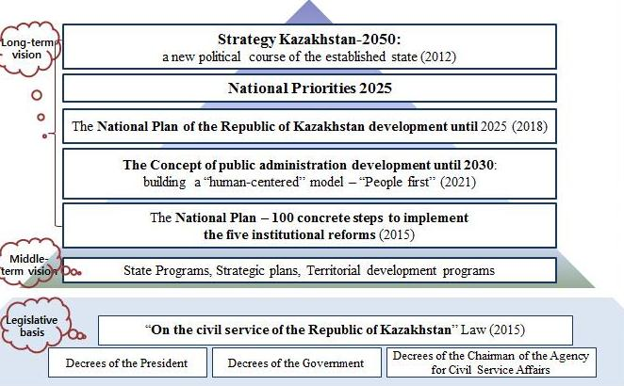

Figure 12 – Key legislation of civil service in Kazakhstan

Note – Compiled by the author

Nowadays, another wave of public administration reform is necessary. According to the Recommendations based on the results of analytical research on the topic: “Public administration in the Republic of Kazakhstan “Strong state. Mature society” (2020), there are milestones of country development that could be systemized by applying a SWOT analysis method (table 9).

Table 9 – SWOT analysis of civil service development in Kazakhstan

Strenth  - strategic vision of country development (Strategy 2050, Concept of Public Administration Development until 2030, Strategic Plan 2025, state programs, industry programs, strategic plans of public authorities, territorial development programs, etc);  - political stability;  - legislative framework;  - institutional foundation;  - digitalization and business processes reengineering initiatives, etc. | Opportunities  - development of state policy based on the “People first” approach;  - comprehensive assessment of the results and effects of government policies;  - rethinking the functionality of the state apparatus. Prioritise basic functions;  - improving the effectiveness of the budget;  - radical openness in the budget at all levels;  - creation of a single state body in the field of public administration;  - digital by default;  - rebranding, formation of a strategic and innovative state apparatus;  - transformation of communication channels;  - participatory management practices;  - shaping the image of the future, etc
Weaknesses  - stagnation of effectiveness of current model of public administration;  - impact of information and communication technologies and digital ochlocracy;  - slowing down the pace of civil service development;  - permanent reorganization of state bodies;  - strategic planning, indicative planning, and program-target approach work as separate systems, etc. | Threats  - political transit;  - evolution of global agenda: achieving social progress (population welfare) instead of purely economic indicators;  - digital maturity of the state;  - increasing uncertainty due to the speed of change;  - crisis of trust and decentralization of management;  - rise of populism, etc.
Note – Сompiled by the author based on source [132]

Furthermore, the documents of the state planning system have been reduced by more than 3 times (from 285 to 88), the National Priorities until 2025 have been adopted, the National Development Plan of Kazakhstan until 2025 has been updated, the Concept of Public Administration System Development until 2025 has been approved, and a draft concept of Data-driven Government has been developed.
According to the Concept 2030 the new model of public administration will be based on the principles of a “listening”, effective, accountable, professional and pragmatic state [131]. Kazakhstan is a part of the world space, and it systematically participates in international ratings, in order to give public authorities an opportunity to assess their current position in the global competitive, socio-economic, political and innovation spaces [133]. One of such rankings is the Global Innovation Index (table 10).

Table 10 – National innovation system strengths and weaknesses based on Institutions’ subIndex of the Global Innovation Index-2020

Country | Strengths | Weaknesses
Kazakhstan | Regulatory environment: Cost of redundancy dismissal, salary weeks (rank – 18);  Business environment: Ease of starting a business (20) | –
Russia | – | Regulatory environment: Regulatory quality (105), Rule of law (114)
Belarus | – | Regulatory environment: Regulatory quality (111), Rule of law (116)
Georgia | Political environment: Government effectiveness (41);  Regulatory environment: Regulatory quality (28); Rule of law (48); Cost of redundancy dismissal, salary weeks (16);  Business environment: Ease of starting a business (2) | –
Uzbekistan | Business environment: Ease of starting a business (8) | Regulatory environment: Regulatory quality (127), Rule of law (124)
Note – Compiled by the author based on Global Innovation Index database [134]

Based on the data in table 10 and the Global Innovation Index report 2020, the Institution influences all components of the innovation system. The public sector of the considering countries has a leading role in innovations diffusion due to uncertainty and risk for business entities. Government uses different tools (laws, budget financing, coordination and management, state strategic programs, etc) in order to stimulate actual participants in introducing innovation activities. The state also carries out a comprehensive analysis of regional innovation systems, planning and forecasting the development of the national innovation system [133, р. 12].
Summarizing the retrospective analysis of administrative reform in Kazakhstan, we might conclude that:
1) unlike the most foreign practices (United Kingdom, USA, Canada, France, etc), where the concepts of civil service and public sector are not separated, in Kazakhstan there are special programs for each of two systems;
2) theoretical analysis and practical benchmarking showed a lack of professional, strategic or innovative form of civil service in its “pure” form. Kazakhstan is no exception. Since independence the government of the country applies the best practices by taking into account national aspects. Therefore, individual segments of the public sector are at different stages of development and implementing the experiences of various countries;
3) taking into account paragraph 2 and the OECD report, Kazakhstan is on its way to an innovative civil service and New Public Governance model. While digitalization and the open government initiative are certain features of these models, a complete transition can take place only if all the necessary conditions are in place, including human capital development and transformation of both the structure and work processes of the state bodies;
4) it is necessary to make a paradigm shift adopting a new model by incorporating the citizen centricity principle into all aspects of state apparatus activities. A certain list of tasks is already described in the Concept of Public Administration Development until 2030. The key issue is the high-quality execution of these tasks without losing focus from the major strategic goal;
5) taking into account the analysis of historical and foreign background, the conceptual research model is presented in figure 13.

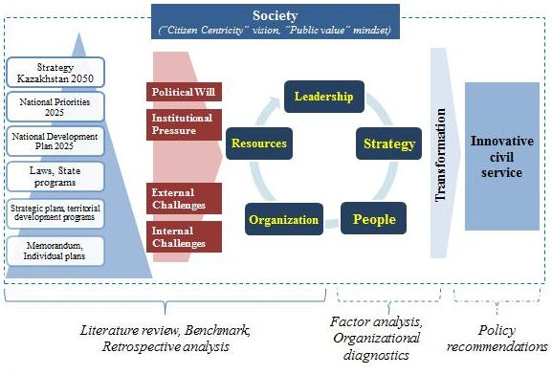

Figure 13 – Conceptual research model with national aspect

Note – Compiled by the author

Thus, the results of analysis of the theoretical approaches, foreign and Kazakhstani experiences of civil service and public administration transformation are taken into account in the course of the current study.

2.2 Case study of new remuneration pilot project
Following the results described in the previous parts and, specifically, the methodology part of the dissertation, this section focuses on two aspects. The first aspect is exploration of the new remuneration project’s main features and preliminary outcomes. And the second part is testing the conceptual model through factor analysis based on the survey administered among the pilot authorities’ employees (first wave).

2.2.1 Pilot project background
The new remuneration system was developed on behalf of the Head of State as part of the implementation of steps 5 and 6 of the National Plan – 100 Concrete Steps. It consists of two parts. The first part is based on a factor-point scale (grading system) that takes into account the nature, scope and complexity of the functions performed. The second part is a bonus, depending on the results of the work at the end of the year. The main aim of the project is to introduce fair remuneration for effective and efficient work, as well as to reduce the disparity in the salaries of civil servants of the center and the regions.
In 2018, a pilot implementation of the new remuneration system was launched in the Agency for Civil Service Affairs and Anti-Corruption (now – Agency for Civil Service Affairs), the Ministry of Justice, and the akimats of Nur-Sultan and Mangystau region. The necessary legal framework has been prepared for the high-quality implementation of the pilot. New staff schedules, departmental assessment methods and individual work plans for the pilot bodies’ employees have been approved. Various stakeholders from the public, private and non-governmental sectors are involved in launching and implementing the project (figure 14).

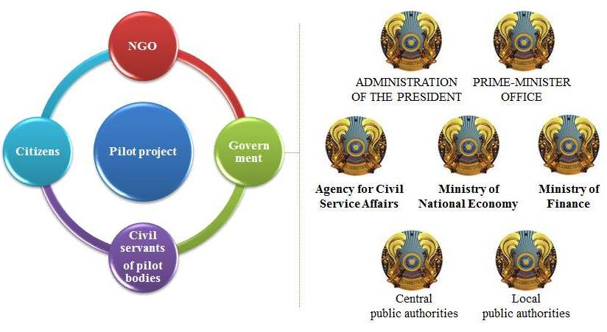

Figure 14 – Main stakeholders of pilot project

Note – Compiled by the author

As the project progresses, other ministries and akimats are also willing to participate, since, according to the survey of the pilot bodies’ employees, 96% of respondents positively assessed the project and believed that this system allows for motivating employees to work effectively. 94% respondents are also sure that the system allows reducing corruption and attracting qualified and competitive specialists to the civil service.
Furthermore, the pilot project allowed for raising the attractiveness of the civil service, and provided an increase in the stability of the personnel structure. In particular, the number of candidates for one vacant seat increased by an average of 2.6 times. The gap in the salaries of civil servants between the central and local level was reduced from 70 to 10%.
This process is accompanied by a reorientation of civil servants’ actions and behavior towards providing effective service to people. As a result, new approaches of personnel management are being developed. The main premise is the start of transformational processes aimed at optimizing structural units, staff numbers, creating shared service centers, digitalization of business processes, etc [135].
Only for the first year of the pilot project implementation of the transformation processes in the pilot bodies have intensified. The Agency created a Common service center for personnel records management, which increased the productivity of one personnel officer 14 times. Instead of 30 people, it serves more than 400. Personnel operations are conducted exclusively in electronic form through the “E-kyzmet” IT system. The transformation was also carried out in the capital’s akimat, where the number of departments was reduced from 30 to 21. In the Mangystau region management links have been abolished and the executive staff has been strengthened.
A fairly successful approbation of the new remuneration system led to the opportunity to scale across the country. Thus, the President of Kazakhstan in his annual address instructed to introduce a factor-point scale from July 1, 2021. This will lead to increased responsibility and motivation of civil servants as “low-paid civil service is too expensive for society. Misunderstanding of this issue leads to negative selection, loss of competence, initiative, and most importantly – to corruption” [136].
Therefore, the Agency has developed a draft Concept of the draft law “On Amendments to the Law of the Republic of Kazakhstan “On the Civil Service of the Republic of Kazakhstan”. The draft Concept proposes the introduction of the new remuneration system for civil servants based on a factor-point scale system. In addition, it is planned to cancel the bonus system for administrative civil servants and return to the system of reward for performance. At the same time, the bonus system would be left only for political civil servants, similar to developed countries (Singapore, Malaysia, Japan, etc) and the corporate sector.
According to the previous management of the state body responsible for the project, the positive effect is observed mainly on personnel issues (staff retention, reduced turnover, increased attractiveness, etc) [7; 8; 9; 10]. At the same time, the question of the project’s effectiveness in other aspects (beside human capital) remains open, as well as in relation to the main beneficiaries – the citizens, given the focus on service-oriented, innovative public administration.
In order to comprehensively consider the transformation process in the pilot bodies, this study assumes to cover other factors, along with human capital. For this purpose, as described in section 1.3, a conceptual model has been developed. The model was tested on the basis of an expert interview and the first wave of a survey of pilot bodies’ employees. Then the conceptual framework would be applied in the course of organizational diagnostics on the example of the Agency and akimat of the capital.
2.2.2 Conceptual model testing
Before proceeding to the analysis of the responses of the pilot authorities’ employees, we asked the experts to test the questionnaire during the interview. The results of questionnaire proofreading are indicated in Part 1.3 of the dissertation. However, the focus here is on studying the results of the responses received from interviewees.
According to figure 15 the responses are mostly similar. Especially, in prioritization of the “Leadership” and “Strategy” factors, then “Human capital”, and “Organization” factors, and, finally, “Resources” factors. If we consider the sub-factors, the experts agree on the importance of systematic achievement of strategy, mission and aim of state body, as well as the presence of an effective organizational structure. The differences are in the evaluation of other sub-factors. For example, if the institutional memory of the state body is important for the civil servant (prevention of a high turnover of personnel), then for a representative of a private company, this sub-factor is the least important in a comprehensive assessment of “Human capital”.

Figure 15 – Factors’ prioritization based on expert interviews results

Note – Compiled by the author

As already mentioned in the methodological section of the dissertation two surveys were conducted. The first wave of the survey covered 2019 year (January, April and June) and was paper-based during internships and offline training at the Academy of Public Administration.

2.2.2.1 Data screening
During the survey period 150 questionnaires were distributed and 120 questionnaires were returned. However, of the 120 questionnaires returned, only 100 were valid, and 20 questionnaires were not accepted for further analysis due lack of the answers to some questions (approximately, 20-50%) and duplication of the same answers for “Section C” (the questionnaire sample is provided in Annex I). Thus the final response set was composed of 100 responses with a response rate of 66,7%.
Therefore, a total of 100 civil servants of the pilot authorities participated in the survey, including 35 respondents from the Agency for Civil Service Affairs and 65 civil servants of Nur-Sultan akimat.

2.2.2.2 Demographic profile of the sample
Demographic characteristics of the participants are presented in table 11.

Table 11 – Demographic characteristics of respondents

Parameter | Answer options | Akimat  of Nur-Sultan |  | Agency for Civil Service Affairs
Parameter | Answer options | number | share, % | number | share, %
Age | 21-30 years | 17 | 26,1 | 11 | 31,4
Age | 31-40 years | 36 | 55,4 | 15 | 42,9
Age | 41-50 years | 10 | 15,4 | 6 | 17,1
Age | More than 50 years | 2 | 3,1 | 3 | 8,6
Gender | Male | 32 | 49,3 | 18 | 51,4
Gender | Female | 33 | 50,7 | 17 | 48,6
Education | Bachelor or Specialist | 46 | 70,8 | 22 | 62,9
Education | Master’s Degree | 18 | 27,7 | 13 | 37,1
Education | Candidate of Science, Doctor of Science, PhD | 1 | 1,5 | 0 | 0
Civil service experience | Less than 3 years | 9 | 13,9 | 3 | 8,6
Civil service experience | From 3 to 5 years | 17 | 26,2 | 5 | 14,3
Civil service experience | From 5 to 10 years | 14 | 21,5 | 11 | 31,4
Civil service experience | From 10 to 15 years | 13 | 20,0 | 10 | 28,6
Civil service experience | From 15 to 20 years | 9 | 13,8 | 4 | 11,4
Civil service experience | 20 years or more | 3 | 4,6 | 2 | 5,7
Current position | Executive level | 43 | 66,2 | 28 | 80,0
Current position | Managerial level | 22 | 33,8 | 7 | 20,0
Total |  | 65 | 100 | 35 | 100
Note – Сompiled by the author based on survey results

The proportion of gender of participants is close to be equal. Although at the regional level, female employees predominate, rather than in the Agency. Taking into account the distribution of staff size and organizational structure of pilot authorities, the executive officers participated more often in the survey (Akimat – 66,2% and Agency – 80%). Regarding the education received, the prevailing share of respondents has a bachelor’s or a specialist’s degree, and only one employee of the akimat has a PhD.

2.2.2.3 Descriptive statistics
Descriptive statistics were analysed to determine whether the data is normally distributed. This included calculating the mean, standard deviations, skewness, and kurtosis values. Overall, the descriptive statistics results (Annex K) show that the distribution for the summated score of the variables is normal.

2.2.2.4 Scales reliability testing
In order to establish the internal consistency of the measurement instruments, reliability analysis was conducted. It was established by calculating the coefficient alpha, also known as Cronbach’s alpha, to measure the internal consistency of the measurement scale. A score of 0.6 and above implies that the construct measurements are reliable (Annex K provides the exact score for each variable (factor) of the proposed research model). According to the data in table J.1 all of the items are found to be reliable, as their values are above the recommended level of 0.7. All of the items showed a good and a very good internal consistency of the scales. Moreover, according to Item-Total Statistics (also shown in Annex K), if any item is omitted the Cronbach’s Alpha mean will not arise, which means that all included items are appropriate applicable for and applicable to this study and the developed research model.

2.2.2.5 Factor analysis
A total of 7 items were selected to construct the structural model of innovative transformation of civil service. Utilising all 7 items, a confirmatory factor analysis was conducted to determine whether the items load satisfactorily in measuring this construct. Confirmatory factor analysis is a technique to confirm a prespecified relationship of observed measures [137]. The factor structure was specified, based on a theoretical background, and confirmatory factor analysis was used to validate the structure through empirical analysis. Following the analysis for each construct, the full measurement model, including all constructs, was developed to estimate the relationship between latent variables. The measurement model drew covariance between all variables and estimated how well the scale items contributed together towards a relationship between the variables.
During evaluation of both measurement and structural models, the researcher must assess overall fits for the model in order to judge whether the model sufficiently represents the set of causal relationships. This is done through assessing goodness of fit measures. According to table 12, three types of goodness of fit measures are used.

Table 12 – Model fit measures and structural model fit indices

Type of measure | Level of acceptable fit | Results
1 | 2 | 3
Chi-square | Smaller is better | 293.157
P-value | Significant | Significant
Absolute fit measures:
Goodness-of-fit index (GFI) | >.90 | .941
Continuation of table 12

1 | 2 | 3
Root mean square error of approximation (RMSEA) | Acceptable <.80  Good fit <.50 | .036
Incremental fit measures:
Tucker-Lewis index (TLI) | >.90 | .968
Adjusted goodness-of-fit index (AGFI) | >.80 | .921
Comparative fit index (CFI) | >.90 | .974
Incremental fit index (IFI) | >.90 | .974
Parsimonious fit measures:
Normed chi-square (CMIN/DF) | Lower limit:1.0  Upper limit 2.0/3.0 or 5.0 | 1.559
Note – Сompiled by the author based on survey results and source [137]

The measurement factor model achieved reasonably good fit, as shown in table 12. While the normed chi-square value suggested adequate fit, all of the other indices were either within or close to threshold values. In order to test the hypotheses, the structural model was used with all the factors tested in the measurement model, and the results, accompanied by a discussion are given in Annex K.
Examining the data in table J.2 it was found that most of the standardized regression weights are very high; over .70. The acceptable value should be more than .50. Therefore, all values are over the acceptable level. All critical ratios are over 1.97. The summarization of data analysis results and the final proposed research model are shown in table 13.

Table 13 – Summary of the hypotheses’ status

Hypothesis | Empirical support
H1. Leadership will positively influence civil servants’ intention to accept innovative transformation of civil service | Supported
H2. Strategy will have a positive effect on innovative transformation of civil service | Supported
H3. Human Capital is positively related to innovative transformation of civil service | Supported
H4. Organization will positively influence civil servants’ intention to accept innovative transformation of civil service | Supported
H5. Resources are less positively related to innovative transformation of civil service | Supported
Note – Сompiled by the author based on survey results

The hypotheses testing results show the verification of the conceptual model that, generally, might be described as follows. According to respondents, such factors as “Strategy”, “Leadership” and “Organization” are most important for the transition to an innovative civil service. The least important factor is the “Resources”. The results of the interviews and the survey confirm the proposed conceptual model. However, some findings would be used for further organizational diagnostics.

2.3 Organizational diagnostics of pilot authorities
Taking into account the results of the conceptual model testing and confirmation, as well as of the methodological part of the dissertation, this section involves approbation of the research model in the course of organizational diagnostics. As we know, during an official meeting with the Head of the Agency for Civil Service Affairs (June 2021), the President of the country noted the need for a functional analysis in the full implementation of the new wage system [138]. Organizational diagnostics is one of the widely used tools of analysis in personnel management. According to the Section 1.3 of the thesis the diagnostics of the ACSA and Nur-Sultan Akimat (applicable to the draft new remuneration system) consists of five logical steps, such as:
1) structural harmony of the state body;
2) comparative analysis with similar foreign authorized bodies;
3) organization’s life cycle;
4) survey of employees;
5) cost-effectiveness analysis of the pilot project implementation.
Next, we will take a detailed look at each diagnostics step in the prism of the three-year project implementation period in each of the pilot bodies

2.3.1 Diagnostics of the Agency for Civil Service Affairs

2.3.1.1 Structural harmony of the state body
First of all, this is an analysis of the strategic guidelines for the development of an organization, a meaning of its existence. Thus, according to the ACSA’s Strategic plan for 2017-2021, the mission is to implement a unified state policy in the areas of civil service and public services’ quality control [139]. In turn, its vision is to be a professional state apparatus that ensures quality implementation of economic programs and a provision of public services. In fact, the mission is replaced by a competence of the state body and requires improvement in terms of the philosophy of its creation and functioning. An alternative is to focus on a professional, competent and transparent state apparatus that serve the people of Kazakhstan.
The vision should acquire clear horizons and be inextricably linked to the overall development strategy of the country. For example, it can be “A professional state apparatus that ensures 100% achievement of the goals of economic programs, including at least 5.2% of the country’s GDP growth, as well as a high level of satisfaction of the population and business with the quality of public services”.
Turning to the goals and target indicators, it should be noted that they do not fully reflect the possibilities for improving a supervised area, but contain a minimum required set (i.e., they are achievable and not ambitious), which leads to stagnation.
Some goals are not specific and unclear. For example, aim “Improving an efficiency of a civil service”. To what extent a professionalism of the state apparatus reflected in improving an efficiency of the civil service?
The wording of individual goals is “bureaucratic”. For example, the aim “Improving the control of public services quality”. The ACSA and its employees should be focused not on strengthening control, but on creating conditions for preventing violations and promoting digitalization in the provision of public services.

2.3.1.2 Comparative analysis with similar foreign authorized bodies
Next, we consider the organizational structure through the prism of foreign experience. As stated in the mission, the ACSA is entrusted with the functions of implementing a unified state policy in the areas of civil service and control the quality of public services. In addition to territorial divisions in all regions, the ACSA has the Academy of Public Administration under the President of the country, as well as the National Center for Civil Service Personnel Management under its supervision and control.
For comparison, let’s take, for example, similar departments of such advanced countries in the field of civil service as Singapore and South Korea, whose distinctive feature is the citizen-centric smart government.
These organizations are only assigned functions in the field of civil service and do not include functions of anti-corruption policy (as the ACSA was previously – the Agency for Civil Service Affairs and Anti-Corruption of Kazakhstan).
For example, the Public Service Division (Singapore) has:
– the competence to transform the public sector (in Kazakhstan, the functions of public administration and administrative reform are concentrated in the Ministry of National Economy);
– the functions for of leadership development; and
– a separate Department for maintaining the HR IT-system.
Similarly, the Ministry of Personnel Management (South Korea) has:
– a more extensive structure for each aspect of the civil service: staff selection, development, remuneration, employment after retirement, etc (in Kazakhstan, the function of remuneration is assigned to the Ministry of National Economy); and
– a separate Bureau of innovations.
Thus, both the ACSA and the Ministry of National Economy have separate functions for public administration. Therefore, there is a question of creating a unified authorized body accountable to the President of the country, with a temporary moratorium on its reorganization or abolition, since only over the past five years, the ACSA’s structural changes have taken place almost annually.

2.3.1.3 Organization’s life cycle
Let’s consider the political agenda and the “portrait” of the Leader during this period (2015-2020) based on the life cycle:
– the ACSA was transformed into the Agency for Civil Service Affairs and Anti-Corruption, ACSAAC (Chairman – K. Kozhamzharov) in 2014. This period can be associated with several phases of the life cycle: active performance, youth, prosperity and stability. This is due to a full-scale change in the legal framework for the development of the civil service system. By the end of 2015, all the necessary legislative acts were adopted as part of the first institutional reform of “100 concrete steps” National Plan, which allowed us to move to the stage of stability, i.e. the systematic implementation of new legislation;
– in December 2015 the ACSAAC was abolished by creating the Ministry for Civil Service Affairs (Minister – T. Donakov), which no longer included anti-corruption functions, as these were transferred to the newly formed Bureau following the example of Hong Kong and Singapore. Despite certain “quick wins”, the Ministry continued the policy previously implemented by the Agency. At the same time, the structure became more branched, the staff of the Central office increased, primarily for strengthening the back-office. Excessive “bloated” Organizational and Control Division of the Administrative Department and other above-mentioned aspects led to the transition to the aristocracy stage;
– with A. Shpekbaev’s appointment as Chairman of the newly established ACSAAC, the previously implemented policy continued. A distinctive feature of this period was the initiation of a number of projects and approaches that, although not systemically, have had a positive impact on the civil service, anti-corruption and public services delivery. At the same time, with the launch of a new payment system in pilot mode, the back-office transformation began. One of the first initiatives was to reduce the number of personnel service employees of the Agency’s territorial divisions by 14 times using the example of shared service centers;
– today we are seeing a return to the original set of functions of the Agency under the leadership of a new Chairperson, who in this new reality induced by the pandemic, needed to take drastic action to transform the government’s work on the principles of efficiency, transparency, customer centricity, innovativeness, initiating a new stage of development of the organization.

2.3.1.4 Survey of employees
The survey of civil servants of the Agency for Civil Service Affairs was conducted between 15-31 October 2020. It aimed at improving the efficiency of the work organization in light of the pandemic. The survey was organized through the online platform (Survio). Full responses were received from 168 employees of the central apparatus and territorial departments of the Agency; the average filling time was 5-10 minutes.
The largest share of respondents (45,2%) were aged 31-40 years. With respect to gender composition, an almost equal share of participants was observed (50,6% men and 49,4% women). The majority of respondents has a higher education level (80,3%) and hold executive positions (75%), which is justified, since it was the rank-and-file positions that were first transferred to the remote format of work during the pandemic. The majority of respondents (48,2%) has an average of 10 years of civil service experience (table 14).

Table 14 – Profile of survey respondents (civil servants of the ACSA)

Parameter | Answer options | Number of respondents, pers. |  | Share, %
1 | 2 | 3 |  | 4
Age | 21-30 years | 52 |  | 31,0
Age | 31-40 years | 76 |  | 45,2
Age | 41-50 years | 30 |  | 17,9
Age | More than 50 years | 10 |  | 6,0
Continuation of table 14

1 | 2 |  | 3 | 4
Gender | Male |  | 85 | 50,6
Gender | Female |  | 83 | 49,4
Education | College graduate |  | 1 | 0,6
Education | Bachelor or Specialist |  | 122 | 72,6
Education | Master's Degree |  | 31 | 18,5
Education | Candidate of Science, Doctor of Science, PhD |  | 1 | 0,6
Education | Other |  | 13 | 7,7
Civil service experience | Less than 3 years |  | 20 | 11,9
Civil service experience | From 3 to 5 years |  | 24 | 14,3
Civil service experience | From 5 to 10 years |  | 41 | 24,4
Civil service experience | From 10 to 15 years |  | 40 | 23,8
Civil service experience | From 15 to 20 years |  | 28 | 16,7
Civil service experience | 20 years or more |  | 15 | 8,9
Current position | Executive level |  | 126 | 75,0
Current position | Managerial level |  | 42 | 25,0
Total |  |  | 168 | 100,0
Note – Сompiled by the author based on survey results

Employees of the Agency’s central apparatus and territorial department for West Kazakhstan (11,3% each), Zhambyl (8,3%), Atyrau (7,7%), Karaganda and Kyzylorda (7,1% each) regions actively participated in the survey.
In order to comprehensively analyze the effectiveness of the Agency’s activities, the questionnaire used a dissertation research model, which included the following key factors: Leadership, Strategy, Human capital, Organization and Resources, as well as a five-point assessment scale (Annex H). In general, the organization of the Agency’s activities during the pandemic was positively evaluated by the staff, since the prevailing share of respondents gave the maximum score for each of the factors (figure 16).

Figure 16 – Distribution of the maximum responses points
for each research factor

Note – Compiled by the author based on the survey results
As can be seen from figure 16, the largest number of positive responses was attributed to the “Leadership” factor (75,2%). We consider this factor taking into account two managerial levels: the first head of a state body and the direct head (head of a department, structural unit). Accordingly, each management unit has its own tasks and competencies. Therefore, we have compiled the questionnaire taking into account three key elements (figure 17).
As it was expected, the data in figure 17 indicates that most respondents find active participation of leaders in change management necessary (this was discussed by Adizes, Kotter and other researchers), including those related to the introduction of a new work regime during the pandemic (i), with appropriate decisions and responsibility. Beside this, the direct supervisor is a “listening” leader, ready to listen to each employee and accept constructive suggestions (ii), always open to online and offline discussions (iii). The respondents rated each element of leadership in their organizations quite highly.

Figure 17 – Distribution of responses for each
element of the “Leadership” factor

Note – Compiled by the author based on the survey results

The second major share of responses was attributed to the “Organization” factor (66,7%). This factor is represented by the organizational structure (i) and culture (ii). However, taking into account the new conditions online interaction of employees with the management of their organizations and with other government agencies (iii), the remote format of work (iv) is also an element of this factor (figure 18).

Figure 18 – Distribution of responses for each
element of the “Organization” factor

Note – Compiled by the author based on the survey results

According to the survey results, we see that about 70% of respondents positively assess the organizational structure and culture adopted in their state body, as well as the effectiveness of online interaction.
However, in the open-ended questions section of the questionnaire, the respondents made proposals for further improving the work of the Agency and its regional departments. Their recommendations cover the following aspects of the organization:
1) structural changes: a clear distribution of the functional responsibilities of each employee; hierarchy of management decision-making, including reducing the dependence of territorial departments from the central apparatus; reduction of managerial positions (for example, heads of divisions) and personnel strengthening at the executive level, including regional departments;
2) changes in the style and process of work: reduce image work, number of meetings and seminars; revision of the work schedule (introduction of a 4-day working week, flexible schedule taking into account the remote work modality);
3) organizational culture changes: strengthening corporate spirit, involvement (ideology) of employees, motivational incentives, etc. The recommendations of the Agency’s employees in more detail are considered in the final chapter of the dissertation.
The factors “Human Capital” and “Strategy” received almost 61% each. Thus, according to figure 19, about 90% of employees believe that they have “comfortably” switched to remote mode (there is enough knowledge or it took a short time to adapt).

Figure 19 – Distribution of responses for each
element of the “Human capital” factor

Note – Compiled by the author based on the survey results

It is noteworthy that more than 30% of the Agency’s employees are trained only as needed, and about half of the respondents are proactive. Regarding the definition of strategic guidelines for the Agency’s development, slightly more than half of the surveyed employees (53,6%) participated. Almost, 1/5 of the respondents found it difficult to answer this aspect of the work (figure 20).

Figure 20 – Distribution of responses for each element of the “Strategy” factor

Note – Compiled by the author based on the survey results

As shown in figure 21, the technical equipment of employees (availability of their own computer and smartphone, technical services, and access to broadband Internet, etc) is evaluated positively by about 65,5% of respondents. However, there is a question about covering the costs associated with remote work. In this case, about 22% of the respondents paid in full for the costs associated with telephone, Internet, electricity, and other services. And 12% believe that most of these costs are not compensated. Summing up these answers with the number of respondents who were not aware of such compensatory opportunity, we get more than half of the Agency’s staff (among respondents) who expressed questions or dissatisfaction with the expenditure part of the online work format.

Figure 21 – Distribution of responses for each element of the “Resources” factor

Note – Compiled by the author based on the survey results

Overall, respondents point to the need for:
– clearly define the strategy and mission;
– changes to the Agency’s organizational structure;
– transformational leader;
– digitalization and optimization of business processes for efficient workflow;
– rational distribution of work load;
– delegation of authority (79% of decisions are made at the political level).
These and other suggestions built a basis of recommendations that are included in the final section of the dissertation.

2.3.1.5 Cost-effectiveness analysis
For a full study of the ACSA’s work, a cost effectiveness analysis was conducted through the prism of key factors of the author’s conceptual model and indicators of the evaluation system of public authorities (table 15).

Table 15 – Indicators of ACSA’s activity for 2017-2020

Factor | Indicators | Year | Agency for Civil Service Affairs, % | Central authorities’ average, % | Country’s average, %
Effects
Leadership | Evaluation of overall effectiveness of a state body | 2017 | 89,8 | 74,8 | 69,4
Leadership | Evaluation of overall effectiveness of a state body | 2018 | 91,2 | 75,5 | 72,3
Leadership | Evaluation of overall effectiveness of a state body | 2019 | 87,2 | 77,7 | 74,0
Leadership | Evaluation of overall effectiveness of a state body | 2020 | 88,3 | 76,7 | 75,8
Strategy | Goal achievement | 2017 | 97,4 | 79,3 | 74,4
Strategy | Goal achievement | 2018 | 93,5 | 86,3 | 82,1
Strategy | Goal achievement | 2019 | 96,4 | 91,6 | 83,9
Strategy | Goal achievement | 2020 | 95,5 | 90,4 | 83,1
Organization | Organizational development | 2017 | 78,5 | 69,3 | 68,8
Organization | Organizational development | 2018 | 88,5 | 71,3 | 69,8
Organization | Organizational development | 2019 | 87,7 | 70,1 | 72,1
Organization | Organizational development | 2020 | 92,3 | 69,7 | 73,4
Human Capital | Net turnover | 2017 | 5,7 | 6,7 | 6,2
Human Capital | Net turnover | 2018 | 4,1 | 7,0 | 6,2
Human Capital | Net turnover | 2019 | 4,8 | 6,9 | 6,0
Human Capital | Net turnover | 2020 | 3,6 | 5,2 | 5,0
Mediating effect
Citizen Centricity | Quality of public services delivery | 2017 | 79,6 | 65,9 | 65,9
Citizen Centricity | Quality of public services delivery | 2018 | 86,6 | 69,8 | 72,4
Citizen Centricity | Quality of public services delivery | 2019 | 80,6 | 77,1 | 74,8
Citizen Centricity | Quality of public services delivery | 2020 | 85,0 | 81,7 | 81,0
Citizen Centricity | Interaction with citizens | 2017 | 84,7 | 72,5 | 71,0
Citizen Centricity | Interaction with citizens | 2018 | 91,6 | 71,3 | 66,4
Citizen Centricity | Interaction with citizens | 2019 | 77,5 | 71,4 | 65,9
Citizen Centricity | Interaction with citizens | 2020 | 77,1 | 69,9 | 70,8
Costs
Resources | Budget of Payroll Fund | 2017 | 6,6 mln. USD | 3,2 mln. USD | 4,1 mln. USD
Resources | Budget of Payroll Fund | 2018 | 10,5 mln. USD | 5,0 mln. USD | 4,8 mln. USD
Resources | Budget of Payroll Fund | 2019 | 11,5 mln. USD | 7,4 mln. USD | 8,0 mln. USD
Resources | Budget of Payroll Fund | 2020 | 12,0 mln. USD | 7,6 mln. USD | 9,2 mln. USD
Note – Сompiled by the author based on official databases [125-129]

In accordance with the table above, almost all indicators’ values are higher than the national average and showed a positive dynamics in 2017-2018. However, over 2019 (the year of pilot project implementation) there has been a downward trend in preventing high net turnover of personnel, overall organizational development and the quality of public services by 0,7, 0,8 and 6%, respectively. The most noticeable decrease is in the effectiveness of interaction with the population (about 14%). The situation of the majority of indicators is changed in a positive direction only in 2020 again.
At the same time, the ACSA’s payroll expenses increased twofold during this period. Bonuses are an incentive supplement for effective performance. Thus, there is a question about the size of the bonus fund, taking into account that not all aspects of the ACSA’s work have shown growth.

2.3.2 Diagnostics of the Nur-Sultan Akimat

2.3.2.1 Structural harmony of the state body
There are several documents and projects on the capital development, such as:
- General Plan of capital development till 2030;
- Development program of Nur-Sultan for 2016-2020;
- Forecast of socio-economic development of Nur-Sultan for 2020-2024;
- Memorandum between the Akim of the capital and the Prime Minister;
- as well as various Nur-Sultan development projects in the fields of Public Transportation, Construction, Engineering Infrastructure, Site Improvement, and Shared Building [140].
According to the Regulation, the Akimat’s mission includes information and analytical, organizational and legal support for the activities of the Akim, which contributes to the implementation of state policy. Tasks imply ensuring the implementation of the powers of the Akim within the competence established by the legislation of the Republic of Kazakhstan, as well as assistance in ensuring the implementation of the national policy of the executive power in conjunction with the interests and needs of the development of the relevant territory and other tasks [141].
Thus, the mission and tasks of the Akimat do not contain a real vision of the city’s development, but list the functions of the state institution. It is not clear to the ordinary citizen and guest of the capital for what long term goals of prosperity of the city this office strives for.

2.3.2.2 Comparative analysis with similar foreign authorized bodies
It is difficult to imagine a clear list of capitals of the world from which the capital of Kazakhstan should be taken as an example. Each country has its own characteristics, advantages and disadvantages. One of the main trends in the development of cities is the concept of “Smart city”, characterized by the use of information and communication technologies and innovative solutions. Smart cities are territorial formations that are economically, environmentally and socially sustainable, which in turn attracts gifted specialists and innovations. The industrially developed countries of North America, Western Europe and Southeast Asia are moving especially actively in this direction [142].
Every year, research companies publish ratings of the best cities. In 2021, such a review was published by Resonance Consultancy. Experts evaluated the cities according to 6 categories of parameters: location, infrastructure, people, prosperity, cultural life, promotion [143]. Each evaluated parameter has its own leading cities and outsiders. In general, London, New York and Paris were popular with tourists in the top three. The cities of Europe, Asia and the USA were in the top 10.
In Kazakhstan, in 2014, the Concept of the capital’s entry into the ranking of the 10 best cities in the world until 2050 was adopted. This document reflects the trends and vision of the development of the Nur-Sultan until 2050 [142].
The basis is an innovative model of management of long-term development of territories, which includes the following tasks:
1) formation of Nur-Sultan as a world city, which is the economic center of the Eurasian continent, attractive both for the population of the country and foreign countries and, above all, for carriers of new knowledge, ideas and those able to implement them;
2) economic positioning and determination of Nur-Sultan’s place in the international system of division of labor (the center for the provision of world-class educational and medical services, technological transfer, innovative technological development, the development of the “green economy” and others);
3) Nur-Sultan development as a center of agglomeration;
4) implementation of the “Safe City” project, including environmental protection and prevention of natural and man-made emergencies on the territory of the city.
Each city is unique and needs to be developed taking into account local priorities, history, culture, geographical location, size and economy. At the same time, the city cannot be changed, it can only be transformed with the goals of improving the efficiency of urban economy, living standards of the population and sustainability of development [144].
As part of the transformation the Akimat of the capital approved a new scheme of local governance. Thus, 17 divisions instead of 26 divisions were created by the beginning of 2018 [145]. In summary, the results of a large-scale transformation of the Akimat of the capital are presented as follows:
– the number of departments has been reduced from 30 to 21;
– all control functions are concentrated in one Department (architectural and construction control, licensing, veterinary and housing inspection);
– a unified public authority for state procurement for the capital's development budget (Assets and State Procurement Department) was established;
– a unified service for personnel management and development (recruitment, adaptation, evaluation, etc) was founded;
– the Division of Urban Environment Regeneration of the capital was created (on the example of Musanada, United Arabic Emirates);
– the Monitoring and Rapid Response Situation Center was open and functioning.
In addition, due to the introduction of a new remuneration system in the pilot mode, the attractiveness of the local civil service as an employer increased, making it possible to attract competent specialists, as well as ensure institutional memory.

2.3.2.3 Organization’s life cycle
One of the characteristic features of the institutional system, not only at the local level, but also in Kazakhstan overall, is a constant change of management staff, and first of all ministers and akims. During the analyzed five year period four akims of the capital were replaced:
1. Dzhaksybekov A.R. (October 22 2014 – June 21 2016).
2. Issekeshev A.O. (June 21 2016 – September 10 2018).
3. Sultanov B.T. (September 11 2018 – June 12 2019).
4. Kulginov A.S. (from June 13 2019).
At the same time, significant transformation processes described above occurred during the work of A. Issekeshev as akim. However, the results of changes over the past two years have not been summed up.
Moreover, it is not clear from the existing strategic documents what further actions will be taken by the Akimat, as well as when the current large-scale projects will be completed.

2.3.2.4 Survey of employees and stakeholders
After the interview with the Head of Unified Service for Personnel Management and Development the following questions are proposed to Nur-Sultan Akimat:
- How combined functional areas are operating nowadays? Isn’t there a conflict of interest?
- How clear s the new structure and distribution of competences between divisions; Did it allow the Office to achieve the “one window” effect and optimize business processes?
- Does the decision-making improve?
- What other scenarios could be implemented to gain maximum effect from the transformation?
In addition, as part of the consulting work on the methodology of personnel assessment and new remuneration system, it is recommended to apply an approach to decomposing the indicators of the Memorandum of the Capital Akim into individual plans of heads of city divisions. Today, the plans contain clearly achievable indicators, a report on which is formed by divisions from departmental data. These and other recommendations were accepted by the Head of Unified Service (Annex B). Some part of these proposals, including those that address the above-mentioned issues, was also analyzed during the second wave survey among Nur-Sultan akimat civil servants.
Similarly with the survey of the Agency’s civil servants, during 15-31 October 2020, employees of the akimat and capital residents were interviewed through the online platform (Survio). Various methods of collecting information were applied. Thus, the civil servants of the akimat were covered by the target method. Targeting of the questionnaire included the use of departmental web networks, participation in the distribution of Survio links by the Unified Personnel Management Service of the Akimat and the Department of the Agency for Civil Service Affairs in Nur-Sultan, as well as coverage of all state institutions of the capital. Based on the data screening process the responses from 103 civil servants of the akimat were accepted. The average filling time was 5-10 minutes. The survey of capital residents was conducted using the snowballing, random sampling method, so social networks were used to distribute links to the survey. Fully filled answers were received from 109 capital resident. The average filling time is 5 minutes.
The largest share of respondents from Nur-Sultan akimat (42,7%) were 31-40 years old. Gender balance of participants was observed (48,5% of men and 51,5% of women). The majority of respondents have a higher education (78,6%), no more than five years of civil service experience (47,6%), and hold executive (70%) positions (table 16).

Table 16 – Profile of survey respondents (civil servants of the Nur-Sultan akimat)

Parameter | Answer options | Number of respondents, pers. | Share, %
Age | 21-30 years | 40 | 38,8
Age | 31-40 years | 44 | 42,7
Age | 41-50 years | 15 | 14,6
Age | More than 50 years | 4 | 3,9
Gender | Male | 50 | 48,5
Gender | Female | 53 | 51,5
Education | Bachelor or Specialist | 78 | 75,7
Education | Master's Degree | 21 | 20,4
Education | Candidate of Science, Doctor of Science, PhD | 1 | 1,0
Education | Other | 3 | 2,9
Civil service experience | Less than 3 years | 22 | 21,4
Civil service experience | From 3 to 5 years | 27 | 26,2
Civil service experience | From 5 to 10 years | 23 | 22,3
Civil service experience | From 10 to 15 years | 17 | 16,5
Civil service experience | From 15 to 20 years | 11 | 10,7
Civil service experience | 20 years or more | 3 | 2,9
Current position | Executive level | 72 | 69,9
Current position | Managerial level | 31 | 30,1
Total |  | 103 | 100,0
Note – Сompiled by the author based on the survey results

In the context of state institutions, the respondents who participated in the survey were employees of the capital Akim’s apparatus (18,4%), of the Division of Assets and Public Procurement (14,5%), of the Baikonur district akim’s apparatus (11,6%), of the Division of Control and Quality of the Urban Environment (8,7%), as well from the Division of Housing and Housing Inspection (6,8%), and the Division of Fuel and Energy Complex and Utilities (6,8%). Civil servants of capital akimat are invited to give their recommendations to the research questions (figure 22).

Figure 22 – Distribution of the maximum responses points for each research factor

Note – Compiled by the author based on the survey results

The data in figure 22 demonstrate that the largest number of positive responses corresponds to the “Leadership” factor (68,9%). The respondents rated each of these elements of leadership in their institutions quite highly (figure 23).

Figure 23 – Distribution of responses for each element of the “Leadership” factor

Note – Compiled by the author based on the survey results

This is followed by the factors “Organization” (60,9%) and “Human Capital” (55,7%) (shown in figures 24 and 25).

Figure 24 – Distribution of responses for each element of the “Organization” factor

Note – Compiled by the author based on the survey results

Figure 25 – Distribution of responses for each element of the “Human capital” factor

Note – Compiled by the author based on the survey results

According to the survey results, we see that more than half of the respondents positively assessed the organizational structure and culture adopted in their state body, as well as the effectiveness of online interaction. However, almost 1/5 of the surveyed employees of the akimat (18,1%) made suggestions for improvement. In particular, they proposed to reduce the number of meetings, completely eliminate paper document flow, digitalize the main business processes, revise the work schedule, etc. In addition, the respondents suggested improving the motivation system, including monetary part (bonuses, wages, compensation), strengthening performance discipline, reviewing the staff number with an increase in performance and reduction of managerial levels. The remaining managers should improve their leadership and managerial competencies. Only 44,7% of respondents expressed a desire to increase their competencies on a permanent and proactive basis (figure 25). This result can be explained by the range of tasks performed, since only 50,5% civil servants noted an equally combination of current, innovative and strategic work (the “Strategy” factor), as shown in figure 26. At the same time, 28,2% of Akimat employees found out difficult to answer the question about their role and participation in strategic planning.

Figure 26 – Distribution of responses for each element of the “Strategy” factor

Note – Compiled by the author based on the survey results

Next, we will consider in more detail the online work format during the pandemic. About a quarter of the employees of the capital Akimat found it difficult to answer about reducing the workload and eliminating unnecessary processes with the introduction of a remote format work modality (“Organization” factor), the system of compensation for costs associated with this (“Resources” factor), as well as in indicating the presence of shortcomings in the regulations for the distance work regime (“Strategy” factor).
As shown in figure 27, if the technical equipment is evaluated positively (65%), then the question arises about the effectiveness of labor organization. In fact, the number of meetings and unnecessary coordination procedures has not decreased, internal control has been strengthened, and on top of that the costs of telephone communication, Internet, electricity and other related expenses “fell on the shoulders” of the employees.
Therefore, a clear regulation and a new format of work should help to optimize business processes, including interaction with the population in providing services and consultations. Furthermore, the expenditure part of the state institutions’ budgets should provide for compensation (specified list of items and amounts payable) for remote workers.

Figure 27 – Distribution of responses for each element of the “Resources” factor

Note – Compiled by the author based on the survey results

Summing up the analysis of the survey of the Akimat’s civil servants, it is noted that most of them positively assessed the organization of work in the new conditions. According to the majority of respondents, this was facilitated by the availability and openness of managers, the presence of a balanced organizational and corporate culture, a well-established organizational format of work, the sufficiency of existing knowledge and skills, as well as material and technical equipment. At the same time, it is noted that there was considerable misunderstanding of their tasks and opportunities to participate in the strategic development of the capital and enhancement of the state body activities, as well as on compensation for the costs of online work.
However, how much does this coincide with the opinion of the residents of the capital – service recipients?
To find joint solutions, Nur-Sultan citizens are invited to give their recommendations (Annex I). The majority of the capital residents who responded to the survey belong to the economically active population aged from 21 to 40 years (76,1%). In the gender cross-section, women prevail (62,4%). 56% of respondents have a higher education at the bachelor’s (or specialist) level. 27,5% are employees of the private sector, and 21,1% are studying at universities (table 17).

Table 17 – Profile of survey respondents (residents of the capital)

Parameter | Answer options | Number of respondents, pers. | Share, %
1 | 2 | 3 | 4
Age | Under 20 years of age | 6 | 5,5
Age | 21-30 years | 46 | 42,2
Age | 31-40 years | 37 | 33,9
Age | 41-50 years | 16 | 14,7
Age | Over 50 years old | 4 | 3,7
Continuation of table 17

1 | 2 | 3 | 4
Gender | Male | 41 | 37,6
Gender | Female | 68 | 62,4
Education | College graduate | 3 | 2,8
Education | Bachelor or Specialist | 61 | 56,0
Education | Master's Degree | 31 | 28,4
Education | Candidate of Science, Doctor of Science, PhD | 6 | 5,5
Education | Other | 8 | 7,3
Field  of activity | Student | 23 | 21,1
Field  of activity | Civil servant | 19 | 17,4
Field  of activity | Entrepreneur | 8 | 7,4
Field  of activity | Employee of a private company | 30 | 27,5
Field  of activity | Employee of a quasi-public sector organization | 9 | 8,3
Field  of activity | Self-employed | 13 | 11,9
Field  of activity | Other | 7 | 6,4
Total |  | 109 | 100,0
Note – Сompiled by the author based on the survey results

Usually citizens appeal to state institutions of the akimat for receiving public services (68,8%). Most of the respondents were not fully satisfied with the work of the akimat (62,4%) and considered the list of services provided insufficient (73,4%) (shown in figures 28 and 29, respectively).

Figure 28 – The level of satisfaction with the work of the capital Akimat

Note – Compiled by the author based on the survey results

Figure 29 – The level of sufficiency of the list of services of the capital Akimat

Note – Compiled by the author based on the survey results

About half of the respondents (54,1%) requested services at the unified contact center (109), meanwhile 49,3% of capital residents received incomplete information, and 21,9% of respondents did not receive proper consultation (figure 30).

Figure 30 – The level of satisfaction with the work
of the Unified Contact Center of the capital

Note – Сompiled by the author based on the survey results

This kind of negative assessment of the work of the akimat and the call center is because their employees possess insufficient professional knowledge (34,3%) and competencies (27%), and their answers are usually formalistic (21,3%). In addition, 66,1% of respondents were critical, because they believed that the residents of the capital are not involved and do not influence the decision-making on the development of the city (figure 31).

Figure 31 – The level of involvement in decision-making on the capital development

Note – Compiled by the author based on the survey results

To find common ground, citizens are invited to give their recommendations, which are systematized taking into account the previously conducted stages of analysis in Chapter 3 of the dissertation.

2.3.2.5 Cost-effectiveness analysis
In order to evaluate the effectiveness of the pilot project the cost-effectiveness analysis was based on comparison of Nur-Sultan and Mangistau region akimats’ results. As we can see in table 18, the “Leadership” factor showed a positive dynamic toward improving the efficiency of the Akimat of the capital in 2017-2018. However, in 2019-2020 the akimat’s percentage rating was lowered not only in comparison with previous years, but also in relation to other local authorities’ and the country’s average values. In contrast, a similar indicator for the akimat of Mangystau region has a positive trend during 2018-2020.

Table 18 – Indicators of Nur-Sultan and Mangistau region akimats’ activity for 2017-2020

Factor | Indicators | Year | Nur-Sultan Akimat,% | Mangistau region Akimat, % | Local authorities’ average, % | Country’s average, %
1 | 2 | 3 | 4 | 5 | 6 | 7
Effects
Leadership | Evaluation of overall effectiveness of a state body | 2017 | 67,4 | 58,7 | 64,0 | 69,4
Leadership | Evaluation of overall effectiveness of a state body | 2018 | 69,2 | 54,1 | 69,2 | 72,3
Leadership | Evaluation of overall effectiveness of a state body | 2019 | 68,0 | 56,2 | 70,2 | 74,0
Leadership | Evaluation of overall effectiveness of a state body | 2020 | 67,8 | 66,3 | 74,8 | 75,8
Strategy | Goal achievement | 2017 | 73,5 | 64,4 | 69,5 | 74,4
Strategy | Goal achievement | 2018 | 85,7 | 68,6 | 77,8 | 82,1
Strategy | Goal achievement | 2019 | 81,6 | 67,7 | 76,1 | 83,9
Strategy | Goal achievement | 2020 | 79,6 | 73,3 | 75,7 | 83,1
Continuation of table 18

1 | 2 | 3 | 4 | 5 | 6 | 7
Organization | Organiza-tional development | 2017 | 73,3 | 56,9 | 68,3 | 68,8
Organization | Organiza-tional development | 2018 | 66,3 | 49,2 | 68,2 | 69,8
Organization | Organiza-tional development | 2019 | 70,6 | 47,1 | 74,2 | 72,1
Organization | Organiza-tional development | 2020 | 62,0 | 62,9 | 77,1 | 73,4
Human Capital | Net turnover | 2017 | 5,3 | 7,5 | 5,7 | 6,2
Human Capital | Net turnover | 2018 | 2,5 | 3,6 | 5,2 | 6,2
Human Capital | Net turnover | 2019 | 1,6 | 4,6 | 5,1 | 6,0
Human Capital | Net turnover | 2020 | 1,8 | 4,4 | 4,5 | 5,0
Mediating effect
Citizen Centricity | Quality of public services delivery | 2017 | 72,8 | 23,0 | 67,5 | 65,9
Citizen Centricity | Quality of public services delivery | 2018 | 66,7 | 38,3 | 69,6 | 72,4
Citizen Centricity | Quality of public services delivery | 2019 | 71,2 | 74,0 | 75,3 | 74,8
Citizen Centricity | Quality of public services delivery | 2020 | 75,9 | 74,5 | 80,3 | 81,0
Citizen Centricity | Interaction with citizens | 2017 | 59,9 | 53,5 | 69,4 | 71,0
Citizen Centricity | Interaction with citizens | 2018 | 55,5 | 44,4 | 61,5 | 66,4
Citizen Centricity | Interaction with citizens | 2019 | 51,9 | 53,9 | 60,3 | 65,9
Citizen Centricity | Interaction with citizens | 2020 | 61,8 | 62,8 | 71,7 | 70,8
Costs
Resources | Budget of Payroll Fund | 2017 | 6 mln. USD | 8,7 mln. USD | 3,0 mln. USD | 4.1 mln. USD
Resources | Budget of Payroll Fund | 2018 | 12,9 mln. USD | 17,1 mln. USD | 5,8 mln. USD | 4,8 mln. USD
Resources | Budget of Payroll Fund | 2019 | 14,1 mln. USD | 18,5 mln. USD | 6,9 mln. USD | 8,0 mln. USD
Resources | Budget of Payroll Fund | 2020 | 15 mln. USD | 19,1 mln. USD | 8,0 mln. USD | 9,2 mln. USD
Note – Сompiled by the author based on official databases [125-129]

Taking into account the “Strategy” factor, there is a positive change in the quality of strategic planning and budgeting in 2017-2018, due to the delegation of these powers to the level of state bodies and akimats and, accordingly, allowing for flexibility and efficiency in decision-making. However, the akimat’s percentage rating declined in the following years, but it remained above the local authorities’ average level. The instability of dynamics in this indicator is also demonstrated by the akimat of the Mangystau region.
A downtrend in the “Organization” factor for akimat of Nur-Sultan is observed in 2017-2018. This indicator reveals the effectiveness of both structural changes and organizational culture. If there are improvements in the latter aspect across the entire system and pilots (enhanced ethical standards, identified ethics officers, reduced processing, optimized business processes, etc), then questions arise about structural changes.
As already mentioned at step 2 of the diagnostics process, the capital Akimat dramatically changed its structure in 2018-2019. This had a negative impact on the results of the assessment in 2018. A possible explanation is the unstable moral and psychological climate due to the transformation. In relation to the significant optimization of management levels and the transfer of staff numbers to the district level, there was a reduction in staff numbers.
Beside this, the akimat of the Mangystau region descends to a minimum according to the “Organization” factor, thereby being an outsider of the rating among all local executive bodies of the country. Thus, in the Mangystau region, there were no significant changes in the structure of the local public authority during the reviewed period. At the same time, the Department of Construction and The Department of Architecture and Urban Planning have been merged, eliminating duplication of functions. Excessive management structures have been optimized, and 24 units have been allocated to strengthen the executive level. The position of Deputy Director in small departments (for example, the Youth Policy Department – seven units, Tourism Department and Department for Languages Development, Archives and Documentation - five units each) were excluded.
In general, the trend is positive for the “Human Capital” factor. These regions are characterized by a competitive private sector with a high level of remuneration (oil and gas industry, trade, financial activities, etc). Therefore, monetary motivation by increasing wages two times on average allowed to retain employees in the civil service, thereby safeguarding its stability. For example, if earlier the head of the Department received a monthly salary of 670 USD approximately, it is currently 2,000 USD. This increase also applied to executive positions. For instance, the salary of the chief specialist increased from 305 USD to 800 USD. Overall, such compensation levels correspond to the median market values of the private sector. Under these new conditions, the local service has become more attractive to private sector professionals, with an eightfold increase in the number of appointments in the local civil service level.
The mediation factor, “Citizen Centricity” is characterized by mostly negative dynamics in pilot authorities. Thus, the capital Akimat displayed an adverse trend in 2018 due to its structural transformation and, therefore, the collapse of the work of service providers for a quarter of the year. The region also has shown a downward trend in the quality of interaction with citizens. According to the data of public monitoring on the quality of public services, the akimat is the outsider when compared with the ratings among all 17 local executive bodies in 2020. At the same time, the Akimat of Mangystau region has significantly improved its position in terms of the quality of services provided to the population. Thus, this indicator has more than tripled in 2017-2020 (from 23 to 74,5%).

2.3.3 Summarizing the diagnostics results
The overall results of the analysis are summarised in table 19 with the following assumptions in mind:
1) taking into account budgetary processes, the payroll fund for the standard mode is unchanged, except for conversion to the percentage of inflation, the parameter of which is determined by the National Bank of Kazakhstan;
2) indicator of the overall effectiveness of the pilot body is calculated annually on the basis of an assessment of its activities by authorized bodies under the leadership of the Presidential Administration. Given that the reporting period (2017-2020) is included in the perimeter of the analysis, it is allowed to use data for 2017 as a base year.

Table 19 – Cost-effectiveness ratio for pilot authorities

Parameter | Year | Agency for Civil Service Affairs |  | Nur-Sultan Akimat
Parameter | Year | pilot mode | standard mode | pilot mode | standard mode
Equivalent total cost (Budget of Payroll Fund), mln. USD | 2017 | 6,6 | 6,6 | 6,0 | 6,0
Equivalent total cost (Budget of Payroll Fund), mln. USD | 2018 | 10,5 | 6,8 | 12,9 | 6,2
Equivalent total cost (Budget of Payroll Fund), mln. USD | 2019 | 11,5 | 7,0 | 14,1 | 6,4
Equivalent total cost (Budget of Payroll Fund), mln. USD | 2020 | 12,0 | 7,2 | 15,0 | 6,6
Total effectiveness measure, % | 2017 | 89,8 | 89,8 | 67,4 | 67,4
Total effectiveness measure, % | 2018 | 91,2 | 89,8 | 69,2 | 67,4
Total effectiveness measure, % | 2019 | 87,2 | 89,8 | 68,0 | 67,4
Total effectiveness measure, % | 2020 | 88,3 | 89,8 | 67,8 | 67,4
Cost-effectiveness ratio* | 2018 | 0,115 | 0,076 | 0,186 | 0,092
Cost-effectiveness ratio* | 2019 | 0,132 | 0,078 | 0,207 | 0,095
Cost-effectiveness ratio* | 2020 | 0,136 | 0,080 | 0,221 | 0,098
* – For Cost-effeciveness ratio calculation 2017 data is not included since the project of new remuneration system for pilot authorities started from 2018

Based on the table above we can conclude that formula (2):

CER (pilot mode) > CER (standard mode) (2)

where CER – Cost-effeciveness ratio.
Thus, it can be concluded that the effectiveness of pilot bodies is insufficient compare to significant costs and an increase in the payroll fund. Moreover, the conclusion is made not only by comparing different years, but also in comparison with the average value of all referenced state bodies and, as well as the country’s average level (table 20).

Table 20 – The final result of the analysis

Factor | Effect
Factor | ACSA | Nur-Sultan akimat
Leadership | Negative | Negative
Strategy | Positive | Positive
Organization | Negative | Negative
Human Capital | Negative | Positive
Citizen Centricity | Negative | Negative
Total Result | Negative | Negative
Note – Сompiled by the author based on organizational diagnostics

It follows from table 20, that the strengths of the ACSA and Nur-Sultan akimat’s activities are the formation of strategy and budget planning, as well as reducing staff turnover. At the same time, “bottlenecks” are organizational culture and structural transformation, leadership changes, and citizen centricity. The overall conclusion is based on organizational diagnostics of two pilot authorities (table 21).

Table 21 – Hypothesis testing

Hypothesis | Empirical support
H0: a positive change in all factors justifies the resources spent; while the value of the mediating factor is a decisive factor for assessing the overall indirect effect | Not supported
H1: if at least one factor generates negative effects, the project of new remuneration system for civil servants is considered as insufficient | Supported
Note – Сompiled by the author based on organizational diagnostics results

According to the table above that hypothesis H1 is supported. This means that taking into account that each pilot authority has shown negative dynamics for at least one factor, its activities are generally recognized as ineffective. With this in mind, a list of measures is proposed for further improvements, taking into account the results of the diagnostics at each stage (table 22). More detailed recommendations are given in the final chapter of the dissertation

Table 22 – Outcomes of the ACSA and the Nur-Sultan Akimat diagnostics

Diagnostics stage | Factor of conceptual model | Agency for Civil Service Affairs |  | Nur-Sultan Akimat
1. Structural harmony | 1) Strategy 2) Organization | It is necessary to improve the mission and vision in the strategic development documents of the institution.
2. Country comparative analysis | Organization | It is proposed to change the functionality and structure of the organization taking into account the best foreign practices. |  | It is proposed to analyze the results of the transformation over the past period to develop specific solutions.
3. Organization’s life cycle | Leadership | The question of frequent changes in the organizations’ management remains open, which hinders the quality development of the supervised sphere and region.
4. Survey of employees | Human Capital | Pay attention to the development of soft skills of civil servants taking into account the unified framework of competencies of Kazakhstan and lists of competencies of foreign civil service systems.
5. Cost-effectiveness analysis | 1) Leadership  2) Strategy  3) Organization  4) Human Capital  5) Resources  Additionally, Citizen Centricity (mediator) | The results of the analysis show that there are “bottlenecks” in the organizations’ activities.
5. Cost-effectiveness analysis |  | For ACSA it is turnover of personnel (Factor “Human Capital”) and quality of public services (Factor “Citizen Centricity”). | For Nur-Sultan Akimat it is organizational development due to transformation processes (Factor “Organization”) and interaction with citizens (Factor “Citizen Centricity”).
Note – Сompiled by the author based on organizational diagnostics results
Data in table 22 show that despite different levels of administration (central and local), the issues of personnel policy are very similar. Summarizing the results of the second section the following key points should be noted:
1. The retrospective, PEST and SWOT analyses on the formation and development of the civil service of Kazakhstan shows that the basis and fundamental principles of the system were established. However, not all goals were achieved. There is space for further improvement if the civil service of Kazakhstan aspires to reach OECD standards.
2. Returning to our formula and hypotheses, it should be concluded that none of the pilot bodies showed a cumulative improvement in performance. The results confirmed hypothesis H1.
3. The survey results allowed us to consider innovative civil service in three dimensions: at the central and local levels; in the country’s capital and remote region; for state bodies and citizens of the country.
4. The final stage of the organizational diagnostics – a cost-effectiveness analysis is conducted on the basis of current statistics and methodology. However, it does not fully reflect the essence of the factors (it is not about solving current minor issues, but it is about a reserve for the future). The main reason for this is the methodology laid down in the assessment of state bodies. It is based more on statistical and departmental indicators than sociological surveys.
5. The diagnostics was carried out on the basis of available data obtained from open sources, as well as during the internship. Therefore, the pilot authorities, and the civil service in general, should be more transparent in terms of information availability. For example, on the official websites of these state bodies, mostly statistics and reports are published. Moreover, not all functional areas of the pilot bodies are openly reported and discussed in the media.
6. According to the methodology of the evaluation center, the activities of the pilot bodies are rated as low-effective and, accordingly, the pilot project requires adjustments. For example, closely link the performance of a state body with the size and expenditure of the bonus fund. Also, when auditing a project, it is necessary to take a more careful approach to the issue of efficiency of the pilot body’s transformation during the piloting period.
Furthermore, a number of questions are raised about the budget’s capacity to absorb an increase in wages (the size of the Payroll Fund has increased by two times), as well as on the appropriateness of how the transformations are carried out. Discussion of these issues allows for developing certain recommendations in the third part of this thesis.
3 Key directions of civil service transformation in the Republic of Kazakhstan

3.1 Scientific and practical recommendations of change management integration in state apparatus
Based on the results of the analysis carried out in the previous parts of the dissertation, a number of recommendations were developed. These proposals are categorized as system-wide and factorial (methodological recommendations have also been developed taking into account the diagnostics of pilot bodies). This section will present system-wide measures. The factorial and methodological recommendations are indicated in section 3.2 of this dissertation. Before proceeding to system-wide measures, we discuss the changes that have occurred recently in the public administration system and the key priorities of the country’s development.
As mentioned in the second chapter of the dissertation, new strategic documents (National priorities until 2025, National Development Plan of Kazakhstan until 2025, Concept of the development of the public administration system until 2025, Concept of Data-driven Government) determined the direction of further development of the state. The connecting thread of these documents is the focus on the interests of citizens. Taking into account the subject of the study, the following strategic guideline, considered a key area of the country’s national priorities, is most relevant. “Quality of institutions” leads to guidelines for a new model of public administration [131; 146; 147]. In the National Development Plan of Kazakhstan until 2025, this priority is disclosed aspiring to bring about fundamental changes by 2025:
1) creating the necessary conditions for unhindered access to information, openness, and transparency of the activities of the state apparatus (public monitoring of the implementation of programs and policies, digitalization of public services);
2) shifting from complexity of the process of performing actions to managing results and qualitative changes based on an integrated approach of the effectiveness of public administration and measuring the real needs of society and business;
3) moving away from a bulky state apparatus to a compact, efficient, flexible and “human-centered” state apparatus with high controllability and well-structured activities;
4) switching from operational management and excessive control over the execution of individual orders to project management and concentration on the implementation of strategic documents;
5) shifting from a formalized approach in the field of public services to the proactive provision of services based on the requests and future expectations of citizens.
It is known that the effectiveness of achieving goals directly depends on high-quality and thoughtful implementation. Taking into account the reference point and fundamental changes laid down in the key strategic documents of the country's development, recommendations are offered. These proposals, of course, do not cover the entire range of possible actions, but they suggest specific solutions taking into account the results of this research (figure 32).
Accessibility, openness
Effectiveness
Collaboration
(Citizen Centricity)
Innovation, adaptability, flexibility
New model
of public administration

Figure 32 – Characteristics of the new model of public administration

Note – Compiled by the author based on research results

For example, accessibility and openness are characteristics of the new model of public administration. During the survey, the limited functionality of using the online platform “Open Dialogue” was established. This site performs the function of posting information, including surveys and conferences, only on the initiative of the state bodies themselves, that is, unilaterally. This is evidenced by the names of the services. For example, the Internet conference Service invites users to “participate in the conference”, the Survey Service – “take a survey”, and not initiate them by citizens themselves.
Therefore, taking into account the best foreign experience (UK, Canada, the Republic of Korea, etc), a proposal was sent to the authorized bodies (the Ministry of Digital Development, Innovation and Aerospace Industry and “National Information Technologies” JSC) to improve this platform, giving it the status of a truly public platform for the exchange of views of all interested parties (citizens, non-governmental and research organizations, representatives of state authorities).
As of today, a positive conclusion has been received on taking into account the initiative made in the course of further improving the work of the portal (screenshots of the answers are presented in Appendix B). Appropriate measures are currently being taken.
Another example is the Open Data portal, where information is posted by state bodies according to their own approved list. The lack of open access to many departmental information leads to citizens’ distrust of the work being done. Therefore, it is proposed that all information (with the exception of classified information) must be published on the portal. For this process, the OECD index of Multiple Use of Open Data is proposed as an indicator.
Effectiveness is the next characteristic of modern public administration. The results of organizational diagnostics presented in Chapter 2.3 showed that in addition to insufficient information in the public domain, there are shortcomings in the current system of evaluation of state bodies. In particular, we believe that the evaluation system should evaluate the state body as a single organism and offer recommendations for improving the organization of its work and other transformations. Currently, each evaluation unit is not interconnected with the other. Measurements are made separately by separate authorized bodies. And based on the results of the assessment, recommendations of a systemic nature or typical for all state bodies are mainly given. In addition, state bodies are ranked, and proposals for improving efficiency in the form of action plans are similar.
Today, the effectiveness of state bodies is assessed through statistical and survey indicators. At the same time, the number of indicators calculated on the basis of a sociological survey is about 12%. Only 10 out of 19 central state bodies are evaluated taking into account the results of a sociological survey, the proportion of which from the total number of indicators varies from 9 to 50%. It should be noted that almost all state bodies provide public services. However, the evaluation of only 52% of state bodies out of the total number evaluated by conducting sociological surveys does not fully take into account the opinion of citizens and contributes to improving the efficiency of the public administration system. Also, 13 out of 19 or 68% of central government agencies are evaluated taking into account these international ratings. At the same time, official statistical information and departmental data are mainly used as sources of information for performance assessment.
In general, it should be noted that the involvement of civil society in the system of public administration and the development of public policy, as well as in assessing the effectiveness of public management decisions, is not fully taken into account. Also, indicators aimed at evaluating, for example, the introduction of innovations and digital technologies in the activities of government agencies are not used. These approaches are actively used in international practice.
Also, when assessing the government's implementation of innovations in the UAE, such indicators are used as: Innovation Readiness Percentage, Percentage of Innovations out of Employees Suggestions, Percentage of Innovations gained Patents or Intellectual Property Rights, Percentage of Innovations Adopted by Local or International Entities, Percentage of Employees Trained in Innovation, Percentage of Workshops or Events Organized in Innovation.
To carry out deep changes, a method of organizational diagnostics is proposed. At the same time, it is necessary to improve the indicators that are used by state bodies. Since they are taken mainly from the current assessment methodology and open data of state bodies (the decision is made by the organizations).
Next, we will take a closer look at the recommendations for Collaboration (Citizen Centricity). The Collaborative Governance concept has served as a catalyst for the development of new digital technologies. Such technologies allow citizens to become genuine participants in the decision-making process and the provision of public services. The introduction of e-government significantly contributed to the expansion of access to information, participation in discussions, as well as civil monitoring of the government. In turn, digitalization, as one of the main directions of transformation of the state apparatus, is impossible to thrive without the presence of an innovative system, the construction of which affects not only the «technical part», but also the culture and self-consciousness of the country’s residents.
We believe that in order to enrich the civil service with innovations, it is necessary to transform not only the authorities, but also the civil servants themselves, taking into account the vision of citizens. The citizens and civil servants surveys results allowed us to consider innovative civil service in three dimensions: at the central and local levels; in the country’s capital and remote region; for state bodies and citizens of the country.
During the survey of civil servants responses were received about:
– negative stereotypes of the image of a civil servant/civil service in society;
– changes in their state body;
– innovations in the civil service.
In general, the respondents emphasized that society still has a stereotype of an official as a bureaucrat, a corrupt official, an unscrupulous and incompetent employee, insulated from society and disconnected from reality. Therefore, this stereotype reveals complete distrust of the state apparatus and information about their activities, which is considered as a “show-off”, a waste of time and budget. To overcome these “patterns” and transform the situation, civil servants surveyed proposed a number of initiatives that can be divided into two key blocks:
1) transformation of the organizational structure and processes by revising the number of management units and internal departments and strengthening the executive staff and local bodies. The respondents also recommended digitalization and optimization of business processes, eliminating paper document management (except for confidential documents), providing modern computer equipment, as well as reducing the number of meetings, seminars and events. In addition, it was proposed to revise the work schedule, making it more flexible with the possibility of a four-day working week, introducing remote work as much as possible and eliminating overtime;
2) transformation of organizational culture involves changing approaches to human resource management, as well as the use of strategic approaches to improve the corporate spirit among employees. It was proposed to provide a decent social package (housing, sanatoriums, etc) and pay for individual work according to the results achieved. The competence component is also affected through continuous training, strengthening the role of the leader and improving the feedback of subordinates to management.
On the question of innovation for the civil service, respondents largely duplicated the same measures that are aimed at improving their working conditions. As a systemic solution, civil servants proposed the complete digitalization and integration of all systems, providing large-scale information of citizens, dialogue with public, mobility, and independence in decision-making. These aspects of transformation towards innovative civil service are discussed by M. Barrett (2015), J. Torfing (2016), J. Singh (2017), D. Kimberly (2018) and other researchers [148-151].
Most of the proposals of citizens were received on the quality of the work of the akimat and interaction with the population. About 80% of respondents focused on this aspect. Recommendations are related to:
– employees of the akimat: improving competence, official responses to be more explanatory and more citizen-friendly to allow for easy understanding of what needs to be done and how, red tape and bureaucracy, efficiency in providing services, especially electronic ones, conscientious attitude, responsibility for their work, assistance in decisions concerning the city and residents;
– principles of the akimat’s work: it is necessary to be audible and keep a constantly open channel of communication with the population to develop joint solutions; to conduct online discussions on key issues of the city’s development in social networks; transparency, accountability (Annex L).
Thus, respondents pointed to the lack of information about the results of work in open access, the need to conduct an assessment of the work of the Akim’s office by the residents of the capital with real responsibility to the citizens. In addition, it is proposed to ensure transparency in tenders and budget expenditures, to conduct inspections without prior notice to see the real state of affairs. Special attention is paid to the issue of long-term planning (the repetition of mistakes in the management of the city from year to year).
Only 0.9% of the surveyed citizens believe that they are fully involved in making decisions on the development of the capital. In this regard, the respondents expressed their opinion about the closeness and inaccessibility of the akimat, the lack of feedback from the population. Citizens recommend that the Akim of the capital study issues without journalists and subordinates (experience first hand a bus ride or wonder about how a person on an average salary can survive living in the capital).
The respondents suggest introducing mechanisms of direct influence of the population on the decisions of the akimat, including openness and availability of information about plans and budget expenditures. Such mechanisms are a direct dialogue with the population through meetings and social networks, conducting surveys, and conducting popular voting on the official website on important aspects of the city’s development. The reception of citizens can be organized through initiative groups. Social media accounts created by the mayor of the capital and the mayors of the city’s districts should be used more effectively. So, respondents suggested to conduct reports in Instagram, Tik-Tok and make publications so that “people see what they are working on and what they are doing” (“Some do not even know where the Akim is”).
According to the survey, the Akim’s office is invited to actively involve the expert community, take into account feedback provided through the Call-Center (Service 109) and other communication channels, talk more about the ongoing changes, explain the logic of decision-making. This information should be presented in a simple language that is understandable to the majority of the population, without formalism and meaningless statistics. As a fundamental change, it is proposed to introduce the election of akims.
In general, the essence of the capital residents’ proposals does not imply innovation but it focuses on the systemic problems of the civil service. The need to address these issues is stated in every strategic and policy document adopted over the years of the country’s independence.
These are, of course, the fight against corruption, increasing human resources creating a compact state apparatus, reducing bureaucracy, introducing digitalization and open dialogue with, and receive feedback from, the population, including through online broadcasting by state bodies of their activities. Silvia (2011), Abels (2012), Gray (2018) and other researchers mentioned the importance of these aspects in the prism of improving the efficiency of public authorities [152-154].
In addition, the respondents suggested automation of repetitive functions (for example, budget execution, monitoring, etc), implementing project management, agile and kaizen methods, blockchain technologies, and artificial intelligence that minimize employee participation in decision-making. They also suggested that civil servants should change their way of thinking, becoming more customer-oriented, flexible, and open. Maintain constant feedback and reporting, invite citizens to discuss decisions through social media accounts, and be personally responsible for the results of their work. As examples, the experiments of US statesmen, as well as the mayors of the cities of New York, London, and other capital cities are given.
Similar conclusions were also made by Kazakhstani studies (Bokayev et al., 2021). The researchers by analyzing the process of digitalization in Kazakhstan concluded that when switching to the automation of public services, it is necessary to use the “bottom-up” principle, that is, to take into account the initiative of the population and take into account the position of citizens [155].
Taking into account the opinions of citizens, a profile of a civil servant was formed. In addition to professional competencies, knowledge of languages, practical experience, and outlook, I would like to note the prevailing share of the so-called “human qualities”, such as empathy, which many respondents talked about. According to the residents of the capital, an employee of the Akim’s office is a decent, honest, tactful, incorruptible person, ready to resolve issues promptly and substantively, open to discussion, and patriot of the city, country, and people, ready to contribute to their development.
The analysis of the interviewees’ responses (Chapter 1.3) shows that similarly to citizens and civil servants, experts link the improvement of the effective functioning of the state apparatus, first of all, with digitalization and optimization of business processes. And one of the key aspects of motivation and social protection of personnel includes a decent salary, a competitive social package and effective organization of work.
At the same time, the wishes of ordinary employees of the capital or its remote regions, are essentially similar and are associated with overtime, lack of clear boundaries between work and personal time, lack of health care, housing, and logistics.
If we contrast the responses of civil servants and citizens, then the former in their responses are focused primarily on solving internal problems of the civil service system. Only a few responses indicate an understanding of the needs of the population. Therefore, special attention needs to be paid to the issue of improving the efficiency of interaction between the authorities and the population.
Innovation, adaptability, flexibility. In foreign theory and practice the “public sector” and “civil service” are equal dimensions of public services provider. Coordination in the development guidelines, common successful practices of the work of state bodies and organizations of the quasi-public sector is a characteristic feature of the modern model of public administration. This requires a compact state apparatus that has the optimum set of functions. Further decentralization with the transfer of powers to regional authorities, as well as the transfer of state functions to a competitive environment will allow achieving this goal. Rebranding of the state apparatus: instead of a clumsy bureaucratic machine, should be a compact, flexible, adaptive structure.
In this regard, the model of transparent management based on change management is interesting, which allows to quickly respond to changing conditions. The key to success is the use of flexible project management techniques. Project approach in management is:
– innovative;
– focused on obtaining a new product, service, or on creating new conditions for obtaining a well – known product;
– used to make changes to existing work processes, creating new ones [79].
The Triple Helix model of innovation can be used to introduce innovative changes in the public sector. The range of applications of the Helical framework theory of innovation is quite wide. Initially, the authors of this theory (Etzkowitz and Ledersdorff, 1995) represented each sector by a circle: University, Industry, and Government. In the context of the current study, it is proposed to include: Academy, Citizens, and Government (figure 33).

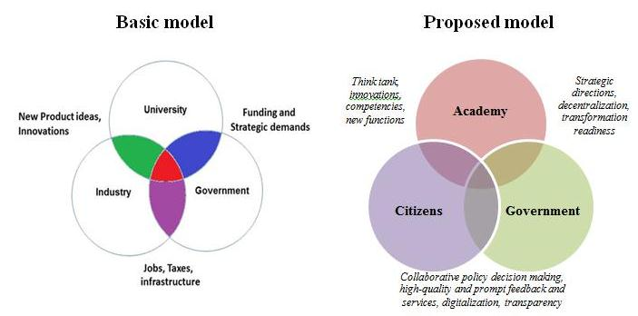

Figure 33 – Triple helix model of innovation: basic and transformed models

Note – Compiled by the author based on source [156]

Over the past five years, the Academy of Public Administration under the President of Kazakhstan has significantly expanded its sphere of influence based on thoughtful decisions of its leaders – transformational leaders: the project management office, competencies assessment center, research center, etc.
Therefore, it is proposed to study the possibility of further development of the Academy. For example, to expand the boundaries of Development Day by transforming them into an Accelerator with the involvement of active citizens in decision-making in the civil service. Currently, the Accelerator operates on the site of the Nur-Sultan Akimat, and it has more of a local character, since it is aimed at solving pressing issues of the capital's development. Thus, by introducing Academy based Accelerator new ideas will be developed not only by civil servants, but also by concerned residents of the country and experts in the relevant sectors of the economy. In the future, this will lead to a reduction in the number of meetings and discussions, as well as speed up the timing of making informed decisions.
Further expansion of this proposal will serve as the basis for the formation of the so-called digital ministry on the example of the Ministry of Possibilities UAE. A virtual ministry that seeks to incubate and solve the “systemic impossibilities” of government by bringing together individuals from across government to form experimental “time-bound departments” (Department of Proactive Services, Department of Behavioural Rewards, Department of Government Procurement, Department of UAE Talent), to develop transformative solutions that fully replace existing practices and make government more seamless and proactive [157].
Continuing the thread of the research, it is necessary to note the fundamental conditions for changes in the public sector (this was also noted by the respondents). According to the results of the survey and analysis using statistical methods of analysis, it was noted that out of the five proposed factors of the conceptual model of the study, the “Resources” factor has the least influence on the readiness for transformation. Therefore, to launch qualitative changes, it is proposed to take into account the presence of: Transformational Leader, Transformational Vision, Transformational Agents, and Transformational Culture (figure 34).
Nowadays, these aspects are important for the transition to a service-oriented “listening” state. For example, relatively few employees are interested in offering their suggestions for innovation because of the risk of being punished (“initiative is punishable”).
Also, a kind of “disease” of the state apparatus is urgent orders that go down for execution often in the evening, at the end of the working day and must be executed by the next morning. Experts also noted that lack of understanding of the overall end goal leads to employees’ apathy. Tasks planned at the beginning of the year are often irrelevant by the end of the first quarter.
Besides, all decisions are reduced to the decision of the first head, which is often done in meetings at higher bodies. This often creates a collapse and a lack of efficiency. The available information technology is obsolete, business processes are bureaucratic. Even the initiative of the authorized body for digitalization to create the architecture of the state body, which should contribute to the restructuring of the work on the way to its optimization and automation, has not yet been completed.
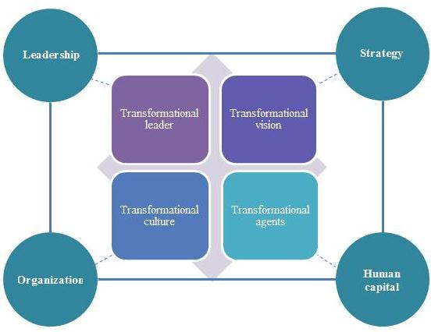

Figure 34 – Principal elements for starting the transformation process

Note – Compiled by the author based on research results

The difficulties include avoidance of personal responsibility, lack of understanding of the overall task (performance is limited to their functional responsibilities) and synchronization of goals in structural units, as well as the problem of goal-setting and corporate culture. Despite material rewards (bonuses on KPI) and non-material ones (Competition “The Best Civil Servant”, a set of youth to the Presidential Personnel Reserve, charitable actions, etc), the majority of civil servants are not particularly interested to introduce initiatives (as it is noted above), nor to take responsibility for everyday routine work. The reason, according to the experts, lies in the avoidance of responsibility at all levels of government.
As one of the experts noted, the punishment for untimely, poor quality and other processing of the order is mainly borne by the executors. Disciplinary liability of such employees is considered at the Interdepartmental Commission, which includes middle managers (Directors of departments), and headed by the Head of Apparatus. Thus, people who decide on punishment are not interested to take responsibility for them. Also, bureaucracy has generated shifting responsibility between structural units. Usually, orders redirected from one department to another closer to the deadline. All these and other problems, according to experts, occur due to the lack of a common unifying mission and strategy of the organization, as well as lack of corporate culture based on mutual assistance and joint responsibility.
Thus, a recommendation is to strengthen interdepartmental coordination of the purposes and priorities in open dialogue; involvement (and not only control) of higher bodies (Presidential Administration, Office of the Prime Minister), reduction of the state apparatus and functions.
When performing official duties, civil servants are obliged to be guided by two rules. The first is the observance of state interests, optimal reduction of financial expenses, and assessment of the feasibility of any planned activities. The second is the care of people, maximum facilitation of relations between the population and government agencies, the exclusion of all red tape and ambiguous provisions; the latter being prerequisites for avoiding corruption.
In this regard, as mentioned above, it is proposed to switch to a Transparent management model, which assumes mutual responsibility and transparency of the actions of the employer and the employee, their joint efforts to achieve the greatest results in the work. The article Gierlich-Joas et al. (2020) provides an example of such a model (figure 35).

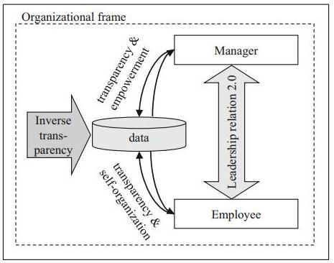

Figure 35 – New leadership relationships based on inverse transparency

Note – Compiled by the author based on the source [158]

In line with the conducted research, it will be important to study the opinions of the interviewed experts (Chapter 1.3). The experts agree that innovativeness in the public sector implies the proactivity of employees, providing an opportunity to introduce innovative ideas. Also, it is important to plan correctly, to predict the results of political decisions, as well as introduce digitalization.
Beside the transparency element, one of the keys to success are self-organization of employees and their empowerment by leaders (figure 35). “It is impossible to take a place in the advanced group, while maintaining the previous model of consciousness and thinking. Therefore, it is important to concentrate, change yourself and adapt to changing conditions to take the best of what the new era brings” [135]. Thus, it is important to change not only the model of public administration, but also to increase the awareness of public sector employees:
1) cult of knowledge – a continuous improvement of knowledge and skills level as an opportunity to be “one step ahead” and meet the needs of modern time;
2) competitiveness from the position of a civil servant is the presence of basic competencies in accordance with the unified framework of competencies and the development of new competencies for achieving a decent level of competitiveness;
3) pragmatism – a clear statement of goals, use of well-thought-out tools and methods, how to achieve them, and the necessary measures taking into account the set of economic indicators;
4) preservation of national identity is a meritocratic principle that should guide every head of a state body;
5) evolutionary development – ability to implement new approaches based on existing forms of management while preserving the national path of development;
6) openness of consciousness – ability to manage changes and anticipate hidden opportunities using the latest technologies [80].
The next aspect of flexible management mechanisms is the change of working conditions. In the prism of the new reality, remote work and “career time-out” are becoming more and more relevant.
The use of such approaches is planned in large companies abroad. In particular, Sberbank has defined new working conditions in Russia. First, it is an opportunity to take a sabbatical for up to a year (to complete training, launch a startup, write a scientific paper or relax). It can be interrupted at any time. At the same time, the workplace and the position of the employee are preserved. Secondly, there are new conditions for remote work: employees will be able to work remotely for three months a year, retaining all corporate benefits. Thus, there are three formats: work from the office, remote work and mixed.
Google plans to leave about 20% of its employees on permanent remote work. In the future, up to four weeks a year, employees will be able to temporarily work not in the main office, but from anywhere in the world. Transition to a hybrid working week, when most employees will work three days in the office and two days where it is convenient.
CitiGroup also supports this approach: employees can work remotely two days a week. Initiatives are being taken to help employees cope with fatigue due to remote work: a ban on working video calls on Fridays, non-paid vacation, to refuse to schedule work meetings outside of working hours.
McKinsey & Company introduced their own vision on the future of the workplace:
1) embrace the hybrid work model (organizations that have articulated more specific policies and approaches for the future workplace have seen employee well-being and productivity rise). More than 20% of the workforce could work remotely three to five days a week as effectively as from an office;
2) reimagine the physical space;
3) manage fundamental human needs (it is difficult to feel connected to colleagues and manage work-life boundaries) [159].
According to OECD the future of work in the civil service raises many questions about the role of technology and innovation in government, and how the civil service will need to become more:
1) forward looking – in terms of identifying skills, ensuring learning opportunities and managing knowledge;
2) flexible – greater flexibility into standard operating procedures to enable the public sector to adapt as needed while maintaining transparency and accountability;
3) fulfilling – focus on engagement and performance, leadership and work design to ensure the civil servants experience the value and impact of their work [160].
Beside this, OECD defines seamless government by key driving efforts:
– invisible government – shifting from making government an ever-present factor in people’s lives to building proactive and automated services;
– matrixed government – making bureaucratic and sectoral boundaries permeable and bringing together different pieces of society in order to work together to achieve goals;
– anticipatory government – exploring scenarios and taking action today to actively shape tomorrow [161].
Kazakhstan has created the legislative conditions for this. In his 2021 Address, the President of the Republic outlined key areas of support for employees, including increasing their wages [162]. The Labor Code defines the concept of “combined remote work”, and fixed accounting of working hours is established for remote workers, the employer’s obligation to provide employees with equipment, communication services and other working conditions.
In the course of the conducted research, the theoretical and practical aspects of the transformation of the civil service are touched upon. In particular, in the course of the literature review, it was possible to consider in detail the relationship between the reform of the state apparatus and the models of the development of the public administration system. In addition, taking into account the lack of theoretical developments, the innovative characteristics of the civil service and the innovative approach of civil servants are studied in depth. For practical recommendations, surveys and interviews with public sector employees were conducted. And to verify their compliance with the needs of citizens, a survey of residents of the capital was also carried out.
Thus, as the results of the study show, despite the different models of development of the civil service and the public administration system, in general, despite the versatility of innovations, the state apparatus of transformation must begin with an understanding of the pressing problems of citizens. Based on this, to build a follow-up work that will no longer be perceived in the eyes of the public as “detached from reality”, and the above-mentioned negative stereotypes will be overcome.

3.2 Transformation methodology (lessons learnt from pilot authorities)
This section considers proposals and methodological recommendations in the prism of three conditions:
1) strategic priority: a new model of public administration;
2) the conceptual model of the study (factors);
3) the specifics of the state body.
First, it should be noted that based on the results of the organizational diagnostics carried out, methodological recommendations have been developed for the transformation of pilot bodies. A distinctive feature of this document is its focus on innovative transformation, the use of in-depth analysis, and practical application. This methodology is coordinated directly with the key stakeholders of the study. (Annex N) contains methodological recommendations and expert reviews. They originate from the Hay Group company, the Agency for Civil Service Affairs, and the Akimat of Nur-Sultan (experts who are managing the pilot testing of the new remuneration system in their organizations and have the appropriate qualifications and authority). The methodological recommendations were approved by the Agency for Civil Service Affairs.
Next, we will present the results of the diagnostics themselves, which allow us to determine the guidelines for the development of each pilot organization. In general, there are positive changes in the Agency for Civil Service Affairs activity (figure 36).

Figure 36 – Transformation of the Agency for Civil Service

Note – Compiled by the author based on diagnostics results

This is evidenced by the individual performance indicators, as well as by the ongoing initiatives (for example, the “Best Civil Servant” competition) and on behalf of the country’s leadership (transferring the work of civil servants to a remote system, crowdsourcing proposals for reengineering public service delivery).
However, there are no systematic measures to restructure the work of the state apparatus in response to requests of population during the pandemic, e.g. rapid response, transparency and access to departmental data, etc or cope with the inefficiency of quasi-public sector organizations.
Thus, it is proposed to define a single state body responsible for the functioning of the public sector (including the civil service). This could be the Agency for Civil Service Affairs which would also take over the relevant functions and powers in the field of public administration from the Ministry of National Economy.
It would also be a good idea to create divisions for innovative development and transformation of the public sector in the Agency, as the Agency already initiates and coordinates such innovative work on digitalization of public services, introduction of a new system of remuneration, project management, etc. Such an initiative would improve the Agency’s performance as the main promoter of reforms in the public sector.
In addition, given that 60% of the surveyed employees are assigned the task of introducing innovations and determining the guidelines for the development of their policy domains, the need arises to instill a “Life Long Learning culture” in them so they can constantly improve their knowledge and skills. At the same time, the knowledge should be applicable in their work, and certificates for their additional learning are internationally recognized. Thus the culture of continuous improvement of civil servants and transfer of such knowledge to their colleagues should be encouraged by management. In fact, continuous improvement, and transfer of knowledge is included as a KPI for civil servants for receiving a bonus.
In order to cultivate creative ideas, as well as encourage employees to take initiative, it is proposed to include employees’ proposals as KPIs in strategic documents, and to maintain an innovative climate and to provide feedback on recommendations or ideas made by employees on an ongoing basis. An example for this is the creation of a Bank of Ideas, where employees’ contributions will be acknowledged by management by way of gratitude (email, certificate of commendation, gratitude addressed to parents, etc) or material encouragement, taking into account the level of contribution. This will not only create an effective corporate culture in the organization but will also ensure success in developing and implementing an organisation’s strategic goals.
Furthermore, the Agency’s employees directly propose the following:
1) change the management structure, including reducing the number of departments by merging, respectively reducing the number of managers, and increasing the number of performers;
2) clearly distribute functional responsibilities among employees, including the management and executive levels;
3) eliminate paper-based document flow (except for confidential documents);
4) strengthen mentoring;
5) introduce flexible working methods, including a 4-day working week, remote work;
6) reduce the number of events, workshops, seminars, etc;
7) change approaches to human resource management and apply strategic approaches to improve the corporate spirit among employees;
8) expand the package of incentives and social support measures.
Additionally, the Agency’s territorial departments propose to reduce the middle link in the central apparatus, supervising the structural divisions in territorial bodies (that is, to abolish or consolidate the departments in the Agency’s branch departments), as well as provide greater independence to territorial units in decision-making.
As a result of implementation of recommendations for the transformation the improvement of Agency’s activity is expected. When calculating values of the forecast indicators, a number of assumptions were made, including:
1) implementation of the proposed transformations based on the developed conceptual model and methodological recommendations for organizational diagnostics;
2) improvement of the external environment (stabilization of the pandemic situation, foreign policy, and economic security, etc.);
3) enhancement of the methodology of the annual assessment of state bodies (taking into account the recommendations proposed in the course of this study).
At the same time, it is assumed that the recommendations will be phased in from 2022 to 2024 (table 23).

Table 23 – Estimated and forecast indicators of ACSA’s activity for 2021-2024

Factor | Indicators | 2020  (actual value), % | 2021  (estimated), % | 2022  (forecast), % | 2023  (forecast), % | 2024  (forecast), %
Leadership | Evaluation of overall effectiveness of a state body | 88,3 | 89 | 91 | 93 | 95
Strategy | Goal achievement | 95,5 | 95,6 | 97 | 98 | 100
Organization | Organizational development | 92,3 | 92,5 | 94 | 95 | 96
Human Capital | Net turnover | 3,6 | 3,5 | 3,2 | 3,0 | 2,8
Citizen Centricity | Quality of public services delivery | 85,0 | 86 | 88 | 90 | 92
Citizen Centricity | Interaction with citizens | 77,1 | 78 | 82 | 84 | 86
Note – Сompiled by the author

Despite the significant transformation in 2018, no systemic changes have been achieved in the capital akimat’s activities over the past three years, as evidenced by the assessment indicator values, as well as the surveys of employees of state institutions and residents of the capital (figure 37).

Figure 37 – Transformation of the Nur-Sultan Akimat

Note – Compiled by the author based on diagnostics results

A little more than half of the surveyed employees of the akimat of Nur-Sultan (56,4%) positively assessed the organization of the work of state institutions of the capital during the pandemic. However, an in-depth analysis of the proposals of employees and residents of the city allows us to identify “points of further improvement” for more effective work.
First. Increase the effectiveness of interaction with the population.
This aspect is multifaceted, since it covers various elements of feedback from citizens. The Akimat is invited to work on this issue in several directions:
– posting up-to-date information on the website of the Akimat and timely informing the operators of the Unified Contact Center;
– strengthening the accountability of the mayors of the capital and districts of the city, including through providing information through official accounts in social networks, holding online meetings and referendums on every important issue of the city’s development;
– prohibiting formal responses, instilling a culture of “bringing the issue to result”, etc.
Second. To improve the work of the Unified Contact Center (109) by providing more functionality and authority to monitor the execution of requests.
Also, it is proposed to pay special attention to the quality of the personnel and their motivation package. Operators should be interested in solving the issue, providing mandatory feedback with up-to-date and complete information.
Third. On the basis of organizational diagnostics, review the structure, staffing and functionality of city departments. One of the last large-scale transformations was carried out in 2018 and led to a reduction in the number of departments from 26 to 17. Surplus staff was transferred to the district akimats of the capital. However, the functionality of the departments has not decreased, since there was a merger and renaming of state bodies. The tasks in strategic and program documents require a functional analysis to eliminate unnecessary functions, strengthen individual departments, as well as reduce the management staff (according to the Agency for Civil Service Affairs, there are four employees per head in central state bodies and two executors in villages). Despite the fact that proposal on akimat reorganization was expressed by only 9% of respondents, they represent socially significant government organizations: the Department of Housing and Housing Inspection; the Department of Public Health; the Department of Architecture, Urban Planning and Land Relations; the Department of the Fuel and Energy Complex and Utilities; and the Department of Control and Quality of the Urban Environment.
In the light of the pandemic and new state initiatives on social protection of the population, these areas are becoming more important, and therefore they face increased demands for services from citizens. This is evidenced by the answers of citizens regarding the quality of services (Appendix K).
Fourth. To increase human capital, including the leadership potential of the heads of state bodies of the capital. Despite their workload, employees of the akimat propose that more opportunities are provided for distance learning in addition to the statutory period of professional development once every three years. It is proposed to create programs on the basis of educational portals (for example, Coursera), as well as international certification courses of the Bureau of Continuing Professional Training of the International Financial Center of the capital. The timeliness of these measures is evidenced by the increased expectations of the population for the quality of services and consultations received, as well as the requirements for the availability of adaptive skills to rapidly changing conditions (digitalization, project approach, innovation, creativity, openness, etc).
Fifth. Review the rules of operation of state institutions of the capital. The introduction of an online format of work has not actually led to a real reduction in the number of meetings, paper-based document flows, unnecessary functions, and coordination procedures. About 7% of respondents indicated an increase in the number of Internet conferences and strengthening of internal control. At the same time, half of the respondents represented the offices of akims of districts and the capital, which, according to official instructions, are more involved in organizational and administrative work (logging, organizing meetings, monitoring performance discipline, etc).
It is proposed to prohibit the holding of staff meetings and working meetings on compliance with performance discipline and hearing reports, since this information can be reported electronically to all interested officials. Furthermore, the topics of the meetings should be limited to the most urgent and socially significant issues. At the same time, decisions should be taken within the framework of one meeting without launching a “coordination sheet”.
Also, all documents should be executed in electronic format (with the exception of documents marked “for official use” and “secret”). And the budget for the operation and maintenance of the state body’s premises should be revised downwards, thus reducing such expenditure.
Sixth. Improvement of the staff motivation system, including the creation of an open model for encouraging employees’ initiative. As is known, the majority of akimats, in comparison with ministries, are characterized by low turnover of personnel in middle-level managerial positions (heads of departments, deputy heads of departments). In addition, departments often do not have the opportunity to save administrative costs. Thus, the range of motivational tools for encouraging young initiative specialists is quite limited, since material and career components are excluded. Therefore, it is proposed to create a departmental model of non-monetary motivation of personnel. Examples are the mandatory feedback from the organization’s management about the rationality of an initiative, expressing gratitude and informing all staff about such significant contributions. The most proactive specialists who come forward with innovative and creative ideas to be put into practice should be part of a talent pool to whom grant programs for advanced training, flexible working hours and other incentives should be offered.
Seventh. Delineation of clear procedures for compensating employees for expenses incurred while working remotely (telephone and Internet services, electricity, etc). Nowadays, this issue is most urgent. This is evidenced by the answers of 35% of respondents who reported that they cover part or all such costs themselves. And about 26% of the employees of the akimat do not know about the procedure for costs compensation. With the same assumptions mentioned above the following table provide forecast information on enhancement of Nur-Sultan Akimat’s activity in 2021-2024.

Table 24 – Estimated and forecast indicators of Nur-Sultan akimat’s activity for 2021-2024

Factor | Indicators | 2020  (actual value), % | 2021  (estimated),% | 2022  (forecast), % | 2023  (forecast),% | 2024  (forecast),%
Leadership | Evaluation of overall effectiveness of a state body | 67,8 | 68 | 70 | 74 | 78
Strategy | Goal achievement | 79,6 | 81 | 83 | 85 | 87
Organization | Organizational development | 62,0 | 65 | 70 | 74 | 78
Human Capital | Net turnover | 1,8 | 1,8 | 1,6 | 1,5 | 1,4
Citizen Centricity | Quality of public services delivery | 75,9 | 76 | 80 | 82 | 84
Citizen Centricity | Interaction with citizens | 61,8 | 64 | 68 | 72 | 76
Note – Сompiled by the author

In general, these recommendations, although they do not exhaust the entire range of opportunities for improving the work of the government organisations, are in fact the most relevant given the current realities; and their implementation will allow for launching further positive transformation initiatives of the state institutions of the capital. These recommendations were adopted by the pilot bodies to further improve the efficiency of work (Annexes B, M, and N).
Summarizing the research results discussed in chapter 3 of this dissertation, the following should be noted:
1. Practical recommendations for improving the efficiency of the state apparatus, taking into account the given strategic orientation for the formation of a new model of public administration, are proposed.
2. Considering the results of expert interviews, and of the surveys of civil servants of the Agency and the Akimat of Nur-Sultan, as well as with the residents of the capital, “bottlenecks” in the work of these pilot bodies were identified and directions for improving activities were outlined. The respondents recommended paying special attention to the quality of the staff and the motivation package. Employees should be interested in solving the issue, providing mandatory feedback, and possessing up-to-date and complete information.
3. Methodological recommendations for conducting organizational diagnostics have been developed. Their application is an important stage in the beginning of innovative transformations, since it allows you to comprehensively assess the current state of the organization and determine the points of further growth. These methodological recommendations have been tested, then agreed with the experts from the pilot bodies and Korn Ferry Hay Group company, as well as approved by the Agency for Civil Service Affairs for further implementation (Annex N).

CONCLUSION

One of the key aspects of modern state development is the desire to improve the management model and mechanisms of interaction with society. The main trend is to transition to a Service Model. The basic characteristics of this model are orientation to the needs of citizens, receiving constant feedback, providing high-quality services, instituting widespread automation and optimization of business processes, etc.
Therefore, the approaches to public administration under the Service Model are based on the concept of active involvement of civil society. To find the most rational solutions to meet the broad social needs of society, the State apparatus must be open and accessible, accountable and responsive, and work to serve citizens. This is measured by various indicators in the reports of international development institutions.
For instance, according to the latest World Bank survey on public administration performance (Worldwide Governance Indicators), Kazakhstan demonstrated progress on 5 out of 6 indicators in 2020. In government efficiency; quality of the regulatory climate; political stability; rule of law; and the fight against corruption. In sum, the quality of the work of the state apparatus and the level of public satisfaction with public services have increased. At the same time, the country has improved its position in the Transparency International Corruption Perception Index by 19 levels (94th place), as well as by 10 points in the e-government development rating (29th place).
The measures taken by the state under the quarantine regime in connection with Covid-19 were insufficient, as evidenced by numerous appeals and complaints of the population on social networks. The key issues were related not only to specific social policy areas (health, education, social protection, housing relations, etc), but, equally, to the organization of remote work of state institutions, the bandwidth of the Internet connection and the e-government portal.
The strategic development documents, and the messages of the President of the country orient the state authorities to a systematic change in their approaches to work. In an attempt to understand the reasons for the lack of efficiency of the state apparatus, this study was conducted. It covered two time periods, which made it possible to measure the current situation in the pilot bodies and develop proposals.
The conducted dissertation research allowed us to derive a number of theoretical conclusions and practical recommendations. Thus, it was possible to achieve all the objectives of the study.
1. The conducted analysis of the literature showed the relevance of the study. The issues of innovation activity and transformational management are widely studied in foreign literature. However, there are few such works in the prism of civil service and practical applicability. Moreover, there is no definition of an innovative civil service.
Despite this, the author has made an attempt to systematize the available research. About 50 approaches of transformational management, which is used in the private sector, have been identified. It is established that innovation accompanies transformations.
According to the results of this research, an innovative civil service is a model of civil service in which political decisions are made on the basis of cooperation with the main stakeholders, taking into account their needs, for the development and implementation of innovative solutions to advance socio-economic prosperity for all.
In addition, despite the variety of transformation models, the success factors for both concepts are basically similar. These are: Leadership, Strategy, Human Capital, Organization and Resources. These factors of the conceptual model are obtained on the basis of the study of the theory of contextual transformation and publications on public sector innovations based on factors.
2. The in-depth study of major trends of civil service transformation in foreign countries shows that more and more countries are creating innovative hubs or management units embedded in the structure of the government organisation responsible for the development of the civil service system. In addition, indicators and indices of innovation are being introduced into the existing performance evaluation systems. At the same time, innovation is not only the management of talents, but also the support of both civil servants and citizens in an attempt to improve the system of public administration.
A remarkable example is the transformation of the Academy's development day into an Accelerators of Innovative Changes event extending an invitation to society to participate on a platform of open dialogue.
3. Taking into account an in-depth literary review and analysis of foreign practice, a conceptual model of the study is developed. For its validation, an expert survey was conducted, and then the model was tested as part of the first stage of the survey of civil servants of the Agency for Civil Service Affairs and the Akimat of Nur-Sultan (2019).
The results of testing the conceptual model proved its validity. At the same time, as noted in the hypotheses of the study, the “Resources” factor played the least role in the readiness and decision-making on the implementation of changes. Therefore, in the further parts of the study, this factor could be used as an opposition (for example, cost-effectiveness analysis).
In addition, the survey results consider innovative civil service in three dimensions: at the central and local levels; in the country's capital and remote region; for state bodies and citizens of the country.
4. The conducted diagnostics of pilot bodies, including surveys of employees and residents of the capital, as well as an analysis of evaluation indicators for 2017-2020, indicate that the pilot bodies are not sufficiently effective.
The proposed hypothesis was confirmed. Thus, state bodies should think about the expediency of paying bonuses to employees, at a time when the state body itself does not demonstrate effective work.
The final stage of the organizational diagnostics - a cost-effectiveness analysis was conducted on the basis of current statistics and methodology. However, it did not fully reflect the essence of the factors (it is not about solving current minor issues, but it is about a reserve for the future).
5. The retrospective, PEST and SWOT analyses on the formation and development of the civil service of Kazakhstan showed that the basis and fundamental principles of the system were approved. However, not all goals were achieved. There is space for further improvement in accordance with OECD standards.
6. As a result of the conducted surveys and diagnostics, the main directions of civil service transformation in Kazakhstan were identified.
First of all, these are recommendations of a systemic nature that allow us to improve the quality of the work of the state apparatus, making it more transparent and customer oriented. So, for accessibility and openness, it is proposed to improve the functionality of the “Open Dialog” and “Open Data” portals. To increase efficiency, it is necessary to improve the existing assessment methods and introduce diagnostics, as well as increase the accountability of bodies in the implementation of projects.
For citizen centricity, the key is to implement the principles of Collaborative Governance. According to the interviewed residents of the capital, it is necessary to expand the tools of public influence in making significant decisions, increase transparency of information about budget expenditures, and pursue the professionalization and competence development of civil servants. For innovation, adaptability and flexibility of the state apparatus, it is proposed that a transparent management model is introduced; an adapted Triple helix model of innovation, a change in working methods.
The proposals received from the results of the dissertation research are of an applied nature. The proposed methodological recommendations, systematic and targeted measures will contribute to the achievement of the goals set in the country’s strategic documents to create a new model of public administration, which is innovative, transparent and citizen oriented.
Thus, by systematically and logically solving the tasks set at the beginning of the study, answers to all the research questions were obtained.
REFERENCES

- Абучакра Р., Хури M. Эффективное правительство для нового века. – M.: “Олимп-Бизнес”, 2015. – 155 с.
- Global trends reports, 2020 // https://trends.oecd-opsi.org/. 05.09.2021.
- Agile Governance Reimagining Policy-Making in the Fourth Industrial Revolution // https://www3.weforum.org/docs/WEF_. 20.09.2021.
- Open Government: The Global Context and the Way Forward / Organization for Economic Cooperation and Development. – Paris: OECD Publishing, 2016. – 141 p.
- Indicators of the quality of public administration in the countries of the world // http://info.worldbank.org/governance/wgi/index.aspx#home. 15.09.2021.
- Address of the President of the Republic of Kazakhstan to the People of Kazakhstan. “Strategy Kazakhstan-2050”: new political course of the established state, 2012 // https://www.akorda.kz/en/events/astana. 10.10.2021.
- President of Kazakhstan. Growing Welfare of Kazakh Citizens: Increase In Income And Quality of Life// http://www.akorda.kz/en/addresses. 20.10.2021.
- Шпекбаев A. Выступление Председателя Агентства по делам государственной службы и противодействию коррупции. – 2019 // https://www.zakon.kz/4969551-shpekbaev-dostoynaya-zarplata-na.html. 20.09.2021.
- Шпекбаев A. Вполне реально – Шпекбаев о двукратном повышении зарплат госслужащим // https://total.kz/ru/news/vnutrennyaya. 20.09.2021.
- Шпекбаев A. 147 кадровых единиц сократили в агентстве рк по делам госслужбы // http://lenta.inform.kz/ru/147-kadrovyh-edinic-sokratili. 20.09.2021.
- Peters L. Downsizing the Civil Service in Developing Countries: golden handshake or smiling farewells? // Public Administration and Development. – 1999. – №18. – P. 381-386.
- Egorov V. State power and public service in Russia: towards new quality // Public Service. – 2006. – №5. – P. 23-26.
- Kalinin А. Reform of public administration structure: reasons and technology // Society and economics. – 2006. – №7-8. – P. 10-17.
- Menning N., Parison N. Public administration reform: international experience. – M: Wordwide, 2006. – 88 р.
- Васильева Е.А. К вопросу мотивации государственных служащих: социологический анализ // Вестник Томского государственного университета. Философия. Социология. Политология. – 2016. – №1(33). – P. 25-33.
- Фомичев Е.В. Трудовая мотивация государственных служащих в условиях реформирования российской государственной службы: дис. … док. PhD: 22.00.08. – Р-на-Д., 2011. – 167 с.
- Batalli M. Factors Affecting the Transformation of Public Administration // AUDJ. – 2016. – №3. – P. 31-43.
- Benchmarking Civil Service Reform in Kazakhstan / OECD. – Paris: OECD Publishing, 2018. – 130 p.
- Kamarck E. Government Innovation Around the World. – Cambridge: Harvard University, 2004. – 51 p.
- Waldorff S.B., Kristensen L.S., Ebbesen B.V. The complexity of governance. Challenge for public sector innovation // In book: Public innovation through collaboration and design. – London: Routledge, 2014. – P. 70-88.
- Ebbers W.E., Pieterson W.J., Noordman H.N. Electronic government: Rethinking channel management strategies // Government Information Quarterly. – 2008. – Vol. 25(2). – P. 181-201.
- Gareis K., Cullen K., Korte W. Putting the user at the center. Implications for the provision of online public services // In book: eAdoption and the knowledge economy. Issues, applications, case studies. – Amsterdam, 2004. – P. 611-618.
- Brown K., Osborne S.P. Managing Change and Innovation in Public Service Organizations. – London: Routledge, 2005. – 272 р.
- Thelen K. Institutional change in advanced political economies // British Journal of Industrial Relations. – 2009. – Vol. 47(3). – P. 471-498.
- Sørensen E. and Torfing J. Enhancing collaborative innovation in the public sector // Administration and Society. – 2011. – Vol. 43(8). – P. 842-868.
- Bokayev B., Davletbayeva Zh., Amirova A. et al. Transforming E-government in Kazakhstan: A Citizen-Centric Approach // The Innovation Journal. – 2021. – Vol. 26(1). – P. 1-21
- Rogers E. Diffusion of innovations. – NY: Free Press of Glencoe, 1962. – 367 p.
- Schumpeter J. The theory of economic development: an inquiry into profits, capital, credit, interest and the business cycle. – Cambridge: Harvard Economic Studies, 1934. – Vol. 46. – 267 р.
- Kuznets S. Modern Economic Growth: Findings and Reflections // https://www.nobelprize.org/prizes/economic-sciences/1971/kuznets. 20.09.2021.
- Кондратьев Н.Д. Большие циклы конъюнктуры и теория предвидения: избр. тр. – М.: ЗАО «Издательство «Экономика», 2002. – 767 с.
- Twiss B. Managing Technological Innovation. – Ed. 4th. – Philadelphia: Trans-Atlantic Pubns, 1992. – 352 p.
- Galbraith J. Designing the innovating organization. – Winter, 1992. – 20 р.
- Freeman C., Soete L. The Economics of Industrial Innovation. – Cambridge: MIT Press, 1997. – 470 p.
- Freeman C., Clark J., Soete L. Unemployment and Technical Innovation: A Study of Long Waves and Economic Development. – Westport, Connecticut: Greenwood Press, 1982. – 214 p.
- Лазарев В.С. «Характеристики инновационной деятельности» // Муниципальное образование: инновации и эксперимент. – 2008. – №1. – C. 4-6.
- Вареник К.А. Теория инноваций как ключевое направление научных исследований XX века // Современные проблемы науки и образования. – 2013. –№5. – C. 1-11.
- Eleanor D. Glor. A Gardener Innovator’s Guide to Innovating in Organizations. – Ontario, 2006. – 262 p.
- Lee Zh. Bridging the gap between technology and business strategy: a pilot study on the innovation process // Management Decision. – 1995. – Vol. 33(8). – P. 13-21.
- Borins S. Innovations in Government. Research, Recognition and Replication. – Washington, DC: Brookings Institution, 2008. – 231 p.
- Glor E.D. Is Innovation a Question of Will or Circumstance? An Exploration of the Innovation Process through the Lens of the Blakeney Government in Saskatchewan // The Innovation Journal. – 2000. – Vol. 5(2). – P. 1-190.
- Glor E.D. Key Factors Influencing Innovation in Government // The Innovation Journal. – 2001. – Vol. 6(2). – P. 1-20.
- Glor E.D. Innovation Patterns // The Innovation Journal. – 2001. – Vol. 6(3). – P. 1-42.
- Glor E.D. Identifying Organizations Fit For Change // The Innovation Journal. – 2007. – Vol. 12(1). – P. 1-25.
- Glor E.D. Assessing Organizational Capacity to Adapt // Emergence: Complexity and Organization. – 2007. – Vol. 9(3). – P. 27-40.
- Glor E.D. Toward Development of a Substantive Theory of Public Sector Organizational Innovation // The Innovation Journal. – 2008. – Vol. 13(3). – P. 1-28.
- Rogers E.M., Kim J.I. Diffusion of Innovations in Public Organizations // In book: Innovation in the Public Sector. – Beverley Hills CA: Sage Publications, 1985. – P. 85-105.
- Rogers E.M. Diffusion of Innovations. – NY.: Free Press. – 2003. – Ed. 5th. – 551 р.
- Rogers E.M., Eveland J.D. Diffusion of Innovations in Public Organizations, Perspectives on National R&D Assessment: Communication and Innovation in Organizations // In book: Technological Innovation: A Critical Review of Current Knowledge. – San Francisco, CA: San Francisco Press, 1978. – P. 275-297.
- Rogers E.M, Medin U.E., Rivera M. et al. Complex Adaptive Systems and the Diffusion of Innovations // The Innovation Journal. – 2005. – Vol. 10(3). – P. 1-26.
- Jacques J., Ryan E.J. Does management by objectives stifle organizational innovation in the public sector? // Canadian Public Administration. – 1978. – Vol. 21(1). – P. 17-25.
- Mohr L.B. Determinants of Innovation in Organizations // The American Political Science Review. – 1969. – Vol. 63(1). – P. 111-126.
- Merritt R.L. Innovation in the Public Sector: An Introduction // In book: Innovation in the Public Sector. – Beverley Hills: Sage Publications, 1985. – P. 9-16.
- Grady D. Promoting Innovations in the Public Sector // Public Productivity and Management Review. – 1992. – Vol. 16(2). – P. 157-171.
- Borins S.F. Innovating With Integrity: How Local Heroes Are Transforming American Government. – Washington, D.C.: Georgetown University Press, 1998. – 368 р.
- Borins S. The Challenge of Innovating in Government. – Arlington, VA, 2001. – 52 р.
- Sørensen E., Torfing J. Introduction Collaborative Innovation in the Public Sector // The Innovation Journal. – 2012. – Vol. 17(1). – P. 1-14.
- Sørensen E. Measuring the accountability of collaborative innovation // The Innovation Journal. – 2012. – Vol. 17(1). – P. 1-18.
- Walker R., Jeans E., Rowlands R. Managing Public Service Innovation. Bristol: Policy Press, 2001. – 144 р.
- Osborne S., Brown K. Managing Change and Innovation in Public Service Organizations. – London: Routledge, 2005. – 273 р.
- Harley J. Innovation in governance and public service: Past and present // Public Money and Management. – 2005. – Vol. 25. – P. 27-34.
- Gow J.I. Public Sector Innovation Theory Revisited // The Innovation Journal. – 2014. – Vol. 19(2). – P. 1-22.
- Behn R.D. Managing by Groping Along // Journal of Policy Analysis and Management. – 1988. – Vol. 7(4). – P. 643-663.
- Behn R.D. Leadership Counts. – Cambridge, MA, Harvard University Press, 1991. – 44 р.
- Behn R.D. The Dilemmas of Innovation in American Government // In book: Innovation in American Government. Challenges, Opportunities and Dilemmas. – Washington, D.C.: The Brookings Institution, 1997. – P. 3-37.
- Behn R.D. Rethinking Democratic Accountability. – Washington, D.C.: The Brookings Institution, 2001. – 317 р.
- Behn R.D. The Adaptation of Innovation: the Challenge of Learning to Adapt Tacit Knowledge // In book Innovations in Government. Research, Recognition and Replication. – Washington, D.C. Brookings Institution, 2008. – P. 138-158.
- Kusumasari B., Pramusinto A., Santoso A. et al. What shapes public sector innovation? // Public Policy and Administration. – 2019. – Vol. 18(4). – P. 430-446.
- Amri M. Innovative City Governments: A Transaction Cost Approach to Explain Public Innovation in Mid-Sized Cities of Indonesia and the Philippines: thes. … doc. PhD. – Singapore, 2015. – 372 p.
- Bloch C., Bugge M.M. Public Sector Innovation-From Theory to Measurement // Structural Change and Economic Dynamics. – 2013. – Vol. 27. – P. 133-145.
- Arundel A., Casali L., Hollanders H. How European Public Sector Agencies Innovate: The Use of Bottom-up, Policy-Dependent and Knowledge-Scanning Innovation Methods // Research Policy. – 2015. – Vol. 44(7). – P. 1271-1282.
- Agolla J.E., Van Lill J.B. Public Sector Innovation Drivers: A Process Model // Journal of Social Sciences. – 2013. – Vol. 34(2). – P. 165-176.
- De Vries H., Bekkers V., Tummers L. Innovation in the Public Sector: A Systematic Review and Future Research Agenda // Public Administration. – 2016. – Vol. 94(1). – P. 146-166.
- Carstensen H.V., Bason Ch. Powering collaborative policy innovation: Can innovation labs help? // The Innovation Journal: The Public Sector Innovation Journal. – 2012. – Vol. 17(2). – P. 1-25.
- Stevens V., Verhoest K. A next step in Collaborative Policy Innovation Research: Analyzing Interactions using Exponential Random Graph Modelling // The Innovation Journal. – 2016. – Vol. 21(2). – P. 1-19.
- Simpson. Presentation of the Armour company. Taxonomy of change models, 2017 // https://www.slideshare.net/MarkSimpson13/taxonomy. 15.10.2021.
- Lessem R., Schieffer A. Transformation Management. Towards the Integral Enterprise. – London, 2009. – 352 р.
- Сулейманкадиева А. Теория и методология трансформационного менеджмента. – СПб.: СПбГЭУ “ЛЭТИ”, 2016. – 168 с.
- Sardana G.D. Managing Organizational Transformation // South Asian Journal of Business and Management Cases. – 2015. – №4. – P. 7-12.
- Andersen L.B. Achieving High Quality Through Transformational Leadership: A Qualitative Multilevel Analysis of Transformational Leadership and Perceived Professional Quality // Public Personnel Management. – 2018. – Vol. 47(1). – P. 51-72.
- Жакыпова Ф.Н., Абдыкаликова М.Н., Казбекова Д.С. Менеджмент в сфере государственной службы: настоль. кн. руководителя государственного органа Республики Казахстан. – Астана: АГУ при Президенте РК, 2017. – 84 с.
- Bertot J.C., Jaeger P.T. The E-Government paradox: Better customer service doesn’t necessarily cost less // Government Information Quarterly. – 2008. – Vol. 25(2). – P. 149-154.
- Government Transformation Strategy / The Cabinet Office, United Kingdom – London, 2016. – 93 p.
- Wise L.R. The Use of Innovative Practices in the Public and Private Sectors: The Role of Organizational and Individual Factors // Public Productivity & Management Review. – 1999. – Vol. 23, №2. – Р. 150-168.
- Allas T., Checinski M., Dillon R. et al. Elements of a successful government transformation. – July 9, 2018 // https://www.mckinsey.com. 20.09.2021.
- Allas T., Checinski M., Dillon R. et al. Solveigh Hieronimus, and Navjot Singh. Delivering for citizens: How to triple the success rate of government transformations. – May 31, 2018 // https://www.mckinsey.com/industries/public-and-social-sector/our-insights/delivering-for-citizens-how-to-triple-the. 20.09.2021.
- Global & Regional Trends in Civil Service Development / Astana Civil Service HUB. – Astana, 2016. – 276 p.
- Panchamia N., Thomas P. Civil Service Reform in the Real World Patterns of success in UK civil service reform. – London: Institute for Government, 2014. – 107 p.
- Barber M., Levy A., Mendonca L. Global trends affecting the public sector // In book: Transforming Government. – Washington: Kinsey & Company, 2007. – P. 4-12.
- Ministry of Personnel Management of the Republic of Korea // www.mpm.go.kr. 17.09.2021.
- Office of Personnel Management of the United States of America // www.opm.gov. 17.09.2021.
- Civil Service Commission of the United Kingdom // www.civilservicecommission.independent.gov.uk. 17.09.2021.
- Government of Canada // www.tbs-sct.gc.ca. 17.09.2021.
- Public Service Division of Singapore // www.careers.gov.sg. 17.09.2021.
- Civil Service Bureau of Hong Kong // www.csb.gov.hk. 17.09.2021.
- Amirova A. Exploring the Role of Strategy and Values on Civil Service Transformation (A Case of Central Public Authorities of Kazakhstan) // International Journal of Management and Applied Science. – 2019. – Vol. 5, Issue 6. – P. 42-47.
- Australian Government official web site // https://www.apsreview. gov.au/news/vision-australias-public-service. 17.09.2021.
- Civil Service Blog of the United Kingdom. A brilliant civil service // https://civilservice.blog.gov.uk/tag/a-brilliant-civil-service. 17.09.2021.
- Civil Service transformation John Manzoni: Analysis and factual trends, Making organisations work well // https://quarterly.blog.gov.uk /2018/01/25/civil-service-transformation. 17.09.2021.
- Dowden O. A strategic approach to government innovation. – 13 June 2019 // https://civilservice.blog.gov.uk/2019/06/13/a-strategic-approach. 17.09.2021.
- Transforming the Public Service to Build Our Future Singapore https://www.psd.gov.sg/what-we-do/transforming-the-public-service-to. 17.09.2021.
- Singapore made innovation go viral in its public service // https://apolitical.co/en/solution_article/singapore-made-innovation-go. 17.09.2021.
- National Strategy for advanced innovation // https://u.ae/en/about-the-uae/strategies-initiatives-and-awards/federal-governments-strategies. 17.09.2021.
- Verdegem P., Verleye G. User-centered E-Government in practice: A comprehensive model for measuring user satisfaction // Government information Quarterly. – 2009. – №26. – P. 487-497.
- Amirova A. Digital transformation: reshaping public authorities towards innovative civil service of Kazakhstan (case study of remuneration by results project) // Государство будущего: новые технологии и государственное управление: сб. междунар. науч.-исслед. конф. – Астана: АГУ при Президенте РК, 2018. – С. 29-33.
- Şandor S.D. Measuring public sector innovation // Transylvanian Review of Administrative Sciences. – 2018. – №54. – P. 125-137.
- Samaratunge R., Alam Q., Teicher J. Public sector reforms and accountability: The case of south and Southeast Asia // Public Management Review. – 2008. – №10. – P. 101-126.
- Baimenov A., Liverakos P. Cooperation and partnerships for International Development in the Era of the SDGs // In book: In Public Service Excellence in the 21st Century. – Singapore: Palgrave Macmillan, 2019. – P. 319-340.
- Civil Service Reform Paper / United Nations Public Administration Network. – NY.: UNPAN, 2000. – 31 p.
- Amirova A. “Digital transformation: reshaping public authorities towards innovative civil service of Kazakhstan (case study of remuneration by results project)” // Proceed. of the internat. res. conf. “State of the Future: New Technologies and Public Administration”. – Astana: Academy of Public Administration under the President of the Republic of Kazakhstan, 2019. – P. 29-33.
- Amirova A. Transforming e-government adoption in a framework of innovative civil service of Kazakhstan // Bulletin of L.N. Gumilyov ENU. – 2021. – №1. – P. 140-150.
- Davis F. Perceived Usefulness, Perceived Ease of Use, and User Acceptance of Information Technology // MIS Quarterly. – 1989. – Vol. 13, №3. – P. 319-340.
- Hitt L., Brynjolfsson E. Productivity, Business Profitability, and Consumer Surplus: Three Different Measures of Information Technology Value // MIS Quarterly. – 1996. – Vol. 20. – P. 121-142.
- Wu J-H., Wang S-Ch. An Empirical Study of Consumers Adopting MC in Taiwan An Empirical Study of Consumers Adopting Mobile Commerce in Taiwan: Analyzed by Structural Equation Modeling // Proceed. 7th pacific Asia conf. on inform. systems. – Adelaide, 2011. – P. 81-94.
- Katz E., Lazarsfeld F.P. Personal influence; the part played by people in the flow of mass communications. – Glencoe, IL: The Free Press, 1955. – 256 р.
- Amirova A. Study on Transformation Factors For Innovative Civil Service of Kazakhstan: the Case of Kyzylorda Region // The landmarks of Kazakhstan’s socio-political modernization: coll. of mater. of the internat. scient. conf. – Nur-Sultan: Eurasian Integration Institution, 2019. – P. 46-59.
- Amirova A., Ismailova R. Cost-effectiveness analysis of new remuneration project towards accountable civil service // Journal of Al-Farabi Kazakh National University. – 2021. – Vol. 1(135). – P. 3-13.
- Saha P. Government e-service delivery: identification of success factors from citizens’ perspective. – 2008 // https://www.researchgate.net/. 20.10.2021.
- Hair J.F.J., Black W., Babin B., Anderson R., Tatham R.L. Mutivariate Data Analysis // Technometrics. – 2006. – Vol. 31(3). – P. 1-27.
- Hair J., Celsi M., Money A., Samouel Ph., Page M. The Essentials of Business Research Methods. – Ed. 3rd. – NY.: Routledge, 2015. – 506 р.
- Amirova A. On the issue of transformational management at the Agency for Civil Service Affairs in the course of a new remuneration system piloting // Bulletin of the Karaganda University. – 2020. – №4. – P. 5-14.
- Липатов С. Методы социально-психологической диагностики организации: введение в практическую социальную психологию. – М., 1994. – 377 с.
- Adizes I. Managing Corporate Lifecycles. – Los Angeles: Adizes Institute Publications, 2017. – 553 р.
- Johnson J. Cost-effectiveness and cost-benefit analysis of governance and anti-corruption activities. – Bergen, 2014. – 41 p.
- Levin H.M., McEwan P.J. Cost-Effectiveness Analysis: Methods and Applications. – Thousand Oaks, CA: Sage, 2001. – 308 p.
- Результаты оценки эффективности государственных органов за 2016-2018 годы // https://www.bagalau.kz/results/govagency/2. 10.10.2021.
- Результаты общественного мониторинга качества оказания государственных услуг за 2017 год // http://qogam.gov.kz/ru/pages/rezultaty-obshchestvennogo-monitoringa-kachestva-okazaniya-gosudarstvennyh. 17.10.2021.
- Результаты общественного мониторинга качества оказания государственных услуг за 2018 год // http://www.qogam.gov.kz/ru/pages /obshchestvennyy-monitoring-kachestva-okazaniya-gosudarstvennyh. 10.09.2021.
- Результаты общественного мониторинга качества оказания государственных услуг за 2019 год // https://data.egov.kz/datasets/view. 20.10.2021.
- National report on civil service development in the Republic of Kazakhstan // https://kyzmet.gov.kz. 17.09.2021.
- Amirova A. A vision of innovative civil service thru the lenses of state and business // Вестник ЕНУ. – 2020. – №1. – P. 52-62.
- Указ Президента Республики Казахстан. Об утверждении Концепции развития государственного управления в Республике Казахстан до 2030 года: утв. 26 февраля 2021 года, №522 // https://adilet.zan.kz/rus/docs. 20.10.2021.
- Исекешев А.О., Жакыпова Ф.Н., Ошакбаев Р.С. и др. Сильное государство. Зрелое общество: реком. по результатам аналитического исследования по теме: Государственное управление в Республике Казахстан. – Нур-Султан, 2020. – 34 с.
- Stavbunik Y., Pělucha M. The Innovation System of Kazakhstan in the Context of the Global Innovation Index // The Innovation Journal. – 2019. – Vol. 24(1). – P. 1-23.
- Global Innovation Index report 2020 // https://www. globalinnovationindex.org/gii-2020-report#. 17.09.2021.
- Nazarbayev N. Course towards the future: modernization of Kazakhstan’s identity // www.akorda.kz/en/events/akorda_news/press_conferences/course-towards-the-future-modernization-of-kazakhstans-identity. 21.10.2021.
- President of Kazakhstan K.-J. Tokayev’s State of the Nation Address “Kazakhstan in a new reality: Time for action”, September 1, 2020 // https://www.akorda.kz/en/addresses/addresses_of_president/president. 21.10.2021.
- Abrahim S., Mir B.A., Suhara H. et al. Structural equation modeling and confirmatory factor analysis of social media use and education // International Journal of Educational Technology in Higher Education. – 2019. – Vol. 16. – P. 1-25.
- Глава государства принял председателя Агентства по делам государственной службы Анар Жаилганову, 01 июня 2021 года // https://www.akorda.kz/ru/glava-gosudarstva-prinyal-predsedatelya. 21.10.2021.
- Стратегический план Агентства Республики Казахстан по делам государственной службы на 2017-2021 годы // https://www.gov.kz/memleket/ entities/qyzmet/documents/details/1085?lang=ru. 15.09.2021.
- Nur-Sultan Akimat // astana.gov.kz. 21.10.2021.
- Положение о государственном учреждении «Аппарат акима города Нур-Султан // http://astana.gov.kz/ru/page/polozhenie_akimata. 05.09.2021.
- Постановление Правительства Республики Казахстан. Об утверждении Концепции вхождения столицы в рейтинг 10-ти лучших городов мира до 2050 года: утв. 29 декабря 2014 года, №1394 // https://adilet.zan.kz/rus /docs/P1400001394. 21.10.2021.
- Лучшие города для жизни – какой город выбрать для проживания // https://immigrantinvest.com/blog/luchshie-goroda-dlya-zhizni-kakoj. 28.10.2021.
- Куприяновский В.П., Буланча С.А., Кононов В.В. и др. Умные города как «столицы» цифровой экономики // International Journal of Open Information Technologies. – 2016. – Vol. 4, №2. – P. 41-52.
- Постановление акимата. О реализации решения маслихата города Астаны от 29 декабря 2017 года №232/26-VI «О Схеме управления столицей Республики Казахстан – городом Астаной»: утв. 12 января 2018 года // https://astana.gov.kz/ru/news/proekty_npa/15393. 15.10.2021.
- Указ Президента Республики Казахстан. Об Общенациональных приоритетах Республики Казахстан до 2025 года: утв. 26 февраля 2021 года, №520 // https://adilet.zan.kz/rus/docs/U2100000520. 10.10.2021.
- Указ Президента Республики Казахстан. Об утверждении Национального плана развития Республики Казахстан до 2025 года и признании утратившими силу некоторых указов Президента Республики Казахстан: утв. 15 февраля 2018 года, №636 // https://adilet.zan.kz/rus/docs. 15.10. 2021.
- Barrett M., Hinings B. Service Innovation in Professional Service Firms // In book: The Oxford Handbook of Professional Service Firms. – Oxford: Oxford University Press, 2015. – P. 238-254.
- Torfing J., Sørensen E., Røiseland A. Transforming the Public Sector Into an Arena for Co-Creation: Barriers, Drivers, Benefits, and Ways Forward // Administration & Society. – 2016. – Vol. 51, №5. – P. 795-825.
- Singh J., Brady M., Arnold T. et al. The Emergent Field of Organizational Frontlines // Journal of Service Research. – 2017. – Vol. 20(1). – P. 3-11.
- Kimberly D., Elsbach I.S. Design Thinking and Organizational Culture: A Review and Framework for Future Research // Journal of Management. – 2018. – Vol. 44 №6. – P. 2274-2306.
- Silvia C. Collaborative Governance Concepts for Successful Network Leadership // State and Local Government Review. – 2011. – Vol. 43, №1. – P. 66-71.
- Abels M. Managing through Collaborative Networks: A Twenty-First Century Mandate for Local Government // State and Local Government Review. – 2012. – Vol. 44, №1. – P. 29S-43S.
- Gray J., Gerlitz C., Bounegru L. Data infrastructure literacy // Big Data & Society. – 2018. – Vol. 5, №2. – Р. 1-13.
- Bokayev B., Torebekova Z., Abdykalikova M. et al. Exposing policy gaps: the experience of Kazakhstan in implementing distance learning during the COVID-19 pandemic // Transforming Government: People, Process and Policy. – 2021. – Vol. 15, №2. – Р. 275-290.
- Etzkowitz H., Leydesdorff L. The Triple Helix: University-Industry-Government Relations: A Laboratory for Knowledge Based Economic Development // EASST Review. – 1995. – №14. – Р. 14-19.
- Official UAE’s Government Portal. Ministry of Possibilities // https://u.ae/en/about-the-uae/the-uae-government/ministry-of. 10.10.2021.
- Gierlich-Joas M., Hess T., Neuburger R. More self-organization, more control – or even both? Inverse transparency as a digital leadership concept // Bus Res. – 2020. – Vol. 13. – P. 921-947.
- Mugayar-Baldocchi M., Schaninger B., Sharma K. The future of the workplace: Embracing change and fostering connectivity // https://www.mckinsey com/business-functions/organization/our-insights/the-organization. 10.09.2021.
- Gerson D. Leadership for a High Performing Public Service: Towards a Senior Civil Service Systems in OECD countries // https://www.oecd.org/gov /leadership-for-a-high-performing-civil-service-ed8235c8-en.htm. 10.09.2021.
- OECD. Embracing innovation in government. Global trends 2020. Seamless government, September 2020 // https://trends.oecd-opsi.org/wp-content/uploads/2020/09/OECD-Seamless-Government-Final.pdf. 24.10.2021.
- Address of the President of the Republic of Kazakhstan K.-J. Tokayev. Unity of the people and systemic reforms are a solid foundation for the nation’s prosperity // https://strategy2050.kz/en/page/message. 26.09.2021.

annex A

Certificates of participation

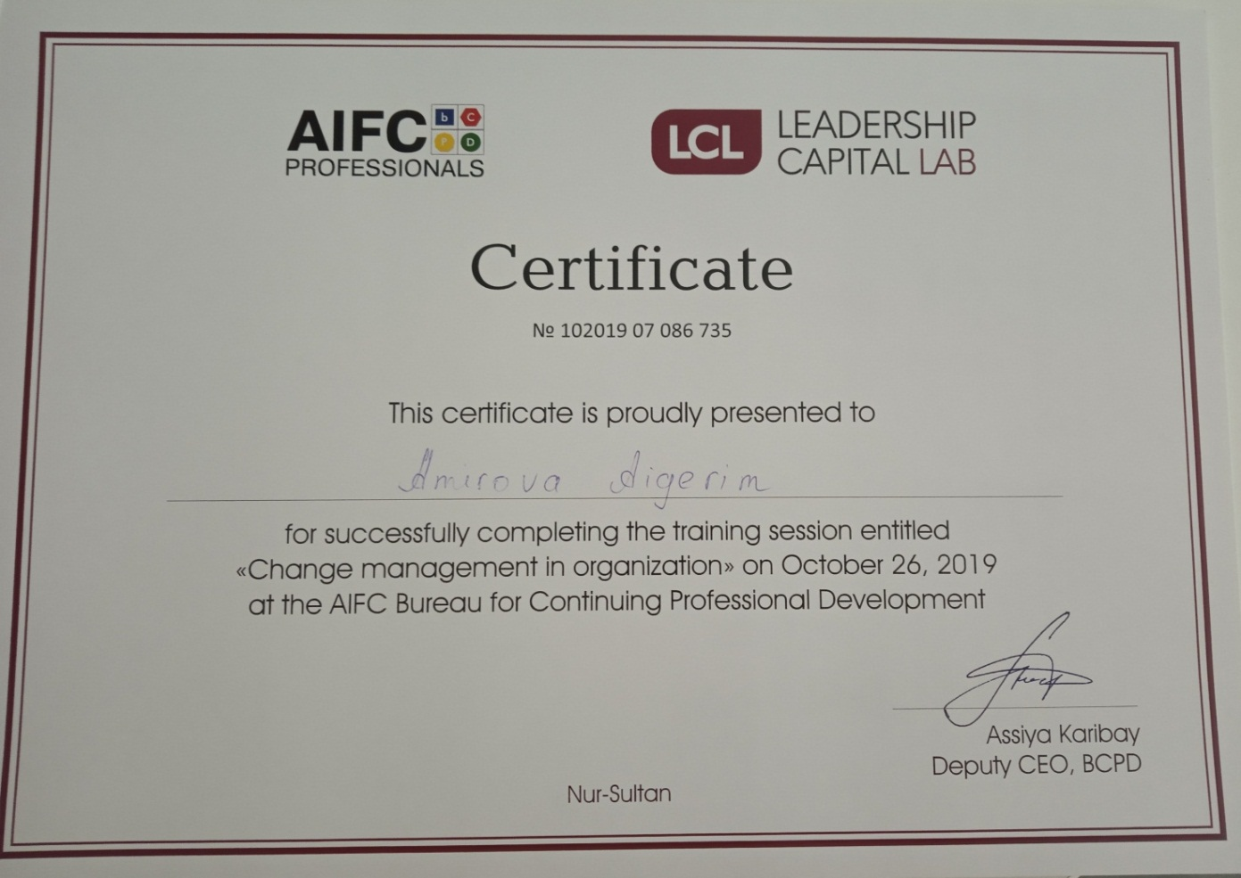

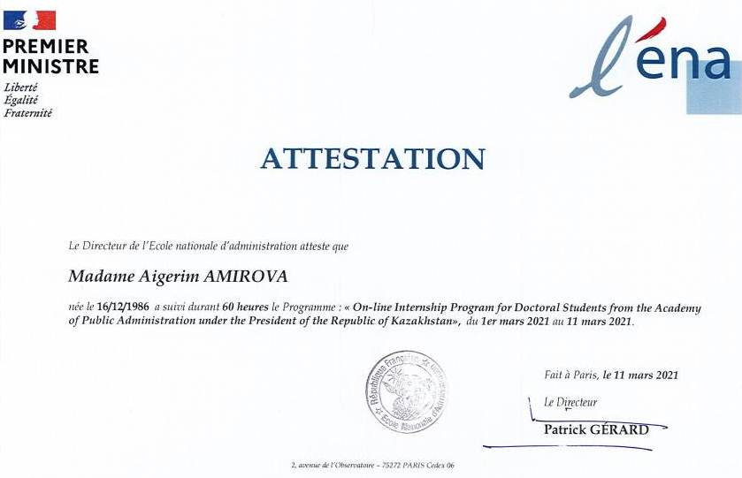



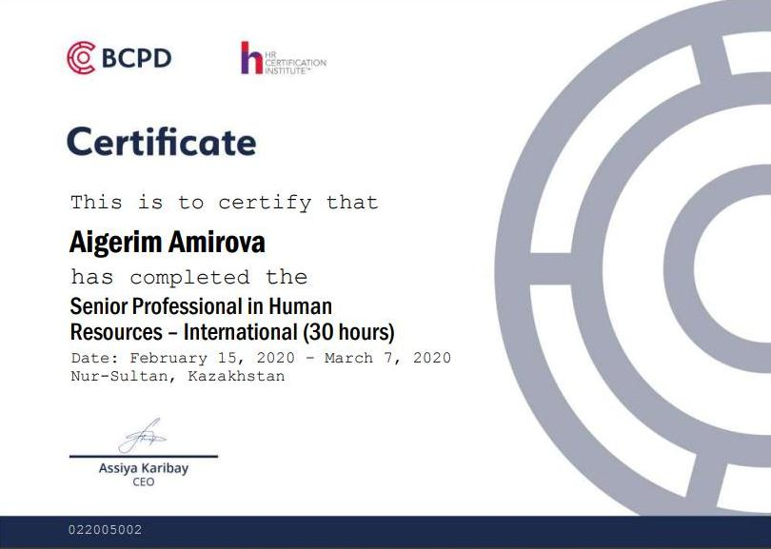
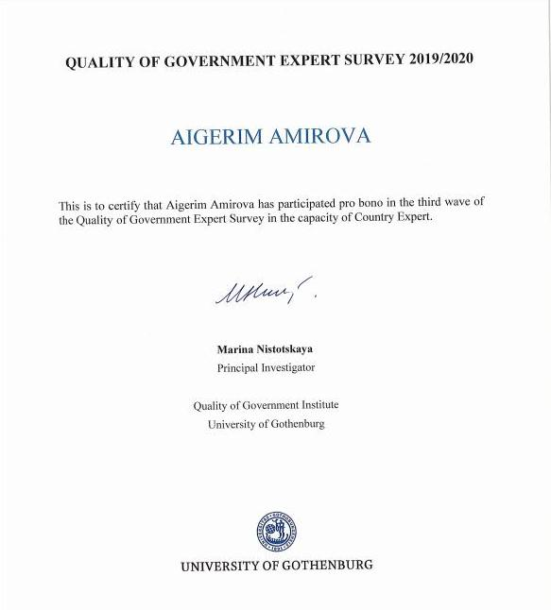

annex B

Acts on the research results implementation

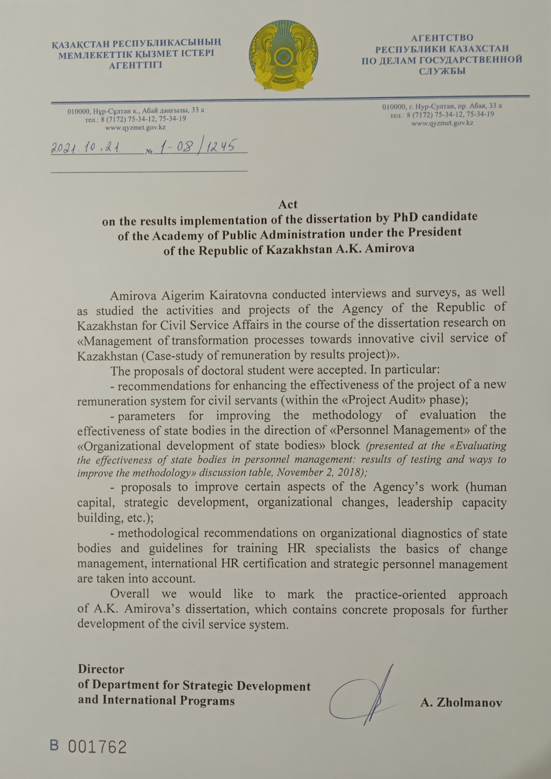
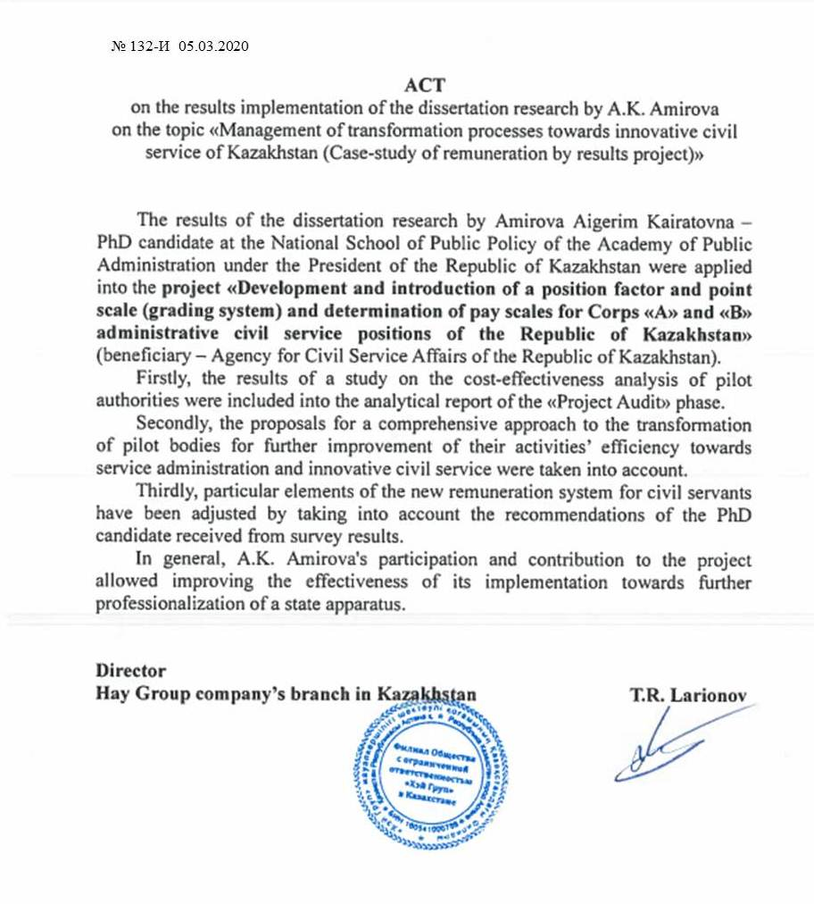

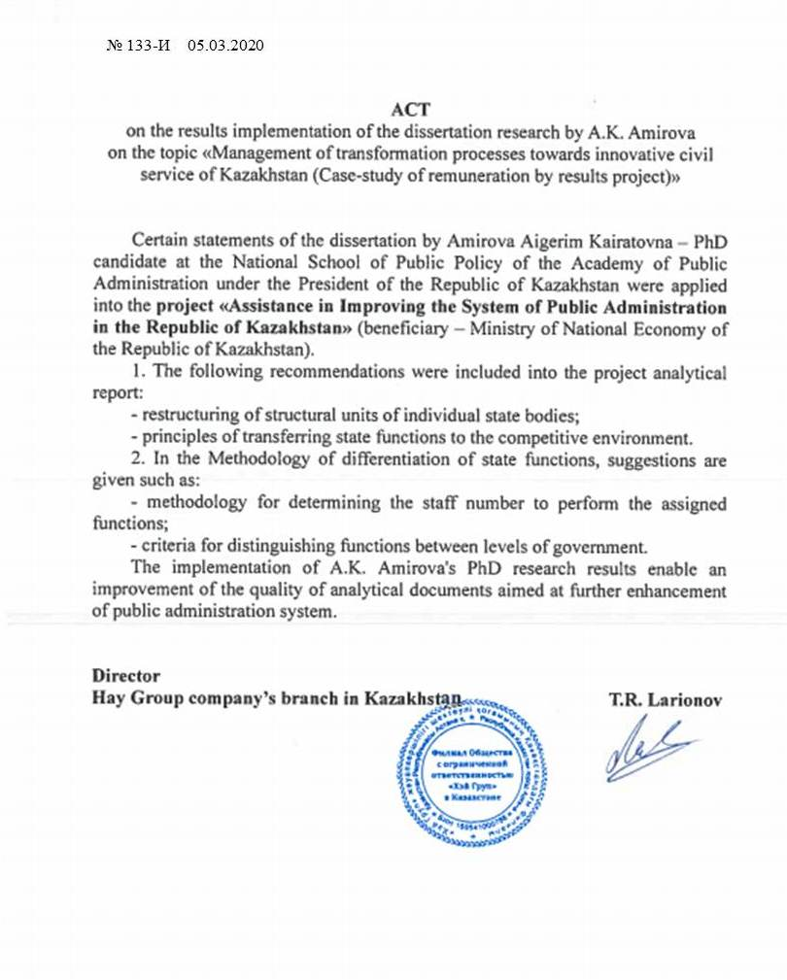

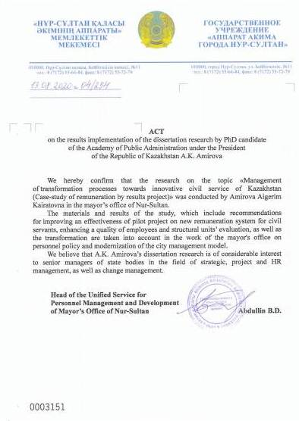

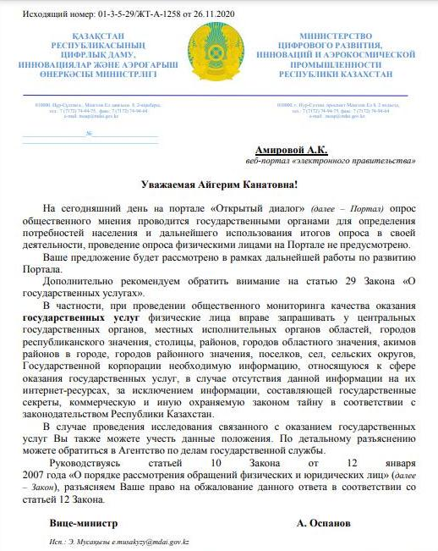

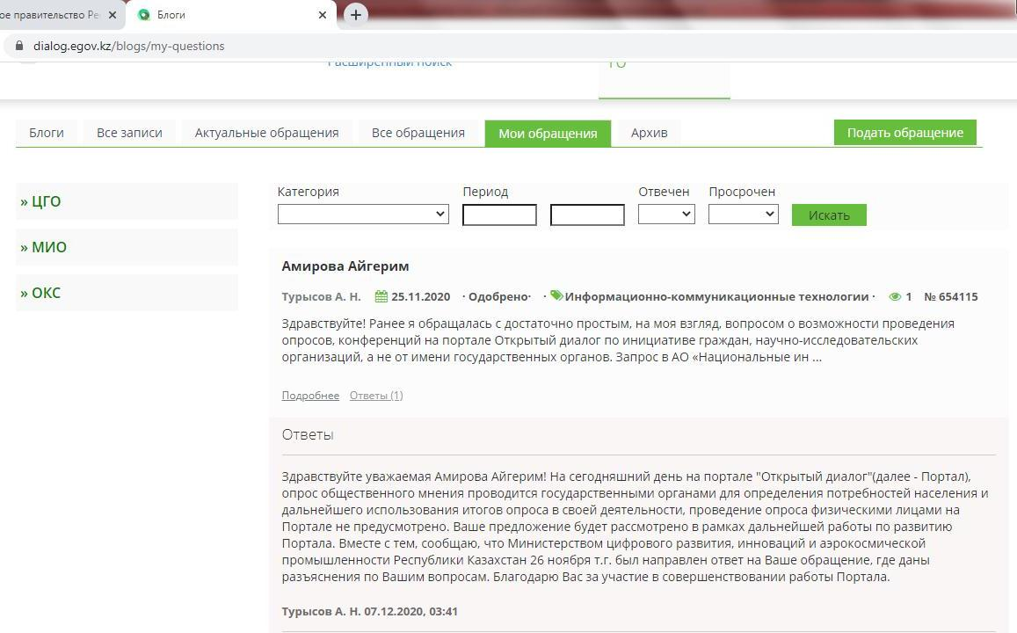

annex C

Table С.1 – Main Models of Transformational Management

Type | Model Name
1 | 2
Actionable | - Accelerating Implementation Methodology (AIM).  - ACMP Standard.  - Change Delta Framework.  - Beckhard and Harris, change management process.  - CHAMPS2.  - Change Leaders Roadmap Methodology.  - CMI body of knowledge & maturity model.  - Conner Partners’ Change Execution Methodology (CEM).  - Cummings and Worley's Model for Managing Change.  - Galpin's Wheel of Nine Wedges.  - GE Change Acceleration Process.  - Judson’s Five-Phase Model.  - Kotter’s Eight-Stage Change Model.  - LaMarsh Global Managed Change™ Methodology.  - Lippitt, Watson and Westley Model.  - People Centred Implementation (PCI).  - Prosci’s ADKAR™ Change.  - Viral Change.  - Change Rx - Change Management Project Methodology.  - BPI - Whole System Transformation.  - Positive Deviance
Supporting | - Beckhard and Harris, change formula.  - Cooperrider’s Appreciative Inquiry (AI).  - Kubler-Ross Change Model.  - Managing Successful Programmes (MSP).  - PMI’s Change Management methodology.  - SPIRAL DYNAMICS® Change State Indicator.  - Theories of Change
High Level | - Beckhard’s Transition Model.  - Bullock and Batten’s Planned Change Model.  - Carnall model.  - Decipher DeltaV.  - Edwin Cornelius – Implementing a Planned Change.  - Lewin’s Change Management Model (three-step model).  - Pritchett’s Change Management Model.  - Prochaska and DiClemente Model.  - Rogers technology adoption.  - Senge, systemic model & the Fifth Discipline.  - Stacey and Shaw, complex responsive processes.  - Teece – Dynamic Capabilities.  - Galbraith Star Model
Contextual | - Burke & Litwin Model.  - EFQM Excellence Model & RADAR.  - McKinsey’s Seven-Step Model.  - Nadler and Tushman, congruence model.  - Weisbord 6 Box Model.
Continuation of table С.1

1 | 2
- William Bridges, managing the transition.
- Theory U
Note - Compiled by source [75]

annex D

Table D.1 – Civil service systems’ features and visions worldwide

Aspect | UK | Canada | Singapore | USA | Australia
1 | 2 | 3 | 4 | 5 | 6
Authorized body in the field of civil service | Civil Service Commission | Government of Canada | Public Service Division | Office of Personnel Management | Public Service Commission
Key vision | Brilliant Civil Service | Citizens first | From Public Sector 2021 to Public Sector Transformation.  Mission: 1) we work with the elected Government to shape Sin ga pore’s future, forge a common vision among Singaporeans and transform the vision into a reality;  2) we safeguard the indepen dence, sovereignty, security and prosperity of Singapore;  3) we uphold justice and equality, guided by the principles of incorruptibility, meritocracy and impartiality | Recruit, Retain and Honor a World-Class Workforce to Serve the American People | 1) a strong Australian public service united in a collective endeavor;  2) a world-class Australian public service in its policy, regulation and delivery;  3) an Australian public service that is truly an employer of choice;  4) trusted and respected by its partners;  5) renowned for using dyna mic, digital and adaptive systems and structures
Values | 1) honesty;  2) integrity;  3) impartiality;  4) objectivity | 1) respect for democracy;  2) respect for people;  3) integrity;  4) stewardship;  5) excellence | 1) integrity;  2) service;  3) excellence. | Making our government more transparent, participatory, and collaborative. | N/A
Competencies | - ability to see the big picture; | - values and ethics: honesty | 1) accountability, moral courage, fairness and impartiality; | 1) drive the change:  - creativity and | 1) maintain and enhance confidence in public service;
Continuation of table D.1

1 | 2 | 3 | 4 | 5 | 6
 | - changes and improvements;  - effective decision making;  - leadership and communication;  interaction and partnership | - and respect;  - strategic thinking: analysis and new ideas;  - mobilization of people, organiza tions, partners;  management excellence | 2) dedication to nation, empathy and compassion, profession nalism;  3) quality orientation, team work, continuous improvement. | - innovation;  - internal awareness;  - flexibility;  - adaptability;  - strategic thinking;  - vision;  2) people manage ment;  conflict resolution | 2) apply government systems;  3) manage compliance with legislation in the public sector;  4) manage policy implement tation;  5) manage resources;  6) manage quality client service
 | - achievement of long-term econo mic results;  - ensuring value for money;  - public services quality manage ment;  - timely execution | human resource management, financial management. |  | - effective use of diversity;  - team building;  3) result orientation:  - responsibility;  - public services cus tomer orientation;  - decisiveness;  - entrepreneurial potential;  - problem solving;  - technical capabilities;  4) business qualities:  - financial management;  - human resource management;  - technology management; | 7) influence workforce effectiveness;  8) establish and maintain strategic networks;  9) manage personal work priorities and professional development.
Continuation of table D.1

1 | 2 | 3 | 4 | 5 | 6
5) coalition building:
- establishing part nerships;
- political experien ce;
- impact or negotia tion
Career or position based? | Career | Career | Career | Position | Career
Displays features of the other system? | Yes. Contract ap pointtees of some senior executives | Yes. In allowing external appli cants for top posts | No | Yes. In rank-inperson and in OPM oversight | Yes. In open recruitment of department heads
Generalists or specialists? | Generalists and specialists | Generalists | Generalists | Generalists and specialists | Generalists
Basis of selection | Merit-based com petition through Public Service Commission. Selection for top posts through separate process | Merit and open  Supervised by Public Service Commission | Closed system  Merit-based competition through Public Service Commission | Merit and open. Except for 10% political appointees | Merit and open to all within and outside government
Managing the se nior civil service | Cabinet Office | Treasury Board and Public Ser vice Commission | Public Service Commission and Public Service Division in the Prime Minister’s Office | Office of Personnel Management and Agency Heads | Public Service Department and Public Service Commission
Talent management system | Transformational leadership has been recruited and the change process is led | The talent mana gement policy in the Canadian pub lic service seeks to achieve two goals: | There are four key talent mana gement schemes in Singapore, managed primarily by the Public Service Commission: | N/A | N/A
Continuation of table D.1

1 | 2 | 3 | 4 | 5 | 6
 | by the Cabinet Secretary and Head of the Home Civil Service. | 1) make available competent, repre sentative and experienced leaders, now and in the future, to fill the continuum of senior lea dership positions;  2) maintain an efficient, effective and sustainable management sys tem of the execu tive commu nity resulting in excel lent products, policies and servi ces to Canadians | 1) pre-service scholarships;  2) management associate program;  3) administrative service;  4) high potential program.
Note – Compiled from source [86, р. 142; 87, р. 36; 89; 90; 91; 92; 93; 94; 95, р. 45; 96]

Table D.2 – Approaches for public sector innovation evaluation

Country | USA | UK | EU | Australia
1 | 2 | 3 | 4 | 5
Method name | The Innovations in American Government Award | Public sector innovation indices (scorecard approach) | European Public Sector Innovation Scoreboard | Australian Public Sector Innovation Indicators (APSII)
Organization | Ash Center for Democratic Governance at Harvard University | National Endowment for Science, Technology and the Arts (NESTA) | European Commission | Australian Government
Criteria | 1) novelty, the degree to which the program or initiative demonstrates a leap in creativity;  2) effectiveness, the deg ree to which the program or initiative has achieved tangible results;  3) significance, the degree to which the program or initiative successfully addresses an important problem of public concern;  4) transferability, the degree to which the program or initiative, or aspects of it, show promise of inspiring successful replication by other governmental entities | 1) impact:  – improvement in organiza tional key performance indicators;  – improvement in service evaluation; improvement in efficiency;  – improvement context;  2) innovation activity:  – accessing new ideas;  – selecting and developing ideas;  – implementing ideas;  – diffusing what works;  3) innovation capability:  – leadership and culture;  – management of innovation;  – organizational enablers of innovation;  4) wider sector conditions for innovation:  – incentives;  – autonomy;
Continuation of table D.2

1 | 2 | 3 | 4 | 5
 |  | – leadership and culture;  – enablers | innovation;  – active management involvement in innovation;  – importance of external knowledge;  – share of employees involved in groups that meet regularly to develop innovations;  3) outputs;  3.1) innovators:  – share of organizations in public admi nistration with services, communication, process or organizational innovations;  – share of “New” services out of all services innovations | – innovation intensity;  – intangible outputs;  4) outcomes:  – societal and environmental impacts;  – quality, efficiency and productivity;  – improved employee satisfaction
 |  |  | – public sector productivity;  3.2) effects on business performance:  – improvements in public services for business;  – impact of innovative public services on business);  3.3) government procurement:  – government procurement as a driver of business innovation;  – government procurement of advanced technology products;  – importance of innovation in procurement. | – benefits for users;  – other intangible effects (e.g. trust and legiti macy);  5) environmental condi tions:  – user demand and sup plier capacity;  – wider public sector leadership and culture;  – political and legislative factors;  – other enablers/barriers to innovation (e.g. re search basis, skills shortage)
Note – Сomplied by the author based on source [105]

annex E

Expert Interview Format

Interview Consent Form

I hereby confirm that I have had extensive conversations with Aigerim Amirova (the Interviewer). I understand that the Interviewer is writing and will publish a research work, which is titled “Management of transformation processes towards innovative civil service of Kazakhstan (case-study of remuneration by results project)”. Furthermore:
- I confirm that I have voluntarily disclosed to the Interviewer information and opinions about myself and other aspects.
- I warrant that the information disclosed by me is true and factual, to the best of my knowledge, and does not invade the privacy of any third party.
- I acknowledge and understand that my statements may form the basis for conclusions and discussions regarding the topic, and other issues relating to the Interview’s research work.
- I grant to the Interviewer the right to copy, reproduce, paraphrase, publish, and use all or a portion of the Interview for incorporation in her research work by providing my anonymous.
- I acknowledge and agree that I am not entitled to receive any form of payment from the Interview.

Agreed and confirmed:
_____________________________
(Interviewee Signature)
_____________________________
(Interviewee Name)
(Date)

Comments:

Interview Questions

- Interviewee profile:

Name
Age
Work experience as a civil servant (Work experience for private sector)
Occupied position
Work experience at the occupied position

B. Expert opinion

B.1. Conceptual model confirmation

Interviewer: “Could you please take a look at this Figure. It consists of transformational factors which are identified from the literature review and foreign benchmark. Do you agree with this conceptual model or you could suggest some additions and corrections?”

Interviewee’s comments:

B.2. Survey Questionnaire Pre-test

Interviewer: “Could you please take a look and fill this survey form in order to make the necessary changes. This questionnaire will be used further for conceptual model testing”.

Interviewee’s comments:

B.3. Discussion

Interviewer: “Could you please answer for these questions. Your expert opinion will contribute to the proposals for the further enhancement of civil service system”:

- What does “innovative civil service” mean to you? Could you describe your vision in more detail?
- What factors do you think influence on improvement of state apparatus effectiveness? Could you briefly describe them?
- What kind of changes is needed to increase the efficiency of public authorities (for example, organizational change, enhancement of human resources competencies, etc.)?
- What are the difficulties of public authorities’ daily work? How can these difficulties be overcome?
- Returning to the question of effective innovative civil service, what recommendations would you suggest?

Interviewee’s comments:

annex f

Table f.1 – Conceptual model operationalization

Concept | Conceptual definition | Operational definition | Sub  concept | Abbreviation | Items (Statement) | Measures | References
1 | 2 | 3 | 4 | 5 | 6 | 7 | 8
Independent Variables
Leadership | In many studies of change management, the leadership factor is one of the key aspects for trans formation. Special attention is paid to such qualities of a leader as the ability to hear his subo rdi nates when making decisions, as well as the willingness to change | The degree to which Leadership can affect the transformation thru readiness to hear and make changes | Transformational Leader | L1 | It is important that the head of the organization actively participates in making changes | Ordinal scale  (5-point Likert scale format) | Behn (1991); Borins (1998); Waldorff et al. (2014);  Adizes (2017); Andersen (2018)
Leadership |  |  | Listening Leader | L2 | The ability of the mana ger to hear and accept con structive suggestions from subordinates is important | Ordinal scale  (5-point Likert scale format)
Strategy | The strategy is often mentioned in the studies of foreign and domestic scientists and practitioners as one of the keys to the successful implementation of innovations | It is important to clearly and correctly formulate and successfully implement the strategy, as well as to bear joint responsibility for the results of the evaluation | Formulation | S1 | It is important to clearly defi ne the strategy/mis sion/pur pose of the public authority | Ordinal scale  (5-point Likert scale format) | Lee (1995); Samaratunge et al. (2008); Lessem and Schieffer (2009)
Strategy |  |  | Implementation | S2 | It is important to systematically achieve the strategy/mission/ goal of the state body | Ordinal scale  (5-point Likert scale format)
Strategy |  |  | Responsibility | S3 | Joint responsibility for the achievement of the strategy/mission/ goal of the state body is important | Ordinal scale  (5-point Likert scale format)
Human capital | Transformation and innovation are inextricably linked to human resources as one of the most important capital of any organization, whether private or public | Human capital is multifaceted and can be characteri zed by both quali tative and compe tence components | Qualitative characteristics | HC1 | The qualitative characte ris tics of the staff (level of edu cation, knowledge of langua ges, etc.) are important | Ordinal scale  (5-point Likert scale format) | Grady (1992); Osborne and Brown (2005); Fomichev (2011);
Human capital |  |  | Competences | HC2 | It is important to take into account the competence | Ordinal scale  (5-point Likert scale format) | Grady (1992); Osborne and Brown (2005); Fomichev (2011);
Continuation of table F.1

1 | 2 | 3 | 4 | 5 | 6 | 7 | 8
 |  | In the prism of the organization, this factor becomes more complex, since it is already associated with intra-organizational changes (the distribution of staff numbers, etc.) |  |  | approach in the appoint ment (matching the abili ties and knowledge of the employee to the position) |  | Baimenov and Liverakos (2019), etc.
 |  |  | Workload prevention | HC3 | It is important for the rational distribution of workload |  | Baimenov and Liverakos (2019), etc.
 |  |  | Staffing | HC4 | The staffing of the state body (timely filling of vacant positions) is important |  | Baimenov and Liverakos (2019), etc.
 |  |  | Turnover prevention | HC5 | It is important to avoid high turnover of staff (preservation of institutional memory) |  | Baimenov and Liverakos (2019), etc.
Organization | The organization as a “living organism” is described in many studies devoted to the issues of transformation and personnel management. Moreover, they distinguish a separate direction as organizational transformation | The degree to which employees:  - evaluate organizational changes as effective;  - consider the employer attractive;  - accept and res pect the values and culture of the organization | Organizational structure | O1 | An effective organiza tional structure (ratio of executive and manage rial staff in depart ments/offices, number of employees in structural units, etc.) is important | Ordinal scale  (5-point Likert scale format) | Wise (1999); Harley (2005); Glor (2006); Thelen (2009); Bloch (2013); Sardana (2015)
Organization |  |  | Employer attractiveness | O2 | It is important to create conditions to increase the attractiveness of the employer | Ordinal scale  (5-point Likert scale format)
Organization |  |  | Organizational culture | O3 | It is important to have a properly organized organizational culture in the state body | Ordinal scale  (5-point Likert scale format)
Continuation of table at Annex F

1 | 2 | 3 | 4 | 5 | 6 | 7 | 8
Resources | An absolute component of any organization and initiative is the availability of the necessary resources. In the context of this study, material resources (budget, technical, etc.) are meant, since other resources are specified in separate factors | Resource is a set of specific components dealing with budget, material and technical security, labor premises | Budgetary resources | R1 | It is important to have the necessary budgetary resources | Ordinal scale  (5-point Likert scale format) | Jacques and Ryan (1978); Merritt (1985); Walker et al. (2001)
Resources |  |  | Material and technical security | R2 | Material and technical security of the state body (office equipment, office furniture, etc.) is important | Ordinal scale  (5-point Likert scale format)
Resources |  |  | Sufficient space | R3 | It is important to have sufficient space (for example, a separate of fice, a separate building) | Ordinal scale  (5-point Likert scale format)
Mediator
Citizen  Centricity | The degree in which civil servants/government are oriented towards citizens’ needs | Nowadays, scientists agree that collaboration is an essential condition of an innovative and service-oriented government | Collaboration | CC | It is important to maintain constant collaboration between the government and citizens | Ordinal scale  (5-point Likert scale format) | Gareis et al. (2004); Egorov (2006);  Bertot and Jaeger (2008); Verdegem and Verleye (2009); Isekeshev et al. (2020); Bokayev et al. (2021)
DEPENDENT VARIABLE
Civil Ser vice Innova tive Trans formation | Intention to change current system and adopt innovative patterns | The degree to which civil ser vants are willing to adopt and citizens to accept | Transformational management | ICS1 | Generally, I have a positive attitude towards transformation of civil service | Ordinal scale (5-point Li kert scale format) | Galbraith (1992); Kamarck (2004);
Continuation of table F.1

1 | 2 | 3 | 4 | 5 | 6 | 7 | 8
 |  | innovative transformation in civil service | Innovativeness | ICS2 | Generally, I have a positive attitude towards innovation implementation in civil service |  | Brown and Osborne (2005);  Borins and Sandford (2008);  Batalli (2016);  Zhakypova et al. (2017); Allas et al. (2018); Dowden (2019)
CONTROL VARIABLES
Descriptive statistics data | Certain groups of citizens and civil servants are more likely to positively attitude towards innovative civil service, including younger, better educated, and higher income representatives | Demographic characteristics (age, gender, education level, occupation) affect on transformation adoption | Age |  | What is your age? | Interval scale | Wu and Wang (2005);  Arundel et al. (2015);  De Vries et al. (2016); Kusumasari et al. (2019)
Descriptive statistics data |  |  | Gender |  | What is your gender? | Nominal scale
Descriptive statistics data |  |  | Education level |  | What is your education level? | Nominal scale
Descriptive statistics data |  |  | Occupation |  | What is your occupation? | Nominal scale
Note – Сompiled by the author based on source [12, р. 25; 16, р. 142; 17, р. 37; 19, р. 34; 20, р. 82; 22, р. 615; 23, р. 142; 24, р. 483; 26, р. 18; 32, р. 15; 37, р. 157; 38, р. 18; 39, р. 142; 50, р. 21; 52, р. 11; 53, р. 165; 54, р. 249; 58, р. 92; 59, р. 157; 60, р. 32; 63, р. 18; 67, р. 348; 69, р. 142; 70, р. 1278; 72, р. 153; 76, р. 215; 78, р. 11; 79, р. 67; 80, c. 39; 81, р. 150; 83, р. 162; 84; 99; 103, р. 492; 106, р. 117; 107, р. 338; 113, р. 93; 122, р. 432; 132, c. 18]

annex G

Survey Questionnaire Format

SURvey
for conceptual model test

Dear Respondent,

First of all, let me thank you for your interest and participation in this research.
My name is Aigerim Amirova. I am a PhD candidate of the National School of Public Policy at the Academy of Public Administration under the President of the Republic of Kazakhstan.
This study is conducted within the framework of the thesis research: “Management of transformation processes towards innovative civil service of Kazakhstan (case-study of remuneration by results project)”. The focus of the research covers issues of transformation processes and innovativeness in public authorities, which are participants of pilot project dedicated to the new remuneration system for civil servants.
As a result of the survey the integrated conceptual model will be used for further organizational diagnostics of pilot authorities in order to improve an effectiveness of their activities.
Thank you for your cooperation and assistance!

Guidelines for Respondents

The survey is anonymous.
The questionnaire consists of four sections.
I. “Section A” includes questions for collecting general demographic information, which will be used in a generalized form (percentage value).
II. “Section B” includes introductory questions according to the topic of the dissertation, the answers to which will clarify the conceptual model and directions for further research.
III. The “Section C” will ask you to indicate to what extent you agree or disagree with the listed statements. There is no right or wrong answer. Moreover, the main aim of this section is to know your answer that best reflects your opinion, according to the following five-point Likert-scale:
1 | 2 | 3 | 4 | 5
Strongly Disagree | Disagree | Neutral or  No opinion | Agree | Strongly  Agree

IV. “Section D” is optional. Here you can specify any additional information, as well as your wishes regarding the issue of improving the efficiency of the state apparatus.

We ask you to answer all the required questions in all sections.
To complete this questionnaire, please tick (V) the answer box that best matches your opinion.

Thank you for participation!

Questionnaire

section A: General Data

1. What is your age?

Less than 20 years 21-30 years 31-40 years

41-50 years More than 50 years

2. What is your gender?

Male Female

3. What is your highest level of formal education you completed?

High school graduate College graduate

Bachelor degree Master’s degree

Doctorate (PhD) degree Other ___________ (please, specify)

4. What is your work experience as a civil servant?

Less than 3 years 3-5 years 5-10 years

10-15 years 15-20 years More than 20 years

5. What is your occupied position?

Executive level Managerial level

6. What is your work experience on category of occupied position (for example, С-О-3)?

Less than 1 year 1-2 years 2-3 years 3-5 years

5-7 years 7-10 years More than 10 years

Section B: Preliminary questions

- In your opinion, what kind of factors increases the effectiveness of the state apparatus? (you can select more than one answer)
А. Public authority strategy
B. Human capital (personnel)
C. Organizational structure and culture
D. Resources (financial, technical, etc.)
E. All answers are right
F. Other ______________________________________ (please specify)
- What motivates you most to work in civil service? (please select only one answer)
А. Social protection of public servants
B. Strategy and objectives of your public authority
C. New remuneration system (factor-point scale and bonus system)
D. Public service and the possibility of self-realization
E. Other ______________________________________ (please specify)
- What would you like to change in your state body? (please select only one answer)
А. Structure of public authority
B. Work schedule (offer your own option____________________________)
C. Distribution of tasks in structural divisions
D. Cancel the “freeze” of vacancies for additional financial incentives for employees
E. Other ______________________________________ (please specify)
- Under what working conditions do you think the maximum efficiency of employees is achieved? (please select only one answer)
А. When each employee knows for what area of work is personally responsible
B. When your opinion is taken into account by the management
C. When your achievements are noted in front of other employees
D. When a public authority sends a letter of thanks to parents/spouse/children indicating your achievements
E. When the results of the work affect the welfare of the population/economic situation in the country
F. Other ______________________________________ (please specify)
- What is the determining factor for transformation in the system of public administration? (please select only one answer)
А. Political will of the Head of state
B. Support of the initiative by the first head of the state body and its ability to change (transformational leader)
C. Initiatives on the part of employees, their commitment to the values of the public service and the objectives of the public authority
D. Needs of society (including as a result of citizens’ appeals)
E. Other ______________________________________ (please specify)

Section C

Table G.1 – Driving forces of transformational processes

Statement | 1 | 2 | 3 | 4 | 5
Leadership
It is important that the head of the organization actively participates in making changes
The ability of the manager to hear and accept constructive suggestions from subordinates is important
Strategy
It is important to clearly define the strategy/mission/ purpose of the public authority
It is important to systematically achieve the strategy/mission/ goal of the state body
Joint responsibility for the achievement of the strategy/mission/ goal of the state body is important
Human capital
The qualitative characteristics of the staff (level of education, knowledge of languages, etc.) are important
It is important to take into account the competence approach in the appointment (matching the abilities and knowledge of the employee to the position)
It is important for the rational distribution of workload
The staffing of the state body (timely filling of vacant positions) is important
It is important to avoid high turnover of staff (preservation of institutional memory)
Organization
An effective organizational structure (ratio of executive and managerial staff in departments/offices, number of employees in structural units, etc.) is important
It is important to create conditions to increase the attractiveness of the employer
It is important to have a properly organized organizational culture in the state body
Resources
It is important to have the necessary budgetary resources
Material and technical security of the state body (office equipment, office furniture, etc.) is important
It is important to have sufficient space (for example, a separate office, a separate building)
Citizen centricity
It is important to maintain constant collaboration between the government and citizens
Civil service innovative transformation
Generally, I have a positive attitude towards transformation of civil service
Generally, I have a positive attitude towards innovation implementation in civil service
Note:
1 – Strongly Disagree.
2 – Disagree.
3 – Neutral or No opinion.
4 – Agree.
5 – Strongly Agree
Section D: Additional

Here you can specify any additional information, as well as your wishes regarding the issue of improving the efficiency of the state apparatus

~ The end of questionnaire ~

THANK YOU FOR PARTICIPATion IN THIS RESEARCH!

annex H

Survey Questionnaire Format

SURvey
for approbation of conceptual model
among civil servants of pilot authorities

https://www.survio.com/survey/d/C2Y1Y9C2K6T9M7J4N

Dear respondent!

We kindly ask you to take part in the survey on the effectiveness of pilot authorities’ activities, taking into account the new realities (COVID-19, quarantine regime, transfer to remote work, etc.). This aspect is considered within the framework of the dissertation: “Management of transformation processes towards innovative civil service of Kazakhstan (case-study of remuneration by results project)”.
Your opinion is very important, please be sincere. All information obtained during the anonymous survey will be kept completely confidential and used in a generalized form.
The questionnaire consists of three sections:
- Section “A” (introductory part) includes questions for collecting general demographic information, which will be used in a generalized form;
- Section “B” (main part) contains research questions structured according to factors “Leadership”, “Strategy”, “Human capital”, “Organization”, and “Resources”;
- Section “C” (final part) involves making suggestions by the respondent.
By continuing further, you agree that:
1. Voluntarily submitted information and data about yourself, as well as other aspects raised in the survey.
2. The information you provide is true and based on facts known to you, and does not affect the privacy of third parties.
3. Your opinion can serve as a basis for conclusions and discussion of the research topic.
4. You grant the right to copy, reproduce, paraphrase, publish and use all or part of the information, while maintaining your anonymity.
5. You do not claim to receive any payment for the survey.

Agree!

questionnaire

Section A: General Data

1. What is your age?

Please choose one of the following answers:
Less than 20 years
21-30 years
31-40 years
41-50 years
More than 50 years

2. What is your gender?

Please choose one of the following answers:
Male
Female

3. What is your highest level of formal education you completed?

Please choose one of the following answers:
College graduate
Bachelor degree or Specialist
Master degree
Doctorate (PhD) degree
Other ___________ (please, specify)

4. What is your work experience as a civil servant?

Please choose one of the following answers:
Less than 3 years
3-5 years
5-10 years
10-15 years
15-20 years
More than 20 years

5. What is your occupied position?

Please choose one of the following answers:
Executive level
Managerial level

6. Specify the full name of your public authority?
__________________________________________ (drop-down list of names)

Section B: Research questions

1. “Leadership” factor

1) The first head of your government body is actively involved in making changes, including those related to the introduction of a new working regime during the pandemic.

Please choose one of the following answers:
I totally agree
Rather agree, this happens quite often
Difficult to answer
Rather disagree, this happens very rarely
I completely disagree, this does not apply to us

2) Your direct supervisor is always ready to hear and accept constructive suggestions.

Please choose one of the following answers:
I totally agree
Rather agree, this happens quite often
Difficult to answer
Rather disagree, this happens very rarely
I completely disagree, this does not apply to us

3) Your direct supervisor is always available to discuss work issues online.

Please choose one of the following answers:
I totally agree
Rather agree, this happens quite often
Difficult to answer
Rather disagree, this happens very rarely
I completely disagree, this does not apply to us

2. “Strategy” factor

1) You have participated in determining / changing the development guidelines of your state body/region (for example, the mission, vision, directions, goals specified in the strategic plan or the region development program)

Please choose one of the following answers:
I totally agree
Rather agree, my suggestions are partially taken into account
Difficult to answer
Rather disagree, I haven’t made a suggestion
I completely disagree, I have never familiarized myself with the strategic documents of our state body/region
2) In your state body the rules of remote work are clearly defined and followed.

Please choose one of the following answers:
I totally agree
Rather agree, there are certain shortcomings, but in general I follow
Difficult to answer
Rather disagree, the work is chaotic
I completely disagree

3. “Human capital” factor

1) The scope of your functional responsibilities includes an even combination of routine, innovative and strategic work.

Please choose one of the following answers:
I totally agree
Rather agree, the tasks of introducing innovations and determining the development guidelines for the supervised industry and/or civil service sphere prevail
Difficult to answer
Rather disagree, routine tasks prevail
I completely disagree, functional responsibilities consist only of routine tasks

2) You constantly improve your skills and gain additional knowledge to effectively perform functional duties.

Please choose one of the following answers:
I totally agree, I enhance my competencies on an ongoing basis, as well as gain additional knowledge proactively through a variety of courses
Rather agree, I go through training as needed
Difficult to answer
Rather disagree, I am trained within the time limits established by law only in the recommended courses
I completely disagree, I base my work on the knowledge gained earlier

3) Your knowledge and skills are sufficient to work remotely.

Please choose one of the following answers:
I totally agree
Rather agree, it took me a little time to adapt
Difficult to answer
Rather disagree, I need additional training and / or clarification
I completely disagree, I do not like and it is difficult to work remotely

4. “Organization” factor

1) The organizational structure in your public authority is effective (the ratio of executive and managerial staff in departments / units, the number of employees in structural divisions, etc.).

Please choose one of the following answers:
I totally agree
Rather agree, but there are proposals for individual structural divisions
Difficult to answer
Rather disagree, most approaches need to be changed
I completely disagree, the structure and staffing of the state body should be completely reviewed

2) The organizational culture (the system of values, rules and norms of behavior) adopted in your state body allows to implement functions and provide public services that fully meet the needs of citizens and increase confidence in the state apparatus.

Please choose one of the following answers:
I totally agree
Rather agree, but there are suggestions for improving individual elements
Difficult to answer
Rather disagree, most approaches need to be changed
I completely disagree, it is necessary to completely review (or form) the organizational culture in our organization

3) Your public authority has an effective online interaction with the management and other government agencies.

Please choose one of the following answers:
I totally agree
Rather agree, but there are suggestions for improving certain aspects of interaction
Difficult to answer
Rather disagree, most approaches need to be changed
I completely disagree, the format of the work should be completely revised

4) The remote format allows you to reduce the load and eliminate unnecessary processes in your work.

Please choose one of the following answers:
I totally agree
Rather agree, partially affected the improvement of the quality of work
Difficult to answer
Rather disagree, there are small positive changes
I completely disagree, the new format had a negative impact on the quality of the work performed
5. “Resources” factor

1) In your state body, the necessary conditions have been created for the organization of a digital workplace that meets the requirements of the time and allows you to effectively perform tasks, including remotely (having your own computer and smartphone, access to broadband Internet, availability of advice from technical services, etc.).

Please choose one of the following answers:
I totally agree
Rather agree, but there are suggestions for improving certain aspects of technical equipment
Difficult to answer
Rather disagree, most approaches need to be changed
I completely disagree, questions of technical equipment are solved by employees independently

2) Your state body has a clear system of compensation for the costs associated with remote work (telephone, Internet, electricity, etc.).

Please choose one of the following answers:
I totally agree
Rather agree, most expenses are compensated
Difficult to answer
Rather disagree, most expenses are not compensated
I completely disagree, the expenses are covered by the employees themselves

Section C: Recommendations

We offer you leave your suggestions (in free form) in the answers to the following questions:

1. What negative stereotypes of the image of a civil servant (civil service), in your opinion, still exist in society?

2. What would you like to change in your state body?

3. What innovations do you think are necessary for the public service and what would you like to implement??

THANK YOU FOR PARTICIPATion IN THIS research!

annex I

Survey Questionnaire Format

SURvey
for approbation of conceptual model
among citizens of Nur-Sultan

https://www.survio.com/survey/d/L0A6H9B9T9Q5M4A5M

Dear Respondent!

We kindly ask you to take part in the survey if you have interacted with the state institutions of the Akimat of Nur-Sultan. The issue of the effectiveness of their activities is considered in the framework of the dissertation “Management of transformation processes towards innovative civil service of Kazakhstan (case-study of remuneration by results project)” and will be used to develop recommendations to the Akimat of the capital.
Your opinion is very important, please be sincere. All information obtained during the anonymous survey will be kept completely confidential and used in a generalized form.

By continuing further, you agree that:
1. Voluntarily submitted information and data about yourself, as well as other aspects raised in the survey.
2. The information you provide is true and based on facts known to you, and does not affect the privacy of third parties.
3. Your opinion can serve as a basis for conclusions and discussion of the research topic.
4. You grant the right to copy, reproduce, paraphrase, publish and use all or part of the information, while maintaining your anonymity.
5. You do not claim to receive any payment for the survey.

Agree!

questionnaire

1. What is your age?

Please choose one of the following answers:
Less than 20 years
21-30 years
31-40 years
41-50 years
More than 50 years

2. What is your gender?

Please choose one of the following answers:
Male
Female

3. What is your highest level of formal education you completed?

Please choose one of the following answers:
College graduate
Bachelor degree or Specialist
Master degree
Doctorate (PhD) degree
Other ___________ (please, specify)

4. Your activity field?

Please choose one of the following answers:
Student
Civil servant
Entrepreneur
Employee of a private company
Employee of a quasi-public sector organization
Self-employed
Your answer _________________

5. What questions do you most often address to the state institutions of the capital??

Please choose one of the following answers:
Receiving a public service
Filing a complaint
Getting a consultation
Your answer _________________

6. Please specify how satisfied you are with the work of the Akimat of the capital?

Please choose one of the following answers:
To the full extent
Partly
Not satisfied

7. What would you like to change in the work of the Akimat of the capital?

Your answer:
________________________________________________________________
________________________________________________________________

8. Have you contacted the Unified Contact Center of the capital 109?

Please choose one of the following answers:
Yes
No

9. If you answered positively to the previous question, please specify how satisfied you are with the advice provided?

Please choose one of the following answers:
To the full extent
Partly, incomplete information received
Not satisfied, the consultation was not provided properly

10. What would you like to change in the work of the Unified Contact Center of the capital 109?

Your answer:
________________________________________________________________
________________________________________________________________

11. What, in your opinion, more hinders the effective work of the state institutions of the capital?

Please choose one of the following answers:
Tight deadlines
Formalism of responses
Insufficient professional knowledge of employees
Insufficient competencies of employees
Your answer ________________________________

12. In your opinion, to what extent are the residents of the capital involved and influence the decision-making on the development of the city (for example, the construction or repair of roads, the design of public spaces, etc.)?

Please choose one of the following answers:
To the full extent
Partly
Not involved or influential

13. How, in your opinion, should the interaction between the residents and the Akimat of the capital be built?

Your answer:
________________________________________________________________
________________________________________________________________

14. Are you satisfied with the list of services provided by the state institutions of the capital at the present time?

Please choose one of the following answers:
To the full extent
Partly
Not satisfied

15. What services would you like to receive from the Akimat of the capital and in what way?

Your answer:
________________________________________________________________
________________________________________________________________

16. What innovations do you think are necessary for civil service and what would you like to change?

Your answer:
________________________________________________________________
________________________________________________________________

17. What professional and personal qualities, in your opinion, should a civil servant of the capital’s akimat possess?

Your answer:
________________________________________________________________
________________________________________________________________

THANK YOU FOR PARTICIPATion IN THIS research!

annex J

Table J.1 – Civil Service Systems in the CIS and Caucasus countries at a Glance

Category | Armenia | Azerbaijan | Belarus | Georgia | Kazakhstan | Kyrgyzstan | Moldova | Tajikistan | Ukraine
Legal foundation | Law on Civil Service, 2001 | Constitution; Law on Civil Service, 2000 | Constitution; Law on Civil Service, 2003 | Law on Civil Ser vice, 1997; amended, 2015 | Decree of the Pre sident “On Civil Service” (had a for ce of Law), 1995; Law on Civil Service, 2015 | Constitution; Law on Civil Service, 2004 | Law on Public Office and Status of Civil Ser vants, 2008 | Constitution; Law on Civil Service, 2007 | Law on Civil Ser vice, 1994; amended, 2015
Civil Ser vice Agency estab lis hed on: | Civil Service Council, 2001 | Civil Servi ce Commis sion under the Presi dent, 2005 | No special agency | Civil Service Bureau of Georgia, 1997 | Agency for Civil Service Affairs, 2000 | State Personnel Service | State Chan cel lery, Gene ral Division for Policy Co ordi nation, 2008 | Agency for Civil Ser vice under the Presi dent, 2013 | National Agency of Ukraine on Civil Ser vice, 1994
Central Training Agency | Civil Service Commis sion | Civil Service Commission; Academy of Public Admi nistration | N/A | Civil Service Bureau | Academy of Public Administration | N/A | Academy of Public Adminis tration | Institute of Public Admini stration | Academy of Public Administration
Performance evaluation system | Attestation every  3 years; perfor man ce apprai sal yearly | Attestation every  5 years; per for mance appraisal yearly | No performan ce appraisal system in place | Attestation every  3 years;  performance apprai sal yearly | Performance appraisal yearly | Perfor mance appraisal yearly with the use of KPIs | Performance appraisal yearly | N/A | N/A
Promotion system | Seniority based | Seniority based | Performan ce evalua tion results and senior rity-based | Performance evalua tion results and senio rity-based | Competition based. Performance apprai sal, experience and training | Performance evaluation results, experience and senior rity based | Performance appraisal system | Performance appraisal, experience and training | Performance appraisal and experience
Note - Compiled from source [86]

annex K

Factor analysis results (Conceptual model testing)

Table K.1 – Cronbach’s alpha for variables in the conceptual model

Items | Cronbach’s alpha
Leadership:  - Transformational Leader  - Listening Leader | 0.86
Strategy:  - Formulation  - Implementation  - Responsibility | 0.89
Human capital:  - Qualitative characteristics  - Competences  - Workload prevention  - Staffing  - Turnover prevention | 0.82
Organization:  - Organizational structure  - Employer attractiveness  - Organizational culture | 0.83
Resources:  - Budgetary resources  - Material and technical security  - Sufficient space | 0.72
Citizen Centricity:  - Collaboration | 0.80
Civil Service Innovative Transformation:  - Transformational management  - Innovativeness | 0.74
Note – Compiled by the author based on survey results

Table K.2 – Path loadings, critical ratios in the Structural model

Item |  |  | Estimate | S.E. | C.R. | P
L1 | <--- | L | 1.000
L2 | <--- | L | 1.261 | .113 | 11.116 | ***
S1 | <--- | S | 1.000
S2 | <--- | S | .928 | .079 | 11.676 | ***
S3 | <--- | S | .956 | .082 | 11.633 | ***
… |  |  | 1.000
*** – Significant

annex L

Table L.1 – Recommendations of the capital residents on improving the efficiency of Nur-Sultan Akimat

Research questions | Recommendations
1 | 2
- What would you like to change in the work of the Akimat of the capital? | Most of the proposals of citizens were received on the issue of the quality of the work of the akimat and interaction with the population. About 80% of respondents focused on this aspect. The recommendations relate to:  - employees of the akimat: improving competence, prohibiting formal answers, red tape and bureaucracy, efficiency in providing services, especially electronic ones, conscientious attitude, responsibility for their work, assistance in decisions concerning the city and residents;  - the principles of the akimat’s work: it is necessary to be listening and keep constant feedback with the population to develop joint solutions; conduct online discussions on key issues of the city’s development in social networks; transparency, accountability.  Thus, respondents point to the lack of information about the results of work in the open access, the need to introduce an assessment of the work of the akimat by residents of the capital with real responsibility to the citizens.  In addition, it is proposed to ensure transparency in tenders and budget expenditures, to conduct inspections without prior notice to see the real state of affairs.  Special attention is paid to the issue of long-term planning (repeating mistakes in the management of the city from year to year)
The sphere of public utilities:
- prompt solution of communal problems;
- pay more attention to neighborhoods, courtyards;
- prompt snow removal, sidewalks.
The sphere of architecture and urban planning:
- checking the legality of all extensions to houses;
- the opportunity to participate in urban planning councils in AstanaGenPlan;
- solving problems of ramps in courtyards;
- prohibition of construction of cafes and entertainment establishments near residential buildings and educational institutions;
- taking into account the opinion of residents during construction

Continuation of table L.1

1 | 2
The sphere of communications:
- control over the structure of roads from the point of view of urbanism (correct organization of water drains);
- open dialogues, solving problems of urban infrastructure not only on the central streets;
- the solution of the parking issue before the akimat.
The sphere of land relations:
- under strict control, the provision of services for the registration of land plots, since there are facts of making decisions that contradict the Land Code of the Republic of Kazakhstan.
System-wide measures:
- eliminate corruption, especially in the arrangement and cleaning, land issues;
- simplification of the process of obtaining EDS;
- to restore the balance of power between the maslikhat and the akimat (the formality of the city maslikhat);
- election of the capital akim.
- What would you like to change in the work of the Unified Contact Center of the capital 109 | First of all, it should be noted that citizens are poorly informed about the availability of such a service (about half of the respondents did not apply).  The remaining part of the respondents is partially or completely dissatisfied with the work of the Service 109, due to receiving incomplete information. As the main criticism, the citizens note:  - the answer is not on the merits of the question asked;  - lack of complete up-to-date information about the work and contact details of state institutions of the capital during the quarantine period;  - providing false information;  - superficial, formulaic answers;  - long waits for operator responses.  In this regard, the residents of the capital suggest that the 109 Service should leave the functions of the transfer link (registrar of appeals) and strengthen its work by:  1) turnkey solutions of issues from the application to the successful completion with mandatory feedback;  2) control over the execution of requests;  3) anticipating the needs of citizens (a proactive approach to organizing activities, developing a protocol of assistance);  4) speed up the routing of the request to the contractor
Continuation of table L.1

1 | 2
5) training of employees: product knowledge, flexible skills, instilling an ethical and conscientious approach to work;
6) develop a motivational package for operators (salary revision, incentive payments and non-material incentives).
- How, in your opinion, should the interaction between the residents and the Akimat of the capital be built? | Only 0,9% of the respondents believe that they are fully involved in making decisions on the capital development. In this connection, there is an opinion about the closeness and inaccessibility of the akimat, the lack of feedback from the population. Citizens recommend that the Akim of the capital actually study problematic issues without journalists and subordinates (bus trips, salary levels, etc.).  It is proposed to introduce mechanisms of direct influence of the population on the decisions of the akimat, including openness and availability of information about plans and budget expenditures (for example, repairs of Kabanbay batyr avenue, construction of LRT, celebration of the day of the capital), instant reaction to the events and incidents through the Akim’s blog. Such mechanisms are a direct dialogue with the population through meetings and social networks, conducting polls, popular votes on the official website on important aspects of the city’s development. It is possible to organize the reception of citizens through initiative groups. The social media accounts created by the mayor of the capital and the akims of the city’s districts should be used more effectively. So, respondents suggest conducting reports in stories and making publications so that “people can see what they are working on and what they are doing” (“Some do not even know where the akim is”).  The Akimat should actively involve the expert community, adequately take into account feedback through the 109 Service and other communication channels, tell more about the changes being made, explain the logic of making a decision. At the same time, the information should be presented in simple language that is understandable for the majority, without formalism and faceless statistics.  As it was noted above, it is proposed to introduce the electivity of akims as dramatical changes in public administration system.
- What services would you like to receive from the Akimat of the capital and in what way? | 73,4% of respondents believe that the list of services of the akimat is insufficient. However, an in-depth study of the answers reveals not so much new services as the volume and quality of their provision. So, it is proposed:  - to carry out repairs of the roadway, and not “patching holes” in certain places;  - more landscaping, playgrounds, coworking, free children’s sports sections;  - a list of recommended schools or kindergartens, development centers, taking into account the age of the child in the family and the area of residence;  - availability in an online format of up-to-date information about the actual occupancy of students in schools, children in kindergartens, availability of free places;

Continuation of table L.1

1 | 2
- online movement of budget funds and their effectiveness in electronic format;
- services for humane monitoring of the number of stray and domestic animals;
- timely cleaning of the city;
- assistance to single mothers with a certificate F4, in the allowance for them until the child is 3 years old;
- housing issues, assistance to mothers with many children;
- do not request documents and certificates, but receive them independently from state bodies, especially if you need to update the data or re-submit it to the same organization;
- all services were provided in an electronic format in a proactive form;
- inform in advance about upcoming hearings, plans;
- control of the work of the cooperative of apartment owners (CAO), including with the involvement of non-governmental organizations as moderators.
As in the previous question, residents recommend that their opinion be taken into account when providing services by voting and general polling, including through social networks.
- What innovations do you think are necessary for civil service and what would you like to change? | The content of the proposals of the residents of the capital does not imply innovations, but focuses on the systemic problems of the civil service. The need to address these issues is stated in every strategic and program document adopted during the years of independence of the country.  These are, of course, the fight against corruption, increasing human resources and a compact state apparatus, reducing bureaucracy, digitalization, open dialogue and feedback with the population, including through online broadcasting of their activities by state bodies.  Thus, it is proposed to automate repetitive functions (for example, budget execution, monitoring, etc.), introduce project management, agile and kaizen methods, block chain technologies, artificial intelligence that minimize employee participation in decision-making.  To the remaining employees, akims, change the way of thinking, becoming more customer-oriented, flexible, open. Keep constant feedback and reporting, invite citizens to discuss decisions through social media accounts and bear personal responsibility for the results of work. As examples, the experiments of US statesmen, as well as the mayors of New York, London and other capitals are given

Continuation of table L.1

1 | 2
- What professional and personal qualities, in your opinion, should a civil servant of the capital’s akimat possess? | Taking into account the opinion of the citizens, a certain portrait of an employee of the capital’s akimat has developed.  In addition to professional competencies, knowledge of languages, practical experience and outlook, I would like to note the prevailing share of so-called “human qualities”, empathy, which many respondents talk about.  According to the residents of the capital, an employee of the akimat is a decent, honest, tactful, incorruptible person, ready to solve issues quickly and objectively until the final result is obtained, open to discussions, a patriot of his city, country, people, ready to contribute to their development
Note – Compiled by the author based on survey results

annex M

The best research projects of 2021
of the National School of Public Policy at the Academy of Public Administration under the President of the Republic of Kazakhstan



annex N

Methodological recommendations

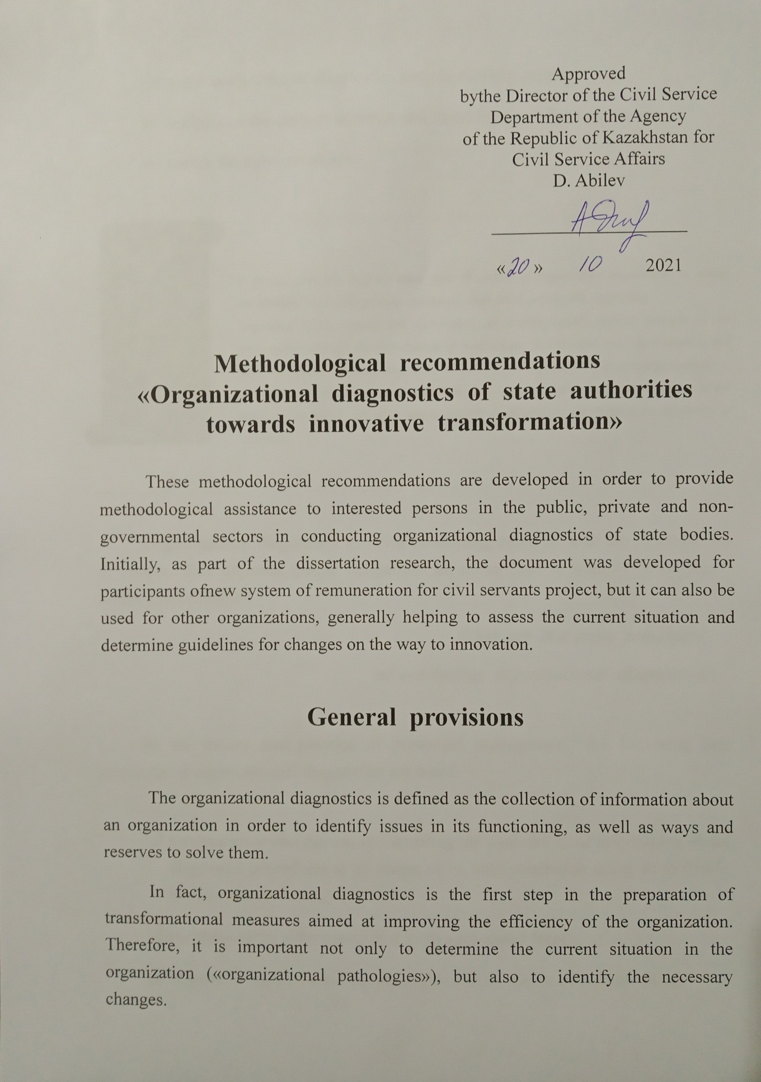

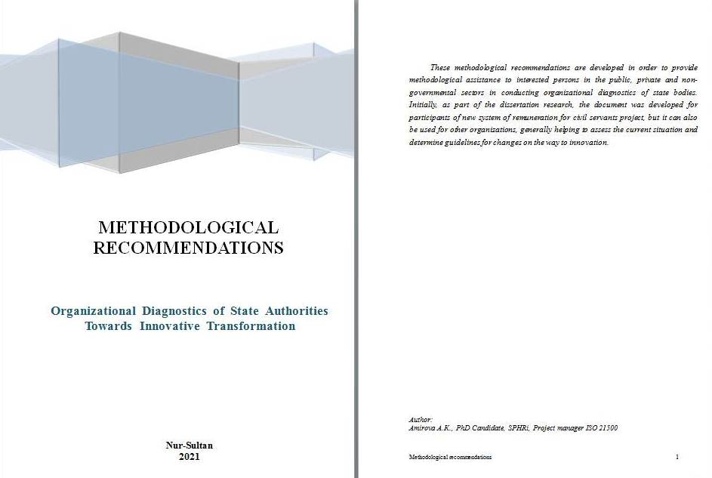
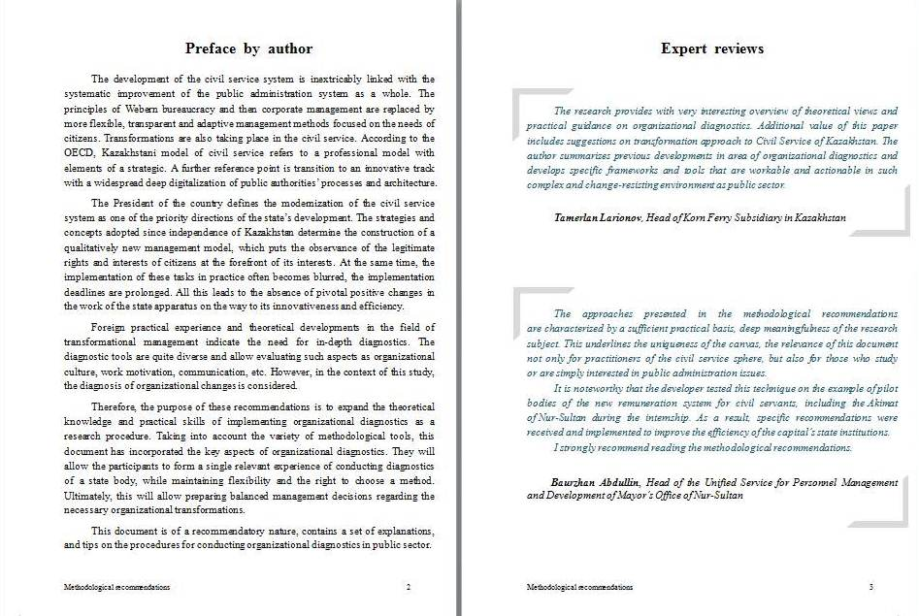
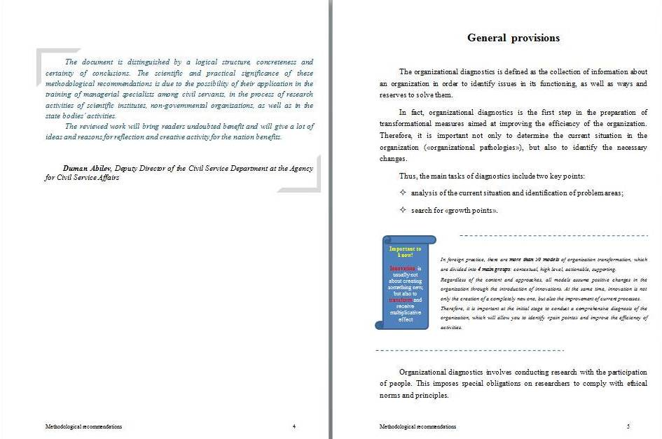
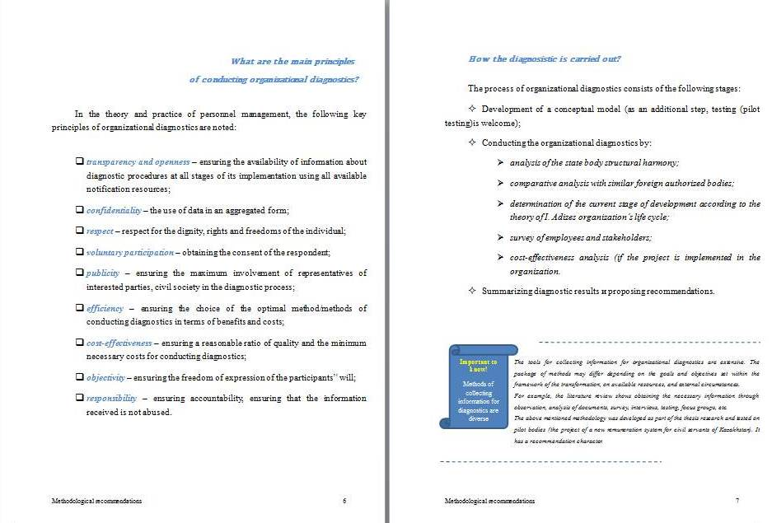
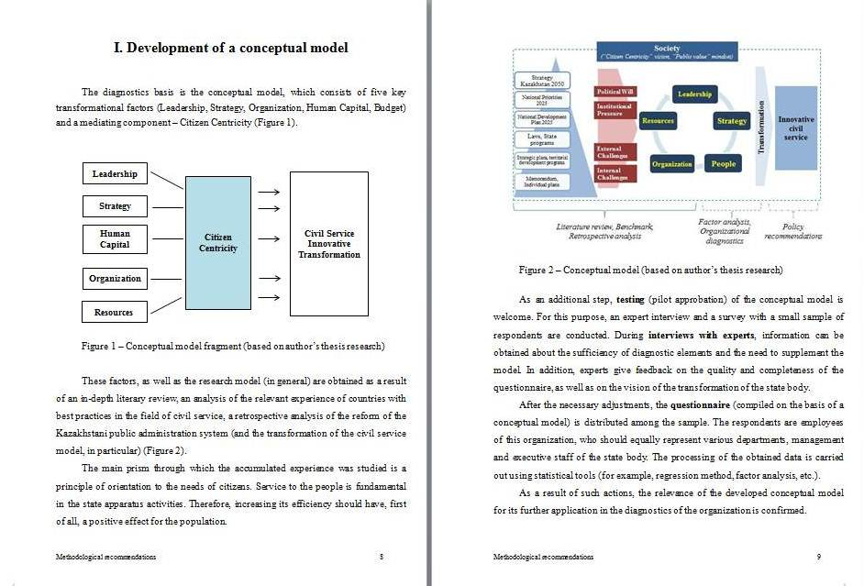
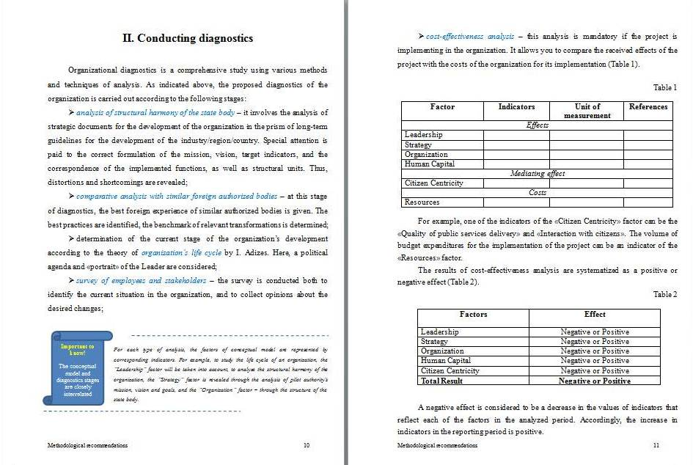
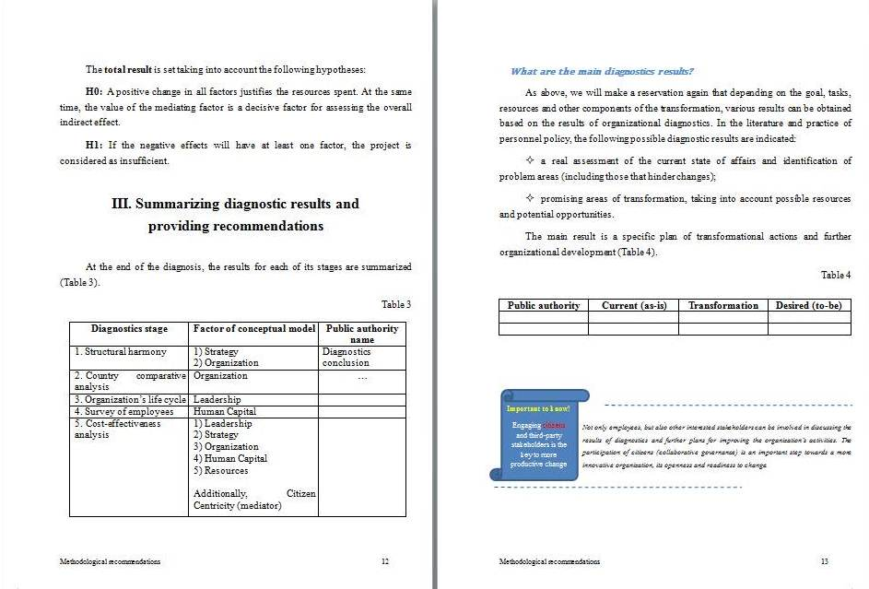


Review of Nur-Sultan Akimat

